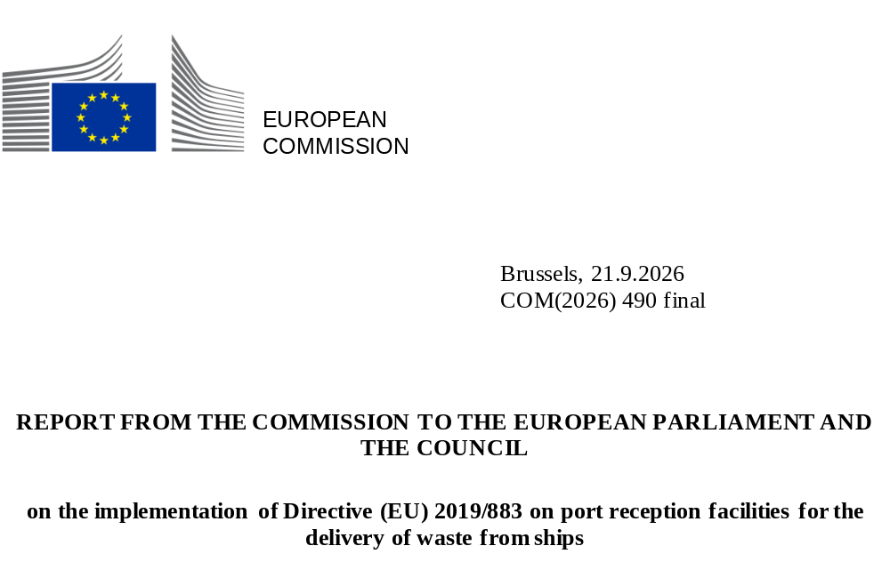

Contents
Executive Summary 1
1. Introduction 2
2. Objectives of the Directive and measures to achieve them 2
3. Transposition of the Directive into national law 3
4. Implementation of the Directive 3
a. waste delivered by ships to port reception facilities in the EU 4
b. the adequacy of port reception facilities in the EU 5
c. gaps in implementation 6
5. Conclusions and follow-up 11
Annex - Best waste prevention and management practices on board ships 12

Executive Summary
The European Commission released an implementation report on Directive (EU) 2019/883 on port reception facilities for the delivery of waste from ships. The report covers the period 2022-2025 and highlights the progress made in improving the availability and use of port reception facilities as well as the delivery of waste by seagoing ships to those facilities.
The Directive aims to prevent marine pollution by ensuring that waste from ships is not discharged into the sea but collected at ports in the European Union (EU). The Directive reflects the MARPOL Convention which regulates discharges from ships globally.
The report shows that more waste is being delivered by ships to EU ports, with oil, garbage and sewage being the most common types of waste delivered. The adequacy of port reception facilities is improving in terms of their operational conditions meeting the needs of the ships calling at EU ports. There are better facilities to collect, segregate and manage waste in EU ports, shipmasters have easier access to information about waste delivery, and the involvement of port authorities in waste management is increasing. However, there are still a number of challenges to tackle, including the lack of reporting by Member States resulting in missing information, for example about exempted ships and ports. In addition, more inspections of ships’ waste management are needed to reach the 15% target and more transparent information on indirect fee and waste fee reduction is needed across EU ports.
The Commission will continue its outreach activities towards the Member States as well as the monitoring of the implementation of the Directive and will take stock of progress with regular updates. As required by the Directive, an evaluation will be carried out, building on this interim report, newest data reported and on the analysis of the visit cycle by EMSA to the Member States.

Introduction
This is a report on the implementation of Directive (EU) 2019/883 on port reception facilities for the delivery of waste from ships (the Directive). It describes implementation between 2022 and 2025. The report reviews the objectives of the Directive and the measures put in place to achieve them, paying particular attention to the adequacy of port reception facilities. The EU Ports Strategy highlights that ports are becoming strategic hubs for circular activities which requires appropriate waste reception facilities. This report underlines the transition of the maritime sector to collecting more waste on board seagoing ships and delivering it at ports without polluting the sea for a cleaner marine environment.
Article 23 of the Directive calls for detailing best waste prevention and management practices on board ships. Therefore, there is a dedicated annex to this report about waste prevention and management practices.
Article 23 also calls for submitting the results of an evaluation to the European Parliament and the Council in 2026 however, due to the delayed transposition by Member States which resulted in insufficient data and experience by 2026, this report has been produced ahead of the evaluation as an interim step. In addition, the Commission tasked the European Maritime Safety Agency (EMSA) with making a regulatory compliance assessment of national measures implementing the Directive by carrying out a visit cycle to coastal Member States. The evaluation of the Directive will build on this first interim report, the newest, more robust data reported by the Member States and on the assessment by EMSA. This report is therefore a key step towards complying with the requirement set in Article 23.

Objectives of the Directive and measures to achieve them
The Directive’s objective is to ‘protect the marine environment against the negative effects from discharges of waste from ships, using ports located in the Union, while ensuring the smooth operation of maritime traffic, by improving the availability and use of port reception facilities and the delivery of waste to those facilities’ (Article 1).
The Directive aims to prevent marine pollution by ensuring that waste from ships and passively fished waste is not discharged into the sea but collected at EU ports and managed as required under Union waste law. It reflects the relevant International Maritime Organization (IMO) rules of the International Convention for the Prevention of Pollution from Ships (MARPOL) and provides for measures to ensure effective enforcement. The Directive covers waste categories defined by five technical annexes of the MARPOL Convention which regulate discharges from ships (oil, sewage, garbage, etc.).
One of the key requirements of the Directive and of MARPOL is the provision of adequate port reception facilities to receive waste from ships. This requirement relates to the operational conditions of the facility in terms of meeting the needs of ships, as well as to the conditions allowing for the disposal of ships’ waste to take place in an environmentally appropriate way.
The Directive provides measures for:
- mandatory waste delivery from ships (Article 7);
- a cost recovery system for ports to cover the costs of waste collection (Article 8); and
- a system of ship inspections with a risk-based targeting approach (Article 11),
all of which are facilitated by electronic reporting and the exchange of information (Article 13).
The assessment of the implementation of the Directive involves checking if the objectives of the Directive are being met as well as reviewing the availability, the use by ships of port reception facilities and the delivery of waste to those facilities.

Transposition of the Directive into national law
The Directive repealed Directive 2000/59/EC which previously had provided broader rules on port reception facilities. The Directive entered into force in 2019 with a transposition deadline of 28 June 2021. Four related implementing acts were adopted in 2022. Most Member States experienced delays in transposing the Directive into national law. Delayed transposition resulted in insufficient national data to carry out an evaluation in 2026. Statistics presented in this report reflect these gaps.
The Directive has nevertheless been transposed into national law in all Member States, despite delays in some of them. Hungary and Slovakia have applied the derogation provided for in Article 3(3) so they may not have any ports falling within the scope of the Directive and may not allow ships, including craft, that fall within the scope of the Directive to fly their flag. The Directive applies to both maritime ports as well as inland ports designed to be visited by seagoing vessels.

Implementation of the Directive
This chapter provides an assessment of the implementation of the Directive by the 22 coastal Member States for 2022-2025, noting the gaps in the data for the first years after transposition. It also takes into account the findings of the European Court of Auditors’ report on tackling sea pollution from ships.

waste delivered by ships to port reception facilities in the EU
More waste is being delivered by ships to EU ports, as shown in Figure 1. The upward trend was further confirmed by members of the Waste from Ships sub-group of the European Sustainable Shipping Forum, and to some extent by the representatives of ports and port reception facilities asked in a survey in 2025, while the total number of ships calling in the EU did not change significantly. Most waste delivered to port reception facilities were oil and garbage, followed by sewage. Additionally, the amount of passively fished waste increased, with nearly 1 300 tonnes collected in 2022 and over 1 500 tonnes collected in 2023. The upward trend in quantities of waste delivered by ships to EU ports can point to collecting more waste on board ships and delivering it at ports without polluting the sea.
Figure 1. Waste delivered by ships to EU ports in 2022 and 2025 based on information from advance waste notifications.

Source: THETIS EU

the adequacy of port reception facilities in the EU
The adequacy of port reception facilities is improving in terms of their operational conditions meeting the needs of the ships calling at EU ports. An example of such better facilities are the port reception facilities for sewage collection in the Baltic Sea region. There is also more involvement of port authorities in managing waste from ships according to stakeholder consultations carried out in 2025. Particularly, there is better communication between port authorities and the port reception facility providers as well as better facilities to collect and manage waste in EU ports. Port authorities develop and review their strategies, programmes and waste reception and handling plans. For example, 76% of TEN-T core ports have waste management plans available online and 84% of ESPO EcoPorts that have environmental monitoring programmes for ship waste. Waste reception and handling plans are generally easy to find online. All TEN-T core ports provide information about their waste reception services on their websites. This shows that shipmasters can have easier access to information about waste delivery possibilities in EU ports.
However, according to representatives of ports and port reception facilities, information about how a ship should dispose of its waste is not always clear. Furthermore, a number of challenges have been identified. For instance, participants of the Waste from Ships sub-group of the European Sustainable Shipping Forum and the Expert Group note that some EU ports are not in line with Article 4(2d) because they do not collect separately the waste that had previously been segregated on board.
To sum up on the strengths of implementation, thanks to the Directive (i) more waste is delivered by ships to EU ports contributing to less pollution at sea, (ii) the availability of adequate port reception facilities that meet the needs of ships is improving and (iii) shipmasters can have easier access to information about waste delivery possibilities in EU ports.

gaps in implementation
In line with the vision of a cleaner marine environment without pollution from ships, a ship must deliver its waste at port or have sufficient dedicated storage capacity for its waste during the next voyage as set out in Article 9(5). Not delivering the waste at the port may increase the risk of illegal discharge at sea. Three measures are detailed in this section to point to implementation gaps which may increase the risk of illegal discharge:
- waste inspections on board ships as set out in Article 11;
- a waste fee requirement to cover the costs of waste collection in ports as set out in Article 8; and
- the exchange of information on waste from ships with mandatory electronic reporting as set out in Article 13.
- Waste inspections on board ships
Member States must inspect at least 15% of ships calling at their ports in relation to their waste management (Article 11(1)) to ensure that ships handle waste properly. Figure 2 shows that some Member States inspect fewer ships. The 15% inspection rate was not met or not recorded by eight coastal Member States in 2025. The European Court of Auditors reported that Member States were often still failing to meet their target rates for waste inspections. The audit pointed to the need to improve how Member States report on their compliance with these requirements to carry out checks and apply penalties.
Figure 2. The percentage of waste inspections of ships in 2022 and 2025 in relation to the inspection target (100% is meeting the target).

Source: THETIS EU; the 2022 data is not complete as six Member States did not deploy their inspection systems nor record inspections at the time.
On the other hand, there is a positive trend when comparing 2022 and 2025 percentages in Figure 2 and also when comparing the total number of inspections reported. This points to an improvement in inspection rates and a reduction of the implementation gap.
- in 2022, there were over 5 800 inspections but not all Member States reported,
- in 2025, there were over 10 800 inspections and all Member States fulfilled their reporting obligation.
- Waste fee requirements
The Directive requires that EU ports have in place systems for (i) indirect fees in line with Article 8(2) and (ii) reduced fees in line with Article 8(5).
- An indirect fee must be charged at EU ports for garbage (MARPOL Annex V waste type) irrespective of the amount delivered.
- A reduced waste fee should apply for short sea shipping and for ships with sustainable waste management on board.
This assessment shows that information on waste fees of EU ports is incomplete and there is a significant information gap. The data reported by Member States in the SafeSeaNet Central Location Database until 2025 indicates that waste fee information is not always communicated in the plans or recorded. Representatives of ports and port reception facilities could not confirm that their ports always offer reduced fees. Moreover, only 61% of surveyed ports offered environmentally differentiated dues while Article 8(5) requires that Member States have such system in place for all their ports. Therefore, currently evidence is missing that there are indirect fee and reduced fee regimes in place in all EU ports.
- Exchange of information on waste from ships
Member States must report and exchange information about ships which did not deliver their waste (Article 13). Such ships create a potential risk of illegal discharge at sea. Member States exchange such information electronically via a dedicated system called SafeSeaNet. This assessment shows that the exchange of information and the monitoring of the ships suspected of pollution is limited because Member States do not always fulfil their reporting obligations. There is insufficient data reported by Member States on how waste from ships is managed when it reaches a port and this hinders pollution risk management and can be seen as a missed opportunity to recover feedstock for a circular economy. Statistics presented in this section reflect the gaps in reporting.
Advance waste notifications and waste receipts
An advance waste notification is a document that a ship delivers to a port ahead of a port call to inform the port on the quantity and types of waste it plans to deliver (Article 6). The percentage of missing advance waste notifications is monitored in relation to port calls. Figure 3 provides an overview on missing records.
A waste receipt is a document that a ship receives from the port acknowledging that the ship delivered its waste (Article 7). The percentage of missing waste receipts is monitored in relation to the advance waste notifications sent by ships. Figure 3 provides an overview of missing records.
In 2025, all Member States fulfilled their reporting obligation under Article 6(2) and 7(3) however some do not report all their advance waste notifications and waste receipts.
Figure 3. Missing advance waste notifications and waste receipts in 2022 and 2025
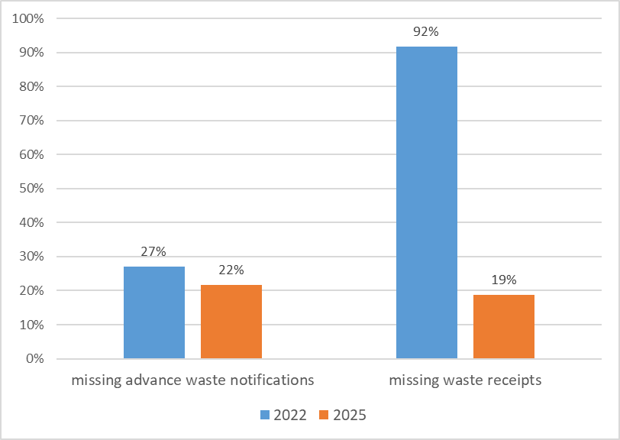
Source: SafeSeaNet; the 2022 data for waste receipts is not complete as 13 Member States did not record their values. In some cases, the reason why waste receipts are missing is that a ship did not deliver any waste although it had planned to do so. Therefore, the percentage of missing waste receipts will never be zero.
The figure shows that information is missing about the quantity and type of waste delivered by some ships calling at EU ports. If this information is missing in SafeSeaNet and cannot be exchanged then it is a missed opportunity for assessing if the ship was involved in possible illegal discharge en route and for targeting ships for waste inspections.
On the other hand, there is a positive trend when comparing 2022 and 2025 percentages in Figure 3 showing a reduction of the implementation gap. In 2022, 13 Member States did not record their waste receipts in SafeSeaNet, whereas in 2025 all Member States did so.
Exemptions
There are only a few exemptions reported by the Member States under the Directive. The Directive allows exemptions to (i) ships in scheduled traffic and (ii) small ports. Member States record such exemptions in SafeSeaNet. Having a few exemptions can be positive because it can mean that the requirements of a directive are met but this can mark a deficiency when exemptions are not granted although they should have been granted or when the information about exempted entities is not reported in the system.
Ships in the scope of the Directive
Ships engaged in scheduled traffic with frequent and regular port calls can be exempted from delivery of waste and/or notification and/or payment (Article 9). In 2025, only 6 out of 22 coastal Member States recorded their exemptions for ships in SafeSeaNet. The remaining Member States did not meet their reporting obligation under Article 13 or did not exempt any ships. Missing information about ship exemptions hinders the data exchange between Member States and impacts SafeSeaNet data quality.
Figure 4. Exemptions for ships reported in 2022 and 2025
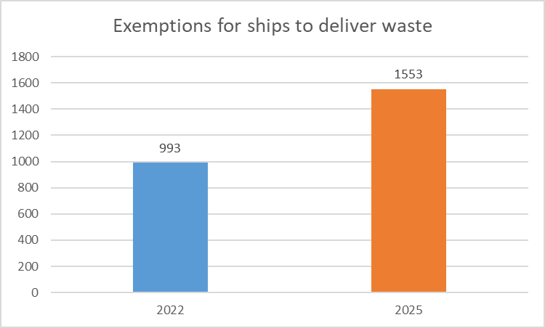
Source: SafeSeaNet
Ports in the scope of the Directive
Exemptions can also be granted by Member States to their ports. Ports may be exempted from holding a waste reception and handling plan if they are small, non-commercial and are characterised by rare or low traffic from recreational craft (Article 5(5)) or ports can be exempted from issuing waste receipts if they are small with unmanned facilities or remotely located (Article 7(2)). In 2025, only two Member States recorded port exemptions. The majority of Member States did not meet their reporting obligation under Article 13 or did not exempt any port. Without complete data on exempted ports, it is unclear which ports comply with the obligations on holding waste reception and handling plans and issuing waste receipts.

Figure 5. Exemptions for ports reported in 2022 and 2025
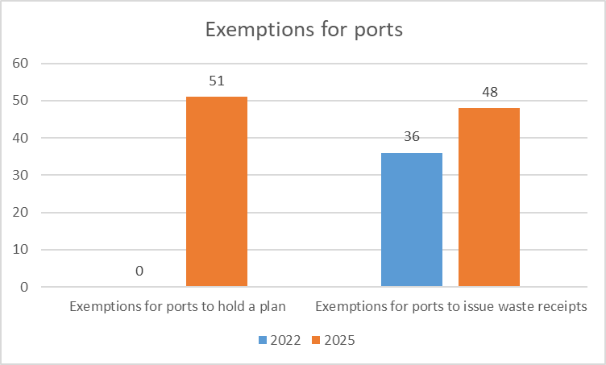
Source: SafeSeaNet
On the other hand, progress has been made, with more information in SafeSeaNet in 2025 as compared to 2022. The increased numbers of exemption records reflect some improvements, however the implementation gap is still substantial.
Information about port reception facility providers in waste reception and handling plans
Member States must report information from their waste reception and handling plans (Article 5(1-2)) in SafeSeaNet Central Location Database. This includes information about waste types, waste fees and contact details. The information is not always complete, nor is it always regularly updated in SafeSeaNet. In 2025, only 7 out of 22 coastal Member States updated information about port reception facility providers. If data concerning port reception facilities is missing, the access to information about services provided in EU ports is limited therefore the reporting system established under Article 13 does not reach sufficiently its objective for exchange of information.

Conclusions and follow-up
Based on the assessment of the first four years of implementation, the Directive has an added value:
- more waste is delivered by ships to port reception facilities in the EU.
There has also been an improvement in the adequacy of port reception facilities, including better facilities to collect, segregate and manage waste in EU ports. However:
- more inspections of ships’ waste management are needed to reach the 15% target to be in line with Article 11(1);
- horizontal and transparent information on indirect fee (Article 8(2)) and waste fee reduction (Article 8(5)) is needed to ensure that ships can deliver their waste efficiently across the EU; and
- more notifications (Article 6), waste receipts (Article 7), exemptions (Articles 5(5), 7(2) and 9) and information from plans about providers of port reception facility services (Article 5(1-2)) must be reported to ensure a meaningful information flow.
Still, progress has been made, with more information reported in SafeSeaNet each year. The increased numbers of reports reflect improvements and stronger enforcement measures applied by Member States as well as the commitment to reduce the implementation gap. The Commission will continue its outreach activities bilaterally with individual Member States on the specific implementation gaps and within the existing forum the Expert Group on Waste from Ships. The Expert Group meets twice a year and provides a platform for sharing best practices on how Member States address the identified gaps as well as cooperate and coordinate on questions relating to the implementation of the Directive including updating the guidance document “Guidance for Ship Inspections under the Port Reception Facilities Directive (EU) 2019/883”.
Summing up, the Directive has been relevant to achieving reduced waste discharges at sea because waste volumes delivered at EU ports increase and port reception facilities improve. The Commission will continue to monitor the implementation of the Directive and will take stock of progress with regular updates.

Annex - Best waste prevention and management practices on board ships
Article 23 of the Directive calls for detailing best waste prevention and management practices on board ships. Therefore, the annex presents such practices on board ships. Improved waste management can lead to a reduction in waste generation on board, which can also potentially result in less waste being discharged overboard by ships in European seas, leading to better protection of the marine environment.
These waste prevention and management activities are based on IMO guidelines and examples from the shipping industry. The IMO notes that ‘[t]he most effective way of reducing ship-generated wastes/residues is to reduce materials that become waste at the source’. The list below shows how the industry puts into practice the vision for less waste and better waste management on board.
Prevention and rethinking
- At corporate-level, a long-term waste management strategy.
- A waste management plan for each ship adapted to the ship’s operations, including the garbage management plan.
- Considering the durability of products purchased and the possibility of repairing them, i.e. buy more robust products less often.
- Sustainable purchasing practices incorporated into voyage planning. Procurement agreements with suppliers that accept upon delivery the return of packaging and the return of used products.
- Increased familiarity of the crew with the ship’s waste collection and storage practices, as well as repurposing and repairing of equipment on board.
- Avoiding single use plastic.
Segregation during the voyage
- Separate collection on board e.g. compacted aluminium cans, crushed glass, paper, plastic, cooking oil and digested food waste.
- Compliance with the criteria of Commission Implementing Regulation (EU) 2022/91, e.g. (i) ship does not discharge sewage into the sea and delivers it at port, (ii) oily water separator.
Delivery of all waste to port reception facility
- Delivering recyclable waste in separate, labelled or colour-coded bags, including hazardous waste.
- Delivery of all waste to adequate port reception facilities. Agreements with port reception facilities incorporated into voyage planning.
- Reporting any inadequate port reception facilities to the flag administration in a timely and accurate manner using IMO procedures and forms.
- Informing the port in advance waste notification by indicating the sub-categories (as in blue below).

Advance waste notification
Deliver the waste separately and inform the port what waste you have segregated out.
C. Domestic waste: specify in the column ‘waste description’ what will be delivered separately: paper, glass, metal/cans/aerosol cans, wood/ EUR-pallet, oily rags, medical waste, light bulbs.
F. Operational waste: specify in the column ‘waste description’ what will be delivered separately: fire extinguishers, pyrotechnics, paint/chemical drums, mooring lines.
I. E-waste: specify in the column ‘waste description’ what will be delivered separately: small electrical and electronic equipment (computers, radios, generators), big electrical and electronic equipment (washing machines), batteries, printer cartridges.

Summing up, the best practices above show the transition and the pathway for the maritime industry towards a cleaner marine environment minimising pollution from ships.

Directive (EU) 2019/883 of the European Parliament and of the Council of 17 April 2019 on port reception facilities for the delivery of waste from ships, amending Directive 2010/65/EU and repealing Directive 2000/59/EC, OJ L 151, 7.6.2019, pp. 116-142 ELI: http://data.europa.eu/eli/dir/2019/883/2019-06-07
EU Ports Strategy, COM/2026/112 final, ELI: https://eur-lex.europa.eu/legal-content/EN/TXT/?uri=CELEX%3A52026DC0112
Passively fished waste - waste fished out of the sea by fishers during regular fishing activities
MEPC.1/ Circ.834 - Consolidated Guidance for Port Reception Facility Providers and Users
Commission Implementing Regulation (EU) 2022/91 of 21 January 2022 defining the criteria for determining that a ship produces reduced quantities of waste and manages its waste in a sustainable and environmentally sound manner in accordance with Directive (EU) 2019/883, OJ L 15, pp. 12–15, ELI: https://eur-lex.europa.eu/eli/reg_impl/2022/91 Commission Implementing Regulation (EU) 2022/92 of 21 January 2022 laying down rules for the application of Directive (EU) 2019/883 as regards monitoring data methodologies and the format for reporting passively fished waste, OJ L 15, 24.1.2022, pp. 16–20, ELI: https://eur-lex.europa.eu/eli/reg_impl/2022/92/oj/eng Commission Implementing Regulation (EU) 2022/89 of 21 January 2022 laying down rules for the application of Directive (EU) 2019/883 as regards the method to be used for the calculation of sufficient dedicated storage capacity, OJ L 15, 24.1.2022, pp. 1–6, ELI: https://eur-lex.europa.eu/eli/reg_impl/2022/89/oj/eng Commission Implementing Regulation (EU) 2022/90 of 21 January 2022 laying down rules for the application of Directive (EU) 2019/883 as regards the detailed elements of the Union risk-based targeting mechanism for selecting ships for inspection, OJ L 15, 24.1.2022, pp. 7–11, ELI: https://eur-lex.europa.eu/eli/reg_impl/2022/90/oj/eng
The Commission opened infringement procedures against 21 Member States that failed to communicate their transposition and closed them all by 2024.
European Court of Auditors, 2025, Special Report 06/2025 on tackling sea pollution from ships
European Sustainable Shipping Forum sub-group on Waste from Ships, 2024, Report concerning activities of the ESSF Waste from Ships sub-group
16 out of 31 participants answered ‘yes’ to the question ‘What is your impression, is more waste delivered by ships in your port?’ in a survey conducted amongst ports (members of the European Sea Ports Organisation) and port reception facilities (members of Marine Care Association) in 2025.
European Maritime Safety Agency and European Environment Agency, 2025, European Maritime Transport Environmental Report (EMTER) More information on types of waste, see ‘yearly distribution of waste by type’ at https://portal.emsa.europa.eu/web/thetis-eu/compliance/prf
Not all waste that is generated on ships must be delivered to ports. Some can be discharged into the sea. The MARPOL Convention authorises limited, regulated discharges.
HELCOM - Baltic Marine Environment Protection Commission, 2025, HELCOM port reception facilities dashboard 2006-2024
Survey conducted amongst ports (members of the European Sea Ports Organisation) and port reception facilities (members of Marine Care Association) in 2025.
26 out of 31 participants answered ‘yes’ to questions ‘In your view, is there stronger involvement of port authorities? Is there more communication between port authorities and port reception facilities now than in 2018?’ in the 2025 survey.
19 out of 31 participants answered ‘yes’ to the question ‘What is your impression, are there better facilities to collect, segregate and manage waste in your port?’ in the 2025 survey.
28 out of 31 participants answered ‘yes’ to the question ‘Is there a waste reception and handling plan for your port?’ in the 2025 survey.
European Commission, 2026, European Maritime Space: Work Plan 2026. Towards sustainable, smart, seamless and resilient maritime transport
European Sea Ports Organisation, 2025, ESPO Environmental Report 2025
23 out of 31 participants provided the website for the waste reception and handling plan for their port in the 2025 survey.
16 out of 31 participants answered ‘yes’ to the question ‘What is your impression, is there clear information about how a ship should dispose of its waste?’ in the 2025 survey.
To put Figure 2 in perspective, Member States where the number of port calls is high must perform more inspections.
European Court of Auditors, 2025, Special Report 06/2025 on tackling sea pollution from ships
SafeSeaNet is the Union Maritime Information and Exchange System
16 out of 31 participants answered ‘yes’ to the question ‘Does your port have a reduced fee for ships that produce reduced quantities of waste, and manage its waste in a sustainable and environmentally sound manner?’ in the 2025 survey.
European Sea Ports Organisation, 2025, ESPO Environmental Report 2025
EMSA, 2023, Guidance for Ship Inspections under the Port Reception Facilities Directive (EU) 2019/883
Information is based on the input from the Baltic and International Maritime Council (BIMCO), the International Association of Independent Tanker Owners (INTERTANKO) and the Cruise Lines International Association (CLIA Europe)
MEPC.1/ Circ.834 - Consolidated Guidance for Port Reception Facility Providers and Users
Commission Implementing Regulation (EU) 2022/91 of 21 January 2022 defining the criteria for determining that a ship produces reduced quantities of waste and manages its waste in a sustainable and environmentally sound manner in accordance with Directive (EU) 2019/883, OJ L 15, 24.1.2022, pp. 12–15, ELI: https://eur-lex.europa.eu/eli/reg_impl/2022/91

