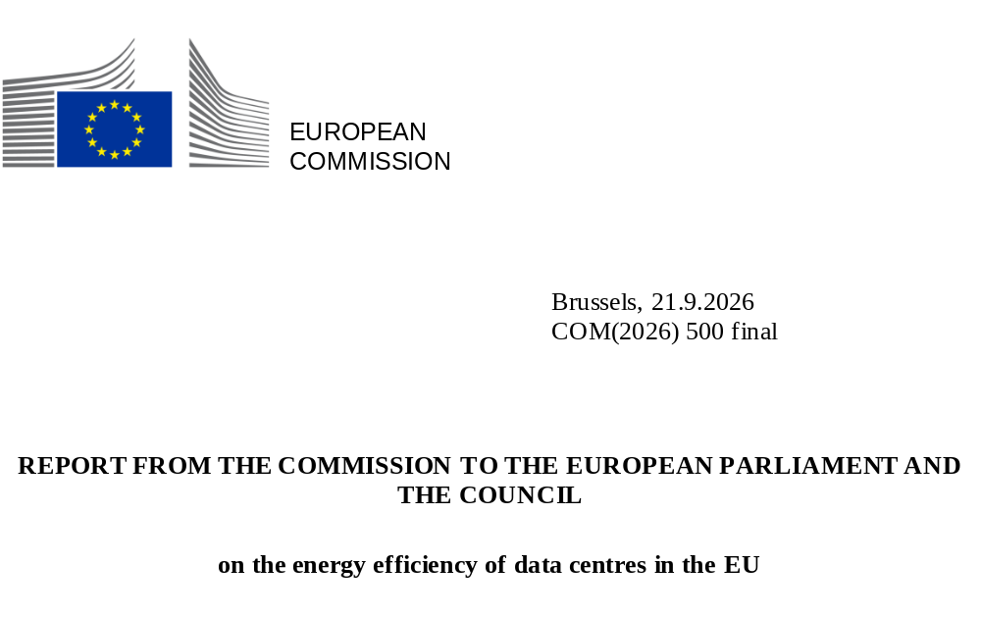

Contents

1. Introduction 3
2. Assessment of available data on the sustainability of data centres in the EU 4
2.1. Completeness and quality of the available data on the sustainability of data centres in the EU 4
2.2. Assessment of the energy efficiency and sustainability of European data centres 6
2.2.1. Assessment of the Power Usage Effectiveness in European data centres 6
2.2.2. Assessment of the Water Usage Effectiveness in European data centres 8
2.2.3. Assessment of the Energy Reuse Factor in European data centres 9
2.2.4. Assessment of the Renewable Energy Factor in European data centres 10
3. Next steps and legislative proposals towards a more sustainable data centre sector 11
3.1 Simplification and improvement of the reporting scheme 12
3.2. Proposal for the establishment of a common EU rating scheme for data centres 13
3.3 Proposal for the establishment of minimum performance standards for data centres 14
3.4. Assessment of the feasibility of a transition towards a net-zero emission data centre sector 16
4. Conclusion 17

1. Introduction
The information and communication technology (ICT) sector is one of the fastest-growing sectors in Europe and globally. In 2024, data centres in the EU consumed 68 TWh of electricity. This consumption is expected to rise to 114 TWh by 2030, reaching 3.2% of the electricity demand of the EU. These projections could be revised upwards considering the strong growth of emerging digital services and technologies, the accelerated adoption of artificial intelligence and the EU’s commitment to become a leading AI continent.
The Commission adopted the Cloud and AI Development Act to support the objective of strengthening the EU’s technological sovereignty, including by increasing computing capacity and fostering the development and deployment of AI on the Union’s territory, and to contribute to a more balanced geographical distribution of computing capacity. Maintaining strategic capacity in areas where technological sovereignty is required is essential, but also entails challenges. The expanding data centre sector poses a challenge for energy availability, availability of electricity grids, carbon emissions and environmental resources such as water.
In response, the EU’s digital strategy emphasises the need for highly energy-efficient and sustainable data centres and called for transparency measures regarding the sector’s environmental footprint. The Draghi report also highlights the crucial role of efficiency for the competitiveness of European industries. By cutting energy, and by extension operational costs, companies can reinvest in R&D, skills and jobs, boosting Europe’s competitiveness.
On 13 June 2025, the Commission made a renewed commitment towards energy efficiency and presented an energy efficiency roadmap which identifies 10 priority areas to guide EU action on energy efficiency. The roadmap aspires to streamline the implementation of EU energy efficiency rules and facilitate and enable increased uptake of energy efficiency measures and projects. One of the key deliverables of the roadmap is a data centre energy efficiency package, of which this report is a part.
In 2007, the EU established the Code of Conduct for Energy Efficiency in Data Centres to support voluntary improvement of data centre efficiency, by highlighting best practices and efficiency benchmarks for operators. Directive (EU) 2023/1791 (recast Energy Efficiency Directive, EED) includes measures to promote energy-efficient and sustainable data centres. Article 12 of the EED requires Member States to mandate data centres on their territory to publish information on their energy performance and sustainability. It also tasks the Commission with establishing an EU-level database containing this information to promote greater transparency. In March 2024, the Commission adopted Delegated Regulation (EU) 2024/1364, defining the first set of KPIs and sustainability indicators to be reported by data centre operators.
In accordance with Article 12(5) of the EED, this report assesses the available data on the energy efficiency and sustainability of data centres, based on submissions to the European database. Building on this analysis, the report explores the need for further measures to improve the sector’s sustainability, including setting minimum performance standards.
The data reported to the database include information on the reporting data centre (e.g. name, owner and operator, type), information on the operation of the reporting data centre, energy and sustainability indicators (e.g. energy consumption, water consumption, waste heat reused, renewable energy consumption), ICT capacity indicators and data traffic indicators in accordance with Delegated Regulation (EU) 2024/1364.
The Commission procured a technical assistance study to support the underlying analysis used in this report. Technical reports,, were published, providing a detailed analysis of the sustainability of data centres in the EU, the assessment of the existing regulatory framework and of the need for and feasibility of further measures. As part of the study’s consultation activities, a series of workshops and interviews were organised and engaged a diverse group of stakeholders, including Member States, the data centre industry, academia and civil society.
Other deliverables of the data centre energy efficiency package include the adoption of Delegated Regulation (EU) 2026/7000 establishing a common Union scheme to rate the sustainability of data centres and the launch of a public consultation on the establishment of minimum performance standards for data centres. The package complements the Strategic roadmap for digitalisation and AI in the energy sector (COM(2026) 501 final) and the Commission proposal for a Cloud and AI Development Act (COM(2026) 502 final), legislative initiatives that aim to enhance Europe’s cloud computing and AI capabilities, and promote the digitalisation of the European energy system and the better integration of the energy and digital systems in the Union.

2. Assessment of available data on the sustainability of data centres in the EU

2.1. Completeness and quality of the available data on the sustainability of data centres in the EU
In accordance with Article 12(1) of Directive (EU) 2023/1791, Member States must require owners and operators of data centres in their territory with a power demand of installed information technology (IT) of at least 500 kW to make publicly available information set out in Annex VII of that Directive. Delegated Regulation (EU) 2024/1364 introduced the European database on data centres and defined key performance indicators to be reported by data centre operators, first by 15 September 2024, then by 15 May 2025, and every year thereafter. The following assessment covers reported data from the first reporting period (May-September 2024). Both the completeness and the quality of the reported data have been reviewed in the technical assistance study. All data have been anonymised to avoid disclosing personal, company, or location-specific details pursuant to Article 5(5) of Delegated Regulation (EU) 2024/1364.
770 data centres reported their data in the first reporting period, representing around 36% of the estimated total of data centres in the EU falling under the reporting requirement. Six Member States have reported zero data centres, and five Member States have reported fewer than three data centres, providing a limited picture of the sector in those regions.
Figure 1 – Estimated total and number of reporting data centres per EU Member State
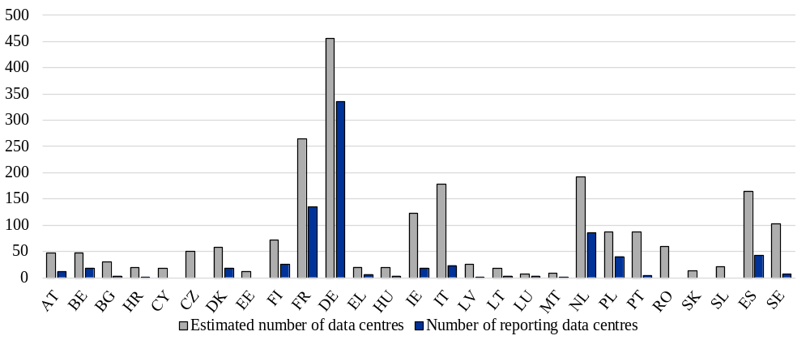
Given the complexity of the data centre landscape and the lack of publicly available data about it, this sample already yields valuable insights and constitutes a meaningful starting point for identifying prevailing industry trends. An increase in data submissions is anticipated in the upcoming reporting periods as awareness on the reporting scheme is growing, and operators have had time to adapt to the new regulatory processes and compile the necessary data. However, the Commission calls on Member States to ensure full and swift implementation of Article 12 of the EED and will accelerate enforcement to ensure that the number of reporting data centres increases in the future to support upcoming analyses and allow better-informed policymaking. The Commission also calls on data centre operators to comply with their reporting obligations.
To support the implementation and to ensure better transparency, the Commission supports operators by making a user manual, a reporter guide, frequently asked questions and guidance documents publicly available. In this context, in the second reporting period, the Commission has already received preliminary data from at least 30% more data centres. This data will be analysed in a subsequent report that the Commission is currently preparing.
For the first reporting period, a data quality assessment was run to verify the plausibility, accuracy and consistency of the reported metrics and ensure the reliability of the subsequent analyses and interpretations. Overall, 70.1% of the reported data are deemed to be reliable, implying that consistent figures have been reported across the given metrics. However, due to data centres not always reporting the full set of KPIs in the first reporting period, the number of data points differs per indicator. These inconsistencies need to be addressed through further validation and stakeholder engagement, but also by clarifying the indicators’ definitions and measurement methodologies. This is essential to improve the reliability of the dataset and ensure a more accurate picture of energy and water usage within the EU data centre ecosystem.

2.2. Assessment of the energy efficiency and sustainability of European data centres
The energy efficiency and sustainability assessment is based on the calculation of four metrics: Power Usage Effectiveness (PUE), Water Usage Effectiveness (WUE), Energy Reuse Factor (ERF) and Renewable Energy Factor (REF). The calculations are made using the validated reported data from the first reporting period.

2.2.1. Assessment of the Power Usage Effectiveness in European data centres
Data centres rely heavily on energy, primarily electricity, to operate servers, storage, network, cooling and other supporting systems. Electricity typically accounts for over 90% of a data centre’s direct energy use.
PUE, defined as the ratio of total facility energy consumption to IT equipment energy consumption, is a key measure of energy efficiency in data centres. It represents how much extra energy is required for non-IT systems. A lower PUE indicates greater efficiency, with values typically ranging from 1.0 (the theoretical ideal where every single watt is utilised for IT equipment) to 2.0 or more in less efficient facilities. In practice, values below 1.2 are considered excellent, values between 1.2 and 1.5 are regarded as good and values above 1.5 suggest room for improvement. PUE can fluctuate over the years due to internal (e.g. optimisation or utilisation) and external factors (e.g. weather conditions).
In 2024, the average reported PUE of data centres in the EU stood at 1.36. In comparison, the global average PUE in 2023 was 1.58, while the US reported an improved national average of 1.4 and China targets an average PUE of below 1.5 by the end of 2025.
The EU average hides significant differences across the continent, with national PUE values ranging from 1.15 to 1.66 (Figure 2). These results suggest efficiency disparities and a variety in technology choices, as analysis of the data indicates that climatic variations is not the main factor affecting the PUE values. Smaller data centres (500 – 1000 kW) report an average PUE of 1.64, considerably above the average, whereas larger data centres tend to have lower PUE, because they are often more recently built and benefit from economies of scale in terms of efficiency.
Overall, most reporting data centres in the EU still exceed typical PUE targets, such as the ones set, for example, by Germany or in the Climate Neutral Data Centre Pact (CNDCP) pledge. The German Energy Efficiency Act sets specific targets for PUE for data centres that range between 1.2 and 1.3 in the long term. CNDCP, a self-regulatory initiative by the data centre industry, commits operators within the EU to achieve climate neutrality by 2030, and targets a PUE of 1.3 for new data centres in cool climates and 1.4 in warmer regions (by 2030). While not setting specific targets, the EU Code of Conduct for Energy Efficiency in Data Centres has historically encouraged continuous improvement in PUE through a catalogue of best practices covering cooling, power distribution, IT optimisation and monitoring. The results from the first reporting period indicate substantial potential for improving PUE and energy efficiency in European data centres. Achieving this requires further optimisation and targeted investment in energy-saving technologies and infrastructure upgrades. Improving PUE not only improves sustainability and reduces grid stress but also cuts operational costs through lower energy consumption. Such improvements can boost the sector’s competitiveness, positioning the EU as a leader in sustainable practices within the global digital economy.
Figure 2 - Average PUE of data centres by Member State
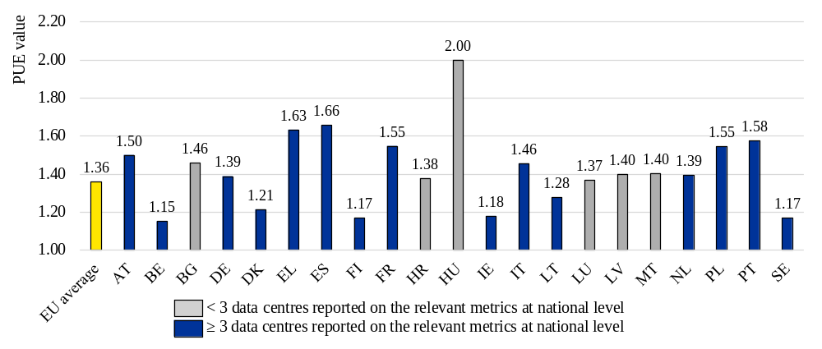

2.2.2. Assessment of the Water Usage Effectiveness in European data centres
Water consumption in data centres depends primarily on the cooling technology employed. Facilities using water‑based or evaporative systems consume substantial amounts of water, whereas those relying on air‑side or liquid‑direct cooling operate with minimal to no water use.
WUE, defined as the ratio of total water input to IT equipment energy consumption, allows measuring how efficiently a data centre uses water. A lower WUE indicates greater water efficiency, meaning that less water is used per unit of IT energy consumption.
In 2024, the average reported WUE of data centres in the EU was 0.58 (Figure 3). However, WUE varies significantly across Member States, ranging from 0.07 to 1.28. This variability is influenced by technology choices but also climate conditions, with cooler regions having in general less need for water cooling, while warmer regions may depend more on those systems. It should be noted that in some Member States, WUE figures are dominated by a few large operators with single facilities, that happen to report higher water input. WUE tends to increase with facility size, likely due to the rare use of evaporative cooling in smaller facilities. This variability underscores the challenges in optimising water efficiency across the board.
During the first reporting period, most data centres fell short of the CNDCP WUE target of 0.4 m³/MWh (by 2040). However, improving water efficiency remains a critical priority for the industry. Achieving responsible water management is essential for meeting long-term sustainability goals and ensuring efficient resource use across the board. Reducing WUE offers several benefits, including lower operational costs, enhanced environmental sustainability, and reduced pressure on local water resources.
Figure 3 - Average WUE of data centres by Member State
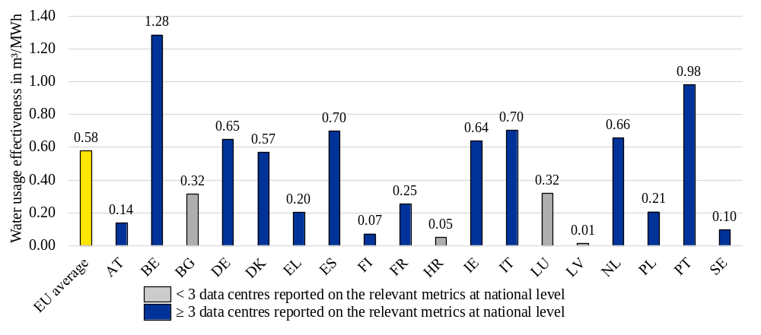

2.2.3. Assessment of the Energy Reuse Factor in European data centres
Europe has significant potential for excess heat recovery from power production, industry and commercial premises. This is especially true for large sites including the newer very large data centres.
The ERF is defined as the ratio of the total energy reused to the total energy consumption. It contributes to evaluating the energy efficiency of data centres by measuring how much energy has been reused for other purposes beyond the boundaries of the facility. Energy reuse results in reduced energy demand and fossil fuel use in surrounding areas, which aligns data centre operations with sustainable urban development, circular economy principles and better integration in the energy system. The ERF is expressed as a ratio between 0 and 1, where an ERF of 1 means that all energy consumed by the data centre is being reused and an ERF of 0 that no energy is being reused. In the case of data centres, energy reuse focuses on waste heat since practically all electricity consumed by a data centre eventually turns to heat.
Only 67 data centres reported some waste heat reuse in the first reporting period. The limited waste heat reuse can be attributed to several challenges, including varying waste-heat-readiness levels across facilities, the need to invest in upgrading and transferring the heat to off-takers, the irregular or unsuitable pattern of heat offered, or the lack of heat off-takers. The reported data (Figure 4) indicates that approximately 1.8% of the total heat generated by data centres is being reused in the EU. Smaller data centres have lower ERF values, as reuse of waste heat reuse from smaller facilities is typically not economically feasible. The results highlight the substantial potential for improvement in the future.
Figure 4 - Average ERF of data centres by Member State
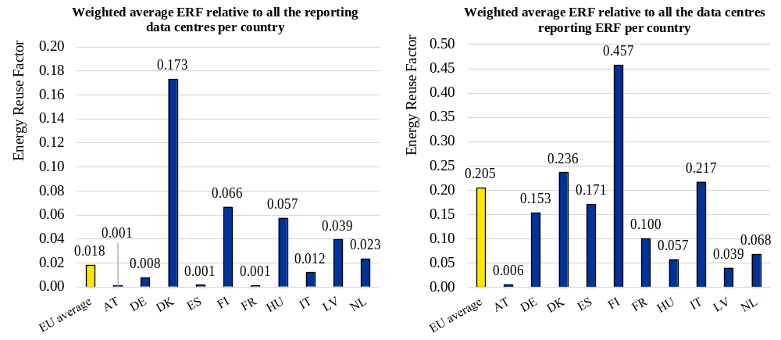
Improving waste heat reuse can enhance energy security, reduce the reliance on imported fossil fuels and mitigate the impact of volatile energy prices. Nevertheless, it is difficult to set a target for ERF, as waste heat reuse is only possible if there is demand for waste heat from local heat off-takers and local infrastructure for waste heat reuse exists around the facilities. Special attention also needs to be given to climatic and seasonal variations, as demand for heat reuse is lower in warmer climate zones than in colder regions. Even in regions with high heating demand, the seasonality of demand remains a major barrier for high heat reuse rates.

2.2.4. Assessment of the Renewable Energy Factor in European data centres
Integrating clean energy sources into data centre operations is important for reducing the facilities’ carbon footprint. As increasingly important electricity consumers, data centres can play a pivotal role in the transformation of the power system by investing in and expanding renewable and nuclear energy capacity. So far, data centres reported only their renewable energy consumption in accordance with Article 4 and Annex III of Delegated Regulation (EU) 2024/1364. For this reason, this report only analyses the reporting of renewable energy consumption.
The REF is defined as the ratio of total renewable energy consumption to total energy consumption. It assesses the proportion of the energy consumed by a data centre coming from renewable sources. It is expressed as a ratio or as a percentage, where a REF of 1 indicates that all energy consumption comes from renewable sources.
In many Member States, data centres achieve very high REF, contributing to a reported EU-wide weighted average of 0.86 (Figure 5), highlighting that data centres are already leaders in renewable energy sourcing. In general, larger data centres achieve higher REF, which also improves the total weighted REF of the sector. Over 70% of the reported sites already match 100% of their electricity consumption with renewable energy on an annual basis. Signatories of the CNDCP have committed to matching their electricity consumption with 75% of renewable energy or hourly carbon-free energy by the end of 2025, and 100% by the end of 2030. The reported data suggest that aiming at having a REF of 1.0 for all data centres in the coming years is realistic. However, analysis showed that a large degree of renewable energy is sourced by power purchase agreements (PPA) and guarantees of origin (GOO) that are not necessarily connected to local production or new additions of renewable production.
Thus, in the future, attention should increasingly be given to the origin (on-site generation, guarantees of origin, power-purchase agreement), the technology, the additionality of the renewables used as well as the temporal matching between supply and demand. This is also means that there is space, in alignment with the ongoing discussion in the GHG Protocol, to improve the definition of REF and what it covers.
The same applies for the consumption of other clean energy sources, such as on-site nuclear or guarantees of origin.
Figure 5 - Average REF of data centres by Member State
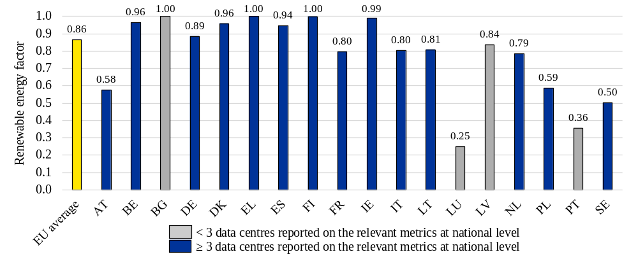

3. Next steps and legislative proposals towards a more sustainable data centre sector
The comprehensive assessment of the energy and water efficiency of data centres, based on data submitted to the European database in the first reporting period, reveals that while progress has been made, there remains significant potential to further improve the sector’s sustainability. This underscores the necessity and the opportunity for additional measures to promote sustainable operations of data centres across Europe. Legislative frameworks can play a crucial role in driving these advancements.
This section outlines several options that aim at improving the sustainability of European data centres. These recommendations have been developed through a combination of desk research, stakeholder engagement and quantitative analysis. The analysis draws upon technical standards, existing legislation and voluntary frameworks, ensuring that the proposals are well-aligned with current policy and market trends. Stakeholder engagement, consisting of surveys, interviews, workshops and collaboration within the EED Experts Group, provided valuable insights into industry readiness and validated the feasibility of the proposed measures. Additionally, an evaluation of the best available technologies ensured that the recommendations are practical and scalable, and that they consider regional differences.

3.1 Simplification and improvement of the reporting scheme
In March 2024, with the adoption of Delegated Regulation (EU) 2024/1364, the Commission introduced the European database on data centres and a reporting scheme designed to collect key performance indicators regarding the sustainability of data centres in the European Union.
As part of an ongoing effort to simplify and harmonise EU policy initiatives, the reporting scheme was assessed, considering feedback from operators gathered through targeted interviews and surveys. The aim was to identify strengths and limitations and pinpoint opportunities to amend Delegated Regulation (EU) 2024/1364 and improve the existing reporting framework.
The assessment showed that simplification should focus on removing indicators whose reporting is considered difficult and whose impact to the next steps is limited, such as the data traffic indicators, which are not directly relevant in computing the four efficiency and sustainability metrics (PUE, WUE, ERF, REF) or any possible equipment efficiency metric. The assessment also showed that reporting could be simplified by standardising indicators across policy initiatives to avoid potential misalignments between legislative frameworks. For example, the current reporting of ‘potable water input’ could be replaced with ‘freshwater input’, harmonising the scheme with indicators used in EU water policies,.
In addition, future data collection should cover nuclear energy consumption, as it can provide large volumes of low-carbon power to data centres. It is important to apply the principle of technological neutrality towards low-emission energy sources, to stimulate new investments in low-emission energy and to accelerate the clean energy transition of the sector.
To enhance the accuracy and reliability of the reported data by data centre operators, additional methodologies and definitions should also be introduced to clarify the reporting requirements for operators and maximise the proportion of correct entries submitted, leading to a better understanding of the data centre landscape. In addition, it would be important to implement some logical checks, as part of the database’s input interface, and promote the use of monitoring and reporting certification by reporting data centres.
Acknowledging the varied environments in which data centres operate is important for effective regulation. In the future, a more detailed reporting scheme could integrate new indicators to better contextualise the operations of each facility, particularly concerning local water availability and associated supply risk factors. While the World Resources Institute’s Aqueduct Water Risk Atlas and the Water Exploitation Index Plus (WEI+) of the European Environmental Agency provide already some assessment concerning water stress in the EU, further development of an EU-wide basis on how to assess the local environmental impact of data centres is needed as announced in the Water Resilience Strategy.
Furthermore, the reporting scheme should acknowledge the distinct challenges faced by colocation facilities, which often struggle to access complete operational KPIs due to client-controlled IT equipment. To address this, reporting requirements should consider the feasibility of data centres to receive data from their customers.
Finally, to further support sustainability, voluntary reporting of smaller data centres and data centres that are in the design phase could further incentivise and promote exemplary behaviour within the sector while providing more information on the European data centre ecosystem.

3.2. Proposal for the establishment of a common EU rating scheme for data centres
Articles 12 and 33(3) of the EED require further steps to ensure that the data centres sector adopts and implements more sustainable technologies and practices. Delegated Regulation (EU) 2024/1364 already laid the foundations by introducing the European database on data centres and a reporting scheme for the collection of key performance indicators to be used in an EU rating scheme. A second Delegated Regulation concerning the establishment of the common Union rating scheme has been adopted as part of the data centre energy efficiency package.
A comprehensive rating scheme is needed to foster transparency and inform better policy making and procurement of more sustainable digital assets and services across Europe. The rating scheme will allow to evaluate and promote new designs or appropriate efficiency interventions in new or existing data centres that can result not only in a considerable reduction of energy and water consumption, but also in increased use of renewable and other low-emission energy, an increase in the efficiency of the grid, or in the reuse of waste heat in nearby facilities and heat networks.
Building on the reporting scheme established by Delegated Regulation (EU) 2024/1364, indicators displayed on the label have been selected among those already communicated by data centre operators to the European database and identified as the most relevant ones for achieving the objectives of the regulation, while also respecting confidentiality concerns. The thresholds have been set based on the analysis of the data from the first reporting period and on stakeholder feedback and comply with established standards and international benchmarks. Indicators and thresholds will be subject to future review to align with technological advancements, improve the effectiveness of the scheme and strive for higher sustainability standards.
By leveraging existing data, the rating scheme will not involve any additional burden on Member States and data centre operators. Automation within the reporting platform will generate rating labels at the end of each period, facilitating consistent and regular assessments. Ensuring transparency, the label will be publicly accessible in electronic form, enhancing visibility on the environmental footprint of data centres.

3.3 Proposal for the establishment of minimum performance standards for data centres
Article 12(5) of the EED asks the Commission to advance legislative proposals aimed at enhancing energy efficiency in data centres, including by setting minimum performance standards. Comprehensive analysis has identified these standards as a critical opportunity to ensure that all new or retrofitted data centres in Europe meet set benchmarks in energy efficiency, water usage, and other sustainability criteria. Data from the first reporting period (Figures 6 and 7) reveals that roughly half of reporting data centres in Europe exceed a recommended PUE baseline of 1.5 and/or a recommended WUE baseline of 0.4. These findings underscore the opportunity for improvement and additional regulatory measures to encourage industry-wide advancement. The International Energy Agency (IEA) estimates suggest that empowering efficiency in data centres through measures like minimum performance standards could save globally around 65 TWh of energy per year, of which almost 20 TWh in Europe.
Figures 6 and 7 - The distribution of PUE (left) and WUE (right) according to the reported data in the first reporting period
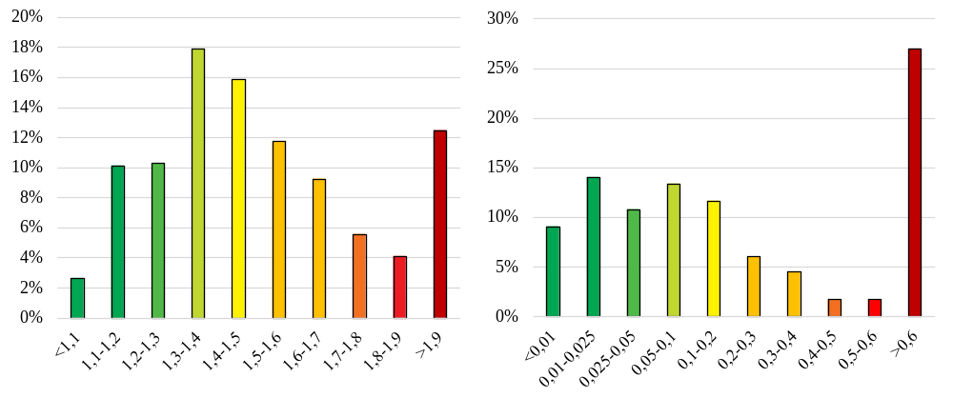
Setting minimum performance standards would mark the third phase in advancing the sustainability of data centres, complementing existing efforts to increase transparency and accountability via the reporting scheme and promote exemplary technologies and practices via the rating scheme. Setting these standards aims not only at phasing out outdated and inefficient practices but also at improving the sector’s competitiveness by making better use of energy and water. The creation of common performance standards in the EU would also prevent the multiplication of disparate national legislative frameworks, which creates a complex regulatory landscape and results in varying levels of efficiency and sustainability. Such fragmentation complicates the operational environment for data centres, obstructing the seamless expansion across borders due to inconsistent compliance requirements. Moreover, the lack of standardisation prevents the EU from fully leveraging collaborative efforts to optimise energy efficiency and sustainability on a larger scale.
The minimum performance standards could set thresholds for key performance indicators such as PUE, WUE, and REF, or a combination of them, ensuring a minimum level of performance is met by all data centres. The thresholds should be ambitious yet realistic, derived from the reported performance data, reviews of national and international frameworks and tailored to account for variations in size, age, climatic conditions and location of data centres.
The Commission is committed to supporting the sector’s transition by illustrating viable options and solutions that align with the EU’s energy, climate and competitiveness goals. Stakeholder engagement has demonstrated a readiness within the sector to work with efficiency and sustainability indicators, validating the feasibility of the proposal. The initiative anticipates establishing a timeframe for existing data centres to comply with these standards, thereby fostering sustainability improvements without hindering the sector’s needed development in Europe as expressed in the Europe’s Digital Decade, the AI Continent Action Plan, and the Cloud and AI Development Act.
As a first step, the Commission is publishing a call for evidence and an open public consultation to define the initiative’s scope as precisely as possible, followed by an impact assessment to evaluate policy options. Continuous dialogue with stakeholders and Member States should inform and refine the regulatory proposal, ensuring its practical execution aligns with both industry capabilities and environmental imperatives.

3.4. Assessment of the feasibility of a transition towards a net-zero emission data centre sector
The European Commission, in its strategic document ‘Shaping Europe’s Digital Future’, has set an ambitious goal for data centres and telecommunications to achieve climate neutrality by 2030. As projections for energy consumption continue to rise, aligning the sector with clear climate neutrality targets becomes increasingly crucial.
Achieving carbon neutrality in data centres requires a multifaceted approach, including decarbonising the electricity supply, synchronising electricity usage with generation timings and using energy-efficient technologies. Incentivising the use of low-emission energy sources on the label or in minimum performance standards can further contribute to achieving this target while respecting a technology-neutral approach. Beyond direct operational efforts, addressing upstream and downstream emissions is crucial. Measures such as extending IT hardware service life through repair and refurbishment, developing infrastructure on brownfield sites with sustainable materials, and using waste heat as a substitute for fossil-based heating in district-heating networks contribute significantly to advancing towards a carbon-neutral sector. Installing sustainable cooling systems and using sustainable refrigerants are also essential for achieving carbon neutrality in data centres.
While most European data centres can feasibly achieve net-zero emissions in the coming years, success depends on factors such as grid carbon intensity, local site constraints and financial resources. Thus, achieving climate neutrality should be seen as a broadly attainable objective, though not uniformly guaranteed for every facility.
Therefore, the introduction of specific regulation for climate neutrality is so far deemed unnecessary. Instead, the rating scheme and proposed minimum performance standards constitute foundational steps toward climate-neutral operations, with potential for review to incorporate technological advancements and increased sustainability ambitions. This approach maintains the focus on practical frameworks, facilitating the sector’s transition toward climate-neutral benchmarks without imposing premature regulatory burdens.

4. Conclusion
Establishing a reporting scheme for data centres in Europe has started a rich discussion among all public and private stakeholders on the need and ways to promote the sustainability of data centres. The first reporting period provided important evidence and insights on what is the current state and where improvements could be pursued. Although some aspects of the reporting scheme need to be improved, the data obtained and the public consultation that took place throughout the year supported the concept of introducing a label that will offer even more transparency, exhibit sustainable practices and pull the sector to adopt the best technologies available. Even more, it supported the idea of an untapped potential for energy and water savings, increased use of renewable and other low-emission energy, better integration to the energy system, and eventually smaller carbon footprint that in the next months will be further explored and assessed by the Commission, as part of an initiative to introduce minimum performance standards for data centres in Europe.

https://www.iea.org/reports/key-questions-on-energy-and-ai.
https://www.iea.org/reports/key-questions-on-energy-and-ai.
https://electricity-data.eurelectric.org/electricity-demand.html.
https://www.iea.org/reports/energy-and-ai.
https://digital-strategy.ec.europa.eu/en/library/ai-continent-action-plan.
Proposal for a Regulation of the European Parliament and of the Council establishing a framework of measures for strengthening Europe’s cloud and AI ecosystem (Cloud and AI Development Act), COM(2026) 502 final, https://digital-strategy.ec.europa.eu/en/library/proposal-cloud-and-ai-development-act-cada.
https://commission.europa.eu/publications/european-commission-digital-strategy_en.
Draghi, M. (2024), The Future of European Competitiveness–A Competitiveness Strategy for Europe. https://commission.europa.eu/document/97e481fd-2dc3-412 d-be4c-f152a8232961_en.
https://energy.ec.europa.eu/topics/energy-efficiency/new-impetus-energy-efficiency_en.
https://e3p.jrc.ec.europa.eu/en/groups/data-centres-code-conduct.
Directive (EU) 2023/1791 of the European Parliament and of the Council of 13 September 2023 on energy efficiency and amending Regulation (EU) 2023/955 (recast) (OJ L 231, 20.9.2023, p.1, ELI: http://data.europa.eu/eli/dir/2023/1791/oj).
‘Technical Assistance in support of implementing Article 12(5) of Directive 2023/1791 on the energy performance and sustainability of data centres’: https://www.borderstep.org/projekte/eudcear/.
European Commission: Directorate-General for Energy, AIT, Borderstep and EY, Assessment of the energy performance and sustainability of data centres in EU – First technical report, Publications Office of the European Union, 2025, https://data.europa.eu/doi/10.2833/3168794.
European Commission: Directorate-General for Energy, AIT, Borderstep and EY, Assessment of next steps to promote the energy performance and sustainability of data centres in EU, including the establishment of an EU-wide rating scheme – Second technical report, Publications Office of the European Union, 2025, https://data.europa.eu/doi/10.2833/0828045.
Kamiya, G. and Bertoldi, P., Energy Consumption in Data Centres and Broadband Communication Networks in the EU, Publications Office of the European Union, Luxembourg, 2024, doi:10.2760/706491.
Commission Delegated Regulation (EU) 2026/7000 supplementing Directive (EU) 2023/1791 of the European Parliament and of the Council and amending Delegated Regulation (EU) 2024/1364 as regards the establishment of a common Union rating scheme for data centres.
Communication from the Commission to the European Parliament, the Council, the European Economic and Social Committee and the Committee of the Regions, Strategic Roadmap for Digitalisation and AI in the Energy Sector, COM(2026) 501 final, https://energy.ec.europa.eu/publications/strategic-roadmap-digitalisation-and-ai-energy-sector_en.
European Commission: Directorate-General for Energy, AIT, Borderstep and EY, Assessment of the energy performance and sustainability of data centres in EU – First technical report, Publications Office of the European Union, 2025, https://data.europa.eu/doi/10.2833/3168794.
To estimate the number of data centres in Europe and per country that should report to the European database, multiple sources were consulted, including commercial databases and inputs from national data centre associations and industry stakeholders during the consultation phase. The estimated total includes data centres above 500 kW and data centres above the national reporting thresholds (e.g. data centres above 300 kW in Germany have to report their data).
European Commission: Directorate-General for Energy, AIT, Borderstep and EY, Assessment of the energy performance and sustainability of data centres in EU – First technical report, Publications Office of the European Union, 2025, https://data.europa.eu/doi/10.2833/3168794, p.23.
Energy performance of data centres: https://energy.ec.europa.eu/topics/energy-efficiency/energy-efficiency-targets-directive-and-rules/energy-efficiency-directive_en#energy-performance-of-data-centres.
Checking processes included cross-checking indicators to identify inconsistencies and removing values falling outside the expected ranges for each indicator. Expected ranges have been set according to expert input, industry benchmarks and external sources.
These four metrics are delineated under Annex III of Delegated Regulation (EU) 2024/1364.
European Commission, Study on greening cloud computing and electronic communications services and networks: Towards climate neutrality by 2050, 2022. Available at: https://digital-strategy.ec.europa.eu/en/library/study-greening-cloud-computing-and-electronic-communications-services-and-networks-towards-climate.
In addition, data collected and monitored within the EU Code of Conduct for Energy Efficiency in Data Centres indicates that the average PUE of participants’ data centres (more than 400, in 2024, of any type and size) decreased from 1.8 to less than 1.3 over the period 2010-2024 (JRC calculation).
Uptime Institute, Global PUEs: Are They Going Anywhere? 2023, https://journal.uptimeinstitute.com/global-pues-are-they-going-anywhere/.
Lawrence Berkeley National Laboratory, United States Data Center Energy Usage Report, December 2024, https://eta-publications.lbl.gov/sites/default/files/2024-12/lbnl-2024-united-states-data-center-energy-usage-report.pdf.
The State Council of the People’s Republic of China, China’s Government Reports on Digital Infrastructure, 24 July 2024, https://english.www.gov.cn/news/202407/24/content_WS66a0b167c6d0868f4e8e96ba.html.
Average PUE is calculated as a weighted average, with each facility’s total energy consumption serving as weight. For the first reporting period, 681 data centres reported PUE values deemed reliable. In 5 Member States, less than 3 data centres submitted their data, potentially leading to non-representative figures. Source: European Commission: Directorate-General for Energy, AIT, Borderstep and EY, Assessment of the energy performance and sustainability of data centres in EU – First technical report, Publications Office of the European Union, 2025, https://data.europa.eu/doi/10.2833/3168794, p.34.
European Commission: Directorate-General for Energy, AIT, Borderstep and EY, Assessment of next steps to promote the energy performance and sustainability of data centres in EU, including the establishment of an EU-wide rating scheme – Second technical report, Publications Office of the European Union, 2025, https://data.europa.eu/doi/10.2833/0828045
Uptime Institute, Large data centers are mostly more efficient, analysis confirms, 2024, https://journal.uptimeinstitute.com/large-data-centers-are-mostly-more-efficient-analysis-confirms/.
Climate Neutral Data Centre Pact, Working groups. Available at: https://www.climateneutraldatacentre.net/working-groups/.
Acton M., Booth, J. and Paci, D., 2025 Best Practice Guidelines for the EU Code of Conduct on Data Centre Energy Efficiency, Publications Office of the European Union, Luxembourg, 2025.
m³/MWh can be replaced with L/kWh, but this report uses units in line with EN 506400-4.
Average WUE is calculated as a weighted average, with each facility’s total energy consumption serving as weight. For the first reporting period, 458 data centres reported WUE values deemed reliable. Only data centres that reported a total water consumption higher than 0 were included in the analysis (therefore, excluding data centres relying on dry cooling technologies). Source: European Commission: Directorate-General for Energy, AIT, Borderstep and EY, Assessment of the energy performance and sustainability of data centres in EU – First technical report, Publications Office of the European Union, 2025, https://data.europa.eu/doi/10.2833/3168794, p. 39.
Climate Neutral Data Centre Pact, Working groups, https://www.climateneutraldatacentre.net/working-groups/.
A typical example is that cooling of data centres in warmer regions coincides with very low to zero heating needs in residential and office buildings.
Figure 4 displays both the (weighted) average national ERF relative to all the data centres in the country and the (weighted) average ERF relative to the data centres reporting ERF values only. Source: European Commission: Directorate-General for Energy, AIT, Borderstep and EY, Assessment of the energy performance and sustainability of data centres in EU – First technical report, Publications Office of the European Union, 2025, https://data.europa.eu/doi/10.2833/3168794, p. 41.
This figure may not be fully representative of the data centre heat reuse landscape in the EU as some computed values seemed unrealistically high, although they could not be fully falsified. Moreover, although there are known heat reuse projects in some Member States, those same Member States have not reported any data centres on heat reuse.
Average REF is calculated as a weighted average, with each facility’s total energy consumption serving as weight. For the first reporting period, 584 data centres reported WUE values deemed reliable. Source: European Commission: Directorate-General for Energy, AIT, Borderstep and EY, Assessment of the energy performance and sustainability of data centres in EU – First technical report, Publications Office of the European Union, 2025, https://data.europa.eu/doi/10.2833/3168794, p. 43.
Climate Neutral Data Centre Pact, https://www.climateneutraldatacentre.net/working-groups/.
https://ghgprotocol.org/.
Group of Experts on the Energy Efficiency Directive (E03228).
https://op.europa.eu/en/publication-detail/-/publication/83be4c3e-5c79-11f0-a9d0-01aa75ed71a1/language-en.
Directive 2000/60/EC of the European Parliament and of the Council of 23 October 2000 establishing a framework for Community action in the field of water policy.
Communication COM/2025/280 from the Commission to the European Parliament, the Council, the European Economic and Social Committee and the Committee of the Regions, European water resilience strategy
World Resources Institute, Aqueduct Water Risk Atlas, https://www.wri.org/applications/aqueduct/water-risk-atlas/.
https://www.eea.europa.eu/en/analysis/indicators/use-of-freshwater-resources-in-europe-1.
A colocation data centre is a shared facility where one or multiple third-party organisations can rent space for their servers and data storage equipment.
Directorate-General for Energy, AIT, Borderstep and EY, Assessment of next steps to promote the energy performance and sustainability of data centres in EU, including the establishment of an EU-wide rating scheme – Second technical report, Publications Office of the European Union, 2025, https://data.europa.eu/doi/10.2833/0828045, p.26.
https://www.iea-4e.org/edna/publications/.
Such as Germany’s Energieeffizienzgesetz, China’s GB 40879-2021, and the Climate Neutral Data Centre Pact.
For example, the Commission published a structured quantitative assessment of 66 Best Available Technologies (BATs), focusing on their relevance, feasibility and impact in data centre operation providing data centre operators with a practical starting point for improvement: https://op.europa.eu/en/publication-detail/-/publication/29aa14ed-a4ba-11f0-a7c5-01aa75ed71a1/language-en.
Stakeholder consultation confirms the practicality of the proposed minimum performance standards: 91% of surveyed organisations reported having adopted internal sustainability plans, with 83% expecting to meet their targets within five years. The most common targets already pursued include carbon-free energy (44%), PUE reductions (26%) and WUE improvements (22%). For more details: https://op.europa.eu/en/publication-detail/-/publication/29aa14ed-a4ba-11f0-a7c5-01aa75ed71a1/language-en.
https://digital-strategy.ec.europa.eu/en/policies/europes-digital-decade.
Communication from the Commission to the European Parliament, the Council, the European Economic and Social Committee and the Committee of the regions AI Continent Action Plan, COM/2025/165 final, https://digital-strategy.ec.europa.eu/en/library/ai-continent-action-plan.
https://ec.europa.eu/info/law/better-regulation/have-your-say/initiatives/14628-AI-Continent-new-cloud-and-AI-development-act_en.
EC, Shaping Europe’s Digital Future, COM(2020) 67 final, 19 February 2020, 22, https://commission.europa.eu/system/files/2020-02/communication-shaping-europes-digital-future-feb2020_en_4.pdf.
In the first reporting period, only 15% of the data centres reporting their type of refrigerant declared using a refrigerant with a global warming impact of less than 150 tons of CO₂-equivalent.

