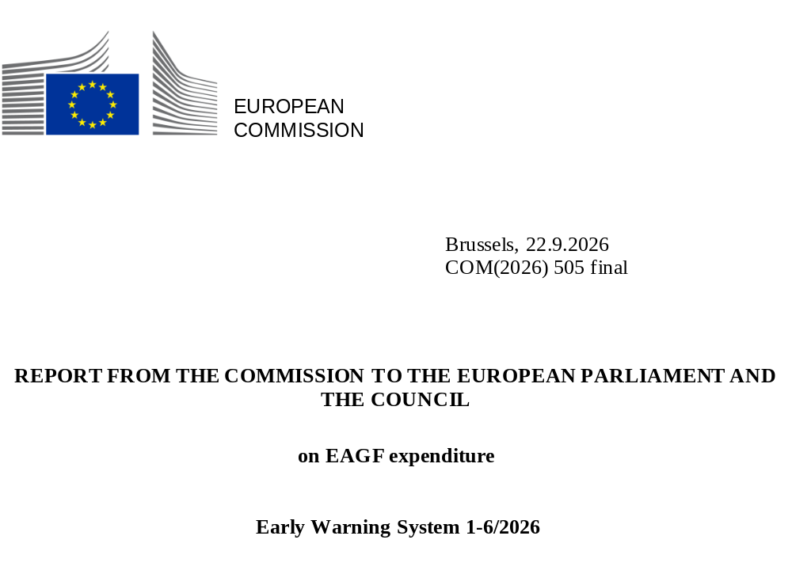

- The 2026 EAGF budget procedure
The European Union’s general budget for 2026, based on an agreement reached between the Council and the European Parliament on 15 November 2025, was adopted by the Council on 24 November 2025 and by the Parliament on 26 November 2025. Under the approved budget, the European Agricultural Guarantee Fund (EAGF) was allocated EUR 40 011.3 million in commitment appropriations and EUR 39 958.1 million in payment appropriations. The difference between the two amounts reflects the use of differentiated appropriations for specific measures implemented by the Commission under direct management, mainly related to operational technical assistance and promotion measures implemented through multi programmes and other actions.

- Revenue assigned to the EAGF
Pursuant to Article 45 of Regulation (EU) 2021/2116, revenue originating from financial corrections under financial and conformity clearance decisions as well as from irregularities constitutes assigned revenue within the meaning of Article 21(5) of Regulation (EU, Euratom) 2024/2509.
Under Article 45(2), collected assigned revenue may be used to cover the financing needs of any EAGF or EAFRD expenditure. Any assigned revenue collected and remaining unused at the end of a given financial year is automatically carried over to the following financial year⁽⁾.
The 2026 EAGF budget includes:
- the Commission's estimates of the financing needs for market measures (including the agricultural reserve) and direct payments under shared management as well as other expenditure under direct management.
- the estimates of assigned revenue to be collected during the financial year.
- and the assigned revenue remaining unused from the previous financial year.
For the 2026 EAGF budget, the Commission proposed a level of appropriations determined by subtracting the total estimated assigned revenue from the overall estimated expenditure needs.
At the time of establishing the 2026 budget, the Commission estimated the available assigned revenue at EUR 928.5 million, of which EUR 70.2 million was carried over from the 2025 budget. While in principle available to any EAGF intervention, the Commission considered the overall estimated assigned revenue for the basic income support for sustainability budget line (item 08 02 04 01), for simplification reasons.
- Table provisional consumption on 30/04/2026
This report presents the provisional implementation of the 2026 budget for the EAGF until 30/04/2026, with details given in the below table.
A comparison is made between the implementation level and the expenditure profile of the early warning system set up in accordance with Article 19 of
Regulation (EU) 2021/2116.

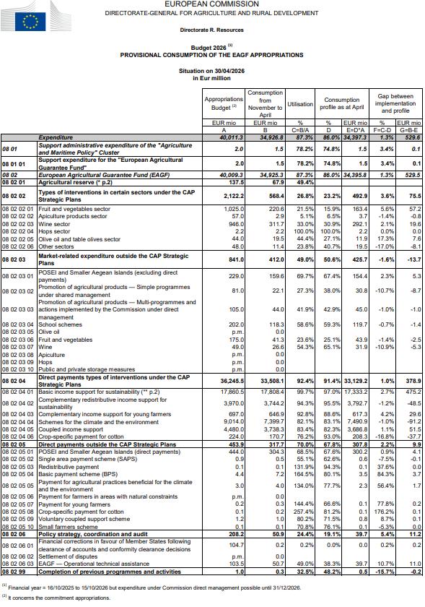
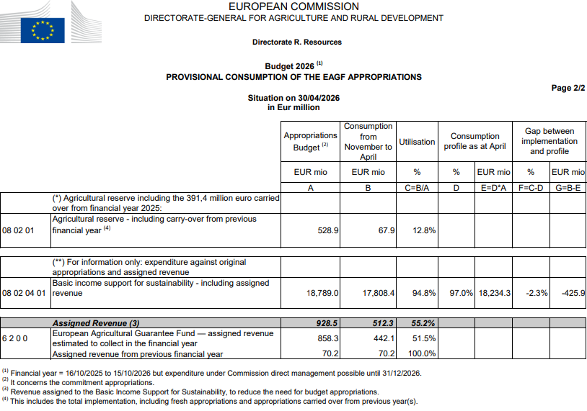
- Comments on the 2026 agricultural reserve
The 2026 budget includes an amount of EUR 528.9 million for the agricultural reserve expenditure needs, of which EUR 391.4 million is carried over from the 2025 budget. Of this overall amount, EUR 78.9 million was earmarked to cover expenditure related to measures adopted in 2025 but with eligibility dates falling within the 2026 budget year, while the remaining EUR 450 million was available for new measures in 2026.
The total implementation until 30 April 2026 for the measures adopted in 2025 with eligibility dates expiring in 2026 is EUR 68 million, with the following breakdown (in EUR million):

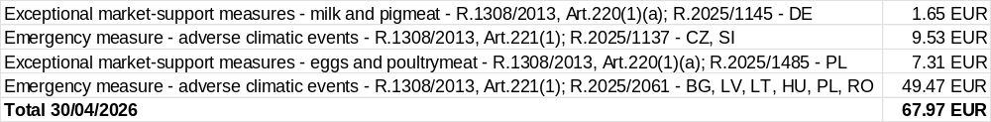

Four measures, allocating EUR 64 million, have been adopted, so far, in the current financial year concerning:
- Hungary (Foot and mouth disease)⁽⁾: the maximum amount of Union part-financing shall be EUR 0.4 million.

- France (temporary exceptional crisis distillation measure to address the market disturbance in the wine sector)⁽⁾: the maximum amount of EU support is EUR 40 million.
- Bulgaria, Estonia, Hungary (adverse climatic events)⁽): the maximum amount of Union part financing shall be EUR 21.5 million as exceptional support to farmers.
- Slovakia (Foot and mouth disease)⁽): the maximum amount of Union part-financing shall be EUR 2.1 million.

No expenditure has been declared by the Member States up to 30 April 2026 regarding these measures.

- Comments on the provisional implementation of the 2026 EAGF budget
The provisional execution of the 2026 EAGF budget appropriations, for the period up to 30 April 2026, is slightly above the calculated expenditure profile (1.3 percentage points).
The overall expenditure for the sectoral types of interventions under the CAP Strategic Plans (08 02 02) shows an upward deviation from the profile (3.6 percentage points). The line-by-line analysis shows differences depending on the sector:
- For the fruit and vegetables and wine sectors, the higher consumption compared to the profile under the CAP Strategic Plans is partially compensated by the lower execution outside the CAP Strategic Plans.
- In the olive oil sector, budget execution is above expectations at this point of the year, whereas implementation in the “other sectors” is 17 percentage points below the profile.
Regarding direct payment types of intervention under the CAP Strategic Plans (08 02 04), budget execution of the voted appropriations exceeds expectations by 1 percentage point. Most schemes are close to the profile, apart from cotton that is 16.8 percentage points below the profile.
Concerning direct payments outside the CAP Strategic Plans (08 02 05), the budget item for POSEI and smaller Aegean islands shows an execution very close to the profile, whereas the budget lines for completion of the previous direct payments schemes, in particular Basic Payment Scheme and the Payment for agricultural practices beneficial for the climate and the environment, have been executing at a considerably higher rate than the profile. These completion lines have been showing a decreasing trend over the past years. However, this year the trend is less pronounced.
An amount of EUR 512.3 million of assigned revenue (6 2 0 0) is already available and additional amounts are expected to be collected during the financial year. However, the revised estimates, taking into account the actual clearance decisions and the offsetting possibility for 2026, now indicate a lower overall level of assigned revenue than initially projected. This is only partially compensated by lower needs for financial corrections in favour of Member States and other EAGF interventions.
In order to ensure that sufficient appropriations are available in financial year 2026 to cover in full the EAGF expenditure that Member States declare, the Commission has requested in its draft amending budget (DAB) 2/2026 a reinforcement of EUR 140 million for the EAGF. The additional funds will be sourced from the available margin under the EAGF sub-ceiling.
Provided that the DAB 2/2026 is adopted by the budgetary authority, the Commission considers the total EAGF appropriations sufficient to cover all EAGF expenditure. Consequently, no EAGF surplus is expected at this stage.

() Art 12(4)(b) of Regulation (EU, Euratom) 2024/2509 of the European Parliament and of the Council of 23 September 2024 on the financial rules applicable to the general budget of the Union determines that appropriations corresponding to internal assigned revenue may be carried over only to the following financial year. Therefore, in the interests of sound budget management, assigned revenue carried over is generally used first before the voted appropriation of the concerned budget article.
() Commission Implementing Regulation (EU) 2026/530 of 10 March 2026 on exceptional support measures for the sheep meat and pigmeat sectors in Hungary (OJ L, 2026/530, 11.3.2026, ELI: http://data.europa.eu/eli/reg_impl/2026/530/oj).
() Commission Delegated Regulation (EU) 2026/744 of 31 March 2026 on a temporary exceptional crisis distillation measure to address the market disturbance in the wine sector in the marketing year 2025/2026 (OJ L, 2026/744, 1.4.2026, ELI: http://data.europa.eu/eli/reg_del/2026/744/oj).
() Commission Implementing Regulation (EU) 2026/847 of 16 April 2026 providing for emergency financial support for the agricultural sectors affected by adverse climatic events in Bulgaria, Estonia and Hungary, in accordance with Regulation (EU) No 1308/2013 of the European Parliament and of the Council (OJ L, 2026/847, 17.4.2026, ELI: http://data.europa.eu/eli/reg_impl/2026/847/oj).
() Commission Implementing Regulation (EU) 2026/1100 of 21 May 2026 on exceptional support measures for the milk and pigmeat sectors in Slovakia (OJ L, 2026/1100, 22.5.2026, ELI: http://data.europa.eu/eli/reg_impl/2026/1100/oj).

