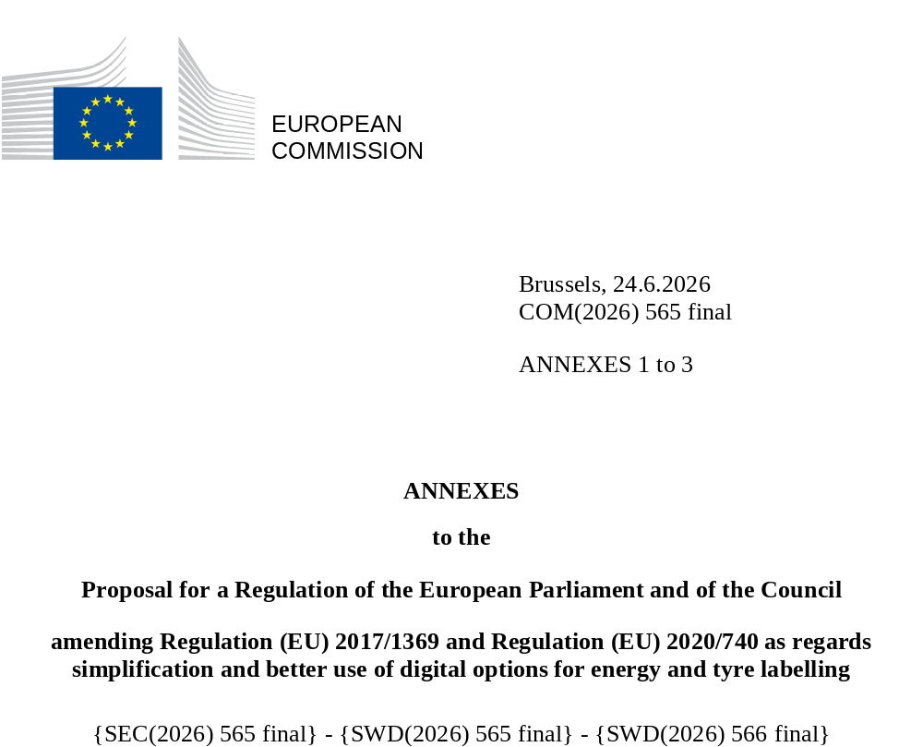

ANNEX I
‘ANNEX III
PUBLIC INFORMATION TO BE ENTERED INTO THE PRODUCT DATABASE BY THE SUPPLIER
Pursuant to point 1 of Article 5, the supplier shall enter into the product database the information as set out in Tables III A-D below, that becomes the product information sheet. Promotional material or other commercial documents provided with the tyre shall include the EPREL registration number or the link or QR code leading to the tyre type registration in EPREL.
Table III A
Product Information Sheet
C1 tyres, C2 tyres and C3 tyres
1 | Trade name or trademark: | text |  | Commercial designation: |  | text
2 | Tyre type identifier (article code/number): | text |  | Tyre class: |  | C1 / C2 / C3
3 | Tyre-size designation: | xxx | xx | R / B / D | xx | xx | E/F/G/J/K/L/M/N/P/Q/R/S/ T/U/H/V/ZR/W/Y
3 | Tyre-size designation: | nominal section width (s1) / | nominal aspect ratio | construction type | nominal diameter “d” of the rim in inches | load index | speed rating
4 | Fuel efficiency class: | A / B / C / D / E |  | Rolling resistance coefficient value (N/kN) |  | x,x
5 | Wet grip class: | A / B / C / D / E |  | Wet grip index value |  | x,xx
6 | External rolling noise class: | A / B / C |  | External rolling noise level in dB(A): |  | xx
7 | For use in severe snow conditions (3PMSF marking): | yes / no |  | For use in severe snow conditions (ice stalagmite marking): |  | yes / no
8 | Tyre certification number (type approval): | text |  | UN ECE revision: |  | text
Complementary parameters not relevant for compliance verification
Table III B
C1 tyres
1 A | Extended mobility ⁽¹⁾: | (RF) Run flat / EMT) Extended mobility / Support Ring
2 A | OEM vehicle brand marking: | None/OEM mark | Vehicle brand(s)
3 A | Category of use ⁽⁴⁾: | normal / special use | If special use: | M&S / ET
Table III C
C2 tyres
1 B | Extended mobility: | RF / EMT / Support Ring
2 B | Additional service description: | xxx | xxx | E / F / G / J / K / L / M / N / P / Q / R / S / T / U / H
2 B | Additional service description: | load-capacity index for single mounting | load-capacity index for dual mounting | speed category symbol
3 B | Category of use ⁽⁴⁾: | normal / special use | If special use: | M&S / ET / ML / MPT (multiple possible)
Table III D
C3 new tyres
2C | Mission profile:  (multiple possible) ⁽²⁾: | Long haul | Regional | Urban | Municipal | Construction (on-off)
2C | Mission profile:  (multiple possible) ⁽²⁾: | yes / no | yes / no | yes / no | yes / no | yes / no
1C | Axle position ⁽³⁾: | F / D / T/ Z | If axle=T: FRT
3C | Additional service description (load-capacity index): | xxx | xxx |  | E / F / G / J / K / L / M / N / P / Q / R / S / T / U / H
3C | Additional service description (load-capacity index): | single mounting | dual mounting |  | speed category symbol
4 C | Tread depth (mm): | xx | Wet grip index value of half worn tyre: |  | x,xx
5 C | Category of use ⁽⁴⁾: | normal / special use | If special use: |  | M&S / ET / ML / MPT (multiple possible)
⁽¹⁾ RF) Run flat, “snail” marking, / EMT) Extended mobility, “swirl” marking, UNECE R30 E/ECE/324/Rev.1/Add.29/Rev.3/Amend.7
⁽²⁾ As from Annex I, table 1 of Regulation 2017/2400
⁽³⁾ F=front, D=drive, T=trailer, Z=any, FRT=free rolling as in UNECE R.54 E/ECE/324/Rev.1/Add.53/Rev.3/Amend.5
⁽⁴⁾ As defined in UNECE R54 E/ECE/324/Rev.1/Add.53/Rev.3, in R.117 E/ECE/324/Rev.2/Add.116/Rev.5 and in R.54 E/ECE/324/Rev.1/Add.53/Rev.3/Amend.5
ANNEX II
Annex IV to Regulation (EU) 2020/740 is amended as follows:
- the title is replaced by the following:
‘INFORMATION TO BE PROVIDED IN VISUAL ADVERTISEMENTS, IN PRODUCT CATALOGUES, IN TECHNICAL PROMOTIONAL MATERIAL AND IN DISTANCE SELLING, INCLUDING DISTANCE SELLING ON THE INTERNET”
- points 1 and 2 are replaced by the following:
‘1. Printed material
(I.) For the purposes of ensuring conformity with the requirements laid down in Articles 4(3), 4(4) and 6(2), in visual advertisements, in product catalogues and in technical promotional material, and in the case of paper-based distance selling and telemarketing-based distance selling, the rolling resistance class and the range of classes available on the label, the wet grip class and the range of classes available on the label and the external rolling noise class and value shall be displayed as indicated in Figure 1, and in accordance with the following additional specifications:
      - ‘class arrows’ shall be used, containing the letter, indicating the fuel efficiency, wet grip and noise, centred in the rectangular part of the arrow;
      - the class arrows shall have a border, and the internal background colour shall match the colour of respectively fuel efficiency, wet grip and noise class in the full label;
      - the typeface of the ‘class letter’ shall be Noto Sans, bold, 100 % white, with an outline in 100 % black and in a size equivalent to that of the price, if the price is shown;
      - the typeface of the range of available energy-efficiency classes shall be in Noto Sans 100 % black on a white background.
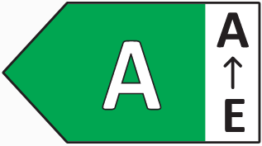  (a) class arrow, with range of fuel efficiency classes |   - (b) class arrow, with range of wet grip classes | 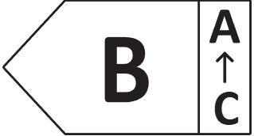  (c) class arrow, with range of external rolling noise classes
Figure 1: class arrows example, with range of energy-efficiency classes
(II.) By way of derogation from point I, if the visual advertisement, technical promotional material or paper-based distance selling is printed in monochrome, points I.(b) and I.(c) are replaced by the following:
(b) the class arrow shall have a border, and the internal background shall be uncoloured, matching the colour of the background support;
(c) the typeface of the ‘class letter’ shall be Noto Sans bold, 100 % black, and in a size equivalent to that of the price, if the price is displayed.
2. Online material
(III.) For the purposes of ensuring conformity with the requirements laid down in Articles 4(3), 4(4) and 6(2), in visual advertisements, in product catalogues and in technical promotional material, in distance selling and telemarketing on the internet, both for products and for packages, the rolling resistance class and the range of classes available on the label, the wet grip class and the range of classes available on the label and the external rolling noise class and value shall be displayed as indicated in Figure 1, in accordance with the following additional specifications:
(a) the class-arrow images shall be each the nested display of the label set out in Annex III and as available from the product database;
(b) the label shall be displayed by pop up, new tab, new page or inset screen display and must appear on the first mouse click or mouse-over on the class arrow image;
(c) for magnification of the label on tactile screens, the device conventions for tactile magnification shall apply;
(d) the label shall cease to be displayed by means of a close option or other standard closing mechanism;
(e) the alternative text for the class arrow image, appearing with a mouse-over, shall be respectively “fuel-efficiency class is”, “wet grip class is”, “external rolling noise class is”, followed by the class letter and the text “(range A-x)”, where “x” is the worst permitted class.
(f) a text indicating ‘Product Information Sheet’, in proximity to the class arrow, shall give direct access to the product-information sheet, as available from the product database, or to the model page in the product database.’.

ANNEX III
Annex VII to Regulation (EU) 2020/740 is amended as follows:
- the title is replaced by the following:
‘INFORMATION TO BE ENTERED IN THE COMPLIANCE PART OF THE PRODUCT DATABASE BY THE SUPPLIER’;
- point 1 is deleted.
- point 2 is replaced by the following:
‘2. Information to be entered into the compliance part of the product database:
      - the tyre type identifier of equivalent tyre types placed on the market;
      - the parameters of the product information sheet set in Annex III table III A that are part of compliance assessment;
      - copy of the type approval document relevant for the specific tyre type family;
      - copy of test reports for any parameter in the label if the class corresponds to a coefficient of rolling resistance, to an index of wet grip or to a noise emission value more favourable than the one corresponding to the worst case as resulting from the type-approval documentation in point (c). The test reports can be those corresponding to the type approval or any other of equivalent level of accuracy that justifies the declared values;
      - alternatively to point (d), when the declared value does not correspond to a test result, the supplier shall provide detailed description of how the value used to determine the class was determined. Any simulation or extrapolation procedure must ensure that the declared values are identical -or worse- to those obtained in a physical test of the relevant tyre dimension;
      - specific precautions, if any, that shall be taken when the tyre type is maintained, mounted or tested.’.

