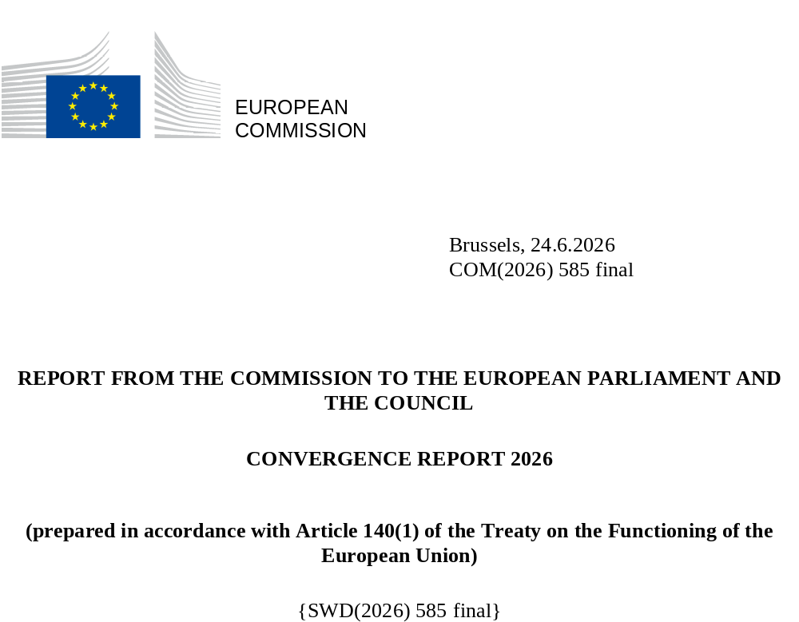

- PURPOSE OF THE REPORT
The euro is intended to be the single currency of the European Union as a whole. It is currently used every day by around 355 million people in the 21 Member States of the euro area. The practical benefits of the euro include more stable prices, lower transaction costs for people and businesses, more transparent and competitive markets and increased trade within the EU and with the rest of the world. The euro is currently the second most used currency worldwide.
Article 140(1) of the Treaty on the Functioning of the European Union (TFEU) requires the Commission and the European Central Bank (ECB) to report to the Council at least once every two years, or at the request of a Member State with a derogation, on the progress that Member States with a derogation have made in fulfilling their obligations to achieve economic and monetary union. The latest Commission and ECB regular convergence reports were adopted in June 2024.
On 25 February 2025, Bulgaria submitted a request for an ad hoc convergence assessment. Following the preparation of a Convergence Report on Bulgaria and on the basis of a proposal by the Commission, the Council decided in July 2025 that Bulgaria fulfilled the necessary conditions for adopting the euro on 1 January 2026.
This 2026 Convergence Report covers the following five Member States with a derogation: Czechia, Hungary, Poland, Romania and Sweden. The staff working document accompanying this report provides a more detailed assessment of the state of convergence in these Member States.
Article 140(1) TFEU requires the reports to include an examination of the compatibility of national legislation, including the statutes of national central banks, with Articles 130 and 131 TFEU and the Statute of the European System of Central Banks and of the European Central Bank (‘the ESCB/ECB Statute’). The reports must also examine whether a high degree of sustainable convergence has been achieved in the Member State concerned (i) by referring to the fulfilment of the four convergence criteria (price stability, public finances, exchange rate stability and long-term interest rates); and (ii) by taking account of other factors relevant to economic integration and convergence mentioned in the final subparagraph of Article 140(1) TFEU. The four convergence criteria are developed further in a protocol annexed to the Treaties (Protocol No 13 on the convergence criteria).
The convergence assessment in this report is presented against the backdrop of several major economic and policy developments over the course of 2025 and the first half of 2026. In 2025, volatility in US trade policy and the increase in the US trade tariffs, although lower than originally announced, disrupted global trade flows and led to heightened policy uncertainty. However, despite this challenging external environment, the EU economy showed resilience and continued to grow at a steady pace. Following moderate economic growth of 1.0% in 2024, the EU economy gained momentum in 2025, with GDP consequently growing by 1.4%. This growth was underpinned by a strong labour market, easing inflationary pressures, and favourable financial conditions. Following its peak in 2022-23, annual consumer price inflation fell to 2.6% in 2024 and 2.5% in 2025. Driven by lower energy prices and falling services inflation, it continued to fall across the EU during the first half of 2025, before stabilising at around 2% during the second half of the year and the first two months of 2026.
However, the outbreak of the war in the Middle East on 28 February 2026 materially changed this picture, by creating the most significant global energy supply disruption in recent history. The Middle East conflict was followed by the virtual closure of the Strait of Hormuz, which reduced seaborne flows of oil and LNG and led to a surge in energy prices. Between the outbreak of the Middle East conflict and 29 April - the cut-off date for the technical assumptions of the Commission’s Spring 2026 Economic Forecast, which is the basis for the sustainability assessment in this Convergence Report - oil and gas prices increased by 65% and 50% respectively, leading to a strong acceleration of energy inflation. Price pressures are set to broaden progressively, as rising energy costs feed through the production chain and are partially passed through to consumers. The external assumptions of the Commission’s Spring 2026 Economic Forecast take into account the path of futures prices for energy commodities at the time of the cut-off date of the forecast. These energy commodity assumptions suggest a relatively swift, albeit partial, normalisation of supply conditions, with oil and gas prices expected to stabilise at around 20% above pre-war levels by 2027.
In parallel, Russia’s continued war of aggression against Ukraine implies a significant threat to European security and requires spending to be increased on defence for the foreseeable future. As part of this, the Commission presented a defence package in March 2025 under the ReArm Europe Plan/Readiness 2030 initiative. Under this plan, the Commission invited Member States to request the activation of the National Escape Clause of the Stability and Growth Pact, which provides them additional budgetary space to transition to a durably higher level of defence expenditure, within the EU fiscal rules. The amount of the planned deviation from the recommended net expenditure path under the escape clause is capped at 1.5% of GDP, available for a period of four years. In addition, the new Security Action for Europe (SAFE) package provides loans of up to EUR 150 billion to help EU Member States quickly and substantially increase investments in Europe’s defence capabilities.
Faster implementation of the national recovery and resilience plans (RRPs), ahead of the closure of the Recovery and Resilience Facility (RRF) at the end of the year, along with progress in the implementation of 2021-2027 cohesion policy programmes are expected to partly offset the negative consequences of the current geopolitical instability and contribute to the convergence process of non-euro area EU Member States. Besides contributing to higher growth and improved public finances, the RRF and cohesion policy programmes strengthen Member States’ long-term growth and resilience by supporting major reforms and investments that help address both long-standing and new challenges, such as diversifying energy supplies. By the end of May 2026, RRF disbursements reached EUR 405.9 billion, which is around 70% of the total amount of support committed under the RRF. For the 2021-2027 period, the EU will provide cohesion policy funding of EUR 420 billion to Member States. Cohesion policy is concentrated on fields that are critical for promoting convergence and competitiveness. It supports long-term investment in line with EU priorities, encourages EU GDP growth, and has a particularly high impact on the Member States and regions that are the main beneficiaries of the policy. The mid-term review of cohesion policy, which was concluded in autumn 2025, provided Member States with greater flexibility and incentives to deploy existing resources more rapidly and accelerate programme implementation and better align funding with key EU priorities.
On 22 April 2026, the Commission adopted the ‘AccelerateEU’ Communication, which presented a comprehensive set of actions and measures to address rising energy costs and further reduce dependency on volatile fossil fuel markets, while putting Europe on a steady pathway to energy independence. The plan aims to provide relief to consumers facing energy price spikes and accelerate the transition to clean, secure and affordable energy. Many Member States have adopted budgetary policy measures to mitigate the social and economic impact of high energy prices on households and businesses. According to the Commission’s 2026 Spring Economic Forecast, the total budgetary cost of such measures is EUR 14.6 billion, or 0.07% of EU GDP in 2026, with large differences between Member States.
On 3 June 2026, the Commission published its 2026 European Semester Spring Package. The package includes the Commission’s assessment of Member States’ compliance with the relevant Council recommendations on fiscal policy. For the 10 Member States currently under excessive deficit procedure (EDP), including Hungary, Poland and Romania, the Commission assessed the action taken in response to the Council recommendations under the EDP. For the other Member States (not currently in EDP), including Czechia and Sweden, the Commission assessed progress with the implementation of the medium-term plans and compliance with the relevant Council recommendations. For Member States that benefit from a fiscal adjustment period of seven instead of four years in the context of their medium-term plans, including Romania, the Commission also assessed the implementation of the key steps of reform and investment commitments underpinning the extension. The Commission also announced that Member States that take action to strengthen Europe's energy security and accelerate the transition away from fossil fuels may request limited fiscal flexibility under the current National Escape Clause for defence spending. Upon request by the Member State, the scope of the clause can be expanded to include measures undertaken since February 2026 that reduce the dependence on imported fossil fuels, subject to a dedicated annual cap for the period 2026-2028 (0.3% of GDP) and a cumulative cap (0.6% of GDP).
Convergence criteria
The examination of the compatibility of national legislation, including the statutes of national central banks of Member States with a derogation, together with Article 130 TFEU and the compliance duty under Article 131 TFEU, includes an assessment of observance of the prohibition of monetary financing (Article 123 TFEU) and the prohibition of privileged access to financial institutions (Article 124 TFEU); the consistency with the ESCB’s objectives (Article 127(1) TFEU) and tasks (Article 127(2) TFEU); and other aspects relating to the integration of national central banks into the Eurosystem.
The first indent of Article 140(1) TFEU defines the price stability criterion as ‘the achievement of a high degree of price stability; this will be apparent from a rate of inflation which is close to that of, at most, the three best performing Member States in terms of price stability’.
Article 1 of the Protocol on the convergence criteria further provides that ‘the criterion on price stability […] shall mean that a Member State has a price performance that is sustainable and an average rate of inflation, observed over a period of one year before the examination, that does not exceed by more than 1.5 percentage points that of, at most, the three best-performing Member States in terms of price stability. Inflation shall be measured by means of the consumer price index on a comparable basis, taking into account differences in national definitions’.
The sustainability requirement implies that the satisfactory inflation performance must be attributed to the behaviour of input costs and other factors that influence price developments in a structural manner, rather than the influence of temporary factors. Therefore, the convergence examination includes an assessment of the factors that affect the inflation outlook and is complemented by a reference to the most recent Commission inflation forecast.
The inflation reference value was calculated as 2.7% in May 2026, with Cyprus, France and Denmark being the three ‘best-performing Member States’.
No Member States were identified as outliers in terms of inflation performance for calculating the reference value, as none of their inflation rates deviated by a wide margin from the euro area average due to country-specific circumstances.
The second indent of Article 140(1) TFEU defines the convergence criterion dealing with public finances as ‘the sustainability of the government financial position; this will be apparent from having achieved a government budgetary position without a deficit that is excessive as determined in accordance with Article 126(6)’.
Furthermore, Article 2 of the Protocol on the convergence criteria states that this criterion means that ‘at the time of the examination the Member State is not the subject of a Council decision under Article 126(6) of the said Treaty that an excessive deficit exists’.
The TFEU refers to the exchange rate criterion in the third indent of Article 140(1) as ‘the observance of the normal fluctuation margins provided for by the exchange-rate mechanism of the European Monetary System, for at least two years, without devaluing against the euro’.
Article 3 of the Protocol on the convergence criteria provides that: ‘The criterion on participation in the exchange rate mechanism of the European Monetary System […] shall mean that a Member State has respected the normal fluctuation margins provided for by the exchange-rate mechanism of the European Monetary System without severe tensions for at least the last two years before the examination. In particular, the Member State shall not have devalued its currency’s bilateral central rate against the euro on its own initiative for the same period’.
The relevant two-year period for assessing exchange rate stability in this report ran from 18 June 2024 to 17 June 2026. In its assessment of the exchange rate stability criterion, the Commission takes into account developments in auxiliary indicators such as foreign reserve developments and short-term interest rates. It also takes into account the role of policy measures (including foreign exchange interventions) and international financial assistance (wherever relevant) in maintaining exchange rate stability.
The fourth indent of Article 140(1) TFEU requires ‘the durability of convergence achieved by the Member State with a derogation and of its participation in the exchange rate mechanism’ to be ‘reflected in the long-term interest rate levels’.
Article 4 of the Protocol on the convergence criteria further states that ‘the criterion on the convergence of interest rates […] shall mean that, observed over a period of one year before the examination, a Member State has had an average nominal long-term interest rate that does not exceed by more than 2 percentage points that of, at most, the three best-performing Member States in terms of price stability. Interest rates shall be measured on the basis of long-term government bonds or comparable securities, taking into account differences in national definitions’.
The interest rate reference value was calculated as 5.1% in May 2026.
Article 140(1) TFEU also requires the reports to take into account other factors relevant to economic integration and convergence. These include the integration of markets, the development of the balance of payments on the current account and of unit labour costs and other price indices. The additional factors to be considered are important indicators of whether a Member State would integrate into the euro area without difficulties. They also broaden the view on the required high degree of sustainable convergence.
The assessment of the degree of sustainable convergence for the Member States with a derogation presented in this report draws on the Commission’s Spring 2026 Economic Forecast and the policy guidance provided under the 2026 European Semester Spring Package. It is informed in particular by: the Chapeau Communication for the Spring package, including the conclusions on (i) the fiscal surveillance carried out under the Stability and Growth Pact and (ii) the Macroeconomic Imbalance Procedure. The assessment also refers to the findings in the 2026 In-Depth Reviews and the 2026 Country Reports. The assessment also reflects the Commission’s assessments of fiscal sustainability risks and of the national fiscal framework, as well as the implementation of the RRP. Labour and product market performance, labour participation, skills availability, wage formation, social resilience and territorial cohesion are also relevant, as they contribute to shape adjustment capacity, competitiveness and the ability to participate smoothly in the euro area.

- CZECHIA
In the light of its assessment on legal compatibility and on the fulfilment of the convergence criteria, and taking into account the additional relevant factors, the Commission considers that Czechia does not fulfil the conditions for adopting the euro.
Legislation in Czechia, in particular the Czech National Council Act No 6/1993 Coll. on the Česká národní banka (the ČNB Law), is not fully compatible with the requirements of Article 131 TFEU. Incompatibilities concern the independence of the central bank, prohibition of monetary financing, and the integration of the central bank into the Eurosystem with regard to the ČNB's objectives and the ESCB/ECB objectives and tasks laid down in Article 127(1) and (2) TFEU and Articles 2 and 3 of the ESCB/ECB Statute. In addition, the ČNB Law also contains imperfections relating to ESCB/ECB tasks.
Czechia fulfils the criterion on price stability. The average inflation rate in Czechia during the 12 months to May 2026 was 1.9%, below the reference value of 2.7%. It is projected to increase by the end of 2026 and decrease in the second half of 2027, but should stay below the reference value in both years.
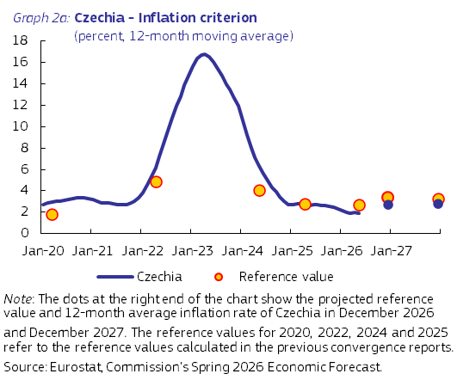
Following a period of high inflation in 2021-2023, which started with the post-COVID recovery and was aggravated by the energy price shock following Russia’s full-scale invasion of Ukraine, HICP inflation started to moderate in 2024 (2.7%) and 2025 (2.3%). The decline in headline inflation was driven by a slowdown in food prices in 2024 and energy prices in 2025. Services inflation, which typically is relatively persistent and driven by wages, cooled off during that period but remained well above headline inflation. Annual inflation slowed down further in the first two months of 2026, before increasing in the subsequent months and reaching 1.8% in May 2026, driven by services inflation and a spike in energy inflation due to the conflict in the Middle East. Annual HICP inflation rates in Czechia in 2024 and 2025 were on average slightly higher than those for the euro area as a whole.
The Commission’s Spring 2026 Economic Forecast projects that average annual HICP inflation will increase to 2.7% in 2026 and 2.8% in 2027. The projected increase is attributed to spikes in energy prices, only partially balanced out by slower growth in services and food prices. The level of consumer prices in Czechia was about 88% of the euro area average in 2024, suggesting that there is still potential for further price level convergence in the long term.
Czechia fulfils the criterion on public finances. Czechia is not the subject of a Council Decision on the existence of an excessive deficit. The general government deficit increased from 2.0% of GDP in 2024 to 2.1% in 2025, reflecting higher public wages and increased government subsidies for renewable energy sources, despite higher GDP growth. The Commission’s Spring 2026 Economic Forecast expects the general government deficit to reach 2.8% of GDP in 2026 due to, among other things, the full phase-out of the windfall tax on energy company profits and taking over from electricity consumers the payment of the renewable energy levy. In 2027, the government deficit ratio is forecast to be 2.9%.
On 21 January 2025, the Council adopted a recommendation endorsing Czechia’s medium-term fiscal-structural plan. The plan sets out a fiscal adjustment path over four years, with maximum net expenditure growth of 4.5% in 2025, 2.5% in 2026, 2.6% in 2027 and 2.9% in 2028. In July 2025, the Council activated the national escape clause for increases in defence spending for Czechia, allowing Czechia to deviate from, and exceed, the net expenditure path of the medium-term fiscal-structural plan. On 3 June 2026, the Commission concluded that net expenditure in Czechia grew by 4.9% in 2025 and 6.0% cumulatively over 2024 and 2025. Net expenditure growth in 2025 was above the recommended maximum growth rate, corresponding to a deviation of 0.2% of GDP in annual terms. When considering 2024 and 2025 together, the cumulative growth rate of net expenditure is below the recommended maximum growth rate. As Czechia benefits from flexibility under the national escape clause, the assessment of compliance focusses on the latter comparison.
Net expenditure is projected to grow by 6.4% in 2026, above the recommended growth of 2.5%. The deviation above the recommended maximum is equivalent to an annual deviation of 1.5% of GDP and a cumulative deviation of 0.1% of GDP when considering 2024, 2025 and 2026 together. Taking the flexibility under the national escape clause into account, the projected deviation for 2026 is within the flexibility of the national escape clause based on current projections for defence spending.
The government debt-to-GDP ratio increased from 43.3% in 2024 to 44.3% in 2025 and is forecast to increase to 45.8% in 2026 and then to 47.2% in 2027. This is driven by a negative primary balance, the interest expenditure and, to a lesser extent, the debt-increasing stock-flow adjustment, but is partly offset by nominal GDP growth. Debt sustainability risks appear medium over the medium term, with government debt projected to increase from around 44% of GDP in 2025 to around 56% in 2036. The Czech national fiscal framework is performing well, but is facing growing challenges due to, among other things, a strong increase in general government debt since the pandemic, compliance with the structural balance rule requiring additional consolidation measures before 2028, and the exclusion of defence spending above 2% of GDP from the national expenditure framework.
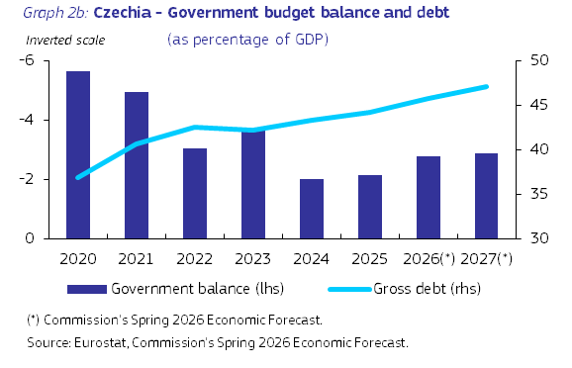
Czechia does not fulfil the exchange rate criterion. The Czech koruna does not participate in the Exchange Rate Mechanism II. Since the late 1990s, the ČNB has been operating an explicit inflation targeting framework combined with a floating exchange rate regime, which allows for foreign exchange market interventions by the central bank. Between April 2024 and January 2025, the Czech koruna was trading at around 25.2 CZK per euro. By the end of 2025 the Czech koruna had appreciated to around 24.3 and fluctuated around that level till mid-2026. In May 2026, the koruna was about 2% stronger against the euro compared with two years earlier. The monetary policy easing cycle of the ČNB between December 2023 and May 2025 led to a large, steady decrease in the Czech three-month PRIBOR and, accordingly, in the spread vis-à-vis the euro area, which dropped below 100 basis points in the second half of 2024. From September 2024, the spread began to widen slightly until mid-2025. Thereafter, the spread stabilised at around 150 basis points, reaching 133 basis points in May 2026.
Czechia fulfils the criterion on the convergence of long-term interest rates. The average long-term interest rate in the year to May 2026 was 4.5%, below the reference value of 5.1%. Czechia’s long-term interest rate decreased in the second half of 2024, reaching 3.8% in September that year. It then increased gradually to 4.7% in December 2025 in line with rising inflationary pressures. The long-term interest rate reached 4.9% in May 2026, with the spread versus the German benchmark bond reaching 184 basis points.
The Commission has also examined additional factors, including balance of payments developments, the integration of markets and the institutional environment. Czechia’s external balance (i.e. the combined current and capital account) recorded a surplus amounting to 2.2% of GDP in 2025. The Czech economy is highly integrated with the euro area through trade and investment linkages. Selected indicators related to the institutional environment show that Czechia ranks higher than the average for euro area Member States in this regard. The financial sector in Czechia is smaller and less developed than in the euro area. Market-based financing is less developed, as reflected in the very small markets for equity and private sector debt. The Czech banking sector is highly integrated into the euro area financial system, in particular through a high degree of foreign ownership of banks. In the context of the Macroeconomic Imbalance Procedure, the Commission concluded in its Alert Mechanism Report for 2026 that it was not necessary to carry out an In-Depth Review analysis for Czechia.
Czechia’s recovery and resilience plan (RRP) includes measures to address a series of structural challenges, in synergy with other EU funds, including cohesion policy funds, to boost its competitiveness and stimulate sustainable growth, and reduce the country’s territorial and social disparities. The RRF funding provides Czechia with EUR 8.4 billion in grants and EUR 343 million in loans over the 2021-2026 period. Czechia has submitted six payment requests, five of which have already been assessed resulting in a total disbursement of EUR 6.8 billion by the end of May 2026. Moreover, it has fulfilled approximately 71% of the milestones and targets of its RRP. Key reforms in Czechia’s RRP include those in the areas of renewable energy, zero-emission mobility, long-term care, affordable housing, and conflict of interest and lobbying rules. In addition, cohesion policy provides Czechia with EUR 24.2 billion for the 2021-2027 period. Cohesion policy financing aims particularly to further support Czechia’s competitiveness, by helping research and innovation, SMEs competitiveness, energy efficiency improvements, modernisation of public employment services, skills development and lifelong learning, as well as work-life balance and equal opportunities.

- HUNGARY
In the light of its assessment on legal compatibility and on the fulfilment of the convergence criteria, and taking into account the additional relevant factors, the Commission considers that Hungary does not fulfil the conditions for adopting the euro.
Legislation in Hungary, in particular the Law on the Magyar Nemzeti Bank (MNB), is not fully compatible with the requirements of Article 131 TFEU. Incompatibilities notably concern the independence of the MNB, prohibition of monetary financing and the integration of the central bank into the Eurosystem with regard to the ESCB/ECB tasks laid down in Article 127(1) and (2) TFEU and Articles 2 and 3 of the ESCB/ECB Statute. In addition, the Law on the MNB contains imperfections relating to the MNB’s independence and its integration into the Eurosystem.
Hungary does not fulfil the criterion on price stability. The average inflation rate in Hungary during the 12 months to May 2026 was 3.3%, above the reference value of 2.7%. Inflation is projected to decrease and to fall below the reference value by the end of 2026. It is expected to rise above the reference value in the first half of 2027, but to fall back below it by the end of 2027.
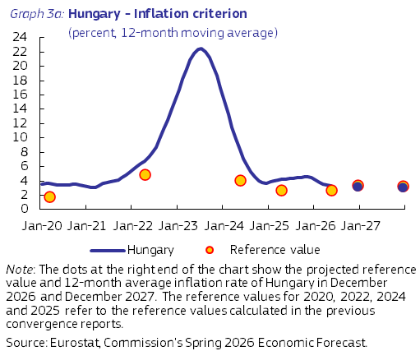
Annual HICP inflation in Hungary slowed in 2024 but picked up again in 2025, averaging 3.7% and 4.4% respectively. Annual HICP inflation increased from 3.9% in May 2024 to 5.7% in January and February 2025. The increase in inflation in 2024 and early 2025 was mostly driven by elevated services inflation fuelled by strong consumer demand, high wage growth and sector-specific tax hikes, even though administered prices had a dampening effect in 2024. Headline inflation subsequently slowed, reaching 3.3% in December 2025, mainly due to lower energy inflation. It further declined at the beginning of 2026, bottoming at 1.6% in February, before increasing gradually in the subsequent months. HICP inflation stood at 2.3% in May 2026, owing to a decline in food inflation, modest repricing of services and the regulation of fuel prices to limit the impact of rising oil prices due to the conflict in the Middle East. Annual HICP inflation rates in Hungary in 2024 and 2025 were on average higher than in the euro area as a whole.
The Commission’s Spring 2026 Economic Forecast projects that annual HICP inflation will decrease to 3.2% in 2026 and to 3.1% in 2027, with the currency appreciation in 2026 set to moderate inflation. The level of consumer prices in Hungary was about 70% of the euro area average in 2024, suggesting that there is still potential for further price level convergence in the long term.
Hungary does not fulfil the criterion on public finances. Hungary is the subject of a Council decision on the existence of an excessive deficit. Since 2020, Hungary’s general government deficit has remained above the 3% of GDP Treaty reference value. The general government deficit decreased from 5.1% of GDP in 2024 to 4.7% of GDP in 2025, but still remained above the 3% of GDP reference value. The decrease in 2025 was due to revenue increasing faster than expenditure, mainly because of strong VAT revenue growth driven by robust consumption, strong wage increases leading to an increase in social security contributions as well as large cuts to public investment. The Commission’s Spring 2026 Economic Forecast expects the general government deficit to increase to 6.2% of GDP in 2026 due to, among other things, personal income tax reductions, public sector wage growth, and bonuses and expenditure overruns. In 2027, the government deficit ratio is forecast to decrease to 5.8%.
On 18 February 2025, the Council endorsed Hungary’s national medium-term fiscal-structural plan. The plan sets out a fiscal adjustment path over four years, with maximum net expenditure growth of 4.3% in 2025, 4.0% in 2026, 3.9% in 2027 and 3.7% in 2028. The Council also adopted a recommendation with a view to bringing an end to the situation of an excessive deficit. The recommended maximum net expenditure growth rates under the excessive deficit procedure (EDP) were in line with those set out in the medium-term fiscal-structural plan. These are consistent with a minimum annual structural adjustment of at least 0.5% of GDP as a benchmark required under an excessive deficit procedure. The EDP correction deadline is 2026, at which point the plan envisages a deficit of 2.5% of GDP. In July 2025, the Council activated the national escape clause for increases in defence spending for Hungary, allowing Hungary to deviate from, and exceed, the correction path under the EDP and the net expenditure path of the medium-term fiscal-structural plan.
Net expenditure is projected to grow by 9.7% in 2026, above the recommended growth rate of 4.0%. The deviation above the recommended maximum is equivalent to an annual deviation of 2.3% of GDP and a cumulative deviation of 3.0% of GDP. On 3 June 2026, the Commission concluded that, after considering the flexibility provided by the national escape clause, Hungary is assessed to be compliant with the recommended maximum growth rate of net expenditure in 2025, whereas it is projected to be at risk of material non-compliance in 2026. At this stage, the Commission nonetheless assesses Hungary as having taken effective action in 2025. As a result, the EDP is held in abeyance.
The government debt-to-GDP ratio rose from 73.5% in 2024 to 74.6% in 2025. It is forecast to increase to 75.1% in 2026 and to 76.8% in 2027, driven by a high primary deficit and elevated interest expenditure. Debt sustainability risks for Hungary appear high in the medium term, with government debt projected to increase from around 75% in 2025 to around 103% of GDP in 2036. While the country’s fiscal framework has gradually been brought more into line with EU legal requirements, it has not fostered transparency and a prudent fiscal stance. Establishing a realistic and stable national medium-term budgetary framework would enhance the credibility and effectiveness of the country’s fiscal policy. Moreover, the role and the independence of the Fiscal Council could be strengthened.
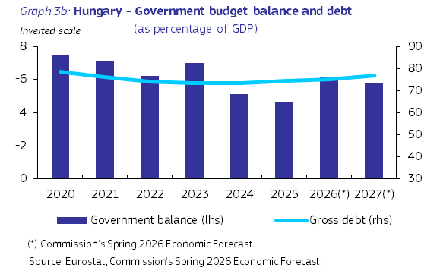
Hungary does not fulfil the exchange rate criterion. The Hungarian forint does not participate in the Exchange Rate Mechanism II. Hungary operates a floating exchange rate regime, which allows for foreign exchange market interventions by the central bank. The forint depreciated against the euro in 2024 but appreciated over the course of 2025 up to the end of February 2026. This reflected the differences between the monetary policies of the MNB and the ECB, differences in inflation rate paths and heightened uncertainty throughout the period. In March 2026, uncertainty due to the Middle East conflict caused the forint to temporarily depreciate. However, with inflation converging to the euro area average and following the results of April’s national elections, the forint appreciated once again. In May 2026, the forint was about 8% stronger against the euro compared with two years earlier. Short-term interest rate differentials vis-à-vis the euro area declined in 2024 to a minimum of 299 basis points in August, with the MNB reducing its policy rate much faster than the ECB. The short-term spread then rose in 2025 with the MNB keeping its rate unchanged and the ECB easing its policy further. The short-term spread declined slightly again in 2026, reaching 390 basis points in May, with the MNB lowering its policy rate in February 2026 while the ECB left rates unchanged. Short-term interest rates also fell following the elections in April.
Hungary does not fulfil the criterion on the convergence of long-term interest rates. The average long-term interest rate in the year to May 2026 was 6.7%, well above the reference value of 5.1%. Hungary’s long-term interest rate has been relatively stable since the previous report, with only small changes in the policy rate and fairly stable inflation. The policy rate cut in February and the sharp decline in inflation in early 2026 caused Hungary’s long-term interest rate to decrease. However, heightened risks due to the war in the Middle East temporarily raised it to 7.1% in March, the highest level since 2023. The results of April’s elections caused the long-term interest rate to return to a declining path, reaching 5.7% in May 2026. The long-term interest rate spread vis-à-vis Germany was relatively stable in 2025, and then fell in 2026 following the decrease in the long-term interest rate. The long-term spread versus the German benchmark bond was 260 basis points in May 2026.
The Commission has also examined additional factors, including balance of payments developments, the integration of markets and the institutional environment. Hungary’s external balance (i.e. the combined current and capital account) improved to 2.2% of GDP in 2024 mainly due to an improvement in the trade balance. It remained at 2.2% of GDP in 2025 with its widening trade deficit in goods and trade surplus in services cancelling each other out. The Hungarian economy is highly integrated with the euro area through trade and investment linkages. Selected indicators relating to the institutional environment show that Hungary performs worse than many euro area Member States in this regard. Hungary faces challenges in areas such as regulatory quality and control of corruption. It also performs worse than the euro area average in terms of government effectiveness and rule of law. Hungary’s financial system is characterised by a large presence of foreign holdings that perform no financial intermediation in the domestic economy. Excluding these, Hungary’s financial system is less developed than the euro area average. Hungary's banking sector has a large and relatively stable weight in the financial sector and is well integrated into the euro area financial system due to a relatively large share of foreign ownership. The equity and debt markets are small and relatively less developed. In the context of the Macroeconomic Imbalance Procedure, the Commission concluded in its Alert Mechanism Report for 2026 that an In-Depth Review (IDR) was warranted for Hungary. The IDR concluded that Hungary is experiencing vulnerabilities related to its high government debt and government financing needs, cost competitiveness and house prices. Taking into account this assessment in the IDR, the Commission, in its Communication on the 2026 European Semester Spring Package, considers that Hungary continues to experience macroeconomic imbalances.
Hungary’s recovery and resilience plan (RRP) includes measures to address a series of structural challenges, in synergy with other EU funds, including cohesion policy funds, to boost its competitiveness and stimulate sustainable growth and reduce the country’s territorial and social disparities. The RRF funding provides Hungary with EUR 10 billion over the 2021-2026 period. Key reforms in Hungary’s RRP include those in the areas of Rule of Law (e.g. the judicial system, anti-corruption, public procurement), sustainable transport, energy, water management and circular economy,taxation and the fiscal framework. In addition, cohesion policy provides Hungary with EUR 23.7 billion for the 2021-2027 period. Cohesion policy financing aims to further support Hungary’s competitiveness, including through innovation and the uptake of advanced technologies, the green transition, and upward social convergence, by addressing, among other things, poverty and developing education systems and skills. While Hungary has made progress in implementing cohesion policy, challenges remain and significant social and regional disparities persist.

- POLAND
In light of its assessment on legal compatibility and on the fulfilment of the convergence criteria, and taking into account the additional relevant factors, the Commission considers that Poland does not fulfil the conditions for adopting the euro.
Legislation in Poland, in particular the Act on the Narodowy Bank Polski (the NBP Act) and the Constitution of the Republic of Poland, is not fully compatible with the requirements of Article 131 TFEU. Incompatibilities concern the independence of the central bank, prohibition of monetary financing and the integration of the central bank into the Eurosystem. In addition, the NBP Act also contains some imperfections relating to the NBP’s central bank independence and its integration into the Eurosystem with regard to the ESCB/ECB tasks laid down in Article 127(2) TFEU and Article 3 of the ESCB/ECB Statute.
Poland does not fulfil the criterion on price stability. The average inflation rate in Poland during the 12 months to May 2026 was 2.9%, slightly above the reference value of 2.7%. It is projected to increase and remain above the reference value until the end of 2026. It is, however, expected to fall for most of 2027 and to pass below the reference value by the end of 2027.
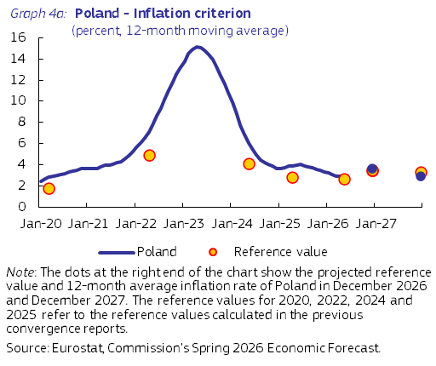
Headline inflation fell substantially from 10.8% in 2023 to an average of 3.7% in 2024 and 3.3% in 2025. Most inflation components, except for services and processed food, contributed to this reduction. Food prices were impacted by the phasing out of the temporary zero rate of VAT on basic food products at the end of March 2024. In 2025, the freeze on gas and electricity prices for households also came to an end. After moderating to 2.5% in January and February 2026, HICP inflation increased in the subsequent three months, reaching 3.3% in May 2026, driven by rising global commodity prices as a result of the conflict in the Middle East but mitigated by a temporary reduction in fuel taxes and a daily price cap introduced at the end of March 2026. In 2024 and 2025, annual HICP inflation rate in Poland was on average higher than in the euro area as a whole.
Looking ahead, inflation is expected to increase in 2026 but then to fall in 2027, while remaining above the euro area average in both years. The Commission’s Spring 2026 Economic Forecast projects that annual HICP inflation will average 3.6% in 2026 and 2.9% in 2027. The inflation outlook remains uncertain due to risks related to global commodity prices and geopolitical situation. The level of consumer prices in Poland was about 69% of the euro area average in 2024, suggesting that there is still potential for further price level convergence in the long term.
Poland does not fulfil the criterion on public finances. Poland is the subject of a Council decision on the existence of an excessive deficit. Since 2022, Poland’s general government deficit has remained above the 3% of GDP Treaty reference value, increasing from 3.4% of GDP in 2022 to 6.4% of GDP in 2024 and 7.3% of GDP in 2025. This is due to higher public spending driven by substantial defence investments, increased social benefits (including pension indexation and also the new Active Parent and Widow Pension programmes), rising costs of servicing public debt, increased salaries in the public sector and higher spending on healthcare. The Commission’s Spring 2026 Economic Forecast expects the general government deficit to decrease to 6.5% of GDP in 2026, due to restraint in nationally-financed expenditure and the adopted discretionary revenue measures. In 2027, the government deficit ratio is forecast to be 6.3%.
On 21 January 2025, the Council adopted a recommendation endorsing Poland’s national medium-term fiscal-structural plan. The plan sets out a fiscal adjustment path over four years, with maximum net expenditure growth of 6.3% in 2025, 4.4% in 2026, 4.0% in 2027 and 3.5% in 2028. The Council also adopted a recommendation with a view to bringing an end to the situation of an excessive deficit. The recommended maximum net expenditure growth rates under the EDP were in line with those set out in the medium-term fiscal-structural plan. These are consistent with a minimum annual structural adjustment of at least 0.5% GDP as a benchmark required under an EDP. The EDP correction deadline is 2028, at which point the plan envisages a deficit of 2.9% of GDP. In July 2025, the Council activated the national escape clause for increases in defence spending for Poland, allowing Poland to deviate from, and exceed, the correction path under the EDP and the net expenditure path of the medium-term fiscal-structural plan. On 3 June 2026, the Commission concluded that based on the assessment of effective action, the excessive deficit procedure for Poland is held in abeyance.
Net expenditure is projected to grow by 4.0% in 2026, below the recommended growth of 4.4%. The cumulative deviation from the recommended maximum is equivalent to 1.0% of GDP. However, the projected deviation is within the flexibility of the national escape clause based on current projections for defence spending.
The government debt-to-GDP ratio increased from 54.8% in 2024 to 59.7% in 2025 and is projected to increase to 64.5% in 2026 and to 68.3% in 2027. This is driven by a high primary deficit, elevated interest expenditure and upward stock-flow adjustments. Poland’s debt sustainability risks appear high in the medium term, with government debt projected to increase steadily from around 60% in 2025 to around 107% of GDP in 2036. The fiscal framework in Poland was subject to two significant reforms in 2024, which strengthened Polish fiscal discipline and fiscal sustainability by introducing an ex ante correction mechanism into the national expenditure rule to ensure consistency with EU fiscal requirements and a comprehensive fiscal policy monitoring mandate for the Fiscal Council.
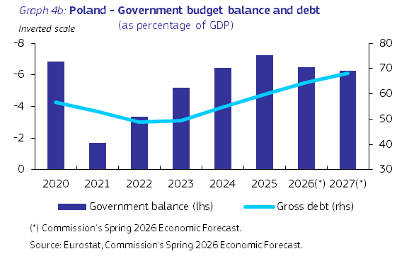
Poland does not fulfil the exchange rate criterion. The Polish zloty does not participate in the Exchange Rate Mechanism II. Since April 2000, Poland has been operating a free-floating exchange rate regime that allows foreign exchange market interventions by the central bank, if it deems this necessary, in order to achieve the inflation target. Throughout 2024 the zloty remained relatively stable, averaging around 4.31 PLN/EUR. Between January and March 2025, it strengthened slightly, from 4.25 to around 4.18. This was followed by rapid depreciation and then a period of relatively minor fluctuations at around 4.24 level. Between May 2025 and the end of the year, the exchange rate stayed close to 4.25 PLN/EUR. In May 2026, the zloty exchange rate against the euro averaged 4.25. It was about 1% stronger against the euro compared with two years earlier.
The short-term interest rate differential with the euro area increased continuously over the course of 2024 and the first three months of 2025, reaching 341 basis points in March 2025. During this period, in line with the easing of the ECB’s policy rate, the euro area short-term rate continued to fall, while the Polish three-month rate remained stable. From May 2025 onwards, the NBP embarked on an easing cycle that led to a substantial narrowing of the interest rate differential to 200 basis points in December. This trend continued into 2026, with the interest rate differential reaching 162 basis points in May.
Poland does not fulfil the criterion on the convergence of long-term interest rates. The average long-term interest rate in the 12 months to May 2026 was 5.4%, slightly above the reference value of 5.1%. Poland’s long-term interest rate initially moved slightly upwards in 2024, peaking at 5.7% in June 2024, in a context of restrictive monetary policy and a high fiscal deficit. Over that period, the long-term interest rate spread vis-à-vis the German benchmark bond remained relatively stable, before increasing from 319 basis points in July 2024 to a peak of 355 basis points in December 2024. Since January 2025, the long-term interest rate has been gradually decreasing, albeit with some fluctuations as monetary policy has been eased, to reach 5.7% in May 2026. As a result, the long-term interest rate spread versus the German benchmark bond narrowed steadily to around 269 basis points in the course of May 2026.
The Commission has also examined additional factors, including balance of payments developments, the integration of markets and the institutional environment. Poland’s external balance (i.e. the combined current and capital account) deteriorated in both 2024 and 2025, largely driven by a decline in the current account, as export prices fell faster than import prices. The external balance moved from a surplus in 2024 (0.6% of GDP) to a neutral position in 2025. Poland’s economy is well-integrated with the euro area, through both trade and investment linkages. Based on selected indicators relating to the institutional environment, Poland ranks below the average for euro area Member States in this regard. The financial sector in Poland is smaller and less developed than in the euro area. It is dominated by banks, which are well-integrated into the euro area’s financial system through a high level of foreign ownership. Market-based financing is less developed than in the euro area, as reflected in the very small markets for equity and private sector debt. In the context of the Macroeconomic Imbalance Procedure, the Commission concluded in its Alert Mechanism Report for 2026 that no In-Depth Review was warranted for Poland.
Poland’s recovery and resilience plan (RRP) includes measures to address a series of structural challenges, in synergy with other EU funds, including cohesion policy funds, to boost its competitiveness and stimulate sustainable growth and reduce the country’s territorial and social disparities. The RRF funding provides Poland with EUR 54.7 billion in grants and loans over the 2021-2026 period. The implementation of Poland’s RRP is ongoing, with a total disbursement of EUR 34.15 billion (or 62.4% of the total amount) at the end of June 2026. Key reforms in Poland’s RRP include those in the areas of decarbonisation of the Polish economy, facilitating the development of network infrastructure to ensure universal access to the internet, reforming the health sector and labour market institutions. In addition, cohesion policy provides Poland with EUR 80.6 billion for the 2021-2027 period. Cohesion policy financing aims particularly to further support Poland’s competitiveness, environmental sustainability as well as skills and social fairness. While Poland has made progress in implementing cohesion policy, challenges remain, with regional disparities between eastern regions and the rest of the country continue to widen.

- ROMANIA
In the light of its assessment on legal compatibility and on the fulfilment of the convergence criteria, and taking into account the additional relevant factors, the Commission considers that Romania does not fulfil the conditions for adopting the euro.
Legislation in Romania, in particular Law No. 312 on the Statute of the National Bank of Romania of 28 June 2004 (the BNR Law), is not fully compatible with the requirements of Article 131 TFEU. Incompatibilities concern the independence of the central bank, prohibition of monetary financing and the integration of the central bank into the Eurosystem. In addition, the BNR Law contains imperfections relating to the BNR’s independence and its integration in the Eurosystem with regard to the ESCB/ECB tasks laid down in Article 127(2) TFEU and Article 3 of the ESCB/ECB Statute.
Romania does not fulfil the criterion on price stability. The average inflation rate in Romania during the 12 months to May 2026 was 8.4%, well above the reference value of 2.7%. It is projected to decrease in the second half of 2026, but remain well above the reference value by the end of 2026. It is projected to continue decreasing in 2027, but remain above the reference value through to the end of 2027.
Annual HICP inflation in Romania rose to 6.8% in 2025, from 5.8% in 2024. Disinflation, which followed the energy price shock in 2022, stalled and subsequently reversed in mid-2025. The year-on-year headline HICP inflation rate fell from 7.3% in January 2024 to 4.9% in April 2025, before increasing steadily and significantly to 8.6% in September and remaining at that level in December 2025. Surging food and energy prices were the main contributors to the rise in headline inflation. The rise in inflation in the second half of 2025 was largely the effect of the removal of the household electricity price cap in July 2025, combined with hikes in the VAT rate and excise duties. Prices of unprocessed food rose as a result of the impact of adverse weather conditions on agriculture, while services inflation remained persistently high, due to strong, but moderating wage growth in 2025 following a public-sector wage freeze. The increase in energy prices following the conflict in the Middle East caused headline inflation to increase to 9.7% in May 2026 from 8.3% in February 2026. Annual HICP inflation rates in Romania in 2024 and 2025 were higher than in the euro area as a whole.
The Commission’s Spring 2026 Economic Forecast projects that the annual average rate of inflation will increase slightly to 7.0% in 2026 and then ease to 3.7% in 2027. Disinflation over the forecast period is expected to be supported by strong moderation in wage growth while a hike in energy prices will slow it down. The relatively low price level in Romania, which was about 61% of the euro area average in 2024, suggests potential for price level convergence in the long term.
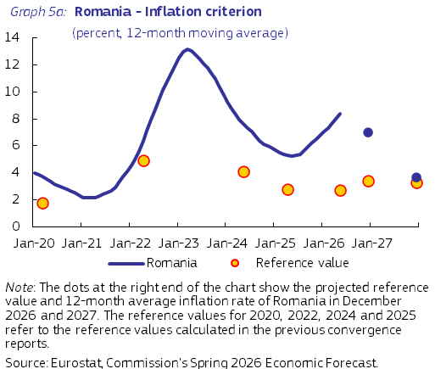
Romania does not fulfil the criterion on public finances. Romania is the subject of a Council decision on the existence of an excessive deficit. The general government deficit improved from 9.3% of GDP in 2024 to 7.9% in 2025, but remained well above the 3% of GDP Treaty reference value. This improvement was due to stronger tax collection and two major fiscal consolidation packages in 2025, with a combined estimated revenue-increasing and expenditure-reducing yield of about 3.7 percentage points of GDP. The Commission’s Spring 2026 Economic Forecast expects the general government deficit to decrease to 6.2% of GDP in 2026, reflecting the full-year effect of the 2025 fiscal adjustment packages as well as additional revenue in 2026, through higher VAT and excise duties, a higher dividend tax, property tax changes, and the broadening of the health contribution base, alongside tighter controls on current expenditure. In 2027, the government deficit ratio is forecast to be 5.8%.
On 20 June 2025, the Council adopted a decision under Article 126(8) of the TFEU establishing that Romania had not taken effective action to correct its excessive deficit. On 8 July 2025, the Council then revised Romania’s EDP fiscal adjustment path, under which Romania must keep nominal net expenditure growth below 2.8% in 2025, 2.6% in 2026, 4.6% in 2027, 4.4% in 2028, 4.2% in 2029 and 4.0% in 2030. These maximum net expenditure growth rates equate to an annual adjustment of about 2 percentage points per year in 2025 and 2026 and about 1 percentage point thereafter, above the minimum annual structural adjustment of at least 0.5% of GDP as a benchmark required under an EDP. The EDP correction deadline is 2030 at which point the July 2025 revised recommendation under Article 126(7) TFEU envisages a deficit of 2.8% of GDP. The revised recommendation of July 2025 replaced the original net expenditure path of Romania’s medium-term fiscal-structural plan as the operative benchmark for EDP monitoring, while the reforms and investments underpinning the plan’s extended adjustment period remain in force and continue to be monitored by the Commission. On 3 June 2026, the Commission concluded that Romania had taken effective action in response to the Council recommendation and the excessive deficit procedure was therefore held in abeyance. Net expenditure in 2026 is projected to increase by 1.8%, which is below the ceiling recommended by the Council of 2.6% for 2026, and the cumulative net expenditure growth by 2026 is projected to remain within the recommended cumulative ceiling of 5.5%.
The government debt-to-GDP ratio increased from 54.8% of GDP in 2024 to 59.3% in 2025 and is expected to increase further to 61.6% in 2026 and to 63.4% in 2027, driven by a high primary deficit and rising interest payments. Romania’s debt sustainability risks appear high in the medium term, with government debt projected to increase rapidly to around 90% of GDP in 2036. Regarding Romania’s fiscal framework, severe weaknesses remain in relation to recruitment to the Fiscal Council and the management of public investments.
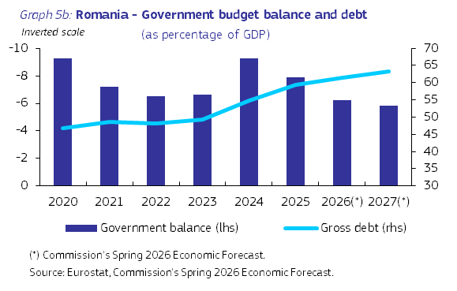
Romania does not fulfil the exchange rate criterion. The Romanian leu does not participate in the Exchange Rate Mechanism II. Romania operates a ‘crawl-like’ exchange rate arrangement that allows for foreign exchange market interventions by the central bank. Exchange rate stability has been used by the BNR as an important mechanism to ensure financial stability and anchor inflation expectations. The leu was relatively stable against the euro in 2024 and depreciated in 2025. In May 2025, capital outflow pressures in the context of increased political uncertainty triggered a strong depreciation episode, with losses against the euro of 2% compared to the previous month. This was followed by a period of moderate volatility in the second half of the year. In May 2026, the leu was about 5% weaker against the euro compared with two years earlier. The short-term interest rate spread vis-à-vis the euro area increased substantially (by around 300 basis points) between August 2024 and June 2025, reflecting the pause in the BNR’s key policy rate as of mid-2024 and the monetary policy easing cycle in the euro area. The spread widened further amid stress on Romania’s money market in late spring, peaking at around 515 basis points in June 2025. It then decreased steadily during the second half of 2025 and in early 2026, reflecting improved liquidity conditions on Romania’s money market. It reached 362 basis points in May 2026.
Romania does not fulfil the criterion on the convergence of long-term interest rates. The average long-term interest rate in the 12 months to May 2026 was 6.7%, well above the reference value of 5.1%. Romania’s long-term interest rate increased gradually throughout 2024, rising to 7.1% in January 2025. After decreasing slightly during the first few months of 2025, it began to climb again in April, fuelled by increased market risk aversion amid a widening fiscal deficit and investors’ concerns over the outlook for fiscal consolidation. The long-term interest rate then decreased steadily during the second half of 2025, following the government’s adoption of fiscal consolidation measures. During the first five months of 2026, Romania’s long-term interest rate was broadly stable, standing at 6.2% in May 2026. The long-term spread versus the German benchmark bond was 312 basis points in May 2026, down from its peak of 485 basis points in June 2025.
The Commission has also examined additional factors, including balance of payments developments, the integration of markets and the institutional environment. Romania’s external balance (i.e. the combined current and capital account) improved slightly from -6.7% of GDP in 2024 to -6.0% in 2025, mainly due to an increase in the capital account surplus thanks to better absorption of EU funds. Romania’s current account deficit remained considerable, at 7.9% of GDP in 2025, despite a marginal decrease in the second half of the year amid fiscal consolidation and weaker domestic demand. The Romanian economy is well-integrated with the euro area through trade and investment linkages. Selected indicators relating to the institutional environment show that Romania performs worse than many euro area Member States in this regard. Romania faces challenges in areas such as control of corruption. The financial sector in Romania is smaller and less developed than in the euro area. Romania's banking sector is well-integrated into the euro area’s financial system, in particular through a high level of foreign ownership in its banking system. However, market-based financing is less developed than in the euro area, as reflected in the very small markets for equity and private sector debt. In the context of the Macroeconomic Imbalance Procedure, the Commission concluded in its Alert Mechanism Report for 2026 that an In-Depth Review (IDR) was warranted for Romania. The IDR concluded that Romania continues to face vulnerabilities related to large fiscal and external deficits, despite improvements since the second half of 2025. At the same time, wage and cost pressures have moderated, with a potential positive impact on cost competitiveness. Romania’s high government deficit has been a key driver of the large external deficits and borrowing needs. The fiscal consolidation process initiated in 2025 helps reducing Romania’s vulnerabilities and is expected to continue. Taking into account this assessment in the IDR, the Commission, in its Communication on the 2026 European Semester Spring Package, considers that Romania continues to experience excessive macroeconomic imbalances.
Romania’s recovery and resilience plan (RRP) includes measures to address a series of structural challenges, in synergy with other EU funds, including cohesion policy funds, to boost its competitiveness and stimulate sustainable growth and reduce the country’s territorial and social disparities. Following the 2025 revision of its RRP, Romania’s RRF envelope amounts to about EUR 21.4 billion for 2021-2026, including EUR 13.5 billion in grants and EUR 7.8 billion in loans. The revised plan substantially reduced the loan component from EUR 14.9 billion to EUR 7.8 billion, due to implementation delays and the scaling back of measures considered no longer fully achievable. Romania had submitted four payment requests by the end of 2025. By June 2026, total disbursements amounted to around 60% of the total envelope. Key reforms in Romania’s RRP concern pensions, decarbonisation/phase-out of coal and lignite energy production, state-owned enterprises, tax administration and tax reform, and social and healthcare. In addition, cohesion policy provides Romania with EUR 33.7 billion for the 2021-2027 period. Cohesion policy financing aims to further support Romania’s competitiveness and upward social convergence, including through investments in research, innovation, and SMEs competitiveness, the green and just transition, the modernisation of labour market institutions, the development of skills and increased quality and inclusiveness of education and training, as well as poverty reduction. While Romania has made progress in implementing cohesion policy, challenges remain, with significant territorial disparities in terms of investment and employment between the capital region and other regions, as well as between urban and non-urban areas.

- SWEDEN
In the light of its assessment on legal compatibility and on the fulfilment of the convergence criteria, and taking into account the additional relevant factors, the Commission considers that Sweden does not fulfil the conditions for adopting the euro.

Legislation in Sweden, particularly the Riksbank Act, is not fully compatible with the requirements of Article 131 TFEU. Incompatibilities and imperfections persist in the fields of the independence of the central bank, prohibition of monetary financing and the integration of the central bank into the Eurosystem with regard to the Riksbank’s objectives and the ESCB/ECB tasks laid down in Article 127(1) and (2) TFEU and Articles 2 and 3 of the ESCB/ECB Statute.

Sweden fulfils the criterion on price stability. The average HICP inflation rate in Sweden during the 12 months to May 2026 was 2.2%, below the reference value of 2.7%. It is projected to decrease by the end of 2026 before increasing slightly in 2027, but should remain below the reference value in both years.

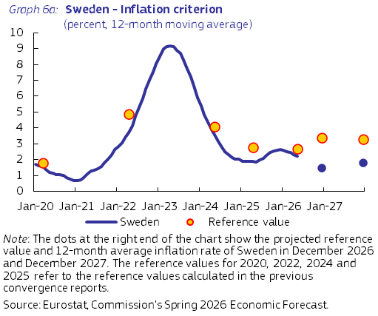

Sweden’s annual HICP inflation rate averaged 2.0% in 2024 and increased to 2.6% in 2025. These inflation rates were broadly in line with those for the euro area. Lower energy prices, base effects and moderate wage growth on the back of moderate multiannual wage agreements helped disinflation in both years. Strong deceleration of food prices in 2024 and a pronounced easing of price rises in the non-energy industrial goods in both years also contributed to lower headline inflation, while services inflation remained elevated but declined from 4.9% in 2024 to 3.8% in 2025. In 2025, somewhat stronger food and energy prices accounted for the rebound in headline inflation. The lagged impact from the stronger krona effective exchange rate in 2024 helped dampen price increases for imported goods and services. HICP inflation decelerated in the first few months of 2026, as the effects of the Middle East conflict were outweighed as from April by substantial decreases in indirect taxes on food and fuels, combined with weak underlying inflation.

The Commission’s Spring 2026 Economic Forecast projects that average annual inflation will decrease to around 1.5% in 2026 before increasing slightly to 1.8% in 2027. Inflation developments in 2026 mirror the impact of higher import prices, particularly for oil products, partly offset by VAT and excise cuts, moderate wage increases, and the lagged impact from the stronger krona, with special factors set to fade in 2027. The price level in Sweden is relatively high, at about 110% of the euro area average in 2024.

Sweden fulfils the criterion on public finances. Sweden is not the subject of a Council Decision on the existence of an excessive deficit. The general government deficit improved slightly from 1.5% of GDP in 2024 to 1.3% of GDP in 2025, reflecting sluggish economic growth. According to the Commission’s Spring 2026 Economic Forecast, the general government deficit is expected to reach 2.8% of GDP in 2026 due to weakening total revenues. In 2027, the government deficit ratio is forecast to be 2.5%.
On 21 January 2025, the Council adopted a recommendation endorsing Sweden’s national medium-term fiscal-structural plan. The plan covers the period 2025-2028 and sets an upper limit for net expenditure growth over the four years, with maximum growth rates of net expenditure of 4.0% in 2025, 4.4% in 2026, 4.4% in 2027, and 4.6% in 2028. On 3 June 2026, the Commission concluded that net expenditure is projected to grow by 6.5% in 2026, above the recommended growth of 4.4%. The deviation above the recommended maximum is equivalent to an annual deviation of 1.0% of GDP. However, when considering 2024, 2025 and 2026 together, the projected cumulative growth rate of net expenditure is below the recommended maximum growth rate. Net expenditure in 2026 is projected to increase by 6.5%, which is above the ceiling recommended by the Council of 4.4% for 2026, and the cumulative net expenditure growth by 2026 is projected to remain within the recommended cumulative ceiling of 15.5%.

The government debt-to-GDP ratio increased from 34.1% in 2024 to 35.1% in 2025 and is expected to increase further to 36.5% of GDP in 2026 and then to 37.7% of GDP in 2027, driven by a higher primary deficit. Sweden’s debt sustainability risks appear low over the medium term, even though government debt is projected to increase to around 44% of GDP by 2036. Sweden has a robust fiscal framework with clear rules and a medium-term focus, which maintains the debt anchor at 35% of GDP.

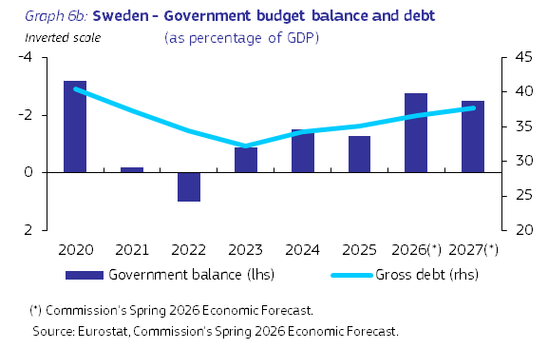

Sweden does not fulfil the exchange rate criterion. The Swedish krona does not participate in the Exchange Rate Mechanism II. Sweden operates a free-floating exchange rate regime, that allows foreign exchange market interventions by the central bank. After the krona experienced a long period of depreciation against the euro, weakening from 8.3 SEK/EUR in August 2012 to 11.8 SEK/EUR in September 2023, it recovered somewhat in 2024 and 2025, reaching 10.6 SEK to EUR in February 2026, before weakening again slightly. The three-month STIBOR-Euribor spread has been volatile over the last few years. After a short but strong increase in 2022, it subsequently fell, turning negative in the second half of 2024. Since then, it has fluctuated between -20 and 20 basis points, i.e. significantly below the years before 2022 (around 50 basis points). In May 2026, the spread stood at -21 basis points and the exchange rate was 10.9 SEK/EUR, i.e. 7% stronger against the euro compared with two years earlier.

Sweden fulfils the criterion on the convergence of long-term interest rates. The average long-term interest rate in Sweden in the 12 months to May 2026 was 2.6%, well below the reference value of 5.1%. After increasing considerably in 2022 and 2023, Sweden’s long-term interest rates decreased in 2024 before returning to 2023 levels in 2025. Since the beginning of 2024, the long-term interest rate has been fluctuating between 2.2% and 2.8%. The spread versus the German benchmark bond remained relatively small with some volatility in 2024 and 2025. In general, the spread has decreased in recent years and turned slightly negative in 2024, reaching -34 basis points in July 2024. It then increased slightly until January 2026, before decreasing gradually to -31 basis points in May 2026.

The Commission has also examined additional factors, including balance of payments developments, the integration of markets and the institutional environment. Sweden’s external balance (i.e. the combined current and capital account) remained in surplus, at 7.0% of GDP in 2024 and 6.2% in 2025. Sweden’s economy is well-integrated with the euro area through trade and investment linkages. Selected indicators relating to the institutional environment show that Sweden performs better than most euro area Member States in this regard. The financial sector in Sweden is highly developed and well-integrated into the euro area’s financial system. Banking dominates the financial sector, although the insurance and pension funds also account for a sizeable part of it. Moreover, Sweden has one of the most advanced credit and equity markets in the EU, and the level of market financing is among the highest in the EU. In the context of the Macroeconomic Imbalance Procedure, the Commission concluded in its Alert Mechanism Report for 2026 that an In-Depth Review was warranted for Sweden. The IDR concluded that Sweden faces vulnerabilities that relate to its real estate market and high private debt. While house prices have moderated somewhat from their 2022 and 2023 levels, household leverage remains high and is expected to increase further. While the financial sector is highly exposed to real estate, it is profitable with sizeable capital buffers against adverse developments. Rigidities in housing supply remain, the rental market has seen limited reform, leading to long waiting lists and a low vacancy rate compared to other EU countries. Taking into account this assessment in the IDR, the Commission, in its Communication on the 2026 European Semester Spring Package, considers that Sweden no longer experiences macroeconomic imbalances.
Sweden’s recovery and resilience plan (RRP) includes measures to address a series of structural challenges, in synergy with other EU funds, including cohesion policy funds, aimed at reducing the country’s territorial and social disparities. The RRF funding provides Sweden with EUR 3.4 billion over the 2021-2026 period. Sweden submitted its second payment request in January 2026. Key investments and reforms in Sweden’s RRP include those in the areas of financing of greenhouse gas emissions-saving technologies and infrastructure, insulation of housing, training for elderly care and broadband roll-out in sparsely populated areas. A first RRF reimbursement took place in July 2025, with the remaining payments under assessment for 2026. In addition, cohesion policy provides Sweden with EUR 2.4 billion for the 2021-2027 period. Cohesion policy financing aims particularly to further improve the conditions for research and innovation, create opportunities for entrepreneurship and industrial transformation, and support digitalisation, internationalisation and competitiveness. While Sweden has made progress in implementing cohesion policy, challenges remain, with persistent disparities between the capital region and the rest of the country.

The Member States that have not yet fulfilled the necessary conditions for the adoption of the euro are referred to as ’Member States with a derogation’. Denmark negotiated an opt-out before the adoption of the Maastricht Treaty and does not participate in the third stage of economic and monetary union.
Council Decision (EU) 2025/1407 of 8 July 2025 on the adoption by Bulgaria of the euro on 1 January 2026 (OJ L 1407, 14.7.2025, pp. 1-4).
By virtue of Protocol No 16 to the Treaties on certain provisions relating to Denmark, Denmark has an exception as regards the single currency and the procedure referred to in Article 140 TFEU can only be initiated at its request. Denmark has not made that request and is therefore not covered by the assessment.
The cut-off date for the data used in this report is 17 June 2026. The convergence assessment is based on a range of monthly convergence indicators calculated up to May 2026.
The examination of the compatibility of national legislation is based on the legislation in force by the end of April 2026.
For the purpose of the price stability criterion, inflation is measured by the Harmonised Index of Consumer Prices (HICP) defined in Regulation (EU) 2016/792.
All forecasts for inflation and other variables in this report are from the Commission’s Spring 2026 Economic Forecast. The forecasts are based on a set of common assumptions for external variables and on a ‘no policy change’ assumption, but also take into consideration measures that are known in sufficient detail.
The respective 12-month average inflation rates were 0.9%, 1.2% and 1.6%.
In assessing compliance with the exchange rate criterion, the Commission examines whether the exchange rate has remained close to the ERM II central rate. Reasons for an appreciation may be taken into account, in accordance with the Common Statement on Acceding Countries and ERM2 by the Informal ECOFIN Council held in Athens on 5 April 2003.
The reference value for May 2026 was calculated as the simple average of the 12-month average of long-term interest rates of Cyprus (3.1%), France (3.5%) and Denmark (2.6%), plus two percentage points.
COM(2026) 200 final, 3.6.2026.

