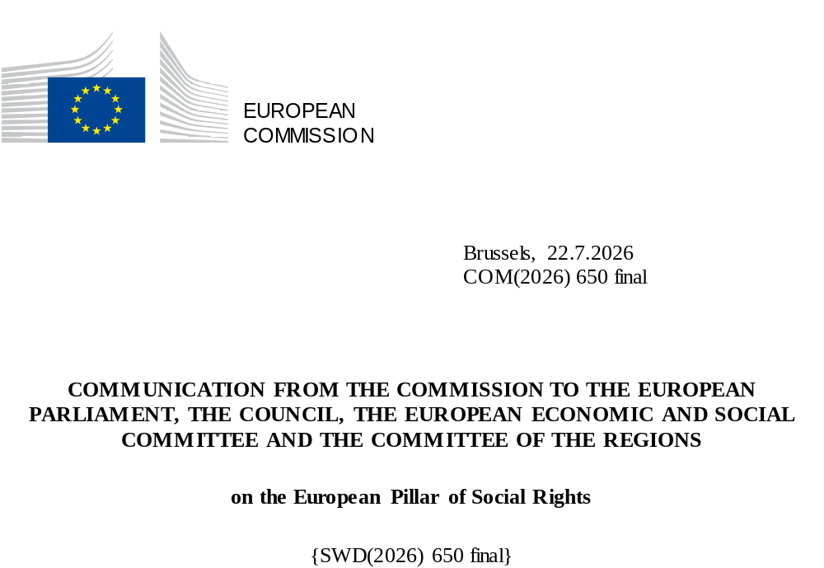

Communication on the European Pillar of Social Rights
Introduction
The European Union is founded on the belief that social progress and human dignity are the bedrock of a fair, democratic and resilient society. Article 3 of the Treaty on European Union sets the Union the objective of a highly competitive social market economy aiming at full employment and social progress, and reflects a lineage running from the Treaty of Rome’s vision of shared prosperity to the social vision defined in the 1989 Community Charter of the Fundamental Social Rights of Workers and affirmed in the Charter of Fundamental Rights. This steadfast commitment to the Union’s values and principles has shaped a Europe that seeks to lead the way globally in solidarity, equality, and people’s well-being.
The European Pillar of Social Rights is social Europe’s defining framework. The Pillar was proclaimed to guide the European social model, which has been a success story and has made the EU a world-class place, to live, to work and to study. It remains the EU’s social shield and compass for fairness in an age of fast-transformation and challenge, but also opportunity. It is a permanent reminder of the kind of Europe the Union seeks to build: a Europe that protects and empowers citizens.
Jointly proclaimed in 2017 by the European Parliament, the Council and the Commission, the European Pillar of Social Rights’ 20 principles established a shared framework to promote social rights and improve living and working conditions across the EU. The 2021 Action Plan endorsed at the Porto Social Summit translated these principles into concrete initiatives to strengthen the EU’s social fabric, putting forward 75 actions and three 2030 headline targets. The Action Plan also reinforced the Union's commitment to fundamental rights and the achievement of the Sustainable Development Goals under the 2030 Agenda.
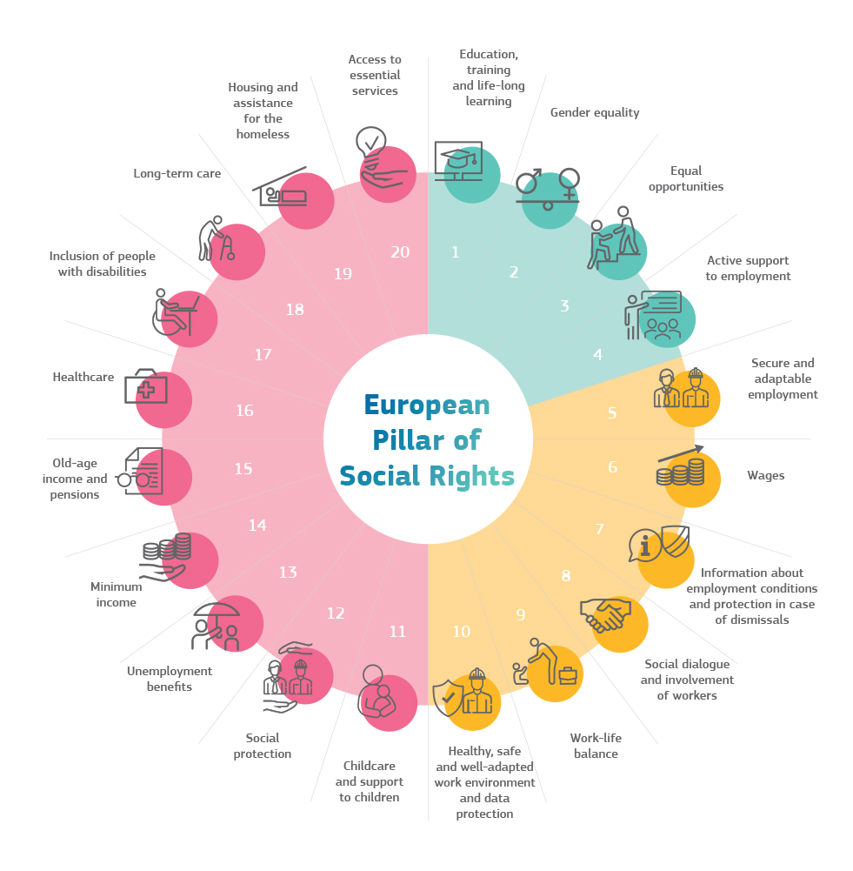
The Pillar has guided measures at EU level and in Member States, proving its value as a shield in times of crisis and a compass to help guide us through the transformations facing the EU, as confirmed in the 2024 La Hulpe Declaration. The COVID-19 pandemic, Russia’s war of aggression against Ukraine, and the ensuing energy and cost-of-living crisis tested the EU’s social fabric. Yet, through EU solidarity and effective crisis response instruments – such as SURE, the Recovery and Resilience Facility and cohesion policy funds – alongside investments and reforms at national and regional level, the Union collectively managed these shocks while safeguarding jobs, skills and social protection. Today, however, the challenges are evolving: geopolitical tensions, the overall security situation, trade frictions, democratic backsliding and fragmented international cooperation demand that Europe strengthens resilience from within.
The Pillar and its principles remain as relevant as ever – if not more so – as we need to anticipate, prepare for and manage structural changes. Demographic shifts – highlighted in the 2026 Commission report Demographic transformation in the EU: understanding change and adapting to its consequences – are accelerating changes in the EU’s workforce and society. The digital and green transitions, amidst global geopolitical challenges and security concerns, are also reshaping Europe’s industry, jobs and skills demands. Managing these shifts requires a regulatory environment that allows businesses to invest and grow, as well as education and training systems to equip everyone with in-demand skills, access to quality and affordable services, including to support an inclusive labour market, and robust social protection and social inclusion systems. In order to support this balance, as the “One Europe, One Market Roadmap” asserts, Europe’s industrial policy must be developed “in a manner that respects the European Pillar of Social Rights creating a just transition that secures quality jobs and leaves no one behind.”
The Pillar also continues to shape the Commission's external action by promoting high labour and social standards beyond the EU. Building on the 2021 Action Plan, the Commission is strengthening multilateral engagement, advancing decent work and responsible business conduct in global value chains, and supporting partner countries in aligning their employment, skills and social policies with the principles of the Pillar. As a key benchmark for enlargement and neighbourhood countries, the Pillar promotes the EU social model while providing a framework for dialogue, cooperation and mutual learning.
With the 10th anniversary of the Pillar’s proclamation approaching, this Communication aims at further deepening the implementation of the Pillar. It takes stock of progress to date and identifies concrete priorities where further action is needed to anticipate and deliver the opportunities brought by the transformations facing the EU. This Communication proposes additional targeted actions which complement the 2021 Action Plan and will deliver concrete added value, in line with the EU’s commitment to simplification and implementation. It also sets the path for further strategic reflection and anticipation and management of structural changes. With the cost of inaction far outweighing investment, integrating social considerations into all policy areas is essential for Europe’s prosperity and competitiveness.

- Progress since the 2021 Action Plan on the 2030 headline targets
The 2021 Action Plan set three EU-level headline targets, including sub-targets, to be reached by 2030:
- at least 78% of people aged 20 to 64 should be in employment compared to 2019
  - at least halve the gender employment gap
  - increase the provision of formal early childhood education and care (ECEC)
  - decrease the rate of young people neither in employment, nor in education or training (NEETs) aged 15-29 from 12.6% (2019) to 9%
- at least 60% of all adults should be participating in training every year
  - at least 80% of those aged 16-74 should have basic digital skills
  - early school leaving should be further reduced and participation in upper secondary education increased
- at least 15 million fewer people at risk of poverty or social exclusion, compared to 2019
  - this should include at least 5 million children
The targets were endorsed by EU leaders at the Porto Social Summit in May 2021 and subsequently reflected in national targets. Progress towards the headline targets has been uneven, with persistent regional and territorial disparities. The EU-level trends are as follows:
- Standing at 76.1% in 2025, the EU is on course to meet its employment target. The gender employment gap now stands at 9.6 pp, which represents a slight decrease of 1.3pp. since 2021. However, the 2026 Spring Economic Forecast points to softening labour demand that could weigh on this progress in the years ahead. Employment rates of specific groups show a mixed picture (e.g. a persisting disability employment gap, 24.2 pp in 2025 and a Roma employment gap of 21 pp in 2024).
- Significant further efforts are needed on the skills target. Adult participation in learning stood at 39.5% in 2022, against a target of 60%.
- More progress is also needed on the poverty reduction target. The number of people at risk of poverty or social exclusion in the EU fell by around 3.5 million between 2019 and 2025, falling short of the target reduction of 15 million.
The headline targets are not out of reach but achieving them will require stronger implementation efforts at both EU and Member State level. Progress on the sub-targets is reported in the accompanying Staff Working Document. The Commission will continue to monitor progress towards the EU 2030 targets. Combating poverty demands data-driven, evidence-based policymaking, supported by comparable high-quality indicators.
While there is positive development on the rate of employment, further efforts are still needed on its quality, focusing on well-paid jobs with opportunities for personal and professional development, autonomy and purpose, within an adaptive work environment. This encompasses fair wages, job security, occupational safety and health, wellbeing at work, social protection, gender equality, and equal opportunities. The 2025 Quality Jobs Roadmap outlined the policy actions to support quality jobs in a competitive economy.
Actions:
- The Commission will strengthen the monitoring of job quality in the EU based on the updated job quality monitoring framework of the Employment Committee (EMCO), including in the Joint Employment Report (JER).
- Following the work already started, the Commission will initiate a consultation of Member States, through the Employment Committee, and with relevant stakeholders on a possible new target on job quality beyond 2030.
- The Commission will put forward a Quality Jobs Act (Q4 2026).
- As announced in the EU Anti-Poverty Strategy, to improve monitoring of poverty, the Commission will put forward new indicators to measure the impact of affordability components and reflect different dimensions of poverty, with a view to having them agreed by 2028. Subject to agreement with the Employment, Social Policy, Health and Consumers Affairs Council (EPSCO) and its advisory committees, this could then also lead to a review of the related indicators in the social scoreboard in view of strengthening the relevant analysis in the Social Convergence Framework.

- The 2021 Action Plan: implementation and delivery
The 2021 Action Plan has been implemented through a collective effort by EU institutions, Member States, regional and local authorities, social partners, civil society, and other stakeholders. Political momentum was strengthened at the Porto Social Summit (May 2021), where EU leaders endorsed the headline targets and reaffirmed their support for the European Pillar of Social Rights. This was further reinforced by the La Hulpe Declaration (April 2024), which underscored the Pillar’s role as Europe's social compass and called for its continued implementation amid the green, digital and demographic transitions. The Pact for European Social Dialogue (2025) renewed the commitment to strengthen social dialogue and address key labour market and economic challenges.
The Action Plan’s final milestone was its own review. For this purpose, the Commission carried out broad internal and external consultations in 2025, alongside an analytical assessment of progress in implementing the 75 initiatives. The goal was to take stock of achievements, identify remaining gaps and inform future priorities.
The findings reveal tangible progress since the Pillar’s proclamation nearly a decade ago. New social rights and protections have been codified and operationalised across the EU, with advances – though uneven – toward all three headline targets. However, the review also identified persistent implementation gaps and the need to accelerate the implementation of key initiatives. Strengthening delivery is a shared responsibility across EU, national, regional, and local levels, with social partners and civil society playing a central role. The findings of the review are detailed in the accompanying Staff Working Document.
- Strengthening the implementation of the Pillar
Since the adoption of the Action Plan in 2021, the environment in which social and employment policies operate has changed dramatically. Through the consultation and analysis, the Commission has identified three pressure points which require urgent and additional attention. These are complementary to existing and ongoing Commission initiatives on jobs, skills, mobility and poverty reduction, strengthening their implementation and focusing on new and rapidly evolving challenges.
3.1 The cost of living and affordability
In recent years, the cost of living has emerged as Europeans’ biggest concern. High costs for housing, food, energy, transport and other essential goods and services impact heavily on living standards, social inclusion and economic security, particularly among households in vulnerable situations and young people. The cost of living also has implications for democratic resilience: persistent income insecurity, perceived unfairness and reduced opportunities can weaken trust in institutions and fuel social fragmentation.
Looking ahead, additional challenges may further increase pressure on households, potentially impacting further on poverty and social exclusion. Employment growth is projected to remain positive but slow to 0.3% in 2026 and 0.4% in 2027, while recent geopolitical developments, including military tensions and shifts in global trade patterns, risk generating additional inflationary pressures. Low-income households are particularly exposed to such pressures. Obtaining a more granular overview of how the rising cost of living affects different groups in society could help better monitor the situation of different groups experiencing poverty, as well as the situation of women.
Fostering access to the labour market and quality jobs is one clear pathway out of the affordability crisis. While employment in the EU is at a record high, a considerable reservoir of untapped talent remains outside the labour market. In 2025, almost 50 million people of working age were outside the labour force, alongside 12 million unemployed people and 6.5 million underemployed workers (including part-time workers, especially women) who wished to work full-time but were unable to find such opportunities. Women account for the largest share of non-participation with around 32 million of those in working age being outside the labour market. Their labour market participation is strongly affected by gender inequalities, including the uneven distribution of family and care responsibilities, as well as by the availability and quality of care services.
Facilitating transitions from inactivity to work is not only important for labour market inclusion and competitiveness, but also one of the most effective tools for reducing poverty and exclusion. Bringing more people into the labour market contributes directly to GDP growth, reduces skills shortages and broadens the tax and social contribution base needed to sustain Europe's social protection systems. With a view to exploring possible further measures, in full respect of subsidiarity and proportionality in this field, the Commission is thus launching the first-phase consultation of EU social partners on the possible direction of an EU action on activation of of persons facing significant barriers to employment.
Public Employment Services continue to play a central role through personalised guidance, skills assessment, activation measures and job matching. The Commission will submit in 2026 an evaluation report on the European Network of Public Employment Services and, subject to its findings, will propose the continuation of the Network. Social dialogue will also remain essential to anticipate skills needs, identify barriers to labour market participation and develop solutions adapted to sectoral realities.
The Directive on adequate minimum wages in the EU in force since 2022, was a crucial achievement for ensuring fair working conditions. It established a common framework to ensure the adequacy of statutory minimum wages and promote collective bargaining on wage-setting. Since its adoption, minimum wages have increased significantly across the EU, notably in the countries with the lowest levels. This has helped raise pay and living standards for many workers: in-work poverty rates have steadily fallen from a high of 9.6% in 2016 to 8.3% in 2025. More details can be found in the monitoring report published alongside this Communication.
Housing has emerged as a particularly acute challenge – especially in urban areas. In many regions, housing costs have risen faster than incomes, limiting access to affordable and quality housing and affecting labour and learning mobility, family formation and social and territorial cohesion. Demand for social housing has become more important in the context of limited public and private investments in affordable housing. As part of the EU Anti-Poverty Strategy presented on 6 May, a proposed Council Recommendation on fighting housing exclusion emphasises long-term solutions and prevention to combat housing exclusion and homelessness. It also promotes more social and affordable housing, focusing on a people-centred approach. The European Affordable Housing Plan sets out a strategy to tackle the wider housing crisis across Europe. It aims to increase housing supply, trigger investment and reforms, and support the people and the areas that are most affected. The Commission is preparing the Affordable Housing Act, to support public authorities in identifying areas of housing stress and enable them to take measures to protect and promote housing affordability in those areas. The recently adopted Council Recommendation on the New European Bauhaus (NEB) encourages Member States to align their national policies to an integrated approach to the design and transformation of buildings, neighbourhoods and public spaces. Member States should use all available funding possibilities including through cohesion funds and the Social Climate Fund to support affordable and social housing. Member States are invited to integrate the housing dimension in other relevant policies or in areas, including social welfare, equality, employment, urban, rural and regional development, territorial cohesion, research and development and healthcare. The Commission will publish a study on housing inequality and discrimination in 2027, as well as a housing simplification package that will contribute to facilitate the supply of affordable housing.
Food poverty is also a growing concern in EU, as the share on EU population unable to afford a meal with meat, chicken, fish (or vegetarian equivalent) every second day has increased from 6.8 % in 2019 to 8.5 % in 2025, although with important disparities across Member States. The Commission will publish in 2026 a study on food affordability, and will launch a pilot project on food access.
Energy poverty continues to affect millions of Europeans. 9.2% of EU households were unable in 2024 to keep their home adequately warm while 26% of them were unable in 2026 to keep their homes comfortably cool in summer. Energy renovations or access to energy efficiency solutions and renewable energy sources, are the most effective ways to address the root causes of energy poverty and prevent vulnerability. The Citizens Energy Package, adopted by the Commission in March 2023, underlines the importance of tackling energy poverty in the EU with a focus on protecting and empowering consumers.
Transport poverty, understood as the inability or difficulty to meet the costs of private or public transport, or lack of access to transport services, is another important challenge: 21% of households at risk of poverty face unaffordable transport costs. Decarbonisation and strong climate action are among the most effective ways to reduce high energy and transport costs, making essential services more affordable, and at the same time strengthening Europe’s energy independence. Good examples in that context are the investments financed with the revenue from the sale of ETS allowance via the Social Climate Fund and relevant climate action and reforms.
Access to essential services, enshrined in the Pillar, is a critical yet often overlooked dimension of affordability. Even when services exist, barriers such as high costs, physical distance, bureaucratic hurdles, or lack of awareness often exclude people, especially those in vulnerable situations. Closing these gaps is essential for social cohesion, as unequal access exacerbates territorial inequalities. Services of General Economic Interest (SGEI) play a key role in promoting social and territorial cohesion. Under EU State aid rules revised in 2025, compensation for the provision of SGEI can be envisaged by Member States in relation to affordable and social housing, access to and reintegration into the labour market or the care and social inclusion of vulnerable groups including accessibility and assistive technology services for persons with disabilities. Member States should combine these tools with broader strategies, such as the Council Recommendation on the Social Economy (2023), to uphold universal access and territorial fairness.
Building on the European Care Strategy (September 2022), the Commission will work towards a more coherent framework for addressing long-term care workforce challenges and will present a European Care Deal in 2027. By strengthening the availability and access to care services, the initiative will contribute to Europe's competitiveness, reducing pressure on informal carers and by stimulating job creation in the sector as well as investments into digital enabled technologies supporting both carers and people in need of care.
Actions:
- The Commission will launch the first-phase consultation of EU social partners on the possible direction of EU action on activation of persons facing significant barriers to employment, including regarding equality between men and women with regards to labour market opportunities (together with this Communication).
- The Commission will put forward an Affordable Housing Act (Q3 2026)to support public authorities in identifying areas of housing stress and enable them, in full respect of subsidiarity, to take measures to protect and promote housing affordability in those areas, and a housing simplification package (2027).
- The Commission will put forward a European Care Deal (2027).
- The Commission presents a monitoring report on the Adequate Minimum Wages Directive (together with this Communication).

3.2 Artificial Intelligence (AI) – the future of work and shared prosperity
The rapid development and adoption of artificial intelligence (AI), accelerated by the emergence of generative AI since 2022, is transforming labour markets and society at large. It offers major opportunities for innovation, productivity, learning and growth – but raises also important critical questions about the future of jobs, education, skills, social inclusion, and fundamental rights. In the EU in 2025, nearly 20% of enterprises used some form of generative AI, and 61% of European workers believe they will need new skills to keep pace with AI by 2029, while only 15% have received any training so far, as a Cedefop survey revealed.
Europe must be ready for these profound changes, ensuring that citizens, workers and businesses fully benefit from AI’s potential. As the European Declaration on Digital Rights and Principles for the Digital Decade emphasises, a human-centred digital transformation is essential to ensure that digital technologies respect fundamental rights and European values. Social rights, grounded in the Pillar principles, are at the centre of this transformation.
When it comes to the impact of AI on labour demand and the organisation of work, the aggregate impacts in the EU appear small to date, even though certain groups, notably young people in entry-level positions, risk seeing a slow-down in hiring in some sectors and occupations. AI is expected to accelerate employment growth – in 2025, firms making significant use of AI were about 4 percentage points more likely to have expanded their workforce than firms that did not use AI. Such job gains are likely to be concentrated in some occupations,. AI can also transform existing jobs and skills requirements, notably digital and soft skills. However, the trends are still volatile and need to be better understood. As highlighted in the Apply AI Strategy, key priorities include upskilling and reskilling, supporting labour market transitions through effective activation policies and adequate income protection. In this context, the Commission continues to develop real-time labour market intelligence and early warning tools.
Besides the impact of AI, parallel labour market and demographic trends across the EU bring to the fore sectors with strong job creation potential, replacement needs and growing labour demand (i.e. “job creation engines”), including long-term care, healthcare, construction, social services, circular economy and clean tech. Empowering workers to access new opportunities and raise productivity is a key collective task, involving policy-makers, education and training providers, public employment services and social partners. Ensuring that the jobs created are quality jobs will be essential to their attractiveness and sustainability over time.
Moreover, AI can help strengthen public services. AI-powered profiling and job-matching tools can help public employment services provide more targeted support, for example through better job matching, more personalised support and earlier identification of unemployment risks. It can also improve the recognition and matching of skills. AI can improve preparedness and support healthcare and long-term care systems facing growing pressures from demographic ageing, in particular in areas struggling to provide adequate access to essential services. By improving diagnosis, service delivery and administrative efficiency, AI can contribute to better outcomes for citizens while making welfare systems more effective and sustainable.
When not properly designed and used, AI can also raise important concerns regarding equal opportunities and inclusion. The use of AI in the labour market and in public administrations comes with a risk of algorithmic bias, including biases embedded in the data used to train AI systems, potentially reinforcing inequalities and discrimination affecting different groups, particularly if AI systems were not designed and deployed in a manner compliant with the AI Act. Effective implementation and compliance with EU legal instruments, such as the AI Act, is key for addressing biases and risks. At the same time, AI can reshape how individuals learn, reskill, and solve problems. As emphasised in the Apply AI Strategy, boosting AI literacy is a key enabler for inclusion and equal opportunities and crucial to ensure Europeans can use these tools critically and responsibly. These developments raise pressing policy questions for the EU. Policymakers must consider how AI will affect future labour demand and supply, affect inequality, and more broadly test the resilience of the European social model. Moreover, reliance on non-European AI technologies can bring additional risks, notably where sensitive data, critical infrastructure or security-relevant functions are involved. Adequate policy responses must therefore be found to reduce risks associated with technological disruption while enabling the EU to realise AI’s economic and societal benefits.
To realise these benefits, Member States will need the administrative and institutional capacity to deploy AI responsibly. This includes appropriate governance arrangements, human oversight, data management, impact assessment, monitoring and safeguards against discrimination and other risks to fundamental rights, in line with the AI Act.

Actions:
- The Commission will set up a High-level Experts Group to examine the potential impact of AI on the labour market, ensuring coherence, complementarity and synergies with existing initiatives, including the AI Observatory launched as part of the Apply AI Strategy, with a view to:
  - Develop scenarios for the potential long-term trajectory for EU employment, as impacted by the deployment of AI in workplaces, building on inputs from the AI Observatory and the European Skills Intelligence Observatory.
  - Examine how the impacts of AI on jobs can be anticipated and managed most effectively, including by considering enhanced analytical tools for monitoring, early warning, foresight and anticipation of the impact of AI on jobs to equip policymakers, businesses and social partners; and considering avenues for calibrating labour market policies and improving the functioning of labour markets.

- Without prejudging possible EU action in the context of the Quality Jobs Act, for which a consultation of the EU social partners is ongoing, the Commission will consider support activities for the responsible adoption of Algorithmic Management tools and practices in workplaces, such as sharing of good practices, mutual learning and capacity building.

3.3 Inequalities, fairness and equal opportunities
The European Union remains firmly committed to reducing persistent inequalities that undermine social and territorial cohesion, economic resilience and the fundamental Pillar’s promise of equal opportunities for all. In the Union, inequalities are markedly lower than in most other parts of the world, as a result of the implementation of the European social model. Despite progress during the last years, inequalities persist in all areas of life, requiring continued efforts to implement cost-effective measures. Inequalities are not merely a social concern, but structural barriers that weaken the EU’s long-term sustainability, innovation and competition capacity and demographic fabric.
Europeans increasingly perceive that life is not fair: in 2022, only 38 % perceived that most outcomes in their lives occur fairly, down from 51% in 2017. Income inequality decreased following the COVID-19 pandemic but still remain high: the top 20% earn almost five times the income of the bottom 20%. Wealth concentration is even more pronounced: according to the European Central Bank 2025 data for the Euro area, the wealthiest 10% owned around 57.3% of total net wealth of households (largely unchanged compared to 2023), whilst the bottom 50% owned around 5%.
Regional and territorial disparities continue to exacerbate social inequalities by limiting access to quality education, employment, healthcare, long-term care and other essential services. Disadvantaged neighbourhoods, rural and remote areas, and outermost regions are particularly affected, facing population decline, youth outmigration and the risk of falling into or deepening talent development traps. These challenges carry significant social and economic costs, undermining territorial cohesion, competitiveness and the full potential of the Single Market.
At the same time, socio-economically disadvantaged, discriminated and marginalised groups are often more exposed to pollution and environmental degradation, and to the negative effects of climate change (floods, wildfires, heatwaves, soil shrinking, etc.), with fewer opportunities to move away from risks. Environmental inequalities are also present in housing: lower-income households are more likely to live in inadequate and sometimes poorly insulated homes and may have limited ability to move away from areas exposed to risks such as flooding.
To close these gaps, decisive action has been taken under the 2021 Action Plan to tackle inequalities and widen access to equal opportunities. To prevent unintended consequences – from the very beginning – policies need to be designed with distributional effects in mind. The Commission will publish a study on distributional impacts assessments in the Member States in 2027 and will further promote their use in policy-making.
The Union of Equality provides an overarching policy framework, covering strategies for gender equality, LGBTIQ+ equality, the rights of persons with disabilities, anti-racism, and Roma equality, inclusion and participation. The Commission will monitor and report on the implementation of this framework, including national developments, through the forthcoming Union of Equality reporting.
The enforcement of EU anti-discrimination laws and policies also remains central. For example, the Racial Equality Directive and the Employment Equality Directive aim to prevent and combat discrimination based on racial or ethnic origin, religion or belief, disability, age, and sexual orientation. Effective, proportionate, and dissuasive sanctions are essential to combating discrimination and the barriers it creates to employment and other areas of life. The Commission calls on Member States to ensure effective sanctions against discrimination.
The Pay Transparency Directive , which entered into force in May 2023, and had to be transposed into national law by Member States by June 2026, reinforces the principle of equal pay for equal work or work of equal value between men and women, helping to advance gender equality in the labour market. The Commission remains fully committed to ensure its implementation and enforcement. To this end, the Commission will continue to provide support to Member States and social partners to implement the Directive effectively, keeping administrative burden proportionate while ensuring full compliance. Furthermore, the Commission will provide further support in particular to SMEs, as key actors in realising the tangible impact of fair and transparent pay practices, including to ensure that implementation entails the least possible administrative burden.
Unequal career progression is also visible in the gender pension gap (standing at 23.9% in the EU in 2025) and higher poverty rates for older women (standing at 21.9% in the EU for 65+ women in 2025). The Intergenerational Fairness Strategy and the Gender Equality Strategy 2026-2030 highlight that inequalities in employment, pay, and unpaid care work accumulate over the life course and lead to significant gender gaps in pensions and income security in old age.
Healthcare coverage has a poverty-reducing impact comparable to cash transfers, and well-designed healthcare reform can further contribute to the EU’s anti-poverty effort. It is essential for Member States to leverage the potential of the tools and guidelines developed under EU4Health actions, including those that can trigger a fairer distribution of health benefits, more affordable healthcare, or improve access to healthcare for persons with disabilities. These actions also include instruments supporting Member States in addressing health workforce shortages, such as health workforce planning models as well as fair and sustainable labour mobility schemes with countries of origin to attract care workforce to the EU, including under Talent Partnerships.
The Commission is strengthening the territorial dimension of the European Pillar of Social Rights through recent EU level territorial strategies, and is preparing a Strategy for Outermost Regions, and a Strategy on the Right to Stay, with a particular focus on improving access to opportunities and essential services so that people can thrive in the place they call home.
Inequalities start early in life and accumulate over time. Persistent inequalities in education, compounded by underinvestment and teacher shortages in disadvantaged areas, continue to limit social mobility and economic potential.
Inequality is not only about today’s outcomes, but also about fairness throughout generations. Reducing the transmission of inequalities across generations requires policies that intervene early on and prevent the accumulation of disadvantages over the life course. The Strategy on Intergenerational Fairness promotes a stronger long-term perspective in policymaking and giving greater weight to the views and concerns of young people. Balanced with the need to ensure long-term fiscal sustainability, adequate and well-targeted, place-based and person-centred social investment helps prevent the accumulation of social disadvantages and reduces long-term fiscal and economic costs. The strengthened European Child Guarantee, and the new EU target on improving the basic skills of disadvantaged learners are key tools to address these challenges. Furthermore, broad access to supplementary pensions can help maintain adequate pensions for future retirees, particularly considering the effects demographic change in the Union will have on households.

Actions:
- The Commission will provide further support, in particular for SMEs, in implementing the Pay Transparency Directive.
- The Commission will take stock of available indicators to monitor socio-economic inequalities and social mobility, in cooperation with the Member States.
- The Commission will provide guidance on inclusive hiring practices through the EU Platform of Diversity Charters.
- In line with the commitments made under the Union of Skills, the Commission is developing an Education Package to support Member States in improving school education performance and a Vocational Education and Training (VET) Strategy to make VET systems more attractive, innovative, and inclusive.
- The Commission is working on the Right to Stay Strategy, with particular attention to addressing territorial disparities in access to essential services.
- The upcoming EU Youth Strategy for the post 2027 period will aim to ensure that all young people have the opportunities to realise their full potential in a fair and inclusive manner (2027).

- Making social rights a reality for all – relaunching the collective effort
4.1. Simplification, implementation and enforcement
As social and employment challenges evolve, the EU social acquis must remain effective, accessible and easy to implement, while fully preserving the rights and standards that underpin the European social model. In line with the Commission’s commitment to simplicity by design, future initiatives will continue to integrate simplification, implementation and enforcement considerations from the outset, while preserving rights and protections. The Commission is committed to proactively and meaningfully reducing the administrative burden on businesses, workers and citizens, while upholding social standards. To this end, it will identify implementation challenges through the European Semester and work closely with Member States and stakeholders to facilitate the effective application of the EU social acquis. The forthcoming Fair Labour Mobility Package will contribute to these objectives by promoting simpler, fairer and more effective rules for labour mobility, including for cross-border workers, while strengthening enforcement and supporting the proper functioning of the Single Market.
The Commission is strengthening efforts to ensure that the social acquis remains fit for purpose. This includes stress-testing existing legal frameworks and continuing implementation dialogues with stakeholders and social partners as appropriate, in order to identify practical obstacles to implementation and opportunities for simplification. Future initiatives, such as the Fair Labour Mobility package and certain elements in the Quality Jobs Act, will contribute tangibly to simplification and to supporting the proper functioning of the Single Market, while strengthening workers’ rights, including cross-border workers, enhancing the enforcement of social and labour legislation, and combating unfair competition and social fraud and abuse. In 2027 the Commission will review the implementation of Directive (EU) 2019/1152 on transparent and predictable working conditions in the European Union.
In line with the 2025 Pact for European Social Dialogue, the Commission will continue to strengthen cooperation with social partners, whose role remains essential in both the design and implementation of labour market policies. Civil society organisations will also remain key partners as they play a vital role in shaping inclusive employment and social policies by amplifying marginalised voices, monitoring implementation gaps, and fostering grassroots innovation. Work will continue with EU agencies to support implementation, evidence gathering and monitoring. Existing governance structures and cooperation mechanisms will be further leveraged to facilitate the exchange of good practices and improve policy delivery.
4.2 Coordination, funding, and monitoring for social and employment priorities
As Member States work to align their national strategies, reforms and investments with the European Pillar of Social Rights and the 2030 headline targets, coordinated action, optimised use of EU funding, and rigorous monitoring, including at sub-target level, are essential to ensure tangible progress.
The European Semester and the 2026 Employment Guidelines provide a clear roadmap and their delivery requires strong investments and data-driven policy-making. The 2026 European Semester cycle marked the second year of implementation of the new EU economic governance framework, in which the Pillar is firmly embedded. The new framework enabled a deeper integration of economic, employment, education, skills and social policies within the Semester process, including through the introduction of a Social Convergence Framework. This stronger policy integration reflects the role of social reforms and investment as drivers of inclusive economic growth, productivity and competitiveness. Moreover, the 2026 European Semester cycle marked an important shift, looking at competitiveness even more acutely through the lens of people. It introduced the first-ever Human Capital Recommendation. The Semester has also provided a comprehensive analysis of affordable housing policies and of job quality challenges, based on the updated EMCO monitoring framework. The Commission calls on Member States to implement their country specific recommendations.
To further enhance the effectiveness of policies at EU and national level, policy evaluation and design need to rely on reliable and adequate data. To this end, efforts will be made to establish an EU administrative data platform ensuring improved access and allowing for secondary use of employment, social security and taxation data for policy analysis, evaluation, research purposes and monitoring. The use of these data can be more efficient, less costly and timelier than alternatives, such as survey data.
Moreover, the Commission calls on Member States to make optimal use of existing and future EU funding instruments, ensuring that resources are directed toward priority areas such as skills development, social protection, labour market inclusion, and just transitions.
In the context of NextGenerationEU following the COVID-19 pandemic, the Recovery and Resilience Facility (RRF) has supported Member States in implementing reforms and investments addressing access to quality education, employment, and care, and contributing to equal opportunities and social inclusion, with more than EUR 144 billion allocated to social objectives.
With an EU budget of EUR 94 billion (EUR 139 billion when national cofinancing is included), the European Social Fund Plus (ESF+) remains a cornerstone for supporting initiatives that promote employment, education, and social inclusion. Its current funding period has been programmed following the Pillar principles, and as such, it is the main instrument to support the implementation of the Pillar. The funding objectives mirror the three chapters of the Pillar and the minimum spending thresholds reflect strong commitment towards the delivery of the Pillar principles.
The European Regional Development Fund (ERDF) also supports these efforts by financing investments in infrastructure and equipment and cooperation across borders to support access to quality and inclusive services. Additionally, the Social Climate Fund, financed with the revenue from the sale of the ETC allowances, will continue to play a crucial role in mitigating the potential social impacts of the new emission trading system (ETS2) for buildings, road transport and additional sectors, ensuring that vulnerable households, vulnerable transport users and micro-enterprises are supported as the EU moves towards climate neutrality. Moreover, Erasmus+ features horizontal priorities on the green and digital transitions and is a key instrument for building the knowledge, skills, and attitudes on climate change, supporting sustainable development, as well as digital education and skills.
During the current programming period, the Technical Support Instrument (TSI) has also supported Member States, on demand, in the design and implementation of reforms relevant to the European Pillar of Social Rights, including in areas such as labour-market policies, skills governance, social protection, healthcare policies, and the digitalisation of public administrations. In the remaining period of the 2021–2027 TSI cycle, targeted technical support can continue to support Member States strengthen the administrative and institutional capacity needed to implement Pillar-related reforms.
Member States are urged to leverage all funding opportunities to their fullest extent, both under the current programming period and within the proposed National and Regional Partnership Plans in the next long-term EU budget.
Beyond direct funding, Member States should explore opportunities to crowd in private investment under InvestEU and the future European Competitiveness Fund, scaling up innovative solutions that align with the objectives of the Pillar. Public-private partnerships, blended financial instruments, and budgetary guarantees can serve as powerful levers to mobilise additional resources, amplifying the impact of EU funding and fostering sustainable, market-driven solutions.

- Conclusion
The full implementation of the European Pillar of Social Rights is not just a Union imperative – it is a strategic advantage, driving opportunity and empowerment and enabling its competitiveness.
The Commission calls on all partners to intensify joint efforts and fully deliver on the European Pillar of Social Rights, as well as the 2030 policy targets for the Member States and the Union. This demands targeted and long-term funding, strategic as well as policy reforms and measures that generate lasting economic and social returns.
The Pillar has stood the test of time and remains the compass of a strong and resilient social Europe. Its 20 principles help to strengthen Europe’s social market economy, which is a beacon of hope for many as our labour markets and societies go through fundamental changes. We must give greater visibility to social rights and reinforce the assessment of social standards and upward social convergence, at a time when our Union is facing major challenges. With 2027 marking the 10th anniversary of the Pillar’s proclamation, it is a key moment to accelerate its implementation and underline the commitment to continue to anchor a strong social dimension in the present and future of the European Union.
In times of deep and fast transformation, the Pillar – and Europe‘s social dimension as a whole – is the strongest definition of the EU’s values and what holds us together. The Pillar provides the necessary safety nets and a clear and resilient framework to anticipate and manage the changes brought by AI and technological, demographic and geopolitical transformations. Reinforcing its implementation is a joint responsibility that starts at national, regional and local level, with a key role for social partners and civil society. Therefore, while fully respecting and embracing the different approaches across Europe, we need to step up action, asserting our common values and recommitting to the Pillar’s 20 principles and rights to bring the best opportunities for people, economy and society as a whole.

Also in relation to the Pact for the Mediterranean
The 2021 Action Plan also set different sub-targets, which are further detailed in the Staff Working Document.
Progress on the three 2030 headline targets is tracked on an annual basis through the Joint Employment Report.
Council Conclusions on Housing: shifting demographics and shaping policies.
To strengthen the evidence base, the Commission’s Joint Research Centre has developed high-resolution accessibility indicators, available through the Transport Poverty Hub, to identify areas across the EU where poor transport connectivity limits access to essential services.
AI-powered profiling and job-matching tools will frequently be considered as high-risk AI systems under Annex III, points 4 and 5 of the AI Act. In this context, providers of high-risk AI systems will be subject to stringent obligations designed to ensure that their AI systems do not, among others, pose a risk to fundamental rights, are accurate and unbiased, and can be adequately overseen. Deployers of high-risk AI systems are also subject to relevant obligations that concern, for instance, human oversight, monitoring the operation and keeping the logs of AI systems. In addition to the high-risk rules, the AI Act also imposes, inter alia, includes targeted prohibitions, including in what regards to AI systems inferring emotions in the workplace (Article 5(1)(f)) and biometric categorisation AI systems that categorise individually natural persons based on certain characteristics such as trade union membership (Article 5(1)(g)).
These include the EU Agenda for Cities, the Communication on the EU’s eastern regions bordering Russia, Belarus and Ukraine, and the EU Strategy for Islands.
The Joint Research Centre supports this strategy with a monitoring tool (to be officially launched in September) allowing tracking how different age groups are currently doing in terms of economic, social, environmental and societal resilience. The tool also allows assessing evolution of life conditions over time, by comparing current conditions to those of the same age groups in the past.
In this regard the Commission adopted in November 2025 a supplementary pensions package with a set of legislative and policy measures designed to boost private and occupational retirement savings across the EU to help ensure adequate retirement income.

