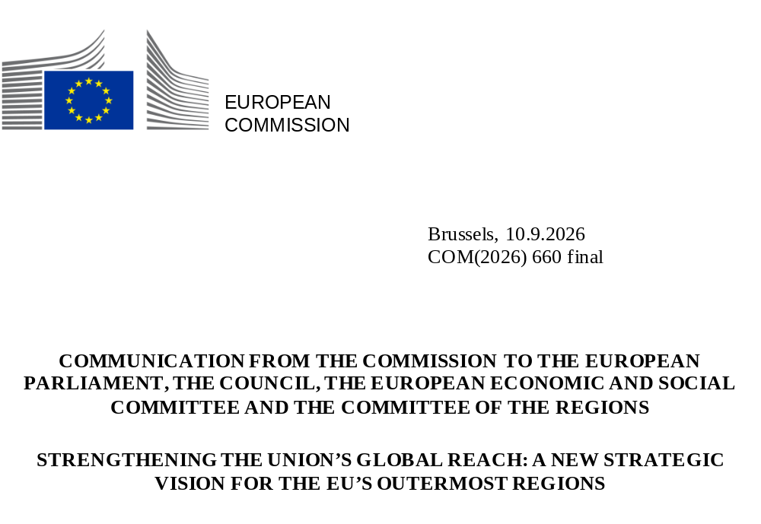

Contents

1. Introduction 2
2. The outermost regions: opportunities and challenges 3
3. An ambitious vision for the EU’s outermost regions 6
3.1. Geostrategic potential of the outermost regions and regional integration 6
3.2. Competitiveness and enhanced access to the single market 8
3.3. Resilience and preparedness 10
3.4. Social fairness and supporting people 12
4. The way forward: a stronger partnership with the EU’s outermost regions. 13
4.1. Addressing challenges under current EU legislation: the regulatory package 13
4.2. Strengthening dialogue and increasing awareness 16
4.3. Mainstreaming the outermost regions’ specific constraints in new initiatives 17
4.4. Maximising the impact of EU policies, funds and programmes in the outermost regions 18
4.4.1. Need for reinforced administrative and technical capacity 18
4.4.2. The next multiannual financial framework (the 2028-2034 MFF) 20
5. Conclusion 22

Introduction
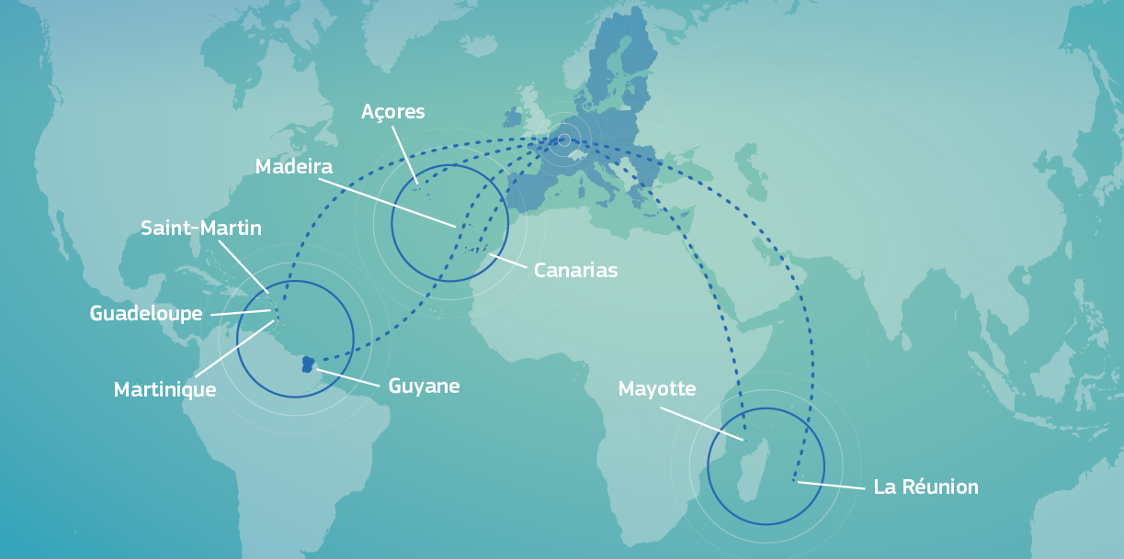
The outermost regions are the most remote parts of the EU and gateways to the world, as they extend the EU’s presence to South America, the Caribbean and the Indian and Atlantic Oceans. These are the regions of French Guiana, Guadeloupe, Martinique, Mayotte, Réunion and Saint-Martin (France); the Azores and Madeira (Portugal); and the Canary Islands (Spain).
Figure 1: Location of the outermost regions
With the rise in geopolitical tensions worldwide, the EU’s outermost regions are increasingly important as strategic outposts of the EU. Their unique assets should be better harnessed for the mutual benefit of both the regions themselves and the EU as a whole.
In line with Article 349 of the Treaty on the Functioning of the European Union (TFEU), successive Commission strategies (), together with targeted legislative measures and specific support from EU funds and programmes, have had a positive impact on the prosperity of the outermost regions. The latest strategy of 2022 () included around 80 actions to support the outermost regions and is now fully implemented, as evidenced in the 2024 implementation report ().
Cohesion policy has played a key role in the development of the outermost regions, with EUR 9.7 billion, from the 2021-2027 EU budget. It has contributed to economic diversification and modernisation, improving transport and digital connectivity, supporting access to essential infrastructures and services, social cohesion and skills development. In addition, the EU allocated EUR 6.4 billion in the same period for agriculture and fisheries, strongly contributing to food security and autonomy in the outermost regions and supporting rural and coastal communities.
However, challenges persist in terms of socio-economic development, inequalities, connectivity, competitiveness and full access to the single market, as well as administrative and technical capacity for the implementation of EU funds. There are large economic disparities with continental EU and amongst the outermost regions themselves. In the most disadvantaged outermost regions, access to basic goods and essential services remains limited.
These specific challenges and constraints, together with the new opportunities arising from the outermost regions’ geostrategic position, call for a shift in the EU’s approach to these regions. A comprehensive, coordinated and tailored set of measures is needed to strengthen support for them and boost their socio-economic growth, including by upgrading their critical infrastructure, and to unlock their full geostrategic potential for the benefit of both the regions and the Union as a whole.
In this context, this Communication sets out a new strategy for the EU outermost regions, to better identify and adapt EU initiatives to their specific needs, challenges and strategic assets, in line with the EU political priorities.
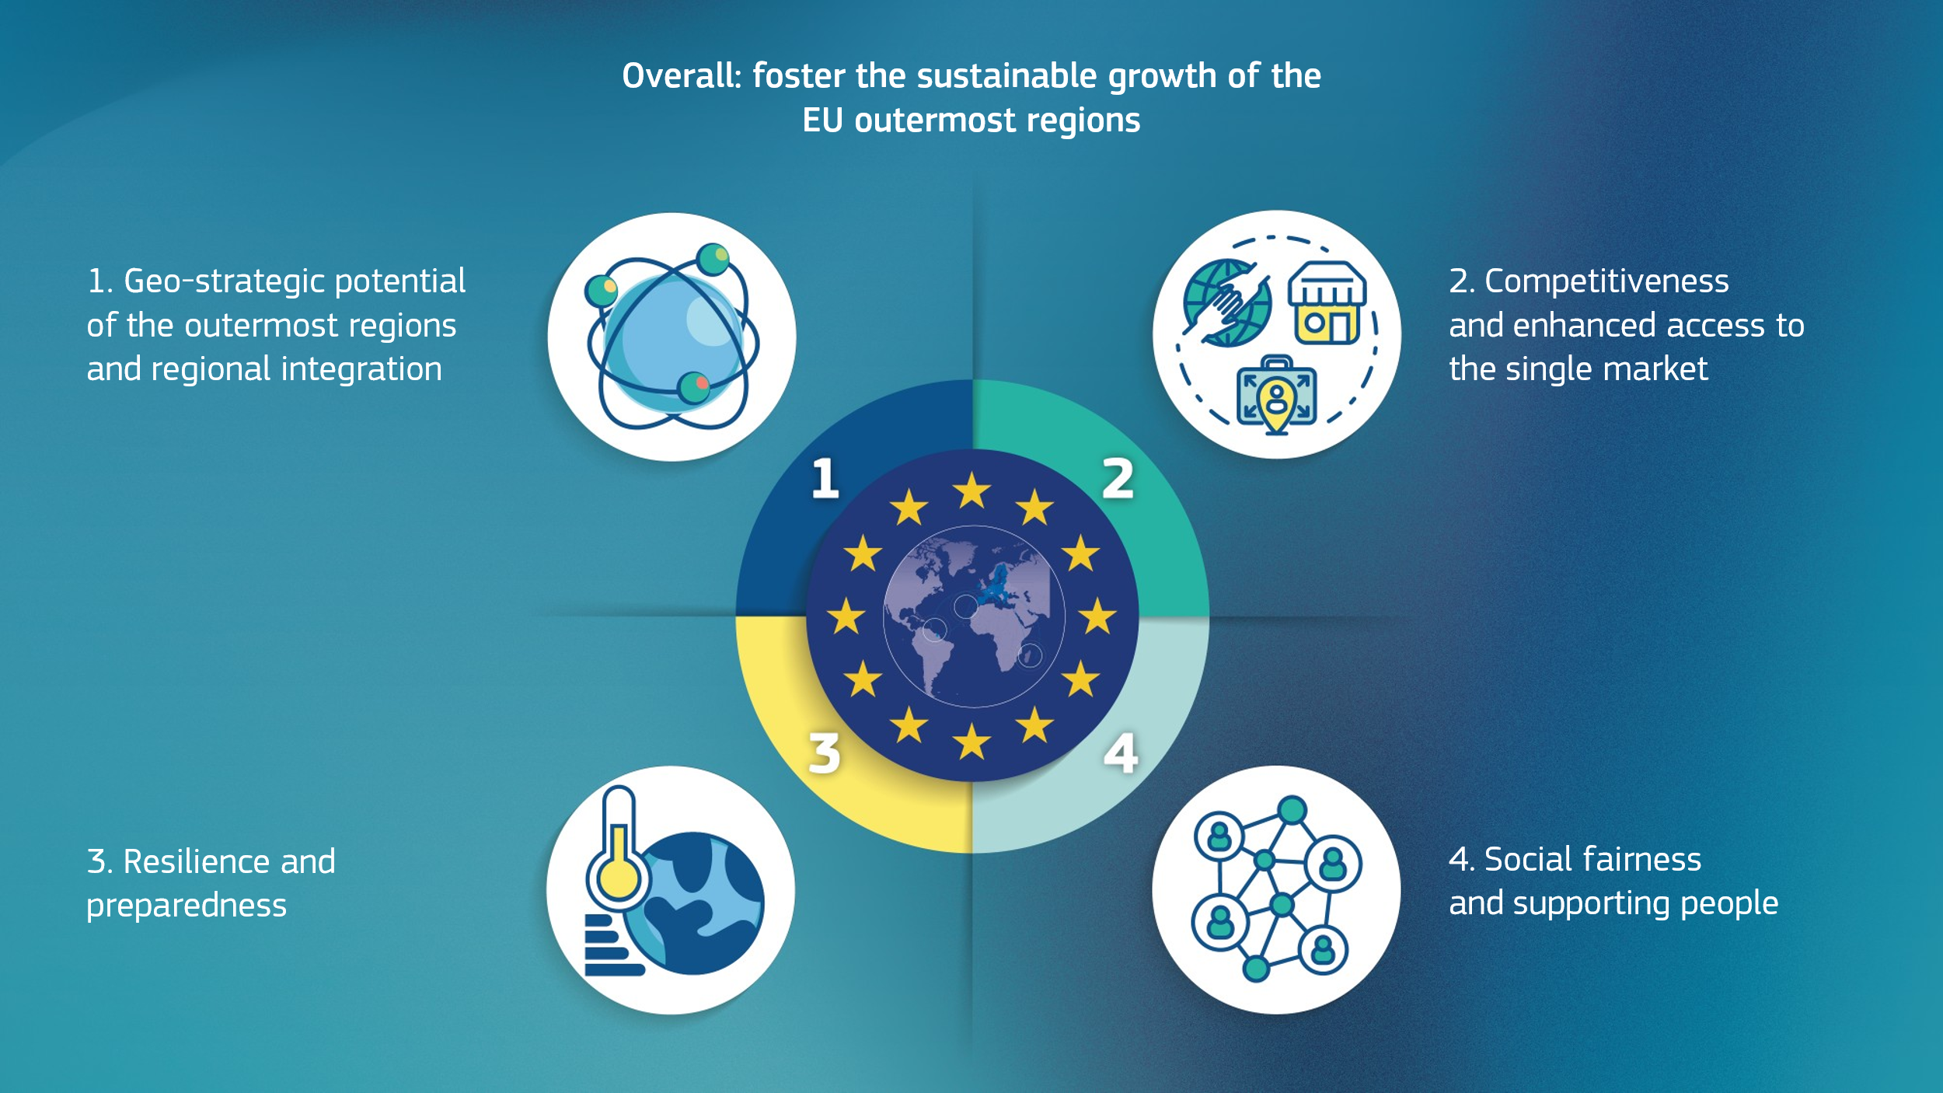
The strategy focuses on four objectives to foster sustainable growth in these regions:
Figure 2: Key objectives of the strategy for the outermost regions
The strategy also aims to develop a stronger partnership between the outermost regions, their Member States and the Commission, rooted in a more systematic application of Article 349 TFEU.
Alongside this strategy, the Commission is presenting a regulatory package proposing targeted amendments to specific EU sectoral legislation to address challenges affecting the outermost regions and support their growth.
A stronger partnership will also help to better address the specific nature of the outermost regions in future EU initiatives and to maximise the existing opportunities in EU laws and funding.

The outermost regions: opportunities and challenges
The outermost regions are home to 5 million EU citizens and offer untapped opportunities that could greatly benefit the entire Union. Situated in strategic locations in critical sea lanes and on major trade routes, and offering key digital and transport global connections, the outermost regions can play an important role in EU trade, regional cooperation, security and defence.
Their vast maritime zones, which represent over half of the EU’s exclusive economic zones, have clear potential for the blue economy and economic ventures. The exceptional geographical characteristics of these regions and their spaceport facilities and state-of-the-art observatories make them well placed to advance the EU’s goals in the space sector.
Their diverse ecosystems and climates create research and innovation opportunities for the EU in the fields of the bioeconomy (including biotechnology) and marine sciences. Hosting over 80% of the EU’s biodiversity, the outermost regions are critical to conservation efforts on land and at sea. They hold great potential for the development of renewable energy resources, including solar, wind, geothermal, tidal, and wave energy, thereby contributing to the EU’s clean transition. They are also well placed to become major sustainable tourism destinations, which would preserve their natural beauty, unique cultures, improve their living standards and boost economic growth.
The outermost regions are very diverse, but they face common specific challenges and permanent constraints which differ from those in the rest of the EU. These include their remoteness, insularity, mostly small size, difficult topography, economic dependency on a few sectors, and high exposure to extreme weather events, external shocks and crises. Cyclone Chido (Mayotte) in 2024 and Cyclone Garance (Réunion) in 2025 were stark reminders of the vulnerability of these regions and their need to develop stronger value chains and better climate resilience and all-hazard preparedness.
The remoteness of the outermost regions (up to 9 400 km from continental Europe) results in large connectivity costs and often infrequent air and maritime transport services, with no alternative means of transport to continental Europe. They are particularly exposed to external shocks, as shown by the COVID-19 crisis (), the impact of Russia’s war of aggression against Ukraine and more recently the rise in energy prices spurred by the situation in the Middle East. These issues reveal high vulnerability to crises, geopolitical instability and disruptions in international supply chains, due to high dependence on imports, fossil fuels and sectors such as tourism.
The Ninth Cohesion Report () shows that these challenges have resulted in: (i) high levels of unemployment, particularly among young people (ranging from 29.5% in the Canary Islands to 40.2% in Mayotte); (ii) low gross domestic product (GDP) per capita (below 75% of the EU average in eight outermost regions, with Mayotte at 30%, the lowest GDP in the EU); (iii) greater economic disparities; and (iv) lower educational attainment (with higher rates of early leavers and a substantial number of young people not in employment, education or training (NEET) ().
Figure 3: GDP per head in the outermost regions, 2024 - Source: Eurostat (online data code: nama_10r_2gdp], population at risk of poverty or social exclusion, 2025 (online data code: ilc_peps11n)
Figure 4: Unemployment and youth unemployment in the outermost regions, 2025 - Source: Eurostat (online data codes: lfst_r_lfu3rt and yth_empl_110)
Although the outermost regions share many common challenges, the intensity and impact of these challenges vary, as highlighted in the independent ‘Study on living conditions and access to selected basic needs in the outermost regions’ (). In the least developed outermost regions, it can be difficult to access basic services and essential goods such as staple foods, clean water, housing, electricity, sanitation, healthcare, and education.
Many of these regions are impacted by demographic challenges. Between 2025 and 2050, the populations of Martinique, Guadeloupe, the Azores and Madeira are projected to decline by between roughly 15% and 25%, reflecting low fertility rates (around 1.3–1.5 births per woman) and the outflow of young adults. The share of residents aged 65 and over rises to between one-third and one-half, placing these regions among the fastest-ageing ones in the EU. French Guiana and Mayotte, by contrast, are the EU's two youngest regions with the highest fertility rates in the EU (around 3.0–3.5 births per woman) and strong population growth of about 50% projected for the same period ().
Others face specific challenges, such as strong migratory pressure in Mayotte, the Canary Islands and French Guiana, especially for unaccompanied minors.
Due to their geographical position, they are also particularly vulnerable to security threats and risks. For instance, their vast maritime zones imply a high exposure to security risks such as drug trafficking from Latin-America, the Caribbean and Western Africa. This vulnerability is aggravated by their maritime connectivity, including via supply chains, which facilitates access to continental Europe, as identified in the EU Drugs Strategy () and the EU Action Plan against Drug Trafficking (). Some of these regions are also seeing a steep rise in the cost of living to a varying degree, mainly for basic goods (the French outermost regions) and housing (the Canary Islands and Madeira).
The persistent and combined effects of these constraints and specific challenges undermine these regions’ competitiveness, socio-economic development, social fairness and overall resilience. As a result, they struggle to fully access and reap the benefits of the single market and achieve their rich potential.

An ambitious vision for the EU’s outermost regions
The Commission is fully committed to working with the outermost regions and their Member States to build a robust framework, within which to boost the sustainable growth of these territories and improve quality of life for people living there.
The actions under this strategy aim to complement those taken by the regions themselves and their respective Member States, which remain primarily responsible for shaping and implementing tailored development strategies. At the same time, a coordinated and cross-sectoral EU approach is essential to ensuring that the outermost regions’ progress contributes to the EU’s goals of overall prosperity, strategic autonomy and preparedness.
This Communication sets out an overarching vision, structured around the following four key objectives, which are closely aligned with the current geopolitical context and EU political priorities.

3.1. Geostrategic potential of the outermost regions and regional integration
The outermost regions are crucial assets in furthering the EU’s presence in South America, the Caribbean and the Indian and Atlantic Oceans.
They contribute to the EU’s external, trade, security and defence policies, which are key to cooperation and to the forging of ties between the outermost regions, neighbouring non-EU countries and overseas countries and territories (OCTs). Such cooperation is to be pursued through the development of common initiatives in line with jointly identified regional priorities, with a view to strengthening their competitiveness and regional integration. The outermost regions can act as operational platforms for structured regional engagement and can build upon regional economic ecosystems and their membership in regional organisations, as they share the challenges of their neighbours.
The EU will build on cooperation with the outermost regions’ neighbours, including through existing agreements and initiatives with Africa, Latin America and the Caribbean and the Indo-Pacific (Samoa agreement (), EU-LAC strategic partnership (), and EU-Indo Pacific strategy ()). In addition, it will work to promote cooperation between the outermost regions, OCTs and the Small Island Developing states (SIDS), with which they share some common characteristics.
The EU supports the regional integration of the outermost regions through the Interreg programmes. Moreover, opportunities under EU trade agreements and within regional organisations, such as the Caribbean Community (CARICOM) () and the Organisation of Eastern Caribbean States (OECS) (), should be further explored collectively to strengthen economic cooperation and regional trade opportunities. The outermost regions can also serve as regional logistical hubs for the EU and its Member States, strengthening the Union’s capacity to provide rapid assistance and respond to crises and disasters in neighbouring countries and territories, as well as to repatriate EU citizens where needed.
Strengthening these regions’ capacities in space and defence brings clear added value for the EU. The outermost regions already contribute to the EU’s autonomous access to space, due to their ground infrastructures and uplink and downlink capabilities in satellite communication, and Earth observation and intelligence, which are not feasible from continental Europe (). Due to their strategic location, these regions offer a diverse range of sites for EU space infrastructure, thereby improving the physical resilience of the EU’s space systems ().
The outermost regions also play a key strategic role in European defence and security and in fostering cooperation with allies on capacity-building. Their geographical position on global maritime routes offers unparalleled value across critical domains for defence and security (), including maritime security and surveillance, maritime and aerial domain awareness, drones and counter-drones, and space. Harnessing this strategic potential is key to achieving defence readiness by 2030 and to implementing the EU Maritime Security Strategy ().
These regions can serve as security hubs, as some of them host cutting-edge military installations and training ranges. In addition, the outermost regions can serve as critical geostrategic nodes within the EU’s security architecture, including as operational hubs for military mobility and law enforcement operations. These include operations to interdict drug trafficking, facilitated by criminal groups operating in, through or in proximity to the outermost regions, in line with the EU Action Plan against Drug Trafficking ().
To achieve the above objective, the Commission will:
- Enhance coordination between the EU’s internal and external policies to capitalise on the outermost regions’ strategic location, e.g. when revising EU global geographical strategies and initiatives, including neighbourhood policies.
- Support regional integration and engagement with neighbouring regions and organisations and OCTs, including by mobilising private investments under the Global Gateway, and participation in Team Europe. Areas of special relevance for the EU comprise: sargassum valorisation, sustainable economic development, transport and digital connectivity, maritime affairs, energy transition, research and innovation (R&I), resilience, security, disaster risk management and the coordination of rapid responses to natural disasters using tools such as Stormwatch.
- Foster regional cooperation by strengthening funding complementarity within the future Interreg Plan and ensuring their consistency with the proposed Global Europe Regulation, the Decision on Overseas Association including Greenland (DOAG) and other sources of funding (e.g. the European Investment Bank).
- Liaise with Member States and continue preparations for a macro-regional strategy for the Atlantic, as requested by the European Council in December 2025 (), and ensure active participation by the outermost regions within Macaronesia (the Azores, Madeira, the Canary Islands).
- Raise awareness of the opportunities under trade agreements so that the outermost regions can better integrate global trade flows and increase trade with their regional partners, in particular in strategic products.
- Boost space, security and defence capabilities in the outermost regions by:
  - fostering their contribution to the space sector, including ground infrastructures, such as launching sites and satellite uplink and downlink stations;
  - assisting the creation of regional defence systems, with forward-basing and staging areas, and platforms for situational awareness and the surveillance of maritime and air domains;
  - identifying, in close cooperation with the Member States, targeted upgrade needs for improving the resilience and protection of their key infrastructure, in line with the priorities set along the EU Military Mobility corridors;
  - supporting the capacity of the outermost regions and their Member States to respond to maritime security threats under the EU maritime security strategy, the Djibouti Code of Conduct () and the EU Drugs Strategy.

3.2. Competitiveness and enhanced access to the single market
Most outermost regions continue to face a significant competitiveness gap with the rest of the EU. They need stronger support to promote growth, innovation and economic diversification, and offer more opportunities to people living there.
Their small market size, limited economies of scale and high cost of living limit their attractiveness for investment. To bolster the competitiveness of their companies, including small and medium-sized companies (SMEs), and to deepen their access to the single market, the Commission will take measures to capitalise on these regions’ assets, and support their strategic products and the most promising sectors (fisheries and the blue economy, biotech, renewable energy, tourism, trade and logistics). Such measures can help to maximise the impact of EU investments in the outermost regions and promote the uptake of EU technologies, standards and innovation.
Air and maritime transport networks are critical for the competitiveness and resilience of the outermost regions. Transport connections facilitate business, trade and tourism, and remain essential for ensuring territorial continuity with continental Europe and access to essential goods and services.
Research and the EU’s education, digital and cultural policies have a key role to play in the smart specialisation of the outermost regions and delivering on the EU biodiversity and climate targets. Their capabilities in research and training in higher education can increase their regional influence and facilitate their integration in bi-regional cooperation frameworks. The adaptation of EU competition and taxation policies to the local realities of the outermost regions also plays a key role in supporting their competitiveness.
To achieve the above objectives, the Commission will:
- Strengthen the competitiveness of ports in the outermost regions under the EU ports strategy; with focus on improving connectivity, security, safety, electrification and access to grids, through different funding instruments, including cohesion funds and under competitive programmes such as the Connecting Europe Facility for Transport ().
- Encourage the use of EU space services such as the EU Governmental Satellite Communications programme (GOVSATCOM) and the Infrastructure for Resilience, Interconnectivity and Security by Satellite (IRIS2), including areas not accessible by cable or where terrestrial systems are unavailable.
- Continue to take into account the specific nature of outermost regions in impact assessments and evaluations for upcoming negotiations on relevant trade agreements and for the deepening of such agreements. Safeguards for sensitive products will be considered where required.
- Support research and innovation with a view to develop the outermost region’s competitive advantages – notably within the framework of Horizon Europe and the upcoming European Competitiveness Fund. Foster their economies’ environmental, energy, climate and digital transitions, and drive innovation in agriculture to gain a competitive edge over neighbouring countries, e.g. EU bi-regional cooperation agendas on research and innovation under EU-CELAC cooperation ().
- Promote smart specialisation in the development and diversification of the local economies, with a focus on:
  - space, security and defence (upcoming European Space Shield action plan, revised EU maritime security strategy);
  - energy (opportunities for energy diversification and clean transition under the upcoming Energy Union package for the decade ahead);
  - fisheries, the sustainable blue economy and the ocean (upcoming European Ocean Act and Vision 2040 for fisheries and aquaculture).
- Boost agriculture and food security, through measures to strengthen the competitiveness of agricultural activities, support local agricultural production, promote diversification and enhance market access for local products, using the relevant instruments under the Common Agricultural Policy.
- Continue monitoring the evolution of the fishing fleet and the state of fish stocks in the outermost regions, based on scientific advice, specifically on the basis of the updated guidelines () for analysing the balance between fishing capacity and fishing opportunities for fleet segments of vessels under 12 metres.
- Tackle specific socio-economic constraints via taxation policy, in particular through the upcoming revision of the Council decisions on the AIEM ().
- Promote sustainable tourism, including through the outermost regions’ participation in the upcoming EU Sustainable Tourism Strategy and related initiatives, such as the European Tourism Skills Academy and the future Common European Tourism Data Space.

3.3. Resilience and preparedness
Given their high vulnerability, the outermost regions must be equipped to respond and adapt to external shocks, including environmental challenges (e.g. sargassum), climate change, natural disasters and hazards (e.g. cyclones), marine pollution and supply chain disruptions.
The outermost regions would also benefit from strengthened food security and diversification, with enhanced protection for human and animal health. They can further contribute to Earth observation and intelligence for the monitoring and assessment of land and water policies. The European Ocean Pact, adopted in 2025, Copernicus programme and OceanEye () support these objectives by promoting coastal resilience and ecosystem protection and restoration.
Crisis preparedness and response mechanisms, as well as energy and water autonomy must also be strengthened given the outermost regions’ distance from continental Europe, their non-connected grids and their challenges on security. To this end, it remains essential to support stockpiling efforts (), renewable energy, energy efficiency and energy storage in future initiatives, and to bolster the resilience of interconnections and critical infrastructure (such as ports, airports, submarine cables and energy networks) and regional value chains.
To enhance their resilience, it is also crucial for environmental, climate, agricultural and health policies to be adapted to the realities of the outermost regions (e.g. water management and resilience, nature protection, waste management and the circular economy, food safety, agriculture and fisheries). The geographic location of the outermost regions comes with higher exposure to security threats and external shocks. These regions have limited capacity to enforce security measures (e.g. against trafficking, money laundering and political instability in certain neighbouring countries) and are particularly vulnerable to hybrid threats (e.g. the disruption of undersea digital cables). Tackling irregular migration and border management challenges is another key priority for their overall resilience.

To achieve the above objectives, the Commission will:
- Support the outermost regions in boosting climate adaptation, resilience and preparedness, building on the results of EU Missions, including under the forthcoming European Integrated Framework for Climate Resilience.
- Promote investment and synergies amongst EU funds to build the resilience of critical infrastructure (e.g. ports and airports) and digital infrastructure (e.g. submarine cables, with backup connections and protection against cyberattacks).
- Encourage the integration of nature‑based flood‑defence (mangroves, coral reefs, wetland restoration) into the resilience‑investment.
- Promote the use of Copernicus’ emergency, marine and land services and its Coastal Hub, to prevent and monitor potential natural hazards (e.g. rising sea levels, floods) and to support sustainable fisheries, tourism and research. Ensure that the implementation of the OceanEye observation initiative takes into account the specificities of outermost regions.
- Support farmers and the strengthening of agricultural supply chains in the outermost regions, promoting agricultural diversification and climate-resilient crops to strengthen local production and food security.
- Strengthen efforts to combat illegal, unreported and unregulated fishing in the outermost regions’ maritime zones, including through closer cooperation with non-EU countries and targeted support by the European Fisheries Control Agency (EFCA) to improve monitoring and control activities by Member States.
- Continue supporting the outermost regions on the conservation of their very rare, primary ecosystems, including through initiatives such as BEST under the LIFE programme.
- Support the outermost regions in tackling major environmental and biodiversity challenges (e.g. sargassum, pollution, biodiversity loss, pollinators and invasive alien species, waste collection and treatment, water resilience) and environmental crime (e.g. gold panning, poaching), including through dedicated dialogue and workshops.
- Continue to engage with the relevant authorities regarding the storage and treatment of sargassum and the flexibility offered by the Landfill Directive.
- Promote the energy transition and improve energy autonomy through measures to support small and isolated energy systems and energy communities, in particular through the Clean Energy for EU Islands initiative in the context of the Citizens Energy Package.
- Assess the outermost regions’ potential for solar and wind energy production through a dedicated study by the Commission’s Joint Research Centre, contributing to their energy security.
- Strengthen crisis preparedness and response through:
  - support to the concerned Member States and the outermost regions in implementing relevant follow-up initiatives under the Preparedness Union Strategy, such as on the continuity of essential services, and supply-chain resilience;
  - continue post-disaster recovery assistance (including from the cohesion funds, the EU Solidarity Fund and the proposed National and Regional Partnership Plans and EU Facility);
  - follow-up measures under the Union prevention, preparedness and response plan for health crises.
  - strengthened disaster risk management efforts through their alignment with ongoing and planned activities under the EU-Latin America and Caribbean Memorandum of Understanding on disaster risk management.
- Support Member States in assessing the security situation in the outermost regions, taking into account the ProtectEU Strategy and the EU Drugs Strategy and the EU Action Plan against Drug Trafficking, in particular their exposure to transnational maritime threats.
- Where possible, support measures to combat the infiltration of organised criminal groups, especially those involved in money laundering, corruption and drug trafficking to the EU, as well as criminal operations towards the Outermost Regions and continental Europe.
- Support the management of irregular migration, including through the upcoming initiative to strengthen Frontex and digitalise the return process.
- Consider in the future review of the EU Pact on Migration and Asylum the specific migration challenges in the outermost regions, for instance regarding border management and control, the integration of migrants, and the situation of unaccompanied minors.

3.4. Social fairness and supporting people
Those living in the outermost regions are at a much higher risk of poverty than the general EU population. The EU’s first-ever Anti-Poverty Strategy recognises that ensuring the availability of social services is a particular challenge in the outermost regions. There is a clear need to improve access to clean water and sanitation (especially in Mayotte and French Guiana) and to health services.
In order to ensure the minimum service standards, the Commission’s Principles () for effective anti-poverty policies suggest that national, regional and local authorities should support innovative service delivery models, mobile and outreach services, safe and reliable transport solutions to enhance access to services, and targeted investment planning to address persistent service gaps. The Commission will continue to support Member States in meeting people’s basic needs in the outermost regions, through cohesion and other policies, including social, employment, environmental, health and housing policies.
The Commission will also help address the high cost of living and the housing crisis affecting many outermost regions in order to reduce inequalities.
To promote social fairness and reduce regional and territorial disparities, in line with the Communication on the European Pillar of Social Rights (), the Commission will continue to support investments in quality education, training and employment in the outermost regions, notably through cohesion policy funds and the upcoming National and Regional Partnership Plans. This will help to address skills and labour shortages and improve young people’s access to the labour market and regional cooperation on higher education. Together with targeted social inclusion programmes, these actions will create opportunities at local level to ensure the right to stay and access to healthcare, long-term care and other essential services. In turn, developing the human capital of the outermost regions will help diversify economic activity, boost entrepreneurship and expand trade and mobility opportunities with neighbouring countries and the rest of the EU.
To achieve the above objectives, the Commission will:
- Continue reflecting the specific nature of the outermost regions in initiatives for poverty reduction and social inclusion, including in the follow-up to the EU anti-poverty strategy, the Communication on breaking the cycle of child poverty, which strengthens the European Child Guarantee, and in the 2026 Communication on the implementation of the European Pillar of Social Rights.
- Make full use of EU instruments, in particular cohesion policy funds and the upcoming National and Regional Partnership Plans, to support youth employment and labour mobility, expand access to education and skills development, combat poverty, and promote social inclusion and fair working conditions in the outermost regions.
- Support efforts to tackle the demographic challenges of the outermost regions, including youth out-migration and skills shortages, facilitating the development of tailored mobility, return and retention schemes in order to provide citizens with an effective right to stay wherever they choose to live.
- Encourage Member States to consider the specificities of the outermost regions when preparing their relevant Social Climate Plans, duly reflecting the constraints of the outermost regions and the specific investment needs of the most vulnerable groups.
- Launch a new youth project to support small-scale projects led by young people or youth organisations in the outermost regions, built on the lessons learned from the previous grant scheme created in 2023 and including a mentoring/coaching scheme for the selected projects.
- Support national and regional authorities to boost housing supply and expand provision of social and affordable housing, mobilise investment, drive reforms and protect the most vulnerable as presented in the European Affordable Housing Plan.

The way forward: a stronger partnership with the EU’s outermost regions
A more ambitious vision for the development of the outermost regions is also fostered by a stronger partnership between the European Commission, these regions and their Member States. This partnership will be centred on reinforced collaboration and a set of key initiatives aiming to ensure the more systematic application of Article 349 TFEU and increase awareness and technical support to enable the full use of existing regulatory flexibility and funding possibilities.

Addressing challenges under current EU legislation: the regulatory package
The application of Article 349 TFEU has shown varied levels of ambition, consistency and effectiveness across EU policy areas. These shortcomings have been highlighted by stakeholders and authorities at national, regional and local level during consultations (). In addition, recent research and reports () provide evidence of the potential benefits of a more systematic application of Article 349 TFEU, advocating for EU laws, funds and programmes to be better tailored to the specific constraints of the outermost regions.
To address this situation, the Commission will take action in certain areas which may be hindering the regions’ economic growth and impacting their access to the single market. In this context, particular attention will be paid to the proportionate and consistent design and implementation of EU legislation, while continuing the mainstreaming efforts across EU policies.
The Commission will pay particular attention to these challenges, namely through specific measures in upcoming relevant legislative files and other initiatives, in areas such as state aid, support for the renewal of the small-scale fishing fleet, transport, migration and access to housing. The regulatory package accompanying this Communication is a key first step in the continuous process for the delivery of this approach. It proposes a first set of targeted adaptation measures, including exemptions and derogations from, or adaptations to a set of EU legal requirements. These measures can deliver tangible benefits for the people living in these regions, as well as for businesses (including SMEs) and local and regional administrations.
This regulatory package covers key policy areas identified during the various consultations and exchanges with authorities and stakeholders. It comprises two legal acts: (I) a proposal for a Council regulation; and (ii) a proposal for a Council decision.
Proposals to be covered by the regulatory package:
- Taxation: amend the Dock Dues (“octroi de mer”) Council Decision () to simplify the specific tax regime applicable to the French outermost regions in order to enable immediate updates to the list of eligible products for exemption and shorten the Council decision-making process.
- Forestry: amend the EU Deforestation Regulation () to provide for an exemption from its requirements for relevant products produced and consumed domestically in French Guiana.
- Agriculture: amend the Regulation establishing a Common Organisation of the Markets in agricultural products () to extend eligibility for support under the common agricultural policy to tropical products (e.g. manioc, turmeric).
- Fisheries:
  - amend the Common Fisheries Policy Regulation () to postpone the deadline for setting a fishing capacity ceiling in Mayotte to 31 December 2030;
  - amend the Autonomous Tariff Quotas Regulation () to grant autonomous tariff preferences for southern red snapper caught by non-EU-country vessels in French Guiana’s exclusive economic zone and processed in French Guiana.
- Migration: amend the Asylum Procedures Regulation () to allow the decision on entry for the purpose of seeking international protection at the border to be taken by an authority other than the determining authority designated under the Regulation, based on the binding opinion of the asylum authority, given that the French outermost regions are located outside the Schengen area.
The package will be supplemented in due course by separate acts where provisions require adoption through secondary legislation.
The Commission will also:
- Simplify import controls on foodstuffs of non-animal origin in the French outermost regions by revising Commission Delegated Regulation (EU) 2019/2126;
- Propose to introduce, through a Commission Delegated Act, dedicated reference values for the fossil fuels comparator for the outermost regions for bioliquid fuels in Annex V of the Renewable Energy Directive ().
- Propose to include Mauritius, through a Commission Delegated Act under the Waste Shipment Regulation, in the list of non-OECD countries to which certain non-hazardous waste can be exported from the EU for recovery.
This regulatory package is intended to be part of a continuous process and does not preclude further measures at sectoral level, both by the Commission and the EU co-legislators, to address the specific constraints of the outermost regions.
One concrete example is the Commission’s recently adopted proposal for the review of the EU Emissions Trading System, which extends until 31 December 2035 the existing aviation and maritime derogations covering flights and voyages between an outermost region and another airport or port in the same Member State, as well as links within or between outermost regions belonging to that Member State. It also takes account of the specific waste-management constraints of the outermost regions by allowing Member States to exempt waste-incineration installations in these regions from the obligation to surrender allowances until 31 December 2035.
Another example is the proposal to strengthen the Carbon Border Adjustment Mechanism (), where co-legislators propose to introduce a mechanism for outermost regions allowing Member States to request a targeted exemption from the obligations under the Regulation. The Commission will work on the conditions of such an exemption with the co-legislators and looks forward to the swift conclusion of the corresponding legislative procedure.
In addition, the Commission’s proposal for a Public Procurement Act, which sets the new EU legal framework for public procurement, allows for Member States to adapt the application of certain aspects of it to the specific challenges of public procurement markets in the outermost regions.
The Commission’s upcoming proposal for a European Product Act, which is designed to modernise product rules across the single market, will also take into account the specific environmental and economic constraints faced by the outermost regions. To this end, it will allow for adaptations to the specific product requirements where that is demonstrably necessary and proportionate, in particular in view of the local conditions, in conformity with primary law, including Article 349 TFEU.
Other EU legislation relevant to the outermost regions is currently undergoing sectoral legislative revision, allowing potential issues affecting the outermost regions to be identified, assessed and addressed where necessary. Specific examples of such adaptations of sectoral policies and legislation are listed below.
The Commission will:
- Ensure adequate and justified possibilities for aid in outermost regions, taking into account their specific constraints, in particular, under the ongoing revision of the General Block Exemption Regulation and the 2014 Guidelines on State aid for Airports and Airlines.
- Assess, as part of the 2028 review of the FuelEU Maritime Regulation (), the need for extending the current temporary exemptions for the outermost regions under it, to preserve their territorial continuity and to ensure consistency with the specific provisions for these regions as proposed by the Commission under the 2026 review of the EU Emissions Trading System ().
- Pay specific attention to the outermost regions’ needs in the 2029 revision of the guidelines for State aid in the fishery and aquaculture sector ().
- Take into account the outermost regions’ specific needs when preparing implementing rules for traceability under the fisheries control regulation.

4.2. Strengthening dialogue and increasing awareness
To ensure more efficient policy delivery and optimise the flexibility and the opportunities available to these regions, dialogue between the Commission and the outermost regions and their Member States will be reinforced, and access to information simplified.
In order to achieve this, different measures will allow for regular and more structured exchanges on key sectoral policies and to raise the outermost regions’ awareness of the main Commission initiatives impacting them, including legislation, funds, programmes, events and calls for projects ().
The Commission will:
- Create a dedicated portal to allow for direct engagement with the outermost regions and bring together relevant information on: calls for evidence and consultations on upcoming policy initiatives, workshops, seminars and events of interest to the outermost regions across EU’s policy areas, legislation, and programmes ().
- Strengthen collaboration between the Commission, the outermost regions and their Member States to better integrate their specificities into EU policy making, including through: the Commission’s Outermost Regions Working Group; a yearly structured dialogue; targeted exchanges; and workshops on key sectoral policies.
- Engage with the EU CAP Network and the Local Action Group of the LEADER Network to involve representatives of the Member States to which the outermost regions belong.
The Commission encourages the outermost regions and their Member States to:
- Use the flexibilities for addressing the outermost regions’ specificities provided under EU legislation and set up regular dialogues between national and regional authorities to tackle challenges and maximise opportunities for these regions.
- Report measures planned at national and regional level and identify issues where coordinated action at EU, national and regional level could provide more effective solutions.

4.3. Mainstreaming the outermost regions’ specific constraints in new initiatives
The Commission applies an integrated approach to better regulation, both when preparing new initiatives and evaluating existing ones. Within this framework, and in line with the communication “A simpler, clearer and better enforced EU rulebook” (), the Commission establishes the necessary evidence and analysis in function of the nature of the initiatives and their expected impacts.
This includes the analysis of differential impacts across regions, where relevant. The analysis of territorial impacts can support the identification of place-based risks, distributional effects and possible mitigation measures, whenever significant impacts are distributed heterogeneously across different types of regions such as the outermost regions. As part of its better regulation approach, the Commission will seek to identify, at an early stage, whether an upcoming initiative may have significant and differential impacts on outermost regions, and consider such impacts in an integrated manner as part of its impact assessment process.
To ensure the systematic integration of the ‘outermost regions angle’ into the design of future Commission’s initiatives, the Commission will screen initiatives relevant to the outermost regions. In addition, the Commission will increase the visibility of initiatives that could potentially impact the outermost regions and incentivise their active participation in relevant calls for evidence and public consultations.
The Commission will:
- Create a specific section - “Share your views” - under the portal for the outermost regions to inform the outermost regions’ stakeholders on upcoming public consultations, calls for evidence and other initiatives of special relevance to them.
- Better consider the specific constraints of the outermost regions throughout its relevant activities, in line with the better regulation process, including in stress tests of existing EU policies and through sectoral dialogues on initiatives that are particularly relevant to these regions.
The Commission encourages the outermost regions and their Member States to:
- Respond to calls for evidence and public consultations on Commission initiatives that could potentially impact the outermost regions.
- Alert the Commission at an early stage about any potentially negative impact of upcoming EU initiatives, substantiating this with data and information.

4.4. Maximising the impact of EU policies, funds and programmes in the outermost regions
The EU has consistently supported the outermost regions, significantly increasing specific EU funding in 2021-2027 () under cohesion, agriculture and fisheries policies and funds.
Cohesion policy and funding remain vital in reducing disparities, increasing living standards and thus creating the conditions that encourage people to stay in these regions, ensuring their citizens’ right to stay in the place they call home. It contributes to improving essential services and enhancing connectivity - including EU investments in airports and digital connectivity - as well as education, employment, and innovation and technology, with a focus on SMEs. Under the mid-term review of cohesion policy, most outermost regions have strengthened investments in key EU strategic priorities, including affordable housing, water resilience, energy transition, and defence and security (e.g. dual-use infrastructure for ports and airports).
The POSEI programme supports local agriculture through direct payments to farmers, market stabilisation, processing and creating added value as well as supply chain improvements, while the European Agricultural Fund for Rural Development (EAFRD) promotes modernisation, sustainability, and competitiveness in rural areas. For fisheries, the European Maritime, Fisheries and Aquaculture Fund (EMFAF) can support businesses in outermost regions, helping to compensate for their additional operating costs, as well as promoting sustainable fishing, aquaculture, and blue economy growth, balancing economic development with marine biodiversity protection.
To maximise the impact of EU funds in the outermost regions, it is essential to strengthen administrative and project-development capacity, improve access to competitive EU programmes, promote synergies between different sources of funding and facilitate effective implementation. Robust cooperation at all levels of governance and expertise tailored to each region’s needs will be key to achieving this.

4.4.1. Need for reinforced administrative and technical capacity
To maximise the impact of EU funds in the outermost regions, robust cooperation at all governance levels is crucial, alongside developing expertise tailored to each region’s unique needs. Structural weaknesses in some outermost regions need to be addressed, particularly in administrative and technical capacity for implementing shared management funds and developing projects. Furthermore, it is essential to build project engineering and expertise in order to develop quality projects adapted to real needs, attract public and private investment and implement complex projects effectively.
The Commission’s 2022 strategy for the outermost regions introduced an advisory tool exclusively for these regions to target their specific needs. This on-demand advisory tool helped them to carry out the necessary reforms and investments, seize cooperation opportunities in EU programmes, and improve their administrative capacity.
In 2023, the Technical Support Instrument financed an OECD project for the French outermost regions () involving a national and regional action plan and a toolbox to facilitate participation in EU competitive programmes. Furthermore, Member States and outermost regions can make use of Joint Assistance to Support Projects in European Regions (JASPERS) to boost technical capacity for developing large-scale projects in transport, energy, waste and wastewater management, and innovation projects.
To address the specific financing, administrative and technical needs of the outermost regions, it is essential to foster continuous dialogue and collaboration, enabling the exchange of best practices and innovative solutions to effectively programme and implement EU funds. This will be achieved partly through actions such as the above-mentioned dedicated portal for the outermost regions and thematic workshops, but additional initiatives are required to promote capacity-building across various EU programmes and funds.
The Commission will:
- Launch an improved advisory tool for outermost regions to offer additional support and follow-up recommendations; the advisory tool will offer a streamlined set of tailor-made services for stakeholders, a simplified application process and help to use other tools.
- Promote the opportunities offered by the existing tools to support the outermost regions’ public administrations and potential beneficiaries of EU funds (e.g. TAIEX, FI Compass, Smart Specialisation Platform, Green Assist).
- Develop tailored measures to build capacity at managing authority level, such as the pilot action to ‘improve the attraction, development and retention of key skills in the cohesion policy management and control system’.
- Promote the participation of smaller organisations from the outermost regions in Horizon Europe, Erasmus+ and Creative Europe programmes and other relevant competitive programmes by offering specific support measures, such as facilitating matchmaking and promoting participation in networks, and more accessible project formats (e.g. reinforced mentorships and preparatory visits for Erasmus+ and the NCP_WIDERA.NET project under Horizon Europe).
The Commission encourages the outermost regions and their Member States to:
- Devote adequate resources and expertise to effectively implement EU programmes and funds at both regional and national levels, supported by Member State efforts to boost administrative, analytical and technical capacity.
- Actively pursue interplay between EU, national and regional funds and programmes, particularly in preparation for the new EU long-term budget (MFF 2028-34).
- Make full use of existing EU tools to increase the regions’ administrative and technical capacity (e.g. TAIEX-REGIO Peer2Peer+, JASPERS).
- Accelerate the absorption of EU funds and maximise their impact under the 2021-2027 programming period, including by making use of all the simplification options (e.g. financing not linked to costs and simplified cost options).

4.4.2. The next multiannual financial framework (the 2028-2034 MFF)
At present, support for the outermost regions is spread across several EU funds, with limited coordination. The Commission’s proposal for the 2028-2034 Multiannual Financial Framework (MFF) (), which is currently being discussed in the European Parliament and the Council, introduces the National and Regional Partnership Plans (NRPP) as a central part of the new financial architecture, combining structural investments and key reforms. The outermost regions and their Member States will have more responsibility over setting their own objectives, milestones, targets and outputs for the implementation of EU funds. The Member States’ commitments, vis-a-vis their outermost regions, to specific reforms and investments will be nonetheless closely linked to the EU’s strategic priorities, thereby increasing the impact of EU funds.
The proposal for a National and Regional Partnership Fund () recognises the specific challenges faced by the outermost regions () by requiring the Member States concerned to incorporate measures to address the outermost regions’ constraints into their National and Regional Partnership Plans. In continuity with today’s interventions, the National and Regional Partnership Plans will allow for measures in areas such as food security, housing, transport and digital connectivity, energy, water, waste management, employment, education and skills, social inclusion, migration, climate change, environmental protection, healthcare and economic development, including the blue economy. Most importantly, the National and Regional Partnership Plans provide for an integrated framework to design measures to cover structural investments and compensatory support across cohesion and common agricultural and fisheries policies.
Member States would have flexibility in designing their National and Regional Partnership Plans and may include dedicated chapters for measures in the outermost regions. The partnership principle will remain at the core of the National and Regional Partnership Plans, and the outermost regions will have the possibility to retain their role as managing authorities and continue to liaise directly with the Commission.
Member States and regions are encouraged to already start designing their Plans and the Commission stands ready to assist and engage as necessary. Throughout this process and when assessing the plans, the Commission will ensure that the specificities of the outermost regions are sufficiently taken into account and that they are involved in designing the relevant measures and receive an adequate level of support to meet their unique challenges.
In addition to the National Regional and Partnership Plans, the Commission’s proposal for a European Competitiveness Fund includes the objective of untapping their potential as geostrategic outposts, including by supporting their SMEs, as they are the main business fabric of these regions. The Commission will aim to support active participation of outermost regions under this priority by setting up a number of relevant virtual workshops under the future Competitiveness Fund programmes.
The interconnected nature of funding under the future Global Europe Regulation, Interreg, the Decision on Overseas Association including Greenland, and the National Regional and Partnership Plans will be strengthened from the beginning of the programming period. This will optimise the integration of the outermost regions into their neighbourhood.
The specific nature of the outermost regions (such as the smaller size of their markets and projects) may result in higher costs and difficulties in accessing private finance, which in turn affects their competitiveness and investment capacity. These market conditions and failures should be duly identified, as extending the use of financial instruments is key to securing additional public and private resources, particularly given the flexibility proposed in the legislative framework for the next MFF.
The Commission will:
- Develop tailored measures (e.g. trainings and workshops on project design, implementing funds under the new MFF, including under the National and Regional Partnership Plans, and on implementation requirements).
- Organise, where appropriate, dedicated workshops for authorities and stakeholders in the outermost regions to share information on available opportunities under the European Competitiveness Fund, the Connecting Europe Facility (), Horizon Europe, Erasmus+ and AgoraEU in the 2028-34 MFF, once it has been adopted.
- Assess whether the National and Regional Partnership Plan for each concerned Member State takes adequate account of the specific needs of the outermost regions, including the need to build administrative capacity.
- Assess the existence of market failures in terms of accessing finance in the outermost regions and subsequently promote tailored financial products under shared management together with specific assistance for stakeholders.
The Commission encourages the concerned Member States and their outermost regions to:
- Ensure that the outermost regions can fully benefit from the National and Regional Partnership Plans, identifying their key priorities for reform and investment and taking into account the European policy reference framework, including the European Semester’s country-specific recommendations and other relevant documents.
- Strengthen administrative capacity in the outermost regions and ensure there is sufficient human and financial resources and expertise to support the timely, efficient and effective implementation of EU funds.
- Take advantage of technical assistance, with a view to supporting the full implementation of future EU programmes under the 2028-2034 MFF.
- Consider the use of financial instruments to leverage additional private resources in order to maximise the impact of EU Funds.

Conclusion
The outermost regions have a growing strategic importance in the European Union, particularly in the current geopolitical context. Their strategic locations give the EU a unique opportunity to expand its presence and strengthen its position and influence as a global player. The Commission remains fully committed to bridging the gap in standards of living and development between the outermost regions and continental Europe. It aims to reinforce support to address persisting challenges, so that these regions can thrive by capitalising on their unique assets.
To this end, this Communication sets out an overarching vision to strengthen the EU’s capacity to meet the specific needs of these regions in a more consistent and ambitious manner. It is a vision underpinned by the cooperation with their Member States to achieve substantial socio-economic progress in line with the EU’s broader objectives of unity, prosperity and strategic autonomy. To empower the outermost regions, this strategy also aims to build a stronger partnership between the Commission, the outermost regions and their Member States on ensuring a more systematic implementation of Article 349 TFEU.
As the main deliverable of the strategy, the Commission is to adopt the first ever regulatory package for the outermost regions. This will not be a one-off exercise, as the effectiveness of the regulatory package will be examined regularly. Other key deliverables include measures to strengthen dialogue and to ensure that the outermost regions will be duly considered in relevant upcoming EU initiatives, as well as actions to pave the way for improving their administrative and engineering capacity. These will enable the outermost regions to maximise the opportunities offered by the 2028-2034 MFF.
The Commission will closely monitor the implementation of the strategy and its priority actions working with the outermost regions and their Member States to turn this renewed ambition into tangible results. Stronger and more resilient outermost regions will strengthen the Union as a whole - its cohesion and competitiveness, its capacity to withstand and respond to crises, and its ability to promote its interests and values in the world.

() Adopted in 2004, 2007, 2008, 2012, 2017 and 2022.
() COM(2022) 198 final.
() COM(2024) 435 final and SWD(2024) 227 final.
() Study on the impact of COVID-19 on the Outermost Regions (2021).
() Ninth Report on Economic, Social and Territorial Cohesion (March 2024).
() Source: Eurostat for 2025.
() Study on living conditions and access to selected basic needs - Publications Office of the EU (January 2024).
() Eurostat, Population Projections at Regional Level – EUROPOP25 (proj_25r, 2026).
() Council Conclusions from 5 March 2026 on Council conclusions on the EU Drugs Strategic Framework.
() Council on the implementation of the new EU action plan against drug trafficking.
() The Samoa Agreement is a Partnership Agreement between the EU and the Organisation of African, Caribbean and Pacific States (OACPS) which foresees strengthening cooperation with the Outermost Regions.
() Bi-regional framework between the EU and 33 Latin-America and Caribbean countries.
() Joint Communication to the European Parliament and the Council on the EU strategy for cooperation in the Indo-Pacific. JOIN(2021) 24 final.
() CARICOM, the Caribbean Community, is a regional organization of Caribbean nations focused on economic integration, cooperation, and coordinated foreign policy.
() The OECS is an inter-governmental organisation promoting economic integration, regional cooperation, and sustainable development among Eastern Caribbean states.
() Kourou (French Guiana) hosts the main access point for the EU to the space sector; Santa Maria space ports in the Azores; several observatory stations in the Canary Islands.
() Galileo sites (control station, sensor stations, SAR stations) in Réunion, the Canary Islands, the Azores.
() White Paper on European Defence Readiness and the Security Action for Europe (SAFE) Regulation. (EU) 2025/1106.
() JOIN/2023/8 Joint communication on the update of the EU Maritime Security Strategy and its Action Plan: An enhanced EU Maritime Security Strategy for evolving maritime threats.
() COM(2025) 744 final.
() European Council conclusions, 18 December 2025
() The Djibouti Code of Conduct is a crucial framework for maritime security in the Western Indian Ocean and the Gulf of Aden and aims to combat piracy and armed robbery against ships.
() Connecting Europe Facility (CEF) for Transport
() High-level political dialogue on bi-regional partnership between EU and its Member States with the Community of Latin American and Caribbean States (CELAC) for a new Agenda for Cooperation in Research and Innovation, in the framework of EU-LAC partnership.
() COM(2025) 798 final.
() The AIEM (Arbitrio sobre Importaciones y Entregas de Mercancías en las Islas Canarias) is a tax specific to the Canary Islands (Council Decision (EU) 2020/1792 (COM 2020/355)).
() OceanEye: An EU Ocean observation initiative – COM(2026) 268.
() EU stockpiling strategy: Boosting the EU´s material preparedness for crises, COM (2025) 528 final.
() SWD(2026) 771 final.
() COM(2026) 650 final.
() Targeted consultations of the presidents of the outermost regions and their relevant ministers in May 2025 and the call for evidence published on 17 November 2025 and ending on 12 January 2026.
() Report on the implementation of the 2022 Communication on outermost regions, Commission studies on living conditions and access to basic services in the outermost regions, OCED reports on Global Value Chains and individual region reports.
() Council Decision 2021/991/EU.
() Regulation (EU) 2023/1115.
() Regulation (EU) No 1308/2013.
() Regulation (EU) No 1380/2013.
() Council Regulation (EU) 2023/2720.
() Regulation (EU) 2024/1348.
() Directive (EU) 2018/2001 of the European Parliament and of the Council of 11 December 2018 on the promotion of the use of energy from renewable sources.
() Regulation (EU) 2023/1805 of the European Parliament and of the Council of 13 September 2023 on the use of renewable and low-carbon fuels in maritime transport.
() COM(2026) 616 final.
() Communication from the Commission Guidelines for State aid in the fishery and aquaculture sector 2023/C 107/01.
() The Commission held an Implementation Dialogue with representatives of the main economic sectors from all outermost regions on 21 April 2026. The aim was to identify the main barriers and bottlenecks for access to the single market and business cooperation within their geographical area.
() The Commission’s proposal (COM(2025) 545 final) includes a Single Gateway as the single access point about funding opportunities across the EU budget.
() COM(2026) 380 final.
() The 2021-2027 EU budget allocated EUR 16 billion for the outermost regions – a major increase over the EUR 13 billion of 2014-2020 – under the cohesion, agriculture and fisheries policy funds.
() ‘For a better mobilisation of EU programmes under direct and indirect management in the outermost regions’ – Technical Support Instrument 2023.
() EU budget 2028-2034
() 2025/0240(COD) – Proposal for a regulation establishing the European Fund for economic, social and territorial cohesion, agriculture and rural, fisheries and maritime, prosperity and security for the period 2028-2034 and amending Regulation (EU) 2023/955 and Regulation (EU, Euratom) 2024/2509 – COM(2025) 565/2, 16.7.2025.
() In line with provisions under Title VI of the Commission’s proposal for a Regulation establishing the EU Regional and National Partnership Plan.
() Connecting Europe Facility - European Commission.

