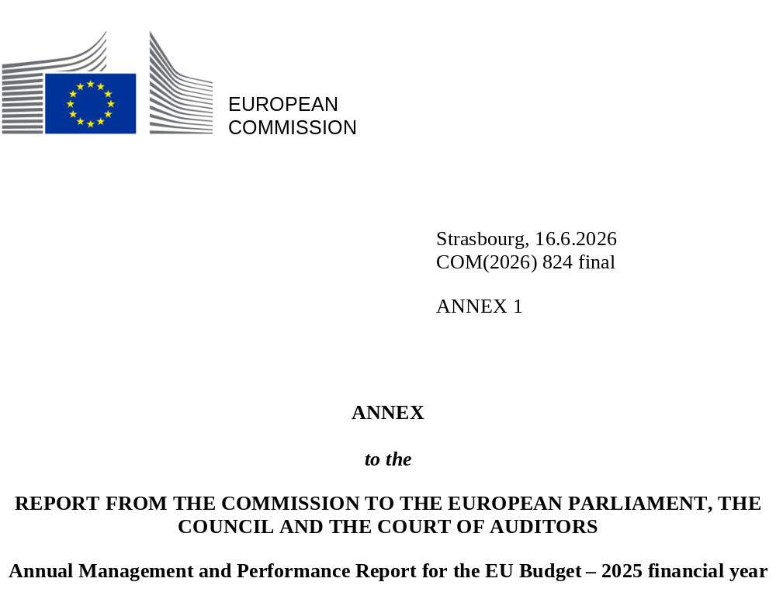

Contents
Annex 1 – Performance of the EU budget in 2025 5
1. EU budget performance monitoring 7
2. EU budget support for reforms 12
3. EU budget supporting the EU’s political priorities in 2025 18
4. Horizontal policy priorities in the EU budget 48

Annex 1 – Performance of the EU budget in 2025

1. EU budget performance monitoring
The EU budget is at the heart of EU policy action. Over the decades, it has helped improve the quality of life and livelihoods of people within the EU and beyond. It drives investment in the future, for a cleaner, digital and more competitive Europe. At the same time, it has provided a vital lifeline in times of crisis: it helped to overcome a pandemic and save millions of jobs during the lockdowns, assisted people and companies in getting through energy crises and is providing vital and reliable support for Ukraine in the face of Russia’s unprovoked and unjustified war of aggression.
The EU budget is an essential tool to deliver on the EU’s priorities. Through its programmes, the budget supports the EU’s internal and external policies. It creates EU added value by delivering results that would not be achievable through uncoordinated national spending. EU programmes are tailored to unlock synergies, catalyse private and public funding and provide a coordinated boost to the EU’s priorities.

Budget implementation in 2025
In 2025, the EU’s long-term budget (the multiannual financial framework) and NextGenerationEU continued to prove their capacity to underpin the EU’s policy response to multiple crises – such as Russia’s war of aggression against Ukraine, the energy crisis, supply chain disruptions, unprecedented natural disasters and humanitarian crises – while at the same time remaining instrumental to the delivery of the Union’s longer-term priorities. To achieve this, EUR 206.5 billion was committed in 2025 from the EU budget () to promote the EU’s sustainability, competitiveness and prosperity, in particular by investing in the green and digital transitions. This investment will strengthen the resilience of the EU’s social market economy, foster job creation and help to build a fairer, more sustainable future for all Europeans.
Multiannual financial framework: 2025 EU budget commitment appropriations by budget heading (million EUR)
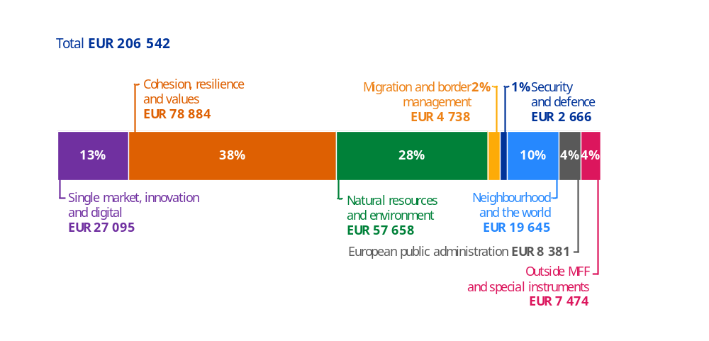
Source: European Commission.
The state of implementation varies across EU programmes. In their fifth year of implementation, programmes under direct and indirect management made substantial progress towards achieving their specific objectives. For shared management programmes, such as under the cohesion policy funds, the implementation of the 2021-2027 programmes significantly accelerated in 2025. As of the end of 2025, Member States had selected operations amounting to 64% of their European Regional Development Fund, Cohesion Fund, Just Transition Fund (including Interreg Europe) and European Social Fund Plus allocation. The midterm review of cohesion policy programmes in 2025 opened up an opportunity to ensure support to the most pressing priorities.
In total, EUR 34.6 billion of cohesion policy funds have been reallocated to EU strategic priorities in 25 Member States:
- EUR 15.2 billion (or 43% of the total) for competitiveness (with the strategic technologies for Europe platform (STEP) accounting for EUR 15.1 billion);
- EUR 11.9 billion (34%) for defence;
- EUR 3.3 billion (close to 10%) for housing;
- EUR 3.1 billion (9%) for water investments; and
- EUR 1.2 billion (slightly above 3%) for energy security.
NextGenerationEU further boosted the EU budget capacity to support Europe’s economic recovery with a long-lasting growth impact, and a strong focus on the digital and green transitions. From 2021 to 2026, the Recovery and Resilience Facility (RRF), which is the core of NextGenerationEU, is providing EUR 577 billion of funding in grants and loans to Member States (), including EUR 16.4 billion funded with revenue from the EU Emissions Trading System and transfers from the Brexit Adjustment Reserve. In 2025, EUR 95.8 billion of NextGenerationEU funds were disbursed, mostly driven by the payments under the RRF amounting to EUR 87.3 billion (EUR 40.1 billion in non-repayable support and EUR 47.2 billion in loans). This brought the total disbursements under the Facility to EUR 393.4 billion, divided into EUR 237.5 billion in non-repayable support (66% of the total EUR 360 billion RRF non-repayable support envelope at end 2025) and EUR 155.9 billion in loans (56% of the total EUR 277 billion RRF loan envelope at the end of 2025).
In 2025, EUR 5.5 billion was paid for commitments made under several EU programmes in the previous programming period (2014-2020). Most of these payments were associated with cohesion policy (including the European Regional Development Fund, the Cohesion Fund and the European Social Fund), along with the European Agricultural Fund for Regional Development and the Connecting Europe Facility.

Monitoring performance
In 2025, EU programmes continued to progress towards achieving their key objectives and delivering value for all EU citizens. Progress towards the programme objectives is monitored most notably by means of performance indicators. For those indicators with defined targets and for which implementation progress allowed an assessment, the vast majority (79%) were considered to be on track to reach their targets by the end of the implementation of the programmes. Detailed information at the programme level is available in the programme performance statements, Annex 4 to this report.
Breakdown of 2021-2027 core performance indicators by progress towards targets
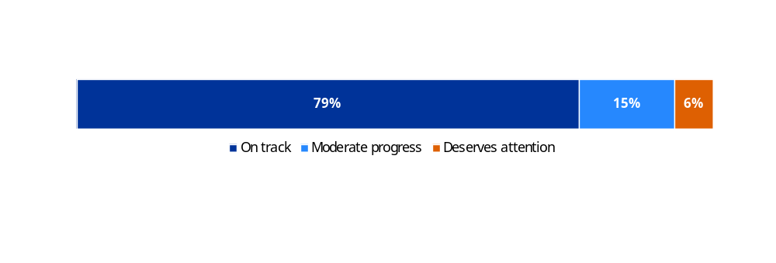
NB: The graph displays progress as measured by the share of the core performance indicators that are on track to meet their respective
targets. It does not include indicators for which the results do not allow an assessment at this stage.
Source: European Commission.
Spending must address the challenges and deliver the expected results on the ground. The table below shows examples of results from the EU budget achieved under both the 2014-2020 and the 2021-2027 multiannual financial frameworks.
Examples of results achieved
Climate ()
- 42 gigawatt-hours of estimated energy efficiency savings per year from private and public buildings by the InvestEU programme, cohesion policy funds, the LIFE programme and the Recovery and Resilience Facility, in the 2021-2025 period.
- 124 million tonnes of carbon dioxide equivalent avoided per year, of which almost half was through NextGenerationEU green bond investment. Additionally, 962 million tonnes of carbon dioxide equivalent reduction are expected from the Innovation Fund projects, ongoing or completed at the end of 2025, during their first 10 years of operations.
- 108 additional gigawatt of renewable energy capacity was installed by the InvestEU programme, cohesion policy funds, the Just Transition Mechanism and the Recovery and Resilience Facility, in the 2021-2025 period.
Digital
- 20 million additional dwellings were provided with internet access via very-high-capacity networks by the Recovery and Resilience Facility, InvestEU and cohesion funds by the end of 2025.
- 10 362 terabits per second of additional capacity were created by deployed backbone networks, including submarine cables, by the Connecting Europe Facility by the end of 2025.
Employment
- More than 50 million individuals were supported in obtaining skills relevant to employment and 360 000 jobs were created or maintained between 2021 and 2025 with support from the EU budget ().
- Around 16 million people participated in European Social Fund Plus activities to improve their employment situation by the end of 2025.
The next section of this Annex focuses on the EU budget support for reforms. The third section of this annex describes how EU programmes have contributed to political priorities. The fourth section of this annex, on horizontal policy priorities in the EU budget, provides information at the EU budget level on the financing of initiatives relating to climate, biodiversity, gender equality, the digital transition and the sustainable development goals (SDGs) (). Annex 4, Programme performance statements, provides a detailed analysis of the individual programmes and their performance, presented as a website to enhance reader friendliness.

Making performance information more reliable
The European Commission places great emphasis on the reliability of its performance information and continually works to further improve its already robust processes for performance reporting. To maintain high standards, data on core performance indicators are recorded and managed through a dedicated SAP-based database that incorporates automatic quality control rules to strengthen data quality and reliability. In addition, climate-related contributions from the EU budget are directly estimated using data extracted from the Commission’s accounting system, ensuring traceability and precision.
In 2025, the Commission continued to implement and consolidate a strengthened control approach to ensure the reliability of performance information on EU programmes. Commission departments continued to report in their annual activity reports for 2025 (which are an important source of information for this annual management and performance report) on the results of their controls, based on the specific guidance and requirements issued in 2023 in response to internal and external audit recommendations. In 2025, no major shortcomings were reported with regard to the reliability of the performance information for their respective EU programmes.

Performance framework for the 2028-2034 long-term budget
In 2025, the Commission adopted a proposal for a robust and future-proof long-term budget for the 2028-2034 period. As part of the modernisation of the EU budget, it introduces for the first time a regulation establishing a common performance framework applicable to all programmes: the ‘Performance Regulation’ ().
The Performance Regulation operationalises the requirements introduced in Regulation (EU, Euratom) 2024/2509 (the 2024 Financial Regulation), and addresses key lessons learnt from the 2021-2027 period. These include the heterogeneous application of horizontal principles across programmes, such as the ‘do no significant harm’ principle and gender equality; the fragmentation in the definition of performance indicators, which has created complexity and made it difficult to aggregate and monitor results; inconsistencies in the expenditure tracking methodologies; and the multitude of performance reports, which has increased complexity and reduced transparency.
The proposed Performance Regulation equips the future budget with a simpler, more robust and unified performance framework to monitor how the budget is spent and the results it achieves. This will increase transparency, accountability and consistency, reduce administrative burden and ensure more effective delivery of EU priorities.
Harmonised horizontal provisions and principles  A single approach to implement climate and environment, the do no significant harm principle, social policies and gender equality | Common methodology to track EU budget expenditure  A single methodology to monitor the expenditure supporting climate mitigation, climate adaptation, environment and social objectives | Common list of performance indicators  Streamlined output and result indicators, moving from over 5 000 to around 900 indicators, and allowing aggregation at the EU budget level
A single report on performance  From 32 programme-specific reporting requirements to a single performance report: the Annual Management and Performance Report | The single gateway portal  Merging over 30 portals and dashboards into a single entry point for funding opportunities and EU budget performance information | Streamlined evaluations  Implementation report replacing midterm evaluation
The proposed Performance Regulation also includes the ‘single gateway’ portal, which will provide a single entry point for EU funding opportunities and for performance information, which is currently spread across multiple platforms. The portal will enhance accessibility and transparency for potential beneficiaries and users of information on the implementation and performance of the EU budget.

2. EU budget support for reforms
The EU budget supports reforms alongside investment in Member States and partner countries. While investment finances tangible projects that promote growth and development, reforms serve as enablers, helping enhance the impact and effectiveness of investment, and act as catalysts for change and for aligning policies with the EU’s strategic priorities.
Within the EU, the synergy between reforms and investments is particularly embodied in the Recovery and Resilience Facility, where disbursements are based on the achievement of predefined milestones and targets. In addition, several EU programmes have built-in conditionalities to ensure that EU money is spent effectively and in line with broader EU objectives. EU programmes providing funding to Member States or regions, namely under cohesion policy, have strengthened the link with EU priorities in various forms. Financing from the EU budget should contribute to these shared priorities to deliver EU added value. Where Member States need support, the Technical Support Instrument provides tailored expertise and guidance to design and implement complex reforms. In external action, the EU uses conditional budget support and investment facilities to promote reforms and investments in neighbouring and candidate countries, along with other partner countries. In partner countries, the joint support for reforms and investments is particularly relevant in the Instrument for Pre-Accession Assistance, the Ukraine Facility, the Reform and Growth Facility for the Western Balkans, and the Reform and Growth Facility for Moldova.

Recovery and Resilience Facility
The midterm evaluation of the Recovery and Resilience Facility highlighted the key role played by the facility in supporting reforms in Member States. The Recovery and Resilience Facility introduced new stimulus and financial incentives for implementing critical and long-awaited reforms, thanks to the requirements from the RRF Regulation and the novel link between reforms and investments. The implementation of reform measures has generally been frontloaded compared with that of investments, as reforms often serve a ‘preparatory’ function vis-à-vis the relevant investments, notably to maximise the impact of the latter.
Reform measures under the Recovery and Resilience Facility are distributed across its six policy pillars, with a greater number of measures under the pillars covering growth and resilience-enhancing policies (see chart ‘Milestones and targets per Recovery and Resilience Facility pillar associated with reforms’). The pillars represent EU priorities consistent with the country-specific recommendations (CSR) addressed to Member States by the Council of the European Union in the context of the European semester.
The country-specific recommendations assessment, published as part of the 2025 European semester spring package (COM(2025) 200 final), demonstrates an increase in the implementation of country-specific recommendations adopted in 2019 and 2020 compared with the implementation before the Recovery and Resilience Facility. By June 2025, the share of country-specific recommendations adopted in 2019-2020 and recording at least some progress reached 79%. By comparison, before the Recovery and Resilience Facility, 62% of the country-specific recommendations adopted in 2015-2016 had recorded at least some progress in 2021 (i.e. after the same amount of time for implementation). This shows that the incentives provided by the Recovery and Resilience Facility, with its performance-based approach and emphasis on reforms, contributed to reinforcing the implementation of country-specific recommendations.
Milestones and targets per Recovery and Resilience Facility pillar associated with reforms
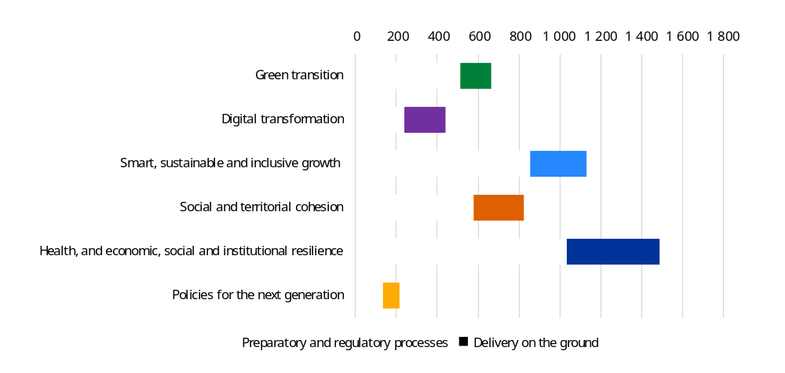
NB: The graph shows the number of reform milestones and targets per Recovery and Resilience Facility pillar categorised as ‘preparatory and regulatory process’ or ‘delivery on the ground’.
Source: European Commission.
During its first four years of implementation, the Recovery and Resilience Facility supported the delivery of a wide range of key reforms across Member States, including reforms.
- Legislation has entered into force to encourage tax compliance and improve the effectiveness of audits and controls. One reform improved the quality of the databases used to produce compliance letters (i.e. notices through which the Italian tax authorities report discrepancies). As a result, the tax revenue generated by compliance letters has increased by 30% compared to 2019 (Italy).
- Introduction of reforms to improve fiscal sustainability in the medium and long term. These include improving the long-term fiscal sustainability of the pension system through changes to the first pay-as-you-go pension pillar and improving the functioning of the second pension pillar, along with enhancing fiscal discipline through binding multiannual expenditure ceilings (Slovakia).
- Streamlining and simplifying permitting procedures for renewable energy and electricity infrastructure. The legislation reduces administrative burden, sets clear deadlines, removes restrictions on self-consumption and improves network capacity allocation (Spain).
- Ensuring access to medical care, by establishing a reimbursement system for nurses to incentivise them to work in remote areas, and by increasing the share of people admitted in nursing training (Estonia).
- Enabling policymakers to better assess and limit regulatory burdens on SMEs, promoting a more supportive environment for their growth (Ireland).

Cohesion funds
Under cohesion policy, reforms are supported via the enabling conditions. These ensure that the necessary conditions for the effective and efficient use of the funds are in place. These cover:
- policy and strategic frameworks, to ensure that the strategic documents at the national and regional levels which underpin investments are of high quality and in line with EU standards;
- regulatory frameworks, to ensure that implementation of operations co-financed by the funds complies with the EU acquis.
The progress in the fulfilment of these conditions since the adoption of programmes in 2022 is significant. At the end of December 2025, only 1.3% of the European Regional Development Fund / Cohesion Fund / European Social Fund Plus allocations remain blocked by unfulfilled enabling conditions, compared with 22.3% at the time of adoption.
The midterm evaluation of the 2021-2027 programming period showed that enabling conditions allowed to set up strategic policy frameworks, systems and other arrangements for the effective and efficient implementation of the funds.

Technical Support Instrument
By bringing together expertise from different backgrounds, such as from international organisations, the private sector and other Member States, the Technical Support Instrument helps Member States to carry out reforms that create jobs, inclusive societies and sustainable growth.
In 2025, the Technical Support Instrument continued to support smart, sustainable and socially responsible reforms in a wide range of policy areas while strengthening all types of administrative capacities, especially the internal administrative mechanisms for reforms across the EU. For instance, the Technical Support Instrument multi-country sustainability in local public finances project focuses on developing the foundations for ‘SDG budgeting’ in local governance systems. The project supported the delivery of city-specific and joint reports assessing SDG budgeting practices, while developing tailored methodologies, key perfomance indicators and action plans with a view to improving budgeting coherence, transparency and resource allocation. This helped lay the groundwork for institutionalised SDG-oriented financial management benefiting around five million residents and serving as a transferable model for other EU municipalities.
The Technical Support Instrument contributed to reinforcing Member States’ competitiveness drivers, improving the functioning of the single market and Member States’ ability to deliver reforms for trade and open strategic autonomy (see Technical Support Instrument – 2024 annual report for more details). For example, the public administration cooperation exchange multi-country flagship project aims to promote cooperation and cross-border exchanges among Member States to build administrative capacity and prepare the next generation of policymakers in the EU, giving more than 800 civil servants the opportunity to to exchange experience between 2023 and 2025. It leverages Technical Assistance and Information Exchange (TAIEX) between administrations of different Member States.
In 2026, the instrument is expected to focus on supporting Member States in the implementation of complex country-specific recommendations.

External action
The Instrument for Pre-accession Assistance III is designed as a performance-based instrument, differentiating assistance in scope and intensity according to the performance of beneficiaries, thereby incentivising commitment to fundamental reforms. This approach aligns with the 2020 communication on the revised enlargement methodology (), which proposed increased funding for countries making progress on agreed reform priorities. Performance assessment is embedded in the annual bilateral programming process, drawing on Commission enlargement reports, external expert assessments, implementation track records and reporting against the Instrument for Pre-accession Assistance III Results Framework indicators.
In the case of the Ukraine Facility, the Council’s Implementing Decision (EU) 2024/1447 of 14 May 2024 on the approval of its assessment of the Ukraine plan () sets out a detailed roadmap of conditions, in the form of qualitative and quantitative steps linked to reforms and investment. Fulfilment of these conditions can trigger direct EU support for Ukraine’s budget (Pillar I of the Ukraine Facility). The Ukraine plan includes 151 steps organised around 15 sectoral chapters (public administration reform; public financial management; judiciary; fight against corruption and money-laundering; financial markets; management of public assets; human capital; business environment; decentralisation and regional policy; energy; transport; agri-food; management of critical raw materials; digital transformation; green transition and environmental protection) and three horizontal chapters (reconstruction and modernisation processes across all levels of the government; mechanisms and arrangements to protect the financial interests of the EU; and stakeholders’ consultation during the preparation of the Ukraine plan).
Ukraine fulfilled a total of 45 steps due during 2025 across several chapters of the plan, triggering the disbursement of EUR 10.7 billion in non-repayable support and loans. Since the roll-out of the Ukraine Facility, it has disbursed a total of EUR 26.8 billion against 68 steps (including the five steps reflected in the memorandum of understanding for the exceptional bridge financing).
Ukraine reform accomplishments
In 2025, Ukraine accomplished reforms across several areas:
- human capital, agri-food, management of critical raw materials (5 steps each);
- decentralisation and regional policy, digital transformation, green transition and environmental protection (4 steps each);
- business environment, energy (3 steps each);
- public financial management, judiciary, financial markets, management of public assets, transport (2 steps each);
- public administration reform, fight against corruption and money-laundering (1 step each).
For example, in the area of green transition and environmental protection, a new law ‘On the basic principles of state climate policy’ now defines the key mechanisms and goals for climate governance. Another key step in this area was the adoption of a more ambitious second ‘Nationally Determined Contribution of Ukraine’ to the Paris Agreement. In the area of human capital, a reform of preschool education now pursues access to quality preschool education with the aim of increasing the participation of women with preschool children in the labour force. On decentralisation, Ukraine adopted key amendments to the Law on Local State Administration; this step directly contributes to public administration reform, a core priority under the ‘Fundamentals’ cluster of the accession process. The fight against corruption and money laundering was strengthened through the entry into force of a law reforming the Asset Recovery and Management Agency, which introduced several improvements to the management and functioning of the agency.

The Reform and Growth Facility for the Western Balkans and the Reform and Growth Facility for Moldova are performance-based instruments, with disbursements conditional on the achievement of agreed reform steps by beneficiaries. In 2025, EUR 396 million was released in pre-financing and disbursements under the Reform and Growth Facility for the Western Balkans, including EUR 164 million for Albania, EUR 45 million for Montenegro and EUR 77 million for North Macedonia. In the same year, EUR 288.9 million in loans was disbursed under the Reform and Growth Facility for Moldova. Moreover, the Reform and Growth Facility for the Western Balkans works in complement with the Instrument for Pre-accession Assistance III, which provides technical assistance, including Technical Assistance and Information Exchange and Twinning support, to help countries build the capacity needed to advance reforms, while the facility creates fiscal incentives to legislate and implement them.
In delivering on the Global Gateway through the Neighbourhood, Development and International Cooperation Instrument – Global Europe, the Commission promotes reforms to support the investment-enabling environment in partner countries, in accordance with the EU policy priorities and in complementarity with all Team Europe stakeholders. These reforms relate to the countries’ economic governance (e.g. public procurement, public investment management or debt management) or are considered enablers for successful Global Gateway projects (e.g. upgrading the regulatory framework for the production/commercialisation of solar or wind power, or for operators in strategic transport corridors).
The Ukraine Investment Framework (Pillar II of the Ukraine Facility) and the European Fund for Sustainable Development Plus crowd in private capital to promote investments, respectively in Ukraine and in EU partner countries. Moreover, budget support promoted regulatory reforms in the energy sectors of Benin, Solomon Islands and Vietnam. It encouraged renewable energy, notably by allowing EU development finance institutions to fund these investments directly with EU blending support. In the context of Global Gateway, such synergies are also sought, for instance, in Jamaica and Kyrgyzstan for digitalisation, Liberia, Rwanda and Uzbekistan for agriculture value chains and Mauritania for green hydrogen.
In the neighbourhood region, macro-financial assistance financed by Neighbourhood, Development and International Cooperation Instrument – Global Europe plays an equally important role to promote reforms.
In both Jordan and Morocco, a large budget support portfolio promotes reforms in various sectors such as renewable energies, circular economy, water, skills, social protection or public administration modernisation/digitalisation for a more conducive business environment. In Armenia, Egypt, Jordan and Tunisia, this effort to promote reforms is complemented by dedicated strategic and comprehensive partnerships. In the neighbourhood region, macro-financial assistance for countries under financial distress also promotes important economic reforms such as in Egypt and Jordan, where a new macro-financial assistance operation was established in 2025.
In Palestine (), the support to the Palestinian Authority (through direct financial support via the EU PEGASE mechanism) is anchored in the reform agenda of the Palestinian Authority. In other fragile/recovery contexts in the Middle East and Africa region, the EU contributes to strengthening core administrative and public finance management functions are always being supported (Iraq, Lebanon, Libya, Yemen and, since 2025, Syria).
This support to reforms with capacity development is coordinated with the International Monetary Fund, the World Bank Group, the Organisation for Economic Co-operation and Development and EU Member States.
Results under the Neighbourhood, Development and International Cooperation Instrument – Global Europe ():
- 110 countries supported by the EU to strengthen revenue mobilisation, public financial management and/or budget transparency (GERF (Global Europe results framework) 2.19);
- 22 countries and cities with climate change and/or disaster risk reduction strategies: (a) developed or (b) under implementation (GERF 2.5);
- 2 countries supported by the EU to (a) develop and/or revise, (b) implement digital-related policies/strategies/laws/regulations (GERF 2.10) a) 4 and b) 1);
- 3 countries supported by the EU to strengthen investment climate (GERF 2.16);
- 356 government policies developed or revised with civil society organisation participation through EU support (GERF 2.29).

3. EU budget supporting the EU’s political priorities in 2025

The Competitiveness Compass
Europe's independence will depend on its ability to compete in today's turbulent times. We have everything it takes to thrive here in Europe – from our Single Market to our social market economy ().
Ursula von der Leyen
President of the European Commission

Boosting the EU’s competitiveness
Europe’s prosperity depends on having a competitive, sustainable and resilient economy that delivers opportunities for its people and businesses, now and in the future. Building on Mario Draghi’s report on European competitiveness, in 2025 the Commission presented the Competitiveness Compass, setting out actions aimed at closing the innovation gap, decarbonising the EU’s economy, reducing dependencies, cutting red tape, removing barriers to the single market, enabling more efficient financing and mobilising private capital, promoting skills and quality jobs and ensuring better coordination. In 2025, the EU budget contributed to the achievement of these objectives through various means.
Making business easier and faster through simplification
Complementing the use of the EU budget, in 2025 the EU put forward initiatives to boost competitiveness by cutting red tape, modernising taxation and supporting fair competition, aiming to help businesses, especially small and medium-sized enterprises, thrive across borders. The targets are clear: lower administrative burden by at least 25% for all businesses and at least 35% for small and medium-sized enterprises – cutting recurring administrative costs by EUR 37.5 billion by 2029.
Horizon Europe is the EU’s flagship research and innovation programme, contributing to the EU’s efforts to boost its competitiveness. By the end of 2025, Horizon Europe projects produced over 10 000 innovative products, processes, methods and intellectual property rights applications; contributed to industry, innovation and infrastructure with over EUR 20 billion; and contributed with EUR 12.8 billion to digital activities, of which EUR 2.5 billion in 2025 alone. Examples of projects financed under Horizon Europe include research into the safe recycling of hazardous plastics and into improved space weather forecasting (useful for satellites). Moreover, to facilitate the deployment of clean technologies, clean mobility and waste reduction, in 2025 the Commission allocated EUR 540 million under Horizon Europe to dedicated Clean Industrial Deal calls () and increased the size of the InvestEU guarantee by EUR 2.9 billion (). Funding of over EUR 1.25 billion was announced in 2025 for the Marie Skłodowska-Curie actions to support the career and skills development of researchers.
Horizon Europe also funds European Innovation Council Fund, a venture capital instrument to help bridge the funding gap for breakthrough technologies in Europe. By the end of 2025, the fund had invested over EUR 1 billion across 214 companies and projects. This has amounted to the mobilisation of approximately EUR 3 billion in additional private investment, with a leverage ratio of over 3.5 private euro per each public euro. The newly launched EIC strategic technologies for Europe platform Scale-Up scheme provided EUR 300 million in 2025. By the end of 2025, the EIC Accelerator funding stream invested approximately EUR 1 billion in over 200 companies, including projects on quantum computing, neurostimulation therapies and cost-effective and environmentally friendly solar electric water propulsion systems ().
Horizon Europe: looking ahead
In 2025, the Commission adopted the Horizon Europe work programme for the years 2026-2027, worth over EUR 14 billion, looking at fostering Europe’s sustainable prosperity and competitiveness. The work programme includes additional funding for the Choose Europe for Science initiative launched under the Marie Skłodowska-Curie actions, on top of the EUR 500 million announced in May 2025, increasing the overall figure for the initiative to nearly EUR 900 million in 2025-2027. This work programme allocates EUR 634 million to topics relating to critical raw materials, and also supports research on advanced materials and alternatives to rare earth elements; and over EUR 870 million to valorisation topics on market, societal and policy uptake of research results ().
Through the Innovation Fund, the EU has been supporting highly innovative technologies, processes or products that have a significant potential to reduce greenhouse gas emissions, and projects aimed at scaling up innovative technologies. By the end of 2025, 197 projects were under implementation or completed. The grants provided continue to have a leverage effect of approximately five times, with EUR 11.7 billion of Innovation Fund support enabling around EUR 58 billion in mobilised investments. In 2025:
- 83 new grant agreements were signed for decarbonisation projects;
- the Innovation Fund 2024 Net Zero Technology Call closed, allocating EUR 2.9 billion to select 61 cutting-edge net zero technology products;
- the Innovation Fund also committed EUR 643 million to five projects under the call for electric vehicle battery manufacturing;
- the second Innovation Fund Auction for renewable hydrogen production (Innovation Fund 2024 Auction) saw the signature of six projects for a total of EUR 270.6 million.
Furthermore, in 2025, through the Innovation Fund, the Commission announced over EUR 3.5 billion in funding for innovative low-carbon technologies, using revenues from the EU Emissions Trading System. This includes, among other things, projects aimed at supporting electric vehicle battery cell production (), projects aimed at decarbonising industrial processes (e.g. low-carbon cement production ()), renewable hydrogen production () and a zero-emission ocean-going cruise ship capable of carrying 400 persons for 30 days (). Complementing this, the Innovation Fund is also supporting the European battery value chain: the 2025 battery booster strategy included a EUR 1.5 billion Battery Booster Facility financed by the Innovation Fund, which will provide interest-free loans.
InvestEU helped to boost investments across Europe by lowering risk for financial institutions and helping to attract private capital. Through guarantees backed by the EU budget, it supported projects in areas such as sustainable infrastructure, social investment and skills, small and medium-sized enterprise, research, innovation and digitalisation. By the end of 2025, the total approved guarantee amount stood at EUR 26.8 billion. The volume of InvestEU operations approved by implementing partners reached EUR 80.6 billion and is expected to mobilise investments of EUR 329.1 billion, with 69.2% of this coming from the private sector. With InvestEU support, by 2025, 91 294 enterprises have been supported and 2.1 million households and enterprises gained fast-access broadband. InvestEU appoved operations invest in energy, for example with EUR 500 million in the ‘SG Pan EU Wind Package’ project (), sustainable infrastructure, for example with EUR 100 million in the ‘Marguerite III (CDPE)’ project (), and digital connectivity and infrastructure, for example with EUR 350 million in the cristal fibre rollout project ().
In 2025, cohesion policy strengthened Europe’s competitiveness, more so after the midterm review of the cohesion policy reallocated EUR 15.2 billion to competitiveness, with most investments going to critical technologies and industries under the strategic technologies for Europe platform to reduce technological dependencies on non-EU countries. It also included investment in skills development linked to decarbonisation of production capacities. Cohesion policy supported competitiveness funding for regional- and interregional-level research and innovation, decarbonisation, energy transition and innovation, including through the Interregional Innovation Investments Instrument. This instrument supported 70 innovation projects in the scale-up and commercialisation phase, focusing on integrating less-developed regions into European value chains, representing EUR 301 million of EU funding invested so far.
To boost the competitiveness of regions most affected by decarbonisation efforts, the Commission also relied on the Just Transition Mechanism. By the end of 2025, 58.4% of the total budget of the Just Transition Fund (EUR 15.45 billion), the 1st pillar of the mechanism, was allocated to selected projects. Under the mechanism’s 2nd pillar, the InvestEU Fund implementing partners reported a total of EUR 9.13 billion of investment mobilised by its operations. Moreover, the Public Sector Loan Facility, the 3rd pillar of the Just Transition Mechanism, provided support via a combination of European Investment Bank loans and grants from the EU budget, which in 2025 amounted to EUR 679 million, supporting investments worth EUR 868 million. The mechanism supported projects such as a university hospital in Spain () and a rare-earth magnet factory in Estonia (). Moreover, the Public Sector Loan Facility pillar of the Just Transition Mechanism provided vital support to public authorities in regions facing socio-economic challenges from the transition to climate neutrality, via a combination of European Investment Bank loans and grants from the EU budget, which in 2025 amounted to EUR 86 million, supporting investments worth EUR 868 million.
The EU budget has also been supporting competitiveness via the digital Europe programme, helping to bring digital technology to citizens, businesses and public administrations. By the end of 2025, the programme delivered achievements such as the following.
- 19 AI factories started to be deployed in 16 Member States, featuring the procurement of 15 new supercomputers optimised for artificial intelligence, and one major system upgrade for a fivefold increase in the EU’s artificial intelligence computing capacity. Thirteen AI Factory Antennas were also selected to extend AI Factory services to SMEs, startups, local research bodies, and public institutions across Europe.
- Conclusion of contracts for three new supercomputers (Daedalus in Greece; Arrhenius in Sweden and Alice Recoque in France), along with upgrades of existing ones (Leonardo to Lisa in Italy; Discoverer to Discoverer+ in Bulgaria).
- Jupiter, the EU’s first EU exascale supercomputer, reached its full performance of one exaflop, or more than 1 quintillion operations per second.
- The EuroHPC Joint Undertaking procured 6 quantum computers, of which 2 were inaugurated in 2025, and 2 additional analogue quantum simulators were inaugurated under the HPCQS (high performance computer – quantum simulator) project.
- 14 common European Data Spaces are being deployed, including infrastructures that can benefit from interoperable language resources and multilingual data services.
- Five semiconductor pilot lines were launched, where EU industry can test, experiment and validate next-generation chip technologies and designs.
- 30 competence centres were launched in all Member States (and Norway) to support companies, in particular SMEs and start-ups, in getting access to semiconductor technologies via training, technology transfer and development support.
The digital Europe programme budget is also supporting strategic digital technologies, including semiconductors, via financial instruments. EUR 83.63 million was committed to support strategic digital technologies, such as AI, quantum or cybersecurity. Under the Chips Fund, EUR 98 million was committed for investments in semiconductor technologies and applications. These investments are expected to mobilise 14.2 times the amounts committed, facilitating access to finance to key companies across Europe.
In 2025, the digital strand of the Connecting Europe Facility awarded projects totalling EUR 389 million. Grant agreements concluded in the year included funding for projects concerning the deployment of global gateways (mainly submarine cables), deployment of 5G large-scale pilots in smart communities and along major transport paths, and the further deployment of an interconnected European quantum communication infrastructure (EuroQCI).
In 2025, the Commission financed transport infrastructure with the Connecting Europe Facility. EUR 3.02 billion was allocated to projects advancing a sustainable, intelligent, eco-friendly and resilient transport network. Examples of support by the facility include the Rail Baltica standard gauge railway line development in Estonia, Latvia and Lithuania (), along with the development of a pan-European network of publicly accessible and interoperable recharging infrastructure dedicated to electric heavy-duty vehicles ().

The strategic technologies for Europe platform
The strategic technologies for Europe platform (STEP) is designed to strengthen the EU’s ability to create and ramp up strategic technologies, making it more competitive globally. As of the end of 2025 and since its inception in 2024, STEP has cumulatively pooled resources across 11 EU funding programmes amounting to EUR 24 billion, to support strategic technologies across sectors such as digital and deep tech innovation, clean and resource efficient technologies and biotech. This is the result of the combined efforts of the five EU programmes directly managed by the Commission and the reprogramming of financial envelopes by Member States and EU regions under the cohesion policy. In total for 2025 alone, the initial budget earmarked by programmes in direct management in support of STEP-relevant technologies amounted to EUR 5.3 billion, representing a 14.6% year-on-year increase to the figure of EUR 4.6 billion reported for 2024. Cumulatively, this represents a total budget of around EUR 10 billion allocated to STEP-relevant calls for proposals across the five EU programmes since the inception of STEP in March 2024.
Resources earmarked for STEP by programmes in direct management, by sector in 2024 and 2025 (in million EUR) ()
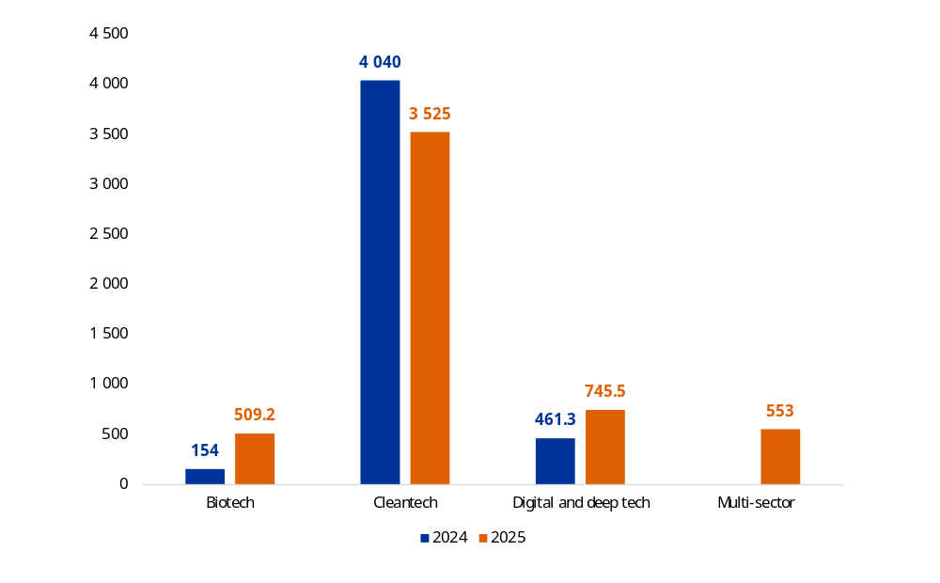
Regarding cohesion policy funds, as of the end of December 2025, 96 STEP amendments were adopted in 19 Member States, amounting to EUR 13.9 billion. This represents more than a doubling compared to 2024. In 2025, a new STEP Sector for defence technologies was introduced via the cohesion policy midterm review adopted in September 2025 () and the Defence Mini-omnibus Regulation adopted in December 2025 ().
To date, the Commission has awarded more than 600 STEP Seals to the best-performing projects in their respective evaluations. Among these, a majority of 451 seals were awarded in 2025 alone. This quality label will help project promoters in securing complementary funding for their projects, both in case they were already awarded funding by the Commission to cover part of the project costs or in the case they were not retained for funding, due to the limited budget of the call.
Total STEP allocations in adopted cohesion policy programmes as of the end of 2025
(in million EUR)
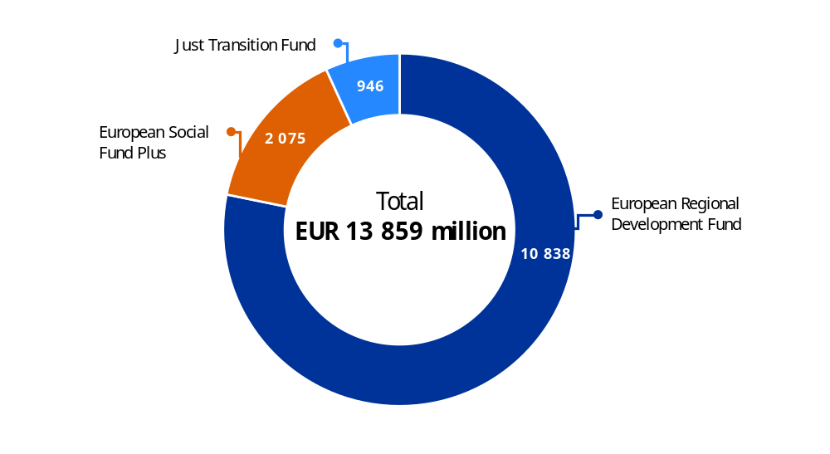
The interim evaluation of STEP was published in July 2025, and it points to STEP’s success in effectively steering EU investment to innovative technologies and simplifying access to EU funding via a one-stop shop online portal, the STEP Portal.

A new era for European defence and security
This must be Europe's Independence Moment. I believe this is our Union's mission. To be able to take care of our own defence and security ().
Ursula von der Leyen
President of the European Commission

Investing in defence
The EU stepped up its defence efforts in 2025 through the rearm Europe plan, which mobilised new financial instruments to strengthen Europe’s defence capabilities and close investment gaps for full defence readiness by 2030. The rearm Europe plan includes Security Action for Europe, which will provide up to EUR 150 billion in loans to support urgent defence investments and address critical capability gaps. Member States demonstrated strong interest in the instrument, with 19 Member States submitting national defence industry investment plans by 30 November 2025, covering 691 projects, 65% of which involved joint procurement.
The EU also invested in defence collaborative research, development and innovation through the European Defence Fund. In its 2025 work programme, the European Defence Fund (EDF) allocated close to EUR 1 billion in funding and received a record 410 project proposals in response, which will lead to funding projects in the course of 2026. By 2025, EUR 5.1 billion had been committed to defence research and development, supporting 225 collaborative European Defence Fund projects and including the 2025 commitment. This positions the fund among the EU’s top defence research and development investors. As part of the EDF, the EU Defence Innovation Scheme (EUDIS) continued to support non-traditional defence players, including SMEs. Two defence hackathons were organised across 16 locations in Europe and two new initiatives were launched: the EUDIS Business Accelerator, an eight-month support programme providing targeted and tailored support to defence and dual use start-ups and small and medium-sized enterprises (supporting 20 companies in 2025); and EUDIS Matchmaking, establishing a platform to foster connections between defence innovators, investors, end users, corporates and other relevant defence stakeholders, and organising four events across Member States in 2025.
In 2025, the Act in Support of Ammunition and Production helped to ramp up the production of ammunication in the EU, contributing to its strategic autonomy and to the competitiveness of its defence technological and industrial base. It supported the implementation of 31 projects in areas such as explosives, powder, shells, missiles and testing and reconditioning, providing total support of about EUR 514 million.
In 2025 the mid-term review of cohesion policy resulted in EUR 11.9 billion shifted toward supporting defence related projects, from military mobility to defence industry and civil preparedness. Of this amount EUR 1.3 billion was specifically allocated to support the defence industry’s capacities.

Investing in space capabilities
In a world first, the Galileo open service navigation message authentication function was declared operational in July 2025, after adding two satellites to its costellation. It introduces a mechanism to verify the authenticity of navigation data transmitted from Galileo satellites, helping protect against spoofing (the transmission of false signals), and significantly enhances trust in the EU’s Galileo satellite system, the only system in the world with this security feature.
Moreover, delivering on the Union Secure Connectivity priority flagship, the development of a multi-orbital satellite constellation of around 290 satellites – IRIS² (Infrastructure for Resilience, Interconnectivity and Security by Satellite) – continued at full speed on the basis of a competitive and innovative public–private partnership established under a 12-year concession contract signed with the SpaceRISE consortium in 2024. In 2025, several important sub-contracts were signed with core consortium team members and key suppliers.
The Commission also pursued establishing international agreements with Iceland and Norway for their participation in the EU secure connectivity programme and in the EU’s governmental satellite communication programme (GOVSATCOM). A similar process is underway to allow for the opening of formal negotiations with Ukraine.
For the next multiannual financial framework, the Commission has proposed boosting the defence and space budget to EUR 131 billion, five times the current budget, within the European Competitiveness Fund.

Enhancing the EU’s preparedness and crisis management
Learning from past challenges and faced with unprecedented threats, the EU continuously aims to enhance its ability to anticipate, prevent and respond to them. In 2025, the EU made available over EUR 245 million for the Union Civil Protection Mechanism. In addition, to support resilience in Member States and non-EU countries participating in the mechanism, the Commission co-financed 27 prevention and preparedness projects, including 13 under the single-country grants to disaster risk management authorities and 14 under the multi-country grants. The European Civil Protection Pool was further strengthened as the primary reserve of response capacities available for Union Civil Protection Mechanism response operations. The resources under the European Civil Protection Pool increased by 19.4% in the past year. In 2025, European Civil Protection Pool capacities were deployed for consular and medical evacuations, forest firefighting and emergency medical support.
Union Civil Protection Mechanism response to wildfires in 2025
During the 2025 European wildfire season, the Union Civil Protection Mechanism was activated 18 times in response to wildfires, with 16 activations in Europe and two activations outside of Europe.
Countries affected included Albania, Bosnia and Herzegovina, Bulgaria, Greece, Montenegro, Portugal, Spain and Syria. The Commission also co-financed the stand-by availability of rescEU aerial forest fire-fighting capacities, including 18 firefighting planes and 4 helicopters in case of requests for assistance.
Forest fires – burnt areas in the EU in 2025 (in hectares)
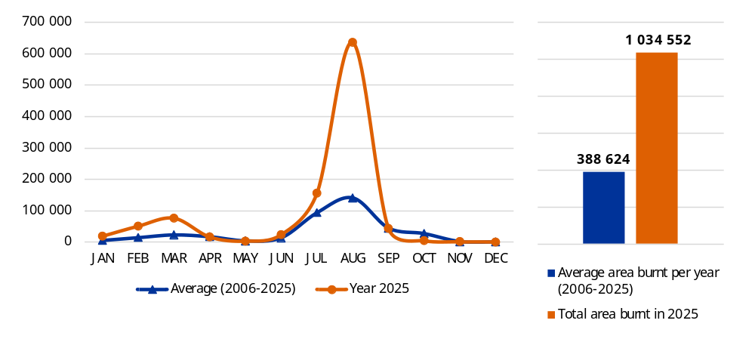
RescEU, the Commission’s own preparedness reserve, was strengthened in 2025, moving closer to a fully-fledged aerial firefighting fleet at the European level. The Commission continued the work with the rescEU transitional arrangement to combat the increasing wildfire threat across Europe. During the spring of 2025, the Emergency Response Coordination Centre pre-positioned firefighting capacities across the EU ahead of the summer’s wildfire season.
Helping people cope with natural disasters
In 2025, the European Union Solidarity Fund mobilised EUR 1.3 billion to assist recovery and reconstruction in six Member States and two accession countries struck by natural disasters in 2024 and 2025. The fund allocated EUR 280 million to Austria, Bosnia and Herzegovina, Czechia, Moldova, Poland and Slovakia following floods, and made available EUR 1 057 million for Spain (floods) and France (two cyclones). In the case of Spain, after storm Dana hit the Valencia region in October 2024, the fund mobilised EUR 946 million, which is the second-largest contribution in the fund’s history.

Enhancing internal security, border control and migration management
To enhance safety and security across Europe, border control, and manage migration, the EU budget funds actions through a number of funds, such as:
- the Internal Security Fund, focused on preventing and combating terrorism and radicalisation, organised crime and cybercrime;
- the Asylum, Migration and Integration Fund, promoting efficient management of migration flows; and
- the Border Management and Visa Instrument, addressing external border management challenges.
The 2025 budget for the Internal Security Fund amounted to EUR 336.6 million. This amount included EUR 195.5 million for initial allocations to Member States’ programmes, the largest share of which is destined to strengthen Member States’ capabilities in fighting organised crime and terrorism (41%). The fund notably advances the interopeprability of communication technology systems and the information exchange mechanisms across Member states, while also supporting cross-border operations aimed at seizing drugs (22 196 kg by 2025) or weapons (302 by 2025). Under the Internal Security Fund’s Thematic Facility, the Commission has also funded 13 projects starting in 2025, with EUR 30 million to strengthen the protection of public spaces such as shopping centres, public transportation, entertainment venues and places of worship ().
The 2025 budget for the Asylum, Migration and Integration Fund amounted to EUR 1.9 billion. This amount included EUR 972.9 million for initial allocations to Member State programmes, the largest share of which is for strengthening and developing the Common European Asylum System (36%). By 2025, the Asylum, Migration and Integration Fund registered 15 635 participants who applied for long-term status, 107 739 voluntary returnees, 14 602 returnees removed and 4 771 applicants for and beneficiaries of international protection transferred from one Member State to another.
The 2025 budget for the Border Management and Visa Instrument amounted to EUR 1.2 billion. The largest share of the EU’s financial contribution to Member State programmes is allocated to European integrated border management (87%). The common visa policy accounts for 8% of the allocated budget for Member State programmes, with the main achievements relating to the digitalisation of visa processing.
Considering the rapidly evolving threat landscape and risks at the EU external borders, additional funding was made available from the Border Management and Visa Instrument to further enhance border control capabilities, with EUR 169.6 million for the purchase of various uncrewed equipment to be used for border surveillance at the national level and put at the disposal of the European Border and Coast Guard Agency (Frontex equipment) and EUR 250 million for the purchase of drones and counter-drone systems. Under the Border Management and Visa Instrument, EUR 50.55 million was also made available to support the Schengen-associated countries in the implementation of the EU Pact on Migration and Asylum. Funding for border management was also provided by the Customs programme, which helped to kick off the European Union Customs Alliance for Borders expert team, enhancing operational cooperation among Member State customs authorities.
Moreover, the EU has been enhancing internal security by investing in the security of submarine data cables. These cables carry 99% of intercontinental internet traffic, making them essential for modern life and the European economy. In 2025, the Commission intesified efforts to increase the security and resilience of this critical infrastructure. In the EU action plan on cable security adopted in 2025, the EU set aside EUR 20 million to strengthen the security of Europe’s submarine cables, via the digital Europe programme, to support the creation of regional cable hubs and stress-testing of the resilience of undersea cable infrastructure. Moreover, under the Connecting Europe Facility, 25 projects aimed at boosting the resilience and security of submarine cables and key terrestrial connections were selected in 2025, totalling EUR 186 million in EU contributions.

Supporting people, strengthening our societies and our social model
Our economy must work for people and business alike. And if we modernise the business, the industry, and the workplace, we also have to modernise the labour market and the working conditions. Europe must deliver for all of its people ().
Ursula von der Leyen
President of the European Commission

Providing clean and affordable energy
In 2025, the Commission took action aimed at providing immediate relief to consumers while pursuing a long-term transformation towards a decarbonised, competitive and secure energy system. In February, the Commission presented an action plan for affordable energy (). The plan aims to provide relief to households facing high energy bills and to industries struggling with high production costs. Overall savings are projected at EUR 45 billion in 2025, rising to EUR 130 billion annually by 2030 and EUR 260 billion by 2040.
In line with the Affordable Energy Action Plan, the cohesion policy mid-term review promoted a new priority on energy transition, which aimed at untapping the many bottlenecks in our grid infrastructure and helped completing the Energy Union. About EUR 1.2 billion has been reallocated to this new priority for the period until 2027. Moreover, cohesion policy supported the circular economy by investing in regional and local waste management systems towards circularity (prevention, reuse, recycling), thus reducing external dependencies on recyclable materials.
In 2025, the Commission awarded approximately EUR 650 million to 14 cross-border energy infrastructure projects under the Connecting Europe Facility’s energy strand. Among the projects selected for funding, six are related to electricity infrastructure, including smart electricity grids, and eight are hydrogen infrastructure investments. The Connecting Europe Facility also provided the first grant for works for a hydrogen project.
In July, the Commission and the European Investment Bank disbursed EUR 3.66 billion from the Modernisation Fund to support 34 clean energy projects. In September, they also launched the Energy Efficiency for SMEs Initiative, a EUR 17.5 billion financing programme expected to help more than 350 000 companies reduce their energy consumption.
In February 2025, Estonia, Latvia and Lithuania synchronised their electricity grids with the Continental Europe Network, in cooperation with Poland. This marks the full integration of the Baltic states into the EU energy market, ending dependence on Belarusian and Russian systems. This flagship project of the Connecting Europe Facility for Energy, started in 2014, received more than EUR 1.2 billion in funding, representing 75% of investment costs ().
The EU has also been supporting clean energy via the LIFE programme. Since its inception in 2021, LIFE’s clean energy transition has funded 267 projects, with a total EU contribution of EUR 427 million addressing capacity building, investment mobilisation and market uptake to support the clean energy transition. Projects include, among other things, research into standardised heat pump solutions for the food industry and on the use of low temperature renewables and waste heat for district heating.

Investing in people
Between 2021 and 2027, the EU is investing over EUR 150 billion to support people, businesses, education institutions and others to develop the education and skills needed for a thriving, competitive European economy. Under the European Social Fund Plus, implementation accelerated, with project selection reaching approximately EUR 92.5 billion by December 2025, while nearly EUR 7 billion in interim payments was made to Member States in 2025. The European Social Fund Plus primarily reaches those who are out of work due to inactivity or unemployment, accounting for 11.8 million participants. More than half of all participants (8.2 million) are low-skilled, with lower secondary education or less. With 3.6 million children and 3.9 million young people aged 18 to 29 supported, the European Social Fund Plus provides significant assistance to younger generations. Vulnerable groups also benefit substantially from European Social Fund Plus support, including 1.3 million persons with disabilities, 2 million third-country nationals and 312 000 homeless participants to date. In addition, measures addressing material deprivation have reached 35.2 million end recipients with direct food support or material assistance, or indirect support through vouchers.
The EU is also investing in people, regions and territories through cohesion policy funds. As of December 2025, total net payments of EUR 39.9 billion were disbursed under the European Regional Development Fund and the Cohesion Fund. By the end of 2025, Member States had selected operations amounting to 63.4% of the allocations for these two funds for the 2021-2027 period (i.e. EUR 185 billion under the European Regional Development Fund and EUR 30 billion under the Cohesion Fund), which is expected to lead to an accelaration of payment rates in 2026. Cohesion policy benefits all regions, with an assessment of the policy under the previous programming period (2014-2020) showing that each euro funded by it led to almost 3 euro in return (). By 2025, both funds financed over 3 550 000 megawatt-hours/year of savings in annual primary consumption, modernised healthcare facilities, enabling them to serve over 9 million people per year and covered over 26 million people in projects supported by the funds in the framework of strategies for integrated territorial development.
Via the Union of Skills, the Commission supports people in obtaining high quality education, training and support lifelong learning. To address skills challenges in Europe, in 2025 the Commission launched the Union of Skills (). This strategy focuses on reskilling and upskilling efforts, and improving high quality education, training and lifelong learning. As part of this, the Commission has also committed to enhancing the Pact for Skills to help workers across strategic sectors to gain new skills, with an aim of upskilling 25 million workers by 2030. In 2025, 3.9 million people benefited from training initiatives under the Pact for Skills. The pact mobilised a network of 277 600 stakeholders, which collectively invested over EUR 1 billion in upskilling and reskilling activities in 2025, 82% of which invested by public authorities using national or EU funds and programmes such as Erasmus+, Horizon Europe or the European Social Fund Plus (). This is complemented by EUR 5.7 billion for education infrastructure, equipment, skills development and education cooperation across borders under the European Regional Development Fund (including Interreg).

Supporting learning and educational mobility
Throughout 2025, the Erasmus+ programme helped to promote transnational learning mobility, cross-organisational cooperation and to enrich the lives of people in Europe. Since 2021, Erasmus+ has supported more than 3.8 million learners in their mobility activities, with over 1.5 million taking advantage of Erasmus+ mobility in 2025. In 2025, 321 capacity-building projects were selected, aiming to promote international cooperation between organisations active in higher education, vocational education and training, youth and sport within and beyond the EU.
Moreover, since the start of Russia’s war of aggression against Ukraine, the Commission has mobilised over EUR 200 million through Erasmus+ to support projects promoting educational activities and facilitating integration into new learning environments of individuals fleeing from the war. Further focus has been given to sector-specific priorities under ‘partnerships for cooperation’. Since 2023, grants supporting this priority have amounted to EUR 48 million. Support has also been provided to organisations, learners and staff in Ukraine. Since 2022, a total of EUR 31 million has been contracted in grants for Ukrainian organisations focused on capacity-building projects in higher education, vocational education and training, youth and sport.
Fostering solidarity through volunteering
The European Solidarity Corps provides young people aged between 18 and 30 years (35 in case of humanitarian aid activities) with the opportunity to take part in volunteering and solidarity activities either abroad or in their own country. Since 2021, over 120 000 opportunities for young people have been created, and 12 000 projects have benefited from grants. The European Solidarity Corps has provided support for projects and activities on four cross-cutting priorities: promoting inclusion and diversity; contributing to the green and digital transitions; contributing to democratic participation; and contributing to EU values. In 2025, the Commission expanded this to include the promotion of waste management and recycling solutions. The volunteering opportunities through the Humanitarian Aid strand enabled nearly 400 young people to support vulnerable communities in 35 countries.

Investing in culture
The creative Europe programme is the EU’s flagship programme to support the culture and audiovisual sectors, with a budget for the 2021-2027 period amounting to EUR 2.44 billion, with EUR 364.2 million for 2025. The adoption of the Culture Compass for Europe, a new strategic framework for European cultural policy, was a major milestone in 2025. With 20 flagship initiatives, the Culture Compass will provide shared principles for future cultural policy cooperation at the EU level.
With a budget of EUR 182 million, the Media strand attracted 2 165 eligible proposals in 2025. Numerous works created with the support of the Media strand received international professional recognition, including Oscar nominations for six films released in 2025. The Culture strand attracted a record number of applicants in 2025 (1 648) with 122 projects selected.
The year 2025 also saw the 40th anniversary celebrations of the European Capitals of Culture initiative. Since 1985, more than 70 cities have used the title to celebrate diversity, strengthen their European identity and shape their future through culture.

Improving people’s health
EU-level actions on health complement national policies. These actions aim to protect and improve the health of EU citizens, support the modernisation and digitalisation of health systems and infrastructures, address territorial disparities in access to quality health services (particularly in disadvantaged, rural and remote areas), improve the resilience of Europe’s health systems and equip Member States to better prevent and address future pandemics.
The Commission has also been supporting innovative companies focused on health through HERA Invest. By the end of 2025, HERA Invest has funded three European innovative small and medium-sized enterprises, with loans of EUR 20 million each.
In 2025, the Commission also invested in rapid diagnostics to help address the root causes of antimicrobial resistance. Through the EU4Health programme, financial support of EUR 8.85 million was provided to five partners from four Member States to develop and bring to the market a diagnostic device providing results in less than one hour that will help clinicians select the most appropriate treatment for patients requiring antibiotics.
More than half of the EU4Health’s annual budget for 2025 went to investments in crisis preparedness and response actions, including serious cross-border threats to health. These actions include increasing preparedness, prevention and response planning against vector-borne diseases, setting up EU Reference Laboratories, improving integrated surveillance systems in participating countries and providing training to (public) health professionals. EU4Health investments have also been supporting the establishment of the European Health Data Space, developing cross-border digital health infrastructures, setting up and expanding health data access bodies for enabling the reuse of health data.
EU4Health investments addressing rare diseases have targeted IT tools for diagnosis and treatment, such as the telemedicine tool Clinical Patients Management System 2.0. In 2025, the European reference networks system was further developed, supported by EUR 77.4 million in EU4Health grants for the period 2023-2027. In 2025, 2.7 million patients with rare conditions benefited from access to diagnosis and treatment in the 24 European reference networks.

Europe’s beating cancer plan
Under EU4Health, 24 actions were launched in 2025 under the implementation of the cancer cross-cutting approach. Actions include, for example, collaborative work in the field of cancer under the Joint Action ‘Enhancing the Digital Capabilities of Cancer Centres in Europe to Improve Prevention and Care’ to improve e-health, telemedicine and remote monitoring systems, and to enhance access to and exchange of health data in existing and future cancer centres. Moreover, in 2025, with the support of EUR 90 million under EU4Health, the Commission launched the EU Network of Comprehensive Cancer Centres, aimed at ensuring that 90% of eligible cancer patients have access to high-quality prevention, diagnosis, treatment and care by 2030.
In close alignment and synergy with the Cancer Plan, the EU Cancer Mission under Horizon Europe continued to deliver results by advancing actions on environmental exposure in young people, innovative treatments for cancer in children and adolescents, surgical clinical trials and nutrition interventions for older cancer patients. In 2025, the Cancer Mission developed 25 multi-country clinical trials, 42 new tools for prevention, detection and treatment and over 850 collaborations across research, healthcare and policy.

Sustaining our quality of life: food security, water and nature
Our democracy must also deliver for those who suffer the impacts of climate change. We must protect people and nature from devastating wildfires. We must preserve our precious water, that is the most vital of all natural resources. And we must deploy the best science to protect our Ocean ().
Ursula von der Leyen
President of the European Commission

Building a competitive and resilient agriculture and food system
The EU advanced efforts to build a sustainable, competitive and resilient agri-food system, providing food security and fair living standards for farming and rural communities. The common agricultural policy (CAP) continued to support the sector through the implementation of the CAP strategic plans, increasing incomes and building resilience. Particular attention was given to income support for small farms. In 2025, 5.5 million farmers received direct CAP support.
The December 2025 CAP simplification package supports the competitiveness, resilience and digitalisation of the agricultural sector with targeted support for young and organic farmers. These measures could save up to EUR 1.6 billion annually for farmers and EUR 210 million for national administrations. The package also brings flexibiity and simplification in the handling of payments, certain requirements and crisis tools.
Moreover, in 2025 the EU provided, under the CAP, emergency support to farmers in disaster-affected regions ():
- EUR 73 million in emergency support for farmers affected by climate change and natural disasters in Czechia, Spain, Croatia, Cyprus, Latvia, Hungary and Slovenia ();
- EUR 1.7 million in exceptional support for the milk and pig-meat sectors in Germany ();
- EUR 49.5 million in emergency support for fruit, nut and vegetable farmers affected by climate change in Bulgaria, Latvia, Lithuania, Hungary, Poland and Romania ();
- EUR 7.3 million to help compensate farmers in areas affected by outbreaks of avian influenza in Poland ();
- Exceptional changes to POSEI (the programme of options specifically relating to remoteness and insularity) to help farmers in Mayotte restart production after Cyclone Chido ().
Furthermore, the food strand of the single market programme provided more than EUR 240 million in 2025 in the areas of animal and plant disease control, EU reference laboratories and the EU vaccine bank for animal diseases, reducing risks to food security by ensuring resilience against outbreaks of major transboundary animal diseases.

Investing in water-smart economy, oceans and fisheries
The midterm review of cohesion policy included a new dedicated priority for water resilience. These actions aim at improving access to clean water, sustainable water management and water resilience amid frequent droughts and other climate change impacts, along with reducing water pollution. EUR 3.1 billion has been reallocated to this priority, on top of EUR 13 billion already under implementation. As underlined in the Competitiveness Compass and the water resilience strategy, building a water-smart society is an important pillar for Europe’s economic security.
The EU Maritime Fisheries and Aquaculture Fund contributes to a sustainable blue economy in coastal, island and inland areas, and to the development of fishing and aquaculture communities. Member States received EUR 554.9 million in payments. These financed projects such as upskilling and reskilling for people who work in and around ports () and research into the decline in European eel and salmon populations (), along with research into optimised trawling gears with a view to lowering fuel consumption (). To support ocean conservation, ocean sciences, sustainable fisheries, aquaculture and the blue economy, the Commission presented the European Ocean Pact at the 2025 UN Ocean Conference, alongside EUR 1 billion in investment for the ocean ().
In 2025, the European digital twin of the Ocean became fully operational. It integrated Copernicus and European marine observation data, allowing for high-resolution modelling of climate adaptation and sustainable resources management. Moreover, the European Marine Observation and Data Network has continued to provide marine data on a findable, accessible, interoperable and reusable basis, resulting in annual benefits of between EUR 150 million and EUR 400 million through increased productivity and innovation for users and better information on our seas and oceans.
Horizon Europe’s Mission ‘Restore our ocean and waters’ supported the blue transition and strengthening the protection and restoration of marine and freshwater ecosystems in all sea basins. By the end of 2025, 80 projects worth EUR 400 million were developing innovative solutions in 223 local demonstration sites.

Promoting a circular economy, climate resilience and biodiversity
The LIFE programme aims to support the EU’s transition to a clean, circular, competitive and climate-resilient economy. Since 2021, the circular economy and quality of life sub-programme under LIFE funded 180 projects focusing on resource efficiency, air and soil quality, water resilience and management of waste and dangerous chemicals. These projects represent an investment exceeding EUR 1 billion, with LIFE contributing EUR 530 million, and include actions such as the development of new technology to recycle end-of-life solar panels, the conversion of insect excrement (frass) into fertilisers, along with research into solutions to stabilise mercury in contaminated soils.
LIFE’s climate change mitigation and adaptation sub-programme financed, up until 2025, 123 projects. Across the programming period, this corresponds to a total project value of EUR 681 million and an EU contribution of EUR 399.2 million. Projects awarded in 2025 include EUR 66 million to 24 standard action projects and EUR 25.8 million for strategic projects. Calls for standard action projects and strategic projects launched in 2025 are set to award EUR 61.5 million and 30 million respectively to successful proposals.
LIFE’s nature and biodiversity sub-programme has financed 170 projects, contributing to improved conditions for around 560 wild species and more than 2 million hectares of habitats by 2025. Examples include:
- the EUR 4.8 million mosaic of life project, restoring over 550 hectares of grassland habitats across eight Natura 2000 sites in Croatia;
- the EUR 8.5 million LIFE riverflow project, improving river connectivity across eight rivers in Latvia and restoring over 1 034 km of waterways; and
- the EUR 17 million LIFE repeat project, restoring 1 044 hectares of raised bogs and fens in three Natura 2000 sites in the Hannover region.
Cohesion policy funds support climate adaptation, with more than EUR 14 billion allocated for the 2021-2027 period. These investments focus on prevention of climate risks and prioritise nature-based solutions. As a result, more than 97 million people will benefit from flood protection, and over 288 million from wildfire protection. Additionally, through the mid-term review, Member States reallocated funds towards climate adaptation, notably floods and drought risk, under the ‘water resilience’ priority.

Protecting our democracy, upholding our values
Europe's independence is about protecting our freedoms. The freedom to decide. To speak out. To move around a whole continent. The freedom to vote. To love. To pray. To live in a Union of equality. Our democracy and the rule of law are the guarantors of those freedoms ().
Ursula von der Leyen
President of the European Commission

Protecting European democracy
In 2025, the EU reinforced democratic resilience against internal and external pressures while empowering citizens to actively engage in policymaking and shape their communities. Building on the European Democracy Action Plan and the defence of democracy package, the European Democracy Shield was presented in November to strengthen democratic institutions, protect the integrity of elections and support media freedom and pluralism.
The Citizens, Equality, Rights and Values programme helped to support participatory democracy. In 2025, the programme allocated over EUR 1.9 million to support the European Citizens’ Initiative (ECI) mechanism, putting citizens at the heart of European democracy by promoting direct participation in EU policy development. Throughout the year, six new initiatives were registered, amounting to 49 initiatives between 2021-2025, with a record four initiatives reaching the one-million signature threshold, confirming growing citizen engagement at the EU level ().

Building a true union of equality and upholding the rule of law
The citizens, equality, rights and values programme also promotes rights and values enshrined in the EU treaties and the Charter of Fundamental Rights. By the end of 2025, the programme had supported 6 737 civil society organisations across all Member States and eligible non-EU countries. The programme provided operational support and capacity-building actions, particularly support to local, regional, national and transnational civil-society organisations. Furthermore, between 2021 and 2025, 2 155 funded projects are expected to reach at least 79 million people. Examples of projects include cooperation between municipalities and civil society organisations to combat discrimination and promote inclusion, awareness-raising actions against hate speech and online hatred and transnational citizens’ events encouraging debate on Europe’s history, democratic values and future and the organisation of transnational events to reflect on the past, present and future of Europe.
The citizens, equality, rights and values programme also supports award schemes focused on promoting accessibility, inclusion and equality at the local level. Through the Access City Award and the European Capitals of Inclusion and Diversity Award, the programme gave recognition to towns and cities that performed concrete actions in advancing accesibility for persons with disabilities and fostering inclusive, discrimination-free communities. By doing so, the Commission spotlighted exceptional work at the local level, sharing good practices and encouraging peer learning among local authorities.
Justice and fundamental rights are also supported by the justice programme. The justice programme supports judicial cooperation in civil and criminal matters, judicial training and access to justice. In 2025, the programme’s implementation covered action grants on judicial cooperation, judicial training and access to justice with a total indicative budget of EUR 15.4 million. Moreover, the programme continued to support actions by the Council of Europe in the area of justice: the network of prison-monitoring bodies, the delivery of the SPACE report (an annual report on prison statistics providing clear insights into the detention situations in the Member States) and the Council of Europe’s European Commission for the Efficiency of Justice annual study on the efficiency, quality and independence of justice systems among the EU Member States. In addition, procurement contracts, for a total of EUR 9.2 million, were concluded in 2025 to support development and maintenance of IT tools and key EU policies in the justice field through activities including a study to support the impact assessment for the revision of the Eurojust Regulation.

A global Europe: Leveraging our power and partnerships
The way forward is through partnerships. Partnerships based on common interests and respect for sovereignty. That is what unites us here today. That is Europe's approach ().
Ursula von der Leyen
President of the European Commission

Maintaining the EU’s unwavering support for Ukraine
The EU remains committed to supporting Ukraine and its people. By the end of 2025, the EU and its Member States had provided around EUR 193.3 billion, of which EUR 88.3 billion enabled by the EU budget. In 2025 alone, the EU covered 84% of Ukraine’s external financing needs. The Commission continued to coordinate the EU assistance with other partners through the Ukraine Donor Platform.

Financial and economic support
In 2025, the EU disbursed EUR 18.1 billion to Ukraine via an exceptional Macro-Financial Assistance loan, as part of the G7 Exceptional Revenue Acceleration Loans initiative agreed in 2024. To enable the G7 initiative, the EU set up the Ukraine Loan Cooperation Mechanism to offer Ukraine non-repayable financial support, financed by leveraging the financial contribution raised on extraordinary windfall profits stemming from immobilised Russian Central Bank assets. Ukraine can use this support to repay the EU and other eligible G7 loans, including interest and other related costs.
In addition, the Ukraine Facility continued to support the recovery, reconstruction and modernisation of Ukraine in line with its EU path. Since its roll-out, the Ukraine Facility has disbursed EUR 26.8 billion as exceptional financing and under the Ukraine plan. The facility subsidised the borrowing costs on the loans to Ukraine provided under the facility for the first time in 2025, relieving Ukraine's national finances by EUR 321 million.
The Ukraine Investment Framework, the investment arm of the Ukraine Facility, has received a total of EUR 9.5 billion in EU support in the form of EU budgetary guarantee and blending operations and is expected to mobilise up to EUR 21.8 billion in public and private investment. So far, EUR 6.9 billion has been allocated to fund investment programmes that directly benefit the people of Ukraine – creating new jobs, delivering electricity, heat and clean water, supporting affordable housing, building bomb shelters, rehabilitating war-damaged infrastructure and more.
To restore critical energy capacity and directly reinforces Ukraine's national grid, the EU supported the relocation of a full thermal power plant from Lithuania to Ukraine in December 2025. The plant is capable of supplying power to approximately one million Ukrainians – the largest single operation to date under the Union Civil Protection Mechanism ().
The Solidarity Lanes, set out in May 2022, continue to ensure that Ukraine can import the goods it needs and export agricultural and other products. While the Solidarity Lanes were essential for Ukraine’s agricultural exports until mid-2023, Ukraine has since successfully fought against Russia to secure its Black Sea corridor. The EU supports Ukraine’s Black-Sea-linked trade by backing this corridor, which enables Ukrainian vessels to continue exporting. In parallel, the EU has invested in infrastructure and coordination to ensure this maritime route remains viable and secure.
The EU continued to use export credit guarantee instruments during the year to support trade. For example, in June, the first deal under the EU’s Ukraine Export Credit Guarantee Facility was struck, providing EUR 20 million in guarantees for EU exports to Ukraine via Denmark’s Export–Import Office ().
To improve transport connections between the EU, Ukraine and Moldova, by 2025 the EU has mobilised more than EUR 2.3 billion, including EUR 0.6 billion in funding from the Connecting Europe Facility. For example, in July, the Connecting Europe Facility signed a new project to construct an EU-standard-gauge railway link from Poland to Sknyliv (near Lviv) in Ukraine for an EU contribution of EUR 73.5 million (). In September, Ukraine opened its first EU-standard-gauge railway, enabling direct train travel from Ukraine to cities like Budapest in Hungary and Vienna in Austria ().

Humanitarian support to Ukraine
In 2025, the EU continued to provide humanitarian aid in Ukraine and Moldova for emergency assistance. This included EUR 40 million allocated to help Ukrainians endure a fourth winter of Russia’s war of aggression, assisting EU humanitarian aid partners in delivering shelter materials, repairing damaged homes and centres for displaced people and improving access to water, sanitation and heating. Since Russia’s full-scale invasion in February 2022, the Commission has allocated over EUR 1.2 billion for humanitarian aid programmes in Ukraine, including EUR 220 million in 2025.
Humanitarian aid for Ukraine and Moldova from the EU and its Member States (2022-2025)
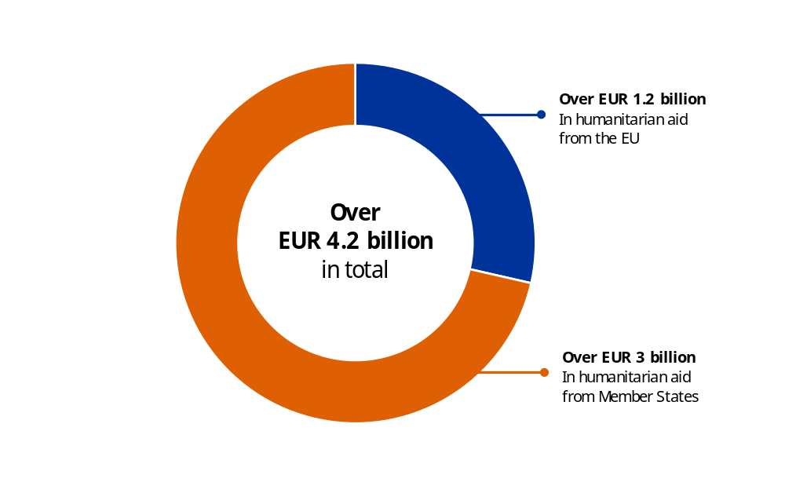
Supporting people in Ukraine
From 2022 to 2025, the EU has provided the following to the people in Ukraine ():
- EUR 220 million in humanitarian aid funding responding to the needs of the most vulnerable;
- EUR 100 million dedicated to supporting safe access to education for children in Ukraine;
- EUR 60 million for projects aimed at building the capacity of Ukrainian universities, vocational education and training institutions, and sport and youth organisations under Erasmus+;
- EUR 65 million for free, healthy school lunches for 700 000 primary school students in Ukraine;
- more than EUR 50 million to support Ukraine’s cultural and creative sectors, including over EUR 11.5 million dedicated to cultural heritage;
- more than EUR 700 000 in mobility grants for artists and cultural professionals;
- EUR 123 million to support civil-society organisations in Ukraine.

Military support and defence research
The EU and the Member States have provided around EUR 69.3 billion in military support since 2022 through the European Peace Facility. EUR 6.1 billion of this has been channelled via the European Peace Facility. Additionally, the EU has provided EUR 3.7 billion from the proceeds of Russian immobilised assets, out of which EUR 3.3 billion were channelled to the European Peace Facility and EUR 0.4 billion to the Ukraine Facility. The EU trains the Ukrainian Armed Forces through the EU Military Assistance Mission in support of Ukraine, which has so far trained around 85 000 Ukrainian military personnel.
The EU is also providing defence research and innovation instruments, mainly through the European Defence Fund. In 2025, the EU adopted the regulation to incentivise defence-related investments in the EU budget, which enabled the association of Ukraine to the European Defence Fund, with the objective of further enhancing industrial cooperation between the EU and Ukraine. Moreover, the EU announced the launch of BraveTechEU, a joint EU–Ukraine initiative aimed at bringing closer together the EU and Ukrainian defence innovation ecosystems to develop battlefield-proven solutions.

Restrictive measures
The EU adopted four additional packages of sanctions against Russia and Belarus in response to its war of aggression against Ukraine, further cutting access to critical technology, industrial goods and financial services, and reducing Russia’s revenue streams, in particular from energy. In order to increase the effectiveness and impact of the sanctions, the EU continued to put greater emphasis on anti-circumvention measures in the area of trade and energy, including the targeting of the shadow fleet used by Russia to evade the oil price cap. In parallel, the EU reinforced its cooperation and outreach to non-EU countries.

EU enlargement and the EU’s wider neighbourhood
In 2025, the EU provided a wide range of support to enlargement countries, including the following.
- EUR 184 million in support disbursed under the Reform and Growth Facility for the Western Balkans.
- As of June, the Western Balkans Guarantee 4 SME Resilience had committed the last of its EUR 60 million in EU funds, unlocking a total of EUR 886 million in financing to support the sustainable growth of small and medium-sized enterprises in the region.
- EUR 288.9 million was disbursed under the new Reform and Growth Facility for Moldova.
In 2025, the Commission finalised the programming of the Instrument for Pre-Accession Assistance III bilateral and multi-country multiannual action plans in favour of the Western Balkans and Türkiye, with the exception of Kosovo (). Actions adopted included a multi-country and civil society facility and media multiannual action plan for 2025–2027 worth EUR 553.9 million; a multiannual action plan covering bilateral actions in favour of Albania, Bosnia and Herzegovina, Montenegro, North Macedonia and Serbia for 2025–2027 of EUR 491.9 million; a multiannual action plan in favour of Türkiye for 2025–2027 for EUR 311.7 million; and a multiannual action supporting essential needs for refugees and migration management in Türkiye for 2025–2027 of EUR 1.15 billion.
Moldova became a candidate country in 2022. The EU has cooperated with Moldova via the framework of the European Neighbourhood Policy and the Eastern Partnership. In February 2025, in the context of the energy crisis caused by the insecurity of Russian supplies, the Commission and Moldova agreed on a two-year comprehensive strategy for energy independence and resilience, providing quick EU support of up to EUR 160 million to the country. In March, the Reform and Growth Facility for Moldova was created, a new financing tool of EUR 1.9 billion (2025-2027) to enact the Growth Plan. In June 2025, Moldova received EUR 270 million in pre-financing loans under the facility, and EUR 24.3 million was released as non-repayable support. Continued financial support under the facility is conditional upon successful implementation of reform. In September 2025, having established that Moldova had met four reform indicators from the Agenda, the Commission made its first regular payment under the facility, unlocking EUR 18.9 million in loans. The reforms included the development of open and competitive electricity and gas markets, along with measures to guarantee energy security.
In the Eastern Neighbourhood, the Eastern Partnership continues to be the overarching policy framework to enhance regional cooperation, promote stability and economic growth and bring partner countries closer to the EU. Assistance through multi-annual action programmes covering the 2025-2027 period was approved in July for Armenia, Azerbaijan, Belarus, Georgia and Moldova, totalling EUR 668.2 million.
In the Southern Neighbourhood, a multiannual cooperation programme was adopted for Libya, with a budget of EUR 102 million to support governance and stabilisation (EUR 55 million), economic growth and digital transformation (EUR 23.5 million), along with climate, energy and environmental action (EUR 23.5 million). Moreover, in 2025, the Strategic and Comprehensive Partnership with Egypt (concluded in 2024) supported Egypt’s green transition and overall social and economic development. The partnership also includes an ongoing macro-financial assistance operation of up to EUR 4 billion to support Egypt’s financial situation, out of which EUR 1 billion was disbursed in January 2026. Furthermore, in September 2025, the EU disbursed the first instalment of the ongoing macro-financial assistance operation to Jordan, amounting to EUR 250 million. Furthermore, the adoption of the Pact for the Mediterranean provided a new framework for EU-Southern Mediterranean relations.
In 2025, the volatile situation in the Middle East highlighted the need for a more structured and coordinated approach to cooperation in the region. The EU presented a proposal for a multiannual comprehensive programme for Palestine’s recovery and resilience for the period 2025–2027, for an amount of EUR 1.6 billion. Moreover, cooperation and engagement with the Gulf Cooperation Council (GCC) and individual Gulf countries were strengthened, particularly in the areas of security, climate change, digital cooperation, and the energy transition. In addition, Syria’s efforts to restart its economy, including through reinforced capacity building and support to key economic sectors, were supported with EUR 139 million.

The EU’s foreign policy and international relations

International partnerships
The Global Gateway is instrumental in supporting the EU’s international partnerships. In 2025, the EU and its Member States continued scaling up the Global Gateway strategy. The second Global Gateway Forum was organised and President von der Leyen announced that the EU, Member States and European financing institutions, following a Team Europe approach, had mobilised over EUR 306 billion in investments, exceeding the original EUR 300 billion target.
The 25th anniversary of the EU–African Union partnership was celebrated in 2025. Through the Global Gateway, by 2025 the EU mobilised EUR 120 billion for projects across Africa. At the G20 Summit in South Africa, the final pledging event of the Scaling up Renewables in Africa Global Gateway campaign mobilised EUR 15.5 billion for clean energy and access to electricity across the continent ().
Throughout 2025, the EU-Latin America and the Caribbean (LAC) Global Gateway Investment Agenda delivered tangible results, reaffirming the EU’s position as the leading investor in the region. More than 80 projects advanced in their implementation, illustrating the strength of the Team Europe approach and its concrete impact on the ground, including, for example: regional electricity integration, the EU-LAC high- performance computing network and the valorisation of sargassum in the Caribbean.
In 2025, a Team Europe Global Gateway investment package mobilised EUR 12 billion for Central Asia and, at the first-ever EU–Pacific Business Forum, the Commission announced nearly EUR 300 million of Global Gateway investments dedicated to the entire Pacific region. The EU also introduced a EUR 42 million initiative to strengthen Asia-Pacific capacities in using Copernicus data for spatial planning and climate change mitigation.
The European Fund for Sustainable Development Plus contributed to the expansion of the Global Gateway by sharing the risks of development finance partners when they mobilise their own resources, thereby attracting additional investors, notably from the private sector. In 2025, the EU budget provided cover for European Investment Bank loans of approximately EUR 4 billion, which are expected to leverage EUR 14 billion in total investment. The extended guarantee also covered open architecture guarantees for EUR 2.5 billion, with an estimated total investment of at least EUR 5 billion. Examples of open architecture guarantees under the European Fund for Sustainable Development Plus include scaling up sustainable finance in Africa (), contributing to a reliable and sustainable energy supply in Africa and the Asia Pacific region () and access to finance for small and medium-sized enterprises, particularly start-ups and woman-led enterprises, in Africa and the European Neighbourhood ().
As part of the EU–Overseas Countries and Territories cooperation, the Decision on the Overseas Association, including Greenland has supported actions up to 2025 amounting to EUR 366.3 million. In 2025, the first three new intra-regional actions were adopted for a total of EUR 4.8 million: one intra-regional programme for the French Southern and Antarctic Lands, a programme dedicated to culture and a support-measures programme, both covering all overseas countries and territories. Territorial cooperation continued to cover several sectors from water to energy, tourism or natural capital. The EU supported, for example, cases such as the disaster risk reduction policy of Saint Barthélemy, supported with EUR 2.5 million, where by 2025 the territory had acquired four rescue and assistance vehicles, carried out training courses on search and rescue and installed a tsunami alert system.

Supporting peace and security
Under the Neighbourhood, Development and International Cooperation Instrument – Global Europe, in 2025 the EU supported 85 crisis response interventions amounting to EUR 228.85 million, and other interventions related to foreign policy needs totalling EUR 112.45 million. This included responding to Russia’s war of aggression against Ukraine, supporting the Middle East peace process, addressing instability in Lebanon, Sudan and Syria and fighting disinformation in the Sahel and Moldova. Moreover, EUR 121.5 million was provided for resilience and peacebuilding. In the case of Afghanistan, in 2025 the Commission adopted an EUR 83 million programme to support basic needs and livelihoods under the ‘for women, by women’ principle and allocated an additional EUR 38.5 million to address the displacement crisis. To support peace and security in South Asia, the EU launched a EUR 5 million programme ‘Supporting Asian countries’ resilience to violent extremism in the digital space’ and adopted a regional programme to support resilience and cross-border cooperation, notably to respond to challenges posed by technology-enabled crime and terrorism.
Under the common foreign and security policy, in 2025 the EU financed, with a total of EUR 416.7 million, 13 civilian common security and defence policy missions; 13 EU Special Representatives; and 30 ongoing non-proliferation and disarmament actions, with 12 actions launched in 2025.
In the context of the Global Alliance to Counter Migrant Smuggling, the Commission launched an action on the financial and digital dimensions of migrant smuggling as part of a EUR 78 million EU funding package. The Commission also makes use of funds from the Asylum, Migration and Integration Fund towards actions under the Global Alliance to Counter Migrant Smuggling, including EUR 10 million in 2025, and contributed with approximately EUR 12 million through the Internal Security Fund to the Common Operational Partnership with non-EU countries to counter migrant smuggling and trafficking in human beings.

EU provision of humanitarian aid
The current hardening geopolitical context and the impacts of climate change are exacerbating tensions, fuelling existing conflicts and extending protracted crises. In this context, the EU remains a reliable and principled humanitarian actor.
In 2025, the EU continued its support to Palestine (). The situation in the occupied Palestinian territory has deteriorated dramatically following the October 2023 terrorist attacks on Israel and the ensuing military operations by Israel in Gaza and the West Bank, resulting in a catastrophic humanitarian situation, large-scale destruction and suffering, with the entire population of Gaza (2.1 million) subject to security and protection risks of unprecedented severity. Under the humanitarian aid programme, EUR 220 million was committed to address the needs of the occupied Palestinian territories where the entire population of Gaza is facing acute food insecurity. In April 2025, the Commission presented a proposal for a EUR 1.6 billion multiannual and comprehensive programme for Palestinian recovery and resilience (2025-2027). Part of the funds (i.e. EUR 0.5 billion) was committed in 2025.
Furthermore, in 2025 the EU provided EUR 2.56 billion in humanitarian aid to the most vulnerable people. Overall, the EU and its Member States are providing around 33.8% of the global share of committed humanitarian aid contributions. Examples of this support include:
- EUR 273 million in response to the crisis in Sudan, which continues to be the world’s largest displacement crisis;
- EUR 129 million to the African Great Lakes Region, in response to the dramatic escalation of conflict in the eastern part of the Democratic Republic of the Congo;
- EUR 124 million in humanitarian assistance, chiefly food security and nutrition, to the Central Sahel region, despite growing humanitarian access restrictions, to address the crisis triggered by forced displacements to the Gulf of Guinea and Mauritania;
- EUR 55 million to address the conflict in Myanmar, along with over 1 000 metric tonnes of aid via multiple humanitarian air bridges;
- EUR 39 million in humanitarian aid to Rohingya refugees in Bangladesh;
- EUR 52 million to help people in Venezuela have, among other things, access to health services and clean water.
EU humanitarian aid in 2025
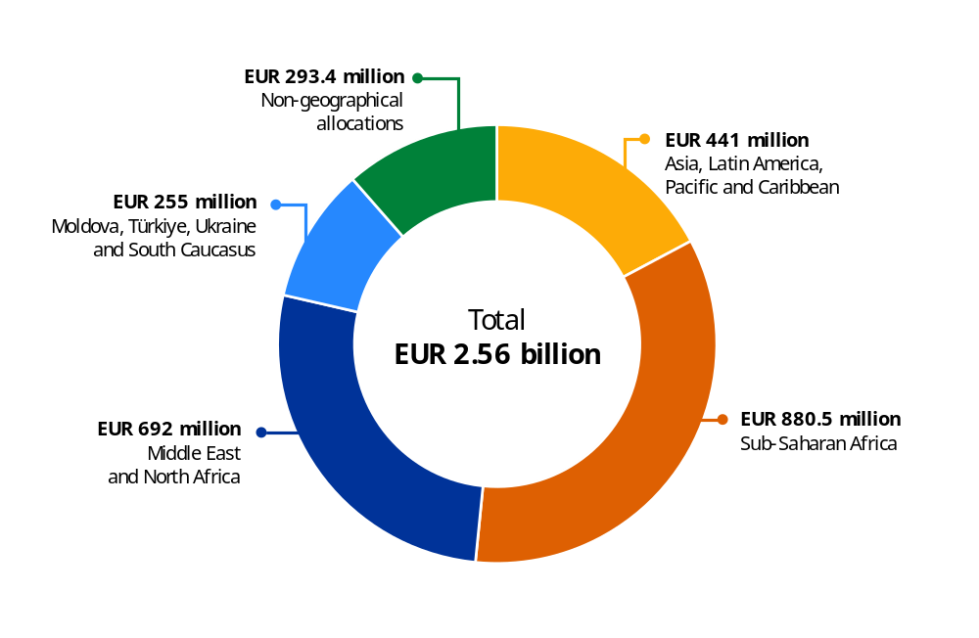
NB: Support for Moldova, Türkiye, Ukraine and South Caucasus includes EUR 2 million for Central Asia, allocated within the Humanitarian Implementation Plan for Türkiye.
In 2025, over EUR 110 million was allocated for the operational activities of ReliefEU. During 2025, ReliefEU funding was mobilised a total of 118 times in 60 countries, providing a total of EUR 53.5 million in first-line emergency humanitarian funding. ReliefEU capacities responded to 20 crises affecting 18 countries.

Delivering together and preparing our Union for the future
We want a budget that ensures Europe's agency in a fast-changing world. A budget that is faster and more ambitious. Simpler and more flexible. A strong budget for Europe's independence moment ().
Ursula von der Leyen
President of the European Commission

Working on an ambitious budget for the future
In 2025, the Commission adopted its proposal for the 2028-2034 multiannual financial framework, designed to provide a simpler, more flexible and future-proof budget, and to respond to growing geopolitical, economic and sustainability challenges. At nearly EUR 2 trillion (equivalent to 1.26 % of the EU gross national income), with about EUR 25 billion annually (0.11% the EU gross national income) for the repayment of the loans used to finance NextGenerationEU, it would provide a simpler, more flexible and more targeted budget to support the EU’s independence, security, prosperity, inclusiveness and resilience in the coming decade.
The Commission proposal is anchored on three main pillars:
- fostering the achievement of the EU’s priorities at the local, regional and national levels with the new national and regional partnership plans worth EUR 865 billion;
- delivering on a more competitive Europe though the European Competitiveness Fund and Horizon Europe, worth EUR 409 billion;
- building long-term, mutually beneficial partnerships with non-EU countries though Global Europe, worth EUR 200 billion.
These main pillars are complemented by other programmes, including the EU’s flagship programmes for infrastructure investments (the Connecting Europe Facility) and for investing in people and values (Erasmus+ and AgoraEU).
Overall, the next proposed multiannual financial framework would:
- provide greater flexibility across the EU budget, thus allowing the EU to act and react quickly when faced with unexpectedly circumstances or new policy priorities;
- be simpler, with more streamlined and harmonised EU financial programmes, making it easier for people and businesses to access funding opportunities;
- be more adaptable to local needs, with national and regional partnership plans allowing more targeted impacts and greater flexibility for supporting economic, social and territorial cohesion across the EU;
- boost competitiveness via greater support for innovation, technological development and for secure supply chains;
- establish new own resources to ensure appropriate revenues for EU priorities while minimising pressure on national public finances.
The proposal also provides for innovative financing via five new own resources, to reduce pressure on national budgets. These will provide the EU with the means to fund its priorities while repaying what the EU has borrowed under NextGenerationEU and limiting the national contributions to the EU budget. These include revenues from the EU Emissions Trading System, proceeds from the Carbon Border Adjustment Mechanism, a new own resource based on non-collected e-waste, a tobacco excise duty and a contribution from companies operating and selling in the EU with a net turnover of at least EUR 100 million.
Proposal for the 2028-2034 multiannual financial framework
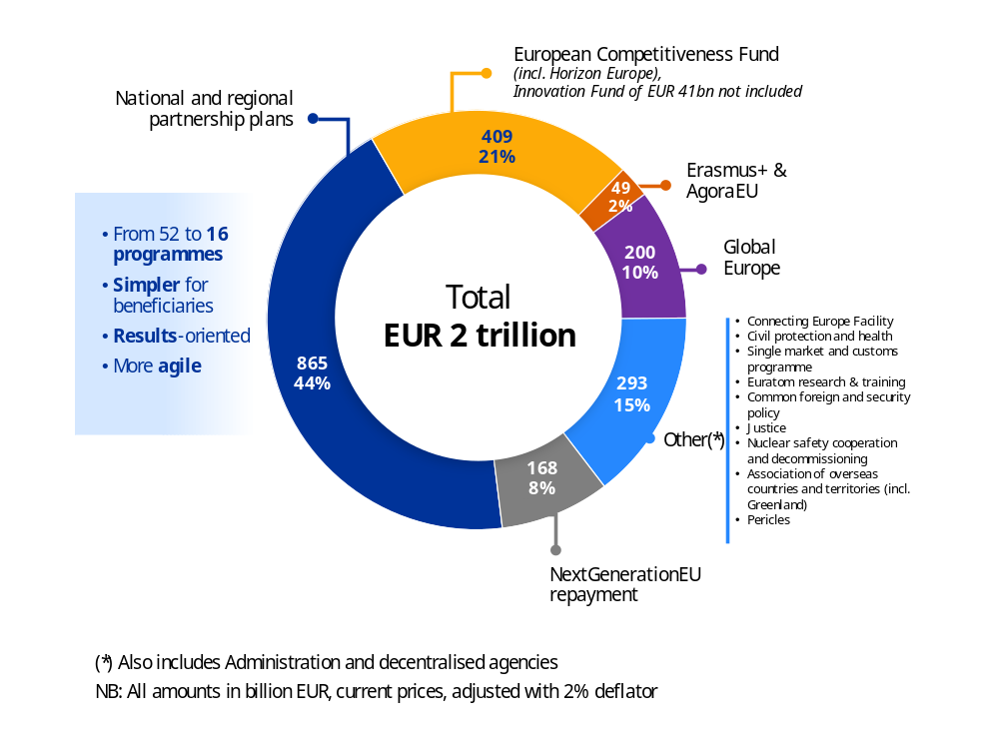

4. Horizontal policy priorities in the EU budget
This section provides information on the financing of initiatives relating to the objectives of climate, biodiversity, gender equality and SDGs, as provided for in point 16(d–g) of the interinstitutional agreement of 16 December 2020 (). Information on the contribution of the EU budget to the promoting the digital transition is also provided.

Green budgeting
The Commission uses green budgeting to enhance the transparency of EU funding and support the achievement of climate and environmental objectives, in line with the Paris Agreement and the European Green Deal.
To underscore its commitment to its climate and environmental goals, the EU has set quantitative spending targets for its 2021-2027 multiannual financial framework and NextGenerationEU funding. In particular, the EU has committed to dedicating at least 30% of its multiannual financial framework and NextGenerationEU budget to climate-relevant expenditure, and 7.5% of the 2024 annual budget and 10% of the 2026 and 2027 annual budgets to protecting and enhancing biodiversity.
Expected climate and biodiversity contribution (budgetary commitments) in the 2021-2027 period (million EUR)
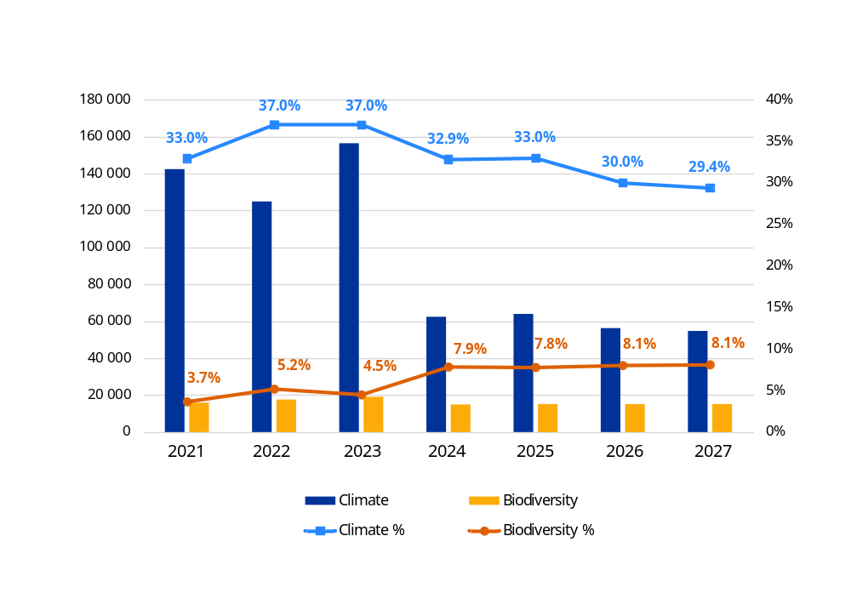
NB: As the same action can contribute to more than one objective, it is important to recall that horizontal priorities (e.g. climate and biodiversity figures) cannot be summed up to avoid double counting.
Source: European Commission.
The data available for the 2021-2027 period show that the EU budget, including NextGenerationEU,
is on track to reach its 30% target for climate mainstreaming over the period, thanks to the strong contribution from the Recovery and Resilience Facility and the REPowerEU plan. The figures presented
in this report use past commitments for the years 2021-2025 and expected commitment appropriations
for 2026-2027 ().
The Innovation Fund, financed by revenues from the Emission Trading System and channelled through the EU budget, provides important impetus to the climate objectives. The Modernisation Fund, an off-budget instrument financed by the Emission Trading System, also contributes to the climate efforts of Member States.
For biodiversity mainstreaming, while the 2024 ambition was achieved, the 2026 and 2027 targets are projected to fall below the initial ambitions. More details are available in the dedicated biodiversity section below.
The climate and biodiversity contributions are calculated based on commitment appropriations, as shown below.
- For direct management, estimates are prepared based on the most updated data available. For future estimates, work programmes, sectoral targets and historical values are used.
- For shared management, past and future figures are presented on the basis of the programmes and CAP strategic plans agreed with the Member States, and updated in accordance with the annual reports.
- For indirect management, the figures are based on the existing targets and agreements with implementing partners, along with their annual reports.
- Past expenditure is revised annually following a quality review conducted by Commission departments, incorporating additional information available on the selected project.

Focus on results ()
49 gigawatt-hours of estimated energy efficiency savings per year from private and public buildings. | 1 380 additional gigawatt-hours  of renewable energy capacity installed.
124 million tonnes of carbon dioxide equivalent avoided per year, of which almost half was through NextGenerationEU green bond investment. Additionally, 962 million tonnes of carbon dioxide reduction are expected from the Innovation Fund, ongoing or completed projects, over their first 10 years of operation.

A clear focus on results is essential for effective green budgeting and EU budget implementation in general. The results stemming from available indicators can be used to achieve more targeted spending and to improve steering of the EU budget. It can also make the green transition more efficient by improving accountability. The latter is also important in view of the need to contribute to multiple international commitments.
The focus on emission reductions through energy efficiency and renewable energy expansion is crucial for achieving the EU’s climate neutrality goals and achieving the 2030 targets. The above results show that the EU budget is helping Member States to diversify their energy mix and gradually reduce their reliance on fossil fuels. This results in lower energy costs and decreased emissions of greenhouse gases and air pollutants, helping combat climate change.

Measuring the impact of NextGenerationEU investment
In December 2025 the Commission published the third annual impact report for NextGenerationEU green bonds. The reports mark a major achievement in transparency, enabling the measurement of the concrete climate impact of the investment financed by these bonds.
Building on the robust EU green bond framework, the report is based on detailed analyses of the milestones and targets for green-bond-financed investment under the Recovery and Resilience Facility. This provides the basis for calculating their climate impact, allowing the measuring of progress on the path to a sustainable future and ensuring a direct link between funding and climate impact.
The analysis shows that after full implementation, NextGenerationEU green bond investment has the potential to avoid greenhouse gas emissions by a total of 53.4 million tonnes of carbon dioxide equivalent per year – equivalent to 1.5% of the EU’s total emissions in 2022. The report estimates a current annual reduction of 14.0 million tonnes of carbon dioxide equivalent, a figure that represents 26.2% of the total projected amount and continues to increase as the implementation of the Recovery and Resilience Facility accelerates (compared with 2.7% in 2024).

EU-supported activities and the EU taxonomy for sustainable finance
For the third consecutive year, the ‘programme performance statements’ (Annex 4 to this report) of several key EU budget programmes include an analysis of how their supported activities relate to the EU taxonomy for sustainable activities. This addition provides an important starting point for future analyses of how EU spending contributes to a greener future ().
While the analysis of the relationship between the supported activities and the taxonomy in the Recovery and Resilience Facility has been detailed previously in the context of NextGenerationEU green bond reporting,
the scope covers additional programmes that may invest in activities covered by the EU taxonomy.
This approach offers a more comprehensive view of the EU’s commitment to sustainable financing across its various initiatives.

Support to climate and environmental objectives in the 2028-2034
long-term budget
The impact assessment () underpinning the Commission proposal for a Performance Regulation highlighted the lessons learned from the current programming period. It identified a number of positive developments and challenges, such as the lack of a harmonised methodology to track contributions to green objectives across EU budget programmes, overlaps in tracking between climate and biodiversity and a lack of programme-specific targets for biodiversity.
As a result, for the 2028-2034 multiannual financial framework, the Commission proposed a spending target of 35% of the EU budget, covering all climate and environmental objectives, including circular economy, water and clean air, in addition to climate change mitigation and adaptation, and biodiversity, while avoiding risks of double counting. The proposal further includes programme-specific spending targets for national and regional partnership plans, the European Competitiveness Fund, Horizon Europe, the Connecting Europe Facility and Global Europe. The contribution of all EU budget programmes to climate and environmental policies will be tracked according to a harmonised methodology set out in the Performance Regulation, allowing to track contributions relevant for the European Green Deal.
The proposed Performance Regulation further introduces, for the first time, a harmonised set of output and result indicators applicable across all EU budget programmes. This would allow the aggregation of performance data at the EU budget level and strengthen monitoring of climate action and environmental protection. The framework includes indicators such as ‘annual GHG emissions avoided (tCO2e)’, ‘new or additional energy capacity installed in electricity production (MW)’ and ‘hectares of protected or restored areas’.
The Commission also proposed a horizontal and systemic approach to integrate the do no significant harm principle across all EU programmes. Guidance on do no significant harm will define environmental and climate conditions, building on the lessons learned from the implementation of the do no significant harm principle in existing programmes.

Climate mainstreaming

Examples of achievements
LIFE projects have achieved a reduction of 14 162 593 tonnes of carbon dioxide equivalent per year, annual primary energy savings of 8 332 gigawatt-hours and additional renewable energy production of 3 153 gigawatt-hours per year. Over 3.5 million citizens have benefited from reduced vulnerability to climate change. | Under Global Europe (Neighbourhood, Development and International Cooperation Instrument), the EU is actively advancing the green transition in the Eastern Partnership through targeted programmes delivering concrete results. The EU4Climate Resilience programme (EUR 17 million) provides technical support and pilot projects to strengthen climate adaptation at the municipal level, helping partner countries meet their Paris Agreement commitments and align with EU legislation.
In the ‘Cities’ mission of Horizon Europe, 103 cities have formally committed to climate neutrality, with an expected reduction of carbon dioxide emissions equal to approximately 6.2% of the EU total in 2023. | Under the CAP, actions to enhance carbon sequestration and storage in soils and biomass have been carried out on 38% of the EU’s agricultural area.
Cohesion Policy plays a key role in strengthening climate adaptation not only through infrastructure investments, but also by supporting the development and implementation of climate adaptation strategies. By the end of 2025, the funds have supported the creation of 52 strategies across EU regions, ensuring a structured and long-term approach to resilience.

How much do we spend?
Climate contribution in the 2021-2027 period (million EUR)
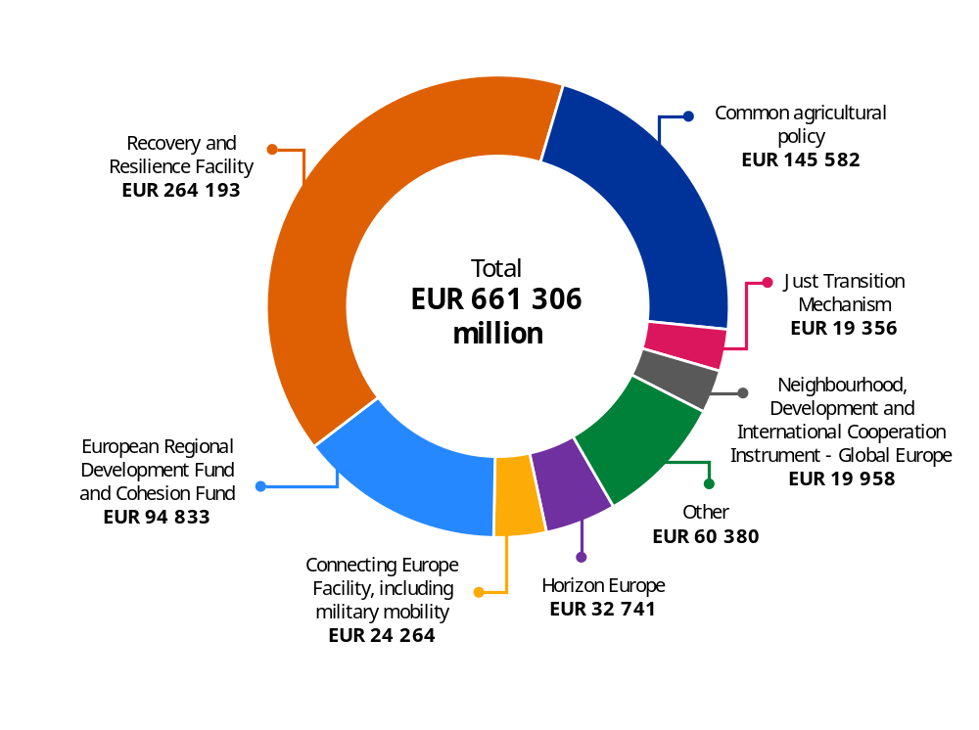
Source: European Commission.
For the 2021-2027 period, the EU budget – including NextGenerationEU – is projected to contribute EUR 662 billion to climate mainstreaming objectives, representing 34% of the budget envelope, surpassing the initial target of 30%. Additionally, through the InvestEU programme, the EU budget is expected to help mobilise over EUR 128 billion in investment to meet EU climate goals.

Differentiating between climate change mitigation and adaptation expenditure
Under the interinstitutional agreement of 16 December 2020, the Commission committed to report on climate expenditure, differentiating between climate change mitigation and adaptation, where feasible. To allow for such reporting, an external study was commissioned to assist in developing a methodology to disaggregate climate expenditure across these two dimensions.
The methodology was designed to avoid creating additional administrative burdens by building on the existing system of intervention fields used under the Common Provisions Regulation for cohesion funds and the Recovery and Resilience Facility. For external action programmes, existing methodologies were used, while for the CAP, the methodology was developed as a part of a specific study commissioned for this policy.
Climate contribution in the 2021-2025 period disaggregated by climate mitigation
and climate adaptation
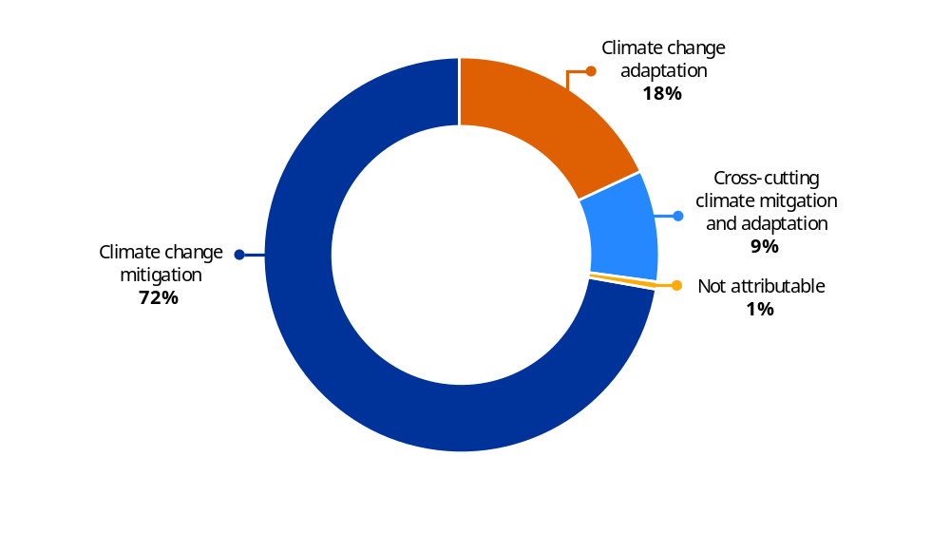
NB: Figures for the CAP refer only to the 2023-2025 period.
Source: European Commission.

Biodiversity mainstreaming

Examples of achievements
65 million hectares of land are covered by selected projects to protect against wildfires under cohesion policy funds. The Copernicus monitoring services contribute to monitoring changes in ecosystems and biodiversity loss,  in support of the EU biodiversity strategy,  the EU Nature Restoration Regulation, the Convention on Biological Diversity and reporting on the SDGs. | Under LIFE, biodiversity loss has been halted  or reversed across 2.0 million hectares of habitats, and 557 species have benefited from conservation effort.
2 691 measures contributing to ‘good environmental status’ were selected between 2022 and 2024 under the European Maritime, Fisheries and Aquaculture Fund. | 41 million Hectares (25.3% of EU farmland)  are covered by biodiversity conservation  and restoration commitments in 2024  under the CAP.

How much do we spend?
Biodiversity contribution in the 2021-2027 period (million EUR)
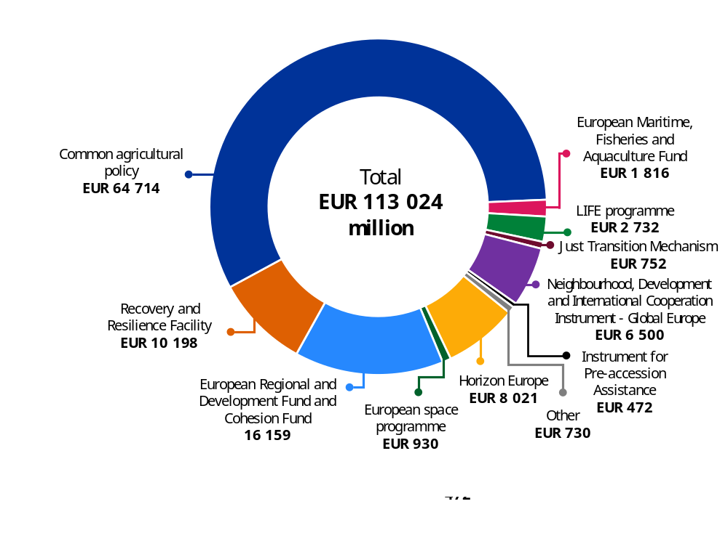
Source: European Commission.
For the 2021-2027 period, the EU budget – including NextGenerationEU – is contributing EUR 113 billion, or 5.8% of the total budget, to biodiversity mainstreaming objectives. While the ambition of allocating 7.5% of the EU budget to biodiversity in 2024 was achieved, the 10% targets for 2026 and 2027 are projected to fall below the initial ambitions.
The CAP methodology for the 2023-2027 period gives more granular and accurate results compared with the previous period. As from the 2024 draft budget, the contribution of the CAP to biodiversity is estimated by the Commission through the application of EU coefficients (100%, 40% and 0%) and weighting factors (100%, 70% and 50%) that aim to reflect the differentiated contribution of each type of intervention towards the biodiversity objectives. Furthermore, given the design of the CAP and the cohesion policy – and the financial programming of the two programmes – it is not possible to assign resources to specific years, as projects have a multiannual nature that cannot be attributed to a single year.

Gender equality mainstreaming
In response to persistent gender gaps and intersecting inequalities, the EU has intensified efforts to make
its budget and policymaking more inclusive. Challenges such as the cost-of-living crisis, care burden disparities and unequal access to digital and green jobs have highlighted the need for sustained investment
in gender equality.
As a result, gender mainstreaming is now embedded across major EU policies and funding programmes, including the European Social Fund Plus, the European Regional Development Fund, the Just Transition Fund, Horizon Europe, the CAP and the Neighbourhood, Development and International Cooperation Instrument – Global Europe. These tools promote equal access to resources, economic participation and social protection, along with the prevention of conflict-related violence and participation in peace processes – particularly for women and under-represented groups.
Looking ahead, a new gender equality strategy for 2026–2030 was published in March 2026, following up on the 2024 political guidelines for the 2024-2029 Commission. The strategy not only builds on past achievements but also sets a new benchmark in advancing gender equality, marking a decisive step forward in both ambition and accountability. It responds to emerging challenges with a more robust and forward-looking approach, while significantly enhancing the way financial contributions to gender equality are tracked and measured.

Examples of achievements
The citizens, equality, rights and values programme contributed strongly to the three pillars
of the EU gender equality strategy, with 25% of the programme’s budget having gender equality
as a primary objective. In 2025, this was mainly driven by the Daphne call, which aims to prevent
and combat gender-based violence and violence against children, where EUR 15.4 million out of EUR 23 million contributed to score 2. Overall, approximately 54% of the programme budget was allocated to gender score 1, demonstrating strong gender mainstreaming across programme actions.
Under Horizon Europe, gender equality is a cross-cutting priority. Under the programme, research
and innovation contribute to gender equality primarily through the effective integration of the gender dimension in research and innovation content, i.e. the consideration of sex and gender differences in research objectives, methodologies, data collection, analysis and results. The Improve project supports victims of domestic violence – particularly those from marginalised groups – by developing AI tools for reporting, detection and assistance. Moreover, the grass ceiling project (Cluster 6) addresses gender inequalities by co-designing solutions with rural women innovators. Through community hubs, it brings together women farmers, enterprise officers, financial institutions and researchers to identify barriers, co-create support systems and generate new businesses, partnerships and policy recommendations.
With EUR 2.4 million in funding, the European Social Fund Plus supports the project ‘FairPlusService’ in Austria to enhance the professional development and further training of formally low-skilled and unqualified women, fostering equal opportunities and empowerment. The initiative targets women with limited formal qualifications, offering a range of measures to support employment, such as providing compact training and short learning units to stimulate continuous skill development, along with tailored consulting and coaching services for both Austrian companies and the women themselves. The project focuses on key sectors such as trade, tourism, health and social care and education, where advisory services are delivered to bridge skill gaps and promote career advancement. These services are complemented by comprehensive outreach efforts and broad knowledge-sharing initiatives to ensure long-term impact. Overall, the project seeks to promote long-term employment stability, gender equality and labour market participation for some of Austria’s most vulnerable women.
The European Regional Development Fund continues to play a pivotal role in advancing gender equality through a dual approach of gender mainstreaming and targeted interventions. For the
2021-2027 programming period, a total of EUR 19.9 billion has been earmarked for gender-targeted and mainstreaming measures. For example, this support will facilitate the participation of women in research and innovation, embed a gender lens in sustainable urban development and renewable energy transitions and alleviate the disproportionate care burdens shouldered by women by improving access to quality care services.
The Recovery and Resilience Facility supported a wide range of measures contributing to gender equality. These include investments and reforms specifically designed to tackle inequalities based on gender (score 2, contributing to this objective with around EUR 12.4 billion over the lifetime of the Recovery and Resilience Facility) and other type of investments and reforms which are directly or indirectly contributing to gender equality (score 1, corresponding to around EUR 5.7 billion). For example, a measure specifically designed to tackle gender inequalities is the Portuguese reform to combat inequalities between women and men, which awards a seal to companies with a narrow gender pay gap. An example of measures directly or indirectly contributing to gender equality includes investments and reforms improving the access to and the quality of long-term care, for which women traditionally take a disproportionate burden in households in Czechia, Estonia, Spain, Cyprus, Lithuania, Austria, Poland, Slovenia and Slovakia.
Under the Instrument for Pre-accession Assistance III, 35% of all actions adopted between
2021 and 2025 have gender as a significant or principal objective and an increasing number of country and regional actions have gender equality as a principal objective. These targeted actions include, amongst others, the fight against gender-based violence in North Macedonia through the ‘We care: United we stand to fight against sexual and gender-based violence’ action, which empowers civil society organisations to encourage positive behavioural change across society for the effective protection of women. In Albania, the EU supports equal participation and leadership through the ‘EU for Gender Equality II – Gender Equality Facility in Albania’, which seeks to promote the consistent application of gender-responsive governance by national authorities, to strengthen equality, combat discrimination, and enhance women's empowerment and human rights, in line with the EU acquis on gender equality.
Under the Neighbourhood, Development and International Cooperation Instrument – Global Europe, between 2021 and 2025, the share of external actions contributing to gender equality and women’s empowerment reached 83% and, of these, 4.7% (about 90 programmes at the country, regional and global levels) had gender equality as a principal objective. For instance, the Advocacy, Coalition Building and Transformative Feminist Action Programme is a EUR 22 million initiative funded by the EU and implemented by UN Women. The programme strengthens women’s rights movements to advocate and work with public authorities on policy and legal reforms and accountability mechanisms to end all forms of violence against women and girls, particularly in contexts of shrinking civic space.
In 2025, through the programme, women’s rights organisations and activists shaped more than 20 global and regional normative and policy processes, such as the adoption of the Mercosur Agreement
on the Mutual Recognition of Protection Measures for Women in Situations of Gender-Based Violence, the ratification of the International Labour Organization’s Convention 190, and continental justice
and accountability frameworks, notably the African Union Convention on Ending Violence against Women and Girls.

How much do we spend?
In line with the 2020-2025 gender equality strategy, the 2021-2027 multiannual financial framework and NextGenerationEU support a range of initiatives promoting women’s labour market participation, work–life balance, care infrastructure, female entrepreneurship and gender balance in education and professions. Dedicated funding also supports civil-society and public institutions tackling gender-based violence.
The Commission developed a methodology to track gender-related spending at the programme level, in collaboration with the European Institute for Gender Equality and informed by the European Court of Auditors’ 2021 report on gender mainstreaming in the EU budget ().
Since the 2023 financial year, the monitoring of gender expenditure has been enhanced with the inclusion
of the gender-disaggregated data available per programme in the programme performance statements (Annex 4 to the present report).
The EU budget allocation to gender equality scores
The EU budget allocation to gender equality scores, based on the aggregation of the 2025 interventions qualifying for each score, is outlined below. In line with the methodology, a programme may qualify for one or more gender scores based on the objectives pursued by its respective interventions.
- Score 2: interventions whose principal objective is to improve gender equality corresponded to
1% of the EU budget implemented in 2025 and were included in 13 programmes.
- Score 1: interventions that have gender equality as an important and deliberate objective (but not as the main reason for the intervention) corresponded to 19% of the EU budget implemented in 2025 and were included in 22 programmes.
- Score 0*: interventions that have the potential to contribute to gender equality corresponded to 5% of the EU budget implemented in 2025 and were included in 3 programmes.
- Score 0: interventions that do not have a significant bearing on gender equality corresponded to 76% of the EU budget implemented in 2025 and were included in 53 programmes.
In 2025, almost 20% of the EU budget was allocated to measures supporting gender equality (scores 2 and 1), marking a solid continuation from the previous year and confirming that gender equality remains a strong and consistent priority within the EU’s financial framework. This sustained level of ambition demonstrates that promoting gender equality is not a one-off effort, but an objective that is systematically taken into account year after year in budgetary decisions. It reflects a credible and enduring commitment, alongside a deepening integration of gender mainstreaming across budgetary instruments. More broadly, it shows that the EU is increasingly embedding gender considerations into the core of its spending, ensuring that financial resources are consistently directed toward policies and programmes that advance gender equality across Member States.
In concrete terms, this sustained prioritisation translates into significant financial support: in 2025, the EU allocated a total of EUR 37.5 billion to projects promoting gender equality (gender scores 2 and 1), reinforcing both the scale and the credibility of its commitment in this area.
Overall, the 2025 results reflect continued progress across EU programmes, both in implementation and in strengthened reporting capacity, enabling a more precise and granular understanding of how the EU budget contributes to gender equality. The further reduction in expenditure classified as 0* illustrates sustained efforts to refine methodologies, improve clarity and better identify gender-relevant spending – supporting a more accurate recognition of the EU budget’s gender dimension.
At the same time, 0* has now reached a normal and expected level of 5%, which is a striking contrast to the initial amount reported in 2021, namely 95%. Today, 0* primarily reflects the inherent time lag of certain types of projects where gender impacts can only be demonstrated over time. This confirms that 0* is no longer driven by methodological or capacity gaps, but corresponds to the natural life cycle of interventions, indicating that the system is now functioning as intended. In other words, it is no longer systemic, but rather correspeonds to a natural rate. For example, certain actions where integrating the gender dimension in research and innovation is mandatory, such as research under Horizon Europe, require an ex post assessment to verify how this has been implemented. Until such evidence is available, these actions are assigned a 0*, indicating a likely – but not yet demonstrated – positive impact on gender equality. Today, 0* only concerns these types of projects.
Gender scores as a percentage of the total EU budget in 2025
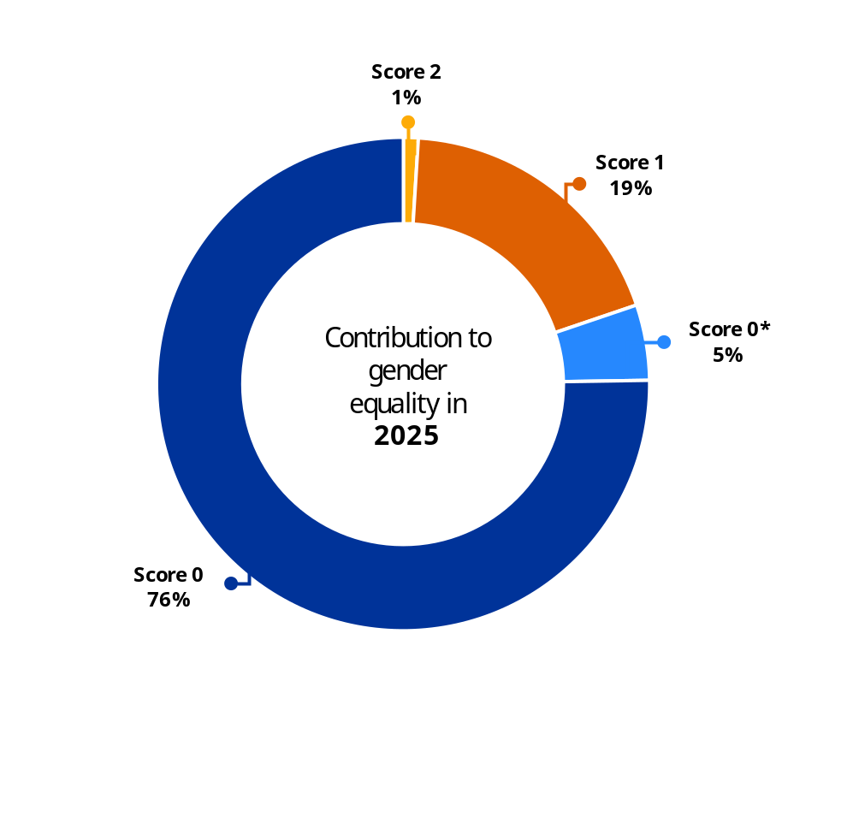
Source: European Commission.

2021-2025 aggregate results
Past expenditure is revised annually through a quality review conducted by the Commission departments, incorporating additional information available on the selected projects. This is particularly the case for measures that were assigned a gender score of 0* in previous years. In this context, the reassessment concluded that, over the 2021-2025 period, 13% of the EU budget expenditure contributed to the promotion of gender (gender scores 1 and 2), amounting to a significant EUR 190 billion over these five years.
At the same time, the share of the EU budget under gender score 0* has steadily declined and now stands at just 3% for the four-year period. This reflects the effectiveness of the Commission’s ongoing reassessment efforts, which have contributed to a more precise and clearer understanding of the EU budget support for gender equality. For the 2021-2025 period, 84% of allocations were assigned a score of 0, due to the systematic reassessment of 0* expenditure from 2021 to 2025.
The financial commitments made over this five-year period had a tangible impact across various domains, including employment, social protection and economic empowerment, reinforcing the EU’s role as a global leader in gender equality financing.
Gender scores as a percentage of the total EU budget (2021-2025)
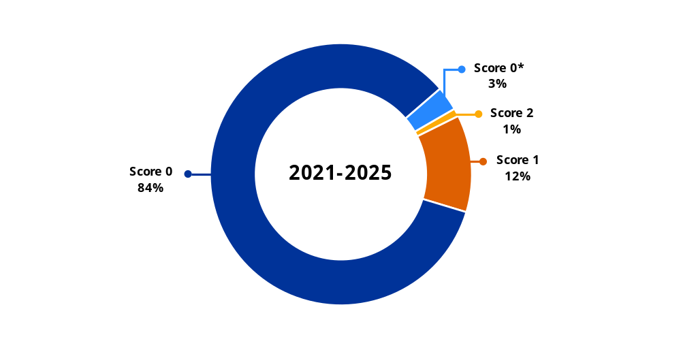
Source: European Commission.

Gender-disaggregated data
This year, for the third time, the programme performance statements (Annex 4 to this report), which provide detailed performance information at the programme level, were enhanced to include the relevant gender-disaggregated information available for each programme. This includes a wide array of gender-disaggregated data aimed at improving the monitoring of the performance of the programme in relation to gender equality. For some programmes, particularly those under shared and indirect management, the availability of gender-disaggregated data is constrained by the programme regulations and the implementation agreements. Looking ahead to the post-2027 multiannual financial framework, Article 44 of the Financial Regulation requires that data relating to performance indicators of financial programmes be gender-disaggregated where feasible, and appropriate in accordance with the relevant sector-specific rules. Building on this, the Commission proposed a Performance Regulation in July 2025. It provides that such data be disaggregated by gender for a set of indicators, where relevant and feasible. This is an important step to improve gender equality monitoring in EU programmes. It also complements the updated better regulation guidelines, which ensure that future ex ante impact assessments of relevant spending programmes consider gender equality from the outset.
Examples of gender-disaggregated data reported in the programme performance statements (Annex 4 to this report)
- Under the Recovery and Resilience Facility, Member States report gender disaggregated data for results and outputs achieved with Recovery and Resilience Facility support within common indicators 8, 10, 11 and 14. For example, research facilities supported by the Recovery and Resilience Facility employed 34 900 male and 23 400 female full-time equivalent researchers in 2025 (common indicator 8). So far, participants in education and training supported by the Recovery and Resilience Facility amounted to a total of 12.9 million participants across all age groups. Out of the total, 7.7 million females and 5.2 million males were reported (common indicator 10). The total number of 7 million people in employment or job-searching activities supported by the Recovery and Resilience Facility is subdivided into 3.7 million females and 3.3 million males across all age groups (common indicator 11). The number of young people aged 15-29 receiving support from the Recovery and Resilience Facility amounted to 863 200 males and 893 400 females (common indicator 14).
- Under Horizon Europe, as of January 2026, women coordinated 32% of Horizon Europe projects (6 281 women). There are large variations across the programme: the share of women is higher in social-science-oriented actions (Cluster 2: 45%) and lower in industry-focused ones (Cluster 4: 23%). Women represent 53.1% of members of Horizon Europe boards and expert groups, with 55.6% in official expert groups (70 women) and 49.3% in special groups (40 women). Among Horizon Europe researchers, women accounted for 38.3% (101 142), compared with 61.6% for men (162 705), while 0.05% identified as non-binary (128).
- Under Erasmus+, in 2024, 60% of the provided mobility opportunities were taken up by women. The gender distribution varies depending on the field of education; adult education has the highest percentage of women (69.3%), followed by school education (65.3%), higher education (60.4%), youth (57.6%), vocational education and training (54.3%) and sport (41.7%)
- Under the CAP, the total number of farmers receiving direct support (provisional data for 2024) was 5 604 178, of which: women: 1 768 426 (31.6%); men: 3 553 350 (63.4%); non-binary: 250 (0.0%); no prevalence: 209 340 (3.7%) and prefer not to say: 72 812 (1.3%).
- Under the European Social Fund Plus, all common indicators on participants are broken down by gender. By the end of 2025, 16.0 million participants had been supported, of whom 8.4 million were women, 7.5 million were men and 0.1 million were non-binary.
- Under the Instrument for Pre-accession Assistance III, 393 418 people directly benefited from EU-supported interventions that aim to reduce social and economic inequality. Available sex-disaggregated data indicates that at least 202 532 were female and 191 068 were male.
- Under the humanitarian aid programme, the percentage of beneficiaries disaggregated by gender in 2025 is as follows: 50% female, 42% male and 8% unknown ().

Support gender equality in the 2028-2034 long-term budget
During the 2021–2027 multiannual financial framework, gender budgeting was strengthened through the introduction of a dedicated expenditure-tracking methodology in 2021 and via mainstreaming across some of the EU budget programmes. This progress resulted in around 13% of the EU budget over the 2021–2025 period supporting gender equality. At the same time, there is clear scope for further progress, as a large majority of expenditure (around 84%) remains classified under score 0, indicating no identified contribution. This reflects, in part, inconsistent provisions across programmes, including on monitoring, limited data availability on gender equality, along with the limited integration of gender equality considerations in impact assessments underpinning the 2021-2027 programmes’ basic acts. These limitations have constrained the overall effectiveness of gender budgeting and highlight the need for a more robust and harmonised EU budget framework to support and monitor gender equality objectives.
In response to these challenges, the Commission has proposed the Performance Regulation for the 2028-2034 multiannual financial framework. Under the Commission’s proposal, gender equality will remain fully integrated as a horizontal principle across EU budget programmes, in line with the requirements from the Financial Regulation. It will allow to reinforce support for objectives such as equal access to the labour market, fair working conditions, women’s entrepreneurship, participation in research and innovation and the fight against gender-based violence.
For the first time, the Performance Regulation introduces binding, horizontal rules to operationalise gender equality across all management modes, ensuring that gender equality considerations are integrated throughout the policy cycle – from planning to implementation and evaluation. It also strengthens monitoring and accountability by requiring gender-disaggregated data in performance indicators where relevant and feasible. In addition, it introduces an enhanced expenditure tracking methodology, building on lessons from the 2021-2027 period, which classifies expenditure according to its contribution to gender equality (scores 2, 1 and 0). Dedicated gender equality guidance will support the implementation of the tracking methodology.
Overall, the proposed framework for the 2028-2034 multiannual financial framework elevates gender equality as a cross-cutting principle across all EU funding programmes, strengthening its integration into the design, implementation and monitoring of EU expenditure. It aims to ensure that gender equality remains a central driver in the implementation of the EU budget.

Digital tracking
The digital transition is a core element of the Commission’s competitiveness agenda. Beyond enhancing EU competitiveness, including leadership in AI innovation, it serves as a vital catalyst for prosperity, economic recovery and resilience while enabling innovative solutions to tackle global challenges.
In 2021, the Commission presented its vision for the EU’s digital transformation by 2030, with a digital compass for the EU’s Digital Decade that evolves around four digital dimensions:
- skills,
- secure and sustainable digital infrastructure,
- digital transformation of businesses, and
- digitalisation of public services.
On 14 December 2022, the co-legislators adopted the Digital Decade policy programme, taking up the digital compass and its vision, setting quantitative EU targets for the four cardinal points to be reached by 2030, and establishing a cooperation mechanism with the Member States to progress towards these targets.

Examples of achievements
20 million dwellings gained access to very-high-capacity internet networks, including 5G networks and gigabit speed, through measures under the Recovery and Resilience Facility, InvestEU and cohesion funding  by the end of 2025. | 13 video games, whose development was supported by the media strand of the creative Europe programme, received 34 nominations in the most important industry competitions () in 2025.
Under the Connecting Europe Facility, 10 362 terabits per second of additional capacity were created in 2025 by deployed backbone networks, including submarine cables. | In 2025, 19 AI factories started to be deployed in 16 Member States, offering AI start-ups, small and medium-sized enterprises and researchers access to AI-optimised high-performance computers, AI training and technical expertise to promote cutting-edge research and AI applications. AI factories benefit from the world-leading public supercomputing network established by the European High-Performance Computing Joint Undertaking.

How much do we spend?
The 2026 stocktaking exercise to estimate EU spending on the digital transition was conducted for the implementation of the 2021-2027 EU budget over the 2021-2025 period. The findings show that the EU budget, including NextGenerationEU, is channelling significant contributions to all of the digital transition’s key dimensions. The Commission’s ambition is to build on the findings to develop a comprehensive and robust methodology for measuring the EU budget’s overall contribution to the digital transition across all programmes.
Based on the results of the stocktaking exercise, almost EUR 229 billion of the EU budget (including NextGenerationEU) was dedicated to the digital transition between 2021 and 2025, representing 14.5% of the total EU budget for that period (). A significant share of this amount came from the Recovery and Resilience Facility, which dedicated EUR 150.9 billion towards the digital transition during the same period.

Estimated contributions to the digital transition of the EU budget programmes in 2021-2025 (cumulatively) (*)

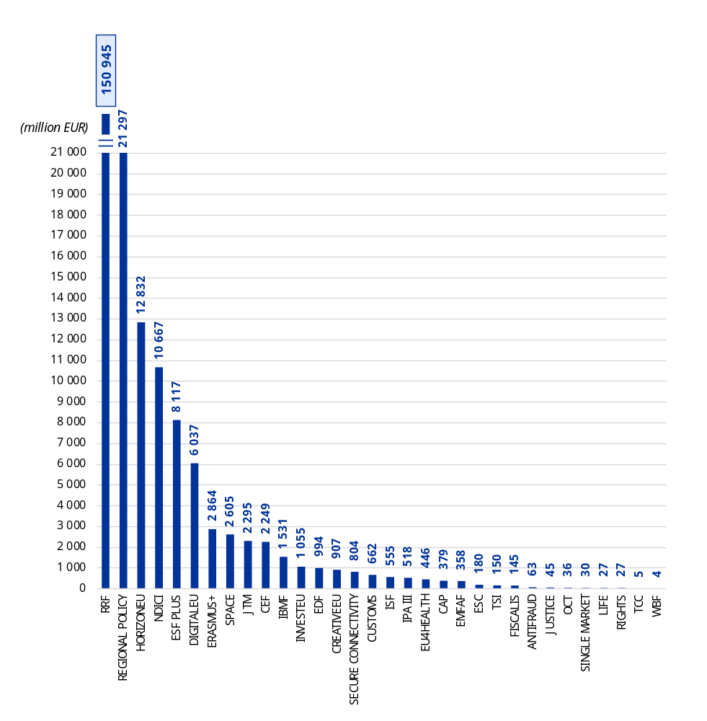
(*) Including NextGenerationEU, in million EUR.
NB: For readability purposes, the scale is broken, as the Recovery and Resilience Facility provides more than 10 times more support to the digital transition than the next most contributing programme. The abbreviations stand for: RRF – Recovery and Resilience Facility; HORIZONEU – Horizon Europe; NDICI – Neighbourhood, Development and International Cooperation Instrument – Global Europe; DIGITALEU – digital Europe programme; ESF PLUS – European Social Fund Plus; JTM – Just Transition Mechanism; SPACE – EU space programme; CEF – Connecting Europe Facility; IPA III – Instrument for Pre-accession Assistance III; IBMF – Integrated Border Management Fund; ISF – Internal Security Fund; CREATIVEEU – creative Europe programme; CAP – common agricultural policy; EMFAF – European Maritime, Fisheries and Aquaculture Fund; SECURE CONNECTIVITY – EU secure connectivity programme;
TSI – Technical Support Instrument; ESC – European Solidarity Corps; OCT – Decision on the Overseas Association, including Greenland; RIGHTS – citizens, equality, rights and values programme; TCC – Turkish Cypriot community; EDF – European Defence Fund;
WBF – Western Balkans Facility.
Source: European Commission.

Almost all EU budget programmes contribute to the digital transition. However, due to data limitations, digital-related expenditure for the 2021-2025 period could only be tracked for 32 out of the 53 spending programmes implemented in 2025.
In terms of thematic concentration, significant efforts are being made to support the digitalisation of public services (in particular government ICT solutions and the digitalisation of healthcare) and businesses, with strong support directed towards small and medium-sized enterprises. More information is provided in the following sections.
Estimated contributions to the digital transition by key digital dimensions (2021-2025) (*)
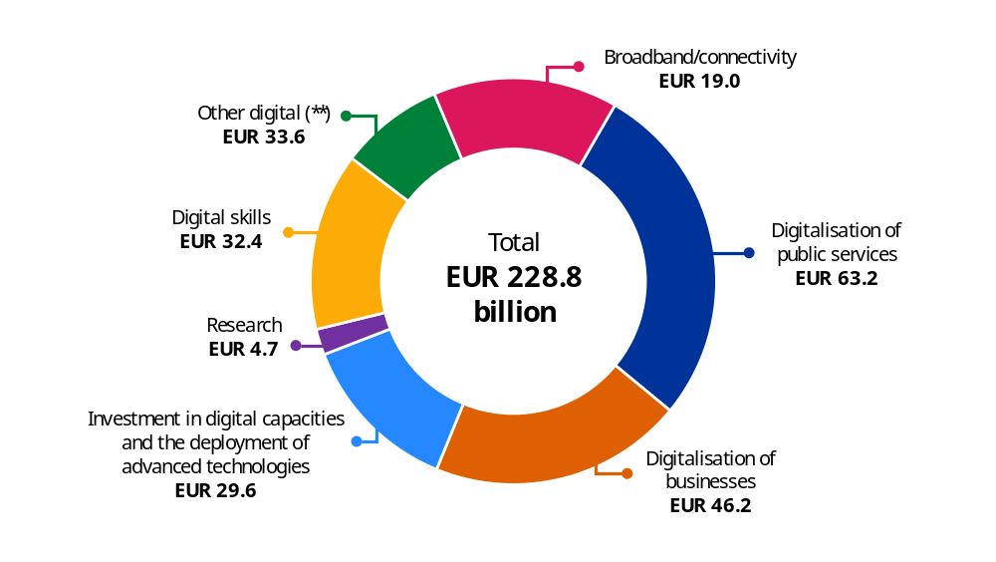
(*) Including NextGenerationEU, in billion EUR.
(**) Includes programmes that could not be disaggregated into specific categories due to methodological limitations (Erasmus+, European Solidarity Corps programme, Creative Europe, the CAP and the common fisheries policy, Technical Support Instrument, LIFE programme, European Defence Fund and the EU Secure Connectivity Programme).
Source: European Commission, based on the 2026 stocktaking exercise.

Digitalisation of businesses and public services
The EU budget (including NextGenerationEU) is making a significant contribution to the digitalisation of the private and public sectors. For the 2021-2025 period, an estimated EUR 63.2 billion was dedicated to the support of the EU budget to public services (including the digitalisation of health and justice systems) and EUR 46.2 billion for the support of the digitalisation of businesses. The Recovery and Resilience Facility, the European Regional Development Fund and the Cohesion Fund are important contributors to this investment. From 2021 to 2025, 11.8% of the amounts from the European Regional Development Fund and the Cohesion Fund were used to finance interventions that advance the digital transition, in particular supporting small and medium-sized enterprises and public services.
Estimated contributions of the EU budget to the digitalisation of public services
(2021-2025) (*)
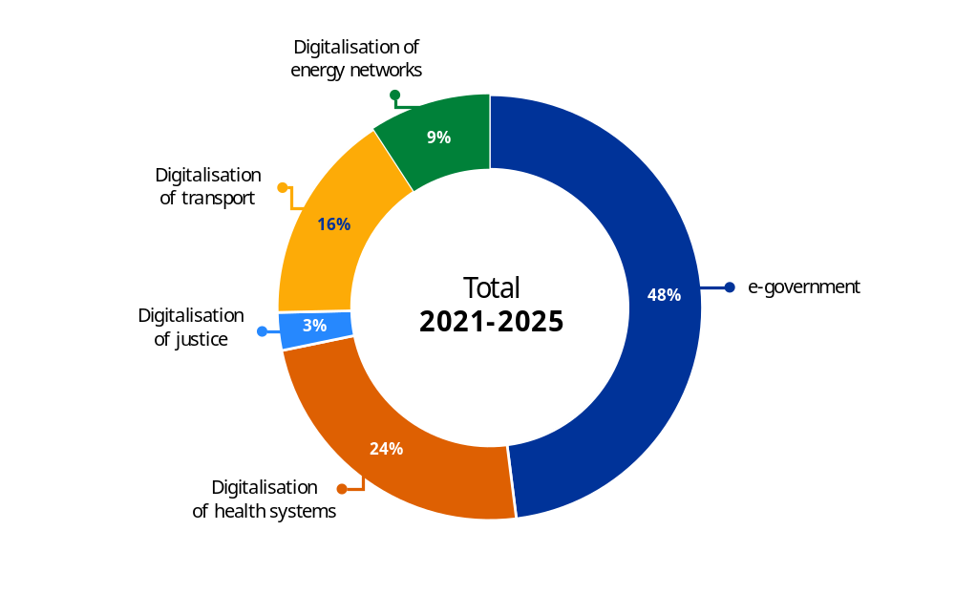
(*) Including NextGenerationEU.
(**) These amounts are the result of the stocktaking exercise conducted for 2021 to 2025 and exclude the external action programmes, expenditure under indirect management, Erasmus+, European Solidarity Corps programme, creative Europe, the CAP and the common fisheries policy, Technical Support Instrument, LIFE programme, European Defence Fund, and the EU Secure Connectivity Programme due to methodological limitations.
Source: European Commission, based on the 2026 stocktaking exercise.

Supporting the development and deployment of digital technologies and research
From 2021 to 2025, estimates indicate that the EU contributed EUR 29.6 billion to investment in digital capacities and the deployment of advanced technologies, and EUR 17.5 billion to research. These numbers include contribution to the digital objective from Horizon Europe, whose primary objective is supporting research. These figures are not yet final and will be updated as more information from funded projects becomes available.
The main contributing programmes towards investment in digital capacities and the deployment of advanced technologies and research are the Recovery and Resilience Facility, Horizon Europe, the EU space programme, the European Regional Development Fund, the Cohesion Fund and the digital Europe programme.

Investing in digital skills
From 2021 to 2025, the EU budget, including NextGenerationEU, made a significant contribution to both basic and advanced digital skills, with an estimated investment totalling EUR 32.4 billion. In addition to supporting the development of digital skills at all levels, along with information technology services and applications for digital skills and digital inclusion, particular emphasis was placed on supporting young people. The main programmes contributing to improving digital skills are the Recovery and Resilience Facility (EUR 22.0 billion) and the European Social Fund Plus (EUR 8.1 billion), providing support to youth employment and the socioeconomic integration of young people.

Enhancing digital connectivity
The EU budget, including NextGenerationEU, is contributing to enhancing digital connectivity, which will give citizens and businesses new opportunities to benefit fully from the digital single market and accelerate economic growth. Between 2021 and 2025, investment in digital connectivity, including investment in very-high-capacity broadband networks and 5G network coverage, is estimated to have reached EUR 19.0 billion. The main programmes contributing are the Recovery and Resilience Facility (EUR 12.7 billion), the cohesion policy funds (EUR 1.0 billion) and the Connecting Europe Facility. Already reported figures on the contribution from the Recovery and Resilience Facility needed to be adjusted because of amendments to the national recovery and resilience plans that took place in 2025.
The CAP plays a key role in improving broadband access in rural areas by supporting broadband infrastructure and improved access to e-government services. Nearly 13 million people living in rural areas are benefiting from improved access to ICT services and infrastructure as a result of support from the EU budget.
Under the Connecting Europe Facility, 10 300 terabits per second of additional capacity were created by deployed backbone networks, including submarine cables. More than EUR 800 million was awarded to
45 projects to support the digitalisation of the trans-European transport network, notably through support
for the European Railway Traffic Management System technology. The programme also aims to modernise energy grids and deploy digital connectivity infrastructure to support the EU’s digital transition. Specifically, the programme will support the deployment of 5G systems and high-capacity digital networks to transform various sectors, including healthcare, education and manufacturing. This will enhance digital readiness, competitiveness and inclusiveness, particularly in the outermost regions, and contribute to the EU’s economic recovery and growth. Through InvestEU, more than two million households, enterprises or public facilities have obtained access to high-speed internet. The European Investment Fund allocated EUR 3.6 billion to support small and medium-sized enterprises in innovation and digitalisation through a dedicated guarantee supported by InvestEU. This guarantee supports various digitalisation efforts, including innovative business models, supply chain management and digital skills acquisition. With a focus on joint small and medium-sized enterprises, the fund also supports investments fostering the development of digital, cultural and creative industry solutions.

The twin transition: exploiting synergies
The twin green and digital transitions are deeply interconnected, offering the potential to create significant synergies. The EU budget is instrumental in this process, acting as a key enabler in unlocking these synergies. It provides the necessary financial support for initiatives that align with the objectives of both transitions, thereby ensuring that the potential benefits can be fully realised. The table below provides illustrative examples of some of the synergies that are being achieved with the support of the EU budget.
- The IM4CA project, funded under Horizon Europe, strengthens climate action by improving Europe’s capacity to monitor and understand methane emissions. By combining satellite and ground-based observations, the project provides data and methods to better quantify methane sources, sinks and trends, supporting evidence-based mitigation and progress towards EU and global climate targets.
- Supporting smart grids, such as those under the Connecting Europe Facility energy strand, contributes to sustainable development by the integration of energy from renewable sources and the development of smart energy grids. An example is the Danube inGrid project, whose first phase is expected to be completed by the end of 2027. The project adopts smart grid technologies and fosters the roll-out of modern energy infrastructure at the cross-border areas of Hungary and Slovakia, to efficiently support the increased demand of consumers, prosumers and distributed renewable energy sources.
- In addition, as a result of the investments in smart energy systems financed through the cohesion policy funds through the entire 2021-2027 programming period, around 2 million additional end users will be connected to the smart energy systems.
- Supported by the cohesion policy funds, a public water company in Sardinia has digitalised and centralised its water service, providing drinking water to over 1.6 million residents. It has improved its service quality by developing a centralised data control and acquisition system that enables real-time monitoring, remote management and tools for simulating and optimising water resource flows. This will enable better planning of targeted interventions to ensure water availability in the context of increasing water stress in the region.
- As part of the EU’s broader efforts to modernise agriculture and rural development under the CAP, strategic plans under the policy support the twin transition by helping farmers adopt digital technologies that can also deliver environmental and climate benefits. This support is channelled mainly through investment projects EIP-AGRI operational group projects, but also through eco-schemes and agri-environment-climate commitments. For example, in Flanders, farmers can use satellite-guided machinery
to reduce overlaps and input use. Another example is the Soil Passport, which helps farmers use parcel-level soil data to improve sustainable soil management. Other Member States, including Estonia, Poland and Romania, have also planned investments in precision agriculture.
- The EU’s Galileo satellite system supports technologies that are key enablers for
smart and sustainable transport, and in particular for connected and autonomous driving. In road transport, using navigation and positioning services from Galileo leads to a range of innovative applications that enable smart mobility and multi-mode transport digitalisation with optimised travel routes, in turn allowing for a reduction of carbon dioxide emissions. In air transport, using the European Geostationary Navigation Overlay Service for the efficient definition of flight routes helps reduce fuel consumption and carbon dioxide emissions.

The EU budget and the sustainable development goals

What do we do?
The United Nations’ 2030 Agenda for Sustainable Development, with its 17 SDGs and
169 targets, has given new impetus to global efforts to achieve sustainable development.
The EU has played an important role in shaping the agenda, through public consultations, dialogue with partners and in-depth research. The EU is committed to playing an active role to maximise progress towards the SDGs, as outlined, for example, in the Commission communication ‘Next steps for a sustainable European future’, in the Commission staff working document ‘Delivering on the UN’s Sustainable Development Goals – A comprehensive approach’ and recently in the first-ever EU voluntary review on progress in the implementation of the 2030 Agenda for Sustainable Development, adopted on 15 May 2023. Moreover, Eurostat publishes a report annually on monitoring progress towards the UN SDGs in an EU context.
In line with the 2021 Commission communication on the better regulation agenda and the objectives of the current multiannual financial framework, the Commission further strengthened the integration of the SDGs into the EU’s policy and budgetary cycle. Overall, this approach ensures that all major legislative and financial proposals are assessed for their contribution to the 2030 Agenda for Sustainable Development, thereby reinforcing the EU’s commitment to sustainability, strategic foresight and evidence-based policymaking. To this end, since 2021 the Commission has been systematically identifying the relevant SDGs for each proposal and examining how the initiative supports their achievement. In addition, links to the SDGs will be included throughout evaluations and impact assessments. At the EU level, sustainable development challenges are addressed through policies and regulatory instruments. As far as the former are concerned, the EU budget, through its spending programmes, provides a significant contribution to sustainable development by complementing national budgets, in line with the principle of subsidiarity. In doing so, the design and implementation of the EU spending programmes aim to deliver on the objectives in each policy field, while promoting sustainability through the initiatives and interventions of the relevant programmes in a connected and consistent way. In particular, 49 out of 53 of the 2021-2027 EU spending programmes contributed towards at least one SDG in 2025.

Number of 2021-2027 programmes contributing to individual sustainable development
goals in 2025
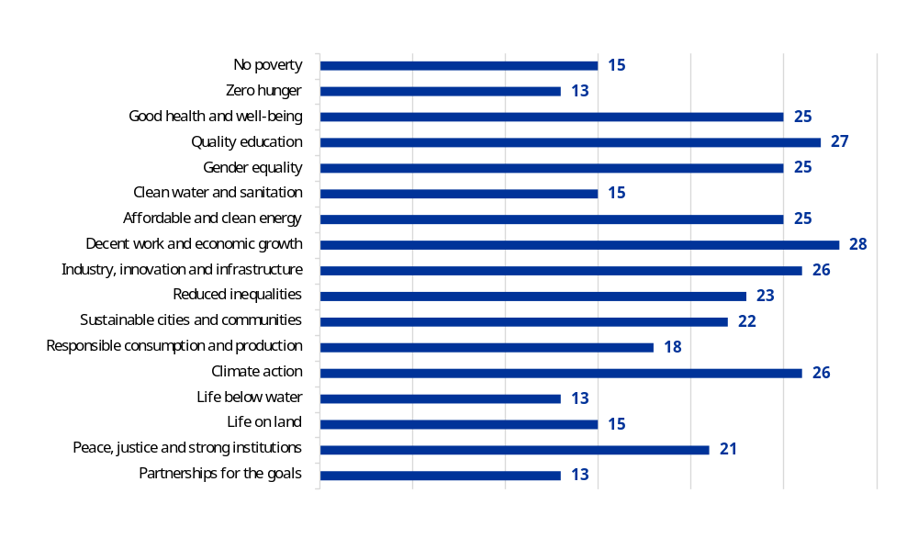
Source: European Commission.
In light of the cross-cutting nature of the SDGs, and to ensure a holistic approach in addressing sustainable development, 99% of the EU budget contributes to SDGs. In addition, the vast majority of the 2021-2027 programmes (43 out of 53) are designed to address multiple SDGs through their policy measures. In the programme performance statements (Annex 4 to this report), the Commission presents the SDGs to which each EU funding programme contributes, along with examples of their contribution. The infographic below provides, in a non-exhaustive manner, examples illustrating how EU programmes contribute to the SDGs.
The 2023 EU voluntary review on the implementation of the 2030 Agenda for Sustainable Development, together with the 2026 Sustainable Development in the European Union – Monitoring report on progress towards the SDGs in an EU context – 2026 edition, reaffirmed the EU budget as a key driver for delivering substantial progress on the 2030 Agenda for Sustainable Development (). Looking ahead, the EU has reinforced its commitment to systematically integrate and report on the implementation of the SDGs across all relevant EU programmes, ensuring policy coherence and sustained momentum towards achieving all goals.

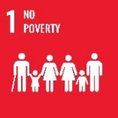 | In Bulgaria, the European Social Fund Plus supports a project modernising social protection systems, with the goal of improving access for vulnerable groups, including children and people with disabilities. By enhancing the capacity of staff, the Agency of Social Assistance will ensure adequate care by offering those in need competent and multi-component support, in line with new technologies and ensuring an improvement in their quality of life. This initiative ensures faster, more efficient support, helping prevent social isolation and improve quality of life. | 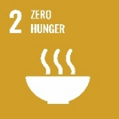 | The single market programme supports initiatives such as emergency measures for animal and plant disease control, EU Reference Laboratories and the EU vaccine bank for animal diseases, directly reduce risks to food security by ensuring sustainable agricultural production and resilience against outbreaks of diseases like African swine fever, avian influenza, foot-and-mouth disease, lumpy skin disease, peste des petits ruminants and sheep pox and goat pox.  The programme supports the European Food Bank Federation’s activities to facilitate food donation and increase the share of surplus food made available for human consumption, thereby addressing both food security and preventing food waste. The annual grant helps increase the federation’s capacity to redistribute food.
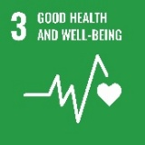 | The EU4Health programme and its annual work programmes deliver actions to implement the ‘Healthier together’ initiative, Europe’s beating cancer plan, the comprehensive approach to mental health, and addresses key risk factors to reduce premature mortality from non-communicable diseases. The programme also funds actions that are producing guidance to improve healthcare access contributing to SDG 3.8, while also funding actions to address SDG 3.3 to end the epidemics of HIV/AIDS, tuberculosis, neglected tropical diseases and combat hepatitis, water-borne diseases and other communicable diseases. The programme funds actions to strengthen the capacity of countries for early warning, risk reduction and management of national and global health risks, addressing SDG 3.D. | 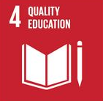 | Financed by Erasmus+, the share the music for inclusive learning in education project was designed to support teachers in addressing this challenge by providing a practical framework and showcasing best practices for managing inclusion and diversity in education. Its primary goal is to offer pre-primary and primary schoolteachers new knowledge, key competencies and ready-to-use educational materials to effectively use music as a pedagogical tool for inclusive education.  Additionally, the project aims to help teachers develop their social and digital skills through its digital repository and online training resources. While the project has been designed for teachers, the ultimate beneficiaries are the students, whose well-being and academic performance are expected to improve as a result of these integrated inclusive practices.
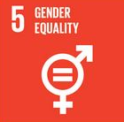 | Under the Technical Support Instrument in 2025, a number of new gender-related projects started recently. For instance, the Technical Support Instrument project on the assessment on the effectiveness of work–life balance and gender equality policies in the labour market is helping Portugal to address its demographic challenges and promote a more inclusive and equitable society, contributing to the country’s sustainable economic development and competitiveness. | 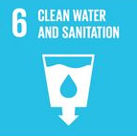 | The EU provides safe drinking water, sanitation and hygiene support through its humanitarian aid operations and the Union Civil Protection Mechanism, whose main objective is to save and preserve life and alleviate the suffering of populations facing severe environmental health risks and water insecurity in the context of anticipated, ongoing and recent humanitarian crises, for example in Ukraine. The mechanism has also been active in responding to flooded areas with non-food items, health and water access and sanitation and hygiene material, such as in the response to Hurricane Melissa in the Caribbean (Cuba, Jamaica) and in earthquake-affected areas such as Myanmar. These donations were offered by Member States, and the Emergency Response Coordination Centre co-funded transport and deployment costs.
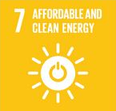 | Through Horizon Europe, the ascend project, with an EU contribution of EUR 19.99 million, supports affordable and clean energy in cities by delivering two Positive Clean Energy Districts in Lyon and Munich and engaging eight partner cities to prepare replication. The project develops and disseminates scalable, cost-effective district-level energy solutions to accelerate urban energy transitions. | 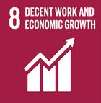 | Under the Instrument for Pre-accession Assistance, the regional project ‘Supporting the development of a modern payment system and a regional investment area in the Western Balkans’, implemented by the World Bank, supports the Western Balkan partners to join the Single Euro Payments Area (SEPA). In 2025 North Macedonia and Serbia joined SEPA’s geographical scope, after Albania and Montenegro who had already joined at the end of 2024. Moreover, as of October 2025, Albania, Montenegro and North Macedonia started enjoying SEPA’s concrete benefits by joining its payment schemes. This resulted in faster transactions and in a reduction of transaction costs by up to ten times. It is estimated that SEPA’s full implementation in the Western Balkan region could potentially save up to EUR 500 million per year for individuals and businesses.
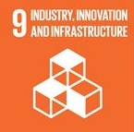 | Digital Europe is contributing to the broader digital transformation of areas of public interest and of industry. The acquisition and deployment of advanced supercomputing capabilities aim to enhance Europe’s industrial competitiveness. Moreover, the established network of European Digital Innovation Hubs contributes to the digitisation of industry and addresses issues of technological accessibility, ensuring that businesses, including small and medium-sized enterprises, have access to cutting-edge technologies and finance for adapting to digital change. The interoperable Europe action supports the development of reusable interoperability infrastructure/solutions, with the view to support the digital transformation of the public sector and create capacity for public authorities to collaborate effectively to set up seamless cross-border services. | 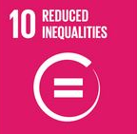 | Under the Asylum Migration and Integration Fund, phase 7 of the regional development and protection programme for North Africa is running from 2025 to 2028 with a budget (EU grant amount maximum) of EUR 37.5 million. The main objective of the proposed action is to support non-EU countries in North Africa and across the Atlantic and Mediterranean migration route to consolidate their migration and asylum systems and build their capacity to provide adequate reception, protection and durable solutions for vulnerable migrants, asylum seekers and refugees.
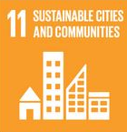 | Under Neighbourhood, Development and International Cooperation Instrument – Global Europe, in 2025 the EU launched, the third phase of its flagship initiative Mayors for Economic Growth (2025-2028, EUR 8 million), implemented by the United Nations Development Programme, reinforcing its support for local economic development across the Eastern Partnership since 2017. This new phase empowers cities and towns in Armenia, Moldova, and Ukraine to tackle challenges such as rural depopulation, job creation, climate change, and the digital transition, with a strengthened focus on local economic development planning and access to finance. In 2025 alone, the initiative unlocked approximately EUR 1 million to support local governments in leading their own economic transformation. | 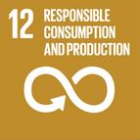 | By the end of 2025, the Recovery and Resilience Facility supported the installation of photovoltaic capacity in business premises in Luxembourg.
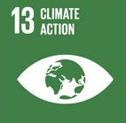 | The Innovation Fund is designed to answer this goal and take urgent action to combat climate change and its impacts. The grip project aims to decarbonise industrial heat production up to 200 °C by scaling up the industrialisation of the innovative rotation heat pump technology. Project endor aims at producing electric sustainable aviation fuel to support the decarbonisation of the aviation sector. | 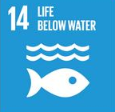 | Regional fisheries management organisations promote the conservation and sustainable use of the oceans, seas and marine resources by improving management measures adopted following scientific advice and by promoting healthy tuna stocks in the Atlantic and Indian Oceans, and through the governance framework established by sustainable fisheries partnership agreements with a number of non-EU countries.
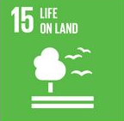 | The European Regional Development Fund planned EUR 9.5 billion to support this goal. For instance, the urban biodiversity parks project in Turku (Finland) reflects the New European Bauhaus principles by promoting urban ecological restoration and regeneration through the creation of biodiversity parks and pilot green spaces. It reflects Turku’s ambition to become one of the world’s leading ‘nature and climate cities’. The project aim is to establish a 20-hectare biodiversity park, providing a recreational area – while also serving as a platform for community engagement and experiential learning. The concept is being piloted in Turku’s Skanssi area, with more, smaller pilots planned in other suburban neighbourhoods. | 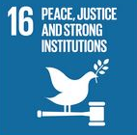 | The common foreign and security policy measures contribute to the preservation of peace, conflict prevention, strengthening of international security, consolidating and supporting democracy, the rule of law and human rights by advising and building capacity on security sector reforms, the rule of law and border management, by supporting mediation and conflict resolution initiatives or by supporting the universalisation and effective implementation of international treaties and conventions addressing the proliferation of weapons of mass destruction or conventional weapons.
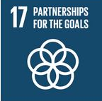 | The humanitarian aid programme supports local actors and partners to reinforce both their capacities, security of staff and ability to reach communities in hard-to-reach areas. This work is further empowered by our commitment to inclusiveness in coordination mechanisms wherever possible. In Myanmar, one third of the budget goes to local organisations, with many programmes operating through large networks of local partners that ensure principled, context-sensitive and timely humanitarian assistance, even in highly constrained and insecure environments. These partnerships strengthen local ownership, improve access and acceptance at community level, and contribute to more sustainable humanitarian outcomes.

() This amount includes EUR 190.9 billion from the final adopted budget; EUR 1.6 billion from appropriations carried over or made available again from 2024; and EUR 14.1 billion from appropriations stemming from assigned revenues (of which EUR 0.4 billion from NextGenerationEU).
() As of January 2026.
() Aggregated data of core performance indicators, reflecting estimated and expected impact from the EU budget project as from 2014.
() Financed by the following 2021-2027 programmes: Fiscalis; customs programme; European Maritime Fisheries and Aquaculture Fund; Recovery and Resilience Facility; Euratom; European Social Fund Plus; Just Transition Mechanism; Erasmus+; European Globalisation Adjustment Fund for Displaced Workers; creative Europe; European Solidarity Corps; justice programme; Asylum, Migration and Integration Fund; Internal Security Fund; Horizon Europe; InvestEU; single market programme; digital Europe programme; regional policy; European Agricultural Guarantee Fund.
() As provided for in point 16(d–g) of the interinstitutional agreement for the 2021-2027 multiannual financial framework.
() Proposal for a Regulation of the European Parliament and of the Council establishing a budget expenditure tracking and performance framework, along with other horizontal rules for the Union programmes and activities, COM(2025) 545 final of 16 July 2025, https://eur-lex.europa.eu/legal-content/EN/TXT/?uri=CELEX%3A52025PC0545&qid=1753797488776.
() Communication from the Commission to the European Parliament, the Council, the European Economic and Social Committee and the Committee of the regions – Enhancing the accession process – A credible EU perspective for the Western Balkans, COM(2020) 57 final of 5 February 2020, https://enlargement.ec.europa.eu/enhancing-accession-process-credible-eu-perspective-western-balkans_en.
() Council Implementing Decision (EU) 2024/1447 of 14 May 2024 on the approval of the assessment of the Ukraine Plan (OJ L, 2024/1447, 24.5.2024, ELI: http://data.europa.eu/eli/dec_impl/2024/1447/oj).
() This designation shall not be construed as recognition of a State of Palestine and is without prejudice to the individual positions of the Member States on this issue.
() Cumulative data for the Neighbourhood, Development and International Cooperation Instrument – Global Europe Instrument for the 2021-2025 period.
() European Commission: Directorate-General for Communication, ‘Speech by President von der Leyen at the Copenhagen Competitiveness Summit’, news article, 1 October 2025, https://ec.europa.eu/commission/presscorner/detail/en/speech_25_2272.
() European Commission, ‘Horizon Europe Work Programme 2026-2027 – 14. Horizontal activities’, European Commission Decision C(2025) 8493 of 11 December 2025, calls HORIZON-CID-2026-01 AND HORIZON-CID-2027-01, https://ec.europa.eu/info/funding-tenders/opportunities/docs/2021-2027/horizon/wp-call/2026-2027/wp-14-horizontal-activities_horizon-2026-2027_en.pdf.
() Regulation (EU) 2025/2005 of the European Parliament and of the Council of 16 December 2025 amending Regulations (EU) 2015/1017, (EU) 2021/523, (EU) 2021/695 and (EU) 2021/1153 as regards increasing the efficiency of the EU guarantee under Regulation (EU) 2021/523 and simplifying reporting requirements (OJ L, 2025/2005, 23.12.2025, ELI: http://data.europa.eu/eli/reg/2025/2005/oj).
() European Innovation Council, European Innovation Council and SMEs Executive Agency, EIC Data Hub, filtered for Accelerator funding stream, accessed on 24.4.2026 – https://eic.ec.europa.eu/impact/eic-data-hub_en.
() European Commission (n.d.), ‘Horizon Europe 2026-2027 work programmes’, Research and innovation website, Horizon Europe work programmes - Research and innovation.
() European Commission, ‘ACCEPT: Automotive Cells Company European Production Take-off’, Innovation Fund project factsheet, https://ec.europa.eu/assets/cinea/project_fiches/innovation_fund/101250958.pdf.
() European Commission, ‘MeCaClay: Green Cement Production through Mechano-Chemical Activation of Clay’, Innovation Fund project factsheet, https://ec.europa.eu/assets/cinea/project_fiches/innovation_fund/101250933.pdf.
() European Commission, ‘H2CRI: RFNBO hydrogen production plant in Zaragoza’, Innovation Fund project factsheet, https://ec.europa.eu/assets/cinea/project_fiches/innovation_fund/101241587.pdf.
() European Commission, ‘Swap2Zero’, Innovation Fund project factsheet, https://ec.europa.eu/assets/cinea/project_fiches/innovation_fund/101191050.pdf.
() European Commission: Directorate-General for Internal Market, Industry, Entrepreneurship and SMEs (n.d.), ‘SG Pan EU Wind Package’, InvestEU website, https://investeu.europa.eu/investeu-operations/investeu-operations-list/sg-pan-eu-wind-package_en.
() European Commission: Directorate-General for Internal Market, Industry, Entrepreneurship and SMEs (n.d.), ‘Marguerite III (CDPE)’, InvestEU website, https://investeu.europa.eu/investeu-operations/investeu-operations-list/marguerite-iii-cdpe_en.
() European Commission: Directorate-General for Internal Market, Industry, Entrepreneurship and SMEs (n.d.), ‘Cristal Fiber Rollout’, InvestEU website, https://investeu.europa.eu/investeu-operations/investeu-operations-list/cristal-fibre-rollout_en.
() European Commission (n.d.), ‘2024-7-ES-SP-CHUAC’, Kohesio website, https://kohesio.ec.europa.eu/en/projects/Q7421383.
() European Commission (n.d.), ‘Magnetic plant Narva’, Kohesio website, https://kohesio.ec.europa.eu/en/projects/Q7423897.
() European Commission (2026), ‘Rail Baltica – 1 435 mm standard gauge railway line development in Estonia, Latvia and Lithuania (Part IX C)’, CEF Transport programme, https://ec.europa.eu/assets/cinea/project_fiches/cef/cef_transport/23-EU-TC-RBGP%20Part%20IX%20C.pdf.
() European Commission (2026), ‘MILES General: Mobility Infrastructure for Logistics – Electric & Sustainable in AT, BE, DE, DK, ES, FR, IT, NL, and SE’, CEF Transport programme, 24-EU-TG-MILES General.pdf.
() ‘Multi-sector’ refers to the budget allocated to STEP from calls for proposals and tenders which target more than one STEP-relevant sector.
() Regulation (EU) 2025/1914 of the European Parliament and of the Council of 18 September 2025 amending Regulations (EU) 2021/1058 and (EU) 2021/1056 as regards specific measures to address strategic challenges in the context of the mid-term review (OJ L, 2025/1914, 19.9.2025, ELI: http://data.europa.eu/eli/reg/2025/1914/oj).
() Regulation (EU) 2025/2653 of the European Parliament and of the Council of 19 December 2025 amending Regulations (EU) 2021/694, (EU) 2021/695, (EU) 2021/697, (EU) 2021/1153 and (EU) 2024/795, as regards incentivising defence-related investment in the EU budget to implement the ReArm Europe Plan (OJ L, 2025/2653, 22.12.2025, ELI: http://data.europa.eu/eli/reg/2025/2653/oj).
() European Commission: Directorate-General for Communication, ‘2025 State of the Union Address by President von der Leyen’, 10 September 2025, https://commission.europa.eu/strategy-and-policy/state-union/state-union-2025_en.
() European Commission (n.d.), ‘Projects funded under the Internal Security Fund call for proposals on the protection of public spaces: ISF-2024-TF2-AG-PROTECT’, https://home-affairs.ec.europa.eu/document/download/cc4034e6-bc2a-4d71-9238-9f61d465c91b_en?filename=Projects%20funded%20under%20ISF_booklet.pdf.
() European Commission: Directorate-General for Communication, ‘Speech by President von der Leyen in the European Parliament plenary debate on the Commission Work Programme’, news article, 21 October 2025, https://ec.europa.eu/commission/presscorner/detail/en/speech_25_2462.
() Communication from the Commission to the European Parliament, the European Council, the Council, the European Economic and Social Committee and the Committee of the Regions – Action Plan for Affordable Energy Unlocking the true value of our Energy Union to secure affordable, efficient and clean energy for all Europeans, COM(2025) 79 final of 26 February 2025, https://eur-lex.europa.eu/legal-content/EN/TXT/?uri=CELEX:52025DC0079
() European Commission: European Climate, Infrastructure and Environment Executive Agency (n.d.), ‘CEF Energy: Instrumental funding to achieve the Baltic synchronisation with the Continental European Network’, https://cinea.ec.europa.eu/cef-energy-instrumental-funding-achieve-baltic-synchronisation-continental-european-network_en.
() Model simulations for the 2014-2020 ex post evaluation. Exactly EUR 2.9, 15 years after end of period.
() Communication from the Commission to the European Parliament, the European Council, the Council, the European Economic and Social Committee and the Committee of the Regions – The Union of Skills, COM(2025) 90 final of 5 March 2025, https://eur-lex.europa.eu/legal-content/EN/TXT/?uri=celex:52025DC0090.
() European Commission (2025), ‘Pact for Skills Annual Report 2025’, https://pact-for-skills.ec.europa.eu/document/download/84378a3e-3380-488f-b35a-9bd97a024ab1_en?filename=Annual%20Report%202025_FINAL.pdf.
() European Commission: Directorate-General for Communication, ‘Speech by President von der Leyen in the European Parliament plenary debate on the Commission Work Programme 2026, news article, 21 October 2025, https://ec.europa.eu/commission/presscorner/detail/en/speech_25_2462.
() European Commission (2026), ‘The EU in 2025: General report on the activities of the European Union’, Chapter 5: A Europe fit for the digital age, https://op.europa.eu/webpub/com/general-report-2025/en/chapter5.html#subchapter5-2.
() Commission Implementing Regulation (EU) 2025/441 of 6 March 2025 providing for emergency financial support for the agricultural sectors affected by adverse climatic events and natural disasters in Spain, Croatia, Cyprus, Latvia and Hungary, in accordance with Regulation (EU) No 1308/2013 of the European Parliament and of the Council (OJ L, 2025/441, 10.3.2025, ELI: http://data.europa.eu/eli/reg_impl/2025/441/oj and OJ L, 2025/1137, 11.6.2025, ELI: http://data.europa.eu/eli/reg_impl/2025/1137/oj).
() Commission Implementing Regulation (EU) 2025/1145 of 10 June 2025 on exceptional support measures for the milk and pigmeat sectors in Germany (OJ L, 2025/1145, 11.6.2025, ELI: http://data.europa.eu/eli/reg_impl/2025/1145/oj).
() Commission Implementing Regulation (EU) 2025/2061 of 10 October 2025 providing for emergency financial support for the agricultural sectors affected by adverse climatic events in Bulgaria, Latvia, Lithuania, Hungary, Poland and Romania, in accordance with Regulation (EU) No 1308/2013 of the European Parliament and of the Council (OJ L, 2025/2061, 13.10.2025, ELI: http://data.europa.eu/eli/reg_impl/2025/2061/oj).
() Commission Implementing Regulation (EU) 2025/1485 of 24 July 2025 on exceptional market measures for the eggs and poultry meat sectors in Poland (OJ L, 2025/1485, 25.7.2025, ELI: http://data.europa.eu/eli/reg_impl/2025/1485/oj).
() Regulation (EU) 2025/1276 of the European Parliament and of the Council of 24 June 2025 amending Regulation (EU) No 228/2013 as regards additional assistance to, and further flexibility in respect of, outermost regions affected by severe natural disasters and in the context of the devastation caused by cyclone Chido in Mayotte (OJ L, 2025/1276, 27.6.2025, ELI: http://data.europa.eu/eli/reg/2025/1276/oj).
() European Commission: European Climate, Infrastructure and Environment Executive Agency (n.d.), ‘Blue ports: Empowering ports for a greener future’, https://cinea.ec.europa.eu/featured-projects/blue-ports-empowering-ports-greener-future_en.
() European Commission: European Climate, Infrastructure and Environment Executive Agency (n.d.), ‘Diaspara project: Unlocking the secrets of Europe’s endangered eel and salmon’, https://cinea.ec.europa.eu/featured-projects/diaspara-project-unlocking-secrets-europes-endangered-eel-and-salmon_en.
() European Commission: European Climate, Infrastructure and Environment Executive Agency (n.d.), ‘Decarbonyt – Decarbonising the fishing fleet in the Mediterranean and Black Sea’, https://cinea.ec.europa.eu/featured-projects/decarbonyt-decarbonising-fishing-fleet-mediterranean-and-black-sea_en.
() European Commission (2026), ‘The EU in 2025: General report on the activities of the European Union’, Chapter 5: A Europe fit for the digital age, https://op.europa.eu/webpub/com/general-report-2025/en/chapter5.html#subchapter5-2.
() European Commission: Directorate-General for Communication, ‘2025 State of the Union Address by President von der Leyen’, 10 September 2025, https://commission.europa.eu/strategy-and-policy/state-union/state-union-2025_en.
() Information on the initiatives can be found at https://citizens-initiative.europa.eu/find-initiative_en.
() European Commission: Directorate-General for Communication ‘Keynote speech by President von der Leyen at the Global Gateway Forum’, news article, 9 October 2025, https://ec.europa.eu/commission/presscorner/detail/en/speech_25_2337.
() European Commission, ‘Commission delivers thermal plant to supply power for 1 million Ukrainians’, press release, 22 December 2025, https://ec.europa.eu/commission/presscorner/detail/en/ip_25_3137.
() European Commission, ‘First deal under EU’s Ukraine export credit guarantee facility: €20 million for EU exports to Ukraine through Denmark’s EIFO’, press release, 5 June 2025, https://ec.europa.eu/commission/presscorner/detail/en/ip_25_1429.
() European Commission (2026), ‘Implementation of the 1435 connectivity PL/UA border – Mostyska II – Sknyliv (Lviv) Stage 1’, CEF Transport programme, https://ec.europa.eu/assets/cinea/project_fiches/cef/cef_transport/24-UA-TG-EUUA1435PLUABCPML1.pdf.
() European Commission: Directorate-General for Mobility and Transport, ‘New EU-funded railway line brings Ukraine even closer to EU’, news article, 5 September 2025, https://transport.ec.europa.eu/news-events/news/new-eu-funded-railway-line-brings-ukraine-even-closer-eu-2025-09-05_en.
() European Commission (2026), ‘The EU in 2025: General report on the activities of the European Union’, Chapter 1: The EU’s support for Ukraine, https://op.europa.eu/webpub/com/general-report-2025/en/chapter1.html#subchapter1-1.
() This designation is without prejudice to positions on status, and is in line with UNSCR 1244/1999 and the ICJ Opinion on the Kosovo declaration of independence.
() European Commission, ‘Europe leads pledging effort in campaign mobilising €15.5 billion for clean energy in Africa’, press release, 21 November 2025, https://ec.europa.eu/commission/presscorner/detail/en/ip_25_2781.
() European Commission: Directorate-General for International Partnerships (n.d.), ‘African Local Currency Bond Fund’, https://international-partnerships.ec.europa.eu/funding-and-technical-assistance/funding-instruments/european-fund-sustainable-development-plus/african-local-currency-bond-fund_en
() European Commission: Directorate-General for International Partnerships (n.d.), ‘Accelerate the Energy Transition – AccelerET’, https://international-partnerships.ec.europa.eu/funding-and-technical-assistance/funding-instruments/european-fund-sustainable-development-plus/accelerate-energy-transition-acceleret_en
() European Commission: Directorate-General for International Partnerships (n.d.), ‘Access to Finance’, https://international-partnerships.ec.europa.eu/funding-and-technical-assistance/funding-instruments/european-fund-sustainable-development-plus/access-finance_en
() The designation of Palestine shall not be construed as recognition of a State of Palestine and is without prejudice to the individual positions of the Member States on this issue.
() European Commission: Directorate-General for Communication, ‘Speech by President von der Leyen at the European Parliament plenary debate on the new 2028-2034 Multiannual Financial Framework: architecture and governance’, news article, 12 November 2025, https://ec.europa.eu/commission/presscorner/detail/en/speech_25_2673.
() Interinstitutional Agreement between the European Parliament, the Council of the European Union and the European Commission on budgetary discipline, on cooperation in budgetary matters and on sound financial management, as well as on new own resources, including a roadmap towards the introduction of new own resources Interinstitutional Agreement of 16 December 2020 between the European Parliament, the Council of the European Union and the European Commission on budgetary discipline, on cooperation in budgetary matters and on sound financial management, as well as on new own resources, including a roadmap towards the introduction of new own resources, (OJ L 433I, 22.12.2020, ELI: http://data.europa.eu/eli/agree_interinstit/2020/1222/oj).
() Data on budget programming for 2026 and 2027 presented in this report reflect information available as of 31 May 2026.
() Aggregated data of core performance indicators reflecting estimated and expected impact from the EU budget programmes during the 2014-2025 period (contributions from the regional policy, the LIFE programme, the InvestEU programme, the Innovation Fund, the Just Transition Mechanism and the Recovery and Resilience Facility).
() Taxonomy alignment is not a prerequisite for funding.
() Commission staff working document – Impact assessment report accompanying the document Proposal for a Regulation of the European Parliament and of the Council establishing a budget expenditure tracking and performance framework and other horizontal rules for the Union programmes and activities, SWD(2025) 590 final of 16 July 2025, https://eur-lex.europa.eu/legal-content/EN/TXT/PDF/?uri=CELEX:52025SC0590.
() European Court of Auditors, Gender Mainstreaming in the EU budget: Time to turn words into action, Publications Office of the European Union, Luxembourg, 2021, https://www.eca.europa.eu/lists/ecadocuments/sr21_10/sr_gender_mainstreaming_en.pdf.
() Number of beneficiaries by age and sex reached by humanitarian aid operations available in EVA actions operational data (such data reflect information encoded in Fiche Opérationnelle and in the European Hospital and Healthcare Federation).
() The Game Awards, The Indie Game Awards, Tribeca Games, Game Developers Choice Awards, IGF, DEVGAMM, A Maze, Swedish Game Awards, Golden Joystick Awards, TIGA Awards, Venice Immersive, VR Awards.
() Given that a fully-fledged tracking methodology for the digital contributions of the EU budget has not yet been established, any aggregation of the contributions of individual programmes at this stage should be interpreted with caution. This is because the methodologies employed by individual spending programmes may not be strictly comparable. Despite this, such aggregation can still provide a general estimate of the total digital contribution from the EU budget. Almost 70% of the reported digital expenditure this year could be attributed to the four categories of the digital compass.
() European Commission: Eurostat, Sustainable development in the European Union – Overview of progress towards the SDGs in an EU context – 2026 edition, Publications Office of the European Union, 2026, https://data.europa.eu/doi/10.2785/9931334; https://ec.europa.eu/eurostat/product?code=KS-01-25-064.

