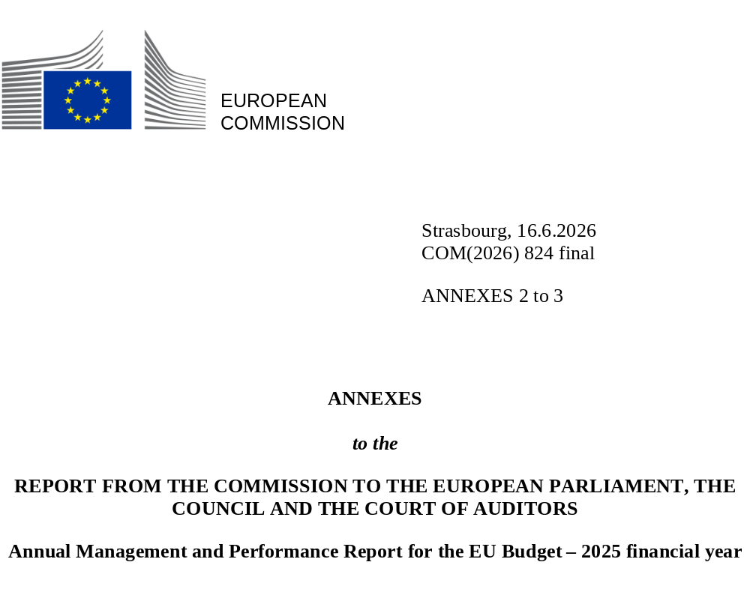

Contents
Annex 2 – Internal control and financial management 5
1 Strong tools to manage the EU budget in a complex environment 7
2. Cost-effective controls protecting the EU budget 21
3. Management assurance 53
4. Outlook for 2026 and beyond 59
Annex 3 – The Recovery and Resilience Facility under NextGenerationEU 61
1. The Recovery and Resilience Facility– an innovative and successful crisis response tool 63
2. Control results confirm the satisfactory fulfilment of all milestones and targets for payments
made in 2025 68

Annex 2 – Internal control and financial management

- Strong tools to manage the EU budget in a complex environment
The European Commission must fulfil its crucial role in shaping and implementing the European Union’s policies while making the best possible use of taxpayers’ money. It is therefore essential to ensure that EU spending is effective, efficient and economical, while also complying with the applicable rules. The Commission strives to achieve the highest standards of financial management while striking the right balance between a low level of error, prompt payments and reasonable control costs.
  - The EU budget: a wide variety of areas, recipients and spending in a complex environment
In 2025, the expenditure managed by the Commission amounted to EUR 166.7 billion (see figures below) (). This encompasses the share of the EU budget managed by the Commission, along with the European Development Fund () and the EU trust funds. This expenditure was made through almost 328 000 payments, ranging from a few hundred euro per beneficiary (for Erasmus+ mobility grants) to hundreds of millions of euro (for large projects such as the ITER thermonuclear reactor or Galileo and Copernicus, along with budgetary support for partner countries) and even billions of euro (for Member States under cohesion funds, agricultural funds and the Recovery and Resilience Facility, or for Ukraine). This shows that the recipients of EU funds are very diverse and numerous. This expenditure concerns both the 2014-2020 and the 2021-2027 programming periods. In 2025, the amount of the payments relating to the latter became higher than that of the payments relating to the former.
Relevant expenditure of the EU budget implemented by the Commission in 2025, by policy area
Single market, innovation and digital | Cohesion, resilience and values | Natural resources and environment | Migration and border management | Security and defence | Neighbourhood and the world | European public administration  EUR 8.9 billion (5.3%)
EUR 25.1 billion (15.0%) | EUR 54.0 billion (32.4%) | EUR 58.0 billion (34.8%) | EUR 2.8 billion (2.3%) | EUR 0.6 billion (0.4%) | EUR 16.4 billion (9.8%) | European public administration  EUR 8.9 billion (5.3%)
 |  |  |  |  |  | European public administration  EUR 8.9 billion (5.3%)
More than 4 300 Horizon Europe grants were signed in 2025, 19 500 cumulatively and almost EUR 53 billion of EU contribution since 2021. | Around 5 million enterprises have been supported and almost 145 million people have been covered by improved health services since 2014. | Some 5.6 million beneficiaries were supported by agricultural funds under a variety of different interventions and schemes in 2025. | Member States received an additional allocation of EUR 169.9 million for the purchase of equipment to be used for border surveillance. | Since 2021, the European Defence Fund has supported 225 collaborative projects focusing on research and development in defence. | Sustainable development, stability, and partnerships were supported across around 130 non-EU countries throughout the world. | European public administration  EUR 8.9 billion (5.3%)
Source: European Commission annual activity reports for 2025.
Under the EU budget, expenditure for which the management is shared between the Commission and Member States () (especially expenditure on cohesion policy and agriculture) represents the biggest share of the total expenditure. The rest of the budget was implemented either directly by the Commission or indirectly through entrusted entities such as international organisations, the European Investment Bank and national promotional banks. The table that follows describes the three management modes.
2025 expenditure from the EU budget by management mode
 | Examples  of programmes/spending | Other actors involved, in  cooperation with the Commission
 | Direct management  Funds are implemented by the Commission.
 | Horizon programmes; Connecting Europe Facility; administrative expenditure. | n/a (funding goes directly to the beneficiaries).
Indirect management
Funds are implemented in cooperation with entrusted entities.
 | Erasmus+; part of development and humanitarian aid; pre-accession assistance; external action. | Agencies; joint undertakings; United Nations; World Bank; European Investment Bank; European Bank for Reconstruction and Development; non-EU countries; etc.
Shared management
Funds are implemented in cooperation with Member States’ national and/or regional authorities, which have the first level of responsibility for budget implementation.
 | Agricultural funds; European Maritime, Fisheries and Aquaculture Fund; European Regional Development Fund; Cohesion Fund; European Social Fund and youth employment initiative; migration, border management and internal security funds. | Paying agencies for the common agricultural policy: 72; Managing authorities for the operational programmes for cohesion policy funds: 441, in all Member States for the 2014-2020 programming period (380 for 2021-2027) Managing authorities for programmes for the European Maritime, Fisheries and Aquaculture Fund (26) and the three Home Affairs Funds (39).
Source: European Commission draft annual accounts 2025 – Statement of financial performance.

In addition, the Commission spent almost EUR 115.9 billion using the amounts borrowed on capital markets. These funds are all implemented directly by the Commission. In 2025, the majority of these funds was used for the Recovery and Resilience Facility, for both loans (EUR 47.2 billion) and non-repayable support (EUR 33.2 billion). The remaining amounts were used for macro-financial assistance (MFA) loans to Ukraine (EUR 18.1 billion) and Jordan (EUR 250 million), loans under the Reform and Growth Facilities for the Western Balkans (EUR 184.4 million), the Republic of Moldova (EUR 288.9 million); and the Ukraine Facility (EUR 10.1 billion). In addition, EUR 6.6 billion were used for non-repayable support under NextGenerationEU other than the Recovery and Resilience Facility.
Use of the amounts borrowed in 2025 on capital markets
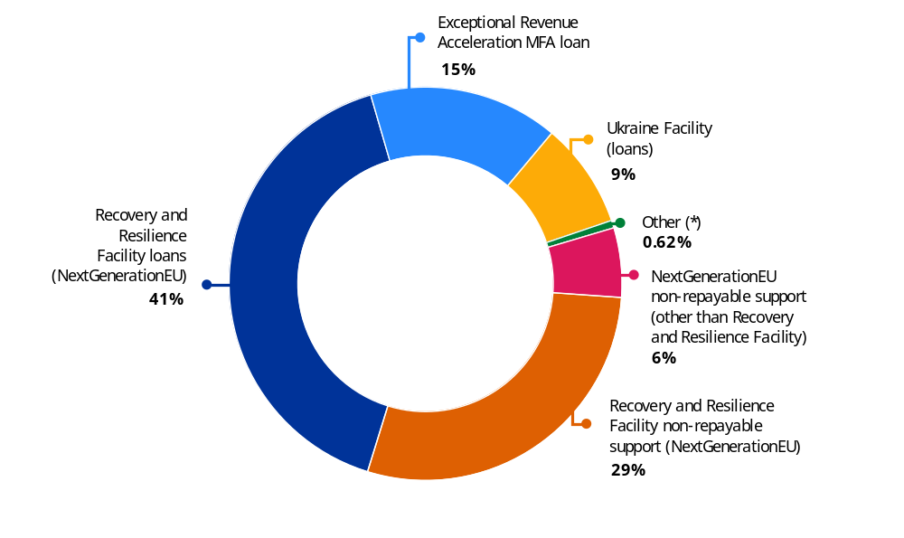
(*) Reform and Growth Facility for the Western Balkans, Reform and Growth Facility for Moldova and Macro Financial Assistance
to Jordan.
Source: European Commission draft annual accounts 2025 – Statement of financial performance.

  - A robust governance system underpinning the College’s responsibility
As the authorising officer of the Commission, the College of Commissioners is politically responsible for the management of the EU budget and thus accountable for the work of the Commission’s departments. The EU budget’s governance is built on a clear division of responsibilities between the political and management levels; an independent internal audit supported by the Audit Progress Committee, which includes external experts; an independent accountant; a strong commitment to performance management and compliance with the legal framework; transparency and high ethical standards; and transparent reporting.
The Commission’s governance system and chain of accountability are tailored to its unique model of decentralised decision-making in budget implementation. The College of Commissioners delegates the day-to-day operational management to 52 authorising officers by delegation (), who manage and steer their departments to deliver on the objectives in their strategic outlooks, taking into account available resources. Each authorising officer by delegation is accountable for the share of the EU budget implemented in their department.
In their annual activity reports, the authorising officers by delegation report in a transparent way on the performance and results achieved, on the functioning of their internal control systems and on the financial management of their share of the EU budget – taking account of the assurance provided by Member States under shared management and the implementing partners under indirect management. Each annual activity report contains a declaration of assurance. It may be qualified with a reservation if an authorising officer by delegation identifies weaknesses with a significant impact.
The annual management and performance report synthesises the annual results for the EU budget at the Commission level, on the basis of the assurance and reservations contained in all the annual activity reports. This report is part of the Commission’s integrated financial and accountability reporting package, which is adopted by the College of Commissioners ().
The ensuing annual budgetary discharge procedure allows the European Parliament and the Council of the European Union to hold the Commission politically responsible for the implementation of the EU budget. The Parliament’s decision takes into consideration the Commission’s integrated financial and accountability reporting; the annual and special reports of the Court of Auditors, along with the latter’s statement of assurance on the reliability of the accounts and the legality and regularity of underlying transactions; the hearings of Commissioners and Directors-General; and a recommendation from the Council.
These robust governance arrangements help the College of Commissioners to deliver on the Commission’s objectives, to use resources efficiently and effectively and to ensure that the EU budget is implemented in accordance with the principles of sound financial management. An overview is presented in the chart below.

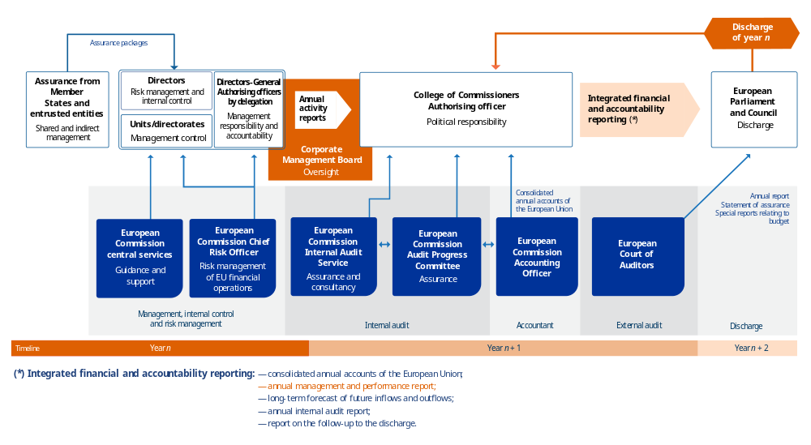
The Commission’s assurance-building and accountability for the EU budget: clear roles and responsibilities

  - A mature internal control framework contributing
to the achievement of the Commission’s objectives in an evolving environment
    - A mature internal control framework continually adjusted to address minor weaknesses
The Commission relies on a strong corporate internal control framework based on the highest international standards. It also employs a robust risk management policy to identify, assess and manage risks at every level of the organisation, in order to provide assurance about the achievement of its objectives. In 2025, the Commission continued to ensure that the amounts allocated from the EU budget were invested for their intended purpose in strict compliance with the financial rules, in order to minimise, detect and prevent errors, avoid double funding, prevent fraud, enhance transparency and pave the way to the discharge.
Overall, in 2025, the Commission departments concluded that the internal control principles underlying their internal control systems were present and working as intended, and stable over the years (see graph below), even if minor improvements are needed in some areas. This overall assessment confirmed that the Commission departments had continued their efforts to address the deficiencies in their internal control systems identified in 2024. Progress made in 2025 resulted from, among other things, the improvement of local strategies in various areas (e.g. human resources, anti-fraud), increased participation in learning activities, the adoption of business continuity plans and relocation plans, and the improvement of the quality of information provided on local intranets.
Assessment of the functioning of the components and internal control principles (*)
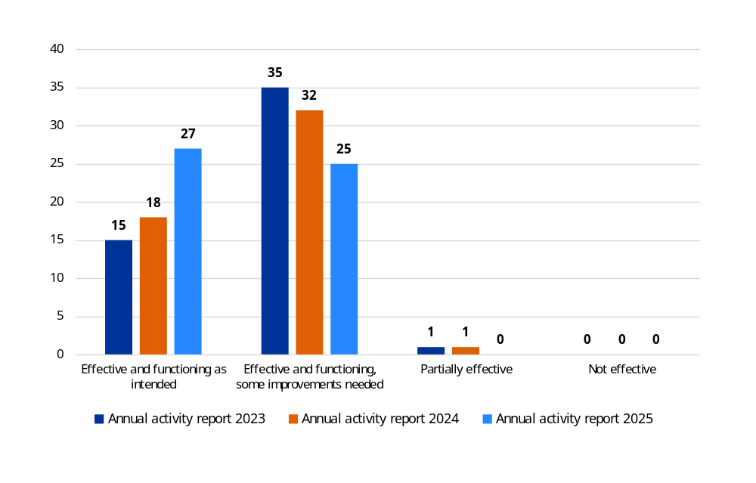
(*) The number of Commission departments reporting that internal control components and principles were upheld and functioned properly in 2023, 2024 and 2025.
Source: European Commission annual activity reports.
Commission departments, with the support of the Central Financial Service, continued to enhance, update and fine-tune their internal control systems where necessary. For some internal control principles, improvements are still needed, corresponding mostly to minor deficiencies. Similarly to previous years, partial effectiveness is often related to external factors. This assessment is inherent to the unstable political situation in certain non-EU countries and regions where operations are taking place. This heightened volatility prevents the full implementation of standard monitoring, evaluation and control activities without discontinuing the urgent and essential delivery of financial assistance. Most of the time, partial effectiveness was detected by audits (internal or external) and led to audit recommendations for which action plans have been developed and implementation has already started but is not yet completed. The departments concerned and the areas for improvement vary from one year to another. This is why variations over the years at the Commission level remain marginal. An overview can be found in the assurance provided by the Internal Audit Service in Volume III, Annex 6.
    - Progress in the Commission’s digital transformation
Against a backdrop of unprecedented challenges, the Commission’s digital transformation is moving forward by continuing to develop more efficient corporate information technology tools to increase the efficiency of its business processes and offering increasing data management and reporting capabilities.
In 2025, in line with the EU’s digital strategy, the Commission continued to implement and deploy its new corporate financial platform, SUMMA. This was an important milestone in the business-driven digital transformation of the Commission. It was a change and an update of an unprecedented order of magnitude (see box below).
SUMMA – the Commission’s new corporate financial platform
The platform went live in the Commission departments and executive agencies in January 2025, fully replacing the former central accounting, budgetary and treasury system. In January 2026, the European External Action Service and 22 decentralised EU agencies also started to use SUMMA. By 2027, SUMMA will be further deployed to each of the 27 entities still using the previous financial system, and to the Joint Sickness Insurance Scheme and the European Development Fund.
SUMMA is a modern financial system that is designed in close cooperation with the business owners, based on the best industry standards and fully integrated into the Commission’s corporate information technology landscape. Its integration with the main corporate and local systems increased the overall level of automation of the Commission’s operations.
SUMMA is an important source for the central data and reporting hub, which designs and delivers modern reporting solutions, from interactive dashboards to corporate reports, for a wide range of stakeholders: the Commission, the executive agencies and other bodies, institutions and decentralised agencies. The reporting hub makes the financial data clear, reliable and easy to use. The data and reporting hub also provides planning and forecasting solutions, allowing the EU entities to better programme their expenditure.
The SUMMA program has a strong governance framework and uses a thorough quality assurance system, based on regular tests on SUMMA processes and integrations.
Overall, SUMMA offers a significant increase in business efficiency, along with flexibility through integrated real-time analytics and decreased costs relating to ownership and future maintenance.
    - An enhanced framework for the risk management of financial operations
Since the NextGenerationEU borrowing programme was launched at the end of 2021, the EU’s financial operations have expanded significantly in volume and in scope to address emerging challenges. Budgetary guarantees and loans to achieve the EU’s policy objectives, funded through the issuance of debt securities, have been used on a large scale to tackle emerging challenges and successive crises. The Commission completed its funding programme for 2025, raising a total of EUR 155 billion over the course of the year. The 2025 issuance brought the total outstanding amount of EU bonds to EUR 560 billion by year end, with EUR 78.5 billion issued in the form of NextGenerationEU green bonds.
In this context, the Commission has appointed a Chief Risk Officer to devise, develop and implement an appropriate risk management and compliance framework to protect the EU’s financial interests and to ensure that the various risks stemming from the borrowing operations are adequately identified, managed and mitigated in a timely manner. This framework has been continually enhanced by putting in place processes, control points and risk oversight across all the core borrowing and lending activities, including funding planning, the execution of borrowing transactions, liquidity management, cost calculation and allocation.
Taking into account the increased complexities and scale of all EU financial operations, the Commission needed to evolve quickly towards a more comprehensive and sophisticated risk management framework, aligned with best practices in the industry. This was achieved at the beginning of 2025 by extending the Chief Risk Officer’s role beyond the EU’s borrowing and related lending and debt management operations to asset management operations, budgetary guarantees and financial assistance for non-EU countries (). In line with best practices, the Commission has implemented the ‘three lines of defence’ risk management model:
- the first line of defence is composed of the directorates-general responsible for the EU’s financial operations in accordance with the Financial Regulation, which should implement sound financial risk management processes, ensure compliance with the risk management framework and report any deviations;
- the Chief Risk Officer acts as the second line of defence at the corporate level, and is responsible for establishing a common financial risk management framework for all of the EU’s financial operations and for independent risk assessment and reporting;
- the third line of defence is the Internal Audit Service, which exercises its role in accordance with Article 118 of the Financial Regulation.
The Commission is now developing the framework governing financial risk management and compliance for the various categories of the EU’s financial operations. This framework will ensure consistent and harmonised risk approaches across Commission services. The policies will ensure alignment with international standards by adopting best practices for risk measurement and monitoring.
The Commission is now developing the framework governing financial risk management and compliance for the various categories of the EU’s financial operations. This framework will ensure consistent and harmonised risk approaches across Commission services. The policies will ensure alignment with international standards by adopting best practices for risk measurement and monitoring.

  - Multiannual control strategies to ensure that expenditure
is legal and regular
Authorising officers, as managers of the EU budget, put in place multiannual control strategies to prevent, detect and correct errors. In line with their responsibility to carry out individual payments, they need to build their assurance from the bottom up and in detail (i.e. by programme or other relevant segment of expenditure). This allows the Commission to detect weaknesses and errors in a detailed and differentiated manner for each programme or segment of expenditure; to identify the root causes of systemic errors (e.g. the complexity of rules in certain policy areas, such as research or cohesion); to take targeted and proportionate corrective measures; and to ensure that lessons learned are used to improve the management and control systems and the design of future financial programmes.
EU spending programmes are multiannual by design, and so are the related control strategies. This implies that the detection and correction of errors may take place continuously, until programme closure. Moreover, the control strategies are risk differentiated (i.e. they are adjusted to the characteristics and risks associated with different management modes, actors involved, policy areas and/or funding arrangements). Control strategies usually entail preventive controls (ex ante controls) carried out before the Commission payment takes place and corrective controls (ex post controls) carried out after the payment has been made.
The current approach for cost-based expenditure, and for expenditure where an error rate is determined, is presented in the visual below. The Commission’s key preventive and corrective mechanisms are detailed in Volume III, Annex 5.
The European Commission’s multiannual control cycle
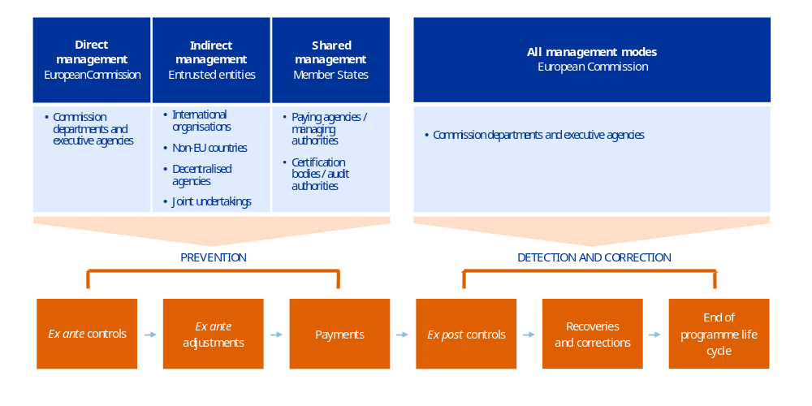
Source: European Commission.
For cost-based instruments, risk at payment and risk at closure are determined at different points in time, as explained in the visual below.
Risk at payment and risk at closure
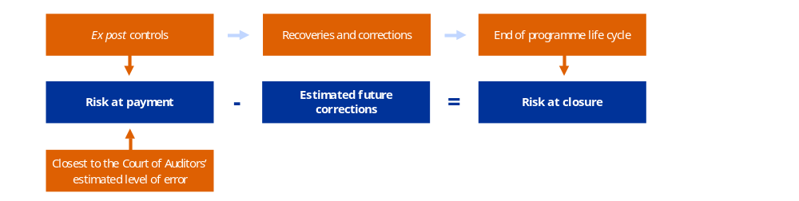
Source: European Commission.
For additional information regarding the 2025 risk at payment and at closure, see Section 2.1 below and Volume III, Annex 5, Sections 5.1 and 5.2.
For performance-based payments, the sequence of controls remains similar to the one described above but there is no calculation of a risk at payment and risk at closure. For expenditure under the new delivery model for the 2023-2027 common agricultural policy, there is a focus on the functioning of the systems in place in the Member States and systems audits, both from the national audit authorities () and from the Commission. For the expenditure under the Ukraine Facility, given the early stage in the life cycle of the instrument and the progress already made in its implementation, and taking into account the situation on the ground, the assessment is mainly based on ex ante desk reviews. Similar to cost-based instruments, the controls continue to result in adjustments and corrections, be they before the payment is made with suspensions and reductions or after the payment is made with financial corrections and recoveries.
Regarding the other funding programmes for the 2021-2027 multiannual financial framework, given the acceleration in payments in 2025, the Commission is now able to implement fully its control strategies. More payments mean more transactions to sample for auditing and thus less need to resort to flat rates, but also the possibility to rely on audit results for the error rates, which become more accurate, keeping a conservative approach.

  - Fight against fraud: the Commission’s anti-fraud strategy
and further proposals
    - Implementation of the Commission’s anti-fraud strategy
action plan
The Commission has zero tolerance for fraud. Pursuant to Article 325 of the Treaty on the Functioning of the European Union, the Commission and the Member States protect the EU budget from fraud and other illegal activities.
Throughout 2025, Commission services and the European Anti-Fraud Office made progress in the implementation of the action plan accompanying the Commission anti-fraud strategy () from 2019. The strategy plays a significant role in preventing the possible misuse of EU money. It is accompanied by an action plan, revised in 2023 (), including 44 measures under seven themes that cover the Commission’s priorities in fighting fraud. The target date for the different measures varies from 2023 to 2026, but for the majority the implementation is ‘done’, or ‘done and continuous’. The European Anti-Fraud Office further supported Commission services in the design of their anti-fraud strategies and continued sharing the latest developments on anti-fraud policy within the Fraud Prevention and Detection Network.
During the year, the European Anti-Fraud Office advanced its strategic analytical work, which is used to feed into Commission departments’ and Member States’ fraud risk assessments, notably through analyses of the detection and reporting of irregularities and fraud in different sectors and of the impact of and vulnerability to fraud in the various areas of the cohesion policy.
The European Anti-Fraud Office has engaged with national authorities to improve the reporting of irregularities and fraud, and provided strategic analysis to feed into Commission departments’ and Member States’ fraud risk assessments. The European Anti-Fraud Office continued engaging with Member States, both in the context of the Advisory Committee for the Coordination of Fraud Prevention and by providing on-demand support to their anti-fraud activities, including to candidate countries, such as Ukraine. The 2024 annual report on the protection of EU’s financial interests () included an updated qualitative assessment of the national anti-fraud strategies.
As a result of its investigative work, in 2025 the European Anti-Fraud Office recommended EUR 597 million for recovery, and that EUR 18.1 million be prevented from being unduly spent. The European Anti-Fraud Office reports on its investigative activities in its annual report ().

Review of EU anti-fraud architecture
In July 2025, the Commission launched a review of the EU anti-fraud architecture (). This anti-fraud review aims to promote efficiency at every stage of the anti-fraud cycle, supporting complementarity between anti-fraud actors in the prevention, detection, investigation, correction and prosecution of fraud and the more efficient and effective recovery of amounts for the EU budget. The White Paper also invited stakeholders and anti-fraud architecture actors to contribute to the review. The outcome of the review will be presented in 2026 and may be accompanied by legislative proposals.

Early detection and exclusion system
In 2025, building on the novelties introduced by the 2024 Financial Regulation, the Commission intensified its efforts to promote the early detection and exclusion system – a key tool in safeguarding the EU's financial interests against fraud, corruption and other forms of misconduct, such as breaches of conflict-of-interest rules or incitement to hatred and discrimination. This included awareness-raising activities addressed to all EU institutions, bodies, offices and agencies. This also led to a more harmonised application of the early detection and exclusion system framework and scrutiny of exclusion situations across services. In addition, in 2025, the rules of procedure of the early detection and exclusion system panel were revised to accelerate authorising officers’ decisions and improve the overall efficiency of the system.
    - Ensuring cybersecurity
Security, safety, cybersecurity and business continuity are very high on the Commission’s agenda. In 2024-2025, the Commission launched and ran the ‘Be prepared’ campaign, the internal flagship initiative to raise staff awareness of these issues. Leveraging the ‘Be prepared’ tips sent to all staff of the Commission, the ‘Be prepared’ snap visuals shown on screens across Commission buildings, the ‘Be prepared’ roadshows and the ‘Be prepared’ dedicated initiatives, the horizontal services in charge of security, safety, cybersecurity and business continuity raise the contextual awareness of Commission staff on specific relevant matters in these four areas. Building on the successful results, the campaign has been extended to the 2026-2027 period, further promoting active and dynamic engagement with staff.
As regards cybersecurity, attacks against the Commission have been contained successfully and the impact of incidents has been limited successfully. The Commission continues to be an attractive target for cyber-threat actors in the current geopolitical context and threat landscape, which is characterised by the exploitation of technical and human vulnerabilities in increasingly sophisticated ways. In this context, the Commission continuously invests in improving its cybersecurity posture and evolving its threat intelligence, detection and response capabilities.
As required by the regulation on cybersecurity at the institutions, bodies, offices and agencies of the EU (), the Commission established an initial cybersecurity review, ran the maturity assessment and reported on its cybersecurity plan, building on the internal existing cybersecurity governance, monitoring and reporting framework, and the corporate cybersecurity strategy. The implementation of the first complete cycle of reporting required by the regulation contributed to the establishment of a comprehensive and binding framework to ensure a high common level of cybersecurity across the EU entities, including obligations on governance, risk management, incident reporting and cooperation.
In the current geopolitical context, digital sovereignty also emerges as a critical area. In November 2025, the Commission’s corporate information technology governance body endorsed a digital sovereignty action plan, which aims to increase control over the Commission’s own digital assets. The action plan was proactively shared through the Interinstitutional Committee for Digital Transformation, to serve as a reference for other EU institutions that retain administrative autonomy for their own digital choices.
The Commission is actively promoting European leadership, innovation and strategic autonomy, and has already taken steps to reduce reliance on non-EU providers for critical infrastructure, to increase resilience and to safeguard competitiveness. In October 2025, the Commission launched a EUR 180 million sovereign cloud tender to be awarded under a new cloud sovereignty framework. By embedding sovereignty considerations into its information technology procurement procedures and establishing a benchmark for sovereign use of cloud services, the Commission contributes to shaping market practices that support sovereign solutions and leads by example with regard to the Member States.
  - Other tools to ensure the protection of the EU’s
financial interests
    - Conditionality regime
Since 2021, the regulation on a general regime of conditionality for the protection of the EU budget () (Conditionality Regulation) has protected the budget from breaches of the principles of the rule of law that affect or seriously risk affecting the financial interests of the EU in a sufficiently direct way. The Conditionality Regulation complements other procedures established by EU legislation for the protection of the EU budget. The validity of the Conditionality Regulation was fully upheld by the Court of Justice of the European Union in two judgments from 2022 (). Following those judgments, the Commission adopted its guidelines on the application of the Conditionality Regulation (). Since then, the Commission has been monitoring the situation across all Member States under the Conditionality Regulation and will trigger the procedure under the regulation if all its conditions are fulfilled.
At the end of 2022, one procedure was launched, concerning Hungary. The Council decided to suspend 55% of the budgetary commitments for three programmes () under cohesion policy, corresponding to an amount of approximately EUR 6.4 billion for the 2021-2027 period, and prohibited the Commission from entering into new legal commitments with public-interest trusts or entities maintained by them (many of which are universities) under any EU programme directly or indirectly managed by the Commission.
The prohibition regarding the second measure has been challenged before the General Court (the case is still pending).
In 2025, the Commission continued to monitor the situation in all Member States and protective measures remained in place as regards Hungary. The Commission reassessed the situation for Hungary at the end of 2023 at its own initiative, and at the end of 2024 following a written notification from Hungary on remedial measures to address the outstanding concerns. Each time, it concluded that the EU budget remained at the same level of risk and did not propose any lifting or adaptation of the protective measures. In 2025, Hungary did not notify new remedial measures to address the issues identified by the Council. Further details can be found in the annual rule-of-law report ().
    - Use of the single data-mining and risk-scoring tool – Arachne
The Financial Regulation (recast), adopted in September 2024, requires a modernised data-mining and risk-scoring tool, to be used in all management modes. The existing data-mining and risk-scoring tool, Arachne, on which the future tool will be based, is already used by Commission services and by a number of Member States on a voluntary basis in shared management and for the Recovery and Resilience Facility. An expert group was established with Member States in 2025 with a view to assessing the readiness of that tool, for which compulsory data feeding will be required from all Member States as from the next programming period, starting in 2028. Based on that assessment, the possibility to make the use of the tool by Member States compulsory may be discussed again by the co-legislators.
- Cost-effective controls protecting the
EU budget
In line with Article 33 of the Financial Regulation, to ensure that controls remain cost-effective, the Commission aims to strike the right balance between the following.

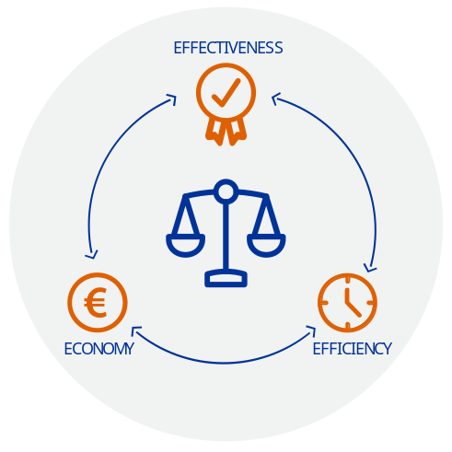
- Effectiveness. The level of error found, based on the controls carried out, which allows the expenditure to be grouped into different risk categories.
- Efficiency. The average time taken to make a payment. Beyond this, the Commission is also constantly looking for and developing new ways to increase efficiency, notably by creating synergies wherever possible.
- Economy. The proportionality between the costs of controls and the funds managed.

Cost-effectiveness is obtained through differentiation of the controls: riskier areas trigger a higher level of scrutiny and/or frequency and intensity of controls, whereas low-risk areas should result in less-intensive, less-costly and less-burdensome controls. Other ways to ensure the cost-effectiveness of controls include reducing the risk of errors through simplified rules and processes, such as simplified cost options (i.e. lump sums, flat rates and unit costs), cross-reliance on existing assessments, and audits and controls performed by other entities and achieving economies of scale by pooling the control functions.
In line with the principle of sound financial management, more instruments are using the progress in the achievement of objectives, monitored with performance indicators, as a triggering factor for the payment of EU funds. This requires the adjustment of controls and a different approach to building the assurance.

  - The Commission’s control results confirm that the EU budget
is well protected
    - Overall results for 2025
With the increasing share of performance-based expenditure – most of the common agricultural policy expenditure since 2024 and the expenditure under the Ukraine, Western Balkans and Moldova facilities since 2025 – the Commission presents the control results at the level of individual multiannual financial framework headings. For the entire EU budget, expenditure is presented for each category of risk: low, medium and high.
For cost-based and compliance-based payments, the Commission considers that the budget is effectively protected when, at the latest by the closure of the programmes (i.e. when all controls, corrections and recoveries have been implemented), the risk at closure is below 2%. This is the same materiality threshold as used by the Court of Auditors. For more details on these concepts and the methodology used to determine these estimates, along with the control results for each policy area, see Volume III, Annex 5. Based on the audits and controls carried out, each year the Commission departments estimate the level of risk for the legality and regularity of EU spending at two stages of the multiannual control cycle: at payment and at closure of the programmes.
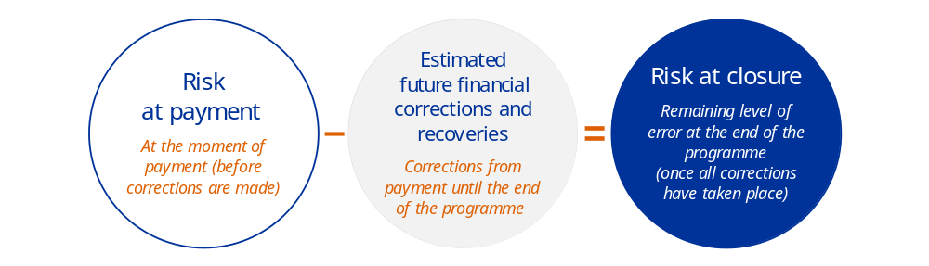
Source: European Commission.
Until 2023, this was the only indicator used to measure the level of protection of the EU budget, and it was also used for the entire Commission. This indicator continues to be applied for those headings under which payments are cost based and compliance based, thus for 2025 headings 1, 2, 4, 5 and 7.
Overview of risk at payment and risk at closure for cost- and compliance-based expenditure
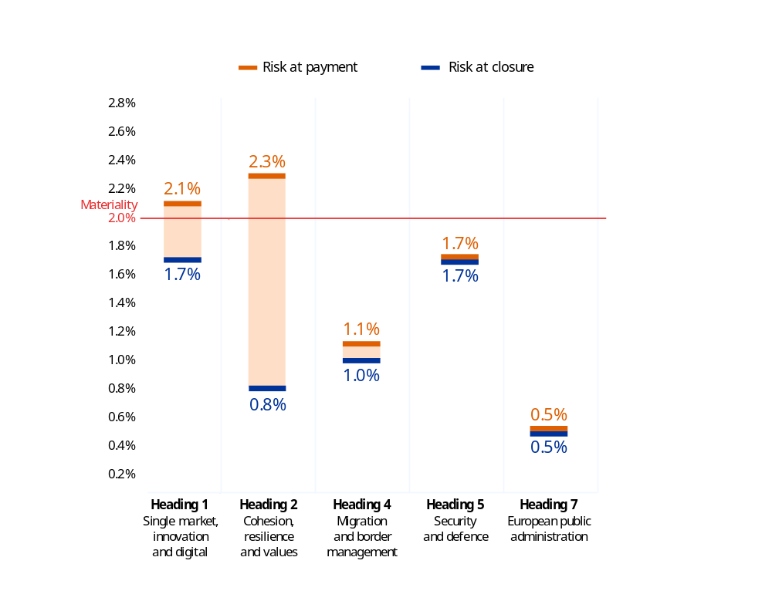
Source: European Commission annual activity reports for 2025.
For instruments where expenditure is performance based, a qualitative assessment is made allowing the share of expenditure in each category of (risk, low, medium and high) to be determined. This concerned the following headings.
- Natural resources and environment. Since 2024, with the new delivery model under the 2023-2027 common agricultural policy, the focus has been on performance, based on the achievement of results, and on the proper functioning of the governance systems in the Member States. As Member States no longer report to the Commission on control statistics at the beneficiary level, a risk at payment and risk at closure cannot be determined. Instead, the corresponding expenditure is grouped into three categories of risk (low, medium and high), based on the assessment of the functioning of the systems in place in the Member States to ensure the legality and regularity of the underlying transactions, along with the quality of performance results and progress made on the performance part. For instance, if a system is assessed as functioning well, all expenditure made through that system will be considered low risk. Controls carried out continue to result in suspensions, reductions, financial corrections and recoveries.

- Neighbourhood and the world. Since 2025, regarding the Ukraine (), Western Balkans and Moldova facilities, expenditure has been considered performance based, given that payments are made once predefined steps (equivalent to milestones and targets) are satisfactorily fulfilled. For the assurance, the Commission makes a qualitative assessment of the satisfactory fulfilment of the steps submitted for payment. This qualitative assessment is difficult to translate into quantitative terms with an error rate. In addition, the investments and reforms included in the beneficiary countries’ plans are very diverse, which hinders statistical extrapolation. In this context, a meaningful error rate cannot be determined. Here as well, expenditure is grouped into three categories of risk (low, medium and high), based on the assessment of the level of risk of the steps associated with the payment made, complemented by the result of ex ante and ex post controls (). For instance, if a step relates to the adoption of a reform, it is usually considered low risk, and the amount paid corresponding to that step is also considered low risk. See more details in Section 2.1.2, under ‘Heading 6 – neighbourhood and the world’. As foreseen in the regulation, controls will result in suspensions, reductions, financial corrections and recoveries when errors are identified or in cases of serious breaches of the beneficiaries’ obligations.
Consequently, control results are reported per heading, some with risk at payment and risk at closure, some with share of low, medium and high-risk expenditure. This latter presentation is also used to the EU expenditure as a whole.
For 2025, all headings managed under the cost-based and compliance-based payment delivery model have a risk at at closure below 2%. For the heading on natural resources and environment, the share of low-risk payments is 64%, in line with the range for the period 2020 - 2024 (50.6% to 77.6%). For the heading on neighbourhood and the world, the share of low-risk payments is 89.6%, in line with the range for the period 2020 - 2024 (from 76.6% to 100%). The corresponding expenditure is thus well protected.
For the single market, innovation and digital and the cohesion, resilience and values headings, the risk at payment is above 2% and the risk at closure below 2%. For these headings, the Commission is continuing its efforts to further reduce the level of risk at the time of payment. Since the risk at closure is below 2%, this means that the corresponding expenditure is ultimately well protected thanks to the efforts of the Commission (and Member States) after payment, through controls and ensuing corrections.

To allow for comparability and to have an overview, the information is presented below per risk category (low, medium or high) for each heading (see Section 2.1.2) and for the entire Commission.
Overview of expenditure per risk category for the entire Commission
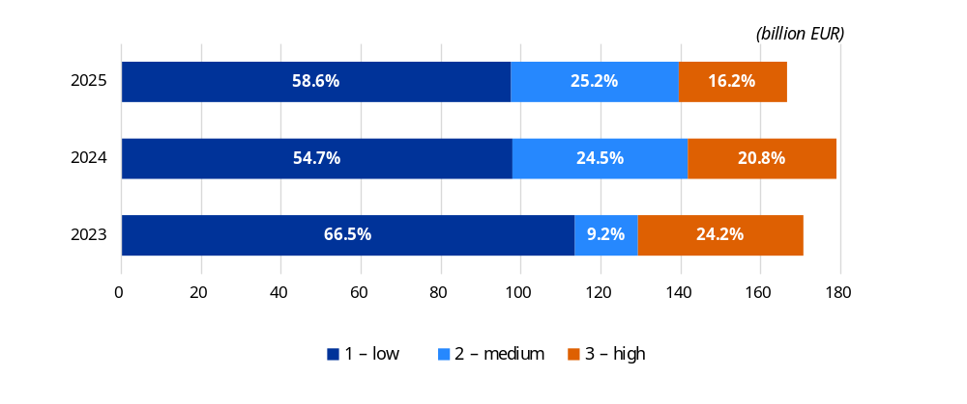
Source: European Commission annual activity reports for 2025.

Preventive and corrective measures
This new approach to assurance on performance-based payments has no impact on preventive and corrective measures that continue to be applied.
Total preventive and corrective measures (Commission and Member States): EUR 9.0 billion (2024: EUR 2.7 billion).
This increase relates to cohesion policy funds and is mostly due to the corrections made to the 2014-2020 programmes, for which final accounts were submitted and taken into account in the financial year 2025.
See Section 2.1.3 below, heading ‘cohesion, resilience and values’, and Volume III, Annex 5, Section 5.4 for more details.
Reservations: 32 (18 in 2024), of which 30 related to expenditure from the EU budget with a total financial impact of EUR 867 million (17 and EUR 330.9 million in 2024) and two related to expenditure from the Resilience and Recovery Facility with a financial impact of EUR 343 million (EUR 17.5 million in 2024).
See Section 3.1 below and Volume III, Annex 5, Section 5.3 for more details.

    - Control results by lower-, medium- and higher-risk programme segments
The Commission has reliable, evidence-based information showing the diversified situation of the funds it manages. It identifies which programmes or segments of expenditure are higher risk, allowing it to efficiently provide its support and address specific weaknesses even for policies that are generally lower risk, such as the common agricultural policy.
For cost-based expenditure, the split between the categories of risk is based on the risk at payment (i.e. before any future correction is implemented): lower risk – risk at payment below 2.0%; medium risk – risk at payment between 2.0% and 2.5%; and higher risk – risk at payment above 2.5%. For cohesion, this analysis is also applied at the level of the individual programmes in the Member States.
Performance-based expenditure is directly split between the low-, medium- and high-risk categories according to the assessment made based on methodologies tailored to the means of payment. For expenditure under the new delivery model of the 2023-2027 common agricultural policy, this is based on the assessment of the functioning of the systems in the paying agencies, at the intervention level. For expenditure under the facilities, this is based on the risk assessment of the milestones and targets (steps) submitted for payment. As a result, the new approach maintains or even increases the granularity: in the case of the common agricultural policy, because information on the weaknesses and deficiencies is at a level lower than paying-agency level; in the case of the facilities, because the information is at the level of each individual payment.
The European Commission’s categorisation of expenditure into lower-, medium- and higher-risk segments, as a percentage of the total relevant expenditure for 2025
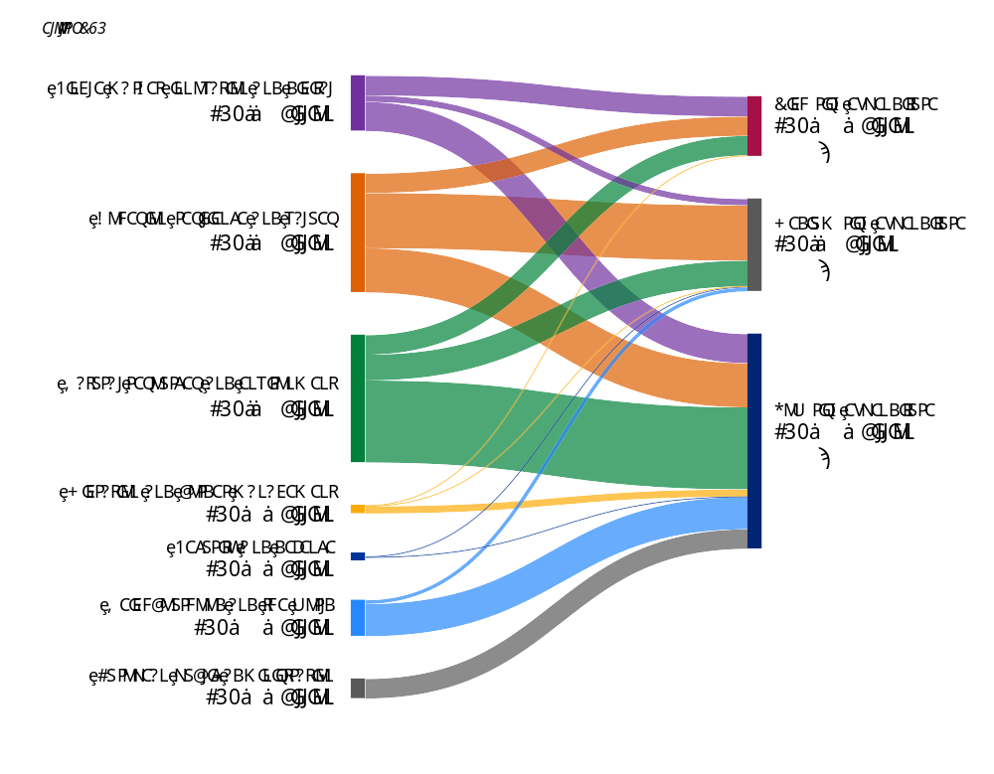
Source: European Commission annual activity reports for 2025.

In 2025, the relevant expenditure decreased from EUR 179 billion in 2024 to EUR 166.7 billion in 2025. The share of the respective lower-, medium-, or higher-risk segments remained stable overall, with some changes in the components.
- Lower risk. Expenditure in this category amounted to EUR 97.6 billion in 2025, representing 58.6% of the total expenditure (54.7% in 2024). This increase is due to the fact that, under the 2021–2027 programming period, many cohesion programmes present low error rates, since the initial amounts of expenditure declared are generally less error-prone compared to expenditure declared at later stages of implementation.
As in previous years, this lower-risk category also includes the majority of expenditure managed under the new common agricultural policy delivery model (amounting to more than EUR 31.5 billion, corresponding to 2 188 interventions with a governance system assessed as functioning well out of a total of 2 865).
It also includes expenditure managed by 49 out of 68 paying agencies and by the United Kingdom for rural development; most of the expenditure implemented under shared management in the maritime affairs and fisheries areas; and expenditure relating to the Connecting Europe Facility – transport programme for the 2014-2020 period, Erasmus+, the Marie Skłodowska-Curie actions, Horizon Europe financial instruments, the vast majority of contributions to other EU bodies and international organisations (e.g. the European Union Agency for the Space Programme, the European Joint Undertaking for ITER and the Development of Fusion Energy and the European Space Agency), 87.6% of the Asylum, Migration and Integration Fund, 83.7% of the Internal Security Fund, humanitarian aid, expenditure in the neighbourhood and the world policy area (89.6% of the total expenditure of that heading), and administrative expenditure in general.
- Medium risk. Expenditure in this category amounted to EUR 42.0 billion in 2025, or 25.2% of the total expenditure, compared to EUR 43.9 billion in 2024, or 24.5%. This apparent overall stability is explained by an increase in expenditure under the new common agricultural policy delivery model allocated to this category of risk (from EUR 4.7 billion in 2024 to EUR 11.2 billion in 2025), along with a higher share of governance systems being assessed as partially functioning (448 out of 2 865 in 2025 compared to 152 out of 1 526 in 2024), which is largely offset by a decrease in expenditure under cohesion considered in this category due to error rates below 2%.
This category also included expenditure in research and innovation, in particular grants under Connecting Europe Facility – transport programme for the 2021-2027 period, along with other expenditure related to the common agricultural policy, such as market measures and rural development measures.
- Higher risk. Expenditure in this category decreased from EUR 37.2 billion in 2024, or 20.8% of the total expenditure, to EUR 27.1 billion in 2025, or 16.2% of the total expenditure. In 2025, 98.5% of expenditure in this category of risk was equally split between three headings: (1) single market, innovation and digital (33.1% in 2025 versus 13.8% in 2024); (2) cohesion, resilience and values (32.5% in 2025 versus 64.6% in 2024); and (3) natural resources and environment (32.9% in 2025 versus 19.7% in 2024). This corresponds mainly to the grants under the Horizon Europe and digital Europe programmes; to the lower number of cohesion programmes with a high error rate in 2025 compared to 2024; and to the higher number of interventions assessed as not functioning in 2025 (229 out of 2 865) compared to 2024 (268 out of 1 526). For detailed explanations, see Section 2.1.2 under the relevant headings.

The Commission’s detailed analysis confirms that the level of error and share of high-risk expenditure are closely related to the nature of the funding. Most programmes or segments of expenditure, corresponding to more than 50% of the year’s relevant expenditure, are estimated to be in the lower-risk category because they encompass more entitlement-based payments. On the other hand, some programmes or segments of expenditure with complex reimbursement-based rules appear to have a relatively higher risk at payment (as is typically the case under cohesion policy, with many applicable national, regional or programme rules in addition to EU rules). Nevertheless, the control systems in place allow the risks relating to some of the more complex programmes to be mitigated and, as a result, the level of risk at payment to be reduced.
The Commission is closely monitoring the risks at payment and at closure for the various programmes and segments of expenditure, and is taking further action to reduce them. For the medium- and higher-risk categories in particular, the Commission is continually looking for ways to further decrease them by raising beneficiaries’ and implementing partners’ awareness of issues, adjusting the control strategies where necessary, applying the lessons learned to future programmes and simplifying rules wherever possible.
    - Control results by policy area
The Annual Management and Performance Report for the EU Budget is a summary of the annual activity reports of the 52 Commission departments. The spending covered in each of these reports is allocated in full to one of the seven headings of the multiannual financial framework. Since 2022, considering its size, the spending for security and defence by DG Defence Industry and Space has been divided between heading 1 and heading 5. Since 2025, spending by DG Economic and Financial Affairs has been split between heading 2 and heading 6 (expenditure related to Ukraine) and spending by DG Budget has been split between heading 2 (interest paid on NextGenerationEU borrowing), heading 6 (expenditure related to Ukraine) and heading 7. The situation for each policy area is described below.

Heading 1 – single market, innovation and digital
Total relevant expenditure: EUR 25.0 billion (2024: EUR 24.2 billion).
Risk at payment: 2.1% (2024: 1.6%).
Risk at closure: 1.7% (2024: 1.2%).
Total preventive and corrective measures: EUR 232.9 million (2024: EUR 348.5 million):
- preventive measures: EUR 153.3 million (2024: EUR 244.7 million);
- corrective measures: EUR 79.6 million (2024: EUR 103.8 million).
Reservations: 13 (2024: one reputational reservation without financial impact ()).
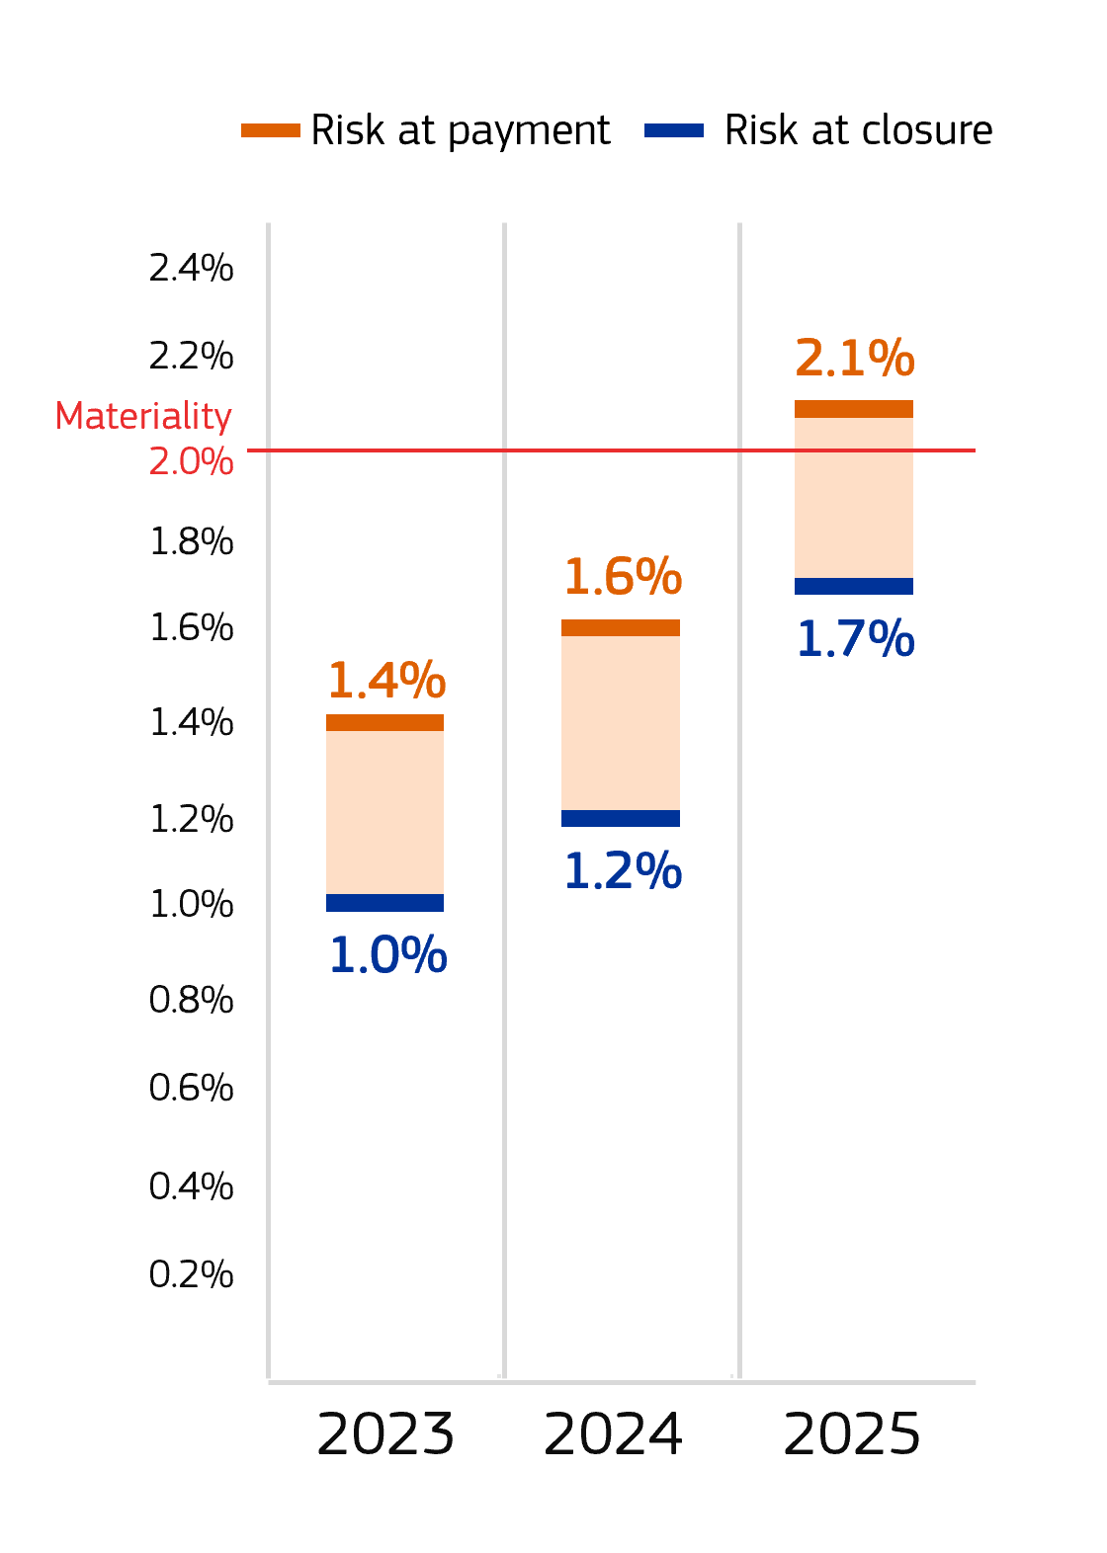
In 2025, the risks at payment (2.1%) and at closure (1.7%) increased by 0.5 percentage points compared to 2024. This is due to the increase in the risk at payment for grants under both Horizon programmes and for grants under the digital Europe programme.
For Horizon 2020, the risk at payment increased from 3.55% to 3.83%, whereas the total expenditure of that heading decreased from 20.3% to 16.9%. As in previous years, and despite ongoing efforts and improvements, the risk at payment remained above 2% because of the inherent complexity of the rules and the nature of the payments. Payments made in 2025 corresponded mostly to final payments for larger and more complex projects, which are more error prone than interim payments. Similarly to previous years, the research departments did not qualify their declarations of assurance with a reservation in relation to the Horizon 2020 programme (). At the same time, the risk at closure, at 1.78%, is in line with 2024, at 1.79%, and remained below the materiality threshold.
For Horizon Europe, the risk at payment increased from 2% to 4.38% () and the share in the total expenditure of that heading increased from 17.9% to 25.8%. The risk at closure is estimated overall at 4.05% in 2025. This higher level of error is the combined result of (1) a population of beneficiaries composed of newcomers to the programme and small and medium-sized enterprise beneficiaries, for which cost claims are generally more error prone; (2) significant errors identified in three participations/projects that had a big impact on the error rate in a still rather limited audited population, being at the beginning of the audit campaign of the programme; and (3) the limited impact of lump sum grants in the Horizon Europe control results, since few have yet been paid and reviewed. Similar to Horizon 2020, the most frequent errors are related to personnel costs (e.g. missing or unreliable time reporting system, wrong calculation of daily rates).
To reduce these error rates, the Commission is focusing its efforts on communication, both external
and internal. Dedicated webinars and training sessions targeting beneficiaries were organised throughout the year for Horizon Europe. In the context of the client centricity project, the error-rate-reduction campaign that was launched in 2024 continued in 2025, with three additional rounds of personalised notifications sent to the most error-prone beneficiaries that were approaching their reporting deadlines. These notifications were revised to maximise their impact and included practical tips on how to avoid the most common errors.
The Commission is also pursuing the roll-out of lump sums under Horizon Europe with the goal of lump-sum grants reaching at least 50% of the call budget in the main 2026-2027 work programme. According to the Horizon Europe midterm evaluation (), lump sums help avoid financial errors while safeguarding the EU’s financial interest, and controls thereof have led to grant reductions at the evaluation and payment stages. In addition, this model helps shift the focus during the implementation stage from financial controls to the project’s content. However, the impact on the error rate will not be felt before 2029, when a larger number of such grants are paid and ex post control results start to become available.
Regarding the digital Europe programme, similarly to last year it is the error rate for the Horizon Europe programme that has been used, given the limited number of available audit results at the end of 2025 and considering the similarities with that programme (eligibility criteria, number of beneficiaries in common and type of beneficiaries).
In 2025, a total of 13 reservations were issued, an increase of 12 reservations compared to 2024. Reservations were issued for those programmes for which the error rate after corrections remains above the materiality threshold of 2%: for the grants under the Horizon Europe programme, in the declaration of assurance of the eight departments implementing them and where the de minimis rule does not apply; for the grants under the digital Europe programme, in the two departments implementing them; and for the promotion of agricultural products programmes (one department). In addition, a reservation was issued in the two departments implementing the European Innovation Council concerning weaknesses affecting the award decision process. Action plans to address the weaknesses and reduce the level of the error rate have been put in place. Further details are provided in Volume III, Annex 5, Section 5.3.3.
The decrease in the amount of preventive measures, from EUR 244.7 million in 2024 to EUR 103.3 million in 2025, resulted mainly from the transition to the Commission’s new accounting system, SUMMA, where only preventive measures exceeding EUR 500 000 are reported. Under this heading, a significant part of those preventive measures fall below this threshold, hence they are outside the reporting scope.
Multiannual financial framework heading 1 – single market, innovation and digital –
overview of risk segmentation for 2023-2025
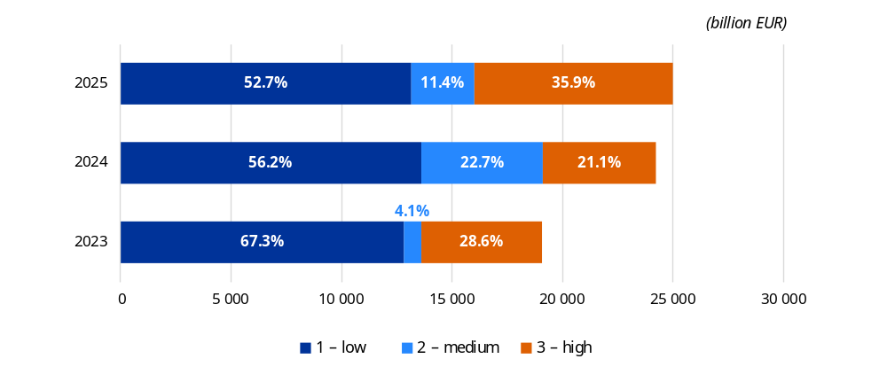
Source: European Commission annual activity reports for 2025.

Heading 2 – cohesion, resilience and values
Total relevant expenditure: EUR 54.0 billion (2024: EUR 64.1 billion) ().
Risk at payment: 2.3% (2024: 2.9%).
Risk at closure: 0.8% (2024: 1.7%).
Total preventive and corrective measures (Commission and Member States): EUR 7 191 million (2024: EUR 1 028.6 million):
- preventive measures: EUR 590.2 million (2024: EUR 579.9 million);
- corrective measures: EUR 6 600.8 million (2024: EUR 448.7 million).
Reservations: five reservations with a financial impact of EUR 304 million (2024: five reservations with a financial impact of EUR 73 million).
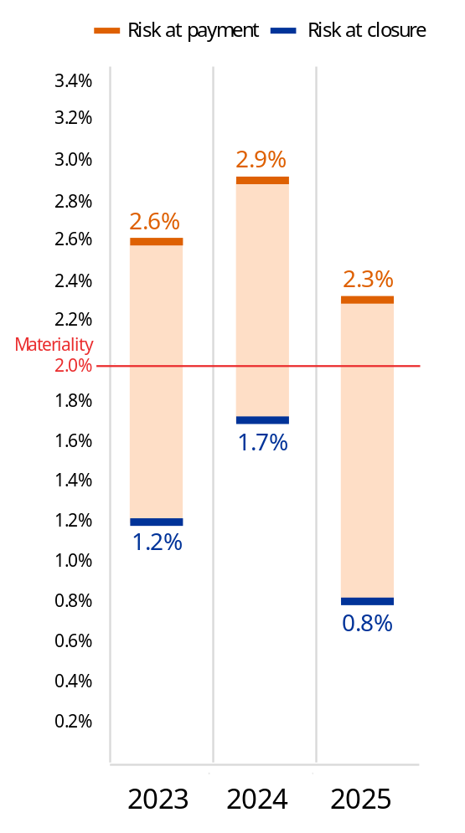
The reduction in total relevant expenditure under this heading from EUR 62 billion in 2024 to EUR 54 billion in 2025 is largely attributable to the timing of the Member States’ accounts submissions for 2014-2020. The expenditure for 2025 includes only 20% of the final account submissions, with the remaining 80% being deferred to 2026 due to the Strategic Technologies for Europe Platform Regulation (), which postponed the deadline for submitting the accounts by one year.
The risk at payment for this heading decreased from 2.9% to 2.3%, while the risk at closure

decreased from 1.7% to 0.8% (). The risk at payment and risk at closure were mostly driven by the amounts paid for the cohesion policy funds () managed under shared management, which represented around 84% of the total relevant expenditure for this heading.
For all the cohesion policy funds, the risk at payment remained material in the range of 2.0% to 2.7%, a decrease from the range observed in 2024 of 2.3% to 3.2%. The decrease is mainly due to the prudent approach taken by the Commission for expenditure corresponding to the 2021-2027 programming period of using a flat rate of 2%, increased where necessary on a programme-by-programme basis based on information available, due to the limited audit results received for the 2024-2025 accounting year () and the increased share of this expenditure in the total cohesion expenditure, from 15.3% in 2024 (EUR 8.4 billion) to 80.5% (EUR 36 billion) in 2025. In 2024, most of the cohesion expenditure corresponded to the 2014-2020 programming period, for which the risk at payment was higher.
Overall, the Commission has reasonable assurance that the management and control systems function sufficiently well for 85% of the cohesion programmes (). Nevertheless, the risk at payment remained above the 2% materiality threshold. This is mainly due to the inherent complexity of the projects financed by these funds, the variety of actors concerned and the difficulty of tackling certain complex rules at both the national and the EU level, in particular those relating to public procurement and State aid. Weaknesses remain mainly at the level of managing authorities or their intermediate bodies. The main categories of irregularities identified by the Member States’ audit authorities and the Commission are similar to those identified by the Court of Auditors: ineligible expenditure; ineligible projects or beneficiaries; errors in public procurement procedures; and missing supporting information or documentation.
For the cohesion funds, the Commission applied additional financial corrections for those programmes where it confirmed individual error rates above 2%, so that the risk at closure will ultimately be below 2% for all the programmes. Estimated future corrections corresponded to a range of 1.24% to 2.05%, leading to an estimated risk at closure of 0.76%.
The sharp increase in preventive and corrective measures in 2025 compared to 2024 was mainly driven by corrective measures related to operational programmes under the 2014-2020 programming period, which reached the closure stage. Member States reported EUR 6 518 million in corrective measures () for cohesion funds under the 2014-2020 programming period. This marks a sharp increase from EUR 211 million in the previous year, which was exceptionally low due to the limited number of final accounts submitted (i.e. only 20%, due to the additional year provided under the Strategic Technologies for Europe Platform Regulation () to submit them). The convergence of the last accounting period for the 2014-2020 programming period, concentrating the highest volumes of accounts (), and the additional time frame led to a significantly amplified scale of adjustments, as programme authorities in Member States undertook a final, comprehensive review of both the current and the previous accounting years. In this context, the closure acted as a critical safeguard, ensuring that remaining irregular or inaccurate expenditure was identified and excluded.
For the 2021-2027 programming period, the preventive measures increased slightly from EUR 565 million in 2024 to EUR 586 million in 2025. As it is still early in the programme life-cycle implementation, the corrective measures were rather low at EUR 9 million (2024: EUR 8 million).
One specific feature of the 2021-2027 multiannual financial framework for the European Regional Development Fund, Cohesion Fund and European Social Fund Plus is the need for Member States to comply with a set of thematic and horizontal enabling conditions to allow for the effective implementation of the funds. At the end of 2025, around 97% of the applicable thematic enabling conditions were assessed as fulfilled for the European Regional Development Fund, Cohesion Fund and European Social Fund Plus programmes that had been adopted. By the end of April 2026, all Member States except Hungary fulfilled the horizontal enabling conditions ().
At the end of 2025, four reservations were issued in relation to cohesion policy funds (two per programming period): one for the European Regional Development Fund and Cohesion Fund and one for the European Social Fund, the youth employment initiative and the Fund for European Aid to the Most Deprived. These reservations concern operational programmes that presented significant weaknesses in their management and control systems or for which the error rate was above the materiality threshold, or, less frequently, for which the audit work at the Member State level was deemed insufficient or unsatisfactory.
- Two reservations for the 2014-2020 period: the number of programmes under reservation (40) was higher than in 2024 (26), while the financial impact increased from EUR 68 million to EUR 143 million. The increase in both number of programmes under reservation and the corresponding financial impact is explained by the larger number of programmes closed during 2025 (i.e. 80% of accounts). In 2024, the Strategic Technologies for Europe Platform Regulation postponed the deadline for submitting the accounts by one year, which resulted in an unusually low level of submission of accounts (only 20%) ().
- Two reservations for the 2021-2027 period: the number of programmes under reservation (28) was higher than in 2024 (7), and the total financial impact increased from EUR 3 million to EUR 156 million. The increase is explained by the higher number of programmes gaining speed in implementation in 2025 compared to 2024 and the corresponding accounts that are submitted.
Reservations are only lifted once the system weaknesses have been addressed and the error rate is below 2%. Usually, the reasons for the reservations are not structural, and it takes one to two years for most reservations to be lifted. For more details on reservations, see Volume III, Annex 5.
The Commission continues to take action to support programme authorities in improving their management and control systems and to bring the risk at closure for cohesion below 2%. In December 2024, following a participative debate with both audit and managing authorities, the Commission established a jointly agreed action plan to improve the programme authorities’ error detection capacity comprising 22 measures covering the following categories: the dissemination of information to beneficiaries to improve their understanding of their obligations and rules; the analysis of errors detected, and in particular additional errors reported by EU audits; the enhanced use of information technology tools; staff training; the enhanced preventive role of auditing; the use of complete and updated audit checklists; and effective audit practices in line with audit standards (e.g. documentation of verifications/checks done). Throughout 2025, the Commission monitored the implementation of the measures. The progress was discussed in the annual coordination meetings between the audit authorities of all of the Member States. In addition, the Commission updated its single audit strategy to target high-risk areas, taking account of resource constraints, by significantly increasing the coverage of its on-the-spot audits and by reflecting its new approach for compliance audits (faster, preventive and targeted).
Multiannual financial framework heading 2 – cohesion, resilience and values –
overview of risk segmentation for 2023-2025
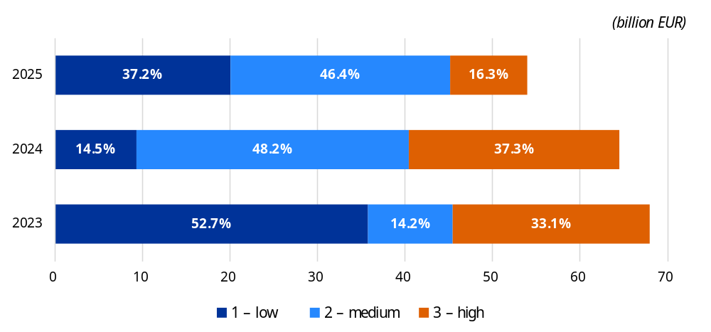
Source: European Commission annual activity reports for 2025 ().

Heading 3 – natural resources and environment
Total amount of relevant expenditure: EUR 58.0 billion (2024: EUR 57.4 billion):
- compliance-based assurance model: EUR 11.7 billion (2024: EUR 14.5 billion);
- performance-based assurance model: EUR 46.3 billion (2024: EUR 42.9 billion).
Share of low-risk expenditure: 64.4% (2025), 77.6% (2024).
Total preventive and corrective measures (Commission and Member States): EUR 1 417.1 million (2024: EUR 1 069.8 million):
- preventive measures: EUR 201.6 million () (2024: EUR 178.4 million);
- corrective measures: EUR 1 215.6 million (2024: EUR 891.4 million).
Reservations: seven reservations with a financial impact of EUR 301 million (2024: seven reservations with a financial impact of EUR 254 million).
Multiannual financial framework heading 3 – natural resources and environment –
overview of risk segmentation for 2023-2025
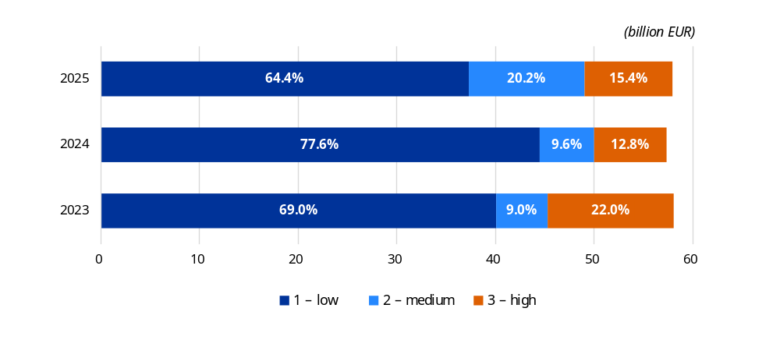
Source: European Commission annual activity reports for 2025.
In 2025, for natural resources and environment, 64% of the expenditure was considered low risk. This corresponds to expenditure with a risk at payment below 2%, for compliance-based payments; and expenditure for which the systems in place in the Member States have been assessed as low risk, functioning well or functioning, for performance-based payments. This is the same as the share of low-risk expenditure for agriculture (64%), which represents the bulk of the expenditure in this policy area (98%), the rest corresponding to maritime affairs and fisheries (), environment and climate expenditure. This is a decrease compared to the share of low-risk expenditure in 2024 (77%) and in 2023 (69%), and is slightly below the average for 2020-2024 of 66.7%. This mainly reflects a shift from low to medium risk, which is partly due to improved assessment and the resulting gradings of the systems by the certification bodies, which gained experience in the second year of implementing the new delivery model (notably in France, aligning with DG Agriculture and Rural Development audit findings), combined with end-of-programme effects in the 2014-2022 rural development programmes, where accelerated spending at closure can increase amounts under reservation / at risk. Greece’s continued precautionary reservation also remained a significant driver in absolute terms.
The 2023-2027 common agricultural policy represents a shift from compliance-based payments to a greater focus on performance and results achieved, with these changes applying for the first time for the payments made in 2024. With this new delivery model, Member States have more flexibility and responsibility in setting beneficiary rules in their national plans within the general EU framework. The Commission focuses on progress towards results and the effectiveness of national governance systems rather than on checking individual transactions. As Member States no longer report beneficiary-level control statistics, the Commission cannot calculate error rates at the paying agency or the common agricultural policy level.
For this new delivery model, the Commission’s assurance model therefore assesses the performance, the progress towards achieving the results and how well Member States’ systems ensure the legality and regularity of the underlining transactions and the quality of the performance results. The Commission draws on certification bodies’ annual assessments of the systems in place (with gradings assigned by paying agency and intervention), on Commission audits and on findings by the Court of Auditors, and may adjust gradings on a case-by-case basis.
Based on the final system grading (), the Commission classifies common agricultural policy expenditure as low, medium or high risk. Low risk corresponds to grades 3-4, medium to grade 2 and high to grade 1. The Commission issues reservations where serious system deficiencies in the Member States’ governance systems are identified (grade 1) or where a Member State is behind on its milestones.
Reliance on the certification bodies plays a crucial role under the single audit principle that is applied by the Commission. As a result, it only audits paying agencies if the work of the certification bodies cannot be relied upon. In 2025, the Commission performed 45 conformity audits, targeting the governance systems in place in the Member States. The same audits, where relevant, also covered the legality and regularity of expenditure under the 2014-2022 programming period.
The corrective measures implemented in 2025, amounting to EUR 1 216 million, still relate to the previous common agricultural policy system. No net financial corrections have yet been decided for expenditure under the 2023-2027 common agricultural policy. The 2025 audits showed that, in general, Member States’ governance systems for the new common agricultural policy are operational. Some potentially serious deficiencies were found for which conformity procedures have been opened to confirm the deficiencies and to assess more precisely the risk to the EU budget. Conformity procedures need time to offer the Member States the opportunity to contradict the Commission’s findings. As of the end of 2025, no conformity procedures had been finalised for the expenditure under the common agricultural policy strategic plans.
For the expenditure implemented outside the strategic plans for rural development, market measures and direct payments (19% of this heading’s expenditure), the estimated overall risk at payment was higher in 2025 (3.46%) than in 2024 (2.79%), with 3.75% for rural development, 2.41% for market measures and 1.60% for direct payments. For rural development and, to a lesser extent, market measures, error rates are generally higher than for direct payments, largely due to the complexity of the rules. The higher rates in 2025 are mainly due to the end-of-programme effects, for which more expenditure is found to be at risk.
Expenditure relating to fisheries, the environment and climate initiatives – 2% of this heading’s expenditure – continued to be low risk. The estimated risk at payment for the European Maritime and Fisheries Fund, for the 2014-2020 programming period, is 1.02% (compared to 0.59% in 2024). The estimated risk at payment for the 2021-2027 European Maritime, Fisheries and Aquaculture Fund was 0.59%. Overall, the risk level has remained stable since 2021, at around 1%. Similarly, for climate and environment-related initiatives, the risk at payment is low (0.21% for DG Environment and 0.41% for DG Climate Action), reflecting the predominance of inherently low-risk payment types (e.g. procurements, subsidies to decentralised agencies, contribution agreements with international organisations).
At the end of 2025, there were seven reservations for this heading, as described below.
Five recurrent reservations for segments of expenditure or programmes where control weaknesses and/or error rates are above 2%:
- European Agricultural Guarantee Fund market measures in relation to five aid schemes in three Member States, quantified;
- direct payments (programme of options specifically relating to remoteness and insularity) in relation to one Member State, quantified;
- European Agricultural Fund for Rural Development measures in relation to 10 paying agencies in 10 Member States, quantified;
- European Maritime and Fisheries Fund, for management and control system weaknesses in two Member States, non-quantified;
- EU emissions trading system registry, one reservation related to information technology risks, non-quantified.
Two new reservations for expenditure under the common agricultural policy strategic plans for interventions in Member States where potential serious deficiencies were identified in the functioning of the governance systems. Given the qualitative assessment, no financial impact can be determined, and the reservations are not quantified:
- for expenditure that falls under the integrated administration and control system (19 reservations in 19 paying agencies for 14 Member States affecting 56 interventions);
- for expenditure that does not fall under the integrated administration and control system (15 reservations in 15 paying agencies for 11 Member States affecting 26 interventions).
In all cases where the deficiencies identified have led to reservations, close follow-up measures are in place, including conformity clearance procedures to ultimately protect the EU budget, monitoring of the implementation of remedial measures taken by Member States and, where necessary, interruption or reduction/suspension of payments to the Member States (for more details, see Volume III, Annex 5).

Heading 4 – migration and border management
Total amount of relevant expenditure: EUR 3.8 billion (2024: EUR 3.5 billion).
Risk at payment: 1.1% (2024: 1.3%).
Risk at closure: 1.0% (2024: 1.2%).
Total preventive and corrective measures (Commission and Member States): EUR 115.6 million (2024: EUR 45.5 million):
- preventive measures: EUR 115.6 million (2024: EUR 44.4 million);
- corrective measures: EUR 0.02 million (2024: EUR 1.1 million).
Reservations: two reservations without a financial impact (2024: two reservations with a financial impact of EUR 3.4 million).
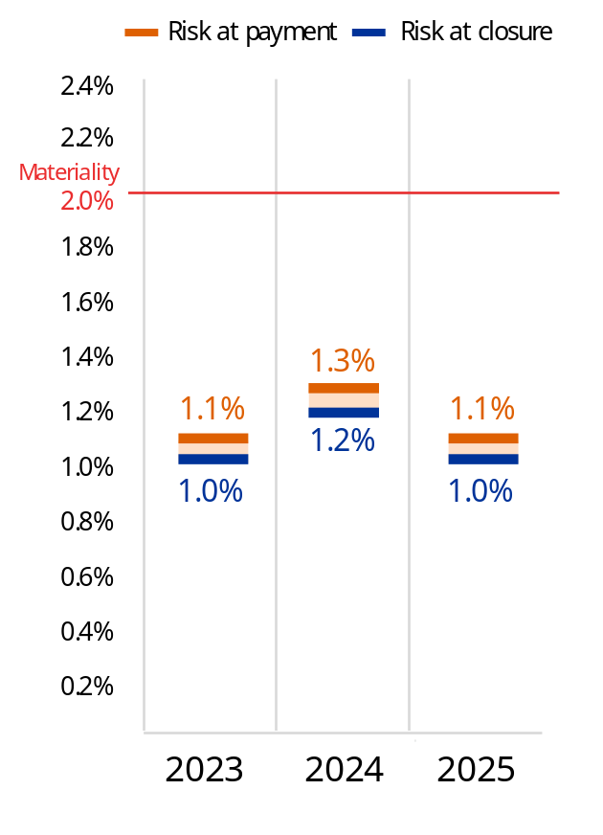
For migration and border management (), both risk at payment and risk at closure decreased slightly compared to 2024 and the share of low-risk expenditure (risk at payment below 2%) increased from 73.2% in 2024 to 87.6% in 2025 (see graph to the left). The preventive measures more than doubled compared to 2024. This increase reflects the further advancement in the implementation of programmes under the 2021-2027 multiannual financial framework, as such preventive measures were implemented by 25 Member States in 2025, compared to 13 in 2024.
This policy area consisted mostly of low-risk segments of expenditure relating to the implementation of the Internal Security Fund, the Asylum, Migration and Integration Fund and the Border Management and Visa Policy Instrument under the shared management mode (46% of the expenditure), which are considered overall not to be error-prone programmes, and to subsidies to decentralised agencies voted by the budgetary authority (40% of the expenditure), which are considered an error-free type of expenditure.
The high-risk expenditure corresponds to expenditure under shared management for 25 programmes (out of a total of 139) for which management and control systems are not functioning effectively, even if the risk at payment is below 2%, and to EU action and emergency assistance grants to support Member States in the fields of migration and border management, where the risk at payment is above 2%.

At the end of 2025, two reservations were identified:
- one reservation concerning the Border Management and Visa Policy Instrument, the Asylum, Migration and Integration Fund and the Internal Security Fund for the 2021-2027 programming period, for two Member States;
- one reservation concerning the Asylum, Migration and Integration Fund and the Internal Security Fund for the 2014-2020 programming period, for seven Member States and two Schengen-associated countries.
Multiannual financial framework heading 4 – migration and border management –
overview of risk segmentation for 2023-2025
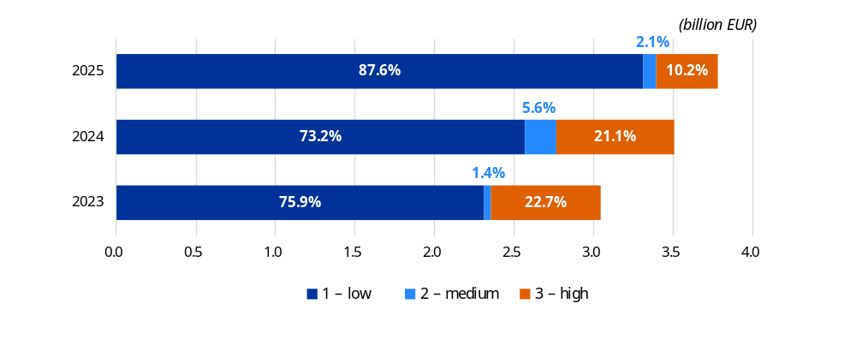
Source: European Commission annual activity reports for 2025.

Heading 5 – security and defence
Total amount of relevant expenditure: EUR 615.6 million (2024: EUR 318.7 million).
Risk at payment: 1.7% (2024: 0.5%).
Risk at closure: 1.7% (2024: 0.5%).
Total preventive and corrective measures: EUR 9 million (2024: EUR 7.5 million):
- preventive measures: EUR 9.0 million (2024: EUR 7.2 million);
- corrective measures: none (2024: EUR 0.3 million).
Reservations: none (2024: none).
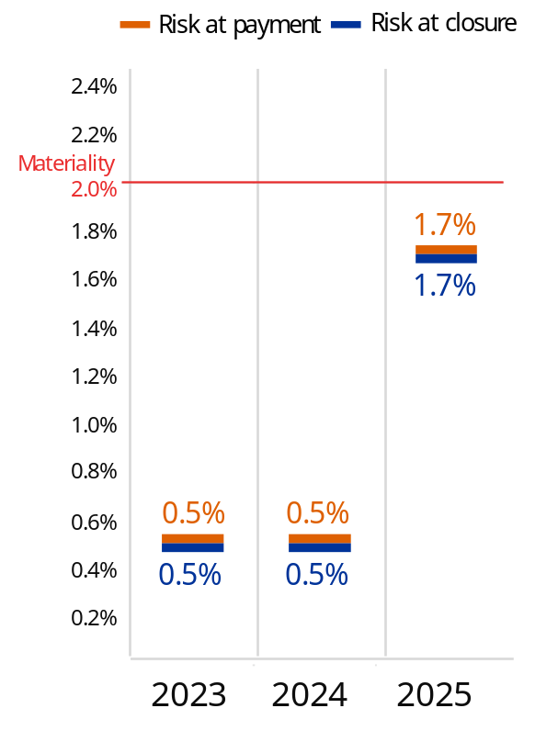
In 2025, the risk at payment, 1.7%, increased significantly compared to 2024. This is due to a combination of the following.
- The use of a conservative flat error rate of 2% for the payment of grants under direct management. This prudent approach has been retained pending the results of a new audit campaign that will start once a sufficient number of payments have been made.
- The significant increase in payments of grants under direct management, which almost doubled in 2025 compared to 2024, to EUR 466 million, and represents the bulk of the expenditure under this heading. This increase is due to the progress in the life cycle of projects, with an increasing number for which interim and final payments are made.
Together, these two factors explain that, in 2025, most of the expenditure was medium risk (with an error rate between 2% and 2.5%). The remaining expenditure, mainly for experts and procurements, is by definition low risk, at 0.5%.
Multiannual financial framework heading 5 – security and defence –
overview of risk segmentation for 2023-2025
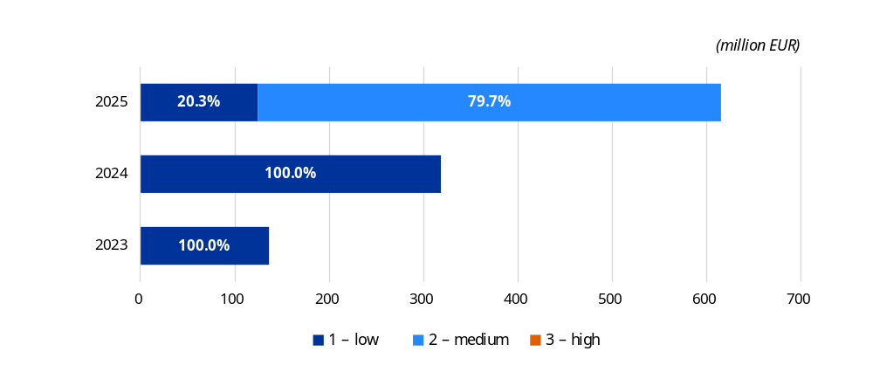
Source: European Commission annual activity reports for 2025.

Heading 6 – neighbourhood and the world
Total amount of relevant expenditure: EUR 16.4 billion (2024: EUR 20.4 billion) ().
Share of low-risk expenditure: 89.6% (2024: 92.4%).
Total preventive and corrective measures: EUR 74.1 million (2024: EUR 153.1 million):
- preventive measures: EUR 67.3 million (2024: EUR 125.5 million);
- corrective measures: EUR 6.8 million (2024: EUR 27.6 million).
Reservations: two reservations without financial impact (2024: one reservation).
Multiannual financial framework heading 6 – neighbourhood and the world –
overview of risk segmentation for 2023-2025
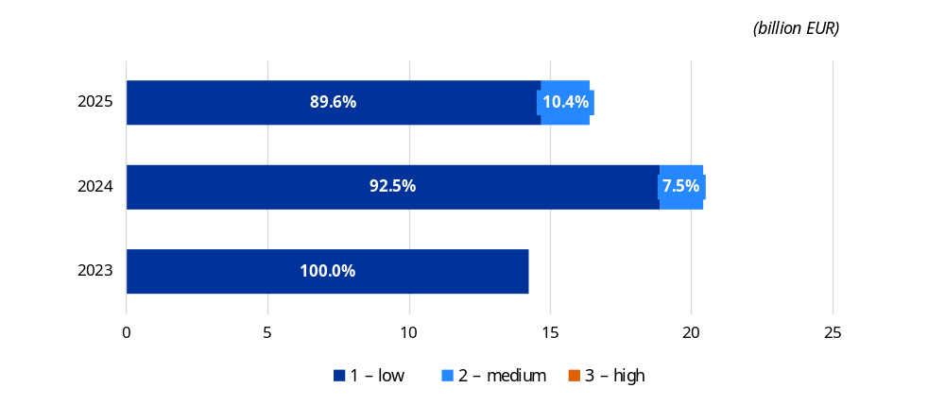
Source: European Commission annual activity reports for 2025.
From 2025 onwards, there is no risk at payment determined for the heading ‘neighbourhood and the world’. This is because part of the expenditure is performance-based and no quantified error rate can be determined. As a result, it is no longer possible to determine a risk at payment for the entire heading, and the new indicator about control results and the legality and regularity of the expenditure is the share of low-risk expenditure.
In 2025, for neighbourhood and the world, almost 90% of the expenditure was considered low risk. This is in line with the share of low-risk expenditure for the heading in 2024, at 92.4%, and slightly lower compared to 2023, at 100%. In 2025, most of the compliance-based expenditure, still the bulk of all the payments under this heading at EUR 15.8 billion, has a risk at payment below 2%. In addition, performance-based payments, amounting to EUR 601.3 million in 2025 under the Ukraine Facility, have been assessed as low risk, based on a qualitative assessment of the milestones and targets that triggered the payments (see box below for a more detailed description of the approach). Regarding the expenditure considered medium or high risk, it mostly corresponds to grants under direct management with a risk at payment respectively above 2% and 2.5%.
After a significant increase in 2024 due to high-value payments, the total amount of relevant expenditure under this heading in 2025 was broadly in line with the amounts in 2023. The difference compared to 2023 is mainly explained by the support provided to Ukraine (non-repayable support under the Ukraine Facility, the Ukraine Loan Cooperation Mechanism and the interest rate subsidy for macrofinancial assistance).
The main errors identified (missing supporting documents, procurement issues and excess clearing) are in line with the Court of Auditors’ findings. They are mainly due to the misunderstanding or misinterpretation of the relatively complex contractual conditions, a lack of capacity in some countries, a lack of safeguarding of the financial documentary evidence after project completion or a lack of response to the auditors. This is further exacerbated by a complex operational environment, characterised by unpredictability, volatility and insecurity. The difference between the Court of Auditors’ estimated level of error (4.9% in 2024) – and its conclusion that all expenditure under this heading is high risk – and the Commission’s residual error rates and assessment that most of the expenditure is low risk is mostly due to the different approaches: the Court of Auditors audits payments on ongoing contracts whereas the Commission audits closed contracts to identify only the remaining (residual) errors after all controls and ensuing corrections have taken place.
The Commission continued to look into possibilities to improve its financial management of programmes, in particular for those areas for which expenditure is categorised as medium or high risk. For instance, Commission services have taken mitigating measures, such as strengthening the dialogue and verification processes to increase transparency in cooperation with international organisations. In 2025, DG International Partnerships finalised the review of its control strategy in view of improving the efficiency and effectiveness of its internal control framework. A first outcome already achieved at the beginning of 2026 is the reduction of the sample size used to determine the yearly error rate, leading to a considerable improvement of the cost efficiency of controls. Other important measures are in the course of finalisation, such as the risk profiling dashboard, which will lead to more informed decision-making on mitigating measures for high-risk contracts and high-risk implementing partners.

The Ukraine Facility and the Westen Balkans and Moldova facilities are new types of instrument (). Similarly to the Resilience and Recovery Facility (see Annex 3), funds are disbursed following a qualitative assessment of the satisfactory fulfilment of predefined/agreed milestones and targets (named ‘steps’ in the case of the facilities) measuring the implementation of reforms and investment designed to respond to the challenges faced by these countries and to boost their progress with a view to their accession to the EU. These funds are paid by the Commission to the beneficiary country, and in the case of the Western Balkans Facility also partially to the Western Balkans Investment Framework and the Neighbourhood Investment Platform for the Moldova Facility. Hence the Commission does not check transactions between the country and the individual final recipients. This is why these payments are considered to be performance based, as opposed to the compliance-based payments, for which the amounts disbursed correspond to invoices and expenditure incurred by the beneficiaries / final recipients. The situation regarding payments and disbursements is presented in the graph below.
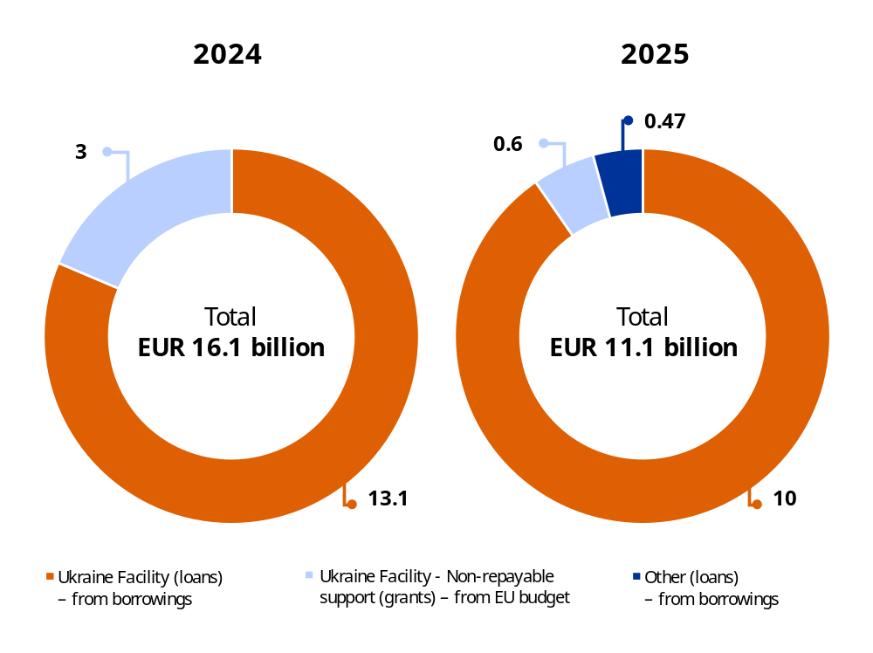
For the assurance, similarly to the Resilience and Recovery Facility, the Commission makes a qualitative assessment of the level of risk associated with the payments made. The Commission focuses on evaluating the progress towards achieving the steps and on the functioning of the systems put in place by the beneficiary countries to manage the funds thus received and their compliance with the applicable rules and regulations. This qualitative assessment is difficult to translate into quantitative terms with an error rate, as the latter is a quantitative assessment, which is pertinent when the expenditure can be directly attributed to a quantitative criterion. In addition, the investments and reforms included in the countries’ plans are very diverse, which hinders any statistical extrapolation. In this context, a meaningful error rate cannot be determined.
Assurance for the facilities is obtained through a risk-based model combining three complementary layers of control and, where relevant, taking into account the work of the European Court of Auditors. Where a high level of risk is identified for a payment, the authorising officer by delegation may issue a reservation limited to a beneficiary country, a specific payment request and/or an implementing entity. More specifically, for the Ukraine Facility, the payments made in 2025 are considered low risk, following the three-layer assurance model below.
- Primary layer of control – Commission ex ante audit.
  - The beneficiary country’s authorities operate a management and control system in line with the framework agreement between the EU and the country. No blocking issues were identified through the full-scale system audit carried out in the first years of the facilities.
- Secondary layer – Commission ex ante checks.
  - The Commission carries out a risk assessment of the steps submitted for payment in the payment request. Some of these steps are considered low risk given their nature, for instance corresponding to legislative reforms.
  - The Commission makes an assessment of each payment request, along with the accompanying supporting evidence, management declarations and audit summaries, and confirms the satisfactory fulfilment of the steps and that no issues are identified.
- Tertiary layer – Commission ex post audits. The Commission plans targeted audits on higher-risk steps (notably information-technology-related measures, recruitment and investment/procurement-related steps) once a sufficient number of such steps are reported for payment.
  - For these riskier steps, ad hoc ex post audits on their continuous fulfilment will take place as from the second half of 2026, i.e. when a sufficient number of medium- and high-risk steps are declared for payment.
For Ukraine, all the payments made in 2025 were considered low risk. Regarding the ex ante audit, the auditors issued a qualified opinion with recommendations to strengthen the system, but no blocking issues were identified. The Ukrainian authorities fully accepted three of the 23 findings, and partially accepted two. All the steps in the payment requests submitted were assessed as low risk and no other issues were identified by ex ante controls in the payment requests submitted. Since no high-risk steps were declared to be fulfilled in 2025, no ex post audits were carried out.
The total amount of preventive and corrective measures decreased from EUR 153.1 million in 2024 to EUR 74.1 million in 2025. This evolution is due to the transition to the Commission’s new accounting system, SUMMA, where only preventive measures exceeding EUR 500 000 are reported. Since all of the preventive measures taken under this heading fall below this threshold, they are outside the reporting scope. As far as corrective measures are concerned, the difference is attributed to major recoveries that increased the ex post total amount in 2024.
The reservation concerning projects in Libya, Syria and Ukraine in 2025 has been maintained in 2025, but is now issued by two departments following the creation of a new department in the Commission dealing with the Mediterranean and North African regions. One reservation corresponds to programmes in Libya, Palestine and Syria, and the other corresponds to programmes in Ukraine. In these countries, the EU delegations cannot implement standard monitoring and control activities due to security and political constraints on the ground. Mitigating measures have been put in place, including remote monitoring and cross-checking information from various sources. Still, they do not allow the impact on the assurance of the corresponding expenditure to be fully addressed.

Heading 7 – European public administration
Total amount of relevant expenditure: EUR 8.9 billion (2024: EUR 9.1 billion ()).
Risk at payment: 0.5% (2024: 0.5%).
Risk at closure: 0.5% (2024: 0.5%).
Total preventive and corrective measures: EUR 0.1 million (2024: EUR 5.9 million):
- preventive measures: none (2024: EUR 4.3 million);
- corrective measures: EUR 0.1 million (2024: 1.6 EUR million).
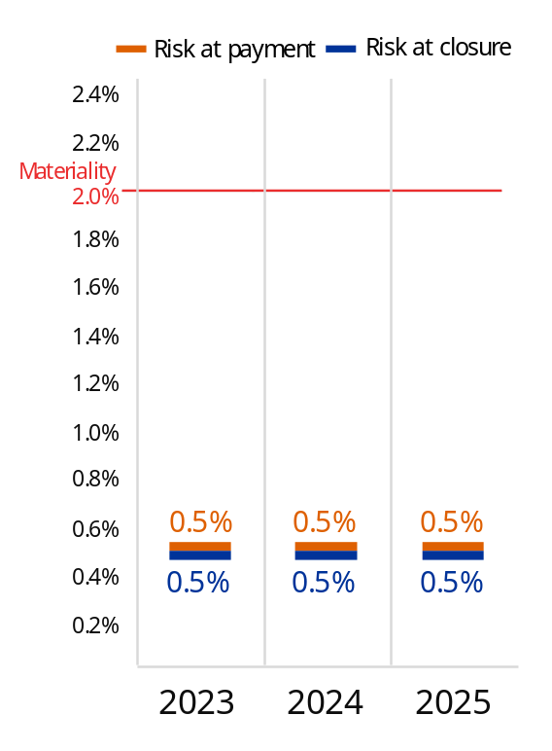
Reservations: one reputational reservation (2024: one reputational reservation).
The risk at payment for this heading remains at 0.5%, which is consistent with the types of activity and expenditure under this heading. This heading groups together all of the Commission services and departments that mostly provide services to other Commission services and departments and have no operational policy objectives. These entities thus mostly manage administrative expenditure under the direct management mode, such as the Office for the Administration and Payment of Individual Entitlements, which represents approximately 78% of the expenditure for this heading.
The risk at payment was prudently set at 0.5% for this low-risk type of expenditure. As most of the corresponding control systems involve predominantly ex ante controls, the estimated future corrections were often set at a prudent 0.0%. Thus, the risk at closure is equal to the risk at payment and remained very low at 0.5%.
In 2025, the total of amount preventive and corrective measures decreased from EUR 5.9 million to EUR 0.16 million because of the decrease in preventive measures. The absence of preventive measures in 2025 is due to the transition to the Commission’s new accounting system, SUMMA, where only preventive measures exceeding EUR 500 000 are reported. Since all preventive measures taken under this heading fall below this threshold, they are outside the reporting scope.
In this policy area, the reputational reservation raised in 2023 and 2024 on the issues encountered in implementing new selection procedures and competitions was maintained. It was considered prudent to maintain the reservation until competitions with the new contractor, planned in 2026, have taken place according to plan.
Multiannual financial framework heading 7 – European public administration –
overview of risk segmentation for 2023-2025
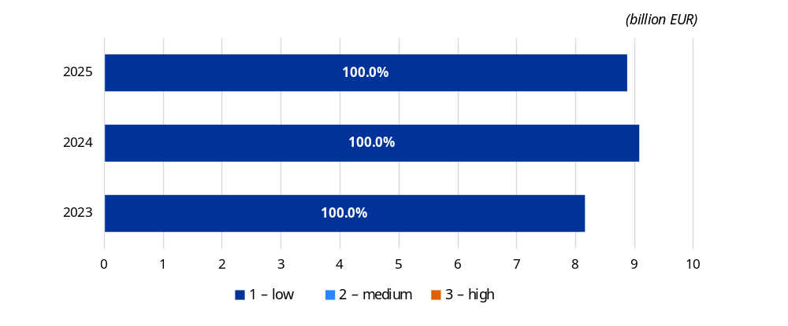
Source: European Commission annual activity reports for 2025 ()
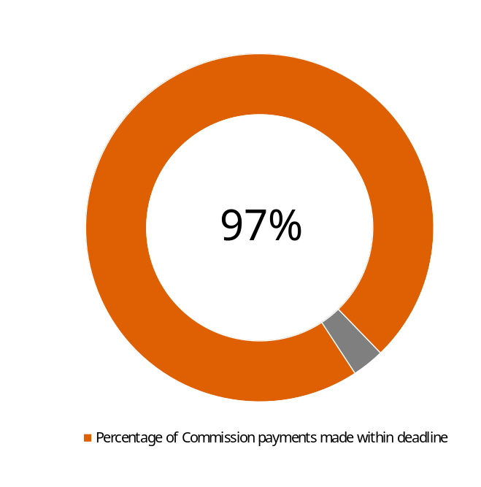
    - Efficiency measures have been taken
In 2025, 97% of payments (in value) were made within the legal payment deadline versus 99% in 2024. The slight decrease in performance for this indicator is explained by the transition in 2025 to the Commission’s new accounting system, SUMMA. The adjustments to this new system had an impact on budget implementation tasks, processes and financial management activities, particularly during the first part of the year. In a limited number of cases, this resulted in lower performance for some standard financial indicators, such as timely payment.
Time to pay is the main indicator used to measure the efficiency of procedures and controls in place for making payments and is of paramount importance, as many beneficiaries rely on these payments to carry out their activities and projects, which, in turn, contribute to the Commission’s objectives.
The Commission is continually striving to improve the efficiency of its operations so as to deliver on its objectives under tight budgetary constraints and to achieve the objectives set in its digital agenda. Processes are being streamlined to ensure the most efficient use of limited resources. Some examples of initiatives leading to improved economy and efficiency are presented in the box below.
Examples of improved economy and efficiency
- One of the measures that continues to have the widest and longest-term effect is the increased use of simplified cost options, in particular lump sums and unit costs. In the area of research, the use of lump sums has grown significantly. In 2025, lump sums accounted for more than 35% of the overall call budget for the main Horizon Europe work programme, and successfully reached the goal of at least 50% for the 2026-2027 work programme adopted in December 2025. The Horizon Europe midterm evaluation (adopted in April 2025) confirmed that lump-sum grants effectively reduce administrative burdens, help avoid financial errors and shift the focus from financial controls to project content.
- In the same area, the European Research Executive Agency continued its drive for efficiency by piloting artificial-intelligence-assisted expert allocation tools to compare the quality and efficiency of pre-allocations produced by different systems. Additionally, a simplification hackathon in 2025 brought together over 70 colleagues to generate ideas for streamlining proposal evaluations and grant management, which directly informed the development of the 2026-2027 work programme and the next research and innovation framework programme.
- In external action policies, in the Directorate-General for Enlargement and Eastern Neighbourhood, data openness and interoperability have been strengthened through the development of a statistical platform designed to gather quantitative and qualitative data on corruption and organised crime in enlargement countries. This platform supports structured assessments of rule-of-law performance, contributing to evidence-based policymaking.
- The Reusable Solutions Platform, a set of software building blocks, saves Commission departments from requiring lengthy procurement procedures or development periods, including through the reuse of corporate multilingual and artificial intelligence-based language services where appropriate. The success of these reuse–buy–build principles was highly visible in 2025, with new digital solutions developed by other departments, such as eAidRegister and eNotifications, achieving reuse rates of over 70% and 90% by relying on these corporate building blocks. This improves economy, efficiency and information technology security at the corporate level.
- In relation to cohesion policy, the push for simplification accelerated in 2025, reflecting a growing awareness among Member States of the importance of streamlining fund delivery. Building on tools like Kohesio, DG Regional and Urban Policy developed nine new financing not linked to costs models to simplify the delivery of midterm review priorities. Over the course of the year, 18 Member States and six Interreg programmes developed 197 simplified cost options methodologies accounting for EUR 8.1 billion, while 13 Member States developed 28 financing not linked to costs schemes totalling almost EUR 5 billion.

The impact of artificial intelligence
In 2025, the Commission’s Information Management Steering Board continued to closely monitor the implementation of the communication on artificial intelligence in the Commission () to maximise artificial intelligence opportunities while mitigating risks and ensuring compliance with the EU Artificial Intelligence Act (). The existing Corporate AI@EC network continued to facilitate collaboration on artificial intelligence use cases and extrapolations among over 6 000 members from more than 60 Commission departments, agencies and other EU institutions and bodies. To foster a digital culture across the institution, an AI Champions network was successfully launched, featuring 105 champions across more than 50 Commission departments and executive agencies. Furthermore, the training of the first EU institutional large language model using European supercomputers (Leonardo and MareNostrum 5) was advanced, with the aim of enhancing artificial intelligence services across all of the official EU languages.
In relation to research and innovation, a substantial increase in the number of proposals received has been noted for many calls, which is likely due, at least in part, to the rapid adoption of generative artificial intelligence by applicants. In 2025, this trend escalated significantly across the executive agencies, with an increase of between 25% and 49%. This in turn increased the workload and the pressure on resources during the evaluation and selection of proposals, stretching operational capacity and impacting indicators such as time-to-grant.
There are also risks associated with the use of artificial intelligence tools by experts and Commission staff, along with the ethical implications of using such tools within projects. Examples are as follows: a possible positive bias in evaluations towards artificial-intelligence-assisted proposals due to better drafting quality, at the cost of overlooking scientific excellence in other proposals; possible manipulation of researchers’ curricula vitae, requiring an increase in checks and verifications by evaluation experts; lower quality and success rates of projects drafted by artificial intelligence; and project reports and deliverables with unreliable content.
To address both these risks and the increase in applications, an AI Task Force is exploring emerging issues and designing measures to address them. As a practical adjustment in 2025, for the Marie Skłodowska-Curie actions, the requirement for applicants to demonstrate robustness in relation to artificial intelligence in their main proposals was removed, with any necessary assessments instead addressed through the ethics screening process. Agencies are also beginning to leverage artificial intelligence themselves to manage the workload, such as the European Research Executive Agency piloting artificial-intelligence-assisted expert allocation tools, and corporate systems such as Arachne+ integrating artificial intelligence and machine-learning algorithms to forecast risks such as double funding and bankruptcy.

    - The costs of controls are proportionate to the associated risks
In 2025, after having assessed their effectiveness, efficiency and economy, all Commission departments reached a positive conclusion on the cost-effectiveness of their controls. The resources allocated to controls are aligned with the risks relating to the nature of the programmes and/or the context in which they are implemented. The cost of controls, which for some departments also includes the cost of supervision of executive agencies and joint undertakings, has remained generally stable over time. The variety of spending programmes and their different features do not allow for a meaningful comparison of their control costs. However, some common cost drivers can be identified, as shown in the following text box.
Examples of common cost drivers
The intrinsic complexity of the programmes managed. Grants based on the reimbursement of real costs imply labour-intensive controls as opposed to financing based on lump sums, simplified cost options or financing not linked to costs, such as performance-based instruments. It is on this cost driver that the Commission is focusing, mostly by introducing options for simplifications in its programmes (e.g. by developing lump-sum grants in Horizon Europe).
The complexity of the environment in which programmes are implemented. The cost of controls is likely to be higher in the case of a multisite organisational structure or when partners and/or beneficiaries are located outside the EU’s jurisdiction.
The volumes and amounts to be processed. A high number of low-value payments will generate higher control costs than recurrent mass payments, while the regulatory framework requires certain incompressible controls. This results in diseconomies of scale.
The type of budget implementation mode. Under the indirect and shared management modes, the cost of controls is shared between the Commission and its implementing partners, while for the direct management mode the burden is entirely borne by the Commission.
The life cycle of the programme. Towards the final stage of programmes (e.g. in the direct management mode), despite the low level of expenditure, a minimum level of controls still has to be carried out, which results in an increase in the ratio of cost of controls to expenditure controlled.
The increase in the average standard staff costs, driven by salary adjustments and fluctuations in currency exchange rates. In the last several years, inflation has led to significant increases in staff costs, whereas the overall budget managed and controlled every year has remained stable. In external action, an additional factor relates to currency exchange rates.
For the sake of transparency and completeness, departments dealing with shared and/or indirect management have also reported on the cost of controls in Member States and entrusted entities separately from the Commission’s own cost of controls in their annual activity reports.
- Management assurance
As part of the governance system explained above, overall management assurance is ensured through the assurance given by the Directors-General, the Internal Audit Service and the Audit Progress Committee. It is supplemented by the opinion of the Court of Auditors and points on the 2024 discharge given by the budgetary authority and by the follow-up of the discharge and external audit recommendations.
  - Assessments, assurance and reservations declared by authorising officers
For the 2025 reporting year, all 52 authorising officers by delegation ⁽⁾ declared in their respective annual activity reports ⁽⁾ that they had reasonable assurance that (1) the information contained in their reports presents a ‘true and fair view’ (i.e. reliable, complete and correct) of the state of affairs in their departments; (2) the resources assigned to their activities were used for their intended purpose and in accordance with the principle of sound financial management; and (3) the control procedures put in place give the necessary guarantees concerning the legality and regularity of the underlying transactions, taking into account the multiannual character of some programmes and the nature of the payments concerned.
Within their overall assurance-building process, and from their management perspective, the authorising officers by delegation use all information available during the year, especially the results of their controls, to spot any potential significant weakness in quantitative or qualitative terms for each programme or segment of their portfolio. At the end of each financial year, they determine whether the financial impact of such a weakness is likely be above the materiality threshold of 2% and/or whether the reputational impact is significant. If so, they qualify their declaration of assurance with a reservation for the specific segment affected.
Reservations EU budget: number and financial impact by policy area in 2025 ⁽⁾ (million EUR)
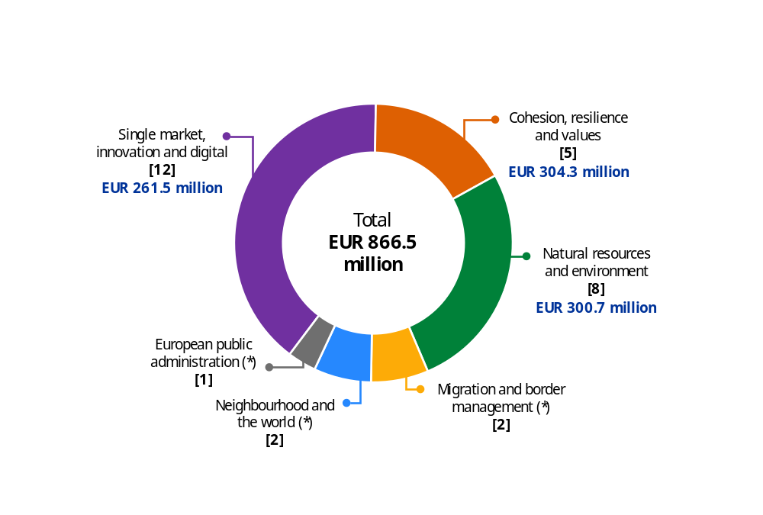
(*) Non-quantified reservation.
Source: European Commission annual activity reports.
In 2025, 19 authorising officers by delegation qualified their declaration of assurance with one or more reservations. In total, 32 reservations were issued: 30 for the EU budget, 12 new and 18 recurring (),
and two for the Recovery and Resilience Facility, a recurring reservation regarding conflicts of interest in one Member State, and a new reservation concerning the satisfactory fulfilment of two milestones in another Member State.
While the number of new reservations for the EU budget amounts to 12, they are linked to three underlying issues: residual error rates above 2% for Horizon Europe and for the digital Europe programme (affecting the reports of eight and two services respectively), and one critical Internal Audit Service recommendation leading to a reservation in two reports. As these issues relate to programmes implemented across several services, they result in a higher overall number of new reservations than the three distinct underlying risks. Additionally, a new reservation concerning the satisfactory fulfilment of two milestones in another Member State was issued for the Recovery and Resilience Facility.
A total of 19 reservations have been carried over from previous years. These reservations have been maintained mainly because the root causes of the material level of error or the lack of assurance can be partially mitigated but not fully eradicated under the current programmes’ legal frameworks. No reservations issued in 2024 were lifted in 2025.Most recurrent reservations concern shared management, where each reservation consists in an increased number of paying agencies and operational programmes, for which systems in place do not function or function only partially, or the error rate is above 2%, compared to 2024.
In eight cases, no reservation was issued due to the de minimis rule, whereby segments with a residual error rate above the 2% materiality threshold are not considered substantial if they represent less than 5% of the department’s total payments and have a financial impact below EUR 5 million. The total financial impact of these cases in 2025 was very limited, amounting to EUR 4.5 million, almost half the level recorded in 2024.
The total financial impact of the 2025 quantified reservations under the EU budget amounts to EUR 866.5 million (), representing 0.5% of the total relevant expenditure, which marks an increase compared to 2024 (0.2%). This increase is driven by the new reservations linked to higher error rates in Horizon Europe and the digital Europe programme, and by a higher number and volume of reservations in the cohesion policy area. However, the financial impact in 2025 remains within the range of the previous year’s values. The financial impact of the reservations related to the Recovery and Resilience Facility amount to EUR 326.1 million in total (see details in Annex 3, section 2.2.10).
Annex 5 in Volume III provides a complete list of the reservations for 2025, along with further explanations and details.

  - Work of the Internal Audit Service and overall conclusion
The Commission’s Directorates-General and services also base their assurance on the work done by the Internal Audit Service.
As required by its mission charter, the Internal Audit Service issues an annual overall conclusion on the Commission’s financial management. This is based on the audit work in the area of financial management in the Commission covering the past three years (2023 to 2025). The overall conclusion also takes into account information from other sources, notably the reports of the European Court of Auditors. The overall conclusion is issued at the same time as this report and covers the same year.
Based on this audit information, the Internal Auditor considered that, in 2025, the Commission had put in place governance, risk management and internal control procedures which, taken as a whole, are adequate to give reasonable assurance over the achievement of its financial objectives, with the exception of those areas of financial management over which authorising officers by delegation have expressed reservations in their declaration of assurance as listed in the annex.
Without further qualifying the overall conclusion for 2025, the Internal Auditor drew the attention to the need to ensure that the control and assurance framework remains robust, proportionate and effective to manage risks to an acceptable level, especially in the context of concurrent priorities and continuous pressure on resources. This is further detailed in Annex 6 to this report.
The Internal Audit Service performs an independent assessment of the effectiveness of governance, risk management, and control processes for operational and policy activities, financial management and supporting functions within the Commission and its departments, executive agencies and European offices.
It issued independent conclusions on the quality of management and control systems and made recommendations for ensuring compliance and improving performance, effectiveness, efficiency and accountability. For all accepted or partially accepted recommendations, the auditees drafted action plans that were submitted to the Internal Audit Service, which subsequently assessed them as being satisfactory or requested a revised action plan. For the recommendations that were partially not accepted, the auditees accepted the residual risk. Finally, the Internal Audit Service pursued its strict follow-up policy and assessed the actual implementation of its recommendations by the Commission’s departments on a regular basis. Overall, the Internal Audit Service considers the implementation of its recommendations issued between 2021 and 2025 to be satisfactory and comparable to previous reporting periods. This result indicates that the Commission services are diligent in implementing the recommendations and mitigating the risks identified by the Internal Audit Service.
Annex 6 includes more information on the assurance provided by the Internal Audit Service. In addition, a report on the internal auditor’s work is forwarded by the Commission to the discharge authority, in accordance with Article 118(8) of the Financial Regulation, as part of the integrated financial and accountability
reporting package.

  - Assurance obtained through the work of the Audit
Progress Committee
The Audit Progress Committee oversees audit matters within the Commission and reports annually to the College of Commissioners. It ensures the independence of the Internal Audit Service, monitors the quality of internal audit work and ensures that internal and external (i.e. from the European Court of Auditors) audit recommendations are properly taken into account by the Commission’s directorates-general and services and that they receive appropriate follow-up.
During this reporting period, which continued to be shaped by the aftermath of the unprecedented challenges that have impacted on the EU since 2020, the committee maintained its important role in enhancing governance, organisational performance and accountability across the entire organisation. It held four rounds of meetings during the reporting period, focusing on the key objectives set out in the 2025 and 2026 work programmes. The committee took note of the broad convergence between the results of the risk assessments performed by management and the Internal Audit Service, which continued to illustrate the robustness of the institution’s approach.
The committee discussed critical and very important audit findings raised by the Internal Audit Service with relevant auditees and urged the completion of mitigating actions as soon as possible. It held discussions on important topics such as data protection, human resources and information technology security, which is especially relevant in the current cybersecurity environment, and on financial management and financial instruments.
The committee was satisfied with the independence of the internal auditor and quality of the internal audit work and welcomed the internal auditor’s reassurances that the audit plan for 2026 provides coverage of the highest risks and delivery of the overall conclusion on financial management. The effective implementation rate of the internal auditor’s recommendations remained very high (i.e. covering 94% of recommendations issued and followed up during 2021-2025), and only five very important internal audit recommendations were overdue by more than six months as of December 2025, which the committee is monitoring closely.
The committee continued its exchanges with the European Court of Auditors and held a discussion with the external auditor on its multiannual strategy for 2026-2030 and its annual work programme for 2026. It also continued to monitor the progress in implementing the Court of Auditors’ recommendations, and was satisfied when, for the 18th time in a row, the Court of Auditors gave a clean opinion on the reliability of the consolidated EU accounts.
During this period, the committee contributed to the revision of the Audit Progress Committee’s Mission Charter, with the last version dating from 2020. The aim of this update was mainly to reflect the changes in the revised Internal Audit Service Mission Charter prompted by the revision of the Global Internal Audit Standards, in particular clarifying that since the Audit Progress Committee has no management powers, the ‘board’ responsibilities, with respect to the governance of the internal audit function as set out in the Global Internal Audit Standards, are assumed by the College of Commissioners.
Annex 7 to this annual management and performance report, in Volume III, includes more information on the work and conclusions of the committee.

  - The opinions of the Court of Auditors on the 2024 accounts and on the legality and regularity of transactions
The Court of Auditors’ Annual reports on the implementation of the EU budget for the 2024 financial year and on the activities funded by the 9th, 10th and 11th European Development Funds (EDFs) for the 2024 financial year, published in October 2025, gave a clean opinion on the EU accounts for the 18th year in a row. Revenue also continued to be free from material error.
As regards the legality and regularity of expenditure, under the multiannual financial framework, the Court of Auditors maintained its adverse opinion, even if its estimated overall level of error for the EU budget decreased from 5.6% in 2023 to 3.6% in 2024.
The Court of Auditors explains its adverse opinion through both the reported level of error and the fact that material and pervasive errors remain in what the Court of Auditors considers to be high-risk expenditure. The Court of Auditors considers as such expenditure that is often subject to complex rules and is mainly based on reimbursement of costs, in particular in the areas of cohesion, research and innovation, rural development, migration and border management, and neighbourhood and the world. It concludes that high-risk expenditure represented 68.9% of the audited population for 2024 (against 64% in 2023).
On the other hand, the Court of Auditors confirmed again that the risk of error is lower for expenditure subject to simpler rules, mainly entitlement-based payments (as opposed to reimbursement-based payments). This concerns, for instance, direct payments to farmers, but also administrative expenditure (mostly salaries and pensions in the EU civil service). Both these types of expenditure continue to be free from material error.
The Court of Auditors also issued an audit opinion on the Recovery and Resilience Facility for the fourth time. It considered that the overall effects of its findings are material but not pervasive to this year’s Recovery and Resilience Facility expenditure. Based on these quantitative and other qualitative findings, the Court of Auditors issued a qualified opinion ().
  - Discharge of the budget for 2024
The Parliament granted the discharge to the Commission for the 2024 financial year on 29 April 2026, after having examined the reports of the Court of Auditors, the Commission’s integrated financial and accountability reporting package and the Council’s discharge recommendation. The Parliament’s Committee on Budgetary Control also invited selected Commissioners and Executive Vice-Presidents for discharge hearings structured according to the headings of the multiannual financial framework, after having held exchanges of views with selected Directors-General (focused on the respective annual activity reports).
During the procedure, the key stakeholders – the Parliament, the Council and the Court of Auditors – focused on how to ensure transparency in the use of the EU budget, how to improve its results and how to further reduce the level of errors. The Recovery and Resilience Facility was again one of the key elements of the discharge discussions due to its financial magnitude and the specific nature of its delivery mode, which is performance based rather than based on costs incurred. This discussion on the lessons learned from the implementation of the Recovery and Resilience Facility was often put in the context of the Commission’s proposal for the 2028-2034 multiannual financial framework.
The discussions on discharge also touched upon issues such as:
- the rule of law and fundamental rights;
- the transparency of financing of non-governmental organisations, in particular in respect of financing for advocacy activities;
- the need for the smoother implementation and absorption of EU funds and for the simplification of rules and procedures;
- the growing cost of repayment of the debt under NextGenerationEU;
- revising the guidance on final recipients in national Recovery and Resilience Facility plans;
- drawing conclusions from the implementation of the Recovery and Resilience Facility in light of the next multiannual financial framework;
- cooperation among various stakeholders in the EU anti-fraud architecture;
- the methodologies to estimate the level of error and the level of risk, and cases where the Court of Auditors and the Commission reached different conclusions on the eligibility of expenditure;
- the need for a comprehensive EU approach to defence funding.
Within the annual discharge procedure, the Commission informs the Parliament and the Council (as the two arms of the budgetary and discharge authorities) about the implementation of their recommendations through two reports: (1) an overview follow-up report (published in the summer); and (2) a more detailed report with replies to specific requests from the Parliament and the Council (sent in the autumn).
Regarding recommendations issued by the Court of Auditors, the Commission’s replies are published together with the Court of Auditors’ reports, stating which recommendations are accepted, partially accepted or rejected. The follow-up to the accepted recommendations is tracked in an information technology tool, ensuring the traceability of each step of the implementation. Each Commission department reports on the implementation of these recommendations in its annual activity report. Moreover, the state of play of the implementation of these recommendations is presented on a regular basis to the Audit Progress Committee in the context of its mandate.
The Court of Auditors also monitors the Commission’s implementation of its recommendations and provides feedback, helping the Commission to enhance its follow-up activities. In its 2024 annual report, the Court of Auditors reviewed the extent to which the Commission had pursued the implementation of 194 audit recommendations addressed to it in 27 special reports published in 2021. Eleven recommendations were not yet due for implementation at the time of the Court of Auditors’ follow-up review. Of the remaining 183 recommendations, the Commission had implemented 100 (55%) in full, 40 (22%) in most respects
and 34 (18%) in some respects. In one case (1%), no assessment of the implementation status was required,
as the Court of Auditors considered the recommendation to be no longer relevant. Of the eight recommendations (4%) that the Court of Auditors considered not to have been implemented, the Commission had not accepted five. Compared with the previous year, the total proportion of recommendations fully or mostly implemented increased from 68% to 77%. The proportion of recommendations not implemented decreased from 11% to 4%.
- Outlook for 2026 and beyond
  - The preparation of the 2028-2034 multiannual
financial framework
In July 2025, the European Commission adopted its proposal for the 2028-2034 multiannual financial framework. This proposal introduces a fundamentally redesigned EU budget, centred on flexibility, simplification and impact. It is structured around clearer political priorities, streamlining financial programmes and national and regional partnership plans, ensuring targeted investments and reforms where they are most needed. It also includes a reinforced system of own resources to finance the budget, so as to support EU priorities while easing pressure on national budgets.
One of the main simplification measures proposed in the Commission proposal is the more widespread use of simplified cost options and financing not linked to costs, which should both significantly reduce the reporting obligations on recipients of funds, by focusing checks and controls on the deliverables of the projects rather than on the costs, and reduce the complexity of the programmes, thus reducing the error rates.
The proposal for a performance regulation () will provide the following: (1) a common methodology to track EU budget expenditure supporting climate mitigation, climate adaptation, environment and social objectives; (2) a common list of performance indicators; (3) a single report on performance; and (4) a single gateway portal.
The harmonisation of expenditure tracking and performance indicators through a single common list of intervention fields and indicators, as embedded in the proposal, is expected to generate further efficiency gains and administrative savings in the long run. These potential savings may arise in particular from the reduction in the total number of performance indicators from 5 000 to approximately 700.
The proposed Single Gateway portal – merging over 30 portals and dashboards into a single entry point – should also further enhance transparency and accessibility by providing a single entry point for information on the EU budget, including funding opportunities, and on implementation and results.
  - Large-scale review of the Commission’s organisation
and operations
The Commission initiated a discussion on the large-scale review of its organisation and operations in March 2025. Based on the results of extensive internal consultations, and considering experiences from previous organisational change exercises, workstreams would focus around three main interwoven poles: structures, processes, and people and culture. The final recommendations are expected to be submitted to the President before the end of 2026, with implementation starting in 2027.

Annex 3 – The Recovery and Resilience Facility under NextGenerationEU

- The Recovery and Resilience Facility–
an innovative and successful crisis response tool
The Recovery and Resilience Facility () is the centrepiece of NextGenerationEU, established to help EU Member States recover faster from the COVID-19 pandemic and become more resilient. It provides a powerful tool at the EU level to support accelerated and ambitious green and digital transitions. In 2022, it was expanded to include REPowerEU chapters in Recovery and Resilience Plans, thus contributing to the REPowerEU plan, the European Commission’s response to the economic hardship, high inflation and energy crisis triggered by Russia’s unprovoked full-scale invasion of Ukraine.
The Commission assessed 34 payment requests, submitted by 24 different Member States (all except Germany, Lithuania and Hungary) covering 1 174 milestones and targets in total (794 milestones and 380 targets). By the end of 2025, 52% of all milestones and targets with an indicative due date up until Q4 2025 had been assessed as fulfilled by the Commission and an additional 26% had been reported by the Member States as completed. (). The milestones and targets relating to the disbursements pertain to a large scope of measures covering the six pillars of the Recovery and Resilience Facility Regulation.
Recovery and Resilience Facility – implementation of milestones and targets
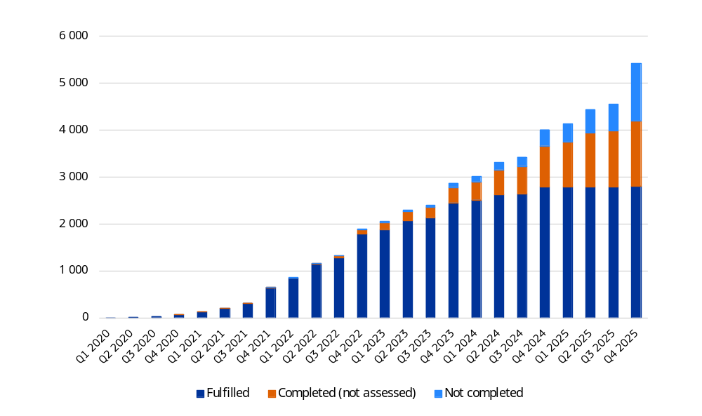
Source: European Commission.
In 2025, the Commission disbursed a total of EUR 87.3 billion, including EUR 40.1 billion in
non-repayable support and EUR 47.2 billion in loans. The visual below presents the disbursements made in 2025 per Member State.
Disbursements made in 2025 per Member State for non-repayable support and loans, including pre-financing (million EUR)
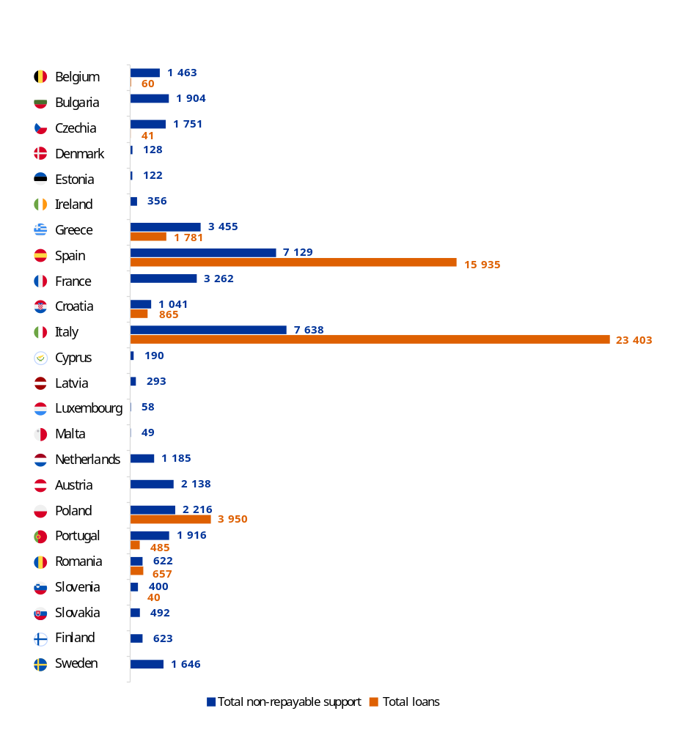
Source: European Commission.
For the entire facility, this brought the total disbursements to EUR 393.4 billion out of a total envelope of EUR 637.1 billion at the end of 2025 (see details in visual below).
Disbursements made and to be made, at the end of 2025
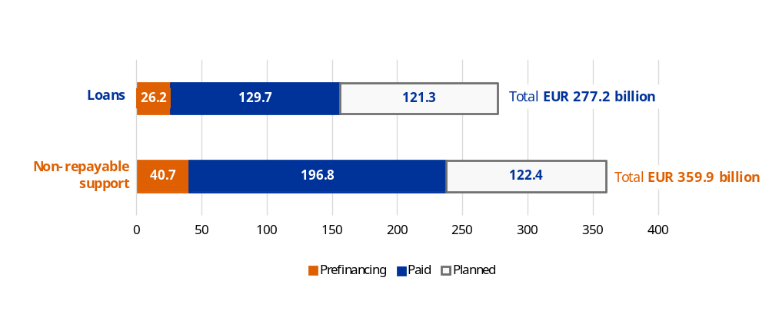
Source: Recovery and resilience scoreboard.
  - Progress made in 2025 – ensuring timely implementation
Ensuring the timely implementation of the Recovery and Resilience Facility remained a central priority for the Commission in 2025. Activities in 2025 centred on monitoring the execution of national recovery and resilience plans, assessing Member States’ payment requests and streamlining recovery and resilience plans to facilitate their full implementation by the end of 2026.
In June 2025, the Commission called on Member States to streamline their recovery and resilience plans so as to maximise impact in light of implementation delays and the approaching end of the Recovery and Resilience Facility in 2026 (). The Commission provided guidance on plan revisions, stressing that recovery and resilience plans should retain only those measures that can be fully implemented by 31 August 2026. This approach aims to simplify implementation and the assessment of payment requests and to reduce administrative burdens, while ensuring recovery and resilience plans remain fully compliant with the Recovery and Resilience Facility Regulation.
In 2025, 50 requests for revision were received and positively assessed by the Commission, as Member States continued to revise their recovery and resilience plans to address implementation delays, to mitigate external constraints and engaged in an effort to simplify milestones and targets. By the end of 2025, 543 milestones and targets had been removed, leading to a reduction of around 20% in the outstanding number of milestones and targets left to be assessed in the final phase of the Recovery and Resilience Facility. Regarding REPowerEU, in July 2025, the Council adopted the last chapter, for Bulgaria, which brought the total number of REPowerEU chapters to 27, accounting for a total of EUR 57.6 billion of funding. As a result of the revisions that took place in 2025, the total financial envelope under the Recovery and Resilience Facility amounted to EUR 637 billion, split into EUR 360 billion in non-repayable support (a EUR 1 billion increase compared to 2024) and EUR 277 billion in loans (a decrease of EUR 14 billion).

  - Achieving performance results
Member States use the funds provided by the Recovery and Resilience Facility to implement ambitious reforms and investments that will make their economies and societies more sustainable, resilient and prepared for the green and digital transitions.
The results obtained by the end of 2025 indicate that the facility is making a key difference in the lives of EU citizens. The common indicators demonstrate the progress of the implementation of the recovery and resilience plans towards common objectives and the overall performance of the facility.
Common indicator | Results by the end  of 2025
Savings in annual primary energy consumption | 37 568 052 MWh/year
Additional operational capacity installed for renewable energy | 62 444 MW and  18 MW for hydrogen
Alternative fuels infrastructure (refuelling/recharging points) | 940 866
Population benefiting from protection measures against floods, wildfires and other climate-related natural disasters | 36.8 million
Additional dwellings with internet access provided via very-high-capacity networks | 17.6 million
Enterprises supported in developing or adopting digital products, services and application processes | 1.4 million
Users of new and upgraded public digital services, products and processes | 2 402 million ()
Researchers working in supported research facilities | 231 136
Enterprises supported (small (including micro), medium and large) | 4.9 million
Number of participants in education or training | 30.7 million
Number of people in employment or engaged in job-searching activities | 3.5 million
Capacity of new or modernised healthcare facilities | 60.2 million
Classroom capacity of new or modernised childcare and education facilities | 4.2 million
Number of young people aged 15-29 receiving support | 12.7 million

Furthermore, the Recovery and Resilience Facility helped to deliver some key reforms during the first four years of implementation, including the following.
- Ensuring access to medical care by establishing a reimbursement system for nurses to incentivise them to work in remote areas and by increasing the share of people admitted to nursing training (Estonia).
- Enabling policymakers to better assess and limit regulatory burdens on small and medium-sized enterprises, promoting a more supportive environment for their growth (Ireland).
- Streamlining and simplifying permitting procedures for renewable energy and electricity infrastructure. The legislation reduces administrative burdens, sets clear deadlines, removes restrictions on self-consumption and improves network capacity allocation (Spain).
- Bringing in legislation to encourage tax compliance and improve the effectiveness of audits and controls. One reform improved the quality of the databases used to produce compliance letters (i.e. notices through which the Italian tax authorities report discrepancies). As a result, the tax revenue generated by compliance letters has increased by 30% compared to 2019 (Italy).
- Introducing reforms to improve fiscal sustainability in the medium and long term. These include improving the long-term fiscal sustainability of the pension system through changes to the first pay-as-you-go pension pillar and improving the functioning of the second pension pillar, along with enhancing fiscal discipline through binding multiannual expenditure ceilings (Slovakia).
In addition, the Recovery and Resilience Facility has contributed to unlocking the full potential of structural reforms by complementing them with key investment. Some of this investment, with key steps already completed, includes the following.
- Granting 147 557 tax credits to businesses to support innovation and digitalisation, through investment in tangible and intangible capital goods, standard intangible assets, research and development, innovation and training activities (Italy, EUR 13.4 billion).
- Creating more than 21 000 new study places in regional vocational education at upper secondary level, with priority given to unemployed people or people with education levels below upper secondary education (Sweden, EUR 92 million).
- Developing a dedicated platform and increased funding for school boards to support students in their last year of school, aiming to mitigate learning losses due to the COVID-19 pandemic (Netherlands, EUR 19.5 million).
- Upgrading the Clinical Hospital Centre Sestre Milosrdnice with modern medical equipment, digital tools and a renovated neurosurgery clinic, to enable faster and more efficient care, an improved patient experience and a 22% increase in treatment capacity. The hospital now serves more than 700 000 patients a year (Croatia, EUR 16.3 million).
- Rolling out early childhood interventions to support families in vulnerable situations during pregnancy and early childhood, thereby promoting health equality and social fairness. The programme has achieved full coverage in all districts (Austria, EUR 15 million).
- Bringing the Energy Data Centre into operation, thereby improving the preconditions for the connection of renewable energy sources by streamlining required data. This allows the aggregation of flexibility while improving the conditions for energy communities and the sharing of renewable energy sources (Slovakia, EUR 3.3 million).
An overview of how the implementation of the Recovery and Resilience Facility and the national recovery and resilience plans is progressing is provided through the recovery and resilience scoreboard and the map of projects supported by the facility.
Each recovery and resilience plan is required to contribute at least 37% and 20%, respectively, to climate and digital objectives. This is reflected in the significant budgetary contribution of the facility to both the green and digital transitions.
- Climate contribution. EUR 264.2 billion from 2021 to 2025 (42.7% of the total envelope, including non-repayable support and loans).
- Digital contribution. EUR 150.9 billion from 2021 to 2025 (24.4% of the total envelope, including non-repayable support and loans).
- Control results confirm the satisfactory fulfilment of all milestones and targets for payments made in 2025
  - A dedicated control environment to ensure the protection
of EU funds
The Recovery and Resilience Facility Regulation sets out the respective roles and responsibilities of Member States and of the Commission for protecting the EU budget. The facility is a fully performance-based instrument, and, unlike the majority of other EU funding programmes, the Commission does not reimburse Member States based on actual costs incurred for the reforms and investment included in their recovery and resilience plans. Instead, the Commission pays predefined instalments solely when agreed milestones and targets are satisfactorily fulfilled. The Recovery and Resilience Facility funds, once disbursed, enter each national budget with no direct link to the expenditure incurred to finance the reforms and investment. As per the regulation, Member States are responsible for ensuring that the facility is implemented in compliance with EU and national rules and with the principles of sound financial management. The Commission should be able to receive sufficient assurance from them in that regard.
Member States must put in place suitable monitoring and control systems to protect the financial interests of the EU and to ensure that the use of funds complies with EU and national law. These systems are described in detail in the recovery and resilience plans and were assessed by the Commission before each plan was adopted. During the lifetime of the facility, Member States must ensure the effectiveness of these control systems. Notably, they must undertake systematic work to ensure that the systems prevent, detect and correct irregularities. If a Member State detects any specific irregularities, it must take action to correct them and inform the Commission of them. If a Member State does not undertake the necessary corrections in cases of fraud, corruption or conflict of interest, the Commission will reduce or recover the affected amounts from the Member State. Moreover, if a Member State seriously breaches its obligations under the financing or loan agreements, the Commission may apply a flat-rate correction to the funds received by the Member State in the context of the facility.
The Commission has designed its control strategy to fully comply with its responsibilities stemming from the Recovery and Resilience Facility Regulation (see overview in visual below).
- The Commission must ensure the legality and regularity of payments to the Member States, which are solely linked to the satisfactory fulfilment of the milestones and targets. For this purpose, the Commission carries out ex ante assessments of all the payment requests received from the Member States; ex post audits for a selection of payment requests, milestones and targets; system audits on milestones and targets; and an analysis of the Member States’ management declarations and summaries of audits
- The Commission has the right to reduce and recover any amount, or ask for early repayment of the loan, in cases of fraud, corruption or conflicts of interest affecting the financial interests of the EU that have not been corrected and recovered by the Member State, or in cases where the information and justification underlying a payment request is found to be incorrect, or for a serious breach of an obligation resulting from the financing and/or loan agreement signed with the Member State. For this purpose, the Commission makes an assessment of the control systems described in the plans (and subsequent revisions) submitted to the Commission before their adoption. In addition, the Commission carries out system audits on the protection of the financial interests of the EU in the Member States over the entire duration of the facility and audits on the work done by the national audit authorities. It also assesses the checks carried out by the Member States on compliance with public procurement rules and State-aid rules, including the effectiveness of these checks.
- The timely implementation of outstanding audit recommendations is key, in particular given that the Recovery and Resilience Facility is approaching its final phase. The Commission continuously monitors the implementation of the issued audit recommendations ().
Recovery and Resilience Facility – overview of the control environment at the Commission level
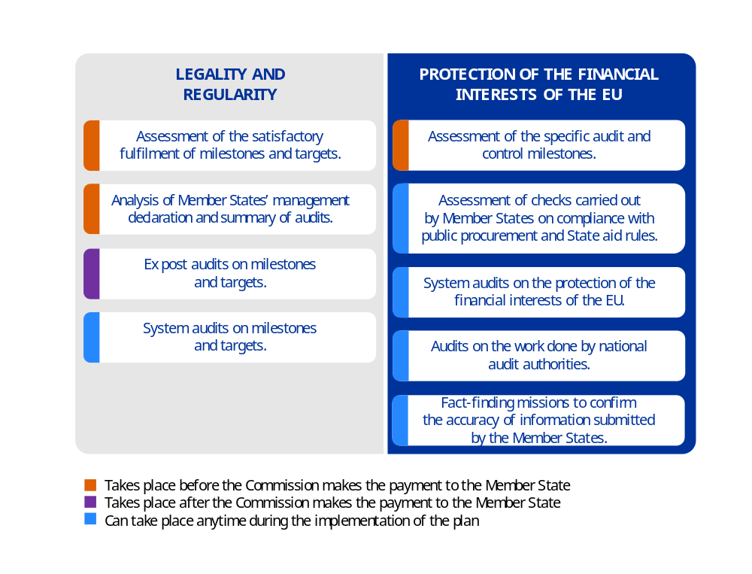
Source: European Commission.
The Commission makes a qualitative assessment of the control results and the level of risk associated with the operations. Unlike other EU programmes, this assessment cannot be quantified with an error rate. Error rates reflect a quantitative assessment, which is pertinent when the expenditure can be directly attributed to a quantitative criterion. Payments in the context of the Recovery and Resilience Facility are based on a qualitative assessment of the fulfilment of milestones and targets, which is difficult to translate into quantitative terms. Even when milestones and targets have not been satisfactorily fulfilled and a reduction will be made, this reduction cannot correspond to an amount of ineligible expenditure. In addition, the investments and reforms included in the recovery and resilience plans are very diverse, both within a Member State and between Member States, which prevents any statistical extrapolation. In this context, a meaningful error rate cannot be determined.
In the course of 2025 and the first half of 2026, the Commission has consolidated the existing audit and control architecture by introducing targeted improvements, including taking into account new recommendations from the European Court of Auditors.
- The Guidance on the assessment of the internal control systems set in place by the Member States under the Recovery and Resilience Facility, as well as the Guidance to Member States for the preparation of the summary of audits under the Recovery and Resilience Facility were updated. The key control points in the areas of public procurement and State aid were clarified and expanded, following the recommendations stemming from the ECA Special Report 09/2025 on public procurement and State aid. And the guidance was complemented with best practices in relation to recovery of amounts affected by fraud and for reporting of fraud and suspected fraudulent cases, to address the recommendations issued by ECA in its Special Report 06/2026 on tackling fraud in the RRF.
- The Commission adopted in April 2026 the Guidelines for Member States on operational aspects related to the final phase and closure of the Recovery and Resilience Facility. It describes the final steps of the programme’s implementation until the end of 2026 and the applicable procedures and obligations beyond 2026, also in relation to audit and control. It recalls the regulatory framework and provides additional information on how the Commission intends to operationalise key aspects of the Facility’s closure. It also clarifies the Member States’ continued obligations as regards the period beyond 2026 and provides final dates for Recovery and Resilience Facility-related reporting obligations.
  - Control results are predominantly positive
    - Full approval of the revised plans following their assessment
In the context of the revision of the national plans, the audit and control systems of the respective Member States were reassessed in 2025, taking into account all the new and additional information obtained, since the original assessment took place, notably through the various audits carried out by the Commission. In light of this information, the Commission considered whether the arrangements for the audit and control system put forward by the Member States in the revised plans were (still) adequate. In 2025, a total of 50 revisions were approved and the Commission proposed one additional audit and control milestone (for Slovakia).
    - Ex ante controls at the payment stage
In 2025, the Commission assessed and paid 34 payment requests submitted by 24 Member States, corresponding to 794 milestones and 380 targets (1 174 in total), of which 11 were assessed as not satisfactorily fulfilled. Parts of disbursements were subsequently suspended for the corresponding payment requests submitted by Romania (1), Spain (1) and Bulgaria (2) and suspensions of payments were applied amounting to EUR 1 737.5 million (). The Commission also lifted the suspension for three milestones and targets (Spain (1), Cyprus (1) and Czechia (1)) as the necessary measures had been taken to satisfactorily fulfil the related milestones and targets. The Commission reduced one Member State’s financial contribution for one milestone that remained not satisfactorily fulfilled by the end of the suspension procedure (). In the case of Belgium, while a suspension decision was adopted in 2024, the suspension was lifted in 2025 as the national plan was subsequently revised.

Positive assessment of the specific milestones on audit and control for all
Member States
Since the beginning of the Recovery and Resilience Facility’s implementation, a total of 83 audit and control milestones have been incorporated into the national plans of 24 Member States (). By the end of May 2026, 56 had been assessed by the Commission as satisfactorily fulfilled, in 23 Member States. The Commission assessed the achievement of these milestones based on desk reviews and in-depth analyses of the evidence provided by the Member States. All of the remaining 27 audit and control milestones are related to Hungary, which has yet to submit its first payment request.
Examples of such milestones
- Putting in place and implementing a repository system for monitoring the implementation of the Recovery and Resilience Facility.
- The entry into force of laws or decrees setting out legal mandates or defining audit and control procedures.
- Creating and implementing an action plan regarding the prevention of conflicts of interest in the context of the Recovery and Resilience Facility and adopting an audit strategy ensuring independent and effective auditing of the Recovery and Resilience Facility implementation.
In addition, as a follow-up to the positive assessment of the implemented audit and control milestones, 13 commitments were made by 11 Member States (Belgium, Ireland, Greece, Spain, France, Italy, Lithuania, Luxembourg, Poland, Romania and Finland) to ensure the continuous fulfilment of the related audit and control milestones. All of the 13 commitments have been implemented (five in 2025), based on the Commission’s preliminary assessment published alongside the respective payment requests.

Analysis of management and audit summaries confirms the Commission’s
initial assessment
The Commission reviewed the management declarations and audit summaries accompanying the payment requests submitted in 2025. For the payments for which funding was suspended in 2025 due to milestones and targets not being satisfactorily fulfilled, the review of management declarations and summaries of audits had previously raised doubts about their fulfilment, which were then confirmed by the Commission’s assessment ().
    - Ex post audits on milestones and targets confirm the satisfactory fulfilment of milestones and targets
In 2025, the Commission carried out 23 ex post audits () on milestones and targets. These audits are risk based, usually covering 100% of high-risk milestones and targets, along with some medium-risk milestones and targets. The payment requests not audited included milestones and targets that were low risk, or notably related to measures audited in previous years and/or had been audited by national audit authorities or the European Court of Auditors providing reasonable assurance to the Commission. By the end of May 2026, the Commission had audited 80 milestones and targets in total, comprising 69 high-risk milestones and targets and 11 medium-risk milestones ().
Based on its audit work, for the payments assessed in 2025 the Commission found no evidence that the audited milestones and targets were not satisfactorily fulfilled at the time of payment. Any other discrepancies identified between the data declared and the data audited remained within the margin of 5% considered by the Commission for its assessment (). In the case that the Commission considers ex post that a milestone or a target was not reached, it will initiate financial corrections to recover the undue part of the payment made. This has not happened for the payments made in 2025.
    - System audits on the protection of the financial interests
of the EU confirm the adequacy of the systems in place
Between the start of the facility and the end of May 2026, the Commission carried out 36 system audits on the protection of the financial interests of the EU, covering all Member States at least once, including one system audit in 2025, in five Member States: Ireland, France, Poland, Finland and Sweden ().In the context of these system audits and other audit work, the Commission verified in particular whether the Member States regularly check compliance with State-aid and public procurement rules, including the effectiveness of such checks. System audits also covered procedures to avoid double funding between the Recovery and Resilience Facility and other EU programmes.
Based on the ongoing audit work, an overall improvement in the implementation of control systems has been observed across the audited implementing and coordinating bodies. Member States are taking corrective action in response to audit findings, and audit and control milestones have provided an additional incentive for their timely implementation. The timely implementation of outstanding recommendations is key, in particular given that the Recovery and Resilience Facility is approaching its final phase. Therefore, the Commission continues to monitor the implementation of these recommendations closely and regularly, in close collaboration with Member States and in line with agreed deadlines.
Several good practices have been observed among audited bodies. As acknowledged by the Court of Auditors (), the Commission’s audits are effective tools, which have led for instance to improvements in the anti-fraud systems of the Member States by introducing procedures to detect potential fraud, corruption, conflicts of interest and double funding – often supported by data-mining tools such as Arachne (see Annex 2, Section 1.6.2). Other positive examples include staff training programmes designed to raise awareness of fraud and corruption risks, and the use of the fraud risk assessment templates. Notable progress has also been made regarding data collection.
Nonetheless, areas for improvement remain. These include improving controls to prevent conflicts of interest, reinforcing procedures to verify the absence of double funding, ensuring compliance with publicity obligations, further increasing participation in fraud awareness training and ensuring that suspected fraud cases are still followed up and reported to the Commission in line with the specific guidelines () adopted in April 2026. In 2025, OLAF investigated 18 cases linked to the Facility.
The Commission can give reasonable assurance regarding the protection of the EU’s financial interests from fraud, corruption and conflicts of interest, based on the outcomes of the system audit work carried out in 2025 and considering the results of the analysis of the management declarations and audit summaries mentioned above, with the exception of one Member State ().
For 2026, given that the Recovery and Resilience Facility will enter its final phase of implementation, the focus is shifted towards more targeted selection of protection of the financial interests of the EU audits and combining these with other types of audits for an efficient use of resources. The risk assessment performed in the first quarter of 2026 led to plans of conducting additional protection of the financial interests of the EU audit work in four Member States (Czechia, Italy, Netherlands and Sweden).
    - Controls on Member States’ obligation to ensure compliance with public procurement and State-aid rules
Since 2023, the Commission has audited all Member States at least once regarding their obligation to ensure compliance with public procurement and State-aid rules, under either system audits, compliance audits or ex post audits, where applicable (), as a result of the Court of Auditors’ recommendation in the context of its 2023 annual report (). This includes ensuring that the financing provided is properly used in accordance with all applicable EU and national rules, particularly in the areas of public procurement and State aid, including the effectiveness of such checks. In 2025, 12 Member States were checked on public procurement and 14 on State aid. From January 2026 to date, public procurement has been checked in another 11 Member States, and State aid in nine Member States. These checks confirm that overall, Member States fulfilled their obligation to ensure compliance with public procurement and State-aid rules.
In its Special Report 09/2025 (), the Court of Auditors acknowledged the positive developments as regards the enhanced checks on public procurement and State aid with the use of comprehensive checklists and provided some targeted recommendations for further improvement. The Commission implemented all seven accepted recommendations (), following which the existing audit checklist on State aid was amended in early 2025 to reflect this more clearly, and rolled out immediately.
    - Audits of the national audit authorities
Since 2023, the Commission has performed an increasing number of audits to assess the reliability of the work performed by the national audit authorities, encompassing two key areas: (1) audits of national control systems, to ensure that national and EU rules are complied with (including public procurement and State-aid rules) and that the EU budget is protected; and (2) audits of milestones and targets. Furthermore, these audits include checks that the risk of double funding is adequately addressed. This effort aims to further strengthen the effectiveness of the audit work performed at the national level while minimising the duplication of audits and increasing the efficiency of the audit work overall, in the spirit of the single audit approach. Since the start of the facility, 23 Member States have undergone a compliance audit or have been subject to an audit that included a compliance dimension.
In a number of instances, areas for further improvement have been identified for example the need to include deadlines for the implementation of recommendations by national audit bodies; better defining follow-up procedures; improving audit manuals, checklists or documentation; improving the verification of public procurement procedures or State-aid rules; and addressing staffing issues or issues with the assignment of audit staff.
In early 2025, the methodological framework defining the conditions under which the Commission can rely on national audit work for ex post audits of milestones and targets was refined. Under this framework, the Commission may rely on the work of national audit bodies where Commission compliance audits result in either an unqualified opinion or a qualified opinion with limited impact. In such cases, Commission auditors may rely on the national audit bodies’ assessments and are not required to include in their ex post audit selection any high-risk milestones and targets () already assessed as satisfactorily fulfilled by those national bodies.
    - Follow up of Commission’s audit recommendations
The Commission has pursued a rigorous and enhanced monitoring of outstanding open recommendations, in close cooperation with Member States’ authorities, to ensure that these are implemented in a timely and efficient manner. When assessing Member States’ implementation of audit recommendations, the Commission applies a well-defined methodology, thoroughly assessing Member States’ replies and supporting documents that evidence the implementation of the audit recommendations. The recommendations are considered as ‘implemented’ only if sufficient, adequate and reliable evidence of implementation is provided by the Member State. Where substantial progress has been made and only minor issues remain, the residual importance of the finding may be downgraded. To date, 90% (2 400 out of 2 700 issued recommendations) are closed or assessed as ‘preliminary closed’. This follow-up activity is increasingly important as the final phase of the Recovery and Resilience Facility is approaching.
    - Annual audit and management opinions
Based on the audit work described above, the Commission issued 24 annual audit opinions covering all payments made in 2025 (). These audit opinions were then used in addition to any other available information to provide a management opinion on the payments made to the 24 Member States concerned in 2025.
Both audit opinions and management opinions provide a level of risk for the elements of the assurance and thus support the conclusion on the overall declaration of assurance. The audit opinions provide a level of risk on the legality and regularity of the payment; on the compliance by the Member States with all applicable rules (); and on the correction by the Member States of any amount due to the EU budget in cases of fraud, corruption or conflicts of interest affecting the financial interests of the EU (). The audit opinions are used by the Commission’s operational units, together with other sources of information at their disposal (such as annual implementation meetings and reports), as the basis for the management opinion provided to the authorising officer by delegation in charge of the Recovery and Resilience Facility.
Detailed information on the level of risk of each payment request is presented in the table in Section 2.2.9.
    - Ongoing work of the Court of Auditors in the context of the 2025 statement of assurance
By 28 May 2026, the Commission had received the clearing letters from the Court of Auditors covering the 34 non-repayable support payments () made to 24 Member States in 2025. In addition, the Commission has received three clearing letters on the Court of Auditors’ assessment of suspensions being lifted for three payments in 2025. Since the Court of Auditors’ findings may be used to determine the level of risk of the payments, the Commission assessed them when determining the level of risk for each payment made in 2025.
With respect to the clearing letters concerned, the Commission, after careful analysis, maintained its position (based on its ex ante and ex post controls) that the milestones and targets included in the corresponding payment requests had been satisfactorily achieved except for two targets related to a payment to Poland, disbursed in December 2025. Additionally, the Commission also identified an error in its preliminary assessment of one milestone and consequently sent a draft review report to the Member State concerned (Italy) requesting additional information and justification regarding the satisfactory fulfilment of that milestone.
    - Qualitative assessment of the legality and regularity of payments and of compliance with Article 22(2)(a) and Article 22(5) of the Recovery and Resilience Facility Regulation indicates generally low/medium risk
The Commission’s qualitative assessment as regards the legality and regularity of the payments is based on a combination of results from the following sources: (1) the Commission’s ex ante assessment of the payment requests; (2) the Commission’s ex post audits on milestones and targets, taking into account the risk profile of the milestones and targets submitted; and (3) the European Court of Auditors’ findings, if deemed acceptable.
As a result, the Commission determines a level of risk to the legality and regularity of each payment and, for each Member State, a level of risk to compliance with Article 22(2)(a) and Article 22(5) of the Recovery and Resilience Facility Regulation. The level of risk can be classified as low, medium or high.
The Commission’s conclusions per payment request received are summarised in the following table.

Qualitative assessment payments made in 2025
 |  | Level of risk
 |  | Legality and regularity |  |  | Compliance with
 |  |  |  |  | Applicable rules  (a) | Obligation to correct  (b)
Member State | Payment request | Audit opinion | Management opinion | Overall | Audit opinion | Audit opinion
Belgium | Second | Low | Low | Low | Low | Low
Belgium | Third | Low | Low | Low | Low | Low
Bulgaria | Second | Low | Low | Low | Low | Medium
Bulgaria | Third | Low | Low | Low | Low | Medium
Czechia | Third | Low | Low | Low | Medium | High
Czechia | Fourth | Low | Low | Low | Medium | High
Denmark | Third | Low | Low | Low | Medium | Medium
Estonia | Third | Low | Low | Low | Medium | Low
Ireland | Second | Low | Low | Low | Low | Low
Ireland | Third | Low | Low | Low | Low | Low
Greece | Fifth | Low | Low | Low | Low | Medium
Greece | Sixth | Low | Low | Low | Low | Medium
Spain | Fourth | Low | Low | Low | Low | Medium
Spain | Fifth | Low | Low | Low | Low | Medium
France | Fourth | Low | Low | Low | Medium | Medium
Croatia | Sixth | Low | Low | Low | Low | Low
Croatia | Seventh | Low | Low | Low | Low | Low
Italy | Seventh | Medium | Medium | Medium | Low | Low
Italy | Eighth | Low | Low | Low | Low | Low
Cyprus | Second | Low | Low | Low | Low | Low
Cyprus | Third | Low | Low | Low | Low | Low
Cyprus | Fourth | Low | Low | Low | Low | Low
Latvia | Third | Low | Low | Low | Low | Low
Luxembourg | Second | Low | Low | Low | Low | Low
Malta | Third | Low | Low | Low | Medium | Low
Netherlands | Second | Low | Low | Low | Low | Medium
Austria | Second | Low | Low | Low | Medium | Medium
Austria | Third | Low | Low | Low | Medium | Medium
Poland | Third | High | High | High | Low | Medium
Portugal | Sixth | Low | Low | Low | Low | Medium
Portugal | Seventh | Low | Low | Low | Low | Medium
Romania | Second | Low | Low | Low | Medium | Medium
Slovenia | Fourth | Low | Low | Low | Low | Medium
Slovakia | Fifths | Low | Low | Low | Medium | Medium
Finland | Second | Low | Low | Low | Low | Medium
Finland | Third | Low | Low | Low | Low | Medium
Sweden | First | Low | Low | Low | Medium | Medium
NB: Applicable rules: Article 22(2)a of the Recovery and Resilience Facility Regulation. Obligation to correct: Article 22(5) of the Recovery and Resilience Facility Regulation.
Source: European Commission.

Overall, the Commission concludes the following.
- Regarding legality and regularity, the level of risk is high for the 3rd payment to Poland and is medium for the 7th payment request to Italy and low for all of the other payments made. Based on the audits and controls carried out, none of the milestones and targets included in the payments made were assessed as not satisfactorily fulfilled. The Commission carefully analysed the results of the Court of Auditors’ audits for payments made in 2025, and maintained its position that the milestones and targets included in the corresponding payment requests were satisfactorily achieved with the exception of the 3rd payment to Poland. A financial reservation was therefore introduced. The financial impact amounts to EUR 326.1 million. This corresponds to a financial exposure representing 14.39% of the non-repayable support paid to Poland in 2025 and 0.72% of total amount of non-repayable support paid in 2025.
- Regarding compliance with all applicable rules, namely public procurement and State aid (), the level of risk is medium for 9 Member States and low for the remaining Member States. Regarding the obligation to make corrections in cases of fraud, corruption or conflict of interest, or a serious breach of obligations resulting from the financing and loan agreements (), the level of risk is high for Czechia, medium for
17 Member States and low for the remaining 6 Member States. For CZ on the basis of the audit results obtained in 2024, which identified two individual cases of conflicts of interest, a financial reservation was introduced in 2024 and maintained in 2025, as no corrective actions had been taken by the Czech authorities neither at national level or at the level of the final recipients (). The financial impact amounts to EUR 16.85 million, representing 0.96% of non-repayable support paid to Czechia in 2025 and 0.04% of total non-repayable support paid in 2025 ().
    - The authorising officer by delegation for the facility confirmed they had reasonable assurance
In their conclusions on the assurance for the Recovery and Resilience Facility, the officer () confirmed they had reasonable assurance on:
- the legality and regularity of the payments made in 2025 for the Recovery and Resilience Facility, based on the positive assessment of the evidence of the satisfactory fulfilment of the milestones and targets provided in the payment requests, on ex post audit work on the milestones and targets, and considering the outcomes of the audit work carried out by the Court of Auditors in the context of its statement of assurance 2025 (for clearing letters received and assessed by 28 May 2026) with the exception of one payment for one Member State, as described in Section 2.2.10, for which a reservation was issued.
- public procurement and State aid and the respect of the obligation of Member States laid down in Article 22(2)(a) of the Recovery and Resilience Facility Regulation to regularly check that the financing provided in the context of the underlying transactions has been properly used in accordance with all applicable rules, including the effectiveness of these checks, and that any measure for the implementation of reforms and investment projects under the recovery and resilience plan has been properly implemented in accordance with all applicable rules, in particular regarding the prevention, detection and correction of fraud, corruption and conflicts of interest;
- the implementation of Article 22(5) of the Recovery and Resilience Facility Regulation on the proportionate reduction of the support under the facility and the recovery of any amount due to the EU budget, or the request for early repayment of the loan, in the case of fraud, corruption or conflicts of interest affecting the financial interests of the EU that have not been corrected by the Member State, or a serious breach of an obligation resulting from the agreements referred to in Articles 15(2) and 23(1) of the regulation, with the exception of a Member State, as described in Section 2.2.10, for which a reservation was maintained.

() The amount of the Commission’s relevant expenditure corresponds to the payments made in 2025 minus the pre-financing paid out in 2025, plus the pre-financing paid out in previous years and cleared in 2025 (for definitions and more details, see Annex 5). This amount only includes the payments made from the EU budget.
() The European Development Fund has been incorporated into the EU’s general budget for the 2021-2027 multiannual financial framework.
() Under shared management, Member States’ bodies select projects, distribute funds and manage expenditure in accordance with EU and national law and report back to the Commission about the results achieved.
() The term ‘authorising officers by delegation’ covers Directors-General of the Commission and heads of executive agencies, offices, services, task forces, etc. Article 74(1) of the Financial Regulation (Regulation (EU, Euratom) 2024/2509 of the European Parliament and of the Council of 23 September 2024 on the financial rules applicable to the general budget of the Union (OJ L, 2024/2509, 26.9.2024, ELI: http://data.europa.eu/eli/reg/2024/2509/oj)) states that ‘The authorising officer shall be responsible in the Union institution concerned for implementing revenue and expenditure in accordance with the principle of sound financial management, including through ensuring reporting on performance, and for ensuring compliance with the requirements of legality and regularity and equal treatment of recipients.’
() As required by Article 253 of the Financial Regulation, the integrated financial and accountability reporting package also includes the final consolidated annual accounts of the EU, the report on the follow-up to the budgetary discharge for the previous financial year, the annual report to the discharge authority on internal audits carried out and the long-term forecast of future inflows and outflows of the EU budget covering the next five years.
() Commission Decision (EU, Euratom) 2025/369 of 21 February 2025 establishing the role of the Chief Risk Officer overseeing the financial risks arising from the Union’s financial operations (OJ L, 2025/369, 25.2.2025, ELI: http://data.europa.eu/eli/dec/2025/369/oj).
() Certification bodies in the case of agriculture.
() Communication from the Commission to the European Parliament, the Council, the European Economic and Social Committee, the Committee of the Regions and the Court of Auditors – Commission anti-fraud strategy action plan – 2023 revision, COM(2023) 405 final of 11 July 2023, https://eur-lex.europa.eu/legal-content/EN/ALL/?uri=CELEX:52023DC0405.
() Commission staff working document – Action plan – 2023 revision, SWD(2023) 245 final of 11 July 2023, https://eur-lex.europa.eu/legal-content/EN/TXT/?uri=CELEX%3A52023SC0245&qid=1747126601079.
() Report from the Commission to the Council and the European Parliament – 36th annual report on the protection of the European Union’s financial interests and the fight against fraud – 2024, COM(2025) 426 final of 25 July 2025, https://eur-lex.europa.eu/legal-content/EN/TXT/?uri=CELEX%3A52025DC0426&qid=1778508410193.
() European Commission: European Anti-Fraud Office, ‘Annual OLAF reports’, European Commission website, https://anti-fraud.ec.europa.eu/about-us/reports/annual-olaf-reports_en.
() White Paper for the anti-fraud architecture review, COM(2025) 546 final of 16 July 2025, https://eur-lex.europa.eu/legal-content/EN/TXT/?uri=celex:52025DC0546.
() Regulation (EU, Euratom) 2023/2841 of the European Parliament and of the Council of 13 December 2023 laying down measures for a high common level of cybersecurity at the institutions, bodies, offices and agencies of the Union (OJ L, 2023/2841, 18.12.2023, ELI: http://data.europa.eu/eli/reg/2023/2841/oj), which entered into force in January 2024.
() Regulation (EU, Euratom) 2020/2092 of the European Parliament and of the Council of 16 December 2020 on a general regime of conditionality for the protection of the Union budget (OJ L 433, 22.12.2020, p. 1, ELI: http://data.europa.eu/eli/reg/2020/2092/oj), which entered into force on 1 January 2021.
() See judgments of the Court of Justice of 16 February 2022, Hungary v Parliament and Council, C-156/21, ECLI:EU:C:2022:97, https://eur-lex.europa.eu/legal-content/EN/TXT/?uri=CELEX%3A62021CJ0156&qid=1778574960258 and Poland v Parliament and Council, C-157/21, ECLI:EU:C:2022:98, https://eur-lex.europa.eu/legal-content/EN/TXT/?uri=CELEX%3A62021CJ0157&qid=1778575036967.
() Communication from the Commission – Guidelines on the application of the Regulation (EU, Euratom) 2020/2092 on a general regime of conditionality for the protection of the Union budget (COM(2022)1382OJ C 123, 18.3.2022, p. 1, https://eur-lex.europa.eu/legal-content/EN/TXT/?uri=CELEX:52022XC0318(02)).
() The environmental and energy efficiency operational programme plus, the integrated transport operational programme plus and the territorial and settlement development operational programme plus.
() European Commission: Directorate-General for Communication, ‘2025 rule of law report – Communication and country chapters’, European Commission website, https://commission.europa.eu/publications/2025-rule-law-report-communication-and-country-chapters_en.
() The Ukraine Facility started in 2024 but, for that year, the same error rate as that for budget support has been applied to the payments made under the EU budget which amounted to EUR 3 billion. The approach was changed in 2025 to align it with the one applied to the Recovery and Resilience Facility.
() Given the relatively early stage of implementation of the facilities, and the nature of the steps submitted for payment to this point, ex post controls have not yet taken place.
() The programme concerned (the promotion of agricultural products) is funded by the European Agricultural Guarantee Fund, which is currently under budget heading 3 – natural resources and environment. However, it is reported under heading 1 – single market, innovation and digital for consistency with previous reports.
() Proposal for a Council decision establishing the specific programme implementing Horizon 2020 – The framework programme for research and innovation (2014-2020), COM(2011) 811 final of 30 November 2011, https://eur-lex.europa.eu/legal-content/EN/TXT/?uri=CELEX%3A52011PC0811&qid=1747145040788.
() In 2024, for Horizon Europe, as the number of payments was not meaningful, no representative error rate could be determined. Instead, using a conservative approach already used in 2023, a flat rate of 2% had been used for the risk at payment, taking into account the information available at that time.
() Communication from the Commission to the European Parliament and the Council – Horizon Europe: Research and innovation at the heart of competitiveness, COM(2025) 189 final of 30 April 2025, https://eur-lex.europa.eu/legal-content/EN/TXT/?uri=CELEX%3A52025DC0189&qid=1778583080645.
() The total amount of relevant expenditure reported in the AMPR 2024 for this heading was EUR 62.0 billion for the financial year 2024. The difference with the amounts of EUR 64.1 billion at the end of 2024 mentioned in the text corresponds to the payments made in the context of the European Union Recovery Instrument (EUR 2 116.2 million in 2024) that had been counted with the expenditure under the heading European public administration in 2024.
() Regulation (EU) 2024/795 of the European Parliament and of the Council of 29 February 2024 establishing the Strategic Technologies for Europe Platform (STEP), and amending Directive 2003/87/EC and Regulations (EU) 2021/1058, (EU) 2021/1056, (EU) 2021/1057, (EU) No 1303/2013, (EU) No 223/2014, (EU) 2021/1060, (EU) 2021/523, (EU) 2021/695, (EU) 2021/697 and (EU) 2021/241 (OJ L, 2024/795, 29.2.2024, ELI: http://data.europa.eu/eli/reg/2024/795/oj).
() For the third consecutive year, the Commission’s risk at payment is outside the error-level range of between 3.3% and 8.1%, estimated by the Court of Auditors. See European Court of Auditors, Annual reports on the implementation of the EU budget for the 2024 financial year and on activities funded by the 9th, 10th and 11th European Development Funds (EDFs) for the 2024 financial year, Publications Office of the European Union, Luxembourg, 2025, https://data.europa.eu/doi/10.2865/7727690, p. 215. The higher level of error estimated by the Court of Auditors can be explained by divergences in the interpretation of breaches of applicable rules that, in some cases, do not constitute irregularities in the sense of Regulation (EU) 2021/1060 (the Common Provisions Regulation), for which the Commission has assessed that it would not have legal grounds to impose financial corrections, and by differences in the methods used to quantify some errors.
() These include the European Regional Development Fund, the Cohesion Fund, the European Social Fund, the youth employment initiative and the Fund for European Aid to the Most Deprived. See detail in Volume III, Annex 5, Section 5.2.2.
() A total of 245 out of 380 programmes submitted accounts and the Commission was able to confirm only 105 programmes.
() This concerns 374 out of 441 programmes for the 2014-2020 programming period.
() For the last accounting year, all financial corrections (withdrawals, recoveries and deductions at closure) reported by the Member States were considered as corrective measures, whereas in previous years deductions at closure were considered as preventive measures. This is because no further action is possible after the submission of the final accounts in next payment applications, or subsequent accounts, to take preventive measure into account and they become de facto corrective in nature.
() Article 14(4) ‘Amendments to Regulation (EU) No 1303/2013’: ‘in Article 138, the following subparagraph is added: “By way of derogation from the deadline set out in the first subparagraph, Member States may submit the documents referred to under points (a), (b) and (c) for the final accounting year by 15 February 2026.”.’
() Also incorporating the one-off REACT EU submission for an amount of EUR 40.8 billion.
() There are four horizontal enabling conditions linked to overarching, horizontal aspects of programme implementation, ensuring compliance with general EU principles and effective programme management (Annex 3 to the Common Provisions Regulation).
() Regarding the closure accounts of the programmes for the 2014-2020 period: 20% were submitted in February 2025 and reported in financial year 2024; 80% were reported in February 2026 and reported in financial year 2025.
() The total amount of relevant expenditure reported in the AMPR 2024 for this heading was EUR 62.0 billion for the financial year 2024 and EUR 67.3 billion for financial year 2023. The difference with the amounts of EUR 64.1 billion in 2024 and EUR 66.6 billion in 2023, shown in this visual corresponds to the payments made in the context of the European Union Recovery Instrument (for an amount of EUR 2 116.2 million in 2024 and EUR 694 million in 2023) that had been both counted with the expenditure under the heading European public administration.
() Preventive measures for performance-based expenditure are not included in the 2025 amounts.
() European Maritime and Fisheries Fund expenditure, although included under the natural resources and environment heading, follows the same delivery mechanism as cohesion expenditure.
() There are four grades describing the functioning of the governance systems of the interventions: 4 – functioning well, for governance systems for which no or very few exceptions in the tests of controls were found; 3 – functioning, for governance systems for which few exceptions in the tests of controls were found; 2 – partially functioning, for governance systems for which some exceptions in the tests of controls were found; 1 – not functioning, for governance systems for which several systemic exceptions in the tests of controls were found, substantially affecting the effectiveness of controls.
() Heading 4 also includes the Internal Security Fund of heading 5, since all the funds managed by DG Migration and Home Affairs are audited and controlled on the basis of the management mode and the type of payment, and the risks thus determined cannot be split between the budget headings.
() The total amount of relevant expenditure reported in the AMPR 2024 for this heading was EUR 20.0 billion for the financial year 2024. The difference with the amounts of EUR 20.4 billion at the end of 2024 mentioned in the text and shown in the visual corresponds to the interest rate subsidy for the macro financial assistance (loan) to Ukraine (EUR 421 million), that was counted with the expenditure under the heading European public administration.
() The Ukraine, Western Balkans and Moldova facilities were established respectively in February 2024, May 2024 and March 2025.
() The total amount of relevant expenditure reported in the AMPR 2024 for this heading was EUR 11.6 billion for the financial year 2024. The difference with the amounts of EUR 9.1 billion mentioned here corresponds to (i) the costs associated with the funds borrowed on the capital markets on behalf of the Union in the framework of the European Union Recovery Instrument (for an amount of EUR 2 116.2 million in 2024) and (ii) interest rate subsidy for the macro financial assistance (loan) to Ukraine (EUR 421 million in 2024), that were both counted with the expenditure under the heading European public administration and are now added respectively to the heading “cohesion, resilience and values” and the heading “neighbourhood and the world”.
() The total amount of relevant expenditure reported in the AMPR 2024 for this heading was EUR 11.6 billion for the financial year 2024 and EUR 8.9 billion for financial year 2023. The difference with the amounts shown in the visual: EUR 9.1 billion in 2024 and EUR 8.2 million in 2023, corresponds to (i) the costs associated with the funds borrowed on the capital markets on behalf of the Union in the framework of the European Union Recovery Instrument (for an amount of EUR 2 116,2 million in 2024 and EUR 694 million in 2023) and (ii) interest rate subsidy for the macro financial assistance (loan) to Ukraine (EUR 421 million in 2024), that were both counted under the heading European public administration and are now added respectively to the heading “cohesion, resilience and values” and the heading “neighbourhood and the world”.
() Communication to the Commission – Artificial intelligence in the European Commission (AI@EC) – A strategic vision to foster the development and use of lawful, safe and trustworthy artificial intelligence systems in the European Commission, C(2024) 380 final of 21 January 2024, https://commission.europa.eu/system/files/2024-01/EN%20Artificial%20Intelligence%20in%20the%20European%20Commission.PDF.
() Regulation (EU) 2024/1689 of the European Parliament and of the Council of 13 June 2024 laying down harmonised rules on artificial intelligence and amending Regulations (EC) No 300/2008, (EU) No 167/2013, (EU) No 168/2013, (EU) 2018/858, (EU) 2018/1139 and (EU) 2019/2144 and Directives 2014/90/EU, (EU) 2016/797 and (EU) 2020/1828 (Artificial Intelligence Act) (OJ L, 2024/1689, 12.7.2024, ELI: http://data.europa.eu/eli/reg/2024/1689/oj).
() See footnote 4.
() European Commission: Directorate-General for Communication, ‘Annual activity reports’, European Commission website, https://commission.europa.eu/strategy-and-policy/strategy-documents/annual-activity-reports_en.
() Excluding the reservation issued for the Recovery and Resilience Facility.
() One reservation issued in 2024 by DG Neighbourhood and Enlargement Negotiations, concerning external constraints affecting the control of financial programmes in Libya, Syria and Ukraine, is reflected in the 2025 annual activity reports of DG Enlargement and Eastern Neighbourhood (Ukraine) and DG Middle East, North Africa and Gulf (Libya, Palestine and Syria).
() Excluding the reservation issued for the Recovery and Resilience Facility.
() Where the Court of Auditors finds a material level of error and determines its impact on a given audit opinion, the Court of Auditors must determine whether the errors are ‘pervasive’ to the audit population. When errors are material and pervasive, the Court of Auditors issues an adverse opinion. This was not the case for Recovery and Resilience Facility, where the overall effects of findings are material, but not pervasive to the year’s accepted expenditure, thus leading to a qualified opinion. See European Court of Auditors, Annual reports on the implementation of the EU budget for the 2024 financial year and on activities funded by the 9th, 10th and 11th European Development Funds (EDFs) for the 2024 financial year, Publications Office of the European Union, Luxembourg, 2025, https://data.europa.eu/doi/10.2865/7727690, p. 56.
() Proposal for a regulation of the European Parliament and of the Council establishing a budget expenditure tracking and performance framework and other horizontal rules for the Union programmes and activities, COM(2025) 545 final of 16 July 2025, https://eur-lex.europa.eu/legal-content/EN/TXT/?uri=CELEX%3A52025PC0545&qid=1778582482205.
() Regulation (EU) 2021/241 of the European Parliament and of the Council of 12 February 2021 establishing the Recovery and Resilience Facility (OJ L 57, 18.2.2021, p. 1, ELI: http://data.europa.eu/eli/reg/2021/241/oj) (the Recovery and Resilience Facility Regulation).
() This includes milestones and targets reported as delayed, on track or not completed based on October 2025 Member State reporting.
() See Communication from the Commission to the European Parliament and the Council – NextGenerationEU – The road to 2026, COM(2025) 310 final/2 of 4 June 2025, https://eur-lex.europa.eu/legal-content/EN/TXT/?uri=CELEX%3A52025DC0310&qid=1778678792265.
() The indicator counts the total number of uses rather than the number of unique individuals.
() A continued and close cooperation with the Member States allowed the Commission to close or preliminary close 90% of the issued recommendations.
() Romania (six milestones and targets, EUR 869.8 million), Spain (two milestones and targets, EUR 500.3 million), Bulgaria (three milestones and targets, EUR 367.4 million).
() In accordance with Article 24(8) of the Recovery and Resilience Facility Regulation, in relation to Czechia, for an amount of EUR 16,85 million.
() Of the 83 audit and control milestones: 72 from the onset, 10 added in the revisions that took place in 2023 and 1 in 2025.
() Eleven milestones and targets assessed as not satisfactorily fulfilled in 2025, leading to partial suspension of the disbursements for the payment requests submitted by Bulgaria (2), Spain (1) and Romania (1).
() These audits covered second payments for Belgium, Ireland, Luxembourg and Austria; third payments for Belgium, Bulgaria, Denmark, Estonia, Ireland, Cyprus, Latvia, Malta, Austria, Poland, Romania and Finland; fourth payments for Czechia, France, Cyprus and Slovenia; fifth payments for Greece, Spain and Slovakia; sixth payments for Greece, Croatia and Portugal; and seventh payments for Croatia and Italy.
() Based on the risk assessment methodology, payments made in 2025 to Czechia (third payment request), Spain (fourth payment request), Italy (eighth payment request), Portugal (seventh payment request) and Finland (second payment request) were not subject to ex post audits on milestones and targets, as these payments did not include any high-risk milestones or targets.
() A minimal deviation from amounts specified in a milestone/target is defined as around 5% or less.
() For Poland and Finland, further checks were performed via compliance audits, focusing on the work of national audit bodies and two targeted system audits on public procurement and State aid in France and Ireland.
() European Court of Auditors, Tackling Fraud in the RRF – Work in progress – Special report 06/2026, Publications Office of the European Union, Luxembourg, 2026, https://data.europa.eu/doi/10.2865/9261783.
() Commission Notice C/2026/2647: Guidelines for Member States on operational aspects related to the final phase and closure of the Recovery and Resilience Facility
() Two individual cases of conflict of interests identified in Czechia in 2024 and one case in 2025.
() To support this work, the Commission applied comprehensive checklists on public procurement and State aid across all its audit activities. These checklists were introduced in April 2023 and formally approved in September 2023. In September 2024, the Commission enhanced its audit methodology by introducing specific sampling requirements for procurement procedures to be reviewed during audits, for each implementing body. The audit checklist was amended in early 2025 to reflect more clearly whether Member States have verified compliance with the conditions of relevant schemes, such as the General Block Exemption Regulation and the State-aid framework for research and development and innovation.
() European Court of Auditors, Annual reports on the implementation of the EU budget for the 2023 financial year and on activities funded by the 9th, 10th and 11th European Development Funds (EDFs) for the 2023 financial year, Publications Office of the European Union, Luxembourg, 2024, https://data.europa.eu/doi/10.2865/346460.
() European Court of Auditors, Systems for ensuring compliance of RRF spending with public procurement and state aid rules – Improving but still insufficient – Special report 09/2025, 2025, Publications Office of the European Union, Luxembourg, 2025, https://data.europa.eu/doi/10.2865/2297025.
() To this end, the Commission updated two guidance documents in September 2025: ‘Guidance on the assessment of the internal control systems set in place by the Member States under the Recovery and Resilience Facility’ and ‘Guidance to Member States for the preparation of the summary of audits under the Recovery and Resilience Facility’.
() In Croatia, Estonia and Greece, the Commission had performed compliance audits of the national audit authority and was overall satisfied with the audit work conducted by the latter. Seven high-risk milestones and targets had already been audited by the audit bodies of these Member States and DG ECFIN relied on their results.
() The audit opinion is a formal assessment by the Commission’s responsible audit units on internal control systems for the Recovery and Resilience Facility and is supported by detailed assessments for each Member State containing a summary of the information from the Commission’s own audits, the audits of other bodies, national audit bodies, the Court of Auditors and the results of enquiries by the European Anti-Fraud Office.
() In accordance with Article 22(2)(a) of the Recovery and Resilience Facility Regulation, the Member State shall ‘check that the financing provided has been properly used in accordance with all applicable rules and that any measure for the implementation of reforms and investment projects under the recovery and resilience plan has been properly implemented in accordance with all applicable rules in particular regarding the prevention, detection and correction of fraud, corruption and conflicts of interests’.
() In accordance with Article 22(5) of the Recovery and Resilience Facility Regulation, the Commission may reduce proportionately the non-repayable support under the Recovery and Resilience Facility and, where applicable, recover any amount due to the EU budget in cases of fraud, corruption or conflicts of interest affecting the financial interests of the EU that have not been corrected by the Member State, or a serious breach of an obligation resulting from this agreement.
() The Court of Auditors does not select loans in their sample.
() Article 22(2)(a) of the Recovery and Resilience Facility Regulation.
() Article 22(5) of the Recovery and Resilience Facility Regulation.
() The Commission has initiated the recovery procedure, starting with the contradictory procedure with the Member State. The reply submitted by the Member State in the context of this contradictory procedure is to date under assessment. As a result, the correction has not yet been implemented. This reduces the level of risk to medium according to the risk level methodology however due to the other case in 2025 the overall risk is maintained as high for Czechia.
() In addition, another conflict-of-interest case was identified in Czechia in 2025, however no reservation is issued for this case, as the financial impact (EUR 10565) is below the de minimis threshold of EUR 5 million.
() The Director-General for Economic and Financial Affairs has been designated as the authorising officer by delegation for the Recovery and Resilience Facility.

