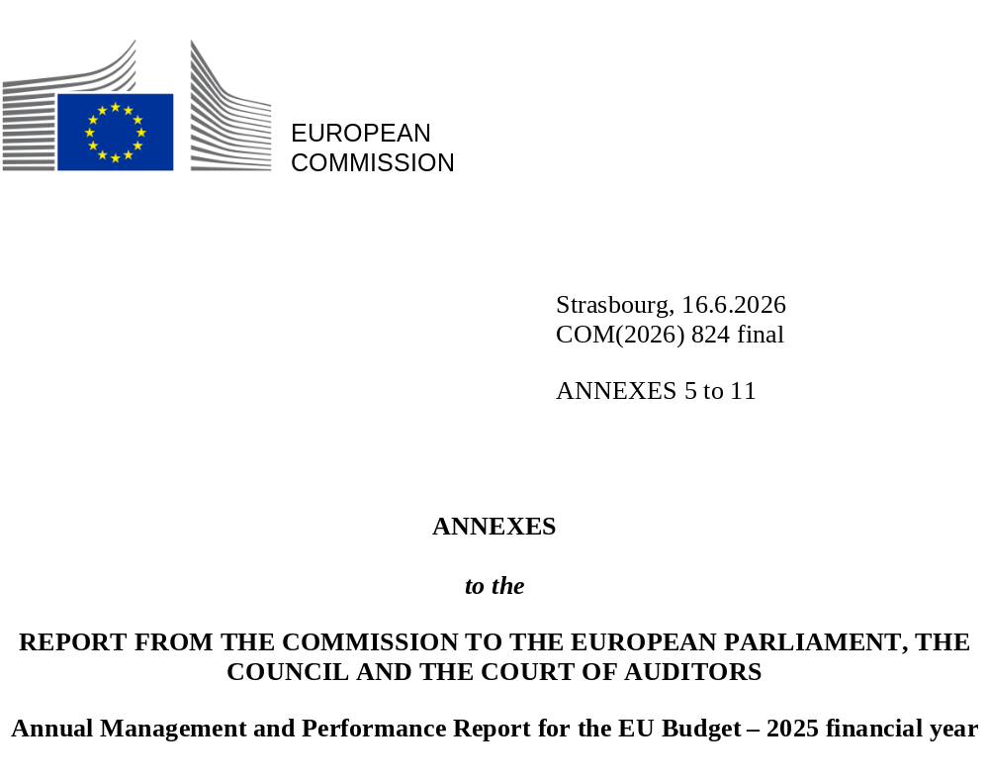

Contents
Annex 5 – Multiannual control cycle and control results 7
Annex 6 – Assurance provided by the Internal Audit Service 35
Annex 7 – Summary of the work and conclusions of the Audit Progress Committee 43
Annex 8 – Compliance with payment time limits 49
Annex 9 – Summary of waivers of recoveries of established amounts receivable 55
Annex 10 – Report on negotiated procedures 59
Annex 11 – EU trust funds 69

Annex 5 – Multiannual control cycle and control results

Annex 5 – Multiannual control cycle and control results
This annex describes the preventive and corrective measures taken by the European Commission and the EU Member States for expenditure under shared management, to protect the EU budget from illegal or irregular expenditure. More specifically, the annex presents:
- Section 5.1: the preventive and corrective measures to protect the EU budget and related concepts;
- Section 5.2: the risk at payment/closure reported in the 2025 annual activity reports, which measure the effectiveness of the controls;
- Section 5.3: the reservations qualifying the assurance provided by the authorising officers by delegation;
- Section 5.4: the quantification of the preventive and corrective measures implemented in 2025.

5.1. Measures to protect the EU budget and related concepts
The Commission has put in place internal control systems to ensure the sound financial management of EU funds (see the figure below). As part of these systems, it has designed multiannual control strategies to prevent errors before payments are made and, when errors have not been detected preventively, to correct them after the payments and until the closure of the programmes. Therefore, for cost-based expenditure (), the control results are reported at two points in the programme cycle: through the estimated risk at payment and the estimated risk at closure.
For performance-based expenditure in shared management (i.e. expenditure under the new delivery model for the common agricultural policy strategic plans), or the Recovery and Resilience Facility and facilities in the external action domain, the control strategies have the same aim. In the case of agriculture, the focus is on the proper functioning of the systems put in place in the Member States. For the Recovery and Resilience Facility, the focus is on the risk assessment of the milestones and targets submitted for payment, combined with an assessment of the proper functioning of the systems put in place in the Member States, whereas for the Moldova, Ukraine and Western Balkans facilities, it is based on evaluating the progress towards achievement of the steps and on the functioning of the systems put in place by the beneficiary countries. For such expenditure, The Commission is grouping the expenditure in three categories of risk – low, medium and high – as a result of its qualitative assessment of the systems in place and of the milestones and targets, based on its own controls and system audits and those carried out by the national audit authorities. The share of low-risk expenditure became the indicator for the level of protection of the EU budget. Systems audits are neither ex ante nor ex post controls but they may result in both preventive measures and corrective measures.
Main features of the Commission’s control strategies
CONTROL OBJECTIVES
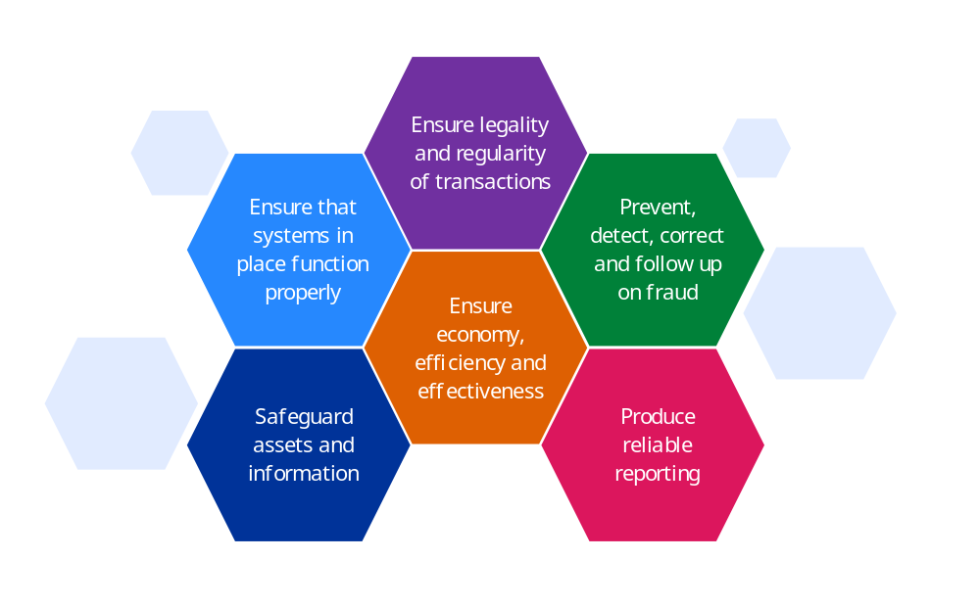

CONTROLS
Ex ante measures | Ex post measures
Simplification of programmes  (based on lessons learnt from previous programmes) | Ex post controls (after payment took place)  (e.g. audits of cost statements, ex post technical reviews, system and compliance audits, on-the-spot checks)
Prevention of double funding  (e.g. each beneficiary cannot receive more than one grant for the same expenditure) | Fraud investigations  (e.g. fraud cases pursued by the European Anti-Fraud Office)
Ex ante controls (before payment takes place)  (e.g. desk reviews, compliance checks, authorisation of payments, systems audits) | Financial recoveries and corrections
Funding suspensions and corrections
(e.g. recovery of unused pre-financing, rejection of costs claimed, financial corrections and deductions made by Member States)
Fraud proofing
(e.g. European Anti-Fraud Office review of programmes)
Awareness-raising measures
Measures taken to address systems deficiencies
Source: European Commission.

5.1.1. Preventive measures
Preventive measures take place before the Commission makes payments. They result from ex ante controls (mostly desk reviews) carried out by the Member States, in shared management, implementing partners, in indirect management, before they submit their annual accounts/expenditure to the Commission, and by the Commission, in direct management, before accepting and reimbursing expenditure, clearing pre-financing (i.e. transferring its ownership to the beneficiary) and making interim/final payments. In accordance with the Financial Regulation (), all financial operations are subject to controls before payment, under all management modes.
In shared management, the amounts corrected at the Member State level may be reused under certain circumstances, which serves as an incentive for Member States to carry out the necessary verifications and audits and correct irregular expenditure before submitting their accounts to the Commission.
Regarding measures to address systems deficiencies in the Member States, they will mostly result from systems audits that are both ex ante and ex post controls: ex ante because they can prevent errors in future payments, and ex post because they can also detect issues with payments that were already processed.

5.1.2. Corrective measures
Corrective measures take place after the Commission has made the payment or accepted the expenditure. They result from ex post controls () typically performed on-site, on a sample basis that is either statistically representative or risk-based. The errors found may lead to financial corrections () implemented by the Commission during the same or subsequent years, by way of recoveries or offsetting from final recipients under direct and indirect management, or from the Member States under shared management.
In shared management, the Commission also performs system audits of Member States’ systems, including the work of their audit bodies. Deficiencies identified in the systems put in place at the national level will lead to net financial corrections. This will also be the case under the new delivery model for the common agricultural policy 2023-2027 (see Section 5.4).
The Commission improves its processes and internal control systems on a continual basis by addressing detected weaknesses. For shared and indirect management, the Member States and implementing partners are mainly responsible for improving their management and control systems. The root causes of errors are taken into account when preparing future (simplified) legislation and when (re)designing controls to further reduce the level of error in the next generation of funding programmes.
The quantification of the preventive and corrective measures implemented as a result of Member States’ and EU controls during the 2025 reporting year is presented in Section 5.4 of this annex.

5.1.3. Concepts used for compliance / cost-based assurance model

Risk at payment
The risk at payment quantifies the errors that remain after applying preventive controls and processing payments () but before applying corrective measures. These errors are typically detected by Commission departments through ex post audits and through the assessments of the results of audits carried out by Member State in shared management. Measurement at this stage enables the Commission to correct the errors, to take additional preventive measures (e.g. additional guidance for Member States, entrusted entities or beneficiaries) and to assess the effectiveness of the ex ante controls and adapt them, if necessary.
For segments of expenditure that are performance-based – expenditure under the new delivery model for the common agricultural policy and the three Facilities in the external actions area – the detected error rate / risk at payment is replaced by the share of low risk expenditure, based on a qualitative assessment.
Each Commission department estimates its detected error rates per programme or other payment segment of expenditure, except for the performance-based expenditure. Some departments may use different terminology in their annual activity reports to reflect the specificity of their internal control system (). Nevertheless, the departments use a consistent methodology to assess the risk of error in their financial operations, based on an institutional framework.
For low-risk expenditure, where there are indications that the error rate might be close to zero (e.g. administrative expenditure or operating subsidies for agencies), some Commission departments use a conservative error rate of 0.5%.
The Commission calculates the actual financial impact of the errors on the EU budget. This is obtained by aggregating the financial impact of errors determined per programme or segment of expenditure at the level of the department and the heading (except for those that also have performance-based expenditure). This results in the overall risk at payment as a value, which is the sum of all the amounts of risk at payment, and as a percentage, which is the overall weighted average of the risk at payment.

Estimated future corrections
A detected error is corrected either via a recovery or by offsetting against future payments. As both detection and remedy may not be immediate, corrections resulting from ex post controls rarely take place within the same financial year as the payment. As a result, the risk at payment may provide an incomplete picture, as errors can still be corrected during subsequent years, up to the closure of the programme.
Therefore, for cost based expenditure, the Commission makes an estimate of the percentage of future corrections that could still be implemented until the closure of the programme. These are conservative and forward-looking estimates. They are based on the average of corrections implemented during the last seven years, adjusted to exclude exceptional recoveries, taking into account the incidence of the implementation of new programmes (e.g. simpler rules leading to fewer corrections) and possible trends (decrease or increase in the last few years).
For programmes with no set closure point (e.g. the European Agricultural Guarantee Fund) and for some multiannual programmes for which corrections are still possible after the end of the programmes (e.g. the European structural and investment funds, including the European Agricultural Fund for Rural Development), all possible corrections are considered for this estimate.
The future corrections can never be fully equal to the risk at payment, because some errors, although deserving of attention, do not always result from undue payments, and therefore do not always give rise to financial corrections or recovery orders: when the risk at payment is based on a statistical estimation, it cannot lead to corrections (no flat-rate correction may be applied to all beneficiaries, only a correction to the beneficiary of funds where an error has been found). For the cohesion policy funds, only programmes with residual total error rates above 2% are subject to corrections to reach at least the 2% threshold, and not all the cases used to determine the upper value of the range of the risk at payment (i.e. the worst-case scenario, see section 5.3 Table B) materialise after the contradictory procedure of the audit/control is finalised.
Estimated future corrections must not be confused with the actual corrective measures implemented during 2025 (detailed in Section 5.4). The estimated future corrections relate to the corrections that will happen in the future until the closure, whereas the corrections implemented correspond to the recovery orders, withdrawals by Member States and net financial corrections implemented in 2025. In addition, for some programmes (e.g. research and innovation programmes such as Horizon 2020 or Horizon Europe), until 2024 some corrections never led to recovery orders but were still treated as equivalent to recovery orders for reporting purposes, as they had the same accounting impact, since they were deducted directly from the payment requests received by the Commission, based on the result of its controls, and are not captured in the accounting system. With the new accounting system of the Commission, SUMMA, it is not possible to deduct the results from audits directly from a subsequent cost claimts and all corrections resulting form an ex post audit have to be recorded through a recovery order.

Risk at closure
This risk is estimated at programme closure, meaning that when all ex post controls are completed, all corrections are applied and no further action may legally be taken (). The risk at closure is obtained by deducting the estimated future corrections from the risk at payment, both as a value and as a percentage. These amounts and percentages represent the most up-to-date estimations of the outcome expected by the closure of each programme. As such, the risk at closure is more representative of the real risk to the expenditure than the risk at payment. 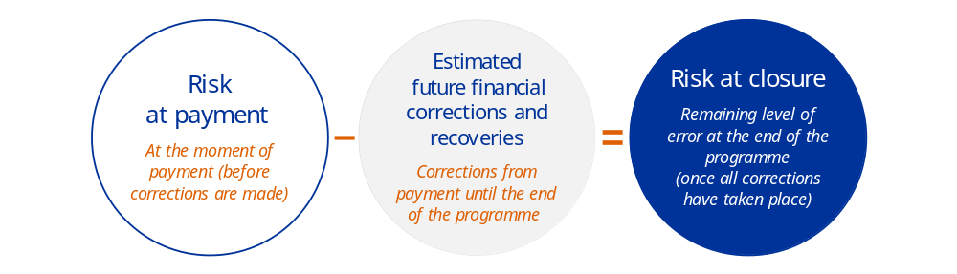 Similar to the risk at payment, the results per programme or segment are aggregated to provide, at the level of the department and the heading, the overall risk at closure as a value, which is the sum of all the amounts of risk at closure, and as a percentage, which is the overall weighted average of the risk at closure.

5.1.4. A bottom-up approach that fits the Commission’s management context for all assurance models
In order to provide bottom-up management assurance and to identify and address issues in specific areas, the Commission calculates the error rates for cost-based expenditure (per programme or other relevant segment of expenditure) and groups performance-based expenditure in three categories of risk – low, medium and high – down to the level of paying agencies and within the paying agencies, to the level of interventions they are managing. Moreover, with the risk at closure, the Commission’s methodology takes into account the multiannual nature of the spending programmes. In this sense, the Commission’s approach differs from that of the European Court of Auditors, as it stems from a management perspective to prevent and correct irregular spending and provides more detailed information. Even if this approach can lead to differences between the Court of Auditors’ error rate and the Commission’s risk at payment, there is a convergence regarding key concepts and the riskiest areas or types of expenditure (i.e. cohesion, research, some types of interventions in natural resources and environment). The ‘materiality threshold’ set, in most cases, at 2% of the relevant expenditure () is also in line with the Court of Auditors’ methodology (). The Court of Auditors’ ‘estimated level of error’ and the Commission’s risk at payment are both an estimate of the share of expenditure in the EU accounts that did not comply with the applicable EU or national law at the time of the audit. In 2025, common workshops were organised and there was a general agreement that it helped further enhance the mutual understanding of the respective institutions’ positions. This will be continued in 2026.
The risk at payment, used under the cost-based assurance model, is conceptually closer to the Court of Auditors’ ‘estimated level of error’ (). In the last years (2022 to 2024), the main differences in the error rates determined by the Court of Auditors and the risk at payment determined by the Commission concern the cohesion policy programmes. Starting in 2024, the Court also determines an error rate for the heading neighbourhood and the world, showing also a significant difference with the Commission’s risk at payment. In general, the main differences with the Court of Auditors may be explained by: differences in approach and methodology; divergences in interpreting rules and regulations, including national rules; and timing differences between the Commission’s checks and the Court of Auditors’ audits, in particular for expenditure in the external actions area (e.g. documents not provided on time lead to an error whereas they are not missing and are usually provided but with some delay).

5.2. Risk at payment/closure reported in the 2025 annual activity reports

5.2.1. Relevant expenditure
The risk at payment, risk at closure and share of low, medium and high risk are determined against the relevant expenditure of the year, in line with the approach of the Court of Auditors. The amount of the Commission’s relevant expenditure is established in line with the Court of Auditors’ scope of transactions reviewed (). It corresponds to the aggregation of the following components for a given financial year:
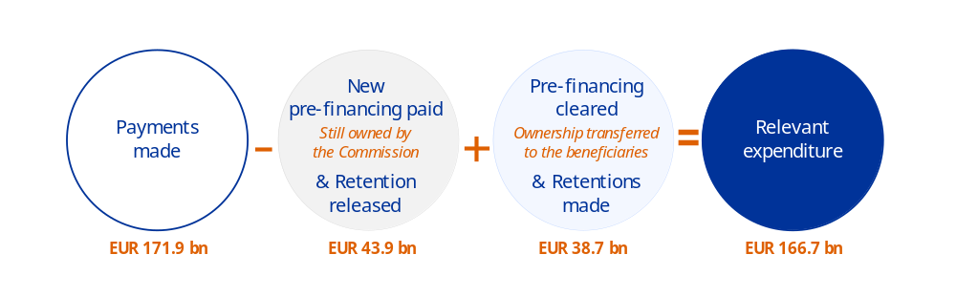

In this approach, pre-financing and retentions () are only taken into account when the final recipient of EU funds has provided evidence of their use and the Commission (or another body managing EU funds) has accepted the final use of the funds (by clearing the pre-financing or releasing the amount retained), because this is where errors of legality or regularity may occur. Therefore, the risks at payment and at closure are determined against this amount.
Relevant expenditures also include expenditure made under the European Development Fund and the four EU trust funds, since the Commission manages them as well.
- European Development Fund. Until 2020, this budget was separate from the EU budget. It is currently co-managed by four departments in the Commission () and in 2025 amounted to a total of EUR 1.6 billion of relevant expenditure.
- EU trust funds. These are the EU Trust Fund for the Central African Republic, the EU Regional Trust Fund in Response to the Syrian Crisis, the EU Emergency Trust Fund for Africa and the EU Trust Fund for Colombia (see Volume III, Annex 11). In 2025, the relevant expenditure amounted in total to EUR 420 million. Complete coverage is provided in the annual activity reports of the relevant Commission departments ().
Relevant expenditures do not include the payments made under the Resilience and Recovery Facility, as they are not funded from the EU budget. The corresponding payments are presented separately in Volume II, Annex 3.
The relevant expenditures for 2025 are presented, per heading, in Table A.

5.2.2. Overview of the Commission’s risk at payment and at closure
Table A presents an overview of the Commission’s risk at payment/closure by heading. For the purpose of this report, each of the 52 Commission departments is allocated entirely to only one of the seven headings, except for DG Budget, DG Economic and Financial Affairs and DG Defence Industry and Space.
Table A – Risk at payment/closure by policy area for the whole Commission in 2025
(million EUR)
Policy area | 2025 |  |  |  | 2024
Policy area | Relevant expenditure  (million EUR) (*) | Estimated risk at payment  (in percent) (**) | Estimated future corrections  (in percent) | Estimated risk at closure  (in percent) | Relevant expenditure  (million EUR) | Estimated risk at payment  (in percent) (**) | Estimated future corrections  (in percent) | Estimated risk at closure  (in percent)
1. Single market, innovation and digital | 25 008.9 | 2.1% | 0.4% | 1.7% | 24 240.3 | 1.6% | 0.4% | 1.2%
2. Cohesion, resilience and values | 54 007.9 | 2.3% | 1.6% | 0.8% | 61 973.7 | 2.9% | 1.2% | 1.7%
3. Natural resources and environment | 57 982.9 | N/A | N/A | N/A | 57 373.0 | N/A | N/A | N/A
4. Migration and border management | 3 782.0 | 1.1% | 0.1% | 1.0% | 3 507.5 | 1.3% | 0.1% | 1.2%
5. Security and defence | 615.6 | 1.7% | 0.0% | 1.7% | 318.7 | 0.5% | 0.0% | 0.5%
6. Neighbourhood and the world | 16 401.1 | N/A | N/A | N/A | 19 999.4 | 0.8% | 0.1% | 0.7%
7. European public administration | 8 883.0 | 0.5% | 0.0% | 0.5% | 11 625.3 | 0.5% | 0.0% | 0.5%
Grand total | 166 681.4 | N/A | N/A | N/A | 179 037.8 | N/A | N/A | N/A

(*) For the headings ‘Natural resources and environment’ and ‘Neighbourhood and the world’, the amounts include the performance-based expenditure.
(**) For 2025, there are no risk at payment and risk at closure determined for the headings ‘Natural resources and environment’, ‘Neighbourhood and the world’ and for the whole Commission.
NB: Due to the rounding of figures to the nearest million EUR, some financial data in the table above may appear not to add up.
Source: European Commission annual activity reports.

Cohesion
The two cohesion-related departments determine a range of values:
- the lower value corresponds to the departments’ risk at payment for the 2025 relevant expenditure, based on their confirmed residual total error rate for the 2023-2024 accounting year;
- the upper value corresponds to a worst-case scenario (i.e. maximum risk), taking into account possible additional risks, on top of the confirmed residual error rate, in parts of expenditure not reviewed under EU audits that indicate the possibility for higher error rates for some programmes.
Table B – Risk at payment for cohesion policy funds in 2025
 |  | Relevant expenditure (million EUR) | Lower value | Upper value
DG Employment, Social Affairs and Inclusion | Entire directorate-general | 12 545 | 2.05% | 2.40%
DG Employment, Social Affairs and Inclusion | European Social Fund, youth employment initiative, Fund for European Aid to the Most Deprived – 2021-2027 | 7 850 | 2.00% | 2.01%
DG Employment, Social Affairs and Inclusion | European Social Fund, youth employment initiative, Fund for European Aid to the Most Deprived – 2014-2020 | 4 400 | 2.24% | 3.22%
DG Employment, Social Affairs and Inclusion | European Social Fund, youth employment initiative, Fund for European Aid to the Most Deprived – pre-2014 | 12 | 0.5% | 0.5%
DG Employment, Social Affairs and Inclusion | European Social Fund, youth employment initiative, Fund for European Aid to the Most Deprived – Total | 12 263 | 2.08% | 2.44%
DG Regional and Urban Policy | Entire directorate-general | 32 720 | 1.99% | 2.79%
DG Regional and Urban Policy | European Regional Development Fund and Cohesion Fund – 2021-2027 | 28 132 | 2.00% | 2.78%
DG Regional and Urban Policy | European Regional Development Fund and Cohesion Fund – 2014-2020 | 4 174 | 2.06% | 3.12%
DG Regional and Urban Policy | European Regional Development Fund and Cohesion Fund – pre-2014 | 118 | 0.87% | 0.87%
DG Regional and Urban Policy | European Regional Development Fund and Cohesion Fund – Total | 32 424 | 2.00% | 2.81%
Total | Two directorates-general cumulated | 45 266 | 2.00% | 2.68%
 | Cohesion policy funds all together | 44 688 | 2.03% | 2.71%
Source: European Commission annual activity reports for 2025.

5.3. Reservations reported in the 2025 annual activity reports
Reservations preserve the principle of sound financial management by acting as a tool to address weaknesses and prevent them in future through the development of action plans to mitigate risks and to strengthen control systems. Each authorising officer by delegation signs a declaration of assurance in the annual activity report. If necessary, the declaration of assurance may be qualified by one or more reservations, which ensure transparency concerning any challenges or weaknesses encountered and their potential financial impact.
To conclude on their assurance, at the end of each financial year, the authorising officers by delegation perform a detailed analysis for each segment of expenditure of their portfolio and determine the residual error rate for each programme. This residual error rate is based on the detected error rate but takes into account any corrections made until the end of the reporting year. It is a snapshot of the level of error still affecting the 2025 expenditure at year-end. Where this residual error rate is above the materiality threshold of 2%, the authorising officers duly qualify their declarations of assurance with a reservation. This is in line with the materiality threshold used by the Court of Auditors to form their opinion (). A reservation may or may not have a quantifiable financial impact (). The authorising officers may also issue a reservation in other situations, such as significant weaknesses in the management of funds or an event creating reputational damage to their department and/or the entire Commission.

5.3.1. 2025 reservations
For the 2025 reporting year, all 52 authorising officers by delegation declared in their annual activity reports that they had reasonable assurance ().
The majority of the authorising officers by delegation issued unqualified declarations of assurance, while 19 qualified their declarations with a total of 32 reservations. These reservations concerned the expenditure side of the budget and related to a programme or a specific segment of expenditure affected by a weakness (see figure below). In all these cases, the authorising officers by delegation adopted action plans to address the underlying weaknesses and mitigate the resulting risks.
- For the EU budget, twelve reservations are new. However, they stem from only three underlying issues: residual error rates above 2% in Horizon Europe and the digital Europe programme (affecting eight and two services respectively), and one critical Internal Audit Service recommendation leading to reservations in two departments. As these issues relate to programmes implemented across several services, they result in a higher overall number of new reservations than the three distinct underlying risks. The higher error rate in Horizon Europe is mainly due to more error-prone beneficiaries (including newcomers and small and medium-sized enterprises) and complex rules. In addition, for 2025, a limited audited population with a few high-impact errors, and the still limited effect of lump-sum grants, also had an incidence on the high error rate.

- A total of 18 () reservations have been carried over from previous years, divided broadly equally between quantified and non-quantified. These reservations have been maintained mainly because the root causes of the material level of error or the lack of assurance can be partially mitigated but not fully eradicated under the current programmes’ legal frameworks. No reservations issued in 2024 were lifted in 2025.
Most recurrent reservations concern shared management, where each reservation consists of an increased number of paying agencies and operational programmes, for which systems in place do not function or only partially, or the error rate is above 2% compared with 2024.
For cohesion policy, the higher number of programmes in reservation (78 v 26 in 2024) is mainly due to the increased number of accounts submitted in 2025. For the 2014-2020 period, 80% of the programmes submitted closure accounts (versus 20% in 2024 following the one-year extension under the STEP Regulation ()), while for the 2021-2027 period, more accounts were submitted as programmes gained speed in implementation. Overall, this level is in line with the number in 2023 (71), while 2024 was exceptionally low (26) due to limited account submission. In this area, higher error rates are caused by complex rules, particularly on public procurement and State aid, along with the inherent complexity of the projects and the wide range of actors involved.
An increase in the number of systems under reservation is also observed for the new delivery model under the 2023–2027 Common Agricultural Policy. This is due to better identification of potential serious deficiencies in governance systems thanks to improved system assessments by certification bodies, based on experience gained in implementing the new model. These reservations cannot be quantified and the final level of risk and the corresponding financial corrections will be determined through ongoing conformity procedures. The year 2027 is expected to be the first in which such procedures are finalised.
- In addition, two reservations were recorded in relation to the Recovery and Resilience Facility: a recurring reservation regarding conflicts of interest in one Member State, and a new reservation concerning the satisfactory fulfilment of two milestones in another Member State.
In accordance with the de minimis rule, a financial quantified reservation is deemed not to be substantial and will not be issued () for residual error rates above 2% if the financial impact is less than EUR 5 million and the related segment represents less than 5% of the department’s total payments. In 2025, eight cases with a residual error rate above 2% were found not to exceed the two thresholds of the de minimis rule, and therefore were deemed as not substantial for issuing a financial quantified reservation. The total financial impact of these cases in 2025 was very limited, amounting to EUR 4.5 million, almost half the level recorded in 2024 (EUR 8.6 million).

5.3.2. Financial impact of reservations
The total financial impact of the quantified reservations amounts to EUR 866.5 million (), representing 0.5% of the total relevant expenditure, which marks an increase compared with 2024 (0.2%). This increase is driven by the new reservations linked to higher error rates in Horizon Europe and the digital Europe programme, and by a higher number and volume of reservations in the cohesion policy area, reflecting the increased number of final accounts submitted for the 2014-2020 and acceleration of the implementation of the 2021–2027 programmes. However, it should also be noted that the financial impact in 2024 was unusually low (see the trend in the graph below). Excluding 2024, the financial impact in 2025 remains in the range of previous year’s values.
The composition and evolution of the financial impact over the years are presented in the following figure and Table C. The financial impact of the reservation for the Recovery and Resilience Facility is not included, as the facility is not part of the EU budget.
Financial impact of quantified reservations for 2019-2025 () (million EUR)
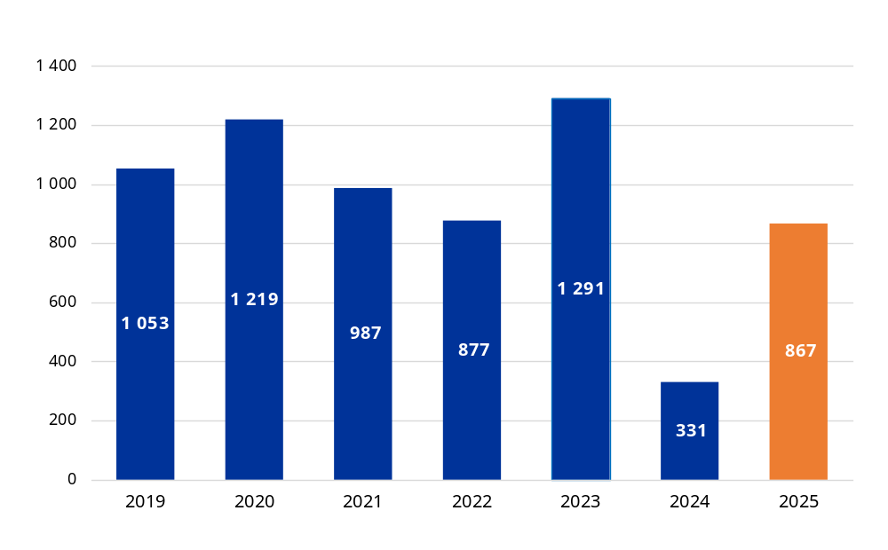
Source: European Commission annual activity reports.
Table C – Financial impact of the quantified reservations in 2025 by heading () (million EUR)
Policy area | Payments in 2025 | Relevant expenditure in 2025 | Financial impact of the reservations
Policy area | Payments in 2025 | Relevant expenditure in 2025 | in 2025 | in 2024
Single market, innovation and digital | 26 769.8 | 25 008.9 | 261.5 | 1.3
Cohesion, resilience and values | 53 314.4 | 54 007.9 | 304.3 | 72.7
Natural resources and environment (*) | 57 752.8 | 57 982.9 | 300.7 | 253.6
Migration and border management | 4 371.3 | 3 782.0 | 0 | 3.4
Security and defence | 1 003.8 | 615.6 | 0 | 0
Neighbourhood and the world | 19 735.7 | 16 401.1 | 0 | 0
European public administration | 8 886.9 | 8 883.0 | 0 | 0
Total | 171 834.7 | 166 681.4 | 866.5 | 330.9
2021-2027 programmes |  |  | 419.4 | 6.0
2014-2020 programmes |  |  | 447.1 | 324.9
(*) With segments of expenditure that are performance-based.
Source: European Commission annual activity reports.
The tables below present the details concerning the reservations for 2025:
- Table D presents the 30 reservations for 2025 affecting the expenditure, divided according to the 2021-2027 and 2014-2020 programme periods;
- Table E presents the reservation for 2025 affecting the Recovery and Resilience Facility;
- Table F presents all the cases where the de minimis rule applied.

5.3.3. Full list of reservations
Table D – 2025 list of reservations (million EUR)
Policy areas | Description of reservation | Department | Impact on legality and regularity | Financial impact
Programmes of the 2021-2027 multiannual financial framework
Single market, innovation and digital | Reservation regarding the rate of residual error within grant payments in Horizon Europe | European Climate, Infrastructure and Environment Executive Agency | Reservation issued in 2025  Quantified | 30.4
Single market, innovation and digital |  | DG Communications Networks, Content and Technology | Reservation issued in 2025  Quantified | 46.6
Single market, innovation and digital |  | European Innovation Council and SMEs Executive Agency | Reservation issued in 2025  Quantified | 32.2
Single market, innovation and digital |  | European Research Council Executive Agency | Reservation issued in 2025  Quantified | 36.8
Single market, innovation and digital |  | European Health and Digital Executive Agency | Reservation issued in 2025  Quantified | 42.4
Single market, innovation and digital |  | European Research Executive Agency | Reservation issued in 2025  Quantified | 32.3
Single market, innovation and digital |  | DG for Mobility and Transport | Reservation issued in 2025  Quantified | 2.8
Single market, innovation and digital |  | DG Research and Innovation | Reservation issued in 2025  Quantified | 26
Single market, innovation and digital | Reservation concerning the rate of the residual error within grant payments in the digital Europe programme | DG Communications Networks, Content and Technology | Reservation issued in 2025  Quantified | 10.1
Single market, innovation and digital |  | European Health and Digital Executive Agency | Reservation issued in 2025  Quantified | 1.9
Single market, innovation and digital | Reservation on reputational grounds concerning weaknesses affecting the European Innovation Council | European Innovation Council and SMEs Executive Agency | Reservation issued in 2025  Non-quantified | —
Single market, innovation and digital |  | DG Research and Innovation | Reservation issued in 2025  Non-quantified | —
Cohesion, resilience and values | European Social Fund Plus management and control systems  (12 programmes in 9 Member States) | DG Employment. Social Affairs and Inclusion | Quantified | 12.9
Cohesion, resilience and values | European Regional Development Fund / Cohesion Fund / Just Transition Fund  (16 programmes in 11 Member States) | DG Regional and Urban Policy | Quantified | 145
Natural resources and environment | Common agricultural policy strategic plans – European Agricultural Guarantee Fund and the European Agricultural Fund for Rural Development (expenditure under the integrated administration and control system)  (19 reservations for 14 Member States) | DG Agriculture and Rural Development | Non-quantified | —
Natural resources and environment | Common agricultural policy strategic plans – European Agricultural Guarantee Fund and the European Agricultural Fund for Rural Development (expenditure outside the integrated administration and control system)  (15 reservations for 11 Member States) | DG Agriculture and Rural Development | Non-quantified | —
Natural resources and environment | Reputational reservation concerning the high level of known irregularities in part of the multi-beneficiary grants funded by the Promotion of agricultural products programme | European Research Executive Agency | Non-quantified | —
Natural resources and environment | EU emissions trading system registry – security weakness | DG Climate Action | Non-quantified | —
Migration and border management | Management and control systems for the Border Management and Visa Policy Instrument, Asylum, Migration and Integration Fund and Internal Security Fund  (4 reservations in 2 Member States) | DG Migration and Home Affairs | Non-quantified | —
Neighbourhood and the world | Monitoring of projects in volatile areas affected by security concerns (Libya, Palestine (*), Syria) | DG Middle East, North Africa and the Gulf | Non-quantified | —
Neighbourhood and the world | External restrictions to control financial programmes in Ukraine | DG Enlargement and the Eastern Neighbourhood | Non-quantified | —
European public administration | Reputational reservation on the problems encountered with the testing platform and automated proctoring system in online testing | European Personnel Selection Office | Non-quantified | —
Total | 22 reservations | 16 departments | - | 419.4
Programmes of the 2014-2020 multiannual financial framework
Cohesion, resilience and values | European Social Fund / Youth Employment Initiative / Fund for European Aid to the Most Deprived  (10 programmes in 6 Member States) | DG Employment, Social Affairs and Inclusion | Quantified | 95.9
Cohesion, resilience and values | Reservation regarding the residual error rate in the Citizens, Equality, Rights & Values and Justice programmes – direct grants | DG Justice and Consumers | Quantified | 3.4
Cohesion, resilience and values | European Regional Development Fund / Cohesion Fund  (30 programmes in 12 Member States and the United Kingdom, including 3 Interreg programmes) | DG Regional and Urban Policy | Quantified | 47.1
Natural resources and environment | European Agricultural Guarantee Fund – market measures  (6 reservations for 3 Member States) | DG Agriculture and Rural Development | Quantified | 17.4
Natural resources and environment | European Agricultural Guarantee Fund – direct payments  (1 reservation for 1 Member State) | DG Agriculture and Rural Development | Quantified | 1.8
Natural resources and environment | European Agricultural Fund for Rural Development  (10 reservations for 10 Member States) | DG Agriculture and Rural Development | Quantified | 281.5
Natural resources and environment | European Maritime and Fisheries Fund  (2 Member States) | DG Maritime Affairs and Fisheries | Non-quantified | —
Migration and border management | Management and control systems for the Asylum, Migration and Integration Fund and the Internal Security Fund  (14 reservations in 7 Member States and 2 Schengen-associated countries) | DG Migration and Home Affairs | Non-quantified | —
Total | 8 reservations | 6 departments | — | 447.1
Total for 2025 | 30 reservations | 18 departments | — | 866.5
(*) This designation shall not be construed as recognition of a State of Palestine and is without prejudice to the individual positions of the Member States on this issue.
Source: European Commission annual activity reports.

Table E – 2025 list of reservations for the Recovery and Resilience Facility (million EUR)
Policy areas | Description of reservation | Department | Impact on legality and regularity | Financial impact
Recovery and Resilience Facility | Cases of conflict of interest  (1 reservation for 1 Member State) | DG Economic and Financial Affairs | Quantified | 16.9
Recovery and Resilience Facility | Reservation concerning the satisfactory fulfilment of two targets (1 reservation for 1 Member State) | DG Economic and Financial Affairs | Reservation issued in 2025  Quantified | 326.1
Total for 2025 | 2 reservation | 1 department | — | 343
Source: European Commission annual activity reports.
Table F – Application of the de minimis rule – reservations not issued during 2025 (million EUR)
Policy area | Description of reservation | Department | Impact on legality and regularity | Financial impact in 2025
Single market, innovation and digital | Pilot projects and preparatory actions | DG Communications Networks. Content and Technology | Quantified | 0.51
Single market, innovation and digital | Programme for the competitiveness of small and medium-sized enterprises. 2014-2020 grants segment | European Innovation Council and SMEs Executive Agency | Quantified | 0.11
Single market, innovation and digital | Connecting Europe Facility. telecom sector – digital service infrastructure | European Health and Digital Executive Agency | Quantified | 0.3
Single market, innovation and digital | Third health programme | European Health and Digital Executive Agency | Quantified | 0.4
Single market, innovation and digital | Reservation concerning the rate of residual error in grant payments in Horizon Europe | DG for Defence Industry and Space | Quantified | 1.3
Single market, innovation and digital |  | DG Energy | Quantified | 0.02
Natural resources and environment | Instrument for Pre-accession Assistance Rural Development Programmes – indirect management | DG Agriculture and Rural Development | Quantified | 1.83
Recovery and Resilience Facility | Cases of conflict of interest | DG Economic and Financial Affairs | Quantified | 0.01
Total for 2025 | 8 reservations | 7 departments | — | 4.5
Source: European Commission annual activity reports.

5.4. Preventive and corrective measures implemented in 2025
Preventive and corrective measures implemented in 2025 result from both the Commission and the Member States’ audits and controls and relate mainly to expenditure from previous years. Under shared management. the Member States are primarily responsible for identifying any amounts unduly paid and recovering them from beneficiaries. Their controls, which are a key component of the preventive and corrective mechanisms, lead to corrections implemented by the Member States before and after they submit their payment claims or annual accounts to the Commission. In addition, the Commission can apply preventive measures and/or financial corrections due to: irregularities or serious deficiencies identified but not corrected by Member State authorities; its own verifications and audits; investigations by the European Anti-Fraud Office; and audits by the Court of Auditors.
In general, for corrective measures, corrections implemented are used as booked in the accounting system of the Commission, but the situation differs between agriculture and cohesion.
- Agriculture. This includes financial corrections applied by the Commission and Member States’ recoveries reported to and booked into the Commission’s accounting system. A financial correction is implemented when: (i) it is recorded in the Commission’s accounts; (ii) it is deducted from the amounts declared by the Member State in an interim, final payment claim or annual accounts; and (iii) the commitment appropriations corresponding to the financial correction amount have been cancelled. For the Member States’ recoveries, corrections are implemented when the Member States have issued the recovery orders (or equivalent) to the final beneficiaries and reported them accordingly to the Commission (DG Agriculture and Rural Development) in the updated ‘debtors ledger’ of year n (usually in February n + 1).
- Cohesion. The situation differs depending on the programming periods in question and not all data come from the Commission’s accounting system.
  - Pre-2014 programmes. If no financial transaction will take place at the closure of the programme, a correction is implemented by the Commission when it has been applied and included in the pre-closure/closure letter accepted by the Member State.
  - Post-2014 programmes. All corrections are implemented by Member States. The amounts are obtained from the assurance packages submitted to the Commission.
Table G provides a complete overview of all the preventive and corrective measures implemented in 2025 by the Commission and the Member States to protect the EU budget, irrespective of the year in which the initial expenditure was made.

Table G – Overview of the preventive and corrective measures resulting from the controls
of the Commission and of the Member States, amounts implemented in 2025 (million EUR)
Multiannual financial framework heading | Preventive |  |  | Relevant  expenditure | Corrective |  |  | % of relevant expenditure | Preventive and corrective total
Multiannual financial framework heading | Member State controls | EU controls | Total | Relevant  expenditure | Member State controls | EU controls | Total | % of relevant expenditure | Preventive and corrective total
Multiannual financial framework heading | (a) | (b) | (c) =  (a) + (b) | (d) | (c) | (f) | (g) = (c) + (f) | (h) =  (g) / (d) | (i) =  (c) + (g)
1. Single market, innovation and digital | - | 153.3 | 153.3 | 25 008.9 | - | 79.6 | 79.6 | 0.32% | 232.9
2. Cohesion, resilience and values | 575.1 | 15.1 | 590.2 | 54 007.9 | 6 307.8 | 293.0 | 6 600.8 | 12.22.% | 7 191.0
3. Natural resources and environment | 194.7 | 6.9 | 201.6 | 57 982.9 | 430.4 | 785.1 | 1 215.6 | 2.10% | 1 417.1
4. Migration and border management | 108.8 | 6.8 | 115.6 | 3 782.0 | - | 0.0 | 0.0 | 0.00% | 115.6
5. Security and defence | - | 9.0 | 9.0 | 615.6 | - | - | - | 0.00% | 9.0
6. Neighbourhood and the world | - | 67.3 | 67.3 | 16 401.1 | - | 6.8 | 6.8 | 0.04% | 74.1
7. European public administration | - | - | - | 8 883.0 | - | 0.1 | 0.1 | 0.00% | 0.1
Total | 878.6 | 258.4 | 1 136.9 | 166 681.4 | 6 738.2 | 1 164.7 | 7 902.9 | 4.74% | 9 039.9
(a) For shared management, details for each Member State are provided in the annual activity reports of DG Employment. Social Affairs and Inclusion, DG Agriculture and Rural Development, DG Maritime Affairs and Fisheries, DG Regional and Urban Policy and DG Migration and Home Affairs.
(f) The total of EUR 1 164.7 million of corrective EU controls is composed of: (i) the amounts booked in the Commission’s accounting system, including recovery orders issued by the Commission in all headings and the financial corrections in the agriculture sector; and (ii) for cohesion, amounts decided and agreed following the Commission’s audits (and the follow-up of European Anti-Fraud Office investigations and Court of Auditors audits) implemented directly by the Member States (EUR 219.7 million), along with corrections implemented by the Commission (EUR 73.3 million).
An overview of amounts recommended for recovery and prevention from undue spending following the European Anti-Fraud Office’s investigative activities can be found in Volume II of the AMPR, Annex 2, Section 1.5.
NB: Due to the rounding of figures to the nearest million EUR, some financial data in the table above may appear not to add up.
Source: European Commission annual activity reports.

5.4.1. Cohesion, resilience and values
Under this heading, preventive measures (EUR 590.2 million) implemented in 2025 relate primarily to the cohesion policy funds for the 2021-2027 programming period and are slightly higher than in 2024 (EUR 580 million). Overall, the levels remain relatively low because the deductions at closure for the 2014-2020 programming period were reported as corrective measures () and because the underlying expenditure under the 2021-2027 programming period is relatively low-risk at the beginning of the period, thus resulting in fewer preventive actions.
The corrective measures implemented in 2025 (EUR 6 600.8 million) increased sharply compared with 2024 (EUR 449 million). A significant part of this amount, EUR 6 518.0 million, is related to the 2014-2020 programming period cohesion policy funds and corresponds to deductions at closure, withdrawals and recoveries deducted in the 2023-2024 annual accounts, out of which EUR 6 298.3 million () is attributed to Member State audits and controls. This marks a sharp increase from EUR 211 million in the previous year, which was exceptionally low because, under the Strategic Technologies for Europe Platform (STEP) Regulation (), only 20% of programmes submitted their closing accounts, while the remaining 80% submitted them in March 2026. As a result, the additional time frame led to a significantly amplified scale of adjustments, as programme authorities in Member States undertook a final, comprehensive review of both the current and the previous accounting years. In this context, the closure acted as a critical safeguard, ensuring that remaining irregular or inaccurate expenditure was identified and excluded.
For the same programming period, the Member States also implemented corrective measures attributed to the Commission’s controls, follow-ups to investigations of the European Anti-Fraud Office and audits of the Court of Auditors for an amount of EUR 219 million (2024: EUR 70 million).
Other corrections might be linked to the Commission’s work, such as additional extrapolated corrections to bring the residual error rate below the materiality threshold following Commission and Court of Auditors audit work. However, as most of these corrections overlap with the ones implemented following the audits of the Court of Auditors, Commission and Member States, the Commission conservatively only reports this minimum amount. Furthermore, a total of EUR 6.5 million corrective measures were implemented in relation to the 2021-2027 programming period.
For 2007-2013 and previous programming periods, the Commission applied corrective measures of EUR 44.1 million, a decrease from EUR 154 million in 2024.
In 2025, the Commission implemented the first net financial correction for Slovakia for the 2014-2020 programming period amounting to EUR 27.1 million.

5.4.2. Natural resources and environment
The corrective measures applied in 2025 amounted to EUR 1 215.6 million, which is an increase compared to 2024 at EUR 891 million. Most of these corrections, EUR 1 197.8 million, concerned agriculture and rural development. In this area, Member States’ controls resulted in EUR 414.0 million in corrective measures (), whereas the Commission’s net financial corrections implemented amounted to EUR 783.7 million. The net financial corrections in 2025 represent an increase compared to 2024 (EUR 447.7 million) and exceeded the average of the previous three years (2022-2024: EUR 431 million). This is mainly due to a significant net financial correction of EUR 415 million for Greece, adopted in 2025 and resulting from a series of enquiries and spanning several financial years. Net financial corrections are characteristic of the European Agricultural Guarantee Fund and the European Agricultural Fund for Rural Development, as they are applied after a procedure in which the duration may vary, creating the variation in the amounts between years. The net financial corrections that took place in 2025 are still fully related to expenditure under the 2014-2022 common agricultural policy basic act. No conformity procedure related to the 2023-2027 common agricultural policy expenditure has been finalised yet.
The remaining EUR 17.8 million concerned maritime affairs and fisheries, where Member States’ controls resulted in EUR 16.4 million in corrective measures, whereas the corrections linked to the Commission’s work amounted to EUR 1.4 million.

5.4.4. Multiannual overview
Preventive and corrective measures implemented for 2019-2025 (million EUR)
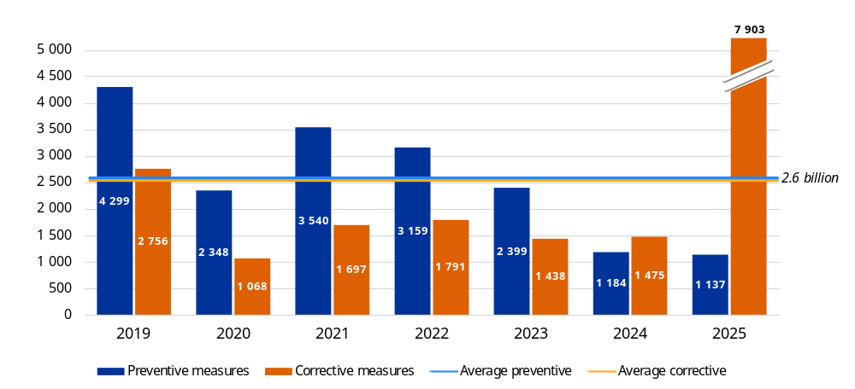
Source: European Commission 2019-2025 annual activity reports and annual management and performance reports.
For the 2019-2025 period, the preventive and corrective measures amounted to EUR 36.2 billion. The highest amounts of preventive and corrective measures are under heading 2 (cohesion, resilience and values) and heading 3 (natural resources and environment), which is consistent with the high level of expenditure under these headings.
Preventive measures amounted to EUR 18.07 billion for the period, substantiating the important role of the Member States in protecting the EU budget through their controls before the Commission accepts and reimburses expenditure. The overall trend remains relatively stable, with an average annual amount of EUR 2.6 billion, comparable to the average annual amount of EUR 2.8 billion for the 2019-2024 period. The closure of the 2014-2020 programming period led to a notable decrease in preventive measures for cohesion over the last two reporting years, as all measures applied in the final accounting year 2023-2024 were reported as ‘corrective’, because no further action is possible after the submission of the final accounts (in the next payment applications or subsequent accounts).
Corrective measures amounted to EUR 18.13 billion for the period. The evolution of corrective measures in shared management is influenced by the significant backlog in their implementation, in accordance with the applicable legislation. Especially for cohesion policy funds, the significant corrective measures applied during the first years analysed related mostly to expenditure declared in previous programming periods, which had a significantly higher risk at payment at the Commission level. The corrective measures applied for the 2014-2020 programming period have increased over time, in line with the maturity of the expenditure implementation. The sharp increase in 2025 is predominantly due to the closure of the 2014-2020 programming period cohesion policy funds and reflects the intensified final verifications conducted by Member States and a significant increase in corrective measures to exclude irregular expenditure at closure. For a more detailed analysis of the situation in cohesion policy, please refer to Section 5.4.1 of this report.

5.4.5. Net financial corrections implemented by the Commission in 2025
The following table presents the types of net financial corrections applied by the Commission as corrective measures in shared management in 2025.
Table H – 2025 net financial corrections implemented by the Commission (corrective measures in shared management) (million EUR)
Multiannual financial framework heading/fund | Net financial corrections
Multiannual financial framework heading/fund | 2014-2020 multiannual financial framework and previous frameworks |  |  | 2021-2027 multiannual financial framework |  |  | Total net financial corrections
Multiannual financial framework heading/fund | Recovery order | Decommitment | Total | Recovery order | Decommitment | Total | Total net financial corrections
Multiannual financial framework heading/fund | (a) | (b) | (c) =  (a) + (b) | (d) | (e) | (f) =  (d) + (e) | (g) = (c) + (f)
2. Cohesion, resilience and values (*) | 30.2 | 5.9 | 36.1 | — | — | — | 36.1
European Regional Development Fund and Cohesion Fund | 30.2 | 5.7 | 35.9 | — | — | — | 35.9
European Social Fund / youth employment initiative and Fund for European Aid to the Most Deprived | — | 0.3 | 0.3 | — | — | — | 0.3
3. Natural resources and environment | 432.4 | — | 432.4 | 351.3 | — | 351.3 | 783.7
European Agricultural Guarantee Fund | 299.6 | — | 299.6 | 355.0 | — | 355.0 | 654.6
European Agricultural Fund for Rural Development | 132.8 | — | 132.8 | -3.7 | — | -3.7 | 129.1
European Maritime and Fisheries Fund / European Fisheries Fund / Financial Instrument for Fisheries Guidance | — | — | — | — | — | — | —
4. Migration and border management | — | — | — | — | — | — | —
Total | 462.6 | 5.9 | 468.5 | 351.3 | — | 351.3 | 819.9
European Globalisation Fund (special instruments) | — | — | — | — | — | — | —
Total, including special instruments | 462.6 | 5.9 | 468.5 | 351.3 | — | 351.3 | 819.9
(*) For cohesion funds, the amounts presented in the table above concern net financial corrections applied in respect of pre-2014 and on the 2014-2020 programmes.
During the 2000‐2006 and 2007‐2013 programming periods, the applicable legislation allowed Member States to replace irregular expenditure with new expenditure if they took the necessary corrective action and applied the related financial corrections (confirmed financial corrections). However, if the Member States did not have such additional expenditure to declare, the financial corrections became (at least in part) net corrections.
Net financial corrections also originate from Commission decisions (‘decided’ financial corrections), which always have a direct and net impact on the Member State, as it was not possible to reuse the corrected amount for other eligible operations and the Member States had to return the financial corrections amounts to the EU budget.
In both cases of net financial corrections, the operational programmes’ envelopes were reduced and the Member States had to pay the amounts back to the EU budget (implementation by recovery order issued by the Commission – column a) and/or at closure they received a lower overall funding envelope (implementation by decommitment – column b).
NB: Due to the rounding of figures to the nearest million EUR, some financial data in the table above may appear not to add up.
Source: European Commission.

Annex 6 – Assurance provided by the Internal Audit Service

Annex 6 – Assurance provided by the Internal Audit Service
The work of the Internal Audit Service, its audit findings and recommendations, and the results of the oversight provided by the Audit Progress Committee contribute to the overall assurance-building process at the European Commission level. For the 2025 reporting year, the Internal Audit Service produced an annual internal audit report, in line with Article 118(4) of the Financial Regulation , which (1) summarised the internal audits completed in 2025, (2) presented the principal recommendations issued in 2025, (3) focused on the overall compliance with the principles of sound financial management and performance, (4) outlined the actions taken by auditees regarding the Internal Audit Service’s recommendations, and (5) indicated whether any systemic problems have been detected by the Commission’s financial irregularities panel.
Through its audit work, the Internal Audit Service adds value to the effective and efficient implementation of risk management, control and governance processes, EU policies, programmes and actions, efficient and economical management of resources, legal and regular spending of the EU budget and compliance with the legal frameworks by the audited entities. In this way, the Internal Audit Service contributes to providing value for money for citizens and thus to increasing public confidence in the EU and enhancing its image.

Financial management: Internal Auditor’s overall conclusion
Based on:
- the work done by the Internal Audit Service covering the years 2023-2025, the principal findings and recommendations of which are summarised in its reports and annexes submitted under Article 118(4) of the Financial Regulation issued in parallel to the annual overall conclusion,
- reviews of the related accountability reports provided by management and the assurances given by management in their annual activity reports and annexed declarations of assurance,
- information presented in the draft Annual Management and Performance Report for the EU Budget - financial year 2025 (Volume II, Annexes 2 and 3, and Volume III, Annex 5), the Annual Management and Performance Report for the EU Budget – financial year 2024 (Volume II, Annexes 2 and 3, and Volume III, Annex 5) and the Annual Management and Performance Report for the EU Budget – financial year 2023 (Volume II, Annexes 2 and 3, and Volume III, Annex 5), as part of the integrated set of financial and accountability reports (Article 253 of the Financial Regulation ())
- information from other sources, the European Court of Auditors’ reports,
and taking into account that:
- management has adopted plans which the Internal Audit Service considers are adequate to address the residual risks identified by auditors, and to implement the accepted recommendations made by the Internal Audit Service (), and
- the implementation of these plans is monitored through reports by management and through follow-up audits by the Internal Audit Service.
The Internal Auditor considers that in 2025 the Commission put into place governance, risk management and internal control procedures which, taken as a whole, are adequate to give reasonable assurance over the achievement of its financial objectives, with the exception of those areas of financial management over which authorising officers by delegation have expressed reservations in their declaration of assurance.
Without further qualifying the overall conclusion for 2025, the Internal Auditor draws the attention to the need to ensure that the control and assurance framework remains robust, proportionate and effective to manage risks to an acceptable level, especially in the context of concurrent priorities and continuous pressure on resources. This is particularly pertinent in view of the need to accelerate implementation and ensure a timely closure of the current programmes while preparing for the upcoming multi-annual financial framework, which will introduce further innovative instruments and delivery models.
The challenging socio-economic and political environment and need to respond to the various crises during the past few years required rapid mobilisation of unprecedented amounts of resources and funding, and the creation of novel performance-based instruments. Delays in finalising and implementing the control and audit strategies for the current programming period, as a result of the necessary adaptations to the revised delivery models, should be given due attention. At the same time, the Commission has to continue the simplification efforts to ensure that EU funding remains accessible and delivers results while ensuring sound financial management.
In the context of a major overhaul of funding and delivery models under the next multi-annual financial framework, the Commission should make use of the lessons learned from the current 7-year period and ensure that the assurance model is defined from the outset, in order for control strategies for individual instruments to be developed in good time before implementation starts.
The continued shift towards performance-based delivery models will require a revised approach to enable the Commission to provide assurance on the legality and regularity of expenditure, including where necessary support to the Member States, adjustments to the organisation of the audit function and revision of traditional legality and regularity indicators, such as the error rate.
Continued attention needs to be paid to proportionate and effective controls for the oversight of budget amounts implemented by the Member States and/or third parties, considering the increased reliance the Commission places on them.
In addition, the expanding financial operations of the Union highlight the importance of a robust and well-integrated risk management framework and strong oversight of loans, budgetary guarantees and financing through the issuance of debt securities.
Finally, to ensure delivery of its objectives relating to accountability, sound financial management and protection of the EU budget, the Commission should continue efforts and seize opportunities to optimise the use of limited resources and to adjust its organisation, processes and operations. The design of new assurance models and the individual control strategies should be accompanied by a definition of adequate human resources, in numbers, skills and timing, and a strategy for effectively leveraging appropriate technological means, while carefully managing the risks they introduce.

Performance: results of audits by the Internal Audit Service
The Internal Audit Service’s 2025 engagements indicate that the Commission’s financial management, operational and support processes remain robust, though certain areas require attention to ensure compliance and long-term effectiveness.
While financial management systems are generally effective, some vulnerabilities in procurement and grant management, notably assurance and audit strategies, require to be addressed. Audits of funding programmes revealed a need for greater consistency in performance measurement, where clearer indicators and streamlined processes could enhance transparency and impact, in particular in view of moving towards performance-based delivery models. Similarly, the operational performance would benefit from clearer definition of roles and responsibilities of parties involved and from the sound management of risks related to the support systems, mainly IT. Finally, considering the reliance of the Commission on the talent and technological resources, the systems for selection and recruitment of staff, for IT project management and for cybersecurity management require strengthening as key founding blocks for modern public administration.

Financial processes
The Internal Audit Service audits consisted in providing assurance to the College of Commissioners, as well as to heads of audited entities, on the efficient and effective implementation of internal controls on financial management. Five audits carried out by the Internal Audit Service did not reveal any major weaknesses in the control systems under examination and the other 13 audits revealed a need for improvements and led to the issuance of critical and very important recommendations.
In the field of grant management, the Internal Audit Service identified a couple of cases where the entities under examination needed to improve the processes in place.
Five audits carried out by the Internal Audit Service on grant management ended in unqualified audit conclusions: (a) NGO funding under the LIFE programme; (b) implementation of the Connecting Europe Facility; (c) project management and payment process for the EU4Health programme; (d) project management and payment process of the European Defence Fund; and (e) early implementation of grants in the short-term defence instruments EDIRPA and ASAP.
An audit on the European Innovation Council grant agreements preparation and award procedures resulted in a negative opinion and a critical recommendation concerning the need for the directorate-general and the executive agency concerned to revise the award decision process specific to the European Innovation
Council Accelerator scheme in line with the applicable rules. The audit also issued a number of very important recommendations to both auditees for reinforcement of the controls related to the grant agreement preparation; revision of the reporting on the time-to-grant indicator in the Annual Activity Report and assessing the key root causes for delays; revision of the amending award decision process; and
reinforcement of budget monitoring, and ensuring formal transmission of the award decisions to the European Investment Bank.
In another audit carried out on grants, the internal control system for managing grants under the customs control equipment instrument programme had been found to be adequately designed and effectively implemented, except for two issues related to the instrument’s control strategy, and for documenting of the project monitoring and payment processing in the eGrants tool.
In the field of programme management for the current programming period, the Internal Audit Service carried out two audits.
With the view of enhancing simplification in the implementation of the cohesion policy funds in the 2021-2027 programming period, adequate and effective internal control processes for the capacity building, ex ante assessment and monitoring and reporting on simplified cost options and financing not linked to costs had been designed and implemented. However, related guidance, documentation and ex ante assessments need to be improved. In addition, training needs to be enhanced and risks of dependency on external experts need to be monitored. Finally, the directorates-general need to improve monitoring and reporting.
In another audit, the Internal Audit Service concluded that the internal control processes for reviewing and approving the amendments to the Common Agricultural Policy national strategic plans, has been adequately designed and implemented. However, there was a lack of clarity on the date of start of eligibility for approved changes in the EAFRD interventions which were previously notified but found non-compliant with the legal basis for notifications. In addition, a very important weakness was identified regarding the clarification on the acceptable deviations between result indicators and outputs and correction of detected non-compliances in the CAP Strategic Plans.
In the thematic area of assurance building and audit strategy, the Internal Audit Service identified cases where the entities under examination needed to improve the processes in place.
In a programme covered by the Common Provisions Regulation for the 2021-2027 programming period, the audited directorate-general set up audit arrangements based on the single audit strategy but by the end of the fieldwork it had not fully established additional audit arrangements related to the special handling of documents, a comprehensive risk assessment approach and audit planning incorporating fund-specific and common risk factors.
In another audit, risk management and control processes for the Recovery and Resilience Facility risk assessment methodology and ex post audits on milestones and targets in compliance with the Recovery and Resilience Facility Regulation had been adequately designed and effectively implemented, except for two very important issues related to: (a) the duration of audits; and (b) auditing standards and quality assurance programme.
Relating to the reliability of audit opinions on the legality and regularity of Erasmus+ expenditure declared by National Agencies, the audited directorate-general had effectively implemented measures that are adequately designed to ensure the reliability of audit opinions issued by the independent audit bodies to obtain the necessary assurance, except for one issue related to the management of observations.
To ensure that the financial aid provided to the countries covered by a crisis declaration is delivered following the principle of sound operational and financial management, the risk management and control systems put in place had been found to be adequately designed and effectively implemented, except for the monitoring and reporting mechanism related to contracts concluded under flexible procedures.
The Internal Audit Service also carried out limited reviews on control results provided by partners which concluded that the systems designed and implemented by the responsible directorates-general in the area of external relations to ensure that the management declarations contribute to the assurance on the effective implementation of EU funds under indirect management with entrusted entities are adequate, except for issues related to some aspects of the design and to the effectiveness and efficiency of management declarations as a control measure.

Support processes
Furthermore, the Internal Audit Service continued to provide reassurance to the College of Commissioners and the directorates-general and services on the efficient and effective implementation of the internal controls for the administrative processes that support the functioning of the Commission (human resources, IT, etc.).

Human resource management
An audit carried out on the human resources transformation programme concluded that although the programme’s governance structure and processes are overall well set up, a very important issue relating to the IT security management processes remains and may affect the achievement of the programme’s strategic objectives and compliance with the Commission’s internal security standards.

Information technology governance, IT project management and IT security management
Two audits were carried out by the Internal Audit Service in this area.
An audit carried out on IT governance and IT security management in one directorate-general revealed that, overall, the governance, risk management and control system put in place with regard to IT governance and IT security arrangements is adequately designed and efficiently and effectively implemented except for one issue related to aligning business needs and recovery expectations, maintaining IT security plans and formalising processes about incident and user access management.
For the Arachne+ project, the governance, risk management and control processes put in place by a directorate-general, as system owner, with the support of other directorates-general, were not appropriate to deliver phase 2 of the project effectively and to achieve the strategic objectives and business expectations for the overall project within the allocated time and resources. IT security and personal data protection control processes were compliant with the Commission’s process steps, though significant improvements are necessary as regards the quality of IT security artefacts.
Additionally, a number of other audits looked at the IT aspects of audited processes and identified in different cases adequate controls or weaknesses.

Operational and policy processes
The Internal Audit Service performed six audits that focused on specific activities or programmes.
In an audit on the management of EURES and the EURES portal, the responsible directorate-general and the affiliated decentralised agency have put in place a number of arrangements to govern the cooperation between themselves. However, these arrangements had not always been sufficiently detailed or up to date in a number of areas, including IT governance and the mandate of the IT Steering Committee.
An audit carried out on the coordination mechanisms related to the financial supervision, the Commission’s directorate-general had adequately designed and effectively and efficiently implemented the coordination mechanisms with the three supervisory authorities except for issues related to the questions and answers process, and review and evaluation.
Another audit found that processes for managing the control data of the Common Fisheries Policy had been adequately designed and effectively and efficiently implemented, in line with the legal framework applicable at the time of the audit, except for one issue related to the reception, use and publication of data related to fishing opportunities.
An audit on the selection process in the European Personnel Selection Office, concluded that the governance, risk management and control processes set up by the responsible Office for the new competition model for permanent staff are not adequately designed. The identified issues included the management of clients’ needs and related communication aspects, the roadmap for the deployment of the new competition model and procedure for the selection process, and the indicators and monitoring for assessing the achievement of the objectives of the new competition model.
In an audit carried out on the management of childcare services, the offices in charge have overall designed an adequate framework and control system. However, issues were identified in the implementation concerning the roles and responsibilities of the oversight committees and external actors involved; the establishment of the interinstitutional budget and allocation of costs and calculation of parental and institutional contributions; and IT controls on project management and IT security of the relevant IT tool.
An audit on the management of in-kind contributions under Horizon Europe concluded that overall, the responsible directorate-general had provided adequate support to the joint undertakings, except for one very important issue concerning the IT support and the functionalities available in its IT tool.

Annex 7 – Summary of the work and conclusions of the Audit Progress Committee

Annex 7 – Summary of the work and conclusions of the Audit Progress Committee
The Audit Progress Committee of the European Commission (hereafter referred to as the Committee) held four () rounds of meetings between June 2025 and May 2026. The Committee’s work was structured around the four key objectives set out in the 2025 and 2026 work programmes. During this reporting period, the Committee also considered a number of other issues.
The reporting period continued to be affected by the consequences of the succession of unprecedented challenges impacting the EU since 2020. At various occasions, the Committee took stock of the potential impact of these events on the internal audit work and capacity, and was informed about the risks on performance, control, audit and assurance-building aspects of the implementation of the EU budget. This occurred especially when considering the internal and external audit planning for 2025 and 2026 and holding the related discussions on the list of critical risks identified by management for 2026 and the Internal Auditor’s overall conclusion on financial management for 2025.
The majority of the Committee’s work between June 2025 and May 2026 related to the four main objectives of its annual work programme: (i) considering the audit planning; (ii) analysing audit reports and other relevant communications to identify potentially significant risks, including where appropriate in a thematic manner; (iii) monitoring the follow-up to significant residual risks identified by internal or external audit work, including where appropriate in a thematic manner; and (iv) ensuring the independence of the Internal Auditor and monitoring the quality of internal audit work.
The Committee took note of the update from the Internal Auditor on the Internal Audit Strategy 2025-2029 and its implementation, and of the risk assessment performed by the Internal Audit Service in the last quarter of 2025. It further welcomed the audit plan for 2026 and the reassurances provided by the Internal Auditor that the audit plan will provide adequate coverage of the highest risks, in line with the priorities of its audit strategy and to support the overall conclusion on financial management. The Committee also took note of the broad convergence between the results of the risk assessments performed by management and the Internal Audit Service, which continues to illustrate the robustness of the institution’s approach.
The Committee took note of the draft annual internal audit report and the draft overall conclusion on the state of the Commission’s financial management for 2025 and its placeholders, and of the fact that it was only qualified by the reservations set out by the services in their annual activity reports. It welcomed the reassurance provided by the Internal Auditor that the risks identified through the audit work were properly reported by the Commission services and, where appropriate, were the subject of reservations by the Directors-General in their annual activity reports. The committee took note of the emphasis of matter raised by the Internal Auditor, which did not qualify the overall conclusion, but drew the attention of the College and the authorising officers by delegation to the need to ensure that the control and assurance framework remains robust, proportionate and effective to manage risks to an acceptable level. In particular, it took note of the issues raised, namely the expansion of financial operations of the Union, the need for continued oversight of the budget implemented by the Member States and/or third parties, the continued shift towards more performance-based delivery models, the need to finalise and implement the control and audit strategies for the current programming period while ensuring that the assurance model under the next one is defined from the outset and, lastly, the need for the Commission to optimise the use of limited human resources and appropriate technological resources. The committee took note of the state of play of the preparation of the 2025 Annual Management and Performance Report as presented by the Secretariat-General and the Directorate-General for Budget, highlighting the key challenges faced by the Commission and welcomed the reassuring messages from the central services on the reported achievements in internal control and financial management, and that the EU budget is well managed and protected and continues to deliver on the Commission’s overall objectives.
During the reporting period, the Committee examined audit reports on an individual or thematic basis according to the seriousness or significance of the findings. It examined 13 final audit reports from the Internal Audit Service in the presence of the audited services. The Committee held discussions on important topics such as data protection, human resources, IT security and financial management and financial instruments.
During the reporting period, the Committee monitored the effective implementation of internal audit recommendations by reviewing and discussing the quarterly reports on long-overdue recommendations. All ‘critical’ and almost all ‘very important’ recommendations () issued by the Internal Audit Service and discussed during the reporting period were accepted by the audited services and management established action plans to address the risks identified. Overall, the situation for the implementation of the recommendations was very satisfactory.
The rate of the Internal Auditor’s recommendations issued between 2021 and 2025 that were found to have been effectively implemented in an Internal Audit Service follow-up audit was 94%. Based on the information provided by the Internal Audit Service, overall, the number of ‘critical’ and ‘very important’ audit recommendations that are more than six months overdue has fallen considerably over recent years, as shown in the chart below.
Number of critical and very important Internal Audit Service recommendations overdue for more than six months
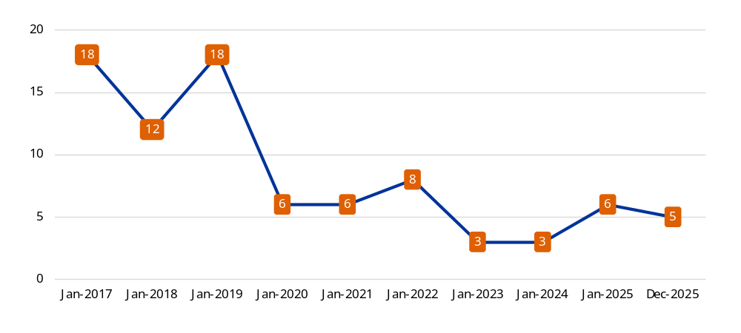
Source: European Commission.
During the reporting period, the Committee also continued its exchanges with the European Court of Auditors and held a discussion with the external auditor on its 2026-2030 multiannual strategy and its annual work programme for 2026. It also continued to scrutinise the state of play of implementation of the Court of Auditor’s recommendations, which remained high and therefore satisfactory, with none of the outstanding recommendations relating to the reliability of the European Union consolidated accounts. It also scrutinised the Commission’s follow-up to the Court of Auditor’s 18th consecutive clean opinion on the reliability of the EU’s consolidated accounts.
The Committee remains an effective player in the Commission’s governance structures and continues to play an important role in enhancing governance, organisational performance and accountability across the entire organisation.

Annex 8 – Compliance with payment time limits

Annex 8 – Compliance with payment
time limits
The statutory time limits for payments are laid down in the Financial Regulation on the financial rules applicable to the general budget of the EU (). There are also some exceptionally applied time limits, which are detailed in sector-specific regulations.
Article 116 of the Financial Regulation foresees that payments to creditors must be made within the deadlines of 30, 60 or 90 days, depending on how demanding and complex it is to test the deliverables against the contractual obligations. For contracts and grant agreements for which payment depends on the approval of a report or a certificate, the time limit for the purposes of the payment periods is no longer automatically suspended until the report or certificate in question has been approved.
The period of two months remains valid for payments under Article 93 of the Common Provisions Regulation () laying down the general provisions on the European Regional Development Fund, the European Social Fund and the Cohesion Fund.
Compliance with payment time limits has been reported by the services in their annual activity reports since 2007. In accordance with the applicable rules, the payment times reported in this annex have been calculated based on the data available in the Commission’s corporate accounting system, SUMMA, as follows.
For payments relating to contracts and grant agreements signed before 2013, the time limits specified in the 2007 Financial Regulation are applied:
- where the payment is contingent upon the approval of a report, the time from approval of the report until payment;
- where no report is required, the time from reception of the payment request until payment.
For payments relating to contracts and grant agreements signed as from 2013, the time limits specified in the 2024 Financial Regulation is applied:
- where no report is required and where the payment is contingent upon the approval of a report, the time from reception of the payment request until payment.
The Commission’s global average payment time is monitored by the Accounting Officer. It evolved as follows in the last five monitored years.
Global average payment time in days
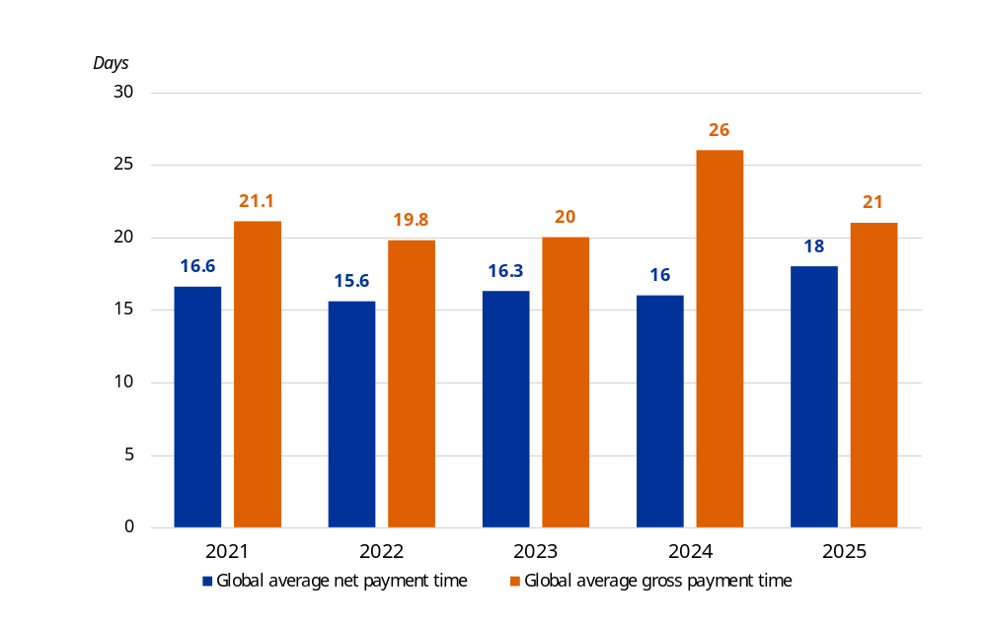
Source: European Commission.
The data shows that the global average net payment time of the Commission services, i.e. including the time of suspensions, and the global average gross payment time, i.e. excluding the time of suspensions, was below 30 days in the last five years for all time limits combined. The average payment time with and without suspensions improved in comparison with the previous year. Services are encouraged to continue their efforts in this regard and to implement follow-up measures whenever payment time challenges are identified.
The table below illustrates the evolution of ‘late payments’, i.e. payments made after expiry of the statutory time limit in recent years for all payments combined.
Evolution of late payments (2021-2025)
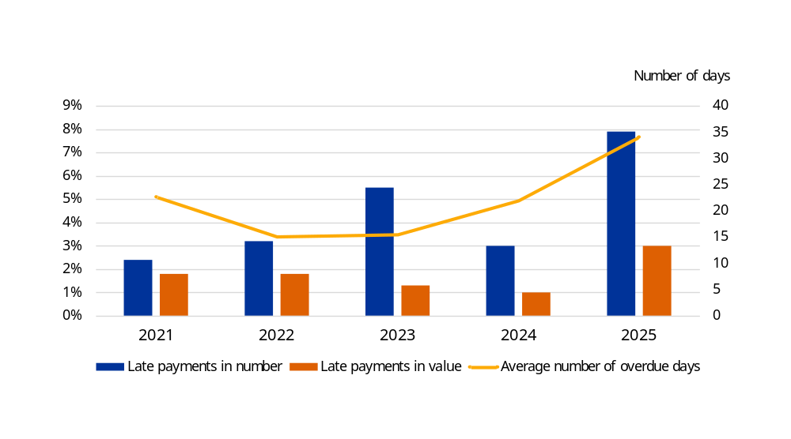
Source: European Commission.
The share of late payments, both in numbers and values, increased compared to the previous year due to the transition to a new system, SUMMA, in the first part of 2025.
Concerning the interest paid for late payments (), the total amount paid by the Commission in 2025 increased compared with the previous four years.
 | 2021 | 2022 | 2023 | 2024 | 2025
Interest paid for late payments (in EUR) | 235 456 | 164 535 | 327 473 | 480 924 | 1 092 031
Source: European Commission.
In general, the causes of late payments include the transition in 2025 to the Commission’s new accounting system, SUMMA, that has required the adjustment to a new system and has impacted budget implementation tasks, processes and financial management activities, particularly during the first part of the year. Other causes are associated with difficulties in coordinating the financial and operational checks of payment requests, issues with the management of payment suspensions and a temporary lack of payment appropriations and the complexities of evaluating the supporting documents that are a prerequisite for all payments. This is particularly onerous when the supporting documents are reports of a technical nature that sometimes have to be assessed by external experts.
The 2009 communication establishing Commission-internal payment targets provided a clear incentive to services to reduce their payment times. Despite the results achieved, there is scope for decreasing payment times even more. When setting up action plans in this area, services should focus on further reducing late payments from their current levels of 7.9% of payments in terms of their number and 3% in terms of their value. The aim is to meet the statutory payment time for every payment.
 | 2021 | 2022 | 2023 | 2024 | 2025
Total number of suspensions | 20 552 | 23 856 | 23 015 | 21 908 | 19 891
The table below shows the number of suspensions of payments over the last five years.
Source: European Commission.
Suspensions are a tool that allows the responsible authorising officer to temporarily withhold the execution of a payment because the amount is not due, because of the absence of appropriate supporting documentation or because there are doubts about the eligibility of the expenditure concerned. It is a basic tool for the authorising officer in the payment process towards avoiding irregular or erroneous payments and fundamental towards ensuring sound financial management and protecting the EU’s financial interest.

Annex 9 – Summary of waivers of recoveries of established amounts receivable

Annex 9 – Summary of waivers of recoveries of established amounts receivable
In accordance with Article 101(5) of the Financial Regulation (), the Commission reports to the budgetary authority each year on the waivers it has granted in an annex to the summary of the annual activity reports. The table below shows the total value and the number of waivers above and below EUR 60 000 in 2025. The individual annual activity reports of the Commission’s departments provide more details on the individual waivers above EUR 60 000.
EU budget area | Total value of waivers | Waivers above EUR 60 000 |  | Waivers below EUR 60 000
EU budget area | Total value of waivers | in number | in value (EUR) | in number | in value (EUR)
Directorate-General for Mobility and Transport | 42 744 |  |  | 1 | 42 744
Directorate-General for Environment | 2 369 984 | 2 | 2 369 984
Directorate-General for Research and Innovation | 869 994 | 7 | 812 461 | 4 | 57 533
Directorate-General for Communications Networks, Content and Technology | 7 122 861 | 24 | 6 705 870 | 16 | 416 991
Directorate-General for Enlargement and Eastern Neighbourhood | 1 712 378 | 4 | 1 553 193 | 6 | 159 186
Directorate-General for the Middle East, North Africa and the Gulf | 1 385 425 | 1 | 1 325 971 | 1 | 59 454
Directorate-General for International Partnerships | 2 165 096 | 13 | 2 079 652 | 7 | 85 444
Service for Foreign Policy Instruments | 98 949 | 1 | 98 806 | 1 | 143
Office for Infrastructure and Logistics in Brussels | 1 038 |  |  | 3 | 1 038
European Innovation Council and SMEs Executive Agency | 1 911 373 | 4 | 1 911 373
European Education and Culture Executive Agency | 279 676 | 1 | 88 524 | 9 | 191 153
European Climate, Infrastructure and Environment Executive Agency | 1 176 749 | 3 | 1 176 749
European Research Executive Agency | 1 299 960 | 7 | 1 177 161 | 5 | 122 798
European Health and Digital Executive Agency | 19 546 |  |  | 1 | 19 546
European Commission total | 20 455 774 | 67 | 19 299 744 | 54 | 1 156 030
European Development Fund | 1 005 400 | 5 | 687 758 | 15 | 317 642
Mutual Insurance Mechanism | 13 301 741 | 41 | 12 837 762 | 16 | 463 979
Total | 34 762 916 | 113 | 32 825 265 | 85 | 1 937 651
Source: European Commission

In 2025, the Commission continued implementing its enhanced corporate strategy for managing the Commission’s debtors by adopting two combined waiver decisions. The decrease in total amounts of waivers, from EUR 84.9 million in 2024 to EUR 34.8 million in 2025, is mainly explained by a reduction in the backlog of waivers and the establishment of a more stable situation. No waivers of competition fines were registered for DG Competition, which accounted for EUR 18 million in 2024. This is considered to be a rather normal situation. Furthermore, a slight decrease in the number of waivers recorded in the systems was observed, partly due to the migration to the new corporate financial system.

Annex 10 – Report on negotiated procedures

Annex 10 – Report on negotiated procedures

10.1. Legal basis
This report is established pursuant to Article 74(10) of the Financial Regulation () and provides an overview of negotiated procedures awarded in 2025, including an analysis of their use and any measures adopted where necessary to address significant increases.

10.2. Methodology
A distinction is made between the 48 departments () that normally do not provide external aid and those four departments (DGs International Partnerships, Middle East, North Africa and Gulf, Enlargement and Eastern Neighbourhood and the Service for Foreign Policy Instruments – ‘external actions’ departments) that conclude procurement contracts in the area of external actions or award contracts on their own account but outside of the EU ().
These four departments have special characteristics as regards data collection (decentralised services, etc.), the total number of contracts concluded and the thresholds to be applied for the recording of negotiated procedures (EUR 20 000), along with the possibility of having recourse to negotiated procedures within the framework of the Rapid Reaction Mechanism (extreme urgency). For these reasons, a separate approach has been used for procurement contracts awarded by these departments, and the number of their negotiated procedures is compared to each other instead of being compared with the other 48 departments.

10.3 Overall results of negotiated procedures recorded
The number of negotiated procedures, including those conducted by the ‘external actions’ departments, continued to decline, falling to 158 in 2025, compared with 193 in 2024 and 200 in 2023, in line with the downward trend also observed in the overall number of procurement procedures (764 in 2025, 893 in 2024 and 960 in 2023).

10.3.1 The 48 departments, excluding ‘external actions’
 | 2025 |  | 2024 |  | Change
 | Number | EUR billion | Number | EUR billion | Number | EUR billion
Negotiated procedures | 80 | 1.88 | 85 | 0.458 | – 5 | + 1.422
Total procurement procedures | 523 | 6.7 | 613 | 6.4 | – 90 | + 0.3
In 2025, negotiated procedures accounted for 15% of all procedures in terms of number and 28% in terms of value. While the share in terms of number remained broadly stable compared with 2024 (14%), the significant increase in value, compared with 7% in 2024, was mainly driven by a limited number of exceptionally high-value procedures carried out by DG Digital Services in its role as the Commission’s domain leader for IT, representing around 85% of the total value of negotiated procedures ().
The most frequent reason to use negotiated procedures was point 11.1(b) of Annex I to the Financial Regulation, relating to artistic or technical reasons, exclusive rights or technical monopoly situations, which accounted for the majority of procedures, followed by procedures based on point 11.1(e), concerning the repetition of similar services or works, notably in the IT domain where technical dependency and continuity requirements often limit competition. The urgency exception under point 11.1(c) was used only in a limited number of cases.
Authorising Officers by Delegation are required to report to the institution where the proportion of negotiated procedures awarded, relative to the total number of contracts, is considered ‘distinctly higher than the average recorded for the institution’ ().
During the reporting year, more than half of the departments (26) did not use negotiated procedures. Among the departments that did, the proportion was considered ‘distinctly higher’ for six departments. However, most of these departments concluded between one and three negotiated procedures only, and the comparatively low overall number of procedures conducted by those departments (fewer than eight) resulted in proportionally higher averages. Consequently, these results should not be regarded as significant.
The following categories of justification for the use of negotiated procedures were reported by the departments exceeding the thresholds.
- Objective situations in the relevant economic sector. This is where the number of operators is very limited or where monopoly situations exist due to specific technical expertise or reasons, exclusive rights or highly specialised markets with little or no competition. Situations of technical captivity may also arise, particularly in the field of information technology, owing to the absence of competition for technical reasons and/or the protection of exclusive rights linked to proprietary licences or the maintenance and continuity of existing applications.
- Additional services and higher-than-anticipated demand during contract implementation. In certain cases, services not initially included in the contract became necessary due to unforeseen circumstances or evolving priorities.

10.3.2 The ‘external actions’ departments
 | 2025 |  | 2024 |  | Change
 | Number | EUR billion | Number | EUR billion | Number | EUR billion
Negotiated procedures | 78 | 0.110 | 108 | 0.244 | – 30 | – 0.134
Total procurement procedures | 241 | 0.631 | 280 | 0.625 | – 39 | + 0.006
Concerning the ‘external actions’ departments, negotiated procedures accounted for 32% of all procedures in terms of number and 18% in terms of value. Compared with 2024, this represents a decrease from 39% in both number and value. The most frequent used legal basis across the external relations departments was point 39.1(a) of Annex I to the Financial Regulation, concerning services entrusted to public-sector bodies or non-profit organisations followed by point 11.1(e), relating to the repetition of similar services or works. Point 11.1(c), concerning cases of extreme urgency caused by unforeseeable events, was the third most frequently used justification, notably by DG Middle East, North Africa and Gulf and DG International Partnerships.
Authorising Officers per Delegation are required to report to the institution when the proportion of negotiated procedures awarded, relative to the total number of contracts, is considered ‘distinctly higher’ than the average recorded for the institution (). None of the four departments fell into this category.

10.4 Lists of procedures by department
The tables below present the negotiated procedures and the summary of procedures by department and legal basis (relevant section of the former Financial Regulation (Regulation (EU Euratom) 2018/1046)), as recorded in the corporate financial and accounting information systems of the Commission.
- Table I presents the negotiated procedures (internal > EUR 60 000 and external > 20 000) of the departments, excluding ‘external actions’.
- Table J presents the negotiated procedures (internal > EUR 60 000 and external > 20 000) of the ‘external actions’ departments.

Table I –Negotiated procedures of the departments, excluding ‘external actions’
By department and legal basis | In number | In value (EUR)
DG Budget | 4 | 42 830 000.00
Annex 1 – 11.1(b) – Artistic/technical reasons or exclusive rights or technical monopoly / captive market | 4 | 42 830 000.00
DG Climate Action | 3 | 10 683 489.96
Annex 1 – 11.1(e) – New services/works consisting in the repetition of similar services/works | 1 | 10 000 000.00
Annex 1 – 11.1(b) – Artistic/technical reasons or exclusive rights or technical monopoly / captive market | 2 | 683 489.96
DG Communication | 11 | 31 600 703.75
Annex 1 – 11.1(e) – New services/works consisting in the repetition of similar services/works | 7 | 31 245 541.20
Annex 1 – 11.1(a) – Follow-up of an open/restricted procedure where no (or no suitable) tenders / requests to participate have been submitted | 1 | 120 000.00
Annex 1 – 11.1(b) – Artistic/technical reasons or exclusive rights or technical monopoly / captive market | 3 | 235 162.55
DG Communications Networks, Content and Technology | 1 | 998 157.00
Annex 1 – 11.1(e) – New services/works consisting in the repetition of similar services/works | 1 | 998 157.00
DG Digital Services | 4 | 1 559 338 477.18
Annex 1 – 11.1(b) – Artistic/technical reasons or exclusive rights or technical monopoly / captive market | 3 | 866 319 807.11
Annex 1 – 11.1(e) – New services/works consisting in the repetition of similar services/works | 1 | 693 018 670.07
DG Energy | 3 | 4 270 000.00
Annex 1 – 11.1(b) – Artistic/technical reasons or exclusive rights or technical monopoly / captive market | 3 | 4 270 000.00
DG Human Resources and Security | 3 | 114 318 717.04
Annex 1 – 11.1(b) – Artistic/technical reasons or exclusive rights or technical monopoly / captive market | 3 | 114 318 717.04
DG Internal Market, Industry, Entrepreneurship and SMEs | 2 | 7 566 000.00
Annex 1 – 11.1(e) – New services/works consisting in the repetition of similar services/works | 1 | 7 500 000.00
Annex 1 – 11.1(b) – Artistic/technical reasons or exclusive rights or technical monopoly / captive market | 1 | 66 000.00
DG Mobility and Transport | 1 | 119 576.00
Annex 1 – 11.1(b) – Artistic/technical reasons or exclusive rights or technical monopoly / captive market | 1 | 119 576.00
DG Regional and Urban Policy | 1 | 466 400.00
Annex 1 – 39.1(b) – Tender procedure unsuccessful (external procedures > EUR 20 000) | 1 | 466 400.00
DG Research and Innovation | 1 | 5 000 000.00
Annex 1 – 11.1(e) – New services/works consisting in the repetition of similar services/works | 1 | 5 000 000.00
DG Taxation and Customs Union | 1 | 385 000.00
Annex 1 – 11.1(c) – Extreme urgency caused by unforeseeable events not attributable to the contracting authority | 1 | 385 000.00
DG Trade and Economic Security | 1 | 200 000.00
Annex 1 – 11.1(b) – Artistic/technical reasons or exclusive rights or technical monopoly / captive market | 1 | 200 000.00
Eurostat | 1 | 99 750.00
Annex 1 – 11.1(b) – Artistic/technical reasons or exclusive rights or technical monopoly / captive market | 1 | 99 750. 00
European Health and Digital Executive Agency | 2 | 18 081 900. 00
Annex 1 – 11.1(b) – Artistic/technical reasons or exclusive rights or technical monopoly / captive market | 1 | 81 900.00
Annex 1 - 11.1 (e) - New services/works consisting in the repetition of similar services/works | 1 | 18 000 000.00
European Innovation Council and SMEs Executive Agency | 1 | 2 999 999.00
Annex 1 – 11.1(e) – New services/works consisting in the repetition of similar services/works | 1 | 2 999 999.00
European Research Council Executive Agency | 1 | 480 000.00
Annex 1 – 11.1(a) – Follow-up open/restricted/competitive procedure with negotiation where contract notice is published and no (or no suitable) tenders / requests were submitted | 1 | 480 000.00
European Research Executive Agency | 1 | 1 500 000.00
Annex 1 - 11.1 (e) - New services/works consisting in the repetition of similar services/works | 1 | 1 500 000.00
Joint Research Centre | 30 | 15 676 519.76
Annex 1 – 11.1(a) – Follow-up of an open/restricted procedure where no (or no suitable) tenders / requests to participate have been submitted | 1 | 78 000.00
Annex 1 – 11.1(b) – Artistic/technical reasons or exclusive rights or technical monopoly / captive market | 27 | 15 246 142.80
Annex 1 – 11.1(c) – Extreme urgency caused by unforeseeable events not attributable to the contracting authority | 1 | 99 376.96
Annex 1 – 11.1(e) – New services/works consisting in the repetition of similar services/works | 1 | 253 000.00
Office for the Administration and Payment of Individual Entitlements | 1 | 3 140 000.00
Annex 1 – 11.1(b) – Artistic/technical reasons or exclusive rights or technical monopoly / captive market | 1 | 3 140 000.00
Office for Infrastructure and Logistics in Brussels | 6 | 55 790 721.00
Annex 1 – 11.1(c) – Extreme urgency caused by unforeseeable events not attributable to the contracting authority | 2 | 22 790 430.00
Annex 1 – 11.1(a) – Follow-up open/restricted/competitive procedure with negotiation where contract notice is published and no (or no suitable) tenders / requests were submitted | 1 | 449 709.00
Annex 1 – 11.1(b) – Artistic/technical reasons or exclusive rights or technical monopoly / captive market | 3 | 32 550 582.00
Office for Infrastructure and Logistics in Luxembourg | 1 | 128 000.00
Annex 1 – 11.1(b) – Artistic/technical reasons or exclusive rights or technical monopoly / captive market | 1 | 128 000.00
Total | 80 | 1 875 673 410.69

Table J – Negotiated procedures of the ‘external actions’ departments
By department and legal basis | In number | In value (EUR)
DG Enlargement and Eastern Neighbourhood | 18 | 42 838 221.11
External procedures > EUR 20 000 | 18 | 42 838 221.11
Annex 1 – 11.1(c) – Extreme urgency caused by unforeseeable events not attributable to the contracting authority | 1 | 2 698 090.00
Annex 1 – 11.1(e) – New services/works consisting in the repetition of similar services/works | 13 | 38 746 267.11
Annex 1 – 39.1(a) – Services entrusted to public-sector bodies or non-profit institutions or organisations | 4 | 1 393 864.00
DG International Partnerships | 46 | 61 721 065.36
External procedures > EUR 20 000 | 44 | 48 081 815.36
Annex 1 – 11.1(c) – Extreme urgency caused by unforeseeable events not attributable to the contracting authority | 8 | 9 446 469.80
Annex 1 – 11.1(e) – New services/works consisting in the repetition of similar services/works | 4 | 3 803 667.50
Annex 1 – 11.1(b) – Artistic/technical reasons or exclusive rights or technical monopoly / captive market | 3 | 211 912.54
Annex 1 – 39.1(c) – Early termination of existing contract | 1 | 131 890.45
Annex 1 – 39.1(a) – Services entrusted to public-sector bodies or non-profit institutions or organisations | 22 | 28 925 809.25
Annex 1 – 39.1(b) – Tender procedure unsuccessful | 6 | 5 562 065.82
Internal procedures > EUR 60 000 | 2 | 13 639 250.00
Annex 1 – 11.1(e) – New services/works consisting in the repetition of similar services/works | 2 | 13 639 250.00
DG for the Middle East, North Africa, and the Gulf | 12 | 3 769 772.00
External procedures > EUR 20 000 | 12 | 3 769 772.00
Annex 1 – 11.1(b) – Artistic/technical reasons or exclusive rights or technical monopoly / captive market | 3 | 1 279 700.00
Annex 1 – 11.1(c) – Extreme urgency caused by unforeseeable events not attributable to the contracting authority | 4 | 1 322 252.00
Annex 1 – 39.1(a) – Services entrusted to public-sector bodies or non-profit institutions or organisations | 3 | 618 520.00
Annex 1 – 39.1(b) – Tender procedure unsuccessful | 2 | 549 300.00
Service for Foreign Policy Instruments | 2 | 1 799 992.00
External procedures > EUR 20 000 | 2 | 1 799 992.00
Annex 1 – 11.1(c) – Extreme urgency caused by unforeseeable events not attributable to the contracting authority | 1 | 249 992.00
Annex 1 – 11.1(e) – New services/works consisting in the repetition of similar services/works | 1 | 1 550 000.00
Total | 78 | 110 129 050.47

Annex 11 –
EU trust funds

Annex 11 – EU trust funds
The European Commission, along with several external donors, established four EU trust funds between 2014 and 2016. During their life cycle, up to the end of 2025, the four EU trust funds received approximately EUR 7.9 billion in contributions from the EU budget, the European Development Fund, Member States and other external donors.
Source of financing of EU trust funds (million EUR)

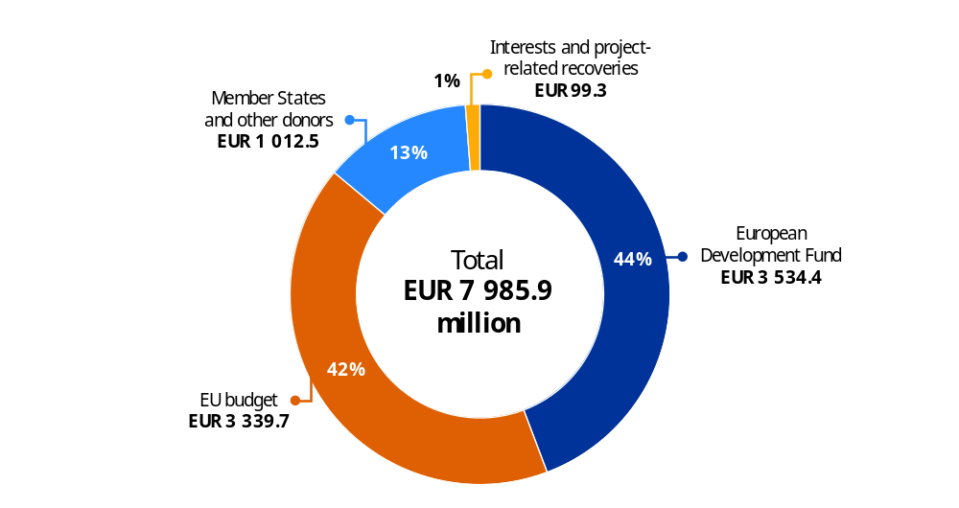
Source: European Commission.
Cumulative amount made available for payments (million EUR)
The cumulative amount made available for payments at the end of 2025 amounted to EUR 7.8 billion, including EUR 3.3 billion from the EU budget, EUR 1 billion from EU Member states and other donors and EUR 3.4 billion from the European Development Fund.
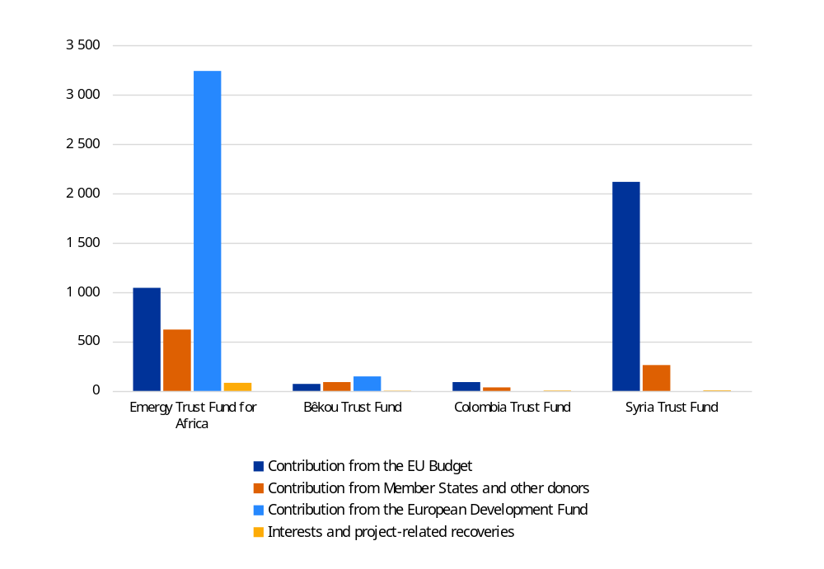
Source: European Commission.
The EU trust funds’ annual reports set out, in accordance with Article 258 of the Financial Regulation (), the activities they supported, their implementation and performance and their accounts. These reports are annexed to the annual activity reports of DG Middle East, North Africa and Gulf and DG International Partnerships.

Established (year) | EU trust fund | Annual report annexed to DG’s annual activity report
2014 | Bêkou Trust Fund – EU Trust Fund for the Central African Republic | DG International Partnerships
2014 | EU Regional Trust Fund in Response to the Syrian Crisis | DG Middle East, North Africa and Gulf
2015 | Africa Trust Fund – European Union Emergency Trust Fund for stability and addressing root causes of irregular migration and displaced persons in Africa. This EU trust fund involves three regions: the Horn of Africa, the Sahel and Lake Chad, and the North of Africa (management cross-sub-delegated to DG Neighbourhood and Enlargement Negotiations) | DG International Partnerships
2016 | Colombia Trust Fund – European Union Trust Fund for Colombia | DG International Partnerships
The constitutive act of the EU trust funds, signed by the Commission and the donors, details the main features of each EU trust fund, including its specific objectives, the rules for its composition and the internal rules of its board, and the (limited) duration of the trust fund.
The EU trust funds were set up for an initial 60 months (five years), apart from the Colombia Trust Fund which was set up for four years. Before their end date, they were all subject to a one-year extension that was adopted after consultation with the European Parliament and the European Council. This one-year extension allowed the EU trust funds to adapt their activities in order to address the challenges relating to COVID-19 in the countries within their scope. This also gave the EU trust funds the necessary time to adapt the ongoing initiatives to the new challenges and to finalise their contracting by the end of 2021. The implementation of the existing projects will, however, continue until 2025.

11.1. The Bêkou Trust Fund
The total contributions from external donors, the European Development Fund and the EU budget reached over EUR 310 million. France, Germany, Italy, the Netherlands and Switzerland have contributed to this EU trust fund. By 31 December 2025, the Bêkou Trust Fund had funded actions for a total value of EUR 308 million in commitments and contracted EUR 306 million in total, corresponding to an implementation rate of 99%.
The priority sectors that the trust fund has supported include basic services, notably in health, agriculture development, restoration of national and local administrations, economic recovery and reconciliation within the Central African Republic’s society.

11.2. The EU Regional Trust Fund in Response to the Syrian Crisis
By the end of 2025, the contributions from the EU budget amounted to more than EUR 2.1 billion, while the contributions received from Member States and other donors amounted to EUR 262 million, including EUR 24.7 million from Türkiye. By 31 December 2025, the following donors had contributed to the trust fund: the EU budget, 22 Member States and Türkiye, with total contributions available reaching more than EUR 2.3 billion.
Projects mainly focus on education, livelihoods and health, for which more than EUR 2.3 billion has been contracted to the trust fund’s implementing partners on the ground. The benefiting region is the Middle East, mainly Iraq, Jordan, Lebanon and Türkiye.
These programmes support refugees and host communities with their needs for basic education and child protection, training and higher education, better access to healthcare and improved water and wastewater infrastructure, along with support for projects promoting resilience, economic opportunities and social inclusion.

11.3 The Africa Trust Fund
By the end of 2025, the 27 EU Member States, together with Norway, Switzerland and the United Kingdom, had contributed a total of EUR 623 million to the EU Emergency Trust Fund for Africa. Contributions from EU budget instruments and the European Development Fund amounted to EUR 4 440 million.
In 2025, no new programme or budgetary top-up took place for any of the three regions of the Africa Trust Fund, in line with the end of the contracting period on 31 December 2021.
As of 31 December 2025, the total amount committed for this trust fund amounts to EUR 5 053 million. The split was EUR 2 085 million (41%) for the Sahel and Lake Chad region, EUR 1 790 million (35%) for the Horn of Africa and EUR 882 million (17%) for the North of Africa region, along with EUR 296 million (7%) for regional and other programmes. Contracts have been signed with implementing partners for a total amount of EUR 4 963 million.
The trust fund has aimed to help foster stability and contribute to better migration management in line with the EU development-led approach to forced displacement. It has also helped address the root causes of destabilisation, forced displacement and irregular migration by promoting economic and equal opportunities, security and development. The Africa Trust Fund has covered a comprehensive group of African countries crossed by the major migration routes.

11.4 The Colombia Trust Fund
By the end of 2025, the contributions from the EU budget amounted to EUR 94 million, while the contributions received from 21 Member States, along with a contribution by Chile, amounted to EUR 37 million.
The Colombia Trust Fund has committed a total amount of EUR 134 million, out of which 98% was contracted.
The Colombia Trust Fund has helped to support the implementation of the peace agreement in the early recovery and stabilisation phases of the post-conflict environment. The overall objective is to help Colombia secure stable and lasting peace, to rebuild its social and economic fabric and to give new hope to the people of Colombia.

() Expenditure-based simplified cost options such as lump sum or financing not linked to costs are also included in this category.
() Article 74(5) of Regulation (EU, Euratom) 2024/2509 of the European Parliament and of the Council of 23 September 2024 on the financial rules applicable to the general budget of the Union (OJ L, 2024/2509, 26.9.2024, ELI: http://data.europa.eu/eli/reg/2024/2509/oj).
() Article 74(6) of the Financial Regulation.
() Such corrections are not sanctions and do not include penalties and fines.
() Or equivalent, such as after the expenditure is accepted (i.e. registered in the Commission’s accounting system) or after the pre-financing is cleared.
() For example, ‘adjusted error rates’ is used by DG Agriculture and Rural Development and ‘residual total error rates’ is used by DG Employment, Social Affairs and Inclusion, DG Maritime Affairs and Fisheries and DG Regional and Urban Policy.
() For the common agricultural policy, the term ‘estimated final amount at risk’ is used instead, to better reflect the fact that there is no set closure point for European Agricultural Guarantee Fund measures. For cohesion policy funds, after the final assessment of legality and regularity of the programmes.
() The only exceptions are: (i) 1% for revenue, which is stricter than the Court of Auditors, in view of the very large amounts; and (ii) the range of 2–5% for the Horizon 2020 programme (see details in Volume II, Annex II, Section 2.1.2 of this report).
() European Court of Auditors, Annual report on the implementation of the EU budget for the 2023 financial year, Publications Office of the European Union, Luxembourg, 2024, Annex 1.1, paragraph 36, https://www.eca.europa.eu/ECAPublications/AR-2023/AR-2023_EN.pdf.
() European Court of Auditors, Annual report on the implementation of the EU budget for the 2024 financial year, Publications Office of the European Union, Luxembourg, 2025, paragraph 1.31, https://www.eca.europa.eu/ECAPublications/AR-2024/AR-2024_EN.pdf.
() European Court of Auditors, Annual report on the implementation of the EU budget for the 2024 financial year, Publications Office of the European Union, Luxembourg, 2025, Annex 1.1, paragraph 19, https://www.eca.europa.eu/ECAPublications/AR-2024/AR-2024_EN.pdf.
() For cohesion funds.S
() DG Education, Youth, Sport and Culture, DG International Partnerships, DG European Civil Protection and Humanitarian Aid Operations and the European Education and Culture Executive Agency.
() DG Enlargement and Eastern Neighbourhood, and DG International Partnerships.
() European Court of Auditors, Annual report on the implementation of the EU budget for the 2024 financial year, Publications Office of the European Union, Luxembourg, 2025, Chapter 1, Annex 1.1, paragraph 36, https://www.eca.europa.eu/ECAPublications/AR-2024/AR-2024_EN.pdf.
() Reservations are non-quantified when the financial impact is zero, when it is not possible to assess the financial impact accurately or when the consequences are only reputational.
() European Commission: Directorate-General for Communication (n.d.), ‘Annual activity reports’, European Commission website, https://commission.europa.eu/strategy-and-policy/strategy-documents/annual-activity-reports_en.
() One reservation issued in 2024 by the Directorate-General for Neighbourhood and Enlargement Negotiations, concerning external constraints affecting the control of financial programmes in Libya, Syria and Ukraine, is reflected in the 2025 AARs of DG Enlargement and Eastern Neighbourhood (Ukraine) and Directorate-General for the Middle East, North Africa and the Gulf (Syria, Libya and Palestine).
() Regulation (EU) 2024/795 of the European Parliament and of the Council of 29 February 2024 establishing the Strategic Technologies for Europe Platform (STEP), and amending Directive 2003/87/EC and Regulations (EU) 2021/1058, (EU) 2021/1056, (EU) 2021/1057, (EU) No 1303/2013, (EU) No 223/2014, (EU) 2021/1060, (EU) 2021/523, (EU) 2021/695, (EU) 2021/697 and (EU) 2021/241 (OJ L, 2024/795, 29.2.2024, ELI: http://data.europa.eu/eli/reg/2024/795/oj).
() Without prejudice to issuing a reservation for reputational reasons, if applicable.
() Excluding the reservation issued for the Recovery and Resilience Facility.
() Excluding the reservation issued for the Recovery and Resilience Facility.
() Excluding the reservation issued for the Recovery and Resilience Facility.
() For the last accounting year, all the financial corrections (withdrawals, recoveries and deductions at closure) reported by the Member States have been considered as corrective, whereas in previous years, deductions at closure were considered as preventive measures. This is because no further action is possible after the submission of the final accounts in the next payment applications, or subsequent accounts, to take preventive measure into account and they become de facto corrective in nature.
() This amount includes the corrections made to ensure a risk at closure below 2% for all programmes.
() Article 14(4) ‘Amendments to Regulation (EU) No 1303/2013’: ‘in Article 138, the following subparagraph is added: “By way of derogation from the deadline set out in the first subparagraph, Member States may submit the documents referred to under points (a), (b) and (c) for the final accounting year by 15 February 2026.”.’
() Out of the EUR 414 million: EUR 219 million was for penalties/reductions imposed on final beneficiaries by the Member States, recovered and reimbursed to the EU budget, and EUR 195 million was for penalties/reductions applied by the Member States, recovered and reused as regular expenditure to other final beneficiaries without reimbursement to the EU budget.
() Regulation (EU, Euratom) 2024/2509 on the financial rules applicable to the general budget of the Union (recast) of 23 September 2024.
() Action plans resulting from two audits are under discussion with respective auditees.
() 119th, 120th, 121st and 122nd rounds of the Audit Progress Committee between June 2025 and May 2026. Each round comprised up to three meetings of the Preparatory Group to prepare the Committee meeting.
() Three ‘very important’ recommendations were partially accepted by the relevant audited services.
() Regulation (EU, Euratom) 2024/2509 of the European Parliament and of the Council of 23 September 2024 on the financial rules applicable to the general budget of the Union (OJ L, 2024/2509, 26.9.2024, ELI: http://data.europa.eu/eli/reg/2024/2509/oj).
() Regulation (EU) 2021/1060 of the European Parliament and of the Council of 24 June 2021 laying down common provisions on the European Regional Development Fund, the European Social Fund Plus, the Cohesion Fund, the Just Transition Fund and the European Maritime, Fisheries and Aquaculture Fund and financial rules for those and for the Asylum, Migration and Integration Fund, the Internal Security Fund and the Instrument for Financial Support for Border Management and Visa Policy (OJ L 231, 30.6.2021, p. 159, ELI: http://data.europa.eu/eli/reg/2021/1060/oj).
() In other words, no longer conditional upon the presentation of a request for payment (with the exception of amounts below EUR 200).
() Regulation (EU, Euratom) 2024/2509 of the European Parliament and of the Council of 23 September 2024 on the financial rules applicable to the general budget of the Union (OJ L, 2024/2509, 26.9.2024, ELI: http://data.europa.eu/eli/reg/2024/2509/oj).
() Negotiated procedures in accordance with point 11.1, points (a) to (f), and point 39 of Annex I of Regulation (EU, Euratom) 2024/2509 of the European Parliament and of the Council of 23 September 2024 on the financial rules applicable to the general budget of the Union (OJ L, 2024/2509, 26.9.2024, ELI: https://eur-lex.europa.eu/eli/reg/2024/2509/oj).
() Directorate-General or Executive Agency or Office.
() They have a different legal basis; see Articles 179 and 181 of the Financial Regulation.
() More information can be found in the DG Digital Services annual activity report.
() The average proportion for the Commission of the number of negotiated procedures in relation to the total number of contracts they awarded in 2025 was 15% for all departments (excluding the four ‘external relations’ departments). The proportion of a department is considered ‘distinctly higher’ when it deviates by more than 50% upwards from the Commission’s average (23% for 2025), and when there is an increase of at least 10 percentage points in the proportion of negotiated procedures compared to the proportion of the previous year.
() The average proportion for the three ‘external relations’ departments of the number of negotiated procedures in relation to the total number of contracts they awarded in 2025 was 32%. The proportion of a department is considered ‘distinctly higher’ when it deviates by more than 50% upwards from the Commission’s average (49% for 2025), or when there is an increase of at least 10 percentage points in the proportion of negotiated procedures compared to the proportion of the previous year.
() Regulation (EU, Euratom) 2024/2509 of the European Parliament and of the Council of 23 September 2024 on the financial rules applicable to the general budget of the Union (OJ L, 2024/2509, 26.9.2024, ELI: http://data.europa.eu/eli/reg/2024/2509/oj).

