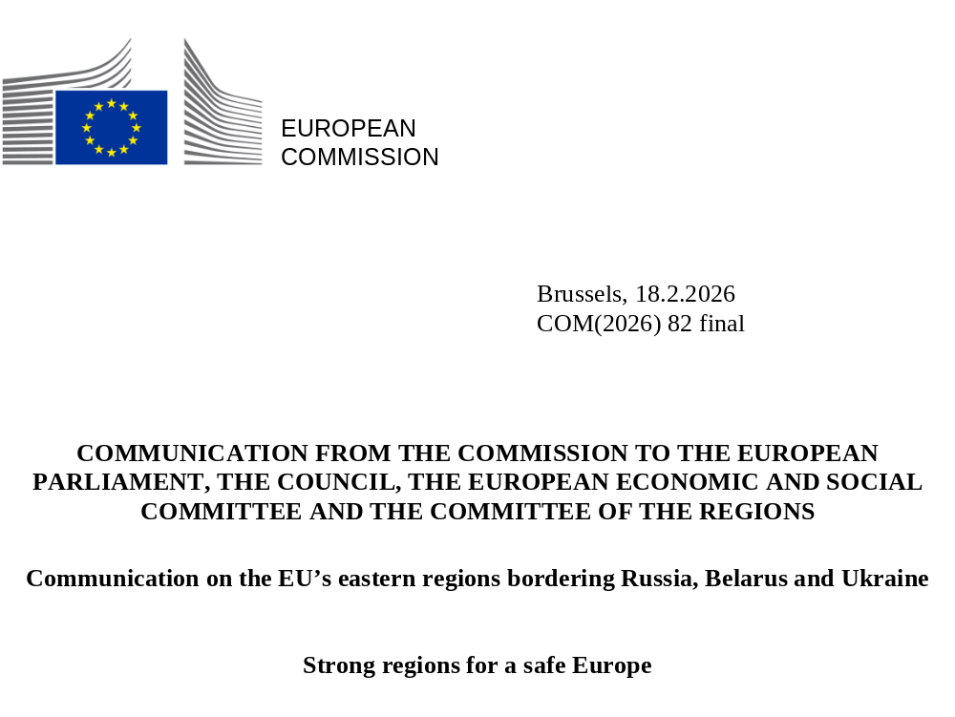

‘Last week, I saw this for myself when I visited frontline Member States. They know best the threat Russia poses. And there is no doubt: Europe’s eastern flank keeps all of Europe safe.’ Ursula Von der Leyen, State of the Union speech 2025.
As Russia’s full-scale war of aggression against Ukraine continues into the fifth year, our common security is directly linked to the strength, resilience and stability of the eastern regions bordering Russia, Belarus and Ukraine . The challenges caused by Russia and Belarus are numerous, including hybrid threats, weaponised migration, violation of airspace by drones and fighter jets, radio frequency interference, notably jamming and spoofing of global navigation satellite systems (GNSS), cyber-attacks, sabotage of air traffic and land and subsea infrastructure, as illustrated by recurrent damage to underwater cables , foreign information manipulation and interference (FIMI) and hostile rhetoric.
Moreover, these regions face some of the EU’s most acute demographic pressures, with some having lost more than 17% of their population in the last decade. Overall, the population of the eastern border regions decreased by 2.6% on average between 2016 and 2025, compared to 1.2% population growth in the EU as a whole. Low fertility, population ageing and emigration -intensified by heightened security risks, economic downturn and uncertainty - have accelerated the departure of young, educated and skilled people. This has deepened demographic decline, leading to labour shortages, weakened public finances and the closure or scaling back of essential services. If left unaddressed, depopulation risks becoming long-term and irreversible reducing the resilience of regions and Member States to respond to crises and security threats.
Yet, in the face of these threats and pressure, these regions are adapting and turning structural vulnerabilities into strategic assets, becoming a powerful source of inspiration for the rest of Europe. They show that innovation can thrive, solidarity can deepen and – even in difficult times – cooperation and determination can drive progress and unity forward.
The EU’s eastern regions with a land border with Russia, Belarus and Ukraine – key facts:
- The most affected Member States have long land borders with Russia and Belarus: Finland, Estonia, Latvia, Lithuania and Poland share 3 646 km of border with them (25% of total EU European external land borders) – respectively 1 346 km for Finland, 340 km for Estonia, 453 km for Latvia, 893 km for Lithuania and 614 km for Poland.
Poland, Slovakia, Hungary and Romania share 1 372 km of land border with Ukraine (10% of total EU external land borders).
The EU’s regions bordering the sea border with Ukraine – key facts:
- Romania and Bulgaria have a combined Black Sea coastline of over 600 km, bordering the maritime Black Sea basin also shared with Ukraine and Russia.
The EU’s border with Russia, Belarus and Ukraine runs along regions in nine Member States (Finland, Estonia, Latvia, Lithuania, Poland, Slovakia, Hungary, Romania, and Bulgaria).

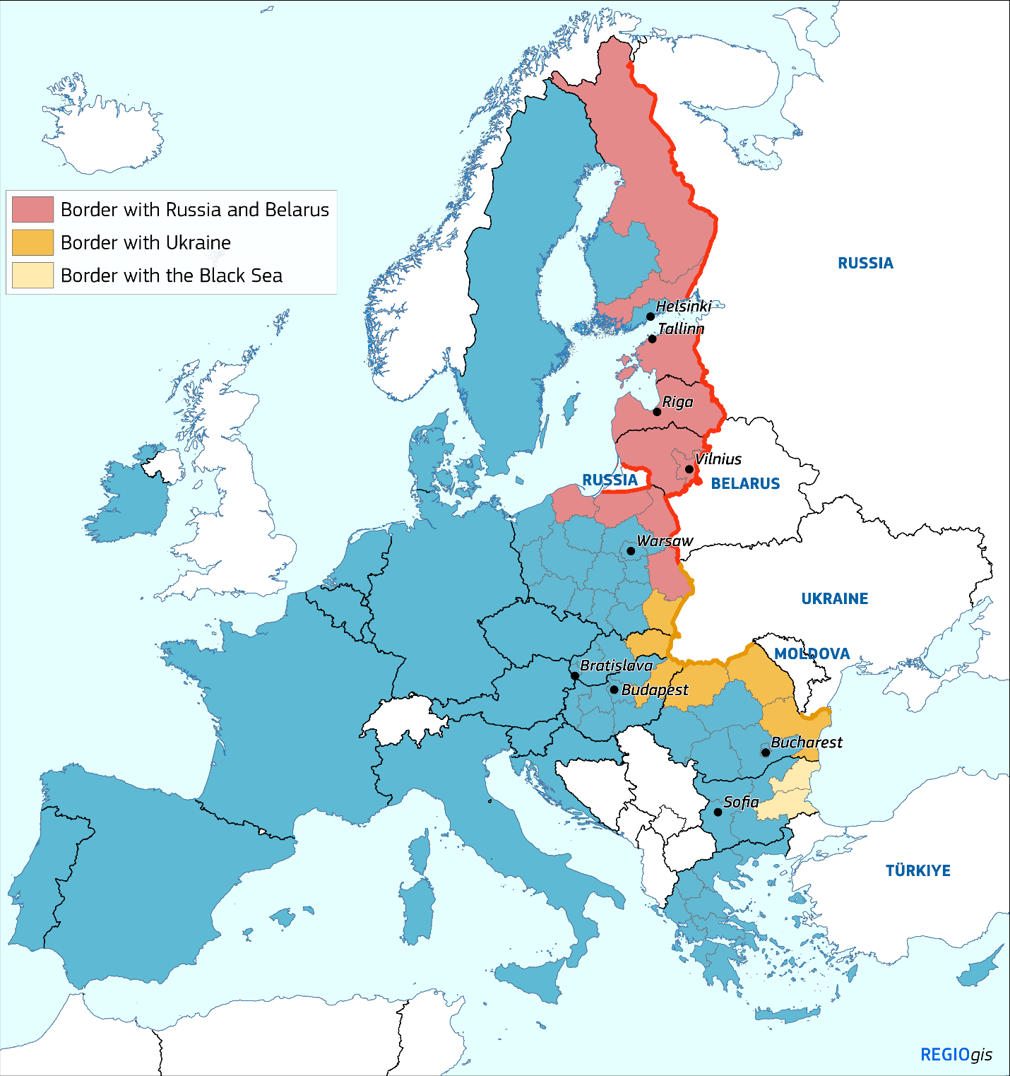
The regions most affected by the deteriorating security environment and by increased risks of conventional military actions are those on the external border with Russia and Belarus (see map above representing regions at NUTS 2 level). Russia’s war of aggression against Ukraine and hostile behaviour by Russia and Belarus have led to border restrictions and brought cross-border activities to a standstill. As a consequence, cross-border trade, transport and vital economic exchanges have been almost completely cut off, severely impacting local communities and the Member States concerned more broadly. Security conditions have worsened, and the situation is particularly critical in the Member States bordering Russia, which continues its illegal invasion in Ukraine, and EU-funded cross-border projects with the Russia and Belarus have been suspended because of the breakdown in relations. The recent use of weather balloons to transport illicit cigarettes from Belarus to Lithuania or Poland highlights how criminal organisations adapt to sustain their illegal activities.
Regions bordering Ukraine also face important economic and social challenges, including an influx of displaced persons, disruptions in trade, smuggling of excise goods, particularly tobacco products, and deteriorating housing stock, health and social services. Additionally, redirected cargo traffic has increased pressure on the regional logistics network. Mining of the Black Sea has led to higher shipping costs and disruptions to local fisheries in EU regions bordering it. The EU–Ukraine Solidarity Lanes have been essential in mitigating blocked Ukrainian Black Sea export routes sustaining trade flows and facilitating EU‑supported infrastructure investments. Moreover, the continued support of the EU and its Member States, coupled with Ukraine’s anticipated future accession, will contribute to the stabilisation and strengthening of the EU regions along this border.
The latest analyses indicate that Member States on the eastern external border have experienced slower GDP growth and higher inflation because of the economic fallout from Russia’s war of aggression. The median harmonized index of consumer prices inflation rate in Member States along the eastern border was at least 3.7 percentage points higher than the EU average, while the annual average GDP growth in 2022–2023 was 1.9 percentage points lower than the projection for the EU . This situation has been compounded by higher borrowing costs, weaker investment and consumer spending, while also driving an increase in defence spending. Before the war, Russia accounted for over 30% of Lithuania’s machinery exports, more than 40% of Latvia’s food-processed exports and around 50% of Finland’s wood imports. Since the conflict, tighter border controls and sanctions have disrupted trade, significantly impacting the eastern border regions’ economies. In addition, foreign tourist nights in the most affected Member States were down by around 10–35%, while rail freight volumes dropped by as much as 75–80%. Their higher energy intensity and larger dependence on Russian gas and oil amplified the shock from energy and food price spikes, pushing up inflation to levels not seen in decades. These impacts have also been felt in EU Member States that have a Black Sea coastline, such as Bulgaria, with economic repercussions which have contributed to overall slower growth and increased inflation.
At the same time, the eastern border regions have important assets, not only in terms of established industries, agriculture, forestry, emerging tech hubs, educational institutions and unique natural resources, but also the resilience of their people.
This Communication confirms the Commission’s commitment to supporting eastern border regions, given their importance and relevance to the EU collective security and prosperity. It presents an initial set of actions the Commission intends to launch to help these regions address the specific and unprecedented challenges they face. It builds on solid foundations: the recognition of their importance in the State of the Union, the call for evidence , and the close cooperation with national administrations, regions, municipalities and the public and private sectors. It also builds on several initiatives targeting these regions, notably the inclusive and participatory processes of the Interreg programmes, as well as work done by the Association of European Border Regions and initiatives carried out in cooperation with the Organisation for Economic Co-operation and Development (OECD) and the World Bank Group.
During the preparatory outreach and call for evidence, stakeholders from these regions highlighted the urgent challenges they faced, stressing the need for targeted support, including financial assistance, and a coordinated response. Consequently, a comprehensive set of actions at all levels, from the local to the European, is required .
In the implementation of the initiatives outlined in this communication, the Commission will be guided by the adherence of the Member States concerned to the shared values of the EU, notably to the rule of law.

Ongoing efforts and support
Since the start of the war of aggression against Ukraine, the EU has been providing political, technical and financial assistance to the eastern border regions, in particular through cohesion policy and the common agricultural policy (CAP). These policies play a key role in strengthening infrastructure, boosting economic resilience, promoting skills development, supporting employment and social inclusion, ensuring sustainable farming and improving crisis preparedness and response. For example, the agricultural reserve was mobilised for the benefit of some eastern border regions.
The mid-term review of cohesion policy – launched as part of the ongoing effort to adapt EU investments to evolving challenges – identified key priorities of direct relevance for the eastern border regions: defence and civil preparedness, competitiveness, energy, affordable housing and water resilience. Their specific situation was recognised with targeted measures, including a 9.5% increase in pre-financing and a higher 10% co-financing rate to programmes in these regions.
Member States along the eastern border have made extensive use of this flexibility under the mid-term review as demonstrated by the substantial allocations towards security and resilience. Finland and Estonia are reprogramming significant amounts for the defence industry and military mobility. Latvia is channelling considerable resources to defence infrastructure, military mobility and emergency shelters. Lithuania is allocating parts of their multi-fund programme towards its defence sector, critical infrastructure, civil preparedness and protection training, and military mobility. In Poland, the eastern regions are planning to mobilise sizeable investments to support civil preparedness, dual-use infrastructure, defence-related industries and water and energy security. The new investments also include protection of critical infrastructure, such as hospitals, water treatment facilities and energy generators in public buildings. With the recently reallocated funding, Slovakia is supporting defence, security and civil preparedness, whereas Hungary and Romania are investing in military mobility. And Bulgaria is reprogramming to support strategic sectors, enhance its industrial capacity, and develop and manufacture defence and dual-use technologies.
The Just Transition Fund (JTF) targets around EUR 19.3 billion to regions most affected by the transition to climate neutrality. EUR 10.1 billion (more than half of this allocation) benefit the nine countries bordering Russia, Belarus and Ukraine, directly supporting several of the regions located along the eastern border.
Interreg programmes are improving cross-border security cooperation and exchange of good practice on resilience, as well as linking industry and academia to address skills gaps in cybersecurity or defence. At the start of Russia’s war of aggression, the Commission immediately suspended Interreg programmes with Russia and Belarus, leading to the reallocation of EUR 150 million to internal cooperation programmes and EUR 160 million to external cooperation programmes with Ukraine and Moldova. Targeted calls and dedicated support for potential beneficiaries from these regions, have also been implemented. While stakeholders have considered these measures to be very helpful, these actions have not fully offset the negative impacts resulting from the suspension of certain Interreg programmes.
Support has also been channelled through many other instruments and programmes. The Recovery and Resilience Facility (RRF) contributes to strengthening defence capabilities, building connectivity infrastructure, creating employment opportunities and facilitating the economic transition along the EU’s eastern border. The recovery and resilience plans of relevant Member States have allocated approximately EUR 14.5 billion for investments in these areas. These investments are accompanied by relevant reforms, further contributing to economic growth.
An additional EUR 170 million under the Border Management and Visa Policy Instrument supports Member States bordering Russia and Belarus in upgrading surveillance systems, telecommunications and counter-drone capabilities. Complementing these efforts, the EU Space and Secure Connectivity Programmes provide secure and resilient space-based services that can operate effectively in both nominal and degraded environments. Through advanced satellite connectivity, advanced Galileo services supporting precise positioning, navigation and time synchronization, and Earth observation capabilities, the EU ensures continuous and precise operations enhancing autonomy and situational awareness while providing valuable data for local and regional needs.
Agriculture, food production, forestry, and communities in these predominantly rural regions have been supported by the CAP, sustaining farm income, promoting sustainable practices and strengthening rural development. LEADER and European innovation partnerships encourage bottom-up innovation, improving productivity and supply chains. To mitigate the negative impact of the war in Ukraine on the fisheries, aquaculture and processing sector, specific financial crisis support measures were also introduced under the European Maritime, Fisheries and Aquaculture Fund.
Horizon Europe funds research across a wide range of domains, including in energy, transport, agroecology, water resilience, food systems and the bioeconomy, while also helping to strengthen of regional innovation ecosystems.
The Technical Support Instrument and the Catching-up Regions Initiative provide additional help in administrative capacity building and addressing bottlenecks to growth.
Digital transformation in these regions has been supported through the European Broadband Competence Offices Network, which provides technical assistance and shares best practices to strengthen digital infrastructure and bridge the digital divide. The European Digital Innovation Hubs (EDIHs) also help strengthen the EU’s eastern flank and support Ukraine.
The Commission, in collaboration with the European External Action Service, is also strengthening resilience against disinformation. Through the recently adopted European Democracy Shield , the EU is intensifying its efforts to scale up capacity-building and support coordinated action to counter FIMI and disinformation campaigns. These activities will be facilitated by the new European Centre for Democratic Resilience.
Moreover, the European Digital Media Observatory (EDMO) and its national and regional hubs are promoting fact-checking and media literacy across the eastern border. A new EDMO hub – FACT (fighting against conspiracies and trolls) – has been set up to support Ukraine and Moldova as well as the Member States most exposed to Russian information manipulation. Erasmus+ and Creative Europe are developing digital literacy, civic engagement and cultural cooperation projects.
The Connecting Europe Facility (CEF) Transport has mobilised EUR 9.1 billion to support the eastern border regions through strategic connectivity and security investments. This includes accelerated Trans-European Transport Network (TEN-T) cross-border links along the Baltic Sea-Black Sea-Aegean Sea corridor and North Sea-Baltic corridor, including EUR 800 million for dual use infrastructure. Investments in Finland and the Baltic states are also supporting development of the European standard gauge to improve military mobility and strengthen economic integration. While connections with Russia and Belarus have been downgraded, the EU has strengthened the connectivity and integration of the eastern border regions within Europe as well as improved cross border connectivity with Ukraine and Moldova with EUR 1.36 billion provided to regions bordering these candidate countries.
As part of the above mentioned support, cohesion policy programmes, combined with CEF Transport, have also contributed to the EU Solidarity Lanes initiative, a lifeline for Ukraine’s economy, by supporting key infrastructure in EU Member States with nearly EUR 2 billion to strengthen cross-border road and rail connectivity, including Danube navigability and increased capacity at key border crossings and ports such as Constanța. In addition, the Baltic-Black Sea-Aegean corridor represents a strategic extension of the TEN-T towards Ukraine and Moldova, supporting their gradual integration into the Union’s transport and logistics system.
In the area of energy, CEF supported Member States on the eastern border with EUR 3 billion since 2014. Through support to 57 Projects of Common Interest, CEF has contributed significantly to enhance the connectivity of the eastern border regions.
The EU4Health programme supports the eastern border regions’ resilience, including by improving healthcare for displaced Ukrainians and advancing health emergency preparedness and cross-border threat response.
The Union Civil Protection Mechanism, notably through the Emergency Response Coordination Centre, supports and complements the effort of its Member States, throughout all the disaster risk management cycle (prevention, preparedness and response) in the event of both natural and man-made crises.

Stepping up our support to the eastern border regions
These efforts have laid important groundwork, but as the situation evolves, continued and stronger action remains essential for ensuring the stability and prosperity of our eastern border regions.
Further action is needed in five key areas: (i) security and defence; (ii) securing investment; (iii) leveraging the regions’ local strengths; (iv) improving connectivity; and (v), focusing on people, as the resilience of any region lies in the strength of its communities.

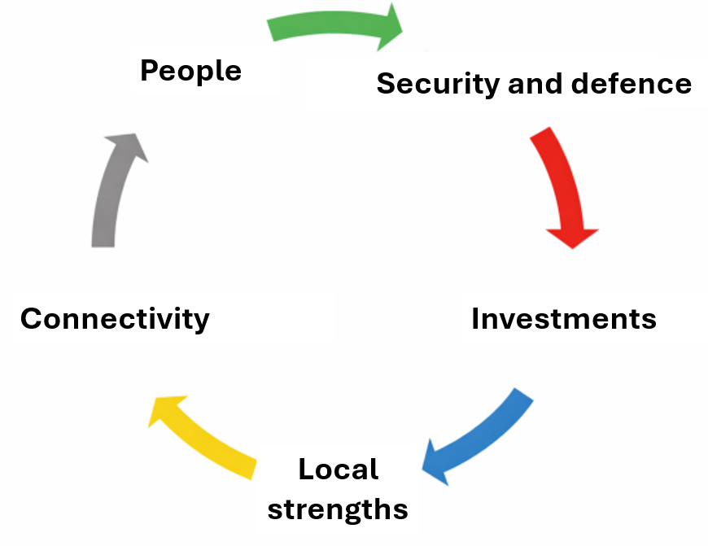
1. Security and resilience – to protect, deter and reassure
The growing number of hostile incidents in EU territory demonstrates the persistence of hybrid threats and security gaps. The increasing frequency of incidents affecting critical infrastructure, including harmful interference affecting GNSS and the radio spectrum, underline the need to ensure its protection and fast repair, while integrating resilience requirements when designing new infrastructure. In this context, the Joint Communication Preserving Peace – Defence Readiness Roadmap 2030 sets out clear objectives and milestones to achieve defence readiness by 2030, as outlined in the White Paper for European Defence.
Two of its flagship initiatives – the Eastern Flank Watch and the European Drone Defence Initiative – have the objective of integrating air defence, counter-drone systems, ground and maritime security measures and situational awareness to build a comprehensive European border defence capability combining civilian-military tools in close cooperation with NATO. The Eastern Flank Watch will include real-time space surveillance to detect movements of hostile forces and a European Drone Defence Initiative and European Air Shield to protect Europe’s sky, directly benefitting the security of the eastern border regions and the whole Union.
Furthermore, the Action Plan on Drone and Counter-drone Security addresses the threats posed by drones – airborne (including balloons), maritime surface, underwater or terrestrial, which pose significant challenges for the protection of external borders, critical infrastructure and public spaces. It aims to enhance future capabilities of law enforcement, specialised counter drone training, a drone incident platform, as well as pooling and sharing of resources. The action plan also includes several funding opportunities for drone and counter-drone capabilities and a specific focus on defence readiness.
EUR 150 billion in loans have been made available to interested Member States under the Security Action for Europe (SAFE) financial instrument. 19 Member States have expressed interest and submitted related investment plans. This includes all nine Member States along the EU’s eastern border, which have been tentatively allocated more than 65% of the total amount. Given the importance of the eastern border regions for EU security, they should be prioritised in the development of a resilient regional defence-industrial ecosystem, capable of scaling-up production and capacity in response to evolving security needs.
The proposed military mobility package will improve dual-use transport infrastructure, streamlining rules for the transport of military equipment and border-crossing procedures across Europe. These measures would support faster movement of military assistance towards the Union’s eastern border regions and beyond. These efforts will help reinforce the resilience of eastern border regions, and improve their connections, strengthening European security and defence. Together with EU Member States, critical bottlenecks (‘hotspots’) will be identified along the EU Military Mobility corridors short term investments prioritised. The military mobility strand of the Connecting Europe Facility within the multiannual financial framework (MFF) 2028-2034 proposes a tenfold increase to support dual-use investments and digital infrastructure for military transport.
Additionally, the proposed funding for migration, border management and internal security has also been increased threefold as part of the MFF 2028-2034. This increase reflects the unique challenges, faced by the Member States bordering Russia and Belarus to manage migration flows and secure the EU’s external borders.
Moreover, in light of the escalating threat environment, there is a need to develop a comprehensive plan to prevent and counter the intensification of Russian hybrid warfare against the EU across terrestrial, aerial, maritime, and digital domains. All these objectives and security concerns are equally critical across the Baltic Sea and the Black Sea regions, given the interconnected prosperity and security continuum between them, as highlighted in the new strategy for a stable and secure Black Sea region . The Baltic Sea region is a strategic and crucial area for the security and defence of the EU. It constitutes an essential part of NATO’s collective defence architecture and plays a key role as a maritime, energy and infrastructure corridor. The Baltic Sea region remains particularly exposed to the Russian hybrid warfare activities, which require enhanced resilience and coordinated EU responses.
The Commission will:
- support Member States in developing the Eastern Flank Watch, the European Drone Defence Initiative, the European Air Shield and the European Space Shield directly benefiting the security of the eastern border regions, with a view to achieving the ambitious milestones set out in the Defence Readiness Roadmap;
- develop an action plan of measures aimed at preventing and countering the escalation of Russian hybrid warfare against the EU in terrestrial, aerial, maritime and digital domains, including by using the potential of the respective funding programmes in those areas;
- focus on improving military mobility in the EU, including in the eastern border regions, by supporting the development of dual-use infrastructure;
- assess the possibility of higher EU support rate and pre-financing rates for eastern border regions for military mobility purposes;
- identify, in close cooperation with the Member States, targeted short-term investments (‘hotspots’) to be implemented by Member States as a matter of priority along the EU military mobility corridors of critical importance in eastern external borders and regions;
- work closely with Member States to ensure the effective use of the increased funding for migration, coordinated customs controls, border management and internal security, with a particular focus on Member States facing unique security challenges and assess whether that increased funding appropriately addresses the specific needs of the eastern border regions;
- in line with the EU Preparedness Union strategy , strengthen crisis preparedness in the eastern border regions to protect populations, economies, industries, and ensure the resilience and functionality of critical, defence and dual-use infrastructure, including in healthcare systems. Resilience considerations should be integrated into and mainstreamed across the EU eastern border regions initiatives, applying the principle of ‘preparedness by design’;
- step up efforts together with Member States to fight illicit imports of tobacco and tobacco related products from third countries.
In that regard, the Commission:
- will support cross-border areas to form resilience clusters that can pool resources, share best practice and collaborate on disaster preparedness, crisis management and long-term resilience;
- stands ready to deploy response capacities, including rescEU ones, through the Union Civil Protection Mechanism, to the most affected eastern border regions;
- invites the eastern border regions to direct investment towards the deployment of ground navigation infrastructure to reinforce resilience to interference and the deployment of fibre optic networks to connect to the EU-wide services critical infrastructure and industries within the region;
- invites Member States to use capabilities, including EU-funded, to prevent and counter hybrid threats, including the European Centre of Excellence for Countering Hybrid Threats integrating results of the EU-funded network EU-HYBNET;
- will facilitate the development in the eastern border regions of strategic hubs for augmented regional space services, through the Union’s investment in the EU IRIS² system;
- stands prepared to strengthen secure connectivity through IRIS² including the reinforcement of its Arctic coverage, and to accelerate the Earth observation governmental service to ensure space-based geo-intelligence including dedicated European capacities and pooling and sharing of national capacities;
- stands ready to support the setting-up of the EU Black Sea Security Hub, aiming at strengthening the region’s security and resilience on the short and long term.

2. Growth and regional prosperity – fostering access to financing, innovation, technology and SME development
Regions along the EU’s eastern borders face mounting economic pressures, in addition to existing economic development challenges . They need to cope with significantly reduced cross-border trade and tourism flows, disrupted supply chains and declining investment confidence. In addition, they face stronger pressure to direct more resources into security and defence than other parts of Europe. Business operators perceive these regions as high-risk, making loans and investment more costly. In addition, many municipalities have limited financial resources, making it difficult to finance development projects and even to provide essential services. As confirmed by the responses to the call for evidence, access to finance has been identified as one of the most immediate challenges.
Despite these challenges, the eastern border regions hold significant potential for growth. As gatekeepers at the EU’s eastern frontier, they can host critical logistical and defence infrastructure while capitalising on natural resources and skilled workforces. Focusing on defence technology and innovation, renewable energy and the bioeconomy can attract targeted investment, while tourism, culture and the creative sectors and industries can help rebrand and diversify local economies. Rule of law and high-quality governance are prerequisites for unlocking these opportunities and ensuring sustainable growth.
The evolving security landscape has created new opportunities for example for investment in dual-use goods. Industries focusing on cybersecurity, surveillance technology, energy security, and transport infrastructure are increasingly seen as strategic sectors for regional development .
In particular, the drone industry can play a key role in this growth, with applications in border surveillance, search and rescue operations, and environmental monitoring. Moreover, the development of counter-drone technologies can provide a new opportunity for innovation and entrepreneurship.
As a result of EU cohesion policy support, the eastern border regions boast many inspiring examples.
The cutting edge NEO factory in Narva (Estonia), supported by EUR 14.5 million from the JTF, started producing permanent magnets that are essential for Europe’s net-zero industry and strategic autonomy.
A former shopping centre built for tourists from Russia in Imatra, South Karelia, Finland, is being transformed into a manufacturing production facility for high-tech green technologies, supported by EUR 2 million from the JTF.
Līvāni in Latgale region has emerged as a Latvian fibre optic valley, with several high-tech companies operating in the sector.
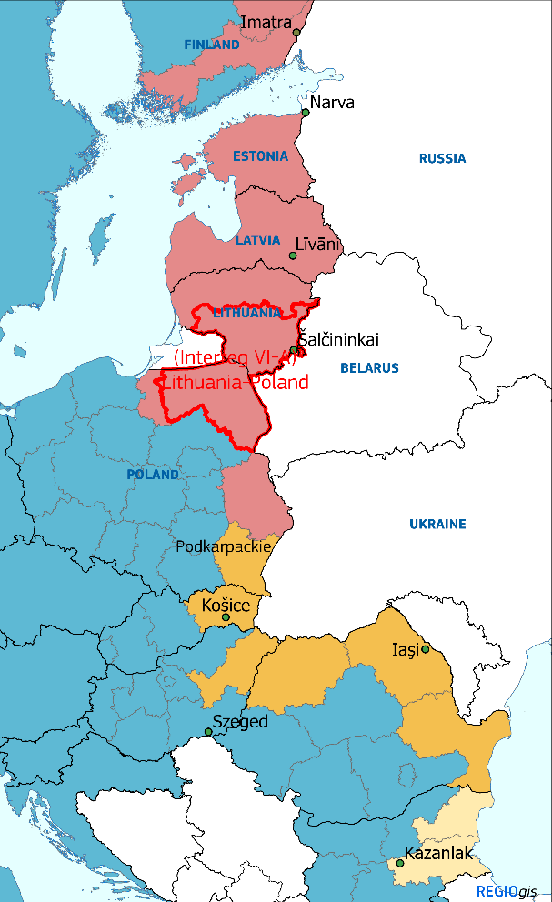
A strong defence cluster is emerging in Šalčininkai (Lithuania), with a EUR 540 million loan from the European Investment Bank (EIB) Group.
The Interreg Lithuania-Poland cross-border project is strengthening policy and public cooperation to improve preparedness for emergencies and wartime scenarios.
With EUR 10 million from the European Development Fund (ERDF) Podkarpackie in Poland will support the creation of ‘Drone Valley’ – the country’s first dual-use competence centre for drones.
The Košice Innovation Centre in Eastern Slovakia, developed with EUR 8.2 million funding from ERDF contributes to the innovation potential of the whole region.
In Szeged, EUR 26 million from the Cohesion Fund helped transform the city’s heating network from gas to geothermal, demonstrating the geothermal energy potential, including in the region bordering Ukraine.
In Iași (Romania), the building of INOVA a+ Research Centre, supported by EUR 75 million from the ERDF, will boost research, production capacity, and supply security for critical medicines, vaccines and antibiotics.
In Kazanlak (Bulgaria), EUR 43 million funding from the Just Transition Fund is building on the high-skilled workforce around Stara Zagora to diversify the economy away from coal and develop a Centre of Excellence for Defence R&D paving the way to a regional hub serving both defence and civilian markets.
Stronger links between academia, business and civil society are essential to maximise this potential. Regional actors should work together to design smart specialisation strategies that combine their unique competitive advantages with new emerging fields of bioeconomy, sustainable agriculture, digital technologies and eco-tourism, while also tapping into partnerships with vocational education and training (VET).
Educational institutions hold significant potential as drivers of innovation and key engines of regional economic growth. In 2025, Riga Technical University (RTU, Latvia), Tallinn University of Technology (TalTech, Estonia), and Kaunas University of Technology (KTU, Lithuania) signed a memorandum of understanding to foster strategic cooperation in defence and security research and innovation to pool their expertise to jointly engage in major international R&D initiatives and strengthen ties with industry.
In Finland, Savilahti ecosystem brings together Kuopio University Hospital, the University of Eastern Finland, Savonia University of Applied Sciences, Savo Vocational College, several research institutes, the KPY Novapolis business park, and more than 200 companies. Together, they provide a platform for growth, development, experimentation, and innovation.
Under the Strategic Technologies for Europe Platform (STEP), Romania will finance EUR 77 million of investments in technology upgrades in emissions trading system installations in the clean and resource efficient technologies sector, notably for the transformation of the existing steelworks in Galați.
As part of the MFF 2028-2034 package, the national and regional partnership (NRP) plans will provide comprehensive and integrated support to Member States and regions facing the dual challenge of boosting security while supporting their economies and people. When submitting NRP plans, Member States will demonstrate how they contribute to reducing economic, social and territorial disparities, including by focusing on the specific needs and challenges of their eastern border regions, particularly in the areas of security, border management and economic development . Moreover, they will need to assign territorial codes that will allow investments in those regions to be tracked.
The Commission will prioritise investment in the eastern border regions by:
- Setting up the EastInvest facility, a dedicated financing platform for eastern border regions, bringing together the EIB Group, international financial institutions and several national and regional promotional banks of the Member States concerned. The facility will address investment needs identified in the development strategies of these regions through targeted lending support by participating institutions, including the EIB Group, the European Bank for Reconstruction and Development (EBRD), the Nordic Investment Bank (NIB) and the Council of Europe Development Bank (CEB), which may be provided at more favourable conditions, for example if combined with cohesion policy financing instruments. The establishment of a dedicated platform will allow for better coordination among the relevant investors, ensure high complementarity and synergies of their interventions in the affected eastern border regions, while respecting the mandates and comparative advantages of the actors involved. To that end, the EIB Group, EBRD, CEB and the NIB aim to provide at least EUR 28 billion in 2026-2027 in private and public investments in the affected Member States, leveraging in turn further private financing. EastInvest will also serve to coordinate lending and advisory support, including to local public authorities, in the eastern border regions.
- Assessing – as part of its 2026 review of the General Block Exemption Regulation whether amendments are required to the State aid rules to address the specific challenges of the eastern border regions.
- In the context of the regional aid guidelines, the Commission will explore the need to maintain, beyond 2027, the existing flexibilities for STEP technologies which are crucial to building resilience.
- Reviewing how the eastern border regions can best benefit from the opportunities offered by the upcoming European Competitiveness Fund , in order to bring innovation and industrial transformation closer to these regions, notably in agriculture, bioeconomy, the defence industry and the resilience of supply chains.
- Within the future European Competitiveness Fund, and building on the InvestEU Advisory Hub, offering targeted advisory support to public and private entities in eastern border regions – including national, regional and local authorities – to facilitate access to financing and to support the development of a pipeline of investment projects.
- Working with Member States under the current MFF to set up simplified forms of reimbursement (such as vouchers or other forms of simplified cost options) to facilitate access to funding for micro and small enterprises in the eastern border regions. Additionally, explore in the context of the implementation dialogues further simplification measures for the benefit of these regions.
- Promoting the creation of clusters in the eastern border regions, including through the European Cluster Platform , to foster local innovation ecosystems, collaboration among small and medium-sized enterprises and access to EU funding opportunities.
- Increasing its cooperation with the World Bank Group under the Catching-up Regions Initiative in the Baltic states to provide municipalities with expertise and help develop projects for business retention and expansion, human capital development as well as capacity building, in close cooperation with local stakeholders. This targeted assistance will be extended to the most affected eastern border regions in Poland and Finland to support economic diversification, expanding market access for local companies, workforce upskilling and foreign direct investment.
- Ensuring that the challenges and needs of the eastern border regions regarding investments and reforms are integrated into the reference policy frameworks of future national and regional partnership plans under the new MFF. Moreover, when preparing the guidance on the ‘Do no significant harm’ principle for the next MFF, the Commission will take into account territorial specificities and challenges of the eastern border regions ensuring the principle is applied proportionately. Furthermore, given the heightened security risks in the eastern border regions, including the increased risk of conventional military threats, the guidance will further detail the scope of the exceptions to security and defence, in particular when it comes to dual-use projects and those with a civil preparedness dimension.
In addition, the Commission calls on Member States to:
- make use of financial instruments under their cohesion policy envelopes to create more favourable lending conditions in the eastern border regions and contribute to de-risk private financing;
- ensure that the challenges and opportunities of the eastern border regions are properly considered when programming future national and regional partnership plans;
- increase incentives for economic activity in these regions, such as targeted tax measures and State-aid-compliant subsidies for companies already established or to incentivise new investments in the eastern border regions;
- explore the potential benefits of setting up new special economic zones in the eastern border regions, and of extending the list of facilities under the existing ones subject to the State aid rules.

3. Building on local strengths – bioeconomy, energy, environment, agriculture and skills
The eastern border regions are rich in untapped natural resources, including wood, biomass and rare earth elements, offering significant potential for the growth of bio-based industries, renewable energy development, and mining and processing sectors.
The forest sector, by using the currently untapped resources sustainably, has the potential to develop competitive, market-based value chains for carbon capture or innovative bio-based materials (e.g. bio-based plastics and polymers, fibre-based packaging, bio-based textiles, bio-based chemicals, and bio-based construction products). These solutions can reduce emissions, foster innovation, create green jobs and revitalise rural areas.
Finland, with significant reserves of lithium, cobalt and nickel, is already a key player in the EU’s push to secure supplies for batteries and renewable energy technologies. Estonia is also positioned to contribute significantly to the EU’s Critical Raw Materials objectives, having already opened a permanent magnet plant. Poland, a major producer of copper and with potential for processing rare earths, is expanding its exploration of lithium, while Romania has promising magnesium and copper deposits. Steel accounts for more than half of Slovakia’s eastern region’s industrial production in addition to a variety of other minerals, such as antimony, gold, silver, uranium, molybdenum and magnesite. The above-mentioned also have a growing focus on sustainable mining practices, positioning themselves as environmentally conscious suppliers of key materials.
Maintaining the potential of agricultural, fisheries and aquaculture production along the eastern border and ensuring its continuity via generational renewal and further support to rural areas is key for the vitality of these regions. Securing forestry and agricultural production also contributes to food security and ensures a stable supply of raw materials for businesses in the area. To develop these initiatives, farmers in the eastern border regions may receive increased coupled income support .
Environmental sustainability in EU border regions can be enhanced through collaborative efforts to protect natural resources and foster circular economies, ensuring long-term resilience and ecological balance across diverse landscapes. Investments in efficient and circular water systems and modern wastewater treatment can also support industry and agriculture, and increase operational continuity during crises.
Strengthening the energy systems and unlocking the renewable energy potential of the eastern border regions is a critical component of Europe’s energy security. The lack of a robust grid in many eastern border regions reduces energy security and industrial development. Ensuring that renewable energy projects can be fully integrated into the electricity network will require strategic grid investments in the eastern border regions of for example the Baltic states and Finland. Following the synchronisation of the Baltic countries’ electricity systems with the European grid, further work is needed to fully integrate them into the EU electricity market. This includes reinforcing resilience and upgrading existing infrastructure, improving grid flexibility and enhancing connectivity with neighbouring countries. Moreover, additional gas storage, reverse-flow capacities, grid and infrastructure upgrades, interconnectors and the integration of renewables are necessary to ensure resilience to energy disruptions and hybrid threats. Accelerating the deployment of renewable energy, through streamlined and expedited permitting processes, can harness the vast potential of the eastern border regions . Local energy resilience can also be increased by expanding energy communities. These communities can pool local resources to produce renewable energy, thus reducing reliance on external sources, as well as build microgrids and energy storage systems, providing backup power during disruptions.
The eastern border regions also present a large potential for biomass supply for the EU bioeconomy, while also valorising residues and increase local circularity and resilience. They can support the ReFuelEU Aviation and FuelEU Maritime strategies by providing the feedstock for advanced biofuel production, building on lead technologies such as biorefineries, fermentation and biogenic.
By investing in on-farm or cooperative biogas installations, farmers can recycle manure, waste and crop-residues into valuable bioenergy and digestate, which itself can be further processed to bio-based fertilizer. This helps to substitute expensive and to a large extent imported and fossil-based chemical fertilizers, and at the same time contributes to sustainability, energy security and energy affordability.
The Commission will:
- speed up the integration of the Baltic states’ electricity systems with the European networks, including reinforcing resilience of infrastructure and offshore grids, as well as cross-border hydrogen infrastructure such as the Nordic-Baltic Hydrogen Corridor, through the Baltic Energy Market Interconnection Plan High-Level Group;
- continue to support the implementation of priority cross-border infrastructure projects in the region, as also reflected in the Energy Highways identified as part of the European Grids Package, including through the Central and South-Eastern Europe Energy Connectivity High-Level Group;
- continue to support projects of common interest and projects of mutual interest with third countries including via the CEF;
- support circular-industry initiatives, including industrial symbiosis valleys and regional bioeconomy hubs in the eastern border regions, building on the Bioeconomy Strategy;
- support the production of biogas and biomethane production, in line with REPowerEU targets and the lead market for biobased-fertilisers outlined in the Bioeconomy Strategy, that recycle agricultural and forestry residues, as well as local organic waste, into digestate and bio-based fertiliser;
- support strategic projects under the Critical Raw Materials Act, building on RESourceEU Action Plan and the region's supply potential for critical raw materials, through Innovation Fund calls and Cohesion investments via STEP;
- promote the eastern border regions specific activities within the Rural Pact, such as networking and capacity building, to address the unique challenges faced by these regions;
- encourage the participation of young people in farming in the eastern border regions via the EU strategy for generational renewal in farming and continue to support the development of rural areas and farming via the future national and regional partnership plans;
- address the key challenges facing tourism in the eastern border regions in the upcoming EU strategy for sustainable tourism, helping the adoption of sustainable models, strengthening resilience and restoring international confidence through targeted promotion efforts.
The Commission invites Member States to:
- improve energy planning in creating a framework to better coordinate investment pipelines to speed up the green transition, resilience and grid integration across the eastern border regions;
- further reinforce energy security by fast-tracking interconnectors, LNG/biogas capacity, electricity grid resilience and energy storage, including creating strategic fuel reservoirs in the eastern border regions, and integrate these investments into the future revision of Member States’ national energy and climate plans;
- deploy renewable energy projects and modernise district heating in the eastern border regions;
- include in their Social Climate Fund investments measures to reduce energy poverty including in the eastern border regions to the benefit of vulnerable households and micro-enterprises.

4. Connectivity – to connect people and support growth
Russia’s war of aggression against Ukraine has prompted a strategic decoupling of transport links with Russia and Belarus, including by closing the airspaces of the adjacent countries, directly impacting the eastern border regions. Russia and Belarus have been removed from the TEN-T maps, and cross border connections with these countries have been downgraded. The shift in trade dynamics following the closure of borders and economic sanctions has underlined the importance of securing strong connections to international markets, particularly through alternative land, rail, and maritime routes.
The EU has taken decisive steps to adjust and strengthen the TEN-T corridors, prioritising the full integration of the eastern border regions into the EU internal market and security framework. Connectivity in the eastern border regions within the EU has been significantly strengthened, by introducing new corridors alignments to enhance their integration into the EU transport market as well as strengthening cross border connectivity with Ukraine and Moldova.
The integration of the eastern border regions into the EU networks by removing barriers and developing the European standard gauge infrastructure in the Baltic states and Finland represents a strategic investment in EU cohesion, economic resilience, and security preparedness. At the same time, strengthening the economic and security resilience of the Danube/Black Sea-Aegean Sea remains equally important for Europe’s overall security on the eastern flank.
At local level, adequate access to public transport and on demand transport services is needed to make sure people can reach their jobs and public services in the eastern border regions.
The Commission will:
- boost cooperation in infrastructure networks, involving the relevant national administrations in line with the Trans-European Transport Network (TEN-T) European Transport Corridors, including extensions to Ukraine and Moldova, as well as increase capacity in the Baltic ports and support the development of the Rail Baltic/TEN-T corridor and north-south military mobility;
- support and facilitate integration of the eastern border regions railway systems within the TEN-T and CEF cooperation frameworks, both with the rest of the EU as well as with Ukraine and Moldova, to improve military mobility and security, and create additional economic opportunities.
The Commission invites Member States to:
- upgrade infrastructure to increase regional competitiveness and security, prioritising quality road and rail connections with major urban centres, including where they can serve dual-use purposes, prioritising TEN-T corridors;
- facilitate implementation of critical ongoing major cross-border projects, such as Rail Baltica, which are essential for the connectivity and security of the eastern border regions;
- ensure the timely implementation of the joint Action Plan on enhanced cooperation in the framework of Baltic Sea-Black Sea-Aegean Sea corridor ;
- make use of future national and regional partnership plans, the Connecting Europe Facility and the European Competitiveness Fund to ensure timely implementation of TEN-T and EU military mobility corridors;
- make use of Social Climate Fund allocations to reduce transport poverty in the eastern border regions, e.g. by investing in sustainable public transport, social electric vehicle leasing, public transport, shared mobility and on-demand transport.
Digital connectivity between the eastern border regions and the rest of the EU is crucial for economic integration, cross-border trade, communication and innovation, as well as for cyber-security and protection from hybrid attacks. Yet the eastern border regions continue to lag significantly behind the rest of the EU, with gaps in broadband coverage, slow internet speed, limited digital public service delivery and scarce digital skills. These shortcomings hinder local companies, limit access to education, training and healthcare, and weaken cross-border coordination. Targeted actions should ensure the availability of gigabit-capable broadband and 5G coverage including in rural communities and along border corridors, as well as of critical infrastructures such as backbone networks.
The Commission will:
- provide funding on a competitive basis under the second Connecting Europe Facility digital work programme 2024-2027 to support 5G digital connectivity within the EU as well as between the EU and non-EU countries, with a focus on backbone networks;
- facilitate technical assistance to public authorities through the European Broadband Competence Offices Network to support the rollout of fibre and 5G networks, and to companies through EDIHs to enhance the adoption of digital technologies.
The Commission invites Member States to:
- integrate the specific circumstances of the eastern border regions into their national digital decade strategic roadmaps, ensuring that upcoming adjustments focus on the regions unique challenges and priorities. This includes improving broadband and 5G coverage, secure cross-border connectivity and access to digital public services;
- make full use of the RRF and cohesion policy programmes to close the digital divide to help create new opportunities, strengthen economic resilience and improve quality of life in the eastern border region.
Cross-border cooperation has long been a vital tool for fostering regional development and economic growth in border regions. However, the breakdown of relations with Russia and Belarus has disrupted these cooperative frameworks. As a result, it is necessary to explore alternative territorial cooperation initiatives that allow these regions to maintain and diversify connections, find new partners and set up new cooperation opportunities.
As part of the 2028-2034 MFF proposal, the Commission has introduced a new Interreg-specific objective for ‘more resilient regions bordering Russia, Belarus and Ukraine’ . This proposal aims to give the Member States concerned and their regions full flexibility in exploiting territorial cooperation to address their most pressing challenges, including safety and civil preparedness, de-population and disinformation. At the same time, regions bordering Russia and Belarus, which lost cross border opportunities following the termination of programmes with those two hostile neighbours, will be better equipped to redirect their cooperation efforts westwards. For the regions bordering Ukraine, the new specific objective will allow an increased focus on addressing the challenging conditions that currently prevail. The new specific objective will also make it possible for future transnational cooperation spaces to dedicate part of their funding to cooperation with Ukraine and Moldova.
The Commission will:
- support the Member States concerned to prepare their future 2028-2034 Interreg chapters also taking into account north-south cooperation. If so decided by the Member States bordering Russia and Belarus, this could take the shape of a specific Interreg plan chapter dedicated to using the new specific objective to foster greater cooperation and learning opportunities among regions facing similar challenges.
The Commission invites Member States to:
- make full use of the recently adopted BRIDGEforEU Regulation to help resolve cross-border obstacles between regions in the eastern flank.

5. People – regions are as strong as the communities living there
The people of the eastern border regions have shown exceptional strength and adaptability in the face of adversity. Their continued resilience depends on community cohesion and preparedness to absorb shocks. Depopulation, ageing and low population density pose significant challenges.
In addition, housing markets are stagnating, and low collateral values impede access to mortgages. This risks triggering a negative cycle of outmigration and declining attractiveness, which threatens the resilience of the EU’s eastern border (as evidenced by studies conducted by ESPON, the OECD and Interreg Europe).
To counter these trends, Member States should strengthen place-based policymaking and multi-level governance, empower regional and local authorities and civil society, while upholding good governance and the Rule of Law.
Ensuring the provision of essential and social services is crucial for the well-being of communities in border regions. However, the limited financial capacity of local governments, leave these regions with chronic shortages of education, training and care professionals and weaker infrastructure. This is further aggravated by an ageing population and workforce. The situation requires targeted investment to ensure accessible and affordable social, health, child and long-term care services and infrastructure. In the context of escalating geopolitical tensions, mental health has emerged as a critical concern, with increasing levels of insecurity, stress, and depressive symptoms posing major challenges. New approaches, such as telemedicine, digital consultation hubs and mobile services, show considerable potential to help overcome barriers of distance, providing access to remote areas. Social entrepreneurship can also revitalise the economy and improve social cohesion .
Moreover, many border regions are home to diverse minority groups; fostering their integration and inclusion is key to strengthening these areas.
The Commission will:
- support the creation of an eastern border region community of practitioners to exchange best practices and preparedness solutions among municipalities;
- explore – together with Member States – how to facilitate municipalities’ access to critical equipment, including through joint procurement, e.g. emergency communication and broadcast systems, reserves of agri-food products, community energy projects and off-grid energy solutions;
- promote community-led local development initiatives, including LEADER, engaging the population in local decision-making and finding solutions tailored to the specific regional needs, including youth retention and access to quality services for all.
A skilled and adaptable workforce is essential for the eastern border regions to thrive. However, labour and skills shortages remain high. This includes key sectors such as healthcare and long-term care, green industries and the digital economy. At the same time, the eastern border regions also report high numbers of young people not in employment, education or training.
Addressing these challenges requires education and training better aligned with local labour market needs, supported by partnerships with companies and stronger science, technology, engineering and mathematics education. Ensuring a smooth school-to-work transition, flexible learning options and the full implementation of the Youth Guarantee will help retain young talent.
The Commission invites Member States to:
- scale up vocational education and training (VET) and re/upskilling including via the European Social Fund Plus, and through committing to the EU Pact for Skills;
- build stronger education-to-employment links through Erasmus+ centres of vocational excellence, the European Alliance apprenticeships, VET teacher upskilling and research/innovation;
- prioritise youth retention in the eastern border regions through education-to-employment pathways and by setting up first-time homebuyer schemes under cohesion policy programmes, offering low-interest loans to young professionals ;
- support the eastern border regions’ cities and urban areas to apply for the upcoming European Urban Initiative call, aimed at implementing the recently adopted Cities’ Agenda;
- foster cooperation between municipalities, including through pooling available resources and ensuring essential and social services for their communities;
- strengthen civic participation, education, volunteering, media and financial literacy, preparedness and grassroots initiatives, boosting local resilience, mutual trust and social inclusion;
- promote the socio-economic integration of nationals from non-EU countries and minorities in the eastern border regions by making full use of EU funding opportunities.
Culture fosters trust in democratic institutions and cohesion and should remain high on the political agenda of the eastern border regions. Youth participation in decision-making should be formalised, while schools and public campaigns targeting all population segments should strengthen critical thinking and media literacy.
The Commission will:
- support the economic resilience of the media sector through the Media Resilience Programme;
- promote the use of small-scale grants to support local NGOs in upholding digital and media literacy and to support arts and crafts initiatives;
- develop a peer-learning project to strengthen pupils’ civic engagement and sense of democratic citizenship through culture, both within and around schools;
- bolster efforts to improve citizens-centred communication and address risks posed by FIMI, which are particularly acute in the eastern border regions, including through the EDMO national or regional hubs, the new European Network of Fact-Checkers and the CAP Network for rural communities;
- support fact-checking organisations and local media to strengthen the information space on issues of particular relevance to rural communities within the eastern border regions .

Way forward
EU’s eastern border regions are not only gatekeepers of our security but also vital gateways for connectivity and economic opportunity. Strengthening their resilience and attractiveness is not only a question of solidarity; it is a crucial strategic investment in Europe’s security, future stability, competitiveness and cohesion.
Security and resilience are integral to the long-term sustainability of the eastern border regions. Strategic investments and co-ordinated governance can help transform security challenges into opportunities and prosperity and to ensure sustainable regional development.
Through targeted EU and national policies, additional and integrated investments and empowered local governance, the EU can turn its frontier regions into resilient engines of sustainable growth and European unity and security.
The needs and circumstances of the eastern border regions are unique. They will be integrated into relevant future policies and investments and reflected in funding priorities at every level – regional, national and European. This should include targeted calls for proposals and preferential treatment for the eastern border regions.
The Commission will continue to work closely with national administrations and regions to further promote place-based approaches and multi-level governance ensuring tailored, effective solutions for these regions, making the most of the existing and future EU funds implementation structures ensuring that their unique needs are consistently addressed.
Member States whose regions are most affected by the current security environment are encouraged to recognise the special status of these areas in their own national and regional development strategies and planning, including territorial cooperation. In this context, dedicated financial resources should be specifically allocated for the eastern border regions to foster their economic development and promote resilience.
This Communication serves as a starting point, laying the foundation for continued solidarity and efforts that will be adapted to address the evolving challenges and opportunities.
Continuous dialogue will be necessary to align EU, national and regional policies so that they effectively address these challenges and opportunities. To ensure a systematic follow-up, the Commission proposes to set up an annual high-level political dialogue to discuss EU policies and their contribution to the development and security of the eastern border regions. The first high level dialogue will be held on 26 February 2026.

‘The eastern border regions do not represent national borders, but they are European borders. Our action in these regions plays a key role to defend our common European values. Our duty is to ensure that the people in these regions feel safe, protected and supported with opportunities for good jobs, quality education and services’ Rafaelle Fitto at the EU Eastern Border Regions High-Level Conference in Białowieża, June 2025, Poland.
For the purposes of this Communication, eastern border regions are defined as those bordering Russia, Belarus or Ukraine.
Cable Security Action Plan, JOIN(2025) 9 final
In 2025, Lithuanian authorities intercepted 600 contraband balloons launched from Belarus.
European Economic Forecast Autumn 2025.
249 replies received between 7 August and 18 September 2025, available in the Commission’s Have your say portal: Call for evidence.
European Parliament resolution on Discharge 2023: EU general budget – Commission, executive agencies and European Development Funds, recommendation 40.
REPORT on strengthening rural areas in the EU through cohesion policy | A10-0092/2025 | European Parliament.
Speech by Executive Vice-President Fitto at the EU Eastern Border Regions High-Level Conference in Białowieża, Poland.
Regulation (EU) 2025/1914 ; Regulation (EU) 2025/1913.
JOIN (2025)791.
Finland, Estonia, Latvia, Lithuania, Poland, Slovakia, Hungary, Romania, Bulgaria.
JOIN (2025) 27 final.
JOIN (2025) 846 final.
COM (2025) 547 final.
JOIN (2025) 135 final.
JOIN(2025) 130 final.
GDP per capita in the eastern border regions is 12 to 21% lower than in the rest of the same country (excluding the capital region).
For example the ResilEast is a pilot project proposing a regional development initiative designed to strengthen the resilience, security, and economic vitality of EU eastern border regions through an integrated approach that combines energy infrastructure, defence readiness, and sustainable economic growth. It is envisioned as a pilot project for the broader RESIL EU concept, where Europe’s border regions act as pioneers in building new sources of growth and competitiveness across the continent.
COM(2025) 565 final/2.
Article 22 of the NRPP proposal (COM(2025) 565 final).
COM(2025) 555 final.
https://www.clustercollaboration.eu/.
Under the CAP MFF proposal, Member States have the possibility to increase their allocation to coupled income support, usually limited to 20% of Union contribution to specific interventions, by up to 5% provided that this additional financial allocation is targeted to specific priorities including, in particular, for farmers in the eastern border regions.
Untapped potential for renewable energy from wind, solar and hydropower.
Strategy for generational renewal for agriculture (COM/2025/872 final).
Memorandum of understanding on enhanced cross-border cooperation in the framework of the Black Sea – Aegean Sea Corridor Platform (December 2025).
Member States are requested to submit adjustments to their national digital decade strategic roadmaps in December 2026 (based on Article 8 of the Decision (EU) 2022/2481 establishing the Digital Decade Policy Programme 2030).
COM(2025) 552 final.
Regulation (EU) 2025/925 of the European Parliament and of the Council of 7 May 2025 on a Border Regions’ instrument for development and growth (BRIDGEforEU).
‘Baltics CuRI Forum: Social Enterprise for Regional Resilience’ organised by the World Bank Group and the Commission on 17-18 September in Anykščiai, Lithuania.
Developed under CuRI Slovakia in Prešov Region to increase the knowledge and awareness about social economy as instrument to address local challenges and its contribution to development and inclusive growth.
Model for financial instruments and grants with co-financing from the EIBG and others for affordable housing.
Information measures relating to the common agricultural policy programme (IMCAP).

