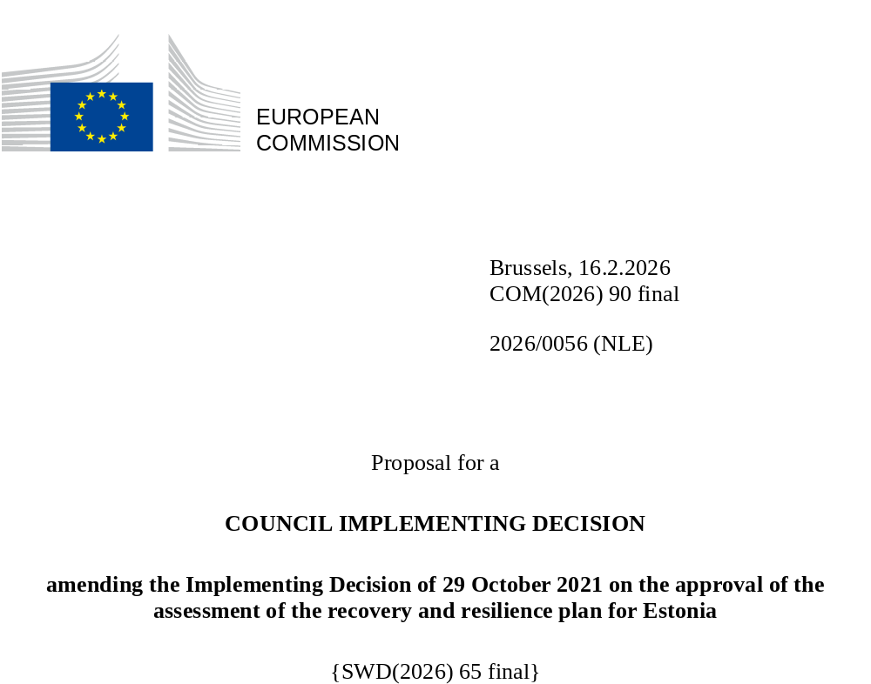

2026/0056 (NLE)
Proposal for a
COUNCIL IMPLEMENTING DECISION
amending the Implementing Decision of 29 October 2021 on the approval of the assessment of the recovery and resilience plan for Estonia
THE COUNCIL OF THE EUROPEAN UNION,
Having regard to the Treaty on the Functioning of the European Union,
Having regard to Regulation (EU) 2021/241 of the European Parliament and of the Council of 12 February 2021 establishing the Recovery and Resilience Facility, and in particular Article 20(1) thereof,
Having regard to the proposal from the European Commission,
Whereas:
(1) Following the submission of the national recovery and resilience plan (‘RRP’) by Estonia on 18 June 2021, the Commission proposed its positive assessment to the Council. On 29 October 2021, the Council approved the positive assessment by means of an implementing decision (‘the Council Implementing Decision of 29 October 2021’). The Council Implementing Decision of 29 October 2021 was amended by Council Implementing Decisions of 16 June 2023 and 13 November 2025.
(2) On 29 January 2026, Estonia made a reasoned request to the Commission to make a proposal to amend the Council Implementing Decision of 29 October 2021 in accordance with Article 21(1) of Regulation (EU) 2021/241 on the grounds that the RRP is partially no longer achievable because of objective circumstances. On that basis, Estonia has submitted an amended RRP.
Amendments based on Article 21 of Regulation (EU) 2021/241
(3) The amendments to the RRP submitted by Estonia because of objective circumstances concern five measures.
(4) Estonia has explained that two measures are partially no longer achievable, because of insufficient market demand and unexpected delays in the implementation. This concerns measure 4.7 (Pilot Energy Storage Programme) and measure 4.8 (Boosting offshore wind farms development). On this basis, Estonia has requested that those measures be amended. The Council Implementing Decision of 29 October 2021 should be amended accordingly.
(5) Estonia has explained that two measure have been amended to implement better alternatives that allow the administrative burden to be reduced and simplify the Council Implementing Decision, while still achieving the objectives of those measures. This concerns measure 3.6 (Establishing the strategic analysis of money laundering and terrorist financing in Estonia) and measure 8.1 (Facilitating the deployment of renewable energy sources). On this basis, Estonia has requested that these measures be amended. The Council Implementing Decision of 29 October 2021 should be amended accordingly.
(6) Following the decrease in the level of implementation of measure 4.7 (Pilot Energy Storage Programme) in accordance with Article 21 of Regulation (EU) 2021/241, Estonia has requested to use the resources freed up by the decrease in the level of its implementation to increase the level of implementation of one measure. This concerns 5.3.a (Construction of the Rail Baltic viaducts and terminal). On this basis, Estonia has requested that the level of implementation of one measure be increased. The Council Implementing Decision of 29 October 2021 should be amended accordingly.
Distribution of milestones and targets
(7) The distribution of milestones and targets in instalments should be amended to take into account the amendments to the RRP and the indicative timeline presented by Estonia.
Corrections of clerical errors
(8) Seven clerical errors have been identified in the text of the Council Implementing Decision of 13 November 2025, affecting six measures under three components. The Council Implementing Decision should be amended to correct these clerical errors, which do not reflect the content of the RRP submitted to the Commission on 18 June 2021, as agreed between the Commission and Estonia. Those clerical errors relate to measure 1.1. (Digital transformation in enterprises) and target 3 of that measure under component 1 (Digital transformation of enterprises); target 40a of measure 2.6 (Green Fund) under component 2 (Accelerating the green transition in enterprises); measure description of measure 6.1 (A comprehensive change in the organisation of health care in Estonia), milestone 100a of measure 6.2.a (Construction of TERVIKUM), milestone 114 of measure 6.6 (Providing labour market measures to reduce youth unemployment) and milestone 120 of measure 6.8 (Long-term care) under component 6 (Healthcare and social protection). Those corrections do not affect the implementation of the measures concerned.
Distribution of milestones and targets
(9) The distribution of milestones and targets in instalments should be amended to take into account the amendments to the RRP and the indicative timeline presented by Estonia.
Commission’s assessment
(10) The Commission has assessed the amended RRP against the assessment criteria laid down in Article 19(3) of Regulation (EU) 2021/241.
(11) The Commission considers that the amendments put forward by Estonia do not affect the positive assessment of the RRP set out in the Council Implementing Decision of 29 October 2021 regarding the relevance, effectiveness, efficiency and coherence of the RRP against the assessment criteria laid down in Article 19(3) of Regulation (EU) 2021/241 points (a), (b), (c), (d), (da), (db), (e), (f), (g), (h), (j) and (k).
Costing
(12) In accordance with Article 19(3), point (i), of, and criterion 2.9 of Annex V to, Regulation (EU) 2021/241, the justification provided in the amended RRP on the amount of the estimated total cost of the RRP is to a medium extent (rating B) reasonable and plausible, is in line with the principle of cost efficiency and is commensurate to the expected national economic and social impact.
(13) The changes in the cost estimates for two amended measures are considered proportional and as such the reasonability and plausibility of these cost estimates were not altered compared to the original RRP. Finally, the amount of the estimated total cost of the RRP is in line with the principle of cost efficiency and commensurate to the expected national economic and social impact.
Positive assessment
(14) Following the positive assessment by the Commission of the amended RRP, with the finding that the RRP satisfactorily complies with the criteria for assessment set out in Regulation (EU) 2021/241, in accordance with Article 20(2) of and Annex V to that Regulation, the reforms and investment projects necessary for the implementation of the amended RRP, the relevant milestones, targets and indicators, and the amount made available from the Union for the implementation of the amended RRP should be set out.
Financial contribution
(15) The estimated total costs of Estonia’s amended RRP is EUR 953 380 000. As the amount of the estimated total cost of the amended RRP is higher than the updated maximum financial contribution available for Estonia, the financial contribution determined in accordance with Article 4a of Regulation (EU) 2021/1755 of the European Parliament and of the Council, and with Article 20(4) and Article 21a(6) of Regulation (EU) 2021/241 that is allocated for Estonia’s amended RRP should be equal to EUR 953 184 800. Therefore, the financial contribution made available to Estonia remains unchanged.
(16) The Council Implementing Decision of 29 October 2021 should therefore be amended accordingly. For the sake of clarity, the Annex to the Council Implementing Decision of 29 October 2021 should be replaced entirely.
(17) This Decision should be without prejudice to procedures relating to distortions of the operation of the internal market that may be undertaken, in particular under Articles 107 and 108 of the Treaty. It does not override the requirement for Member States to implement the measures in accordance with Union and national law and, in particular, to notify instances of potential State aid to the Commission under Article 108 of the Treaty,
HAS ADOPTED THIS DECISION:
Article 1
Approval of the assessment of the RRP
The assessment of the amended RRP for Estonia on the basis of the criteria provided for in Article 19(3) of Regulation (EU) 2021/241 is approved.
Article 2
Amendments
The Council Implementing Decision of 29 October 2021 on the approval of the assessment of the recovery and resilience plan for Estonia is amended as follows:
the Annex is replaced by the text set out in the Annex to this Decision.
Article 3
Addressee
This Decision is addressed to the Republic of Estonia.
Done at Brussels,
For the Council
The President

OJ L 57, 18.2.2021, p. 17, ELI: https://eur-lex.europa.eu/eli/reg/2021/241/oj.
See documents ST 12532/21 INIT; ST 12532/21 ADD 1; ST 12532/21 ADD 1 COR 1; ST 12532/21 ADD 1 COR 1 REV 1 at http://register.consilium.europa.eu.
See documents ST 9367/23 INIT; ST 9367/23 ADD 1 REV 1 at http://register.consilium.europa.eu.
See documents ST 14442/25 INIT; ST 14442/25 ADD 1 at http://register.consilium.europa.eu.
Regulation (EU) 2021/1755 of the European Parliament and of the Council of 6 October 2021 establishing the Brexit Adjustment Reserve (OJ L 357, 8.10.2021, p. 1, ELI: http://data.europa.eu/eli/reg/2021/1755/oj).

