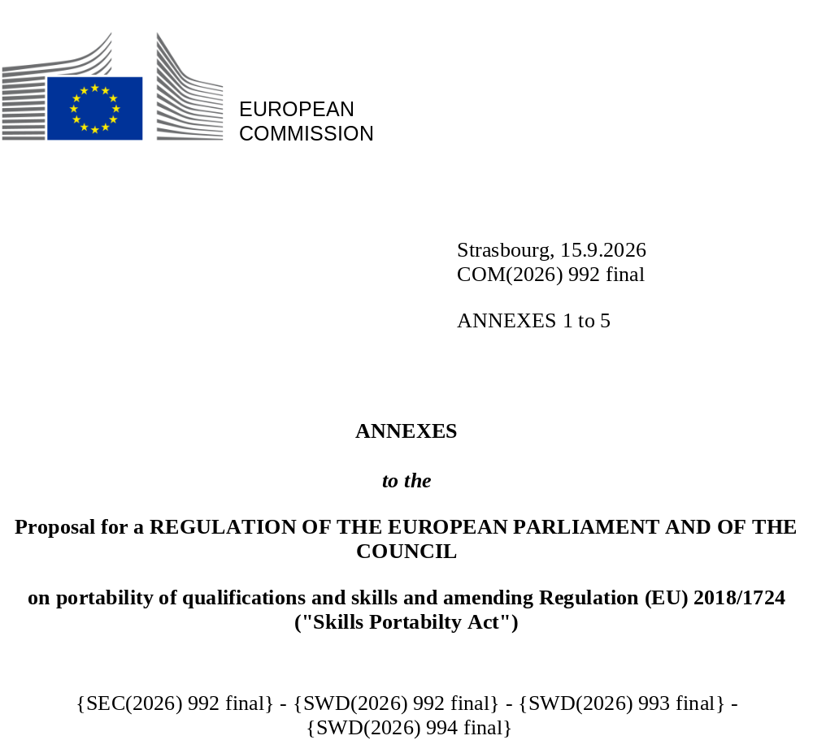

Annex I
Union standard specifications for digital qualification attestations
- The digital qualification attestation and the tools and systems relevant for its issuance and verification shall comply with W3C Verifiable Credential Data Model and with Regulation (EU) No 910/2014.
- The digital qualification attestation and information on the awarding body, accreditation and qualification shall use a common semantic model which is the European Learning Model⁽¹⁾.

Annex II
Specifications for data fields in digital qualification attestations referred to in Article 4(2)
- Mandatory data fields:
FIELD NAME | DESCRIPTION
Given Name | The holder's given name
Family Name | The holder's family name
Date of Birth | The holder's date of birth
Birthplace | The country as an alpha-2 country code as specified ISO 3166-1, or the state, province, district, or local area or the municipality, city, town, or village where the user to whom the holder's data relates was born
Nationality | One or more alpha-2 country codes as specified in ISO 3166-1 representing the nationality (or nationalities) of the holder
Qualification Title | The official title of the qualification provided in at least one specified language
Qualification Title in commonly agreed language | The official title in commonly agreed language
Field of Education and/or Training | The field of study, classified in accordance with the International Standard Classification of Education Fields of Education and Training (ISCED-F-2013)
Valid From | The date and time when the digital qualification attestation was issued
Valid Until | The date and time the digital qualification attestation ceases to be valid
EQF Level | The applicable level of the European Qualifications Framework
NQF Level | The qualification level as specified in the national qualifications framework
Issuer | The legal identifier, name and location of the issuing organisation which issued the digital qualification attestation
Awarding Body/Bodies | The legal identifier, name and location of the awarding body/bodies that awarded the qualification
Country/countries of Award | The Member State(s) in which the qualification was awarded
Where applicable, Region of Award | The code of the region in which the qualification was awarded, where applicable
Date of Award | The date on which the qualification was officially awarded
Learning Outcomes⁽¹⁾ OR Description of the Qualification⁽²⁾ | Summary of learning outcomes OR description of the qualification composed of knowledge, skills and responsibility and autonomy
Accreditation Details | Information on the accreditation of the awarding body, including jurisdiction and the relevant regulatory framework
Professional Experience, where applicable | Professional experience gained to obtain the qualification
Professional Title, where applicable | Professional title obtained as a result of qualification being awarded
Access Rights, where applicable | A statement on the access rights to regulated professions conferred by the qualification
- Optional data fields:
FIELD NAME | DESCRIPTION
Holder's National ID and the country | National ID and country issuing it
Uniform resource Identifier (URI) to qualification standard | URI to qualification standard published in a qualification database such as Europass established by Decision (EU) 2018/646 of the European Parliament and of the Council
ESCO Skills reference | Reference to European Skills, Competences, and Occupations classification
Duration of Study | The official duration of the learning programme expressed in time or credits of the European Credit Transfer and Accumulation System
Grades / Marks | The grades or marks achieved, accompanied by an explanation of the grading scale used
Mode of Learning | The mode of delivery, such as full-time, part-time, distance learning
Main subjects / modules | A list of the main subjects or modules covered by the programme of study
Practical Training | Details of a mandatory practical training that was completed
Assessment Methods | Information on the methods used for assessment (e.g. examination, project work)
Language of Study | The primary language(s) in which the programme was taught
Thesis/ Final Project Title | The title of the final thesis or project, if applicable
International Mobility | Information on any international mobility periods undertaken as a part of the programme
- Data fields covered in this Annex can be supplemented by additional data only as far as it is necessary for the functioning of the relevant data in the EUDI Wallet system. Otherwise, no other data fields than those covered by this Annex shall be included in digital qualification attestation referred to in Article 4(2).

Annex III
European Qualifications Framework
Each of the 8 levels is defined by a set of descriptors indicating the learning outcomes relevant to qualifications at that level in any system of qualifications.

 | Knowledge | Skills | Responsibility and autonomy
 | Knowledge is described as theoretical and/or factual. | skills are described as cognitive (involving the use of logical, intuitive and creative thinking) and practical (involving manual dexterity and the use of methods, mate rials, tools and instruments). | responsibility and autonomy is described as the ability of the learner to apply knowledge and skills autonomously and with responsibility
Level 1 The learning outcomes relevant to Level 1 are | basic general knowledge | basic skills required to carry out simple tasks | work or study under direct supervision in a structured context
Level 2 The learning outcomes relevant to Level 2 are | basic factual knowledge of a field of work or study | basic cognitive and practical skills required to use relevant information in order to carry out tasks and to solve routine problems using sim ple rules and tools | work or study under supervision with some autonomy
Level 3 The learning outcomes relevant to Level 3 are | knowledge of facts, principles, processes and general concepts, in a field of work or study | a range of cognitive and practical skills required to accomplish tasks and solve problems by selecting and applying basic methods, tools, materials and information | take responsibility for completion of tasks in work or study adapt own behaviour to circumstances in solving problems
Level 4 The learning outcomes relevant to Level 4 are | factual and theoretical knowledge in broad con texts within a field of work or study | a range of cognitive and practical skills required to generate solutions to specific problems in a field of work or study | exercise self-management within the guidelines of work or study contexts that are usually predictable, but are subject to change supervise the routine work of others, taking some responsibility for the evaluation and improvement of work or study activities
Level 5 (*) The learning outcomes relevant to Level 5 are | comprehensive, specialised, factual and theoretical knowledge within a field of work or study and an awareness of the boundaries of that knowledge | a comprehensive range of cognitive and practical skills required to develop creative solutions to abstract problems | exercise management and supervision in con texts of work or study activities where there is unpredictable change review and develop performance of self and others
Level 6 (**) The learning outcomes relevant to Level 6 are | advanced knowledge of a field of work or study, involving a critical understanding of theories and principles | advanced skills, demonstrating mastery and innovation, required to solve complex and unpredictable problems in a specialised field of work or study | manage complex technical or professional activities or projects, taking responsibility for decision-making in unpredictable work or study contexts take responsibility for managing professional development of individuals and groups
Level 7 (***) The learning outcomes relevant to Level 7 are | highly specialised knowledge, some of which is at the forefront of knowledge in a field of work or study, as the basis for original thinking and/or research critical awareness of knowledge issues in a field and at the interface between different fields | specialised problem-solving skills required in research and/or innovation in order to develop new knowledge and procedures and to integrate knowledge from different fields | manage and transform work or study contexts that are complex, unpredictable and require new strategic approaches take responsibility for contributing to professional knowledge and practice and/or for reviewing the strategic performance of teams
Level 8 (****) The learning outcomes relevant to Level 8 are | knowledge at the most advanced frontier of a field of work or study and at the interface between fields | the most advanced and specialised skills and techniques, including synthesis and evaluation, required to solve critical problems in research and/or innovation and to extend and redefine existing knowledge or professional practice | demonstrate substantial authority, innovation, autonomy, scholarly and professional integrity and sustained commitment to the development of new ideas or processes at the forefront of work or study contexts including research
Compatibility with the Framework for Qualifications of the European Higher Education Area
The Framework for Qualifications of the European Higher Education Area provides descriptors for three cycles agreed by the ministers responsible for higher education at their meeting in Bergen in May 2005 in the framework of the Bologna process. Each cycle descriptor offers a generic statement of typical expectations of achievements and abilities associated with qualifications that represent the end of that cycle.
(*) The descriptor for the short cycle developed by the Joint Quality Initiative as part of the Bologna process, (that can be within or linked to the first cycle), corresponds to the learning outcomes for EQF level 5.
(**) The descriptor for the first cycle corresponds to the learning outcomes for EQF level 6.
(***) The descriptor for the second cycle corresponds to the learning outcomes for EQF level 7.
(****) The descriptor for the third cycle corresponds to the learning outcomes for EQF level 8.

Annex IV
Minimum data requirements referred to in Article 8(1) point (b)
- Minimum data requirements for information on qualifications:
DATA | Mandatory / Optional
Title of qualification | Mandatory
Field⁽¹⁾ | Mandatory
Country(countries)/Region(s) (code) | Mandatory
EQF Level | Mandatory
NQF level | Mandatory
Description of learning outcomes | Mandatory
Awarding body/bodies | Mandatory
Credit points/ notional workload needed to achieve the learning outcomes | Optional
Internal quality assurance processes | Optional
External quality assurance / regulatory body | Optional
Further information on the qualification | Optional
Identifier of related degrees for the same study programme | Optional
Source of information | Optional
Link to relevant supplements | Optional
Uniform Resource Identifier (URI) of the qualification | Mandatory
Entry requirements to obtain a qualification | Optional
Expiry date (if relevant) | Optional
Ways to acquire qualification | Optional
Relationship to occupations or occupational fields | Optional
- Minimum data requirements for information on awarding bodies:
PROPERTY | DESCRIPTION | MANDATORY/OPTIONAL
Unique Identifier | Unique identifier for the awarding body record | Mandatory
Legal Name | The organisation's legal name (multilingual, one per language) | Mandatory
Address | The identifiable address of the organisation | Mandatory
Registration Identifier | Legal registration identifier with the registering authority | Optional
Accreditation URI | Link to associated Accreditation record(s) | Optional
Type | Nature/genre of the organisation | Optional
Status | Publication status | Optional
Contact Information | Contact Information | Optional
Publisher | Entity responsible for publishing the record | Optional
Historical Awarding Body Reference | Link to another awarding body in case of succession | Optional
- Minimum data requirements for information on accreditations
PROPERTY | DESCRIPTION | MANDATORY/OPTIONAL
Unique Identifier | A unique identifier for the accreditation record | Mandatory
Title | A name given to the resource (multilingual, one per language) | Mandatory
Accrediting Agent | The Quality Assuring Authority issuing the accreditation decision | Mandatory
Awarding Body URI | The awarding body whose activities are being accredited, expressed as a URI | Mandatory
Type | The nature/genre of the accreditation (controlled vocabulary) | Mandatory
Jurisdiction | Administrative territories where the accreditation is valid | Mandatory
Description | A free-text account of the resource | Mandatory
Decision | The decision issued by the quality assuring authority | Mandatory
Report | Date of formal issuance | Mandatory
Date of Issuance | Period in which the accreditation is/was applicable | Optional
EQF Level | EQF levels the accreditation covers | Optional
[Abstract] Programme | Specific programme/qualification the accreditation applies to | Optional
Supplementary Document | Additional public documentation | Optional
Publisher | Entity responsible for publishing the record | Optional

Annex V
Specification for data fields in digital qualification attestations referred to in Article 9(4)
- Minimum mandatory data fields
FIELD NAME | DESCRIPTION
Given Name | The holder's given name
Family Name | The holder's date of birth
Date of Birth | The country as an alpha-2 country code as specified ISO 3166-1, or the state, province, district, or local area or the municipality, city, town, or village where the user to whom the holder's data relates was born
Birthplace | The country as an alpha-2 country code as specified ISO 3166-1, or the state, province, district, or local area or the municipality, city, town, or village where the user to whom the holder's data relates was born
Nationality | One or more alpha-2 country codes as specified in ISO 3166-1 representing the nationality (nationalities) of a holder
Qualification Title | The official title of the qualification provided in at least one language
Valid From | The date and time when the digital qualification attestation was issued
Valid Until | The date and time the digital qualification attestation ceases to be valid
EQF Level (if applicable) | If available, and only for qualifications awarded after 2008 and in accordance with the relevant national qualifications framework referencing to the European Qualifications Framework: the applicable level of the European Qualification Framework
NQF Level (if applicable) | If available, for the qualification specified in the national qualifications framework
Issuer | The legal identifier, name and location of the issuing organisation which issued the digital qualification attestation
Awarding Body/Bodies | The legal identifier, name and location of the awarding body/bodies that awarded the qualification
Country/countries of Award | The Member State(s) in which the qualification was awarded
Where applicable, Region of Award | The code of the region in which the qualification was awarded, where applicable
Date of Award | The date on which the qualification was officially awarded
Accreditation Evidence | Formal evidence of the awarding body's accreditation at the time of award, including, where the awarding body no longer exists in its original legal form, evidence of succession establishing the chain of continuity to the entity providing the evidence
Professional Experience, where applicable | Professional experience gained to obtain the qualification
Professional Title, where applicable | Professional title obtained as a result of qualification being awarded
Access Rights, where applicable | A statement on the access rights to regulated professions conferred by the qualification
- Optional data fields:
FIELD NAME | DESCRIPTION
Holder's National ID and the country | National ID and country issuing it
Qualification Title in a commonly agreed language | The official title in commonly agreed language
Field of Education and/or Training | The field of study, classified according to the ISCED fields of Education and Training (ISCED-F-2013)
Description of the Qualification | Description of the qualification composed of knowledge, skills and responsibility and autonomy
ESCO Skills reference | Reference to European Skills, Competences, and Occupations classification
Duration of Study | The official duration of the learning programme expressed in time or credits of the European Credit Transfer and Accumulation System
Grades / Marks | The grades or marks achieved, accompanied by an explanation of the grading scale used
Copy of Original Qualification Document | An embedded image or scan of the original physical qualification issued to the holder, where available
Mode of Learning | The mode of delivery, such as full-time, part-time, distance learning
Main subjects / modules | A list of the main subjects or modules covered by the programme of study
Practical Training | Details of a mandatory practical training that was completed
Assessment Methods | Information on the methods used for assessment (e.g. examination, project work)
Language | The primary language(s) in which the programme was taught
Thesis/ Final Project Title | The title of the final thesis or project, if applicable
International Mobility | Information on any international mobility periods undertaken as a part of the programme
- Data fields covered in this Annex can be supplemented by additional data only as far as it is necessary for the functioning of the relevant data in the EUDI Wallet system. Otherwise, no other data fields than those covered by this Annex shall be included in digital qualification attestations referred to in Article 9(4).

(1) https://op.europa.eu/en/web/eu-vocabularies/dataset/-/resource?uri=http://publications.europa.eu/resource/dataset/snb-model
(1) To be provided for qualifications issued as of [date of entry of application of the Regulation] or, if available in Member State's NQF, before that date. Leaning outcomes shall be described in accordance with the European Guidelines for the development and writing of short, learning outcomes-based descriptions of qualifications, see https://www.cedefop.europa.eu/files/6222_en.pdf
(2) Description shall be provided where no Learning Outcome is available. However, for digital qualification attestations awarded between [date of adoption date of this regulation minus 10 years], the description of qualification may become an optional data field.
(3) Decision (EU) 2018/646 of the European Parliament and of the Council of 18 April 2018 on a common framework for the provision of better services for skills and qualifications (Europass) and repealing Decision No 2241/2004/EC (OJ L 112, 2.5.2018, pp. 42–50), ELI: https://eur-lex.europa.eu/eli/dec/2018/646/oj )
(4) https://education.ec.europa.eu/education-levels/higher-education/inclusive-and-connected-higher-education/european-credit-transfer-and-accumulation-system
(1) ISCED FoET2013
(2) The minimum required information on the awarding body/bodies should facilitate to find information about it, which would include its name, or if applicable the name of the group of awarding completed with a URI or contact information.
https://education.ec.europa.eu/education-levels/higher-education/inclusive-and-connected-higher-education/european-credit-transfer-and-accumulation-system

