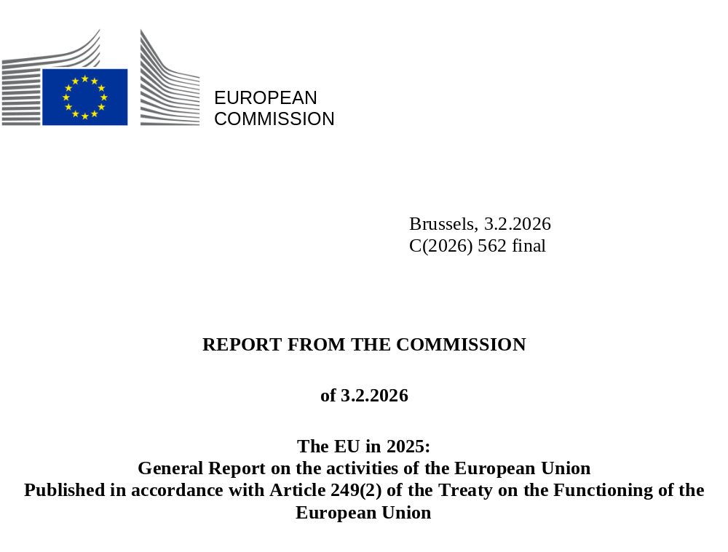

The EU in 2025

GENERAL REPORT ON THE ACTIVITIES OF THE EUROPEAN UNION

Published in accordance with Article 249(2) of the Treaty on the Functioning of the European Union

Contents

1. The EU’s support for Ukraine 3
2. A sustainable, prosperous and competitive Europe 11
3. Strengthening Europe’s defence and security 31
4. Supporting people and strengthening societies 43
5. Sustaining quality of life in Europe 59
6. Upholding European democracy and values 72
7. A global Europe for peace, partnerships and economic stability 79
8. Preparing Europe for the future 92

CH01-PH06
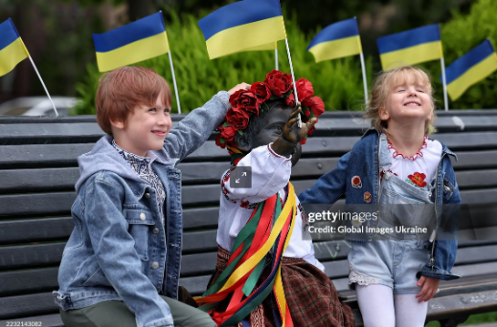
Children pose for a photo near the sculpture of Lybid dressed in a vyshyvanka in Kyiv, Ukraine, on 24 August 2025, the country’s Independence Day.

1. The EU’s support for Ukraine

Introduction
The European Union remains steadfast in its commitment to supporting Ukraine in the face of Russia’s unprovoked and unjustified war of aggression against the country and its illegal attempts to annex Ukrainian territory. Ukraine’s freedom is Europe’s freedom, which is why the EU will continue to provide, in coordination with like-minded partners and allies, comprehensive political, financial, economic, humanitarian, military and diplomatic support to Ukraine and its people.
The EU has provided unprecedented military support to Ukraine’s armed forces and has welcomed more than 4 million Ukrainians seeking refuge in the Member States. It is also engaged in supporting Ukraine’s reforms on its path towards EU membership, including advancing Ukraine’s gradual integration into the Single Market. The EU has also contributed substantial financial support to boost the country’s resilience, recovery and reconstruction. Finally, the European Commission continues to push for a just and long-lasting peace in line with international law – including the principles of the UN Charter – that preserves Ukraine’s sovereignty, independence and territorial integrity.

Supporting Ukrainians
It has been nearly four years since Russia launched its full-scale war of aggression against Ukraine. The EU remains committed to supporting Ukraine and its people for as long as it takes. This effort continued in 2025, backed by the EU’s conviction that Ukraine will soon be a peaceful, prosperous country for all its citizens, fully at home in the EU. By the end of 2025, the support provided by the EU and its Member States since the beginning of the war amounted to €193.3 billion. In 2025 alone, the EU covered 84 % of Ukraine’s external financing needs. The Commission continued to coordinate its assistance with other key supporters through the Ukraine Donor Platform. At the European Council of 18 and 19 December, EU leaders decided to mobilise an additional €90 billion in financing for 2026–2027 through common borrowing backed by the EU budget.
CH01-GR01
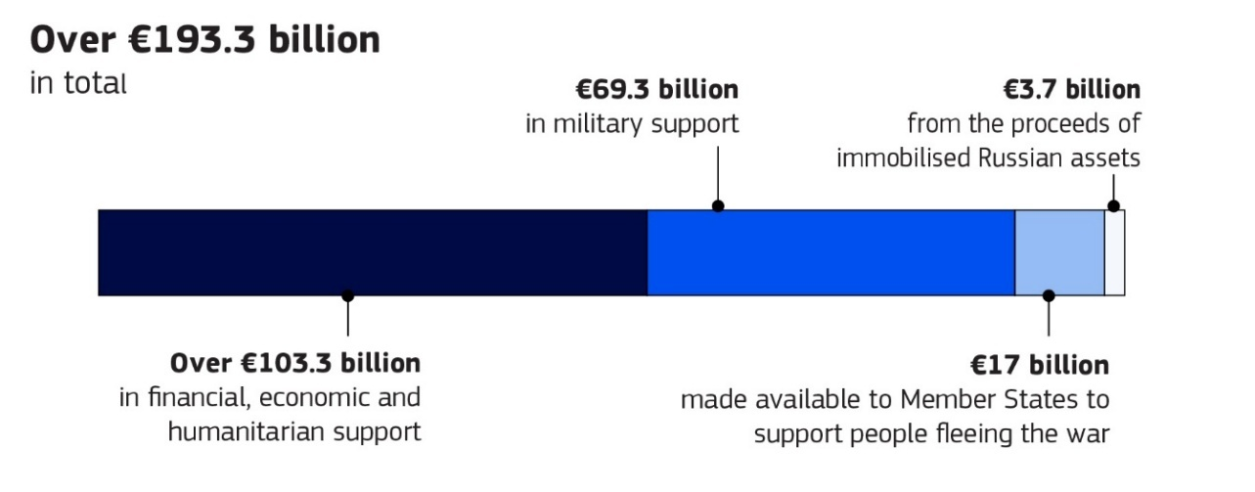
The EU continued to support vital humanitarian aid in both Ukraine and Moldova, with funding directed towards emergency assistance. This includes €40 million allocated in September to help Ukrainians endure a fourth winter of Russia’s war of aggression, assisting EU humanitarian aid partners in delivering shelter materials, repairing damaged homes and centres for displaced people and improving access to water, sanitation and heating.
Since Russia’s full-scale invasion in February 2022, the Commission has allocated over €1 billion for humanitarian aid programmes in Ukraine, including €220 million in 2025.
To provide emergency assistance to Ukrainians, the EU is coordinating its largest-ever activation of the EU Civil Protection Mechanism. So far, all 27 Member States, together with six participating countries (Iceland, Moldova, North Macedonia, Norway, Serbia and Türkiye), have offered in-kind assistance ranging from medical supplies and shelter items to vehicles and energy equipment. In total, over 156 000 tonnes of assistance have been channelled to Ukraine. Additionally, since 2022, more than 4 700 patients have been transferred for care in hospitals throughout Europe.

CH01-GR02
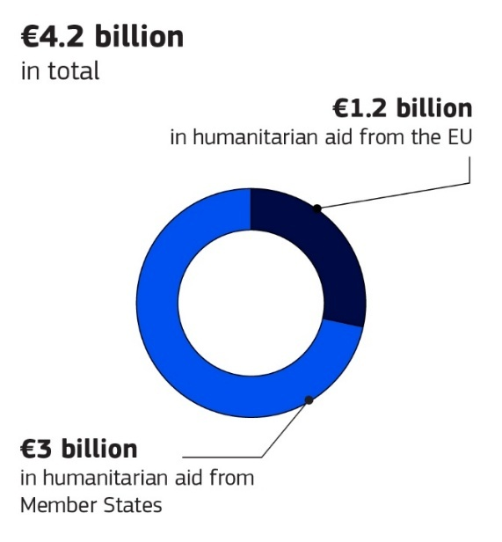
CH01-PH02
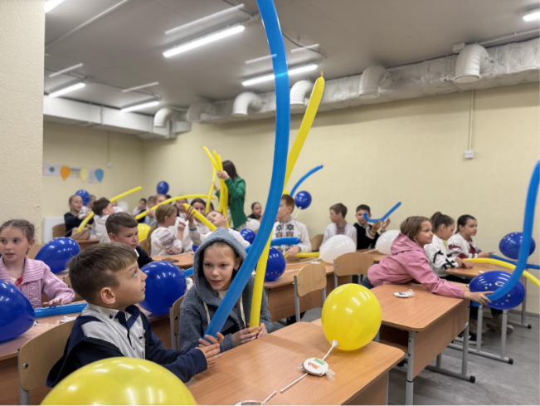
Ukrainian children playing and learning at a new EU-funded shelter in Molodizhne, Odesa oblast, Ukraine, that opened in May 2025. This modern anti-radiation facility provides space for 700 Ukrainian students to return to offline education, serving as an underground school, cultural centre, and youth hub.
CH01-PH03
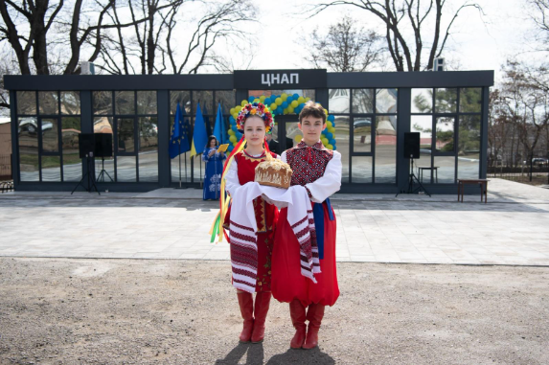
A ceremony taking place at an administrative service centre established in Bashtanka, Ukraine, in April 2025 as part of the EU4Recovery scheme, a partnership between the EU and the UN.
The EU also continues to welcome those fleeing the war. Member States agreed in 2025 to extend the current temporary protection status, which allows Ukrainians to live, work and study in the EU, until 4 March 2027. Since 2022, the Member States have welcomed more than 4 million people. In June, the Commission proposed that Member States start preparing for a transition out of the temporary protection system towards other legal status options and that they facilitate the return and reintegration of those who wish to be repatriated to Ukraine.
In July, the Commission also announced its commitment to provide Ukraine with associate membership of the Erasmus+ programme, expanding educational and mobility opportunities for Ukrainian students and teachers. In addition, Erasmus+ will support the distribution of 2 million new textbooks to Ukrainian pupils in the 2025/2026 school year.
CH01-INFO03
EU support for education, culture and civil society in Ukraine (2022–2025)
€100 million dedicated to supporting safe access to education for children in Ukraine.
Mobility of more than 52 000 Ukrainian citizens in education, training, youth and sport under Erasmus+.
€60 million for projects aimed at building the capacity of Ukrainian universities, vocational education and training institutions, and sport and youth organisations under Erasmus+.
€65 million for free, healthy school lunches for 700 000 primary school students in Ukraine.
More than 380 school buses donated.
1.5 million textbooks delivered to students.
More than €50 million provided to support Ukraine’s cultural and creative sectors, including over €11.5 million dedicated to cultural heritage.
Team Europe Initiative for Cultural Heritage in Ukraine now comprised of 75 initiatives by 24 Member States and the Commission.
More than €700 000 in mobility grants for artists and cultural professionals.
€123 million to support civil-society organisations in Ukraine.

CH01-PH04
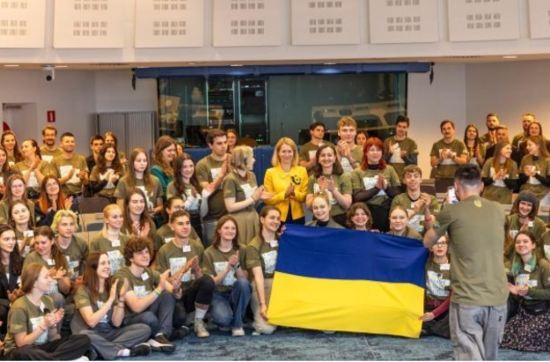
Kaja Kallas, High Representative of the Union for Foreign Affairs and Security Policy and Vice-President of the European Commission, welcoming to the Commission a delegation of students and team members from the Ukrainian Leadership Academy, Brussels, Belgium, 5 May 2025. The academy is a value-based formative platform for the personal and social development of young people.

Securing a just and lasting peace for Ukraine
Ukraine’s security is inextricably linked to that of Europe. This is why the EU’s top priority is to end Russia’s war of aggression and its illegal attempts to annex Ukrainian territory, and to ensure a fair and lasting peace. Throughout 2025, the EU took several significant steps towards this immensely challenging and complex objective, including providing continued military support and launching successive packages of sanctions that have imposed real costs on Russia’s economy.
With the new sanctions, the EU has further restricted Russia’s access to battlefield technologies, weakened its military–industrial complex and stepped up the fight against its shadow fleet. The EU has also tightened restrictions on Russia’s energy revenues and introduced a ban on imports of Russian liquefied natural gas as of 1 January 2027.
The EU and its Member States have provided around €66 billion in military support since the start of Russia’s full-scale military aggression against Ukraine, €6.4 billion of which has been channelled via the European Peace Facility. The EU has also provided €3.4 billion from the proceeds of Russian immobilised assets, while being an essential provider of training to the Ukrainian Armed Forces through the EU Military Assistance Mission in support of Ukraine, which has so far trained around 85 000 Ukrainian military personnel. All these forms of military support help strengthen Ukraine on the battlefield and at the negotiation table, safeguarding Ukrainian lives.

Holding Russia accountable
Throughout 2025, the EU continued to ensure that Russia’s leadership is held accountable for the atrocity crimes committed in and against Ukraine. In February, the Commission, the High Representative for Foreign Affairs and Security Policy, the Council of Europe and Ukraine, along with 37 other countries, laid the foundations for the establishment of the Special Tribunal for the Crime of Aggression against Ukraine. The agreement between the Council of Europe and Ukraine on the establishment of the tribunal was signed in June. The tribunal will have the power to hold to account Russia’s political and military leaders, who bear the greatest responsibility for the atrocities committed in Ukraine. In December, the Commission signed the Convention establishing the International Claims Commission for Ukraine on behalf of the EU. The signature marked a key moment in Europe’s collective efforts to ensure accountability and justice for Ukraine and the Ukrainian people, ensuring that the victims of Russia’s brutal war of aggression are properly compensated.
CH01-INFO02
200 302 incidents of alleged international crimes are under investigation by Ukraine, and the actual number of atrocities is suspected to be even higher.
More than 65 000 claims had been submitted to the Register of Damage for Ukraine, in 13 categories, by the end of 2025.
18 Member States have already opened national investigations into international crimes committed in Ukraine.
6 Member States are part of a joint investigation team supported by Eurojust – along with Ukraine, the International Criminal Court and Europol – to coordinate the collection of evidence and investigations into core international crimes committed in Ukraine.
5 Member States are participating, along with Ukraine, in the International Centre for the Prosecution of the Crime of Aggression against Ukraine, with the close involvement of the International Criminal Court.
To make sure that EU sanctions are fully implemented, EU law has been strengthened to allow Member States to confiscate assets linked to criminal offences. Thanks to the Freeze and Seize Task Force, by the end of 2025 the Member States had frozen more than €27 billion of private assets belonging to Russian and Belarusian oligarchs and their associates.

Helping Ukraine’s economy and integration
The EU has established the Ukraine Facility, a dedicated financing instrument of up to €50 billion, to provide predictable and flexible support to Ukraine for 2024–2027 to support its recovery, reconstruction and modernisation, in line with its EU path.
In February 2025, the EU offered a new support package to Ukraine to enable its full integration within the European energy market by early 2027, together with Moldova, along with further integration into the EU gas sector, provided that Ukraine significantly accelerates the necessary market reforms.
In parallel, the EU has continued to advance Ukraine’s gradual integration into the Single Market, notably through the opportunities offered by the EU–Ukraine Deep and Comprehensive Free Trade Area. As a result, Ukraine joined the Roam Like at Home area on 1 January 2026. In addition, the EU and Ukraine have renewed their road transport agreement until March 2027, enabling smoother cross-border freight transit to the benefit of both economies. The Commission has also completed the transportation of an entire thermal power plant from Lithuania to Ukraine to support the population’s energy needs – the largest single operation to date under the EU Civil Protection Mechanism.
The Solidarity Lanes, set out in May 2022, continue to ensure that Ukraine can import the goods it needs and export some agricultural and other products. While the Solidarity Lanes were essential for Ukraine’s agricultural exports until mid 2023, Ukraine has since successfully fought against Russia to secure its Black Sea corridor. The EU supports Ukraine’s Black Sea-linked trade by backing this corridor, which enables Ukrainian vessels to continue exporting. In parallel, the EU has invested in infrastructure and coordination to ensure this maritime route remains viable and secure.
CH01-GR04
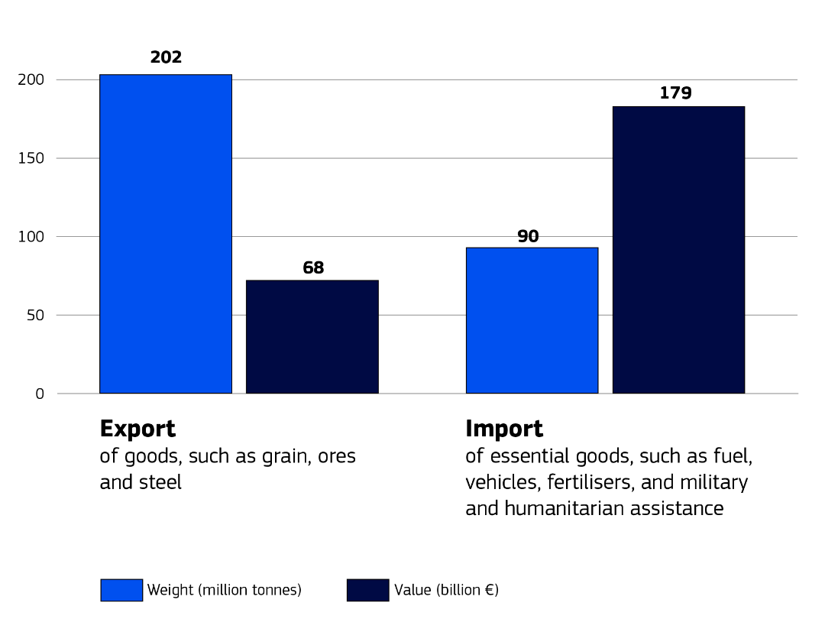
The EU continued to use export credit guarantee instruments during the year to support trade. For example, in June, the first deal under the EU’s Ukraine Export Credit Guarantee Facility was struck, providing €20 million in guarantees for EU exports to Ukraine via Denmark’s Export–Import Office.

The reconstruction of Ukraine
The EU’s ongoing commitment to Ukraine’s reconstruction in 2025 combined financial instruments, guarantees, grants and reform‐conditional support to boost the country’s resilience and economic stability and to support its long-term sustainable recovery. Central to these efforts is the 2024–2027 Ukraine Facility. The Ukraine Investment Framework, the investment arm of the Ukraine Facility, has been provided with a total of €9.5 billion in EU support and is designed to mobilise up to €40 billion in public and private investment for Ukraine’s recovery and reconstruction. So far, €6.9 billion has been allocated to fund investment programmes that directly benefit the people of Ukraine – creating new jobs, delivering electricity, heat and clean water, supporting affordable housing, building bomb shelters, rehabilitating war-damaged infrastructure and more.
A call for proposals to support small businesses, war-affected communities and recovery investments was launched in March. It aimed to expand access to financial support for micro-, small and medium-sized enterprises through banks to strengthen Ukraine’s socioeconomic cohesion. This was followed by a new call for expressions of interest that ended in October.
To improve transport connections between the EU, Ukraine and Moldova, the EU has mobilised more than €2.3 billion to date, including €1.55 billion in non-reimbursable grant support from the Connecting Europe Facility. For example, in September, Ukraine opened its first EU-standard-gauge railway line, enabling direct train travel from Ukraine to cities like Budapest in Hungary and Vienna in Austria. In July, a new €73.5 million project under the facility was selected to construct an EU-standard-gauge railway link from Poland to Sknyliv (near Lviv) in Ukraine. This will contribute to Ukraine’s further integration into the EU rail network.
Beyond direct financing, the EU is focusing on structural and institutional reforms as part of the reconstruction process. Ukraine is tasked with implementing a recovery and reform plan; upholding democratic mechanisms, the rule of law and human rights; and maintaining transparent, accountable governance.
CH01-PH05
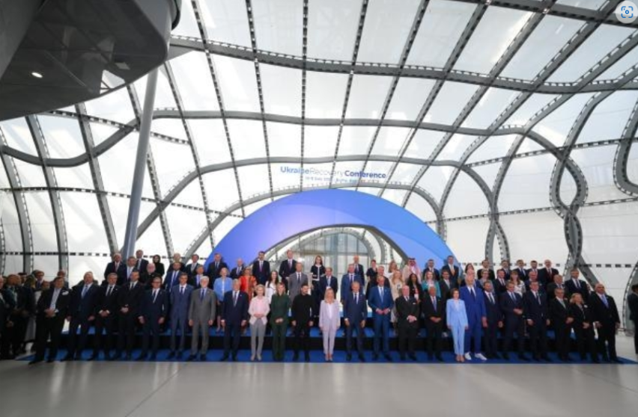
Ursula von der Leyen, President of the European Commission (first row, ninth from left), and António Costa, President of the European Council (first row, 16th from left), photographed with other leaders at the Ukraine Recovery Conference, Rome, Italy, 10 July 2025.
CH01-INFO04
Investment in Ukraine’s future
The agreements made during the Ukraine Recovery Conference aim to unlock up to €10 billion in investment to rebuild homes, reopen hospitals, revive businesses and secure energy, helping Ukraine move closer to the EU every day. These efforts reflect a vision of reconstruction that links the rebuilding of physical spaces with the strengthening of Ukraine’s capacity to integrate with European norms, values and markets.
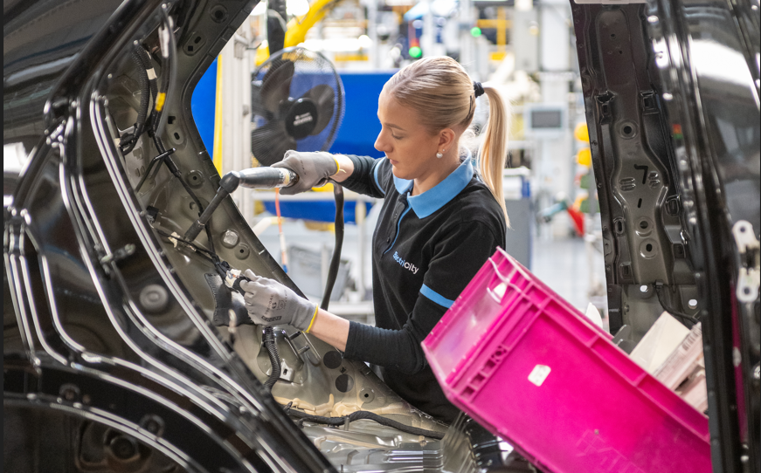
CH02-PH01
An employee working on the electric car assembly line at the Renault factory in Douai, France, 5 March 2025.

2. A sustainable, prosperous and competitive Europe

Introduction
Europe’s prosperity depends on having a competitive, sustainable and resilient economy that delivers opportunities for its people and businesses, now and in the future. In 2025, the European Union strengthened its industrial base, accelerated the clean and digital transitions and deepened the Single Market. Guided by the Competitiveness Compass and the Clean Industrial Deal, it worked to close the innovation gap, reduce dependencies, and align climate ambition and economic growth. New initiatives to cut red tape, modernise taxation and support fair competition will help businesses, especially small and medium-sized enterprises, to thrive across borders. Strategic investments in clean technologies, digital innovation and critical raw materials are driving long-term competitiveness, while the Savings and Investments Union and the European Competitiveness Fund, together with Horizon Europe, aim to channel more capital into Europe’s future industries. People remain central to a competitive Europe, and the union of skills, launched in 2025, will equip them with the skills needed for a transforming economy (see Chapter 4).

Making business easier and faster

The Competitiveness Compass
The Competitiveness Compass is the roadmap that will guide the EU’s work on competitiveness for the next five years. It is based on the Draghi and Letta reports and follows three orienting principles: closing the innovation gap; a joint plan for decarbonisation and competitiveness; and enhancing economic security by reducing excessive dependencies. These principles are supported by horizontal measures that will enable and strengthen competitiveness across the EU’s economy.
CH02-INFO01
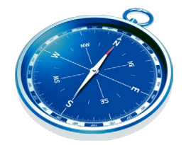 | Horizontal enablers for EU competitiveness  - Cutting red tape.  - Removing barriers within the Single Market.  - Enabling more efficient investment financing.  - Promoting skills and quality jobs.  - Ensuring better coordination of policies between the EU and the Member States.

Completing the Single Market
While the compass provides the strategic direction (innovation, decarbonisation, security) on the road towards competitiveness, completing the Single Market ensures that the path is obstacle-free. On 21 May, the European Commission proposed a Single Market Strategy to make it easier to do business in the EU. The strategy focuses on making the cross-border provision of services and the cross-border movement of goods more seamless and on ensuring that Single Market rules are enforced quickly and efficiently. The Single Market has increased the EU’s gross domestic product by at least 3–4 % and created 3.6 million jobs since its establishment. Fully integrating the Single Market would double the gains already achieved and make the EU more competitive.
In this context, the Commission published the 2024 report on competition policy. It also released the 2025 annual Single Market and competitiveness report, which tracks the EU’s progress across nine key drivers of competitiveness.
CH02-PH02
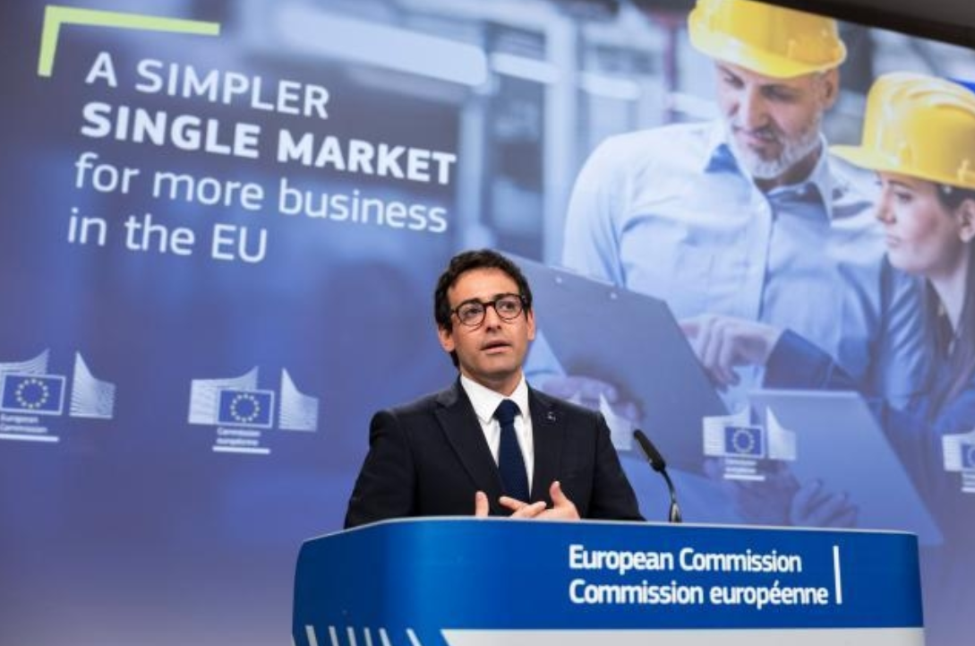
Stéphane Séjourné, Executive Vice-President of the European Commission for Prosperity and Industrial Strategy, at a press conference on the Single Market Strategy and the fourth Omnibus proposal on small mid-caps, Brussels, Belgium, 21 May 2025.

CH02-INFO02
Main measures under the Single Market Strategy
- Dismantling the 10 most harmful barriers, known as the ‘terrible 10’, that are disrupting the smooth flow of goods and services in the Single Market.
- Addressing the challenges faced by specific service sectors when operating across borders.
- Making it easier for small and medium-sized enterprises (SMEs) to operate in the Single Market.
- Simplifying the business environment through digitalisation.
- Strengthening Member State cooperation in enforcing Single Market rules.
CH02-INFO05
CH02-PH03
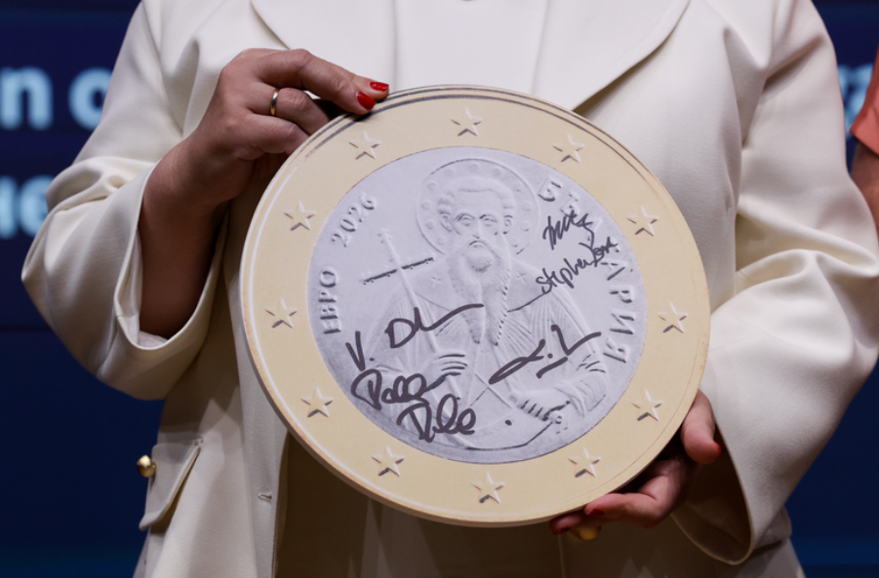
A model of the Bulgarian €1 coin signed by Valdis Dombrovskis, European Commissioner for Economy and Productivity and for Implementation and Simplification, Luis de Guindos Jurado, Vice-President of the European Central Bank, Temenuzhka Petkova, Bulgarian Minister for Finance, Stephanie Lose, Danish Minister for Economic Affairs, and Paschal Donohoe, Irish Minister for Finance, who were present at the official ceremony for Bulgaria joining the euro area, Brussels, Belgium, 8 July 2025.
In July, Bulgaria’s adoption of the euro as of 1 January 2026 was approved, making it the euro area’s 21st Member State.

Modernising and simplifying customs procedures for e-commerce goods
In November, Member States reached an agreement to abolish the €150 customs duty relief threshold, transforming the way e-commerce goods are handled and aiming to level the playing field between e-commerce and traditional retail. This marks the first achievement of the 2023 customs reform proposal, which seeks to address the e-commerce challenges arising from the increase in low-value goods arriving directly with EU consumers from non-EU countries.

Modernising VAT rules for the digital age
In May, the Council agreed on a new plan for value added tax (VAT) rules. The changes focus on e-commerce imports and the taxation of goods sold from outside the EU. The goal is to incentivise the use of the VAT One-Stop Shop, which simplifies VAT declaration and collection, reduces paperwork for EU businesses and supports efforts to combat VAT fraud.
The landmark VAT in the Digital Age package was adopted in March, marking a significant step forward in digitalising and modernising the EU’s VAT system. It will make the system more business-friendly, tougher on fraud and better equipped to address the challenges of the growing platform economy.

Reducing administrative burdens
Creating a favourable business environment also means easing administrative requirements, especially for SMEs. Instead of 27 different national laws, the EU wants to create a single, optional EU-wide company law, known as the 28th regime, to make it easier and faster for businesses to set up and operate anywhere in the EU, using digital tools and streamlined procedures. Its aim is to simplify cross-border business and make it easier for companies to attract investment.
The EU is also supporting SMEs in managing the complexities associated with sanctions. The EU has more than 40 sanctions regimes in place to prevent conflict or respond to crises. In March, the Commission launched the EU Sanctions Helpdesk, a one-stop shop offering resources, events and a Compliance Support Service. The helpdesk helps SMEs understand and comply with sanctions, providing guidance to those that find it challenging to carry out due diligence independently.
The proposed European Business Wallets are digital tools that will make it easier for companies of all sizes to interact and communicate securely with public authorities and other businesses anywhere in the EU. Companies and public authorities will be able to identify, authenticate and exchange data with full legal effect throughout the EU. The Business Wallets build on the European Digital Identity Framework and form part of the broader simplification agenda.
To reduce tax complexity, the Council adopted an amendment to the Directive on Administrative Cooperation in Taxation (DAC9). It allows multinational enterprise groups to file a single top-up tax return for the whole group, rather than multiple filings in every jurisdiction. Tax authorities will also benefit from a standardised system for information exchange.
Through its Technical Support Instrument, the EU will support 109 reforms to help Member States improve business conditions, close the innovation gap, build a net-zero economy and bolster the EU’s economic security. Among them, 38 reforms will specifically ease burdens on SMEs and support start-ups and scale-ups.
Finally, the EU is also reviewing its own rules to remove administrative barriers in the Single Market (see the section ‘Simplifying EU rules’ in Chapter 8).

Competition policy
The EU safeguards long-term competitiveness and a thriving Single Market by ensuring the consistent enforcement of rules that promote fair competition among businesses across all Member States. Through the enforcement of its competition-policy instruments (antitrust, merger control and State aid), the Commission maintains a level playing field within the Single Market, encouraging companies to invest, innovate and grow, and to offer consumers goods and services on the most favourable terms.
The Commission is in the process of revising the EU merger guidelines, addressing, in particular, innovation, resilience, investment, sustainability and efficiency. It will take into account broader trends relevant to the productivity and competitiveness of the EU economy as a whole.
CH02-INFO06
Ensuring fair competition
370 merger decisions were taken in 2025. | 350 State aid decisions were taken in 2025. | €3.97 billion in fines were imposed on companies breaching EU competition law.

In addition, the Commission is carrying out a review of the implementation of the Foreign Subsidies Regulation on tackling market distortions from foreign subsidies. A report on this subject should be ready by July 2026; in the meantime, enforcement continues. For example, in November, the Commission approved the acquisition of Covestro by Abu Dhabi National Oil Company after an in-depth investigation, subject to binding commitments offered by the two parties.
CH02-ANI01

Animation: How does EU competition policy improve everyday life?

Building a new Clean Industrial Deal

Driving clean and competitive industry forward
Facing the triple planetary crisis of climate change, biodiversity loss and pollution (see Chapter 5), and with 2024 being the warmest year on record according to the EU State of the Climate Report 2024, the EU remains committed to turning its response to these challenges into opportunities for sustainable growth and global leadership in the clean transition. The Clean Industrial Deal is central to this effort, aligning climate policy with competitiveness and strategic independence. It will accelerate industrial decarbonisation and help ensure that the objective of climate neutrality by 2050, as set out in the European Climate Law, is achieved.
CH02-INFO08
The EU continues to make measurable progress on climate action. According to the Climate Action Progress Report 2025, total EU net greenhouse gas emissions fell by 2.5 % in 2024 compared to 2023. Emissions now stand at over 37 % below 1990 levels, or 39 % for domestic emissions alone, while the EU economy is 71 % larger than in 1990. The continued decoupling of emissions from economic growth confirms that effective climate action can be achieved alongside sustained economic prosperity.
Environmental degradation and climate change also pose threats to peace, stability and security. In 2025, the EU’s progress report on the implementation of the joint communication on climate and security explores this nexus, highlighting how these issues now feature prominently in the EU’s exchanges with partner countries and international organisations, and how this strengthened focus is driving concrete initiatives.
In June, the Commission adopted the Clean Industrial Deal State Aid Framework. It enables Member States to support clean energy, industrial decarbonisation and clean-tech manufacturing under simplified conditions, and provides targeted support for electricity costs to energy-intensive users. Additionally, in October, the EU global climate and energy vision was presented to strengthen the EU’s position in global markets. By deepening existing partnerships and building new, mutually beneficial ones with international partners, the strategy adds an external dimension to the Clean Industrial Deal and aims to drive a global clean and resilient transition.

CH02-INFO09
Main strands of action to address industry challenges
- Making energy more affordable (see the section ‘Clean and affordable energy’ below).
- Facilitating supply and stimulating market demand for clean products and materials.
- Mobilising financial resources to invest in decarbonisation and competitiveness.
- Securing access to raw materials by advancing the EU’s circular economy.
- Establishing international partnerships to access global markets (see Chapter 7).
- Building a workforce fit for a decarbonised industry, providing quality jobs and ensuring a just transition (see Chapter 4).
CH02-PH04
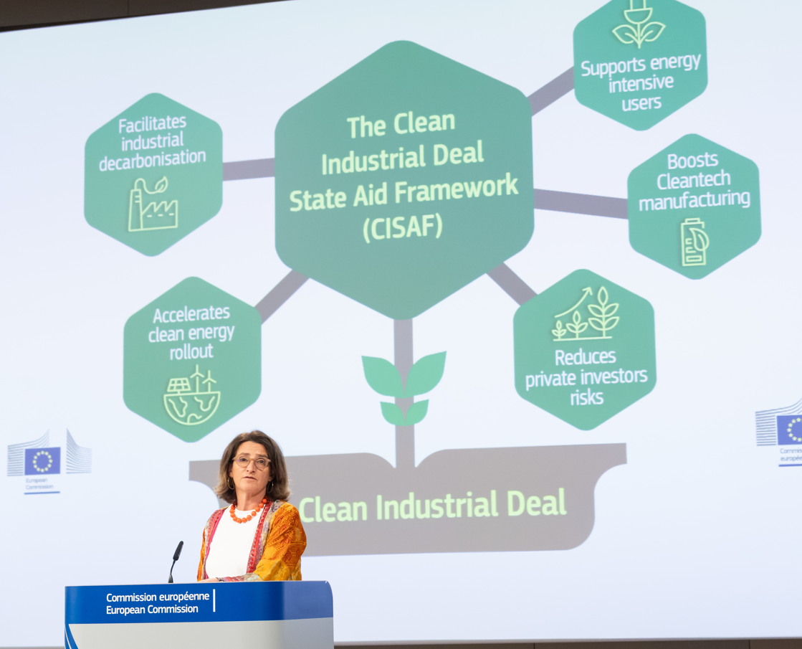
Teresa Ribera, Executive Vice-President of the European Commission for a Clean, Just and Competitive Transition, gives a press conference on the Clean Industrial Deal State Aid Framework, Brussels, Belgium, 25 June 2025.
CH02-INFO10
2025 initiatives to drive the clean transition
- The Important Projects of Common European Interest Design Support Hub was established to help Member States accelerate the design of new innovative projects.
- A political agreement was reached on the amendment of the European Climate Law, which aims to reduce the EU’s net greenhouse gas emissions by 90 % by 2040 (compared to 1990 levels), reinforcing the importance of implementing the Clean Industrial Deal. It will provide investors with long-term certainty, foster innovation, strengthen the industrial leadership of EU businesses and enhance the EU’s energy security.
- The assessment of the national energy and climate plans confirmed that, provided Member States implement both the measures already agreed at the EU level and those set out in the plans, the EU remains on track to collectively achieve the 2030 target of a 55 % reduction in greenhouse gas emissions and a renewable energy share of at least 42.5 %.
- The 30th UN Climate Change Conference (COP30) took place from 10 to 21 November in Belém, Brazil. The EU worked with partners to secure the Global Mutirão agreement, which reaffirms the need to limit the global temperature increase to 1.5 °C and to move away from fossil fuels. The agreement launches a Global Implementation Accelerator and the Belém Mission to 1.5 initiative, to encourage stronger climate commitments and help countries put their climate plans into practice.
- A political agreement was reached by the Parliament and the Council to strengthen and simplify the Carbon Border Adjustment Mechanism. The revision exempts 90 % of importers from reporting obligations, representing less than 1 % of the emissions embedded in imported goods, thus minimising administrative burdens while preserving the EU’s climate goals.
- €2.9 billion in funding was announced for 61 cutting-edge net-zero technology projects and €643 million for five electric vehicle battery cell manufacturing projects through the Innovation Fund, using revenues from the EU Emissions Trading System.
- The Commission adopted the RESourceEU Action Plan to support the EU’s efforts to secure critical raw materials, such as rare earth minerals, cobalt and lithium. (See Chapter 7 for information on the critical raw materials partnerships concluded with global partners in 2025.)
CH02-PH05
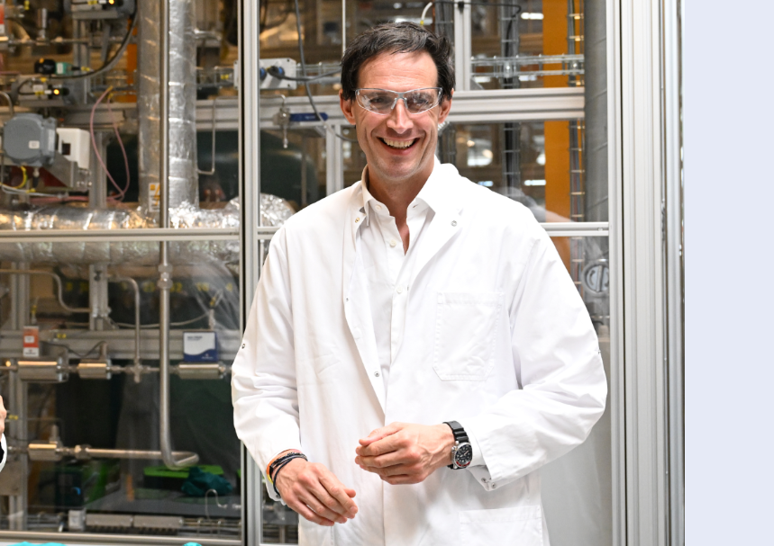
Wopke Hoekstra, European Commissioner for Climate, Net Zero and Clean Growth during a visit to a facility that produces solid oxide electrolysis cells for green hydrogen and e-fuels, Kongens Lyngby, Denmark, 7 May 2025.
CH02-INFO11
Initiatives targeted at industries facing unique challenges
- European Steel and Metals Action Plan. This is a roadmap towards reducing energy costs, strengthening trade protection, preventing carbon leakage, boosting circularity, mobilising investment and safeguarding jobs. As part of the plan, the Commission presented a proposal to protect the EU steel industry from the unfair impacts of global overcapacity.
- Industrial Action Plan for the European Automotive Sector. This plan will support the transition to clean, connected and automated vehicles and help unlock the sector’s innovative potential. A flexibility measure has been proposed to help manufacturers meet the 2025 carbon dioxide emission targets for new cars and vans. The action plan includes the launch of a battery booster investment package, making €1.8 billion available to help EU battery manufacturers scale up and increase their production capacity. The Commission has also presented an automotive package, including a proposal for the revision of the carbon dioxide standards for cars and vans, a proposal on clean corporate fleets, a Battery Booster strategy and an Automotive Omnibus proposal.
- Chemicals Industry Action Plan. This plan outlines measures to help lower energy and feedstock costs, support clean and circular technologies, create a Critical Chemicals Alliance, simplify regulatory requirements and address harmful substances such as PFAS (‘forever chemicals’).

CH02-PH06; CH02-PH07
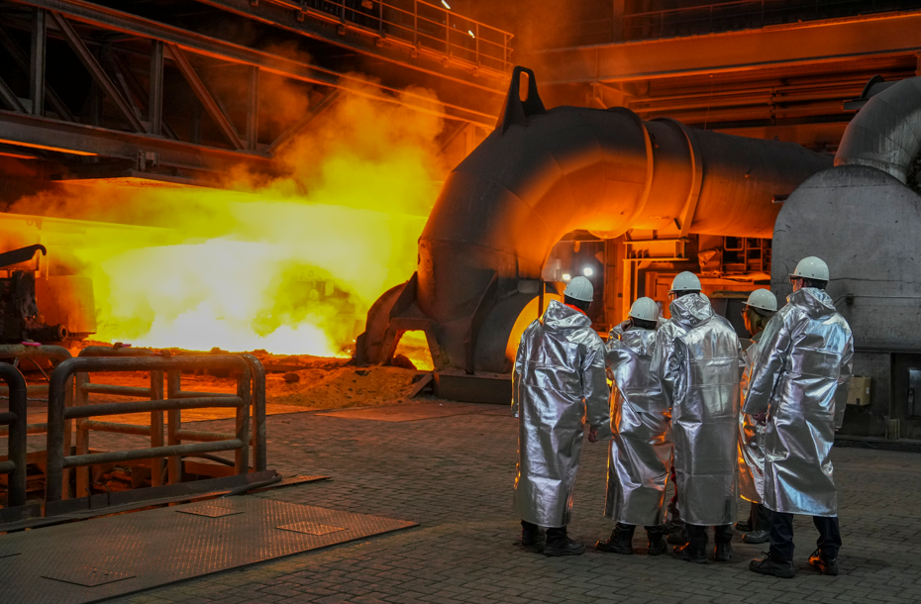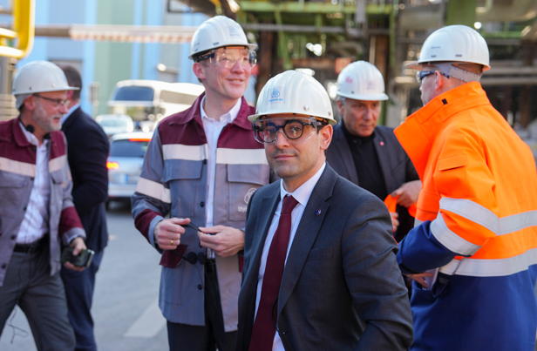
Stéphane Séjourné, Executive Vice-President of the European Commission for Prosperity and Industrial Strategy (third from right), visits thyssenkrupp Steel and presents the European Steel Action Plan at a press conference, Duisburg, Germany, 20 March 2025.

Clean and affordable energy
To deliver on the Clean Industrial Deal, the EU needs affordable energy. In February, the Commission presented an Action Plan for Affordable Energy, introducing short-term measures to reduce energy costs by frontloading the benefits of renewable energy, energy savings, deeper market integration and better energy interconnections. The plan aims to provide relief to households facing high energy bills and to industries struggling with high production costs. Overall savings are projected at €45 billion in 2025, rising to €130 billion annually by 2030 and €260 billion by 2040.
The EU’s REPowerEU plan, launched in 2022, has already made substantial progress in ensuring that citizens and businesses have access to energy that is affordable, secure and sustainable. To end dependence on Russian fossil fuels and strengthen the EU’s strategic autonomy, the Commission published the REPowerEU Roadmap in May, followed by a legislative proposal in June to phase out Russian gas and oil imports by the end of 2027. The Parliament and the Council reached a provisional political agreement on the initiative in December.
CH02-GR01
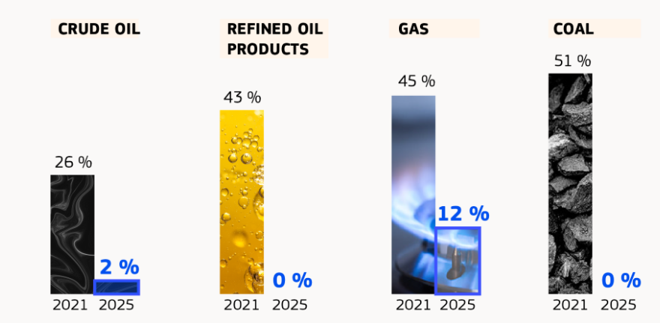
To further strengthen the EU’s energy security, the Commission is working on a revision of the EU’s energy security framework. In December, it also proposed to modernise and expand the EU’s grid infrastructure through the European Grids Package and the Energy Highways initiative.

CH02-INFO12
On 9 February, Estonia, Latvia and Lithuania synchronised their electricity grids with the Continental Europe Network, in cooperation with Poland. The EU supported this strategic European project with funding of more than €1.3 billion, representing 75 % of investment costs. It marks the full integration of the Baltic states into the EU energy market. The move ends dependence on Belarusian and Russian systems and strengthens regional and EU energy resilience.
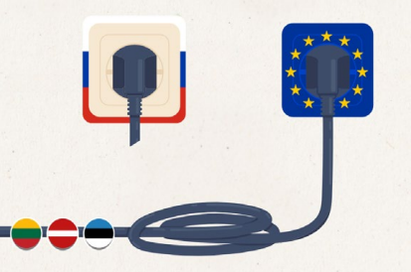
In July, the Commission and the European Investment Bank disbursed €3.66 billion from the Modernisation Fund to support 34 clean energy projects, some of which focus on energy efficiency. In September, they launched the Energy Efficiency in Small and Medium-sized Enterprises initiative, a €17.5 billion financing programme expected to help more than 350 000 companies reduce their energy consumption.
Progress on renewable energy continued in the EU, with renewables accounting for 47 % of electricity generation in 2024. In 2025, a common EU methodology for calculating life-cycle emissions from low-carbon fuels was provided. Nearly €1 billion from the Innovation Fund, financed through revenues from the EU Emissions Trading System, was awarded to 15 renewable hydrogen projects. These projects are expected to produce almost 2.2 million tonnes of renewable hydrogen over 10 years, preventing 15 million tonnes of carbon dioxide emissions.
Member States retain the right to choose their energy mix, and for some, nuclear energy remains vital for decarbonisation, industrial competitiveness and energy security. In May, the Joint Research Centre launched a digital modelling hub to support innovation in areas such as small modular reactors and energy planning. The Commission also published an updated Nuclear Illustrative Programme communication, providing an overview of nuclear development trends and investment needs across the EU, along with guidance on nuclear safety, waste management, skills and international cooperation.
CH02-PH08
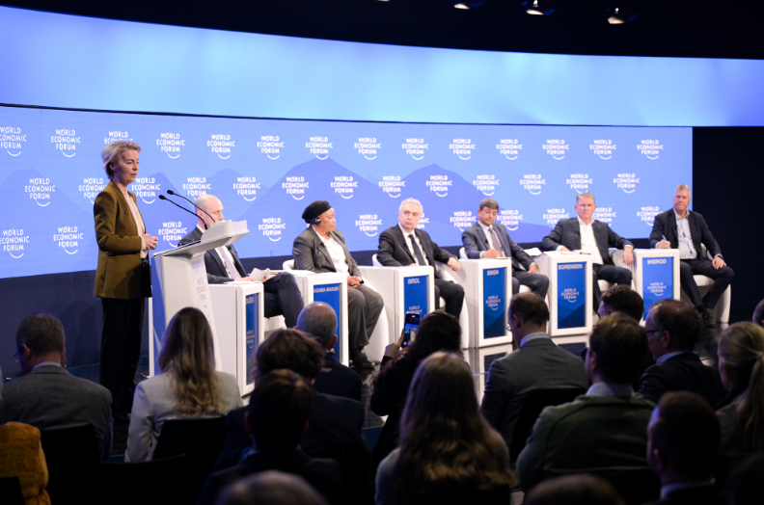
Ursula von der Leyen, President of the European Commission (left) and international partners launch the Global Energy Transition Forum at the World Economic Forum in Davos, Switzerland, 23 January 2025. The forum will unite global partners to advance climate goals and support countries facing greater transition challenges.

Working towards a more circular and resilient economy
The circular economy is key to boosting the EU’s economic security, resilience, competitiveness and decarbonisation. To accelerate its transition towards circularity, the EU announced that it would propose a circular economy act in 2026, building on the second Circular Economy Action Plan. The aim is to establish a single market for secondary raw materials, increase the supply of high-quality recycled materials and stimulate demand for these materials in the EU.
CH02-PH09  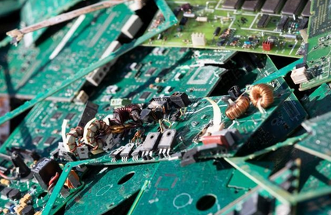 | CH02-INFO13  In 2024, the EU’s circularity rate reached 12.2 %. The goal is to double this rate to 24 % by 2030.
The Commission also adopted the 2025–2030 working plan for the Ecodesign for Sustainable Products Regulation and the Energy Labelling Regulation. The plan sets out a list of products to be prioritised for the introduction of ecodesign requirements and energy labelling over the next five years to make them sustainable, repairable, circular and energy-efficient. In addition, revised rules on the energy consumption of electrical appliances in standby, off mode and networked standby started to apply on 9 May.
CH02-INFO14
Other efforts to further advance the EU’s circular economy
- The targeted revision of the Waste Framework Directive entered into force on 16 October. It introduces new measures, including mandatory extended producer responsibility requirements, to improve the circularity of textiles and cut food waste.
- The proposed end-of-life vehicles regulation will stimulate circularity in the automotive industry and improve the availability of secondary materials and affordable used spare parts.
- An assessment of the EU Ship Recycling Regulation showed that it has largely achieved its objectives and has contributed to higher environmental and social standards in ship recycling practices.
- Rules were adopted to enable economic operators to use fully digital systems for shipping waste across the Single Market, simplify intra-EU waste shipments, ensure recycling at the most suitable facilities and reduce administrative burdens and costs.
- A proposed package of measures will strengthen the EU’s plastic recycling and accelerate the transition to a circular economy.
CH02-PH10
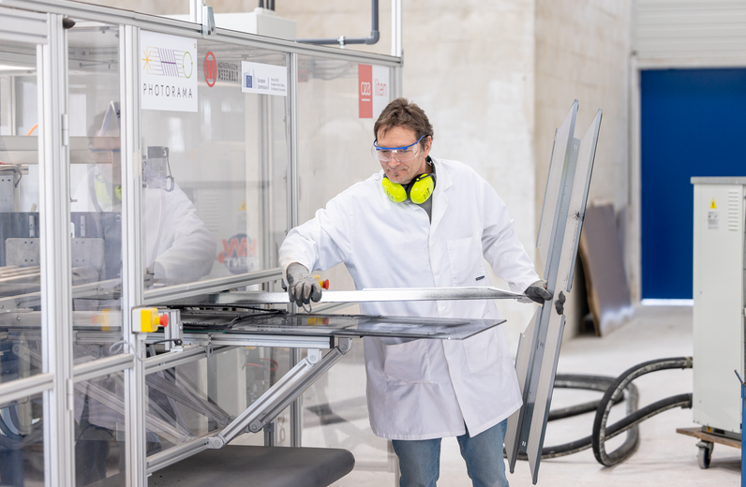
An evaluation of the Waste Electrical and Electronic Equipment Directive highlighted gaps in e-waste collection, critical raw material recovery and extended producer responsibility schemes.
The EU-funded Photorama innovation project aims to improve circularity by recovering raw materials such as glass, aluminium, copper, silver, indium and silicon from old solar panels. Tangermünde, Germany, 15 April 2025.

Sustainable transport
To stay competitive, the EU needs a sustainable, well-connected transport network that strengthens regional integration and mobility. In 2025, the Commission selected 94 transport projects to receive nearly €2.8 billion in EU grants under the Connecting Europe Facility for the modernisation of railways, inland waterways and maritime routes across the Trans-European Transport Network. It also selected more than 100 projects that will receive about €1 billion in Alternative Fuels Infrastructure Facility grants to support the deployment of renewable and low-carbon fuel infrastructure in ports and airports and along key road sections.
In addition, the Sustainable Transport Investment Plan provides a strategic framework to accelerate the decarbonisation of EU transport by boosting investment in renewable and low-carbon fuels for the aviation and waterborne transport sectors. The measures presented under the plan are expected to mobilise at least €2.9 billion by the end of 2027. As a key initiative under the plan, a coalition of first-mover Member States was launched to support the production and uptake of synthetic aviation fuels. This group intends to organise double-sided auctions – offering long-term revenue certainty for producers and competitive short-term contracts for fuel buyers – with the first auction planned for 2026.
The Commission also presented an ambitious plan to accelerate the development of high-speed rail and significantly shorten train travel times across the EU.
CH02-GR05
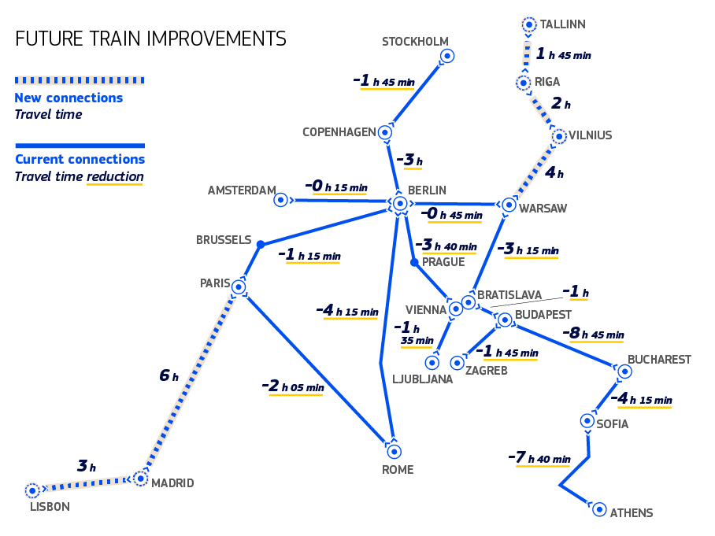
Another major milestone was reached with the breakthrough of the Brenner Base Tunnel, a 56 km rail link between Austria and Italy on the Trans-European Transport Network’s Scandinavian–Mediterranean Corridor. The EU has provided more than €2.3 billion in funding for the tunnel and its access routes through the Connecting Europe Facility. The European Investment Bank has also signed a financing agreement worth €875 million, backed by InvestEU, for Portugal’s Lisbon–Porto high-speed rail line.
CH02-PH11
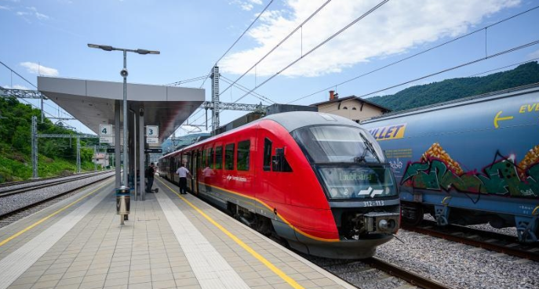
Co-financed by NextGenerationEU through the Recovery and Resilience Facility and the Connecting Europe Facility, the upgrading of Slovenia’s Ljubljana–Brezovica–Borovnica railway line enhanced connectivity along the Mediterranean and Baltic–Adriatic Trans-European Transport Network corridors, removed bottlenecks and improved interoperability upon its completion in 2025. Borovnica, Slovenia, 3 June 2025.
In 2025, the implementation of the 2023 greening freight package advanced steadily. A political agreement was reached on the regulation governing the use of railway infrastructure capacity and on the CountEmissionsEU regulation. These measures will make freight transport more efficient and sustainable by providing stronger incentives for low-emission lorries, improving rail infrastructure management and enhancing the availability of information on transport-related greenhouse gas emissions.
To encourage sustainable road transport, the Commission proposed exempting zero-emission heavy-duty vehicles from road tolls until June 2031 and issued a communication and a legislative proposal to help accelerate the uptake of zero- and low-emission vehicles in corporate fleets, which account for around 60 % of all car registrations in the EU. In addition, the Clean Transport Corridor Initiative, endorsed by nine Member States, aims to speed up the deployment of recharging infrastructure for heavy-duty vehicles along key road freight corridors. To improve air quality and road safety across the EU, the Commission also proposed a comprehensive overhaul of EU road-safety and vehicle-registration rules.
The automotive industry’s clean and digital transition is further supported by research and innovation. Three partnerships, 2Zero, CCAM and BATT4EU, have signed a memorandum of understanding to collaborate on a shared research and innovation agenda under Horizon Europe (see the section ‘Supporting research and innovation’ below). The Horizon Europe Research and Innovation work programme is also pooling €1 billion between 2025 and 2027 to support initiatives in fields such as autonomous driving, next-generation lithium-based batteries and heavy-duty electric vehicle fleets.
CH02-PH12
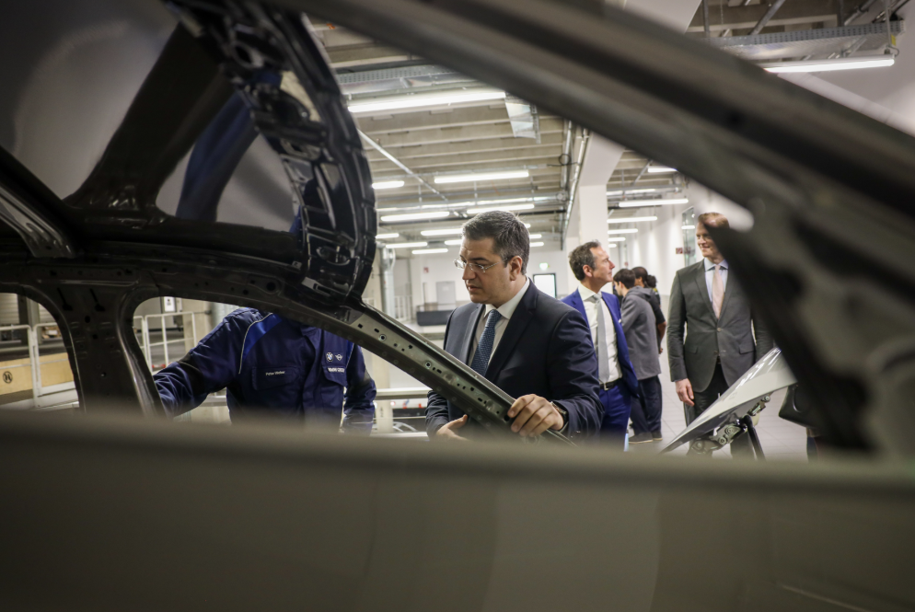
Apostolos Tzitzikostas, European Commissioner for Sustainable Transport and Tourism (left), visiting the BMW headquarters in Munich, Germany, 3 April 2025.
The Commission began work during the year on an EU Ports Strategy and an EU Industrial Maritime Strategy, to enhance the competitiveness, sustainability and resilience of the EU waterborne system, linking ports, the shipping sector and industry. New informal guidance on joint purchasing and standards for electric container-handling equipment in ports aims to accelerate the shift from diesel to electric machinery and cut emissions.
Finally, to keep the transport sector competitive and address labour shortages, several initiatives to make transport careers more attractive were launched. These include the recommendations to attract women to and retain them in the transport sector, the Women in Transport platform, activities by the network of ambassadors for diversity in transport and a conference on making transport professions more attractive to young people.

Boosting productivity through digital technology

Investing in frontier technologies
The EU’s long-term competitiveness depends on leadership in critical technologies such as supercomputing, artificial intelligence (AI) and quantum computing. To strengthen this leadership, the Commission will allocate €1.3 billion under the Digital Europe Programme to deploy technologies vital to the EU’s future and its technological sovereignty.
The state of the Digital Decade 2025 report reviewed progress towards the EU’s 2030 digital goals. While there were advances in areas such as basic 5G coverage and edge deployment, the report highlighted continued gaps in foundational technologies, digital skills and the protection of vulnerable groups, underlining the need for greater public and private investment.
In September, the Commission presented a European Strategy on Research and Technology Infrastructures to strengthen the EU’s research and technology capacity, covering everything from advanced laboratories, large scientific instruments and data centres to pilot lines, testbeds and clean rooms. This infrastructure is essential to the EU’s scientific excellence, competitiveness and technological sovereignty.
In April, the AI Continent Action Plan was published, setting out plans to develop AI gigafactories equipped with more than 100 000 advanced processors. In total, 77 expressions of interest have been received to establish such facilities across 60 sites in 16 Member States. As part of the action plan, the EU launched InvestAI, a new initiative expected to mobilise up to €200 billion in public and private investment for AI infrastructure. Two strategies were launched to speed up AI uptake in European industry and science, namely the Apply AI Strategy and the European Strategy for Artificial Intelligence in Science.
CH02-INFO15
The first AI in Science Summit, held in November, marked the launch of the Resource for AI Science in Europe, a virtual institute that will support researchers with funding, computing capacity, data, and talent and skills building.
2025 also saw the entry into application of the first rules of the AI Act and the EU rules on general-purpose AI models (see also Chapter 6). It marked major advances in the European supercomputer network, with JUPITER becoming Europe’s first exascale supercomputer. Six new AI factories were launched during the year, joining the 13 that were already in place. Thirteen countries were also selected to establish AI factory antennas, meant to complement existing AI factories. The AI factory hosting countries are Bulgaria, Czechia, Germany, Greece, Spain, France, Italy, Lithuania, Luxembourg, the Netherlands, Austria, Poland, Romania, Slovenia, Finland and Sweden .Denmark, Estonia, Norway, Portugal and Türkiye are AI factory partner countries. This was done while taking into consideration the negative impacts that growing AI use and the expansion of data-centre infrastructure have on the demand for energy and water.

CH02-GR04
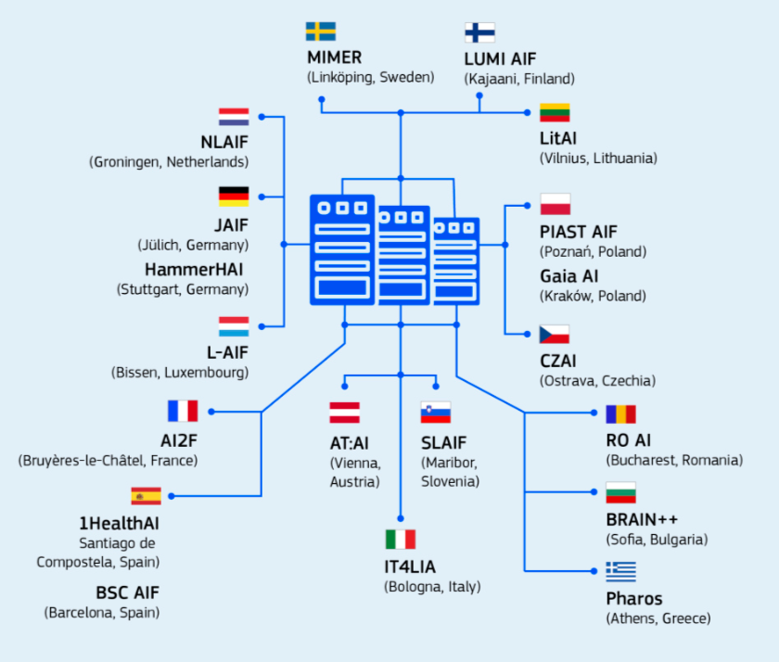
Alongside AI, quantum technologies are set to transform how we tackle complex challenges, from advancing medicine to protecting critical infrastructure. In July, the Commission presented the Quantum Europe Strategy, aiming to make Europe a global leader in this field by 2030 through increased research, stronger ecosystems, greater private investment and the development of quantum skills across the continent.
CH02-PH13
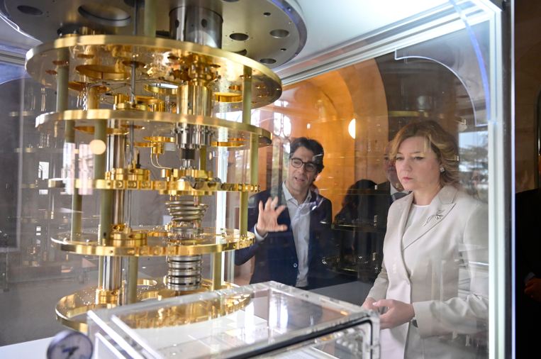
Henna Virkkunen, Executive Vice-President of the European Commission for Technological Sovereignty, Security and Democracy (right), during a visit to the Barcelona Supercomputing Center in Barcelona, Spain, 3 March 2025.
In 2025, the EU also continued implementing the European chips act. Chip manufacturing capacity expanded further, including through the launch of pilot lines under the Chips for Europe Initiative.
The space economy – covering all economic activities enabled by space technologies and data, from satellite infrastructure to the services that rely on it – is another area in which the EU aims to establish itself as a global leader. The Commission’s Vision for the European Space Economy initiative will support this goal, while the EU space act will harmonise space-related regulation across the Member States (see Chapter 3).

CH02-INFO16
Empowering users and businesses through the data union
In 2025, alongside the ongoing roll-out of common European data spaces, the EU Data Act entered into application. This gives users greater control over data from connected devices and creates new opportunities for businesses to develop services. A Data Union Strategy was also launched to unlock data for AI, ensuring that the businesses in the EU have access to high-quality data to help them compete globally and drive innovation.
Under the Digital Services Act, researchers who meet a set of specific conditions will be granted access to internal data from providers of very large online platforms and very large online search engines. A delegated act sets out the technical conditions and procedures needed to enable secure access for vetted research. In addition, the online DSA Data Access Portal supports the data-access management process and facilitates information exchange.

Ensuring, safe, fair and open digital markets
The EU continued to strengthen its digital framework through the implementation of the Digital Services Act and the Digital Markets Act. Together, these laws ensure a safer online environment for users and a level playing field for businesses, reinforcing transparency, accountability and fair and open markets across the EU’s digital landscape. For more detail on how the EU is making online spaces safer, including by protecting minors through the Digital Services Act, see Chapter 6.
CH02-INFO17
How did the EU enforce the Digital Markets Act and the Digital Services Act in 2025?
Digital Markets Act
New investigations:
- investigation into Alphabet for potentially demoting media publishers’ content in Google search;
- market investigation into Amazon Web Services and Microsoft Azure as possible important gateways.
Ongoing investigations:
- non-compliance decisions against Apple and Meta;
- one closing decision against Apple;
- specification decisions issuing formal guidance to Apple;
- two sets of preliminary findings on self-preferencing and steering for Alphabet;
- one set of preliminary findings on Apple’s business model.
Throughout 2025, the Commission held regulatory dialogues with the large tech companies designated as gatekeepers to encourage early compliance with the requirements of the Digital Markets Act. When necessary, it also undertook enforcement action. On 23 April, the Commission adopted its first non-compliance decisions, fining Apple €500 million for breaching the act’s anti-steering rules and Meta €200 million for failing to offer users a less data-intensive alternative to personalised advertising.
Digital Services Act
Ongoing investigations:
- Meta: preliminary findings on a lack of transparency and failure to provide adequate tools to report content and appeal content moderation decisions;
- TikTok: preliminary findings on a lack of transparency – the Commission also accepted and made binding a series of commitments by the platform to address shortcomings in its advertisement repository;
- Temu: preliminary findings on illegal products on its marketplace;
- AliExpress: preliminary findings on a lack of compliance – the Commission also accepted and made binding a series of commitments by the platform to safeguard its users and enhance transparency;
- X: a non-compliance decision and a fine for a lack of transparency.

Supporting research and innovation
Research, innovation, science and technology need to be at the centre of the EU’s economy to drive competitiveness. In 2025, Horizon Europe funding continued to support researchers and innovators, notably including start-ups in sectors such as quantum, biotech and clean technology. The Horizon Europe work programmes for 2025 and for 2026–2027 earmarked more than €7 billion and €14 billion respectively to support research and innovation.
CH02-INFO18
For every €1 invested in Horizon Europe, the EU economy gains up to €11.
CH02-INFO19
Key research funding under Horizon Europe
- The European Research Council is a programme that supports the identification and scaling-up of breakthrough technologies and innovations. In 2025, it allocated over €1.4 billion to identify, develop and scale up research-based breakthrough technologies and disruptive innovations.
- More than €1.25 billion in funding was announced to support research through the career development, training and mobility of researchers under the Marie Skłodowska-Curie Actions. This includes €22.5 million for the new Choose Europe for Science pilot project.
- Three new European partnerships on advanced materials, textiles and photovoltaics were launched to advance the EU’s technological leadership and sustainability goals.
- New European co-funded partnerships were launched, such as Agriculture of Data, which will accelerate the digital transformation of European agriculture.
Besides support through funding, the EU is also creating a better research and innovation environment through the European Research Area Policy Agenda for 2025–2027. The newly launched European Strategy on Research and Technology Infrastructures will facilitate the pooling of resources, help to avoid duplication and strengthen accessibility and collaboration across borders for such infrastructures (see also the section ‘Investing in frontier technologies’ above).

Choose Europe
CH02-PH15
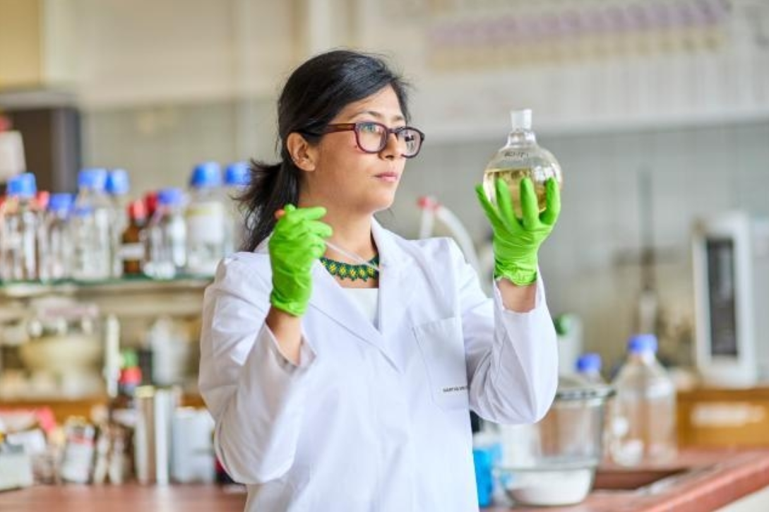
Dr Martha C. Mayorquín-Torres, a Mexican scientist researching renewable resources for sustainable pharmaceutical production. Currently a researcher at Ghent University, she is working on a project funded by Horizon Europe under the Choose Europe initiative. Ghent, Belgium, 23 May 2025.
The EU is working towards becoming the world’s most attractive destination for researchers and innovators. The Choose Europe initiative, a €500 million package of measures put forward in May, aims to attract and retain top scientific talent from around the world by offering robust and stable funding, greater research freedom and attractive living conditions. Additional measures were announced in the following months, bringing the total amount to €874 million. The initiative is proving very attractive, resulting in record-breaking numbers of applications for European Research Council grants and Marie Skłodowska-Curie fellowships. Researchers can access billions of euros worth of funding opportunities through the EURAXESS platform.

The Strategy for European Life Sciences
Life sciences contribute nearly €1.5 trillion to the EU economy and support 29 million jobs. With leading universities, strong patent performance and a growing role in health, food and sustainability, this sector is vital to the EU’s competitiveness. The Strategy for European Life Sciences aims to make the EU the world’s most attractive location for life sciences by 2030.
CH02-INFO20
The three-phase approach of the Strategy for European Life Sciences
- Optimise research and innovation to enhance global competitiveness.
- Ensure rapid market access for life-science innovations.
- Strengthen the trust, uptake and use of these innovations.
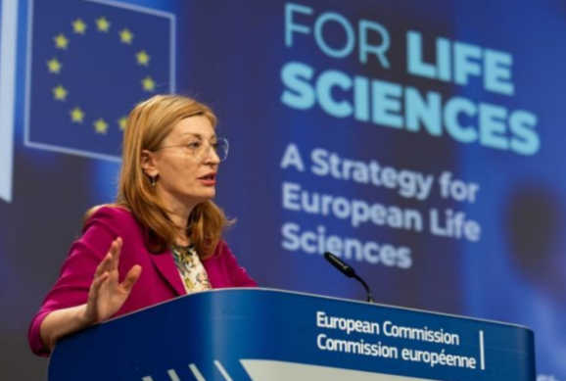
CH02-PH14
Ekaterina Zaharieva, European Commissioner for Startups, Research and Innovation, at a press conference on the Strategy for European Life Sciences, Brussels, Belgium, 2 July 2025.
The proposed EU biotech act, one of the key initiatives that forms part of the strategy, aims to strengthen the EU’s competitiveness in biotechnology by facilitating the translation of research into market-ready innovations. It will streamline clinical trials and create a more supportive environment for companies and innovators, helping cutting-edge therapies reach EU patients faster.
This is complemented by initiatives such as HERA Invest, through which the Commission and the European Investment Bank provide risk funding to help SMEs develop strategic medical tools and technologies for a safer and healthier EU. A new biotechnology and biomanufacturing hub was also created to support innovative companies, particularly start-ups and SMEs, in bringing new products and ideas to market.
In November, the Commission presented the Bioeconomy Strategy, which sets out ways to make better use of the EU’s biological resources, scientific excellence and industrial base to decarbonise its economy and replace fossil-based materials and products.

Start-ups and scale-ups
In May, the Commission launched the EU Startup and Scaleup Strategy to make Europe the best place to start and grow technology-driven companies. Aligned with the Choose Europe initiative, the strategy aims to strengthen the EU’s competitiveness by supporting innovative businesses throughout their life cycle, from creation and growth to maturity within the EU.
In October, the Commission also announced the Scaleup Europe Fund, a new multi-billion-euro fund created in partnership with private investors to support promising EU deep-tech companies. Expected to launch in 2026, the fund will focus on growth capital and late-stage investments across a broad range of EU strategic technology companies, in fields including AI, quantum technologies, semiconductors, robotics and autonomous systems.
The Commission also launched a survey to collect public feedback on the forthcoming Charter of Access for Industrial Users to Research and Technology Infrastructures. The charter aims to improve companies’ access to these infrastructures, enabling them to test, scale up and validate new products more quickly.
CH02-INFO21
Protecting intellectual property
The EU provides SMEs with financial support to better manage and protect their intangible assets. During the year, the Commission and the European Union Intellectual Property Office launched the 2025 SME Fund, a grant scheme designed to help SMEs protect their intellectual property rights, including patents, trademarks, industrial designs and new plant varieties.
A process was also successfully launched to enable free and safe data flows between the EU and the European Patent Organisation. This will simplify the patent protection process for European innovators and contribute to growth and competitiveness in the EU market.

Accelerating investment

The savings and investments union
As a horizontal enabler of the Competitiveness Compass, a strong savings and investments union is central to building a deeper, more liquid and more integrated EU financial system that better serves the needs of EU citizens and businesses. By strengthening the financial system’s capability to connect savings with productive investment, the EU aims to support Member States’ major investment needs in key areas such as digital innovation, the climate transition and defence.
In March, the Commission presented the Savings and Investments Union Strategy, which sets out how capital markets and the banking sector can connect savers seeking better investment opportunities with businesses in need of financing. The strategy aims to empower savers to grow their financial wealth and help businesses scale up, boosting the EU’s economy and competitiveness. This includes removing barriers to the Single Market, including through the enforcement of EU rules.
Targeted measures will focus on empowering citizens with the right tools to support their financial well-being; making it easier for companies to access diversified sources of finance, including across borders; removing barriers that prevent a fully integrated capital market; and ensuring the stronger and more harmonised supervision of financial markets.

CH02-INFO22
Strands of the savings and investments union
1. Citizens and savings.
2. Integration and scale.
3. Investing and financing.
4. Efficient supervision of the Single Market.
CH02-PH16
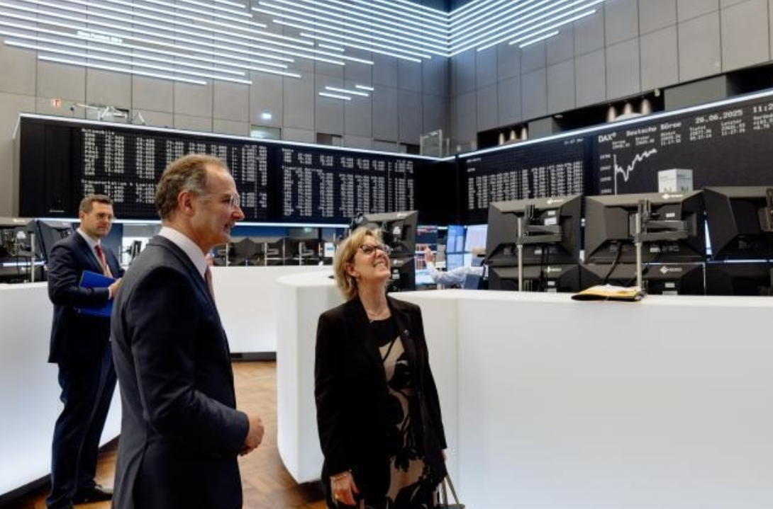
Maria Luís Albuquerque, European Commissioner for Financial Services and the Savings and Investments Union (right), visiting the Frankfurt Stock Exchange in Frankfurt am Main, Germany, 26 June 2025.
The EU also took several other steps to develop the savings and investment union. These included reaching a political agreement to shorten the securities settlement cycle; putting forward a proposal aimed at reviving securitisation in support of bank lending; and encouraging greater retail participation in capital markets through improved savings, investment and financial literacy initiatives. Additional measures focused on helping citizens secure an adequate retirement income by improving access to better supplementary pensions, reaching a political agreement on the retail investment strategy and strengthening the integration and supervision of EU capital markets. These reforms aim to simplify rules, support innovation and remove cross-border barriers within the EU financial system.

Banking
To preserve the competitiveness and stability of EU financial markets, the Commission proposed to maintain the current liquidity treatment for short-term securities financing transactions under the Capital Requirements Regulation. It has also postponed the application of the Basel III market-risk rules (Fundamental Review of the Trading Book) until 1 January 2027. Together, these measures aim to ensure a level playing field for EU banks globally, safeguard market liquidity and align the EU’s prudential framework with international developments.

CH02-PH17
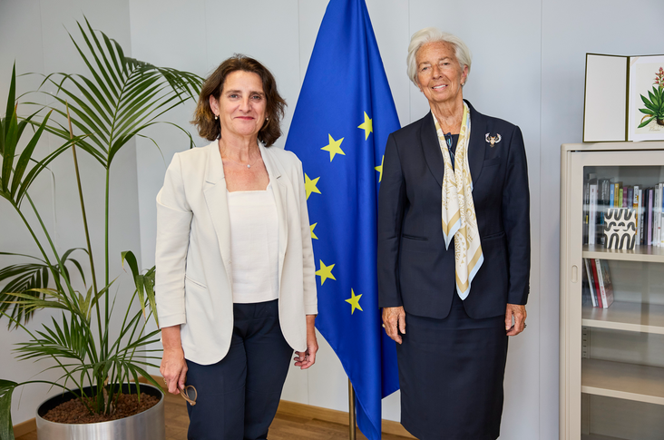
Teresa Ribera, Executive Vice-President of the European Commission for a Clean, Just and Competitive Transition (left), and Christine Lagarde, President of the European Central Bank (right), Brussels, Belgium, 23 June 2025.
CH02-INFO24
In 2025, the Strategic Technologies for Europe Platform celebrated its first anniversary. The initiative supports investment in critical technologies in three main areas: digital technologies and deep tech; clean and resource-efficient technologies; and biotechnologies. Over the past year, it has mobilised more than €13.1 billion by pooling investment from 11 EU programmes to boost the EU’s competitiveness in these three areas.

CH03-PH01
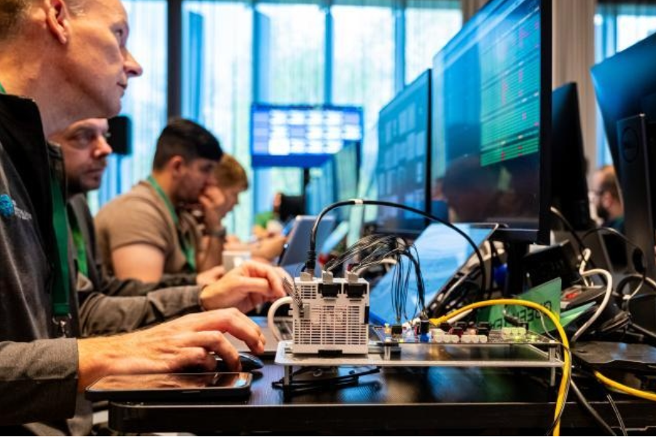
Coordinators and team members during a cyber security defence exercise in Tallinn, Estonia, 6 May 2025. The EU is working to ensure that European EU citizens are safer and more secure, and that Europe has the means to maintain peace.

3. Strengthening Europe’s defence and security

Introduction
The past few years have been a stark reminder of how fragile peace is, and a wake-up call for Europe. The European Union is stepping up its efforts to protect citizens and ensure that Europe has the means to maintain peace through credible deterrence. In 2025, the EU launched a set of new initiatives to help Member States respond to the short-term urgency of supporting Ukraine while also addressing the pressing long-term need to boost Europe’s security and defence readiness. In parallel, the EU set out a new Preparedness Union Strategy.

CH02-INFO01
Europeans’ views on security and defence
69 % agree that the EU is a place of stability in a troubled world.
81 % support a common defence and security policy among Member States.
78 % are concerned about the EU’s defence and security over the next five years.
77 % agree that Russia’s invasion of Ukraine is a threat to the security of the EU.
Source: European Commission, Standard Eurobarometer 103, May 2025.

Building a European defence union
The EU’s ambition is to enhance Member States’ cooperation in defence and leverage the added value offered by the EU and the Single Market in order to build a true defence union. NATO continues to be a cornerstone of European security and defence, with 23 Member States also being NATO allies. However, the EU is assuming more responsibility for its own security, and took major steps in this direction during 2025.
The EU also concluded two key security and defence partnerships in 2025, with Canada and the United Kingdom, thereby demonstrating a shared commitment to strengthening global peace and security and bolstering joint efforts in areas such as crisis management, cyber issues, maritime security, counterterrorism and the resilience of critical infrastructure.

Stepping up investment in defence
The EU decisively stepped up investment in defence in 2025 through Readiness 2030, a comprehensive plan to mobilise up to €800 billion for security and defence via two core pillars: the SAFE (Security Action for Europe) instrument and the new National Escape Clause provision. SAFE will provide up to €150 billion in loans to support joint defence procurement and reinforce Europe’s industrial and operational readiness, while the National Escape Clause will allow Member States to mobilise an additional €650 billion in defence investment without breaching EU fiscal rules under the Stability and Growth Pact.
CH03-PH02
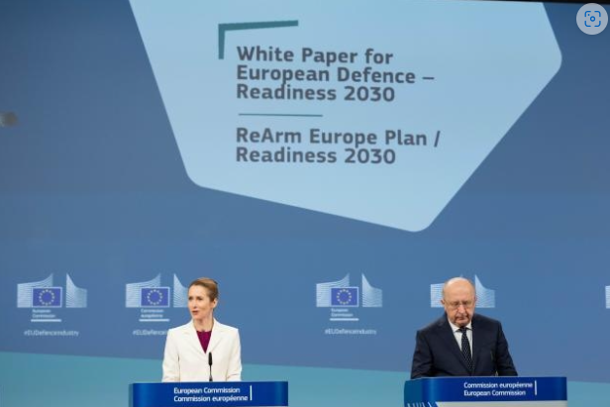
Kaja Kallas, High Representative of the Union for Foreign Affairs and Security Policy and Vice-President of the European Commission, and Andrius Kubilius, European Commissioner for Defence and Space, unveil the White Paper for European Defence, Brussels, Belgium, 19 March 2025.
Further investments include over €1 billion for collaborative defence research and development under the European Defence Fund, covering all military domains, and €300 million under the European Defence Industry Reinforcement through Common Procurement Act to support five cross-border projects in areas such as ammunition, air and missile defence, and legacy platforms. The Defence Industry Transformation Roadmap aims to improve access to finance for defence companies through a fund of funds of up to €1 billion; speed up time to market and procurement, particularly for start-ups and scale-ups; and strengthen skills and talent development across the defence sector.
Alongside this, the Commission proposed boosting the defence and space budget to €131 billion within the European Competitiveness Fund under the EU’s next long-term budget (see Chapter 8) – a fivefold increase compared to the current budget. In parallel, the EU is advancing an ambitious simplification agenda to accelerate defence-capability development and investment. Key measures in 2025 included proposals to streamline defence investment rules; the Defence Readiness Omnibus, published in June to simplify EU legislation and enable up to €800 billion in investment over the next four years; and the Defence Readiness Roadmap, which sets clear objectives, milestones and indicators for achieving readiness by 2030 while highlighting the importance of dual-use research and innovation, as set out in the White Paper for European defence. These measures are complemented by the Military Mobility Package.

Enhancing security in the skies and oceans
As space and satellites play an increasingly strategic role our daily life, a proposal for an EU space act was adopted in June. Its aim is to establish a harmonised, unified regulatory framework for space activities within the EU, with the primary objective of enhancing safety, sustainability, cybersecurity and resilience across the entire EU space ecosystem. Along with this development, the Vision for the European Space Economy set out a strategic framework to boost Europe’s competitiveness, resilience and strategic autonomy in the global space market, which is expected to be worth €1.6 trillion by 2035.
In a world first, the Galileo Open Service Navigation Message Authentication function was declared operational in July 2025. It introduces a mechanism to verify the authenticity of navigation data transmitted from Galileo satellites, helping protect against spoofing (the transmission of false signals), and significantly enhances trust in the EU’s Galileo satellite system, the only system in the world with this security feature. The International Air Transport Association’s 2024 safety report recorded a 500 % increase in commercial aviation spoofing incidents, with 1 500 flights per day affected. The Earth Observation Governmental Service was also announced in November, and will improve reconnaissance capabilities.
Security in the oceans and seas was also a key topic the EU acted upon in 2025, with the EU Action Plan on Cable Security adopted in February. During the year, a landmark report on cable infrastructure was published, alongside the provision of new funding worth €20 million to strengthen the security of Europe’s submarine cables. This funding, under the Digital Europe Programme, will support the creation of regional cable hubs and stress-testing of the resilience of undersea cable infrastructure.

Enhancing the EU’s preparedness and crisis management
Building on the recommendations of the Niinistö report, in 2025 the High Representative and the Commission put forward a Preparedness Union Strategy with 30 key actions focusing on enhancing the EU’s readiness and resilience in the face of future crises. The aim is to bolster its collective capacity to effectively manage challenges such as pandemics, the impact of climate change, hybrid threats and geopolitical instability. This will involve all levels of government (local, regional, national and EU), along with citizens, local communities and civil society, businesses and social partners, and the scientific and academic communities.
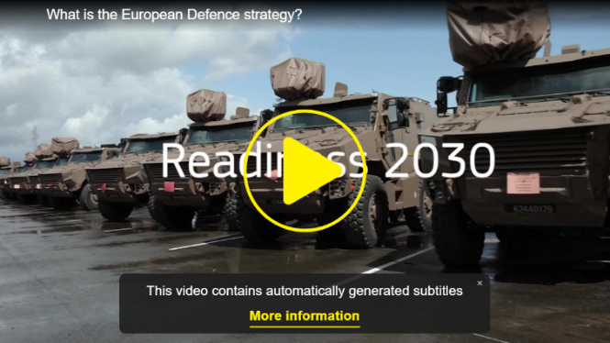
CH03-VIDEO01
VIDEO: What is the European Defence Strategy?
https://civil-protection-humanitarian-aid.ec.europa.eu/news-stories/news/enhanced-preparedness-and-emergency-response-strengthening-eu-civil-protection-mechanism-combined-2025-07-17_enhttps://commission.europa.eu/document/download/0a0f5ee4-6fd8-4315-a019-02bf967fe812_en?filename=MFF_Preparedness.pdfThe EU Stockpiling Strategy will introduce the EU’s first comprehensive approach to safeguarding essential goods such as food, water, fuel and medicines in times of crisis. Alongside it, the Medical Countermeasures Strategy will strengthen Europe’s health security by accelerating the development, production and accessibility of vital medical equipment. The proposed critical medicines act will also improve the availability of critical medicines in the EU by incentivising supply-chain diversification and boosting pharmaceutical manufacturing in the EU. Finally, as part of the EU’s broader framework on preparedness and crisis management, the Commission advanced two flagship initiatives – the European Water Resilience Strategy and the European Ocean Pact, both adopted in June – to strengthen the EU’s capacity to anticipate, prevent and respond to growing environmental and climate-related risks.
CH02-INFO04
Main risks and threats
Natural disasters:
floods, wildfires, earthquakes, extreme weather events.
Human-induced disasters:
industrial accidents, technological failures, pandemics.
Hybrid threats:
cyberattacks, disinformation campaigns, foreign information manipulation and interference, sabotage of critical infrastructure.
Geopolitical crises:
armed conflicts, including armed aggression against Member States.
For more information, see the Commission’s comprehensive Analysis of Risks Europe is Facing.
CH02-INFO05
Operating 24 hours a day, seven days a week, the Emergency Response Coordination Centre ensures the rapid deployment of emergency support and acts as a coordination hub for the Member States, 10 additional participating states, the affected country, and civil protection and humanitarian aid experts. In 2025, there were 64 activations of the EU Civil Protection Mechanism around the world, while overall, since 2001, the centre has coordinated assistance more than 830 times.
https://civil-protection-humanitarian-aid.ec.europa.eu/what/civil-protection/eu-civil-protection-mechanism_enCH03-PH04
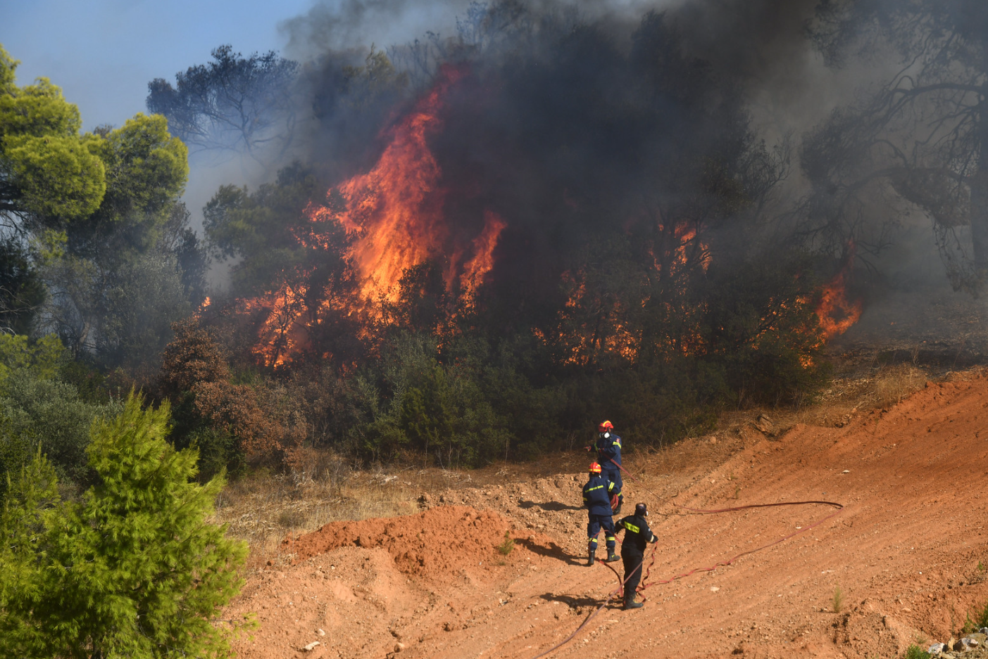
Greek firefighters battling a wildfire in the Paiania region, East Attica, Greece, on 26 August 2025. Firefighters from France and Romania also supported the response.
CH02-INFO06
2025 climate emergency action in figures
- The EU Civil Protection Mechanism was activated 18 times to fight wildfires in Europe and beyond – the most activations ever recorded for wildfires in any given year.
- 650 firefighters from 14 Member States were positioned in high-risk locations in France, Greece, Spain and Portugal to prepare for the summer.
- 58 aircraft – 38 planes and 20 helicopters – and more than 740 firefighters and rescuers were deployed over the summer to fight forest fires in 11 Member States.
- An advance of €100 million was provided from the EU Solidarity Fund to help Spain finance its recovery efforts following the storm that caused catastrophic flooding in Valencia in 2024.
- A proposal was made to allocate €280 million from the Solidarity Fund to support recovery efforts in Austria, Czechia, Poland, Slovakia, Bosnia and Herzegovina and Moldova following the 2024 floods caused by Storm Boris.

Enhancing internal security, border control and migration management
To address increasing security and hybrid threats such as terrorism, organised crime, cybercrime and attacks on critical infrastructure, the EU needs a new approach to its internal security, border control and migration management. EU support in these areas aims to help Member States implement the Pact on Migration and Asylum, which will enter into application in June 2026 (e.g. putting in place faster asylum procedures and more effective returns). It also aims to support Member States in the digitalisation of border control management, better equip border guards and enhance cooperation with non-EU countries. Finally, it aims to equip law enforcement authorities with modernised capabilities to fight terrorism and organised crime, both online and offline.

Improving internal security
Crime is becoming faster, more digital and better organised. Hybrid threats are undermining our democracies and societies. Terrorist threat levels remain high, fuelled by regional crises. In line with the Commission’s political priorities, a major part of the EU’s response to this new reality came in the spring of 2025, with the launch on 1 April of ProtectEU, the new European Internal Security Strategy. This comprehensive, whole-of-society approach to online and offline security threats (including terrorism, organised crime, cybercrime, attacks on critical infrastructure and hybrid threats) includes citizens, businesses, researchers and civil society. It will also ensure that security is integrated into EU legislation and policies.
CH03-INFO07
ProtectEU at a glance
Main principles
1. A whole-of-society approach
including citizens, businesses, civil society, research, academia and private entities.
2. Mainstreaming security across all EU initiatives
with a built-in security check for new initiatives.
3. Boosting investment in security
with more resources for law enforcement, better equipment, investment in technology and stronger EU agencies.
Priority areas and key actions
Increasing threat awareness
thanks to improved intelligence sharing.
Boosting capabilities for law enforcement
including making Europol a truly operational police agency and strengthening Frontex with up to 30 000 extra personnel over time.
Building resilience against hybrid threats
including support to help Member States secure all physical and digital critical infrastructure.
Fighting organised crime
including better protection of young people.
Combating terrorism
including a new toolkit to prevent radicalisation.
Strengthening global cooperation
including the accelerated integration of candidate countries into the EU’s security architecture.
The EU has strengthened its commitment to protecting its citizens, preventing future attacks and promoting a safer and more secure Europe for all with the investment of €30 million under the Internal Security Fund for 13 selected projects. This will help strengthen the protection of public spaces such as shopping malls, public transportation, entertainment venues and places of worship.
CH03-PH05
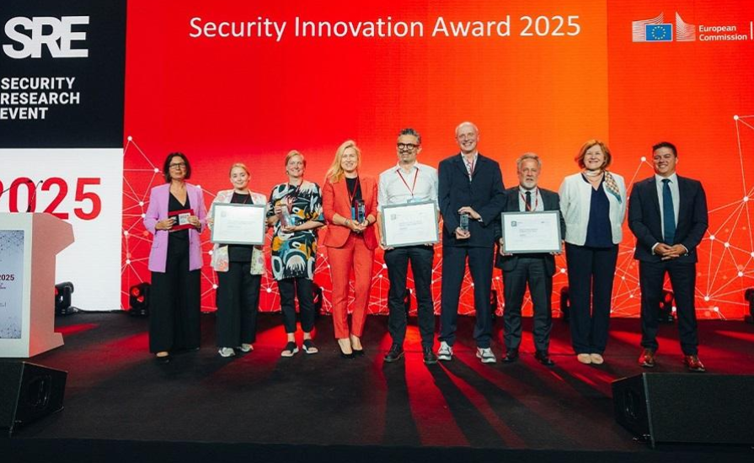
The recipients of the Security Innovation Award 2025. This award is given to those visionaries who are at the forefront of developing advanced solutions to safeguard our society and protect our citizens. The award is also an opportunity to promote innovations based on EU-funded security research projects under Horizon Europe. In June, €250 million was made available for new projects on security research and innovation. Warsaw, Poland, 24 June 2025.
CH03-INFO08
Measures to tackle drug trafficking, organised crime and terrorism
— A new EU Action Plan against Drug Trafficking focuses on operational measures across six priority areas: adapting to the evolving routes and methods used by criminal networks; preventing crime and reducing drug-related violence; stepping up cooperation between law enforcement, judiciary and customs authorities; addressing the challenge of synthetic drugs and drug precursors; advancing research, development and innovation, including with a new Security and Innovation Campus to be launched in 2026; and strengthening international cooperation.
— Agreements on the transfer of passenger name records data were signed in October with Iceland and Norway on the margins of the Justice and Home Affairs Council, to strengthen law enforcement cooperation and step up the joint fight against terrorism and serious and organised crime, including trafficking in drugs, firearms and human beings.
— An EU blueprint for cybersecurity management has been adopted to provide guidance on the EU’s response to large-scale cybersecurity incidents or cyber crises.
— A new action plan bolstering the cybersecurity of hospitals and healthcare providers will create a safer and more secure environment for patients and health professionals.
— The first steps have been taken towards the signature and ratification by the EU of the UN Convention against Cybercrime.
— A single-entry point for companies to report cybersecurity incidents under several laws will cut the burden on entities and boost cybersecurity by speeding up and streamlining the reporting process.
CH03-INFO09
Latest available data on human trafficking in the EU
9 678 victims of human trafficking registered in 2024.
8 % decrease compared to previous year.
63 % were women or girls.
Source: Eurostat, ‘Trafficking in human beings statistics’, January 2026.
Through ProtectEU, the Commission set about developing a new strategy to combat trafficking, addressing every stage from prevention to prosecution.
CH03-PH06
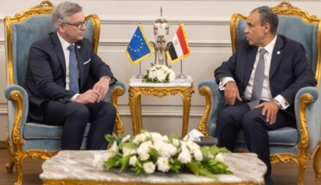
Magnus Brunner (left), European Commissioner for Internal Affairs and Migration, discussing migration management cooperation with Badr Abdelatty, Egyptian Minister for Foreign Affairs, Cairo, Egypt, 9 April 2025.
During his visit to Egypt, Commissioner Brunner was present at the signing ceremony of the Working Arrangement between Europol and Egypt, which will enhance law enforcement cooperation to fight terrorism, drug trafficking, migrant smuggling and organised crime. This landmark agreement, the first of its kind in North Africa, will enhance law enforcement cooperation between the northern and southern Mediterranean. The Commissioner also participated in the Second Ministerial Conference of the Khartoum Process, which promotes cooperation among countries along the migration routes between the Horn of Africa and Europe.

Strengthening common borders
The EU’s key focus on common borders during 2025 was to make them more secure by putting in place a fully functional digital border management system; implementing an integrated border management approach and an EU visa policy strategy; and ensuring a complete and fully functioning Schengen area.
CH03-INFO16
Further work will continue in the following areas:
— strengthening political and operational governance with the effective implementation of agreed rules and the use of common information systems, resources and infrastructure provided by the interoperability architecture;
— accelerating the implementation of the digitalisation framework to prevent security risks;
— continued investment in research and innovation;
— continuous adaptation to the evolving security landscape with a common intelligence picture, joint operational actions and stronger cooperation among law enforcement authorities, including in internal border regions;
— effective measures to return those with no legal right to stay in the EU.

The Commission will continue to track progress through the annual Schengen Scoreboard and further consolidate the Schengen Evaluation and Monitoring Mechanism. This includes systems in both Schengen countries and EU candidate countries. The Commission, with the support of the Schengen Coordinator, will continue to support Member States for effective cooperation on cross-border operational law enforcement.
CH03-INFO10
May
- Europe marks the first European Day of Safe Travel Abroad.
- The shared biometric matching service is launched, marking a significant milestone in the EU’s efforts to enhance internal security, border control and migration management.
June
- A status agreement is signed between Frontex and Bosnia and Herzegovina to strengthen cooperation on migration and border management.
- An agreement is reached between the European Parliament and the Council following interinstitutional negotiations on rules about the suspension of visa-free travel for citizens of non-EU countries.
October
- The progressive launch of the EU’s Entry/Exit System, which captures biometric data such as fingerprints, facial image and other travel information and will gradually replace the current system of passport stamping.
CH03-INFO11
40 years of visa-free travel
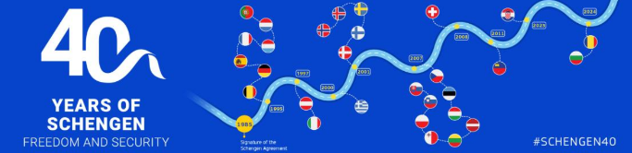
On 14 June, Europe celebrated the 40th anniversary of the signing of the Schengen Agreement. Over the past four decades, this agreement has provided more freedom, reinforced security and unlocked economic opportunities. The Schengen area is more than a geographical zone: it is a living testament to Europe’s commitment to a free, united, prosperous and safe continent. As the world’s largest area of cross-national free movement, the Schengen area is a cornerstone of European identity and a strategic asset for Europe.
29 countries in the Schengen area (25 EU Member States and four associated countries).
Over 450 million people live in the Schengen area.
More than 3.5 million people cross internal borders every day.
Over 32 million enterprises in the Schengen area benefit from faster transportation, reduced costs and increased trade volume.

Managing migration firmly and fairly
Migration remains a European challenge that must be met with a European solution, with solidarity at its heart. Migration patterns continue to shift. Irregular arrivals into the Schengen area are showing a steady decline, but the pressures that have accumulated upon Europe over the years continue to drain resources in the Member States. While pressures differ from place to place, the effects are shared: schools, housing and local services are directly affected, and communities are put under strain.
Having a robust legal framework that is applied in a balanced way across the EU is essential. In 2025, intensified efforts at the political and technical levels were necessary to ensure that all Member States are adequately prepared to implement the legal acts composing the Pact on Migration and Asylum in relation to the Common Implementation Plan presented by the Commission. The EU continued to make significant progress on implementing the legal acts composing the pact, and the Commission has continued to provide effective support to Member States. It put forward several measures to accelerate the implementation plan. These included frontloading two important rules under the pact to facilitate the application of the ‘safe third country’ concept and to accelerate asylum processes and reduce pressure on asylum systems, while preserving the legal safeguards for applicants and ensuring respect for fundamental rights.
CH03-INFO12
New key rules to accelerate asylum processes
- 20 % recognition rate threshold. Member States can apply the border procedure or an accelerated procedure to people coming from countries where, on average, 20 % or fewer applicants are granted international protection in the EU.
- Safe third countries and safe countries of origin can be provided with exceptions. This gives Member States greater flexibility by excluding specific regions or clearly identifiable categories of individuals.

The Commission also proposed to establish a first EU list of safe countries of origin. Some Member States already have national lists, and an EU list would complement these and support a more uniform application of the concept. This would allow Member States to process the asylum claims of nationals from countries on the list using an accelerated procedure, on the basis that their claims are unlikely to be successful.
In March, the Commission proposed to establish a Common European System for Returns with swifter, simpler and more effective return procedures across the EU. The proposed rules on return contain provisions on people posing a security threat. They also provide for the possibility to return people to non-EU countries on the basis of an agreement or arrangement under conditions ensuring the respect of international human standards and the principle of non-refoulement.

CH03-INFO13
Common European system for returns
One EU system  Regulation aims at establishing a common system for returns and at further harmonising the rules on returns.  European Return Order standardises procedures. | Mutual recognition  Return decisions that can be recognised across all Member States.  Mandatory from July 2027.
Voluntary return first, forced if needed  Incentives for voluntary return.  Mandatory forced return in cases of non-cooperation, absconding or security risks. | Clear obligations and consequences  Cooperation required with authorities.  Sanctions for non-cooperation.  Incentives for cooperation: support for voluntary return.
Safeguards and rights  Right to effective judicial protection.  Protection for vulnerable persons, minors and families.  Full respect for human rights and non-refoulement. | Stricter enforcement tools  Financial guarantees and reporting duties.  Designated residence requirements.  Detention of up to 24 months (extendable for security risks).
Security-risk provisions  Early screening for threats.  Longer entry bans and stricter detention rules.  Mandatory forced return for identified risks. | Readmission and return hubs  Systematic readmission requests sent to non-EU countries.  Secure data sharing for enforcement.  Return on the basis of agreements or arrangements (excluding minors and families).
CH03-INFO14
The first European annual asylum and migration report shows a continued improvement in the migratory situation during the reporting period (July 2024 to June 2025), with illegal border crossings down by 35 %, partly due to enhanced cooperation with partner countries.
An important step towards the full implementation of the pact was the launch of the first Annual Migration Management Cycle and the new solidarity mechanism, which combines mandatory solidarity with flexibility. This means greater support for Member States that are under migratory pressure and more flexibility for contributing Member States as regards the choice of their contributions. These contributions include relocations of applicants for international protection and of beneficiaries of international protection; financial contributions, including for action in or in relation to non-EU countries; and alternative solidarity measures such as the deployment of personnel or measures focusing on capacity building.
The Commission also continued to work with Member States to open legal pathways to migration, based on the skills needs of their economies and regions. In June, the Partnerships and Financing for Migrant Inclusion initiative successfully showed how creative financing and collaboration can facilitate the integration of non-EU nationals in Member States.

CH03-INFO15
Partnerships and Financing for Migrant Inclusion initiative boosts migrant integration in Europe

4 pilot projects (Belgium, Finland, Italy, Netherlands).
Over 600 migrant families joined integration activities.
848 professionals trained in migrant financial inclusion.
Over 1 200 migrants benefited from tailored support, including training and coaching.
77 microloans issued, fostering self-employment and economic independence.

Breaking down barriers relating to:
1. integration into labour markets;
2. social inclusion and discrimination;
3. access to education and training;
4. navigating administrative and legal obstacles.
CH03-PH07
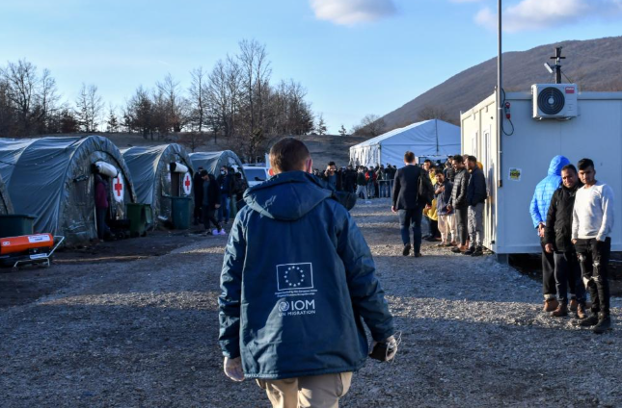
An International Organization for Migration aid worker walking through a refugee reception centre. The Asylum Report 2025 published by the European Union Agency for Asylum reported that the number of asylum applications lodged in EU+ countries had decreased by 11 % in 2024. Five EU countries – Germany (237 000), Spain (166 000), Italy (159 000), France (159 000) and Greece (74 000) – received almost four fifths of all applications lodged in the EU+.

CH04-PH01
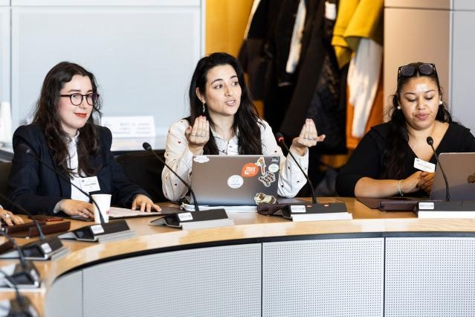
Young participants take part in a Youth Policy Dialogue on international partnerships, Brussels, Belgium, 6 March 2025.

4. Supporting people and strengthening societies

Introduction
Over the past few years, in the face of global challenges, the cost-of-living crisis, climate change and the complexities of the digital transition, the European Union has redoubled its efforts to protect and empower people and communities. In 2025, its work to improve living and working conditions for everyone continued apace. The year was defined by initiatives to tackle labour and skills shortages, thereby supporting the EU’s sustainable and inclusive growth and ensuring its competitiveness. The EU continued to support new measures so workers can enjoy their social rights. In addition, ensuring all citizens are treated fairly and equitably, regardless of background, remained a key priority, with the introduction of a crucial framework to combat gender-based violence, along with plans to strengthen consumer rights.

Promoting social fairness in the modern economy
The European Pillar of Social Rights functions as a beacon guiding the EU towards a strong, social Europe that is fair, inclusive and provides equal opportunities for all. In 2025, the European Commission carried out a review of the European Pillar of Social Rights Action Plan with the aim of better implementing the pillar, turning its 20 key principles into concrete action to benefit citizens. In parallel, the Commission started working on the upcoming EU Anti-Poverty Strategy, the first of its kind at the EU level.
CH04-INFO01
EU targets for 2030
— At least 78 % of the population aged 20 to 64 should be in employment.
— At least 60 % of all adults should participate in training every year.
- At least 15 million fewer people should be at risk of poverty or social exclusion.
Social dialogue plays a crucial role in keeping European enterprises competitive, increasing their productivity, providing quality jobs and ensuring social fairness. On 5 March the Commission and its cross-industry social partners signed a new Pact for European Social Dialogue, which will strengthen the role of the social partners in shaping labour market, employment and social policies. Additionally, the European Parliament and the Member States reached a political agreement during the year on the revised European Works Council Directive, which strengthens the meaningful involvement of employees in company decisions to help manage change in transnational settings.
The social economy has firmly established itself as an integral part of the EU’s economy and society, contributing to Europe’s prosperity, competitiveness and resilience. In 2025, the Commission launched the midterm review of its 2021–2030 Social Economy Action Plan. Already, more than 4.3 million associations, cooperatives, mutual societies, foundations and social enterprises pursue activities that prioritise social and environmental objectives over profit.

Skills for the EU’s prosperity and for economic and societal resilience
Human capital is key to the EU’s prosperity, democracy, economic and societal resilience, and unique social market economy. To be competitive and prepared for the future, the EU needs to support and prepare its citizens with the skills needed for success in education, work and daily life, as highlighted by the Competitiveness Compass (see Chapter 2).
CH04-INFO02
1 in 5 adults struggles with reading and writing (DG Education, Youth, Sport and Culture, Education and Training Monitor 2025 – Comparative report, Chapter 7.2, 2025).
1 in 4 fifteen-year-olds falls short in reading, maths and science (DG Education, Youth, Sport and Culture, The twin challenge of equity and excellence in basic skills in the EU, 2024).
Nearly 4 out of 5 small and medium-sized enterprises cannot find the talent they need (European Commission, Flash Eurobarometer 529, September 2023).
This is why, in March, the Commission launched the union of skills, a comprehensive strategy aiming to support the development of quality, inclusive and adaptable education, training and skills systems to increase the EU’s competitiveness. Enhanced skills intelligence at the EU level will be of key importance in this context, for effective and targeted policies. The union of skills also builds on and works synergistically with action already taken under the European Education Area.
CH04-PH02

Roxana Mînzatu, Executive Vice-President of the European Commission for Social Rights and Skills, Quality Jobs and Preparedness (left), visits the Department of Physics of Stockholm University, Stockholm, Sweden, 10 October 2025.
CH04-INFO03
The union of skills
Building skills for quality lives and jobs.
Upskilling and reskilling for the digital and clean transitions.
Circulating skills across the EU for competitiveness.
Attracting, developing and retaining talent for Europe’s future.
CH04-INFO04
An increase of just 0.1 % in skills investment for young workers could raise employment by 0.25 % and increase gross domestic product by 0.18 % (DG Employment, Social Affairs and Inclusion, Employment and Social Developments in Europe 2024, 2024).
Between 2021 and 2027 the EU is investing over €150 billion to support people, businesses, education institutions and others to develop the education and skills needed for a thriving, competitive European economy. In the new multiannual financial framework (see Chapter 8), set to run from 2028 to 2034, the European Commission proposes that at least 14 % of the funds under any national and regional partnership plans (excluding ring-fenced amounts for agriculture and for the Social Climate Fund) would be dedicated to social objectives. The new budget will help deliver on the European Pillar of Social Rights by investing in people through quality jobs, social inclusion, education, skills, health, housing and social infrastructure.would be dedicated to social objectives. The new budget will help deliver on the European Pillar of Social Rights by investing in people through quality jobs, social inclusion, education, skills, health, housing and social infrastructure.
CH04-INFO05
Investing in people, recognising their skills and attracting talent across Europe are key pillars of the union of skills. In 2025, the Commission celebrated 20 years of Europass, a free and secure online platform that supports citizens throughout their professional journeys.
Attracting talent from non-EU countries is on of the key objectives of the union of skills. In November, the Parliament and the Council of the European Union also reached a political agreement on the EU Talent Pool, a key tool to address the EU’s labour and skills shortages. It will be a user-friendly, modern and trustworthy platform to match jobseekers from non-EU countries with EU employers. Moreover, a Marie Skłodowska-Curie action ‘MSCA Choose Europe’ pilot project was launched in 2025 to increase the attractiveness of European research careers by addressing the issue of precarity and offering excellent working conditions.

Providing quality jobs
Ensuring the availability of quality jobs not only helps to foster social fairness but also contributes to a robust and competitive industrial landscape. The Commission adopted the Quality Jobs Roadmap in December. Prepared with the close involvement of social partners, it focuses on creating and preserving quality jobs, particularly during the clean and digital transitions, while ensuring that workers’ rights keep pace with a modern economy. The roadmap also calls for the enforcement of existing rights, quality services for all and across regions, adequate funding, and strengthened social dialogue and collective bargaining. In conjunction, the Commission launched the first-stage consultation on a quality jobs act to gather social partners’ views on a potential initiative in this field.

Supporting workers
While digital tools provide both workers and employers with more flexibility, allowing for greater autonomy and innovation, there are also increasing calls for safeguards to ensure that digitalisation does not weaken workers’ rights. In 2025, the Commission continued to take steps towards defending workers’ right to disconnect and to fair telework, concluding https://employment-social-affairs.ec.europa.eu/document/cca467bb-f77e-4dac-b3aa-60b205be7ecc_ensecond-stage consultations with social partners. Furthermore, by the end of the year, the Commission had successfully concluded the work of the expert group dedicated to the transposition of the Platform Work Directive into national law, which Member States are required to do by December 2026.
In July, the Commission proposed stronger safeguards for workers exposed to hazardous substances with new chemical exposure limits. The measures are expected to prevent around 1 700 cases of lung cancer and 19 000 other serious illnesses over the next 40 years and could save up to €1.16 billion in healthcare costs. The Commission’s proposal will be discussed by the Parliament and the Council. In a similar vein, the EU also published a new indicative list of hazardous medicinal products, along with guidelines for managing health and safety risks relating to asbestos.
In an increasingly challenging geopolitical environment, the European Globalisation Adjustment Fund for Displaced Workers continued to assist workers dismissed due to major restructuring events. As a flagship initiative of the Action Plan on the Future of the Automotive Sector, the Commission proposed to amend the fund to allow companies to request support for workers facing imminent redundancy.
CH04-INFO06
Funding under the European Globalisation Adjustment Fund for Displaced Workers
- €8 million to support 2 400 workers dismissed after the bankruptcy of Belgian coach manufacturer Van Hool.
- €1 million to support 417 former employees in Belgium after the closure of chip manufacturer BelGaN’s factory.
- €3 million to help 915 workers dismissed following the closure in Germany of Goodyear’s production site in Fulda and the partial shutdown of the site in Hanau.
- €8.5 million to support 5 800 workers dismissed after the bankruptcy of battery maker Northvolt in Sweden.
Furthermore, in May, trade unions and employers’ organisations from five sectors signed guidelines to prevent and tackle violence and harassment related to work. These expand the scope of the existing guidelines to include cyberviolence and underscore the principles of gender equality and anti-discrimination.

Affordable housing and energy
CH04-INFO08
41 % of young people see the cost of living as the most pressing concern for the future.
Source: European Parliament, Flash Eurobarometer – Youth Survey 2024, February 2025.
Unaffordable housing has become a widespread and urgent issue across Europe, making it harder for people to move for studies or work and in turn undermining the EU’s competitiveness and economic prosperity. Following a conference on 24 March, co-organised by the Parliament and the Commission, the process began for the development of the first-ever European Affordable Housing Plan, adopted in late 2025 and drawing on the input of a new Housing Advisory Board. The plan aims to support Member States, regions and cities in overcoming structural challenges, unlocking public and private investment and, ultimately, improving access to sustainable, affordable and quality housing, including social housing.
The plan also proposes measures for a more productive and innovative construction and renovation sector that will address the mismatch between housing supply and demand through the European Strategy for Housing Construction. Bolstering this is the New European Bauhaus initiative, in relation to which the Commission adopted a communication and a proposal for a Council recommendation in December, together with the European Affordable Housing Plan. The initiative seeks to foster sustainable, inclusive and aesthetically pleasing spaces, products and lifestyles, aligning with the European Green Deal and the Clean Industrial Deal, while respecting diverse cultures and traditions.
The issue of access to affordable housing is not confined to lower income groups. As such, in 2025, the Commission proposed to revise the Decision on Services of General Economic Interest, with the aim of ensuring that State-aid rules facilitate investment in both affordable housing and social housing. The Commission will work with national, regional and local authorities to simplify rules and procedures that restrict housing supply, with a particular focus on planning and permitting. A new legislative initiative on short-term rentals will support areas under housing stress.
By addressing the underlying causes of the housing crisis in a comprehensive way, this plan will be particularly beneficial for those most affected: young people, students, essential workers, people with a low income and other disadvantaged groups. The Commission will mobilise new investment in student and social housing and help Member States put in place better solutions for homeless people based on Housing First principles.
The EU is not only working to make housing more affordable but also helping consumers cut their energy costs. The Action Plan for Affordable Energy will bring relief to households and businesses facing high energy bills (see Chapter 2), with the savings from reducing Europe’s dependence on fossil fuels potentially reaching €130 billion by 2030. Additional tailored solutions developed throughout the year, such as the revised rules on the energy consumption of electrical appliances in standby mode – which have applied since 9 May – will further reduce energy use.
CH04-INFO09
The updated standby-mode rules alone are expected to save EU consumers an estimated €530 million annually by 2030.
CH04-PH04
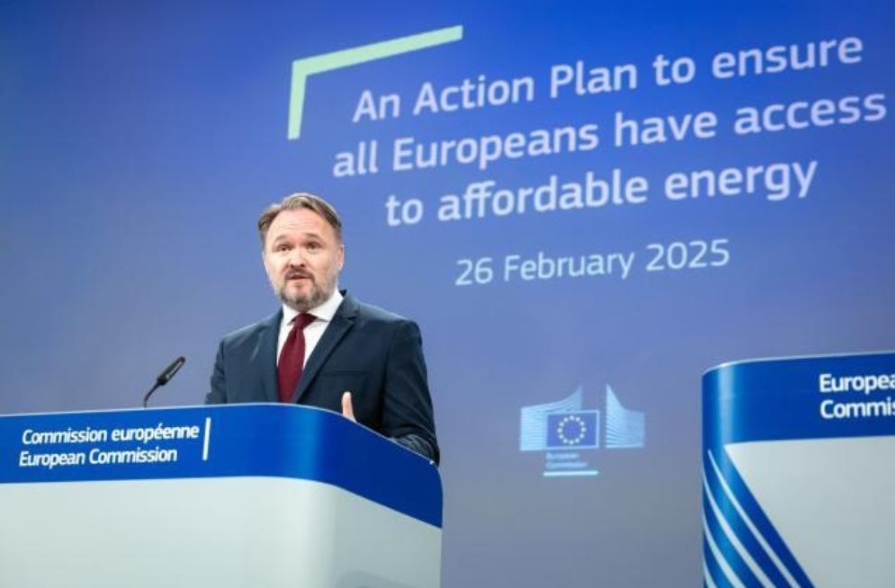
Dan Jørgensen, European Commissioner for Energy and Housing, at a press conference on the Action Plan for Affordable Energy, Brussels, Belgium, 26 February 2025.
The Social Climate Fund will mobilise at least €86.7 billion of spending in the Member States from 2026 to 2032. The fund provides resources to support citizens through the clean transition and to address the potential social impacts of the new Emissions Trading System for buildings and road transport (ETS2) on vulnerable households, microenterprises and transport users. Additionally, in December, the Commission approved the first national Social Climate Plan – submitted by Sweden.

Empowering consumer protections
Thanks to the EU’s consumer protection rules, consumers are well protected from unfair practices and have the right to clear information about the products and services they buy. However, the rise of the digital economy and e-commerce has brought new challenges for consumers online.
CH04-INFO10
The findings of the EU’s 2025 Consumer Conditions Scoreboard
- Online shoppers are 60 % more likely to experience problems than offline shoppers.
- 93 % worry about targeted advertising, including:
  - the collection of personal data without consent (71 %);
  - excessive advertising (67 %);
  - unavoidable personalisation (63 %).
- 45 % had encountered online scams in the previous year.
- Many faced unfair practices, such as:
  - fake reviews (66 %);
  - misleading discounting (61 %).
The new Consumer Agenda for 2025–2030, adopted on 19 November, focuses on strengthening consumer rights within the Single Market. This will improve enforcement, drive competitiveness and sustainable prosperity, protect vulnerable consumers, reduce administrative burdens and promote a fair, green and digital economy. An important element of the agenda will be the digital fairness act, set for adoption in the latter half of 2026, which specifically aims to address harmful practices – such as dark patterns and deceptive influencer marketing – across online spaces, with a particular focus on minors. It will also look into opportunities for simplification and the reduction of burdens without lowering consumer protection. The Commission also published an e-commerce communication to tackle the health and safety risks linked to a surge in low-value imports into EU markets.
CH04-INFO11
The 2025 European Consumer Summit brought together policymakers, businesses and civil society to discuss consumer protection, cross-border e-commerce and digital markets, shaping the new Consumer Agenda and the related action plan. The event also saw two new e-commerce platforms join the Consumer Protection Pledge, joining 10 existing signatories in committing to go beyond legal requirements to protect consumers and their digital rights.

CH04-PH05
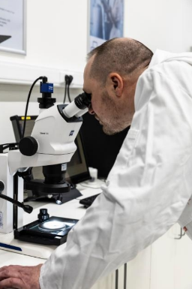
A technician inspects a product under a microscope at the SGS laboratory in Brussels, Belgium on 4 April 2025. Safety tests are carried out at this laboratory to ensure consumer products meet EU safety standards. Through the EU’s Safety Gate system, Member States can rapidly share information on dangerous non-food products to protect consumers across Europe. Published in 2025, the Commission’s 2024 Safety Gate annual report recorded 4 137 alerts on unsafe products, prompting swift action by national market surveillance authorities to remove them from the market.

CH04-VIDEO01

To ensure consumers have access to trustworthy reviews and ratings for tourist accommodation, the EU has supported booking platforms, hotel operators and consumer organisations in developing a new code of conduct.
[Video: Audiovisual Service - Together for reliable online reviews]
CH04-INFO12
Other 2025 consumer protection actions
- The Parliament and the Council reached a political agreement on the new toy-safety rules.
- An investigation by the Commission and national consumer authorities revealed that nearly half of second-hand online traders fail to properly inform consumers of their return rights.
- The Commission hosted an implementation dialogue on consumer protection in the digital environment in July.

Reuniting societies and supporting young people

Youth engagement and participation
The importance of young people in shaping the EU’s future is reflected in the Political Guidelines for the 2024–2029 Commission. The EU is committed to hearing what young people have to say and addressing their concerns directly.
The new President’s Youth Advisory Board, the annual Youth Policy Dialogues and the Commission’s Youth Check put young people at the heart of the EU’s policymaking. In 2025, the Commission applied the Youth Check to its annual work programme for the first time, consulting young people and youth civil society on key initiatives of significant relevance for young people. Moreover, all Commissioners organised Youth Policy Dialogues to encourage young people to share their perspectives, making sure their voices are heard at the highest level of EU decision-making.
The President’s Youth Advisory Board brings together one young representative from each Member State’s National Youth Council and one from the European Youth Forum, along with observers from candidate countries and potential candidates for EU accession. It advises the President on issues that matter most to young people, shares their perspectives on policies developed by the Commission and puts young people at the heart of EU policymaking.
CH04-VIDEO02
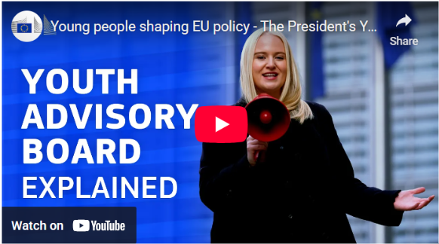
Video: The President’s Youth Advisory Board

CH04-INFO13
Each Commissioner held their first Youth Policy Dialogue within the initial 100 days of the new mandate and continued to personally engage with young Europeans throughout the year:
41 dialogues have been held since the start of this mandate;
9 dialogues provided valuable input for initiatives going through the Youth Check process, such as the European Democracy Shield, the European Ocean Pact and the Vision for Agriculture and Food.
CH04-PH06
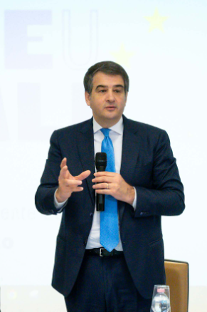
Raffaele Fitto, Executive Vice-President of the European Commission for Cohesion and Reform, at a Youth Policy Dialogue where he addressed themes such as EU values and the impact of the Commission’s policies and programmes on EU citizens’ daily lives, Modena, Italy, 7 March 2025.
CH04-INFO14
New guidelines on the protection of minors have been adopted under the Digital Services Act to protect children and young people from online risks such as grooming, harmful content, and problematic and addictive behaviours, along with cyberbullying and harmful commercial practices.
The Commission’s Political Guidelines also emphasise the importance of guaranteeing intergenerational fairness; focusing on ensuring that decisions taken today do not harm future generations; and fostering solidarity and engagement between people of different ages. In 2025, the Commission organised a European Citizens’ Panel (see also Chapter 6) and a series of strategic dialogues with citizens, institutions and civil society to inform a future Strategy on Intergenerational Fairness.

Supporting education and building bridges
The union of skills significantly builds on and is being implemented together with the European Education Area (EEA), an initiative to help Member States build more inclusive and resilient education and training systems. In June, the Commission published a report on the interim evaluation of the EEA, which serves as a basis for the Council to agree on a new strategic cooperation framework for 2026–2030.
An Action Plan on Basic Skills and a STEM Education Strategic Plan will also come under the union of skills. These aim both to support Member States’ efforts to ensure that all people – from early childhood through to adulthood – have strong basic skills and to increase the share of students enrolled in STEM (science, technology, engineering and maths) fields, with a special focus on female students.
The successful roll-out of the union of skills and the EEA relies on robust support for education and training. Erasmus+ is a lasting EU success story, with nearly 40 years of impact on the personal and academic growth of more than 16 million people. In this context, the Commission proposed to increase the budget of the Erasmus+ programme by 50 % to help young people, adult learners and staff undertake a learning mobility experience in other Member States, thus reinforcing a sense of connection, common EU values and civic engagement. The proposal also aims to extend the programme’s scope to cover volunteering, creating a one-stop shop for all EU-funded youth projects and initiatives.
CH04-INFO15
In 2025, the Erasmus+ programme received the Cercle d’Economia award for European integration.
CH04-PH07
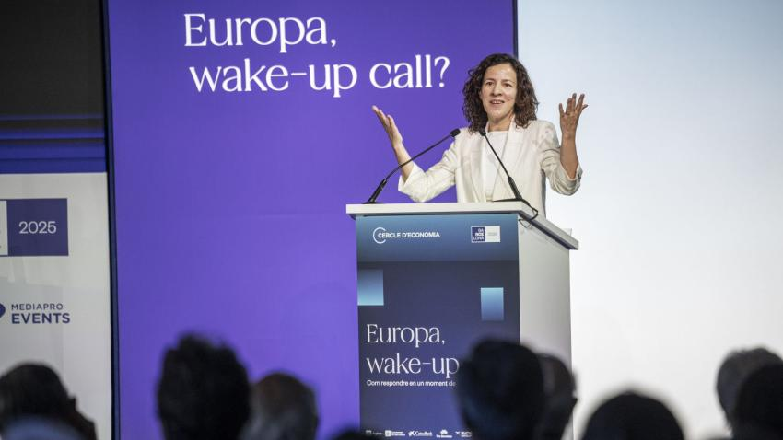
Roxana Mînzatu, Executive Vice-President of the European Commission for Social Rights and Skills, Quality Jobs and Preparedness, accepting the Cercle d’Economia European Integration award in Barcelona, Spain, 7 May 2025.
The 2025 European Education and Skills Summit, under the theme ‘Fuelling Europe’s growth’, focused on preparing Europe’s education systems for rapid societal and economic change. Ministers, policymakers, educators, students, social partners and industry leaders discussed how education can strengthen Europe’s competitiveness, cohesion and democratic values. The Commission also presented the new Education and Training Monitor and the Erasmus+ Annual Report 2024.
Steadfast in its dedication to ensuring a robust EEA, in 2025 the Commission convened the first European Degree Forum in Florence, Italy. It brought together more than 160 representatives of national authorities, universities, quality assurance agencies and student organisations to prepare the ground for the roll-out of a joint European degree label under the Florence Pledge.
Education and skills development is not just confined to universities, however. A variety of stakeholders, such as vocational education and training (VET) providers, schools and labour market stakeholders, benefit from Erasmus+ learning mobility and cooperation projects. The Centres of Vocational Excellence, a flagship initiative of Erasmus+ in the VET field, saw a record number of applications in 2025, reaching a total of 303, up from the previous year’s 132. For the 2021–2027 period, the Erasmus+ programme has allocated an indicative budget of €400 million to finance these centres. In the 2025 call for interest, the budget available allows to fund at least 15 new Erasmus+ projects.
CH04-INFO16
The Herning Declaration on attractive and inclusive vocational education and training for increased competitiveness and quality jobs 2026–2030
Endorsed on 12 September 2025 by ministers responsible for VET from Member States, EU candidate countries, EEA countries, European social partners and the Commission, the Herning Declaration renews and strengthens coordinated efforts for VET reforms in line with evolving societal and labour market needs. The declaration is an important contribution to the upcoming European VET strategy, announced under the union of skills, to help define the new policy framework in this area for 2026–2030.

The European Alliance for Apprenticeships hosted its most recent high-level event over the summer, bringing together more than 230 participants. Key stakeholders, policymakers, social partners, education providers, companies and apprentices gathered to explore how apprenticeships can drive Europe’s clean transition and develop a skilled, resilient workforce for the future. Together with the European Training Foundation, it also organised a seminar for partner countries in Montenegro in October.
CH04-PH08
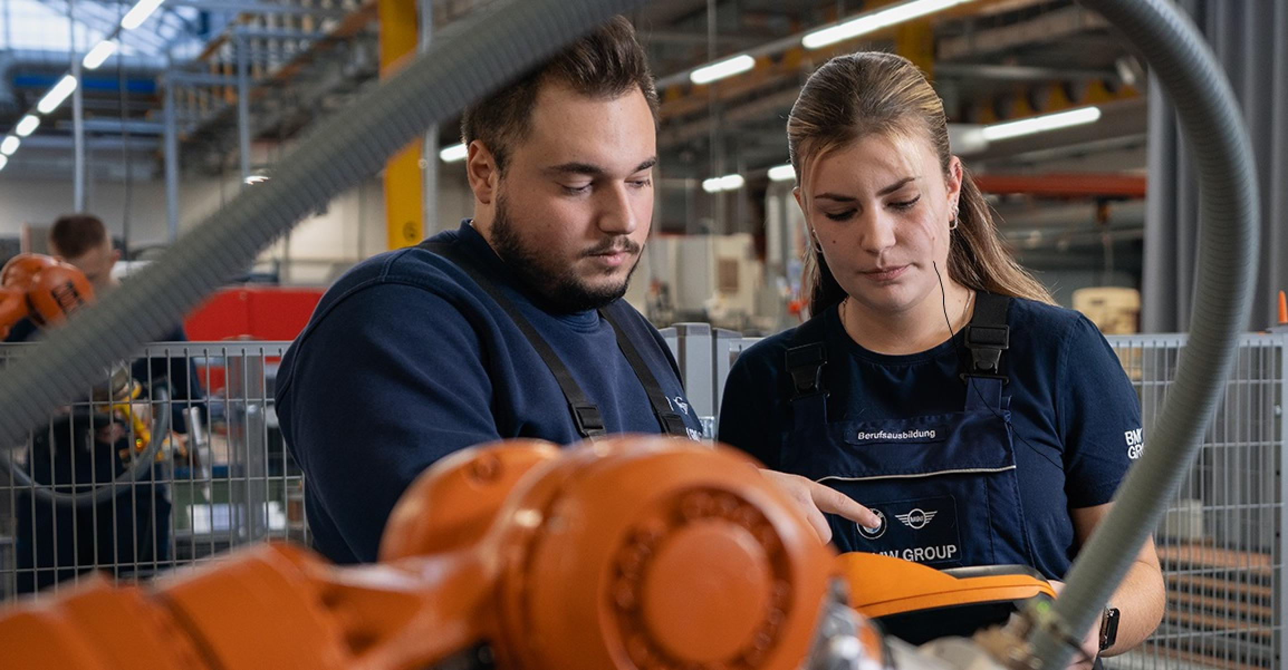
CH04-INFO17
In 2025, the Commission continued to support the negotiations on the proposed traineeships directive, along with the revised Council Recommendation on a reinforced Quality Framework for Traineeships.
For the first time, the Action Plan on Basic Skills, part of the union of skills, also recognises citizenship skills alongside those such as literacy, mathematics and science. With this in mind, the theme for the 2025 edition of the European Innovative Teaching Award was ‘Citizenship education – Participation in democratic life, common values and civic engagement’. During the year, through Erasmus+ Jean Monnet Learning EU initiatives, 106 proposals were selected to deliver a minimum of 120 hours of EU democracy and values teaching per school over a three-year period. The Jean Monnet school networks also expanded in 2025. These networks are composed of institutions across at least three Member States, and help integrate EU topics into primary, secondary and VET classroom learning.
Additionally, in 2025, the Commission launched two DiscoverEU application rounds, offering more than 75 000 travel passes to 18-year-olds across Europe. DiscoverEU helps young people explore the continent’s shared cultural heritage and gain skills and competences that will serve them throughout their lives. These rounds took place in the context of the 40th anniversary of the Schengen Agreement, marking four decades of free movement across much of Europe.

A Culture Compass for Europe
In an era of rapid change, it is imperative to recognise and fully harness culture’s potential and to address the challenges facing the culture and creative sectors and industries. The Commission has therefore presented a Culture Compass for Europe, establishing a vision and setting out key directions for placing culture at the heart of EU policymaking. The compass’s ambition is underpinned by 20 flagship initiatives, including a proposal for an EU Artists Charter to improve working conditions for artistic and culture professionals.
CH04-PH03
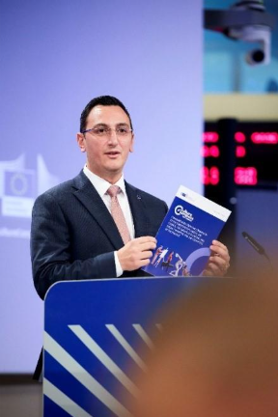
Glenn Micallef, European Commissioner for Intergenerational Fairness, Youth, Culture and Sport, presenting the Culture Compass for Europe upon its adoption, Brussels, Belgium, 12 November 2025.

Building a true union of equality
In 2025, the EU continued to work towards achieving a union of equality. In this context, a key landmark came in March when the Commission unveiled its Roadmap for Women’s Rights. The roadmap outlines a long-term vision for achieving gender equality, aiming to uphold and advance women’s rights and to address gender-equality challenges, including discrimination, violence and technology-facilitated bias. On 16 October, representatives of EU institutions, Member States and women’s rights organisations came together in Brussels, Belgium, to officially endorse the Declaration of Principles for a Gender-equal Society (available as an annex to the roadmap). This declaration builds on the significant progress made under the 2020–2025 Gender Equality Strategy on working towards a society where women and girls can thrive free from discrimination and violence.
CH04-INFO18
1 in 3 women has experienced physical or sexual violence in adulthood.
1 in 5 women has faced domestic violence.
1 in 6 women has experienced sexual violence.
Source: Eurostat, EIGE and FRA, EU Gender-based Violence Survey – Key results, 2024.
On top of this, in October the Commission also launched its LGBTIQ+ Equality Strategy for 2026–2030, which combines targeted measures with strengthened efforts to mainstream LGBTIQ+ equality across all EU policies. Social acceptance of LGBTIQ+ people has increased across the EU in the last five years. According to the Eurobarometer on discrimination in the EU, some 75 % of people say they are comfortable with having gay, lesbian or bisexual colleagues. Nonetheless, LGBTIQ+ people continue to experience disproportionate and unacceptable levels of hate.
CH04-INFO19
1 in 2 LGBTIQ+ people still experiences hate-motivated harassment.
Source: FRA, LGBTIQ Equality at a Crossroads – Progress and challenges, 2024.
CH04-PH09
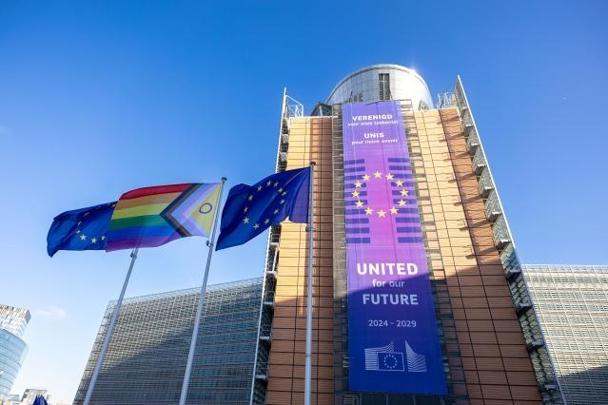
European flags and an Intersex-Inclusive Progress Pride Flag wave in front of the Berlaymont building in Brussels, Belgium, 15 May 2025.

Tackling discrimination
Combating antisemitism was another key area of focus for the EU in 2025, as Europe witnessed a surge in antisemitic hate incidents and violence targeting Jewish people in the wake of the attacks on 7 October 2023. The Commission hosted the second Civil Society Forum on Combating Antisemitism and Fostering Jewish Life in April, which brought together 250 experts and activists to discuss specific measures to further step up the fight against antisemitism in the EU. In the face of manifest threats, the 2021–2030 EU Strategy on Combating Antisemitism and Fostering Jewish Life will continue to guide Commission action to protect the Jewish community.
Anti-racism and accessibility were also on the agenda during 2025. In April, the Commission launched a new public consultation aimed at shaping the upcoming 2026–2030 EU Anti-Racism Strategy. This new strategy will put in place measures to tackle all forms of racism, including antigypsyism and anti-Muslim hatred. It will build on the path set out in the EU Anti-Racism Action Plan 2020–2025, aiming to step up efforts to combat racism at both the individual and the structural level.
CH04-INFO20
Building upon the 18th European Platform for Roma Inclusion on 2 October, the Commission held an implementation dialogue on 12 November to identify remaining challenges, opportunities for simplification and best practices to help reach the targets of the 2020–2030 EU Roma Strategic Framework.
- 70 % of Roma live in poverty. While this is less than in 2016 (80 %), Roma families are still four times more likely to struggle with poverty than the general population in the EU.
Source: FRA, Rights of Roma and Travellers in 13 European countries, 2024.

On the accessibility front, the European Accessibility Act, which has applied in the Member States since 28 June, ensures that key products and services – such as phones, computers, televisions, banking and payment services, public transport, e-commerce platforms and electronic communications – are accessible to persons with disabilities, making it easier for them to fully participate in society.
The Commission also announced, in its 2026 Work Programme, a communication on enhancing the Strategy for the Rights of Persons with Disabilities. Then. in November, the Commission launched a call for evidence and an open public consultation to gather feedback on the current challenges and needs to ensure equal rights for persons with disabilities in the EU.

CH04-INFO21
Making EU cities more accessible
Accessible spaces are a crucial first step towards achieving equality. 2025 marked the 16th anniversary of the Access City Award, recognising the efforts made by EU cities to prioritise accessibility for persons with disabilities.
In December, Zaragoza (Spain) won the 2026 Access City Award, for being a standout example of how EU cities can successfully integrate accessibility into every aspect of urban life.

CH04-PH11
The EU’s commitment to tackling discrimination extends to all spaces, including digital. In 2025, the revised Code of Conduct on Countering Illegal Hate Speech Online + was assessed positively by the Commission under Article 45 of the Digital Services Act, and therefore integrated into the act’s co-regulatory framework (see Chapter 6). The signatories to the code committed to strengthening their systems for detecting and removing illegal hate speech, improving transparency and accountability, and working closely with civil society to prevent the spread of such content, among other things.
CH04-INFO22
Celebrating inclusive societies
Celebrated every year in May, European Diversity Month embodies the EU’s long-term commitment to diverse and inclusive workplaces and societies. In 2025, more than 500 events took place across the EU.
One of the highlights was the fourth annual European Capitals of Inclusion and Diversity Award, which recognises the work done by EU cities, towns or regions to promote inclusion and create discrimination-free societies.
The winners of the various categories were as follows:
- local authorities with more than 50 000 inhabitants: Utrecht, Netherlands;
- local authorities with fewer than 50 000 inhabitants: Mariehamn, Finland;
- specific award category for inclusive housing: Braga, Portugal.
CH04-PH10

In 2025, the Commission elevated the visibility of sport-driven social initiatives via its #BeActive Awards, which recognise organisations and individuals using sport to foster, among other things, inclusion, gender equality and peace.
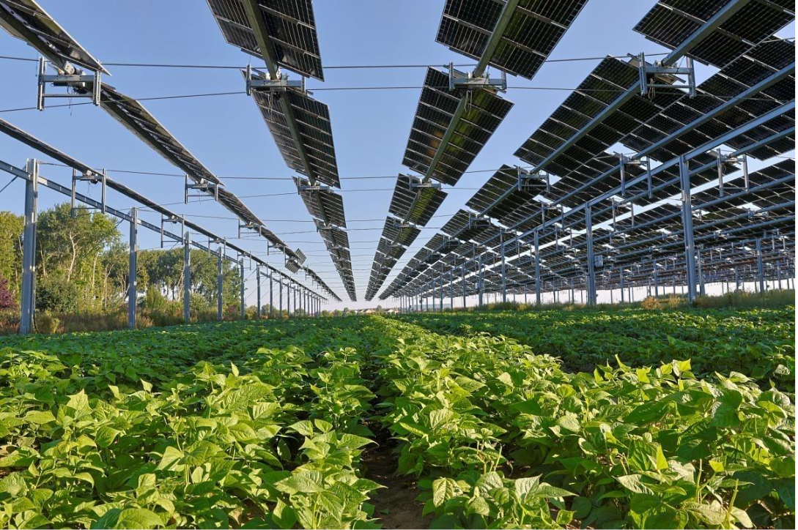
CH05-PH01
One of the first of its kind, this solar panel installation above a crop is co-financed by the EU’s Innovation Fund to promote the use of innovative and energy-efficient solutions in European farming. In addition to protecting crops and generating energy, the system includes an innovative irrigation component that reduces water use by 30 %. Picardy, France, 11 July 2025.

5. Sustaining quality of life in Europe

Introduction
Europe’s quality of life depends on functional ecosystems, which provide for our health and economic activities and for a secure and affordable supply of quality food. Europe enjoys some of the healthiest and highest-quality food in the world, and that is thanks to farmers, fishers and the wider agri-food sector. In 2025, the European Union continued its work to ensure that farming remains a core part of the European way of life, while also acting on climate change to ensure food and water security. Water is a cross-cutting resource. Investing in a water-smart economy will enhance the EU economy’s resilience and competitiveness, while at the same time promoting research, innovation, new technologies and skills development to maintain the EU’s leadership as a knowledge provider.

Building a competitive and resilient agriculture and food system

The Vision for Agriculture and Food
Farming is at the heart of life in Europe. Building on the report of the Strategic Dialogue on the Future of EU Agriculture, and in consultation with the new European Board on Agriculture and Food, in February the European Commission proposed the Vision for Agriculture and Food, which aims to secure the long-term competitiveness and sustainability of the EU’s farming and food sector.
CH05-PH02
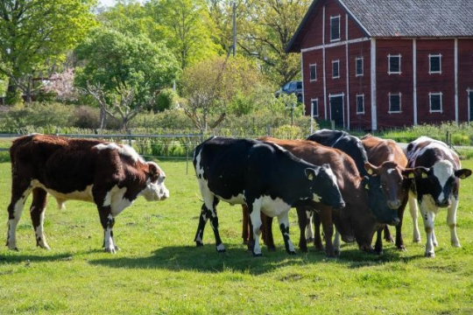
[illustration photo, no caption needed]
CH05-INFO01
The four priority areas of the Vision for Agriculture and Food
1. Attractiveness. Making farming a viable and appealing career.
2. Competitiveness. Strengthening the sector’s position in global markets.
3. Future-proofing. Embracing innovation and sustainability for long-term resilience.
4. Connection. Valuing food, and fostering fair living and working conditions in rural areas.

The EU is reforming its Common Agricultural Policy (CAP), which ensures a stable supply of food, safeguards farmers’ income, protects the environment and keeps rural areas vibrant. The reformed CAP will ring-fence at least €300 billion for income and crisis support, targeted at those who need it most, including young farmers, small and mixed farms, and those operating in areas with natural constraints.

CH05-INFO02
Public support for the Common Agricultural Policy
78 % of people in the EU are aware of the CAP, the highest level since 2007.
77 % of people in the EU agree that the CAP helps the EU secure a stable food supply at all times.
71 % of people in the EU agree that the CAP helps the EU provide safe, healthy and sustainable food of high quality.
Source: European Commission, Special Eurobarometer 556, January 2025.

The CAP simplification package, adopted in December, supports the competitiveness, resilience and digitalisation of the agricultural sector, and young and organic farmers in particular. The measures could save up to €1.58 billion annually for farmers and €210 million for national administrations, while making payments, certain requirements and crisis tools more flexible and easier to manage.
To prepare for the future, the EU is taking action to provide an evidence-based framework to adjust policies both within and outside the scope of the CAP. As part of this effort, a new livestock workstream was launched in May to support this sector, which is particularly vulnerable to various shocks and to global competition. There are other factors that also greatly affect the agricultural sector, ranging from shifting consumer expectations to climate and environmental demands.
The Commission also presented a Strategy for Generational Renewal to support the next generation of farmers by tackling the main barriers that young and new farmers face and making rural life more attractive.
CH05-PH11
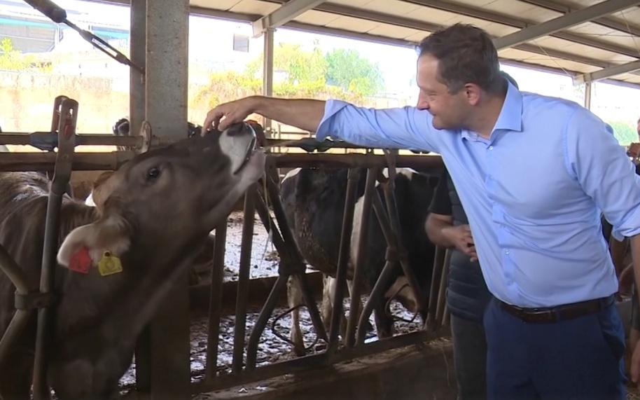
Christophe Hansen, European Commissioner for Agriculture and Food, visiting a dairy farm in Swieqi, Malta, 13 October 2025.

CH05-INFO03
2025 initiatives to support farmers in disaster-affected regions
- €109 million in emergency support for farmers affected by climate change and natural disasters in Czechia, Slovenia, Spain, Croatia, Cyprus, Latvia and Hungary.
- €5 million in exceptional support for the milk and pig-meat sector in Germany.
- €50 million in emergency support for fruit, nut and vegetable farmers affected by climate change in Bulgaria, Latvia, Lithuania, Hungary, Poland and Romania.
- €14 million to help compensate farmers in areas affected by outbreaks of avian influenza in Poland.
- Exceptional changes to the POSEI scheme to help farmers in Mayotte restart production after Cyclone Chido.
- Reducing red tape to help fruit and vegetable producers and winemakers in Valencia, Spain, recover after exceptional weather led to damaged crops and production facilities.
CH05-INFO19
The Commission has proposed a range of measures to ensure the EU’s wine sector remains competitive, resilient and a vital economic force in the decades to come. The sector is facing various challenges, such as shifting consumer trends, climate change and market uncertainties.

Strengthening Europe’s water security
CH05-INFO04
Europe’s water supplies are increasingly threatened. About 20 % of the continent’s territory and 30 % of its population are affected every year by water stress.
Source: European Environment Agency, Europe’s State of Water 2024 – The need for improved water resilience, 2024.

Water is a pillar of life and of the economy, playing a vital role in farming, fisheries, industry production processes and sanitation. However, reports in 2025 showed that Europe’s water is under significant stress, including from pollution, floods, scarcity and drought.
The European Water Resilience Strategy, adopted in June, aims to restore and protect the water cycle, build a water-smart economy to boost competitiveness, and secure clean and affordable water and sanitation for all. To safeguard people, assets and vital infrastructure from heightened flood risks, the strategy provides for more than 50 specific measures in five priority areas.
CH05-INFO05
Priority areas of EU action on water resilience
- Governance and implementation to raise awareness and facilitate change.
- Increased EU financing and cooperation with the European Investment Bank to secure investment and modernise infrastructure.
- Digitalisation and use of artificial intelligence to make it quicker and easier to implement efficient water management techniques.
- Research and innovation for a more competitive water sector.
- Security and preparedness to reduce the risk of disaster and boost collective resilience.
CH05-PH10
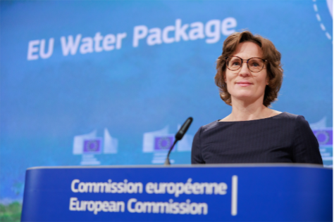
Jessika Roswall, European Commissioner for Environment, Water Resilience and a Competitive Circular Economy, at a press conference on the EU water package, Brussels, Belgium, 4 February 2025.

Ocean and fisheries
To support ocean conservation, ocean sciences, sustainable fisheries, aquaculture and the blue economy, the Commission announced its flagship initiative, the European Ocean Pact, at the 2025 UN Ocean Conference, alongside €1 billion in investment for the ocean. The pact brings EU ocean policies together under a single reference framework, developing a comprehensive strategy to address the opportunities for and threats to the ocean, coastal communities, islands and the EU’s outermost regions.
CH05-INFO06
The six key priorities of the European Ocean Pact
Protecting and restoring ocean health.
Boosting the competitiveness of the EU sustainable blue economy.
Supporting EU coastal communities, islands and outermost regions.
Advancing ocean research, knowledge, skills and innovation.
Enhancing maritime security and defence.
Strengthening EU ocean diplomacy and international ocean governance.

The blue economy
The EU’s blue economy is a major driver of economic growth and innovation. It plays a key role in the EU’s industrial and security strategies, encompassing traditional sectors such as fisheries and shipping, along with emerging fields such as renewable energy and blue biotechnology.

CH05-PH06 + INFO07
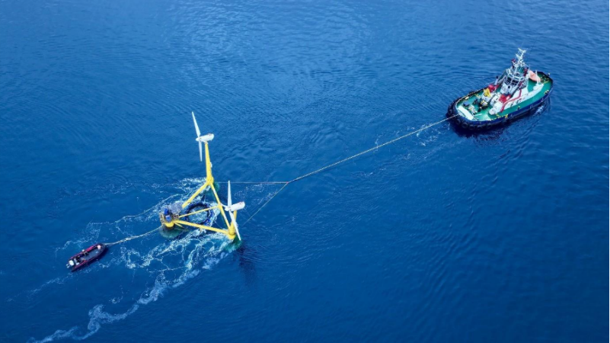
European Maritime Day is an opportunity to put EU maritime sectors and activities in the spotlight. AquaWind was one such project presented at the 2025 event. It is an innovative prototype combining offshore wind energy and aquaculture.
CH05-VIDEO02
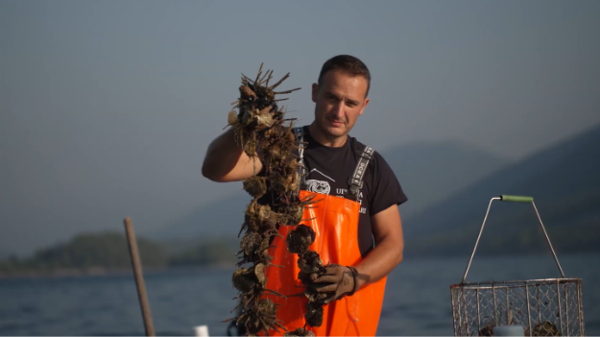
Video: EU aquaculture.
Aquaculture – the farming of fish, shellfish, algae, etc. – leads the way in sustainable food production in the EU. In July, the Commission proposed to simplify data collection on aquaculture and fisheries, reducing the reporting burden on Member States. The cultivation of algae can contribute to Europe’s blue bioeconomy, food security, climate neutrality and ocean restoration. The Second EU Algae Awareness Summit, which took place in Berlin, Germany, in October, highlighted the economic and environmental benefits of algae cultivation.

Ocean and waters
The 2025 Copernicus Ocean State Report highlights the triple planetary crisis of climate change, pollution and biodiversity loss, with global sea surface temperatures reaching a record 21 °C in 2024.
CH05-INFO08
Under the Marine Strategy Framework Directive, Member States are required to monitor, protect and take measures to improve the environmental status of their seas. Many EU policies have contributed to reducing air pollution, pesticide use and plastic litter at sea, but more can be done to combat harmful noise, microplastic release into the environment, nutrient pollution and waste, as evidenced in the Zero Pollution Monitoring and Outlook 2025 and the fourth clean air outlook. The Zero Pollution Dashboard shows progress in regions and selected cities.
The EU Mission: Restore our Ocean and Waters has now supported more than 1 000 initiatives in protecting and restoring marine and freshwater ecosystems. The mission provides a systemic approach for the protection and restoration of the ocean and Europe’s seas and waters up to 2030. In 2025, the EU invested €116 million in 13 new projects that focus on protecting migratory fish habitats, reducing the environmental impact of fisheries and empowering local communities to lead restoration efforts. At the Third UN Ocean Conference, the EU also proposed a new initiative on ocean observation and launched the prototype of the European Digital Twin of the Ocean platform, a digital tool to help better understand, manage and protect the ocean.
In September, with support from the EU, the World Trade Organization Agreement on Fisheries Subsidies entered into force – a significant step in ocean protection, deeply aligned with the priorities of the European Ocean Pact.
On 20 September, the Biodiversity Beyond National Jurisdiction Agreement, also known as the High Seas Treaty, reached 60 ratifications, triggering its entry into force in early 2026 – a landmark moment for global ocean conservation. The EU and its Member States have been central to advancing the agreement, leading the Biodiversity Beyond National Jurisdiction High Ambition Coalition – a group of over 40 nations committed to ambitious, science-based ocean governance. This coalition’s political leadership has been critical in shaping the treaty and expediting its ratification.
CH05-INFO09
Key measures to protect the ocean in 2025
- The EU pledged over €300 million in aid of ocean conservation efforts to support action in the fields of the sustainable blue economy, marine pollution, marine protected areas, and ocean and climate change.
- The EU helped facilitate international ocean protection agreements, including the adoption of specific catch limits for all major tropical tuna species. It also secured an agreement to help achieve net-zero greenhouse gas emissions from global shipping by 2050.
- The EU successfully concluded its 2025 chairing of the All-Atlantic Ocean Research and Innovation Alliance.

Fisheries
The Common Fisheries Policy was developed to ensure that fisheries and aquaculture are environmentally sustainable and managed in a way that is consistent with the objectives of achieving economic, social and employment-related benefits. The 2025 evaluation of the policy assessed the performance of the related regulation and whether it remains fit for purpose, involving extensive stakeholder consultation and using evidence from studies on topics such as the landing obligation.
The ‘Fishers of the future’ study examined the role of fishers in society across the EU’s 22 coastal Member States and projected four potential scenarios up to 2050, depending on the extent of climate and biodiversity changes in marine ecosystems and variations in consumer demand and market dynamics.
In 2025, multiple initiatives were undertaken to bolster the rights of European fishers operating beyond EU waters. Full reciprocal access to waters for fishing activities between the EU and the United Kingdom has been guaranteed until 30 June 2038, while a new memorandum of understanding with Iceland enhanced cooperation on sustainable fisheries and ocean affairs. Additionally, renewed sustainable fisheries partnerships grant EU vessels access to the waters of Côte d’Ivoire and São Tomé and Príncipe for four years, and to those of the Cook Islands for seven years.
CH05-PH07
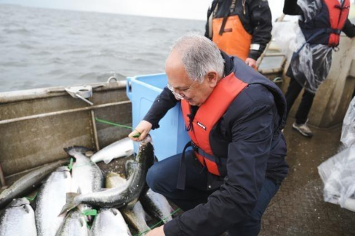
Costas Kadis, European Commissioner for Fisheries and Oceans, visiting a fish farm in Loviisa, Finland, 26 June 2025.

Promoting biodiversity and protecting ecosystems
Over half of the measures outlined in the Biodiversity Strategy for 2030 are now in place, and most of the remaining initiatives are under way, including through the implementation of the Nature Restoration Regulation.
The adoption of the Soil Monitoring Law, the first ever EU law on soil, addresses key soil degradation processes, such as erosion, loss of organic matter, salinisation, contamination, compaction, sealing and loss of soil biodiversity. The new directive aims to also include measures on the monitoring and assessment of soil health.
CH05-INFO10
Mission Soil progress in 2025
€561.5 million in funding.
63 research projects, with more than 1 400 participants.
45 of the planned 100 living labs and lighthouses.

The Roadmap towards Nature Credits is an opportunity for simultaneous income generation from public and private sources of finance for nature restoration. It aims to boost biodiversity and preserve habitats by incentivising private investment that restores and maintains nature.
In December, the Council adopted a targeted revision of the EU regulation on deforestation-free products, aimed at simplifying its implementation. The Commission also published the first benchmarking list in 2025, a tool to classify countries according to their risk of deforestation due to the production of cattle, cocoa, coffee, oil palm, rubber, soya and wood.

CH05-PH08 + CH05-INFO11

[illustration photo, no caption needed]
Thanks to the EU’s Birds Directive and dedicated projects under the LIFE programme, Europe stands out as one of the few places where many bird of prey and vulture populations are improving or stabilising, including the recovery of griffon and cinereous vultures, and the revival of the bearded vulture in the Alps.

Following the increase in wolf populations in Europe in recent years, the European Parliament and the Council of the European Union have approved an amendment to the Habitats Directive, following the amendment of the protection status of the wolf in the Bern Convention, giving Member States more flexibility to manage their local wolf populations.

Protecting the environment and tackling pollution
Thanks to the National Emission Reduction Commitments Directive, air pollutant emissions continued to decline across most Member States. Urban waste water is one of the main sources of water pollution if it is not collected and treated in accordance with EU rules. The revised Urban Wastewater Treatment Directive, which entered into force in January 2025, addresses remaining pollution and new challenges in urban wastewater management.
In 2025, the 2027 European Green Capital Award was won by Heilbronn in Germany, while Assen in the Netherlands and Siena in Italy were both awarded European Green Leaf Awards, showcasing how cities can take the lead in tackling air, water and noise pollution, waste management and the circular economy, along with increasing biodiversity, reducing emissions and adapting to climate change.
The new Packaging and Packaging Waste Regulation entered into force during the year, with the objective of curbing the growth of packaging waste generation. This will promote waste prevention and remove substances of concern from the value chain. In July, the Commission published the 2025 environmental implementation review to support the implementation of EU rules and raise awareness about their importance in ensuring a healthy environment as a basis for the long-term prosperity and competitiveness of people living in the EU. The Commission also adopted guidance to support Member States in applying extended producer responsibility to the costs of cleaning up litter.
The Commission presented the new European Chemicals Industry Action Plan in July, which is designed to strengthen the sector’s competitiveness and drive its transition towards safe, sustainable and innovative chemical production. The EU has also taken action to ban the use of harmful chemicals, endocrine disruptors and bisphenols in toys sold in the EU, while the use of PFAS (‘forever chemicals’) in firefighting foams has been restricted. In April, the Commission published a guide to support companies in adhering to the new restrictions on microplastics. In addition, new and clearer rules on detergents agreed by the co-legislators in June will help to better protect the health of people and the environment.
CH05-INFO12
2025 measures to help monitor pollution
- A political agreement on updating the mandate of the European Maritime Safety Agency. As part of its increased role, the agency will employ enhanced surveillance tools to detect and deter illegal discharges at sea, while also developing its emissions monitoring systems.
- The Commission adopted a regulation putting in place a voluntary Flight Emissions Label, offering a clear and trustworthy methodology for calculating flight emissions. This will help passengers make informed decisions and protect them from misleading greenwashing claims.
- A political agreement was reached on the proposed CountEmissionsEU regulation, which creates a common EU framework for calculating greenhouse gas emissions from freight and passenger transport.
- New product environmental footprint category rules for apparel and footwear provide a harmonised, science-based method to assess a product’s environmental impact across its life cycle.
- Adoption of the ‘one substance, one assessment’ package, which aims to streamline the hazard and risk assessment of chemicals across the EU and improve access to information on chemicals through a common data platform.

Boosting climate adaptation, preparedness and solidarity
CH05-INFO14
85 % of people in the EU believe climate change is a serious problem.
81 % support the EU-wide goal of reaching climate neutrality by 2050.
77 % of people in the EU agree that the economic cost of damage due to climate change is much higher than the investment needed for a net-zero transition.
Source: European Commission, Special Eurobarometer 565, June 2025.
CH05-INFO15
The European State of the Climate Report 2024, published in 2025, found that 2024 was the warmest year on record, and was also the first year with an average temperature exceeding 1.5 °C above pre-industrial levels.

CH05-INFO16
Europe experienced record temperatures in its central, eastern and south-eastern regions. Severe storms and widespread flooding claimed at least 335 lives in 2024, and affected an estimated 413 000 people.

There is evidence that every part of the ocean is now under threat from climate change, biodiversity loss and pollution, affecting ecosystems, food security, economies, coastal communities and global climate regulation.
The Preparedness Union Strategy (see Chapter 3) also recognises climate change as a key risk driver, stressing the role of anticipation and prevention, and a holistic approach to risk management. To this end, work has begun on the Integrated Framework for European Climate Resilience and Risk Management.
The EU Mission: Adaptation to Climate Change under Horizon Europe translates the EU Adaptation Strategy into specific action. In 2025, 18 new mission projects were launched to scale up proven approaches, embed adaptation across governance levels, promote systemic and cross-sectoral solutions and support the most vulnerable social groups.
With an overall budget of €2.3 billion, the 2025–2027 funding opportunities under the LIFE programme aim to drive the EU’s transition to a clean, circular, competitive and climate-resilient economy. In addition, the Commission has invested €86 million in new strategic integrated projects focused on improving water quality and availability, cleaning up polluted rivers, improving fire and flood protection and reducing greenhouse gas emissions. The European Water Resilience Strategy also addresses climate change impacts such as floods and droughts.
The EU Civil Protection Mechanism aims to strengthen civil protection cooperation between the Member States and participating countries to improve prevention of, preparedness for and response to disasters, including climate events (see Chapter 3).

Improving people’s health
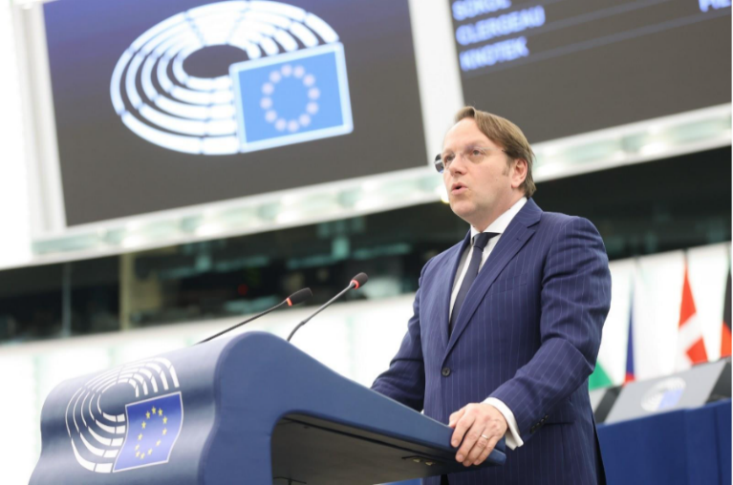
CH05-PH09
Olivér Várhelyi, European Commissioner for Health and Animal Welfare, speaking at the presentation of the critical medicines act proposal in the European Parliament, Strasbourg, France, 11 March 2025.
The EU has been building a strong European health union, in which medical supplies are available, affordable and innovative; all Member States are prepared for health crises and respond to them together; and Member States work to improve prevention, treatment and aftercare for diseases such as cancer and cardiovascular disease.
Within the first 100 days of its mandate, the Commission proposed the critical medicines act to improve the availability, supply and production of critical medicines within the EU. This act will help ensure patients have access to the medicines they need, when they need them. Complementing the critical medicines act, a political agreement has been reached on the pharma package. This is the first major reform of EU pharmaceutical legislation since 2004.
The European Health Data Space entered into effect during the year. It is a cornerstone of the European health union and a milestone in the EU’s digital transformation. The Commission also presented the action plan on the cybersecurity of hospitals and healthcare providers in January, to further reinforce digital security in our healthcare systems.
In December, the Commission presented the first-ever EU cardiovascular health plan, to tackle the leading cause of death in Europe. The new plan aims to reduce the number of premature deaths due to cardiovascular disease in the EU through better prevention and the early detection, treatment and management of these diseases.
A Union prevention, preparedness and response plan was put forward by the Commission as a toolbox for policymakers and crisis managers working in health emergencies. It is a key action in implementing the Preparedness Union Strategy in the health sector. The Commission has continued to advance important projects to reinforce the EU’s preparedness for future health emergencies, by inaugurating a new development hub for vaccines and facilitating access to medicines via new joint procurement agreements.
The Commission has also presented the Medical Countermeasures Strategy to reinforce the EU’s protection against priority health threats, including viruses with pandemic potential, antimicrobial resistance, climate-change-induced health threats, armed-conflict-related threats and chemical, biological, radiological and nuclear threats.

CH05-INFO17
Measures to prevent and treat disease
- More than 90 % of the measures under Europe’s Beating Cancer Plan have already been implemented or are underway, with significant support from the EU Mission: Cancer and the Horizon Europe programme.
- EU marketing authorisation has been given for Zuranolone, a medicine to treat postpartum depression, for which no specific treatments had previously been approved.
- Authorisation has been given for a medicine that treats mild cognitive impairment in the early stages of Alzheimer’s disease – the first such medicine to be authorised in the EU.
- A Joint Action on Dementia and Health has been implemented, with €4.5 million from the EU4Health programme to help Member States address dementia in a comprehensive way: from improving health literacy and awareness, screening and primary prevention to supporting people living with dementia and other neurological disorders.
- A Joint Action on Respiratory Diseases has been launched, with almost €5 million from EU4Health to tackle chronic respiratory diseases and improve lung health across Europe.

Thanks to its Global Health Strategy, the EU has made substantial strides in strengthening health systems and expanding universal health coverage, and in improving preparedness for and responses to cross-border health threats. In this context, in 2025, the Commission signed new agreements with Health Emergency Readiness Canada and with the Pan American Health Organization. The Commission also provided €9.4 million to support the Partnership to Accelerate Mpox Testing and Sequencing in Africa. This will strengthen mpox detection and monitoring, while also supporting innovative tests.
The 12th European and Developing Countries Clinical Trials Partnership Forum, held in Kigali, Rwanda, reviewed the progress of this landmark clinical trials partnership with Africa. The partnership has now spent over €1.5 billion on 477 clinical studies, which have led to new medicines such as the world’s first two malaria vaccines.
CH05-INFO18
The EU supports the World Health Organization (WHO), the leading authority on global health in the UN system. Since 2020, the EU has been an active and engaged partner working with WHO countries and other relevant bodies on an ambitious Pandemic Agreement. Adopted in 2025, the agreement aims to improve the prevention of, preparedness for and response to future global pandemics. The WHO launched version 2.0 of the Epidemic Intelligence from Open Sources system at the WHO Pandemic Hub in Berlin, Germany, with close support from the EU and its Member States. The EU is also involved in the ongoing work on the Pathogen Access and Benefit Sharing system.

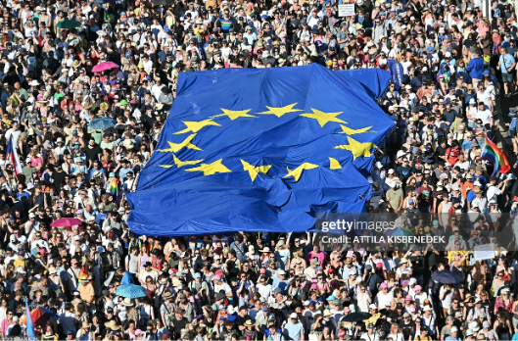
CH06-PH08
People carry a giant EU flag as they take part in the Budapest Pride parade in Budapest, Hungary, 28 June 2025.

6. Upholding European democracy and values

Introduction
In a thriving democracy, citizens are free to express their views and form their own opinions. They can participate in democratic life, choose their political representatives and have a say in their future, in a public space where different views can be expressed and diversity is embraced. In 2025, the European Union stepped up its work to strengthen democracy and its resilience to internal and external pressures. It also continued to empower citizens to participate actively in the democratic process and shape the policies that affect their lives and communities.

Protecting European democracy

The European Democracy Shield
Building upon work already set out under the European Democracy Action Plan and the Defence of Democracy package, the European Democracy Shield was presented in November. It is set to strengthen European democracies and empower Europeans to exercise their rights, freely form and express their opinions and participate in the democratic life of the EU actively and safely. Its actions will strengthen democratic institutions, protect the integrity of elections and support media freedom and pluralism.
CH06-INFO01
Key priorities of the European Democracy Shield
— Reinforce situational awareness and support response capacity to safeguard the integrity of the information space.
— Strengthen democratic institutions, free and fair elections, and free and independent media.
— Build societal resilience by supporting citizenship education, skills for democracy and media literacy, and boost citizens’ engagement in democratic life.
Acting as an operational hub for the new European Democracy Shield, a European Centre for Democratic Resilience is set to be established to anticipate and detect threats, issue early warnings and coordinate rapid responses. With Member States at its core, the centre will act as a framework to facilitate information sharing and build the capacity to withstand evolving common threats, in particular foreign information manipulation and interference, and disinformation.
CH06-PH02

Michael McGrath (centre), European Commissioner for Democracy, Justice, the Rule of Law and Consumer Protection, hosting a Youth Policy Dialogue to exchange views on the democratic empowerment of young people as part of the Commission’s work on the European Democracy Shield, Dublin, Ireland, 3 March 2025. The main objectives of Youth Policy Dialogues are to encourage young people to express their views on EU policy initiatives by interacting with Commissioners and to integrate them in the EU’s political agenda (see also Chapter 4).
In 2025, the Commission also pledged to step up its engagement with, protection of and support for civil society, recognising the important role it plays in strengthening democracies and building resilient societies. The new EU Strategy for Civil Society has the following three main objectives.

Main objectives of the EU Strategy for Civil Society
- Strengthen effective and meaningful engagement with civil society as a partner in governance.
- Ensure an open, safe and enabling civic space by providing support and protection to civil-society organisations.
- Support civil-society organisations with adequate, sustainable and transparent funding.

Ensuring information integrity
New technologies have made it possible for hostile actors to operate and to spread disinformation at a scale and with a speed never seen before. Therefore, tackling foreign information manipulation and interference and enhancing societal resilience against these threats are pressing issues for the EU and its Member States.
CH06-INFO02
82 % of Europeans agree that the existence of news or information that misrepresents reality or is false represents a problem for democracy.
77 % of Europeans agree that the existence of such news or information is a problem in their country.
Source: European Commission, Standard Eurobarometer 102, November 2024.
The EU’s Code of Practice on Disinformation, established in 2018, is the world’s first voluntary self-regulatory instrument for online platforms and search engines. Since February 2025 it has been formally integrated into the Digital Services Act’s co-regulatory framework as a code of conduct.
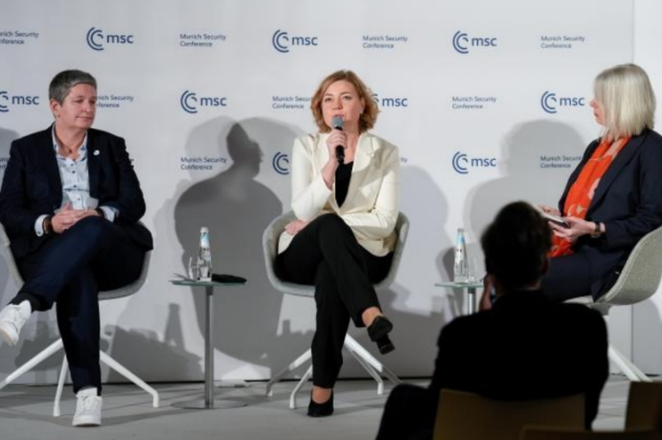
CH06-PH03
Henna Virkkunen (centre), Executive Vice-President of the European Commission for Tech Sovereignty, Security and Democracy, attending a panel discussion on ‘Disinformation and the “AI-pocalypse” for democracies’ during the 2025 Munich Security Conference in Munich, Germany, 14 February 2025.
CH06-INFO03
General-purpose artificial intelligence (AI) models are becoming the basis for many AI systems in the EU. To ensure safe and trustworthy AI, the AI Act puts in place rules for the providers of such models. To help the industry comply with these rules, which started to apply in August, a voluntary code of practice was published with input from over 1 000 stakeholders, including model providers, small and medium-sized enterprises, academics, AI safety experts, rights holders and civil-society organisations.
The European Digital Media Observatory is an important pillar of the EU’s efforts to gain insights into Europe’s online information space and to strengthen societal resilience against disinformation. A new regional European Digital Media Observatory hub, called FACT, began its work in 2025 to support Moldova and Ukraine, among other countries, in fighting disinformation. As part of its mission, FACT also monitored the 2025 electoral period in Moldova, contributing to ensuring its electoral integrity.

Strengthening electoral rules
Facilitating electoral participation for all citizens is essential for guaranteeing a healthy democracy and building trust in the EU. This is why, in June, the EU adopted new rules to strengthen the rights of mobile citizens to vote and to stand as candidates in European elections, regardless of where in the EU they live. Member States now have until June 2027 to transpose the rules into national law.
A key element of free and fair elections is that of the electorate’s unfettered access to information. The EU’s new rules on the transparency and targeting of political advertising, which have applied since October, ensure open debate, fair campaigns and free elections. They also support the accountability of political actors and the right of citizens to be informed. Under the rules, political adverts must be clearly labelled as such and must indicate who paid for them, how much they paid and whether they are targeted at a specific audience. This will allow citizens to identify political advertisements easily and make informed choices.

Upholding the rule of law
Europe’s democracy, security and economy rely on the rule of law. It is the means through which EU values are translated into tangible benefits for those living in the EU, fostering stability, social cohesion, competitiveness and economic prosperity. Respect for the rule of law is also a must for EU funds. The European Union is committed to upholding the rule of law so that people and businesses across the EU can enjoy the rights and freedoms they are entitled to.
CH06-INFO04
89 % of EU citizens recognise the importance of respect for EU values, including the rule of law.
Source: European Commission, Special Eurobarometer 553, July 2024.
The 2025 rule of law report, which looks at the Member States and four candidate countries – Albania, Montenegro, North Macedonia and Serbia – confirmed that there is a positive trajectory in many Member States, as important reforms have been undertaken. Challenges remain, however, and in a few cases the situation is serious. In the report, particular emphasis was placed on the Single Market dimension to help identify and address rule-of-law issues that have a direct impact on how companies invest, compete and grow in Europe. The 2025 EU Justice Scoreboard presents new indicators relevant to the Single Market, highlighting the essential role of efficient and independent justice systems in fostering a fair and competitive market environment.

Media freedom and pluralism
On a global scale, the EU remains a stronghold for free media, setting a standard for democracy. Yet, there are increasingly worrying trends that confirm the need for the EU to take stronger measures to protect this tenet of European democracy. To that end, most of the provisions of the European Media Freedom Act started to apply as of 8 August. The rules aim to better protect media and journalists against political interference and to ensure that they can operate more easily across borders, without undue pressure. The new European Board for Media Services, established under the act, aims to strengthen cooperation at the EU level, including against foreign information manipulation and interference, and to promote the effective and consistent application of the EU media law framework.
CH06-INFO05
EU support for free media
€900 000 to strengthen the position of press and media councils in a converged media environment.
€500 000 to implement a media ownership monitoring system to provide a country-based database.
€2 million in grants to support innovation by local and regional media and boost pluralism.
€3 million for a rapid response mechanism to provide practical help to protect journalists under threat.
€1.1 million to implement a Media Pluralism Monitor to identify potential risks to media pluralism.
€5.2 million to support regranting for media sectors of special relevance to democracy (such as local and investigative journalism, public-interest journalism and community media).
€2.9 million for a media freedom hub to support existing and established independent Belarusian and Russian media working in the EU.
€3 million for a European festival of journalism and media freedom.
CH06-INFO06
Each year, the Parliament awards the Sakharov Prize to honour exceptional individuals and organisations defending human rights and fundamental freedoms, safeguarding the rights of minorities and fighting for the respect of international law, democracy and rule of law.
The 2025 Sakharov Prize for Freedom of Thought was awarded to Andrzej Poczobut from Belarus and Mzia Amaglobeli from Georgia, two journalists imprisoned for speaking truth to power, both of whom are becoming symbols of the struggle for freedom and democracy. The EU stands with them, and with all those who continue to demand freedom.
CH06-PH07
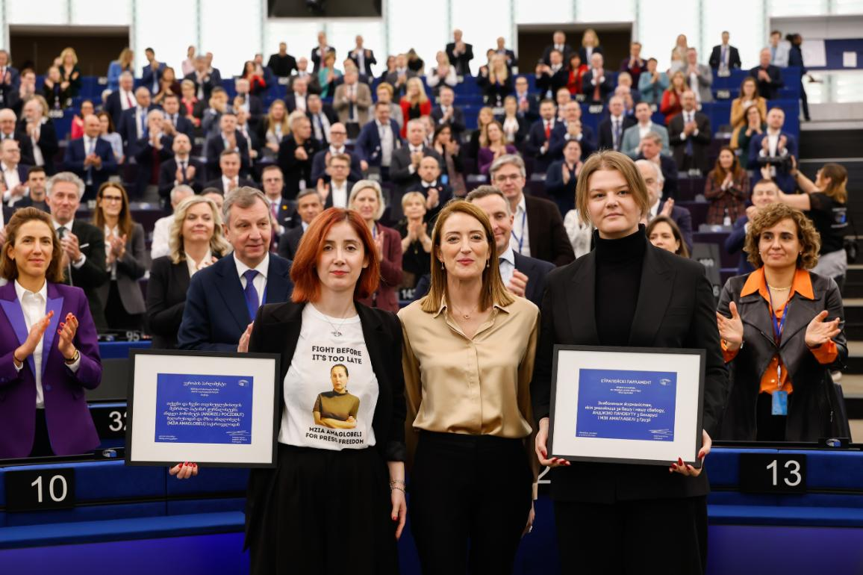
European Parliament President Roberta Metsola with Jana Poczobut (right), daughter of the imprisoned journalist Andrzej Poczobut from Belarus, and Irma Dimitradze (left), representative of the imprisoned journalist Mzia Amaglobeli from Georgia, during the Sakharov Prize for Freedom of Thought award ceremony at the European Parliament, Strasbourg, France, 16 December 2025.

Putting citizens at the heart of European democracy
The key to a healthy democracy is empowered citizens. The EU is committed to listening closely to citizens and stakeholders and engendering public participation in the policymaking process. It achieves this through a number of initiatives, such as public consultations and feedback, the European Citizens’ Initiative and the European Citizens’ Panels. The latter, now a regular part of democratic life in the EU, bring together 150 randomly selected citizens from all 27 Member States to deliberate on critical long-term challenges and make recommendations to policymakers. During the year the EU also launched strategic dialogues with key industry sectors, creating an inclusive forum to address specific challenges.
2025 also saw the Commission follow up on the successful 2023 European Citizens’ Initiative ‘Stop finning – Stop the trade’, which called on the EU to take action to end the international trade in loose shark fins. As of January 2025, the EU had stepped up the monitoring of the shark-product trade thanks to 13 new tariff codes for sharks and their fins.
CH06-INFO07
98 public consultations launched in 2025.
Feedback received on:
201 calls for evidence documents;
51 legislative proposals;
224 draft implementing and delegated acts.

4 new European Citizens’ Initiatives launched:
- ‘HouseEurope! Power to Renovation’;
- ‘Food is a Human Right for All! Guaranteeing healthy, just and sustainable food systems’;
- ‘Save your right, save your flight!’;
- ‘Demand the full suspension of the EU–Israel Association Agreement in view of Israel’s violations of human rights’.

2 new citizens’ panels organised:
- The European Citizens’ Panel on the EU Budget;
- The European Citizens’ Panel on Intergenerational Fairness.
CH06-PH06

A session of the European Citizens’ Panel on Intergenerational Fairness, in Brussels, Belgium, September 2025. This panel was convened to discuss what an intergenerationally fair, sustainable and inclusive EU should look like. The citizens’ recommendations will directly inform the upcoming Strategy on Intergenerational Fairness, due in 2026.

CH06-INFO08
2025 strategic dialogues
 | 30 January | Automotive industry (first dialogue)
 | 3 March | Automotive industry (second dialogue)
 | 4 March | Steel sector
 | 8 April | Pharmaceutical industry
 | 15 April | High-speed rail
 | 12 May | Chemical industry  Defence industry
 | 1 July | Ports and maritime industry
 | 2 July | Circularity
 | 17 July | Clean corporate fleets  Renewable and low-carbon fuels in maritime and aviation
 | 12 September | Automotive industry (third dialogue)

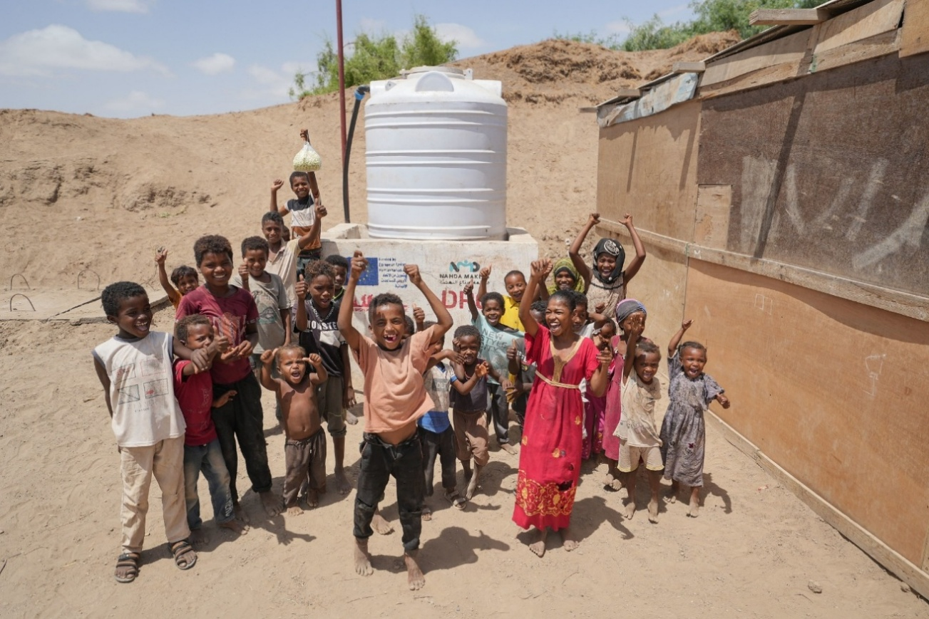
CH07-PH01
Living in turmoil: 15.2 million people in Yemen need access to safe water, sanitation and hygiene services. At the Al-Makhshab site, water is consistently available thanks to the new system funded by the EU. Since the beginning of the war in 2015, the EU has contributed almost €1.6 billion to respond to the crisis. Al-Makhshab, Yemen, 14 May 2025.

7. A global Europe for peace, partnerships and economic stability

Introduction
The world has changed drastically in recent years. In the face of Russia’s war of aggression in Ukraine, the conflict in Gaza, more aggressive and unfair economic competition from China, the relationship with the United States and the rise of divisive politics, the European Union has worked to defend and promote a rules-based international order, build effective trade partnerships and strengthen the role of global institutions. The EU remains firmly committed to effective multilateralism with the United Nations at its core, supported by other international institutions such as the World Trade Organization. The EU also remains the largest donor of development aid and among the leading donors of humanitarian aid in the world.

Enlarging the EU
Enlargement is a strategic investment in Europe’s long-term peace, stability and prosperity, and is crucial for increasing the EU’s influence on the global stage. The EU regularly evaluates the progress of all enlargement countries, including within the framework of the annual enlargement package. The gradual integration of aspiring members into specific areas of EU policies, including parts of the Single Market, strengthens ties with the EU before their accession. The European Commission is notably supporting enlargement countries’ efforts to join the Single Euro Payments Area and the Roam Like at Home area. The Growth Plan for Moldova, the Growth Plan for the Western Balkans and the Ukraine Facility are facilitating this process and driving the investments and reforms necessary to prepare enlargement countries for their accession to the EU.
CH07-PH02
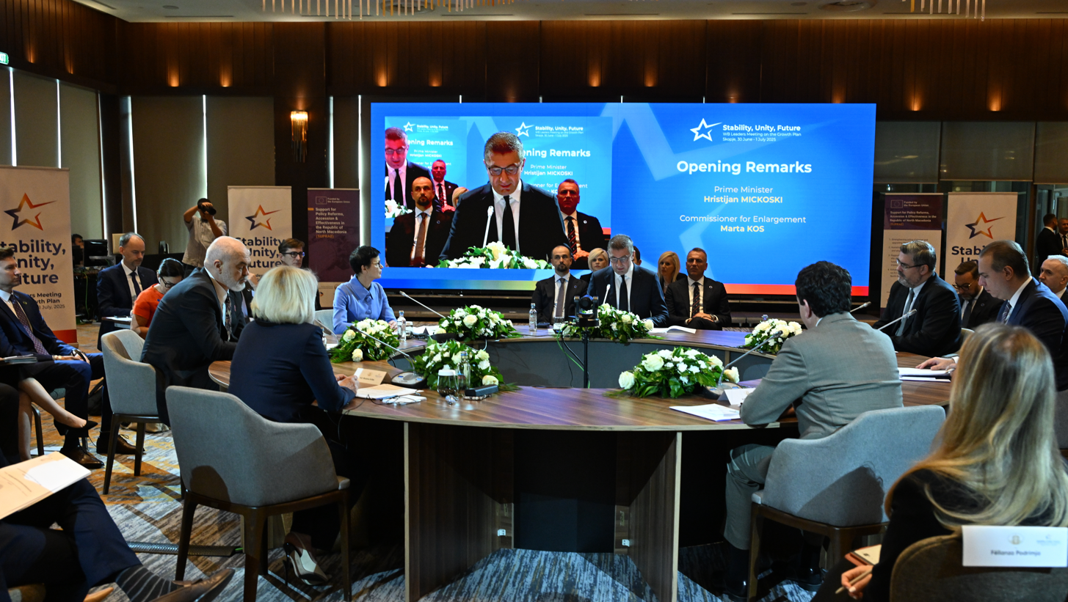
Marta Kos, European Commissioner for Enlargement (centre left, in light blue), at the Western Balkans Leaders’ meeting in Skopje, North Macedonia, 30 June 2025. The leaders of Albania, Bosnia and Herzegovina, Kosovo, Montenegro, North Macedonia and Serbia gathered to affirm their continued commitment to the Growth Plan for the Western Balkans.
CH07-INFO01
EU support for enlargement countries in 2025
- €184 million in support was disbursed under the Reform and Growth Facility for the Western Balkans.
- Through the WiFi4WB (Wi-Fi for Western Balkans) initiative, the EU provides free Wi-Fi hotspots to up to 500 municipalities across the Western Balkans.
- As of June, the Western Balkans Guarantee 4 SME Resilience had committed the last of its €60 million in EU funds, unlocking a total of €886 million in financing to support the sustainable growth of small and medium-sized enterprises in the region.
- €288.9 million was disbursed under the new Reform and Growth Facility for Moldova.
- An overall package of €250 million was agreed as part of the two-year Comprehensive Strategy for Energy Independence and Resilience of Moldova, to help reduce Moldova’s energy dependence on Russia, increase its resilience and help it integrate into the EU energy market.
- https://enlargement.ec.europa.eu/news/eu-delivers-additional-eu189-million-moldova-and-calls-businesses-invest-country-2025-09-04_enThe expansion of the European Digital Innovation Hubs Network to Albania, Kosovo (this designation is without prejudice to positions on status and is in line with UNSCR 1244/1999 and the ICJ Opinion on the Kosovo declaration of independence), Montenegro, North Macedonia, Serbia, Türkiye and Ukraine is strengthening digital transformation in the region.
- The first regional EU–Western Balkans Investment Forum was held in Albania.
- At the EU–Montenegro Investment Conference, 14 new partnership projects were launched between Montenegrin and EU businesses.
- The Ukraine Facility continues to support Ukraine’s recovery, reconstruction and path towards EU accession (see Chapter 1).
CH07-INFO02
2025 actions to enhance trade relations with candidate countries
— Agreements on a modernised trade relationship with Moldova and with Ukraine.
— High-level dialogues between Türkiye and the EU on trade, the economy, migration and security.
— Finalisation of the revision of trade regimes with Moldova and Ukraine, in the context of their EU accession process.

The EU’s wider neighbourhood

Eastern Partnership and Black Sea region
Regional cooperation under the Eastern Partnership brings the EU, Armenia, Azerbaijan, Belarus, Georgia, Moldova and Ukraine together with the objective of tackling shared challenges and pursuing common objectives. Belarus suspended its participation in 2021, following the drastic deterioration in the overall human rights, democracy and rule-of-law situation in the country in the run up to and the conduct and aftermath of its August 2020 elections. Cooperation continues with key Belarusian non-state stakeholders, including civil-society organisations and the democratic forces for a democratic Belarus.
Regional cooperation in the Eastern Partnership also contributes to the implementation of the EU’s strategic approach to the Black Sea region, adopted in May 2025. Amidst Russia’s war of aggression against Ukraine, the strategy will also reinforce the EU’s geopolitical role as a reliable actor in the Black Sea region.
CH07-INFO03
Three pillars for future EU–Black Sea cooperation
1. Enhancing security, stability and resilience.
2. Fostering sustainable growth and prosperity.
3. Promoting environmental protection, climate-change resilience and preparedness, and civil protection.
In October, a Cross-Regional Connectivity Agenda was launched with the aim of coordinating strategic investment to strengthen trade, transport, energy and digital links between Europe and Central Asia, via Türkiye and the Black Sea and South Caucasus countries. It reflects the EU’s strategic efforts to forge partnerships and advance cross-regional cooperation.

Middle East and North Africa
A prosperous, connected, resilient and secure Mediterranean basin is in the strategic interest of the EU as it strives to improve its competitiveness, increase its security and manage migration. The Pact for the Mediterranean, launched by Member States and the Southern Mediterranean partners, renews and elevates the EU’s ambition to engage more deeply with countries across the region so as to stimulate investment and bring added value for people and economies on all shores of the Mediterranean. The pact proposes flagship projects under its three pillars: people, economy and security.
CH07-INFO04
Strategic and comprehensive partnerships
- The first-ever EU–Egypt Summit, held concurrently with an EU–Egypt high-level event, marked a pivotal opportunity to convert shared ambition into concrete results, building on the EU–Egypt Strategic and Comprehensive Partnership.
- The EU and Jordan signed a joint declaration launching a new strategic and comprehensive partnership to better tackle common challenges and to advance shared values of peace, democracy and human rights. They also signed a memorandum of understanding launching the implementation of €500 million of macrofinancial assistance to support Jordan’s economic stability, growth, long-term resilience and reforms.
- Jordan also signed the renewed Partnership for Research and Innovation in the Mediterranean Area Agreement, which aims to build research and innovation capacities and develop knowledge and solutions for water management, farming systems and food-chain value in the Mediterranean. Jordan will contribute €4.5 million to the partnership between 2025 and 2027.
- The Council adopted the EU mandate to launch negotiations with each of the six Gulf Cooperation Council countries – Bahrain, Kuwait, Oman, Qatar, Saudi Arabia and the United Arab Emirates – with the aim of concluding bilateral strategic partnership agreements.
CH07-PH03
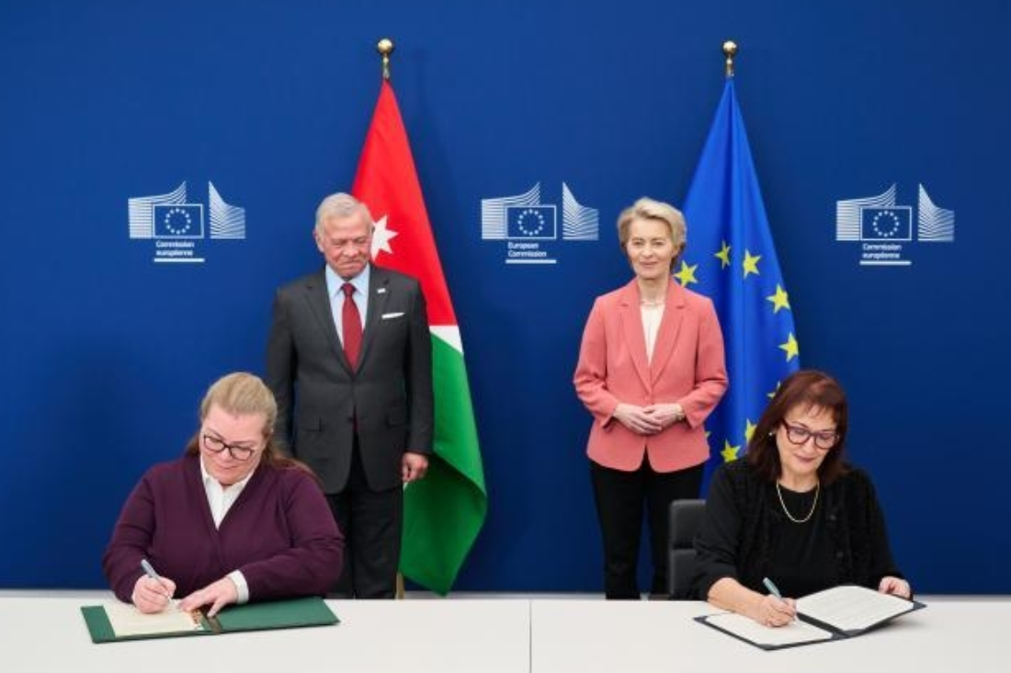
Dubravka Šuica, European Commissioner for the Mediterranean (front right), and Zeina Toukan, Jordanian Minister for Planning and International Cooperation (front left), signing the EU–Jordan Strategic and Comprehensive Partnership Agreement, in the presence of Ursula von der Leyen, President of the European Commission (rear right), and Abdullah II, King of Jordan (rear left), Brussels, Belgium, 29 January 2025.

The EU’s foreign policy and international relations
The EU continues to defend and promote a rules-based international order and is working to strengthen the role of global institutions. It does so with the aim of ensuring that its values are upheld and that Europe stands strong in a more contested and unstable world.
Ahead of the 80th UN General Assembly, the EU reaffirmed its commitment to multilateralism based on international law, including the UN Charter, recognising the intrinsic link connecting peace with security, human rights and sustainable development. The EU will remain a predictable, reliable and credible partner, committed to finding global solutions to common challenges, including through the implementation of the Pact for the Future. The EU is also determined to accelerate efforts to deliver on the 2030 Agenda and achieve the Sustainable Development Goals and to support the ongoing UN reform process.

Economic security
A new economic foreign policy that focuses on economic security, trade and investment in partnerships is central to Europe’s prosperity. Open trade can grow businesses and create jobs, but fair competition and a level playing field must be maintained between domestic and foreign producers. Trade defence tools continue to protect EU jobs by promoting a fair business environment for EU firms.
To prevent outbound investments from negatively impacting the EU’s economic security, the Commission has called on Member States to review such investments in non-EU countries by companies within their territories, in relation to three areas of strategic importance to the EU: semiconductors, artificial intelligence and quantum technologies. This will inform the need for possible future action in this area. Furthermore, interinstitutional negotiations on improving the EU’s framework for the screening of foreign direct investment were concluded in December, to make investment screening a stronger, more coherent strategic instrument.
The EU’s Steel and Metals Action Plan, published in March, is designed to strengthen the sector’s competitiveness and safeguard the industry’s future.
In December, the Commission adopted an economic security package consisting of a communication on strengthening the EU’s economic security and the RESourceEU Action Plan.
CH07-INFO05
The EU is the world’s second-largest economy and the biggest trading sector in the world.
CH07-INFO06+ PH05
Spread Key trade and international cooperation developments in 2025

— Joint statement with the United States on a framework agreement on reciprocal, fair and balanced trade. | The EU is continuously engaging with the United States to lower tariffs, thus restoring stability and predictability in EU–US trade and investment relations and benefiting businesses, workers and citizens on both sides of the Atlantic.
— Two proposals for landmark deals in Latin America, the EU–Mercosur Partnership Agreement and the EU–Mexico Modernised Global Agreement, that form a critical part of the EU’s strategy to diversify its trade relations. | These agreements will create billions of euro worth of export opportunities for EU companies of all sizes, contribute to economic growth and competitiveness, support hundreds of thousands of European jobs and promote EU interests and values in the region.
— Entry into force of the EU–Chile Interim Trade Agreement, boosting the competitiveness of businesses on both sides. | This work will be further underpinned by ongoing initiatives under the Global Gateway, such as the development of critical raw materials value chains for lithium and copper and the production of green hydrogen in Chile.
— A new chapter in the EU–UK relationship with agreements on several fronts, including reciprocal access for fishers until 2038 and a security and defence partnership. The latter will enable the United Kingdom to participate in common procurement actions.

— Joint declaration with Switzerland to strengthen cooperation in the critical areas of research, land transport and health.

– Negotiations launched with the United Arab Emirates on a free trade agreement, opening the possibility of the first comprehensive EU trade deal in the Gulf region.

— Strategic partnership established with the five Central Asian countries – Kazakhstan, Kyrgyzstan, Tajikistan, Turkmenistan and Uzbekistan.  — EU–Uzbekistan Enhanced Partnership and Cooperation Agreement signed. | As a first sign of the new impetus in this relationship, a Global Gateway investment package of €12 billion will support cooperation on climate, energy and critical raw materials between the EU and these partners.
— Landmark digital trade agreement (DTA) signed with Singapore, negotiations concluded on a DTA with South Korea and work started on a DTA with Canada. | These agreements are in line with EU’s new International Digital Strategy, which announces the EU’s intention to establish a Digital Partnership Network and expand the network of digital trade agreements. The strategy will also develop an EU tech business offer by combining EU private- and public-sector investment to support the digital transition of partner countries and will strengthen global digital governance in line with the EU’s fundamental values.
— Shared commitment with Japan reaffirmed to strengthen cooperation on trade and economic security, Competitiveness Alliance established and High-Level Economic Dialogue expanded.
— Negotiations relaunched on an EU–Malaysia free trade agreement.

— Negotiations finalised on the EU–Indonesia Comprehensive Economic Partnership Agreement. | 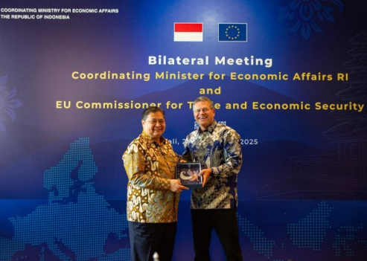  Maroš Šefčovič, European Commissioner for Trade and Economic Security and for Interinstitutional Relations and Transparency (right), and Airlangga Hartarto, Indonesian Coordinating Minister for Economic Affairs (left), celebrating the conclusion of negotiations on the EU–Indonesia Comprehensive Economic Partnership Agreement in Jakarta, Indonesia, 22 September 2025.

CH07-INFO07
2025 measures to ensure fair trade
— Reduced the liberalisation rate from 1 % to 0.1 % to limit the amount of steel that can be imported into the EU tariff-free.
— Made a proposal for a trade measure addressing the negative trade-related effects of global steel overcapacities on the EU market.
— Activated a customs surveillance system to monitor the import and export of metal waste and scrap into and out of the EU, to ensure sufficient access to scrap for the EU’s metals industries.
— Started tracking imports of industrial chemicals, which are rapidly filling up the EU market and causing or threatening to cause injury to EU industry, so that the EU can level the playing field.
—Set up an import surveillance task force to inform decisions and actions to protect the Single Market.
— Imposed International Procurement Instrument measures (due to consistent discrimination against EU medical devices in China’s public procurement market) to exclude bidders from China from participating in EU public tenders for medical devices with an estimated value of more than €5 million, and limited the share of medical devices originating from China to no more than 50 % of the value of relevant contracts.
— Took action to prevent the dumping of mobile access equipment from China, which causes significant harm to producers in Europe, where annual sales in this field amount to €1 billion.
— Imposed duties on imports of aluminium road wheels from Morocco, which were found to be unfairly subsidised, including via China’s Belt and Road Initiative, and as such were harming the industry in the EU.
— Launched arbitration proceedings against Algeria’s trade and investment restrictions, which infringe on the EU–Algeria Association Agreement.
— Brought a successful dispute settlement procedure against China at the World Trade Organization on anti-suite injunction decisions by Chinese courts relating to standard essential patents, for example 5G for mobile phones.

International partnerships
International partnerships are a key component of the EU’s external policy. The Global Gateway strategy, which draws on financial tools such as the Neighbourhood, Development and International Cooperation Instrument – Global Europe, is the EU’s contribution to narrowing the global investment gap, fully aligned with the UN’s 2030 Agenda and its Sustainable Development Goals, and with the Paris Agreement. It has become a trusted strategy to mobilise investment worldwide, creating good local jobs and adding value across the globe, while also strengthening the EU’s competitiveness and security. https://commission.europa.eu/topics/international-partnerships/global-gateway_enhttps://enlargement.ec.europa.eu/funding-technical-assistance/neighbourhood-development-and-international-cooperation-instrument-global-europe-ndici-global-europe_enSo far, the Global Gateway has mobilised €306 billion in public and private investment – overshooting the initial target of €300 billion by 2027.
The Global Gateway Investment Hub, launched in October, will significantly add to these efforts by facilitating investment projects by EU companies across partner countries. To consolidate and strengthen the EU’s role as a global actor, the Commission has proposed to increase the efficiency of the External Action Guarantee by cutting red tape and introducing simplification measures. The External Action Guarantee is a key financial tool under the Global Gateway strategy, offering more affordable loans to unlock investment and build trade relations with partner countries around the world.

CH07-INFO09
Fostering high-level diplomacy and partnerships between the EU and Africa
CH07-PH07
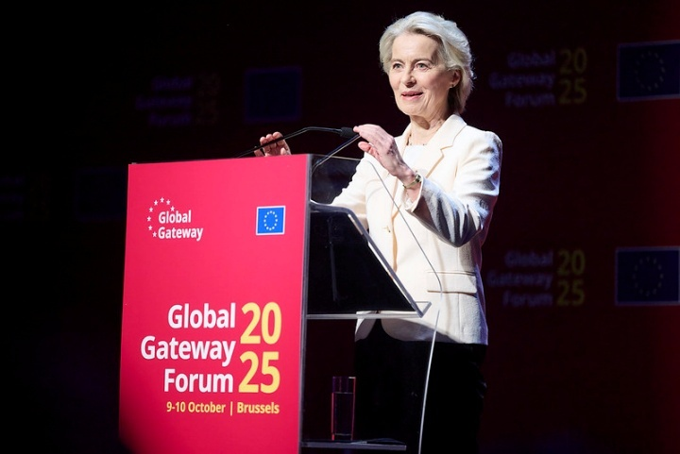
Ursula von der Leyen, President of the European Commission, at the Global Gateway Forum in Brussels, Belgium on 9 and 10 October 2025, during which she announced a €618 million Team Europe package to scale up renewables in Africa. This announcement built on the €545 million package unveiled at the UN General Assembly earlier during the year, showing that the EU continues to deliver on its commitments.
In 2025, the EU and the African Union celebrated the 25th anniversary of their partnership with the seventh edition of the EU–African Union Summit. Through the Global Gateway, the EU has already mobilised €120 billion for projects across Africa. At the G20 Summit in South Africa, the final pledging event of the Scaling up Renewables in Africa Global Gateway campaign mobilised €15.5 billion for clean energy and access to electricity across the continent. The funding provided by the EU and Member States in a Team Europe approach expands the EU’s clean energy efforts in Africa. The campaign has also joined forces with Mission 300, a World Bank Group initiative that aims to provide electricity to 300 million people in Africa by 2030. It will help power homes, schools and hospitals across the continent and will create thousands of green jobs, from Côte d’Ivoire and Lesotho to Madagascar and Somalia.
CH07-PH08
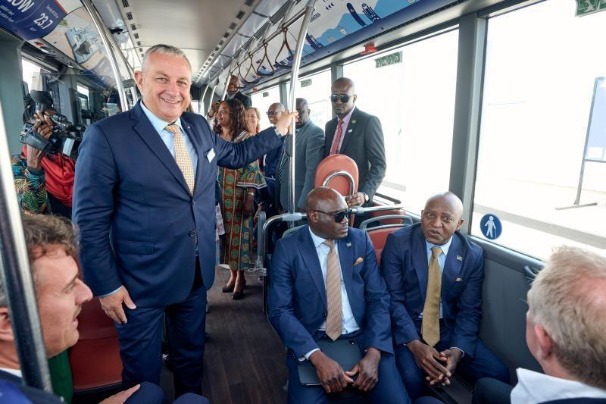
Jozef Síkela (standing, left), European Commissioner for International Partnerships, during a visit to the project ‘Towards an inclusive design of the renewable energy transition’, in Windhoek, Namibia, 17 September 2025.

International summits
The EU participated in several summits with partner countries in 2025. At the June G7 Summit in Canada, leaders discussed how to step up support for Ukraine and reiterated their commitment to peace and stability in the Middle East. Other key topics discussed at the summit included strengthening economic coordination, the secure supply of critical minerals, new technologies (artificial intelligence and quantum), the energy transition and ways to better prevent and mitigate wildfires.
The G20 Summit in Johannesburg, South Africa, marked the first summit on the African continent and concluded the G20’s first cycle of presidencies. The summit outcome focused on important priorities for Europe and Africa, such as the energy transition, critical minerals and debt sustainability. Other key topics discussed included global imbalances, climate action, disaster resilience and artificial intelligence.
CH07-PH06+INFO08
Research and Innovation
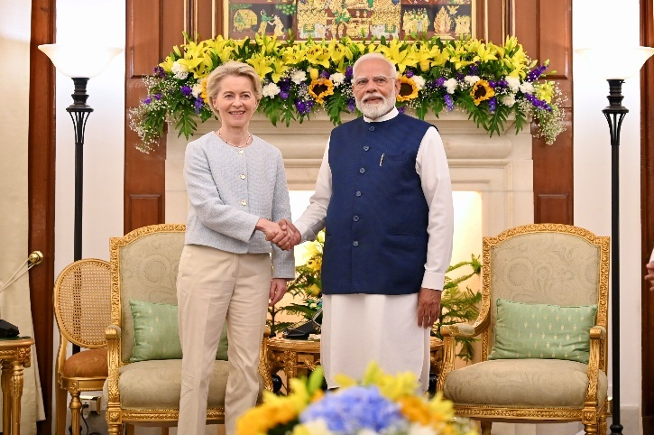
Ursula von der Leyen, President of the European Commission (left), shaking hands with Narendra Modi, Prime Minister of India (right), during the visit of the College of Commissioners to India. New Delhi, India, 27 February 2025.
Cooperation with India in research and innovation gained momentum in 2025, particularly within the framework of the EU–India Trade and Technology Council. Under the council’s Working Group on Green and Clean Energy Technologies, collaborative research has been launched with India on marine plastic pollution, waste-to-renewable-hydrogen solutions and the recycling of batteries for electric vehicles, with a joint investment of around €60 million.

Horizon Europe is the EU’s key funding programme for research and innovation, and provides a platform to collaborate with the best research communities across the world. In 2025, Egypt, South Korea and Switzerland joined Horizon Europe, bringing the total number of associated countries to 22.

Supporting peace and security
At the first-ever EU–Palestine High-Level Political Dialogue (this designation shall not be construed as recognition of a State of Palestine and is without prejudice to the individual positions of the Member States on this issue), the Commission proposed a multiannual Comprehensive Support Programme to foster Palestinian recovery and resilience. The Commission also convened the first meeting of the Palestine Donor Group in Brussels, Belgium, bringing together global partners to support the implementation of Palestinian reforms, help strengthen governance, improve economic resilience and advance Gaza’s recovery. Several Member States have pledged a total of €88 million, to be securely channelled to the Palestinian Authority through the Pegase (Palestinian–European Socio-Economic Management and Assistance) mechanism.
CH07-GR02
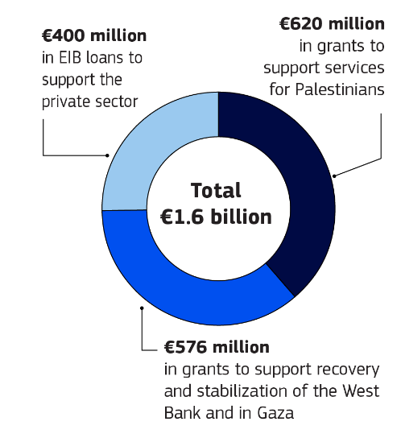
To foster peace in the Middle East, the Commission proposed to suspend certain trade-related provisions of the EU–Israel Association Agreement and to impose additional sanctions on Hamas, extremist ministers and violent settlers. The Commission also put on hold its provision of bilateral support to Israel, with the exception of support for civil society and Yad Vashem (the World Holocaust Remembrance Center).
CH07-PH09
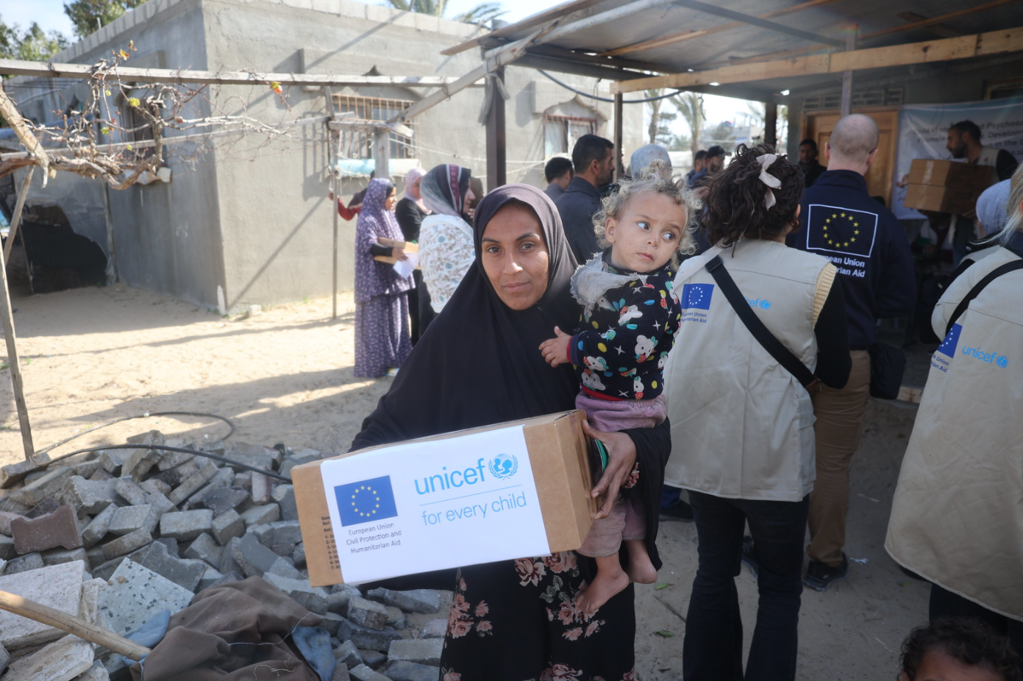
EU humanitarian efforts in Gaza: a lifeline amid destruction. With funds from the EU, UNICEF distributed winter clothing to 150 000 children. 5 February 2025.
CH07-INFO10
The EU remains the biggest international donor and provider of humanitarian aid to Palestinians, having allocated and disbursed a total of €220 million in emergency humanitarian support to Gaza and the West Bank, including East Jerusalem, in 2025.
The EU reaffirmed its commitment during the year to supporting the Syrian people and aiding Syria’s transition and recovery. At the ninth Brussels Conference, ‘Standing with Syria: Meeting the needs for a successful transition’, the EU announced nearly €2.5 billion worth of financial commitments for 2025 and 2026 to aid Syria’s transition process and its socioeconomic recovery. The Commission also lifted economic sanctions on Syria, with the exception of those based on security grounds, and in 2025, for the first time, the annual Day of Dialogue was held in Syria. Finally, following the reintroduction of UN sanctions on Iran, the Commission agreed to reimpose a number of sanctions in relation to the country’s nuclear proliferation activities.

Humanitarian aid
When major natural disasters occur or conflicts break out, millions find themselves in peril. Humanitarian aid becomes a lifeline, providing food, shelter and medical care.
The EU, together with its Member States, is at the forefront of these relief efforts and was the world’s leading donor of humanitarian aid in 2025. It provides life-saving aid based on needs, upholds the protection of humanitarian workers, safeguards international humanitarian principles, protects civilians and defends international humanitarian law – all of which are at the heart of humanitarian diplomacy. In 2025, the EU allocated €2.56 billion in humanitarian assistance and protection.
The EU provided humanitarian aid to its immediate neighbourhood, focusing on Armenia, Moldova, Türkiye and Ukraine. Beyond Palestine, the EU’s humanitarian assistance in the Middle East and North Africa focused on Syria and addressing the needs of Syrian refugees in the region.
The EU is a global humanitarian actor. The war in Sudan and its spillover into neighbouring countries, the complex and volatile situation in the Greater Horn of Africa and in West and Central Africa and extreme weather events in the southern Africa and Indian Ocean region have resulted in mass displacement, food insecurity and even famine. The EU’s humanitarian aid provided life-saving assistance to millions of the most vulnerable and those affected by these crises.
In Asia, EU humanitarian aid continued to address protracted humanitarian crises, such as those in Afghanistan, Bangladesh and Myanmar/Burma, while also responding to sudden natural disasters such as floods in Pakistan and tropical cyclones in the Philippines and Vietnam, among others.
In Latin America, EU humanitarian aid supported communities affected by the ongoing crises in countries such as Colombia, Haiti and Venezuela, along with victims of disasters such as Hurricane Melissa in the Caribbean.

CH07-PH10

Hadja Lahbib, European Commissioner for Equality, Preparedness and Crisis Management, visiting a Red Cross centre in Bogotá, Colombia, ahead of the EU–Community of Latin American and Caribbean States Summit. 5 November 2025.
CH07-GR03
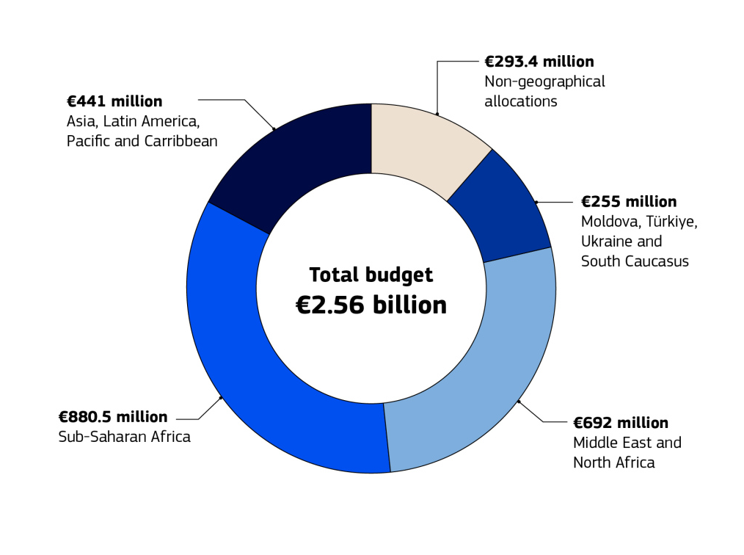
CH08-PH08
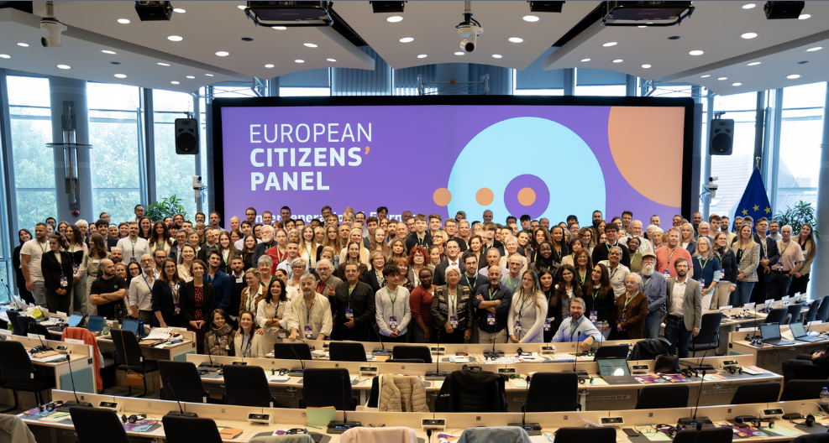
The European Citizens’ Panel on the New EU Budget, Brussels, Belgium, 28 March 2025.

8. Preparing Europe for the future

Introduction
In 2025, the European Union focused on preparing itself for the challenges and opportunities of the coming decade. Its institutions worked together to strengthen resilience, simplify rules and ensure that policies deliver tangible results for both people and businesses. A central pillar of this effort was the preparation of the new multiannual financial framework for 2028–2034, which was designed to provide a simpler, more flexible and future-proof budget. At the same time, the EU put forward reforms to cut red tape, reduce costs and improve financial risk management. Through foresight, stronger partnerships and effective enforcement, the EU is building a framework for long-term prosperity and security.

A proposed new budget

The 2028–2034 multiannual financial framework
The EU’s long-term budget, the multiannual financial framework (MFF), supports citizens, farmers, researchers, businesses and regions across the EU and beyond. The current MFF (for 2021–2027), together with the NextGenerationEU recovery plan, has been vital in tackling the COVID-19 pandemic and the energy crisis, protecting millions of jobs and driving the clean and digital transitions. It has also delivered unprecedented support to Ukraine and strengthened Europe’s security in the face of Russia’s war of aggression.
In 2025, the European Commission adopted its proposal for the 2028–2034 MFF, designed to respond to growing geopolitical, economic and sustainability challenges. At nearly €2 trillion (equivalent to 1.26 % of the EU’s gross national income), it would provide a simpler, more flexible and more targeted budget to support the EU’s independence, security, prosperity, inclusiveness and resilience in the decade ahead.
CH08-INFO01
A more inclusive and democratic process
While preparing the budget, the Commission ran a Europe-wide campaign to gather input from stakeholders at every level, from national governments to citizens.
 | February | - Start of the Tour d’Europe to consult Member State authorities, regional stakeholders and EU budget beneficiaries on the new MFF.  - Roadmap for drawing up the new budget proposal published.
 | February–May | - Public consultation on the new budget via the Have Your Say portal.
 | May | - European Citizens’ Panel on the new European budget (see Chapter 6) agrees on 23 recommendations for the new budget.
 | 16 July | - First proposal for the new budget published.
 | July–October | - Public consultation on the proposal via the Have Your Say portal.
 | 3 September | - Final proposal for the 2028–2034 EU long-term budget published.

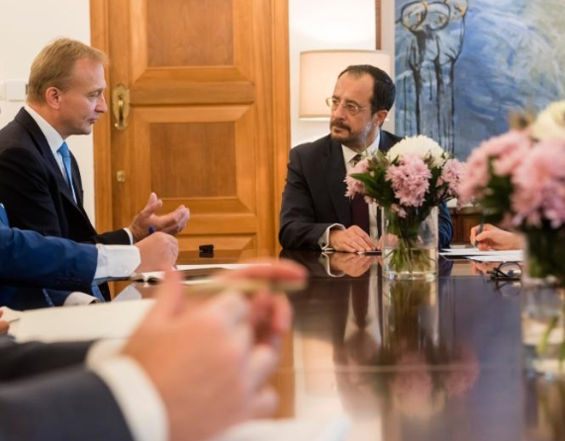
CH08-PH02
In 2025, Piotr Serafin, European Commissioner for Budget, Anti-Fraud and Public Administration (left), undertook a Tour d’Europe to foster a broad and inclusive discussion across the continent, underscoring the Commission's commitment to working closely with Member States. During his visit to Nicosia, he met with Nikos Christodoulides, President of Cyprus (right), and other high-level officials. The visit, ahead of the Cypriot Presidency of the Council starting in January 2026, highlighted the country’s strategic role at a crucial stage of the negotiations on the multiannual financial framework. Nicosia, Cyprus, 4 September 2025.

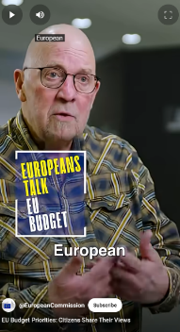
CH08-VIDEO03
VIDEO: Participants in the European Citizens’ Panel on the new European budget share what they want from the EU budget, how the money should be spent and what it should support.
CH08-INFO02
The MFF proposal is built on several core drivers, recognising that the status quo is no longer adequate:
- create a budget that is simpler, more agile and more impactful;
- address the need to invest in common strategic priorities, including defence, competitiveness, security and the clean and digital transitions;
- modernise common policies, such as the Common Agricultural Policy, the Common Fisheries Policy and economic, social and territorial cohesion;
- balance predictability – for long-term investment support, farmers and regions – with flexibility where needed in a fast-changing world;
- send a clear message on the EU’s unity, independence and commitment to promoting and defending its core values;
- ensure the EU’s credibility by providing a clear pathway for NextGenerationEU repayments.
CH08-GR01
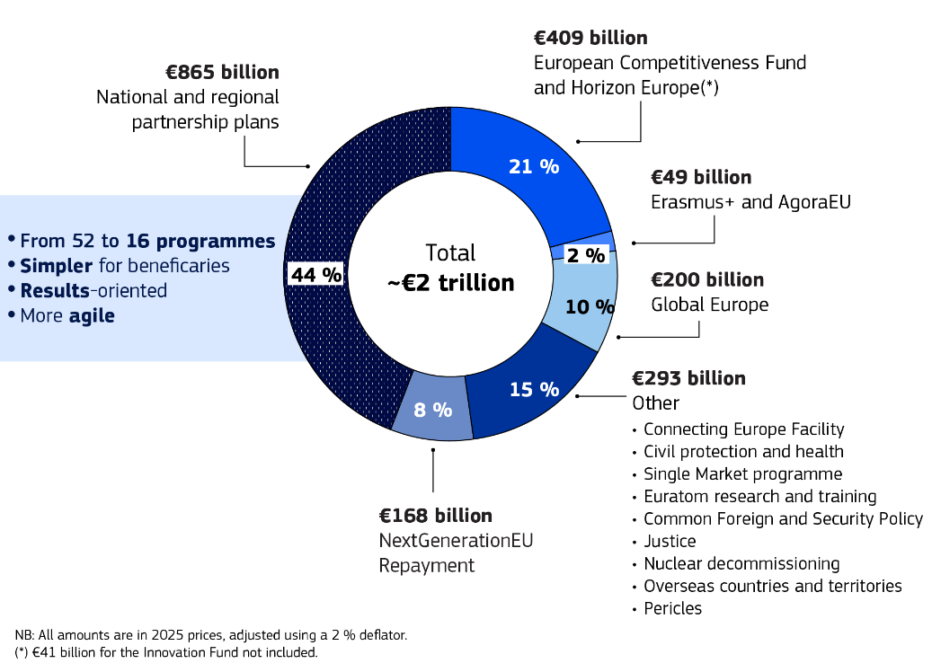
CH08-INFO03
Under the proposed budget:
- a minimum of around €296 billion would be ring-fenced to support farmers’ and fishers’ income, and there would be a 10 % rural target under the national and regional partnership plans;
- 35 % of total spending would be dedicated to climate and environmental objectives, mobilising at least €700 billion;
- almost €220 billion would be earmarked for investment in less-developed regions, alongside stable and predictable funding for transition and more-developed regions;
- respect for the rule of law and the Charter of Fundamental Rights of the European Union would remain non-negotiable;
- the budget of the Erasmus+ programme would be increased by 50 %;
- the budget for transport infrastructure would double to improve connections across the continent and adapt the network for military purposes;
- €131 billion would be allocated to defence and space – five times more than under the current MFF;
- a social target of 14 % of the total budget for national and regional partnership plans – excluding what is ring-fenced for farmers and fishers, and resources from the Social Climate Fund – would support skills development, poverty reduction and social inclusion;
- the budget for research and innovation activities would be almost doubled to strengthen the EU’s competitiveness, increasing from the current €95 billion to €175 billion.
With the EU facing rising financial needs, mounting pressure on national budgets and the upcoming start of loan repayments for the NextGenerationEU instrument in 2028, the Commission has proposed new ways to increase its own resources, aiming to generate about €58.2 billion per year (in 2025 prices) through new and revised revenue streams.
CH08-GR02
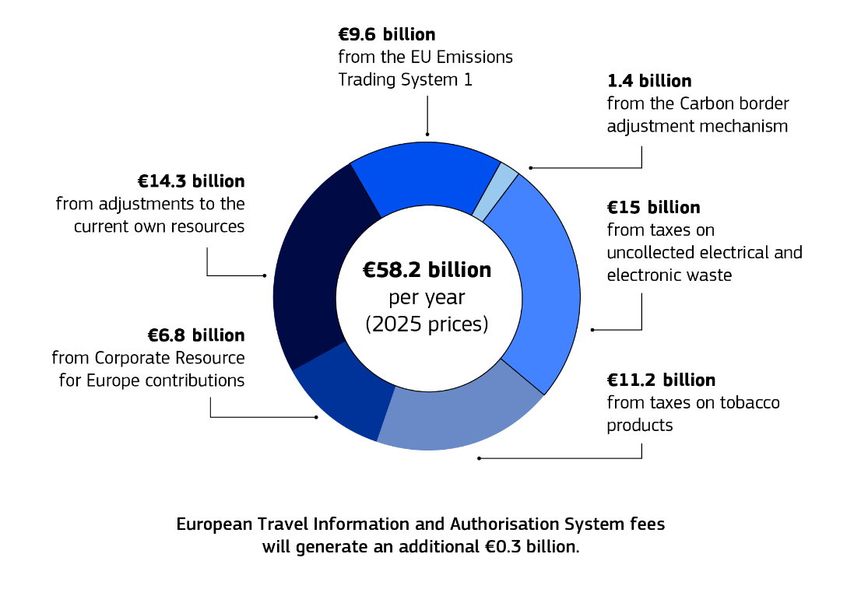
In its proposal for the next MFF, the Commission envisages the establishment of three main funds: a European Fund for economic, social and territorial cohesion, agriculture and rural, fisheries and maritime, prosperity and security; a European Competitiveness Fund that would support the development, scaling and deployment of strategic technologies; and a Global Europe Instrument that would allow for more strategic external action funding worldwide.
The midterm review of the EU’s cohesion policy, adopted in 2025, realigns funding from the 2021–2027 MFF to help Member States and regions reallocate resources towards new strategic priorities, including competitiveness, security and defence, civil preparedness, housing, water resilience and the energy transition.

Protecting the EU budget from fraud
Protecting every euro is essential to ensure that the EU budget delivers for its people. In July, the Commission launched a review of the EU anti-fraud architecture to strengthen the protection of the EU’s financial interests in response to evolving threats. These include transnational fraud; organised crime targeting EU funds; and the misuse of advanced technologies such as artificial intelligence and cryptocurrencies.

Strengthening the EU’s financial risk management framework
The EU’s financial risk management framework covers risks linked to the EU budget, NextGenerationEU and other financial instruments. In 2025, the Commission strengthened this framework by expanding the role of the independent Chief Risk Officer, who now oversees all EU financial operations, including borrowing, lending, budgetary guarantees and asset management. This change responds to recommendations from the European Court of Auditors to reinforce oversight and risk management of the EU’s borrowing, guarantees and related financial instruments.
CH08-INFO04
The European Semester
The European Semester plays an important role in the EU’s economic governance. The 2025 spring package marks the conclusion of the first full annual cycle of macroeconomic surveillance under the reformed economic governance framework, which entered into force in April 2024. This reinforces the Semester’s role not only as a channel for guiding reforms and investment, but also as the backbone of the EU’s fiscal oversight.
In 2025, country-specific recommendations advised Member States to focus on the issues of competitiveness and security. For the first time, the Semester package also contained key recommendations on skills and quality jobs, while ensuring social fairness.
The country reports analysed the fiscal, taxation, innovation, climate and environmental policies of Member States and regions, along with their labour, social and health policies. They also included a review of the implementation of recovery and resilience plans and cohesion-policy programmes.
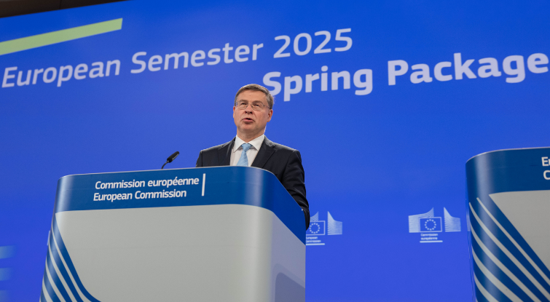
CH08-PH03
Valdis Dombrovskis, European Commissioner for Economy and Productivity and for Implementation and Simplification, at the press conference on the 2025 Spring European Semester, Brussels, Belgium, 4 June 2025.

The success of the Recovery and Resilience Facility
As the Recovery and Resilience Facility (RRF) nears its 2026 end date, it continues to drive reforms and investment across the EU. In 2025, the Commission urged Member States to accelerate progress while simplifying their processes, and paved the way towards the smooth and successful closure of the RRF. As the centrepiece of NextGenerationEU, the RRF disbursed around €394 billion to Member States by the end of 2025, supporting economic and social resilience, along with the clean and digital transitions.
The fourth annual report on the implementation of the RRF showed that the facility enhanced public investment – expected to reach 3.8 % of gross domestic product in 2025, up from 3.2 % in 2019. It did so by supporting, among other initiatives, the decarbonisation and digitalisation of industrial production and services, the deployment of over 900 000 clean-vehicle recharging stations and the connection of 16 million households to high-speed internet. According to a Commission study, the total financial impact of the RRF over the 2020–2030 period is estimated at €892 billion, with more than €546 billion in direct impact and more than €345 billion in spillover effects across Member States’ economies.
CH08-VID04
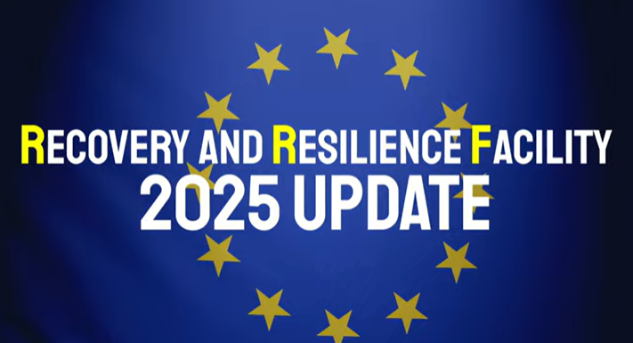
VIDEO: A 2025 update on the progress of the Recovery and Resilience Facility.

Towards a future-ready EU

Strengthening the EU’s resilience
The EU must strengthen its resilience to protect its citizens and its prosperity in the face of growing security threats, a shifting international order and the escalating impacts of climate change and environmental degradation. The 2025 strategic foresight report, published in September, set out the steps needed to ensure the EU remains peaceful, true to its values and committed to the well-being of its inhabitants amid turbulent times and uncertainty.
CH08-INFO05
The report proposes eight areas for action:
- building a coherent global vision for the EU;
- amplifying internal and external security;
- harnessing artificial intelligence and the power of technology and research;
- strengthening long-term economic resilience and preparing for labour market upheavals;
- supporting sustainable and inclusive well-being;
- reimagining education and skills;
- safeguarding democracy;
- anticipating demographic transformation and promoting intergenerational fairness.
The report highlights the need to consider even unfamiliar or hard-to-imagine scenarios, making foresight a standing feature of EU policymaking. From 2026, annual foresight reports will go beyond the analysis of trends to cover the stress-testing of policies against various scenarios, ensuring that the EU is better prepared for the future.

Simplifying EU rules
To deliver a future-ready EU, resilience and a greater capacity to act must go hand in hand with cutting red tape and making rules work better in practice. Continuing its work under the Better Regulation agenda, the EU intensified its efforts to simplify policies and laws, as outlined in the communication on a simpler and faster Europe. These efforts included implementation dialogues, which provide a political-level forum for Commissioners to gather practical feedback from stakeholders on how EU rules and programmes work in practice. Complementing these dialogues, each Commissioner prepared an annual progress report on simplification, implementation and enforcement for the first half of 2025, outlining progress, challenges and concrete next steps within their respective portfolios.
The EU’s commitment to better regulation is already yielding results: it was ranked first in an Organisation for Economic Co-operation and Development analysis of transparency, stakeholder engagement and regulatory impact assessment, according to the OECD Regulatory Policy Outlook 2025.
CH08-INFO06
The 10 simplification packages adopted in 2025 will bring savings of around €12 billion in annual administrative costs. By 2029, the Commission aims to cut administrative burdens by at least 25 % for all companies and 35 % for small and medium-sized enterprises.
CH08-PH04
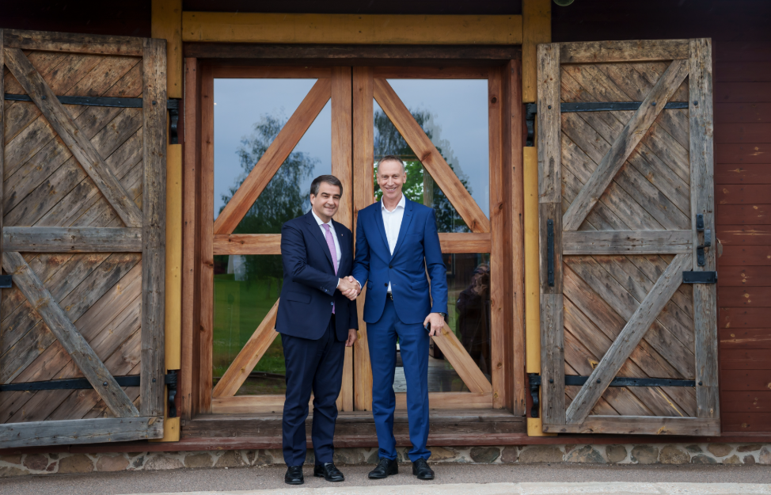
Raffaele Fitto, Executive Vice-President of the European Commission for Cohesion and Reforms (left), visiting the EU-funded project ‘BUSINESS Station’ in Alūksne, Latvia, 10 June 2025.

Ensuring the effective implementation of EU law
Laws only reach their full potential when they are fully implemented and applied. To that end, the Commission works closely with Member States to help them implement EU law and policies. When Member States fail to do so, the Commission can open infringement procedures against them. However, it works hard to prevent breaches from happening in the first place by offering practical guidance, meetings, training and technical assistance. For example, through the new guidance on battery-related data sharing, the Commission helped Member States apply the Renewable Energy Directive’s updated provisions. This guidance helps Member States establish a harmonised approach to sharing information such as a battery’s state of charge, health and location. It provides practical clarification and technical support to ensure consistent implementation across the EU.
CH08-INFO07
552 new infringement procedures were opened in 2025.
554 infringement procedures were closed.
71 cases were referred to the Court of Justice of the European Union concerning 21 Member States.
Financial sanctions were requested in 20 cases.

Strengthened interinstitutional partnerships
The EU’s institutional framework continues to evolve in response to new political and strategic priorities. In 2025, first Poland and then Denmark held the rotating presidency of the Council of the European Union, each placing particular emphasis on security and resilience.
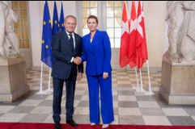
CH08-PH05
Donald Tusk, Prime Minister of Poland (left), and Mette Frederiksen, Prime Minister of Denmark (right), at an informal meeting of Heads of State or Government where EU leaders discussed how to strengthen Europe’s common defence and support for Ukraine. Copenhagen, Denmark, 1 October 2025.

As the Commission advanced legislative proposals, the European Parliament and the Council of the European Union acted as co-legislators to deliver on shared priorities. Member States, supported by the Commission’s oversight role and the work of other EU institutions and bodies, ensured effective implementation across the EU.
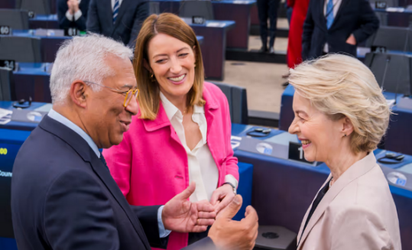
CH08-PH06
From left to right: António Costa, President of the European Council, Roberta Metsola, President of the European Parliament, and Ursula von der Leyen, President of the European Commission, at a European Parliament plenary session in Strasbourg, France, 1 April 2025.
In order for the EU to function properly as a democracy, strong and transparent cooperation between its institutions is essential. In September, the Parliament and the Commission finalised negotiations on an updated Framework Agreement to improve interinstitutional relations, trust, transparency and dialogue. The agreement is based on nine political principles agreed by the President of the European Parliament and the President of the European Commission in October 2024.
CH08-INFO08
75th anniversary of the Schuman Declaration
Every year on 9 May, the EU celebrates Europe Day. In 2025 the occasion held special significance, as it marked the 75th anniversary of the Schuman Declaration. Presented by French Foreign Minister Robert Schuman on 9 May 1950, the declaration proposed the creation of the European Coal and Steel Community, the predecessor of today’s EU.
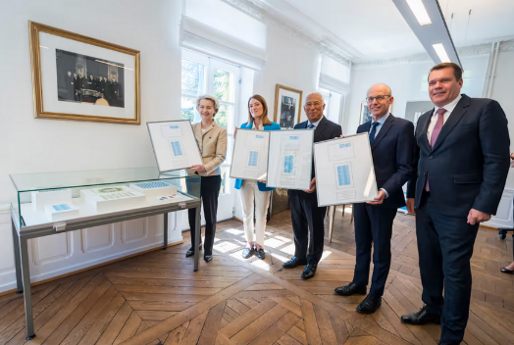
CH08-PH07
From left to right: Ursula von der Leyen, President of the European Commission, Roberta Metsola, President of the European Parliament, António Costa, President of the European Council, and Luc Frieden, Luxembourgish Prime Minster, in Robert Schuman’s house, Luxembourg, Luxembourg, 9 May 2025.

