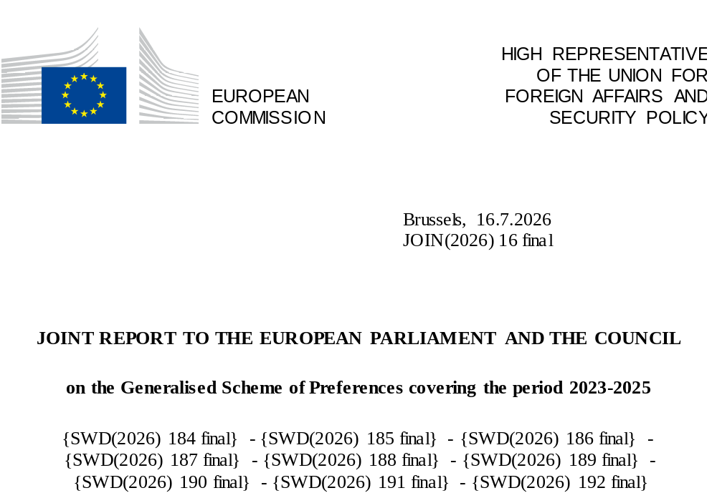

- INTRODUCTION AND HIGHLIGHTS
The Generalised Scheme of Preferences (GSP) is a key tool through which the European Union (EU) supports low- and lower middle-income countries in their pursuit of poverty reduction, economic growth and sustainable development. The EU unilaterally grants preferential access to the EU market to such countries by eliminating or reducing import tariffs; least developed countries (LDCs) benefit from duty free, quota free access. To promote sustainability, GSP beneficiaries are required to implement their commitments to specific international conventions and agreements on human rights, labour rights, environment and climate, and good governance with regard to drugs control and anti-corruption.
Regular monitoring and reporting are part of GSP implementation as laid down in the GSP Regulation. Just as the previous edition, this fifth report to the European Parliament and the Council on the implementation of the GSP is adopted jointly by the European Commission (the Commission) and the High Representative, given the importance of the GSP also from the perspective of the EU’s broader foreign policy and external action. This is the last report under the current GSP Regulation. It will mark the transition to the new GSP Regulation, which will notably feature reinforced sustainability and transparency requirements as of 1 January 2027.
This report covers the implementation and the impact of the GSP over 2023-2025 (the ‘reporting period’) through its three arrangements: 1) Standard GSP for low- and lower-middle income countries; 2) the special incentive arrangement for sustainable development and good governance (GSP+), available to those Standard GSP beneficiary countries that take on further sustainability commitments; and 3) Everything But Arms (EBA), applying to LDCs. This year marks the 25th anniversary of the EU EBA instrument.
Currently, 65 developing countries are benefitting from the EU’s GSP, 44 of which are LDCs. This corresponds to over 3 billion people worldwide, out of which more than 1 billion live in LDCs. In 2024, GSP beneficiary countries benefited from preferential tariffs with an estimated value of EUR 5 billion savings, with EBA beneficiaries accounting for more than EUR 3 billion of this total.
The largest beneficiaries of the scheme are Bangladesh (EUR 19 billion of EU imports using EBA preferences in 2024), India (EUR 11.7 billion of EU imports using Standard GSP preferences), and Pakistan (EUR 7.1 billion of EU imports using GSP+ preferences). Clothing is by far the top sector, accounting for 59 % of all trade under the GSP scheme.
Beyond its trade and economic benefits, GSP remains an attractive and effective incentive for sustainable development in beneficiary countries in relation to social, environmental, and climate-related issues, based on internationally recognised norms and standards. The EU’s monitoring and engagement under GSP plays a key role: GSP+ in particular facilitates structured engagement between EU institutions, beneficiary governments, and civil society. It supports the advancement of international human rights, labour rights, climate and environment commitments and helps strengthen anti-corruption and rule-of-law reforms. The scheme continues to ensure a balance between encouraging beneficiary countries’ trade growth potential and promoting shared values and sustainability objectives. Fostering trade with GSP beneficiaries through duty savings also supports the EU economy and businesses, while the scheme safeguards the EU’s economic interests and the competitiveness of sensitive sectors.
This report is accompanied by nine country specific Staff Working Documents (SWDs) for each of the current eight GSP+ beneficiaries Bolivia, Cabo Verde, Kyrgyzstan, Mongolia, Pakistan, The Philippines, Sri Lanka, and Uzbekistan and one for the EBA countries under enhanced engagement (Bangladesh, Cambodia and Myanmar). The report reflects the Commission services’ and the European External Action Service’s (EEAS) engagement with beneficiaries’ authorities, civil society, social partners and business communities, including through monitoring missions to GSP+ beneficiaries and enhanced engagement with some key EBA beneficiaries. The report also builds on and incorporates, as appropriate, the findings of international monitoring bodies in areas relating to the GSP conditions for beneficiary countries.

- LEGISLATIVE DEVELOPMENTS DURING THE REPORTING PERIOD
- Developments in implementation
The Commission adopted several legal acts relating to the implementation of the GSP Regulation during the reporting period:
- Country graduation from GSP: Indonesia reached Upper Middle-Income status as classified by the World Bank for three consecutive years and, therefore, will leave the GSP as of 1 January 2027. For Kenya, the EU-Kenya Economic Partnership Agreement (EPA), which applies since 1 July 2024, will fully replace the GSP as of 1 January 2027.
- Transition from EBA to Standard GSP: Bhutan graduated from LDC status on 13 December 2023 based on a UN decision. Following a three-year transition period, Bhutan will therefore cease to benefit from EBA preferences and transition to standard GSP as of 1 January 2028. Likewise, São Tomé and Príncipe graduated from LDC status on 13 December 2024 and will transition to standard GSP as of 1 January 2029.
- Vulnerability thresholds: Further to amendments to the list of beneficiary countries, the vulnerability threshold relevant for GSP+ was reviewed.
- Product graduation: Standard GSP tariff preferences were suspended for the years 2023 to 2025 for several products imported from India, Indonesia, and Kenya after attaining the relevant import thresholds and subsequently [also for the year 2026].
- Safeguards: In 2024, following the re-opening of the investigation, general safeguards measures for export of Indica rice from Cambodia and Myanmar were re-imposed. In 2025, special agricultural safeguards for imports of ethanol originating in Pakistan were imposed.

- GSP after 2026
The number of GSP beneficiaries is expected to further reduce in the future. In terms of upcoming graduations, two GSP+ beneficiaries have been qualified as Upper-Middle Income Country by the World Bank (Cabo Verde in 2025, and Mongolia in 2024 and 2025). If they are so qualified in three consecutive years, they will no longer benefit from the GSP. In addition, several of the current EBA beneficiaries are scheduled to graduate from LDC status in the coming years. These countries (see Section 4c for detail) would exit EBA following a three-year transition period after their LDC graduation and will then likely move to the Standard GSP arrangement unless they successfully apply for the more beneficial GSP+ status.
On 22 September 2021, the Commission tabled a legislative proposal for the EU’s new Generalised Scheme of Preferences for the period 2024-2033. As this new EU GSP was not yet adopted in 2023, the co-legislators extended the period of application of the current GSP Regulation until 31 December 2027. The new GSP Regulation for 2027-2036 was adopted on 17 June 2026 and will apply as of 1 January 2027.
The agreement on the new Regulation is an important milestone and ensures that the EU continues to support developing countries in their pursuit of economic growth and sustainable development based on a fair and predictable framework. The new Regulation safeguards the EU’s generous approach to tariff concessions on imports from developing countries. It maintains the main thrust of the previous legislation in order to ensure continuity and predictability for GSP beneficiary countries and their exporters, as well as for EU importers.
The new Regulation adds five new international conventions to the list of GSP-relevant instruments for GSP beneficiaries to respect (the GSP conditions, see Section 3c), and introduces the Paris Climate Agreement, which replaces the Kyoto Protocol. The new Regulation introduces the possibility to withdraw the arrangement for serious and systematic violations of the principles related to the environmental and climate and good governance conventions, as well as for serious and systematic shortcomings related to the international obligation to readmit a beneficiary country’s own nationals in the context of irregular migration. The new scheme will improve monitoring, transparency, and civil society involvement, and introduce an urgent withdrawal procedure for particularly grave violations. It will also make the safeguards mechanisms more effective for addressing cases where a surge in imports from a beneficiary country may harm producers in the EU.
To retain GSP+ status under the new GSP Regulation, current GSP+ beneficiaries will need to reapply. All GSP+ applicants will have to submit a Plan of Action for the effective implementation of the arrangement under the new rules. Current GSP+ beneficiaries will be granted a transitional period of two years until the end of 2028, and the Commission and the EEAS stand ready to support beneficiaries in the reapplication process.

- IMPACT OF THE GSP
- Trade Impacts 2022-2024
The GSP provides for three arrangements responding to beneficiaries’ levels of development and commitment:
- Standard GSP applies to eligible low- and lower-middle-income countries that have no other preferential trade arrangements with the EU. It grants duty reductions of 66 % of tariff lines for imports into the EU, with 26 % of these tariff lines being duty-free. Eleven countries currently benefit from this arrangement.
- GSP+ is a special arrangement that offers standard GSP beneficiaries’ duty-free access on 66 % of tariff lines, contingent on the effective implementation of core international human rights, labour, environmental, climate, and good governance conventions and agreements. Eight countries currently benefit from this arrangement.
- EBA is designed for LDCs and provides duty-free access for all imports into the EU, except arms and ammunition. The EU is offering this arrangement without any expiry date. 46 countries benefit from EBA, two of which (Bhutan and São Tomé and Príncipe) have graduated from LDC status but, according to the GSP Regulation, can still benefit of the EBA during the transitional period.

Figure 1: GSP beneficiaries
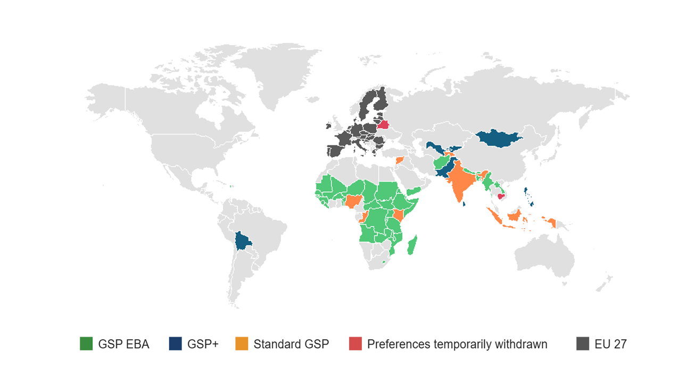
Note: Grey areas represent countries that are not covered by the EU GSP.

In 2024, the EU imported almost EUR 60 billion worth of goods under GSP preferences, benefitting partner countries as well as EU importers and consumers alike. Of these, a little more than 50 % or EUR 30 billion worth of goods were imported under the EBA arrangement, EUR 11.5 billion from GSP+ beneficiaries, and around EUR 17 billion from standard GSP beneficiaries.
EU imports by GSP arrangement
Figure 2. Trend in EU imports under the three GSP arrangements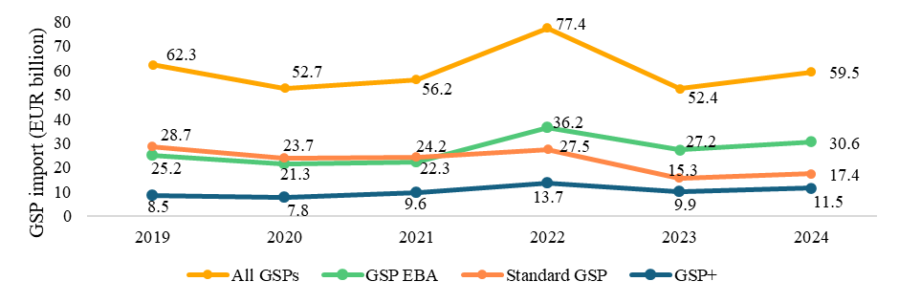
Imports under the GSP were up to EUR 59 billion in 2024 from around EUR 52 billion in 2023, but down compared with the 2022 peak, when imports using GSP preferences reached around EUR 77 billion and compared with the pre-COVID-19 pandemic, at EUR 62 billion in 2019. The post-COVID-19 rebound, combined with Russia’s war of aggression against Ukraine, which triggered an energy crisis, pushed global prices and, therefore, EU import values to record highs in 2022. As the COVID-19 rebound softened and energy prices fell from 2023 onwards, trade figures normalised. In addition, Viet Nam is no longer a Standard GSP beneficiary as of 1 January 2023, following the conclusion of an FTA with the EU. This also reduced trade under Standard GSP preferences by several billion euros.

Top product sections benefiting from GSP
Figure 3: Top sections being imported under GSP (Standard GSP, GSP+ and EBA) in 2024 (EUR billion and as share of overall imports)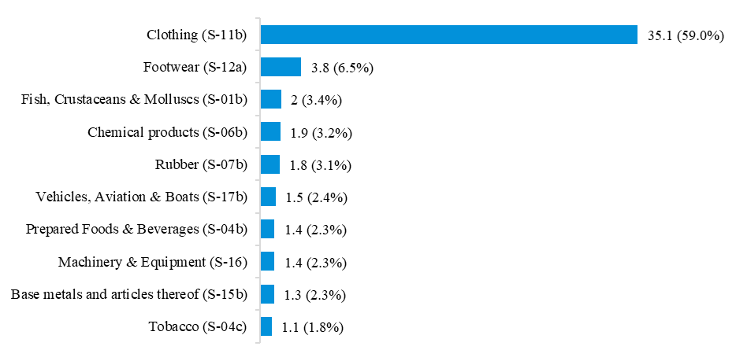

In 2024, clothing (S-11b) was, by far, the sector that benefited most from GSP with EUR 35.1 billion imports into the EU under the scheme, accounting for 59 % of all trade under GSP. The next largest sectors were footwear (S-12a) (EUR 3.8 billion), and fish, crustaceans and molluscs (S-01b) (EUR 2 billion). In all years of the reporting period, clothing (S-11b) was the largest sector. However, machinery and equipment (S-16) declined in importance (from 2nd place in 2022 to 8th place in 2024), whereas categories such as vehicles, aviation and boats (S-17b) and prepared Foods & Beverages (S-04b) entered the top 10 since 2022.
GSP savings from tariffs
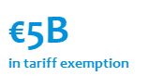
Thanks to the GSP, beneficiary countries under the three arrangements benefited from an estimated EUR 5 billion in tariff reductions or exemptions in 2024, with EBA countries accounting for more than EUR 3 billion of the total. Duty savings are accrued both by exporters in GSP beneficiary countries and EU importers, and thus also benefit EU businesses and consumers.

Top countries using GSP
Figure 4: Top 10 countries by GSP utilisation value in 2024

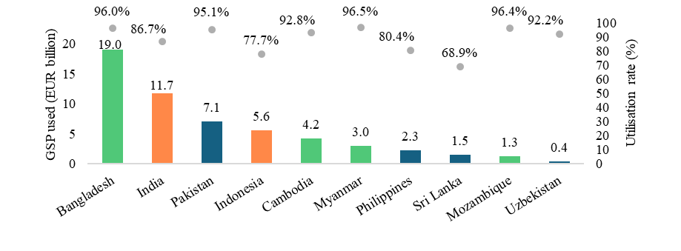
The preference utilisation rate is the ratio of imports from a specific country that used the preferences compared to the imports that were theoretically eligible for GSP preferences. On average, the preference utilisation rate was 88.8 % for all GSP-related imports into the EU in 2024. It reaches 94.5 % on average for LDCs under EBA. Some countries achieve 100 % utilisation rate in certain sections, such as Ethiopia in cut flowers (section S02-a). Reasons for not using 100 % of the available tariff concessions under GSP are complex, but factors include insufficient awareness of the system, administrative shortcomings, and coexistence of alternative trade arrangements.
In 2024, Bangladesh recorded the highest value of exports to the EU using the GSP preferences, amounting to EUR 19 billion, with a strong utilisation rate of 96 %. India followed, with imports into the EU of EUR 11.7 billion using the Standard GSP arrangement, with a lower utilisation rate of 87 %. Among GSP+ beneficiaries, Pakistan stands out with EUR 7.1 billion worth of GSP+ imports into the EU and a preference utilisation rate of 95.1 %, while Uzbekistan made it to the top 10 overall GSP beneficiaries since it joined the GSP+ in 2021.
Countries experiencing highest growth in GSP utilisation
Between 2022 and 2024, Benin recorded the highest growth in use of GSP preferences, with a 128 % increase, from EUR 5.1 million in 2022 to EUR 11.7 million in 2024. Malawi ranked second in growth in GSP use, with a 19 % increase over the same period, contributing to a 13 % rise in its total exports to the EU. São Tomé and Príncipe, and Eritrea joined the countries with the highest growth in use of GSP, which were all beneficiaries of the EBA arrangement. The sectors driving growth varied across countries, for example, Benin saw the strongest increases in textiles (S-11a and S11-b).

Figure 5. Top 4 countries in growth of GSP used (2022-2024)
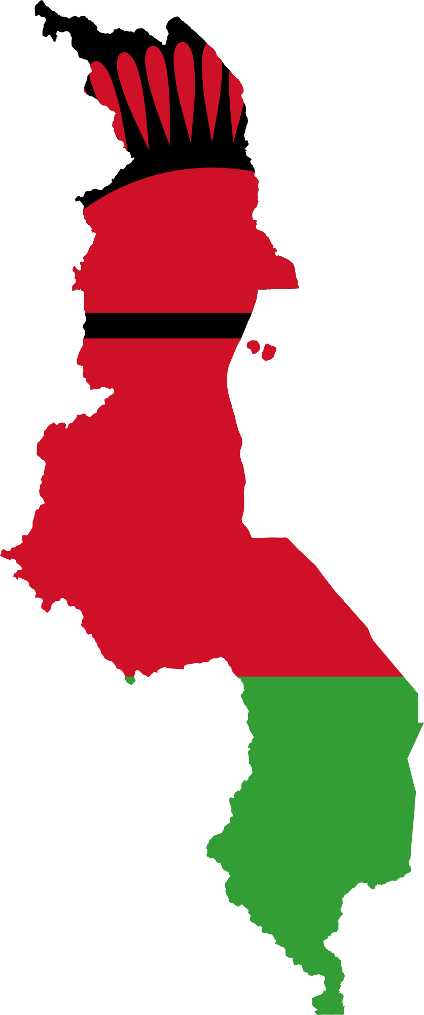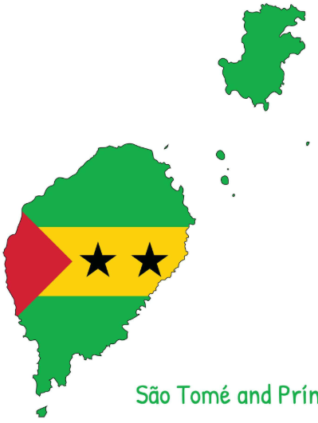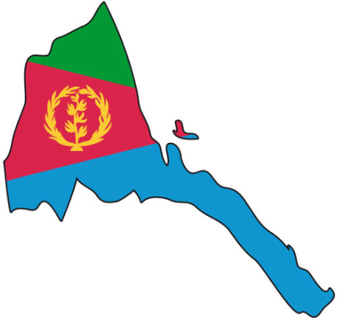
128 % growth in EBA used
Benin
19 % growth in EBA used
Malawi
10 % growth in EBA used
Sao Tome and Principle
8 % growth in EBA used
Eritrea
- Compliance with international conventions and agreements
GSP beneficiaries continue, in general, to make progress towards sustainable development and the respect of the international principles and standards that are part of the GSP conditionality.
Although the ratification of international conventions alone is not sufficient to uphold international standards, it is a fundamental first step. Most GSP beneficiary countries have high ratification rates in relation to the relevant international conventions. For instance, among EBA beneficiary countries (which are not subject to the obligation to formally ratify the GSP-relevant conventions), Bangladesh – the EBA beneficiary benefitting the most from the scheme – has ratified all the 27 conventions currently listed in the GSP Regulation as well as the additional conventions to be introduced by the new GSP Regulation.
Beneficiary countries’ ratification efforts tend to go beyond the formally established list of relevant conventions and agreements listed in the GSP Regulation. For example, all eight GSP+ beneficiaries have ratified the Convention on the Rights of People with Disabilities and are parties to the Paris Climate Agreement, which are not listed in the current GSP Regulation but will be part of the scheme from 2027.
A large number of GSP beneficiaries have also advanced in the ratification of the newly established fundamental International Labour Organisation (ILO) conventions relating to occupational safety and health, as well as other ILO conventions, for example on labour inspections and tripartite consultations, which are not listed in the current GSP Regulation either.
As further set out in section 4b) below and in the SWDs issued together with this Report, in particular the GSP+ remains a strong and structured framework linking trade to sustainable development, a platform for policy dialogue and reform. GSP+ also provide strong incentives and enablers for beneficiaries to comply with internationally recognised standards they have themselves decided to commit to.

- THE THREE ARRANGEMENTS
- Standard GSP
During the reporting period, Standard GSP beneficiaries continued to make up a significant share of total GSP imports at 29.3 % in 2024. Clothing (S-11b), footwear (S-12a), and chemical products (S06b) were the main products benefiting from the Standard GSP in 2024. Out of the eleven current Standard GSP beneficiaries (with Vanuatu added in 2025), India and Indonesia were the main beneficiaries, with India representing EUR 11.7 billion worth of all imports into the EU under GSP preferences in 2024, and Indonesia following with EUR 5.56 billion. However, this will change as, in addition to Indonesia and Kenya (see section 2), India is expected to graduate from Standard GSP and thus exit the scheme once the bilateral trade agreement with the EU (negotiations concluded in February 2026) enters into application and the subsequent two-year transition period expires.
Figure 6. Trends in Standard GSP eligible imports, used imports, and utilisation
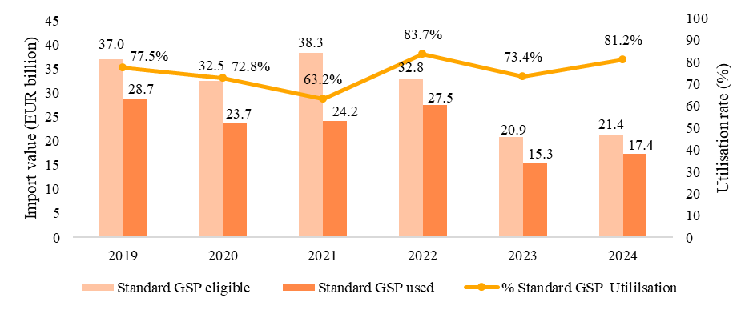

Whilst the utilisation rate under Standard GSP fluctuates at a high level, both eligible imports and those actually claiming the GSP preferences have declined since pre-COVID levels, from EUR 37 billion eligible and 29 billion used in 2019 to EUR 21 billion eligible and 17 billion used in 2024. This was mainly due to countries leaving Standard GSP, in particular Viet Nam as of January 2023, following the transition period after this formerly top beneficiary entered into an FTA with the EU in 2020. In addition, Uzbekistan upgraded to GSP+ in April 2021.
- GSP+
The trend for GSP+ imports is rather positive, setting aside the 2022 COVID-19 rebound and energy price effects. GSP+ eligible imports increased from pre-COVID-19 levels of EUR 10 billion in 2019 to EUR 13 billion in 2024; consequently, imports for which preferences were actually claimed are up to EUR 11 billion in 2024.

Figure 7. Trend in GSP+ imports and utilisation

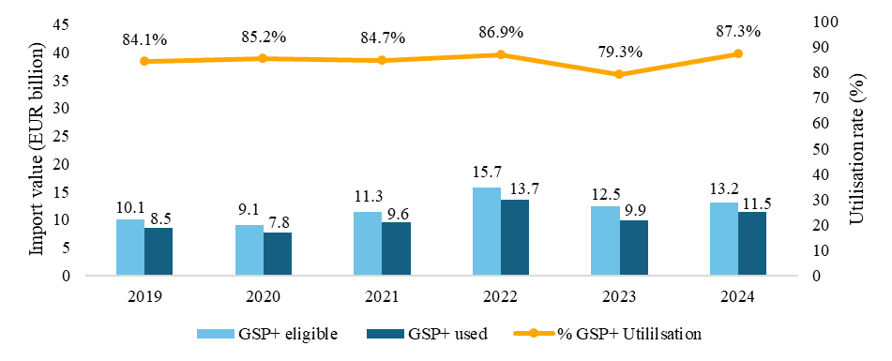

The preference utilisation rate for EU imports under the GSP+ arrangement increased from 86.9 % in 2022 to 87.3 % in 2024. This modest improvement followed a drop in 2023, when the rate fell to 79.3 %.
Pakistan was the main GSP+ beneficiary, using preferences for EUR 7.1 billion in EU imports. The Philippines followed with around EUR 2.3 billion in EU imports, and Sri Lanka was the third biggest GSP+ beneficiary in value terms at EUR 1.5 billion.
In terms of compliance with the international conventions listed in the GSP Regulation during the reporting period, all GSP+ beneficiaries have maintained full ratification of the 27 GSP-relevant international conventions and agreements and have issued no new reservations.
This report is accompanied by eight country-specific Staff Working Documents that provide full detail on the GSP+ beneficiaries’ commitments on human rights, labour rights, environment and climate, and good governance – and the EU’s engagement with these partner countries in these areas. As further detailed in those SWDs, many positive developments were observed over the reporting period, but challenges remain.
Many current GSP+ beneficiaries strengthened human rights legislation and institutional arrangements during the period covered by this report. For instance, Kyrgyzstan, Uzbekistan, Sri Lanka, and Pakistan all reinforced legislation against domestic violence, while Bolivia, Mongolia, Uzbekistan, and The Philippines adopted child protection reforms. Pakistan reduced the scope of the death penalty and adopted implementing rules of the Anti-Torture Act, as well as new Child Marriage Restraint Acts in Balochistan and Islamabad. Sri Lanka strengthened domestic national human rights institutions, and The Philippines established new oversight mechanisms and inter-ministerial coordination bodies for human rights.
Most GSP+ beneficiaries also showed progress with respect to labour rights. For example, Mongolia pioneered a module on forced labour in the private economy in a national labour force survey and included a section on conscript labour. There were continued efforts to eradicate forced labour in Uzbekistan, and The Philippines produced a roadmap to advance Freedom of Association and a strategy to reduce child labour. Pakistan ratified the ILO Protocol to the Forced Labour Convention and started an initiative for the transition of workers from the informal to the formal economy to further promote decent work. Several beneficiary countries introduced measures to reduce child labour and strengthen anti-trafficking frameworks.
Many GSP+ beneficiaries also remained committed to environmental protection, submitting climate transparency reports under the relevant Multilateral Environmental Agreements; strengthening biodiversity and protected-area legislation and action plans in line with the Convention on Bio-Diversity; advancing implementation of the Montreal Protocol; and undertaking climate adaptation and mitigation planning linked to Nationally Determined Contributions (NDCs) in the context of ensuring implementation of the Paris Agreement.
Governance with regard to drugs control and anti-corruption improved in a number of countries. This included updated policies intended to fight corruption in Bolivia, Kyrgyzstan, Pakistan and Sri Lanka.
However, challenges with regard to the implementation of GSP+ commitments remain.
Cross-cutting human rights concerns common to many GSP+ beneficiaries include insufficient judicial independence and limited access to remedy and accountability for violations and abuses, restrictions to civic space, freedom of expression and media freedom; reports of torture, lack of accountability, and incomplete alignment of domestic frameworks with the Anti-Torture Convention; persistent gender-based violence (GBV), continuing with impunity; and structural discrimination against minorities and LGBTIQ+ persons. In some GSP+ beneficiary countries, the protection of socio-economic rights contrasted with weak anti-poverty strategies, limited education opportunities, major gaps in social protection systems, or lack of support for the economic empowerment of women. Data gaps also remain significant, particularly related to GBV, torture investigations, child labour, and human trafficking prosecutions.
Similarly, with respect to labour rights, while legislative frameworks improved, implementation and enforcement remain uneven, and labour inspectorates often face capacity constraints. Overall, discrimination against all vulnerable groups persist. Freedom of association remains constrained in several jurisdictions and collective bargaining coverage is limited in many contexts. Child labour and forced labour persist, in particular in agriculture and the informal sector. Labour rights of female workers should still be improved. Data gaps in all GSP+ relevant ILO conventions should be addressed without delay.
Many GSP+ beneficiaries also faced environmental protection constraints, with delays in environmental reporting (for example under the Stockholm Convention, CITES, Cartagena Protocol frameworks); capacity and resource limitations affecting enforcement, and significant climate vulnerability that strains institutional systems. While commitments are ambitious, implementation often lags behind.
Governance could be enhanced through stronger efforts to fight drug-trafficking, improved demand-side measure in line with international human rights standards and increased anti-corruption efforts.
In addition, economic crises (Bolivia, Sri Lanka) and natural disasters (Pakistan, the Philippines, Sri Lanka) exacerbated structural challenges and further hampered implementation capacity during the reporting period.
EU partnership projects can help to address some of these challenges through cooperation and country-specific measures are outlined in the GSP+ SWDs accompanying this Report.
c) Everything But Arms arrangement
  - Economic data
The EU GSP benefits are most substantial for EBA beneficiaries. Preferential imports from EBA beneficiaries stood at EUR 30.6 billion in 2024, up from EUR 25.2 billion in 2019.
Figure 8. Trend in EBA imports and utilisation
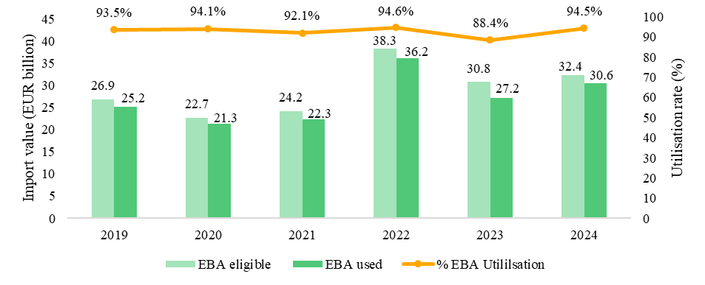
Utilisation rates under the EBA arrangement only fluctuated slightly between 2022 and 2024. The rate stood at 94.6 % in 2022, then declined to 88.4 % in 2023 and subsequently recovered to 94.5 % in 2024. In 2022, imports under the EBA arrangement peaked due to the COVID-19 rebound and energy prices mentioned above. Looking at the trend over time, there is an increase from pre-COVID-19 imports in 2019 (EUR 27 billion eligible imports, out of which imports with a value of EUR 25 billion used EBA preferences) to 2024 (EUR 32 billion eligible imports, out of which imports with a value of EUR 31 billion used EBA preferences).
Figure 9. EU imports by GSP arrangement and from EBA enhanced engagement countries
 | EU imports from GSP (EUR million), excluding non-preferential |  |  |  | share of imports from EBA countries 2022-2024
 | 2019 | 2022 | 2023 | 2024 | share of imports from EBA countries 2022-2024
GSP (all) | 62 326 | 77 393 | 52 419 | 59 450 | share of imports from EBA countries 2022-2024
Standard GSP | 28 665 | 27 489 | 15 331 | 17 402 | share of imports from EBA countries 2022-2024
GSP+ | 8 496 | 13 662 | 9 896 | 11 476 | share of imports from EBA countries 2022-2024
EBA (all) | 25 164 | 36 243 | 27 192 | 30 573 | share of imports from EBA countries 2022-2024
EBA (only Africa) | 2 782 | 4 141 | 3 151 | 3 888 | 11.9 %
Enhanced Engagement under EBA
Bangladesh | 15 366 | 23 134 | 17 064 | 19 019 | 63.0 %
Cambodia | 4 174 | 4 324 | 3 534 | 4 207 | 12.8 %
Myanmar | 2 471 | 4 112 | 2 993 | 2 962 | 10.7 %

During the reporting period and compared to pre-COVID levels, the relative importance of EBA overall, but in particular of EBA beneficiaries on the African continent, has continued to increase. At the same time, three of the largest EBA beneficiaries continued to be under enhanced engagement. The report reflects further on these trends below.
ii. Beneficiaries moving up
The GSP aim is to promote economic development. It is, therefore, good news when beneficiaries move up from their Least Developed Countries’ status, i.e. when they graduate and subsequently exit from the EBA arrangement after a transition period. They still have the opportunity to apply for GSP+ to retain most of their benefits.
Several upward movements are expected for the near future. Bangladesh, the Lao PDR, and Nepal are scheduled for LDC graduation in 2026; Solomon Islands is scheduled for graduation in 2027; and Cambodia and Senegal are scheduled for graduation in 2029.
At the UN CDP (Committee for Development Policy)’s 2024 triennial review, the Republic of Rwanda, Uganda, and Tanzania were found to have met the graduation thresholds for the first time. All three countries met two of the three criteria. These countries are scheduled to be considered again in 2027 and, if they meet the criteria for a second time, could be recommended for graduation.
Kiribati and Tuvalu were recommended for LDC graduation in 2018 and 2012, respectively, but ECOSOC deferred a decision on their graduation. In 2024, ECOSOC, recalling its decision in 2021 to defer the consideration of their graduation to 2024, further decided to consider their graduation at a later date.
At the 2024 triennial review, the UN CDP decided to defer its decision on the graduation of Myanmar and Timor-Leste to 2027.
For the current EBA beneficiaries, moving to GSP+ after their graduation would preserve a broadly equivalent level of savings, also at approximately EUR 3.3 billion for 2024, whereas the simple transition to standard GSP would reduce these to around EUR 0.75 billion, a reduction of approximately 80 % (see Figure 10). Joining GSP+ can never fully compensate for EBA status as it entails inter alia becoming subject to certain special safeguards and more stringent rules of origin which usually reduce the preferences that can effectively be claimed. This is particularly apparent for countries exporting garments.
In addition to the generous transition periods, the EU will continue to support countries graduating from the EBA arrangement, notably beneficiary countries that seek to join the GSP+ arrangement thereafter; with a view to avoid any negative impacts on exporters from these countries and on the EU companies trading with them.

Figure 10: Estimated tariff savings/ revenue gains under EBA compared to under GSP+ or Standard GSP for the same beneficiaries in 2024 (EUR billion)
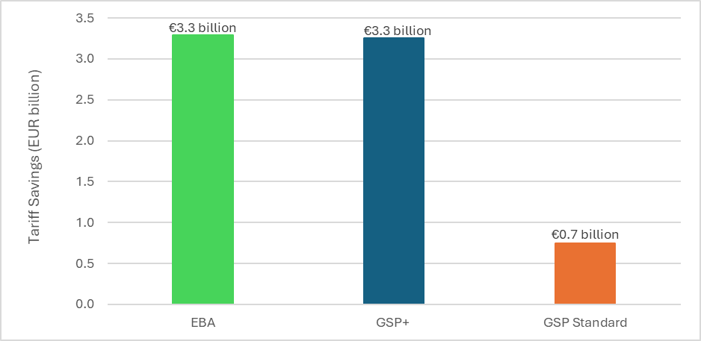
  - Promoting Africa’s competitiveness
Three quarters of the EBA beneficiary countries are on the African continent (33 of the 46). Soon, African countries will be the dominant group in EBA, given the significant number and size of Asian beneficiaries that are set to be graduating out of the scheme. All three arrangements under the EU’s GSP are important pillars of the EU’s support to Africa’s economic diversification and integration into the global value chains but EBA stands out.
Preferential EU imports from African EBA beneficiaries stood at EUR 3.9 billion in 2024, up from EUR 2.8 billion in 2019 (see also Table/Figure 9 above). The utilisation rate of the EBA preferences was at 88.9 % in 2024, showing an increased use of the preferences by African beneficiaries over the past years, but also potential to do more. Thanks to duty free access of the EBA arrangement, African EBA beneficiaries were exempted from about EUR 213 million in EU import duties in 2024. Over the 2022–2024 period, the top African EBA exporters were Mozambique (EUR 4.2billion), Mauritania (EUR 1.2 billion), Ethiopia (EUR 975.5 million), Tanzania (EUR 934.7 million), and Madagascar (EUR 848.1 million).

Figure 11: Top 5 EBA beneficiaries in Africa (total EBA used imports; EUR million)
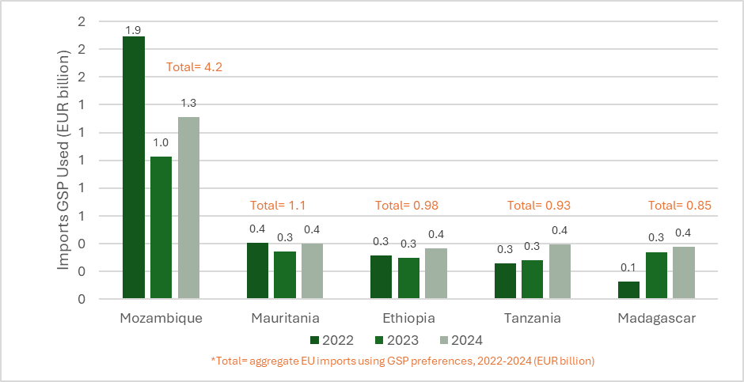
As indicated above, outside of EBA, a few African countries benefit from other GSP arrangements. Nigeria, the Republic of the Congo, and Kenya fall under standard GSP (with Kenya graduating in 2027 due to the entry into application of the EU-Kenya Economic Partnership Agreement on 1 July 2024), while Cabo Verde benefits from GSP+. For the period 2022-2024, aggregate EU imports using GSP preferences from these four African countries totalled EUR 579.4 million, with Nigeria accounting for the largest share (EUR 372.4 million with an utilisation rate 70 %), followed by Cabo Verde (EUR 172.5 million; utilisation rate 85 %), Kenya (EUR 15.7 million; utilisation rate 1 %), and the Republic of the Congo (EUR 18.7 million; utilisation rate 58 %). Notably, Cabo Verde's GSP+ status provides significantly greater duty waivers than Standard GSP would have done (EUR 12.0 million compared to EUR 3.9 million) representing an additional EUR 8.1 million in preferences.
Compared to similar schemes by which other developed countries grant unilateral preferences, the EU’s EBA has the highest number of different products exported (53 % of total tariff lines) showing that EU imports from LDCs are very diversified. According to UNCTAD, the EU EBA offers the largest tariff savings in absolute terms, compared to the schemes of the US, Japan, and Canada. Unlike special regimes offered to Africa by China or the US, the EBA arrangement stands out not only for its automatic eligibility for all LDCs, but also because it has no expiry date. This unique feature provides long-term certainty for business and offers significant benefits for African beneficiary countries: by removing the need for periodic renewals typical of other countries’ GSP arrangements, the EBA fosters investor confidence, facilitates strategic investment decisions and encourages the diversification of export structures. This is particularly relevant in times of additional challenges for developing countries that are facing less support and increased difficulties in accessing certain other markets.
Thus, the EBA and its generous market access for LDCs in Africa and beyond is a proof of the EU’s strong commitment to continue supporting growth and sustainable development in LDCs and their further integration in the global economy through open, stable, and predictable trading terms.
iv. Enhanced Engagement
In parallel to the continuous monitoring with GSP+ beneficiaries, the Commission and the EEAS also carry out enhanced engagement processes to support and incentivise individual EBA beneficiary countries to improve their record in critical areas related to the GSP, notably relevant core human rights and labour rights international conventions. This enhanced engagement with Bangladesh, Cambodia, and Myanmar is particularly relevant also in light of their very important share of total EU imports under the EBA arrangement, as shown in Table/Figure 9 above. At the same time, they present highly different political, economic, and development situations, which have led to start a dedicated enhanced engagement process following a different track and focus with each of them. The respective engagements also take into account all EU instruments available – beyond the EBA – to address the identified issues. More detail on the three EBA beneficiary countries under enhanced engagement are provided in the dedicated Staff Working Documents accompanying the present Report.

- PARTNERSHIPS AND COOPERATION/ SUPPORT FOR GSP BENEFICIARIES
While the GSP is a comprehensive tool to support long-term sustainable development in beneficiary countries, trade policy needs to be coupled with development policy and cooperation to achieve the desired effectiveness. Most EU’s Multiannual Indicative Programmes (MIPs) for 2021-2027 defining the EU’s priority areas and specific objectives for development cooperation include support for sustainable growth and decent jobs, with fair and just working conditions. Work towards ratification and effective implementation of conventions and commitments related to good governance, human rights, labour rights, and environmental standards also have ample support from MIPs. For the eight GSP+ beneficiary countries, all MIPs pay particular attention to GSP+ compliance and support to the relevant areas of sustainable development.
Labour rights were a particular focus of the Trade for Decent Work project (2019-2021 and 2022-2024, EUR 6 million), co-funded by the EU and Finland and implemented by the ILO. It promoted the implementation of ILO fundamental conventions in seven countries under the EU GSP+ and EBA arrangements (Bangladesh, Cabo Verde, Mongolia, Madagascar, Mozambique, Pakistan, and The Philippines).
Another strand of the EU’s support to GSP beneficiary countries, more explicitly focused on ensuring that trade can be used as an instrument for sustainable development, is the Aid for Trade (AfT) initiative. Through AfT, the EU supports partner countries in creating the right environment for trade to boost competitiveness and sustainable integration into the world economy.
The EU, together with its Member States, has been the largest provider of AfT since the initiative was launched. In 2023, the EU committed EUR 16.2 billion to partner countries under AfT, many of which are GSP beneficiaries. Looking specifically at the GSP+ beneficiaries, as mentioned above, the EU supports them in meeting the requirements of this arrangement but through AfT also helps them in making full use of the preferences provided under this scheme. EU AfT funding for 2021-2023 to the eight GSP+ beneficiaries, a total of 1.4 billion EUR focused on areas such as building infrastructure, improving production capacity (including investment climate reform and value chain development), trade facilitation, implementation and compliance with standards, and much more.
Figure 12. EU Aid for Trade funding to GSP+ beneficiaries, total EUR 1.4 billion, 2021-2023
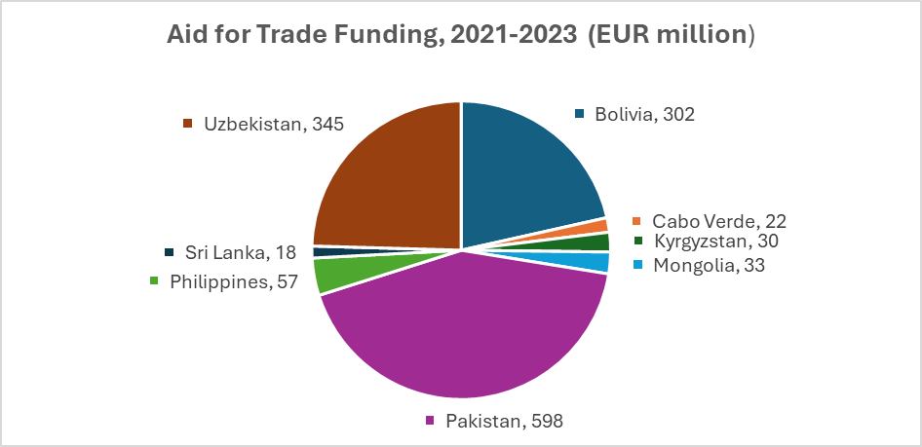
Finally, AfT supports the trade and investment enabling environment of the Global Gateway, a flagship strategy launched in 2021 to mobilise investments in priority sectors. In line with the EU’s geopolitical ambitions and commitment to the 2030 Agenda for Sustainable Development, the Global Gateway strategy aims to boost smart, clean, and secure investments in digital, energy and transport, and to strengthen health, education, and research systems across the world while promoting universal values and high standards, good governance, and transparency.
The EU also supported the provision of comprehensive, transparent, centralised information on GSP for beneficiaries, businesses, civil society, and policy makers alike via the GSP Hub project. The GSP Hub started in 2019 and aimed to improve awareness and transparency of the GSP, its economic benefits and its monitoring, via a dedicated website, written publications, and a series of awareness events in Europe and in GSP beneficiary countries. The maintenance and update of the website will continue under the new GSP Regulation.
- CONCLUSIONS
During the last GSP monitoring cycle under the 2012 GSP Regulation (2023-2025), the scheme continued to deliver on its main objectives of contributing to economic progress and sustainable development in beneficiary countries.
The EU GSP provided generous economic benefits to partner countries as well as to EU importers and consumers, remaining a source of stability and predictability in times of trade, economic, and geopolitical volatility.
Almost EUR 60 billion worth of goods were imported by the EU in 2024 using GSP preferences, benefitting EU importers and beneficiary countries alike. Total imports using the GSP preferences in 2022-2024 fluctuated in line with broader trends, while remaining slightly above pre-COVID-19 levels when taking into account significant beneficiaries leaving the GSP scheme.
The largest category of beneficiaries both by number of beneficiaries and value of imports remained LDCs under the EBA arrangement, which also have the highest utilisation rates at nearly 95 %. The relative importance of the EBA will continue to increase as large Standard GSP beneficiaries (India, and Indonesia) and GSP+ beneficiaries (The Philippines) upgrade their trade relationships with the EU through Free Trade Agreements and graduate from GSP. Looking ahead, most GSP beneficiary countries’ economic circumstances continue to improve, with several on track to graduate out of UN LDC status. This reflects the success of development efforts and the positive contribution of the EU GSP in those countries.
As a consequence, the number of countries benefitting from the EU’s unilateral preferences scheme will continue to decline. GSP will remain important as it will accompany graduating beneficiaries through transitional periods; and because it will continue providing EBA preferences for remaining LDCs, notably on the African continent. Given the EU EBA’s unique offer to African countries, the Commission and the EEAS – in headquarters as well as through EU Delegations – will make further efforts to strengthen communication and dialogue on GSP, to increase the visibility, awareness and up-take-up of EBA on the African continent.
Aside from EBA, the GSP+ also continues to bring significant benefits: four out of the top ten beneficiaries of the entire GSP scheme are GSP+ beneficiaries, and nearly 20 % of all EU imports under the GSP originate in GSP+ beneficiary countries. At the same time, GSP+ continues to deliver on its goal to incentivise sustainable development and good governance based on internationally agreed and recognised standards. While the situation remains challenging in many GSP+ beneficiary countries, the GSP+ detailed monitoring and dialogue remains a unique platform for discussion and a driver for improvement over time.
The EU has extended the GSP for another decade, with the new GSP Regulation expected to enter into application on 1 January 2027. Through the new GSP rules, the EU ensures the continuity of its attractive unilateral trade preference offer through the three dedicated arrangements. It confirms the EU’s long-standing commitment to supporting growth and sustainable development in our partner countries across the globe; through generous, stable and predictable trading-terms.
Ahead of the application of the new GSP provisions, this report and the accompanying SWDs will serve as a solid baseline. This is in particular the case for current GSP+ beneficiaries who will need to reapply if they wish to continue benefitting from GSP+ in the future. It applies as well for current EBA beneficiaries who would wish to apply for GSP+ status once they have graduated from LDC status. The EU remains committed to supporting beneficiary countries throughout such transitions.

Regulation (EU) No 978/2012 of the European Parliament and of the Council of 25 October 2012 applying a scheme of generalised tariff preferences and repealing Council Regulation (EC) No 732/2008.
2023 (JOIN(2023) 34 final.
Some elements falling under the current reporting period were already covered in the previous report 2023 (JOIN(2023) 34 final.
Standard GSP beneficiary countries: the Republic of the Congo, Cook Islands, India, Indonesia, Kenya, Micronesia, Nigeria, Niue, Syria, Tajikistan and Vanuatu.
GSP+ beneficiary countries: Bolivia, Cabo Verde, Kyrgyzstan, Mongolia, Pakistan, The Philippines, Sri Lanka and Uzbekistan.
Commission Delegated Regulation (EU) 2025/1951 of 29 September 2025 amending Annexes II, IV and VII to Regulation (EU) No 978/2012 of the European Parliament and of the Council http://data.europa.eu/eli/reg_del/2025/1951/oj (hereafter: Commission Delegated Regulation (EU) 2025/1951 of 29 September 2025). The new Comprehensive Economic Partnership Agreement (CEPA) is expected to govern future trade relations between the EU and Indonesia. All links provided in this document were up to date as of 28 April 2026.
Commission Delegated Regulation (EU) 2025/214 of 28 November 2024 amending Annex II to Regulation (EU) No 978/2012 of the European Parliament and of the Council as regards Kenya. https://eur-lex.europa.eu/eli/reg_del/2025/214/oj.
Commission Delegated Regulation (EU) 2024/1363 of 12.3.2024 amending Annex IV to Regulation (EU) No 978/2012 of the European Parliament and of the Council in order to remove Bhutan from the list of beneficiary countries of the special arrangement for the least-developed countries. ELI: http://data.europa.eu/eli/reg_del/2024/1363/oj
Commission Delegated Regulation (EU) 2025/1951 of 29 September 2025.
Commission Delegated Regulation (EU) 2025/1951 of 29 September 2025.
Product graduation ensures that preferences are provided to those countries and products most in need and avoids competitive pressure among GSP beneficiaries
Commission implementing Regulation 2023/2780 of 14 December 2023 amending Implementing Regulation (EU) 2022/1039 as regards the extension of the suspension of certain tariff preferences granted to certain GSP beneficiary countries. http://data.europa.eu/eli/reg_impl/2023/2780/oj
Commission Implementing Regulation 2025/1909 of 24 September 2025 laying down rules for the application of Regulation (EU) No 978/2012 of the European Parliament and of the Council as regards the suspension for the years 2026-2028 of certain tariff preferences granted to certain GSP beneficiary countries.http://data.europa.eu/eli/reg_impl/2025/1909/oj
Commission Implementing Regulation 2024/842 of 11 March 2024 re-imposing safeguard measures with regard to imports of Indica rice originating in Cambodia and Myanmar/Burma.http://data.europa.eu/eli/reg_impl/2024/842/oj
Commission implementing Regulation 2025/1206 of 19 June 2025 on the suspension of the GSP+ tariff preferences with regard to imports of ethanol originating in Pakistanhttp://data.europa.eu/eli/reg_impl/2025/1206/oj
https://policy.trade.ec.europa.eu/news/commission-proposes-new-eu-generalised-scheme-preferences-promote-sustainable-development-low-income-2021-09-22_en
Regulation (EU) 2023/2663 of the European Parliament and of the Council of 22 November 2023 amending Regulation (EU) No 978/2012 applying a scheme of generalised tariff preferences. http://data.europa.eu/eli/reg/2023/2663/oj
Regulation (EU) 2026/1395 of the European Parliament and of the Council of 17 June 2026 on applying a generalised scheme of tariff preferences and repealing Regulation (EU) No 978/2012, ELI: http://data.europa.eu/eli/reg/2026/1395/oj
The five new international conventions and agreements are the following: the Optional Protocol to the Convention on the Rights of the Child on the Involvement of Children in Armed Conflict (2000); the Convention on the Rights of Persons with Disabilities (2007); the ILO Convention on Labour Inspection No 81 (1947); the ILO Convention on Tripartite Consultations No 144 (1976); The Paris Agreement on climate change (2015), and the UN Convention against Transnational Organised Crime (2000).
The Kyoto Protocol to the United Nations Framework Convention on Climate Change (1998).
Source for all statistics: Eurostat data on nominal trade based on latest available validated full year data as of September 2025. GSP statistics only cover goods imported into the EU market, i.e., goods released for free circulation in the EU. The GSP statistics do not cover other EU-imports, like goods imported for the customs inward processing procedure or re-imports after the customs outward processing procedure. Trade flows registered as ’confidential’ do not appear in the GSP+ usage figures and regime 1 normal trade; but do appear in total trade figures (regime 4). https://ec.europa.eu/eurostat/cache/metadata/en/ext_go_agg_esms.htm#conf1537195068659.
Congo, Cook Islands, India, Indonesia, Kenya, Micronesia, Nigeria, Niue, Syria, Tajikistan, Vanuatu.
Bolivia, Cabo Verde, Kyrgyzstan, Mongolia, Pakistan, The Philippines, Sri Lanka and Uzbekistan.
https://ec.europa.eu/eurostat/en/web/products-eurostat-news/w/ddn-20240701-1
Products that benefit from GSP are separated in sections according to GSP Regulation. Information on which CN codes are included in the GSP sections can be found in Annex V of the Regulation No 978/2012. EUR-Lex - 02012R0978-20250101 - EN - EUR-Lex.
In addition, the EU applies 0 % tariffs in many areas, irrespective of GSP preferences. This obviously applies also to imports from GSP beneficiary countries, allowing them to benefit from Most Favoured Nation treatment under WTO rules, making their total duty-free imports into the EU and therefore duty savings even higher.
The sectors facing the highest drops in utilisation rate between 2022 and 2023 were Hides & Leather (S-08a) from 98.8 % to 65.9%, Cork, Straw & Plaiting (S-09b) from 86.3 % to 62.2 % and Textiles (S-11a) from 97.1 % to 83.3 %. All three sectors subsequently increased utilisation the following year (2024).
The Montreal Protocol on Substances that Deplete the Ozone Layer.
UN Convention against Torture and Other Cruel, Inhuman or Degrading Treatment or Punishment.
Stockholm Convention on Persistent Organic Pollutants (POPs).
Convention on International Trade in Endangered Species of Wild Fauna and Flora.
The Cartagena Protocol on Biosafety to the Convention on Biological Diversity.
2019 data is included as a pre-COVID reference baseline.
Extended cumulation was granted between Cambodia and Vietnam for bicycles in 2023: Commission Decision (EU) 2023/1810 of 19 September 2023 on a request for extended cumulation between Cambodia and Vietnam, in accordance with Article 56(1) of Delegated Regulation (EU) 2015/2446, as regards the rules of origin used for the purposes of the scheme of generalized tariff preferences pursuant to Delegated Regulation (EU) 2015/2446 for certain materials or parts used in the production of bicycles. http://data.europa.eu/eli/dec/2023/1810/oj EBA preferences were partially withdrawn from Cambodia through Commission Delegated Regulation (EU) 2020/550 of 12 February 2020.
In February 2026, Bangladesh’s Government asked formally to the UN for a three-year deferral of the country’s graduation out of the LDC category.
United Nations Economic and Social Council.
São Tomé and Príncipe is no longer an LDC, however it will still benefit from EBA preferences until it graduates out of the EBA on 1 January 2029.
Preferences granted to Kenya under the GSP regulation do not affect market access preferences provided through other instruments such as the so-called Market Access Regulation (MAR) Regulation (EU) 2016/1076 of the European Parliament and of the Council of 8 June 2016 applying the arrangements for products originating in certain states which are part of the African, Caribbean and Pacific (ACP) Group of States provided for in agreements establishing, or leading to the establishment of, economic partnership agreements, OJ L 185, 8.7.2016, p. 1–191. This is relevant in particularly for cut flowers.
EUROSTAT COMEXT.
https://docs.wto.org/dol2fe/Pages/SS/directdoc.aspx?filename=q:/WT/COMTD/LDCW73.pdf&Open=True
UN Conference on Trade and Development.
UNCTAD, ’The Generalized System of Preferences: How much does it matter for developing countries?’, UNCTAD/DITC/TSCE/2023/1, 2023, p.vii.
EBA preferences were partially withdrawn from Cambodia through Commission Delegated Regulation (EU) 2020/550 of 12 February 2020.
Preamble 4 of the GSP regulation states that the EU’s common commercial policy is to be consistent with and consolidate its policy in the field of development cooperation. REGULATION (EU) No 978/2012 of 25 October 2012 applying a scheme of generalised tariff preferences. https://eur-lex.europa.eu/legal-content/EN/TXT/PDF/?uri=CELEX:32012R0978.
Aid for Trade is a WTO-OECD initiative from 2006, statistically part of Official Development Assistance (ODA) covering the following main categories: technical assistance for trade policy and regulations, trade-related infrastructure and productive capacity building.
The latest year with available data.
https://international-partnerships.ec.europa.eu/policies/global-gateway_en
https://gsphub.eu/

