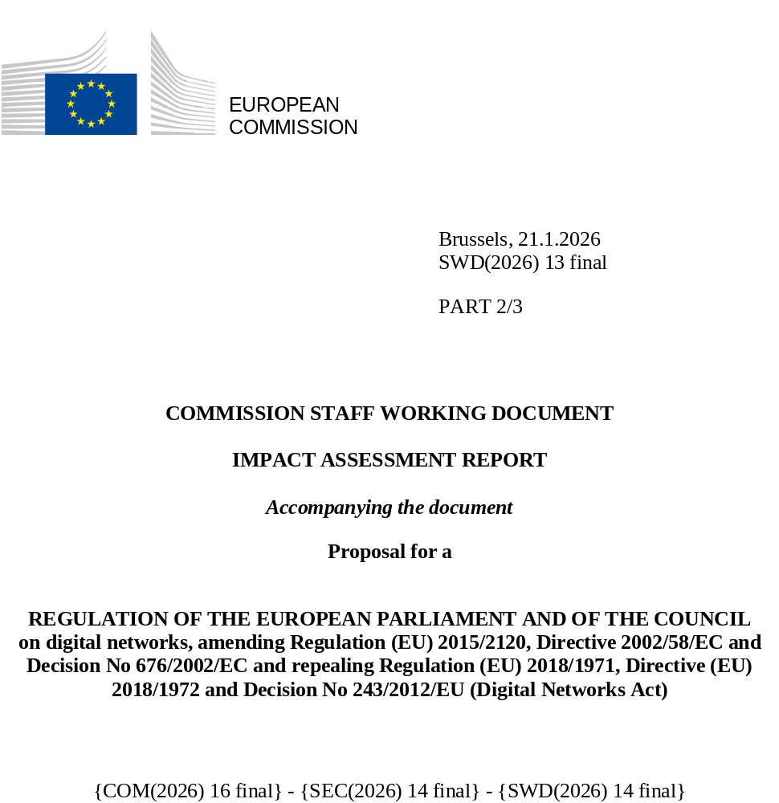

Contents
Annex 1: Procedural information 2
1. Lead DG, Decide Planning/CWP references 2
2. Organisation and timing 2
3. Consultation of the RSB 7
4. Evidence, sources and quality 7
Annex 2: Stakeholder consultation (Synopsis report) 9
1. Stakeholder consultation strategy 9
2. Summary of the outcome of the stakeholder consultations 10
Annex 3: Who is affected and how? 18
1. Practical implications of the initiative 18
2. Summary of costs and benefits 19
2.1. Transition to fibre 24
2.2. Spectrum 25
2.3. Authorisation 28
2.4. Regulatory governance 32
3. Application of ‘One In’ ‘One Out’ approach 34
4. Relevant sustainable development goals 34
Annex 4: Analytical methods 36
1 Methodology for the demand modelling and quantitative Impact Assessment of the copper-Switch-off and Access options 36
1.1 Analytical approach to the socio-economic and environmental Impact Assessment 36
1.2 Quantification of impact of the different options on FTTH coverage, take-up, average speeds and data consumption (all evidence combined in one document and summarised at the top) 37
1.2.1 Impact on FTTH coverage 38
1.2.2 Impact on FTTH penetration and technology mix 40
1.2.3 Impact on speed 44
1.2.4 Impact on data consumption 50
1.3 Economic impacts 55
1.3.1 Economic impact of fixed broadband in the literature 55
1.3.2 Theory-based modelling for the quantitative impacts 61
1.4 Impacts on society 65
1.4.1 Societal impact of VHCN 65
1.4.2 Societal Impact of Internet access on vulnerable consumer groups 68
1.5 Environmental impacts 70
1.5.1 The lifecycle of environmental impacts linked to networks 70
1.5.2 Fixed network deployment 72
1.5.3 Fixed network operation 72
1.5.4 Fixed network end-of life 84
1.6 Methodology for estimation of fragmentation costs 85
2 Methodology for the modelling and quantitative Impact Assessment of the Spectrum options 88
2.1 Overview of the methodology 88
2.2 Options considered 90
2.3 Assumptions concerning the effect of spectrum related policy measures on mid-banc coverage, download speeds and data consumption 92
2.3.1 Intervention logic linking mobile policies with outputs 92
2.3.2 Translation of directional effects into quantitative input assumptions 95
2.4 Methodology for the estimation of GDP impacts resulting from increases in full 5G adoption and associated speed increases 114
2.5 Methodology for the estimation of environmental impacts 117
2.6 Findings 119
3 Methodology for the analysis of spectrum-auction regulatory approaches and market outcomes 121
3.1 Introduction 121
3.2 Fragmented Market Outcomes 122
3.2.1 Selection of market-outcome indicators 122
3.2.2 Data sources 122
3.2.3 Member States considered in the analysis 122
3.2.4 Observed Variation in Market Outcomes across Member States 123
3.2.5 Composite Measure of Market Outcomes 124
3.3 Fragmented Regulatory approaches 126
3.3.1 Selection of indicators of regulatory approaches 127
3.3.2 Data sources 127
3.3.3 Member States considered in the analysis of regulatory approaches 127
3.3.4 Observed Variation in Regulatory Approaches across Member States 128
3.3.5 Scoring of Spectrum Caps 128
3.3.6 Scoring of Access Obligations 130
3.3.7 Scoring of Reservations and Set-Asides 131
3.3.8 Scoring of Final Auction Prices (EUR/MHz/pop) 132
3.3.9 Scoring of Coverage Obligations 133
3.3.10 Composite measure of Regulatory approaches 135
3.4 Visual comparison of Market outcomes and Regulatory approaches 136
3.5 Analysis of possible correlations between regulatory approaches and relevant market outcomes 136
3.5.1 Methodology and Tools 136
3.5.2 Data and Variables 137
3.5.3 Summary of Results 139
3.5.4 Limitations 141
Annex 5: Competitiveness check 142
1. Overview of impacts on competitiveness 142
1.1. Transition to fibre 142
1.2. Spectrum 142
1.3. Authorisation 142
1.4. Regulatory governance 142
2. Synthetic assessment 143
3. Competitive position of the most affected sectors 144
Annex 6: SME check 148
Annex 7: Further Evidence on the Problems and Problem Drivers 152
1 Problems 152
1.1 Fixed networks: Slow deployment and adoption of future-proof networks and services 152
1.2 Mobile networks: lack of investment and investment needs 153
1.2.1 Lack of investments in fully-fledged 5G networks 153
1.2.2 Investment needs 158
1.3 Satellite: Barriers to the development of advanced and resilient connectivity 159
1.3.1 Non-Terrestrial Networks in 5G and 6G 159
1.3.2 Pan-European satellite services 161
1.3.3 Fragmentation in satellite authorisation 165
1.3.4 D2D communications market potential 167
2 Problem drivers 169
2.1 Factors slowing down the deployment and adoption of fibre networks/services 169
2.1.1 Regulatory approaches, business choices and persistence of copper networks 169
2.1.2 Persistence of copper networks slows down the deployment and adoption of fibre networks/services 181
2.2 Spectrum regulation and market factors slowing down investment in high quality mobile connectivity 183
2.2.1 Inefficient use of spectrum: difficulty to satisfy increased demand due to spectrum scarcity 183
2.2.2 Insufficient flexibility for interservice and intra-service spectrum sharing 185
2.2.3 EU mobile markets and number of mobile network operators 187
2.3 Fragmented, complex rules, authorisation conditions 188
2.4 Governance problem drivers 189
Annex 8: Details of the Policy options 190
1 Transition to fibre 190
2 Spectrum 193
3 Authorisation 196
4 Governance 199
Annex 9: Analytical background for the assessment of impacts and comparison of Policy Options 201
1. Impact and comparison of the policy options 201
1.1. Transition to fibre 201
1.1.1. Effectiveness 201
1.1.1.3. Option 1 204
1.1.1.4. Option 3 217
1.1.1.5. Option 4 219
1.1.2 Efficiency 221
1.1.2.1. Administrative costs under the baseline 221
1.1.1.3. Option 2 222
1.1.3 Impact on stakeholders 235
1.2 Spectrum 259
Relevance 259
EU added value 259
1.3 Authorisation 260
Relevance 260
EU-added value 260
1.4 Governance 261
Relevance 261
EU added value 262
2. Further background how the actual impacts will be monitored and measured 262
2.1 Transition to fibre and access regulation 262
2.2 Spectrum 265
2.3 Authorisation 266
2.4 Governance 267
3. Background on Impacts on Spectrum Including for Satellite 269
3.1. Spectrum measures impact based on economic, environmental and societal benefits of 5G 269
3.1.1. Economic and sectorial impacts of 5G 269
3.1.2. Economic impacts of 6G deployment 271
3.2. Satellite: The cost of legal and regulatory fragmentation of authorisation and spectrum assignment 272
3.2.1. Satellite authorisation, licencing and monitoring efforts 272
3.2.2. Effects of Delays in Satellite Authorizations 275
Annex 10: EU and International, incl. United States, Spectrum Governance 278
Annex 11: Evaluation: Review Report on the EECC and related Acts 285

Annex 1: Procedural information

Lead DG, Decide Planning/CWP references
This Staff Working document was prepared by Directorate B 'Electronic Communications Networks and Services' of Directorate General 'Communications Networks, Content and Technology'.
This Staff Working document is accompanied by the Review Report assessing the functioning of the EECC since its applicability as of 21 December 2020, in particular Articles 61(3), 76, 78 and 79, which you can find in Annex 11.

Organisation and timing
In accordance with the Better Regulation Guidelines, an Inter-service consultation group (ISCG) was set up with representatives from various Directorates General and services of the Commission to assist DG Communication Networks, Content and Technology in the preparation of the Impact Assessment and legal proposal. The ISCG, chaired by SG, DG CNECT is supported by the representatives of the following DGs: BUDG, COMP, DEFIS, DIGIT, ECFIN, EMPL, ENV, FISMA, GROW, HOME, JRC, JUST, MOVE, REGIO, RTD, SG, SJ, TRADE and CLIMA.
The ISCG met for the first on 16 May 2025, where it provided information on the background of the Digital Network Act, on the policy elements to consider, on the high-level policy options and on the summary of consultation activities, together with the planned timeline of the initiative.
Shortly after the ISCG was consulted on the draft Call for Evidence on the Digital Networks Act looking to collect views on how to address the current and emerging challenges in the European electronic communication sector.
On 10 July 2025, the ISCG met again and discussed state of play of the DNA package, the problem tree and intervention logic and the high-level evaluation and options for the different policy areas.
On 16 September 2025, the ISCG met to discuss the draft Impact Assessment SWD, and comments received orally and in written have been duly considered for the finalisation of this Impact Assessment.
On 20 November, the ISCG group met before resubmission of the Staff Working Document to the Regulatory Scrutiny Board (RSB). On 26 November 2025, the Impact Assessment to the revision of the Digital Networks Act was resubmitted to the RSB. On 17 December 2025, the RSB issued ‘positive opinion with reservations’. The remarks of the RSB were addressed in this Impact Assessment as follows below.
Changes made in the revised version of the Impact Assessment report
The table hereafter provides an overview of the main changes made in the revised version of the Impact Assessment report in the light of the RSB recommendations accompanying its second positive opinion on the draft assessment report. In addressing these points, the lead Service has further extensively reviewed the draft impact assessment report.

Key issue/what to improve | Addressed in revised IA report: section number and annex | How have the issues been addressed
In assessment of impacts, uncertainties of key assumptions are not sufficiently addressed, hence resulting projections and comparison of options are not robust. | Throughout the IA report and annex 4 | Annex 4 better explains the underlying assumptions and methodology applied. The IA now also includes a sensitivity analysis based on a range of parameters for assessing the impacts of the different options.
It is not clear what the direct and indirect costs are and how they are distributed among different stakeholder groups. Environmental impacts are not monetised. Administrative costs and cost savings are not quantified for all options. | Section 6 and annex 3 | Section 6 and annex 3 have been updated to address these comments.
The report should clarify the magnitude of the problem and proportionality of the copper switch off options taking into account that FTTP coverage is projected to reach 90% by 2030 according to the 2025 Digital Decade Policy Programme report, while reaching the remaining 10% would be subject to significant costs. | Section 2 | Based on existing studies, the investment gap for full fibre coverage is quantified and evaluated under different scenarios of technology mix (e.g., use of FWA in remote and rural areas).
The report should more systematically justify the key assumptions underpinning the analysis of impacts. For fibre and spectrum coverage and penetration, it should explain how the projections were derived, which demand, and supply factors were considered and how. The report should provide a sensitivity analysis of the projections on the key underlying assumptions. | Section 6  And Annex 2.3.2. | For spectrum, section 6 justifies the assumptions linked to 5G mid-band coverage projection, including the definition of mid-band (1-7 GHz) and the assumptions explaining why Options 2 and 3 reach the same coverage level. The Annex 4 also further clarifies average speed assumptions and projections and strengthened the explanation underpinning the projected speeds.  For fixed, also in section 6, the links between the FTTH coverage, the technological mixture in the access network, the average download speed and the impact on GDP is assessed and analysed for the different policy options. Existing studies for the relation of the broadband speed and GDP have been considered and a sensitivity analysis for different values of the related coefficient is presented. Results are quantified for the different options/ scenarios for the transition to fibre.
The report should better justify how the key coefficient linking the speed and GDP has been established. It should better assess marginal benefits and marginal costs, including 2 based on perceptions of economic actors. The rationale for assuming linear effects on GDP even of marginal increase of speed at given overall speed levels should be substantiated and where relevant non-linear assumptions considered. Given the high variability of the estimates in literature and resulting uncertainties regarding the impact on GDP, the report should use conservative assumptions or ranges. This uncertainty should be highlighted in the summary table of the report and Annex 3. | Section 6 and annexes 3 and 4 | For spectrum, the coefficient and sensitivity range are discussed in Annex 4 with a reference to empirical literature. A clarification was added to explain the use of linear modelling.  For fixed, in Section 6, there is a detailed analysis of the relation between the broadband speed (in relation with FTTH coverage, technological mixture and FTTH take up) and GDP. Based on available studies, the range of the relevant coefficient is defined, and its selected value is justified. A sensitivity analysis for different values of the coefficient is presented for the available policy options.  In Annex 4, further information and a more detailed analysis can be found.
Given the expected highest effectiveness of spectrum Option 3, the report should substantiate or re-assess the same quantitative projection of Option 2 and Option 3 in terms of the coverage which directly drives the economic impact of the options and in turn their comparison. The assumptions, calculations and related narratives need to be fully aligned through the report and annexes. The report should explain how different levels of economies of scale of various spectrum options were accounted for in the modelling. | Section 6 and annex 4 | For spectrum, further explanations are provided, including the limitations of the model used. The IA also outlines how economies of scale are taken into account in the model.
The report should provide a summary table of the costs and benefits of all options, quantified and monetised to the extent possible, and establish the benefit-cost ratios. The report should be explicit regarding who will bear the costs and clearly distinguish between public authorities, businesses and citizens. | Annex 3 | A summary table of the costs and benefits of all options included into the Annex, monetising the impacts to the extent possible. A description regarding who will bear the costs can be found in the details provided in Annex 3 for each 4 policy areas, plus in Annex 9.
The estimates of administrative costs and cost-savings that are currently expressed in FTEs, should be converted into monetary values.  The assessment and comparison of spectrum options on efficiency criteria should include a full quantification of total administrative costs over the appropriate assessment period taking into account expected smaller number of regulated entities for Option 3. | Sections 6 and 7, and Annex 3. | The summary table of the costs and benefits of all options included into the Annex contains the monetary values of the FTEs expressed in later sections.  For fixed, the estimated change in one-off and recurring administrative costs in FTEs and its quantification in billion EUR is presented in section 7.  For spectrum and satellite in Annex 3, the IA clarifies the administrative costs at EU level for the preferred option for all spectrum measures (including terrestrial and satellite spectrum authorisation).  An explanation has been added in Section 6 indicating that the new well-resourced EU-level institutional structure with legal, economic, and technical capacity that would coexist for a relatively long transitional period with national spectrum governance structures.
The report should strengthen the environmental impact analysis by better integrating the lifecycle findings presented in Annex 9. The resulting impacts should be monetised and included in the overall assessment of costs and benefits. The reporting of the results should clearly highlight the underlying uncertainty as the analytical Annex 4 states that reported CO₂ values should not be interpreted as measurements with high numerical precision but rather as outputs of a scenario-based estimation model. | Section 6 and Annex 4.6 | For spectrum, environmental impacts were monetised and integrated into the assessment, with a clarification on how to interpret the CO₂ results.  For fixed, section 6 presents the analysis regarding the environmental impact of the transition to fibre, namely the CO2 emissions, as a function of the electricity consumption of the different options (which depends on the technological mixture of the access network of the different policy options).  Further details analysis can be found in Annex 4.
The report should present a more systematic and comprehensive sensitivity analysis across all policy options. It should identify the key parameters driving results, explain how sensitive these results are to changes in the most important assumptions and state where uncertainty remains high and reflecting this in the conclusions. | Sections 6 and 8 | For satellites, uncertainty around key inputs was explicitly highlighted, clarifying that simplification potential and cost reductions depend on assumptions regarding the timing and scale of future constellations, with savings therefore difficult to quantify.  For spectrum, GDP and environmental sensitivities results are presented in the main text via footnotes, and remaining uncertainty is acknowledged.  For general authorisation and introducing a Union-level passport for electronic communications networks and services: The report provides data on costs and analyses the possible efficiency gains.
The report should be a concise self-standing document. By removing repetitions all and inconsistencies the report should be reduced in length. All four problems and corresponding policy blocks should be analysed in a uniform way throughout all sections of the report. |  | The IA report and its annexes have been reviewed to address this comment.

Consultation of the RSB
An upstream meeting was held with the Regulatory Scrutiny Board (RSB) on 23 June regarding the impact assessment for the Digital Network Act. The points raised by the RSB members has been addressed in this document.
This staff working document was discussed at the RSB meeting on 22 October 2025.

Evidence, sources and quality
The options considered in this impact assessment were designed by taking into account the following main inputs:
          - The contributions received to the exploratory consultation on the future of the electronic communications sector and its infrastructure, launched in February 2023.
          - The stakeholders’ feedback to the White Paper - ‘How to master Europe’s digital infrastructure needs?’ of February 2024.
          - The stakeholders’ feedback received for the Call for Evidence on DNA published in 2025.
The three review studies that were conducted to support the preparation of this impact assessment are:
          - Study 2024-025 on "Completing the Digital Single Market (DSM): Regulatory enablers for cross border networks - FWC No FW-00141705; referred to as ‘Study on Digital Single Market’.
          - Study 2024-026 on 'Review of Access Regulation under the European Electronic Communications Code and analysis of future Access policy in full fibre environment' - FwC No FW-00141705; referred to as ‘Study on Access Regulation’.
          - Study 2024-028 on 'Financial conditions, demand and investment needs and their regulatory and policy implications including on the universal service' - FwC No FW-00141705; referred to as ‘Study on Finance and USO’.
The Impact assessment was carried out on the basis of interim study results of the three review studies quoted above. Finalisation is planned at this stage by the end of January 2026.
The analysis of the studies is primarily based on secondary data (public reports, data and opinions published by stakeholders and unpublished sources received directly from stakeholders) and on primary data collected directly from stakeholders through the Commission’s Call for Evidence on the DNA and a targeted survey of stakeholders (including a dedicated survey of NRAs and NCAs).
The data from the Commission’s Call for Evidence (326 responses) was analysed and included in the studies as relevant (mainly in the sections related to feasibility). This data is of qualitative nature and not specific enough for the analysis of proposed policy options because the Call for Evidence was held fairly high-level and did not outline any policy options.
Additionally, a quantitative model has been also developed and used as part of the study, for which the methodology is described in detail in Annex 4.

Annex 2: Stakeholder consultation (Synopsis report)

Stakeholder consultation strategy
A derogation from the obligation to conduct a public consultation was granted as in line with the Better Regulation guidelines, the Commission has been consulting widely to gather key information and ensure that the public interest is well reflected in the design of the Digital Networks Act (DNA). In particular, consultation activities regarding the topics that will be part of the future DNA and other related activities started already in 2023, with the launch of a very broad exploratory consultation on the future of the electronic communications sector and its infrastructure. With over 56 questions (many with sub-questions), requesting quantitative and qualitative information, it gathered the views of all stakeholders on the changing technological and economic trends and their current and possible future impact on the connectivity sector and its infrastructure, and required changes in the regulatory framework and overall sectoral policy. The exploratory consultation, launched via the eSurvey tool, received 437 responses and 164 position papers, fully relevant for the scope of the planned DNA initiative. The Commission also received many contributions outside the formal consultation tool. Two main takeaways of this large broad consultation - a need for innovation and efficient investment into future networks, and the need to leverage the Single Market to exploit economies of scale - are directly in line within the DNA’s scope.
More recently, in February 2024, the Commission opened a consultation on its White Paper ‘How to master Europe’s digital infrastructure needs?’ (White Paper). The consultation, which aimed to go more in-depth on the takeaways of the 2023 exploratory consultation, focused on three pillars (technology, single market and resilience) and proposed different scenarios to address the identified challenges. Titled ‘Completing the Digital Single Market’, Pillar II was the lengthiest and most substantial section of the White Paper. It identified challenges and discussed possible scenarios for public policy action to incentivise building the digital networks of the future with a view to meet future connectivity needs of all end-users, underpinning the competitiveness of our economy; it is thus very much aligned with the scope of the DNA. The White Paper was published on ‘Have Your Say’ for feedback for 18 weeks and received 357 feedback contributions. Pillar II attracted feedback from most stakeholders with 191 contributions providing feedback on Pillar II scenarios, which are directly linked to the DNA. The mission letter to Executive Vice-President Virkkunen explicitly indicated that the DNA should take “into account responses to the Commission’s White Paper of February 2024”.
Building on the significant feedback from the exploratory consultation and the White Paper, the Commission launched on 6 June 2025 a 4-week Call for Evidence aimed to inform the public and stakeholders about the Commission's plans so they could provide feedback on the intended initiative, the problems identified, its objectives and main policy options. The Call for Evidence was published via ‘Have Your Say’ and gathered 326 contributions including 271 additional papers.
In addition, complementing the Call for Evidence, the contractors of the three studies commissioned by the Commission for the preparation of the EECC review, the impact assessment and the legal proposal, have conducted two rounds of targeted consultations to 134 selected stakeholders, one in January 2025, and the second one between June and July 2025 to complete the evidence gathering exercise. The targeted industry stakeholders represented different ECN and ECS providers and other service providers. The majority were fixed network operators but also included a sizable number of CAPs and broadcasters. The targeted consultations were also responded by 18 EU NRAs and 7 NCAs.
The targeted consultations provided additional insights as regards various policy options considered, complementing the high-level options illustrated in the Call for Evidence. Some insights have been added briefly in this respect in the assessment of the Call for Evidence input.
In parallel, between March and July 2025, the Commission organised strategic workshops with BEREC and the Radio Spectrum Policy Group (RSPG), to gather the views of high-level representatives from the competent authorities of all Member States. Furthermore, a dedicated workshop was organised with BEUC and the correspondent national consumer organisations on 16 July 2025 to ascertain the concerns and challenges for consumers and end-users of electronic communications. These efforts have been complemented with a high number of meetings held with industrial stakeholders active across the whole digital value chain, and their business associations.

Summary of the outcome of the stakeholder consultations
2.1. Statistical summary of the consultation activities
The exploratory consultation received 437 responses to the consultation including 164 position papers, of which 108 contributions were submitted by companies (25%), 87 by business associations (20%), 124 by citizens (114 by EU citizens and 10 by non-EU citizens) (28%), 47 by non-governmental organisation (“NGOs”) (11%), 16 by research / academic institutions (3,7%), 14 by consumer organisations (3,2%) and 5 by trade unions (1%). In addition, 17 public authorities provided feedback (4%), representing a mix of bodies with different scope, such as European (2), national (13), and regional/local authorities (2). As regards the country of origin of the respondents, most of the replies (85%) came from EU Member States. The remaining replies came from stakeholders located outside the EU, mainly from the United States (7,7%) and the United Kingdom (2,7%).
The White Paper received 357 contributions of which 116 were submitted by business associations (32%), 103 by companies (29%), 32 by public authorities (9%), 26 by NGOs (7%), 23 by citizens (21 by EU citizens and 4 by non-EU citizens), 21 by research / academic institutions, 3 by consumer organisations and 4 by trade unions. 14 Member States provided feedback via the ‘Have your Say’ platform, while 3 NRAs and 8 regional authorities sent contributions outside the platform. As regards the country of origin of the respondents, most of the replies (93%) came from EU Member States. The remaining replies came from stakeholders located outside the EU, mainly from the United States (5%) and the United Kingdom (1%).
In response to the Call for Evidence, the Commission received 326 feedback contributions, including 271 with additional papers, which provide a comprehensive evidence base for the Impact Assessment and the subsequent DNA legislative proposal. Out of those contributions, 128 were submitted by companies (39%), 98 by business associations (30%), 29 by NGOs (9%), 26 by citizens (25 by EU citizens and 1 by non-EU citizen) (8%), 10 by research / academic institutions (3%), 6 by consumer organisations (2%) and 4 by trade unions (1%). In addition, 12 public authorities, mostly regulatory or authorities with governmental competences, provided feedback (4%). Over 90 % of the contributions were submitted from EU Member States. Of the remaining contributions the majority originated from the United States.
2.2. Analysis of the responses to the consultations
2.2.1 Exploratory Consultation
Respondents identified network virtualisation, open networks, and edge cloud as the technological breakthroughs that will have the largest impact in the coming years. These technologies are expected to bring about a shift from traditional electronic communications networks to cloud-based, virtualised, software-defined networks, driving down costs, improving the resilience and security of networks and introducing new, innovative services, while transforming the ecosystem and business models.
These developments are also considered capable to promote the digital single market, whilst most of the respondents consider that full integration of the market is hampered by the sector fragmentation. The majority, mostly companies and business organisations, welcomed the idea of more integration in the spectrum market and a more harmonised approach to spectrum management across the EU, including the need of addressing harmful interference from third countries at the EU-level. The views of respondents were instead not conclusive in relation to the issues of fairness to consumers and the fair contribution by all digital players.
A full summary report on the results of the exploratory consultation can be consulted at https://digital-strategy.ec.europa.eu/en/library/results-exploratory-consultation-future-electronic-communications-sector-and-its-infrastructure.
The exploratory consultation provided a robust basis to further investigate and assess the evolution of the sector and the needs of the digital infrastructure, and to engage in a thorough reflection on scenarios for policy intervention that can unleash the Single Market for digital networks and make our connectivity more secure and future-proof.
2.2.2. White Paper
The White Paper analysed the challenges Europe currently faces in the rollout of future connectivity networks and presented possible scenarios for public policy action going forward, including possible future DNA, divided in three pillars.
Under pillar I (Creating the 3C Network – Connected Collaborative Computing) on the trends and challenges in the digital infrastructure, stakeholders agreed on the importance of modern, secure and resilient digital infrastructures for EU competitiveness and recognised the trend towards cloud- and software-based infrastructures and the need to significantly upgrade the network infrastructures. Many stakeholders also referred to the evolving geopolitical context, which reinforces the need for competitiveness in this field.
The broad range and convergence of players in the broader ecosystem around digital networks is widely recognised, illustrated by partnerships between telecom suppliers and operators with cloud providers and CAPs. However, Internet and cloud players underlined that general cloud services and telecom services remain distinct.
Most players involved in network roll-out agreed with the Commission’s diagnosis of the sector and the challenging investment environment. Players less focussed on infrastructure rollout, e.g. access seekers, some Internet players, and some other players, did not see the financial situation of telecom operators as particularly problematic.
Consumer groups were concerned about the focus on infrastructure and would have welcomed a clearer recognition of consumer issues. Whereas the need for higher quality of services was acknowledged, price and choice for consumers were underlined as remaining important.
Regarding the several possible scenarios proposed to address those challenges, attract investments, foster innovation, increase security, and achieve a true Digital Single Market in the context of a proposal for a future DNA, input received on the relevant scenarios is provided below:
On Completing the Single Market (Pillar II), the objective of achieving a true digital single market was widely supported. Improvements towards a Single Market for telecom services were also seen as an opportunity by many, although rather in the long term in view of the considerable obstacles identified. The need for scale across borders was in particular recognised by stakeholders considering cross-border network operations or services provision. Setting a regulatory environment enabling centralisation of networks and services was welcomed by many, in particular larger players, while smaller and local players raised the risk of consolidation and less competition. The broader ISP community was positive on the prospect of simplification and harmonisation of rules. However, some concerns were raised as regards additional complexity in incentivising cross-border operations/services. Several respondents pointed to important barriers which are considered challenging to remove, e.g. security and law enforcement.
In relation to the proposal to remove ex ante access regulation, AltNets and access seekers showed concerns to lose current conditions that are a basis for their infrastructure and business model (e.g. ducts, bitstream). The proposal for a harmonised access product was not fully understood by market players and NRAs and telcos raised the concern that such a product could ease the entry of non-EU players who do not invest in infrastructure. The business association of large ECNs showed a preference for a voluntary market solution under fair and reasonable terms, rather than a regulatory remedy with price obligations.
The measures proposed to accelerate copper switch-off were welcomed by some AltNets as a means to end the (former) incumbents’ copper dominance but had a cautious reception by incumbents as it risks undermining their position, if conditions are not appropriate.
On spectrum, on the scenario suggesting a more integrated spectrum governance at EU level, Member States and NRAs considered the existing spectrum governance model appropriate and signalled opposition to centralising competences at EU level, or to modifying the current institutional set-up regarding cooperation with the CEPT. However, they were open to discuss improvements to the peer review process. On common deadlines for the availability of bands, some raised concerns as regards the need to consider national particularities.
The telco community was positive on the prospect of more coordinated assignment procedures and conditions (e.g. increased licence duration, auctions more focused on investments, a notification mechanism to enhance consistency) across the EU, but did not support a centralised EU-level assignment process or full harmonisation, and was sceptical on synchronisation of timing of assignment procedures. However, telcos were generally positive about a spectrum roadmap, and more EU harmonisation on spectrum allocation, fees, reporting obligations, technology standards.
There was overall support for maintaining the current cooperation framework with the CEPT. Although the telcos were also open to having an ad-hoc cooperation group, alternative to CEPT, for clearly defined cases impacting security and resilience.
Other stakeholders from the broader digital supply chain had mixed positions, some positive towards an increased level of spectrum harmonisation.
On a more harmonised approach to general authorisation and the possible application of the CoO principle to activities less connected to consumer retail markets and local access networks, the telco community was generally positive on the idea of harmonising and easing applicable conditions attached to authorisation. They agreed with the reinforcement and, if possible, harmonisation of security requirements, but were cautious about mandating any changes in the implementation of legal requirements which come with significant costs and efforts (e.g. complex systems for lawful intercept or data retention). They also raised concerns regarding the risks of non-telco entrants that do not invest in infrastructure to benefit from a CoO-based authorisation regime combined with a standard wholesale access product.
Member States and NRAs did not see scope for the application of the CoO principle indicating that a significant set of national rules would remain. Consequently, they considered a two-layer authorisation/governance as unnecessary complex, not working in practice and bearing risks of “forum shopping”.
On ensuring a Level Playing Field, the large telco incumbents were positive to the idea of the regulatory level playing field but raised questions about the regulatory solution. Cloud providers were concerned about being included in the scope of telco-specific regulation. Cloud operators consider themselves as core network operators, use peering or transit, and regulation was considered unjustified and counterproductive. Some smaller telcos were sceptical about the requirement to centralise core networks and its real benefit. Member States and NRAs questioned the idea of core networks as basis for the level playing field and related legal rights and obligations.
On Secure and resilient digital infrastructures in Europe (Pillar III), stakeholders broadly welcomed the focus on security and resilience in general, and on submarine cable infrastructures specifically, highlighting the importance of cybersecurity and the EU initiatives and funding. There was substantive support across stakeholders for the measures envisaged on cables such as the Cable Projects of European Interest. A few non-EU stakeholders were critical towards restricting access to funding or markets for companies based on geographical / security grounds, in particular regarding high-risk vendors.
The feedback to the White Paper was crucial to conclude that a new regulatory framework is needed to overcome the barriers to and complete the digital single market and ensure the security and resilience of our networks, as well as contribute to the competitiveness and digital sovereignty of the Union.
2.2.3. Call for Evidence
The feedback received is described below following the objectives and policy options set out in the Call for Evidence, complemented when appropriate with feedback obtained from the targeted consultations and the workshops organised with BEREC and the RSPG, as well as with BEUC and national consumer organisations.
Simplification
Most stakeholders supported broadly the objective of reducing reporting obligations and removing unnecessary regulatory burdens, with some business associations emphasising the need to avoid duplication in data collection. A national association of ECNs and a broadcaster noted that, while the objective is shared, the benefits would depend on the specific regulatory design. A business association of mobile network operators expressly welcomed the objective advocating for excluding business customers from consumer protection rules and for re-focusing of Universal Service obligations on affordability. One non-European ECN welcomed removing excessive compliance burdens for cross-border operators and a provider of IoT solutions noted that this would benefit entry of operators in new markets across the EU. Some NRAs were however more reticent. On the reduction of reporting obligations, one NRA submitted that national regulators need market data to adopt well founded measures, and another NRA warned against equating simplification with de-regulation.
On the general authorisation regime, while some of the respondents (namely public authorities and some companies) stated that no or limited changes to the general authorisation regime are warranted and stressed the importance of national contexts, many companies and industry associations pointed however that the divergent conditions of the general authorisation applied across Member States create obstacles to cross-border operations and deters new entry. They mostly advocated for more harmonisation of the general authorisation conditions and streamlining practices with a single Member State notification for cross-border providers and BEREC with a possible coordination role, to reduce fragmentation and allow for network centralisation and coherent service provision across Members States.
In particular, ECNs generally called for simplification of the general authorisation regime, ensuring that it is proportionate and aligned with technological advancements. This included reducing unnecessary regulatory barriers that can hinder the deployment of new technologies and services. They also emphasised the need for improved coordination among NRAs to ensure consistent application of rules and obligations, which would further facilitate the business environment for in particular telecom operators, currently subject to the obligations. Industry associations acknowledged however the need for some national flexibility to address country-specific security or spectrum concerns.
Other stakeholders, including namely NGOs and some companies and industry associations, supported a partial harmonisation of the general authorisation regime applicable to e.g., satellite and B2B providers, based on the application of the conditions of the Member State of main establishment (“CoO” principle) and the mutual recognition in all other Member States where networks and services are provided. On the specific application of the CoO principle, some ECNs raised the risk that non-telco new entrants that do not invest in network infrastructure could benefit “unfairly” from such regime, in particular if this was combined with the introduction of a standard EU wholesale access product.
Responding Member States and NRAs however did not see scope for a fully-fledged CoO regime for electronic communication services because a significant set of national rules would remain. In their view, the application of the CoO principle would lead to a two-layer authorisation/governance that would be unnecessary complex, not working in practice and raising risks of “forum shopping”.
Consumer organisations acknowledged the benefits of harmonisation, but were concerned that de-regulation lowers consumer protection and thus stressed the need to safeguard national consumer protection measures.
As regards universal service, most stakeholders acknowledged the need for the USO framework to flexibly accommodate varying regional needs and market conditions across Member States. Member States, NRAs and consumer organisations advocated for an inclusive and future-proof USO framework that supports digital inclusion, ensuring all citizens, particularly those in rural or underserved areas, have access to high-quality internet services. Most telecom operators argued that the market now provides a wide variety of offers to meet the needs of consumers, and suggested that USO could be phased out. Public intervention, for example through voucher schemes, would be a more efficient way to address the needs of vulnerable and low-income consumers. A smaller number of companies and associations welcomed the possibility to re-focus USO on affordability, while others emphasised the need to focus on stimulating demand.
There was a call from internet service companies to leverage technological advancements and cost-effective solutions to meet universal service goals without imposing significant financial strains on the sector, emphasising the importance of a technologically neutral approach.
Regarding end-users protection, Member States, NRAs and consumer organisations emphasised that robust consumer protection must be maintained, but supported simplification of end-user rules where possible, for example regarding enhanced transparency and clearer information for consumers. These stakeholders highlighted the importance of sector-specific end-user protection. Consumer organisations, in particular, pointed to the necessity of rules concerning contract terms, pricing transparency, and quality of service, amongst others. Moreover, these stakeholders, as well as several companies and business associations acknowledged the need for sector-specific rules on number portability and switching. These rules empower consumers through improved rights to switch providers, facilitating competitive markets and better service offerings, while preventing unfair lock-in practices by operators.
More broadly, most telecom operators and service providers called for simplification and the removal of sector-specific rules in cases where it is not, in their view, justified, considering the high level of protection already afforded by horizontal consumer law. Many companies and business associations also called for removing end-user protections in the case of business-to-business transactions. Some companies and one Member State suggested that an EU approach to anti-fraud prevention would be welcome. Moreover, as digital services proliferate, stakeholders, in particular those representing telecoms providers, emphasised the need for regulatory frameworks to expand beyond traditional telecommunications, encompassing digital service providers to ensure consistent protection across all digital platforms. Other business associations did not see the need for extending the rules to different business models.
In the dedicated workshop with consumer organisations (BEUC and national organisations), held on 16 July 2025, consumers notably advocated for maintaining competition in the electronic communications market and not weakening overall current levels of consumer protection across national retail markets. They further supported reinforcing, at EU level, the cross-border implementation and enforcement of consumer rules.
Spectrum
Overall, most stakeholders advocated for investment-friendly spectrum policy that enhances legal certainty and efficiency in spectrum use, while Member States and NRAs stressed the need to maintain national discretion over the assignment process to match local market demands and argued against longer license duration. There was considerable support, especially from the industry, for reducing market fragmentation, strengthening ex ante scrutiny at EU level, including making it mandatory, acknowledging that the system so far has not been effective in ensuring consistency in market shaping measures, supporting investment and sustainable competition. Industry supported coordination of national authorisation procedures and conditions as well as of the timing of assignment through national roadmaps coordinated with an EU roadmap. The vast majority of telecom operators supported extended license durations to foster investment; some however cautioned against rigid timelines for spectrum awards. Additionally, several stakeholders, in particular alternative operators endorsed policies like "use it or trade it or lose it" to prevent spectrum hoarding and promote innovative spectrum use, while opposing centralised EU control and emphasising the importance of spectrum sharing and cooperation among Member States to address cross-border interference and enhance network efficiency. The need to facilitate spectrum sharing as well as pro-investment spectrum authorisation conditions was very prominent also at the RSPG workshop of 16 June 2025 and at the targeted consultation confirming expected effectiveness of enhanced spectrum sharing and trading and of pro-investment conditions as coverage and quality of service commitments. The RSPG also acknowledged that there is room to improve the current peer review procedure. Member States showed openness to improve coordination in spectrum management, while underlining the national competences in this field and the need to maintain national procedures and current governance.
A harmonised, pan-European approach to satellite market access was considered essential to unlock the full potential of satellite connectivity across the EU by a number of satellite operators who noted that the growing demand for satellite access, combined with fragmented and non-harmonised authorisation procedures, may lead to discriminatory outcomes, encourage ‘forum shopping’, and raise barriers to cross-border satellite service development. Satellite operators called in particular for regulatory simplification (e.g. of existing reporting obligations) and the elimination of unnecessary regulatory burdens, for instance through greater consistency regarding requirements for satellite authorization, compliance and enforcement frameworks and reduced overlaps in EU regulations. An EU-level mechanism for selection of satellite operators (e.g. based on MSS decision), and a common satellite authorisation at EU level were also supported by some operators. Stakeholders also highlighted the need to ensure long-term spectrum predictability through flexible and transparent assignment conditions. Furthermore, stakeholders stressed the need for a level playing field between satellite constellations accessing the EU market and terrestrial mobile networks, and to address the potential interference risks that Direct-to-Device satellite services may pose to existing terrestrial systems.
The need for a level playing field, including common authorisation requirements, was unanimously acknowledged by the RSPG. The RSPG’s Opinion on the EU-level policy approach to satellite Direct-to-Device connectivity and related Single Market issue (RSPG25-020 Final) also includes this recommendation. Moreover, during the discussion on different aspects of satellites connectivity at the TTE (Telecom) Council of 6 June 2025, Member States were very supportive of stronger coordination in the satellite field, including common authorisation requirements and common enforcement mechanisms.
Level Playing Field
Traditional telecom operators called for a recalibration of the regulatory framework that currently places them at a disadvantage compared to CAPs. They advocated for the principle “same service – same rules” and for a fair regulatory environment when it comes to issues related to IP interconnection. The key arguments of telecom operators were that the majority of data traffic on telecom networks comes from a small number of very large CAPs, which creates a disproportionate burden on telecom networks, while most of the investment burden falls on telecom operators. Also, during commercial negotiations on peering, telecom operators claim CAPs have strong bargaining power and impose peering conditions on telcos, while telcos lack leverage to demand compensation.
However, a significant number of respondents, i.e. CAPs, consumer associations, Internet-related associations and some individual contributors, opposed any dispute resolution mechanism in the IP-interconnection system that would introduce any type of “network compensation” mechanism from content providers to network providers. In their view, such regulation could undermine the principle of Open Internet, increase costs for end-users, restrict competition and strengthen the market power of large operators, without a justified need for regulatory intervention. Member States and NRAs opposed regulatory intervention in the interconnection market unless market failure is clearly demonstrated.
Cloud providers rose concerns over being included in telco sector-specific regulation. European small cloud operators were concerned that they would be burdened by “telco-style regulation”.
However, quite a few contributions coming from a wide spectrum of stakeholders (cloud, CAPs, smaller ECNs) supported the idea of creating effective cooperation among the actors of the broader connectivity ecosystem in e.g. traffic management, forecasting and analysis, enhancing network performance, reliability, efficiency, energy efficiency and enhancing innovation.
On Open Internet, many connectivity providers pointed that under the Open Internet rules the treatment of specialised services lacks clarity and requested further guidance. However, the Internet community and consumer groups opposed changes to the Open Internet rules that would, in their view, create a privileged tier for so-called "innovative services". In their view, this could contravene the core principles of Open Internet, and for the Internet community could also lead to discriminatory practices by telcos that would tilt the competitive balance unfavourably, creating entry barriers, particularly disadvantageous for smaller and newer market entrants.
Access Policy including copper switch-off
Whereas incumbent operators called largely for removing ex ante regulation in case of sustainable competition and to focus on limited bottlenecks, access seekers and consumer associations had more cautious stance on deregulation, warning against prematurely relaxing SMP obligations, which might jeopardise smaller players and stunt fibre network investment. Access seekers and consumer associations praised the current system for its ability to accommodate market-specific conditions and encourage competition and investment in broadband infrastructure. while incumbent operators considered that regulation is not needed due to the changing competitive environment and that it hampers investments in networks.
NGOs, consumer associations and academic and research associations largely mirror the arguments of access seekers and consumer associations supporting ex ante regulation, based on the existing regulatory framework (built on the well-established concepts of “Significant Market Power” and “Three Criteria Test”) Most public authorities also argued for maintaining the existing EU regulatory framework.
Most companies and business associations expressed concerns over a pan-EU harmonised wholesale access product, arguing that such a uniform product might not meet the nuanced demands of varying national market conditions and could place disproportionate burdens on operators.
As regards copper switch-off, some ECNs (AltNets) advocated for setting a specific EU-wide target date to encourage fibre adoption and environmental benefits. Others stressed the need for transition plans based on actual fibre coverage instead of rigid deadlines. Concerns were raised about potential digital exclusion and market distortions if the switch-off is premature. Many stakeholders favoured voluntary mechanisms with derogations to protect underserved areas, urging for policy support to address infrastructure challenges and ensure competition neutrality during the transition to future-proof fibre networks.
The Commission takes the diverse viewpoints into account and intends to propose an access framework that fosters sustainable competition and investment incentives towards advanced networks. As regards the access framework, the Commission will work towards a targeted improvement and simplification of the existing framework that will still be based on well-established concepts of competition law. Targeted modifications (such as rendering the recommended markets optional or more focus on the survey of geographical market) could be introduced to enable the Commission and NRAs to better reflect market developments.
Governance
Respondents emphasised the importance of clear and consistent governance structures to ensure that regulatory decisions are predictable and conducive to long-term planning for telecommunications operators. The majority of respondents (operators, business associations, public authorities) supported preserving the independence of national regulatory authorities, ensuring they have the autonomy and resources necessary to address specific national and regional market conditions effectively.
Many stakeholders, namely large operators and EU-wide business associations, called for improved coordination between NRAs and EU-level bodies to avoid regulatory fragmentation and conflicting policies that could hinder market efficiency, This included enhancing mechanisms for cooperation and information sharing among Member States to ensure coherent implementation of regulations across the EU, although it was underlined the need to maintain the current balance of powers with NRAs keeping decision-making powers.
There was also a focus on the need for adaptive governance frameworks that can respond to the rapid pace of technological advancements and market changes, ensuring that regulations remain relevant and supportive of innovation.

Annex 3: Who is affected and how?

Practical implications of the initiative
Copper switch-off and access regulation measures: practical implications for:
- Operators: Copper network operators would be obliged to switch-off their copper networks by the end of 2030 but may continue operating them longer under the sustainability clause. Operators would be required to provide more granular geographic data to the NRA or other competent authority regarding the location and nature (technology) of network infrastructure
- NRAs (or competent authorities): Requirement to assess copper switch-off plans and to ensure that the process is handled effectively and in a manner that protects consumer welfare and preserves competition. Collect geographic data and assess progress regarding FTTH deployment and copper switch-off.
- EC and BEREC: Establish best practice specifications for wholesale access products and adopt an Implementing Act.
Spectrum measures: practical implications for:
- EU level (EC, BEREC Office): The Commission will harmonise certain licencing processes and conditions and establish the EU spectrum strategy and roadmaps and monitor their implementation, taking into account RSPG advice. RSPG will be able to take on activities easier as it will be supported by the reinforced BEREC Office that will help not just in meeting organisation but will be able take over some preparatory work, like preparing first drafts or summarising comments.
- The Commission as well as RSPG and BEREC, supported by the BEREC Office, will have to analyse draft measures on auction designs and conditions and the Commission will have the right to ask the relevant competent authority to amend the draft measure if it contains elements that could be detrimental to a long-term sustainability of the market or if the duration of rights would not guarantee proper return on investments.
- Member States’ authorities: For each planned auction, the competent authorities (CAs) will need to submit a draft measure to the Commission, BEREC and RSPG checking via BEREC Office, and they will need to change it if asked by the Commission. The CAs will need to follow the guidance given by the Commission harmonisation acts in designing authorisation processes and conditions. They will prepare national spectrum roadmaps implementing the EU roadmaps and they will need to assign spectrum within defined timeframes. A Member State will be able to ask for RSPG assistance in cases of harmful interference from other Member State, and for support from the Commission and other Member States if the harmful interference is caused by a non-EU country. Member State will have to endeavour to stop or mitigate harmful interference to other Member States in set deadlines.
- Operators will benefit from more harmonised spectrum conditions and will be able to scale up and provide their services in other Member States. Unlimited licence duration or longer licence duration with easier renewal possibility will give operators certainty and stability for long-term investment planning without uncertainty brought by periodical reauctioning of spectrum. Operators will not be obliged to pay exorbitant prices for new spectrum as pro-investment auction design and conditions will apply and be ex ante checked by the Commission, RSPG and BEREC. The spectrum roadmaps will provide operators with information when a particular band becomes available so they could easier plan their investments. Operators and other spectrum users will timely benefit from interference free environment along the Member States’ borders.
- Innovators will be able to obtain access to spectrum easier and for the time they need it. They will be able to initiate the process under which the current use of particular spectrum band could be reconsidered and if relevant changed.
Satellite measures: practical implications for:
- Satellite Operators will face reduced regulatory burden to access satellite spectrum as a single authorisation will be granted by a single European authority. This consistent and harmonised regulatory framework in space communications across the EU will, together with the EU Space Act, facilitate the deployment of European LEO (Low-Earth Orbit) mega-constellations, and, ultimately, enhance EU space competitiveness in the global market.
- Member States’ authorities: the transfer of responsibility for satellite authorisations, spectrum assignment, monitoring and enforcement from Member State institutions to the Commission will have a clear impact on staffing needs: Member States will require fewer resources. Finally, deadlocks and conflicts among Member States are expected to be avoided or significantly reduced.
- EU level (EC, BEREC Office): EU satellite authorisations will be issued by Commission, assisted by the BEREC Office. They will also carry out selection procedure in case of scarcity of satellite spectrum. This will need to significantly increase their staffing (see section 2.4. of this Annex).

Summary of costs and benefits
I. Overview of Benefits (total for all provisions) – Preferred Option
Description | Amount | Comments
Direct benefits
Reduction in CO₂ emissions | 0.7 million tonnes  EUR ~ 0.56 billion for fix  and EUR 0.01 billion reduction from mobile | Accumulated impact for the period 2025-2035
Streamlined and harmonised system for general authorisation (single ‘passport’) and EU authorisation for satellite spectrum assignment across the EU | Providers benefit from single passport/ declaration (authorising the provision of networks and services, which is valid in all 27 Member States).  Those providing pan-European or global constellations transitioning from 27 separate authorisations to a single one.  - Savings linked to complying with one single set of authorisation conditions and avoided duplication (1 procedure instead of 27)  - Avoided lost revenues due to possible delays in authorisation in some MS (examples of possible savings)  - Increased consumer benefit  No coverage gaps (EU continuous connectivity) because of lack of authorisation in some MS.  Estimated cost savings due to reduction of admin. burden and compliance costs from EUR 15-25 million to between EUR 6-11 million yearly per operator (40-44% reduction).  Satellite:  One-off administrative costs related to in country requirements for a new satellite service tin MSs will be indicatively reduced around EUR 3.2 million across all MS. | EU selection for satellite services in cases of spectrum scarcity (access under EU general authorisation in case of no scarcity).  EU assignment of satellite spectrum management will also address the regulatory fragmentation that has been acute in the MSS 2 GHz band.  Easier access to satellite spectrum will be of value not only for new market entrants, who need to face complex and lengthy requirement in some MS, but also for established firms
More effective enforcement of satellite rules for all players | Providers benefit from a level playing field where all providers respect rules (e.g. ITU rules on interferences)  Avoided revenue losses due to delayed market entry. | The coordinated enforcement mechanism of satellite rules ensures stronger enforcement and quicker solutions of harmful interferences issues.
Costs savings for EU budget | Costs savings / increased efficiency by transfer of administrative and substantive responsibilities to BEREC Office and RSPG.  This Option would also reduce direct costs for the Commission (albeit with limited effect on the EU budget). | Expected direct cost savings are moderate, but could be amplified by increase in task linked to DNA
Costs savings for MS budget | Cost savings due to transfer to certain cross-border decisions to the EU level.  The BEREC Office would take on more ‘substance-related’ responsibilities and this would relieve some of the pressure on NRAs. In view of the above, it is estimated that in preferred Option, NRAs’ costs would increase only incrementally, notwithstanding the need for their increased collaboration in BEREC. | Expected direct cost savings are moderate, but could be amplified by increase in task linked to DNA
Indirect benefits
Increase in GDP due to increase in fibre and mid band 5G coverage and take up, as well as average speeds | For fix a GDP increase of EUR ~157(more conservative scenario) EUR - 327 (less conservative scenario) billion for fibre. | Accumulated GDP impact for the period 2025–2035 compared to the status quo. Main beneficiaries are businesses and consumers through productivity gains associated with higher broadband speeds and mid band 5G /fibre take-up.
Increased GDP thanks to higher QoS/speed due to increased mid band coverage | The preferred Option would lead to an overall GDP increase over 10 years (2025-2035) of EUR 1 553 billion compared to 1 489 of the baseline, therefore an increase of EUR 73 billion. A sensitivity analysis accounting for potential uncertainties of the model yields a GDP impact ranging from EUR 179 to EUR 2 116 billion, with the lower bound reflecting model conservatism and the upper bound representing upside potential from increased 5G mobile broadband speeds.  Relevant increases would then range from EUR 8 billion (lower bound reflecting model conservatism) to EUR 101 billion (upper bound representing upside potential from increased 5G mobile broadband speeds). To assess the overall impact properly this quantitative analysis is integrated by the qualitative one since the 6G impact cannot be taken into account in the quantitative analysis | The GDP increase calculated by the model is only a partial representation of the measure impact since it does not take into account the spill-over effects on vertical sectors (like for example healthcare, manufacturing, automotive and transport, energy and environment and agriculture) and the additional gains linked to the timely deployment of 6G. See qualitative description below.
Accelerated shift from 5G to 6G | Not quantified | Early standardisation efforts and research roadmaps indicate that 6G is expected to enable enhanced capabilities such as real-time distributed intelligence, ultra-low latency, integrated sensing and communication, and improved energy efficiency—all of which may generate cross-sectoral economic benefits similar or even superior to those observed for 5G.
Innovation acceleration | Not quantified | Industry (verticals, SMEs, R&D actors) benefits from enhanced 5G QoS and specialised services offers and from access to localised/licensed spectrum for innovative services (e.g. private 5G, IoT), particularly in manufacturing, health, agriculture, and transport and from the capacity to scale up thanks to the harmonisation of authorisation conditions.
Improved legal certainty | Not quantified | NCAs, industry, and Commission benefit from clearer, more predictable procedures through EU-level licensing guidance and stakeholder petition mechanisms.
Lower entry barriers for SMEs | Not quantified | Simplified and more flexible access regimes and harmonisation of authorisation conditions reduce administrative and regulatory burdens for SMEs entering niche or local spectrum markets.
Potential green benefits (indirect)  Reduction in CO₂ emissions | Marginal  The ecological footprint of 5G mobile networks under the preferred Option would lead to 5,250,198 CO_{2e} mobile / wireless broadband network emissions which is lower than the 5,257,074 t CO_{2e} under the baseline. When monetised, environmental impacts under the preferred Option are estimated at around EUR 4.62 billion, compared to EUR 4.63 billion under the baseline, a marginal improvement. (See Annex 4, Section 2 for methodology and findings). In monetary terms this represents a EUR 0.01 billion reduction from mobile.  The options show an average of over 96% reduction from 2025 to 2035, due to significant decrease in electricity consumption per gigabyte linked to new mobile technologies, however the difference between the baseline and the preferred option is negligible.  There will be additional energy-saving effect of 6G and of its accelerated introduction due to spectrum measures that has not been included in this model given the technology is still being developed, however this is likely to be significant, given that future mobile generations such as 6G are being designed with energy efficiency and renewable-energy integration as core principles. | Reduction on CO₂ is marginal compared to baseline; however the model presents only part of the environmental benefits. Additional gains are expected from 6G. Potential for smart systems (e.g. connected transport or logistics) through IoT and private 5G.  The preferred option will further accelerate deployment of future mobile generations like 6G that are being designed with energy efficiency and renewable energy integration as core principles and should therefore favourably impact energy efficiency. In parallel, the deployment of edge computing and AI-driven energy optimisation (e.g., adaptive sleep modes, intelligent traffic steering, and predictive maintenance) will further enhance the sustainability of mobile networks. While AI can make processes more energy-efficient, it may also increase electricity demand due to the greater computing capacity required. Any comprehensive assessment should therefore weigh AI-enabled efficiency gains against the incremental power needs of expanded compute infrastructure.
Push toward innovative spectrum sharing solutions | Not quantified | The preferred option supports the uptake of advanced sharing mechanisms (e.g. dynamic spectrum access, AI-based coordination), unlocking additional efficiencies and supporting coexistence in dense spectrum environments.
Petition mechanism supports harmonisation for innovators | Not quantified | The stakeholder petition mechanism empowers innovators (e.g. in satellite-IoT or non-terrestrial networks) to request harmonised spectrum access at EU level, enabling timely deployment of emerging technologies.
Regulatory outcomes | Enhanced harmonisation due to increased decision-making power by EC and BEREC Office as a fully-fledged agency, and RPSG as an independent advisor. | More consistent regulatory outcomes across MS ultimately contributes to increased harmonisation / level playing field for market operators, and reduction of compliance costs for economic operators.
Market development | Further empowerment of NRAs and NCA, contributing to enhanced market development | Ultimately leads to lower compliance costs for cross-border operators, and in terms of satellite spectrum/EU authorisation fosters innovation and investment in new technologies.
(1) Estimates are gross values relative to the baseline for the preferred option as a whole (i.e. the impact of individual actions/obligations of the preferred option are aggregated together); (2) Please indicate in the comments column which stakeholder group is the main recipient of the benefit;(3) For reductions in regulatory costs, please describe in the comments column the details as to how the saving arises (e.g. reductions in adjustment costs, administrative costs, regulatory charges, enforcement costs, etc.); (4) Estimates of GDP impacts are indicative and scenario-based. They are derived from literature-based coefficients linking improvements in broadband speed and take-up to productivity and GDP growth. Given the high variability of estimates in the empirical literature and uncertainty regarding marginal effects at higher speed levels, absolute values are sensitive to key assumptions. Sensitivity analysis is provided in Annex [X]; results should therefore be interpreted as orders of magnitude rather than precise forecasts, while the relative comparison between options remains robust
 | II. Overview of costs – Preferred option
 |  |  | Citizens/Consumers |  | Businesses |  | Administrations
 |  |  | One-off | Recurrent | One-off | Recurrent | One-off | Recurrent
Action (a) |  | Direct adjustment costs |  |  |  |  |  | The BEREC Office would be strengthened by recurrent 25 FTEs to fulfil new tasks, including support to the COM and RSPG (currently BEREC Office has staff 48 FTEs).  The annual cost of BEREC Office is estimated for approx. EUR 12 m (currently EUR 8.1. m).  10 FTEs estimated to cover additional tasks by the COM.
 |  | Direct administrative costs |  |  | EUR 49 m | EUR 25 million | EUR 24 m | EUR 13 million
 |  | Direct regulatory fees and charges |  |  |  | Satellite operators will no longer pay multiple fees; instead, a single fee will be paid to one European Authority |  | Fees are considered for services provided to the operators, however not finalised, therefore not quantified at this stage.
 |  | Direct enforcement costs
 |  | Indirect costs
- Estimates (gross values) to be provided with respect to the baseline; (2) costs are provided for each identifiable action/obligation of the preferred option otherwise for all retained options when no preferred option is specified; (3) If relevant and available, please present information on costs according to the standard typology of costs (adjustment costs, administrative costs, regulatory charges, enforcement costs, indirect costs;).
In the following sections, we provide further details by policy areas.

Transition to fibre
I. Overview of Benefits (Transition to fibre) – Preferred Option
Description | Amount | Comments
Direct benefits
Reduction in CO₂ emissions | 0.7 million tonnes  EUR ~ 0.56 billion | Accumulated impact for the period 2025-2035
Indirect benefits
CSO and access – increase in GDP due to increase in fibre coverage and take up, as well as average speeds | EUR ~157(more conservative scenario) - 327 (less conservative scenario) billion | Accumulated GDP impact for the period 2025–2035 compared to the status quo. Main beneficiaries are businesses and consumers through productivity gains associated with higher broadband speeds and fibre take-up.
(1) Estimates are gross values relative to the baseline for the preferred option as a whole (i.e. the impact of individual actions/obligations of the preferred option are aggregated together); (2) Please indicate in the comments column which stakeholder group is the main recipient of the benefit;(3) For reductions in regulatory costs, please describe in the comments column the details as to how the saving arises (e.g. reductions in adjustment costs, administrative costs, regulatory charges, enforcement costs, etc.); (4) Estimates of GDP impacts are indicative and scenario-based. They are derived from literature-based coefficients linking improvements in broadband speed and take-up to productivity and GDP growth. Given the high variability of estimates in the empirical literature and uncertainty regarding marginal effects at higher speed levels, absolute values are sensitive to key assumptions. Sensitivity analysis is provided in Annex [X]; results should therefore be interpreted as orders of magnitude rather than precise forecasts, while the relative comparison between options remains robust
II. Overview of costs – Preferred option
 |  | Citizens/Consumers |  | Businesses |  | Administrations
 |  | One-off | Recurrent | One-off | Recurrent | One-off | Recurrent
Action (a) | Direct adjustment costs
Action (a) | Direct administrative costs |  |  | CSO and access – 510 FTEs – EUR 49 m | CSO and access – 265 FTEs per year – EUR 25 m | CSO and access –255 FTEs – EUR 24 m | CSO and access – 133 FTEs per year – EUR 13 m
Action (a) | Direct regulatory fees and charges
Action (a) | Direct enforcement costs
Action (a) | Indirect costs
- Estimates (gross values) to be provided with respect to the baseline; (2) costs are provided for each identifiable action/obligation of the preferred option otherwise for all retained options when no preferred option is specified; (3) If relevant and available, please present information on costs according to the standard typology of costs (adjustment costs, administrative costs, regulatory charges, enforcement costs, indirect costs;).

Spectrum
I. Overview of Benefits (Spectrum) – Preferred Option
Description | Amount | Comments
Direct benefits
Compliance cost reduction | Not quantified | Businesses (especially SMEs and non-MNOs) benefit from reduced legal/advisory burden and simpler access to harmonised spectrum via more flexible licensing and spectrum sharing. In the long term, fewer auctions and greater use of licence renewals can ease administrative workload for both operators and public authorities, improving planning certainty and lowering transaction costs.
Improved service quality and availability for end users | Not quantified | End users, especially in rural/underserved areas, benefit indirectly from faster rollout, broader service options, higher QoS and higher coverage of high-quality networks enabled by investment oriented licensing conditions, local licensing and shared access. For consumers, better response to interference translates into improved connectivity, especially in cross-border areas.
Increased competition | Not quantified | The preferred option adapts certain eligibility restrictions that previously limited participation in spectrum awards (e.g. requirements linked to network coverage or service provision), which enables wholesale-only operators and new entrants to gain better access to spectrum; this stimulates service competition and service diversification.
Reduced spectrum underutilisation | Not quantified | Wholesale-only operators and NCAs benefit from enforced use-it-or-share-it-or-lose-it and shared access rules, unlocking unused capacity in mid-bands. In addition, it enables the use of spectrum by resolving cross-border interference issues, both within the EU and with third countries (mainly along external land borders), thereby preventing related service disruptions.
Indirect benefits
Increased GDP thanks to higher QoS/speed due to increased mid band coverage | The preferred Option would lead to an overall GDP increase over 10 years (2025-2035) of EUR 1,553 billion compared to 1 480 of the baseline. A sensitivity analysis accounting for potential uncertainties of the model yields a GDP impact ranging from EUR 179 to EUR 2,116 billion, with the lower bound reflecting model conservatism and the upper bound representing upside potential from increased 5G mobile broadband speeds. | The GDP increase calculated by the model is only a partial representation of the measure impact since it does not take into account the spill-over effects on vertical sectors (like for example healthcare, manufacturing, automotive and transport, energy and environment and agriculture) and the additional gains linked to the timely deployment of 6G. See qualitative description below.
Accelerated shift from 5G to 6G | Not quantified | Early standardisation efforts and research roadmaps indicate that 6G is expected to enable enhanced capabilities such as real-time distributed intelligence, ultra-low latency, integrated sensing and communication, and improved energy efficiency—all of which may generate cross-sectoral economic benefits similar or even superior to those observed for 5G.
Innovation acceleration | Not quantified | Industry (verticals, SMEs, R&D actors) benefits from enhanced 5G QoS and specialised services offers and from access to localised/licensed spectrum for innovative services (e.g. private 5G, IoT), particularly in manufacturing, health, agriculture, and transport and from the capacity to scale up thanks to the harmonisation of authorisation conditions.
Improved legal certainty | Not quantified | NCAs, industry, and Commission benefit from clearer, more predictable procedures through EU-level licensing guidance and stakeholder petition mechanisms.
Lower entry barriers for SMEs | Not quantified | Simplified and more flexible access regimes and harmonisation of authorisation conditions reduce administrative and regulatory burdens for SMEs entering niche or local spectrum markets.
Potential green benefits (indirect)  Reduction in CO₂ emissions | Marginal  The ecological footprint of 5G mobile networks under the preferred Option would lead to 5,250,198 CO_{2e} mobile / wireless broadband network emissions which is lower than the 5,257,074 t CO_{2e} under the baseline. When monetised, environmental impacts under the preferred Option are estimated at around EUR 4.62 billion, compared to EUR 4.63 billion under the baseline, a marginal improvement. (See Annex 4, Section 2 for methodology and findings).  The options show an average of over 96% reduction from 2025 to 2035, due to significant decrease in electricity consumption per gigabyte linked to new mobile technologies, however the difference between the baseline and the preferred option is negligible. | Reduction on CO₂ is marginal compared to baseline; however the model presents only part of the environmental benefits. Additional gains are expected from 6G. Potential for smart systems (e.g. connected transport or logistics) through IoT and private 5G.  The preferred option will further accelerate deployment of future mobile generations like 6G that are being designed with energy efficiency and renewable energy integration as core principles and should therefore favourably impact energy efficiency.
Push toward innovative spectrum sharing solutions | Not quantified | The preferred option supports the uptake of advanced sharing mechanisms (e.g. dynamic spectrum access, AI-based coordination), unlocking additional efficiencies and supporting coexistence in dense spectrum environments.
Petition mechanism supports harmonisation for innovators | Not quantified | The stakeholder petition mechanism empowers innovators (e.g. in satellite-IoT or non-terrestrial networks) to request harmonised spectrum access at EU level, enabling timely deployment of emerging technologies.
(1) Estimates are gross values relative to the baseline for the preferred option as a whole (i.e. the impact of individual actions/obligations of the preferred option are aggregated together); (2) Please indicate in the comments column which stakeholder group is the main recipient of the benefit;(3) For reductions in regulatory costs, please describe in the comments column the details as to how the saving arises (e.g. reductions in adjustment costs, administrative costs, regulatory charges, enforcement costs, etc.;).
II. Overview of costs – Preferred option
 |  | Citizens/Consumers |  | Businesses |  | Administrations
 |  | One-off | Recurrent | One-off | Recurrent | One-off | Recurrent
Action (a) | Direct adjustment costs | – | – | Low (procedural adaptation for SMEs and verticals engaging in new models) | Low (adaptation to new licence types and petition processes) | Moderate (NCAs and EC – setup of spectrum scrutiny system, EU spectrum strategy and spectrum roadmaps and national roadmaps, petition system, shared dynamic geolocation database,) | Moderate (continued adaptation to EC recommendations and decisions addressing authorisation process aspects and conditions, authorisation regimes, spectrum Single Market procedure, updating EU spectrum strategy /roadmaps and national roadmaps, including after successful petition)  At EU level for all spectrum measures (listed above and also including satellite spectrum authorisation below) a progressive yearly growth to additional 10 FTE for EC (approx. EUR 768,000) and 15 FTE for BEREC Office (approx. EUR 1.8 m in the first year up to EUR 3.4 m in year 2034) is to be considered and is quantified in the governance section.
Action (a) | Direct administrative costs | – | – | – | – | Moderate (public consultation, review of petitions, spectrum scrutiny implementation) | Moderate (licensing support and stakeholder engagement, contribution to RSPG-work,)
Action (a) | Direct regulatory fees and charges | – | – | – | – | – | Low (spectrum levies may slightly increase to cover NCA admin tasks)
Action (a) | Direct enforcement costs | – | – | – | – | Moderate (monitoring compliance with sharing and use-it-or-lose-it rules, with harmonising recommendation and decisions) | Moderate (investigation,)

- Estimates (gross values) to be provided with respect to the baseline; (2) costs are provided for each identifiable action/obligation of the preferred option otherwise for all retained options when no preferred option is specified; (3) If relevant and available, please present information on costs according to the standard typology of costs (adjustment costs, administrative costs, regulatory charges, enforcement costs, indirect costs;).

Authorisation
I. Overview of Benefits (Authorisation) – Preferred Option
Description | Amount | Comments
Direct benefits
Streamlined and harmonised system for general authorisation (single ‘passport’) and EU authorisation for satellite spectrum assignment across the EU | Providers benefit from single passport/ declaration (authorising the provision of networks and services, which is valid in all 27 Member States).  Those providing pan-European or global constellations transitioning from 27 separate authorisations to a single one.  - Savings linked to complying with one single set of authorisation conditions and avoided duplication (1 procedure instead of 27)  - Avoided lost revenues due to possible delays in authorisation in some MS (examples of possible savings)  - Increased consumer benefit  - No coverage gaps (EU continuous connectivity) because of lack of authorisation in some MS. | EU selection for satellite services in cases of spectrum scarcity (access under EU general authorisation in case of no scarcity).  EU assignment of satellite spectrum management will also address the regulatory fragmentation that has been acute in the MSS 2 GHz band.  Easier access to satellite spectrum will be of value not only for new market entrants, who need to face complex and lengthy requirement in some MS, but also for established firms
More effective enforcement of satellite rules for all players | Providers benefit from a level playing field where all providers respect rules (e.g. ITU rules on interferences) | The coordinated enforcement mechanism of satellite rules ensures stronger enforcement and quicker solutions of harmful interferences issues.
Indirect benefits
Reduced administrative burden | Not quantified | For authorisation use of a centralised BEREC database and mandatory notification template will reduce administrative burdens and compliance costs for providers, particularly SMEs and satellite operators.  Reduced burden and swifter resolution of potential disputes, especially in the area of IP peering through the voluntary conciliation mechanism. For satellite, it will be reduced regulatory burden as there will be only EU-level authorisation decisions; consistency could improve the internal market. Reduce burden will not only affect authorisations but also compliance and enforcement of competences, operators and other national competent authorities will benefit from it.
Innovation acceleration | Not quantified | More innovation (creation of new services and solutions) by all ECN/ECS providers,  More investments towards new services, including New Space, and technologies (e.g. 5G/6G, XR, services requiring low-latency, such as automated driving etc.) by ECN/ECS providers and LEO operators.
Improved legal certainty | Not quantified | Since the Commission will directly manage authorisation processes, it should be well positioned to ensure consistent and predictable time frames for transition for existing bands and innovative New Space D2D services, including the 2 GHz band. A more predictable regulatory environment and higher investments will lead to more RDI activity by all companies.
More choice in services offered, more competition | Not quantified | New services are likely to appear due to increased innovation increasing the choice for (end-)users.  A more predictable regulatory environment attracts more companies to the market, especially SMEs, including New Space SMEs
(1) Estimates are gross values relative to the baseline for the preferred option as a whole (i.e. the impact of individual actions/obligations of the preferred option are aggregated together); (2) Please indicate in the comments column which stakeholder group is the main recipient of the benefit;(3) For reductions in regulatory costs, please describe in the comments column the details as to how the saving arises (e.g. reductions in adjustment costs, administrative costs, regulatory charges, enforcement costs, etc.).
II. Overview of costs – Preferred option
 |  | Citizens/Consumers |  | Businesses |  | Administrations
 |  | One-off | Recurrent | One-off | Recurrent | One-off | Recurrent
Action (a) |  |  |  |  |  |  | At EU level for all spectrum measures (including terrestrial authorisation above) a progressive growth to additional 10 FTE for EC and 15 FTE for BEREC Office is to be considered and is quantified in the governance section.
Action (a) | Direct administrative costs |  |  | Satellite providers in multi-Member States, modest one-off costs to adapt to harmonised conditions. | Low recurrent costs of monitoring/ information exchange | For satellite authorisations: one-off costs to establish new coordination mechanisms. And one-off transition costs to Member States | Substantial costs due to EU-level authorisation and, in the case of spectrum scarcity for satellite providers, selection, spectrum assignment, monitoring.
Action (a) | Direct regulatory fees and charges |  |  | Satellite operators will no longer pay multiple fees and administrative charges; instead, a single fee and administrative charge will be paid to one European Authority |  | Fee collection and administrative charges will be transferred from competent national authorities to the European Authority
Action (a) | Direct enforcement costs |  |  | Satellite operators will be able to establish dedicated teams focused on enforcement, responding to requests from a single organisation. This streamlined approach will reduce internal regulatory compliance costs. |  | Increased costs due to EU-level selection, general, spectrum assignment, monitoring and enforcement | EU substantial costs for enforcement responsibilities
Action (a) | Indirect costs
- Estimates (gross values) to be provided with respect to the baseline; (2) costs are provided for each identifiable action/obligation of the preferred option otherwise for all retained options when no preferred option is specified; (3) If relevant and available, please present information on costs according to the standard typology of costs (adjustment costs, administrative costs, regulatory charges, enforcement costs, indirect costs;).

Regulatory governance
I. Overview of Benefits (Regulatory governance) – Preferred Option
Description | Amount | Comments
Direct benefits
Costs savings for EU budget | Costs savings / increased efficiency by transfer of administrative and substantive responsibilities to BEREC Office and RSPG.  This Option would also reduce direct costs for the Commission (albeit with limited effect on the EU budget). | Expected direct cost savings are moderate, but could be amplified by increase in task linked to DNA
Costs savings for MS budget | Cost savings due to transfer to certain cross-border decisions to the EU level.  The BEREC Office would take on more ‘substance-related’ responsibilities and this would relieve some of the pressure on NRAs. In view of the above, it is estimated that in preferred Option, NRAs’ costs would increase only incrementally, notwithstanding the need for their increased collaboration in BEREC. | Expected direct cost savings are moderate, but could be amplified by increase in task linked to DNA
Indirect benefits
Regulatory outcomes | Enhanced harmonisation due to increased decision-making power by EC and BEREC Office as a fully-fledged agency, and RPSG as an independent advisor. | More consistent regulatory outcomes across MS ultimately contributes to increased harmonisation / level playing field for market operators, and reduction of compliance costs for economic operators.
Market development | Further empowerment of NRAs and NCA, contributing to enhanced market development | Ultimately leads to lower compliance costs for cross-border operators, and in terms of satellite spectrum/EU authorisation fosters innovation and investment in new technologies.
(1) Estimates are gross values relative to the baseline for the preferred option as a whole (i.e. the impact of individual actions/obligations of the preferred option are aggregated together); (2) Please indicate in the comments column which stakeholder group is the main recipient of the benefit;(3) For reductions in regulatory costs, please describe in the comments column the details as to how the saving arises (e.g. reductions in adjustment costs, administrative costs, regulatory charges, enforcement costs, etc.).
II. Overview of costs – Preferred option
 |  | Citizens/Consumers |  | Businesses |  | Administrations
 |  | One-off | Recurrent | One-off | Recurrent | One-off | Recurrent
Action (a) | Direct adjustment costs |  |  |  |  | EC: limited one-off costs for transition to a new model.  BEREC Office, supporting RSPG: moderate one-off costs for adaptation to new role. | The BEREC Office would be strengthened by recurrent 25 FTEs to fulfil new tasks, including support to the COM and RSPG (currently BEREC Office has staff 48 FTEs).  The annual cost of new BEREC Office is estimated for approx. EUR 12 m (currently EUR 8.1 m).  10 FTEs estimated to cover additional tasks by the COM.
Action (a) | Direct administrative costs |  |  |  |  |  | Participating costs in working groups for NRAs and CAs expected for i) BEREC: EUR 26 400 per year (corresponding with c.a. 550 hours), ii) Member States: EUR 5 500 (corresponding to 115 hours).
Action (a) | Direct regulatory fees and charges |  |  |  |  |  | Fees (ranging between EUR 2.3 m in 2028 to EUR 5.2 m in 2034) are considered for satellite spectrum authorisation, and, if available, fees for the rights of use of pan-European numbering resources.  The satellite fees are linked to the spectrum fees linked to procedures for upcoming EU-level spectrum assignment/extension/renewals established in the DNA and MSS (first procedure for 2 GHz MSS band expected to take place in 2027).  As complement, if needed and operationally feasible, administrative charges/spectrum fees could be collected from undertakings subject to EU satellite authorisation after the entry into force of the DNA.
Action (a) | Direct enforcement costs
Action (a) | Indirect costs
- Estimates (gross values) to be provided with respect to the baseline; (2) costs are provided for each identifiable action/obligation of the preferred option otherwise for all retained options when no preferred option is specified; (3) If relevant and available, please present information on costs according to the standard typology of costs (adjustment costs, administrative costs, regulatory charges, enforcement costs, indirect costs;).

Application of ‘One In’ ‘One Out’ approach
III. Application of the ‘one in, one out’ approach – Preferred option(s)
[million EUR] | One-off  (annualised total net present value over the relevant period) | Recurrent  (nominal values per year) | Total
Businesses
New administrative burdens (INs) | Low (EUR 73 m) – FTTH and copper switch-off plans | Low (EUR 38 m) – Additional data gathering for forecasts and declarations | Low (EUR 73m one-off and EUR 38 m recurring)
Removed administrative burdens (OUTs) | Satellite:  Administrative costs will be indicatively reduced around EUR 3.2 m across all MS | EUR 6-11 m yearly per operator, resulting an overall yearly EUR 60m cost saving, calculating with min. 10 operators. | EUR 6-11 m yearly per operator. Resulting an overall EUR 60 m cost saving  Satellite:  Administrative costs will be indicatively reduced around EUR 3.2 m across all MS
Net administrative burdens* | - | Negative (Net OUT_ | Negative (Net OUT)
Adjustment costs** |  | – | -
Citizens
New administrative burdens (INs) | 0 | 0 | 0
Removed administrative burdens (OUTs) | 0 | 0 | 0
Net administrative burdens* | 0 | 0 | 0
Adjustment costs** | 0 | 0 | 0
Total administrative burdens*** | +EUR 73 m | Negative (Net OUT) | Negative (Net OUT)

Relevant sustainable development goals
IV. Overview of relevant Sustainable Development Goals – Preferred Option(s)
Relevant SDG | Expected progress towards the Goal | Comments
Relevant Green Deal compliance with EU Climate targets and contributing EU policies | The preferred option of the transition to fibre switch-off initiatives will result in 4 % decrease in CO2 emission (compared to Option 0) over the period 2025-2035 | In addition to energy and CO2 savings, the copper switch-off may have other environmental benefits such as mitigation of water pollution.

Annex 4: Analytical methods
This Annex describes the analytical methodology used to estimate the socio economic and environmental impacts of the policy options assessed under the Digital Networks Act (DNA), both for options affecting fix networks deployment (Section 1) and high-quality mobile network deployment (Section 2). The Annex also presents in Section 3 the methodology for the regression analysis analysing possible links between regulatory approaches and market outcomes.
The description is based on the studies accompanying the Impact Assessment for a Digital Networks Act” Study 2024-025 on "Completing the Digital Single Market (DSM): Regulatory enablers for cross border networks - FWC No FW-00141705; and Study 2024-026 on 'Review of Access Regulation under the European Electronic Communications Code and analysis of future Access policy in full fibre environment' - FwC No FW-00141705.

Methodology for the demand modelling and quantitative Impact Assessment of the copper-Switch-off and Access options

Analytical approach to the socio-economic and environmental Impact Assessment
The quantification of economic and environmental impacts of the different policy options for the Digital Networks Act is based on a 3-step process. This process is illustrated for fixed broadband in the diagram below.
Figure A4 1-1: Three-step approach to assessing socio-economic and environmental impacts
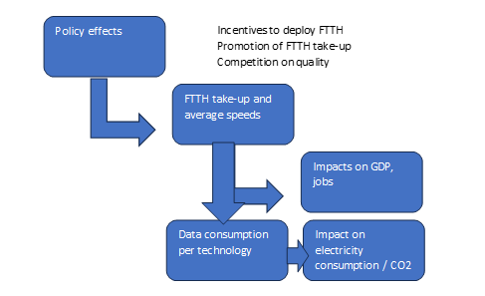
Source: WIK-Consult.
Impacts on coverage, take-up and competition
Each policy option is assessed in terms of its impacts on FTTH coverage and take-up as well as competition in broadband quality (via infrastructure competition where viable or otherwise access regulation permitting full differentiation). These impacts translate into projected increases on average download speeds (e.g. take-up of gigabit offers) and data consumption (per user and on aggregate).
Quantification of GDP impact
Expected changes in broadband speeds are linked with GDP impacts using coefficients derived from academic literature.
Quantification of environmental impact
Expected changes in broadband speeds and data consumption result in changes to electricity consumption and CO2 emissions, based on technology-specific data.

Quantification of impact of the different options on FTTH coverage, take-up, average speeds and data consumption (all evidence combined in one document and summarised at the top)
This section elaborates on the assumptions, data sources and modelling parameters used to estimate impacts on GDP and CO2 emissions for fixed and mobile broadband.
The diagram below shows the intervention logic linking access policy options, outcomes and impacts.
Figure A4 1-2:Intervention logic linking policy initiatives with economic and environmental impacts
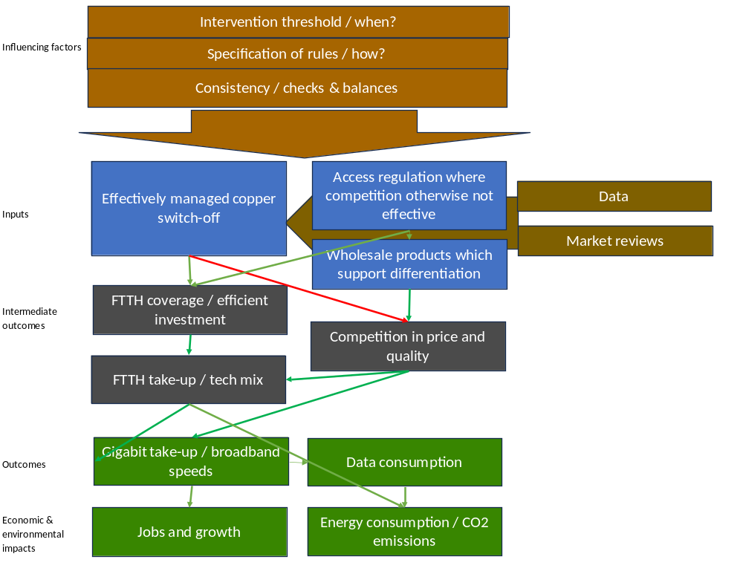
Source: WIK-Consult.
Based on the intervention logic, the table below provides an overview of the directional effects of the policy options on outcomes such as FTTH coverage, take-up and related factors. The different elements of each option are separated to indicate their directional effects (showed using + and -). These directional effects serve as inputs for quantifying the impacts of the entire option (on FTTH coverage and take-up, the wider technology mix, average speeds and data consumption).
The rationale for these assessments is provided in the subsequent sections.
The quantification of the impact of the options on FTTH coverage, FTTH take-up and penetration, average speeds and average data consumption is the basis for the estimates of GDP and environmental impact. The impact on GDP is calculated as a function of download speed, while for the environmental impact, CO2 emissions are calculated based on the share of subscribers by technology. The modelling also shows the data consumption per GB and the electricity intensity of the different options.

Impact on FTTH coverage
The projected effects of the policy options on FTTH coverage over time is shown in figure A4 1-3. The projections are based on the directional effects of the options.
The impact on coverage refers specifically to FTTH coverage and excludes FTTB using G.fast. Where relevant, FTTB/HFC is treated as cable coverage. Based on broadband coverage data differentiated by technology, on the number of subscribers differentiated FTTH and FTTB from the FTTH Council market panorama, on data of NRAs which have differentiated between technologies as well as FTTB and FTTH and on information about regulation of in-building telecommunications infrastructure (e.g. for building owners) it is possible to approximate in which countries FTTB means FTTB with HFC in the building or with G.fast/vectoring in the building.
According to FTTH Council forecasts, the share of FTTB in Europe is expected to reach 27% in 2030. In 2018, the FTTH Council forecasted a 36.2% share for 2025 but the latest data indicate a share of 34% in 2024 (see figure below).
Figure A4 1-3:FTTH/B Architecture Evolution from FTTB to FTTH
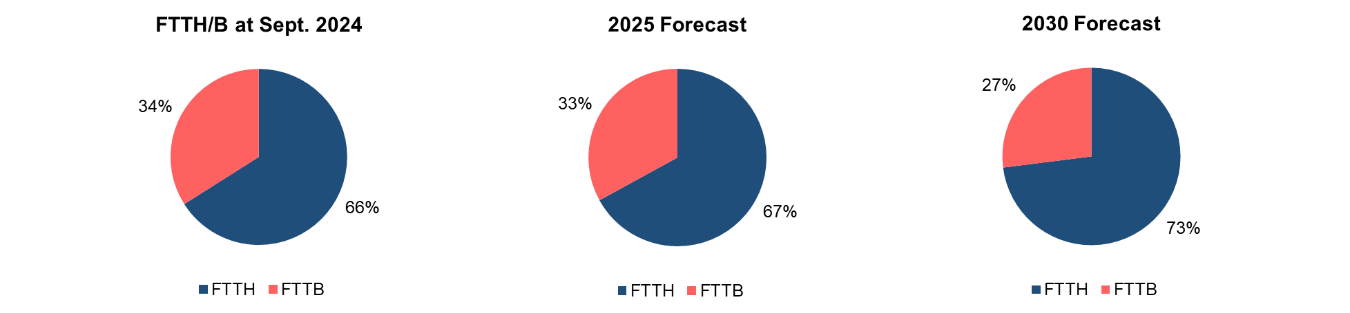
Source: FTTH Council (2025).
A projection of the decline in FTTB until 2035 would result in an FTTB G.fast share of around 4% under options 0, 1 and 3. Under option 4, FTTB G.fast ceases to be relevant in 2030 due to the CSO provisions. Under option 2, FTTB G.fast becomes negligible by 2035 due to the mandatory copper switch-off (CSO) without a sustainability clause. The share of FTTB G.fast under options 0, 1 and 3 decreases gradually as shown in the figure below.
Figure A4 1-4:Development of share of FTTB G.fast
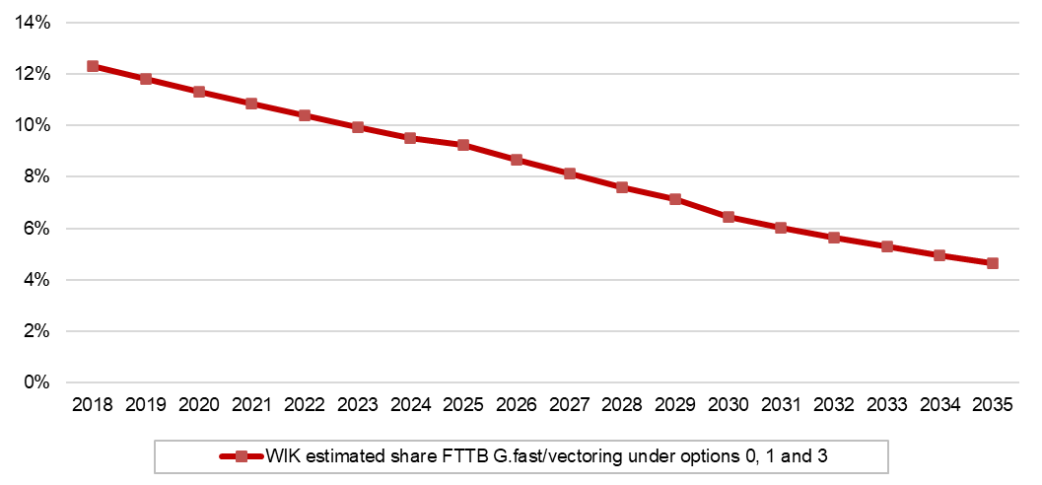
Source: WIK based on FTTH Council
Based on coverage and subscriber data, FTTB using G.fast/vectoring plays a significant role in five Member States (CZ, LT, EE, IT, SK), whereas in countries such as BE, DE and PL, FTTB with in-building HFC appears more prevalent.
In practice, mobile or FWA technologies have been used as alternatives to FTTH to support connectivity in remote areas (e.g. Sweden and Estonia) following copper switch-off. This approach is also being discussed in countries that are further advanced in terms of fibre roll-out and copper switch-off. However, countries with less dispersed rural populations might opt for greater coverage with FTTH.
The highest FTTH coverage in 2030 is projected under options 2 and 4. Under option 4 accelerated fibre roll-out occurs until 2030 due to the mandatory CSO by 2030, complemented by SMP-based duct access obligation that supports alternative fibre deployment. The lowest FTTH coverage is projected under option 3, as the absence of a CSO target and more limited access to physical infrastructure reduce incentives for network roll-out.
Figure A4 1-5:FTTH coverage by option (this does not include measures to address the connectivity gap and USO yet)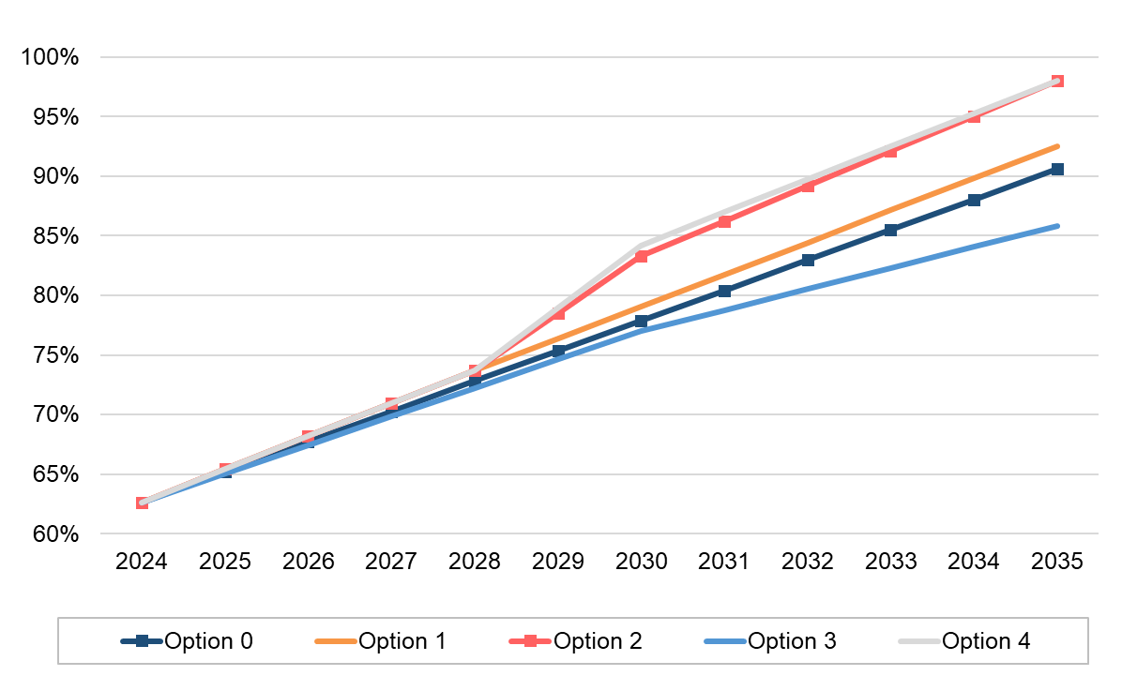
Note: FTTB G.fast coverage under all options is not included in the FTTH coverage.
Source: WIK based on DESI dashboard for the Digital Decade (2023 onwards), https://digital-decade-desi.digital-strategy.ec.europa.eu/s/dbXJPLz04nqNw/
Table A4 1-1: FTTH coverage in 2030
Option 0 | Option 1 | Option 2 | Option 3 | Option 4
77.9% | 79.1% | 83.3% | 77.0% | 84.2%
Source: WIK.
Table A4 1-2: FTTH coverage in 2035
Option 0 | Option 1 | Option 2 | Option 3 | Option 4
90.6% | 92,5% | 98,0% | 85,8% | 98,0%
Source: WIK.

Impact on FTTH penetration and technology mix
FTTH penetration (FTTH subscriptions as a percent of households) differs across the policy options.
Option 1 is projected to increase FTTH penetration by a Compound Annual Growth Rate (CAGR) of approx. 5%, slightly above the 4% growth rate under the status quo.
Option 4 is expected to have the strongest effect on FTTH penetration as it does not include a sustainability clause for the mandatory CSO.
Under option 2, which includes a sustainability clause, FTTH penetration is projected to be slightly lower than under option 4 at 78% in 2035, but still significantly higher than the status quo.
Under option 4, FTTH penetration increases sharply in 2030 due to the strict CSO deadline, resulting in the forced migration of customers who would otherwise have remained on copper. The mandatory CSO date is also likely to result in gaps in FTTH coverage in certain countries. In such cases, affected end-users would be migrated to other technologies in 2030 (mandatory CSO date), resulting in a higher share of FWA and 4G/5G mobile connections under option 4 compared to options 1 and 2. After 2030 the share of FWA and mobile 4G/5G decreases under option 4, as FTTH coverage and take-up continue to progress after the CSO. However, if more performant full 5G and 5G-based FWA technologies become available, customers may have reduced incentives to switch to FTTH once it becomes available, potentially weakening the FTTH business case. The extent to which these outcomes materialise remains uncertain.
ADSL is expected to be gradually phased out across the EU, as customers transition to FTTH, DOCSIS 3.1, FWA or 4G/5G mobile broadband. Given that DOCSIS 3.1 technology is capable of Gigabit download speeds (and DOCSIS 4.0 upgrades are planned in some countries as for example in the Netherlands), cable take-up is expected to remain relatively stable in the near term, but decline over time as customers transition (or are upgraded by their existing cable operators) to more performant and energy efficient FTTH/B. Meanwhile FWA penetration is expected to increase from a low base as 5G FWA offers expand and replace DSL, in particular in less dense areas or in countries where FTTH/B is less widespread.
Projected FTTH penetration under options 1, 2 and 4 includes the impact of a “right to connectivity” for consumers in regions with close to full FTTH coverage. In such regions, the right to connectivity enables homes passed by fibre (within a distance defined by the competent authority) to be connected to FTTH at a standard tariff. This applies only to regions where the fibre network has been commercially rolled out.
The graphs below show the technology mix (share of technology in % of households) including FTTH penetration associated with each option.
Figure A4 1-6: Technology shares by option in 2030 (in % of households)
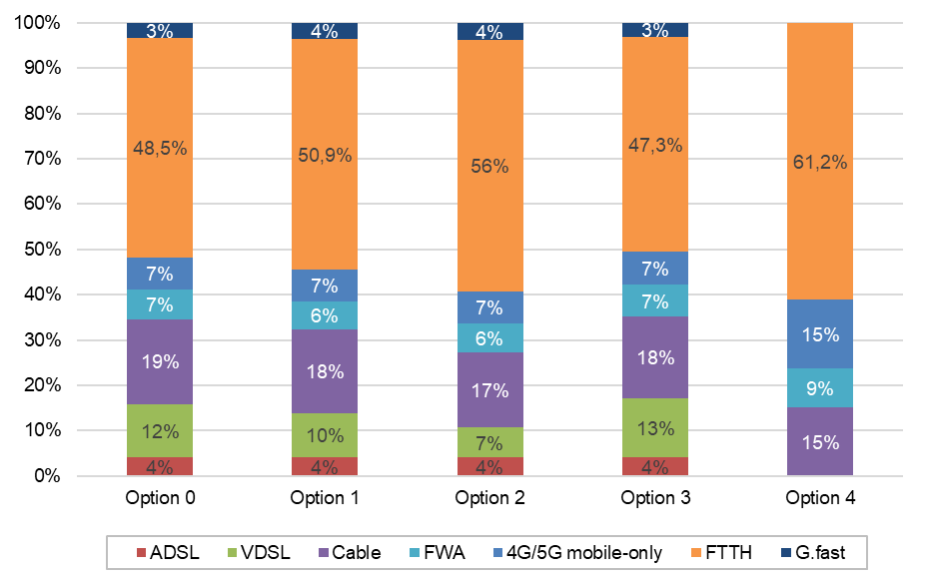
Source: WIK-Consult.
Figure A4 1-7:Technology shares by option in 2035 (in % of households)
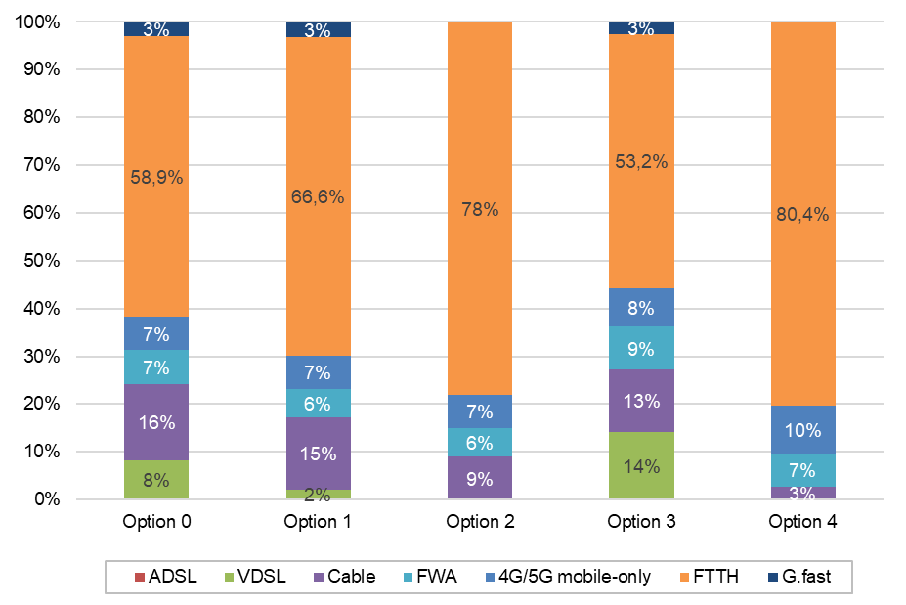
Source: WIK-Consult.
Universal Service Obligation
To estimate the impact of USO affordability measures on gigabit take-up among consumers with low incomes or special social needs, it was first analysed which Member States are likely to introduce affordability measures at a gigabit level for each option, and then estimate the subsequent take-up of those measures. Under option 1, no Member State is expected to define adequate broadband at a gigabit level.
As noted in earlier sections, the most popular tariff in France, Romania, Spain, Portugal, Ireland, Denmark, Hungary, Latvia and Luxembourg is expected to be a gigabit tariff by 2035. Consequently, the affordability measures imposed on consumers with low incomes and special social needs under option 2 will impact gigabit take-up in these Member States.
As option 3 phases out the affordability provision, this option will not have an impact on gigabit take-up.
Option 4 updates adequate broadband to a gigabit level by 2030. All Member States, except those addressing universal service entirely outside the USO regime are expected to implement affordability measures.
To estimate take-up of affordability measures, the analysis relies on the current proportion of consumers with low incomes or special social needs who benefit from these measures, as reported by the NRAs. Six NRAs have provided these figures:
Table A4 1-3:Beneficiaries of currently applied affordability measures for consumers with low income or special social needs (Ø 2021-2024)
 | Belgium | Bulgaria | Cyprus | Czech Republic | Hungary | Spain | Ø
Total | 200 529 | 115 379 | 25 853 | 27 065 | 9 | 19 186 | 64 670
% of HH | 3.86% | 4.04% | 6.90% | 0.59% | 0.00% | 0.10% | 2.58%
Source: WIK-Consult calculation based on National bodies (Answers to the WIK-Consult questionnaire).
The average percentage of households benefiting from existing measures for people on low incomes and with special needs (2.58%) is used as a predictor of future take-up. This percentage is extrapolated to all Member States expected to introduce USO reaching a gigabit level. Where a gigabit connection is defined as adequate broadband, vulnerable consumers are assumed to receive affordability measures.
For the estimation, the take-up of affordability measures is assumed to grow linearly between 2030 and 2035. This assumption reflects several factors:
- Implementation of the amended USO regime in the Member States is expected to take time and not be simultaneous across all countries. While some Member States have already introduced affordability measures, others may need to develop new ones.
- Awareness of these measures among eligible consumers is expected to increase steadily.
- Some eligible consumers are likely to remain tied to their existing (non-gigabit) broadband subscription due to minimum contract terms, even where gigabit tariffs become more popular.
Under option 2, affordability measures at a gigabit level are expected to be introduced in nine Member States by 2035. This would lead to 1% increase in the FTTH penetration (in % of households).
Under option 4, most Member States are expected to introduce affordability measures at a gigabit level. This would have an impact on the FTTH penetration of 2%.
Figure A4 1-8:Technology mix by 2035 including USO
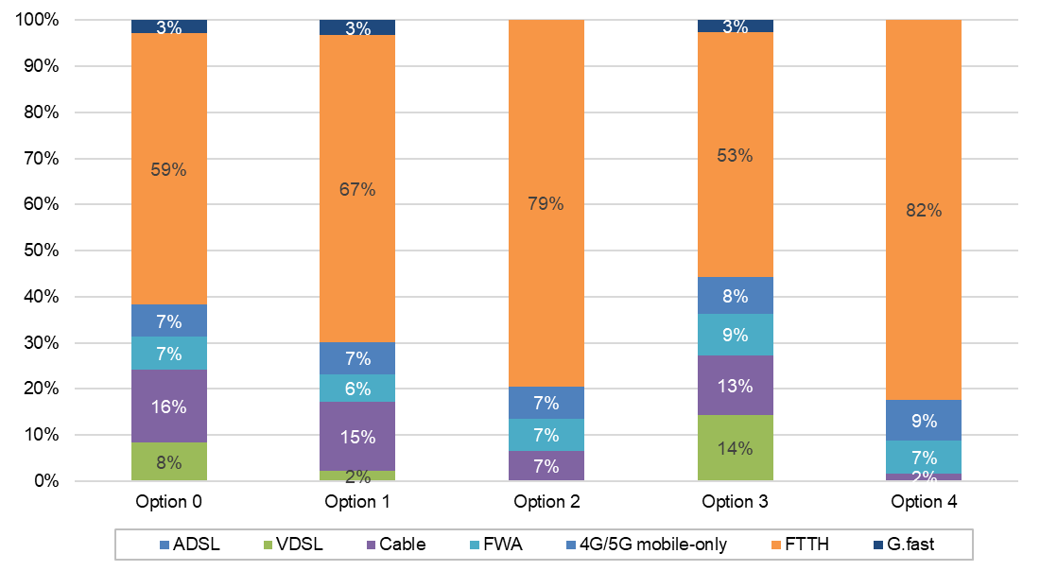
Source: WIK-Consult.

Impact on speed
For the purpose of the impact assessment, actual speeds delivered over the different technologies are projected to evolve as follows:
- FTTC speeds will continue to increase from 100 Mbps by around 4%.
- Cable speeds will increase from 200 Mbps by 7%.
- ADSL speed will remain stable at 10 Mbps (based on the development of Ookla broadband speeds in countries with a high share of VDSL, cable and fibre respectively in terms of coverage and subscriptions).
- Fibre speeds will accelerate from 250 Mbps across all options until 2029 by 8% reflecting technological progress in active equipment associated with fibre lines. From 2030 onwards the growth rates differ with a growth rate which increases from 8 to 16% for option 2, 15% for options 1, 3 and 4 (with a faster increase under option 1 after 2030).
The evidence supporting these assumptions regarding average speeds by technology is elaborated below.
The figure below shows average broadband speeds today. These are shown by groups of countries based on the prevailing technologies in those countries.
Figure A4 1-9:Average Broadband speeds (in Mbps) for Member States grouped by technology
￼
Source: WIK based on Ookla Speedtest data, European Commission (2025) and Ofcom.
As shown in the chart above, higher fibre coverage is associated with higher average speeds but fibre penetration is a stronger predictor of average speeds. This is supported by data showing significantly higher average speeds in countries with higher FTTH penetration rate. For example, Openvault reports that fibre penetration is a strong indicator for internet speeds experienced by users. Openvault also points out the relevance of upload speeds which reflect particularly well the speeds experienced by users with a fibre connection. The figure below shows this relation for 2023.
Figure A4 1-10:Fibre penetration and internet speeds
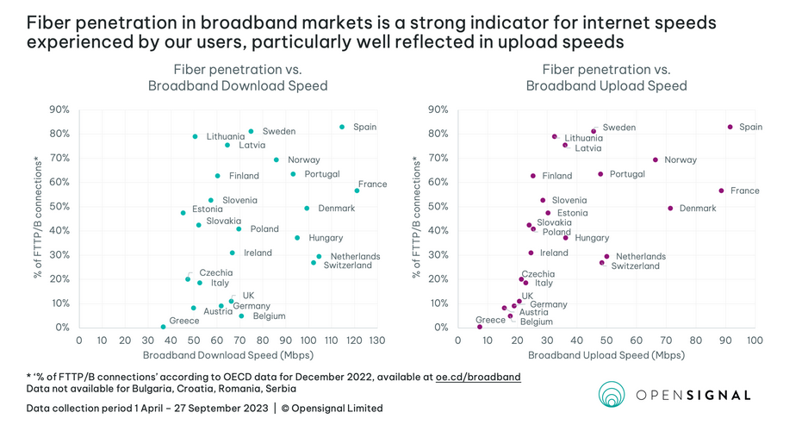
Source: https://www.opensignal.com/2023/10/12/european-markets-show-significant-disparity-in-broadband-user-experience (last accessed on 01.07.2025)
Notably, the CTU in Czechia has corrected the data on speeds for cable networks to adapt to effective speeds (as compared to advertised speeds). The availability of gigabit was revised to exclude those cable connections which do not provide gigabit speeds.
A headline speed of 250 Mbps is assumed for FTTH, consistent with average fixed speeds observed in countries with a high FTTH penetration. Speeds provided via FTTH could accelerate further due to the evolution in the capabilities of the technology in general. However, speeds actually purchased and received depend not only on the take-up of FTTH but on the degree to which there is competition on quality either through infrastructure competition (where viable) or otherwise through wholesale product specifications such as unbundled fibre which allow competition on quality, as evidenced in countries such as France, Italy and (in relation to the availability of symmetric offers) Sweden.
As mentioned above, the assumed annual speed increase on fibre is 8% under all options until 2029. This reflects technological progress in active equipment associated with fibre lines. From 2030 onwards the growth rates differ to reflect the potential for competition on quality resulting from the policy options pursued. This leads to a growth rate rising from 8% to 16% for option 2, 15% for options 1, 3 and 4 (with a faster increase under option 1 after 2030).
The evolution of average broadband speeds differs across the policy options due to variation in Gigabit pricing, which reflects the extent of competition and the type of wholesale access products available. Passive wholesale products such as fibre unbundling enable greater competition, particularly in pricing, speed and innovation. As a result, the increase in broadband speeds could be highest under options 2, which include a provision for best practice specifications for fibre unbundling and VULA. However, the impact of these provisions depends on proactive regulatory action by NRAs. In contrast, bitstream is expected to be the predominant form of access under options 3 and 4.
Speeds provided via FTTB G.fast are lower than FTTH and cable but higher than VDSL. An average speed of 150 Mbps is assumed, with an annual growth rate of 4% for FTTB G.fast.
Comparison of average speed by technology shows lower speeds on cable networks. An average speed of 200 Mbps is assumed, with an annual growth rate of 7% for cable networks.
Average broadband speeds via 4G/5G FWA are estimated at around 70 Mbps based on Ookla Speedtest results available for rural areas in the US from Verizon and T-Mobile. In its 2025 Connected Nations report on planned network deployment in the UK Ofcom expects FWA networks offering at least 100 Mbps download speeds. In Denmark, the average marketed speed of FWA subscriptions was 78 Mbps. Average FWA speeds are estimated at around 120 Mbps in 2024. As FWA connections are progressively upgraded with (and new connections added based on) 5G, the average speeds are expected to increase by around 8% per year.
The CTU also reports internet access connections differentiated by technology and speed which include WiFi (unlicensed), FWA and mobile (see figures below).
Figure A4 1-11:Internet access differentiated by technology and speeds in the Czech Republic (2023)
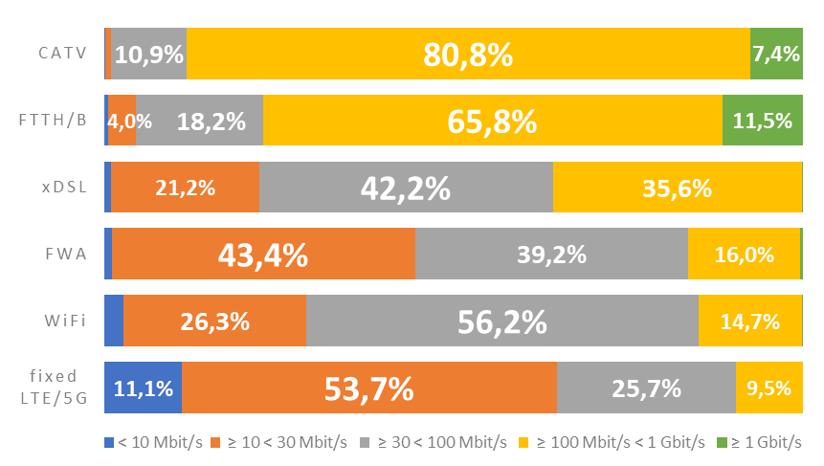
Source: CTU (2025).
An average mobile broadband speed of 100 Mbps is assumed, based on the average mobile download speed of 124 Mbps in the EU-27 in 2025 reported by Ookla. The assumed speed is lower because mobile broadband is likely to be more relevant in rural areas, and Opensignal data indicates a gap of ca. 20% between mobile broadband speeds in urban and rural areas.
Where customers can migrate to cable, the effective speeds are likely to increase compared with copper. However, where only mobile or FWA is available, speeds are likely to be lower. Depending on the mobile and FWA technology available, speed and reliability may be less than under the status quo with copper for these customers. If more performant full 5G and 5G FWA technologies are available, customers may experience increased performance compared with copper. In the mobile impact assessment growth rates of 6% for 5G average speeds are assumed resulting in bandwidths of 250 Mbps in 2035. However, in the case of in-building usage of 5G for stationary access to the internet, the increased performance can only be achieved to serve households and businesses based on dense fibre networks which are deployed at least to the building. In particular in modern buildings which are energy efficient (e.g. with thermal insulation) the indoor signal reception deteriorates and reduces bandwidths and latency significantly. In case fibre is deployed to the building and the network operators decides to use wireless technologies in the building, WiFi 6 is more efficient. As explained, mobile broadband is likely to be more relevant in less dense and rural areas where fibre networks are less dense. As a result, lower bandwidths have been assumed for mobile networks.
The implications of each policy option on the average download speeds are shown in the following figure. The measures related to access regulation under option 2 are assumed to accelerate take-up of gigabit speeds.
Average download speeds across the EU are expected to reach around 743 Mbps under option 2 by 2035. Average speeds under the other options are projected between 500 and 700 Mbps, which is not significantly higher than the base case. Option 4 would reach speeds of 691 Mbps. With 542 Mbps, Option 3 would result in lower speeds in 2035 than the evolution of average speeds under the status quo, due to limits on SMP PIA impeding FTTH deployment and limitations on access regulation that may not address all cases of ineffective competition and do not reward or require forms of wholesale access that support competition based on quality.
Figure A4 1-12:Projected average download speeds by option (in Mbps)
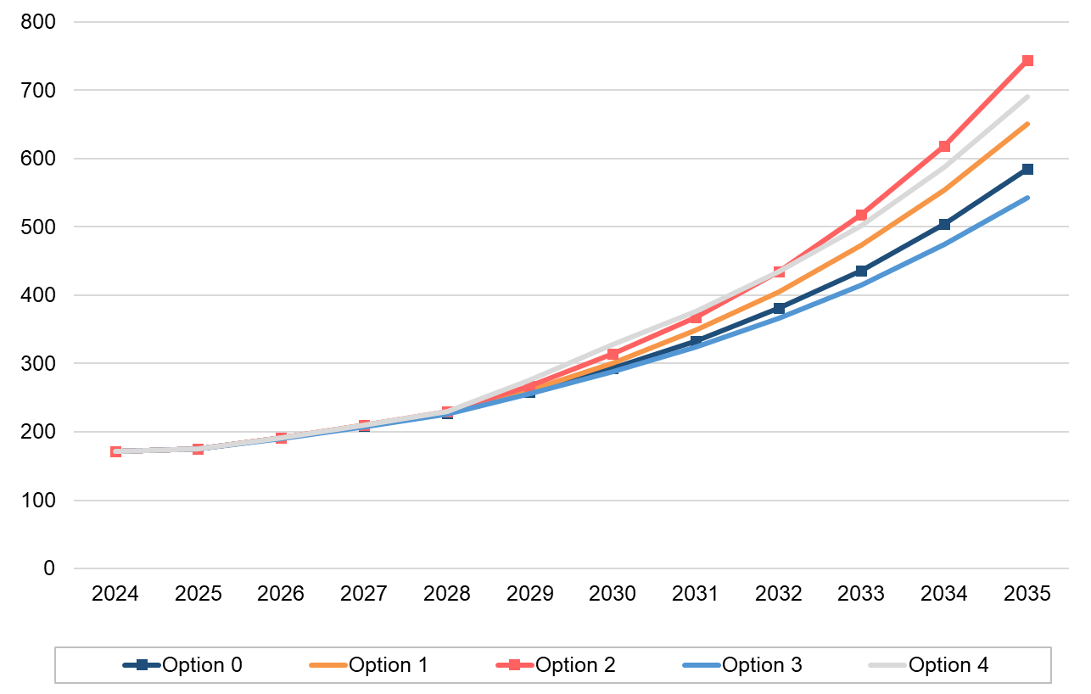
Source: WIK-Consult
Table A4 1-4: Projected average download speeds by option in 2030 (Mbps)
Option 0io | Option 1 1 | Option 2n 2 | Option 3 3 | Option 4 4
293 | 301 | 314 | 288 | 328
Source: WIK.
Table A4 1-5: Projected average download speeds by option in 2035 (Mbps)
Option 0i | Option 1 | Option 2n | Option 3 | Option 44
584 | 651 | 743 | 542 | 691
Source: WIK.
The figure below shows the implications for average actual download speeds experienced by consumers of the options including the impact of universal service obligation. Under option 2, including USO, the average download speed across the EU would be expected to reach around 746 Mbps by 2035 — an impact of around 2 Mbps from the USO. By comparison, the impact of USO on option 4 is 10 Mbps.
Universal Service Obligation
Figure A4 1-13:Projected download speeds (in Mbps) by option including USO
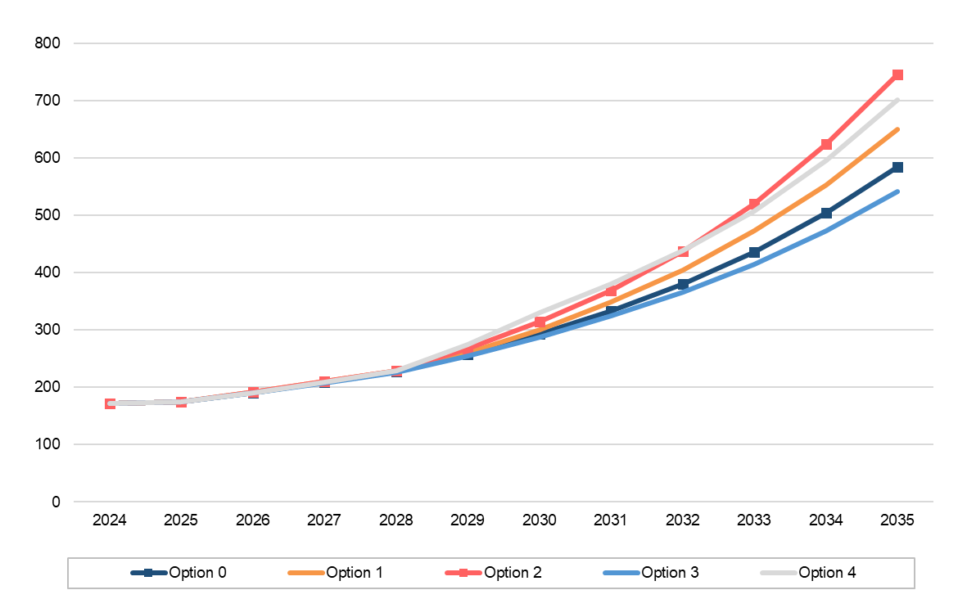
Source: WIK-Consult

Impact on data consumption
There is relatively little information available that distinguishes between the bandwidth used by customers with DSL connections and that used by customers with cable or FTTH connections. However, there is a recognised link between the download speed and overall data consumption.
Extrapolating from the distribution of broadband connections in Austria, Belgium, Denmark, Ireland, Germany, Portugal and the UK, ADSL users account for approximately 40 GB of data consumption per month, while cable users consume up to 450 GB. For FTTH, average monthly consumption is assumed at 600 GB, based on the relation between broadband speeds (see below) and average consumption in countries with high fibre take-up.
Data consumption for FWA is estimated as a function of its relative speeds compared with FTTC, which can be considered the nearest in technological performance today. Projections are developed by increasing consumption in line with anticipated speed growth for the different technologies
Evidence on the link between download speed and overall data consumption is discussed below.
As regards absolute consumption, OpenVault reports that at the end of 2023 the average household’s usage was 641 GB, up from 587 GB in the previous year.
Figure A4 1-14:Data usage by provisioned speed tier – 4Q 2023 (Openvault)
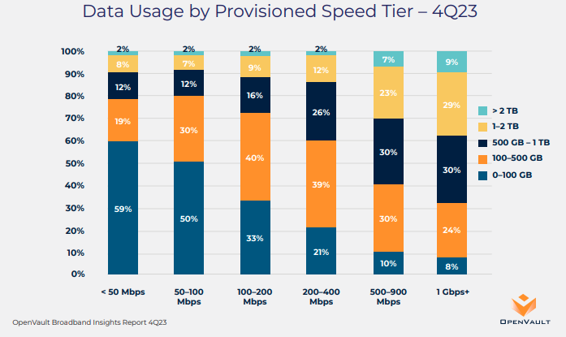
Source: Openvault (2023): Broadband Insights Report (OVBI) 4Q23, https://openvault.com/wp-content/uploads/2024/02/OVBI_4Q23_Report_v3.pdf
Openvault also highlights in its Q1 2025 Broadband Insights that after growing by nearly 50% during the pandemic year of 2020, the rate of growth for average daily consumption declined steadily in the ensuing years but in Q1 2025 not only rebounded but also accelerated with a 9.5% growth rate.
Figure A4 1-15:Year-over-Year global average usage growth
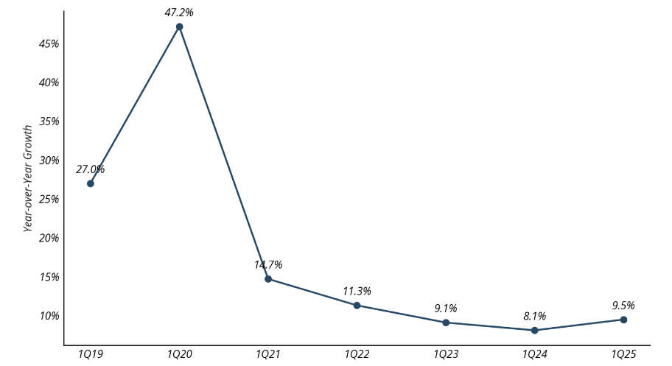
Source: Openvault (2025): A Boom in Business and a Peek at Peaks, OpenVault Broadband Insights.
FTTH networks offer higher speeds than legacy networks. Higher FTTH coverage is associated with higher fixed data consumption. Countries with more than 80% FTTP coverage (Spain, Portugal, Latvia, Lithuania, Bulgaria) are also in the top quartile of high FTTP penetration and overall high fixed data usage (GB/month). Belgium and Denmark, which have high cable coverage, exhibit consumption patterns similar to FTTP countries, with high level of fixed data usage. Conversely, countries with low FTTP tend to show lower fixed data consumption.
The same report notes that FTTH subscribers tend to use more data-intensive applications, and that data consumption typically doubles when a customer is upgraded from xDSL to FTTP.
Data from Ofcom on the average monthly data usage per connection in the UK shows that the data usage for full-fibre connections is significantly higher than the average monthly data usage over all connections.
Table A4 1-6: Average monthly data usage per connection GB in the UK (2024)
 | Average monthly data usage per connection (GB)
 | All connections | Full-fibre connections
England | 539 | 805
Northern Ireland | 510 | 589
Scotland | 480 | 627
Wales | 508 | 646
UK | 531 | 766
Source: Ofcom analysis of provider data (July 2024). Data usage is the total data downloaded and uploaded over the broadband connection during July 2024. Due to a change in methodology, this usage data is not directly comparable with usage data reported in previous years.
According to Ofcom’s current market review, consumers in the UK – who tend to have higher levels of broadband usage than in other European countries - consumed 535 GB per connection in 2024, up from 453 GB in the previous year. Consumers with FTTP connections have higher data usage than those using other broadband technologies, with an average of 766 GB per month for FTTP connections.
The quantification of average monthly bandwidth consumption for the different options shows the following results:
- Under the status quo, average monthly bandwidth consumption is projected to increase threefold within 10 years (from around 400 GB in 2025 to 1 371 GB in 2035).
- Under option 2, the results show a fourfold increase (from 400 GB to 1 768 GB).
- Under option 3, there is a threefold increase (from 400 GB to 1 266 GB),
- Under options 1 and 4, the increase is fourfold (from 400 GB to 1 535 and 1 642 GB respectively).
The different technology shares under the policy options are expected to affect total data consumption as shown in the following chart (see Figure A4 116). Option 2 is expected to result in the consumption of around 357 Exabytes (EB) by 2035 compared with around 277 Exabytes in the status quo. Option 4 would result in a total data consumption of 332 EB respectively in 2035. Option 1 is expected to result in the consumption of around 310 EB in 2035. Option 3 would show the lowest bandwidth consumption with 256 EB in 2035.
Figure A4 1-16:Total data consumption EU (in Exabyte) by option (projections to 2035)
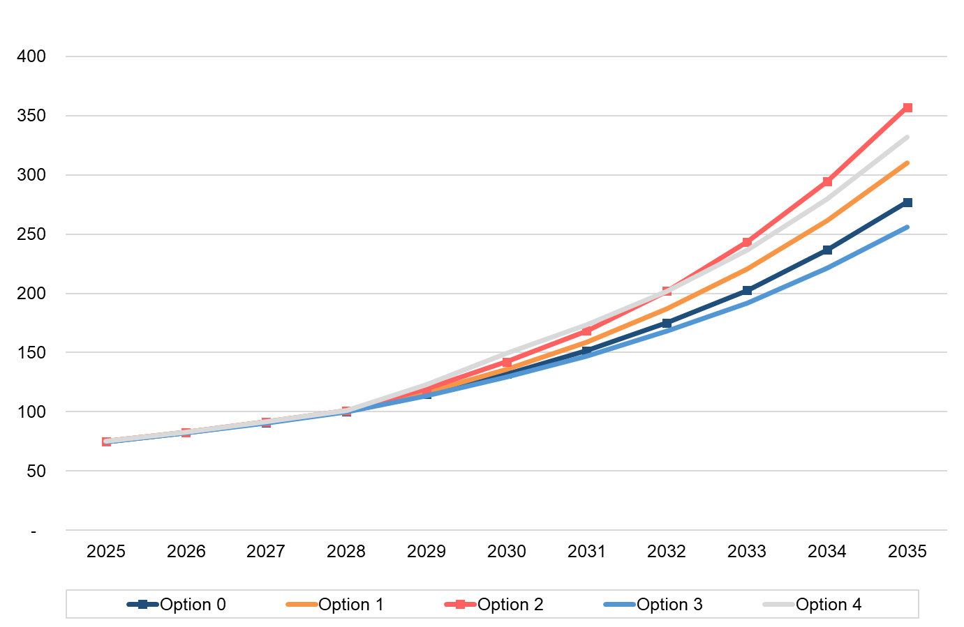
Source: WIK-Consult
Table A4 1-7: Total data consumption by option in 2030 (in Exabyte)
Option 0 | Option 1 | Option 2 | Option 3 | Option 4
132 | 136 | 142 | 129 | 149
Source: WIK.
Table A4 1-8: Total data consumption by option in 2035 (in Exabyte)
Option 0 | Option 1 | Option 2 | Option 3 | Option 4
277 | 310 | 357 | 256 | 332
Source: WIK.
Data consumption estimates for the calculation of sensitivity in the environmental impact
The tables below show data consumption on fibre networks under the assumption that usage is not linked to speed and grows more slowly after CSO in 2030. Under this assumption, differences between the options reflect differences in the technology mix. Overall, total data consumption would be lower due to the smaller increase in average data consumption per subscriber per technology (GB per moth).
Table A4 1-9: Total data consumption by option in 2035 (in Exabyte)
 | Option 0 | Option 1 | Option 2 | Option 3 | Option 4
Data consumption not speed related and smaller increase | 223 | 240 | 261 | 207 | 258
Delta to speed related data consumption with strong growth | -54 | -70 | -96 | -49 | -74
In % | 19% | 22% | 27% | 19% | 22%
Source: WIK.
Universal Service Obligation
The figure below shows the expected total data consumption by option by 2035 taking the options for the universal service into account. While universal service has no impact on total data consumption under the status quo, option 1 and option 3, it is expected to increase total data consumption by around 2 EB by 2035 under option 2 and by 5 EB under option 4.
Figure A4 1-17:Total data consumption in the EU 27 (in Exabyte) including USO (projections to 2035)
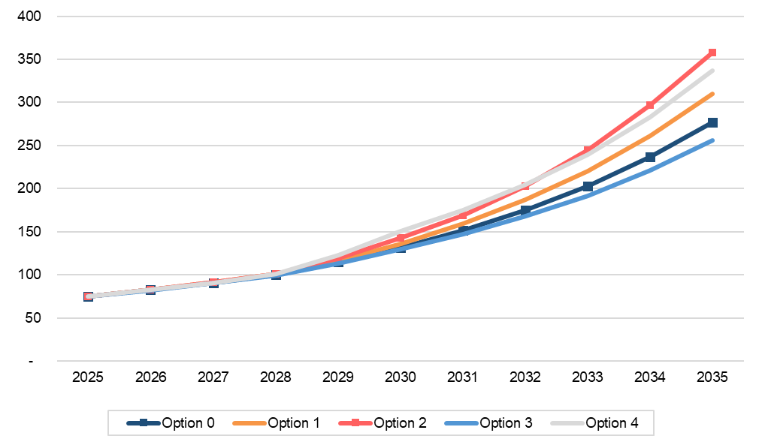
Source: WIK-Consult

Economic impacts
This section estimates the economic impact of improved broadband quality, drawing on available academic literature.
It summarises recent literature on the economic impacts of faster broadband in terms of GDP growth and job creation and it then presents the results of the associated theory-based modelling exercise.

Economic impact of fixed broadband in the literature
A wide range of literature supports a link between fixed broadband connections and economic benefits, including increases in GDP. More recently, as broadband has become prevalent, attention has shifted to examining whether higher quality broadband - defined in terms of speed or technology - is linked to greater economic benefits than “basic” or lower speed broadband. Existing literature generally confirms this relationship.
A 2025 study by Briglauer et al./EcoAustria, based on panel data for 32 OECD countries, analysed the causal effect of high-speed broadband networks coverage (fixed and mobile) as well as the adoption (take-up) of high-speed broadband services on GDP. The study looked at two observation periods: 2005-2020 and 2009-2020. In the later period, the networks with much higher speeds played a bigger role in broadband connections. The study shows that fixed broadband adoption for both observation periods exerts a substantial and significant impact on GDP while network deployment per se has only minor multiplier-related effects on economic growth. In the longer period (2005-2020) a 1% increase in fixed broadband adoption impacts per capita GDP growth in a range of 0.026% to 0.033%. The effects are considered conservative because they do not include difficult-to-measure effects such as consumer surplus, nor do they capture longer-term benefits that emerge as users familiarise themselves with new high-speed services or as companies make complementary investments in digital transformation. Positive effects on economic resilience during exceptional events such as the COVID pandemic, are also not captured. As policy conclusion, the authors recommend focussing public funding not only on supply-side deployment of broadband infrastructure but also on demand-side measures to accelerate the adoption of fast fibre-based connections, thereby generating far greater welfare effect in terms of GDP and consumer surplus. Suggested measures include vouchers, tax reliefs and increase of “e-literacy”.
Earlier research by Briglauer and Gugler also found positive macroeconomic effects of fibre-based broadband infrastructure investments by utilising a comprehensive panel dataset of Member States for the period from 2003 to 2015. The study assessed the causal impact of fibre-based broadband on GDP controlling for basic broadband adoption. In contrast to their 2023 study, it did not consider the simultaneous impact of network coverage and adoption, and the dynamic effects related to broadband adoption. Therefore, the estimated effects of fibre-based broadband adoption were significant but rather small. The study estimates that 1% increase in fibre-based broadband adoption causes an GDP increase of about 0.002%-0.005%. Hybrid fibre broadband has a slightly lower incremental effect over basic broadband of about 0.002%-0.003%.
An ITU (2025) study on the economic impact of digital transformation, using the Generalised Method of Moments (GMM), finds that fixed broadband continues to have a significant impact on the world economy and that the coefficient of impact has slightly increased since the previous 2021 study conducted by the ITU. Although the main regressors used are adoption/penetration rather than Mbps, speed may affect GDP indirectly via adoption proxies and network quality. This could partly explain why the economic contribution of fixed broadband is found to be greater in higher-income countries, which generally have higher take-up of higher-bandwidth fixed broadband than developing countries, where lower-bandwidth mobile connections play a more significant role. Based on a global dataset extending to the end of 2023, the ITU concludes that a hypothetical 10% increase in fixed-broadband penetration would raise GDP per capita by 1.59%.
Another study by Briglauer et al. (2023) provides an overview table of previous studies on the impact of broadband and the adoption of related services on economic development since the early 2000s.
Table A4 1-10 Overview studies on impact of broadband on GDP
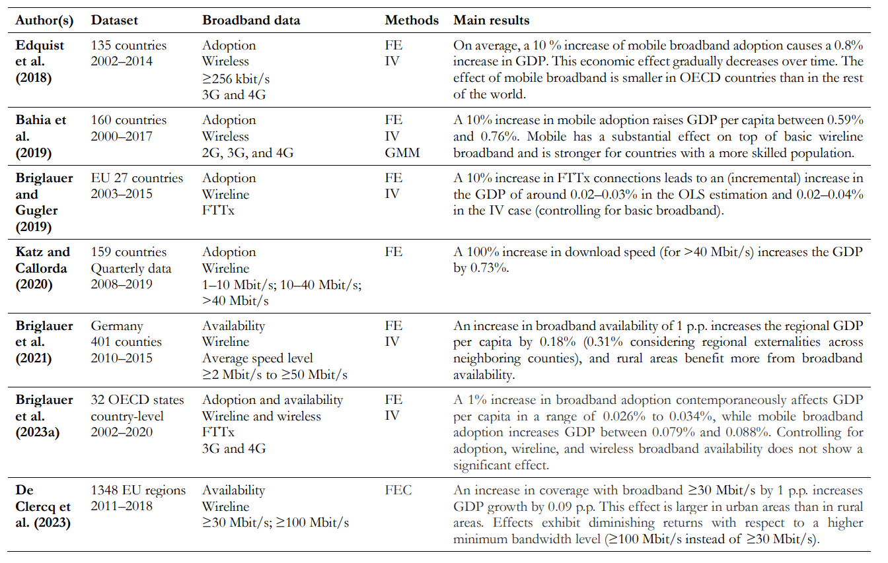
Source: Briglauer et al. (2023)
A study by Katz/Jung (2022) investigated the contribution of fixed broadband speed to the economic growth of the USA between 2010 and 2020. Within this period the fixed broadband average download speed of US households grew with a CAGR of 33.04% from 10.03 Mbps in 2010 to 174.23 Mbps in 2020. Based on several econometric models, the authors estimate that within these 10 years, this annually 33.04% speed growth caused a GDP-growth 0.44% per year (CAGR). Converted, 10% higher speed would trigger 0.1332% GDP-growth on average. This effect of higher broadband speeds is slightly higher than the effect of the expansion of fixed broadband networks that additionally induced an annually GDP growth of 0.41% (CAGR).
A study by Katz/Callorda (2020) analysed the impact of the cable industry’s investments in faster HFC networks on economic growth. To this end, they used an econometric model that incorporated data from 2008 and 2019 from 159 countries. The model’s results indicate that 1% increase in broadband speed yields a 0.73% increase in GDP.
A study by Rohman/Bohlin (2012) of OECD countries estimated that doubling the connection speed related to an additional 0.3 percentage points to annual GDP growth. WIK, together with Ecorys and VVA also identified a correlation between broadband speeds across the EU and Total Factor Productivity across a number of sectors in the context of a 2016 study supporting the Impact Assessment for the EU Electronic Communications Code, and concluded that if past relationships between broadband speed and GDP growth were to be replicated going forwards, an accelerated deployment of FTTP/B infrastructure which resulted in 55% of households using FTTP by 2025 could result in GDP levels 0.54% higher than the status quo.
A recurrent issue in estimating the impact of broadband speed on economic growth is the endogeneity of broadband. For this reason, Kongaut/Bohlin (2017) implemented a two-stage regression model to deal with the endogeneity problem. The authors estimated a production function that maps the impact of broadband download speed on GDP per capita across OECD countries. The broadband speed function is obtained in the first stage and then plugged into a panel data equation in the second stage. Their model indicates that a 10% increase in broadband speed yields an 0.8% increase in GDP per capita. However, the study authors note that the effects of broadband speed are greater in countries with lower income.
Nadiri et al. (2018) also find for the US, a positive link between high-speed broadband deployment and productivity gain. This effect is achieved through cost savings across all industries, although the extent of these gains varies by sector.
Confirming these results, Koutroumpis (2018) observes also on the basis of analysis of data from OECD countries that fixed broadband adoption along with increasing network quality has had a positive effect on national economic output. The study concludes that new services and telework has helped increase GDP by an average of 0.38% each year for the OECD countries and that this effect is related to the quality of infrastructure. On average a country at the highest speeds (capped by the 9.8 Mbps threshold) would gain 0.08% more on its annual GDP compared to an identical country at the lowest speeds (the lowest quartile in the sample, which is 0-1Mbps). Koutroumpis acknowledges the diminishing returns to scale associated with higher speeds, but argues that the threshold beyond which further increases in speed become unproductive should increase over time, as new services emerge to help firms and individuals make productive use of improved infrastructure.
Hasbi (2017) investigated the impact of very high-speed broadband networks on local growth. It is based on panel data from 2010 to 2015 covering more than 36 000 French municipalities except Paris, Lyon and Marseille. The study analysed positive local effects on the number of companies in the tertiary sector and the creation of new businesses. The local population benefits from spill overs as unemployment decreases. This study does not provide a quantitative effect on GDP growth.
An earlier study on the economic effects of gigabit broadband availability, conducted by Analysis Group in 2014, showed that in US metropolitan areas with at least 50% household coverage of fixed gigabit broadband, the per capita GDP is approximately 1.1% higher than in metropolitan areas with little or no availability of gigabit services.
A recent industry white paper by the US Fiber Broadband Association estimates the value of time lost when using a typical fixed broadband connections of 100 Mbps download and 20 Mbps upload speed compared with a symmetrical Gigabit bandwidth connections. The study finds that the average consumer loses 19.8 minutes per day when performing standard online activities, amounting to 13.5 full workdays per year. According to the white paper, upgrading home users from 100/20 Mbps to symmetrical Gigabit fibre could increase US GDP by 1.2% (or USD 326 billion).
Various studies have also identified links between FTTH or faster broadband and employment.
An OECD report which examined the effect of fibre networks in 290 municipalities in Sweden for the period 2010 – 2012 further found that on average 1% higher FTTP/FTTB penetration is correlated with a 0.11% higher employment rate, when controlling for other significant factors such as urbanisation level, population evolution, income, education level and business creation.
Canada, Singer et al. (2015) investigate the effect of FTTP rollout on employment on the basis of the deployment experiences in 39 regions between 2009 and 2014. They estimate that fibre deployment to 100% of a region is associated with an increase in employment of about 2.9% – even if the region already previously benefited from a broadband infrastructure.
Briglauer et al. (2023) also provides an overview table (see Table A4 1-11) of previous studies on the effect of broadband via the labour market on GDP.
Table A4 1-11: Overview studies on impact of broadband on labour market
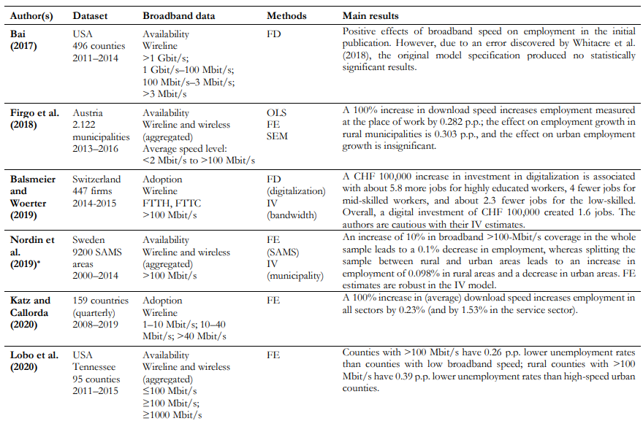
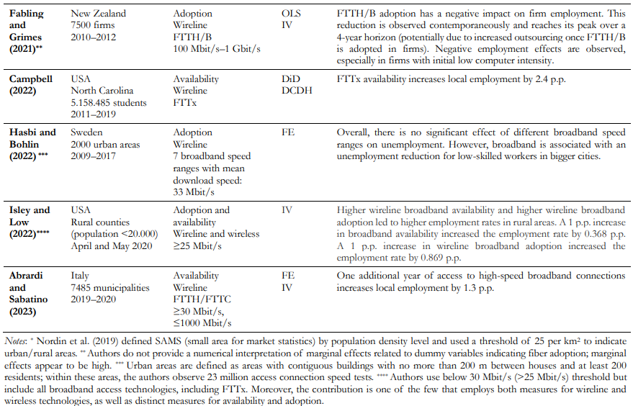
Source: Briglauer et al. (2023)
Some studies have also identified links between average broadband speeds and employment.
As regards the effects of Gigabit speeds, utilizing a panel of 496 U.S. counties sampled from 2011 to 2014, Bai (2017) found that increasing broadband speeds from 100 Mbps to 1 Mbps was more effective in boosting country employment than increasing speeds from 3 Mbps to 100 Mbps. Similar to the findings that GDP effects may be subject to diminishing marginal returns, Bai found that increasing broadband speeds beyond 1 Gbps would have a smaller, although still positive, effect on employment. However, it is also possible that new applications and the increased bandwidth requirements associated with teleworking in the wake of the COVID pandemic, might increase the employment effects and productivity gains associated with speeds above 1 Gbps.
A similar look at the relationship between broadband speeds and effects on GDP was made by Kongaut/Bohlin (2017). Speed data was taken from Ookla in a combination of fixed and mobile broadband download speeds, and other economic and population data was taken from OECD and World Bank statistics. The study calculates five models with different control variables for the impact of broadband speed on GDP per capita. All five models suggest significant positive impacts, but their values vary from 0.01 to 0.08. The study authors’ preferred model could be interpreted as an increase in broadband speed of 10% is leading to an increase in GDP per capita of 0.8%. But the authors also ask for caution with interpreting these exact numbers as they did not intend to quantify exact effects of broadband speed on GDP. What they did was to show the clear causality between broadband speed and economic growth and the significance of this relationship.

Theory-based modelling for the quantitative impacts
Drawing on the literature, a theory-based model is used to estimate how projected increases in fixed internet speeds impact GDP.
Coefficient for the link between increase in speed and GDP growth
The academic literature consistently finds a positive impact of VHCN on GDP. Several studies (e.g. Briglauer et al. (2025), Briglauer/Guggler (2019), Sosa/Analysis (2014)) analyse the impact of improved availability and increased penetration of high-speed broadband. These studies quantify the effect of increased coverage and penetration on economic growth.
A defining characteristic of the new broadband networks is their substantially higher performance, particularly in terms of data transmission speed. The most recent study by Briglauer et. al (2025) provides evidence of a causal relationship implies a causality between increases in speed and a positive GDP impact.
For the quantification of the impact of an increase in speed on GDP, this analysis draws on several studies that estimate the causal relationship between broadband speed and economic growth. The table below shows selected estimates of the impact of increased speeds on GDP.
Figure A4 1-18:Quantifications of impact of increased speeds in literature
Study | Quantification | GDP increase caused by a 1% higher speed
Kongaut/Bohlin (2017) | “10% increase in broadband speed yields an 0.8% increase in GDP per capita” | 0.08%
Katz/Callorda (2020) | “1% increase in broadband speed yields a 0.73% increase in GDP” | 0.73%
Katz/Jung (2022) | “33.04% speed growth caused a GDP-growth 0.44% per year” | 0.01332%
Sources: Kongaut/Bohlin (2017), Katz/Callorda (2020), Katz/Jung (2022)
Linear vs. degressive/progressive impact on annual GDP growth
All academic studies consulted ensured that the quantifications were based on causal effects rather than random correlations.
The question arises whether increases in speed have a linear impact on annual GDP growth and what coefficient should be applied. The studies indicate that the effect of VHCN is not necessarily linear. Briglauer et al. (2025) argue that full economic benefits only unfold over time, for example as consumers adopt better and new services enabled by higher speeds and more reliable connections, and as firms make complementary investments in digital transformation. Koutroumpis (2018) acknowledges diminishing returns at higher speeds, but argues that the threshold beyond which further increases in speed become unproductive rises over time, as new services emerge to help firms and individuals make productive use of improved infrastructure.
Since it is unclear, to what extent the coefficient used for the link between increased speed and GDP should decrease or increase, the model applies a linear factor over the projection period.
In the impact assessment projected increases in broadband download speeds arising from the different options were converted to GDP impacts based on the equation that 1% increase in speed results in 0.06% increase in GDP. The coefficient applied lies in the corridor of the coefficients indicated in the literature (0.01%-0.08%). This corridor excludes outliers such as the results from the study by Katz/Callorda (2020) that a 1% increase in broadband speed yields a 0.73% increase in GDP. As regards the remaining studies, a coefficient in the upper range was chosen because take-up of gigabit speeds in the EU27 is not yet very high. The demand forecast showed that there is a gap between gigabit take-up and the forecasted demand (without restrictions). This means that there is potential to leverage benefits from increased gigabit take-up. A sensitivity analysis is included assuming a coefficient of 0.01%. Calculations were made for each year between 2025-2035.
The impact of increased fixed broadband speeds on GDP per capita
Table A4 1-12 displays the overall impact over 10 years (2025-2035) on GDP for each option (in EUR billions). Option 2 has the highest impact on GDP with an increase in GDP of EUR 1,862 billion. Option 3 has the lowest cumulative impact. It is possible that there may be declining marginal returns relating to the impact of increasing broadband speeds on productivity (expected to be driven by factors such as support for home-working, use of digital public and commercial services and associated efficiencies, increased availability of higher capacities for businesses including SMEs). However, there could equally be increased returns if higher speeds for broadband in premises unlock new behaviour patterns or new business models or improve efficiencies e.g. in the delivery of healthcare and other public services etc. The results of the impact of speed increases on GDP are shown in the table below for four different estimated values of the coefficient: 0.01 (low estimate), 0.03 (medium estimate – lower part), 0.06 (medium estimate – higher part) and 0.08 (high estimate). This does not change the comparison of the different options.
The results under options 2 are subject to the uncertainty and problems related with the approach to access regulation. GDP benefits could be increased further if those problems were addressed.
Table A4 1-12: Accumulated GDP impact (2025-2035) of options (EUR billion)
Coefficient | Option 0 | Option 1 | Option 2 | Option 3 | Option 4
0.08 (high estimate) | 2 073 | 2 179 | 2 514 | 1 938 | 2 388
0.06 (medium estimate – upper part) | 1 535 | 1 679 | 1 862 | 1 437 | 1 761
0.03 (medium estimate – lower part) | 753 | 822 | 910 | 706 | 862
0.01 (low estimate) | 248 | 270 | 299 | 233 | 238
It should be mentioned that a coefficient value in the upper half part but well below extreme estimates (i.e., around 0.06) is considered as the most appropriate for the estimation of the impact, because take-up of gigabit speeds in the EU27 is not yet very high. The forecasted demand gap between gigabit take-up and the demand shows that there may be potential to leverage benefits from increased gigabit take-up and the economic benefits will appear in the course of time. Using a coefficient at the upper end of the empirically supported range for speed-related effects is justified in a forward-looking assessment that explicitly models the “speed → adoption → productivity → GDP” pathway. A coefficient of 0.06% reflects both the substantial role of speed in enabling adoption and the cumulative, quality-driven economic effects.
Figure A4 1-19 shows the anticipated impact on GDP growth per capita of FTTH download speed over 10 years (2025-2035), based on the elasticity of GDP growth per capita, estimated at 0.08% GDP increase per each percent point of broadband speed increase. The expected economic growth is a multiple of the FTTH download projections, that is, an elasticity coefficient multiplies the projected download speed.
Figure A4 1--19:FTTH download speed impact on GDP growth of access options
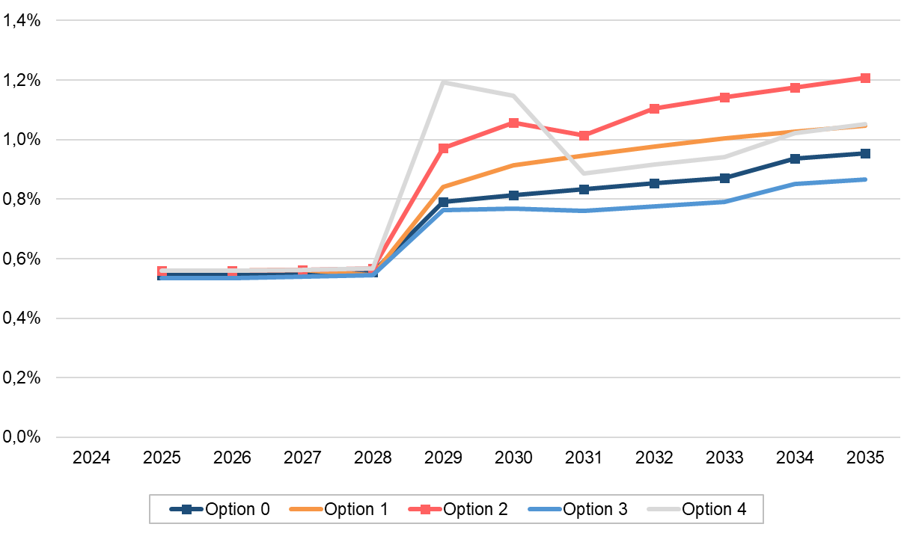
Source: WIK based on FTTH projections and literature review.
The strong growth from 2028 to 2029 of Option 4 reflects the accelerated fibre roll-out induced by the strict mandatory copper switch-off date. After copper switch-off, fibre roll-out continues at a slower pace. Fibre roll-out and the extension of coverage is linked with higher take-up and to an increase in speed. But the increase in speed is limited by low take-up of gigabit speed under this option due to the high share of active wholesale access and higher price levels and a price structure with high surcharges for higher bandwidths. Further, under option 4 a coverage gap remains and in consequence copper switch-off results in a higher share of FWA and 4G/5G mobile which are linked with lower speed compared to fibre or cable. Under option 2 fibre roll-out does not accelerate to the same extent as under option 4 but access to passive wholesale products could result in a higher choice of speeds at lower price levels and smaller price steps for higher bandwidths.
Option 2 has the strongest impact on GDP followed by option 4. Such results are consistent with the literature, highlighting the role of FTTH in enhancing economic performance.
Universal Service Obligation
Table A4 1-13:Accumulated GDP impact (2025-2035) of options (billion EUR)
Scenario | Option 0 | Option 1 | Option 2 | Option 3 | Option 4
Excl. USO | 1 535 | 1 679 | 1 862 | 1 437 | 1 761
Incl. USO | 1 535 | 1 679 | 1 865 | 1 437 | 1 781
Δ USO (from 2030 onwards) | 0 | 0 | 3 | 0 | 20

Source: WIK-Consult
Table A4 1-13 shows the estimated impact of each USO option on GDP. USO option 2 and option 4 would have an estimated impact of 5 (option 2) and 28 (option 4) billion EUR respectively. In total the GDP impact would still be highest under option 2 at EUR 2 525 billion.
Figure A4 1-1920: FTTH download speed impact on GDP growth of access options including USO options 2 and 4
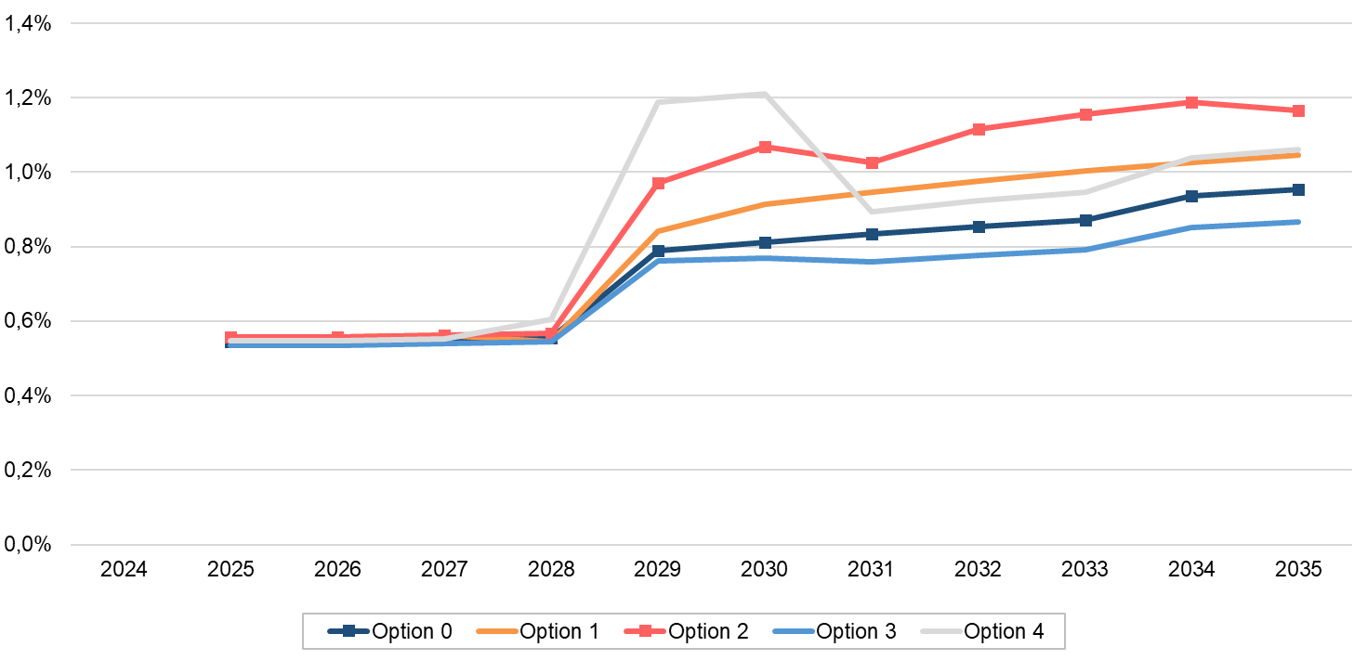
Source: WIK based on FTTH projections, Bohlin Rohman Kongaut (2017) and Briglauer et al. (2025).
Figure A4 1-20 shows the expected impact of the access and USO options on GDP growth. While options 1 and 3 of USO would have no impact on GDP, options 2 and 4 have a positive impact, as shown in Table A4 1-13. However, the growth curve is essentially determined by the impact of the access options.

Impacts on society
The terms societal impact and social impact are often used synonymously and interchangeably in literature. While societal impact refers to the impact of science on various levels and areas of society, social impact often refers to a more personal level of influence, affecting people directly (private) or indirectly (public). In this section, the term societal impact is used to cover direct benefits to citizens as well as indirect benefits to society of ultrafast broadband.

Societal impact of VHCN
Examples of societal benefits from Gigabit broadband include home care applications as well as greater educational opportunities, support for teleworking and improved entertainment options. In addition to boosting consumer welfare, these applications can also save money both for the individuals concerned and for the service provider.
A recent evaluation of the Superfast Broadband Programme in the UK found that it led to an increase in house prices of between GBP 1 900 and GBP 4 900. This increase in willingness to pay can be interpreted as a gain in social welfare associated with access to superfast and gigabit capable broadband networks. In 2018, Simetrica-Jacobs found that having access to superfast broadband was associated with an increase in wellbeing worth around GBP 225 (equivalent to around EUR 260) per household per year. While in these studies, superfast broadband was defined as having a download speed of only 30 and 24 Mbps respectively, other research confirms that services which require higher bandwidths could provide equal (or even greater) contributions to consumer welfare and play an important role in reducing inequalities. For example, one important function of Gigabit broadband, which has received increased attention following the COVID-19 pandemic, is the ability to support remote working.
In a 2015 article published in Psychological Science in the Public Interest Allen et al. (2015) found that teleworking is associated with many benefits for employees, such as increased job satisfaction, organizational commitment, and job performance and lower work stress and exhaustion. In contrast, Eurofund (2022a) reports that during the pandemic, teleworkers registered lower well-being scores, which can be partly explained by pandemic-related restrictions. A meta-analysis by Eurofund (2022b) suggests that teleworking positively impacts job productivity during the pandemic. Citing evidence from Austria, Belgium, Czech Republic, Finland, Germany, Ireland, Italy, Luxembourg, Malta and the Netherlands they report that 39-68% of employees say that remote working increases their productivity. Aksoy et al. (2023) quantified the time savings associated with teleworking, drawing on data from 27 countries. In their sample, the average daily time saving when working from home was 72 minutes. Workers allocated 40% of this time to their jobs and around 11% to caregiving activities.
A quantitative model estimation by SQW (2013) of the projected social impacts of faster broadband speeds indicates that the increase in teleworking driven by faster broadband would save about 60 million hours of leisure time per annum in the UK by 2024. In addition, by avoiding commuting costs, the additional teleworking enabled by faster broadband would lead to total household savings of GBP 270 million per year by 2024. Furthermore, SQW projected that increased productivity from teleworking could reach GBP 1.8 billion by 2024.
Figure A4 1-21:Net annual GVA impact of faster broadband speed on increased teleworker productivity in the UK, 2008 – 2024
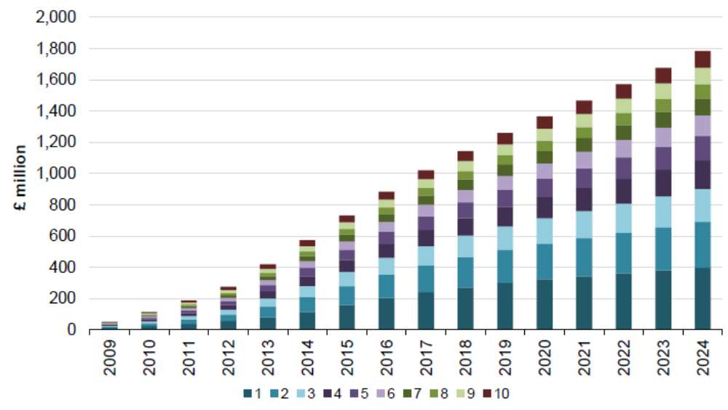
Source: SQW (2013), UK Broadband Impact Model. 1-10 represents population density from the least dense to the most dense
However, Samek Lodovici et al. (2021) note on a societal level that teleworking may contribute to the emergence of new employment and social inequalities, between those who can telework and those who cannot, because they are employed in non–teleworkable sectors/occupations or have no access to a broadband connection. Thus, the absence of a suitable connection to support teleworking (and the failure to digitize in sectors which could take advantage of remote working opportunities) could have detrimental effects on equality and societal cohesion.
Inadequate broadband connectivity is likely to be a particular challenge for rural areas, because the cost of deployment is significantly higher. The effects of inadequate connectivity (amongst other factors) may have been amongst the drivers of rural unemployment and depopulation. It is estimated that the population in urban regions will increase between 2023 and 2051 on average by 1.0% per year while rural regions will shrink by 3.3% per year. However, various studies suggest that improved broadband connectivity in rural areas could help to reverse these trends and ensure more equitable distribution of economic benefits. For example, using data from 290 Swedish municipalities between 2007 and 2010, Forzati and Mattson (2012) found that an increase in the proportion of the population living within 353 metres from a fibre-connected (FTTP) premise was linked to both higher migration and a positive change in employment (resulting both from migration and independently). A study by de Clercq et al. (2023) confirms that high-speed broadband (at least 100 Mbps) can significantly boost economic growth in rural regions across 1 348 EU regions between 2011 and 2018. This highlights the importance of expanding high-speed digital infrastructure in rural Europe in order to close the urban-rural digital divide. According to the World Social Report 2021 published by the UN, improved Internet access and connectivity will provide better jobs and higher standards of living for the roughly 3.4 billion people living in rural areas. The latest World Social Report 2025 emphasises that there is still a digital divide between rural and urban areas, a division that is made more meaningful by innovations in education, employment, civic participation, social protection and more.
Faster broadband can also support more efficient delivery of healthcare in rural areas (as well as elsewhere). A study assessing developments in Sweden found significant savings in using digital FTTH-based homecare especially in rural areas. It concluded that even with limited adoption, these solutions could contribute to annual net cost reductions of USD 0.6 million in a rural municipality with 8 000 residents by 2020. In another study, examining the effects of ultrafast broadband deployed in the rural county of Cornwall in the UK, Garner et al. (2019) found, that eHealth readiness improved over 18 months from 4.36 out of 10 to 4.59 out of 10. The authors concluded that one of the reasons for improved readiness for the adoption of eHealth services was the rollout of ultra-fast broadband, which increased both people’s personal ability to use eHealth and their methods of access.
The COVID-19 pandemic also highlighted the importance of ultrafast connectivity for education, confirming the need not only to ensure high performance connectivity for students but also for schools and higher education institutions themselves.
A study by Briglauer et al. (2024) provides an overview of previous research on the impact of fast broadband on education, which shows mixed results. A New Zealand study (Grimes and Towsend, 2018) found that fibre availability in state schools had a positive effect on grades, increasing them by around 1 percentage point per year in primary schools. Similar results were found by Campbell (2024) when analysing students' maths and reading test scores in the US. However, an Italian study by Cambini et al. (2021) found that the availability of high-speed broadband decreased the maths and Italian test scores of 8th graders. This effect was particularly evident among male students whose parents had a low level of education and who attended schools with low IT usage. Briglauer et al. (2024) conclude that progress must be made in closing the digital divide, both between urban and rural areas, and between those who can afford high-speed internet connections, and those who cannot. Another report from the Broadband Commission reports as well as a White Paper by Hyperoptic illustrates, on the basis of various case studies, the overall benefits education and school connectivity can bring to society.

Societal Impact of Internet access on vulnerable consumer groups
The impacts on the technology mix of the different options associated with copper switch off and access could have an important effect on vulnerable consumer groups. While Option 1 would involve incremental improvements and limited disruption, Options 3 and 4 could entail significant changes impacting vulnerable consumer groups. By removing safeguards which currently support competition in retail broadband services, Option 3 would be likely to lead to market consolidation competition, leading to higher prices, which could have a disproportionately negative impact on vulnerable consumer groups. Meanwhile option 4 could result in a high proportion of consumers relying on copper (which may include the elderly, disabled and those in remote locations) being disconnected and forced to rely on mobile or wireless connectivity. The quality or reliability of these connections may not in all cases match those available via copper, leading to a deterioration in consumer experience. While option 4 would safeguard retail competition, because competition would be based on active wholesale access on fair and reasonable pricing, it may not provide sufficient safeguards to avoid price increases in cases where service providers are reliant on an infrastructure provider which can exploit market power. Conversely, option 2 would provide explicit safeguards for consumers to ensure that copper switch-off would not occur unless consumers can be transferred to equivalent services without price increases. It would also likely result in improvements in quality for a similar price, as consumers would be transferred for the most part to more performant FTTH networks. As CSO could occur where FTTH coverage is at 95%, it can be expected that some consumers would nonetheless be transferred to wireless or mobile alternatives. The onus would be on Member States in this case to ensure that appropriate safeguards are provided to ensure that all customers receive an adequate broadband service, through use of USO provisions on adequate broadband availability, where necessary.
Those transferred to fibre-based broadband should however experience numerous benefits as described in the following literature.
While 94% of all EU households have internet access, significant gaps remain for low-income households, consumers with disabilities, and the elderly. In 2022, 2.4% of the EU's total population could not afford an internet connection. This figure was significantly higher for people at risk of poverty, at 7.6%. Similarly, while 93.5% of people aged 16–74 without disabilities in the EU used the internet regularly (at least once a week in the previous three months), the figure was significantly lower for those with disabilities at 78.2%. The gap widens with age: among 55–74-year-olds, only 70.8% of people with severe disabilities used the internet regularly, compared to 84.3% of those without disabilities in the same age group. The use of internet can help to reduce inequalities and improve welfare for those consumer groups.
For example, Zuo (2021) analysed the effects of a discounted broadband programme launched in 2021 in the US for low-income families in the U.S on labour market outcomes. He found that enrolees were 14.3% more likely to be employed.
Access to the internet and digital engagement can improve older people’s social lives, thereby enhancing their well-being. Mohan and Lyons (2024) examined patterns of internet use and psychosocial outcomes for over 3,500 people aged 50 and over in Ireland using the Irish Longitudinal Study on Ageing. They found that high-speed broadband access increased internet use and improved quality of life among older adults. However, there is little evidence that internet access reduces loneliness in this group. Studies have found positive associations between internet use and the health of older people. Tavares (2020) used data from 66,279 individuals aged 50 to 106 collected by the Survey of Health, Ageing and Retirement in Europe (SHARE). Their analysis showed that internet use was related to older people reporting better health, even when after socio-economic characteristics were taken into account. Silva et al. (2022) analyse the impact of internet usage on the social isolation of people aged above 50 in Europe. Their study found that internet use reduces the risk of social isolation among elderly people.
Similarly to the group including elderly people, internet access has been shown to have a positive impact on the wellbeing of people with disabilities. Duplaga and Szulc (2019) use a dataset collected from the panel study “Social Diagnosis” from 2015 to analyse the effects of internet usage on the health and wellbeing of people with disabilities via regression. The data collected consists of interview responses from 2 529 people. This work presents that people with disabilities tend to have a more positive view of their lives, less experience of loneliness, and report less frequent suicidal thoughts. Furthermore, Duplaga and Szulc found that people with disabilities tend to have better physical health due to a lower chance of consuming alcohol and smoking, while having a higher chance of being physically active.
The impact of the COVID-19 pandemic on vulnerable consumer groups highlights another important aspect regarding the benefits of internet access. Caton et al. (2024) conducted a study on the impact of internet usage on people with disabilities via interviews during April and May 2021 in the United Kingdom. Their results suggest that people with disabilities were able to combat social isolation and loneliness during the COVID-19 pandemic by maintaining social connections through online activities.
In summary, the literature review has shown that internet access generally benefits the physical and mental well-being of consumers with disabilities due to reduced loneliness. The COVID-19 pandemic demonstrated the importance of having access to the internet especially for vulnerable consumer groups.

Environmental impacts
The deployment and operation of fixed broadband can have significant environmental impacts. This section considers the potential effects of the policy options on greenhouse gas emissions (GHG). It also examines the wider potential of fibre networks to support GHG emission reductions in other sectors.

The lifecycle of environmental impacts linked to networks
The environmental impacts associated with electronic communications networks can be classified into three distinct phases The deployment phase, encompassing the manufacturing of equipment, ducts, and cables, as well as the civil engineering works required for network installation, including excavation and construction activities. The operation phase, referring to the continuous functioning of the network, entails mainly the electricity consumption but also regular maintenance activities to ensure reliable service delivery. The decommissioning phase, involving the dismantling and removal of network infrastructure and equipment, together with the management and recycling of the resulting waste materials.
Figure A4 1-22:Lifecycle overview of the environmental impacts for electronic communications networks
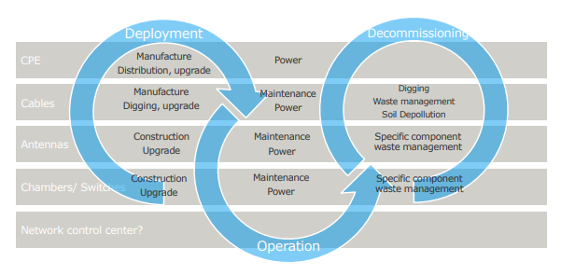
Source: Ramboll and WIK-Consult
The usage phase accounts for the largest share of the footprint by far. Sample calculations by Nokia for typical fixed and mobile networks show that around 90 % of emissions occur during this phase (see Figure A4 1-23). The zero or negative contribution of the end-of-life phase in this sample calculation is due to recycling of copper and other precious raw materials. Recycling prevents higher emissions from newly extracted raw materials.
Figure A4 1-23:Percentage of GHG emissions from different product lifecycle stages
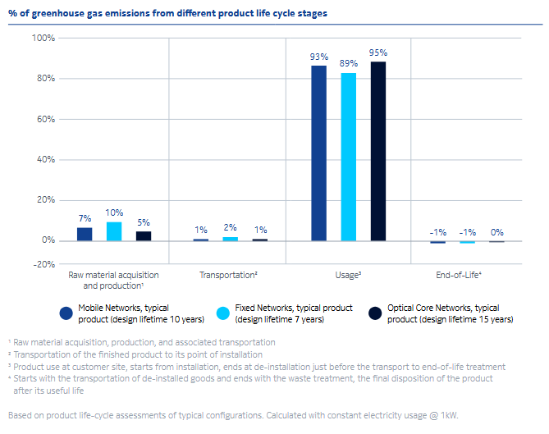
Source: Nokia (2019)

Fixed network deployment
Research on the environmental effects of fixed network deployment shows that construction methods have a significant impact on ecological outcomes. Smaller excavation volumes and infrastructure reuse provide the most substantial benefits. Life Cycle Assessment studies, such as Solivan's (2015) analysis of fibre cable construction, show that micro-trenching and ploughing methods minimise environmental disruption compared to traditional trenching. This is particularly true when they are used under asphalt surfaces, as they reduce fuel consumption for machinery and limit the transformation of natural land. Further environmental gains can be achieved by reusing existing infrastructure, including ducts, sewer pipes, water pipes, gas pipes and cable decoring. As demonstrated by Ecobilan (2008) and Stockman and Zhao (2014), this produces significantly lower environmental impacts than traditional civil engineering works. While underground cable installation primarily causes environmental damage during the construction phase, overhead wires create permanent visual impacts, which are particularly problematic in environmentally sensitive areas, such as cultural heritage sites and ridgelines.
In a study by the Fibre Broadband Association (2024) an estimate was made of the carbon footprint associated with the manufacturing one kilometre of FTTH compared with an HFC network. The sample calculation resulted in a carbon footprint of 883 kg CO2e for one kilometre of FTTH and 2,408 kg CO2e for one kilometre of HFC. In this comparison with an HFC network, the manufacturing of an all-fibre network produces an approximately 60% lower carbon footprint.

Fixed network operation

Environmental impact of broadband operation in the literature
The operation is an important part of the lifecycle of electronic communications networks as these systems often remain in place for many years. In a study of an Italian dense urban area (Griffa et al., 2010) found the use phase to dominate emissions representing between 57.5% and 73% of total emissions of FTTx deployment.
A wide range of studies has been conducted to analyse CO₂ emissions and energy consumption in access networks in the last decade. The available studies vary significantly with regard to their methodological approach and are targeted to different regions and technological mixes. The most relevant methodologies that are applied to quantify the effects include bottom-up approach, top-down approach and life cycle analysis.
Relevant studies with a focus on fixed broadband operation include the following:
Several studies have investigated the environmental impact and energy consumption associated with alternative wired systems. Aleksic & Lovric (Energy Consumption and Environmental Implications of Wired Access Networks, 2011) found FTTH could reduce GHG emissions per Gbit by 88% compared to the prevailing mix of Digital Subscriber Line (DSL) and Hybrid Fibre Coax (HFC) in 2008. Baliga et al. (Energy Consumption in Wired and Wireless Access Networks, 2011) found that at higher access rates a Passive Optical Network (PON) has clear energy advantages over other networks such as HFC, DSL, and FTTN. Similarly, Oberman (Nachhaltigkeitsvergleich der Zugangsnetz-Technologien FTTC und FTTH, 2020) found an improved higher energy efficiency of PON compared to FTTC. Finally, Breide et al. (Energy consumption of telecommunications access networks, 2021) found reduced energy consumption of the PON access network of above 80% compared to VDSL2 and a reduction of 10% including CPE.
Griffa et al. (Carbon Footprint of Next Generation Fixed Networks, 2010) indicates, however, that when considering deployment FTTH may indeed lead to higher emissions compared to FTTC in absolute terms but suggest that with low-power modes on CPE this may significantly improve over time. Baliga et al. (Energy Consumption in Wired and Wireless Access Networks, 2011) also indicate potential for improvement in energy efficiencies over time, suggesting that “the per-user power consumption of most high-speed access technologies should fall by around 70 percent from 2010 to 2020”.
Looking across from the first version JRC’s Code of Conduct on Energy Consumption of Broadband Equipment to the most recent in 2020 (EC JRC, 2020), also indicates significant energy efficiency improvement potential across all network equipment. It is therefore generally recognized that fibre (PON) can reduce energy consumption for the data delivered to the end user. It is also likely that these systems will improve their energy efficiency over time.
Where a connection is not fully utilized, however, the potential reductions in CO2 emissions are likely to be much lower. For example, the reduction in energy consumption is much less in a 10% utilization case (Obermann, 2020). In aggregate, however, the copper switch-off is likely to reduce energy consumption and hence emissions. In a study by WIK-Consult, Godlovitch et al. (Neutral fibre and the European Green Deal, 2020) found that “if there was a complete migration from the current technology mix in the EU to all fibre … the power consumption would be reduced from 52,608 GWh to 10,857 GWh. Moreover, if there is a complete switch to point-to-point (PtP) connections the power consumption would decrease further to 3,376 GWh.” They find that this would reduce GHG emissions by more than 90% if all households switched to PtP FTTH connections.
Zuloaga et al. (2025) quantify the ecological effects of fibre roll-out and copper-to-fibre migration on energy consumption and carbon emissions. Using disaggregated data on fibre coverage and take-up rates in Germany, they estimate energy-consumption differences across access technologies and model several deployment and migration scenarios through 2050. They find that FTTH is the most energy-efficient access technology (in terms of kWh/ GB), particularly when compared with alternatives commonly found in Germany such as FTTB and DOCSIS. Energy savings increase substantially when policy measures accelerate full-fibre migration to FTTH – especially in urban regions, where comparatively less efficient technologies such as FTTB and DOCSIS remain prevalent.
Zuloaga et al. (2024) analyse and quantify the energy consumption and CO₂ emissions associated with operating access networks (including fixed broadband (FFTH) and mobile networks (4G/5G)) in Germany, using a bottom-up modelling approach. The study also investigates how different settlement structures impact the environmental footprint of telecommunications networks. Based on these findings, the study analyses whether using mobile networks is a more sustainable way to supply rural areas than fixed network technologies. The analysis shows that, from an environmental perspective, FTTH access networks perform better than mobile access networks. These findings apply to all regional structures but are particularly significant for rural areas. Energy consumption in FTTH access networks is driven by usage, i.e. the number of end users. Regarding differences between FTTH topologies (PtP and Point to Multipoint - PtMP), the energy curves of PtP and PtMP converge with an increasing number of end customers.
The study estimates, that FTTH PtP totals 31.5 kWh/a per connection, while FTTH PtMP reaches 30.8 kWh/a per connection. It takes into consideration results from other studies for validation (see Table A4 1-14).
Table A4 1-14:Energy consumption FTTH PtP and PtMP
 | FTTH PtP | FTTH PtMP
 | kWH/a per connection | kWH/a per connection
Zuloaga (2024) | 31.5 | 30.8
Obermann (2022) | 30.7 | 53.4
Breide et al. (2021) | 52.9 | 37.1
Source: Zuluoga et al. (2024)
Zuloaga et al. (2024) analyse the ecological impact of Austria’s fibre broadband deployment applying a bottom-up model. The study assesses energy consumption and CO₂ emissions for six rollout scenarios (2025 to 2050) and for different technologies. Scenario modelling results show that a complete transition to FTTH could reduce cumulative CO₂ emissions by 2050 by up to 33.8% compared to a moderate baseline scenario. In contrast, alternative scenarios could result in substantial increases in energy demand, particularly if data volume requirements increases rapidly and the existing stationary mobile based broadband connections are kept instead of being migrated to energy-efficient fibre networks. The study concludes that early and complete migration to FTTH is critical for maximising environmental benefits and aligning with Austria’s climate targets.
Figure A4 1-24:Energy efficiency in Austrian access networks 2024 (Wh/Mbps per user)
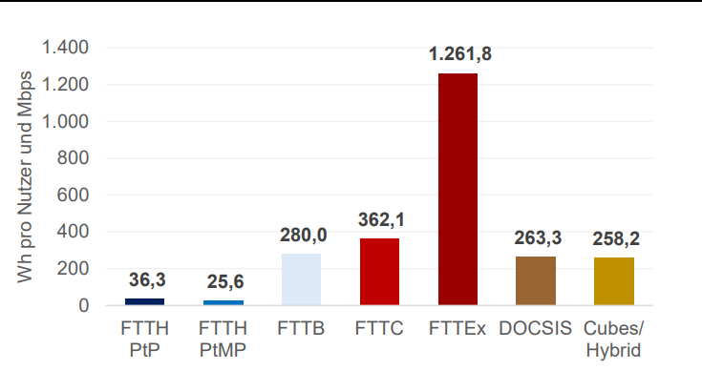
Source: Zuloaga et al. (2024)
Analysys Mason (2023) deals with energy consumption in different networks in the context of a broader study. It outlines that copper-based FTTC and coax-based DOCSIS technologies use 8 to 18 times more power than fibre-based GPON technology per connection (just for the network equipment).
Figure A4 1-25:Energy Usage and environmental impact of different fixed network technologies
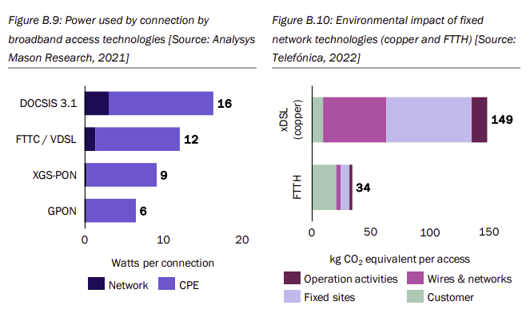
Source: Analysys Mason
Obermann (2022) provides a comprehensive comparison of internet access network technologies regarding environmental sustainability, emphasising energy consumption and CO₂ emissions across FTTH, FTTB, FTTC, and HFC networks. Employing a bottom-up approach, the analysis measures power consumption of network components, evaluates deployment scenarios across urban and rural regions, and considers varying load levels to assess utilisation effects. The findings highlight FTTH as the most energy-efficient technology, consuming up to six times less energy than HFC networks. Additionally, implementing sleep modes in network equipment could reduce energy consumption by up to 40%.
Breide et al. (2021) provides a detailed analysis of energy consumption and CO₂ emissions across broadband access technologies, including FTTH differentiating it in PtP and PtMP architectures. They use network energy consumption averages derived from actual regional network nodes from six municipalities in North Rhine-Westphalia, Germany. Findings indicate that FTTH PtMP is the most energy efficient technology, with consumption ranging between 56 kWh/year per capita, significantly lower than HFC and VDSL2, which require approximately 61 kW and 88 kW, respectively.
Godlovitch et al. (2020) analyses the role of fibre networks for the European green deal based on a detail analysis of the Stokab fibre network with regard to its contribution to Stockholm’s ecological sustainability. It estimates that a complete migration from the current fixed broadband technology mix in the EU to all fibre would result in emissions from the use of broadband access falling from 15.5 Mio t CO2 to 3.2 Mio t (fibre technology mix) and to 1.1 Mio t of CO2 (only point to point (PtP) connections) per year, if the existing power sources remained unchanged. This represents a reduction in emissions of more than 90% if all broadband connections in the EU moved to PtP FTTH.

Theory based quantification of the environmental impact of the different options
To estimate the environmental impact of increased FTTH coverage, a two-step procedure is applied. First, total electricity consumption resulting from changes in the access network technology mix is estimated. Second, the corresponding electricity demand is translated into CO₂ emissions. Based on the emission calculation, the CO2 emissions per MB can be derived, as well as electricity intensity (kW/GB).
Estimation of total electricity consumption
Total electricity consumption in the access network is derived from (i) the evolution of the technology mix over time across the different options and (ii) the electricity intensity of each access technology. The technology mix reflects how the number of subscribers using ADSL, FTTC, FTTB, FTTH, cable, mobile, or FWA evolves in each scenario, thereby capturing shifts from copper-based to fibre-based infrastructures. As the subscriber distribution changes, the aggregate electricity demand of the access network changes accordingly, since each technology exhibits a distinct power profile. Each technology is associated with a specific data-transmission capability, allowing us to account for the increase in data consumption that is expected across each of the options.
The technology mix is obtained from the projected number of subscribers per access technology over time, implying a growing share of fibre connections (and associated data traffic) and a declining share of copper-based connections as defined by each option.
For the electricity intensities (kWh/ subscriber) across different types of access network technologies, the model uses the values reported by Zuloaga et al. (2024). The electricity consumption per subscriber is as follows:
- ADSL: 3.6 W per subscriber
- FTTC: 10.3 W per subscriber
- Cable: 15 W per subscriber
- FWA: for FWA a consupmtion of 0,069 kWh/GB was assumed
- FTTH: 4.6 W per subscriber
- Mobile: 8.8 W per subscriber
- G.fast: 16 W per subscriber
Electricity consumption has therefore been calculated as follows:
$$E_{ANT,n}={sub}_{ANT,n}*EI_{ANT}*365*24$$
Where:
- $E_{AT,n}=$ total electricity consumption, W, for access network technology, ANT, in year n
- ${sub}_{AT}=$ number of subscribers for access network technology, ANT in year n
- $EI_{xG,2010}=$ electricity intensity, W/subscriber, for access network technology ANT
For FWA, electricity consumption is derived directly from kWh/GB and projected data traffic.
Annual electricity use across the access network is then obtained by summing the technology-specific values according to the technology mix in each year and scenario.
Estimation of CO2 emissions
To quantify GHG emissions resulting from electricity consumption, the model uses EEA data on the emission intensity of electricity generation.
For Europe, the CO₂ intensity of electricity generation is expected to decline rapidly as renewable energy sources expand, falling from 0.161 kg CO₂e per kWh in 2025 to 0.046 kg CO₂e per kWh in 2035. A linear trajectory between the two years is assumed.
CO₂ emissions are then estimated by multiplying total electricity consumption by the corresponding year-specific emission intensity factor.
The results are summarized in Table A4 1-15. This shows that in the Status Quo (Option 0), aggregate emissions of 13.7 million tonnes CO₂e can be expected across the 2025-2035 period. Options 1 and 3 show slightly lower CO2e, for option 1 however with a higher level of data consumption than options 0 and 3. Option 4 leads to a considerable reduction in emissions of almost 8% compared to the status quo also with a higher data consumption. However, the data consumption under option 4 is lower than under option 2 which also leads to a reduction of CO2e of around 0.6 m (ca. 6% compared to the status quo) despite showing the highest data consumption.
The results under option 2 are subject to the uncertainty and problems related with the approach to access regulation. Emissions could be reduced and efficiency increased further if those problems were addressed.
Table A4 1-15:Emissions summary for fixed broadband network 2025-2035
 | Option 0 | Option 1 | Option 2 | Option 3 | Option 4
Aggregate t CO₂e | Ca. 13.7 m | Ca. 13.6 m | Ca 13.1 m | 13.7 m | 12.6 m
Difference |  | Ca -0.15 m | Ca -0.6 m | Ca -0.04 | Ca -1.1 m
Relative difference to status quo |  | -1.07% | -4.5% | -0.33% | -8%
Source: WIK.
Figure A4 126:Emissions (in t CO2e) by option (projections to 2035)
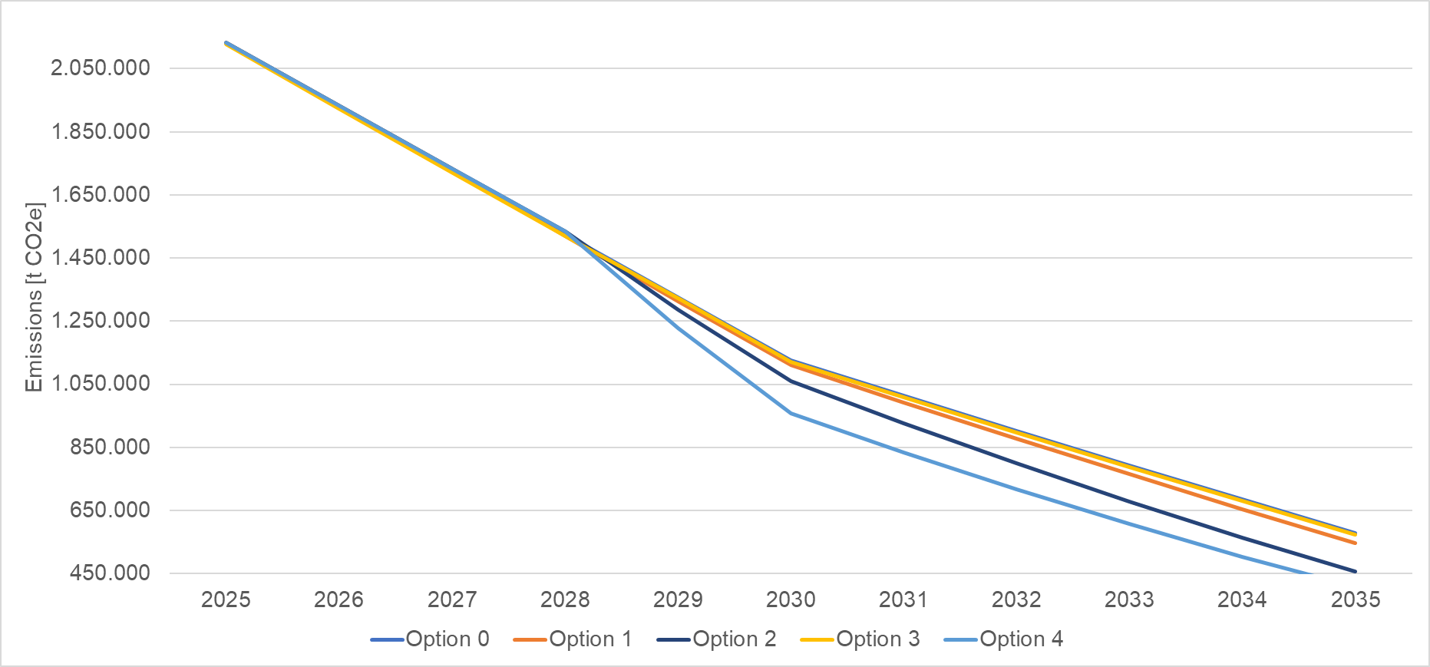
Source: WIK-Consult
Table A4 1-16:Electricity intensity summary for fixed broadband network 2025-2035
 | Option 0 | Option 1 | Option 2 | Option 3 | Option 4
kWh/GB in 2035 | 0.048 | 0.05 | 0.037 | 0.052 | 0.04
Difference to 2025 in % | 73% | 73% | 79% | 71% | 77%
Relative difference to status quo |  | -0% | -22% | 8% | -16%
Source: WIK.
Data consumption
On fibre networks, data consumption is not the main driver of electricity consumption and as a result the CO2 emissions. This means that a growth in data consumption on fibre networks leads to significantly lower increase in CO2 emissions compared to a growth in data consumption on copper, cable or mobile networks. Against the background that fibre networks are significantly more energy efficient than copper, cable and mobile networks, the migration to fibre networks means that
- either CO2 emissions are reduced significantly if the data consumption remains unchanged, or
- data consumption can grow only with a small impact on CO2 emissions.
The results of the modelling can be used to calculate the CO2 emissions per GB for the different options (see figure below). The results show that under options 2 and 4, the decrease of CO2 emissions per GB is lower than under options 1 and 3.
Figure A4 1-27:Emissions per GB (in t CO2e) by option (projections to 2035)
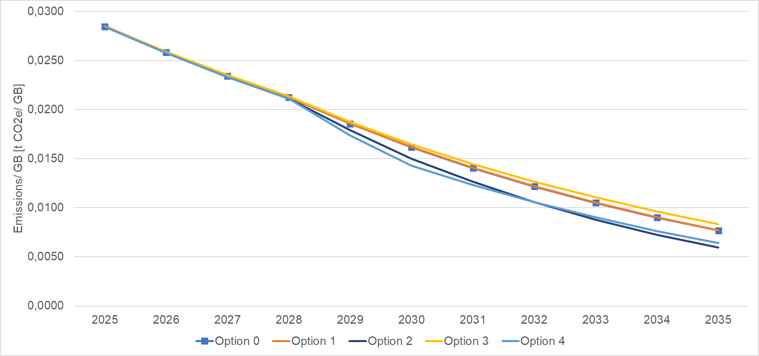
Source: WIK-Consult
Electricity intensity
Total electricity consumption of the access network is calculated based on number of subscribers and the electricity intensity of data consumption. This approach takes into account the expected increase in data consumption under each option.
Results show a significant reduction in electricity intensity for data traffic, from around 0.18 kWh per GB to 0.037 kWh/GB under option 2. Across all the options it shows the biggest reduction with around 79% from 2025 to 2035. With an electricity intensity that is 22% lower in Option 2 compared to the status quo scenario.
Figure A4 11-28:Electricity intensity (in kWh/GB) by option (projections to 2035)
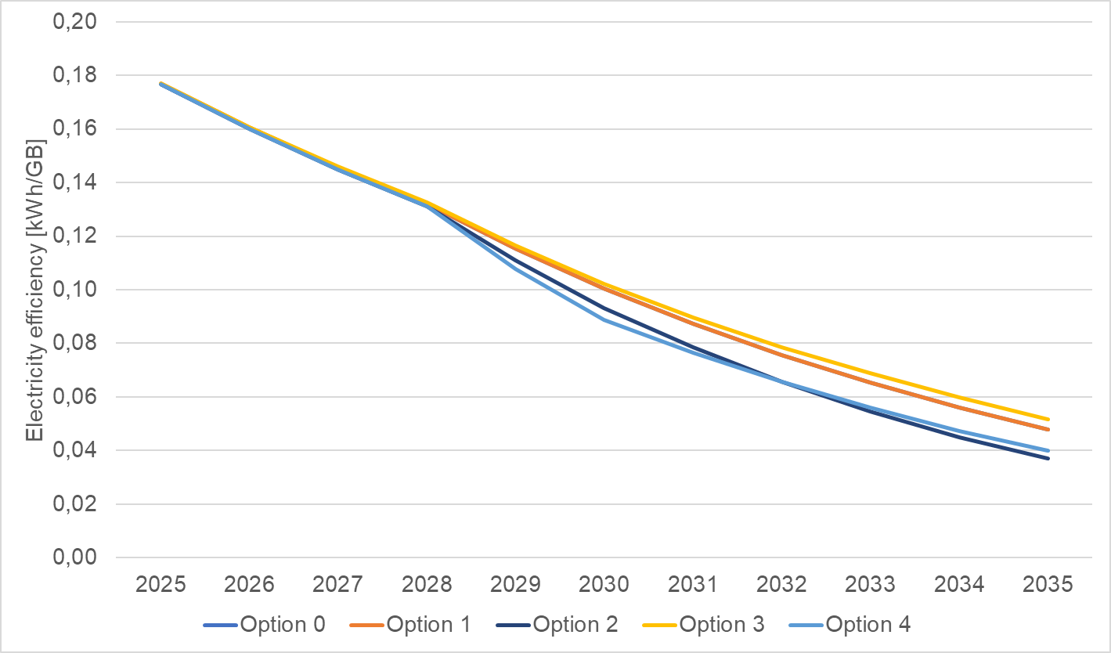
Source: WIK-Consult
Universal Service Obligation
Table A4 1-17:Emissions summary for fixed broadband network 2025-2035 including USO
 |  | Option 0 | Option 1 | Option 2 | Option 3 | Option 4
Without USO | Aggregate  t CO₂e | Ca. 13.7 m | Ca. 13.6 m | Ca 13.1 m | 13.7 m | 12.6 m
Without USO | Difference |  | Ca -0.15 m | Ca -0.6 m | Ca -0.04 | Ca -1.1 m
Without USO | Relative difference |  | -1.07% | -4.5% | -0.33% | -8%
Including USO | Aggregate  t CO₂e | Ca. 13.7 m | Ca. 13.6 m | Ca. 13 m | Ca. 13.7 m | Ca. 12.5
Including USO | Difference |  | Ca. -0.15 m | Ca. -0.7 | Ca. -0.04 | Ca. -1.2
Including USO | Relative difference |  | Ca. -1% | Ca. -5% | Ca. -0.3% | Ca. -9%
Source: WIK-Consult
The table Universal Service Obligation
Table A4 1-17 shows the estimated GHG emissions for the various options, including those for USO. Affordability measures targeting low-income households or individuals with specific social needs are expected to increase gigabit broadband adoption under Options 2 and 4.
Figure A4 1-29:Electricity intensity (in kWh/GB) by option including USO (projections up to 2035)
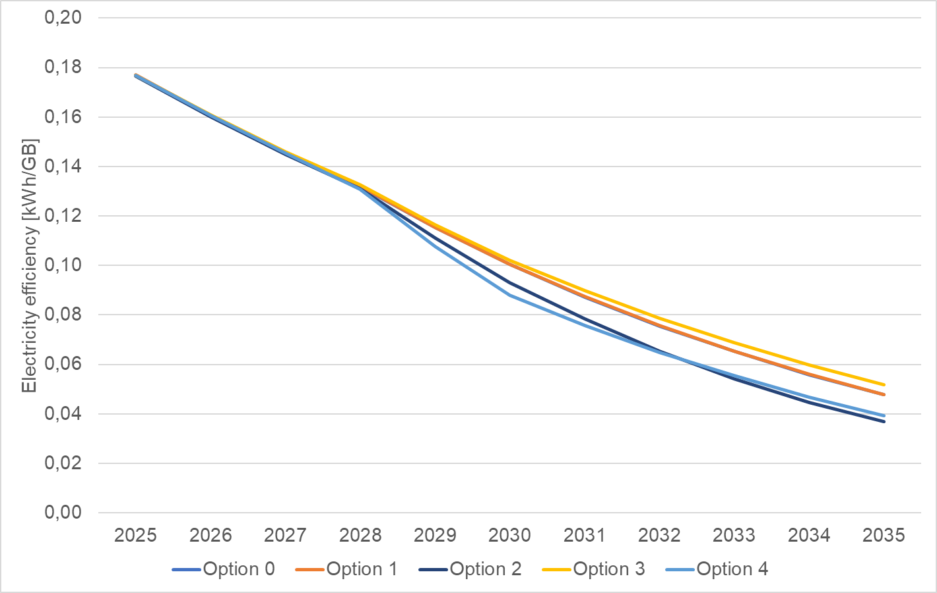
Source: WIK-Consult
As shown in Figure A4 1-29, option 2 leads to significant reductions in the electricity intensity of data traffic, from 0.177kWh per GB to 0.037 kWh per GB (this is 22% lower than the electricity intensity under the status quo in 2035). The impact of USO on electricity efficiency is limited.

Sensitivity analysis of data consumption
The impact of options on data consumption was also quantified for the scenario in which the growth in data consumption on fibre networks is not related to speed increase and in which data consumption grows at a slower pace after CSO in 2030. The difference in data consumption between the options under such an assumption would be related to differences in the technology mix. Overall, there would be a lower level of data consumption due to the smaller increase in average data consumption per subscriber per technology.
As the CO2 emissions are calculated based on the technology mix, a different scenario for the data consumption would not impact the accumulated CO2 emissions. However, the data consumption would be lower in all options and as shown in the table below.
Table A4 1-18: quantified data consumption with lower growth and no link between access speeds and data consumption
 | Option 0 | Option 1 | Option 2 | Option 3 | Option 4
Data consumption not speed related and with slower growth | 223 | 240 | 261 | 207 | 258
Delta to speed related data consumption with strong growth | -54 | -70 | -96 | -49 | -74
In % | 19% | 22% | 27% | 19% | 22%
Source: WIK.
Data consumption
The calculation of the CO2 emissions per GB for the different options under the different scenario of data consumption is show in the figure below. The CO2e per GB would decrease less under options 2 and 4 if there is no link between speed growth and data consumption and if data consumption would not increase to the same extent. However, options 2 and 4 would still be linked with more environmental benefits in terms of lower CO2 emissions per GB than options 1 and 3 due to the higher share of FTTH in the technology mix.
Figure A4 1-30: Emissions per GB (in t CO2e) by option (projections to 2035)
Source: WIK-Consult
Electricity intensity
In this scenario for data consumption results show a reduction in electricity intensity for data traffic, from around 0.18 kWh per GB to 0.05 kWh/GB under option 2, this is less 0.02 kWh/GB than assuming speed related and stronger growth for data consumption. Option 2 shows a reduction of around 71% from 2025 to 2035. With an electricity intensity that is 14% lower in Option 2 compared to the status quo scenario (in the other data consumption scenario it was 22% lower).
Figure A4 1-31:Electricity intensity (in kWh/GB) by option (projections to 2035)
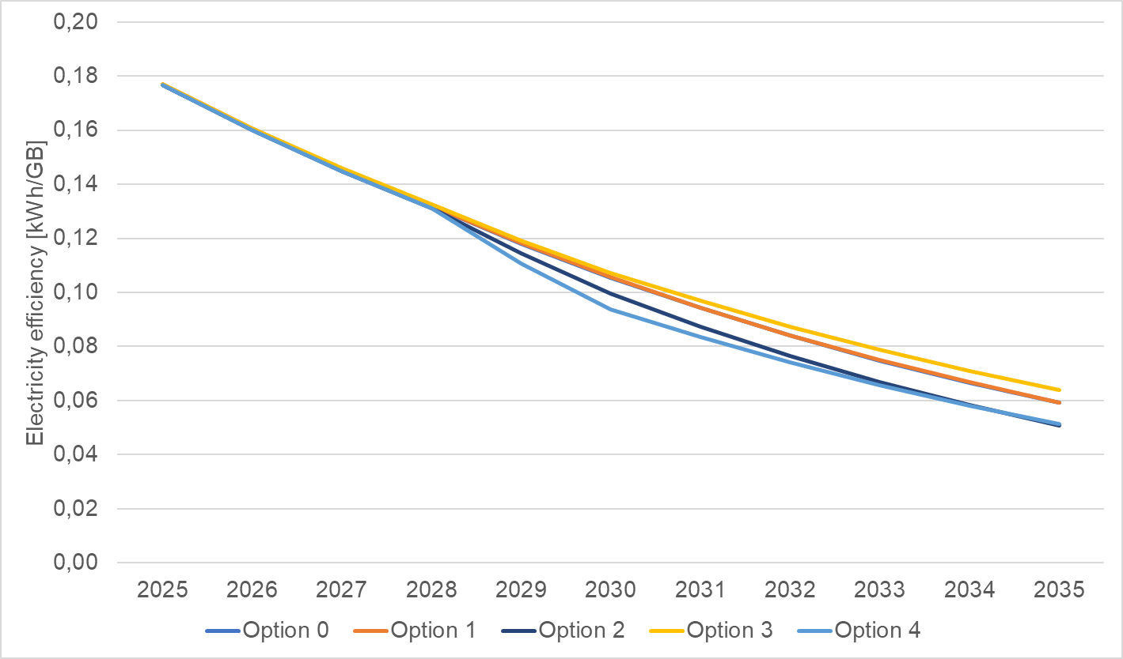
Source: WIK-Consult

Fixed network end-of life
Fibre optic lines generally have a longer lifespan than copper lines due to their greater durability and lower susceptibility to damage or theft. In contrast, copper lines are more frequently recycled due to their high material value and reusability, which mitigates the environmental impact of replacement. As most fibre optic lines have not yet reached the end of their service life, future disposal practices remain uncertain. The situation is quite different for copper networks, which represent valuable raw material reserves for their operating companies following the copper switch-off. Nevertheless, the end-of-life impact of both materials is relatively minor compared to that arising from production, installation and operation.
To give an idea of the scope of recycling potential: BT recycled more than 4 300 tonnes of copper in 2023. The company estimates to be able to recover around 200,000 tonnes of copper from their old legacy network through the 2030s. There are estimates that the fully extracted copper networks of BT in UK could be worth up to GBP 1.5 bn, depending on the fluctuating market prices and costs of extraction. TXO, a UK-based engineering firm specialising in the circular economy, estimates that 800 000 tonnes of copper could be reclaimed from telecommunications networks worldwide over the eight to ten years. Using recycled copper brings causes more than 90% less environmental impact than mining copper. Given the high demand for copper for the expansion of electricity grids and the electrification of many sectors, copper prices are expected to remain high or even rise.

Methodology for estimation of fragmentation costs
The estimate builds on a model for an operator with a meaningful physical presence and regulatory footprint in all Member States, which owns a telecom network, hosts its own numbers and delivers voice and data services.
The costs are broken down into four key categories: personnel, regulatory fees and contributions, compliance and legal and consultancy costs for proceedings.
Estimated annual regulatory compliance costs for an EU telecom operator
Category | Description / Key Assumptions | Per-Country Estimate | Total (27 MS) | Estimated Range (million EUR)
1. Personnel: Regulatory Affairs & Legal Teams | - Largest and most critical cost component.  - Requires dedicated regulatory and legal experts in each Member State.  Major Markets (10): Germany, France, Italy, Spain, Netherlands, Poland, Belgium, Sweden, Austria, Ireland.  Other 17 Countries: Denmark, Finland, Portugal, Czech Republic, Hungary, Slovakia, Slovenia, Croatia, Greece, Romania, Bulgaria, Estonia, Latvia, Lithuania, Luxembourg, Cyprus, Malta.  - Major markets: full-time regulatory affairs manager (EUR 120 000) + legal support (EUR 80 000) → EUR 200 000 per country.  - Other markets: part-time manager (0.5 FTE = EUR 50 000) + legal support (EUR 50 000) → EUR 100 000 per country.  - On-the-ground presence essential for managing NRA relations and ensuring compliance with national remedies.  Additional HR-related detail: According to internal estimates, the pure HR cost for a medium-sized operator could range between EUR 0.40–0.70 m annually to manage GA (General Authorisation) obligations — including applying for authorisations, notifying NRAs/Competent Authorities, and providing required updates across all 27 MS. When combined with total annual operational compliance and legal costs, this figure could reach EUR 0.50–1.20 m. | Major markets: EUR 200 000  Others: EUR 100 000 | (10×200 000) + (17×100 000k) = EUR 3.7 m | EUR 3.5–4.0 m
2. Regulatory Fees & Contributions | - Mandatory payments to NRAs: administrative fees, numbering fees, and Universal Service contributions.  - Based on turnover and operational scale in each country.  - Similar obligations apply to cross-border operators.  - Average assumed at EUR 150 000 per country (range EUR 50 000–EUR 300 000 depending on market size). | EUR 150 000 | 27×150 000 = EUR 4.05 m | EUR 3.5–4.5 m
3. Compliance Reporting & Audits | - Regular NRA reporting on network quality, service availability, fault repair, wholesale access, etc.  - NRAs frequently perform audits, requiring preparation by internal teams and external consultants.  - Reporting requirements vary by country; no unified EU template. | EUR 200 000 | 27×200 000 = EUR 5.4 m | EUR 4.5–6.0 m
4. Legal & Consultancy for Proceedings | - Covers participation in public consultations, and potential appeals.  - Requires support from economic and legal consultants.  - Cost varies with complexity and frequency of regulatory actions. | — | — | EUR 2.0–5.0 m
→ Total Annual Cost Estimate | Combined recurring and variable costs across all 27 EU Member States. | — | — | EUR 15–25 m
Potential Savings under Full EU Harmonisation | - A single EU-level authorisation, reporting, and fee framework could significantly reduce administrative duplication.  - Would eliminate multiple national submissions and overlapping NRA obligations. | — | — | Savings of EUR 6-11 m (about 40-44% reduction from EUR 15-25 m) per year without changes in the fee framework.  Savings of EUR 10–15 m/year (≈60–80% reduction if with single fee framework.

Summary of the estimates – between low and high are the following:
- The largest recurring burden comes from reporting and audit obligations (EUR 4.5–6.0 million), reflecting the effort required to produce country-specific documentation and undergo reviews.
- Personnel costs for in-house and external regulatory/legal expertise are also significant (EUR 3.5–4.0 million), highlighting the need for sustained specialist capacity to manage national requirements. Out of this, the pure HR cost related to applying for General Authorisation (GA), notification and providing relevant updates, if required, separately across 27 Member States, could range between EUR 0.40–0.70 million. Including the total annual operational costs for compliance and legal obligations, the figure could reach approximately EUR 0.50–1.20 million.
- Fees and contributions to national authorities (EUR 3.5–4.5 million) represent fixed costs linked to operating rights, numbering, and universal service obligations.
- Major regulatory proceedings, such as consultations and appeals, vary more widely (EUR 2.0–5.0 million) depending on the number and complexity of cases in a given year.
- Annual regulatory compliance costs are estimated at EUR 15–25 million, representing overhead created by market fragmentation. In a fully harmonised single market, streamlined authorisation and reporting, if there is a single fee foreseen it could reduce this burden by 60–80%, creating savings of EUR 10–15 million per year. However, in the scenario where there is no single fee proposed the burden reduction is lower 40-44% and cost savings would be approximately EUR 6-11 million per year.
- This scenario represents a best-case estimate of cost reduction due solely to regulatory harmonisation and the elimination of fragmented, overlapping national requirements, including the hypothetical assumption that national fees are replaced by a single EU-level fee, eliminating multiple mandatory contributions. It also provides estimation of costs reduction without changes in the fee framework.

Methodology for the modelling and quantitative Impact Assessment of the Spectrum options

Overview of the methodology
The quantification of economic and environmental impacts associated with the different spectrum options for the Digital Networks Act is based on a 3-step process. This process is illustrated for mobile broadband in the following diagram.
Figure A4 2-1:Three-step approach to assessing socio-economic and environmental impacts
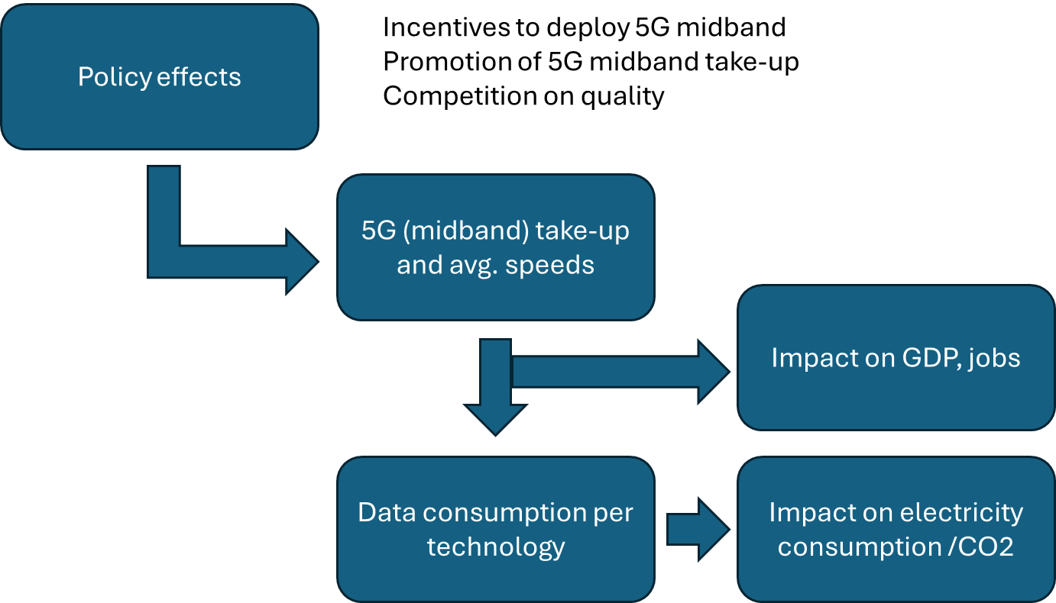
Source: WIK-Consult.
In the first step, the effects of the different policy options on full 5G coverage and take-up were assessed. It was estimated what the projected increases in full 5G coverage and take-up would mean for consumers in terms of the average speeds (download speeds) they would enjoy and the per user (and total data) that would be consumed.
In a second step, the effects of increased take-up of full 5G and mobile broadband speeds on GDP were assessed with reference to academic literature.
Then the effects of mobile broadband speeds on data consumption were assessed and the implications for electricity consumption and CO2 emissions were analysed.
In this Annex, the underlying assumptions and methodology used are elaborated as well as the approach taken to estimate impacts on GDP and GHG emissions associated with policy options affecting mobile broadband.

Options considered
Table A4 2-1 Policy options on spectrum
 | PO1 soft harmonisation | PO2 more single market to enhance investment, innovation | PO3 strong harmonisation and EU level rules
Duration | Longer licence duration (min 25 years) | Indefinite licence duration by default, with safeguards of revocation and exceptions with strong renewal guarantees | Indefinite licence duration
Assignment conditions | Toolbox of best pro-investment/pro-efficient use authorisation practices, developed by EC with RSPG | Mandatory application of pro-investment auction designs with common set of criteria to promote effective competition  For public networks, possibility for EC to recommend pro-investment authorisation processes aspects and conditions; all deviation thereof should be justified; possibility of EC decision, if deviations persist, or to promote pan-European provision of services or to incentivise scale.  For non-public networks, on request, possibility of harmonising authorisation conditions in certain Member States through RSPG | Full harmonisation of authorisation processes aspects and conditions (e.g. auction design, reserve prices, award fees, annual fees, coverage obligations, QoS)  Mandatory deadlines for assignments set for every band, with auction on standard pre-established condition if a deadline is passed
Authorisation regime | Possibility for EC to recommend authorisation regime for EU harmonised bands, and promotion of flexible licencing | Possibility for EC to harmonise certain authorisation and award conditions | EU level award of harmonised spectrum for certain services  Mandatory authorisation regime for nationally assigned spectrum, with a possibility to request joint selection procedure
Ex ante control | Ex ante spectrum Single Market procedure by EC and RSPG/BEREC of spectrum assignment measures resulting in non-binding EC opinion on measures | Mandatory ex ante spectrum Single Market procedure by EC and RSPG/BEREC of spectrum assignment measures resulting in EC opinion on measures with possibility of EC veto on market shaping measures and/or limited licence duration, if they are not justified | Mandatory ex ante Spectrum Single Market procedure by EC and RSPG/BEREC of national spectrum assignment measures resulting in EC opinion with possibility of EC veto on market shaping measures, if they are not addressing only the case of dominance
Roadmaps | Spectrum roadmap for 6G developed by EC with RSPG and regularly updated | National roadmaps based of the EU strategy and spectrum roadmaps and consequences for not respecting the timelines
International governance | Recommended coordination of positions at CEPT on issues related to security / technology sovereignty | Mandatory coordination of position at CEPT on issues related to security / technology sovereignty | In exceptional cases, harmonisation work by ad hoc/ high-level only MSs group instead of CEPT
Petition rule-making | Petition of rule-making mechanism with EC obligation to respond to request and justify eventual refusal | Petition for rule making mechanism to request spectrum harmonisation with procedures and obligations for competent authorities | Petition for rule making mechanism with an extended scope to also cover authorisation aspects and innovative approaches to improve spectrum efficiency
Spectrum sharing | Removing legal / regulatory obstacle for spectrum sharing / pooling, especially in rural/ underserved areas  Promoting flexible spectrum licensing | Stronger and more coordinated EU approach through mandatory spectrum sharing (subject to technically feasible and not distort competition) , including “use it or share/lose it” conditions and dynamic geolocation databases  Addressing barriers to assigning spectrum to wholesale network operators | Mandatory EU framework for spectrum sharing across all EU-harmonised bands  Generalising the use of dynamic geolocation database systems to all bands
Cross-border harmful interference | Deadlines introduced in current mechanism for solving coordination issues between Member States  Enhancing solidarity in case of issues with third countries | Mechanism for solving coordination issues between Member States with deadlines and extended to non harmonised spectrum  Enhancing solidarity in case of issues with third countries | Mechanism for solving coordination issues between Member States coupled with private enforcement  Mechanism for coordinating Member States response under RSPG to issues with third countries

Assumptions concerning the effect of spectrum related policy measures on mid-banc coverage, download speeds and data consumption

Intervention logic linking mobile policies with outputs
The following Figure A4 2-2 shows the intervention logic linking mobile policy options, outcomes and impacts.
In this context, it is relevant to note that there are two key drivers underlying the different inputs:
- Spectrum policy determines how much and which types of radio spectrum are made available to mobile operators, as well as the conditions attached to its use.
- The proposed spectrum options ensuring longer licence duration, harmonisation of spectrum authorisation conditions and consistent use of market shaping measures would lead to a pro-investment auction design and conditions and will directly affect the allocation of mid-band frequencies (that is particularly critical for achieving wide 5G and in the future 6G coverage and high capacity. By defining license durations, auction designs, market shaping measures, and usage rights, regulators influence the cost of spectrum and investment and other investment outcomes, like the speed and the scale of 5G rollout and the possibility to benefit from economies of scale. The longer licence durations, easier renewals and more predictable regulatory approaches also enhance financial attractiveness of mobile projects with better access to capital. Such certainty encourages sustained, long-term commitments in network infrastructure, in particular against a background of increasing spectrum needs. Moreover, the granting of rights of use with indefinite duration does not prevent regulators from foreseeing periodic checks and updates of coverage or quality of service obligations. Moreover, indefinite duration will be coupled with “use it or share it or lose it” obligations which would exclude spectrum hoarding. A supportive, harmonised spectrum policy therefore promotes faster and more cost-effective deployment of mid-band infrastructure and enables a greater proportion of users, including industrial ones, to benefit from higher bandwidths, and quality.
- Predictability is further enhanced by ex-ante auction scrutiny that increases consistently applied pro-investment auction design.
- The proposed EU spectrum strategy and roadmaps to ensure transparent and timely availability of spectrum, including for the coordinated launch of 6G will have a positive effect on predictability and future swift deployment.
- The proposed measures on enhanced spectrum sharing might further promote the deployment of high-quality private networks that can provide specialised services with guaranteed quality of service.
- Coverage obligations, often attached to spectrum licenses, further guide the spatial distribution of 5G networks. These obligations compel operators to extend service to underserved or rural areas, ensuring that 5G deployment does not remain concentrated in urban centres. The resulting improvement in 5G mid-band coverage drives broader adoption and a more balanced technology mix, as users across regions gain access to advanced services. At the same time, such obligations, in particular where they are combined with high reserve prices, can affect the pace and cost of deployment, potentially influencing investment priorities and collaboration among operators.
Figure A4 2-2:Intervention logic linking mobile policy initiatives with economic and environmental impacts

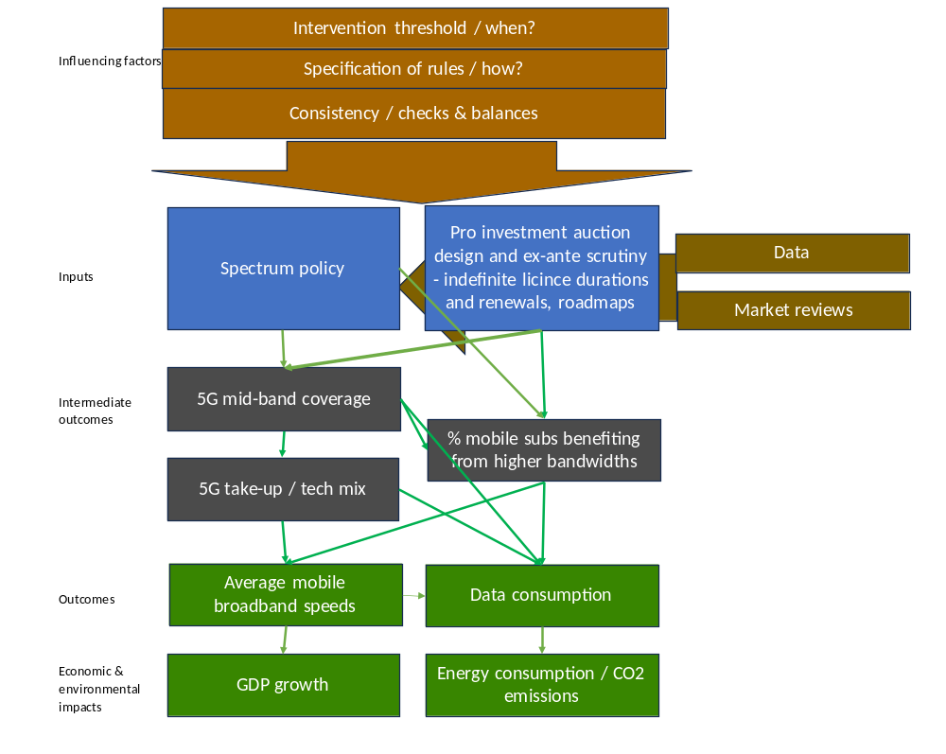
Source: WIK-Consult.
Drawing on the intervention logic, an overview of the assumed directional effects of the different options on outcomes concerning mobile 5G (mid-band) coverage, average download speeds and other factors is shown in the following table. The different elements of each option are separated to show the directional effects for each aspect (showed using + and -). These are then used to adjust the inputs for the quantification of the overall impacts of the option bundles on 5G mid-band coverage and average download speeds. The rationale for these assessments is explained in the following sections.

Table A4 2-2:Directional effects of options on outputs (December 2035)
Objectives | Options | Coverage of 5G in mid-band spectrum | Business use of 5G incl. in verticals | Average 5G mobile download speeds (Mbps) | Average mobile download speeds (all technologies) | Geographic coverage | Service innovation | Consistency in spectrum awards and licence conditions | Security and resilience
Boost deployment of high capacity mobile | Option 0 | 90% | 0 | 250 | n/a | n/a | n/a | n/a | n/a
Boost deployment of high capacity mobile | Option 1 | 2% increase on baseline | + | 2% increase on baseline (255 Mbps) | n/a | n/a | n/a | n/a | n/a
Boost deployment of high capacity mobile | Option 2 | 6% increase on baseline | ++ | 6% increase on baseline (265 Mbps) | n/a | n/a | n/a | n/a | n/a
Boost deployment of high capacity mobile | Option 3 | 6% increase on baseline | ++ | 6% increase on baseline (265 Mbps) | n/a | n/a | n/a | n/a | n/a
Provide wider access to spectrum to boost innovation and support efficient use | Option 0 | n/a | 0 | n/a | n/a | 0 | 0 | n/a | n/a
 | Option 1 | n/a | + | n/a | n/a | + | + | n/a | n/a
 | Option 2 | n/a | ++ | n/a | n/a | ++ | ++ | n/a | n/a
 | Option 3 | n/a | ++ | n/a | n/a | +++ | +++ | n/a | n/a
Provide for greater consistency in spectrum assignment procedures and conditions to boost service deployment | Option 0 | n/a | n/a | n/a | n/a | 0 | 0 | 0 | n/a
 | Option 1 | n/a | n/a | n/a | n/a | ++ | + | ++ | n/a
 | Option 2 | n/a | n/a | n/a | n/a | +++ | ++ | ++++ | n/a
 | Option 3 | n/a | n/a | n/a | n/a | ++++ | +++ | ++++ | n/a

Translation of directional effects into quantitative input assumptions
The directional effects of the different options on coverage of 5G in midband spectrum, business use of 5G, average 5G mobile download speeds, geographic coverage etc. have been translated into quantitative estimates regarding the impact of the different options on 5G broadband coverage and mobile broadband speeds. These quantitative estimates are shown in the following table, along with additional aspects for which directional (qualitative) effects are shown.

Assumptions regarding mid-band coverage
The Commission has urged Member States to fully assign mid-band spectrum (in particular 3.4–3.8 GHz) and implement coordinated rollouts to boost capacity and performance. The 3.6 GHz band has now been assigned across all Member States. Ericsson notes that although Europe is now in line with the global average of 50 percent in 5G mid-band coverage, further deployments are needed to achieve coverage levels comparable to those in North America and India.
Figure A4 2-3:Mid-band coverage (in % of population) split by region, end 2024
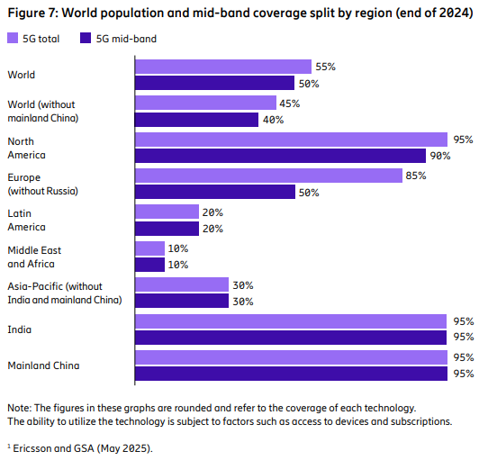
Source: Ericsson (2025) - https://www.ericsson.com/49e9b6/assets/local/reports-papers/mobility-report/documents/2025/ericsson-mobility-report-june-2025.pdf
Mid-band spectrum is critical for applications like industrial automation, real-time gaming, and connected vehicles due to its balance of coverage and throughput.
5G mid-band spectrum can be defined in different ways. In the Ericsson mobility report, a leading industry data source, it is defined as 1-7 GHz. However, the only data available for midband 5G from official EU sources – the DESI report – measures the coverage of 3.4-3.8 GHz.
The DESI data were prioritised because of its official status and transparent methodology.
DESI data is supplied by National Regulatory Authorities (NRAs) and reflects at least at least one operator providing 3.6 GHz service on at least one site within a 1 km² grid. These grid results are aggregated to regional or national figures. Coverage is calculated by counting households in each 1 km² cell where service is reported, based on the European Population 1 km² Grid or other recognised data sources of spatial population data.
Ericsson’s 2025 Mobility Reports gives mid-band 5G coverage in Europe as 50%, considerably below India and China on 95% and North America on 90%. Ericsson’s Europe figure is also below the DESI mid-band estimate of 68% EU coverage. It is hard to understand why the European figure is so low and this is another reason to base projections on the DESI data.
However, relying solely on 3.4-3.8 GHz does not capture the effects of the policy options on renewing existing mobile bands such as 1800 MHz, 2.1 GHz and 2.6 GHz or the expected award of the upper 6 GHz band. Policy proposals relating to licensing or awards would have little direct effect on 3.6 GHz as it has already been assigned in all Member States, although investment-related measures could be beneficial.
5G mid-band was therefore defined as 1-7 GHz, while the DESI figures were used as a basis for estimating likely coverage in this wider range. The same methodological assumptions as DESI were applied, with coverage estimated on the basis of 1 km² blocks with a base station including at least one mid-band transceiver.
The estimate began by considering the likely maximum coverage of 3.4-3.8 GHz by 2035. An important consideration is the propagation characteristics of the band. Its maximum coverage radius – 2 km – is about a third of what can be achieved in the lower bands. For example, 2.1 GHz can reach about 6 km. (See diagram below)
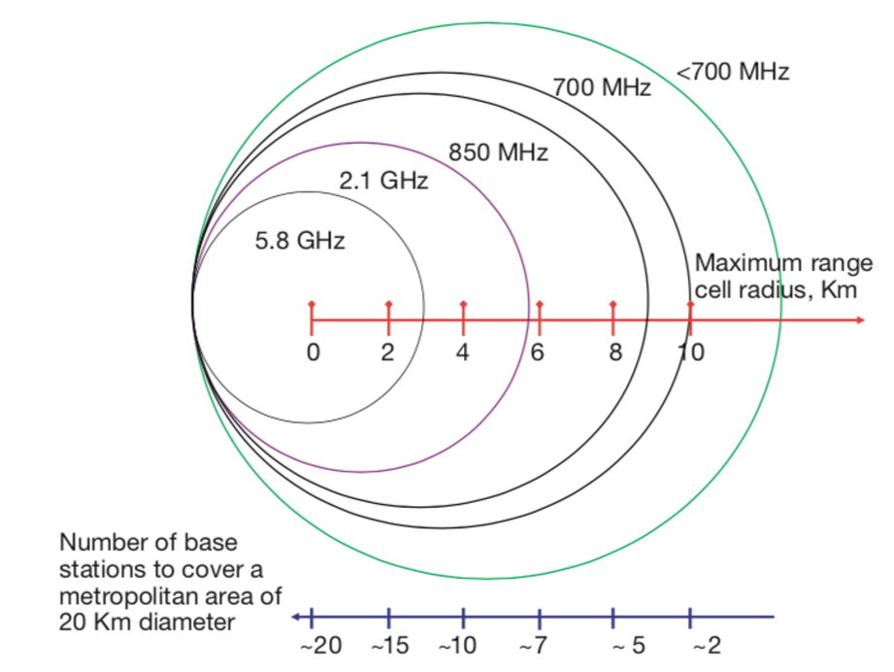
Figure A4 2-4:Propagation characteristics of common mobile bands (Source: BBC R&D)
The economics of covering rural areas using 3.4-3.8 GHz are therefore challenging. Sub-1 GHz coverage bands such as 700 MHz would be the more cost-effective choice as they require fewer base stations.
The difficulties of covering rural areas can be seen in the DESI data: in 2025 just 26% of rural EU households had access to 3.4-3.8 GHz compared to 68% of all EU households. Recent figures estimate that 72% of the total population of the EU population live in cities, towns and suburbs so this is a useful crosscheck for our analysis.
On the other hand, the DESI data shows that seven Member States already have coverage of over 80% of households (See graph below). The Netherlands scores the highest with coverage of 99% of households but is the second most densely populated country in the EU with a 93% urban population. Italy, which has the second highest 3.4-3.8 GHz coverage, is the sixth most densely populated EU country with 72% living in urban areas.

Figure A4 2-5:DESI figures on 5G coverage in 3.4-3.8 GHz band
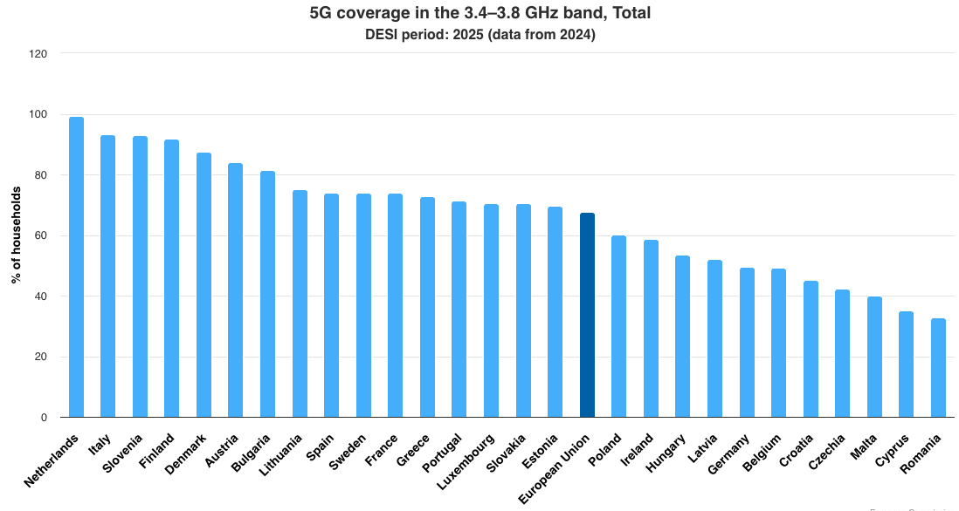
In the lower half of the coverage scale the examples of Romania and Ireland suggest that settlement patterns will act as a brake on 3.4-3.8 GHz coverage. Romania has 55% urban population and Ireland has 65%, meaning that rollout of a low propagation band like 3.4–3.8 GHz would be relatively expensive.
As operator interviews showed little evidence of network densification, MNOs are likely installing 3.4-3.8 GHz on their existing base stations. This means that 3.4-3.8 GHz could extend into rural areas if the operator already has wide coverage in its current grid. It was therefore assumed that 3.4-3.8 GHz could grow to 85%, somewhat more than the proportion of the EU living in urban and suburban areas.
To expand this estimate to include all 1-7 GHz bands, the DESI figure for overall 5G coverage was used as a guide. This is currently an EU average of 94%. It is reasonable to assume that all 5G coverage would be 99-100% by 2035. The estimate of 1-7 GHz coverage was therefore derived as the "all 5G coverage" figure minus the additional coverage provided by 700, 800 and 900 MHz.
It was estimated that the without any new policy intervention, average 5G coverage in1-7 GHz coverage would be 90%.
Taking into account the impact of policy options relating to award design, licence length and fewer market shaping measures on stimulating investment for all licence renewals and upper 6 GHz, the following growth in coverage was estimated:
- Baseline: 90%
- Option 1: 92%
- Option 2: 96%
- Option 3: 96%
The figure is the same for options 2 and 3 because it is not considered that the option 3 proposals on licence length,processes, or market shaping measures will make a significant difference.
Figure A4 2--6:5G midband coverage by option
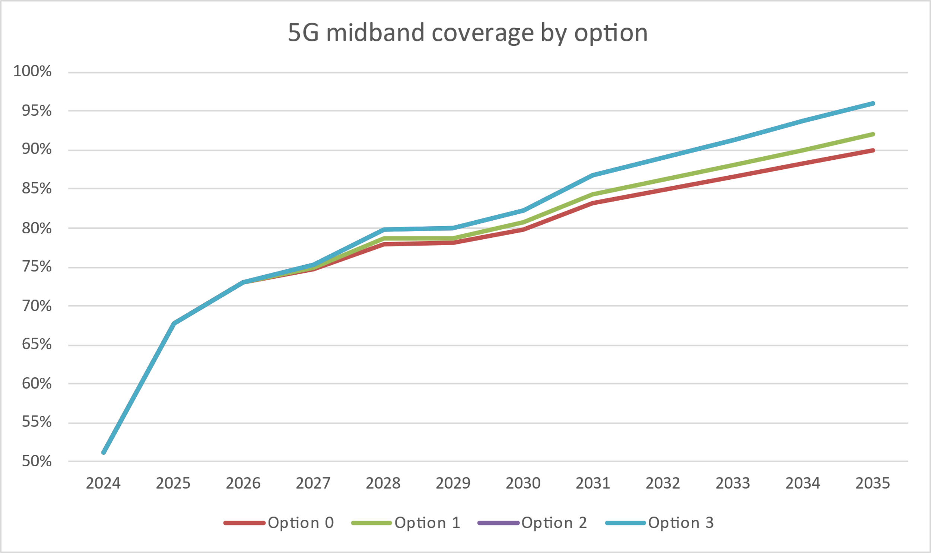
Source: WIK-Consult.
The evolution of 5G coverage can be segmented between coverage of low- and mid-band spectrum usage. European mobile network operators employ the 3.5 GHz band for 5G as this delivers the fast average speeds and reasonable coverage. According to Opensignal other bands see less frequent 5G use.

Assumptions regarding download speed projections
Mobile network speeds in Europe have steadily improved since 2020, driven by the ongoing rollout of 5G. Many EU countries have seen substantial speed increases as 5G adoption has grown. According to an OpenSignal analysis, European markets experienced an average increase in mobile download speeds of around 7.4 Mbps in 2023 alone. This increase was largely due to 5G deployment and more efficient use of the radio spectrum.
Median 5G SA download speeds in Europe reached 221.17 Mbps, slower than those in the Americas (384.42 Mbps) and both Developed (237.04 Mbps) and Emerging (259.73 Mbps) Asia Pacific. Southern and Central European countries have overtaken the Nordic countries in terms of download speed. Greece (547.52 Mbps) had the fastest median download speed in Q4 2024 thanks to its use of the 3.5 GHz band, while Spain and Austria had the best rural 5G SA coverage due to their intensive deployment of the 700 MHz band.
The difference in 5G download speed across European countries is increasingly defined by spectrum strategy. Markets that deploy mid-band spectrum are achieving much faster 5G speeds. Conversely, countries that use low-band 5G are falling behind in terms of speed. However, lower bands like 700 MHz are needed to add capacity or to meet coverage obligations.
Figure A4 2-2-7: Mid-band deployments in Europe and higher download speeds
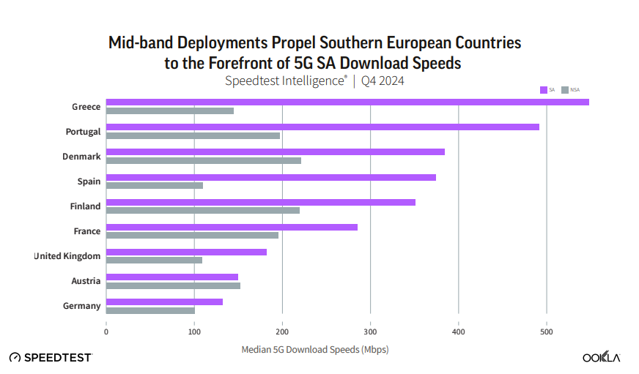
Source: Ookla/ Omdia (2025), A Global Evaluation of Europe’s Digital Competitiveness in 5G Standalone, p. 25.
The Figure A4 2-8 below shows average mobile broadband speeds today in the EU.
Figure A4 2-2-8: Broadband speeds per Member State
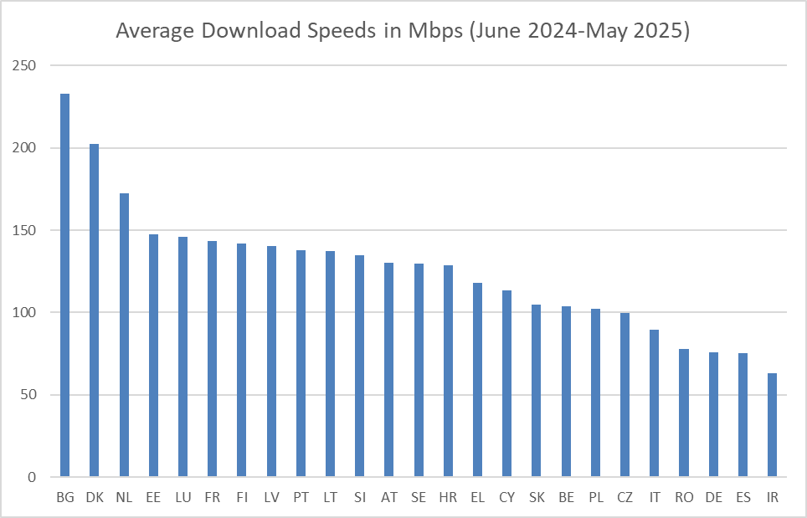
Source: Ookla (2025), https://www.speedtest.net/global-index
Opensignal does not publish a list of download speeds for all the EU member states but some information can be gleaned from its individual country reports. The table below gives the download speed for the top performing operator in 11 EU Member States based on tests from in the past two years. The average is 214 Mbps.

Table A4 2-3: Average 5G download speeds from best performing MNOs in each country (Source: Opensignal)

Member State | Mbps
Denmark | 331.7
Greece | 187.7
Czechia | 130.1
Poland | 127.5
France | 246.6
Finland | 260.1
Italy | 231.3
Romania | 242.3
Spain | 267.4
Netherlands | 166.5
Germany | 165.5
Average | 214.2

This is likely to be an over-estimate because the worst performing operators are not included. However, it is much closer to the Ookla figure of 117 Mbps for all mobile technologies.
A general positive correlation can be observed: countries with higher 5G coverage tend to exhibit higher download speeds, though this relationship is not perfectly linear, see for example:
- Bulgaria (BG) has the highest download speed (232.79 Mbps) despite moderate 5G coverage (70.9%), suggesting strong network performance or efficient spectrum use.
- Denmark (DK) and Netherlands (NL) show both 100% 5G coverage and very high speeds (202.67 and 172.28 Mbps), reinforcing the expected link between widespread 5G and high throughput.
- On the other hand, Belgium (BE) and Romania (RO) have low 5G coverage (40.4% and 32.8%) and correspondingly low download speeds (103.53 and 78.05 Mbps).
- Germany (DE) is an exception, with high 5G coverage (98.1%) but relatively low download speeds (75.67 Mbps), indicating that coverage alone does not guarantee performance, possibly due to non-midband deployments or network congestion.
Figure A4 2-2-9: 5G coverage and Average Mobile download Speeds, 2025

Source: WIK based on Ookla (2025) and Statista (2024)
In summary, while higher 5G coverage generally aligns with better download performance, other factors such as spectrum quality, network capacity, and deployment density play a crucial role in actual speed outcomes.
The 3.5GHz band is widely seen as ideal for 5G because it balances capacity and coverage, making it well-suited for enhanced mobile broadband services. Open Signal’s analysis shows a strong correlation (R²=0.56) between increased 3.5 GHz usage and improvements in average 5G download speed.
Figure A4 2-10: Correlation between changes in the use of 3.5GHz band and changes in 5G Download speed
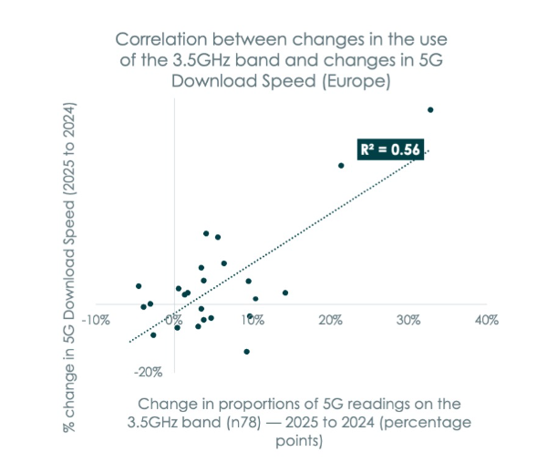
Source: OpenSignal (2025). Data collection period: Feb 1 – May 1, 2024, Feb 1 – May 1 2025.
Currently, European operators rely heavily on the 3.5GHz band for 5G – which also delivers the fastest average speeds. According to Opensignal other bands see less frequent 5G use, which is currently changing.
As 5G evolves, operators will increasingly use lower frequencies to boost capacity using multi-band carrier aggregation. Sweden is one of the examples where the 2.1 GHz band seems to be gaining prominence in 5G roll-outs. This evolving spectrum landscape underscores a strategic balance between speed and coverage, as operators adapt their deployments to meet growing demands.
For speed projections, different mobile broadband speed is assumed based on the used technologies. According to recent estimates by Opensignal, the average 5G download speed for the 700 MHz band is 104.3 Mbps. For mid-band spectrum it is on average 217.6 Mbps.
There is a one published figure for the 5G average download speed in the whole EU: Medux estimates this at 70 Mbps.
Figure A42-2-11: Average download speed across Member States (Mbps, Q1 2025)
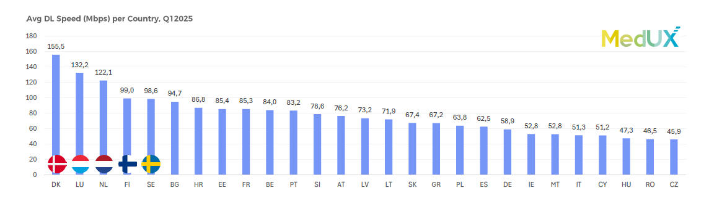
However, other companies suggest a higher figure. Ookla puts the median EU speed in all mobile technologies at 117 Mbps. The number for 5G is likely to be higher if the slower results from earlier mobile generations are removed.
The model assumes an average mobile broadband speed of ca. 69 Mbps across all technologies. As a reasonableness check, Statista reports an average mobile download speed of 62.4 Mbps for 2023, making the modelled assumption for 2024 a plausible incremental increase on recent observed data. The average mobile broadband speed is lower because 4G mobile broadband is likely to be more relevant in rural areas and, based on data from Opensignal, a gap of ca. 20% between mobile broadband speeds in urban and rural areas can be assumed.
There are only marginal speed differences between the options as speed is mainly driven by the availability of mid-band 5G usage which will not be available widespread until 2035. Nevertheless, over the next decade, mobile download speeds are expected to increase substantially, and could potentially quadruple relative to current levels.
Without further policy intervention, two main factors are expected to contribute to higher average mobile download speeds towards 2035:
1. Upgrading from 4G to 5G
- With the natural telecoms equipment replacement cycle of 8 years, it is assumed that all networks will be upgraded from 4G to 5G by 2035. According to Opensignal, 5G is four times faster than 4G.
- EU-wide 5G coverage is currently 94% according to DESI.
- The transition from 4G to 5G is estimated to increase average mobile download speeds to around 177 Mbps. This reflects the refarming of existing mobile bands (such as 900 MHz, 1800 MHz and 2.6 GHz) from 4G to 5G and the progressive rollout of 5G by multiple operators in already covered areas, which increases capacity and enables more efficient spectrum use.
2. Moving from 5G NSA to 5G SA
- According to Ookla, 5G SA is currently available to only 2% of European consumers, much less than China (80%), India (52%), and the United States (24%).
- Median download speeds on 5G SA were 57% higher than 5G NSA in Europe and 84% higher in China.
- With no changes to policy, it seems reasonable to assume that 5G SA will continue to roll out, reaching levels of at least 40% availability
- Starting from a current average 5G download speed of around 177 Mbps (predominantly reflecting 5G NSA), applying a 57% uplift implies an average 5G SA speed of approximately 278 Mbps. Combining 40% of subscriptions at this level with the remaining 60% continuing at around 177 Mbps yields a population-weighted average of approximately 217 Mbps.
- This figure is adjusted upwards to around 250 Mbps to reflect the possibility of higher 5G SA adoption rates over time and the fact that leading operators in at least six EU Member States already report download speeds exceeding this level.

Modelling the impact of the policy options
Policy changes can improve download speeds in three ways: firstly, by encouraging investment in the expensive business of upgrading whole networks to 5G SA. Secondly, by ensuring the affordability of the upper 6 GHz band when it is auctioned. The additional mid-range bandwidth in 6 GHz will increase download speeds without the need to install expensive new base stations. Thirdly, by allowing the purchase of more spectrum in renewals and any other awards by relaxing the use of market-shaping measures. This can also improve speeds by providing additional bandwidth.
The stronger measures suggested in Option 2 relating to licence length, award design, market shaping measures and the need to consider the policy impact on investment can therefore make a greater impact on download speeds.
Based on the baseline figure of 250 Mbps by 2035, the impacts of the policy options were considered as follows:
Option 1: 2% increase in download speed
Option 2: 6% increase in download speed
Option 3: 6% increase in download speed
As discussed for 5G midband coverage the figure is the same for Options 2 and 3 because it is not considered that the Option 3 proposals on licence length, authorisation processes or market shaping measures will lead to significantly different outcomes in the proposed analysis period (2025-2035) and would lead to similar results in terms of benefits from reduced fragmentation, increased predictability and economies of scale considering the scope of the model assessment.
Figure A4 2-12: Projected download speeds by option
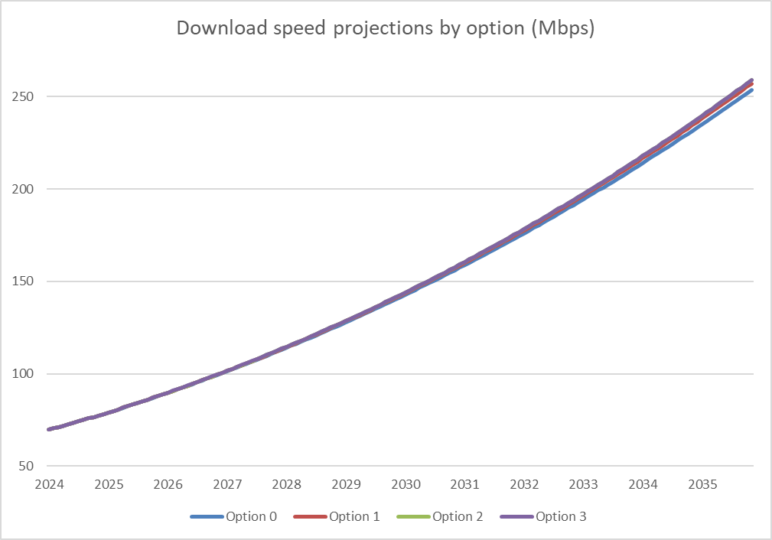
_____________________________________________________________________________
Source: WIK-Consult

Assumptions regarding 5G take-up
Figure A4 2-13 shows the projected evolution of mobile subscription technologies from 2024 to 2035. It highlights a clear and steady transition toward 5G. In 2024, 4G still holds the majority share, while 5G accounts for around one-quarter of subscriptions. However, over time, 5G rapidly gains ground, surpassing 50% by 2027 and becoming the leading mobile technology.
By 2030, 5G is projected to account for approximately 75% of all mobile subscriptions, making it the dominant access technology. The decline of 4G continues steadily until it nearly disappears by 2033. By 2035, 5G makes up almost 100% of the mobile subscription base, effectively replacing earlier generations. This shift reflects growing consumer adoption, increasing device compatibility, and the gradual phase-out of legacy networks across Europe and globally.
Figure A4 2-13: Evolution of mobile technology shares in the EU27 (in % of mobile subscriptions) 2024-2035
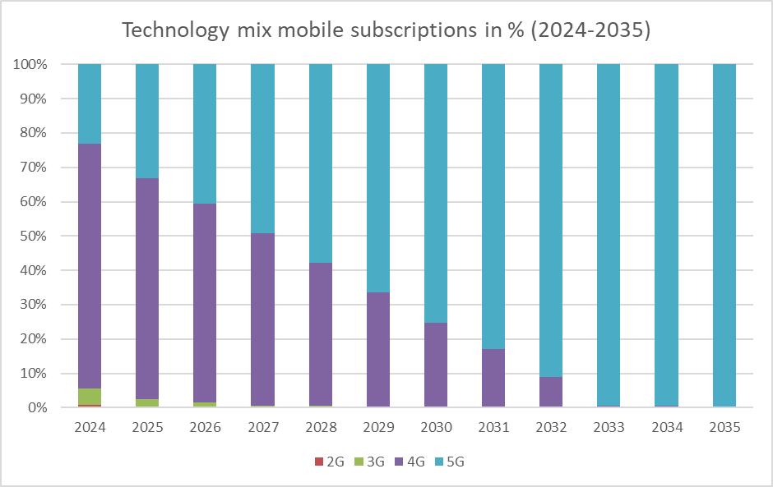
Source: WIK Consult
While projections for overall 5G adoption are increasingly robust, any specific predictions regarding the take-up or use of 5G midband (3.4–3.8 GHz) remain speculative due to a critical lack of publicly available data on the number of users connected via midband spectrum. Most statistics and market reports – such as those from Ericsson Mobility Report, or GSMA – track 5G adoption in aggregate without distinguishing between low-band, midband, or millimeter wave usage. This limits the precision of forecasts related to midband-specific take-up.
The following development was estimated for the options with regard to the impact of midband (see Figure A4 2-14).
Figure A4 2-14: Mobile subscriptions benefiting from higher bandwidth supported by 3.5 GHz
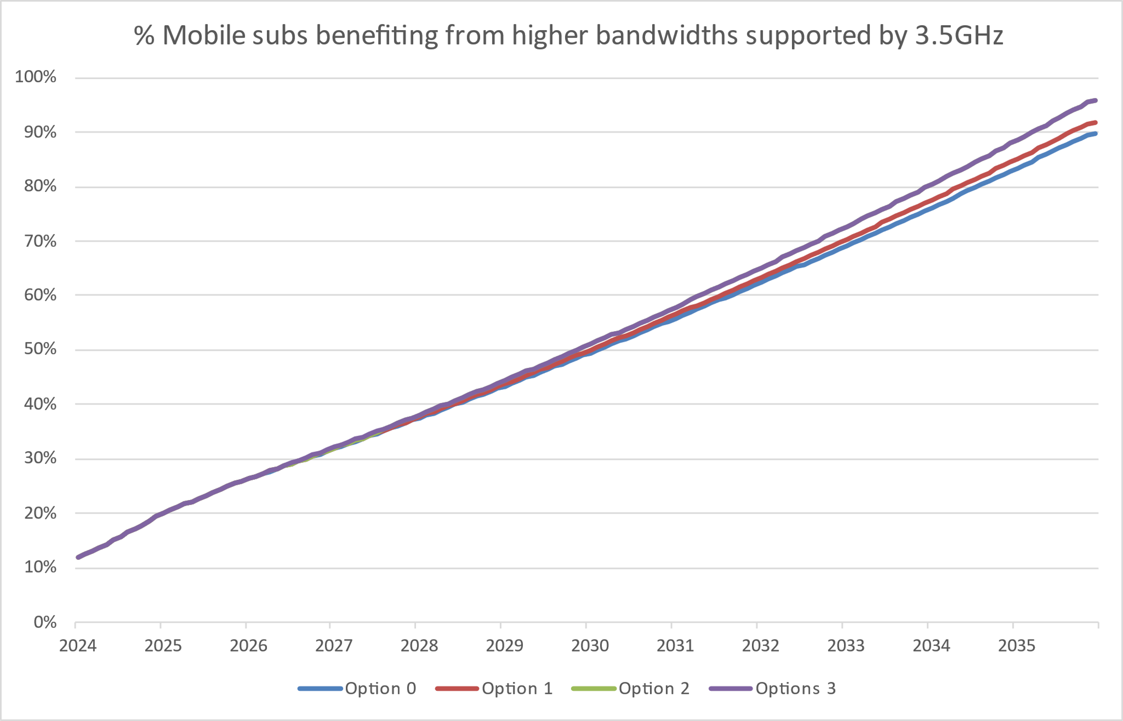
Source: WIK-Consult estimates.
The figure illustrates the projected percentage of mobile subscribers who will benefit from higher bandwidths enabled by the 3.5 GHz spectrum between 2024 and 2035, under the four different action options. Starting from a baseline of around 10% in 2024, all options show a steady increase over time, reaching approximately 90-95% by 2035.

Assumptions regarding mobile data consumption
Regarding mobile data consumption, there is relatively limited information available which distinguishes between bandwidth used by customers with 5G connections compared to 4G customers. More importantly, it is even more difficult to find data on bandwidth consumption between 5G customers using low- or mid-band frequencies. However, there is a link between the download speed and overall data consumption. Opensignal reports that 5G users consume more data than 4G users which can be contributed to higher available speeds. This ranges from a factor of 1.9 in the US where mainly low-band 5G is employed to countries like the UK, Japan or Germany where due to mid-band 5G the factor is on average 2.6.
Figure A4 2-15: Data usage by mobile network technology (Opensignal)
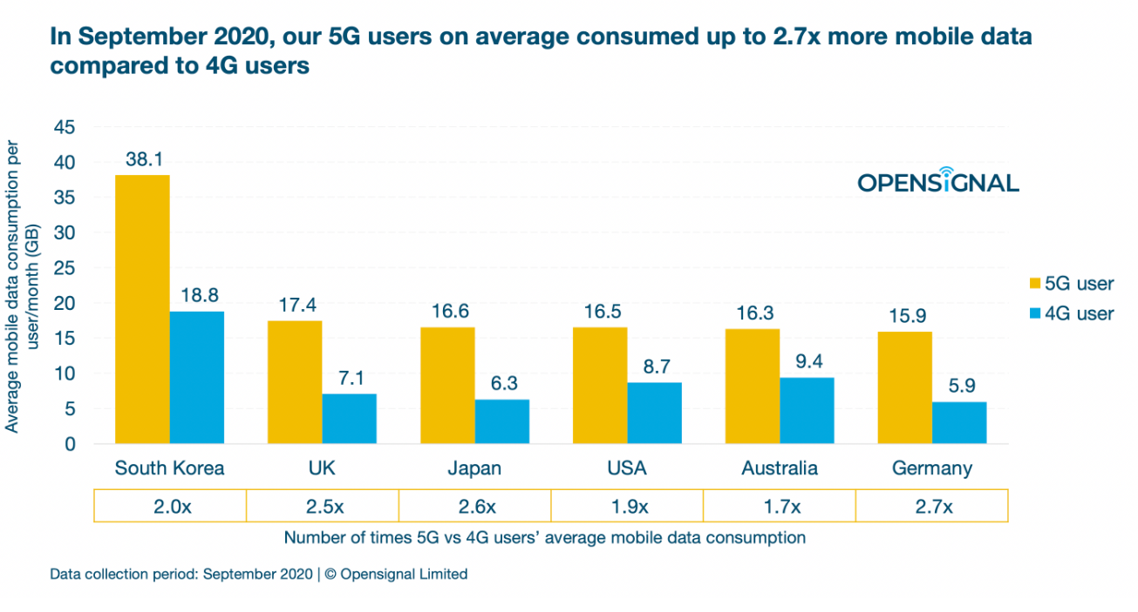
Source: Opensignal (2020): 5G users on average consume up to 2.7x more mobile data compared to 4G users, https://www.opensignal.com/2020/10/21/5g-users-on-average-consume-up-to-27x-more-mobile-data-compared-to-4g-users
The different technology shares affect total bandwidth consumption as shown in the following FigureA4 2-16. The graph shows the projected monthly bandwidth consumption per subscriber from 2024 to 2035, broken down by technology: LTE, 5G low-band, and 5G mid-band. Consumption increases steadily across all technologies, with 5G mid-band showing the highest usage, reaching over 120 GB/month by 2035, followed by 5G low-band and LTE. This trend highlights the growing data demands associated with more advanced mobile technologies.
Figure A4 2-16: Estimated bandwidth consumption per subscriber for 4G, 5G low-band and 5G mid-band until 2035
_____________________________________________________________________________
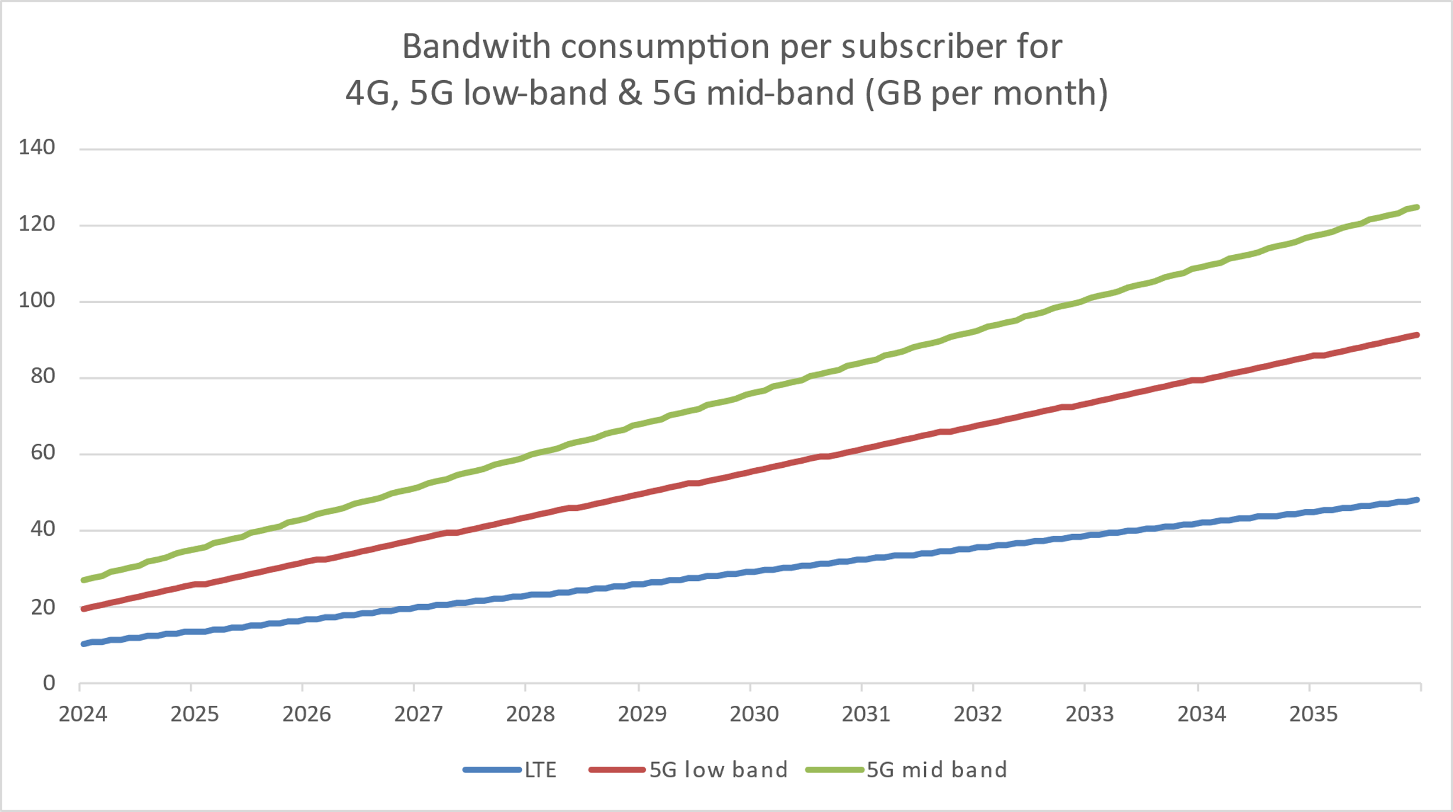
_____________________________________________________________________________
Source: WIK-Consult
Mobile data usage in the EU has increased exponentially. On average, a smartphone user in Western Europe consumed 19 GB of data per month in 2023, rising to 22 GB in 2024. Ericsson forecasts that mobile data consumption will rise up to 47 GB per month by 2030, increasing by 20 % per year. Overall, mobile data consumption in Europe will reach 37 EB per month in 2030. Similarly, the GSMA forecasts that mobile data usage in Europe will increase up to 7 GB per user per month by 2030.
Figure A4 2-16 displays projected monthly mobile data consumption for 5G mid-band from 2024 to 2035 across the four mobile policy options. Data usage grows steadily for all options, with Option 3 resulting in the highest consumption, approaching 140 million GB/month by 2035.
Figure A4 2-17: Mobile data consumption for 5G midband – projections by options until 2035
_____________________________________________________________________________
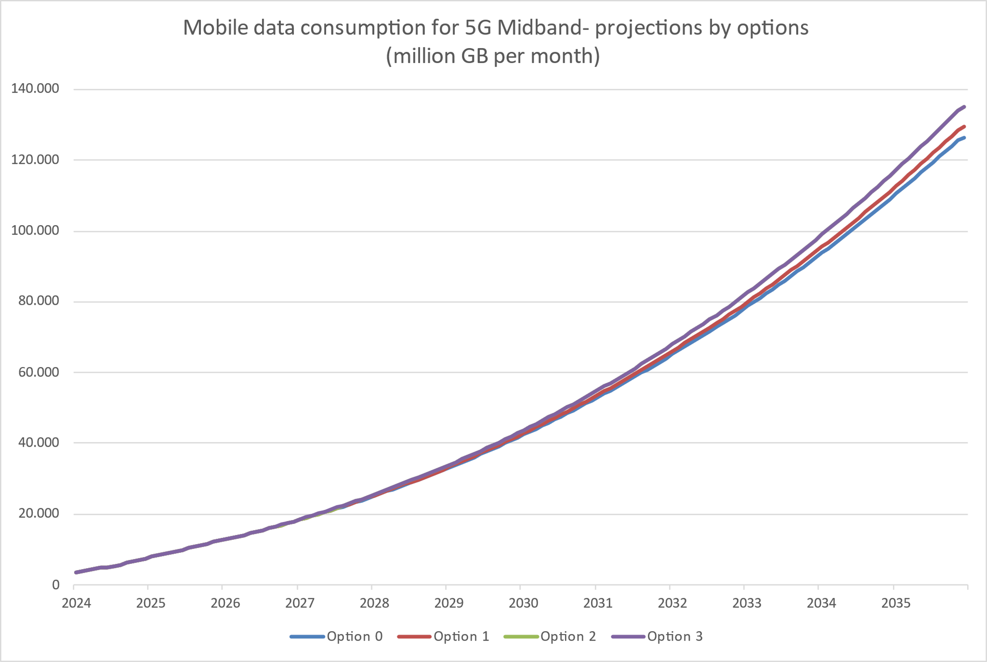
Source: WIK-Consult
The following table provides an overview of the estimates regarding the quantitative effects of the different policy options and the underlying justification.
Table A4 2-4: Assumptions and estimates for quantification of impact
 | Option 0 | Option 1 | Option 2 | Option 3 | Description quantification estimates
Coverage of 5G in mid-band spectrum | 90% | 92% | 96% | 96% | Coverage data employed from DESI from 2023 until 2025. The average coverage of 5G midband rose from just under 41% to 68% between 2023 and 2025. It can be assumed that coverage will now increase at a slower rate. By 2035, midband 5G coverage is expected to reach around 90%.
Business use of 5G | 0 | + | ++++ | ++++ | Business use cases are primarily driven by use of IoT and vertical application with private 5G networks.
Average 5G mobile download speeds | 250 | 2% increase on baseline | 6% increase on baseline | 6% increase on baseline | Medux estimates current average mobile speeds at 70 Mbps. However, other estimates suggest a higher figure. Ookla puts the median EU speed in all mobile technologies at 117 Mbps. The number for 5G is likely to be higher if the slower results from earlier mobile generations are removed.
Geographic coverage | 0 | ++ | ++++ | +++++ | Pro-investment approach to awards will reduce the cost of roll-out. Spectrum sharing will allow operators targeting underserved areas to access frequencies for FWA or mobile services.
Service innovation | 0 | ++ | ++++ | +++++ | Petition for rule-making will allow innovators access to spectrum, as will increased spectrum sharing
Consistency in spectrum awards and licence conditions | 0 | ++ | ++++ | ++++ | 6G spectrum roadmap, stronger measures on licence duration and harmonisation of authorisation regime will all increase consistency.

Methodology for the estimation of GDP impacts resulting from increases in full 5G adoption and associated speed increases
Potential effects of the different policy options on GDP were estimated with reference to academic literature linking increased adoption of mobile technologies and GDP. Specifically, the assessment of the impact on GDP relies on elasticities provided in a recent study by Briglauer et al./EcoAustria (2025). The authors note that coefficient estimates suggest that a 1% increase in per capita weighted mobile broadband adoption leads to an increase of GDP per capita by 0.084–0.113%. They analysed a panel dataset covering 32 OECD countries from 2002 until 2020 where the authors estimate the following formula:
$$\log{GDP_{\left\{it\right\}}}= β_{0}+β_{1}\log{CAPITAL_{\left\{it\right\}}}+β_{2}\log{LABOUR_{\left\{it\right\}}}+β_{3} logBB_{{COV}_{\left\{it\right\}}^{\left\{j\right\}}}+β_{k} logBB_{{ADOP}_{\left\{it\right\}}^{\left\{k\right\}}}+β_{h}\log{EDUC_{\left\{it\right\}}^{\left\{h\right\}}}+ β_{4} years_{adop}_{\left\{it\right\}}^{\left\{k\right\}}+ α_{i}+ α_{t}+ ε_{\left\{it\right\}}$$
$BB_{ADOP}_{\left\{it\right\}}^{\left\{k\right\}}$ is the aggregated number of customers that adopt new broadband connections. $β_{k}$ estimates the percentage change in the increase of GDP per capita when mobile broadband adoption increases by 1 percent. The estimate of 0.084% corresponds closely to Edquist et al. (2018), that find an elasticity of 0.08%.
As the study focuses on the adoption (and not merely coverage) of mobile broadband during a period when the then new generation technology 4G was deployed, it implicitly reflects the impact of increasing mobile broadband capabilities on GDP. As the considered policy options are not likely to significantly affect standard 5G (including NSA) coverage (which is near universal) or 5G uptake (which is currently limited inter alia by the devices in use), assessment of the impacts focused on the degree to which the options are likely to improve mobile broadband quality, as measured by increases in speed.
This would reflect findings from other studies that link economic benefits to the deployment of new generation (more performant) mobile technologies. For example, Oxford Economics (2023) estimates that mid-band deployment and mmWave spectrum with 5G technologies could contribute USD 2.1 trillion (1.7 %) to global GDP until 2030. The inference that the influence of mobile broadband adoption of more recent generations affects GDP via improvements in broadband quality is supported by a study by Edquist (2021), which aimed to investigate the association between mobile broadband speed and labour productivity by building panel data of 116 countries over 2014–2019. Their results suggest a significant and robust effect when an one-year lag of mobile broadband speed is introduced. Their modelling suggests that a 10% increase in mobile broadband speed in a given period is associated with a 0.2% increase in productivity in the following period.
Forecasted increases in broadband speeds resulting from the different options were converted to GDP impacts based on the estimate from Briglauer et al./EcoAustria (2025) noted above. Calculations were made for each year between 2024 until 2035. The results are presented in the main report. The resulting forecasts are consistent with other findings in the literature. For instance, with predictions by Oxford Economics or PwC.
While estimates have assumed a linear relationship between improvements in mobile broadband speed and GDP, there are uncertainties around this assumption. The panel data used by the authors covers the 4G era. Therefore, the estimate does not include improvements relating to the use of verticals and latency. It is unclear how the estimate would change in the 5G era. Therefore, the estimate should be viewed conservatively. The model does not account for spillover effects on different sectors of the economy. These 5G-specific effects have not been included in the calculations due to significant uncertainty surrounding the measurement of the impact of technologies for which there is limited empirical evidence. Nevertheless, these spillover effects could provide an additional upside to the effects outlined in the study.
To account for potential uncertainties, a sensitivity analysis is conducted that relies on varying estimates (0.01 % to 0.113 %). The lower bound is taken into consideration to account for multiple uncertainties. These are for example that the study period of Briglauer et al. (2025) ends in 2019 and does not account for speed increases due to 5G or the fact that the estimate only accounts for adoption of mobile broadband but not directly estimates speed increases. The upper bound (0.113 %) is the higher coefficient estimated by Briglauer et al. (2025). This can be seen as more upside potential from increased 5G mobile broadband speeds.
Table A4 2-5: Sensitivity analysis: Cumulative 5G impact on GDP 2025-2035 (in billion EUR)
Scenario | Option 0 | Option 1 | Option 2 | Option 3
Baseline (coefficient 0.084 %) | 1 480 | 1 505 | 1 553 | 1 553
Lower bound (coefficient 0.01 %) | 171 | 174 | 179 | 179
Upper bound (coefficient 0.113 %; Briglauer et al. (2025)) | 2 015 | 2 049 | 2 116 | 2 116
Source: WIK-Consult.
Under the lower-sensitivity scenario, which assumes a smaller impact of increased mobile broadband speeds on productivity and GDP (for example, due to uncertainties regarding the effective use of 5G-enabled technologies across sectors or slower diffusion of digital applications), the cumulative GDP impact for the EU over 2025–2035 is estimated at EUR 179 billion for option 2, compared to EUR 171 billion for the baseline and EUR 179 billion for option 3.
Conversely, under the upper-sensitivity scenario, which assumes a higher responsiveness of GDP to broadband speed improvements (for instance, reflecting faster adoption of 5G-driven innovations or stronger network effects), the overall GDP impact for the EU over the same period is estimated at EUR 2,116 billion for option 2, compared to EUR,2 015 billion for the baseline and EUR2,116 billion for option 3.
These results illustrate that while the magnitude of impacts varies substantially across sensitivity assumptions, the relative differences between policy options remain limited, suggesting that the overall ranking of options is robust to variations in the assumed elasticity of GDP to broadband speed increases.
Figure A4 2-18: 5G download speed impact on GDP growth (baseline)
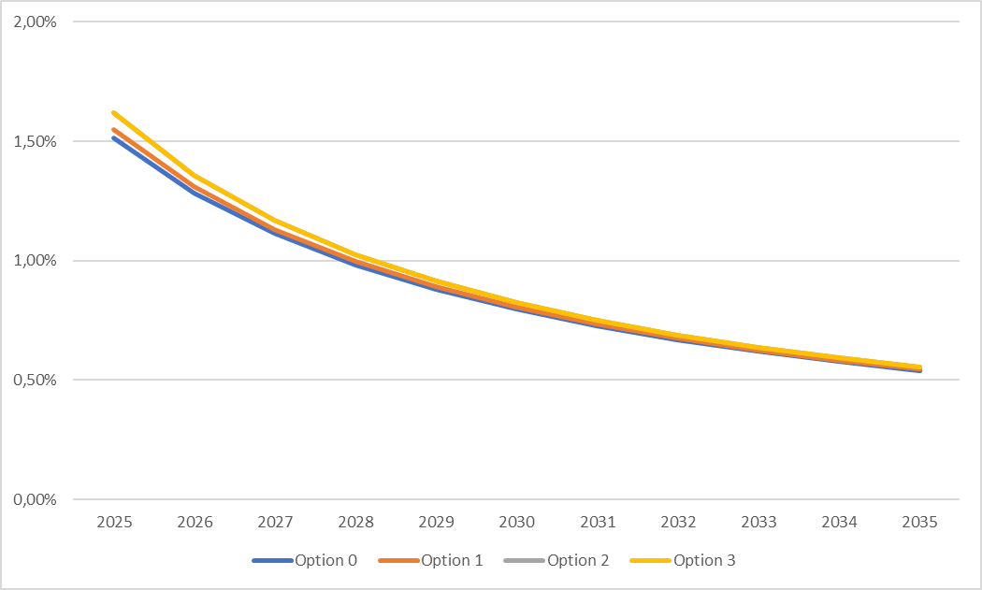
Source: WIK based on Briglauer et al. (2025).
Figure A4 2-19: 5G download speed impact on GDP growth (lower bound)
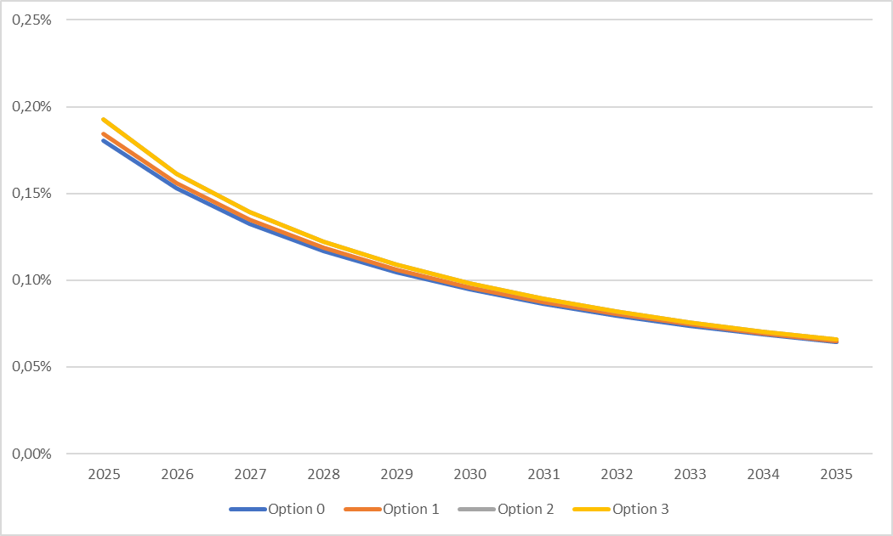
Source: WIK based on Briglauer et al. (2025).
Figure A4 2-20: 5G download speed impact on GDP growth upper bound)
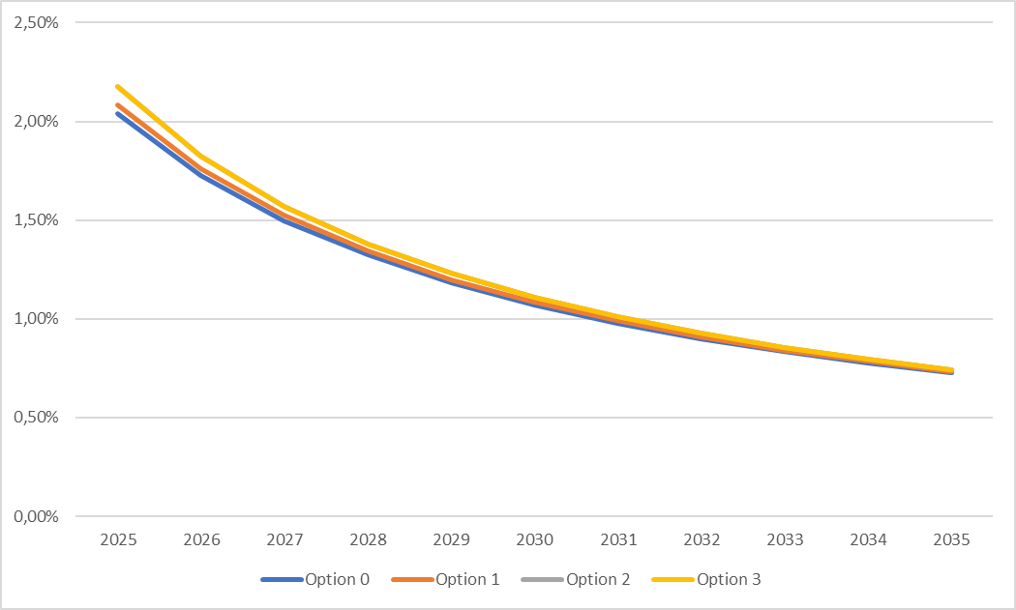
Source: WIK based on Briglauer et al. (2025).

Methodology for the estimation of environmental impacts
In order to estimate the environmental impact of full 5G coverage, estimates were derived for increases in bandwidth consumption associated with the increased deployment and associated take-up of different technologies. The bandwidth use per technology was then translated into environmental impacts based on linkages identified in literature. The details are provided below.
To investigate the environmental impact of annual data consumption across networks, the analysis builds upon the model developed by (Andrae & Edler, 2015). Here the electricity consumption for 4G (LTE) is found to be 0.6 kWh per GB in 2010. As a best estimate the energy efficiency is assumed to improve by 22% annually until 2020.
The electricity consumption per network can therefore be calculated based on the following equation (Andrae & Edler, 2015):
$$E_{xG,2010+n}=ADT_{xG}*EI_{xG,2010}*{\left(100\%-EE\%\right)}^{n}$$
Where:
- $E_{xG,2010+n}=$ total electricity consumption, kWh, for network xG in year 2010+n
- $ADT_{xG}=$ annual data traffic, GB, for network xG
- $EI_{xG,2010}=$ electricity intensity, kWh/GB, for network xG
- $EE=$ annual electricity efficiency improvement
For 5G the model is refined to differentiate between basic 5G and full 5G. Laidler (Curtailing carbon emissions - can 5G help?, 2019) estimates that a 5G cell has 8-15% the electricity intensity compared to a like-for-like 4G cell. mmWave 5G has potential to fall to 1-2% of a 4G cell, it is therefore estimated that midband (3.5GHz) may be able to obtain electricity intensity of 6.5% of 4G using the midpoints. Accordingly, the energy intensity of 5G is estimated as follows:
- Basic 5G: 0.069 kWh per GB
- Full 5G: 0.025 kWh per GB
The analysis also accounts for the shift in electricity generation in the EU from fossil fuels to renewables. This is based on calculations made by enerdata showing decrease from 0.161 kg CO₂e per kWh in 2025 to 0.046 kg CO₂e per kWh in 2035.
Figure A4-2-20 shows the results in terms of the development for the different options.
Figure A4 2-21: Development of GHG emissions
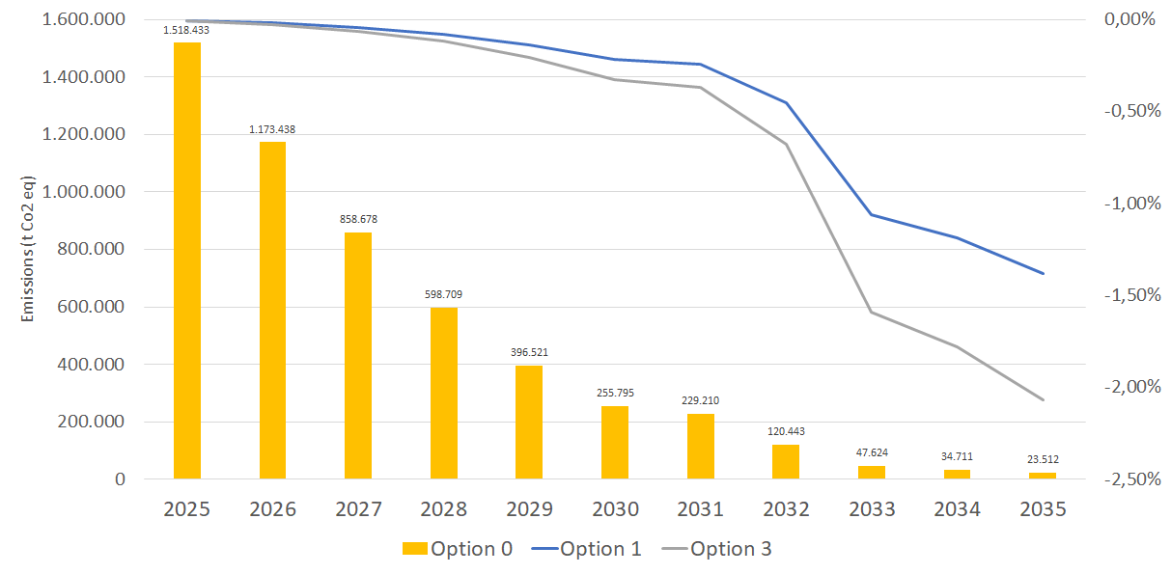
In this analysis, increased data traffic is considered (based on projections). Network densification is not explicitly modelled, but may be reflected indirectly in the estimates, as the energy efficiency associated with the operation of “full” (mid-band) 5G is likely to be affected by densification that often (although not always) takes place in order to meet increasing bandwidth demand. In this context, it is relevant to note that per individual base station, mid band can transmit more data simultaneously (higher efficiency per station) – but the energy consumption per MB across the same area might be higher, due to the increased infrastructure that is required. Concerns have been raised in several studies in this regard that increased use of mid-band spectrum with densification could reduce the energy efficiency associated with mobile broadband provision.
The main environmental impacts are expected in the operation phase. Studies from mobile equipment manufacturers suggest that the environmental impact of new generations of mobile communications at the deployment phase is likely to be limited compared with impacts associated with network operation.

Findings
The table presents greenhouse gas (GHG) emissions projections across four options for the years 2025 to 2035. In general, the emissions decrease progressively each year for all options, with Option 0 starting at the highest emissions in 2025 and reducing to the lowest in 2035. The total emissions in Option 0 are 5,257,074, while Options 1, 2, and 3 show a slight reduction, with differences of -4,584, -6,670, and -6,877, respectively. These small differences translate into negligible percentage changes, with the percentages of difference between the options ranging from -0.09% to -0.13%. This indicates that the variations in GHG emissions across the four options are minimal, suggesting similar strategies for emissions reductions in the given time frame. Overall, the slight differences in the totals demonstrate that the options lead to similar results in terms of GHG reduction.
For completeness, greenhouse gas emissions are also monetised using a fixed damage cost per tonne of CO₂e. Applying a damage cost of EUR 800 per tonne of CO₂e, the resulting climate-related damage costs attributable to mobile telecommunications amount to approximately EUR 4.63 billion under the baseline and around EUR 4.62 billion under Options 1, 2 and 3. Consistent with the emissions results, differences in monetised environmental impacts across options are negligible.
Policy option 2 will further accelerate deployment of future mobile generations like 6G that are being designed with energy efficiency and renewable energy integration as core principles and will therefore favourably impact energy efficiency
The reported CO₂ values should not be interpreted as measurements with high numerical precision but rather as outputs of a scenario-based estimation model. These results represent the outcome of a defined set of assumptions. The actual uncertainty range around these values is broader and depends on the sensitivity of key parameters.
A sensitivity analysis with respect to the total data consumption is not conducted insofar as the model assumes a linear relationship, i.e., a 10% increase in data volume would lead to a 10% rise in GHG emissions when the assumed technology mix stays the same. For this reason, a sensitivity analysis is conducted for the energy-efficiency factor, which is set at 22% per year in the base model. Variations in this factor accordingly affect the different options. Table A4 2-6 shows the results.
Table A4 2-6:Sensitivity analysis: Variations in energy-efficiency factor
 |  | Absolute GHG emissions
 |  | Option 0 | Option 1 | Option 2 | Option 3
Energy efficiency improvement factor | 5% | 5,689,509 | 5,682,062 | 5,678,545 | 5,678,338
Energy efficiency improvement factor | 10% | 5,542,002 | 5,535,594 | 5,532,596 | 5,532,390
Energy efficiency improvement factor | 20% | 5,298,659 | 5,293,826 | 5,291,616 | 5,291,410
Energy efficiency improvement factor | 22% | 5,257,074 | 5,252,490 | 5,250,404 | 5,250,198
Energy efficiency improvement factor | 30% | 5,110,378 | 5,106,615 | 5,104,940 | 5,104,733
 |  | Deviation from initial value
Energy efficiency improvement factor | 5% | 8,23% | 8,18% | 8,15% | 8,15%
Energy efficiency improvement factor | 10% | 5,42% | 5,39% | 5,37% | 5,37%
Energy efficiency improvement factor | 20% | 0,79% | 0,79% | 0,78% | 0,78%
Energy efficiency improvement factor | 22% | 0,00% | 0,00% | 0,00% | 0,00%
Energy efficiency improvement factor | 30% | -2,79% | -2,78% | -2,77% | -2,77%

The ranking is stable across all scenarios: Option 3 always performs best, followed by Options 2, 1, and 0. However, the differences between options are very small, around 0.1–0.2% (e.g., baseline 22%: 5,257,074 vs. 5,250,198 for Option 0 vs. 3).
Around the baseline, absolute emissions decline almost linearly by several tens of thousands of units per additional efficiency percentage point, with slightly diminishing marginal returns. Prioritizing an increase in the efficiency factor delivers meaningful GHG reductions, while the choice among Options 0–3 yields only marginal gains.
The additional energy-saving effect of 6G has not been included in this model. Nevertheless, it is likely to be significant, given that future mobile generations such as 6G are being designed with energy efficiency and renewable-energy integration as core principles. In this context, spectrum measures that enable the swift assignment of 6G frequencies are expected to yield further benefits, not captured here, in terms of absolute energy savings and the speed at which those savings materialize. In parallel, the deployment of edge computing and AI-driven energy optimisation (e.g., adaptive sleep modes, intelligent traffic steering, and predictive maintenance) will further enhance the sustainability of mobile networks.
At the same time, 6G is expected to improve energy efficiency at the network and service levels. While AI can make processes more energy-efficient, it may also increase electricity demand due to the greater computing capacity required. Any comprehensive assessment should therefore weigh AI-enabled efficiency gains against the incremental power needs of expanded compute infrastructure.

Methodology for the analysis of spectrum-auction regulatory approaches and market outcomes

Introduction
This annex sets out the methodology used to analyse the possible relationship between regulatory approaches applied in recent 5G spectrum awards and the resulting market outcomes across Member States. The objective of this exercise is to present market outcomes and to assess whether, and to what extent, specific elements of auction and award design may influence investment incentives, market performance and user experience in mobile broadband markets.
To this end, the analysis considers the most relevant indicators of market outcomes and regulatory design for the 3.4–3.8 GHz and 700 MHz bands. Given the substantial heterogeneity observed across Member States in both market outcomes and regulatory approaches, the assessment proceeds in two steps. First, composite indicators of market outcomes as well as regulatory design were constructed to provide initial visual insights into potential relationships. These simplified representations help to identify broad patterns but are not intended to constitute statistical evidence. Building on these initial observations, the second step consists of a multiple regression analysis examining the associations between individual regulatory instruments and the various market-outcome indicators, while controlling for key non-regulatory factors.
The following sections of this annex describe the data sources used, the approach for quantifying and scoring regulatory design and market outcomes, the construction of the composite indicators, as well as the methodology applied in the multiple regression analysis.

Fragmented Market Outcomes

Selection of market-outcome indicators
To assess how 5G markets perform across Member States, the analysis focuses on three core dimensions of market outcomes: coverage, quality of service and consumer prices. These dimensions capture, respectively, the geographic reach of 5G networks, the performance experienced by end-users, and the affordability of mobile broadband services.
For coverage, the analysis considers both overall 5G population coverage and 5G coverage in the 3.4–3.8 GHz band. Mid-band 5G coverage is particularly relevant for this initiative, as it reflects the availability of high-quality 5G services in the key pioneer band targeted by recent spectrum awards. At the same time, overall 5G coverage is included to provide a more complete picture of the extent to which 5G networks are available, in particular when analysing outcomes associated with the 700 MHz band.
For quality of service, the indicators used comprise average download speeds, 5G-specific download speeds, upload speeds and latency. Download speeds, and especially 5G download speeds, are central to end-user experience and the support of data-intensive applications, while upload speeds and latency are particularly relevant for business users and advanced use cases that rely on real-time communication or upstream data flows.
For consumer prices, the analysis relies on standardised usage baskets that reflect different types of mobile users. Three packages are considered: 50 GB with 100 calls, 20 GB with 30 calls, and 10 GB with no calls. These baskets are designed to be broadly representative of high, medium and lower-usage consumers and, as PPP-adjusted price indicators, allow for consistent comparisons across Member States.

Data sources
The indicators used in this section are based on existing, harmonised data sources:
- Coverage: 5G population coverage and 5G coverage in the 3.4–3.8 GHz band are taken from the Commission’s Digital Decade / DESI monitoring tool (DESI indicators, reference year 2024), as presented in the Digital Decade DESI visualisation environment.
- Quality of service: Average download speed, 5G download speed, average upload speed and latency were provided by MedUX.
- Consumer prices: Price indicators for the three mobile usage baskets are drawn from the study “Mobile and Fixed Broadband Prices in Europe 2023”, which provides a PPP-adjusted comparison of retail prices across Member States.

Member States considered in the analysis
Data on market outcomes were collected for all Member States across the full set of performance indicators defined in Section 3.2.2. However, it should be noted that the datasets used for the subsequent visual assessment in Section 3.3.10 and for the regression analysis in section 3.4 cover a smaller group of Member States. This reflects limitations in the availability of information required to characterise regulatory approaches in recent 5G spectrum awards, as well as the absence of band-specific final auction prices in some Member States. Further details are provided in the corresponding sections. To provide a comprehensive picture of differences in mobile-connectivity performance across the EU, all Member States are nevertheless retained in the descriptive comparison of cross-country market-outcomes variation presented in Section 3.2.4.

Observed Variation in Market Outcomes across Member States
The data for all Member States included in this analysis are presented in Table A4 3-1: covering the three dimensions of market outcomes: 5G coverage (both overall and in the 3.4–3.8 GHz band), quality-of-service indicators (average download speed, 5G download speed, upload speed and latency), and PPP-adjusted consumer prices for the three usage baskets. The figures illustrate a highly fragmented landscape, with substantial variation across Member States in each of the outcome variables.
Table A4-3-1: Market-Outcome Indicators for the 21 Analysed Member States
MS | 5G coverage  (%) | 5G  3.6 GHz coverage  (%) | Avg. DL Speed  (Mbps) | Avg. 5G DL Speed (Mbps) | Avg. UL Speed  (Mbps) | Avg. Latency  (Ms) | Price for  50 GB,  100 calls  (EUR, PPP) | Price for  20 GB,  30 calls  (EUR, PPP) | Price for  10 GB,  0 calls  (EUR, PPP)
AT | 99,5% | 84,0% | 76,23 | 125,05 | 21,7 | 19,1 | 16,99 | 8,82 | 6,23
BE | 96,9% | 49,3% | 83,96 | 134,59 | 19,3 | 22,5 | 22,34 | 18,76 | 13,40
BG | 81,3% | 81,3% | 94,67 | 170,51 | 19,6 | 23,7 | 10,11 | 10,11 | 10,11
HR | 94,2% | 45,2% | 86,79 | 146,09 | 18,3 | 27,3 | 28,78 | 9,65 | 9,65
CY | 100,0% | 35,0% | 51,15 | 73,65 | 13,9 | 38,5 | 21,85 | 10,88 | 10,88
CZ | 99,1% | 42,4% | 45,87 | 66,41 | 14,4 | 20,0 | 35,17 | 35,17 | 16,06
DK | 100,0% | 87,5% | 155,59 | 206,08 | 27,2 | 21,4 | 10,32 | 5,61 | 4,94
EE | 91,5% | 69,5% | 85,36 | 195,00 | 18,9 | 23,0 | 29,98 | 20,06 | 9,05
FI | 99,5% | 91,9% | 99,01 | 179,71 | 18,3 | 24,3 | 21,69 | 17,17 | 12,57
FR | 94,3% | 74,0% | 85,33 | 163,58 | 17,5 | 27,3 | 12,92 | 9,24 | 9,24
DE | 99,1% | 49,5% | 58,87 | 91,43 | 17,2 | 23,0 | 22,04 | 20,64 | 9,53
EL | 99,8% | 72,9% | 67,2 | 121,71 | 14,7 | 20,6 | 36,21 | 26,03 | 10,87
HU | 85,6% | 53,4% | 47,3 | 91,21 | 15,4 | 23,9 | 47,42 | 23,11 | 19,73
IE | 89,9% | 58,8% | 52,83 | 90,77 | 16,1 | 23,1 | 12,61 | 12,61 | 10,93
IT | 99,5% | 93,3% | 51,25 | 110,95 | 12,8 | 38,1 | 13,54 | 13,54 | 9,98
LV | 71,1% | 52,2% | 73,2 | 137,69 | 20,1 | 25,9 | 32,79 | 27,16 | 17,48
LT | 99,7% | 75,1% | 71,92 | 150,99 | 16,0 | 31,0 | 19,92 | 17,27 | 11,83
LU | 99,6% | 70,6% | 132,16 | 192,45 | 22,2 | 20,3 | 34,26 | 22,81 | 13,66
MT | 100,0% | 40,0% | 52,8 | 69,90 | 12,3 | 43,6 | 25,22 | 16,82 | 10,30
NL | 100,0% | 99,4% | 122,13 | 154,02 | 31,5 | 18,3 | 13,24 | 10,67 | 6,41
PL | 89,3% | 60,2% | 63,78 | 148,63 | 13,9 | 35,9 | 12,15 | 10,42 | 10,42
PT | 98,7% | 71,4% | 83,23 | 186,24 | 16,9 | 20,7 | 33,09 | 17,05 | 11,37
RO | 46,8% | 32,8% | 46,46 | 100,16 | 17,2 | 27,6 | 3,57 | 3,57 | 3,23
SK | 87,9% | 70,6% | 67,39 | 106,04 | 19,7 | 24,7 | 25,22 | 22,58 | 12,61
SI | 96,7% | 92,9% | 78,64 | 120,62 | 18,0 | 25,7 | 16,97 | 13,43 | 8,14
ES | 95,7% | 74,0% | 62,47 | 133,23 | 15,7 | 30,8 | 16,03 | 7,94 | 7,94
SE | 98,6% | 74,0% | 98,57 | 130,41 | 22,1 | 32,5 | 25,9 | 18,48 | 12,99
CV* | 12,4% | 28,5% | 34,9% | 29,9% | 23,3% | 24,7% | 45,7% | 46,1% | 33,5%
*CV = Coefficient of variation computed as Standard deviation divided by the Mean, indicating relative dispersion.
Although consumer prices in most Member States are relatively low by international standards, the underlying data reveal pronounced differences within the EU, with some Member States displaying significantly higher retail prices across all usage baskets than others. A similarly diverse picture emerges for 5G mid-band coverage. While a number of Member States has already achieved extensive population coverage in the 3.4–3.8 GHz band, others lag considerably behind, resulting in uneven access to advanced 5G performance across the Union. Differences are likewise observed in overall 5G coverage, although the dispersion is generally less pronounced than in the mid-band and more problematic only for a limited number of Member States. The quality-of-service indicators show substantial disparities as well. Average and 5G-specific download speeds vary widely among Member States, and the same applies to upload speeds and latency. These differences translate directly into heterogeneous user experiences, particularly for data-intensive or latency-sensitive applications. Taken together, the results indicate that market outcomes for 5G connectivity remain fragmented across the EU, with considerable variation in prices, mid-band 5G availability and network performance, as reflected in the dispersion measure presented in Table A4 3-1. This heterogeneity provides the basis for examining whether differences in regulatory approaches to spectrum assignment may, among other factors, contribute to the observed differences in market outcomes.

Composite Measure of Market Outcomes
For the statistical analysis presented in Section 4 of this annex, the individual values of each market-outcome indicator were used directly. However, to provide an initial visual overview of a potential relation between market outcomes and regulatory approaches, a composite indicator was constructed. This composite indicator serves exclusively for graphical illustration and does not enter the regression analysis.
The composite indicator is constructed as a weighted average of the nine market-outcome variables, grouping coverage, quality of service and consumer-price indicators into a single measure of overall 5G performance. Before applying the weights, each variable was normalised to ensure comparability. For indicators where a higher value represents a better outcome (e.g. coverage or download speeds), each Member State’s value was rescaled relative to the best performance observed in the sample, while also reflecting its distance from the lowest performance possible. Conversely, for indicators where a lower value signals a better outcome (i.e. latency and consumer prices), the rescaling was inverted so that lower values receive higher normalised scores. This approach ensures that all indicators contribute on a uniform “higher-is-better” scale and that the relative position of each Member State reflects both how close it is to the sample leader and how far it is from the weakest outcome possible. The resulting normalised indicators were then aggregated using the following weighting structure:
Table A4 3-2: Weighting Structure for the Composite Market-Outcome Indicator
Criterion | Weight
Overall 5G coverage | 0.125
5G coverage (3.6 GHz) | 0.125
Download speed | 0.150
5G download speed | 0.100
Upload speed | 0.100
Latency | 0.100
Price: 50 GB / 100 calls | 0.100
Price: 20 GB / 30 calls | 0.100
Price: 10 GB / 0 calls | 0.100
Total | 1.000

The weighting reflects the three core dimensions of mobile broadband performance. Coverage accounts for one quarter of the composite indicator, balancing the importance of general 5G availability with that of high-capacity mid-band deployment. Quality-of-service indicators collectively receive the largest share, recognising that end-user experience is driven primarily by download performance, with upload speed and latency included to capture wider performance characteristics relevant for business users and advanced applications. Consumer prices represent 30% of the composite and are weighted equally across the three usage baskets to reflect affordability for different user profiles without assuming a particular distribution of consumption patterns given that there is no information available on the take up of considered broadband consumption baskets. The weighted sum obtained for each Member State was then standardised using z-scores, allowing the resulting index to be plotted on a common scale with the similarly standardised regulatory-design score presented in the next section. This rescaling facilitates interpretation of the figures without altering the underlying structure of the composite indicator.
In addition to this overall composite, a second index was derived to support the visual exploration of the relationship between consumer prices and network performance in the figures presented in Section 2.2.2 of the main report (Consumer Prices in Relation to Mid-Band Coverage and Quality of Service and Consumer Prices, Mid-Band Coverage and Quality of Service Across Selected Member States). For this purpose, only the indicators directly related to the capacity-driven performance of 5G networks were retained. Accordingly, overall 5G coverage was not included in this index, and its weight was fully reallocated to the mid-band (3.6 GHz) 5G coverage indicator, ensuring that the coverage dimension reflects the availability of high-capacity 5G services only. After removing the price dimension (0.30), the weights of the remaining coverage and quality-of-service indicators were re-scaled to sum to one. The resulting measure provides a focused representation of mid-band 5G availability and quality of service, allowing for direct comparison with the price indicators.
Figure A4 3-1 below illustrates how Member States fall into distinct performance configurations when comparing retail price levels with mid-band coverage and quality of service. As shown, some Member States combine relatively low consumer prices with strong mid-band performance, while others display higher price levels alongside more limited coverage and network quality.
Figure A4-3-1: Consumer Prices in Relation to Mid-Band Coverage and Quality of Service
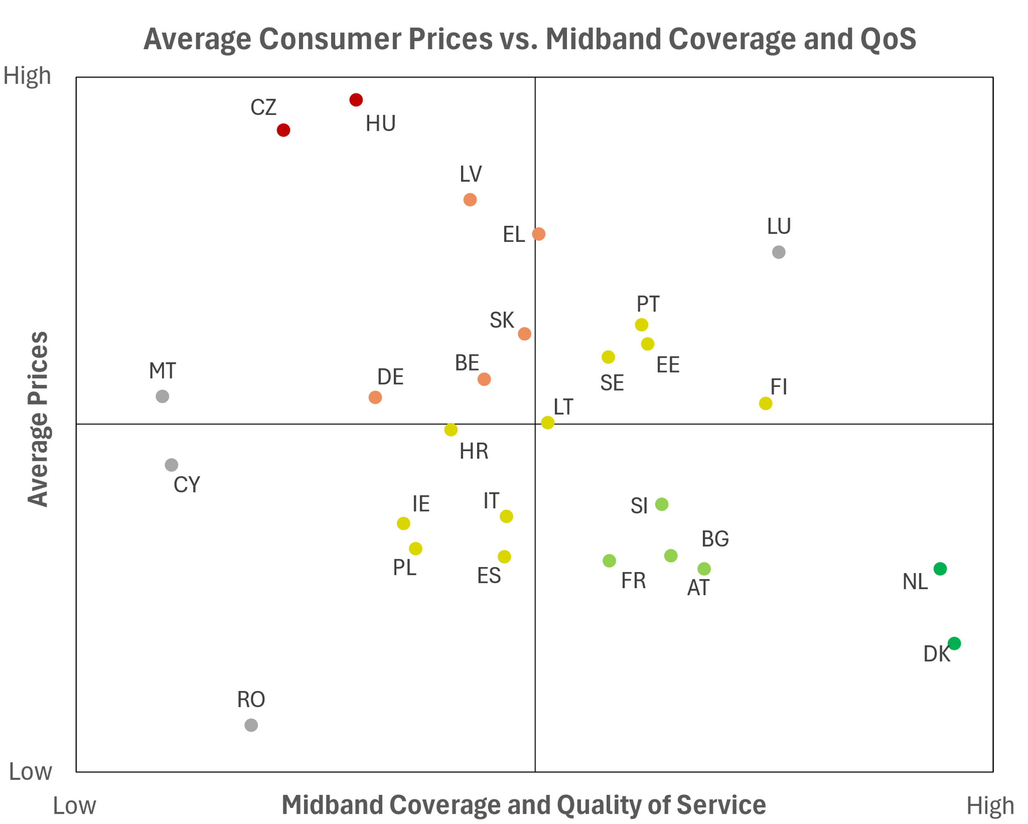
In Figure A4-3-2, the same market outcomes are presented in a way to transparently reflect the various elements assed. The left-hand panel of the figure presents average consumer prices in each Member State calculated as a weighted mean across the three usage baskets, with each basket entering according to its assigned weight and its observed price level. The right-hand panel of this figure presents the corresponding values of the mid-band coverage and quality-of-service index, enabling a side-by-side comparison of affordability and performance across the EU.
Figure A4-3-2: Consumer Prices, Mid-Band Coverage and Quality of Service across selected Member States
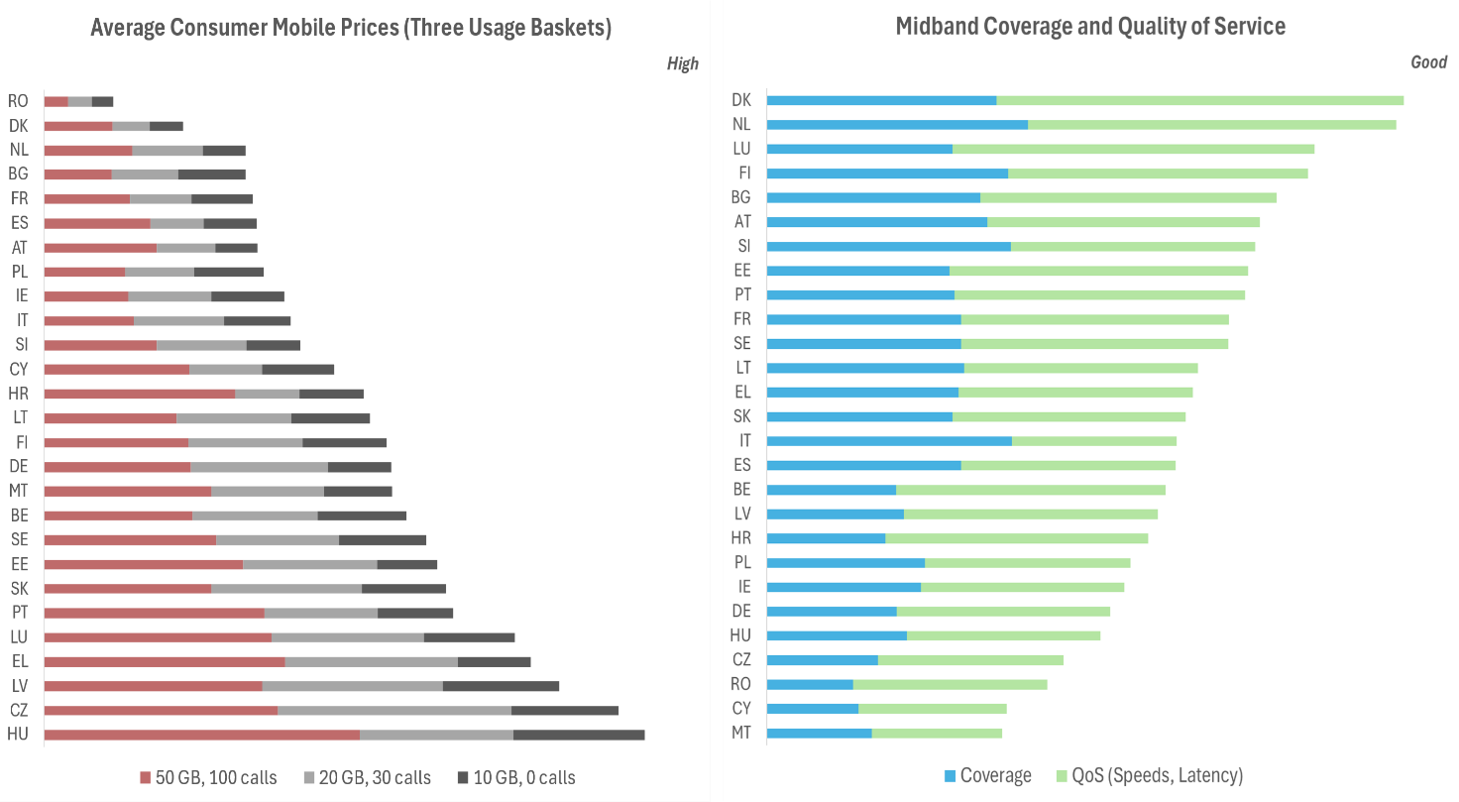

Fragmented Regulatory approaches
This section describes the methodology used to characterise regulatory approaches in the assignment of 5G spectrum and to assess the extent to which these approaches vary across the EU. The analysis focuses on the two 5G pioneer bands, 3.4–3.8 GHz and 700 MHz, as these bands play a central role in enabling high-capacity and wide-area 5G connectivity. The aim is to categorise Member States according to the relative intrusiveness of their auction and award conditions, based on a set of observable regulatory indicators. The resulting regulatory-design scores serve as inputs to the multiple regression analysis conducted in the following section.

Selection of indicators of regulatory approaches
To capture the degree of regulatory intervention applied in the assignment of 5G spectrum, the analysis considers a set of auction and award conditions that are both observable across Member States and directly relevant to operators’ ability and incentives to invest in 5G networks. The indicators selected for both the 3.4–3.8 GHz and the 700 MHz bands are:
- Spectrum caps – limits on the maximum amount of spectrum any single operator may acquire in a given band. These caps shape market structure and may restrict incumbent operators’ ability to expand capacity.
- Access obligations – including obligations relating to MVNO access, service-provider access or national roaming. These requirements influence wholesale market conditions and may affect operators’ business models and investment strategies.
- Coverage obligations – requirements to achieve defined population or geographic coverage levels within specified timeframes. These obligations can support wide-area rollout but may also impose significant deployment costs.
- Reservations and set-asides – spectrum blocks specifically reserved for new entrants, regional operators or vertical/industrial users. Such measures restrict the effective supply available to existing MNOs and may influence auction dynamics and investment incentives.
- Final auction prices (Price/MHz/pop) – the final price paid per MHz per capita. Although influenced by demand and competitive dynamics, high final prices may reflect auction design or limited spectrum availability and can affect operators’ ability to invest post-auction.
These indicators were selected because they represent the core dimensions along which Member States differ in their regulatory design choices, and because they are sufficiently comparable across countries and across both pioneer bands.

Data sources
Information on regulatory conditions was obtained primarily from the Cullen International spectrum database, which provides harmonised cross-country information on spectrum caps, access and coverage obligations as well as estimates of final auction prices. To ensure completeness, particularly regarding reservations and set-asides, this material was supplemented with information from PolicyTracker, and cross-checked where relevant against recent Commission studies and publicly available auction documentation. These sources together provide a consistent evidence base for comparing regulatory approaches across Member States and for developing the indicators used in the subsequent analysis.

Member States considered in the analysis of regulatory approaches
The analysis covers the Member States for which sufficiently detailed and comparable information on regulatory conditions was available for at least one of the two pioneer bands. The following countries were included in the assessment: Austria, Belgium, Bulgaria, Croatia, Czechia, Denmark, Finland, France, Germany, Greece, Hungary, Italy, Lithuania, the Netherlands, Poland, Portugal, Romania, Slovakia, Slovenia, Spain and Sweden.
For some Member States, however, not all indicators could be used in the band-specific assessments. In the 3.4–3.8 GHz band, Denmark and Romania were excluded from analyses involving final auction price estimates (EUR/MHz/pop) because the combinatorial auction format did not allow the attribution of payments to specific frequency bands. In the 700 MHz band, Austria, Denmark and Romania were excluded from price-based comparisons for the same reason. These Member States are nonetheless retained for the descriptive overview of regulatory measures to provide a comprehensive picture of the diversity of approaches across the EU.

Observed Variation in Regulatory Approaches across Member States
While the European Electronic Communications Code has harmonised certain principles of spectrum management, Member States retain broad discretion in the detailed design of spectrum awards. The information assembled for the two pioneer bands shows a wide variety of approaches across countries and across regulatory instruments.
Across both the 3.4–3.8 GHz and the 700 MHz bands, spectrum caps differ substantially, ranging from relatively restrictive limits that leave operators with little flexibility to acquire additional spectrum, to more permissive frameworks that allow bidders to obtain large shares of the band. Access obligations vary from general obligations to negotiate access to explicit requirements for national roaming or mobile virtual network operator access. Coverage obligations differ not only in their presence but also in their intensity, with some Member States imposing detailed population or geographic coverage targets within defined timeframes, and others applying only limited or generic rollout conditions, or none at all. The use of reservations and set-asides likewise varies, with some awards reserving portions of the band for specific user groups such as new entrants or local or industrial networks, while many make the full band available to mobile network operators. Finally, final auction prices per megahertz and per inhabitant display considerable dispersion across awards in both bands, reflecting differences in auction formats, competitive dynamics, spectrum availability and regulatory conditions.
Taken together, these observations confirm that regulatory approaches to the assignment of the two pioneer bands remain highly heterogeneous across the Union, both in terms of the breadth and intensity of intervention and in terms of the specific combinations of caps, access conditions, coverage obligations, reservations and price outcomes applied in different national contexts.
For the purposes of both the visual exploration and the multiple regression analysis examining the relationship between market outcomes and regulatory approaches, a quantitative assessment of the regulatory frameworks and their cross-country differences was required. To this end, a set of scores was developed for each of the regulatory categories under the lead of a spectrum-auction expert, as described in the following subsection. While these scores provide the necessary granularity for the regression analysis, a composite regulatory-design index was also constructed for the visual analysis to summarise the overall restrictiveness of the award conditions applied in each Member State. The construction of such scores inevitably involves a degree of judgement, yet care was taken to apply consistent criteria and to reflect the underlying regulatory differences as objectively as possible.

Scoring of Spectrum Caps

3.4–3.8 GHz band
The categorisation of spectrum caps in the 3.4–3.8 GHz awards is based on an assessment of how intrusive the applicable limits are in practice. Expert opinion generally considers that mobile network operators require 80–100 MHz of contiguous mid-band spectrum to achieve the full performance potential of 5G in this band. This benchmark is consistent with the distribution of licences observed in Europe: in the PolicyTracker Spectrum Database, only 11percent of the 254 national licences in multi-operator European markets in the 3.3–3.8 GHz range exceed 100 MHz, with the largest licence reaching 200 MHz.
Against this background, spectrum caps were scored according to the maximum amount of 3.4–3.8 GHz spectrum an operator could hold after the award, including any existing holdings:
- Score 3: no spectrum caps applied, allowing operators to acquire any amount of spectrum in the band
- Score 2: caps above 100 MHz, that is caps allowing holdings beyond the level generally required to reach full 5G capacity
- Score 1: caps between 80 and 100 MHz, corresponding to the range considered adequate for fully exploiting the capabilities of the band
- Score 0: caps below 80 MHz, that is below the recommended threshold for optimal mid-band 5G performance
A few country-specific points require clarification to ensure the scoring is applied consistently:
- Czechia (score 0): in the 3.4–3.8 GHz band, the award imposed a 60 MHz cap for the three existing mobile network operators and a 100 MHz cap for potential new entrants. The cap also included spectrum already held in the 3.6–3.8 GHz range. Given that the three incumbent operators entered the auction with pre-existing assignments, their total possible holding remained below 80 MHz, placing Czechia in the lowest scoring category.
- Germany (score 3): it was confirmed that no band-specific cap was applied in the 3.6 GHz award, meaning operators could in principle acquire unlimited amounts of mid-band spectrum.
- Netherlands (score 2): the cross-band cap of 384 MHz did not constrain operators’ ability to secure 100 MHz in the 3.6 GHz band. The operator with the largest existing portfolio, Odido, held 260 MHz before the award and could still have acquired an additional 120 MHz before reaching the overall limit.
- Slovakia (score 2): the applicable cap allows mid-band holdings of up to 140 MHz, which places it above the 100 MHz threshold.
- Slovenia (score 2): although a total cap of 190 MHz applies across the 2.3 GHz and 3.4–3.8 GHz ranges, the 2.3 GHz band contains only 100 MHz of unpaired spectrum, typically in blocks of around 40 MHz. In practice, this means the cap does not restrict an operator’s ability to obtain 100 MHz in the 3.6 GHz band.

700 MHz band
The categorisation of spectrum caps in the 700 MHz band follows an assessment of how restrictive the applicable limits are relative to common sub-1 GHz holdings and typical 700 MHz assignment patterns. Across the EU, most mobile network operators hold 2×10 MHz in the 700 MHz band, which is generally considered adequate for delivering wide-area 5G coverage. With 2×30 MHz available in total, the band can conveniently be divided among three operators, which aligns with the market structures observed in many Member States. Because the 700 MHz band has propagation characteristics similar to those of 800 MHz and 900 MHz, regulators can also balance overall sub-1 GHz holdings across these three bands.
Against this background, spectrum caps were scored according to the maximum amount of 700 MHz spectrum an operator could obtain, taking into account existing sub-1 GHz holdings where relevant:
- Score 3: no caps applied, allowing operators to acquire any amount of 700 MHz spectrum
- Score 2: caps above 2×10 MHz, that is above the most common assigned bandwidth
- Score 1: caps of 2×10 MHz, corresponding to the most widely allocated bandwidth across the EU
- Score 0: caps below 2×10 MHz, that is below the standard assignment level
Several country specific points require clarification for consistency of scoring:
- Austria (score 2): the applicable caps allowed operators to acquire more than 2×10 MHz, placing Austria in the category above the commonly assigned bandwidth.
- Denmark (score 2): the cap of 2×35 MHz across the 700 MHz, 800 MHz and 900 MHz FDD bands meant operators could obtain more than 2×10 MHz in the 700 MHz band while remaining within the overall limit.
- Lithuania (score 0): for most operators, the effective cap restricted potential 700 MHz holdings to below 2×10 MHz, which places Lithuania in the lowest scoring category.
- Netherlands (score 2): excluding the 700 MHz band, operators already held 50 MHz or 40 MHz of sub-1 GHz spectrum, meaning they could have acquired more than 2×10 MHz in 700 MHz and still remained below the 80 MHz low-band cap; the effective cap therefore allowed holdings above the standard assignment level.
- Slovenia (score 2): under the combined cap of 2×35 MHz across the 700 MHz, 800 MHz and 900 MHz FDD bands, an operator could hold the typical 2×10 MHz in both 800 MHz and 900 MHz while still being able to obtain more than 2×10 MHz in the 700 MHz band.

Scoring of Access Obligations

3.4–3.8 GHz band
The classification of access obligations in the 3.4–3.8 GHz band is constrained by the limited availability of consistent, detailed information on the exact nature of wholesale access requirements across Member States. For this reason, a simplified quantitative approach was applied, starting from a base score of 10, which reflects the situation in which no access obligations are imposed on spectrum assignees. Points are then deducted depending on the type of obligation attached to the award, with the level of deduction representing the relative intrusiveness of the obligation from the perspective of a mobile network operator.
- A deduction of 3 points is applied where the award requires access for mobile virtual network operators. MVNO obligations typically require operators to provide wholesale access under reasonable terms but generally leave more flexibility to negotiate commercial arrangements. They are therefore considered moderately intrusive.
- A deduction of 2 points is applied where obligations relate to service-provider access. These obligations usually involve a lighter form of wholesale access with fewer technical or operational constraints. As they impose a comparatively limited intervention in the operator’s control over retail and wholesale strategy, they are scored as less intrusive than MVNO or roaming obligations.
- A deduction of 4 points is applied in cases where national roaming must be provided. Such obligations can significantly affect operators’ network planning, customer acquisition strategies and competitive positioning, especially when applied to support a new entrant. National roaming therefore represents the most intrusive form of access requirement and receives the largest deduction.
This scoring framework allows the varying degrees of intervention associated with different types of wholesale access obligations to be reflected in a consistent manner, even where the underlying regulatory texts differ in their formulation or detail.

700 MHz band
For the 700 MHz awards, access obligations were assessed using the same scoring framework as for the 3.4–3.8 GHz band, reflecting the comparable role of wholesale access requirements and the broadly similar information available for both bands. The assessment starts from a base score of 10, with deductions of 3 points for MVNO access, 2 points for service-provider access, and 4 points for national roaming, corresponding to the relative intrusiveness of each obligation for the spectrum assignee.

Scoring of Reservations and Set-Asides

3.4–3.8 GHz band
The categorisation of reservations and set-asides in the 3.4–3.8 GHz band is based on an assessment of how intrusive these measures are in practice for operators seeking to acquire sufficient mid-band spectrum for effective 5G deployment. Reservations for new entrants and set-asides for vertical or local private networks reduce the pool of spectrum available to national mobile operators and may limit their ability to obtain the 80–100 MHz typically needed for high-performance mid-band 5G.
To ensure comparability across Member States and with the 700 MHz band, the analysis quantifies the extent of each reservation or set-aside as a percentage of the total 400 MHz available in the 3.4–3.8 GHz range. Smaller set-asides have limited effect, whereas reservations at or above 20 percent can materially constrain national operators, especially in markets with four mobile network operators, where the remaining bandwidth may not be sufficient. The percentage of spectrum reserved enters the regression analysis in its original form, with no further scoring or transformation applied. Several country specific constellations require clarification for consistency of scoring:
- Denmark: around 10 MHz at 3.4–3.41 GHz was made available for local private networks, representing a small share of the band.
- Germany: 100 MHz at 3.7–3.8 GHz was set aside for local industrial use under a dedicated licensing framework.
- Greece: 10 MHz at 3.4–3.41 GHz was reserved for research purposes. As this portion lies at the edge of the band and does not affect the ability of operators to obtain standard mid-band holdings, it is included for completeness but treated as having limited practical impact.
- Netherlands: 100 MHz of the 3.6 GHz band remained outside the national award to support local and private networks.
- Slovenia: a small part of the band was allocated for local use in a three phase award process open initially to vertical users and municipalities.
- Sweden: 80 MHz in the 3.72–3.8 GHz range was designated for local licences rather than national assignment.

700 MHz band
The categorisation of reservations in the 700 MHz band follows the same principle, assessing how far reservations for new entrants reduce the amount of spectrum available for national operators in a band where 2×10 MHz assignments are widely regarded as standard for ensuring effective 5G coverage. Reservations are expressed as a percentage of the total 60 MHz of paired 700 MHz spectrum, enabling comparability across Member States and with the mid-band assessment. Larger reservations, especially near or above 20 percent, can materially restrict spectrum availability in markets with four operators. As in the 3.4–3.8 GHz band, the percentage reserved is used directly in the regression models.
Several country specific constellations require clarification for consistency of scoring:
- Belgium: part of the 700 MHz band was reserved for a potential new entrant as part of a broader reservation scheme across multiple mobile bands.
- Czechia: one 2×10 MHz block was formally reserved for a new operator. Although the block was ultimately acquired by an existing operator, the reservation formed part of the auction design and is treated as such.
- Italy: a newcomer was eligible for an additional reserved package and successfully obtained two 2×5 MHz blocks under this mechanism.

Scoring of Final Auction Prices (EUR/MHz/pop)
The quantification of final auction prices in the 3.4–3.8 GHz band is based on a standardised metric expressed in euro per MHz per population (EUR/MHz/Pop), which enables a consistent comparison of price levels across Member States irrespective of market size or bandwidth offered. Thus, final auction prices also enter the regression analysis directly, without the need to construct a separate score. The data were sourced from the Cullen International Spectrum Database, which provides harmonised information on spectrum assignments and auction outcomes.
Observed price levels reflect the combined effect of several factors, including the reserve prices set by regulators, the competitive intensity in the auction, the structure of national mobile markets, and the broader award conditions such as coverage obligations, access requirements, and reservations or set-asides. As a result, cross-country variation in prices cannot be attributed solely to regulatory design but captures the full interaction between regulatory and market drivers.

3.4–3.8 GHz band
For the 3.4–3.8 GHz band, band-specific price estimates could not be derived for Denmark and Romania, as the auction format did not allow for disaggregated information by band. These Member States are therefore excluded from the mid-band price analysis conducted in the next section but remain part of the wider assessment where other data are available. Figure A4 3-3 presents the distribution of 3.4–3.8 GHz auction prices across the Member States for which data are available. The coefficient of variation, defined as the standard deviation divided by the mean, amounts to 122%.
Figure A4-3-3: Distribution of 3.4–3.8 GHz auction prices across Member States

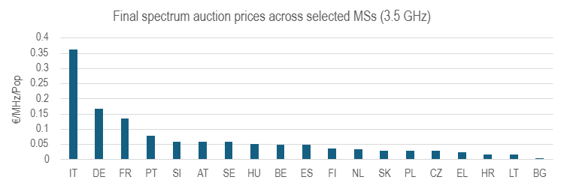

3.3.8.2 700 MHz band
For the 700 MHz band, final price estimates are not available for Austria, Denmark, and Romania, owing to similar limitations. Consequently, these Member States are excluded from the price-based analysis for this band conducted in the next section. Figure A4 3-4 illustrates the variation in 700 MHz auction prices across the Member States included in this part of the assessment. The coefficient of variation, defined as the standard deviation divided by the mean, amounts to 57%.
Figure A4-3-4: Distribution of 700 MHz auction prices across Member States
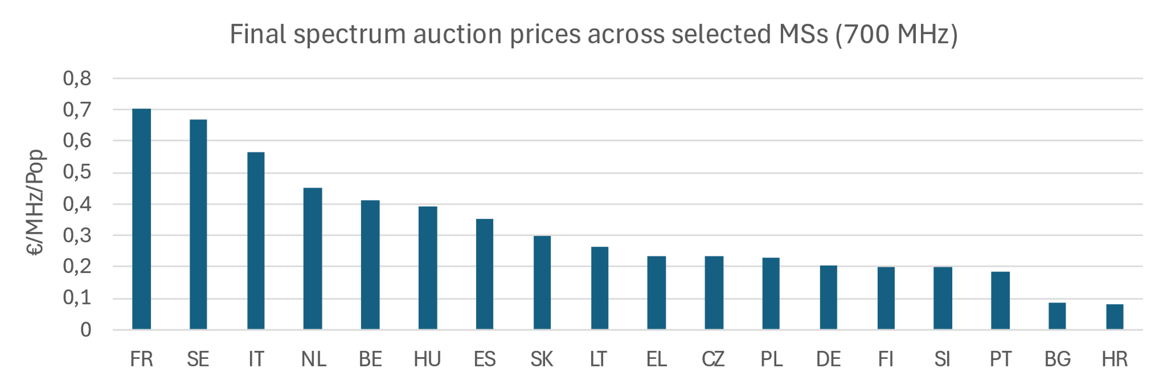

Scoring of Coverage Obligations
Coverage obligations have been assessed and scored but this scoring has been used only in a limited way and has not been included in the composite regulatory indicator due to reasons explained in section 3.3.10.

3.4–3.8 GHz band
The categorisation of coverage obligations in the 3.4–3.8 GHz band is based on an assessment of how intrusive the requirements are in practice for operators deploying mid-band 5G networks. To ensure comparability across Member States, the assessment focuses on coverage and rollout conditions that explicitly relate to the use of 3.6 GHz spectrum and therefore have a direct bearing on the deployment of high-capacity 5G infrastructure.
Coverage obligations were assessed on a scale from 0 to 10, where 10 corresponds to awards without any coverage obligation and 0 to the most demanding set of requirements. The scoring reflects expert judgement based on several elements, including:
- the required share of national population or territory to be covered
- the presence of specific geographic or functional areas to be covered, such as rural regions, transport corridors or priority locations
- explicit 5G New Radio deployment targets or technology specific requirements
- quantified roll out conditions such as the minimum number of base stations to be deployed
- obligations related to shared networks or infrastructure provision
Obligations that require extensive geographic reach, explicit 5G deployment and performance targets, and significant roll out commitments receive lower scores on this scale, as they are considered more intrusive from the perspective of the spectrum assignee. Obligations that are more limited in scope or expressed in generic terms receive higher scores.

700 MHz band
For the 700 MHz band, a different scoring framework is applied, reflecting the availability of the Spectrum Award Efficiency Study (2022) that evaluated coverage obligations in 700 MHz awards across the EU. This study developed a set of criteria distinguishing obligations by their scope and complexity, and these criteria were translated into a five-point scoring scale for the purposes of this analysis. The same scoring approach was applied to Member States not included in the original study to ensure consistency across the sample.
Coverage obligations were assigned a score from 0 to 4, where higher values reflect more extensive and detailed requirements:
- Score 0 – No coverage obligation: The licence contains no explicit 700 MHz coverage requirement.
- Score 1 – Generic coverage requirements: Obligations formulated in broad terms such as percentage of population or territory, number of locations or number of base stations, without further differentiation.
- Score 2 – More specific coverage requirements: Obligations that go beyond generic indicators and include targeted geographic or functional requirements.
- Score 3 – Coverage requirements combined with user-experience elements: Obligations combining basic coverage metrics with performance-related conditions, for example minimum download or upload speeds, explicit references to 5G deployment or requirements supporting certain 5G use cases.
- Score 4 – Detailed coverage requirements combined with user-experience elements: Obligations involving more granular coverage specifications, such as requirements for non-urban areas, underserved communities or transport routes, together with explicit user-experience conditions such as minimum speed, latency or reliability thresholds.
Higher scores thus reflect obligations that are more intrusive for spectrum assignees, either because they impose more granular geographic deployment targets or because they include performance-based requirements in addition to basic rollout metrics.

Composite measure of Regulatory approaches
For the econometric analysis presented in Section 3.5, each regulatory indicator enters the regression directly, without any aggregation or weighting. Specifically, the models use the original expert-based scores for spectrum caps, access obligations, and coverage obligations, as well as the directly observed numerical values for final auction prices (in EUR/MHz/Pop) and the percentage of spectrum reserved or set aside. No further transformation is applied in the regression models.
However, to provide an initial visual overview of the potential relationship between regulatory design and market outcomes, a composite indicator of regulatory approaches was constructed. This composite measure serves exclusively for graphical illustration and does not enter the regression analysis. It is plotted against the composite market-outcome indicator described in Section 3.2.5.
The composite regulatory indicator is based on the four regulatory dimensions: spectrum caps, access obligations, final auction prices, and reservations or set-asides. Each dimension is first normalised to ensure a consistent zero-to-one scale, where one denotes the least intrusive regulatory approach and zero the most intrusive. For all score-based variables (spectrum caps, access obligations, and coverage obligations in the 3.4–3.8 GHz and 700 MHz bands), normalised values were obtained by rescaling the expert scores relative to the range of observed values. Regarding auction prices, Member States with the lowest price per MHz per population receive values closest to one, while higher price levels translate into lower normalised scores. For reservations and set-asides, the score reflects the share of the band not reserved, ensuring that a greater amount of spectrum available to national operators results in a higher score.
As regards coverage obligations, while this regulatory dimension has been assessed and some preliminary regression analysis done it has not been included in the composite indication, accordingly coverage obligations receive a weight of zero. To be noted that for this preliminary assessment of coverage obligations in the 700 MHz band, where the original categories increase in numerical value as obligations become more demanding, the transformation was inverted to maintain the “higher-is-less intrusive” score interpretation consistent across all dimensions.
The exclusion of coverage obligations from the composite index reflects both the conceptual and methodological difficulties associated with developing comparable scores across Member States with very different geographic and demographic conditions, and the fact that coverage obligations did not display explanatory power in the preliminary regression analysis presented in Section 3.5.
For the composite regulatory-design indicator, the resulting normalised variables were aggregated using the weighting structure shown in Table X, reflecting the relative importance of the different dimensions in shaping operator flexibility and investment incentives.
Table A4 3-3: Weighting Structure for the Composite Regulatory-Design Indicator
Criterion | Weight
Spectrum caps | 0.20
Access obligations | 0.30
Auction prices | 0.20
Reservations/Set-asides | 0.30
Total | 1.00

The weighting is designed to capture the influence of those parts of the regulatory approach that directly influence operators’ ability to obtain and use spectrum in an investment-enhancing manner. Reservations and set-asides receive a weight of 0.30, reflecting their potentially substantial effect on the amount of spectrum available for national networks. Access obligations are similarly weighted at 0.30, acknowledging their direct impact on the commercial flexibility of licence holders. Spectrum caps and auction prices are weighted at 0.20 each, capturing their influence while recognising that their effects tend to be more context-dependent and intertwined with market structure.
The weighted sum for each Member State was then standardised using z-scores, allowing the resulting index to be plotted on a common scale with the composite market-outcome indicator. This rescaling facilitates the visual comparison presented in Section 3.2.2 of the main report without altering the underlying structure of the composite.

Visual comparison of Market outcomes and Regulatory approaches
Figure A4 3-5 below illustrates the resulting comparison between the composite regulatory-design indicator and the composite measure of market outcomes. The visual representation suggests that more interventionist regulatory approaches may, in some cases, be associated with less favourable market performance, particularly in the 700 MHz band. This may indicate that more restrictive and less investment-oriented auction and award conditions applied in certain Member States are linked to more limited coverage, lower quality of service and higher consumer prices. At the same time, and as emphasised above, the patterns visible in this simplified comparison are not conclusive and do not constitute statistical evidence. Rather, they provide motivation for the more sophisticated regression analysis presented in the following section.
Figure A4-3-5: Regulatory Design and Market Outcomes in the 3.6 GHz and 700 MHz Bands
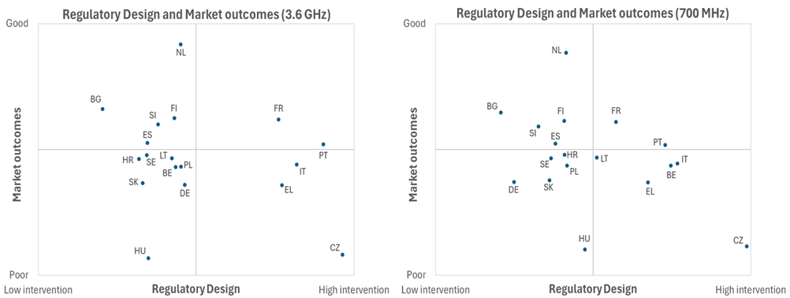

Analysis of possible correlations between regulatory approaches and relevant market outcomes
This section presents the methodology and results of an econometric analysis exploring how selected elements of regulatory design are associated with market outcomes in 5G deployment across Member States. The exercise follows a structured regression-based approach applied to the best available cross-country data. It aims to identify patterns that may help explain variations in coverage, prices and quality of service by relating them to differences in spectrum-auction designs, while recognising the important role of non-regulatory drivers and the inherent limitations of a small sample.

Methodology and Tools
The analysis of potential correlations between regulatory approaches and market outcomes follows a structured and iterative regression-based methodology. The starting point is a set of theoretically grounded hypotheses, informed by economic reasoning, existing regulatory frameworks and observed market structures. On this basis, potential explanatory variables were identified, including GDP per capita, rural population share, population density, spectrum caps, access and coverage obligations, set-aside or reservation percentages, and average band prices expressed in euro per MHz per population.
Multiple ordinary least squares (OLS) regression models were then estimated, varying the dependent variable across four key outcomes: 5G household coverage, 5G download speeds, retail consumer prices for the three different usage baskets, and spectrum-auction prices expressed in euro per MHz per population. In some specifications, spectrum prices also enter as explanatory variables in order to examine how they relate to coverage, quality of service and retail prices. Each model was evaluated with respect to its overall statistical significance, its explanatory power as measured by R² and adjusted R², and the direction and magnitude of each coefficient. Particular attention was paid to the effects of regulatory variables such as spectrum caps, access and coverage obligations, reservations and set-asides, and average band prices, both in terms of statistical significance and consistency of the estimated relationships with theoretical expectations.
In practical terms, the regression models were specified in a way that made it possible to examine the influence of each factor while holding other variables constant. This approach helped indicate, for example, whether higher set-aside shares are associated with higher consumer prices, or whether access obligations show any relationship with download speeds or overall 5G coverage. Simpler specifications were also estimated to verify whether certain structural variables, such as GDP per capita, exert a strong standalone influence and whether their effects persist when additional factors are included.
The model specifications were refined iteratively by estimating reduced forms, adding or removing explanatory variables, and exploring potential confounding influences or interaction effects. This iterative process made it possible to isolate robust relationships, identify key findings, and assess the policy relevance of different regulatory instruments. The ultimate goal was to move beyond correlation and toward plausible causal inference, while remaining attentive to sample limitations and diagnostic robustness.
The models were implemented as ordinary least squares (OLS) regressions using the statistical software STATA. OLS provides a solid and sufficiently reliable basis for the exploratory assessment carried out here. Interpretation of the regression outputs was supported by AI-based analytical assistance. However, the analytical process was overseen by an experienced economic expert, Prof. J. Scott Marcus, who reviewed all AI-generated results for methodological soundness and overall reasonableness.
Unless stated otherwise, the reported results are statistically significant at the 95% level. A small number of results achieve significance at the more demanding 99% level. Some estimates reach only marginal significance at the 90% level, while others that fall short of conventional significance thresholds may still be informative when interpreted in context. Such cases are clearly indicated.
It should be noted that statistical significance applies separately to the model as a whole and to the individual explanatory variables. Where a model is statistically significant overall but a specific variable is not, this is indicated accordingly, and such findings are interpreted as suggestive rather than definitive.

Data and Variables
Table A4 3-4 provides an overview of all variables used in the regression analysis, distinguishing between outcome variables, regulatory indicators and exogenous controls. The analysis uses raw values where available, combined with expert-based scoring where necessary, as indicated below. This approach preserves quantitative comparability while still capturing meaningful differences in regulatory approaches across Member States and ensures that variables enter the analysis in their original form wherever feasible.
The outcome variables comprise the market-performance measures described in Section 3.2.4, including overall 5G household coverage, 5G coverage in the 3.4–3.8 GHz band, average and 5G download speeds, latency and consumer prices for the three us-age baskets. Spectrum-auction prices, expressed in euro per MHz per population for both the 700 MHz and 3.4–3.8 GHz bands, are also treated as outcome variables where the aim is to identify their determinants. However, in several model specifications these price variables also enter as explanatory inputs in order to examine how they relate to coverage, performance and retail pricing. All of the variables mentioned in this paragraph enter the analysis in their raw form.
The explanatory variables comprise two groups. The first consists of exogenous/structural drivers that influence 5G deployment and performance independently of spectrum-auction design. These include GDP per capita, population density, rural population share and the number of mobile network operators, all of which are used in their raw form. These variables capture fundamental economic and demographic conditions that shape deployment costs, investment incentives and consumer demand. Their inclusion is essential for disentangling the effects of regulatory design from broader structural determinants, since market outcomes such as coverage, prices, download speeds and investment incentives cannot be attributed to regulatory choices alone. Prosperity levels influence both operator investment incentives and consumers’ willingness to pay; population density and rural share shape the cost of network roll-out; and the competitive structure contributes to pricing dynamics and investment behaviour.
The second group of explanatory variables comprises regulatory variables, covering the different dimensions of auction design described in Section 3.3. For reservations and set-asides, the analysis uses the raw percentage of the band reserved, allowing the regressions to capture the direct effect of limiting the spectrum available to incumbent or potential operators. For spectrum caps, access obligations and coverage obligations, the analysis relies on structured comparative scores, developed by a spectrum expert (Martin Sims) on the basis of harmonised information from Cullen International and PolicyTracker. These scores provide a consistent comparative representation of regulatory intensity across Member States in cases where policies differ qualitatively and cannot be directly compared using numerical values alone. The scoring methodologies for each category of regulatory measure are set out in Section 3.3.
The dataset covers 21 Member States for which comparable information is available, specifically Austria, Belgium, Bulgaria, Croatia, Czechia, Denmark, Finland, France, Germany, Greece, Hungary, Italy, Lithuania, Netherlands, Poland, Portugal, Romania, Slovakia, Slovenia, Spain and Sweden. For models involving band-specific auction prices, the sample is reduced because not all auction formats allow the derivation of final prices that are specific to a single band. In the 3.4–3.8 GHz band, auction prices cannot be derived for Denmark and Romania, resulting in a maximum sample of 19 Member States. In the 700 MHz band, band-specific prices cannot be derived for Austria, Denmark and Romania, which reduces the usable sample to 18 Member States. All auctions considered in this analysis were conducted between 2018 and 2025. Given the small cross-sectional sample and the absence of a time series, the estimation strategy must be parsimonious and efficient, focusing on variables that are theoretically justified and empirically meaningful.
Table A4-3-4: Indicators Used as Dependent Variables, Independent Variables and Exogenous Controls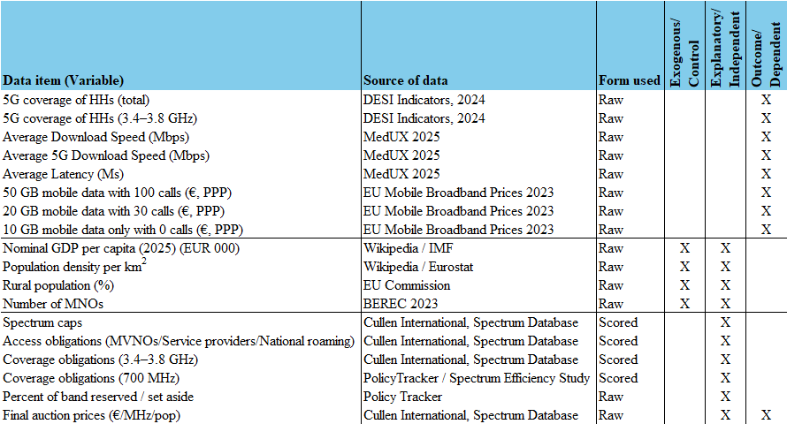
Together, these variables provide the basis for examining potential relationships between regulatory design choices and key market outcomes, while controlling for the structural and economic conditions that play a central role in shaping 5G deployment and performance across the EU.

Summary of Results
The regression analysis identifies several robust relationships between regulatory approaches and market outcomes, as well as a number of suggestive patterns. The exercise confirms that variation in certain regulatory elements is associated with material differences in market outcomes. While non-regulatory factors such as GDP per capita, population density, rural share and competitive structure – which are controlled for in the regression specifications – remain important determinants of investment and performance, several regulatory choices show consistent relationships with both operator incentives and end-user outcomes.
In the following, all reported specifications in which the regulatory variables of interest reach statistical significance likewise satisfy conventional significance requirements for the overall model, as indicated by standard F-statistics. The specifications include the core structural controls used throughout the analysis (see above).
Across a range of model specifications, spectrum reservations and set asides emerge as the regulatory variable most consistently associated with weaker market outcomes. The share of spectrum that is reserved or set aside is correlated with higher spectrum auction prices, higher consumer prices and lower 5G download speeds, with most of these relationships reaching conventional significance thresholds.
- Regarding auction prices, higher reservation and set-aside shares are correlated with higher prices per MHz per population, consistent with the economic expectation that limiting the amount of spectrum available for competitive bidding increases scarcity. For the 700 MHz band, the estimated coefficient is positive but does not reach statistical significance. For the 3.4–3.8 GHz band, the estimated effect is statistically significant with a p-value of 0,028 and sizeable in magnitude, indicating that increases in the reservation or set-aside share are associated with materially higher auction prices.
- Regarding consumer prices, the relationship between reservations and set-asides intensity and retail price levels is statistically significant and economically meaningful. In the model using the 20 GB and 30 calls basket, the coefficient on the reservations and set-asides shares is statistically significant with a p-value of 0.011. A ten-percentage point increase in the reservation and set-aside shares is associated with an increase of EUR 3.98 in the price of this basket, indicating a notable effect on affordability for end users.
- Regarding download speeds, higher reservation and set-aside shares are correlated with weaker performance. For overall average download speed, the estimated coefficient is negative but does not reach statistical significance. For 5G download speeds, however, the coefficient on the reservation and set-aside shares is statistically significant with a p-value of 0,003. A ten-percentage point increase in set asides is associated with a reduction of approximately 20.8 megabits per second in 5G download speeds. This represents a substantial decline in performance in absolute terms.
Given that regulatory choices may also react to pre-existing market conditions, these results do not establish a causal link. Nevertheless, the observed associations are consistent with the intuition that restricting the effective supply of spectrum increases cost pressure on operators, dampens investment incentives and leads to weaker quality of service and higher consumer prices.
The results for access obligations indicate a pattern of potentially meaningful effects, although the statistical significance of these results varies across specifications. Overall, access obligations tend to be associated with lower consumer prices and with lower 5G population coverage, while their estimated impact on download speeds is negative but not statistically significant.
- A model using the 20 GB and 30 calls basket shows a marginally significant negative correlation between access obligations and consumer prices, with the estimated coefficient carrying a p-value of 0.088.
- Furthermore, access obligations display a marginally significant negative correlation with 5G population coverage, with the estimated coefficient carrying a p-value of 0.067.
- Access obligations also show a negative, though statistically insignificant, association with overall average download speeds.
These findings point to a possible trade-off between affordability and deployment incentives. While access obligations may exert downward pressure on consumer prices, they may at the same time reduce operators’ incentives to expand network coverage.
Spectrum caps, although potentially useful for safeguarding competition when appropriately applied, do not appear to be systematically associated with differences in market outcomes. Coverage obligations likewise display little explanatory power for the observed variation in market outcomes, which, however, may reflect the difficulty of comparing such obligations across Member States given their diverse design, geographic context and implementation conditions.
Overall, the results point to a coherent pattern. The most consistent regulatory determinant of market outcomes is the extent to which spectrum is withheld from competitive bidding through reservations or set asides. Higher set aside shares are associated with higher costs for operators, reduced investment incentives and higher prices for end users. Access obligations show weaker and less consistent effects but may have a marginally negative impact on network deployment. Spectrum caps and coverage obligations do not appear to drive substantial variation in market outcomes in the present dataset. These results should be interpreted with appropriate caution in light of the methodological limitations discussed in section 3.5.4.

Limitations
The interpretation of the regression results should take account of several methodological limitations inherent in this type of cross-country analysis.
First, the dataset is necessarily small, as it is restricted to the group of EU Member States for which complete and comparable information on regulatory design and market outcomes is available. Analyses based on around twenty observations are common for EU-level policy considerations but they inevitably limit statistical power and make results more sensitive to individual country cases. This constrains the complexity of the models that can be estimated and means that relationships may change significance when additional controls are introduced.
Second, several regulatory variables rely on structured expert scoring, particularly where regulatory choices differ qualitatively across Member States and cannot be expressed through simple numerical indicators. This concerns especially coverage obligations, where Member States use highly diverse formulations, geographic definitions, timelines and implementation conditions. These differences make direct numerical comparison difficult and require a degree of judgement to translate into consistent categories. The scoring therefore provides an approximation of regulatory intensity rather than an exact quantitative measure, although care was taken to apply transparent distinctions and consistent criteria.
Third, the regressions were implemented in specialised econometric software (STATA), which enables standard diagnostic checks, including assessments of multicollinearity, heteroskedasticity, functional-form misspecification and influential observations. These diagnostics help to identify specifications in which results may be sensitive to modelling choices or to individual Member States. However, given the small cross-sectional sample and the absence of a time dimension, diagnostic tests have limited statistical power and cannot eliminate concerns about omitted variables or endogeneity. Accordingly, findings, particularly those close to conventional significance thresholds, should still be interpreted as indicative correlations rather than precise causal estimates.
Fourth, it is important to recall that a wide range of non-regulatory factors influence market outcomes and investment incentives in mobile networks. These include demand for mobile services, income levels, population density, rural share, geographic conditions, competitive structure, legacy network assets and differences in national cost conditions. While the regression analysis incorporates several key control variables, it cannot fully capture the full set of structural and country-specific factors that shape 5G deployment and performance.
Finally, regulatory choices may in some cases be endogenous to market conditions, for example when more interventionist auction designs are adopted in response to pre-existing concerns about competition, pricing or investment. In such cases, part of the observed association may reflect underlying market characteristics rather than the effect of the regulatory choice itself. The cross-sectional nature of the dataset does not allow us to distinguish between these mechanisms. Time-series or panel data would in principle allow before–after comparisons of market outcomes following specific auctions and provide stronger grounds for causal inference, but obtaining and integrating such data into the model would require substantial additional effort and resources, which lies beyond the scope of this analysis. The regression results should therefore be interpreted as descriptive associations rather than causal estimates.
Taken together, these limitations are typical for EU-wide comparative studies and reflect the nature of the available data rather than shortcomings of the analytical approach. They underline, however, that the results should be understood as indicative of general patterns rather than as precise causal estimates.

Annex 5: Competitiveness check

Overview of impacts on competitiveness

Transition to fibre
Dimensions of Competitiveness | Impact of the initiative  (++ / + / 0 / - / -- / n.a.) | References to sub-sections of the main report or annexes
Cost and price competitiveness | n.a. | Could not be quantified
International competitiveness | 0 | Annex 7
Capacity to innovate | + | Annex 4
SME competitiveness | + | Annex 6

Spectrum
Dimensions of Competitiveness | Impact of the initiative  (++ / + / 0 / - / -- / n.a.) | References to sub-sections of the main report or annexes
Cost and price competitiveness | n.a. | Could not be quantified
International competitiveness | ++ | Annex 3
Capacity to innovate | ++ | Annex 3
SME competitiveness | + | Annex 6

Authorisation
Dimensions of Competitiveness | Impact of the initiative  (++ / + / 0 / - / -- / n.a.) | References to sub-sections of the main report or annexes
Cost and price competitiveness | n.a. | Could not be quantified
International competitiveness | ++ | Annex 3
Capacity to innovate | + | Annex 3
SME competitiveness | + | Annex 6

Regulatory governance
Dimensions of Competitiveness | Impact of the initiative  (++ / + / 0 / - / -- / n.a.) | References to sub-sections of the main report or annexes
Cost and price competitiveness | 0 | -
International competitiveness | + | Annex 3
Capacity to innovate | + | Annex 3
SME competitiveness | 0 | -

Synthetic assessment
Access
Regulated access combined with the specifications of key wholesale products that enable service differentiation, under the preferred option should serve to stimulate competition on speeds, helping to foster greater availability of Gigabit speeds at an affordable price, and fostering uptake.
Provisions regarding standardised wholesale product specifications should be positive for broadband service providers, providing they are defined in a manner that supports product differentiation and innovation. While broadband service providers would also incur costs to adapt their systems to new types of wholesale product offerings, the advantages in terms of lower costs to connect multiple infrastructures and greater innovation potential (including in retail services that could be monetised) are likely to significantly outweigh implementation costs.
Demand modelling based on evolutions in applications and the requirements of SMEs suggest that 50% of SMEs will require Gigabit connectivity by 2035, and many will require symmetric bandwidths. The preferred option could make a substantial contribution to ensuring that these needs are met. Harmonisation of specifications for key wholesale products and quality of service guarantees for businesses should contribute to the development of competition in services for multi-site and multinational enterprises. This is important, noting that retail and wholesale market shares of incumbents in the supply of such services are often higher than for residential customers, and competition may be limited by the lack of availability of wholesale access with appropriate service guarantees at all required locations. Further details on the impacts on SMEs can be find in Annex 9.
Spectrum
The proposed spectrum measures are expected to yield significant benefits to the competitiveness of the EU industry. They are designed to provide maximum investment certainty and regulatory clarity, especially for cross-border and long-term spectrum users and therefore bring significant benefits to telecom operators and finally to end users in terms of quality of service and of 5G and 6G services. The shift to indefinite licence durations by default delivers a strong and credible long-term investment signal. Where exceptionally shorter duration is applied, the reversed burden of proof removes the threat of unpredictable non-renewal decisions. Long-term licences provide investment certainty and planning stability, reduce the risk premium on capital expenditures and are strongly advocated by the industry. They also improve financial predictability, and lower the cost for capital-intensive 5G and future 6G deployments. The Commission’s role in overseeing authorisation processes ensures greater regulatory convergence and guaranties investment-friendly auction designs, flexible licensing conditions, or pro-security obligations (e.g. supply chain scrutiny, trusted vendor requirements). The possibility for the Commission to harmonise authorisation conditions would also have the benefit of facilitating cross-border provision of service and consolidation between telco operators, which would allow these operators to obtain scale. Binding common conditions upon request for private networks enable innovators to scale up network-as-a-service solutions. Restricting market-shaping measures to commonly agreed EU criteria limit distortions while maintaining national flexibility. Inconsistent national practices (e.g. unjustified market shaping measures and reserve prices) may be corrected, contributing to a level playing field and reducing cross-border investment barriers. While early planning, timely authorisation, and cross-border coordination for 6G bands is key, the success of 6G spectrum awards depends on how auction conditions—such as duration, license flexibility, reserve prices, and obligations—are designed to support investment in a context of technological and commercial uncertainty. Predictability and affordability will be critical to incentivise timely deployment and long-term industrial research for high-value vertical use cases. Coordination of timing of spectrum awards will also enhance predictability for equipment manufacturers and operators, bringing benefits in terms of synchronous deployment, and availability of devices and services. Pro-security and sharing obligations bring benefits in terms of more secure networks for all.
The preferred option is expected to deliver significant benefits, for large-scale and cross-border spectrum investments. The reduction in regulatory risk, combined with a credible, enforceable commitment to licence stability and market-friendly conditions, offers major advantages for accelerating the EU’s connectivity goals, increasing EU competitiveness also opening up new opportunities to new spectrum users.
SME competitiveness
In the report on the future demand in the business sector [ref demand chapter of Study on Finance and USO] WIK showed that for SMEs QoS, reliability and scalability is essential to be able to satisfy future demand for connectivity also for smaller SMEs. For large business customers the availability of dark fibre would allow for the (self-) provision of customised bundles of services and innovation in this segment.

Competitive position of the most affected sectors
Figures provided in third party reports as well as data gathered for this Annex 5 provide a mixed view of financial performance in the telecom sector, with differences between service types as well as countries, business models and operators with different degrees of scale and history.
Some stakeholders claim a real term decline in revenues, with low ARPUs for mobile services in particular. Fixed broadband revenues are significantly higher.
- Available data suggest that revenues for retail telecom service providers have not increased in line with inflation, in particular during the inflationary spike that followed the COVID pandemic.
- Mobile ARPUs in Europe in particular are generally lower on average than in other regions.
- However, higher and more stable ARPUs have been achieved in fixed broadband.
- The profitability of incumbent operators in Europe is similar to that in other regions.
Smaller mobile operators and new entrants are struggling in several countries in Europe and internationally. JVs/extensive network sharing may have helped to support profitability in some cases.
- Financial challenges experienced by new entrants in crowded European mobile markets.
There are differences in profitability between vertically integrated telcos in different European countries. Contrasting levels of investments in FTTH and degree of network duplication alongside differences in willingness to pay may explain some of these differences.
- As regards country-specific differences, an analysis of third party reports as well as data gathered shows that within Europe profitability is relatively robust amongst both incumbent and alternative operators in Germany, Austria, Sweden and some of the Baltic countries (Lithuania and Latvia), with France following. Spain, Italy and (of the non-EU countries, the UK) show specific weaknesses.
- The reasons for country specific differences are likely to vary. However, factors that may be relevant in supporting higher profit margins in Germany and Austria are delays in the deployment of FTTH regulated dark fibre backhaul for mobile, and reliance on low-band spectrum for deployment of 5G SA. Meanwhile, earlier deployment and the lack of duplication of alternative FTTH networks by incumbents in Sweden (through the commercial decision of the incumbent) and France (as a result of symmetric regulation) together with more rapid migration to fibre in the absence of FTTC may have supported the business case for fibre. Both France and Sweden have four player mobile markets. However, in both cases, there is widespread availability of dark fibre backhaul (via regulation in France and from municipal operators in Sweden). Sweden also benefits from spectrum pooling and deep network sharing, which is likely to have limited the investment requirements for mobile. Deployment of 5G SA and mobile network densification has been relatively limited thus far in Sweden and France, which may also have enabled stronger financial results.
- In contrast, Italy and Spain have both experienced significant FTTH deployment including widespread duplication of FTTH networks, as well as intense competition with disruptive entry in the mobile segment, which may have impacted prices and profit margins. A lack of country-specific breakdowns amongst larger telecom groups make it challenging to assess levels of profitability at country-level elsewhere in Europe.
ROCE and FCF are affected by the investment cycle. Improvements in ROCE following investment depend critically on take-up / market share
- Data shows that capex levels tend to vary over time, and that capex intensity has been higher for alternative operators than for incumbents, although the figures are now converging. Although the data is not disaggregated in a manner that would allow such analysis, it can be inferred from the timing of capex increases in different countries that variations in capex levels over time reflect investment cycles in FTTH and/or 5G (including the acquisition of s). In turn changes in capex affect other metrics relating to returns and profitability.
- Variations in the ROCE may reflect the degree of success in transferring or acquiring customers onto newly built or upgraded infrastructure alongside any impacts on ARPU that may be affected by willingness to pay, and the degree to which the company has relied on debt financing. FCF as a proportion of revenues is also likely to be affected by investment cycles which are funded through cashflow, and thus reductions in FCF as a % revenue may be particularly pronounced amongst operators which have been able to invest in FTTH based on high cashflows from their legacy business, but have not yet converted these investments to customers or higher revenues.
Cable operators that have not yet upgraded to FTTH tend to have strong financial performance. This could change once upgrades are made.
- Due to the performance capabilities of DOCSIS 3.1 (and potential upgrade path to DOCSIS 4.0), pure cable operators in countries such as Belgium and the UK may have benefited from higher returns due to the lack of urgent pressure to upgrade networks to FTTH and therefore lower capex requirements than rivals. In contrast, cable operators that invested heavily in FTTH, show the same pattern as for other fibre investors – with high capex % linked to lower ROCE and reduced FCF % during the period of the deployment.
- Wholesale only operators are struggling to make returns. Low take-up is an important problem. Further insight on the drivers of financial outcomes in specific capital intensive segments (including the impact of capex timing, take-up, and debt) can be gained by looking at results of pure fibre investors and towercos.
- Amongst investors for whom data is available, low take-up seems to be a particular concern.
- Financial results provided in third party reports show an expansion in revenues for towercos, with ROCE lying between 4-6%. This is below ROCE expected for vertically integrated telecom operators, but reflects the perception of the business model of towercos as a low risk investment.
Levels of debt amongst wholesale only fibre cos are high. Debt levels amongst vertically integrated operators in Europe have increased, but are comparable with levels in other regions.
- Another concern regarding the majority of regional investors / wholesale only companies reviewed are the very high levels of leverage.
- The ratio of net debt to EBITDA amongst EU headquartered vertically integrated operators lies between 2.5-4 and has in most cases increased in recent years.
Many EU telecom operators operate multi-nationally. However cross-border presence does not seem to be linked to improved financial performance in the current fragmented Single market for electronic communications
- The analysis of company data shows that many telecom groups headquartered in the EU, as well as some groups headquartered elsewhere, have built a portfolio of businesses across different countries.
- The data does not provide clear indications of whether or not there are benefits to operating in multiple markets in the current scenario with no genuine Single market for electronic communications. There are examples of successful regional fibre investors and more localised tower companies that perform better than larger scale companies. Meanwhile some multinational operator groups are financially struggling while others are better positioned. This may however result from the fact that companies today operate as national entities with limited exploitation of synergies in the core. There is limited data available for standalone providers of specialist cross-border services such as automotive IoT and the provision of services to multi-national businesses. The data available suggest relatively low returns for the players concerned.

Annex 6: SME check
Overview of impacts on SMEs
Relevance for SMEs
Based on the European Commission’s SME filter , this initiative is considered relevant for SMEs.
While most of the impacts for SMEs are indirect (as potential downstream business consumers), some direct impacts may also exist for a targeted number of SMEs. This is the case for ECN operators, for instance, as well as for some other network operators.
(1) Identification of affected businesses and assessment of relevance
Are SMEs directly affected? In which sectors?
The Initiatives assessed as part of DNA would not introduce any obligations specifically impacting SMEs as consumers of electronic communications services. SMEs acting as ECN operators or other (non-ECN) network operators (e.g. New Space SMEs) may be impacted as described in the sections relating to those categories of stakeholders. Those effects that are specific to SMEs acting as ECN or other network operators are highlighted in this section.
Estimated number of directly affected SMEs
< 50 (assumption based on EU market of ECN operators)
Estimated number of employees in directly affected SMEs
< 1000 (assuming average of 20 employees per impacted SMEs)
Are SMEs indirectly affected? Yes In which sectors? What is the estimated number of indirectly affected SMEs and employees?
All SMEs who are consumers of electronic communications services are indirectly impacted by the DNA initiatives, as it is expected that their demand for higher bandwidth will increase. Further details of this impact are described in section 2.2 of Annex IV, containing the number of businesses by different segments and the expected bandwidth demand change. The modelling of the broadband requirements of SMEs in possible scenarios was carried out in three phases by the contractor for the Study on access regulation:
- Starting point was the SME user segmentation
- Next, scenarios were developed to show possible shifts in the SME user segments up to 2035
- Finally, bandwidth requirements of the user segments were estimated for different scenarios in 2035
- Consultation of SME stakeholders
How has the input from the SME community been taken into consideration?
The Commission has been consulting widely to gather key information and ensure that the public interest is well reflected in the design of the Digital Networks Act (DNA). The SME community had the opportunity to express their viewpoint not only during the exploratory consultation and the White Paper (as further outlined in Annex II), but recently by responding to the Call for Evidence aimed to inform the public and stakeholders about the Commission's plans.
A share of 16% of the total respondents to the Call for Evidence identified themselves as SMEs, and focusing on the 128 businesses responding, 40% claimed to be SME. This represents a growing trend as in the earlier consultations a share of 10% of the total respondents to the White Paper identified themselves as SMEs, and focusing on the 103 businesses responding, 33% claimed to be SME, while a share of 5% of the total respondents to the Exploratory Consultation identified themselves as SMEs, and focusing on the 108 businesses responding, 22% claimed to be SME.

The feedback provided by SMEs were duly considered during the assessment of the initiatives.
Are SMEs’ views different from those of large businesses?
SMEs acting as ECN operators or other (non-ECN) network operators had similar viewpoints as other large enterprises providing similar services.

- Assessment of impacts on SMEs
What are the estimated direct costs for SMEs of the preferred policy option? (Fill in only if step 1 flags direct impacts)
Qualitative assessment
Direct adjustment costs: Low one-off costs for procedural adaptation for SMEs and verticals engaging in new models.
Quantitative assessment
EUR 407 billion accumulated impact on GDP for the period 2025-2035 for all EU economy (including SMEs as well) compared to the status quo as described in Annex 3.
What are the estimated direct benefits/cost savings for SMEs of the preferred policy option?
Qualitative assessment
Simplified procedures such as a unified notification template and single notification reduce administrative and compliance costs, enabling SME providers to allocate resources to innovation and growth rather than bureaucracy. These also positively impact competitiveness by enhancing legal certainty and regulatory predictability for SMEs.
Compliance cost reductions: SMEs benefit from reduced legal/advisory burden and simpler access to harmonised spectrum via more flexible licensing and spectrum sharing.
Quantitative assessment
Please refer to Annex 3 for the figures on all consumers.
What are the indirect impacts of this initiative on SMEs? (Fill in only if step 1 flags indirect impacts)
Innovation acceleration: SMEs benefit from access to localised/licensed spectrum for innovative services (e.g. private 5G, IoT), particularly in manufacturing, health, agriculture, and transport and from the capacity to scale up thanks to the harmonisation of authorisation conditions.
Lower entry barriers for SMEs: Simplified and more flexible access regimes and harmonisation of authorisation conditions reduce administrative and regulatory burdens for SMEs entering niche or local spectrum markets.

- Minimising negative impacts on SMEs
Are SMEs disproportionately affected compared to large companies?
If yes, are there any specific subgroups of SMEs more exposed than others?
SMEs are not foreseen to be disproportionally subject to negative impacts of the measures proposed.
Have mitigating measures been included in the preferred option/proposal? (Yes/No)
Considering the absence of disproportionate impacts for this specific initiative, no specific mitigation measures are included.
Certain options assessed in the Impact Assessment however favour SMEs more than other companies, e.g. cross-border SMEs are likely to benefit most comparatively to other companies, by engaging in cross-border provision of ECN/ECS, a centralised BEREC database and mandatory notification template which reduce administrative burdens and compliance costs for providers, particularly SMEs.
The impact of the cooperation mechanism option on SMEs would be more limited, since the sector is largely dominated by bigger players, but the introduction of a Code of Conduct could still benefit smaller CAPs and local ISPs by improving transparency and ensuring non-discrimination in IP peering practices.

Contribution to the 35% burden reduction target for SMEs
Are there any administrative cost savings relevant for the 35% burden reduction target for SMEs?
Not applicable, due to the lack of specific direct impact on SMEs for this initiative

Annex 7: Further Evidence on the Problems and Problem Drivers

Problems

Fixed networks: Slow deployment and adoption of future-proof networks and services
High-speed internet is a foundational infrastructure requirement for the EU’s digital transformation and long-term strategic goals. Without future-proof connectivity, the EU risks falling behind in innovation, economic growth, and global influence. High-speed internet is a cornerstone of the EU’s vision for a sustainable, inclusive, and technologically advanced society by 2030 and beyond. Below are the key reasons why the EU requires a resilient, high-speed internet connectivity.
- Economic Growth and Competitiveness
- The EU aims to become a global leader in the digital economy. High-speed internet enables businesses (especially SMEs) to adopt advanced technologies like cloud computing, AI, and big data analytics, which are essential for innovation and productivity.
- Manufacturing and industrial sectors rely on high-speed connectivity for smart factories, IoT-enabled systems, and automation, which are central to the EU’s Industry 4.0 strategy.
- Global Trade and Services: High-speed internet supports cross-border e-commerce, digital services, and remote collaboration, helping EU businesses compete in the global market.
- Social Inclusion and Equity
- Rural and remote areas in the EU still lack adequate broadband access. High-speed internet ensures all citizens, regardless of location, can access education, healthcare, and public services.
- Post-pandemic, remote work and online learning have become essential. High-speed internet enables seamless video conferencing, access to digital resources, and participation in the modern workforce.
- E-Government Services: Efficient digital public services (e.g., tax filing, healthcare appointments, social benefits) require reliable, fast internet to ensure transparency and accessibility for all EU citizens.
- Innovation and Research: High-speed internet is critical for universities, research institutions, and tech hubs to collaborate on cutting-edge projects in fields like AI, quantum computing, and genomics.
- Startups and SMEs need fast, reliable connectivity to develop and scale innovative solutions, contributing to the EU’s goal of becoming a "digital powerhouse."
- Environmental Sustainability
- High-speed internet supports smart grids, energy-efficient buildings, and real-time environmental monitoring, helping the EU meet its Green Deal targets for carbon neutrality by 2050.
- Broadband access enables remote work and virtual meetings, reducing the need for physical travel and lowering carbon emissions.
- Digital Sovereignty and Security
- Reducing Dependence on Foreign Tech: The EU seeks to reduce reliance on non-EU tech giants by building its own digital infrastructure. High-speed internet underpins this digital sovereignty agenda.
- Robust connectivity is essential for implementing secure digital systems and protecting EU citizens’ data in an increasingly connected world.
- Future-Proofing for Emerging Technologies
- High-speed fibre networks are the backbone for 5G and future wireless technologies, enabling innovations like autonomous vehicles, smart agriculture, and real-time robotics.
- EU’s European Data Strategy relies on high-speed internet to process and analyse large datasets, driving advancements in healthcare, transportation, and public policy.
- Connecting billions of IoT devices (e.g., smart meters, traffic sensors) requires ultra-fast, low-latency networks to function effectively.

Mobile networks: lack of investment and investment needs

Lack of investments in fully-fledged 5G networks
Since the ‘3G era’, Europe has increasingly lagged in the adoption of new technologies. Europe was one of the leading regions for the deployment and adoption of 3G technologies. For 4G, it fell behind the US; for 5G, it has lagged the US, China and the GCC, as well as developed APAC markets (Figure A7 1-1).
Figure A7 1-1: 3G/4G/5G penetration
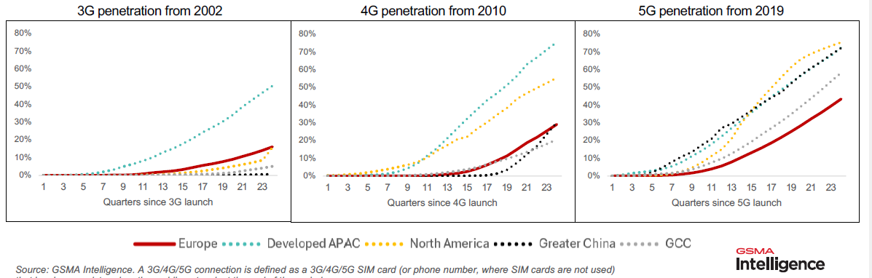
High quality 5G networks are considered a key element for a thriving digital economy. Businesses (referred to as "verticals") need to have advanced connectivity to digitize their operational processes and value chains, and drive competitiveness and profitability, while consumers require increased capacity and quality-assured mobile services.
Despite considerable differences between Member States due to the inherently different market and regulatory landscapes, the Single Market delivered on basic 5G coverage and low mobile prices for consumers, that are on average significantly lower than in the US. The Single Market underpinned by the EECC, however, did not deliver on the mass deployment of advanced wireless infrastructures and services, like 5G SA or advanced industrial and IoT services, due limited demand and investment capacity, leaving Europe considerably behind India, China and US.
Consumer experience in the EU indicates that basic 5G does not necessarily ensure a step change quality of service (QoS) compared to 4G; that can be only achieved by 5G SA, enabling slicing and QoS differentiation.
There is a significant divergence between theoretical 5G coverage and the 5G coverage and quality of 5G services actually available to the end-users. On average, in major EU cities, end-users are still connected 25% of time only to 4G.
MedUX data confirm that EU consumers and businesses continue to face frequent fallback to 4G – in major EU cities, end-users are on average 25% of time connected only to 4G as indicated MedUX field measurements - and limited access to high-quality 5G (mid-band and standalone). Further details are provided in Annex 11 (see several figures on quality of services and quality of experience).
Currently, there is still a significant number of European MNOs in an intermediate stage of 5G adoption, as they maintain the massive use of 5G NSA without a clear perspective for adopting 5G SA. This implies relevant limitations for innovative features enabled by 5G SA, including network slicing, thus preventing the efficient deployment of a set of relevant use cases. While the expectation is that in the coming few years, the EU will catch up with the other major regions regarding 5G SA, thanks to improved technology maturity, a better developed device ecosystem and a growing demand among enterprises for more advanced use cases requiring 5G SA, the competitiveness of the European economy depends on its ability to lead and not to trail in the deployment of transformative technologies.
Deployment of 5G SA networks in the mid-band is significantly more expensive than of basic 5G networks, when the cost of densification of networks is included. In terms of the spectrum used, low-band spectrum (700 MHz in the EU, 600 MHz in North America) allows rapid roll-out of networks to provide basic 5G coverage. However, due to limited capacity, a 5G network based on low-band spectrum can only provide marginal improvements in end-user experience when compared with LTE networks.
Lack of investment in 5G SA can also negatively affect the transition to and timely deployment of 6G networks, as 5G SA, with its enhanced capabilities and flexibility, is an enabling bridge towards 6G deployment and thus essential to ensure that Europe can be at the forefront of global innovation.
Based on Ookla speed tests, 5G SA availability in Europe was as low as 2% in late 2024, compared to 80% in China, 52% in India and 24% in the US (Figure A7 1-2). Most European users experience 5G mainly as faster 4G, without the full benefits of 5G SA. These include ultra-low latency, where connections respond almost instantly; greater reliability, allowing networks to remain stable even in crowded places like stadiums or festivals; and advanced features such as network slicing, which can dedicate parts of the network to emergency services, autonomous cars, or industrial automation.
Figure A7 1-2: 5G SA share of total 5G samples for different regions. Source: Ookla/Omdia (2025), A Global Evaluation of Europe’s Digital Competitiveness in 5G Standalone, p. 1.
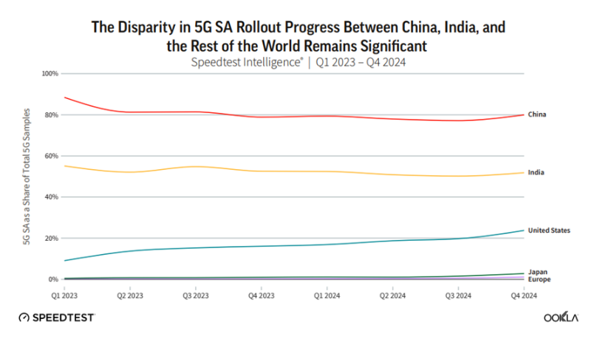
Ookla speed tests findings for Europe are in line with MedUX’s finding of 2.1% 5G SA availability when users are connected to 5G; when considering all access technologies, 5G SA accounts for only 1.2% of usage. In the international comparison, MedUX data indicate that in 5G SA adoption, the EU is far behind a number of countries (for example, India records 25% 5G SA usage and the US 18%).
Figure A7 1-3: International comparison: 5G SA usage, Source Medux
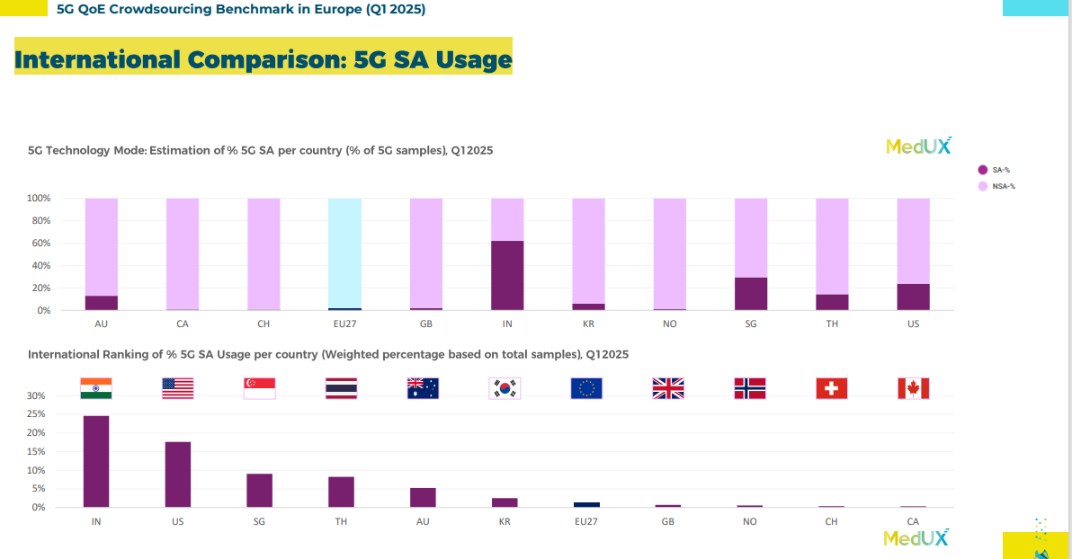

The limited deployment in mid-bands has limited the speeds achievable on 5G SA networks in Europe.
While mid- and high-band spectrum can deliver higher capacity and faster speeds it has more limited propagation characteristics, and hence smaller antenna coverage areas. Therefore, 5G SA deployments in mid-band depend more on network densification, e.g. through installing addition of small cells. North America, China, and Southeast Asia have significantly higher number of small cell deployment, compared to Western and Eastern Europe.
The Commission study also considers that limited use of mid-band spectrum in 5G deployment in Europe, despite the widespread availability of this spectrum in most Member States as of 2022, is confirmed by the lower numbers of small cells compared with those of the US and Asia as reported in surveys conducted by the Small Cell Forum (SCF).
Network densification across the EU remains well below the levels required to support advanced 5G services . Without significant densification, especially in bands above 3.6 GHz (e.g. mm-wave bands), the promise of 5G to support high-throughput, low-latency industrial use will remain unfulfilled.
From the societal perspective, the rate of fully-fledged 5G deployment has direct repercussions in terms of quality of experience for end users. EU27 average download speed stands at 69.9 Mbps, which is lower than South Korea (162.2 Mbps), the US (129.3 Mbps) and China (100 Mbps) and also below international average values standing at approx. 70.4Mbps, according to MedUX data (see Figure A7 1-4 and Evaluation Report Annex 11 Appendix II B). Ookla puts the median EU speed in all mobile technologies at 117 Mbps. The number for 5G is likely to be higher if the slower results from earlier mobile generations are removed.
Figure A7 1-4: International comparison of average downlink speed, Source Medux
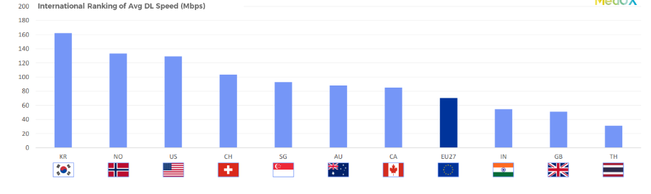
This underperformance has also economic repercussions, as Briglauer et al. (2025) states that the adoption of mobile broadband is a key driver of economic growth in terms of GDP (See Annex 4). It is the actual speeds experienced by customers and businesses that result in economic growth, not coverage.
The EU is also trailing other parts of the world in the deployment of private networks, which are early adopters of 5G SA. As regards the deployment of private 5G networks, in its report BEREC highlights several spectrum-related and regulatory challenges holding back the deployment of private 5G networks in the Union. Among these are in particular the inconsistent availability of dedicated frequency bands for private networks, the large variety of technical or administrative requirements between the Member States resulting in complexity with regard to the licensing procedure and price variations, challenges pertinent to the specific characteristics of stakeholders (like the timely licensing for private networks that will cover urgent circumstances, or the differentiation of the license with regard to its duration) or the contradiction between the need for temporary licences and location-nomadic licences (e.g. for media production for outdoor events) and longer-term licences (e.g. at ports).

Investment needs
As regards investment needs, a Commission study estimated in 2023 a need of EUR 11.5 billion investments for ‘basic 5G’ (upgrade existing 4G sites), but indicated that the ‘full 5G’ (stand-alone 5G) deployment will require EUR 33.5 billion for network densification. In addition, between EUR 26 billion and EUR 79 billion is needed for main transport corridor connectivity, depending on deployment options.
These investment needs are expected to be covered mainly through private investments, with a very limited and targeted support from State aid in cases where a market failure has been clearly demonstrated. While many Member States have implemented substantial programmes to grant public support for the roll-out of fixed broadband network in market failure areas, the amount of State aid for the deployment of mobile networks notified to the Commission under the Broadband Guidelines has been much more limited and is concentrated in a few countries (notably Italy, Spain and Germany). Article 52a of the General Block Exemption Regulation also foresees the possibility to grant State Aid for mobile network deployment without a notification if several conditions are fulfilled including the existence of a market failure, the use of open and competitive selection procedures, the imposition of wholesale access obligations, and the respect of proportionality and transparency requirements..
The JRC’s update of “Mapping of EU Funds to Digital Decade Targets 2021–2027” estimates a Digital Decade-related budget of approximately EUR 177 billion. Within this funding, support for 5G remains relatively modest compared to funding of fixed broadband initiatives. Notably, the CEF Digital programme’s ”5G and Edge Cloud for Smart Communities” and “5G corridors” strands had a dedicated budget of EUR 227 million for 2021–2027, with an additional EUR 106 million transferred from other strands already awarded. This funding targeted early 5G deployments focused on socio-economic use cases, particularly for public administrations and providers of services of general economic interest (e.g., hospitals, schools, municipalities), as well as enhancing 5G coverage along key transport corridors. The level of funding specifically allocated to the rollout of 5G SA networks remain limited.
Further, the Recovery and Resilience Facility (RRF) has supported 5G rollout across a broader range of use cases. For instance, Italy’s 5G Plan allocates EUR 2.02 billion to incentivise deployment in areas of market failure, while Spain has committed EUR 680 million to extend 5G SA networks in underserved rural areas. The General Block Exemption Regulation (GBER) has facilitated the use of additional funds managed by Member States to improve mobile connectivity in underserved zones. The currently limited use of the GBER, inter alia by exempting under Article 52a, aid for 4G and 5G (with Member States reporting EUR 5.78 million in block-exempted aid up to 2023) reflects primarily the fact that most 5G rollout has taken place in commercially viable areas where no market failure exists, rather than any constraint arising State aid rules. Overall, while CEF Digital, RRF, and funds managed by Member States (including EU funds under shared management) collectively provide several billion euros for targeted 5G initiatives, total public funding dedicated specifically to 5G remains significantly lower than the multi-billion euro investments directed toward fixed broadband under broader digitalisation programmes, confirming that the vast majority of 5G deployment has been driven by private investment. This trend is expected to continue in the future, with public financing limited to cases of demonstrated market failure.
According to the Commission study, the limited use of State aid for 5G may have constrained support for higher-risk investments, in particular given that demand for innovative applications enabled by 5G is still at an early stage.

Satellite: Barriers to the development of advanced and resilient connectivity
Before turning to the specific barriers to develop resilient connectivity though pan-European satellite services, it is important to outline the technological context to clarify the broader policy implications.

Non-Terrestrial Networks in 5G and 6G
Synergies between mobile (terrestrial) and satellite (non-terrestrial) network components began emerging within the 5G ecosystem, marked notably by the 3GPP’s standardization of 5G over Non-Terrestrial Networks (NTN) in Release 17 in 2022. Rel-17 provided detailed specifications enabling 5G systems to incorporate satellite components, thereby unlocking new possibilities of communication and innovative services over satellite networks. Since then, numerous partnerships between telecommunications companies and satellite operators have been announced worldwide. In nearly every country, satellite operators are actively seeking market access, while regulators face increasing pressure to establish appropriate regulatory frameworks.
One of the fundamental technological advancements introduced by 6G will be the seamless integration of terrestrial and non-terrestrial networks (NTNs) into a unified system architecture. This hybrid approach will combine traditional ground-based infrastructure (for example base stations) with non-terrestrial components—most notably Low Earth Orbit (LEO) satellite constellations—enabling ubiquitous, resilient, and high-performance connectivity on a global scale.
Figure A7 1-5: 6G-NTN network architecture
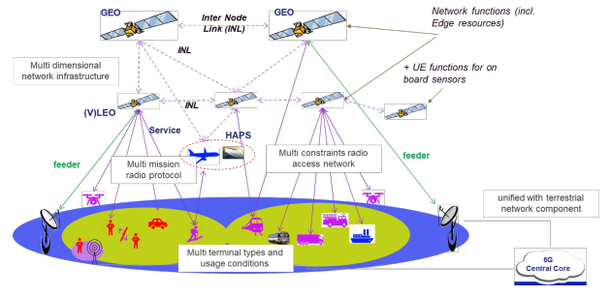
Source: 6G-NTN project
A disruptive capability of NTN components—such as LEO satellite constellations—is their ability to provide direct-to-device (D2D) connectivity. This means they can deliver seamless, high-speed access to smartphones, to antennas mounted on moving platforms like trains, aircraft, or ships, as well as to IoT sensors deployed in remote agricultural fields via non-terrestrial connectivity systems.
While satellite connectivity was primarily used for backhauling traffic from remote base stations (satellite broadband services), with the advent of 6G, a major shift is underway. Emerging NTN platforms—including LEO satellites, high-altitude platforms (HAPS), and drone-based networks—are now being designed to offer direct connectivity to end users. This evolution marks a significant transformation in network architecture, enabling ubiquitous, reliable access without reliance on ground infrastructure. Most importantly, it poses a structural challenge to existing regulatory frameworks, which have traditionally maintained a strict separation between terrestrial mobile communications (IMT) and satellite communications. The convergence of these two domains under 6G's hybrid architecture necessitates a reconsideration of EU spectrum policy, regulation and governance structures, paving the way for a more integrated and harmonised regulatory approach.

Pan-European satellite services
In an unstable geopolitical situation of growing security risks and attacks of different nature against EU connectivity infrastructures and services, from natural disasters due to climate change to jamming or spoofing of signals used for navigation, satellite connectivity has become an essential component of a sovereign, secure and resilient connectivity ecosystem, thanks to technical progress, reduced costs and improved launch and manufacturing. Low Earth Orbit (LEO) providers now offer or develop advanced connectivity services such as Direct-to-Device (D2D), and Internet of Things (IoT) services, comparable to terrestrial mobile or fixed connectivity services. At the ITU level, the vision, requirements and evaluation guidelines for 5G satellite radio interfaces were defined, and 3GPP (a global organisation that defines the technical standards for mobile networks) has been developing specifications for 5G non-terrestrial networks (NTN), including satellite, following the acceleration of the convergence of TN and NTN (Figure A7-1-6). Satellite will be native in 6G.
Figure A7 1-6: 6G: Towards a fully integrated ecosystem (source: GSOA)
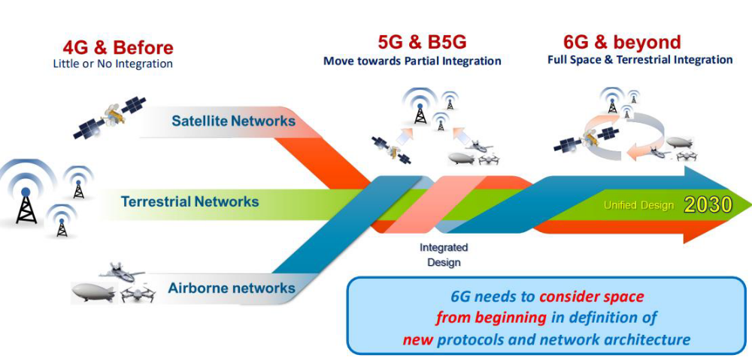
Since the 3G-PPP publication of Rel-17 in mid-2022, NTN has been integrated into the 5G/6G landscape, marking a significant milestone for the satellite community by being the first terrestrial standard to natively incorporate a space component.
Figure A7 1-7: 3G-PPP standardisation plan for 6G
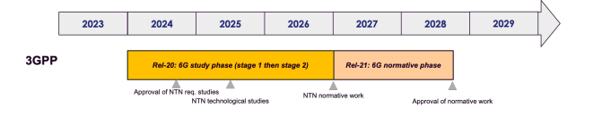
The dramatic drop in launch cost in recent years thanks to improved technology is enabling business models that would not have been viable in the past, resulting in a dramatic increase in planned satellite deployments. The great majority of this activity has been for Low Earth Orbit (LEO) constellations, each of which entails a great many satellites. A summary of NewSpace data by Detecon (2025) makes clear that the number of constellations early in the planning or prototyping stages is large (see Figure A7 1-8). The number of new satellites planned, either as extensions to existing constellations or as new constellations, totally dwarfs the total number of satellites in service today, even when one discounts the most speculative plans. This has also implication on the number of expected authorisation requests.
Figure A7 1-8: Satellite constellations launched and planned.
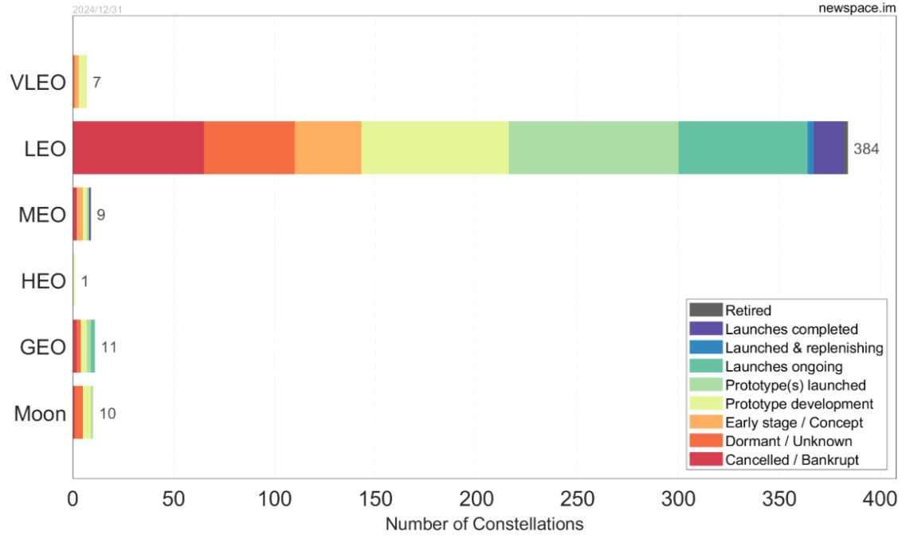
Source: newspace.im, March 2025 as reported in Majoor, R. and Perty, H.-P. (2025). Study on mobile satellite services (MSS) in the 2 GHz band in the EU: Implementation of the current regulatory framework and an overview of the satellite connectivity market, Study by Detecon for the European Commission, pp. 104-109: https://op.europa.eu/en/publication-detail/-/publication/5c28e25b-41b3-11f0-b9f2-01aa75ed71a1/language-en.
Although Europe used to be a frontrunner in satellite communications, it has failed to anticipate the innovation potential of this market and was slow to invest in LEO constellation deployment. The EU is facing critical capacity, competitiveness and sovereignty challenges, as regards launching capacity and deployment of LEO constellations as illustrated in section 2.1.2. with only 773 LEO satellites launched and 3120 planned, the EU lags behind China (i.e. 220 launched, 27 198 planned) . and the USA (i.e. 7 633 launched, 33 397 planned). The increasing dependence on third country constellations raises concerns around lock-in effects, creates the risk of “shut down” and challenges European security and strategic autonomy. Moreover, existing and planned constellations of thousands of satellites from third countries risk accumulating orbit and spectrum resources for their commercial interests, rather than EU’s strategic ones.
The convergence of satellite and mobile technologies within the 6G ecosystem represents a structural disruption to long-standing regulatory paradigms. Historically, mobile communications—governed under the IMT (International Mobile Telecommunications) framework—and satellite communications have been treated as distinct domains, each with different spectrum allocations, authorisation-licensing regimes, and other operational assumptions (i.e. national spectrum planning, regulatory bodies and other governance structures, etc). Furthermore, the increasing need for shared use of terrestrial mobile spectrum by satellite systems to provide complementary coverage in remote and scarcely populated regions exerts pressure for a revision of the ITU framework to globally allow convergence of terrestrial and satellite spectrum use. This calls for reinforced EU-coordination for the establishment of rules in support of the single market and their promotion in the ITU regulatory process. These must address the risk of interference from satellite mega-constellations, and underpin its monitoring and prevention, In this regard, serious interference cases have been reported vis-à-vis EU’s radio astronomy services from LEO constellation such as Starlink satellites could be high enough to seriously disturb ground-based observatories and space-based telescopes. Stakeholders from the radioastronomy sector stress the need of a minimally disturbed dark and radio-quiet sky for conducting fundamental research in astronomy and important public services such as planetary defence, technology development, and high-precision geolocation Similarly (unintended) LEO satellite interference could potentially affect other satellite applications, including earth observation or space connectivity. This ineffective and uncoordinated enforcement of ITU interference rules against harmful radio frequency interference at EU is likely to become more challenging with the growing global demand of LEOs satellites to access satellite spectrum.
In response, the EU Infrastructure for Resilience, Interconnectivity and Security by Satellite (IRIS2) consortium up to 2030 was developed to provide secure connectivity services to the EU and its Member States as well as broadband connectivity for governmental authorities, private companies and European citizens, including in underserved areas. Among others, the current barriers would impede IRIS2 constellations access to the spectrum.

Fragmentation in satellite authorisation
There is wide evidence on the fragmentation of the satellite authorisation systems in 27 MS as confirmed by a recent study on MSS, previous studies and as described in Section 2.2.4.
Against this background of exponential growth of the number of satellites, and of by default limited availability of spectrum resources, there are several barriers that can prevent the development of EU wide services. An important barrier is the increasing risk of interference that can distort competition especially if enforcement mechanisms are not effective, and do not ensure a level playing field in accessing spectrum resources leading to inefficient use of resources. An additional barrier is also represented by technical and legal obstacles to the provision of cross-border satellite services, and navigate through different authorisations in each Member State with different procedures, national conditions and fees and the risk that the service is not authorised in all MS.
Evidence of this fragmentation is presented in studies related to the MSS authorisation process in all Member States conducted for the Commission in 2014, 2019, and 2025 that clearly demonstrate that there was a great deal of variability in (1) the nature of the authorisation and spectrum assignment, (2) when it was authorised with spectrum assigned, (3) the fees that the selected MSS operators had to pay to each Member State, and (4) the handling of CGCs.
As far as the nature of the authorisation and spectrum assignment, the situation as of 2019 was:
- License exemption (i.e. no license required): Austria.
- General authorisation: Belgium, Croatia, The Czech Republic, Denmark, Estonia, Finland, Hungary, Ireland, Lithuania, Luxembourg, The Netherlands, Poland and Sweden.
- Individual rights of use: Bulgaria, Cyprus, France, Germany, Greece, Italy, Latvia, Malta, Portugal, Romania, Slovakia, Slovenia, Spain, United Kingdom.
The individual rights of use granted in Bulgaria, Cyprus, Germany, Greece and Portugal covered both the satellite and terrestrial CGC component, thus facilitating implementation of an integrated MSS and CGC network. Elsewhere, MSS and CGC rights are distinct.
As for when each selected company was authorised with spectrum assigned, the steps taken at the EU level probably accelerated the process, but it was still slow and highly variable. Even though the selection was completed in 2009, five years later it was still early days. “As of the end of March 2014, Solaris [was] entitled to use the specific radiofrequencies and to operate a mobile satellite system (MSS component) in seventeen Member States. Inmarsat [was] entitled in nine. As of the end of March 2014, Solaris [was] entitled to provide CGCs in four Member States. Inmarsat [was] entitled only in one jurisdiction.”
As regards fees, Table A7 1-1 presents the high level of variability in the fee structure for satellite authorisation in the MSS band with conditions covering the full range of options no fees, one-time administrative/assignment/authorisation fees, annual radio spectrum use fees and other annual fees.
Table A7 1-1: MSS fee structure, per Member State (as of 2019)
Applicable fees |  | Member States
No fees |  | AT, HR, DK, EE, FI, IE, LV, LT, LU, NL
One-time administrative/ application fee |  | BE, CZ, EL, ES, HU, IT, MT, PT, SE, SK
Annual radio spectrum user fees | Fixed amount | BG, EL, IT, MT, PL, RO
Annual radio spectrum user fees | Radio spectrum reserved/ bandwidth | FR, SI, SK ES
One-time assignment/ authorisation fee |  | BG, DE
Other annual fees |  | BE, BG, CY, EL, ES, FR, PT, SE, SI SK

Source: Based on Pujol, Frédéric, Manero, Carole, Enjalbal, Ariane, Carle, Basile and Victoria Gerus (2019). Mobile Satellite Services (MSS) authorisation regimes, authorisations and enforcement in the EU Member States, study for the European Commission: https://op.europa.eu/en/publication-detail/-/publication/7997aa72-d865-11e9-9c4e-01aa75ed71a1/language-en.
The conditions for CGCs are even more varied. Recital 18 of the MSS Decision explains the following: “Complementary ground components are an integral part of a mobile satellite system and are used, typically, to enhance the services offered via the satellite in areas where it may not be possible to retain a continuous line of sight with the satellite due to obstructions in the skyline caused by buildings and terrain. In accordance with Decision 2007/98/EC, complementary ground components use the same frequency bands as MSS (1980 to 2010 MHz and 2170 to 2200 MHz).
A more recent study confirms that though many Member States are authorising satellites under general authorisation, the conditions attached to the general authorisation differ significantly and, according satellite operators, are not always suitable for satellite operators. The Ground segment requires individual authorisations in all Member States, which is accompanied with lengthy coordination procedures and complex requirements especially in some Member States. While such requirements can be met by large, experienced market operators, they are difficult to satisfy for new-comers, New Space SMEs and startups.

D2D communications market potential
With 6G enabling direct-to-device (D2D) communications, the clear demarcation between terrestrial and satellite networks is becoming increasingly obsolete. This blurring of boundaries necessitates an integrated regulatory response to avoid fragmentation and interference issues, especially in spectrum bands that will be shared across terrestrial and satellite operators. Therefore, to fully capitalize on the potential of future hybrid connectivity scenarios in Europe—where users seamlessly transition between terrestrial base stations and non-terrestrial network (NTN) satellite nodes—it is required to: i) issue EU harmonised spectrum authorisations for operators providing hybrid services and ii) promote spectrum sharing between terrestrial and satellite systems as endorsed in the RSPG opinion on 6G vision. Ultimately, the risk for the EU is to miss the opportunity for the timely deployment of autonomous and sovereign satellite systems, in particular for catching up with the advance of large-scale LEO/MEO satellite constellations, in order to secure self-sustained global, low-latency broadband services both, for the governmental and business use cases. Such satellite systems are crucial for the provision of (D2D) connectivity, i.e. satellite communications directly to mobile or fixed mass market equipment such as off-the-shelf mobile phones, modules on board transport vehicles or IoT sensors, using either terrestrial of dedicated mobile satellite spectrum (such as the EU-harmonised 2 GHz/S-band). The benefits of sovereign D2D service availability include the removal of the present dependence on non-EU satellite operators, and the deployment of convergent, ubiquitous, secure and resilient wireless services across the Union, especially for emergency situations and PPDR. It should be noted, that the D2D market is rendered an important economic potential. According to GSMA intelligence, the global market size for D2D is set to rise from 25.88 in 2025 to USD 32.74 billion in 2035 (an increase of 26.5%) the whole market.
According to Analysys Mason the global satellite direct-to-device market could generate USD 137 billion in cumulative service revenue between 2022 and 2023.
Figure A7 1-9: Satellite D2D service revenue, worldwide, 2022–2032
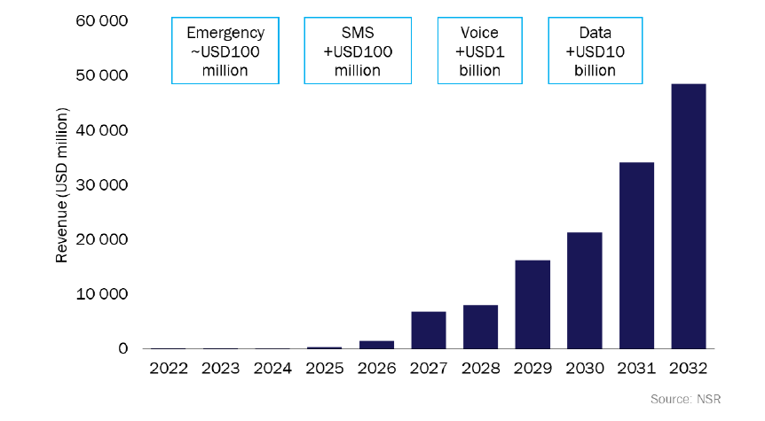
Source: NSR
Recently, alternative business models have begun to take shape, diversifying the landscape of the industry. While today some models rely heavily on customer acquisition and significant capital investment (each new user requires the purchase and installation of hardware such as a dish and a router), other strategies consist of developing space-based mobile networks designed to connect directly to unmodified smartphones. This latter approach circumvents the traditional hardware requirement by deploying satellites equipped with large phased-array antennas that function as orbiting cell towers (similar to terrestrial base stations in the space), delivering mobile broadband directly to users’ smartphones, which eliminates the need for dishes, satellite phones, or any additional user hardware.
Currently, smartphones do not support 3GPP NTN (Non-Terrestrial Network) standards, so satellite operators must partner with mobile network operators to access terrestrial frequencies and reach smartphone users. These models are proposed by AST SpaceMobile (who has already an agreement in Europe with Vodafone) or Skylo (who uses satellites from Viasat and Echostar both licensees the 2GHz MSS band), that completely change the economic approach by focusing on the smartphone—the device already used by around five billion people globally. Through a single commercial agreement with a mobile carrier (who increases network coverage without substantial CAPEX given that satellite networks can already cover large territories), millions of users can be reached at once. However, these partnerships with mobile operators are likely a transitional solution. Once the chips in the smartphones begin to support 3GPP NTN standards, LEO (Low Earth Orbit) satellites will be able to connect directly to smartphones, eliminating the need to rely on terrestrial networks. This particular model proposed by SpaceX will put emphasis on the large-scale connectivity establishing a new connectivity market with global scale, i.e. billions of world-wide smartphone users, rather than individual sales and/or wholesales, and this difference, in the telecommunications sector, is highly significant with major regulatory implications.

Problem drivers
This section provides additional details for the problem drivers presented in Section 2.2 of the main document.

Factors slowing down the deployment and adoption of fibre networks/services

Regulatory approaches, business choices and persistence of copper networks
The table below provides an overview of the application by NRAs of provisions related to SMP findings and access obligations. The differing regulatory approaches by NRAs contributed to the variations in fibre deployment and take-up.
Figure A7 2-1: Overview of application of EECC provisions Articles 22, 26, 61 (3), 72-80
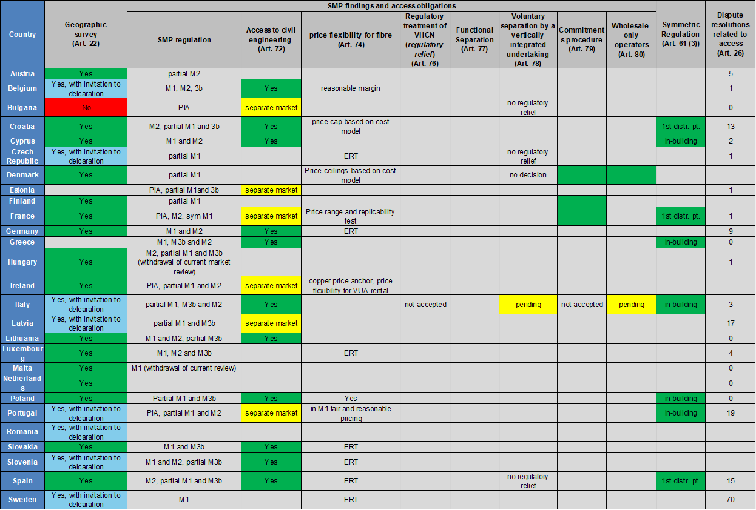
Source: WIK’s interim report
In addition, the following table provides an overview of the degree of infrastructure competition and regulatory approaches taken towards FTTC / VDSL and FTTH in a sample of 15 European countries (14 EU + the UK) and juxtaposes these against outcomes in terms of FTTH coverage, take-up, retail competition (via HHI), and retail pricing.
Figure A7 2-2: Overview of degree of infrastructure competition and regulatory approaches with outcomes in terms of FTTH coverage, take-up, retail competition and retail pricing.

 | Regulatory approach |  |  |  |  |  | Outcomes
Country | Strong SMP PIA (to support alternative deployment) Y / N | Role of infrastructure competition (pre-existing + regulatory focus) | Use of Art 61(3)? | Declarations to deploy consistent with Art 22 EECC? | Support for FTTC / VDSL deployment e.g. through low SLU price or long-term pricing / pricing flexibility? | Flexibility or forbearance on regulation of FTTH? | FTTH coverage = FTTH homes passed / total household (Digital Decade DESI 2025) | FTTH take-up = FTTH subscriptions / total FTTH homes passed (data for 2024 from FTTH Council) | HHI | Gigabit take as % BB lines (DESI 2025) | Gigabit pricing absolute per month, double play | 100 Mbit/s FTTH or cable pricing in relation to 30Mbit/s %
 | FTTC / VDSL focus
Germany | N (SMP PIA Ref Offer since 2024) | Pre-existing cable but partial coverage | Y (in-building only) |  | Y vectoring + long-term pricing | Y (ERT) | 37 | 26,4 | na | 5.7 |  | 18%
Austria | N | Pre-existing cable but partial coverage | N |  | Y – retail minus / encouragement of vectoring, then commercial agreement | Y – retail minus, then commercial agreement | 45 | 24,7 | Higher than average, decreasing | 1.2 |  | 25%
UK | Y (separate market) | Pre-existing cable but partial coverage |  |  | Y pricing flexibility FTTC / VULA | Y | 73 | 37.1 |  | 6
Greece | Y (remedy M1) | No cable, regulatory efforts to enable new entry | Y (in-building only) |  | N? | N (CO) | 46 | 28,3 | na | 0 |  | 4%
Czechia | N | Pre-existing cable but partial coverage | N | Y | Y (ERT) | Y (ERT) | 41 | 45,4 | Lower than average, increasing | 4,3
Italy | Y | No cable, regulatory efforts to enable new entry | Y (in-building only) | Y | Y SLU pricing | N | 71 | 27,6 | Lower than average, decreasing | 25,2
 | Early FTTH focus incl. SMP PIA in-building standards and access
France | Y (separate market) | No Mutualisation Art 61(3) -> 80% HH monopoly in FTTH | Y (first distrib point – 1,000 HH in less dense areas) | Y | N | N | 87 | 83,8 | na | 58,9
Spain | Y Remedy M2) | Pre-existing cable partial coverage + regulatory focus on additional infrastructure competition | Y (first distribution point, but with restricted no. HH) |  | N | Y | 95 | 91 | Lower than average | 25,4
Portugal | Y (separate market) | Pre-existing cable (extensive) + regulatory focus on additional infrastructure comp | Y (in-building only) | Y | N | Y | 93 | 89,9 | na | 15,1 |  | 8%
 | Duopoly – nationwide historic cable
Netherlands | N | Pre-existing nationwide cable | N |  | Y – long-term pricing / commercial offers | Y – long-term pricing / commercial offers | 85 | 38 | na | 10,5 |  | 6%
Belgium | N remedy in M2, but limited ducts | Pre-existing nationwide cable | N | Y |  | Y (reasonable margin) | 31 | 35,7 | Higher than average increasing | 5,5
Malta | N | Pre-existing nationwide cable | N | N |  | Y (ERT) | 86 | 59,4 | Higher than average, stable | 17
 | Early regional / public / utility FTTH investors
Sweden | N | Municipal networks have significant coverage | N | Y |  | Y (ERT) | 86 | 81,9 |  | 9,8
Denmark | N | Utility networks have significant FTTH coverage | N |  |  | N – currently price ceilings based on cost model | 87 | 56,5 | Lower than average, decreasing | 33,7
 | Cable & FTTH consolidator
Romania | N | Former cable operator engaged in early FTTH deployment & consolidation | N | Y |  |  | 96 | 81,7 |  | Higher than average, increasing |  | 34,2
Source: WIK’s interim report

In the table above, Member States have been grouped based on common characteristics that could influence market outcomes. This enables an analysis of the effects of similarities and differences in the regulatory or wider political approaches.
- First group: FTTC/VDSL group
The first group covers Member States in which FTTC / VDSL has played a significant role. This includes Germany, Austria, Belgium, the UK, Greece, Czechia and Italy. A common feature amongst most of these countries is that regulatory incentives were given for the deployment of FTTC VDSL. In Germany this included support for FTTC VDSL vectoring by the incumbent and support for long-term pricing arrangements for FTTC VDSL Layer 2 bitstream that locked in alternative operators into multi-annual VDSL access arrangements. Flexible pricing for FTTC VDSL VULA was provided in Austria, the UK and Czechia, while in Italy, the regulatory regime supported competition in the deployment of FTTC VDSL through reductions in pricing for subloop unbundling and regulatory approaches which sought to limit the use of vectoring that would have impeded competition in the upgrade of the subloop with VDSL. Outcomes in this group of countries regarding FTTH coverage and take-up and the associated levels of take-up of Gigabit broadband are poor, with the exception of Italy. Italy’s significantly higher FTTH coverage than the other countries in this group may be explained by a number of factors. These include the significant use of EU Funding to support FTTH deployment and policies that facilitated FTTH deployment by the alternative fibre investor Open Fiber, including shareholdings from the public investment body CDP and (at the outset the utility Enel), stringent application of the BCRD to utility duct and pole access, SMP PIA regulation, access to in-building fibre wiring under Article 61(3), and a system of declarations that sought to identify black, white and grey areas for fibre investment. High coverage of FTTH in Italy along with infrastructure competition has resulted in low prices and relatively high take-up of Gigabit broadband compared with many other countries. However, infrastructure competition between FTTC and fibre, which limited take-up at wholesale level has been a key factor underlying the underperformance of Open Fibre and its ability to carry out the network. Finally, Belgium, where the number of vectored copper/VDSL lines is significant is characterised by low fibre roll-out, high prices and limited use of passive infrastructure.
As regards Czechia, while Gigabit broadband offers are available at an affordable price, the footprint is limited by the limited coverage of FTTH in this market. It is notable that Gigabit pricing is particularly high in Austria. This market is one of only four cases in which WLA SMP regulation was removed, as it was considered that commercial wholesale offers would be sufficient to support competitive outcomes. However, the prevalence of active access in this market with high charges for higher bandwidths may limit the prospects for competition on quality.
- Second group: early FTTH focus with SMP PIA and Art. 61(3)
The second group of Member States listed focused on the deployment of FTTH from an early stage (pre 2010) and designed the regulatory approach with this aim in mind. This group includes France, Spain and Portugal. Common features of the regulatory approach in this group were strong and early regulation of SMP- based access to physical infrastructure, coupled with standards for in-building fibre wiring and rules regarding access to such wiring consistent with Article 61(3) EECC. Systems involving declarations regarding the deployment of FTTH were also applied in France and Portugal. However, there are also some important differences in the approaches that were taken. France sought to limit unviable duplication of FTTH networks from the outset by requiring the mutualisation of fibre terminating segments (essentially unbundled fibre loops) at points enabling access to at least 1,000 households in areas outside the most densely populated conurbations. This meant that for around 80% of total households, only one fibre access line was constructed, thereby creating a monopoly on fibre. However, the deployment of fibre to these households was linked to access obligations which included requirements to offer co-investment through Indefeasible Rights of Use (IRU) and rental, at rates which were ultimately determined by the NRA via dispute resolution based on principles of cost-orientation with a premium to reflect risk (including risk relating to the timing of the co-investment). France is one of the only countries in the EU to have applied Article 61(3) in an extensive way, going well beyond access to in-building wiring to stipulate a location for connection which was considered viable for access seekers. Conversely, Portugal took a considerably more conservative approach to access regulation, limiting its application of Article 61(3) to in-building wiring, and forbearing from SMP access regulation on FTTH for a considerable period, while encouraging infrastructure-based competition (duplication of fibre access networks). While SMP access obligations on FTTH were eventually introduced in Portugal, they cover a small proportion of access lines.
The regulatory approach taken in Spain falls somewhere in between the two. While, like Portugal, there was a strong emphasis on infrastructure competition and forbearance on access to FTTH at higher speeds for some time, access to fibre terminating segments was provided under Article 61(3) to small groups of households in some cases, and SMP WLA regulation was eventually applied outside areas characterised by infrastructure competition.
All three of these Member States have achieved very high levels of FTTH coverage and take-up. However, differences can be seen in the pricing and take-up of Gigabit broadband, with extremely high take-up rates of Gigabit broadband in France (59% of broadband connections), but relatively low rates in Portugal, and mid-level rates in Spain which might be explained by the higher price premiums for Gigabit broadband in those countries. It seems likely (also taking into account experience in Italy) that the universal availability of passive access to fibre (fibre unbundling) in France on the basis of IRU, coupled with the limitations on infrastructure duplication may have enabled lower overall costs than in Spain and Portugal and increased competition on quality and thus lower prices for Gigabit offers. France is also one of the few out of those countries for which data was available where significant fibre investment had occurred, and alternative broadband providers were able to meet or approach their cost of capital.
- Third group: Presence of copper and cable network operators
Member States characterised by the historic presence of the incumbent and cable include Belgium, the Netherlands and Malta. Belgium can also be mentioned here, as it also displays characteristics of this group of countries (in addition to the characteristics related to the first group). SMP PIA has not been mandated in Malta or the Netherlands and plays a very limited role in Belgium also because of the limited presence of ducts in Belgium. However, SMP access regulation or other measures with a similar effect has been applied with a focus on active rather than passive wholesale products. In Belgium, SMP access regulation was applied to the incumbent and cable operator, while in Malta SMP access regulation applies only to the incumbent. In the Netherlands, the incumbent entered into binding commitments following a market investigation under competition law. Flexible approaches to wholesale price regulation on fibre access have been applied in these countries, with Economic Replicability Test (ERT) in Malta, reasonable margin in Belgium and long-term pricing arrangements in the Netherlands. While there are some similarities in market structure, there are significant differences in outcome. While the Netherlands and Malta have achieved high fibre coverage rates and moderate fibre take-up (limited by the existence of parallel cable networks), very limited fibre deployment has occurred in Belgium.
Indeed, in Belgium, wholesale competition is mainly driven by regulated access to cable (not fibre) networks. There are also notable differences in outcomes for consumers, with high prices and low take-up for Gigabit offers in Belgium, while low prices have been reported for Gigabit offers in Malta.
- Fourth group: Early regional / public / utility FTTH investors
Sweden and Denmark are characterised by regional fibre operators, controlled by municipalities in the case of Sweden and by utilities in the case of Denmark. These players have been the primary contributors to high coverage of FTTH in these countries, although incumbents have also deployed FTTH in certain areas or to certain types of dwellings e.g. SDUs in Sweden. FTTH take-up is significantly lower in Denmark than in Sweden, likely as a result of the presence of a competing cable network owned by the incumbent, which may have impacted profitability of Danish fibre utilities such as Fibia. As the primary investors in FTTH in these countries have been able to exploit their own duct and pole facilities and there are limited expectations regarding additional infrastructure competition, there has been limited focus on regulation of PIA or regulation of access to in-building wiring. Attention has focused more on promoting competition in retail markets through SMP regulation. In Sweden, the SMP access regime currently in force applies only on the incumbent (based on ERT for fibre unbundling). While data from the NRA suggests that municipalities have very high market shares on fibre in many areas, in particular for Multi-Dwelling Units (MDU), and do not always operate on the basis of passive-only networks, these networks are not currently subject to access regulation. In contrast, following a recent market review, certain regional fibre utilities have been designated as having SMP in Denmark. Access regulation has been applied but is on the basis of bitstream. Gigabit pricing is higher and take-up of Gigabit connections is lower than may be expected given the long history of FTTH deployment in these countries. It is possible that this may be affected by limitations in competition on quality that may result from the lack of demand for and access to fibre unbundling in the Danish market alongside the lack of attention to access conditions from municipalities in Sweden in areas where they have a leading position in the supply of wholesale fibre access. The Finnish market is historically divided into local geographic markets with local incumbents. In some of those geographic markets there are wholesale-only, open networks which remain unregulated due to the absence of competition problems.
Finally, in Ireland, the joint venture between local energy company and alternative operator (Vodafone) is deploying an alternative fibre wholesale-only network to the one currently being rolled out by the local incumbent. This is complemented in Ireland by deployment under the State aid framework, with open wholesale access.
- Fifth group: Competitive constrains stemming from alternative networks in densely populated areas – Poland and the Baltic states
Investments in fibre are also indirectly driven by existing competition, in particular from hybrid coax-fibre networks. Large scale investments in fibre, followed by partial deregulation took place in larger cities of Poland, due to the presence of upgraded cable networks offering much better quality of services than the incumbent’s copper network. Similar situation can be observed in Latvia and Estonia where large cities are characterised by infrastructure-based competition and fibre investments. In those areas access to physical networks (ducts and poles) is not imposed to facilitate investments in independent networks. The regulated access to cables is however needed in more rural areas.
An analysis of access regimes under the EECC and outcomes for competition, investment and consumer welfare suggests that the current access-related rules under the EECC have enabled certain countries to achieve highly positive results, but some regulatory approaches did not support or even delayed the achievement of the Gigabit connectivity targets.
The analysis of practices across the EU suggests that high fibre coverage has been driven by infrastructure competition in the presence of low barriers such as access to SMP ducts or low deployment costs (e.g. Spain, Portugal, Romania) and/or central planning e.g. France, which made use of geographic surveys, symmetric regulation and declarations to limit duplication of fibre networks and provide investor certainty by limiting the risks of overbuild. Public authorities support either by state aids or by direct investment via publicly owned company has also played an important role.
A common factor amongst the countries which lag furthest behind in FTTP deployment is that they feature FTTC/VDSL deployment by the incumbent (e.g. Austria, Belgium, Germany and Italy). The deployment of this interim technology (‘vectoring’ which allows elimination of cross talks for higher bandwidths) may have provided short term gains in terms of lower capital intensity, while improving services to customers (e.g. downstream/upstream rate 250/40 Mbps and for very short copper lines up to 100 meters – Gbps bandwidth is possible). However, the strategy to deploy FTTC led to a deferral by incumbents of required investments in FTTP to a later stage. In addition to deferring the incumbents’ investments, the availability of FTTC / VDSL may also have served to deter deployments in fibre by alternative investors, by limiting the performance gap between copper and fibre. In turn, this has hindered take-up of fibre, further undermining the business case. If the demand/take-up developments do not meet the expectations of operators and/or investors, the incentive to invest further and to invest in new infrastructure projects is reduced.
Profitability of the operators
Regulation also has consequences in terms of revenues and profitability of the telecom operators. However, it is important to note that regulation is only one of many factors that influence these financial outcomes. It must be noted from the outset that while segmented fixed and mobile Average Revenue Per user (ARPU) data may be available, profitability is generally only provided in aggregate form, collating the results from fixed and mobile together, and often also combining results from multiple countries, in particular for smaller markets.
With that said, the financial results show that there are differences in profitability between vertically integrated telcos in different European countries, and in many cases differences between the profitability of incumbents compared with alternative operators / access seekers (with incumbents typically being more profitable). It is possible that (along with other factors), aspects of the regulatory regime which affect FTTH deployment and associated investment requirements and the duplication of FTTH networks (infrastructure competition) may have influenced the different outcomes seen.
An overview of results from one of the Barclays 2024 reports is provided below. It appears that all incumbents are meeting their cost of capital apart from Telecom Italia. The financial performance of alternative operators is lower, but there are country-specific variations. The following list provides an overview from strongest to weakest financial performance, in terms of the number of players with Return on Capital Employed (ROCE) close to or exceeding the company-specific Weighted Average Cost of Capital (WACC) (or incumbent WACC where not provided):
- In Germany, all the main broadband providers listed are profitable or appear close to profitability, with particularly strong performance from the incumbent and from 1&1, which was at the time of the data provided, mainly a service provider (in both fixed and mobile). TF Deutschland is not profitable, but as its broadband market share and fixed investments are understood to be limited, this may result from dynamics relating to the mobile market.
- In France, the incumbent and two of the main alternative broadband providers are profitable or appear close to profitability. Only Altice is reported as making very low returns, although its company-specific WACC is not given.
- In the Netherlands, the incumbent is highly profitable. The alternative operator Odido’s ROCE is significantly lower (and below the incumbent WACC), while Vodafone Ziggo is not meeting its WACC.
- In Spain, the incumbent is significantly exceeding its WACC, but its competitors are falling significantly short of their cost of capital.
- In Italy all operators are falling far short of their cost of capital.
The degree of investment in FTTH (and associated cost) and the timing of that investment is likely to have affected profitability as well as the extent to which FTTH networks were duplicated as opposed to shared amongst broadband providers. This could for example have contributed to higher levels of profitability in Germany, which had limited FTTH deployment as of 2023. In contrast, in Italy the acceleration in FTTH deployment, infrastructure competition from Open Fiber and relatively low retail prices may have contributed to low levels of profitability including for the incumbent. However, other factors including commercial decisions and debt levels are also likely to have played a role. In Spain, the focus on infrastructure competition, requiring high levels of investment by all broadband players may have contributed to low levels of profitability amongst alternative broadband operators.
In contrast, the relatively higher levels of profitability amongst alternative operators in France compared with other countries may have been supported by limitations in FTTH duplication, encouraged by regulatory policies which favoured co-investment rather than infrastructure competition, alongside the earlier deployment of FTTH (compared with Italy and Germany) and associated higher take-up.
Data available to WIK shows that specialist alternative fibre investors are amongst those with the most troubling financial results. While municipal operators such as Stokab have been able to achieve adequate returns on capital with early fibre investment using a wholesale only model to stimulate take-up, others e.g. Fibia, SIRO, Open Fiber and CityFibre with later FTTH investments, greater reliance on debt and in a market with significant competition, are yet to translate their investments into profitability. Amongst investors for whom data is available, low take-up seems to be a particular concern. It is notable that in all cases with the exception of Stokab, which deployed fibre from the early 2000s, at a time when the performance available from competitors on copper and cable was limited, fibre was deployed by the other regional operators listed in competition with upgraded cable networks (in particular by TDC in Denmark) and FTTC/VDSL (by incumbents and access-seekers in Italy, the UK and Ireland). The duplication of fibre networks deployed by fibre investors by incumbents in the UK, Ireland and Italy is likely to have presented another challenge. Poor financial outcomes amongst the alternative fibre investors described above may have been influenced by policies in some countries which actively favoured the prolongation of copper infrastructure through promoting FTTC/VDSL deployment by incumbents. In turn, the improved quality on copper networks is likely to have deterred consumers from switching to fibre. In addition, the overall profitability for some operators still using FTTC/VDSL infrastructures did not incentivise their move towards fibre.
Although regulatory approaches appear to have impacted operators’ profitability to some extent – among other contributing factors - this does not allow us to infer that the operators showing higher profitability were those that invested more heavily in fibre.

Persistence of copper networks slows down the deployment and adoption of fibre networks/services
A forward-looking assessment to support coverage and target potential regulation in a full fibre environment should include an assessment of the replicability of fibre networks, as well as identifying potential gaps, which may need to be addressed via State Aid. However, to date NRAs can only rely on Article 22 EECC (geographic surveys) of the Code, which does not include an assessment relating to VHCN or fibre coverage and instead allows data gathering based on speeds of only 100 Mbps. Provisions relating to forecasts are also optional. Therefore, the evidence available to NRA to inform their regulatory decisions and recommend policy choices to policy makers is limited.
In addition, the current prioritisation of SMP regulation over symmetric measures may have deterred the use of measures which would have been more suitable to supporting sustainable investment and competition in a fibre environment. It should be noted that the EECC mandates NRAs to carry out market analyses on relevant markets that have been identified as susceptible to ex ante regulation via the publication of such markets in the Relevant Market Recommendation by the Commission, and to regulation based on SMP where this is found. This focus on SMP regulation is mirrored in the large number of provisions that have been developed to guide the application of SMP regulation under the EECC, some of which have proven not to be effective. In contrast, while it has proven to be very effective in supporting sustainable competition and investment in fibre when applied in an extensive way e.g. in France, the application of Art 61(3) which allows NRAs to mandate “symmetric access” to fibre terminating segments is optional and the burden of proof is high when mandating access at points beyond in-building wiring, up to first distribution point.
Meanwhile, the proportion of wholesale access lines which may be physically rented by access seekers (allowing for unbundled access), which permits the widest degree of innovation as the access seeker has a full control of the rented line, remains limited, at a constant 20% of incumbent FTTH lines.. Although many NRAs impose access to passive infrastructure (ducts and poles) to allow investments in own fibre networks, active access to the existing lines of SMP operators still remains indispensable in a large number of markets. The majority of currently deployed FTTH lines, due to their physical characteristics, cannot be rented but may be used for wholesale products which restrict access seekers from utilising the full capabilities of the infrastructure or tie such capabilities to prices set by the access provider. This could serve to limit competition on quality, undermining the provision and take-up of Gigabit offers.
To illustrate the problem, the figure below shows the types of access to FTTH provided on incumbent networks. WIK concludes that these are frequently based on (or favour through pricing conditions) active access in forms which limit service differentiation,.
Figure A7 2-3: Wholesale share of unbundling where access seeker physically rent the connection and controls it vs active access (access seeker has only ‘virtual’ access and access provider retains control of the connection) on incumbent FTTH lines, 2020-2023
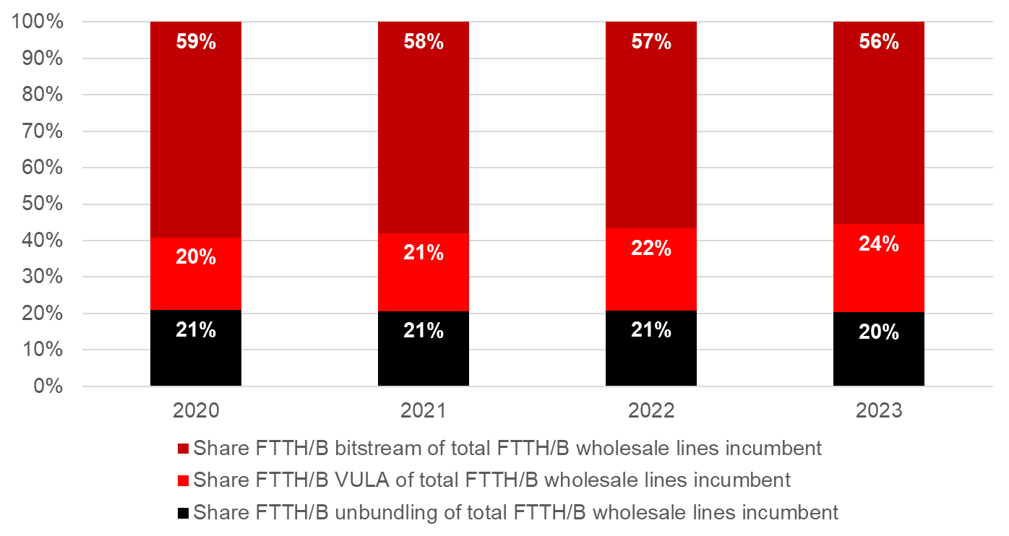
Source: WIK based on NRA data gathering for Study on Access Regulation.
The lack of wholesale products enabling differentiation, is also likely to have affected the provision and take-up of Gigabit offers, for the reasons explained above.

Spectrum regulation and market factors slowing down investment in high quality mobile connectivity

Inefficient use of spectrum: difficulty to satisfy increased demand due to spectrum scarcity
The increasing diversity of wireless services and applications for consumers and different technologies and sectors (e.g. 4G/5G/6G, IoT, satellite, verticals/local use, public safety etc), the expansion of connected devices as well as competing network technology options for service delivery have been intensifying spectrum usage and squeezing the available spectrum resources, in particular in low and mid-bands, which offer both good coverage and capacity.
Figure A7 2-4: Europe country-average spectrum assigned to mobile operators
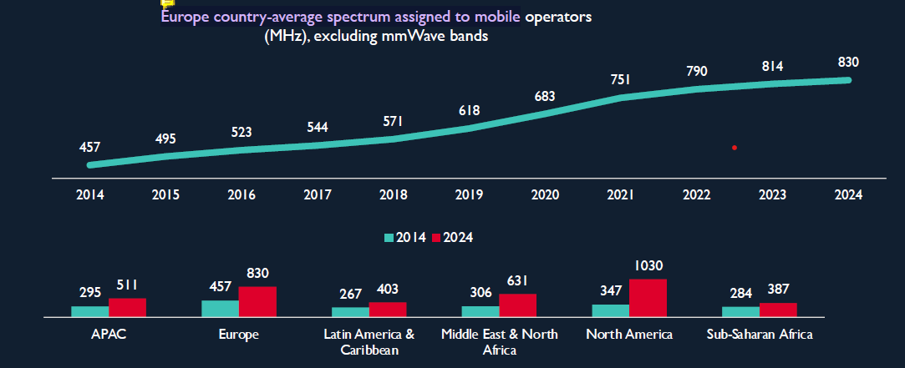Average MHz assigned to mobile operators for frequency bands below 7 GHz; Source: GSMA, “Global Spectrum Pricing 2025.05.15,” p. 15. Available at: https://www.gsma.com/spectrum/wp-content/uploads/2025/05/GSMA_Global_Spectrum-Pricing_2025.05.15.pdf
Figure A7 2-5: Spectrum holdings
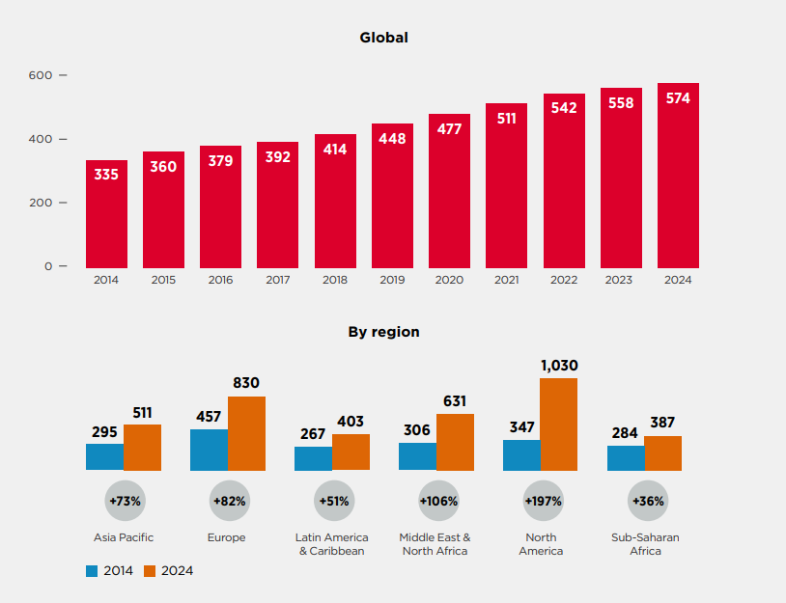
This is demonstrated on the one side by the fact that according to GSMA European operators had to nearly double the average spectrum holdings assigned to them by country to bring 4G and 5G to consumers and on the other side by the controversy and competing demands for the sub-700 MHz band (by terrestrial broadcasting and mobile operators as well as by users of wireless microphones) and for the upper 6 GHz band (by various stakeholders including from the satellite, mobile and RLAN communities). Both frequency bands are considered as potentially last opportunities to access valuable spectrum in the low-band and mid-band range, respectively.
This growth in wireless data consumption and spectrum demand, combined with the persistent inefficient use of certain spectrum bands (e.g. mm-waves but also mid-bands like 2.6 GHz) is not matched by a bold regulatory mindset and market readiness to take up in particular spectrum trading and sharing solutions, to ensure timely and efficient access to spectrum. The result is artificial spectrum scarcity as well as hindrance to innovation and service expansion.
Therefore, the following problems have emerged:
- Spectrum is often not (a) timely available, (b) authorised / accessible to maximise its benefits, (c) used in some geographical regions.
- Efficient use of spectrum is not ensured through sharing/flexibility; coverage obligations or other auctions conditions could be an obstacle to pooling spectrum for collaborative use, use it or share it or lose it principles are not enforced. Immature regulatory mindset to make shared use a mainstream approach of spectrum authorisation, taking advantage of innovative technological solutions, results in a lack of incentives and framework for spectrum sharing. The RSPG, in its opinion RSPG21-022, recognised that spectrum sharing in the Union has so far been implemented in a rather static and conservative manner and emphasized the need for further development — particularly to enhance the efficient use of radio spectrum and to provide incentives for innovation.
Despite technological advancements that enable secure and efficient spectrum sharing—such as dynamic frequency selection, spectrum sensing, and real-time coordination databases—these tools are not widely adopted. Rigid licensing conditions, exclusive long-term rights without use-it-or-share-it flexibility, and obligations linked to coverage or infrastructure investment discourage collaboration or shared use.

Insufficient flexibility for interservice and intra-service spectrum sharing
The RSPG emphasises the growing importance of interservice spectrum sharing, i.e. between different users providing different services, often using incompatible radio access technology, on the path to 6G. Interservice spectrum sharing promotes investment and competitiveness of EU economy, delivering to citizens and businesses wider access to communications services, intra-service sharing (i.e. between peer users offering similar service), which optimises investment cost, makes use of innovative technical solutions and similarly ensures efficient spectrum use. In its Opinion on the 6G Strategic Vision, the RSPG calls on policymakers, spectrum managers, spectrum users and industry to shift their mindset and prepare for more flexible interservice sharing models. It also recommends that spectrum sharing be further promoted through EU legislation.
Interservice sharing is consistent with competition law principles, as it concerns sharing between services that are not competing. However, with rising cost of network investments in newer technology generations (6G, LEO satellite constellations), the deployment of inter-service spectrum sharing arrangements, including also active infrastructure, may receive due regulatory review and should always remain subject to potential competition scrutiny.
Current regulatory frameworks do not provide sufficient flexibility for spectrum use across different services/technologies (e.g. terrestrial vs. satellite) or among similar/competing market actors (e.g. between mobile operators). As market structures and user needs evolve, spectrum authorisation remains locked into outdated models. Long-duration licences are often not accompanied by mechanisms to lease, trade, or share spectrum, leading to its inefficient utilisation.
Awarded players not fully using assigned spectrum/ spectrum hoarding
Inefficient spectrum use—including the risk of spectrum hoarding, where operators hold significant amounts of assigned spectrum without fully utilising it—exacerbates spectrum scarcity. This problem has been already experienced in Germany, where BNetzA introduced strict conditions on spectrum assignments in the 3.7–3.8 GHz band for private and local 5G networks. Under its "use-it-or-lose-it" rule, a spectrum assignment can be revoked if it has not been used within one year of being granted, or if it remains unused for the intended purpose for more than a year. The regulator also monitors roll-out and spectrum utilisation and has the authority to revoke underused spectrum—demonstrating a proactive enforcement approach to prevent hoarding. Other regulatory solutions introduced more horizontal approaches against hoarding, like for example in Africa for high-demand bands where licensed spectrum that remains unused for 2 years can be reclaimed by the regulator. In the U.S., the Citizens Broadband Radio Service (CBRS, 3.5 GHz) introduced a dynamic three-tier sharing model that prevents spectrum hoarding. Under the “use-it-or-share-it” principle, licensed users (Priority Access Licenses, PALs) must actively use their spectrum or allow unlicensed users to access it opportunistically. This prevents spectrum from lying idle and ensures efficient use via a Spectrum Access System. Launched in 2020, CBRS has enabled broad participation by new players and is seen as a model for applying ‘use-it-or-share-it’ principles to other bands.
The "use-it-or-share- or-lose-it" principle when included in the licences allows regulators to revoke or reassign unused spectrum. However, these principles are rarely enforced, and sharing remains optional rather than standard practice.
Underutilised Technological Capabilities for Sharing and Conservative Regulatory Approaches
Despite advances in technologies that enable efficient spectrum sharing—such as dynamic frequency selection, automated access systems, AI-driven allocation, and real-time databases—these tools remain underused. Their limited adoption hinders real-time coordination and enforcement of shared usage rights, reducing overall spectrum efficiency. At the same time, spectrum sharing solutions require not only technology progress but also a bolder regulatory mindset (as demonstrated in the RSPG opinion on spectrum sharing).
While the EECC provides for flexibility and shared use, these provisions are seldom applied in practice. Mechanisms such as “use it or share it” remain underused. Moreover, strict coverage obligations and auction conditions often hinder spectrum pooling and discourage more collaborative or efficient models of use.
Meeting future connectivity needs will require a more dynamic and adaptive spectrum allocation strategy. This includes broader application of spectrum sharing mechanisms and flexible licensing models to ensure that valuable spectrum is used efficiently and equitably in light of rising demand from 6G, IoT, and satellite services.
The spectrum inventory, developed by the Joint Research Centre (JRC), covers spectrum use between 400 MHz and 6 GHz. Its objective was to identify frequency bands where spectrum efficiency can be improved, enable spectrum sharing and reallocation opportunities, and support the analysis of spectrum use. Member States are responsible for collecting national spectrum data, while the Commission conducts the analysis of technology trends, future needs, and spectrum demand.
However, key limitations of the current inventory are that it is not available to operators, and functions primarily as a static database, lacking the capability to reflect real-time spectrum usage. This significantly reduces its practical value—particularly for spectrum sharing, where up-to-date information on frequency occupancy is essential to be provided to the sector to ensure efficient use and prevent interference.
In addition, the tool’s maintenance involves a high annual cost—estimated by the JRC at approximately EUR 100 000—despite its very limited utilisation.
An additional non-addressed need is the lack of regulatory instruments allowing innovative users that develop projects requiring harmonised spectrum to activate the process of harmonisation.
In the EU, spectrum harmonisation is initiated by the Commission, with strategic guidance from the RSPG. The Commission may mandate CEPT to conduct technical studies, which subsequently form the basis for an Implementing Decision adopted in cooperation with Member States via the RSC. While the RSPG provides strategic guidance and engages stakeholders through consultations and workshops, the current framework presents a regulatory gap: there is no formal mechanism to ensure that emerging or innovative spectrum needs from the stakeholders are systematically addressed. Stakeholders currently have no way to directly trigger a harmonisation process. As spectrum demand becomes increasingly diverse and innovation-driven, this lack of a structured bottom-up channel limits the EU’s ability to respond swiftly and effectively to evolving market needs.
By contrast, the US provides a clear example of bottom-up regulatory access through the FCC’s petition for rulemaking process. Under U.S. law, any interested party can formally petition the FCC to issue, amend, or repeal a regulation, including those related to spectrum allocation. One notable example is the Citizens Broadband Radio Service (CBRS) in the 3.5 GHz band, where input from rural ISPs, technology stakeholders, and other interested parties led to a dynamic spectrum-sharing framework. This approach opened 150 MHz of mid-band spectrum to new and local operators under a use-it-or-share-it model. In Europe, a comparable mechanism that enables stakeholders to initiate harmonization remains absent from the current spectrum framework

EU mobile markets and number of mobile network operators
The figure below shows the number of mobile network operators that were present in selected countries in Europe as of 2025, indicating that four players are present in the vast majority of cases, especially once more recent entry is considered in Portugal, Belgum and Germany.
Figure A7 2-6: Number of mobile network operators in selected countries in Europe as of 2025.
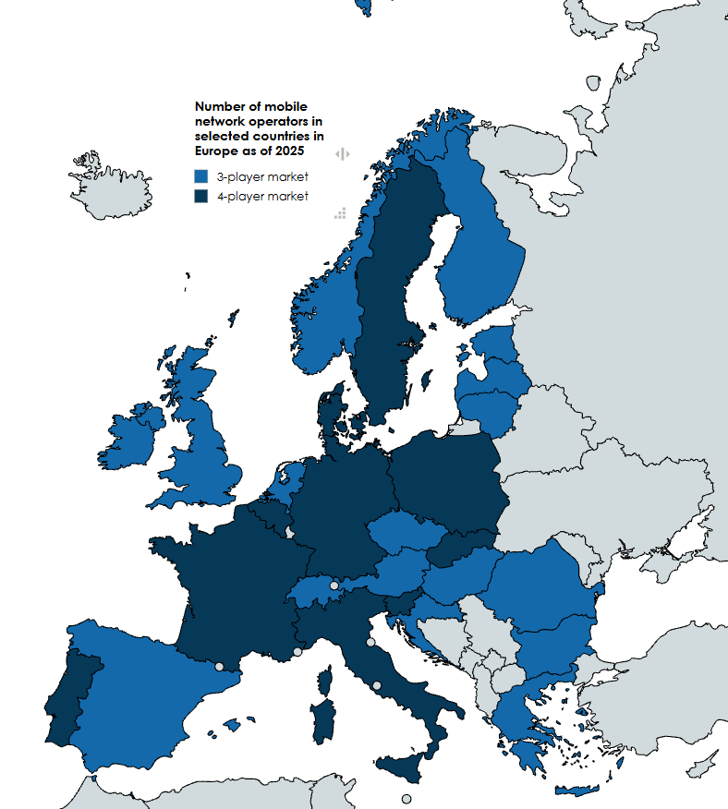
Source: Map created by WIK-Consult with mapchart.net based on information in https://www.kratosspace.com/constellations/articles/the-recent-vodafone-three-merger-suggests-that-most-europeans-may-soon-have-three-mnos-per-country.

Fragmented, complex rules, authorisation conditions
The divergences in terms of compliance with general authorisation conditions, in particular for SMEs, make it more difficult to operate across borders and increase the administrative burden to cope. Concerning the transparency on providers entering the market, there are also discrepancies in the registration/notification regime regarding the non-public ECNs such as some submarine cable systems or the NI-ICS. They operate based on a registration in one country of main establishment, but not under the EECC GA, what posed challenges to NRAs to exercise proper supervision and to intervene in case of issues. As a result, inconsistencies led to differentiated regulatory treatment and even to lowering the level of consumer protection. Despite the efforts of the directive to further harmonise the possible GA conditions a considerable discretion remained for the Member States to further develop and specify the various requirements, often by adding more requirements justified by national specifics and thus, considerably increasing the excessive bureaucracy, especially for cross-border operations and smaller players.

Governance problem drivers
As regards governance, the first driver is the strong national influence on BEREC and RSPG that may result in some cases in limiting EU single market perspective. BEREC consists of NRAs, and positions are shaped mainly by national perspectives rather than by a common EU-wide vision. Moreover, a lack of a more structured coordination mechanism between BEREC and RSPG led to a very limited cooperation between the two bodies where spectrum issues have regulatory implication, Since decisions are in practice taken by consensus, its outcome in some cases reflects compromises between NRAs instead of a more ambitious, single, harmonised approach putting the benefits of a Single Market above individual Member State’s interests. This limits BEREC’s ability to ensure consistent implementation of rules across the Union, leaving the Single Market fragmented. The persistence of diverging national practices makes it harder for operators to expand services cross-border and sustains the complexity of meeting different authorisation and regulatory conditions. Regarding RSPG, particular national interests are at least in some contentious cases, prioritised over EU-wide benefits.
The second governance driver is the expanding regulatory scope of NRAs’ creating inconsistencies among the NRAs and between the tasks of NRAs and BEREC. While some NRAs take on responsibilities beyond electronic communications under frameworks such as the DSA or Data Act, in other Member States these tasks are entrusted to other CAs. These additional tasks broaden the regulatory agenda of NRAs beyond core connectivity issues and, although enrich discussion, can in the future complicate efforts to harmonise approaches across Member States as the governance landscape is not homogenous. Because the pace and focus of implementation differ nationally, the overall framework becomes less coherent. This makes it more difficult to achieve a level playing field, as operators may be subject to different combinations of requirements depending on the jurisdiction in which they operate. Furthermore, due to its NRA members’ involvement or expertise in certain topics, such as e.g. cloud switching, BEREC often becomes a natural forum to discuss such issues, while as a body it lacks a legal empowerment to contribute.
A third set of drivers for the governance concerns resource constraints and structural weaknesses. Many NRAs face challenges in terms of funding and staffing, which affect their ability to carry out both existing and newly assigned functions. Similarly, the BEREC Office has faced high staff turnover in recent years, which for a small agency creates operational strain, loss of institutional knowledge, and reduced efficiency. These limitations weaken the ability of BEREC to support harmonised implementation across the EU and sustain the persistence of fragmented regulatory outcomes, making the Single Market harder to realise. Similarly, even within the current scope of RSPG tasks and workload, it is challenging for some of the Member States to be actively involved in the RSPG work that could result in RSPG outcomes biased to the interests of some Member States. Due to extremely limited staff (1,5 FTE), the RSPG secretariat provided by DG CNECT cannot offer any support on substance.

Annex 8: Details of the Policy options

Transition to fibre
Option 1: Non-binding copper switch-off and limited updates to access regulation
For CSO, this option sets a non-binding EU target date of 31 December 2030. Member States would be required to submit national plans for fibre deployment and CSO. Article 81 EECC would be amended to cover all copper network operators, not only those with SMP. BEREC would be mandated to publish guidance on best practices for CSO and geographic surveys. References in Article 22 EECC on geographic surveys, which currently focus on networks with a performance of at least 100 Mbps would be changed to reflect the progress in network deployment and allow NRAs to focus on gigabit networks.
For access regulation, the current SMP framework, including SMP Guidelines and the Relevant Market Recommendation, would be retained.
Access to physical infrastructure would remain possible under the Gigabit Infrastructure Act (GIA). Where the GIA is not considered sufficient, NRAs may include additional access obligations based on SMP.
Article 61(3) EECC would be amended to allow NRAs to impose access to in-building wiring. NRAs could require operators deploying fibre to provide a drop cable connection to buildings passed by fibre within a given distance.
Access beyond the first concentration point under Article 61(3), second subparagraph, would continue to be available as a complementary tool.
To ensure more consistent regulatory practices and reduce fragmentation in the single market, harmonised EU wholesale access products would be established. BEREC would issue guidelines on these harmonised EU wholesale products. NRAs could still impose other remedies, provided they justify the reasons for doing so.
Option 2: Conditional copper switch-off and updated access regulation
This option contains a strong mechanism geared at fostering fibre deployment and take-up, including via a EU-wide copper switch off date by 2030, subject to certain conditions, and increasing accountability of Member States. It includes a review date in 2035 and very strong safeguards for end-user.
By 2029 Member States will submit to the Commission’s scrutiny a “Transition to Fiber Plan” setting out their strategy for the entire country. The plan will include:
- the identification of the areas where transition to fibre is feasible and the CSO process started or will start at the latest in 2030
- for the areas where CSO cannot start by 2030, set out the measures to transition to fibre at the latest in 2035

In assessing whether the CSO should start by 2030 the following aspects should be considered by Member States:
- Sufficient coverage by fibre networks in a given area [ indicative 95%]
- Ensuring affordability through comparable prices for comparable services
- Ensure that appropriate safeguards, including alternative solutions, for vulnerable customers are in place

The first two aspects will be addressed via the so-called “sustainability conditions”, that are requirements for the copper switch-off to start in a certain area.
More precisely, the sustainability conditions, which will need to be met cumulative are the following:
- Fiber coverage in a certain area of 95%
- Availability of retail offers for broadband connections over alternative technologies (to copper) that offer comparable or increased capabilities to those available over copper at the same or lower price.

The third aspect will be addressed via additional safeguards and measures that will be set by NRAs or other national authorities.
By 2035 Member States should review the fulfilment of the Transition to Fiber Plan and transmit the review for Commission’s scrutiny. In particular, they should:
- ensure that in all the areas of the country where the CSO started, it is completed as soon as possible, and
- in all remaining areas where fiber deployment is not viable (e.g. remote areas geographically difficult to reach), explain the reasons for the exceptions and provide alternative connectivity solutions for customers in these areas.

NRAs will be required to:
  - gather and publish on an annual basis geographic data regarding FTTH coverage, and retail broadband pricing segmented by technology and speed with separate reporting of copper / FTTC-based broadband, cable (including FTTB/HFC), FTTH-based and FWA-based broadband.
  - Produce a list of areas meeting the sustainability conditions for CSO as described above, based on Commission’s guidance on how to define these areas to be issues shortly after adoption of the DNA
  - Conduct a market analysis in line with the process outlined in relation to access (see below), to assess the market conditions and effects of the CSO obligation on competition, investment and retail pricing for mass-market and enterprise connectivity and ensure that consumers can benefit from choice, quality and reasonable prices, during and after the transition to full FTTH.
  - Adopt, as needed, safeguards for vulnerable customers or advise national authorities on how to do so.
  - For areas meeting the conditions for mandatory copper switch-off, require ECN operators deploying FTTH to provide a connection (drop cable) on standard terms and conditions to households which are passed within a given distance from the network, to be defined at national level.
  - For other areas not (yet) meeting the conditions, NRAs would be empowered, but not required to impose such a connectivity obligation.
  - Advise the relevant national authorities responsible to order, where needed, the copper switch off.
  - Review and approve the copper switch off plans of the operators, following the national authority’s decision to order the switch off of their copper network. These plans should include a timeframe for the completion of the copper switch off (maximum within 3years). The NRAs will oversee the completion of this plan and may adopt sanctions if the timeframe is not complied with.
Consistency across the EU will be achieved via a Commission’s scrutiny over the Transition to Fiber Plan and the copper switch-off process and the Commission’s guidance setting out the criteria for the definition of the areas for the copper switch off. For access regulation, this option provides NRAs with more tools for ex ante regulation, allowing for a targeted use based on the market situation. The possibility for SMP regulation remains based on the three criteria test.
The NRAs should first analyse whether the existing symmetric regulation (GIA) would be sufficient to address the identified problems. In the next step, if GIA is not sufficient, the NRAs could decide to apply SMP regulation or the symmetric rules under Article 61(3), depending on what is most appropriate to address the identified competition problems. in a given area. In this option the application of the symmetric rules is broader than in option 1 as it covers not only the possibility to impose access to in-building wiring but also access beyond the building if the criteria of Article 61(3) EECC (high and non-transitory barriers to replicability) are met. Both access to the in-building wiring part and access provided beyond in- building wiring could be imposed ex-officio (and not by request as it is currently the case) to facilitate deployment and to tackle more localised competition concerns.
For access, this option provides greater consistency in the application of ex ante regulation. The possibility for SMP regulation remains. The approach to geographic surveys would be expanded, requiring NRAs to gather data on retail markets and the underlying infrastructure periodically. These data would be important for NRAs to assess the market conditions and decide whether ex ante intervention is required.
To support the standardisation of wholesale offers, a list of essential wholesale products will be included in the DNA, and the European Commission would have to adopt an Implementing Act to establish best practice specifications and/or to amend the list, following consultation with BEREC. NRAs must ensure that these harmonized products are reflected in wholesale access obligations under ex ante regulation. They could focus, for instance, on FTTH physical and virtual unbundling alongside Ethernet leased lines and business grade QoS. The NRAs could impose also other remedies in justified cases, but the Commission will have a veto over remedies that go beyond the pan-European wholesale access products and when the draft measures have a negative effect on the single market.
Option 3: Market driven copper switch-off and bottleneck-based access regulation
For CSO, this option relies on market-driven transition to fibre. NRAs’ oversight over the CSO would be removed and operators would have full discretion over the timing and conditions of the CSO.
For access regulation, this option focuses on deregulation. SMP-based regulation would be replaced by a bottleneck approach, whereby wholesale access obligations would only apply in areas served by a single fixed network.
Where price regulation applies to wholesale access products, cost-orientation would be replaced with fair, reasonable and non-discriminatory terms and conditions. Access to civil engineering infrastructure is handled via the GIA exclusively. This option would also include harmonised EU wholesale access products, combined with a Commission veto right over remedies.
Article 22 EECC on geographic surveys would be deleted.
Option 4: Mandatory copper switch-off and symmetric regulation
For CSO, this option establishes a mandatory EU-wide CSO. It would require operators to switch off their copper networks by 31 December 2030 and would require Member States to develop plans for fibre deployment and CSO. No sustainability conditions are envisaged.
NRAs would be tasked with collecting and publishing data on CSO, including geographic surveys of Gigabit-capable fixed wireless networks, along with the status of copper to fibre migration. Article 22 would be updated to replace the current 100 Mbit/s threshold and to collect forecasts for unserved areas.
The scope of Article 81 EECC would be extended to all copper networks operators, including those with no SMP.
For access regulation, this option would replace the existing SMP regime and Article 61(3) EECC with a requirement for all fixed network operators to provide wholesale local access on fair terms and dispute resolution by NRAs if no agreement is reached within two months. The option would also require copper network operators, including those previously deemed to have SMP, to provide access to ducts and poles based on cost-orientation and non-discrimination, in line with guidelines from the Commission or BEREC.
To support harmonisation, an initial list of harmonised EU wholesale access products would be included in the DNA. The NRAs would consider imposing them during the resolution of access disputes. The Commission may adopt an Implementing Act to specify best practices or amend this list. The harmonisation of regulatory approaches would be supported through a veto right for the Commission regarding the application of the access remedies.

Spectrum
Detailed description of the policy options for Spectrum:
Option 1: Soft harmonisation
In this option the minimum licence duration would be extended from current 20 years to 25 years still following the Article 49(2) EECC rule (initial 20 years extended by 5 years). When authorising spectrum, the national competent authorities would be supported by a toolbox of best practices on pro-investment and pro-efficient use of spectrum authorisation processes that could address, e.g. auction designs, reserve prices, annual fees, coverage commitments, QoS obligations, spectrum sharing solutions, and be developed by the Commission assisted by RSPG. To enhance investment and improve spectrum use efficiency in underserved/rural areas, any unjustified legal or regulatory obstacles to spectrum sharing or pooling would be removed. This option also envisages promoting flexible spectrum licencing, e.g. licences limited to a particular location or time period, especially for verticals. The Commission could, following an RSPG opinion, recommend an authorisation regime to be used in particular EU harmonised spectrum band.
When designing spectrum assignment measures, the competent authorities would need to assess potential market shaping measures, e.g. limiting the max amount of spectrum per operator, on the basis of a forward-looking analysis of the market competitive conditions (Article 52 EECC). All draft assignment measures would need to be submitted to an ex ante spectrum Single Market procedure by the Commission, and RSPG and BEREC. The Commission would, taking into account RSPG and BEREC opinions, issue a non-binding opinion on the necessity of such measures, which the competent authority would need to take into account. The timely and coordinated launch of 6G would be facilitated by an evolving spectrum roadmap developed and regularly updated by the Commission assisted by RSPG to provide predictability and information necessary for investment planning. Deadlines would be introduced to the procedural steps under Article 28 EECC to faster resolve cross-border interference between Member States. Enhanced solidarity from EU and Member States, with possibility of biding measure, would be established in the case of interference from third countries. Stakeholders would have a possibility request the Commission to launch a harmonisation of a particular spectrum band use (petition for rule making), and the Commission would need to reply within a defined timeframe and justify an eventual refusal. For the issues potentially affecting EU security or technology sovereignty, discussed at the CEPT, Member States would be recommended to coordinate their positions.
Option 2: More single market to enhance investment and innovation
This option envisages harmonisation of spectrum authorisation conditions and procedures. The Commission would recommend pro-investment authorisation processes aspects and conditions for spectrum used for public networks, notably for 6G, based on RSPG opinion; if deviations persist, or if there is a need to promote the pan-European provision of service or the need to pursue economies of scale, the Commission would be allowed to adopt measures to harmonise the authorisation conditions. The Commission would be able to decide on the authorisation regime (general authorisation or individual) for certain bands, to ensure that it best promotes efficient and strategic use of spectrum, including sharing. This would allow to take into account specific requirements necessary for public security, including harmonised spectrum available for critical communication. This measure draws from the Draghi report which suggested to harmonising EU-wide spectrum licensing rules and processes, to provide for quasi automatic renewal and facilitation of spectrum trading and leasing.
With the view to regulatory predictability and to incentivising the development of a secondary market for spectrum, licenses would be granted or renewed for an unlimited duration by default (provided of course that the conditions are fulfilled, that there is no technology or competition development justifying a new assignment procedure and subject to revocation under certain conditions), and in case of shorter duration with strong guarantees of renewal, if the licence conditions are fulfilled, based on a reversed burden of proof mechanism). Any additional condition accompanying the renewal would be proportionate to the value of it. Operators of public and non-public networks would have a right to request that competent authorities from different Member States supported by RSPG harmonise their authorisation conditions for the use of particular spectrum band, thus allowing scaling up of business cases at EU level. Spectrum sharing would be mainstreamed, in due respect of competition law, on the basis of extensive use it or share it or lose it-conditions (also to ensure efficient use of spectrum in cases of indefinite duration licenses) and the development of dynamic geolocation databases in bands where sharing would be most beneficial. Obstacles to the assignment of spectrum to wholesale network operators, such as coverage or quality obligations, would be addressed, to ensure the most efficient use of spectrum and cost-efficient deployment.
While designing spectrum assignment measures, the competent authorities would be obliged to apply pro-investment auction designs, with more consistent set of rules to promote effective competition based on commonly set criteria. They would be required to justify spectrum policies with regard to the impact on investment and the economic sustainability of the market structure envisaged (for example taking into account the level of service and infrastructure competition and in particular the number of infrastructures that can be economically sustained in the market, with reference to the characteristics of the spectrum awarded and associated investment requirements needed to achieve the quality of service targeted) and choose every time the least distortive measure. Spectrum assignment measures would be subject to mandatory ex ante spectrum Single Market procedure at EU level as in Option 1; however, it could result in a Commission opinion on the necessity of the measures, with veto on market shaping measures and limited licence duration. This measure echoes the proposal for Commission veto on auctions not following harmonised guidelines in the Draghi report, in particular as regards reservations.
The EU spectrum strategy with spectrum roadmaps would cover not just spectrum for the 6G launch but also for other technologies, such as WiFi. Competent authorities would need to develop corresponding national roadmaps, which would provide increased legal certainty and regulatory predictability to investors and authorise spectrum within a period of time shorter than 24 months. If a competent authority does not assign spectrum within defined timelines, it could be taken to the national court on the grounds of failure to act. This measure echoes the proposal in the Draghi report to harmonise the release of new frequency bands to allow investment across Member States by EU players, guarantee the timing of harmonisation and include the release of additional WiFi-dedicated bands into the spectrum guidelines, to allocate enough spectrum to 5G and 6G.
The current mechanism for addressing harmful interference between Member States would be extended to non-harmonised bands (in addition to setting deadlines). Lastly, a petition for rule-making mechanism would be established for innovators to request the harmonisation of a band across the EU, with a procedure and obligations for the authorities to consider such request, giving innovators a structured process to support their innovative projects. Member States would be required to coordinate their positions at CEPT for issues related to security or technology sovereignty.
Option 3: Strong harmonisation and EU level rules
In this option fully harmonised authorisation processes aspects and conditions (e.g. auction design, reserve prices, award fees, annual fees, coverage obligations, QoS) would be imposed. The assignment of spectrum will based on indefinite licence duration. To exclude any artificial spectrum scarcity, the national authorities would be only authorised to impose market shaping measures (e.g. spectrum caps) in case of dominance. The competence for awarding harmonised spectrum for certain services, would be transferred at Union level, under certain conditions (e.g. delays in assignment). All assignment measures for spectrum assigned at national level, should be submitted to ex-ante spectrum scrutiny as under Option 2 with the same possible outcome. For spectrum assigned nationally, in addition to mandating an authorisation regime, including flexible authorisation, operators would have a right to request from multiple authorities to assign to them spectrum in a joint selection procedure under harmonised authorisation conditions. A mandatory EU framework would be established to increase efficiency and enable spectrum sharing across all EU-harmonised bands. This framework would require the use of dynamic geolocation database systems. Coordination of the timing of assignment for every band would be done through deadlines set in hard law. Passed the deadline, the band would be auctioned on the basis of standard pre-established conditions. A mechanism under RSPG would coordinate the response of Member States to harmful interferences from third countries while for interferences between Member States it would be coupled with private enforcement to increase its effectiveness. Lastly, the scope of the petition for rulemaking would be extended beyond harmonisation of spectrum to also cover authorisation aspects like (innovative) shared spectrum use (e.g. shared use, local licences, temporary licences), as well as innovative approaches to improve spectrum efficiency. In exceptional cases, instead of CEPT, an ad hoc/high-level group of EU MS-only representatives would carry out the harmonisation work.

Authorisation
Option 1: Partial harmonisation of authorisation:
Option 1 addresses the lack of resilient pan-European networks by improving consistency through partial harmonisation of authorisation conditions and stronger enforcement of the EECC regime. Enhanced BEREC tools and templates help reduce fragmentation and improve security compliance. It supports more pan-European services by simplifying regulatory processes, though impact remains limited. authorisations stay largely national. This option establishes an EU-level maximum list of conditions for the general authorisation (updated), while conditions for satellite services would be softly harmonised through a common template. Providers still obtain authorisation from the Member State of destination. However, cross-border providers (e.g. satellite operators, other B2B providers not offering B2C services) would benefit from a one-stop shop notification system. The BEREC Office could act as the one-stop shop, or as an intermediary between the notifying Member State and those where services are provided. Under this option even with the one-stop shop, national authorisation is still required in each Member State and conditions and rules applicable are not further simplified and harmonised.
Under this option, on satellite, to better address the existing barriers to the development of pan-European satellite services, the Commission would be empowered to conduct a selection procedure for licensees of satellite spectrum for the provision of pan-European services. This would ensure that licensees may cost-efficiently deploy services covering the entire single market. Conditions for rights would still be defined and spectrum assigned at national level.
Option 2: Single “passport” for other networks and services than satellite and an EU-level authorisation for satellite spectrum
Single “passport” for other networks and services than satellite
Option 2 strengthens pan-European resilience by introducing a “single passport” for networks and services and harmonised EU-level authorisation for satellite spectrum. This creates a coherent regulatory environment, enabling seamless cross-border operations and reliable connectivity. It effectively promotes more pan-European services by removing administrative barriers and fostering market scalability and ensuring coordinated enforcement to establish a level playing field in satellite.
This option proposes to simplify and fully harmonise all EECC conditions for the general authorisation, through a fixed and exhaustive list of conditions applicable in all Member States.
Providers would notify in one Member State only (the ‘Member State of notification’). Its competent authority would then coordinate with all other Member States where the provider intends to operate to ensure compliance with applicable rules. During this process, the authority would be assisted by the [BEREC Office], which would provide technical and procedural guidance to ensure consistency across the Union. Once coordination is complete, the Member State of notification issues the declaration(s) authorising the provision of networks and services, which are then valid in all Member States.
Specific national rules and non–DNA requirements, such as the ones related to e.g. cybersecurity, data retention or lawful interception would be coordinated among Member States. To facilitate the process BEREC would issue guidelines to provide technical and procedural guidance to approximate that conditions as much as possible across the union. Coordination would first take place to inform the development of these BEREC guidelines, ensuring clarity on the applicable conditions and rules, and would subsequently continue for the approximation of any remaining national rules. These guidelines would also cover nationally specific rules/conditions. Such a cooperation mechanism could provide additional value over time.
Terrestrial spectrum would continue to be assigned at national level, by each Member State, based on measures defined in section 5.2.2.

EU-level authorisation for satellite spectrum
There would be a simplified authorisation at EU level. More specifically, the operator, by derogation to the Member State notification system, would notify its intention to provide satellite networks or services to the Commission which would issue the declarations to provide networks or services and the authorisations to use spectrum including individual rights of use of spectrum, in the Member States where the provider wishes to provide services, even in the entire EU. In performing this task, the Commission would be assisted by [BEREC] Office. In cases of spectrum scarcity, the Commission would undertake a selection at EU level granting them spectrum licences through binding acts.
There would also be a binding EU-level compliance and enforcement framework for ensuring that satellite constellations’ access to the EU market complies with the common conditions in line with international law, thus addressing RSPG call for common authorisation requirements and for a coordinated enforcement approach. Coordinated enforcement at EU level would include withdrawal of the authorisation for the entire single market.
Option 3: Country-of-origin authorisation for cross-border and B2B services
Option 3 improves cross-border resilience by allowing one Member State’s authorisation to apply EU-wide, reducing duplication and speeding service deployment. It facilitates pan-European services by simplifying compliance and encouraging expansion. However, it poses serious risks of forum shopping, as providers could exploit jurisdictions with weaker enforcement, undermining fairness and market integrity.
This policy option entails the introduction of a general authorisation and notification obligation in only one country (the country of origin) for cross border (e.g., satellite) and B2B services. While providers would be obliged to respect the legislation of the Member States where they provide services, only the Member State of origin would impose authorisation conditions and would be able to prevent the operator from providing services. It also foresees the simplification of conditions attached to the rights of use of numbers when used extraterritorially for B2B services.
As regards satellite, the Commission would be empowered to conduct a selection procedure for licensees of satellite spectrum for the provision of pan-European services. In order to manage access to the EU market of satellite constellations from third countries, the Commission, supported by the RSPG and (BEREC/RSPG) Office, would set common requirements for satellite authorisations based on International Telecom Union (ITU) and create a coordinated compliance and common enforcement mechanism among Member States for allowing and efficiently control satellite constellations’ access to the EU market. The country of origin would issue the rights of use following the common requirements and impose sanctions in case of non-compliance. This option entails mutual recognition of all applicable general authorisation conditions by all other Member States where networks and services will be provided.

Governance
Option 1 – BEREC and RSPG as two separate bodies supported by the BEREC Office
Under this option, the RSPG would become a self-standing body, with a structure similar to BEREC. The RSPG will receive support from the BEREC Office, which will take over the RSPG secretariat function currently provided by DG CNECT. BEREC well-established two-tier structure would otherwise remain unchanged.
Given the lack of legal personality, BEREC and RSPG would not adopt any binding decisions. The decision-making competence would remain with the Commission, and Member States’ authorities. BEREC and the RSPG would advise, issue opinions, guidelines and undertake other types of activity supporting the EU policymaking (monitoring, reporting etc.). Member States and RSPG will maintain their competence on spectrum policy. To better align approaches in spectrum assignments, all major assignments will be subject to a mandatory Single Market spectrum procedure where RSPG and the Commission will be able to comment on draft measures in their entirety. The Commission could veto market shaping spectrum assignment conditions. The Commission advised by RSPG with a support of BEREC Office could also coordinate aspects of spectrum assignment, such as the development of authorisation conditions, manage the EU satellite authorisation and coordinate their enforcement, and select satellite licensees in cases of spectrum scarcity, following the example of the 2 GHz band.
BEREC Office (EU agency) would provide expert and administrative assistance to both BEREC and RSPG. Specific mechanisms will be set up to ensure coherence and coordination between BEREC and RSPG as well as in areas where NRAs have responsibilities beyond electronic communications under frameworks such as the DSA, Data Act, or NIS2. This option includes also mandatory participation of Office’s staff to BEREC and RSPG working groups, including taking over some co-chairs’ workload if needed, which should increase BEREC’s and RSPG’s impact on harmonisation. The representativeness of BEREC output will be enhanced by mandating representation of other CAs each time a subject within their remit is discussed within BEREC. Under this option, NRAs will perform a role of national contact points responsible for coordinating and presenting their positions at the BEREC level.
Option 2 - EU Agency (BEREC and BEREC Office merged), providing an office (support on administrative and preparatory tasks) to the RSPG
In this option, BEREC and the BEREC Office structures will be merged into a fully-fledged EU decentralised agency. This EU agency would take over the RSPG secretariat function currently provided by DG CNECT and provide support on administrative and preparatory tasks to the RSPG. The governance in the spectrum area would remain the same as in option 1, i.e. the RSPG would be established as a self-standing body with working groups, evolving from the status of Commission expert group, tasks division will be also the same as in option 1.
The agency can be entrusted with decision-making powers on selected cross-border issues. To accomplish these tasks, the agency would need to be equipped with more staff and resources, entailing administrative and financial costs. National regulatory authorities would keep implementation powers. The impact on harmonisation and representativeness of BEREC as well as the coordination between BEREC and RSPG will be addressed as in option 1.
Option 3 - Two separate agencies – BEREC + BEREC Office & RSPG
Under this option, BEREC and the RSPG would become two separate – due to their diverse membership (NRAs for BEREC and NRAs and other CAs for RSPG) as well as different remit (electronic communications market regulation for BEREC and cross-sectoral radio spectrum policy for RSPG) – fully-fledged EU decentralised agencies, with legal personality and decision-making powers. This option would require establishing some enhanced coordination between BEREC and RSPG. The Commission would have a monitoring or supervisory role and some decisional powers with respect to certain spectrum-related tasks, e.g. veto powers under Single Market/EU spectrum scrutiny procedure (see option 2).
The two agencies may have the power to take binding decisions on new cross-border related tasks, where required and within the limits of their competences. In relation to spectrum, this option is likely to affect the allocation of shared competences between the Commission and the Member States, e.g., the selection and authorisation of operators of satellite spectrum, enforcement measures.

Annex 9: Analytical background for the assessment of impacts and comparison of Policy Options

Impact and comparison of the policy options
This section provides further details on the impacts and comparison of the policy options.

1.1. Transition to fibre

1.1.1. Effectiveness
The effectiveness of the policy options is assessed against their ability to achieve the general objectives. These objectives correspond to a set of intermediate and outcome indicators, including FTTH coverage and take-up, retail market concentration (HHI), take-up of Gigabit offers, prices for high-speed and Gigabit broadband, and average actual download and upload speeds.
Some of these indicators are assumed to be interrelated based on the data analysis. For example, FTTH take-up is linked to FTTH coverage (homes passed) and the availability of in-building fibre wiring in MDUs. Average download and upload speeds depend on FTTH take-up and on the take-up of Gigabit offers on Gigabit-capable networks, which is influenced by the price of Gigabit offers relative to other bandwidths. These prices, in turn, may be affected by infrastructure-based competition and other competitive dynamics that enable differentiation in speed and quality.
Objective | Indicators
Foster full fibre coverage and take-up | FTTH coverage (homes passed as % HH)  FTTH adoption (homes activated as % HH)
Foster competition to boost innovation and take-up of higher speeds |  |  | Intermediate indicators: number of ISPs offering VHCN / HHI in VHCN  Final outcomes:  Prices for Gigabit broadband  Take-up of Gigabit offers  Average download and upload speeds
Address fragmentation impeding the single market | Consistency in wholesale access specifications across the EU including QoS guarantees for business services  % take-up of wholesale access via mechanisms which permit differentiation (unbundling, uncontended VULA offering full flexibility)
Simplification by updating and removing redundant provisions |  |  | Removal of unused or contested provisions  Improved coherence (external and internal)  Reduction in administrative burden
The policy options differ in their approach to copper switch-off and access regulation, including when market analyses are triggered and what remedies are applied. The following sections present evidence on how these policies are likely to affect FTTH deployment and take-up, as well as end-user choice, price, and quality. This evidence informs the assessment of how effective each policy option is.
Effects of the national Plans
The requirements on national authorities to draft a national plan setting out the measures to achieve transition to fibre, based on the input of the NRAs, ensures coordination at national level. In particular, in the option where these plans are subject to the Commission’s scrutiny (Transition to Fibre Plan is submitted for Commission scrutiny in option 2), also consistency at EU level is ensured. The plans also ensure accountability of Member States in putting in place the right measures to directly and indirectly foster the deployment of fibre networks.
Effects of copper switch-off policies on outcomes
Copper switch-off should increase FTTH coverage by reducing penetration risk (low take-up) and strengthening the business case for FTTH investment. Financial investors have identified copper switch-off as the single most important policy for improving the viability of alternative FTTH deployment.
In areas already covered by FTTH, accelerating copper switch-off can directly boost FTTH take-up by requiring wholesale and retail customers on copper to migrate to fibre within a set timeframe. However, this only works if FTTH is available at the time of switch-off; otherwise, customers may have to rely on lower-performance technologies such as cable, FTTB/G.fast, FWA or mobile.
Higher FTTH take-up is also linked to higher average broadband speeds, since FTTH supports more advanced performance than other technologies. At the same time, safeguards are needed to ensure consumers are not forced to pay higher prices for equivalent services when moving from copper to fibre.
Figure A9 1-1: FTTP take-up in % of HH and median download speed (2024)
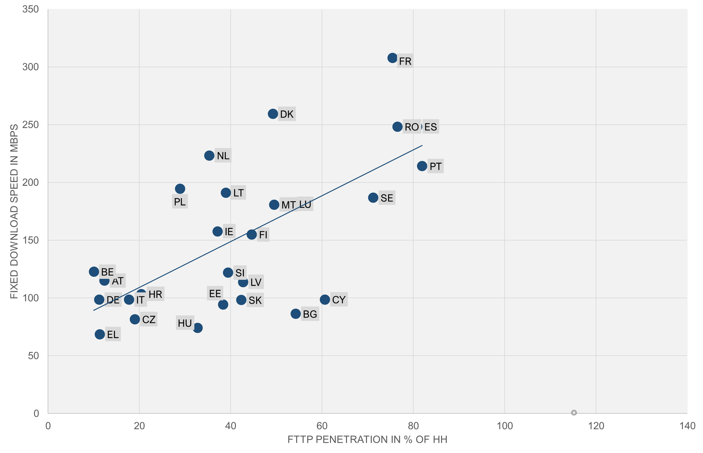
Source: WIK based on FTTH Council (2025) and Ookla (2025).
A key problem is the lack of commercial incentives for copper network owners to deploy FTTH or switch-off copper networks in cases where they upgraded copper to FTTC. Therefore, options which require copper switch-off under conditions, where the switch off could be expected to be a reasonable response to the market situation and would result in improvements in consumer outcomes, are likely to be more effective in expanding FTTH deployment and take-up. Conversely, options which merely encourage copper switch-off or rely on market forces to achieve the migration to modern fibre lines are likely to be less effective.
Effects of access regulation on outcomes
The approach to access regulation influences FTTH coverage through infrastructure competition, in particular through the application of SMP regulation of physical infrastructure, which, as described in Annex 7, has been a key enabler for the deployment of fibre. This enables alternative fibre investors to use the incumbents’ ducts and poles to deploy their own fibre networks. In turn, increased FTTH coverage is linked to increased FTTH take-up.
In areas where extensive network duplication is not economically viable, access regulation also plays a vital role in promoting competition in retail broadband services for the ultimate benefit of end users.
The impact of access regulation on investment, choice, price and quality depends on how well it is targeted. This requires NRAs to proactively gather data, understand market dynamics, and adjust regulation as needed. The threshold for intervention is also key. Today, intervention is mainly based on SMP. NRAs may also apply Article 61(3) to require access to wiring up to the first distribution point (and sometimes beyond) when replicating such infrastructure would be economically inefficient or physically impractical.
The effects of regulation also depend on whether remedies are appropriately designed. In particular, to achieve competition in quality and price, it is necessary that the wholesale access products allow access seekers to make use of the full capabilities of the underlying infrastructure and differentiate their offers from those of the access provider. Effective retail competition in quality and price, linked to infrastructure competition or unbundling, is linked to higher availability and lower prices for high-speed broadband offers, which should lead to higher take-up in the absence of consumer inertia.
      - Option 1
Option 1 would set a non-binding 2030 target for copper switch-off across the EU. Past experience with similar non-binding tools—like the Digital Decade Policy Programme (DDPP) and the 2020 Connectivity Toolbox—shows that such approaches can help coordination but are generally not effective enough. For example, the DDPP already includes a 2030 Gigabit coverage target and requires national roadmaps, yet large differences in fibre rollout remain across the EU, with major gaps in countries such as Germany, Austria, Greece, and Czechia. In some cases, public funding and regulation even supported FTTC, working against the fibre goal. Likewise, the Connectivity Toolbox ultimately needed legal obligations under the Gigabit Infrastructure Act because voluntary guidance alone failed to deliver results.
Non-binding guidance has also failed to harmonise wholesale access products. Differences in specifications and limited support for competition persist despite EU-level guidance on VULA and BEREC’s reports on Layer 2 wholesale access. Therefore, while legally mandated BEREC Guidelines on copper switch-off and wholesale products might help somewhat, they are unlikely to substantially change today’s widely varying national practices.
This option contains elements that should have a broadly positive effect on the management of copper switch-off processes and support for mapping and planning for the deployment of FTTH networks. Specifically, updating the VHCN definition to include fibre to the home (rather than being limited to the distribution point or terminating segment) should increase the focus of Member States on facilitating the deployment of fibre in-building and adopting the required standards to support these developments.
By updating the reference in the current Article 22 (geographic surveys) EECC to refer to FTTH rather than 100 Mbps, this option would improve the relevance of forecasts regarding the reach of Gigabit capable infrastructure, although the collection of data regarding planned VHCN deployments would remain optional. In this context it is worth noting that only 17 of the 24 Member States that provided information chose to collect data on a forward-looking basis, and only 9 chose to make use of that information to invite declarations regarding the deployment of broadband at speeds of more than 100 Mbps, despite the analysis of regulatory approaches taken and associated outcomes suggesting that such a measure could have been helpful in facilitating FTTH deployments and identifying gap areas while seeking to limit unviable network duplication.
The delinking of provisions on migration (Article 81) from SMP and linkage to ownership of copper networks under this option would enable greater utilisation of these measures by NRAs, supporting in the copper switch-off process. This is important, in view of the developments in some Member States to find no SMP in the copper segment of the wholesale local access market due to potential for substitution in this segment with mobile and/or fixed wireless broadband access.
Regarding access regulation, this option provides for stability in the regime regarding SMP regulation, which, was the preferred option amongst nearly all categories of stakeholder with the exception of some incumbents. The current regime requires NRAs to proactively conduct market reviews and act where required to address competition concerns via SMP regulation where not otherwise adequately addressed through commercial means or other provisions in the GIA or EECC. The EU-wide consistency and predictability ensured by this approach should support the continued investment and competition in FTTH networks that was achieved under the current regulatory framework.
However, a shortcoming of this option (as well as option 2) is that it may not be well suited to addressing situations involving tight oligopolies that would not give rise to competitive outcomes in the absence of ex ante regulation. However, as stated in Annex 11 (Evaluation Report), the oligopolistic markets have, so far been addressed either under the spectrum authorisation regime or under competition law. Furthermore, the SMP Guidelines, adopted in 2018, specifically focus on the joint SMP findings. The amendment to Article 61(3) to enable NRAs to apply it pro-actively up to the first distribution point would further improve the existing access regime, as it could encourage the use of Article 61(3) for the sharing of in-building fibre wiring, facilitating infrastructure competition for MDUs more widely across the EU (noting that only 7 NRAs have made use of Article 61(3) thus far). Although this is likely to apply only in limited cases, it could also potentially facilitate the use of Article 61(3) beyond in-building wiring in cases where fibre has been deployed in a manner that would allow access at an economically viable access point outside the building such as when point to point fibre deployments have been pursued. Option 2.
The requirement for Member States to develop, based on the input provided by NRAs, a Fibre Transition Plan will ensure a coordination at national level in supporting the deployment of fibre through concrete measures. This would also ensure that the coverage measures and the copper switch off measures are coordinated and complement each other. In particular, meeting the coverage objectives will facilitate meeting the requirements for the start of the CSO and therefore increase take up. The assessment of the NRA will inform the national authorities’ decision to switch off the network and will also ensure that the other conditions and safeguards for the CSO are met. The scrutiny of the Commission will ensure consistency and coordination at EU level.
The requirement for Member States to ensure copper switch-off, under certain conditions, along with safeguards to protect competition and consumers, should accelerate FTTH deployment and copper switch-off. This approach supports the viability and expansion of FTTH investments and ensures consumers benefit from improved infrastructure availability, quality and reliability. With a legal requirement, Member States are more likely to take concrete steps to address fibre gaps through declarations, State Aid, and attention to technical aspects like in-building fibre wiring standardization.
A mandate for CSO will be a clear signal for investors and the market at large across the Union. It can incentivize alternative fibre investors to achieve 95% coverage and offer competitive retail and wholesale prices, facilitating a smooth consumer transition without additional charges. Additionally, the obligation for NRAs to analyse mass-market and enterprise connectivity related to CSO will address potential reductions in infrastructure competition. This will support fibre-based competition on best-practice wholesale product specifications defined at the EU level, fostering differentiation in quality and price.
This option would also provide a clear signal to consumers and business users as well as building-owners which have not yet upgraded their in-building wiring that migration will occur and that they should prepare for this outcome. This could accelerate the replacement of legacy equipment and connections relying on copper (in particular by businesses), and could encourage end-users to switch to fibre networks in advance of the deadline. Those (estimated at around 20%) that may be resistant to switching, would also be migrated, subject to the legal requirements being met, thereby increasing take-up on FTTH networks and improving the business case.
Market analysis by the NRA with appropriate intervention at wholesale level where needed, coupled with requirements that CSO should only take place if it does not result in higher prices for similar services along with the right to connectivity at standard terms and conditions should limit the potential for price increases under this option and safeguard end-users.
Available data suggests that a mandatory transition from copper (incl. FTTC) to FTTH should result in end-users experiencing increased speeds and greater reliability for similar price. According to our price comparison in Member States with high share of copper-based connections, the cheapest fibre-based offer is no more expensive than the cheapest copper-based offer.
Table A9 1-1: Price comparison – cheapest offers
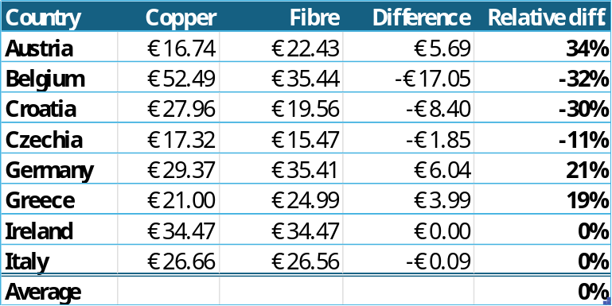
Source: DG CNECT
While the average price difference is 0%, the differences in member States range from -32% to +21% . Hereby, it should be noted that offers vary over time, and some depend on the location. The above table presents the situation in November 2025 and for random locations (when address is required). In some cases (e.g. Proximus and Telenet in Belgium, NOVA in Greece), operators offer the same product independent of technology and specify that the service is delivered over fibre, copper or cable depending on the address.
In terms of download speeds, the average difference of almost 600%, meaning the cheapest fibre-based product is six times faster than the cheapest copper one. Hereby, the speed advantage of fibre varies from -33% to 1150%.
Table A9 1-2: Download speed (Mbit/s)
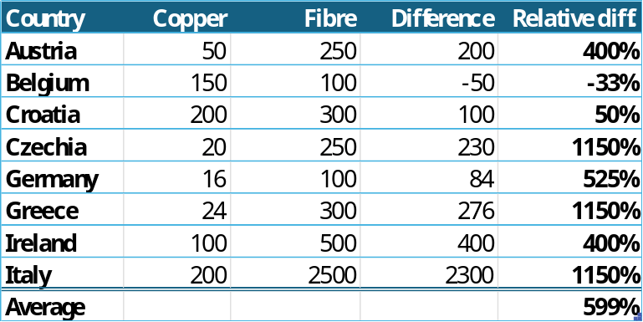
Overall, based on our sample, fibre-based products are no more expensive than copper-based ones but offers superior speed and quality.
This finding is consistent with the fact that the cost of fibre-based broadband is not intrinsically higher than that of copper-based broadband. This is particularly the case when unviable duplication of infrastructure is removed via copper switch-off, thereby eliminating the demand-risk associated with parallel operation of copper and fibre. It is noteworthy that NRAs have been setting regulated prices for copper networks based on the cost structure of FTTH, as it is considered the most cost-effective technology.
The experience of countries such as France (see following chart) and Italy shows that when there is effective competition enabling differentiation on price and quality on fibre (via physical unbundling and IRU), charges for even very high bandwidths over fibre (Gigabit bandwidths) are similar to charges for broadband provided over copper at significant lower speeds.
Figure A9 1-2: Development of broadband prices in France (2012-2024)
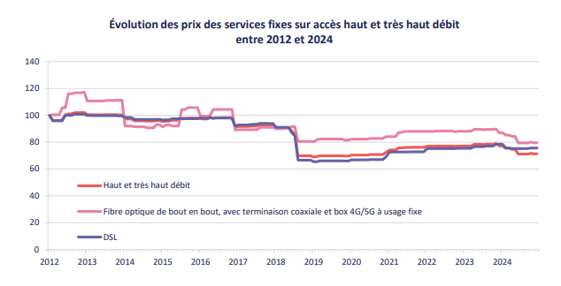
Source: Arcep
Alongside the CSO obligation on copper network operators at the EU level, it is essential to plan a detailed migration and copper switch-off process. This option requires copper network operators that have not already done so to submit a CSO plan, providing clarity and transparency to investors in FTTH and access seekers. It ensures that NRAs take appropriate steps to oversee the CSO process, complying with EU law regarding deadlines, supporting competition and investment in FTTH networks, and protecting consumer welfare. In most countries that have progressed with CSO, NRAs have been involved in overseeing, implementing, and monitoring this process, setting conditions such as transparency obligations, coverage thresholds, alternative technologies identification, and notice periods. It encourages switch-off in areas where alternative investors have deployed fibre and requires Member States to determine which alternative technologies might be used in specific cases, such as rural areas where FTTH may not be viable for all households.
Regarding the feasibility of this option, it is important to note that, aside from the need to ensure widespread FTTH coverage, copper switch-off requires implementation at several layers.
According to the Study on Access Regulation, supporting the impact assessment, for example IT-processes have to be developed to implement the stop sell and switch-off by area (e.g. defined as area covered by a copper exchange or municipality). Information campaigns and procedures to inform end users also have to be planned and implemented.
In addition, copper switch-off means that critical safety devices still running on copper PSTN have to be migrated to alternative networks. Key services which belong to this category are intruder & fire alarms, stand-alone security alarms, telecare / medical alert, lift emergency autodiallers, miscellaneous monitoring services (fire panels, SCADA, building-management, traffic & ATM lines). It also impacts monitoring control systems used by the water, energy and transport industries.
There is no comprehensive data on the share of critical devices or monitoring systems using copper networks. In the context of a WIK study on copper migration and copper switch-off for the Gigabitforum in Germany, network operators and service providers interviewed were unanimous in their opinion that all the associated problems can be solved and have already been solved to a large extent in the migration from the PSTN to all IP. It is also relevant to note that PSTN switch-off has progressed in many countries in advance of copper switch-off.
There is also evidence to suggest that upgrades to legacy equipment are being prioritised for operational reasons, and that maintaining such equipment could give rise to safety concerns. In contrast with that, the migration of consumers, businesses and government is linked with benefits as for example the take-up and use of a new generation of telecare services and energy savings.
With these factors in mind, it is assumed that the challenges related to the migration of critical services will be addressed. A mandatory CSO by a target date, subject to certain conditions, could have a positive effect by raising awareness of the technical challenges and ensure that the relevant planning and decision processes are initiated ahead of time.
Countries likely to be most affected by the CSO policies associated with this option are those lagging in FTTH deployment, with widespread FTTC deployments and a high proportion of FTTB coverage. These countries will experience pronounced positive effects from this option, although the benefits may be delayed beyond 2030 due to incomplete fibre coverage and other conditions. More specifically, an analysis of available data (which is however incomplete), regarding FTTH coverage, FTTB prevalence, focus on in-building fibre wiring and copper switch-off plans suggests that the status of compliance with the conditions requiring CSO will be as follows.
Full nationwide CSO by 2030 is expected to be possible in 15 countries (CY, DK, EE, FR, HR, IE, IT, LT, LU, MT, NL, PT, RO, SI and ES). In the remaining countries, in most cases, the majority of areas will meet the coverage and pricing condition by 2030 (while those which do not meet the pricing condition might do so in future if appropriate action is taken to promote competition on FTTH following a market analysis). Based on our analysis of available data, the following developments might be expected:
- In 5 countries (AT, CZ, DE, EL, BE) the conditions are unlikely to be met in 2030 for a significant number of areas representing at least 15% of households. Excessive pricing for fibre-based broadband may also need to be addressed.
- In 3 countries (LV, PL, SK) conditions may not be met for a smaller share of households (<15%) which are not served with fibre as of 2030.
- In 4 countries (BG, FI, HU, SE) conditions may not be met for in some areas for some MDUs due to the need to upgrade the wiring from copper to fibre and extra time may be required to complete this process.
As regards effects of the CSO obligation envisaged under option 2 on coverage, speed and greenhouse gas emissions, as illustrated in the game theoretic analysis (see below), when accompanied with measures under art 61(3) regarding in-building wiring (or access at other points if relevant), this option has the effect of providing an incentive for different operators (cable, incumbent, alternative fibre investor) to be first to deploy fibre in-building, creating a race to invest.
This should accelerate the pace of FTTH and maximise both speeds and environmental benefits. Examples of these effects can be seen in France, Spain and Portugal. However, operators would need to have access to the building to deploy in-building fibre, or otherwise, if they wish to maintain control/maintenance of the in-building wiring themselves, building owners would need to be obliged to make upgrades to legacy wiring within a given period. In addition, for the race to invest to materialise, alternative fibre investors would need equivalent access to ducts and poles as those available to the copper network owner. It would therefore be important for NRAs in countries which have limited FTTH coverage, to consider whether this could be fostered by improving conditions for ex-ante regulated access to physical infrastructure, in the context of market reviews associated with copper switch-off.
Table A9 1-3 Analysis of effects of options targeting FTTH/ CSO on FTTH / B deployment incentives for different categories of operator
 | Obligation on copper owner i.e. incumbent to switch-off copper (twisted copper pair) in areas where 95% coverage FTTH by 2030 (derogation possible)
Scenario 1:  Cable operator controls coax in-building in a given area. | Cable operator: Deploys FTTB if not already deployed to deter parallel FTTH deployment. May maintain coax in-building temporarily in situations where duplication of fibre is not viable. Then upgrades in-building to FTTH in order to trigger switch-off and transfer of customers from incumbent. Refuses wholesale access to in-building cabling. May alternatively offer bitstream access at excessive rates or refuse wholesale access to bitstream  Incumbent: If duplication to building viable and if others have not reached the building first, seeks to deploy FTTH and switch-off copper. May face issues in accessing the building if the building owner is not required to give access. If duplication to building is not viable and/or the incumbent is not able to gain access to deploy fibre in-building, it may maintain existing copper network FTTC or deploy FTTB / G.fast and request derogation to 2035  Alternative fibre investor: If duplication to building viable and if others have not reached the building first, seeks to deploy FTTH to trigger a copper switch-off obligation on the incumbent to facilitate transfer of customers onto its network. If duplication to the building is not viable and / or it has issues in gaining access to deploy in-building fibre, no fibre deployment takes place.
Scenario 2:  Building owner is responsible for in-building cabling. In-building cabling may in these cases involve coax in addition to twisted copper pairs | Cable operator: If duplication is viable, may race to seek access to building to upgrade in-building to FTTH in order to gain monopoly in-building and trigger switch-off. If duplication is not viable, and fibre not already deployed, cable operator deploys FTTB and uses access to coax in-building temporarily to limit viability for others to deploy FTTH. In time, may seek access to building to upgrade to FTTH in order to trigger switch-off and transfer of copper customers.  Incumbent: If duplication is viable or if duplication is not viable but no other network is there yet, and access to building is possible, may race to seek access to building to upgrade in-building to FTTH to gain monopoly. Triggers switch-off with aim of transferring copper customers to its own fibre network. If access to building is challenging, and it is viable, may deploy FTTB and make use of in-building coax if has capability to do so (to limit potential for others to be there first). Derogation not relevant for incumbent in this case. Presumably it would voluntarily seek to decommission copper up to the building.  Alternative fibre investor. If viable (i.e. no other fibre network there, or if there is fibre but duplication is viable), will race to gain access to building to upgrade in-building cabling to fibre to gain monopoly and trigger switch-off to transfer copper customers to its own network. If building access is difficult or if another actor is likely to be first and duplication is not possible, no investment.  Building owner. May have incentive to upgrade in-building wiring to fibre in view of switch-off target, especially if it can gain financially from providing access to operators. Or may grant access to an operator to upgrade.
Scenario 3:  Fibre gaps – incumbent may have FTTC / VDSL today,  Likely high share of in-building copper | Cable operator: If present, and if access to building is possible, incentive to race to deploy FTTH in-building, benefit from in-building monopoly and trigger switch-off  Incumbent. Incentive to race to deploy FTTH in-building, benefit from in-building monopoly and trigger switch-off (will seek to transfer to its own network)  Alternative fibre investor. If access to building is possible, incentive to race to deploy FTTH in-building, benefit from in-building monopoly and trigger switch-off
Source: WIK-Consult
Effects of the updated access regulation
The requirement to gather data at regional level is likely to be positive, strengthening the quality of market analyses and ensuring that access regulation is appropriately targeted. Data gathering requirements encompassing data regarding dedicated connectivity as well as mass-market connectivity, could lead to a better understanding of the competitive dynamics of this market, and improved targeting of access regulation Enabling NRAs to use Article 61(3) instead of SMP regulation in certain situations and to apply Article 61(3) beyond the first distribution point (including potentially to active access) on their own initiative should also be positive, and could potentially encourage additional use of this provision, which was a key driver behind the outcomes experienced in the French broadband market.
The requirement for the CSO process to be accompanied by a comprehensive and forward-looking market review with a view to ensuring that the transition is effectively managed in a manner which supports competition in a fibre environment, should ensure that, in the initial phase of the implementation of this option under the DNA, NRAs consider the use of Article 61(3) as described above as well as potentially adaptations to SMP regulation to reflect changes in market structure and technology following CSO. Such a market review should also ensure that NRAs reflect best practice wholesale specifications when determining what, if any, adaptations should be made to remedies in connection with the transition from copper to fibre.
Such a market review will also be needed to ensure that a smooth transition can made between copper and fibre at the wholesale level, whether between different products on the former incumbents’ network or between the former incumbent and a new fibre wholesale access provider. WIK considers that the threat of unviable fibre over-build (construction by the former incumbent in an area where an alternative fibre network has been deployed and only one fibre network is viable) is also likely to be heightened during the CSO process, as former incumbents seek to avoid transferring customers to an alternative fibre network.
In this context, it is relevant to note that, on a forward-looking basis, data , as well as theoretical models, and responses by NRAs and stakeholders to the online survey issued by the WIK study team in Q2 2025 (following figure) suggest that on average, in an FTTH environment following CSO, more than 50% of households will be served with only one FTTH infrastructure.
Financial investors also observe that, to maintain viability in FTTH, it is necessary to limit duplication to the minimum with one noting that no more than around 20% households lie in areas where network duplication (i.e. two or more infrastructures) would be considered economically sustainable..
The positive effects on competition, pricing on fibre networks and the take-up of higher speed broadband offers on fibre that have been assumed to be linked to this option, have been conditioned on the accompaniment of the copper switch-off process by a market analysis process and the associated imposition and/or amendment of remedies as needed (via Article 61(3) and/or SMP regulation applying to PIA, WLA and dedicated connectivity) to safeguard consumer and business interests.
However, while a market review timed around CSO should secure positive outcomes in the short term, this option may be associated with uncertainties in a longer-term horizon, in the event that there are no longer obligations for NRAs to periodically review connectivity markets.
It should be noted that the review of the RRM is not part of this process. In addition, even if the Commission were to amend the text of the DNA to make the issuance of this Recommendation merely optional (and not an obligation on the Commission as in the current text of the EEC), this would not automatically imply that the Commission would decide not to issue such a Recommendation any longer. However, WIK considers in its study that if the RRM is made optional under this option and the Commission ultimately decides not to recommend markets for ex-ante regulation and no other mechanism is introduced requiring NRAs to periodically assess the market situation, this could result in an increase in Type II errors (a failure to tackle competition problems where they exist). Conversely, WIK considers that, in the event that an analysis is conducted, the EC could still issue a veto in the event that such a conclusion is not justified, avoiding over-regulation (addressing Type I errors). Action proposed by the NRA would also be subject to scrutiny by national courts.
In addition, according to WIK, the likely perception by NRAs and the financial markets that there is no longer a presumption that any market will be susceptible to ex ante regulation EU-wide in a full fibre environment. In turn, this may increase the perception of risk associated with broadband service providers relying on wholesale access, affecting investor sentiment. As alternative broadband operators already have a higher operator-specific WACC than incumbents as reported by Barclays in the Study on Finance and USO and as the majority of these providers are already failing to meet their cost of capital, deregulatory signals could further undermine the financial viability of these actors. These concerns have also been represented by stakeholders.
The above factors could lead to reduced levels of retail competition, which may in turn lead to higher prices for high-speed broadband, limiting take-up of Gigabit offers and reducing average broadband speeds. These effects are likely to be mitigated, as certain countries such as France have already implemented long-term regulatory solutions which support competitive FTTH markets on the basis of long-term agreements (IRUs), while others may continue to take the required action at a national level, and provide the additional analysis required to meet new requirements e.g. in relation to the three-criteria test. WIK considers that these problems could be addressed, in case the RRM is not maintained in its current form, by requiring NRAs to periodically analyse the geographic data they are required to gather and assess whether it indicates any competition problems on retail markets based on a modified greenfield approach (i.e. taking into account underlying infrastructure duplication and forward-looking expectations regarding replicability). If competition problems are identified, NRAs could be required to review the underlying wholesale markets in detail and pursue appropriate measures based on SMP and/or Article 61(3) in the event that other measures such as the GIA PIA would be insufficient to address the identified competition issues.
The establishment of harmonised product specifications for key wholesale products including FTTH unbundling, VULA, ethernet leased lines and Quality of Service parameters for business should also ensure that, in cases where regulation is applied, wholesale products will enable greater consistency in applying access regulation across the Union. Further to that the harmonised products should ensure differentiation in quality and price and hence contribute to higher degree of competition. The harmonization of access products coupled with well-targeted regulation including access to in-building wiring and potentially beyond should support greater take-up of Gigabit broadband and higher broadband speeds.
Evidence regarding the positive impacts of physical fibre unbundling on the availability of Gigabit offers at affordable prices, can be found in countries such as France and Italy. Evidence regarding the impact of EU-wide action to standardise wholesale products in a manner which boosts competition and innovation can also be seen from the impact on broadband deployment and speed of the 2000 Local Loop Unbundling Regulation. These impacts were quantified in a 2015 study of the impact of unbundling on UK broadband, which showed how this measure fostered broadband by stimulating competition in the upgrade of active equipment on passive unbundled loops.
VULA, “virtual unbundled local access” is a locally provided bitstream product (where the access provider retains full control of its connection). This product should mimic the functionality of “unbundling” in those situations where (due to technical reasons) physical unbundling is not feasible. VULA is used where there is no end-to-end connection which can be physically separated and rented.
VULA, in order to mimic unbundling should have the following features:
- occur locally (point of handover)
- be generic and provide access seekers with a transmission capacity which should support different types of services and is uncontended in practice;
- provide access seekers with sufficient control over the transmission network to allow for product differentiation and innovation
- be provided with pricing that facilitates its use in a similar manner to physical unbundling.
VULA is an access product created for regulatory purposes. Therefore, divergences in its applications have been observed. The aim of the harmonisation is to ensure that VULA products in the future contain the above-mentioned features.
It is important to note that the effects on innovation and speed of VULA at EU level are unlikely to match the effects on innovation of copper unbundled loops, due to point to multi-point fibre architectures which limit viability of unbundling and the intrinsic limitations of VULA compared with physical unbundling. However, even if harmonised EU specifications mainly affect the specification of VULA, this should have positive impacts on competition in higher bandwidth broadband services.
Harmonisation of specifications for key wholesale products as well as attention to quality of service guarantees for businesses should also contribute to the development of competition in services for multi-site and multinational enterprises. This is important, noting that retail and wholesale market shares of incumbents in the supply of such business services are often higher than for residential customers, and competition may be limited by the lack of availability of wholesale access with appropriate service guarantees at all required locations. Stakeholders specialised in the provision of services to multi-national businesses confirm the value of this option in supporting cross-border service provision. Other stakeholders which are more focused on national service provision suggest that the impact of standardised wholesale characteristics on cross-border provision in multiple countries would be limited.
      - Option 3
Option 3 involves a significant shift in the current approach regarding access regulation, with an emphasis on deregulation and reliance on existing measures regarding access to physical infrastructure (such as ducts and poles) under the GIA. This option was widely preferred by former incumbent operators participating in interviews and responding to the online survey issued for the purposes of this study.
This option would significantly simplify the existing regime, as it would imply the widescale removal of the existing access-related provisions. However, it is associated with a number of challenges which are likely to limit its effectiveness in achieving the Gigabit objectives or in securing harmonised outcomes.
A key negative aspect is that it would require a significant change from the regulatory approaches in place at the time when fibre investments were made. This is likely to create considerable uncertainty amongst investors, undermining confidence and potentially impacting the already fragile financial situation, in particular of alternative fibre investors and alternative broadband providers, which rely on wholesale access.
The changes envisaged under option 3 are likely to have negative impacts on fibre investment and take-up in two ways. Firstly, a shift away from SMP regulation of ducts and poles (which has been the primary mechanism used to support deployment by alternative investors) towards PIA regulation under the GIA would mean replacing a regime which relies on strict cost-orientation and non-discrimination, as advocated under the 2024 EC Gigabit Recommendation, with one in which access to telecom ducts (including those of the incumbent) would be subject to fair and reasonable pricing. In line with Article 3 of the GIA, various additional conditions, such as the impact of pricing of duct and pole access on the business case for VHCN of the access provider would need to be taken into account when setting wholesale charges. Wholesale prices would also be set in the context of case-by-case dispute resolution rather than established in a Reference Offer via a market review procedure. The differences in the pricing principles between the two regimes mean that the wholesale price of duct and pole access from the former incumbent would be likely to increase. This could deter further investments by alternative providers as well as putting into question the business case of alternative operators whose existing fibre deployments have been based on SMP regulated duct and pole access. This may have a widespread effect, noting that 17 of the 27 Member States currently mandate SMP duct and pole access and take-up of PIA under the GIA is significantly lower than SMP PIA. The vast majority of respondents to the June-July 2025 stakeholder survey considered that duct and pole access was key for fibre deployment and favoured the inclusion in the DNA of duct and pole access regulation that goes beyond that permitted under the GIA. More than half of existing FTTH deployments to date have been made by alternative operators, many of whom are likely to have relied been on SMP duct and pole access. The majority of alternative fibre investors favour the retention of strong PIA measures under the DNA. They consider that an increase in the price of ducts and poles that are already being used by alternative investors could further tip an already challenging business case for these operators, expanding the profitability challenges that these operators already face.
Negative impacts from this option would include significant limitations in the regulatory regime for access to fibre, likely to result in the worsening of access conditions for fibre in areas where competition would not be effective in the absence of regulated access.
In this context, it is worth noting that it is common practice for network operators controlling fibre networks to voluntarily offer wholesale access, including in areas served with a single fibre network, in order to maximise take-up on the network. This was confirmed by operators deploying fibre networks in the context of a questionnaire distributed for the Study on Access Regulation. Changing the threshold for intervention so that no access regulation can be applied if a network is “open”, would also provide incentives to continue the provision of such voluntary offers, or provide access in the event that this is not provided today.
However, access seekers in the replies to the questionnaires distributed in the context of Study on Access Regulation, highlighted that wholesale access will only have a meaningful effect on retail competition and consumer welfare (in circumstances where this is not secured via infrastructure competition) if the access provided allows access seekers to compete on quality and price. WIK considers that in the absence of more concrete and elaborated wholesale access obligations, including obligations to provide access at the passive layer or products having a similar level of flexibility, access providers which are not constrained by competitive forces are likely to offer bitstream services, set charges for higher bandwidth offers at a high level, and may (if they are vertically integrated) discriminate in favour of their own retail operations to maximise profits at both the wholesale and retail level. This risk was clearly highlighted by access seekers and is supported by the fact that access providers typically prefer to offer active access. Conversely, access seekers in particular in the mass-market, but also for large business sites and mobile backhaul, highlight the need for access to passive products or, in the absence of that, products allowing the differentiation of offers from that of the access providers.
The restrictions on the circumstances in which access could be mandated along with the absence of standardised wholesale products would likely also worsen the existing fragmentation of offers.
Under this option, copper migration and possibly also copper switch-off may be accelerated in certain cases following the removal of restrictions e.g. regarding FTTH coverage and the availability of alternatives in the limited cases where FTTH is not available. However, experience suggests that accelerated switch-off would occur in areas where this was to the benefit of the copper incumbent i.e. where it has its own fibre access network. On the other hand, as with the status quo, the incumbent copper owner would not have any obligation or incentive to switch off its network in areas where an alternative provider has deployed fibre. This option is unlikely to produce any change either on the incumbents’ plans and incentives to deploy fibre. In countries where FTTC is widespread, this would likely worsen the already fragile business case for alternative fibre providers, limiting investment incentives and restricting take-up. Withdrawing provisions which enable NRAs to oversee the copper switch-off process would also likely result in reduced transparency regarding incumbents’ copper switch-off plans and may negatively impact also end-users.
      - Option 4
Option 4, which involves the replacement of the current SMP and Art 61(3) regime with an obligation on all operators to negotiate wholesale access would also significantly simplify the existing framework, as the majority of existing provisions could be removed.
A strict deadline for copper switch-off would eliminate uncertainties and the potential for delay inherent in the approaches to copper switch-off proposed in options 1 and 2. This would likely increase the incentives for Member States as well as operators to address coverage gaps and establish switch-off plans. This would likely result in an acceleration in FTTH deployment ahead of the switch-off deadline. However, the lack of flexibility over the deadline could lead to an over-use of public funding to address gaps that might otherwise be addressed via commercial means, and/or an outcome in which a material proportion of consumers are unserved with adequate fixed broadband offers at the moment when switch-off occurs, and would thus be forced to use alternative options such as the use of mobile broadband at a fixed location. This would have implications for the achievable bandwidths available for such customers.
According to the BEREC progress report on managing copper network switch-off and the NRA survey conducted for the Study on Access Regulation, 9 countries (DK, FR, LU, MT, PT, RO, SE, ES and CY) are planning to switch-off copper by 2030 or earlier. 16 countries (AT, BG, CZ, DE, EE, EL, FI, HR, HU, IE, LV, LT, the NL, PL, SK and SI) have not set a target date. Estonia and Finland are already advanced in copper switch-off. 6 countries (Bulgaria, Hungary, Ireland, Lithuania, the Netherlands, Poland and Slovenia) have a fibre coverage of at least 70% so that they might succeed in achieving the target date.
However, a further 7 countries (Austria, Belgium, Czechia, Germany, Greece, Latvia and Slovakia) are lagging behind in fibre roll-out and FTTH penetration (in % of broadband subscriptions) which means that in these countries there may be a need for additional public funding and customers will have to be migrated to other technologies or alternative cable/fibre networks (if available). However, there are countries where there is no or only limited coverage of cable such as CZ, HR, IT, EL, LV and SK.
In conclusion, it is expected that at least 9 countries (AT, CZ, DE, EL, HR, LV, SK, IT, BE) would need to address coverage gaps with public funding in order to meet the switch-off deadline with a transition to fibre or highly specified 5G FWA, or would need to rely on alternative technologies, including potentially mobile. Nevertheless, there will be a stronger impact on FTTH coverage and take-up than under option 2 resulting from the effort of copper network operators to comply with requirement.
As regards access regulation on physical infrastructure, the hard-wiring into legislation of the obligation for copper networks owners, which were previously found to have SMP to provide duct access on cost-oriented and non-discriminatory terms and conditions on an ongoing basis, would likely increase certainty for alternative fibre investors. This strengthening of the conditions to access incumbents’ duct and pole infrastructure, could support additional fibre deployment by alternative investors, which could in turn foster a race to invest between incumbent and alternative fibre investors. This is likely to increase the pace of fibre deployment, leading to higher take-up of fibre.
Reliance on symmetric regulation for wholesale access to fibre would implicitly mean that access would be required in cases characterised by non-competitive oligopoly, thereby addressing a challenge that may persist in the other options under consideration. This could result in additional choice in fibre-based broadband services compared with the status quo or other options. However, as this option would apply fibre access obligations on all operators, it would be necessary (as is the case in the GIA) for such obligations to be less stringent than those applied based on SMP or on other findings relating to competitive concerns. For example, this may mean that common specifications for wholesale access products might focus on bitstream rather than physical and virtual unbundling and quality of service parameters for business. Meanwhile, wholesale prices would likely be set on the basis of a fair and reasonable test rather than cost-orientation, which may not be appropriate in situations where the access provider has the ability and incentive to set wholesale prices above the competitive level and is not adequately constrained from doing so. If applied in this way, access obligations are likely to be less effective than the status quo, as well as options 1 and 2 in supporting differentiated offers (including higher speeds) in situations where the market alone would not deliver competitive outcomes in the absence of ex ante regulation.
Reliance on case-by-case dispute resolution instead of a periodic market analysis procedure could also reduce the efficacy of measures regarding access regulation (by delaying their resolution and making the procedure more complex), in addition to increasing administrative costs and creating uncertainty. This would be likely to reduce the quality of competition compared with options 1 or 2. In addition, it should be noted that the shift in the threshold for access regulation from the current regime that is implied by this option carries the same downside regarding uncertainty and a lack of predictability as described in option 3.

1.1.2 Efficiency
Efficiency assessments involve a comparison of direct and indirect costs and benefits. As the direct benefits can be derived from the assessment of effectiveness, while indirect benefits are described in relation to economic, social and environmental impacts.

1.1.2.1. Administrative costs under the baseline
The main obligations in the EECC which give rise to costs to stakeholders and which are relevant to the Impact Assessment under the DNA are:
- Data Collection (Article 22): NRAs must gather and update geographical survey data every three years, detailing electronic communications networks' capabilities and quality of service. This data informs National Broadband Plans, coverage obligations, and State Aid. BEREC provides implementation guidelines.
- Market Analysis (Article 64 & 67): The Commission must adopt and update a Recommendation on relevant product and service markets. NRAs analyse these markets every five years or within three years of a Commission recommendation. If Significant Market Power (SMP) is found, NRAs impose obligations such as wholesale access, non-discrimination, price control, and transparency.
- Network Decommissioning (Article 81): SMP-designated undertakings must notify NRAs before decommissioning networks, including legacy copper networks. NRAs ensure a transparent timetable, appropriate notice periods, and availability of alternative products of comparable quality. Migration obligations may be withdrawn upon NRA confirmation of compliance.
The following table provides information about the number of FTEs currently involved in activities related to access regulation across the EU. Extrapolations from data provided by NRAs suggest that, out of a total FTEs employed in NRAs/ DSBs of approximately 9,500, around 725 FTEs are involved in access-related issues.
Table A9 1-4: FTEs involved in access related issues
 | Total FTEs NRA /DSB | FTEs engaged in dispute resolution BCRD/GIA | FTEs engaged in market reviews | FTEs engaged in symmetric regulation | FTEs engaged in geographic survey's | FTEs engaged in dispute resolutions (Art. 26)
Total | 5 238 | 59.2 | 185 | 26.5 | 118 | 41.1
Total responses | 15 | 12 | 17 | 9 | 12 | 13
Average number of FTEs per NRA and topic | 349.20 | 4.93 | 10.88 | 2.94 | 9.83 | 3.16
Total number of FTEs in the EU27 per Topic based on average | 9 428.40 | 133.20 | 293.82 | 79.50 | 265.50 | 85.36
Source: WIK-Consult
According to the data provided by NRAs in the context of online survey Jan 2025, 34% of FTEs in NRAs are involved in market reviews and the imposition of access regulation on SMP operators. An average of 9% are involved in symmetric regulation (although this is likely to be skewed by figures in France and Croatia, which rely on these measures extensively). Meanwhile, a relatively high proportion (31%) of resources within NRAs are engaged in the preparation of geographic surveys (data gathering) in connection with Article 22 and a further 10% in dispute resolution under Article 26 EECC.
If twice as many resources are deployed in the private sector in relation to access regulation, with a per FTE cost of EUR 95 400, total costs would be around EUR 207.5 million EU-wide.
1.1.2.2. Option 1
Option 1 involves relatively few new mandated actions on the part of Member States, ECN operators or NRAs. As such, while it provides guidance at EU level, it offers significant flexibility regarding the approach taken to copper switch-off, market analysis and the application of ex ante regulation and the choice of wholesale remedies. This means that the effect on costs resulting directly from the EU measure as opposed to national decisions, is likely to be relatively limited.
That said, aspects of this option which could result in additional direct costs resulting from EU legislation are:
- The requirement for Member States to produce FTTH and copper switch-off plans
- Requirement for national authorities to collect geographic data and assess progress regarding FTTH deployment and copper switch-off
- The requirement for BEREC to develop and adopt Guidelines on best practice wholesale products
Although Option 1 sets a target for copper switch-off of 2030, this is non-binding. This means that the ultimate decision on the CSO date will continue to lie with copper network owners. While national administrations themselves could decide to require copper switch-off under certain conditions, this would not result from obligations at EU level.
In large part, due to the non-binding nature of the provisions, this option is not associated with material indirect costs and unintended effects.
      - Option 2
Direct costs:
Option 2 includes additional mandatory elements, which could result in the following direct costs.
- Requirement for Member States to establish Fibre Deployment and and Copper switch-off plans
- Requirement for Member States to ensure the switch-off of copper networks by 2030 in areas where cetrain conditions are met, and thereafter on a rolling basis with a review mechanism in 2035.
- Requirement for copper network operators to develop copper switch-off plans and to submit such plans to the NRA
- Requirement for national regulatory authorities to collect geographic data and assess progress regarding FTTH deployment and copper switch-off. This would be unlikely to add significantly to costs as most NRAs already gather data on these aspects in the context of Article 22 EECC and data gathering for BEREC monitoring exercises. However, there would be an increased focus on data gathering relating specifically to copper switch-off and the frequency of data gathering is likely to increase, noting that Article 22 only requires data gathering every 3 years as a minimum.
- Requirement for national regulatory authorities to conduct a market review in relation to copper switch-off plans and expected implications for market dynamics. In connection with such an analysis, NRAs may also be required to mandate a requirement related to drop-cables in areas affected by copper switch-off. This review process and associated obligations is likely to require additional one-off resources in particular where this results in the need for a review earlier than the standard 5 years cycle and/or for markets that were previously deregulated. It can be expected that most NRAs would conduct a subsequent review at least within 5 years of the review associated with CSO. If the RRM is made optional under this option, then additional analysis may be needed regarding the 3 criteria test to support the continuation of regulation. However, any such additional costs are likely to be counteracted by savings linked to potential deregulation that may arise and/or the increased use of Article 61(3) on existing networks as an alternative to SMP, which may be more cost-efficient. The impact on recurring costs associated with market analysis under this option are thus assumed to be neutral.
- Requirement for Member States to review the situation in 2035 and inform the Commission accompanied by a Commission scrutiny.
- Requirement for EC in consultation with BEREC to adopt an Implementing Act to establish best practice specifications for wholesale access products, a requirement for NRAs and other competent authorities to take these into account when imposing wholesale access, and for operators to reflect the amended specifications in their wholesale offers
- Extension of the EC powers to include a veto on remedies (rather than just on SMP). This would be unlikely to add significantly to direct costs as a process already exists to express serious doubts regarding remedies. The existence of a veto power may however result in more cases being pursued in practice.
Direct costs associated with the above measures are mostly administrative and included in the relevant table. However, the requirement that Member States should ensure that copper network owners start switching off their networks in 2030 in areas where the conditions ae met, will trigger operational costs for copper network owners, and other affected ECN operators, as well as end-users related to the copper to fibre transition. It is important to note that, as all copper networks will eventually be replaced with fibre, such operational costs would be incurred regardless of any EU obligation. Moreover, in a number of countries (Belgium, Denmark, France, Luxembourg, Malta, Portugal, Romania, Sweden, Spain, Cyprus), this obligation will not entail any additional operational costs compared with the status quo, as CSO has been planned or is likely to take place by 2030.
However, for those countries which would not otherwise achieve CSO by 2030, an EU-wide requirement for Member States to achieve CSO by 2030 will result in operational migration costs being incurred earlier, and may mean that a higher proportion of end-users will be subject to forced migration than would otherwise be the case.
As situations vary and limited concrete information is available from literature or via stakeholder consultation, it is not possible to quantify the implementation costs associated with earlier copper switch-off and migration in the affected countries. However, the following information can be given. In this context, it is important to note that while there might be operational costs associated with an acceleration of the process (it is not clear that earlier implementation would affect the level of cost). Meanwhile, accelerating the process is also likely to result in cost savings (both capex and opex) and the release of cashflows from the sale of copper earlier than might otherwise occur. This is further explained below.
Implementation costs associated with copper switch-off
As an illustration, in the context of the WIK evaluation report on pilot projects for copper switch-off in Germany, the following cost categories were identified as being expenses linked to migration:
  - Clarification of the initial data
  - Interaction with end customers,
  - Internal organisational process costs, including manual or IT costs for setting up IT solutions as part of the pilot for customer support and for ordering processes at the wholesale level (DSL transition product)
  - Interim product in the migration process
  - Cancellation of copper-based wholesale products,
  - Wholesale charges (incl. infrastructure charges) for FTTH wholesale products,
  - End devices at the end customer,
  - Expenses for measures aimed at end customers as part of the pilot projects.
Other possible cost categories that were not relevant or not identifiable in the pilot were not considered.
Other one-off implementation costs identified in a previous (2021) WIK study include
- Dismantling of collocation
- Establishment of new access points with collocation
- Dismantling of MSAN and street cabinets
From a regulatory perspective, attention will be needed to how these costs are allocated amongst different players in the context of access regulation.
Regarding values, it is not possible to provide an EU-wide or even a country-based estimate of the non-administrative costs associated with copper switch-off and migration, as there are many variables involved, and it would be necessary to understand the difference in cost relating only to the timing of migration.
Costs (and cost savings) associated with FTTH deployment
Option 2 does not mandate FTTH deployment or mandate CSO except in areas where FTTH coverage is high. Therefore, costs associated with FTTH deployment cannot be attributed to this option. However, it is relevant to note that this option is likely to incentivise faster and more extensive FTTH deployment and the provision of services at equivalent prices to reach the threshold that would trigger copper switch-off. This would particularly apply to alternative fibre investors or copper network owners that have fibre in a given area falling short of the coverage threshold, and would thus benefit financially from copper switch-off.
In practical terms, this option should result in a more rapid release of capex under commercial conditions than under the status quo to achieve full fibre coverage. As regards the amounts that may be released, according to a WIK study for the EC published in 2023, based on data from 2021, there was a remaining capex requirement of approximately EUR 114 billion to achieve 100% coverage of FTTH EU-wide, of which EUR 74 billion was estimated to be economically viable without subsidies in a situation of no network duplication (i.e. in the absence of parallel copper or fibre networks). This figure would be reduced to around EUR 108 billion of which around EUR 29 billion would be needed in subsidies if 5G FWA is used for the most remote households. This latter figure is more relevant when considering the 95% FTTH threshold that is proposed in the context of option 2. Moreover, if remodelled today, this figure would be significantly lower now as since 2021, FTTP coverage has increased from 50% to 69% (in 2024), thereby reducing the size of the remaining investment need.
Importantly, noting that the costs and associated commercial viability estimated in the 2023 WIK study were based on a single network, without duplication, a CSO obligation would increase the percentage of households that would be viably served in the absence of State Aid compared with the status quo, where the continued presence of copper networks reduces take-up and therefore-profitability and economic viability of fibre networks. Option 2 should thus significantly limit the degree to which public funds are required to secure full FTTH coverage compared with the status quo. An update to the 2023 study and associated model would be required to estimate the precise level of savings in public funds associated with a CSO obligation.
Direct benefits via cost reductions and/or accelerated potential to realise cashflows
Reductions in total capex
It should be noted that a mandated switch-off, subject to conditions, which results in an earlier more time-compressed capex could reduce the total costs that would otherwise arise from sequential network upgrades and individual in-building fibre connections. In this context WIK has modelled the costs of sequential fibre roll-out with reference to the final drop and in-building infrastructure and also with reference to fibre roll-out step-by-step for copper to fibre migration, comparing the cost of deploying FTTC→FTTB / FTTC→FTTH / FTTB→FTTH, vs. deploying FTTH without intermediate steps.
Some estimates follow for the German market:
The results for a direct migration path from FTTN (fibre to the node) to FTTH PtP in Germany are total investments of 61 bn. EUR, or per home passed (HP) of EUR 1,379. For the actual sequential deployment of FTTN through FTTC and FTTB to FTTH PtP the investments sum up to EUR 114.8 billion and the stranded investment (i.e. investments that cannot be re-used in the context of eventual FTTH deployment) sums up to EUR 6.4 billion. This results in capex of EUR 2,741 per home passed. If the 3 migration steps were made after 42 months (3.5 years) each, the total time taken would be longer than 10.5 years.
A longer path consisting of 5 steps with observable plausibility would involve starting again with FTTN, using next FTTC, then FTTS (fibre to the street) and proceeding towards FTTB PtMP, ending in FTTH PtP as before. Its investment sums up to EUR 128.3 billion, the accumulated stranded investment to EUR 20.3 billion and the investment per home passed to EUR 3 361. Not considered, but however relevant in some cases, are additional interim steps in the GPON architecture family for PtMP fibre topologies, causing additional investments into OLTs and ONUs, additional delay and potentially further stranded investment.
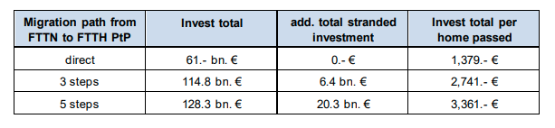
When FTTH involves the provision of fibre to MDUs, there is also a specific cost associated with in-building fibre wiring. Based on interviews conducted in the context of a research project, WIK assumes average costs of in-building wiring per dwelling (from the basement to the dwelling excl. of the drop-connection) of EUR 250-450, although some network operators indicate that the cost of in-building connections per dwelling amount to EUR 800. However, it is important to note that a simultaneous deployment of in-building fibre wiring as would be likely to occur in the context of a CSO obligation is significantly less costly than a sequential deployment, as may occur in the absence of such an obligation. WIK has modelled the cost of the sequential roll-out out of drop-connections compared with the immediate roll-out in one area and estimates that in Germany each percent of dwellings which have to be rolled-out when extending the network from homes passed to homes connected costs between EUR 69 and EUR 108 million . Thus a copper switch-off requirement which incentivises simultaneous deployment to all dwellings within a building is likely to imply reduced costs on average compared with sequential deployment.
Reductions in operational cost
According to WIK’s study on migration to fibre and CSO in the context of the Gigabitforum, if a telecommunications company operates both an FTTC and an FTTH network in the same area, its operating costs are duplicated in part. FTTH has lower operating costs than the copper network. This is due to no electricity costs, more remote maintenance, fewer faults, and thus lower fault repair costs for FTTH. However, the relative repair costs (per case) are higher for FTTH than for FTTC.
In the interviews conducted for the Study on Access Regulation, supporting the impact assessment, one operator stated (comparatively and statically) a 30% lower level of operating costs for FTTH compared to the copper network. Estimates or figures from other operators of 50%-60% savings were considered significantly too high. According to calculations based on WIK’s cost models, the operating costs of a fibre optic connection are in the range of EUR 10 to EUR 15 per line per year. In contrast, the BNetzA estimates operating costs for copper local loops to be more than EUR 15 per line per year.
Further insights on operational cost savings come from Verizon, which last year said it had upgraded 4.5 million circuits on its network from copper to fibre and converted 36 of its central office locations to all fibre. The conversion of those 36 central office locations, the company said, had resulted in operational savings of around USD 180 million.
CSO will also allow for the sale of copper, thereby unlocking significant funds, potentially earlier than might otherwise have been possible. In this context, a recent report suggests that telecom groups globally are forecast to make more than USD 15 billion from the sale of copper over the next 15 years. More specific examples come from reports by BT which noted in 2024 that it had netted GBP 105 million from the sale of its surplus copper cables and expects to "recover up to 200,000 tonnes of copper – in line with customer migrations” by the 2030s. Meanwhile, Brazil’s Telefónica|Vivo hopes to raise as much as BRL 4.5 billion (EUR 711 million) by selling the physical assets underpinning its legacy fixed-line voice and broadband services.
Regarding direct costs to consumers and businesses, migration from copper to fibre involves a migration from copper to fibre-based broadband services, and the potential deployment of a new connection (drop-wire) where this has not previously been deployed. However, the safeguards provided in option 2 would mean that mandated CSO would not occur in areas where consumers would be charged more as a result of the migration.
Unintended costs
Option 2 limits unintended costs on end-users by ensuring that copper switch-off would only occur in cases where there is 95% FTTH coverage and prices to end-users for similar services would not be higher. It further ensures that consumers passed by the network have a right to be connected to the network as long as they pass within a certain distance that would be determined by the NRA (subject to possible right of refusal by the fibre network operator in case of disproportionality / impossibility of securing the connection). There could be unintended costs for those consumers which fall outside the 95% FTTH coverage. However, the possibility for national authorities to continously review the situation and adopt approppriate remedies in terms of fibre deployment or of adopting alternative solutions, even in 2035, where the conditions are not met, whould mitigate such risks.
In addition, provisions on universal service enable Member States to ensure universal availability meeting conditions for adequate broadband, in the event that the market would fail to deliver.
Given expected performance levels of new generation wireless and mobile technology as discussed in the Study on Finance and USO, it could be reasonably expected that mobile and wireless connections will allow similar performance to copper networks at the time of copper switch-off at similar prices. For example in Poland and Germany the least expensive double play offers with >= 100 < 200 Mbps are based on LTE/5G, the least expensive >= 200 < 999 Mbps double play offer in Poland is based on LTE/5G, the least expensive >= 100 < 200 Mbps standalone offer in Romania, Slovakia and Sweden is based on LTE or 5G.
If this is not the case, and this results in digital exclusion, then Member States could step in to address the gap as explained above. Furthermore, any public expenditure needed to subsidise cost-effective wireless connections for the expected small proportion of households which may remain unserved with FTTH (anticipated at only 2% under option 2), is likely to be significantly lower than the public funds that will be saved as a result of extending the reach of commercially viable FTTH roll-out through copper switch-off. Direct costs in terms of subsidies needed to achieve high FTTH coverage while safeguarding broadband quality for users not passed by FTTH, are thus likely to be significantly lower under Option 2 than under the status quo.
Costs in relation to benefits
As regards assessing the benefits in relation to the costs copper switch-off as envisaged in Option 2 is likely to have significant impacts, in particular in certain countries, on the completion of connections along with the take-up of FTTH and on broadband speeds, without affecting prices. Improvements to the access regime to gather more precise market data, facilitate the use of Article 61(3), and to foster the implementation of best practice wholesale specifications should also have the effect of boosting competition on price and quality, resulting in take-up of higher speed broadband. Available academic literature suggests that this is likely to have significant and positive knock-on effects on GDP and reduce emissions associated with electronic communications.
      - Option 3
Option 3 would eliminate costs for operators and NRAs related to data gathering and market analysis under SMP regulation and Article 61(3). However, NRAs would still handle case-by-case dispute resolution, and the EC would review dispute results related to the “bottleneck” test. Evidence from countries like France, which have used dispute-led approaches, suggests this shift could increase costs and create delays due to the case-by-case nature of investigations. This option would reduce NRA oversight on copper switch-off, leading to cost savings for incumbents but potentially causing significant unintended costs for consumers, alternative investors, and broadband providers. Consumers might not be adequately served during copper switch-off, alternative investors could face processes favouring incumbents, and broadband providers might see deteriorated wholesale access conditions, further weakening their profitability. Only former incumbent operators believe the benefits of this option outweigh the costs.
      - Option 4
Option 4 would involve the following costs as a result of mandated measures.
- Requirement on copper network owners to establish copper switch-off plans and to make arrangements for the switch-off of copper networks by 2030.
- Requirement for Member States to establish FTTH coverage plans (as options 1 & 2)
- Requirement for NRAs to monitor fibre coverage by area
- Requirement for NRAs to collect forecasts and invite declarations in areas which are projected to be underserved
- Requirement for the EC or BEREC to provide guidelines on the terms and conditions for mandatory duct access
- Requirement for NRAs to settle disputes in relation to the obligation to make available wholesale access on fair and reasonable terms and conditions, including price
- Potential adoption by EC of Implementing Act establishing specifications for bitstream access, following consultation with BEREC
Option 4 would, like option 3 remove costs associated with data gathering and market analysis linked to the application of SMP regulation and Article 61(3), but would also (like option 3) involve a dispute resolution process. Moreover, unlike option 3, this would apply in a wide set of circumstances due to the symmetric access regulation associated with this option. Experience with the application of the BCRD dispute resolution process – which relates to only a limited set of wholesale products (i.e. access to ducts and poles). This would likely result in higher costs than the current market review process. Costs would also be spread across a broader base of operators, including potentially SMEs. All stakeholder groups with the exception of competent authorities responding to the survey consider that the costs of this option would outweigh the benefits
    - Comparison of direct (administrative) costs
An estimate of the direct FTEs associated with the application of the different options is provided in the following tables along with the status quo. The tables reflect, FTEs for competent authories, FTEs for stakeholders and total FTEs. In making these assumptions, the following factors have been taken into account. All the calculations are provided by WIK-Consult in the context of the Study on Access Regulation, supporting the impact assessment.
- Regarding copper switch-off, a high proportion of Member States may already have experts devoted to addressing this topic, even amongst those which have not issued formal plans. For example, there are several activities ongoing in Germany on this subject, including pilot projects (costing 3.5 FTE per year according to an evaluation report) and discussions in a stakeholder forum, despite there being no plans announced by the incumbent and no decision from the NRA regarding conditions associated with copper switch-off. Additional costs for options advocating (Option 1) or requiring (Options 2 and 4) a CSO deadline are therefore associated with the expansion of these preparatory activities to those MS not already engaged in such activities and the extension of requirements e.g. to publish and monitor FTTH coverage and switch-off plans. It is assumed that under Option 1 (non-binding CSO) 4 additional FTEs would be involved on average in public authorities per Member State across the EU27. This would be increased to 7 additional FTEs per MS for Option 2 (which would allow an extended period, thus encompassing a timeframe in which resources would have been likely to be engaged under the status quo) and 10.5 for Option 4 (which would require accelerated CSO in 2030 without the potential for extension). This would be a one-off cost, spread over a limited number of years surrounding the CSO process.
- Regarding data gathering / geographic surveys under art 22, NRA questionnaires reveal that a significant amount of data is already gathered through this mechanism including data on coverage of specific technologies. Costs linked to additional data gathering requirements (in relation to Options 1, 2 and 4) therefore relate to the extension of data gathering to MS not already conducting such activities, and any extension in scope e.g. to gather data regarding forecasts, expand data gathering to better support the market analysis process (where this is not already the case) and potential to invite declarations for unserved areas. Options involving data gathering requirements (Option 1, 2 and 4) are anticipated to require set-up costs of 2FTE (centrally e.g. in the EC or BEREC) and 0,5 per NRA. As regards recurring costs, for option 1, it is assumed that the additional data gathering requirements would result in an uplift of 20% in resources associated with Art 22 geographic surveys for public authorities as well as for stakeholders compared with the status quo. This would increase to a 50% uplift for options 2 and 4 due to the additional requirements on reporting, and encouragement to make use of declarations to facilitate fibre deployment. While the expansion of Article 22 would be greatest under Option 4, with a requirement to make use of declarations, reporting focused on CSO would be concentrated in a narrower time period under this option.
- The requirement to conduct a market review in relation to the copper switch-off process (option 2) is likely to result in increased one-off costs in countries which would need to conduct a market review earlier than the standard 5 year cycle or which would need to analyse markets (such as dedicated access) which may previously have been deregulated. One-off costs averaging 2 FTE per NRA have been assumed, although this is likely to be concentrated in affected countries. Options (potentially option 2), to the extent that they may involve the removal of an obligation for the EC to adopt a RRM without any requirement in law for NRAs to conduct a market analysis will result in widespread but relatively minor recurring cost increases arising from the requirement to conduct the 3 criteria test (which is not required today for market reviews of markets included in the RRM), in the event that no RRM is adopted. However, these cost increases are likely to be counterbalanced by cost reductions arising from the reduction in the number of market analyses conducted, leaving costs broadly similar.
- Options (option 3) which involve the removal of SMP regulation and limitation on symmetric regulation under Article 61(3) will continue to incur some recurring costs relating to Article 61(3) specifically regarding in-building wiring. In-building wiring obligations currently apply in 7 MS. It is assumed that this number will increase as FTTH deployment and connections expand. 50 FTE have been assumed EU-wide for this activity.
- Options (option 4) which remove SMP and symmetric regulation under Article 61(3) exception in-building wiring, but replace it with a regime subject to dispute resolution will have limited costs linked to SMP / 61(3) (assumed 50 FTE EU-wide as for option 2), but a significant increase in recurring costs associated with dispute resolution. Dispute resolution costs have been estimated by looking at costs associated with GIA dispute resolution (much of which relates to access conditions). This involved 133 FTE per annum based on data collected from DSBs and involves a single access product and associated information (Physical infrastructure / ducts and poles). It is assumed that there will be more disputes and therefore dispute-related costs in option 4 due to the obligations being applied on all operators than in option 3, where the scope of the access obligation is narrow.
- It is assumed that costs relating to the development of best practice wholesale access specifications will be proportionate to the complexity of the process, with higher costs linked to an EC Implementing Act (option 2) than BEREC guidelines (option 1 – where 2 FTE are assumed for 1 year + inputs from 0.5 FTE for each of the 27 MS), and higher costs linked to specifications for multiple wholesale products (included in options 1 & 2 compared with a single product (bitstream – option 4). It should be noted however that these are one-off costs, and are not likely to persist after 18-24 months. Additional one-off costs may be applicable to regulated firms in the event that wholesale specifications the introduction of or changes in the provision of wholesale products e.g., to provide additional flexibility in relation to a VULA product.
- From interviews conducted in the context of the IA associated with the EECC, it is assumed that stakeholders as a group (mainly ECN and ECS providers) will incur administrative costs of approximately double that applicable to the NRA, with more costs accruing to regulated firms e.g. in the context of SMP regulation then access seekers. These costs are linked to providing data and engaging with the NRA in the market analysis process and subsequent monitoring and enforcement proceedings.
- Costs have been derived from estimations regarding changes in FTE requirements on a one-off and recurring basis. The annual cost of an FTE has been calculated based on ISCO values of hourly earnings in 2022 + non-wage labour costs + 25% overhead, assuming that 50% of resources are ISCO 1 (legislators, senior officials and managers) and 50% are ISCO 2 (professionals), and that there are 250 working days per year each involving 8 hours of labour. The resulting annual cost for an FTE is EUR 95 400.
- These tables do not include costs incurred by end-users. These are likely to be substantial if they are required to bear the costs of fibre connections and/or the cost of upgrading legacy equipment. This is possible under option 4 (CSO without sustainability clause), but is precluded up to 2035 by the conditions linked to CSO under option 2.
Table A9 1-5:Estimated administrative costs (in FTE per year) to competent authorities
Option | FTTH and copper switch-off plans and implementation (one-off) | Data gathering under art 22, forecasts and declarations (one-off) | Data gathering under art 22, forecasts and declarations (recurring) | Market analysis, SMP and symmetric (art 61(3)) regulation one-off | Market analysis, SMP and symmetric (art 61(3)) regulation recurring | Best practice wholesale access specifications (one-off) | Dispute resolution in relation to EECC (recurring)
Option 0: Status quo | 50 |  | 265 |  | 374 | 0 | 85
Option 1: Non-binding copper switch-off and limited updates to access regulation | 108 | 15,5 | 318 |  | 374 | 15,5 | 85
Option 2: Conditional copper switch-off and updated access regulation | 189 | 15,5 | 397,5 | 54 | 374 | 46,5 | 85
Option 3: Market driven copper switch-off and bottleneck-based access regulation | 0 | 0 | 0 |  | 50 | 0 | 266
Option 4: Mandatory copper switch-off and symmetric regulation | 283.5 | 15.5 | 397.5 |  | 50 | 15,5 | 532
Source: Study on Access Regulation
Table A9 1-6:Estimated administrative costs (in FTE per year) to stakeholders
Option | FTTH and copper switch-off plans and implementation (one-off) | Data gathering under art 22, forecasts and declarations (one-off) | Data gathering under art 22, forecasts and declarations (recurring) | Market analysis, SMP and symmetric (art 61(3)) regulation one-off | Market analysis, SMP and symmetric (art 61(3)) regulation recurring | Best practice wholesale access specifications (one-off) | Dispute resolution in relation to EECC (recurring)
Option 0: Status quo | 100 | 0 | 530 | 0 | 748 | 0 | 170
Option 1: Non-binding copper switch-off and limited updates to access regulation | 216 | 31 | 636 | 0 | 748 | 31 | 170
Option 2: Conditional copper switch-off and updated access regulation | 378 | 31 | 795 | 108 | 748 | 93 | 170
Option 3: Market driven copper switch-off and bottleneck-based access regulation | 0 | 0 | 0 | 0 | 100 | 0 | 532
Option 4: Mandatory copper switch-off and symmetric regulation | 567 | 31 | 795 | 0 | 100 | 31 | 1 064
Source: Study on Access Regulation
Table A9 1-7:Total Estimated administrative costs (in FTE per year)
Option | FTTH and copper switch-off plans and implementation (one-off) | Data gathering under art 22, forecasts and declarations (one-off) | Data gathering under art 22, forecasts and declarations (recurring) | Market analysis, SMP and symmetric (art 61(3)) regulation one-off | Market analysis, SMP and symmetric (art 61(3)) regulation recurring | Best practice wholesale access specifications (one-off) | Dispute resolution in relation to EECC (recurring)
Option 0: Status quo | 150 | 0 | 795 | 0 | 1 122 | 0 | 255
Option 1: Non-binding copper switch-off and limited updates to access regulation | 324 | 46,5 | 954 | 0 | 1 122 | 46.5 | 255
Option 2: Conditional copper switch-off and updated access regulation | 567 | 46,5 | 1 192.5 | 162 | 1 122 | 139.5 | 255
Option 3: Market driven copper switch-off and bottleneck-based access regulation | 0 | 0 | 0 | 0 | 150 | 0 | 798
Option 4: Mandatory copper switch-off and symmetric regulation | 850.5 | 46.5 | 1 192.5 | 0 | 150 | 46.5 | 1 596
Source: Study on Access Regulation
The following table shows the estimated change in one-off and recurring administrative costs taking costs for both public authorities and stakeholders into account. Option 1 is expected to be associated with a one-off cost of EUR 25 million, mainly associated with CSO and FTTH plans, as well as guidelines for the reporting of data and best practice wholesale products. One-off costs of around EUR 73 million are anticipated for option 2 linked to preparations for the mandatory switch-off of copper networks (as well as introduction of harmonised wholesale products) with slightly higher one-off costs for option 4 linked to intensified preparations for copper switch-off without the potential for extension beyond 2030. One-off cost savings of around EUR 14 million might be expected if it results in the removal of existing oversight mechanisms for copper switch-off, although this cannot be presumed. Regarding recurring costs, increases of 7% are expected for option 1 and 18% for option 2 (linked mainly to increased focus on data gathering), while an increase of 35% is expected for option 4 linked to the switch from ex ante regulation to the more resource-intensive process associated with dispute resolution. Cost savings of around 56% are expected from the removal of the market review framework under option 3 and its replacement with dispute resolution with a much narrower scope.
Table A9 1-8:Estimated change in one-off and recurring administrative costs
Option | One-off FTE (CSO + data + market review + wholesale products) | Change in one-off FTE | Change in one-off costs | Recurring FTE (Data gathering, market analysis, dispute resolution) | Change in recurring FTE | Change in recurring cost (EUR 000) | % Change in recurring cost
Option 0: Status quo | 150 | - | - | 2.172 | - | -
Option 1: Non-binding copper switch-off and limited updates to access regulation | 417 | 267 | 25 471 800 | 2.331 | 159 | 15.169 | 7%
Option 2: Conditional copper switch-off and updated access regulation | 915 | 765 | 72 981 000 | 2.570 | 398 | 37.922 | 18%
Option 3: Market driven copper switch-off and bottleneck-based access regulation | - | - 150 | - 14 310 000 | 948 | - 1 224 | - 116.770 | -56%
Option 4: Mandatory copper switch-off and symmetric regulation | 944 | 794 | 75 699 900 | 2.939 | 767 | 73.124 | 35%
Source: Study on Access Regulation

1.1.3 Impact on stakeholders
Impact on ECN operators
Relevant policies
Under option 2, the following provisions would impact ECN operators:
- From 2030, copper network owners (mainly former incumbents) that have not already done so would be expected to start switching off their networks in areas with at least 95% FTTH coverage. Where needed, operators must submit switch-off plans to the NRA.
- Geographic data: ECN operators must provide more granular geographic and technology-specific network data to the NRA or other competent authority.
- ECN operators must support the NRA in conducting any market analysis related to copper switch-off. This may involve additional work beyond the status quo if a new market review is triggered before the normal 5-year cycle.
- Wholesale product obligations: Where wholesale access obligations apply, operators would be expected to offer the standardised wholesale products listed in the DNA Annex.
- NRAs to make greater use of Article 61(3), including for access to in-building wiring and, in some cases, as an alternative to SMP WLA beyond the first distribution point.
Impacts of copper switch-off
Starting the copper switch-off process will entail some administrative and operational costs for copper network owners, as well as other ECN operators including broadband providers making use of wholesale offers and alternative fibre investors. However, as all copper networks will eventually be replaced with fibre, such operational costs would be incurred regardless of any EU obligation. The measure is changing only the timing of the migration.
As situations vary and limited concrete information is available from literature or via stakeholder consultation, it is not possible to quantify the implementation costs associated with earlier copper switch-off and migration in countries where the obligation may lead to earlier switch-off than would otherwise occur.
In this context, while there might be operational costs associated with an acceleration of the process, it is not clear to what extent (if at all) earlier implementation would affect the level of cost. Meanwhile, accelerating the process of FTTH deployment and reducing the timeframe for the parallel operation of copper and fibre is also likely to result in cost savings (both Capex and Opex) for ECN operators involved in the migration to fibre and (for copper network owners) the release of funds from the sale of copper earlier than might otherwise occur.
All the costs related to that option are discussed in detail in the previous chapter (Annex 9, p.1.1)
Distribution of costs and benefits amongst different operator types
The costs and benefits described above are likely to be attributed to different ECN operator types in the following ways:
Incumbent operators that have not widely deployed FTTH and are required to switch off copper earlier than planned may face additional administrative costs, including preparing CSO plans, supplying data, and engaging with NRAs. While precise incremental costs are unclear, copper owners in 18 Member States may need new or updated CSO plans. Assuming around 8 extra FTEs per affected Member State, this implies roughly 139 additional FTEs EU-wide (about EUR 13 million). If early market reviews are triggered, an estimated 54 extra FTEs (about EUR 5.2 million) may also be needed.
CSO implementation costs—system changes, operational adjustments, and consumer information campaigns—may be incurred earlier under option 2. Higher forced-migration rates could raise communication and customer-engagement costs. Some costs may ultimately be passed on to wholesale access seekers if fibre wholesale services continue.
As regards indirect costs, earlier switch-off of copper networks which have been fully depreciated might affect profitability and ROCE of copper network owners. However, as noted in a WIK study for the German authorities, the impacts of CSO on profitability cannot be considered in isolation, and should also take into account profits incurred on a forward-looking basis over own-build or alternative fibre networks in the post-CSO environment. For example, even if a copper network owner has not deployed its own fibre network in a given area, if unbundled fibre is available on cost-oriented rates from an alternative provider, this should not in principle lead to reductions in profitability. It is also important to note that option 2 requires Member States to ensure that copper network owners switch off copper networks, while leaving the precise mechanism to the MS concerned. This might, if and where appropriate involve compensation, if considered appropriate.
Earlier copper switch-off could also accelerate financial gains from copper sales. Globally, operators are projected to generate over USD 15 billion from copper recovery over the next 15 years. For example, BT reported GBP 105 million from copper sales in 2024 and expects to recover up to 200 000 tonnes by the 2030s; Telefónica|Vivo aims to raise up to BRL 4.5 billion (EUR 711 million).
Finally, operational costs for FTTH are lower than for legacy networks due to reduced energy use and fewer faults. FTTH’s superior energy efficiency relative to FTTC/FTTB is is clear from the following diagram, which shows the average kWh of energy used per subscriber and year per technology in Austria.
Figure A9 1-3: Average kWh per subscriber and year by technology in Austria
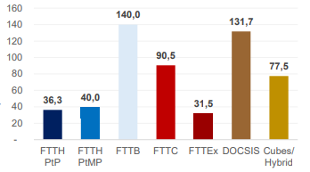
Source: https://www.rtr.at/TKP/aktuelles/veranstaltungen/veranstaltungen/veranstaltungen_2024/ 11122024/oekologische-effekte-des-glasfaserausbaus.de.html
Incumbent operators that have already invested widely in FTTH and plan to switch off copper by 2030 are likely to be largely unaffected; BEREC indicates this applies in 9 Member States. Others with substantial FTTH deployment but no concrete CSO plans may benefit from the obligation if it accelerates the removal of barriers to fibre rollout. The scale of these benefits depends on each operator’s FTTH footprint relative to alternative fibre investors.
Alternative fibre investors without copper networks may face some administrative costs linked to CSO planning and contributing to Member States’ FTTH deployment plans, though these would be far lower than those of copper network owners. If their resource needs amount to roughly half those of incumbents, this would imply about 70 extra FTEs (EUR 6.5 million) across the 18 Member States lacking CSO plans, plus around 27 FTEs (EUR 2.6 million) for participation in CSO-related market analyses.
They will also need to ensure customers can be connected to their networks—e.g., deploying drop cables or in-building wiring—but these costs are generally passed on to end users through connection fees or monthly charges, and only arise where operators control in-building infrastructure. Unlike copper owners, they face no major additional operational costs from migration beyond switching and number portability.
Indirect effects are strongly positive. Alternative fibre investors stand to benefit most from CSO, as non-discriminatory switch-off would increase penetration on their networks, reduce risk, and improve profitability and ROCE. Many of these operators are currently highly leveraged and loss-making. Therefore, a binding CSO timetable would significantly improve investment certainty. Financial investors highlight that eliminating parallel copper networks enhances pricing dynamics, boosts take-up, strengthens long-term returns—especially in less dense areas—and improves valuations by providing more predictable cash flows.
Broadband service providers that depend on copper-based wholesale access may be negatively affected by the CSO obligation, as many still rely heavily on copper products in several Member States. They will face administrative costs linked to reviewing CSO plans and contributing to CSO-related market analyses to secure reasonable fibre wholesale terms. If their resource needs are roughly half those of copper network owners, this implies about 70 FTEs (EUR 6.5 million) for CSO planning and 27 FTEs (EUR 2.6 million) for market-analysis engagement across the EU. These providers will also incur implementation costs from system changes and customer communications. CSO mainly affects the timing of these costs, though they may rise if accelerated switch-off compresses resource needs or increases the volume of automatically migrated customers. Their dependence on copper is significant: copper and FTTC/VDSL still represent over half of all wholesale access supplied by incumbents to alternative operators. The greater degree of reliance on ADSL copper by access seekers compared with incumbents is also evident from data provided by NRAs which shows that for mass-market broadband services, as of 2023, 24% of total incumbent (wholesale and retail) copper (ADSL) lines were based on wholesale access. This compared with 14% of total incumbent (wholesale and retail) VDSL lines and 16% FTTH lines.
When considering the reliance of broadband service providers (altnets) on copper wholesale products, it is important to note that this applies not only to mass-market connections provided to consumers, but even more significantly to mass-market broadband connections provided with a business-grade SLA. This is illustrated in the following chart.
Figure A9 1-4: Wholesale access to incumbent business grade mass-market broadband by type in % of total business-grade services of incumbent (wholesale and retail) 2020-2023
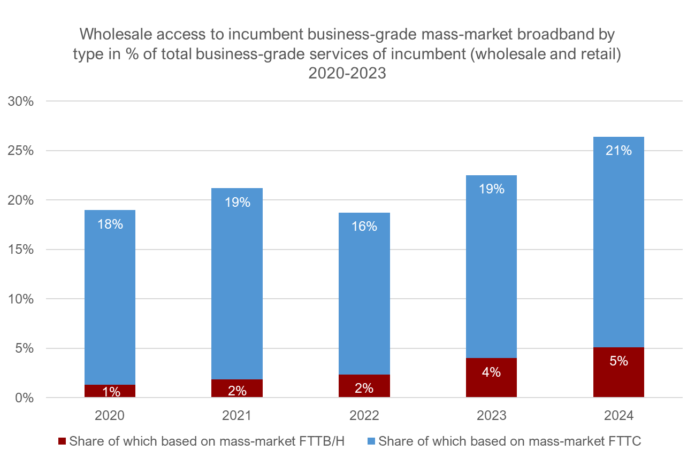
Note: countries included here are Austria, Belgium, Bulgaria, Croatia, Ireland
Reliance by altnets on copper to serve business customers, is significantly greater than that of incumbents, although it is notable that as of 2023 38% of all non-dedicated business products from countries which reported such data, was provided on the basis of FTTC.
Indirect costs arise because broadband service providers will need to migrate copper customers to fibre networks, where wholesale conditions may be less favourable—particularly regarding pricing and service differentiation—unless regulatory safeguards are applied. Today, almost all wholesaled copper lines are physically unbundled, while only about 20% of fibre lines are, and copper and FTTC/VDSL products are often cost-oriented. By contrast, FTTH wholesale access is priced flexibly in many Member States.
As CSO removes copper-based competitive constraints, FTTH wholesale terms may worsen over time—especially where fibre becomes a monopoly or duopoly—unless NRAs intervene. Because wholesale-reliant broadband providers are generally less profitable than incumbents, any deterioration in wholesale conditions could disproportionately harm them. Providers that have co-invested in FTTH through regulated IRUs (available mainly in FR and IT) face lower risk.
Impacts of changes to access regulation
The additional cost associated with requirements to provide data to the NRA or other competent authority on a more granular level is likely to be relatively limited because (i) geographical surveys have already been implemented in the vast majority of member states, and some may already contain the necessary degree of detail, (ii) ECN operators should already have granular data available regarding the location and type of infrastructure for network planning purposes; (iii) the addition of data on the location of cables should be complementary to the mapping of existing physical infrastructure which is required for all ECN operators under the GIA; and (iv) most NRAs already require the provision of granular data in the context of periodic market analysis for the WLA market (regulated in 23 out of 27 MSs). Additional cost could be incurred by ECN operators to provide granular data regarding dedicated connections, as data gathered in the context of this study suggests that it was not collected by many NRAs (15 out of 27 did not provide detailed data regarding dedicated connectivity).
The additional resourcing needs relating to data gathering amongst ECN operators compared with the status quo could involve set-up costs of 4 FTE at EU level (to input into the development of guidelines) and 1 FTE per Member State amounting to total one-off costs around EUR 3 million. If recurring costs associated with data provision increase by 50% compared with the status quo this might require around 265 additional FTE EU-wide (approximately EUR 25 million), of which half may be attributable to incumbent operators and the remainder evenly split between alternative fibre investors and broadband service providers.
As regards benefits, if the resulting data is published, more stringent obligations regarding geographic data gathering could benefit ECN operators by providing evidence which could be used to support claims for intervention or deregulation in the context of market analyses.
Option 2 does not involve major s changes to the existing regime of access regulation. Specific one-off costs linked to the CSO-related market review have been covered under the discussion of CSO. More generally, option 2 might lead to a more widespread imposition of access to in-building wiring under Article 61(3) which may entail some administrative inputs and implementation costs where not already applied (depending on decisions taken by the NRA), but contribute to substantial cost-savings for all operators deploying FTTH through sharing rather than duplication of in-building wiring in MDUs and office buildings. option 2 might also lead to Article 61(3) being used beyond the first distribution point for existing networks in some cases as an alternative to SMP WLA obligations. This should in principle give rise to administrative cost savings, as the Article 61(3) procedure should be more straightforward to apply than SMP in cases where there are multiple local monopolies. However, as the decision will remain with the NRA and the outcomes are uncertain, it is not possible to quantify such savings. The costs for the market analysis process will remain neutral for all parties involved under option 2.
While the effects would be delayed by the obligations to conduct market reviews associated with copper switch-off, it should be noted that there could be indirect effects in the event that the publication by the European Commission of the RRM, which lists relevant markets considered susceptible to ex ante regulation, becomes optional. This will result in indirect costs and benefits for ECN operators which will differ depending on the implications this has for specific operator groups that may have been (or might otherwise be) considered likely to be subject to ex ante regulation or may have relied on ex ante regulation to provide broadband services to end-users.
However, making the RRM optional does not guarantee that it will be removed (not adopted). The potential impacts discussed are hypothetic and depend on several factors, including NRAs actions. Therefore, the actual effects of a potential decision to make the RRM optional remain uncertain and contingent on future decisions and actions.
If the RRM is made optional this could be seen by financial markets as positive for incumbent operators, as these operators are currently subject to SMP designations and making the RRM optional will signal there may not be a perceived need for ongoing regulation in a fibre environment at EU level. This may raise expectations about the potential for deregulation of existing markets that are presumed to be susceptible to ex ante regulation. This effect is likely to be EU-wide due to the effect of the DNA in providing signals to the market and to NRAs, but is likely to be tempered by expectations about what NRAs may do at national level, which is likely to differ between the different countries.
Making the RRM optional could have mixed impacts on alternative fibre investors. On one hand, it could signal reduced NRA scrutiny of market power transferred to these operators post-copper switch-off in areas where incumbents did not deploy their own fibre networks. However, it could also decrease long-term certainty regarding wholesale access terms and limit focus on SMP regulation, including SMP PIA, which some investors rely on to deploy and sustain infrastructure. Deregulatory signals could undermine the market shares and positioning of alternative broadband service providers, detrimental to fibre investors reliant on them. The current proposal does not discuss the removal of the RRM. Even if it becomes optional, the impact on operators will be delayed until after 2035, as retail market analysis will act as a substitute for the RRM in the interim. In addition, the actions of NRAs need to be taken into account also in the long term.
Broadband service providers may face significant drawbacks if changes to the EECC make the RRM optional and there is a decision not to issue an RRM. This could reduce regulatory certainty in a fibre environment, signalling potential deregulation and increasing perceived risks. Higher risk perceptions could elevate their cost of capital, already higher due to project-based financing. The impact will vary by country based on existing access agreements and NRA proactivity. Overall, the risk for broadband service providers may increase, as they currently benefit from ex ante regulation in most Member States. However, for the reasons explained above many factors play a role in this context.
Standardised wholesale product
Under the preferred option, all ECN operators will face one-off administrative costs for developing standardized wholesale access product specifications for FTTH, QoS, and fixed wireless networks at the EU level and nationally (estimated at 93 FTE, ~ EUR 9 million). Incumbent operators will incur adaptation costs for wholesale specifications and interconnection points, but these may be recouped over time through charges for new wholesale products, including co-location and ordering system changes. Benefits could include faster infrastructure take-up due to competitive pricing and innovation.
For incumbents found to have SMP, mandating these specifications could increase market share, but may also lead to revenue loss if basic wholesale products replace more advanced ones. Alternative fibre investors would face similar costs and benefits, with additional potential gains from cross-border standardization.
Broadband service providers stand to benefit from product differentiation and innovation, though they will also incur adaptation costs. However, these benefits may be reduced if the focus on wholesale access regulation is limited. Overall, the impacts vary by market structure and the presence of SMP.
Table A9 1-9:Estimated costs and benefits to ECN operators linked to the preferred DNA option
 |  | Incumbents |  | Alternative fibre investors |  | Broadband service providers
 |  | One-off | Recurrent | One-off | Recurrent |  | One-off | Recurrent
Copper switch-off | Direct costs | CSO plan + contribution to FTTH plan where relevant Est 139 FTE (EUR 13 m) extra. CSO related market review 54 FTE ~EUR 5 m  Migration costs (but would also be incurred in status quo). |  | CSO plan + contribution to FTTH plan where relevant Est 70 FTE (~EUR 6.5 m).. CSO related market review 27 FTE ~EUR 2.6 m |  |  | CSO plan + contribution to FTTH plan where relevant Est 70 FTE (~EUR 6,5 m). CSO related market review 27 FTE ~EUR 2.6 m  Migration costs (but would also be incurred in status quo)
Copper switch-off | Indirect / unintended costs | For incumbents with high reliance on copper / limited FTTH, potential reductions in revenues and ROCE, but depends on replacement scenario incl. wholesale access conditions. Otherwise, limited negative effects |  |  |  |  | For altnets with high reliance on copper / limited FTTH, reductions in revenues and ROCE, but depends on replacement scenario incl. wholesale access conditions.
Copper switch-off | Direct benefits | Potential for accelerated sale of copper yielding significant revenues / cashflows |  | Increased penetration on FTTH networks
Copper switch-off | Indirect benefits | For incumbents which have deployed widespread FTTH, reduced barriers to switching, reducing Opex related to operating parallel networks  For all incumbents – Reduced energy consumption and associated costs for operating fibre, reduced capital expenses associated with repairs over time |  | Increased revenues and ROCE |  |  | Reduced energy consumption / opex if able to access passive inputs or if benefits are passed on in wholesale offers
Access regulation: Data gathering | Direct costs | Set-up of data gathering templates and processes est 15 FTE ~EUR 1.5 m | Increased data provision costs est 132 FTE extra (~EUR 12.6 m) | Set-up of data gathering templates and processes est 8 FTE ~EUR 0.7 m | Increased data provision costs Est 66 FTE extra (~EUR 6.3 m) |  | Set-up of data gathering templates and processes est 8 FTE ~EUR 0,7 m | Increased data provision costs est 66 FTE extra (~EUR 6,3 m)
Access regulation: Data gathering | Indirect / unintended costs |  |  | Granular data gathering may highlight regional market power
Access regulation: Potential increased use of Art 61(3) / Potential for RRM to be made optional | Direct costs |  | Likely no change (reduced number of reviews, but 3CT), although use of Art 61(3) beyond first distr point instead of WLA could reduce costs if used in cases of local monopoly |  | Likely no change (reduced number of reviews, but 3CT) although use of Art 61(3) beyond first distr point instead of WLA could reduce costs if used in cases of local monopoly |  |  | Likely no change (reduced number of reviews, but 3CT) although use of Art 61(3) beyond first distr point instead of WLA could reduce costs if used in cases of local monopoly
 | Indirect / unintended costs | Greater incidence expected of legal challenge and associated cost in absence of RRM |  | Increased uncertainty regarding future approach to regulation  Greater incidence expected of legal challenge and associated cost in absence of RRM |  |  | Deregulation signal likely to reduce valuations and increase cost of capital  Greater incidence expected of legal challenge and associated cost in absence of RRM
 | Indirect benefits | Reduced costs / increased ease of deployment of FTTH if article 61(3) is applied more widely |  | Reduced costs / increased ease of deployment of FTTH if article 61(3) is applied more widely |  |  | Reduced costs / increased ease of deployment of FTTH if article 61(3) is applied more widely
Access regulation: Harmonised wholesale products | Direct costs | Contribution to development of specifications est 46 FTE extra (~EUR 4.4 m)  Product development and introduction – but added to wholesale charge |  | Contribution to development of specifications est 23 FTE extra (~EUR 2.2 m) |  |  | Contribution to development of specifications est 23 FTE extra (~EUR 2.2 m)
Access regulation: Harmonised wholesale products | Indirect / unintended costs | Where standardised products applicable (subject to SMP finding), reduced scope to market active access -> reduced revenues and profits |  | Where standardised products applicable (subject to SMP finding), reduced scope to market active access -> reduced revenues and profits |  |  | Where standardised products applicable (subject to SMP finding), increased scope for price and quality differentiation -> increased profitability
Source: WIK-Consult
National Regulatory Authorities (NRAs) and other competent authorities
Relevant policies
The preferred option has the following implications for NRAs and other competent authorities compared with the status quo:
- Requirement for NRAs to assess copper switch-off plans and to ensure that the process is handled effectively and in a manner that protects consumer welfare and preserves competition. Competent authorities will also engage in preparing FTTH plans and advise national governments in the context of copper switch-off.
- Requirement for NRAs or competent authorities to collect geographic data and assess progress regarding FTTH deployment and copper switch-off.
- Requirement to conduct a market analysis in the context of copper switch-off
- Possibility to consider application of Article 61(3) on own initiative. In the event that no RRM is adopted, removal of the existing requirement to analyse markets listed in the RRM, and a requirement to conduct the 3CT in addition to an SMP analysis for markets currently in the RRM.This may occur earlier, if markets are removed from the RRM.
- Requirement for EC in consultation with BEREC to adopt an Implementing Act to establish best practice specifications for wholesale access products, a requirement for NRAs and other competent authorities to take these into account when imposing wholesale access.

Copper switch-off
In relation to copper switch-off, SMP operators are already required to notify decommissioning plans to the NRA. The DNA is likely to affect the timing rather than the extent of NRAs' resourcing needs. In the nine countries planning CSO by 2030, few changes are expected.
Other countries may need more resources to oversee the transition to FTTH post-DNA implementation. Many Member States already have experts focused on this topic. For instance, Germany is engaged in various activities despite lacking formal plans. Additional costs will arise from expanding these activities to less-prepared Member States and extending requirements, such as reviewing switch-off plans, advising governments and accelerating FTTH deployment. Estimating precise costs is challenging without current resourcing data, but employing an additional 5 FTE per Member State (or 7-8 FTE in 18 Member States planning CSO before 2030) could require around 189 FTE, increasing resourcing needs by about EUR 13 million if 50 FTE are currently engaged in CSO support across the EU. Additionally, 54 FTE might be needed for market analyses related to CSO, costing around EUR 5 million.
The obligation to gather data at a more granular level will have limited resource implications in countries already collecting such data, based on the current code, but may increase the frequency of data gathering. Countries not currently collecting granular data will need additional resources, involving one-off costs to adapt data gathering systems and recurring increases in resources. Developing new guidelines at the EU level will also require resources. Set-up costs for new data gathering templates are estimated at 2 FTE at the EU level (e.g., in BEREC) and 0.5 FTE per NRA, totalling 15.5 FTE on a one-off basis, costing around EUR 1.5 million. A 50% increase in resources devoted to data gathering, based on current annual resources of around 265 FTE, would result in additional annual resourcing needs of 132.5 FTE, costing around EUR 12.6 million across the EU.
Changes to access regulation, with an increased focus on Article 61(3) for in-building wiring, may require additional resources. However, expanded use of Article 61(3) beyond the first distribution point could enable cost efficiencies, potentially balancing out the costs. If the RRM becomes optional, the need for ex ante regulation may decrease, reducing the number of market reviews over time. This could be counteracted by increased resources for conducting the 3CT for all markets and additional analysis triggered by regional data considerations. Overall, there is likely to be no change in resourcing and administrative costs associated with market reviews, but NRAs may face higher legal challenges and associated costs when they intervene.
For harmonized wholesale product specifications, set-up costs would be incurred by BEREC and contributing NRAs. This includes a one-off contribution of 2x3 FTEs over two years for developing BEREC guidelines and an additional 0.5 FTE per Member State over three years for national specifications. The total one-off resourcing need is estimated at around 46.5 FTE, costing approximately EUR 4.4 million.
Table A9 1-10:Estimated costs and benefits to NRAs and other competent authorities linked to the preferred DNA option
 |  | NRAs and other competent authorities
 |  | One-off | Recurrent
Copper switch-off | Direct costs | 139 FTE additional ~EUR 13.2 m for review of CSO plans  54 additional FTEs for CSO market review ~EUR 5.2 m
Copper switch-off | Indirect costs
Copper switch-off | Direct benefits
Copper switch-off | Indirect benefits
Access regulation: Data gathering | Direct costs | 15.5 FTE ~EUR 1.5 m for establishment of templates | 132.5 FTE additional ~EUR 12.6 m
Access regulation: Data gathering | Indirect costs
Access regulation: Data gathering | Direct benefits | More accurate data to input to geographic market analyses
Access regulation: Data gathering | Indirect benefits
Access regulation: Extension of Article 61(3). Potential for RRM to be made optional | Direct costs | No change | No change although there could be cost savings if Art 61(3) is used instead of SMP WLA in cases of local monopoly
 | Indirect costs | If RRM optional, reduced legal certainty / threat of legal challenge and associated costs  Increased risk of under-regulation (but impacts mainly on ECN operators and end-users)
 | Direct benefits
 | Indirect benefits
Access regulation: Harmonised wholesale products | Direct costs | 46.5 additional to draft and implement ~EUR 4.4 m | Reduced costs associated with development of remedies
Access regulation: Harmonised wholesale products | Indirect costs
Access regulation: Harmonised wholesale products | Direct benefits | Simplification / streamlining of process of defining remedies on ongoing basis
Access regulation: Harmonised wholesale products | Indirect benefits
Source: WIK-Consult
Consumers
Relevant policies
Consumers will be directly affected by the requirement for Member States to ensure that copper switch-off occurs in areas which have reached 95% coverage with FTTH and retail prices which allow equivalent services to be provided at no extra charge. In addition, consumers will be indirectly affected by changes to access regulation that influence choice, price and quality in broadband offers.

Copper switch-off
Regarding copper switch-off, as previously noted, the requirements under the DNA will affect the timing of a migration from copper to fibre that can be seen as inevitable. However, they will do so in a manner which seek to limit any negative impacts, and in particular the potential for increased costs, to consumers.
Regarding direct costs, copper switch-off and the associated FTTH deployment will require the deployment of in-building fibre wiring. In cases where this does not already exist in MDUs, this may involve costs for the deployment of such wiring, which may be met directly by consumers e.g. if it is the responsibility of the building owner, or indirectly, if the costs are met by ECN providers, but then passed onto consumers. Upgrades to fibre wiring are already required for major renovations under Article 10 GIA. However, accelerated fibre deployment under the DNA may also necessitate the accelerated deployment of in-building fibre in existing buildings. The manner in which these connection costs are passed on could be one important element addressed in the copper switch-off plan to be prepared by national authorities. Such costs can be minimised for example by adopting best practice standards and ensuring the sharing of wiring between multiple providers under Article 61(3). ECN operators could also commit to distributing connection costs over a longer period so that they do not impose an undue burden on consumers.
The preferred option seeks to ensure that all consumers passed by a fibre network within a given distance will have the right to connect at standard terms and conditions (which may be free if the connection is paid over time through the rental fee). The CSO requirement in the DNA should also make it more likely that connections are installed in parallel rather than sequentially. As discussed in relation to the impact on ECN operators, this should significantly reduce the total costs involved in installing connections, limiting the burden on consumers.
Regarding ongoing charges for fibre, the provisions in the DNA include provisions that switch-off should occur only if prices for equivalent services are not higher over the replacement infrastructure. This should ensure that consumers do not pay more for fibre-based broadband. In practice, evidence shows that significantly higher bandwidths over fibre are available at no extra charge to copper in the majority of Member States.
In fact, available data suggests that a mandatory transition from copper (incl. FTTC) to FTTH should result in end-users experiencing increased speeds and greater reliability for similar price. Recently published Empirica data shows (see figures below) that, as of 2023, in only 6 countries (DE, BG, EE, PT, AT, EL) would charges for an FTTH or cable connection of more than 100 Mbps be more expensive than an FTTC or ADSL connection at less than 100 Mbps for double and triple play including broadband and fixed telephony and TV in the case of a the triple play offer (the results are similar for standalone broadband).
Indeed, the presence of such a difference could prompt a review in these outlier countries of whether competition on fibre (including via access regulation where necessary) is sufficient to ensure that retail prices remain competitive following copper switch-off. Evidence from the vast majority of other countries suggests that better quality connections should be available for no extra charge.
Figure A9 1-5: Double play pricing – difference between copper and cable or fibre-based connections from >= 30 < 100 Mbps to >= 100 Mbps < 200 Mbps (internet and phone)
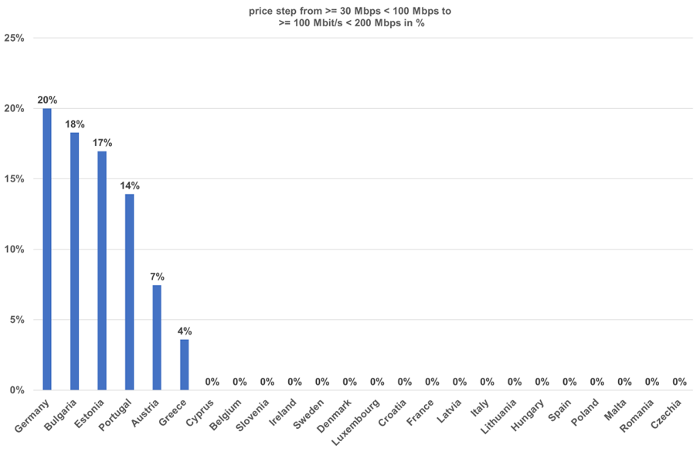
Note: The Netherlands and Slovakia excluded as least expensive offer based on xDSL. >= 100 < 200 Mbps offers in Poland and Germany based on LTE/5G. No data was available for Finland.
Source: empirica (2025): Mobile and Fixed Broadband Prices in Europe 2023, Prices as of October 2023, least expensive fixed broadband offer.
https://digital-strategy.ec.europa.eu/en/library/mobile-and-fixed-broadband-price-europe-2023-insights-european-broadband-market
Figure A9 1-6: Triple play pricing – difference between copper and cable or fibre-based connections from >= 30 Mbps < 100 Mbps to >= 100 Mbps < 200 Mbps (internet, phone and TV)
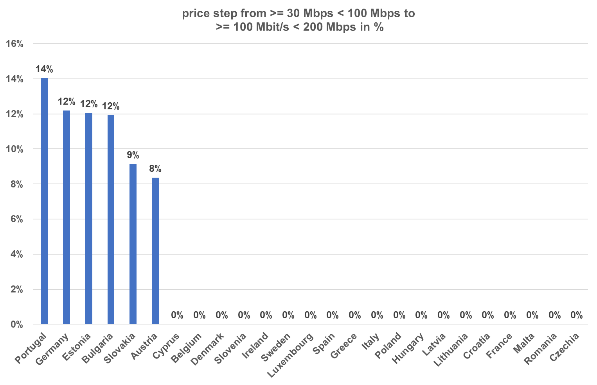
Note: Netherlands not included in this graph as prices referred to xDSL offer. No data was available for Finland. Germany and Estonia refer to cable.
Source: empirica (2025): Mobile and Fixed Broadband Prices in Europe 2023, Prices as of October 2023, least expensive fixed broadband offer.
https://digital-strategy.ec.europa.eu/en/library/mobile-and-fixed-broadband-price-europe-2023-insights-european-broadband-market
This finding is consistent with the fact that, when unviable duplication of infrastructure is removed via copper switch-off, thereby removing the demand-risk associated with parallel operation of copper and fibre which would otherwise increase the WACC, the cost of fibre-based broadband is not intrinsically higher than that of copper-based broadband. NRAs have for some time based charge controls on copper networks on the basis of bottom-up models in which costs are based on FTTH as the modern equivalent asset.
As can be seen from the following chart, the migration from low-speed copper to double and triple play offers with Gigabit speeds could be associated with considerable price increases in some countries. However, while the transfer to a fibre connection should provide additional options for consumers, there is no obligation for consumers to upgrade to Gigabit and incur these extra charges. Moreover, and importantly, the obligation under the preferred option for NRAs to conduct market reviews in connection with CSO could provide an opportunity for NRAs to address any barriers to competition (including inadequately specified wholesale products) that are preventing Gigabit speeds from being offered at competitive rates.
Figure A9 1-7: Double play pricing – difference between copper and cable or fibre-based connections from >= 30 < 100 Mbps to >= 1 Gbps (internet and phone)
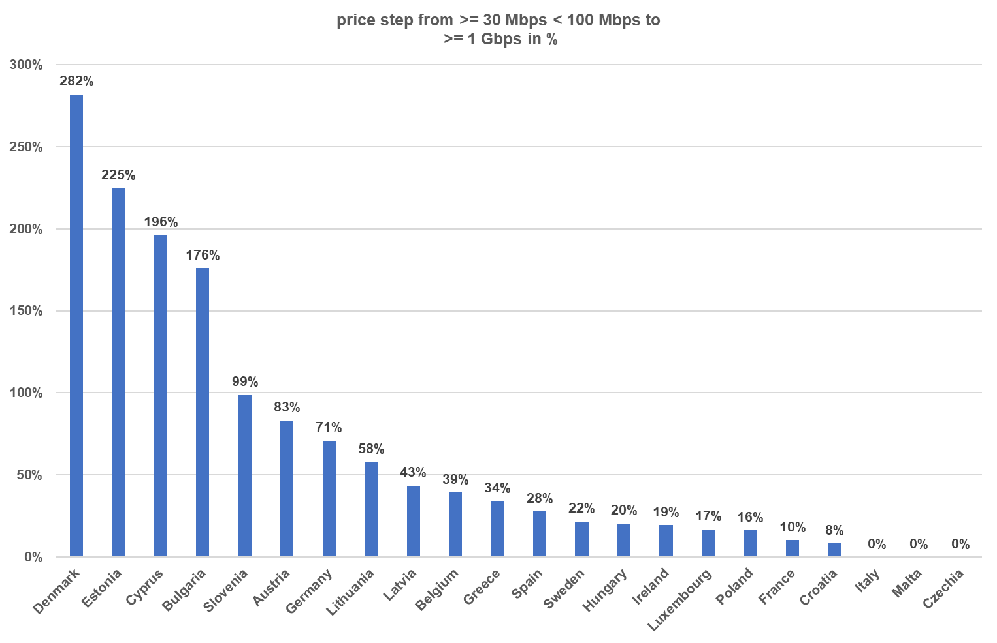
Note: The Netherlands, Poland, Portugal, Romania and Slovakia excluded as offer refers to bandwidth below 1 Gbps. No data was available for Finland. Germany and Estonia based on cable.
Source: empirica (2025): Mobile and Fixed Broadband Prices in Europe 2023, Prices as of October 2023, least expensive fixed broadband offer.
https://digital-strategy.ec.europa.eu/en/library/mobile-and-fixed-broadband-price-europe-2023-insights-european-broadband-market
In summary, under the preferred option, the vast majority of consumers and businesses will benefit from higher speeds and reduced environmental impacts as well as reduced energy consumption compared with the status quo. Attention to the maintenance of competition during the copper to fibre migration along with legal safeguards should mean that consumers benefit from higher quality broadband at no additional cost. However, a limited proportion of consumers may need to switch to wireless and/or mobile solutions. There is evidence to suggest that in most cases, these wireless technologies already provide capabilities that are comparable to those available over copper. Thus, even consumers which are not served with FTTH should not be disadvantaged by copper switch-off. In the event that this is not the case, Member States could allow, following the 2035 review, the continued use of copper in residual areas where the deployment of fibre would not be viable or take action to secure an appropriate safety net via USO measures for those consumers who are not served with an FTTH network when copper is switched off to ensure an adequate internet access service.
Access regulation
Although they may not benefit directly from changes to access regulation, consumers should benefit from increased choice and quality on their fibre connections in situations where harmonised wholesale products are introduced. The wider scope of application of Article 61(3) which has been achieved very positive outcomes in countries such as France, could also help to support increased competition on fibre networks in countries where there are multiple local monopolies.
On the downside, in the event that there is no RRM and NRAs do not act proactively to ensure appropriate access regulation on fibre networks, consumers could face the risk of increased prices for broadband and constraints on quality. However, as explained also above, the review of the RRM is a separate process. In addition, a potential Commission decision to make the RRM optional in the text of the DNA does not automatically imply that there is a decision not to issue a RRM. NRAs in the vast majority of countries expect that, following copper switch-off, there will be only one FTTH network reaching the majority of households with a high proportion of duopoly, and very limited presence of three or more infrastructures. Financial investors note that network duplication should be minimised and enabled only in the densest areas, reaching around 20% of households. Therefore, NRAs will need to assess risks of exploitative pricing and limitations on quality and act as needed.
Assuming that it serves to ensure that NRAs address competition problems in broadband markets, the preferred option should increase take-up of Gigabit connectivity compared with the status quo, due to the combined effects of CSO on FTTH coverage and the development of harmonised wholesale product specifications which enable competition on quality. Projections suggest that in concrete terms consumers could benefit from increased broadband speeds (from 176 to 743 Mbit/s in 2035) under the preferred option, compared with speeds of 584Mbit/s in 2035 under the status quo.

Table: A9 1-11: Estimated costs and benefits to consumers linked to the preferred DNA option
 |  | Consumers
 |  | One-off | Recurrent
Copper switch-off | Direct costs | In-building wiring (where not already deployed), but would also occur later under status quo – and could be minimised and distributed over time as part of the CSO process | None – as the conditions prevent CSO which would lead to higher prices
Copper switch-off | Indirect costs | Disruption associated with migration.  A limited % of consumers may need to be transitioned to FWA / mobile, but these often offer equivalent speeds to copper and (if not) action could be taken under CSO to support minimum quality guarantees
Copper switch-off | Direct benefits | Higher speeds and more reliable connections at no extra cost
Copper switch-off | Indirect benefits | Positive impacts on growth, jobs and sustainability
Access regulation: Data gathering | Direct costs | N/A
Access regulation: Data gathering | Indirect costs | N/A
Access regulation: Data gathering | Direct benefits | N/A – although may affect outcomes of market analysis (see below)
Access regulation: Data gathering | Indirect benefits
Access regulation: RRM made optional | Direct costs | N/A
Access regulation: RRM made optional | Indirect costs | In the event that the RRM is made optional, there would be a risk of under-regulation / lack of targeting in regulation leading to reductions in competition and associated limitations in choice, quality and reasonable pricing. Under preferred option, some consumers needing Gigabit connections may not be served with such connections at an affordable price
Access regulation: RRM made optional | Direct benefits | N/A
Access regulation: RRM made optional | Indirect benefits | N/A
Access regulation: Harmonised wholesale products | Direct costs | N/A
Access regulation: Harmonised wholesale products | Indirect costs | N/A
Access regulation: Harmonised wholesale products | Direct benefits | Where applied, potential for greater competition in quality (higher speeds for same price)
Access regulation: Harmonised wholesale products | Indirect benefits
Source: WIK-Consult
Large enterprises
Large enterprises will be directly affected by the obligation to switch off copper networks by 2030. In addition, enterprises will be indirectly affected by changes to access regulation that influence choice, price and quality in broadband offers.
Copper switch-off
Large enterprises will incur migration costs for copper-based leased lines, such as those used for alarms and elevators, to alternative technologies like fibre, wireless, or mobile connections. One-off costs include purchasing new equipment, while ongoing costs may involve differences in broadband pricing. These costs are inevitable but CSO obligations primarily affect their timing. The scale of changes needed is significant but data is limited. Network operators and service providers have successfully migrated from PSTN to all-IP, suggesting similar success for CSO. Delays in migration could lead to economic losses, as noted by BT Group, emphasizing the need for timely migration to avoid productivity and participation losses.
Enterprises will benefit from wider fibre connectivity, improved reliability, and quality of connections. However, dedicated connections offering multi-Gigabit symmetric capabilities will be crucial for advanced use cases, especially outside dense areas. Large enterprises will be more affected by gaps in FTTH availability, highlighting the importance of addressing dedicated connectivity in market reviews. Overall, CSO can raise awareness and ensure timely planning, addressing migration challenges without necessitating deadline extensions.
Access regulation
Large enterprises could benefit from NRAs gathering more granular data on fibre rings and point-to-point connections, and from harmonized wholesale specifications for Ethernet leased lines and business-grade QoS. However, they may be negatively impacted, in case of deregulation of the dedicated business connectivity market. if the market review process and remedies become optional if there is a removal of the RRM. Currently, only 15 out of 27 NRAs regulate the dedicated connectivity market, and many lack market information.
Table A9 1-12:Estimated costs and benefits to large enterprises linked to the preferred DNA option
 |  | Consumers
 |  | One-off | Recurrent
Copper switch-off | Direct costs | In-building wiring (where not already deployed), costs associated with replacement of legacy analogue equipment but would also occur later under status quo | Equivalent service quality for the same price should be assured at least for mass-market grade connections. For business-grade connections (dedicated capacity) the market review requirement connected to CSO should seek to address any barriers to competition
Copper switch-off | Indirect costs | Potential gaps in availability of dedicated capacity for critical applications  Disruption associated with migration including replacement of analogue equipment.
Copper switch-off | Direct benefits | Greater availability of Gigabit-capable broadband. Higher quality connections for the same cost
Copper switch-off | Indirect benefits
Access regulation: Data gathering | Direct costs | N/A
Access regulation: Data gathering | Indirect costs | N/A
Access regulation: Data gathering | Direct benefits | N/A – although may affect outcomes of market analysis (see below)
Access regulation: Data gathering | Indirect benefits
Access regulation: RRM made optional | Direct costs | N/A
Access regulation: RRM made optional | Indirect costs | In the event that the RRM is made optional, there would be a risk of under-regulation / lack of targeting in regulation leading to reductions in competition and associated limitations in choice, quality and reasonable pricing. This risk may be increased for dedicated capacity compared with mass-market, as there is already less data and attention given to this market
Access regulation: RRM made optional | Direct benefits | N/A
Access regulation: RRM made optional | Indirect benefits | N/A
Access regulation: Harmonised wholesale products | Direct costs | N/A
Access regulation: Harmonised wholesale products | Indirect costs | N/A
Access regulation: Harmonised wholesale products | Direct benefits | Where applied, should increase availability of QoS guarantees for business and dedicated capacity
Access regulation: Harmonised wholesale products | Indirect benefits

SMEs
Affected SMEs include smaller telecom infrastructure and service providers as well as small and medium enterprises and smaller public sector bodies (such as GP surgeries, schools) in the wider economy.
SMEs in the telecom sector will be directly affected by both the obligation to switch off copper networks by 2030 as well as changes to access regulation.
SMEs in the wider economy will be directly affected by the obligation to switch off copper networks by 2030. In addition, such SMEs will be indirectly affected by changes to access regulation that influence choice, price and quality in broadband offers.
Copper switch-off
SMEs in the telecom sector are likely to be affected by copper switch-off because this category of actor is likely to include smaller ISPs which rely on wholesale access to offer retail services to end-users. Due to the small scale of these providers, such connections are likely to be on a rental basis rather than IRU and may include a high proportion of copper wholesale access lines, in certain countries. Copper switch-off will force such players to find alternatives sources of access, and may impact profits and the ongoing viability of such actors, in particular if wholesale access options on fibre are not available on reasonable terms and conditions. The role of the market review to be conducted in the context of CSO will therefore be important in addressing reductions in competition arising from CSO that may be detrimental to these stakeholders. On the other hand, smaller players offering wireless services could benefit from new business in cases where copper switch-off leaves gaps in the availability of connections, which need to be addressed through alternative technologies.
SMEs in the wider economy will need to migrate existing copper-based leased lines, including those used for applications such as alarms, elevators, to alternative technologies. In some cases, for critical connections, dedicated fibre connections may be appropriate. In other cases wireless or mobile connections could be adequate. One-off migration costs may involve the purchase of new equipment, while ongoing costs may include differences in pricing associated with the broadband connections offered via alternative technologies. SMEs may be more affected by these migration challenges than large enterprises, as there may be a higher share of legacy equipment, although the precise proportion of SMEs affected is not known. While costs are inevitable during this migration process, they would also occur in the status quo. The main impact of the CSO obligations would be on the timing of those costs. SMEs are expected to reap significant benefits from copper switch-off, through the wider availability of FTTH connectivity, and associated improvements in reliability and quality of connections, which will support a wide range of applications. However, dedicated connections offering multi-Gigabit symmetric capabilities will be needed to support advanced use cases in the coming decades, for SMEs, and smaller public sector bodies as well as larger businesses, in particular where they seek to make use of services involving big data processing and two-way video communication. For SMEs to reap the benefits, it will therefore be important to ensure that such connections can be provided, in particular outside very dense areas, noting that SMEs and smaller public sector bodies are likely to be dispersed across the country. It should also be noted that businesses and public sector bodies in general including SMEs would be more affected than residential consumers by gaps that may be caused by requirements for copper switch-off in areas where there is no FTTH network available (and the potential for dedicated connectivity) for a portion of premises (even if less than 5%), because cable and wireless would not provide a substitute for critical use cases. The role of market reviews and associated access regulation in less dense areas is therefore particularly important to address the needs of SMEs based outside large cities.
Access regulation
SMEs could benefit indirectly from requirements for NRAs to gather data at a more granular level, if such data includes information about the reach and location of fibre rings and point to point fibre connections providing dedicated capacity as well as FTTH. They will also benefit from measures to include Ethernet leased lines and business grade QoS in a list of harmonised wholesale specifications at EU level. However, they are likely to be disproportionately negatively impacted compared with residential consumers in the event that RRM is removed. A lack of an RRM and / or associated guidance at EU level to require an examination of markets could also have the effect of reducing attention to business grade QoS in relation to “mass-market” products such as fibre unbundling and FTTH VULA.
Demand modelling based on evolutions in applications and the requirements of SMEs suggest that 50% of SMEs will require Gigabit connectivity by 2035, and many will require symmetric bandwidths. The preferred option could make a substantial contribution to ensuring that these needs are met.
Table A9 1-13:Estimated administrative costs to SMEs (in the wider market) linked to the preferred DNA option
 |  | Consumers
 |  | One-off | Recurrent
Transition to fibre | Direct costs | In-building wiring (where not already deployed), costs associated with replacement of legacy analogue equipment but would also occur later under status quo. The limited right to connectivity under the preferred option should protect SMEs that others might be refused or charged excess fees for connection to the fibre network | CSO conditions should ensure that fibre-based access is available at no extra charge
Transition to fibre | Indirect costs | Some SMEs may be forced to rely on FWA or mobile following CSO. Depending on specifications, this may not meet the requirements of business. Attention could be given to this issue in the context of USO, if needed.  Potential gaps in availability of dedicated capacity for critical applications. Attention could be given to this issue in the context of the market review process  Disruption associated with migration including replacement of analogue equipment.
Transition to fibre | Direct benefits | Greater availability of Gigabit-capable broadband, in areas where copper switch-off by 2030 would support the business case for FTTH deployment
Transition to fibre | Indirect benefits
Access regulation: Data gathering | Direct costs | N/A
Access regulation: Data gathering | Indirect costs | N/A
Access regulation: Data gathering | Direct benefits | N/A – although may affect outcomes of market analysis (see below)
Access regulation: Data gathering | Indirect benefits
Access regulation: RRM made optional | Direct costs | N/A
Access regulation: RRM made optional | Indirect costs | Risk of type II errors (lack of intervention where it might be warranted) / lack of targeting in regulation leading to reductions in competition and associated limitations in choice, quality and reasonable pricing. This risk may be increased for dedicated capacity and mass-market with business-grade QoS compared with mass-market, as there is already less data and attention given to these markets. The gap between demand for Gigabit and take-up under this option may not be fully closed and is likely to be dependent on the approaches taken by individual NRAs
Access regulation: RRM made optional | Direct benefits | N/A
Access regulation: RRM made optional | Indirect benefits | N/A
Access regulation: Harmonised wholesale products | Direct costs | N/A
Access regulation: Harmonised wholesale products | Indirect costs | N/A
Access regulation: Harmonised wholesale products | Direct benefits | Where applied, should increase availability of QoS guarantees for business and dedicated capacity
Access regulation: Harmonised wholesale products | Indirect benefits
Source: WIK-Consult

1.2 Spectrum
The comparison of the Spectrum options from the perspective of Relevance and EU added value:

Relevance
The baseline is not well-suited to meet current and future investment needs in gigabit networks, 5G/6G, and next-generation infrastructure. It perpetuates regulatory fragmentation and uncertainty, discouraging large-scale deployment. Option 1 is relevant as it introduces long-term licensing predictability and voluntary alignment tools. Option 2 responds more closely to evolving needs, introducing renewal guarantees and placing investment sustainability at the centre of spectrum policy design encouraging 5G SA deployment and ensuring a solid bridge towards 6G in EU. Binding authorisation rules, mandatory spectrum sharing (without prejudice to competition law), and the removal of barriers to flexible spectrum access support new market entrants and business models. With a focus on coordinated timing of awards, this option promotes harmonised EU-wide 6G deployment in strategically important bands. Option 3 is particularly relevant for addressing pan-European investment models, cross-border consolidation, future shared infrastructure, and strategic initiatives like the EU Digital Decade and the Connectivity Toolbox, by ensuring consistency, scalability, and long-term visibility. Indefinite license duration and harmonised award conditions promote consistency, scalability, and long-term certainty across Member States.

EU added value
The baseline leaves investment incentives and regulatory certainty entirely in the hands of Member States. Option 1 demonstrates added value through voluntary tools that encourage convergence and partially reduce regulatory risk. Option 2 achieves greater EU added value by embedding investment-related criteria into auction designs, thus promoting effective competition, and aligning spectrum policy with broader EU investment rules and goals (e.g. Digital Decade). The ability of the Commission to recommend binding authorisation conditions for private networks, support pro-security rules, and promote spectrum sharing strengthens the Union’s capacity to support innovative and secure connectivity models. Coordinated EU and national roadmaps for spectrum awards ensure better synchronisation of high-value bands. Option 3 provides the clearest added value in the long term, creating a harmonised investment environment that reduces transaction costs, increases cross-border consistency, and strengthens the EU’s collective ability to deliver on infrastructure goals through stable spectrum governance. It enables fully scalable and predictable rollout conditions across the Union, thus possibly fostering cross-border consolidation and telcos obtaining scale in a potentially wider market. The short and medium term added value is instead less prominent due to the needed to very complex task to synchronise licence expiry dates and band-specific conditions to enable centralised auctioning, inefficiencies linked to the limited ability of operators to reallocate spectrum efficiently, slow change of market structure and related transition inefficiencies.
Conclusion: the options have the following main outcomes:
- Option 1: Limited benefits due to non-binding measures.
- Option 2: Boosting 5G and future 6G deployment through increased predictability, pro-investment spectrum authorisation and efficient use in the Single Market, incentivising cross-border provision of services and scale.
- Option 3: entails the highest costs with comparable outcomes. While it would have the benefit of facilitating cross-border consolidation it would represent a direct intervention in the market structure.

1.3 Authorisation

Relevance
The relevance of the baseline scenario for the current and future needs and the intervention objectives is low as it does not address the need to simplify rules and is not conducive to creation of more cross-border ECNs/ECSs. Option 1 is more relevant than the baseline since it addresses the need of simplification and defragmentation of rules related to general authorisation, supports the broader competitiveness of the sector and the creation of cross-border services and networks. However, it is unlikely to fully meet stakeholder needs and stops short of addressing the regulatory gaps in access conditions for new satellite constellations, limiting its relevance for future-focused strategic goals such as space competitiveness, sovereignty and secure connectivity. Option 2 is more relevant in addressing the need for simplification and full harmonisation and considers the emerging realities of more virtualised networks and more software-based innovative services. Problematic aspects from the point of view of stakeholders’ areas (e.g. data retention, lawful interception) are also addressed (cooperation mechanism to ensure compliance with applicable conditions, including resulting from other acts than DNA, but still relevant for authorised DNA providers). EU satellite authorisation is also the most relevant to the emerging realities of the satellite sector and EU strategic needs. It positions the EU as a prominent and influential actor in the rapidly evolving space industry, and provides the strongest basis for the development and operation of sovereign, pan-European satellite infrastructure, and facilitates the enforcement of security and competition-related safeguards. It supports scalable, secure, and investment-friendly access to spectrum, particularly important in the context of the Union Secure Connectivity Programme and deployment of multi-orbit satellite systems. Option 3 introducing the country of origin principle is the less relevant to current challenges, it requires mutual recognition and might incentivise forum shopping practices.

EU-added value
EU added value of the baseline scenario will continue as the current rules provide for reduced administrative burden for cross-border operators; however, for satellite authorisation, the fragmented approach undermines the EU’s capacity to support pan-European satellite networks, enforce common conditions, or ensure strategic autonomy in space. Option 1 produces a moderate EU added value for cross-border providers and new entrants, especially for SMEs, as it simplifies the relevant rules and procedures across all countries. However soft harmonisation will not fully address fragmentation, in all areas. Decision-making remains national and the role of the BEREC Office is limited to a limited one-stop-shop functionality, for the purposes of implementation and enforcement. Option 2 brings high EU added value as full harmonisation could not be achieved by Member States acting alone. Especially EU satellite authorisation significantly increases EU added value by reducing administrative burden for the industry and establishing a clear role for EU level governance (the Commission/Office/RSPG) in satellite spectrum selection, licensing and enforcement. It supports transparent market access and introduces a unified approach to handling scarcity and interference, protecting internal market integrity, promoting secure and competitive services, and ensure alignment with strategic objectives. It positions the EU as the primary actor for ensuring spectrum policies support secure, scalable, and strategically autonomous satellite communications. Option 3 brings the lowest EU added value since it is based on a country-of-origin principle that increases national fragmentation and incentivises forum shopping practices, which are detrimental to the intervention objectives.
In conclusion, the options have the following main outcomes:
- Option 1 – has limited benefits due to partial harmonisation.
- Option 2 – facilitates compliance and removes excessive national requirements for general authorisation and offers the highest level of effectiveness considerably simplifying satellite authorisations.
- Option 3 – introduces the country-of-origin principle, but only for a subset of providers and risks/incentivise forum shopping practices in areas that cannot be fully harmonised such as national security.
Based on the above assessment option 2 is considered the preferred option.

1.4 Governance
The comparison of the Governance options from the perspective of Relevance and EU added value:

Relevance
The relevance of the EECC regulatory structure is likely to increase under option 1 due to the Commission empowerment to make decisions on certain cross-border (spectrum) tasks. The BEREC Office would likely increase in effectiveness and hence relevance if it is enhanced to support BEREC and the RSPG on substance and administrative matters. However, this is somewhat diminished in this option (compared to option 2) as the RSPG and BEREC will remain without legal personality and cannot adopt binding decisions. Compared to the baseline and option 1, the relevance of option 2 is potentially higher as it positions the Commission and BEREC to respond more effectively to new challenges and opportunities in relation to spectrum and cross-border tasks. However, as in option 1, RPSG would retain an advisory role, potentially limited gains in relevance compared to the baseline. In option 3, empowering the Commission to monitor certain cross-border tasks and empowering BEREC and RSPG to take decisions in this area may lead to an increase in relevance in this area compared to the baseline (although the impact will be smaller compared to under option 2, given the more limited competences granted to the Commission). The creation of the RSPG as a fully-fledged agency may increase the relevance of the latter, but the creation of two separate agencies (BEREC and RSPG) may limit the ability to respond quickly to emerging issues.

EU added value
The increased administrative and on the merit support provided by the BEREC Office under option 1 could lead to more consistent regulatory outcomes across Member States, thereby further contributing to the completion of the single market in electronic communications as compared with the baseline scenario, where currently the support from the BEREC office is limited to administrative tasks. In particular, by empowering the Commission to adopt decisions on spectrum, option 1 will contribute to the establishment of the Single market and facilitate pan-EU provision of wireless services, including satellite services. Option 2 would ensure that operators – in particular cross-border and satellite operators – benefit from centralised regulatory decisions that individual actions by Member States may not achieve. However, effectiveness and efficiency gains may be reduced by BEREC and the RSPG remaining separate entities, limiting also the EU added value of this option. Empowering the Commission to monitor certain cross-border tasks with BEREC and RSPG as independent agencies with decision-making powers in option 3 could enhance EU added value by ensuring that spectrum policies are effectively implemented across Member States and cross-border issues are resolved in a consistent manner. However, the potential for duplication may limit the overall added value of this option.
In conclusion, the options have the following main outcomes:
- Option 1: ensures required outcomes with moderate cost increase while retaining the tested structure;
- Option 2: provides slightly better outcomes with higher costs;
- Option 3: entails the highest costs with lower outcomes.
Option 1 is considered to be the preferred option.

Further background how the actual impacts will be monitored and measured

2.1 Transition to fibre and access regulation
As regards transition to fibre and access regulation, the specific objectives are to increase FTTH coverage and take-up. The actual impacts of the legislative act will be evaluated based on relevant monitoring indicators, assessing its effectiveness in achieving its intended objectives. The evaluation will inform future decision-making and potential revisions to the legislation, ensuring its continued relevance and impact. The specific objectives will be monitored through the following indicators:
FTTH homes passed absolute and as % HH, FTTH homes connected, and take-up FTTH, with a target of 95% FTTH coverage by 2035 and 78% FTTH take-up as % HH by 2035, measured annually.
Prices for Gigabit broadband, take-up of Gigabit broadband as % total broadband, and HHI in Gigabit-capable broadband, with a target of 40% take-up of Gigabit broadband as % all BB by 2035, measured annually.
The operational objectives are, and how they will be monitored, are presented below.
Problem | Operational objective
Coverage of fibre is limited in some countries due to the persistence of copper and threat of unviable overbuild | Switch off copper networks by 2030 and no later than 2035
Some households passed by fibre are being refused connections | Provide a limited right to Gigabit connectivity for homes passed by fibre under specified conditions
Take-up of Gigabit broadband is lagging due to limits on competition in quality and price | Harmonise wholesale product specifications so that they are consistent and enable competition on quality and price
Market fragmentation including the regionalisation of networks is creating challenges for nationwide and pan-EU service delivery
Wholesale access regulation is not always well targeted and granular data is not always available for mass-market and dedicated connections,  There will be an even greater need for granular data gathering and associated market analyses during and following the switch-off of copper networks due to the reduced infrastructure competition that will arise in certain geographic areas and increased focus on fibre access. | Require regular data gathering at regional level and mandate NRAs to take this into account when reviewing markets

The table below shows how the specific and operational objectives will be monitored for transition to fibre:
 | Objective | Indicator | Unit of measurement | Data source | Frequency of measurement | Baseline | Target
Specific objectives | Foster FTTH coverage, connectivity and take-up | FTTH homes passed absolute and as % HH  FTTH homes activated  FTTH penetration | No. and % HH | EC | Annual | 63% homes passed as % HH  37% FTTH penetration as % HH | 95% FTTH coverage by 2035  78% FTTH penetration as % HH by 2035
Specific objectives | Boost Gigabit broadband take-up by promoting competition in very high speed services | Prices for Gigabit broadband  Take-up of Gigabit broadband as % total broadband  HHI in Gigabit-capable broadband | EUR (absolute and PPP)  No. and % BB  No. | EC | Annual | 22% Gigabit as % fixed BB | 40% take-up of Gigabit broadband as % all BB by 2035
Operational objectives | Switch off copper networks by 2030 and no later than 2035 | Penetration of copper-based broadband including FTTC / VDSL, FTTB / G.fast | No. and % broadband | NRAs, EC | Annual | 24% as % total HH | 7% of HH by 2030, 0% by 2035
Operational objectives | Switch off copper networks by 2030 and no later than 2035 | Households served with copper based broadband including FTTC / VDSL, FTTB / G.fast | No and % HH | NRAs, EC | Annual | 74.5% ADSL coverage (2024) | 0% by 2030
Operational objectives | Harmonise wholesale product specifications so that they are consistent and enable competition on quality and price | Prices for and take-up of Gigabit broadband (as above)
Operational objectives |  | Take-up of FTTH unbundling as % total connections and as % wholesale BB connections  Take-up of FTTH VULA as % total connections and % total wholesale BB connections  Availability of dedicated connectivity as % business premises  Availability of mass-market FTTH with business-grade QoS | No. and % total connections and % wholesale connections  Present in country | NRAs, EC  NRAs | Annual | See Study on Access Regulation. FTTH unbundling is 20% FTTH wholesale connections | 30% by 2035  Available in all MS by 2030
Operational objectives | Require regular data gathering at regional level and mandate NRAs to take this into account when reviewing markets | Availability of data on FTTH, other Gigabit technologies, copper, dedicated connectivity, at retail level and regional level at the infrastructure layer | Present in country | NRA / competent authority  Review by EC | Annual | Variable. 15 MS did not provide data on enterprise connectivity to study team | Present in EU 27
Operational objectives |  | Reviews conducted of retail markets for mass-market and enterprise connectivity based on data gathered | Present in country / notification to EC | NRA  Review by EC | 5 yearly (but rolling collection of number of reviews by EC) |  | Present in EU 27

2.2 Spectrum
Objective: Monitoring the impact of spectrum measures in ensuring high quality mobile networks to better serve end-users and enable quality-assured services requires a focus on the evolution towards “real 5G”, i.e. networks operating in Standalone (SA) mode with a native 5G Core (6G in the future) and sufficient spectrum resources. SA coverage and availability and quality of service-quality of experience are the defining step beyond NSA, unlocking the advanced performance and service capabilities expected from 5G and forming the foundation for 6G.
- KPI 1: The core indicator to measure this progress should be Quality of Service and Quality of Experience, measured through key metrics such as speed, latency, jitter, traffic share on mid-band and comparative SA vs. NSA performance.
- 5G SA coverage and availability, expressed as the share of total 5G radio coverage and the measure of how often end-users get 5G SA.
Objective: Ensure a comprehensive assessment of spectrum measures and related investments, additional supporting indicators should be tracked.
These include:
- KPI 1.1. 5G SA coverage and availability, expressed as the share of total 5G radio coverage and the measure of how often end-users really get 5G SA in a daily usage
- KPI 1.2. Mid-band population coverage (percentage of population covered in the 3.4–3.8 GHz band), ensuring that deployment is measured where capacity and performance are meaningful.
- KPI 1.2 Spectrum readiness (MHz/pop, assigned in 5G mid-band and future 6G pioneer bands), directly reflecting impact of spectrum measures, regulatory preparedness and efficient spectrum use.
- KPI 1.4 Quality of Service and Quality of Experience, measured through key metrics such as speed, latency, jitter, traffic share on mid-band and comparative SA vs. NSA performance.
Objective: simplify access to spectrum and efficient use
KPI: Time to obtain spectrum authorisation: This indicator will evaluate if simplification measures reduce timing to access spectrum
KPI Number of Licenses with sharing conditions. This indicator will measure if spectrum rights promote a flexible and simplified use of spectrum.
KPI Amount of spectrum used by more than one user/category of user. The indicator will report if simplified measures facilitate access to spectrum e.g. by other actors.

2.3 Authorisation
General Authorisation – single ‘passport’
Objective | Indicator | Unit of measurement | Data source | Frequency of measurement | Baseline | Target
To monitor the adoption and effectiveness of the simplified, fully harmonised general authorisation framework across the EU, by tracking how many providers utilize the cross-border notification system. | Number of providers using the cross-border general authorisation regime | The KPI counts the number of new cross-border providers (including those who want to expand their operations) that have successfully notified under the harmonised general authorisation regime in a Member State and are authorized to provide services in at least one additional Member State. | notifications database of the Member State of notification, coordination logs with other Member States, BEREC Office reports and GA Data Base. | Annual | 0 | Not quantified

Satellite authorisation
Objective: increase pan-European network operation and service provision,
KPI. Number of pan-European satellite licensees
KPI Number of operators selected through a centralised selection procedure for satellite harmonised bands
KPI Time to complete satellite authorisation requirements
KPI Number of interference issues in the EU which have been timely and effectively addressed
KPI. Number of pan-European satellite licensees providing innovative services (e.g. D2D)
Objective: Alignment with ITU Radio Regulations to prevent and solve in a timely manner EU satellite interference
KPI: Average length of solving space interference complains in the EU
KPI number of enforcement procedures successful in ending interference issues

2.4 Governance
Currently BEREC is reporting annually on the key developments and market trends in the EU’s electronic communications sector, putting focus on market dynamics and the development of EU public policies and regulatory practices. The report presents BEREC perspectives based on the collective expertise and knowledge of its members, and describes BEREC’s own contribution to the development of the electronic communications sector in Europe. This report is submitted to the European Parliament, the Council, the Commission and the European Economic and Social Committee by 15 June each year.
The BEREC Office is also subject to annual reporting, preparing consolidated annual activity reports in accordance with Article 47 of Delegated Regulation (EU) No 1271/2013, taking into account guidelines set by the Commission. The report and its assessment are submitted to the European Parliament, the Council, the Commission and the Court of Auditors by 1 July each.
The reporting obligations should be kept for both BEREC and BEREC Office. In line with the preferred option, the BEREC Office will be providing expert and administrative support to the RSPG and consequently, this part of its activities will be covered in the relevant reporting. In addition, RSPG should also be subject to reporting obligations.
Moreover, both BEREC and BEREC Office are subject to periodic evaluation. In particular, every five years the Commission shall carry out an evaluation to assess BEREC’s and the BEREC Office’s performance in relation to their objectives, mandate, tasks and location. The evaluation addresses the possible need to modify the structure or mandate of BEREC and the BEREC Office, and its financial implications.
The proposed KPI measures the number and quality of BEREC, RSPG and BEREC Office outputs that directly contribute to single-market objectives. These include deliverables that:
- Enhance harmonisation across Member States,
- Support consistent regulatory practices,
- Facilitate the effective functioning of the single market for connectivity,
- Implement or support EU-level procedures (e.g., satellite authorisation, spectrum coordination).
The proposed KPI has two components: quality and quantity of outputs.
Quality of outputs is assessed through:
- Impact (e.g., contribution to harmonisation or regulatory convergence),
- Uptake (e.g., extent to which NRAs rely on or implement the outputs),
- Regulatory relevance (e.g., alignment with evolving EU policy priorities),
- Quantity of relevant outputs is assessed by tracking the volume of outputs directly related to single-market completion, such as: BEREC guidelines,
- BEREC and RSPG opinions and consultations,
- Ex ante scrutiny of spectrum award procedures and market analyses,
- EU satellite authorisation procedures,
- Centralised selection procedures for harmonised satellite bands.
The proposed KPI is measured in intervals aligned with work programme and reporting cycles, with progress reviewed regularly by the BEREC Office, based on the data drawn from the Work Programme, internal monitoring, and post-adoption assessments. Examples of output indicators could be the following:
- Number of ex ante single market spectrum procedures and market analyses,
- Number of new EU satellite authorisation procedures,
- Number of centralised selection procedures for harmonised satellite bands,
- Number of BEREC/RSPG opinions and public consultations and their impact measured by stakeholders participation in the consultation process,
- Number of BEREC guidelines adopted and their up take measured by number of references in the decisions of the NRAs,
- Average case-handling time for resolving non-compliance with EU satellite authorisation or space-interference requirements,
- Number of successful enforcement actions resolving intra-EU interference issues.

Background on Impacts on Spectrum Including for Satellite
This section draws from and includes excerpts of the study supporting this impact assessment which are relevant for understanding the impacts of the policy options.

Spectrum measures impact based on economic, environmental and societal benefits of 5G

3.1.1. Economic and sectorial impacts of 5G
In addition to boosting mobile broadband speeds for consumers, a key driver of economic benefits from 5G is expected to come from knock-on effects in other sectors resulting from 5G IoT applications. The text box below provides some illustrations of use cases which could benefit from the ultrafast speeds and low latency offered by 5G technology.
Table A9 3-1: Anticipated impacts of 5G by sector:
Healthcare. Both mobile and fixed ultrafast connectivity and minimum latency (<1ms) will critically enable instantaneous high-quality data transmission and processing. It will therefore increase the number of multi-sensors, biometric wearables, and remote treatment opportunities and operations enhanced via AR/VR and automation. The latter might drastically improve resource management, drug reliability and treatment care. 5G wearables can decrease cost by remote diagnosis and monitoring of patients. Healthcare applications using 5G are estimated to add USD 530 billion to global GDP by 2030.
Manufacturing. This sector is expected to be highly affected by the 5G revolution and massive internet of things (IoT). Three main benefits expected are a) remote and automated quality control; b) higher working safety; c) productivity and operational effectiveness. The latter specifically benefits from Machine Learning applied to quality checks to prevent faults and reduce scrap costs. With a massive 5G deployment –it will be possible to achieve automated factory floors, human-to-robot collaboration and high skilled remote support through drones and AR/VR. Additionally, remote control and low latency will prevent a human worker from operating in dangerous situations as well as provide new tools for first aid. It is forecasted that the number of connected IoT devices will reach 29.4 billion until 2030. McKinsey forecasted in 2020 that the manufacturing sector could generate between USD 400 to USD 650 billion of additional global GDP due to smart manufacturing based on 5G technologies. Other estimates by PwC state contributions of USD 134 billion until 2030.
Automotive and transport. IoT ultrafast mobile data collection and elaboration might finally enhance autonomous driving at all levels – from exit-to-exit highway remote driving to self-driving cars. It would boost supply chain efficiency, increase elderly and mobility for people with disabilities, improve road safety, and transform public infrastructure. Connected vehicles could improve commute times and reduce pollution by optimizing routes. Support devices like stolen vehicle tracking, massive media car infotainment, remote vehicle monitoring would become possible, enhancing vehicles life spans and their efficiency. Until 2030, the total value stemming from connected-car business cases is estimated to be USD 550 billion starting from USD 64 billion in 2020. This equals a growth rate of 25 % per year.
Energy and environment. Instant connectivity would enable smart grid implementation, significantly reducing energy consumption, operational costs via real-time remote monitoring and energy wastes. Smart grids might be applied to smart street lighting and residential smart meters. Ultimately, IoT enhanced by applying monitoring drones, AR/VR tools and automated support would increase the reliability of the infrastructure and increase workers’ safety. Smart utilities depending on 5G are predicted to add USD 330 billion to global GDP until 2030. Ericsson estimates that the use of ICT can reduce interruption durations in the power grid, yielding a yearly increase in revenue of up to EUR 40 million for one Swedish operator.
Agriculture. Accenture explored the application of 5G connectivity and highlighted three trajectories: a) pest and weed remote individuation and eradication using drones and AI, allowing targeted pesticides usage b) crops and livestock welfare and monitoring through sensors and drones c) connected and remotely controlled/automated equipment able to reduce human employment and increase sector’s efficiency. The GSMA estimates that 5G automated agricultural solutions could decrease water usage and needed human resources by 40 %.

3.1.2. Economic impacts of 6G deployment
While quantification of economic effects has been possible for 4G and 5G technologies due to their commercial maturity and measurable deployment, it is not yet feasible to reliably quantify the potential impacts of 6G. The technology is still under development and has not been deployed at scale, meaning real-world data on adoption, performance, and impact on productivity or GDP is not available. As such, any forward-looking assessment of 6G’s economic contribution must remain qualitative. Nonetheless, early standardisation efforts and research roadmaps indicate that 6G is expected to enable enhanced capabilities such as real-time distributed intelligence, ultra-low latency, integrated sensing and communication, and improved energy efficiency—all of which may generate cross-sectoral economic benefits similar or even superior to those observed for 5G.
In this context, spectrum-related measures such as early planning, timely authorisation, and cross-border coordination for 6G bands (particularly in the upper mid-band and sub-THz ranges) will be key to avoid delays in commercial rollout. The success of 6G spectrum awards will depend not only on the amount and quality of spectrum made available, but also on how auction conditions—such as duration, license flexibility, reserve prices, and obligations—are designed to support investment in a context of technological and commercial uncertainty. Building on the lessons of 5G rollout, ensuring predictability and affordability in 6G spectrum awards will be critical to incentivise timely infrastructure deployment and long-term R&D commitments. Conversely, fragmented or misaligned spectrum strategies across Member States could hinder the creation of a harmonised EU-wide 6G market and delay the delivery of anticipated economic and societal benefits.
The first complete 6G standard (3GPP Release 21) is expected by 2028, with early commercial deployments starting around 2030. EU-level spectrum decisions made between 2025–2028 will thus be crucial in shaping the conditions for early trials, industrial uptake, and large-scale 6G infrastructure investment. Timely and coordinated spectrum allocation will be necessary to support industrial research and early network planning, particularly for high-value vertical use cases. Without such preparation, there is a risk the EU could lag behind countries such as the US, China, South Korea and Japan, which have already launched national 6G strategies and spectrum planning initiative. A strategic and investment-friendly spectrum policy will therefore be indispensable to secure Europe’s global competitiveness in next-generation mobile communications.

Satellite: The cost of legal and regulatory fragmentation of authorisation and spectrum assignment
This section will examine the key aspects of fragmentation within the satellite authorization domain. It will cover the fragmentation of satellite authorization itself, the regulatory efforts involved in satellite authorization, licensing, and monitoring, and, finally, the effects of delays in satellite authorizations

3.2.1. Satellite authorisation, licencing and monitoring efforts
There is significant and multi‑layered fragmentation across EU Member States either for satellite spectrum and for ground stations licensing which include four main areas: the authorisation model, the procedural steps and decision time, the fees calculation and application, and the ancillary national obligations that are bundled with ground operations (security, lawful interception, data routing, emergency services, EMF and planning). In practice this means that the same earth/ground station can be subject to very different costs, lead times and compliance artefacts depending on where it is deployed, with the slowest or most onerous jurisdiction often dictating the overall rollout schedule and eroding the programme’s Net Present Value, especially where services depend on a minimal set of operational sites, and a delay of one to three months in one jurisdiction can postpone revenue across multiple markets.
Fee structures and categories show great dispersion across Member States also. For pan-European provision of satellite D2D broadband services, according to some operators reporting Member States could impose on average one-off administrative cost for satellite authorisation (general and individual) reaching up from few thousands to EUR 110 000, plus annual administrative cost often between EUR 10 000 and EUR 50 000. In addition, the site authorisation for satellite ground stations could incur a one-off permit cost up to EUR 130 000, plus, annual administrative costs between EUR 5 000 and EUR 30 000. Further, some Member States also apply spectrum usage charges of EUR 1 000 to EUR 10 000 per site annually. Therefore, there is a considerable potential for reduction of administrative fees linked to the EU licencing procedure; however, the amount is difficult to assess as it depends on relevant projects and the location of ground components, for which annual costs can differ by tens of thousands of euros depending on the MS of location. Further, as part of the authorisation process, operators are required to conduct in-country testing in each Member State. This would necessitate at least 6 FTE dedicated to regulatory testing, the deployment of a temporary ground station/gateway (incurring CAPEX costs), approximately EUR 120 000 for gateway relocation, and the engineering resources needed for its movement and installation. In total, the indicative cost of meeting these requirements across all Member States is estimated at around EUR 3.2 million.
Regarding operator’s staff it is involved in many activities, needed for licencing, testing, launch and operation of constellation. It is estimated that for securing spectrum authorisations (general authorisations, individual licensing and ground components) for a satellite constellation covering entire EU an operator needs 6 FTE centrally for assessing the scope and requirements to launch services across each Member States, including working on spectrum assignments and additional further resources (approx. 1-2 FTE) per Member State to apply for spectrum authorisation. An operator needs to have technical teams in Member States tasked with carrying out the technical requirements necessary to demonstrate compliance with licensing requirements. These estimates may also include a minimum of additional 6 FTEs if Member States request in-country testing before the launch of satellite services
In order to gain a comprehensive understanding of the challenges associated with licensing and monitoring satellite authorizations, the Commission conducted a brief survey of NRAs and SMAs in support of this study. The 16 NRAs or SMAs that responded to date have all provided useful quantitative data on the number of Full Time Equivalent (FTE) staff working on these satellite aspects (see Figure A9 3-1).
Figure A9 3-1: NRA / SMA staff performing satellite authorisation, spectrum management, and enforcement (2025)

Source: Authors’ elaboration of the results of a survey conducted by the Commission in support of this study.
Based on the information provided and on an imperfect assumption that the number of FTEs needed is somewhat proportional to population, it was estimated that EU-wide 63,5 NRA/SMA FTEs are dealing with satellite authorisation and spectrum assignment today, and an additional 34,2 FTEs are dealing with enforcement, for a total of approximately 98 FTEs. This is however a rough estimate, first because the division of responsibilities between different Member State agencies and in some cases Ministries differ, and second because it was necessary to interpret the data (for instance where the NRA or SMA expressed the number of FTEs as a range).
Moreover, it is reasonable to expect an increasing number of satellite authorisation requests in the future, in particular for LEO constellations. According to the Detecon MSS Study (2025), around 9 000 LEO satellites were in operation worldwide at the beginning of 2025, and this number is expected to grow by at least a factor of six over the next decade, equivalent to roughly 60 000 operational LEO satellites by 2035 globally. This study also identifies around 25 global operators/LEO constellations with launched, planned or announced LEO satellites relevant in the coming years. These numbers will surely impact the FTEs needed to address these requests and ensure enforcement, monitoring and dealing with increasing harmful interferences.
Taking the staff size of the EU Member States dealing with satellite spectrum to be roughly 98 FTEs and adding 1.5 FTEs for the European Commission’s current role, there are currently about 100 FTEs engaged in satellite authorisation and spectrum management across the EU. Under option 2, this number would be expected to decrease in NRA / SMA staffing needs, as much of the administrative work related to the assessment and issuance of authorisations would be centralised at EU level. However, Member States will still be responsible for monitoring, interference management and inspection tasks related to the ground components. At the same time, a progressive and moderate increase in resources would be required at the BEREC Office (up to 15 FTEs, approx. EUR 3.4 million annually, for satellite authorisations depending on the number of requests) to handle the operational functions transferred from national authorities, and at the Commission, where staff would progressively grow from around 1.5 to 5 FTEs (approx. EUR 768 000 annually) to oversee and coordinate implementation. Overall, the net reduction can be assumed to amount to roughly 20% to 30%, corresponding to total staffing of about 70 to 80 FTEs. Assuming a burdened labour cost of EUR 95 400 annually, this would result in annual savings of approximately EUR 2 to 3 million annually. While such an adjustment would not occur instantaneously, it represents a realistic order of magnitude for the efficiency gains expectable over time once the system is established.
As regard the expected workload, lacking concrete data from the EU, data from the United States indicate that applications for space and earth stations have risen by factors of four and three respectively between 2015 and 2023, corresponding to compound annual growth rates of 19% and 15%. Since this growth in the EU is driven by similar factors as in the United States, mainly by the sharp rise in Low Earth Orbit constellation deployments, similar increases could occur in the EU. If such growth were to continue over the next five years, applications for ground stations could double and those for satellites increase by a factor of 2.4, while the labour required, and the associated budget increase would remain below this rate due to scale economies and progressive efficiency gains. Under business-as-usual conditions, a rough estimate suggests a potential increase in staffing of about one-third, but with the expected efficiency gains in staffing use resulting from the reform introducing EU level authorisation, overall staffing would likely remain close to today’s level. The proposed EU-level authorisation regime could thus ensure that, at least over the next years, workload increases are absorbed without requiring additional administrative resources.
Probably to better address the growing volume and complexity of requests from New Space activities, the FCC created a distinct Space Bureau in 2023.
The FCC has published an organisation chart for the 16 middle managers of the Space Bureau, a newly distinct team created in 2023, and there are 9 staff in satellite licensing division and 9 staff in earth station licensing division. The overall budget for the FCC shows a actual headcount for the Space Bureau just above 50 FTEs (see Table A9 3-1 below).
Table A9 3-2 FCC Space Bureau staff (2023-2026)
Year | FTEs | Budget (USD, thousands)
2023 (establishment year) | 20 | 4 896
2024 | 56 | 12 780
2025 (requested from Congress) | 54 | 12 696
2026 (requested from Congress) | 51 | 12 705
Source: FCC (2024). 2025 Budget-in-Brief, DOC-401129A1, p. 11: https://docs.fcc.gov/public/attachments/DOC-401129A1.pdf?ref=broadbandbreakfast.com; FCC (2025). 2026 Budget Estimates to Congress, DOC-411718A1, p. 14: https://docs.fcc.gov/public/attachments/DOC-411718A1.pdf.
To put this in comparative context, the FCC has a total headcount of some 1,523 in 2024. At the same time, the FCC has a significantly greater burden than the typical EU NRA or SMA. The USA has more than 6,000 civilian satellites of all sizes, orbits and services, and almost 114,000 earth stations. By contrast, France (the EU Member State with the largest number of satellites) has only some 600 to 700 satellites – an order of magnitude less.
It is also important to bear in mind that the burden on a regulatory agency is driven not only by who performs the tasks, and which overall functions must be fulfilled, but also by how the tasks are to be accomplished. This is continuously evolving. For example, the FCC implemented new rules in August 2025 that seek to reduce the regulatory burden for satellite service providers and for the FCC itself. They simplify the process for Ground-Station-as-a-Service (GSaaS) operators to receive a baseline licence with a simple notification, without having to first identify a specific satellite point of communication. The FCC estimates that this change will eliminate half of all earth station modification applications. “The new rules streamline and expedite processes for space stations and earth stations, including removing many requirements to file license modification applications. The reforms expand the list of license modifications that do not require prior authorization, adopt a 30-day shot clock for most earth station renewal applications, and eliminate repetitive requests for special temporary authority for geostationary orbit satellites.”

3.2.2. Effects of Delays in Satellite Authorizations
This section evaluates the impacts of authorization delays. When the delay occurs at the point when the satellite communication service provider is first able to deliver the service, the immediate financial impact may be limited, since the customer base at that stage is small or possibly zero. However, this does not imply that the medium-term consequences are insignificant. When modelling the deployment of a new service, it is common to assume that customer adoption follows a sigmoid (logistic) curve (see Figure A9 3-2), which closely resembles exponential growth in the initial phases—before reaching the inflection point where market saturation begins. The firm’s total revenue is roughly proportional to the area under this adoption curve, representing the cumulative number of users multiplied by the duration of their usage. Therefore, if the delay in securing authorization and spectrum allocation causes the entire adoption curve to shift to the right, the negative effects could extend over many years, resulting in a substantial loss of potential revenue. In some cases, this revenue loss can be decisive, determining whether the business case is viable or no.
Figure A9 3-2: Adoption of new technologies and services is often modelled as a sigmoid logistics curve.
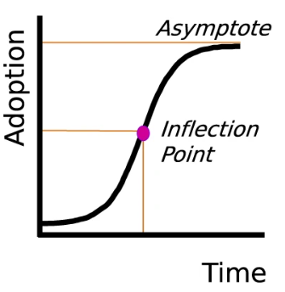
Source: Gregory Nemet, Jenna Greene, Finn Müller-Hansen, Jan C. Minx (2023). Dataset on the adoption of historical technologies informs the scale-up of emerging carbon dioxide removal measures, Communications Earth & Environment: https://www.nature.com/articles/s43247-023-01056-1.
Consumers also lose out if a satellite communication service provider lacks authorisation to deliver a service that it would otherwise be able to offer. If the satellite communication service provider is prohibited from offering the service, consumers cannot purchase or use it. This constitutes a different way of looking at the impact of a missing or delayed authorisation. The normal economic insight is that the gross loss of consumer surplus is at least as great as the price that the user would have otherwise paid for the service – if this were not the case, the service would not have been purchased.
The net loss of consumer surplus may be less in practice because a substitute service may, or may not, be available. The substitute service will generally be less attractive in terms of price/performance, otherwise it would have been preferred in the first place. So one should expect that there will always be a loss of surplus when a satellite communication service provider lacks authorisation to deliver its service, but the net loss of consumer surplus might be either more or less than the loss of revenue to the satellite communication service provider.
As an example one of the two EU Mobile Satellite Services provider in the 2GHz, faced considerable legal uncertainty and delays of several years in the authorisation process, which negatively affected its business case. Delays in accessing space spectrum caused by fragmented national authorization regimes can significantly hinder European competitiveness. To improve this situation, it is essential to streamline and harmonize the authorization processes across Member States. By adopting a more unified regulatory framework for space spectrum access, Europe can enhance its competitiveness on the global stage. For instance, estimates for the space connectivity services to be delivered by the pan-European IRIS² constellation suggest full utilisation of all 33 satellites (O3b Classic and O3b mPOWER) by 2030. The projected investment up to 2030 is approximately EUR 1.8 billion, with peak annual spending of around EUR 400 million between 2027 and 2030. Once the constellation reaches full capacity, revenues are expected to exceed operating costs significantly, with an anticipated EBITDA margin of 55%. Based on this, annual revenues in 2030 could reach around EUR 600 million, equivalent to approximately EUR 50 million per month across the EU. This implies that a one-month delay in the provision of IRIS² services across the entire EU in 2030 could result in lost revenue of around EUR 50 million. Similarly, if services were unavailable in a single Member State for a month, the revenue loss would be roughly proportional to that Member State’s share of the total EU revenue — calculated as a percentage of EUR 50 million.

Annex 10: EU and International, incl. United States, Spectrum Governance
            - Radio Spectrum essentials and satellite spectrum
Radio Spectrum Decision 676/2002/EC defines radio spectrum as radio waves in frequencies between 9 kHz and 3000 GHz; radio waves are electromagnetic waves propagated in space without artificial guide.
Contrary to the electromagnetic spectrum, the radio spectrum does not exist independently; its existence depends on the electromagnetic waves that propagate without the need for artificial guidance. Thus, it is a virtual space, a physical reality that is used for the provision of services such as telecommunications: radio and television broadcasting, defence, emergency, transport, scientific research, etc.
Figure A10 1-1: Electromagnetic Spectrum
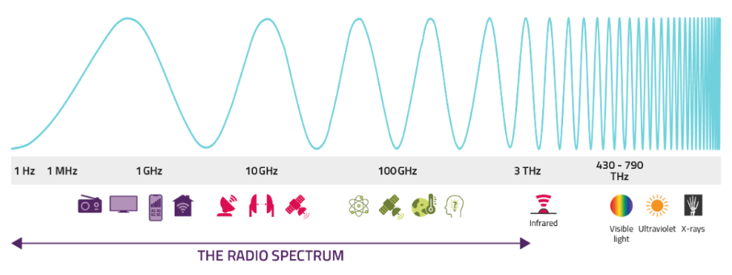
Source: Ofcom
Depending on the specific features of each wave, the waves are grouped into frequency ranges, forming what is known as radio spectrum bands, each of which takes in a set of consecutive bands of frequencies that share the same properties that affect speed coverage (signal reach and penetration), and capacity of services (bandwidth), to be provided in the band.
Figure A10 1-2: Low and High frequency band proprieties
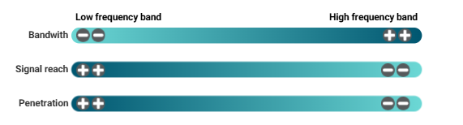Source: Cullen International
The radio spectrum is a finite resource— new frequencies can’t be created. As demand for spectrum access continues to grow, this scarcity poses a significant challenge for both regulators and industry. While the total amount of spectrum remains fixed, advances in technology enable us to use it more efficiently, allowing for greater capacity and a wider range of applications. These improvements will play a crucial role in transforming how citizens live and work in the future.
To prevent interference between users, the generation and transmission of radio waves are rigorously regulated by national governments. These national efforts are coordinated on a global scale by the International Telecommunication Union (ITU) a specialised agency of the United Nations. Unlike terrestrial radio communications systems, the spectrum used for satellite communications requires a higher degree of international and national coordination because satellites operate across multiple countries and regions, often transmitting signals across national borders. This necessitates coordinated spectrum management to prevent interference and ensure smooth operations.
Satellite communications use various frequency bands which, because of their different properties, are suited to different service types, see Figure A10 1-3 below.
Figure A10 1-3: Satellite communications use spectrum across wide range of spectrum
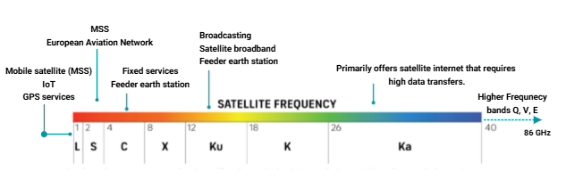
Source: Cullen International
The lower bands (below 4 GHz), such as the EU MSS Band, enjoy good propagation characteristics but offer less bandwidth. These bands are generally used for voice and low data rate applications and are a hot spot for the deployment of D2D services (i.e. some newer smartphones offer D2D using spectrum allocated to MSS). The mid bands, such as the C-band (4–8 GHz), are mainly used for fixed satellite services and Earth station feeder links. Higher frequency bands offer more bandwidth but have less good propagation and are more sensitive to weather conditions. Popular new satellite constellations, including Starlink, Project Kuiper, and Eutelsat OneWeb, use high band spectrum, such as the Ku (12–18 GHz) and Ka (26–40 GHz) bands for fixed broadband, but its to be expected that they will move to lower bands in the future to provide D2D services.
            - Spectrum for 5G
The 5G pioneer bands 700MHz, 3.6GHz and 26GHz have different properties. For instance, the 700MHz band as a low-band (sub-1GHz) has limited speed but long range and coverage. Low-bands can travel far and penetrate buildings easily (indoor coverage). The 3.6GHz band belongs to the mid-band spectrum (1-6 GHz) and offers a good balance between speed, coverage and capacity. Finally, the 26GHz is a high band (mmWave bands and above 24GHz), which provides very high speed (multi Gbit per second) but limited coverage as it does not travel so fast. These bands require many small cells placed close to each other to provide coverage.
Considering that no single band can meet all 5G technical requirements well, operators need a combination of bands to effectively provide good quality 5G services. 5G SA will be deploying full 5G both at the radio and the core network, without relying on 4G LTE components. Similarly, the deployment of 6G will most probably have a progressive and evolutionary phased approach.
            - Spectrum governance
The International Telecommunication Union (ITU) plays a central role in spectrum management by coordinating the global use of the radio-frequency spectrum to ensure interference-free and equitable access. Specifically, the ITU:
- Prevents Interference: It establishes international regulations and procedures to minimize radio interference between countries and services.
- Allocates Frequency Bands: It defines and allocates frequency bands to different services (like broadcasting, mobile, satellite) on a global scale. For the purposes of coordination and international planning, the world has been divided into three large regions (Figure A10 1-4)
Figure A10 1-4. Regions of Frequency Allocation
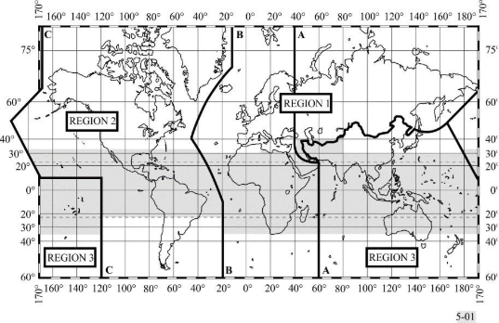
: ITU
- Facilitates Coordination: It enables countries to coordinate spectrum use and resolve disputes related to spectrum assignments.
- Promotes equitable use of radio spectrum: As a UN specialized agency, the ITU ensures spectrum resources are shared fairly among all countries, supporting global connectivity and communication.
Besides the ITU role in spectrum management, States also cooperate at the regional level in spectrum management affairs (see Table below).
Table A10 1-1: Regional Bodies for Spectrum Regulation
ITU Region | Regional Body
Region 1 (Europe -Africa) | European Conference of Posts and Telecommunications (CEPT)  African Telecommunications Union (ATU)  Arab Spectrum Management Group (ASMG)  Regional Commonwealth in the Field of Communications (RCC)
Region 2 (America) | Interamerican Telecommunications Commission (CITEL)
Region 3 (Asia-Pacific | Asia-Pacific Telecommunity (APT)
              - Spectrum governance in the EU
In the European Union, radio spectrum policy is managed through a multi-layered approach (cf. the US in Annex 10) involving cooperation between the European Commission, regional bodies and national regulators.
- European Commission. The European Commission plays a key role in coordinating spectrum management to promote competition and ensure harmonized conditions for the availability and efficient use of radio spectrum. This coordination supports the effective functioning of the internal market across critical policy areas such as electronic communications, transport, and research and development (R&D). The governance model for radio spectrum policy in Europe is based on the Radio Spectrum Decision, which provides the powers of the Commission to harmonise the technical and operational conditions for the use of spectrum in the EU through comitology procedure, which involves the Radio Spectrum Committee (RSC). In addition, the European Commission is supported on strategic spectrum matters by a high-level advisory body known as the Radio Spectrum Policy Group (RSPG).
- European Conference of Postal and Telecommunications Administrations (CEPT): CEPT is a European regional organization where European countries collaborate on telecommunications matters. Pursuant to Article 4 of the Radio Spectrum Decision, the European Commission regularly issues mandates to the CEPT to study and develop harmonised technical and operational conditions for the provision of electronic communications services within specific radio frequency bands. The technical conditions proposed by CEPT are the preparatory work on which the Commission is basing its draft implementing Decisions that it submits to the RSC for approval, before adoption.
- National Authorities with Spectrum competences (depending on the MS these can be National Regulatory Authorities (NRAs), or other Competent Authorities, i.e. Spectrum authorities). Each Member State has its own authorities or group of authorities (NRA, Agency and Ministry), according to the national law, responsible for implementing spectrum management policies at the national level. These authorities monitor the use of spectrum, ensure legal compliance, carry out authorisation procedures (including competitive (auctions) or comparative (beauty contests) selection procedures) and issue authorisations for spectrum use under the technical conditions set-up in the Commission Implementing Decisions and in line with the procedures of the EECC. In some Member States the NRA that is represented in BEREC does not have or has only partially spectrum competences. Under the EECC Article 5, where NRAs are not competent for spectrum management, they should at least provide advice regarding the market-shaping and competition elements of national processes related to the rights of use for radio spectrum for ECNS. Moreover, even where NRAs have extensive spectrum competences, often it is the relevant Ministries participate in the RSPG, given that the task of this high-level expert group is to advise the Commission and the co-legislators on spectrum policy. For these reasons, the composition of the RSPG is different than the one for BEREC.
              - Spectrum governance in the US
The US has a highly centralised governance based on two main bodies: the Federal Communication Commission (FCC) and the National Telecommunications and Information Administration (NTIA). Unlike the EU, where national governments and NRAs retain significant discretion over mobile licensing, satellite authorisations, coverage obligations, and authorisation processes, including auction design, US states have no role in spectrum management and only a limited role in mobile service regulation more broadly—. The FCC is an independent agency that is the exclusive regulator of non-Federal spectrum use, while the NTIA (under the Department of Commerce) is the sole agency responsible for authorising Federal spectrum use and is the President's principal advisor on telecommunications policies, coordinating and communicating the views of the Executive Government.
The US system is not without its own internal tensions—particularly between the FCC and NTIA— but the scale and coherence of its spectrum management regime stand in stark contrast to the EU’s more fragmented landscape. Centralisation in the US yields clear economies of scale, as it allows the US to conduct large-scale, nationally coordinated spectrum auctions with uniform licensing conditions. This facilitates rapid deployment of new technologies such as 5G and supports cross-border service provision. U.S. operators benefit from a single licensing regime, uniform coverage mandates, and centralised interference management—allowing them to consolidate legal, engineering, and compliance functions. This reduces transaction costs and enables more efficient planning and investment.
The cooperation between FCC and NTIA was institutionally strengthened by a Memorandum of Understanding in 2022, which formalized consultation and conflict-resolution mechanisms. Via this MoU there is an increased coordination between Federal spectrum management agencies to promote the efficient use of the radio spectrum in the public interest.
Further to these main bodies there are other entities which are regularly consulted by the main/lead organisations (NTIA and FCC) on spectrum management:
- The Interagency Spectrum Advisory Council (ISAC), established by Presidential Memorandum, serves as the principal interagency forum for senior agency officials to advise NTIA on spectrum policy matters and to ensure that all decisions made by NTIA take into consideration the diverse missions of the Federal Government.
- The Interdepartment Radio Advisory Committee (IRAC) is used for any activity that falls within its purview, incorporating the interests of defense, security, and scientific agencies into spectrum policy
- The Commerce Spectrum Management Advisory Committee (CSMAC) represents the improved national framework for collaboration on spectrum policy envisioned in the US Spectrum Strategy that will be established to involve collaboration between non-Federal stakeholders and Federal agencies (i.e. transport), beginning after its creation, which is projected for September 2025.
Further indications about the human resources of the space section of FCC can be found in Annex 9.
            - Overview of the US mobile market
The mobile market in the US is a highly concentrated market dominated by three major nationwide players AT&T, Verizon and T-Mobile/Sprint who merged recently. These three service providers have networks that cover at least 95% of the U.S. population and at least 68% of U.S. road miles with their 4G LTE networks. Further, there are many Mobile Virtual Network Operators (MVNOs) who buy wholesale spectrum access from the three major carriers and resell these services to consumers. MVNOs offer retail competition but they heavily rely on the wholesale spectrum access from the big three. Given that they have no independent spectrum, they cannot replicate nationwide networks so they can only compete on pricing not on infrastructure.
At the same time, it should be noted that the different parts of the US communications market are becoming increasingly interconnected. For example, cable companies are expanding into mobile service through Mobile Virtual Network Operators (MVNOs) that can shift traffic onto Wi-Fi and mobile operators are starting to compete with traditional home internet providers through their 5G home broadband offerings. In addition, the FCC created the world’s first “Supplemental Coverage from Space” (SCS) a hybrid terrestrial and satellite legal framework, which allows the use of advanced satellite technology to help terrestrial networks reach remote and underserved areas.
The structural concentration of the US mobile market is driven by the spectrum aggregation (spectrum holdings) and high barriers of entry. Spectrum holdings – i.e., the amount of radio-frequency spectrum licenses that mobile operators use to run their networks – are competitive factors that affect the US mobile market structure. In the US, the mobile operators AT&T, T-Mobile and Verizon together control the vast majority of the US terrrestrial specturm. These holdings create strong asymmetric advantages that prevent equal competition.
Table A10 1-2 below, indicates that in the US Low-band and Mid-band spectrum is dominated by T-Mobile, AT&T and Verizon. In summer 2025 Echostar sold to AT&T spectrum licenses in the 3.45 GHz and 600 MHz bands, a total of 50 MHz of nationwide spectrum, increasing the spectrum concentration in the US market.
Table A10 1-2: Spectrum assigned to US network operators, sorted by band

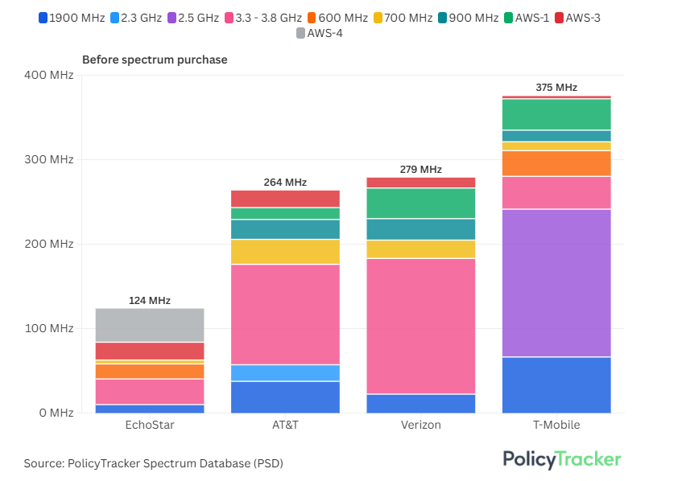
Source: PolicyTracker, 2025
In sum, the US market is characterised by concentration of spectrum holdings—more than 82% of spectrum controlled by three operators—, an uneven distribution of valuable mid- and low-band spectrum, and the absence of a fully established fourth competitor, which indicate that the market functions more like a three-player oligopoly.

Annex 11: Evaluation: Review Report on the EECC and related Acts
Please, find the Annex in a separate file.

See: https://ec.europa.eu/info/law/better-regulation/have-your-say/initiatives/14709-Digital-Networks-Act_en.
One FTE is EUR 95 400/year
FTTH Council (2025): FTTH/B Forecast for Europe With thanks to European Market View FTTH Council Europe’s Market Intelligence Committee, https://www.ftthcouncil.eu/resources/all-publications-and-assets/2362/ftth-market-forecasts-2024-2030 (last accessed on 26.03.2025).
See WIK (2020): Copper switch-off: European experience and practical considerations https://www.wik.org/fileadmin/Studien/2020/Copper_switch-off_whitepaper.pdf.
This is based on the implications of this option for the conditions for SMP PIA, noting that SMP PIA is considerably more widely used than GIA PIA. GIA PIA is assumed not to compensate for the loss of SMP PIA as conditions for telecom PIA under GIA are less favourable, and the regime as a whole is based on dispute resolution rather than ex ante regulation, a mechanism that has been found to be less effective in addressing entrenched barriers associated with PIA.
As regards take-up of FTTH, IDATE estimates that as of September 2024, there was a take-up rate of 55% (as a proportion of households served by fibre) across the EU27 and the UK. This was an increase of 2% pp on the previous year. IDATE projects that take-up rates of FTTH will increase to 70% of FTTH homes passed by 2030. IDATE (Sept 2020) FTTH/B Market panorama and IDATE (2021) European FTTH/B Historical and forecasts.
Study on Access Regulation.
These assumption is based on empirical observations of the German fixed broadband market. See https://www.bmv.de/DE/Themen/Digitales/Breitbandausbau/Potenzialanalyse/bericht-zur-potentialanalyse.pdf?__blob=publicationFile, page 19, Last Call 07.07.2025.
The estimator is based on historical data and total households, as it represents the best approximation. There a several factors that complicate an estimation based on the number of eligible consumers. Firstly, the definition of eligible consumers is the responsibility of the Member States and therefore varies. There is no EU-wide statistic that would represent this group of consumers. Secondly, statistics about unemployment or disabilities usually reference to the share of total population instead the share of households. Therefore, they do not allow conclusions to be made about take-up as a share of total households.
Ookla Speedtest data retrieved from https://www.balcanicaucaso.org/eng/Areas/Europe/EU-Internet-connections-are-getting-faster-and-faster-235091; European Commission (2025), DESI dashboard for the Digital Decade (2023 onwards), https://digital-decade-desi.digital-strategy.ec.europa.eu/datasets/desi/indicators and Ofcom (2024) Connected Nations UK Report, the UK regulatory authority Ofcom, reports that in 2024, download speeds offered over ADSL were on average 14,8 Mbps and over FTTC 58 Mbps.
CTU (2024): ZPRÁVA O VÝVOJI TRHU ELEKTRONICKÝCH KOMUNIKACÍ SE ZAMĚŘENÍM NA ROK 2023, p. 47, https://ctu.gov.cz/sites/default/files/obsah/stranky/472017/soubory/zovt_2023.pdf (last accessed on 01.08.2025).
https://www.ookla.com/articles/fixed-wireless-access-us-q3-2023.
CTU (2024): ZPRÁVA O VÝVOJI TRHU ELEKTRONICKÝCH KOMUNIKACÍ SE ZAMĚŘENÍM NA ROK 2023, p. 53, https://ctu.gov.cz/sites/default/files/obsah/stranky/472017/soubory/zovt_2023.pdf (last accessed on 01.08.2025).
https://www.speedtest.net/global-index (last access on 03.07.2025).
See https://www.opensignal.com/2024/05/07/frances-urban-rural-mobile-experience-gap-has-narrowed-with-5g (last accessed on 03.07.2025).
https://openvault.com/wp-content/uploads/2024/02/OVBI_4Q23_Report_v3.pdf.
https://www.adlittle.com/en/insights/report/evolution-data-growth-europe.
Ofcom (2024): Connected Nations UK Report 2024, p. 14, https://www.ofcom.org.uk/siteassets/resources/documents/research-and-data/multi-sector/infrastructure-research/connected-nations-2024/connected-nations-uk-report-2024.pdf?v=386497.
As the UK represents a high usage country, the assumption is that the average bandwidth consumption for the EU per technology is at around half of the levels reported for the UK. Electronic communications statistics of the NRAs and Ofcom (2024): Connected Nations UK Report 2024, p. 14, https://www.ofcom.org.uk/siteassets/resources/documents/research-and-data/multi-sector/infrastructure-research/connected-nations-2024/connected-nations-uk-report-2024.pdf?v=386497.
Ofcom (2025): Promoting competition and investment in fibre networks: Telecoms Access Review 2026-31, Volume 2: Market definition and SMP assessment, https://www.ofcom.org.uk/siteassets/resources/documents/consultations/category-1-10-weeks/consultation-telecoms-access-review-2026-31/main-documents/volume-2-market-definition-and-smp-assessment.pdf?v=392945, p. 23.
See for example Roller and Waverman (2001), Datta and Agarwal (2004) and other references listed in Castaldo, Fiorini and Maggi (2016) More recently, Castaldo et al. (2018) https://www.dss.uniroma1.it/RePec/sas/wpaper/20161_CFM.pdf. find a positive correlation between fixed broadband diffusion and economic growth across all 23 OECD countries. By constructing a panel data regression centred around GDP growth, the authors find detailed positive results regardless of the economic forecasts applied to the model. Their results support the hypothesis that broadband diffusion is both statistically significant and positively correlated with real GDP growth per capita.
Briglauer, Wolfgang; Cambini, Carlo; Gugler, Klaus, Sabatino, Lorien (2025): Economic benefits of new broadband network coverage and service adoption: evidence from OECD member states, Industrial and Corporate Change, 2025, 00, 1-26, available at: https://doi.org/10.1093/icc/dtae043
The study does not refer to actual measured average speeds.
See: Briglauer, Wolfgang und Klaus Peter Gugler (2019), Go for Gigabit? First Evidence on Economic Benefits of High‐speed Broadband Technologies in Europe, Journal of Common Market Studies 57(5) , 1071-1090, available at: https://doi.org/10.1111/jcms.12872.
Briglauer, W., Cambini, C., Gugler, K. et al. Net neutrality and high-speed broadband networks: evidence from OECD countries. Eur J Law Econ 55, 533–571 (2023). https://doi.org/10.1007/s10657-022-09754-5.
ITU, The impact of digital transformation on the economy – Econometric Modelling, April 2025, https://www.itu.int/hub/publication/d-pref-econ-mod-2025/.
See: Briglauer, Wolfgang; Krämer, Jan; Palan, Nicole (2023): Socioeconomic benefits of high-speed broadband availability and service adoption: A survey, Research Paper, No. 24, EcoAustria - Institute for Economic Research, Vienna, available at: https://hdl.handle.net/10419/279416.
Katz, Raul; Jung, Juan (2022): The contribution of fixed broadband to the economic growth of the United States between 2010 and 2020, Telecom Advisory Services LLC, Network On, June 2022, available at: https://www.teleadvs.com/wp-content/uploads/ContributionofFixedBroadbandtoEconomicGrowth_RaulKatz.pdf.
Katz/Callorda (2020): Assessing the Economic Potential of 10G Networks, Telecom Advisory Services LLC, https://www.teleadvs.com/wp-content/uploads/Assessing-the-Economic-Potential-of-10G-Networks.pdf.
Rohman, Ibrahim Kholilul and Erik Bohlin (2012): Does broadband speed really matter for driving economic growth? Investigating OECD countries, https://papers.ssrn.com/sol3/papers.cfm?abstract_id=2034284.
WIK, Ecorys and VVA (2016) support for the Commission in the Impact Assessment for the Review of the EU framework for electronic communications SMART 2015/0005.
Kongaut, C., Bohlin, E., 2017. Impact of broadband speed on economic outputs: An empirical study of OECD countries. Economics and Business Review 3 (17), 12–32. doi:10.18559/ebr.2017.2.2.
Nadiri, M.I., B. Nandi and K.K. Akoz (2018): Impact of modern communication infrastructure on productivity, production structure and factor demands of US industries: Impact revisited, New York University, United States, Telecommunication Policy Volume 42, July 2018, pages 433-451, available at: https://www.scopus.com/record/display.uri?eid=2-s2.0-85048129273&origin=inward&txGid=d54ecdbd045c2987e0384a0d2fa1e01b.
P. Koutroumpis (2018): The economic impact of broadband: Evidence from OECD countries”, University of Oxford, August 2018, available at: https://www.ofcom.org.uk/__data/assets/pdf_file/0025/113299/economic-broadband-oecd-countries.pdf.
Hasbi, Maude (2017): Impact of Very High-Speed Broadband on Local Economic Growth: Empirical Evidence, 14th Asia-Pacific Regional Conference of the International Telecommunications Society (ITS): "Mapping ICT into Transformation for the Next Information Society", Kyoto, Japan, 24th-27th June, 2017, International Telecommunications Society (ITS), Calgary, available at: https://www.econstor.eu/handle/10419/168484.
Sosa/Analysis (2014): Early Evidence Suggests Gigabit Broadband Drives GDP, Analysis Group, available at: https://www.analysisgroup.com/globalassets/content/insights/publishing/gigabit_broadband_sosa.pdf.
The Underappreciated Need to Enable AI and Data Center Growth: Increased and More Strategic Fiber Interconnections, https://fiberbroadband.org/wp-content/uploads/2025/07/FBA-103_AI_Datacenter_WhitePaper_lv6.pdf.
See: RVA (2024): Gigabit Fiber Can Add $326B to US GDP, White Paper on behalf of Fibre Broadband Association, available at: https://fiberbroadband.org/wp-content/uploads/2024/08/GigabitFiber_WhitePaper_FIN-2.pdf.
Mölleryd, B. (2015), Development of High-speed Networks and the Role of Municipal Networks, OECD Science, Technology and Industry Policy Papers, No. 26, OECD Publishing, Paris.
Singer, H., Caves K. and A. Koyfman (2015) Economists Incorporated: The Empirical Link Between Fibre-to-the-Premises Deployment and Employment: A case study in Canada, Annex to the Petition to Vary TRP 2015-326, Bell Canada.
See: Briglauer, Wolfgang; Krämer, Jan; Palan, Nicole (2023): Socioeconomic benefits of high-speed broadband availability and service adoption: A survey, Research Paper, No. 24, EcoAustria - Institute for Economic Research, Vienna, available at: https://hdl.handle.net/10419/279416.
Bai, Y. (2017), The faster, the better? The impact of Internet speed on employment, Information Economics and Policy, 40, 21-25.
Although it does not specifically look at ultrafast broadband, on the basis of survey data from 166 businesses in Wales, WERU (2017), Superfast broadband business exploitation project: Economic impact report, Cardiff University. argues that SMEs with superfast broadband are more likely to engage in innovation activity than standard broadband users. The report also finds that superfast broadband users tend to be characterised by higher labour productivity growth.
See Kongaut, Chatchai and Bohlin, Erik (2017): Impact of broadband speed on economic outputs: An empirical study of OECD countries, Economics and Business Review, Vol 3 (17), No. 2, 2017:12-32, available at: https://www.econstor.eu/handle/10419/101415.
Superfast Broadband Programme Evaluation: Key Benefits and Impacts, 1 March 2025, https://www.gov.uk/government/publications/superfast-broadband-programme-evaluation-benefits-and-impacts/superfast-broadband-programme-evaluation-key-benefits-and-impacts.
Eurostat (2024): Digital economy and society statistics - households and individuals, available at: https://ec.europa.eu/eurostat/tistics-explained/index.php?title=Digital_economy_and_society_statistics_-_households_and_individuals.
Eurostat (2923), How many EU people can afford an internet connection?, available at: https://ec.europa.eu/eurostat/de/web/products-eurostat-news/w/edn-20230801-1
Eurostat (2025), Disabled people less likely to be internet users, https://ec.europa.eu/eurostat/web/products-eurostat-news/w/ddn-20250313-1.
Zuo, G. W. (2021), Wired and hired: Employment effects of subsidized broadband Internet for low-income Americans. American Economic Journal: Economic Policy, 13(3):447–482
Mohan, G., & Lyons, S. (2024), High-speed broadband availability, Internet activity among older people, quality of life and loneliness. new media & society, 26(5), 2889-2913.
Tavares, A. I. (2020). Self-assessed health among older people in Europe and internet use. International journal of medical informatics, 141, 104240.
Silva, P. et al. (2022), The Contribution of the Internet to Reducing Social Isolation in Individuals Aged 50 Years and Older: Quantitative Study of Data From the Survey of Health, Ageing and Retirement in Europe. Journal of medical Internet research, 24(1), e20466.
Duplaga, M. & Szulc, K. (2019), The Association of Internet Use with Wellbeing, Mental Health and Health Behaviours of Persons with Disabilities. International Journal of Environmental Research and Public Health, 16(18), 3252.
Caton, S. et al. (2024), Online social connections and internet use among people with intellectual disabilities in the United Kingdom during the COVID-19 pandemic. New Media & Society, 26(5), 2804-2828.
See Godlovitch et. al (2021): Environmental impact of electronic communications, Study for BEREC.
Nokia (2019): People & Planet Report 2019.
.Godlovitch et. al (2021): Environmental impact of electronic communications, Study for BEREC.
Solivan (2025): Life Cycle Assessment on fiber cable construction methods.
Ecobilan (2008): Developing a generic approach for FTTH solutions using LCA methodology.
Stockman and Zhao (2014): White Paper: Innovative FTTH Deployment Technologies.
Fiber Broadband (2024: Fiber Broadband Deployment is Paramount to Achieving Zero Carbon Footprint.
An extensive literature overview is provided by Briglauer et al. (2023): The Impact of ICT on Electricity and Energy Consumption and Resulting CO2 Emissions: a Literature Review, in: International Review of Environmental and Resource Economics, 2023.
See in detail Zuloaga, G. et al. (2024): Sustainability: modern fixed and mobile networks compared across different regional structures, WIK Working Paper No. 10, Bad Honnef, December 2024, https://www.wik.org/fileadmin/user_upload/Unternehmen/Veroeffentlichungen/Working_Papers/2024/WIK_Working_Paper_No10.pdf.
Zuloaga, G. et al. (2025). CO₂-Bilanz der Kupfer-Glasfaser-Migration in Deutschland [Carbon footprint of the copper-to-fibre migration in Germany]. WIK research programme 2025, publication expected by 12/2025.
Zuloaga, G. et al. (2024): Sustainability: modern fixed and mobile networks compared across different regional structures, WIK Working Paper No. 10, Bad Honnef, December 2024, https://www.wik.org/fileadmin/user_upload/Unternehmen/Veroeffentlichungen/Working_Papers/2024/WIK_Working_Paper_No10.pdf.
Zuloaga, G. et al. (2024): Sustainability: modern fixed and mobile networks compared across different regional structures, WIK Working Paper No. 10, Bad Honnef, December 2024, https://www.wik.org/fileadmin/user_upload/Unternehmen/Veroeffentlichungen/Working_Papers/2024/WIK_Working_Paper_No10.pdf.
See Obermann, K. (2022): Nachhaltigkeitsvergleich Internet-Zugangsnetz-Technologien. Technische Hochschule Mittelhessen, 03.03.2022, Expert Study for Federal Association of Broadband Communication (BREKO), https://www.brekoverband.de/wp-content/uploads/2025/03/gutachten_nachhaltigkeit_2_v09_final_2024-1-22.pdf.
See Breide, S., Helleberg, S., Schindler, J., Waßmuth, A. (2021). Energy Consumption of Telecommunication Networks. Prysmian Group.
See in detail Zuloaga, G. et al. (2024): Sustainability: modern fixed and mobile networks compared across different regional structures, WIK Working Paper No. 10, Bad Honnef, December 2024, https://www.wik.org/fileadmin/user_upload/Unternehmen/Veroeffentlichungen/Working_Papers/2024/WIK_Working_Paper_No10.pdf , page 45 ff.
Zuloaga, G. et al.. (2024): Ökologische Effekte des Glasfaserausbaus (ecological effects of fibre roll out), study for RTR, November 2024, Oeko-Effekte_20241206_Bericht (1).pdf.
Zuloaga, G. et al.. (2024): Ökologische Effekte des Glasfaserausbaus (ecological effects of fibre roll out), study for RTR, November 2024, Oeko-Effekte_20241206_Bericht (1).pdf, page 39.
See Analysys Mason (2023): Full-fibre networks in Europe: state of play and future evolution, report for Meta, 3 May 2023, https://www.analysysmason.com/contentassets/1d7e13ed1dba4cc6917daa023f27834b/analysys_mason_fibre_in_europe_may2023.pdf.
See Analysys Mason (2023): Full-fibre networks in Europe: state of play and future evolution, report for Meta, 3 May 2023, https://www.analysysmason.com/contentassets/1d7e13ed1dba4cc6917daa023f27834b/analysys_mason_fibre_in_europe_may2023.pdf, page 15.
See Obermann, K. (2022): Nachhaltigkeitsvergleich Internet-Zugangsnetz-Technologien. Technische Hochschule Mittelhessen, 03.03.2022, Expert Study for Federal Association of Broadband Communication (BREKO), https://www.brekoverband.de/wp-content/uploads/2025/03/gutachten_nachhaltigkeit_2_v09_final_2024-1-22.pdf.
See Breide, S., Helleberg, S., Schindler, J., Waßmuth, A. (2021). Energy Consumption of Telecommunication Networks. Prysmian Group.
See Godlovitch et al. (2021) Neutral fibre and the European Green Deal, WIK study for Stokab, October 2020, https://stokab.se/download/18.15d457b6178eff38ee02a4/1619693498369/Neutral%20fibre%20and%20the%20European%20Green%20Deal_2021.pdf.
https://www.eea.europa.eu/en/datahub/datahubitem-view/3b7fe76c-524a-439a-bfd2-a6e4046302a2?activeAccordion=1091606
BT Group (2024): Annual Report 2024, https://www.bt.com/bt-plc/assets/documents/investors/financial-reporting-and-news/annual-reports/2024/2024-bt-group-plc-annual-report.pdf, P. 60.
https://www.ispreview.co.uk/index.php/2024/09/bt-get-105m-for-first-sale-of-old-uk-copper-telecoms-cables.html.
https://www.datacenterdynamics.com/en/opinions/the-world-is-running-short-of-copper-telecoms-networks-could-be-the-answer/.
In this context, full 5G refers to 5G SA, making use where appropriate of mid and high-band spectrum, and involving network densification in areas of high demand to ensure consistent delivery of high bandwidths.
5G Observatory Report 2025: https://ec.europa.eu/newsroom/dae/redirection/document/116970 .
https://www.ericsson.com/49e9b6/a/ssets/local/reports-papers/mobility-report/documents/2025/ericsson-mobility-report-june-2025.pdf.
https://www.ericsson.com/en/reports-and-papers/mobility-report/dataforecasts/network-coverage.
See https://www.ericsson.com/en/reports-and-papers/mobility-report/articles/securing-the-right-5g-spectrum.
See DESI methodological note and discussion with European Commission.
Ericson Mobility Report June 2025 p 10 see https://www.ericsson.com/en/reports-and-papers/mobility-report/reports/june-2025.
Retrieved from Economic Impacts of Alternative Uses of the Digital Dividend - Intereconomics.
https://digital-decade-desi.digital-strategy.ec.europa.eu/datasets/desi/charts/desi-indicators?indicator=desi_5gcov_3400_3800&indicatorGroup=desi2023-2&breakdown=hh_deg3&period=desi_2024&unit=pc_hh&country=AT,BE,BG,HR,CY,CZ,DK,EE,EU,FI,FR,DE,EL,HU,IE,IT,LV,LT,LU,MT,NL,PL,PT,RO,SK,SI,ES,SE.
See European Environment Agency 2015 briefing p129.
Eurostat 2023 https://ec.europa.eu/eurostat/databrowser/view/DEMO_R_D3DENS__custom_10822572/bookmark/table?lang=en&bookmarkId=9daaf3b7-86a3-40fc-9171-fcd05d859892&c=1712824409289.
World Bank 2024 https://data.worldbank.org/indicator/SP.URB.TOTL.IN.ZS.
Eurostat 2023 https://ec.europa.eu/eurostat/databrowser/view/DEMO_R_D3DENS__custom_10822572/bookmark/table?lang=en&bookmarkId=9daaf3b7-86a3-40fc-9171-fcd05d859892&c=1712824409289.
World Bank 2024 https://data.worldbank.org/indicator/SP.URB.TOTL.IN.ZS.
Ibid.
https://digital-decade-desi.digital-strategy.ec.europa.eu/datasets/desi/charts/desi-indicators?indicator=desi_5gcov&indicatorGroup=desi2023-2&breakdown=total_pophh&period=desi_2025&unit=pc_hh&country=AT,BE,BG,HR,CY,CZ,DK,EE,EU,FI,FR,DE,EL,HU,IE,IT,LV,LT,LU,MT,NL,PL,PT,RO,SK,SI,ES,SE.
More frequencies, higher impact: How spectrum band usage for 5G is expanding across Europe | Opensignal.
https://www.opensignal.com/2024/02/01/mobile-network-speeds-leaped-ahead-in-2023-but-some-markets-lag-behindhttps://www.opensignal.com/2024/02/01/mobile-network-speeds-leaped-ahead-in-2023-but-some-markets-lag-behind.
Country sample selected based on having a high share of regional 5G SA samples. The Americas sample includes the United States, Canada, and Brazil; Developed Asia comprises Australia, Singapore, Japan, Hong Kong, Macau, South Korea, and China; and Emerging Asia consists of India, Thailand, the Philippines, and Malaysia. South Korea is excluded from the Developed Asia sample for median latency calculations. Ookla/ Omdia (2025), A Global Evaluation of Europe’s Digital Competitiveness in 5G Standalone, p.19.
https://www.opensignal.com/2025/07/02/more-frequencies-higher-impact-how-spectrum-band-usage-for-5g-is-expanding-across-europe/dt.
See https://www.opensignal.com/market-insights.
Ibid Various reports from 2023 -2025.
More frequencies, higher impact: How spectrum band usage for 5G is expanding across Europe | Opensignal.
More frequencies, higher impact: How spectrum band usage for 5G is expanding across Europe | Opensignal.
https://www.opensignal.com/2025/07/02/more-frequencies-higher-impact-how-spectrum-band-usage-for-5g-is-expanding-across-europe/dt.
See https://medux.com/blog/all-5g-networks-are-not-created-equal-unveiling-true-qoe-5g-europe-lll
The average mobile download speed is calculated as a weighted average of observed technology-specific speeds, where the weights reflect the distribution of mobile subscriptions across technologies and frequency bands. First, population coverage of 5G mid-band, as reported by DESI, is multiplied by the share of mobile subscriptions that benefit from 5G, based on GSMA data, resulting in the share of mobile subscriptions benefiting from 5G mid-band coverage. Second, the average speed projection is calculated by multiplying the share of subscriptions benefiting from each technology by the corresponding average download speed and aggregating across technologies. Technology-specific speeds are based on Opensignal measurements (4G: 42 Mbps; low-band 5G: 104.3 Mbps; mid-band 5G: 217.6 Mbps). Differences in average download speeds across options are mainly driven by differences in 5G mid-band coverage.
https://www.statista.com/statistics/689876/average-mobile-speeds-download-and-upload-in-western-europe/.
See https://www.opensignal.com/2024/05/07/frances-urban-rural-mobile-experience-gap-has-narrowed-with-5g (last accessed on 03.07.2025).
This increase should be interpreted as an indicative, order-of-magnitude development rather than a precise forecast, given data limitations and methodological differences across sources.
See https://www.opensignal.com/2023/06/29/5g-is-more-consistent-than-4g-across-all-hours-of-the-day-in-the-uk.
See https://www.ookla.com/articles/europe-5gsa-2025.
It is reasonable to assume that the new 6G standard will be introduced at the start of the 2030s. As detailed technical specifications are not yet available, a 6G share has not been estimated here for the reasons of simplification.
https://www.opensignal.com/2020/10/21/5g-users-on-average-consume-up-to-27x-more-mobile-data-compared-to-4g-users
Ericsson Mobility report 2025, available at: https://www.ericsson.com/49e9b6/assets/local/reports-papers/mobility-report/documents/2025/ericsson-mobility-report-june-2025.pdf, Ericsson Mobility report key figures, available at: https://www.ericsson.com/en/reports-and-papers/mobility-report/key-figures.
GSMA (2023): The Mobile Economy 2023, available at: https://www.gsma.com/solutions-and-impact/connectivity-for-good/mobile-economy/wp-content/uploads/2023/03/270223-The-Mobile-Economy-2023.pdf.
Business use cases were not employed in the GDP estimation. The focus of the GDP estimation was based on improved speeds. The benefit of using 5G private networks is resilience and security.
Oxford Economics (2023): The Global Economic Potential of 5G-Enabled Technology, available at: https://www.oxfordeconomics.com/wp-content/uploads/2023/03/GlobalEconomicPotential5G_290323.pdf.
Edquist H. “The Economic Impact of Mobile Broadband Speed”, 23rd Biennial Conference of the International Telecommunications Society (ITS), June 2021, available at: https://www.econstor.eu/bitstream/10419/238018/1/Edquist.pdf.
Oxford Economics (2023): The Global Economic Potential of 5G-Enabled Technology, available at: https://www.oxfordeconomics.com/wp-content/uploads/2023/03/GlobalEconomicPotential5G_290323.pdf
World Economic Forum and PwC “The Impact of 5G: Creating New Value across Industries and Society”, January 2020; page 9.
As mobile broadband is still evolving (5G, IoT, edge computing), time series are too short to robustly identify non-linear dynamics, or to make assumptions regarding whether the effects would be regressive or progressive. For this reason, a linear relationship between speed improvements and GDP is applied as an indicative approximation. This approach is consistent with the literature underpinning the selected coefficients and is complemented by a sensitivity analysis covering a wide range of elasticities.
Also, with regard to 6G it must be noted, that the technology is still under development, meaning real-world data on adoption, performance, and impact on productivity or GDP is not available.
https://eneroutlook.enerdata.net/forecast-world-co2-intensity-of-electricity-generation.html.
See for example literature reviewed in WIK-Consult (2022) for BEREC https://www.berec.europa.eu/en/document-categories/berec/reports/external-sustainability-study-on-environmental-impact-of-electronic-communications.
Estimates from equipment manufacturers such as Nokia (2020) suggest that the operation phase is responsible for about 90% of the emissions associated with electronic communications networks, with raw materials and transportation associated with the deployment phase accounting for the remainder.
Greenhouse gas emissions are monetised using a fixed damage cost of EUR 800 per tonne of CO₂e, based on estimates by the German Environment Agency (UBA).
Data provided to EC on the Status of 5G Quality and Experience in Europe” prepared for the European Commission as part of the MedUX Impact programme (September 2025). For details on the methodology see https://medux.com/blog/europes-5g-progress-meeting-expectations.
Empirica (2025): Mobile and fixed broadband price is Europe in 2023: Insights into the European Broadband Market | Shaping Europe’s digital future (Available online at: https://digital-strategy.ec.europa.eu/en/library/mobile-and-fixed-broadband-price-europe-2023-insights-european-broadband-market).
See Qualcomm opinion https://www.ofcom.org.uk/siteassets/resources/documents/consultations/uncategorised/93522-award-of-the-spectrum-bands/responses/qualcomm.pdf p8 and BT https://www.ofcom.org.uk/siteassets/resources/documents/consultations/category-1-10-weeks/129955-award-of-the-700-mhz-and-3.6-3.8-ghz-spectrum/responses/response-to-2020-further-consultation-bt, p8.
See para 101 here: https://www.bundesnetzagentur.de/SharedDocs/Downloads/EN/Areas/Telecommunications/Companies/TelecomRegulation/FrequencyManagement/ElectronicCommunicationsServices/FrequencyAward2018/20181214_Decision_III_IV.pdf?__blob=publicationFile&v=1.
See e.g. PolicyTracker Spectrum Database.
LS telcom, PolicyTracker and VVA (2022): Study on assessing the efficiency of radio spectrum award processes in the Member States, including the effects of applying the European Electronic Communications Code (Available online at: https://op.europa.eu/publication-detail/-/publication/036d50f1-a1e2-11ed-b508-01aa75ed71a1).
For example, analysis conducted in the context of the review of the RRM shows that in countries where NRAs have segmented the market for dedicated capacity by geography, incumbent market shares of 70% or more have been observed in the non-competitive zones for dedicated capacity. Limitations in competition have also been found e.g. in Spain in the provision of services to multi-site businesses.
VVA, PolicyTracker and LS Telcom (2023), p. 19.
RSPG (2024). Opinion on Spectrum Policy for Next-Generation Wireless Systems (6G). Available at: https://rspg-spectrum.eu.
LS Telcom, PolicyTracker & VVA (2023). Study on Assessing the Efficiency of Radio Spectrum Award Processes in the Member States. Available at: https://op.europa.eu/en/publication-detail/-/publication/036d50f1-a1e2-11ed-b508-01aa75ed71a1.
https://ec.europa.eu/docsroom/documents/63274
The costs and benefits data in this annex are consistent with the data in annex 3. The preferred option includes the mitigating measures listed in section 4.
The direct benefits for SMEs can also be cost savings.
Gulf Cooperation Council (Bahrain, Kuwait, Oman, Qatar, Saudi Arabia and the United Arab Emirates).
GSMA Intelligence.
Mobile broadband prices vary widely across the EU not only in nominal terms but also at price purchasing parity. See European Commission, Directorate-General for Communications Networks, Content and Technology, Mobile and fixed broadband prices in Europe https://digital-strategy.ec.europa.eu/en/library/mobile-and-fixed-broadband-prices-europe-2022
Ookla, 2024, A Global Evaluation of Europe’s Competitiveness in 5G SA,p.14.
Connect Europe (2025), State of Digital Communications, p. 23.
Analysys Mason (2024). 5G Global Progress Report; OpenSignal (2024). 5G Experience Report Q4.
Study on Digital Single Market.
BEREC (2023). Study on wholesale mobile connectivity, trends and issues for emerging mobile technologies and deployments, BoR(23) 41: https://www.berec.europa.eu/en/document-categories/berec/reports/study-on-wholesale-mobile-connectivity-trends-and-issues-for-emerging-mobile-technologies-and-deployments.
SCF (2024). SCF Market forecast report: https://www.smallcellforum.org/docs/scf-market-forecast-report/?.
See additional data in WIK‑Consult. (2023). Investment and Funding Needs for the Digital Decade Connectivity Targets. Study for the European Commission, DG CONNECT (Unit B5). Available at: https://digital-strategy.ec.europa.eu/enc/library/investment-and-funding-needs-digital-decade-connectivity-targets.
Medux data on Status of 5G Quality and experience in EU.
Study on Digital Single Market.
BEREC Report on the evolution of private 5G networks and interrelation with public networks in Europe (BoR (25) 33 of 13 March 2025).
WIK‑Consult. (2023). Investment and Funding Needs for the Digital Decade Connectivity Targets. Study for the European Commission, DG CONNECT (Unit B5). Available at: https://digital-strategy.ec.europa.eu/en/library/investment-and-funding-needs-digital-decade-connectivity-targets.
Communication from the Commission on the Guidelines on State aid for broadband networks 2023/C 36/01. OJ C 36, 31.1.2023, pp. 1–42.
SA.100557 (2022/N) IT RRF- Italian 5G plan; SA.39090 (2014/N) - Mobile telephony in mountainous areas of Bolzano (Passo Rombo) IT 07/04/2015 Article 4(3); SA.39089 (2014/N) - Mobile telephony in mountainous areas of Bolzano (Favogna, Mazia, Alpe Guazza).
State Aid SA.108821 (2023/N) – Spain RRF-Modification of the measure “RRF –Support for 5G equipment and infrastructure”; State Aid SA.104933 (2023/N) – Spain RRF - Support for 5G equipment and infrastructure; State Aid SA.104933 (2023/N) – Spain RRF - Support for 5G equipment and infrastructure; SA.103451 (2022/N) ES - RRF -Deployment of backhaul networks for mobile connectivity; SA.64394 (2021/N) RRF - Spain- National aid scheme for passive infrastructure for mobile networks; and SA.57216 (2021/N) Mobile coverage in rural areas in Galicia-Spain.
SA.59574 (2021/N) Deployment of high-performance mobile infrastructure in Germany; SA.56426 (2021/N) High-performance mobile infrastructure roll-out in Lower Saxony –DE; SA. 54684 (2020/N) High-capacity mobile infrastructure roll-out in Brandenburg-DE; SA.58074 (2020/N) Mobilfunk Bayern Modification – DE; SA. 55578 (2020/N) Mobilfunk - Mobile telecommunication Hessen-DE; SA.48324 (2018/N) – Mobilfunk Bayern.
Commission Regulation (EU) No 651/2014 of 17 June 2014 declaring certain categories of aid compatible with the internal market in application of Articles 107 and 108 of the Treaty Text with EEA relevance. OJ L 187, 26.6.2014, pp. 1–78.
Up to 2023, only EUR 5.78 million has been reported by Member States.
JRC Publication https://publications.jrc.ec.europa.eu/repository/bitstream/JRC141966/JRC141966_01.pdf.
Study on Finance and USO.
Detecon International GmbH, Study on Mobile satellite services (MSS) in the 2 GHz band in the EU - Implementation of the current regulatory framework and an overview of the satellite connectivity market.
Report ITU-R M.2514-0: Vision, requirements and evaluation guidelines for satellite radio interface(s) of IMT-2020.
The 3GPP Rel-17 from 2022 defined the first specifications addressing NTN, which have been further developed and extended in Rel-18 (in 2024) and Rel-19 (to be released in 2025).
Technical specifications developed by 3G-NTN cover several use cases. The key use case categories enabled by 6G-NTN are the following: i) service ubiquity and Global Connectivity which targets the digital divide by providing direct connectivity to end-user terminals (including smart phones, household devices and IoT sensors); ii) service continuity and network resilience that ensures uninterrupted service delivery by integrating terrestrial (TN) and non-terrestrial (NTN) components. Key use cases include maintaining connectivity for high-speed terrestrial platforms, such as trains, autonomous vehicles, and commercial aircraft, where consistent handover and latency-sensitive services are critical. The iii) use case refers to service scalability and efficient broadcast-multicast delivery useful for mission critical public safety, dissemination of software and firmware updates, and Broadcast of alerts, educational content, or media services.
Majoor, R. and Perty, H.-P. (2025). Study on mobile satellite services (MSS) in the 2 GHz band in the EU: Implementation of the current regulatory framework and an overview of the satellite connectivity market, Study by Detecon for the European Commission, pp. 104-109: https://op.europa.eu/en/publication-detail/-/publication/5c28e25b-41b3-11f0-b9f2-01aa75ed71a1/language-en.
Majoor, R. and Perty, H.-P. (2025). Study on mobile satellite services (MSS) in the 2 GHz band in the EU: Implementation of the current regulatory framework and an overview of the satellite connectivity market, Study by Detecon for the European Commission, pp. 104-109: https://op.europa.eu/en/publication-detail/-/publication/5c28e25b-41b3-11f0-b9f2-01aa75ed71a1/language-en.
The EU is the world’s third largest player in most aspects of the satellite sector, following the United States and China. As of 2023, Europe’s share of the downstream market was estimated to represent 23.0% (EUR 89 billion) of the total global market value (EUR 387 billion) – see Euroconsult (2023) as cited in the European Commission’s Impact Assessment for the Space Act (SWD(2025) 335 final), part 1/2, p. 4.
Detecon International GmbH 2025. Detecon tabulates the launches and planned satellites Adding up the satellite constellations by country of ownership (ignoring the complexities of multiple shareholders from different countries, unless it is close to a 50/50 split). Note that this metric excludes the most optimistic claims of some of the announcements, including Starlink’s additional 4450 to 12 000 satellites in the USA column (reported as submitted to the ITU in 2019) and the additional 10 700 satellites which the Thousand Sails constellation may expand to which would add to the China column. Note that counting satellites may also not be the most accurate metric, as it does not account for weight. Comparing kilograms in orbit is probably a more meaningful metric, if such ever becomes available.
Unintended electromagnetic radiation from Starlink satellites detected with LOFAR between 110 and 188 MHz | Astronomy & Astrophysics (A&A).
Call to Protect the Dark and Quiet Sky from Harmful Interference by Satellite Constellations: Draft_IAU_CPS_position_statement_9Z8xEO1.pdf.
Multi-orbital constellation of 290 MEO and LEO satellites, deployed by SpaceRISE, an industry consortium, comprising three major EU satellite operators.
Mobile satellite services (MSS) in the 2 GHz band in the EU - Implementation of the current regulatory framework and an overview of the satellite connectivity market, July 2025, Detecon International GmbH, available at https://op.europa.eu/en/publication-detail/-/publication/4c769094-41b5-11f0-b9f2-01aa75ed71a1/language-en.
Gerus, V., Manero, C., Pujol, F.et al., Mobile Satellite Services (MSS) authorisation regimes, authorisations and enforcement in the EU Member States – Final report, Publications Office, 2019, https://data.europa.eu/doi/10.2759/974409.
Olswang (2014). MSS authorisation regimes, authorisations and enforcement in the EU Member States, study for the European Commission: https://op.europa.eu/sl/publication-detail/-/publication/0ccf1b70-dbd6-4530-8f09-f44262856dab/language-en.
Pujol, Frédéric, Manero, Carole, Enjalbal, Ariane, Carle, Basile and Victoria Gerus (2019). Mobile Satellite Services (MSS) authorisation regimes, authorisations and enforcement in the EU Member States, study for the European Commission: https://op.europa.eu/en/publication-detail/-/publication/7997aa72-d865-11e9-9c4e-01aa75ed71a1/language-en.
Majoor, R. and Perty, H.-P. (2025). Study on mobile satellite services (MSS) in the 2 GHz band in the EU Implementation of the current regulatory framework and an overview of the satellite connectivity market, Study by Detecon for the European Commission: https://op.europa.eu/en/publication-detail/-/publication/5c28e25b-41b3-11f0-b9f2-01aa75ed71a1/language-en.
The quote is from the 2019 study rather than the 2025 study because the latter does not provide equivalent tables with Member State details. Pujol, Frédéric, Manero, Carole, Enjalbal, Ariane, Carle, Basile and Victoria Gerus (2019). Mobile Satellite Services (MSS) authorisation regimes, authorisations and enforcement in the EU Member States, study for the European Commission, p. 24: https://op.europa.eu/en/publication-detail/-/publication/7997aa72-d865-11e9-9c4e-01aa75ed71a1/language-en.
Olswang (2014). MSS authorisation regimes, authorisations and enforcement in the EU Member States, study for the European Commission: https://op.europa.eu/sl/publication-detail/-/publication/0ccf1b70-dbd6-4530-8f09-f44262856dab/language-en.
Study on Digital Single Market.
Study on Digital Single Market.
Report “Satellite 2.0: going direct to device”: https://www.gsmaintelligence.com/research/research-file-download?id=69042417&file=220322-Satellite-2.0-going-direct-to-device.pdf.
With a share of 3% in the total telecom market.
https://www.vodafone.com/news/corporate-and-financial/vodafone-and-ast-space-mobile-sign-agreement-to-create-european-direct-to-device-satellite-service-provider
SpaceX planning first tests of new direct-to-device spectrum next year - SpaceNews
ERT with regard to both copper and fibre LLU and VULA access
The Dutch NRA permitted KPN to agree wholesale contracts with long-term volume discounts for the new FTTC VULA product introduced in 2015. The pricing regime was based on commercial agreement subject to review by the NRA. The Dutch NRA notes that the incumbent was incentivised to reach agreement due to its proposal to prohibit vectoring and to set wholesale charge on the basis of cost-orientation in the absence of agreement.
The only other similar case is Croatia, but this provision was introduced considerably later, and the Croatian regulatory system differs from that of France in other ways.
In Italy in contrast, while there are offers for passive access to fibre on the basis of IRU, which supports affordable Gigabit offers, the persistence of FTTC in Italy has deterred migration to FTTH where deployed.
For example, there has been no successful cases of application of Article 76 (co-investment in VHCN) despite the development of detailed Guidelines on this subject by BEREC.
Innovation made possible via fibre unbundling is discussed inter alia in WIK (2023) Neutral fibre as a platform for innovation. The study noted that in Stockholm unbundled fibre had enabled Rapid 5G deployment with one of the fastest 5G download speeds of Nordic cities in Q2 2022; Innovation in business communication in Stockholm with low latencies, use of capacities of 10 and 100 Gbps symmetric; trials with quantum communication by KTH Royal institute of Technology and Ericsson; Broadcasting and media application, mobile links on top of DF achieving 1.6 Tbit/s for public events.
Study on access policy including review of the relevant markets recommendation, and review of access provisions of the EECC.
In Spain and in France access seekers can use only regulated access to passive networks, In the remaining regulated markets passive access is regulated together with some forms of active access to the existing regulated networks of SMP operator.
This is noted inter alia in benchmarks conducted for a 2020 study for the Danish authorities – competition and investment in the Danish broadband market https://www.wik.org/en/publications/publication/competition-and-investment-in-the-danish-broadband-market.
In similar vein, studies show that commercial wholesale access (MVNO) offers on mobile networks often limit differentiation of the access seeker compared with the host. This may not be necessary in cases where mobile markets are competitive at the retail level on the basis of infrastructure competition, but could become relevant in the event of consolidation which limits retail competition. In addition, in particular where there are conflicts of interest or limited competition, availability of the required wholesale capabilities to provide cross-border quality-assured services including for IoT may not be present.
Opinion on Spectrum Sharing – Pioneer initiatives and bands (RSPG21-022) https://radio-spectrum-policy-group.ec.europa.eu/system/files/2023-01/RSPG21-022final_RSPG_Opinion_Spectrum_Sharing.pdf.
RSPG Report on 6G Strategic Vision (RSPG26-006).
RSPG Report on 6G Strategic Vision (RSPG26-006).
RSPG Opinion on Spectrum Sharing – Pioneer initiatives and band (RSPG21-022).
Between 2019 and 2024, usage was extremely low: the inventory was not accessed at all in 2021 and 2024, and in 2019 and 2020, it was accessed fewer than five times. In 2022, usage rose to around 20 accesses, with a further increase to approximately 60 accesses in 2023.
Based on ‘The BEREC input to the EC on the functioning of BEREC and the BEREC Office in view of the evaluation under Article 48 of the BEREC Regulation’, September 2023: Average 2018-2022: 13.87% (2018: 18.87%; 2019: 24.1%; 2020: 5.48%; 2021: 4.60%; 2022: 16.28% (p. 29) BoR (23) 114 BEREC input to the European Commission on the functioning of BEREC and the BEREC Office.pdf.
An example could be the harmonisation of spectrum for critical communications for the use by public security or safety authorities.
RSPG25-020.
The same logic was followed in 2009, when BEREC was created from an EC advisory group.
i.e. a Board and working groups.
See FTTH Council (2025): FTTH/B Market Panorama in Europe, September 2024, https://www.ftthcouncil.eu/resources/all-publications-and-assets/2358/european-ftth-b-market-panorama-2025 (last accessed on 14.07.2025).
See: OOKLA, Fixed broadband median download speeds as of April 2025 https://www.speedtest.net/global-index.
The link between strong regulation of incumbent ducts and poles via SMP regulation has been identified in various studies, including the support study associated with the EECC Impact Assessment. Relevant early cases include France, Spain, Portugal. Countries such as the UK which adopted strong SMP PIA regulation at a later phase also subsequently saw an acceleration in FTTH deployment by alternative investors and a response from the incumbent. In certain countries with high FTTH coverage, use of utility or municipal duct infrastructure has also played an important role.
This estimate is derived from a questionnaire distributed to a representative set of stakeholders in June 2025.
Prices were collected (from 10 November to 17 November 2025) from the websites of the two largest fixed network operators. Installation and activation fees were included when calculating the average 24-month price.
See for example experiences from the pilot projects in France and Germany. Strube Martins, S.; Neumann, K.-H.; Schwarz-Schilling, C. (2024): Final evaluation report on the copper migration and switch-off trial Deutsche Telekom (last accessed on 02.08.2025); Strube Martins, S. (2022): Kupfer-Glas-Migration in Frankreich und im Vereinigten Königreich (last accessed on 02.08.2025).
See for example experiences from the pilot projects in France and Germany. Strube Martins, S.; Neumann, K.-H.; Schwarz-Schilling, C. (2024): Final evaluation report on the copper migration and switch-off trial Deutsche Telekom (last accessed on 02.08.2025); Strube Martins, S. (2022): Kupfer-Glas-Migration in Frankreich und im Vereinigten Königreich (last accessed on 02.08.2025).
Frontier Economics (2023): Switching off the PSTN: Migrating from analogue to digital landlines, https://www.bt.com/bt-plc/assets/documents/about-bt/all-ip/migrating-from-analogue-to-digital-landlines.pdf (last accessed on 02.080.2025).
Neumann, K.-H.; Plückebaum, T.; Strube Martins, S. and Schwarz-Schilling, C. (2021): Übergang von Kupfer- auf Glasfasernetze: Interessen, Spannungsfelder und mögliche Schnittmengen – Studie zur Erörterung im Gigabit-Forum, https://www.gigabitforum.de/SharedDocs/Downloads/DE/Sachgebiete/Telekommunikation/Breitband/Gigabitforum/WIK-Studie_Uebergang_Kupfer_Glasfaser.pdf?__blob=publicationFile&v=1 (last accessed on 09.10.2025).
For example, in a 2020 study, WIK noted that a number of countries with limited FTTH coverage such as Germany and the UK nonetheless had targets for PSTN switch-off falling well before 2030. https://www.wik.org/fileadmin/Studien/2020/Copper_switch-off_whitepaper.pdf
Frontier Economics (2023): Switching off the PSTN: Migrating from analogue to digital landlines, https://www.bt.com/bt-plc/assets/documents/about-bt/all-ip/migrating-from-analogue-to-digital-landlines.pdf (last accessed on 02.080.2025).
According to the BEREC progress report on managing copper network switch-off and the NRA survey conducted for the access study 9 countries (DK, FR, LU, MT, PT, RO, SE, ES and CY) are planning to switch-off copper by 2030 or earlier. 16 countries (AT, BG, CZ, DE, EE, EL, FI, HR, HU, IE, LV, LT, the NL, PL, SK and SI) have not set a target date. Estonia and Finland are already advanced in copper switch-off, although high proportions of FTTB in FI may affect copper switch-off readiness. 6 countries (BG, HU, IE, LT, NL, PL and SI) have a fibre coverage of at least 70%, which may limit the need for derogations if they succeed in accelerating FTTH deployment and addressing in-building fibre gaps. Italy has set a copper switch-off date but only with reference to the switch-off of copper exchanges enabling the continued provision of FTTC / VDSL. This means there would be decommissioning of the secondary copper network, but not the primary copper network. Under option 2, switch-off of the full copper network would then be required in Italy. FTTH coverage in Italy has grown significantly, and State Aid has been allocated to provide for near full coverage. Moreover, prices for fibre-based broadband are affordable. There is also a strong imperative to achieve copper switch-off in Italy as it is characterised by high levels of FTTC which has made customers reluctant to switch. Copper switch-off is therefore likely to be triggered across a high proportion of households in Italy in the event of a copper switch-off obligation. However, challenges may remain regarding connections in some areas, in particular less dense areas. Belgium has set a target date of 2035 and is lagging behind in fibre roll-out but copper is switched-off after 5 years at the latest when FTTH is available to customers in an area which means that the progress in copper switch-off will be directly related to FTTH roll-out. However, a further 6 countries (AT, CZ, DE, EL, LT and SK) are lagging behind in fibre roll-out and FTTH penetration (in % of broadband subscriptions). Of these, the situation is most critical in AT, CA, DE and EL.
WIK (2023) for the EC “Investment and funding needs for the Digital Decade connectivity targets” shows that EUR 114 billion would be required to achieve full FTTH coverage taking into account FTTP coverage present in 2022. This assumed the deployment of only one FTTH network. Models by WIK prepared in the context of previous studies have highlighted that duplication in FTTH is likely to be economically viable only in very dense areas.
According to written responses to a supplementary questionnaire, network duplication is considered negatively by long term financial investors in fibre infrastructure. They consider that it is highly inefficient, leading to wasteful capital allocation and undermining the economic viability of fibre investments as well as contributing to emissions. The only exception is dense urban areas which may, in very rare cases, sustain limited network duplication, depending on local market conditions, especially population density, legacy infrastructure and investments predictability. One investor notes that the share of households where more than one fixed fibre network can be sustainably supported in the long term is likely to remain modest, under 20%. Another notes that overbuild in rural and suburban regions typically stems from incumbent players seeking to protect legacy market shares, not from sustainable infrastructure logic. Instead, duplication should be avoided and the focus should be on a shared, open access fibre model. One notes that in countries such as Sweden and Denmark where there are functioning wholesale access markets where customers have several ISP options and competitive FWA solutions there should be no overbuild stimulation at all.
Mattia Nardotto, Tommaso Valletti, Frank Verbovenht (2015) UNBUNDLING THE INCUMBENT: EVIDENCE FROM UK BROADBAND - Nardotto - 2015 - Journal of the European Economic Association - Wiley Online Library.
Specifically, as a layer 2 bitstream product, VULA does not permit flexibility over the choice of active equipment, leaving this under the control of the access provider.
For example, analysis conducted in the context of the review of the RRM shows that in countries where NRAs have segmented the market for dedicated capacity by geography, incumbent market shares of 70% or more have been observed in the non-competitive zones for dedicated capacity. Limitations in competition have also been found e.g. in Spain in the provision of services to multi-site businesses.
https://digital-strategy.ec.europa.eu/en/library/recommendation-regulatory-promotion-gigabit-connectivity.
SMP PIA has played a very significant role in supporting infrastructure competition in countries such as France, Spain, Portugal and Ireland. For example, in Spain in the second trimester 2024 117,000 km of SMP ducts were used by network operators. In contrast, available data suggests extensive use of BCRD PIA in just two countries – Italy and Slovakia.
Analysys Mason State of Digital Communications 2025 notes that challenger operators have achieved FTTH coverage levels of 52% in Europe, with cable operators providing coverage of 15%. “Leading” operators (likely incumbents) accounted for 49% coverage.
In a report by Barclays (Barclays. (2024). On the path to value creation, but not for all) coving 6 incumbents and 18 (mainly fixed and mobile vertically integrated) alternative operators, it can be seen that the ROCE of 4 out of the 6 incumbents (DT, Orange FR, TF Spain, KPN) exceeds the WACC provided by Barclays (whereas TI and BT are not recovering their WACC according to Barclays). For the alternative operators, where an operator-specific WACC has been provided by Barclays, in 12 of the 13 cases, the operators are not covering their WACC, as reported.
For example, in Finland the regulator did not set conditions for copper switch-off and the different regional SMP have proceeded to switch-off copper. Copper customers were migrated to fibre and mobile networks so that the share of copper in fixed retail broadband lines was 4% in 2024.
Additional resources might be involved in countries where other competent authorities have been given responsibility for geographic surveys under Art 22 EECC. However, this competence is understood to have been granted to the NRA in the majority of cases.
Strube Martins, S.; Neumann, K.-H.; Schwarz-Schilling, C. (2024): Final evaluation report on the copper migration and switch-off trial Deutsche Telekom, https://www.wik.org/fileadmin/user_upload/Unternehmen/Veroeffentlichungen/Studien/2024/WIK_evaluation_report_pilot_copper_switch-off_Gigabit_Forum.pdf (last accessed at 08.10.2025).
See Neumann, K.-H.; Plückebaum, T.; Strube Martins, S. and Schwarz-Schilling, C. (2021): Übergang von Kupfer- auf Glasfasernetze: Interessen, Spannungsfelder und mögliche Schnittmengen – Studie zur Erörterung im Gigabit-Forum, https://www.gigabitforum.de/SharedDocs/Downloads/DE/Sachgebiete/Telekommunikation/Breitband/Gigabitforum/WIK-Studie_Uebergang_Kupfer_Glasfaser.pdf?__blob=publicationFile&v=1 (last accessed on 09.10.2025).
The precise figure cannot be calculated without an understanding of the level of FTTH coverage in different geographic areas in each EU Member State, as costs vary widely depending on national factors such as labour costs as well as on population density. However, it is important to note that option 2 is likely to incentivise both private (and where necessary public) investment to occur earlier and on a more widespread basis, but does not require such costs to be incurred
Wernick, C.; Knips, J.; Lachmann, R.; Strube Martins, S. (2024): Ursachen für die wachsende Schere zwischen FTTH Homes Passed und FTTH Homes Connected, https://www.wik.org/fileadmin/user_upload/Unternehmen/Veroeffentlichungen/Diskus/2024/WIK_Diskussionsbeitrag_Nr_526.pdf and Plückebaum, T.; Ockenfels, M. (2020): Kosten und andere Hemmnisse der Migration von Kupfer- auf Glasfasernetze, https://www.wik.org/fileadmin/user_upload/Unternehmen/Veroeffentlichungen/Diskus/2022/WIK_Diskussionsbeitrag_Nr_457.pdf (last accessed on 08.10.2025).
See Neumann, K.-H., Strube Martins, S.; Schwarz-Schilling (2024): Kosten und Preise für den Zugang zur Glasfasergebäudeinfrastruktur, https://www.wik.org/fileadmin/user_upload/Unternehmen/Veroeffentlichungen/Kurzstudien/2024/WIK_Kurzstudie_Kosten-und-Preise-Glasfaserinfrastruktur.pdf and Neumann, K.-H., Strube Martins, S.; Schwarz-Schilling , Eltges, F. (2023): Gebäudeinterne Infrastruktur – ein notwendiger Schritt zur Entwicklung von FTTH, https://www.wik.org/fileadmin/user_upload/Unternehmen/Veroeffentlichungen/Diskus/2023/WIK_Diskussionsbeitrag_Nr_499.pdf.
Based on the relation between homes passed and homes connected in 2024. See Wernick, C.; Knips, J.; Lachmann, M. R.; Strube Martins, S. (2024): Ursachen für die wachsende Schere zwischen FTTH Homes Passed und FTTH Homes Connected, https://www.wik.org/fileadmin/user_upload/Unternehmen/Veroeffentlichungen/Diskus/2024/WIK_Diskussionsbeitrag_Nr_526.pdf.
See Neumann, K.-H.; Plückebaum, T.; Strube Martins, S. and Schwarz-Schilling, C. (2021): Übergang von Kupfer- auf Glasfasernetze: Interessen, Spannungsfelder und mögliche Schnittmengen – Studie zur Erörterung im Gigabit-Forum, https://www.gigabitforum.de/SharedDocs/Downloads/DE/Sachgebiete/Telekommunikation/Breitband/Gigabitforum/WIK-Studie_Uebergang_Kupfer_Glasfaser.pdf?__blob=publicationFile&v=1 (last accessed at 09.10.2025).
https://www.kearney.com/service/digital-analytics/article/a-blueprint-for-copper-decommissioning.
Source: https://www.ft.com/content/2e1cbcf8-67c3-48b1-94bf-66c344b155b8.
https://www.datacenterdynamics.com/en/news/bt-calls-for-uks-critical-national-infrastructure-to-shift-away-from-copper-networks/.
https://www.telcotitans.com/telefonicawatch/vivo-targets-700m-bonus-from-fixed-line-shutdown/9244.article#:~:text=Brazil's%20Telef%C3%B3nica%7CVivo%20hopes%20to,of%20acquisitions%20over%20recent%20years.
See: https://www.wik.org/fileadmin/user_upload/Unternehmen/Veroeffentlichungen/Studien/2024/WIK_evaluation_report_pilot_copper_switch-off_Gigabit_Forum.pdf.
https://op.europa.eu/en/publication-detail/-/publication/ef401042-9a90-11e6-9bca-01aa75ed71a1.
See Lachmann, R.; Neumann, K.-H.; Wernick, C. (2025): Eine Modellanalyse zur Abschaltung des Kupfernetzes und zur Kupfer-Glas-Migration, p. 16, https://bmds.bund.de/fileadmin/BMDS/Dokumente/Studie_Modellanalyse_KGM.pdf (last accessed at 08.10.2025).
To avoid creating additional reporting burdens, these indicators will be implemented gradually, building on the methodology for mapping QoS of 5G networks, currently being developed by the European Commission in collaboration with BEREC. In the interim, they could be complemented by crowdsourced datasets and international benchmarks, currently available on the market, until harmonised NRA reporting is fully established. This monitoring framework should be grounded in official data from Member States and NRAs collected through Connectivity (former Broadband) Coverage Europe Study 2025-2027, ensuring regulatory credibility and comparability across the Union. These data will be complemented, not replaced, by international benchmarks (Ericsson, GSMA, GSA) and crowdsourced analytics (Ookla, OpenSignal, MedUX, Mozark, etc.) to validate trends and assess Europe’s positioning against global peers. Importantly, the framework does not increase the reporting burden for NRAs, as it builds on existing data flows and harmonised methodologies. This approach will allow the Commission to measure the effectiveness of spectrum policy measures, the pace of 5G and 6G deployment and the real-world benefits delivered to EU citizens and businesses, while supporting Europe’s ambition to lead globally in mobile connectivity. Together, these indicators make it possible to monitor the critical steps on Europe’s path towards the full capabilities of 5G, including advanced applications such as vehicle-to-everything (V2X), autonomous mobility and mission-critical services.
Commission Delegated Regulation (EU) 2019/715 of 18 December 2018 on the framework financial regulation for the bodies set up under the TFEU and Euratom Treaty and referred to in Article 70 of Regulation (EU, Euratom) 2018/1046 of the European Parliament and of the Council, OJ L 122, 10.5.2019, p. 1.
Accenture “The Impact of 5G on the European Economy”, February 2021, page 46.
A. Moglia et al., "5G in Healthcare: From COVID-19 to Future Challenges," in IEEE Journal of Biomedical and Health Informatics, vol. 26, no. 8, pp. 4187-4196, Aug. 2022, doi: 10.1109/JBHI.2022.3181205.
GSMA “Study on Socio-Economic Benefits of 5G Services Provided in mmWave Bands”, December 2018, page 45.
Devi, D. H., Duraisamy, K., Armghan, A., Alsharari, M., Aliqab, K., Sorathiya, V., Das, S., & Rashid, N. (2023). 5G Technology in Healthcare and Wearable Devices: A Review. Sensors, 23(5), 2519. https://doi.org/10.3390/s23052519.
PwC (2021): The global economic impact of 5G, available at: https://www.pwc.com/gx/en/tmt/5g/global-economic-impact-5g.pdf.
World Economic Forum and PwC Report page 12.
Accenture report page 29.
GSMA report page 53.
Noor-A-Rahim, M., John, J., Firyaguna, F., Sherazi, H. H. R., Kushch, S., Vijayan, A., O’Connell, E., Pesch, D., O’Flynn, B., O’Brien, W., Hayes, M., & Armstrong, E. (2023). Wireless Communications for Smart Manufacturing and Industrial IoT: Existing Technologies, 5G and Beyond. Sensors, 23(1), 73. https://doi.org/10.3390/s23010073.
McKinsey (2020): Smarter factories: How 5G can jump-start Industry 4.0, available at: https://www.mckinsey.com/capabilities/mckinsey-digital/our-insights/digital-blog/smarter-factories-how-5g-can-jump-start-industry-40.
PwC (2021): The global economic impact of 5G, available at: https://www.pwc.com/gx/en/tmt/5g/global-economic-impact-5g.pdf.
GSMA report page 47.
Analysys Mason report for Ericsson and Qualcomm “Costs and benefits of 5G geographical coverage in Europe”, March 2021, page 48.
McKinsey (2022): The future of automotive computing: Cloud and edge, available at: https://www.mckinsey.com/industries/semiconductors/our-insights/the-future-of-automotive-computing-cloud-and-edge.
World Economic Forum and PwC Report page 18.
Accenture report page 54.
PwC (2021): The global economic impact of 5G, available at: https://www.pwc.com/gx/en/tmt/5g/global-economic-impact-5g.pdf
Ericsson (2020): Bringing 5G to power: Opportunities and challenges with connected power distribution grids, available at: https://www.ericsson.com/4ac680/assets/local/reports-papers/industrylab/doc/bringing-5g-to-power---industrylab-report.pdf.
Ibid page 63.
https://www.gsma.com/5ghub/smartagri/
RSPG (2024). Opinion on Spectrum Policy for Next-Generation Wireless Systems (6G). Available at: https://rspg-spectrum.eu.
LS Telcom, PolicyTracker & VVA (2023). Study on Assessing the Efficiency of Radio Spectrum Award Processes in the Member States. Available at: https://op.europa.eu/en/publication-detail/-/publication/036d50f1-a1e2-11ed-b508-01aa75ed71a1 .
European Commission (2022). Strategic Roadmap Towards 6G for Europe. Available at: https://digital-strategy.ec.europa.eu/en/policies/6g.
CEPT/ECC (2024). CEPT Roadmap for 6G Spectrum. Available at: https://cept.org/ecc.
For more details on Space Bureau responsibilities see Study on Digital Single Market (DSM).
FCC (n.d.). Space: https://www.fcc.gov/space.
FCC (2023). FCC Space Bureau & Office of International Affairs to Launch Next Week: https://docs.fcc.gov/public/attachments/DOC-392418A1.pdf.
SES (2024), “SES & Spacerise sign IRIS2 concession contract”.
Article 2 Decision No 676/2002/EC of the European Parliament and of the Council of 7 March 2002 on a regulatory framework for radio spectrum policy in the European Community.
The electromagnetic spectrum is the range of all types of electromagnetic radiation, arranged according to their frequency. This includes Radio waves, infrared, ultraviolet, X-Rays, etc.
see 2024 US national spectrum strategy implementation plan.
Memorandum of Understanding Between the FCC and NTIA | National Telecommunications and Information Administration.
FCC Communications Marketplace Report FCC-24-136A1.pdf.
Two of the largest MVNOs are owned by cable providers who have entered the mobile wireless marketplace through these MVNO arrangements, and also have begun to deploy their own facilities-based networks.
82% does not include the 50MHZ spectrum sent from EchoStar to AT&T.

