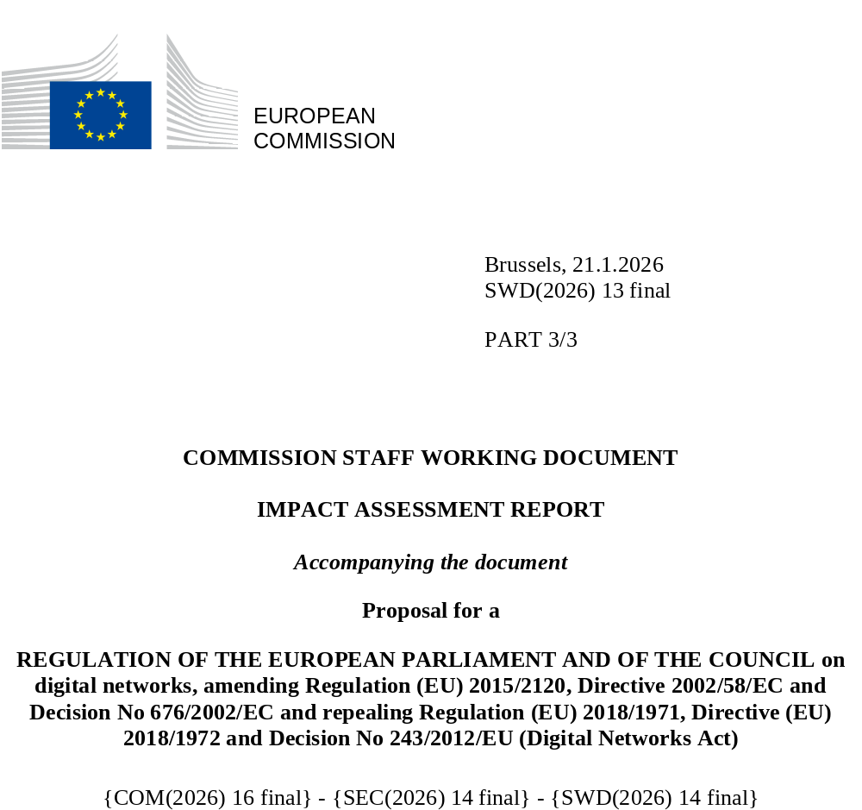

Annex 11 to the Impact Assessment: Evaluation – Review of the functioning of European Electronic Communications Code (EECC), BEREC Regulation, Open Internet Regulation, and certain aspects of the ePrivacy Directive
1. Introduction 4
2. Context 5
3. Objectives and Single Market 6
3.1. Intervention logic 6
3.2. Complexity and simplification potential, including observation on ‘gold plating’ 7
3.3. Single Market 9
3.4. General Objectives 10
3.5. Scope and level playing field 18
4. Access regulation 26
4.1. Harmonisation of regulatory remedies (Art 32) 26
4.2. Market developments 28
4.3. Overview and evaluation of the access provisions 33
5. Spectrum 48
5.1. Strategic Dimension of spectrum 48
5.2. Spectrum provisions in the EECC 49
5.3. Radio Spectrum Policy Programme 50
5.4. Effectiveness in promoting connectivity 51
5.5. Effectiveness in promoting development of the Single Market 70
5.6. Efficiency 78
5.7. Coherence 84
5.8. Relevance 87
5.9. EU added value 88
6. General Authorisation 89
6.1. Effectiveness 91
6.2. Efficiency 92
6.3. Coherence 93
6.4. Relevance 93
6.5. EU added value 94
7. Universal service obligations 94
7.1. Effectiveness 96
7.2. Efficiency 99
7.3. Relevance 100
7.4. Coherence 102
7.5. EU added value 103
8. End-user rights 103
8.1. Effectiveness 106
8.2. Efficiency 113
8.3. Relevance 114
8.4. Coherence 118
8.5. EU added value 119
9. Governance 120
9.1. Independence of NRAs 120
9.2. BEREC and BEREC Office 121
9.3. Radio Spectrum Policy Group (RSPG) 121
10. Lessons Learnt and Conclusions 126
Appendix I Sources 129
Appendix II – Radio Spectrum (Policy Programme) – additional information on spectrum 131
Appendix III Evaluation of BEREC and the BEREC Office 148

Table of Figures
Figure 1: Figure on existing political frameworks and initiatives influencing the green digital transition 13
Figure 2: Application of symmetric regulation according to Art. 61 (3) EECC 37
Figure 3: Total 5G households coverage- 5G Observatory Report 2025 | Shaping Europe’s digital future 52
Figure 4: 5G coverage of households in the 3.6 GHz band - 5G Observatory Report 2025 | Shaping Europe’s digital future 53
Figure 5: World population and mid-band coverage split per region (end of 2024) 54
Figure 6: 5G SA coverage, by region, 3Q 2024, Source Analysys Mason, 2024 55
Figure 7: International comparison of average download speed 56
Figure 8: Timeline of pioneer band awards by EU Member State (2015-2025) 58
Figure 9: 5G population coverage vs. years to awards, Source: Study on assessing the efficiency of radio spectrum award 59
Figure 10: Overview of private networks’ information on 3400-4200 MHz – for illustrative purposes only Source: BoR(25) 33 60
Figure 11: Mobile ARPU comparison and real-term changes across global regions (2022–2023) 67
Figure 12: Examples and observed impact of market shaping measures in EU auctions 69
Figure 13: Geographic distribution of cross-border harmful spectrum interference in Europe 73
Figure 14: Revenue per MHz per connection in Europe 80
Figure 15: Average band prices in each award (€/MHz/pop) 80
Figure 16: Inflation adjusted price trends in EU awards of 700 MHz and 3.6 GHz 2015-2025 81
Figure 17: % of new cars sold in selected EU countries, 2015-2024 112
Figure 18: % of new cars sold by 2024, per country 112
Figure 19: Stakeholder views: Publication of information (e.g. description of offered services) by providers beneficial Y/N 115
Figure 20: Spectrum competent authorities’ assessment of added value of RSPG work 124
Figure 21: MedUX - 5G QoE Benchmark in Europe: Drive Testing Report published at MWC25 (Q42024 data) 143
Figure 22: Status of 5G usage in Europe 143
Figure 23 :International comparison of 5G usage 144
Figure 24: Status of 5G SA usage in Europe 144
Figure 25: International comparison of 5G SA usage 145
Figure 26: International comparison of average download speed 145

Introduction
As a starting point, the European Electronic Communications Code (hereafter “EECC”) article 122 requires the Commission to review the functioning of the EECC. Therefore, one aim of this review report is to assess the functioning of the EECC since its applicability as of 21 December 2020, in particular Articles 61(3), 76, 78 and 79.
In addition, Article 122(2) requires that the Commission shall review the scope of universal service in light of social, economic and technological developments. The aim of this report is also to review the scope of universal since the applicability of the current rules as of 21 December 2020.
Next, Article 122 (3) allows the Commission, taking utmost account of the opinion of the body of European Regulators for Electronic Communications (BEREC), to publish a report on the application of the general authorisation provisions, including on the possible conditions and to submit a legislative proposal to amend those provisions where it considers this to be necessary for the purpose of addressing obstacles to the proper functioning of the internal market.
Furthermore, Article 123 of the EECC requires that the Commission publishes a report on the application of end-user rights, taking utmost account of the BEREC opinion. The aim of this report is also to accomplish this.
Finally, in view of new challenges concerning the competitiveness of the sector, the need to deepen the Single Market for electronic communications as well as security and resilience of networks, the need for a major regulatory reform has been identified. Therefore, this report includes a comprehensive review in light of the announced Commission initiative to propose a Digital Networks Act (DNA). Accordingly, this review of the entire EECC is conducted together with the review of the Regulation (EU) 2018/1971 establishing the Body of European Regulators for Electronic Communications (BEREC) and the Agency for Support for BEREC (BEREC Office), and includes an assessment of the Regulation (EU) 2015/2120 on Open Internet Access (OIR), some telecom specific (number-related) aspects (Art. 7 on Itemised billing, Art. 8 on Presentation and Restriction of Calling and Connecting line identification and Art. 10 on the related exceptions, Art. 11 Automated calls forwarding and Art. 12 Public directories) of the Directive 2002/58/EC (ePrivacy Directive) and the Radio Spectrum Policy Programme (RSPP).
To ensure overall coherence of this report, the evaluation is organised separately by individual subject areas, and a summary is provided.
The sections on these subject areas cover a short evaluation carried out with available data and elaborates, where relevant, specifically on some of the evaluation criteria of effectiveness, efficiency, relevance, EU added value and coherence. To allow for easy reference, in chapter 5 on spectrum, the evaluation criteria are assessed for individual subject areas separately where necessary.
For these assessments, the European Commission (Commission/EC) gathered feedback from various sources, the main sources are listed in Annex I.
Stakeholders were consulted on the review and on the evaluation of the interventions together with the proposals for the DNA, for which the details are provided in Annex 2 of the Impact Assessment.

Context
The EECC, the BEREC Regulation, the OIR, the 2012 Radio Spectrum Policy Programme (RSPP), the Decision No 626/2008/EC (MSS Decision) and the ePrivacy Directive have not been significantly changed since December 2020. Legal, judicial and regulatory developments since December 2020 are outlined in the specific sections below where relevant.
The exploratory consultation of 2023 and the feedback to the White Paper “How to master Europe’s digital infrastructure needs” of 2024 identified the following as the main technological developments impacting the connectivity sector: network virtualisation, artificial intelligence, open networks, edge cloud, low earth orbit satellite communications and next generation radio communications. Most respondents recognise the trend towards cloud- and software-based infrastructures and the need to significantly upgrade the network infrastructures. Many stakeholders underline the trend towards enabling data and AI centric applications. The diverse range and convergence of players in the broader ecosystem around digital networks is widely recognised, illustrated by partnerships between telecom suppliers and operators with cloud providers and content and application providers (CAPs). However, Internet and cloud players underline that general cloud services and telecom services remain technologically distinct. Some disagree on the concept of “convergence” between telecom and cloud services depicted in the White Paper.
Commercial/market developments:
Many operators that were previously present across several EU Member States have divested or rolled back certain of their operating units to focus on a smaller set of countries, to improve financial results and meet the expectations of investors. This includes, most recently Vodafone, Liberty Global, and BT Global Services (the former global business service unit of BT). The main aim in these divestments has been to focus on specific countries in which these operators have a stronger market position. Other operators are expanding to operate in more EU Member States e.g. Digi and Iliad, pursuing multi-country expansion strategies. The delayering of the telecom sector and the introduction of new players in the form of fibre netcos and towercos has tended to have a positive impact on investment in FTTH and towers for the provision of mobile services by improving transparency and offering the potential for higher take-up rates by aggregating demand. Certain incumbent operators have also opted for a legal, structural or functional separation of their business. With video streaming now dominating internet traffic, ISPs face increasing pressure to deliver high-quality content efficiently. Broadcasters transition to OTT as consumers shift from OTA (Over-the-air, including Cable TV and IPTV) to OTT (Over-the-top internet-based streaming). Beyond the challenge of bandwidth management, streaming represents also a major monetisation opportunity for ISPs. The synergy of connectivity and AI powers innovation like autonomous systems, smart cities, healthcare, and immersive virtual/augmented reality experiences. Applications such as automated driving or telemedicine run on advanced networks that will look increasingly like a computing continuum, ranging from chips and high-speed processors to connectivity, cloud, edge, software and AI. Technologies like AI and cloud computing converge with significantly enhanced connectivity needs.

Objectives and Single Market

3.1. Intervention logic
As to the EECC, at the time when the proposal had been made, the three primary objectives of promoting (1) competition, (2) the internal market, and (3) citizen interests, which were in place under Article 8 of the Framework Directive as well as the regulatory principles relative to investment and innovation were considered to remain valid and relevant. The telecoms sector was generating more and more spillovers to the rest of the economy, becoming the foundation of modern, innovative economic systems and as well as of certain societal services, such as e-transport, e-government, e-health care and e-learning. This was considered to require appropriate networks to be rolled out at a sufficient scale and that Very High Capacity connectivity became accessible and affordable to all citizens and businesses. Such connectivity was recognised as the underlying driving force for the digital society and economy, underpinned by technological changes and evolving consumer and market demands. It appeared necessary that the objectives should be flanked by a novel connectivity objective, spelled out as: "Access and take-up by all European citizens and businesses of very high-capacity connectivity, both fixed and mobile, and interpersonal communications services, on the basis of affordable price and choice, enabled by effective and fair competition, by efficient investment with adequate returns, by innovation, by common rules and predictable regulatory approaches in the internal market and by the necessary sector-specific rules to safeguard the interests of citizens.
As to the BEREC Regulation and to RSPG, it was intended to ensure that the relevant regulatory functions were attributed to the different actors such as national regulatory authorities (NRAs), BEREC, RSPG or the European Commission and that the structure of BEREC is simplified in order to have a streamlined and efficient governance set-up.
As to the Open Internet Regulation, the measures proposed were intended to lead to greater levels of innovation by lowering entry-market barriers and thus establishing a level playing field among providers of applications and services, while at the same time ensuring the highest protection for end-users and promoting the internet as an engine of innovation.
As to the ePrivacy Directive (Directive 2002/58/EC), the latest amendments introduced in 2009 intended to mainly update the existing Directive 97/66/EC (i.e., preceding the GDPR) on the processing of personal data and the protection of privacy in the telecommunications sector to take account of new services and technological developments. The aim was to cover all electronic communications services in a technology neutral fashion. A harmonised level of data protection in the electronic communications sector was an essential element for the functioning of the internal market in electronic communications services and networks. There was a need to provide subscribers and users with safeguards to protect their privacy in view of calling line and connected line identification services (CLI and COLI) and allowed access to blocked CLI information for emergency services and for tracing of malicious or nuisance calls. It was extended to new article on mobile location information. Among the other important consumers’ rights introduced by the 2002 Directive was the subscribers’ right and means to undo the forwarding of calls to their line and the subscribers’ right to non-itemised bills.

3.2. Complexity and simplification potential, including observation on ‘gold plating’

3.2.1. Complexity of and delays in the national transposition process
Member States were required to adopt and publish, by 21 December 2020, the laws, regulations and administrative provisions necessary to implement the EECC into their national law. However, the transposition of the EECC had been progressing rather slowly. Many Member States were late in complying with their implementation obligations. Only three Member States (EL, FI, HU) had complied with the transposition deadline of 21 December 2020. In February 2021, infringement procedures were opened against 24 Member States. By September 2021, only six of those had fully transposed and communicated the implementation. In April 2022, ten Member States (ES, HR, IE, LT, LV, PL, PT, RO, SE, SI) still had not complied with the transposition obligations and were referred to the Court of Justice of the European Union for their failure to fully transpose and communicate to the Commission the transposition measures. The transposition in all 27 Member States was completed in August 2024, with the official publication of the relevant Polish legislation The significant delays accumulated by Ireland, Latvia, Poland, Portugal and Slovenia lead to judgements by the European Court of Justice which imposed significant fines.
Transposition of many provisions of the EECC presented issues for some Member States. Only one in every seven Articles could be considered as not problematic and straightforward in all 27 Member States. The majority of Member States drafted completely new legislation. The remaining ten Member States amended their existing laws. In most cases, Member States provided a corresponding transposition of the EECC provisions (i.e. transposition of the meaning of the provision without given the exact verbatim expression). However, four Member States (CY, EL, IE, MT) seemed to use literal or almost literal transposition systematically for many EECC provisions. Also, transposition of certain provisions is more often literal than others; in particular, about half of the Member States assessed have transposed the definitions of Art. 2 EECC in a literal or almost literal manner.
Several Member States accumulated political and administrative delays in the transposition process, which was mentioned by six countries (BE, EE, IE, IT, MT, RO). In Belgium the outgoing government acted as caretaker government and could not propose a bill as that could have prejudiced the policy of the future government. In addition, emission levels for electromagnetic fields had to be adapted to allow permit granting for 5G deployment in Brussels. In Estonia, the timeframe for the transposition remained a challenge procedurally, with the communication between national authorities and the legislator passing through the three readings of the Parliament being a time-consuming procedure. In Ireland, the transposition required primary legislation which resulted in a delay. Moreover, there was a Supreme Court decision during this period which set new standards for fair procedures and oral hearings in quasi-judicial administrative proceedings, which required the enforcement provisions to be redesigned. In Italy, the division of competences among different authorities presented significant challenges. The implementation of the EECC involved both the Communications Regulatory Authority (AGCOM) and the Ministry of Enterprises and Made in Italy (MIMIT), with additional input required from privacy authorities. As not all provisions of the EECC fell under the jurisdiction of a single authority, it often led to inefficiencies and delays, requiring protocols of understanding and extensive coordination between different entities. In Malta, a comprehensive implementation required extensive consultation with different stakeholders, allowing for reasonable timeframes to provide an informed input. While such challenges did not necessarily involve all stakeholders, the major authorised service providers required substantial time to provide their input to the legislative proposals envisaged in transposing the EECC. In turn, the Malta Communications Authority (MCA) and the Government required some time to evaluate the submissions made and to modify the original legislative proposals. In Romania, the process took longer than anticipated due to the unique aspects of the Romanian legal framework, which requires inter-institutional approvals. The extended timeline was also attributed to the inclusion of infrastructure development components in the legislation, which were not part of the EECC transposition.
This evidence confirms the overall complexity of the transposition of the EECC and sets out the significant delays accumulated by various Member States in completing the transposition process.

3.2.2. National rules in addition to transposition measures
Several Member States adopted national provisions which relate to EECC provisions but go beyond what would be strictly necessary for the completeness and conformity of the transposition. Such, accompanying provisions were identified in eight Member States were dispersed across various legal frameworks.
For example, Cyprus and Sweden had gone beyond the EECC requirements by implementing more frequent updates and broader information-gathering for their geographical surveys of broadband networks.
Furthermore, the EECC requires Member States to ensure that in the event of a significant threat to the security of public electronic communications networks or services, providers must inform potentially affected users about any protective measures or remedies available to them. Additionally, where appropriate, providers should also inform users about the nature of the threat itself. For example, Cyprus has adopted a provision that goes further by specifying that providers must also inform users about all possible ways to prevent such threats, including relevant costs associated with these measures. In Croatia, it is additionally emphasised that operators must take appropriate and urgent measures at their own expense to prevent damage from security incidents, which adds a proactive element not explicitly stated in the EECC. The Maltese provision also includes the obligation to inform users about the threat itself where appropriate, ensuring that users are well-informed about potential risks.

3.3. Single Market

3.3.1. Harmonisation Aspects
There were several provisions introduced in the EECC to ensure harmonisation and strengthen the single market. The Significant Market Power (SMP) regime remains the key instrument for ex ante regulation. The detailed evaluation of the harmonisation of regulatory remedies under Article 32 EECC can be found in section 4.1. below. Several novelties were introduced by the EECC in relation to spectrum policy to strengthen its single market dimension. A detailed evaluation of the spectrum provisions, which are a key factor for fragmented national markets, can be found in chapter 5. Another important aspect limiting the development of the single market is the authorisation regime, which is today based on national procedures and conditions: general authorisation is covered in chapter 6. Other harmonisation aspects also contribute to the single market: standardisation is covered in section 3.5.3. Harmonisation of end user rights is addressed in chapter 8.
The EECC introduced specific requirements to support machine-to-machine/Internet of Things (M2M/IoT) pan-European services. Article 93(4) mandates Member States to make available a range of non-geographic numbers for extraterritorial use within the EU. BEREC was tasked to set up a database with these number ranges. Not all Member States implemented this requirement, and 9 Member States did not notify such number ranges to BEREC database. Stakeholders that provide M2M services providers indicated that certain conditions attached to the right of use of number would not be relevant in such use cases: i.e. number portability, contract duration, reporting obligation in every Member State where the M2M/IoT service is deployed. Current obligations incumbent on cross-border service providers could be harmonised.

3.3.2. Open Internet Regulation
The second Report from the Commission to the European Parliament and the Council on the implementation of the open internet access provisions of Regulation (EU) 2015/2120 (Open Internet Regulation, OIR) of 2023 concluded that the principles enshrined in the Regulation are still fit for purpose and guarantee the appropriate balance between protection of end-users and technological development. Nevertheless, the Report mentioned that the interpretation of certain provisions is not sufficiently clear, especially considering the developments that took place in networking technologies since 2015, such as network slicing and virtualisation. During stakeholder consultations, some stakeholders have highlighted that there is not sufficient flexibility in the interpretation of the open internet provisions and accordingly not sufficient legal certainty for the introduction and provision of innovative differentiated and quality-optimised services.
For example, until the rulings of the Court of Justice of the European Union which ruled that the so-called “Zero-Rating” offers are not compliant with the provisions of the OIR, this commercial practice was widely applied within the EU, although the approach of the national regulators vis-a-vis these offers varied. A diversified approach among the regulators, which subsequently got modified by the courts, had reduced the profitability of offers which had already been rolled out widely in the market and could no longer be offered.
Examples of categories of use cases that could benefit from more legal certainty which could lead to increases in expected profitability of roll-out are provided by the Camara project: remote monitoring, surveillance and repairs services, digital payments, banking secure payment transactions, digital health monitoring services, connected vehicles, drones and navigation related services, connected smart meters, Industry 4.0 services (e.g. connected factories, supply chain services, like product shipping monitoring, inventory and warehouse management, smart factory production line (robotics), transport hubs, e.g. ports, airports (fleet and container tracking services, smart stadiums (e.g. live 5G connected cameras on field, security personnel communication), mission critical services like railway operations, public safety communications (PPDR), energy grids, disaster response or emergency medical services (EMS), Augmented Reality/Virtual Reality services, Network APIs (connectivity services with specific architecture): e.g. connectivity services in NaaS Platforms, Video Gaming, OTA (over-the-air) critical software updates for vehicles, OTA vehicle maintenance or professional broadcasting services (live event broadcasting, remote transmission of live broadcasting streams).
While it is maintained that the conclusions of the 2023 Report are still valid and the provisions of the Regulation are still fit for purpose and do not require major changes, it is suggested that, in order to address issues like the one on specialised services illustrated above, if BEREC guidance or, if considered necessary, the Commission’s Recommendation will not bring sufficient legal certainty, the Commission could be empowered to issue binding guidance in the form of implementing or delegated acts in instances where the market would benefit from more legal certainty.

3.4. General Objectives
The EECC consolidated and updated the previous EU Framework for Electronic Communications (adopted in 2002 and updated in 2009). It aimed at boosting connectivity and better protecting users by establishing forward-looking and simplified rules that facilitate the provision of very high-quality, secure, and affordable electronic communications services throughout Europe. While many of the measures in the EECC built on pre-existing measures present in the previous EU Framework for Electronic Communications, it added new elements that have required transposition and implementation within the Member States.
Under the EECC, NRAs and other competent authorities as well as BEREC, the Commission and the Member States shall pursue each of the following general objectives, which are not listed in order of priority:
(a) | promote connectivity and access to, and take-up of, very high-capacity networks, including fixed, mobile and wireless networks, by all citizens and businesses of the Union;
(b) |  | promote competition in the provision of electronic communications networks and associated facilities, including efficient infrastructure-based competition, and in the provision of electronic communications services and associated services;
(c) |  | contribute to the development of the internal market by removing remaining obstacles to, and facilitating convergent conditions for, investment in, and the provision of, electronic communications networks, electronic communications services, associated facilities and associated services, throughout the Union, by developing common rules and predictable regulatory approaches, by favouring the effective, efficient and coordinated use of radio spectrum, open innovation, the establishment and development of trans-European networks, the provision, availability and interoperability of pan-European services, and end-to-end connectivity;
(d) |  | promote the interests of the citizens of the Union, by ensuring connectivity and the widespread availability and take-up of very high capacity networks, including fixed, mobile and wireless networks, and of electronic communications services, by enabling maximum benefits in terms of choice, price and quality on the basis of effective competition, by maintaining the security of networks and services, by ensuring a high and common level of protection for end-users through the necessary sector-specific rules and by addressing the needs, such as affordable prices, of specific social groups, in particular end-users with disabilities, elderly end-users and end-users with special social needs, and choice and equivalent access for end-users with disabilities.
The EECC, therefore, introduced a new general objective (in addition to the previous objectives regarding competition, consumer protection and the internal market, see Article 3 EECC) to promote connectivity and access to, and take-up of, very high-capacity networks, including fixed, mobile and wireless networks, by all citizens and businesses of the Union. Increased emphasis was also given to the need to take into account the variety of conditions relating to infrastructure and competition in different geographic areas and the need to promote efficient investment and innovation in new and enhanced infrastructures.
As to maintaining security of networks and services, ex-Article 41 of the EECC, now integrated in Directive (EU) 2022/2555 of the European Parliament and of the Council of 14 December 2022 on measures for a high common level of cybersecurity across the Union (NIS 2 Directive), provided that Member States should ensure that competent national regulatory authorities have powers to issue binding instructions, including regarding time limits for implementation and have the power to require information and security audits from providers. To follow up on the implementation of these obligations provided for in the EECC and, accordingly, to ensure the cybersecurity of 5G networks, Member States authorities adopted in January 2020 the 5G Toolbox, endorsed by the European Council and the Commission. It contains a set of key measures to be taken by Member States. In particular, it sets out a thorough and objective process to assess risks and threats and identifies proportionate and non-discriminatory measures to mitigate and manage appropriately identified risks posed to the security of the network and services. The purpose of the toolbox is to guide Member States in the transposition and implementation of the relevant security provisions of the telecommunication regulatory framework (and currently in relation to Directive (EU) 2022/2555) in the area of 5G networks security. The EECC predates the EU’s Green Deal and therefore does not systematically account for environmental sustainability considerations. There are two references to environmental protection in the EECC (Art. 44 on colocation and network sharing and Art. 57 on deployment and operation of small-area wireless access points). Some recitals also refer to compliance with environmental requirements (Recital 46), deploying networks in environmentally responsible way and improving facility sharing for environmental reasons (Recital 105), including spectrum sharing (Recital 106) and environmental security (Recital 94).
In June 2021, the Council and Parliament adopted legislation that enshrines sustainability objectives into Europe’s first Climate Law. Although the EECC does not itself specifically include general objectives relating to environmental sustainability, the telecom sector is subject to a variety of other legislation in this area. The EU environmental sustainability measures which apply to ICT include the Ecodesign Directive (covering energy consumption and labelling requirements for certain electronic goods), and Waste of Electrical and Electronic Equipment Directive, which seeks to increase recycling of electronic equipment. In addition, the EC facilitated the development of voluntary Code of Conduct covering broadband equipment, 2024 Best Practice Guidelines on energy efficiency and a forthcoming Code of Conduct for sustainable telecommunications networks. Taxonomy establishes criteria under which companies can claim that their activities are “sustainable” for the purposes of establishing the degree to which an investment is environmentally sustainable (Art. 1 (1) Taxonomy Regulation).
An overview of the environmental measures impacting the ICT sector is shown in the following figure. This environmental sustainability overview and the figure below show that there is already existing legislation in place covering the electronic communications sector. However, there is still room to further streamline the reporting obligations under the horizontal acts and coordinate more the work of the various competent authorities involved in the environmental sustainability activities to facilitate the sector specific monitoring by the telecom regulators and BEREC and respectively, the compliance by the sector.
Figure 1: Figure on existing political frameworks and initiatives influencing the green digital transition
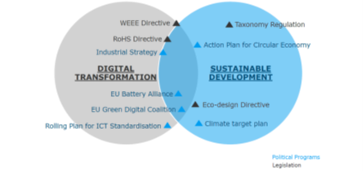

Compared to the strong emphasis put on competition, the EECC does not sufficiently account for competitiveness of the telecoms sector or of the EU industry at large. As widely recognised by stakeholders and set out in the Commission White Paper, the connectivity ecosystem is expanding driven by technological change, e.g. cloudification and AI. Competitiveness therefore becomes a very important element in view of the development of the AI continent.
As regards network rollout as basis for competitiveness, where VHCNs including dark fibre are not widely available this can limit service quality and competition on 5G. It can also affect the bandwidths available to enterprises and thus their capacity to benefit from big data processing/AI as well as the development of future applications such as quantum communications. It is notable that some urban areas in the EU have achieved world-leading levels of innovation supported in part on the availability of a dark fibre network. The lack of networks supporting full innovation capabilities elsewhere could limit Europe’s wider competitiveness in the global economy. Availability and take-up of future-proof connectivity provides a key input to European industry and is vital to enable societal participation in the digital economy as well as to drive European competitiveness. Figures from available reports provide a mixed view of financial performance in the telecom sector, with differences between service types as well as countries, business models and operators with different degrees of scale and history. An overview is provided below. However, there has been a real term decline in revenues, with low ARPUs for mobile services. Fixed broadband revenues are significantly higher. Further overview is provided below in the Coordinated spectrum policy.
In the current geopolitical context security and resilience of integrated electronic communications infrastructures (terrestrial, non-terrestrial such as satellite or submarine) have become an important concern which has not been addressed by the EECC, only partially and in a limited manner. Resilience under the EECC is considered mainly in the context of availability of services (voice communications services and internet access services) provided only over public electronic communications networks in the event of catastrophic network breakdown or in cases of force majeure (Art. 108 EECC). Not all EECC providers are subject to general authorisation conditions concerning public warnings, natural disasters or emergencies (Art. 110 EECC).
Nevertheless, resilience is also key for the integrity of networks irrespective of their purpose to avoid disruptions and ensure the uninterruptedness of communications. This could not be comprehensively addressed in the current framework. For example, submarine cable systems owned by content and application providers (CAPs) are considered as non-public ECNs and are not covered by the above-mentioned EECC requirements unless Member States decide at national level to subject such networks and non-public ECS to the general authorisation regime. Since international connectivity enhances and accelerates the competitiveness of the Union and its economy, and in a challenging and dynamic geopolitical context, it is important that resilience is equally ensured by all networks which provide crucial services for our economic activities, public safety, health and environment. Even when considering existing legal instruments addressing the physical or cyber resilience of infrastructures, not sufficient emphasis is given to the EU preparedness for crisis and to the role of NRAs and BEREC in enhancing the EU preparedness based on an EU networks’ contingency plan.

3.4.1. Effectiveness
Within the wide spectrum of assessments, most stakeholders of all types consider that – overall – the EECC is currently achieving, or is on track to achieve, its core objectives. However, the Digital Decade report 2025 documents reveal differences in reaching various connectivity targets at EU level or, at the very least, in some Member States. VHCN and basic 5G roll-out is on track across the EU with some lagging only in some Member States. while many Member States are still lagging behind in mid-band 5G coverage that is necessary to ensure high quality 5G connectivity. Accordingly, some governments and a majority of industry stakeholders argued that the EECC missed out on the objectives of promoting connectivity and investment. An example of this shortcoming is the persisting urban-rural divide. According to the State of the EU Digital Transformation in 2025: progress and horizontal recommendations , the coverage of households by fixed VHCN in the EU-27 reached 82.5% in 2024, with a growth rate of 4.9%, while fibre coverage stood at 69.2% of households in 2024, marking an 8.4% annual increase, but rural deployment with fibre is only 58.8% in 2024. Incumbents, mobile operators as well as some alternative operators of broadband networks argue that the EECC does not strike the right balance between the objectives of facilitating investment, on the one hand, and the promotion of citizens’ benefits and competition, on the other. This is in line with the emphasis by EU and national policies on the promotion of citizens’ benefits and competition.
Governments and industry stakeholders, such as incumbents, alternative operators, mobile operators, OTT providers agree that the EECC helped achieve/maintain effective competition in the market for electronic communications networks and services. There are multiple operators in each country on average 3-5 mobile operators and around 10 fixed operators, and even about 20 MVNOs in some Member States Stakeholders consider these numbers as signifying strong competition and sufficient to cover demand. Some positively noted the flexibility of the EECC, which allows NRAs to address market failures specific to their national markets and thus sustain competitive dynamics.
In terms of scaling up, incumbents and large mobile operators argued that the EECC failed to achieve its objective of effective competition because it is too much focused on market entry, blocking market exit, avoiding price increases fostering lower prices and discouraging investment resulting in fragmentation and a small user base per operator/provider. Consumer organisations are concerned that consumers would lose out on price, quality, and network deployment if there would have been more consolidation. There are some telcos active in several countries (e.g. Vodafone, Telefonica, Deutsche Telekom, Orange, Iliad, Digi) Furthermore there are regional operators present in more than one country (Telia, Telenor in northern Europe).
At the same time, the Significant Market Power (SMP) regime remains a central instrument for ex ante regulation as a guardian of competition both at infrastructure and service level in key access markets.
Overall, effective competition tends to be lower in some (national) markets (in particular for wholesale local access where more than 20 regulators still imposed remedies and wholesale dedicated capacity with 15 regulated markets) and for more advanced services. Competition in electronic communications in the EU is also shaped by external factors, such as technological developments and the presence of dominant non-EU hyperscalers that shape market demand.
On trade-offs between different regulatory objectives of the EECC, it shall be emphasised that most stakeholders either do not perceive any trade-offs or see them a useful flexibility allowing to address the regulatory needs of a given national market.
Concerning potential addition of new objectives and especially, on the governance side, the evaluation results presented that BEREC should widen its focus beyond electronic communications to address emerging digital market issues that affect the telecommunication market. Network resilience and cybersecurity were mentioned as areas of particular importance in this regard. However, a potential issue is that not all NRAs may have competencies in these areas, and if some NRAs do and others do not have these competencies, it could reduce the representativeness of opinions by BEREC and ultimately could lead to reduced harmonisation. This evaluation outcome shows that if expanding the policy objectives there would be a need to overcome the divergence in regulatory competences to tackle effectively the newly emerging issues in the single market.
In view of the wide range of assessments, it will be important to balance any new proposals under the Commission’s DNA initiative carefully, to address new challenges appropriately while preserving and expanding the benefits which have been achieved under the EECC.

3.4.2. Efficiency
The results of the study show that views are largely aligned between several governments and industry stakeholders on the administrative burden of the current legislation and the need to simplify the regulatory framework to achieve the regulatory objectives. The governments mention the simplification of regulation specifically to achieve the objective of the promotion of connectivity and investment. This applies in particular to the rules related to the deployment of VHCNs in high-cost deployment regions (e.g. rural or remote). Simplification can also achieve effective competitiveness because some EECC obligations (e.g. reporting obligations) do not differentiate between larger and smaller companies. It is also indicated that simplification and alignment of rules (related to general authorisation and end-user protection) may lead to greater harmonisation in some instances, thus contributing to the creation of the internal market.

3.4.3. Coherence
There is major agreement that there is no evidence of gaps in the coherence of the EECC objectives as such. Nevertheless, several stakeholders pinpointed a few specific issues of incoherence between the EECC, on the one hand, and Regulation (EU) 2022/1925 of the European Parliament and of the Council of 14 September 2022 on contestable and fair markets in the digital sector and amending Directives (EU) 2019/1937 and (EU) 2020/1828 (Digital Markets Act/DMA), Regulation (EU) 2022/2065 of the European Parliament and of the Council of 19 October 2022 on a Single Market For Digital Services and amending Directive 2000/31/EC (Digital Services Act/DSA) and Directive (EU) 2022/2555 of the European Parliament and of the Council of 14 December 2022 on measures for a high common level of cybersecurity across the Union, amending Regulation (EU) No 910/2014 and Directive (EU) 2018/1972, and repealing Directive (EU) 2016/1148 (NIS 2 Directive), on the other.
Many stakeholders (including those who did not find any incoherence) pointed out that inconsistencies may emerge at the transposition and application stage, especially where different national authorities are responsible for the enforcement. All other digital legislations are new, and there is very limited experience with transposing and applying them, which might be the reason why so few instances of incoherence were reported. Therefore, many governments and industry stakeholders argue that the focus of the EU should be on guiding the transposition and application process. Several stakeholders also noted the need for more cooperation arrangements between different authorities.

3.4.4. Relevance
There is broad agreement that the current EECC objectives remain relevant. Nevertheless, there were calls to improving implementation, ensuring better alignment with related legislation such as the NIS 2 Directive, DMA and the Regulation (EU) 2024/1309 of the European Parliament and of the Council of 29 April 2024 on measures to reduce the cost of deploying gigabit electronic communications networks, amending Regulation (EU) 2015/2120 and repealing Directive 2014/61/EU (Gigabit Infrastructure Act/ GIA).
Although it seems there is certain interest in adding resilience as a possible new objective, there are nuances on what resilience means. Some stakeholders connected it to cybersecurity, while others explicitly stated that it was separate from security (i.e. network resilience as technical and organisational measures to meet risk-identified threats that can disrupt or break the operational continuity of electronic communications networks, including the international interconnection in case of cut off of power supply, man-made or natural catastrophes).
The views on including industrial competitiveness as a new objective in the DNA showed some tension between interested parties, with larger industry stakeholders (incumbents, mobile operators) supporting such new objective. The arguments in support were largely in line with the arguments from the Draghi report: the necessity to scale up, promote large investments, and ensure the global competitiveness of European companies. The review of the Horizontal Merger Guidelines is ongoing.
Although the EECC encompasses satellite communications networks and services and submarine cables, due to the recent technological advances, market developments and geopolitical challenges, the issues of competition, security, resilience and technological sovereignty regarding these networks came to the fore. While all stakeholders acknowledge the pertinence of satellites and submarine cables to EU’s security, resilience and strategic autonomy/technological sovereignty, stakeholders have divergent views on whether these issues should be tackled under the EECC. Therefore, considerations about introduction of such new objectives should consider existing provisions in this regard in other instruments and complement them only where necessary.

3.4.5. EU added value
While the EECC provides a harmonised legal basis for electronic communications across the EU, the views on its meeting connectivity and investment objectives differ. Stakeholders broadly recognise the EECC's role in supporting gigabit rollout through longer licence durations, access regulation, and spectrum provisions, contributing to increasing VHCN and 5G coverage. However, still urban-rural divide persists: EU-wide 5G coverage stands at 94.3% in 2024 which is comparable to the 97% estimated coverage in the US and 95% in China and India. Rural 5G coverage in the EU and in the US are comparable with the EU at 79.6% and the US at 82%. Both regions have lower rural coverage compared to China (85.2% estimated) and India, which leads with 92.1% rural coverage. This gap is attributed to spectrum assignment delays, low rural investment returns, and planning barriers. European telecom operators also lag global peers in 5G Standalone availability, small cell deployment, and capital intensity. On the other hand, in view of stakeholders, consumer benefits under the EECC have generally improved, with wider service availability, better quality, and competitive pricing.
In view of the wide range of assessments, it will be important to balance any new proposals under the Commission’s DNA initiative carefully, to address new challenges appropriately while catching up the delays in achieving the digital decade connectivity targets and at the same time, preserving and expanding the benefits which have been achieved under the EECC.
The evaluation, on the background of a challenging geopolitical dynamics and climate change, revealed the need for some rebalancing of objectives, in the sense of prioritising all dimensions of connectivity (investment, demand), including in green networks, to foster enhanced competitiveness for innovation in advanced infrastructures and services, and to strengthen infrastructure security and resilience. Given the rapid evolution of electronic communications services and their use, high level of consumer protection and competition remain important, while single market dimension of electronic communications needs to be reinforced.

3.5. Scope and level playing field
The EECC introduced an extension of the scope of legislation reflecting the considerable evolution of communication services and the technical means of their delivery resulting in the inclusion of the number-independent interpersonal communication services (NI-ICS). Interpersonal communications services that constitute a minor ancillary feature intrinsically linked to another service (e.g. chats in online games, comment sections on e-commerce websites) are excluded from the scope of the EECC. Like in the previous framework, the EECC does not cover the content of services delivered over electronic communications networks using ECS such as broadcasting content and financial services. The extended scope of ECS also covers transmission services used for the provision of machine-to-machine services which reflects the development of the Internet of Things and connected objects.
The extension of the scope of the legal framework aimed at greater levelling of the playing field between traditional telecom services which are number-based (NB-ICS) providers and NI-ICS providers. However, NI-ICS providers still enjoy a lighter regulatory regime. For instance, NI-ICS are explicitly exempted from the scope of the general authorisation regime in Art. 12 EECC. Nevertheless, NI-ICS providers may be subject to some lighter EECC obligations like providing NRAs, other competent authorities and BEREC the information that may be necessary for the fulfilment of their tasks (Article 20 EECC), in the same way as NB-ICS providers.
Since the adoption of the EECC, the rapid evolution of technology has continued, and certain convergence trends have emerged gradually. As a result, the boundaries of ECN/S and cloud computing become increasingly blurring. In this regard, BEREC in its Report on Cloud and Edge Computing Services shares the view that the EECC scope (Art. 2 (4) on definitions) covers already cloud-based services such as NB-ICS (e.g., Amazon Connect) and NI-ICS (e.g., Microsoft Teams). This could possibly encompass new edge computing services and cloud-based networks services for transport connectivity and network related capabilities which include conveyance of signals such as Network as a Service (NaaS).
As regards the interconnection, the EECC did not change the previous framework in terms of scope of involved undertakings and kept the right and, when requested by other undertakings under the general authorisation, the obligation to negotiate interconnection with each other, limited to providers of public ECNs only. Other providers of non-public ECNs providing backbone infrastructure/networks are not covered by the interconnection provisions. Given that NI-ICS are a type of ECS, the provisions on dispute resolution in the EECC, both at the retail and wholesale levels, apply to this category of players (Article 25 and 26 EECC). Compared to the previous framework, the dispute resolution provision is limited to disputes arising between providers with respect to their obligations under the EECC. In this context, Articles 60-61 EECC regulating interconnection are relevant. Article 60 EECC requires that operators of public ECNs, (not the non-public ECNs,) negotiate interconnection for providing services and offer access and interconnection on terms set by NRAs.
Furthermore, a CAP such as Liberty Global can be viewed as a public ECN provider because it serves substantial numbers of end-user customers but also as a CAP due to the provision of entertainment content. Similarly, certain activities of a company like Alphabet are considered content provision services (video streaming services) and do not fall under the EECC. Furthermore, even though Alphabet operates one of the largest IP-based networks in the world, because it does not provide network access to end-users in the EU, it also does not fall under the scope of Art. 60 as the network is not public.
NI-ICS are not, in principle, obliged by the EECC to make their services interoperable. However, such an obligation can be imposed when end-to-end connectivity between end-users is endangered due to a lack of sufficient interoperability, and only on NI-ICS with a significant level of coverage and user uptake. In this regard, Article 61(2)(c) EECC sets out the criteria under which interoperability could be mandated in relation to NI-ICS. The latter may be subject to both the EECC and DMA. The regimes of the two legislations can be considered complementary. The EECC aims to ensure competition in the markets for electronic communications, while the DMA ensures contestability and fairness in digital services markets by curbing the power of gatekeepers. Article 61 EECC empowers NRAs to impose obligations on service providers to ensure end-to-end connectivity and interoperability, particularly on those with SMP. NRAs may require access to infrastructure within buildings when replication is impractical. According to BEREC, there does not seem to be sufficient practice in enforcement of Art. 61(2)(c) EECC. However, the evaluation confirmed that the threshold for regulatory intervention under the EECC seemed to be higher than the one under the DMA.
Some EECC provisions pertaining to end-user rights also apply to NI-ICS e.g., information requirements including the contract summary (Art. 102 EECC), possibility to impose the requirement to contribute to financing the universal service by sharing the net cost of universal service obligations between providers of electronic communications networks and services (Art. 90 EECC), non-discrimination (Art. 99 EECC), transparency obligations including information obligations related to quality of service under (Art. 103 EECC).
According to BEREC access to the European emergency communication number 112 is solely defined as an NB-ICS, in Articles 109(1) and 109(2) of the EECC. This has led to different views on whether equivalent access solutions under Article 109(5) could be provided by NI-ICS, potentially causing inconsistencies and challenges across Member States which undermines the effectiveness of the measure. However, in the event of major accidents or natural disasters, BEREC considers that operators must grant the continuous transmission of messages and notifications, taking all necessary measures to ensure uninterrupted access to all emergency service numbers and considering the increased use of NI-ICS.
To improve interoperability, freedom of choice for users and to encourage interconnectivity in the internal market, Article 39 EECC provides that the European Commission may request (and Member States may encourage) that standards be drawn up to ensure interoperability of services and end-to-end connectivity, among other aims. Furthermore, voluntary use of standards included in a list established by the Commission is to be encouraged by Member States. In the case that existing standards have not been adequately implemented so that interoperability of services in one or more Member States cannot be ensured, the EC, by means of including mandatory standards in the list, can make the implementation of such standards or specifications compulsory where this is strictly necessary to ensure interoperability and to improve freedom of choice for users. The list of voluntary standards had not been changed over the reporting period and is still considered to be relevant. The Commission has never used its competence to make the use of standards mandatory under this provisions which is still considered necessary as a measure of last resort.
The EECC security related articles (Art. 40 and Art. 41) were repealed by the NIS 2 Directive in October 2024. According to this directive and in terms of reporting obligations, the principle of country of destination applies only to public ECNs and to all ECS while the principle of the “country of main establishment” is applicable to all other digital entities in the scope of NIS 2 Directive. This implies obligations of public ECNs and of ECS to at least report to national authorities subject to national rules in 27 Member States in the event of significant cyber incidents. The study results confirm that different Member States still have different approaches, regulations and standards related to the cybersecurity of electronic communications, which requires harmonisation.

3.5.1. Effectiveness
The extended EECC scope proved to be effective in terms of covered networks, but it also showed that the flexibility posed challenges in regulation. In this regard, the level of regulation remains differentiated which results in a fragmented approach and divergent solutions in addressing various issues effectively. For example, under the EECC, regulatory remedies for submarine cables owned by public ECNs providers include access obligations, transparency measures and price control. Submarine cable systems operated by content and application providers (CAPs) are considered as non-public networks and as a result, are subject to general authorisation regime only in 4 MS and the national legislation on access and interconnection does not apply to non-public ECNs in at least 16 MS.
Furthermore, regarding the effectiveness of the scope, a differentiated treatment in imposing NI-ICS’ requirements was also observed. In this regard, in its submission to the European Commission’s White Paper on “How to master Europe’s digital infrastructure needs” published on 21 February 2024, BEREC declared some openness towards analysing the position of NI-ICS providers on the market.
In addition, the fact that some cloud-based services (e.g., NI-ICS) already fall also under the definition of Article 2 of the EECC and, thus, are at the same time ECN/S for certain types of services, requires their compliance with the electronic communications’ regulatory framework preceded by identification of the applicable legal requirements for levelling the playing field. In this regard, a clear delineation with the EU cloud acquis is needed for ensuring coherence between the acts.
Concerning the functioning of relationships between various interconnecting networks, as quantitative data on effectiveness of competition is not available, for qualitative assessment we note polarised stakeholder positions, among others of those expressed in response to the White Paper. According to a certain number of stakeholders and BEREC in its 2024 Report on IP interconnection, the IP interconnection negotiations occur in a balanced setting, and monitoring on a case-by-case basis proves that the current legal framework (consisting of civil law and competition law) and the EECC provisions on interconnection are effective. As examples are mentioned a few disputes occurred during 2020-2024 through litigation (e.g. Deutsche Telekom vs Meta; DAZN live-streaming). BEREC focuses its conclusions on market developments without need of regulatory intervention. Other sources in 2025 (e.g., Cullen International June 2025⁾ also describe that IP interconnection market balanced without regulatory intervention (few disputes in Europe where or regulator or court intervened). It quotes BEREC data indicating that traffic via on-net content delivery networks (CDNs) has increased more than traffic exchanged through peering and transit. In the similar vein, another source (German Monopolies Commission in 2023) notes that there is a rebalancing of the bargaining power on the market: the importance of the large network operators is in decline as the data traffic in parts of the network is routed through networks built by CAPs (i.e. own core networks and on-net CDNs). The German Monopolies Commission observes more often settlement in the form of free peering agreements and that the number of connections via IP transit is decreasing.
On the other hand, another group of stakeholders, mainly big telecom operators, shares the view that the large asymmetry in bargaining power is compounded by the large scale of certain CAPs, which are much more powerful than any of the telecom incumbents, and that this leads to ISPs not getting fair conditions in IP peering agreements with CAPs. They claim that the lack of disputes reported by ISPs to NRAs or litigated in courts could be a proof of the legal framework not working. The EECC has been designed with traditional electronic communications in mind and does not adequately address all specific requirements of the broader digital sector. Large operators also state that the current legal framework (mainly the OIR) weakens their bargaining position as ISPs, because it obliges them to comply with net neutrality rules and to carry all traffic in a neutral manner, irrespective of whether an agreement can be reached and the traffic is paid for. This is necessary to ensure that all end-users have access to, and can deliver, the content, services or applications of their choosing. CAPs generating large traffic are not under obligation to interconnect their private infrastructure (e.g. CDNs, data centres, undersea (submarine) cables) or negotiate an agreement. Their global reach allows large CAPs to re-route their traffic easily.
In contrast, as indicated in the Commission White Paper, and supported by most governments and industry stakeholders, the IP interconnection market in general works well. There have been very few known cases of intervention by regulatory authority or by court. Accordingly, most NRAs state that, within their countries, they do not observe or receive reports/information on any disputes related to IP peering. These NRAs support the conclusions of the BEREC Report on the IP Interconnection ecosystem and of the White Paper that the ecosystem is driven by functioning market dynamics and the cooperative behaviour of market players. It is worth mentioning also other regulatory initiatives regarding IP interconnection. For example, in 2020 the Italian regulator (AGCOM) adopted general obligations, reference standards and the minimum set of functionalities that each operator must make available for the provision of VoIP/IP interconnection at national level.
While some stakeholders state that no quality-based services exist at the moment, the majority maintain that they are actually provided although still a few. For instance, new specifications such as 5G release 17 and CAMARA show that the sector is heavily committed to launch innovative services in the domain of quality-enhanced services, as mentioned in the section on the Open Internet Regulation.

3.5.2. Efficiency
Regarding IP interconnection and level playing field between ISPs and CAPs, the framework is not designed for the currently emerging broader connectivity ecosystem. Therefore, it can not be concluded that all potential issues can be addressed under the current legal framework. However, many stakeholders of different types (except telco providers) do not find any major inefficiencies in the current rules and do not experience any administrative burden. Telcom incumbents raised the lengthiness of court proceedings, which allegedly discourages more reliance on dispute resolution. Due to the lack of evidence and only a handful of known disputes, it is difficult to draw clear conclusions and assess whether cooperation among involved parties had been sufficiently facilitated by the current rules.
Moreover, the OIR provisions clearly affirm that internet access service providers shall not discriminate amongst internet traffic and shall enable the end-users to reach every internet end-point, irrespective of the content, application or service used. The OIR provisions also establish that internet access service providers cannot discriminate internet traffic based on commercial agreements. As mentioned above, the European Commission’ 2023 report on the implementation of the OIR has concluded that these provisions are still fit for purpose and did not put forward any proposal for review or changes.

3.5.3. Coherence
As a part of the coherence evaluation, particular attention is paid to the main recent EU legislations related to digital infrastructures and services (i.e. external coherence), namely the Gigabit Infrastructure Act (GIA), the Digital Markets Act (DMA), Digital Services Act (DSA), Artificial Intelligence Act (AIA), Data Act and NIS 2 Directive. No incoherence has been identified within the EECC itself; therefore, the EECC is internally coherent, but there are issues related to the external coherence.
In terms of coherence with other acts, the extension of scope does not necessarily lead to more rules for new providers because for instance, for certain categories of information society service providers in the EECC scope, the rules of Directive (EU) 2015/1535 of the European Parliament and of the Council of 9 September 2015 laying down a procedure for the provision of information in the field of technical regulations and of rules on Information Society services (INFOSOC Directive) apply. For instance, NI-ICS are not subject to the general authorisation regime under the EECC, and they comply with the INFOSOC and the eCommerce Directive rules.
On the other hand, the DSA was designed to cover intermediary services (i.e. mere conduit, cache or hosting services) that do not fall under the EECC. However, in practice, the distinction is not always easy, and the DSA gives some examples of services (e.g. Voice over IP, messaging services, web-based email, see Recital 28 DSA) that are within its scope, but are also NI-ICS in the sense of the EECC. Hence, as also requested by BEREC, a clarification of the scope is necessary in this regard.
Regarding the lack of a level playing field in terms of services, many governments and industry stakeholders refer that “the legal framework shall provide for a level playing field for services that have the same functionality”. Stakeholders point out that, in the environment of technological convergence, both “traditional” and “non-traditional” service providers play an equally important and similar role in delivering digital communications but are subject to different sets of rules. For instance, NI-ICS are comparatively less regulated than NB-ICS, and NRAs' enforcement powers regarding them are weaker. If the DMA and DSA regimes are considered, stakeholders note that large CAPs are subject to EU-level rules and enforcement, which gives greater legal certainty when offering services across the EU. By contrast, electronic communications providers are subject to national rules and enforcement by individual NRAs in each Member State where they choose to offer services .
As for interconnecting networks, the role of NRAs in resolving potential IP interconnection disputes between ISPs and CAPs and in monitoring and data collecting related to the CAPs markets is also unclear, from the perspective of a few NRAs.
Regarding the interoperability between services, the requirement under Art. 61 (2) (c) EECC on NI-ICS providers, which reach a significant level of coverage and user uptake, to make their services interoperable can only be imposed where “end-to-end connectivity is endangered”. This appears to be a higher threshold than under Article 7 of the DMA.
Standardisation assessed from the level playing field angle, proves that efforts continue to move towards an all communication technologies (terrestrial/TN) and non-terrestrial/NTN) overarching network management architecture which would allow the provision of end-to-end (user to user) network connections or network slices using all NTN (high-altitude platform station/HAPS), Low Earth Orbit (LEO), Medium Earth Orbit (MEO), Geostationary orbit/GEO) and TN technologies according to their capabilities and characteristics, even if they are not operated by one firm, but by buying respective wholesale capacities and by interoperating the related communication platforms management systems over standardised interfaces. Such solution would allow for communication resilience in case of natural disasters or other damages at the best available capacity and quality resources and if the network access can be granted, or alternatives are still available.

3.5.4. Relevance
In terms of relevance of the EECC scope considering such technology trends as 6G, edge computing, advanced cloud services and AI, a great majority of governments, a consumer protection organisation and a minority of industry stakeholders (alternative providers, ISPs, MVNOs) do not think that an extension of the EECC scope is warranted in the face of the said technology trends. A smaller group of governments supported changes to the EECC without being specific in what exactly needs to change (most simply that the EU framework needs to change to create a forward-looking regulatory environment fostering innovation, promoting competitiveness, lowering entry barriers and administrative burden, and addressing potential challenges).
As said before, all stakeholders acknowledge the pertinence of satellites and submarine cables to EU’s security, resilience and strategic autonomy, although stakeholders disagree on whether these issues should be tackled under the EECC. The Recommendation on secure and resilient submarine cable infrastructures is a good example of acknowledgment of the issues and the EU should continue studying them, analyse the EU legal framework and identify other opportunities for EU-level specialised interventions (e.g. mapping; real-time monitoring; increasing EU-level funding for satellite and undersea infrastructures, for instance, through Connecting Europe Facility/CEF-Digital; joint repair and emergency capacities; restricted access to information about submarine cables; cross-body and cross-border cooperation for cybersecurity and resilience). Based on the findings, such measures can be included in the EU-wide policy on critical digital infrastructure that would cover terrestrial and non-terrestrial such as submarine infrastructures..

3.5.5. EU added value
The objectives and scope of the EECC, as also pointed out by many stakeholders, they have not significantly changed by comparison to the previous legal framework. Hence, some stakeholders stated that the EECC has not changed the situation but continued down the pathway laid down by previous legislation. Because of this, only a few benefits of added value were indicated.
A few stakeholders also mentioned the value added of promoting a level playing field between small operators active in only one country and large international operators.
For the standards part, the main evaluation findings describe that different Member States still have different approaches, regulations and standards related to the cybersecurity of electronic communications, which requires harmonisation..
In terms of networks and their interconnection based on the evaluation outcomes, it could be concluded that there have been a few legal challenges concerning networks and especially, on the topic of data traffic termination in national courts (e.g., Germany DT vs Meta). When such issues are taken to court by a party, the likelihood of lengthy procedures continuing for several years is high. These are disputes on commercial contracts and are not under the jurisdiction of the Commission. Therefore, at EU level, we could conclude that it would be useful to establish an ecosystem cooperation mechanism to monitor the market development and its impact on the competitive dynamics in the context of various dimensions of IP-networks and enhanced interaction with the national competent authorities and BEREC (e.g. resilience and redundancy, smooth functioning of IP networks, including if integrated with other types of networks, environmental sustainability etc.)
Regarding the evolution of services, the findings confirm that there is room for further extension of obligations to functionally equivalent services e.g., VoIP when justified by public interest (e.g., resilience preparedness for natural disasters and public warnings or emergency communications) and at the same time, avoiding overregulation by analysing carefully the effects of existing similar provisions in other acts. For coherence purposes, solutions should be also sought for facilitating compliance with other relatively recently adopted digital legislation.
The technological evolution and the gradual transition to IP networks revealed new challenges in terms of level playing field concerning consumer protection and tackling fraud. The scope of the EECC definition of ECS providers and the respective IP addressing systems used, the different services provided as well as the related e-privacy directive provisions signal some issues related to fraud which need special attention (details in the End-users' part).

Access regulation

4.1. Harmonisation of regulatory remedies (Art 32)
Although NRAs have increasingly defined markets subject to regulation as regional or local and some NRAs decided to deregulate at national level, the Significant Market Power (SMP) regime remained the key instrument for ex ante regulation, even if regulatory intervention can be envisaged outside of the SMP regime under the specific conditions set in Article 61 of the EECC through symmetric regulation.More specifically, a total of 23 NRAs indicated that they had found SMP in the market for wholesale local access at a fixed location (Market 1), while in 15 countries SMP was found in the corresponding Market 2 – wholesale access for dedicated capacity. 12 EU MS identified SMP in the former Market 3b - Wholesale Central Access market, and 6 countries identified SMP in a separate market for Physical Infrastructure Access (PIA). The following table provides an overview of SMP findings by market and country.
Table 4-1: SMP findings (at least part of the market)
 | Separate PIA | Market 1 | Market 2 | Market 3b
Austria |  | No | Yes (partial) | No segmentation between WLA and WCA
Belgium |  | Yes | Yes | Yes
Bulgaria | Yes | No | No | No
Croatia |  | Yes (partial) | Yes | Yes (partial)
Cyprus |  | Yes | Yes | No
Czech Republic |  | Yes (partial) | No | No
Denmark |  | Yes (partial) | No | No segmentation between WLA and WCA
Estonia | Yes | Yes (partial) | No | Yes (partial)
Finland |  | Yes (partial) | No (court decision) | No
France | Yes | Yes | Yes | No
Germany |  | Yes | Yes | Yes (partial)
Greece |  | Yes | Yes | Yes
Hungary |  | Yes (partial) but withdrawal | Yes | Yes (partial) but withdrawal
Ireland | Yes | Yes | Yes (partial) | No
Italy |  | Yes (partial) | Yes (partial) | Yes (partial)
Latvia |  | Yes (partial) | No | Yes (partial)
Lithuania |  | Yes | Yes | Yes (partial)
Luxembourg |  | Yes | Yes | Yes
Malta |  | Yes but withdrawal | No | No
Netherlands |  | No | No | No segmentation between WLA and WCA
Poland |  | Yes (partial) | No | Yes (partial)
Portugal | Yes | Yes (partial) | Yes (partial) | No
Romania |  | No | No | No
Slovakia |  | Yes | No | Yes
Slovenia |  | Yes | Yes | Yes (partial)
Spain |  | No | Yes | Yes (partial)
Sweden |  | Yes | No | No

Under the SMP regime, regulatory intervention on a specific product and geographic market can be justified if proven that these markets are characterised by high barriers to entry and do not tend towards effective competition, and that competition law instruments are insufficient to tackle the identified competition problems (so called three criteria test under Article 67 EECC). An undertaking is deemed to have SMP, if, either individually or jointly with others, it enjoys a position equivalent to dominance, i.e. a position of economic strength, which gives it the power to behave to an appreciable extent independently of competitors, customers and ultimately consumers. Guidance on the market definition and SMP assessment has been provided in the 2018 SMP Guidelines and in the 2020 RRM. Additionally, guidelines on the imposition of remedies are provided in the 2024 Gigabit Recommendation.
When the EECC became fully applicable on 21 December 2020, it introduced the promotion of connectivity, access to and take-up of VHCN as a new objective of the regulatory framework, alongside the promotion of competition, the development of the internal market and the interests of Union citizens. The market environment has also changed dramatically as a consequence of huge amounts of investments required to replace the copper local loop by fibre and the emergence of players other than the historic telecom incumbents that are deploying FTTH loops in certain geographic areas.
Specifically, as regards copper switch-off, operators with significant market power and subject to network access obligations must notify NRAs when they plan to decommission or replace their copper networks. The aim of the currently applicable regulation is to ensure that migrations from regulated networks are transparent with a clear timetable and adequate notice periods, do not harm competition or end-user rights and that alternative access products of comparable quality are available.

4.2. Market developments
Article 3 of the EECC provides that NRAs and other competent authorities should “promote regulatory predictability by ensuring a consistent regulatory approach over appropriate review periods”, “take due account of the variety of conditions relating to infrastructure, competition, the circumstances of end-users and in particular consumers in the various geographic areas” and “impose ex ante regulatory obligations only to the extent necessary to secure effective and sustainable competition in the interest of end-users and relax or lift such obligations as soon as that condition is fulfilled”.
A key trend in business models since the last review of the telecom framework and relevant market recommendation is the emergence of wholesale-only companies in both fixed (netcos) and mobile (towercos). The following diagram provides an overview of fibre netcos across the EU as of 2023
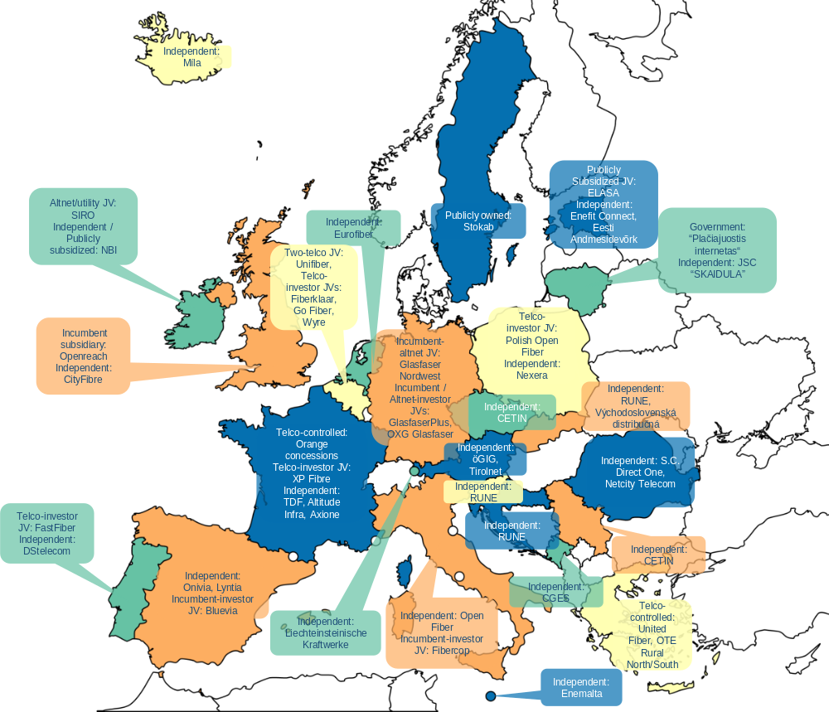
The switch-off of legacy copper networks is another development that is likely to influence market structures going forwards. While it is expected that the switch of copper networks will the limit demand risk for FTTH on a market-wide basis, the way in which the copper switch-off is managed (and any associated conditions) may influence where the copper customers go. Subsequently, this will influence the business case for alternative fibre investors, as well as the possibility for alternative operators to provide broadband services via wholesale access to the incumbent’s upgraded copper network. Copper switch-off, if managed in a way that allows incumbents to delay fibre roll-out and progressively migrate customers to its own fibre network alternative fibre providers in areas where only one FTTH network is viable, will increase market concentration at the infrastructure layer by replicating with fibre networks the same market situation already present in copper-based markets.
Technological trends
The physical components, topologies and transmission technologies associated with the access networks, determine the performance that can be achieved on an access network regarding capacity and quality. These factors can also affect the degree to which networks can be open to competition (allowing innovation by access seekers) as well as the degree to which they will be future proof, allowing for the expansion of capacity and quality to meet future needs. The EECC currently includes the objective to promote connectivity and access to, and take-up of, very high capacity networks (VHCN). BEREC has provided guidelines regarding the interpretation of this concept. For fixed networks either a FTTB (Fibre to the building) should be provided (Criterion 1) or certain criteria regarding bandwidth and quality must be met (Criterion 3). The quality of the in-building connection is not considered.
Table below provides an overview of the performance capabilities of fixed broadband access technologies:
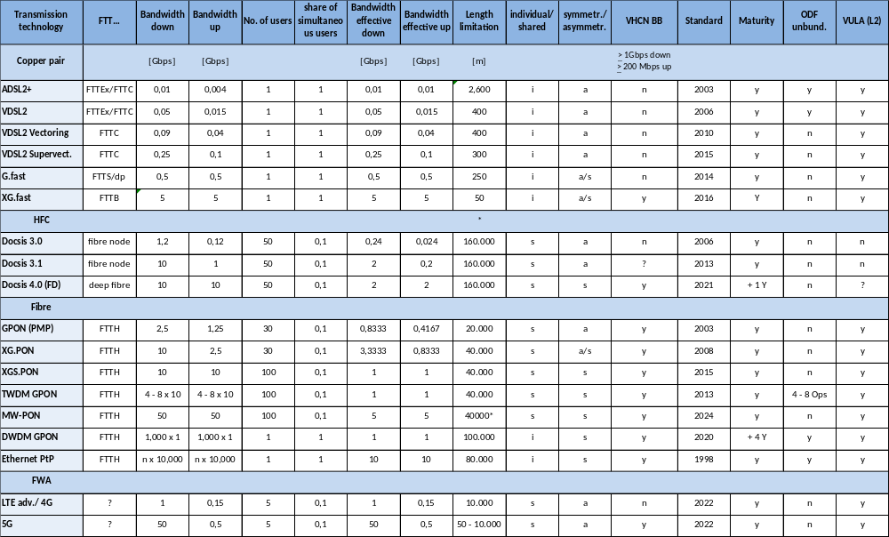
The main access products are the following:
Physical unbundling at ODF sites can only occur as an individual connection in access network topologies of the kind FTTH Point-to-Point (PtP) (see the last line in the fibre section of the table above) or in the old-fashioned copper FTTEx topologies, where the fibres end in the local exchange (FTTEx). Unbundling of PON is feasible, and is provided in certain cases e.g. by Fibercop in Italy, but requires multiple components.
When topologies are shared and thus physical unbundling is challenging, an alternative can be to provide virtual unbundled local access (VULA). Its ideal characteristics have been defined in State Aid case, based on BEREC recommendations. Common for all VULA approaches is the use of the Layer 2 Ethernet protocol, which allows for a higher degree of product definition freedom than a layer 3 Internet Protocol (IP).
There is one access network technology, hybrid fibre coax network (HFC), which does not support Ethernet based communication as a regular capability. Layer 2 communication in form of virtual Local Access Networks (vLAN) is only enabled if an additional optional feature of DOCSIS (3.0 – 4.0), called BSOD (Business services over DOCSIS), is implemented. These operators offer IP-based bitstream access, if at all.
5G or in future 6G radio transmission techniques can be used for fixed wireless access (FWA) services in directed antenna applications from the central mast to the individual fixed receiver locations, i.e. as substitutes for expensive and hard to approach fixed fibre access lines, even when deploying aerial constructions. The frequency bands in Europe for this use case are between 26 – 29 GHz, thus of high capacity, but of short range and require line of sight. The short range associated with these high frequencies can be overcome to some extent through directed and bundled outdoor antennas at both sides, central antenna mast and home. Thus far not all member states have deployed FWA to a significant degree. When deployed in a suitable manner, 5G FWA is a fixed network technology and could be capable of meeting the BEREC fixed network VHCN conditions. Its performance remains however below that of FTTH connections.
Overall, data shows that deployment and take-up of VHCNs is progressing across the EU (although at different rates in different countries) and that a choice of options is available for most end-users.
The graph below shows that coverage in 11 MS exceeded 80%, with ES, RO and PT achieved the highest levels, while 8 MS have a fibre coverage between 70 and 80%. Another 4 have reached more than 50% of households, only 5 MS have a fibre coverage below 50%: AT, EL, CZ, DE and BE. Europe benefits from significantly higher FTTH coverage than the US, and according to figures provided by Analysys Mason for Connect Europe, bypassed South Korea at the end of 2024
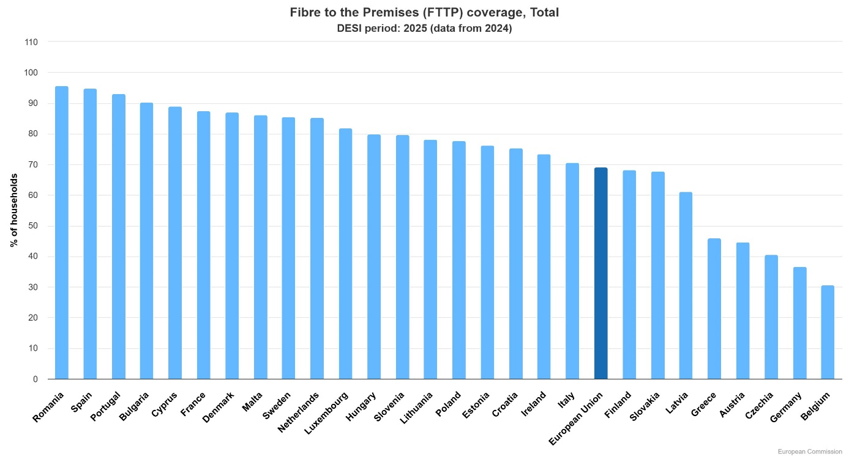
Meanwhile, the data shows that most European consumers have a choice of multiple providers of VHCN services, based on a combination of own infrastructure (in some cases supported by regulated duct access), services based on co-investment and services based on wholesale access. The following table, based on data provided by NRAs, shows the crucial role played by wholesale local access in supporting choice to consumers.
Table: Role played by wholesale local access (“WLA”) in supporting consumer choice
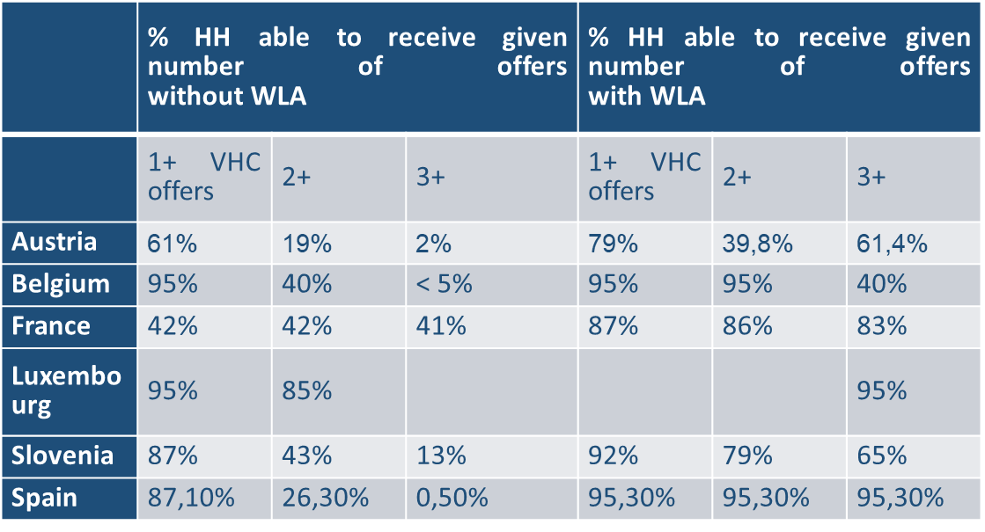

4.3. Overview and evaluation of the access provisions
Wholesale access regulation has been widely applied across the EU. Access regulation has supported the development of infrastructure-based competition (also via granting access to physical infrastructure) and choice in broadband services, including VHCN, for a high proportion of households in the EU. Meanwhile evidence of the effects of asymmetric (and some cases symmetric) wholesale local access regulation on the choice for consumers is also visible by looking at the proportion of retail broadband lines that have been provided on the basis of wholesale access, either directly resulting from regulation, or as a result of regulatory incentives or a continuation of practices that were triggered by regulation in the past.
The success of the EECC’s access rules would allow for further deregulation of markets and for some simplification of provisions which have not - or only scarcely - been used.

4.3.1. Effectiveness
Except for incumbent operators, which mostly favour a withdrawal of access regulation in case of sustainable competition and focus only on limited bottlenecks, other stakeholders generally consider that the EECC access-related provisions have provided regulatory predictability and are well-understood by NRAs and the market. Alternative operators further observe that their existing investments (which amount to around one quarter of the FTTH lines deployed in Europe) were based on the existing regulatory regime, and these investments would be undermined in the event of changes.
An analysis of the approaches taken to access regulation under the EECC shows that NRAs have reflected in their market analysis and other regulatory decisions, factors which should serve to minimise ex ante regulation to that needed to support competition in the interests of end-users. In particular:
- NRAs have taken into account commercial agreements when considering whether ex ante access obligations are appropriate. Such considerations have led to deregulation or lighter touch regulation in several countries. Whereas Article 79 EECC was directly implemented only in three relevant markets, it also served as a point of orientation for those NRAs that decided to apply it mutatis mutandis
- In line with Article 72 EECC, NRAs increasingly focused on passive infrastructure access (PIA) markets, either as a remedy for problems identified on wholesale local access or, where such markets are not regulated, as a reason to define separate markets for access to physical infrastructure and mandate access to those. This has contributed to downstream deregulation (reliance on PIA alone) in cases where it has supported competition at the level of active network infrastructure.
- NRAs have increasingly defined markets subject to regulation as regional or local. As a result, there has been progressive removal of ex ante regulation (other than access to physical infrastructure) in wholesale local access and dedicated connectivity in many areas, in particular urban areas, where competition takes place. In many countries, regulation is limited to some geographic markets, often rural or less densely populated areas. This has ensured that regulation is adapted to specific conditions in the different geographic areas. The NRAs in the EU Member States have conducted extensive geographical analyses to assess whether there is a need to define geographical markets.
- In Demark and Finland the segmentation is based on the network reach of local and regional network operators.
- In Ireland, in a first step the market is segmented in two areas (intervention area IA NG area and commercial NG area) based on network reach of the network operators Eircom and NBI. The competitive conditions are assessed in a second step for each area.
- In France, Hungary, Netherlands and Portugal the NRAs also combine the assessment of competitive conditions and the network reach of operators/market leaders in the geographical market analysis.
- 16 NRAs use municipalities as a geographical unit. Other geographical units used are the modified exchange of Eircom (Ireland), the energy supply areas (Denmark), 6 digit postal code and concession areas (Hungary).
- With reference to the rationale/methodology used to segment the market, the majority of NRAs combine criteria with reference to retail market share, minimum number of alternative operators and a threshold for the coverage of alternative operators (in sum or individually).
- In this respect, geographic surveys (under Article 22 EECC) provide an important input that should help national administrations and NRAs to understand to what extent there may be regions that are likely to be underserved with VHCN on a commercial basis, and which may therefore require State Aid to ensure adequate coverage. In areas where commercial deployment is envisaged, geographic surveys can also be used to understand to what extent infrastructure-based competition is present (or could emerge), data which is essential in defining geographic markets and tailoring SMP (or symmetric) regulation to reflect the competitive situation in the area concerned. Information about network technologies and spectrum use could also provide important insights regarding the quality of mobile services. NRAs could, therefore, use the provisions in Article 22 much more to address several issues related to achieving connectivity and accelerating copper switch-off. They could with this approach identify the areas which are relevant for state aid. Combined with analysis based on cost modelling, they could identify areas where duplication of networks is unviable and where infrastructure competition can be expected.
- Many NRAs have refrained from imposing cost-orientation remedies when mandating access to FTTH, and instead relied on pricing flexibility, sometimes coupled with Economic Replicability Test. Those which have nonetheless applied cost-orientation have noted that it has been justified based on an absence of sufficient competitive constraints.
- Under Article 32(10) EECC NRAs, in exceptional circumstances, where that there is an urgent need to act, to safeguard competition it may immediately adopt proportionate and provisional measures (without the EU consultation process). As of 2020 only 11 interim measures were adopted by 6 NRAs and communicated to the Commission.
- Furthermore, despite overall general effectiveness of the process which allowed the EU markets for electronic communication develop by removing part of high entry barriers and allowed greater tendency towards effective competition, several problems were identified. In particular:
- the Commission pointed in its comments letter to the fact that some market reviews are delayed.
- a significant time gap was observed between the market review and the imposition of remedies (sometimes reaching three years). The Commission in a number of its comments letters stressed that significant time gap between the market review and the imposition of remedies, and the imposition of various remedies in piecemeal manner, undermines the goal of predictable regulation, as set out in Article 3(4) of the EECC.
- Data supporting the market analysis were not up-to-date (sometimes four years old);
As for symmetric regulation (Article 61 of the EECC), eight countries have applied symmetric access to in-building wiring. Of these, four countries (Cyprus, Greece, Italy and Poland) imposed symmetric access for in-building wiring only, while the other four (France, Spain, Portugal and Croatia) imposed symmetric access at the first distribution point with a possibility for this to lie outside the building. Access to in-building wiring typically refers to passive access.

Figure 2: Application of symmetric regulation according to Art. 61 (3) EECC
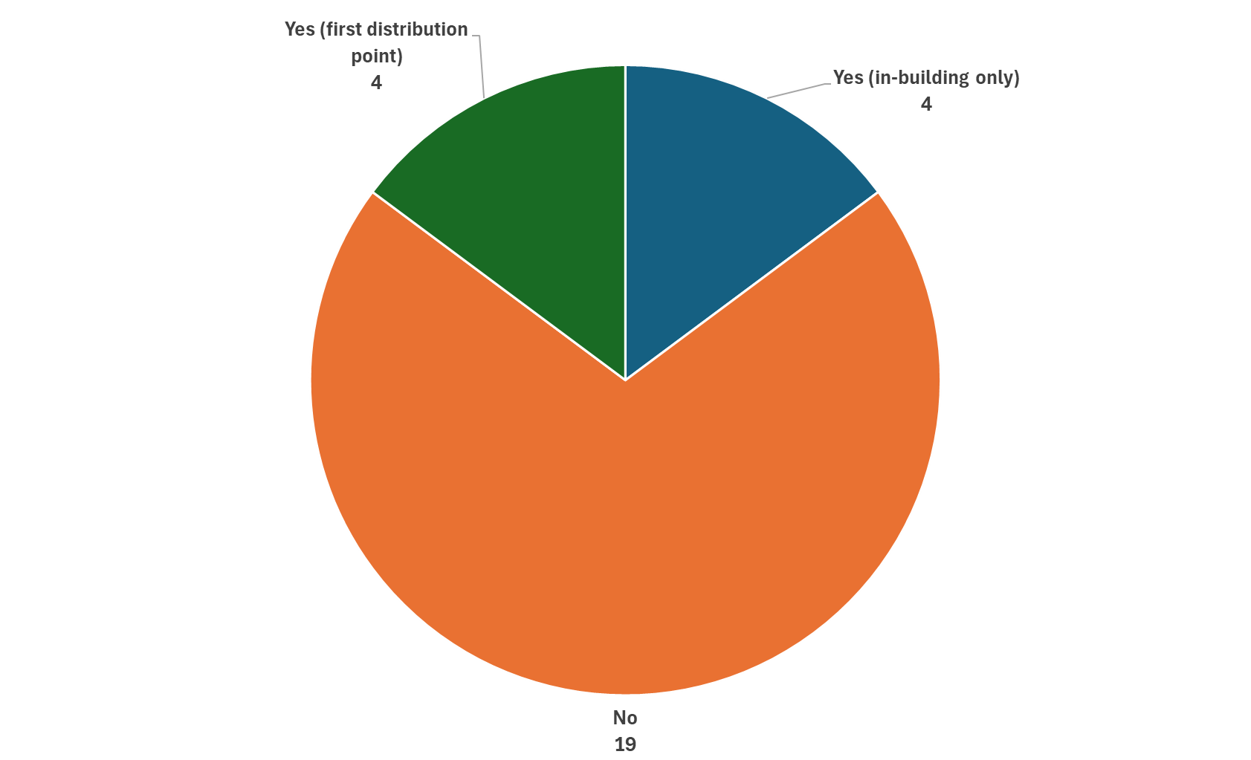
Source: NRA online survey and Godlovitch, I. et al. (2023).
Under Article 122 of the EECC, the Commission shall evaluate in particular the market implications of Article 61(3) and Articles 76, 78 and 79:
Symmetric regulation under Article 61(3) was designed, inter alia, to limit network duplication in areas where it is not viable by identifying a viable connection point for wholesale access and requiring the provision of access by any network operator that deploys in such an area. However symmetric regulation has only been used to limit FTTH duplication in areas where it is not viable in two Member States (France and Croatia). This may be in part because the provisions relating to symmetric regulation are optional (i.e. NRAs are not obliged to impose them but to react to “reasonable request”), whereas the requirement to conduct a market analysis of markets listed in the Relevant Market Recommendation as susceptible to ex ante regulation is, in principle, mandatory.
In addition, art 61(3) seems to place a focus on in-building wiring or access to the first concentration point (which is typically not a viable connection point when chosen by the operator concerned). This requires a high burden of proof for the imposition of passive access at this point for which there is limited elaboration or case law, and sets an even higher burden of proof to mandate access at a point “capable of hosting a sufficient number of end-user connections to be commercially viable for efficient access seekers”, with a further justification required to impose active access. Moreover, it makes only brief mention of the conditions that can be attached to access. This contrasts with the extensive menu of measures and obligations that may be linked to SMP regulation.
The limited use of symmetric regulation under Art 61(3) by other Member States could therefore be due, not only to the high burden of proof, but also to the fact that the weight of attention in the EECC (and the associated number of provisions) was rather towards SMP regulation. SMP regulation, in fact provides an alternative means of mandating wholesale access including to FTTH. Such wholesale access, however is based on the existing market power of an identified operator in a given area, rather than a prospective analysis of the potential (or otherwise) for networks to be viably duplicated in general.
Provisions in the EECC that can be said to have been particularly effective in minimising the overall burden of ex ante regulation are those which highlighted the need to prioritise civil engineering access where possible (Article 72) and to take into account different geographic conditions. The newly introduced option to make use of “commitments” instead of obligations to address SMP concerns (Article 79) has also been successfully used, albeit in a limited number of cases and has been supported by stakeholders interviewed by WIK.
The EECC acknowledged the positive role that can be played by commercial agreements including co-investment by requiring NRAs to consider the impact of such agreements on competitive dynamics, when they consider imposing SMP obligations. However, regarding co-investment under Article 76, there were no cases, in which the NRAs have formally applied this provision.
Therefore, Article 76 EECC did not prove to be an efficient tool to incentivize SMP operators to share investments with (potential) competitors on a voluntary basis. The co-investment provisions in Art 76 EECC appeared complex, limiting their potential application. The provision, if applied, could potentially be counterproductive, as it would risk locking in customers to the SMP operators’ network, thereby reducing the potential customer base that would be needed to support the entry of infrastructure-based competitors. Therefore, Article 76 provisions should either be substantially revised or removed.
No NRA has mandated functional separation under Article 77. However voluntary legal or functional separation has been pursued in at least three countries under Article 78.
As regards the effectiveness and relevance of Article 80, the possibility of lifting regulation does not seem to have been a key driver in either incentivising wholesale-only models or separation by former incumbents . The key driver for the emergence of wholesale only operators seem to have been rather investor expectations and business choices.
Article 80, indeed, offers regulatory relief (no strict price control). However, while NRAs and alternative telecom providers agree that there may be reduced incentives for wholesale-only undertakings to engage in anti-competitive behaviour, such as discrimination (in the absence of preferential agreements with retailers), they highlight that a risk of excessive pricing remains in cases where the wholesale-only operator keeps a SMP position.
Part of stakeholders interviewed by WIK for the access study considered that specific provisions relating to wholesale only companies should be removed, leaving the analysis to be conducted in line with standard market analysis procedures. On the other hand, wholesale only providers argue that the existing provisions should remain but be clarified e.g. to allow the provision of services to business customers or to favour wholesale only companies which offer passive access. Meanwhile, former SMP operators which have engaged in separation consider that the conditions to be considered as wholesale only operators are too strict.
The EECC also requires, under Article 122, the Commission to review whether ex ante and other intervention powers pursuant to the EECC are sufficient to enable NRAs to address possible competition issues in the markets with an oligopolistic structure, and to ensure that competition in electronic communications markets continues to thrive to the benefit of end-users.
No recent cases have been confirmed in which joint SMP was found and access obligations applied in the context of ex ante regulation under the access provisions of the EECC. At the same time the number of draft measures, notified under Article 32 of the EECC, with collective dominance finding was very limited. In 2018 the Commission provided guidance on the interpretation and application of the joint SMP concept in the context of the SMP Guidelines of April 2018. This was followed by a finding of joint SMP by the Dutch NRA ACM later in 2018, which was not vetoed by the Commission under the review procedure for market analyses in force at that time (Article 7(3) Framework Directive). However, despite the Commission’s absence of objection against the finding of joint SMP, the ACM’s decision was subsequently annulled by the Dutch court.
In February 2022 and in March 2023, the European Commission adopted the decisions requiring the Czech telecommunications regulator, CTU, to withdraw its proposed draft measures to regulate wholesale access to mobile networks in Czechia via a finding of joint SMP. A key factor was that other regulatory tools such as the enforcement of already imposed spectrum related obligations had the potential to solve the problems.
In turn, the Maltese regulator attempted to regulate the broadband access market with two local nationwide networks on the basis of single SMP findings and to regulate only one out of two nationwide networks. After a thorough investigation, the Commission found that the Maltese regulator should take into account the role of the second operator with an alternative cable infrastructure and the competitive constraints it imposes. Therefore, the Commission has determined that the draft measure is not compatible with EU law and has issued a veto.
No other proposed cases involving joint SMP or oligopolistic markets have been notified.
Despite of small number of joint dominance cases under the SMP regime, competitive concerns in oligopolistic markets which involve a limited number of (most often two) significant players with similar market positions have been addressed in different ways, not all of which involve the traditional application of access-related measures under the EECC. The SMP Guidelines adopted by the Commission set out the main principles and criteria for determining single SMP and joint SMP.
For example, in the Belgian market they were addressed through distinguishing separate markets for FTTx-based access and cable, while in the Dutch market, following the legal challenge to the NRA’s proposed joint SMP finding, concerns were addressed via commitments, which were entered into following a market investigation under competition law. Meanwhile, proposals to apply SMP regulation in Czechia (mobile market) Malta (fixed broadband access market) to address refusal to supply by the incumbent operator, were withdrawn following a veto decision issued by the Commission. While in general, the EECC’s provisions on the access regulation have contributed to supporting competitive outcomes, one issue of the access-related provisions concerns how to address uncompetitive oligopolies. The test of joint SMP is based on the competition law concept of joint dominance, as further detailed in the case-law of EU Courts starting from the Airtours judgement, which has set a higher level the required burden of proof. There are also different views among stakeholders, as to what extent the ex ante intervention into oligopolistic electronic communications market is needed.
While incumbent operators generally observe that one network is sufficient if wholesale access is provided and that the situation in which at least two players are present does not raise competition issues (and thus that the concept of joint SMP is not relevant), NRAs, consumer representatives, MVNOs and some alternative operators consider that it all depends on the behaviours and incentives of the oligopolistic operators. These stakeholders underline that the lack of cases is due mainly to the high burden of proof for joint SMP established by the case law and the difficulty faced by enforcers to prove a case.
As regards Article 81 regulating copper switch-off, operators with significant market power and subject to network access obligations must notify NRAs when they plan to decommission or replace their copper networks. This ensures that migrations are transparent with a clear timetable and adequate notice periods, do not harm competition or end-user rights and that alternative access products of comparable quality are available. These requirements apply only to migrations of operators with SMP and had only limited practical relevance either because (i) the incumbents had not announced copper switch off plans, (ii) the conditions for copper switch off were set prior the entry into force of the EECC or (iii) copper markets were deregulated. Several Member States (e.g., Belgium, France, Spain, Italy and Portugal) have implemented copper switch-off conditions through their SMP market reviews, while others as Ireland have set a specific framework. More generally, this provision was not aimed and did not contribute in any fashion to accelerate the move from copper to fibre, as it only gave the means to regulators to govern the process for the switch off.
As regards the application of Article 32(10) EECC which allows NRAs, who are in position In exceptional circumstances, where a NRA considers that there is an urgent need to act, in order to safeguard competition and protect the interests of users, by way of derogation from the procedure set out in paragraphs 3 and 4, it may immediately adopt proportionate and provisional measures.
Furthermore, despite overall general effectiveness of the process which allowed the EU markets for electronic communication develop by removing part of high entry barriers and allowed greater tendency towards effective competition, several problems were identified. In particular, the significant time gap between the market review and the imposition of remedies (sometimes reaching three years), and imposition of various remedies, addressing identified competition problems in different manner in different markets and in piecemeal manner, undermines the goal of predictable regulation.

4.3.2. Efficiency
Data gathered from NRAs shows that the direct costs associated with the access regulation processes are relatively limited. As shown in the following table, extrapolations from data provided by NRAs suggest that, while the total Full Time Equivalent (FTEs) employed in NRAs/ Dispute Settlement Bodies (DSBs) was around 9,500, across Europe, only around 725 of these were involved in access-related issues. Likewise, the European Commission employs approx.. 15 FTEs for the tasks related to access regulation procedures. Under the assumption that twice as many resources are deployed in the private sector in relation to access regulation, with a similar per FTE cost of €60,000, total costs would be around €133m.
 | Total FTEs NRA /DSB | FTEs engaged in dispute resolution BCRD/GIA | FTEs engaged in market reviews | FTEs engaged in symmetric regulation | FTEs engaged in geographic survey's | FTEs engaged in dispute resolutions (Art. 26)
Total | 5238 | 59,2 | 185 | 26,5 | 118 | 41,1
Total responses | 15 | 12 | 17 | 9 | 12 | 13
Average number of FTEs per NRA and topic | 349,20 | 4,93 | 10,88 | 2,94 | 9,83 | 3,16
Total number of FTEs in the EU27 per Topic based on average | 9428,40 | 133,20 | 293,82 | 79,50 | 265,50 | 85,36

The following chart shows that 34% of FTEs were involved in market reviews, with an average of 9% involved in symmetric regulation (although this is likely to be skewed by figures in France and Croatia, which rely on these measures extensively). Meanwhile, a relatively high proportion (31%) were engaged in geographic surveys and a further 10% in dispute resolution.
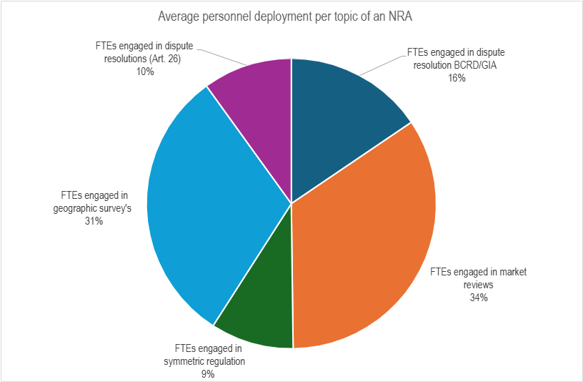

4.3.3. Coherence
The access-related provisions of the EECC are largely internally coherent, as they build upon a long tradition of economic regulation in the telecom sector based on findings of “significant market power”, while offering the possibility (pursued in only a small number of countries such as France and Croatia) to follow an approach based on symmetric regulation as an alternative to achieve the public policy objective of fostering the deployment of VHCN.
Some internal inconsistencies have become apparent in relation to provisions that were newly introduced in the EECC. In particular:
- The attempted application of Article 76 (co-investment) in the Italian market revealed that there can be tensions between this provision and the objective in Art 3 EECC that NRAs should promote efficient infrastructure-based competition. Specifically, in cases where co-investment relies on long-term commitments involving a high share of access lines, this could limit the potential for an alternative VHCN infrastructure to secure sufficient take-up and remain economically viable. This issue was considered by the Italian competition authority AGCM ((Autorità Garante della Concorrenza e del Mercato) as well as the NRA during their review of the proposed co-investment.
- The provision that civil engineering access can be mandated as a remedy even where not referenced in the market definition (Art 72) is only practicable in cases where SMP duct and pole access does not provide a core foundation for downstream competition. Where it does play a significant role, it has proved necessary to identify a separate and distinct market for PIA in order to allow the effects of this remedy on downstream competition to be considered in the market analysis and reflected e.g. through geographic segmentation.
- Provisions on wholesale only require operators to not have retail operations in retail markets for electronic communication services provided “to end-users in the Union”. However, for the purposes of a market analysis, only the provision of retail services in the geographic market concerned is relevant. Some stakeholders also question whether the provision in Art 80 limiting the application of regulatory obligations including price control on wholesale only companies is objectively justified and coherent with wider provisions in the EECC, noting that wholesale only companies may still have the ability and incentive to raise prices above the competitive level, if they enjoy a position of significant market power.
- Provisions regarding commitments have proven to be difficult to apply for SMP operators engaging in structural separation as the company engaging in separation cannot enter into commitments on behalf of a future separated entity. This may have limited their usefulness in providing assurances regarding the regulatory implications of separation for the companies concerned.
As regards external coherence, access regulation is based on the principles of EU competition law. Markets which are no longer subject to ex ante access regulation (based on a competition policy-based test), continue to remain subject to competition law. It is therefore coherent.
In the same vein, as regards external coherence with other legislative and soft law instruments, the provisions of the EECC overlap to a certain extent (but are not inconsistent with) provisions of the GIA. Areas of overlap include:
- Provisions on rights of access to public infrastructure under Art 3 GIA (including rooftops, street furniture). The GIA provisions overlap and extend beyond provisions specifically relating to Small Area Wireless Access Points (SAWAP) under Art 57 EECC.
- Provisions on the processes to obtain Rights of Way and permits under Art 7-9 along with rights for access to public buildings and associated dispute resolution under the GIA could overlap and go beyond provisions regarding RoW in the EECC, in particular by introducing shorter timeframes and stipulating specific procedures for applications and dispute resolution around the terms of access.
Other aspects of the GIA have synergies with the EECC and do not conflict to any significant degree. These include:
- Provisions on access to ducts and poles under Art 3 GIA. These complement the potential (indeed encouragement in the context of the market review process) to mandate SMP PIA under the EECC by adding the potential for access to other physical infrastructure and may be considered as subsidiary to such provisions. The requirement in the context of Art 3 GIA to take into account the impact on the business case when establishing prices for access to PIA further highlights the fact that these provisions do not substitute for SMP PIA, as they seek to reduce costs for and extend VHCN roll-out (and include measures which reduce the attractiveness of PIA and serve to limit VHCN duplication in this context), whereas SMP PIA obligations are focused on promoting, where possible, infrastructure competition by fostering the sharing of (largely historic) physical infrastructure deployed by SMP operators.
- Provisions to establish standards and obligations to deploy in-building infrastructure and fibre wiring (Art 8 GIA) complement obligations under art 61(3) EECC for owners of such infrastructure to provide access to in-building wiring. One point where there may be a lack of coherence however is that whereas Art 8 GIA refers to in-building fibre wiring specifically, Art 61(3) goes beyond these provisions to grant access to wiring that could go beyond the in-building wiring and extend to the first concentration or distribution point. The focus on ensuring fibre wiring in-building in the GIA may also signal a need to review the case for excluding in-building wiring or other wireless connectivity from the definition of VHCN.
- Provisions to grant access to in-building infrastructure under Art 9 GIA are understood to refer to in-building ducts and chambers and as such do not overlap but rather complement provisions in Art 61(3) that refer to access to wiring.
- Provisions in the GIA that refer to the development of Single Information Points (SIP) for existing physical infrastructure (Art 4 GIA) and planned civil works (Art 6 GIA), complement provisions in the EECC (Art 22) regarding geographic surveys. Specifically, whereas the GIA focuses on the location of physical infrastructure suitable for the deployment of VHCN, such as ducts, poles, towers and public buildings, Art 22 EECC focuses on networks deployed (existing and forecast) and can also be used to track the technologies used and associated quality as well as the number of networks deployed in specific locations.
The EECC has adopted the Digital Decade Policy Programme (DDPP). As such, it does not make reference to the specific objectives included in the DDPP such as the target that all end-users at a fixed location should be covered by a gigabit network up to the network termination point. The reference to “Very High Capacity Networks” in the EECC could be interpreted consistently with that target, as it is defined in the EECC to mean “an electronic communications network which consists wholly of optical fibre elements at least up to the distribution point at the serving location” or a network which offers equivalent capabilities.
Certain provisions in the EECC are however not consistent with the coverage targets in DDPP and therefore could be viewed as not internally coherent. Specifically, Art 22 regarding geographic surveys permits NRAs to designate areas where no undertaking or public authority has deployed or is planning to deploy “a very high capacity network or significantly upgrade or extend its network to a performance of at least 100 Mbps download speeds”. On the basis of this information, NRAs may invite undertaking to declare an intention to deploy VHCN or extend network performance to 100Mbit/s. As quality of service and bandwidths achievable over fibre networks improves, the reference to 100Mbit/s may become increasingly divorced from Europe’s aspirations regarding VHCN. Such a bandwidth may also over time depart from approaches taken to State Aid, which is likely to provide a vital contribution in closing the gap to achieving the DDPP targets. In this context, it should be noted that the 2023 Broadband Guidelines refer to Gigabit-capable networks.

4.3.4. Relevance
The consultation process under Article 32 EECC plays a key role in developing and implementing consistent market-based regulatory guidance to be applied by NRAs. The role of the publicly available Commission’s letters is not only to provide the assessment of individual cases but to promote consistent regulatory approach in the EU.
The Commission’s assessments in phase I can have a form of a “no comments” or “comments” letters. In case the notified draft measure may not be compatible with EU law, the Commission adopts and publishes its “serious doubts letter” which is the basis for a further in-depth investigation in phase II and is also a basis for stakeholders to submit their comments. Finally, the Commission can adopt a decision requiring an NRAs to withdraw its draft regulatory measure (veto decision) with respect to the market definition, the analysis of the three criteria test and SMP assessment. The Commission can also adopt a recommendation under Article 33 EECC which may affect the proposed remedies at the end of phase II assessment. The legal consequence of a veto decision is that the NRA must withdraw its notify draft regulatory measure and cannot adopt it. In case of a recommendation, the NRAs must provide reasons as to why they decide not to amend or withdraw their draft measures.
Despite the very short deadline (one month without any possibility of prolongation) for the assessment of legally and economically complex files, the Commission has responded to all the notified draft measures. The short EU consultation process does not, therefore, cause delays in the preparation and adoption of regulatory measures. In turn, it is instrumental in ensuring consistency in implementing ex ante regulation across the EU.
In the vast majority of the cases, the Commission closed its assessment after one month by adopting a ‘no comments’ or ‘comment’ letter. Only a small fraction of cases required in-depth investigation during the Phase 2 investigation.
The number of cases, assessed after the adoption of the EECC i.e. after 1 January 2019, broken down by the outcome of the analysis are shown in the chart below:

Even if NRAs have increasingly defined markets subject to regulation as regional or local the access-related provisions remain relevant for the future. However, some streamlining could be considered (in particular in relation to some of the newly introduced measures i.e. access to civil engineering infrastructure (Article 72), regulatory commitments (Article 79) and wholesale-only (Article 80). Other measures, such as Article 76 (co-investment), Articles 77 and 78 (mandated and voluntary separation) that, as detailed in the previous sections, have proven to be of limited application and therefore relevance, could be removed in an effort of simplification.
More generally, while measures are well adapted to addressing instances of significant market power including local monopolies, which may become more widespread in a post-copper world, the EECC asked also the Commission to carry out a review of the legal framework to assess its ability to address concerns related to oligopolies. As detailed in the previous sections, the number of cases regarding the oligopolistic markets, notified under Article 32 EECC was insignificant. The oligopolistic markets have, so far been addressed either under the spectrum authorisation regime or under competition law. Furthermore, the SMP Guidelines, adopted in 2018, specifically focus on the joint SMP findings.

4.3.5. EU added value
Under the EECC, the imposition of ex ante regulatory obligations on undertakings that have SMP on a specific market can be justified if proven that (i) these markets are characterised by high barriers to entry and (ii) do not tend towards effective competition, and that (iii) competition law instruments are insufficient to tackle the identified competition problems (this is the so-called the three criteria test).
EU consultations regarding draft regulatory decisions which aim at imposing ex-ante regulation, based on the SMP finding play a central role in the process. The draft regulatory measures must be always notified to the Commission, BEREC and other NRAs. The Commission has a power to require NRAs to withdraw their draft measures if the market definition and/or SMP assessment creates a barrier in the internal market or if there is lack of compatibility with Union law. Furthermore, the Commission can adopt recommendations with regard to the proposed remedies. Consistency of regulatory approaches taken by NRAs is of fundamental importance to avoiding distortions of the single market and to creating legal certainty for all investing undertakings. For this the Commission’s publicly available assessments of the notified draft measures (including the so called comment letters or no comments letters) play a key role in guiding the NRAs’ regulatory practices. EU consultations regarding draft regulatory decisions which aim at imposing ex ante regulation plays a central role in the process.
As indicated in the graph below, the number of notified cases is lower after 2019, in particular due to the removal of the markets for wholesale termination on fixed and mobile networks from the list of recommended markets (Article 76 EECC removed the risk of charging excessive prices by operators terminating the calls). However as of 2020 the number of cases notified annually was fairly stable. Despite slightly lower intensity of notifications in comparison with 2019, the complexity of the assessed cases increased. Indeed, the regulators and the Commission need to assess the markets for a more regional perspective with competitive and non-competitive areas. Moreover, regulatory obligations, in some cases are different to reflect variations of competitive conditions in the geographic areas.
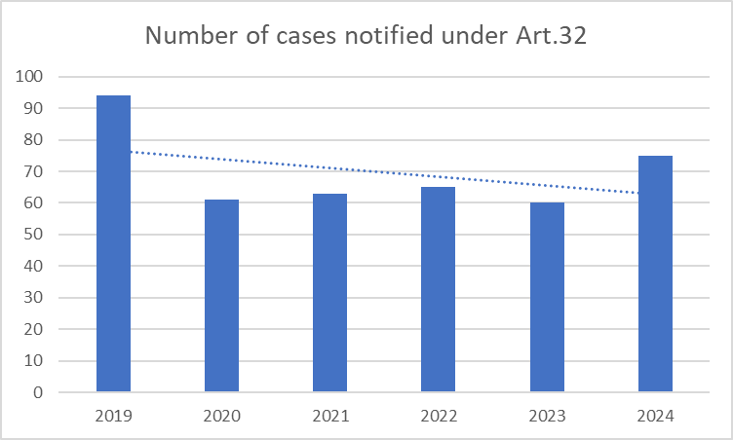
There is a presumption that for the markets listed in the Recommendation on relevant markets, the three criteria test is met across the Union. However, an NRA may consider it appropriate, based on specific national circumstances, to conduct its own three criteria test on the wholesale markets in this Recommendation and notify its findings according to the consultation procedure set out in Article 32 of the EECC.
At the same time, NRAs should always carry out the three criteria test when they intend to regulate a market which is not listed in the Recommendation but which, in the light of specific national circumstances and having conducted an analysis of competition at retail level, could be susceptible to ex ante regulation.
An undertaking is deemed to have SMP, if, either individually or jointly with others, it enjoys a position equivalent to dominance, i.e. a position of economic strength, which gives it the power to behave to an appreciable extent independently of competitors, customers and ultimately consumers.
The NRAs should then impose obligations on SMP operators which are proportionate, justified and based on the nature of the problem identified, also with a view to achieving the objectives set out in Article 3 of the EECC. When assessing the proportionality of the obligations and conditions to be imposed, as when carrying out their market analysis, NRAs should take into account the different competitive conditions existing in the different areas within Member States.
Consistency of regulatory approaches taken by NRAs is of fundamental importance to avoiding distortions of the single market and to creating legal certainty for all investing undertakings.
The access-based provisions have, therefore, added considerable value compared with Member States acting alone. Specifically, pursuing a common ruleset based (in the vast majority of cases on SMP), has meant that common and well-understood principles could be applied across Europe, while ensuring that the regime was sufficiently flexible to address very different underlying market situations at national and local level. The use of common principles for access regulation has also enabled the progressive deregulation of telecom markets in areas where competition can be sustained in the absence of regulation.

Spectrum

5.1. Strategic Dimension of spectrum
Radio spectrum is of outmost strategic and geopolitical importance; it is essential to enable communication, drive economic growth and social prosperity, and support security and provision of mission critical services across various sectors. Spectrum has become a pre-requisite for EU’s strategic autonomy and security, hence the need for its effective management and strategic and efficient utilisation.
The EECC and the previous framework were developed at a different geopolitical context and hence its strategic dimension had not been addressed. As a basic commodity, like electricity, it can also become a vulnerability. Spectrum supports vital services like critical communication, emergency communications, air traffic control, maritime navigation, and public security and safety networks. Today spectrum is weaponised in the context of armed and economic conflicts. It is not only used for operating drones and radars, but also for jamming and spoofing signals and disturbing key military and civil activities (from transport to banking).
The basic legal acts of the EU framework on spectrum management consists of the Radio Spectrum Decision, the EECC and the Radio Spectrum Policy Programme.
The Radio Spectrum Decision created an EU legal framework in order to ensure the coordination of policy approaches and harmonised conditions with regard to the availability and efficient use of the radio spectrum necessary for the establishment and functioning of the internal market in all EU policy areas not only for electronic communications but also for policies such as transport and research and development (R&D). It will not be incorporated in the DNA, as its scope is wider than the DNA since it covers all spectrum usages including uses not related to electronic communications and as it creates a technical harmonisation process for spectrum that is specifically addressed to the Member States.

5.2. Spectrum provisions in the EECC
The EECC defines a harmonised framework of objectives and principles for the strategic planning and coordination of the effective management and efficient allocation, assignment and effective use of radio spectrum for electronic communications. Spectrum policy is a shared competence between the Union and the Member States, therefore the EECC defines elements that competent authorities should consider while authorising radio spectrum at national level, both through general authorisation and individual rights of use. It also defines rules for strategic planning and coordination of spectrum use between Member States and means to address harmful interferences.
Several novelties were introduced by the EECC in the spectrum regulatory framework to strengthen its single market dimension. It created an integrated process of cross-border radio spectrum coordination between Member States. It introduced longer duration of spectrum usage rights for wireless broadband services to increase predictability and formalised the possibility to renew existing spectrum usage rights. It also formalised a peer review process to promote peer learning and convergence of the authorisation of spectrum usage rights. It set a coordinated timing of assignment for spectrum that was technically harmonised under the Radio Spectrum Decision. Moreover, the EECC developed a basis for timely 5G deployment and network densification, by setting specific deadlines for the assignment of the 5G pioneer bands, facilitating access to radio local area networks and defining common criteria for the deployment and operation of small-area wireless access points
However, the effect of the improvements introduced by the EECC in 2018 has not been sufficient to fully exploit the potential of the single market in supporting effective and efficient spectrum policy and in ensuring EU leadership in mobile connectivity and advanced 5G deployment for citizens and businesses. Because of its voluntary nature, the peer review failed to align authorisation processes and conditions. Member States also chose different approaches in the case of duration of spectrum usage rights and conditions to renew them. All that failed in fostering regulatory predictability and investment capacity. Despite the binding deadlines imposed by law, delays in the assignment of 5G pioneer and other bands, due to exogenous (e.g. interference) but also endogenous reasons (e.g. delays or litigation) have also considerably slowed down deployment. The EECC has also not been fully effective in addressing harmful interferences between Member States and from third countries, due to limitations in the legal basis, therefore limiting the use of spectrum. Regulatory uncertainty further affected the limited attractiveness of the mobile sector for financial investors due to low profitability and significant investment required for acquiring spectrum and densifying networks.

5.3. Radio Spectrum Policy Programme
The Radio Spectrum Policy Programme (RSPP) dates to 2012 and sets out policy orientations and objectives for strategic spectrum planning and harmonisation, and actions for swift implementation of policy objectives. It applies to a broad range of EU policies that involve spectrum use such as electronic communications, research, technological development and space, transport, energy and audiovisual policies. While some RSPP general objectives are still valid and, based on RSPG opinion and related public consultation, stakeholders see the RSPP merits as a strategic measure setting orientations, the EU policy, regulatory and technology context has changed considerably. Many RSPP actions were designed to support EU political priorities that are now either completed or outdated. Moreover, certain provisions have already been integrated in the EECC, as for example Article 5 on competition into Article 52 EECC and Article 10(2) on cross-border coordination with third countries into Article 28 EECC.
Based on previous evaluation Reports, studies and stakeholder inputs (above mentioned RSPG opinion and related public consultation), we identified which actions included in the RSPP could be considered as completed and which provisions have become obsolete (including due to the substantive revision of spectrum rules brought about by the EECC). The analysis identified on the one hand which objectives and general principles of the RSPP remain relevant in the context of strategic policy needs and support of broader EU policy objectives, taking into account the current and future needs of key stakeholders. On the other hand, it specified which provisions have been taken over and further developed in the policy options of the Digital Network Act Impact Assessment (see Annex II for more details).
Objectives and general principles which remain relevant include:
- Authorisation principles to maximise flexibility and efficiency in spectrum use,
- fostering development of the internal market by promoting the emergence of future Union-wide digital services,
- fostering the collective use of spectrum as well as shared use of spectrum within the limits imposed by competition law rules, assessing the justification and feasibility of extending the allocations of unlicensed spectrum,
- co-operation between Member States and the European Commission to allocate sufficient spectrum for wireless services, including in the unlicensed bands, as part of an evolving roadmap,
- promoting competition, innovation and investment,
- the need to avoid harmful interference,
- promoting technology and service neutrality in the rights of use of spectrum
- promoting spectrum harmonisation,
- upgrading networks to the most efficient technology in order to ensure that all citizens have access to advanced digital services including broadband in remote and sparsely populated areas,
- exploring the availability of sufficient spectrum for the provision of broadband satellite services enabling internet access,
- allocating sufficient and appropriate spectrum in a timely manner to support Union policy objectives and satisfying the increased wireless data traffic as part of an evolving spectrum roadmap,
- encouraging efficient management and use of spectrum, ensuring sufficient spectrum, harmonised where necessary, for specified uses including wireless broadband, provision of innovative audiovisual services like earth monitoring services and transport systems, safety of life services, Scientific services, PMSE, IoT services.
The RSPP also refers to certain aspects of international governance of spectrum that are still relevant such as the role of the Union in international negotiations relating to spectrum matters, such as for instance the recurrent World Radio Communications Conferences of the International Telecommunications Union and the role of the Union in assisting Member States with legal, political and technical support to resolve spectrum coordination issues with neighbouring third countries.
Annex II also identifies a set of key challenges moving forward, such as for example allocating sufficient and appropriate spectrum in a timely manner the need for greater focus on spectrum sharing and flexible licensing solutions, the need to support development of satellite communications. These challenges are further elaborated in the sections below evaluating the EU spectrum policy effectiveness, in particular in the sections on delays in 5G bands assignments, on effectiveness of spectrum sharing, transfer and leasing and on supporting satellite EU-wide connectivity.

5.4. Effectiveness in promoting connectivity
Effectiveness is assessed with regard to promoting advanced 5G connectivity and ensuring investments and benefits for citizens.

5.4.1. 5G Connectivity achievements
While the deadlines for the assignment of 5G pioneer bands’ and the RSPG’s 5G Roadmap, sent a clear regulatory signal and helped define a common EU vision, they have not been successful in ensuring a coordinated timing of the 5G pioneer bands’ assignment and promoting mobile and wireless connectivity by all citizens and business in the Union (Art. 3 EECC connectivity objective).While the single market delivered on basic 5G coverage and low mobile prices for consumers, that are generally significantly lower than in the US, both prices and basic coverage differ considerably between Member States due to inherently different market and regulatory landscapes. Average 5G household coverage by at least one basic 5G network across the EU reached 94.3% by the end of 2024, behind South Korea (100%), Japan (99.2%), Norway and Iceland (99%), and the United States (97%), although with only 79.6% of households in rural areas being covered by 5G.
Figure 3: Total 5G households coverage- 5G Observatory Report 2025 | Shaping Europe’s digital future
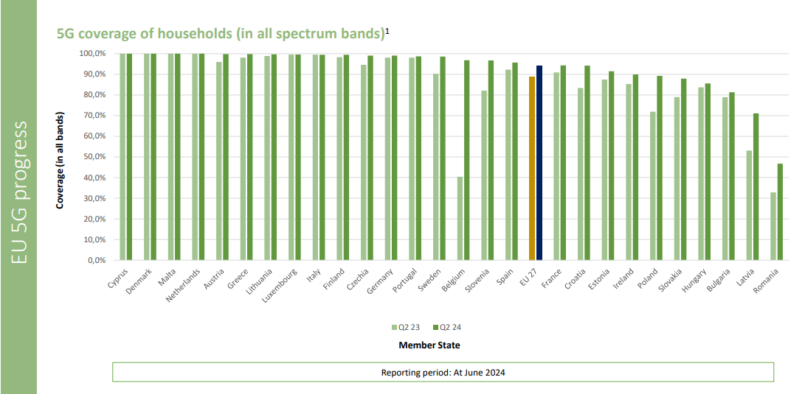
5G deployment has not been even across the EU, in particular coverage with the 3.6 GHz band and deployment of 5G standalone (SA) networks. The EU average household coverage with the 3.6 GHz band was at around 67%, with 90% in Netherlands, Italy, Slovenia and Finland while it stood below 45% in Croatia, Czechia, Malta, Cyprus and Romania . Moreover, only 26% of households in rural areas in the EU were covered by 5G using mid-band spectrum in 2024. 5G SA requires substantially higher investments and is essential for industrial use relying on very-high reliability, security, low latency and higher throughput, and is a prerequisite to 6G deployment. High-capacity networks, based on 5G SA, require high-band spectrum characterised by limited coverage and need for network densification. Article 57 EECC and the adoption of a Commission Regulation on a light deployment regime for small cells aimed to boost high-capacity network deployment (5G and beyond). However, application of this regime remains limited and has not delivered any significant take-up compared with the US and Asia, as confirmed in surveys conducted by the Small Cell Forum (SCF).
Figure 4: 5G coverage of households in the 3.6 GHz band - 5G Observatory Report 2025 | Shaping Europe’s digital future
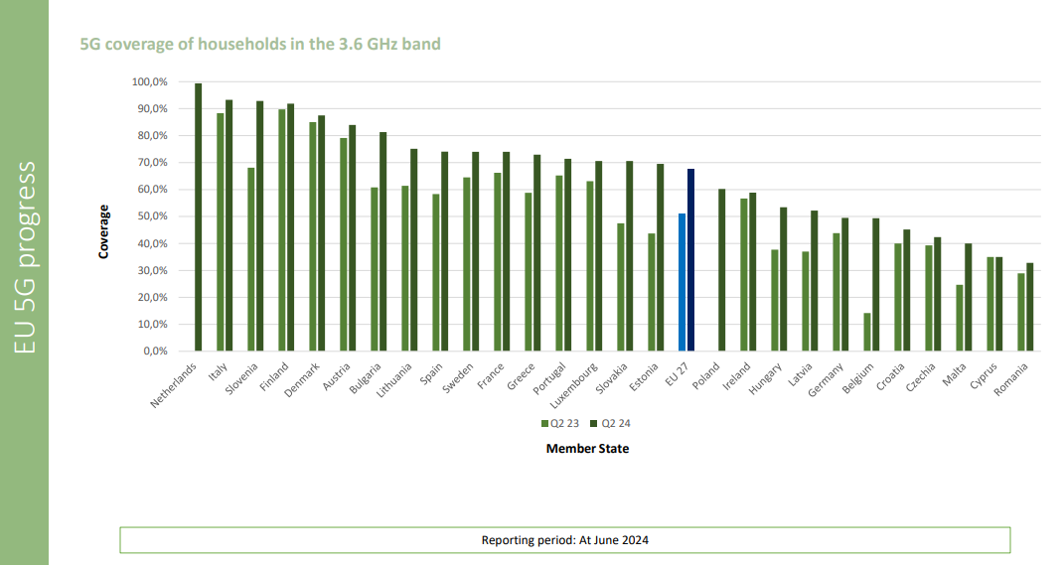
Ericsson data see Figure 5 on mid-band coverage that follow a different methodology and allow for an international comparison alarmingly confirm that Europe is lagging in mid-band coverage with 50% compared to 95% in India and China and 90% in the US.
Figure 5: World population and mid-band coverage split per region (end of 2024)
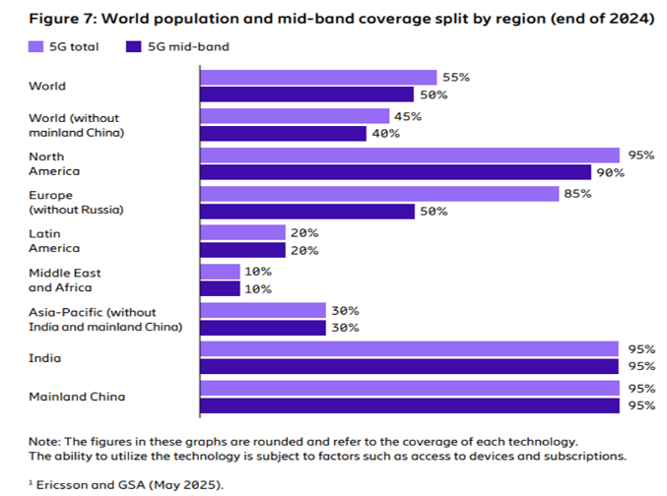
Data from Connect Europe on 5G SA also confirm this finding: the EU lags considerably behind other major regions, marking the weakest performance in this advanced technology. The very low availability of 5G SA in the EU (2%) compared to other global economies, China (80%), India (52%), and the USA (24%), is confirmed by Ookla’s Speedtest® sample share.
The EC study also confirms the limited use of mid-band spectrum in Europe, despite the widespread availability of this spectrum in most Member States as of 2022.
Article 57 EECC and the adoption of a Commission Regulation on a light deployment regime for small cells aimed to boost high-capacity network deployment (5G and beyond). However, application of this regime remains limited and has not delivered any significant take-up compared with the US and Asia, as confirmed in surveys conducted by the Small Cell Forum (SCF)..
Use of mid-band and high band spectrum requires network densification. Operators indicate that they are hesitant to invest heavily in small cells given that, despite their potential to boost network capacity in dense urban areas, small cells face significant economic hurdles (high cost of equipment compared to small coverage area, complexity of deployment, permits) and they consider that until the regulatory framework and deployment economics improve, small cells might remain a secondary option.
Analysys Mason data also confirms low 5G standalone coverage in Europe, with values at around 40% compared to 90% in North America and 45% in Asia Pacific.
Figure 6: 5G SA coverage, by region, 3Q 2024, Source Analysys Mason, 2024
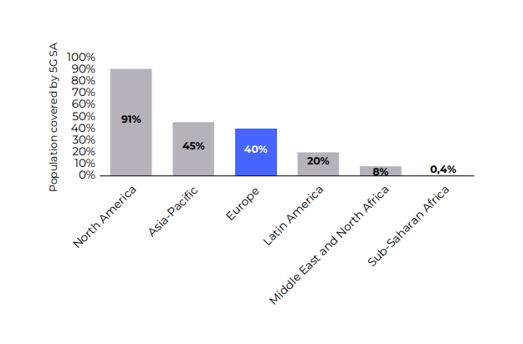
According to an EC study, the lack of 5G SA-based connectivity, especially in mid-band frequencies enabling the use of bandwidth intensive services on mobile devices is the main cause for the lower take-up of innovative fully-fledged 5G services together with lack of availability of unlimited data packages as well as high prices in some countries, together with financial (profitability) challenges in particular for smaller operators, which impede their capacity to invest. These problems and the underlying drivers are further elaborated below. Moreover, a lack of demand or perceived willingness of consumers to pay for 5G and of enhanced mobile connectivity in general has also played a significant role.
Moreover, it appears that in Q4 2024, users in major EU cities still connected to 4G for 25% of the time on average, some cities lagged in 5G mid-band deployments and some 5G networks failed to deliver promised speed and advantages. See in Appendix II B MedUX - 5G QoE Benchmark in Europe: Drive Testing Report published at MWC25 (Q42024 data).
From the consumer and business end-user perspectives, MedUX QoE data confirm the trend of EU lagging behind on high quality 5G (mid-band and standalone). While overall across EU states, 5G availability (any type of 5G) stood at 46.6% based on end user experience (5G devices only), deployments that rely specifically on the mid-band 3.4-3.8 GHz have now reached approximately 57.2% of this 46.6%, whereas 5G SA availability represents less than 2.5% (2.1%). See in Appendix II B MedUX – Status of 5G Quality and Experience in Europe, Report prepared for the EC (Q12025 data).
MedUX QoE data show that, despite wide 5G coverage on paper, users in many EU countries still rely predominantly on 4G. Across the EU27, average 5G usage (any type) stands at 46.6% among 5G-ready devices, meaning more than half of their traffic still flows over 4G or earlier technologies. This lags behind the US (74%), Thailand (57%), Switzerland (56%) and Norway (53%). Of the overall 5G deployments (when users are connected to 5G), usage of the mid-band 3.4–3.8 GHz has reached approximately 57.2% in the EU27, compared to 67.6% at the international level. However, on average across all technologies, end-users in the EU are connected to the mid-band only around 27.1% of the time. The deployment of 5G SA in Europe remains very limited. In the EU27, less than 2.5% of 5G connections are on SA, and when considering all access technologies, SA accounts for only 1.2% of usage. This reflects the fact that most European operators still operate in the 5G Non-Standalone (NSA) phase. By contrast, internationally, the situation is more advanced: 48.3% of 5G connections are already SA (vs 2.1% in EU27), and SA represents 20.5% of all access technologies. Certain markets are leading the global transition: India records 25% SA usage and the US 18%, positioning them far ahead of the EU average (1.2%), (considering all access technologies).
Average download speed performances in the fastest markets are led by South Korea (162.2 Mbps), followed by Norway (133.3 Mbps), the US (129.3 Mbps), and China (100 Mbps). In most markets, speeds exceed 85 Mbps. By contrast, the EU27 lags behind with an average of 69.9 Mbps - about 2.3 times slower than South Korea and slightly below the global average (70.4 Mbps). The UK and some Asian countries, such as India and Thailand, record even lower figures, with download speeds at or just below 50 Mbps.
Figure 7: International comparison of average download speed
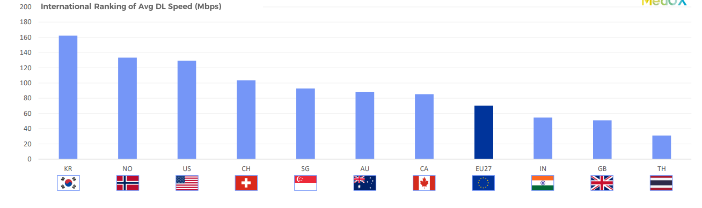

The RSPG analysis confirms this trend and recalls that the adoption of 5G SA is occurring slowly and unevenly among European MNOs and that European operators had been relatively hesitant in making the transformation to 5G SA compared to the US and Asia.
Despite EECC measures meant to ensure timely 5G deployment (cf. following section), delays in assignment of 5G pioneer bands, lack of demand, non-timely transposition of the EECC, slow national administrative processes and unresolved cross-border interference, together with low investment capacity have negatively affected the deployment and achievement of advanced 5G connectivity across the EU. Additionally, lack of market demand, particularly for the 26 GHz frequency band, further contributed to fragmented assignments.
Despite the launch of 5G in 2020, the uneven pace and quality of deployment, including low 5G SA core usage, show that the situation in the EU is highly fragmented and the EU is lagging behind other major economies. Hence, the EU intervention did not achieve the desired level of effectiveness within the envisaged timelines, negatively affecting overall 5G deployment.
The lack of investment in ”full 5G” (including 5G SA using mid and high band spectrum) limits the quality of overall mobile services in EU, as well as the availability of quality-assured services that require high bandwidths and/or low latency, therefore affecting business innovation potential. Capex trends reported by Analysys Mason show that capex in 5G mobile plateaued at 20% of total European telecom capex in 2023, with capex in FTTH networks more than double this value.
The Sections below will evaluate the likely causes of limited deployment of 5G SA, like delays in 5G pioneer band assignments, auction design and conditions (licence duration, coverage requirements, spectrum cost, market shaping measures) and availability of spectrum for industry/verticals.

5.4.2. Delays in 5G pioneer band assignment
The EECC aimed to ensure timely spectrum assignment to enable swift 5G roll-out by imposing coordinated timing of assignment for the use of two of the three pioneer spectrum bands for 5G (3.6 GHz frequency band and at least 1 GHz in the 26 GHz frequency band upon market demand, see Article 54) by 31 December 2020. For the third 5G pioneer band (700 MHz), the UHF Decision 2017/899/EU had set the deadline for the assignment by 30 June 2020. The EECC also set a general obligation to assign spectrum at the latest 30 months after the adoption of a harmonisation Decision (Article 53).
Although such legal deadlines could have had some accelerating effect on assignments of 5G pioneer bands, Member States finally accumulated significant delays in the assignment of all three 5G pioneer bands, and a large number (about half) of Member States has not met the overall deadline of 31 December 2020. The process for authorising 5G pioneer spectrum across the EU has been very long, spanning over 10 years and in 2025, and is still not yet completed (5 years after the overall deadline). The chart below underscores the fragmentation in spectrum policy implementation and rollout timelines across the EU for the three pioneer 5G bands between 2015 and 2025. The 700 MHz and 3.3–3.8 GHz frequency bands are more widely awarded contrarily to the 26 GHz frequency band reflecting the latter’s more limited uptake to date.
Figure 8: Timeline of pioneer band awards by EU Member State (2015-2025)
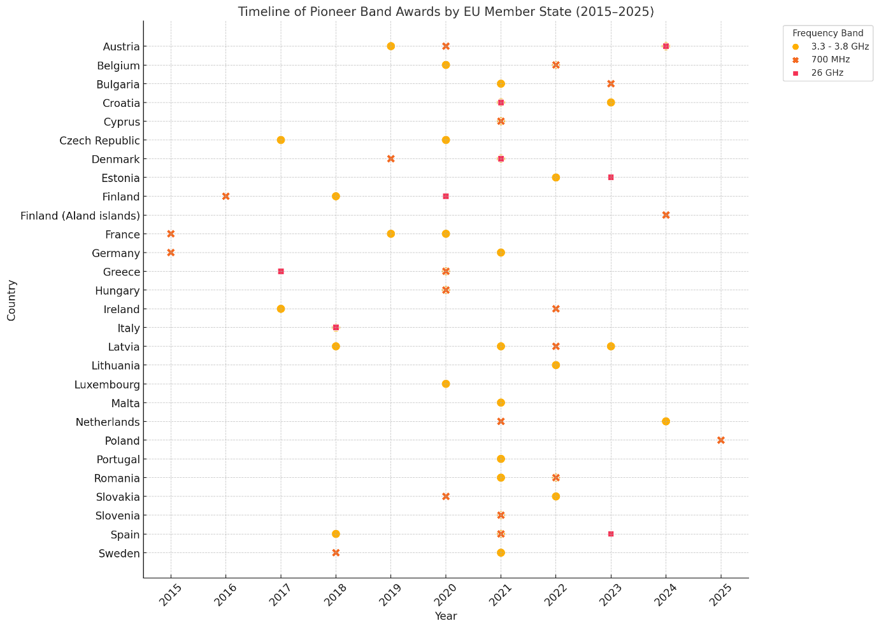
Source: Policy Tracker (2025)
In particular, most national auctions for the 3.6 GHz frequency band (3.4-3.8 GHz) took place in a relatively long-time span, between 2017 and 2024, starting with early assignments in the Czech Republic and Ireland in 2017, complemented with additional assignment in 2018-2020 leading to overall 17 Member States (two of them only provisionally) respecting the 2020 legal deadline and ending with the most recent in the Netherlands in 2024. As for the 700 MHz frequency band, six Member States awarded it before the 30 June 2020 deadline, and another seven followed in the second half of 2020. Poland was the last Member State to complete the assignment process during 2025. The band has been assigned in all Member States except Malta where there is no market demand. As for the 26 GHz frequency band (24.25–27.5 GHz), by early 2025, only 12 Member States have assigned the band, while the remaining 17 consider that there is no market demand. Overall, the assignment of EU pioneer spectrum bands was at 75% on EU average in February 2025, mainly because of the 26 GHz frequency band. However, the 26 GHz band, remains pivotal for advancing innovative private networks and fostering overall technological innovation.
The delays in assignment were largely due to non-timely transposition of the EECC, slow national administrative process of spectrum assignment (partially due to the Covid-19 crisis), delays in freeing the bands from previous uses and, in certain cases, unresolved cross-border interference with non-EU countries or lack of market demand (in particular for the 26 GHz frequency band).
According to an EC study, there is a strong correlation between time of 5G spectrum assignment and 5G deployment and 5G population coverage. Member States that assigned spectrum earlier have generally seen faster and broader 5G deployments and achieved high 5G population coverage faster than the late movers. Figure 9 shows strong negative correlation between the time taken to award 5G pioneer bands and 5G population coverage: almost 20% of the variation in 5G population coverage in the EU can be explained by the delay in awarding the three 5G pioneer bands.
Figure 9: 5G population coverage vs. years to awards, Source: Study on assessing the efficiency of radio spectrum award
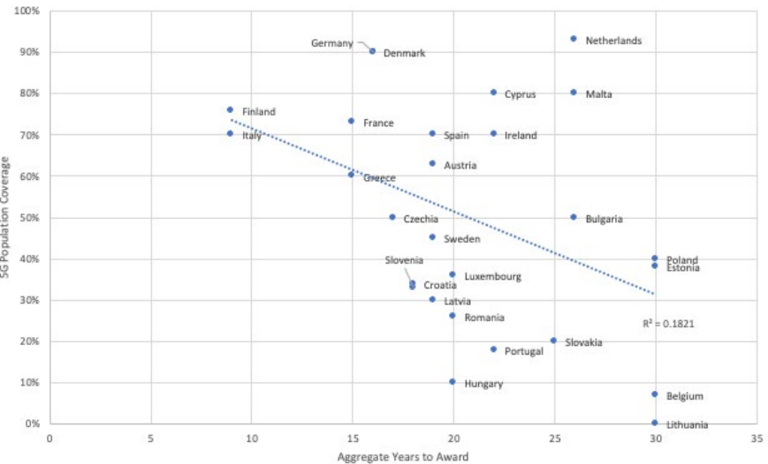
While the 30 months authorisation deadline set by the EECC (Article 53) has been generally respected (e.g. with the revamped harmonisation of the 900 MHz and 1800 MHz frequency bands in 2022), it may, as a side effect, impose a constraint in the EU harmonisation process in cases of questionable market demand burdening the authorisation process, thus calling for more legal flexibility in the formulation of certain deadlines. This became evident during the harmonisation of the 42 GHz frequency band where many Member States expressed concerns that the application of the 30 months authorisation deadline would impose considerable administrative burden in the persistent absence of market demand.

5.4.3. Spectrum for industry: verticals and private networks
The EECC does not contain measures facilitating development of private networks or harmonising conditions for local networks. However, EECC rules are flexible enough to allow for local 5G spectrum awards. Local networks are used primarily by verticals (e.g. transport, energy, manufacturing, mining, seaports) that have special needs as regards security, resilience, low latency and high-performance wireless connectivity. In general, spectrum for private mobile networks is made available on a licence-exempt basis where possible, or on a licensed basis through local assignments for private network use or can be leased from existing operators who hold exclusive usage rights.
Spectrum for local use has been made available in at least 13 Member States, yet in a fragmented way, i.e. in different frequency bands such as 2.3 GHz, 2.6 GHz, 3.6 GHz or 26 GHz and under different procedures (auction, most commonly on a first-come first-served basis) and conditions (price, duration of rights, between 5 and 20 years). Spectrum for intelligent transport systems (connected and automated mobility) in the 5.9 GHz frequency band has not been taken up also due to lack of consensus in the industry on the preferred technology to be used (cellular or Wi-Fi based).
Germany, Finland, Estonia, Spain, Latvia and Sweden have private networks also in the 26 GHz frequency band, Finland, Slovenia and Spain in the 2.3 GHz frequency band, Croatia and France in the 2.6 GHz frequency band. Belgium, Greece, Spain and Slovenia reported private networks, integrated in public networks and based on MNO spectrum. In Denmark, it is up to MNO's commercial consideration if it uses licenced spectrum for standalone private networks and for public integrated private networks. France has made the 3.8–4.0 GHz frequency band available for local licensing, with up to 100 MHz per site and has issued more than a dozen licenses since 2022. Belgium and Denmark have taken steps to open the 3.8–4.2 GHz frequency band for private networks, with similar initiatives underway in Spain. Slovenia has auctioned the 2.3 GHz frequency band for private networks targeting local administrations, while the Netherlands has issued local licenses across multiple frequency bands including 2.3 GHz, 3.5 GHz, and 3.7–3.8 GHz, catering to sector-specific connectivity demands. Overall, Germany has granted around 400 authorisations, Sweden 90, Spain 10 and Slovenia 1 private and 5 local licences.
Figure 10: Overview of private networks’ information on 3400-4200 MHz – for illustrative purposes only Source: BoR(25) 33
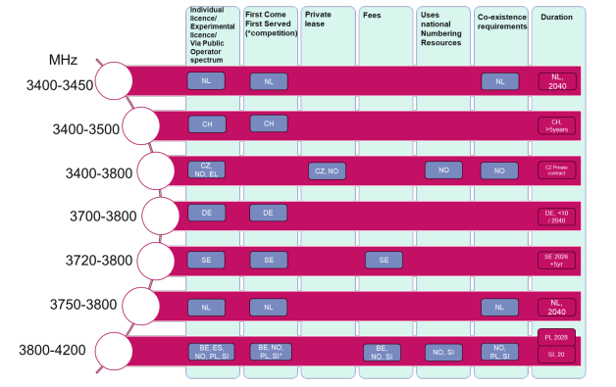
Overall, despite being a core driver of 5G development, vertical sectors have shown slow adoption across the EU. Worldwide, 1489 private mobile network deployments have been identified, of which only 694 (47%) use 5G. In manufacturing—the leading sector for such networks—298 deployments were recorded, of which only 60% included 5G. In contrast, Asia-Pacific countries like Japan and South Korea have advanced more quickly, driven by favourable policies and coordinated industrial strategies.
Systemic barriers help to explain the limited uptake. Spectrum access remains uneven, due to lack of spectrum sharing between public and private networks, with only a few Member States offering transparent and affordable local licensing regimes. Many companies—especially SMEs—face uncertainty on return on investment, given high costs of deployment, integration, and cybersecurity. The limited availability of skilled personnel and a still-nascent ecosystem of industrial-grade 5G devices (with fewer than 2% designed for robotics e.g.) further restrict adoption.
Moreover, unresolved legal and regulatory issues—such as data governance, service-level agreement frameworks for network slicing, and cross-border IoT regulation—have fragmented the investment landscape. Without coordinated regulatory reform, spectrum access facilitation, and vertical-specific integration support, Europe risks falling behind in realising the strategic benefits of industrial 5G connectivity.

5.4.4. Conditions of assignment (duration, coverage, price)
The EU legal framework entrusts Member States with carrying out most authorisation aspects of spectrum use in a context of shared competence. The EECC includes a number of requirements regarding duration of rights of use, coverage and quality of service and competition.
Duration of rights of use
Article 49 of the EECC introduced new requirements for minimum duration of rights of use. Member States must ensure 20 years of regulatory predictability through rights lasting a minimum of 15 years, with an option for a 5-year extension based on clear criteria related to spectrum utilisation and competition. An assessment before expiration determines if conditions are met for extension; if they are not, rights are reassigned through an open procedure.
First, it has to be noted that since the EECC's introduction in 2020, there has been a significant shift towards longer duration. The EC 2023 study, shows that 92% of pioneer band licenses from 2020 onwards were for 15 years or more, compared to 77% before 2020. Between 2022 and 2025, 96% of the 23 awarded licenses in the EU were for 15 years or longer. Only Finland issued a 9-year license for the 700 MHz frequency band with a term shorter than 15 years (however, this was done before the EECC entered in force). These findings suggest that longer license terms have become more prevalent.
However, the EECC's goal of ensuring 20-year predictability and enhancing investment certainty and business efficiency by supporting long-term planning has been only partially met. First, a number of auctions were conducted under the old rules, due to delays in EECC transposition, ignoring longer licence durations introduced by the EECC and rules on license renewals. This results in persistent sub-optimal licence durations and lack of renewal possibilities for spectrum which is currently in use by MNOs therefore still leaving untapped potential to enhance predictability. Second, many Member States still opted for the minimum solution allowed by the EECC, i.e. providing limited predictability (15+5) with less than half of the licences (46%) reaching 20 years or beyond. Overall, since 2010, out of 929 licenses lasting one year or longer, 650 (70%) were licensed under 20 years duration, while 279 (30%) were licensed for 20 years or longer (source: Policy Tracker 2025).
Moreover, operators are claiming that even the 20-year EECC licence duration is insufficient and still represents a business continuity risk, negatively affects the investment return timescales and depreciation rates and is putting pressure on the mobile operators to cope with an investment horizon shorter than other communication technologies. Moreover, MNOs must sustain spectrum assignment cycles repeated in Europe approximately every seven years since 2000 (new and expiring licences).
Third, the guarantees for renewals are still considered insufficient to support long term investment planning, especially if compared to some other markets like the US, Australia, and New Zealand that typically grant for a first limited period of 10 to 20 year-licences, but with options for indefinite or recurrent renewal. For instance, FCC licenses typically are issued for a fixed (limited) period, but renewals are routine.
Finally, the criteria for renewal under article 49, are considered by the telcos too broad and fail to provide sufficient guarantees for renewal. They relate to the need to ensure the effective and efficient use of the radio spectrum concerned, to avoid harmful interference and protect public health against electromagnetic fields, or to fulfil general interest objectives related to ensuring safety of life, public order, public security or defence; and the need to ensure undistorted competition. Moreover, derogations from the standard framework are allowed for specific cases such as geographical limitations or experimental use. Additionally, Member States may synchronize expiry dates to effectively manage spectrum allocation.
In France, under the “New Deal Mobile” agreement between ARCEP and mobile operators, the latter were granted the renewal of their 900 MHz, 1 800 MHz, and 2 100 MHz spectrum licences free of charge, in return for binding commitments to significantly improve mobile coverage, particularly in rural and underserved areas. Operators were required to deploy at least 5 000 new mobile sites in so-called “white zones” identified by local authorities, as well as upgrade existing sites to 4G. The agreement also included obligations to cover 10 000 specific locations (such as town centres, tourist areas, and major roads) with 4G within a set timeframe. To facilitate this deployment, operators were encouraged to share infrastructure, particularly in areas where individual investment would be economically unviable. ARCEP monitors compliance through a dedicated dashboard, and operators face penalties in case of non-compliance.
The German regulator BNetzA has opted to extend mobile licences in the 800 MHz, 1 800 MHz and 2.6 GHz frequency bands rather than re-auction them. These licences, due to expire at the end of 2025, will be prolonged for five years under the current award procedure. The aim is to align their expiry with later-ending licences and to prepare a larger pool of spectrum for future allocation. The extension will be accompanied by obligations for further mobile network rollout and measures to promote competition.
Lastly, Spain's Ministry for Digital Transformation and Public Service extended existing mobile operator spectrum licenses for an additional 10 years at no extra cost, effective from June 2024. This measure, part of revisions to the General Telecommunications Law, grants operators certainty for their 5G and future 6G deployments by extending license durations to 2040 and beyond. The extension applies to frequency bands like 800 MHz, 900 MHz, 1.8 GHz, 2.1 GHz, 2.6 GHz, and 3.5 GHz, and encourages investment in network upgrades and deployment.
According to GSMA Intelligence, assignments in frequency bands such as 900 MHz, 1 800 MHz and 2 100 MHz – widely used for 2G and 3G – are approaching expiry in more than 30 countries in 2025. In parallel, 61 network sunsets for 2G and 3G are planned in the same year.
According to a report by Aetha for Ericsson, out of the 32 countries studied (European Economic Area plus Switzerland and the UK), only two – Liechtenstein and the United Kingdom – do not have any spectrum licences expiring within the next 10 years (from 2002 onwards). The frequency bands with the highest number of upcoming expiries are 800 MHz, 900 MHz, 1 800 MHz, 2.1 GHz and 2.6 GHz. Among these, 800 MHz and 2.6 GHz are key 4G frequency bands, while 900 MHz and 2.1 GHz are typically used for 2G and 3G. In the longer term, however, all frequency bands are expected to be refarmed for 5G use.
For the above reasons, it is important for operators to have confidence that spectrum renewal processes will enable them to retain key spectrum at a price that is affordable in the long term, so that they can divert their energy and investments into deploying 5G and enhancing mobile network coverage.
Coverage requirements
When necessary to limit the number of rights of use, Article 55(2) EECC requires Member States to design a selection process and allows to follow additional objectives in relation to coverage, quality of service, efficient use of spectrum, and innovation and business development. Member States may attach to the spectrum rights conditions related to coverage and quality of service and to any commitment the holder of spectrum rights has taken in the process prior to the granting of the rights (Article 13 EECC and Annex I, Part D, 1 and 7).
Coverage obligations have become a widely adopted regulatory tool in EU spectrum auctions over the past decade, to promote equitable network deployment and reduce the digital divide, so that mobile operators who receive valuable spectrum rights invest in infrastructure rollouts aligned with public interest objectives—particularly in rural areas, underserved regions, and along critical transport routes. Nearly all EU Member States have included some coverage obligation into their 5G auction frameworks, even if the scope, ambition, and enforceability of these obligations vary significantly. The use of coverage obligations has remained relatively stable with only a few percentage points variation from 2020 onwards (coverage obligation - 85% before 2020 and 82% after 2020). In a study published by OECD in 2022, it stands out that nearly 49% of spectrum auctions between 2016–2021 included coverage obligations, rising to 73% for sub-1 GHz frequency bands, essential for rural deployment.
Two main types of coverage obligations emerged across Member States: “hard” or demanding obligations, and “soft” or flexible obligations. Hard obligations include quantitative, time-bound, and geographically specific requirements, designed to directly influence the investment strategies of mobile network operators, that may target population coverage (e.g. 90–98% in a defined timeframe), geographic reach (e.g. minimum number of municipalities), infrastructure milestones (e.g. motorway or railway coverage), or service-specific requirements (e.g. institutions like schools and hospitals). However, hard coverage obligations, applied in all spectrum lots in an auction may raise obstacles for certain business cases, such as that of wholesale only operators, which do not control the service provided to end-users, and to the development of efficient deployment methods, such as spectrum sharing.
France shows one of most prominent examples of this approach. Its 2020 auction for the 3.4–3.8 GHz frequency band included a multi-tiered obligation framework: deployment of 3,000 sites within two years, ramping up to 8 000 by 2024 and 10 500 by 2025; prioritisation of transport corridors; and mandatory upgrades of existing 4G sites to 5G. These obligations were complemented by a rural network sharing requirement to reduce duplication and improve cost efficiency. Similarly, Austria’s 2020 auction imposed binding obligations to cover 349 locations monitored by RTR. Operators were required to submit enforceable deployment plans. Germany also implemented hard obligations in both its 700 MHz and 3.6 GHz frequency bands. Each operator was required to achieve 98% population coverage by 2022, ensure continuous service along federal highways and key transport routes, and deliver high-performance benchmarks (e.g. 100 Mbps per user). These requirements were backed by strict enforcement clauses and regular reporting to the Bundesnetzagentur (BNetzA), ensuring compliance. Several Member States also set obligations in relation to coverage of roads, highways and railway lines, including defining coverage and quality of service targets by set deadlines; for example, the incumbent rights holders in Belgium should cover within two years, 98% of 15 major rail links with speeds of at least 10 Mbps.
In contrast, “soft” or flexible obligations were adopted in some Member States thanks to market maturity, or the desire to attract broader participation in auctions. These obligations often consisted of non-binding coverage goals, flexible timelines, or best-effort principles incorporated into broader national strategies but without enforceability through licence conditions.
Italy’s 2018 auction illustrates this model. Despite raising EUR 6.5 billion and awarding significant spectrum resources, including the 700 MHz and 26 GHz frequency bands, the coverage requirements were limited. Deployment concentrated in dense urban areas, with rural coverage progressing more slowly. Poland presents a similar case: while early spectrum plans included 5G rollout obligations, these were softened or removed following legal and political delays. When spectrum was finally awarded in mid-2023, the associated obligations lacked the detailed geographic and performance conditions found in countries like Germany or France.
In general, obligations to cover the most difficult-to-reach areas represent an important means to ensure investments, but also represent a significant additional cost associated with acquiring the spectrum licence which needs to be considered in the spectrum design and pricing. Moreover, the existence of coverage and quality of service obligations in auction conditions could limit the possibility for wholesale only operators, such as tower operators, to bid for spectrum, unless the auction design considers this possibility. Investment commitments instead of coverage obligations have been used only in limited cases (e.g. Austria, France cf. infra under efficiency).
Other examples include a positive discrimination for new entrants allowing them more time to reach a certain coverage target; e.g. in Belgium, the new entrant has 7 more years to reach the railway coverage target.
Furthermore, for mid-wave bands which used to deliver capacity services within reduced coverage area, coverage obligations are not so extensive as in the frequency bands below 1 GHz; e.g. for 3.5 GHz, Member States generally required right holders to cover main populated areas (Austria, Bulgaria, Slovenia) or to activate a minimum number of base stations or sites (Czechia, Estonia, France, Latvia, Slovakia) by a set deadline or a combination thereof (Greece). Finland and Hungary only requested that the 3.5 GHz frequency band be used for the provision of services by a certain deadline (Hungary), and if not so, to be available for lease (Finland). The mm-wave bands are used for local use cases where a high capacity is needed. For example, for the 26 GHz frequency band, Member States have not specified any coverage obligation (Finland, Estonia, Greece, Italy, Spain) or requested only a minimum number of sites activation by defined deadline (Austria, Slovenia).
Auction designs that align spectrum awards with long-term infrastructure goals have proven more effective in promoting rapid deployment. Hybrid models, such as France’s 2020 auction, balanced moderate spectrum costs with binding rollout obligations, linking licenses to transport corridor and municipal coverage targets, and achieving 5G availability in over half of municipalities within two years. Other regulators, such as those in Austria and Ireland, have explicitly set low reserve prices to avoid crowding out investment in network deployment. Moreover, Austria, attached coverage targets for underserved areas to its auction framework, demonstrating how tailored auction design can effectively channel investment toward rural connectivity.

Spectrum price
The EECC does not mandate a specific type of selection procedure in cases of limiting the number of rights of use. However, it outlines limited set of objectives that a competent authority may follow besides promoting competition when designing a selection procedure. These objectives include promotion of coverage or of efficient use of spectrum (Article 55(2) EECC) and common rules for setting spectrum fees, including reserved prices (Article 42 EECC).
Prevalently, price auctions were used by Member States for assigning spectrum for wireless broadband networks and services, including 5G; only recently more investment-oriented auctions were used, combining price and coverage commitments (see example of Austria above in the coverage obligations section). Prices have been relatively diversified as we can deduct from data presented in the efficiency section below. In several cases, spectrum segmentation and availability conditions artificially increased the resulting price of selections thereby hampering operators’ investment capacity.
Relatively high spectrum prices have been particularly problematic due to the context in which mobile operators have been operating. The European mobile sector is currently facing relatively low profitability compared to other economies, prompting the need for pro-investment measures in spectrum. European operators have spent significant amounts in spectrum, with approximately EUR 29 billion on 5G spectrum auctions, to be added to spectrum for 4G (total EUR 40 billion) and 3G (total EUR 109.7 million. Despite downward trends in absolute spectrum cost, the costs as proportion of recurring revenues have increased by more than 150% as a proportion of recurring revenue since 2014 (infra efficiency section).
Achieving the EU objectives with regards to high quality 5G deployment will require substantial investment, including in midband spectrum, estimated between EUR 25-30 billion, alongside expenditures on additional cell-sites and small cells.

5.4.5. Mobile profitability and financial attractiveness
Profitability metrics, particularly mobile ARPUs (Average Revenue Per User), present a bleak picture for European operators: adjusted for purchasing power, they were among the lowest compared to international counterparts, just under EUR 15 per month in 2023. This contrasts significantly with regions like USA with ARPUs as high as EUR 41.70, allowing operators to invest a lot more in 5G SA networks (24% coverage against 2% in the EU) in a logic of “more for more” for users. For the GDP/capita adjusted figure, the US ARPU is still 67% higher at 24.9 EUR/month, and ARPUs in Japan, South Korea and China are all at least 33% higher than in the EU. The mobile ARPU in Europe experienced a steep fall of some 6% between 2022 and 2023, unlike other regions. Figures from Connect Europe show that ARPUs in Europe are declining at a faster rate than in the other economies, having fallen 5.9% in 2022-3, compared to a fall of 3.5% in the USA and a rise of 2.2% in China. This trend is also evident in the analysis provided by Analysys Mason and other regulatory bodies, where ARPU levels in Europe hovered around €11 throughout 2024, only marginally above China’s figures.

Figure 11: Mobile ARPU comparison and real-term changes across global regions (2022–2023)
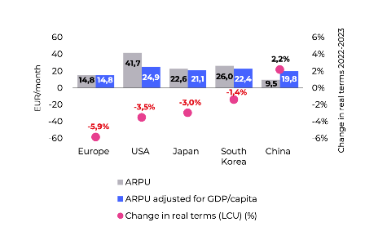
Source: Connect Europe, State of Digital Communications report 2025, p40
Limited revenue prospects and low or uncertain consumer willingness to pay for 5G reduce mobile network operators' (MNOs) incentives to deploy 5G Standalone (SA) using mid-band spectrum. Financial investors have also pointed out the high costs and demand uncertainties tied to 5G. In contrast, Fiber-to-the-Home (FTTH) has received a more favourable outlook, attracting substantial investment from long-term infrastructure funds. Capex trends reported by Analysys Mason show that capex in 5G mobile plateaued at 20% of total European telecom capex in 2023, with capex in FTTH networks more than double this value.

5.4.6. Market shaping measures
Article 52 EECC allows competent authorities to impose market shaping measures in spectrum authorisations to support or incentivise effective competition in electronic communications networks and services (ice). Market shaping measures have the potential to serve a more strategic approach by regulators to align spectrum management with broader connectivity, competition, and industrial policy objectives. However, as the EECC aimed at enhancing legal certainty, transparency and predictability for investment, the use of such measures is only allowed where necessary to maintain or achieve effective competition. The EECC therefore introduced the obligation for competent authorities to carry out a forward-looking assessment of market competitive conditions and likely effects on existing and future investments before applying such measures. However, the assessments carried out under the EECC have been of different quality and depth, there has been no control over their consistency and quality and their alignment with the forward-looking requirements, and no verification of the extent these met a certain burden of proof.
Nevertheless, Member States increasingly adopted market shaping measures to influence the structure and dynamics of national mobile markets, by supporting market entry, and to develop vertical use cases such as industrial automation, smart transport, and digital healthcare. The most frequent measure under Article 52(2) EECC was spectrum caps and floors. Spectrum caps are used to prevent a single operator from acquiring a disproportionate share of spectrum in a frequency band or across frequency bands, helping to ensure a level playing field. However, Member States also used them to establish adequately equal spectrum holdings for all operators active on the national market, especially in the lower bands, or to protect the structure of the market, e.g. to avoid the exit of a small operator. Usually, spectrum caps were agnostic, but in some Member States tougher caps were applied to incumbent operators, such as in Austria in 700 MHz or in Czechia for 3.4-3.8 GHz. A few auctions were reserved to new entrants (in 2.1 GHz band in Cyprus). In a few Member States, certain bands were granted on condition of providing wholesale access to MVNO (Croatia, Czechia, France, Greece) or/and service providers (Croatia, Czechia, Germany – obligation to negotiate) or national roaming (Czechia, Greece). Spectrum floors, though less common, are intended to secure a minimum allocation for smaller or new operators. In Sweden and Ireland, this approach has improved the chances for smaller players to obtain spectrum and compete effectively.
Set-asides is another market-shaping tool that consists in reserving specific frequency blocks for entities outside the traditional mobile operator landscape, such as private industrial networks. Germany’s 2019 decision to reserve 100 MHz in the 3.7–3.8 GHz frequency band enabled companies like BASF and Lufthansa to deploy their own 5G networks. Similarly, Poland and Netherlands earmarked parts of the 3.8–4.2 GHz frequency band for private use, although actual commercial uptake has so far been limited, due in part to regulatory and market readiness issues. Local spectrum allocation for verticals is another emerging trend that reserves spectrum for non-public networks—often in the 3.8–4.2 GHz or 26 GHz frequency bands—to support specific industrial use cases. While uptake has generally been slow due to complex licensing procedures and a still-developing ecosystem, this model has attracted interest in several EU countries, e.g. Poland and Latvia.
As to the assessment of the market shaping measures, GSMA study argues that private networks are growing equally in countries without set-asides, as in countries which have limited the availability of spectrum through a set-aside or sharing regime Conversely, according to GSMA, limiting spectrum supply lowers quality of service and raises network costs GSMA claims that the impact of 100 MHz set aside in 3.5 GHz is 24% lower download speed. .
Additional mechanisms include service-based competition obligations and reserve price structures. To encourage MVNO access and enhance retail competition, some Member States included national roaming or wholesale access obligations in auction terms, e.g. in Czechia in 2020. Also auction pricing strategies can significantly shape outcomes: Italy's 2018 auction featured high reserve prices, driving revenues but possibly delaying investment. In contrast, France adopted lower reserve prices and flexible payment schedules to allow operators to invest more directly in network deployment. See below the table showing examples of market shaping measures used, and their impact.

Figure 12: Examples and observed impact of market shaping measures in EU auctions
Country | Year | Market shaping measures | Observed impact
Germany | 2019 | - Spectrum caps in key bands- 100 MHz (3.7–3.8 GHz) reserved for industrial networks- MVNO access obligation  - Ambitious coverage target: 98% of households and transport routes by 2022 | - €6.55 billion raised, among the highest in EU- High prices criticised by operators- No new entrants- Stimulated industrial 5G use, but led to concerns about delayed investments
France | 2020 | - Staged deployment obligations (e.g. 3 000 sites by 2022)  - Minimum quality of service commitments  - Guaranteed spectrum blocks for those accepting obligations- Low reserve prices | - Moderate auction revenue- All four MNOs retained- Rapid rural 5G rollout- Over 80% population covered by mid-2023 (primarily via 700 MHz)- Balanced market outcomes with no exits
Italy | 2018 | - High reserve prices  - No spectrum caps- Minimal rollout obligations | - €6.5 billion raised- Highest € per MHz/pop in the EU- No new entrants- Market structure unchanged- Investment delays reported
Poland | 2020–2023 | - Initially strong coverage and investment obligations-  Auction delayed due to COVID-19 and legal-political hurdles  - Later included set-asides for verticals (3.8–4.2 GHz) | - Spectrum awarded only in mid-2023- Regulatory uncertainty delayed 5G deployment- Low uptake of industrial spectrum- Concerns raised over investor confidence
Austria | 2020 | - Coverage obligations targeting 349 underserved communities  - Rollout planning requirements  - Wholesale access obligation | - Affordable auction outcome- Stimulated rural investment- All three MNOs remained active- Positively evaluated by regulators
Source: BEREC (2023). Study on Wholesale Mobile Connectivity: Trends and Issues for Emerging Mobile Technologies and Deployments (BoR (23) 41).
Spectrum reservations have been correlated with high auction prices. In this context, some operators expressed concerns that these measures may have been misused at times, potentially creating artificial spectrum scarcity and increasing costs even in absence of problems in the retail market, which could negatively impact deployment and hinder the achievement of connectivity objectives.
For example, some argue that the reservation of spectrum for verticals in the 2019 auction for the 3.6 GHz frequency band in Germany led to a suboptimal outcome in terms of high prices. There were 4 MNOs interested in nationwide 3.5 GHz licences, while the reservation of 25% of the available spectrum for local licences, without any economic cost/ benefit analysis and justification increased spectrum scarcity and drove prices up. The auction generated €6.55 bn, as a combination of spectrum scarcity and aggressive bidding strategies inflated final prices. According to operators, the set aside caused auction prices to increase by around EUR 50 million per block. This means that public network operators had to pay around EUR 2.2 billion more for the amount of spectrum available, with all bidders ending up with less than what they considered an optimal amount of spectrum in the band, due to the effect of spectrum-set aside. This increased cost is also likely to have a negative effect on network investment. Based on a Arthur D Little, Compass Lexecon study for Vodafone, the estimated consumer welfare loss was of EUR 6.2-15.6 billion (to 2040) due to higher prices and reduced network quality. Operators also regretted that in Italy only half of the 400 MHz available in the 3.6 GHz frequency band was made available in the 5G auction and further divided into four blocks (80/80/20/20), forcing two “winners” and two “losers”. Resulting scarcity in the auction drove prices up to EUR 4.35 billion – 6x typical benchmark averages. Moreover, 20 MHz is not technically sufficient to deploy quality 5G services as 80-100 MHz is needed to provide Gigabit speeds. Italy’s 2018 auction remains one of the most expensive examples, raising over EUR 6.5 billion, largely due to elevated reserve prices for 700 MHz and 3.7 GHz. Prices reached 0.35 EUR/MHz/pop—more than twice the EU average.
As to market structure and competition, despite measures such as spectrum set-asides for instance in Czechia, recent auctions have not led to sustainable entry of new mobile network operators (MNOs). This is a sign of a broader structural challenge: the economics of mobile networks increasingly favour a limited number of infrastructure players, as the cost of deploying each new generation of mobile technology (e.g. 5G and soon 6G) rises. In this context, it is likely that set-asides alone cannot compensate for the declining viability of infrastructure-based competition. Economic theory emphasizes the crucial balance between profitability, scale and investment.

5.4.7. Promoting advanced 5G
Though recognising the need to consider national specificities in conditions for spectrum assignment across the EU, we can conclude from the data presented above that the EECC has not been successful in establishing a pro-investment assignment framework and, partially as a result, the EU is lagging in high quality 5G deployment. Spectrum assignment conditions remained fragmented thus delaying the full realisation of benefits that might have been achieved through a more harmonized approach to incentivize investments across the EU while ensuring regulatory predictability. Assignments have not always used justified and well-designed market shaping measures and coverage obligations. Cost of spectrum has been excessive on account of high reserve prices and revenue-oriented auctions. Licence duration has not been sufficiently long to encourage more ambitious deployment of networks and advanced services offers, including cross border. Predictability has not increased sufficiently to improve the weak financial attractiveness of operators, also linked to low profitability of the mobile market in the EU.

5.5. Effectiveness in promoting development of the Single Market
Effectiveness is analysed with respect to promoting the development of the Single Market
The sections below assess the effectiveness of the EU spectrum policy in contributing to the development of the Single Market by facilitating convergent conditions and developing predictable regulatory approaches and by favouring the effective, efficient and coordinated use of radio spectrum (Art. 3, para (c)EECC - internal market objective). They look at measures related to the peer review mechanism, spectrum coordination and cross border interferences, measures aimed to incentivize spectrum sharing, transfer and leasing across the single market, the authorisation of satellite services and the provision of pan-European services.

5.5.1. Coordination/harmonisation of assignments - Peer review
The EECC aimed at enhancing convergence of spectrum policies and assignment conditions across the EU inter alia, through i) a voluntary peer review/learning mechanism and ii) a possibility to organise a joint authorisation procedure.
Voluntary peer review
Under Article 35 of the EECC, a competent authority may voluntarily ask other competent authorities to review its draft measure for the selection of assignees for EU harmonised spectrum, including through a Peer Review Forum with participation of BEREC experts experienced in forward looking assessment of market competitive conditions. The intention was not just to inform on future assignment procedures but mainly to achieve, through peer learning and assessment, more effective efficient and consistent selection methods, assignment conditions and market shaping measures.
The Council of EU in conclusions on the White Paper recognised “that the current peer review mechanism has proven to be valuable …” In its opinion to the White Paper, the RSPG stated that “the peer review has proven to be a valuable mechanism to share lessons learned and to engage in discussion between the Member States’ experts on awards. It helps understanding specific procedures based on national situations. This also serves as a tool for methodological harmonisation and to increase transparency between peers.” At the same time, the RSPG acknowledged that “there is room for enhancing the peer review mechanism further”. The Council of EU recognised “that the current peer review mechanism has proven to be valuable …”.
However, it is hard to assess/quantify the real added value of the current peer review mechanism. Firstly, it is a voluntary mechanism. Out of 30 draft measures notified to RSPG, only 10 cases led to voluntary Peer Review Forums and the RSPG never used its right under Article 35(2) to convene the Peer Review Forum on its own initiative. Furthermore, those assignment procedures which did raise criticism by market players have not even been subject to a peer review. Secondly, there was no tangible follow up to the Peer Review Forums in the form of an RSPG opinion on the draft measure pursuant to Article 35(9) EECC on a notifying administration request or any other RSPG activity building on experience gained during the authorisation process. Thirdly, there was not sufficient investment of resources in the mechanism as not all Member States were represented or actively participated in the Forums. Joint authorisation procedure
The EECC also established a joint authorisation procedure under Article 37 to allow several Member States to cooperate to grant spectrum usage rights through common conditions and procedure; however, as this is dependent on the voluntary initiative of the Member States, prospective users have not been able to require and rely on such coordination. To date, this joint procedure has never been used.

5.5.2. Harmful interference
Article 28 EECC provides for spectrum coordination among Member States to ensure that no Member State is prevented from using harmonised spectrum due to cross-border interference in harmonised bands and that cross-border coordination issues or interferences are solved between Member States and with third countries. Such interferences have a negative economic, and in certain cases social/cultural impact. The Commission relies on the RSPG, which may propose coordinated solutions upon request by an affected Member State, which may also request the Commission to adopt a decision if interference persists in harmonised bands. the RSPG good offices’ involvement in cross border-interferences issues has brought significant added-value according to participants (see section on governance/RSPG).
The RSPG proactively engaged in solving cross-border issues in relation to use of the 700 MHz frequency band. It also adopted an opinion with a coordinated solution for the 700 MHz frequency band on interference between Italy and Croatia. The RSPG mediation was also sought in coordination issues between Italy and France, and within Cyprus. However, the limitation of the scope of Article 28 to harmonised spectrum, thus excluding for instance FM radio, prevents adoption of appropriate measures regarding non harmonised spectrum which nevertheless has a high economic, cultural and social value and could solve issues such as between Italy and Slovenia, Croatia and France.
The RSPG good offices framework facilitated coordination negotiations between the Union and third countries including with Tunisia, Libya, Albania, Montenegro, North Macedonia, Moldova, Belarus, Russia and Ukraine. However, on cross-border coordination issues with third countries in general, the RSPG assistance has not been completely effective since the RSPG lacks a legal basis to act in the same way as with intra-EU cross border coordination. The support provided by the Union to Member States in case of interference caused by a third country would gain in effectiveness if Member States, acting altogether or with a particular push by EU action, could also intervene alongside the Commission.
Figure 13: Geographic distribution of cross-border harmful spectrum interference in Europe
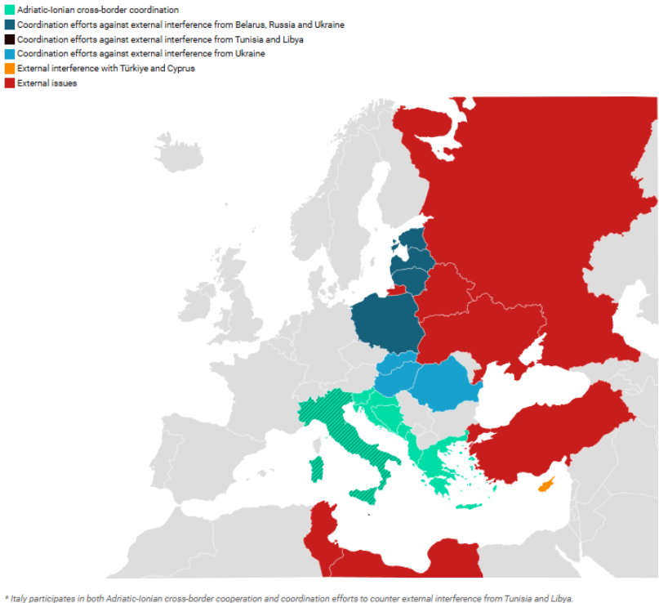
Source: Own desk research based on information and notes from the European Commission

5.5.3. Spectrum sharing, transfer and leasing
The demand for radio frequency spectrum has been rapidly increasing due to the evolution from 4G to 5G, and eventually toward 6G. This trend is affecting all sectors—from telecom to transportation, healthcare, manufacturing, and beyond. Comparing to 4G, 5G brought 10x faster speeds, ultra-low latency and massive device connectivity, while 6G is expected to offer terabit-per-second speeds and support real-time, AI-driven, immersive experiences (e.g., holograms, extended reality). Combined with an explosion of the number of devices (smartphones, IoT, sensors, autonomous machines) and new applications emerging (Smart cities, Industry 4.0, autonomous vehicles, remote surgery, AR/VR, and metaverse), we can anticipate a massive increase in spectrum bandwidth needs beyond the electronic communications sector and hence spectrum sharing continues to be important.
Spectrum sharing and leasing are supported under Articles 45, 46, 48, and 51 of the EECC. The EECC emphasizes that spectrum sharing, when complying with relevant competition law rules, can increase effective and efficient use of spectrum and facilitate the rapid deployment of mobile networks. However, these provisions are voluntarily applied and seldom used, and the framework lacks clear support for shared or local access models. In several prominent cases, agreements on spectrum sharing have been subject to competition law scrutiny.
In its 2021 Opinion on Spectrum Sharing – Pioneer Initiatives and Bands, the RSPG highlighted that spectrum sharing in the Union has so far been implemented in a rather static and conservative manner and called for further development — particularly to enhance the efficient use of radio spectrum and to promote innovation. The examples of spectrum sharing in the EU remain limited and fragmented. The RSPG recommended that the EC and Member States identify use cases requiring spectrum sharing and develop a proof-of-concept framework using ICT systems with innovative technologies, such as Artificial Intelligence/Machine Learning. Several regulators and industry bodies—such as BNetzA, ARCEP and GSMA— also emphasise the need for more dynamic spectrum management, including spectrum-sharing mechanisms like Licensed Shared Access and flexible licensing models for private or local networks. These tools are seen as essential to maximise efficiency, particularly in higher frequency bands (e.g. mmWave and future terahertz) where exclusive licences risk underuse.
The EECC allows spectrum licensees to transfer or lease their usage rights to third parties, to promote more efficient spectrum use and market flexibility. Under Article 51, such transfers or leases must be notified to NRAs, which may impose conditions or block transactions to prevent market distortion or inefficiencies. The process must be transparent, with transfers made public. Article 52 further enables regulators to attach conditions to spectrum rights that encourage effective use while maintaining technological and service neutrality. However, implementation is left to Member States, resulting in fragmented secondary market activity across the EU. Mechanisms such as Licensed Shared Access (LSA) and spectrum trading/leasing have seen limited uptake, often due to inconsistent national implementation and lack of centralised guidance.
The EC study indicates that there have been very few spectrum trades in Europe in the highest value sector (mobile). The study mentions two cases: a rearrangement of 1 800 MHz spectrum held by four operators in Slovakia in 1 800 MHz in 2022; and Proximus’ purchase of 3.6 GHz spectrum from an existing operator in 2024. This contrasts sharply with Australia, where the Productivity Commission estimates the annual turnover of spectrum licences at 6%, similar to the commercial property market. In the United States, deals worth hundreds of millions of dollars are not unusual in the mobile market. For example, the biggest spectrum trade was in 2014 T-Mobile announced a mutual deal with Verizon Wireless estimated to be worth USD 3.3 billion. These are not takeovers of one company by another, but voluntary trades where only spectrum was sold or exchanged.
In Finland, spectrum pooling has been implemented to improve coverage and efficiency in sparsely populated areas, particularly through joint network deployments by mobile operators. In Italy, AGCOM introduced the “club use” model for the 26 GHz frequency band whereby five licensees each hold 200 MHz and may dynamically access up to 1 GHz of spectrum in areas not used by others, based on commercial agreements. While countries like the Netherlands and Finland have introduced flexible spectrum leasing models, others, such as Poland, maintain rigid frameworks that prevent optimal reallocation. This fragmentation led to inefficiencies, with an inexistent secondary spectrum trading market, with operators in some markets unable to lease unused spectrum due to restrictive national policies or adjust spectrum holdings to meet evolving demand.
According to the study, the main driver for very active spectrum trading markets in the US and elsewhere is the combination of national with local licences. While national mobile licences have been the norm in the EU, the experience from other parts of the world shows that trading is a viable policy option and could be more relevant in the future with the authorisation of higher band spectrum (e.g mid-band and mmW band spectrum) in a combination of national and regional/local way.
EECC rules on spectrum sharing, transfer, and leasing have not been effective in promoting efficient spectrum use, as evidenced by the inconsistent and limited utilisation of these models across the EU. Although some Member States adopted flexible leasing and sharing models, the lack of EU-wide coordination and support for shared or local access models caused underutilisation of spectrum, which is a concern as demand for wireless broadband increases with the arrival of 6G. The absence of a harmonized framework for secondary spectrum trading has further led to inefficiencies, with restrictive national policies inhibiting optimal spectrum reallocation. The divergences among Member States prevented the creation of a single market, resulting in a fragmented secondary market and inconsistent spectrum management in the EU.
The "use-it-or-lose-it" principle
The "use-it-or-lose-it" principle allows regulators to revoke or reassign spectrum if it remains unused, helping to prevent hoarding and promote efficiency. While the EECC does not mandate it, it allows national regulators to include such conditions as authorisation conditions. Implementation at EU level is hence uneven, with some Member States having incorporated such provisions into their regulatory frameworks, while others not.
Germany's Federal Network Agency (BNetzA) has included "use-it-or-lose-it" clauses in certain spectrum licenses, requiring licensees to meet specific rollout obligations within defined timeframes. Specifically, in the context of local broadband applications in the 3 700–3 800 MHz and 26 GHz frequency bands, BNetzA stipulates that spectrum assignments can be revoked if use of the spectrum has not commenced within one year of the assignment, or if the spectrum has not been used for its intended purpose for more than one year.
Outside the EU, the United Kingdom's communications regulator, Ofcom, has enforced adherence to spectrum license conditions on a "use-it-or-lose-it" basis, particularly in the context of mobile spectrum licenses. Furthermore, Canada and Australia apply clearer policies: Canada’s 2024 reform enables reallocation in underserved areas, while Australia links licences to rollout obligations with penalties for non-compliance.
These approaches encourage efficiency, though overly strict enforcement may deter investment. A more harmonised EU application could improve spectrum use and accelerate reallocation.

5.5.4. Supporting satellite EU-wide connectivity
While the EU used to be strong in space and satellite connectivity, the EECC approach to satellite connectivity has not been successful to meet the evolving technology landscape and the needs of the single market for EU-wide secure connectivity.
Despite their inherent cross border nature, authorisation of satellite networks and services in the EECC is national. Although they may use the same network, with one or several satellites to provide services to several Member States, operators are obliged to notify under general authorisation to all Member States where they provide services and to respect nationally defined authorisation conditions. To use spectrum, they should also either respect nationally predefined conditions for unlicensed use of spectrum or request rights of use from every Member State where they intend to provide service.
Such fragmented regulatory framework does not facilitate scaling up through the EU wide provision of satellite services. In 2008, a specific procedure was created for the selection at EU level of operators using the 2 GHz Mobile Satellite Services (MSS) frequency band, to promote the provision of pan-EU satellite services in this band. After the EU selection in 2009, Member States issued authorisations to the two selected MSS operators for the use of radio spectrum, both for the satellite component and for any complementary ground components (CGC) mainly from 2011 onwards.
However, the types and conditions of authorisations issued considerably varied between Member States thereby partially undermining the harmonisation objective of the process. For CGCs, 24 Member States issued individual authorisations whereas 2 Member States used general authorisations. For the satellite spectrum, 20 Member States issued individual authorisations, in 4 of which with an integration of the CGC and spectrum authorisations, 2 used general authorisations, and 2 followed a hybrid approach.
While there are no specific provisions in the EECC on satellite spectrum assignment and authorisation, satellite communication networks and services fall within the scope of application of the EECC that is supposed to guarantee a degree of harmonisation. The provisions of the EECC relevant to general authorisation (Article 12 and following) and the provisions which concern the assignment of spectrum, under general authorisation (Article 46) or individual rights of use (Article 48) fully apply for the provision of satellite networks and the use of satellite spectrum. It is left to national authorities to decide how to authorise the use of spectrum for satellite networks and services; this varies from individual authorisation to the notification or registration of the provision of satellite services without reference to the specific spectrum bands used. Moreover, conditions and requirements attached to the provision of a satellite service differ between Member States: individual authorisations vary from 5 to 20 years for the space segment and from 5 to 10 years for ground stations. Moreover, it is often unclear whether general authorisations are associated with the fulfilment of certain requirements, even basic ones such as the respect of ITU-R Radio Regulations. A recent EC study indicates that in the case of MSS authorization different licensing approaches created fragmentation, including wide variations in timescales for issuing a licence, different approaches to national coordination with existing services, different fees and different conditions attached to the licences; the list of country specific conditions is substantive and does not in every instance appear to be justified by national laws.
Fragmented authorisation, lack of common requirements and of consistent authorisation conditions and enforcement encourages disrespect of the authorisation rules, regulatory forum shopping and weak enforcement mechanisms and allows large satellite constellations to defy rules to protect interference and guarantee access to the EU market. In recent years, the number of interference cases has increased. Some publicly available evidence of this can found for example in the recent report of the Director of the ITU Bureau to the Radio Regulation Board in July 2025 where many cases are listed (see Appendix II on Radio Spectrum with information on cases of harmful interference concerning space services)
Data shows that the EU lacks sovereignty as regards satellite networks and services. Existing and planned constellations of thousands of satellites from third countries are occupying and will increasingly occupy orbit and spectrum resources, which are becoming more and more scarce. Based on the current number of satellites in Low Earth Orbit (LEO) (just under 9 000 as of February 2025), a recent EC study indicates that this number is expected to increase by at least a factor of six in the next decade. This will place increasing pressure on both shared and exclusive spectrum which mostly works on a “first come, first served” approach. With only 773 LEO satellites launched and 3.120 planned, the EU lags behind the USA (i.e. 7 633 launched, 33 397 planned) and China (i.e. 220 launched, 27 198 planned). In case of spectrum scarcity, a procedure to select operators at EU level for clearly cross border services will be necessary to ensure availability of spectrum across the EU. This shows the need for more unified EU-level coordination to streamline processes and improve satellite connectivity effectively.

5.5.5. Lack of Single Market for Spectrum
The EECC has not been effective in creating a single market for spectrum. Differentiated conditions across Member States persist and have led to limited predictability and inconsistencies that prevent a uniform regulatory framework throughout the EU. Deployment has been slow due to regulatory uncertainty. Problematic auctions have not been reviewed ex ante. The voluntary joint authorisation procedure allowing several Member States to cooperate to grant spectrum usage rights through common conditions and procedure has never been used since prospective users do not have a right to it. Regarding cross-border harmful interferences between Member States, the RSPG good offices’ involvement has not been fully efficient, as it does not apply to non-harmonised frequency bands and has also not been completely effective on cross-border coordination issues with third countries where the EU and the RSPG has no legal basis to act in the same way as for intra-EU cross border coordination issues. Spectrum sharing is voluntary and has seldom been used and there has only been a limited and fragmented secondary trading market. For satellite services that have a clear cross-border potential, the authorisation framework is fragmented, as it relies on national authorisation, there are no minimum common authorisation conditions or requirements, and no common selection procedures except for the 2 GHz frequency band. Such fragmentation is not favourable to scaling up for the EU-wide provision of satellite services and may incentivise regulatory forum shopping.

5.6. Efficiency

5.6.1 Compliance, administrative cost
Evaluating the EECC efficiency on compliance and administrative costs, the EC study concludes that the costs for following spectrum management rules in the EECC are generally seen as fair and necessary by about 80% of stakeholders, aligning with the goals of efficient spectrum use and market competition. No major unfair costs were found, as most believe the expenses are justified by the goals of using spectrum efficiently, advancing technology, and encouraging market competition. However, fragmented spectrum policies, besides direct compliance costs, further add indirect costs, as operators must allocate extra resources to meet differing obligations across countries. Streamlining these processes to reflect opportunity costs and economic impacts could enhance efficiency by reducing unnecessary burdens, allowing resources to be better utilized in accordance with the EECC objectives of ensuring adequate connectivity and fostering infrastructure competition.
Current compliance costs associated with spectrum management under the EECC consist of a mix of adjustment, administrative, and regulatory costs. NRAs and mobile operators incur adjustment costs related to spectrum refarming and policy adaptation. Spectrum refarming, though necessary to allow new technologies like 5G, involves significant planning and technical reconfiguration. Broader institutional adaptation, including updating domestic legislation and enhancing administrative capacities, also add to costs, which vary substantially across Member States.
As to administrative costs, NRAs report varying levels of annual expenditure. While the peer review process under Article 35 EECC involves some administrative effort—such as the summarising and presentation of draft measures—the costs are widely considered manageable. Basic notifications to the RSPG Secretariat entail minimal burden, though costs increase when a Peer Review Forum is convened, requiring active participation by multiple Member States. These regulatory activities are typically financed by charges imposed on the industry, in line with Article 16 EECC. These charges fund administrative costs and are generally seen as proportionate by stakeholders. While significant, they are widely regarded as necessary for achieving the broader EECC objectives of efficient spectrum use, technological advancement, and market competition.
Beyond direct compliance costs, indirect and transaction-related costs are also notable under the current framework. Fragmentation in national licensing and spectrum-sharing regimes imposes additional burdens on operators. For instance, Orange allegedly needs to allocate separate legal and technical resources to comply with differing obligations in France, Spain, and Germany that increase the cost and complexity of delivering cross-border services. These inconsistencies prevent operators from fully benefiting from economies of scale and act as barriers to innovation and investment.

5.6.2. Spectrum cost
The EECC requires in Article 42 that Member States ensure that fees for radio spectrum use are set at a level which ensures efficient assignment and use of radio spectrum including by setting reserve prices as minimum fees based also on the value of possible alternative uses, taking into account costs linked to the conditions attached to the right of use and applying payment arrangements linked to the availability of spectrum. There is therefore a trade-off between spectrum cost and investment conditions: the higher the cost of spectrum, the lower the investment incentives.
High spectrum prices had a negative effect on deployment and investments GSMA econometric estimates show that spectrum cost negatively impacts coverage, speeds and services provided to end users: concretely a 10-percentage point (p.p.) higher spectrum cost to recurring revenue ratio decreased 4G and 5G coverage by up to 6 p. p. and decreased average speeds by up to 8%. An Ericsson report also shows that spectrum costs account for some 7% of mobile service revenues across Europe. Since the total capital intensity of European mobile Communication Service Providers (CSPs) is around 18%, spectrum costs represent about 35-40% of their capital expenditures. A GSMA report on global spectrum pricing confirms that while spectrum needs have increased over the last decade, due to rapid growth in demand for mobile data and new use cases, the average revenue per MHz in Europe declined by 58% between 2014 and 2024. This reduction has not been fully reflected in spectrum prices, that have declined overall but not at a similar pace. While spectrum prices would normally respond to a decrease in its value in a market driven assignment process, GSMA claims that spectrum licences are often influenced by non-market factors such as regulatory intervention through high reserve prices or measures artificially increasing spectrum scarcity.

Figure 14: Revenue per MHz per connection in Europe
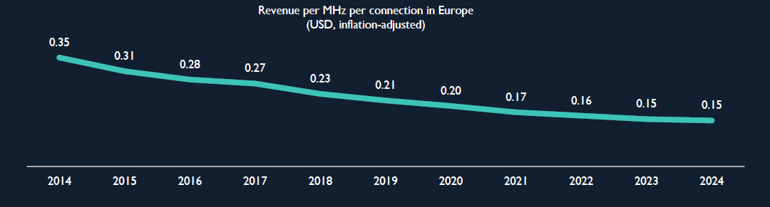
Source: GSMA
Moreover, data show a significant discrepancy in prices per MHz per population. The table below shows the average spectrum prices (€/MHz/pop) for three 5G frequency bands—700 MHz, 3.3–3.8 GHz, and 26 GHz—across Member States: for 700 MHz from as low as €0.08 (Croatia, Estonia) to over €0.69 (France). For mid-band (3.3–3.8 GHz), prices vary widely—from under €0.01 (Romania, Bulgaria) to €0.38 in Italy—highlighting differing national auction strategies and demand levels. The 26 GHz frequency band shows the lowest values overall, with prices typically below 0.002 EUR/MHz/pop due to limited range and early market stage. Several entries are marked “incalculable” where license terms, population coverage, or price data were insufficiently defined.
Figure 15: Average band prices in each award (€/MHz/pop)
Country | 700 MHz | 3.3 - 3.8 GHz | 26 GHz
Croatia | 0.0824 | 0.0093 | 0.0012
Latvia | 0.095152 | 0.0689 | Not awarded
Portugal | 0.1864 | 0.0763 | Not awarded
Germany | 0.2005 | 0.1691 | Not awarded
Finland | 0.2008 | 0.0363 | 0.0016
Greece | 0.2367 | 0.0242 | 0.0015
Czech Republic | 0.2423 | 0.0289 | Not awarded
Slovakia | 0.2984 | 0.03007 | Not awarded
Spain | 0.3552 | 0.0461 | 0.000431
Luxembourg | 0.4432 | 0.0878 | Not awarded
Italy | 0.5737 | 0.3823 | 0.0028
Sweden | 0.6629 | 0.0567 | Not awarded
France | 0.6918 | 0.1328 | Not awarded
Malta | Not awarded | 0 | Not awarded
Romania | Uncalculable | 0.0073 | Uncalculable
Bulgaria | Uncalculable | 0.0075 | Not awarded
Ireland | Uncalculable | 0.0424 | Not awarded
Netherlands | Uncalculable | 0.03433 | Not awarded
Austria | Uncalculable | 0.034839 | 0.001344
Denmark | Uncalculable | Uncalculable | Uncalculable
Hungary | Uncalculable | Uncalculable | Not awarded
Cyprus | Uncalculable | Uncalculable | Not awarded
Slovenia | Uncalculable | Uncalculable | Uncalculable
Belgium | 0.42294 | 0.050035 | Not awarded
Estonia | 0.077783 | 0.033805 | 0.001533
Lithuania | 0.256855 | 0.01489 | Not awarded
Poland | 0.22566 | Not awarded | Not awarded

The Commission study indicates that “high spectrum auction costs continue to be a major concern. High spectrum auction fees and divergent national pricing policies contribute to substantial opportunity costs. Despite some alignment in auction outcomes across the EU, Member States like Italy and Greece have recorded fees exceeding 20% of operator revenues. According to EC study, mid-band spectrum costs in Europe an average 14.5% of operator revenues—almost triple that of North America. Such pricing structures can reduce investment headroom for infrastructure deployment and delay network rollout. Industry stakeholders also argue that cumulative financial pressures could become even more pronounced during future rollouts of advanced technologies like 6G. If the EU market is functioning properly, the decline in revenues (see data on faster decline in EU mobile ARPU then in other economies) should mean that MNOs have less money to spend so they will pay less in spectrum auctions. The price of administrative assignments should also come down if administrations follow the changing financial fortunes of operators. 5G pioneer bands also show declining prices. The graph below analyses pricing in 700 MHz and 3.6 GHz that have been awarded in nearly all Member States, unlike 26 GHz.
Figure 16: Inflation adjusted price trends in EU awards of 700 MHz and 3.6 GHz 2015-2025
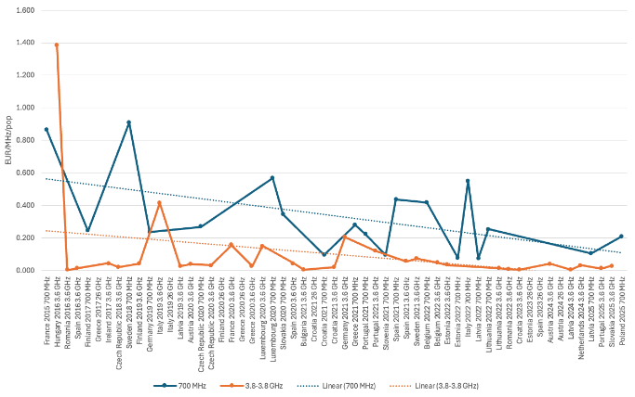
Source: PolicyTracker Spectrum Database 2025; figures adjusted for inflation with 2015 as the baseline using HICP figures from Eurostat https://ec.europa.eu/eurostat/web/hicp/database
On the other side GSMA is currently working on a spectrum pricing report and the preliminary analysis for Europe shows that spectrum costs have increased by more than 150% as a proportion of recurring revenue since 2014, when one excludes outlier 2.1 GHz prices for Germany and the UK:
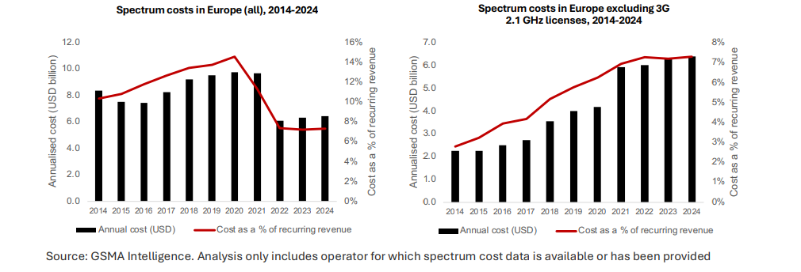
Source: GSMA Intelligence. Analysis only includes operator for which spectrum cost data is available or has been provided GSMA
In a recent report, the GSMA argues that the decline in spectrum prices has not sufficiently reflected MNOs falling revenues. The Global Spectrum Pricing report says aggregate spectrum costs now account for 7% of operator revenues, representing a 63% increase over the past decade. While admitting that spectrum prices have declined in the past 10 years, it stresses that these “were not sufficient to offset the build-up in the total cost of spectrum, largely driven by acquisition of the additional spectrum needed to deliver greater mobile data traffic and the launches of 4G and 5G networks”. The report considers this issue globally rather than on an EU basis, pointing that, when measured in a different way, spectrum prices may be insufficiently responsive to changing market conditions.
GSMA supports some spectrum auction model examples, like for example the Austrian model where operators did not pay cash for licences but committed to infrastructure investments and coverage obligations. This “cashless” or “negative” auction approach aimed to accelerate mobile network expansion, especially in underserved rural areas. While this approach presents social and economic benefits it also brings challenges in monitoring and enforcing the investment commitments. With proper safeguards in place to ensure enforcement, Austria is now seen as a potential blueprint in seeking to balance digital inclusion goals with sustainable telecom investments.

5.6.3. Reserve prices for the 5G auctions
A 2017 study showed that reserve prices are a key factor in determining the final price paid in spectrum auctions. Although many factors can influence auction prices, from wider economic trends to the strength of competition, high reserve prices can lead to nothing other than high final prices or unsold spectrum, while low reserve prices allow the auction to determine a market price. High reserve prices can therefore lead to final auction prices which exceed the economically sustainable market level and hinder investment in networks.
Art. 42 EECC is not specific about how administrations should determine reserve prices, requiring merely that spectrum fees should be “objectively justified, transparent, non-discriminatory and proportionate” and that setting reserve prices should have “regard to the value of those rights in their possible alternative uses.” The tendency of reserve prices becoming the final price may be a sign that procedures need to be tightened. One way of assessing whether auction prices have been set too high is to establish whether the auction closed without any competitive bidding i.e. the final auction price was the same as the reserve price. While this rough method does not capture all cases where the reserve price has been set too high, the table below of 5G auctions shows that 16% (6/37) closed at the reserve price.
Another way of assessing whether a reserve price is too high is to compare it to the average price for that band in the EU over the past 10 years. These are shown in the table below. The final column shows the reserve prices as a percentage of the EU average final price for that award. Taking the relative price into account suggests that the auctions in the last three rows in Spain Portugal and Romania in 2021 may have been reasonable, even though they closed at the reserve price. This is because the reserve prices were all below the average price for the respective bands. See Appendix II B for an analysis on How final auction prices differed from the reserve price in EU 5G auctions.
However, the Italian 700 MHz auction in 2018 raises concerns because the reserve was more than double the average price for that band and there was no competitive bidding. This suggests MNOs may have been forced to pay more than the market rate. The same is true of the Luxembourg 700 MHz award in 2020, although the reserve was a little less in relative terms. Similar concerns can be raised about the French 700 MHz in 2015 where the reserve was more than twice the band average price. There was a small amount of competitive bidding but the price level at which this occurred was likely inflated by the high reserve price.
In conclusion, most auctions seem to work well, demonstrating competitive bidding and a reasonable reserve price, but the design and pricing of a number of awards seems flawed. Two of these happened before the implementation of the EECC in 2020 – in France in 2015 and Italy in 2018 – but the Luxembourg auction occurred in the same year. We also note that the level of reserve prices seems to be moderating. From 2022 onwards no reserve price has been above the EU average final band price.
Table 2: Average final prices in EU spectrum awards 2015-2025
 | Average final price for band (€/MHz/pop)
700 MHz | €0.2667
3.6 GHz | €0.0682
26 GHz | €0.0014
Telecom operators warn that high prices deviate funds from infrastructure investment, thus delaying network rollout. Several providers call for reforms, suggesting that spectrum fees should reflect opportunity costs and economic impact instead of focusing on revenue generation. On the other side they also caution that an EU-wide auction model might benefit large operators, hurting competition.

5.6.4. Cost of Peer review
It is difficult to estimate the costs related to a peer review. The current mandatory notification of the measure should not cause any excessive administrative costs, at least comparing to the organisation of the authorisation process, as it obliges the competent authority just to officially inform the RSPG Secretariat about a measure. If the notifying competent authority asks the Peer Review forum is convened, then it needs to contribute some time and efforts to prepare materials for the Peer Review forum, but it should not be more that what it already prepares for meetings to explain the process to the stakeholders or participants.
Over the course of 2021-2025, 12 Peer Review Forums were held. Seven National Competent Authorities (NCAs) indicated that they attended all meetings during this time, usually with 1-2 representatives (the number of representatives could not be linked to the size of the NCA). Only one mid-size NCA indicated that they attended with five persons on average. The average effort of participating in Peer Review Forum meetings depends on the number of NCA representatives attending, with an average of 30 hours per year per NRA. The effort is considerably higher if the NCA asked for a peer review of an auction, but due to the limited quantitative data obtained, it is impossible to calculate the extent of the additional effort in this case. The perceived added value by RSPG members is still relatively high, although the views show higher divergence than for other work strands . However, certain assignment procedures, which has raised criticism by market players, have not even been subject to a peer review.
Moreover, there is no legal obligation for the Commission the RSPG and the Competent authorities to devote resources in analysing the spectrum auctions measures, assess the evidence provided and develop an opinion. The process requires only limited information provided for the Peer Reviews Forums, with no possibility to request additional information, which de facto does not allow to undertake throughout analysis of the measure. It depends on the good will of the participants, and for this reason it has remained of limited utility in the most difficult cases. There is therefore a limited cost but also a very limited impact.

5.7. Coherence
The spectrum regulatory framework is made up of several legislative acts that pursue common objectives: the EECC works in combination with the provisions of the RSPP, the 2002 Radio Spectrum Decision, the RSPG Commission Decision of 2019 and the EU legal framework for MSS and the UHF Decision. The Commission harmonisation process is supported by the CEPT and by the Radio Spectrum Committee, while the MSS process is supported by the Communication Committee (COCOM) and its specific MSS sub-group. The framework is also flanked by a large number of Commission Implementing Decisions on the EU-wide designation of various frequency bands under harmonised technical conditions as well as a Commission Implementing Regulation on a permit-free regime for small cells.
EECC spectrum measures versus RSPP: To a certain extent, the EECC duplicates the RSPP which under other aspects has now become obsolete and needs an overhaul in the light of technological, economic and policy developments. The Radio Spectrum Policy Group (RSPG) also proposed a range of measures to update the RSPP and ensure it fosters the goals of the EU's Digital Decade and supports that objectives of the EECC. Stakeholders see the EECC as establishing clear legal rules for spectrum management, while the RSPP serves as a strategic planning tool, complementing the EECC by defining long-term spectrum policy goals. However, there is a strong view that the RSPP, which dates back to 2012, is outdated and should be revised to reflect technological advancements, particularly regarding 6G spectrum planning and the evolving digital landscape. Appendix II A to this Report presents the State of play of the implementation of the RSPP and of the proposed incorporation of relevant parts in the Digital Network Act.
EECC spectrum measures versus RSPG Decision: The work of the RSPG is central for the radio spectrum policy development in the EU and for any review of the regulatory framework. Established in 2002, the RSPG has been granted with new tasks by the EECC since 2019, such as related to the peer review. The RSPG Decision reflects a new RSPG status, i.e. it advises not only to the EC but also to European Parliament, the Council and Member States on issues related to spectrum policy, and new tasks related especially with the peer review, the cross-border coordination and preparation to World Radiocommunications Conferences.
The RSPG continues to issue reports and opinions on all crucial elements of EU spectrum policy, as for example recently the Opinion on satellite Direct-to-Device (D2D) connectivity and related Single Market issues and the report on the 6G Strategic Vision, which are in general welcomed by stakeholders and the assessment of the added value of RSPG work is high between the participating MS representatives. For the RSPG deliverables to pursue broader EU benefit, it would be beneficial that the RSPG Secretariat, which is currently provided by the Commission, would evolve from offering only administrative and organisational support, to support the work of the group also on substance.
EECC versus spectrum measures in the EU framework for MSS: the MSS Decision sets specific provisions for the coordinated selection and assignment of spectrum for mobile satellite services in only one band, the 2 GHz band and acts as a ‘lex specialis’, with the EECC acting as ‘lex generalis’, i.e. regulating the issues which are not specified in the MSS Decision.
EECC spectrum measures versus ITU Regulations and international spectrum rules: The ITU-R Radio Regulations (RR) are an international treaty between the 194 ITU Member States on the use of the radio spectrum and coordination rules to provide access to it. The ITU-R RR deal with the allocation of spectrum bands to one or more radiocommunication services (e.g. broadcasting, mobile, fixed and various space services) and establishing regulatory, organisational and technical conditions to avoid cross-border or cross-service harmful interference. They do not mandate the actual implementation and spectrum use by a system or application. That is why an ITU Member State or a group of them (such as the EU) could decide to use different services or different conditions in a given spectrum band, however, taking into account sharing conditions and cross-border coordination requirements defined in the RR in order to protect the use of frequencies in other countries. Selected subset of the ITU-R RR is reviewed and, if necessary, revised every three to four years in the context of World Radiocommunications Conferences (WRC). At each WRC, there are certain agenda items with the EU relevance, i.e. they could affect EU law, policies or programmes, which could result in adopting or amending the technical harmonisation measures adopted under the Radio Spectrum Decision. An EU position for each WRC is set by the Council Decision pursuant to Article 218(9) TFEU.
As regards satellites, ITU-R RR introduce a multistage coordination and notification procedure—ranging from advanced publication to bringing satellite systems into use and recording them in the Master Register. ITU filings and coordination obligations fall solely on Member States, not the EU or other transnational bodies, limiting the feasibility of shared spectrum management models such as Licence Shared Access at the international level.
ITU-R RR by defining rules for avoidance of harmful interference are linked to one of the main principles of spectrum management under Article 45 EECC, which requires Member States, when applying the EECC, to comply with international law. ITU-R RR could be also linked to the authorisations as the EECC expressly allows Member States to attach to the spectrum rights of use technical and operational conditions necessary for avoidance of harmful interference.
The interplay between ITU obligations and national satellite licensing frameworks continues to require careful coordination within the EU, particularly where multiple operators seek access to the same bands, such as the 2 GHz MSS band, and where pan-European solutions must still rely on filings by individual Member States.
EECC spectrum measures versus Space Act proposal – The adoption of the Space Act should not interfere with, but would, regarding satellite communications, be complementary to the regulation of radio spectrum under the EECC as the scope and objectives of these two acts are different. The Space Act is meant to regulate the safety, resilience and sustainability of space activities in the Union in the framework of Member States responsibilities under the Outer Space Treaty and related treaties, while the authorisation, use and management of radio spectrum are governed by the EECC and the Radio Spectrum Decision 676/2002/EC in the context of rules adopted in the context of the International Telecommunications Union rules.

5.8. Relevance
The EECC is seen by most stakeholders as a relevant and effective framework for EU spectrum policy, particularly for terrestrial services. However, several stakeholders highlighted shortcomings in addressing services with cross-border or pan-European scope, such as satellite communications. Several novelties were introduced by the EECC in the regulatory framework in relation to spectrum policy to strengthen its single market dimension. These include the establishment of a peer review process to promote consistency of the conditions attached to the selection and granting of spectrum usage rights, a spectrum coordination mechanism to avoid cross-border interference between Member States, longer duration of spectrum usage rights for the crucial bands to increase predictability, more coordination of spectrum assignments, facilitation of the access to radio local area networks all over the EU, and common EU criteria for the deployment and operation of small-area wireless access points. The regulatory improvements in spectrum policy introduced by the EECC went to the right direction, aimed at addressing persistent problems, however the agreed measures were not sufficient to fully exploit single market benefits, nor to sufficiently incentivise investments.
In the meantime, a new need emerged to address the quickly evolving satellite market and to better integrate the specific EU legal framework for MSS in the general framework. While the EECC focused on establishing harmonised rules for authorisation of spectrum mainly for terrestrial broadband network and services, including 5G, it has left the authorisation of satellite spectrum to national processes, despite of its inherent cross-border potential. This resulted in a very fragmented rules and conditions between Member States that do not allow the EU satellite operators to easily attain scale and offer cross-border services, especially satellite connectivity services, which have become crucial for providing connection to underserved and remote areas, enhancing resilience and enabling new technologies. Spectrum for satellite use is harmonised and managed primarily at the international (ITU) level while the Member States authorise it in different ways for the provision of satellite services. Therefore, a common approach to satellite authorisation is necessary to improve and level the conditions for satellite operators to use radio spectrum across the EU. The RSPG adopted an Opinion on satellite Direct-to-Device (D2D) connectivity and related Single Market issues, in which it recognises the need to frame access to EU satellite market by setting common authorisation requirements and by establishing an appropriate coordinated enforcement mechanism, the ongoing work aims also at levelling the playing field with constellations from outside the EU.

5.9. EU added value
The EU spectrum framework has brought added value setting a vision for 5G deployment, encouraged early national preparations and supported harmonised spectrum planning. The early identification by the RSPG of the need for low (coverage in 700 MHz), mid (capacity in 3.5 GHz) and high (pioneering and innovation in 26 GHz) frequency bands for 5G proved to be the right recipe. The EU framework has laid the foundation for common technical conditions and harmonised band planning, supporting equipment interoperability and cost reduction. Thus the 700 MHz and 3.5 GHz frequency bands have been established as the core bands for 5G. Some Member States have also awarded, or by other means made the 26 GHz frequency band available. However, 5G rollout in the 26 GHz frequency band is not developing as anticipated in the EECC.
In the EU, spectrum is harmonised based on a successful European governance model that is unique in the world. The European model aims to coordinate contributions to international and European harmonisation initiatives and to leverage and act as a multiplier of EU positions for World Radiocommunication Conferences. In some instances, the model has been quite effective. The RSPG process leading to the EU position on WRC helped increasing the awareness among Member States at an early stage about the EU interest related with particular WRC agenda items and building trust and consensus about direction of related EU position. This contributed to the swift adoption of a Council Decision on WRC. Moreover, Member States were able to insert elements of EU position in the CEPT preparatory work, so that European Common Proposals when adopted by CEPT were supporting the EU position.
In areas such as regulatory predictability, cross-border coordination, market integration and investment outcomes however, the progress has been insufficient comparing to its objectives, initial ambition and EU needs. There remains huge untapped potential in providing investment predictability by coordinating authorisation procedures, as regards valuable spectrum for wireless broadband and satellite. Moreover, spectrum sharing and flexible licensing models, as enabled under Articles 45, 48, and 51 of the EECC underused in practice. Mechanisms like Licensed Shared Access (LSA) and spectrum trading have seen limited uptake, largely due to inconsistent national implementation and a lack of centralised guidance.
An example of missed opportunity in terms of improved predictability is the low regulatory predictability stemming from the non-adoption of long licence durations. Most of the Member States opted for the minimum allowed in the EECC and only half (46%) of the 5G auctions opted for assigning spectrum for 20 years or beyond. This has not had the effect of enhancing investment certainty for operators and left EU markets far behind the US and Asia, where long licence terms and quasi automatic renewals are standard. This has significantly reduced the attractiveness of the EU mobile sector to financial investors and deprived operators from access to capital, thus delaying deployment.
Another example is the RSPG peer review mechanism which has been reduced to a peer learning process, without tangible impact. Participation has been limited, and Member States’ engagement has been uneven. Strengthening participation in the peer review process could contribute to greater consistency across the EU. Moreover, cross-border coordination challenges—particularly with third countries—can undermine the coordinated timing of spectrum authorisation as envisaged under Article 53 of the EECC. Addressing these challenges requires the strategic use of existing tools, notably the RSPG “good offices” mechanism, which is however currently effective only for interference between Member States in harmonised bands. Despite these mechanisms, persistent interference from non-EU neighbours—particularly along the EU’s eastern borders—continues to affect 5G deployment. While some cases have been resolved through coordination efforts, many remain unresolved, particularly in areas close to conflict zones or with high frequency congestion, it is a missed opportunity that the EU could not benefit from increased solidarity and a more systematic intervention of the RSPG also to tackle interferences from third countries.
Furthermore, there is at present no harmonised EU licensing framework simplifying cross-border spectrum use by establishing common procedures for authorisation, renewal, and compliance. There is therefore untapped Single Market potential to reduce administrative burden for operators needing licences in multiple Member States and to improve regulatory predictability—through uniform pro-investment licencing conditions, making the EU more attractive for investment.
As regards satellite, currently, most large satellite constellations are registered in the United States, where operators benefit from a single licensing process and clearer timelines. They then provide services in the EU, benefiting from the open skies framework and the general authorisation regime, even in some cases from the absence of any specific rule at national level (cf. RSPG D2D Report). The lack of an EU harmonised model with streamlined access to spectrum, especially for satellite services but also for future 6G networks, represents a barrier to the development of a strong EU satellite sector, the EU wide development of services and to related potential of enhancing EU resilience and security.

General Authorisation
Under the EECC general authorisation, Member States may set ex-ante conditions for the provision of networks or services and for the use of spectrum or numbers and that there is currently some harmonisation, as there is a maximum list of those conditions (albeit very open) set by the sector-specific EU law i.e. EECC. Any provider that complies with these conditions may provide electronic communications networks or services and any control can take place only ex-post.
Pursuant to Article 122 (3) EECC, BEREC shall adopt, by 21 December 2021 and every three years thereafter, an Opinion on the national implementation and functioning of the General Authorisation (hereinafter: GA), and on their impact on the functioning of the internal market. The EECC was adopted in 2020 and since then, BEREC delivered two Opinions - in December 2021 and in December 2024.
According to the 2024 BEREC Opinion (see footnote 179), the EECC transposition shows that most of the Member States have a general authorisation system in place (except for Denmark not implementing a general authorisation regime) and France which has the system in place but does not require a notification), with the NRA being entrusted to manage the whole general authorisation (GA) scheme.
Article 12 EECC provides for the maximum amount of information that can be requested from notifying providers under general authorisation of electronic communications networks and services. Article 13 EECC on the related conditions that may be attached to the GA turns the list of the possibly applicable GA conditions in Annex I EECC into an exhaustive, maximum one and thus limiting the range of data that national authorities can ask notifying operators to provide. The maximum requirement that can be imposed on providers to enter the market is to submit a notification to the national competent authority (Germany and Sweden require only notifications).
In fulfilment of Art. 12 (4) EECC requirements about the minimal information required from providers for operating on the market, BEREC published guidelines for the notification template and established a GA database, a Union database of the notifications transmitted to the competent authorities by providers falling under the GA regime and subject to the notification requirement (EU register for authorised undertakings).
The majority of EU NRAs are responsible for implementing the relevant provisions related to the notifications and the rest of the tasks under Title 2, Chapter 2 EECC except for IT where a ministry is designated as a competent authority while the regulator (AGCOM) forwards the national notifications to BEREC. The BEREC database is maintained by the BEREC Office.
Although the harmonised BEREC notifications’ template is used by more than half of the NRAs, being non mandatory, and according to BEREC’s Opinion on the national implementation and functioning of the general authorisation, and on their impact on the functioning of the internal market, pursuant to Article 122, paragraph 3 EECC, it seems that national adaptations are still possible, and especially, by the authorities which decided not to adapt their national notification form. Some regulators also opted for further simplifying BEREC notification requirements by setting aside certain fields (e.g., no distinction between a wholesale and retail level providers). This approach questions the EU added value of the measure and may have a dissuasive effect on cross-border operations.
The BEREC database was set up and running by December 2020. As of 18.11.2025, 25 171 country providers’ notifications were submitted to the BEREC database. 23 299 notifications are for networks and 51 723 for services. Most NRAs upload the database monthly but there are also regulators that do it less regularly (e.g., every 3-4 months, once a year etc.). In addition, the course of the analysis of the functioning of the GA and its effects on the single market a 2024 BEREC Opinion (see footnote 179) draws the attention to the fact that authorised ECN/ECS providers have signalled divergencies in national notification experiences outside the EECC requirements which stem from either EU or national legislation and concern security, data protection, data retention requirements, the duty to notify the beginning of the activity in national language, the duty to have a national digital identity to run the online notification process, the duty to have national representatives to interact with national authorities etc. Despite falling outside its remit, BEREC in its 2024 Opinion (see footnote 179) also admits that all these requirements sometimes are very burdensome and constitute obstacles for completing the single market and enabling cross-border operations and activities.

6.1. Effectiveness
In its Opinion, BEREC confirms that the harmonised maximum requirements for the notifications under the GA have contributed to lowering obstacles to market entry, promoting market transparency and/or consistency in notification-related requirements across Europe. In general, the general authorisation regime has contributed to achieving the EECC objectives.
Industry stakeholders’ assessment of the effectiveness of EECC provisions related to general authorisation is more nuanced. Industry stakeholders mostly agree that the EECC has been effective, even – in the words of one stakeholder – “world-wide best practice” in terms of direct one-off costs (if any) for the notification. Several industry stakeholders also point out that the effectiveness varies across Member States due to specifics of national implementation and application.
Article 12 (1) EECC explicitly exempts NI-ICS from the general authorisation regime, but the flexibility provided by the Directive reveals different approaches regarding the types of networks or services to which the general authorisation applies. For example, submarine cable systems owned by CAPs are considered as non-public ECNs and Member States may decide at national level to subject such networks and non-public ECS to the general authorisation regime. Regarding non-public ECNs and non-public ECS only 4 Member States require prior notification. Conveyance of signal services such as transmission services used for M2M services are not always subject to general authorisation. Sometimes, this depends on whether there are contractual relationships with local businesses, or the connectivity component is not intrinsically linked with the IoT/Machine-to-machine service or product. A notification for such services is also not always required.
The BEREC notification template was adopted fully by the majority of NRAs, which adds to effectiveness by “promoting market transparency and/or consistency in notification-related requirements” across the EU. The functioning of the current database revealed some issues related to the identification of providers and treatment of duplicates, as the same undertaking is not unified when providing networks and services in more than one country. To avoid duplications and inconsistencies, further improvements are needed for cross-border providers of networks and services to ensure they notify only once according to a harmonised template. Concerning updates of the database, BEREC recommends maximum update intervals of 2 months to increase the reliability of the database.
The maximum list of harmonised conditions introduced by the general authorisation system and the harmonisation powers provided to BEREC as regards the notifications and the database, in general, functioned well because they limited to a certain extent the possibility for the Member States to impose additional conditions. However, the transposition revealed certain divergencies among Member States and allowed for NRAs to further develop the general authorisation conditions in secondary legislation or other administrative/regulatory decisions. The lack of a uniform approach led to incoherent application and revealed some limitations either for cross-border or smaller, national providers. Furthermore, there is no harmonised approach to all other applicable national rules and conditions relevant for the authorised ECN/ECS providers which do not stem from the EECC but are also part of other EU legislation. In this regard, some stakeholders share that divergent national rules on lawful interception present a market barrier for telecom operators causing legal uncertainty and possibly delaying the commencement of their activities or the launch of new services. This may undermine the objective of further harmonising general authorisation rules within the EU. Several industry associations (incumbents and mobile operators) stated that administrative charges for general authorisation/notification have never impeded entry into the EU electronic communications market.

6.2. Efficiency
All governments consider the cost for operators of compliance with Articles 12 and 16 EECC as necessary and proportionate to their objectives.
At the same time, a great majority of NRAs do not assess their own cost of compliance. Several NRAs state that their administrative fees are very low and have included the possibility to exempt smaller operators from them or otherwise adjust the fees (e.g. in one example, 0.2% of turnover and a minimum turnover threshold needs to be achieved for the fee to become due). A few NRAs mention that they neither levy any administrative charges nor change them for several years, having sufficient budget to cover their needs. This signifies that for some NRAs the costs of compliance are low, and consequently Articles 12 and 16 EECC can be considered efficient.
Many industry stakeholders find the cost of compliance with Articles 12 and 16 EECC reasonable and not significant but note differences in implementation between Member States that constitute an additional administrative burden. The procedural conditions of general authorisation also vary. Some countries require companies to have an address and establishment within their jurisdiction; others require digital identities. In contrast to the governments, the consulted industry stakeholders found that some changes to the Annex I conditions are warranted to further simplify the authorisation process. Also, despite the BEREC Notification Template, the conditions required are very different in practice across different countries.
Overall, many industry stakeholders find their reporting obligations under Arts. 20 and 21 EECC cumbersome and complex and ask for more harmonisation in this regard.
This concerns following issues: duplication of requests for information (e.g. same or similar data is requested for statistical reporting and later for market analysis), different data and information requests by different NRAs for the same purposes without apparent reasons or justifications, different frequency of information requests, no difference in reporting obligations for smaller operators, which is more burdensome for them. However, the responding stakeholders have not quantified the additional administrative burden caused by these inefficiencies.
Overall, many industry stakeholders find their reporting obligations under Arts. 20 and 21 EECC cumbersome and complex and ask for more harmonisation in this regard.

6.3. Coherence
The national implementation of the EECC provisions on general authorisation is internally coherent but – according to industry stakeholders (incumbents and mobile operators) – lacks external coherence with national rules on cybersecurity, lawful interception, data retention and e-privacy, which often result from relevant EU legislations. This lack of coherence is noted specifically in relation to the conditions that may be attached to the general authorisation, according to Annex I EECC.
In the area of cybersecurity, the diverging national rules seem to result from the differences in the transposition of the NIS 2 Directive. The said industry stakeholders suggest that further harmonisation and closer cooperation between Member States are necessary, for example, to define common security conditions for telecom operators. Some industry stakeholders consider that the lack of coherence between the general authorisation conditions related to cybersecurity, lawful interception, data retention and e-privacy leads to fragmentation and may prevent the achievement of the single market in electronic communications.

6.4. Relevance
While all stakeholders agree that the current general authorisation regime under the EECC remains relevant, their views on what changes might be necessary are divided. Governments have not identified any further areas requiring harmonisation in the context of the general authorisation. By contrast, some governments warned against “over-harmonisation” that would limit the discretion of NRAs to adjust to the national circumstances.
Several industry stakeholders consider that the scope of application of the general authorisation regime must be expanded to include NI-ICS providers to level the playing field with providers of electronic communications services. Currently, NI-ICS are required to notify only in several countries and this may pose challenges for instance, in the emergency communications and especially, for people with disabilities or in terms of VoIP services and the ability to address related issues (fraud, interconnection) in a harmonised way.
In its 2024 Opinion (see footnote 179), BEREC also signals the need for reflections around the suitability of expanding the scope of the GA framework to NI-ICS providers, other digital players, virtualised communications services or activities, also in the light of the EECC review (see reference in footnote 179). BEREC draws the attention to the need for reflection for expanding the scope to other players with a view to ensuring the same regulatory treatment in relation to the provision of the same services and relevant end-user protection guarantees in the usage of both NB-ICS and NI-ICS.

6.5. EU added value
Almost all governments and most industry stakeholders agree that the general authorisation regime under the EECC has brought added value beyond the TFEU guarantees of freedom of establishment and services provision. However, the extent of this added value has been differently assessed by stakeholders.
A few governments point out that the specific EECC contribution is marginal or non-existent because the general authorisation regime was introduced decades earlier.
Some stakeholders point out that the exemptions from administrative changes for small operators are not guaranteed, and they may experience disproportionate administrative burdens. Only a few NRAs mention the problem with operators not having an establishment in the country where they provide electronic communications services.
At the same time, the value added of the EECC general authorisation regime is not only in simplifying domestic and cross-border market entry, but also in providing the NRAs with sufficient information for carrying out monitoring compliance and supervision of operators under their jurisdictions, conducting enforcement activities and market reviews. Art. 12 EECC and the BEREC Notification Template specifically contribute to this added value.
The evaluation findings point out to the need for further harmonisation, update and simplification of the general authorisation regime and paving the way for facilitating the deployment of more virtualised and centrally managed electronic communications networks and software (cloud)-based electronic communications services in the EU.

Universal service obligations
All Member States have transposed the EECC universal service provisions (Articles 84 to 92) that require and allow Member States to put in place obligations serving as a safety net and ensuring that all consumers have access at an affordable price to adequate internet access and voice communications services, including the most vulnerable in society as well as persons with disabilities and those in remote areas.
The universal service rules should be assessed in the context of the overall availability and affordability of adequate broadband and voice communications in the EU. In 2024, over 94% of EU households had internet access, although the availability of an internet connection at home is significantly lower among persons with disabilities as opposed to those without disabilities. Fixed broadband coverage (for download speed of minimum 30 Mbps) achieves 90% of households in almost all EU countries. In nearly all Member States LTE-mobile coverage is close to 100%. Satellite coverage of households in almost all EU Member States is 100%. As regards affordability, according to ITU (2025): “The Europe region leads in broadband affordability, making connectivity accessible to all. In terms of affordability, Europe stands out as the region with the most affordable broadband services globally. Entry-level mobile-broadband services account for just 0.3 per cent of gross national income (GNI) per capita, compared to a global average of 1.1 per cent.“ The share of people in the EU that could not afford to have an internet connection has significantly declined over the last decade and was around 2.1% in 2024. For those identified as being at risk of poverty, the share was higher, reaching over seven per cent (of people at risk of poverty) in 2022.
Adequate broadband has been defined (Article 84) by 21 Member States, while six Member States have not yet done so or do not intend to. Most countries have set a minimum download speed of 10 Mbps and few have set 30 Mbps. One Member State has defined 100 Mbps (Romania) maximum download speed which is the maximum so far. Where upload requirements are set, they range from one to five Mbps. Sixteen Member States have requirements also for voice communications services. BEREC’s latest report on best practices to support the defining of the adequate broadband access by Member States was published in March 2024.
Affordability measures (Article 85) can be imposed for consumers with a low income or special social needs. Member States take different approaches in determining the price of an affordable universal service (nationwide average, based on thresholds etc.). Due to the variety of measures, some of which are outside the universal service regime, the supporting study provides various figures on the affordability measures in Member States. There are legislative measures for consumers with low income for broadband/voice communications in around 15 Member States. Legislative measures for consumers with disabilities for broadband/voice communications and specific equipment and services exist in 15 Member States. Providers make voluntary offers for social tariffs in six Member States. Voluntary offers for consumers with disabilities exist in seven Member States.
Public funding is envisaged for financing the universal service unfair financial burden (Article 90) in nine Member States. Seventeen Member States envisage to use an industry fund, of which five Member States intend to use both industry and public funding. Austria's industry funding model allows for contributions from non-traditional and independent communications service providers (NI-ICS). Eight Member States have defined how to assess an unfair burden. Only two of the Member States have reported actually paid compensation since 2021.
Recent comprehensive figures of the cost of universal service obligations (USO) in Member States are not available. According to Cullen International data, Member States’ annual net cost calculations, where available, range between under 1 million euro to around 8,6 million euro.
A designation of a universal service provider (Article 86) has been imposed in nine Member States. Designation in certain service areas/regions only and case-by-case designation for individual request are also possible in three countries. In Sweden, no service provider is obliged to provide universal service, but there is a state aid measure administered by PTS (the Swedish Post and Telecom Authority).
Several Member States have made use of the options to extend the scope of universal service rules to other groups. For requesting an adequate broadband internet access, microenterprises are eligible in 14 Member States (MS), small enterprises are eligible in 13 MS, medium enterprises are eligible in 10 MS, not-for-profit organisations are eligible in 12 MS. Affordability applies also to microenterprises, SMEs and not-for-profit organisations in three Member States.

7.1. Effectiveness
The EECC objectives (Art 3(2)) include “high and common level of protection for end-users”. This includes addressing the needs, such as affordable prices, of specific social groups, in particular end-users with disabilities, elderly end-users and end-users with special social needs, and choice and equivalent access for end-users with disabilities. The three characteristics of the current universal service concept address affordability, accessibility (in universal service rules this includes also support to consumers with disabilities for terminal equipment, and specific equipment and specific services) and a possibility for Member States to address availability. A challenge to harmonisation is posed by the significant variation in implementation of the rules in Member States.
As regards the stakeholders’ feedback on the assessment of universal services rules, the responses to the exploratory consultation (2023) were diverse and not conclusive on universal service. An equal number of respondents considered USO significantly or “not at all” useful to grant connectivity access to low-income consumers. Many respondents did not reply to the questions on universal service funding. Among those who replied, close to half of them indicated that the USO should continue to be funded by the public general budget, while the others considered that the USO should be funded by ECN providers. Companies (mainly ECN providers and broadcasters), business associations and almost all the responding public authorities expressed their support for maintaining the current financing model.
The feedback to the Commission’s 2024 White Paper “How to master Europe’s digital infrastructure needs?” (although there was no specific scenario proposed for the USO) highlighted that proper enforcement of current rules was missing; and therefore, focus should be on implementation and compliance of current rules. According to the feedback, some Member States have not created many internet connections under the universal service regime. The EECC already provides a framework for incentivising telcos to prioritise accessible connectivity and deployment of broadband to consumers in more remote regions. BEREC underlined in its answer that before introducing changes and imposing new universal service obligations it would be necessary to assess the economic impact on all actors, and that the current rules are future-proof. European Consumer Organisation BEUC highlighted that it is too early to conclude if changes to universal service financing model are needed.
The Commission’s 2025 Call for evidence on the Digital Networks Act highlighted universal service for protecting vulnerable end-users and re-focusing universal service obligation on affordability. In their feedback, most stakeholders acknowledged the need for the USO framework to flexibly accommodate varying regional needs and market conditions across Member States. Member States, NRAs and consumer organisations advocated for an inclusive and future-proof USO framework that supports digital inclusion, ensuring all citizens, particularly those in rural or underserved areas, have access to high-quality internet services. The majority of telecom operators argued that the market now provides a wide variety of offers to meet the needs of consumers and suggested that USO could be phased out. Public intervention, for example through voucher schemes, would be more efficient. The technologically neutral approach was emphasised.
Data on availability of adequate broadband on the different fixed, mobile (4G LTE and 5G) and satellite technologies show that the availability (Article 86) of adequate broadband <30 Mbps is already largely ensured in the Member States and not a significant issue in terms of coverage. The EECC underlines technological neutrality on provision of universal service. A technology or technical solution is not favoured over another for fulfilling the availability of adequate broadband requirement. The most efficient and effective technology is chosen, which makes the approach future-proof.
Given the widespread commercial roll-out of fixed and mobile networks capable of providing adequate broadband, availability does not seem to be a concern based on the quantitative figures. The availability of adequate broadband internet access service (as defined by the Member States) in almost all Member States is fulfilled by offers based on either commercial or publicly funded networks. Availability is also addressed through alternative public policy tools such as State Aid measures or financial instruments. Even where universal service providers were designated the actual number of imposed obligations was relatively low. Therefore, the supporting study argues that the benefits of the universal service regime as regards availability in the past (2021 to 2024) have been limited, however, the low number of requests does not necessarily indicate ineffectiveness of the availability rules that can be considered to be neutral in terms of effectiveness.
Measures to ensure affordability (Article 85) for consumers with low-income and special social needs differ significantly across Member States. The measures include various forms of support, such as vouchers, social tariffs and discounts. According to the universal service supporting study, ten Member States apply affordable broadband prices to all consumers, while 11 Member States limit measures to specific groups, notably users with low income or those with special social needs. Four Member States address affordability through the social welfare system. Eligibility definitions differ: some countries restrict affordability schemes to consumers, while in three countries eligibility is extended to microenterprises, SMEs and not-for-profit organisations.
Member States have defined an affordable price for adequate broadband services, typically applying a uniform rate nationwide. The methodologies for determining what constitutes an affordable price vary and include, for example, affordability based on national market prices for products that meet only the minimum technical USO requirements, or use of income or expenditure-based benchmarks. In some Member States operators also provide voluntary offers for users with special social needs or low income. Voluntary offers are available in some countries but lack regulatory oversight, leading to inconsistency. Lack of transparency and the complexity of procedures can be important barriers. While measures are in place, their practical impact seems limited due to low take-up, administrative burden, and lack of visibility or lack of proactive consumer service.
Member States have additional measures to support consumers with disabilities through the universal services regime (Article 85(4)). These include, for example, higher quality of service, free service and equipment support and measures outside universal service.
Stakeholders highlight the important role of competition in continuing to ensure affordable prices to consumers in the EU. Affordability remains a problem in rural areas or areas with limited competition, where prices can be high, especially in fibre-only areas. Some Member States have addressed these gaps through targeted public subsidies, such as the “conecta35.es” programme in Spain.
While market competition has generally kept broadband prices low across the EU, affordability issues persist in certain areas, making USO-based measures an important but limited safety net. The universal service supporting study also points out that the variable application of the provision may mean that not all consumers with difficulties have been addressed in all Member States.
Overall, the effectiveness of affordability measures for consumers with low income and special social needs seems to be low to neutral, while further data is needed to fully understand the implications of the affordability measures for consumers with disabilities.
Article 90 EECC allows Member States to finance universal service obligations through public funding, industry contributions, or both, following principles such as transparency and proportionality. However, it seems challenging to activate the funding in practice and according to the universal service supporting study, there is no conclusive evidence of net cost calculations to universal service providers of providing adequate broadband for internet access service. Relatively few Member States have designated universal service providers and even fewer have assessed an unfair burden. It is therefore not possible to assess the effectiveness of the measure as updated in the EECC. Also based on past experience, funding processes are seen as bureaucratic and costly, with risks of litigation particularly with industry funds. NRAs generally view the mechanisms as appropriate, but operators argue that universal service, as a public policy tool, should be state-funded. The practical use and demonstrated effectiveness of the costing and funding mechanism remain limited.

7.2. Efficiency
The number of end-users benefitting from the provision by a designated universal service provider seems to be relatively low compared to the resources it requires. There is limited data available, but considerable administrative costs can be incurred by public authorities, particularly where broadband access is provided on a case-by-case basis. The average annual administrative costs vary in Member States, however, the scope covered by the universal service schemes of the Member States differ, with some Member States treating social aspects separately from the universal service and the figures are thus not comparable. The costs stem from technical reviews required to assess the actual unavailability of broadband, coordination with operators, and the process of selecting and designating universal service providers. The efficiency of the mechanism for securing availability could thus be questioned due to the resources required for relatively limited outcomes in terms of new coverage or consumer uptake. Several industry stakeholders emphasize the high administrative cost of the regime, and the procedures can be very lengthy for consumers.
Most Member States have not set an affordable price and/or not all consumers are eligible. The administrative costs linked to affordability provisions are generally low, as NRAs and ministries are not extensively engaged in designing or monitoring such schemes. The limited implementation also means that the benefits in terms of promoting internet take-up among consumers with low income and special social needs are still minimal. The proportion of beneficiaries remains very small in most countries—ranging from negligible levels to a maximum of around 2.8% of the population. These figures do not allow for conclusions to be reached about the efficiency of the affordability provisions, as costs could outweigh benefits both in cases where there are objectively few concerns around affordability, as well as in cases where consumers with genuine needs have not been reached. These figures do not fully align with the broader population segments that report affordability as a barrier to internet adoption, suggesting a possible mismatch between policy objectives and implementation.
While most Member States have envisaged a specific financing regime to be applied, there has been limited actual use of the financing mechanism. As mentioned above, according to the universal service supporting study, since 2021 and until 2025, only two Member States reported that they have paid compensation in practice. This does not provide sufficient information to assess its efficiency. However, due to the design of the universal service costing and financing system (and from previous experience), it is reasonable to expect that there will be significant administrative costs if it becomes operational. The costs could be outweighed by the benefits in terms of beneficiaries of the regime.

7.3. Relevance
The ubiquitous availability of basic broadband access in Europe is calling into question the relevance of the availability component of the universal service regime. The data shows that increasingly, at least at the level of safety net, technologies like mobile and satellite may provide a widespread solution. While there may be limited gaps regarding mobile coverage, satellite offers 100% coverage in most of the Member States. Over a longer time horizon, measures taken by Member States under the Digital Decade Policy Programme to achieve availability of Gigabit fixed connectivity and 5G to all households may raise the level of availability significantly above the quality thresholds that have currently been set for universal service internet access. This raises a question about the relevance of the availability rules in the universal service regime.
There is a low number of requests for availability under the EECC provisions. However, the universal service regime principle as a safety net ensuring that all consumers are included in a fully developed digital society continues to be relevant and related to the Digital Decade targets. It should be noted that universal service may also appear less relevant where affordability of essential services, including connectivity, is addressed through the social welfare system and not within the sector specific universal service regime.
The objective of ensuring that adequate internet access is affordable and that consumers with a low income or special social needs can participate in the digital society remains relevant. However, as noted by the supporting study, this objective can also be addressed through other means.
- First, affordability is often a competition issue and can be addressed through market regulation. Prices for broadband in the EU are some of the lowest globally due to consistently high levels of retail competition over the last decade. Operators report that the electronic communications sector has consequently become an outlier in terms of overall inflation in the last three years, showing a price deflationary trend in contrast to other sectors.
- Second, affordability for consumers with low incomes or special social needs is part of the social legislation and the social welfare system. For this reason, not all Member States apply sector specific universal service measures for these consumers. Nevertheless, in the event that these other measures are not sufficient to meet specific needs (in particular for those with low income, special social needs and consumers with disabilities), given the importance of digital inclusion to society, affordability provisions in the context of an updated EECC could be relevant going forwards.
The share of people in the EU that could not afford to have an internet connection has significantly declined over the last decade and was around 2.1% in 2024. Data also shows that affordability for consumers with low income or special social needs remain a relevant problem in several Member States, especially in rural areas where only expensive technologies (e.g. satellite) may be available. The share of people in the EU that could not afford to have an internet connection is higher among people who are at risk of poverty (2024 Commission report on access to essential services). It is also relevant to note that affordability (costs) is not necessarily the main reason why consumers without internet do not subscribe. Recent data is not available, but based on data from 2019, most common reasons were “not needed” and lack of skills, while the cost was the third most common reason why consumers without internet did not subscribe.
The relatively small relevance of the universal service availability possibility can also be assessed in relation to the EU broadband state aid spending outside the universal service regime. Many Member States which do have a rural coverage gap have allocated state aid for the deployment of Gigabit-capable broadband. According to European Commission data, Member States spent €5.26bn on broadband state aid in 2023, representing a 69% increase compared to 2022.

7.4. Coherence
The services provided in Member States under the universal service regime constitute a Service of General Economic Interest (SGEI) within the meaning of Article 106(2) TFEU. Compensation may fall outside Article 107(1) TFEU if the Altmark criteria are fulfilled; otherwise, it constitutes State aid but can be declared compatible for example under the SGEI Decision or the SGEI Framework. This ensures full coherence between the universal service regime and the State aid framework.
Universal service is designed to encompass limited basic services. NRAs, when addressing availability of adequate broadband internet access services, take into account, inter alia, ongoing and planned commercial roll-outs, as well as pending roll-outs based on State aid measures or EU funding. Therefore, there should be no incoherence between State aid rules and universal service provisions, which do not target the same level of quality of service and complement other EU policies on investments in network roll-out. Most stakeholders agree that universal service is not an instrument for network roll-out of the “highest” quality in the market. It is also important to distinguish clearly between the universal service regime, under which Member States define a limited SGEI aimed at guaranteeing essential connectivity, and broadband State aid measures, which support the deployment of very high-capacity networks. These mechanisms serve different policy objectives and therefore do not lead to overlaps or inconsistencies under the State aid framework.
Affordability can also be covered by the social welfare system of the Member States. Several Member States report that affordability measures for consumers with low income and special social needs are covered by their social welfare system. In such cases, the flexibility of the EECC and its consideration of national circumstances ensures the coherence with national social welfare systems but do not provide for harmonised measures.
Social vouchers can also support broadband access for some specific categories of consumers and can be designed in line with State aid provisions as one alternative tool open to Member States to ensure that users have access to affordable broadband.
The European Accessibility Act (EAA) refers to and complements the EECC by setting forth additional accessibility requirements related to electronic communications services. EECC universal service rules set a requirement on support to consumers with disabilities. The scope of the EAA is complementary to the universal service provisions and it lays down concrete accessibility obligations as regards electronic communication services, imposing for instance that real time text is provided by electronic communication services in addition to voice communication and requesting the provision of total conversation in the cases where video is provided in addition to voice communication. Moreover, the EAA sets forth mandatory accessibility requirements as regards access to emergency communications delivered by providers of electronic communication services, complementing the accessibility obligations laid down in Article 109 of the the ECC. The EAA also ensures that, when handling emergency communications to ‘112’, PSAP operators responding to those communications issue accessible responses, that persons with disabilities can perceive and understand. The scope of the two acts is slightly different since the obligations of the EAA relate to electronic communication services with the exception of transmission services used for the provision of machine-to-machine services, whereas the EECC universal service regime relates to the provision of adequate broadband internet access and voice communication services.
The universal service supporting study assesses that the public funding mechanism for universal service is coherent but concludes that the industry funding mechanism may create artificial preference over other mechanisms funded via public funds and may be incoherent with the wider objectives of the EECC. According to the universal service supporting study, the funding for universal service policy should come from state resources rather than an industry fund, as the primary goal is to address market failures and social inequalities.

7.5. EU added value
The universal service regime is designed in a flexible way to allow Member States to implement it taking national circumstances into account due to the significant differences between the countries. The EU added value refers to the benefits provided by EU legislation. However, the national flexibility and divergence of the implementation of the rules limits the EU added value in terms of economies of scale and efficient administrative procedures.
That said, the USO regime has provided an important basis for the harmonisation of approaches that may otherwise have diverged to a significant degree. Before the entry into force of the EECC provisions on universal service broadband, nine Member States had already introduced a broadband universal service, with some degree of variability in the definition across those countries. EECC rules provide limitations on the definition of adequate broadband as well as the minimum set of services set out in Annex V that provide a coordinated approach for the minimum bandwidth. The EECC provides legal certainty and guidance on the costing (in EECC Annex VII) and financing of universal service.
While giving certain legal certainty, the availability provisions seem to have limited EU-added value since, for several reasons, notably because of commercial and publicly funded roll-out, the availability of adequate broadband (at universal service speeds) is widely ensured throughout the EU.

End-user rights
In general terms, Europeans enjoy a high-level of end-user experience and protection in the electronic communications sector for choice, price and quality of services. The European electronic communications legislative framework (EECC) and the EU’s competition policy ensure consumer choice and competitive markets. In 2024, over 94 per cent of EU households had an internet access, up from 80 per cent in 2014. Nine in ten Europeans are also satisfied with the upload and download speed of their internet connection at home. In global comparison, Europe stands out as the region with the most affordable broadband services. According to the Study on mobile and fixed broadband prices in Europe 2022, in comparison, the EU27 region tends to offer the most affordable prices, particularly for Single Play offers below 999 Mbps. The EECC's end-user rights ensure solid consumer protection and empower consumers in aspects like changing providers, porting numbers or getting information on the quality of services. Nearly half of Europeans who have changed a service package provider have not experienced problems in doing so. The European Consumer Organisation BEUC notes in its feedback to the Commission’s Call for evidence on the Digital Networks Act in 2025 that the “EECCs end-user rights chapter provisions on switching, contract summaries, affordability, transparency and quality-of-service have proven essential for consumer empowerment and fair market functioning”.
These findings are supported by the draft single market (DSM) supporting study that concludes that, overall, the majority of governmental and some industry stakeholders stated that the EECC did provide benefits to end-users. This indicates that the EECC reached its objective of promoting consumer choice, thanks to the provisions facilitating early termination of contracts, number portability and easy switching. This positive effect can also be observed in the data according to which both fibre coverage as well as 5G availability and subscriptions increased.
The sector-specific end-user rights provisions in Articles 98-116 of the EECC complement general horizontal consumer protection rules, including the Directive 2011/83/EU on consumer rights, since there are sector-specific issues in the market which justify additional rules to protect end-users.
Article 123 of the EECC on “Specific review procedure on end-user rights” requires that the Commission, taking utmost account of the BEREC opinion, shall publish a report on the application of end-user rights and shall submit a legislative proposal to amend where necessary to ensure that the objectives set out in Article 3 of the EECC continue to be met.
The general objectives in Article 3 include promoting the interests of the citizens by enabling maximum benefits in terms of choice, price and quality on the basis of effective competition by ensuring high and common level of protection for end-users through the necessary sector-specific rules.
The BEREC Opinion on the market and technological developments and on their impact on the application of rights of end-users in the EECC was adopted by BEREC in December 2024. The first BEREC opinion was adopted in 2021. The 2024 opinion considers the current end-user provisions to be ”future-proofed, ensuring that end-user rights are upheld despite ongoing developments in the electronic communications sector. In most cases, the framework's robust structure allows it to adapt to new challenges and technological changes. However, there are some areas where improvements could be made to enhance its efficiency and end-user experience.”
As of 21 December 2020, by virtue of the EECC definitions, the ePrivacy Directive applies to public electronic communications networks, all electronic communications services, including number-independent interpersonal communications services. Given the technological evolution and the new challenges in this regard, the relevance of the current directive and to what extent it is fit for purpose is under consideration. Some telecom-specific/number-related provisions such as the presentation and restriction of the calling and connected line identification, and especially, for tracing malicious, nuisance or fraudulent calls, remain relevant but need to be updated, and taking also into account the evolution of networks and services (e.g., transition to all IP networks).
Article 4 of the Open Internet Regulation (EU) 2015/2120 (OIR) on transparency measures for ensuring open internet access, contains provisions that are complementary to the end-users rights in the EECC (Article 4 OIR establishes obligations for internet service access providers, while the EECC end-users provisions contain obligations for electronic communications service providers, except internet access service providers). As mentioned above, the European Commission’ report on the implementation of the OIR of 2023, concluded that the provisions of the Regulation, including Article 4, are still fit for purpose. In view of a possible simplification and streamlining of the electronic communications legal framework, Article 4 OIR could be merged with the rest of end-user rights provisions of the EECC, without substantial changes in the merit.
The Commission’s Call for evidence on the Digital Networks Act in 2025 showed that Member States, NRAs and consumer organisations support maintaining high-level of protection of consumers in the sector, while simplifying the rules where possible. Most operators and service providers called for simplification and removal of sector specific rules, where justified, in view of existing horizontal consumer law and for removal of protection in business-to-business transactions. However, many stakeholders, including several companies, agree on the necessity for sector-specific rules especially mentioning number portability and switching.

8.1. Effectiveness
The evaluation of effectiveness of the EECC end-user rights considers how successfully the benefits in terms of choice, price and quality and high and common level of protection for end-users have been achieved. According to BEREC, most of the sector-specific consumer protection rules are fit for purpose and ensure the objectives of the EECC continue to be met. These findings indicate that the EECC reached several of its related objectives concerning end-user rights.
On broadband speeds, as mentioned above, compared to other countries around the globe, most end-users in the EU lose out in terms of median mobile broadband speed. On fixed broadband median speeds the situation is only slightly better with most countries behind the US, South Korea and Japan.
The EECC opts for a maximum harmonisation approach (Article 101) for the applicability of the same rules across the Union. This aims to reduce single market barriers created by divergent implementation of rules and improve its functioning especially for cross-border providers. The effectiveness of this provision has been reduced by the possibilities included in various EECC end-user rights articles for national rules. These possibilities exist in several different paragraphs of the end-user rights articles. Member States have also widely used the possibilities. However, a distinction should be made between transposition stricto sensu – many Member States included the possibility to derogate in their transposition measures - and the effective use of the derogation. According to Commission’s own analysis, the transposition of a future possibility to derogate has been done by 5 – 26 Member States (depending on the provision). According to BEREC collected data, 4 – 15 Member States of them have also effectively used the possibilities, based on a sample of 25 Member States.
In stakeholder feedback to the targeted survey, collected by the DSM supporting study, some stakeholders (companies, business associations and a few NRAs) sought full harmonisation across the EU together with partial removal of EU level sector specific rules. The respondents mention that it would reduce administrative burden, lower compliance costs and enhance the delivery of cross-border services. The regulatory fragmentation of the consumer protection rules has been mentioned by industry stakeholders as a barrier to a Single Market for telecommunications preventing operating at scale or offering consistent cross-border services to business customers and increasing compliance costs. However, BEREC, in its 2024 opinion of Article 123 EECC, refers to Member States concerns of loss of certain elements of consumer protection in full harmonisation and confirms that a certain level of flexibility remains necessary to achieve the objectives in EECC Article 3.
End-user rights Article 102 “Information requirements for contracts” and related Annex VIII include provisions on the information requirements for contracts and sets the obligation on the contract summary template. The template was included in the Commission Implementing Regulation (EU) 2019/2243. The contract summary aims to identify the main elements of information for the benefit of end-users to make free and informed choices that contribute to the effective achievement of the general objectives in Article 3.
According to the DSM supporting study most industry stakeholders and many public sector stakeholders note that consumers are encountering an information overload when being presented with the contract and the supporting documents. They mention that there is too much information, and of a very technical nature. In its 2024 opinion, also BEREC notes the issue of information overload and that some NRAs have raised the issue of excessive information obligations. The European Consumer Organisation BEUC is in general inviting to consider an obligation to provide consumers with a summary of the General Terms and Conditions to help to partly counteract the asymmetry of knowledge created by the sheer volume of information that consumers are required to process.
The contract summary obligation is scoped widely to electronic communications service providers, including number-independent services. According to BEREC, the contract summary today is used as a tool to record the most important terms of the contract for the end-user to check before agreeing to them as well as for later reference. It has had a positive impact on the effectiveness. Furthermore, BEREC considers the contract summary an important element enabling end-users to make free and informed choices. The European Consumer organisation (BEUC) highlights that the EECC’s end-user rights chapter provisions on different aspects, including contract summaries, have proven essential for consumer empowerment and fair market functioning. These rules enable informed consumer choice. According to DSM supporting study some stakeholders mention that the contract summary is already a step in the right direction, but some stakeholders note that consumers often receive the contract summary right before signing their contract and it cannot be effectively used to compare offers. The European Consumer Organisation BEUC mentions that its members report on certain operators failing to adequately provide their contract summaries with enough time in advance to consumers.
The EECC Article 103 requires that NRAs ensure that end-users have access free of charge to at least one independent comparison tool. In its report in 2023 BEREC reported on comparison tools. Comparison tools are implemented in different ways and only in one Member State it was possible to compare number-independent interpersonal communications services. There were also countries where the NRA certifies an independent provider. In 12 of the 15 countries where the tool was already implemented at the time of the BEREC report, the comparison tool can compare bundles. The main advantage of comparison tool is the possibility to compare prices and tariffs, while advertised speed is the criterion most frequently used by comparison tools. In most countries the certification regime for comparison tools was not yet in place. The main challenges faced in the implementation of the comparison tool were reported as the data collection, the design and testing of the algorithm used to order the offers, the definition of the requirements of the tool and its update and maintenance.
Some NRAs mentioned that the development of AI will affect the understanding and use of ECSs. The DSM supporting study mentions an absence of publicly available data on user engagement with NRA comparison tools or on their perceived usefulness, limiting the ability to assess their impact on consumer decision-making.
Information on the quality of service (QoS) (Article 104 and Annex X in addition to requirements in Annex VIII), such as maximum download and upload speeds, supports consumer choice. According to Eurobarometer findings speed (together with pricing and bundle offers) is one of the most important factors for consumers when choosing an internet provider.
BEREC adopted QoS parameters of fixed networks and mobile networks in 2024. BEREC opinion on end-user rights highlights the importance of quality-of-service parameters of the EECC that complement Article 4(1) of the Open Internet Regulation (EU) 2015/2120. Sixteen NRAs reported using the option under Article 104 of the EECC to require internet access and publicly available interpersonal communications service providers to publish information on service quality. While quality of service parameters rely on technical information, providing methodology and standards, this was viewed by some stakeholders as being more directly relevant to comparison by providers among themselves and for regulatory purposes rather than for the benefit of end-users. In its opinion, BEREC also notes the growing importance of comprehensive information on quality of service and mentions the value of having information regarding “quality of experience” that may have greater utility than QoS. According to the Eurobarometer findings, nine in ten Europeans are satisfied with the upload and download speed of their internet connection at home. Since 2020, the overall level of satisfaction has increased substantially for both types of speed.
In general, BEREC assesses that the provision on end-user rights during the contract (Article 105) are effective. Most of the provisions of the article are scoped to all end-users. This raises issues on relevance of applicability to business-to-business relations discussed below.
The DSM supporting study refers to some stakeholder feedback about consistency with the case law of the European Court of Justice and ruling C-326/14 (based on the rules preceding the EECC) that contract price increases resulting from indexation do not give the consumer the right to cancel the contract (as detailed in the ruling). In its opinion, BEREC highlights a concern relating to price increases during the contract. According to the Eurobarometer findings seven in ten Europeans (70%) have not been notified of an increase in price by their internet provider during their current contract.
On contract duration, BEREC observed that for the most part Member States use provisions which mandate shorter (than 24 months) maximum contractual commitment periods on basis of Article 105(1). According to Commission’s own analysis, 13 Member States have made use of this option, setting periods between 6 – 12 months or a combination of 12-month and 24-month. Connect Europe study notes that Denmark imposes a six-month limit for consumers. Germany, similar to some other Member States (France, Croatia, Italy, the Netherlands and Poland,) apply legacy rules, originally introduced under the repealed Universal Service Directive, to maintain the availability of at least one 12-month contract option. Providers that wish to offer their services cross-border within the EU may find a disincentive in the different maximum periods of contract duration that some stakeholders see as excessive.
The rules on switching and number portability (Article 106) support end-users in benefiting from a competitive market. By decreasing the switching costs, the provisions stimulate competition in the telecom sector since they decrease the switching costs of the consumers. The Article is scoped to all end-users, but it has also been questioned whether business customers should be protected and granted the receiver-led switching process.
In a poll done by Connect Europe among 9600 European adults (aged 18-64) in 2024, 44% of respondents mentioned that they switched mobile communications providers in the past 5 years. 39% of all respondents had already switched provider for fixed internet in the last five years. 58% of respondents find it simple and quick to switch telecom providers. The Eurobarometer shows that nearly six in ten Europeans (57%) have changed bundle service providers. Nearly half of Europeans (46%) who have changed service package provider have not experienced any problems. A stakeholder study mentions that competition and end-user empowerment has advanced significantly through switching rights. On this basis, the rules on provider switching and number portability appear to have been effective in achieving the objectives of the EECC in terms of choice on the basis of effective competition. BEUC mentions that a member still reports lock-in measures that prevent consumers from easily switching operator for better offers on connectivity. According to BEREC one of the most common complaints received by the NRAs is related to provider switching and number portability. In its opinion, BEREC highlights that the requirement to ensure there is a minimum (or no) service interruption during the switching process is a key requirement to achieve the objective to encourage end-users to compare. Furthermore, BEREC mentions that switching scenarios involving satellite operators and tying contractual commitments to devices provided by satellite operators should be studied more in detail.
The EECC Article 106 on provider switching and number portability carried over Article 30 of the Universal Service Directive which already included that operators must port and activate numbers within the shortest possible time. The additional impact of the EECC in effectiveness is therefore not easy to assess. Evidence from some Member States shows continued increase in switching after the applicability of the EECC.
According to BEREC, there’s a growing trend of bundled services across the EU. The Eurobarometer findings show that over six in ten Europeans (64%) have subscribed to two or more services as part of a bundle with fixed internet access, mobile telephone and television channels being the most frequently included services. Most NRAs agreed that the provisions on bundled offers (Article 107) are effective. However, some issues were flagged by NRAs. For example, some found that Article 107 is unclear on the ability of end-users to terminate a bundled service when the service works well, but the mobile device (or another product in the bundle) does not, and legal remedies, such as warranties instituted by the rules of contracts for the sales of goods or for the supply of digital content, are inapplicable. According to BEREC, there are also questions about bundled contracts with separate minimal periods applicable to separate services.
The supporting study points out that under the current definition, an IoT device is considered terminal equipment, if it is connected directly or indirectly to a public communications network. If an IoT device is connected to a private communications network, it may be not seen as a terminal equipment. This would result in Article 107(3) EECC not being applicable to the end-user contract that includes such an IoT device.
On Article 109: the 2024 Report of the Commission to the European Parliament and Council on the implementation of the single European emergency number ‘112’ highlights the continued implementation of packet switched technologies in Member States both in emergency communication services and Public Safety Answering Points (PSAP). This technological change is triggered by the broader trend of migration to 4/5G networks and 2/3G switch-off. The report indicates that the implementation of handset-derived caller location continued to improve in the EU. 25 Member States ensure that their PSAP system is AML enabled. However, only eight Member States confirmed that handset-derived location is available for roaming end-users. In addition, the report shows that end-users with disabilities do not yet benefit from fully equivalent means of access to emergency services, especially when roaming. When these end-users are not able to place a call to ‘112’, they have to rely on nationally fragmented solutions. However, this situation is expected to change as Member States are preparing their PSAP systems to handle and electronic communication service providers are preparing to deploy interoperable real time text by June 2025 in line with the requirements of the European Accessibility Act. The Delegated Regulation 444/2023 adopted under Art 109(8) further specifies caller location criteria parameters, equivalence requirements for end-users with disabilities and need to upgrade the PSAP system to packet switched technology.
As stated in the BEREC Opinion most of surveyed NRAs consider the Public Warning Systems (Article 110), Directory Enquiry Services (Article 112), Interoperability (Article 113), and ‘Must Carry’ Obligations (Article 114) to be clearly outlined in the EECC.
Article 110 of the EECC provides for the implementation of public warning systems (PWS) in mobile networks, that is Cell-broadcast or SMS based PWS. Currently 10 Member States did not notify the implementation of compliant PWS.
Article112 on directory Enquiry Services requires that all providers of number-based interpersonal communications services meet all reasonable requests to make available directory enquiry services and directories, the relevant information in an agreed format, on terms which are fair, objective, cost-oriented and non-discriminatory. According to the DSM supporting study’s evaluation, some companies and business associations think that it should be completely removed. On the other hand, almost the same number of NRAs state that the current provisions should not be changed. The same opinion is shared by consumer protection associations and some companies as well as. Given the divide in answers, it can be concluded that there is no solid evidence or arguments for introducing changes to this provision nor for maintaining it given the evolution of other functionally equivalent services. The consequences from the possibility for different treatment of end-users’ data in directories under the e-privacy Directive and in other functionally equivalent services under the GDPR should be assessed in updating the directory and directory enquiry services provisions.
On Article 113 on interoperability of car radio, consumer radio receivers and consumer digital television equipment BEREC notes that the provisions are clearly outlined in the EECC, though several NRAs have reported challenges in implementation. The single market supporting study noted that the measure of mandating all car radios integrated in new vehicles to be equipped with radios enabled to allow digital audio broadcasting/DAB+ reception has worked well. In 2018, when the new measure had been adopted as part of the EECC, only 21% of new cars were sold with a DAB+ radio. This figure rose to 70% in 2020, by which time the measure had to be transposed in all Member States and finally reached 97% in 2024.
Figure 17: % of new cars sold in selected EU countries, 2015-2024
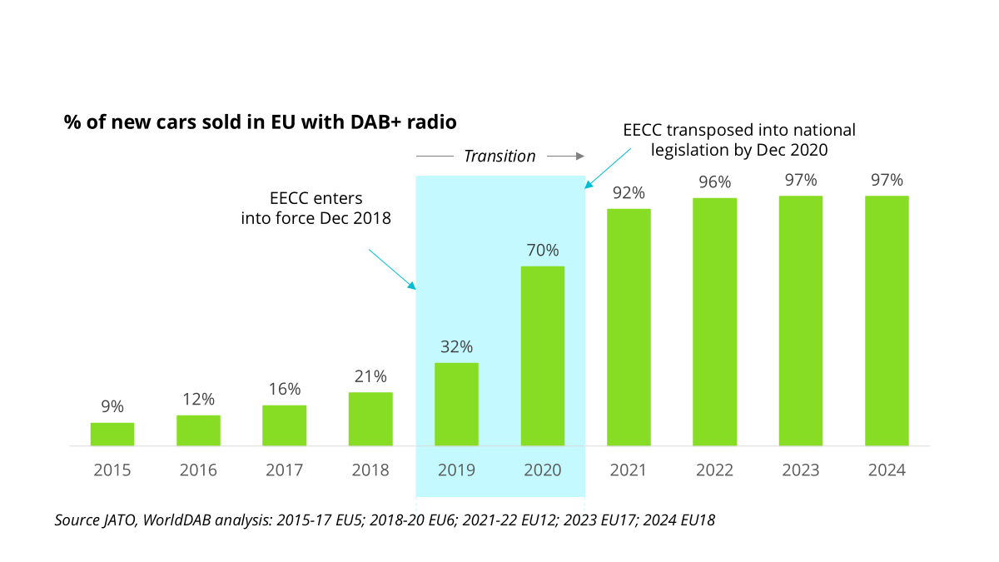
In 15 EU Member States 97% or more of cars are equipped with DAB+ radios.
Figure 18: % of new cars sold by 2024, per country
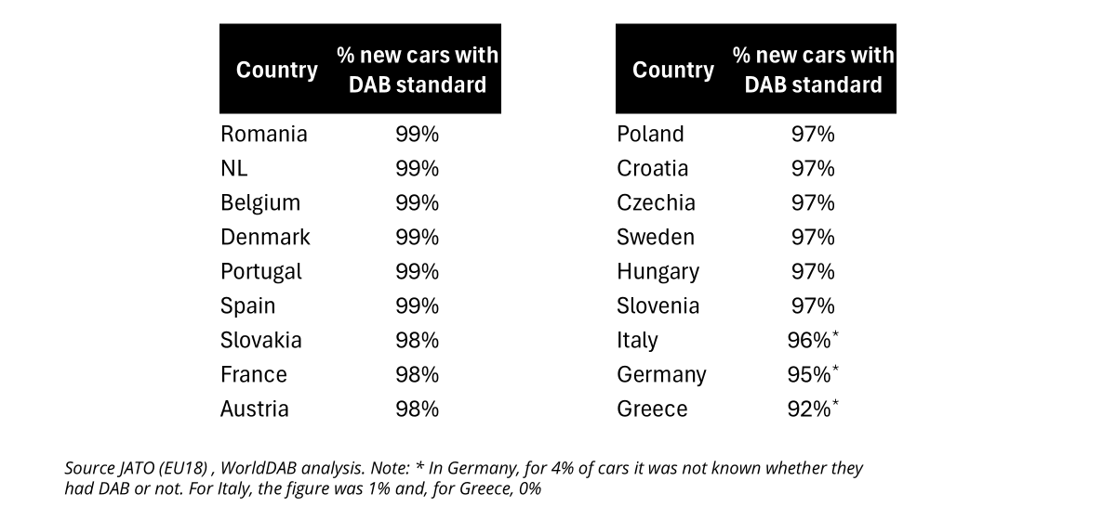
The effectiveness of the measure has also contributed to more EU Member States being covered by DAB+ radio broadcast networks (the latest information is about launch in Estonia in September 2025 and in Luxembourg in November 2025) and to substantial increases in coverage of existing DAB+ networks in some other Member States (France and Spain). DAB+ broadcast networks are available in the vast majority of Member States, with an increasing number of radio channels available. Only in Belgium several regions have adopted requirements for consumer radio receivers other than car radios to include a DAB+ receiver, in accordance with Article 113(2) EECC.
Art. 114 EECC leaves the possibility of imposing a reasonable must carry obligation to the discretion of Member States, in particular in relation to end-users with disabilities. The majority of respondents to the targeted survey (almost half of all NRAs, quite some companies, most consumer protection associations) find that there should be no change to the must carry obligations which is a proof that the provision has confirmed its effectiveness and therefore, maintaining it seems a reasonable way forward.

8.2. Efficiency
As pointed already by the previous evaluation of the framework the efficiency of the rules depends on the transposition by Member States that determine the costs and benefits for different stakeholders. The possibilities included in the framework for Member States to maintain or introduce divergent rules in several end-user rights provisions result in varying benefits for end-users and compliance costs for providers and makes an efficiency assessment difficult.
The single market supporting study highlights simplifying information provisions for efficiency. There is no clear conclusion whether the amount of information that an operator must provide under Article 102 is efficient. Simplifications could be made, amongst which reducing duplications (overlaps with general consumer protection law), streamlining publication requirements and simplifying the language. Industry associations argued for decreasing the regulatory burden resulting from end-user provisions in the EECC, while one association also noted that changing the status quo will result in new costs. As regards the benefits of Article 102, BEREC considers that the current EECC provisions concerning the conclusion of contracts, the contract summary template (Article 102, Annex VIII) and the accompanying implementing act (Commission Implementing Regulation (EU) 2019/2243) are important elements of the regulatory framework enabling end-users to make free and informed choices based on complete, timely and understandable contractual information. BEUC highlights the benefits of the EECCs end-user rights chapter in general, including provisions on contract summaries, that have proven essential for consumer empowerment and fair market functioning. According to BEUC, these rules enable informed consumer choice and ensure minimum guarantees.
The DSM supporting study gives an example of the efficiency of the Article 113 on interoperability of car radio and consumer radio receivers and consumer digital television equipment. Although the provision is considered as effective, in terms of its efficiency, it could have some adverse effects, beyond increasing the cost for buyers of new cars because of the increasing take-up of alternatives like internet radio and Bluetooth speakers. Based on the supporting study’s evaluation findings, a potential simplification could be applied to this Article and in particular, the related Annex XI. This simplification would involve making the provision more technologically neutral. Doing so would help to avoid barriers to innovation and improve the efficiency of the regulation.
BEREC also explored potential ways to reduce the administrative burden on providers. Certain obligations in Articles 105 to 107 may not serve a meaningful purpose for business customers (legal entities), which fall under the scope of the end-user definition.
Another aspect mentioned by stakeholders is the amount of information during the conclusion of contracts with end-users and possible inconsistencies between various pieces of European legislation related to user and consumer rights, for example regarding transparency obligations. Industry stakeholders mention in this context an increasing regulatory burden for European telecom operators over the past decade.

8.3. Relevance
Sector-specific end-user protection rules are especially relevant for sector specific issues that are not covered in other EU legislation. The DSM supporting study concludes that there is consensus among government stakeholders that the EECC remains a relevant framework that protects and strengthens consumer rights. For example, contract termination and provider switching (Articles 105-106) are particularly relevant considering 5G, the copper switch-off and the provision of emergency services.
In its feedback, BEUC has highlighted a rise in consumer complaints, many originating in the electronic communications sector. Those complaints concern issues such as unilateral price hikes or lower quality of service, and misleading marketing of offers to lock-in measures. Consumer organisations have also reported price hikes and too few competitive offers and multiple disparities across Member States between advertised offers and the actual service provided, especially regarding fibre to the home or 5G. According to the DSM supporting study’s targeted consultation, a limited number of public sector stakeholders and several industry associations said that there should be no extension or change to the end-user rights or that these provisions should even be deleted to avoid redundancy since they are covered by horizontal legislation.
The EECC Article 103 requires that providers of internet access and interpersonal communications services publish information (detailed in EECC Annex IX), including description of the services offered, about their services. The targeted stakeholder consultation carried out by the DSM supporting study shows the continued relevance of this provision with most respondents (53 out of 81 answers in total) finding the provision beneficial as shown in the figure below.
Figure 19: Stakeholder views: Publication of information (e.g. description of offered services) by providers beneficial Y/N
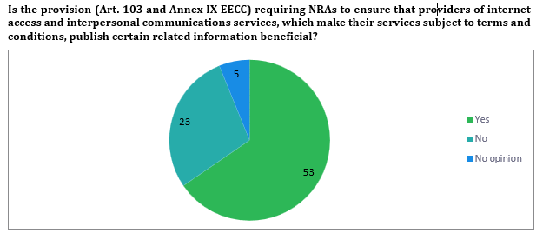
Some business associations consulted in the context of the DSM supporting study believe that there are commercial clients who reap the benefits of end-user rights, even though they are not as vulnerable as consumers, for example, it could be questioned whether Articles 105(3) (notice period after automatic prolongation), 105(4) (rights of termination before end of contract), 105(6) (compensation before end of contract) should in general apply to all end-users. The scope of end-user protection in electronic communications is wider than that of horizontal consumer legislation that applies to business-to-consumer commercial practices. BEREC noted that it was found that certain obligations may not serve a meaningful purpose for business customers (legal entities). One key observation was that the obligation in Article 105(3), which requires providers to offer end-users the best tariff information at least annually, seems unnecessary for business customers with bespoke contracts. The lacking relevance of the obligation to give business end-users best tariff information is confirmed by the targeted stakeholder consultation carried out by the DSM supporting study. In the consultation many respondents argue for the removal of the extension of end-user protection to B2B relations (i.e. end-user protection should apply only to consumers). A stakeholder gave an example of the requirement to inform all end-users yearly about the most advantageous tariffs, which is irrelevant for "bespoke business such as the Large/Enterprise market" where no comparable tariffs exist.
An issue of increased relevance is the use of eSIMs in connected objects and the possibilities of switching. The eSIM market is significantly increasing. Number porting of eSIMs is covered under Article 106 EECC, and consumers should be easily able to port their numbers to other providers. However, manufacturers of devices i.e., mobile phones, tablets, IoT devices, etc. could limit specific eSIM profiles. BEREC noted that it might harm competition and lead to significantly higher prices for electronic communications services in devices reliant on eSIM-based connectivity if it is not possible to switch provider.
New issues of increasing relevance are the price indexation increases during the contract, which is an issue for possible further clarification of the rules in line with the horizontal consumer protection legislation. According to BEREC, some NRAs have also observed that the additional facilities listed in Annex VI of the EECC (enabling Member States to impose on providers obligations such as to offer pre-payment and phased payment options) have become less relevant as they are increasingly provided voluntarily, on a commercial basis. The targeted stakeholder consultation carried out by the DSM supporting study asked whether the facilities referred to in Annex VI are beneficial to end-users. The views were divided, the results showed that around half of respondents (39 out of 75 answers in total) did not consider the facilities beneficial and around half of the respondents considered them beneficial or did not give an opinion. BEREC considered in its opinion appropriate to evaluate the possibility of making facilities such as cost control, itemised billing, and the deactivation of third-party billing mandatory.
BEREC considers that the contract summary (Article 102) is likely to have an increasingly important role to play for end-users, though its relevance for comparison has decreased. The development of artificial intelligence could also benefit the development of comparison tools.
Article 107 rules on bundled contracts remain highly relevant. According to the Eurobarometer over six in ten Europeans (64%) have subscribed to two or more services as part of a bundle with fixed internet access, mobile telephone subscriptions and television channels being the most frequently included services. The BEREC external Study on Communication Services for Businesses found that telecom and ICT bundling is widespread. In 2022 40-50% of 1,000 European business interviewed indicated that they subscribed to bundles of ECS and cloud storage and/or collaborative solutions. 30-40% of IT services are subscribed with an ECS bundle.
An increased reliance on NI-ICS for interpersonal communications has raised a question on re-evaluating the end-user rights for traditional electronic communications services and NI-ICS to reduce regulatory gaps and improve its relevance. Some industry associations are of the opinion that Articles 98-115 EECC provide a robust framework for traditional telecom operators but are not projected well onto NI-ICS providers. Industry stakeholders pointed out that it might be necessary to extend Article 109 EECC to include NI-ICS in the EECC.
Concerning Article 113 during the consultation period on the European Commission’s Call for Evidence organised on the Digital Networks Act in July 2025, the provisions, in general, were assessed as relevant by the concerned stakeholders. Furthermore, some of them insist that all new vehicles of categories M and N placed on the EU market to be equipped with radio receivers supporting FM, DAB+, and IP radio. This ensures interoperability, allows seamless switching between platforms, and guarantees continued access to free-to-air radio across all environments. Furthermore, in times of crises, such as natural disasters or major emergencies, broadcast radio plays a critical role in keeping the public informed. When all else fails, broadcast radio is the only way for people to stay up to date with news and public safety alerts and recommendations. The recent power outage in Spain and Portugal highlighted the crucial role of radio. However, relevance should be assessed from more angles, including the nuanced views under the efficiency analysis in paragraph 8.2. of this Report. The role of radio broadcasting as a measure for disseminating public warning communications, complementary to those mandated by the EECC for providers of mobile number-based interpersonal communications services has so far been raised only by broadcasters and by car radio manufacturers.
The "must carry" obligation in Article 114 had been justified by national circumstances which proves the relevance of such article. National factors, such as social, economic, and infrastructural conditions, can necessitate the application of "must carry" rules to ensure access to radio and television broadcast channels where this is necessary to meet general interest objectives such as media pluralism and cultural diversity.
As of increased relevance for end-user rights since 2021 BEREC mentions especially the continued growth and importance of data use in mobile communication, increase in demand for connectivity and high-capacity internet connections, the significant increase of fraudulent traffic and scams and the growth of usage of digital platforms. The most important technical developments were deployment of 5G, phase-out of 2G/3G and copper switch-off.
The consumer Trends Report 2024/25 EBA notes that payment fraud is one of the most relevant topics inside of the European Union. According to the Eurobarometer slightly under a fifth (19%, +6pp compared to results in 2020) of respondents reported receiving a call from an unknown number and being charged for it after answering or calling back, a slight increase since 2020. Since 2020, the share of respondents receiving this kind of calls has increased in 18 countries. Member States implement anti-fraud measures ordering operators to preventively block numbers or services rather than leave it to national authorities that are enabled in Article 97(2) to issue orders after case-by-case analysis. These measures aim to balance e-privacy concerns with the need to fight the growing economic and societal impact of fraud schemes perpetrated through interpersonal communication services on end-users.

8.4. Coherence
One of the main coherence aspects of the EECC end-user rights is its alignment with horizontal Union consumer protection legislation. The Consumer Rights Directive (CRD) contains general consumer law rules on pre-contractual information, which link with the information requirements for contracts in Article 102. Stakeholders have asked for an improved alignment of the content of the pre-contractual information that needs to be provided, several industry associations suggesting deletion of what is covered by horizontal legislation.
BEREC’s opinion points out that full harmonisation and its interactions (and sometimes clashes) with established interpretations in the areas of contract and consumer law at national level were identified as a concern. BEREC has also raised issues of coherence both internally and externally concerning the beneficiaries of the protection and the different applicability to all end-users, certain groups of end-users or only to consumers. On the rules on bundled offers (Article 107), BEREC observed some concern that there is a mismatch between the beneficiaries of the protections of Article 106(1) in a stand-alone situation and in a bundle situation, because of the formulation of Article 107(4) EECC that includes a possibility to waive all or parts of the provisions.
According to the DSM supporting study operators have mentioned concerns about potential overlap under the EECC Article 108 and the Directive on the resilience of critical entities.
The EECC and Digital Services Act are considered largely complementary, but according to the DSM supporting study, the scoping to certain NI-ICS could be clarified.
The Open Internet Regulation (OIR Regulation 2015/2120) and the EECC largely align, though some interplay issues have been mentioned. Article 106 lays out provisions to facilitate provider switching, including for providers that offer internet access. On the other hand, OIR contains a broad baseline provision on the quality of access to internet service that is referred to in the context of the contract summary and Annex VIII.
The EECC and the Digital Content Directive can be considered largely complementary though some interplay issues between the two instruments have been pointed out on terminating contracts regarding contract modifications.
The provisions of Article 109 on emergency communications are coherent and complementary with other sectoral EU legislation, namely, the European Accessibility Act and eCall legislation.
When assessing the coherence of the scope with other acts, several governments and industry stakeholders commented on the rules on personal data protection in electronic communications and found incoherence of the ePrivacy Directive with the GDPR and the EECC. A few stakeholders pointed out that, due to the repeal of the proposal for an ePrivacy Regulation, alternative solutions should be sought that align the rules for electronic communications with the GDPR. For instance, unsolicited communications, direct marketing, malicious calls, and cookies may already be sufficiently covered by the GDPR and do not require duplicate sectoral regulation. However, some sector-specific provisions remain necessary.

8.5. EU added value
The added value of EU sector specific end-user protection rules in the electronic communications sector is two-fold. It appears essential to continue to regulate key elements specific to the electronic communications market (such as switching and number portability) so that consumers can profit from competition. Second, consumer protection rules are part of the conditions that operators are obliged to comply with when providing electronic communications services and as such have a great impact on the conditions to do business and on the competition within the single market. In this latter context, full harmonisation has generated additional value. Harmonised end-user rules support also interoperability and cross-border services operating at scale, as highlighted by industry stakeholders.
The principle of maximum harmonisation is set in the EECC Article 101. As discussed in the section on effectiveness, many Member States have used the EECC provisions that give Member States possibilities to introduce additional rules in various end-user rights articles. This can present a risk of reducing the EU added value and fragmenting the overall market. On the other hand, several stakeholders noted that this allows for flexibility, taking national circumstances into account and having more tailored national rules where necessary.
According to the DSM supporting study, almost all public sector stakeholders agree that some provisions in the EECC provide added value beyond the horizontal rules that are in place. Overall, they note that the EECC provides stronger, sector-specific protection to ensure transparency, fair competition, and consumer rights in a rapidly evolving telecom market. Furthermore, the EECC harmonises the extension of certain protections beyond consumers, for example to micro and small enterprises and not-for-profit organisations meaning that also they are better protected throughout the EU. While some industry stakeholders mention the burden that some of the EECC provisions (e.g. contractual information or the added value of Article 113) place on operators, the need to ensure resilience of communication of public interest information and of public warnings in disaster situations and in case mobile communication networks are not working or are congested has been highlighted by public service broadcasters and EP parliamentarians.

Governance
The overall governance as it results in EECC involves the role of several actors, including the Commission, NRAs and other national competent authorities, as for example Spectrum Authorities, BEREC and BEREC Office, and RSPG. interacting among themselves and coordinating horizontally at national level or vertically between the national and the EU level. The allocation of competences has been done according to different modalities, either listing the competences as for example Article 5 EECC on competences of NRAs or allocating specific tasks as for example to BEREC in Article 76 or Article 82 EECC regarding the guidelines. In other cases, the competences were allocated at the stage of transposition normally between competent Authorities and NRA.

9.1. Independence of NRAs
The EECC contains provisions on the functions and independence of the NRAs (Articles 5-11). The Directive provides high-level principles to which Member States need to abide to ensure that the NRAs have the necessary resources (both in terms of budget and staff) to execute their tasks. The Member States maintain a high level of discretion in the actual implementation of the provisions. The novelties introduced by the EECC compared to the previous legal framework relate mainly to strengthening the independence of personnel: the EECC has requirements not only for the dismissal but also for the appointment of the NRA head and members of the NRA board.
In its final report on the independence of NRAs, BEREC distinguished between an independence de jure, stemming from the actual provisions, and an independence de facto, which is influenced by other elements. EU-level legal provisions on NRA independence leave a lot of leeway for the Member States for their implementation in the national legislation. In addition, the practice of NRA independence (de facto independence) varies across countries, leading to even more diversity. As a result, although there is a harmonised de jure framework at the EU level, there is still a diversity of de jure and de facto independence at the national level.
In addition to the independence, Member State shall also ensure that NRAs have adequate financial and human resources to enable them to actively participate in and contribute to BEREC’s goals of promoting greater regulatory coordination and consistency.

9.2. BEREC and BEREC Office
The evaluation of BEREC and BEREC Office according to the evaluation criteria (effectiveness, efficiency, coherence, EU added value, relevance) is contained in separate document entitled: Evaluation of BEREC and the BEREC Office. It is attached as Appendix III to this evaluation report.

9.3. Radio Spectrum Policy Group (RSPG)
The Radio Spectrum Policy Group (RSPG) is a Commission high-level advisory group established by to support the Commission in the coordination of radio spectrum policy. Its members are high-level representatives responsible for strategic radio spectrum policy from Member States and, since 2023, from EEA EFTA countries, and observers from the EU candidate countries, the CEPT and ETSI. The RSPG Secretariat is provided by the Commission.
With the entry into force of the EECC at the end of 2018, the RSPG role has been strengthened and tasks expanded to inter alia peer review of spectrum assignment procedures under Article 35 of the EECC and good offices to address any problem or dispute in relation to cross-border coordination under Article 28 of the EECC. Additionally, the RSPG assists the Commission in preparatory work for establishing the EU position for the World Radiocommunications Conferences (WRC) pursuant Article 218(9) TFEU. The RSPG also assists Member States and could, upon request, advise the Council and the European Parliament. New tasks were reflected in Commission Decision of 11 June 2019.
Since the beginning of 2020, the RSPG adopted 15 opinions, including on three Commission’s consultations, and 11 reports, including three annual reports on the Peer Reviews. Besides its activities stemming from its biennial work programmes, the RSPG accepted all ad hoc Commission requests for an opinion, such as on the Mobile Satellite Services in the 2 GHz band.
The main areas addressed in deliverables were related to spectrum for future wireless connectivity, including 6G, spectrum sharing, future use of the UHF band, WRCs and their outcome, satellite connectivity, and climate change. The RSPG deliverables provided valuable input for further EC considerations – for example the RSPG opinion on WRC-23 set a basis for the EU position at the WRC-23 established by a Council Decision – and are welcomed also by stakeholders. In general, all RSPG deliverables contributed to the development of the internal market and to support the development of a Union-level radio spectrum policy. However, as the RSPG adopts deliverables in general by consensus, at least on some sensitive issues, a fine balance needed to be struck between different national interests and the EU and national prerogatives, sometimes regretfully to the detriment of the broader EU benefit. Additionally, , in its Opinions, the RSPG’s tendency has been to focus mainly on technical issues when advising the EC on radio policy issues and to a lesser degree economic, political, cultural, strategic, health and social considerations.
Since the entry into force of the EECC, Member States notified pursuant Article 35 of the EECC to the RSPG 30 draft measures for authorisation of EU harmonised spectrum, but only 10 Peer Review Forums were held. Notifications and Peer Review Forums “replaced” the RSPG peer review platform established in 2016 and authorisation workshops that served for peer learning on the authorisation procedures. In its opinion on the White paper “How to master Europe’s digital infrastructure needs”, the RSPG recognised the value of peer review mechanism for sharing of lessons learned and exchanging of views, leading to award harmonisation and increased transparency among peers. At the same time, the RSPG admitted the peer review could be enhanced. Indeed, due to the peer review’s voluntary nature, the lack of structure and obligation to devote resources and to conduct a thorough assessment of the notified measures, the peer review has been totally unsuccessful in influencing the design of authorisation procedures in a consistent manner in line with the objectives of the EECC for investment in high-capacity connectivity. There has been no tangible modification of authorisation conditions and market shaping elements following the peer review. Furthermore, experience shows that certain assignment procedures, which has raised criticism by market players, have not even been subject to a peer review.
Through its Good Offices subgroup, the RSPG proactively monitored cross-border coordination issues, including harmful interference, related to implementation of the 700 MHz band in the EU. It proposed a coordinated solution for an outstanding interference issue between two Member States pursuant to Article 28(3) of the EECC and together with the EC assisted Member States in cross-border coordination with the third countries. In this way it facilitated the 5G services deployment in the EU, and hence establishment of single market. However, the RSPG assistance falls short when it comes to cross-border coordination issues with third countries on general or, between Member States involving the non-EU harmonised spectrum (e.g. FM radio), as the RSPG simply does not have a legal basis and appropriate tools to act.
The RSPG played an important role in setting the EU position for the WRC-23 held in November and December 2023 through a well-established preparatory process. That process consists of identifying together with the EC items of the WRC agendas that might affect EU law, policies or programmes and then recommend for each of them the position that the EU should take at the WRCs. The draft Council Decision on WRC-23 proposed by the EC contained all items of the WRC-23 agenda identified by the RSPG as of the EU relevance and the EC relied very much on the RSPG recommendations when proposing draft EU positions for each of them. The RSPG recommendations proved useful for organising the EU coordination during the WRC-23. In its Report on the WRC-23, the RSPG did not just assess of the outcome compared to the initial EU positions but also provided very useful lessons learnt that will be used in the subsequent WRC cycles. Currently, the RSPG is working on an opinion for the WRC-27. However, such a coordination phase of the Union’s position does not exist when Member States participate at CEPT, where they co-develop technical harmonisation, which could have a significant impact at EU level.
The RSPG work is guided by biennial work programmes corresponding to the Chairperson’s term of office. It is assisted by subgroups, created by the EC for implementation of topics outlined in a particular work programme, or ad hoc as a result of the EC request for an RSPG Opinion. On average, under each work programme, RSPG has 7 subgroups, with 3 of them being permanent (Good Offices, Peer Review and WRC); others are dissolved as soon as they fulfil their mandate. Generally, subgroups are open to the RSPG members and observers, except the Good Offices and Peer Review, and WRC subgroups, which are limited to RSPG members and to EU Member States respectively thus reflecting their more sensitive tasks. Subgroups’ work is stirred by two co-chairs, from Member States of all sizes and different geographical parts of the EU. Under current work programme, the cochairs are coming one from DE, DK, FI, FR, HU, IE, IT, LT, MT, SE, SI and 3 from EL.
Since the beginning of the Covid-19 confinement, the RSPG has been meeting mainly in hybrid format and its subgroup in online format respectively. Only occasionally, the subgroups met also in the hybrid format, with a physical part taking place mainly in the EC premises in Brussels, to discuss more sensitive outstanding issues. These working arrangements of subgroups facilitated participation of experts, including of EC representatives, and thus exchanging of views and experiences and peer learning on the topics on interest among broader groups of experts. The number of subgroups’ members is high (currently 45 and 100 members from 17 to 22 Member States), but not all are connecting to meetings and are actively engaged in subgroups’ work. In general, big administrations can afford to be active in all subgroups, whereas small administrations only in the subgroups of their particular interest (such as Good Offices).
In general, the RSPG deliverables were adopted in the time frames foreseen in working programmes or in the EC requests for the opinion. Only in some rare, more sensitive cases, the subgroups needed a few more months to finalise work, but it was never carried to the new working cycle. When necessary, an extraordinary RSPG plenary meeting was organised. A few RSPG deliverables were adopted through written procedure, such as the mandate to develop a 6G spectrum roadmap as an addendum of the Work programme 2024 and beyond.
During preparation of deliverables, the RSPG subgroups issued questionnaires targeted to Member States authorisations or to various stakeholders, or organised targeted hearings or workshops with broad range of stakeholders to collect evidence for substantiating their views. All deliverables, except the RSPG replies to the EC consultations and interim RSPG opinions on WRCs, were published for 6-weeks long public consultation before being adopted by the RSPG plenary.
All the RSPG workstream are considered to have a very high added value by participating Member States representatives as emerged from a survey conducted by the EC study (see Figure 1). The highest added value was indicated to the development of the common position for the WRC, followed by approaches to D2D and access to satellite markets.
Figure 20: Spectrum competent authorities’ assessment of added value of RSPG work

The RSPG, the BEREC and the BEREC Office signed in 2019 special working arrangements. BEREC experts are regularly invited and participate at the Peer Review Forums. In 2020, they issued a common Position Paper on spectrum-related EMF issues. However, there is not tangible cooperation beside those two examples of cooperation between the two groups, so RSPG deliverables might not be so holistic as one would expect and the cooperation with BEREC is insufficient. For example, some opinions which hinted to the need of further cooperation between BEREC and RSPG (e.g. D2D and access to satellite market) have not been further developed.
The RSPG Secretariat is provided by the Commission. It offers the RSPG, mainly an administrative support (e.g. organising the meetings on different levels, helping in organising hearings, managing documents, databases, preparing the steering documents), and legal support on the topics related to the RSPG functioning. For the RSPG deliverables to pursue broader EU benefit, it might be beneficial, if the RSPG Secretariat is involved more into substance too. Currently, this is impossible because of the lack of staff (around 1.5 FTEs) and the EC staff could represent at the same time the RSPG Secretariat and the EC experts.
Regarding the costs, 3 RSPG Plenary meetings are held per year - one of them might be online only, and hybrid format. For hybrid meetings, as they are taking place in the Commission’s premises, costs are in a range of 10,000-15,000 euro per meeting, with a major part attributed to reimbursement of travel costs for one person per Member State, and a smaller part to costs of catering. There are no costs associated with the online only meetings. Subgroups are organised mainly in the online only format, as well as hearings. For occasional subgroup meetings in a hybrid format (about 5 times per year) and RSPG workshops (about 3 times per year) costs are lower that for the RSPG Plenary as the travel costs are not reimbursed and they were in the range from 900 euro (subgroup) to 4000 euro (workshop).
It is hard to assess costs per Member State for being involved in RSPG work as it depends on various factors. None of administration seems to have a special RSPG dedicated staff. The Commission is reimbursing travel costs for one person per delegation of a Member State only for RSPG Plenary meetings. Some Member States have special national arrangements to coordinate positions before each RSPG Plenary meeting, that could involve also consulting with stakeholders. It depends also on a degree of involvement of experts in the work of a subgroup – it is obvious that co-chairs should invest more efforts than other members of the subgroup, the workload could be shared among the members of a subgroup (such as drafting or assessing replies to a questionnaire).
Based on the EU study, the average number of hours that Member State devote per year to the specific activities is the following: around 60 hours and 250 hours for participation in RSPG plenary and sub-groups respectively, 90 hours of additional efforts for chairing sub groups, 30 hours for participating to peer reviews and 30 hours of additional effort if the Member State asks for a peer review of the auction.
Considering the limited cost, the current RSPG efficiently contributes to EU spectrum policy making with its opinions and reports and the preparation of the WRC and with the good offices activity. However, the RSPG effectiveness is reaching its limits. As indicated in the EC study, stakeholder see the merits in providing RSPG with more administrative support than is currently provided by the Commission. Such support could facilitate the work especially of RSPG subgroups, by taking over some preparatory and administrative work from the co-chairs. Such support would be even more pertinent, if in the future, the scope of RSPG tasks and responsibilities is increased.
Overall, the coordination among authorities of Member States remains the core task in both entities, where pan-EU perspectives had been taken only to a limited extent, and there was no sufficiently strong boost to the completion of the single market. A lack of sufficient alignment of the organisation of workstreams and of the co-ordination of tasks prevented in several instances to achieve sufficient coherence in the governance of the sector.

Lessons Learnt and Conclusions
The analysis above has shown that the EECC, through its objectives of promotion of connectivity and access to, and take-up of, very high-capacity networks, helped achieve/maintain effective competition in the market for electronic communications networks and services and protect the interests of the end users. However, the EECC, as a Directive leaves significant room for national divergence leading to fragmentation and therefore, the evaluation shows its limitations in achieving more single market. Furthermore, the evaluation revealed the need for some rebalancing of objectives, in the sense of prioritising all dimensions of connectivity (investment, demand), and considering the addition of new objectives of enhanced competitiveness for innovations in advanced infrastructures and services, and integration of infrastructures’ security and resilience to the core objectives of the new framework.
Several pillars of EECC still remain relevant:
- The Significant Market Power (SMP) regime remains the key instrument for ex ante regulation. Ex-ante regulation is still an important tool to ensure that markets work well, and main tool used by NRAs. However, NRAs have increasingly defined markets subject to regulation as regional or local level and lower the intensity of ex ante regulation.
- Radio spectrum is of outmost strategic and geopolitical importance; it is essential to enable communication, drive economic growth and social prosperity, and support critical services across various sectors.
- The universal service obligations (USO) in the EECC are a safety net to ensure all consumers in the Union have affordable adequate internet and voice communications services, however the use of the USO by MS had decreased.
- The provisions on end-user rights are mostly still fit for purpose but in some respects could be simplified;
Access regulation is based on competition law principles and on transparent consultation mechanisms with the Commission as the guardian of the treaties, ensuring that the proposed regulations would not create a barrier to the internal market and are compatible with Union law. Such a system promotes regulatory predictability by ensuring a consistent regulatory approach.
The current framework is, in principle, well adapted to addressing instances of significant market power including local monopolies, which is relevant in full fibre environment in a post-copper world. The number of cases regarding the oligopolistic markets, notified under Article 32 EECC was very limited. Possible issues in oligopolistic markets have been addressed either under the spectrum authorisation regime or under competition law.
Moreover, as indicated in the report, there is a room for simplification of some key provisions that have either not been applied by regulators (Article 76 regarding co-investments, Article 77 regarding the imposition of functional separation) or were applied by some regulators but should be further simplified to enable their broader application (Article 61(3) covering symmetric regulation, Article 79 covering regulatory commitments, Article 80 regulating wholesale-only networks).
As regards copper switch-off, Article 81 has had limited practical relevance primarily due to the lack of plans announced by incumbent operators and has not significantly contributed to accelerating the transition from copper to fibre networks. Instead, its primary purpose has been to provide NRAs with a framework to manage the switch-off process in a transparent and competitive manner, ensuring that migrations do not harm competition or end-user rights, and that alternative access products of comparable quality are available.
On wireless connectivity, although the EU spectrum policy framework has laid the foundation for coordinated 5G deployment through early harmonisation and binding deadlines for the assignment of spectrum, and has ensured competitive prices for end users, the EU is lagging in high quality 5G deployment compared to leading world economies with negative implications not only for consumers but also for EU’s industrial competitiveness and innovation. The reasons are diverse: spectrum assignment conditions remain excessively fragmented and have not ensured consistent outcomes in terms of investments. Excessively high reserve prices, revenue-oriented auction designs, insufficiently long duration of licenses, unjustified market shaping measures, lack of flexibility and incentives to share spectrum and use it more efficiently have increased the cost of spectrum which combined with limited mobile revenues and lack of demand have negatively affected deployment.
The procedural tools of the EECC to help establish the single market for spectrum, and in particular the voluntary peer review of spectrum assignment procedures or the voluntary joint authorisation procedure allowing several Member States to cooperate to grant spectrum usage rights through common conditions and procedure have been ineffective to promote regulatory predictability and investment. As regards cross-border harmful interferences between Member States, the RSPG good offices’ involvement has brought significant added-value according to participants but has not been fully efficient to address cross-border coordination issues with third countries or in non-harmonised bands. Overall lack of regulatory predictability and inefficient use of spectrum have affected the financial attractiveness of 5G investment projects.
For satellite services that have a clear cross-border potential, the failure to establish a Single Market is even more apparent. There are no minimum common authorisation conditions or requirements for satellite spectrum, and no common selection procedures except for the 2 GHz band, wide variations in timescales for issuing a license, different approaches to national coordination with existing services, different fees and different conditions attached to the licences. This fragmentation does not allow to leverage the strength of the internal market to ensure a level playing field in space and is not favourable to scaling up for the EU-wide provision of satellite services and allows for regulatory forum shopping. These barriers affect EU readiness for the Direct-to-Device challenge in a context where the EU risks being strategically dependent on foreign players for services crucial for its security and defence.
The evaluation findings on the general authorisation provisions pointed out to the need for further harmonisation, update and simplification of the general authorisation regime and paving the way for facilitating the deployment of more virtualised and centrally managed networks and software (cloud)-based electronic communications services in the EU.
The provisions on end-user rights are mostly still fit for purpose and there must be continued focus on their enforcement and implementation. At the same time, some updates and simplification could be beneficial for both end-users and service providers, for example, streamlining of contractual information (Article 102), as well as the harmonisation at EU level of some aspects, such as parameters on quality of services (Article 104)
As regards, authorisation and objectives, the fragmentation of rules, in particular the conditions under the general authorisation regime and for satellites combined with nationally diverging rules in the area of end-user protection as well as law enforcement, cyber-security or privacy, hampers companies from deploying pan-European innovative services. The evaluation revealed the need for some rebalancing of objectives, in the sense of prioritising all dimensions of connectivity (investment, demand), including in green networks and considering the addition of enhanced competitiveness for innovations in advanced infrastructures and services, and integration of infrastructures’ security and resilience to the core objectives of the new framework.
As regards governance the assessment of BEREC and the BEREC Office and their contribution to the harmonised implementation of the EECC had been overall positive in particular as regards quality of BEREC guidelines and report, and overall supporting NRAs in reaching common approaches. Yet BEREC guidelines and exchanges of best practices were not sufficient to bring about the single market in the communication sector.
As markets, technology and broader digital ecosystem rapidly evolve BEREC’s mandate should also evolve to encompass new tasks in e.g. digital markets, cybersecurity, spectrum, data, AI. Also, BEREC Office should be strengthened to increase its capacity to support BEREC also on substance, with aim to ensure better alignment with EU-level policies.
Similarly, the assessment of the contribution of the RSPG in spectrum policy is positive. Its deliverables related to spectrum for future wireless connectivity, including 6G, spectrum sharing, future use of the UHF band, WRCs and their outcome, satellite connectivity, and climate change have provided valuable input for further EC considerations. However, as the RSPG adopts deliverables in general by consensus, at least on some sensitive issues, a fine balance needed to be struck between different national interests and the EU and national prerogatives, sometimes regretfully to the detriment of the broader EU benefit. RSPG opinions tend to be too technical and not as political as its role of a high-level advisory group to the Commission would require. Moreover, several limitations have significantly limited its impact, such as the voluntary nature of the peer review, or the legal limitations to use its Good Offices mechanism to address interferences from third countries. Synergies between RSPG and BEREC work in technical, economic and overall policy dimensions have not been leveraged.

Appendix I Sources
1) National implementation reports from the NRAs (not available or carried out for the EECC, country reports for DD could be used to some extent) and BEREC:
2) The BEREC Opinions and reports:
BEREC Opinion on the national implementation and functioning of the general authorisation, and on their impact on the functioning of the internal market, pursuant to Article 122, paragraph 3 EECC.
BEREC Report on Member States’ best practices to support the defining of adequate broadband internet access service (2024).
BEREC Opinion on the market and technological developments and on their impact on the application of rights of end-users in the EECC (2021) and (2024).
BEREC report on interoperability of Number-Independent Interpersonal Communication Services (NI-ICS)
3) The studies:
Ongoing studies
The objective of Study 1 on Completing the Digital Single Market (DSM) - Regulatory enablers for cross-border networks led by EY is to Develop and assess concrete policy options for the EECC review and the scenarios of the White Paper relevant for cross-border operation and the move towards a Single Market for digital networks and services. Relevant areas include Technology challenges and Convergence, Scope of the regulatory framework, Level Playing Field, Quality Based Services, Authorisation, Spectrum, Sustainability and Regulatory governance, as well as end-user protection.
Review of Access Regulation under the European Electronic Communications EECC and analysis of future Access policy in full fibre environment (Terms of reference) - Study 2, on Review of Access Regulation under the EECC and analysis of future Access policy in full fibre environment led by WIK, is to i) to evaluate in particular the market and regulatory implications of key provisions of the EECC, including as a minimum Articles 61(3), 76, 78 and 79 regarding the access provisions concerning symmetric measures, co-investment, voluntary separation and commitments in relation as well with the objective of the EECC; ii) the assessment of the appropriateness of intervention powers to address oligopolistic market structures; iii) the assessment of the impact of symmetrical regulation; iv) the assessment, on a forward looking forward-looking basis, of the markets included in the current Recommendation on Relevant Markets and evaluation of other markets, if any, still warranting ex ante regulation at EU level; and v) assessment of the options set out in the White Paper in the field of access regulation. The study will also support the review of the Recommendation on relevant markets and possible guidance on Article 3 of the GIA Regulation.
Study 3 on financial conditions, demand and investment needs of the electronic communications sector and their regulatory and policy implications, including on the Universal Service also led by WIK aims at providing an estimate of the demand for very-high-capacity connectivity networks in EU Member States in the light of the Digital Decade 2030 targets and the evolution of households and industry’s needs.
This study also aims at identifying financial and regulatory incentives and barriers for investment in the EU electronic communications sector as well as making an assessment of the financial situation of the sector.
Finally, it aims to assess whether the scope of the Universal Service provisions in the EECC needs to be changed or redefined in light of social, economic and technological developments, taking into account, inter alia, mobility and data rates in view of the prevailing technologies used by most end-users.

Appendix II – Radio Spectrum (Policy Programme) – additional information on spectrum
Appendix II A. State of play of the implementation of the Radio Spectrum Policy Programme and proposed incorporation of relevant parts in the digital network act
This Annex addresses the current state of play of the implementation of the RSPP Decision and assesses which aspects are completed or obsolete and which remain still relevant, to be integrated in the DNA. This was done through an examination of existing ￼ and ￼ which, the Radio Spectrum Policy Group’s (RSPG) 2021 opinion on the RSPP and the responses to the related public consultations.
The analysis focused on a description of the current status of application of the RSPP Decision collected and identified the following:
what actions included in the RSPP Decision could be considered as completed,
what provisions of the RSPP Decision have become obsolete (including due to the substantive revision of spectrum rules brought about by the EECC) and
what objectives and general principles of the RSPP Decision remain relevant in the context of strategic policy needs and support of broader EU policy objectives, taking into account the current and future needs of key stakeholders.
In this analysis, completed actions are regarded as areas that designated bodies, such as the European Commission or Member States, have completed within the set timeframe. On the other hand, obsolete provisions refer to those that have become superseded or no longer useful. The third area assesses the relevance of the key objectives and general principles of the RSPP Decision in the current context. Section 2 identifies a key set of challenges that map the problems identified in the RSPP in Section 3.
In the course of this analysis, existing policy documents were reviewed, including relevant RSPG opinions and stakeholder consultation responses, and the principles of Tool #2 in the Commission’s Better Regulation Toolbox, the Regulatory Fitness Programme (REFIT), were applied. The approach also considered the goals of simplification and burden reduction, in order to enhance the effectiveness of the policy document.
The chapter below summarises the findings of the analysis. The report acknowledges that assessing whether an action is obsolete is a rather qualitative process and therefore, the analysis is based on stakeholder views obtained through desk research and assessment of the strength of the argument in each case.
What actions included in the RSPP Decision could be considered as completed?
In addressing what actions defined in the RSPP Decision could be considered as completed, the study considered those actions which a designated body – such as the European Commission or Member States – must complete, usually within a set timeframe. Having reviewed the RSPP and its impact reports, the following actions are considered as complete:
Article 3 (b) RSPP Decision
Article 3 RSPP Decision outlines the policy objectives that Member States and the European Commission shall cooperate to support and achieve.
Article 3 (b) RSPP Decision highlights the importance of allocating:
“sufficient and appropriate spectrum in a timely manner to support Union policy objectives and to best meet the increasing demand for wireless data traffic, thereby allowing the development of commercial and public services, while taking into account important general interest objectives such as cultural diversity and media pluralism; to that end, every effort should be made to identify, based on the inventory established pursuant to Article 9, at least 1 200 MHz of suitable spectrum by 2015. That figure includes spectrum already in use”.
Article 3 (b) RSPP Decision recommends the identification of at least 1 200 MHz of suitable spectrum by 2015 to “support Union policy objectives” and to satisfy “the increasing demand for wireless data traffic”. In 2021, the RSPG estimated that there is “already more than 12 GHz of harmonised spectrum available for wireless services”. Based on this information, the study considers this a completed action. The RSPG sees no need to define quantitative targets in a RSPP as it can “develop long-term spectrum availability plans including needs for harmonisation initiatives for key EU policy areas upon request”.
However, allocating sufficient and appropriate spectrum in a timely manner to support Union policy objectives and to meet spectrum demand remains an important policy consideration. More than half of stakeholders consulted for this study agreed that updating the approach to establishing future spectrum needs was one of the most important issues related to revising the RSPP.
Some stakeholders, such as the mobile industry body, the GSMA, and Telefonica, are more supportive of targets, both arguing that 5G needs an additional 1-2 GHz of new spectrum. ECTA further argues for identifying new specific bands for licensing by a specific deadline, as was done in Article 6(4) RSPP Decision.
Article 4 (7) RSPP Decision
Article 4 RSPP Decision is dedicated to the enhanced efficiency and flexibility of spectrum use.
Article 4 (7) RSPP Decision indicates:
“For electronic communications services, Member States shall, by 1 January 2013, adopt allocation and authorisation measures appropriate for the development of broadband services, in conformity with Directive 2002/20/EC, with the aim of achieving the highest possible capacity and broadband speeds”.
As the Authorisation Directive has already been transposed into national law, and in fact superseded by the 2018 EECC, this Article has in the literal sense been completed. Furthermore, in terms of fulfilling the policy goal, Member States have progressively followed objectives of enhanced efficiency and flexibility in spectrum use, further reinforced in Article 45(2)(f) EECC. The EECC also seeks to facilitate greater coordination of spectrum assignment across Europe, setting a deadline for making 5G bands available for use.
Article 6 (2) RSPP Decision
This provision required Member States to make available the 3.4-3.8 GHz, 2.6 GHz, 900 MHz and 1800 MHz frequency bands under terms and conditions of Commission Decisions 2008/411/EC, 2008/477/EC, and 2009/766/EC, and carry out the authorisation processes by the end of 2012. As detailed in European Communications Office Report 03, Member States have progressively implemented these harmonisation Decisions and this action has generally been completed.
However, as noted by the RSPG, assigned spectrum in harmonised EU bands varies by Member State. “These differences are resulting from various factors, in particular inter alia: the differences in national demands, in the characteristic of the band itself, in usages relative to public security and defence and in the need to protect existing services different from electronic communication”. Furthermore, some Commission decisions referred to above have been amended, notably to account for revised technical conditions for band usage.
As regards the 3.4-3.8 GHz band, Article 54(1) EECC states that “By 31 December 2020, for terrestrial systems capable of providing wireless broadband services, Member States shall, where necessary in order to facilitate the roll-out of 5G, take all appropriate measures to:
reorganise and allow the use of sufficiently large blocks of the 3,4-3,8 GHz band”.
All Member States have now assigned this band for 5G.
Article 6 (4) RSPP Decision
This provision required Member States to carry out the authorisation process in order to allow the use of 800 MHz for electronic communications services by the end of 2015. In addition, “If a Member State’s substantiated cross-border frequency coordination problems with one or more countries, including candidate or acceding countries, persist after 31 December 2015 and prevent the availability of the 800 MHz band, the Commission shall grant exceptional derogations on an annual basis until such problems are overcome”.
Despite the possibility for Member States to apply for derogations, the European Commission’s 2014 report on the implementation of the RSPP noted that “Delays in assigning the 800MHz band demonstrate the need for more nimble and flexible mechanisms for the harmonised timing of assignments throughout the Union or for categories of Member States based on the characteristics of the wireless broadband market, and for the harmonised duration of spectrum usage rights”.
Since then, the assignment of the 800 MHz band has been completed in all EU Member States.
Article 6 (5) first subparagraph RSPP Decision
This provision requires Member States and the European Commission to “continuously monitor the capacity requirements for wireless broadband services” and “report to the European Parliament and the Council by 1 January 2015 on whether there is a need for action to harmonise additional frequency bands”. The European Commission delivered its report in September 2014, noting that “With the aim of using resources effectively, the Commission will continue to cooperate with the Member States both in collecting data that are already available at Member State level and in obtaining additional data on a targeted basis. In particular frequency bands relevant to the implementation of the RSPP will be targeted”.
While this action has been completed, there is a continuing need to monitor the spectrum needed for wireless broadband services and constantly update targets to keep them up to date with technological progress and demand, e.g. in an evolving spectrum roadmap.
Previously conducted stakeholders survey showed considerable support for ensuring sufficient spectrum for wireless broadband as part of the RSPP review:
more than half regarded the updating of the approach to spectrum needs as a priority;
two thirds (18 out of 26) agreed that "ensuring that spectrum policy meets the requirements of the Digital Decade policy, in particular connectivity targets” was an important issue;
just under half (13 out of 26) supported the need for quantified spectrum targets;
one third (9 out of 26) agreed with identifying specific spectrum bands for 6G.
Article 9 (2) RSPP Decision
This provision required the implementing act for the setting up of a spectrum inventory to be adopted by 1 July 2013. This has been done but the usefulness of the spectrum inventory is now disputed, as discussed further below.
Article 15 RSPP Decision
Article 15 RSPP Decision specifies that, by “10 April 2014, the Commission shall report to the European Parliament and the Council on the activities developed and the measures adopted pursuant to this Decision. Member States shall provide the Commission with all information necessary for the purpose of reviewing the application of this Decision. By 31 December 2015, the Commission shall conduct a review of the application of this Decision”.
Regarding the reporting requirement, the European Commission’s report on the implementation of the Radio Spectrum Policy Programme was delivered on 22 April 2014. The review of the application of the RSPP was completed with the 2016 Fitness Check.
What provisions of the RSPP Decision have become obsolete?
This Section identifies provisions of the RSPP Decision which are obsolete in the sense of being no longer useful in their current formulation, archaic, superseded or obsolete in the sense of their functions having been transferred to other legislation. It is possible that an obsolete provision needs to be updated to reflect state-of-the-art developments. Determining whether an action is obsolete is a process which is subject to a more qualitative assessment than deciding whether an action is completed: the analysis is based on stakeholder views found via desk research and the strength of arguments in each case.
Article 2 (2) RSPP Decision
This provision refers to specific principles which apply in accordance with Articles 8a, 9, 9a and 9b of the Framework Directive. However, this Directive has been repealed and replaced with the EECC, so this Article is obsolete.
Article 3 (m) and Article 8 (2) RSPP Decision
The RSPP’s environmental commitments, as listed in these two provisions, remain relevant but need an update in the light of the EU’s European Green Deal policies. Article 3 (m) RSPP Decision lists as a policy objective reducing “the Union’s carbon footprint by enhancing the technical efficiency and energy efficiency of wireless communication networks and equipment.” Article 8 (2) RSPP Decision has the objective of conducting studies on “saving energy in the use of spectrum in order to contribute to a low-carbon policy” as well as making spectrum available for wireless technologies which can save energy in other networks such as water or electricity. This could be expanded to include the monitoring of progress towards EU environmental targets, as proposed by the RSPG.
The European Commission policy options related to spectrum availability tackle the obsolescence of the current RSPP by requiring that spectrum is allocated to support not only the increasing demand for wireless communication but also environmental policy by:
ensuring that sufficient spectrum is made available to support technologies that promote environmentally efficient use of energy and a reduction of the environmental footprint;
envisioning that spectrum users would cooperate to develop their services and networks in such a way as to maximise environmental efficiency;
spectrum users reporting on their carbon emissions and actions taken to contribute to the achievement of the Union's environmental targets.
These elements will be integrated in the Commission proposal for the DNA.
Article 3 (c) and Article 6 (1) RSPP Decision
These provisions are obsolete in the sense that they make reference to the 2010 Digital Agenda for Europe target of access to broadband at speeds of not less than 30 Mbps for all EU citizens by 2020. This target has been superseded by new goals.
The 2016 Gigabit Society targets were for 2020 to make 5G connectivity available as a fully-fledged commercial service in at least one major city in each Member State, building on commercial introduction in 2018 while a strategic objective set for 2025 targeted uninterrupted 5G coverage across all urban areas and all major terrestrial transport paths.
Irrespective of whether these milestones have been achieved or not, they are obsolete because the new Digital Decade targets are to achieve by 2030 fixed line gigabit connectivity for all and that all populated areas are covered by next-generation wireless high-speed networks with performance at least equivalent to that of 5G.
These elements will be integrated in the Commission proposal for the DNA, in the sense that the DNA will be consistent with the EU policy objectives applicable at its adoption.
Article 4 (1) second paragraph RSPP Decision
This refers to the use of ‘white spaces’, a type of dynamic spectrum access (DSA) technology which has had limited application, whereas interest in DSA continues. Here the reference to white spaces is obsolete and could be replaced by DSA, which in any case includes white space technology. The policy options described in the DNA Impact assessment to promote spectrum sharing and flexible licensing, as a mandatory part of certain assignment procedures, aims at updating this obsolete provision in the RSPP Decision.
Article 5 RSPP Decision
Deleted with effect from 21 December 2020 (Article 125 EECC).
Article 6 (6) RSPP Decision
This provision urges the promotion of “broadband services using the 800 MHz band in remote and sparsely populated areas” while protecting programme making and special events (PMSE) users. While the provision of rural broadband is still an important policy goal, the emphasis on 800MHz has been superseded and a more modern formulation is likely to include bands like the 700MHz 5G pioneer band.
Article 6 (8) RSPP Decision
This provision, which allows for the transfer or leasing of rights of use of spectrum in harmonised bands, has been superseded by Article 51 EECC, which covers the same topic in greater detail. These elements will be integrated in the Commission proposal for the DNA.
Article 6 (10) RSPP Decision
This provision requires Member States and the European Commission to “examine the possibility of spreading the availability and use of picocells and femtocells”, as well as taking account of the benefits of wireless mesh networks. Both of these technologies are now widely used and adopted by operators in mobile and other networks where appropriate so this provision has been superseded.
Furthermore, the EECC incorporates a provision on small-area wireless access points, a categorisation which includes picocells and femtocells. Article 57 EECC stipulates that small-area wireless access points that meet defined characteristics shall not require town planning permits. This makes them easier to erect than macrocells, which usually do require planning permits. These elements will be integrated in the Commission proposal for the DNA and further updated to increase the efficient use of Radio Local Access Networks.
Article 9 RSPP Decision
Article 9 RSPP Decision provides for the setting up of an inventory covering uses of the spectrum between 400 MHz - 6 GHz. Its objective is to identify bands where spectrum efficiency can be improved, enable spectrum sharing and re-allocation opportunities and support the analysis of spectrum use. It requires Member States to collect the data and the European Commission to carry out an analysis of technology trends, future needs and demand for spectrum. To support this work, the Joint Research Centre (JRC) developed the Radio Spectrum Inventory (RSI) tool.
A key disadvantage of the current spectrum inventory is that it functions primarily as a static database, without the capability to reflect real-time spectrum usage. This significantly limits its practical value—especially in contexts such as spectrum sharing, where accurate, real-time data on frequency occupancy is essential for ensuring efficient use and avoiding interference. The limited practical use of the inventory suggests it has not been effectively incorporated into spectrum management practices. Furthermore, its maintenance involves a high annual cost—estimated at around €100,000 by the JRC—despite its limited utilisation.
The RSPG has recommended that Article 9 of the current RSPP is not maintained. It described the inventory as “burdensome” for administrations and called for a more targeted approach focussing on “frequency bands identified by RSPG as potential bands for wireless broadband services or other strategic applications”. Desk research showed very limited support for continuing the inventory. Of the responses to the 2021 RSPG consultation on the RSPP, only the LoRa Alliance gave unqualified backing while United Wireless gave support to a revised inventory which concentrated efforts on wireless broadband frequencies. This is very similar to the approach advocated by the RSPG.
Given these shortcomings, it would be more effective to phase out the current static inventory and replace it with a more dynamic and targeted database. A dynamic database—focused on specific frequency bands—would better identify underutilised spectrum and support more efficient spectrum use and sharing practices.
Such a dynamic inventory, could also contribute to the development and implementation of a spectrum roadmap to feed into Europe’s 2030 Digital Decade’s targets. 78.6% of respondents to the 2030 Digital Compass consultation (out of 56 participants) think that an evolving spectrum roadmap as a guiding but non-mandatory monitoring mechanism integrating input from a broad range of relevant stakeholders would increase the efficiency and effectiveness of spectrum management.
What key objectives and general principles of the RSPP Decision remain relevant?
The RSPP Decision contains many key objectives and general principles which remain relevant and which will be taken over and further developed in the policy options of the DNA Impact Assessment. These include:
applying the least onerous authorisation systems to maximise flexibility and efficiency in spectrum use (Article 2 (1) (a) RSPP Decision). This principle is extended and enhanced by the proposals to promote spectrum sharing and flexible licensing.
“fostering development of the internal market by promoting the emergence of future Union-wide digital services” (Article 2 (1) (b) RSPP Decision). The policy proposal on satellites explained in the policy options of the DNA Impact Assessment aims at helping to foster EU-wide digital services.
fostering “the collective use of spectrum as well as shared use of spectrum” (Article 4 (1) first subparagraph RSPP Decision) and promoting spectrum sharing (Article 9 (1) (b) and Article 9(1) (d) RSPP Decision).
assessing the “justification and feasibility of extending the allocations of unlicensed spectrum” (Article 6 (7) RSPP Decision). The policy proposal described in Section 6.2.3.2 proposes wide-ranging co-operation between Member States and the European Commission to allocate sufficient spectrum for wireless services, including in the unlicensed bands, as part of an evolving roadmap.
promoting competition, innovation and investment (Article 2 (1) (b), Article 2 (1) (c), Article 3 (f), Article 3 (i), Article 4 (4), and Article 9 (1) (d) RSPP Decision).
the need to avoid harmful interference: (Article 2 (1) (c), Article 2 (2) (c) and Article 3 (k) RSPP Decision).
promoting technology and service neutrality in the rights of use of spectrum (Article 2 (1) (e), Article 2 (2) (a) and Article 3 (f)) RSPP Decision).
promoting spectrum harmonisation (Article 2 (2) (b) and Article 4 (3) RSPP Decision).
upgrading networks to the most efficient technology (Article 6 (3) RSPP Decision).
in order to ensure that all citizens have access to advanced digital services including broadband in remote and sparsely populated areas, exploring “the availability of sufficient spectrum for the provision of broadband satellite services enabling internet access” (Article 6 (9) RSPP Decision) allocating sufficient and appropriate spectrum in a timely manner to support Union policy objectives and satisfying the increased wireless data traffic (Article 3 (b) RSPP Decision), as part of an evolving spectrum roadmap.
encouraging efficient management and use of spectrum (Article 3(a) RSPP Decision).
ensuring sufficient spectrum, harmonised where necessary, for specified uses including:
Wireless broadband (Article 6 RSPP Decision),
Satellite and terrestrial provision of innovative audiovisual services (Article 7 RSPP Decision). The satellite policy options described in Section 6.2.2.1 would benefit these new services,
Earth monitoring services and transport systems (Article 8 (1) RSPP Decision),
Safety of life services (Article 8 (3) RSPP Decision),
Scientific services (Article 8 (4) RSPP Decision),
PMSE (Article 8 (5) RSPP Decision),
IoT services (Article 8 (6) RSPP Decision).
The commitment to ensuring sufficient spectrum for specified services would be strengthened by the policy option concerning the establishment of an EU-level spectrum roadmap.
Article 10 (1) RSPP Decision, which sets out how international spectrum negotiations will be conducted if the subject matter falls within EU or Member State competences remains relevant as these negotiations will continue for the foreseeable future. From a substance point of view, this provision is not obsolete although it would have to be adapted to the 2017 European Court of Justice judgement confirming the EU’s role in establishing common positions for ITU World Radio Conferences (WRC) and to the established practice illustrated by the recent Council Decisions based on Article 218(9) TFEU of 13 June 2019 for WRC 19 and of 12 September 2023f for WRC 23.
Article 10 (2) RSPP Decision which relates to the EU, on request, assisting “Member States with legal, political and technical support to resolve spectrum coordination issues” with neighbouring third countries, is an ongoing issue and therefore still relevant.
Ensuring appropriate cooperation in spectrum matters between the European Commission (including the Joint Research Centre), Member States and CEPT (Article 11 RSPP Decision).
Key RSPP challenges
The review of the reports which have assessed the RSPP, relevant RSPG opinions and relevant consultations, as well as stakeholder research carried out for the EC study, identifies a set of key challenges moving forward. On a top-level, these challenges are summarised below.
Allocating sufficient and appropriate spectrum in a timely manner
Allocating sufficient and appropriate spectrum in a timely manner to support Union policy objectives and to meet demand remains an important policy consideration. More than half of stakeholders questioned for a study agreed that updating the approach to establishing future spectrum needs was one of the most important issues related to revising the RSPP. The RSPG, in its 2021 opinion on the RSPP highlighted the need to make available EU harmonised spectrum to support the development of 6G and other technologies beyond 5G. Furthermore, the 2023 RSPG response to the European Commission’s exploratory consultation states that further work is needed to provide timely access to harmonised spectrum for verticals, with the RSPG’s 2021 opinion on the RSPP saying there is a particular need for this to apply to the mmWave bands.
In this regard, the policy options of the DNA Impact Assessment propose that the Commission, together with the RSPG, develop an evolving roadmap of spectrum needs and that Member States develop national roadmaps which mirror such EU roadmap and adapt it to national circumstances, thus providing regulatory predictability to prospective spectrum users.
Greater focus on spectrum sharing and flexible licensing solutions
The assessment of the RSPP emphasised the need for a greater focus on spectrum sharing and flexible licensing solutions. The 2016 Fitness Check highlighted these as “key issues for the future”. In the same way, the more recent RSPG opinions (add sharing opinion and 6G vision) confirm this as a priority.
The RSPG 2021 opinion on the RSPP states that, to improve broadband connectivity, it is necessary to ensure availability of spectrum for WAS/RLAN applications and to use shared spectrum including innovative approaches such as automated shared spectrum solutions. It also recommends “enhancing flexibility in spectrum access by following the “use-it-or-share-it” principle, and to support the development of spectrum pooling and multi-tiered spectrum access approaches, including those assisted by geolocation databases or other ICT-based solutions.”
Supporters of mixed authorisation models also emphasise the efficiency benefits. For example, in its response to the RSPG’s 2021 RSPP consultation, DIGITALEUROPE argues for ensuring “a timely, appropriate and balanced approach enabling access to additional licensed and licence-exempt spectrum to serve businesses and consumers, while working towards greater efficiency and intensity of use in existing and new bands.” In its report on 6G Strategic vision from February 2025, the RSPG recognised the enhanced need from spectrum sharing.
Supporting the development of satellite communications
In the assessments, there is a recognition that the commercial and technological developments are transforming the satellite sector in a time of changing national needs and the RSPP needs to support this. In its 2021 opinion on the RSPP, the RSPG considers that spectrum policy should support the development of “an innovative satellite system to achieve EU controlled connectivity and to provide governmental services with reliable, resilient and cost-effective satellite communications services.”
More recently, the RSPG, in its Opinion on satellite Direct-to-Device connectivity and related Single Market issues from June 2025, recognised the fragmentation in the authorisation of the use of satellite service spectrum. It proposed to set in the EU law “common requirements” which should be applied by every MS granting access to its / EU market to the satellite operators active on the EU market. The RSPG also identified a need for a mechanism on the EU level for collective reaction on the EU level in the case of non-compliance to such requirements, if it cannot be resolved at national level.
Supporting efforts to prevent climate change
The need to ensure that spectrum is used for environmentally beneficial purposes was a theme in the assessments that have been reviewed. The current RSPP Decision mentions the need to procure and safeguard spectrum for monitoring the Earth’s atmosphere (Article 8 (1) RSPP Decision) as well as studying energy saving mechanisms and making frequencies available for applications such as smart grids (Article 8 (2) RSPP Decision).
In the stakeholder survey carried out for this study, a respondent from the utility sector argued that the goals of Article 8 (2) RSPP decision have yet to be achieved and they needed more support from spectrum policy to ensure the sector delivered its environmental potential.
The 2021 RSPG opinion on the RSPP argues that where there are EU initiatives to combat climate change, adequate spectrum needs to be made available under harmonised conditions to support this. However, where the need for spectrum is worldwide, such as for scientific services, this is best agreed upon through ITU processes.
The 2021 RSPG opinion on the RSPP supports the goal of reducing the energy consumption of wireless networks. In terms of policy measures to achieve this, it supports voluntary measures taken by operators and urges that this is taken into account when funding research.

Appendix II B. Additional supporting data on specific topics
Figure 21: MedUX - 5G QoE Benchmark in Europe: Drive Testing Report published at MWC25 (Q42024 data)
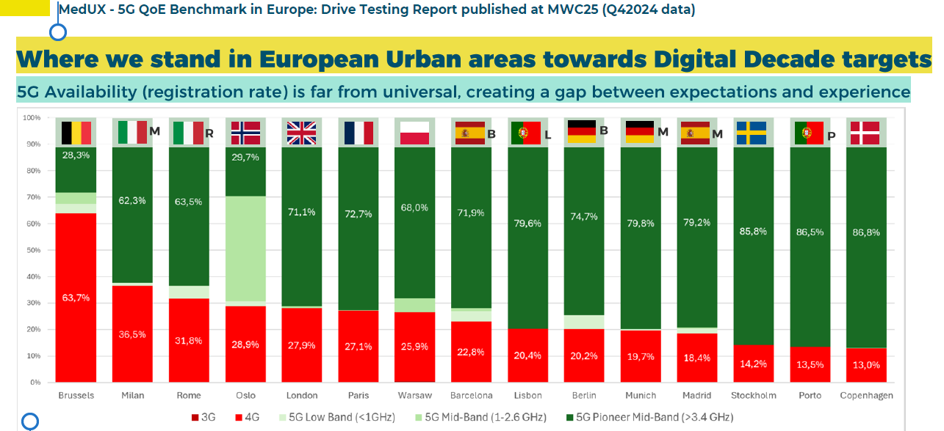
Figure 22: Status of 5G usage in Europe
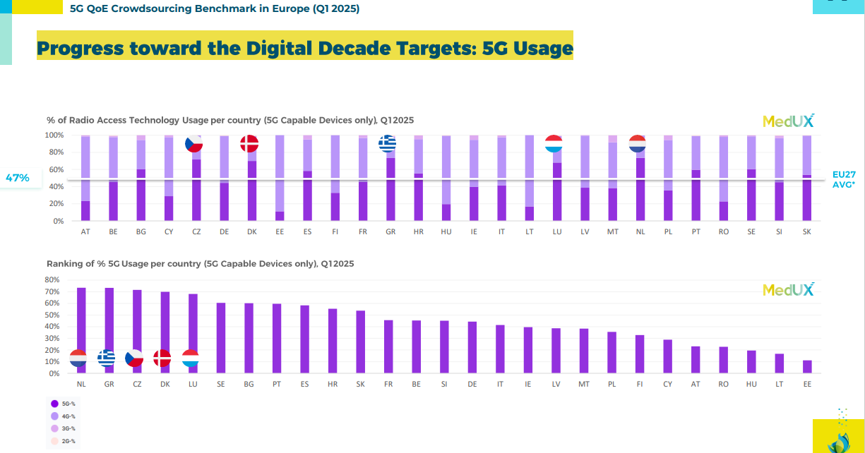
Figure 23 :International comparison of 5G usage
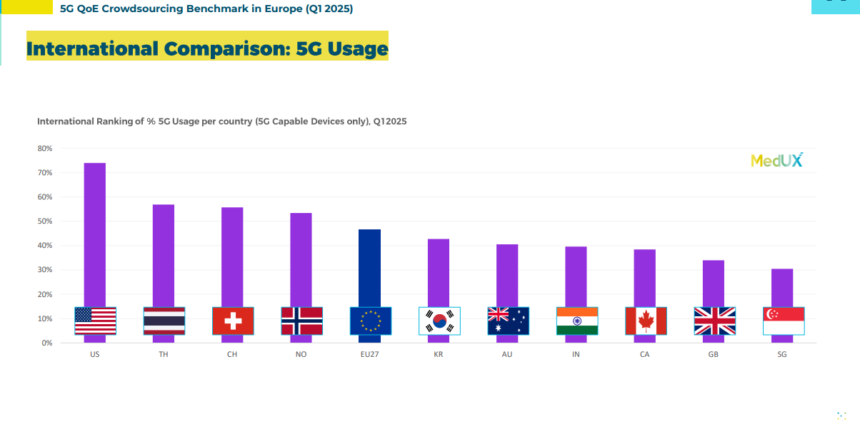
Figure 24: Status of 5G SA usage in Europe
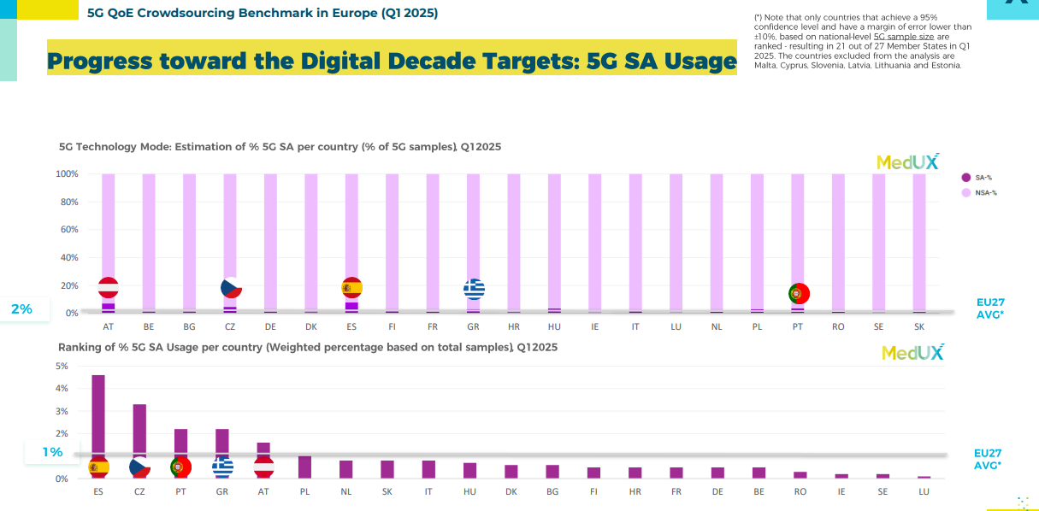

Figure 25: International comparison of 5G SA usage
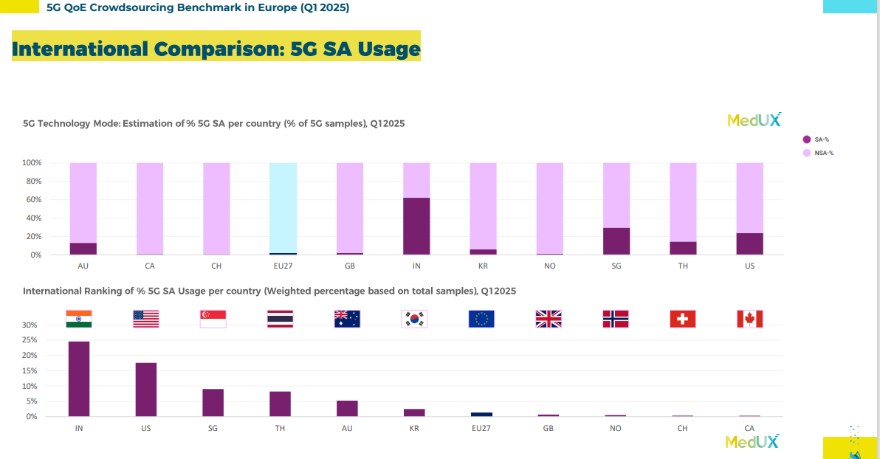
Figure 26: International comparison of average download speed
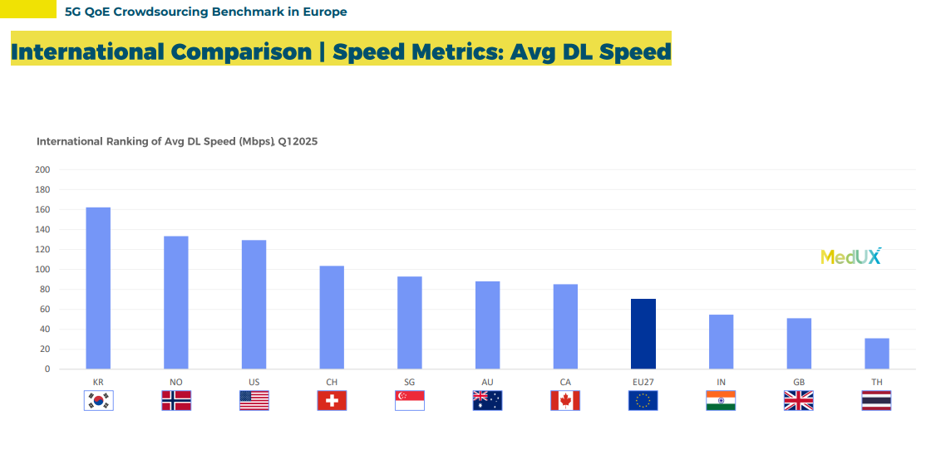

Table 1 – ITU Summary of cases of harmful interference concerning space services
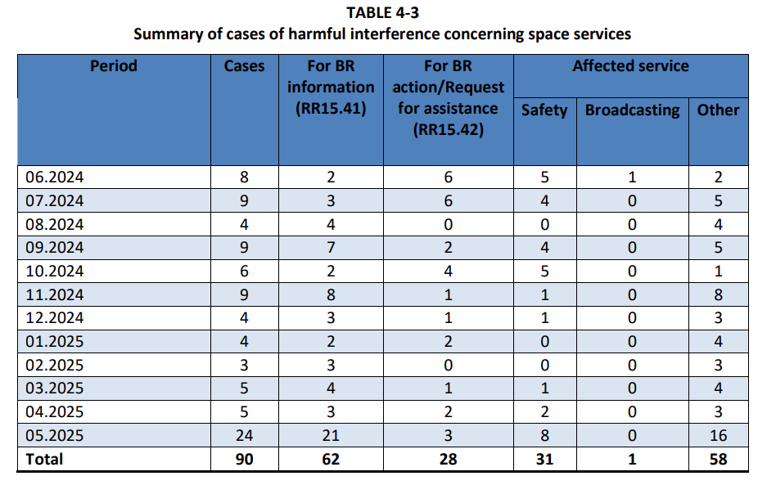
Source: Table 4-3 of the Report of the Director of the ITU Bureau to the Radio Regulation Board in July 2025

Table 2 How final auction prices differed from the reserve price in EU 5G auctions
Award | Reserve as % of EU average band final price | Reserve as % of EU average band final price
Germany 3.6 GHz 2021 | 85.05 | 3%
Latvia 3.6 GHz 2018 | 26.10 | 4%
Sweden 700 MHz 2018 | 14.12 | 18%
Italy 3.6 GHz 2018 | 11.44 | 49%
Estonia 3.6 GHz 2022 | 9.79 | 5%
Ireland 3.6 GHz 2017 | 9.75 | 6%
Estonia 700 MHz 2022 | 8.85 | 3%
Austria3.6 GHz2024 | 8.52 | 6%
Czech Republic 3.6 GHz 2017 | 6.82 | 4%
Italy 26 GHz 2018 | 5.12 | 39%
Spain 3.6 GHz 2018 | 4.37 | 15%
Czech Republic 700 MHz 2020 | 4.19 | 22%
Portugal 3.6 GHz 2021 | 3.95 | 28%
France 3.6 GHz 2020 | 3.05 | 64%
Germany 700 MHz 2015 | 2.22 | 34%
Latvia 700 MHz 2021 | 2.06 | 17%
Greece 700 MHz 2020 | 2.02 | 44%
Estonia26 GHz 2023 | 1.88 | 55%
Luxembourg 3.6 GHz 2020 | 1.86 | 69%
Sweden 3.6 GHz 2021 | 1.29 | 65%
Spain 700 MHz 2021 | 1.25 | 107%
Finland 3.6 GHz 2018 | 1.20 | 44%
Czech Republic 3.6 GHz 2020 | 1.18 | 36%
Austria26 GHz2024 | 1.17 | 80%
France 700 MHz 2015 | 1.12 | 231%
Bulgaria 3.6 GHz 2021 | 1.12 | 10%
Croatia 700 MHz 2021 | 1.11 | 28%
Slovakia 700 MHz 2020 | 1.02 | 110%
Finland 700 MHz 2016 | 1.01 | 75%
Finland 26 GHz 2020 | 1.01 | 115%
Croatia 26 GHz 2021 | 1.01 | 90%
Italy 700 MHz 2018 | 1.00 | 215%
Greece 26 GHz 2020 | 1.00 | 110%
Luxembourg 700 MHz 2020 | 1.00 | 166%
Spain 3.6 GHz 2021 | 1.00 | 65%
Portugal 700 MHz 2021 | 1.00 | 70%
Romania 3.6 GHz 2021 | 1.00 | 11%

Appendix III Evaluation of BEREC and the BEREC Office
- INTRODUCTION
This report to the European Parliament, the Council and the Management Board outlines the Commission’s findings of the evaluation of the performance of BEREC and the BEREC Office, in accordance with Article 48 of Regulation (EU) 2018/1971 of the European Parliament and of the Council of 11 December 2018 establishing the Body of European Regulators for Electronic Communications (BEREC) and the Agency for Support for BEREC (BEREC Office) ¹, hereinafter the ‘BEREC Regulation’. The accompanying staff working document contains more detailed evidence and analysis supporting these findings.
- METHOD
The evaluation was carried out in compliance with the Commission Better Regulation Guidelines² and builds on the study supporting the evaluation of BEREC and the BEREC Office prepared for the Commission³. While in principle it encompassed the period from 2019 to 2023, most relevant developments until mid-2025 are also covered. This report assessed the performance of BEREC and the BEREC Office across the following evaluation criteria: effectiveness, efficiency, relevance, coherence, and EU value added.
The evaluation support study used several methods of data collection and analysis, including inter alia: desk research, document analysis, surveys for NRAs and for external stakeholders, as well as an interview programme with representatives from stakeholders categories.
In its evaluation, the Commission has also taken into consideration BEREC own initiative input to the Commission on the functioning of BEREC and the BEREC Office in view of the evaluation under Article 48 of the BEREC Regulation⁴.
- BEREC AND BEREC OFFICE UNDER REGULATION (EU) 2018/1971
The Body of European Regulators for Electronic Communications as it exists today was established by the BEREC Regulation, together with the Agency for the Support for BEREC. They succeeded the original BEREC and its office, set up by Regulation (EC) No 1211/2009, as part of the 2009 telecoms reforms package, in order to ensure greater harmonisation of practices among the NRAs, promote an effective internal market in this sector, and act as an exclusive forum for cooperation among NRAs, and between the Commission and NRAs. In 2018, following the evaluation undertaken under Regulation (EC) No 1211/2009⁵, BEREC’s role was further strengthened by the BEREC Regulation and by the EECC.
BEREC’s mandate was notably expanded to issue several guidelines to facilitate the harmonised implementation of the EECC, as well as to establish and maintain specific databases, for instance on numbering and general authorisations.
The two-tier structure of BEREC and the BEREC Office was maintained in 2018 by the co-legislators, while the Commission had initially proposed in 2016 to expand BEREC on the model of a decentralised agency. As a result, only the BEREC Office, which succeeded the Office, is a decentralised EU Agency dedicated to delivering professional and administrative support to BEREC, the body gathering NRAs. The BEREC Office possesses a legal personality and maintains legal, administrative, and financial autonomy.
Like Member States, including NRAs, as well as the Commission and the Radio Spectrum Policy Group (RSPG), BEREC is pursuing the general objectives set out in Article 3 of the EECC, that is: promoting connectivity and access to very high capacity networks (VHCN); promoting competition and efficient investment; contributing to the development of the internal market; promoting the interests of the citizens of the Union. The objective of promoting connectivity was added in the EECC as electronic communications were becoming essential for the economy and the society overall.
Additionally, BEREC must, according to Article 3 of the BEREC Regulation, ensure - in particular - a consistent implementation of the regulatory framework for electronic communications (EECC, Roaming Regulation⁷ and Open Internet Regulation⁸).
- MAIN FINDINGS
4.1 Effectiveness
In general, over the period assessed, BEREC has been effective in delivering on its main objectives, i.e. promoting connectivity and access to VHCN; promoting competition and efficient investment; contributing to the development of the internal market; promoting the interests of the citizens of the Union (Article 3 EECC).
Under EECC BEREC has been tasked with elaboration of 11 guidelines⁹, on complex technical, economic and legal aspects, aiming to provide guidance to NRAs for more harmonised implementation of the EECC. BEREC devoted significant resources and expertise in elaboration of the guidelines, which in general are perceived as important guidance supporting NRAs common approaches. Yet those guidelines alone were not sufficient to create European single market in the communication sector, as the guidelines always adhere to the principle of NRAs flexibility. In this context, safeguarding BEREC and NRAs independence from political influences and from other stakeholders, has been and remains an important determinant of their effectiveness in implementing the regulatory framework.
During the period analysed, more complex and interrelated digital markets have led to the enactment of new rules in the digital ecosystem in recent years e.g., the Digital Services Act¹⁰, the Digital Markets Act¹¹, the Data Act¹² and Data Governance Act¹³ and the AI Act¹⁴. This resulted in new responsibilities assigned to competent authorities in these digital markets. However, in these new fields as well as in cybersecurity or spectrum, these new aspects are not always reflected in BEREC’s mandate. Moreover, since these new responsibilities are not necessarily granted nationally to NRAs, BEREC cannot always rely on the experience of all of its members when implementing (new) tasks entrusted to it or, acting on its own initiative, providing advice or input on these new aspects Therefore, better cooperation with competent authorities other than the NRAs in the field of electronic communications, as well as upskilling of the NRAs, are becoming even more important as digital regulation is extending beyond the traditional telecommunications sector. While more coordination and exchange of information between the NRAs and other competent authorities, or the direct involvement of the latter in the work of BEREC, would further improve its effectiveness, the above also prompts the question whether the scope of BEREC’s tasks should not evolve, to keep up with these regulatory developments.
Moreover, as also recognised by BEREC and as indicated in the Commission’s White Paper ‘How to master Europe’s digital infrastructure needs?’ a virtualisation and softwarisation of electronic communications networks is ongoing, as well as a shifting of network functions to the cloud or the edge¹⁵. The convergence of electronic communications networks and services and cloud infrastructures does not only concern the infrastructure layer, but also the service operations. Furthermore, in the last years AI-based applications have profoundly changed the way of life and affected all economic sectors. It is important for BEREC to be able to respond to the convergence of the traditional telecoms market and the wider digital ecosystem to fulfil its role, including the increasingly supranational scope of connectivity markets. Should the European dimension of the sector further develop, and with it, scope and objectives of regulatory framework, including regulatory issues such as authorisation, ensuring better functioning of broader connectivity eco system and very importantly resilience and sustainability broader and amore EU-focused governance setup should also be considered.
When it comes to the BEREC Office, generally speaking, it has been successfully providing support to BEREC, even during periods of increased workload or when having to adapt to significant global events, such as the Russia war of aggression on Ukraine. Nevertheless, the Commission shares the view of many NRAs that the BEREC Office should not only provide administrative support but also additional professional support and, in particular, play a more central role in data collection and analysis. This could be an important development in the BEREC Office’s role, as demand for data analytics, and better understanding of technological trends and their determinants are essential for BEREC to fulfil its role, now and in the foreseeable future. Strengthening the BEREC Office so that it can support BEREC also on substance will allow BEREC deliverables to take more into account EU perspective and better align with EU-level policies.
  - Efficiency
BEREC is generally considered as an organisation with a clear and straightforward setup, governance and procedures, yet relatively flexible. Nevertheless, the frequent reliance on the bigger NRAs for leading BEREC working groups, the mentioned asymmetry in the NRAs’ competences or their related limited knowledge in specific areas might challenge the representativeness of specific BEREC outputs. While the current mandate of the BEREC Office might not provide much margin of manoeuvre, requesting more content-related support from the BEREC Office could improve the situation.
Moreover, the number of BEREC Working Groups and the delineation of their tasks should be assessed to ensure that developments in the sector are addressed while avoiding possible overlaps or inconsistencies. Finally, as also raised by NRAs/BEREC, better coordination and planning with the EU institutions could enable more effective task delivery regarding ad hoc work requested from BEREC.
Being among the smallest EU agencies, the BEREC Office strives to provide support to BEREC as efficiently as possible within its budgetary constraints. The BEREC Office – and its Management Board – is, however, regularly deviating from the Commission’s guidance on staff to recruit more colleagues. At the same time, there is currently a relatively high rate of staff turnover at the BEREC Office, mostly visible for external staff dealing with administrative tasks, and reportedly due, in part, to the location of the Agency. This turnover leads to continuity issues, including retaining knowledge.
The BEREC Office should address these issues in order to be more efficient. This could be done through reorganisation of functions inside the Agency, as well as closer collaboration with Commission services or other decentralised agencies. As a matter of fact, providing more content-related support e.g. on data analysis and report drafting, could make the overall balance between operational staff and administrative support staff more appropriate. This could make the BEREC Office a more attractive employer. Furthermore, the BEREC Office’ IT tools could be further improved to make them more straightforward to use, and secure in view of persistent cybersecurity threats (both to the BEREC Office itself, in view of its location, as well as a compromise vector towards EU telecoms operators). In any event, it will be important that the BEREC Management Board addresses human and financial resources issues in accordance with the overall framework for European agencies and uses the resources efficiently.
  - Coherence
More coordination and exchange of information at EU and/or national level, between the NRAs and other competent authorities, or the direct involvement of other competent authorities in BEREC’s work for which NRAs are not all in charge at the national level, would also foster the coherence of certain BEREC outputs. In the Commission’s view, BEREC should in any event adapt its outputs and expertise to relevant emerging topics such as AI, cybersecurity, and other digital matters, and very importantly sustainability and resilience of networks, which are addressed in different EU policies and legal instruments.
Specific reference should also be made to spectrum matters in this context. While a significant number of BEREC members are responsible for spectrum matters at national level, and both BEREC and the BEREC Office are addressing authorisation issues in a number of ways, they are involved in spectrum matters only in limited instances so far, such as via participation in RSPG peer reviews. Recent developments in the area of satellite-based applications particularly calls for strengthened involvement of BEREC and the BEREC Office in the field of spectrum, in view of inherently pan-European nature of satellite-based services.
  - EU added value
By bringing together expertise from 27 NRAs, BEREC plays a pivotal role in the implementation of the electronic communications' regulatory framework, in particular for the NRAs and the EU institutions.
At the same time, its contribution to fostering regulatory consistency, hence the internal market for electronic communications and end-users, should be further encouraged. In particular, BEREC could play a more active role in promoting a harmonised approach to the implementation of the European regulatory framework for electronic communications in line with Article 3 of the BEREC Regulation, notably through its guidelines. During the evaluation period, BEREC guidelines were instrumental in supporting the harmonisation of NRAs approaches but were not sufficient, among also many other factors not directly related to BEREC, to ultimately lead to the creation of European single market for communication Nevertheless, while BEREC can adopt its opinions by simple majority, in practice it strives to achieve consensus/unanimity and common ground among all involved NRAs. In effect this significantly limits BEREC ability to act with focus on pan-European interests, as opposed to sometimes more conservative and ‘naturally’ more focused on local specificities, national views.
BEREC’s opinions generally provide valuable inputs to the NRAs and the EU policy process. However, those issued on its own initiative and/or during inter-institutional negotiations could be better coordinated with the Commission and co-legislators to ensure their usefulness in the policymaking process. This would plead for finding the appropriate ways and timing for the Commission or other institutions to collect BEREC’s views, and to clarify BEREC’s current mandate to provide input in relation to the preparation of legislative proposals in the field of electronic communications.
Moreover, BEREC’s expertise needs to be sustained, deepened and broadened, in view of the rapidly evolving electronic communications and digital markets, and this, despite any diverging powers of its members at national level. In that regard, in its response¹⁶ to the Call for Evidence BEREC states that it is keen to assume new institutional responsibilities in view of further strengthening the single market dimension and broader digital policy perspective, while such expansion can also work well within its current two-tier structure. Further, BEREC stresses the need to clearly delineate the areas of responsibilities and accountability among various institutional actors, and acknowledges the growing need for structured cooperation with other EU-level bodies overseeing interrelated areas of digital policy, such as data governance, digital services, cybersecurity, and AI.
Finally, the increasing number of participants from third country NRAs, while helping to promote the EU electronic communication markets and exchange of views and learning from each other, implies reflecting on the respective roles, capacities to make decisions and organisation of BEREC work.
  - Relevance
Asymmetries in NRAs’ competences in Member States may limit the relevance of BEREC’s work for certain NRAs. This is prompting the question how BEREC could best ‘contribute to the regulatory environment fit for the digital age in the run-up to 2030’, as BEREC puts it in its own input to the evaluation.
The current governance structure has been conceived for markets which are national in scope, and where ex ante regulation is the main tool in the regulatory toolbox. This is changing, since the European dimension of the sector has been developing, while competitive conditions have evolved. Also, greater potential to rely on symmetric rules means that the scope of ex-ante regulation, based on a regular review of national markets can be progressively reduced. Recent technological changes create various opportunities and challenges for the sector, as indicated in the Commission in the White Paper on digital infrastructure needs, and recent feedback in the Call for evidence accompanying the legislative process for the Digital Networks Act. The draft Strategy recognises the profound changes of the digital technologies and the intertwined/reciprocal nature of electronic communications and digital technologies (AI, data processing, virtualisation, cloud and edge computing). In order to ensure its relevance in the coming years BEREC identifies key priorities, which besides its current focus (connectivity, competition, end user interests), also put emphasis on environmental sustainability, cybersecurity and resilience.
The currently decentralised governance mechanism and the traditional setup of BEREC might not be sufficient and appropriate to cope with this evolution. Furthermore, the regulatory toolbox might need to be modernised to address the market and technological changes, with possible broader use of harmonised tools (for example access product) and its most rarely (if ever) used tools, such as resolution of cross-border aspects, may gain prominence. In this respect, and while BEREC’s current tasks are mostly of an advisory nature, the question arises how the role and mandate of BEREC and the BEREC Office should possibly be strengthened and adapted to new responsibilities in the broader digital field.
The current setup also challenges the relevance of BEREC’s work on digital markets for certain industry and consumer representatives. External stakeholders want to engage more with BEREC in virtual events or public consultations, often ask for more time to respond to consultations, and for more transparency on upcoming initiatives. In that regard during 2024 and 2025 BEREC has put significant emphasis on improving its effective communication with stakeholders, to ensure transparency, build trust and engage with stakeholders, ensuring that all its outputs remain relevant. This has been underlined as one of the aspects of strengthening BEREC capabilities in its draft Strategy 2026-2030, which aims to set BEREC priorities for the upcoming 5 years.¹⁷
- CONCLUSION
This report, and its accompanying Staff Working Document, mainly look backwards, into the performance of BEREC and the BEREC Office over the period 2019-2023, while also taking into account main developments until August 2025. This report draws a number of lessons from this analysis, including on the mandate and the organisation of BEREC and the BEREC Office.
Overall, BEREC and the BEREC Office have proven to be quite effective in delivering on their main objectives. The contribution of independent NRAs, which share the same objectives, is essential in this respect.
However, the situation has been developing over the reporting period and continues to evolve significantly. More complex and interrelated digital markets have led to the enactment of new rules and new tasks granted to many BEREC members in e.g. digital markets, cybersecurity, spectrum, data, AI which are not always reflected in BEREC’s mandate. This is increasing the asymmetry between NRAs’ responsibilities at national level, as well as between NRAs’ responsibilities and BEREC’s mandate. Moreover, recent market and technological changes are creating opportunities and challenges for the sector, as indicated in the Commission’s White Paper on digital infrastructure needs.
These developments are pleading for more coordination and exchange of information at national level or the direct involvement other competent authorities in the work of BEREC, which could improve its effectiveness. Moreover, changes occur in the electronic communications sector itself, with evolving competitive conditions and blurring delineation between different aspects of digital networks and electronic communication and digital services. These developments are calling for sustaining and broadening BEREC’s role and expertise, as also recognised by BEREC itself, while underlining the need for clear delineation of new responsibilities and accountability of various institutional actors and preserving BEREC’s and NRA’s independence.

Directive - 2018/1972 - EN - eecc - EUR-Lex.
See Draghi, M., The Draghi report: A competitiveness strategy for Europe (Part A), 2024 as well as Draghi, M., The Draghi report: In-depth analysis and recommendations (Part B), 2024,Letta, E., Much more than a market – Speed, Security, Solidarity Empowering the Single Market to deliver a sustainable future and prosperity for all EU Citizens, 2024 and Niinistö, S., Report: Safer Together – Strengthening Europe’s Civilian and Military Preparedness and Readiness | European Commission.
Decision No 243/2012/EU of the European Parliament and of the Council of 14 March 2012 establishing a multiannual radio spectrum policy programme, Text with EEA relevance (OJ L 81, 21.3.2012, p. 7–17): https://eur-lex.europa.eu/eli/dec/2012/243(2)/oj.
Decision No 243/2012/EU of the European Parliament and of the Council of 14 March 2012 establishing a multiannual radio spectrum policy programme, Text with EEA relevance (OJ L 81, 21.3.2012, p. 7–17) : https://eur-lex.europa.eu/eli/dec/2012/243(2)/oj.
https://digital-strategy.ec.europa.eu/en/library/results-exploratory-consultation-future-electronic-communications-sector-and-its-infrastructure.
See SWD(2016) 303 final, PART 1/3, p57 pp.
See SWD(2016) 303 final, PART 1/3, p62
See COM(2019) 203 final, p 12.
As amended by Directive 2009/136/EC of the European Parliament and of the Council of 25 November 2009 amending Directive 2002/22/EC on universal service and users’ rights relating to electronic communications networks and services, Directive 2002/58/EC concerning the processing of personal data and the protection of privacy in the electronic communications sector and Regulation (EC) No 2006/2004 on cooperation between national authorities responsible for the enforcement of consumer protection laws (Directive 2009/136/EC) The 2009 intervention logic for the amendments of the 2002 e-Privacy Directive was based on the increased security breaches, and the lack of mandatory notification of security breaches resulting in users’ personal data being lost or compromised. At that time, there were not sufficient measures available at Member State level to combat spam. It was not clear that the Directive also applies to public communications networks supporting data collection and identification devices (including contactless devices such as Radio Frequency Identification Devices). That’s why, the relevant amendments were introduced by Directive 2009/136/EC.
Judgements in cases C-439/22 (Ireland), C‑454/22 (Latvia), C-452/22 (Poland), C-449/22 (Portugal) and C-457/22 (Slovenia),
https://www.berec.europa.eu/en/tools/numbering-database-for-extra-territorial-use?language_content_entity=en.
https://digital-strategy.ec.europa.eu/en/library/second-report-implementation-regulation-open-internet-access.
https://camaraproject.org/.
NIS Cooperation Group, Cybersecurity of 5G networks - EU Toolbox of risk mitigating measures, 23 January 2020.
Regulation (EU) 2021/1119 of the European Parliament and of the Council of 30 June 2021 establishing the framework for achieving climate neutrality and amending Regulations (EC) No 401/2009 and (EU) 2018/1999, OJ L 243, 09.07.2021: https://eur-lex.europa.eu/eli/reg/2021/1119/oj/eng.
Directive 2009/125/EC of the European Parliament and of the Council of 21 October 2009 establishing a framework for the setting of ecodesign requirements for energy-related products , OJ L 285, 31.10.2009: https://eur-lex.europa.eu/legal-content/EN/ALL/?uri=celex%3A32009L0125.
Directive 2012/19/EU of the European Parliament and of the Council of 4 July 2012 on waste electrical and electronic equipment (WEEE), OJ L 197, 24.07.2012: https://eur-lex.europa.eu/legal-content/EN/TXT/?uri=CELEX:02012L0019-20180704.
Publications; EU Code of Conduct on Energy Consumption of Broadband Equipment: Version 9.0 (current version valid from 1.1.2024) and for Version 9.1 Code of conduct on energy consumption of broadband equipment - Publications Office of the EU.
2024 Best Practice Guidelines for the EU Code of Conduct on Data Centre Energy Efficiency.
Regulation (EU) 2020/852 of the European Parliament and of the Council of 18 June 2020 on the establishment of a framework to facilitate sustainable investment, and amending Regulation (EU) 2019/2088, OJ L 198, 22.06.2020: https://eur-lex.europa.eu/eli/reg/2020/852/oj/eng.
Green and sustainable telecom networks - The Joint Research Centre: EU Science Hub.
Reference in Section 2.2.8 of the First Interim Report on Completing the DSM.
See AI Continent Action Plan.
‘Very High Capacity Networks’ means either an electronic communications network which consists wholly of optical fibre elements at least up to the distribution point at the serving location, or an electronic communications network which is capable of delivering, under usual peak-time conditions, similar network performance in terms of available downlink and uplink bandwidth, resilience, error-related parameters, and latency and its variation; network performance can be considered similar regardless of whether the end-user experience varies due to the inherently different characteristics of the medium by which the network ultimately connects with the network termination point.
See reference to the access study section 9.1.1.
See reference to the finance study section 3.4 / 4.3.
Reference to Page 22, 2024 BEREC Report on the general authorisation and related frameworks for international submarine connectivity: ”Non-public ECN and non-public ECS are subject to prior notification/registration under the general authorisation regime only in 4 MS”.
See Spectrum section 5.4.1. Figure Error! Main Document Only.: Total 5G household coverage.
See Spectrum section 5.4.1. Figure Error! Main Document Only.: 5G coverage of households in the 3.6 GHz band Observatory Report 2025 | Shaping Europe’s digital future.
Reference to the State of the Digital Decade 2025 report: State of the Digital Decade 2025 report | Shaping Europe’s digital future.
Reference to Section 3.1.2 of the Final 1st Interim Report on Completing the DSM.
Reference to Section 4.1.2.1 of the Final 1st Interim Report on Completing the DSM.
Reference to 3.1.2 of the Final 1st Interim Report on Completing the DSM.
Reference in Section 4.5.2 of the Final 1st Interim Report on Completing the DSM.
Reference to 4.1.2 of the Final 1st Interim Report on Completing the DSM.
Reference to 4.1.2 of the Final 1st Interim Report on Completing the DSM.
Regulation - 2022/1925 - EN - EUR-Lex.
Regulation - 2022/2065 - EN - DSA - EUR-Lex.
Directive - 2022/2555 - EN - EUR-Lex.
Reference to Section 4.1.2 of the Final 1st Interim Report on Completing the DSM. Examples are related to the difference between the EECC and DMA for the thresholds of regulatory intervention concerning NI-ICS falling under both the EECC and under the DMA as a Core Platform Service. With regard to the DSA, a few stakeholders found issues with the EECC. In particular, the obligation to designate a single point of contact under Art. 11 DSA duplicates the activity notification under Art. 12 EECC. The former Art. 40 and 41 EECC had rules tailored to the security of electronic communications networks and services, while the NIS-2 Directive repealing these provisions apply to “network and information systems” that include both ICT networks and telecom networks.
Reference to Section 4.1.2 of the Final 1st Interim Report on Completing the DSM.
Reference in Section 4.1.5 of the Final 1st Interim Report on Completing the DSM.
Regulation - EU - 2024/1309 - EN - EUR-Lex.
Draghi, M., The Draghi report: A competitiveness strategy for Europe (Part A), 2024 as well as Draghi, M., The Draghi report: In-depth analysis and recommendations (Part B), 2024.
Reference in Section 4.1.2 of the Final 1st Interim Report on Completing the DSM.
Reference in Section 4.1.2 of the Final 1st Interim Report on Completing the DSM.
Reference in Section 4.1.5 of the Final 1st Interim Report on Completing the DSM.
Reference in Section 3.1.1 from the Final 1st Interim Report on Completing the DSM.
BEREC Report on Cloud and Edge Computing Services - https://www.berec.europa.eu/system/files/2024-10/BoR%20%2824%29%20136_BEREC%20Report%20on%20Cloud%20and%20Edge%20Computing%20Services.pdf
Reference to Section 3.1.1. in the Final 1st Interim Report on Completing the DSM.
See also BEREC (2021). Report on the interplay between the EECC and the EC’s proposal for a Digital Markets Act concerning number-independent interpersonal communication services, BoR(21) 85: https://www.berec.europa.eu/sites/default/files/files/document_register_store/2021/6/BoR_(21)_85_Report_on_the_interplay_EECC-DMA_on_NI-ICS_-_Clean_(final).pdf.
BEREC Report on Interoperability of NIICS - | BEREC.
Reference to Section 4.1.2 of the Final 1st Interim Report on Completing the DSM.
Reference to Section 5.2.5.1 of the draft WIK-Consult - EY Study on USO.
Reference to Section 4.1.2 of the Final 1st Interim Report on Completing the DSM.
Reference to Page 2 in the 2025 Draft BEREC Report on Submarine Cables Connectivity - BoR (25) 85 Draft BEREC Report on Submarine cables connectivity in Europe.pdf. According to BEREC, the large majority of the submarine cables corresponds to purely domestic submarine cables (with all landing stations in the same country), while only 12% of them are part of an international cable system. Almost a third of the submarine cable systems are between 10 and 25 years old, and nearly a fifth of the domestic submarine cables analysed in this report benefitted from public funding (page 2 of the Draft Report). In addition, 14% of the submarine cable systems started operating over 35 years ago, which may impact the capacity of submarine cable systems in the near future. Regulatory approaches vary (Page 3 of the Draft Report): the report shows that six NRAs (HR, FR, EL, Iceland, PT and ES) have carried out a market analysis regarding or including domestic submarine cables leading to regulation of submarine cables with designation of an operator with significant market power (SMP). Over these six NRAs who regulate or have regulated submarine cables, four of them (Croatia, Greece, Iceland, Portugal) are still regulating this market, whereas the other two (FR and ES) stopped regulating it, respectively in 2017 and 2024.
Reference to p. 23 of the Draft BEREC Report on the general authorisation and related frameworks for international submarine connectivity .
BEREC’s input to the EC public consultation on the White Paper “How to master Europe’s digital infrastructure needs?”, BoR (24) 100_1, p20 https://www.berec.europa.eu/system/files/2024-07/BoR%20%2824%29%20100_1_%20BEREC%20Input_White%20Paper_final.pdf.
For details on the two disputes please see Annex I in BEREC Report on the IP Interconnection ecosystem, BoR(24) 93: https://www.berec.europa.eu/system/files/2024-06/BoR%20%2824%29%2093_draft%20BEREC%20Report%20on%20the%20IP-IC%20ecosystem_1.pdf.
Cullen International June 2025 IP interconnection disputes (IP peering and IP transit).
Monopolkommission (2023) Ein Beitrag von datenverkehrsintensiven Over-The-Top-(OTT)-Anbietern an den Netzausbaukosten ist abzulehnen!, 12. Policy Brief: https://www.monopolkommission.de/images/Policy_Brief/MK_Policy_Brief_12.pdf.
Reference in Section 4.1.2.5 of the Final 1st Interim Report on Completing the DSM.
References in Section 4.1.2.5 of the 1st Interim Report on Completing the DSM.
A few disputes occurred through litigation or NRA intervention (e.g. Deutsche Telekom vs Meta; DAZN live-streaming, Orange vs Cogent, Liberty Global/Ziggo; Telekomunikacja Polska (now Orange Poland), ANISP vs DIGI, etc.)..
https://www.berec.europa.eu/system/files/2025-01/BoR%20%2824%29%20177_BEREC%20Report%20on%20the%20IP-IC%20ecosystem_0.pdf.
White Paper - How to master Europe’s digital infrastructure needs? | Shaping Europe’s digital future.
Cullen International June 2025, IP interconnection disputes (IP peering and IP transit).
Reference in Section 4.2.2 of the Final 1st Interim Report on Completing the DSM
References in Sections 4.1.2 of the Final 1st Interim Report on Completing the DSM.
Reference in Section 4.1.2 in the First 1st Interim Report on Completing the DSM.
Directive - 2015/1535 - EN - EUR-Lex.
See also BEREC (2021). Report on the interplay between the EECC and the EC’s proposal for a Digital Markets Act concerning number-independent interpersonal communication services, BoR(21) 85: https://www.berec.europa.eu/sites/default/files/files/document_register_store/2021/6/BoR_(21)_85_Report_on_the_interplay_EECC-DMA_on_NI-ICS_-_Clean_(final).pdf.
References in Section 2.2.3 of the Final 1st Interim Report on Completing the DSM.
Reference to Section 4.1.2 in the Final 1st Interim Report on Completing the DSM.
Reference to Section 4.1.2 in the Final 1st Interim Report on Completing the DSM.
Reference to Section 4.1.2 of the Final 1st Interim Report on Completing the DSM.
Reference to Section 2.1.10 on Network Convergence of the Final 1st Interim Report on Completing the DSM.
Reference in Section 4.1.2 of the Final 1st Interim Report on Completing the DSM.
Commission Recommendation (EU) 2024/779 of 26 February 2024 on Secure and Resilient Submarine Cable Infrastructures.
Reference in Section 4.1.2 of the Final 1st Interim Report on Completing the DSM.
Reference in Section 4.3.6 of the Final 1st Interim Report on Completing the DSM.
Reference in Section 4.1.2 of the Final 1st Interim Report on Completing the DSM.
For details on the two disputes please see Annex I in BEREC Report on the IP Interconnection ecosystem, BoR(24) 93: https://www.berec.europa.eu/system/files/2024-06/BoR%20%2824%29%2093_draft%20BEREC%20Report%20on%20the%20IP-IC%20ecosystem_1.pdf.
Market 1 is not regulated in BU, RO, NL and AT. Market 2 is not regulated in BU, CZ, DK, EE, FI, LV, MT, NL, PL, RO, SK, SE.
There is widespread use of SMP regulation (only 2 out of 27 NRAs do not apply it at all). This is mirrored in the large number of provisions that have been developed to guide the application of SMP regulation under the EECC.
In particular, Article 61(3) provides that access obligations can be imposed with respect to wiring and associated facilities inside buildings or up to the first concentration or distribution point where the replication of these network elements would be economically inefficient or physically impracticable; under strict conditions such obligations can be extended up to a point beyond. These provisions are applicable outside of the context of a market analysis, and irrespective of whether the undertaking concerned has been designated as having significant market power.
EL, EE (partly), SK, SE, CY, LV (partly), LU, DK (partly), CZ (partly), DE, IT (partly), BE, HR (partly), MT, FR, IE, FI (partly), LT, LI, PT (partly), HU, PL (partly), SI. It should be noted however that there is no distinction between WLA and WCA in Austria, Denmark and Netherlands.
EL, CY, LU, DE, IT (partly), BE, HR, AT (partly), FR, IE (partly), LT, ES, PT (partly), HU.
EL, SK, LV, LU, IS, DE, SI, BE, HR, FI, LT, PL.
EE, IE, LV, BG, FR and PT.
Guidelines on market analysis and the assessment of significant market power under the EU regulatory framework for electronic communications networks and services (2018/C 159/01).
Commission Recommendation (EU) 2020/2245 of 18 December 2020 on relevant product and service markets within the electronic communications sector susceptible to ex ante regulation in accordance with the EECC (2020 Recommendation on Relevant Markets) (OJ L 439, 29.12.2020, p. 23-31).
Commission Recommendation (EU) 2024/539 of 6 February 2024 on the regulatory promotion of gigabit connectivity (C/2024/523) (OJ L, 2024/539, 19.2.2024).
See Article 81 EECC.
BOR (20) 165, section 3
The table is based on several predecessing studies and updated to the state of the art, see also: Godlovitch, I.; Hocepied, C.; Lemstra, W.; Plückebaum, T.; Strube-Martins, S.; Kroon, P.; Lucidi, S.; Alexiadis, P.; Char, S.; Future electronic communications product and service markets subject to ex-ante regulation, European Commission Brüssel/ Luxemburg Juni 2019, https://op.europa.eu/en/publication-detail/-/publication/7309fa31-b758-11ea-bb7a-01aa75ed71a1.
Column 1 names the transmission technologies. The lines for the technology descriptions are grouped per access line technology: copper pairs, Hybrid Fibre Coax (HFC), fibre, and Fixed Wireless Access (FWA). The FTT… abbreviations of column 3 enable the identification of technologies which meet criterion 1 (FTTB and FTTH). Column VHCN BB quality notes, if the criteria 1 or 3 are met or not. It can be seen in this context, that cable technologies of DOCSIS 3.1 or above and 5G FWA, could meet the VHCN quality criteria (depending on specification). Meanwhile, some older mass-market FTTH technologies such as GPON, while meeting the VHCN definition, may not be Gigabit capable.
Virtual Unbundled Local Access.
Plückebaum, T.; Godlovitch, I.; Assessment of the technicalities of VULA products in the context of a state aid investigation, Expert opinion, Version 2, EC, Brussels, March 2018, ISBN 978-92-79-79903-7, http://ec.europa.eu/competition/publications/reports/kd0418126enn.pdf.
Drafts and all documents incl. the original (BoR (15) 133) available at: https://www.berec.europa.eu/en/document-categories/berec/reports/berec-report-on-common-characteristics-of-layer-2-wholesale-access-products-in-the-european-union.
In Italy FWA is part of the State aid solution for accessing the remaining connectionless homes in the Italia 1 Gig connectivity approach by the RFF funded state aid initiative. FWA there has to meet the fixed network VHNC quality conditions of fixed networks (BEREC Criterion 3).
BEREC Guidelines on VHC Networks, BoR (20) 165, https://www.berec.europa.eu/en/document-categories/berec/regulatory-best-practices/guidelines/berec-guidelines-on-very-high-capacity-networks.
Source: Digital Decade DESI visualisation tool.
State of Digital Communications 2025.
The referenced “access study” is the currently unpublished supporting study “Review of Access Regulation under the European Electronic Communications Code and analysis of future Access policy in full fibre environment”. The possible confidentiality of the data from the NRAs is being checked.
Data from FR includes the role played by co-investment under symmetric regulation. Symmetric regulation of the fibre terminating segment in FR applies to around 90% of all households, and is based on the principle that, outside very dense urban areas, only one FTTH network is viable.
Primarily based on SMP, but also symmetric regulation in the case of FR and HR.
An analysis of the technologies used for the provision of wholesale access on incumbent operators’ networks shows that copper and FTTC-based wholesale access still accounts for more than 50% of wholesale connections sold by incumbents, despite accounting for only 26% of retail lines.
Reference to the access study, section 4.3.1. and the results of the call for evidence (see Annex 2 of the Impact Assessment).
Reference to the access study section 4.3.1.
Denmark (DK/2021/2346), where four (out of 17 proposed for regulation) regional operators offered commitments. DBA proposed to make the commitments binding, and to impose no additional obligations on the concerned operators, France (broadcasting – FR/2022/2365): TDF proposed a set of commitments, which were accepted by ARCEP and made binding for 5 years, Finland (broadcasting – FI/2022/2401): Digita’s commitments accepted and made binding and complemented by additional remedy (cost orientation).
Austrian wholesale broadband access market (case AT/2022/2389).
17 Member States regulate PIA based on SMP, out of it: 6 countries (Bulgaria, Estonia, France, Ireland, Latvia, Portugal) have defined a separate PIA market and 11 countries (Belgium, Croatia, Cyprus, Germany, Greece, Italy, Lithuania, Poland, Slovakia, Slovenia, Spain) have imposed PIA as a remedy in market 1.
Out of the 12 Member States in which the NRA conducted a geographic segmentation of the WLA market and found SMP in a portion of the territory, 10 have distinguished between areas based on differing competitive conditions. In Croatia, the Czech Republic, Estonia, Ireland, Italy, Latvia, Poland and Spain the NRAs continue to regulate in the non-competitive areas. in Denmark and Finland geographic segmentation has been based on the network reach of local and regional network operators, leading to the designation of different operators with SMP in different areas.
Of the 23 countries which found SMP on market 1 (2020)/market 3a (2014), 11 apply cost orientation to fibre-based wholesale products. Depending on the results of the geographical market segmentation, this may apply only to non-competitive areas of the market.
BU, IT, HU – 1 measure each, EL – 2 measures, DE, HR – 3 measures each.
ES/2022/2361, MT/2024/2484, PL/2024/2528, DE/2024/2512.
E.g. DE/2018/2133, DE/2020/2258.
AT/2023/2446, DE/2024/2512.
in accordance with Article 61 (3) EECC. Of these, four countries (Cyprus, Greece, Italy and Poland) impose symmetric access for in-building wiring only, while the other four (France, Spain, Portugal and Croatia) impose symmetric access at the first distribution point with a possibility for this to lie outside the building.
Godlovitch, I.; Knips, J.; Strube Martins, S.; Wernick, C.; Tenbrock, S.; Hocepied, C. (2023): Study on the evolution of the competition dynamics of tower and access infrastructure companies not directly providing retail services, study for BEREC, BoR (23) 206, https://www.berec.europa.eu/system/files/2023-12/BoR%20%2823%29%20206_Rev1_Study_towernetco_PUBLIC_0.pdf (last accessed on 19.03.2025).
Only in Italy country an SMP operator sought to make use of the new possibility offered by the Article 76 EECC. AGCOM, however, withdrew its notification once the SMP operator unilaterally changed its offer on an essential element (prices), thus requiring a new assessment by AGCOM. Later, AGCOM requested amendments of the offer and eventually, when the SMP operator did not implement them, rejected the offer as non-compliant with the EECC.
WIK.
Czechia (although this took place before the entry into force of the Code), Denmark, Italy.
Only one NRA (DBA in Denmark) decided to regulate wholesale only operators.
See. DK/2021/2346.
https://digital-strategy.ec.europa.eu/en/library/communication-smp-guidelines.
Commission Decision C(2018) 5848 final of 30.8.2018 concerning Cases NL/2018/2099 and NL/2018/2100: Wholesale fixed access market in the Netherlands.
https://www.jdsupra.com/legalnews/highest-dutch-court-annuls-acm-s-joint-71679/.
Commission closes its in-depth investigation on the proposed Czech regulation on mobile access market | Shaping Europe’s digital future.
https://digital-strategy.ec.europa.eu/en/news/commission-closes-its-depth-investigation-proposed-regulation-market-wholesale-access-mobile.
In a 2023 study, see https://www.berec.europa.eu/system/files/2023-04/BoR%20%2823%29%2041%20Study%20on%20wholesale%20mobile%20connectivity%20trends%20and%20issues%20for%20emerging%20mobile%20technologies%20and%20deployments_final_0.pdf, WIK-Consult noted that the nature of MVNO obligations in spectrum licences might affect the degree to which an MVNO could differentiate its services from that of its host and thus its potential to provide competitive disruption. It noted that in the Czech case, the spectrum licence provides “prices must allow equally efficient operators to profitably operate on the downstream (retail) market”. The study noted in this context that “The fact that the spectrum licence MVNO obligations require wholesale prices to be set on the basis of an EEO margin-squeeze test in practice limits the potential for MVNOs to engage in price competition.”
C(2024) 1928 final.
See points 46-49 and 51 of the SMP Guidelines.
See Article 81 EECC.
Dispute resolution under the BCRD / GIA (not relevant to the assessment of the EECC access-related provisions) but interesting as a comparison accounted for 16% of the total FTE.
Art 1(2) GIA: If any provision of this Regulation conflicts with a provision of Directive 2002/77/EC, (EU) 2018/1972 or (EU) 2022/2555, the relevant provision of those Directives shall prevail, while Art 3(9) notes that Physical infrastructure which is already subject to access obligations imposed by NRAs pursuant to Directive (EU) 2018/1972 or resulting from the application of Union State aid rules shall not be subject to the obligations set out in paragraphs 1, 4, and 5 for as long as such access obligations are in place.
https://eur-lex.europa.eu/legal-content/EN/TXT/?uri=celex%3A32022D2481.
See points 56 and following https://eur-lex.europa.eu/legal-content/EN/TXT/?uri=celex%3A52023XC0131%2801%29.
Under Article 64 EECC the Commission is mandated to publish and regularly review its recommendations on relevant markets.
Decision No 676/2002/EC of the European Parliament and of the Council of 7 March 2002 on a regulatory framework for radio spectrum policy in the European Community (Radio Spectrum Decision) (OJ L 108, 24/04/2002).
Decision No 676/2002/EC of the European Parliament and of the Council of 7 March 2002 on a regulatory framework for radio spectrum policy in the European Community (Radio Spectrum Decision) (OJ L 108, 24/04/2002).
Decision No 243/2012/EU of the European Parliament and of the Council of 14 March 2012 establishing a multiannual radio spectrum policy programme (OJ L 91, 21.3.2012, p. 7), https://eur-lex.europa.eu/legal-content/EN/ALL/?uri=CELEX%3A32012D0243.
RSPG Opinion on a Radio Spectrum Policy Programme (RSPP) (16 June 2021) https://radio-spectrum-policy-group.ec.europa.eu/document/download/00cfd520-efa9-48a1-bfec-d2980f511c3c_en?filename=RSPG21-033final-RSPG_Opinion_on_RSPP.pdf.
Public consultation on the draft RSPG Opinion on a Radio Spectrum Policy Programme (RSPP) (https://radio-spectrum-policy-group.ec.europa.eu/consultations-0_en).
Commission report on the implementation of the Radio Spectrum Policy Programme (COM(2014) 228 final) (22 April 2014), https://eur-lex.europa.eu/legal-content/EN/TXT/PDF/?uri=CELEX:52014DC0228&rid=1 and Commission report on the Radio Spectrum Inventory (COM(2014) 536 final), 1 September 2014, https://eur-lex.europa.eu/legal-content/en/ALL/?uri=CELEX:52014DC0536, the Commission’s 2016 fitness check accompanying the Code legislative proposal- Commission Staff Working Document on Evaluation of the regulatory framework for electronic communications (SWD(2016) 313 final), 14 September 2016, https://eur-lex.europa.eu/LexUriServ/LexUriServ.do?uri=SWD:2016:0313:FIN:EN:PDF.
European Commission, Directorate-General for Communications Networks, Content and Technology, LS Telcom, PolicyTracker and VVA, Study on radio spectrum policy programme – Taking stock and discussing future scenarios – Executive summary, Publications Office of the European Union, 2024, https://data.europa.eu/doi/10.2759/687724.
Aligned with the UHF Decision and supported by the 2016 5G Action Plan “Communication from the commission to the European Parliament, the Council, the European Economic and Social Committee and the Committee of the Regions. 5G for Europe: An Action Plan”, European Commission, Brussels, 2016.
Radio Spectrum Policy Group: Strategic Roadmap towards 5G for Europe: Spectrum related aspects for next-generation wireless systems (5G) and 5G implementation challenges Final progress report of RSPG Working Group 5G (2016-2019) on the Strategic Roadmap towards 5G for Europe to the RSPG Plenary, 2019.
Mobile broadband prices vary widely across the EU not only in nominal terms but also at price purchasing parity. See European Commission, Directorate-General for Communications Networks, Content and Technology, Mobile and fixed broadband prices in Europe.
5G Observatory Report 2025 | Shaping Europe’s digital future In the majority of Member States household 5G coverage is reaching levels around or above 90%, with only Hungary, Bulgaria, Latvia and Romania lagging behind.
European Commission. (2025). Digital Decade 2025 – 5G Observatory Report. Directorate-General for Communications Networks, Content and Technology. Available at: https://digital-strategy.ec.europa.eu/en/policies/5g-observatory-2025.
The 3,6 GHz band, together with the 700 MHz and the 26 GHz bands are the 5G pioneer bands. While the 700 MHz ensures wide coverage, the 3,6 GHz band is the “sweet spot” which strikes the best balance between speed capacity and coverage, is more accessible than mmW band, making it ideal for deploying 5G services to the general public and supporting the substantial data demands of dense urban areas and industry.
5G Observatory Report 2025 | Shaping Europe’s digital future.
The Ericsson data are favoured compared to DESI data, to ensure comparability with performance of major economies, DESI data are instead presented in the Annex and include also data per MS.
By the end of 2024, 5G SA coverage in North America reached 91%, in Asia-Pacific 45%, while Europe lagged at only 40%, despite the number of commercial 5G SA networks nearly doubling from 10 in 2023 to 19 in 2024. In Europe, Spain and Austria reported the highest proportions of 5G SA networks, with Germany and Greece following, although overall levels remain low. cf. Connect Europe (2025), State of Digital Communications, p. 5.
Availability refers to the proportion of 5G connections that utilize 5G Standalone (SA) technology within the total number of 5G connections tested or sampled. It highlights the level of adoption and usage of 5G SA networks by users in various regions, as reflected in Ookla's Speedtest® data. This differs from coverage, which measures the percentage of the population or geographic area that has access to 5G SA networks, irrespective of actual usage.
Ookla/ Omdia (2025), A Global Evaluation of Europe’s Digital Competitiveness in 5G Standalone.
Study on Completing the Digital Single Market (DSM): Regulatory enablers for cross-border networks.
BEREC (2023). Study on wholesale mobile connectivity, trends and issues for emerging mobile technologies and deployments, BoR(23) 41: https://www.berec.europa.eu/en/document-categories/berec/reports/study-on-wholesale-mobile-connectivity-trends-and-issues-for-emerging-mobile-technologies-and-deployments.
SCF (2024). SCF Market forecast report: https://www.smallcellforum.org/docs/scf-market-forecast-report/?.
WIK‑Consult. (2025). Financial Conditions, Demand and Investment Needs and Their Regulatory and Policy Implications, Including the Review of the Universal Service (Study for the European Commission).
https://medux.com/blog/all-5g-networks-are-not-created-equal-unveiling-true-qoe-5g-europe-lll?utm_source=chatgpt.com.
RSPG Opinion on 6G vision RSPG25-006 FINAL.
The amount of spectrum assigned and ready for 5G use within the 5G pioneer bands. All three spectrum bands have an equal weight. 5gobservatory.eu, DESI indicators.
5G Observatory Report 2025 | Shaping Europe’s digital future.
Study on assessing the efficiency of radio spectrum award processes in the Member States, including the effects of applying the EECC Jan 2023, https://digital-strategy.ec.europa.eu/en/library/study-assessing-efficiency-radio-spectrum-award-processes-member-states-including-effects-applying.
Commission Implementing Decision (EU) 2024/1983 of 18 July 2024 on the harmonisation of the 40,5-43,5 GHz frequency band for terrestrial systems capable of providing wireless broadband electronic communications services in the Union.
Global mobile Suppliers Association (GSA). (2024). Private Mobile Networks Summary Report – September 2024: https://gsacom.com/paper/private-mobile-networks-september-2024/ .
Global mobile Suppliers Association (GSA). (2024). Private Mobile Networks — Industry Focus: Manufacturing: https://gsacom.com/paper/private-mobile-networks-september-2024/.
Study on assessing the efficiency of radio spectrum award processes in the Member States, including the effects of applying the EECC, 2023, p.329.
Study on assessing the efficiency of radio spectrum award processes and Study on Completing the Digital Single Market (DSM): Regulatory enablers for cross-border networks.
For example, in its response to the EC’s Call for Evidence on the DNA, GSMA argued that moving towards indefinite licences — or at least extending licence terms to 40 years with tacit renewal conditions — would significantly support long-term network planning and deployment.
Federal Communications Commission (FCC). Auction 107 – 3.7 GHz Band: https://www.fcc.gov/auction/107.
Arcep (2022). Le New Deal Mobile: https://www.arcep.fr/la-regulation/grands-dossiers-reseaux-mobiles/la-couverture-mobile-en-metropole/le-new-deal-mobile.html.
Sörries, B., Franken, M., Baischew, D., & Lucidi, S. (2020). Einfluss von Versorgungsauflagen auf die Mobilfunkabdeckung in der EU (WIK Diskussionsbeitrag Nr. 470). Bad Honnef: WIK Wissenschaftliches Institut für Infrastruktur und Kommunikationsdienste GmbH. Available at: https://www.wik.org/fileadmin/user_upload/Unternehmen/Veroeffentlichungen/Diskus/2022/WIK_Diskussionsbeitrag_Nr_470.pdf.
Study on assessing the efficiency of radio spectrum award processes.
ECD (2022). Developments in Spectrum Management for Communication Services: https://www.oecd-ilibrary.org/docserver/175e7ce5-en.pdf.
Connect Europe, State of Digital Communications 2025.
The mobile investment need for the provision of “full 5G services” has been estimated at EUR 33.5 billion by a Commission study and between EUR 26 billion and EUR 79 billion for main transport corridor connectivity to be covered mainly by private investments - WIK‑Consult. (2023). Investment and Funding Needs for the Digital Decade Connectivity Targets. Study for the European Commission, https://digital-strategy.ec.europa.eu/en/library/investment-and-funding-needs-digital-decade-connectivity-targets.
Connect Europe, State of digital communications, 2025, p. 87.
State of Digital Communications 2025 and USO Finance and Financial Condition Study.
WIK‑Consult. (2025). Financial Conditions, Demand and Investment Needs and Their Regulatory and Policy Implications, Including the Review of the Universal Service (Study for the European Commission).
Study on Completing the Digital Single Market (DSM): Regulatory enablers for cross-border networks.
BEREC (Body of European Regulators for Electronic Communications). (2023). Study on Wholesale Mobile Connectivity: Trends and Issues for Emerging Mobile Technologies and Deployments (BoR (23) 41).
Spectrum for Private and Local Networks, GSMA, 2025: https://www.gsma.com/connectivity-for-good/spectrum/spectrum-forenterprise/.
Responses to the Call for Evidence on the Digital Network Act.
https://www.vodafone.com/content/dam/vodcom/files/public-policy/5g-report/an-industrial-5gspectrum-policy-for-europe.pdf.
BEREC (Body of European Regulators for Electronic Communications). (2023). Study on Wholesale Mobile Connectivity: Trends and Issues for Emerging Mobile Technologies and Deployments (BoR (23) 41). Available at: https://www.berec.europa.eu/system/files/2023-04/BoR%20%2823%29%2041%20Study%20on%20wholesale%20mobile%20connectivity%20trends%20and%20issues%20for%20emerging%20mobile%20technologies%20and%20deployments_final_0.pdf.
Council Conclusions on the White paper on “How to master Europe’s digital infrastructure needs?” (15861/24).
RSPG24-019 FINAL RSPG Opinion on “How to master Europe's digital infrastructure needs?”.
Auctions which have raised reactions from stakeholders, such as the Czech or German auctions, were not subject to the voluntary peer review under Article 35 EECC or not followed by a RSPG opinion or other form of RSPG action.
RSPG Report on the results of the RSPG "Good offices" for 700 MHz spectrum clearance and migration of broadcasting service below 694 MHz (RSPG18-042 FINAL).
RSPG Opinion on the application of EECC Article 28(3) in relation to cross-border interference problems between Italy and Croatia in the UHF band (RSPG21-029 FINAL).
See the RSPG Good Offices’ progress reports to each RSPG Plenary.
According to GSMA European operators had to nearly double the average spectrum holdings assigned to them by country to bring 4G and 5G to consumers and on the other side by the controversy and competing demands for the sub-700 MHz band (by terrestrial broadcasting and mobile operators as well as by users of wireless microphones) and for the upper 6 GHz band (by various stakeholders including from the satellite, mobile and RLAN communities). Both frequency bands are considered as potentially last opportunities to access valuable spectrum in the low-band and mid-band range, respectively.
See cerre_implementing_co-investment_and_network_sharing-26.05.2020.pdf .
OECD (2022). Developments in Spectrum Management for Communication Services, pp. 20–22. https://www.oecd-ilibrary.org/docserver/175e7ce5-en.pdf.
PolicyTracker (2022). Slovak operators agree 1800 MHz spectrum trade as regulator publishes 5G auction terms: https://www.policytracker.com/slovak-operators-agree-on-1800-mhz-spectrum-trade-as-regulator-publishes-5g-auction-terms/.
PolicyTracker (2024). Belgian MNO to buy spectrum from IT firm in rare voluntary trade: https://www.policytracker.com/proximus-to-buy-spectrum-from-it-firm-in-rare-voluntary-trade/.
See RTE (2014). T-Mobile to buy Verizon Wireless spectrum in $3.3 billion deal: https://www.rte.ie/news/business/2014/0106/496244-t-mobile-sale.
EP and Council Decision 626/2008/EC.
RSPG Opinion on the EU-level policy approach to satellite Direct-to-Device connectivity and related Single Market issues (RSPG25-020 FINAL)
Study on Mobile satellite services (MSS) in the 2 GHz band in the EU - Implementation of the current regulatory framework and an overview of the satellite connectivity market, July 2025, Detecon International GmbH.
https://www.itu.int/dms_ties/itu-r/md/25/rrb25.2/c/R25-RRB25.2-C-0004!!PDF-E.pdf.
See Broadband Internet, D2D and IoT satellite constellations in terms of total number of launched and planned in Detecon International GmbH, Study on Mobile satellite services (MSS) in the 2 GHz band in the EU - Implementation of the current regulatory framework and an overview of the satellite connectivity market.
Study “Completing the Digital Single Market (DSM): Regulatory enablers for cross-border networks.
In France, Orange allocated extra resources to meet spectrum-sharing obligations, which are quite different from those in Spain and Germany, requiring separate technical adjustments and legal assessments for each market – see study “Completing the Digital Single Market (DSM): Regulatory enablers for cross-border networks.
For example, Croatia reported one-off costs of approximately €200 000 directly linked to the EECC obligation to assign 5G spectrum.
Sweden, for instance, allocates approximately SEK 150 million annually to spectrum management, which includes administrative operations, monitoring, and licensing activities. By contrast, countries such as Greece and Latvia report relatively low compliance costs due to streamlined administrative practices and technology-neutral spectrum assignments.
GSMA Global Spectrum Pricing 2025.
GSMA, “Global Spectrum Pricing report,” Global Spectrum Pricing, GSMA, London, 2025, p. 10.
Ingravallo, R., & Solomon, G. (2022). Spectrum Licence Renewals and Europe's Digital Future: https://www.ericsson.com/en/blog/2022/12/spectrum-licence-renewals-europe.
GSMA Global Spectrum Pricing 2025.
See section Completing the Digital Single Market (DSM): Regulatory enablers for cross-border networks”.
Completing the Digital Single Market (DSM): Regulatory enablers for cross-border networks” reporting GSMA data.
GSMA Global Spectrum Pricing(2025) https://www.gsma.com/connectivity-for-good/spectrum/wp-content/uploads/2025/05/Global-Spectrum-Pricing-v2.pdf.
Ibid p8.
The GSMA report also takes into account annual fees as well as award fees. See p27.
See Austria-Spectrum-Licensing-Best-Practice https://www.gsma.com/connectivity-for-good/spectrum/wp-content/uploads/2025/02/Austria-Spectrum-Licensing-Best-Practice.pdf.
Study on Spectrum Assignment in EU (2017) p97 https://op.europa.eu/en/publication-detail/-/publication/2388b227-a978-11e7-837e-01aa75ed71a1/language-en.
See study: Completing the Digital Single Market (DSM): Regulatory enablers for cross-border networks”.
Decision No 676/2002/EC of the European Parliament and of the Council of 7 March 2002 on a regulatory framework for radio spectrum policy in the European Community.
COMMISSION DECISION of 11 June 2019 setting up the Radio Spectrum Policy Group and repealing Decision 2002/622/EC.
Commission Decision 2007/98/EC of 14 February 2007 on the harmonised use of radio spectrum in the 2 GHz frequency bands for the implementation of systems providing mobile satellite services (MSS). Decision No 626/2008/EC of the European Parliament and of the Council of 30 June 2008 on the selection and authorisation of systems providing mobile satellite services (MSS). Commission Decision 2009/449/EC of 13 May 2009 on the selection of operators of pan-European systems providing mobile satellite services (MSS). Commission Decision 2011/667/EC of 10 October 2011 on modalities for coordinated application of the rules on enforcement with regard to mobile satellite services (MSS) pursuant to Article 9(3) of Decision No 626/2008/EC of the European Parliament and of the Council (notified under document C(2011) 7001) (Text with EEA relevance) (2011/667/EU).
For details see VVA, PolicyTracker and LS Telcom (2024). Study on Radio Spectrum Policy Programme: taking stock and discussing future scenarios, study for DG CNECT: https://digital-strategy.ec.europa.eu/en/library/study-radio-spectrum-policy-programme-taking-stock-and-discussing-future-scenarios.
RSPG (2021). Opinion on a Radio Spectrum Policy Programme (RSPP), RSPG21-033 FINAL: https://radio-spectrum-policy-group.ec.europa.eu/document/download/00cfd520-efa9-48a1-bfec-d2980f511c3c_en?filename=RSPG21-033final-RSPG_Opinion_on_RSPP.pdf.
Commission Decision of 11 June 2019 setting up the Radio Spectrum Policy Group and repealing Decision 2002/622/EC (C/2019/4147).
RSPG (2025). 6G Strategic vision - RSPG Report, RSPG25-006 FINAL: https://radio-spectrum-policy-group.ec.europa.eu/document/download/89457260-ab6b-495a-9a10-437711cbe831_en?filename=RSPG25-006final-RSPG_Report_on_6G_strategic_vision.pdf. RSPG discussed the previously identified issues for timely 6G deployment in the EU, and set a particular focus on inter-service spectrum sharing as an indispensable mechanism to support innovation and efficient spectrum use. That Report studied the six usage scenarios defined by the ITU-R and indicated possible frequency bands for 6G in the EU that will be further investigated in the preparation of a 6G spectrum roadmap. The 6G spectrum roadmap will be developed by the RSPG and address pioneer 6G bands, bands for the commercial launch and bands for vertical market.
See survey results presented in study: Completing the Digital Single Market (DSM): Regulatory enablers for cross-border networks”.
Among novelties introduced in 2018 to the regulatory framework in relation to spectrum policy. the creation of a peer review process to ensure more convergence of the conditions attached to the selection and granting of spectrum usage rights, a spectrum coordination mechanism to avoid cross-border interference between Member States, the incorporation of international law on spectrum into EU law obligations, the harmonisation of the duration of spectrum usage rights as well as of the conditions for renewal of such rights, the coordination of spectrum assignments, the facilitation of the access to radio local area networks, and of the deployment and operation of small-area wireless access points and the reference to certain electro-magnetic limits in view to the protection of human health.
European Commission (2024). White Paper - How to master Europe's digital infrastructure needs?, COM(2024) 81: https://eur-lex.europa.eu/legal-content/EN/TXT/?uri=celex:52024DC0081.
GSMA (2021). Effective Spectrum Licensing, p. 5. https://www.gsma.com/spectrum/wp-content/uploads/2021/07/GSMA-Effective-Spectrum-Licensing.pdf European Electronic Communications Code (Directive (EU) 2018/1972), Articles 45, 48, and 51.
BoR (21) 178, BEREC Opinion on the national implementation and functioning of the general authorisation, and on their impact on the functioning of the internal market, pursuant to Article 122, paragraph 3 EECC, 9.12.2021, see: https://www.berec.europa.eu/en/document-categories/berec/opinions/berec-opinion-on-the-nationalimplementation-and-functioning-of-the-general-authorisation-and-on-their-impact-on-the-functioning-of-theinternal-market-pursuant-to-article-122-paragraph-3-eecc
BoR (21) 178, BEREC Opinion on the national implementation and functioning of the general authorisation, and on their impact on the functioning of the internal market, pursuant to Article 122, paragraph 3 EECC, 9.12.2021, see: https://www.berec.europa.eu/en/document-categories/berec/opinions/berec-opinion-on-the-nationalimplementation-and-functioning-of-the-general-authorisation-and-on-their-impact-on-the-functioning-of-theinternal-market-pursuant-to-article-122-paragraph-3-eecc.
https://www.berec.europa.eu/system/files/2024-12/BoR%20%2824%29%20190_BEREC%20Opinion%20on%20GA%20pursuant%20to%20Art%20122.pdf.
See Section 4.3.2 of the Final 1st Interim Report on Completing the DSM.
Reference to Page 22, 2024 BEREC Report on the general authorisation and related frameworks for international submarine connectivity: ”Non-public ECN and non-public ECS are subject to prior notification/registration under the general authorisation regime only in 4 MS”.
Draft BEREC Report on the general authorisation and related frameworks for international submarine connectivity.
Cullen Report on IoT/M2M roaming connectivity and local SIM profiles in European countries, dated 10 October 2024.
Reference in Section 4.3.2 of the Final 1st Interim Report on Completing the DSM.
Reference to Section 4.3.3.1 Final 1st Interim Study Completing the DSM.
The fee of 0.2% turnover is applied in Bulgaria, Ireland and Latvia.
Reference in Section 4.3.3.1 of the Final 1st Interim Report on Completing the DSM
Reference in Section 4.3.3.2 in the Final 1st Interim Report on Completing the DSM.
Reference in Section 4.3.3.3 of the Final 1st Interim Report on Completing the DSM.
Reference in Section 4.3.4 of the Final 1st Interim Report on Completing the Single Market.
Reference in Section 4.3.4 of the Final 1st Interim Report on Completing the Single Market.
Reference in Section 4.3.5 of the Final 1st Interim Report on Completing the DSM.
Reference to 2.3.2.1 of the 2nd Interim Report on Completing the DSM.
Reference in Section 4.3.6 of the Final 1st Interim Report on Completing DSM.
https://ec.europa.eu/eurostat/databrowser/view/isoc_ci_in_h/default/table?lang=en.
According to the Union of Equality, Strategy for the Rights of Persons with Disabilities 2021-2030 (2021), only 64.3% of persons with disabilities aged 16+ had an internet connection at home, compared to 87.9% of persons without disabilities.
Universal service supporting study. Forthcoming study “Financial conditions, demand and investment needs and their regulatory and policy implications including the review of the universal service”. The study collected data from 24 Member States.
ITU (2025): Measuring digital development State of digital development and trends in the Europe region: Challenges and opportunities, February 2025, page 1.
Eurostat, ilc_mddu07a,
https://ec.europa.eu/eurostat/web/products-eurostat-news/w/edn-20230801-1.
Data based on the universal service supporting study data gathering of 24 Member States, forthcoming
BEREC Report on Member States’ best practices to support the defining of adequate broadband internet access service, 7 March, 2024, BoR (24) 40.
Universal Service supporting study.
Universal Service supporting study.
BEREC Report on Member States’ best practices to support the defining of adequate broadband internet access service, 7 March, 2024, BoR (24) 40. https://www.berec.europa.eu/en/document-categories/berec/reports/berec-report-on-member-states-best-practices-to-support-the-defining-of-adequate-broadband-internet-access-service-0.
Universal Service supporting study.
Universal Service supporting study.
Czech Rep., Finland, Hungary, Latvia, Malta, Portugal, Romania, Slovenia, Sweden. Universal Service supporting study
Austria, Belgium, Bulgaria, Croatia, Cyprus, Denmark, France, Germany, Greece, Lithuania, Malta, Poland, Portugal, Romania, Slovakia, Slovenia and Spain. Universal Service supporting study.
Malta, Portugal, Romania, Slovakia and Slovenia.
Universal Service supporting study.
Universal service obligation: designated providers and net cost. Cullen International data 3 March 2025.
Universal Service supporting study.
BEREC Report BoR (24)40.
Universal Service supporting study
BEREC Report on Member States’ best practices to support the defining of adequate broadband internet access service. BoR(24)40, p. 27.
https://digital-strategy.ec.europa.eu/en/library/results-exploratory-consultation-future-electronic-communications-sector-and-its-infrastructure.
https://www.beuc.eu/sites/default/files/publications/BEUC-X-2024-057_Mind_the_connectivity_gap_making_digital_infrastructure_work_for_consumers.pdf
Universal service supporting study
Universal service supporting study
OMDIA (2024): Broadband Coverage in Europe 2023 - Mapping progress towards the coverage objectives of the Digital Decade, Final Report.
Universal service supporting study
Universal service supporting study
Universal service supporting study
Universal service supporting study
Universal service supporting study..
Universal service supporting study
Universal service supporting study
Universal service supporting study
Universal service supporting study
Universal service supporting study.
Decision (EU) 2022/2481 of the European Parliament and of the Council of 14 December 2022 establishing the Digital Decade Policy Programme 2030.
Universal service supporting study.
Universal service supporting study.
Universal service supporting study.
Eurostat - ilc_mddu07a.
https://op.europa.eu/en/publication-detail/-/publication/404ea31d-c715-11ee-95d9-01aa75ed71a1/language-en. On risk of poverty, see Eurostat In which EU regions are people at risk of poverty? - News articles - Eurostat
Source: Eurostat, Households - reasons for not having internet access at home (2005-2019), https://ec.europa.eu/eurostat/databrowser/view/isoc_pibi_rni__custom_16270621/default/table?lang=en (last call: 15.04.2025).
European Commission. State aid Scoreboard 2024. https://competition-policy.ec.europa.eu/document/download/68225c70-5570-4e10-b983-53efde939d7f_en?filename=state_aid_scoreboard_note_2024.pdf.
Universal service supporting study.
Universal service supporting study.
Directive (EU) 2019/882 of the European Parliament and of the Council of 17 April 2019 on the accessibility requirements for products and services.
Universal service supporting study
Universal service supporting study
BEREC Report on Member States’ best practices to) support the defining of adequate broadband internet access service, 7 March, 2024, BoR (24) 40.
Universal service supporting study.
Universal service supporting study.
Eurostat https://ec.europa.eu/eurostat/databrowser/view/isoc_ci_in_h/default/table?lang=en.
Special Eurobarometer 560. E-Communications and Digital Single Market. 2026.
ITU (2025): Measuring digital development State of digital development and trends in the Europe region: Challenges and opportunities, February 2025, page 1.
https://digital-strategy.ec.europa.eu/en/library/mobile-and-fixed-broadband-prices-europe-2022; Study provides data on 2022 retail prices of fixed and mobile broadband offers for consumers in the EU27, the UK, Icelnad, Norway, Japan, South Korea and the United States.
Special Eurobarometer 560. E-Communications and Digital Single Market. 2026.
https://ec.europa.eu/info/law/better-regulation/have-your-say/initiatives/14709-Digital-Networks-Act%20_en.
“DSM supporting study” refers to forthcoming supporting study “Study Completing the Digital Single Market (DSM): Regulatory enablers for cross-border networks”.
The DSM supporting study 2025 section 4.1.2.
https://www.berec.europa.eu/en/all-documents/berec/opinions/berec-opinion-on-the-market-and-technological-developments-and-on-their-impact-on-the-application-of-rights-of-end-users-in-the-eecc-article-123.
BoR(21)177 https://www.berec.europa.eu/sites/default/files/files/document_register_store/2021/12/BoR_%2821%29_177_BEREC_Opinion_-_Art._123_EECC.pdf.
Directive - 2002/58 - EN - eprivacy directive - EUR-Lex.
https://digital-strategy.ec.europa.eu/en/library/second-report-implementation-regulation-open-internet-access.
https://ec.europa.eu/info/law/better-regulation/have-your-say/initiatives/14709-Digital-Networks-Act%20_en.
BEREC Opinion BoR(24)180 Figure 4, Figure 3.
See Speedtest Global Index – Internet Speed around the world – Speedtest Global Index, latest raking from November 2025.
Articles 102(6), 102(7), 103(4), 105(1), 105(4), 105(6), 106(6) for NRAs to establish details, 107(5), 110(2), 115(2) and 115(3).
DSM supporting study.
BEREC Opinion BoR(24)180. Figure 7, covering 25 Member States.
Supporting study “Completing the Digital Single Market: Regulatory enablers for cross-border networks.”
Feedback on the Commission White Paper “How to master Europe’s digital infrastructure needs?” https://ec.europa.eu/info/law/better-regulation/have-your-say/initiatives/14168-White-Paper-How-to-master-Europes-digital-infrastructure-needs?_en and Connect Europe study “A simplification Agenda for European telecoms 2025”.
”Towards European Digital Fairness”. BEUC framing response paper for the REFIT consultation. https://www.beuc.eu/sites/default/files/publications/BEUC-X-2023-020_Consultation_paper_REFIT_consumer_law_digital_fairness.pdf.
BEREC Opinion BoR(24)180.
Feedback from: BEUC - The European Consumer Organisation.
BEUC response to the public consultation on the European Commission White paper “How to master Europe’s digital infrastructure needs?”. 2024.
https://www.berec.europa.eu/en/document-categories/berec/reports/berec-report-on-comparison-tools-and-accreditation.
Special Eurobarometer 560. E-Communications and Digital Single Market.2026
BEREC Guidelines detailing Quality of Service Parameters of 7 March 2024, BoR (24) 42.
BoR(24) 180.
BoR(24) 180.
Special Eurobarometer 560. E-Communications and Digital Single Market. 2026.
BoR(24) 180.
Article 105(1) on maximum commitment period is scoped to consumers, microenterprises, small enterprises and not-for-profit organisations as specified in article 105(2).
Judgment of 26 November 2015. Verein für Konsumenteninformation v A1 Telekom Austria AG, Case C-326/14, EU:C:2015:782.
Special Eurobarometer 560. E-Communications and Digital Single Market. 2026
BoR(24) 180 and Figure 7.
Connect Europe study “A simplification Agenda for European telecoms 2025”.
Supporting study “Completing the Digital Single Market: Regulatory enablers for cross-border networks.”, forthcoming.
BoR(24) 180.
Connect Europe, Europe’s Digital Pulse Connectivity Tends and Consumer Insights, 2024, https://connecteurope.org/sites/default/files/2024-10/Ipsos%20ConnectEurope%20_Consumer%20survey_Report.pdf.
Special Eurobarometer 560. E-Communications and Digital Single Market. 2026.
Connect Europe study “A simplification Agenda for European telecoms 2025”.
BEUC response to the public consultation on the European Commission White Paper “How to master Europe’s digital infrastructure needs?”. 2024.
BoR(24) 180
DSM Supporting study.
BoR(24) 180
BoR(24)180.
Art. 2 Nr. 41 EECC in conjunction with Art. 1 point (1) of the Commission Directive 2008/63/EC of 20 June 2008 on competition in the markets in telecommunications terminal equipment, OJ L 162, 21.06.2008: https://eur-lex.europa.eu/eli/dir/2008/63/oj/eng.
Even though private networks are not yet widespread and are only implemented by large companies, such as the Port of Rotterdam, Schiphol Airport Amsterdam, the relevance of said technologies will only increase with more future use cases of IoT such as fleet management, agriculture, etc. cf. BoR (23) 41.
For example, in DK car manufactures also fall under the term terminal equipment. This expanded definition can strengthen end-user rights.
https://digital-strategy.ec.europa.eu/en/library/2024-report-implementation-eu-emergency-number-112.
BoR(24) 180. https://www.berec.europa.eu/en/all-documents/berec/opinions/berec-opinion-on-the-market-and-technological-developments-and-on-their-impact-on-the-application-of-rights-of-end-users-in-the-eecc-article-123.
Reference to the DSM supporting study.
BoR(24) 180.
2015-17: Denmark, France, Germany, Italy, Netherlands; 2018-202: same countries plus Belgium; 2023: same countries plus Austria, Czechia, Poland, Portugal, Spain, Sweden; 2024: same countries plus Slovenia.
World DAB summit, 20 November 2025, see https://issuu.com/worlddmb/docs/worlddab_summit_2025_brochure/3?ff
In the Walloon region, legislation has been adopted requiring that all radio receivers need to have a DAB+ receiver, with the exception of low-value receivers which do not have a alpha-numeric display. The Flanders region requires all equipment sold in Flanders intended for the reception of FM radio signals from a radio broadcaster to be able to receive digital radio signals. Exempted is equipment used by radio amateurs, smarphones and tablets. See Belgium | Countries | WorldDAB.
Supporting study “Completing the Digital Single Market: Regulatory enablers for cross-border networks, forthcoming.
Commission Staff working Document SWD(2016) 313. 14.9.2016.
BoR(24) 180.
BEUC response to the Call for Evidence on the forthcoming Digital Networks Act (DNA). 2025.
Reference in Section 4.6.3.2 of the Final 1st Interim Report on “Completing the Digital Single Market”.
BoR(24) 180.
Connect Europe study “A simplification Agenda for European telecoms 2025”.
https://www.beuc.eu/position-papers/mind-connectivity-gap-making-digital-infrastructure-work-consumers.
DSM supporting study.
Supporting study Annex 3 Survey results.
Note that Art. 105(4,6) apply to end-users apart from transmission services used for machine-to-machine services for which those rights are exclusively applied to consumers, microenterprises, small enterprises or not-for-profit organisations.
Alexiadis, P,. Bourreau, M., Cave, M., De Streel, A., Feasey, R., Godlovitch, I., Manganelli, A., Monti, G., Shortall, T., Timmers, P., The Future of European Telecommunications: In-depth Analysis, p. 74-76, 2024.
BoR(24) 180.
GSMA, 2024, eSIM Market China and Beyond, https://www.gsma.com/solutions-and-impact/technologies/esim/wp-content/uploads/2024/07/GSMA-Welcome-and-eSIM-Market-China-and-Beyond.pdf?ref=mobimatter.com.
BoR (24) 180
Council Directive 93/13/EEC on unfair terms in consumer contracts.
BEREC Opinion BoR(24)180.
Special Eurobarometer 560. E-Communications and Digital Single Market. 2026.
BoR (22) 184, interviewed 1,000 business users in various countries: DE, FR, PL, SP.
Draft study “Completing the Digital Single Market”.
BoR(24) 180.
The Court of Justice of the European Unuion has acknowledged that such national differences can justify the imposition of "must carry" obligations, provided they are proportionate and do not infringe on other fundamental rights. This highlights the need for a balanced and context-sensitive application of these rules, aligned with both regulatory principles and local needs. Case C‑87/19.
BEREC Opinion BoR(24)180 Figure 4, Figure 3.
European Banking Authority, 2025, EBA Consumer Trends Report 2024/25, https://www.eba.europa.eu/sites/default/files/2025-03/514b651f-091b-42d3-b738-1fae79264044/Consumer%20Trends%20Report%202024-2025.pdf.
Special Eurobarometer 560. E-Communications and Digital Single Market. 2026.
Directive 2011/83/EU.
DSM supporting study.
Directive (EU) 2022/2557.
On the DMA, see BEREC (2021). Report on the interplay between the EECC and the EC’s proposal for a Digital Markets Act concerning number-independent interpersonal communication services, BoR(21) 85: https://www.berec.europa.eu/sites/default/files/files/document_register_store/2021/6/BoR_(21)_85_Report_on_the_interplay_EECC-DMA_on_NI-ICS_-_Clean_(final).pdf.
European Commission: Directorate-General for Communications Networks, Content and Technology, ICF, Wik Consult, Godlovitch, I., Wiewiorra, L. et al., Study on the implementation of the open internet access provisions of Regulation 2015/2120, Publications Office of the European Union, 2023, https://data.europa.eu/doi/10.2759/026383 discusses this incoherence, but also notes that such legal uncertainty has not yet been observed in the market.
Directive (EU) 2019/770 of the European Parliament and of the Council of 20 May 2019 on certain aspects concerning contracts for the supply of digital content and digital services, OJ L 136, 22.05.2019: https://eur-lex.europa.eu/legal-content/EN/TXT/?uri=CELEX:32019L0770.
See a discussion in: Karin Sein, What rules should apply to smart consumer goods?, 12 (2021) JIPITEC 169: https://www.jipitec.eu/jipitec/article/view/305/298.
Directive (EU) 2019/882 of the European Parliament and of the Council of 17 April 2019 on the accessibility requirements for products and services.
Commission Delegated Regulation 2024/1084.
DSM supporting study.
Discussion in the previous evaluation SWD(2016) 313. 14.9.2016. Evaluation of the regulatory framework for electronic communications.
Feedback on the Commission White Paper “How to master Europe’s digital infrastructure needs?” https://www.ebu.ch/events/2025/10/channels-of-resilience?site=ebu#speakers-4fec4dae-952f-430a-876f-6611995916f0 and Connect Europe study “A simplification Agenda for European telecoms 2025”.
Figure 7. BEREC Opinion on the market and technological developments and on their impact on the application of rights of end-users in the EECC (Article 123). BoR(24)180.
This phenomenon of derogations and the following detrimental effects that could arise by “gold-plating” is discussed by Letta, (2024), Much More than a Market, p. 125.
See https://www.ebu.ch/video-talks/open/2025/10/channels-of-resilience
In some Member States, spectrum competences are split between ad hoc spectrum authorises, ministries and NRA. In some cases, NRAs present in BEREC, don’t have nearly any competence in spectrum.
Study on the NRA independence, BoR (22) 189.
Commission Decision of 11 June 2019 setting up the Radio Spectrum Policy Group and repealing Decision 2002/622/EC (OJ C 196, 12.6.2019, p. 16).
Decision of the EEA Joint Committee No 63/2023 of 17 March 2023 amending Annex XI (Electronic communication, audiovisual services and information society) and Protocol 37 (containing the list provided for in Article 101) to the EEA Agreement [2023/2354].
Commission Decision of 11 June 2019 setting up the Radio Spectrum Policy Group and repealing Decision 2002/622/EC (OJ C 196, 12.6.2019, p. 16–21).
https://radio-spectrum-policy-group.ec.europa.eu/opinions-and-reports_en.
Commission Decision of 11 June 2019 setting up the Radio Spectrum Policy Group and repealing Decision 2002/622/EC (OJ C 196, 12.6.2019, p. 16–21) recital 5) indicates that “The Group should further contribute to the development of a radio spectrum policy in the Union that takes into account not only technical parameters but also economic, political, cultural, strategic, health and social considerations, as well as the various potentially conflicting needs of radio spectrum users with a view to ensuring that a fair, non-discriminatory and proportionate balance is achieved”.
RSPG Opinion on the ITU-R World Radiocommunication Conference 2023 (RSPG22-040 FINAL) https://radio-spectrum-policy-group.ec.europa.eu/document/download/61378c81-1e03-45a6-aa49-6190809ee3ed_en?filename=RSPG22-040final-RSPG_Final_Opinion_on_WRC23.pdf .
RSPG Opinion on EU coordination at ITU-R Radiocommunication Conferences (RSPG19-009 FINAL) https://radio-spectrum-policy-group.ec.europa.eu/document/download/cfb06e5c-1901-4d27-830a-ca800ecdfe84_en?filename=RSPG19-009final_RSPG_Opinion_EU-coordination.pdf .
RSPG Report on the result of the ITU-R World Radiocommunication Conference 2023 (RSPG24-017 FINAL) https://radio-spectrum-policy-group.ec.europa.eu/document/download/3d8d393b-2067-48c4-98f9-b95f4d8ed960_en?filename=RSPG24-017final-RSPG_Report_%20WRC23.pdf.
RSPG Interim Opinion on WRC-27 (RSPG25-022 FINAL) https://radio-spectrum-policy-group.ec.europa.eu/document/download/026c0088-c2ba-4c68-bebe-5019fbe2d38d_en?filename=RSPG25-022final-RSPG_Interim_Opinion-WRC27.pdf.
https://radio-spectrum-policy-group.ec.europa.eu/extraordinary-rspg-plenary-09-december-2022_en.
Study on Completing the Digital Single Market (DSM): Regulatory enablers for cross-border networks
Study on Completing the Digital Single Market (DSM): Regulatory enablers for cross-border networks.
Study on Completing the Digital Single Market (DSM): Regulatory enablers for cross-border networks.
2021: https://www.berec.europa.eu/en/document-categories/berec/opinions/berec-opinion-on-the-national-implementation-and-functioning-of-the-general-authorisation-and-on-their-impact-on-the-functioning-of-the-internal-market-pursuant-to-article-122-paragraph-3-eecc. 2024: https://www.berec.europa.eu/en/all-documents/berec/opinions/berec-opinion-on-the-national-implementation-and-functioning-of-the-general-authorisation-and-on-their-impact-on-the-functioning-of-the-internal-market-pursuant-to-article-122-paragraph-3-eecc.
https://www.berec.europa.eu/en/document-categories/berec/reports/berec-report-on-member-states-best-practices-to-support-the-defining-of-adequate-broadband-internet-access-service-0.
https://www.berec.europa.eu/en/document-categories/berec/opinions/berec-opinion-on-the-market-and-technological-developments-and-on-their-impact-on-the-application-of-rights-of-end-users-in-the-eecc.
https://www.berec.europa.eu/en/all-documents/berec/opinions/berec-opinion-on-the-market-and-technological-developments-and-on-their-impact-on-the-application-of-rights-of-end-users-in-the-eecc-article-123.
BEREC report on interoperability of NI-ICS.
Internal link to Ares: https://webgate.ec.testa.eu/Ares/document/show.do?documentId=080166e5103da7a2&timestamp=1736846325599.
Decision No 243/2012/EU of the European Parliament and of the Council of 14 March 2012 establishing a multiannual radio spectrum policy programme (OJ L 91, 21.3.2012, p. 7), https://eur-lex.europa.eu/legal-content/EN/ALL/?uri=CELEX%3A32012D0243.
Commission report on the implementation of the Radio Spectrum Policy Programme (COM(2014) 228 final) (22 April 2014), https://eur-lex.europa.eu/legal-content/EN/TXT/PDF/?uri=CELEX:52014DC0228&rid=1 and Commission report on the Radio Spectrum Inventory (COM(2014) 536 final), 1 September 2014, https://eur-lex.europa.eu/legal-content/en/ALL/?uri=CELEX:52014DC0536 , the Commission’s 2016 fitness check accompanying the Code legislative proposal- Commission Staff Working Document on Evaluation of the regulatory framework for electronic communications (SWD(2016) 313 final), 14 September 2016, https://eur-lex.europa.eu/legal-content/EN/TXT/?uri=celex:52016SC0313
European Commission: Directorate-General for Communications Networks, Content and Technology, LS Telcom, PolicyTracker and VVA, Study on radio spectrum policy programme – Taking stock and discussing future scenarios – Executive summary, Publications Office of the European Union, 2024, https://data.europa.eu/doi/10.2759/687724
RSPG Opinion on the a Radio Spectrum Policy Programme (RSPP) (16 June 2021) https://rspg-spectrum.eu/wp-content/uploads/2021/06/RSPG21-033final-RSPG_Opinion_on_RSPP .pdf.
Public consultation on the draft RSPG Opinion on a Radio Spectrum Policy Programme (RSPP) https://radio-spectrum-policy-group.ec.europa.eu/document/download/5d3a590a-c3a3-4aa9-abcd-536052e4e566_en?filename=PC_responses_RSPP_2021.zip and Targeted consultation on the 2030 Digital Compass: The European way for the Digital Decade, https://digital-strategy.ec.europa.eu/en/targeted-consultation-2030-digital-compass-european-way-digital-decade.
RSPG Opinion on a Radio Spectrum Policy Programme (RSPP), RSPG21-033 FINAL, 16 June 2021, p. 5 (https://radio-spectrum-policy-group.ec.europa.eu/system/files/2023-01/RSPG21-033final-RSPG_Opinion_on_RSPP.pdf).
Ibid.
A representative sample of 26 stakeholders were surveyed for this study: more details are given in Annexes 2 and 3. When asked “What do you consider to be the most important issues or challenges in view to improve the current RSPP Decision?”, 14/26 interviewees agreed “updating the approach to establishing future spectrum needs” was one of the most important.
GSMA and Telefonica responses in 2021 Public consultation on the draft RSPG Opinion on a Radio Spectrum Policy Programme. (https://circabc.europa.eu/ui/group/f5b44016-a8c5-4ef6-a0bf-bc8d357debcb/library/fc40afef-626f-40ec-b1d0-874c69095f6a/details?download=true).
ECTA response in 2021 Public consultation on the draft RSPG Opinion on a Radio Spectrum Policy Programme. (https://circabc.europa.eu/ui/group/f5b44016-a8c5-4ef6-a0bf-bc8d357debcb/library/fc40afef-626f-40ec-b1d0-874c69095f6a/details?download=true)
Directive 2002/20/EC of the European Parliament and of the Council of 7 March 2002 on the authorisation of electronic communications networks and services, OJ L 108, 24.4.2002, p. 21, no longer in force.
3.6 GHz and 26 GHz: see Article 54 EECC.
Commission Decision 2008/411/EC of 21 May 2008 on the harmonisation of the 3400 - 3800 MHz frequency band for terrestrial systems capable of providing electronic communications services in the Community, OJ L 144, 4.6.2008, p. 77.
Commission Decision 2008/477/EC of 13 June 2008 on the harmonisation of the 2500 - 2690 MHz frequency band for terrestrial systems capable of providing electronic communications services in the Community, OJ L 163, 24.6.2008, p. 37.
Commission Decision 2009/766/EC of 16 October 2009 on the harmonisation of the 900 MHz and 1800 MHz frequency bands for terrestrial systems capable of providing pan-European electronic communications services in the Community, OJ L 274, 20.10.2009, p. 32.
https://efis.cept.org/views2/report03.jsp.
RSPG Opinion on the implementation of the current RSPP and its revision to address the next period, RSPG16-006 FINAL, 24 February 2016 (https://circabc.europa.eu/d/a/workspace/SpacesStore/4709f36a-f27b-4850-a19b-95df0154d5aa/RSPG16-006final_RSPP_opinion.pdf).
27 Member States have assigned at least 50% of the targeted spectrum in this band. DESI 2025, figures at February 2025 - https://digital-strategy.ec.europa.eu/en/policies/5g-observatory-2025 .
Report from the Commission to the European parliament and the Council on the implementation of the Radio Spectrum Policy Programme (COM(2014) 228 final), 22 April 2014 (https://eur-lex.europa.eu/legal-content/EN/TXT/PDF/?uri=CELEX:52014DC0228&rid=1).
Report from the Commission to the European parliament and the Council on the Radio Spectrum Inventory (COM(2014) 536 final), 1 September 2014 (https://eur-lex.europa.eu/legal-content/en/ALL/?uri=CELEX:52014DC0536).
Report from the Commission to the European parliament and the Council on the implementation of the Radio Spectrum Policy Programme (COM(2014) 228 final), 22 April 2014, (https://eur-lex.europa.eu/legal-content/EN/TXT/PDF/?uri=CELEX:52014DC0228&rid=1).
Commission Staff Working Document, Regulatory Fitness and Performance Programme REFIT and the 10 Priorities of the Commission, SWD(2016) 400 final, 25 September 2016, (https://eur-lex.europa.eu/resource.html?uri=cellar:d2b78384-9b80-11e6-868c-01aa75ed71a1.0001.02/DOC_2&format=PDF).
https://www.merriam-webster.com/dictionary/obsolete.
Directive 2002/21/EC of the European Parliament and of the Council of 7 March 2002 on a common regulatory framework for electronic communications networks and services, OJ L 108, 24.04.2002, p33,no longer in force.
Article 125 EECC.
RSPG 2021 opinion on RSPP, section 6.2.
Communication from the Commission to the European Parliament, the Council, the European Economic and Social Committee and the Committee of the Regions, A Digital Agenda for Europe, COM(2010) 245 of 19.05.2010 (https://eur-lex.europa.eu/legal-content/en/ALL/?uri=celex%3A52010DC0245).
Communication from the Commission to the European Parliament, the Council, the European Economic and Social Committee and the Committee of the Regions, Connectivity for a Competitive Digital Single Market - Towards a European Gigabit Society, COM(2016) 587 of 14.09.2016 (https://eur-lex.europa.eu/legal-content/EN/TXT/PDF/?uri=CELEX:52016DC0587).
Decision (EU) 2022/2481 of the European Parliament and of the Council of 14 December 2022 establishing the Digital Decade Policy Programme 2030, OJ L 323, 19.12.2022, p. 4: “all end users at a fixed location are covered by a gigabit network up to the network termination point, and all populated areas are covered by next-generation wireless high-speed networks with performance at least equivalent to that of 5G, in accordance with the principle of technological neutrality”.
Picocells and femto cells are wireless transmitters with a shorter range than the full power mobile base station. The latter has a range of up to about 10 km, while femtocells have a radius of up to 10 metres. Picocells can cover a radius of up to 200 metres (https://commsbrief.com/small-cells-what-are-microcells-femtocells-and-picocells).
A static spectrum usage database is a type of database that contains fixed information entries, regarding the allocation, assignment, and utilization of radio frequency spectrum. Typically, the data is periodically updated but do not reflect real-time changes in spectrum usage.
Between 2019 and 2024, the tool has had very limited use. It was not accessed at all in 2021 and 2024, and in 2019 and 2020, usage remained below five accesses. In 2022, there were approximately 20 accesses, increasing to around 60 in 2023.
RSPG 2021 opinion on RSPP, p. 14.
2021 RSPG consultation responses supporting the inventory by the LoRa Alliance and United Wireless. The latter in fact backs the RSPG proposal to concentrate efforts on wireless broadband frequencies. (https://circabc.europa.eu/ui/group/f5b44016-a8c5-4ef6-a0bf-bc8d357debcb/library/fc40afef-626f-40ec-b1d0-874c69095f6a/details?download=true).
European Commission v Council of the European Union, C-687/15, ECLI:EU:C:2017:803.
i.e. Commission’s 2014 general report on the implementation of the RSPP, Commission’s 2014 report on the spectrum inventory, Commission 2016 fitness check accompanying the Code legislative proposal, RSPG 2021 opinion on the RSPP, the 2021 targeted consultation on the 2030 Digital Compass, RSPG 2021 opinion on the targeted consultation on the 2030 Digital Compass, and the 2023 exploratory consultation on the future of the electronic communications sector and its infrastructure, RSPG 2023 opinion on the future of the electronic communications sector and its infrastructure,
A representative sample of 26 stakeholders were surveyed for this study: more details are given in Annexes 2 and 3. When asked “What do you consider to be the most important issues or challenges in view to improve the current RSPP Decision?”, 14/26 interviewees agreed “updating the approach to establishing future spectrum needs” was one of the most important.
RSPG 2021 opinion on RSPP, p. 5.
RSPG opinion on “The future of the electronic communications sector and its infrastructure”, RSPG23-016 FINAL, 11 May 2023, p. 4 (https://radio-spectrum-policy-group.ec.europa.eu/system/files/2023-05/RSPG23-016final-RSPG_Opinion_on_future_of_electronic_networks_and_services.pdf).
RSPG 2021 opinion on RSPP, p. 6.
Communication from the Commission to the European Parliament, the Council, the European Economic and Social Committee and the Committee of the Regions, Connectivity for a Competitive Digital Single Market - Towards a European Gigabit Society, COM(2016) 587 of 14.09.2016, (https://eur-lex.europa.eu/legal-content/EN/TXT/PDF/?uri=CELEX:52016DC0587)
RSPG 2021 opinion on RSPP, p. 6.
Ibid p3.
2021 Public consultation on the draft RSPG Opinion on a Radio Spectrum Policy Programme.
RSPG25-006 FINAL report.
RSPG 2021 opinion on RSPP, p. 6.
RSP25-020 FINAL opinion.
Ibid p. 7-8.
Ibid pp. 12 and 13.
The table shows only those auctions where the reserve and final price data is available and can be calculated.

