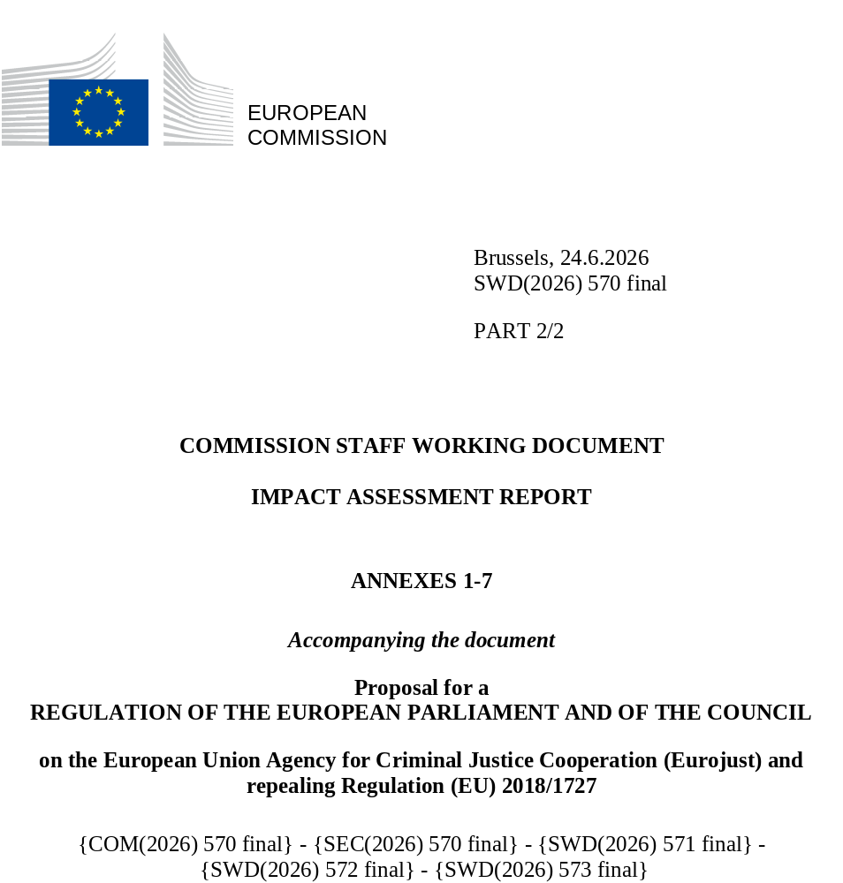

Table of Contents
Annex 1: Procedural information 2
1. Lead DG, Decide Planning/CWP references 2
2. Organisation and timing 2
3. Consultation of the RSB 3
4. Evidence, sources and quality 7
Annex 2: Stakeholder consultation (Synopsis report) 9
1. Introduction 9
2. Consultation strategy 9
3. Consultation activities 9
Annex 3: Who is affected by the initiative and how? 20
1. Introduction 20
Annex 4: Analytical methods 54
1. General approach 54
2. Support study 54
2.1. Study requirements and timeline 54
2.2. Approach and data collection 55
2.3. Challenges and limitations 55
3. Identification and assessment of impacts 56
3.1. Identification of impacts 56
3.2. Assessing impacts 56
3.3. Scores per measure 60
3.4. Aggregated scores per option 66
Annex 5: Competitiveness check 68
Annex 6: SME check 69
Annex 7: Additional Information supporting the Impact Assessment 70
1. Introduction 70
2. Evolution of the broader European judicial legal framework 70
3. Presentation of the current legal framework (Regulation (EU) 2018/1727 on Eurojust) 72
4. Ensuring full compliance with Fundamental Rights 75
5. Legal instruments and strategies including a role for Eurojust 77

Annex 1: Procedural information

1. Lead DG, Decide Planning/CWP references
This Impact Assessment Report was prepared by Directorate A “Justice policies” of the Directorate General “Justice and Consumers” (DG JUST).
The Decide Planning reference is PLAN/2023/2880 and the Decide fiche was validated on 2 July 2025.
The initiative on revising the Eurojust’s mandate was included in the 2026 Commission Work Programme published on 21 October 2025 and had been announced by European Internal Security Strategy ("ProtectEU Strategy") presented on 1 April 2025.

2. Organisation and timing
Chronology of the impact assessment:
September to November 2025: informal/internal brainstorming (JUST, HOME, LS, BUDG, SG, Eurojust’s College and staff)
The work on the impact assessment began with a call for evidence, lasting from 28 October 2025 to 3 December 2025. In total, 42 responses were received.
On 2 December 2025, the open public consultation was launched. The consultation lasted until 24 February 2026. In total, 20 responses were received.
Three Inter-Service Steering Group (ISSG) meetings were held in 2025 and 2026. The ISSG consisted of representatives from various Directorates-General of the Commission: HOME, ECFIN, BUDG, OLAF, INPA, DIGIT, MENA, EEAS, JRC, ENEST, HR, DGT and SJ. The ISSG met on 13 November 2025, 9 January 2026 and on 23 March 2026. The meetings were chaired by DG JUST (the last one co-chaired with SG).
The contributions of the members of the Steering Group have been taken into account in the content and shape of this impact assessment.
The first draft of the Impact Assessment was sent to the ISG on 17 March 2026 (on 11 March regarding chapters 1 to 5).
A consultation meeting took place on 22 October 2025 with the Criminal Law Expert Group.
The support study on the cost and benefits of the assessed policy options was launched on 9 December 2025 (Kick off meeting with the external contractor).
The revision has been presented and discussed at both technical and political levels with the Council, the European Parliament and national parliaments.
- With experts and representatives of Member States - at the COPEN General Matters of 15 September 2025, at the end of which 7 Member States sent a written contribution. A second time, in the COPEN General Matters of 15 December 2025.
- In addition, the Danish Presidency of the EU Council organised a first policy debate at the Council of Ministers of Justice on 13 October 2025. A state of play has been presented in AOB at the Council on 6 March 2026, under the Cypriot Presidency.
- A non-paper has been diffused on 2 February 2026 by 4 Member States (FR, DE, BE and AT). Bilateral meetings at ministerial and technical levels have been led with many countries.
- The project has also been discussed with the European Parliament and Members from national Parliaments (at the ICM - Inter Parliamentary Committee Meeting – on the evaluation of Eurojust activities on 20 November 2025).

3. Consultation of the RSB
3.1. First meeting - upstream
An “upstream meeting” with the RSB was organized on 24 November 2025.
The main questions raised by the RSB were the following:
- With the Ukraine War being identified as a new challenge, are there any additional new general challenges to be considered?
- What is the root cause concerning the poor filtering of cases and the varied implementation of the regulation by Member States?
- What is the data gap concerning the problems of Eurojust’s governance and decision-making, and can it be compensated?
- What is additionally needed to tackle the current phenomenon of more sophisticated crimes?
- Are there significant issues stemming from interoperability and might that be the cause of systems not being compatible? Does this cause a lack of cooperation?

The main points that were raised during the meeting were:
- Objectives and measures should be made smarter/further operationalized;
- The new needs of Member States should be clearly identified to boost proactivity;
- Type of information shared with other JHA Cooperations should be identified;
- The needs for improvement about the international cooperation should be thoroughly assessed;
- Problem drivers and root problems should be distinguished more carefully;
- The first consequence in the table should be the societal problem at hand;
- Evidence is key for the identification of the problem;
- There needs to be a mixture of measures of varying intensity. This will shed light on the trade-offs that are inherent to different options, which should all be assessed technically and politically;
- The need to assess whether the intervention effectively addresses crime-solving, the current situation must be clarified further, particularly by identifying gaps at the Member State level;
- The need to specify the precise sources that are backing up the support study and evaluation;
- The need to avoid adding “straw options”, unless it is useful and feasible;
- The substantive element regarding current criminal phenomena should be justified in a fact-based, and opinion-based manner.
3.2. Second meeting – Examination of the draft impact assessment
On 1 April 2026, the Directorate-General for Justice and Consumers submitted the draft impact assessment to the Regulatory Scrutiny Board (RSB), including its annexes. The executive summary and the minutes and elements of follow up of the ISSG meeting of 23 March were also sent to the RSB.
The RSB examined the draft impact assessment on 29 April 2026. The overall opinion of the Regulatory Scrutiny Board was positive with reservations. These reservations were of two kinds:
- clarity of the concepts and options presented. - clarity of the evaluation methodology used.
The responses to these comments are set out in the two tables below:
RSB comments – Key issues | How RSB comments have been addressed in the IA
The identification of the problems and their drivers is not sufficiently clear on issues arising from legal obstacles despite recent amendments, and from implementation problems. | In chapter 2 of the IA, further details have been provided on the problems and their drivers, clarifying in particular that many of the problems stemmed simultaneously from a lack of clarity in the Regulation and from differing types of interpretation and/or implementation among Member States (some of which may be linked to external problem drivers, such as differences in the judicial systems/cultures of Member States).  Hence addressing problems stemming from these two types of drivers requires a balance between further specifying concepts/dispelling ambiguities where possible in the Regulation, and keeping in it the flexibility required due to external drivers related to differences in the judicial systems/cultures of Member States, or to allow for some changes of focus in future (e.g. to adapt to new/fast emerging needs or to possible changing priorities).
The specific and operational objectives are not defined in a SMART manner to allow measuring success through a comprehensive set of key performance indicators. | The problems and their drivers, as well as the specific objectives that had been defined in response, were initially too detailed to enable the IA analysis to fit into just 40 to 50 pages.  It has been decided to regroup the problems and their drivers into just two main problem sets (with distinct sets of drivers), and so the specific objectives were also regrouped into two sets of objectives. These objectives have been made SMARTer by defining for each of the two specific objectives a set of related (RACER) success criteria (generally reflecting lower-level specific objectives that had been originally defined), with actual targets and timing ambitions.  These indicators were previously detailed within chapter 8 (as part of the impacts expected from the full set of the preferred options in each problem area addressed), where they had low visibility. They finally have been moved to chapter 9 (where they rightfully belong) and now appear in further detail as a comprehensive set of key performance indicators (to help measure success), together with a proposed set of operational indicators (and the related RACER criteria) to allow for periodic monitor and assess global progress after 4 years of implementation, as well as facilitate a subsequent full scale evaluation.  The analysis of the coherence of measures with recent or ongoing initiatives was enhanced by referring to the follow-up the the ProtectEU and the revision of the Europol mandate as well as the discussions currently held in the context of the AFA review and the upcoming revision of the EPPO and OLAF Regulations (see Changes in chapter 8).
The impact of the initiative on fundamental rights (use of personal data) is not sufficiently analysed. | Within Annex 7 (on additional IA information), impacts of the preferred option on fundamental rights were documented in further details, as part of section 7.3 “Ensuring full compliance with Fundamental Rights”, particularly as regards criminal procedural safeguards and data protection.  Related information was also added to the core IA text in section 8.2.4.

RSB comments – Ways of improvements | How RSB comments have been addressed in the IA
Better presentation of the current situation of the agency and clarification/illustration of some key elements such as the complex cases and their prioritisation of versus simple files. | The current internal functioning of the agency has been more explained, in the main report as in annex 7. The complex case, supposed to fall under the competence of Eurojust, has also been described more in detail and compared to a simple case (EJN competence).  A typical example of a complex case – the famous “Encrochat file” – has been added to illustrate the demonstration.
Better use of the 2025 evaluation, by including concrete findings and examples in the analysis of the relevant problems and their drivers. Clarification of the problem definition underlining why the amendments of the Eurojust Regulation since 2022 have not been sufficient for Eurojust to address the challenges. Better develop issues related to governance and organisational culture and why addressing them requires legislative changes. | The nature of the problem driver, whether legal or empirical/practical, has been described for each of them. In addition, further details have been provided on the limited, targeted and circumstantial nature of the three previous revisions of Eurojust’s mandate.  Based in particular on the 2025 evaluation report, it has been further demonstrated that the issues regarding the effectiveness of the agency’s governance stem from problems of administrative culture (implementation of the current legal framework) as well as a lack of clarity in the regulation: ultimately, it is explained that a legislative amendment to the institutional framework is the preferred option.
Make specific and operational objectives SMARTer with related key performance indicators adjusted accordingly, fully taking into account digital solutions. | Chapter 9 on indicators and monitoring has been redrafted to better present and describe, on the one hand, the measurable indicators of success and the proposed targets and, on the other hand, the operational objectives and related indicators proposed.  The RACER indicators are closely linked with the SMART objectives specified in chapter 4.2. (cf previous reply for key issues).
Better explain some measure, such as the ones expanding Eurojust’s competences to new emerging crimes and enhance the assessment of the policy options, notably as regards fundamental rights, in particular data protection (analysis of the associated risks and safeguards envisaged to mitigate them). | The contextual and legal grounds for expanding Eurojust’s operational powers were set out in Chapter 1 and, in greater detail, in Chapter 5 and subsequent chapters, particularly with regard to the analytical and financial aspects of criminal investigations, in order to address new trends in crime.  As previously explained (cf previous reply for key issues), impacts of the preferred option on fundamental rights, in particular data protection, were more documented along with the solutions found to eliminate and reduce the risks.
Strengthen the analysis of the coherence of the measures with recent or ongoing initiatives related to AFA and EU JHA bodies as well as in relation to the EU external policies. | The link between the ongoing revision of Eurojust and the incoming AFA review has been better explained. In addition to the presentation of the relevant drivers, policy options and measures related to specific objective 2 have been more deeply analysed through the MCA (multi-criteria assessment) and in particular the consistency with other EU public policies and the external coherence of the EU action.
Improve the accessibility of the report to non-experts, while keeping it to a reasonable size. | The glossary has been updated and all the concepts and references contained in the report (e.g. SIRIUS project, JIT…) have been defined in a summarized and simple way.  The final report respects the Better Regulation guidelines related to the average number of pages of an IA (around 50).

4. Evidence, sources and quality
A number of inputs and sources of data were used in the preparation of this impact assessment, including the following:
- The Evaluation Report on the implementation of the current Regulation published on 2 July 2025;
- a Call for Evidence closed on 25 November 2025 (42 contributions received);
- a Public Consultation published on 2 December and running until 24 February 2026 (20 contributions received);
- EU case law (especially about power of national judicial authorities to issue MLA requests such as EAW).
- Informal brainstorming led at the internal level of the Commission (DG JUST, DG HOME, SG, LS…), but also with Eurojust staff and College.
- Specific Eurojust’s College meeting on 16 September 2025 and two technical workshops organised on 17 October and 28 November 2025 (vision 2035).
- Works of the Consultative forum of the Prosecutors General and Directors of Public Prosecutions of the EU Member States (19th on 2 October 2025 and 20th on 19 and 20 March 2026) have been mainly focused on the incoming revision of Eurojust.
- Various studies and reports (SOCTA, Road map on drug trafficking etc.) as mentioned in Chapter 1.1
- Targeted surveys and consultations of practitioners and national authorities by the contractor from end of January; 429 replies have been received.
The data sources are thus essentially public authorities in the EU and its Member States. The quality of this data is therefore high, with the proviso that it covers essentially the activity of judicial cooperation and mutual legal assistance.

Annex 2: Stakeholder consultation (Synopsis report)

1. Introduction
This annex presents the results of the consultation activities carried out in the context of the impact assessment support study for the Regulation (EU) 2018/1727. The report has been prepared in accordance with the requirements set out in the European Commission Better Regulation Toolbox.
Its purpose is to provide a qualitative and quantitative analytical overview of the input received from stakeholders through the various consultation tools employed, notably the call for evidence, interviews, the online survey, and the public consultation.

2. Consultation strategy
The consultation strategy was designed to ensure that the supporting study captured the perspectives of a broad range of stakeholders, both internal and external to Eurojust. These included Eurojust staff, national desks, national authorities and practitioners, as well as international organisations. In order to assess the potential impact of measures under Special Objective 4, particular attention was also given to stakeholders from third countries, including Liaison Prosecutors and national authorities.
The consultation strategy built also on information already gathered during the evaluation of the Regulation (EU) 2018/1727, notably in view of possible further legislative developments. The consultations pursued two main objectives: (1) to collect stakeholders’ views on possible options to address the problems identified in the evaluation, including feedback on the recommendations stemming from that exercise; and (2) to gather information on additional issues that may not have been identified in the evaluation of the Eurojust Regulation.

3. Consultation activities
Stakeholders were reached through a combination of direct invitations and openly accessible consultations. This section provides an overview of the consultation activities undertaken as part of the study.
3.1. Public consultation
The Commission launched a public consultation in all 24 official EU languages. The consultation was questionnaire-based. The consultation period was twelve weeks (3 December 2025 to 24 February 2026) with 20 replies received. Out of these responses, 8 were received from public authorities, 9 from stakeholders from EU Member States and three from third countries (Bosnia Herzegovina, North Macedonia and the United States). Most responses were received from Belgian and French stakeholders, with four submissions from each country. The outcome of the open public consultation was analysed by an external contractor. The main points raised by the respondents were the following:
- It found that almost all respondents believed Eurojust’s role in addressing serious and organised cross-border crime in the EU to be important, 50% to be very important.
- Some participants stressed the need to better consider the perspective of victims and witnesses and to clarify case allocation between Eurojust and the EJN.
- Criminal use of the digital space, AI and new technology was, almost unanimously, seen as one of the main challenges that criminal investigations and prosecutions in Europe will face in the coming years.
3.2. Call for evidence
Call for Evidence was launched by the Commission and made available on the “Have Your Say” website from 28 October 2025 until 3 December 2025, with 42 replies received. Responses were submitted by members of the general public covering 21 EU countries, of which the majority were stakeholders representing public authorities (22), followed by EU citizens (9). Other respondents included academic/research institutions (3), companies/businesses (3), one environmental organisation, and two NGOs. The main points raised by the stakeholders concerned the European Judicial Network (EJN), Eurojust’s mandate, and governance-related issues.
- Eurojust and EJN
Several stakeholders emphasised that, rather than competing, the EJN and Eurojust complement each other and have distinct roles and highlighted the strengths and added value of the EJN. It was therefore advocated to maintain the EJN’s autonomy, independence, and practitioner-driven nature.
However, a recurring issue was the allocation of cases between EJN and Eurojust. While one respondent suggested to not solve this issue by a revision of the Regulation, but instead to just accept, that, unless a case is complicated or a coordination meeting is required, the EJN should handle the case, others were in favour of complementarity and clearer definitions, reflected in the revised Regulation.
- Eurojust’s mandate
With Eurojust being an essential and effective actor in the fight against cross-border crime, some respondents argued that its mandate should be strengthened by giving it more operational roles. One advocated for equipping Eurojust with criminal analytical capacity, which could contribute to the early detection of crimes.
On the other hand, it was argued that Eurojust should remain focused on coordinating and facilitating judicial cooperation and should not become more proactive or given “executive powers”.
- Prevention of crimes and Governance
It was recommended to have a database to prevent crimes, where alerts could be sent by anyone, and for Eurojust to better utilise its existing information. A more standardised crime analysis at the European level was also suggested.
Regarding the enhancement of governance and decision-making processes, respondents proposed that the Executive Board should comprise solely elected members of the College. Under this model, the Board would report its activities to the College, while the College would retain the right to decide on certain matters or review the Board’s actions.
- Third country cooperation and evolving nature of crime
The importance of prioritising cooperation with third countries and increasing the number of working arrangements was also emphasised. Eurojust should have sufficient resources and make use of technological tools in order to match the evolving nature of crime. It should also invest in training and advanced technologies to counter new forms of crime.
3.3. Online survey
An Online survey was conducted until 4 March 2026, targeting a range of stakeholder types, including practitioners, the Eurojust administration and national desks, and public officials. Several non-EU and EU countries were represented, with the most responses submitted from Germany, followed by Spain. Serbia, North Macedonia, Iceland, United Kingdom, Albania and Norway are the non-EU countries represented in this survey. Practitioners from EU Member States accounted for nearly half of all responses (48%), making them the most prominent stakeholder group in this survey, followed by members of the Eurojust administration.

The following tables shows the online survey participants per Member State and participating stakeholder groups.
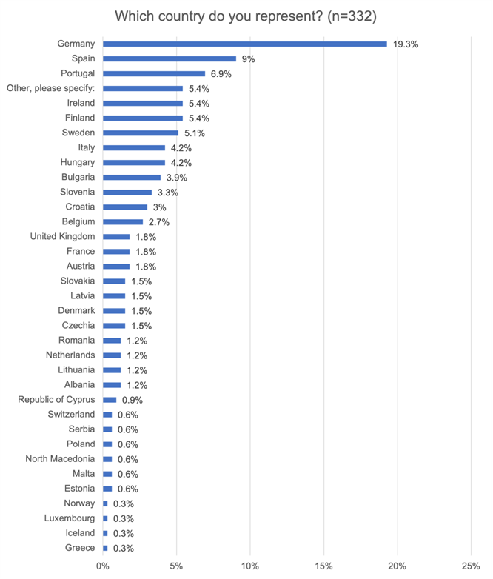
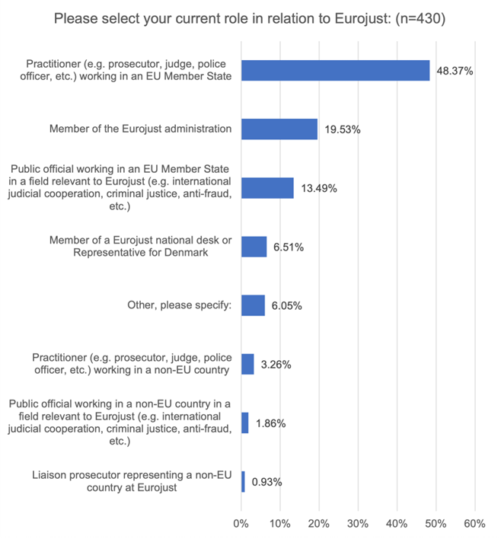

The main points raised by the stakeholders were the following:

- Regarding Eurojust’s governance, decision-making and management structures, the majority of the stakeholders agreed that its governance is currently fragmented due to the coexistence and current roles and responsibilities of the College and its Working Groups, the Executive Board, and the Administration. They therefore stressed the need to review Eurojust’s decision-making processes, highlighting inefficiencies within the College and the unclear division of tasks. The definitions of ‘operational’ and ‘administrative’ responsibilities were not clear.
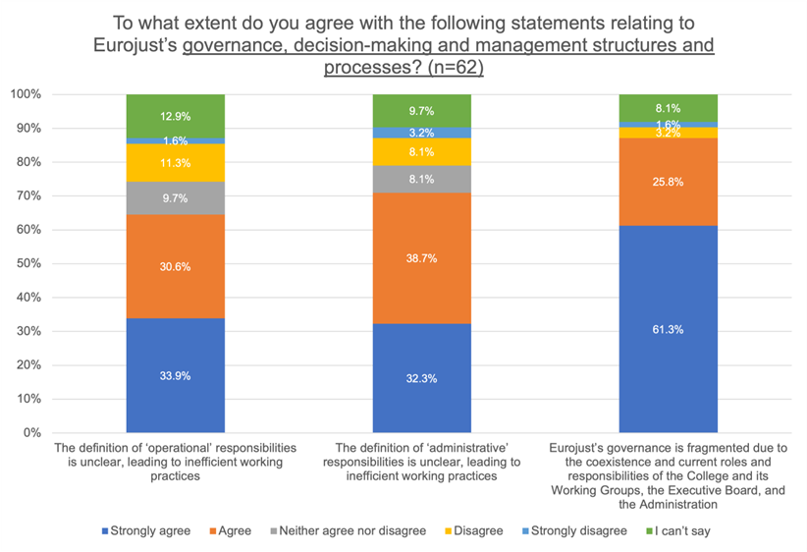
In terms of operational activities and impact, most stakeholders also agreed that the status and powers of National Members vary across Member States. The status and role of Eurojust in EU policymaking and strategic cycles is unclear and not provided for systematically.

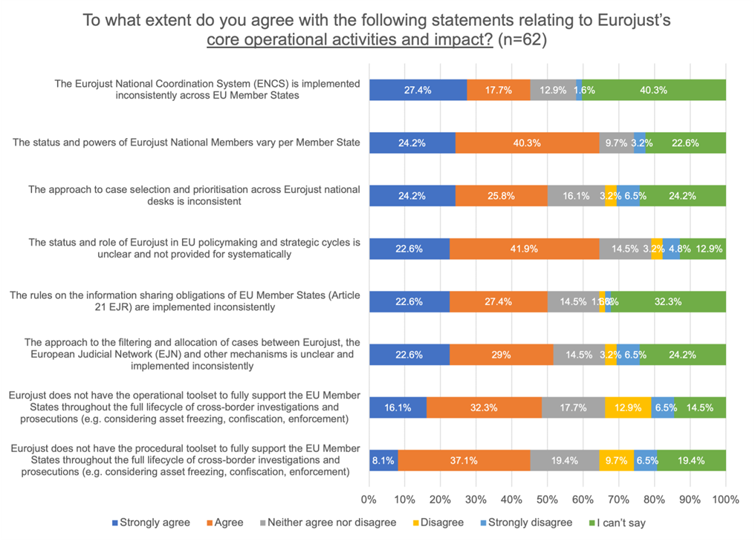
Concerning the cooperation with EU IBOAs the majority of stakeholders found that structural weaknesses exist in the relationship between Eurojust and Europol that hinder effective cooperation. This hindered cooperation between Eurojust and EU partners is seen to be caused by uncertainty about application of rules on data protection. On the other hand, the framework for Eurojust cooperation with OLAF was not considered to be fragmented and insufficiently codified.
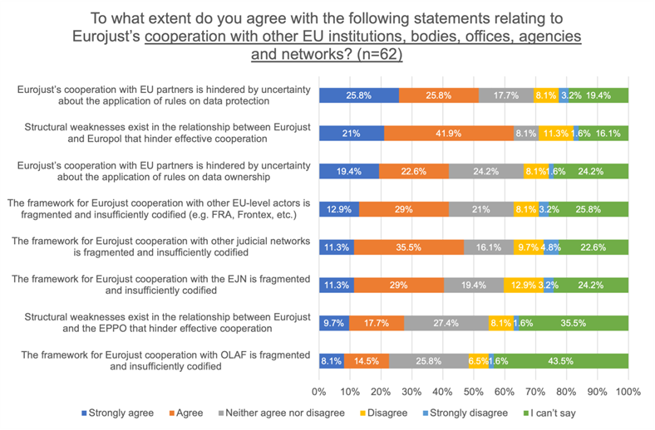
- Regarding Eurojust’s cooperation with third countries and international organisations, most strongly agreed or agreed that the expansion of externally funded projects increases the administrative burden of the agency. The application of data protection rules and the process to negotiate third country cooperation agreements were found to hinder cooperation by 50%.
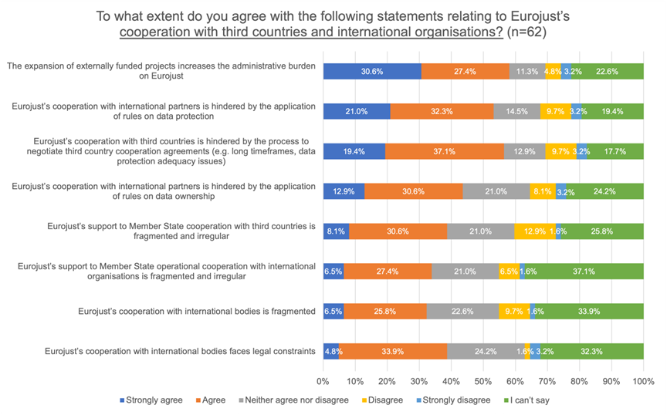
- Looking at the future of Eurojust, an increasing demand for cross-border judicial coordination and evolutions in serious cross-border crime were both deemed very important. As were digitalisation and resource pressures. Geopolitical instability and global shifts to reliance on multilateral mechanisms was considered very important or somewhat important by the majority.
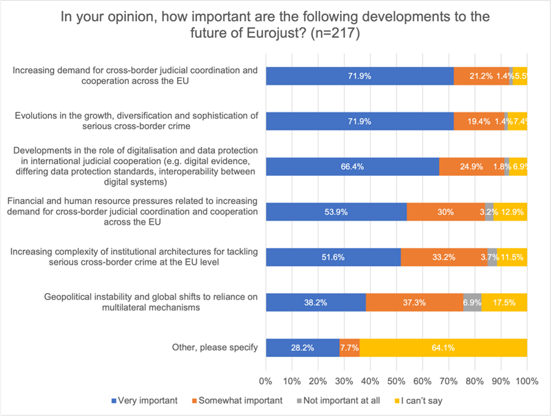
3.4. Interviews
In total, interviews were conducted with 115 stakeholders.

 | Total
Eurojust | 63
External | 52
Total | 115

These interviews cover representatives of the Eurojust administration, national desks and liaison prosecutors, EU IBOAs, EU and third country national-level stakeholders (authorities and practitioners), and international organisations. They include in-person consultation with Eurojust personnel during the site visit, as well as online interviews with a range of stakeholders.

The number of interviews conducted per country is as follows:
Country | Number of interviews
Austria | 2
Belgium | 2
Croatia | 1
Czechia | 1
Estonia | 1
EU-level | 13
Finland | 2
France | 5
Germany | 2
Greece | 1
Ireland | 2
Italy | 3
Latvia | 1
Lithuania | 1
Malta | 2
Netherlands | 1
Poland | 1
Portugal | 1
Slovakia | 1
Slovenia | 1
Spain | 1
Brazil | 1
Chile | 1
Kosovo | 1
Lebanon | 1
North Macedonia | 1
International organisations (Latin America) | 2

The table below shows the interviews per stakeholder group:
Stakeholder type | Total Contacted | Completed
Eurojust – Administration | 41 | 41
Eurojust – National desks & DK | 18 | 18
Eurojust – Liaison Prosecutors | 4 | 4
EU IBOAs | 24 | 13
Independent expert | 2 | 0
International organisation | 3 | 2
National authority - EU | 30 | 10
National practitioner - 3rd country | 8 | 5
National practitioner - EU | 66 | 22
Total | 196 | 115

Consultations were held with third country practitioners and international organisations. They recognised the importance of Eurojust However, these discussions also highlighted opportunities to improve cooperation, with many participants advocating for measures such as establishing resident contact points and appointing Liaison Magistrates. Issues concerning data transfer and capacity were also explored.
Interviews with national practitioners often highlighted the current lack of harmonisation of the roles of National Members, whether crime areas should be added to Annex 1, and the effectiveness of international cooperation from a practitioner perspective.
- Eurojust administration and national desks identified outdated tools, limited cooperation with OLAF, and the advantages of competence over e-evidence orders as current issues. They indicated that, without an amendment of te Eurojust Regulation, in the next 10 years Eurojust’s ability to improve the consistency of its support and impact across Member States would worsen.

- Member State authorities and practitioners
Regarding the varying roles of National Members across Member States, a more harmonised approach is welcomed. However, they warn that there may be constraints due to national legal frameworks. In terms of adding new crime areas to Annex 1, some stakeholders noted that it is crucial to avoid overlaps, while others thought that the key areas are already included.

- EU IBOAs
Concerning third-country cooperation, the level of engagement with Eurojust appears to vary. For instance, certain measures, such as conditionality clauses, may prove more effective in EU candidate countries.

Annex 3: Who is affected by the initiative and how?

1. Introduction
This Annex outlines the benefits of all provisions, as well as those specific to each action. The same applies to the overview of costs. It also includes a table detailing contributions to administrative burden reduction targets, alongside an overview of the relevant Sustainable Development Goals.
Overview expected impacts preferred option (more detail below under I. Overview of benefits)
# | SO | Administrative reduction costs | Reduction of fraud and crime | Benefits to citizen and business | Increased number of complex EJ cases
1.A.i(b) | + | + | N/A | N/A | +
1.A.ii(b) | + | N/A | + | ++ | +
1.A.iii(b) | + | + | 0 | N/A | +
1.A.iv | ++ | N/A | ++ | N/A | +
1.A.v | +++ | N/A | +++ | N/A | +
1.B.i(b) | + | + | + | N/A | +
1.B.ii(b) | + | + | + | N/A | +
1.B.iii | + | N/A | N/A | N/A | +
1.B.iv | + | ++ | ++ | N/A | +
1.C.iii | + | ++ | + | N/A | +
2.D.i(b) | + | N/A | + | + | +
2.D.ii(b) | + | N/A | N/A | + | +
2.D.iii | ++ | N/A | + | + | +
2.D.iv | ++ | N/A | N/A | + | +
2.D.v | +++ | N/A | + | + | +
2.E.i(b) | + | N/A | + | + | +
2.E.ii | + | N/A | + | + | +
2.E.iii | + | N/A | N/A | + | +
2.F.i | + | N/A | N/A | + | +
2.F.ii | + | N/A | + | + | +
2.F.iii | + | N/A | + | + | +
2.F.iv | + | N/A | N/A | + | +

Overview budgetary impact of implementation preferred option (more detail below under: II. Overview of costs – Preferred option)
 | One off costs | Recurrent costs (per annuam)
1.A.i(b) | N/A | EUR 582 000 (staff)  +  EUR 500 000 (mission)
1.A.ii(b) | N/A | EUR 1 552 000 (EJ)  +  EUR 2 916 000 (SNEs) staff
1.A.iii(b) | EUR 2.5-3.7 million (over MFF) | EUR 388 000 staff  +  EUR 1.5 million (non-staff)
1.A.iv | N/A | N/A
1.A.v | N/A | EUR 3 298 000  +  EUR 2 million (non-staff)
1.B.i(b) | N/A | N/A
1.B.ii(b) | N/A | N/A
1.B.iii | N/A | N/A
1.B.iv | N/A | N/A
1.C.i, ii, iii | none | EUR 200 000
2.D.i(b) | N/A | EUR 630 000  +  EUR 1.7 to 2.4 million
2.D.ii(b) | EUR 808 000 | N/A
2.D.iii | N/A | Low
2.D.iv | N/A | Low
2.D.v | N/A | none
2.E.i(b) | EUR 105 000 | EUR 81 500
2.E.ii | EUR 105 000 | EUR 81 500
2.E.iii | Low | Low
2.E.iv | EUR 105 000 | Low
2.F.i | N/A | N/A
2.F.ii | Low | EUR 582 000 + EUR 105 000 + 404 000 staff, plus LM costs of EUR 188 500 per country + EUR 50 000 related costs
2.F.iii | N/A | EUR 776 000 + EUR 420 000 staff
2.F.iv | N/A | EUR 20 000 per RCP
2.F.v | N/A | N/A
Total | Total one-off costs of between EUR 4.4 million and EUR 5.6 million for the implementation of the new measures | Total recurrent costs between EUR 9.3 million and EUR 9.4 million on average per annum over the course of the next MFF for the implementation of the new measures  Additional operational expenditure of EUR 1.7 million on average per annum over the course of the next MFF

I. Overview of Benefits (total for all provisions) – Preferred Option
Description | Amount | Comments
Direct benefits
Strengthen Eurojust’s internal functioning, governance and operational performance (Specific Objective 1) |  | Positioning Eurojust as a key evidence-based contributor to EU legislation would sharpen its strategic focus, helping to align EU priorities (including SOCTA and EMPACT) with actual prosecutorial needs, and generally improving how the strategic response to challenges experienced by judicial professionals. Expanding Eurojust’s operational functions will boost judicial coordination, improve case resolution efficiency, and enhance support for Joint Investigation Teams (JITs) through semi-permanent platforms and temporary secondments.  Broadening Eurojust’s mandate ensures continued relevance in new crime areas. Extending the CICED concept to other crime areas will help Eurojust connect cases and leverage data more effectively.  A unified approach to case definition will reduce fragmentation, enabling a greater focus on complex cases without deterring submissions of simple bilateral matters. Harmonising national member mandates and enhancing capabilities will increase operational efficiency, facilitate urgent cross-border actions, and strengthen procedural support.  Introducing an additional path for opening cases lets Eurojust take a proactive stance, connecting fragmented evidence across countries. Allowing national members to concentrate solely on operations, while Member State authorities direct strategy via the Management Board, clarifies governance, separates strategic, operational, and daily management roles. In total, this is likely to free up more time for National Members to work on operational activities (between 20% to 40%).
Achieve optimal alignment and operational integration with EU partners and Third countries (Specific Objective 2) |  | Automated indirect access to Europol and EPPO databases, though a step toward judicial digitalisation, is unlikely to significantly change the operational use of the hit/no hit system (for any party, not just Eurojust) due to persistent limits on information exchange. Eurojust stresses the need for an updated Cooperation Agreement with Europol to reflect current realities and enhance adaptability, even if its impact may be limited.  Updating the collaboration between the EPPO and national jurisdictions would improve coordination on cases spanning broader criminal operations, clarify Eurojust’s role, reduce legal uncertainty, and improve its relationship with EPPO. Integrating SIRIUS referrals directly into workflows would promote seamless judicial oversight from detection through investigation.  Formal participation of Europol and EPPO in Eurojust College meetings would institutionalise ongoing partnerships and foster cooperation. Making relevant Europol database information accessible to Eurojust for new case openings would support stronger trust and ensure evidence is admissible in court by introducing judicial oversight.  Overall, these measures are expected to improve information flow, data sharing, and case detection across agencies. Aligning third-country standards with EU practices would yield modest benefits, especially where resources are limited. Clarifying the role and status of Liaison Magistrates (LMs) and establishing Resident Contact Points (RCPs) would boost cooperation with third countries, with smaller Member States gaining the most. Involving liaison partners in College meetings would embed external perspectives in Eurojust’s strategies.  Overall, the number of relevant complex cases taken by Eurojust, opened by Member States, National Members or by Eurojust on its own initiative is likely to increase, helping to increase the share of cases for which Eurojust has a real added value.
Administrative reduction costs |  | Taken together, the measures under the preferred option would formalise the "invisible" strategic tasks currently performed on an ad hoc basis. This formalisation ensures that such work is supported by reliable resource allocation, rather than requiring staff to be diverted from their core casework. Additionally, formalising the tasks undertaken by the Eurojust administration—even those not explicitly outlined in the Eurojust Regulation (EJR)—would facilitate better planning of resources.  Increased coordination under this option should result in slight administrative gains, contributing to more efficient operations and resource management within Eurojust.  The overall shift towards cases where Eurojust adds significant value, as opposed to straightforward cases, is expected to yield a low positive impact. This targeted approach ensures that resources are focused on more complex matters where Eurojust’s involvement is most beneficial.  At the same time, all National Members (NMs) would possess full competence, with operational work being appropriately focused. This measure is also anticipated to have a low positive impact, reflecting greater clarity and efficiency in task allocation.  By reducing the need to navigate national authorities, Eurojust's capability to support cross-border cases would be moderately enhanced. This improvement is likely to streamline processes and bolster the agency’s effectiveness in handling cases that span multiple jurisdictions.
Reduction of fraud and crime (General objective) |  | Identifying more, especially complex, cases is expected to increase prosecution rates and reduce the time required for prosecution, reduce crime and fraud, and strengthen deterrence against criminal organisations operating across borders. Improved evidence sharing and continuous information exchange will positively influence investigations and enhance cooperation. New Eurojust functions could moderately improve its impact on reducing losses from crime and fraud, though some benefits may be limited.  Enhanced detection and analytical capabilities would support proactive investigations, leading to increased identification and prosecution of criminal networks. Focusing on high-value cases and responding to urgent requests promptly would reinforce asset freezing and crime reduction efforts. Greater capacity for National Members, Liaison Magistrates, and Regional Contact Points will facilitate cross-border cooperation and prosecutions, particularly in cases involving third countries.  Measures supporting the European Public Prosecutor’s Office (EPPO) are likely to identify more complex cases, raising prosecution rates and further deterring cross-border criminal organisations. These actions will help tackle crimes affecting the EU’s financial interests and broader organised crime, ultimately boosting prosecution rates and reducing crime and fraud.
Benefits to citizen and business |  | Collectively, the preferred option is expected to enhance the ability of national judicial authorities to successfully prosecute large criminal enterprises, particularly those with a third country dimension. This improvement acts as a deterrent to future criminal activity, increases legal certainty, and reduces crime levels, thus ultimately benefiting citizens and businesses alike.
Indirect benefits
Increased number of complex EJ cases |  | The preferred option is expected to lead to an increase in the share of complex cases tackled through Eurojust by promoting a shift in culture towards EJ tackling more complex cases, the ability of the Agency to act on its own initiative, and increased detection in links. Whilst monetising the benefits of Eurojust’s work is hazardous, as every case is different, the evaluation pointed to metrics that could indicate the size of the potential benefits from Eurojust and partners acting together. Table 9 of the Evaluation shows that in the period 2020 – 2023 the monetary impact of Eurojust’s role in supporting JITs was a minimum of EUR 1 billion in a year. Separately Eurojust also contributed to at least another EUR 3 billion through its role in asset freezing and drug seizures.  Given the size of the cost of crime in the EU (approximately EUR 200 billion per annum), even a small contribution from the Agency to the reduction of crime is expected to be high in monetary terms. To illustrate this, should the proposed improvements to Eurojust contribute to addressing a mere 0.05%, this would result overall in a EUR 100 million reduction to the cost of crime.

Ia. Overview of Benefits (Action A - Extending the scope of material competences to face the new judicial landscape) – Preferred Option
Description | Amount | Comments
Direct benefits
Strengthen Eurojust’s internal functioning, governance and operational performance (Specific Objective 1) |  | i. (b) This option would establish Eurojust as an important evidence-based contributor to EU legislation strategic focus. It would help ensure that EU-wide strategic priorities (including SOCTA, EMPACT) are better aligned with prosecutorial and judicial reality.  ii. (b) The evolution of the operational functions of Eurojust would contribute to reducing delays in judicial coordination. As such, it would contribute to increasing Eurojust’s operational capacity.  iii. (b) Strengthening Eurojust’s support to Joint Investigation Teams by establishing, at operational level, semi-permanent platforms enabling the temporary secondment of JIT members to Eurojust would lead to seamless operations between Eurojust and national practitioners, allowing for greater coordination, especially in long, complex cases.  iv. This measure would have high benefits. Extending the mandate of the Agency to new crimes would ensure it remains relevant to fulfil its role of supporting coordination and cooperation between national investigating and prosecuting authorities.  v. Expanding the CICED concept to other crime areas is expected to have very high benefits in the ability of the Agency to identify links between cases and information, making full use of the potential of the data and evidence collected.  Benefits per stakeholder group  EJ administration: benefit from reliable planning,  National Members + National desks: increased ability to undertake tasks, better collaboration tools  MS: benefit from evidence-based output, better collaboration tools  EU policymakers benefit from evidence-based output
Administrative reduction costs |  | i. (b) This option would formalise "invisible" strategic work currently done on an ad hoc basis, ensuring it is supported by reliable resource allocation rather than diverting staff from core casework. Any formalisation of tasks undertaken by the EJ administration, without being formally set out in the EJR would also help in planning the use of resources.  ii. (b) N/A  iii. (b) Increased coordination may lead to slight administrative gains.  iv. N/A  v. N/A
Reduction of fraud and crime |  | i. (b) N/A  ii. (b) New operational functions of EJ could lead to a moderate positive impact on EJ's ability to reduce lost expenditure from fraud and crime  iii. (b) limited benefits in ability to tackle crime  iv. Depending on changes being implemented elsewhere, moderate to high impact on detection of additional cases  v. This option would have very high benefits. The analytical function would allow EJ to develop analysis on other types of crimes. It would help enhance the proactivity of investigations, leading to increased identification (and ultimately prosecution) of criminal networks and large-scale criminal enterprises.
Benefits to citizen and business |  | i. (b) N/A  ii. (b) This measure would have moderate – high positive impact for formalisation of EJ's role in victims' rights in normal cases, but also in mass-casualty crimes or disasters, ensuring they receive coordinated information and support regardless of nationality  iii. (b) N/A  iv. N/A  v. N/A
Indirect benefits
Increased number of complex EJ cases |  | Taken together, these measures are likely to lead to the increase in the share of complex cases tackled through Eurojust by promoting a shift in culture towards EJ tackling more complex cases, the ability of the Agency to act on its own initiative, and increased detection in links, leading to a greater number of relevant complex cases being tackled.

Ib. Overview of Benefits (Action B - Harmonizing Member State implementation of the EJR, including on allocation of cases) – Preferred Option
Description | Amount | Comments
Direct benefits
Strengthen Eurojust’s internal functioning, governance and operational performance (Specific Objective 1) |  | i. (b) This measure would reduce fragmentation by establishing a unified approach to case definition across national desks. While it may play a role in ensuring the Agency focuses on relevant complex cases rather than simple bilateral matters, it is unlikely to stop completely the national desks using Eurojust for simple cases.  ii. (b) This measure would eliminate functional imbalances and structural constraints within the College caused by the heterogeneous mandates of national members. It would ensure that all NMs have the operational tools to perform their functions equally within their mandate.  iii. New capabilities for NMs could increase their efficiency to undertake a number of operational tasks, which may positively affect the setting up of Joint Investigation Teams (JITs) and increase support to the full procedural lifecycle, including asset recovery. It would also ensure that urgent cross-border actions are taken without waiting for national-level requests.  iv. This measure would add an additional path for opening cases, promoting a shift in the Agency’s role from a purely reactive to MS demands to a more proactive, strategically curated case intake. It would allow for NMs to identify and connect fragmented evidence across multiple countries that national authorities might miss while ensuring the reactivity and ownership of a case.  Benefits per stakeholder group  EJ administration: benefit from better resource allocation,  National Members + National desks: increased ability to undertake tasks though the whole procedural lifecycle, more focus on operational and relevant complex cases  MS: benefit from predictable and consistent support
Reduction of fraud and crime |  | i. (b) Any move to support the increased focus of EJ on cases where it can really add value is expected to increase the impact of the Agency on the reduction of fraud and crime.  ii. (b)and iii. The measure should increase the effectiveness of the Agency in reacting in a timely manner to urgent requests. By strengthening of ‘follow the money’ concept, it would also increase the level of successful asset freezing. Overall, this would have a positive impact on reduction of crime due to additional capabilities for EJ; ability for EJ to reduce lost revenue to fraud/crime.  iv. By increasing the ability to identify and open new cases and links between investigations, particularly in areas like organized crime and terrorism, this measure is likely to have a small positive impact. On the reduction of crimes and fraud.
Administrative reduction costs |  | i. (b) Low positive impact due to (limited) shift to cases where EJ adds value (rather than simple cases)  ii. (b) Low positive impact as all NMs will have full competence and operational work is focused on  iii. N/A  iv. Moderate positive impact: would reduce having to go around national authorities; would increase EJ's capability to support cross-border cases in a timely manner
Indirect benefits
Increased number of complex EJ cases |  | Taken together, these measures are likely to lead to an increase in the share of complex cases tackled through Eurojust by promoting a shift in culture and role.

Ic. Overview of Benefits (Action C - Establishing a streamlined governance system that accelerates decision-making) – Preferred Option
Description | Amount | Comments
Direct benefits
Strengthen Eurojust’s internal functioning, governance and operational performance (Specific Objective 1) |  | iii. This measure would free National Members to focus exclusively on operational matters, removing the distraction of purely administrative tasks for which they have not been selected and some of whom are not trained. It would allow Member State authorities to contribute directly to the agency's strategic direction through the Management Board, rather than indirectly through National Members. It would also contribute to clarifying the Agency’s governance system by separating high-level strategy (Management Board) from operational casework (College) and daily management (Executive Board).  Benefits per stakeholder group  National Members: Ability to focus more on operational tasks
Administrative reduction costs | 1.46 FTE per year | iii. Reduction in NM time commitment on College meetings when acting as MB
Reduction of fraud and crime |  | iii. The increased capacity for NM freed up by the creation of a MB to work on operational matters is likely to have a small positive impact on the Agency’s capacity to support the cooperation and coordination of investigations and prosecutions, thus having a small positive impact on the reduction of fraud and crime.
Indirect benefits
Increased number of complex EJ cases |  | iii. Over the long term, a potential positive impact linked to a cultural shift towards EJ tackling more complex cases.

Id. Overview of Benefits (Action D - Fostering and strengthening structured operational cooperation with Europol) – Preferred Option
Description | Amount | Comments
Direct benefits
Achieve optimal alignment and operational integration with EU partners and Third countries (Specific Objective 2) |  | i. (b) This measure would enable automated indirect access to Europol’s database, within the existing constraint of the use of handling codes. While this would represent a significant step toward the digitalisation of the EU judicial area, the measure alone is unlikely to significantly change the operational use of the hit/no hit system, as the root causes of the lack of information exchange lies elsewhere.  ii. (b) Eurojust has long argued that the increasing operational role played by Europol requires the Cooperation Agreement between the two agencies to be updated. By forcing the two Agencies to enter discussions to update the agreement, it would ensure that the cooperation framework remains aligned with operational realities and institutionalises adaptability. Alone, this measure may not have much impact, but as a necessary building block for the measures under this action area, the final impact is likely to be much greater.  iii. A dedicated cooperation channel for SIRIUS referrals would embed judicial coordination directly within existing workflows, ensuring continuity between law enforcement detection and cross-border judicial action, while providing a consistent level of judicial oversight through the whole investigative phase of a case.  iv. The participation of Europol in Eurojust College meetings, would formalise a continuous institutional partnership between the two Agencies, and may ultimately play a positive role in developing a culture of cooperation between the Agencies.  v. This measure is likely to have the highest level of benefit as it would ensure that the relevant information in Europol’s database can be used by Eurojust to open new relevant cases (through national desk, or on its own initiative). A second benefit is that it would help ensure that the evidence collected through OTFs is admissible in court by introducing an appropriate level of judicial oversight and significantly reduce the risk of evidence being deemed inadmissible. Finally, it would also foster greater cooperation and trust between Europol and Eurojust.  Taken together, the measures under this action area are likely to increase the information flow between the two Agencies, ensure better sharing of information, and ultimately detection of relevant cases. Over time, it is also likely to improve the culture of collaboration between Europol and Eurojust.  Benefits per stakeholder group  EJ administration: benefit from better resource allocation, greater cooperation, frustration removal  National Members + National desks: increase early situational awareness  MS: Benefit from better identification of cases and coherence between Europol and Eurojust support  Other (Europol): benefit from better cooperation
Reduction of fraud and crime |  | i. (a) The identification of more (and more complex cases) taken together is likely to lead to higher prosecution rates by Member States in complex cases, which is likely to have some positive impact on the levels of crime and fraud, and ultimately increase the deterrence effect of criminal organisation set up their operations across borders.  ii. (b) N/A.  iii. The increased ability to share to time-sensitive evidence in cross-border cases, would have a positive impact on the levels of crime and fraud, and ultimately increase the deterrence effect of criminal organisation set up their operations across borders.  iv. N/A.  v. The shift toward ongoing and continuous information sharing and operational cooperation is likely to have some positive impact on the levels of crime and fraud, and ultimately increase the deterrence effect of criminal organisation set up their operations across borders.
Benefits to citizen and business |  | Taken together these measures (i(b), ii(b), iii, iv, and v) are likely to improve the ability of national judicial authorities to successfully prosecute large criminal enterprises, which serves as a deterrent to future criminal activity, increase legal certainty ,reduce levels of crime thus ultimately having a positive impact on citizens and business.
Indirect benefits
Increased number of complex EJ cases |  | Taken together these measures (i(b), ii(b), iii, iv, and v) are likely to increase the number of relevant complex Eurojust cases taken on by National Desks or through Eurojust’s ability to open cases on its own initiative. This is likely to result in an increase in the workload for national desks, EJ administration as well as the national judicial systems.

Ie. Overview of Benefits (Action E - Promoting fully developed cooperation with the EPPO ) – Preferred Option
Description | Amount | Comments
Direct benefits
Achieve optimal alignment and operational integration with EU partners and Third countries (Specific Objective 2) |  | i. (b) This measure would enable automated indirect access to the EPPO’s database, within the existing constraint of existing data protection rules. While this would represent a significant step toward the digitalisation of the EU judicial area, the measure alone is unlikely to significantly change the operational use of the hit/no hit system.  ii. Given the EPPO has a strictly defined mandate, this measure would help bridge the gap between cases where the EPPO is competent and national jurisdictions, ensuring better cooperation when EPPO investigations and prosecutions spill over into wider criminal operations. It would also clarify Eurojust’s added value in EPPO cases, which would reduce coordination overlaps and legal uncertainty during complex, multi-state operations. It would also help define the relationship between the EPPO and Eurojust. As a prosecution authority, the EPPO sees itself as a service user of Eurojust, rather than partner, which is the standard arrangement for all JHA agencies and bodies.  iii. The participation of the EPPO in Eurojust College meetings would formalise a continuous institutional partnership between the two organisations and may ultimately play a positive role in developing a culture of cooperation between them.  v Setting up a clearing-house as a structured platform for identifying overlaps and synergies between cases handled by the EPPO and Eurojust would support the alignment and operationalisation of cooperation between the EPPO and Eurojust.  Benefits per stakeholder group  EJ administration: benefit from better resource allocation,  National Members + National desks: increased early situational awareness  MS: Benefit from better identification of cases and coherence between Europol and EPPO support  Other (EPPO): benefit from better cooperation
Reduction of fraud and crime |  | i. (b) Given the nature of the EPPO’s mandate, it is likely that the cases identified through this measure will lead to the identification of more (and more complex cases). This is likely to lead to higher prosecution rates by Member States in complex cases, which is likely to have some positive impact on the levels of crime and fraud, and ultimately increase the deterrence effect of criminal organisation set up their operations across borders.  ii. This measure would have benefits in helping Member States investigate and prosecute cases where crimes affecting the EU’s financial interest (PIF) intersect with wider organised crime areas such as drug trafficking or money laundering. Ultimately, it would lead to higher prosecution rates by Member States in complex cases, which is likely to have some positive impact on the levels of crime and fraud, and ultimately increase the deterrence effect of criminal organisation set up their operations across borders.  iii. N/A  iv. The clearing house mechanism is expected to result in positive impacts on the reduction of fraud and crime, especially those linked to PIF-related cases, where the EPPO has the competence to prosecute crimes under its mandate, but not beyond. By providing a structure for follow-up, of PIF related crimes, it will ensure that investigations into EU budget fraud consistently prompt judicial follow-up on related criminal activities such as money laundering or drug trafficking.
Benefits to citizen and business |  | Taken together these measures (i(b), ii, iii and iv.) are likely to improve the ability of national judicial authorities to successfully prosecute large criminal enterprises, which serves as a deterrent to future criminal activity, increase legal certainty, reduce levels of crime thus ultimately having a positive impact on citizens and business.
Indirect benefits
Increased number of complex EJ cases |  | Taken together these measures (i(b), ii, iii and iv.) are likely to increase the number of relevant complex Eurojust cases taken on by National Desks or through Eurojust’s ability to open cases on its own initiative. This is likely to result in an increase in the workload for national desks, EJ administration as well as the national judicial systems.

If. Overview of Benefits (Action F - Consolidating cooperation with third countries and international organisations) – Preferred Option
Description | Amount | Comments
Direct benefits
Achieve optimal alignment and operational integration with EU partners and Third countries (Specific Objective 2) |  | i. This measure would have a small positive impact towards convergence of third-country standards and practices with those applied within the EU and Eurojust. While the effect would be mitigated by the political will of third countries to amend their frameworks (especially regarding data protection). It is likely to have more of an impact with third countries suffering from lack of resources and therefore more likely to be swayed by the conditionality argument.  ii. Liaison Magistrates (LM) are one of the provisions of the EJR not currently used. One issue is the lack of clarity as to what the role and status of the LMs should be (should they be national magistrates, what powers, if any should they have?). By clarifying the status and role of LMs, this measure would likely allow for the posting of LMs in third countries, thus increasing cooperation. The benefit is likely to be greater for MS with fewer resources, as larger ones may already have LMs posted in certain countries.  iii. Similarly to LM, the benefits of resident contact points (RCP) would be to increase cooperation with third countries. RCPs would have the benefit of being located in house at Eurojust’s premises and therefore to be part of the wider day-to-day Eurojust working ecosystem, being a source of information for all members of national desks and the EJ administration about the legal system and very practical and operational issues they may face when cooperating with a given third country.  iv. The participation of LPs in College meetings would further embed the external dimension of Eurojust’s awareness by ensuring that the operation and cooperation strategies of the Agency reflect the needs and operational realities stemming from third countries.  v. This measure would contribute to the development of a common understanding of judicial cooperation standards with international partners, build long-lasting, continuous dialogue with priority regions. Some coordination savings possible.  Benefits per stakeholder group  EJ administration: benefit from better resource allocation,  National Members + National desks: increased ability to work on complex cases  MS: Benefit from better identification of cases with a third country dimension  Other (Third countries): benefit from better cooperation with Eurojust.
Reduction of fraud and crime |  | i. N/A  ii. and iii. LM and RCPs are likely to lead to an increase in the effectiveness of investigations and prosecution in cases linked to third countries and lead to an increased number of relevant cases for Eurojust.  iv. N/A  v. The measure would lead to the strengthening the judicial systems of third countries directly improves the effectiveness of operational cooperation, leading to more successful investigations and prosecutions of globally relevant cases.
Benefits to citizen and business |  | Taken together these measures (i, ii, iii, iv and v.) are likely to improve the ability of national judicial authorities to successfully prosecute large criminal enterprises with a third country dimension, which serves as a deterrent to future criminal activity, increase legal certainty, reduce levels of crime thus ultimately having a positive impact on citizens and business.
Indirect benefits
Increased number of complex EJ cases |  | Taken together these measures (i, ii, iii, iv and v.) are likely to increase the number of relevant complex Eurojust cases with a third country dimension taken on by National Desks. This is likely to result in an increase in the workload for national desks, EJ administration as well as the national judicial systems.

II. Overview of costs – Preferred option
 | Citizens/consumers |  | Businesses |  | Administrations
 | OO | R | OO | R | One-off | Recurrent
TOTAL for all action areas |  |  |  |  | Total one-off costs of between EUR 4.4 million and EUR 5.6 million for the implementation of the new measures based on:  - EUR 1.9 million in staff costs (noting that all one-off costs relate to one year of FTE, except measure F(iii) where four years of onboarding are anticipated  plus  - between EUR 2.5 and 3.7 million over the period of the MFF (i.e. between EUR 360 000 and EUR 530 000 per annum). | Total recurrent costs ubetween EUR 9.3 million and EUR 9.4 million on average per annum over the course of the next MFF for the implementation of the new measures, based on:  - EUR 6.8 million in staff costs (with additional costs if the number of LM, RCP and capacity building projects under action area F are increased),  - EUR 2 million in non-staff costs linked to extending CICED to other crime areas (A;v).  - Between EUR 3.2 million and EUR 3.9 million over the next MFF (between EUR 460 000 and EUR 560 000 per annum) linked to the IT infrastructure elements included in this IA.  In addition, the progressive use of the new capabilities is expected to generate additional operational expenditure (missions, coordination meetings, JITs related support, cooperation) at around EUR 1.7 million on average per annum over the course of the next MFF.

II. Overview of costs – Preferred option
 |  | Citizens/consumers |  | Businesses |  | Administrations
 |  | OO | R | OO | OO | R | OO
Action A - Extending the scope of material competences to face the new judicial landscape | Direct adjustment costs | N/A | N/A | N/A | N/A | N/A | N/A
 | Direct administrative costs | N/A | N/A | N/A | N/A | i (b) N/A  ii (b) N/A  iii(b) EUR 2.5-3.7 million (over MFF)  iv. N/A  v. N/A | EJ:  i(b) EJ estimates and addition 14 FTEs are needed. On the basis of the existing 19 + 2 FTEs, and taking into account not only a quantitative increase in workload but also the additional complexity of the tasks performed, the implementation of this measure would require 3 additional FTEs (TA-AD/AST – legal and policy officer/assistant.  3 x EUR 194 000 = EUR 582 000  In addition, EJ estimates the need for 110 missions annually for a non-staff total of EUR 500 000  ii(b) In 2025, the total number of resources dedicated to tasks in relation to support in individual cases amounts to 53 FTEs. Assuming a 15% increase in workload, reflecting both the expected rise in the number of cases and the more resource-intensive nature of the support to be provided, this would amount to 8 additional FTEs (TA-AD – legal and policy officer/assistant)  8 x EUR 194 000 = EUR 1 552 000  In addition, each national desk would have to be reinforced with one additional SNE, in order to absorb the expected increase in casework and ensure that the additional operational workload can be handled directly and swiftly at desk level  27 x EUR 108 000 = EUR 2 916 000  iii(b) EJ estimates the introduction of the semi-permanent operational platform to support JITs to require 2 additional FTEs (TA-AD ICT officer)  (2 x EUR 194 000 = EUR 388 000), plus non-staff costs of EUR 1.5 million over the period of the MFF for the digital infrastructures.  iv. N/A – Costs have been provided by Eurojust, however these related to the alignment of the EJR to existing requirements (JUDEX, ECRIS-TCN etc.). As such the costs are not included.  v. On the basis of the resources made available and used for the design, use and maintenance of CICED (16 FTEs + €2million per annum), the expected cost of developing and using a similar type of architecture for other types of crime is expected to be similar: 16 FTEs (TA-AD ICT officer, legal and policy officer, data analyst). In addition, given the expected expansion of data-related operational tools, hit/no-hit system and CICED-typed architectures, Eurojust would need to be equipped with a dedicated fundamental rights officer (with advisory functions to the DPO and the College) to ensure that the development and use of these systems is accompanied by adequate fundamental rights standards: 1 FTE (TA-AD fundamental rights officer)  17 x EUR 194 000 = EUR 3 298 000  + EUR 2 million of non-staff costs per annum  Overall measure v. is expected to cost EUR 5 million per annum  The extension of competences is expected to generate more casework, missions, coordination meetings, JIT-related support amounting to around EUR 750 000 per annum of operational expenditure.
 | Direct regulatory fees and charges | N/A | N/A | N/A | N/A | N/A | N/A
 | Direct enforcement costs | N/A | N/A | N/A | N/A | N/A | N/A
 | Indirect costs | N/A | N/A | N/A | N/A | N/A | Low-moderate costs, more staff and budget needed if operational missions increase
Action B - Harmonizing Member State implementation of the EJR, including on allocation of cases | Direct adjustment costs | N/A | N/A | N/A | N/A | N/A | N/A
 | Direct administrative costs | N/A | N/A | N/A | N/A | i. (b): N/A  ii. (b): N/A  iii.: N/A  iv.: N/A | i. (b): N/A  ii. (b): N/A  iii.: N/A  iv.: N/A
 | Direct regulatory fees and charges | N/A | N/A | N/A | N/A | N/A | N/A
 | Direct enforcement costs | N/A | N/A | N/A | N/A | N/A | N/A
 | Indirect costs | N/A | N/A | N/A | N/A | N/A | EJ + MS:  Low resulting from increase in operational work of national desks and support provided by EJ
Action C - Establishing a streamlined governance system that accelerates decision-making | Direct adjustment costs | N/A | N/A | N/A | N/A | N/A | N/A
 | Direct administrative costs | N/A | N/A | N/A | N/A | iii. none  MS:  Low – based on the need to select MB representative | iii. Assuming two meetings per year (one on site and one external): EUR 200 000 per annum (EUR 80 000 for meeting at EJ; EUR 120 000 for external meeting) for setting up meetings. Could vary depending on frequency and location of meetings  MS:  Low - Cost of sending one person to each MB
 | Direct regulatory fees and charges | N/A | N/A | N/A | N/A | N/A | N/A
 | Direct enforcement costs | N/A | N/A | N/A | N/A | N/A | N/A
 | Indirect costs | N/A | N/A | N/A | N/A | N/A | EJ: Increase in needed support to new cases taken on by NMs
Action D - Fostering and strengthening structured operational cooperation with Europol | Direct adjustment costs | N/A | N/A | N/A | N/A | N/A | N/A
 | Direct administrative costs | N/A | N/A | N/A | N/A | i. (b) N/A  ii. (b) Cost of renegotiating the working arrangement with Europol: 2 FTEs (TA AD/AST legal and policy officer/assistant/interinstitutional relations).  2 x EUR 194 000 = EUR 388 000  iii. N/A  iv. N/A  v. N/A | i. (b) Cost of setting up optimised systems for indirect access to databases: taking into account the set-up phase, testing, maintenance, user support and progressive scaling-up of functionalities, this would require 6 FTEs (CA ICT officer)  6 x EUR 105 000 = EUR 630 000  + non-staff costs between EUR 1.7 million and EUR 2.4. million depending on the functionalities.  ii. (b). Eurojust would also require additional support to operate the renovated systems for the exchange of information, manage the increased cooperation flows, ensure technical and operational follow-up, and implement the new working arrangement once concluded: 4 FTEs (CA ICT officer).  4 x EUR 105 000 = EUR 420 000  iii. low as the system already exists and the costs would be linked to (indirect) additional cases  iv. low (linked to additional circulation of preparation documents, etc).  v. Not direct impact from the measure in itself, but indirect costs linked to expected increase in the number of cases.  The measures are expected to generate more follow-up of Europol requests, coordination meetings and case-preparation work, leading to additional operational expenditure of EUR 250 000 per annum.
 | Direct regulatory fees and charges | N/A | N/A | N/A | N/A | N/A | N/A
 | Direct enforcement costs | N/A | N/A | N/A | N/A | N/A | N/A
 | Indirect costs | N/A | N/A | N/A | N/A | N/A | EJ  Potentially high increase in number of relevant complex cases
Action E - Promoting fully developed cooperation with the EPPO | Direct adjustment costs | N/A | N/A | N/A | N/A | N/A | N/A
 | Direct administrative costs | N/A | N/A | N/A | N/A | i. (b) and ii. – together these measures may require revising the EPPO-Eurojust working arrangement to broaden its scope and establish clear workflows. This would require approximately 1 FTE (CA legal and policy officer/interinstitutional relations)  1 x EUR 105 000 until the working arrangement has been revised and new practices are stably implemented.  iii. Low set up costs as the EPPO can already participate in COL meetings  iv. Costs of set- up of the mechanism would remain limited, as the number of cases is not expected to be large and the architecture not very complex. However, given the need to design, test and implement the mechanism, and ensure coordination with the relevant services, this should be rounded to 1 FTE (CA legal and policy officer/interinstitutional relations)  1 x EUR 105 000 until the systems has been established and new practices are stably implemented. | i. (b) and ii. Taken together, these measures are likely to increase the support provided by Eurojust to the EPPO through reinforced support to setting-up of JITs and JIT funding, enhanced assistance for coordination in relevant cases etc. This support can be expected to represent 1 FTE (CA IT officer/legal officer) = EUR 105 000  iii. low (linked to additional circulation of preparation documents, etc).  iv. low maintenance costs (can be absorbed as part of wider ICT maintenance)  The measures are expected to generate more coordination meetings, JIT support in EPPO cases, and case-preparation work, for an additional operational expenditure of EUR 150 000 per annum.  Other IBOAs (EPPO)  Low recurrent costs linked to travel costs of participation in COL (remote participation not possible currently)
 | Direct regulatory fees and charges | N/A | N/A | N/A | N/A | N/A | N/A
 | Direct enforcement costs | N/A | N/A | N/A | N/A | N/A | N/A
 | Indirect costs | N/A | N/A | N/A | N/A | N/A | EJ  Potentially low-medium increase in number of relevant complex cases
Action F - Consolidating cooperation with third countries and international organisations | Direct adjustment costs | N/A | N/A | N/A | N/A | N/A | N/A
 | Direct administrative costs | N/A | N/A | N/A | N/A | i. N/A  ii. cost of selecting LM (low)  iv. N/A  v. N/A | i. N/A  ii. Administrative support to Liaison Magistrates is estimated at 1 FTE (TA-AD/AST international affairs officer) per area/region covered (Africa, Central and South America, Middle East). In addition, Eurojust would require 1 FTE (CA international affairs officer) for implementation support linked to the scaling-up of cooperation, operational workflows and project-related reporting.  3 x EUR 194 000 = EUR 582 000  1 x EUR 105 000  Eurojust would also require 3 FTEs (TA-AD, CA international affairs officer) for the overall coordination and management of projects, including planning, reporting, implementation follow-up and liaison with the relevant partners.  1 x EUR 194 000  2 x EUR 210 000  + costs of LM = EUR 188 500 per country + related costs (travel, meetings etc) = EUR 50 000  iii. Resident Contact Point: preparation and negotiation of working arrangements require approximately 0.6 FTE per negotiation/country. Assuming a mandate to cover 13 countries, Eurojust estimates to be able to onboard resident contact points and support their work with additional resources corresponding to 8 FTEs (TA-AD and CA international affairs officer)  4 x EUR 194 000 = EUR 776 000  4 x EUR 105 000 = EUR 420 000  iii. Cost for the use of services and premises EUR 20 000 per RCP  iv. N/A – no additional costs given LP are already located in the Hague and participate in relevant agenda of the College.  Enhanced cooperation with third countries and IOs is expected to generate more missions, operational support to liaison magistrates, liaison prosecutors, resident contact points and capacity building work for around EUR 550 000 per annum of operational expenditure.
 | Direct regulatory fees and charges | N/A | N/A | N/A | N/A | N/A | N/A
 | Direct enforcement costs | N/A | N/A | N/A | N/A | N/A | N/A
 | Indirect costs | N/A | N/A | N/A | N/A | N/A | Potential increase in operational work through increase of (complex) cases. The number of cases involving third countries would increase by a higher rate than the current one (+12% between 2019 and 2023).

As a demand-driven Agency, savings relating to administrative burden reduction are likely to translate into increased operational capacity, rather than have any contribution to OIOO.
III. Contribution to the administrative burden reduction targets – Preferred option(s)
Administrative costs [M€] | New recurrent costs (INs)  (nominal values per year) | Removed recurrent costs (OUTs)  (nominal values per year) | Net cost (INs – OUTs)  (nominal values per year) | New one-off costs (INs)  (annualised total net present value over the relevant period) | Removed one-off costs (OUTs)  (annualised total net present value over the relevant period)
All businesses
- in which SMEs
Public administrations
Citizens

IV. Overview of relevant Sustainable Development Goals – Preferred Option(s)
Relevant SDG | Expected progress towards the Goal | Comments
SDG 16, Promote just, peaceful and inclusive societies | Expected progress towards :  - 16.1 Significantly reduce all forms of violence and related death rates everywhere  - 16.4 By 2030, significantly reduce illicit financial and arms flows, strengthen the recovery and return of stolen assets and combat all forms of organized crime, and  - 16.A Strengthen relevant national institutions, including through international cooperation, for building capacity at all levels, in particular in developing countries, to prevent violence and combat terrorism and crime | The expected progress towards SDG 16 is covered in the benefits tables above.

Annex 4: Analytical methods

1. General approach
This Impact Assessment has been prepared by the Commission services in accordance with the Better Regulation Guidelines and Toolbox. The analytical framework structures the assessment of problems, objectives, policy options and impacts in a consistent and traceable manner.

2. Support study

2.1. Study requirements and timeline
An external study was commissioned to provide the Commission with evidence and analysis for use in developing the impact assessment. Whilst the study specifications included a request for assistance to the Commission in refining and collecting additional evidence for the problem definition and intervention logic, the main tasks related to:
- identifying, and to the extent possible quantifying, the baseline scenario.
- analysing and comparing the impacts of possible policy options including through sensitivity analysis.
- identifying elements of a related future monitoring framework, including suitable indicators.
The contractor is also expected to provide technical support in relation to the evidence, methodological or analytical issues that might arise before the submission of the draft Impact Assessment Report to the Regulatory Scrutiny Board and to any potential revision following the remarks and recommendations of the Board.
Due to the tight timeline for the revision, the study specifications required the contractors to provide an interim report in time to feed findings into the Commission’s impact assessment before submission to the RSB. Drafting and acceptance of the final report is only expected after the RSB meeting, allowing the report to reflect any changes and updates due to the scrutiny process. Hence, and in line with the planning, all references in the draft impact assessment submitted on 1 April 2026 refer to a draft report. Moreover, whilst the content and analysis are the same, the draft report has been written following a more complex intervention logic (seven problem areas with 18 associated drivers, four specific objectives and four sets of policy options) based on detailed inputs provided by DG JUST at the start of the contract. During the preparation of the impact assessment, this was simplified significantly (two problem areas with 10 associated drivers, two specific objectives and seven sets of policy options, or intervention areas), to facilitate wider understanding and address the key issues, and also to be compatible with the IA length limit. These ‘structural’ changes, between the draft study report and the impact assessment, reflect the changes and developments happening in parallel. They were fully explained to the steering group in the slides presented at the meeting before the impact assessment.

2.2. Approach and data collection
The study has followed a mixed-methods approach aligned to the BR Guidelines and Toolbox. Evidence was gathered through a range of data collection activities, summarised as follows:
- Documentation and data review: Relevant publicly available and confidential Eurojust documents and data sources were identified and reviewed. In particular, Eurojust provided detailed written responses to targeted requests for quantitative estimates to support the development of the baseline scenario and the assessment of the impacts of the policy options.
- Interview programme and site visit: A comprehensive interview programme targeting all relevant stakeholder groups as undertaken. During a site visit to the Hague on 3-4 February 2026, 52 Eurojust stakeholders were consulted (representatives of the national desks, Denmark and the administration, as well as liaison prosecutors) using a mix of 1-1 interviews and five thematic group discussions. 11 follow-up interviews were then conducted with Eurojust stakeholders. 35 interviews have been conducted with other stakeholders, including representatives of the European Commission (DG JUST.C.3, DG BUDG, DG ENEST, DG INTPA), the European Parliament (LIBE Committee), as well as national authorities and practitioners from EU Member States (AT, BE, HR, EE, FI, FR, IT, LT, MT, NL, PL, PT, SK, ES) and third countries (Brazil, Chile, Kosovo, North Macedonia). Consultations have also taken place with EU IBOAs and international organisations (interview with the EPPO and Europol).
- Targeted online survey of national (EU and third country) authorities and practitioners: The survey received 430 responses covering representatives of Eurojust national desks (28, 6.5%), the Eurojust administration (84, 19.5%), liaison prosecutors (4, 0.9%), EU-based practitioners (208, 48.4%), third country-based practitioners (14, 3.3%), Member State public officials (58, 13.5%) and third country public officials (8, 1.9%). All 27 EU Member States and eight third countries (Albania, Bosnia and Herzegovina, Iceland, North Macedonia, Norway, Serbia, Switzerland, the UK) are represented.
- Call for evidence (CfE) and public consultation: The Commission launched a related CfE (42 responses) and public consultation (20 responses).
For more information on the consultations carried out for this IA, see Annex 2.

2.3. Challenges and limitations
The study faced significant challenges due to the limited time available to organise and conduct the consultations and then process and analyse the evidence collected. The consultations took place over five weeks. Many activities were undertaken in parallel and at an early stage, when options were still being defined. This has a particular impact on the detail and provision that stakeholders can provided in their replies.
Equally, whilst significant effort was made to gather quantitative and monetary estimates e.g. via the targeted request to Eurojust, the survey and the interviews, stakeholders have found it challenging to estimate the impact of the different policy options. This often reflects the lack of existing data on outcomes and costs in Member States, as well as the complexity and significant variation from case to case. As a result, the main quantitative/monetary data provided in this impact assessment relates to the internal costs and benefits to Eurojust e.g. in terms of full-time equivalent staff, time savings, costs of missions.

3. Identification and assessment of impacts

3.1. Identification of impacts
All the impacts which could potentially be associated with the policy options analysed in this Impact Assessment were identified after considering the key impacts set out in the ‘Better Regulation Toolbox’ Tool #18.
In the study specifications a wide range of impacts - positive and negative, direct and indirect, intended and unintended, and short- and long-term - were considered. Drawing on the evidence gathered during consultation activities with stakeholders, through literature review and on expert assessment, the identified impacts concentrate were summarised under the headings:
- Ability to reduce fraud and crime (links to general objective), often expressed in relation to the number of Eurojust cases and rates of deterrence. There are likely to be further (indirect) benefits to society, the environment and the economy from reducing the occurrence and severity of serious and organised crime. However, these cannot be estimated, as they vary from case to case.
- Ability to strengthen internal functioning, governance and operational performance of Eurojust (links to specific objective 1). Typically, this involves increasing time and resources available to operational work, removing overlaps or duplication.
- Ability to achieve optimal alignment and operational integration with EU partners and Third countries (links to specific objective 2). Expected impacts include improvements due to quicker communication and information exchange, better understanding of legal systems and practices, greater continuity, removing overlaps and duplication.
- Wider impacts on citizen and business are noted, related to an overall reduction to crime but not considered in detail.
- The qualitative impacts on administrative costs and simplification are also considered. Given the nature of the work undertaken by Eurojust, and the fact that the review relates to the Regulation for an Agency, the focus and simplification benefits from most of the measures (particularly the ones related to governance) will be to simplify and streamline procedures leading to efficiency gains.

3.2. Assessing impacts
A long list of possible measures was identified to address the different problem drivers and deliver progress against the set objectives. A preliminary screening was conducted to ensure that the measures under consideration were relevant, able to address the identified problems and likely to improve the situation at reasonable cost/effort (effectiveness and efficiency) in a proportionate and coherent manner. The retained the measures were then grouped according to the different intervention areas identified for each specific objective (areas A-C for specific objective 1; areas D-F for specific objective 2). Three policy options were then developed for each intervention area by ‘bundling’ the relevant measures. The options are structured according to their degree of intervention:
- Policy Option 1 (PO1) presents the lightest set of measures, which can be adopted and implemented with relative ease and at limited cost. However, their structural impact is expected to be limited.
- Policy Option 2 (PO2) introduces moderately more incisive measures, which may require legislative amendments, seeking to balance stronger impact with manageable implementation costs.
- Policy Option 3 (PO3) proposes the most far-reaching set of measures, necessitating more substantive legislative changes. While this option may deliver the greatest impact, it may raise more complex institutional and political considerations.
The assessment of the measures and associated policy options is based on a mixed methods approach in which the effectiveness, efficiency and coherence of the measures are graded on a scoring system that summarises the different information sources available. This approach reflects the wide range and differing nature of the measures considered for this impact assessment, plus the mix of qualitative and quantitative evidence and opinion collected.

How the three key criteria were scored:
Effectiveness: the score per measure reflects the potential ‘global’ impact on progress towards the relevant specific objective and the general objective. A total effectiveness score was then calculated. Hence for
  - Specific objective 1 impacts related to strengthening Eurojust’s Internal Functioning, Governance and Operational Performance were considered e.g. more time available for relevant complex cases, less time taken to reach decisions, improving resources available for operational tasks, greater legal clarity etc.
  - Specific objective 2 impacts related to strengthening Eurojust’s External Cooperation and Integration with EU-level and international partners e.g. quicker and better arrangements for cooperation, better identification of relevant complex cases, removal of duplication, improving resources available etc.
  - The general objective, impacts related to enhancing Eurojust’s capacity to deliver efficient, effective, and strategically prioritised judicial coordination and support, thereby improving the EU’s overall response to serious cross-border crime and contributing to the EU’s internal and external security e.g. involvement and contribution to resolving complex cases, reducing crime with a subsequent impact on deterring crime, and hence providing wider, indirect economic, environmental and social benefits.
Efficiency: each measure was scored based on an assessment of the expected (qualitative and quantitative) costs, categorised where possible as one off or recurring against the expected (qualitative and quantitative) benefits.
Coherence: each measure was scored for internal coherence e.g. coherence within the EJR and related measures in a bundle and external coherence e.g. coherence of the measure with other related policies, agencies and JHA actors. Again, a total coherence score was then calculated.

Scoring approach
The original scoring was done using a -3 to 0 to +3 scale, where 0 represents no change against the baseline. The main sources underpinning the scores are the evaluation report, the impact assessment support study and its associated consultations and literature review, inputs from Eurojust and the expert opinion of the team drafting the impact assessment.
-3 – The measure has a strong negative impact
-2 – The measure has a moderate negative contribution impact
-1 – The measure has a minor negative contribution impact
0 – The measure makes no difference (stays at baseline)
1 – The measure has a minor positive contribution impact
2 – The measure has a moderate positive contribution impact
3 – The measure has a strong positive impact.

The following process was then followed:
- Each measure was scored separately by the two teams (contractor team, Commission team) and the results were compared. Scores which differed by more than 0.5 were discussed in depth, leading to a single set of scores for all the measures.
- For each measure, a total score for effectiveness and coherence was calculated. After some consideration and testing of different approaches (such as setting as global score the maximum score of its components - which did not result in sufficient differentiation between measures), it was decided to give equal weight to the impacts related to the specific objective addressed and to the general objective (i.e. to use the average of their scores), and to use also the average of internal and external coherence. Hence for a given measure, total effectiveness =0.5 * (GO score + SO score); total coherence = 0.5 (internal + external coherence). The tables of scores per measure are presented in Section 3.3.
- The scores per criterion were then aggregated for the various measures in each policy option. Different methods of aggregation were tested including total (unweighted) score of all component measures, average score (equal weights per measure), total score based on the maximum score in a bundle. But because there are different numbers of measures in each option, a normalising approach (returning the score to the original -3 to 0 to +3 scale) was required, so the total score approach was quickly rejected. Finally, the average score was selected( since taking instead the maximum score across a bundle ignores both the impact of any additional measures in an option where they have smaller values than the ones already included in a previous option, and the possibility of negative scores). The tables of (average) scores per option together with the results of the sensitivity analysis are presented in Section 3.4.
- To compare the policy options in their relative impacts, we have performed a Multi-Criteria Analysis (MCA) using different weights to calculate the total score per option. The weights assigned to each criterion represent the relative importance assigned to them. To ensure robustness, we have conducted sensitivity analysis, using three different sets of weights:
Total 1 = 1/3 Effectiveness + 1/3 Efficiency + 1/3 Coherence
Total 2 = 1/2 Effectiveness + 3/10 Efficiency + 1/5 Coherence
Total 3 = 2/5 Effectiveness + 2/5 Efficiency + 1/5 Coherence.
Effectiveness: all retained policy options contribute positively to the achievement of the core objectives of the initiative. Differences between options mainly concern the degree rather than the presence or absence of an effect. Since effectiveness plays a decisive role in differentiating between policy options (with respect to the specific objective pursued in the intervention area addressed, as well as with respect to the general objective), effectiveness always has the equal highest or highest weight.
Efficiency: relates to the differences between retained policy options as regards the magnitude and distribution of costs and benefits for companies, citizens and public authorities, whether direct (including any benefits from simplification) or indirect (as impacts on the economy, society, environment etc). Note that the study sought to quantify and monetise the direct costs or savings of individual policy measures which could then be aggregated to option level. The more indirect benefits of measures could only be assessed qualitatively. Note that the degree to which a measure was deemed to contribution to simplification was also assessed as a possibly third component of efficiency. Efficiency was given the same weight as effectiveness in two tests, and a lower weight in one.
Coherence was assigned a lower weight in two of the sensitivity tests, reflecting that all retained policy options are broadly coherent with existing EU law and changes planned in the JHA. Differences between options in terms of coherence are limited and mainly relate to the degree of alignment with existing instruments and frameworks, rather than to fundamental inconsistencies. Coherence is therefore included to ensure overall policy consistency but does not drive the ranking of options.
- The total weighed score for each policy option is calculated as the sum of that policy option’s score for a given criterion multiplied by the associated weight assigned to that criterion.
The sensitivity analysis showed that within each intervention area, the ranking was robust, since it was not affected by the different sets of weights assigned to the 3 criteria.
Note: In the inevitable iterations of developing and reviewing the measures and options, and as a result of discussions with the interservice steering group, several measures were amended. Hence the final scoring only uses the positive scale of 0 to +3.

3.3. Scores per measure
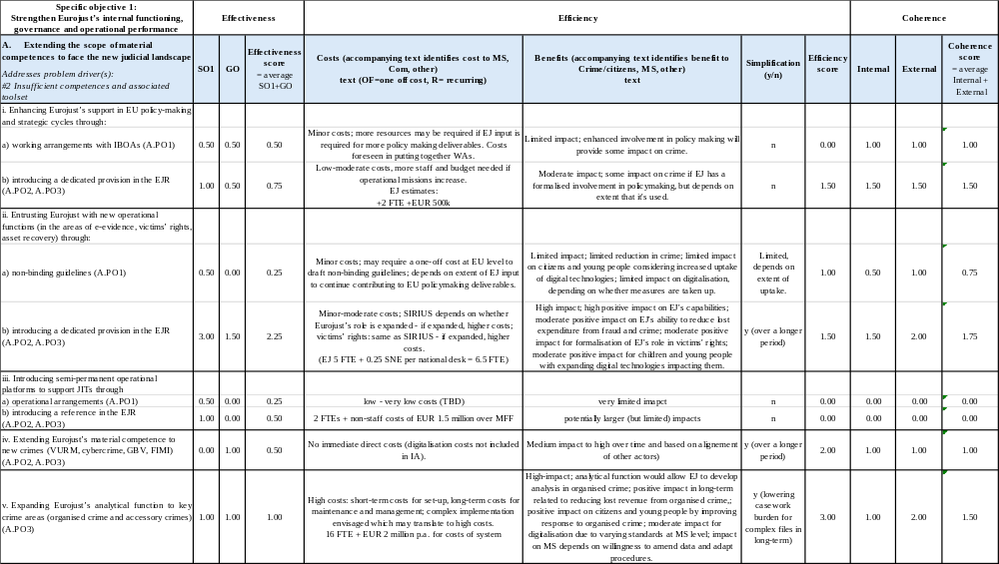
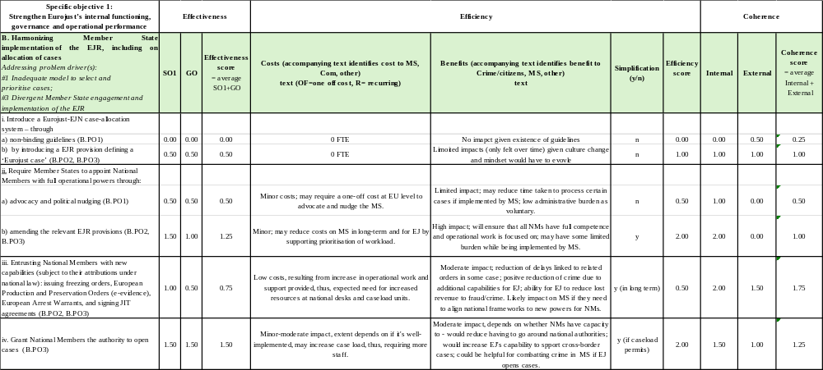

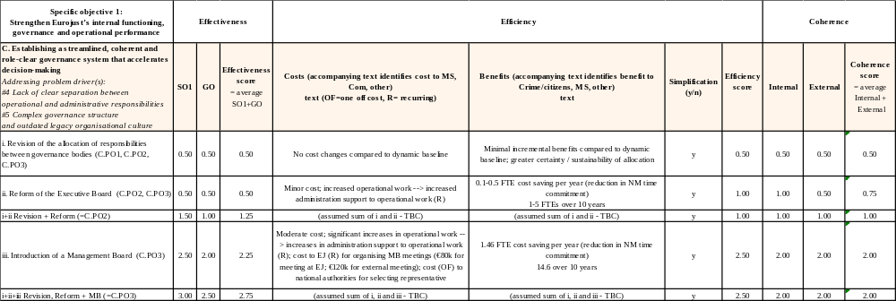

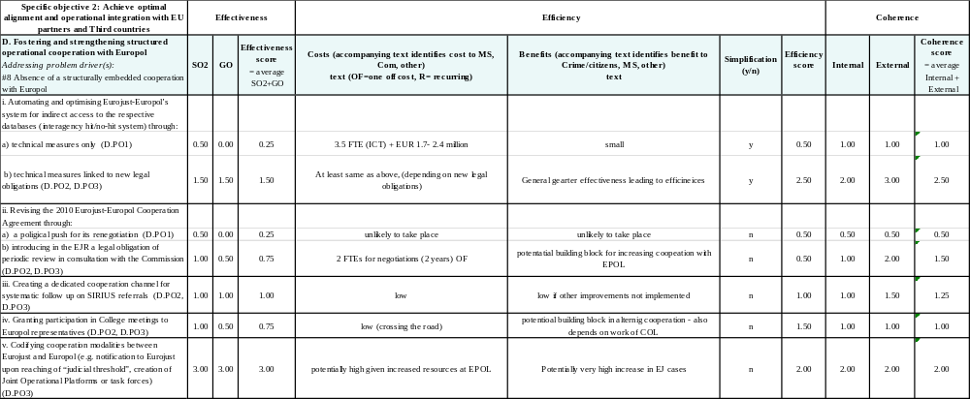

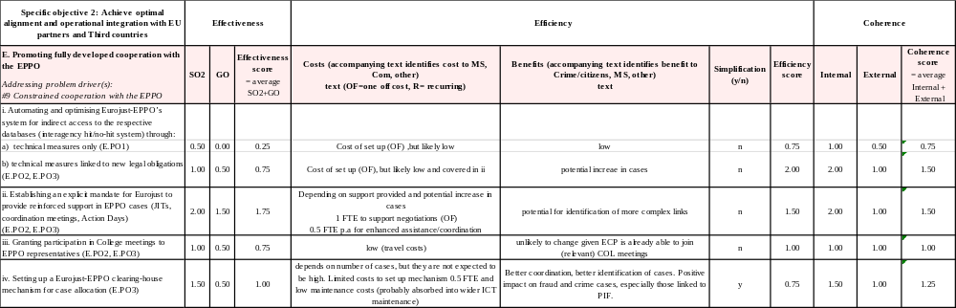

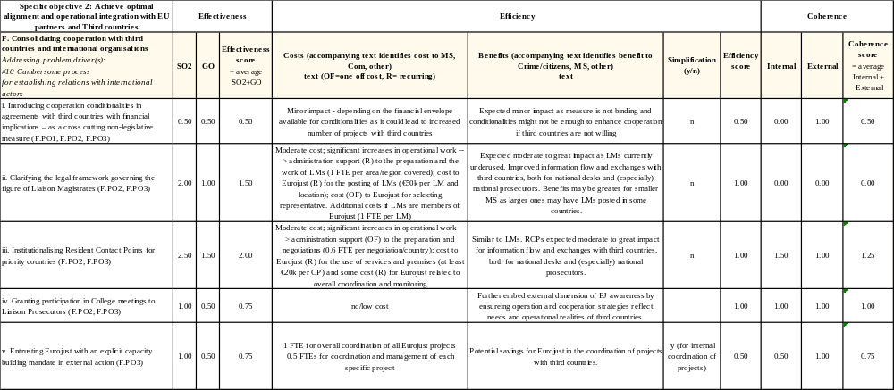

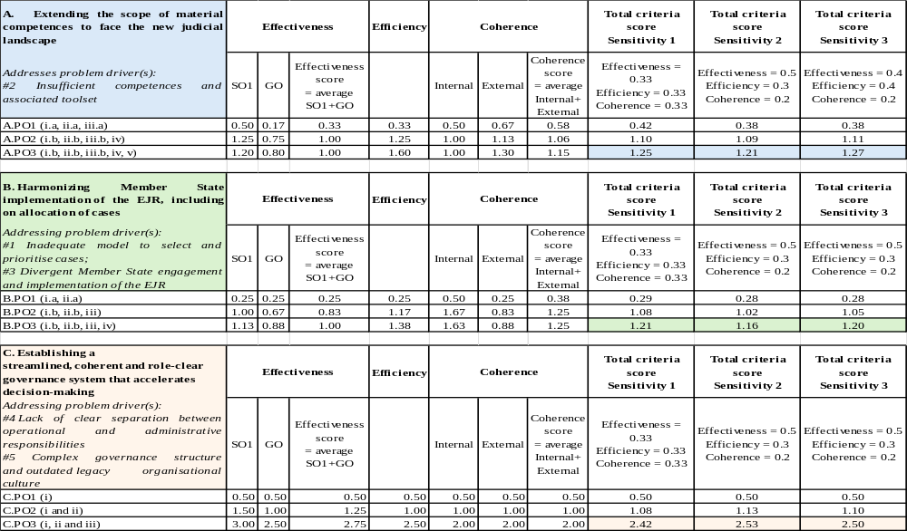
3.4. Aggregated scores per option

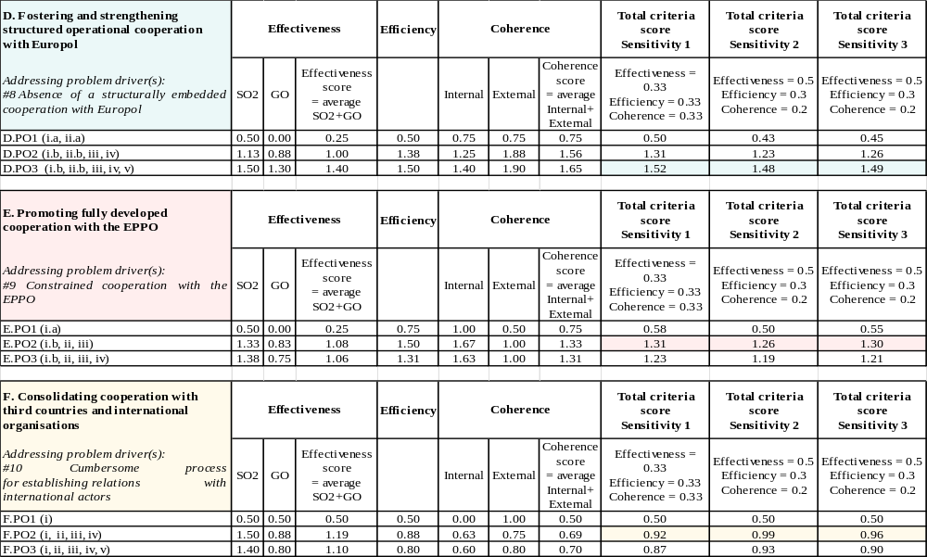

Annex 5: Competitiveness check
There are no direct impact on competitiveness (of any type). Positive (indirect) impact on competitiveness is likely through more level playing field for businesses operating in the EU and reductions in crime affecting businesses. Magnitude of this indirect impact is very hard to assess. Indirect impact is anticipated to be general - i.e not differentiated by type of stakeholder or competitiveness dimension (e.g. cost and price, international, SME, capacity to innovate).

Annex 6: SME check
The measures proposed cannot be not categorised as either ‘relevant’ or ‘highly relevant’ for SMEs. They would be subject to the same indirect benefits as all businesses, with no additional costs.
Whilst the initiative is not directly relevant for SMEs, like all businesses they can be expected to benefit indirectly and (reflecting their limited resources) may actually benefit to a higher degree than larger companies, which possess greater means to defend themselves against criminal and fraudulent behaviours.

Annex 7: Additional Information supporting the Impact Assessment

1. Introduction
This annex provides additional information that could not be accommodated within the main Impact Assessment. It examines the evolution of the broader European judicial legal framework, as well as Eurojust’s compliance with Fundamental Rights. It furthermore lists all legal instruments and strategies that include a role for Eurojust.

2. Evolution of the broader European judicial legal framework
The broader European criminal justice landscape has undergone a profound transformation over the past two decades, evolving from a predominantly intergovernmental framework into a coherent, multilayered architecture that acts across borders to enhance criminal justice cooperation and ensure mutual recognition. Eurojust’s development has taken place against this backdrop of further integration, gradual harmonisation of procedural standards, and the creation of new instruments enabling judicial authorities to cooperate efficiently in the fight against serious cross-border crime. These reforms have progressively shaped the environment in which Eurojust operates, expanding its responsibilities and expectations while strengthening the overall European criminal justice ecosystem.
A series of legal and operational instruments have significantly expanded the tools available to judicial authorities. The introduction of the European Arrest Warrant (2002)20 marked a foundational shift from traditional extradition to mutual recognition, followed later by the European Investigation Order (2014)21, which also provided a streamlined mechanism for gathering evidence across borders. The development of Joint Investigation Teams (JITs) has likewise been a major milestone in European judicial cooperation. While established through the 2000 Convention on Mutual Assistance in Criminal Matters22 and the later 2002 Framework Decision23, the practical operation of JITs has been progressively strengthened, supported by Eurojust’s operational, legal and financial assistance. The creation of the incoming JITs platform24, an EU-level digital environment that facilitates the management, exchange and secure communication of JIT-related information, represents an advancement in the way digitalisation supports operational cooperation.
Asset recovery constitutes another domain in which the European legal framework has evolved rapidly and significantly. In 2018, the Regulation on mutual recognition of freezing and confiscation orders25 introduced mandatory timelines, clearer safeguards and smoother cross-border execution of asset recovery decisions. In 2024 this was reinforced by the new Directive on asset recovery and confiscation26, which strengthens national Asset Recovery Offices, enhances tracing capacities, and introduces more robust confiscation regimes - including non-conviction-based confiscation in specific cases. The Union has moved toward a more coherent approach, recognising that depriving criminal networks of illicit proceeds is essential to dismantling their operations. Eurojust’s ability to coordinate judicial action in freezing and confiscation cases, provide case-law consistency, and support parallel financial investigations has become increasingly important within this framework, also supported by more structured links between Eurojust’s casework and Europol.
Beyond these legal instruments, the broader European criminal justice architecture has been shaped by a range of additional legal and policy developments. One can for instance point towards Eurojust’s growing number of third-country cooperation agreements and liaison prosecutors. These are essential in tackling cases involving global links and non-EU jurisdictions and underline the increased cooperation with judicial authorities outside of the EU.27
Moreover, the establishment of the European Public Prosecutor’s Office (EPPO)28 in 2017 has redefined the European prosecution landscape. A cornerstone of this evolution is the shift toward a more integrated framework for protecting the Union’s financial interests. The recent White Paper for the Anti-fraud Architecture Review29 laid out the strategic blueprint for a modernised, interconnected system involving OLAF, Eurojust, the EPPO and national authorities. It emphasised the need for complementary mandates, seamless information flow, and operational synergies, particularly in complex PIF-related investigations involving multiple jurisdictions. Eurojust’s role as a judicial coordination hub is closely linked to this architecture due to the corresponding need to ensure complementarity, information exchange and de-confliction between Eurojust and the EPPO.
Another dimension of this evolving landscape concerns the consolidation of information-sharing frameworks, which underpin nearly all aspects of cross-border judicial cooperation. The Law Enforcement Directive (LED)30 has established a harmonised data-protection regime for the processing of personal data in criminal matters, ensuring that exchanges between national authorities, Eurojust, and other EU bodies take place within a robust fundamental-rights framework. Complementing this, the Data Protection Regulation for EU institutions, bodies, offices and agencies (EUDPR)31 sets the overarching data-protection standards that apply directly to Eurojust and other agencies. While distinct from the LED, it ensures that Eurojust’s internal processing operations, its Case Management System and its information-exchange channels operate under a coherent, EU-wide regime that guarantees high levels of security, accountability and data-subject protection. For Eurojust, these developments are central: the agency’s coordinating role increasingly depends on timely access to accurate, high-quality data that can be safely shared among competent authorities. By aligning its operational systems with the LED’s safeguards and by preparing to function within the future EUDPR infrastructure, Eurojust strengthens both the legality and the efficiency of information flows. Information-exchange between judicial authority has also been reinforced through measures such as the ECRIS-TCN Regulation32, which enables more efficient identification of criminal records of third-country nationals.
In parallel, following the 2009 Stockholm Programme33 and a Council Roadmap34 to strengthen procedural rights in criminal proceedings, the EU adopted on the basis of Articles 82(2), a series of minimum standards directives aimed at enhancing mutual trust and facilitating mutual recognition. In this regard, the harmonisation of procedural safeguards through directives on victims’ rights35 and suspects’ and accused persons’ rights36 further ensures that judicial cooperation operates within a rights-protective, legally consistent environment across Member States. In the same way, under Article 83 the EU has adopted minimum rules defining certain criminal offences and sanctions in areas with a serious cross-border dimension (“EUcrimes”). Indeed, the rationale for minimum harmonisation of procedural and substantial criminal law is closely tied to the principle of mutual trust: the assumption that all Member States respect fundamental rights and the rule of law such that judicial decisions can be recognised and enforced across borders without re-examination of merits. Harmonised procedural rights and defined “EU crimes” help build a common baseline of protections and reduce legitimate obstacles to mutual recognition.
Additionally, practitioner networks have also played a decisive role in shaping the functioning of the judicial legal framework. Networks such as the European Judicial Network (EJN), the Genocide Network, the Network of National Experts on Joint Investigation Teams, and practitioner communities focused on fields such as cybercrime, trafficking in human beings, migrant smuggling, environmental crime and financial crime have contributed to building a common operational culture. These networks facilitate mutual understanding of legal systems, disseminate best practices, and provide platforms for rapid consultation - elements that directly enhance the effectiveness of Eurojust’s coordination function.37
The broader E-evidence framework, to become fully operational in 202638, also constitutes a next major step in the European judicial continuum. It provides judicial authorities in all Member States with a harmonised system for obtaining digital evidence directly from service providers - an essential capability given the prevalence of encrypted communication, cloud-based storage, and digital anonymity in contemporary criminal activity. Eurojust plays a central role in supporting the judicial application of these instruments. This digital transformation is accompanied by parallel developments such as the modernisation of Eurojust’s Case Management System, which strengthens the agency’s capacity to manage fast-moving, data-heavy criminal investigations.
Overall, it can be said that the European judicial legal framework in which Eurojust operates has become more sophisticated, integrated and digitally enabled. Eurojust sits at the centre of this environment, acting as the operational engine that transforms these legal instruments into concrete, coordinated judicial action capable of tackling the increasingly complex and cross-border nature of serious crime in the European Union.

3. Presentation of the current legal framework (Regulation (EU) 2018/1727 on Eurojust)
Eurojust’s mandate, structure and operational framework are laid down in Regulation (EU) 2018/1727 on the European Union Agency for Criminal Justice Cooperation. The Regulation establishes Eurojust as a Union agency with legal personality, replacing the former intergovernmental predecessor while ensuring continuity of functions and expertise. It aligns Eurojust with the post-Lisbon framework for judicial cooperation in criminal matters and embeds the Agency within the Area of Freedom, Security and Justice under the community method.
The Regulation defines Eurojust’s core mission as supporting and strengthening coordination and cooperation between national investigating and prosecuting authorities in relation to serious crime, in particular where such crime affects two or more Member States or requires prosecution on common bases, on the basis of operations conducted and information supplied by the Member States’ authorities, by Europol, by the EPPO and by OLAF. Eurojust’s role is explicitly supportive and complementary: it does not replace national authorities but facilitates their ability to act coherently in cross-border cases by providing a permanent coordination hub at Union level. Eurojust’s material competence covers serious forms of crime listed in Annex I of the Regulation, together with related offences, ensuring legal clarity while allowing operational flexibility. The Regulation also clarifies the conditions under which Eurojust may act in cases involving a single Member State where the interests of the Union or the effectiveness of judicial cooperation so require, subject to consultation with the concerned national authorities.
A central element of the legal context is the delineation of Eurojust’s relationship with the European Public Prosecutor’s Office. The Regulation establishes a principle of complementarity, whereby Eurojust does not exercise competence for offences falling within the EPPO’s remit once the EPPO has decided to act, while still preserving Eurojust’s coordinating role for cases involving non-participating Member States or requiring broader multilateral judicial coordination. This legal design aims to avoid duplication while ensuring continuity of cooperation across the Union’s prosecution landscape.
The Regulation translates Eurojust’s mandate into a set of clearly defined operational tasks. These include facilitating the exchange of information between national authorities, assisting in the coordination of investigations and prosecutions, supporting the resolution of conflicts of jurisdiction, and enhancing judicial cooperation through instruments such as Joint Investigation Teams. Eurojust is also tasked with assisting national authorities in the execution of mutual legal assistance and mutual recognition instruments, thereby supporting the practical application of Union law in criminal matters.
While Eurojust does not exercise prosecutorial powers itself, the Regulation equips it with structured coordination tools that go beyond informal facilitation. Eurojust may request competent national authorities to initiate or coordinate investigations or prosecutions, to accept that one authority may be better placed to prosecute, to set up a Joint Investigation Team, or to take other measures necessary for effective judicial cooperation. Where coordination difficulties persist, Eurojust may issue reasoned written opinions. National authorities are required to respond without undue delay, subject to limited and explicitly defined refusal grounds.
In practice, operational tasks are carried out primarily through the national members, acting individually or jointly as the College, reflecting the Agency’s role as a facilitator of national judicial action rather than an autonomous prosecutorial body. This reinforces the principle that operational ownership of cases remains with Member States, while Eurojust provides the institutional framework, continuity and coordination necessary to align national actions in complex cross-border proceedings. The Regulation, after its targeted amendment in 2022, also empowers Eurojust to establish and manage the Core International Crimes Evidence Database (CICED), enabling the secure storage and preservation of evidence relating to genocide, crimes against humanity and war crimes.
Eurojust’s operational architecture is thus built around the national member model. Each Member State is represented by a national member, supported by deputies and assistants, who are in principle experienced prosecutors, judges or equivalent officials. This structure ensures that Eurojust’s actions and exercise of powers are grounded in national legal systems while enabling rapid coordination across jurisdictions. The Regulation therefore requires Member States to grant national members the powers necessary to fulfil Eurojust’s tasks, in accordance with national law. These powers may include the ability to issue, execute or transmit judicial cooperation requests, and to take urgent measures in exceptional circumstances. This legal framework seeks to reduce delays caused by fragmented competences while preserving constitutional and procedural safeguards at national level.
Next to the College - which is chaired by the President of Eurojust, who is also a National Member - the Regulation also establishes an Executive Board and an Administrative Director, introducing an agency-style governance framework aimed at improving strategic planning, internal efficiency and accountability.
A cornerstone of the Regulation is the establishment of structured information-exchange obligations. Member States are required to provide Eurojust with the information necessary for the performance of its tasks, and the Regulation specifies categories of cases and situations that should be transmitted, such as those involving multiple Member States, potential conflicts of jurisdiction, or repeated difficulties in executing cooperation requests. This moves judicial cooperation from a largely voluntary model toward a more predictable and systematic exchange of information. To support this obligation at national level, the Regulation requires each Member State to establish a Eurojust national coordination system (ENCS), bringing together national correspondents, contact points and relevant networks, including the European Judicial Network. To ensure operational continuity, the Regulation also establishes an on-call coordination mechanism, requiring Member States to ensure round-the-clock availability of national representatives capable of responding to urgent cross-border judicial cooperation needs. For terrorism-related cases, the Regulation after the 2023 amendment also introduces reinforced and standardised information-sharing obligations, stipulating the particular importance of early identification of cross-border links between proceedings in this area.
The Regulation furthermore provides the legal basis for Eurojust’s Case Management System (CMS) and for digital communication between Eurojust and national authorities. It foresees the use of interoperable IT systems to support efficient, secure and timely exchange of judicial information, thereby underpinning Eurojust’s ability to manage growing volumes of complex case data. Given the sensitivity of judicial cooperation data, the Regulation establishes specific rules governing the processing of operational personal data by Eurojust and situates Eurojust within the overarching data protection frameworks, especially for European agencies and law enforcement-data. It defines the categories of data that may be processed, limits access within the Agency, and subjects Eurojust to internal data protection safeguards and external supervision by the European Data Protection Supervisor.
Finally, the Regulation explicitly places Eurojust within the broader EU judicial cooperation ecosystem. It provides a framework for cooperation with Europol, the European Judicial Network (EJN), OLAF, the EPPO and third countries - including through liaison prosecutors and coordination of multilateral judicial requests.
Taken together, the Eurojust Regulation establishes a comprehensive legal architecture that defines Eurojust’s mandate, tasks and powers; structures its operational and governance model; and equips it with modern information-exchange and data-processing capacities. This framework underpins Eurojust’s role as the central hub for judicial coordination in the Union, while ensuring safeguards, accountability and complementarity within the evolving European criminal justice system.

4. Ensuring full compliance with Fundamental Rights
A revised Eurojust Regulation will fully observe the principles in the Charter of Fundamental Rights of the European Union (the Charter) as recognised in the TEU, as well as the general principles of EU law derived from the European Convention for the Protection of Human Rights and Fundamental Freedoms (ECHR). This is particularly important in areas where Eurojust’s expanded mandate would intersect with criminal procedural safeguards and data protection.
The current EJR reflects a strong commitment to the Charter and the Convention for the Protection of Human Rights and Fundamental Freedoms (ECHR), in particular human dignity (Article 1 of the Charter), the right to integrity (Article 3 of the Charter), the right to liberty and security (Article 6 of the Charter), respect for private and family life (Article 7 of the Charter), the protection of personal data (Article 8 of the Charter), non-discrimination (Article 21 of the Charter), the rights of the child (Article 24 of the Charter), the presumption of innocence and right of defence (Article 48 of the Charter), the principles of legality and proportionality of criminal offences and penalties (Article 49 of the Charter), and the right not to be tried or punished twice in criminal proceedings for the same offence (Article 50 of the Charter).
Given the importance of the access to personal data in Eurojust’s support for the work of judicial authorities and of the processing, this impact assessment focuses specifically on ensuring full compliance with the rights to the protection of personal data (Article 8 of the Charter) and to respect for private life (Article 7 of the Charter).
Rights to the protection of personal data and to respect for private life
Strengthening the possibility of exchanging personal information between Eurojust and other JHA IBOAs, especially Europol, as well as third-country authorities, raises fundamental rights consideration. These considerations primarily concern the right to the protection of personal data under Articles 7 and 8 of the Charter. These issues are particularly important concerning the transfer of data to the national competent authorities of third countries for which only data strictly necessary for judicial cooperation should be shared, in compliance with the EU data protection framework, in particular the Chapter IX of the EUDPR. Enhanced data-sharing, while operationally valuable for combating crime, introduces certain risks that must be carefully managed.
A more frequent exchange of personal data, including sensitive data such as biometric or criminal records, increases the number of actors with access to this information and eventually a longer retention and broader reuse of data may occur. Such interference must therefore meet strict necessity and proportionality requirements. Stronger data exchange may risk blurring the boundary between intelligence and judicial use, a reuse of data for purposes not originally envisaged and a potential reliance on unverified or analytical data in judicial proceedings. Moreover, this threatens the purpose limitation principle that is a core data-protection safeguard.
To mitigate these risks, enhanced exchange must be clearly defined in the legal basis (which is EU secondary legislation), strictly limited to specific categories of data and finally linked to precise objectives in accordance with the principle of proportionality. Lastly, effective protection will require an oversight by the European Data Protection Supervisor (EDPS).
This is why this impact assessment thoroughly takes into consideration these issues of data protection and privacy and any consequences of the proposed amendments to the current legal framework for the processing and sharing of personal data by Eurojust with its European institutional partners (IBOAs or Member States) and third countries.
The preferred policy option, particularly the measures enhancing data exchange with Europol, the EPPO, and third countries (such as D.PO3, E.PO2, and F.PO2), will increase the volume and scope of personal data processing. While this strengthens operational cooperation, it also introduces risks that must be carefully managed.
A more frequent exchange of personal data, including sensitive information such as biometric or criminal records, raises concerns about expanded access by a broader range of actors, potentially leading to longer retention periods and reuse of data beyond its original purpose. Additionally, there is a risk of blurring the boundary between intelligence and judicial use, where data collected for law enforcement purposes (e.g., by Europol) might be repurposed for judicial proceedings without sufficient safeguards. Furthermore, transfers to third countries pose challenges, as data protection standards in those jurisdictions may not fully align with EU requirements, particularly under Chapter IX of the EU Data Protection Regulation (EUDPR).
To mitigate these risks, strict legal bases for data exchange will be established, ensuring that shared data is limited to what is necessary and proportionate for judicial cooperation. Purpose limitation of safeguards will prevent the reuse of data for unintended objectives, while oversight by the European Data Protection Supervisor (EDPS) will ensure compliance with EU standards, particularly for transfers to third countries. A revision of the EJR will also align with the parallel revision of the EUDPR, which will provide harmonised rules for all Justice and Home Affairs (JHA) agencies, further reinforcing data protection.
Procedural Safeguards in Criminal Proceedings
The preferred option aims to strengthen Eurojust’s operational role (e.g., through A.PO3 and B.PO3) without compromising core principles of criminal justice. The presumption of innocence and the right of defense (Article 48 of the Charter) must be upheld, particularly in relation to Eurojust’s expanded analytical functions, such as evidence databases for organised crime, which must avoid prejudicing ongoing investigations or trials. The principle of ne bis in idem (Article 50 of the Charter) will be safeguarded through enhanced coordination mechanisms, which reduce the risk of parallel proceedings.
The legality and proportionality of penalties (Article 49 of the Charter) must also be respected, particularly where Eurojust is granted new competences, such as issuing freezing orders. These competences must align with national procedural autonomy and EU-wide standards.
Key safeguards will ensure that Eurojust’s role remains supportive and coordinative, avoiding any interference with national judicial independence. Transparency and legal remedies will be embedded in operational procedures, providing clear avenues for individuals to challenge data processing or operational decisions that may affect their rights.
Non-Discrimination and Rights of Vulnerable Groups (Articles 21 and 24 of the Charter)
The expansion of Eurojust’s mandate to include gender-based violence and victims’ rights (under A.PO3) must ensure non-discriminatory application and the protection of victims, particularly in cross-border cases. Where cases involve minors, data processing must fully comply with Article 24 of the Charter, which protects the rights of the child, ensuring that procedures are child-sensitive and respectful of their specific needs.]
The preferred option minimises negative impacts on fundamental rights while enhancing Eurojust’s operational effectiveness. The net effect is expected to be neutral or positive, particularly through measures that:
- Reduce risks of jurisdictional conflicts, for example by implementing B.PO3’s case allocation system, which ensures clearer and more consistent case handling.
- Improve coherence with EU data protection frameworks, particularly through alignment with the revision of the EUDPR, which will establish harmonised rules for data processing across JHA agencies.
- Embed procedural safeguards in operational tools, such as analytical databases, ensuring that fundamental rights are protected throughout judicial cooperation processes.

5. Legal instruments and strategies including a role for Eurojust
● European Arrest Warrant (EAW): Framework Decision 2002/584 of 13.06.2002, Articles 16, 17. Eurojust can provide advice in the case of competing EAWs; Eurojust shall be notified when Member states cannot comply with the time limits set out in the Framework Decision.
● Transfer of proceedings: Regulation 2024/3011 of 27.11.2024, Articles 18, 24, 26, 27. Eurojust shall assist the authorities involved at any stage of the procedure, in particular supporting (preliminary) consultations between the authorities, facilitating an agreement on the concentration of the proceedings in one Member State, facilitate the transmission of all communication between the authorities involved.
● Conflicts of jurisdiction: Framework Decision 2009/948 of 30.11.2009, Article 12 and several recitals. Eurojust may facilitate consultations between the authorities, the national authorities shall refer the case to Eurojust where they cannot reach a consensus on how to solve a conflict of jurisdiction. Directive 2017/541 of 15.03.2017 on combating terrorism, Article 19 refers to the role of Eurojust in conflicts of jurisdiction in terrorism cases.
● European Protection Order: Directive 2011/99 of 13.12.2011, Article 8. Eurojust can support in the transmission phase and with obtaining the necessary information.
● European Investigation Order: Directive 2014/41 of 3.4.2014, recital 13. Eurojust can support with a view to ensuring the transmission of the EIO to the competent authority of the executing State.
● Asset tracing: Directive 2024/1260 of 24.4.2024, Article 30(2). Asset recovery offices and asset management offices shall cooperate with Eurojust for the purposes of facilitating the identification of assets to be frozen or confiscated in the course of proceedings in criminal matters, to facilitate the management of frozen and confiscated assets.
● Freezing and confiscation: Regulation 2018/1805 of 14.11.2018, Article 31 and Recital 24, 27, 43, 44. Eurojust may facilitate consultations on the sharing of the costs, facilitate the transmission of freezing and confiscation orders, coordinate freezing/confiscation orders issued to several Member States to avoid excessive confiscations, provide assistance in relation to the procedures for the execution of a freezing/confiscation order given that they may be very different in the two Member States involved, facilitate coordination for the simultaneous execution of freezing/confiscation orders in several Member States.
● European Production and Preservation Order (e-Evidence): Regulation 2023/1543 of 12.07.2023, Article 5(10). Issuing authorities may seek clarification via Eurojust before issuing a European Production Order, including by consulting the competent authorities of the enforcing State, if the issuing authority has reasons to believe that the data requested are protected by immunities or privileges or are subject to rules on determination and limitation of criminal liability relating to freedom of the press or freedom of expression in other media.
● Sanctions evasion: Directive 2024/1226 of 24.04.2024 defining criminal offences and penalties for the violation of EU restrictive measures - Violation of EU restrictive measures/sanctions evasions is now a crime EU-wide and should be explicitly reflected in Annex I EJR. Eurojust has been supporting a growing number of such operational cases. Violation of EU restrictive measures/ sanctions evasions is now a predicate offence to money laundering. Directive on combating money laundering by criminal law has been amended (Article 2(1) (w), by virtue of the Directive on restrictive measures. The scope of Directive 2024/1260 on asset recovery and confiscation has been extended to encompass violation of EU restrictive measures/sanctions violations.
● Support to EU Seize Freeze and Task Force: the EU ‘Freeze and Seize’ Task Force does not have an operational mandate and cannot interfere with the conduct of individual administrative or judicial procedures. This is one of the reasons why Eurojust and Europol have been invited to support the Task Force, within the framework of their respective mandates. At the JHA Council meeting of 4 March 2022 referred to above, Eurojust was invited to exercise its coordination role with regard to both the EU “Freeze and Seize” Task Force and the investigation of core international crimes allegedly committed in Ukraine further to Russia’s invasion of Ukraine.
● Victims’ rights:
o EU Strategy on Victims’ rights 2020-2025, on page 20 whereby Eurojust, in coordination with other EU agencies/networks, “should report on how to improve the cooperation and exchange of information and good practices between the competent authorities in cross-border cases”.
o Directive 2024/1385 of 14.05.2024 against domestic violence and violence against women, recital 87 (exchanging best practices and consulting in individual cases), Article 43(b) (whereby MS are invited to “consult each other in individual cases, including through Eurojust and the European Judicial Network in criminal matters, within their respective mandates”).
o Amendments to Directive 2012/29/EU establishing minimum standards on the rights, support and protection of victims of crime (amendments adopted on 10 December 2025 being finalised but not yet published. Expected reference to Eurojust in Article 17(4) in a supporting role to national authorities in cases involving victims).
● Joint investigation teams (JITs): Regulation 2023/969 of 10 May 2023 establishing a collaboration platform to support the functioning of joint investigation teams and amending Regulation 2018/1726, Articles 9-10. The tasks are for JITs Network Secretariat explicitly, as well as for Eurojust regarding the technical arrangement to enable the use of the JITs CP and connection with IT tool managed by Eurojust, in particular JIT Funding.

I.e. Joined Cases C-566/19 PPU and C-626/19 PPU 12 December 2019; Joined Cases C-508/18 and C. 509/18.CJUE, 27 May 2019.
19 FTEs working on retaining knowledge from cases, provide deliverables prioritised by the College in JCI and crime areas; strategic activities of the College working groups; provide input to COSI, COPEN, other Council working parties and EU agencies – source: EJ ACT 2025 + 2 FTEs to cover EJ’s role in the EU policy cycle.
The existing underlying architecture is based on outdated technologies, which are increasingly costly and complex to maintain. In addition, the current systems operate largely in isolation, as they are not integrated with the Eurojust Case Management System, leading to manual processes, data duplication, and reduced operational efficiency. Following the recommendations of the DCJ study, Eurojust plans to modernise and redevelop the JIT IT ecosystem in order to streamline the support provided to JITs. This initiative will include the development of new integrated systems supporting the full lifecycle of JIT activities, including funding management, claims processing, evaluation and reporting, integration with the new Case Management System (nCMS) and improved interoperability with the JITs Collaboration Platform
Assuming LMs wages are purely paid from EJ’s budget and they are located in the EU delegation’s premises.
Recitals 1-4; Article 1 of Regulation (EU) 2018/1727.
Article 2 of Regulation (EU) 2018/1727.
Article 3; Annex I of Regulation (EU) 2018/1727.
Recitals 5, 7-8; Article 3 of Regulation (EU) 2018/1727.
Recitals 12-15; Article 4 of Regulation (EU) 2018/1727.
Article 4 of Regulation (EU) 2018/1727.
Recital 12; Article 5 of Regulation (EU) 2018/1727.
Article 4(j) Regulation (EU) 2018/1727.
Articles 7-9 of Regulation (EU) 2018/1727.
Article 8-9 of Regulation (EU) 2018/1727.
Recitals 16-21; Articles 10-18 of Regulation (EU) 2018/1727.
Recital 27; Article 21 of Regulation (EU) 2018/1727.
Recital 25; Article 19 of Regulation (EU) 2018/1727.
Recital 26; Articles 20 of Regulation (EU) 2018/1727.
Articles 22-25 of Regulation (EU) 2018/1727.
Recitals 28-53; Chapter IV of Regulation (EU) 2018/1727.
Recitals 54-60; Chapter V of Regulation (EU) 2018/1727.

