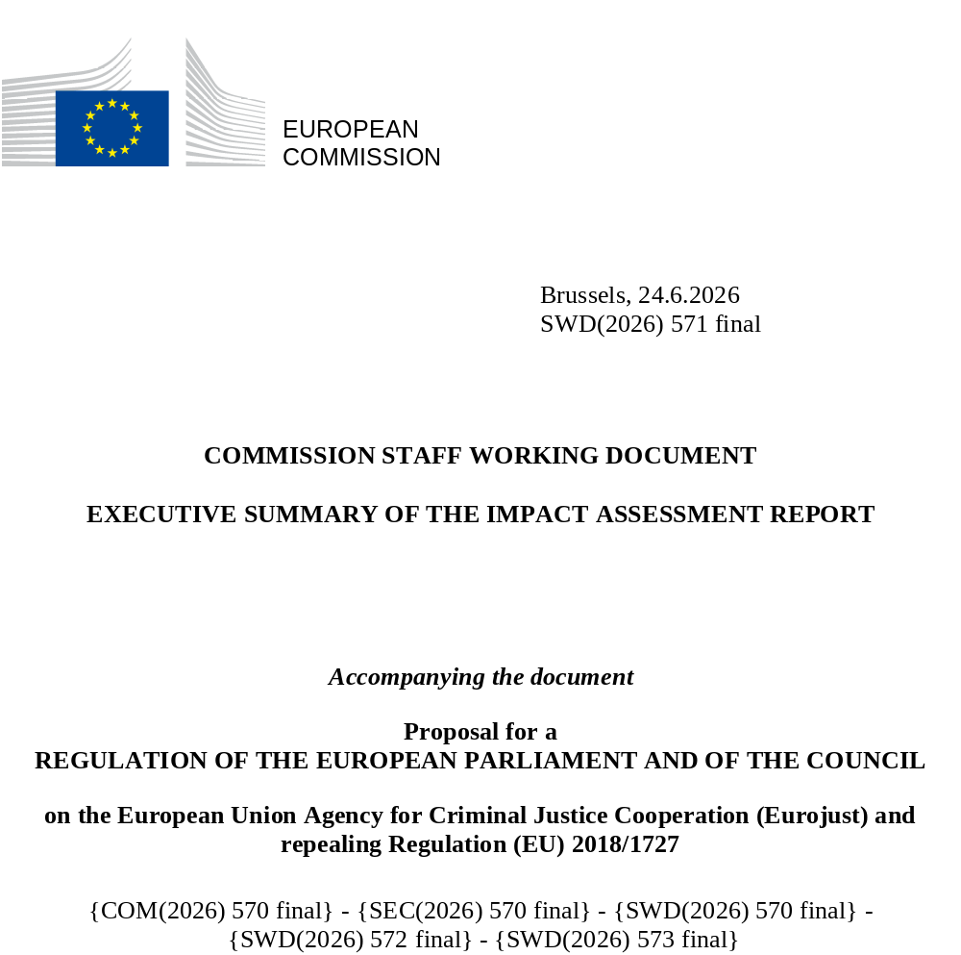

Executive summary sheet
Impact assessment for the review of the Eurojust Regulation (Regulation (EU) 2018/1727)
- Need for action
What is the problem and why is it a problem at EU level?
This impact assessment follows the evaluation of the Eurojust Regulation (Regulation (EU) 2018/1727 on the European Union Agency for Criminal Justice Cooperation, EJR or the Regulation) published on 2 July 2025. The EJR established Eurojust as an EU agency with legal personality, laying down its mandate, structure and operational framework. The Regulation defines Eurojust’s core mission as supporting and strengthening coordination and cooperation between national investigating and prosecuting authorities in relation to serious crime, particularly in cases affecting multiple Member States, based on information supplied by Member States’ authorities, Europol, the European Public Prosecutor Office (EPPO) and OLAF. Eurojust’s material competence covers serious forms of crime listed in Annex I of the Regulation, together with related offences, ensuring legal clarity while allowing operational flexibility.
The evaluation’s findings strongly support the case of reforming Eurojust’s mandate, particularly in areas such as efficiency and cooperation with EU partners and third countries. Optimisation of internal processes and interactions with the broader criminal justice ecosystem would enable Eurojust to fully realise its potential in the fight against serious and organised cross-border crime.
For the purpose of the impact assessment two sets of problems have been identified:
- Problem 1: Suboptimal efficiency of Eurojust’s internal organisation and processes, and
- Problem 2: Limitations in Eurojust’s interaction with partners.
Concretely, problem 1 involves an increasing demand for services across Member States while struggling to filter out lower-complexity cases, which could be more efficiently handled through bilateral cooperation or the European Judicial Network (EJN), thereby diverting resources from complex cases, where Eurojust generates its greatest added value. Due to an expanding mandate and growing caseload tensions have arisen between workload and staff allocation, leading to reduced support capacity and delays in responding to Member States. This problem can partially be explained with the absence of a clearly defined mandate and operating mostly reactively to Member States requests. Another part of the problem lies in the current governance practices of the agency where decisions that could be taken at lower level are often escalated to collective governance bodies, increasing procedural burden. Eurojust’s current governance structure is overly complex, with oftentimes unclear separation between operational and administrative responsibilities. Administrative work tends to deflect a significant share of Eurojust’s National Members’ attention away from casework. Criteria on what qualifies as a “Eurojust case” and how to select or prioritise cases are lacking. The status, powers and skills of Eurojust’s National Members (prosecutors, judges, representatives of a judicial authority) vary across member states, leading to an uneven distribution of Eurojust’s added value across Member States.
Problem 2 describes the shortcomings in Eurojust’s interaction with partners at EU (especially with Europol, the EPPO and OLAF) and international level (cooperation with third countries). Interaction with EU bodies and agencies still lacks structure and institutionalisation and is prone to procedural complexity and duplication. Information exchange could be improved: as system of indirect mutual access to data bases (“hit/no-hit” system) is in place only bilaterally in relation to Europol, EPPO and OLAF and cumbersome requiring manual follow-ups. On the international level, existing arrangements may not be sufficiently robust or evenly implemented. New international agreements cannot be concluded by Eurojust but require the involvement of the European Commission, Council and Parliament which made the process time-consuming. Further issues in this area surround the conclusion of working arrangements (in the absence of international agreements), legally underdefined activities in capacity-building, or the underusage of so-called Liaison Magistrates (Eurojust officials posted in third countries) and Liaison Prosecutors (third-country officials posted at Eurojust on the basis of international agreements).
These problems are genuinely rooted at EU level, since Eurojust is an EU decentralised agency and can therefore only be solved at EU level. The cross-border nature of the crimes dealt with by Eurojust demand a joint European response implementing Eurojust’s mission in line with Article 85 of the Treaty on the Functioning of the European Union (TFEU). Without EU intervention, the problems are likely to persist as they relate to Eurjust’s legal framework, governance design, legacy organisational culture, dependence on Member States, and the broader dynamics in the EU justice architecture.
What should be achieved?
General objective: The revision of the EJR seeks to better attain the goals set out in the Treaties, namely to support and strengthen coordination and cooperation between national investigating and prosecuting authorities and to ensure a high level of security through measures that prevent and combat crime and measures that foster coordination and cooperation between judicial and other competent authorities.
Two specific objectives were identified:
- Strengthen Eurojust’s internal functioning, governance and operational performance
- Strengthen Eurojust’s external cooperation and integration with EU-level and international partners
What is the added value of action at EU level (subsidiarity)?
Eurojust’s functions (coordination, cooperation facilitation, and operational support) are transnational by nature and cannot be performed effectively solely on Member State level. The agency provides a neutral EU-level perspective across juristdictions, facilitates multilateral cooperation in parallel, and ensures that no Member State is placed at a disadvantage. Scale and complexity of cross-border investigations render EU-level coordination indispensable for national prosecutorial and judicial authorities, calling for EU-level action and thus adhering to the subsidiarity principle. Eurojust offers operational, legal, and strategic value that improve the functioning of national systems and the coherence of the EU’s Area of Freedom, Security and Justice. Action by Eurojust does not replace that of national authorities but enhances it through supporting services. There are clear ecomonies of scale and efficiency gains by further improving Eurojust, enabling it to bring together expertise from national practicioners in one agency, coordinate fast and more efficiently in the fight against transnational crime, avoiding duplication and conflicting investigations.
- Solutions
What are the various options to achieve the objectives? Is there a preferred option or not? If not, why?
The impact assessment evaluates policy options spanning from non-legislative to regulatory interventions. Each policy option consists of a set of measures (numbered i, ii, iii, etc.), selected based on their ability to address a given problem (or its driver), and screened for effectiveness, efficiency and coherence. For each of seven intervention areas (A-F), three policy options have been developed, varying in intensity (PO1 being the lightest set of measures, PO2 moderate, and PO3 the most far-reaching set of measures).
Specific objective 1 (Internal):  Strengthen Eurojust’s Internal Functioning, Governance and Operational Performance | Options
 | Light change | Moderate change | Substantial change
A. Extending the scope of material competences to face the new judicial landscape
Addressing problem driver(s):  #2 Insufficient competences and associated toolset | A.PO1 | A.PO2 | A .PO3
i. Enhancing Eurojust’s support in EU policy-making and strategic cycles – through working arrangements with IBOAs (i.a) or by introducing a dedicated provision in the EJR (i.b) | i.a | i.b | i.b
ii. Entrusting Eurojust with new operational functions (in the areas of e-evidence, victims’ rights support to asset recovery) – through non-binding guidelines (ii.a) or by introducing a dedicated provision in the EJR (ii.b) | ii.a | ii.b | ii.b
iii. Introducing semi-permanent operational platforms to support JITs – through operational arrangements (iii.a) or by introducing a reference in the EJR (iii.b) | iii.a | iii.b | iii.b
iv. Extending Eurojust’s material competence to new crimes (VURM, cybercrime, GBV) |  | iv | iv
v. Expanding Eurojust’s analytical function to key crime areas (organised crime and accessory crimes) |  |  | v
B. Harmonising Member State implementation of the EJR, including on allocation of cases
Addressing problem driver(s):  #1 Inadequate model to select and prioritise cases;  #3 Divergent Member State engagement and implementation of the EJR | B.PO1 | B.PO2 | B.PO3
i. Introduce a Eurojust-EJN case-allocation system – through non-binding guidelines (i.a) or by introducing a EJR provision defining a ‘Eurojust case’ (i.b) | i.a | i.b | i.b
ii. Reinforce the status of National Members to give them full operational powers – through advocacy and political push (ii.a) or by amending the relevant EJR provisions (ii.b) | ii.a | ii.b | ii.b
iii. Entrusting National Members with new competences (subject to their attributions under national law): issuing freezing orders (or immediate action), European Production and Preservation Orders (e-evidence), and signing JIT agreements |  | iii | iii
iv. Grant National Members the authority to open Eurojust cases |  |  | iv
C. Establishing a streamlined, coherent and role-clear governance system that accelerates decision-making
Addressing problem driver(s):  #4 Lack of clear separation between operational and administrative responsibilities  #5 Complex governance structure and outdated legacy organisational culture | C.PO1 | C.PO2 | C.PO3
i. Revision of the allocation of responsibilities between governance bodies | i | i | i
ii. Reform of the Executive Board |  | ii | ii
iii. Introduction of a Management Board |  |  | iii
Specific objective 2 (External):  Achieve optimal alignment and operational integration with EU partners and third countries | Options
 | Light changes | Moderate changes | Substantive changes
D. Fostering and strengthening structured operational cooperation with Europol
Addressing problem driver(s):  #8 Absence of a structurally embedded cooperation with Europol | D.PO1 | D.PO2 | D.PO3
i. Automating and optimising Eurojust-Europol’s system for indirect access to the respective databases (interagency hit/no-hit system) – through technical measures only (i.a) or through technical measures linked to new legal obligations (i.b) | i.a | i.b | i.b
ii. Revising the 2010 Eurojust-Europol Working Arrangements – through a political push for its renegotiation (ii.a) or by introducing in the EJR a legal obligation of periodic review in consultation with the Commission (ii.b) | ii.a | ii.b | ii.b
iii. Creating a dedicated cooperation channel for systematic follow up on SIRIUS referrals |  | iii | iii
iv. Granting participation in College meetings to Europol representatives |  | iv | iv
v. Codifying cooperation modalities between Eurojust and Europol (e.g., notification to Eurojust upon reaching of “judicial threshold”, creation of Joint Operational Platforms or task forces) |  |  | v
E. Promoting fully developed cooperation with the EPPO

Addressing problem driver(s):  #9 Constrained cooperation with the EPPO | E.PO1 | E.PO2 | E.PO3
i. Automating and optimising Eurojust-EPPO’s system for indirect access to the respective databases (interagency hit/no-hit system) – through technical measures only (i.a) or through technical measures linked to new legal obligations (i.b) | i.a | i.b | i.b
ii. Establishing an explicit mandate for Eurojust to provide reinforced support in EPPO cases (JITs, coordination meetings, Action Days) |  | ii | ii
iii. Granting participation in College meetings to EPPO representatives |  | iii | iii
iv. Setting up a Eurojust-EPPO clearing-house mechanism for case allocation |  |  | iv
F. Consolidating cooperation with third countries and international organisations
Addressing problem driver(s):  #10 Cumbersome process for establishing relations with international actors | F.PO1 | F.PO2 | F.PO3
i. Introducing cooperation obligations in agreements with third countries with financial implications – as a cross cutting non-legislative measure (i) | i | i | i
ii. Clarifying the legal framework governing Liaison Magistrates |  | ii | ii
iii. Institutionalising Resident Contact Points for priority countries |  | iii | iii
iv. Granting participation in College meetings to Liaison Prosecutors |  | iv | iv
v. Entrusting Eurojust with an explicit capacity building mandate in external action |  |  | v
According to the analysis and the assessment, the preferred option consists of a package of the policy options under each area of intervention: A.PO3, B.PO3, C.PO3, D.PO3, E.PO2, F.PO2. These policy options are complementary and score highest regarding their impact on the three evaluation criteria effectiveness, efficiency and coherence.
What are different stakeholders’ views?
Consultations with stakeholders have shown that there is very broad support for reforming Eurojust.
In particular, stakeholders like Eurojust’s administration were in favour of the proposed governance reform as it would, in their view, address inefficiencies experienced, reducing not only National Members’ time spent in meetings but also time required to take decisions. National Members, however, pointed to the downsides of taking certain decision-making powers away from them and transferring them to a Management Board that might not be as familiar with Eurojust and might still ask to be briefed.
Across all areas of intervention surveys illustrated stakeholder support for measures like giving Eurojust a support role vis-à-vis e-evidence and relations with service providers and strengthen the ability of Eurojust National Members to issue e-evidence orders (50,3%; area A), encouraging Member States to select National Members with strong operational powers and qualifications (64,9%; area B), adopting a more standard governance model by introducing a full Management Board (72,3%; area C), improving the hit/no-hit system between Eurojust and Europol and the EPPO by having an automated process (48,9%; area D and E), allowing the participation of Liaison Prosecutors in the College on cases involving third countries (59,1%; area F). According to the respondents these measures would contribute to achieving the envisaged objectives to a moderate or large extent.
C. Impact of the preferred option
What are the benefits of the preferred option (if any, otherwise of main ones)?
The preferred option is a package that generates cumulative impacts by combining measures that address different but interrelated drivers of the problem. Taken together, these measures form a coherent and mutually reinforcing revision of the Eurojust mandate: they strengthen Eurojust’s ability to support Member States to combat serious and cross-border crime more effectively than any individual measure alone. The two specific objectives would be reached and the package aligns with stakeholder demands and EU strategic priorities, ensuring political feasibility and operational relevance. Eurojust’s proactivity would be improved, transforming it from a reactive coordination body to a strategic and analytical hub for cross-border judicial cooperation. In detail, the measures would:
- codify and expand Eurojust’s mandate and operational competences to emerging crime areas through amendments of Annex I. In parallel, Eurojust’s analytical capacity would be strengthened by providing a mandate to use judicial data, supporting national authorities in evidence-building and strategic case development.
- reinforce operational coordination and legal certainty within Eurojust by spelling out the concept of a “Eurojust case”, the eligiblity requirements for National Members and their powers to issue mutual legal assistance requests and investigative orders.
- modernise Eurojust’s governance, decision making and internal management structure.
- enhance data protection and data management capabilities, specifying the application of the EU data protection regime within the EJR.
- strengthen cooperation with key partners at EU (in particular Europol and the EPPO) and international levels (notably strategic third countries).

