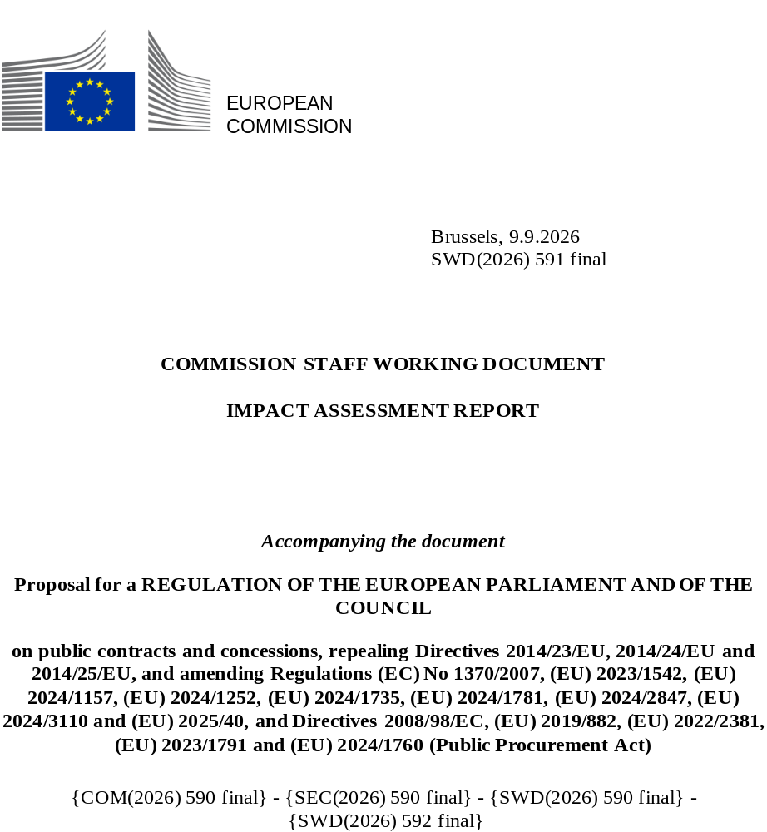

Table of contents
1. Introduction 5
2. Problem definition 6
3. Why should the EU act? 19
4. Objectives: What is to be achieved? 20
5. What are the available policy options? 21
6. What are the impacts of the policy options? 32
7. How do the options compare? 61
8. Preferred option 63
9. How will actual impacts be monitored and evaluated? 68
Annex 1: Procedural information 70
Annex 2: Stakeholder consultation (Synopsis report) 77
Annex 3: Who is affected and how? 88
Annex 4: Analytical methods 93
Annex 5: Competitiveness check 95
Annex 5’ Competitiveness check - the most affected sectors 99
Annex 6: SME check 114
Annex 7: Further information supporting selected sections of the IA 144
Annex 8: Administrative cost analysis 218
Annex 9: Detailed analysis of the open public consultation 251
Annex 10: Digital Marketplace and its effect on the new PP Act 408
Annex 11: Sectorial Legislation in Public Procurement 414
Annex 12: Legal references 427
Annex 13: Bibliography 429

Term or acronym | Meaning or definition
BIM | Building Information Modelling
BRT | Better Regulation Toolbox
BPQR | Best Price-Quality Ratio
European Business Wallet | Instrument aimed to facilitate verification of exclusion grounds and selection criteria
CA | Contracting authority, public buyer
CEN | European Committee for Standardisation brings together the National Standardisation Bodies of different European countries. The working group CEN/TC 440 on Electronic Procurement oversees standardisation in the field of eProcurement to support digital procurement processes and information flows.
CfE | Call for Evidence
CJEU | Court of Justice of the European Union
CoR | Committee of the Regions
CPV | Common Procurement Vocabulary as set out in Regulation (EC) No 2195/2002.
CRI | Corruption Risk Index
DPS | Dynamic Purchasing System(s)
EC | European Commission
ECA | European Court of Auditors
eCertis | Tool aimed at providing information to cross-border public buyers and economic operators on which evidence can be used to prove compliance with selection criteria and exclusion grounds.
eDelivery | Building block of options concerning procurement marketplace developed to ensure that digital data exchange is secure and reliable across various sectors and EU member states. It provides the essential tools, software, and services to create a network for secure digital data exchange
EEA | European Economic Area
eForms | Standardised digital forms used by public buyers for tender submissions on TED, contract awards and compliance checks
eInvoicing | Process of exchanging invoices in a standardised, machine-readable electronic format that enables electronic and automatic handling between a supplier and a buyer
eNotices2 | Platform operated by the Publication Office that allows users to send digital procurement notices published on TED. It provides the same functions as other eForms services provided in each Member State
EO | Economic operator, bidder
ePO | eProcurement ontology is a framework that defines concepts, standards and relationships used in electronic public procurement
ESPD | European Single Procurement Document
Evaluation, the | SWD(2025) 332 final
FSR | Regulation (EU) 2022/2560 on foreign subsidies
GPA | WTO Government Procurement Agreement
GPP | Green Public Procurement
GUO | Global Ultimate Owner
IPR | Intellectual Property Rights
IT | Information technology
LSLI | Low-skilled labour-intensive (sectors)
MEAT | Most economically advantageous tender (as defined in Article 67 of Directive 2014/24/EU)
MS | Member States
OP | Publications Office of the European Union
OPC | Open Public Consultation for the impact assessment
OPC/EV | Open Public Consultation for the Evaluation
PPDS | Public Procurement Data Space
PPES | Public Procurement Eligibility Service
PPI | Public procurement of innovation
SDGs | Sustainable development goals
SMEs | Small and medium-sized enterprises
SRPP | Socially responsible public procurement
TED | Tenders electronic daily - Supplement to the Official Journal of the EU
UCC | Union Customs Code
Utilities | Water, energy, transport and postal services sectors or entities operating in these fields

Country codes used in the main part of the document:

AT - Austria
BE - Belgium
BG - Bulgaria
DE - Germany
DK - Denmark
CY - Cyprus
CZ - Czechia
EE - Estonia
EL - Greece
ES - Spain
FI - Finland
FR- France
HR - Croatia
HU - Hungary
IE - Ireland
IT - Italy
LU - Luxembourg
LT - Lithuania
LV - Latvia
MT - Malta
NL - Netherlands, the
PL - Poland
PT - Portugal
RO - Romania
SE - Sweden
SK - Slovakia
SI - Slovenia
***
CA - Canada
CH – Switzerland
CN – China
IL – Israel
JP – Japan
NO - Norway
TR - Turkey
UK – United Kingdom, the
US – United States, the

Introduction
Public buyers in the EU spend around 15% of GDP a year on public procurement in sectors such as energy, construction, transport, social protection or healthcare services. This makes rules on the procurement of goods, services and works key for ensuring public funds are invested efficiently and effectively while preventing corruption and anti-competitive practices. It makes procurement an instrument to support the Union’s wider policy objectives including further strengthening a highly competitive, resilient and sustainable social market economy. And it requires setting out clear and simple procedures to both, public buyers and economic operators.
Three public procurement directives currently form the core of European public procurement legislation - Directive 2014/23/EU on the award of concession contracts [“Concessions”]; Directive 2014/24/EU on public procurement [“Classical”]; and Directive 2014/25/EU on procurement by entities operating in the water, energy, transport, and postal services sectors [“Utilities”], hereafter referred to as a whole as [“the Directives”]. The Directives operate in compliance with international commitments defined mainly in the Government Procurement Agreement [“GPA”]. Together, the Directives apply to public procurements above EU thresholds and cover an average annual value of EUR 616 billion. The thresholds vary significantly between public works, concessions, supplies and services, and between procuring entities. In addition, currently approximately 60 sector-specific European instruments contain specific procurement provisions (Annex 11), with more in preparation or in the legislative process. They cover sectors ranging from environmental, social, digital, health, justice to trade, transport, security, defence, and energy. Below the EU thresholds, Member States adopt procurement rules that may regulate any of the aspects mentioned above.
This impact assessment analyses policy options for the revision of the Directives. It follows and builds upon the Evaluation of the Directives published in October 2025, which concluded that the objectives of the Directives have only partially been met and remain relevant today [“the Evaluation”].
This initiative relates to a number of sustainable development goals, in particular SDG 9 (Industry, innovation and infrastructure), SDG 12 (Responsible production and consumption) and SDG 8 (Decent work and economic growth). See Annex 3 for more details.

Problem definition
The Evaluation of the Directives published in preparation of this intervention established the following key findings:
- the objective of creating greater legal clarity and certainty with respect to the scope and coverage has not been achieved.
- the remaining objectives have been only partially achieved:
  - simplify, streamline and make more flexible public procurement procedures,
  - use public procurement to support other policy objectives, such as social, environmental and innovation policy,
  - open markets to greater cross-border competition and facilitate the participation of SMEs,
  - strengthen the governance framework to prevent irregularities.
The Evaluation confirmed that all the above objectives remain highly relevant today, while the Directives are not fit for purpose to ensure economic security and respond to supply chains disruptions and dependencies.
The shortcomings identified in the Evaluation affect a market that is economically significant and strategically important. Public buyers are the main source of demand in sectors such as energy, transport, waste management, social protection and the provision of healthcare or education services. Approximately 46 600 public buyers and 173 000 companies signing contracts annually are directly impacted by the rules set up in the Directives. The majority of the bidders are SMEs, they win 71% of awarded contracts (2017-2024 average). The average yearly value of procurement governed by the Directives is EUR 616 billion (with 55% of this value awarded to SMEs), roughly 5% of EU GDP. The EU-level framework creates significant spillover effects across the entire government procurement market (especially to procedures below EU thresholds), which amounts to around EUR 2.6 trillion, representing roughly 15% of GDP (Figure 18, p. 140).

What are the problems?
Public procurement is perceived as burdensome for public buyers, as well as economic operators. In 2019-2024, public buyers spent 20 median person days per above EU thresholds public procurement procedure (i.e. time actively spent on the fulfilment of procedural requirements stemming from the Directives), while in the case of economic operators the median time was 11 person days per procedure. In terms of how burdensome each phase of the procedure was, public buyers spent on average 46% of time in the pre-award phase, 35% in the award phase and 19% of person-days in the post-award phase. For bidders, the share of effort per phase was 31%, 45% and 24% respectively. As far as the pre-award phase is concerned, public buyers most frequently identified the preparation of technical specifications as the most burdensome, with market research, and the completion of required forms among other commonly cited challenges. During the award phase, the evaluation of bids was most frequently reported as most burdensome, especially in cases involving a high volume of bids and extensive documents to verify. For bidders, identifying and producing the necessary documents is most often cited as burdensome across all three phases. For the proposal phase, writing the technical proposal is another frequently mentioned burden.
The above-mentioned time spent on procurement procedures generates administrative costs for both public buyers and economic operators, which for all transaction combined represent on average 0.9% of the total value of procurement. However, for contracts close to the thresholds, the cost of procedures may represent a substantial proportion of the value of the purchased goods or services. The reason is that the distribution of procurement contract values typically follows a strongly right-skewed distribution, where the bulk of procedures is of modest value, while a limited number of large projects generate a long tail and account for a substantial share of the total (e.g. contracts valued below EUR 300 000 comprised nearly 45.2% of the total award notice volume but contributed only 1.9% to the total awarded value). In 2019-2024 the average cost of procedures above EU thresholds was EUR 6 000 for public buyers and EUR 11 400 for bidders. Taking into account costs borne by both sides of the procurement transaction, including costs incurred by unsuccessful bidders, implementing above EU threshold procurement procedure generated an average cost of EUR 43 200. This means that in the worst-case scenario, the administrative costs of procuring goods or services by a central authority for a value just above EUR 140 000 (i.e. the lowest threshold above which the Directives apply), would represent 1/3 of the contract value.
Moreover, the Evaluation found that public buyers face significant legal uncertainty when implementing the Directives. Concepts that were most frequently mentioned by stakeholders as causing legal uncertainty were: opt-outs, exclusion grounds, in-house awards, public-public cooperation, concessions or contract modifications. According to a survey among regional and local authorities, multiple layers of regulation frequently create legal uncertainty, discourage strategic procurement approaches and disproportionately increase the administrative burden.
Despite the possibility to choose from several procedures and procurement techniques, public buyers chose to use the standard open procedure in 82% of all cases, firstly because the conditions to access negotiations are deemed too high of a burden and secondly, the sole decision to use negotiations is frequently perceived as unnecessarily risky (i.e. legally uncertain) and can be challenged. Moreover, the lack of legal certainty around negotiations has been linked to the lack of flexibility for public buyers to provide incentives for economic operators to deliver the best result or even engage in public contracts. Loxbo, K., & Pircher, B. (2025) claim that as the complexity of the rules increases, the challenges of implementation also intensify, often overburdening public authorities tasked with interpreting and applying these rules - these challenges can lead public authorities to adopt a risk-averse behaviour in public procurement. The exact scale of the problem of legal uncertainty cannot be quantified more precisely, while it exacerbates the risk aversion of public buyers and potentially restricts competition.
Public buyers tend to favour the least risky procedural and award choices, even where alternative approaches could deliver better value for citizens’ money and support broader EU policy objectives, such as economic security and strategic autonomy of the EU, or social, environmental and innovation objectives. Evidence collected for the Evaluation indicates that to avoid risks of delays and litigation public buyers predominantly revert to using the lowest price as sole award criterion, risking a detrimental effect on the quality, safety and security of public services; and/or to increasing the level of detail of the procurement documents, thus potentially restricting competition. The continued reliance on lowest-price award criteria is evidence of the limited strategic use of public procurement to contribute to EU’s policy objectives, including environmental, social, innovation and resilience objectives. According to SME United, procurers often award contracts to the lowest bidder out of fear of criticism or concerns about possible complaints, discouraging quality-based decisions to the detriment of the general public.
Economic operators struggle to participate in public procurement, especially when bidding cross-border. The average number of bids per procedure dropped from 5.4 in 2008-2010 to 3.4 in 2017–2024, even if high-value contracts continued to attract strong interest. As far as cross border bidding is concerned, only about 2% of the number and 4% of the value of public procurement in Europe was awarded directly to economic operators not established in the awarding country. Indirect cross-border access to procurement markets is higher (around one-fifth of overall procurement value), reflecting integrated value chains and corporate structures in the single market, but also pointing to firms setting up subsidiaries in another Member State to access its market in the face of difficulties to offer notably services and works cross-border (e.g. common in the construction sector). High administrative burden and regulatory fragmentation are market access barriers that can be particularly discouraging for SMEs participation, in both, domestic and cross-border contexts.

Both, public buyers and bidders are affected by the problem of insufficient transparency and difficulty to monitor public procurement processes. Both problems largely mirror the lack or poor quality of available data, which in case of Tenders Electronic Daily [“TED”] data is a frequent concern, . Approximately 800 000 new notices are published every year and provide information about EUR 616 billion of public spending. The quality of the data collected in TED exhibits several shortcomings, including incomplete entries and inconsistent use of classifications and fields, leading to criticism from ECA. Effective monitoring of public expenditure is critical to ensure fair competition and avoid irregular practices. The incomplete and low-quality data also means that the precise magnitude of the problems and their consequences cannot always be presented in this impact assessment, in some places necessitating reliance on proxies, surveys, and anecdotal evidence.

2.1.1. Consequences
Given the earlier mentioned market size, any inefficiencies of the EU procurement rules have as a consequence less efficient public investment into the EU economy, reducing its potential to stimulate growth, competitiveness, and value for citizens’ money across the Union, ultimately resulting in higher prices and inferior quality for citizens as a result of weaker competitive pressure. According to the Committee of the Regions, the complexity of procurement procedures can divert resources and attention from other critical tasks.
Secondly, the above problems result in an uneven achievement of the EU’s environmental, social, and innovation objectives. By focusing competition primarily on price, public buyers limit the integration of sustainability, social and innovation considerations, thereby undermining the creation of sustainable, fair and innovative lead markets and hampering the use of public procurement as a policy tool. Although there is no reliable and comparable data at EU level (partly due to the lack of harmonised definitions of what precisely constitutes green, social and innovation procurement), self-reported data by Member States suggest that strategic uptake is limited in many countries: Green Public Procurement [“GPP”] accounted for less than 5% of procurement procedure in PT and less than 5% of total value awarded in PL in 2023, while Socially Responsible Public Procurement [“SRPP”] remains anecdotal in countries such as LV or EE (below 1% in 2023). Similarly, for Public Procurement of Innovation [“PPI”] many Member States report figures below 1%, with research confirming that it is concentrated in specific hubs, while approximately half of EU/EEA countries are not making use of Innovation Partnerships introduced in the 2014 Directives.
A third consequence of public buyers tending to favour the least risky procedural and award choices is an increased vulnerability of supply chains, exposing them to security risks and geopolitical dependencies on third countries. Especially in times of crisis, such as during the COVID-19 pandemic and recent energy crises, the procurement system was not agile enough for public buyers to anticipate and respond to supply disruptions, market developments, price shocks or strategic dependencies, and existing procedures were insufficiently flexible to manage risks and ensure reliable access to critical goods and services. In addition, despite the scale and strategic importance of public procurement expenditure, public buyers currently lack adequate tools to favour companies originating in the EU or in partner countries bound by international agreements. As a result, public procurement is unable to function as an instrument to effectively reduce geopolitical dependencies, strengthen European industrial capacity and reinforce strategic autonomy in key sectors.
A fourth consequence notably of insufficient transparency of the EU public procurement system and difficulties in monitoring procurement processes is inefficient prevention of irregularities such as bid rigging and other forms of collusion, increasing the risk of distorted competition and misuse of public funds. ECA(2023) concluded that integrity and transparency are still a challenge. While strong monitoring and transparency can serve as a deterrence of corruption, missing, incorrect and inconsistent data undermine the reliability of information and negatively impact confidence in the system, competition and undermine the effective governance of public procurement. Inconsistencies and lack of coherence of public procurement rules may also contribute to risks of fraud, as analysed by OLAF.

What are the problem drivers?
Figure 1: Problem tree
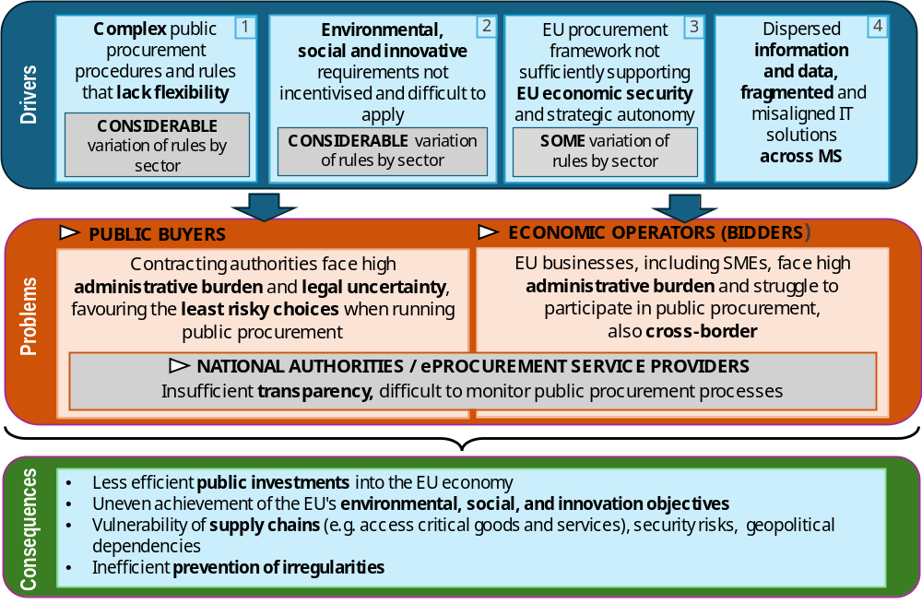

Complex procedures and rules that lack flexibility [driver 1]
In terms of overall setup of the current rules, both public buyers and economic operators are affected by the complexity of procedures and rules that contribute to the problems of legal uncertainty and high administrative burden (section 2.1 above). Among the root causes of the observed complexity are procedural differences between Concessions, Classical and Utilities that need to be considered by public buyers. For example, depending on the legal structure of the public buyer, they may be bound by the provisions of one Directive, but not another.
The lack of legal certainty surrounding negotiations increases the risk aversion of public buyers and constitutes a missed opportunity to increase the efficiency of public expenditure as noted in the Call for Evidence by buyers and economic operators alike. Particularly in the case of smaller public buyers, the lack of legal certainty surrounding negotiations has been associated with efficiency loss during execution, due to the need to engage in complex modifications and cost over-runs. Furthermore, the differences between Directives affects public buyers during the procedures, as e.g. negotiations are limited under some of the Directives, but not under others.
In terms of practical complexity, the unique procedural set up of each Directive is reflected in more than 30 different forms for publishing information about procurement procedures (so called eForms), forcing public buyers to be aware of minor differences depending on the legal instrument used. A recent report by the Committee of the Regions provides multiple examples confirming that applying different procedures is complex for local and regional authorities as the rules are not clear / easy to interpret. Consultations have shown that difficulties (e.g. with the classification of contracts as public contracts or concessions, or access to negotiations under the Classical Directive) persist, the process can be complex, particularly for local and regional authorities that may provide utilities and are thus bound by both the Classical and Utilities Directives. As regards concession contracts, complexities are shown by the legal ambiguity in defining concessions and the level of operating risk to be transferred to private partners. These create divergent uses of the term “concession” across Member States, pose difficulties to classify contracts as public contracts or concessions, uncertainty in risk allocation and potential incentives for opportunistic renegotiation during execution.
Furthermore, the Directives do not exist in isolation but, over time, they have become increasingly complemented by a growing number of sector-specific EU legislative acts covering public procurement. In particular, relevant to the procedures (the “how to buy”), 15 legal acts are related to exclusion grounds (grounds upon which public buyers must exclude a company from a public procurement process). Those provisions create fragmentation and raise legal uncertainty and concerns regarding their consistency with the exclusion grounds in the Classical Directive 2014/24/EU, especially in terms of scope of application, duration of the exclusion, applicability of self-cleaning measures, means of proof, and extraterritorial enforcement of the exclusions. Many stakeholders have expressed concerns about this proliferation that causes fragmentation and a lack of legal coherence across EU public procurement rules. During the public consultation prepared in view of the Evaluation [“OPC/EV”], 37% of respondents (248 replies) disagreed that the rules are coherent and only 11% (73 replies) supported the view of coherence between the Directives and sectoral legislation. Stakeholders highlight the difficulties local and regional authorities face navigating such complex framework and the growing difficulties in applying overlapping legal frameworks in practice. Member States underline the need for streamlining and alignment of the initiatives in the interest of finding a balance among the different objectives, greater legal certainty, overall coherence, and, where appropriate, the reduction of regulatory burden and costs. The observed complexity is often augmented by national gold plating, as confirmed by the CoR.
Another element of driver 1 that contributes to the problems of legal uncertainty and risk aversion (affecting public buyers), as well as high administrative burden (affecting both sides of the procurement transaction) is the lack of flexibility of the rules. For example, stakeholders frequently mention insufficient flexibility regarding contract modifications, which, during periods of high price fluctuation, leads to economic loses, as well as a disenfranchisement of economic operators from procurement. Specifically for concessions, contract modifications during the concession term remain a frequent source of misapplication, even if the long-term nature of concessions means that contracts may need to adapt to economic, regulatory, or technological changes.
For the majority of the OPC/EV respondents, the introduction of multiple procedures and procurement techniques by the Directives did make procurement processes neither simpler nor faster and they are perceived as rigid and not able to adapt to unforeseeable situations or to negotiate best outcomes. 48% (398) of OPC/EV respondents consider that the Directives’ rules aimed at increasing procedural flexibility (e.g. the choice of available procedures, time limits for submitting offers, contract modifications) did not deliver the intended result and the lack of possibilities to modify the tender documents often led to an early termination of the procedures.

Environmental, social and innovative requirements not incentivised and difficult to apply [driver 2]
Low levels of environmental, social and innovation procurement are, among others, driven by a limited use of quality considerations among procurement award criteria. Price-only awards remain widespread overall, accounting for 37% of all procedures between 2017 and 2024, up from 30% in the period 2006–2010. Environmental award criteria only feature in 28% of framework contracts and 22% in one-off contracts, social considerations in 25% for both contract types and innovation aspects in 8% and 7% in one-off and framework contracts. When award criteria frequently do not include qualitative environmental, social and innovation requirements, related solutions are not incentivised. One out of two OPC/EV respondents (49%: 337 replies) considered the frequency of awards based only on price too high.
The need for public buyers and economic operators to identify, take into consideration and apply multiple different green and social provisions included in various EU sectoral legislative acts complicates the application of environmental, social and innovation requirements. Relevant provisions in sectoral acts take the form of i) horizontal provisions on green and socially responsible public procurement requirements; ii) sector-specific provisions containing green and socially responsible requirements on “what to procure” applicable to a specific product group and/or sector; and iii) empowerments to establish public procurement requirements. These provisions, scattered across different EU legal acts, reflect different regulatory approaches and techniques and may set mandatory environmental requirements, in the form of targets, technical specifications, award criteria or contract performance clauses, among others. Often public buyers must include a combination of requirements in the same procurement procedure related to sustainability, energy efficiency, circular economy and due diligence, among others. They raise concerns in terms of scope of application, clarity or the link to the subject matter of the contract, among others, resulting in difficulties in application. As outlined in the Evaluation, the dispersion of public procurement rules across a multitude of sectoral acts has contributed even further to administrative burden, legal uncertainty and propensity to undertake less risky procurement decisions. This is reflected in the number of legal challenges related to the application of green and social considerations.
The difficulty to apply environmental requirements in public procurement is due to a number of root causes. The first is a lack of a uniform definition of what qualifies as Green Public Procurement [“GPP”]. Interpretations of what qualifies as sustainable public procurement not only “vary from one Member State to another”, but “also between contracting authorities from the same Member State” and the lack of a uniform definition of GPP has led to as many as 50 different definitions of what constitutes "green" across Member States, which limits efforts to incentivise and monitor GPP and complicates the cross-border provision of GPP solutions.
Secondly, while environmental labels can serve to implement GPP, in practice they are little used due to regulatory and administrative complexities. According to the analysis of the TED data for DE, FR, IT, SE, DK, HR for the period October 2022-September 2025, only 200 out of 300 000 tenders explicitly referred to ecolabels. With around 230 ecolabels across the EU, their use often requires complex assessments, discouraging public buyers from referring to them, . Labels differ in how they structure requirements, in their technical approaches and are national or regional, creating barriers to cross-border participation (as buyers refer to domestic labels in tender documents). Non-legislative barriers, such as limited administrative capacity, supply chain constraints, and insufficient professionalisation and specialised expertise in managing technically demanding GPP procedures exacerbate the problem.
Several root causes make it difficult for public buyers to apply social requirements in public procurement. First, a lack of clear understanding of what socially responsible public procurement [“SRPP”] entails, including its definition, scope, legal standing, and boundaries. A clear example of this ambiguity relates to the application of the link to the subject matter principle to working conditions of those performing a public contract. Uncertainty persists over whether and how such conditions can be lawfully linked to the procurement processes. Thus, 39% (279) of OPC respondents call to explicitly recognise the link between working conditions of those performing a procurement contract. Member States also identified “difficulties in connecting social considerations to the subject matter of a contract” as a reason for not implementing SRPP. The number of case law related to the inclusion of social requirements further illustrate the magnitude of the problem. The CJEU had to respond to several requests for preliminary ruling, with the most recent delivered in March 2026. Between 2018 and 2025, Spanish administrative courts handling public procurement appeals alone issued at least 81 judgments and rulings concerning the incorporation of social requirements in public procurement processes, highlighting persistent disputes over the interpretation of social criteria, .
Secondly, subcontracting practices can make it difficult for public buyers to apply social requirements because they can fragment responsibility across multiple layers of (sub)contractors. When work is delegated through subcontracting chains, public buyers may lose oversight, where there is no transparency. Nearly half of OPC respondents (46%: 315 replies) identified poor transparency in subcontracting chains as a major barrier to ensuring compliance with labour and social law obligations. As a result, a growing number of countries (e.g. ES, BE, NO) and municipalities introduced transparency measures or banned the subcontracting of the entirety of a contract (i.e. obliging the successful bidder to carry out some of the work itself).
The low uptake of innovation in public procurement is linked to a number of legal root causes. Firstly, the current legal framework and absence of a definition of what constitutes the procurement of an innovative solution [“PPI”] discourages public buyers from using public procurement procedures intended to promote innovation by reinforcing risk-avoiding behaviour. By conditioning the use of such procedures on proof that solutions available on the market cannot objectively meet their needs, the framework places a heavy justificatory burden on public buyers and incentivises defaulting to established market solutions. Thus, the use of the innovation partnership procedure introduced by the Directives for innovation procurement led to only 218 contract awards between 2016-2024. In addition, where public buyers do engage in procurement of innovation, they are exposed to heightened audit and compliance risks, as internal control and audit mechanisms typically treat the procurement of readily available market solutions as the least risky option.
Secondly, while market engagement before and during the call for tender positively impacts innovation in public procurement, this is hindered by a perceived legal uncertainty regarding how to conduct market consultations in a manner that ensures the obligation to maintain a level playing field for all suppliers. Thirdly, the common obligation for intellectual property rights [“IPR”] to be transferred to public buyers in innovation procurement is a disincentive for suppliers to offer highly innovative solutions, lowers competition and leads to higher costs. Such procurement practices requiring the transfer of IPR from suppliers to public buyers can create several risks, such as leakage of proprietary know-how, uncertainty about the value of product lines when core IPR must be transferred contract by contract, or inability to reuse technical solutions developed under previous public contracts (reducing economies of scale and discouraging standardised products). Thus 49% of surveyed companies reported limited ability to reuse previous experience and solutions, 42% reported it hindered their innovation efforts, 36% said it caused difficulties in pricing their bid, 35% refrained from using the best technical tools in the assignment.

EU procurement framework not sufficiently supporting EU economic security and strategic autonomy [driver 3]
The Evaluation found that the Directives’ rules concerning market access for companies from non-EU countries lack clarity and are not fit for purpose to respond to challenges in terms of security of supply, strategic autonomy and support to European industrial capacities. Only 16% (109) of respondents to the OPC/EV considered the rules on market access for companies from third countries to be still relevant and adequate. As regards the security of supply chains, 49% (337) of respondents to the OPC/EV disagreed that the Directives are fit for purpose to contribute to the EU’s strategic autonomy, including the security of EU supply chains. Several MS also expressed concerns relating to the dependence on external suppliers for critical materials and technology.
Non-EU direct and indirect participation accounts for 7.5% of the total awarded contract value and impacts several sectors. For some certain specialised products, such as railway and tramway locomotives and rolling stock, pharmaceuticals, software package and information systems, IT services, medical equipment, support services for land, water and air transport, computer equipment and supplies, telecommunication services and software programming and consultancy services, the percentage exceeds 25%.
Many public buyers are not equipped to take decisions relating to the participation of economic operators from third countries in the EU, with implications for trade and industrial policy. The EC clarified that third-country bidders without a covered trade agreement (e.g., GPA or free trade agreements [“FTAs”]) have no guaranteed access to EU public procurement and may be excluded. Recently, the CJEU in its Kolin and Qingdao judgments specified that the issue of participation by economic operators from third countries falls within the exclusive competence of the EU under the TFEU. Until the EU legislates, public buyers have broad discretion to decide whether or not to exclude economic operators from third countries from participating in public procurement procedures and, if they allow their participation, whether or not to apply score adjustments or other types of differentiation. During consultations, public buyers indicated that they often face uncertainty in relation to the implementation of this possibility. In practice, most public buyers are not sufficiently equipped to exercise this discretionary power effectively and lack access to information on the specific scope and coverage of concluded trade agreements, resulting in uncertainty and the lack of a coherent approach. Although the Access2Market platform developed by the EC allows public buyers and economic operators to check information on scope and coverage, this tool is not systematically used and the information provided is not legally binding. Verifying the origin of goods is also complex and requires the use of different sources and capabilities by public buyers. The only existing tool to prioritise bids from economic operators from the EU, the EEA or countries that have signed such agreements - Article 85 of the Utilities Directive-, remains rarely used in practice, mainly due to a lack of legal certainty.
Last, sectoral acts containing horizontal provisions on security and cybersecurity in public procurement fragment the legal framework and risk leading to inconsistencies and a lack of coherence with the horizontal rules and challenges for public purchasers in implementation.

Dispersed information and data, fragmented and misaligned IT solutions [driver 4]
Insufficient transparency and the difficulty to monitor public procurement processes is driven by dispersed information and data as well as fragmented and misaligned IT solutions, contributing to administrative burden. The Evaluation showed that the degree to which transparency can support the prevention and detection of irregular and anti-competitive procurement practices and help achieve strategic policy objectives depends on the completeness and quality of the data provided, which, however, is of concern. Missing, incorrect and incoherent data undermine the reliability of information and negatively impact confidence in the system, competition and the effective governance of public procurement. Three root causes are identified.
First, eProcurement in the EU is fragmented and characterised by a multitude of IT systems that are not generally interoperable: in total, there are 123 eProcurement systems operating across the EU (Table 20, p.156). This fragmentation results in administrative burden, especially for economic operators (and notably SMEs). While public buyers typically use one eProcurement platform to conduct a public procurement procedure (planning, publishing calls for tenders, communication, evaluation, awarding, contracting), economic operators must use any of the 123 eProcurement platforms chosen by the respective public buyers and their registration, documentation and tendering structure. By increasing administrative burden, the multitude of eProcurement systems reduces competition and limits cross-border participation.
Secondly, the absence of a once-only principle in public procurement implies that public buyers apply divergent evidence and documentation requirements across jurisdictions. The dispersed information requirements contribute to higher administrative burden and cost for the bidders (they need to submit the same information / evidence several times) in particular in cross-border procurement and increase the risk of errors. EE is presently the only Member State that offers access to its national databases for both domestic and cross-border procurement: public buyers from other Member States can access evidence and verify information about EE economic operators.
Lastly, insufficiently integrated data governance and lack of life-cycle monitoring is driven by the fact that the Directives do not establish a digital approach for governing public procurement data and Member States use different data structures and focus monitoring mostly on pre‑award phases. By the end of 2025, three Member States were sharing their national procurement notices with the EU Public Procurement Dataspace [“PPDS”], which is designed to ensure availability of procurement data across Member States. The ECA noted that TED data is not always complete or accurate which hinders effective monitoring. An EP report pointed out to multiple gaps and errors in TED dataset that have not been addressed. An OECD study identified data needed to effectively measure the performance of public procurement - the EU is currently able to compile only a limited subset of this data. The current focus of EU procurement legislation on pre-award stages results in limited governance and oversight of post-award contract implementation. Therefore, no EU‑wide mechanisms exist for coherent, real‑time life-cycle data (e.g. from invoices and completion notices).

How likely is the problem to persist?
As some of the issues identified in section 2.1 constitute a direct outcome of the existing Directives, they will continue to exist as long as the EU does not act. As the problems affect the entirety of the EU, Member State’s actions alone cannot fully tackle the problems. Moreover, the continuous adoption of EU legislation containing public procurement provisions is aggravating the fragmentation of the legal framework and increasing the complexity of application by public buyers and economic operators. Thus, not only are the problems expected to persist, but so are their significant consequences, as detailed in section 2.2.1. The likelihood that the identified problems will persist is also demonstrated in the baseline scenario. The expectation of the persistence of the problems caused by the dispersed information and data and fragmented and misaligned IT solutions aligns with the foresight scenarios concerning the advancement of the digital revolution (i.e. a megatrend of accelerating technological change and hyperconnectivity).

Why should the EU act?

Legal basis
Article 114 of the Treaty of the Functioning of the EU (TFEU) is the appropriate legal basis to achieve the objectives of this initiative, namely creating a simpler and efficient harmonised public procurement system across Member States. This Article is the appropriate legal basis for measures aimed at achieving the objectives set out in Article 26 TFEU. Previous proposals in the field of public procurement relied on Articles 53 and 62 TFEU, in combination with Article 114. Taking into account developments in EU legislation, the existence of sectorial acts harmonising aspects outside public procurement procedures and the objectives pursued by this initiative, it is no longer appropriate to use Article 53 and 62 TFEU as legal basis. While the efforts pursued contribute to the objectives in Article 173 TFEU, the primary aim of this initiative is the harmonisation of public procurement legislation, which excludes the use of Article 173 TFEU as legal basis. Similarly, while aspects of the action, such as the access of third country bidders to the EU procurement market, fall under Article 207 TFEU, these are not sufficient to justify the use of that Article as legal basis.

Subsidiarity: necessity of EU action
While significant efforts have been made in the last 50 years, a single market for public procurement is not yet achieved. Fragmentation persists in the form of divergent policy approaches across initiatives, gold-plating at Member State level, and the use of diverging digital tools and platforms. These issues make the current EU public procurement framework an area of perceived administrative burden and bureaucracy, instead of an instrument for sustainable economic growth. To leverage public procurement as a driver for competitiveness and efficient and effective public investment, also supporting EU policy objectives, EU action is needed. Simplifying the EU public procurement framework and implementing strategic objectives is only possible through EU action that ensures a consistent change across Member State. Absence of EU action would perpetuate the inefficiencies in the system and prevent public buyers from meeting their needs faster and strategically, and economic operators from accessing procurement contracts across the single market. A coherent legal framework for public procurement can only be achieved at EU level. In addition, in absence of EU action, the EU public procurement legislation will continue to underperform in key strategic aspects, such as advancing on sustainability, fostering resilient supply chains or ensuring the strategic autonomy of the EU. Likewise, joint investment in strategic sectors would be limited, while coordinated action will enable leveraging demand better. Finally, the lack of EU actions also creates a missed opportunity, as the legislation becomes outdated in light of current developments (e.g. accelerating digital change and hyperconnectivity) and evolving threats. (e.g. changing security paradigms).

Subsidiarity: added value of EU action
The proposal aims at amending EU legislation, directly touching upon the EU-wide procurement market. The same could not be accomplished at Member State level, in particular considering the need for ensuring a harmonised approach across Member States, such an approach being of critical importance for effective simplification. There is a strong value added of EU-level action because the problems that this proposal tackles are not limited to the territory of a single Member State. Only EU action can regulate the access of third country bidders and goods to the EU procurement market, as this is an exclusive competence of the EU. Similarly, insofar as the commitments of the EU under the GPA remain, Member States may not introduce procedural simplification beyond the level that is set at EU level because the public procurement thresholds and procedures are governed by EU rules implementing the procedural commitments under the GPA.

Objectives: What is to be achieved?

General objectives
The general objectives are to make public procurement a more efficient public investment instrument, supporting policy objectives, in particular single market integration, strategic economic autonomy, social and ecological sustainability and innovation. The general objectives contribute to the achievement of SDG goals, in particular #9 Industry, Innovation and Infrastructure, #12 Responsible consumption and production and #8 Decent work and economic growth.

Specific objectives
In view of the above general objectives and the problem tree presented in Figure 1 above, this EU intervention pursues the following specific objectives:
            - Specific objective 1: simplify and promote flexibility in procurement procedures and increase legal clarity and coherence of applicable rules, so as to facilitate public procurement processes and access to them for economic operators across the single market, including for SMEs;
            - Specific objective 2: increase the uptake of environmental, social and innovation public procurement in support of strategic policy objectives of the Union and provide a more coherent legal framework in this regard;
            - Specific objective 3: improve EU economic security and strategic autonomy in public procurement, promoting a coherent legal framework in this regard;
            - Specific objective 4: facilitate access to public procurement information, data and IT solutions so as to reduce administrative burden and increase transparency and monitoring, thereby preventing and reducing irregular practices and enabling policy-making choices.

What are the available policy options?
This chapter describes the policy options identified to meet the four specific objectives of this EU intervention (as set out in section 4.2), addressing the four problem drivers assessed in chapter 2.
Table 1: Policy options
Specific objective | 1. Simplify and promote flexibility in procurement procedures and increase legal clarity and coherence of applicable rules (FLX) | 2. Increase the uptake of environmental, social and innovation public procurement and provide a more coherent legal framework (ESI) | 3. Improve EU economic security and strategic autonomy in public procurement, promoting a coherent legal framework (BEU) | 4. Facilitate access to public procurement information, data and IT tools (MPL)
Policy options | FLX.0 | ESI.0 | BEU.0 | MPL.0
Policy options | FLX.1: Targeted improvements on simplification, procedural flexibility and coherence | ESI.1: Inducing green, social and innovation procurement | BEU.1: Voluntary European preference | MPL.1: Decentralised eProcurement platforms to establish an interconnected digital marketplace
Policy options |  | ESI.2: Improving coherence and horizontal integration in public procurement | BEU.2: A framework for coherent European preference in selected sectors
Policy options | FLX.2: Simplified & flexible procedures in a more coherent system | ESI.3: Mandating green, social and innovation procurement | BEU.3: Mandatory European preference across all sectors | MPL.2: Centralised EU marketplace replacing MS marketplaces

What is the baseline from which options are assessed?
In the absence of a revision of the Directives, the current policy would be continued, making for a dynamic baseline scenario. The existing Directives would be complemented by further guidance and continued capacity-building measures. Additional procurement provisions would continue to be included in other EU legislative acts. The timeline of this dynamic baseline is until 2032.
In terms of objective 1, if no changes are made, issues relating to the complexity and lack of flexibility of EU procurement procedures would persist. Public buyers would continue facing complexity due to the different rules depending on the type of public buyer, the contract value and the subject matter of the contract, as well as due to the fragmentation and misalignment of provisions related to exclusion grounds in several sectoral acts. Similarly, public buyers would not have the flexibility to adapt to their various day to day purchasing needs or address effectively urgent situations or supply chain disruptions, which, given the volatility of the current geopolitical landscape, may translate into higher costs and delays in the provision of public services.
As for the intended increase in the uptake of environmental, social and innovation public procurement (objective 2), the EC would continue to pursue supportive measures, such as training, guidance, and collaborative networks. Without a policy change, GPP will face additional fragmentation, as difficulties to identify and apply different procurement provisions in sectoral acts will hinder market uptake and scalability. SRPP will remain constrained by legal uncertainties and fragmentation. PPI will continue to be hampered by risk-averse practices. Left unaddressed, these issues will fail to increase the uptake of green, socially responsible, and innovative solutions.
Regarding objective 3, if no policy change is adopted, the differentiated treatment of economic operators and goods from countries that are not parties to the GPA or to an FTA will continue to be a source of complexity for public buyers and bidders. Sectoral rules may continue to develop different approaches, which would further complicate effective implementation. While public buyers have broad discretion to exclude third country bidders, they lack legal clarity and instruments to do so in practice. Current geopolitical developments and policies by third countries are likely to increase the vulnerability of supply chains and affect the EU economic security.
In the case of objective 4, the rollout of the PPDS is likely to continue gradually. The step-by-step adoption of key digital tools including the new European Business Wallets and the interoperability standards can be expected over time, but the extent to which this will happen will depend on the voluntary participation of the 123 procurement platforms. Based on feedback received from Member States, the assumption is made that 30% of eProcurement Systems would be adjusted to become interoperable and that 30% of Member States would develop a national data space to integrate procurement data. The limited alignment would hamper data integration, monitoring capacities to detect irregular practices and transparency to promote accountability. Continuing with the current eProcurement tools would cost the EC a total of about EUR 86 million from 2026 to 2032 (Table 21, p.157). In the same period the average costs for each of the 123 eProcurement systems are estimated at EUR 14.4 million (Table 22, p.157). In addition, each Member State would invest EUR 1.6 million for the development of its national data space (Table 23, p.157). Over the above period the average cost for each public buyer would be EUR 193 000 (Table 24, p.157) and for economic operators participating in procurement procedures EUR 318 000 (Table 25, p.157).

Description of the policy options
All policy options considered underneath are designed to address key future challenges of the Union and take account of megatrends. The digital revolution and emerging geopolitical threats are global developments that are expected to persist and significantly shape the EU and its public procurement markets. While the former has been the key factor in options MPL, the latter has prompted policy options BEU aimed at reinforcing EU economic security and strategic autonomy.

Targeted improvements on simplification, procedural flexibility and coherence (FLX.1)
This option would be focused on targeted improvements of the existing procurement procedures, which would be maintained. The article on the choice of procedures in the Classical Directive would be amended to allow public buyers to have more flexibility while retaining safeguards to ensure proper expenditure and prevent corruption and anti-competitive practices. In doing so, public buyers under the Classical Directive would be able to resort to the competitive procedure with negotiation together with the open procedure and the restricted procedure as default methods. This would increase the internal coherence of the Directives by aligning the options for public buyers under Utilities and the Classical Directive. Further information on the different procedures in the existing Directives and negotiations is available in Annex 7, Ad Section 2.2. and 5.2.1. and 2. In addition, public buyers would explicitly be allowed to make material corrections during procurement procedures e.g. in case of errors, provided that these do not alter the subject matter of the procurement and are made transparent in the procurement detail. In addition, public buyers would receive guidance on how to conduct preliminary market consultations before launching procurement procedures to attract more and better competition and to engage with the market more transparently.
Clearer rules for crisis procurement would be included in the new rules taking into account sectorial acts to increase legal clarity. Member States would be allowed to take measures to ensure that security concerns are considered in the award and performance of contracts.
To improve coherence, this option would cross-reference all exclusion grounds from existing sectorial acts, maintaining them in place in sectoral acts.
This option would include a targeted amendment in relation to concessions, whereby definitions and key notions, such as operating risk, would be clarified without changing the overall approach, simplifying and increasing legal clarity. It would represent a shift from a static understanding of operating risk transfer to a dynamic model of adaptive risk governance, with the new definition recognising that long-term concession projects are inherently exposed to systemic shocks.

Simplified & flexible procedures in a more coherent system (FLX.2)
To improve legal clarity and internal coherence, the three Directives would be merged into one act, with procurement procedures and general horizontal rules common to all contracts covered. This policy option would include the elements of FLX.1 with respect to the introduction of crisis procurement and clarification of concessions.
The six main procurement procedures existing today would be simplified and merged into two main procedures (an open procedure - with optional negotiation - and a dynamic procedure), complemented by two additional specific procedures (an innovation procedure and a special procedure such as for emergencies). These procedures would be aligned with the revision of the Defence Procurement Directive to ensure coherence. All procedures could begin with market consultations, during which public buyers would publish an announcement in the digital marketplace indicating that they are seeking market information on the procurement object and specifying the deadline for submissions. Economic operators would then have a predefined period to submit relevant information to the public buyer through the digital marketplace, such as studies or opinions. Once the consultation period had ended, public buyers would be required to publish a public summary of result of the information received.
To simplify the rules, the current open and negotiated procedures would be merged into a new open procedure with possible negotiations. This procedure would follow the same structure as the current open procedure, but it would provide public buyers with the flexibility to negotiate non-essential characteristics of the solutions if they wish to do so. In this new procedure, public buyers would have to publish a public summary of competition in the marketplace, inviting economic operators to express their interest and submit a first tender within a specific deadline. In the public summary of competition, public buyers would indicate whether they intend to negotiate and specify the characteristics of the contract that would not be subject to negotiation (essential aspects). In case of no negotiations, public buyers would assess the offers received and the lack of exclusion grounds of the economic operators (lack of criminal record, payment of taxes and social contributions, lack of conflict of interests…), and, where applicable, the suitability of the economic operators to perform the contract. If they chose to negotiate, they would invite only those economic operators who were assessed accordingly. Negotiations would be conducted transparently, informing all candidates of the possibility to negotiate and what aspects would be open for negotiation. If negotiations are conducted, public buyers would have to conduct them in a way to ensure that all economic operators have the possibility to negotiate on equal grounds. Once the buyer has negotiated with all participants, possibly in several rounds, they would request final offers and award the contract on the basis of the final offers received.
To mitigate fraud risks, public buyers will inter alia have to use digital fraud detection tools such as ARACHNE+, disclose all clarifications equally to bidders, and justify direct awards in a public summary of result, as well as information gathered during market consultations. Procedures would be recorded in the marketplace to ensure the transparency and traceability of operations. Similar procedures are already the standard in other jurisdictions, including the US, Canada, or Australia. More information can be found in Annex 7. Besides, under current EU public procurement law, irregular practices and arbitrary decisions are counteracted through several elements of the procedural framework, such as the link to the subject-matter and that award criteria must be sufficiently clear and verifiable to enable assessment and, where necessary, verification of the information provided by tenderers. These elements would be retained unchanged. Thus, negotiations would continue to be framed by the principles - transparency, fairness and equal treatment of all competitors - and best practices derived from EU and case law.
Secondly, a dynamic procedure would be established based on the current dynamic purchasing system, following the model of jurisdictions such as the UK. Similar to the current dynamic purchasing system, this option would allow public buyers to keep open lists of interested economic operators and to launch procurements to the participants in the procedure only, useful in particular but not only to purchase off-the shelf products faster by reusing information and specifications and reducing the documentation to be submitted by economic operators.
Special procedures such as for emergency procurement would be foreseen to allow direct awards subject to an emergency, crisis or other situations allowing limited tendering. The direct awards would be subject to monitoring and transparency such as through e-Invoicing. In terms of security, it will include the aspects presented in FLX.1.
All procedures would be conducted through the digital marketplace foreseen under the MPL options. This would ensure, among other benefits, the once-only principle for information provision by economic operators, the reusability of information across procedures, and the uniform gathering of high-quality data. This would enable effective monitoring and the use of tools such as ARACHNE+ for the early detection of patterns of irregular practices. See MPL options.
To improve coherence, legal clarity and simplify the rules, the integration of the Directives into one Act would extend the application of strategic procurement, including green, social and innovation procurement as well as security related aspects, and European preference provisions to concessions. To streamline public procurement “how to buy” provisions in sector-specific acts, sectoral provisions related to exclusion grounds would be deleted from sectoral acts to the extent legally possible and integrated into the future Public Procurement Act. Further information available in Annex 11. The integration of exclusion grounds would allow for making clear and legally certain their scope of application, substantive conditions for exclusion, the possibility of derogation, self-cleaning measures, the burden and means of proof and the maximum period of exclusion for all grounds.

Inducing green, social and innovation procurement (ESI.1)
Policy option ESI1 would include a number of measures to facilitate the application of environmental, social, and innovation requirements, as well as other quality criteria, in public procurement. First, this option would induce green, social and innovation procurement as part of a policy that would encourage public buyers to give larger consideration to quality requirements. Quality requirements can either be defined in technical specifications, or they can be formulated as award criteria to be assessed for the best price-quality ratio (BPQR). This option would establish BPQR as the award method unless the quality of the product, service or works procured can be ensured through the technical specifications or the conditions for the performance of contracts (e.g. for highly standardised products) (“comply or explain” mechanism). A minimum weight would be set for quality parameters in BPQR amounting to 30% for all procurement procedures (meaning the price criteria would be capped at 70% of award criteria), and 50% for labour-intensive contracts, i.e.: those where labour costs normally accounts for at least 50% of the total contract value (the rationale for setting up weighting at this level is provided in Annex 7, Ad section 5.2.3.).
The future Public Procurement Act would not prescribe which quality requirements - from a non-exhaustive list presented in the act, including but not limited to environmental, social, and innovation criteria - to include among award criteria or in technical specifications. As is currently the case, public buyers would retain their existing discretion in each procurement procedure to select appropriate quality criteria according to their specific needs and tailored to the subject matter of the contract (except where EU or national law imposes mandatory quality requirements). This reflects the diverse scope and nature of public procurement procedures. The contracting authority’s discretion over procurement decisions reflects the principle of subsidiarity, as public authorities are best placed to assess which resources are required to provide public services, and which criteria are optimally suited for their needs. As in the current procurement Directives, the future Public Procurement Act would prescribe that, whether included in technical specifications or in award criteria under BPQR, quality criteria must be sufficiently clear, objective, transparent, proportionate, non-discriminatory, and linked to the subject-matter ensuring an effective, fair and objective comparison and verification of the documentation and information provided by the tenderers, in order to ensure fair competition and avoid irregular practices.
Examples for how public buyers can define quality in a manner that is effective, fair and objective include references to standards (e.g. environmental emission standards), measurable inputs (e.g. quality of inputs used to perform the contract), measurable performance criteria (e.g. number of staff trained), recognised labels (e.g. EU Ecolabel), GPP voluntary criteria, the use of Life Cycle Costing (LCC) and Total Cost of Ownership (TCO) methodologies, . Approaches such as LCC may be more feasible for experienced public buyers managing complex high-value contracts than for smaller public buyers with limited resources that may require simpler evaluation approaches using standards, labels and easy to measure quantified inputs or performance criteria. The Commission would provide support and guidance on objective documentation and evaluation to support accessibility and consistency across procurement procedures. This option also includes provisions aimed at strengthening the administrative capacity of public buyers, such as requiring Member States to provide relevant guidance, advice, assistance and other capacity-building measures. To improve coherence of public procurement provisions, under this policy option, horizontal provisions on GPP and SRPP would be referenced in the future Public Procurement Act (and kept in sectoral acts) (see Annex 11).
Under this policy option, coherent definitions of GPP, SRPP and PPI would be provided. In order to promote GPP, labels would be recognised as a useful tool, but remain voluntary for public buyers. Where public buyers decide to accept labels as a proof of compliance with tender requirements, they would be obliged to make use of the EU Ecolabel, where it exists (but will accept equivalent ecolabels as proof of compliance). The Commission will continue to develop Practical Guides on the use of the EU Ecolabel in green public procurement for product groups covered by EU Ecolabel criteria. Where EU Ecolabel criteria are not yet in place, public buyers would be able to request as a proof of compliance with tender requirements other third party-verified ecolabels based on a life cycle perspective.
In order to promote SRPP, this option would ban the possibility for the main contractor and all subcontractors to subcontract a contract in its entirety. To improve transparency, bidders would have to indicate in their tenders the parts of the contract they may intend to subcontract. This option would moreover introduce a legal clarification that working conditions affecting those workers performing a contract may be considered linked to the subject matter (allowing public buyers to take into account working conditions set out, for instance, in collective agreements).
In order to promote PPI, this option would introduce a new innovation procedure that would be based on challenges (public buyers asking economic operators for solutions to address described problems). Public buyers would only be required to demonstrate that they did not identify existing solutions that are appropriate or desirable to address their challenge. Prior market consultations would be required, consisting of a dialogue between the public buyer, economic operators and the interested public and resulting in the definition of a societal challenge that can be solved through procurement of innovation. For the scope of the new innovation procedure, arising IPR would remain with suppliers unless their transfer to the public buyer can be justified to deliver public services.

Improving coherence and horizontal integration in public procurement (ESI.2)
Policy option ESI.2 would consist of option ESI.1 with an increased ambition in relation to coherence. Horizonal provisions on GPP and SRPP, as well as empowerments to adopt delegated and implementing acts to establish sustainability criteria for public procurement, would be deleted from sector-specific acts and integrated into the future Public Procurement Act (for further detail see Annex 11). This option would harmonise terminology and definitions, introduce targeted linguistic refinements, remove redundancies and inconsistencies, and merge related provisions.

Mandating green, social and innovation procurement (ESI.3)
Option ESI.3 would establish BPQR with the minimum weight of non-price criteria set out in option ESI.1 as the standard method for awarding contracts, irrespective of whether quality criteria have been included already in technical specifications and without any opt out via a “comply or explain” mechanism. It would furthermore specify the extent of the link to the subject matter principle by allowing public buyers to take into account a bidder’s overall social and environmental policies when awarding contracts, insofar these are linked to the procured goods, services or works. This option would additionally establish the obligation for Member States to set measurable targets for social, green and innovation procurement, and to report on them. To promote GPP, the use of the EU Ecolabel would become mandatory for public buyers as a means to prove compliance with GPP requirements wherever such requirements exist and EU Ecolabel criteria were established. To promote SRPP, this option would ban the possibility to subcontract beyond the second vertical tier. To promote PPI, this option would include the same procedures as ESI.1 and 2, as well as establishing that in any procurement procedure used (and not only the innovation procedure as under ESI.1), IPR would remain with suppliers unless their transfer to the public buyer can be justified to deliver public services. To streamline public procurement provisions in sectoral acts, in addition to ESI.2, under this option, requirements on “what to procure” applicable only to a product group and/or sector contained in sectoral acts would be deleted and integrated in the general procurement framework, bringing to the same act both horizontal and sector-specific requirements.

Voluntary European preference (BEU.1)
This option would codify CJEU case law and provide in EU law the existing possibility for public buyers to restrict the participation in any procurement procedure to economic operators, or products originating from the EU, a Member of the EEA, a third country that is party to the GPA or with a bilateral/regional free trade agreement with the EU provided that the procurement in question falls within the scope of the public procurement commitments in such agreement (‘covered economic operator’). To facilitate the practical application and allow to check which countries would be covered by the above restriction, public buyers and economic operators would use the Access2Market tool. The origin would be determined in accordance with the International Procurement Instrument Regulation. The EC would provide public buyers and economic operators guidance to implement in a coherent way requirements in sectoral acts that include European preference provisions, including and where relevant by providing tools enabling them to determine the origin of products in a tender using, for instance, the non-preferential rules of origin under the Union Customs Code [“UCC”]. To improve coherence horizontal provisions on cybersecurity in public procurement, procedural aspects related to resilience in public procurement and product and/or sector specific resilience and European preference requirements would be cross-referenced in the future Public Procurement Act (but kept in sectoral acts).

A framework for coherent European preference in selected sectors (BEU.2)
This option would include the codification of CJEU case law as described in BEU.1. In addition, to promote coherence, it would establish a framework for European preference clauses in future sectoral acts and delegated acts, leaving the introduction of such clauses in them. Such sectoral acts and delegated may introduce European preference clauses in strategic sectors to strengthen the EU’s capacity to diversity and reduce dependencies and support EU industrial and security policy, public order, trade policy, or crisis or emergency situations. The future Public Procurement Act would encourage that where acts do include European preference clauses, an analysis of necessity and proportionality should be conducted, comparing expected benefits and costs, such as market impact (prices, competition), procedural risks (e.g. litigation risks) and administrative costs.
Sectoral acts and delegated acts would introduce European preference requirements and tailor them to the sector and/or product group targeted. To ensure coherence and effective application, the future Public Procurement Act would provide a toolbox of mechanisms that such acts may employ. It would include mechanisms restricting the participation to suppliers originating from the EU or covered countries only, require procurement of certain products originating from the EU or covered countries only or, as part of the award criteria, favouring bids that are composed of products originating from the EU or covered countries. Wherever European preference would be deemed appropriate in sectoral legislation or delegated acts, these would include one or several of these mechanisms.
This option would moreover establish common horizontal elements and practical tools to facilitate the practical application and coherence on the ground. These common horizontal elements would include common definitions, documentation requirements and criteria to determine the origin of an economic operator or a product. The option would require the systematic use of the Access2Market tool to determine which countries are covered by relevant international agreements. And it would establish that the non-preferential rules of the UCC are the main reference point for determining the origin of a product and key components in products in the context of public procurement. The EC would moreover issue guidance to guide public buyers when applying the European preference requirements. Last, this option would ensure that the online marketplace(s) (as outlined in MPL options) would integrate these instruments for public buyers and economic operators, facilitating their access to procurement procedures, including across single market borders.
To improve coherence and streamline sectoral provisions, instead of referencing public procurement rules in sectorial legislation, under option BEU.2 horizontal provisions on cybersecurity in public procurement and procedural aspects related to resilience in public procurement would be deleted from sectoral acts and integrated into the future Public Procurement Act (see Annex 11). The EC would work with co-legislators to ensure coherence regarding acts currently in co-decision.

Mandatory European preference across all sectors (BEU.3)
Under this option, when issuing a call for tender, a public buyer would be mandated to restrict the participation to economic operators originating from the EU/EEA or from covered countries, under the same conditions as described in BEU.1. This mandatory exclusion would remove the discretion of public buyers, meaning that all economic operators originating from non-covered third countries would be systematically excluded from public procurement procedures across all Member States, subject to safeguard or exception clauses (i.e. a horizontal exception mechanism would be put into place to allow public buyers to disregard this requirement in the event of a lack of bidders or of excessive additional costs or other similar special circumstances). To streamline public procurement provisions, under this option, in addition to horizontal requirements (as in BEU.2), sector-specific requirements on resilience and Buy European applicable only to a product group and/or sector contained in sectoral acts would also be deleted from sectoral acts and integrated into the future Public Procurement Act, bringing to the same act both horizontal and sector-specific requirements. Like in BEU.2, the EC would publish guidance to facilitate the implementation of this option.

Decentralised eProcurement platforms to establish an interconnected digital marketplace (MPL.1)
This policy option would establish a network of interoperable Member States’ eProcurement platforms. To enable data exchanges between Member States’ eProcurement platforms and ensure their interoperability, the EC would put into place an eProcurement interoperability network which all eProcurement platforms would be required to join. While public buyers could continue using Member States’ platforms to prepare procurement procedures, economic operators could access procurement procedures across Europe through any of the connected eProcurement platforms and submit tenders, thus facilitating cross-border bidding in the single market. The EC would offer one eProcurement platform for public buyers and one for economic operators, which are connected to the Interoperability Network. Member States could decide to discontinue their eProcurement platforms and use the EC platform for buyers. Economic operators could use the EC platform for economic operators to participate in procurement procedures throughout the EU. MPL.1 would mandate the use of a digital business credential tool such as the European Business Wallet to allow economic operators to provide a company profile and to share verified eligibility information EU-wide, facilitating cross-border access to procurement procedures. To harmonise access to the digital business credential tool, the EC would establish a Public Procurement Eligibility Service as a central interface to share and access data.
To facilitate data exchange and coherent monitoring, including of sectoral acts, a data management framework for monitoring and sharing procurement data between Member States and the EC would be established. Member States would be required to set up a national PPDS connected to the EU PPDS established by the EC, to enable automatic digitised monitoring and allow to detect and prevent irregular practices, corruption and bid-rigging. Literature on the topic finds that eProcurement can strengthen oversight by creating electronic audit trails, facilitating scrutiny of procurement decisions, and enable data analytics to detect suspicious patterns.
The availability of better-quality data would allow Member States and the EC to further develop projects leveraging the use of AI in detecting fraud and corruption in public procurement. For example, allowing IT tools such as the EU-developed ARACHNE+ to identify risks related to projects, contractors and contracts, according more than 100 indicators (grouped into risk categories such as procurement, contract management, eligibility, performance, concentration, other reputational and fraud alerts). To ensure cost-efficiency and centralised oversight, ARACHNE+ (or an equivalent data-mining tool) would be managed by designated national central bodies in each Member State (e.g., national procurement agencies, ministries of finance, or anti-fraud offices). Member States would report on implementation progress annually. The IT tool could notify high-risk procurements to relevant public authorities (e.g. auditors, competition authorities, national central procurement offices), as is already the case in 14 Member States. As core data would be public, public watchdogs would also be able to make public buyers accountable for their spending decisions. Pilot projects will be carried out in some Member States on various aspects of MPL to design the implementation of fraud detection.

Centralised EU marketplace replacing Member States’ marketplaces. (MPL.2)
Under this policy option, the EC would establish and manage a central EU-wide eProcurement platform replacing Member State’ eProcurement platforms for all procurement procedures falling under the future Public Procurement Act. Under this central EU system, all European public buyers and economic operators would register to conduct and participate in public procurement procedures across the EU. Member States could maintain their eProcurement system for procurement procedures below the EU-thresholds or decide to use the eProcurement system established by the EC for this purpose. As under MPL.1, the use of a digital business credential tool such as the European Business Wallet would be mandated along with the complementary PPES established by the EC. As under option MPL.1, a data management framework for public procurement would be established to enable data exchange and monitoring (including use of IT tools such as ARACHNE+ and notification of Member States’ authorities).

Options discarded at an early stage
No EU action or stand-alone soft-law: Following the results of the Evaluation this impact assessment discussed problems that cannot be solved by resorting only to soft-law options.
Change of the threshold levels: Raising the thresholds without a revision of the GPA would expose the EU to potential negative reciprocal and retaliation measures. For Member State, this increase would create a legal vacuum between any threshold set at EU level and those at GPA level. In that vacuum, the GPA’s transparency obligations will continue, but procurement techniques deemed favourable by public buyers (e.g. Dynamic Purchasing Systems [“DPS”] or framework agreements) would cease to exist. Member States would not have any margin of manoeuvre to act as this would contravene the EU’s exclusive competence under Article 207 TFEU. In contrast to the above, lowering the thresholds could be considered without this breaching international legal commitments. However, while this would increase the impact of public procurement as a strategic policy instrument, it would generate additional administrative burden for smaller purchases.
Except for the above, all other options were deemed to have negligible impact.

What are the impacts of the policy options?
This section assesses the key impact of each policy options identified above. A screening of significant impacts relevant for different policy options is additionally provided in Annexes 7 and 8.

Impacts of options improving flexibility and coherence (FLX)
Economic impacts including competitiveness: In order to discuss the economic impacts of a more flexible system that would allow for easier access to negotiations, a hypothetical substitution of open by negotiated procedures was used as the closest proxy for the legislative change considered under options FLX. For instance, a 10% increase in the use of the negotiated procedure results in average costs savings per procedure, varying by Member State between 2% and 10%.
Once the additional factor is incorporated into the analysis (i.e. changes in the number of bidders), it becomes clear that the level of competition influences the overall outcome: the greater the number of bidders, the higher the aggregate costs incurred, as more bidders bear costs linked to the preparation of offers, which are not recovered when another bidder wins the contract. However, increased competition can lead to lower prices for buyers. This is supported by the results of the OPC, with around 80% of respondents considering that competition, the number of bidders, and SME participation will increase as a result of FLX measures, and that a decrease in the prices of procured goods and services is a more likely outcome.
According to the CoR, local and regional authorities would benefit, as greater flexibility in procurement rules would reduce their administrative burden, reduce bureaucratic complexity, allow them to streamline processes and to tailor procurement to their local needs. Public authorities responding to the OPC called for the integration of procedures into a reduced number (one open procedure and one procedure with the option of negotiation or dialogue). EU companies and business associations suggested to allow for more negotiation in procurement procedures, with some advocating for the introduction of a “fast-track selection procedure”. NGOs, environmental organisations, and trade unions replied that the proposed simplification measures have the potential to bring about a range of benefits, including improved protection for workers, increased participation of SMEs, and enhanced environmental and social sustainability.
With regards to the potential increased risk of fraud and irregularities due to increased negotiations, it should be noted that there is no analysis concluding that there is a correlation between increased negotiations and fraud. Rather, the risk of corruption or fraud increases where discretion and monopolistic behaviours increase. Moreover, it should be noted that the use of negotiated procedures is neither new nor uncommon in procurement. Between 2014 and 2024, competitive procedures with negotiations accounted for between 4% and 10% of all Classical Directive procedures and between 35% and 47% of all procedures under Utilities. There are inherent risks to public procurement, some of which are inevitable depending on the economic interests at stake, the amount of business involved and the close cooperation that is needed between the public and private sectors throughout public procurement procedures. Nevertheless, there is consensus among institutions and academia alike that one of the most effective remedies is to strengthen transparency throughout the entire procurement cycle.
To counteract the risk of fraud, all options include safeguards, including the limitations to what can be subject to negotiations (non-essential elements of the offer)¹²⁸, and transparency and equal treatment obligations in line with the case law and Treaty principles. Under option FLX.2, all procedures would be conducted fully digitally through the marketplace foreseen in MPL options, where negotiations will also be documented as well as information on contract modifications. As a result, for every procurement there will be a clear trace as to the identities of buyers and economic operators, as well as the type and subject of the contract and the conduct of negotiations. The publication of market consultations in the marketplace would create a traceability chain that would enable competition authorities to detect bid rigging and anti-competitive practices earlier. In addition, and to align with the Financial Regulation, the use of ARACHNE+ or equivalent data-based risk analysis tools will be mandatory for all procedures before contract award and, where relevant, during contract execution. Transparency on contract completion, together with information on e-Invoicing, would enable public buyers and other relevant authorities (e.g. competition authorities) to ensure compliance with general principles such as efficient public spending, transparency, anti-corruption and competition. This increased transparency will act as a trade-off for more flexibility for buyers to engage with economic operators through a pre-defined legal framework for market consultations and negotiations, where they consider these useful. The creation of the marketplace would serve as a double layer of protection against fraud as it would ensure consistent monitoring and transparency promoting accountability.
Cost estimation: Under a scenario where the use of negotiations increases by 10 percentage points, the average cost per procedure is projected to increase by approximately EUR 257 (present value) for public buyers and decrease by EUR 165 for economic operators. This results in a total cost reduction per procurement procedure of around EUR 288 for all participants. Based on the number of above-threshold procedures in the EU, this translates into overall annual savings of roughly EUR 88 million (ranging from EUR 0 in the case of no change in negotiation use to EUR 219 million in the case of a 25 percentage point increase, matching the level of negotiations currently observed under the Utilities Directive). These savings are composed of a cost increase of EUR 78 million for public buyers and a cost decrease of EUR 166 million for economic operators (see table below and Annex 8). These savings relate solely to the negotiation element of the FLX options. Other costs and savings stemming from this option such as simplifications like the once-only principle, clarifications, or improved coherence-were not quantified due to data limitations.
Table 2: FLX options cost change under 10 percentage points increase in use of negotiations scenario (present value annualised).
 | CA | EO | Total
Per Procedure change (€ per procedure) | 257 | - 165 | - 288*
EU wide cost change (€ million)** | 78 | - 166 | - 88
The table presents the annualised present value (PV) over seven years of application at a 3% discount rate.
*takes into account that there are on average 3.3 bids from EO per procedure. Source: In-house analysis. See Annex 8.
Environmental and social impacts: FLX will support environmental and social provisions by cross-referencing (FLX.1) or integrating (FLX.2) exclusion grounds from sectoral acts. FLX.2 will also extend the application of green and social procurement to concessions.

Targeted improvements on simplification, procedural flexibility and coherence (FLX.1)
Economic impacts including competitiveness: By introducing targeted amendments to the current Directives, public buyers would be able to use the competitive procedure with negotiation and make material corrections to the procurement documents with sufficient legal certainty.
To access the competitive procedure with negotiation public buyers using the Classical directive will no longer need to justify that their needs cannot be met without the adaptation of readily available solutions, that the contract includes design or innovative solutions, that the contract entails “specific circumstances related to the nature, the complexity or the legal and financial make-up or because of the risks attaching to them”, because the technical specifications cannot be sufficiently precise, or because a prior call for an open or restricted procedure received only irregular tenders, taking into account that a situation where there is evidence of collusion would be considered irregular. This will align the procedure in the Classical Directive with that of the Utilities Directive.
Allowing access to negotiations and corrections would minimise the risk aversion of buyers and economic operators, simplifying the conduct of the procedure and reducing the number of early terminations due to material errors. According to OPC respondents, allowing corrections to the procurement documents throughout the procedure would bring greater simplification (71%: 496 replies), with only 9% anticipating no or negligible impact. Similarly, allowing negotiations throughout the procedure was deemed to have simplification potential (70%: 466 replies). In terms of negotiations, these are expected to bring some efficiency gains impacting positively on competitiveness and SMEs, as presented in FLX above.
Impacts on coherence between the intervention and the sectoral acts including public procurement provisions: By referencing all exclusion grounds in the future general act, visibility and awareness of those provisions would increase, ensuring that stakeholders can easily identify which exclusion grounds they need to take into account in their procurements. Public buyers and economic operators will no longer need to navigate different pieces of EU legislation, thereby reducing administrative burdens and the risk of non-compliance. By contrast, as this option would stop short of integrating the relevant provisions into the PP act, it would not streamline the varying rules and concepts used into a fully coherent and harmonised single rulebook.
Introducing clearer rules for crisis procurement and clarifying security related concerns in the award and performance of contracts would provide public buyers with clarity on how to conduct their procurement. This would bring greater coherence with existing sectorial provisions, such as the Internal Market Emergency and Resilience Act, the Directive for a high common level of cybersecurity, or the upcoming Cloud and AI Development Act.
Regarding concessions, clarifying the definition of concessions could reduce excessive ex ante financial requirements for economic operators and enhance project resilience. These modifications were supported by 197 respondents to the OPC, with almost 70% of those considering that legal certainty would increase to some extent. However, 50% of respondents consider that this amendment would not have an impact on the reduction of costs, neither for public buyers nor for bidders. As this option considers that the general structure of the Directives would remain unchanged, no impacts on digitalisation can be expected from this option alone.

Simplified & flexible procedures in a more coherent system (FLX.2)
Economic impacts including competitiveness: The new open procedure would provide public buyers with the flexibility to conduct negotiations, with the impacts presented under FLX above. The dynamic procedure would allow public buyers to engage more swiftly with the market, while increasing the available competition and fostering cross-border participation, especially of SMEs.
Facilitating market consultations would encourage their wider use and enable public buyers to gain a better understanding of the market’s structure. While the procurement procedure will be extended by the additional time required to submit and analyse responses, this investment is expected to yield cost savings later in the process. Public buyers may benefit from reduced time spent preparing tender requirements and evaluating bids, as the bids received are likely to be more concrete. All in all, the cost impact is expected to be neutral. Benefits of market consultations include attracting better competition, as well as engaging with the market in a more transparent manner.
Regarding negotiations, in terms of resources, as the new open procedure merges the existing open procedure and competitive procedure with negotiation, and negotiation remains voluntary for the buyer, no additional costs would arise from the obligations under the Public Procurement Act. In terms of timelines, the use of negotiations may increase the length of the procedure where these are used in very simple procedures where the buyer could have proceed directly to the award, or they may decrease the length of the procedure in complex technical cases where non-negotiation may force the public buyer to outsource the evaluation of offers to a technical committee.
Savings generated by reuse of information and widespread use of digital tools would improve the proportionality of procedures, their transparency and their cost efficiency, impacting positively on competitiveness. By facilitating the reuse of public summaries and simplifying the requirements to access procurement, it is expected that the level of competition would increase as the entry barriers and administrative burden would be reduced. This is supported by literature on the topic, which finds that reducing administrative burden in public procurement encourages greater competition and market engagement. Experimental evidence shows that participants exposed to higher administrative burdens report significantly lower willingness to bid, even when they would meet all eligibility criteria (Espaillat et al., 2025). This effect is particularly strong for small and new firms, which often have limited resources and less experience navigating complex procurement processes. Similarly, the use of market consultations would allow economic operators to be aware of upcoming procedures, and public buyers to gain market knowledge.
Such approach for off-the-shelf products was supported by 62% (429 replies) of respondents to the OPC (85%: 92 public authorities consulted considered the impact of introducing such procedure a high simplification, followed by 77%: 66 large companies and 44%: 28 SMEs). Furthermore, based on the above, this option would have positive impacts in terms of digitalisation and competitiveness.
Special procedures by requesting solutions directly such as in case of emergency would enable public buyers to tackle their needs faster, reducing the administrative burden to the minimum and ensuring that the focus is kept on delivering solutions. It would be aligned with emergency instruments such as IMERA to ensure a framework fit for crisis.
All of the above would be brought together through the integration of procurement in a digital ecosystem in line with digital by default principle, enabling greater transparency for public buyers, economic operators and other relevant stakeholders (e.g. competition authorities). These changes would empower public buyers to buy more efficiently and with more flexibility, whilst increasing the legal certainty and ex-post monitoring, ensuring that public funds are well allocated. Moreover, facilitating the reusability of information across procedures would bring significant savings. As reported through the OPC/EV, preparing a tender can cost suppliers significantly more in comparison with private contracts, due mainly to fragmented data and technical requirements. With the proposed measures, economic operators would be able to access procurement from a single-entry point, reusing their documentation and thus public procurement would be better integrated in the day-to-day business practices, while maintaining the necessary safeguards, including transparency, proportionality and equal treatment. Moreover, the new procedures would be aligned with the existing rules under the Remedies Directives, to ensure access to fair review where appropriate.
Merging the three Directives into one act would reduce complexity, simplify procedures, avoid inconsistencies, provide public buyers and economic operators with a coherent and predictable set of rules and ensure proper single market integration by clearly delimiting where public buyers are allowed more discretion and where Member States can complement with national rules. Respondents to the OPC, while advocating for the preservation of separate rules specifically for concessions, favoured their integration into a bigger harmonised framework with clear guidance and increased transparency and legal certainty. In terms of procedures, the biggest change will be on concessions, as at the moment Directive 2014/23/EU does not impose strict procedural rules to these types of contracts. However, given the introduction of new simplified procedures, subjecting concession contracts to public procurement rules would not create significant additional administrative burden. For economic operators, the absence of different ad hoc procedures would provide a single, predictable procedural framework. This would reduce transaction costs and lower barriers to participation, particularly for operators active in several Member States and SMEs. A single legal instrument would allow for a common framework integrating existing “how to buy” public procurement provisions in sectorial acts on “how to buy”. As a result, inconsistencies and overlaps would be avoided, and sectorial requirements would be easily accessible.
Impacts on coherence between the intervention and the sectoral acts including public procurement provisions: This policy option delivers substantial improvements in legal clarity by consolidating all exclusion grounds into a single, unified set of rules, eliminating the need to cross-reference scattered legislation. This approach directly addresses fragmentation, making it far easier for public buyers and economic operators to identify and understand applicable rules. The resulting enhanced readability fosters greater visibility and awareness, ensuring stakeholders can more effectively apply and implement the rules, as they could rely on streamlined concepts in a harmonised manner across the board–ultimately improving compliance and operational efficiency. By promoting this consistent and harmonised application of the rules, discrepancies in interpretation and enforcement would be minimised. Feedback from stakeholders suggests solid support for the integration of exclusion grounds (core “how to buy”) from current sectorial acts into the public procurement framework with 57% (386) respondents supporting it for existing ones and 63% (432) for future ones, and with comments suggesting that integration could help harmonise procedures and reduce complexity.

Impacts of options supporting strategic procurement (ESI)
As far as price effects per procured works, goods or services are concerned, reliable unit price comparisons are difficult to obtain. Commission services’ attempts to estimate unit prices paid in EU public procurement using data collected in TED (e.g. Price Comparison Pilot with Member States experts) were not successful. This section therefore largely relies on a literature review. Considering the assessment of price effects, it should be taken into account that price commonly includes overwhelmingly only the initial purchase cost and often not the total cost of ownership, including maintenance, repair and replacement. Benefits stemming from quality considerations often materialise over time, extending beyond the contract’s conclusion, and cannot be easily estimated, particularly in monetary terms (e.g. user satisfaction, impact of training provided to workers).

Inducing green, social and innovation procurement (ESI.1)
OPC results show that stakeholders have a clear preference for the public procurement framework to further incentivise PPI (73%: 497 replies), GPP (72%: 546 replies) and SRPP (64%: 443 replies). Support was strongest by trade unions and NGOs but sizeable also by other respondent groups, notably in relation to PPI and to a lesser extent to GPP (except public authorities).
Economic impacts including competitiveness: The empirical evidence suggests that the price effects of BPQR are likely to be limited and context-specific. In principle, higher quality requirements may increase suppliers’ costs and therefore lead directly to higher prices. They also affect prices indirectly by influencing bidder participation. However, the size and direction of these effects depend significantly on the institutional capacity of public buyers (more details in Annex 7, sub-section Ad 6.2,). Hoekman and Taş (2024), analysing procurement data from EEA countries, the UK, and North Macedonia, find that a decrease in discretion for contracting authorities is associated with an average increase of prices of approximately EUR 4 189 per tender in countries with high government effectiveness and EUR 2 790 in countries with lower government effectiveness. Furthermore, Lines et al. (2020), using a descriptive comparative analysis of 118 construction projects in the United States and Canada, estimate that best-value procurement is on average 7.12% more expensive than lowest-price procurement. However, the median difference is only around 1%, indicating that at least half of the tenders experience minimal price increases with a small number of tenders with substantially larger increases. Furthermore, having introduced a general rule whereby climate and environmental considerations must be weighted by at least 30% in public procurements (or include climate and environmental requirements in technical specifications) in 2024, Norway did not experience indications of an unusually large increase in price developments in public procurement, as annual costs have increased from NOK 650 billion in 2021, NOK 742 billion in 2022, NOK 780 billion in 2023 and NOK 835 billion in 2024, while the proportion of procurements with an environmental weighting of 30 per cent and/or include environmental requirements in 2025 increased to approximately 75% in 2025, compared to around 57 per cent in 2023. Similarly, the Procurement Report 2024 for Berlin finds that the Berlin procurement law, which requires specific social (like ILO core labour values) and environmental considerations, did not lead to higher prices that could not be due to factors such as inflation.
The absence of significant effects on price, when considered as total life cycle cost, is corroborated by a series of studies. Thus, according to Carvalho, R. (2023), sustainable public procurement enhances efficiency by revealing the long-term financial benefits of sustainable choices. While sustainable products and services may seem more expensive at first glance, life-cycle costing demonstrates how energy-efficient options lead to significant cost savings over time due to reduced operating and maintenance costs, while stimulating economic growth by fostering new industries and creating job opportunities. This is confirmed by Mähönen, M., et al 2023, who find that introducing green requirements in public procurement may increase short-term costs and administrative burden, including higher upfront costs and compliance complexity, but may be outweighed by long-term benefits such as emissions reductions, innovation, lifecycle cost savings, and wider economic gains. Lakić, E., Golja, J.G., Gubina, A.F. (2022), assessing the impacts of the green public procurement uptake in Slovenia, found that the uptake of green public procurement generated around EUR 61 million in financial savings over three years, alongside significant energy and emissions reductions. See Annex 7, Ad Section 6.2 for further details.
Empirical studies assessing the impact of BPQR on competition are limited. Tátrai et al. (2024), using EU27 TED data (2017–2020) and econometric analysis, show that most economically advantageous tender criteria are associated with a lower number of bidders, while lowest-price procedures attract more competition. Yet, the impact appears to depend strongly on the way BPQR is implemented. Research shows that BPQR is more likely to reduce competition when evaluation criteria are vague or subjective, the weight placed on quality is very high, documentation requirements are burdensome, and contracts are large and complex. These conditions tend to discourage participation in particular by smaller firms. However, these negative effects can be mitigated when award criteria are clear and quantifiable, procedures are digitized and standardized, and access for SMEs is facilitated, allowing public buyers to maintain a healthy level of bidder participation while still rewarding quality. Studies show moreover that lowest-price awards reduce product and process innovations, making suppliers focus on their established products and services, . Moreover, including BPQR among award criteria can be considered a more pro-competitive approach than including it in technical specifications. This is because non-compliance with technical specifications excludes bidders upfront, whereas using BPQR as an award criterion-such as by awarding additional points during evaluation-does not completely exclude other bidders. Respondents to the public consultations were neutral on the effect of BPQR on competition, with equal shares considering that competition would either increase or decrease.
Potential effects of BPQR on risk of fraud and irregularities depend on the administrative capacities of public buyers, as set out in further detail in Annex 7. Loxbo and Pircher (2025) find that countries with weaker public administrations experienced an increase in single bidding of approximately 10-11 percentage points, which was associated with their increased use of the most economically advantageous tender (MEAT) criteria. In contrast, countries with strong public administrations saw a reduction in single bidding by 4-7 percentage points, while their MEAT use remained largely unchanged. Single bidding is widely used as a proxy indicator for irregularities and the paper concludes that more flexible award criteria may improve or worsen procurement outcome depending on the capacity of contracting authorities. Further studies suggest that social and environmental clauses are not generally used as a tool for favouritism. Several elements that are part of this policy option would reduce significantly potential risks of irregularities. First, the mandatory link of all quality criteria to the subject matter of the contract constitutes a fundamental safeguard against the exercise of excessive discretion by public buyers, as it prevents the use of unrelated considerations that could favour certain tenders and/or tenderers. By anchoring quality criteria in the specific characteristics, performance, or lifecycle aspects of each particular contract, it ensures that evaluation remains as objective as possible. Second, the legal obligation for all quality criteria to have to comply with the general legal principles of public procurement (i.e. they must be proportionate, non-discriminatory, and transparent) frames the discretion of public buyers and operates as additional and cumulative safeguard against arbitrary decision-making, requiring that award criteria neither unduly restrict competition nor introduce disproportionate quality considerations. Third, the legal obligation that all quality criteria have to be clearly defined in advance and disclosed in procurement documents will further reduce risks of irregular practices as it enables tenderers to fully understand on what basis their tenders will be assessed. Fourth, additional procedural safeguards, such as separating price and quality assessments, securing the “four eyes principle”, conducting individual evaluations prior to collective deliberation, maintaining a documented audit trail and publication of all scoring justifications for high-value contracts would further reinforce objectivity, as would access to review and remedy mechanisms.
Due to the fact that public buyers have to manage trade-offs between different policy objectives when conducting public procurement, a meaningful degree of discretion when defining award criteria is needed. First, the balancing of competing objectives such as environmental sustainability, (digital) innovation, and social inclusion is ultimately a political choice. These trade-offs reflect societal priorities, and policy preferences, which vary across local contexts. Given that much public procurement is funded and implemented at regional or local level, it is appropriate that these decisions are taken as close as possible to the communities affected. Local contracting authorities are better placed to determine how to weigh, for example, climate performance against cost efficiency, in line with local democratic mandates and needs in the award of the BPQR. This discretion allows public buyers to tailor procurement strategies to the specific circumstances of each contract and to identify where the most meaningful intersections between policy objectives lie. Rather than applying one-size-fits-all award criteria, public buyers need flexibility to design award criteria that reflect the actual needs of users and stakeholders, the characteristics of the market, and the practical opportunities for combining objectives. This adaptability is essential to ensure that the BPQR award not only complies with overarching policy ambitions but delivers effective outcomes on the ground.
An increase in litigation could be considered among the potential consequences of extended use of BPQR requirements, particularly among less experienced public buyers who may feel uncertain about its application. This risk will be mitigated to some extent by the built-in safeguards mentioned earlier (under the risk of fraud), as well as by the support provided by the Commission-through standardised requirements, criteria, and guidance on objective documentation and evaluation-and by Member States, through training materials and programmes. Moreover, respondents to the public consultations more often expected that BPQR requirements would likely reduce litigation (35%) than those who considered it unlikely (24%). However, among public authorities, the situation was reversed, with only 7% expecting a reduction in litigation compared to 46% who considered it unlikely.
The impact of award criteria on SME access varies across sectors. In non-Low-Skilled Labour-Intensive (non-LSLI) sectors, the use of criteria other than lowest price is associated with a higher predicted probability of SME award (around 60.2%), while reliance on lowest price reduces this probability to approximately 54.1% (-6 p.p.). In LSLI sectors, the opposite pattern emerges: applying the lowest-price criterion increases the probability of SME award from about 54.4% to 56.9% (+2.5 p.p.). These results indicate that the effects are sector-specific and closely linked to underlying cost structures and delivery models. Some studies have found that the inclusion of sustainability aspects in the evaluation criteria has the effect of increasing SMEs’ bidding, as well as the probability for SMEs to win the contract.
The introduction of BPQR as the standard award method with a “comply or explain” mechanism and a minimum mandatory weight for quality criteria was supported by 50% (378) of OPC respondents. According to almost 9 out 10 (588) OPC respondents, it is very likely (54%: 357 replies) or somewhat likely (35%: 231 replies) that a legal framework that further incentivises BPQR will result in the achievement of strategic policy goals (environmental, social and innovation). The second most likely impact of incentivising BPQR, according to OPC respondents, is improved quality of goods, services, and works, with 57% (383) considering it very likely and 30% (202) somewhat likely.
Public procurement of innovation actively shapes competition dynamics, including dominance and market entry. Literature points out that PPI has a positive impact on competition, provided that the procurement and the underlying contractual conditions are designed effectively, . On the other hand, there is no strong causal evidence in scientific literature that PPI consistently lowers or raises prices. Instead, the evidence suggests that PPI primarily changes how prices are determined, potentially leading to higher upfront costs, while potentially generating savings over the longer term through improved efficiency and performance.
The new innovation procedure would simplify the current innovation partnership procedure, reducing compliance issues and administrative burden. Removing the current procedural restrictions to its use would empower authorities to adopt the innovation procedure more freely. Results from the OPC confirm this approach, with 47% (47) of public buyers, 69% (58) of large companies and 49% (30) of SMEs expressing support for a simplified innovation procedure. Nevertheless, given the subject matter the new innovation procedure would still require administrative resources, expertise and strategic capacity for effective implementation and the absence of standardised methods for valuing innovation and setting price ceilings complicates transparency and monitoring.
This highlights the importance of making market pre-consultations a standard step in the innovation procedure to enable public buyers to understand better the market and the solutions it can deliver and to generate creative ideas while validating market assumptions. By engaging with innovative suppliers early, public buyers foster competition and support collaboration where appropriate. Early dialogue would build a shared understanding of the aim of the innovation sought between buyers and suppliers, paving the way for smoother contractual relationships and better public service outcomes. However, a market consultation too does entail a certain effort: the initial investment is higher due to the resources required for stakeholder engagement and analysis, but this upfront investment often accelerates implementation of the procedure and innovative solution later by reducing uncertainties and aligning expectations on desired outcomes.
An allocation of intellectual property rights to the supplier (unless the public buyer justifies otherwise) for all procurements subject to the new innovation procedure would help prevent adverse consequences stemming from the transfer of IPR to the public buyer. Surveyed innovative companies report that an intellectual property rights transfer to the public buyer makes them refrain from submitting a bid (17%), offer an alternative solution with less negative consequences of such a transfer (12%), increase the price of the bid to factor in the IPR transfer (8%) or expect to delete the requirement of an intellectual property rights transfer in negotiations with public buyers (22%). Allocating intellectual property rights to the supplier in innovation procurement would increase legal certainty, lower barriers to participation in innovation procurement particularly for SMEs and enable the reuse of solutions across projects and the single market, helping firms recover investments and scaling. For suppliers, especially SMEs and start-ups, IPR ownership can be essential to protect proprietary know-how, attract investment, reuse solutions in future projects, and scale innovations across markets. This policy option would resolve a structural dilemma in innovation procurement: when public buyers seek to maximize their ownership of IPR, they are offered less innovative solutions as economic operators have a disincentive to offer such solutions given this would deprive them of the strategic IPR assets they need to innovate, expand, and scale their solutions effectively. That said, where justified, public buyers may mandate the public ownership of IPR where this is required such as to provide critical public services (e.g. security-related services) or to prevent technological lock-in. See Annex 7, Ad Section 6.2 for more detail.
Environmental and social impacts: Incentivising the consideration of quality criteria under BPQR would increase the uptake of environmental, social and innovation procurement. If all additional quality criteria in BPQR were to translate into green criteria, the central scenario-assuming an 18.5% increase in BPQR-could result in green procurement accounting for 40% of all procurement procedures in the EU. In the scenario where Member States align with the countries currently achieving the highest share of GPP, the use of BPQR quality award criteria, as set out in ESI.1, would lead to an increase in GPP uptake of between 30 and 80 percentage points-depending on the current level in each Member State-potentially reaching levels as high as 89%, as observed in LT. Similarly, if additional requirements were translated into social criteria, socially responsible public procurement (SRPP) could reach 43% of all procurement in the EU under the central scenario.
Introducing definitions for GPP, SRPP and PPI would improve legal certainty and coherence, facilitating the use of environmental, social and innovation procurement and reduce single market fragmentation. Legal definitions would support implementation of the BPQR and facilitate processing of data on GPP, SRPP, and PPI in IT systems, reducing administrative burden from easier data gathering and monitoring. Definitions would support the recognition of environmental and social objectives and give public buyers greater confidence in integrating sustainability considerations into their procurement decisions. A more harmonised approach would facilitate cross-border procurement of sustainable and innovative solutions, contributing to reduce the price of sustainable solutions, . OPC respondents strongly supported legal definitions of GPP, while Member State highlighted that the absence of an SRPP definition hindered its implementation.
Option ESI.1 would incentivise the use of the EU Ecolabel, by simplifying the verification of environmental requirements by public buyers for the 27 product groups covered by the EU Ecolabel scheme, which represent roughly 3% of all tenders by number and around 1.5% by value.
The progressive publication by the Commission of Practical Guides on the use of the EU Ecolabel in green public procurement, for product groups covered by EU Ecolabel criteria, could reduce legal uncertainty and facilitate the uptake of the EU Ecolabel, including in the context of BPQR. This is because these product-specific guides provide practical support to public buyers on the most relevant criteria identified by the JRC on the basis of (1) their link to the subject matter of the procurement contract; (2) the ease of verification; and (3) their relevance to environmental hotspots.
During the OPC, 42% (322) of respondents advocated that EU law should make the use of environmental labels easier to apply and more effective so as to support public purchasing of green solutions. Some additional effort would still be needed to determine the usefulness of using labels as proof of compliance and to verify whether EU Ecolabel criteria exists for the desired good or service but procedural savings would occur as public buyers would progressively not need to carry detailed assessments of the link between the EU Ecolabel criteria and the subject matter of the contract and could rely on the criteria published in the Practical Guides for the use of the EU Ecolabel in green public procurement. Suppliers would benefit from an increased use of the EU Ecolabel across the EU. The use of one EU-wide label instead of differing Member State labels would ease cross-border access to procurement.
With regard to SRPP, the clarification that working conditions for employees performing a contract are intrinsically linked to its subject matter would support the effective and more coherent implementation of these conditions, including as part of BPQR. The legal clarification would empower public buyers to prioritise working conditions with confidence, including those agreed in collective agreements. OPC respondents, when confronted with seven different measures to incentivise SRPP, chose this measure as the second most popular (39%: 273 replies).
A ban of subcontracting the entirety of a contract or subcontract to a/another subcontractor would end purely financial subcontracting where a contractor adds no own value. Both, contractor and subcontractor would remain free to subcontract any part(s) of the contract. This approach, which ensures a very high degree of flexibility, has been implemented in some Member States already. The proposed ban of subcontracting a contract in its entirety received support from 30% (189) of OPC respondents and was highest among trade unions (91%: 90 replies). Transparency obligations would mitigate the risk of opaque supply chains and facilitate monitoring and controls of more coherent compliance with labour and social obligations. This was the preferred SRPP measure among OPC respondents (46%: 315 replies).
Impacts on coherence between the intervention and the sectoral acts including public procurement provisions: By referencing all horizontal provisions on green and socially responsible public procurement, as well as product and/or sector specific requirements, this option would enhance visibility and awareness of such requirements, ensuring that public buyers and economic operators can easily identify which rules apply to their specific procedure. By contrast, as this option would stop short of integrating the relevant provisions into the unified set of rules, it would not streamline the varying rules and concepts used into a fully coherent and harmonised single rulebook.
Cost estimation: To assess the administrative costs of introducing BPQR as the standard award method, we assume that half of the current price-only procedures will be replaced by BPQR procedures. This would result in an increase in the use of BPQR by 18.5 percentage points, bringing its share to around 80%. Such a level of BPQR use aligns with the experience of a Member State that previously introduced BPQR subject to a comply-or-explain mechanism. Assessing the impact on costs of procedures indicates that average bidder costs are higher in case of BPQR than price-only award criteria by approximately EUR 2 700 (EUR 12 400 versus EUR 9 700). On the public buyer-side, the administrative costs differ by ca. EUR 1 000 (EUR 6 400 for BPQR procedures compared with EUR 5 400 for non-BPQR). Additionally, we estimate that public buyers will need to spend approximately two hours preparing an explanation in cases where BPQR was not applied. Cost of using EU Ecolabel consist of a one-off application fee of approx. EUR 1 100 and an annual fee of on average EUR 12 500. Assuming an 18.5 percentage point increase in green public procurement (GPP) (as outlined above), and the use of the EU Ecolabel in half of the additional GPP for which an EU Ecolabel exists, one-off administrative costs for around 1 000 affected companies would be around EUR 1.14 million and the recurrent administrative costs EUR 12 million per year (present value). Altogether, ESI.1 is expected to increase the average present value of administrative cost per procedure - calculated across all procedures to ensure comparability with other options - by EUR 181 for public buyers (CA in the table) and EUR 495 for economic operators (EO). At the EU level, this results in an additional annual cost of EUR 55 million for public buyers, along with a one-off cost of EUR 1.1 million and an annual cost of EUR 469 million for economic operators, bringing the total annual cost to EUR 524 million (see table below and Annex 8 for analysis of other scenarios).
Table 3: ESI.1 cost change under 18.5 percentage points increase in use of BPQR (present value annualised).
 | CA | EO | Total
Per procedure change (€)*
BPQR comply or explain | 181 | 456 | 1 686
Voluntary EU Ecolabel |  | 39** | 39
Total | 181 | 495 | 1 725
EU wide cost change (€ million)
BPQR comply or explain | 55 | 457 | 512
Voluntary EU Ecolabel |  | 12** | 12
Total | 55 | 469 | 524
Note: To ensure comparability with other options, the cost per procedure reflects the average cost across all procedures, rather than solely those subject to BPQR or EU Ecolabel requirements. Presented figures are rounded, though totals are calculated using precise values, which may result in minor discrepancies; The table presents the annualised present value (PV) over seven years of application at a 3% discount rate.
* EU wide cost divided by 304 000 procedures in case of CA and additionally by an average number of 3.3 bids in case of EO to arrive at an average comparable across options; ** one off cost of €3.7 per procedure and €1.1 million EU wide. Source: In-house analysis. See Annex 8.

Improving coherence and horizontal integration in public procurement (ESI.2)
Impacts on coherence between the intervention and the sectoral acts including public procurement provisions: In addition to the impacts of option ESI.1, which option ESI.2 encompasses, this policy option would deliver substantial improvements on coherence by integrating horizonal provisions on GPP and SRPP in the future Public Procurement Act. This would first make it far easier for public buyers and economic operators to identify applicable requirements, ensuring stakeholders can more effectively apply and implement the rules-ultimately improving compliance and operational efficiency. Second, it would streamline and simplify the regulatory framework through targeted linguistic refinements, the removal of redundancies, and the merging of related provisions. By harmonising terminology and definitions, the policy option would establish greater legal coherence, reducing ambiguities that often arise from inconsistent language across different acts. Increased clarity and consistency would facilitate smoother implementation and promote a more harmonised application of the rules, minimising discrepancies in interpretation and enforcement. Third, by integrating the existing empowerments to adopt delegated and implementing acts to establish sustainability criteria for public procurement, it would also ensure and future-proof a coherent development of green and social criteria applicable to a specific product group and/or sector. This structured, unified approach to sectoral legislation would ultimately reduce administrative burden, lower the risk of misapplication, and enhance the application of sustainable public procurement.
Cost estimation: Quantifiable administrative cost estimates are the same as in ESI.1, but the total increase in costs-including unquantifiable cost reductions due to increased coherence as described above-is expected to be lower than in ESI.1.

Mandatory rules for green, social and innovation procurement (ESI.3)
OPC respondents expressed support to mandate GPP (55%: 414 replies), SRPP (52%: 332 replies) and PPI (33%: 215 replies), though much less than to incentivise them (see above). Support for mandatory measures was strong among trade unions and NGOs but much less among other groups.
Economic impacts including competitiveness: A compulsory BPQR system, without a “comply or explain” mechanism would limit the ability of public buyers to tailor procurement strategies to the specific market context. First, for off-the-shelf, highly standardized products, identifying measurable added value beyond price can be difficult and ineffective as there is little room for bidders to compete on quality parameters. Bidders would be incentivised to design offers according to quality parameters that make little difference for the public buyer. Second, award criteria are not in all cases the most effective instrument for achieving the optimal balance between cost and performance or achieving the relevant policy objectives. Where public buyers seek a minimum performance threshold, quality parameters are better included in technical specifications or contract performance clauses than in award criteria. In addition, in markets where suppliers are already operating close to the prevailing technological or regulatory benchmark, the marginal scope for additional qualitative differentiation for suppliers may be limited and reliance on award criteria may be artificial and generate limited effects. Where, on the other hand, the market is capable of offering differentiated or innovative solutions, the use of award criteria may be suited to incentivise suppliers to deliver enhanced performance as properly designed award criteria can stimulate competition on quality and encourage tenderers to offer solutions that exceed baseline requirements.
To allocate IPR to suppliers as a default rule across all procurement procedures (and not only within the scope of the new innovation procedure) would create unnecessary administrative burden and disproportionate long-term costs in situations where no genuine innovation or wider commercialisation potential exists. Retaining IPR ownership to commercialise and scale solutions is particularly relevant in the case of very innovative solutions that may be procured through the innovation procedure. It is a lot less relevant in the procurement of off-the-shelf solutions, where the transfer of IPR ownership to the public buyer is less likely to undermine innovation solutions.
The establishment of an obligation for Member States to set measurable targets for GPP, SRPP and PPI met with moderate support of OPC respondents: 29% (222 replies) supported the introduction of binding national targets for GPP, 39% (251 replies) for SRPP and 12% (80 replies) for PPI, while 36% (271 replies) supported non-binding ones for GPP, 32% (222 replies) for SRPP and 22% (152 replies) for PPI. Setting quantitative targets does not necessarily provide information about the actual effectiveness in achieving underlying policy objectives. While it may be possible to measure the extent to which criteria are formally included in procurement procedures, this does not in itself demonstrate whether they produce improvements on substance, nor whether similar results could have been achieved through more cost-effective means. Public buyers would structure procurements to satisfy the formal requirement of reaching a target rather than tailoring the procedure in the manner that best secures value for money. They would face increased reporting requirements, which would not be in line with the simplification objective of this EU intervention.
Environmental and social impacts: A specification of the extent of the link to the subject matter principle would promote strategic policy objectives such as bidders’ overall climate protection or social responsibility. However, this would have important adverse implications. First, to ensure transparency, coherence and fairness it would impose additional administrative burden for public buyers and suppliers, such as standardised certifications or verification mechanisms. Second, it would negatively impact competition as suppliers would risk facing a less uniform procurement landscape with divergent criteria stemming from greater buyers’ discretion that could impact their ability to successfully bid across the internal market. Third, it could lead to increased costs and/or lower quality of products, services and works as competition is diverted away from the characteristics of the subject-matter of the contract to competition on overall company performance with green or social criteria and suppliers face less pressure to improve the price and quality of their offer. Fourth, extending award criteria to general corporate policies and beyond what is essential for the contract’s performance may conflict with the principle of proportionality.
A mandatory use of the EU Ecolabel without opt out would apply to up to 3% of tenders covering products within its scope. Given that around 22% of tenders include green requirements, this would affect an estimated 2 458 companies, which would need to demonstrate EU Ecolabel ownership for their goods and services to participate in these tenders. We assume that half of these firms do not currently hold any ecolabel and would therefore need to acquire one. Additionally, as with ESI.1, we assume an extra 18.5% of green tenders, but in this case, all would require the EU Ecolabel. Altogether, around 3 300 firms are expected to acquire one. Under this scenario, companies which already hold an EU Ecolabel would incur no additional cost. Companies with national ecolabels would need to provide proof of equivalence, facing no new costs, as equivalence is already permitted. For national authorities, requiring an EU Ecolabel (where one exists) would not impose additional administrative burdens and, as in previous scenario, it could generate cost savings, as authorities would gradually be able to rely on Practical Guides for the use of the EU Ecolabel in green public procurement and not need to carry a complex assessment of the link between the EU Ecolabel criteria and the subject matter of the contract. Given the broader application to more tenders and bidders, greater cost reductions than under ESI.1 could be expected. However, quantifying the exact savings is not possible with the available data.
A banning of subcontracting beyond the second tier would shorten subcontracting chains, making them less complex, helping public buyers to maintain direct oversight of contractors and better allowing labour inspectorates to verify compliance with labour and social obligations. However, such a ban, even if only imposed in high-risk sectors, would impose disproportionate costs on firms. A Swedish study estimated that a two-tier cap in construction could add EUR 30–45 billion annually in company costs, including a 10% increase in civil engineering and 2–3% in housing. Such measure would also mean that specialised knowledge from lower-tier firms would have to be incorporated into larger contractors, favouring big, vertically integrated companies. SILO (2026) confirms that subcontracting increases SME participation in public contracts depending on sectoral contexts. OPC respondents showed limited support for this measure beyond trade unions.
Impacts on coherence between the intervention and the sectoral acts including public procurement provisions: The impact of this option would be complete integration of the “how to buy” and “what to buy” provisions into a single set of rules. Some of the rules would be applicable horizontally to any procurement under the scope of the acts and others would be product or sector specific requirements. However, in those cases, sectoral regulations would be left without their procurement-related provisions, even though in some cases these are requirements that constitute integral elements central to the functioning of the sector-specific acts.
Cost estimation: Mandatory BPQR would entail an increase in its use by 37 percentage points to cover all tenders. Given that BPQR procedures are more expensive than price-only criteria-by EUR 2 700 for economic operators and EUR 1 000 for public buyers -the additional EU-wide cost would amount to EUR 953 million and EUR 102 million respectively (present value). As mentioned in section 6.2.1, companies that intend to acquire the EU Ecolabel would bear a one-off application fee of approx. EUR 1 100 and an annual fee of on average EUR 12 500. With an estimated 3 300 companies affected EU-wide, this would translate to a one-off cost of EUR 3.6 million and a recurrent annual cost of EUR 38 million (present value). Altogether, ESI.3 option is expected to raise the average cost per procedure - calculated across all procedures to ensure comparability with other options - by EUR 335 for public buyers (CA in the table) and EUR 1 036 for economic operators (EO). At EU level, this results in an additional annual cost of EUR 102 million for public buyers, along a one-off cost of EUR 3.6 million and an annual cost of EUR 953 million for economic operators, bringing the total annual cost to EUR 1 055 million (see table below and Annex 8).
Table 4: ESI.3 cost change under mandatory use of BPQR (present value annualised).
 | CA | EO | Total
Per procedure change (€)*
BPQR mandatory | 335 | 912 | 3 345
Mandatory EU Ecolabel |  | 124** | 124
Total | 335 | 1 036 | 3 469
EU wide cost change (€ million)
BPQR mandatory | 102 | 915 | 1 017
Mandatory EU Ecolabel |  | 38** | 38
Total | 102 | 953 | 1 055
Note: To ensure comparability with other options, the cost per procedure reflects the average cost across all procedures, rather than solely those subject to BPQR or EU Ecolabel requirements. Presented figures are rounded, though totals are calculated using precise values, which may result in minor discrepancies; The table presents the annualised present value (PV) over seven years of application at a 3% discount rate.
* EU wide cost divided by 304 000 procedures in case of CA and additionally by an average number of 3.3 bids in case of EO to arrive at an average comparable across options; ** one off cost of €11.9 per procedure and €3.6 million EU wide. Source: In-house analysis. See Annex 8.

Impacts of Made in Europe options (BEU)
Economic impacts including competitiveness: Based on an analysis of the top 10 000 companies by award value, using TED publication data from 2018 to 2023, direct and indirect participation by bidders from third countries was estimated to account for 7.5% of the total awarded contract value, with higher rates in specific sectors. Such participation was primarily driven by third-country companies bidding through their EU subsidiaries (indirect third country cross-border procurement). The localisation of the Global Ultimate Owner [“GUO”] of winning companies revealed that bidders indirectly coming from third countries were mostly located in the US (EUR 81.3 billion), the UK (EUR 49.6 billion), CH (EUR 46.9 billion), JP (EUR 19.9 billion), NO (EUR 10.8 billion), CA (EUR 8.6 billion), TR (EUR 5.9 billion) and CN (EUR 5.2 billion). Non-EU-owned economic operators participating directly were typically located in the US, CH, NO, TR, CN.
In terms of contract value, the main categories supplied by non-EU-owned economic operators included construction and civil engineering work, pharmaceuticals, road transport services, waste-related services and medical equipment (Figure 25, p.170). Across the EU, the importance of non-EU-owned economic operators varied widely across Member States. About a dozen Member State award more than 20% of contract value to non-EU companies (IE, PT, AT, SE, CZ, SK, MT, LU, SK, ES, EE, BE, and the NL) (Figure 28, p.173). Restricting access to EU‑owned suppliers could result in increased award concentration in Member State with a narrower supplier base or a greater dependence on non‑EU‑owned operators for various products (Figure 29, p.174). However, where solutions by EU companies are available, it is expected that the free flow of goods and services within the Single Market would adjust to mitigate any disruptions, fostering a more balanced distribution of resources and opportunities across Member State.
The second approach to identify sectors that may be significantly affected by BEU options regarding market access involved analysing sectors frequently represented in the submissions under the Foreign Subsidies Regulation (FSR). These submissions were deemed a reliable proxy for pinpointing sectors of strategic importance, especially considering the substantial value of the contracts subject to FSR. The analysis of FSR data revealed that, out of over 4 100 submissions received between 2023 and 2025, the primary sectors where foreign subsidies were reported were: IT and telecommunication (representing nearly 25.3% of submissions), followed by transport (24.6%), energy (18.1%), construction (10.6%), and health (10.4%). FSR submissions data has been matched with a corporate ownership database, revealing that intra-EU ownership accounts for nearly two-thirds of all FSR cases - or three-quarters of cases for which data was available (Figure 31, p.177). Among the share allocated to third countries, the main trading partners likely to be impacted by the new rules include the US (235 entries or 4% presence in submissions; most prominently represented in pharmaceuticals, machinery and equipment, computers and electronics, as well as in IT and other information services), followed by the UK (147 entries, 2.5%; in IT and other information services, human health services and telecommunications) and CH (106 entries, 1.9%; in the manufacture of transport equipment, as well as in electricity, gas and steam supply, and telecommunications). The list of key countries aligns broadly with the results from the TED data analysis.
The third approach is to use the FIDELIO modelling to anticipate macro-economic effects, taking into consideration that the impact of a domestic content requirement depends hugely on where in the value chain it is applied. FIDELIO's analytical strength lies in capturing economy-wide and sectoral interactions, and for very granular product-level activities, results should be interpreted with caution however. Across all product categories examined, a consistent pattern emerges: local content requirements tend to generate positive effects in upstream EU manufacturing industries, while translating into additional costs for downstream sectors, whether private (such as construction) or public (such as health, education and general administration).
In the case of steel and aluminium (i.e. raw materials in the upstream part of the value chain) the effects of the policy are expected to be predominantly positive (see Table 30 and Figure 48). Almost one third of the positive impact in the EU steel and aluminium sectors would concern DE (EUR 106 million), followed by IT (EUR 44 million). In relative terms, LU stands out with the highest impact on value added (+2.81% with regards to the baseline - owing to the presence of ArcelorMittal in the country – the world’s second largest steel producer) followed by LV (+2.44% increase). The total positive effect in terms of accumulated value added for the EU would be EUR 331 million in 2025-2030.
On the other hand, the construction sector (i.e. downstream) uses steel and aluminium as raw materials (see: Table 31 and Figure 49). According to the JRC estimates, FR, NL and RO would be most affected by the higher price of EU produced steel, accounting for 62 % (EUR 995 million) of the total negative impact (EUR 1.6 billion) of the policy measure. However, in relative terms, HR, HU and RO would show even greater negative impact (-3.74%, -1.54% and -1.47% respectively), likely because of their high dependence on non-EU steel production. In comparison, construction activity in NL and FR, despite much higher monetary values, would see their respective value added reduced with regards to the baseline by -1.09 % and -0.48 %.
A similar upstream-downstream dynamic is observed for radio, television and communication equipment (Figure 51), where the FR general public administration would incur an additional cost of EUR 256 million, PL public health system an increased cost of EUR 49 million, CZ public education system an extra cost of EUR 47 million. On the positive side, DE computer and electronics industry would benefit by EUR 71 million in additional value added and increase its exports by EUR 116 million as a result of Buy European requirements in the public procurement of such equipment. Comparable dynamics emerge for medical, precision and optical instruments (Figure 53), where FR public health system would bear an increased cost of EUR 161 million, while DE industry would benefit by EUR 48 million in value added and increase its exports by EUR 78 million.
A local content requirement in public procurement would also affect the trade balance, as it would directly reduce imports of the goods (or inputs) covered by the measure and increase demand for domestically produced substitutes. Nonetheless, if domestic upstream industries expand, they may achieve economies of scale and improve their competitiveness to an extent that increases exports. For instance, in the case of steel and construction, the combined trade impact of EU content requirements would be nearly neutral in terms of intra-EU trade balances, almost equally impacting intra-EU exports of basic metals and intra-EU imports of the construction sector. Some countries are expected to yield a positive trade balance for the policy measure, especially for DE and IT (see Table 32 and Figure 50). Beyond these quantified effects, the model does not capture the longer-term benefits associated with reduced exposure to foreign supply disruptions and input price shocks, which could materially enhance the resilience of EU value chains in sensitive product categories.
Stakeholders expressed strong support for European preference. When asked about economic security and strategic autonomy (960 replies), preference for European industry in critical sectors was ranked as the most important characteristic to be achieved, while a general preference to European industry came second (out of 7 options). See Annex 9 for further detail.

Voluntary European preference (BEU.1)
Economic impacts including competitiveness: The impact of BEU.1 would be moderated by two main factors: its discretionary nature and existing international obligations. First, the discretionary nature of this option grants public buyers’ full autonomy in deciding whether to implement restrictions. The implementation of BEU.1 would thus not be aligned across Member State and public buyers. Such fragmentation may reduce legal clarity and predictability for bidders, who would need to familiarise themselves with varying practices, and coherence. Regarding the costs, this option could increase transaction costs due to divergent national interpretation of rules and potentially discourage participation and limit competition. Second, a significant number of non-EU owned economic operators originate from countries with which the EU has international agreements on public procurement: US, UK, CH, JP, NO, CA, IL fall under the GPA WTO scope, and UK, CH, NO, JP and CA have additionally signed free-trade agreements [“FTA”] with the EU covering public procurement. However, in the GPA and FTAs not all public procurement is covered.
Contracting authorities would need to consider potential risks of security of supply and dependencies. Among the top ten countries of ownership of non-EU economic operators, fully non-covered third countries represent only 1.7% for CN, 1.9% for TR and 1.5% for KW. Nevertheless, in some sectors the position of economic operators from those countries is strong (i.e. CN in electric modules, TR in the construction sector). Therefore, if public buyers decide to apply exclusions for non-covered bidders, the operational and service provision risks would be limited in some sectors, but for other specific sectors, a voluntary exclusion mechanism may pose a risk of security of supply and dependencies where public buyers fail to identify these risks and act accordingly. On the other hand, under this option, contracting authorities from countries that may benefit from applying European preference in a given procedure would be free to do so, while those not benefiting from European preference would not be required to apply it, resulting in a potentially more optimal outcome for both groups individually though less effectiveness in reaching the EU policy objective.
Impacts on coherence between the intervention and the sectoral acts including public procurement provisions: By referencing all horizontal provisions on cybersecurity in public procurement, procedural aspects of “what to buy” related to resilience in public procurement, as well as requirements on resilience and Buy European applicable only to a product group and/or sector, this option would enhance visibility and awareness of such requirements. By contrast, as this option would stop short of integrating the relevant provisions into the unified set of rules, it would not streamline the varying rules and concepts used into a coherent and harmonised single rulebook.
Cost estimation: BEU.1 does not entail any additional administrative cost.

Framework for mandatory European preference in selected sectors (BEU.2)
Economic impacts including competitiveness: The impact of this option would also be linked to two main factors: the sectors covered and the international agreements in place. Should sectoral legislation introduce EU preference clauses, the following assesses impacts focussing on sectors with a highest proportion of non-EU suppliers and most represented in FSR submissions:
The impact of BEU.2 would be very limited in the pharmaceutical sector, where the majority of contracts awarded to non-EU operators concerned economic operators from the US, CH and the UK, countries with whom the EU has international agreements in force. Although EU-owned firms are present in this sector, they may lack an established record of supplying equivalent volumes across all product categories, which could lead to potential supply disruptions until EU firms are able to scale up accordingly. For software and information systems, the impact would be limited given the predominance of operators from countries covered by international agreements, notably the US and the UK. As with pharmaceuticals, EU-owned alternatives exist but may not be immediately available at equivalent scale, particularly for specialised or high-value solutions.
The construction sector presents a more nuanced picture. While EU-owned firms account for a significant share of participation, TR suppliers, not covered by relevant international agreements, represent a meaningful portion of non-EU participation. BEU.2 would reduce the pool of eligible bidders more significantly than BEU.1. From a cost perspective, the construction sector would also be indirectly affected as a downstream user of steel and aluminium: the FIDELIO model estimates a total negative impact of EUR 1.6 billion on construction value added at EU level as a result of higher input prices driven by local content requirements on those upstream materials. This impact would be particularly pronounced in FR, NL and RO, which together account for 62% of the total negative effect (EUR 995 million). In relative terms, HR, HU and RO would be most severely affected, reflecting their higher dependence on non-EU steel production. Similarly, for technology-intensive sectors (radio, television and communication equipment; medical, precision and optical instruments; office machinery and computers) the effects in these sectors are more mixed. While some Member States such as FR, PL and CZ would face higher procurement costs for their public administrations and health systems, DE computer and electronics industry would benefit from increased domestic output and expanded export opportunities. The net impact would depend on the availability of EU-owned substitutes and the extent to which domestic producers can absorb increased demand.
For electric modules the impact of BEU.2 would be most acute. In 2018 - 2023, 100% of the EUR 371 million procured was awarded to non-EU operators, with EUR 360 million going to economic operators originating from CN, a country not covered by relevant international agreements. A strict restriction on non-covered bidders would therefore carry a high risk of supply disruption, given the near-total absence of EU-owned suppliers currently active in public procurement in this category.
Across all illustrative sectors modelled, an important potential benefit not captured is that, if domestic sourcing of critical materials is strengthened, the EU would become less exposed to future supply chain disruptions and input price shocks stemming from possible third-country policy shifts. This increased resilience of supply chains could reduce vulnerability to external geopolitical or market shocks, thereby supporting longer-term economic stability.
Impacts on coherence between the intervention and the sectoral acts including public procurement provisions: The harmonised framework for sector-specific acts with its common horizontal elements and menu of EU preference mechanisms would ensure coherence, strengthen legal clarity, reduce interpretative discretion, and limit the risk of divergent and disproportionate application.
Cost estimation: For public buyers, the cost of implementing European preference in public procurement would involve verifying the location of the global ultimate owner of participating companies or the origin of procured goods. This verification would be conducted by cross-checking information submitted by economic operators through a dedicated tool within the digital procurement marketplace (MPL option), designed to determine beneficial ownership. Regarding the origin of goods and components, a self-declaration system would leverage existing tools, such as the Digital Product Passport (DPP), which collates relevant product data from manufacturers, distributors, and customs authorities. On average, if the tool such as the DPP contains the relevant information, this verification process is estimated to take on average 2 hours per economic operator. While straightforward for domestic operators, it may take longer in a limited number of cases involving foreign companies, which account for only 2.4% to 6.2% of awarded tenders. The costs for public buyers would remain manageable provided that appropriate EU or Member State-level databases are available for information verification. For economic operators, costs would arise from providing evidence as requested by public buyers, such as details on ownership structure, firm registration, or the origin of components. This process is also estimated to take 2 hours per company. Similar to the verification process for public buyers, it is expected to be straightforward in most cases, particularly for domestic firms, but could require additional time for foreign bidders / where complex value chains necessitate origin verification.
The BEU.2 option is expected to increase the average cost per procedure - calculated across all procedures to ensure comparability with other options - by EUR 25 for public buyers and EUR 7 for economic operators (present value), assuming 10% of public procurement is subject to European preference. At the EU level, this translates into an additional annual cost of EUR 7.4 million for both public buyers and economic operators, resulting in a total annual cost of EUR 15 million (present value) (see table below and Annex 8 for details and analysis of alternative scenarios).
Table 5: BEU.2 cost change under 10% of procurement subject to European preference (present value annualised).
 | CA | EO | Total
Per procedure change (€)* | 25 | 7 | 49
EU wide cost change (€ million) | 7.4 | 7.4 | 15
Note: To ensure comparability with other options, the cost per procedure reflects the average cost across all procedures, rather than solely those 10% subject to European preference. Presented figures are rounded, though totals are calculated using precise values, which may result in minor discrepancies; The table presents the annualised present value (PV) over seven years of application at a 3% discount rate.
* EU wide cost divided by 304 000 procedures in case of CA and additionally by an average number of 3.3 bids in case of EO to arrive at an average comparable across options. Source: In-house analysis. See Annex 8.

Mandatory EU preference across all sectors (BEU.3)
Economic impacts including competitiveness: Applying “European preference” requirements uniformly across all sectors would likely be inefficient and potentially counterproductive. Sectors differ significantly in terms of supply chain structure, availability of domestic inputs, and the degree of international integration. A horizontal approach would therefore risk imposing compliance and verification requirements even in sectors where local sourcing is not feasible or justified, or in sectors where economic operators from non-covered third countries are negligible.
Unlike the voluntary mechanism described under Option BEU.1, an overall mandatory exclusion would remove the discretion of contracting authorities, excluding all economic operators originating from non-covered third countries would be systematically from public procurement procedures across the EU. The potential impact of such a measure would therefore be broader in scope, although it would remain significantly moderated by the international agreements in place.
Overall, the result would be a narrower supplier base across all Member State, without the possibility for contracting authorities to adapt to sector-specific dependencies. The systematic nature of mandatory exclusion would amplify the impact in specific sub-sectors where non-covered suppliers play a critical role. As highlighted in the analysis of BEU.2, this would be particularly true for the electric modules sector, where all the contracts were awarded to economic operators originating from CN, as well as for the construction sector, where a large part of the contracts were awarded to TR suppliers. In the pharmaceutical and software and information systems sectors the impact would be limited given the predominance of operators from countries covered by international agreements.
Among the OPC respondents who supported the idea of excluding bidders from countries not signatories to the EEA, GPA, FTA, or other international agreements with procurement provisions, 71% (278 replies) favoured a mandatory approach, although a voluntary regime was the preferred option amongst public authorities (65%: 34 replies).
Impacts on coherence between the intervention and the sectoral acts including public procurement provisions: The impact of this option would be complete integration of the “how to buy” and “what to buy” Buy European provisions. Some of the rules would be applicable horizontally to any procurement under the scope of the acts and others would be product or sector specific requirements. However, in those cases, sectoral regulations would be left without their procurement-related provisions, even though in some cases these constitute integral elements central to the functioning of the sector-specific acts and do not belong into a horizontal Public Procurement Act.
Cost estimation: BEU.3 is expected to increase the average cost per procedure - calculated across all procedures to ensure comparability with other options - by EUR 245 for public buyers and EUR 74 for economic operators (present value), assuming 100% of public procurement is subject to European preference. This translates into an additional annual cost of EUR 74.5 million for public buyers and economic operators, resulting in a total annual cost of EUR 149 million (present value) (see table below and Annex 8 for details).
Table 6: BEU.3 cost change under 100% of procurement subject to European preference (present value annualised).
 | CA | EO | Total
Per procedure change (€)* | 245 | 74 | 490
EU wide cost change (€ million) | 74.5 | 74.5 | 149
Note: To ensure comparability with other options, the cost per procedure reflects the average cost across all procedures, rather than solely those 10% subject to European preference. Presented figures are rounded, though totals are calculated using precise values, which may result in minor discrepancies; The table presents the annualised present value (PV) over seven years of application at a 3% discount rate.
* EU wide cost divided by 304 000 procedures in case of CA and additionally by an average number of 3.3 bids in case of EO to arrive at an average comparable across options. Source: In-house analysis. See Annex 8.

Impacts of Digital marketplace(s) options (MPL)
Economic impacts including competitiveness: By establishing an interconnection between the eProcurement platforms, economic operators may use their preferred platform to participate in all public procurement procedures across the EU eliminating the need to use multiple platforms and ensuring a coherent system experience. The digital business credential tool would automate the provision and validation of evidence (e.g. exclusion grounds) in one coherent instrument to reduce administrative burden and encourage participation, including cross-border. This will not only simplify public procurement but also push for greater competition, as fragmentation and technical incompatibilities will no longer discourage economic operators from participating. By reducing administrative market access barriers, both MPL options are expected to lead to more economic operators participating in procurement procedures, including cross-border in the single market, with a resulting positive impact on prices given that each additional bid received decreases the price on average by 2.5%.
A second most important impacts of the digital marketplace would be enhanced transparency leading to improved accountability and enabling a more effective prevention and detection of irregular practices. This would be achieved through the collection and combination of full life-cycle procurement and contract implementation data. The availability of this data in one EU-level system would enable the systematic use of IT-tools such as ARACHNE+ to identify procedures with a risk of irregular practices. The automatic notification by the IT tool of high-risk procurements to relevant national authorities (e.g. auditors, competition authorities, national central procurement offices) would facilitate their work in preventing, identifying and pursuing irregular practices.
Preventively, as the OECD (2011) reports, the mere knowledge that procurement procedures may be assessed for risks of irregularities is expected to increase the perceived probability of detection and therefore reduce irregular conduct. The digital marketplace would contribute to improved transparency and greater accountability. Further assessments and examples in Annex 7 ad section 8.
Furthermore, the digital marketplace will support the coherent application of public procurement rules by bundling monitoring and reporting requirements stemming from EU legislation. Common data formats and standards will ensure seamless data exchange and analysis, providing a reliable set of data for the assessment of policy choices. Furthermore, any additional eligibility requirements may also be provided and reviewed centrally, which would also make the contracting authority aware of the existence of all such requirements in EU legislation.
Moreover, the digital marketplace will support policy options on European preference by providing an automated support to contracting authorities for them to verify the application of EU market access rules by allowing for the confirmation of the origin of companies or goods (through the DPP). The Eligibility Network will provide an automated support to verify the company eligibility, reduce administrative burdens and ensure compliance with the EU legal framework. Additionally, in times of crisis, the digital marketplace can mitigate the vulnerability and reduce geopolitical dependencies by providing public buyers with real-time data analytics to anticipate and respond to supply disruptions, market developments and price shocks.
Environmental and social impacts: Setting up a digital procurement marketplace will support and provide a technical infrastructure to implement policy measures aimed at strengthening strategic public procurement (GPP, SRPP and PPI), for example through use of the Digital Product Passport (DPP) (whenever DPP is mandated for a product and the information is available) which contains product sustainability information and which would be available through the PPES. The PPES will moreover allow for the automatic verification of exclusion criteria linked to environmental and social legislation, and provide for more transparency in the supply chain, flagging for example potentially socially harmful subcontracting practices. The Data Network, which is referred to in the proposal as PPDS data exchange, will allow for the use of best practices related to green or social procurement, for example on the use of award criteria or on the connection of social considerations to the subject matter of the contract. It will also provide a valuable tool for policymakers to pursue policy objectives that support sustainable and social goals.
83% (526) of OPC respondents who expressed their view on the matter spoke out in favour of creating a digital procurement marketplace.

Decentralised eProcurement systems to establish an interconnected digital marketplace (MPL.1)
A significant majority of 65% (443) of OPC respondents favoured interconnecting all existing Member States’ eProcurement services. Respondents highlighted potential benefits, including the reduction of administrative burden, easier participation in cross-border procurement and stronger guarantees on data protection and cybersecurity.
IT architecture impacts: In addition to the impacts assessed above, which are common to both options, MPL.1 would align with the principles of digital sovereignty and subsidiarity and preserve flexibility and system integration: Member States and existing eProcurement providers could continue to tailor their procurement platforms and data management system to local needs and to integrate with their other IT systems such as national registries, financial systems, for greater system coherence, ensuring efficiency of public administration. The same platforms and data management systems would moreover continue to be used for procurement procedures above the EU thresholds and procedures falling below these threshold (and thus governed by national law), maintaining synergies for public buyers and allowing economic operators to use the interconnected platforms for any procurement. MPL.1 would also imply reduced implementation risks and costs due to absence of radical system overhaul: public buyers and economic operators could keep using familiar platforms, adjusted only to ensure interoperability. The continued existence of multiple platforms would encourage market-driven competition and innovation as platforms would compete on features, usability and cost, driving continuous improvement.
On the other hand, the co-existence of multiple interconnected platforms and data management systems would be complex to implement and manage. Some eProcurement platforms may experience difficulties in adopting the interoperability standard. Divergent national interpretations of interoperability requirements could lead to interoperability issues, requiring ongoing coordination. In a decentralised system, resolving issues such as compliance disputes, failed submissions, or data mismatches could be more complex. Clear governance and support mechanisms would require continuous collaboration among Member States, platform providers, the EC and CEN to update standards and resolve compatibility issues. This could create bureaucratic overhead and delays, particularly if disagreements arise over technical or policy details.
Cost estimation: As far as cost-benefits are concerned, this option would cost the EC EUR 179 million to provide the digital marketplace including EU-services, over the period covered by the impact analysis (2026-2032). This represents a cost increase of EUR 93.3 million compared to the baseline The cost for upgrading the eProcurement systems would be EUR 14.6 million on average (i.e. per one system), an increase of EUR 280 000 over the baseline. For the required development and interconnection of national data spaces, the average estimated cost per Member State would reach EUR 5.4 million over the above period (an increase by EUR 3.8 million compared to the baseline. While the initial investment is substantial, national data spaces hold potential for generating substantial savings. For the NL alone, such data space could deliver savings of EUR 140 million to EUR 465 million. However, smaller platforms or Member States with limited resources might find it challenging to secure the required funding to ensure interoperability and system integration, potentially requiring EU support. Public buyers and economic operators will bear no IT implementation, development, or operation costs. On the contrary, policy option MPL.1 is expected to yield recurrent administrative cost savings of around EUR 4 714 per public buyer and EUR 2 714 per winning economic operator, due to lower human resources cost caused by automation, as well as the use of the Business Wallet – all comparison are net results with regards to the baseline. Due to network effects stemming from the possibility of using the eProcurement system also below the EU-thresholds, even higher savings can be expected.
Altogether, MPL.1 option is expected to reduce the average cost per procedure - calculated across all procedures to ensure comparability with other options - by EUR 723 for public buyers and EUR 1 348 for economic operators, resulting in a total procedure cost reduction of EUR 3 622 (present value). At the EU level, this results in annual cost savings of EUR 220 million for public buyers and EUR 881 million for economic operators (present value). However, it also entails annual cost increases of EUR 18 million at the Member State level (covering adjustments to 70% of eProcurement platforms and additional spending on national databases and networks) and EUR 18 million for the European Commission (eProcurement support, ARACHNE+ licence cost). Overall, this yields total EU-wide annual cost savings of EUR 1 065 million (See the table below and Annex 8 for further details and alternative scenarios).
Table 7: MPL.1 cost impacts (present value annualised).
 | CA | EO | MS | EC | Total
Per procedure change (€) | - 723 | - 1 348 |  |  | - 3 622
EU wide cost change (€ million) | - 220 | - 881 | 18 | 18 | - 1 065
Note: To ensure comparability with other options, the cost per procedure reflects the average cost across all procedures. Presented figures are rounded, though totals are calculated using precise values, which may result in minor discrepancies; The table presents the annualised present value (PV) over seven years of application at a 3% discount rate.
Source: In-house analysis. See Annex 8.

Centralised marketplace replacing Member States marketplaces. (MPL.2)
This option received low levels of support in the public consultation, accounting for 12% (83) of the responses. Respondents who favoured this option highlighted significant potential efficiency gains and cost savings, improved data collection / analysis, reduced barriers to cross-border participation and overall simplification through the use of a single system.
IT architecture impacts: The central IT infrastructure of MPL.2 would entail the potential for cost savings through economies of scale: Consolidating procurement infrastructure at the EU level would reduce investment needs in Member States systems, lower maintenance costs, and enable shared development of advanced features (e.g. AI-driven analytics, automated compliance checks). It would also strengthen data integrity through a single source for procurement data, which would enable coherent end-to-end data governance, covering pre-award and post-award phases. As MLP.1, it would allow for coherent compliance monitoring, fraud detection and policy evaluation, while, however, reducing the administrative burden of reconciling national datasets.
On the other hand, MPL.2 would not align with the principles of data sovereignty and subsidiarity. It would risk using parallel systems for above- and below-threshold procurements: The new public procurement legislation could only apply for above the EU-threshold. Public buyers would likely continue to use national systems for below-threshold procurement, which comprise a significant portion of their activities, implying fragmentation and lack of coherent systems for economic operators. MPL would moreover imply significant change management challenges, including staff training, data migration, and integration with existing systems, and sunk costs for existing eProcurement platforms in so far as not all the services that Member States have developed over the past years are mandatory for below thresholds procedures. One Member State reported that MLP.2 would mean a sunk investment of up to EUR 120 million. Moreover, MPL.2 would imply a loss of system integration with other national systems: Member States with advanced eProcurement solutions, in particular where tightly integrated with other IT systems, e.g. on contract management, financial systems or national registries, would experience a downgrade in functionality for public buyers and economic operators. A "lowest common denominator" approach might force these systems to abandon features that add value at the local level. In terms of resilience, a single platform would concentrate risk, making it a prime target for cyberattacks or systemic failures.
Cost estimation: As far as cost-benefits of this option are concerned, the centralised marketplace would ensure consistent processes and reduce maintenance costs by eliminating duplicate systems for procurement procedures above the EU-thresholds. This option would mean EUR 201.3 million cost for the EC (over a seven-year application period), which represents a cost increase of EUR 115.6 million compared to the baseline. The average cost per eProcurement system (which Member States may also choose to maintain for below the threshold procurements) would be EUR 13.4 million over the same period, which would constitute savings of EUR 1 million, compared to the baseline. As with MPL.1, the average estimated cost per Member State would reach EUR 5.4 million over seven years (an increase by EUR 3.8 million compared to the baseline). Finally, MPL.2 is expected to bring recurrent administrative cost savings of around EUR 4 714 per public buyer and EUR 2 714 per winning economic operator over (compared to the baseline).
Altogether, the MPL.2 option is expected to reduce the average cost per procedure - calculated across all procedures to ensure comparability with other options - by the same amounts as MPL.1, namely EUR 723 for public buyers and EUR 1 348 for economic operators (present value). At the EU level, this generates annual cost savings of EUR 220 million for public buyers and EUR 881 million for economic operators. At the Commission level, the additional cost of establishing a central eProcurement system is estimated at EUR 16.5 million annually, with the cost of the ARACHNE+ licence amounting to EUR 4.5 million (present value). Conversely, at the Member State level, a centralised EU eProcurement system would yield annual savings of EUR 0.14 million per local eProcurement system, resulting in total EU-wide savings of EUR 17.6 million across all 123 platforms. Overall, this leads to total EU-wide annual cost savings of EUR 1 083 million (see the table below and Annex 8 for further details).
Table 8: MPL.2 cost change (present value annualised).
 | CA | EO | MS | EC | Total
Per procedure change (€)* | - 723 | - 1 288 |  |  | - 3 622
EU wide cost change (€ million) | - 220 | - 881 | - 3 | 21 | - 1 083
Note: To ensure comparability with other options, the cost per procedure reflects the average cost across all procedures. Presented figures are rounded, though totals are calculated using precise values, which may result in minor discrepancies; The table presents the annualised present value (PV) over seven years of application at a 3% discount rate.
Source: In-house analysis. See Annex 8.

Common impacts across all policy options
Impacts on SMEs are analysed across all policy options, either in sections on economic and competitiveness impacts, or in environmental and social impacts – depending on the extent to which SMEs would be affected by the policy measures proposed – and in more detail in Annex 6. Environmental and social impacts are most relevant for options ESI and have been analysed in section 6.2. By this proposal no significant harm to the environment or the security, preparedness and resilience to climate risks are expected under any of the options analysed. Quite the opposite, ESI policy options are expected to generate indirect positive environmental and climate-related impacts. They can contribute to achieving the EU’s 2050 climate-neutrality objective and the Unions 2030 and 2040 climate targets and help mitigate/prevent adverse impacts of climate change. Geopolitical impacts concern only options BEU where they have been discussed – all other options are not significantly affected. Digital by default is the overarching principle guiding this EU intervention. By ensuring further digitisation of procurement procedures, it fully adheres to the notion of digital-ready and interoperable policies. Digital impacts are embedded in all relevant policy measures, whereas the main impacts linked with strengthening the role of IT tools appear in options MPL. Potential impacts on relevant SDGs are mentioned in the introduction and discussed in Annex 3. The policy options discussed in this impact assessment do not impact the Charter of Fundamental Rights. The impacts of options MPL and BEU also align with the foresight scenarios concerning the digital revolution (i.e. a megatrend) and the current geopolitical situation to the extent that it is likely to continue and have a significant influence on the EU public procurement market.

How do the options compare?
The following table compares the various options by assessing their overall effectiveness in terms of meeting relevant specific objectives, efficiency and coherence:
Specific objective s  Policy options | Effectiveness | Efficiency | Coherence
FLX.1: Improved procedural flexibility and coherence | + | - | +
FLX.2: Simplified & flexible procedures in a more coherent system | ++ | + | ++
ESI.1: Inducing green, social and innovation procurement | ++ | ++ | +
ESI.2: Improving coherence and horizontal integration in public procurement | ++ | ++ | +++
ESI.3: Mandating green, social and innovation procurement | +++ | - | +++
BEU.1: Voluntary European preference | + | 0 | -
BEU.2: A framework for coherent European preference in selected sectors | +++ | + | +
BEU.3: Mandatory European preference across all sectors | + | -- | ++
MPL.1: Decentralised network of interoperable & interconnected MS procurement marketplaces | ++ | ++ | +
MPL.2: Centralised EU marketplace replacing MS marketplaces | ++ | + | 0
Legend: Impact ratings: +3 = highly positive; +2 = positive; +1 = moderately positive; 0=neutral/modest impact; -1 moderately negative; -2 = negative; -3 = highly negative
Comparison of FLX options: The main difference between the two options under FLX is the degree of legal clarity, simplification and coherence achieved. Both options would be effective in providing public buyers with further flexibility -to a different extent-, including the possibility to negotiate, giving public buyers a higher degree of discretion. Option FLX.1 would not bring efficiency gains due to the procedural differences between the Directives, which would remain in place. Moreover, by keeping the current Directives, the integration in the marketplace, and thus the monitoring of negotiations, would be limited to the measures potentially already introduced by Member States. Under FLX.2 the benefits of negotiations would be further maximised by the efficiency gains introduced by the dynamic procedure and the new innovation procedure, as well as the minimisation of fraud risk through digital elements. In terms of coherence, by integrating exclusion grounds into the future Public Procurement Act, FLX.2 would allow public buyers to use one single set of applicable rules, and economic operators to have greater legal certainty as to the applicable rules to a given procedure, thus supporting coherence beyond FLX.1, which would merely reference exclusion grounds in sectoral acts. Under FLX.2, the merging of the three directives would moreover allow for the streamlining of procedures, thus increasing legal certainty and allowing for better monitoring compared to FLX.1.
Comparison of ESI options: The primary distinction between the options under ESI lies in the degree and proportionality of regulatory intervention and the degree to which they establish coherence. All three options would be effective in ensuring that quality requirements, including environmental, social and innovation, are included in public procurement procedures. ESI.3, which would make strategic procurement largely compulsory, would be more effective in meeting specific objective 2 than ESI.1 and ESI.2, which seek to incentivise, promote and enable strategic procurement. ESI.3 would, however, be less efficient than ESI.1 and ESI.2 due to its high administrative burden and loss of operational flexibility. By inducing, but not mandating green, social and innovation procurement, ESI.1 and ESI.2 constitute the more proportionate policy options. This is the case also in relation to BPQR, given that ESI.1 and ESI.2 allow public buyers to incorporate quality requirements in technical specifications instead of award criteria where more relevant, or to justify why such criteria are not relevant at all for a given procurement procedure. Options ESI.2 and ESI.3 ensure greater coherence than ESI.1 due to the integration of procurement provisions from sectoral acts.
Comparison of BEU options: All three options would be effective in improving EU economic security and strategic autonomy. However, their distinction lies in the degree of effectiveness and efficiency, and the extent to which they establish a coherent framework for European preference across sectors. BEU.1 would improve legal clarity through codification of case law and support public buyers with guidance and practical tools to restrict participation of non-covered bidders or goods. While useful, the effectiveness of BEU.1 would be limited by the lack of establishing a coherent framework that BEU.2 additionally would introduce. BEU.2 builds upon BEU.1 by establishing a structured and coherent framework for European preference, without itself introducing such preference, leaving this to sector-specific EU legislation or to delegated acts. This would enable targeted European preference requirements to the aimed sectors, in line with harmonised horizontal and procedural elements. BEU.3, by providing a mandatory EU preference across sectors and procurement procedures, would ensure the highest degree of coherence. It would, however, be less effective than BEU.2, as it would encompass within its scope sectors and products posing little or no risk to EU economic security or strategic autonomy. BEU.3 would also be less efficient, given its potentially disproportionate impacts on procedural costs and narrower supplier base across all Member State, without the possibility for contracting authorities to have a sector specific approach.
Comparison of MPL options: Both MPL options would reduce administrative barriers and costs related to the participation in public procurement procedures, thus increasing competition with an expected positive impact on prices and quality of offers made. The main difference between the two options under MPL is how access to procurement data, information and IT tools is being established and thus specific objective 4 is being reached. Option MPL.1 would achieve this specific objective through establishing a network of interconnected and interoperable Member States eProcurement platforms, whereas option MPL.2 would replace such systems by one integrated central EU-level platform. Both options would be similarly effective in facilitating access to procurement information, data and IT solutions. However, MPL.1 would be both, more proportionate and more efficient as it would require lower investments and maintain the integration with Member States’ IT systems as well as eProcurement solutions below the EU thresholds, which would also make it more coherent. By ensuring data integration across Member States and allowing for data integration by Member States also of procedures below EU thresholds, MPL.2 will be the more effective option in preventing and combating possible irregularities (fraud, corruption).

Preferred option

Chosen Options
Based on the above problem definition, description of options and assessment of the impact of policy options, the following combination is chosen for this EU intervention:
Table 9: Comparison of options
Specific objectives | 1. Simplify and promote flexibility in procurement procedures and increase legal clarity and coherence of applicable rules (FLX) | 2. Increase the uptake of environmental, social and innovation public procurement and provide a more coherent legal framework (ESI) | 3. Improve EU economic security and strategic autonomy in public procurement, promoting a coherent legal framework (BEU) | 4. Facilitate access to public procurement information, data and IT tools (MPL)
Policy options | FLX.0 | ESI.0 | BEU.0 | MPL.0
Policy options | FLX.1 | ESI.1 | BEU.1 | MPL.1
Policy options | FLX.2 | ESI.2 | BEU.2 | MPL.2
Policy options |  | ESI.3 | BEU.3
The preferred option to address specific objective 1 is FLX.2 as this is the option ensuring the highest level of simplification and flexibility and results in more legal certainty. This option, however, would imply a significant change for public buyers and would require a certain degree of professionalisation to adapt to the new framework. The costs of optional negotiations would be balanced by the efficiency gains introduced by new simplified procedures.
The preferred option to address specific objective 2 is ESI.2. In terms of effectiveness in meeting this specific objective, ESI.1 and ESI.2 score equally. However, ESI.2 scores better than ESI.1 in terms of the coherence it establishes. Even if ESI.3 would be more effective, it would generate higher administrative burden and costs and offer lower flexibility.
The preferred option to address specific objective 3 is BEU.2 as the combination of a voluntary approach for all sectors with a framework for coherent preference in selected sectors (where sectoral acts provide for such preference). It combines the legal clarity and practical tools offered by BEU.1 with a framework that ensures effectiveness and coherence across sectorial acts, while avoiding the disproportionate scope and one-size fits all approach of BEU.3.
The preferred option to address specific objective 4 is MPL.1 as it would be as effective, but more efficient and more coherent than MPL.2. By establishing an EU public procurement marketplace consisting of a network of interconnected eProcurement platforms, MPL.1 would address the problem of dispersed data and fragmentation, while avoiding the negative impacts of MPL.2.

Combined impact of chosen options
Economic impacts including competitiveness: The combination of FLX.2 and MPL.1 would have strong impacts on the simplification of public procurement, by making procedures more flexible and reducing administrative burden. In doing so, they would counterbalance an increase in complexity and related administrative burden that may result from ESI.2 and BEU.2 supporting the uptake of environmental, social and innovation procurement and improving EU economic security and strategic autonomy respectively. MPL.2 reduces the costs of all other options by digitising their processes. It will serve as the platform for market consultations under FLX.2, as well as for announcing and recording negotiations. It will also facilitate the once-only principle for document provision. Additionally, it will cover all stages of new procedures up to the final e-invoice, enhancing transparency and monitoring.
By simplifying public procurement and reducing administrative burden, the chosen options would increase the number of bids, positively impacting competition, consistent with literature finding (Espaillat et al., 2025). In particular, FLX.2 and MPL.1 would reduce administrative barriers for economic operators to participate in procurement procedures. The dynamic procedure foreseen in FLX.2 would allow public buyers to engage more swiftly with the market, increasing competition and fostering cross-border participation. The same applies to clearer rules on the engagement with economic operators, that are expected to foster competition. ESI.2 would incentivise competition based on quality criteria in addition to price through the enhanced use of BPQR. Cross-border competition in the single market would be enhanced by MPL.1 significantly easing cross-border bidding through the integrated network of digital procurement platforms and the application of the once only principle.
As regards impact on prices, ESI.2 would lead to a limited increase in the cost of procured products, service and works. Higher upfront investment costs are, however, often at least in part expected to be compensated by lower operational costs and positive exogenous effects. The price impact of BEU.2 would depend on the type of sectors covered and the international agreements in place: it would therefore potentially be higher in sectors where there is a high dependency on suppliers in countries not covered by these agreements. These price increases are expected to be balanced by increased competition stemming from FLX.2 and MPL.1. As shown in the evaluation, every additional bid received reduces the average price of a procurement contract by 2.5%.
EU economic security and strategic autonomy would be improved by BEU.2 and the framework and toolbox of mechanisms that it establishes for coherent European preference in selected sectors as well as the codification of case law permitting public buyers to restrict the participation in procurement procedures to economic operators from the EU and its partner countries. MPL.1 would support BEU.2 through digital tools, providing, among others, information on the origin of bidders, supporting data verification and enabling monitoring of contract execution.
The combination of FLX.2, ESI.2 and MPL.1 would be expected to create a more favourable environment for SME participation in public procurement. Lower market entry barriers and compliance costs resulting from simplification measures such as reduced administrative requirements, more coherent clearer procedural rules, and the development of a digital marketplace will support higher SME participation and improve their chances of securing public contracts. Reducing the predominance of price-only award criteria (ESI.2) can improve SMEs’ ability to compete, as smaller operators are often better positioned to compete on quality, innovation, or specialised expertise rather than solely on price. For more details on SMEs impacts see Annex 6.
Greater discretion for public buyers, e.g. through procedural flexibilities, such as negotiations in FLX.2 or the use of BPQR under ESI.2, could entail elevated risks of fraud and irregular practices. These risks would be counterbalanced by several components of these options themselves (e.g. link to the subject matter, proportionality requirement, openness, procedural controls, access to reviews and remedies) and the integration of all procurement procedures in a digital platform under MPL.1, which will strengthen accountability and transparency, improving oversight and data-driven control. By consolidating higher-quality and standardised procurement data, the data network would improve monitoring capabilities at national and EU levels. This would have both, a corrective and preventive effect. The improved availability of data would facilitate the systematic screening of procedures and increase the detection of irregularities. Combined with risk-analysis tools such as ARACHNE+, the data network could detect and flag to competent authorities (e.g. auditors, competition authorities, review bodies) potentially irregular procurement procedures. Preventively, the increased transparency and systematic screening of procurement data would raise perceived likelihood of detection, thereby deterring potential wrongdoing. The system would increase accountability, affect the ex-ante incentives of potential wrongdoers and reduce risks to engage in irregular practices. Among respondents to the public consultation, there was a widespread expectation that the MPL options would aid in the prevention of corruption, with a margin of 72 percentage points above those who disagreed. To a lesser extent, respondents also expected that the simplifications introduced by the FLX options would lead to a reduction in corruption, with a margin of 27 percentage points above those who thought otherwise.
Environmental and social impacts
The combination of options selected would increase the uptake of environmental, social and innovation procurement in support of strategic policy objectives. ESI.2 will incentivise the use of quality award criteria, including green, social and innovation, establishing clear legal definitions and improving coherence through the integration in the future Public Procurement Act of GPP and SRPP provisions from sectoral acts would promote the uptake of environmental, social and innovation procurement. Obligations in relation to subcontracting (notably transparency) and clarifications on the link to the subject matter, among others, will have positive social impacts. Incentivising the use of the EU Ecolabel will facilitate green procurement for public buyers. FLX.2 will extend such procurement to concessions and improve coherence with sectoral legislation, for example regarding exclusion grounds. MPL.1 would facilitate the inclusion of environmental and social considerations in procurement procedures by making this less complex for public buyers, inter alia through the Eligibility Network which automates the verification of exclusion grounds and selection criteria (including environmental and social requirements). Interconnected EU tools such as the DPP (holding key product sustainability information) would help public buyers to compare products. The provision of an automated tool to connect social considerations and the subject matter of the contract would support SRPP. Making market consultations easier to manage digitally would let contracting authorities better identify environmentally and socially sustainable solutions, and the data network would enable improved monitoring and steering of procurement with the aid of comprehensive data and help public buyers identify environmentally and socially sustainable solutions.
Impacts on coherence between the intervention and the sectoral acts including public procurement provisions:
The selected combination of options would significantly increase coherence of the public procurement framework. FLX.2 would integrate the three current Directives into one Public Procurement Act, ensuring the consistent application of common provisions including on strategic procurement. By integrating horizontal procurement provisions from sectorial acts, FLX.2 would provide for a single list of exclusion grounds, enabling public buyers and economic operators to easily identify the applicable rules and avoid conflicts of law. ESI.2. would integrate horizontal public procurement provisions from sectorial acts into the Public Procurement Act, deleting them from sectorial acts. BEU.2 would establish a framework for coherent European preference mechanisms in sectoral acts. By providing through an integrated digital procurement system for all procurement procedures, MPL.1 further enhances coherence, including consistent monitoring.
Cost estimation:
The preferred option results in a one-off cost of EUR 1.14 million and recurrent annual cost savings of EUR 613 million (ranging between EUR 170 million and EUR 1.06 billion) (present value annualised). The probability of generating savings for the scenario of 3.3 bidders is estimated at 97%. FLX.2 and MPL.1 generate annual cost savings of EUR 1 153 million, while ESI and BEU options increase costs by EUR 539 million. On a per-procedure basis, the average public buyer saves approximately EUR 261 per procurement procedure. Compared to the procedure cost of EUR 6 000 calculated by Ecorys (2025), this represents a 4.4% saving. For economic operators, the average saving per procedure is estimated at EUR 1 011. Relative to Ecorys’ cost per procedure for economic operators of EUR 11 400, this equates to a 8.9% saving. The total savings per procedure involving 3.3 bidders amount to EUR 2 136, equivalent to a 4.9% reduction. Finally, the estimated cost impact per entity indicates that an average public buyer is expected to achieve savings of EUR 1 702 annually, while an average economic operator would save EUR 1 530 (see the table below). It should be noted that not all elements were possible to quantify (e.g., the once-only principle, modifications), which adds to the uncertainty of the final outcome.
Table 10: Summary of cost changes under the preferred option (present value annualised).
 | EU wide annual costs  [€ million] |  |  | Cost per procedure^{(a)} [€] |  |  | Cost per entity^{(b)}, annual [€]
 | CA | EO | Total | CA | EO | Total | CA | EO
One off costs (ESI.1.Ecolabel) |  | 1.14 | 1.14 |  | 3.4 |  |  | 2.8
Recurrent costs
FLX.2 | 78 | - 166 | - 88 | 257 | - 165 | - 288 | 1 673 | - 444
ESI.2.BPQR comply or explain | 55 | 457 | 512 | 181 | 456 | 1 686 | 1 180 | 1 228
ESI.2.Voluntary EU Ecolabel |  | 12 | 12 |  | 39 | 39 |  | 32
BEU.2 | 7.4 | 7.4 | 14.9 | 25 | 7 | 49 | 160 | 20
MPL.1 | - 220 | - 881 | - 1 065^{(c)} | - 723 | - 1 348 | - 3 622 | - 4 714 | - 2 366
Total change | - 79 | - 570 | - 613 | - 261 | - 1 011 | - 2 136 | - 1 702 | - 1 530
Note: Presented figures are rounded, though totals are calculated using precise values, which may result in minor discrepancies; The table presents the annualised present value (PV) over seven years of application at a 3% discount rate.
(a) EU wide cost divided by 304 000 procedures, see Annex 8 for details; (b) EU wide cost divided by 46 648 contracting authorities in case of CA and by 372 440 in case of EO; (c) Includes an additional cost of EUR 18 million for Member States and EUR 18 million for the European Commission arising from the implementation of MPL.1. Source: See Annex 8.

A sensitivity analysis of the total EU wide savings, conducted under varying assumptions, indicates that the preferred option generates cost savings across all analysed scenarios - covering increases in the use of negotiations from 0 to 20 percentage points, additional BPQR uptake from 0 to 37 percentage points, and a share of procurement subject to European preferences ranging from 0% to 20% - when the average number of bidders per tender is 3.3 or fewer, as well as in half of the analysed scenarios for 3.4 bidders (probability of savings around 50%). Conversely, all scenarios with 3.5 or more bidders per tender result in cost increases. These findings remain consistent even when accounting for historical growth rates in the number of procedures, public buyers, and economic operators. The presented costs are based on multiple assumptions and scenarios (a total of 66 main scenarios and 121 scenarios each for 3.3 and 3.4 bidders), as well as limitations in the quantification of costs and savings. For further details, please consult Annex 8. We believe that the depicted scenarios provide a robust analysis of potential cost developments for the preferred option, though different assumptions and scenarios would yield different results.

REFIT (simplification and improved efficiency)
The merging of the three directives and reducing the number of available procedures would simplify the public procurement framework and lead to efficiency gains both for bidders and public buyers. The improved legal coherence through the integration of procurement provisions from sectorial acts would further simplify public procurement procedures. A decentralised network of Member States procurement marketplace would improve interoperability between procurement platforms and enable implementation of the one-only principle resulting in improved efficiency and costs savings.

Application of the ‘one in, one out’ approach
The initiative falls within the scope of the "one in, one out" approach. The preferred option entails a one-off cost of EUR 1.14 million for economic operators, alongside recurrent annual cost savings of EUR 649 million (central scenario, present value annualised) for public buyers and economic operators combined. For public buyers, the new administrative burden is estimated at EUR 141 million annually, while the removed burden amounts to EUR 220 million annually, resulting in a net burden reduction of EUR 79 million. For economic operators, the new burden created is EUR 477 million annually, while the removed burden totals EUR 1 047 million annually, leading to a net burden reduction of EUR 570 million. For further details, see the table below, as well as annexes 3 and 8.
Table 11: Summary of “one in one out” applicable annual costs (present value annualised) [EUR million].
 | CA | EO | Total
New administrative burdens (INs)
One off costs (ESI.1.Ecolabel) |  | 0.16* | 0.16
FLX.2 | 78 |  | 78
ESI.2.BPQR comply or explain | 55 | 457 | 512
ESI.2.Voluntary EU Ecolabel |  | 12 | 12
BEU.2 | 7.4 | 7.4 | 15
Total new burden | 141 | 477 | 617
Removed administrative burdens (OUTs)
FLX.2 |  | 166 | 166
MPL.1 | 220 | 881 | 1 101
Total removed burden | 220 | 1 047 | 1 267
Net administrative burdens (INs-OUTs) | - 79 | - 570 | - 649
Note: Presented figures are rounded, though totals are calculated using precise values, which may result in minor discrepancies; The table presents the annualised present value (PV) over seven years of application at a 3% discount rate.
*one off cost of €1.14 million divided by 7 years to arrive at annual value over the projection period. Source: See Annexes 3 and 8.

How will actual impacts be monitored and evaluated?
The future Public Procurement Act would include a provision requiring evaluation every 7 years. The monitoring activities envisage several indicators for each of the objective discussed in this impact assessment (Table 12, below).
Table 12: Monitoring indicators
Research question | Indicators
Specific Objective 1: Simplify, increase flexibility and coherence of public procurement rules and procedures
Has the public procurement framework become more simple, flexible and coherent? | Length of procedures in days counting from the moment of publication of the contract notice until the award (*); Length of procedures in days counting from the moment of publication of the contract notice until the signature of the contract; Cancellation rate (*partially); Share of procedures using negotiations (*now: the use of negotiated procedure)
Specific Objective 2: Increase the uptake of environmental, social and innovation public procurement
Has the number of procedures that include environmental, social and innovation elements increased? | Share of procedures (value and count) that include environmental, social and innovation procurement (*partially) / share of BPQR procedures ;Share of environmental procurement using EU Ecolabel
Specific Objective 3: Improve EU economic security and strategic autonomy in public procurement
Has the EU economic security and strategic autonomy in public procurement improved? | Share of participation of third country operators (direct + indirect); Share of EU origin of goods procured in selected sectors (understood as in the UCC)
Specific Objective 4: Facilitate access to public procurement information, data and IT tools
Has access to information on public procurement improved? | Transparency rate (eg. % of GDP published in TED/MPL) (*); Accessibility and searchability of databases; Data quality (e.g. completeness of data provided) (*); Data integration with other databases (e.g. company register, tax register)
General Objectives
(For public buyers) Facilitate public procurement processes and the implementation of strategic objectives, improve legal certainty | Share of procedures (value and count) that include environmental, social and innovation procurement (*); Number of first instance public procurement review decisions in relation to number of call for competitions
(For economic operators) Facilitate access to public procurement (also cross-border) for EU businesses, including SMEs | Number of bids per procedure (*); Number of contracts awarded to an economic operator in a different MS (*); Number of contracts including a subcontractor from a different MS (*partially); Number of contracts awarded to SMEs (*)
(Horizontal) Reduce administrative burden, increase transparency, facilitate the monitoring to avoid irregularities and enable policy choices | Cost per procedure (for public buyers); Cost per procedure (for economic operators); Length of procedure from planning until the award of the contract; Number of economic operators using the digital tools; Number of public buyers using the digital tools; Cancellation rate; Share of procedures using negotiation (now*: use of negotiated procedure)
Sources of information for indicators: Contract notices published on TED, PPDS and national PPDS; Marketplace; surveys.
Note: indicators already available are marked with *
The input data for the monitoring activities foreseen (i.e. the listed indicators) is either are already available or will be available as a result of the introduction of new IT tools and systems foreseen under option MPI.1. In order to limit administrative burden for public buyers and economic operators this data will be collected automatically while processing public procurement transactions. Data curation and dissemination will also form part of the marketplace, including via dashboards and structured datasets available for download by the general public. This would also strengthen civil oversight by NGOs and academia, helping to detect irregularities. In a very limited number of cases where the automatically available data do not provide sufficient insight (i.e. the longer or shorter duration of procedures is not directly an indicator of simplification), the information will be collected through targeted one-off surveys.

Annex 1: Procedural information
Lead DG, Decide planning / Commission Work Programme references
The lead Directorate-General (DG) is the DG for Internal Market, Industry, Entrepreneurship and SMEs (DG GROW).
Decide entry PLAN/2025/2457.
According to the Commission Work Programme 2026, a new legislative proposal on the Public Procurement Act (Article 114 TFEU) is planned for Q2 2026.
Derogations granted and justification
Not applicable
Organisation and timing
A call for evidence and an open public consultation run from 3 November 2025 - 26 January 2026.
Interservice Coordination Group meetings took place on 13.10.25, 16.12.2025, 10.03.2026, 23.04.2026 and 20.05.2026.
The following Commissions services participated: DG AGRI, DG BUDG, DG CLIMA, DG CNECT, DG COMP, DG DEFIS, DG DIGIT, DG EAC, DG EMPL, DG ECHO, DG ENER, DG ENV, DG ESTAT, DG HERA, DG FISMA, DG HOME, DG INTPA, JRC, DG JUST, DG MOVE, DG ENEST, DG REFORM, DG REGIO, DG RTD, DG SANTE, SG, SJ, DG TAXUD, DG TRADE, OP.
In line with better regulation principles, an Interservice Consultation ran between 10.03.2026 and 13.03.2026, as well as between the 19.05.26 and the 22.05.2026. To the extent possible, comments from the different Commission services were taken into account.

Consultation of the Regulatory Scrutiny Board
The first Regulatory Scrutiny Board meeting took place on 15 April 2026 and resulted in a negative opinion, with comments outlined in Table 13. A second opinion of "positive with reservations" was issued for a revised version on 8 June 2026. The comments and how they were addressed are presented in Table 15.
Table 13: RSB opinion 1: Key issues (part B of the opinion) and the way they were addressed in the revised IA
Question / observation | How addressed?
(1) The report does not adequately analyse the coherence between the intervention and the ca. 60 sectoral acts that include public procurement provisions. It does not sufficiently demonstrate how the problem driver of ‘rules that vary by sector’ can be addressed by the policy options, nor how the intervention would affect these rules. | The problem definition was adjusted to clarify the different degrees of lack of coherence across the four problem drivers (section 2). All policy options were adjusted to address the problem driver of coherence in an improved manner, particularly FLX, ESI and BEU.  The assessment of how each policy option supports coherence, including how sectoral rules would be affected, was strengthened by analysing per categories of sectoral acts and assessing impacts of the intervention per policy option. To support the analysis presented in the main text, a new Annex 11 was introduced, including a detailed list of sector specific provisions, setting out how each of these provisions can be potentially addressed and how each of the policy options addresses coherence.
(2) The magnitude of problems related to environmental, social and innovation objectives is not sufficiently analysed. | The description of the magnitude of problems related to environmental, social and innovation objectives was significantly reinforced in chapter 2 (problem definition), including through the addition of a new sub-section detailing the consequences of the problem with respect to green, social and innovation procurement.  In support of Chapter 2, Annex 7 Ad section 2 was also reworked.
(3) The report does not specify and justify the policy options well enough. It does not explain in enough detail how quality will be defined under BPQR procurement and what this entails for the public buyers across the EU | The descriptions of all policy options were expanded, especially with regard to ESI. A detailed explanation of how quality under BPQR can be defined and assessed was added to chapter 5.2.1, with a corresponding assessment added to chapter 6.2.1.  The link of policy options to problem drivers was reinforced.  The analysis in the main text has been further developed in Annex 7, to include now -among others- a description of how quality will be defined under BPQR, a visualisation of the procedural set up and trade-offs between allowing more discretion and the risk of irregularities.
(4) The report does not sufficiently assess the costs and benefits resulting from the preferred option, including the impacts on competition and prices. The report does not demonstrate the proportionality of the preferred policy option. | Assessments of costs and benefits were strengthened in chapter 6, including with respect to competition and prices (including notably in relation to ESI options). The costs and benefits of the preferred option are further discussed in dedicated annexes (selected subsections of Annex 7 where the analysis was complemented with literature review). Changes in the costs of each option are presented in chapter 6, while a summary of all cost changes is provided in chapter 8. Annex 8 contains the detailed calculations of cost changes. Assessments of proportionality were added to chapters 6 and 7 (comparison of options).
(5) The report does not sufficiently assess the combined impact and unintended consequences of the preferred option, including the risks related to introducing more negotiations and reliance on BPQR principles at the same time. | A detailed assessment of the combined impact has been added to chapter 8, new sub-chapter 8.2. It includes an assessment of unintended consequences (e.g. corruption, bid-rigging), which are also discussed in chapters 6.1 (FLX), 6.2 (ESI) and 6.4 (MPL) and in greater depth in Annex 7 Ad Section 5.2.1 and 2, and Annex 7 Ad Section 8.

Table 14: RSB opinion1: What to improve? (part C of the opinion) and the way they were addressed in the revised IA
Question / comments | How addressed?
(1) The report should analyse the coherence and interactions between the intervention and the ca. 60 sector-specific public procurement provisions. It should specify which measures in each policy option address problem driver 1 – ‘rules that vary by sector’ and ‘how the specific objective 1 to simplify and increase coherence would be achieved’. The analysis of the internal coherence of the various preferred measures and of the external coherence of the initiative with current and future initiatives including specific public procurement rules should be significantly improved. | See the reply to question 1 in the table above.  The description of the policy options in FLX has been updated to address the internal coherence.
(2) The report should substantiate the magnitude of the problems, including related to the use of environmental, social and innovation requirements in public procurement based on evidence from EU and non-EU countries | See the reply to question 2 in the table above.
(3) The policy measures and the choice of options must be better specified and substantiated, based on evidence. The report should provide more details on if and how quality can be defined under BPQR procurement, and if it can be objectively assessed. The report should also better analyse how potential trade-offs between different quality aspects (including environmental, social, innovation and sector-specific objectives), would be addressed under the intervention. If the public procurement act would not define quality criteria and would leave procurers the freedom to define quality according to their needs, the report needs to assess the implications of this approach.  The measure ‘Buy European’ should be more clearly specified, including the approach how to identify the regulated sectors and actors that will be subject to mandatory buy European provisions. | See the reply to question 3 in the table above as regards BPQR.  BEU policy options have been updated to be clearer and more specific about the possible different approaches, including how to identify the sectors and actors.
4. The analysis of risks and unintended consequences should be significantly strengthened and focus on the possible increase of the risks of fraud and irregularities inter alia stemming from increasing complexity due to default of BPQR; and the consequences of potentially exchanging information with some, but not all, bidders in negotiation situations. The report should analyse the effectiveness of the MPL in mitigating these risks. | Assessments of potential risks of irregular procurement practices (e.g. fraud, corruption) were added in chapter 6 with respect to several policy options, notably ESI and FLX. An assessment of the role of MPL options in mitigating these risks was added and a new Annex (Annex 10) was included to further describe the preferred option under MPL and how this option would be operationalised.
(5) The report should assess the combined impact of the various policy options, including impacts following from using BPQR as the default option and increased negotiations at the same time. | An assessment of the combined impact was added to chapter 8.
(6) The report should strengthen the assessment of expected economic impacts, including by better use of observational data. The report needs to adequately assess the impacts of the policy options on competition and prices paid by public buyers and total cost of ownership. This should include the costs and benefits associated with the market outcomes that result from carrying out procurement processes including competitiveness, notably for SMEs. It should also analyse potential effects of the limitations on subcontracting and new default rules on IPR. | The assessment of economic impacts of policy options, including on competition and prices. was strengthened in chapter 6. Where data limitations did not make calculations possible, relevant research from existing literature was assessed and presented supported by findings from stakeholder consultations (+dedicated Annex 7 Ad Section 7). The description and assessment of the policy options on subcontracting and IPR were modified and reinforced (chapters 5 and 6).
(7) The report should present a comprehensive overview of the administrative costs and savings for all options, including the framework for mandatory European preference. | An assessment of administrative costs and savings was added to all options. An assessment of the combined impact of the chosen options in terms of administrative costs and savings was added to chapter 8. An Annex with more detailed cost calculations was added (Annex 8).
(8) Building on the analysis in annex, the assessment of the impact of the non-voluntary ‘Buy European’ policy options should be expanded to all relevant sectors. As the proposal intends to provide a general framework, it should assess the macro-economic impact. | The assessment of the impact of the European preference policy options was significantly reinforced. Based on the sectors most exposed to participation by third countries, and drawing in particular on data from the FSR, the sectors likely to be most affected by the chosen policy option have been identified. A detailed analysis of the potential impact of this option on these sectors is provided in Chapter 6, supplemented by further details in Annex 7 Ad Section 6.3, using in particular the FIDELIO model.
(9) In view of the enabling nature of the initiative, the report should be more precise on the monitoring and evaluation framework that will be put in place to monitor and evaluate success vis-à-vis the objectives. | A more detailed description of the monitoring and evaluation framework was added to chapter 9.
Other technical comments | The revised report introduces several clarifications to the problem section, objectives, and options analysis. Notably, an extensive analysis of the public consultations has been included in Annex 9.

Table 15: RSB opinion 2: Key issues (part B of the opinion) and the way they were addressed in the revised IA
Question / observation | How addressed?
(1) The report does not provide sufficient information on the new open procedure with negotiations. It does not explain in sufficient detail which steps would be followed in a typical negotiation, and the aspects that could be subject to negotiation. | The description of option FLX2 has been expanded to explain how market consultations and negotiations would be conducted, as well as which aspects could be subject to negotiation. The impacts section has also been extended to cover these two elements in greater detail. Further details are provided in Annex 7, Ad Section 5.2.1 and 2 – Negotiations in public procurement.
(2) The report does not adequately specify the approach to the use of quality assessment criteria under BPQR procurement, in particular the “comply or explain” requirement, and it does not sufficiently analyse its possible implications. | The option description has been further clarified to explain when BPQR requirements could be exempted through a "comply or explain" approach, as well as what could be included in quality considerations. It also emphasises that quality criteria are not limited to environmental, social, and innovation aspects. In the impacts section, the differing effects on competition of quality criteria in technical specifications versus award criteria have been addressed, along with a discussion of potential unintended consequences, such as litigation.
(3) The report is not clear enough about the choice of method and the high uncertainties related to the cost benefit analysis and the factors that will determine the final impacts of the intervention. It also does not sufficiently describe the extent to which various assumptions may be driving the overall results of the analysis. As a consequence, some conclusions may potentially be misleading. | The costs and benefits have been recalculated using more conservative assumptions, particularly with regard to savings under the FLX and MPL options. The main report now highlights the uncertainty surrounding cost and savings estimates and presents a range of potential results alongside point estimates. Additionally, Annex 8 has been expanded to further explain the assumptions and methodology of the cost analysis and includes additional sensitivity analyses.

Table 16: RSB opinion 2: What to improve? (part C of the opinion) and the way they were addressed in the revised IA
Question / comments | How addressed?
(1) For the preferred option Flex2, the report needs to clarify the specific procedural steps to be carried out in a typical negotiation procedure, including rounds of negotiation and how, when and where information is documented and disseminated between different actors. The report should better explain the role of the mandatory market consultation. | Additional information on the conduct of negotiations and mandatory market consultation is provided in the option description (Section 5.5.2) as well as in Annex 7, Ad Section 5.2.1 and 2 – Negotiations in Public.
(2) The report should strengthen the assessment of risks and unintended consequences stemming from a potentially more extended use of negotiations in combination with the application of quality criteria as a default option. It should explain in more detail the role of the digital marketplace in possibly mitigating risks, elaborating on the factors that would affect its effectiveness and possible cost implications. | The descriptions of risks and mitigation measures related to negotiations and quality have been strengthened in the respective option descriptions and impacts sections. The combined impact assessment has been improved under the preferred option impacts, with particular attention given to the role of the digital marketplace.
(3) Based on an improved analysis of the magnitude of the problem related to environmental, social and innovation aspects, the report should better specify the option regarding the use of BPQR criteria. The report should be clear regarding under what conditions the “comply or explain” mechanism would apply, including in what circumstances a procurer can abstain from using any BPQR criteria. The report should assess whether it will be possible to apply the ESI criteria in all procurements, considering the requirement of proportionality and objectivity. Unintended consequences should be better assessed, including a possible increase in litigation if the proposed approach to BPQR creates legal uncertainties. | The option description now clarifies that BPQR quality criteria extend beyond environmental, social, or innovation (ESI) aspects, and that other quality considerations may also be applied. The conditions under which BPQR criteria need not be applied have been further strengthened, with examples provided. Additionally, an analysis of the potential increase in litigation has been incorporated into the ESI option impacts analysis.
(4) The report’s analysis of the expected costs and benefits of the different options should be revised, in particular the expected impacts on costs and savings, especially for preferred options on flexible and negotiated procurements, as well as the digital marketplace (taking into consideration that more than half of Member States do not have the marketplace yet). The current analysis appears to, in large part, rely on assumptions that can be driving the results of the analysis, and the report could potentially be misleading as to whether these interventions would lead to net savings or cost increases. The report should describe in sufficient detail the assumptions and the calculations on which the cost estimates of the procedures are based to allow for replicability. The report also needs to assess the impacts on competition and prices for the goods or services bought that follow from the preferred option. | The costs and benefits have been recalculated using more conservative assumptions, particularly regarding savings under the FLX and MPL options. The main report now highlights the uncertainty surrounding cost and savings estimates and presents a range of potential results alongside point estimates. Additionally, Annex 8 has been expanded to provide further explanation of the assumptions and methodology underlying the cost analysis, and includes additional sensitivity analyses.  The assessment of impacts on competition and prices has been further strengthened and is now systematically presented in the analysis of individual options and the preferred option.

Evidence, sources and quality
The analysis presented in this impact assessment is based on sources that are listed in Annex 13: Bibliography.
Additionally, the methodological Annex 4 documents the data preparation, cleaning, and enrichment procedures applied to data used in the empirical analyses. The objective is to ensure transparency, reproducibility, and analytical validity by clearly describing how raw data were transformed and interpreted into the final output.
The primary data source is the Tenders Electronic Daily (TED), complemented by additional files and information coming from external sources, such as ownership information from Orbis database or raw survey results from Ecorys (2025). All operations performed were uniformly applied across all Member States, subject to data availability constraints explicitly described in Annex 4.
            - Reproducibility and Limitations
All cleaning and enrichment steps were applied systematically and documented to facilitate replication. Manual reviews were limited to high-frequency or high-risk cases where automated matching could plausibly induce systematic misclassification. Remaining measurement error is expected to be random and unlikely to bias results in a specific direction.

Annex 2: Stakeholder consultation (Synopsis report)
The revision of the Public Procurement Directive was supported by multiple consultation activities. These included the consultation of Member States through the Expert Group on Public Procurement (EXPP) and the Expert Group on Electronic Public Procurement (EXEPP), a joint call for evidence and online public consultation, a formal hearing of social partners, a hearing of NGOs working on environment and social responsibility, a dedicated survey targeting SMEs and the setting up of a Stakeholder Expert Group on Public Procurement (SEGPP). The revision also built upon earlier public consultations conducted to prepare the evaluation report, as well as targeted consultations carried out by external consultants in preparation for the evaluation study.
This annex summarises the key results of the above public consultation activities. The additional and prior consultations conducted in preparation of the Commission evaluation of the existing Public Procurement Directive are summarised in that report.
- Consultation of Member States
A series of meetings with Member States were held in 2025 and 2026 within the framework of the Commission Government Experts Group on Public Procurement (EXPP) and the Multi-Stakeholder Expert Group on eProcurement (EXEP) to support the preparation of the revision of the Public Procurement Directives.
Commission Expert Group on Public Procurement (EXPP)
In 2025, the EXPP convened six times to discuss key elements of the reform: on 31 January, 27 March, 11 June, 10 September, 3 November and 4 November 2025 (joint meeting with EXEP). In 2026, the group met on 20 January. In addition, the informal EXPP subgroup on exclusion grounds met on 16 January 2026.
The discussions covered a broad range of issues related to the forthcoming reform, including simplification, green public procurement, socially responsible public procurement, innovation procurement, concessions, public-public cooperation, EU preference, thresholds, integrated procurement marketplace, Utilities Directive, legal form of the future act, and discussions on supportive, non-legislative measures.
Multi-Stakeholder Expert Group on eProcurement (EXEP)
The Multi-Stakeholder Expert Group on eProcurement (EXEP) met on three occasions to discuss the revision of the public procurement directives: 5-6 June 2025, 3-4 November 2025 (including a joint meeting with EXPP) and 10 February 2026. The Commission met on two occasions with national stakeholders from each EU Member State and Norway in the annual bilateral eProcurement workshops (between January and June 2025, and between February and April 2026). The discussions focused on several key areas of the reform: the legal framework, standardisation, procurement procedures, eForms, ecertis and ESPD, Once-Only Principle (OOP) and Business Wallet, data governance and full lifecycle monitoring, and integrated procurement marketplace.
Commission Stakeholder Expert Group on Public Procurement (SEGPP)
The Commission Stakeholder Expert Group on Public Procurement (SEGPP) has been appointed to assist the Commission in its work on the evaluation and revision of the EU 2014 public procurement directives. The 23 members of the SEGPP include individuals and organisations representing and/or having experience of work in SMEs organisations, industry and business associations, national, local and regional authorities, national authorities, central purchasing bodies, civil society organizations and NGOs, academia and trade unions. The value of this expert group is the diversity of stakeholder representation covering various points of view and opinions.
The group convened on five occasions in 2025 (on 12 February, 15 April, 17 June, 8 October and 15 December) to discuss:
- simplification of the EU public procurement rules,
- EU preference,
- integration of strategic considerations into public procurement (green public procurement, socially responsible public procurement and public procurement of innovation were each discussed separately),
- concessions and
- exclusion grounds.
Debates addressed both barriers faced by different stakeholders in public procurement procedures and potential solutions to overcome these barriers, with some of discussions leading to proposals for legislative amendments. Varied expertise and background of SEGPP members ensured that diverse viewpoints were duly represented and considered.
- Call for Evidence
The call for evidence to support the revision of the Public Procurement Directives was conducted from 3 November 2025 to 26 January 2026. The call for evidence was first made available in English (3 November – 3 December), and then available in all EU languages. During this period, 745 responses were submitted in response to the call for evidence. All received responses have been published. The largest share of contributions came from business associations (27%: 201 replies) and companies (20.5%: 153 replies), followed by public authorities (14.6%: 109 replies), NGOs (12.9%: 96 replies) and EU citizens (12.6%: 94 replies), with smaller proportions from academic institutions, trade unions, environmental organisations, and non-EU respondents. Geographically, 96% of submissions originated from EU and EEA countries, with Central EU nations (led by Belgium) accounting for 55% of responses. All EU Member States except Malta and Latvia participated, alongside inputs from eleven non-EU countries.
Several recurring themes emerged from the feedback, reflecting both broad consensus and divergent perspectives on key procurement challenges.
The idea of “Made in Europe” or “European preference” was frequently raised, with many stakeholders expressing support but proposing varied approaches to its scope, scale, and implementation. Some concerns were also raised about potential impacts on pricing, competition levels, and the risk of retaliatory measures, advocating for a carefully balanced and strategic approach to such criteria.
Environmental and social sustainability featured prominently, with many respondents calling for a more enabling legal framework to strengthen sustainability considerations. On environmental sustainability, there were calls for greater harmonisation of green criteria and mandatory minimum requirements. For social aspects, many areas of reform were suggested (including subcontracting, collective agreements, due diligence, link to the subject matter), with some contributions cautioning against overburdening procurement with policy objectives better addressed through existing labour regulations.
Simplification was widely supported, with stakeholders emphasising its role in enhancing competitiveness. Key areas for improvement included streamlining procedural requirements, reusing bidder information, and increasing flexibility in contract modifications. Many also highlighted concerns about the complexity and overlap of different legal acts containing public procurement provisions, calling for a more cohesive and user-friendly regulatory approach. Digitalisation was also usually quoted in the context of simplification.
Another topic with many references was the use of price-only awards versus the Best Price-Quality Ratio (BPQR). Many respondents highlighted that excessive reliance on price-only risk poor long-term outcomes, calling for a new approach that would favour a more systematic application of non-price considerations.
Digitalisation was frequently cited as a critical enabler of transparency and efficiency. Stakeholders emphasised the need for interoperable IT platforms to allow data reuse under the ‘once-only’ principle, harmonised data collection as well as direct access to quality public procurement data by competition authorities.
On public procurement of innovation, respondents highlighted legal rigidity and risk aversion as major barriers to procuring innovative solutions. Recommendations included more flexible rules to support SMEs and start-ups and promotion of early-market dialogue to better understand emerging technologies.
- Public consultation
An Open Public Consultation to support the revision of the Public Procurement Directives was conducted from 3 November 2025 to 26 January 2026. The summary of responses is presented below, while a detailed analysis of all questions is provided in Annex 9.
  - Respondents’ characteristics
Of the 1 037 responses received, 41% (424) were submitted by stakeholders registered in the Transparency Register.
In terms of geographical distribution, 97% (1 011) of the contributions originated from EU and EEA countries, while the remaining 3% came from non-EU countries. Contributions were received from all but one EU member state, as well as from one EEA country and nine non-EU countries - the latter including one outermost region and one candidate country.
The distribution of respondents across the countries surveyed reveals a clear concentration in several European nations, with notable variations in participation levels (see Figure 2). Among 1037 replies, 97% (1011) come from EU and EEA countries, and 3% from non-EU countries. We have received contributions from all but one EU country, from one EEA country, and from nine non-EU countries (including one outermost region and one candidate country).
Figure 2: Distribution of responses per country of origin of respondent
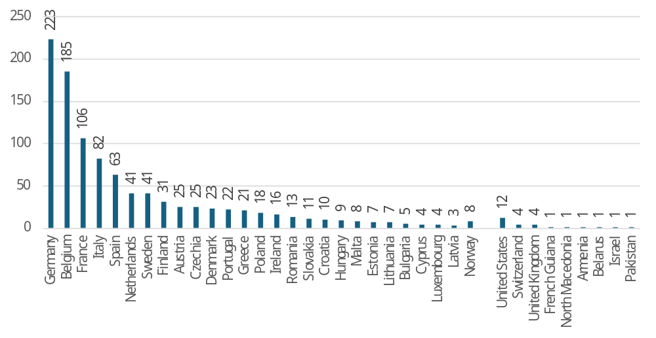
Source: Public Consultations on public procurement reform. Commission own analysis.
Overall, the data highlights a strong representation from Central EU countries, which accounted for 56% (584 replies). This is followed by Southern EU countries with 19% (200 replies), Northern EU countries with 11% (119 replies), and Eastern EU countries with 10% (108 replies).
The breakdown of respondents by category reveals a clear dominance of business-related and institutional stakeholders, with notable representation from public authorities and civil society organisations (see Figure 3).
Figure 3: Distribution of responses by type of respondent
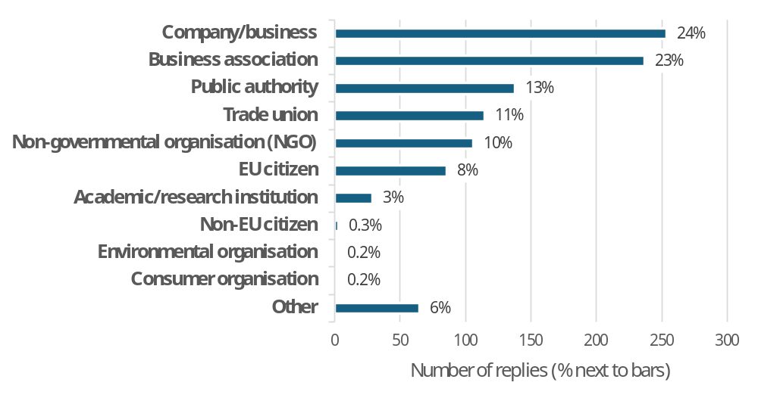
Source: Public Consultations on public procurement reform. Commission own analysis.
  - Overall objectives for the revision
Respondents were asked to identify priorities for the revision of public procurement rules. In terms of improving efficiency and transparency, the top three priorities across most groups were moving beyond the lowest-cost paradigm, making procurement rules more flexible, and reducing administrative burden through full digitalisation. While this ranking was broadly consistent among respondent groups, public authorities differed by prioritising flexibility first and less detailed rules second.
On priorities for green, social, and innovative procurement, most respondents favoured prioritising quality over price (usually first or second), followed by facilitating environmentally friendly purchases (typically second or third), and promoting the purchase of innovative solutions (generally third or fourth). Public authorities again deviated, placing the avoidance of additional administrative burden first, less detailed rules second, and environmentally friendly purchases third.
As regards the integration of economic security and strategic autonomy into public procurement rules, most respondents preferred giving priority to European industry in critical sectors, followed by a general preference for European industry and more flexible rules. However, public authorities ranked flexibility as their top priority, followed by avoiding administrative burden, and then equally supported giving preference to EU industry and having less detailed rules.
  - Detailed questions about the revision
Respondents were invited to respond to more technical questions in relation to the planned revision and approximately 80% (831) of respondents did so.
    - Simplification
Respondents were asked to judge the simplification potential of several policy options covering flexibility of procedures, joint procurement, information exchange, SME participation, and implementation challenges.
When considering flexibility of procedures, respondents most often saw simplification potential in more flexible contract modifications (76%: 546 replies), followed by allowing corrections of procurement documents throughout the procedure (71%: 496 replies), facilitating dialogue with the market (69%: 492 replies), allowing negotiations throughout the procurement procedure (70%: 466 replies) and simplification of procedures for off-the-shelf purchases (62%: 429 replies).
With regard to joint procurement, respondents identified the greatest simplification potential in increasing flexibility in setting the duration of framework agreements (66%: 418 replies). This was followed by facilitating networking among buyers (63%: 440 replies), simplifying rules for setting up joint procurements, especially across borders (56%: 356 replies), and enhancing the role of Central Purchasing Bodies (53%: 358 replies).
To improve information exchange and procedural time limits, respondents most frequently supported allowing the re-use of documentation submitted by bidders (once-only principle) (86%: 620 replies). This was followed by providing model contract templates and technical specifications for public buyers (75%: 535 replies), and establishing a central EU procurement platform alongside enhanced digitisation (67%: 483 replies). Lower but still notable levels of support were seen for setting time limits for bid evaluation (59%: 417 replies) and increasing time limits for submission (46%: 315 replies).
To support SME participation in public procurement, respondents most highly rated simplifying rules for forming consortia, particularly for SMEs (70%: 447 replies). This was followed by encouraging the division of contracts into smaller lots (52%: 348 replies) and introducing EU-level targets for SME participation in public procurement (47%: 294 replies).
According to respondents, improvements in implementation and contract management could be achieved by speeding up payments to contractors, particularly SMEs (66%: 457 replies). This was followed by establishing rules for the post-award phase, including contract implementation (52%: 360 replies), and setting rules for direct payments to subcontractors, especially SMEs (51%: 345 replies). To a lesser extent, respondents also supported increasing the use of pre-financing, particularly for SMEs (43%: 293 replies).
Regarding the expected impacts of these simplification measures, respondents most frequently highlighted increased SME participation (82%: 461 replies), a higher number of bidders (81%: 453 replies), greater competition (81%: 447 replies), and faster procurement processes (81%: 450 replies).
    - Coherence with sectoral rules
Respondents were asked whether and how the reform should address existing and future public procurement provisions in sectoral legislation. Regarding existing rules, responses were divided: 36% (244) supported integrating "how to buy" provisions into the general public procurement framework, 21% (142) favoured integrating both "how and what to buy" provisions, and 19% (128) preferred not integrating these provisions at all.
For future legislation, more respondents (41%: 280 replies) opted for integrating "how to buy" requirements, while the remaining two options received similar levels of support.
    - Concessions
Respondents were asked to identify which concession-related concepts should be modified. Across all respondents, the strongest support for modifications was seen in case of additional rules on contract execution (58%: 256 replies) and rules on duration (55%: 245 replies). Just under half of the respondents backed changes to publication and transparency rules (47%: 208 replies), as well as modifications to the definitions of "concessions" and "operating risk" (44%: 197 replies).
The most likely impacts of such modifications were identified as increased legal certainty (77%: 252 replies), followed by a higher number of bidders (63%: 200 replies), greater competition (62% 198 replies), and reduced litigation (60%: 194 replies).
    - Digitalisation and transparency
Respondents were asked whether they would support the creation of a digital public procurement marketplace with a single-entry point for economic operators to access public procurement procedures across the EU.
Across all respondents, around three-quarters (526) supported one of the three proposed options to change the current eProcurement services, while roughly one in six (118) believed no changes were necessary. Among the options, interconnecting existing Member States’ eProcurement services received the highest support at 65% (443), while only 12% (83) supported replacing national eProcurement services with a central one.
Regarding the impacts of such changes, respondents anticipated a wide range of positive outcomes. The highest-ranked expected impacts included faster exchange of documents (87%: 526 replies), wider access to cross-border procedures (80%: 418 replies), harmonisation of tender requirements across Member States (79%: 478 replies), and increased transparency to aid the prevention of irregularities (78%: 477 replies).
Several National Competition Authorities, including those from Austria, Belgium, Bulgaria, the Czech Republic, Finland, France, Germany, Greece, Italy, Portugal, Slovenia, and Spain, highlighted the high importance of direct access to quality public procurement data for the prevention and detection of bid rigging.
    - Made in Europe
All respondent groups except non-EU participants expressed strong support (above 80%) for prioritising European goods and services in public procurement processes.
When asked how to prioritise European goods and services, respondents showed the strongest preference for expanding the role of non-price criteria, such as social, environmental, resilience, innovation, security, and “Made in Europe” considerations (92%: 560 replies). This was closely followed by defining “Made in Europe” criteria for bidder selection-such as requiring a European business location or setting conditions on the product/service e.g., share of value added (85%: 505 replies). The least favoured option, though still supported by over two-thirds (405) of respondents, was excluding bidders from countries lacking secured access to EU public procurement markets through international legal commitments the EU entered into (e.g. Free Trade Agreements covering public procurement).
When considering the impacts of prioritising European products and services, respondents most frequently expected an increased chance of winning for EU bidders (92%: 620 replies), followed by EU economic operators needing to adjust their supply chains to qualify for bidding (88%: 595 replies). High expectations were also placed on boosts to EU employment and investments (both 84%: 574 replies, 571 respectively). Majorities also viewed the following as likely outcomes: meeting environmental goals (83%: 580 replies), boosting EU innovation (81%: 550 replies), increasing security of supply (76%: 515 replies), and improving the quality of products, services, and works (71%: 485 replies). On the cost and risk side, majorities anticipated an increase in the price of goods and services purchased (63%: 424 replies), potential retaliation by third countries (62%: 413), and higher administrative costs for public buyers (51%: 334 replies) and EU bidders (46%: 309 replies).
    - Best price-quality ratio
Around half of all respondents (378) supported requiring public buyers to apply the best price-quality ratio as the standard contract award criterion. Similarly, roughly 50% (374) of respondents favoured introducing a minimum mandatory weight for quality criteria, with support again varying widely between groups, from 13% (13) among public authorities to 98% (98) among trade unions. Only around a quarter of respondents supported the introduction of national mandatory quality targets.
The top expected impacts of incentivising quality requirements were better achievement of environmental, social, and innovation goals (88%: 588 replies), as well as improved quality of products, services, and works (87%: 585 replies). High proportions of respondents also anticipated a boost to EU innovation (82%: 549 replies) and increased efforts by bidders to adjust their supply chains in order to qualify for bidding (76%: 490 replies).
    - Green public procurement
Regarding environmentally friendly procurement, almost three-quarters (546) of respondents supported further incentives for its use. Slightly more than half (414) backed mandatory green requirements, while around a quarter (173) believed no action was necessary in this area.
Respondents identified clear definitions (56%: 431 replies) and green standards (54%: 410 replies) as the measures most likely to incentivise the use of green procurement, followed by easier use of environmental labels (42%: 322 replies).
Such changes were expected to lead to greater achievement of environmental policy goals (89%: 636 replies), a boost to EU innovation (81%: 568 replies), and improved quality of products, services, and works (75%: 518 replies). Majorities also foresaw an increased chance of EU bidders winning calls for tender (68%: 474 replies) and a boost to EU employment (63%: 438 replies).
On the negative side, respondents anticipated increased prices of products, services, and works (63%: 442 replies), higher costs for EU bidders (56%: 383 replies), and a greater administrative burden for both public buyers and EU bidders (both 54%: 379 replies, 349 respectively).
    - Social considerations in public procurement
Two thirds of respondents (443) support incentivising the use of socially responsible public procurement, with a bit more than half of respondents (332) also considering mandatory requirements, while one third (224) view no need for changing the current rules. While business associations and SMEs both favoured no change to the existing rules, trade union favoured mandatory provisions (with all other response groups favouring incentivising measures).
Among the proposed concrete measures, increased transparency on subcontracting received the highest level of support (46%: 315 replies), followed by clarifying ing the link to the subject matter regarding social considerations affecting workers (39%: 273 replies), banning price-only criteria in labour-intensive sectors (39%: 252 replies), and establishing socially responsible procurement targets (39%: 251 replies).
In terms of expected impacts, these measures were considered likely to improve working conditions (77%: 488 replies), reduce the risk of labour and social law breaches (73%: 454 replies), and contribute to poverty reduction and increased social inclusion (69%: 430 replies). High proportions of respondents also anticipated a boost to EU employment (66%: 415 replies) and an increased chance of EU bidders winning contracts (63%: 391 replies).
On the negative side, respondents expected increased prices (62%: 385 replies), a higher administrative burden for EU bidders (58%: 360 replies), and an increased burden for buyers (54%: 336 replies).
    - Public procurement of innovation
Three-quarters of respondents across response groups (497) recognised a need to further incentivise public procurement of innovation. One-third (215) supported mandatory requirements, while only one in six (91) saw no need for action in this area.
In terms of concrete changes, simplification and removal of legal obstacles was most frequently mentioned (49%: 333 replies), as was a clear legal definition of public procurement of innovation (45%: 303 replies) and direct purchase from start-ups (36%: 245 replies).
Incentivising procurement of innovation was expected to boost EU innovation (91%: 469 replies) and lead to better quality of products, services, and works (80%: 408 replies), as well as provide a boost to EU industry (79%: 399 replies) and employment (68%: 340 replies). It was also anticipated to increase SME participation in procurement (65%: 327 replies) and enhance the chances of EU bidders winning contracts (55%: 275 replies).
On the cost and burden side, around half of the respondents considered an increased administrative burden for public buyers (53%: 271 replies) and EU bidders (44%: 222 replies) likely, along with higher prices (47%: 232 replies).
- Targeted stakeholder Consultations
  - Stakeholder Expert Group on Public Procurement (SEGPP)
In addition to the EXPP and EXEP, the Commission Stakeholder Expert Group on Public Procurement (SEGPP) was appointed to assist the Commission in its work on the evaluation and revision of the Public Procurement Directives. It brings together 23 members from a variety of professional backgrounds, including SMEs organisations, industry and business associations, national, local and regional authorities, central purchasing bodies, civil society organizations and NGOs, academia and trade unions.
The group convened on five occasions in 2025 (12 February, 15 April, 17 June, 8 October and 15 December) to discuss simplification of the EU public procurement rules, EU preference, green public procurement, socially responsible public procurement, public procurement of innovation, concessions and exclusion grounds.
  - Social Partner Hearing
A dedicated hearing with European social partners was held on 13 January 2026. A total of 62 participants were present representing 50 social partners organisations (EU cross-industry and sectoral social partners and national affiliates of cross-industry social partners), including 31 participants from employers’ side and 31 participants from trade unions’ side. The discussions covered four main topics: price-only vs Best Price-Quality Ratio (BPQR), link to the subject matter, collective agreements and subcontracting.
Employers’ representatives advocated for the introduction of price adjustment mechanisms, the retention of the subject-matter principle in its current form, the preservation of the existing approach to collective agreements in public procurement, while strongly opposing any restrictions on subcontracting. Trade unions called for a ban on price-only contract awards, the automatic recognition of working conditions and collective agreements as always linked to the subject matter of a contract, the prioritisation of companies bound by collective agreements and the restriction of subcontracting to a maximum of two vertical tiers.
  - Meeting with NGOs working on environment and social responsibility
On 22 January 2026, a meeting was convened with 13 NGOs active in the field of sustainability to gather their views and priorities concerning the revision of the EU Public Procurement Directives.
During the discussions, NGOs highlighted several critical issues, including the necessity of expanding the use of Best Price-Quality Ratio (BPQR) and ensuring greater coherence between horizontal public procurement rules and sectoral legislation. They also emphasised the importance of reinforcing the legal standing of sustainability within the EU procurement framework, as well as addressing challenges related to the use of standards and labels. Concerns were raised regarding the link to the subject matter principle and its practical application, calling for greater legal certainty. The meeting additionally touched upon professionalisation of procurement officers, the use of reserved contracts, the link between EU preference and sustainability requirements, and the necessity to boost digitalisation.
  - Meeting with SME Envoys Network
A targeted consultation with the Network of SME Envoys took place on 3 December 2025. Participants exchanged views on a number of aspects related to SME participation in public procurement procedures. Several potential legislative and non-legislative measures were discussed, alongside simplification and digitalisation of the legislative framework. The streamlining of existing procedures and improved data collection were highlighted as key elements for enhancing SME participation in procurement. Participants further addressed the issue of different approaches by Member States in implementing the existing rules.
  - SME Panel consultation
A consultation of SMEs was conducted between 17 December 2025 and 15 February 2026, initially launched in English and subsequently made available in all official languages from 13 January 2026. In total, 108 responses were received from SMEs representing different company sizes, countries of origin and a wide range of economic sectors. The consultation aimed to gather targeted feedback on several aspects of the current legislative framework, as well as on the expected costs and benefits of potential legislative measures, with questions specifically designed to reflect the characteristics and needs of SMEs. It covered key policy areas including simplification of existing rules, digitalisation, green, social and innovation procurement, as well as measures related to economic security and strategic autonomy. A detailed summary can be found in Annex 6, Analysis of SMEs participation.

Annex 3: Who is affected and how?
1. Practical implications of the initiative
The revision of the EU public procurement legal framework will streamline and modernise procurement processes across the EU, benefiting economic operators, contracting authorities, national authorities, and society as a whole. Businesses are expected to gain from increased efficiency, clearer rules, and greater access to cross-border tenders, while strategic requirements such as ecolabels and social criteria may involve some adjustment costs but deliver long-term value.
Public buyers will benefit from simplified procedures, a single consolidated legal framework, and improved digital procurement platforms, enabling more efficient and transparent tendering. National authorities and service providers may incur costs in developing and maintaining digital infrastructures but would benefit from harmonised standards and more effective oversight.
Overall, for the society at large, the initiative is expected to support environmental, social, and innovation objectives, enhance legal certainty, and strengthen the resilience and efficiency of EU public procurement, ensuring better value for public investment and increased fairness and transparency across all stakeholders.
2. Summary of costs and benefits
I. Overview of Benefits (total for all provisions) – Preferred combination of Options
Description | Amount | Comments
Direct benefits
Cost reductions due to an increased use of negotiations (FLX.2) | €88 million savings annually (public buyers: cost increase of €85 million, economic operators: cost reduction of €181 million) | FLX.2 - cost reduction due to the free access to negotiations. Actual reduction depends on the number of bidders (smaller if bidders increase, larger if decrease).
Cost reductions due to simplifications (FLX.2) | Not quantified | Cost reductions due to e.g.: reuse of documents (once only principle), possibility for error corrections (reduced number of terminations due to errors), reduced administrative burden in case of emergencies.
Cost reductions due to further implementation of digital technologies to improve procurement processes (MPL.1) | Recurrent administrative cost savings of around €4 714 per public buyer and €2 366 per economic operator due to lower human resources cost caused by automation, as well as the use of the European Business Wallets. EU wide total annual saving of €1 billion. | MPL.1 - economic operators and contracting authorities will bear no IT implementation, development, or operation cost. On the contrary, the preferred policy option is expected to bring savings to them.
Indirect benefits
Improved EU trade balance (BEU.2) | Not possible to quantify. The decline in EU imported inputs in selected sectors where market access can become more difficult will nonetheless improve intra EU trade, with some Member States expected to yield a positive trade balance from the policy measure. | Overall positive indirect impact through stronger domestic sourcing, reduced exposure to foreign supply disruptions, and increased resilience of supply chains. Short-term effects may vary regionally. Reduced imports of inputs combined with increased exports can yield a positive trade balance. Strengthened domestic sourcing reduces vulnerability to external geopolitical or market shocks.
Resilience of supply chains (BEU.2) | Not possible to quantify.  The EU would become less exposed to future foreign supply disruptions and input price shocks. This increased resilience of supply chains could reduce vulnerability to external geopolitical or market shocks, thereby supporting longer-term economic stability.
A single public procurement legal act (FLX.2) | Not possible to quantify.  Improved legal certainty, reduced complexity, avoid inconsistencies, and facilitating the prevention of internal market fragmentation. | A single legal instrument would allow for a common framework integrating existing public procurement provisions in sectorial acts on “how to buy” and gathering references to existing requirements on “what do buy”. This could also close loopholes and achieve better transparency and fairness across all types of public contracts.
More green, social and innovation procurement (ESI.1) | Not possible to quantify.  Improved legal certainty facilitating the use of environmental, social and innovation requirements in public procurement and some cost savings (e.g. reducing litigation-related expenditure and the associated administrative and time burdens for both public buyers and economic operators). EU Ecolabel may generate cost savings, but it is not possible to quantify these potential savings with the available data. Improve generation and use of innovative solutions and better alignment between the tendering process and innovative solutions the market can deliver. | Incentivising BPQR will result in the achievement of strategic policy goals (environmental, social and innovation) and provide long-term value for public investment. The wider use of EU Ecolabel is expected to have a positive effect on cross-border participation. This change would empower public buyers wishing to do so to prioritise working conditions with confidence. Easier to ensure compliance with social and labour obligations, including human rights.
Enhanced transparency in public procurement (MPL.1) | Enhanced transparency in public procurement platforms will facilitate the monitoring of public expenditure. Increased transparency in this area can significantly reduce the risk of corruption, fraud, procurement irregularities and anti-competitive practices, such as bid rigging. Notably, bid rigging can result in an overcharge of approximately 20% or more in the final contract price. Consequently, improved transparency and monitoring can generate substantial cost savings for contracting authorities, ultimately yielding better value for taxpayers' money. | Implementation of digital technologies will improve procurement processes through a strong monitoring and transparency that can improve the ability to prevent and detect corruption, fraud, procurement irregularities and anti-competitive practices like bid rigging. Contracting authorities are the primary beneficiaries with indirect benefits to taxpayers through more effective use of public funds.

II. Overview of costs – Preferred combination of options

Stakeholders (number) |  | Businesses - Economic Operators |  | Public buyers – contracting authorities |  | National authorities / eProcurement service providers |  | European Commission
 |  | 372 440 |  | 46 648 |  | 27 MS/ 123 eProcurement platforms
 |  | One-off | Recurrent | One-off | Recurrent | One-off | Recurrent | One-off | Recurrent
ESI.1 | Direct adjustment costs
ESI.1 | Direct administrative costs- (BPQR) |  | € 457 million |  | € 55 million
ESI.1 | Direct administrative costs- (Ecolabels) | € 1.14 million | € 12 million
ESI.1 | Direct regulatory fees and charges
ESI.1 | Direct enforcement costs
ESI.1 | Indirect costs
BEU.2 | Direct administrative costs |  | € 7.4 million |  | € 7.4 million
MPL.1 | Direct adjustment costs (setting up the digital marketplace) |  |  |  |  |  | € 18 million |  | € 18 million
MPL.1 | Direct administrative costs
MPL.1 | Direct regulatory fees and charges
MPL.1 | Direct enforcement costs
MPL.1 | Indirect costs
See Annex 8 for details.

III. Contribution to the administrative burden reduction targets – Preferred option [EUR million]
Administrative costs  [M€] | New recurrent costs (INs)  (nominal values per year) | Removed recurrent costs (OUTs)  (nominal values per year) | Net cost (INs – OUTs)  (nominal values per year) | New one-off costs (INs)  (annualised total net present value over the relevant period) | Removed one-off costs (OUTs)  (annualised total net present value over the relevant period)
Economic operators  (All businesses) | 477  (ESI.BPQR: 457+  ESI.Labels: 12+  BEU: 7.4) | 1 047  (FLX:166 +  MPL: 881) | - 570 | 0.16**
- in which SMEs* | 337 | -743 | -406 | 0.09***
Contracting authorities | 141  (FLX:78+  ESI.BPQR: 55+  BEU:7.4) | 220  (MPL: 220) | -79
Member States
(Public administrations)
Citizens
* The costs were calculated as 71% of the costs for all economic operators (the best available approximation for the share of SMEs participating in public procurement), except for the ESI Labels option. In this case, the share stands at 57%, based on the data available at https://environment.ec.europa.eu/publications/eu-ecolabel-fees-table-2026_en as of 3 March 2026. See Annex 6;
**EUR 1.14 million / 7; *** EUR 0.16 million * 57%.
Note: Presented figures are rounded, though totals are calculated using precise values, which may result in minor discrepancies.
See Annex 6 and 8 for details.

3. Relevant sustainable development goals
IV. Overview of relevant Sustainable Development Goals – Preferred Option(s)
Relevant SDG | Expected progress towards the Goal | Comments
SDG 9- Industry, innovation and infrastructure | The preferred policy option is expected to contribute to target 9.2 Promote inclusive and sustainable industrialization and 9.b Support domestic technology development, research and innovation. | The preferred option is expected to strengthen EU industrial resilience by increasing demand for EU products- share of EU origin of goods procured in selected sectors. It will also have a positive impact on the procurement of innovation solutions.
SDG12-Responsible production and consumption | The preferred policy option is expected to contribute to target 12.7 Promote public procurement practices that are sustainable, in accordance with national policies and priorities. | By increasing the uptake of environmental, social and innovation public procurement, the preferred policy option will increase the number the share of procedures (value and count) that are sustainable.
SDG 8- Decent work and economic growth | The preferred policy option is expected to contribute to target 8.3 Promote development-oriented policies that support productive activities, decent job creation, entrepreneurship, creativity and innovation, and encourage the formalization and growth of micro-, small- and medium-sized enterprises, 8.4 Improve progressively, global resource efficiency in consumption and production and 8.8 Protect labour rights and promote safe and secure working environments | By increasing the uptake of environmental and social public procurement, the preferred policy option will increase the number the share of procedures (value and count) that ensure the protection of labour rights and secure working environment. The simplification of the procurement procedures and reduction of costs will contribute to the growth of micro-, small- and medium-sized companies.

Annex 4: Analytical methods
The following analytical methods were applied in this IA:
- Key external studies launched in support of this IA
- Study on SME participation by SILO
    - analysing SME participation in the EU public procurement and assessing how different how different procurement practices across key policy dimensions of public procurement influence SME participation and success rates.
- Study on competition by the World Bank
    - assessing the extent to which the public procurement directives achieved one of the main objectives – creating the conditions for the opening of public procurement to competition.
- Study on coherence by Roberto Caranta and Willem Janssen
    - analysing the coherence of the public procurement legislation using practical examples while identifying challenges for the contracting authorities.
- Study on the intellectual property rights (IPR) Christina Wainikka
    - reporting on the current state and emerging trends in the allocation of IPR in public procurement contracts across the EEA and providing qualitative insights into the potential implications of introducing legal instructions on IPR allocation.
- Study on integration of social and green considerations by Andrea Sundstrand
    - analysing to what extent do contracting authorities have difficulties with Vimplementing SRPP and GPP due to the requirement of the link to the subject matter and the principle of proportionality and to what extent they have difficulties using public procurement to promote fair working conditions.
- Study on data by Tünde Tátrai and Isabel da Rosa
    - examining the need for possible modifications of the TED Platform and providing expert advice on development of a holistic data governance model.
- Study on uptake of green public procurement by PwC
    - analysing to what extent GPP criteria are currently integrated in the public procurement, at which stages are GPP requirements applied, what are their impacts in the contract performance and how is this monitored.
- Study on Labels by Felice Alfieri
    - Assessing the uptake of different labels in public procurement procedures, presenting results of consultations with large contracting authorities and comparing the requirements of different labels to measure their equivalence.
- Study on the impacts of the MPL options by PwC
    - The impacts of MPL options are based on an external study that has been carried out in line with the Better Regulation Guidelines and Better Regulation Toolbox to ensure an evidence-based analysis. The following BRT tools were considered for the quantitative and qualitative analyses of the MPL options, namely Tool #56, Typology of costs and benefits, was applied to identify and describe the various types of costs and benefits associated with the policy options. Tool #58, EU Standard Cost Model, was considered to estimate implementation costs and potential savings. Tool #63, Cost-benefit analysis, was implemented to evaluate the costs and benefits related to each policy option. Tool #64, Discount factors, was used to complement the quantitative analysis and to calculate the net present value (NVP).
    - Some cost elements, especially those linked to future IT developments, necessarily rely on assumptions owing to incomplete specifications. Moreover, variations in national systems and survey coverage restrict cross-country comparability. Notwithstanding these limitations, the triangulation of multiple evidence sources provides a robust and balanced analytical basis.

- In-house analysis focusing on:
  - descriptive statistics concerning cross-border procurement across key sectors and countries (to ensure a trend continuation with the most recent study on cross-border by Prometea), which are merged with Orbis financial information to have more detailed info about the winners.
  - submissions made by economic operators or groups of economic operators in accordance with the requirements of Regulation (EU) 2022/2560 and Implementing Regulation (EU) 2023/1441, merged with Orbis database containing in particular information on the name, country and type of the Global Ultimate Owners (GUOs) of the companies mentioned in the FSR submissions.
- Simulation of impacts using FIDELIO model (JRC) - macroeconomic impacts of potential preferences to goods originating from selected countries used to estimate impacts of BEU options.
Methodology and results from each of these workstreams are described in more details in the corresponding sections of this IA.

Annex 5: Competitiveness check
Overview of impacts on competitiveness
Dimensions of Competitiveness | Impact of the initiative  (++ / + / 0 / - / -- / n.a.) | References to sub-sections of the main report or annexes
Cost and price competitiveness | +/0 | Positive due to MPL.1 - savings due to the introduction of digital tools (section 6.4).  Neutral due to BEU.2 - Overall, the impact of local content requirements is likely to reflect a combination of positive and negative effects. Even if the net GDP impact may be ambiguous, depending on the balance between upstream expansion in domestic input producing sectors and potential downstream contraction driven by higher input costs or reduced competitiveness, it will nonetheless improve intra EU trade. (section 6.3 and Annex 4, Options BEU).
International competitiveness | + | Positive due to BEU.2 – At least some countries are expected to yield a positive trade balance from the policy measure, especially for Germany, and Italy (section 6.3 and Annex 4, Options BEU).
Capacity to innovate | ++ | Strongly positive due to FLX.2/ESI.2 – specific measures to support the capacity to innovate such as the new innovation procedure (section 6.1)
SME competitiveness | + | Positive due to FLX.2 and MPL.1 - measures reducing the load of documentation to be presented, facilitating the reuse of technical documentation, and limited weight of price in human resource intensive contracts (ESI.2) (sections 6.1, 6.2, 6.4 and Annex 6).

Most affected sectors
The analysis focuses on construction works (understood as CPV divisions 45 and 71), which constitute the largest sectors covered by the Directives, as well as on the manufacturing of pharmaceuticals, which represents the main component of the third-largest sector (CPV division 33). The relative importance of the sectors in terms of the number of calls for competition is presented in Figure 4 below.
Figure 4: Share of calls for competition published in TED by sector in 2023, EEA [%]
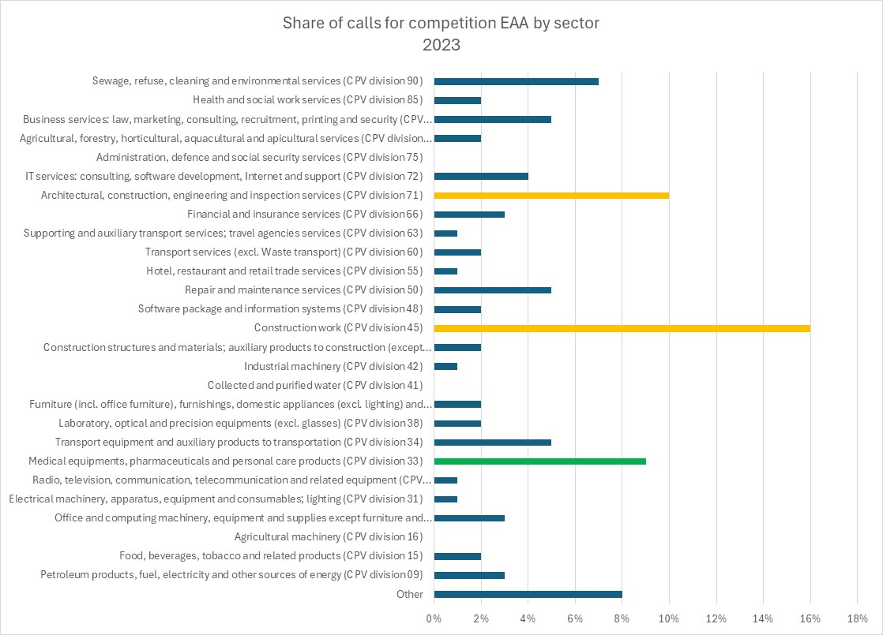
Source: In-house analysis
The construction and pharmaceutical sectors also appear among the key sectors when measured by public procurement value awarded above EU thresholds - over the period 2018–2023, construction contracts amounted to approximately EUR 528 billion, corresponding to around 25% of 70% of total procurement value covered in the analysis, while pharmaceutical-related procurement accounted for approximately EUR 104 billion, representing around 5% of the same total. Their importance for the EU procurement market makes these sectors relevant for assessing their competitive position.
            - Construction sector
Public authorities are among the largest clients in the construction sector, procuring works related to transport networks, schools, hospitals, housing, and other essential infrastructure. Construction projects typically involve high contract values and long lifecycles, making them a significant component of public expenditure. At the same time, the sector is often characterised by complex projects, fragmented supply chains, and a high reliance on subcontracting, which can create risks related to cost overruns, delays, and quality issues. As a result, even small efficiency gains in procurement processes can therefore translate into substantial budgetary savings and influence the quality, durability, and timely delivery of public infrastructure.
The construction sector is one of the largest sectors in the EU economy, with over 4 million firms and 14 million employees in 2024. The construction sector is characterised by a highly fragmented market structure dominated by micro-enterprises, which account for more than 94% of firms. Despite this fragmentation, the sector generates significant economic activity, contributing 5.6% of EU gross value added (GVA). Economic performance has improved in recent years, with net turnover reaching EUR 2.32 trillion in 2024, representing a 71% increase since 2011, and labour productivity rising by 46.6% over the period 2011-2023. Profit margins have also increased slightly over the same period, with the gross operating rate (GOR) reaching approximately 47.7% in 2023. Innovation plays a relatively limited role in the sector, with construction-related R&D expenditure accounting for 0.01% of EU GDP in 2020. Patent activity in civil engineering technologies remains modest, with 4 397 patent applications filed at the European Patent Office in 2024, of which 2 602 (around 59%) were submitted by EU-27 applicants. Globally, the EU accounts for around 18% of construction output as of 2023, although its share has declined due to faster growth in emerging economies, particularly China.
            - Manufacturing of pharmaceuticals
Public authorities are among the largest purchasers of pharmaceuticals, what makes procurement practices in this sector critical for guaranteeing timely access to safe, effective, and affordable treatments. Moreover, pharmaceutical procurement has a significant impact on public budgets, therefore more efficient procurement procedure can generate substantial savings especially with regard to purchases of generic or biosimilar medicines.
The pharmaceutical manufacturing sector is smaller than construction in terms of firms but significantly more capital-intensive and innovation driven. The sector comprised around 4 100 firms in 2024, employing nearly 700 000 workers, with employment concentrated in large firms and representing 1.13% of EU27 GVA. The sector has expanded rapidly, with net turnover rising from EUR 205 billion in 2011 to around €500 billion in 2024, representing an increase of approximately 139%, and labour productivity nearly doubling over the same period. Profit margins are also considerably high, with the GOR reaching nearly 75% in 2023, indicating very strong operating profitability. Innovation also plays a role, with 8 359 pharmaceutical patent applications filed at the European Patent Office in 2024, of which 31% (2 589) originated from EU27 companies. Globally, the EU remains a major pharmaceutical producer and the leading exporter, accounting for 22.2% of global output and 7.42% of global exports in 2023.
Synthetic assessment
The assessment of EU public procurement reforms highlights mixed but largely positive impacts across key areas. Cost and price competitiveness is neutral overall, as digital tools (e.g., under MPL.1) reduce administrative costs, while local content requirements (BEU.2) present trade-offs-potentially boosting upstream domestic sectors but risking higher input costs for downstream industries. Despite ambiguous GDP effects, intra-EU trade may improve. international competitiveness is positive, with countries like Germany and Italy expected to gain a trade surplus from these measures.
Innovation capacity sees a strongly positive outlook (FLX.2/ESI.2), driven by changes like the new innovation procedure. SME competitiveness also benefits from reduced documentation burdens, reusable technical files, and limited pricing weight in labour-intensive contracts (FLX.2/ESI.2/MPL.1).

Annex 5’ Competitiveness check - the most affected sectors
Table 17: Share of calls for competition by sector by year, EEA in 2018-2023 [%]
Sector | 2023 | 2022 | 2021 | 2020 | 2019 | 2018
Petroleum products, fuel, electricity and other sources of energy (CPV division 09) | 3% | 3% | 2% | 2% | 3% | 3%
Food, beverages, tobacco and related products (CPV division 15) | 2% | 2% | 2% | 1% | 2% | 2%
Agricultural machinery (CPV division 16) | 0% | 0% | 0% | 0% | 0% | 0%
Office and computing machinery, equipment and supplies except furniture and software packages (CPV division 30) | 3% | 3% | 3% | 3% | 3% | 3%
Electrical machinery, apparatus, equipment and consumables; lighting (CPV division 31) | 1% | 1% | 1% | 1% | 1% | 1%
Radio, television, communication, telecommunication and related equipment (CPV division 32) | 1% | 1% | 1% | 1% | 1% | 1%
Medical equipments, pharmaceuticals and personal care products (CPV division 33) | 9% | 9% | 9% | 9% | 9% | 9%
Transport equipment and auxiliary products to transportation (CPV division 34) | 5% | 5% | 5% | 5% | 5% | 5%
Laboratory, optical and precision equipments (excl. glasses) (CPV division 38) | 2% | 2% | 2% | 2% | 2% | 2%
Furniture (incl. office furniture), furnishings, domestic appliances (excl. lighting) and cleaning products (CPV division 39) | 2% | 2% | 2% | 2% | 2% | 2%
Collected and purified water (CPV division 41) | 0% | 0% | 0% | 0% | 0% | 0%
Industrial machinery (CPV division 42) | 1% | 1% | 1% | 1% | 2% | 2%
Construction structures and materials; auxiliary products to construction (except electric apparatus) (CPV division 44) | 2% | 2% | 1% | 2% | 2% | 2%
Construction work (CPV division 45) | 16% | 16% | 16% | 17% | 16% | 16%
Software package and information systems (CPV division 48) | 2% | 2% | 2% | 2% | 2% | 2%
Repair and maintenance services (CPV division 50) | 5% | 4% | 5% | 5% | 4% | 4%
Hotel, restaurant and retail trade services (CPV division 55) | 1% | 1% | 1% | 1% | 1% | 1%
Transport services (excl. Waste transport) (CPV division 60) | 2% | 2% | 2% | 2% | 2% | 2%
Supporting and auxiliary transport services; travel agencies services (CPV division 63) | 1% | 1% | 1% | 1% | 1% | 1%
Financial and insurance services (CPV division 66) | 3% | 2% | 2% | 2% | 2% | 2%
Architectural, construction, engineering and inspection services (CPV division 71) | 10% | 10% | 10% | 10% | 10% | 9%
IT services: consulting, software development, Internet and support (CPV division 72) | 4% | 4% | 4% | 4% | 3% | 3%
Administration, defence and social security services (CPV division 75) | 0% | 0% | 1% | 0% | 0% | 1%
Agricultural, forestry, horticultural, aquacultural and apicultural services (CPV division 77) | 2% | 2% | 2% | 2% | 2% | 2%
Business services: law, marketing, consulting, recruitment, printing and security (CPV division 79) | 5% | 6% | 6% | 5% | 6% | 6%
Health and social work services (CPV division 85) | 2% | 2% | 2% | 2% | 2% | 2%
Sewage, refuse, cleaning and environmental services (CPV division 90) | 7% | 7% | 7% | 8% | 7% | 7%
Other | 8% | 9% | 9% | 9% | 9% | 9%
Source: in-house analysis.
Competitive position of the most affected sectors
            - Construction sector
Key facts: over 4 million firms in 2024; 94% of firms are micro-enterprises; over 14 million employees in 2024; 5.6% of EU GVA in 2024; GOR 47.7% in 2023; net turnover EUR 2.3 trillion in 2024; labour productivity EUR 52 232 per employee in 2023; 71% increase in net turnover from 2011-2024; 46.6% increase in labour productivity since 2011-2023; 77% of sector turnover generated by Micro firms and SMEs in 2024; Global output share 18% in 2023; Global export share 2.25% in 2024; R&D expenditure 0.01% of EU GDP in 2020; 2 602 civil-engineering patent applications filed by EU-27 applicants at the European Patent Office in 2024 (59% of total).
Market Structure: In terms of the number of firms in the EU, the construction sector is the third highest among NACE 1 EU sectors, reaching 4 043 781 firms in 2024. This sector has increased significantly with 33.66% compared to 2011, when the number of construction firms was estimated at 3 025 382 (see the figure below). The sector is also the sixth largest employer among NACE 1 sectors, employing 14 019 195 workers in 2024. Employment has grown steadily since 2011, increasing by 19% from 11 775 524 workers.
Finally, the average number of employees in Hight Growth Enterprises (HGEs) in the sector was 9.4 in 2023, representing a decrease of around 0.4 employees compared with 2021 levels.
Figure 5: Number of firms in NACE 1 industries in EU27 (2011-2024)
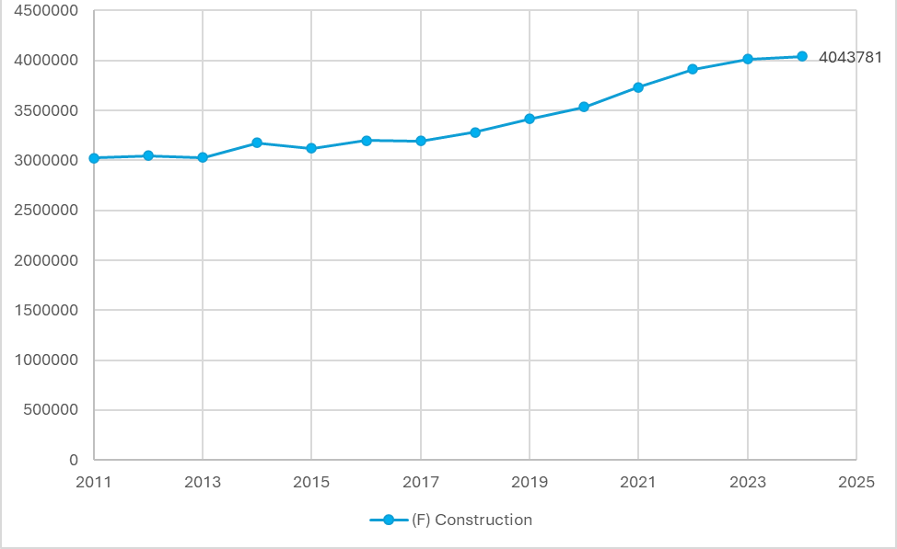
Source: Eurostat
The construction sector is dominated by micro-enterprises (0-9 employees), which is expected from the construction industry, as it has relatively low entry barriers and a project base nature. Out of 3 025 382 firms recorded in 2011, approximately 94.3% (around 2.85 million) were micro-enterprises. Small enterprises (10 to 49 employees) comprised about 5.2% (approximately 157 320 firms), while medium-sized enterprises accounted for roughly 0.5% (around 15 127 firms), putting the total number of SMEs at about 5.7% (around 162 447 firms). Large companies constituted only about 0.05% of all firms (approximately 1 513 enterprises).
In terms of economic contribution, the construction sector accounted for 5.6% of total EU gross value added (GVA) in 2024, ranked as the 7th industry (see the figure below). The sector experienced a small contraction during the period 2010–2015, but value added has increased since 2015 and currently remains slightly below its 2010 share.
Figure 6: Industry share in EU-27 gross value added in 2024 [%]
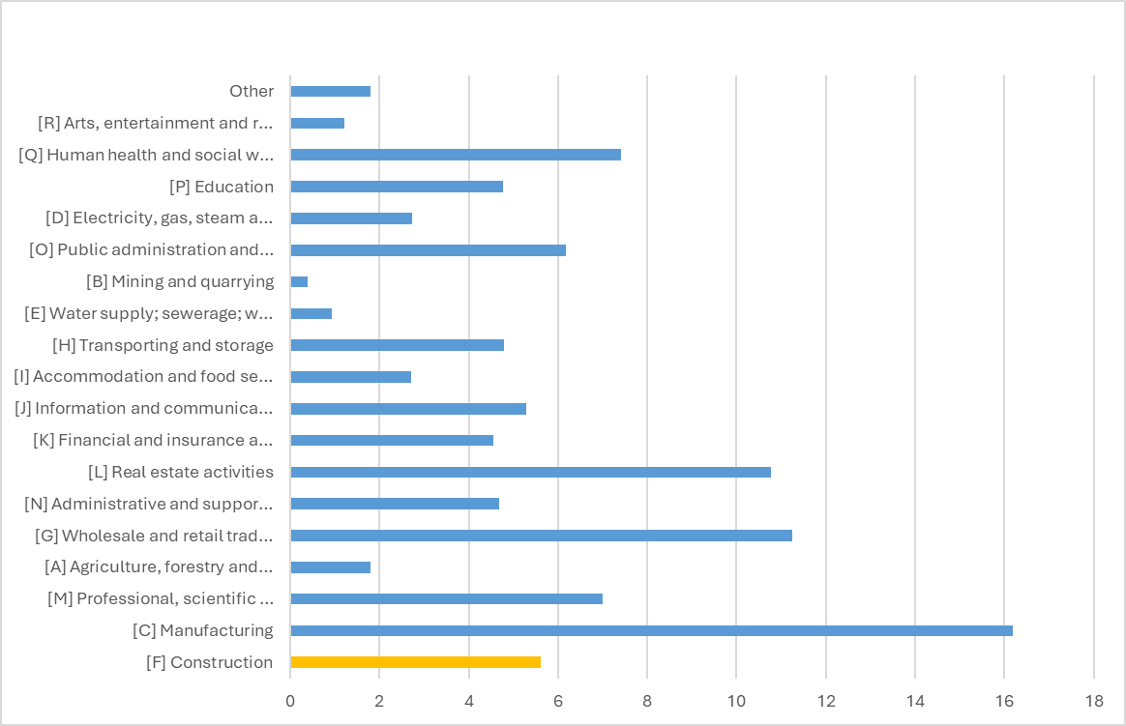
Source: Eurostat
Productivity and profitability of the sector: In 2024, the net turnover of the sector was EUR 2.32 trillion, making it the 7th largest NACE 1 sector by net turnover. The sector has expanded dramatically since 2011 where the original value was EUR 1.36 trillion, increasing by 71%. Investigating further, the distribution of net turnover in the EU construction sector by firm size (see the figure overleaf) reveals the following picture, 33% of the turnover is generated by micro business, small business generate 26.5% of the net turnover, while Medium enterprises generate 17.5% and large enterprises generate close to quarter (23%) of sector turnover. In total Micro firms and SMEs are responsible for 77% of sector turnover, which show that the construction sector is highly SME driven. Large companies play a significant role, most likely in large complex projects, but do not dominate the sector.
Figure 7: Net turnover by firm size 2024 [% share of total]
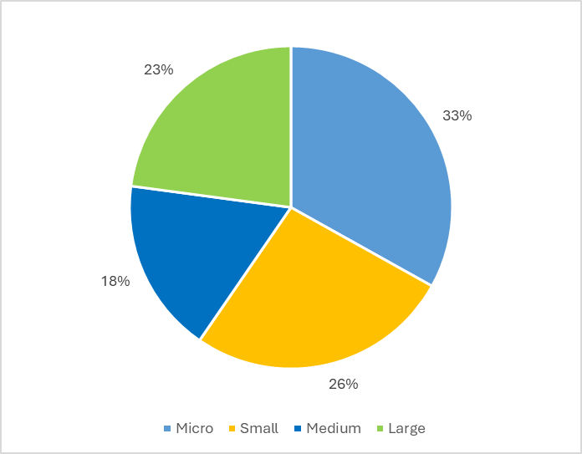
Source: Eurostat
Looking at operating profit margins, which can be approximated by the Gross Operating Rate (GOR), an indicator of sectoral profitability before depreciation, interest and taxes, around EUR 47.7 of operating surplus is generated for every EUR 100 of value added in the EU construction sector. Profitability has increased by 7.95% since 2011 (see the figure below). Over the same period, profitability rose by 5.29% in China, 12.46% in the United States, and around 73% in Japan, suggesting stronger profitability growth in some major international construction markets, .
Figure 8: Gross Operating Rates (GOR) construction sector 2011-2024
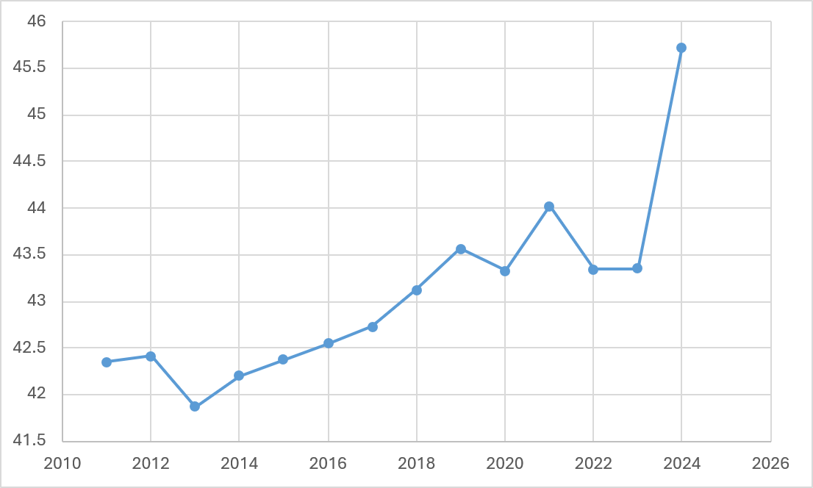
Source: Eurostat
Labour productivity per employee in the EU construction sector has increased over the past decade. It rose from EUR 35 629 per employee in 2011 to EUR 52 232 in 2023, representing an overall increase of 46.6%. Rise of productivity experienced a slight decline in 2020, likely due to COVID-19 pandemic, but has recovered steadily since, reaching in 2023 the highest level in the observed period (EUR 52 232 per employee).
Zooming into productivity per employee by firm size, micro-enterprises account for only 13.56% of the total value added generated per worker across the sector (productivity contribution), small enterprises account for 37.28% of productivity contribution, while medium and large companies account for 22% and 27.1% of productivity contribution (see the figure below).
We can see that labour productivity varies significantly by firm size. Interestingly, smaller enterprises account for the largest share of productivity in the construction sector, followed by large and medium size enterprises. This implies that the majority of value creation is concentrated among firms with greater organization and technical capacity, even if the sector is dominated by micro-enterprises.
Figure 9: Labour productivity per employee by firm size 2023 [% share of the total]
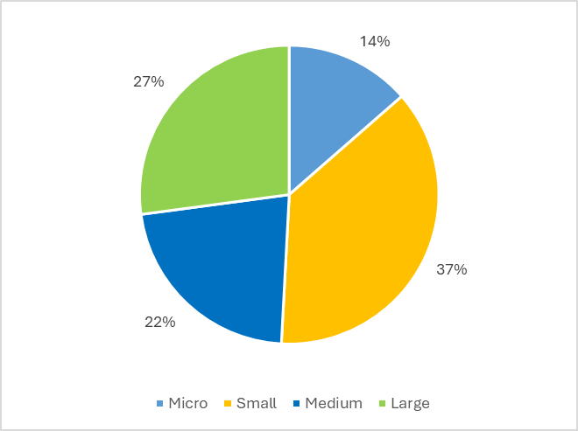
Source: Eurostat
Innovation in the sector: Business enterprise expenditure on research and development (BERD) in the EU construction sector remains very limited, amounting to approximately 0.01% of EU GDP in 2020, with no significant change observed since 2015. This is substantially lower than in manufacturing, where R&D expenditure accounts for around 0.94% of EU GDP. Overall, the EU spent approximately 1.5% of GDP on business R&D in 2020. Traditionally, the majority of business R&D expenditure is concentrated in the manufacturing sector, which accounts for the largest share of private-sector research and development activities.
Patent applications in civil engineering technologies can be used as an indicator for innovation in the construction sector, as they capture technological developments related to building techniques and infrastructure. In 2024, EU27 applicants filed 2 602 civil engineering patent applications at the European Patent Office (EPO), representing 59% of the total 4 397 applications in this technological field. Furthermore, civil engineering patents account for around 4% of all patent applications filed by EU27 countries in 2024, suggesting a notable level of innovation in construction-related technologies.
International position of the sector: the EU construction sector currently accounts for approximately 18% of global construction output in 2023. Although this share remains substantial, it has declined by around 5.57 percentage point decrease since 2010, reflecting faster construction growth in emerging economies, particularly in Asia. However, recent data indicate a modest recovery in the EU’s global position, with its share increasing by 3.85 percentage points relative to the 2015, , , .
As the EU’s share of global construction declined from 23.7% in 2010, China’s share increased rapidly, reaching 23.18% in 2014 and exceeding 27% in subsequent years. This suggests that the EU’s relative decline partly reflects the rapid expansion of construction activity in China (see the figure below). After 2015, the EU share stabilised and gradually recovered from 15.9% to 18.1% by 2023, while the United States shows a steady increase and Japan a continuous decline over the period.
Figure 10: Country share in global construction output, 2010-2023 [%]
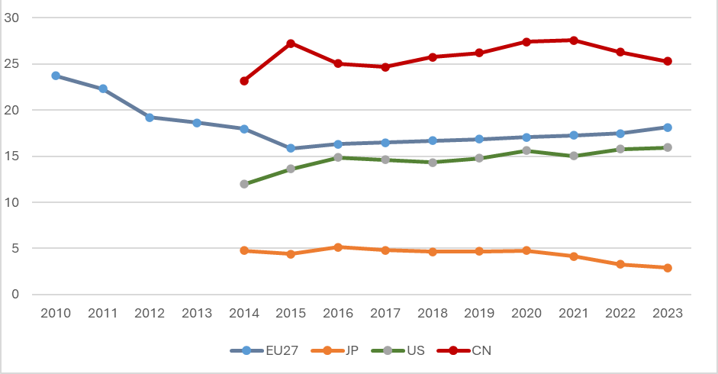
Source: Eurostat
Looking at the EU’s position in global construction exports, the EU maintains a relatively stable but slightly declining share over the period 2011–2024. The EU share decreased from 2.62% in 2011 to around 2.25% in 2024, representing a moderate decline of about 14% over the period. By contrast, China’s share increased significantly, rising from 1.9% in 2011 to nearly 3% in 2024, and surpassing the EU from 2016 onwards, reflecting the growing international presence of Chinese construction firms. This expansion coincides with the relative decline in the EU’s share of global construction exports. The United States also experienced a modest decline over the period, falling by around 14% from its initial level (see the figure below), , , .
Figure 11: Country share in global construction exports 2011-2024 [%]
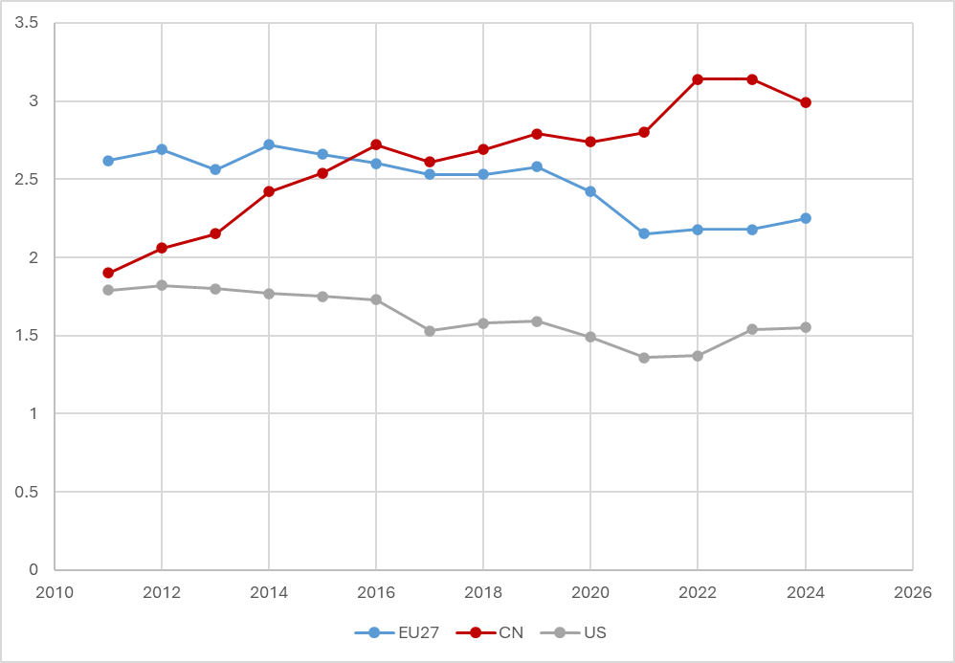
Source: Eurostat
            - Pharmaceutical sector
Key facts: 4 100 firms in 2024; 700 000 employees in 2024; 1.13% of EU GVA in 2023; GOR 75% in 2023; net turnover around EUR 500 billion in 2024; labour productivity EUR 290 875 per employee in 2023; 139% increase in sector turnover 2011-2024; labour productivity increased by about 96% between 2012 and 2023; 8 359 pharmaceutical patent applications filed at the European Patent Office in 2024 (31% from EU-27 applicants); 4% of all EU patent applications; pharmaceutical R&D expenditure EUR 52.4 billion in Europe (EU27+ other countries) in 2023; EU accounts for 22.2% of global pharmaceutical manufacturing output in 2023; EU share of global pharmaceutical exports 7.42% in 2023 (up from 5.13% in 2010).
Market Structure: in 2024, the pharmaceutical manufacturing sector in the EU27 comprised 4 100 firms, representing a notable increase from 3 659 firms in 2010, or approximately 12% growth over the period. A closer examination of the firm-size distribution shows that 37% of firms are small enterprises, 33% are medium-sized enterprises, and around 29% are large enterprises.
Employment in the sector increased even more substantially over the same period, rising from 498 127 employees in 2012 to 694 420 in 2024, representing an increase of approximately 39%. Examining how employment is distributed across firm sizes reveals a strong concentration in large firms. As illustrated in the figure below, 87% of employees work in large companies, while 10% are employed in medium-sized firms and only 3% in small or micro enterprises. This distribution indicates that while firms are relatively evenly spread across size classes, employment is highly concentrated in large pharmaceutical companies, reflecting the capital- and R&D-intensive nature of the sector.
Finally, the average number of employees per high-growth enterprise (HGE) in EU pharmaceutical manufacturing declined from approximately 12.9 employees in 2021 to about 10.9 in 2023. This suggests that high-growth firms in the sector tend to be relatively small enterprises expanding from the minimum size threshold.
Figure 12: Employment share by firm size, 2024 [%]
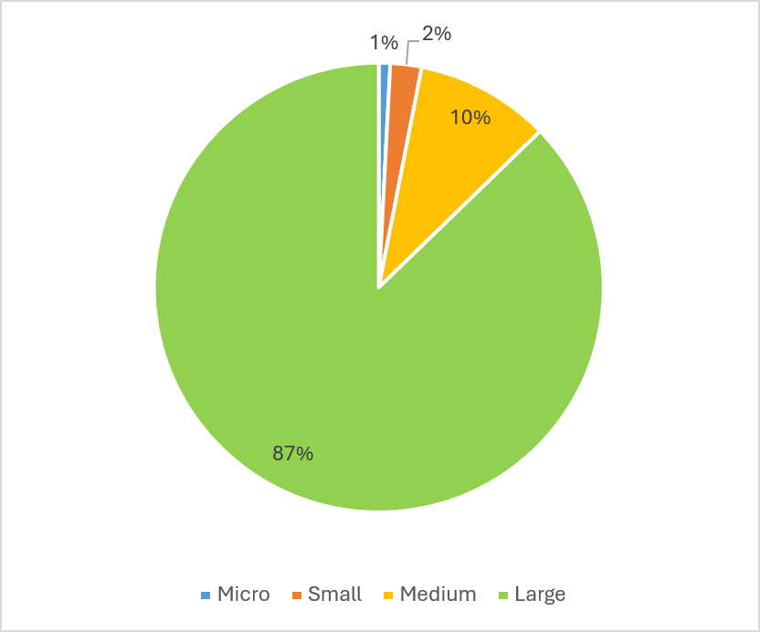
Source: Eurostat
In terms of economic contribution, the share of pharmaceutical manufacturing in total EU Gross Value Added (GVA) increased significantly between 2010 and 2023. Over this period, the sector’s contribution to EU GVA rose by approximately 26.18%, reaching around 1.13% of total EU GVA, indicating the growing economic importance of pharmaceutical production within the EU economy. As shown in the figure below, the EU recorded the strongest long-term increase in the sector’s share of GVA among major economies. By contrast, Japan saw a substantial decline (−20.35%) and China a smaller decline (−10.2%), while the United States recorded a more modest increase of +9.81% over the same period, .
Figure 13: Share in National Gross Value Added of C21 industry, 2010-2023 [%]
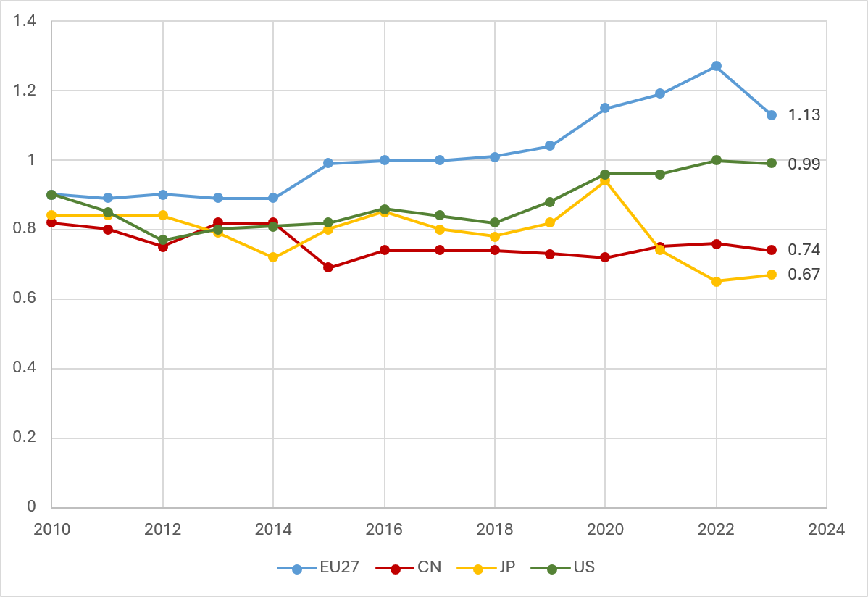
Source: Eurostat
Productivity and profitability of the sector: net turnover in EU pharmaceutical manufacturing increased from approximately EUR 205 billion in 2011 to around EUR 500 billion in 2024 (see the figure below), representing a sharp increase of nearly 139%, which reflects the strong expansion of the sector over the period. The manufacturing sector has experienced substantial expansion over the period, reflecting growing demand and increasing market value of pharmaceutical products.
Figure 14: Net turnover of C21 industry, 2011-2024 [million EUR]
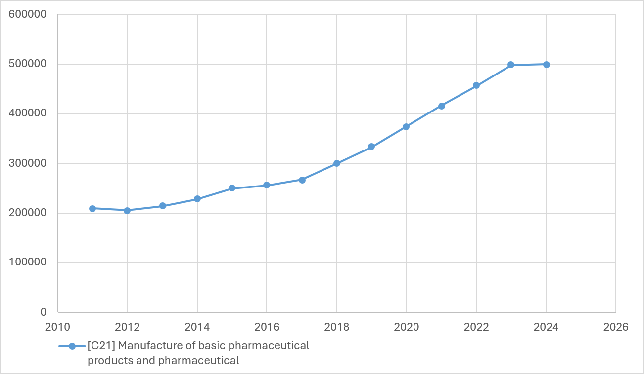
Source: Eurostat
Looking at operating profit margins (see the figure below), which can be approximated by the Gross Operating Rate (GOR), an indicator of sectoral profitability before depreciation, interest and taxes, around EUR 74.9 of operating surplus is generated for every EUR 100 of value added in the EU pharmaceutical sector in 2023. This represents a very high operating profit margin, which has increased moderately by about 9% between 2010 and 2023, suggesting that the sector has maintained strong profitability alongside its expansion in turnover and value added.
Figure 15: Gross Operating Rates of C21 industry, 2010-2023
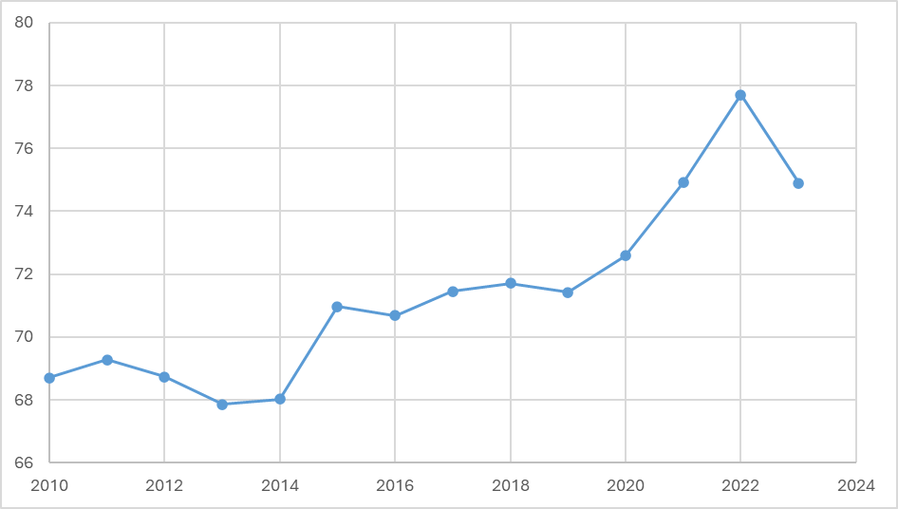
Source: Eurostat

Lastly, looking at labour productivity in EU pharmaceutical manufacturing has increased substantially over the period analysed. Between 2012 and 2023, productivity per employee rose from approximately EUR 146 783 to EUR 290 875, representing a sharp increase of about 96%. This indicates that the sector has significantly improved its ability to generate economic value per worker. This suggests a particularly strong rise in output or value added relative to employment. The increase also likely reflects the high value-added nature of pharmaceutical products, where an increase in patented medicines and specialised biologics generate significant economic value relative to the size of the workforce.
Innovation in the sector: in 2024, the total number of pharmaceutical patent applications filed with the European Patent Office (EPO) reached 8 359, of which 31% (2 589 applications) were submitted by EU27 companies. This represents an increase of 3 percentage points compared to 2023, when EU applicants accounted for 28% of pharmaceutical patent filings at the EPO. Pharmaceutical patents account for around 4% of all EU-27 patent applications and represent the eighth largest technological field in terms of total patent filings at the EPO. Within this field, several EU27 countries rank among the most active applicants at EPO, with Germany, France, the Netherlands, and Spain appearing in the top ten countries by number of pharmaceutical patent applications. This suggests a very notable level of innovation in the pharmaceutical industry.
It should be noted that the R&D expenditure figures in this paragraph refer to EFPIA member countries rather than the EU-27 alone as the data comes from EFPIA , covering the EU-27 as well as Norway, Switzerland, Iceland and the United Kingdom (and Serbia and Turkey). In 2023 Europe has spent EUR 52.4 billion on pharmaceutical R&D in comparison to EUR 38.64 billion euro spent in 2020, which represents around a 35.6% increase over the period. Over the same period US pharmaceutical R&D expenditure has slightly decreased by −1.4%.
International position of the sector: the EU’s share of global output in basic pharmaceutical products and pharmaceutical preparations remains high at 22.2% in 2023 (see the figure below). However, it has declined slightly since 2020, when the EU accounted for 22.5% of global output. Over the longer period, the EU share decreased by around 7% compared with 2010, when it stood at 23.9%. Part of this development can be attributed to the expansion of pharmaceutical manufacturing in China, whose global output share increased to 22.9% in 2023, placing it close to the EU. Over the same period, the United States’ share fluctuated but stabilised at around 21% by 2023. EU, China and the USA hold comparable shares of global pharmaceutical output, , , .
Figure 16: Country share in global pharmaceutical output (%) 2010-2023
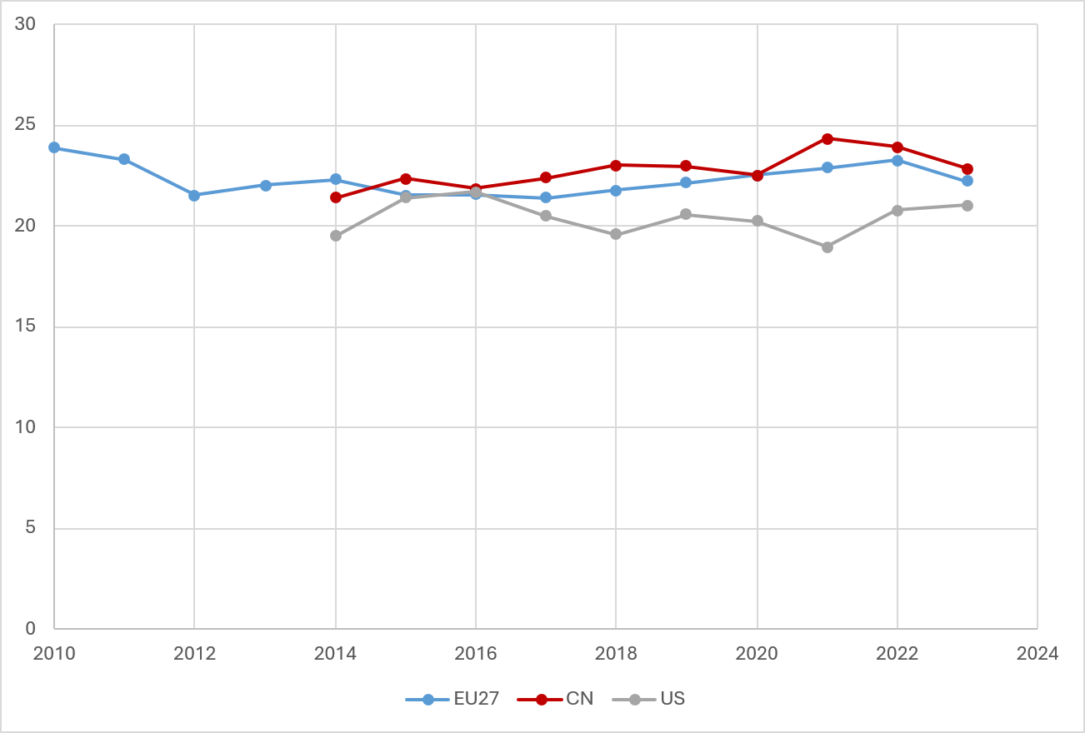
Source: Eurostat
The EU’s share of global exports of basic pharmaceutical products and pharmaceutical preparations has increased significantly over the period 2010-2023, rising from 5.13% to 7.42%, which corresponds to an increase of approximately 44.6% compared to the beginning of the timeline. Despite a small decline in most recent years, the EU remains the largest exporter among major economies considered, , , .
Over the same period (see the figure below), the US share fluctuated between roughly 3% and 4.5%, reaching 4.24% in 2023, while China’s share remained considerably lower, increasing from 1.14% to around 1.48% in 2023. Overall, the data shows that the EU has kept and even extended its lead as a leading global pharmaceutical exported over China and the US.
Figure 17: Country share in global pharmaceutical exports, 2011-2024 [%]
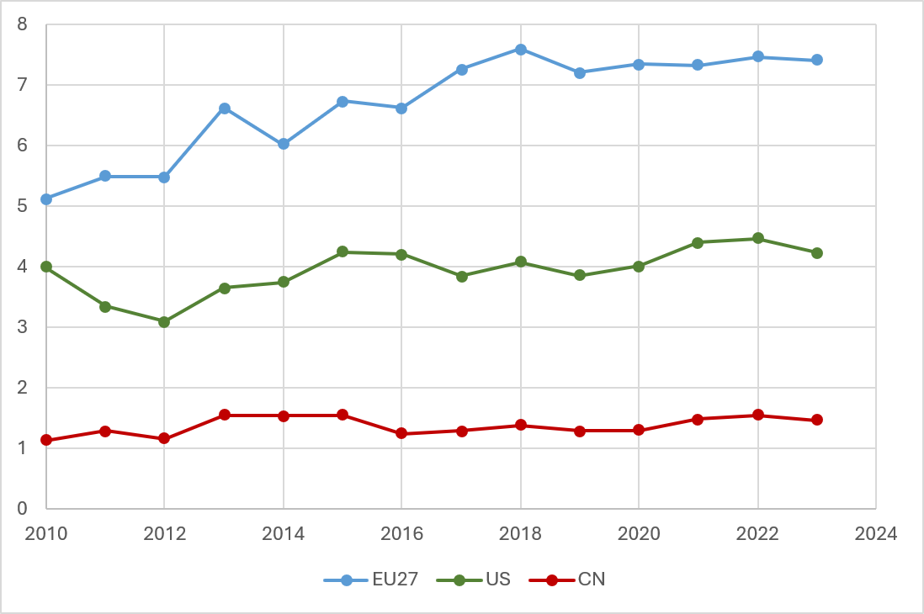
Source: Eurostat

Annex 6: SME check
Overview of impacts on SMEs
Relevance for SMEs
The initiative was considered relevant for SMEs by the SME Filter and the interservice group (ISG).

(1) Identification of affected businesses and assessment of relevance
Are SMEs directly affected? In which sectors?
Yes, SMEs are directly affected. Public procurement is a significant market for SMEs as direct contractors and subcontractors. SME shares of awarded contracts vary by sector: agriculture (83.5%), laboratory/optical/precision equipment (70.2%), office and computing machinery/equipment/supplies (68.8%), construction (63.5%), transport and food (66.2% each). SME shares are lower in IT services (51.5%), health and social work services (45%), and capital-intensive or infrastructure-based sectors such as public utilities (34.7%), petroleum products and energy (33.7%), collected and purified water (32.8%), postal/telecom (28.6%), and financial and insurance services (17.9%). For more details, see SILO 2026.
Estimated number of directly affected SMEs
In 2023, approximately 1.5% of SMEs obtained at least one public procurement contract at EU level (SILO, 2026), corresponding to around 390 thousand SMEs out of 25.8 million SMEs in the EU-27. However, the initiative is relevant not only for SMEs that win contracts, but also for SMEs participating as bidders in public procurement procedures. In 2017–2024, SMEs won 71% of above-threshold contracts, representing 55% of total value published on TED.
Estimated number of employees in directly affected SMEs
In 2023, SMEs winning public contracts accounted for around 2% of total SME employment, corresponding to approximately 1.8 million employees out of 88.7 million people employed by SMEs in EU non-financial business sector. Participation varies considerably across Member States and sectors (SILO, 2026).
Are SMEs indirectly affected? In which sectors? What is the estimated number of indirectly affected SMEs and employees?
Yes, SMEs indirectly affected. Given that public procurement represents around 15% of EU GDP, indirect effects may extend to several million SMEs and a sizeable share of SME employment in procurement-related markets through subcontracting and wider value chain participation, particularly across construction, infrastructure, ICT and service markets.

- Consultation of SME stakeholders
How has the input from the SME community been taken into consideration?
SME feedback has been considered to the maximum extent possible throughout the consultation process. Their feedback was collected via the Open Public Consultation, Call for Evidence, SME Panel consultation, a meeting with the SME Envoy Network, and bilateral meetings.
Are SMEs’ views different from those of large businesses?
Yes and no, depending on the issue in question. The Open Public Consultation shows that SMEs and large companies generally agree on the overall objectives of the new public procurement framework, but differ in their priorities, intensity of support, and expected impacts, particularly in relation to simplification, digitalisation, and green, social, and innovation procurement.

- Assessment of impacts on SMEs
What are the estimated direct costs for SMEs of the preferred policy option?
Qualitative assessment
Award criteria: Limiting the dominance of price in award decisions generally increases SME access, though effects differ by sector. The use of the lowest-price criterion increases the probability that a contract is awarded to an SME in LSLI activities. On the contrary, in non-LSLI activities it is associated with a reduction in SME award probabilities. Sustainability and innovation award criteria do not affect SME access uniformly and appear especially challenging for SMEs in LSLI activities.
Subcontracting: In non-LSLI activities, contracts that are likely to be subcontracted tend to increase SMEs’ chances of winning. In contrast, in LSLI sectors, subcontracting is associated with a slight decrease in the likelihood that SMEs secure the contract.
Division of contracts into lots: Dividing contracts into lots is consistently associated with higher SME participation in LSLI activities, while it has little or no impact in non-LSLI sectors.
Quantitative assessment
Strategic procurement - use of lowest-price criterion: The results of the quantitative assessment indicate that the effects of price-based versus quality-based criteria are sector-specific and closely linked to underlying cost structures and delivery models.
Strategic procurement - mandatory non-price criteria with comply or explain (≤30% price weight): The findings suggest that strengthening non-price criteria can be associated with improved SME access in both LSLI and non-LSLI sectors.
Social procurement - cap price criteria for labour-intensive services (≤50% Price weight): Limiting the weight of the price criterion to below 50% is associated with higher SME award probabilities in both LSLI and non-LSLI sectors.
Inclusion of environmental (green) award criteria: The results suggest that environmental criteria have limited effects in non-LSLI activities, while in LSLI their introduction is associated with a more pronounced reduction in SME award probabilities.
Inclusion of social award criteria: The inclusion of social award criteria is associated with lower SME award probabilities in both sectors, with a stronger effect in labour-intensive activities.
Procurement of innovative solutions: The effects of innovation-oriented procurement instruments on SME access are strongly sector-dependent, with particularly strong negative associations for SMEs in labour-intensive sectors when innovation requirements are applied at the award stage.
Subcontracting (social procurement) – prohibition of 100% subcontracting and mandatory transparency: The findings indicate that subcontracting plays different roles across sectoral contexts: it is associated with improved SME access in non-LSLI sectors, while in labour-intensive sectors it is linked to a modest reduction in the likelihood of SMEs acting as main contractors.
Division of contracts into lots: Dividing contracts into lots is associated with a substantial improvement in SMEs’ access in LSLI sectors, while it makes virtually no difference in non-LSLI sectors.
What are the estimated direct benefits/cost savings for SMEs of the preferred policy option?
Qualitative assessment
Costs and benefits are analysed jointly in the above part of section 3, as they are often closely interlinked: measures that reduce costs for SMEs may simultaneously generate efficiency gains or improved market access. For clarity, the analysis distinguishes quantitative and qualitative impacts.
Quantitative assessment
As above.
What are the indirect impacts of this initiative on SMEs?
Overall, the revision of the Public Procurement Directives is expected to generate positive indirect impacts on SMEs, in terms of reduction of administrative burdens and higher SME participation in public procurement.
The revision may also enable SMEs to shift resources away from time-consuming administrative formalities and compliance obligations, allowing them to focus on the preparation of higher-quality tenders. This reallocation could enhance their competitiveness and improve their chances of winning contracts, effectively transforming compliance effort into strategic business development and value creation.
Finally, clearer, more proportionate and transparent procedures are likely to strengthen trust of economic operators, particularly SMEs, in public authorities.

(4) Minimising negative impacts on SMEs
Are SMEs disproportionately affected compared to large companies? If yes, are there any specific subgroups of SMEs more exposed than others?
We consider that SMEs are not disproportionately affected by the initiative compared to large companies for the reasons explained below.
Have mitigating measures been included in the preferred option/proposal? Yes
The preferred policy option has been designed with SMEs in mind. While certain measures, such as those aiming to incentivise green, social and innovation-related considerations, may entail additional compliance efforts, they were designed in a way to provide public buyers with enough flexibility to adapt to the market. The initiative also includes further elements aimed at facilitating SME participation. For instance, the introduction of a single-entry point to participate in public procurement procedures across the EU, together with the application of the “once-only” principle, is expected to reduce administrative burdens on economic operators, especially SMEs. In addition, the dynamic procedure aims to remove important barriers to SME participation, notably by simplifying selection requirements and reducing administrative steps in the procurement process.

The preferred policy option in the proposal has been designed with SMEs in mind. For example, using a single-entry point to participate in all public procurement procedures across EU, together with reduced reporting burden (once only principle), will facilitate SMEs participation. In addition, the dynamic procedure will remove important barriers for SME participation such as selection criteria and burdensome administrative procedure

Contribution to the 35% burden reduction target for SMEs
Are there any administrative cost savings relevant for the 35% burden reduction target for SMEs?
Savings in administrative costs (annualised present value) :
Administrative cost reductions due to:
Flexibility and simplification (FLX.2): EUR 166 * 71% SMEs = EUR 118 million.
Further implementation of digital technologies to improve procurement processes (MPL.1): EUR 881 million * 71% of contracts won by SMEs = EUR 626 million.
New administrative costs (annualised present value):
BPQR recurrent administrative costs: EUR 457` million * 71% of contracts won by SMEs = 325 million.
EU Ecolabel recurrent administrative costs: EUR 12 million * 57% of Ecolabel licence holders are SMEs = EUR 7 million.
EU Ecolabel one-off administrative costs: EUR 1.14 million * 57% of Ecolabel licence holders are SMEs = EUR 0.6 million.
BEU recurrent administrative costs: EUR 7.4 million * 71% of contracts won by SMEs = EUR 5 million.
Additional information
n.a.

Analysis of SMEs participation
In the SME consultation, SMEs further highlight their concerns: only 54.6% of respondents perceive benefits from allowing contracting authorities to reward companies with collective agreements in place, with a relatively high share expressing uncertainty. Additionally, nearly half (49.1%) anticipate a rise in costs from such a requirement, underscoring the practical burdens it would impose on smaller businesses
Public procurement represents a potentially significant market for SMEs, both as direct contractors and indirectly, for example as subcontractors. SME participation in public procurement varies significantly across sectors. SME shares are particularly high in activities that tend to involve relatively standardised outputs and a strong local or regional dimension. This is especially visible in agricultural and related services, where SMEs win more than four out of five contracts (83.5%). SME shares are also very high in several specialised and more knowledge-intensive sectors, including laboratory, optical and precision equipment (70.2%) and office and computing machinery, equipment and supplies (68.8%), suggesting that SMEs are frequently successful in awards that require technical capabilities. More details on the rate of contracts awarded to SMEs are provided in the study by SILO (2026).
In core public procurement sectors, such as construction works, SMEs win 63.5% of the contracts awarded. Similarly, SME shares are high in transport services (66.2%) and in food (66.2%). By contrast, SME shares are lower in IT services (51.5%) as well as in health and social work services (45%).
In addition, SME shares are much lower in sectors linked to capital-intensive or infrastructure-based markets. SMEs win 17.9% of contracts in financial and insurance services, 28.6% in postal and telecommunications services, 32.8% in collected and purified water, 33.7% in petroleum products and energy, and 34.7% in public utilities. These are areas where scale, regulation, or infrastructure constraints often make it harder for smaller suppliers
Given that public procurement represents around 15% of EU GDP and that subcontracting is particularly prevalent in construction, infrastructure, ICT and service contracts, indirect effects may extend to several million SMEs and a sizeable share of SME employment in procurement-related markets.
Beyond subcontracting, many SMEs also participate as suppliers within wider value chains and supply networks, providing intermediate goods, specialised services, components and inputs to main contractors. The initiative is therefore likely to have broad ripple effects across SME value chains, beyond direct contract holders.
            - Consultation of SME stakeholders
SMEs’ feedback has been taken into account to the maximum extent possible throughout the consultation process. Input received from SME representatives, business associations and individual companies was carefully analysed and, wherever possible, reflected in the impact assessment and policy design. Concretely, SME feedback was mainly collected via the Open Public Consultation (see Annex 2 and 9), Call for Evidence, SME Panel consultation (See Annex 6, Analysis of SMEs participation for a summary), a meeting with the SME Envoy Network, and bilateral meetings with SMEs and representative organisations.
Particular attention was given to concerns frequently raised by SMEs, such as administrative burden, proportionality of selection criteria, division into lots, and the use of digital tools. Where feasible and consistent with broader policy objectives, proposals have been adjusted to address these issues, with a view to improving SME participation, simplifying procedures, and ensuring a more level playing field in public procurement markets.
            - Open public consultation – Main findings
The findings of the open public consultation generally show SMEs’ support for moving beyond lowest-price criterion toward approaches incentivising quality and broader non-price criteria.
As to the European preference, EU SMEs strongly favour prioritising European goods and services in the public procurement process, especially through greater use of non-price criteria, while emphasising the need to avoid additional administrative burden.
Regarding to procedures and procurement practices, SMEs highlighted simplifying rules for forming consortia and introducing EU-level targets for SME participation as key measures to improve SME access. There was somewhat less support for encouraging the division of contracts into lots. Additional priorities included increasing flexibility for contract modifications, facilitating dialogue with the market, and enabling the re-use of bidder documentation (once-only principle), and interconnection of existing Member States’ eProcurement services. Faster payments to contractors were identified as the measure with the greatest potential to improve implementation and contract management, while direct payments to subcontractors, increased pre-financing, and clearer rules for the post-award phase received more moderate support.
On sustainability, SMEs support incentivising green public procurement through a clear legal definition, though backing for increased use of standards is more moderate. In social procurement, most favour maintaining the current framework, with limited support for additional measures such as incentives linked to subcontracting, collective agreements, or non-binding targets, or for relaxing the “link to the subject matter” requirement. Likewise, there was limited support for restricting subcontracting tiers in sectors at high risk of labour rights violations or for prohibiting the subcontracting of an entire contract to a single subcontractor. By contrast, SMEs expressed very strong support for strengthening innovation procurement incentives and were the strongest supporters of making innovation procurement mandatory.
            - Call for Evidence and bilateral meetings – Main findings
Regarding digitalisation, recurrent issues were related to limited visibility of procurement opportunities, fragmented eProcurement platforms across Member States, and lack of interoperability between national platforms. To address these issues, some of the measures suggested by stakeholders included the creation of a single entry point for all tenders (above and below-threshold); real-time notifications for SME-relevant tenders; and expanding use of self-declarations and minimising demands for documentation evidence.
On simplification and procedures, stakeholders pointed to excessive administrative burdens, including repetitive submission of documents across multiple procedures. Several emphasised that complex qualification and selection criteria create structural barriers for SMEs. Others underlined that contracting authorities may lack sufficient knowledge of market capacity, which can result in disproportionate requirements or limited competition. At the same time, some suggested pre-market consultations prior to the publication of calls for tender, to better assess market capacity and design proportionate requirements. For example, in France public buyers use sourcing practices during the preparatory phase of the procurement process, where relevant. This approach aims to improve the understanding of the market without imposing formal constraints, so that buyers can refine their market knowledge and respond more effectively to their needs, while complying with competition rules.
Views on European preference vary, with some stakeholders arguing that it should be only limited to certain strategic sectors (e.g. security), whereas others expressing broader support for its application, provided that sectors, consequences and requirements are clearly defined. Some respondents pointed to the risk of increasing administrative costs for EU bidders due to additional documentation requirements to demonstrate compliance. Others advocated for mandatory European preference criteria in public procurement for digital technologies.
As to financial barriers, respondents highlighted two key issues, namely disproportionate financial guarantees and late payment. One of the stakeholders emphasised that “the revision should also speed up payments from public authorities to contractors, especially SMEs. While there are considerable differences across sectors, public contracting authorities must lead by example”. Some countries have put in place measures aim to reduce financial risks for smaller operators and improve their capacity to participate in public procurement, such as a system of advance payment for SMEs adopted by France.
Many respondents underlined the division of contracts into lots as essential to facilitate SME participation, calling for strengthening of the current rules. In that regard, some proposed to adopt a ‘divide-or-explain' mechanism, whereby contracting authorities should justify any decision not to divide a contract into lots. In addition, they noted that the creation of bidder consortia should be simplified, especially for SMEs.
Regarding green, social and innovation public procurement, respondents generally agreed that the revised legal framework should integrate strategic objectives such as climate action, environmental sustainability, social inclusion, and innovation into public procurement. At the same time, they stressed that these criteria should be applied carefully to avoid discrimination, protect competitiveness, prevent market distortions, and limit administrative burdens, particularly for SMEs. Some respondents supported the use of the "Most Economically Advantageous Tender" (MEAT) criteria prioritising quality, sustainability, and innovation over price. Others warned against mandatory sustainability-related requirements as they would lead to higher compliance costs for SMEs. Many emphasized that these requirements should be directly linked to the subject matter of the contract and not reflect a company’s overall sustainability profile, ensuring procurement opportunities without introducing disproportionate obligations.
Finally, professionalisation of contracting authorities and economic operators, through enhanced training and the dissemination of best practices, also emerged as a key priority.
The Open Public Consultation shows that SMEs and large companies generally agree on the overall objectives of the new public procurement framework, but differ in their priorities, intensity of support, and expected impacts, particularly in relation to simplification, digitalisation, and green, social, and innovation procurement.
            - Simplification
The findings reveal a high degree of convergence between SMEs and large companies, while also highlighting important differences in intensity of support and implications. For example, increasing flexibility in contract modifications and facilitating dialogue with the market emerge as leading priorities for both SMEs and large companies. However, large companies express markedly stronger support for these measures, with very high endorsement rates (89% for both measures), compared with SMEs (52% for flexibility and 47% for dialogue with the market).
A similar pattern can be observed in the context of joint procurement. Both SMEs and large companies consider increasing flexibility in setting the duration of framework agreements to have the highest simplification potential in this area. However, large companies show a higher level of support (68%) compared with SMEs (31%).
When considering measures specifically designed to support SMEs, both groups rank simplifying the rules for forming consortia as having the highest potential, although this is supported by a larger share of SMEs (78%) in respect to large companies (56%). Views diverge significantly regarding EU-level targets for SME participation in public procurement, which are supported by 78% of SMEs but only 24% of large companies. Also, encouraging the division of contracts into lots is backed by 48% of SMEs compared to 27% of large companies.
In the area of implementation and contract management, both SMEs and large companies identify speeding up payments to contractors, especially SMEs, as the measure with the greatest potential to improve contract performance. Support is stronger among SMEs (80%), compared to 36% among large companies. Other measures show some convergence in views, such as establishing rules for direct payments to subcontractors (33% of SMEs vs. 29% of large companies) but also clear divergences, such as increasing the use of pre-financing (37% of SMEs vs. 23% of large companies), and establishing clearer rules for the post-award phase, including contract implementation (40% of SMEs vs. 32% of large companies).
            - Digitalisation and transparency
When asked about a digital public procurement marketplace with a single entry point, SMEs and large companies showed different attitudes. Only 18% of SMEs opposed the idea, compared to 30% of large companies. SMEs also showed stronger support for interconnecting existing Member States’ eProcurement services (alone or alongside a central platform), with 69% in favour versus 51% of large companies.
            - Green, social and public procurement of innovation
In the area of green, social and innovation procurement, SMEs and large companies differ significantly under several aspects. In terms of strengthening quality criteria in public procurement, a strong 93% of SMEs support minimum quality requirements in technical specifications (with a comply-or-explain mechanism), versus 68% of large companies; 89% of SMEs favour changes to the current contract award criteria practice based on the most economically advantageous tender (MEAT), compared to 59% of large companies.
            - Green public procurement
Divergences between SMEs and large companies on green public procurement emerge in both intensity and priorities. Large companies show stronger overall support for EU incentives (78% vs. 60% of SMEs). Among respondents in favour of further incentives (“agree” or “strongly agree”), large companies show stronger support for a clear legal definition of green public procurement (60% vs. 49% of SMEs). They also prioritise easier use of environmental labels (50%) and green standards (47%), whereas SMEs show more moderate support for standards (33%). Conversely, among respondents supporting more regulatory measures (“agree” or “strongly agree”), SMEs favour mandatory product-specific environmental requirements (38% vs. 29% of large companies) and mandatory targets (33% vs. 24%).
            - Socially responsible public procurement
Socially responsible public procurement diverges markedly between SMEs and large companies. Over half of large companies support introducing additional incentives, whereas a majority of SMEs (58%) prefer maintaining the current framework5. Among those in favour of further incentives (“agree” or “strongly agree”), when it comes to relaxing the “link to the subject matter” principle, 32% of large companies support softening this rule to allow consideration of companies’ overall social policies, but only 12% of SMEs do. Allowing collective agreements to be used as an award criterion is supported by 15% of large companies and 26% of SMEs.
Furthermore, SMEs show stronger backing for making social measures mandatory than large companies: among SMEs that “agree” or “strongly agree”, 35% support banning price-only award criteria in low-skilled labour-intensive sectors (vs. 10% of large companies), 35% favour mandating socially responsible procurement targets (vs. 17% of large companies), 23% support limiting subcontracting tiers in sectors at high risk of labour rights violations (vs. 9% of large companies), and 20% would prohibit subcontracting an entire contract to a single subcontractor (vs. 11% of large companies).
Regarding impacts, among respondents that indicated "very likely" or "somewhat likely" answers, large companies are more optimistic about social benefits than SMEs, with 82% expecting improved working conditions (vs. 55% of SMEs), 69% reducing risk of breaches of labour and social law (vs. 51% of SMEs), 67% contributing to poverty reduction and increased social inclusion (vs. 49% of SMEs). SMEs, in contrast, are more concerned about economic burdens: 80% foresee higher prices of products/services/works, 71% foresee greater administrative burdens for EU businesses, and only 29% expect increased SME participation under incentive-based measures. Under mandatory obligations, SMEs’ expectation of increased participation rises to 39%.
            - Public procurement of innovation
Among respondents who “agree” or “strongly agree” that EU public procurement law should further incentivise innovation, SMEs were less supportive than large companies of procedural and legal measures, such as: simplification of procedures including innovation partnerships or competitive dialogue (49% of SMEs vs. 69% of large companies), a clear definition of innovation procurement (34% of SMEs vs. 51% of large companies), and the introduction of a “comply or explain” mechanism to encourage preliminary market consultations when buying innovative solutions, to limit excessive financial guarantees, or to allow suppliers to retain Intellectual Property Rights (26% of SMEs vs. 37% of large companies). Conversely, regarding mandatory elements, SMEs favoured limiting excessive financial guarantees more than large companies (21% vs. 12%).
Expectations regarding the effects of mandatory innovation procurement also diverged. Among respondents indicating "very likely" or "somewhat likely", 81% of SMEs expect improved quality of products/services/works (vs. 66% of large companies). In contrast, large companies are more concerned about costs and administrative burden, with 61% expecting higher costs for EU bidders (versus 41% of SMEs) and 67% expecting greater administrative burden (versus 51% of SMEs).
            - Award criteria
Limiting the dominance of price in award decisions generally increases SME access, though effects differ by sector. The SME study (2026) observed that the use of the lowest-price criterion increases the probability that a contract is awarded to an SME in Low-Skilled Labour-Intensive (LSLI) activities. On the contrary, in non-LSLI activities it is associated with a reduction in SME award probabilities. According to the study, sustainability and innovation award criteria do not affect SME access uniformly and appear especially challenging for SMEs in LSLI activities. Environmental criteria significantly lower the probability of SME awards in LSLI activities but have little or no effect in non-LSLI activities. Similarly, innovation criteria show a marked reduction in SME access in LSLI activities and only marginal effects in non-LSLI activities. Social criteria are linked to lower SME participation in both activities, with a stronger negative impact in LSLI ones.
According to the SME Panel consultation the respondents expect the preferred policy option to deliver qualitative benefits rather than direct cost savings. The wider use of the Best Price–Quality Ratio (BPQR) is strongly supported, even though many respondents anticipate moderate additional preparation or compliance costs.
In contrast, environmental and social compliance-related measures - such as mandatory environmental requirements or proof through labels - are more frequently associated with higher expected costs and a more balanced assessment of benefits, suggesting that while SMEs recognise their policy objectives, they remain cautious about additional administrative and financial burdens.
            - Subcontracting
The SME study (2026) finds that subcontracting plays different roles across procurement markets. In non-LSLI activities, contracts that are likely to be subcontracted tend to increase SMEs’ chances of winning. In contrast, in LSLI sectors, subcontracting is associated with a slight decrease in the likelihood that SMEs secure the contract. This may reflect the fact that in LSLI activities subcontracting is more often linked to procurement structures in which SMEs are less likely to act as main contractors.
In the SME Panel consultation, the potential limiting subcontracting beyond a certain tier in sectors at high risk of labor rights violations received a more mixed assessment. While just over half of respondents considered the measure beneficial, it was also associated with moderate expected costs and a comparatively higher share of uncertainty, indicating a balanced but cautious perception among SMEs regarding its practical implications.
            - Division of contracts into lots
The SME study (2026) finds that dividing contracts into lots is consistently associated with higher SME participation in LSLI activities, while it has little or no impact in non-LSLI sectors. Dividing contracts into lots is generally associated with higher SME participation, particularly in labour-intensive and locally oriented markets. This suggests that breaking contracts into smaller parts is particularly effective in improving SME access in activities that can be naturally split into smaller, relatively independent tasks (e.g. cleaning, maintenance, routine services, construction subcomponents).
In the SME Panel consultation, the division of contracts into lots received broad support in the consultation, with around 70% of respondents assessing it as very highly, highly or moderately beneficial.
            - Procurement of innovative solutions
In the SME Panel consultation, innovation-related measures display a favourable cost–benefit profile. Around two thirds of respondents (66.7%) assessed the introduction of a specific procedure allowing direct purchases from start-ups as beneficial, while approximately 63% supported the establishment of an EU/EEA innovation platform; at the same time, expected cost implications were comparatively lower than for environmental or social compliance measures (around 43.5% and 38.9% respectively anticipating at least moderate costs).
            - Quantitative assessment
Strategic procurement - use of lowest-price criterion: The impact of award criteria on SME access varies across sectors. In non-LSLI sectors, the use of criteria other than lowest price is associated with a higher predicted probability of SME award (around 60.2%), while reliance on lowest price reduces this probability to approximately 54.1% (-6 p.p.). In LSLI sectors, the opposite pattern emerges: applying the lowest-price criterion increases the predicted probability of SME award from about 54.4% to 56.9% (+2.5 p.p.). These results indicate that the effects of price-based versus quality-based criteria are sector-specific and closely linked to underlying cost structures and delivery models.
Strategic procurement - mandatory non-price criteria with comply or explain ≤30% price weight: reducing the weight of price in award decisions to below 20% (i.e. increasing the relative importance of non-price criteria) is associated with higher SME award probabilities across sectors. In non-LSLI sectors, the predicted probability of SME award increases from approximately 57.1% to 61.7% (+4.6 p.p.). In LSLI sectors, the corresponding probability rises from around 54.5% to 57.5% (+3.0 p.p.). These results suggest that strengthening non-price criteria can be associated with improved SME access in both sectoral contexts.
Social procurement - cap price criteria for labour-intensive services at (≤50% Price weight): limiting the weight of the price criterion to below 50% is associated with higher SME award probabilities in both sectoral contexts. In non-LSLI sectors, the predicted probability of SME award increases from approximately 56.7% to 60.5% (+3.9 p.p.) when price is not dominant. In LSLI sectors, a similar effect is observed, with the probability rising from around 54.3% to 58.2% (+3.9 p.p.). These findings indicate that reducing the dominance of price in award decisions may support SME access across different types of activities.
Inclusion of environmental (green) award criteria: the impact of environmental award criteria on SME access differs significantly across sectors. In non-LSLI sectors, the inclusion of environmental criteria is associated with only a marginal change in SME award probability, declining slightly from approximately 57.2% to 56.8% (-0.4 p.p.). In contrast, in LSLI sectors, the introduction of environmental criteria is associated with a more pronounced reduction in SME access: the predicted probability of SME award decreases from around 54.6% to 49.6% (-5.0 p.p.). These results suggest that while environmental criteria have limited effects in non-LSLI activities, but may create proportionately greater constraints for SMEs in labour-intensive sectors.
Inclusion of social award criteria: the inclusion of social award criteria is associated with lower SME award probabilities in both sectoral contexts, with a stronger effect in labour-intensive activities. In non-LSLI sectors, the predicted probability of SME award declines from approximately 57.2% to 55.8% (-1.4 p.p.) when social criteria are applied. In LSLI sectors, the reduction is more pronounced, with the probability decreasing from around 54.5% to 51.2% (-3.4 p.p.). These findings suggest that while social criteria may support broader policy objectives, their design and implementation may entail greater constraints for SMEs, particularly in low-skilled labour-intensive sectors.
Procurement of innovative solutions: the effects of innovation-oriented procurement instruments on SME access are strongly sector-dependent. In non-LSLI sectors, the use of the Innovative Partnership procedure is associated with a marked reduction in SME award probabilities. The predicted probability declines from approximately 57.2% to 46.6% (-10.6 p.p.) when this procedure is applied. In contrast, in LSLI sectors, its use is associated with a slight increase in SME access, with the probability rising from around 54.5% to 56.4% (+1.9 p.p.). A similarly differentiated pattern emerges for innovation-related award criteria. In non-LSLI sectors, their inclusion is associated with only a marginal increase in SME award probability (from 57.2% to 58.1%, +0.9 p.p.). In LSLI sectors, however, innovation criteria are linked to a substantial reduction in SME access, with the predicted probability falling from approximately 54.6% to 42.7% (-11.9 p.p.). Overall, these findings indicate that innovation pursued through specific procedures and innovation embedded in award criteria generate distinct and context-dependent effects, with particularly strong negative associations for SMEs in labour-intensive sectors when innovation requirements are applied at the award stage.
Subcontracting (social procurement): prohibition of 100% subcontracting and mandatory transparency: the association between subcontracting arrangements and SME access varies across sectors. In non-LSLI sectors, contracts not involving subcontracting show a predicted SME award probability of approximately 57.0%. Where subcontracting is expected, this probability increases to around 60.9% (+3.9 p.p.), suggesting that subcontracting can facilitate SME participation in these markets. In LSLI sectors, the pattern differs. When subcontracting is not foreseen, the predicted probability of SME award is about 54.8%, declining slightly to around 53.6% (-1.2 p.p.) when subcontracting is expected. These findings indicate that subcontracting plays different roles across sectoral contexts: it is associated with improved SME access in non-LSLI activities, while in labour-intensive sectors it is linked to a modest reduction in the likelihood of SMEs acting as main contractors.
Division of contracts into lots: in non-LSLI sectors, the predicted probability that an SME wins a contract is 57.4% when the contract is not divided into lots, and 57.1% when it is divided into several lots. This represents a very small decrease of around 0.2 percentage points, indicating that lotting is not meaningfully associated with SMEs’ access in these sectors. In LSLI sectors, the pattern is markedly different. When contracts are not divided into lots, the predicted probability of an SME award is about 51.3%. When the contract is divided into more than one lot, this probability increases to around 56.8%, corresponding to an increase of approximately 5.5 percentage points. Consequently, dividing contracts into lots is associated with a substantial improvement in SMEs’ access in LSLI sectors, while it makes virtually no difference in non-LSLI sectors. This indicates that contract lotting plays a particularly important role for SMEs in low-skilled labour-intensive activities.
            - Qualitative assessment - Indirect impacts of this initiative on SMEs
The revision of the Public Procurement Directives is expected to generate positive indirect impacts on SMEs. Simplified procedures are likely to lower the time and cost needed to prepare tenders, including legal advisory expenses, while reducing the risk of exclusion due to formal errors. Together with digital solutions such as the once-only principle and the single entry portal, these measures should decrease administrative burdens and encourage more SMEs to participate in public procurement.
More proportionate guarantees and simplified financial requirements are expected to reduce financial vulnerability and improve the resilience of SMEs engaged in public contracts. Also, limits to excessive subcontracting chains are expected to encourage direct participation, so that SMEs may increasingly compete as prime contractors rather than remain dependent on large intermediaries, enabling greater autonomy. Increased SME participation may in turn contribute to more resilient and locally anchored supply chains, given that SMEs often operate with production resources based in the EU or neighbouring regions. This would also have a positive effect on employment in Europe.
The revision may also enable SMEs to shift resources away from time-consuming administrative formalities and compliance obligations, allowing them to focus on the preparation of higher-quality tenders. This reallocation could enhance their competitiveness and improve their chances of winning contracts, effectively transforming compliance effort into strategic business development and value creation.
Finally, clearer, more proportionate and transparent procedures are likely to strengthen trust of economic operators, particularly SMEs, in public authorities.
Overall, the revision is expected to lead to increased and diversified competition with more SME participation. Ultimately, this would lead to better value for money in public procurement.

Summary on the SME Panel consultation on the
Impact Assessment of the Public Procurement Directives
About the respondents
The SME panel consultation received 108 replies from SMEs of varying sizes and nationalities. Nearly half of all replies were submitted by micro-sized enterprises (1–9 employees), accounting for 49% (53). Small enterprises (10–49 employees) represented 22% (24) of respondents. Single-person businesses and medium-sized enterprises (50–249 employees) each accounted for 13% (14 replies each). Mid-cap companies (250–749 employees) were minimally represented, with only three replies.
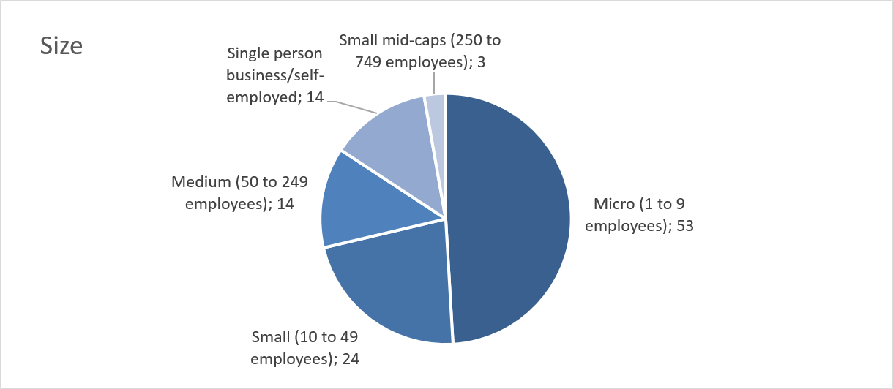
The 108 replies to the SME panel consultation were geographically diverse, with contributions received from both EU Member States and non-EU countries, however the participation was nevertheless concentrated in a limited number of countries. Portugal accounted for the highest number of replies (17), followed by Romania (15) and Greece (13). Poland contributed eleven replies. Belgium, Hungary, Turkey and Italy were each represented by nine respondents, while Bulgaria accounted for eight replies. Spain submitted four replies. Estonia contributed two responses, and Ireland and Ukraine were each represented by one respondent.
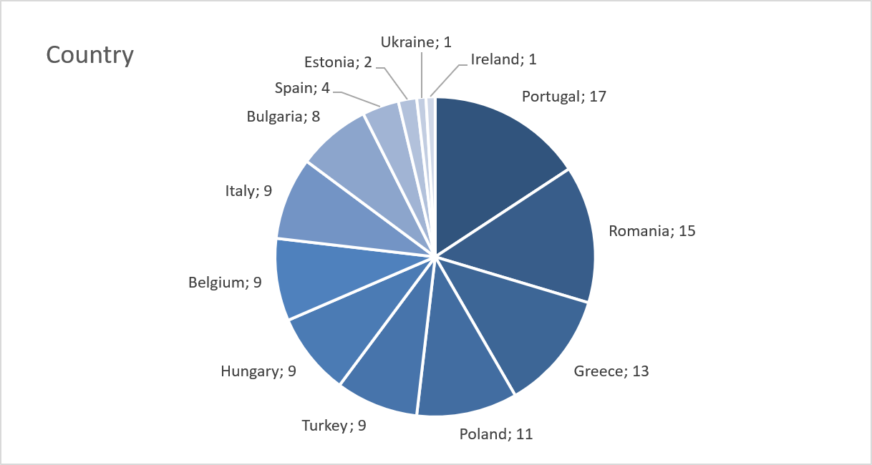

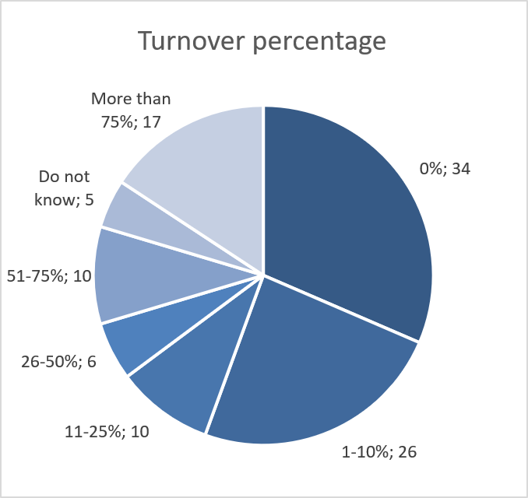
When asked what percentage of their annual turnover comes from public procurement contracts, the largest group of respondents (34) indicated 0%. A further 26 respondents reported a share of 1–10%. At the other end of the spectrum, 17 respondents stated that more than 75% of their turnover derives from public procurement, indicating a high level of dependency among a subset of companies. Smaller numbers reported shares of 11–25% (10), 26–50% (6), and 51–75% (10).

Respondents were fu rther asked about the average value of public procurement contracts for which their business bids. The largest group (26 replies) indicated contracts below €10 000. A further twenty respondents reported bidding for contracts between €10 000 and €50 000. Eight respondents indicated an average contract value of €51 000–€140 000. Seventeen respondents typically bid for contracts valued between €141 000 and €1 000 000, while ten reported bidding for contracts exceeding €1 000 000.

Findings of the SME Panel consultation
Potentially burdensome aspects for SMEs when participating in public procurement

When combining responses indicating that particular aspects are very highly, highly or moderately burdensome, administrative requirements clearly emerge as the most challenging elements of participation. Time required to prepare bids is perceived as burdensome by 74.0% (80 replies) of respondents, while 69.4% (75 replies) report the Documentation requirements as at least moderately burdensome.
Short deadlines (67.6%: 73 replies) and Financial guarantees (66.7%: 72 replies) are also widely considered burdensome with the Selection criteria (64.9%: 70 replies) following. Award criteria and Late payment with same result (62.0% ;67 replies each) similarly present a significant challenge.
By contrast, Language barriers (35.2%: 38 replies) and the use of eProcurement platforms (45.4%: 49 replies) are less frequently perceived as burdensome compared to other aspects. Language barriers even marked as not burdensome at all by 28.7% (31) of respondents.
With regards to language barriers it is worth mentioning that 82 out of the total 108 respondents stated that they participate in public procurement procedures only in their home country.
Overall, the results indicate that procedural complexity, preparation time and financial requirements constitute the most significant obstacles to SME participation in public procurement.
Digitalisation and Transparency

Regarding the eProcurement platforms, using a single entry point to participate in all public procurement procedures across the EU was perceived as potentially very highly beneficial by 51 respondents, highly beneficial by 26 and moderately beneficial by 16 respondents. This suggests that 93 out of 108 respondents would welcome to be able to use a single entry point to participate in all public procurement procedures across the EU.

The respondents were further asked how likely would introducing this tool encourage them to participate in the public procurement procedures in their home countries and other EU Member states. In both cases a clear majority of respondents indicate that such a tool would encourage them to participate more often. The combined share of “very likely” and “likely” responses is almost identical in the two charts, representing roughly seventy percent of respondents. This suggests strong and consistent support for simplification through a single access point, regardless of whether participation concerns domestic or cross-border procurement.
Nearly half of respondents report using only one platform, while a further substantial share use between two and four platforms. A smaller group indicate using between five and ten platforms, and only a very limited number of respondents rely on more than ten platforms.
The graph on the potential savings shows that SMEs expect tangible administrative cost savings from using a single EU-wide tendering platform, although the estimated scale of savings varies.
A notable share of respondents anticipate significant reductions, with many indicating potential savings above 25%, and the same sized group even expects savings exceeding 50%. At the same time, a substantial proportion foresee more moderate savings in the range of 1–25%, suggesting that simplification would generate efficiency gains even if not transformative for all businesses.
A smaller group consider that there would be no cost benefit, while a relatively large number indicate uncertainty (“do not know”), which may reflect difficulties in estimating administrative savings in advance.

Simplification measures

Overall, financial and administrative simplification measures received the strongest support.
When combining responses indicating that measures would be very highly, highly or moderately beneficial, Facilitating dialogue with the market emerges as the most positively assessed measure (81.5%: 88 replies). This is followed closely by Increasing flexibility in contract modifications (79.7%: 86 replies) and allowing the Reuse of documentation under a “once-only” principle (77.8%: 84 replies) For all these measures it can be said that the distribution between very highly – highly – moderately – beneficial response rate was relatively equal.
Speeding up payments to contractors, especially SMEs (76.8%: 83 replies) also receive strong support with the highest percentage of very highly beneficial responses (47.2%: 51 replies). In fact, if the moderately beneficial answers were disregarded for all measures, Speeding up payments would be the second most popular just after Increasing flexibility. Allowing negotiations throughout the procurement procedure and Increasing the use of pre-financing followed with similar popularity (75.0%: 81 replies each) and Simplifying procedures for off-the-shelf purchases (74.1%: 80 replies) was also viewed as very beneficial.
A slightly lower, though still substantial, level of support is recorded for Introducing EU-level SME participation targets (70.4%: 76 replies), Encouraging the division of contracts into lots (69.4%: 75 replies), and Simplifying rules for forming consortia (68.5%: 74 replies). Increasing time limits for submission (66.7%: 72 replies) follows.
Enhancing the role of Central Purchasing Bodies is perceived as comparatively less beneficial (53.6%: 58 replies) and is also associated with a higher share of respondents indicating uncertainty with 13 respondents marking it as not beneficial at all.
Overall, the results show particularly strong support for measures that enhance flexibility, improve dialogue and reduce administrative and financial burdens, while more institutional reforms generate comparatively lower levels of endorsement.

Green, social and innovative public procurement - Benefits

When combining responses indicating that measures would be very highly, highly or moderately beneficial, the Use of the Best Price–Quality Ratio (BPQR) as the standard award criterion emerges as the most positively assessed measure (73.1%: 79 replies). This measure also received the second highest number of very highly positive responses (24.1%: 26 replies) and by far the highest number of highly beneficial responses (31.5%: 34 replies). Closely following are the Introduction of a specific procedure allowing contracting authorities to directly buy innovative solutions from start-ups (66.7%: 72 replies), the Establishment of an EU/EEA platform to communicate public sector innovation challenges and Creating an EU-wide “whitelist” to ensure compliance with labour and social law obligations (63.0%: 68 replies each).
Requiring BPQR instead of price-only criteria in labour-intensive sectors (57.4%: 62 replies) is also viewed as beneficial by many respondents, although the support is less significant. Similarly, allowing contracting authorities to consider a company’s overall social and environmental policy when awarding contracts (56.4%: 61 replies) receives moderate support.
Measures focused specifically on environmental compliance receive somewhat more mixed responses. The Use of labels to prove compliance with environmental requirements (54.6%: 59 replies) and the Introduction of mandatory minimum environmental requirements (55.6%: 60 replies) are considered beneficial by just over half of respondents.
Lower levels of perceived benefit are also recorded for Limiting subcontracting beyond a certain tier in high-risk sectors (53.7%: 58 replies) and for Allowing contracting authorities to reward companies with collective agreements in place (54.6%: 59 replies), both of which show comparatively higher shares of respondents indicating uncertainty.
Overall, the findings suggest stronger support for measures that promote quality-based award criteria and innovation, while more regulatory or compliance-driven simplifications generate more moderate levels of endorsement.
Green, social and innovative public procurement – Costs

When combining responses indicating very high, high or moderate costs, the use of labels to prove compliance with environmental requirements is perceived as the most cost-intensive measure (62.1%: 67 replies) whereas it received the most very high costs responses (16.7%: 18 replies) of all the measures. This is followed closely by the Introduction of mandatory minimum environmental requirements (61.1%: 66 replies) and allowing contracting authorities to consider a company’s overall social and environmental policy when awarding contracts (58.4%: 63 replies), provided that a notable portion of those responses (30.6%: 33 replies) assessed the costs as moderate.
The Use of the Best Price–Quality Ratio (BPQR) as the standard award criterion is also associated with a notable expected cost impact (61.1%: 66 replies), although a substantial share of respondents assesses the costs as moderate (35.2%: 38 replies) rather than high (18.5%: 20 replies) or very high (7.4%: 8 replies).
A somewhat lower, though still significant, expected cost level is recorded for allowing contracting authorities to reward companies with collective agreements (49.1%: 53 replies). Limiting subcontracting beyond a certain tier in high-risk sectors and creating an EU-wide “whitelist” (46.3%: 50 replies each) also fall within this intermediate range as well as banning price-only criteria in labour-intensive sectors in favour of BPQR (45.3%: 49 replies).
Lower expected cost impacts are associated with innovation-related measures. The Introduction of a specific procedure allowing direct purchase from start-ups (43.5%: 47 replies) and the Establishment of an EU/EEA innovation platform (38.9%: 42 replies) are perceived as comparatively less cost-intensive.
Overall, the findings suggest that measures introducing additional environmental or social compliance requirements are expected to generate higher cost implications for businesses, whereas innovation-support measures are perceived as relatively less burdensome in cost terms.
Green, social and innovative public procurement – Costs and Benefits
When combining responses indicating very high, high or moderate costs, environmental compliance measures are perceived as the most cost-intensive. The Use of labels to prove compliance (62.1%) and the Introduction of mandatory minimum environmental requirements (61.1%) generate the highest expected cost levels. Notably, these measures were assessed as beneficial by a more moderate share of respondents (just over half), suggesting a less favourable cost–benefit perception compared to other options.
Similarly, allowing contracting authorities to consider a company’s overall social and environmental policy when awarding contracts (58.4% expecting meaningful costs) was previously associated with moderate levels of perceived benefit. This indicates some hesitation regarding measures that may increase compliance obligations.
The use of the Best Price–Quality Ratio (BPQR) as the standard award criterion presents a more balanced picture. While 61.1% expect at least moderate costs (35.2% moderate costs), it was also the most positively assessed measure in terms of benefits (73.2%), suggesting that respondents may consider the additional costs justified by the expected advantages.
By contrast, innovation-related measures display a more favourable cost–benefit profile. The introduction of a specific procedure allowing direct purchases from start-ups (43.5%) and the establishment of an EU/EEA innovation platform (38.9%) were associated with relatively lower expected costs, while still receiving solid levels of perceived benefit (around two-thirds of respondents).
Measures such as limiting subcontracting tiers or banning price-only criteria in labour-intensive sectors fall in an intermediate range, with moderate expected costs and moderate perceived benefits, indicating a more mixed assessment.
Overall, the comparison suggests that respondents are particularly sensitive to measures that introduce additional environmental or social compliance obligations, whereas flexibility- and innovation-oriented reforms appear to combine comparatively lower expected costs with relatively strong perceived benefits.
Economic security and strategic autonomy

Taken together, the six graphs focused on Economic security and strategic autonomy present a relatively nuanced picture of SMEs’ exposure to non-EU competition and their attitudes towards potential origin-based measures.
First, 47 respondents (43.5%) claim that they do not compete with non-EU companies or companies using non-EU subcontractors (although 35.2%: 38 respondents reported they do not know the origin of their competition). And while a share of respondents reports competing with non-EU companies or firms using non-EU subcontractors (17.6%: 19 replies), this does not appear to translate into widespread perceptions of unfairness. A clear majority (68.5%: 74 replies) indicate that they do not consider such competition to be unfair, and most report that they have not lost tenders to non-EU competitors between 2023 and 2025 (78.7%: 85 replies). This suggests that although non-EU participation is present in the market, it is not systematically perceived by SMEs as distorting competition.
Second, supply chain exposure to non-EU inputs appears limited for many respondents. A large share indicates that they source entirely from within the EU (39.8%: 43 replies), while reliance on non-EU inputs beyond a minimal level is comparatively less common. This is an important contextual factor when assessing potential origin-based restrictions or preferences.
Against this background, the introduction of rules requiring verification and documentation of the origin of goods, services or subcontractors is perceived as burdensome by a majority of respondents (with 31 very and 24 moderately burdensome responses clearly outweighing 17 slightly or 12 not burdensome responses). This indicates sensitivity to additional administrative requirements, particularly in an environment where non-EU competition is not widely viewed as unfair.
Finally, the potential introduction of preferences for EU-origin products or services is largely expected to improve respondents’ competitive position, with a substantial share indicating a very positive (24%: 26 replies) or positive (33.3%: 36 replies) impact. While there is a notable level of uncertainty, negative expectations are limited. This suggests that while firms anticipate competitive advantages from such measures, they remain cautious about the compliance and administrative implications.
Overall, the results point to a measured position among respondents: non-EU competition is acknowledged but not widely perceived as unfair or structurally harmful; origin-based preferences are expected to strengthen competitive positioning; however, additional verification obligations are viewed as a tangible administrative burden. The findings therefore highlight a potential policy trade-off between enhancing strategic autonomy objectives and avoiding additional procedural complexity for participating SMEs.

Annex 7: Further information supporting selected sections of the IA
The data included in this Annex refer to information presented in the main part of this staff working document and provide additional detail, supplementary information, or broader context. The sub-headings indicate the specific sections of the main document to which the respective parts relate.

Ad Section 2 - Problem definition
As mentioned in Section 2, the EU-level framework creates significant spillover effects across the entire government procurement market (i.e. procedures below EU thresholds or exempt markets), which amounts to around EUR 2.6 trillion, representing roughly 15% of GDP. Figure 18 below presents the change in this share over time.
Figure 18: Total government expenditure on public procurement, as % of GDP EU-27
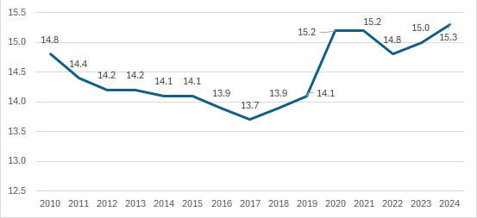
Source: Government revenue, expenditure and main aggregates [gov_10a_main]

Ad Section 2.1.1 - Cost for winners and the number of award criteria
The analysis of the impact of an increasing number of procedural requirements imposed on public buyers and bidders, was supported by data on the number of award criteria was analysed in combination with cost data collected by Ecorys (2025) through the surveys in 2022 and 2025. In particular, in order to assess whether the number of award criteria is associated with effects on economic operators’ costs, the following regression specification was estimated:
, where
- cost_winner = cost of running the procurement procedures for winners,
- c_award = the number of award criteria expressed as a deviation from its sample mean (i.e. c_award is the mean-centred number of award criteria),
- ln(finalprice) = natural log of the final contract value.
Table 18: Regression results - procedural cost for winners (focus on the number of award criteria used)
Linear regression
cost_winner | Coef. |  | St.Err. | t-value |  | p-value | [95% Conf |  | Interval] | Sig
c_award | -704.463 |  | 862.798 | -0.82 |  | .414 | -2398.396 |  | 989.47
c.c_award#c.c_award | 763.071 |  | 253.773 | 3.01 |  | .003 | 264.839 |  | 1261.303 | ***
ln_finalprice | 2444.961 |  | 406.388 | 6.02 |  | 0 | 1647.1 |  | 3242.822 | ***
Constant | -23371.127 |  | 5232.221 | -4.47 |  | 0 | -33643.554 |  | -13098.701 | ***
Mean dependent var |  | 9058.865 |  |  | SD dependent var |  |  | 21105.668
R-squared |  | 0.066 |  |  | Number of obs |  |  | 716
F-test |  | 16.767 |  |  | Prob > F |  |  | 0.000
Akaike crit. (AIC) |  | 16248.893 |  |  | Bayesian crit. (BIC) |  |  | 16267.187
*** p<.01, ** p<.05, * p<.1
Source: In-house analysis based on Ecorys(2025) surveys 2022-2025
The analysis shows that the relationship between the number of award criteria and winner costs is non-linear. More precisely, the winning bidder’s costs increase more than proportionally with the number of criteria used, with the effect becoming stronger the further the tender deviates from the average number of award criteria (1.56). The increase in costs becomes stronger the further one moves from the average, indicating that complexity effects grow at an increasing rate. The squared term is positive (i.e. coefficient on c_award ² is 763 EUR) and highly significant (p = 0.003). The margins plot below (Figure 19) visualises the findings.
Figure 19: Predicted winner costs by deviations from the average number of award criteria
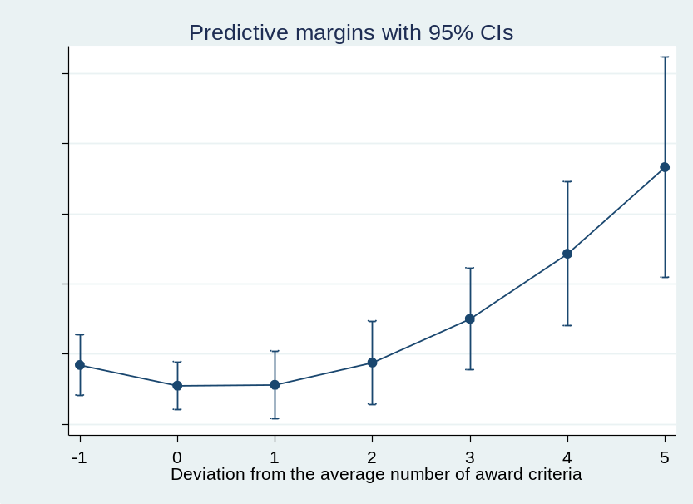
Source: In-house analysis based on Ecorys(2025) surveys 2022-2025
In other words, as the relationship is non-linear, the cost increase associated with each additional award criterion varies with the level of complexity. The marginal cost increases are reported in Table 19 below. It should be noted, however, that the estimated marginal effect associated with an increase of one or two additional award criteria above the average is not statistically significant. Statistical significance emerges from three additional criteria onwards. For example, when three criteria above the average are used, next additional criterion is associated with an increase in winner procedural costs of approximately EUR 3 874.
Table 19: Marginal effects table
 |  |  | Delta-method
 | dy/dx | std. err. |  | T | P>t | [95% conf. |  | interval]
c_award
_at
1 | -704.463 | 862.798 |  | -0.820 | 0.414 | -2398.396 |  | 989.470
2 | 821.679 | 589.713 |  | 1.390 | 0.164 | -336.106 |  | 1979.464
3 | 2347.822 | 682.867 |  | 3.440 | 0.001 | 1007.149 |  | 3688.495
4 | 3873.965 | 1048.836 |  | 3.690 | 0.000 | 1814.784 |  | 5933.145
5 | 5400.108 | 1499.670 |  | 3.600 | 0.000 | 2455.804 |  | 8344.411
6 | 6926.250 | 1978.173 |  | 3.500 | 0.000 | 3042.501 |  | 10810
Source: In-house analysis based on Ecorys surveys 2022-2025
To summarise, the analysis reveals a non-linear relationship between the number of award criteria and costs incurred by winning bidders. Moving away from that average is associated with higher costs for the winning bidder, especially when deviating by more than two additional criteria from the mean. This suggests that overly complex award structures may impose disproportionate compliance and bidding costs.
In contrast to the results for winning bidders, the corresponding regression for buyers’ costs does not display the same clear non-linear pattern. Neither the linear nor the quadratic term capturing deviations from the average number of award criteria is statistically significant. While buyers’ costs remain positively associated with contract value, the relationship between award-criteria complexity and buyers’ administrative costs appears weaker and less systematic.

Ad Section 2.2 – The public procurement directives legal set-up
Directives 2014/23/EU, 2014/24/EU and 2014/25/EU set out horizontal procedural rules on how public buyers should conduct public procurement procedures above certain values (“how to buy”). In parallel, an increasing number of sector-specific instruments have introduced over the years two categories of public procurement provisions to improve the sustainability and resilience of public purchases: requirements on what can be purchased (“what to buy”), but also additional and varying procedural rules on “how to buy”.
The purpose of this Annex is to provide a general perspective of the history and functioning of public procurement and the current legislative framework outside the Directives. It should be noted that both “how to buy” and “what to buy” needs to be read together, as the development of sectorial acts has altered the way the general public procurement framework works.
The Annex also provides a list of all sectoral acts containing public procurement provisions, including those that do not present coherence issues and would hence be kept untouched in the different policy options. The list includes recently adopted proposals that are in co-decision process. The Annex (Ad Section 5.2) also presents an overview of which acts and how would be affected by the different policy options, as described in the report.
How to buy
History of the EU public procurement Directives
The initial Directives date from the 70s. The objectives of the first Directive (71/305/EEC) were inscribed in the logic of the gradual abolition of restrictions to the fundamental freedoms (free establishment and freedom to provide services). They aimed to address trade barriers in the markets for public contracts for works and supplies by coordinating national procedures and, insofar as possible, taking into account existing procedures and practices (i.e. not harmonising procedures, but coordinating them). The following basic principles were thus: the prohibition of technical specifications that could have a discriminatory effect; adequate advertising of contracts; fixing of objective criteria for participation; and the introduction of a procedure of joint supervision to ensure the observation of these principles.
The principle of adequate advertising was directly linked to the aim of ensuring the “development of effective competition” for public works contracts. The second Directive, 77/62/EEC, confirmed these objectives, and also brought into play the second freedom: that of free movement of goods. The concept of “introducing equal conditions of competition”, in this case for supplies contracts, was also added. It also stated explicitly that contracts with a value below predetermined thresholds could be exempted from the coordination “inasmuch as their impact on competition is limited”.
A further objective, progressive realization of the internal market, informed the 1988 and 1989 Directives (88/295/EEC and 89/440/EEC). A contemporary of the "Cecchini" report, the 1988 Directive also introduced the concept that it is "necessary to develop the conditions of effective competition for public supply contracts and the economic, budgetary and industrial benefits which result from it". In this context, it was for instance specified that "time limits for the receipt of requests for participation and tenders in the framework of public supply contracts should be extended in order to improve access and participation by a greater number of suppliers".
The previously stated objectives were re-confirmed and clarified; "to eliminate practices that restrict competition in general and participation in contracts by other Member States' nationals in particular, it is necessary to improve the access of contractors to procedures for the award of contracts". This would "create the necessary conditions for efficient Community-wide competition for contracts so that firms from other Member States can bid on comparable terms to domestic firms". Works concessions were included in Directive 89/440/EEC in view of their "increasing importance".
The first Utilities Directive, 90/531/EEC, was based on the same Treaty provisions and principles as the preceding Directives. It recognized that "the need to ensure a real opening-up of the market and a fair balance in the application of procurement rules in these sectors requires that the entities to be covered must be identified on a different basis than by reference to their legal status", given that "entities providing such services are in some cases governed by public law, in others by private law". It also introduced the idea that, in these sectors, the rules should not "extend to activities of those entities … which fall within those sectors but nevertheless are directly exposed to competitive forces in markets to which entry is unrestricted". For oil, gas, coal or other solid fuels, it envisaged the possibility of "alternative arrangements which will enable the same objective of opening up contracts to be achieved". Finally, it took the approach that "…the rules to be applied by the entities concerned should establish a framework for sound commercial practice and should leave a maximum of flexibility".
The 'Classic Directives' (i.e. the directives applicable to the public sector) were completed with the Services Directive, 92/50/EEC, which based itself on the same considerations, including the realisation of the Internal market, with the particularity that "full application of this Directive must be limited, for a transitional period, to contracts for those services where its provisions will enable the full potential for increased cross-frontier trade to be realized". The subsequent Utilities Directive, 93/38/EEC extended the scope of EU public procurement legislation to service contracts awarded by utilities. Directive 93/38/EC was also a consolidation Directive insofar as it replaced the previous Utilities Directive, 90/531/EEC, incorporated its provisions. Thus Directive 93/38/EEC covered works, supplies and services contracts awarded by utilities.
The next generation of Directives came in 2004, with Directive 2004/17/EC governing Utilities and Directive 2004/18/EC pertaining to the Classic sectors.
The recitals of the 2004 Directives still refer to the opening-up of public procurement to competition. However, these Directives were also seen as being "necessary to meet requests for simplification and modernisation made by contracting authorities and economic operators". Thus, the recitals refer to new phenomena, such as e-procurement, electronic means of communication as a tool for simplification and increased efficiency and transparency. The Directives also refer to the possibility to "help increase competition and streamline public purchasing". In keeping with the aim of allowing a flexible framework that will best adapt to national characteristics, the 16th Recital of the Classic Directive provides that "in order to take account of the different circumstances obtaining in Member States, Member States should be allowed to choose whether contracting authorities may use framework agreements, central purchasing bodies, dynamic purchasing systems, electronic auctions or the competitive dialogue procedure, as defined and regulated by this Directive."
The Directives were also expected to contribute to the fight against corruption and other forms of serious crimes. The Utilities Directive, 2004/17/EC, states that it should not apply to contracts awarded for the pursuit of a relevant activity "if, in the Member State in which this activity is carried out, it is directly exposed to competition on markets to which access is not limited." It adds that there is consequently a need "to introduce a procedure, applicable to all sectors covered by this Directive, that will enable the effects of current or future opening up to competition to be taken into account. Such a procedure should provide legal certainty for the entities concerned, as well as an appropriate decision-making process, ensuring, within short time limits, uniform application of Community law in this area."
The current EU public procurement Directives
The 2014 package contains a framework of procedures to be applied for the award of contracts by contracting authorities, that is, the public buyers which are either contracting authorities subject to the provisions of the Classical Directive (Directive 2014/24/EU), and contracting entities (entities which are subject to the provisions of the Utilities Directive, Directive 2014/25/EU and Concessions, Directive 2014/23/EU). These are designed to work as a “tool-box” for Member States to implement, as such, while the main elements are common to all public buyers, depending on how these have been transposed, there may be practical differences among Member States.
The Directives are only binding for public buyers, understood as contracting authorities and contracting entities. With the exception of central government authorities (Annex I of Directive 2014/24/EU), the Directives do not list the public buyers concerned but provide general definitions as to which buyers are covered. Depending on whether a public buyer is a contracting authority or contracting entity, and whether they award a (public) contract or a concession, different rules apply.
In the Classical Directive, the relevant body means a contracting authority, defined as the State, regional or local authorities, bodies governed by public law, associations formed by one or several of such authorities or one or several of such bodies governed by public law.
The Utilities and Concessions Directives, on the other hand, applies to bodies, collectively covered by the term contracting entity. In fact, the Utilities Directive and the Concessions Directive apply not only to contracting authorities, as just mentioned, but also to two further categories of entities: public undertakings, defined as "any undertaking over which the public authorities may exercise directly or indirectly a dominant influence by virtue of their ownership of it, their financial participation therein, or the rules which govern it", and private undertakings, provided these latter exercise one of the relevant activities on the basis of an exclusive or special right. Exclusive or special rights are currently defined as rights to "the effect of which is to limit the exercise [of one of the relevant activities] to one or more entities, and which substantially affects the ability of other undertakings to carry out such activity on the same territory under substantially equivalent conditions." It should be stressed that, to constitute special or exclusive rights within the meaning of the Utilities or Concessions Directive and for the purpose of determining its scope, it is a further condition that such rights have been granted otherwise than through a transparent mechanism based on objective, non-discriminatory criteria which are open to everybody meeting them. In other words, the fact that a company holds even an exclusive right to e.g. build and operate an airport is not in itself sufficient – the exclusivity will be "nullified" if the private company in question has e.g. won a duly tendered and advertised concessions contract for the construction and operation of the airport.
The relevant activities or sectors concerned by the Utilities Directive are specifically the water, energy, transport and the postal services sectors. The Classical and Concessions Directives however apply to all sectors unless otherwise excluded (e.g. The Classical Directive does not include defence and security contracts, however concessions in this area may fall under the scope of Concessions. Similarly, the water sector is excluded under the Concessions Directive.
In the Utilities’ Directive, it is a further condition that the contracting entity carries out one of the relevant activities and that the procurement concerned is made for the pursuit of that activity. In the electricity sector, this would for instance mean that the directive would apply to above-threshold procurement of not only turbines for the production of electricity or pylons for a transmission network, but also to the procurement of other items such as, e.g., protective clothing for the contracting entity's workers, office furniture for its headquarters, paperclips, coffee to be served at meetings, petrol for company vehicles, insurance coverage of company property or its employees etc., as long as it is for the pursuit of that activity.
The design of the public procurement procedures is guided by the general principles of EU law stemming from the Treaties. This includes notably non-discrimination and transparency. Therefore, the starting point is that all procurement, which is subject to the provisions of the Directives, must begin with the publication of some form of notice in the Official Journal of the EU. These notices are published electronically, since 2023 through eForms.
There are differences in the notices depending on the type of public buyer: all sub-central contracting authorities may choose between a contract notice and a prior information notice as a means of calling for competition in respect of all types of public contracts, Central government authorities however have the possibility of making that choice in respect of services falling within the light regime for social services, while being obliged to use a contract notice in respect of all other types of public contracts that are subject to Directive 2014/24/EU. Prior information notices under the Classical Directive function in the same way as do periodic indicative notices under the Utilities Directive (see below) when both are used as a call for competition. Contract notices are "ad-hoc"-notices, i.e. notices that have to be published specifically in connection with one particular procurement procedure (whether this aims at awarding one single contract, multiple contracts for multiple lots, a framework agreement, including multiple framework agreements, or at establishing a dynamic purchasing system). Contract notices may be used in connection with all types of award procedures, be they open, restricted, competitive procedures with negotiation, competitive dialogues or innovation partnerships.
For procurements falling within the scope of the Utilities Directive, calls for competition may take three different forms, namely, contract notices, periodic indicative notices and notices on the existence of a qualification system.
In the Utilities Directive, periodic indicative notices can be used by all types of contracting entities including contracting entities which are central government authorities, as a means of calling for competition in respect of procurements of any given type of works, supplies or services that will be procured over a twelve-month period, irrespective of the number of individual procurement procedures that will be used for the purpose. When a periodic indicative notice is the chosen means of calling for competition, then the specific contract(s) concerned may not be awarded by open procedures, only by restricted or negotiated procedures or by competitive dialogues in which participants are chosen among those – and only those – having manifested their interest in response to the periodic indicative notice. Periodic indicative notices are often used as a means of calling for competition in respect of repetitive purchases of homogenous goods, services or works.
Notices on the existence of a qualification system can be used – again by all types of contracting entities in the Utilities’ sector– as a means of calling for competition in respect of procurements of any given type of works, supplies or services that will be procured over the duration of the qualification system, irrespective of the number of individual procurement procedures that will be used for the purpose. The following procedure is practically the same as is the case for periodic indicative notices, where a notice on the existence of a qualification system is the chosen means of calling for competition. Qualification systems are often used in connection with procurement of technically exacting works, supplies or services (e. g. railway rolling stock, high pressure gas pipes etc.).
Transparency is further enhanced by the requirement to publish a contract award notice after the award of a contract or the conclusion of a framework agreement. It is noteworthy that this obligation also applies where the contracts has been awarded without a call for competition (i. e. without prior publication). Besides, to strengthen the effectiveness and availability of remedies, there is a minimum of ten days stand-still period between the communication of the decision to award and the conclusion of the contract.
It should finally be mentioned that the Directives provide for a sort of "early warning" system in the form of prior information notices which give some information of planned, future procurement (over the next twelve months) without being used as a formal call for competition. Such non-binding notices may be published either in the Official Journal or on the procurer's own website, called a "buyer's profile" in the Directives. In the latter case, a very short notice (essentially a reference to the publication on the buyer's profile) must also be published in TED. When the level of information given is sufficient (and the notice has been published within the prescribed timeframe for so doing), it may be possible to shorten deadlines applying to the subsequent award procedures for the announced works, supplies or services.
Directives 2014/24/EU and 2014/25/EU both contain provisions setting out various procedures to be used when awarding contracts falling within the scope of the Classical or Utilities’ Directives subject to the full set of rules. As recalled by the first Recital to the Classical Directive, the Directives limit themselves to setting a common framework, they do not harmonise each and every aspect of the various award procedures that are used at the national level. The procedures of the Directives are the open procedure, the restricted procedure, the competitive procedure with negotiation (the negotiated procedure with prior call for competition in the Utilities’ Directive), the competitive dialogue, the innovation partnership and the negotiated procedure without prior publication (or without prior call for competition, respectively). The Concessions Directive does not include specific rules on procedures (besides general principles), but only transparency requirements by means of notices, as described above.
The Classical and Utilities’ Directives both give contracting authorities and entities a free choice between the open and the restricted procedure. This is, however, not the case for competitive procedures with negotiation nor competitive dialogues: as one of the major examples of the additional flexibility that the Utilities Directive provide for, contracting entities may freely choose to award their contracts by negotiated procedures with prior call for competition or by a competitive dialogue. Under the Classical Directive, on the other hand, competitive procedures with negotiation and competitive dialogues may be used exclusively under the exhaustively listed circumstances set out in its Art. 26(4) of Directive 2014/24/EU. Under both Directives, use of the innovation partnership, newly introduced in 2014, is reserved for cases in which there is a "need for an innovative product, service or works that cannot be met by purchasing products, services or works already available on the market." Finally, both Directives exhaustively list the cases in which use of a negotiated procedure without prior publication is exceptionally authorised. Pursuant to longstanding jurisprudence, these cases are to be construed strictly, and it is incumbent on those who invoke them to prove that this was actually justified.
The open procedure is the only one-stage procedure in the Directives: the response to the contract notice is the submission of a full and complete tender, without any intermediary stages such as a selection of the economic operators who will be authorised to submit a tender. That is not to say that the aptness to perform the contract concerned of tenderers, i.e. their technical and economic/financial capacity based on the exclusion grounds and selection criteria, is not verified in an open procedure; the verification simply takes place after the tenders have been presented, not prior to that stage. Following the verification of the tenderers' suitability, the tenders are then assessed in the light of the previously stated award criteria.
The 2014 Directives introduced a new measure of flexibility: the possibility, if implemented in national legislation, to examine the tenders first and only then look at exclusion and selection criteria (for those having submitted an acceptable tender).
Concerning award criteria in particular, it should be noted that in all other procedures than competitive dialogues and innovation partnerships contracting authorities and entities have a completely free choice between the three ways in which the "most economically advantageous tender" ("MEAT") may be assessed, namely, on the basis of a) the price (only), b) cost, using a cost-effectiveness approach such as life-cycle costing, or c) the best price-quality ratio (BPQR) to be assessed on the basis of award criteria linked to the subject-matter of the contract. Note that according to longstanding jurisprudence the rules applicable to award criteria are different from those governing selection criteria and the two sets of criteria may not be confused, mixed or applied twice (professional capacities and experiences of the specific team proposed in the tender to perform the contract may however be a suitable award criterion).
Exclusion grounds are divided into obligatory and non-mandatory exclusion criteria; the obligatory clauses concern cases of final convictions for certain serious crimes (corruption, participation in criminal organisation, fraud or money laundering; terrorist offences and child labour and other forms of trafficking; as cases of final decisions (judicial or administrative) establishing breaches of obligations of payment of taxes and social contribution on the other). These criteria are obligatory for all contracting authorities, including when they act as contracting entities. However, for the other groups of contracting entities (public undertakings and private undertakings, the latter having special or exclusive rights) their use is voluntary, as they may not necessarily have access to the information needed to verify these criteria.
The non-obligatory exclusion criteria concern various situations that render the economic operator unable or unsuited for the task (such as bankruptcy, non-compliance with obligations relating to payment of taxes or social security contributions before the breaches have been established by final decision, convictions of offences affecting the professional conduct - e. g. for breach of environmental legislation or labour laws- or where the economic operator has lied to the procurers). The Utilities Directive provides that the objective rules and criteria, which are used under qualification systems or for the selection of participants may include the just mentioned exclusion criteria of the Classical Directive; however, as mentioned earlier, contracting entities which are contracting authorities are obliged to assess the obligatory exclusion criteria of Directive 2014/24/EU for voluntary exclusions. Under the Concessions Directive, both contracting authorities and entities shall apply the mandatory exclusion criteria, and retain discretion with regards to the optional grounds, as under the Classical Directive.
In addition to the exclusion criteria as described above, a number of sectorial acts have introduced additional exclusion grounds. These are described under “what to buy” below.
Selection criteria are criteria aimed at ensuring that economic operators have the required minimum levels of technical, financial and economic capacities, that they are enrolled in relevant professional or trade register and that, in respect of service contracts, they hold appropriate authorisations etc. Contracting authorities must set out beforehand - in the contract notice (or, where the call for competition was a prior information notice, in the invitation to confirm interest) which level of capacity is required, bearing in mind that these must be related and proportionate to the subject-matter of the contract. Concerning in particular the financial capacity, it should be noted that any requirements of a minimum turn-over must be limited, except in duly justified cases, to at the most twice the estimated contract value.
Compliance with the required minimum levels is initially assessed on the basis of the information (the preliminary evidence) contained in the European Single Procurement Document (ESPD). This may be further verified during the procedure. The contracting authority must verify both the exclusion and the selection criteria as they apply to the "winning" bidder by requesting the full set of up-to-date supporting documents. Which documents are concerned is established in the light of the specific provisions of the Directive on the (types of) documents that may be required as proof. These shall "primarily" be the types of documentary evidences that are introduced in e-Certis, the online repository for documentary evidence operated by the Commission. The Utilities Directive does not regulate these matters to the same degree of details; the selection of economic operators under this Directive must solely be carried out on the basis of objective rules and criteria which are available to interested economic operators. Similarly, the Concessions Directive only indicates that the conditions for participation shall relate to the professional, technical and financial standing of economic operators, and that these shall be related and proportionate to the contract.
In addition to the procedures described above, the Classical and Utilities Directives also include a series of techniques or specific procedural tools that can be used in the context of award procedures, notably: framework agreements and DPS. These options are not mentioned in the Concessions directive.
Framework agreements are a contractual tool typically used to set the conditions for a series of individual purchases, often from more than one economic operator. According to the type of framework agreement, the conditions which apply to the individual procurements pursuant to the agreement are set out either in the framework agreement itself or in the contracts that are based on it. From the procedural point of view, framework agreements may be set up using any of the freely available or justified award procedures described above. Where (all) the conditions governing the individual procurements pursuant to the agreement have not been set in the framework agreement itself and the framework agreement has been concluded with more than one economic operator, contracts based on it are concluded through a mini-competition amongst all those who are parties to it. Framework agreements thus constitute a "closed system", available only to those who were parties to it from the outset (i.e. there is no possibility of the agreement being used by contracting authorities not included from the start, just as no new economic operators may enter the agreements). Their duration is normally limited to four years.
DPS are an entirely electronic system that may be used in connection with repetitive purchases of "off-the-shelf" goods or services. They are used to set up a - continuously open and accessible - list of qualified suppliers among whom the contracts for the specific deliveries will be awarded over the system's duration. Procedurally, three different stages can be distinguished, namely, setting up the system, maintaining/updating it and making the specific purchases. To set up a DPS, the only available procedure is the restricted procedure, in which the requests for participation are examined as described above. If no exclusion criteria apply and the selection criteria are met, then the economic operator will be enrolled into the system.
The system must be open for access (by means of a request for participation as in any restricted procedure) at any moment during its period of validity; this is ensured through the so-called "permanent publication". Contracting authorities dispose of a period of ten working days to evaluate the request for participation; when the system is first set up, the period used for the evaluation of requests for participation may be prolonged (even further) as long as no invitations to tender are sent (i.e. as long as no specific contracts are being launched). Once the invitations to tender for the first specific contracts have been sent, new requests for participation will no longer trigger a "blocking period" – contracting authorities may go on with the award of specific contracts without having to await that the assessment of new requests for participation is finished. The consequences for the economic operators are limited – once they have been admitted to the system (after an assessment which may at the most take 15 working days) they have a right to be invited to tender for all subsequent specific procurements under the DPS over its entire period of validity, which is not limited to any maximum period.
Lastly, when it comes to define the subject-matter of the contract, the Directives contain provisions on technical specifications, labels and means of proof.
An important place in the Directives is given to the provisions on technical specifications, that is, the requirements of a more technical nature that must be met by the works, goods or services which are the subject-matter of the contract. Since the adoption of the 2004 Directives, contracting authorities and entities have had a completely free choice between two main methods of defining their technical specifications, namely, either by reference to European standards (as implemented through national standards) or other technical references, such as European technical assessments, that are issued by European standardisation bodies (e. g. CEN, CENELEC) or in terms of performance or functional requirements, including environmental characteristics. The uptake of functional requirements has however been limited. It is also possible to combine these two basic methods, for instance by defining certain characteristics by reference to a European standard and others in terms of performance, perhaps adding in the latter case that goods or services that conform to, e. g., the chosen common technical specification referred to are presumed to meet the performance or functionality requirements.
The Directives set out a series of explicit, general requirements for the use of labels in the context of public procurement: the label requirements must be linked to the subject-matter (as defined, in respect of award criteria), they must be appropriate to define the required characteristics, be based on objectively verifiable and non-discriminatory criteria and the label itself must be adopted in an open and transparent manner, be accessible to all interested parties and, finally, the label requirements must be set by a third party over which the economic operator applying for the label cannot exercise a decisive influence.
In case a given label meets the just-mentioned requirements and, in addition, each and every one of its label requirements are linked to the subject-matter and appropriate, then the Directives offer contracting authorities an easy way to define their technical specifications: they do so by requiring that the products, services or works concerned have a specific label. However, they must also accept all (other) "labels that confirm that the works, supplies or services meet equivalent label requirements." Furthermore, where an economic operator demonstrably had "no possibility of obtaining the specific label indicated by the contracting authority or an equivalent label within the relevant time limits for reasons that are not attributable to that economic operator" then that economic operator may use "other appropriate means of proof" (e.g. a technical dossier from the manufacturer) to prove that the goods, services or works meet the requirements.
In case a given label meets the above-mentioned general requirements, but not all of its label requirements are linked to the subject-matter and appropriate contracting authorities may copy-paste the relevant label requirements (those which are linked and appropriate) into the technical specifications with the clarification that products, services or works having the label concerned thereby prove that they meet the requirement concerned.
Assessing whether a given solution is – or it is not – technically equivalent to another can be a difficult task that in particular smaller contracting authorities may find difficult to handle. The Directives consequently offer them the possibility to require that tenders be accompanied by third-party verified evidence attesting conformity with the applicable requirements or criteria. It is worth noting that this possibility applies to criteria or requirements set out not only in the technical specifications but also in the award criteria or contract performance clauses. Here as well, if the economic operator demonstrably did not have the time to obtain the required third-party certification, then he may as described above fall back on other appropriate means of proof.
Finally, it should also be recalled that the Directives provide for a general prohibition against among others designing a procurement in such a way as to "artificially narrowing competition.
With regards to joint procurement, the starting point is that nothing in the Directives prevents contracting authorities or entities to purchase jointly (e.g. Article 38 Directive 2014/24/EU). When making use of this possibility occasionally, the Directives include clarification as to how and who needs to fulfil transparency obligation.
In the event that public buyers want to establish a more recurrent way to purchase together, they may have recourse to the formation of central purchasing bodies (CPBs). CPBs are contracting authorities which either act as wholesalers (i. e. buy, stock and sell on to other contracting authorities) or as intermediaries (i. e. award contracts or conclude framework agreements that will be used by other contracting authorities). If a CPB is used, the Directives do not apply to contracts awarded by a contracting authority or a contracting entity to a central purchasing body, provided that the central purchasing body has itself complied with the Classical or the Utilities Directives.
Furthermore, in light of the number of sectorial acts that include provisions on joint procurement including the EU institutions, it should be noted that under the Directives, EU institutions are not contracting authorities or entities, and as such, they cannot act as CPBs under the Directives and benefit from the wholesaler exception. This situation does not however preclude Member States from participating in procurement by the EU institutions (which generally falls under the Financial Regulation, not the Directives).

Ad Section 5.1 - Dynamic baseline
Currently, there are around 123 eProcurement platforms operating across the EU to facilitate business interactions between buyers and suppliers. Buyers prepare and encode data and publish notices (eForms) via their eProcurement service provider on TED. Suppliers find procurement opportunities on TED or national portals and are redirected to the buyer’s system to access necessary documents, ask questions and submit tenders. Additionally, suppliers respond to eligibility criteria through the ESPD to self-declare their eligibility, while buyers assess certifications after bid submission. In case it is a cross-border supplier, buyers use eCertis to assess the equivalence of evidence provided in the other country.
Due to the fragmentation of eProcurement services, tenderers, especially SMEs, face significant challenges when participating EU-wide. Bidders are often required to submit tenders through multiple platforms, each with distinct interfaces and procedural requirements. This not only increases the administrative burden and reduces efficiency but also limits cross-border participation. SMEs are particularly affected, as they typically lack the capacity and technical resources to manage this variety of systems, putting them at a competitive disadvantage. Table 20 below presents the situation as reported by MS.
Table 20: Number of eProcurement services by Member State
Countries | Number of eProcurement services | Sum
BG, CY, EE, HR, HU, IE, LT, LU, LV, MT, RO | 1 | 11 (11 x 1)
BE, EL, FI, NL, PL, PT, SE, SI | 2 to 5 | 16 (8 x 2)
AT, CZ, DK | 6 to 11 | 18 (3 x 6)
ES, FR, SK | 12 to 20 | 36 (3 x 12)
DE, IT | 21 and more | 42 (2 x 21)
Total |  | Min. 123
Source: DG GROW

Table 21: Overview of current eProcurement costs for the European Commission [EUR 000]
Root causes | Component | Y0 - 2026 | 2026-2032
Fragmented eProcurement ecosystem | Standards | 320 | 320
Fragmented eProcurement ecosystem | OP services | 10 205 | 65 490
Absence of a once-only principle | eCertis | 250 | 1 600
Absence of a once-only principle | ESPD | 390 | 2 510
Insufficient data governance, lifecycle monitoring | PPDS | 1 500 | 9 630
Horizontal | eProcurement support team | 800 | 6 220
Total |  | 13 465 | 85 770
Source: PwC(2026), Assessment of policy options …., p. xx.

Table 22: Overview of average costs for one eProcurement Service Provider [EUR 000]
Root causes addressed | Component | Y0 - 2026 | 2026-2032
Fragmented eProcurement ecosystem | Standards | 0 | 130
Fragmented eProcurement ecosystem | National eProcurement system | 2 200 | 14 250
Fragmented eProcurement ecosystem | eProcurement network | 0 | 10
Total |  | 2 200 | 14 390
Source: PwC(2026), Assessment of policy options …., p. XX.

Table 23: Overview of average costs for Member State [EUR 000]
Root causes addressed | Component | Y0 - 2026 | 2026-2032
Insufficient data governance, lifecycle monitoring | National data space | EUR 0 | EUR 1 610
Total |  | EUR 0 | EUR 1 610
Source: PwC(2026), Assessment of policy options …., p. XX.

Table 24: Overview of average costs for one Contracting Authority [EUR 000]
Categories | 2026-2032
Human resources | EUR 193
Total per CA | EUR 193
Source: PwC(2026), Assessment of policy options …., p. XX.

Table 25: Overview of average costs for one Economic Operator [EUR 000]
Categories | 2026-2032
Human resources | EUR 293
Platform subscription | EUR 25
Total per EO | EUR 318
Source: PwC(2026), Assessment of policy options …., p. XX.

Ad Section 5.2.1 and 2 – Negotiations in public procurement
Under the current Directives, access to negotiation varies:
Directive 2014/23/EU does not include any specific procedure, so it is understood that negotiation is always available.
Directives 2014/24/EU and 2014/25/EU both give public buyers a free choice between the open and the restricted procedure. This is, however, not the case for competitive procedures with negotiation (negotiated procedures with prior calls for competition) nor competitive dialogues: as one of the major examples of the additional flexibility that the Utilities Directive provide for, public buyers may freely choose to award their contracts by negotiated procedures with prior call for competition or by a competitive dialogue. Under the Classic Directive, on the other hand, competitive procedures with negotiation and competitive dialogues may be used exclusively under the circumstances set out in the Directives: a) where there is a need for adaptation of readily available solutions; b) the procurement includes design or innovative solutions; it should be noted that the reference to "design" means that all works contracts whose subject-matter include "both the design and execution" of works or a work as defined in Article 2(1)(6) will be eligible for competitive procedures with negotiation or competitive dialogues; c) there is a need for negotiations because of specific circumstances (nature, complexity, legal/financial set-up, risks); d) where the technical specifications cannot be set with sufficient precision by reference to standards etc. and, finally, e) in case of an unsuccessful prior procedure (open or restricted), i. e. where a previous open or restricted procedure yielded only "irregular" or "unacceptable" tenders.
Since Directive 2014/24/EU provides for identical conditions for the use of competitive procedures with negotiation and competitive dialogues, public buyers have an entirely free choice between the two.
Under both Directives, the use of the new innovation partnership is reserved for cases in which there is a “need for an innovative product, service or works that cannot be met by purchasing products, services or works already available on the market”.
The competitive procedure with negotiation
This procedure involves a first stage in which the economic operators, who have requested to participate in the procedure, are selected in the same way and on the basis of the same documentation as in restricted procedures. It is possible to limit the number of candidates that a public buyer intends to invite to participate in the negotiations with a minimum of three participants. Public buyers may announce beforehand that they intend to gradually reduce the number of tenders to be negotiated. This further reduction during the negotiations is carried out by application of the award criteria, bearing in mind that, “in the final stage, the number arrived at shall make for genuine competition in so far as there are enough tenders, solutions or qualified candidates”.
Substantial negotiations may take place, except in respect of the final tenders, in order to “improve the content” of the tenders. Public buyers, however, must set out minimum requirements, which together with the award criteria are non-negotiable. According to Recital 45, negotiations “may concern all characteristics of the purchased works, supplies and services including, for instance, quality, quantities, commercial clauses as well as social, environmental and innovative aspects, in so far as they do not constitute minimum requirements”.
The competitive dialogue
This procedure involves a first stage in which the economic operators, who have requested to participate in the procedure, are selected in the same way and on the basis of the same documentation as for restricted procedures. Just as is the case for the other multiple (i.e. two or more) stage procedures (restricted procedures, competitive procedures with negotiation and innovation partnerships), it is also possible to limit the number of candidates that a public buyer intends to invite to participate in the dialogue. As under the competitive procedure with negotiation, the minimum number is three. As in the competitive procedure with negotiation, public buyers can announce in the tender notice that they intend to gradually reduce the number of solutions to be discussed during the dialogue stage. Further reduction during the dialogue is carried out by application of the award criteria, bearing in mind that, in “the final stage, the number arrived at shall make for genuine competition in so far as there are enough tenders, solutions or qualified candidates”. The main characteristic of a competitive dialogue is of course that it includes a dialogue stage “to identify and define the means best suited to satisfying their needs. [Public Buyers] may discuss all aspects of the contract with the chosen candidates during this dialogue”. Other than this step, the competitive dialogue is virtually identical to the competitive procedure with negotiation.
The innovation partnership
As already mentioned, the innovation partnership is only allowed in cases in which there is a “need for an innovative product, service or works that cannot be met by purchasing products, services or works already available on the market”.
Procedurally, it is based closely on the rules applicable to the competitive procedure with negotiation, with, however, a series of particularities. These are necessary on the one hand because of the innovative subject-matter (e.g. the only admissible award criterion in an innovation partnership is the best-price quality ratio, selection criteria shall in particular focus on the candidates' “capacity in the field of research and development and of developing and implementing innovative solutions”) and on the other because the contract will cover both the R&D stage and the (possible) subsequent (mass)-production of the innovative work, service or product. This latter aspect implies among other that, to avoid technological “lock-ins”, an innovation partnership may be conducted with more than one economic operator. Another particularity of the innovation partnership is the obligation to structure it in successive phases, in accordance with previously agreed performance levels, maximum costs, intermediary targets and agreed partial payments. At the end of each phase, the public buyer may decide to end the innovation partnership or to reduce the number of partners.
Negotiation under FLX.1
Under FLX.1 a targeted amendment of the current Directives is proposed to attain simplification and to provide greater flexibility to public buyers. To provide public buyers with greater flexibility to negotiate, this option would entail an amendment of Article 26 paragraph 2 of Directive 2014/24/EU to include the reference to competitive procedure with negotiation. Paragraph 4 would see the reference to competitive procedure with negotiation removed. In terms of coherence, this amendment would mean that Article 26 Directive 2014/24/EU and Article 44 Directive 2014/25/EU would be aligned when it comes to the choice of procedures.
Negotiation under FLX.2
To simplify the rules, the current open and negotiated procedures would be merged into a new open procedure with negotiation that would allow public authorities to have the flexibility to negotiate wherever they wish to do so. It is important to consider that this proposal comes hand in hand with a merger of the three Directives, whereby in two of them public buyers have unconditional access to negotiations.
The new proposed procedure would follow a modular logic, allowing public buyers to decide whether or not in each case they intend to negotiate, and, if they wish to do so, which non-essential aspects of the contract could potentially be subject to negotiation. To avoid that economic operators would present sub-optimal offers with the intention to negotiate these “upwards” during the procurement procedure, it would be clarified that -same as in the current negotiated procedure- public buyers may always award the contract after receiving the first round of offers. However, public buyers that have not indicated their intention to negotiate would not be able to do so.
Public buyers would have to -in addition to the intention or not to negotiate- make their needs known in the contract notice by describing the subject matter of the contract, the minimum requirements that the contract would have to fulfil, as well as under which parameters will quality in the offer be assessed (see Ad Section 5.2.3. below) and which selection criteria needs to be fulfilled by economic operators.
Economic operators will be asked to submit their initial offer together with their business wallet to ascertain compliance with selection criteria and lack of exclusion grounds. Once the economic operator is considered suitable to possibly performing the contract, public buyers would check the initial offer.
If, after examining the initial offer against the minimum requirements, public buyers consider that the offers can be improved, they may conduct rounds of negotiations with all economic operators, which would be limited in time to prevent one economic operator from having greater access to a public buyer than other, or to have more time to improve their offer. Public Buyers would have to keep a record of these negotiations, which would have to be available equally to all economic operators. Once a public buyer has conducted a round of negotiations with an economic operator, it may either open a new round of negotiations by inviting economic operators to improve their offers; to reduce the number of participants ahead of a new round of negotiations; or, to invite economic operators to submit their final offers to proceed to the award of the contract.

Ad Section 5.2.3 - Level of quality weighting
As far as establishing an appropriate minimum level of quality weighting is concerned, 30% was proposed as it would maintain flexibility for contracting authorities to apply higher weightings where this is likely to deliver genuine qualitative improvements, while not imposing excessive weight on quality when not necessary. It is essential to propose a balanced approach where BPQR does not prevent price to still be a decisive factor and that public buyers can still proceed price-only awards in justified scenarios, for example when high quality standards have been already incorporated in technical specifications. Where quality considerations are assigned too little weight in the evaluation of tenders, competition will be driven predominantly by price, potentially incentivising lower quality or performance and undermining the objective of securing the most economically advantageous tender in terms of the optimal balance between price and quality. Conversely, excessively high weighting of quality criteria may also produce unintended effects. Where the weighting of qualitative elements is set at a level that exceeds the realistic scope for differentiation between tenders, contracting authorities may be required to design evaluation criteria that disproportionately reward relatively minor differences between offers, amplifying marginal distinctions that have limited practical impact on the performance of the contract. This may lead tenderers to incur additional costs in order to differentiate their bids in ways that are rewarded under the scoring methodology, resulting in higher contract prices without a corresponding improvement in substantive quality.
Some jurisdictions have experience with BPQR: In Norway, contracting authorities shall give a minimum of 30% weight to climate and environmental considerations. This has resulted in approximately 76% of procurements in 2025 including either environmental requirements or environmental considerations weighted in the award criteria. In Poland, a 60% price cap applies to most procurements and public buyers and resulted in effectively increasing the number of contracts awarded using BPQR. In the Netherlands, the percentage of tenders for major construction and infrastructure contracts awarded based on lowest price decreased from 70% in 2008 to 22% in 2021, after the introduction of compulsory BQPR with a comply or explain mechanism in 2013.
Introducing an elevated minimum quality award criteria share of 50% for labour-intensive contracts would align with the approach taken in some Member States, such as Italy that has a 30% price cap. Four out of five respondents that agreed in the public consultation that SRPP should further integrate mandatory elements, showed support for banning price-only awards in labour intensive sectors (or 39% of all respondents), the preferred option among all presented. It would reduce the risk of competition negatively affecting salaries and working conditions, while also allowing companies to differentiate themselves based on the quality of the services they provide. Social partners from the cleaning, security and catering sectors (all of them labour-intensive industries), released joint statements by trade unions and employers’ representatives supporting BPQR.
Finally, although some empirical evidence suggests that BPQR leads to higher prices of the goods, services or works purchased, other studies argue that while lowest-price procedures can attract bids averaging around 13% below initial cost estimates, such gains frequently dissipate during project implementation: projects awarded on lowest price end up costing 6% more than agreed (meaning that at least half of the costs savings from lower winning prices are lost because of ex post renegotiation) and almost 1 out of 3 projects end up being delivered later than agreed. The compulsory use of BPQR would contribute to a change of paradigm by better pricing in of long-term effects and sustainable savings rather than prioritising short-term savings (where quality award criteria are defined accordingly).
Environmental change, digital transformation, and social challenges are tightly interconnected, and this interconnectedness carries important implications for public procurement strategies.53. Policymakers and public procurement experts must navigate inherent trade-offs, as objectives such as technological innovation, environmental sustainability, and social protection may at times appear competing or even mutually exclusive. Recognizing and managing these tensions is essential for developing coherent, balanced procurement approaches that address multiple policy goals. Because these policy goals are inherently interconnected, and often in tension, public buyers need a meaningful degree of discretion when defining award criteria in procurement procedures. First, the balancing of competing objectives such as environmental sustainability, digital innovation, and social inclusion is ultimately a political choice. These trade-offs reflect societal priorities, budgetary constraints, and policy preferences, which vary across local contexts. Given that much public procurement is funded and implemented at regional or local level, it is appropriate that these decisions are taken as close as possible to the communities affected. Local contracting authorities are better placed to determine how to weigh, for example, climate performance against social outcomes or cost efficiency, in line with local democratic mandates and needs. Second, discretion allows public buyers to tailor procurement strategies to the specific circumstances of each contract and to identify where the most meaningful intersections between policy objectives lie. Rather than applying one-size-fits-all criteria, contracting authorities need flexibility to design award criteria that reflect the actual needs of users and stakeholders, the characteristics of the market, and the practical opportunities for combining environmental, digital, and social goals. This adaptability is essential to ensure that procurement not only complies with overarching policy ambitions but also delivers effective and context-sensitive outcomes on the ground.

Ad Section 5.2.3 - Visualisation of the procedural setup for BPQR
Figure 20: Procurement process with safeguards guaranteeing oversight and accountability in award decisions based on BPQR
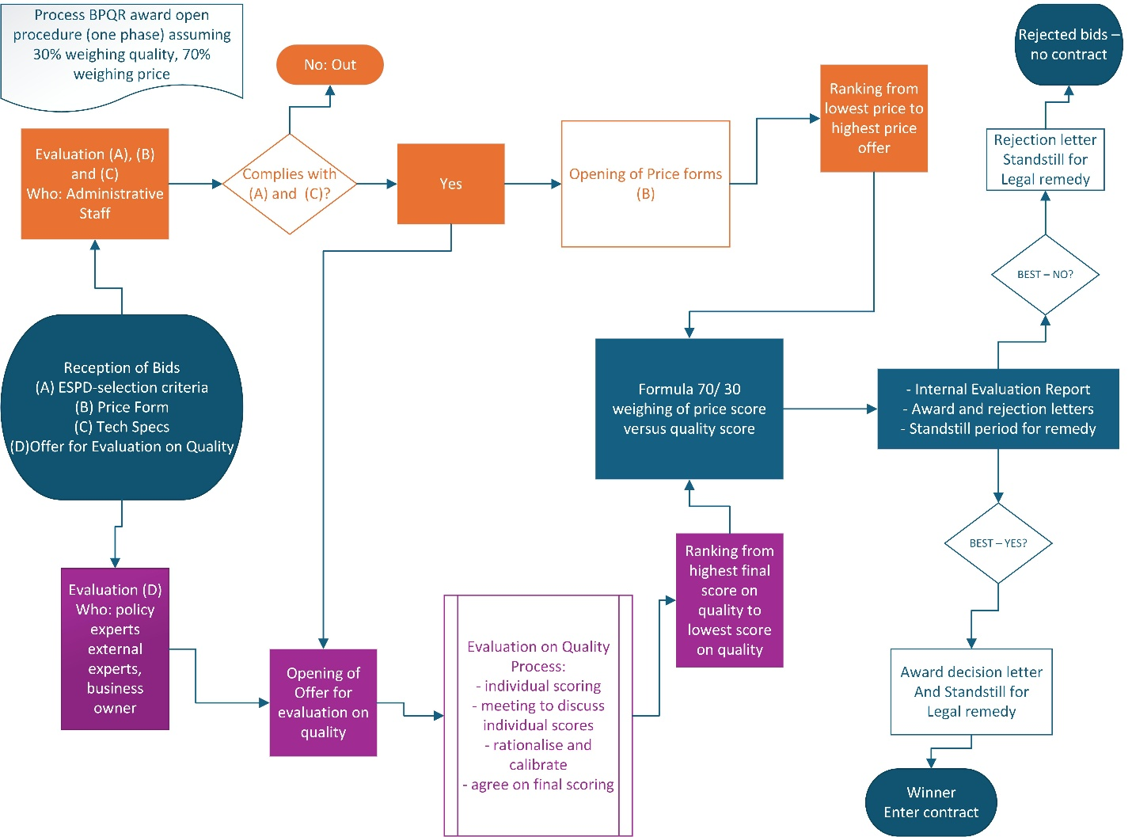
Source: In-house analysis

Ad Section 5.2.3 - Subcontracting, additional data on the impacts on SMEs
The association between subcontracting arrangements and SME access varies across sectors. In non-LSLI sectors, contracts not involving subcontracting show a predicted SME award probability of approximately 57.0%. Where subcontracting is expected, this probability increases to around 60.9% (+3.9 p.p.), suggesting that subcontracting can facilitate SME participation in these markets. In LSLI sectors, the pattern differs. When subcontracting is not foreseen, the predicted probability of SME award is about 54.8%, declining slightly to around 53.6% (-1.2 p.p.) when subcontracting is expected. These findings indicate that subcontracting plays different roles across sectoral contexts: it is associated with improved SME access in non-LSLI activities, while in labour-intensive sectors it is linked to a modest reduction in the likelihood of SMEs acting as main contractors.

Ad Section 6.1 – Overview of the positive and negative impacts for public buyers and innovative suppliers of different IPR allocations
Positive and negative impacts for Public Buyer
 | Positive | Negative
IPR remain with the public buyers | Innovative solutions are funded with taxpayers’ money, public buyers should be able to maximise their value and long-term public benefit on an individual basis. Appropriate IPR provisions are essential to safeguard critical public services and infrastructure. | Public buyers get offered only second-best solutions because suppliers need to retain ownership of their best technologies to preserve their competitive advantage. This can also lead to higher prices in procurement offers.
IPR remain with the supplier | -This approach can help increase SME participation in public procurement, support innovative businesses in scaling and growing, and ultimately allow public buyers to benefit from more mature and market-ready innovative solutions. | A key downside is that, and only in the case of critical public tasks and infrastructure, public buyers may become dependent on negotiations with private operators to access, adapt or continue using innovative solutions.

Positive and negative impacts for innovative suppliers
 | Positive | Negative
IPR remain with the public buyers | For suppliers, retaining IPR can create stronger commercial incentives, including the ability to protect their most advanced solutions and maintain their competitive edge. They offer therefore their second-best solution as a strategy. Another strategy for suppliers is that they increase their value of the IPR in the price of their bid | Transferring or sharing IPR can raise important concerns, including the risk of leakage of proprietary know-how, legal uncertainty regarding the value and future exploitation of product lines, and limitations on reusing solutions across different public procurements. In some cases, protecting core business interests may even discourage companies from participating in tenders altogether.
IPR remain with the supplier | Companies retain governance over strategic assets that are essential for scaling and growth. This approach can also provide greater legal certainty and make it easier for businesses to participate in cross-border procurement opportunities when public buyers apply more standardised approaches across different Member States. | None

Ad Section 6.2 - BPQR requirements (potential economic effects)
To analyse the effect of BPQR requirements on prices, a useful theoretical framework is provided by Estache and Iimi (2012), where tender prices are determined by two components: a direct effect, reflecting the impact of higher quality requirements on costs, and an indirect effect, operating mainly through changes in competition. Formally:
Tender price = Direct quality effect + Indirect competition effect
The direct effect captures whether higher quality requirements lead to higher production costs and therefore higher bids, while the indirect effect reflects how BPQR criteria influence bidder participation, with reduced competition increasing prices.
Direct effect of increased production costs
A simple framework can be used to illustrate the direct effect of BPQR requirements on bid prices. Let p_{i} denote the bid submitted by firm i. Prices are assumed to be set as a mark-up over production costs:
$$p_{i} =\left(1 + μ_{i}\right) c_{i}(q)$$
where μ_{i} denotes the markup, capturing the degree of competition in the tender, and c_{i} (q) is the cost function of firm i, which depends on the required quality level q. Holding competition constant (for a given μ_{i}), an increase in quality requirements under BPQR leads to higher production costs and therefore higher bid prices. This constitutes the direct cost channel through which BPQR can affect procurement price.
There is limited empirical evidence on the direct effect, but some existing research suggests that the direct effect between quality and price is limited. Arai (2021), using panel data and regression analysis for Japanese civil engineering and construction procurement (2007–2018), finds no large correlation between bid prices and quality outcomes, indicating that higher quality does not necessarily require proportionally higher prices. We further explore this issue in the subsequent sub-sections.
Competition effect and number of bids
A central result in auction theory, proven by Jeremy Bulow and Paul Klemperer (1996), shows that an auction with N + 1 bidders yields higher expected revenue than any mechanism involving only N bidders.
Auction with N + 1 bidders
$$\left(1\right) E \left.\left.[max\left(MR_{1}, MR_{2}, …, MR_{\left\{N+1\right\}}\right)]\right.\right.$$
Auction with N bidders
$$\left(2\right) E \left.\left[max\left(MR_{1}, MR_{2}, …, MR_{N}, 0\right)\right.\right]$$
Hence:
$$\left(3\right) \left.\left.E [max\left(MR_{1}, MR_{2}, …, MR_{\left\{N+1\right\}}\right)]\right.\right.≥ \left.E [max\left(MR_{1}, MR_{2}, …, MR_{N}, 0\right)]\right.$$
The extra bidder adds a random draw of marginal revenue with expected value zero, but because the seller takes a maximum, this draw can only increase (or leave unchanged) expected revenue. Hence an auction with N + 1 bidder increases expected revenue in comparison to a situation with N bidders. This result highlights the central role of competition in determining outcomes. In procurement settings, although the institutional framework is not directly equivalent, this insight provides a useful theoretical benchmark: increased competition, in the form of greater bidder participation, is expected to translate into lower procurement prices, which constitutes the indirect price effect of the reform.
The indirect effect through competition appears stronger in empirical research in comparison to direct price effect. Tátrai et al. (2024), using EU27 TED data (2017–2020) and econometric analysis, show that most economically advantageous tender criteria are associated with a lower number of bidders, while lowest-price procedures attract more competition. Similarly, Matas et al. (2025), using logistic regression on Slovenian procurement data (2016–2023), find that the inclusion of non-price criteria increases the probability of achieving costs at least 5% above benchmarks by 10-20%, with green criteria further increasing this probability by 5-15%, while social criteria, interestingly, reduce this probability, . Lundberg et al. (2015), using Swedish procurement data (2009–2010) and OLS analysis, find that Eco labelling has only small effects on participation, suggesting that eco labelling primarily shifts participation toward already compliant firms.
Net effect
There are a few authors, who calculate the net effect on prices. Evidence from construction procurement in North America shows that best-value (BPQR-type) criteria increase prices only moderately. Lines et al. (2020), using a descriptive comparative analysis of 118 construction projects in the United States and Canada (approximately 2010–2019), estimate that best-value procurement is on average 7.12% more expensive than lowest-price procurement, but the median difference is only around 1%, indicating that at least half of the tenders experience minimal price increases, with paper further finding that only a few tenders experiencing large increases, likely push the average up. Paper further calculates cost performance during project execution, it finds that cost performance is significantly better under best-value selection (7.6% vs 12.2% cost growth), suggesting efficiency gains. Similarly, Nguyen et al. (2018), using non-parametric statistical tests and descriptive analysis on 162 projects in the United States and Canada (2010s), find that best-value procurement results in bids that are on average 6.8% higher than the lowest bid, but still 2.2% lower than the average bid, and that winning bidders are consistently ranked among the lowest-price offers (top two in 67% of cases and top three in 88.3% of cases and 24% the lowest bidder is also the highest quality). Lastly, Hoekman (2024), using OLS and logistic regression on procurement data from EEA countries, the UK, and North Macedonia, finds that more restrictive procurement rules increase prices, but the magnitude depends on institutional quality: a one standard deviation decrease in discretion is associated with an increase of approximately EUR 4 189 per tender in high government effectiveness countries and EUR 2 790 in lower effectiveness countries.
Overall, the literature suggests that mandatory quality criteria increase procurement prices, but that the magnitude of the effect is context dependent. In North American construction procurement, available estimates suggest average price increases of around 6.8-7.12%, while the median increase is closer to 1%. This indicates that many tenders experience only limited price effects, while a smaller number of cases may drive the average upward. Expected price effects also likely vary by Member State and institutional effectiveness.
Impact on the risk of corruption
Loxbo and Pircher (2025) find a clear trend of differentiation, with increasing divergence in single-bid contract rates across countries with varying administrative capacities and corruption risks. This underscores a growing disparity between Northern and Western European countries, known for their administrative capacities, and Eastern and Southern European countries, which encounter more significant challenges. The paper applies a difference-in-difference causal model to determine the effects of the 2014 reform on single bidding and the increased use of MEAT using data on EU-28 countries that are separated into four clusters by public-procurement performance and institutional quality, those four groups are compared. The use of single bidding increased dramatically in worse performing countries, by 10 - 11 percentage points. While single bidding declined with 4-7 percentage points in best performing countries. The use of MEAT criteria increased significantly in worst performing countries, while it remained the same or even declined in best performing countries, who seem to prefer lowest price as the main award criteria. This is further substantiated by the finding that most single bidding contracts are MEAT contracts in the worse performing countries. Overall, the study concludes that the introduction of more flexible procurement rules has widened the gap between high- and low-performing countries, leading to differentiated implementation of EU procurement.
To conclude, the introduction of mandatory BPQR rules is likely to have substantially different effects on Member States depending on institutional quality and transparency through increasing discretion. Further reflections on the trade-off between granting contracting authorities’ greater procedural discretion and the potential increased risk of irregularities are provided in Annex 7, Section 8. Further discussion is also provided on the role of transparency, accountability mechanisms, and digital monitoring tools in mitigating such risks.

Ad Section 6.2 – GPP impact per Member State
During the evaluation of the procurement directives, the Commission services gathered data on the uptake of green procurement across Member States. Data were available for 16 countries, reflecting the situation in 2023, with uptake ranging from 89% in Lithuania to 4% in Poland and Portugal. The methodology for data gathering differs by country, making cross-country comparisons not fully reliable.
Under the central scenario of ESI.1/ESI.2 - assuming an 18.5% increase in BPQR (i.e., half of current price-only procedures replaced by BPQR) and further assuming that the additional quality criteria will be green criteria - green procurement could reach nearly a quarter of all procurement procedures in countries with currently low levels. For the best-performing countries, the share could rise to between 65% and 80%.
Examining the gap relative to the best-performing country (Lithuania), achieving this level of green public procurement (GPP) would require countries at the lower end of the scale to increase their GPP share by approximately 80 percentage points. Countries in the mid-range would need to raise their share by about 60 percentage points, while the best-performing countries would need an increase of 30–40 percentage points (see the figure below).
Figure 21: Green procurement uptake by Member States in 2023, showing the gap to the best-performing Member State and an indicated increase under the 18.5% scenario [share of procedures in %].
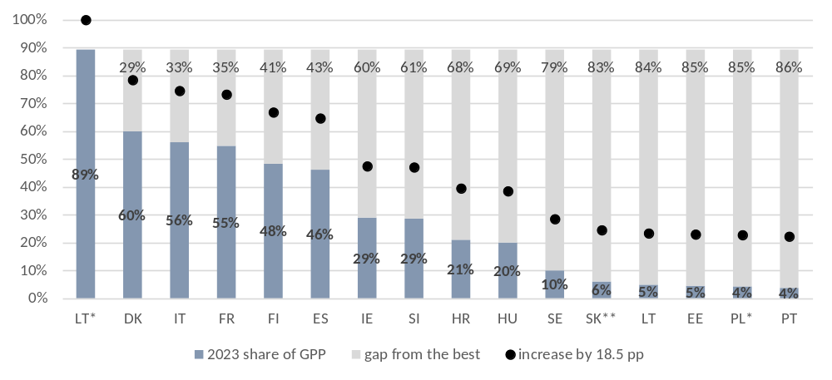
* share of value; **-target
Note: Only countries for which data were available are presented. The methodology for data gathering differs by country, making cross-country comparisons not fully reliable.
Source: In-house analysis based on SWD(2025) 332, pp.225-228

Ad Section 6.3 – Key figures on cross-border public procurement
As far as foreign market access is concerned, around one fifth to one quarter is classified as cross-border procurement. Concretely, the indirect cross-border procurement is estimated at 21.6% by value for awards below EUR 200 million, and 27.1% for awards above EUR 200 million. Direct cross-border procurement share represents 4.1% of value of contracts below EUR 200 million and 5.5% of value of contracts above EUR 200 million. As far foreign market access is concerned, around three quarters of the awarded public procurement contracts are typically domestic in terms of numbers and value. One fifth is classified as an indirect cross-border type and the rest as direct cross-border contracts (Figure 22 below). Recent in-house analysis confirms that the above structure remains broadly stable.
Figure 22: Number (left) and value (right) of awards below EUR 200 million by type of procurement, 2016-2019 [%]
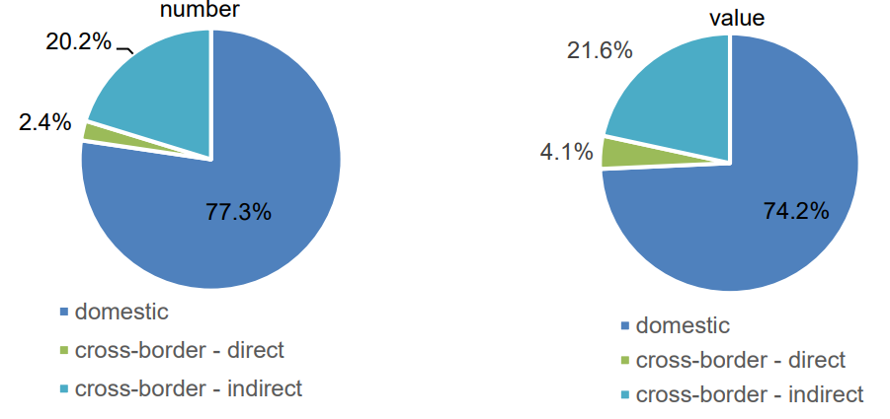
Source: Prometeia (2021), Study on the measurement of cross-border …, p. 20.
As the contract size increases, cross-border procurement becomes more frequent. For example, for the awards above EUR 200 million, it represented around one third of this segment of the public procurement market (Figure 23 below).
Figure 23: Number (left) and value (right) of awards greater than EUR 200 million by type of procurement, 2016-2019 [%]
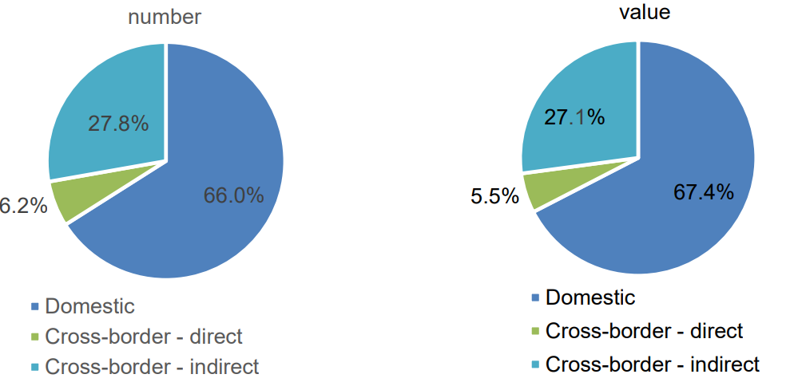
Source: Prometeia(2021), Study on the measurement of cross-border …, p. 20.
Recent in-house analysis, as well as external studies, confirm that the above structure remains broadly stable.
As many contracts in the EU public procurement are awarded EOs that are subsidiaries of firms headquartered abroad, to better understand this foreign presence, it was necessary to identify the ultimate country of ownership of these EOs. The chosen approach to achieve the above was to focus on the top 10 000 EOs ranked by awarded value, a group that accounted for roughly 66% of total contract value between 2018 and 2023. Within this group, the ownership information was successfully matched for 8 743 EOs. These matched entities represented 54% of total awarded value, 28% of all CAN notices, and just 2% of all awarded EOs during the period-highlighting that while ownership was identified for the major value‑holders, it covers only a small fraction of EOs overall.
Based on the analysis of TED publication data, in 2018-2023 non‑EU participation was dominated by firms bidding though their EU subsidiaries. The headquarters of such firms were predominantly located in North America, Europe, Japan, and Turkey. The non-EU-owned EOs participating directly are typically located in the US, Switzerland, Norway, Turkey and China.
Figure 24: Non-EU-owned EOs, awarded value, years 2018-2023, EU 27 [billion euro]
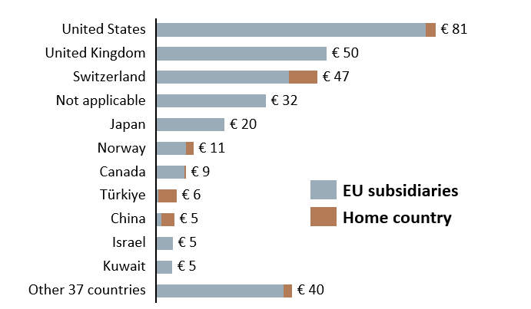
Source: In-house analysis
Comparing the above data to the total value of public procurement published in TED results in an approximate share of the third countries participation of 7.5% (the sum of awarded value for all countries listed above, excluding “not applicable” observations, equals EUR 277 billion; the total value of procurement published in TED in 2018-2023 equalled EUR 3.7 trillion). This is a conservative estimate, as the matching process resulted in a dataset covering only 70% of the total value.
In terms of sectors concerned, the non-EU owned firms were present across most categories that are relevant for EU public procurement (70% of total value), as shown in Figure 25 below.
Figure 25: Top categories procured by EU Member States: distribution of awarded value between EU-owned and non-EU-owned EOs, years 2018-2023, EU 27 [EUR billion]
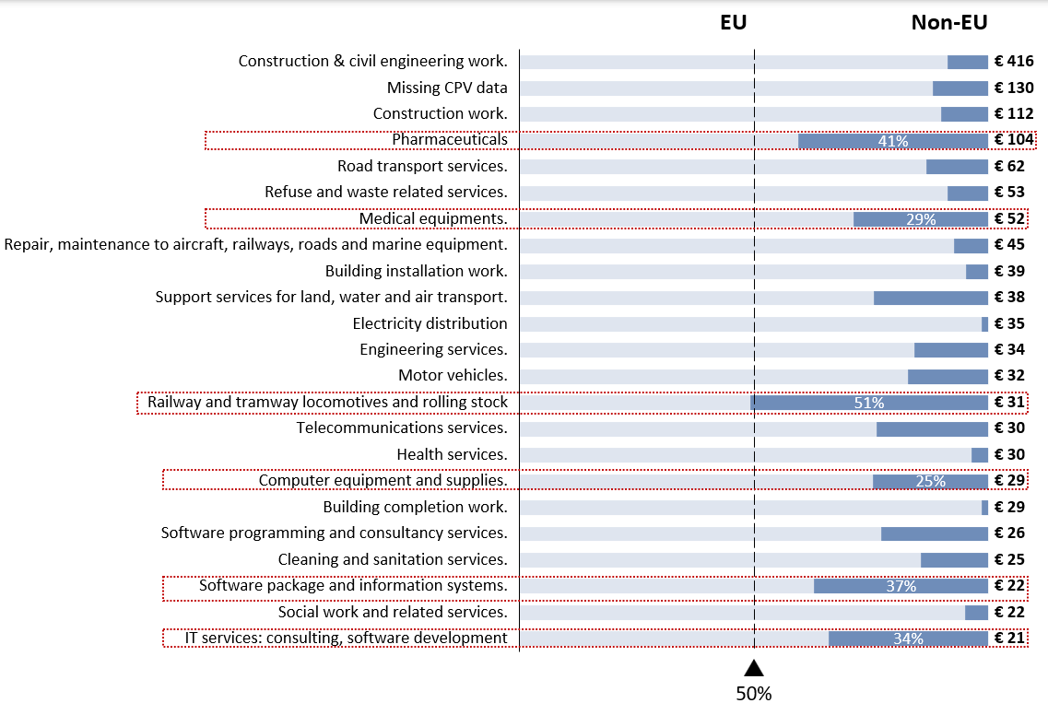
Source: In-house analysis; Note: 70% of total value of in-scope data, 2 trillion euros total in-scope data
The most important sectors (marked in red in Figure 24 above) were analysed in greater depth by examining more granular categories to better understand supply composition at lower levels. As shown in Figure 26 below, the demand in these sectors is largely met by suppliers from other European countries and North America, while certain specialised products, such as power electronic modules, depend almost entirely on Chinese suppliers. Although EU‑owned firms exist in most categories, they may lack a track record of supplying comparable volumes per the data in scope.
Figure 26: Main categories supplied by non-EU-owned EOs, years 2018-2023, EU 27 [million euro]
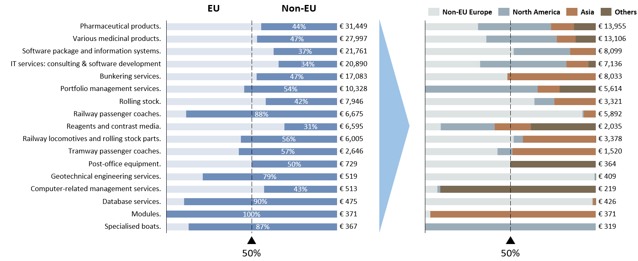
Source: In-house analysis; Note: right panel - awarded value to non-EU-owned EOs only
Figure 27: Top 5 country of ownership of non-EU EOs by awarded value, 2018-2023, EU 27 [EUR billion]
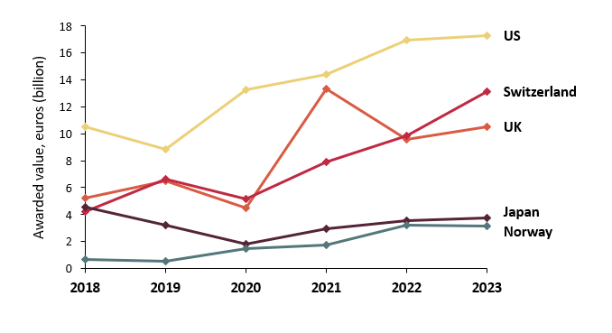
Source: In-house analysis
Among the main countries of origin of non EU-owned economic operators, only Japan experienced a decline in its share in real terms. By contrast, operators from the United States, United Kingdom, Switzerland, and Norway saw their shares grow.
Figure 28: Top 3 countries by value for non-EU-owned EOs in Member States with non-EU-owned EOs share above 20%, 2018-2023
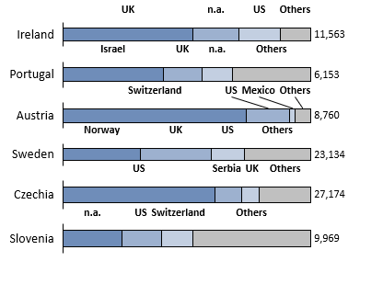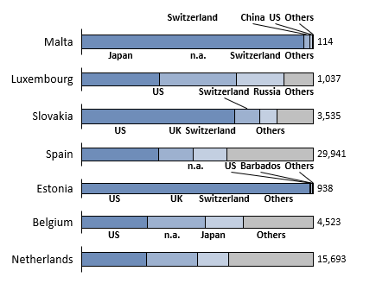
Source: In-house analysis
Thirteen member countries awarded 20% or more of contract value to non-EU-owned economic operators. In these cases, the United States, the United Kingdom, and Switzerland emerged as the principal partners, together accounting for approximately 68% of the total in-scope value awarded (to non-EU-owned EOs in these countries).
Restricting public procurement to EU‑owned suppliers would lead to an estimated three‑percentage‑point increase in award concentration, driven by a reduced pool of eligible bidders. Although the aggregate impact appears limited, concentration effects are uneven, with material variation by country and by product.
Figure 29: Impact on award concentration across Member States, years 2018-2023, EU 27
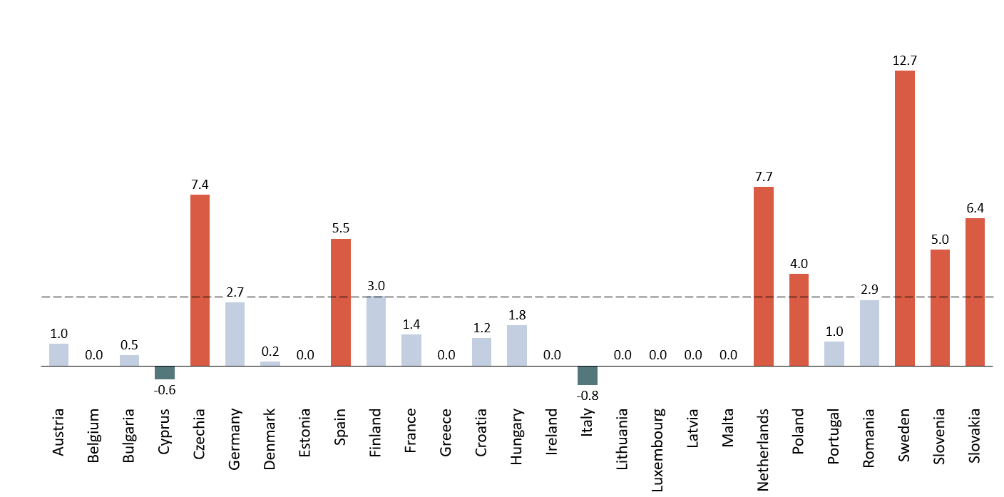
Source: In-house analysis Note: difference in percentage points of median market share of main supplier by CPV product, by country; in-scope data only
While the overall increase in award concentration remains modest (3 p.p.), restricting public procurement to EU‑owned economic operators would have more pronounced impacts in Member States with a narrower supplier base or a higher reliance on non‑EU‑owned operators across multiple products. These impacts are particularly evident in Czechia, Spain, the Netherlands, Sweden, Slovenia, and Slovakia.

Ad Section 6.3 - Analysis of FSR data
The dataset used for the analysis is an extract of submissions made by economic operators or groups of economic operators in accordance with the requirements of Regulation (EU) 2022/2560 (FSR) and Implementing Regulation (EU) 2023/1441. The analysis was made only for the purpose of supporting the Impact Assessment of the Revision of the Public Procurement Directives. The information presented has been processed pursuant to Article 43(3) FSR in such a way as to preserve all confidentiality requirements and to ensure that no information relating to participating companies or to a specific public procurement procedure can be identified.
The initial database contained 4 127 observations (submissions) referring to high-value procurement published in TED in 2023-2025. Observations with status “on hold” and “case not created” were removed from the working file and will not be subject to further analysis. The total number of observations retained was at that stage 4 119 (including pending cases with no status allocated yet).
Table 26: FSR submissions by type, 2023-2025
Submission | Frequency | Percent (%) | Cumulative (%)
Declaration | 3 433 | 83 | 83
Notification | 569 | 14 | 97
Pre-notification | 95 | 2 | 99
Missing | 22 | 1 | 100
Total | 4 119 | 100
Source: In-house analysis
The submissions per countries of contracting authorities and entities are presented below (Table 27).
Table 27: FSR submission status by country of contracting authority or entity, 2023-2025
Country of CAE | Declaration (N and %) | Notification (N and %) | Pre-notification  (N and %) | Total  (N and %)
AT | 75 | 13 | 1 | 89
AT | 84.3 | 14.6 | 1.1 | 100
BE | 50 | 8 | 1 | 59
BE | 84.75 | 13.56 | 1.69 | 100
BG | 11 | 1 | 1 | 13
BG | 84.62 | 7.69 | 7.69 | 100
CZ | 24 | 13 | 1 | 38
CZ | 63.16 | 34.21 | 2.63 | 100
DE | 506 | 148 | 9 | 663
DE | 76.32 | 22.32 | 1.36 | 100
DK | 171 | 31 | 12 | 214
DK | 79.3 | 14.5 | 5.6 | 100
EE | 3 | 2 | 0 | 5
EE | 60 | 40 | 0 | 100
EL | 2 | 0 | 0 | 2
EL | 100 | 0 | 0 | 100
ES | 76 | 7 | 1 | 84
ES | 90.48 | 8.33 | 1.19 | 100
EU | 18 | 6 | 0 | 24
EU | 75 | 25.0 | 0.0 | 100
FI | 37 | 2 | 2 | 41
FI | 90.24 | 4.88 | 4.88 | 100
FR | 847 | 87 | 10 | 944
FR | 89.72 | 9.22 | 1.06 | 100
HR | 7 | 4 | 0 | 11
HR | 63.64 | 36.36 | 0 | 100
HU | 32 | 11 | 0 | 43
HU | 74.42 | 25.58 | 0 | 100
IE | 48 | 11 | 1 | 60
IE | 80 | 18.33 | 1.67 | 100
IT | 588 | 74 | 32 | 694
IT | 84.7 | 10.7 | 4.6 | 100
LV | 165 | 0 | 0 | 165
LV | 100 | 0 | 0 | 100
NL | 262 | 20 | 4 | 286
NL | 91.61 | 6.99 | 1.4 | 100
NO | 3 | 0 | 0 | 3
NO | 100 | 0 | 0 | 100
PL | 135 | 48 | 1 | 184
PL | 73.37 | 26.1 | 0.54 | 100
PT | 0 | 1 | 1 | 2
PT | 0 | 50 | 50 | 100
RO | 161 | 27 | 8 | 196
RO | 82.14 | 13.78 | 4.08 | 100
SE | 174 | 54 | 10 | 238
SE | 73.11 | 22.69 | 4.2 | 100
SI | 6 | 0 | 0 | 6
SI | 100 | 0 | 0 | 100
SK | 32 | 1 | 0 | 33
SK | 96.97 | 3.03 | 0 | 100
Total | 3 433 | 569 | 95 | 4 097
Total | 83.8 | 13.9 | 2.3 | 100
Source: In-house analysis
To obtain a sectoral distribution of submissions, the activities related to the procurement in question were first identified based on the description provided by the applicant. The following sector categories were proposed based on minimum frequencies per group (i.e. at least 5%):
- Transport – railway, ports, airports, road infrastructure, etc.
- Health – medical equipment, pharmaceuticals,
- Energy – wind, solar, hydro, nuclear, energy grid, etc.,
- IT, telecommunications – including postal services,
- Environmental services – urban services, water, waste management, etc.
- Construction works (n.e.c.)
- Other
As only one sector per observation (i.e. submission) was allowed, cases for which allocation to more than one sector could be meaningful (e.g. “construction work for pipelines, communication and power lines, for highways, roads, airfields and railways” could belong to Transport, Energy and Construction works (n.e.c)) were resolved as follows:
- Sector-specific characteristics took precedence: for example, the construction of water locks was categorised as Environmental services, while the construction of an electricity grid was categorised as Energy.
- Construction works were treated as a residual category (n.e.c.): works not clearly belonging to any other category were classified under Construction works (n.e.c.).
- Ambulances were categorised under Health, and not under Transport.
For observations that were still with no categorisation, the contracting authority was used to determine the sector. For example, procurement by railway companies was categorised under Transport, while procurement by a central purchasing body specialising in medical supplies was categorised under Health. This could imply, for instance, that training services for personnel of La Poste would be categorised under sector 4 (IT, telecommunications), rather than under category 7 Other (i.e. otherwise unclassified).
The sectors of activities for which submissions were registered is presented below (Table 28).
Table 28: FSR submissions by sector, 2023-2025
Sector of activity: | Frequency | Percent (%) | Cumulative
IT and Telecommunication | 1 043 | 25.3 | 25.3
Transport | 1 013 | 24.6 | 49.9
Energy | 747 | 18.1 | 68.1
Construction (N.E.C.) | 436 | 10.6 | 78.6
Health | 427 | 10.4 | 89.0
Other | 244 | 5.9 | 94.9
Environmental services | 209 | 5.1 | 100.0
Total: | 4 119 | 100
Source: In-house analysis

The submission status per sector is provided in below.
Figure 30: FSR submissions by sector and status, 2023-2025
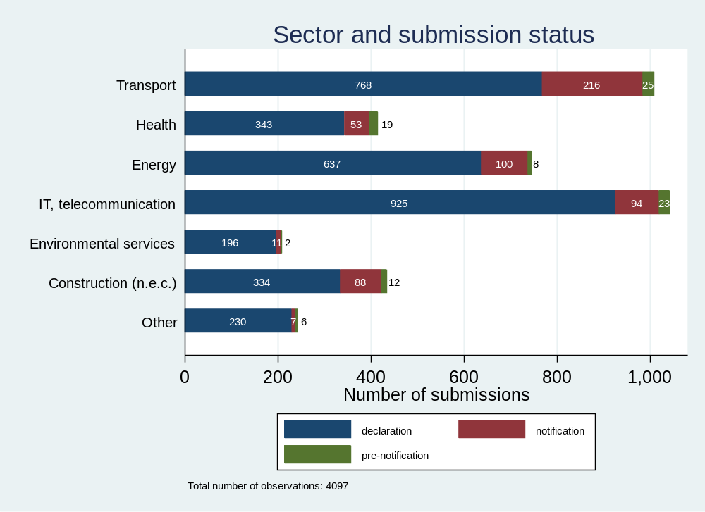
Source: In-house analysis

Overall, the submissions refer to 653 unique TED publications, with an average of 10 submissions per notice (and a maximum of 104 entries for a single notice).
The 4 119 observations consisted of many entries where the economic operators were gathered in a consortium. To the extent possible these cases were split, so that each line/ observation represents one company. As a result, the dataset expanded to 5 809 companies. However, since many companies appeared multiple times across different submissions, the number of unique companies was lower, namely 4 214. These firms were subsequently matched with Orbis to obtain information on their Global Ultimate Owners (GUO). The match rate was 80% with 3 414 companies successfully matched.
Information from Orbis was then merged back into the FSR original data (4 119 observations). However, since the Orbis data are reported at firm level, the base file stabilised at 5 745 observations (as some of the 4 119 submissions were split/multiplied in cases involving consortia).
Figure 31: FSR submissions by GUO type, 2023-2025
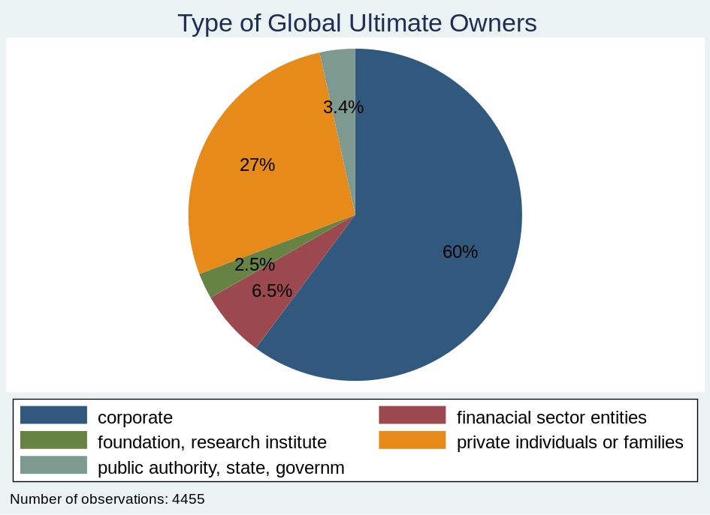
Source: In-house analysis
Based on the FSR submissions received, intra-EU ownership concerned nearly 2/3 of all FSR cases (or ¾ of cases for which data was available), see the figure below. This proportion can be also regarded as a good proxy for the indirect cross-border penetration for high value contracts. This is broadly in line with the above mentioned findings by Prometea (2021) that estimated indirect cross-border procurement at 20.2% (by number) and 21.6% (by value) for awards below EUR 200 million, with the shares increasing to 27.8% and 27.1%, respectively, for awards above EUR 200 million).

Figure 32: Country of GUOs of the companies mentioned in FSR submissions, 2023-2025
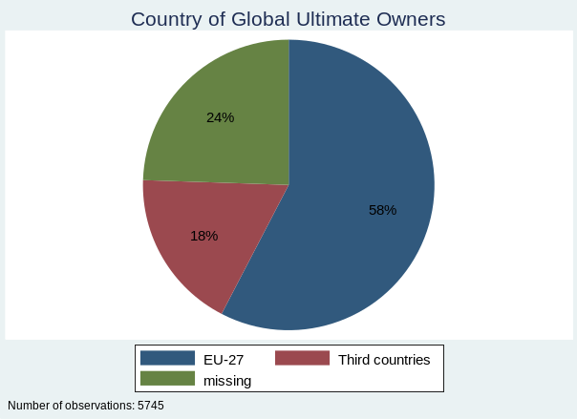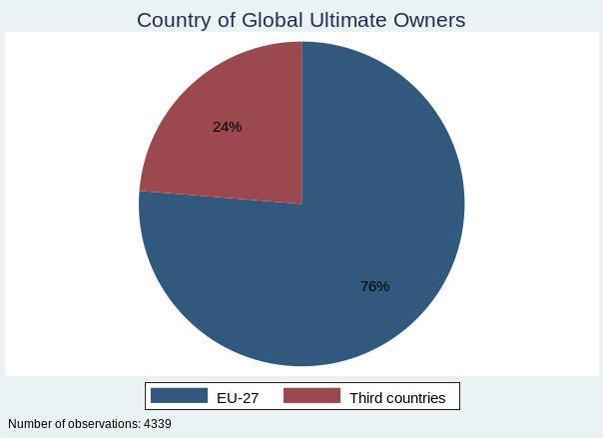
Source: In-house analysis
Out of the share allocated to third countries, the analysis of the FSR submissions indicate that the main trading partners potentially affected by the policy measures foreseen under BEU options could above all: the United States (235 entries or 4% presence in submissions), followed by the United Kingdom (147 entries, 2.5%) and Switzerland (106 entries, 1.9%). More detailed information on the main countries is presented in Table 29 below.
Table 29: Country of GUOs of the companies mentioned in FSR submissions, 2023-2025
Country | Code | Number | (%) | Cumulative (%)
Austria | AT | 138 | 2.4 | 2.4
Belgium | BE | 39 | 0.68 | 3.08
Bulgaria | BG | 21 | 0.37 | 3.45
Croatia | HR | 12 | 0.21 | 3.66
Cyprus | CY | 4 | 0.07 | 3.72
Czechia | CZ | 38 | 0.66 | 4.39
Denmark | DK | 93 | 1.62 | 6.01
Estonia | EE | 3 | 0.05 | 6.06
Finland | FI | 34 | 0.59 | 6.65
France | FR | 877 | 15.27 | 21.91
Germany | DE | 440 | 7.66 | 29.57
Greece | EL | 5 | 0.09 | 29.66
Hungary | HU | 20 | 0.35 | 30.01
Ireland | IE | 71 | 1.24 | 31.24
Italy | IT | 531 | 9.24 | 40.49
Latvia | LV | 128 | 2.23 | 42.72
Lithuania | LT | 5 | 0.09 | 42.8
Luxembourg | LU | 73 | 1.27 | 44.07
Netherlands | NL | 242 | 4.21 | 48.29
Poland | PL | 108 | 1.88 | 50.17
Portugal | PT | 8 | 0.14 | 50.3
Romania | RO | 146 | 2.54 | 52.85
Slovakia | SK | 14 | 0.24 | 53.09
Slovenia | SI | 7 | 0.12 | 53.21
Spain | ES | 125 | 2.18 | 55.39
Sweden | SE | 128 | 2.23 | 57.62
Norway | NO | 45 | 0.78 | 58.4
Switzerland | CH | 106 | 1.85 | 60.24
United Kingdom | UK | 146 | 2.54 | 62.79
United States | US | 235 | 4.09 | 66.88
China | CN | 54 | 0.94 | 67.82
Japan | JP | 86 | 1.5 | 69.31
Canada | CA | 36 | 0.63 | 69.94
South Korea | KR | 21 | 0.37 | 70.3
India | IN | 48 | 0.84 | 71.14
Turkey | TR | 83 | 1.44 | 72.58
Other countries |  | 169 | 2.94 | 75.53
N.A or missing |  | 1 406 | 24.47 | 100
Total |  | 5 745 | 100
Source: In-house analysis

As for the sectors concerned by third countries presence, the following NACE divisions were chosen for further analysis. Basically, the list of sectors was designed to reflect as closely as possible the key sectors declared in the FSR submissions (see Table 28): Manufacture of pharmaceuticals, medicinal chemical and botanical products (NACE division 21), Manufacture of computer, electronic and optical products (NACE division 26), Manufacture of electrical equipment (NACE division 27), Manufacture of machinery and equipment n.e.c. (28), Manufacture of transport equipment (NACE divisions 29-30), Other manufacturing, and repair and installation of machinery and equipment (NACE divisions 31-33), Electricity, gas, steam and air-conditioning supply (35), Water supply, sewerage, waste management and remediation (NACE divisions 36-39), Construction (NACE divisions 41-43), Transportation and storage (NACE divisions 49-53), Telecommunications (NACE division 61), IT and other information services (NACE divisions 62-63), Scientific research and development (NACE division 72), Other professional, scientific and technical activities (NACE divisions 73-75), Human health services (NACE division 86). The figures below represent shares of ownership by key sectors.
Figure 33: Country of GUOs of the companies mentioned in FSR submissions, 2023-2025 – pharmaceuticals
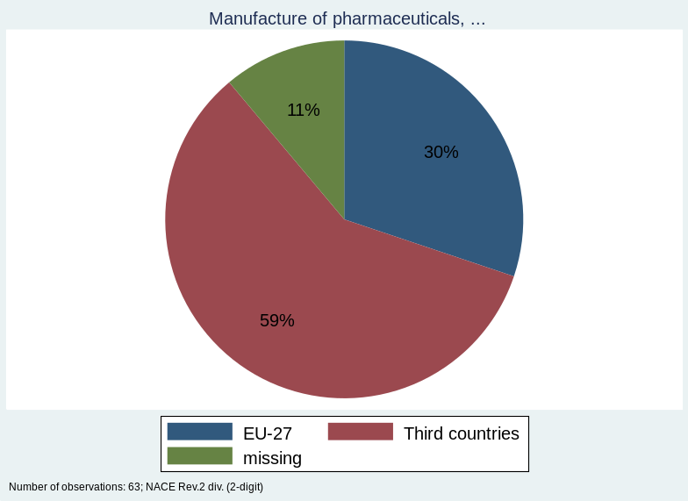
Source: In-house analysis
For manufacture of pharmaceuticals, medicinal chemical and botanical products, third-country entities represent a significant majority at 59% of GOUs, with most originating from the US (13 submissions), followed by India, Japan, South Korea, Switzerland, Turkey and the UK, while EU-27 entities account for 30%.
Figure 34: Country of GUOs of the companies mentioned in FSR submissions, 2023-2025 – computers
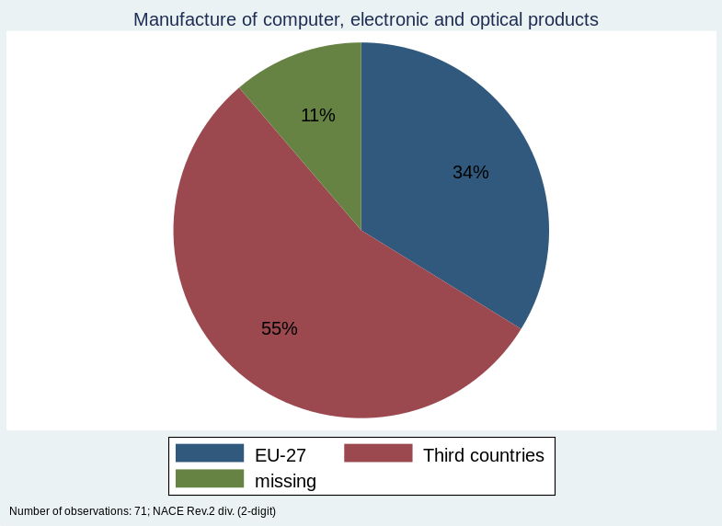
Source: In-house analysis
A similar pattern emerges in the Manufacture of computer, electronic and optical products, where third-country ownership reaches 55%, driven mainly by China and the US (11 submissions each)., with Japan and other countries also represented, compared to 34% for EU-27 entities.
Figure 35: Country of GUOs of the companies mentioned in FSR submissions, 2023-2025 – electrical equipment
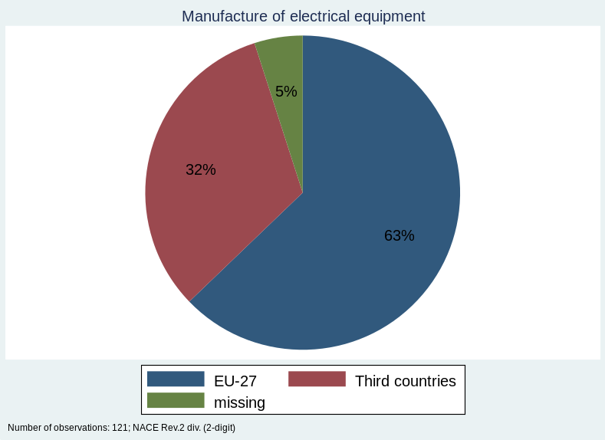
Source: In-house analysis
The Manufacture of electrical equipment presents a different picture, as EU-27 entities dominate at 63%, with third-country ownership accounting for 32%, mainly from China (9 submissions) and Japan (7), alongside the United States (4), South Korea, Switzerland and Norway.
Figure 36: Country of GUOs of the companies mentioned in FSR submissions, 2023-2025 – machinery, equipment
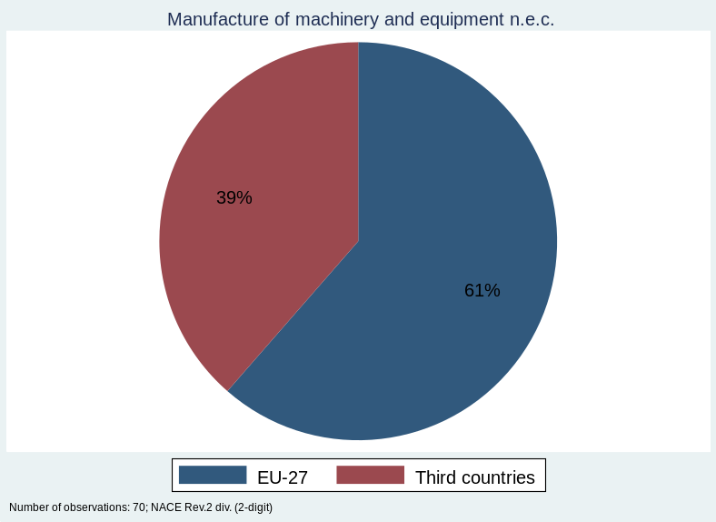
Source: In-house analysis
In the Manufacture of machinery and equipment, EU-27 entities also hold the majority at 61%, while third-country ownership reaches 39%, with the vast majority stemming from the United States (16 submissions) and smaller shares from China, India, Japan and Switzerland.
Figure 37: Country of GUOs of the companies mentioned in FSR submissions, 2023-2025 – transport equipment
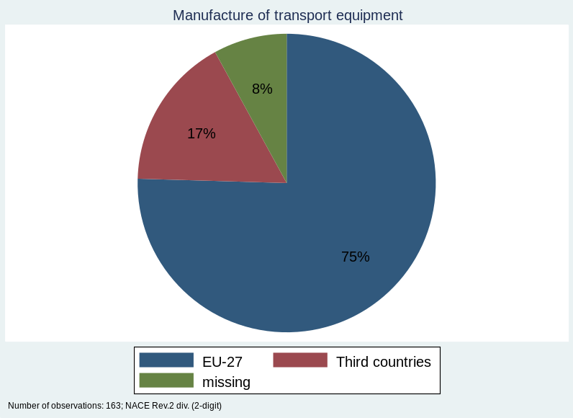
Source: In-house analysis
The Manufacture of transport equipment shows strong EU-27 presence at 75%, with third-country ownership remaining relatively low at 17%, largely driven by Switzerland, (11 submissions) alongside Japan, China, the UK, the USA, Norway, South Korea and Turkey.
Figure 38: Country of GUOs of the companies mentioned in FSR submissions, 2023-2025 – other manufacturing
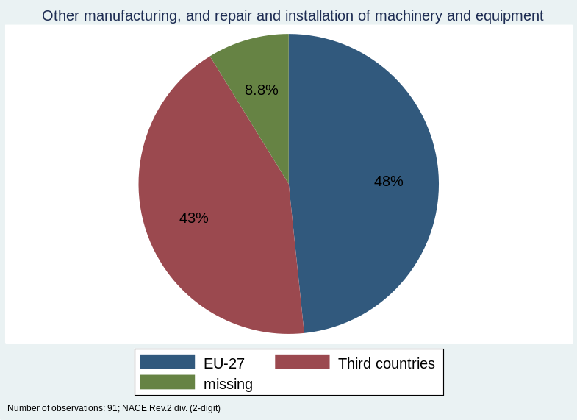
Source: In-house analysis
Other manufacturing, and repair and installation of machinery and equipment, the split is more balanced, with EU-27 entities at 48% and third-country ownership at 43%, mainly from the United Sates (19 submissions), complemented by Canada, China, Japan, Switzerland.
Figure 39: Country of GUOs of the companies mentioned in FSR submissions, 2023-2025 – electricity, gas, steam
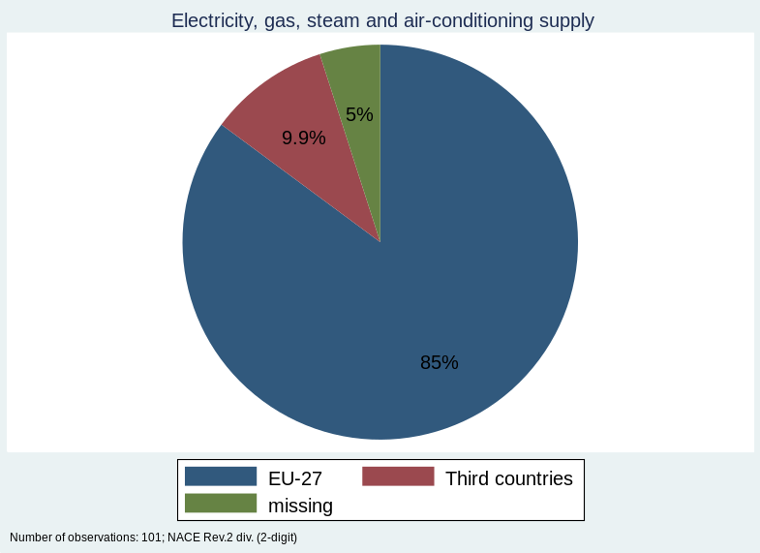
Source: In-house analysis
The Electricity, gas, steam and air-conditioning supply sector is predominantly EU-27 owned at 85%, with third-country ownership limited to around 10%, originating from Switzerland (4 submissions), Japan and Norway.
Figure 40: Country of GUOs of the companies mentioned in FSR submissions, 2023-2025 – water supply, sewerage
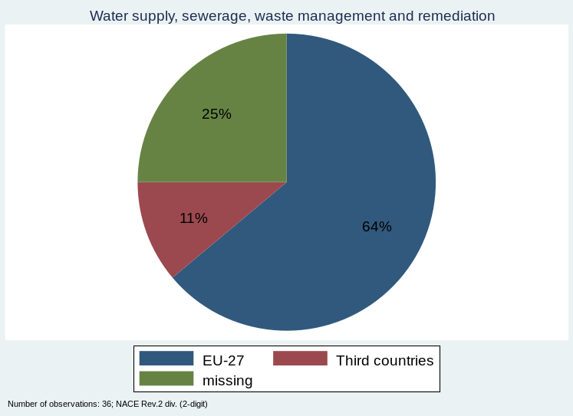
Source: In-house analysis
In Water supply, sewerage, waste management and remediation, EU-27 entities account for 64%, while third-country ownership represents a modest 11%.
Figure 41: Country of GUOs of the companies mentioned in FSR submissions, 2023-2025 – construction
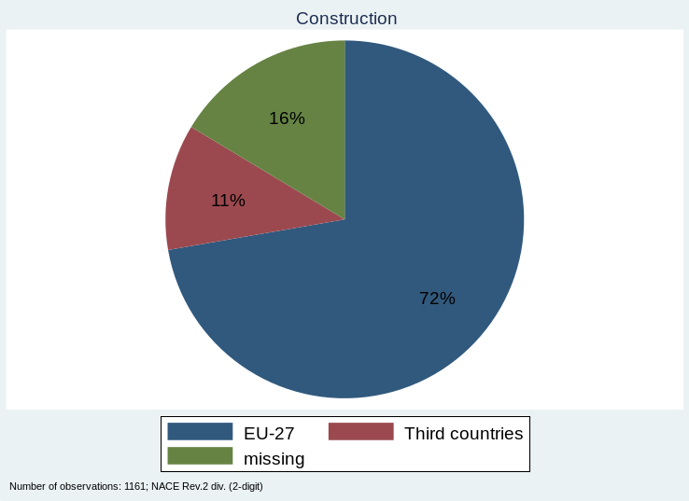
Source: In-house analysis
The Construction sector (1161 submissions in total) follows a similar trend, with EU-27 entities dominating at 72% and third-country ownership at 11%, mainly from Turkey (66 submissions), with additional presence from China, India, Japan, Norway, the UK and the United States.
Figure 42: Country of GUOs of the companies mentioned in FSR submissions, 2023-2025 – transportation and storage
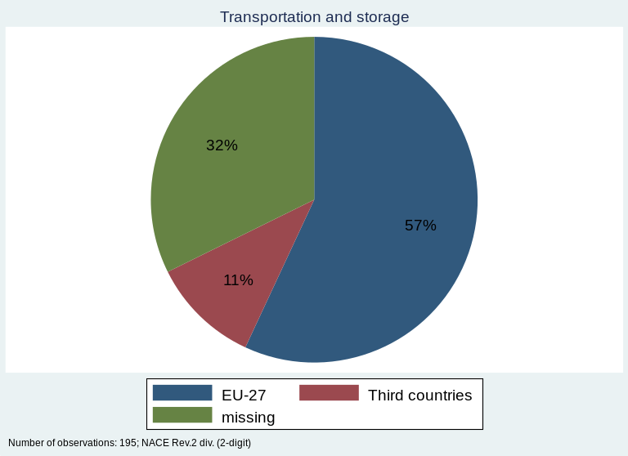
Source: In-house analysis
For Transportation and storage, EU-27 entities represent 57% and third-country ownership accounts for 11% (out of 195 submissions in total), spread across Canada, China, India, Norway (3 submissions each).
Figure 43: Country of GUOs of the companies mentioned in FSR submissions, 2023-2025 – telecommunications
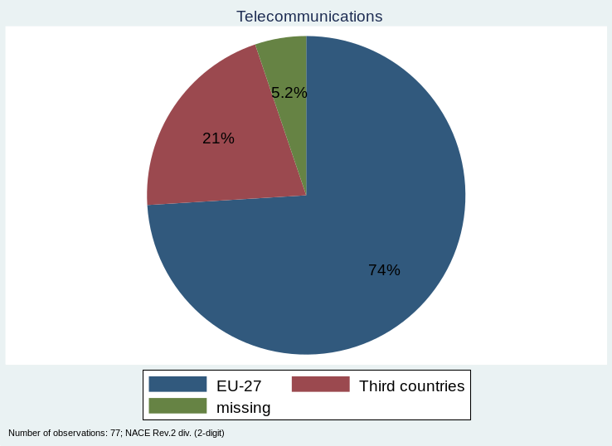
Source: In-house analysis
In Telecommunications, EU-27 entities hold a strong 74%, with third-country ownership at 21%, primarily from Switzerland and the UK (4 submissins each), alongside Canada, Japan, Norway.
Figure 44: Country of GUOs of the companies mentioned in FSR submissions, 2023-2025 – IT and other information services
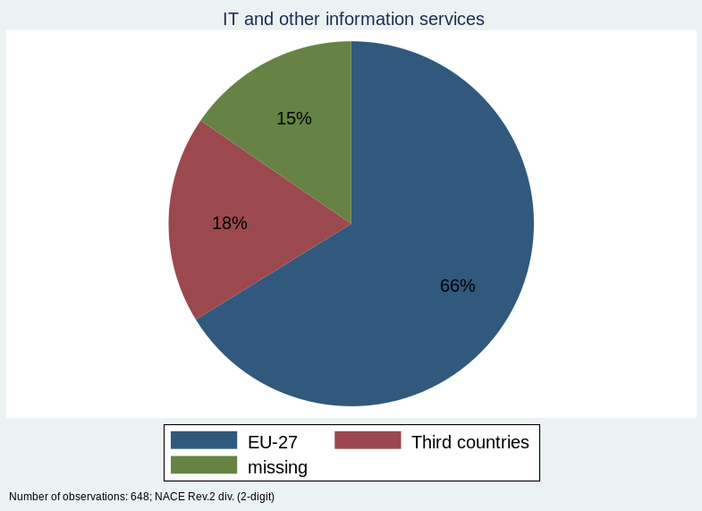
Source: In-house analysis
The IT and other information services sector (648 submissions) saw third-country ownership at 18%, mainly from the United States (38 submissions) and the United Kingdom (37), with Canada (17), Japan (10), Switzerland (8) and India (4) also represented.
Figure 45: Country of GUOs of the companies mentioned in FSR submissions, 2023-2025 – scientific R&D
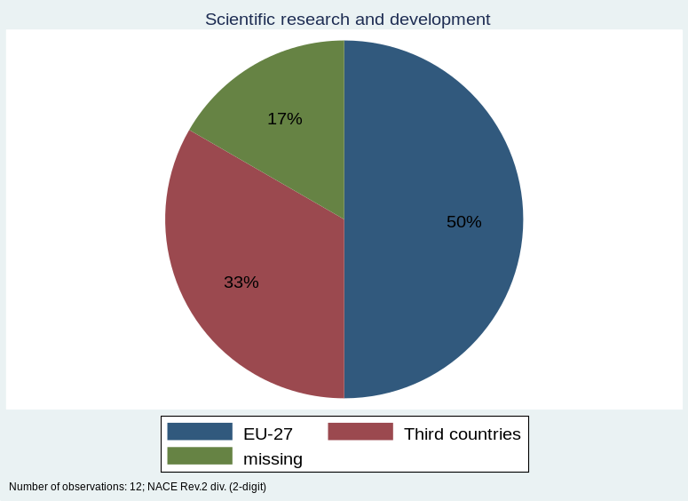
Source: In-house analysis
Within Scientific research and development, EU-27 entities account for 50%, while third-country ownership reaches 33%, originating from China, India and Japan.
Figure 46: Country of GUOs of the companies mentioned in FSR submissions, 2023-2025 – other professional, scientific and technical activities
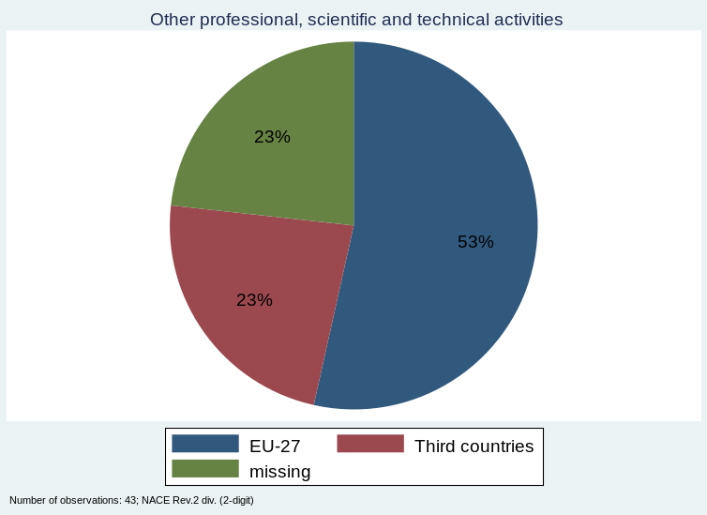
Source: In-house analysis
Concerning Other professional, scientific and technical activities, EU-27 entities represented 53% of 43 submissions, third-country ownership stood at 23% from the United States (4 submissions), Canada, Switzerland and the UK.
Figure 47: Country of GUOs of the companies mentioned in FSR submissions, 2023-2025 – Human health services
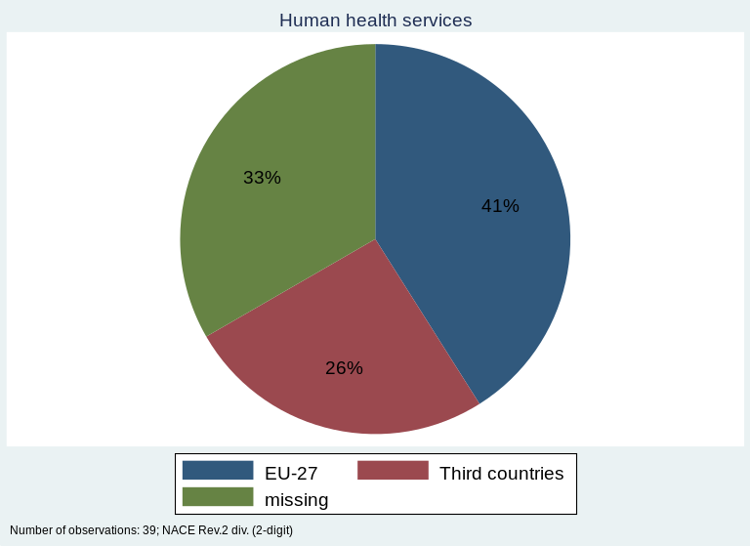
Source: In-house analysis
Finally, in human health services, EU-27 entities accounted for 41%, while third-country ownership reached 26%, primarily from the UK (5 submissions) and Switzerland alongside other countries.

Ad Section 6.3 - Impacts of BEU options using FIDELIO model (JRC)
The analysis of macroeconomic impacts of BEU options was based on the FIDELIO (Full Interregional Dynamic Econometric Long-term Input-Output) model, which is a flexible, multi-region, multi-sector, input-output model developed and run by the Joint Research Centre (JRC) and steered by the Directorate-General for Internal Market, Industry, Entrepreneurship and SMEs (DG GROW) to become the reference model of the EU industrial policy and assess socio-economic and environmental impacts of EU trade and industrial policies. It covers 45 countries, one rest-of-the-world region, 64 economic sectors and 64 products. It is a tool for estimating the socio-economic and environmental impacts of EU industrial, trade, and innovation policies for a fair and sustainable EU economy. FIDELIO’s multi-country general equilibrium structure lets the model capture how e.g. increased domestic demand in one country raises imports from, and activity in, others - something simple national models can’t do.
The purpose of using the FIDELIO model was to estimate the potential impacts of the BEU policy options under consideration, especially as the latter may consist of certain levels for Local Content Requirements (LCR). In view of the above, FIDELIO was expected to test how new LCR requirements in public procurement could affect sectoral outputs and trade balance.
Generally, a local content requirement means that government demand must be sourced more from domestic suppliers (or from “Made in EU” suppliers), and less from imports. In FIDELIO this is basically a change in the import share of public demand. Once government demand shifts to domestic supply (or “Made in EU” supply), FIDELIO propagates effects through the economy: output in domestic sectors supplying to government is expected to increase, imports in those sectors are expected to decrease. Yet it should be noted that the impact of a domestic content requirement depends hugely on where in the value chain it is applied:
- Upstream (raw materials, basic inputs): wide economy-wide spillovers, stronger price effects, higher risk of competitiveness losses downstream.
- Midstream (components): still strong spillovers, but more sector-specific.
- Downstream (final goods): more targeted effects, mainly affecting procurement prices and the specific supplying industries.
Steel and aluminium
The first simulation run for this impact assessment was based on an 85 % “Made in EU” content requirement for steel and aluminium (i.e. upstream / raw materials), which is then used in construction activities procured by the public sector. Running the model resulted in the impacts in terms of accumulated value added in 2025-2030, presented below – first in the case of the upstream sectors of steel and aluminium (Table 30 below) where effects of the policy are predominantly positive, and then for the downstream construction sector where some adverse impact may materialise.
Table 30: Impact of Accumulated Value Added (2025-2030) – steel and aluminium
Public Procurement
Country | Public Procurement | Million EUR
HRV | 0.12 | 0.1
ROU | 0.29 | 5
HUN | 0.76 | 5
LTU | 0.67 | 0.1
NLD | 0.42 | 9
PRT | 0.32 | 2
FRA | 0.27 | 17
AUT | 0.49 | 21
SVN | 0.67 | 3
BGR | 0.38 | 1
POL | 0.59 | 15
DNK | 0.44 | 2
SVK | 0.88 | 8
EU27 | 0.50 | 331
SWE | 0.36 | 10
CYP | 0.10 | 0.0
BEL | 0.91 | 31
EST | 1.00 | 0.3
ESP | 0.36 | 19
LUX | 2.81 | 8
DEU | 0.51 | 106
FIN | 0.61 | 12
ITA | 0.47 | 44
GRC | 0.63 | 7
IRL | 0.27 | 1
MLT | 0.08 | 0.0
LVA | 2.44 | 0.1
NOR | 0.49 | 6
CHE | 0.01 | 0.3
CZE | 0.39 | 5
Source: In-house analysis by JRC using FIDELIO

Figure 48: Impact of Accumulated Value Added (2025-2030) – steel and aluminium
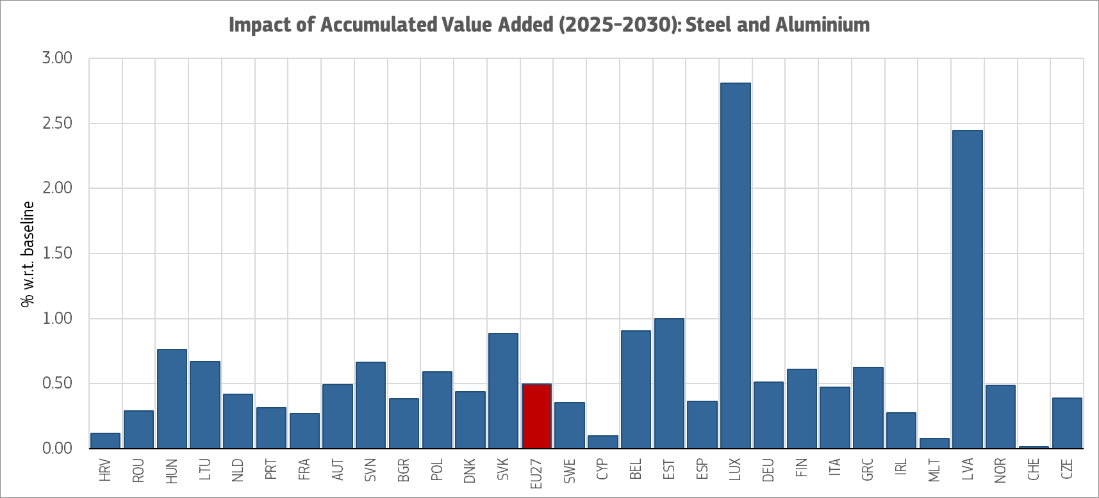
Source: In-house analysis by JRC using FIDELIO
Almost one third of the positive impact in the EU steel and aluminium sectors would concern Germany (EUR 106 million), followed by Italy (EUR 44 million). In relative terms, Luxembourg stands out with the highest impact on value added (+2.81% with regards to the baseline - owing to the presence of ArcelorMittal in the country – the world’s second largest steel producer) followed by Latvia (+2.44% increase). The total positive effect in terms of accumulated value added for the EU would be EUR 331 million in 2025-2030.
As the effects of any local content requirement in public procurement would travel across the value chain, the impacts were also tested on the construction sector (i.e. downstream) that uses steel and aluminium as raw materials (Table 31 and Figure 49 below).
Construction
Table 31: Impact of Accumulated Value Added (2025-2030) - construction
Public Procurement
Country | Public Procurement | Million EUR
HRV | -3.74 | - 74
ROU | -1.47 | - 131
HUN | -1.54 | - 70
LTU | -0.96 | - 25
NLD | -1.09 | - 325
PRT | -0.72 | - 49
FRA | -0.48 | - 539
AUT | -0.34 | - 72
SVN | -0.45 | - 9
BGR | -0.47 | - 7
POL | -0.24 | - 66
DNK | -0.30 | - 44
SVK | -0.26 | - 15
EU27 | -0.27 | - 1 609
SWE | -0.19 | - 55
CYP | -0.21 | - 2
BEL | -0.18 | - 38
EST | -0.09 | - 1
ESP | -0.07 | - 44
LUX | 0.02 | 0.5
DEU | -0.02 | - 31
FIN | -0.02 | - 2
ITA | -0.01 | - 9
GRC | -0.07 | - 1
IRL | -0.01 | - 0.5
MLT | 0.00 | 0.0
LVA | 0.00 | 0.0
NOR | 0.00 | 0.3
CHE | 0.01 | 2
CZE | 0.00 | 0.1
Source: In-house analysis by JRC using FIDELIO

According to the estimates, France, the Netherlands and Romania would be most affected by the higher price of EU produced steel – these three countries would account for 62 % (EUR 995 million) of the total negative impact (EUR 1.6 billion) of the policy measure. However, in relative terms Croatia, Hungary and Romania would show even greater negative impact, (-3.74%, -1.54% and -1.47% respectively) likely because of their high dependence on non-EU steel production. To compare, construction activity in the Netherlands and France, despite much higher monetary values, would see their respective value added reduced with regards to the baseline by -1.09 % and -0.48 %, respectively.
Figure 49: Impact of Accumulated Value Added (2025-2030) - construction
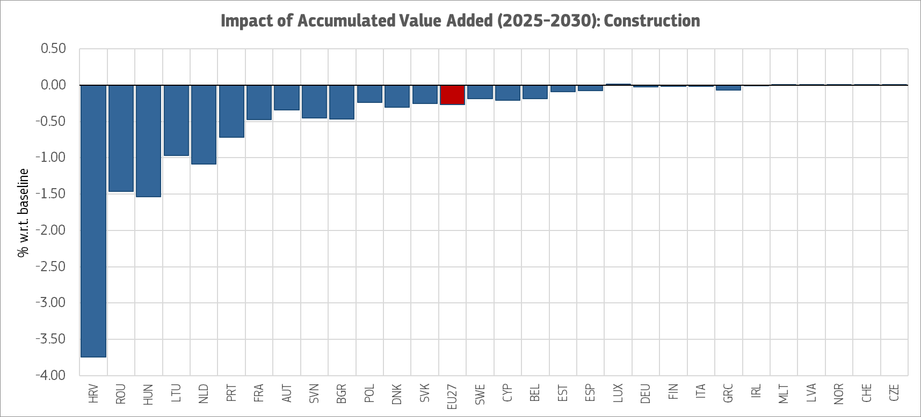
Source: In-house analysis by JRC using FIDELIO

Moving down the value chain, a LCR in government purchasing would also affect the trade balance, as it would directly reduce imports of the goods (or inputs) covered by the measure and increase demand for domestically produced substitutes. Nonetheless, if domestic upstream industries expand, they may achieve economies of scale and improve its competitiveness to the extent that increases exports. Eventually, the trade combined impact of EU content requirements would be nearly neutral in terms of intra-EU trade balances, almost equally impacting intra-EU exports of basic metals and intra-EU imports of the construction sector. Concretely, the EU construction sector increase the intra-EU imported inputs of steel and aluminium, that will be achieved by an increase in exports of steel and aluminium (C24) by the Member states. Therefore, some countries are expected to yield a positive trade balance for the policy measure, especially for Germany and Italy (see the table and figure below).
Table 32: Impact on trade balance - construction, manufacture of basic metals
 | Public Procurement
Country | Construction (F) | Manufacture of basic metals (C24)
DEU | - 120 | 397
FRA | - 382 | 85
NLD | - 240 | 30
ITA | - 51 | 194
BEL | - 67 | 148
ESP | - 36 | 91
AUT | - 63 | 61
ROU | - 99 | 16
POL | - 60 | 54
SWE | - 44 | 38
HUN | - 52 | 16
SVK | - 20 | 38
FIN | - 12 | 44
PRT | - 35 | 8
DNK | - 30 | 4
HRV | - 32 | 0
CZE | - 5 | 23
NOR | - 3 | 21
BGR | - 8 | 16
GRC | - 3 | 19
SVN | - 8 | 12
LUX | - 9 | 8
LTU | - 16 | 0
IRL | - 0 | 3
LVA | - 0 | 2
EST | - 1 | 1
CYP | - 1 | 0
MLT | 0 | 0
CHE | 29 | 1
EU27 | - 1 368 | 1 330
Source: In-house analysis by JRC using FIDELIO

When interpreting data from the above table, it’s worth noting that Switzerland is a special case Swiss imports are negatively affected because the country is not subject to the EU content regulations on public procurement. Moreover, neither Norway nor Switzerland benefits significantly from the policy measure.
Figure 50: Impact on trade balance – construction and manufacture of basic metals
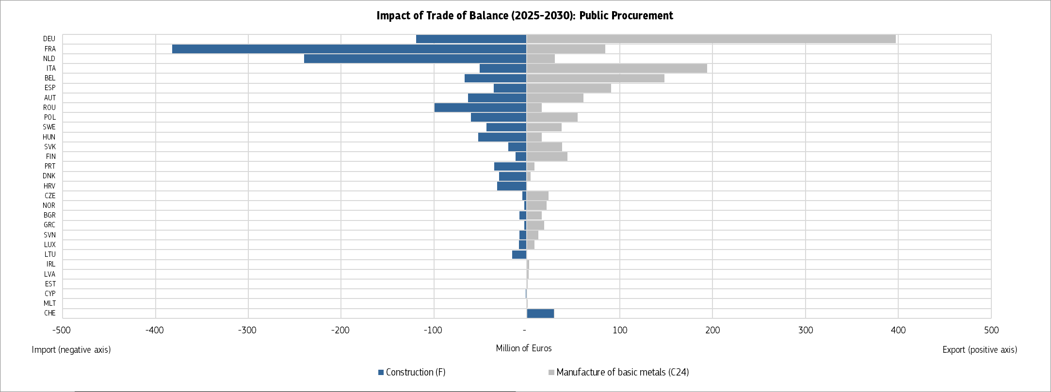Source: In-house analysis by JRC using FIDELIO
Overall, the impact of local content requirements is likely to reflect a combination of positive and negative effects. Even if the net GDP impact may be ambiguous, depending on the balance between upstream expansion in domestic input producing sectors and potential downstream contraction driven by higher input costs or reduced competitiveness, it will nonetheless improve intra EU trade.
At the same time, an important potential benefit that is not captured by the model, namely if domestic sourcing (e.g. of critical materials) is strengthened, the EU would become less exposed to future foreign supply disruptions and input price shocks. This increased resilience of supply chains could reduce vulnerability to external geopolitical or market shocks, thereby supporting longer-term economic stability.
Radio, television and communication equipment and apparatus
The simulation for radio, television and communication equipment and apparatus was also based on an 75 % “Made in EU” content requirement applied to procurement by the public sector. As with the previous product categories, the model was used to estimate the impacts in terms of accumulated value added in 2025-2030, distinguishing between the upstream manufacturing industries and the downstream public sectors that procure these goods, where higher input costs may translate into adverse effects on public budgets.
Figure 51: EU local content requirement on Radio, television and communication equipment and apparatus – changes in the accumulated value-added w.r.t. baseline
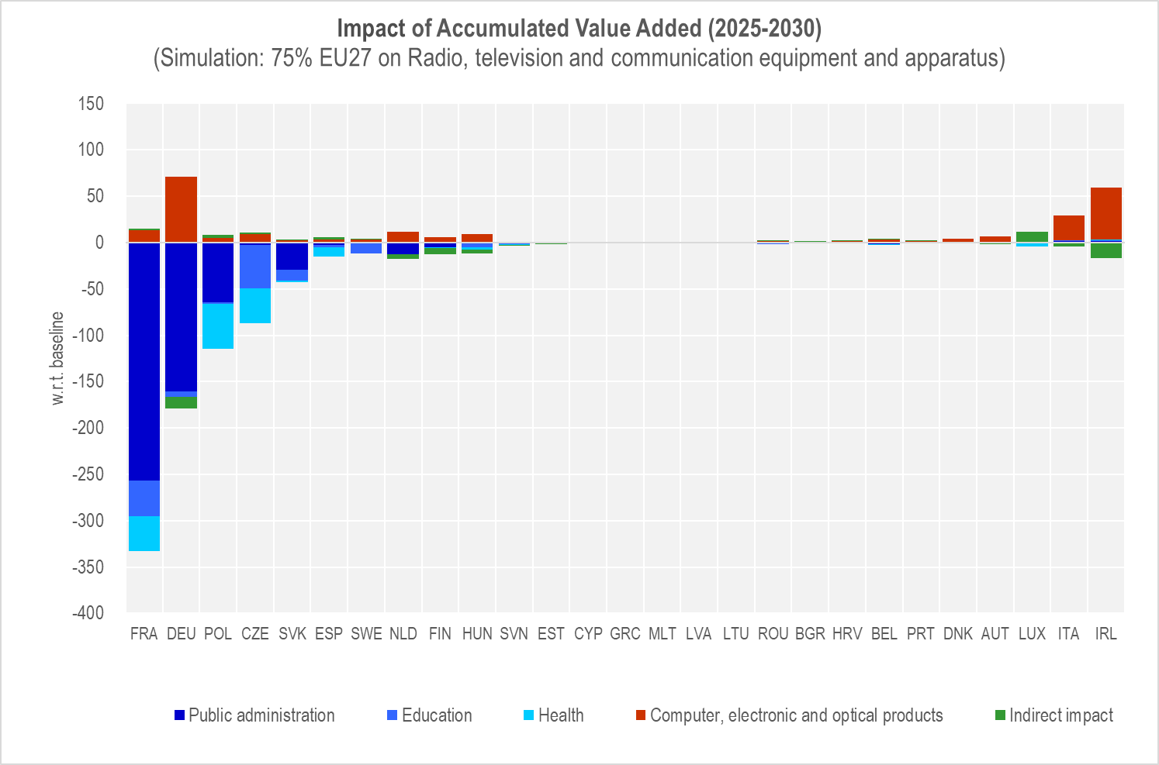
Source: In-house analysis by JRC using FIDELIO
On the upstream side, the EU computer, electronics and optical products industry would be the main beneficiary of the “Buy European” requirement, as procuring entities reorient their demand towards EU-based suppliers. Germany would capture the largest share of this positive effect, with its computer and electronics industry gaining EUR 71 million in additional accumulated value added over 2025-2030 - reflecting the country's well-established specialisation in communication equipment, telecommunication infrastructure and broadcasting technology. At the same time, other German industries supplying inputs along this value chain would experience an added cost of EUR 12 million, highlighting once again how local content requirements may yield mixed effects within the same national economy, depending on each sector's position along the value chain.
On the downstream side, the higher cost of EU-produced radio, TV and communication equipment would translate into additional procurement expenditures for public buyers across the Union, with the impact concentrated in a few large Member States. The French general public administration would face the most significant absolute impact, with an additional cost of EUR 256 million, reflecting both the size of its central administration's IT and communications expenditure and its relatively high reliance on non-EU suppliers in this product category. Poland's public health system would face an increased cost of EUR 49 million, while the Czech public education system would incur an extra cost of EUR 47 million. These figures point to a pattern similar to that observed in the construction sector: the downstream sectors most dependent on extra-EU imports of the regulated goods are also those most exposed to the cost increases driven by the local content requirement.
Figure 52: EU local content requirement on Radio, television and communication equipment and apparatus – trade impacts
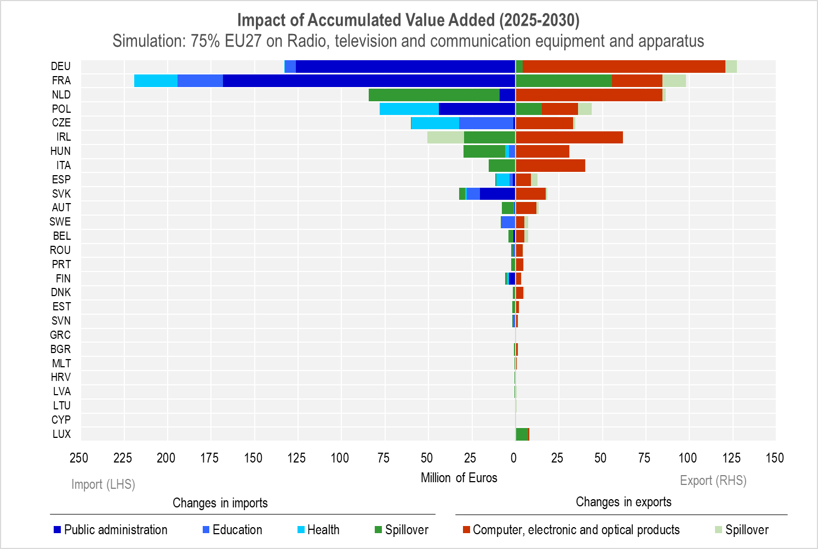
Source: In-house analysis by JRC using FIDELIO
As with the other product categories examined, the effects of the local content requirement would ripple through the value chain and reshape trade flows. The measure would directly reduce extra-EU imports of radio, TV and communication equipment by public buyers, while stimulating intra-EU trade as Member States substitute towards EU-produced equipment. The French general public administration would see its (intra-EU) imports increase by EUR 168 million, Poland's public health system by EUR 34 million, and the Czech public education system by EUR 31 million. Other Dutch imports would also rise by EUR 75 million, reflecting indirect spillover effects from procurement decisions taken in other Member States, a finding consistent with the high degree of integration of the Netherlands within EU logistics and re-export chains.
On the export side, Germany's computer and electronics industry would once again stand out as the main beneficiary, with intra-EU exports increasing by EUR 116 million, complemented by an additional EUR 7 million rise in other German exports linked to procurement decisions in partner countries. Overall, the aggregate trade balance impact at EU level would be broadly neutral, with the increase in intra-EU exports of communication equipment roughly offsetting the increase in intra-EU imports by public buyers. This confirms the pattern already identified for steel and aluminium, medical instruments and office machinery: local content requirements tend to redistribute trade flows within the Single Market rather than alter the EU's overall position vis-à-vis third countries.
Taken together, the results for radio, television and communication equipment reinforce the broader interpretation developed throughout this impact assessment. While the net GDP impact remains ambiguous, depending on the balance between upstream expansion in the EU electronics industry and downstream cost increases in public administration, healthcare and education, the measure would unambiguously strengthen intra-EU trade integration and consolidate the position of a limited number of EU industrial leaders, with Germany emerging as the principal beneficiary. Beyond the quantified effects, an important benefit that is not captured by the model relates to the strategic nature of communication equipment. This product category includes goods that are critical for national security, public administration networks, emergency communications and increasingly for 5G and next-generation telecommunication infrastructures. Strengthening domestic sourcing in this area would reduce the EU's exposure to foreign supply disruptions, mitigate cybersecurity and dependency risks associated with extra-EU vendors, and contribute to the EU's broader objective of technological sovereignty.
Medical, precision, and optical instruments, watches, and clocks
The simulation for this product category was based on an 75 % “Made in EU” content requirement applied to the public procurement of medical, precision and optical instruments, watches, and clocks. As previous examples, the model was used to estimate the impacts in terms of accumulated value added in 2025-2030, distinguishing between the upstream manufacturing sectors (where positive effects are expected to concentrate) and the downstream public sectors that procure these goods (where adverse cost effects may materialise).
Figure 53: EU local content requirement on Medical, precision and optical instruments - changes in the accumulated value-added w.r.t. baseline
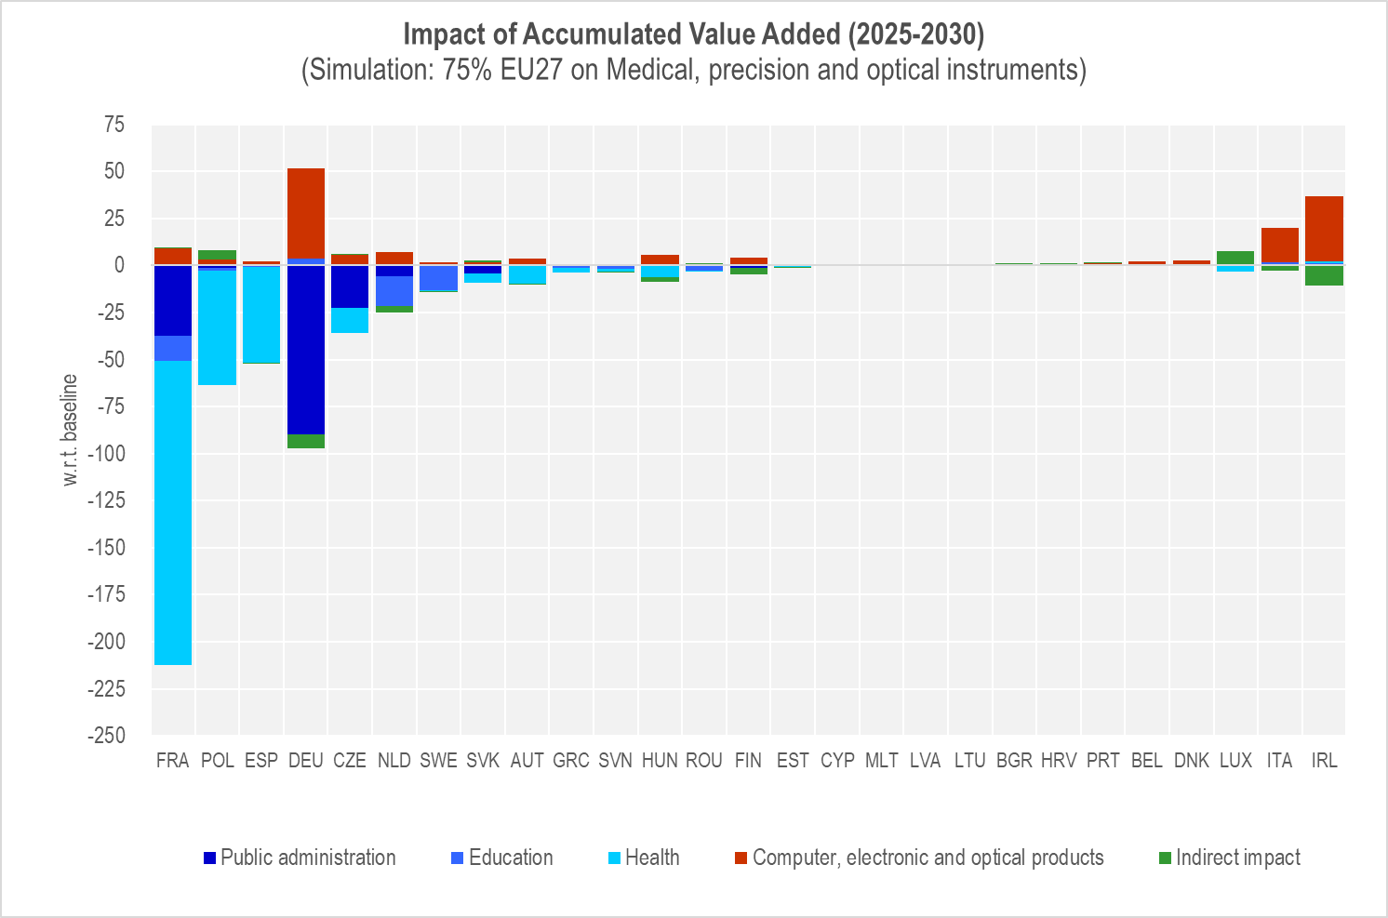
Source: In-house analysis by JRC using FIDELIO
On the upstream side, the EU computer, electronic and optical products industry would be the principal beneficiary of the policy measure, as public buyers would shift demand towards domestically produced equipment. Germany would capture the largest share of this positive effect, with its computer and electronics industry gaining EUR 48 million in additional value added over 2025-2030, reflecting the country's strong specialisation in high-precision instruments and medical devices. Other German industries supplying inputs to this value chain would, however, experience an added cost of EUR 8 million, illustrating how local content requirements can generate mixed effects even within the same national economy depending on a sector's position along the value chain.
On the downstream side, the higher cost of EU-produced medical, precision and optical instruments would translate into additional procurement expenditures for public buyers across the Union. France's public health system would bear the largest absolute impact, with an increased cost of EUR 161 million, reflecting both the size of its hospital network and its relatively high reliance on non-EU imports of medical devices. The German general public administration would incur an additional cost of EUR 90 million, while the Dutch public education system would face an extra cost of EUR 16 million. These figures point to a pattern similar to that observed for construction: the downstream sectors most dependent on extra-EU imports of the regulated goods are also those most exposed to price increases resulting from the local content requirement.

Figure 54: EU local content requirement on Medical, precision and optical instruments trade impacts
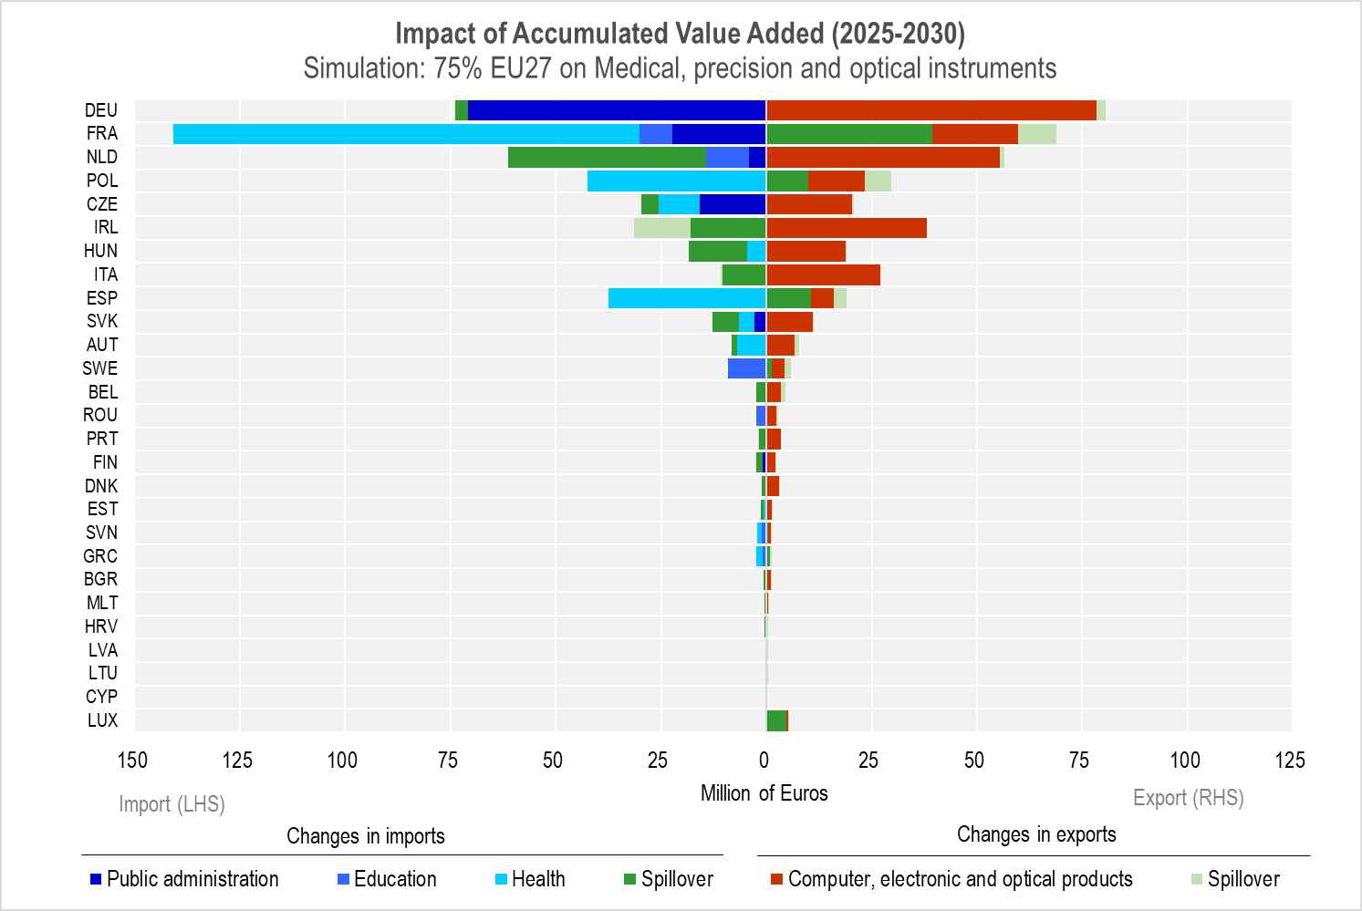
Source: In-house analysis by JRC using FIDELIO
The effects of the local content requirement would ripple through the value chain and reshape trade flows. The measure would directly reduce extra-EU imports of medical, precision and optical instruments by public buyers and, at the same time, stimulate intra-EU trade as Member States substitute towards EU-produced equipment. France's public health system would see its (intra-EU) imports increase by EUR 111 million, the German general public administration by EUR 71 million, and other Dutch imports by EUR 47 million, the latter reflecting spillovers from procurement decisions taken in other Member States. The Dutch education system's import increase would be moderated by EUR 10 million.
On the export side, Germany's computer and electronics industry stands out as the main beneficiary, with intra-EU exports rising by EUR 78 million, complemented by an additional EUR 2 million increase in other German exports linked to procurement decisions in partner countries. Overall, the trade balance impact would be broadly neutral at EU level, with the rise in intra-EU exports of medical and precision instruments roughly offsetting the increase in intra-EU imports by public buyers. This confirms the pattern already identified for steel and aluminium: local content requirements tend to redistribute trade flows within the Single Market rather than alter the EU's aggregate external position.
CPA C26: Office machinery and computers
The simulation for office machinery and computers followed the same methodology, applying an 75 % “Made in EU” content requirement to public procurement in this product category. Given the relatively small size of the EU manufacturing base in office machinery and computers compared to other product categories, the magnitudes involved are more modest, but the structural pattern of impacts is similar to those observed in the other simulations.
Figure 55: EU local content requirement on Office machinery and computers - changes in the accumulated value added w.r.t. baseline
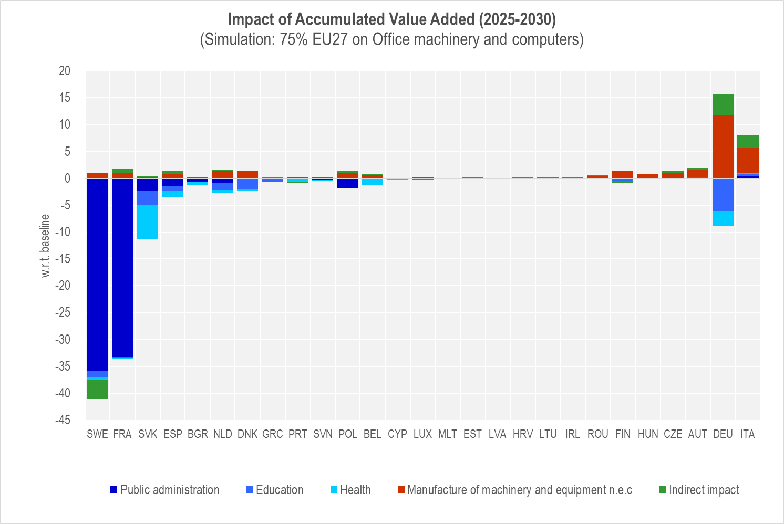
Source: In-house analysis by JRC using FIDELIO
On the upstream side, the EU machinery and equipment sector would benefit from the additional demand generated by the policy. Germany would be the main beneficiary, with its machinery and equipment industry gaining EUR 12 million in accumulated value added over 2025-2030. Unlike in the case of medical instruments, the broader German industrial base would also experience a positive spillover of EUR 4 million, suggesting that the value chain associated with office machinery and computers may be more integrated within the German economy and generate more diffuse benefits.
On the downstream side, public buyers would face higher procurement costs as a result of substituting extra-EU suppliers with EU-based ones. The Swedish general public administration would incur the largest additional cost (EUR 36 million), reflecting both the scale of its IT procurement and its previously high reliance on non-EU suppliers. Slovakia's public health system would face an extra cost of EUR 6 million, while the Danish public education system would see a more limited increase of EUR 2 million. The relatively contained size of these impacts compared, for instance, to those observed for medical equipment, reflects the smaller share of office machinery and computers in total public expenditure.
Figure 56: EU local content requirement on Office machinery and computers - trade impacts
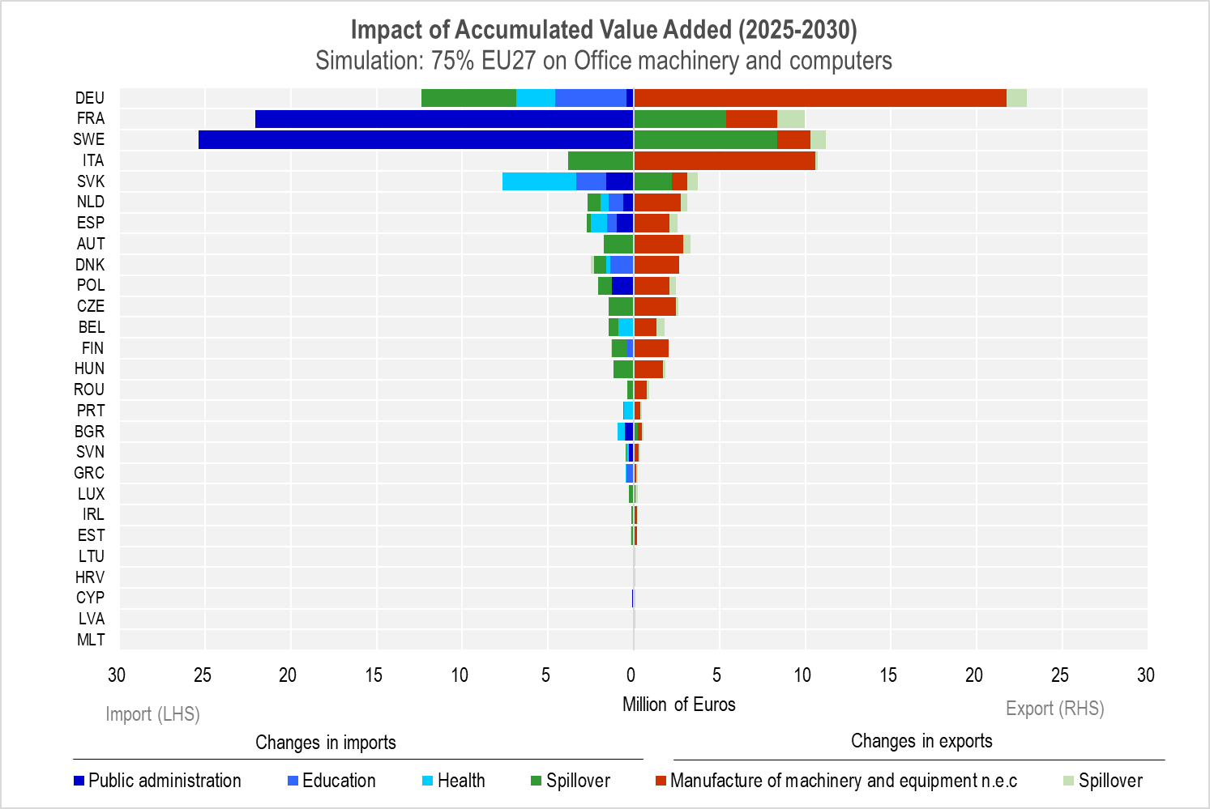
Source: In-house analysis by JRC using FIDELIO
In terms of trade impacts, the policy would once again redirect flows from extra-EU to intra-EU sources. The Swedish general public administration would increase its (intra-EU) imports by EUR 25 million, while Slovakia's public health system and the German education system would each see imports rise by EUR 4 million. Other German imports would increase by EUR 6 million, reflecting indirect effects from procurement decisions taken in other Member States.
On the export side, Germany's machinery and equipment industry would see intra-EU exports rise by EUR 22 million, supplemented by a modest EUR 1 million increase in other German exports. As with the previous product categories, the aggregate trade balance impact at EU level would be broadly neutral, with the increase in intra-EU exports closely matching the increase in intra-EU imports. The measure would therefore primarily affect the geographical distribution of supply across the Single Market rather than the EU's overall trade position with the rest of the world.
Limitations of the FIDELIO model for granular activity- or product-level analysis in all BEU relevant sectors
As explained at the outset, the FIDELIO model is a multi-country macroeconomic input-output model designed to assess economy-wide and sectoral impacts of policy interventions across the EU. While it is well suited for analysing broad policy shocks and structural changes, it presents important limitations when applied to very granular economic activities (e.g. production of specific products such as rolling stock, city buses, etc.). First, this is due to the sectoral aggregation constraints, as FIDELIO relies on a relatively aggregated sectoral classification (based on input-output tables). Individual products or niche activities are embedded within broader sectors (e.g. C30.2: Manufacture of railway locomotives and rolling stock is contained in FIDELIO within C30: Manufacture of other transport equipment, along with other sectors). As a result, product-specific dynamics cannot be isolated cleanly (unless certain coefficients are available and applied, which may not be possible in all relevant sectors), heterogeneity within sectors is averaged out, and policy effects are distributed across the entire sector rather than the specific activity of interest. Secondly, the model is not designed as a product-level or detailed activity-level tool, as it lacks detailed representation of individual product markets, differentiation of technologies, or demand patterns at a granular level, etc. The available sectors are listed in Annex 1 and 2 of the FIDELIO Manual and they do not necessarily match all sectors for which a Buy European measures may be considered. The examples presented above represent the closest matches among the most relevant sectors. This implies that attempting to “force” the model to represent a specific activity (e.g. rolling stock or city buses) could be suboptimal methodologically. Third, as FIDELIO is calibrated to capture macroeconomic and sector-wide effects, when shocks are applied to very small segments (i.e. with small relative weight in the overall sector) the resulting impacts could be diluted in a macro framework (i.e. the effects may fall below the model’s sensitivity threshold). In practical terms, even a meaningful change at the product level may not generate detectable macro or sectoral effects in the model outputs. Finally, the above could trigger risks of misinterpretation as using the model for highly granular questions may lead to misleading conclusions. For example, “no impact” results may reflect model aggregation rather than real-world insignificance and the policy relevance at micro level may be underestimated. In other words, results obtained may be wrongly interpreted as evidence of absence of effects rather than absence of measurable effects at the chosen level of aggregation.
To conclude, FIDELIO is not intended to model each economic activity at a detailed product level therefore not all sectors relevant for the Buy European options can be tested. Its analytical strength lies in capturing economy-wide and sectoral interactions, not micro-level or niche product dynamics. For very granular activities, alternative approaches (e.g. bottom-up sector studies, or case studies) are more appropriate. Attempting to model such activities within FIDELIO risks both analytical dilution and false negatives in impact detection.

Ad Section 6.3 - Ultimate Beneficial Ownership (UBO) registers
Table 33: Ultimate Beneficial Ownership (UBO) registers
Country | Ultimate Beneficial Ownership (UBO) register
Austria | Bundesministerium für Finanzen Register der wirtschaftlichen Eigentümer
Belgium | Registre UBO/UBO Register
Bulgaria | Commercial Register and Non-Profit Legal Entities Register
Croatia | Link for access by national authorities  Link for access by public
Czech Republic | Evidence skutečných majitelů (Czech Register of Beneficial Owners)
Cyprus | National register Cyprus: The Department of Registrar of Companies and Intellectual Property (DRCIP)  Cyprus Trusts Beneficial Owners Register – ‘CyTBOR’
Denmark | The Central Business Register (CVR)
Estonia | The data of the beneficial owner are made public in the commercial register information system: Äriregister/Commercial Register
Finland | Patentti-ja Rekisterihallitus (Finnish Patent and Registration Office)
France | The French Institut national de la propriété intellectuelle (INPI) is the entity who will centralize BO information to be interconnected at EU level  BO info of legal persons are centralized by each greffier des tribunaux de commerce whose coordination instance is the Conseil national des greffiers des tribunaux de commerce
Germany | Transparenzregister (transparency register)
Greece | Κεντρικό Μητρώο Πραγματικών Δικαιούχων (Κ.Μ.Π.Δ.)
Hungary | The link of the BO registry is not available yet.
Ireland | Central Bank of Ireland - Beneficial Ownership Register of Certain Financial Vehicles  Central Register of Beneficial Ownership of Companies and Industrial and Provident Societies - for beneficial ownership information for corporate and other legal entities
Italy | Information not available
Latvia | The information website of The Register of Enterprises of the Republic of Latvia
Lithuania | Legal Entity Participants Information System (JADIS)
Luxembourg | The Register is established under the authority of the AED under the name of “Fiducies and Trusts Register"
Malta | Register of Beneficial Owners for Commercial Partnerships and Legal Entities is administered by the Malta Business Registry (MBR)  In case of the BO Register of Trusts which is administered by the MFSA, the platform is called the Trusts Ultimate Beneficial Ownership Register (TUBOR)
Netherlands | KVK uittreksel UBO-register
Poland | Centralny Rejestr Beneficjentów Rzeczywistych (Central Register of Beneficial Owners)
Portugal | Registo de Beneficiário Efetivo
Romania | The National Trade Register Office manages the Register of Real Beneficiaries
Slovakia | Register konečných užívateľov výhod
Slovenia | Beneficial Ownership register
Spain | Registro Central de Titularidades Reales (RCTIR) website  Access to the procedures that can be carried out in relation to the RCTIR
Sweden | Bolagsverket (Swedish Companies Registration Office)
Sources: provided in footnotes in the table.

Ad Section 6 - Overview of analysed impacts by option
The types of impacts analysed across all options are described below.
Table 34: Overview of analysed impacts by option
Type of impacts | FLX options | ESI options | BEU options | MPL options
Conduct of business including burdens on business | a | a | a | a
Impacts on SMEs | a | a | a | a
Competitiveness* | a | a | a | a
Functioning of the internal market and competition | a | a | a | a
Third countries and trade |  | a | a
Digital economy- digital by default* | a |  |  | a
Property rights; Intellectual property rights |  | a
Innovation (productivity and resource efficiency); research (academic and industrial) |  | a |  | a
Fraud, crime, terrorism and security, including hybrid threats | a |  | a | a
Resilience, technological sovereignty, open strategic autonomy, security of supply |  |  | a | a
Public authorities (and budgets) | a | a | a | a
Working conditions, job standards and quality |  | a
Public health & safety and health systems | a | a | a | a
Governance, participation and good administration | a | a | a | a
Employment |  | a | a
Fundamental rights* | Not significant
Do no significant harm, including climate consistency check* |  | a
Sustainable consumption and production |  | a
Note: *mandatory impacts

Ad Section 7 - Respondents’ views on competition, prices and corruption
During the consultations, respondents were asked to give their opinions on possible policy options and to indicate their expected impacts if such measures were introduced.
Expected impacts on competition
The figure below shows the difference between respondents who considered an increase in competition very or somewhat likely and those who considered it very or somewhat unlikely, categorised by selected respondent group.
Respondents expected that simplification measures (FLX options) would result in increased competition. The difference between those expecting higher competition and those expecting lower competition amounted to between 70 (public authorities) and 76 (all respondents and businesses) percentage points.
A slightly lower margin was observed for the IT marketplace (MPL options), where expectations of higher competition exceeded those expecting reduced competition by 64–65 percentage points among all respondents and EU businesses, and by 52 percentage points among public authorities.
In the case of European preference (BEU), there was an expectation of reduced competition, with a margin of 18 percentage points among all respondents, 29 percentage points among public authorities, and 38 percentage points among EU businesses.
Options on voluntary green, social, and innovation procurement (ESI.1) showed more nuanced expectations. While all respondents considered that BPQR would have no effect and that green and social procurement would have a slight (6–7 percentage points) negative impact on competition, more public authorities and EU businesses (from 18 to 34 percentage points) expected competition to decrease. Regarding innovation procurement, all respondents and EU businesses expected an increase in competition (with differences of 17 and 23 percentage points, respectively), whereas public authorities expected a reduction (10 percentage points).
It is worth noting that respondents more frequently chose “somewhat likely/unlikely” rather than “very likely/unlikely,” likely indicating their uncertainty about the final outcome in the absence of a precise description of the proposed changes. Thus, these responses should be interpreted as the likely expected direction of price changes based on the general ideas presented in the public consultations.

Figure 57: Expected impacts on competition according to respondents to the public consultation.
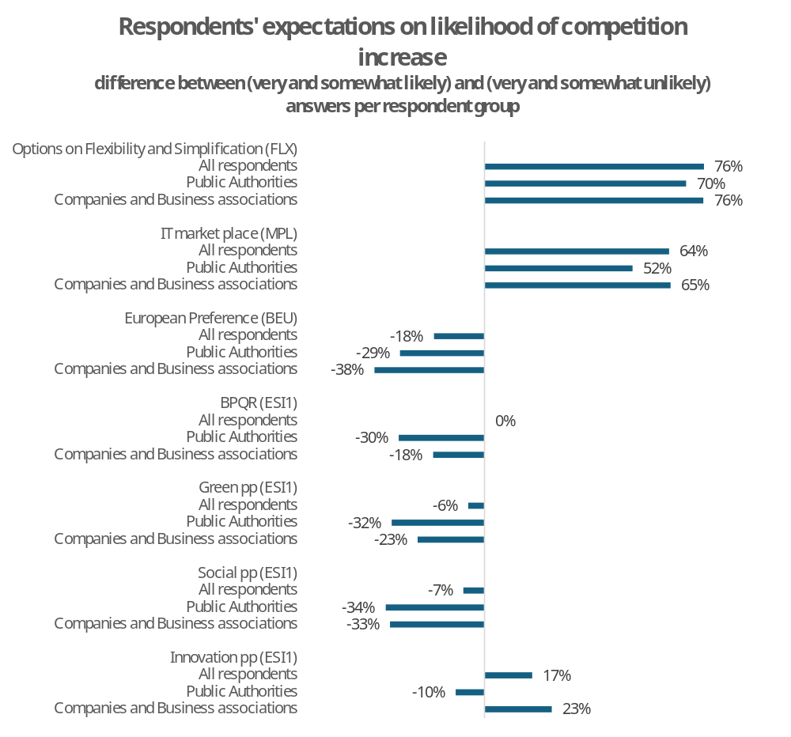
Note: In case of MPL and BEU question was on increase in number of offers/bids received.
Source: Open Public Consultation, see Annex 9

Expected impacts on prices
While estimating the precise effects on the prices of purchased goods and services is impossible due to the individual specificities of each tender, the varying ways in which provisions may be applied, and other factors, we can present respondents’ expectations gathered during public consultations, regarding the impacts of the proposed changes.
The figure below shows the difference between respondents who considered price increases very or somewhat likely and those who considered them very or somewhat unlikely, categorised by selected respondent group.
Regarding the simplification options (FLX options), respondents more often expected that the proposed measures would decrease the prices of procured goods and services. Among all respondents, the difference in responses favouring a price decrease was 24 percentage points (p.p.); for public authorities, it was 16 p.p., and for businesses, 28 p.p.
As for the green and innovation procurement options (ESI.1 option) and European preference (BEU), respondents generally expected prices to increase as a consequence of introducing voluntary measures. Among all respondents, the margin by which those expecting price increases exceeded those expecting decreases ranged from 31 to 45 percentage points. For public authorities and businesses, this margin rose to 59–83 percentage points for BEU, BPQR, green, and social procurement, and to 26–41 percentage points for innovation procurement.
It is worth noting that respondents more frequently chose “somewhat likely/unlikely” rather than “very likely/unlikely,” likely indicating their uncertainty about the final outcome in the absence of a precise description of the proposed changes. Thus, these responses should be interpreted as the likely expected direction of price changes based on the general ideas presented in the public consultations.
Figure 58: Expected impacts on prices according to respondents to the public consultation.
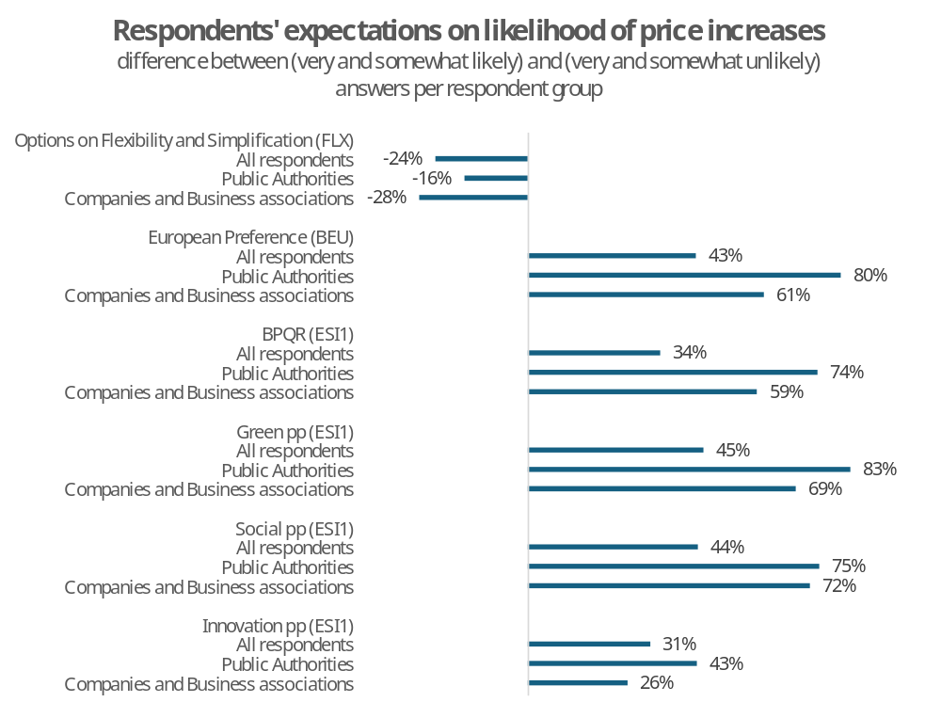
Note: There were no questions on prices for MPL options.
Source: Open Public Consultation, see Annex 9

Expected impacts on corruption
The figure below shows the difference between respondents who considered a reduction in corruption very or somewhat likely and those who considered it very or somewhat unlikely, categorised by selected respondent group.
The question on corruption was asked in relation to the simplification options (FLX options). Among other elements, this option includes increased use of negotiations, facilitation of market dialogue, and flexibility in contract modifications, all of which may present corruption risks. Among all respondents, 27 percentage points more expected that FLX measures would lead to a reduction in corruption. This margin decreased to 8 percentage points for public authorities but increased to 33 percentage points for EU businesses.
In the case of introducing the marketplace (MPL), respondents were up to 72 percentage points more likely (among all respondents and EU businesses) and 45 percentage points more likely (among public authorities) to believe that this option would increase transparency, thereby reducing irregular practices.
It is worth noting that respondents more frequently chose “somewhat likely/unlikely” rather than “very likely/unlikely,” likely indicating their uncertainty about the final outcome in the absence of a precise description of the proposed changes. Thus, these responses should be interpreted as the likely expected direction of price changes based on the general ideas presented in the public consultations.
Figure 59: Expected impacts on corruption according to respondents to the public consultation.
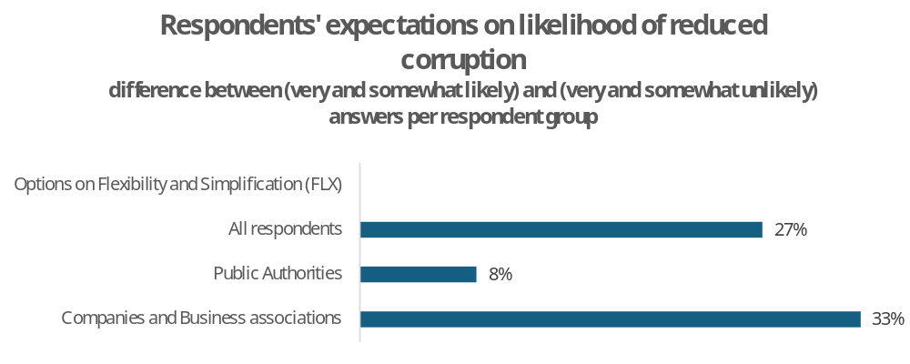
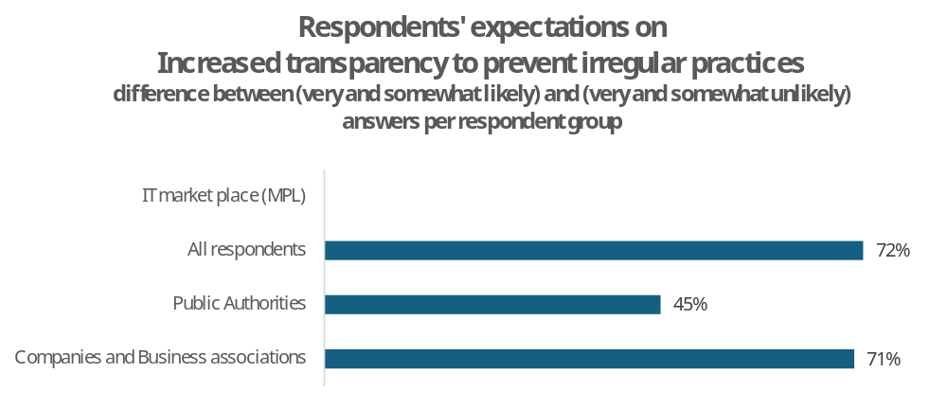
Note: Question on impact on corruption was only asked in case of FLX option.
Source: Open Public Consultation, see Annex 9.

Ad Section 8 - Trade-offs between allowing more discretion in public procurement and the increased risk of irregularities in the process
In order to discuss the trade-offs between allowing more discretion in public procurement and the increased risk of irregularities in the process, one can start from a theoretical model developed by Klitgaard (1988) on how corruption manifests itself in public and private bodies. The model is the following:
$$Corruption=Monopoly+Discretion-Accountability$$
Monopoly refers to the concentration of power over the allocation of a valuable good or service, such as a procurement contract. Discretion denotes the degree of freedom that decision-makers have in determining outcomes. High discretion allows officials to decide who gets the benefit and under which conditions. When rules are ambiguous, complex, or allow subjective interpretation, this gives space for decision bias and hence corruption. Accountability reflects the extent to which decision-makers are monitored and can be held responsible for their actions, this often depends on institutional transparency, oversight mechanism and legal sanctions. Introduction of mandatory BPQR rules would increase discretion, which without proper adjustment in accountability and reduction in procedure complexity could increase the risk of corruption (i.e. one of the forms of irregularities in public procurement).
As far as the accountability dimension of the public procurement rules is concerned, data analytics, interoperable eProcurement platforms, and automated risk-flagging mechanisms are seen as capable of substantially reducing monitoring burden while improving transparency and auditability of procurement procedures. The above has already been recognised by international bodies such as the OECD several years ago, which highlighted the growing role of digitalisation, data analytics, and interoperable eProcurement platforms in strengthening accountability, transparency, and the ex-post detection of irregularities in public procurement. In this regard, technological progress is increasingly perceived as an important factor capable of reducing some of the traditional control-related concerns associated with granting contracting authorities’ greater procedural discretion. In particular, the OECD (2011) report points out:
• The principle of transparency – which relates to the availability of information on contract opportunities, the rules of the process, decision-making and verification and enforcement – is of critical importance in preventing corruption.
• Corruption is facilitated, and thus most likely to occur, where there is a lack of openness or transparency in the procurement process.
• More formal mechanisms by which to protect the integrity of the procurement process include: (i) data analysis tools, such as comparisons of public databases to identify indicators of anticompetitive or corrupt activity, […]. Quantitative analyses of bid data can help procurement agencies (with the support of competition authorities) to identify up-front those sectors where infringements of the competition rules are more likely. In order to do so, it is crucial to examine the bids that have been submitted in the past to determine if the patterns are consistent with a fully competitive process. These analyses would allow procurement and competition authorities to maximise their efforts, optimising tender design in those industry sectors which are at risk and allocating law enforcement resources to the detection of collusion in those sensitive sectors. Retaining data from prior tenders may also help in any later bid-rigging prosecutions.
• Where this is the case, knowing the data has been retained may have a deterrent effect, and thus help to discourage bid-rigging.
The last point quoted from OECD (2011), highlights the fact that the accountability mechanisms embedded in public procurement systems may also have an important deterrent effect on irregular or corrupt behaviour. The existence of reporting obligations, ex-post controls, and the possibility of judicial or administrative review may discourage both contracting authorities and economic operators from engaging in practices that could later be detected and sanctioned. In particular, the increasing digitalisation of procurement procedures strengthens this deterrent effect by improving traceability, facilitating data analysis, and increasing the likelihood that suspicious patterns or conflicts of interest will be identified ex post. As a result, accountability does not only serve a corrective function after irregularities occur, but may also shape behaviour ex ante by increasing the perceived probability of detection and reputational or legal consequences.
In practice, as greater transparency (e.g. publication obligations and access to procurement data) can increase accountability and facilitate both public scrutiny and ex-post controls, Member States increasingly recognise the importance of digital and IT-based tools for the ex-post prevention and detection of irregularities. As an example: Portugal sees the systematic screening of procurement data, as a way to identify patterns potentially associated with irregular conduct and prioritizes digital monitoring tools and data-driven oversight mechanisms.
One of the priorities of the Portuguese Competition Authority (AdC) in 2026: “To enhance the use of innovative IT tools, including artificial intelligence, for the detection of unlawful practices and to support investigations carried out by the AdC teams.”
“In particular, the optimisation of the ScreenIT platform is envisaged, through the use of machine learning and artificial intelligence tools applied to data relating to public procurement procedures collected from the IMPIC database. This tool enables any AdC employee, even without programming expertise, to monitor the data collected, identify warning signals and rapidly and easily detect potentially anticompetitive patterns. In 2026, the AdC will also continue to rely on cooperation with the Judicial Police, pursuant to a protocol concluded between the two entities in the area of investigation, through the promotion of joint training initiatives and the provision of technical and procedural support aimed at enhancing the detection and sanctioning of illegal practices by the AdC.“

Such developments suggest that technological progress may partly mitigate the traditional trade-off between granting contracting authorities’ greater procedural discretion and ensuring sufficient safeguards against misuse or irregularities.
In terms of examples of digital monitoring tools and data-driven oversight mechanisms, one should mention ARACHNE+ which is a risk-scoring tool developed by the Commission, represented by the DG EMPL and DG REGIO, in close cooperation with MS national authorities. Its main purpose is to help authorities identify projects, beneficiaries, contractors, contracts and sub-contractors that may present higher risks of fraud, conflict of interest, irregularities, or reputational concerns, to help authorities in their administrative controls specifically in the area of Structural and Investment Funds.
The latest version of the tool (V2.3) also allows for ex-ante risk calculation function, allowing authorities to simulate potential risks before a grant agreement or contract is signed. This means that the tool can also be used preventively, for example to assess risks linked to a company participating in a call for tender.
It is important to note that ARACHNE+ does not automatically detect or prove fraud, it does not assess individual conduct and does not automatically exclude beneficiaries from EU funding. The tool creates risk indicators, that can help managing authorities prioritise checks, audits, management verification and on the spot controls.
In order to calculate the risk indicators, ARACHNE+ gathers data from MS managing authorities in relation to the European Social and the European Regional Development funds. This includes information on beneficiaries, project partners, turnover, contractors, subcontractors, service providers, consortium members and key members. This data is further enriched with information from commercial databases ORBIS provided by Bureau van Dijk and World Compliance provided by LexisNecis Risk Solutions.
ORBIS provides company financial information, addresses, ownership structures, management, shareholders and historical records. World Compliance provides information on Profiles of Politically Exposed Persons (PEP), as well as those of their family members and close associates, sanctions lists, enforcement lists, regulatory warnings, and risk-relevant media monitoring.
The main benefit is that ARACHNE+ helps managing authorities target their control resources more efficiently. Instead of treating all projects as equally risky, authorities can focus administrative checks and on the spot verifications on cases where risk indicators suggest higher exposure. The tool further improves detection of possible conflicts of interests prior to signing of a contract. The tool is available without any charges for MS. The commission also provides technical support and training to help authorities integrate the tool into their management and control systems.
In terms of challenges and critiques, Some Member States report that ARACHNE+ can increase administrative burden, especially in MS that already have risk-analysis systems. Inputting the needed data takes time and can feel duplicative. There have also been concerns regarding false positives and data quality, some authorities report accuracy issues, where risk alerts are flagged without corresponding to actual problems. Lastly, some authorities have argued that ARACHNE+ is more useful for certain types of projects than for others. For example, Dutch authorities have suggested that the system is better suited to comparing infrastructure projects, while it is less adapted to innovation-oriented projects, where outputs and costs are harder to compare.
In ARACHNE+ V2.3, data processing was internalised within the premises of the European Commission. Data uploaded by MS is no longer transferred outside the Commission and is no longer accessible to the external service provider. Validation, enrichment and risk calculation are now managed by the Commission’s ARACHNE+ IT team and DG DIGIT.
Lastly, a feedback mechanism exists, if a MS or a user identifies an invalid matching between the internal and external data, they can report the issues to the ARACHNE+ team. The correction will affect the risk calculation, although it does not alter the original external source of information.
Another example is the use of machine learning in cartel detection DATACROS III project:
“In DATACROS III red-flags and anomaly indicators are used to signal to LEA and investigative journalists the potential involvement or infiltration of organized and financial crime actors – in a firm. Starting in 2019, DATACROS has been developing increasingly accurate and effective indicators, alongside practitioners and academics. In its third iteration, the Government Transparency Institute brings to the consortium a know-how and experience with public procurement tenders – with the aim of integrating both a European-wide coverage of tenders and a new set of indicators to aid DATACROS III users in evaluating them. [...] Recent research has found that using bid-level indicators alongside various machine learning models, trained on cartels’ strategies, can significantly improve accuracy in spotting cartels. For example, bid-level indicators trained using proven cartel cases in Switzerland were tested on a cartel case in Japan, despite the stark differences between the two markets, cartel classification achieved accuracy rates of 88%–97%. These recent advances suggest that machine learning can provide scalable, data-driven support for competition authorities seeking to find procurement cartels. Just as well, advancements are not limited to the scope of classification models; on the contrary, experimental and emerging modelling tools are also being explored, pioneering new, further ways to identify suspicious cartel behaviour 7-8.”
Another example of collusion being successfully detected is provided by a case in Korea. In 2006, the Korean Fair-Trade Commission (KFTC) introduced the Bid Rigging Indicator Analysis System (BRIAS) to support the detection of bid rigging in public procurement. BRIAS is an automated quantitative-analysis IT system that processes large volumes of public procurement data and assigns tenders a risk score indicating the likelihood of bid rigging. The effectiveness of the system depends heavily on the quality and completeness of the data provided by participating procurement agencies. By 2014, 332 public procurement agencies were participating in BRIAS, including central administrative agencies, local governments and state-owned companies. An OECD report from 2016, finds that the system was flagging around 80 cases per month for further review. One notable success case was the Seoul Subway Line 7 extension case: BRIAS helped identify suspicious bidding patterns, which led to an investigation and, in 2007, a KFTC finding that six major construction companies had engaged in collusion. The companies had allegedly allocated the six individual lots among themselves, coordinating so that each company would bid for a different lot rather than competing against one another. This lack of overlapping bids reduced competitive pressure and contributed to abnormally high prices. The case resulted in fines of approximately USD 20 million. The report further states that even the risk of being detected by the BRIAS system likely reduces fraud risk, which is in line with the theoretical accountability mechanism.

Annex 8: Administrative cost analysis
***********************************************************************
Please note that it was not possible to quantify all savings and costs arising from the options presented in this impact assessment due to a lack of reliable data. Consequently, the savings, costs and scenarios presented relate only to the quantified aspects of the options analysed and should not be regarded as capturing the full monetary impact of those options.
***********************************************************************
This annex analyses quantifiable changes in costs incurred by contracting authorities and economic operators as a result of the different policy options presented in this impact assessment, as well as the preferred option. Where applicable, costs for other entities, such as Member States in general or the European Commission, are also analysed. The analysis presents a central scenario, as well as a selection of alternative scenarios. In addition to the first-year calculations, the annualised present value (PV) over a seven-year application period, applying a 3% discount rate, is presented.
It should be noted that non-quantifiable costs are not analysed in this annex but are addressed in the main text and Annex 7. The benefits analysed in this annex refer only to quantifiable cost reductions; other (non-quantifiable) benefits are described in the main text of this impact assessment.
As public procurement is a regulated activity, all cost changes presented in this annex can be regarded as changes in administrative burden, unless otherwise specified.
The analysis of all options in this annex is underpinned by several common assumptions, which are presented in the table below. Additional option-specific assumptions are presented alongside each option.
Table 35: Common assumptions for cost analysis
Item | Assumption | Source
No of procedures | 304 000 | Ecorys (2025), Table A.39, no. of CANs in 2023
Number of CA | 46 648 | World Bank (2025), p. 22, value for 2023
Number of winning EO | 173 228 | World Bank (2025), p. 22, value for 2023
Average number of bidders (EO) | 3.3 | Ecorys (2025), Table 5.10, overall average for years 2019-2024
Cost of procurement procedure for CA | €6 000
Cost of procurement procedure for EO | €11 400
Wage of a procurement professional | €41/hour | Eurostat Structure of earnings survey 2022, Labour Force Survey data for Non-Wage Labour Costs + 25% overhead, ISCO 2 Professionals
Overlap between EOs winning and EOs losing | 50% | An assumption to avoid overestimating the total number of EOs
Total number of EOs participating | 372 440 | Number of winning EO +(1-overlap)*( Average number of bidders -1)* Number of winning EO:  =  173 228+(1-50%)*(3.3-1)*173 228
Source: Ecorys (2025), Cost-Benefit Analysis, World Bank (2025), Competition in public procurement, Eurostat, in-house analysis.

Assumptions for the sensitivity analysis
For each option, a sensitivity analysis is presented to illustrate the outcomes under varying conditions. For most options, sensitivity is tested with respect to the average number of bidders-this applies to FLX, ESI, MPL, and the preferred option. This sensitivity analysis always shows changes in relation to the central scenario, which assumes an average of 3.3 bidders. For BEU, sensitivity is tested with respect to the share of procurement subject to European preference and the time spent by contracting authorities and economic operators, as these factors have the largest impact.

Choice of range for the average number of bidders
The choice of a 0.1 increment in the number of bidders for the sensitivity analysis is based on two key considerations: the historical trend in bidder participation and the purpose of the analysis as a short-term sensitivity exercise.
Firstly, historical data indicates a long-term decline in the average number of bidders, from 5.9 in 2008–2010 to 3.3 in 2019–2024. This decline occurred alongside a steady increase in the number of contract award notices (CANs) over the same period. This suggests that the average number of bidders decreased by approximately 0.2 per year on average, while the number of CANs rose. A simple regression of the available data indicates a negative relationship, with an average decrease of around 0.016 bidders for every 1 000 additional contract award notices.
One possible explanation for this effect is the mechanical effect of procurement thresholds, which are not indexed for inflation. As a result, a growing number of lower-value contracts fall under the scope of the procurement directives each year, naturally attracting fewer bidders than larger contracts. This trend is illustrated in the figure below (Figure 60).
However, the historical trend should be interpreted with caution. There is no certainty that this trend will continue following the reform, nor that the relationship between the number of contract award notices and the average number of bidders will remain stable over time. The decline in bidder numbers may reflect broader market conditions or changes in the composition of procurement, but it could also be driven by the current regulatory framework. Nonetheless, using the high historical figure of 5.9 bidders would not represent a plausible short-term sensitivity scenario around the current baseline of 3.3 bidders. A return from 3.3 to 5.9 bidders would imply a reversal of a long-term trend observed over more than a decade, rather than a realistic short-term fluctuation.
Instead, the analysis uses smaller increments of 0.1 bidders, as the results are highly sensitive around the break-even point. Furthermore, this incremental approach provides a more plausible and suitable range for testing short-term variations around the current baseline and includes the point at which expected savings turn into costs.
Figure 60 Number of contract award notices and average number of bids.
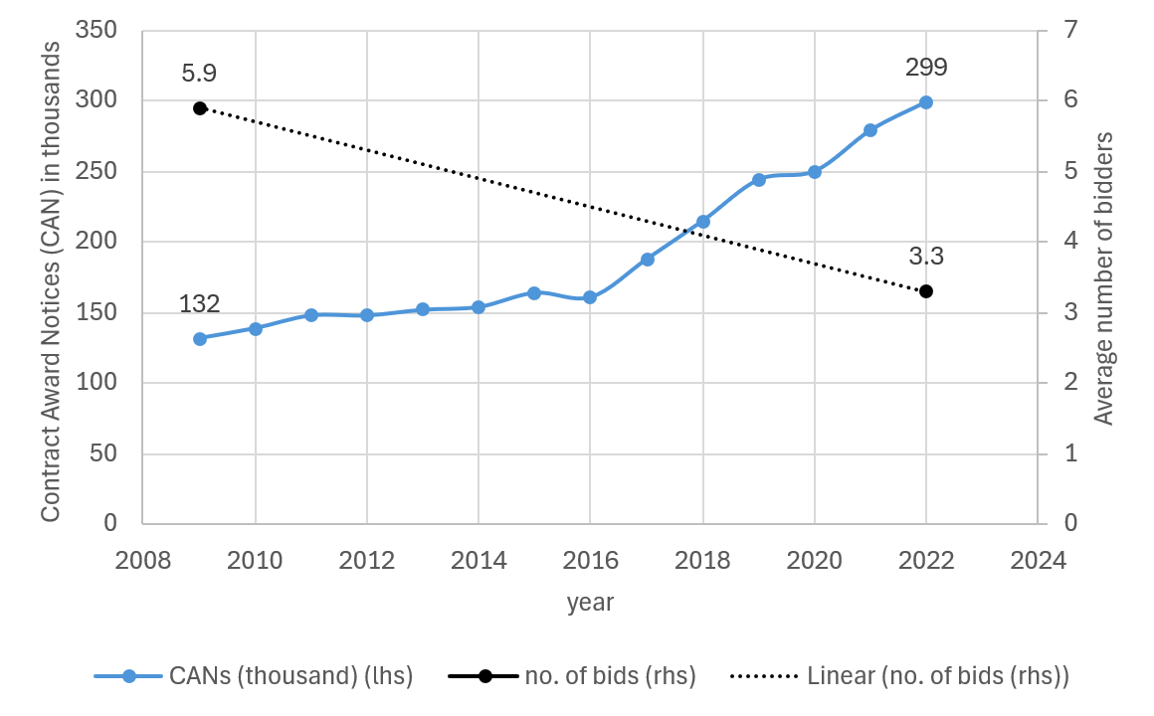
Note: For graphical presentation, the Ecorys average number of bidders is shown at the midpoints of the two periods: 2008–2010 is represented by 2008, and 2019–2024 by 2022.
Source: In-house analysis based on Ecorys(2025).

Change in contracting authorities’ costs with varying average numbers of bidders
To properly assess the impact of changes in the average number of bidders, we adjust the average cost of procurement procedures for contracting authorities by 0.58% (approximately EUR 35) for every change of 0.1 bidders, upwards or downwards. This reflects the change in administrative burden associated with evaluating a higher or lower number of tenders. To avoid double counting in the calculation of the preferred option, this adjustment is applied only under the FLX option.
This estimate was calculated using two aggregated reference points from Ecorys (2025). For the period 2008–2010, when the average number of bidders was 5.9, inflation-adjusted costs for contracting authorities were estimated at EUR 6 900. For 2019–2024, when the average number of bidders had decreased to 3.3, the estimated cost for contracting authorities was EUR 6 000.
Assuming a simple linear relationship between these two points, the difference of EUR 900 over 2.6 bidders implies an additional cost of approximately EUR 346 for each additional bidder. This corresponds to an increase of 5.8% per additional bidder, with each additional 0.1 bidder increasing costs by 0.58%, or around EUR 34.6. This suggests that the economic effect is relatively small, particularly for marginal changes.
However, this estimated relationship should be treated with caution. The comparison is based on only two distinct periods and is therefore likely to reflect broader economic and procurement law developments, rather than solely changes in administrative costs caused by variations in the number of bids. This is especially relevant as the 2008–2010 figures predate the current directives.

Changes in overlap between winning and losing economic operators
The estimated impacts of the MPL options, as well as of the preferred option, depend on the total number of distinct economic operators (EOs) affected.
The total number of distinct economic operators equals the number of winning EOs plus the number of losing EOs, minus the number of EOs that appear in both groups. In other words:
$$Unique EOs = Winning EOs + Losing EOs - EOs both win and lose$$
To characterise the relationship between the two groups, an overlap rate is defined as the share of economic operators that, across different tenders, appear both as winners and as losers, relative to the total number of distinct economic operators. An overlap of 0% implies complete separation between the two groups, meaning that winning EOs never appear as losing EOs and vice versa. Conversely, an overlap of 100% implies that every economic operator that loses at least one tender also wins at least one tender, meaning that no economic operator appears exclusively as a loser.
The available data do not allow the overlap rate, the number of losing EOs or the total number of distinct economic operators to be observed directly. The data provide only an estimate of the number of winning economic operators (173 228 in 2023). Under a hypothetical scenario of 100% overlap, this figure would also equal the total number of distinct economic operators, as every losing EO would also be included among the winners.
Additional assumptions are therefore required to calibrate the sensitivity analysis. Besides the number of winning EOs, the data provide the number of contract award notices (CAN) (304 000 in 2023), implying that each winning economic operator was awarded, on average, approximately 1.75 contracts (304 000 / 173 228). The data also indicate an average of 3.3 bidders per contract award notice. Assuming that winning and losing economic operators participate in tenders with the same average frequency, the estimated number of distinct participating economic operators under a scenario of 0% overlap is:
304 000 × 3.3 / 1.75 = 571 652 economic operators.
This figure should not be interpreted as a mathematical upper bound or as an estimate of the true number of participating economic operators. Rather, it represents a calibration point derived from the assumptions of 0% overlap and equal average tender participation by winning and losing economic operators.
Using the two calibration points – 173 228 economic operators at 100% overlap and 571 652 economic operators at 0% overlap - a linear interpolation is applied to estimate the number of distinct economic operators at intermediate levels of overlap. The formula used in the sensitivity analysis is therefore:Unique EOs = Number of winning EOs + (100% – overlap) × (average number of bidders – 1) × Number of winning EOs
This formula is not intended to estimate the actual number of distinct economic operators. Rather, it provides a transparent and internally consistent calibration for the sensitivity analysis. The true relationship between overlap and the number of distinct economic operators is unknown and need not be linear. Moreover, the approach relies on assumptions that cannot be verified using the available data, in particular the assumption that winning and losing economic operators participate in tenders with the same average frequency. Consequently, the resulting figures should be interpreted as illustrative values used to assess the sensitivity of the estimated impacts to alternative assumptions regarding the degree of overlap between winning and losing economic operators.
The central scenario assumes an overlap rate of 50%, resulting in an estimated 372 440 distinct economic operators (see the figure below). Alternative overlap assumptions are tested in the sensitivity analysis to assess the robustness of the results.

Figure 61: Estimated number of distinct economic operators by assumed overlap rate.
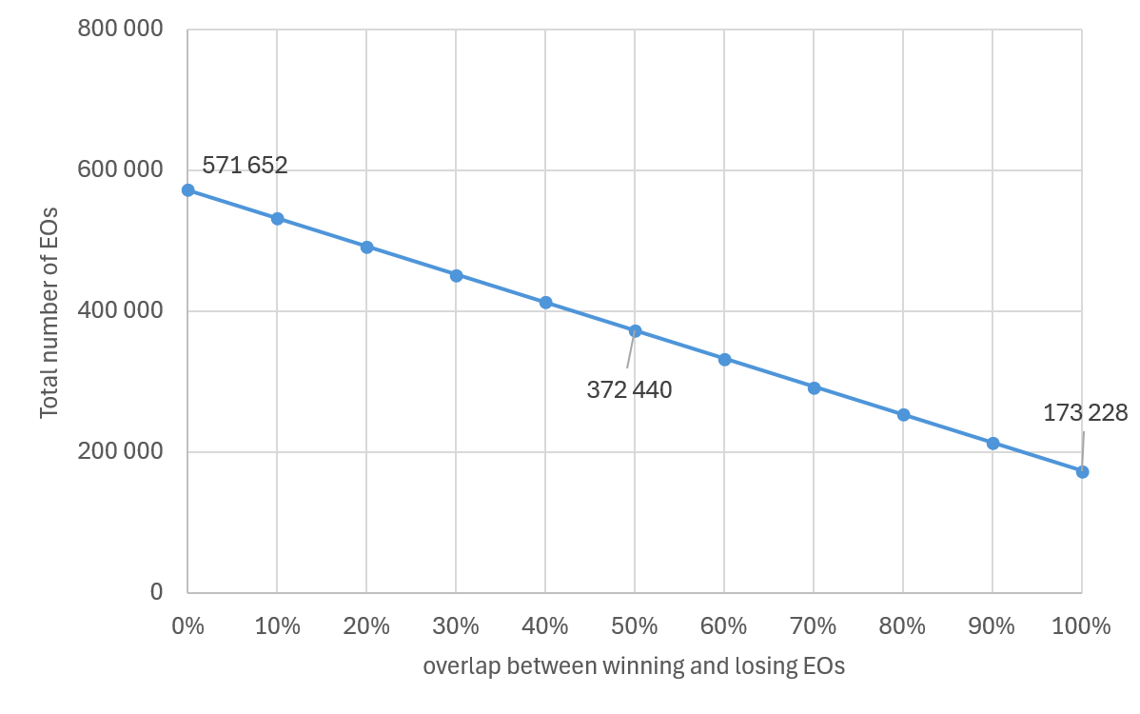
Source: In-house analysis.

FLX options cost
Note: The costing of FLX options relates solely to changes in the use of negotiations. It is important to note that FLX options introduce additional simplification measures that have not been quantified due to a lack of reliable data. These include, for example, the reuse of documents (once-only principle), the possibility for error corrections that should reduce the number of terminations due to errors, harmonised definitions, and a reduced administrative burden in emergencies. Consequently, the savings and scenarios presented relate only to one aspect of the FLX options – negotiations - and should not be considered as capturing the total impact of these options.

Percentage change in costs
In order to evaluate the possible impacts of options FLX, a hypothetical scenario was tested in which the negotiated procedure gradually substituted for the open one by increments of 1%. The analysis is based on data per Member State on the average use of procedures and average number of bidders, as published in TED in 2017-2024. The cost of negotiated and open procedure per contracting authority and economic operators is taken from Ecorys (2025) study, as provided in the table below.
Table 36: Average cost in EUR spent per above EU threshold procedure in 2019-2024 [EUR]
 | Contracting authorities | Economic operators
Open procedure | 8 100 | 10 900
Restricted | 11 400 | 8 800
Negotiated* | 10 900 | 9 100
Framework agreements | 3 500 | 12 100
Overall (cost across all procedures) | 6 000 | 11 400
Source: Ecorys (2025), Cost-Benefit Analysis…, p.60.

The calculation of the total cost followed the approach applied by Ecorys (2025), namely:
$$TC_{p}=C_{CA}+{\overline{N}}_{b}×C_{EO}$$

Where:
- 𝑇𝐶𝑝 - total cost per procedure
- 𝐶_{𝐶𝐴} - average cost incurred by the contracting authority per procedure
- 𝑁_{𝑏} - average number of bids submitted per procedure (per Member State)
- 𝐶_{𝐸𝑂} - average cost incurred by an economic operator per bid submitted
The analysis considered ten hypothetical scenarios in which the share of negotiated procedure increased from the current level by up to 10%. The figure below presents the results of such analysis by Member State. The substitution of open procedure by negotiated is expected to reduce the total cost of procedures, mainly because the former entails higher costs for bidding companies, which are multiplied by the average number of bidders in the calculation formula. Differences in the slopes observed across countries are primarily driven by country-specific levels of competition (as reflected in the average number of bidders) as well as by the existing distribution of procedures in each Member State. In particular, in countries where the current share of negotiated procedure is higher, a 1% increase leads to a more pronounced impact.

Figure 62: Change in the total cost of procedures by Member State, depending on the increase in the use of negotiated procedure.
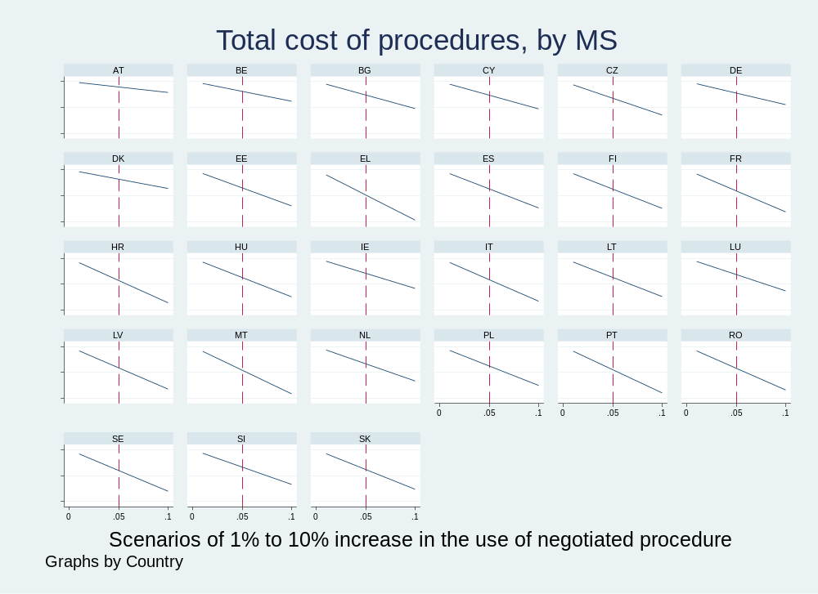
Source: In-house analysis based on Ecorys(2025) survey data.

The estimated range of savings for all countries combined in case of an increase in the use of negotiated procedure by up to 10% is presented in the figure below. For example, with just 1% change the savings would be negligible, but if 5% more procurement contracts were concluded following the negotiated procedure, the costs for authorities and participating firms would reach between 95.1% to 98.9% of the current costs (i.e. the saving would represent 1.1% to 4.9% of total costs of a procedure). Under the extreme scenario, the estimated range would lie between 97.9% and 90.3% (hence, the savings could be at least 2.1% or reach up to 9.7%).
Figure 63: Change in the total cost of procedures, depending on the increase in the use of negotiated procedure [%].
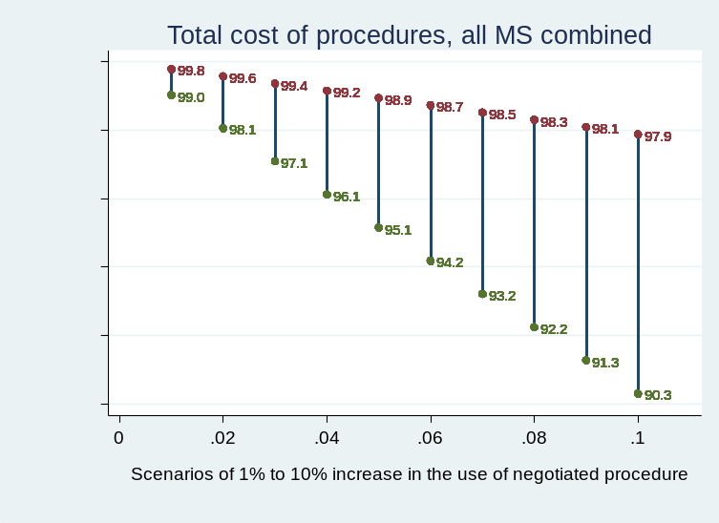
Source: In-house analysis based on Ecorys (2025) survey data.

In the next step, another factor was incorporated into the analysis, namely changes in the number of bidders in increments of 0.1 in both directions, i.e. from -0.5 to +0.5, around an average level of bidders. Once the additional element is added, it becomes clear that the level of competition influences the overall outcome: the greater the number of participating firms, the higher the aggregate costs incurred, as all bidders bear administrative costs while preparing their offers.
Figure 64: Change in the total cost of procedures, depending on the increase in the use of negotiated procedure and the number of bidders participating [%]
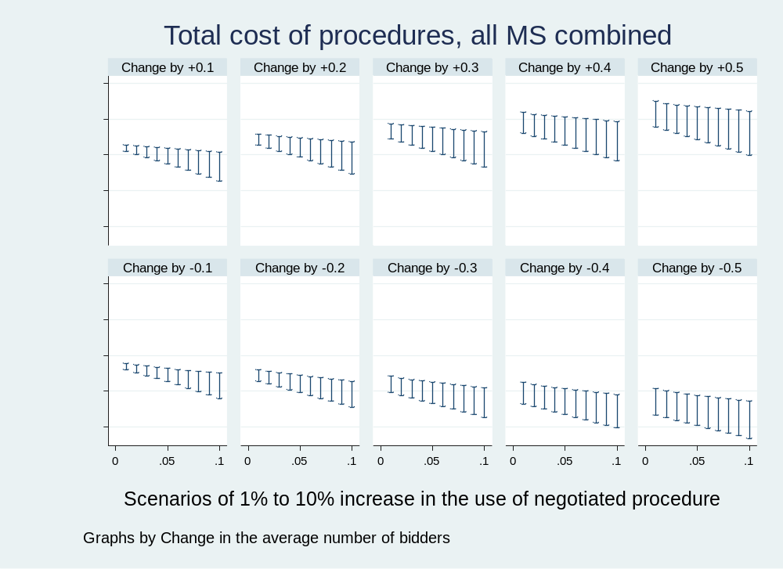
Source: In-house analysis based on Ecorys(2025) survey data.

The five upper panels present scenarios in which the average number of bidders increases by between 0.1 and 0.5 compared to the current Member State averages. The lower panels illustrate the same scenarios, but assuming a gradual decrease in the number of bidders. Each panel constitutes a self-standing figure, with the x-axis representing the previously discussed scenarios of a gradual substitution of the open procedure by the negotiated procedure, and the y-axis showing the resulting change in total costs compared to the current situation.
The overall conclusion that can be derived from the figure above is that any price savings resulting from the substitution in procedural arrangements will be partially neutralised if the number of bidders increases and strengthened if it decreases – for example if the number of bidders decreases by 0.4 and the negotiated procedure is used more frequently in 10% of cases the cost could drop to 80%. Conversely, assuming a 0.5 increase in the average number of bidders, the overall cost is expected to increase across all procedural substitution scenarios, or, at best, remain broadly unchanged (i.e. the upper right-most panel, the bottom of the spike at 10% increase of negotiated procedure is almost aligned with 100% of current costs).
It should also be noted that the above estimate does not account for any potential reduction in overall procedural costs that are expected to materialise if the procurement process is significantly streamlined (i.e. involves less administrative requirements) or due to further digitalisation as foreseen in options MPL.

Cost in Euro
The estimation of costs in euros for the FLX.1 and FLX.2 options is based on the average difference in cost between open and negotiated procedures for the years 2019-2024, as reported by Ecorys (2025). Accordingly, using the negotiated procedure results in an additional cost of EUR 2 800 for contracting authorities and a cost reduction of EUR 1 800 for economic operators.
Currently, under the Classical Directive, negotiations are used in 10% of all procedures (Ecorys, 2025, Figure 5.4, "competitive with negotiations", value for 2024), with their use subject to several restrictions and limited to highly complex contracts. In contrast, under the Utilities Directive-where negotiations face no such restrictions-they account for 35% of all procedures (Ecorys, 2025, Figure 5.5, "competitive with negotiations", value for 2024). However, this higher usage applies to higher-value contracts due to the elevated threshold (EUR 443 000 for Utilities compared to EUR 143 000 for the Classical Directive). Consequently, for our central scenario, we assume an increase in the use of negotiations - resulting from the simplifications introduced by the FLX option - of 10 percentage points. This is slightly below half the gap between the use of negotiations in the two directives. For the sensitivity analysis, we will consider scenarios ranging from 0 to 25 percentage points increase. It should be emphasised that in the new procedure negotiations remain voluntary, so contracting authorities will only use them if they provide added value.
Under the central scenario, where the use of negotiations increases by 10 percentage points, the average cost per procedure is projected to increase by approximately EUR 280 (PV: EUR 257) for contracting authorities and decrease by EUR 180 (PV:165) for each economic operator. This results in a total cost reduction per procurement procedure of around EUR 314 (PV: EUR 288), equivalent to a 0.7% reduction from the total average cost of procedures. Based on the number of above-threshold procedures in the EU in 2023, this translates into overall savings of roughly EUR 95 million (PV: EUR 88 million), composed of an increase of EUR 85 million (PV: EUR 78 million) in costs for contracting authorities and a reduction of EUR 181 million (PV: EUR 165) for economic operators (see table below).
Table 37: FLX options cost under 10 percentage points increase in use of negotiations scenario.
 | CA | EO | No. of bids | Total
Per Procedure (€ per procedure)
Cost change after 10pp increase in negotiations | + 280 | - 180 | 3.3 | - 314
EU wide cost change (€ million)**
After 10pp increase in negotiations | + 85 | - 181 |  | - 95
Annual present value (over 7 years at 3% discount rate)
Per Procedure (€ per procedure)
Cost change after 10pp increase in negotiations | + 257 | - 165 | 3.3 | - 288
EU wide cost change (€ million)**
After 10pp increase in negotiations | + 78 | - 165 |  | - 88
Note: Presented figures are rounded, though totals are calculated using precise values, which may result in minor discrepancies.
* EU wide cost divided by number of CA and EO x average number of bidders from Table 35
** per procedure cost multiplied by number of procedures form Table 35, cost for all EOs presented
Source: In-house analysis.

When examining different scenarios of increased negotiation use under the current average of 3.3 bidders, the present value of cost changes ranges from no impact with no increase in negotiations to savings of EUR 9 million with a 1 percentage point rise, and EUR 219 million with a 25-percentage point increase. This suggests that each percentage point increase in negotiation use corresponds to approximately EUR 8.75 million in EU-wide procurement savings.
The average number of bidders influences the costs. For example, in a scenario with a 10-percentage point increase in negotiations, raising the average number of bidders by just 0.1 (e.g., from 3.3 to 3.4) turns savings into a cost increase of EUR 235 million (PV) - an effective cost increase of EUR 322 million.
As shown in the table below, FLX policy options generate savings when the average number of bidders does not exceed 3.3 for any positive increase in the use of negotiated procedures. When the average number of bidders reaches 3.4 or more, EU-wide costs increase across all considered scenarios of changes in negotiation use.
Table 38: Annualised present value of EU-wide total cost changes for FLX options due to changes in the use of negotiations under different average numbers of bidders, with all other factors held constant [EUR million].
Change in use of negotiations (pp)↓ | Average number of bids→
Change in use of negotiations (pp)↓ | 3 | 3.1 | 3.2 | 3.3 | 3.4 | 3.5 | 3.6
0% | - 982 | - 655 | - 327 | 0 | 327 | 655 | 982
1% | - 989 | - 662 | - 336 | - 9 | 318 | 645 | 972
2% | - 997 | - 670 | - 344 | - 18 | 309 | 635 | 962
3% | - 1 004 | - 678 | - 352 | - 26 | 300 | 625 | 951
4% | - 1 011 | - 686 | - 360 | - 35 | 290 | 616 | 941
5% | - 1 018 | - 693 | - 369 | - 44 | 281 | 606 | 931
6% | - 1 026 | - 701 | - 377 | - 53 | 272 | 596 | 921
7% | - 1 033 | - 709 | - 385 | - 61 | 263 | 586 | 910
8% | - 1 040 | - 717 | - 393 | - 70 | 253 | 577 | 900
9% | - 1 047 | - 724 | - 402 | - 79 | 244 | 567 | 890
10% | - 1 055 | - 732 | - 410 | - 88 | 235 | 557 | 880
15% | - 1 091 | - 771 | - 451 | - 131 | 189 | 508 | 828
20% | - 1 127 | - 810 | - 492 | - 175 | 142 | 460 | 777
25% | - 1 163 | - 848 | - 534 | - 219 | 96 | 411 | 726
Note: The table presents the annualised present value (PV) over seven years of application at a 3% discount rate.
Source: In-house analysis.

ESI options cost

BPQR

The use of BPQR - workdays actively spent on running the procedures
One way to inspect the impact of the use of BPQR is to examine differences in the workdays actively spent on running procurement procedures. For this purpose, the same dataset containing the survey results was used. To reduce the influence of extreme outliers and focus on typical procedure durations, the analysis was carried out on a restricted sample excluding procedures lasting more than 100 days.
Table 39: Duration of procedures in the award phase – buyers
 | Price only  (mean) | BPQR  (mean) | difference
Duration in days | 11.56 | 13.68 | -2.12
No. of observations | 245 | 192
Source: In-house analysis based on Ecorys surveys 2022-2025

Table 39, the average buyer-side duration of procedures in the award phase is 11.6 days for price-only procedures and 13.7 days for BPQR procedures. This corresponds to an estimated difference of around 2.1 days, with BPQR procedures taking longer on average.
Table 40: Duration of procedures in the award phase – winners
 | Price only  (mean) | BPQR  (mean) | difference
Duration in days | 7.87 | 10.05 | -2.18
No. of observations | 454 | 373
Source: In-house analysis based on Ecorys(2025) surveys 2022-2025

Similar patterns can be observed in case of winners, where the duration of award phase is significantly longer under BPQR than when price-only criteria are used. On average, BPQR procedures take around 2.2 days longer. Due to a lack of data for non-winners, we will assume that the same difference applies, though this may result in an overestimation of the costs associated with the BPQR requirement.
To conclude, when focusing on typical procedure durations (i.e. excluding procedures lasting more than 100 days), BPQR procedures are associated with longer durations for both sides of the transaction. Both contracting authorities and winning firms spend more workdays awarding contracts involving BPQR, with differences of around 2.1–2.2 days more devoted to the contract award phase. This suggests that the additional complexity associated with BPQR procedures affects suppliers, as well as contracting authorities.

ESI.1 and 2 BPQR comply or explain
Using the estimated durations of price-only and BPQR procedures, combined with Ecorys (2025) findings on overall procedure costs and the current 63% share of BPQR procedures, we estimate the average current cost for contracting authorities at EUR 5 379 for price-only procedures and EUR 6 365 for BPQR procedures. This means BPQR procedures are EUR 986 (PV: EUR 904) more expensive per case.
If, as a result of ESI.1/ESI.2, the share of price-only procedures falls by half (to 18.5%) and the share of BPQR procedures rises correspondingly, the additional EU-wide annual cost for contracting authorities would increase by EUR 55.5 million (PV: EUR 51 million). For the remaining 18.5% of price-only procedures, contracting authorities would need to justify why BPQR was not applied. We estimate this explanation would cost EUR 81 (PV: EUR 74) per case (based on 2 hours at EUR 40.5 per hour), resulting in an EU-wide cost of EUR 4.5 million (PV: EUR 4 million). Together, the total additional EU-wide cost for contracting authorities under an 18.5% increase in BPQR use is estimated at EUR 60 million (PV: EUR 55 million).
Applying the same logic to economic operators, the average costs are EUR 9 706 for price-only procedures and EUR 12 395 for BPQR procedures - making BPQR EUR 2 689 (PV: EUR 2 465) more expensive per case. Under a scenario where BPQR tenders increase by 18.5%, and considering an average of 3.3 bidders per tender, the additional annual EU-wide cost would amount to EUR 499 million (PV: EUR 457 million).
Combined, the total additional annual EU-wide cost of ESI.1/ESI.2 under an 18.5% BPQR increase scenario is estimated at EUR 559 million (PV: EUR 512 million) (see calculations below).
Table 41: ESI.1/ESI.2 BPQR comply or explain additional costs
Entity | Cost per BPQR procedure (€) | Comments
CA | Comply: 986  (PV: 904) | - Average time of procedures: 11.56 days * 37% (time and share price only procedures) + 13.68 days * 63% (time and share of BPQR procedures)=12.9 days ^{(a)}  - Difference in time in %: (13.68-11.56)/12.9 = 16%  - Difference in € based on average cost: 16% * 6 000 = 986 ^{(b)}
CA | Explain: 81  (PV: 74) | - Cost per “explain” procedure: assumption of 2 hours work for procurement professional remunerated at €40.5/h.^{(c)}
EO | 2 689  (PV: 2 465) | - Average time of procedures: 7.87 days * 37% (time and share price only procedures) + 10.05 days * 63% (time and share of BPQR procedures) = 9.2 days ^{(a)}  - Difference in time in %: (10.05 -7.87)/9.2 = 24%  - Difference in € based on average cost: 24% * 11 400 = 2 689 ^{(b)}
 | Average change in cost for all procedures (€)
CA | 197  (PV: 181) | - (€986 + €81) * 18.5% (assumption additional BPQR procedures)
EO | 497  (PV: 456) | - €2 689 * 18.5% (assumption additional BPQR procedures)
 | EU wide annual costs (€ million)
CA | Comply: 55  (PV: 51) | €986 * 18.5% (assumption additional BPQR procedures) * 304 000 (number of CANs)^{(c)}
CA | Explain: 5  (PV: 4) | €81 * (37% - 18.5%) (remaining price only procedures for which explanation is required) * 304 000 (number of CANs)^{(c)}
CA | Total: 60  (PV: 55)
EO | 499  (PV: 457) | €2 689 * 18.5% (assumption additional BPQR procedures) * 304 000 (number of CANs)^{(c)} * 3.3 (average number of bidders)^{(b)}
Total | 559  (PV: 512)
Note: Presented figures are rounded, though totals are calculated using precise values, which may result in minor discrepancies. The table presents the annualised present value (PV) over seven years of application at a 3% discount rate.
(a) time in days from calculations in previous subchapter based in Ecorys surveys; share of procedures from Ecorys (2025), Table 5.6 ; (b) Ecorys (2025), Table 5.10; (c) Table 35 above.
Source: In-house analysis.

Alternative scenarios with varying increases in BPQR use and different time requirements for preparing justifications yield different cost estimates. For instance, if the share of BPQR procedures remains unchanged at 63%, the EU-wide annual cost of ESI.1/ESI.2 would consist solely of preparing justification notes. Depending on the time required, this could range from EUR 0 (e.g., a simple checkbox in an IT system) to EUR 8 million (PV, 2 hours per case) or EUR 33 million (PV, a full working day per case).
If all procedures were to become BPQR (a 37-percentage point increase from current levels), the annual cost of this option would rise to EUR 1 017 million (PV) - equivalent to the cost of ESI.3 mandatory BPQR.
For further details, see the table below.
Table 42: Annualised present value of the total EU wide costs of ESI BPQR under varying levels of BPQR uptake and time required for comply-or-explain notes [EUR million]
Time (h) ↓ | BPQR uptake (change in brackets) →
Time (h) ↓ | ESI.1/ESI.2 |  |  |  |  |  | ESI.3
Time (h) ↓ | 63%  (+0%) | 68%  (+5%) | 73%  (+10%) | 81.5%  (+18.5%) | 88%  (+25%) | 93%  (+30%) | 100%  (+37%)
0 | 0 | 137 | 275 | 508 | 687 | 824 | 1 017
0.5 | 2 | 139 | 276 | 509 | 688 | 825 | 1 017
1 | 4 | 141 | 278 | 510 | 688 | 825 | 1 017
2 | 8 | 145 | 281 | 512 | 690 | 826 | 1 017
4 | 17 | 152 | 287 | 517 | 692 | 827 | 1 017
8 | 33 | 166 | 299 | 525 | 698 | 831 | 1 017
Note: The table presents the annualised present value (PV) over seven years of application at a 3% discount rate.
Source: In-house analysis.

ESI.3 mandatory BPQR
For the ESI.3 option, the additional costs per procedure remain the same as those described under ESI.1/ESI.2, namely EUR 986 (PV: EUR 904) for contracting authorities and EUR 2 689 (PV: EUR 2 465) for economic operators. The difference arises in the EU-wide cost calculations, as mandatory BPQR implies an increase in the use of BPQR procedures by 37 percentage points, from the current level of 63% to 100%. This results in an EU-wide annual cost increase of EUR 111 million (PV: EUR 102 million) for contracting authorities and EUR 998 million (PV: EUR 915 million) for all economic operators, bringing the total additional cost to EUR 1 109 million (PV: EUR 1 017 million). For further details, see the table below.

Table 43: ESI.3 mandatory BPQR additional costs
Entity | Cost per BPQR procedure (€) | Comments
CA | 986  (PV: 904) | - Average time of procedures: 11.56 days * 37% (time and share price only procedures) + 13.68 days * 63% (time and share of BPQR procedures)=12.9 days ^{(a)}  - Difference in time in %: (13.68-11.56)/12.9 = 16%  - Difference in € based on average cost: 16% * 6 000 = 986 ^{(b)}
EO | 2 689  (PV: 2 465) | - Average time of procedures: 7.87 days * 37% (time and share price only procedures) + 10.05 days * 63% (time and share of BPQR procedures) = 9.2 days ^{(a)}  - Difference in time in %: (10.05 -7.87)/9.2 = 24%  - Difference in € based on average cost: 24% * 11 400 = 2 689 ^{(b)}
 | Average change in cost for all procedures (€)
CA | 365  (PV: 335) | - €986 * 37% (assumption additional BPQR procedures)
EO | 995  (PV: 912) | - €2 689 * 37% (assumption additional BPQR procedures)
 | EU wide annual costs (€ million)
CA | 111  (PV: 102) | €365 * 304 000 (number of CANs)^{(c)}
EO | 998  (PV: 915) | €995 * 304 000 number of CANs)^{(c)} * 3.3 (average number of bidders)^{(b)}
Total | 1 109  (PV: 1 017)
Note: Presented figures are rounded, though totals are calculated using precise values, which may result in minor discrepancies. The table presents the annualised present value (PV) over seven years of application at a 3% discount rate.
(a) time in days from calculations in previous subchapter based in Ecorys surveys; share of procedures from Ecorys (2025), Table 5.6; (b) Ecorys (2025), Table 5.10; (c) Table 35 above.
Source: In-house analysis.

EU Ecolabel

ESI.1/ESI.2 Voluntary EU Ecolabel
Policy Option 1 and 2 (ESI.1/ESI.2) is expected to encourage the use of the EU Ecolabel. Currently, the EU Ecolabel covers 27 product groups, representing roughly 3% of all tenders by number and around 1.5% by value. This figure reflects the maximum potential coverage of EU Ecolabel requirements.
For contracting authorities, the first main requirement will be to determine whether they wish to use labels as proof of compliance and to verify whether EU Ecolabel criteria exist for the good or service being procured before launching a tender. If both conditions are met, authorities will need to explicitly request the EU Ecolabel in the tender application. This is expected to involve negligible or no additional cost. Using the EU Ecolabel may generate cost savings, as the progressive publication by the Commission of Practical Guides on the use of the EU Ecolabel in green public procurement for product groups covered by EU Ecolabel criteria would facilitate its uptake by public buyers. . However, it is not possible to quantify these potential savings with the available data.
Since the use of the EU Ecolabel will remain voluntary and equivalent ecolabels will be accepted, this option is not expected to impose additional costs on bidders in case the share of green procurement requiring ecolabels remains as it is now.
However, if the uptake of green procurement increases-whether as a result of the new Best Price-Quality Ratio (BPQR) recommendation or due to clarifications under this option-contracting authorities may demand EU Ecolabels more frequently than at present. In such cases, the additional cost per company of acquiring an EU Ecolabel would include a one-off application fee of approximately EUR 1 100 (ranging from EUR 200 to EUR 2 000) and an annual fee of around EUR 12 500 (ranging from EUR 0 to EUR 25 000).
Using the increase scenarios for BPQR, we estimate that, for example, if green procurement rises by 18.5 percentage points to around 40.5% of all procurement, and half of the additional tenders for which the EU Ecolabel criteria exist will require it, nearly 1 000 more firms would need to acquire one. This would result in a one-off cost of around EUR 1.1 million and an annual cost of approximately EUR 12.9 million (PV: EUR 12 million). See calculations below.
Table 44: ESI.1/ESI.2 cost of voluntary EU Ecolabel under 18.5% increase in BPQR
Entity | Cost per company (€) | Comments
EO | One-off:  1 100 | Average of minimum EU Ecolabel application fee of €200 and maximum fee of €2 000^{(a)}
EO | Annual fee:  12 500 | Average of minimum EU Ecolabel annual fee of €0 and maximum fee of €25 000^{(a)}
 | EU wide annual costs (€ million)
EO | One-off:  1.1  (PV:1.1) | - Estimation of number firms concerned: 372 440 companies^{(b)} * 18.5% (assumption BPQR increase) * 3% share of tenders covered by EU Ecolabel = 2 067  - 50% of tenders assumed to require EU Ecolabel * 2 067 = 1 034 requiring EU Ecolabel  - 1 034 firms * €1 100 application fee = €1.1m
 | Annual fee: 12.9  (PV: 12) | - 1 034 firms * €12 500 annual fee = €12.9m
 | Average change in annual cost for all procedures (€)
EO | 42  (PV: 39) | - €12.9 million / 304 000 (number of CANs)^{(b)}
Note: Presented figures are rounded, though totals are calculated using precise values, which may result in minor discrepancies. The table presents the annualised present value (PV) over seven years of application at a 3% discount rate. The present value of a one-off cost (paid upfront only once) is equal to its nominal value.
(a) https://environment.ec.europa.eu/publications/eu-ecolabel-fees-table-2026_en situation as of 3 March 2026
(b) Table 35 above.
Source: In-house analysis.

Such an increase in demand would also represent an almost 44% rise in the number of firms holding an EU Ecolabel, increasing from the current figure of around 2 350 to approximately 3 390. Nevertheless, it should be noted that companies might still opt for national ecolabels - for example, due to their wider local recognition - and provide proof of equivalence during the tender process, as equivalence is already permitted under the current rules and will continue to be permitted.
Further scenarios are presented in the table below.
Table 45: Estimated present value of additional costs to bidders under a voluntary EU Ecolabel scheme, based on varying levels of green procurement uptake and requirements for the use of the EU Ecolabel.
 |  | Uptake of green procurement (increase on current level in brackets)
 |  | 22%  (0%) | 27%  (+5%) | 32%  (+10%) | 40.5%  (+18.5%) | 47%  (+25%) | 52%  (+30%) | 59%  (+37%)
% tenders with EU Ecolabel requirement | 0% | No change
% tenders with EU Ecolabel requirement | 25% | No change | F: 140  O: €0.15m  A: €1.6m  T: €1.75m  ∆: 6% | F: 279  O: €0.31m  A: €3.2m  T: €3.51m  ∆: 12% | F: 517  O: €0.57m  A: €5.92m  T: €6.49m  ∆: 22% | F: 698  O: €0.77m  A: €8m  T: €8.77m  ∆: 30% | F: 838  O: €0.92m  A: €9.6m  T: €10.52m  ∆: 36% | F: 1 034  O: €1.14m  A: €11.84m  T: €12.98m  ∆: 44%
% tenders with EU Ecolabel requirement | 50% | No change | F: 279  O: €0.31m  A: €3.2m  T: €3.51m  ∆: 12% | F: 559  O: €0.61m  A: €6.4m  T: €7.01m  ∆: 24% | F: 1 034  O: €1.14m  A: €11.84m  T: €12.98m  ∆: 44% | F: 1 397  O: €1.54m  A: €16m  T: €17.54m  ∆: 59% | F: 1 676  O: €1.84m  A: €19.21m  T: €21.05m  ∆: 71% | F: 2 067  O: €2.27m  A: €23.69m  T: €25.96m  ∆: 88%
% tenders with EU Ecolabel requirement | 75% | No change | F: 419  O: €0.46m  A: €4.8m  T: €5.26m  ∆: 18% | F: 838  O: €0.92m  A: €9.6m  T: €10.52m  ∆: 36% | F: 1 550  O: €1.71m  A: €17.77m  T: €19.48m  ∆: 66% | F: 2 095  O: €2.3m  A: €24.01m  T: €26.31m  ∆: 89% | F: 2 514  O: €2.77m  A: €28.81m  T: €31.58m  ∆: 107% | F: 3 101  O: €3.41m  A: €35.53m  T: €38.94m  ∆: 132%
% tenders with EU Ecolabel requirement | 100% | No change | F: 559  O: €0.61m  A: €6.4m  T: €7.01m  ∆: 24% | F: 1 117  O: €1.23m  A: €12.8m  T: €14.03m  ∆: 47% | F: 2 067  O: €2.27m  A: €23.69m  T: €25.96m  ∆: 88% | F: 2 793  O: €3.07m  A: €32.01m  T: €35.08m  ∆: 118% | F: 3 352  O: €3.69m  A: €38.41m  T: €42.1m  ∆: 142% | F: 4 134  O: €4.55m  A: €47.37m  T: €51.92m  ∆: 175%
Note: The table presents the annualised present value (PV) over seven years of application at a 3% discount rate. The present value of a one-off cost (paid upfront only once) is equal to its nominal value.
F – number of new firms acquiring EU Ecolabel; O -one-off cost; A: annual cost; T: total first year cost; ∆: % increase in no. of firms with EU Ecolabel from current 2 358 firms (as of March 2026).
The number. of firms affected is assumed to be proportional to the number of tenders.
Source: In-house analysis.

ESI.3 mandatory EU Ecolabel
A mandatory requirement to use the EU Ecolabel would apply to up to 3% of tenders covering products within its scope. Given that approximately 22% of tenders already include green requirements, an estimated 2 458 companies would need to demonstrate EU Ecolabel ownership to participate. We assume that half of these firms already hold either an EU Ecolabel or a relevant equivalent national label and can provide proof of equivalence, thus facing no additional cost. For the remaining 1 229 firms, this would represent their first acquisition of any ecolabel.
Additionally, under option ESI.3, BPQR requirements would become mandatory. As with ESI.1/ESI.2, we assume this would add an extra 18.5% of green tenders, but in this case, all tenders for which the EU Ecolabel criteria exist would require it (or an equivalent). This would increase the number of firms needing to purchase the EU Ecolabel by 2 067. Altogether, around 3 296 firms would incur a one-off acquisition cost averaging EUR 1 100 and an annual fee averaging EUR 12 500, resulting in EU-wide costs of EUR 3.6 million and EUR 41.2 million (PV: EUR 38 million), respectively. Detailed calculations are presented below.
Table 46: ESI.3 cost of mandatory EU Ecolabel under 18.5% increase in BPQR
Entity | Cost per company (€) | Comments
EO | One-off:  1 100 | Average of minimum EU Ecolabel application fee of €200 and maximum fee of €2 000^{(a)}
EO | Annual fee:  12 500 | Average of minimum EU Ecolabel annual fee of €0 and maximum fee of €25 000^{(a)}
 | EU wide annual costs (€ million)
EO | One-off:  3.6  (PV: 3.6) | - Estimation of number firms concerned:  (372 440 companies^{(b)} * 22% (current level of green procurement) * 3% share of tenders covered by EU Ecolabel = 2 458 firms * 50% (est. number of firms without EU Ecolabel) = 1 229 firms)  + (372 440 companies^{(b)} * 18.5% (assumption BPQR increase) * 3% share of tenders covered by EU Ecolabel = 2 067)  = 3 296  - 3 296 firms * €1 100 application fee = €3.6m
 | Annual fee: 41.2  (PV: 38) | - 3 296 firms * €12 500 annual fee = €41.2m
 | Average change in annual cost for all procedures (€)
EO | 136  (PV: 124) | - €41.2 million / 304 000 (number of CANs)^{(b)}
Note: Presented figures are rounded, though totals are calculated using precise values, which may result in minor discrepancies. The table presents the annualised present value (PV) over seven years of application at a 3% discount rate. The present value of a one-off cost (paid upfront only once) is equal to its nominal value.
(a) https://environment.ec.europa.eu/publications/eu-ecolabel-fees-table-2026_en situation as of 3 March 2026
(b) Table 35 above.
Source: In-house analysis.

ESI options cost summary
The total estimated annual EU-wide cost of ESI.1/ESI.2 is EUR 512 million (PV), comprising EUR 55 million (PV) for contracting authorities and EUR 469 million (PV) for economic operators. Economic operators are additionally expected to incur one-off costs of EUR 1.1 million.
For ESI.3, the total annual EU-wide cost is estimated at EUR 1 055 million (PV), consisting of EUR 102 million (PV) for contracting authorities and EUR 953 million (PV) for economic operators. Economic operators would also face one-off costs of EUR 3.6 million. For further details, see the table below.
Table 47: Annualised present value of EU wide additional cost of ESI options [EUR million]
 | CA | EO | Total
ESI 1/ESI.2
BPQR comply or explain | 55 | 457 | 512
Voluntary EU Ecolabel |  | 12* | 12
Total | 55 | 469 | 524
ESI 3
BPQR mandatory | 102 | 915 | 1 017
Mandatory EU Ecolabel |  | 38** | 38
Total | 102 | 953 | 1 055
Note: Presented figures are rounded, though totals are calculated using precise values, which may result in minor discrepancies. The table presents the annualised present value (PV) over seven years of application at a 3% discount rate.
* one off cost of €1.1 million
** one off cost of €3.6 million
Source: In-house analysis.

BEU options cost
For contracting authorities, the cost of implementing European preference in public procurement would involve verifying the location of the global ultimate owner of participating companies or the origin of procured goods. This verification would be conducted by cross-checking information submitted by economic operators through a dedicated tool within the digital procurement marketplace (MPL option), designed to determine beneficial ownership. Regarding the origin of goods and components, a self-declaration system would leverage existing tools, such as the Digital Product Passport (DPP), which collates relevant product data from manufacturers, distributors, and customs authorities. On average, this verification process is estimated to take 2 hours per economic operator. While straightforward for domestic operators, it may take longer in a limited number of cases involving foreign companies, which account for only 2.4% to 6.2% of awarded tenders, . The costs for contracting authorities would remain manageable provided that appropriate EU or Member State-level databases are available for information verification.
For economic operators, costs would arise from providing evidence as requested by public buyers, such as details on ownership structure, firm registration, or the origin of components. This process is also estimated to take on average 2 hours per economic operator. Similar to the verification process for contracting authorities, it is expected to be straightforward in most cases, particularly for domestic firms, but could require additional time for foreign bidders or in instances where complex value chains necessitate origin verification.
In the case of BEU.3, where coverage extends to 100% of procurement, costs would apply universally. For BEU.2, however, costs would depend on the share of procurement covered, with the specific sectors to be included determined by sectoral legislation. For estimation purposes, it is assumed that 10% of procurement procedures (by number) would be subject to European preference - roughly equivalent, for example, to the share of medical equipment, pharmaceuticals, and personal care products (CPV division 33) or 2/3 of construction work (CPV division 45).
Combining these factors, the verification procedure is expected to cost contracting authorities EUR 267 (PV: EUR 245) and economic operators EUR 81 (PV: EUR 74) per procedure, resulting in a total cost of EUR 535 (PV: EUR 490) per European preference procedure. Assuming that 10% of tenders will be subject to the European preference procedure (BEU.2), the annual EU-wide cost is estimated at EUR 8.13 million (PV: EUR 7.4 million) for contracting authorities and EUR 8.13 million (PV: EUR 7.4 million) for economic operators, totalling EUR 16.3 million (PV: EUR 14.9 million). If all procedures are covered (BEU.3), these costs would increase tenfold, to EUR 81.3 million (PV: EUR 74.5 million) for contracting authorities and EUR 81.3 million (PV: EUR 74.5 million) for economic operators, with a combined total of EUR 163 million (PV: EUR 149 million) (see table below).
The average additional cost per procedure would amount to EUR 27 (PV: EUR 25) for contracting authorities and EUR 8 (PV: EUR 7) for economic operators in the case of BEU2. These costs would rise to EUR 267 (PV: EUR 245) and EUR 81 (PV: EUR 74), respectively, in the case of BEU3.
Table 48: BEU cost under 10% of procurement subject to European preference.
 | CA | EO | No. of bids | Total
Per Procedure
Time (h) | 2h * 3.3 bids = 6.6 h | 2h | 3.3 | 6.6h + 2h*3.3 bids = 13.2h
€ / BEU procedure | 6.6h * 41€/h =  €267  (PV: 245) | 2h * 41€/h=  €81  (PV: 74) | 3.3 | €535  (PV: 490)
EU wide cost BEU.2**
No. of tenders affected | 10% x 304 000 = 30 400
€ million | 8.13  (PV: 7.4) | 8.13  (PV: 7.4) |  | 16.3  (PV: 14.9)
EU wide cost BEU.3**
No. of tenders affected | 100% x 304 000 = 304 000
€ million | 81.3  (PV: 74.5) | 81.3  (PV: 74.5) |  | 163  (PV: 149)
Average change in annual cost for all procedures (€)
BEU.2  € / procedure | €8.13 million / 304 000 = €27  (PV: 25) | €8.13 million / 3.3 bids / 304 000 procedures = €8  (PV: 7) |  | €27+3.3*€8  =€53  (PV: 49)
BEU.3  € / procedure | €81.3 million / 304 000 = €267  (PV: 245) | €81.3 million / 3.3 bids / 304 000 procedures = €81  (PV: 74) |  | €245+3.3*€81  =€535  (PV: 490)
Note: Presented figures are rounded, though totals are calculated using precise values, which may result in minor discrepancies. The table presents the annualised present value (PV) over seven years of application at a 3% discount rate.
* EU wide cost divided by the total number of CA and EO x average number of bidders from Table 35
** per procedure cost multiplied by number of procedures affected, cost for all EOs presented
Source: In-house analysis.

The table below presents the total annual EU-wide cost of various combinations of the share of tenders subject to European preference and the time devoted by contracting authorities and economic operators to the procedure.
For a 10% share of tenders under European preference, each additional hour spent by contracting authorities and economic operators on the procedure increases EU-wide costs by EUR 7.4 million (PV). For a verification time of two hours, a 10 percentage point increase in the share of procedures subject to European preference increases the costs by around EUR 15 million (PV).
Table 49: Annualised present value of EU wide total BEU options cost increase under different average number of bidders and different time needed for verification (CA) and provision of information (EO) [EUR million].
Time (h) ↓ | share of BEU→
Time (h) ↓ | BEU.2 |  |  |  |  |  |  |  |  | BEU.3
Time (h) ↓ | 10% | 20% | 30% | 40% | 50% | 60% | 70% | 80% | 90% | 100%
0 | 0 | 0 | 0 | 0 | 0 | 0 | 0 | 0 | 0 | 0
1 | 7 | 15 | 22 | 30 | 37 | 45 | 52 | 60 | 67 | 74
2 | 15 | 30 | 45 | 60 | 74 | 89 | 104 | 119 | 134 | 149
3 | 22 | 45 | 67 | 89 | 112 | 134 | 156 | 179 | 201 | 223
4 | 30 | 60 | 89 | 119 | 149 | 179 | 209 | 238 | 268 | 298
5 | 37 | 74 | 112 | 149 | 186 | 223 | 261 | 298 | 335 | 372
6 | 45 | 89 | 134 | 179 | 223 | 268 | 313 | 358 | 402 | 447
7 | 52 | 104 | 156 | 209 | 261 | 313 | 365 | 417 | 469 | 521
8 | 60 | 119 | 179 | 238 | 298 | 358 | 417 | 477 | 536 | 596
Note: The table presents the annualised present value (PV) over seven years of application at a 3% discount rate. The time in hours indicates the time spent by each participant per procedure. For example, 2 hours implies that the contracting authority spends 2 hours and each economic operator spends 2 hours.
Source: In-house analysis.

MPL options cost

Decentralised network of Member States’ marketplaces (MPL.1)
The following tables present detailed cost breakdowns per affected stakeholders in case MPL.1 was chosen, divided by the root causes of drivers identified in section 2.2.4, namely: i) the fragmented eProcurement ecosystem; ii) the absence of a once-only principle to the supply of information and evidence; iii) insufficiently integrated data governance and lack of life-cycle monitoring.
Table 50: MPL.1 - overview of costs for the European Commission [EUR thousand]
Root causes addressed | Component | Cost for 2026-2032 | Changes compared to baseline
Fragmented eProcurement ecosystem | Standards | 2 150 | + 1 830
Fragmented eProcurement ecosystem | OP services* | 86 990 | + 21 500
Fragmented eProcurement ecosystem | eProcurement network | 30 | + 30
Fragmented eProcurement ecosystem | EU services | 68 120 | + 68 120
Absence of a once-only principle | PPES | 5 070 | + 5 070
Absence of a once-only principle | eCertis | 0 | - 1 600
Absence of a once-only principle | ESPD | 0 | - 2 510
Insufficient data governance and lifecycle monitoring | PPDS | 9 630 | 0
Insufficient data governance and lifecycle monitoring | Data network | 930 | + 930
Horizontal | eProcurement support team | 6 220 | 0
Total |  | 179 140 | + 93 370
Note: The table presents the annualised present value (PV) over seven years of application at a 3% discount rate;
+ means higher cost; - means lower cost.
* OP services costs include current human resources. These specific costs have not been reflected in the legislative financial statement.
Source: PwC(2026), Assessment of policy options…, p.66.
Table above features the following components:
- OP services: the Publication Office is providing and maintaining several services, such as TED, eForms (SDK), and the eProcurement Ontology (ePO).
- eProcurement network: Pan-European digital infrastructure designed to enable cross-border procurement by connecting national eProcurement platforms, ensuring interoperability and standardised data exchange.
- EU services: Public Procurement Buyer Platform (PPBP) and Public Procurement Supplier Platform (PPSP). Voluntary services offered by the European Commission for contracting authorities and economic operators, which are connected to the eProcurement Network.
- PPES: Public Procurement Eligibility Service. EU service that integrates the functionalities of the ESPD and eCertis tools to improve cross-border procurement. It connects both the Business Wallet Network and the eProcurement Network, achieving the Once-Only Principle (OOP).
- PPDS: Public Procurement Data Space. Platform that centralises and standardises public procurement data of the EU which is connected to national publication portals (currently Austria, Finland, Germany and Norway), including TED.
- Data network: Digital infrastructure to connect the EU PPDS with national data spaces.
Table 51: MPL.1 - overview of average costs for one National Authority /(eProcurement) Service Provider [EUR thousand]
Root causes addressed | Component | Cost for 2026-2032 | Changes compared to baseline
Fragmented eProcurement ecosystem | Interoperability standards | 730 | + 600
Fragmented eProcurement ecosystem | National eProcurement system | 13 920 | - 330
Fragmented eProcurement ecosystem | eProcurement network | 20 | + 10
Total |  | 14 670 | + 280
Note: The table presents the annualised present value (PV) over seven years of application at a 3% discount rate;
+ means higher cost; - means lower cost.
Source: PwC(2026), Assessment of policy options…, p.70.

Table 52: MPL.1 - overview of average costs per Member State [EUR thousand]
Root causes addressed | Component | Cost for 2026-2032 | Changes compared to baseline
Insufficient data governance and lifecycle monitoring | National database | 5 350 | + 3 740
Insufficient data governance and lifecycle monitoring | Data network | 60 | + 60
Total |  | 5 410 | + 3 800
Note: The table presents the annualised present value (PV) over seven years of application at a 3% discount rate;
+ means higher cost.
Source: PwC(2026), Assessment of policy options…, p.72.

Table 53: MPL.1 - overview of average costs per Contracting Authority [EUR thousand]
Categories | Net cost for 2026-2032 | Changes compared to baseline
Human resources | 190 | - 3
European Business Wallets | - 30 | - 30
Total | 160 | - 33
Note: The table presents the annualised present value (PV) over seven years of application at a 3% discount rate.
- means lower cost.
Source: PwC(2026), Assessment of policy options …., p. 76.

Table 54: MPL.1 - overview of average costs per Economic Operator [EUR thousand]
Categories | Net cost for 2026-2032 | Changes compared to baseline
Human resources | 278 | - 15
Platform subscription | 22 | - 3
European Business Wallets | - 1 | - 1
Total | 299 | - 19
Note: The table presents the annualised present value (PV) over seven years of application at a 3% discount rate.
- means lower cost.
Source: PwC(2026), Assessment of policy options …., p. 73.

Centralised EU marketplace replacing Member States’ marketplaces (MPL.2)
The following tables present detailed cost breakdowns per affected stakeholders in case MPL.2 was chosen, divided by the root causes of drivers identified in section 2.2.4, namely: i) the fragmented eProcurement ecosystem; ii) the absence of a once-only principle to the supply of information and evidence; iii) insufficiently integrated data governance and lack of life-cycle monitoring.
Table 55: MPL.2 - overview of costs for the European Commission [EUR thousand]
Root causes addressed | Component | Cost for 2026-2032 | Changes compared to baseline
Fragmented eProcurement ecosystem | Interoperability standards | 0 | - 320
Fragmented eProcurement ecosystem | OP services* | 78 230 | + 12 740
Fragmented eProcurement ecosystem | PPTP | 102 180 | + 102 180
Absence of once-only Principle | PPES | 5 070 | + 5 070
Absence of once-only Principle | eCertis | 0 | - 1 600
Absence of once-only Principle | ESPD | 0 | - 2 510
Insufficient data governance and lifecycle monitoring | PPDS | 9 630 | 0
Horizontal | eProcurement support team | 6 220 | 0
Total |  | 201 330 | + 115 560
Note: The table presents the annualised present value (PV) over seven years of application at a 3% discount rate;
+ means higher cost; - means lower cost.
* OP services costs include current human resources. These specific costs have not been reflected in the legislative financial statement.
Source: PwC(2026), Assessment of policy options…, p.79.

Table above features the following components:
- PPTP: Public Procurement Tendering Platform. Centralised EU digital platform designed to replace existing national eProcurement platforms for public procurement procedures above the EU-thresholds.
- It incorporates the Public Procurement Buyer Platform (PPBP) and Public Procurement Supplier Platform (PPSP).
Table 56: MPL.2 - overview of average costs for one National Authority/ (eProcurement) Service Provider [EUR thousand]
Root causes addressed | Component | Cost for 2026-2032 | Changes compared to baseline
Fragmented eProcurement ecosystem | Interoperability standards | 0 | - 130
Fragmented eProcurement ecosystem | National eProcurement system | 13 370 | - 880
Fragmented eProcurement ecosystem | eProcurement network | 0 | - 10
Total |  | 13 370 | -1 020
Note: The table presents the annualised present value (PV) over seven years of application at a 3% discount rate;
- means lower cost.
Source: PwC(2026), Assessment of policy options…, p.81.

Table 57: MPL.2 - overview of average costs for one Member State [EUR thousand]
Root causes addressed | Component | 2026-2032 | Changes compared to baseline
Insufficient data governance and lifecycle monitoring | National database | 5 350 | + 3 740
Insufficient data governance and lifecycle monitoring | Data network | 60 | + 60
Total |  | 5 410 | + 3 800
Note: The table presents the annualised present value (PV) over seven years of application at a 3% discount rate;
+ means higher cost.
Source: PwC(2026), Assessment of policy options…, p.66.

Table 58: MPL.2 - overview of average costs per Contracting Authority [EUR thousand]
Categories | Net cost for 2026-2032 | Changes compared to baseline
Human resources | 190 | - 3
European Business Wallets | - 30 | - 30
Total | 160 | - 33
Note: The table presents the annualised present value (PV) over seven years of application at a 3% discount rate.
- means lower cost.
Source: PwC(2026), Assessment of policy options …., p. 85.

Table 59: MPL.2 -overview of average costs per Economic Operator [EUR thousand]
Categories | Net cost for 2026-2032 | Changes compared to baseline
Human resources | 278 | - 15
Platform subscription | 22 | - 3
European Business Wallets | - 1 | - 1
Total | 299 | - 19
Note: The table presents the annualised present value (PV) over seven years of application at a 3% discount rate.
- means lower cost.
Source: PwC(2026), Assessment of policy options …., p. 83.

Cost calculations
In summary, the MPL.1 option generates average annual cost savings of EUR 4 714 per contracting authority and EUR 2 336 per economic operator (EUR 2 714 for winning companies and EUR 2 063 for other tender participants). However, it also incurs additional costs of EUR 40 000 per eProcurement service and approximately EUR 0.5 million per Member State for database and network adjustments. The annualised additional cost for services provided by the European Commission amounts to EUR 18 million (including EUR 5 million licence cost for ARACHNE+).
At the EU level, these changes translate into annual savings of EUR 220 million for contracting authorities and EUR 881 million for all economic operators. For Member States, the cost of adjusting 70% of the 123 identified eProcurement platforms (with 30% adjusting independently as part of the baseline) is estimated at EUR 3.4 million. Including additional spending on national databases and networks, the total Member States’ cost reaches EUR 18 million. With the European Commission’s costs remaining at EUR 18 million, the overall annual savings from MPL.1 are estimated at EUR 1.065 billion. For detailed calculations, please see the table below.
Table 60: Annual present value of MPL.1 cost changes relative to the baseline.
Entity |  | Cost per entity (€) |  |  | Comments
CA |  |  |  | - 4 714 | €33 000 / 7 years (Table 53)
EO |  | winning: |  | - 2 714 | €19 000 / 7 years (Table 54)
 |  | other: |  | - 2 063 | (1-24%)*€19 000 / 7 years; 24% share of time spent on post award phase from Ecorys (2025), Table 5.14
 |  | weighted average: |  | - 2 366 | (-2 714 + (2.15^{(a)}-1) -2 063)/2.15^{(a)}
MS |  | One eProcurement service: |  | 40 000 | €280 000 / 7years (Table 51)
 |  | National database and network |  | 542 857 | €3.8 million / 7 years (Table 52)
EC** |  | Cost European Commission |  | 13 338 571 | €93.37 million / 7 years (Table 50)
 |  | ARACHNE+ licence |  | 4 583 708 | The present value of €5 million per year, discounted at 3% over a seven-year period
 |  | EU wide costs (€ million)
CA |  |  |  | - 220 | - €4 714 * 46 648 CA
EO |  |  |  | - 881 | - €2 366 * 372 440 EOs
MS |  | eProcurement services |  | 3.4 | €40 000 * 123 eProcurement platforms * 70% that needs to be adjusted (30% assumed to be adjusted irrespective of EU action)
 |  | National databases and networks |  | 14.7 | €542 857 * 27 MS
 |  | Total |  | 18 | €3.4 million + €14.7 million
EC^{(b)} |  | Cost European Commission |  | 18 | €13 338 571 + 4 583 708
Total |  |  |  | - 1 065
 | Average change in cost per procedure (€)
CA | - 723 |  | €-220 million / 304 000 (number of CANs)^{(c)}
EO | - 1 348 |  | €- 881 million / 2.15^{(a)} / 304 000 (number of CANs)^{(c)}
Total | - 3 622 |  | (€-220 million + €- 881 million) / 304 000 (number of CANs)^{(c)}
Note: Presented figures are rounded, though totals are calculated using precise values, which may result in minor discrepancies. The table presents only the annualised present value (PV) over seven years of application at a 3% discount rate.
(a) the ratio of the total number of EOs to the number of winning EOs: 372 440 / 173 228 = 2.15
(b) European Commission; (c) Table 35 above.
Source: In-house analysis.

The impacts of option MPL.2 differ from MPL.1 primarily with regard to costs at the Commission and Member State levels. At the Commission level, the additional cost of creating a central eProcurement system is expected to amount to EUR 16.5 million annually, plus EUR 5 million for the ARACHNE+ licence cost. Meanwhile, at the Member State level, a centralised EU eProcurement system would result in annual savings of EUR 142 857 per local eProcurement system, leading to combined EU-wide savings of EUR 17.6 million across all 123 platforms.
Overall, the total annual savings for this option would be EUR 18 million higher than for MPL.1, amounting to EUR 1.083billion. For detailed figures, please refer to the table below.
Table 61: Annual present value of MPL.2 cost changes relative to the baseline.
Entity |  | Cost per entity (€) |  |  | Comments
CA |  |  |  | - 4 714 | €33 000 / 7 years (Table 58)
EO |  | winning: |  | - 2 714 | €19 000 / 7 years (Table 59)
 |  | other: |  | - 2 063 | (1-24%)*€19 000 / 7 years; 24% share of time spent on post award phase from Ecorys (2025), Table 5.14
 |  | weighted average: |  | - 2 366 | (-2 714 + (2.15^{(a)}-1) -2 063)/2.15^{(a)}
MS |  | One eProcurement service: |  | - 142 857 | - €1 million / 7years (Table 56)
 |  | National database and network |  | 542 857 | €3.8 million / 7 years (Table 57)
EC^{(b)} |  | Cost European Commission |  | 16 514 286 | €115.6 million / 7 years (Table 55)
 |  | ARACHNE+ licence |  | 4 583 708 | The present value of €5 million per year, discounted at 3% over a seven-year period
 |  | EU wide costs (€ million)
CA |  |  |  | - 220 | - €4 714 * 46 648 CA
EO |  |  |  | - 881 | - €2 366 * 372 440 EOs
MS |  | eProcurement services |  | -17.6 | - €142 857* 123 eProcurement platforms
 |  | National databases and networks |  | 14.7 | €542 857 * 27 MS
 |  | Total |  | - 3 | - €17.6 million + €14.7 million
EC** |  | Cost European Commission |  | 21 | €16 514 286 + €4 583 708
Total |  |  |  | - 1083
 | Average change in cost per procedure (€)
CA | - 723 |  | €-220 million / 304 000 (number of CANs)^{(c)}
EO | - 1 348 |  | €- 881 million / 2.15^{(a)} / 304 000 (number of CANs)^{(c)}
Total | - 3 622 |  | (€-220 million + €- 881 million) / 304 000 (number of CANs)^{(c)}
Note: Presented figures are rounded, though totals are calculated using precise values, which may result in minor discrepancies. The table presents only the annualised present value (PV) over seven years of application at a 3% discount rate.
(a) the ratio of the total number of EOs to the number of winning EOs: 372 440 / 173 228 = 2.15
(b) European Commission; (c) Table 35 above.
Source: In-house analysis.

The outcome of MPL1 and MPL2 depends on the total number of economic operators affected. The table below presents the outcome of MPL1 based on the average number of bidders and the overlap between winners and losers, ranging from 0% to 100%. For instance, with the current average number of bidders at 3.3, the savings generated by MPL1 can range from EUR 0.65 billion in the case of full overlap between winners and losers to EUR 1.48 billion in the case of no overlap. In other words, a 10-percentage point increase in overlap reduces savings by approximately EUR 82 million.
Table 62: EU-wide total MPL1 cost reduction under different average numbers of bidders and varying percentages of overlap between winners and losers [EUR billion].
Overlap ↓ | Average number of bids→
Overlap ↓ | 3 | 3.1 | 3.2 | 3.3 | 3.4 | 3.5 | 3.6 | 3.7 | 3.8 | 3.9 | 4
0% | -1.37 | -1.40 | -1.44 | -1.48 | -1.51 | -1.55 | -1.58 | -1.62 | -1.65 | -1.69 | -1.73
10% | -1.30 | -1.33 | -1.36 | -1.39 | -1.43 | -1.46 | -1.49 | -1.52 | -1.55 | -1.59 | -1.62
20% | -1.23 | -1.25 | -1.28 | -1.31 | -1.34 | -1.37 | -1.40 | -1.43 | -1.45 | -1.48 | -1.51
30% | -1.15 | -1.18 | -1.20 | -1.23 | -1.25 | -1.28 | -1.30 | -1.33 | -1.35 | -1.38 | -1.40
40% | -1.08 | -1.10 | -1.13 | -1.15 | -1.17 | -1.19 | -1.21 | -1.23 | -1.25 | -1.28 | -1.30
50% | -1.01 | -1.03 | -1.05 | -1.07 | -1.08 | -1.10 | -1.12 | -1.14 | -1.15 | -1.17 | -1.19
60% | -0.94 | -0.95 | -0.97 | -0.98 | -1.00 | -1.01 | -1.03 | -1.04 | -1.05 | -1.07 | -1.08
70% | -0.87 | -0.88 | -0.89 | -0.90 | -0.91 | -0.92 | -0.93 | -0.94 | -0.95 | -0.96 | -0.98
80% | -0.80 | -0.80 | -0.81 | -0.82 | -0.83 | -0.83 | -0.84 | -0.85 | -0.85 | -0.86 | -0.87
90% | -0.73 | -0.73 | -0.73 | -0.74 | -0.74 | -0.74 | -0.75 | -0.75 | -0.75 | -0.76 | -0.76
100% | -0.65 | -0.65 | -0.65 | -0.65 | -0.65 | -0.65 | -0.65 | -0.65 | -0.65 | -0.65 | -0.65
Note: The table presents the annualised present value (PV) over seven years of application at a 3% discount rate.
Source: In-house analysis.

The sensitivity table for MPL2 is identical to that of MPL1, except that all values are reduced by EUR 18 million (PV), reflecting the additional savings of MPL2 derived from the difference in costs to Member States and the Commission.

Preferred option cost
The preferred option combines FLX.2, ESI.2, BEU.2, and MPL.1, resulting in a one-off cost of EUR 1.14 million and recurrent annual cost savings of EUR 613 million (PV). Within this, FLX.2 and MPL.1 generate cost savings of EUR 1 153 million (PV), while ESI and BEU options increase costs by EUR 539 million (PV).
On a per-procedure basis, the average contracting authority saves approximately EUR 261 (PV) per procurement procedure. Compared to the procedure cost of EUR 6 000 calculated by Ecorys (2025), this represents a 4.4% saving. For economic operators, the average saving per procedure is estimated at EUR 1 011 (PV). Relative to Ecorys’ cost per procedure for economic operators of EUR 11 400, this equates to a 8.9% saving. In both cases MPL option contributes the most to the savings. Due to significant variation in contract values and the scale of participating economic operators, average savings should be treated as indicative only and not as a definitive measure of outcomes.
Finally, the estimated cost impact per entity indicates that an average contracting authority is expected to achieve savings of EUR 1 702 annually, while an average economic operator would save EUR 1 530. For further details, see the table below.
Table 63: Summary of cost changes under the preferred option (present value).
 | CA | EO | MS | EC | Total
EU wide costs [€ million]
One off costs (ESI.1.Ecolabel) |  | 1.14 |  |  | 1.14
Recurrent costs
FLX.2 | 78 | - 166 |  |  | - 88
ESI.2.BPQR comply or explain | 55 | 457 |  |  | 512
ESI.2.Voluntary EU Ecolabel |  | 12 |  |  | 12
BEU.2 | 7.4 | 7.4 |  |  | 14.9
MPL.1 | - 220 | - 881 | 18 | 18 | - 1 065
Total annual EU wide cost change | - 79 | - 570 | 18 | 18 | - 613
Cost per procedure* [€]
FLX.2 | 257 | - 165 |  |  | - 288
ESI.2.BPQR comply or explain | 181 | 456 |  |  | 1 686
ESI.2.Voluntary EU Ecolabel |  | 39 |  |  | 39
BEU.2 | 25 | 7 |  |  | 49
MPL.1 | - 723 | - 1 348 |  |  | - 3 622
Total cost change per procedure | - 261 | - 1 011 |  |  | - 2 136
Cost per entity**, annual [€]
FLX.2 | 1 673 | - 444
ESI.2.BPQR comply or explain | 1 180 | 1 228
ESI.2.Voluntary EU Ecolabel |  | 32
BEU.2 | 160 | 20
MPL.1 | - 4 714 | - 2 366
Total cost change per entity | - 1 702 | - 1 530
Note: Presented figures are rounded, though totals are calculated using precise values, which may result in minor discrepancies. The table presents the annualised present value (PV) over seven years of application at a 3% discount rate.
* EU wide cost divided by 304 000 procedures in case of CA and additionally by an average number of 3.3 bids in case of EO to arrive at an average comparable across options; Total CA + 3.3*EO (except for EU Ecolabel)
** EU wide cost divided by 46 648 contracting authorities in case of CA and by 372 440 economic operators in case of EO to arrive at an average comparable across options.
Source: In-house analysis.

To assess the robustness of these findings, we tested the preferred option under a range of scenarios by varying the average number of bids, the percentage point increase in the use of negotiations under FLX, the percentage point increase in BPQR uptake under ESI, and the share of procurement subject to European Preference under BEU. For simplicity, these variations are presented in a two-dimensional graph, divided into 11 incremental scenarios. The scenarios incorporate an increase in the use of negotiations from 0 to 20 percentage points, an additional uptake of BPQR from 0 to 37 percentage points - the threshold at which all procurement would fall under BPQR - and a share of procurement covered by European preferences ranging from 0% to 20%.
Although other combinations of these parameters are feasible, they are omitted from this impact assessment for conciseness. Scenario number 5 represents the central scenario detailed in this assessment. Under the central scenario, the savings amount to EUR 0.61 billion, ranging from EUR 0.17 billion (scenario 10) to EUR 1.06 billion (scenario 0).
The scenario analysis reveals that the average number of bids per tender has the most significant impact on costs. Each increase of 0.1 in the average number of bids triggers a cost rise of around EUR 640 million. Vertical shifts-reflecting changes in negotiation use, BPQR uptake, or European Preference share-are less pronounced, typically amounting to around EUR 100 million.
As a result, the preferred option is projected to generate EU-wide cost savings in all scenarios where the average number of bids is 3.3 or fewer, as well as in scenarios 0 to 4 when the average reaches 3.4 bids per tender. Conversely, it is expected to lead to EU-wide cost increases in all scenarios with an average of 3.5 or more bids per tender, as well as in scenarios 5 to 10 when the average stands at 3.4 bids per tender. For further details, see the table below.
Table 64: Annual present value of impacts of the preferred option under different scenarios and average number of bids, assuming a 50% overlap between winning and losing economic operators, with all other elements (such as the number of procedures, number of contracting authorities and number of winning economic operators) held constant [EUR billion].
 | Average number of bids→
Scenario↓ | 3.1 | 3.2 | 3.3 | 3.4 | 3.5 | 3.6
0: neg.+0%; BPQR+0%; EUpref.+0% | -2.31 | -1.68 | -1.06 | -0.43 | 0.20 | 0.82
1: neg.+2%; BPQR+4%; EUpref.+2% | -2.22 | -1.59 | -0.96 | -0.33 | 0.30 | 0.93
2: neg.+4%; BPQR+8%; EUpref.+4% | -2.13 | -1.49 | -0.86 | -0.23 | 0.40 | 1.03
3: neg.+6%; BPQR+12%; EUpref.+6% | -2.03 | -1.40 | -0.77 | -0.13 | 0.50 | 1.14
4: neg.+8%; BPQR+16%; EUpref.+8% | -1.94 | -1.30 | -0.67 | -0.03 | 0.60 | 1.24
5: neg.+10%; BPQR+18.5%;EUpref.+10% | -1.89 | -1.25 | -0.61 | 0.02 | 0.66 | 1.30
6: neg.+12%; BPQR+20%; EUpref.+12% | -1.86 | -1.22 | -0.59 | 0.05 | 0.69 | 1.32
7: neg.+14%; BPQR+24%; EUpref.+14% | -1.77 | -1.13 | -0.49 | 0.15 | 0.79 | 1.43
8: neg.+16%; BPQR+28%; EUpref.+16% | -1.67 | -1.03 | -0.39 | 0.25 | 0.89 | 1.53
9: neg.+18%; BPQR+32%; EUpref.+18% | -1.58 | -0.94 | -0.29 | 0.35 | 0.99 | 1.64
10: neg.+20%; BPQR+37%; EUpref.+20% | -1.46 | -0.82 | -0.17 | 0.48 | 1.12 | 1.77
Legend: neg.: increase in use of negotiations (percentage points);
BPQR: increase in use of BPQR (percentage points);
EUpref.: share of procurement covered by the European preference (percentage)
Note: All changes presented are relative to the baseline scenario with 3.3 bidders per tender. The time horizon for present value calculations is seven years, with a discount rate of 3%. The analysis assumes that the number of procedures, contracting authorities, and winning economic operators remains constant over the seven-year period examined.
Source: In-house analysis.

We have complemented this analysis by examining how the preferred option performs under varying levels of overlap between winning and losing companies. We calculated the probabilities of cost increases or savings by applying a normal distribution to both the overlap and scenarios, with the mean set at the midpoint (scenario 5, 50% overlap) and a standard deviation equal to the mean. The standard deviation was set equal to the mean, reflecting the high degree of uncertainty around the underlying distribution. This approach gives the highest weight to central assumptions while assigning lower probabilities to extreme outcomes.
Consequently, at an average of 3.3 bidders, the expected value of savings from the preferred option amounts to EUR 0.6 billion, with a 97% probability of the preferred option generating cost savings and a 3% probability of cost increases. The highest savings would occur in cases of low overlap combined with scenarios 0 to 5. Conversely, cost increases would be more likely in cases of high overlap combined with scenarios 8 to 10 (see the table below).
Table 65: Annual present value of the impacts of the preferred option under different scenarios and varying levels of overlap between winners and losers, assuming 3.3 bidders per tender, with all other elements (such as the number of procedures, number of contracting authorities, and number of winning economic operators) held constant [EUR billion].
 | Overlap between winners and losers→
Scenario↓ | 0% | 10% | 20% | 30% | 40% | 50% | 60% | 70% | 80% | 90% | 100%
0 | -1.47 | -1.39 | -1.30 | -1.22 | -1.14 | -1.06 | -0.97 | -0.89 | -0.81 | -0.73 | -0.65
1 | -1.37 | -1.29 | -1.21 | -1.12 | -1.04 | -0.96 | -0.88 | -0.80 | -0.71 | -0.63 | -0.55
2 | -1.27 | -1.19 | -1.11 | -1.03 | -0.94 | -0.86 | -0.78 | -0.70 | -0.62 | -0.54 | -0.45
3 | -1.17 | -1.09 | -1.01 | -0.93 | -0.85 | -0.77 | -0.68 | -0.60 | -0.52 | -0.44 | -0.36
4 | -1.07 | -0.99 | -0.91 | -0.83 | -0.75 | -0.67 | -0.59 | -0.51 | -0.43 | -0.34 | -0.26
5 | -1.02 | -0.94 | -0.86 | -0.78 | -0.69 | -0.61 | -0.53 | -0.45 | -0.37 | -0.29 | -0.21
6 | -0.99 | -0.91 | -0.83 | -0.75 | -0.67 | -0.59 | -0.51 | -0.42 | -0.34 | -0.26 | -0.18
7 | -0.89 | -0.81 | -0.73 | -0.65 | -0.57 | -0.49 | -0.41 | -0.33 | -0.25 | -0.17 | -0.09
8 | -0.79 | -0.71 | -0.63 | -0.55 | -0.47 | -0.39 | -0.31 | -0.23 | -0.15 | -0.07 | 0.01
9 | -0.69 | -0.61 | -0.53 | -0.45 | -0.37 | -0.29 | -0.21 | -0.13 | -0.05 | 0.03 | 0.11
10 | -0.57 | -0.49 | -0.41 | -0.33 | -0.25 | -0.17 | -0.09 | -0.01 | 0.07 | 0.15 | 0.23
Note: For descriptions of the scenarios, see the previous table. All changes presented are relative to the baseline scenario with 3.3 bidders per tender. The time horizon for present value calculations is seven years, with a discount rate of 3%. The analysis assumes that the number of procedures, contracting authorities, and winning economic operators remains constant over the seven-year period examined.

When the average number of bidders increases to 3.4, the expected value of the preferred option amounts to additional cost of EUR 10 million, with a 49% probability of generating cost savings and a 51% probability of cost increases. The highest savings would occur in cases of low overlap combined with scenarios 0 to 5, whereas cost increases would be more likely in cases of high overlap combined with scenarios 5 to 10 (see the table below).
Table 66: Annual present value of the impacts of the preferred option under different scenarios and varying levels of overlap between winners and losers, assuming 3.4 bidders per tender, with all other elements (such as the number of procedures, number of contracting authorities, and number of winning economic operators) held constant [EUR billion].
 | Overlap between winners and losers→
Scenario↓ | 0% | 10% | 20% | 30% | 40% | 50% | 60% | 70% | 80% | 90% | 100%
0 | -0.86 | -0.77 | -0.69 | -0.60 | -0.52 | -0.43 | -0.34 | -0.26 | -0.17 | -0.09 | 0.00
1 | -0.76 | -0.67 | -0.59 | -0.50 | -0.42 | -0.33 | -0.24 | -0.16 | -0.07 | 0.01 | 0.10
2 | -0.66 | -0.57 | -0.49 | -0.40 | -0.32 | -0.23 | -0.15 | -0.06 | 0.02 | 0.11 | 0.19
3 | -0.56 | -0.47 | -0.39 | -0.30 | -0.22 | -0.13 | -0.05 | 0.04 | 0.12 | 0.21 | 0.29
4 | -0.46 | -0.37 | -0.29 | -0.20 | -0.12 | -0.03 | 0.05 | 0.14 | 0.22 | 0.31 | 0.39
5 | -0.40 | -0.31 | -0.23 | -0.15 | -0.06 | 0.02 | 0.11 | 0.19 | 0.28 | 0.36 | 0.45
6 | -0.37 | -0.29 | -0.20 | -0.12 | -0.03 | 0.05 | 0.14 | 0.22 | 0.30 | 0.39 | 0.47
7 | -0.27 | -0.19 | -0.10 | -0.02 | 0.07 | 0.15 | 0.23 | 0.32 | 0.40 | 0.49 | 0.57
8 | -0.17 | -0.09 | 0.00 | 0.08 | 0.17 | 0.25 | 0.33 | 0.42 | 0.50 | 0.58 | 0.67
9 | -0.07 | 0.01 | 0.10 | 0.18 | 0.27 | 0.35 | 0.43 | 0.52 | 0.60 | 0.68 | 0.77
10 | 0.06 | 0.14 | 0.23 | 0.31 | 0.39 | 0.48 | 0.56 | 0.64 | 0.73 | 0.81 | 0.89
Note: For descriptions of the scenarios, see the previous table. All changes presented are relative to the baseline scenario with 3.3 bidders per tender. The time horizon for present value calculations is seven years, with a discount rate of 3%. The analysis assumes that the number of procedures, contracting authorities, and winning economic operators remains constant over the seven-year period examined.
We have also examined how the outcomes of the preferred option would change if the average annual historical growth rates observed between 2018 and 2023 were to continue over the seven-year implementation horizon. These growth rates: +7.2% for the number of procedures, +2.9% for contracting authorities, and +4.9% for winning economic operators - were applied to the same 0 to 10 scenarios, but only for the overlap of 50% between winning and unsuccessful economic operators.
This adjustment resulted in a slightly higher annual net present value of savings for 3.3 bids, ranging from EUR 0.12 billion in scenario 10 to EUR 0.67 billion in the central scenario (scenario 5), and reaching up to EUR 1.22 billion in scenario 0. Extending this analysis to account for different average numbers of bids per tender reveals that the break-even point- where savings transition into additional costs - occurs at 3.4 bids per tender between scenarios 3 and 4. This means that additional costs arise in scenarios 4 to 10 at 3.4 bids, as well as in all scenarios with 3.5 or more bids per tender (see the table below).
Table 67: Annual present value of the impacts of the preferred option under different scenarios and average numbers of bidders, incorporating annual growth in the number of procedures, contracting authorities, and winning economic operators based on historical averages, assuming a 50% overlap between winning and losing economic operators, with all other elements held constant [EUR billion].
 | Average number of bids→
Scenario↓ | 3.1 | 3.2 | 3.3 | 3.4 | 3.5 | 3.60
0: neg.+0%; BPQR+0%; EUpref.+0% | -2.76 | -1.99 | -1.22 | -0.44 | 0.33 | 1.11
1: neg.+2%; BPQR+4%; EUpref.+2% | -2.65 | -1.87 | -1.10 | -0.32 | 0.46 | 1.24
2: neg.+4%; BPQR+8%; EUpref.+4% | -2.54 | -1.76 | -0.98 | -0.20 | 0.58 | 1.36
3: neg.+6%; BPQR+12%; EUpref.+6% | -2.42 | -1.64 | -0.86 | -0.07 | 0.71 | 1.49
4: neg.+8%; BPQR+16%; EUpref.+8% | -2.31 | -1.52 | -0.74 | 0.05 | 0.83 | 1.62
5: neg.+10%; BPQR+18.5%;EUpref.+10% | -2.24 | -1.46 | -0.67 | 0.12 | 0.90 | 1.69
6: neg.+12%; BPQR+20%; EUpref.+12% | -2.21 | -1.42 | -0.64 | 0.15 | 0.94 | 1.72
7: neg.+14%; BPQR+24%; EUpref.+14% | -2.09 | -1.30 | -0.52 | 0.27 | 1.06 | 1.85
8: neg.+16%; BPQR+28%; EUpref.+16% | -1.98 | -1.19 | -0.40 | 0.40 | 1.19 | 1.98
9: neg.+18%; BPQR+32%; EUpref.+18% | -1.87 | -1.07 | -0.28 | 0.52 | 1.31 | 2.11
10: neg.+20%; BPQR+37%; EUpref.+20% | -1.72 | -0.92 | -0.12 | 0.68 | 1.47 | 2.27
Legend: neg.: increase in use of negotiations (percentage points);
BPQR: increase in use of BPQR (percentage points);
EUpref.: share of procurement covered by the European preference (percentage)
Note: All changes presented are relative to the baseline scenario with 3.3 bidders per tender. The time horizon for present value calculations is seven years, with a discount rate of 3%. The analysis assumes that the number of procedures increase by 7.1% annually, contracting authorities by 2.9%, and winning economic operators by 4.9%.
Source: In-house analysis.

Limitations of the cost estimation
Several simplifications and data limitations may affect the cost estimates presented in this chapter. These include:
- The use of EU-wide values rather than country-specific data, along with the reliance on averages and totals instead of individual observations (for example, regarding the average cost of all procedures for contracting authorities and economic operators, average number of bids, share of BPQR and price-only procedures, and the number of contracting authorities and economic operators).
- The lack of information on the total number of participating economic operators, which required estimation based on the average number of winning companies, the average number of bidders and an assumption on overlap between winning and losing companies. This approach may overestimate the number of companies affected.
- The absence of data on the time required for new procedures, such as the "comply or explain" requirement under ESI.1/ESI.2 option or the verification of origin and information provision under BEU options.
- Insufficient information on the use of EU Ecolabel or national ecolabels in the tendering process.
- Uncertainty regarding the uptake of new voluntary measures (such as negotiations under FLX options or BPQR under ESI.1/ESI.2) or the extent of future follow-up regulations (particularly concerning the share of procurement subject to European preference under BEU.2).
Where possible, these limitations were addressed through scenario analysis, which considered different potential developments of the values mentioned above. Nevertheless, these constraints should be borne in mind when using and interpreting these estimates.

Annex 9: Detailed analysis of the open public consultation
***********************************************************************
This annex serves solely as a summary of the contributions submitted by stakeholders during the public consultations on the revision of the Public Procurement Directives. Under no circumstances should it be interpreted as reflecting the official position of the Commission or its services. The responses received through the consultation activities do not constitute a statistically representative sample of the views of the EU population.
***********************************************************************
The public consultation to support the revision of the Public Procurement Directives was conducted from 3 November 2025 to 26 January 2026. During this period, 1 037 responses were submitted via the EU Survey tool. All received responses have been published.
This document constitutes a detailed summary of the responses received. It begins with respondent demographics before addressing the general questions on the broad priorities for the revision. The subsequent sections were completed only by those respondents who chose to answer the detailed technical questions. The document presents stakeholders’ views on Simplification, Coherence, Concessions, Digitalisation and Transparency, Made in Europe, Best Price-Quality Ratio, Green and Social Procurement, and the Procurement of Innovation. The final chapter comprises a summary of the concluding remarks provided by all respondents.
The analysis of responses is structured by respondent type, based on self-identification. The categories include all respondents, European Union public authorities, large companies within the EU, EU small and medium-sized enterprises (SMEs), EU business associations, EU trade unions, EU non-governmental organisations (NGOs, including environmental organisations), academic institutions, EU citizens and other respondents (including consumer organisations), as well as non-EU respondents. To ensure a comprehensive analysis, responses from European Economic Area (EEA) countries (Norway) - which adhere to the EU public procurement rules - have been grouped together with those from EU member states.
The analysis also presents a geographical breakdown of responses, dividing them into four distinct regions. The Central EU region comprises respondents from Austria, Belgium, Germany, France, Luxembourg, and the Netherlands. The Northern EU region (North EU) includes Denmark, Finland, Ireland, Sweden, and Norway. The Southern EU region (South EU) covers Cyprus, Greece, Spain, Italy, Malta, and Portugal. Finally, the Eastern EU region (East EU) encompasses Bulgaria, Czechia, Estonia, Croatia, Hungary, Lithuania, Latvia, Poland, Romania and Slovakia (no replies from Slovenia). Additionally, a separate breakdown of responses from public authorities within these countries is provided.
For each question analysed, only those respondents who provided an answer have been included. The number of respondents is indicated for each category. It is important to note that certain respondent types or groups are represented by a relatively small number of answers, a factor that should be considered when interpreting the results.
Percentages are rounded to the nearest whole number. Totals are calculated using unrounded values, which may result in minor discrepancies between the overall sum and the combined figures presented.
- Respondents’ characteristics
Of the 1 037 responses received, 41% (424) were submitted by stakeholders registered in the Transparency Register.
In terms of geographical distribution, 97% (1 011) of the contributions originated from EU and EEA countries, while the remaining 3% came from non-EU countries. Contributions were received from all but one EU member state, as well as from one EEA country and nine non-EU countries - the latter including one outermost region and one candidate country.
The distribution of respondents across the countries surveyed reveals a clear concentration in several European nations, with notable variations in participation levels (see Figure 2). Among 1037 replies, 97% (1 011) come from EU and EEA countries, and 3% from non-EU countries. We have received contributions from all but one EU country, from one EEA country, and from nine non-EU countries (including one outermost region and one candidate country).
At the forefront, Germany emerges as the most represented country, accounting for 22% of all respondents (223 respondents). This is closely followed by Belgium, which contributes 18% (185 respondents), making these two nations the dominant sources of responses. France also plays a significant role, representing 10% (106 respondents), while Italy and Spain contribute 8% (82) and 6% (63), respectively.
Among the mid-tier contributors, the Netherlands and Sweden each provide 4% of the total responses (41 respondents per country), while Finland accounts for 3% (31 respondents). A cluster of nations-including Austria, Czechia, Denmark, Portugal, Greece, Poland, and Ireland-each contribute between 2% and 1% of the total, with respondent numbers ranging from 16 to 25.
Towards the lower end of the spectrum, countries such as Romania, Slovakia, Croatia, Hungary, Norway, Malta, Estonia, and Lithuania each represent between 0.9% and 1.1% of the total, with respondent counts varying from 7 to 13. Meanwhile, Bulgaria, Cyprus, Luxembourg, and Latvia register minimal participation, each contributing less than 0.5% (3 to 5 respondents).
Beyond Europe, a small number of responses originate from non-European countries, including the United States (1.2%, 12 respondents), the United Kingdom (0.4%, 4 respondents), and a handful of other nations such as Armenia, Israel, Pakistan, and North Macedonia, each with just one respondent.
Overall, the data highlights a strong representation from Central EU countries, which accounted for 56% (584 responses). This is followed by Southern EU countries with 19% (200 responses), Northern EU countries with 11% (119 responses), and Eastern EU countries with 10% (108 responses).
Figure 65: Distribution of responses per country of origin of respondent
Source: Public Consultations on public procurement reform. Commission own analysis.

The breakdown of respondents by category reveals a clear dominance of business-related and institutional stakeholders, with notable representation from public authorities and civil society organisations (see Figure 3).
The largest single group comprises companies and businesses, which account for 24% of all respondents (254 individuals). Closely following are business associations, representing 23% (237 respondents, 235 from EU/EEA). Together, these two categories make up nearly half (47%) of the total responses, underscoring a strong engagement from the private sector.
Public authorities constitute the third-largest group, contributing 13% (138 respondents, all from EU/EEA), reflecting significant input from governmental or regulatory bodies. Trade unions also play a prominent role, with 11% (115 respondents, all from EU/EEA), while non-governmental organisations (NGOs) account for 10% (106 respondents, 101 from EU/EEA). These figures highlight substantial participation from labour representatives and civil society.
Academic and research institutions make up 3% (29 respondents, all from EU/EEA), indicating a moderate level of input from the scholarly community. EU citizens represent 8% (86 respondents), while non-EU citizens contribute just 0.3% (3 respondents).
The smallest categories include environmental and consumer organisations, each with only 0.2% (2 respondents). Finally, 6% of respondents (65 individuals, all from EU/EEA) fall under the "Other" category.
Figure 66: Distribution of responses by type of respondent
Source: Public Consultations on public procurement reform. Commission own analysis.

The questionnaire was answered by 138 public authorities, with responses distributed unevenly across European regions (see the figure below). Among public authorities, around one-third were local authorities (34%, 47 respondents), one-quarter were regional authorities (25%, 35 respondents), nearly one-third were national authorities (28%), and one in five were international authorities (18%).
Around one third of these were local authorities (34%, 47 respondents), one quarter were regional authorities (25%, 35 respondents), almost one third were national authorities (28%) and one in five were international (18%).
Central EU public authorities provided the largest share, contributing 82 responses (59% of the total). Within this group, Germany accounted for 38% (31 respondents), followed by Belgium (21%, 17 respondents), France (18%, 15 respondents), the Netherlands (15%, 12 respondents), Austria (6%, 5 respondents), and Luxembourg (2%, 2 respondents).
Northern EU authorities submitted 28 responses (20%), with Sweden representing 50% (14 respondents) and Finland 36% (10 respondents). Denmark and Ireland each contributed 7% (2 respondents per country).
Southern EU authorities provided 19 responses (14%), led by Spain (58%, 11 respondents), followed by Cyprus (16%, 3 respondents). Italy accounted for 11% (2 respondents), while Portugal, Greece, and Malta each contributed 5% (1 respondent per country).
Finally, Eastern EU authorities submitted 9 responses (7%), with Czechia, Hungary, Estonia, and Lithuania each representing 22% (2 respondents per country), and Slovakia contributing 11% (1 respondent).
Figure 67: Distribution of responses by public authorities per country
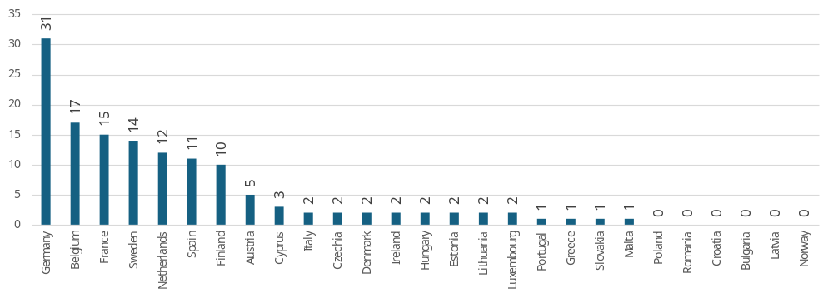
Source: Public Consultations on public procurement reform. Commission own analysis.

Among EU/EEA-based companies and businesses that participated in the consultation, a total of 238 responses were recorded. The distribution by company size reveals a dominant representation from large enterprises, which accounted for 58% (139 responses). Small businesses (10–49 employees) contributed 17% (40 responses), closely followed by micro-enterprises (1–9 employees) at 15% (35 responses). Medium-sized companies (50–249 employees) made up the smallest share, representing 10% (24 responses) (see the figure below).
The analysis extended to examining the primary sectors of activity-classified by NACE codes-of the EU-based large enterprises that participated in the consultation. By cross-referencing the respondents with a commercial firm database, we successfully matched 127 out of the 139 companies (91%). The findings reveal a notable concentration in specific industries. The manufacturing sector emerged as the most prominent, representing 28% (35 firms), followed by electricity, gas, steam, and air conditioning supply at 16% (20 firms). Professional, scientific, and technical activities accounted for 15% (19 firms), while transportation and storage contributed 8% (10 firms). Several other sectors, including information and communication, financial and insurance activities, wholesale and retail trade (including motor vehicle repairs), construction, and water supply; sewerage, waste management, and remediation activities, each represented between 5% and 7% of the responses.
In addition to sectoral analysis, we investigated the geographical location of the global ultimate owners of these large enterprises. For 115 firms, the ultimate owner’s location could be identified. The overwhelming majority-93%-had their ultimate owners based within the EU or EEA. Among these, France was the most common location, hosting 26% of the ultimate owners, followed by Germany (16%) and Austria (10%). The remaining 7% of ultimate owners were located outside the EU, with the United States (3%) and Japan (2%) being the most frequently represented non-EU countries.
Figure 68: Distribution of EU respondents in category Company/business by size
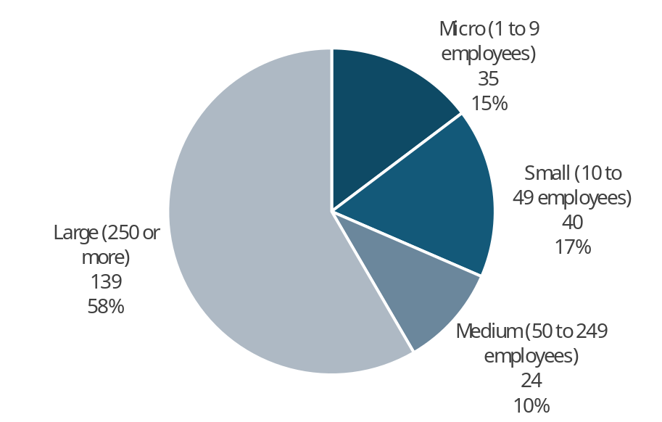
Note: Only replies from the EU considered
Source: Public Consultations on public procurement reform. Commission own analysis.

Overall objectives
This section of the questionnaire was designed to be accessible to all respondents, irrespective of their level of technical expertise in public procurement. It featured three key questions, each asking respondents to rank a set of objectives for the new public procurement framework in order of importance. The objectives were grouped under three overarching themes: improving efficiency and transparency, advancing green, social, and innovative public procurement, and strengthening economic security and strategic autonomy. To ensure impartiality, respondents were presented with seven to eight predefined objectives, which were displayed in a randomised order to mitigate potential response bias. The findings from these rankings are examined in the analysis that follows.
Table 68: Question: Improving efficiency and transparency of the new rules; ranking of the proposed characteristics of the new public procurement legal framework in a decreasing order, by type of respondent.
 | A. Move beyond the lowest-cost paradigm | B. More flexible rules | C. Reduce administrative burden through full digitalisation | D. Facilitate SMEs participation | E. Rules less prone to anti-competitive practices | F. Rules less prone to litigation | G. Less detailed rules | H. Facilitate the aggregation of demand | No. of responses
All | 1 | 2 | 3 | 4 | 5 | 6 | 7 | 8 | 984
Public Authorities EU | 4 | 1 | 3 | 8 | 7 | 6 | 2 | 5 | 129
Large companies EU | 1 | 2 | 3 | 8 | 4 | 6 | 5 | 7 | 135
SMEs EU | 1 | 2 | 4 | 3 | 6 | 7 | 5 | 8 | 94
Business associations EU | 1 | 3 | 2 | 4 | 5 | 7 | 6 | 8 | 220
Trade unions EU | 1 | 4 | 6 | 7 | 3 | 2 | 8 | 5 | 111
NGOs EU* | 1 | 3 | 4 | 2 | 7 | 5 | 8 | 6 | 102
Academia | 2 | 1 | 5 | 6 | 8 | 4 | 3 | 7 | 25
Citizens + other EU** | 1 | 2 | 3 | 4 | 7 | 6 | 5 | 8 | 142
Non-EU | 1 | 3 | 2 | 7 | 5 | 4 | 6 | 8 | 26
Central EU | 1 | 2 | 3 | 4 | 6 | 7 | 5 | 8 | 558
North EU | 2 | 1 | 3 | 6 | 5 | 7 | 4 | 8 | 114
South EU | 1 | 3 | 2 | 6 | 5 | 4 | 8 | 7 | 186
East EU | 1 | 2 | 3 | 7 | 5 | 4 | 8 | 6 | 100
Central EU authorities | 4 | 1 | 3 | 8 | 7 | 5 | 2 | 6 | 76
North EU authorities | 7 | 1 | 3 | 5 | 4 | 8 | 2 | 6 | 26
South EU authorities | 3 | 1 | 2 | 4 | 6 | 7 | 8 | 5 | 18
East EU authorities | 7 | 1 | 2 | 5 | 4 | 6 | 3 | 8 | 9
* NGOs + Environmental organisations; ** includes Consumer Organisations
Note: Top three responses highlighted
A. Prioritise broader policy goals by moving beyond the lowest-cost paradigm (e.g. to include objectives like sustainability, innovation, social responsibility and Made in Europe);
B. Make procurement rules more flexible (e.g. more space for negotiations, more discretion given to public buyers);
C. Reduce administrative burden through full digitalisation (e.g. digitalisation of the entire procurement process, single digital procurement entry point, data reuse);
D. Facilitate SMEs participation (e.g. division into lots, payment schemes including direct payments to subcontractors);
E. Make procurement rules less prone to anti-competitive practices (e.g. wider use of digital tools to facilitate transparency);
F. Make procurement rules less prone to litigation (e.g. more detailed procedural rules to avoid ambiguity);
G. Make procurement rules less detailed (e.g. focus on high-level concepts, less rules defining procedural steps);
H. Facilitate the aggregation of demand (e.g. joint procurement by several authorities, reinforcing the role of central purchasing bodies, framework agreements);
1 – most important, 8 the least important; ranking based on weighting, first choice received weight of eight, second of seven…
EU includes NO; Central EU: AT, BE, DE, FR, LU, NL; North EU: DK, FI, IE, SE and NO; South EU: CY, EL, ES, IT, MT, PT; East EU: BG, CZ, EE, HR, HU, LT, LV, PL, RO, SK; replies of only those who answered are provided
Source: Public Consultations on public procurement reform. Commission own analysis.

The question asked respondents to rank the guiding goals for the public procurement reforms in terms of improving the efficiency and transparency of the rules. Moving beyond the lowest-cost paradigm was the top choice for all groups except Public Authorities and Academia. Making procurement rules more flexible was often the second choice, followed by the reduction in administrative burden through full digitalisation. Regionally, Central, North, South, and East EU respondents showed similar rankings, with slight variations.
Public authorities considered that making rules more flexible should be the first priority of the reform, followed by making procurement rules less detailed and reducing administrative burden. This choice was similar across all regions, except for South EU authorities, which placed moving beyond the lowest price at the third place.
European business generally followed the overall trend of all respondents, with slight shifts in regards to the second and third place, with the exception of SMEs, which considered facilitation of SME participation in procurement as the third priority.
Trade unions, agreeing on the first place with the rest of respondents, placed rules less prone to litigation as second and less prone to anti-competitive practice as the third priority. NGOs gave prominence to SME participation, placing it second after "move beyond the lowest price" and before more flexible rules.
The option that received the least support was facilitating the aggregation of demand. SME participation, rules less prone to litigation and anti-competitive practices, and less detailed rules occupied the middle of the ranking.
Table 69: Question: Green, social and innovative public procurement; ranking of the proposed characteristics of the new public procurement legal framework in a decreasing order, by type of respondent.
 | A. Prioritise quality over price | B. Facilitate environmentally friendly purchases | C. Facilitate purchases of innovative solutions | D. Facilitate socially responsible purchases | E. Avoid additional administrative burden | F. Facilitate SME participation | G. Less detailed rules | H. Prioritise competition and price savings | No. of responses
All | 1 | 2 | 3 | 4 | 5 | 6 | 7 | 8 | 975
Public Authorities EU | 4 | 3 | 5 | 6 | 1 | 8 | 2 | 7 | 130
Large companies EU | 1 | 2 | 3 | 6 | 4 | 7 | 5 | 8 | 134
SMEs EU | 1 | 4 | 2 | 6 | 7 | 3 | 5 | 8 | 92
Business associations EU | 1 | 5 | 4 | 7 | 3 | 2 | 6 | 8 | 220
Trade unions EU | 2 | 3 | 4 | 1 | 7 | 5 | 6 | 8 | 110
NGOs EU* | 1 | 2 | 4 | 3 | 6 | 5 | 7 | 8 | 102
Academia | 2 | 3 | 5 | 6 | 1 | 7 | 4 | 8 | 26
Citizens + other EU** | 1 | 2 | 4 | 3 | 5 | 7 | 6 | 8 | 136
Non-EU | 1 | 3 | 4 | 6 | 2 | 7 | 5 | 8 | 25
Central EU | 1 | 2 | 3 | 6 | 4 | 5 | 7 | 8 | 553
North EU | 1 | 2 | 5 | 3 | 6 | 7 | 4 | 8 | 114
South EU | 1 | 2 | 4 | 3 | 6 | 5 | 7 | 8 | 185
East EU | 1 | 2 | 4 | 3 | 5 | 7 | 6 | 8 | 98
Central EU authorities | 4 | 3 | 5 | 6 | 1 | 8 | 2 | 7 | 77
North EU authorities | 4 | 3 | 6 | 5 | 2 | 7 | 1 | 8 | 26
South EU authorities | 1 | 2 | 5 | 3 | 4 | 7 | 6 | 8 | 18
East EU authorities | 2 | 4 | 5 | 8 | 1 | 7 | 3 | 6 | 9
* NGOs + Environmental organisations; ** includes Consumer Organisations
Note: Top three responses highlighted
A. Prioritise quality over price when seeking value for money (e.g. wider use of the of best price-quality ratio to support strategic and sustainable procurement);
B. Facilitate environmentally friendly purchases (e.g. facilitated use of ecolabels and standards, set targets for green public procurement);
C. Facilitate purchases of innovative solutions (e.g. simplifying innovation partnerships, easing access to public procurement for startups);
D. Facilitate socially responsible purchases (e.g. improved working conditions, social inclusion);
E. Avoid additional administrative burden (e.g. limited rules on social and green conditionalities and associated administrative and evidence requirements for companies and public buyers);
F. Facilitate SME participation (e.g. division into lots, payment schemes including direct payments to subcontractors);
G. Make procurement rules less detailed (e.g. focus on high-level concepts, less rules defining procedural steps);
H. Prioritise competition and price savings (e.g. by avoiding ambitious green and social requirements)
1 – most important, 8 the least important; ranking based on weighting, first choice received weight of eight, second of seven…
EU includes NO; Central EU: AT, BE, DE, FR, LU, NL; North EU: DK, FI, IE, SE and NO; South EU: CY, EL, ES, IT, MT, PT; East EU: BG, CZ, EE, HR, HU, LT, LV, PL, RO, SK; replies of only those who answered are provided
Source: Public Consultations on public procurement reform. Commission own analysis.

The topic of Green, social, and innovative public procurement was explored through a ranking of the proposed characteristics of the new public procurement legal framework in decreasing order, revealing some notable trends.
There was a clear preference among most respondent groups for prioritising quality over price (which mostly occupied first or second place), followed by facilitating environmentally friendly purchases (which was second or third), and the purchases of innovative solutions (third or fourth).
However, public authorities considered avoiding administrative burden as the key priority for green, social, and innovative procurement, followed by making rules less detailed, with facilitation of environmentally friendly purchases taking the third place. This choice was similar across all regions, except for South EU authorities, which voted along the lines of all respondents.
European business generally followed the overall trend of all respondents in terms of the first place. SMEs placed a high priority on facilitating the purchase of innovation (second) and SME participation (third), while Business Associations ranked SME participation second and administrative burden avoidance third.
Trade unions differed from the rest by placing facilitation of socially responsible purchases first, which was also the third choice for NGOs.
Prioritisation of competition and price savings ranked bottom among all groups. Facilitation of purchases of innovative solutions, socially responsible purchases, avoidance of additional administrative burden, SME participation, and less detailed rules occupied middle places in the ranking, with variations between respondent groups.
Table 70: Question: Economic security and strategic autonomy; ranking of the proposed characteristics of the new public procurement legal framework in a decreasing order, by type of respondent.
 | A. Preference to European industry in critical sectors | B. General preference to European industry | C. More flexible rules | D. Avoid administrative burden | E. Rules less prone to litigation | F. Less detailed rules | G. Prioritise competition and price savings | No. of responses
All | 1 | 2 | 3 | 4 | 5 | 6 | 7 | 960
Public Authorities EU | 3 | 5 | 1 | 2 | 6 | 3 | 7 | 129
Large companies EU | 1 | 2 | 3 | 4 | 6 | 5 | 7 | 132
SMEs EU | 1 | 4 | 3 | 2 | 5 | 6 | 7 | 92
Business associations EU | 1 | 3 | 4 | 2 | 5 | 6 | 7 | 216
Trade unions EU | 2 | 1 | 4 | 6 | 3 | 5 | 7 | 108
NGOs EU* | 1 | 4 | 2 | 5 | 3 | 6 | 7 | 98
Academia | 4 | 5 | 1 | 2 | 6 | 3 | 7 | 23
Citizens + other EU** | 1 | 2 | 3 | 4 | 5 | 6 | 7 | 137
Non-EU | 5 | 7 | 2 | 1 | 4 | 3 | 6 | 25
Central EU | 1 | 4 | 3 | 2 | 5 | 6 | 7 | 545
North EU | 3 | 5 | 1 | 4 | 6 | 2 | 7 | 109
South EU | 1 | 2 | 5 | 3 | 4 | 6 | 7 | 183
East EU | 1 | 2 | 3 | 6 | 4 | 5 | 7 | 98
Central EU authorities | 3 | 4 | 1 | 2 | 6 | 4 | 7 | 76
North EU authorities | 4 | 6 | 2 | 3 | 7 | 1 | 5 | 25
South EU authorities | 2 | 1 | 3 | 4 | 5 | 6 | 7 | 19
East EU authorities | 3 | 6 | 1 | 2 | 7 | 4 | 5 | 9
* NGOs + Environmental organisations; ** includes Consumer Organisations
Note: Top three responses highlighted
A. give preference to European industry, products and services in sectors that are critical to EU economic security or of strategic importance to secure Europe’s independence;
B. Give general preference to European industry, products and services (Made in Europe) to support investment, growth and jobs in the EU;
C. Make procurement rules more flexible (e.g. more discretion given to public buyers);
D. Avoid additional administrative burden (e.g. minimal rules on the extent to which Made in Europe requirements are met);
E. Make procurement rules less prone to litigation (e.g. more detailed to avoid ambiguity in case of third countries access);
F. Make procurement rules less detailed (e.g. focus on high-level concepts rather than detailed requirements on what products, services and works public buyers can purchase);
G. Prioritise competition and price savings (e.g. by allowing unrestrained access to European markets to firms from outside Europe);
1 – most important, 7 the least important; ranking based on weighting, first choice received weight of eight, second of seven…
EU includes NO; Central EU: AT, BE, DE, FR, LU, NL; North EU: DK, FI, IE, SE and NO; South EU: CY, EL, ES, IT, MT, PT; East EU: BG, CZ, EE, HR, HU, LT, LV, PL, RO, SK; replies of only those who answered are provided
Source: Public Consultations on public procurement reform. Commission own analysis.

The last ranking in the general section concerned priorities for achieving economic security and strategic autonomy goals with public procurement tools.
There was a clear preference among most respondent groups for giving preference to European industry in critical sectors, followed by a general preference for European industry and more flexible rules. There were noticeable variations among EU regions, with northern countries placing flexible rules first, followed by less detailed rules. Also, avoidance of administrative burden was placed high by the Central EU countries (second) and South EU countries (third).
Public authorities considered more flexible rules, followed by avoiding administrative burden, as the key priorities, with less detailed rules and preference to critical sectors ex aequo on third place. There were regional differences, with South EU authorities differing slightly by more/less following the general preference of all respondents, as well as North EU authorities, which placed on the podium less detailed, more flexible, and burdensome rules.
Large European businesses generally followed the overall trend, but SMEs and Business Associations placed administrative burden avoidance second.
While both Trade Unions and NGOs placed European preference top, they differed from other respondents by prioritising rules less prone to litigation (third place), with NGOs also pointing to the need for flexibility (second).
Notably, Non-EU respondents placed prioritisation of EU industry towards the bottom of the priorities list, focusing instead on administrative burden avoidance, flexibility, and less detailed rules.
Prioritisation of competition and price savings again ranked bottom among all the groups.

This section concluded with a filtering question, offering respondents the choice to either proceed to the subsequent sections-focused on more detailed and technical aspects of the public procurement revision-or to move directly to the final comments section, where they could provide open-ended feedback in free-text format. Of the total respondents, 831 (80%) opted to continue to the detailed sections, while 206 (20%) chose to skip directly to the final comments. The analysis presented in the following section reflects only the views of the 831 respondents who engaged with the technical aspects of the consultation.

Simplification (FLX options)

Flexible procedures
Figure 69: Question: Please assess the potential of each measure to make procedures more flexible; all replies.
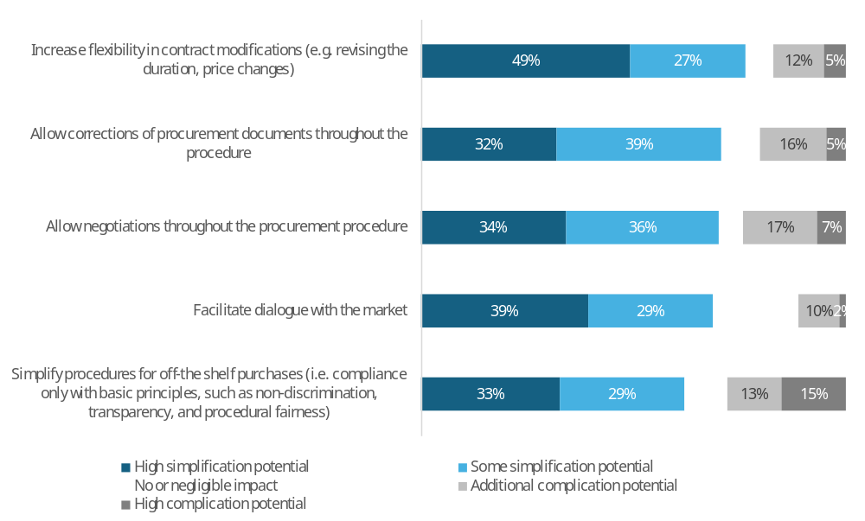
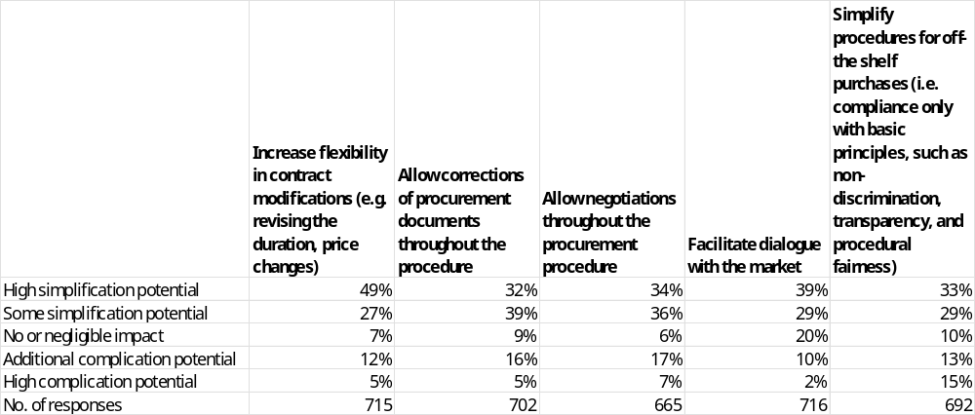
Note: Single-choice responses only; results reflect replies from those who answered.
Source: Public Consultations on public procurement reform. Commission own analysis.

In response to the question “Please assess the potential of each measure to make procedures more flexible”, respondents most often see high or some simplification potential in increasing flexibility in contract modifications (76%: 49% high simplification potential, 27% some potential), followed by allowing corrections of procurement documents throughout the procedure (71%: 32% high, 39% some), facilitating dialogue with the market (68%: 39% high, 29% some), allowing negotiations throughout the procurement procedure (70%: 34% high, 36% some) and simplification of procedures for off-the-shelf purchases (62%: 33% high, 29% some).
Disagreement that these measures would simplify procedures, i.e. seeing additional or high complication potential, is highest for simplifying procedures for off-the-shelf purchases (28%: 13% additional complication, 15% high complication), followed by allowing negotiations throughout the procurement procedure (24%: 17% additional complication, 7% high complication) and allowing corrections of procurement documents (21%: 16% additional complication, 5% high complication). Lower complication expectations are reported for increasing flexibility in contract modifications (17%: 12% additional complication, 5% high complication) and facilitating dialogue with the market (12%: 10% additional complication, 2% high complication).
Across all measures, the share of respondents expecting “no or negligible impact” ranges from 6–7% for allowing negotiations and increasing flexibility in contract modifications, up to 20% for facilitating dialogue with the market, with intermediate levels of 9–10% for allowing corrections and simplifying off-the-shelf purchases.
Table 71: Question: Please assess the potential of each measure to make procedures more flexible; Percentage of respondents that indicated high or some simplification potential, by type of respondent.
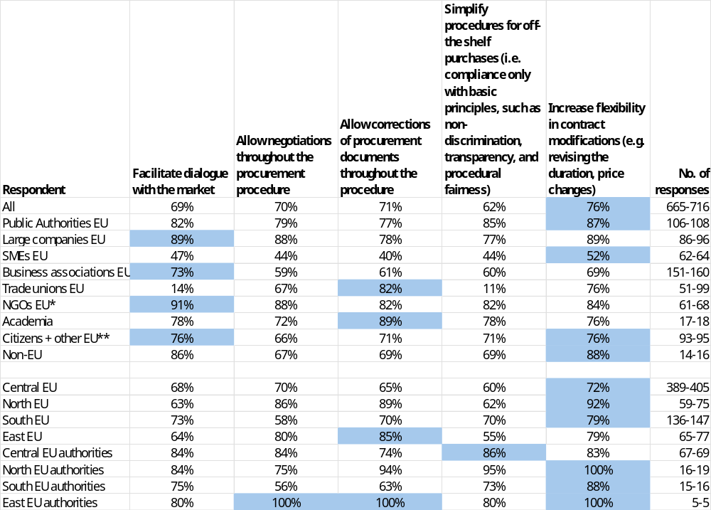
* NGOs + Environmental organisations; ** includes Consumer Organisations
Note: Single-choice responses only; results reflect replies from those who answered. Top response highlighted. The number of responses in the last column is shown as a range, as the number of replies varied per column. EU includes NO; Central EU: AT, BE, DE, FR, LU, NL; North EU: DK, FI, IE, SE and NO; South EU: CY, EL, ES, IT, MT, PT; East EU: BG, CZ, EE, HR, HU, LT, LV, PL, RO, SK; replies of only those who answered are provided
Source: Public Consultations on public procurement reform. Commission own analysis.

This question assessed which measures respondents believed had the highest potential to make procurement procedures more flexible.
The measure attracting the highest overall support was increasing flexibility in contract modifications at 76%. Central, North, and South EU respondents aligned with this preference (72%, 92%, and 79% respectively), while East EU respondents favoured allowing corrections of procurement documents throughout the procedure at 85%.
Public authorities most frequently selected increasing flexibility in contract modifications at 87%, with other measures ranging from 77% to 85%.
Large companies most often selected facilitating dialogue with the market and increasing flexibility in contract modifications, both at 89%, with other measures ranging from 77% to 88%.
SMEs preferred increasing flexibility in contract modifications at 52%, with other measures ranging from 40% to 47%. Business associations favoured facilitating dialogue with the market at 73%, with other measures ranging from 59% to 69%.
Trade unions most frequently selected increasing flexibility in contract modifications at 76% and allowing corrections of procurement documents throughout the procedure at 82%, but showed very low support for facilitating dialogue with the market at 14% and simplifying procedures for off-the-shelf purchases at 11%. NGOs most frequently selected facilitating dialogue with the market at 91%, with other measures ranging from 82% to 88%.
Academia favoured allowing corrections of procurement documents throughout the procedure at 89%, with other measures ranging from 72% to 78%. Citizens and other respondents most often selected facilitating dialogue with the market and increasing flexibility in contract modifications, both at 76%, with other measures ranging from 66% to 71%. Non-EU respondents preferred increasing flexibility in contract modifications at 88%, with other measures ranging from 67% to 86%.

Joint procurement
Figure 70: Question: Please assess the potential of each measure to simplify joint procurement; all replies.
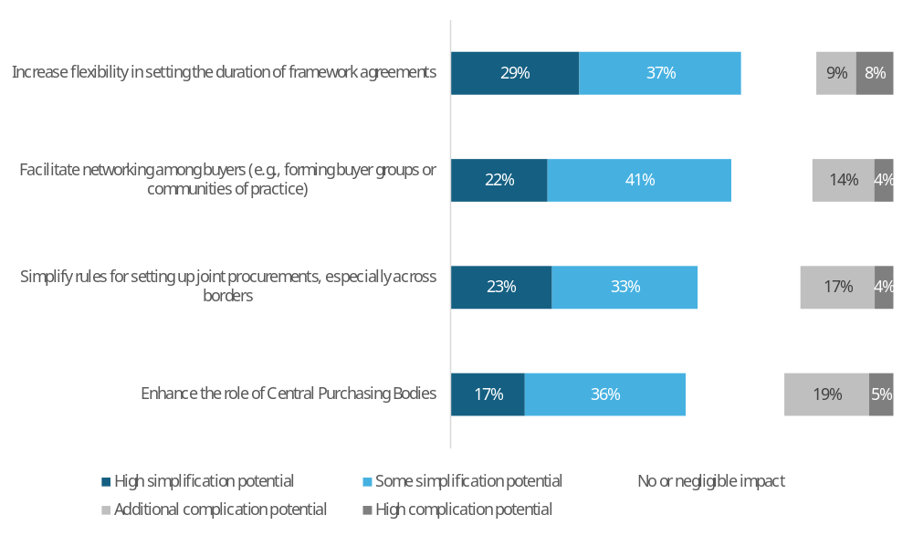
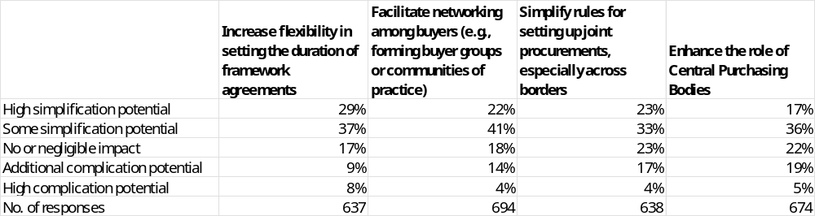
Note: Single-choice responses only; results reflect replies from those who answered.
Source: Public Consultations on public procurement reform. Commission own analysis.

In response to the question “Please assess the potential of each measure to simplify joint procurement”, respondents most often see high or some simplification potential in increasing flexibility in setting the duration of framework agreements (66%: 29% high simplification potential, 37% some potential), followed by facilitating networking among buyers (63%: 22% high, 41% some), simplifying rules for setting up joint procurements, especially across borders (56%: 23% high, 33% some) and enhancing the role of Central Purchasing Bodies (53%: 17% high, 36% some).
Disagreement that these measures would simplify joint procurement, i.e. seeing additional or high complication potential, is highest for enhancing the role of Central Purchasing Bodies (24%: 19% additional complication, 5% high complication) and for simplifying rules for setting up joint procurements across borders (21%: 17% additional complication, 4% high complication), followed by facilitating networking among buyers (18%: 14% additional complication, 4% high complication) and increasing flexibility in setting the duration of framework agreements (17%: 9% additional complication, 8% high complication).
Across all measures, the share of respondents expecting “no or negligible impact” ranges from 17% for increasing flexibility in the duration of framework agreements to 23% for simplifying rules for joint procurements, with intermediate levels of 18% for facilitating networking among buyers and 22% for enhancing the role of Central Purchasing Bodies.

Table 72: Question: Please assess the potential of each measure to simplify joint procurement; Percentage of respondents that indicated high or some simplification potential, by type of respondent.
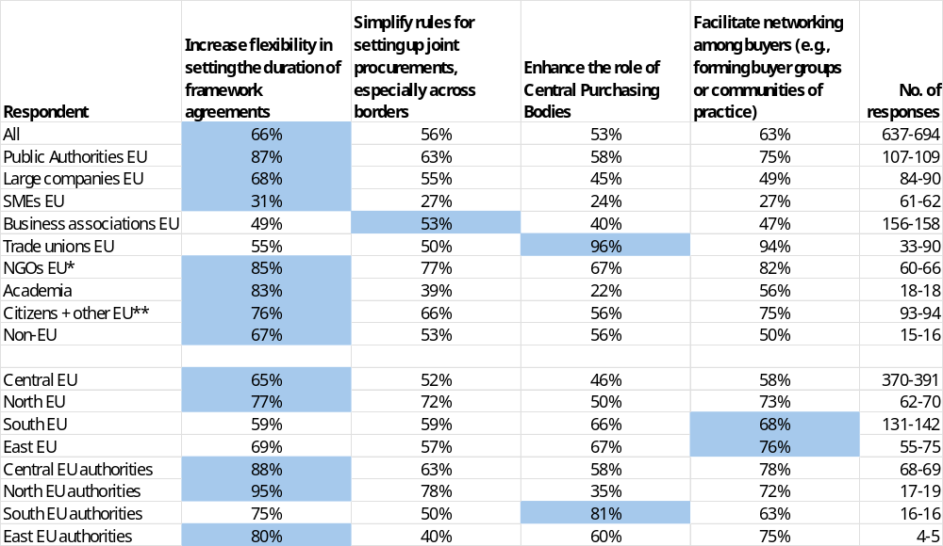
* NGOs + Environmental organisations; ** includes Consumer Organisations
Note: Single-choice responses only; results reflect replies from those who answered. Top response highlighted. The number of responses in the last column is shown as a range, as the number of replies varied per column. EU includes NO; Central EU: AT, BE, DE, FR, LU, NL; North EU: DK, FI, IE, SE and NO; South EU: CY, EL, ES, IT, MT, PT; East EU: BG, CZ, EE, HR, HU, LT, LV, PL, RO, SK; replies of only those who answered are provided
Source: Public Consultations on public procurement reform. Commission own analysis.

This question assessed which measures respondents believed had the highest potential to simplify joint procurement.
The measure attracting the highest overall support was increasing flexibility in setting the duration of framework agreements at 66%. North and Central EU respondents aligned with the overall preference for this measure at 77% and 65% respectively. South EU respondents favoured facilitating networking among buyers at 68%, while East EU respondents also preferred this measure at 76%.
Public authorities most frequently selected increasing flexibility in setting the duration of framework agreements at 87%, with other measures ranging from 58% to 75%.
Large companies most often selected increasing flexibility in setting the duration of framework agreements at 68%, with other measures ranging from 45% to 55%. SMEs preferred increasing flexibility in setting the duration of framework agreements at 31%, with other measures ranging from 24% to 27%. Business associations favoured simplifying rules for setting up joint procurements at 53%, with other measures ranging from 40% to 49%.
Trade unions stood out with very high support for enhancing the role of Central Purchasing Bodies at 96% and facilitating networking among buyers at 94%, but showed lower support for increasing flexibility in setting the duration of framework agreements at 55%. NGOs most frequently selected increasing flexibility in setting the duration of framework agreements at 85%, with other measures ranging from 67% to 82%.
Academia favoured increasing flexibility in setting the duration of framework agreements at 83%, but showed low support for enhancing the role of Central Purchasing Bodies at 22%, with other measures ranging from 39% to 56%. Citizens and other respondents most often selected increasing flexibility in setting the duration of framework agreements at 76%, with other measures ranging from 56% to 75%. Non-EU respondents preferred increasing flexibility in setting the duration of framework agreements at 67%, with other measures ranging from 50% to 56%.

Improve information exchange and procedural time-limits
Figure 71: Question: Please assess the potential of each measure to improve information exchange and procedural time-limits; all replies.
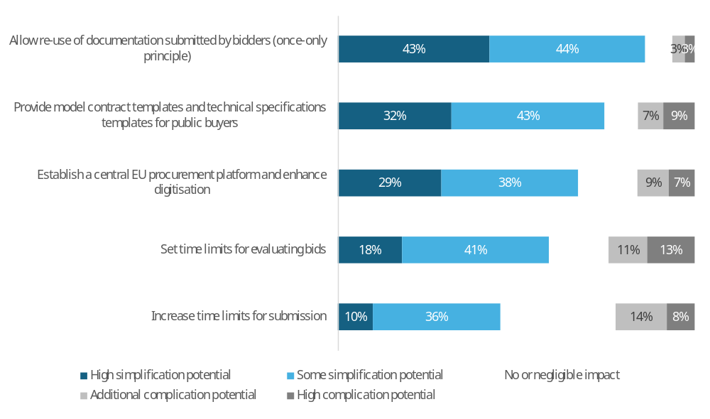
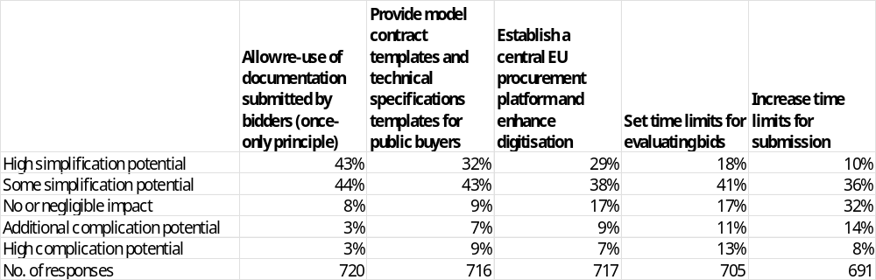
Note: Single-choice responses only; results reflect replies from those who answered.
Source: Public Consultations on public procurement reform. Commission own analysis.

In response to the question “Please assess the potential of each measure to improve information exchange and procedural time-limits”, respondents most often see high or some simplification potential in allowing re-use of documentation submitted by bidders (once-only principle) (87%: 43% high simplification potential, 44% some potential), followed by providing model contract templates and technical specifications templates for public buyers (75%: 32% high, 43% some) and establishing a central EU procurement platform and enhancing digitisation (67%: 29% high, 38% some). Lower but still significant shares see simplification potential in setting time limits for evaluating bids (59%: 18% high, 41% some) and increasing time limits for submission (46%: 10% high, 36% some).
Disagreement that these measures would simplify procedures, i.e. seeing additional or high complication potential, is highest for setting time limits for evaluating bids (24%: 11% additional complication potential, 13% high complication potential), followed by increasing time limits for submission (22%: 14% additional complication, 8% high complication), establishing a central EU procurement platform and enhancing digitisation (16%: 9% additional complication, 7% high complication), providing model templates (16%: 7% additional complication, 9% high complication), and allowing re-use of documentation (6%: 3% additional complication, 3% high complication).
Across all measures, the share of respondents expecting “no or negligible impact” ranges from 8% for allowing re-use of documentation to 32% for increasing time limits for submission, with intermediate levels of 9% for providing model templates and 17% for both establishing a central EU procurement platform and setting time limits for evaluating bids.

Table 73: Question: Please assess the potential of each measure to improve information exchange and procedural time-limits; Percentage of respondents that indicated high or some simplification potential, by type of respondent.
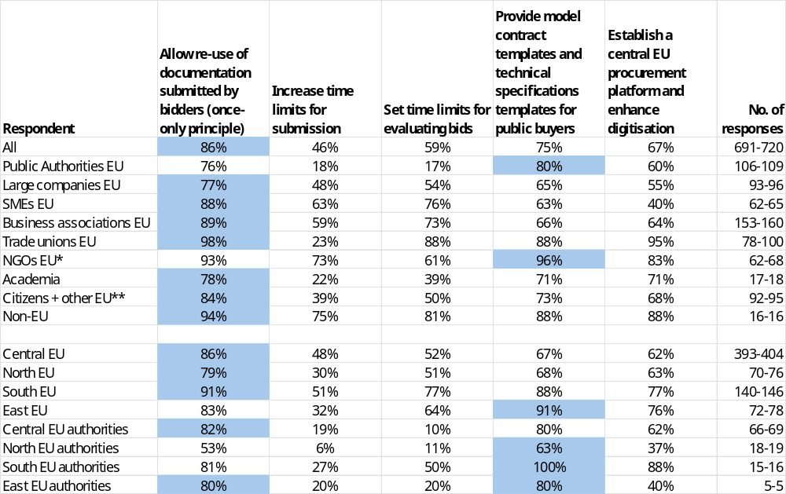
* NGOs + Environmental organisations; ** includes Consumer Organisations
Note: Single-choice responses only; results reflect replies from those who answered. Top response highlighted. The number of responses in the last column is shown as a range, as the number of replies varied per column. EU includes NO; Central EU: AT, BE, DE, FR, LU, NL; North EU: DK, FI, IE, SE and NO; South EU: CY, EL, ES, IT, MT, PT; East EU: BG, CZ, EE, HR, HU, LT, LV, PL, RO, SK; replies of only those who answered are provided
Source: Public Consultations on public procurement reform. Commission own analysis.

This question assessed which measures respondents believed had the highest potential to improve information exchange and procedural time limits.
The measure attracting the highest overall support was allowing re-use of documentation submitted by bidders (once-only principle) at 86%. East EU respondents favoured providing model contract templates at 91%, while Central, North, and South EU respondents aligned with the overall top choice (86%, 79%, and 91% respectively).
Public authorities most frequently selected providing model contract templates at 80%, with other measures ranging from 17% to 76%.
Large companies, SMEs, and business associations all most often selected allowing re-use of documentation (89%, 88%, and 89% respectively). SMEs also showed high support for setting time limits for evaluating bids at 76%. Other measures for these groups ranged from 40% to 73%.
Trade unions most frequently selected allowing re-use of documentation at 98% and establishing a central EU procurement platform at 95%, with very low support for increasing time limits for submission at 23%. NGOs most frequently selected providing model contract templates at 96%, with other measures ranging from 61% to 93%.
Academia favoured allowing re-use of documentation at 78%, with low support for increasing time limits for submission at 22%. Other measures ranged from 39% to 71%. Citizens and other respondents most often selected allowing re-use of documentation at 84%, with other measures ranging from 39% to 73%. Non-EU respondents most frequently selected allowing re-use of documentation at 94%, with other measures ranging from 75% to 88%.

Support small and medium-sized enterprises (SMEs):
Figure 72: Question: Please assess the potential of each measure to support small and medium-sized enterprises (SMEs); all replies.
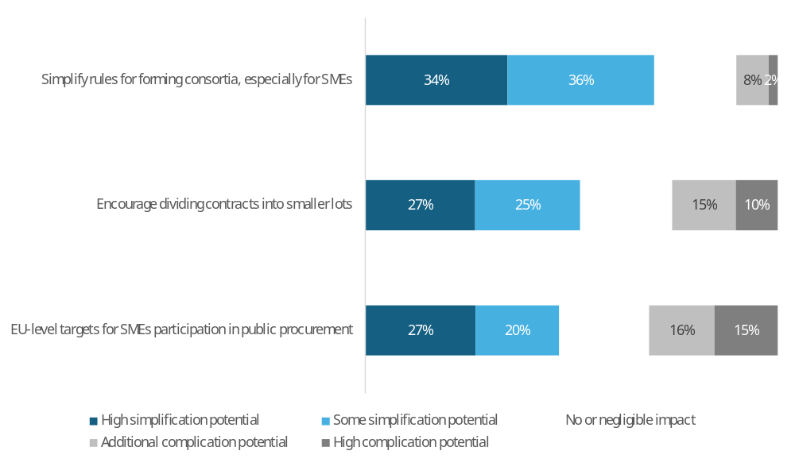
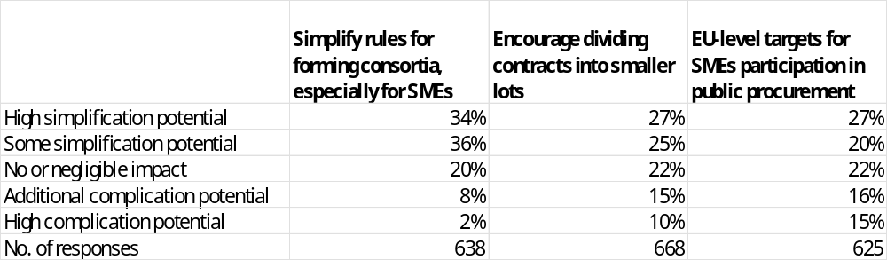
Note: Single-choice responses only; results reflect replies from those who answered.
Source: Public Consultations on public procurement reform. Commission own analysis.

In response to the question “Please assess the potential of each measure to support small and medium-sized enterprises (SMEs)”, respondents most often see high or some simplification potential in simplifying rules for forming consortia, especially for SMEs (70%: 34% high simplification potential, 36% some potential), followed by encouraging dividing contracts into smaller lots (52%: 27% high, 25% some) and EU-level targets for SME participation in public procurement (47%: 27% high, 20% some).
Disagreement that these measures would support SMEs, i.e. seeing additional or high complication potential, is highest for EU-level targets for SME participation (31%: 16% additional complication potential, 15% high complication potential), followed by encouraging dividing contracts into smaller lots (25%: 15% additional complication, 10% high complication) and simplifying rules for forming consortia (10%: 8% additional complication, 2% high complication).
Across all measures, the share of respondents expecting “no or negligible impact” is similar, ranging from 20% for simplifying consortia rules to 22% for dividing contracts into smaller lots and for EU-level SME participation targets.

Table 74: Question: Please assess the potential of each measure to support small and medium-sized enterprises (SMEs); Percentage of respondents that indicated high or some simplification potential, by type of respondent.
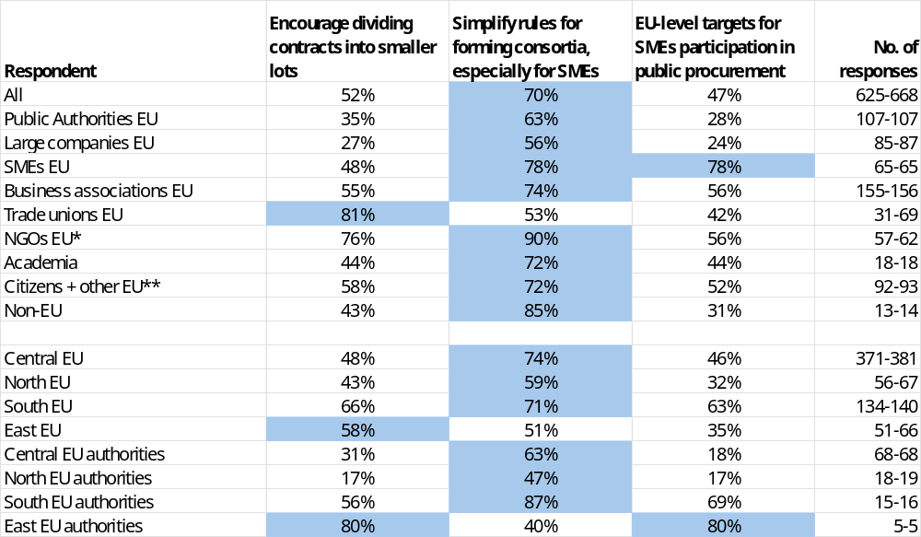
* NGOs + Environmental organisations; ** includes Consumer Organisations
Note: Single-choice responses only; results reflect replies from those who answered. Top response highlighted. The number of responses in the last column is shown as a range, as the number of replies varied per column. EU includes NO; Central EU: AT, BE, DE, FR, LU, NL; North EU: DK, FI, IE, SE and NO; South EU: CY, EL, ES, IT, MT, PT; East EU: BG, CZ, EE, HR, HU, LT, LV, PL, RO, SK; replies of only those who answered are provided
Source: Public Consultations on public procurement reform. Commission own analysis.

This question assessed which measures respondents believed had the highest potential to support small and medium-sized enterprises (SMEs).
The measure attracting the highest overall support was simplifying rules for forming consortia at 70%. East EU respondents preferred encouraging dividing contracts into smaller lots at 58%. Central, South and North EU respondents aligned with the overall top choice (74%, 71%, 59% respectively).
Public authorities most frequently selected simplifying rules for forming consortia at 63%, with other measures ranging from 28% to 35%.
Large companies most often selected simplifying rules for forming consortia at 56%, with other measures ranging from 24% to 27%. SMEs preferred EU-level targets for SME participation and simplifying rules for forming consortia, both at 78%. Business associations favoured simplifying rules for forming consortia at 74%, with other measures ranging from 55% to 56%.
Trade unions most frequently selected encouraging dividing contracts into smaller lots at 81%, with other measures ranging from 42% to 53%. NGOs most frequently selected simplifying rules for forming consortia at 90%, with other measures ranging from 56% to 76%.
Academia favoured simplifying rules for forming consortia at 72%, with other measures at 44%. Citizens and other respondents most often selected simplifying rules for forming consortia at 72%, with other measures ranging from 52% to 58%. Non-EU respondents preferred simplifying rules for forming consortia at 85%, with other measures ranging from 31% to 43%.

Improve implementation and contract management
Figure 73: Question: Please assess the potential of each measure to improve implementation and contract management; all replies.
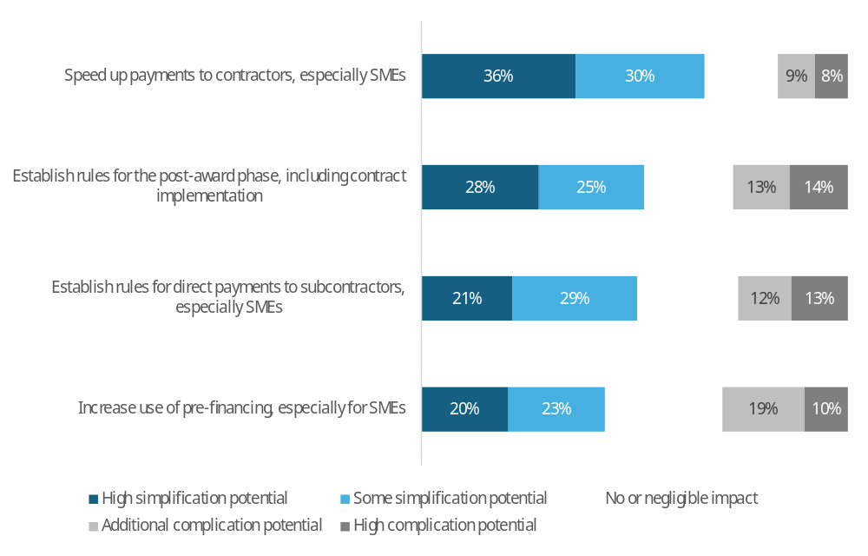
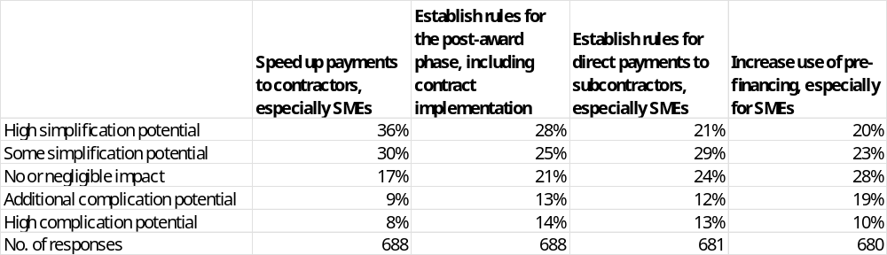
Note: Single-choice responses only; results reflect replies from those who answered.
Source: Public Consultations on public procurement reform. Commission own analysis.

In response to the question “Please assess the potential of each measure to improve implementation and contract management”, respondents most often see high or some simplification potential in speeding up payments to contractors, especially SMEs (66%: 36% high simplification potential, 30% some potential), followed by establishing rules for the post-award phase, including contract implementation (53%: 28% high, 25% some), establishing rules for direct payments to subcontractors, especially SMEs (50%: 21% high, 29% some), and increasing the use of pre-financing, especially for SMEs (43%: 20% high, 23% some).
Disagreement that these measures would simplify implementation and contract management, i.e. seeing additional or high complication potential, is highest for increasing the use of pre-financing (29%: 19% additional complication potential, 10% high complication potential), followed by establishing rules for the post-award phase (27%: 13% additional complication, 14% high complication), establishing rules for direct payments to subcontractors (25%: 12% additional complication, 13% high complication), and speeding up payments to contractors (17%: 9% additional complication, 8% high complication).
Across all measures, the share of respondents expecting “no or negligible impact” ranges from 17% for speeding up payments to contractors to 28% for increasing the use of pre-financing, with intermediate levels of 21% for establishing rules for the post-award phase and 24% for establishing rules for direct payments to subcontractors.

Table 75: Question: Please assess the potential of each measure to improve implementation and contract management; Percentage of respondents that indicated high or some simplification potential, by type of respondent.
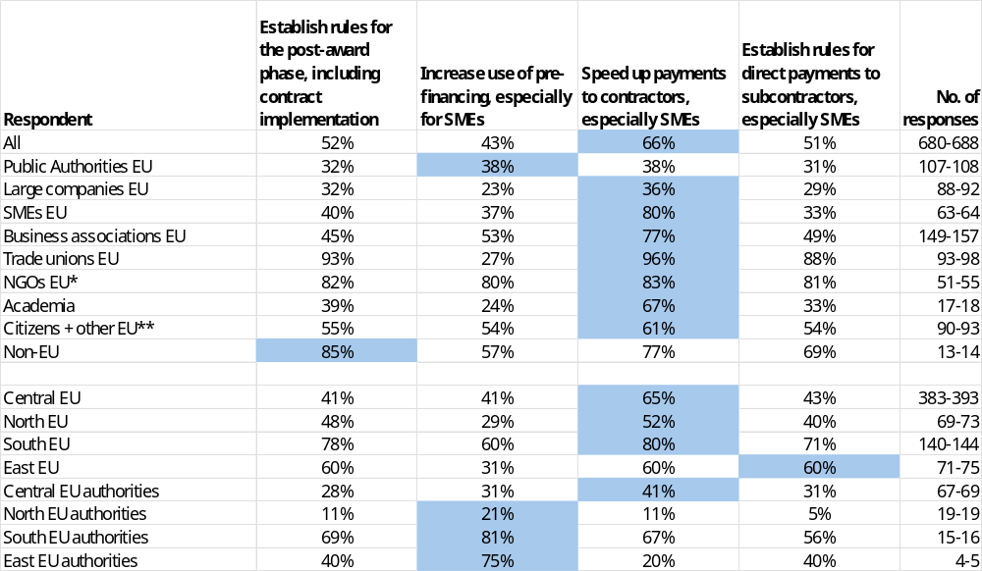
* NGOs + Environmental organisations; ** includes Consumer Organisations
Note: Single-choice responses only; results reflect replies from those who answered. Top response highlighted. The number of responses in the last column is shown as a range, as the number of replies varied per column. EU includes NO; Central EU: AT, BE, DE, FR, LU, NL; North EU: DK, FI, IE, SE and NO; South EU: CY, EL, ES, IT, MT, PT; East EU: BG, CZ, EE, HR, HU, LT, LV, PL, RO, SK; replies of only those who answered are provided
Source: Public Consultations on public procurement reform. Commission own analysis.

This question assessed which measures respondents believed had the highest potential to improve implementation and contract management.
The measure attracting the highest overall support was speeding up payments to contractors, especially SMEs, at 66%. Central, North, and South EU respondents aligned with this preference (65%, 52%, and 80% respectively), while East EU respondents showed equal preference for speeding up payments to contractors, establishing rules for direct payments to subcontractors, and establishing rules for the post-award phase, all at 60%.
Public authorities most frequently selected increasing use of pre-financing and speeding up payments to contractors, both at 38%, with other measures ranging from 31% to 32%.
Large companies most often selected establishing rules for the post-award phase at 36%, with other measures ranging from 23% to 32%. SMEs preferred speeding up payments to contractors at 80%, with other measures ranging from 33% to 40%. Business associations favoured speeding up payments to contractors at 77%, with other measures ranging from 45% to 53%.
Trade unions most frequently selected speeding up payments to contractors at 96% and establishing rules for the post-award phase at 93%, with other measures ranging from 27% to 88%. NGOs most frequently selected speeding up payments to contractors at 83%, with other measures ranging from 80% to 82%.
Academia favoured speeding up payments to contractors at 67%, with other measures ranging from 24% to 39%. Citizens and other respondents most often selected speeding up payments to contractors at 61%, with other measures at 54% to 55%. Non-EU respondents preferred establishing rules for the post-award phase at 85%, with other measures ranging from 57% to 77%.

Simplifications: comments

Public authorities
Approximately 17% of public authorities who provided comments suggested ways to simplify procurement procedures, essentially proposing methods to streamline and ease the processes involved in acquiring goods and services. The majority of respondents from this group highlighted the need for greater flexibility in procurement rules, with many citing the current regulations as overly complex and restrictive, which can lead to unnecessary delays and administrative burdens. A common suggestion was to allow for more negotiation in procurement procedures, with one respondent noting that "the distinction between the legal regimes applicable to public procurement and procurement by entities operating in the water, energy, etc. is no longer justified" and suggesting unification of these regimes to facilitate negotiation. This, they argue, would enable public authorities to respond more effectively to changing needs and make procurement processes more efficient. However, a minority of respondents cautioned against simplification at the expense of social and environmental sustainability objectives, emphasizing the importance of maintaining fair and transparent processes that prioritize these goals. Some respondents also stressed the need to support small and medium-sized enterprises (SMEs) in procurement procedures, with one suggesting the establishment of a "legal reserve for SMEs" to guarantee their participation, and others highlighting the importance of making procurement rules manageable for SMEs, as they "form an integral part of a strong and diversified EU economy". Furthermore, respondents expressed tension between the desire for digitalisation and the potential for increased complexity, with one noting that "digitalisation should not be automatically equated with simplification", and another arguing that "many existing EU digital systems are not user-friendly". Additionally, some respondents raised concerns about the impact of simplification on the ability to ensure quality and value for money, with one suggesting that "quality is also reflected in selection criteria and technical requirements", and therefore should not be compromised in the pursuit of simplification. Overall, public authorities are seeking a balance between simplifying procurement procedures and ensuring that these processes remain effective, sustainable, and supportive of SMEs and social and environmental objectives.

EU companies and business associations
Approximately 18% of EU companies and business associations who provided comments suggested ways to simplify procurement procedures, essentially proposing methods to streamline and ease the processes involved in acquiring goods and services. The majority of respondents from this group highlighted the need for greater flexibility in procurement rules, with many citing the current regulations as overly complex and restrictive, leading to unnecessary delays and administrative burdens. A common suggestion was to allow for more negotiation in procurement procedures, with some advocating for the introduction of a "fast-track selection procedure" to enable contracting authorities to select the most economically advantageous offers more swiftly. Others proposed reducing the number of procedures, replacing the European Single Procurement Document (ESPD) with a simpler system, and allowing contracting authorities to conduct negotiations when they consider it appropriate. However, a minority of respondents cautioned that simplification should not come at the expense of achieving social and environmental sustainability objectives, and that the focus should be on administrative aspects rather than deregulation. Many respondents also emphasized the need to support small and medium-sized enterprises (SMEs) in procurement procedures, with some suggesting the introduction of a "recycling label" for public procurement, the creation of a European register of excluded economic operators, and the promotion of training and templates to enable better lot division and SME-friendly tender design. Some respondents also raised concerns about the impact of simplification on the ability to ensure quality and value for money, with one suggesting that "quality is also reflected in selection criteria and technical requirements", and therefore should not be compromised in the pursuit of simplification. Overall, EU companies and business associations are seeking a balance between simplifying procurement procedures and ensuring that these processes remain fair, transparent, and effective in achieving their objectives. As one respondent noted, "simplification should support the effective implementation of mandatory green and industrial policy criteria, ensuring legal certainty and a level playing field for European circular and bio-based value chains".

EU NGOs, environmental organisations and trade unions
Approximately 45% of EU NGOs, environmental organisations, and trade unions who provided comments suggested ways to simplify procurement procedures, emphasizing that simplification should not lead to deregulation. The majority of respondents from this group highlighted the need for clearer rules on collective bargaining, green and sustainable public procurement, and stricter regulation of subcontracting. Many argued that the existence of a collective agreement with an economic operator is an effective and non-bureaucratic criterion for promoting quality jobs and fair wages. Some respondents suggested that simplification could be achieved through digitalization, improved data systems, and the use of standardized templates and model contracts. However, others warned that simplification should not compromise environmental and social objectives, and that the current voluntary approach has failed to shift procurement away from price-only awards. The need for mandatory environmental and social criteria, as well as clearer guidelines and greater flexibility in the choice of procurement procedures, was also emphasized. As one respondent noted, "simplification should not result in lower standards, but in greater legal certainty, clearer expectations for contracting authorities and bidders, and stronger implementation capacity." Overall, EU NGOs, environmental organisations, and trade unions are seeking a balance between simplifying procurement procedures and ensuring that these processes remain fair, transparent, and effective in achieving social and environmental objectives.

EU academic institutions, consumer organisations, citizen and other respondents
Approximately 17% of EU academic institutions, consumer organisations, citizen, and other respondents who provided comments suggested ways to simplify procurement procedures, emphasizing that simplification should not lead to deregulation. The majority of respondents from this group highlighted the need for clearer rules, more flexibility in procedures, and a focus on simplifying the process for economic operators, while safeguarding the principles of equal treatment and transparency. Many argued that the current public procurement law is over-complex and further fragmented due to national tightening, and that a more principle-based approach, with a focus on high-level principles rather than detailed steps, would be beneficial. Some respondents suggested that simplification could be achieved through digitalization, standardization of documentation, and the use of central procurement platforms. The need for raised thresholds, more flexible time limits, and a simplified fast-track procedure was also emphasized. Additionally, some respondents highlighted the importance of supporting small and medium-sized enterprises (SMEs) and social economy enterprises, and that simplification measures should also apply to these entities. As one respondent noted, "simplification should not be understood as deregulation. While procedural minimalism is a legitimate objective, the EU's strategic goals require a broader focus on structural simplification through openness, modularity, transparency, and digitalization." Overall, EU academic institutions, consumer organisations, citizen, and other respondents are seeking a balance between simplifying procurement procedures and ensuring that these processes remain fair, transparent, and effective in achieving their objectives.

Non-EU respondents
Approximately 23% of Non-EU respondents who provided comments suggested ways to simplify procurement procedures, emphasizing that simplification should not come at the expense of delivering value for money or compromising quality. The majority of respondents from this group highlighted the need for clearer, more objective, and transparent criteria, as well as more flexible and digitalized procedures. Many in medical field argued that introducing preferential procurement criteria would slow patient access, reduce competition, and limit the system's ability to choose the best technology for patients. Some respondents suggested that simplification could be achieved through the reuse of documents across multiple tenders, the extension of time limits for submissions, and applying a time limit for the evaluation of bids. The need for robust payment security, prompt payment timelines, and interest on late payments was also emphasized, as well as the importance of promoting collective bargaining and quality jobs. Additionally, some respondents highlighted the potential of digitalization, standardized contract templates, and data-driven workflows to simplify procurement processes and reduce administrative burdens. As one respondent noted, "simplification cannot be achieved through legal streamlining alone while procurement remains fragmented and document-centric. A shift from document handling to data-driven workflows is essential." Overall, Non-EU respondents are seeking a balance between simplifying procurement procedures and ensuring that these processes remain fair, transparent, and effective in achieving their objectives, while also prioritizing quality, patient outcomes, and value for money.

9.2.7. Simplification impacts
Figure 74: Question: Please assess the likelihood of impacts of the proposed simplification measures; all replies.
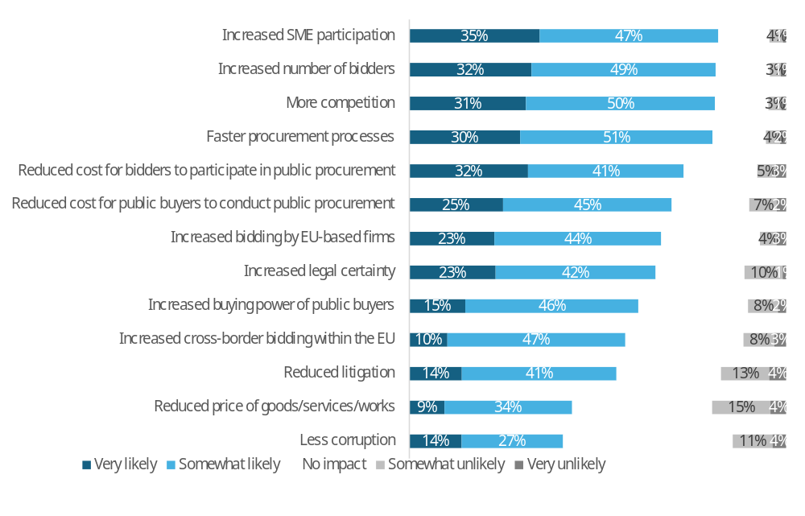
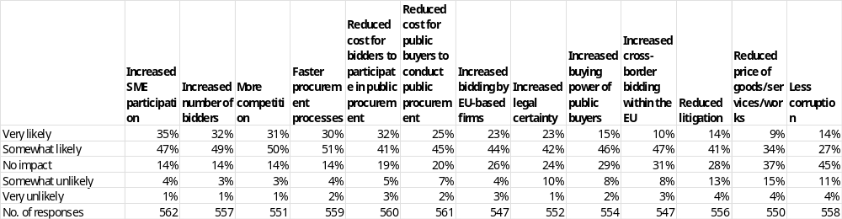
Note: Single-choice responses only; results reflect replies from those who answered.
Source: Public Consultations on public procurement reform. Commission own analysis.

In response to the question “How likely do you believe the following outcomes would occur if the proposed simplification measures were implemented?”, respondents most often expect increased SME participation (82%: 35% very likely, 47% somewhat likely), an increased number of bidders (81%: 32% very likely, 49% somewhat likely), more competition (81%: 31% very likely, 50% somewhat likely), and faster procurement processes (81%: 30% very likely, 51% somewhat likely). This is followed by reduced cost for bidders to participate in procurement (73%: 32% very likely, 41% somewhat likely), reduced cost for public buyers (70%: 25% very likely, 45% somewhat likely), increased bidding by EU-based firms (67%: 23% very likely, 44% somewhat likely), and increased buying power of public buyers (61%: 15% very likely, 46% somewhat likely). A majority also consider increased legal certainty (65%: 23% very likely, 42% somewhat likely) and reduced litigation (55%: 14% very likely, 41% somewhat likely) likely. The lowest shares of positive expectations relate to increased cross-border bidding within the EU (57%: 10% very likely, 47% somewhat likely), less corruption (41%: 14% very likely, 27% somewhat likely), and reduced prices of goods, services and works (43%: 9% very likely, 34% somewhat likely).
Disagreement that these outcomes will occur (somewhat unlikely or very unlikely) is most pronounced for reduced prices (19%: 15% somewhat unlikely, 4% very unlikely) and less corruption (15%: 11% somewhat unlikely, 4% very unlikely), followed by reduced litigation (17%: 13% somewhat unlikely, 4% very unlikely). For other outcomes, disagreement is lower: increased legal certainty (11%: 10% somewhat unlikely, 1% very unlikely), cross-border bidding within the EU (11%: 8% somewhat unlikely, 3% very unlikely), and reduced cost for buyers (9%: 7% somewhat unlikely, 2% very unlikely). All other items record single-digit combined “unlikely” shares, with the lowest disagreement for increased number of bidders, increased SME participation, and more competition (each 4%: 3–4% somewhat unlikely, 1% very unlikely).
Across all outcomes, the share of respondents expecting “no impact” ranges from 9% for more competition and 14% for increased SME participation, faster procurement and increased number of bidders, up to 45% for less corruption and 37% for reduced prices. Intermediate levels of “no impact” responses are reported for increased buying power (29%), increased cross-border bidding within the EU (31%), and increased bidding by EU-based firms (26%).

Table 76: Question: Please assess the likelihood of impacts of the proposed simplification measures; percentage of respondents that indicated “very likely” or “somewhat likely” answers, by type of respondent.
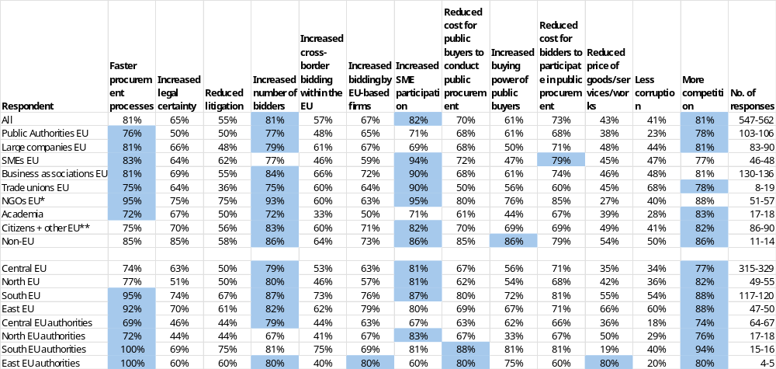
* NGOs + Environmental organisations; ** includes Consumer Organisations
Note: Single-choice responses only; results reflect replies from those who answered. Top three responses highlighted. The number of responses in the last column is shown as a range, as the number of replies varied per column. EU includes NO; Central EU: AT, BE, DE, FR, LU, NL; North EU: DK, FI, IE, SE and NO; South EU: CY, EL, ES, IT, MT, PT; East EU: BG, CZ, EE, HR, HU, LT, LV, PL, RO, SK; replies of only those who answered are provided
Source: Public Consultations on public procurement reform. Commission own analysis.

Respondents were asked to assess how likely different impacts of the proposed simplification measures would be. The table, and the description below, refer only to the combined shares of “very likely” and “somewhat likely” answers (other response options were also available but are not shown).
Among all respondents, the impacts most often seen as likely were increased SME participation (82%), faster procurement processes (81%), increased number of bidders (81%) and more competition (81%). Across the other listed impacts, perceived likelihood ranged from 41% to 82%. Very low likelihood was reported for less corruption (41%) and reduced price of goods/services/works (43%).
Among public authorities, more competition (78%) and an increased number of bidders (77%) were most frequently considered likely impacts. The perceived likelihood of the remaining impacts ranged from 23% to 76%. Very low likelihood was reported for less corruption (23%).
Among large companies, SMEs and business associations, increased SME participation was consistently among the most likely impacts (large companies: 69%; SMEs: 94%; business associations: 90%). Large companies and business associations also saw faster procurement processes (both at 81%) and more competition (both at 81%) as particularly likely, while business associations additionally highlighted an increased number of bidders (84%). Across these three groups, the perceived likelihood of the other impacts ranged from 38% to 84%.
Among trade unions and NGOs, increased SME participation was regarded as a very likely impact (trade unions: 90%; NGOs: 95%), with NGOs also highlighting faster procurement processes (95%), increased number of bidders (93%) and more competition (88%) as particularly likely. For these two groups, the perceived likelihood of the remaining impacts ranged from 27% to 90%. Very low likelihood was reported for reduced price of goods/services/works among NGOs (27%).
Among academia, citizens and other respondents, and non-EU respondents, the most likely impacts tended to cluster around more competition (academia: 83%; citizens and other respondents: 82%; non-EU respondents: 86%), increased SME participation (71%; 82%; 86%) and an increased number of bidders (72%; 83%; 86%). Non-EU respondents also most frequently pointed to increased buying power of public buyers (86%) and reduced cost for public buyers to conduct public procurement (85%) as likely impacts. Across these three groups, perceived likelihood for the other impacts ranged from 28% to 86%. Very low likelihood was reported for less corruption among academia (28%).

9.2.8. Simplification impacts: comments

Public authorities
Approximately 17% of public authorities who provided comments indicated that the proposed simplification measures may have various impacts, including reducing the administrative burden for both buyers and bidders, increasing flexibility and competition, and allowing for more agile purchasing processes. Some respondents noted that clearer and more precise rules may reduce the number of legal disputes, while others highlighted the importance of considering the thresholds for procedures and the potential risks of simplification, such as increased corruption or different interpretations of the rules. A few respondents mentioned that simplification measures should take into account specific requirements, such as health-related needs or strategic interests, and that more flexible and simple procedures may allow contracting authorities to focus on proper procurement and horizontal objectives.
Additionally, some respondents emphasized the need for digitalization and the use of technology to enhance competition, simplify the process, and improve the performance of public procurement. They suggested that digitalization could facilitate the implementation of the "tell us once" principle, improve the interoperability of systems, and simplify tools such as the EU Business Wallet. Others noted that simplification measures could lead to a reduction in lead times and administrative burdens, and that higher thresholds and more room for negotiation could reduce the number of tenders and allow for more practical and timely adjustments.
However, some respondents also expressed uncertainty or lack of clarity about the potential impacts of the proposed measures, and a few noted that the origin of the bidder should not be the primary consideration, but rather the origin of the product or service. Others highlighted the importance of considering the capacity building needs of buyers and bidders, and the potential risks of simplification, such as increased corruption or reduced transparency.
Overall, public authorities are seeking to balance the benefits of simplification, such as reduced administrative burden and increased flexibility, with the potential risks and challenges, and to ensure that simplification measures are effective and achieve their intended objectives. They are looking for a more agile and responsive procurement system that can adapt to changing needs and circumstances, while also ensuring that the principles of transparency, equal treatment, and fairness are upheld.
Some respondents also mentioned that the simplification of procedures could result in a decrease in the legal security of acts, but could also increase performance in public procurement. They noted that being more flexible with changes during the implementation of the agreement could prevent legal uncertainty, and that clearer and more precise rules could reduce the number of legal disputes.
In terms of specific impacts, some respondents noted that simplification measures could lead to increased participation of small and medium-sized enterprises (SMEs) in public procurement, while others suggested that the impact on SMEs would depend on various factors, including the thresholds for procedures and the level of competition. A few respondents mentioned that simplification measures could also lead to increased cross-border procurement, but others noted that this would depend on various factors, including the type of procurement and the level of market knowledge required.
Overall, the comments from public authorities suggest that the proposed simplification measures have the potential to bring about a range of benefits, including reduced administrative burden, increased flexibility and competition, and more agile purchasing processes. However, they also highlight the need for careful consideration of the potential risks and challenges, and the importance of ensuring that simplification measures are effective and achieve their intended objectives.

EU companies and business associations
Approximately 18% of EU companies and business associations who provided comments indicated that the proposed simplification measures may have various impacts, including reducing the administrative burden, shortening procedures, and lowering compliance costs. Some respondents noted that simplification could improve the quality of procurement outcomes, allow for more flexible and less detailed public procurement rules, and increase transparency. Others highlighted the importance of introducing measures to promote the participation of small and medium-sized enterprises (SMEs) in public procurement, such as mandatory division of contracts into lots, promoting trade-specific lots, and obligating Member States to collect specific data to measure SME and micro-enterprises' direct access to public procurement.
Additionally, some respondents emphasized the need for digitalization, standardization of procurement procedures, and the use of technology to enhance competition, simplify the process, and improve the performance of public procurement. The introduction of an EU industrial protection order, which would enable sustainable industrial development and economic, environmental, and social security in the EU, was also mentioned.
However, some respondents also expressed concerns that simplification measures could lead to increased corruption, reduced transparency, and a lack of legal certainty. Others noted that the current directives are adequate and fully sufficient, and that problems arise from their understanding, implementation, and application. The importance of reducing language barriers, increasing flexibility in contract modifications, and promoting joint and cross-border procurement was also highlighted.
Overall, EU companies and business associations are seeking a balance between simplifying procurement procedures and ensuring that these processes remain fair, transparent, and effective in achieving their objectives. They are looking for a more agile and responsive procurement system that can adapt to changing needs and circumstances, while also promoting the participation of SMEs and reducing administrative burdens.
Some respondents also mentioned that simplification measures could lead to a reduction in litigation, as clearer and more precise rules would reduce the number of disputes. However, others noted that litigation is not always a problem, and that the focus should be on ensuring that procurement procedures are fair, transparent, and effective.
The potential benefits of simplification measures, such as increased competition, improved quality of procurement outcomes, and reduced administrative burdens, were also highlighted. However, some respondents noted that these benefits may not be realized if simplification measures are not carefully designed and implemented.
In terms of specific impacts, some respondents noted that simplification measures could lead to increased participation of SMEs in public procurement, while others suggested that the impact on SMEs would depend on various factors, including the thresholds for procedures and the level of competition. A few respondents mentioned that simplification measures could also lead to increased cross-border procurement, but others noted that this would depend on various factors, including the type of procurement and the level of market knowledge required.
Overall, the comments from EU companies and business associations suggest that the proposed simplification measures have the potential to bring about a range of benefits, including reduced administrative burdens, increased flexibility, and improved transparency. However, they also highlight the need for careful consideration of the potential risks and challenges, and the importance of ensuring that simplification measures are effective and achieve their intended objectives.

EU NGOs, environmental organisations and trade unions
Approximately 45% of EU NGOs, environmental organisations, and trade unions who provided comments indicated that the proposed simplification measures may have various impacts, including improving the standards of protection for workers, promoting quality jobs and collective bargaining, and regulating subcontracting. Many respondents emphasized that simplification must not come at the expense of workers' rights and that clearer rules and less legal interpretation are necessary to ensure legal certainty and protection for workers. Some respondents noted that fair trade certifications and social responsibility requirements can help translate social objectives into clear, verifiable procurement criteria, reducing administrative burdens and strengthening legal certainty.
The importance of promoting quality employment, collective bargaining, and effective regulation of subcontracting was also highlighted. Some respondents warned that simplification should not result in a lowering of ambition and that public procurement must retain its capacity to drive demand for sustainable and higher-welfare products. Others emphasized the need for digitalization, standardization of procurement procedures, and the use of technology to enhance competition, simplify the process, and improve the performance of public procurement.
Additionally, some respondents noted that simplification could make socially responsible public procurement (SRPP) easier to use in practice by reducing administrative burdens and legal uncertainty for public buyers and service providers. Clearer procedures and templates have the potential to increase the application of social and quality criteria rather than simply using the lowest price.
However, some respondents also expressed concerns that simplification measures could lead to increased corruption, reduced transparency, and a lack of legal certainty. Others noted that the current directives are adequate and fully sufficient, and that problems arise from their understanding, implementation, and application.
In terms of specific impacts, some respondents noted that simplification measures could lead to increased achievement of EU environmental and climate goals, accelerated green transition, and creation of lead markets for clean products. Others mentioned that simplification could reduce EU dependency on external materials and energy, enhance strategic autonomy, and improve integration with sectoral environmental legislation.
Overall, EU NGOs, environmental organisations, and trade unions are seeking a balance between simplifying procurement procedures and ensuring that these processes remain fair, transparent, and effective in achieving their objectives, while also promoting the protection of workers' rights and the environment.

EU academic institutions, consumer organisations, citizen and other respondents
Approximately 17% of EU academic institutions, consumer organisations, citizen, and other respondents suggested that the proposed simplification measures may have various impacts, including improving worker protection, promoting quality jobs, and regulating subcontracting. They emphasized that simplification must not compromise workers' rights and that clearer rules are necessary to ensure legal certainty. Some respondents noted that simplification could lead to increased innovation, administrative efficiency, and SME participation, which could ultimately benefit the economy and society as a whole.
However, others expressed concerns about potential corruption, reduced transparency, and legal uncertainty, which could undermine the integrity of public procurement processes. The importance of digitalization, standardization, and technology in enhancing competition and simplifying public procurement was also highlighted. Respondents emphasized the need for a balanced approach that considers the interests of all stakeholders, including SMEs, workers, and the environment.
Overall, the comments suggest that simplification measures have the potential to bring benefits, but careful consideration of potential risks and challenges is necessary to ensure effective and targeted implementation. By striking a balance between simplicity and rigor, the EU can create a more efficient and effective public procurement system that supports economic growth, social welfare, and environmental sustainability.

Coherence between general rules applicable to all sectors and sectoral rules
Table 77: Question: Should existing sectoral rules be integrated with the new legislative framework; percentage of answers, by type of respondent.
Respondent | A.  Integrate “how and what to buy” | B.  Integrate How to buy | C.  Do not integrate | Other: | No. of responses
All | 21% | 36% | 19% | 24% | 680
Public Authorities EU | 30% | 28% | 29% | 13% | 93
Large companies EU | 32% | 36% | 22% | 10% | 90
SMEs EU | 15% | 61% | 19% | 5% | 59
Business associations EU | 18% | 58% | 13% | 11% | 158
Trade unions EU | 1% | 2% | 3% | 93% | 91
NGOs EU* | 12% | 32% | 25% | 31% | 65
Academia | 47% | 16% | 37% | 0% | 19
Citizens + other EU** | 30% | 27% | 26% | 17% | 89
Non-EU | 13% | 50% | 6% | 31% | 16
Central EU | 17% | 42% | 20% | 21% | 372
North EU | 12% | 37% | 19% | 32% | 73
South EU | 36% | 25% | 17% | 22% | 143
East EU | 21% | 21% | 21% | 37% | 76
Central EU authorities | 33% | 27% | 25% | 15% | 55
North EU authorities | 6% | 33% | 44% | 17% | 18
South EU authorities | 47% | 27% | 20% | 7% | 15
East EU authorities | 40% | 20% | 40% | 0% | 5
* NGOs + Environmental organisations; ** includes Consumer Organisations
Note: Single-choice responses only; results reflect replies from those who answered. Top response highlighted.
A. Existing “how and what to buy” legal provisions in sectoral acts should be integrated in the general legislative framework and be removed from sectoral acts.
B. Only existing 'how to buy' legal provisions in sectoral acts should be integrated in the general legislative framework and be removed from sectoral acts. Existing 'what to buy' legal provisions should NOT be integrated in the general legislative framework, they would remain in various sectoral acts and be amended therein to ensure coherence where required.
C. Existing “how and what to buy” legal provisions in sectoral acts should NOT be integrated in the general legislative framework. Any conflicting or incoherent provisions in sectoral acts would be removed.
EU includes NO; Central EU: AT, BE, DE, FR, LU, NL; North EU: DK, FI, IE, SE and NO; South EU: CY, EL, ES, IT, MT, PT; East EU: BG, CZ, EE, HR, HU, LT, LV, PL, RO, SK; replies of only those who answered are provided
Source: Public Consultations on public procurement reform. Commission own analysis.

Respondents were asked whether existing sectoral rules should be integrated with the new legislative framework, and if so, how. The figures refer to the share of respondents in each group selecting each option.
Across all respondents, the most frequently chosen option was to integrate “how to buy” only (36%), followed by integrating both “how and what to buy” (21%). Almost one in five preferred not to integrate sectoral rules (19%), while 24% selected “Other”.
Among public authorities, opinions were relatively evenly split between integrating “how and what to buy” (30%), integrating “how to buy” only (28%) and not integrating (29%).
Among large companies, SMEs and business associations, integrating “how to buy” was the dominant option (36% for large companies, 61% for SMEs, 58% for business associations). Large companies also showed some support for integrating both “how and what to buy” (32%), while non-integration attracted lower shares across these three groups (generally between 13% and 22%).
Trade unions overwhelmingly selected “Other” (93%), with very little support for any of the explicit integration options (1–3%). NGOs were more divided, with 32% favouring integrating “how to buy”, 25% opting not to integrate and 12% supporting integrating “how and what to buy.”
Academia most often supported integrating “how and what to buy” (47%), followed by not integrating (37%). Citizens and other respondents were more evenly split between integrating “how and what to buy” (30%), integrating “how to buy” (27%) and not integrating (26%). Non-EU respondents mainly favoured integrating “how to buy” (50%).

Respondents were asked to specify their answer. A summary of their responses is presented below.
Public authorities
Those public authorities who provided comments suggested other ideas for the treatment of existing sectoral rules, emphasizing the need for a harmonized and coherent legislative framework. Some respondents proposed extending existing exemptions for R&D services to include R&D supplies and eliminating impractical exemptions and counter-exemptions. Others suggested integrating existing legal provisions on "how and what to buy" in sectoral acts into the general legislative framework, while remaining clearly linked to their original sectoral acts.
A few respondents proposed that the Public Procurement Directives should establish a generally applicable legal framework for the procurement behaviour of public sector bodies, irrespective of the subject matter of the procurement. Others suggested that sectoral legislation should not contain provisions on public procurement, but should aim at uniform norms and standards for all if the European Union wants to achieve overarching policy objectives through the Single Market.
Some respondents also proposed creating a separate rulebook for all the detailed aspects currently in the public procurement directives and in the sectoral legislation, which can evolve over time while the public procurement directives remain stable over time. Others suggested that only existing legal provisions concerning "how to buy" in sectoral acts should be integrated into the general legislative framework and removed from those sectoral acts, while existing legal provisions defining "what to buy" should remain within the relevant sectoral acts and be amended there, where necessary, to ensure coherence.
Overall, public authorities are seeking a balanced and coherent approach to treating existing sectoral rules, ensuring that the regulatory framework is effective, legally certain, and supportive of public procurement objectives. They emphasize the need for a hierarchy of legislative provisions to manage possible contradictions between existing regulations and propose various ways to integrate sectoral rules into the general legislative framework while preserving coherence and consistency.
All other respondents
Those respondents from all other groups (except Public authorities) who suggested other ideas for the treatment of existing sectoral rules, emphasized the need for consistency and coherence between the general legislative framework and sectoral acts. Many respondents noted that integrating "how to buy" provisions from sectoral legislation into the general framework could harmonize procedures and reduce legal complexity, while "what to buy" provisions should remain in sectoral acts to preserve clarity and ensure policy objectives.
Some respondents proposed that the general framework should focus on defining and simplifying the "how" of procurement, without defining "what" to procure, and that sector-specific provisions on the subject-matter of the procurement should be included in an annex to the Public Procurement Directives. Others suggested that stricter rules for certain procurement items should not be incorporated into the general legal framework and that merging specific procurement requirements into the general procurement legal framework should be assessed on a case-by-case basis.
The importance of promoting collective bargaining, quality jobs, and direct employment through public procurement was also highlighted. Many respondents emphasized that the general framework and sectoral acts should ensure compliance with relevant collective agreements and sustainable procurement, and that the promotion of collective bargaining through public procurement should be a horizontal provision for all buyers and sectors.
Some respondents noted that the EU does not have a food-specific sectoral legislation, and that integrating relevant sustainability and Fair Trade considerations into the horizontal procurement framework is necessary to ensure coherence and to enable contracting authorities to reflect policy objectives in their purchasing decisions. Others proposed that minimum mandatory sustainability criteria for food procurement should be defined in sectoral legislation, such as those set out in the JRC report on Sustainable Public Procurement of Food.
Overall, respondents from all other groups (except Public authorities) are seeking a balanced and coherent approach to treating existing sectoral rules, ensuring that the regulatory framework is effective, legally certain, and supportive of public procurement objectives. They emphasize the need for a hierarchy of legislative provisions to manage possible contradictions between existing regulations and propose various ways to integrate sectoral rules into the general legislative framework while preserving coherence and consistency.

Table 78: Question: Should future sectoral rules be integrated with the new legislative framework; percentage of answers, by type of respondent.
Respondent | A.  Integrate “how and what to buy” | B.  Integrate How to buy | C.  Do not integrate | Other: | No. of responses
All | 22% | 41% | 16% | 22% | 690
Public Authorities EU | 28% | 34% | 26% | 12% | 95
Large companies EU | 33% | 41% | 16% | 10% | 94
SMEs EU | 19% | 63% | 14% | 5% | 59
Business associations EU | 19% | 58% | 12% | 11% | 158
Trade unions EU | 3% | 5% | 5% | 86% | 93
NGOs EU* | 12% | 53% | 12% | 23% | 66
Academia | 47% | 16% | 32% | 5% | 19
Citizens + other EU** | 33% | 33% | 20% | 13% | 90
Non-EU | 19% | 44% | 19% | 19% | 16
Central EU | 19% | 46% | 16% | 19% | 376
North EU | 15% | 42% | 16% | 27% | 74
South EU | 36% | 30% | 13% | 21% | 148
East EU | 20% | 30% | 17% | 33% | 76
Central EU authorities | 30% | 35% | 21% | 14% | 57
North EU authorities | 11% | 33% | 44% | 11% | 18
South EU authorities | 47% | 27% | 20% | 7% | 15
East EU authorities | 20% | 40% | 40% | 0% | 5
* NGOs + Environmental organisations; ** includes Consumer Organisations
Note: Single-choice responses only; results reflect replies from those who answered. Top response highlighted.
A. Future “how and what to buy” requirements should be integrated in the general legislative framework.
B. Only future “how to buy” requirements should be integrated in the general legislative framework. Future 'what to buy' requirements should NOT be integrated in the general legislative framework – they should continue to be included separately in sector-specific legislation.
C. Future “how and what to buy” legal provisions in sectoral acts should NOT be integrated in the general legislative framework.
EU includes NO; Central EU: AT, BE, DE, FR, LU, NL; North EU: DK, FI, IE, SE and NO; South EU: CY, EL, ES, IT, MT, PT; East EU: BG, CZ, EE, HR, HU, LT, LV, PL, RO, SK; replies of only those who answered are provided
Source: Public Consultations on public procurement reform. Commission own analysis.

Respondents were asked whether future sectoral rules should be integrated with the new legislative framework, and if so, how. The figures refer to the share of respondents in each group selecting each option.
Across all respondents, the most frequently chosen option was to integrate “how to buy” only (41%), followed by integrating both “how and what to buy” (22%). A smaller share preferred not to integrate future sectoral rules (16%), while 22% selected “Other”.
Among public authorities, views were relatively balanced: 34% favoured integrating “how to buy”, 28% integrating both “how and what to buy”, and 26% not integrating.
Among large companies, SMEs and business associations, integrating “how to buy” was again the dominant option (41% for large companies, 63% for SMEs, 58% for business associations). Integrating “how and what to buy” attracted some support, particularly among large companies (33%), while non-integration was generally less favoured (between 12% and 16%).
Trade unions overwhelmingly selected “Other” (86%), with very limited support for any of the specific integration options (3–5%). NGOs mainly supported integrating “how to buy” (53%), with smaller shares favouring integrating “how and what to buy” or not integrating (both 12%).
Academia most often supported integrating “how and what to buy” (47%), followed by not integrating (32%). Citizens and other respondents were split between integrating “how and what to buy” and “how to buy” (both 33%), with 20% for not integrating. Non-EU respondents mainly favoured integrating “how to buy” (44%).

Table 79: Question: Those who had selected option B or C in the previous question (Table 78) were asked whether future "what to buy" requirements should be subject to common rules defined in a general legislative framework to avoid conflicts or inconsistencies (e.g. the new general legislative framework should foresee mechanisms and templates for harmonised legislation ensuring coherence of “what to buy” requirements contained in sector-specific rules with the general legislative framework).; percentage of answers, by type of respondent.
Respondent | Yes | No | No. of all responses  from previous question
All | 38% | 15% | 690
Public Authorities EU | 37% | 21% | 95
Large companies EU | 32% | 18% | 94
SMEs EU | 66% | 7% | 59
Business associations EU | 49% | 16% | 158
Trade unions EU | 10% | 1% | 93
NGOs EU* | 48% | 17% | 66
Academia | 32% | 16% | 19
Citizens + other EU** | 34% | 17% | 90
Non-EU | 31% | 31% | 16
Central EU | 40% | 17% | 376
North EU | 35% | 20% | 74
South EU | 35% | 7% | 148
East EU | 38% | 7% | 76
Central EU authorities | 32% | 23% | 57
North EU authorities | 50% | 22% | 18
South EU authorities | 33% | 13% | 15
East EU authorities | 60% | 20% | 5
* NGOs + Environmental organisations; ** includes Consumer Organisations
Note: Single-choice responses only; results reflect replies from those who answered. Top response highlighted. EU includes NO; Central EU: AT, BE, DE, FR, LU, NL; North EU: DK, FI, IE, SE and NO; South EU: CY, EL, ES, IT, MT, PT; East EU: BG, CZ, EE, HR, HU, LT, LV, PL, RO, SK; replies of only those who answered are provided
Source: Public Consultations on public procurement reform. Commission own analysis.

Respondents who chose to integrate "how to buy" requirements only, or who opted not to integrate either "how to buy" or "what to buy" requirements, were still asked whether they agreed that future "what to buy" requirements should be subject to common rules defined in a general legislative framework (e.g. the new general legislative framework should foresee mechanisms and templates for harmonised legislation ensuring coherence of “what to buy” requirements contained in sector-specific rules with the general legislative framework). The majority of these respondents answered affirmatively.

Respondents were asked to specify their answers. A summary of their responses is presented below.
Public authorities
Public authorities proposed various ideas for the treatment of future sectoral rules, emphasizing the need for a clear hierarchy of legislative provisions to manage potential contradictions between future regulations. Some respondents suggested extending existing exemptions for R&D services to include R&D supplies and eliminating impractical exemptions and counter-exemptions. Others proposed that sectoral legislation should not contain provisions on public procurement, but instead aim for uniform norms and standards for all.
Some respondents recommended systematizing the registration of obligatory and general principles outlined in sectoral guidelines in the general directives. They also suggested that sectoral legislation should focus on precise technical specifications relating to products, particularly at the environmental level, and leave considerations related to the binding framework and purchasing methods to the Directives.
A few respondents cautioned against introducing additional requirements, as they would further inflate procurement procedures. Others proposed creating a separate rule book for detailed aspects of public procurement, which could evolve over time while keeping the public procurement directives stable.
Overall, public authorities are seeking a balanced and coherent approach to treating future sectoral rules, ensuring that the regulatory framework is effective, legally certain, and supportive of public procurement objectives. They emphasize the need for a clear hierarchy between sectoral legislation and general public procurement law, and propose various ways to integrate future sectoral rules into the general legislative framework while preserving coherence and consistency.
All other respondents
Respondents from all other groups (except Public authorities) suggested other ideas for the treatment of future sectoral rules, emphasizing the need for consistency and coherence between the general legislative framework and sectoral acts. Many respondents proposed integrating "how to buy" provisions from sectoral legislation into the general framework, while keeping "what to buy" requirements in sectoral acts. They also highlighted the importance of promoting collective bargaining, quality jobs, and direct employment through public procurement, and ensuring that the general framework and sectoral acts ensure compliance with relevant collective agreements and sustainable procurement.
The EU's horizontal legal framework on public procurement must ensure that taxpayers' money goes only to organisations that respect workers' and trade union rights, negotiate with trade unions, and whose workers (and subcontractors' workers) are covered by collective agreements. Respondents suggested that the general legislative framework should prioritize bio-based materials over fossil-based materials in European public procurement, and that green public procurement criteria should be set as a delegated act to the ESPR, focusing on textiles products. They also emphasized the need for a clear hierarchy between sectoral legislation and general public procurement law, ensuring that core elements of the Public Procurement Directives prevail.
The consistent approach to future sectoral rules would also involve the application of representative collective agreements and the clear limitation of subcontracting in the chain to ensure quality jobs. Respondents proposed that the EU public procurement legislation should explicitly establish binding principles and safeguards to ensure that sectoral provisions affecting procurement procedures, eligibility, or award conditions are interpreted and applied in conformity with the principles of equal treatment, non-discrimination, competition, and impartiality. The promotion of collective bargaining through public procurement should be a horizontal provision for all buyers and sectors, which would simplify application and ensure consistency between the general legislative framework and sectoral acts.

Concessions (FLX options)
Table 80: Question on concessions: Which of the following concepts require modification?; percentage of answers, by type of respondent.
Respondent | A.  Definition of “concessions” and “operating risk” | B.  Rules on duration | C.  Publication and transparency | D.  Contract execution additional rules | Other | No. of responses
All | 44% | 55% | 47% | 58% | 35% | 444
Public Authorities EU | 57% | 34% | 15% | 37% | 22% | 79
Large companies EU | 47% | 51% | 36% | 38% | 24% | 45
SMEs EU | 48% | 59% | 44% | 52% | 7% | 27
Business associations EU | 55% | 50% | 44% | 54% | 31% | 80
Trade unions EU | 2% | 84% | 77% | 84% | 78% | 86
NGOs EU* | 61% | 58% | 69% | 61% | 25% | 36
Academia | 43% | 64% | 36% | 64% | 36% | 14
Citizens + other EU** | 60% | 49% | 43% | 66% | 23% | 65
Non-EU | 42% | 42% | 75% | 58% | 42% | 12
Central EU | 51% | 47% | 37% | 46% | 32% | 219
North EU | 30% | 61% | 43% | 59% | 45% | 44
South EU | 46% | 62% | 58% | 72% | 36% | 116
East EU | 28% | 72% | 60% | 74% | 34% | 53
Central EU authorities | 62% | 33% | 15% | 31% | 21% | 52
North EU authorities | 45% | 27% | 9% | 27% | 36% | 11
South EU authorities | 46% | 38% | 23% | 54% | 15% | 13
East EU authorities | 67% | 67% | 0% | 100% | 0% | 3
* NGOs + Environmental organisations; ** includes Consumer Organisations
Note: Multiple choice question; results reflect replies from those who answered. Top response highlighted.
A. Definition of “concessions” and “operating risk” for a more consistent application of the general legislative framework and interpretation of financial, operational, regulatory, and market risks in a concession contract (Article 5);
B. Rules on duration (e.g. include considerations of other elements such as technical, environmental, innovation, social, labour, etc.) (Article 18);
C. Publication and transparency requirements (e.g. public buyers to publish the intent to award a concession at least one year in advance, with exceptions for emergencies, to give more time to the bidders) (Articles 30-37);
D. Additional rules on the execution of the contracts (e.g. monitoring of the contract, verification of compliance with objectives, possibility of adapting to unforeseen needs through modifications of contracts, termination, etc.)
EU includes NO; Central EU: AT, BE, DE, FR, LU, NL; North EU: DK, FI, IE, SE and NO; South EU: CY, EL, ES, IT, MT, PT; East EU: BG, CZ, EE, HR, HU, LT, LV, PL, RO, SK; replies of only those who answered are provided
Source: Public Consultations on public procurement reform. Commission own analysis.

Respondents were asked which concepts on concessions they considered required modification. The figures below refer to the share of respondents in each group selecting each concept.
Across all respondents, the strongest support for modifications was seen in case of additional rules on contract execution (58%) and rules on duration (55%). Just under half of the respondents backed changes to publication and transparency rules (47%), as well as modifications to the definitions of "concessions" and "operating risk" (44%).
Among public authorities, the concepts most often identified as requiring modification were the definition of “concessions” and “operating risk” (57%) and to a lesser extent rules on duration (34%), contract execution additional rules (37%). Very low support was recorded for publication and transparency (15%).
Among large companies, SMEs and business associations, rules on duration were frequently mentioned (50% to 59%). SMEs also highlighted additional rules on contract execution (52%). Business associations identified definition of “concessions” and “operating risk” top (55%) followed by additional rules on contract execution (54%).
Among trade unions, modifications to all concepts-except definitions-received high support, at around 80%. NGOs expressed over 60% support for modifications across all concepts.
Academia showed over 60% support for modifying rules on contract duration and additional rules on contract execution. Citizens and other respondents supported modifications to definitions and additional rules on contract execution, both with over 60% approval. Non-EU respondents expressed the highest preference for changes related to publication and transparency (75%), as well as additional rules on contract execution.

Those who selected Other were asked to elaborate. A summary of their responses is presented below.
Public authorities
Public authorities proposed various concepts relating to concessions that require modification, with some suggesting that fewer rules would be beneficial. A few respondents proposed extending existing exemptions for R&D services to include R&D supplies and eliminating impractical exemptions and counter-exemptions. Others suggested establishing clear and precise rules for procurements below threshold, allowing direct awards below a certain amount or requiring a minimum number of bids above a defined threshold.
Some respondents suggested avoiding national transpositions that are more stringent than EU directives and allowing more flexibility in amending current contracts, which are long-term contracts. Others proposed aligning the thresholds for procedures in the EU below the European thresholds and making no difference in the variety of governments. A few respondents noted that not all concessions are major investments and that the concepts and general rules should be applicable to smaller scale contracts.
There was a lack of consensus among public authorities, with some stating that they do not have enough knowledge to provide an answer and others suggesting that central purchasing bodies should be allowed to conclude concessions. A few respondents mentioned that the duration of a procurement contract is a sensitive issue, as companies need time to innovate and recoup investments, but the market should not be locked down or competition restricted. Overall, public authorities are seeking more flexibility and clarity in concession rules, while avoiding overly complex or restrictive regulations.
All other respondents
A significant proportion of respondents from the group of all other respondents (except Public authorities) who provided comments on the question of which other concepts relating to Concessions require modification, expressed their opposition to extending the scope of the Concessions Directive to other sectors, such as water or waste water. Many respondents, including trade unions and worker organisations, emphasised the importance of ensuring quality jobs and promoting collective bargaining in concessions, as well as guaranteeing employment continuity when concessions or contracts are modified. For example, one respondent stated that "Ensuring quality jobs and promoting collective bargaining is essential for concessions too. When changing concessions/contracts, ensuring employment continuity must be mandatory." Some respondents also called for clearer definitions of concessions and operating risk, and for more transparent and flexible rules on contract duration and modification. A few respondents suggested that the Concessions Directive should be preserved as a standalone legislative instrument, while others advocated for stronger harmonisation and clearer guidance in the area of concessions to improve quality, transparency, and legal certainty. A minority of respondents saw no need for modifications, arguing that essential concepts relating to concessions have already been clarified through case law, and that changes could lead to renewed legal uncertainty.

9.4.1. Concessions impacts
Figure 75: Question: How likely do you believe the following outcomes would occur if the proposed concepts and rules on concessions were modified?, all replies.
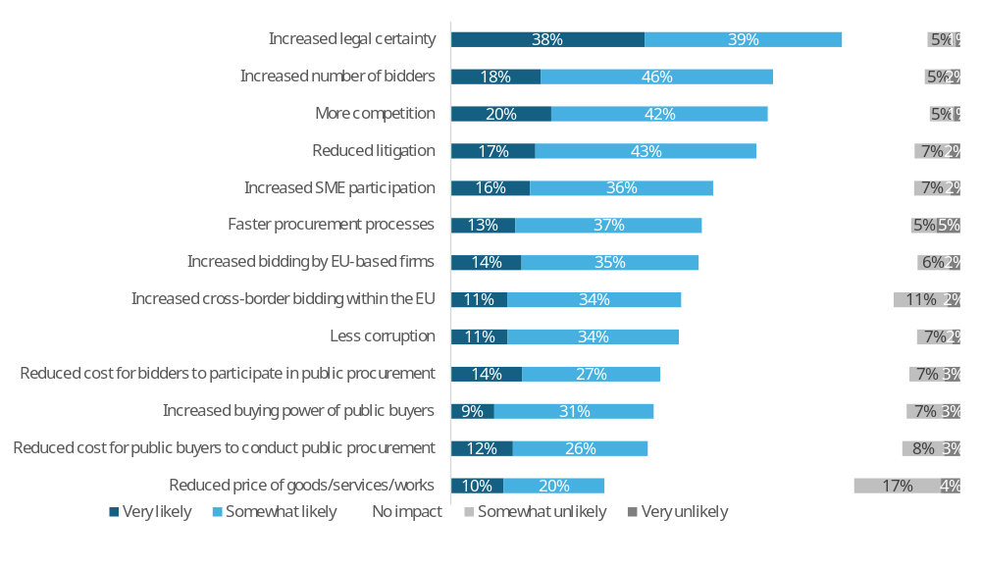
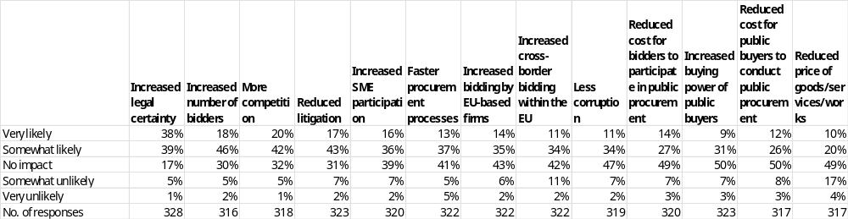
Note: Single-choice responses only; results reflect replies from those who answered.
Source: Public Consultations on public procurement reform. Commission own analysis.

In response to the question “How likely do you believe the following outcomes would occur if the proposed concepts and rules on concessions were modified?”, respondents most often expect increased legal certainty (77%: 38% very likely, 39% somewhat likely), followed by increased number of bidders (64%: 18% very likely, 46% somewhat likely), more competition (62%: 20% very likely, 42% somewhat likely), and reduced litigation (60%: 17% very likely, 43% somewhat likely). Smaller majorities foresee increased SME participation (52%: 16% very likely, 36% somewhat likely), increased bidding by EU-based firms (49%: 14% very likely, 35% somewhat likely), faster procurement processes (50%: 13% very likely, 37% somewhat likely), and increased cross-border bidding within the EU (45%: 11% very likely, 34% somewhat likely). The lowest shares of positive expectations relate to less corruption (45%: 11% very likely, 34% somewhat likely), reduced cost for bidders (41%: 14% very likely, 27% somewhat likely), increased buying power of public buyers (40%: 9% very likely, 31% somewhat likely), reduced cost for public buyers (38%: 12% very likely, 26% somewhat likely), and reduced prices of goods, services and works (30%: 10% very likely, 20% somewhat likely).
Disagreement that these outcomes will occur (somewhat unlikely or very unlikely) is highest for reduced prices (21%: 17% somewhat unlikely, 4% very unlikely), followed by increased cross-border bidding within the EU (13%: 11% somewhat unlikely, 2% very unlikely), and reduced litigation and reduced cost for public buyers (each 9%: 7–8% somewhat unlikely, 2–3% very unlikely). For the remaining outcomes, disagreement is comparatively low: reduced cost for bidders and increased buying power of public buyers (each 10%: 7% somewhat unlikely, 3% very unlikely), less corruption (9%: 7% somewhat unlikely, 2% very unlikely), increased SME participation (9%: 7% somewhat unlikely, 2% very unlikely), increased bidding by EU-based firms (8%: 6% somewhat unlikely, 2% very unlikely), faster procurement processes (10%: 5% somewhat unlikely, 5% very unlikely), more competition (6%: 5% somewhat unlikely, 1% very unlikely), increased number of bidders (7%: 5% somewhat unlikely, 2% very unlikely), and increased legal certainty (6%: 5% somewhat unlikely, 1% very unlikely).
Across all outcomes, the share of respondents expecting “no impact” ranges from 17% for increased legal certainty and 30% for increased number of bidders, up to 50% for increased buying power of public buyers and reduced cost for public buyers, and 49% for reduced prices. Intermediate levels of “no impact” responses are reported for more competition (32%), reduced litigation (31%), increased SME participation (39%), faster procurement processes (41%), increased bidding by EU-based firms (43%), increased cross-border bidding within the EU (42%), less corruption (47%), and reduced cost for bidders (49%).

Table 81: Question: How likely do you believe the following outcomes would occur if the proposed concepts and rules on concessions were modified?; percentage of respondents that indicated “very likely” or “somewhat likely” answers, by type of respondent.
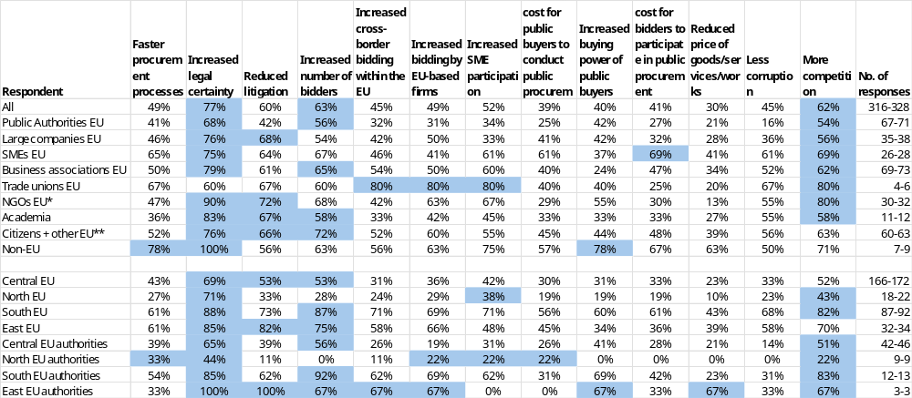
* NGOs + Environmental organisations; ** includes Consumer Organisations
Note: Single-choice responses only; results reflect replies from those who answered. Top three responses highlighted. The number of responses in the last column is shown as a range, as the number of replies varied per column. EU includes NO; Central EU: AT, BE, DE, FR, LU, NL; North EU: DK, FI, IE, SE and NO; South EU: CY, EL, ES, IT, MT, PT; East EU: BG, CZ, EE, HR, HU, LT, LV, PL, RO, SK; replies of only those who answered are provided
Source: Public Consultations on public procurement reform. Commission own analysis.

Respondents were asked how likely they believed various outcomes would be if the proposed concepts and rules on concessions were modified. The figures below describe, for each impact and respondent group, the combined shares of “very likely” and “somewhat likely” answers (other response options were also available but are not shown).
Among all respondents, the outcomes most often seen as likely were increased legal certainty (77%), increased number of bidders (63%) and more competition (62%). Across the other outcomes, perceived likelihood ranged from 30% to 63%. Very low likelihood was reported for reduced price of goods/services/works (30%).
Among public authorities, increased legal certainty (68%) and increased number of bidders (56%) were most frequently considered likely outcomes. For the other outcomes, perceived likelihood ranged from 16% to 56%. Very low likelihood was reported for less corruption (16%) and reduced price of goods/services/works (21%).
Among large companies, SMEs and business associations, increased legal certainty was consistently among the most likely outcomes (large companies: 76%; SMEs: 75%; business associations: 79%). SMEs also highlighted more competition (69%), reduced cost for bidders to participate in public procurement (69%) as particularly likely outcomes, while business associations pointed to an increased number of bidders (65%) and more competition (62%). Across these three groups, perceived likelihood of the remaining outcomes ranged from 24% to 69%. Very low likelihood was reported for increased buying power of public buyers among business associations (24%).
Among trade unions and NGOs, the outcomes most often regarded as likely included increased more competition (trade unions: 80%; NGOs: 80%), SME participation (trade unions: 80%; NGOs: 67%), increased cross-border bidding within the EU (trade unions: 80%) and increased bidding by EU-based firms (trade unions: 80%; NGOs: 63%). However, the top choice for NGOs was increasing legal certainty, selected by 90% of respondents. For these two groups, perceived likelihood of the other outcomes ranged from 13% to 80%. Very low likelihood was reported for reduced price of goods/services/works among NGOs (13%) and among trade unions (20%).
Among academia, citizens and other respondents, and non-EU respondents, increased legal certainty was the most or a strongly likely outcome (academia: 83%; citizens and other respondents: 76%; non-EU respondents: 100%), with reduced litigation also frequently seen as likely (around 66%). Across these three groups, perceived likelihood of the other outcomes ranged from 27% to 100%. Very low likelihood was reported for reduced price of goods/services/works among academia (27%).

Respondents were invited to identify any other likely impacts. A summary of their responses is presented below.
Public authorities
Approximately 14% of public authorities who provided comments on the question of other impacts of the proposed changes to concepts and rules on concessions, identified a need for more flexible options for changes during the implementation phase, as it can be difficult to estimate in advance how feasible the operation will be for the operator. Some respondents, such as research organisations, highlighted the potential benefits of being exempt from EU public tendering law, including increased speed and reduced costs, while still maintaining transparency. Others noted that the rules on concessions are reasonably clear, but there are certain grey areas that could be clarified, such as the interplay between the scope of the requirement that the concessionaire must be truly at risk and the rule that the duration can be as long as is required for them to make back their investment. A few respondents emphasized the importance of simplifying and clarifying the rules on concessions, particularly with regards to valuation and contract duration. Some public authorities also noted that they have little experience with concessions and therefore found it difficult to provide a response. A minority of respondents argued that the EU Concessions regulations should remain in a separate regime and that no additional rules or obligations should be added, as concessions require flexibility due to their varying legal and financial arrangements and risks.
All other respondents
Approximately 15% of all other respondents (except Public authorities) who provided comments on the question of other impacts of the proposed changes to concepts and rules on concessions, identified various potential effects, including the need for more flexibility in concession contracts to adapt to changing circumstances, such as crises or macroeconomic events. Many respondents emphasized the importance of promoting quality jobs and collective bargaining in concessions, which would contribute to reducing litigation, simplifying procedures, increasing legal certainty, and ensuring a level playing field. Some respondents suggested that clearer definitions of concession and operational risk, as well as stronger transparency and post-award obligations, would improve legal certainty and accountability in concessions. Others proposed introducing mandatory price revision clauses in public contracts, collectively defining clear frameworks for renegotiation, and allowing SME bidders to submit variants to offer alternatives to strict requirements. A few respondents highlighted the need for better involvement of regional providers, more direct coordination, and shorter routes. Some also stressed the importance of ensuring that concessions are aligned with EU strategic goals, such as environmental and social objectives, and that they promote innovation and public-private partnerships. For example, one respondent stated that "Measures to promote quality jobs, collective bargaining, limiting subcontracting, help reduce litigation, simplify procedures, increase legal certainty, and ensure greater economic efficiency." Another respondent noted that "Clearer definitions of concession and operational risk are needed, duration must be able to take into account environmental, digital and social investments, obligations to monitor and report impacts are needed, more transparency fosters quality and competition." Overall, the respondents' comments highlighted the complexity and variability of concessions, and the need for a balanced and flexible approach that takes into account the diverse needs and interests of different stakeholders.

Digitalisation and transparency (MPL options)
Table 82: Question: Would you support the creation of a digital public procurement marketplace with a single-entry point for economic operators to public procurement procedures?; percentage of answers, by type of respondent.
Respondent | A.  No | B.  Yes, by interconnecting all existing Member States’ eProcurement services | C.  Yes, by interconnecting all existing Member States’ eProcurement services, and providing a central eProcurement service | D.  Yes, by replacing all existing Member States’ eProcurement services with one central EU eProcurement service | No opinion | No. of responses
All | 17% | 39% | 25% | 12% | 6% | 686
Public Authorities EU | 30% | 26% | 15% | 20% | 10% | 105
Large companies EU | 30% | 28% | 22% | 9% | 10% | 89
SMEs EU | 18% | 47% | 23% | 6% | 6% | 62
Business associations EU | 14% | 33% | 37% | 10% | 6% | 153
Trade unions EU | 0% | 97% | 3% | 0% | 0% | 94
NGOs EU* | 7% | 32% | 47% | 5% | 8% | 59
Academia | 26% | 11% | 21% | 37% | 5% | 19
Citizens + other EU** | 21% | 24% | 30% | 20% | 4% | 89
Non-EU | 0% | 31% | 25% | 44% | 0% | 16
Central EU | 19% | 37% | 26% | 11% | 7% | 381
North EU | 26% | 49% | 11% | 9% | 6% | 70
South EU | 11% | 35% | 37% | 14% | 4% | 142
East EU | 18% | 52% | 13% | 10% | 6% | 77
Central EU authorities | 30% | 20% | 15% | 24% | 11% | 66
North EU authorities | 42% | 32% | 11% | 5% | 11% | 19
South EU authorities | 0% | 47% | 20% | 27% | 7% | 15
East EU authorities | 60% | 20% | 20% | 0% | 0% | 5
* NGOs + Environmental organisations; ** includes Consumer Organisations
Note: Single choice question; results reflect replies from those who answered. Top response highlighted.
A. No, the current environment of eProcurement services is appropriate.
B. Yes, by interconnecting all existing Member States’ eProcurement services. Economic operators could use any compatible service as a single point of entry to participate in public procurement procedures across the EU.
C. Yes, by interconnecting all existing Member States’ eProcurement services, and providing a central eProcurement service. Economic operators could use the central eProcurement service or any Member State compatible service as a single point of entry to participate in public procurement procedures across the EU.
D. Yes, by replacing all existing Member States’ eProcurement services with one central EU eProcurement service.
EU includes NO; Central EU: AT, BE, DE, FR, LU, NL; North EU: DK, FI, IE, SE and NO; South EU: CY, EL, ES, IT, MT, PT; East EU: BG, CZ, EE, HR, HU, LT, LV, PL, RO, SK; replies of only those who answered are provided
Source: Public Consultations on public procurement reform. Commission own analysis.

Respondents were asked whether they would support the creation of a digital public procurement marketplace with a single entry point for economic operators to access public procurement procedures. The figures refer to the share of respondents in each group selecting each option.
Across all respondents, around three-quarters supported one of the three proposed options to change the current eProcurement services, while roughly one in six believed no changes were necessary. Among the three options for change, some form of interconnection between all existing Member States’ eProcurement services-whether standalone or combined with additional central services-received the highest support at 65%. Only 12% of respondents favoured replacing national eProcurement services with a single central system.
Among public authorities, opinions were divided. A significant proportion considered the current eProcurement environment to be adequate (30%), while others preferred one of the interconnecting options (41%) or replacing existing systems with a single central EU service (20%).
Among large companies, SMEs, and business associations, the strongest support was for interconnecting existing Member States’ eProcurement services, either alone or with a central service (large companies: 51%, SMEs: 69%, business associations: 71%). Around one-third of large companies, one in five SMEs, and one in seven business associations preferred to retain the current eProcurement environment.
Trade unions unanimously supported the interconnection of existing Member States’ eProcurement services (100%). NGOs predominantly favoured one of the interconnection options (80%), with minimal support for replacing all systems (5%) or maintaining the current environment (7%).
Academia demonstrated the highest level of support for replacing all existing eProcurement services with a single central EU system (37%), with slightly lower backing for interconnection options (32%) or retaining the current environment (26%). Citizens and other respondents most frequently preferred interconnection (54%), with less support for maintaining the current environment (21%) or adopting a single central EU system (20%). Non-EU respondents expressed the strongest support for interconnection (56%), closely followed by replacing all national services with one central EU system (44%).
Table 83: Question: What functionalities should the eProcurement services include?; percentage of answers, by type of respondent.
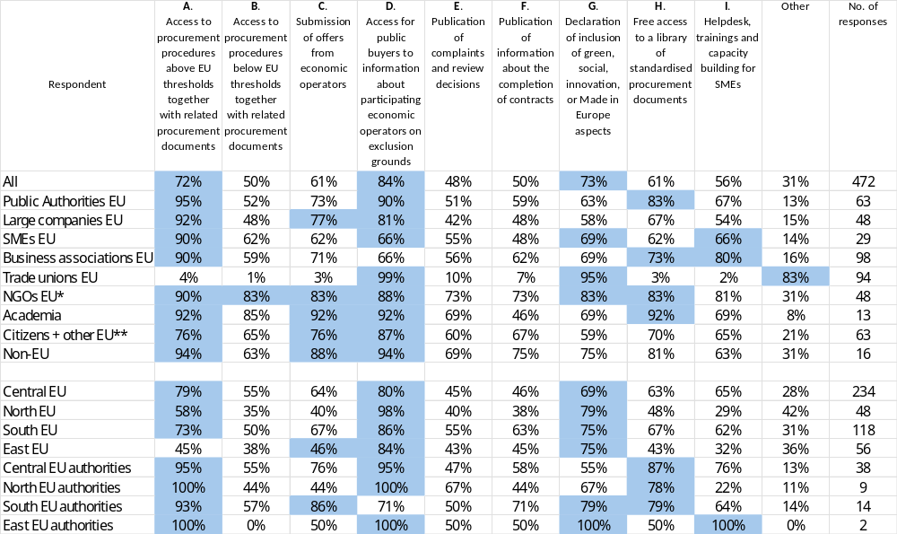
* NGOs + Environmental organisations; ** includes Consumer Organisations
Note: Multiple choice question; results reflect replies from those who answered. Top three responses highlighted.
A. Access to procurement procedures above EU thresholds together with related procurement documents.
B. Access to procurement procedures below EU thresholds together with related procurement documents.
C. Submission of offers from economic operators.
D. Access for public buyers to authentic, up-to-date information about participating economic operators on exclusion grounds (e.g., criminal convictions, bankruptcy, professional misconduct) and selection criteria (e.g. financial capacity, technical ability).
E. Publication of complaints and review decisions.
F. Publication of information about the completion of contracts.
G. Declaration of inclusion of green, social, innovation, or Made in Europe aspects.
H. Free access to a library of standardised procurement documents, such as technical specifications or contract templates at least to public authorities.
I. Helpdesk, trainings and capacity building for SMEs.
EU includes NO; Central EU: AT, BE, DE, FR, LU, NL; North EU: DK, FI, IE, SE and NO; South EU: CY, EL, ES, IT, MT, PT; East EU: BG, CZ, EE, HR, HU, LT, LV, PL, RO, SK; replies of only those who answered are provided
Source: Public Consultations on public procurement reform. Commission own analysis.

Respondents were asked which functionalities eProcurement services should include. The figures below refer to the share of respondents in each group selecting each option.
Respondents most commonly selected functionalities that would provide public buyers with access to information about participating economic operators in relation to exclusion grounds (84%). Additionally, there was strong support for functionalities enabling declarations on the inclusion of green, social, innovation, or Made in Europe aspects (73%), as well as access to procurement procedures above EU thresholds, together with their related procurement documents (72%).
The most often chosen functionalities by all the respondents included access for public buyers to information about participating economic operators on exclusion grounds (84%), declaration of inclusion of green, social, innovation, or Made in Europe aspects (73%) and access to procurement procedures above EU thresholds together with related procurement documents (72%).
Among public authorities, the most frequently requested functionalities were access to procurement procedures above EU thresholds (95%), access for public buyers to information about participating economic operators on exclusion grounds (90%) and free access to a library of standardised procurement documents (83%).
Among large companies, SMEs and business associations, access to procedures above thresholds (around 90%) and submission of offers (62% - 77%) were widely supported as was access for public buyers to information about participating economic operators on exclusion grounds and selection criteria (66% - 81%). SMEs also often selected declarations on green/social/innovation/Made in Europe aspects (69%) and helpdesk, trainings and capacity building for SMEs (66%). Business associations’ second choice was helpdesk (80%) followed by free library of standardised procurement documents (73%).
Among trade unions and NGOs, trade unions prioritised access for public buyers to information on exclusion grounds and selection criteria (99%) and the declaration of inclusion of green, social, innovation or Made in Europe aspects (95%), while recording very low support for most other specific functionalities. NGOs expressed broad support across many functionalities, with the highest levels for access to above (90%) and below (83%) threshold procedures, as well as access to information on exclusion grounds and selection criteria (88%).
Academia recorded over 90% support for access to procedures above (92%) and below (85%) thresholds, submission of offers, access to information on exclusion grounds and free access to a document library (all 92%). Citizens and other respondents most often selected access to information on exclusion grounds (87%). Non-EU respondents expressed strongest support for access to information on exclusion grounds (94%) and above thresholds procedures (94%).

Those who selected Other were asked to elaborate. A summary of their responses is presented below.
Public authorities
Public authorities suggested that eProcurement services should include several additional functionalities to improve the tendering process. One key suggestion was to allow for the submission of paper tenders in certain contexts, such as in fragile areas where access to electronic means is limited. Another suggestion was to include advanced translation services to facilitate tenders with bidders from other countries, where language barriers may be an issue. Some respondents also proposed the creation of a page providing data and figures on EU public procurement, similar to the example provided by the Dutch tendering website. Additionally, respondents suggested that all official languages of the EU Member States should be included, and that information about the content of the procedure, such as scope, time, and value, should be readily available. Other suggested functionalities included the possibility to release an auction, AI tools for research, and procedures for excluding economic operators and notifying contracts that are not completed or terminated. For example, one respondent stated that "Language is an obstacle in tenders with bidders from other countries. There may be tools to facilitate this, some form of advanced translation service for this purpose." Another respondent suggested that "A page that provides data and figures on EU public procurement" would be a useful addition to eProcurement services. Overall, the comments highlighted the need for more flexible, accessible, and user-friendly eProcurement services that can accommodate the diverse needs of public authorities and bidders across the EU.
EU companies and business associations
EU companies and business associations suggested that eProcurement services should include several additional functionalities to improve the tendering process. One key suggestion was the introduction of a European identity card, which would make it easier for European companies to apply for public contracts. Another suggestion was to provide statistics by buyer, including the share of live Very Small Enterprises (VSEs) in public procurement over all public contracts awarded in one year. Respondents also proposed the inclusion of guidance for the application of Green Public Procurement (GPP) in practice, as well as a catalogue of recycled materials to support direct procurement of materials. Additionally, some respondents suggested that the central platform should act as a data repository, providing unrestricted open APIs for retrieving tender documents and Q&A, and for submitting bids. Other suggested functionalities included the enforcement of the "once-only" principle, fully digital bid submission and traceability, and a library with access to all documentation of economic operators. Some respondents also emphasized the importance of transparency and data governance, suggesting that Eurostat should play a key role in monitoring and reporting on public procurement data. For example, one respondent stated that "A centralised repository for pre-populated ESPDs to reduce the burden on SMEs" would be a useful addition to eProcurement services. Another respondent suggested that "AI-Powered Matchmaking" could be used to match procurement opportunities with the profiles of registered SMEs. Overall, the comments highlighted the need for more streamlined, transparent, and user-friendly eProcurement services that can facilitate cross-border procurement and support the participation of SMEs in public procurement.
All other respondents
A significant proportion of respondents from the group of all other respondents (except Public authorities, companies and business associations) emphasized the importance of ensuring the exclusion of companies that have violated workers' rights and labour obligations, as well as those that have engaged in tax avoidance or evasion, or failed to comply with environmental standards. Many respondents suggested that information on excluded economic operators should be made available in a central EU registry. Some respondents also proposed the creation of a European database to track companies that have not respected workers' and trade union rights. Additionally, respondents suggested that eProcurement services should include functionalities such as once-only documentation, digital solutions for accessing authentic information, and automated tools for bid evaluation and risk assessment. For example, one respondent stated that "Ensuring exclusion of companies that violated workers rights and labour obligations is essential. Information on excluded economic operators to be available in central EU registry. Exclusion to also cover companies that engaged in tax avoidance or evasion or did not respect environmental standards." Another respondent suggested that "A centralised European clearing house could represent the optimal solution for consistency and efficiency across the Single Market." Overall, the comments highlighted the need for greater transparency, accountability, and social responsibility in public procurement, as well as the importance of creating a level playing field for all economic operators.

9.5.1. Digital impacts
Figure 76: Question: How likely do you believe the following outcomes would occur if such a digital public procurement marketplace is set up?; all replies.
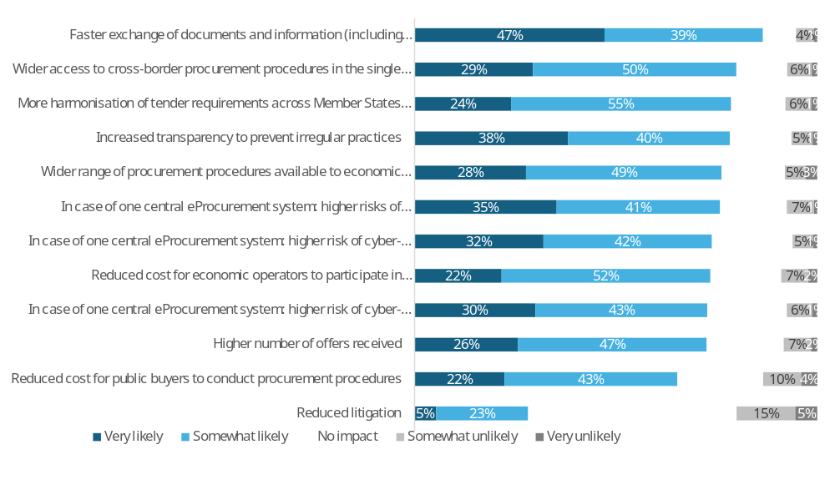
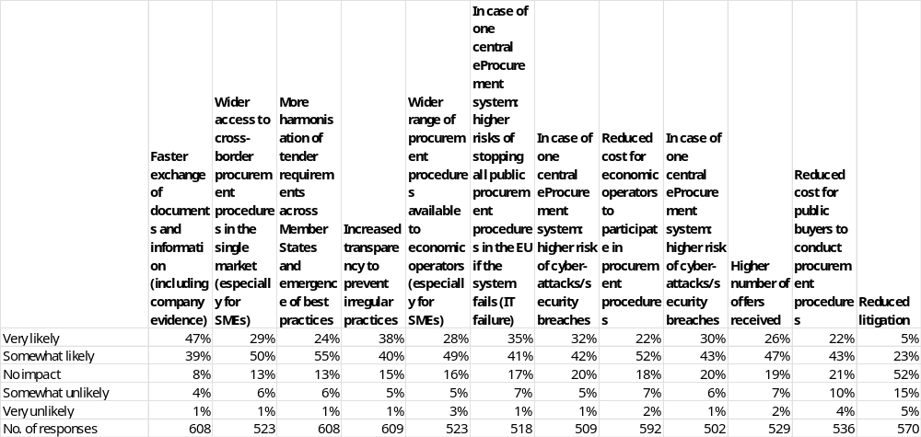
Note: Single-choice responses only; results reflect replies from those who answered. Please note that, due to an error, the questionnaire duplicated the option “In case of one central eProcurement system: higher risk of cyber-attacks/security breaches.” To ensure no responses are omitted, this choice is presented twice in the results.
Source: Public Consultations on public procurement reform. Commission own analysis.

In response to the question “How likely do you believe the following outcomes would occur if such a digital public procurement marketplace is set up?”, respondents most often expect faster exchange of documents and information (including company evidence) (86%: 47% very likely, 39% somewhat likely), followed by wider access to cross-border procurement procedures in the single market (especially for SMEs) (79%: 29% very likely, 50% somewhat likely) and more harmonisation of tender requirements across Member States and emergence of best practices (79%: 24% very likely, 55% somewhat likely). This is followed by increased transparency to prevent irregular practices (78%: 38% very likely, 40% somewhat likely), wider range of procurement procedures available to economic operators (especially for SMEs) (77%: 28% very likely, 49% somewhat likely), and, in case of one central eProcurement system, higher risks of stopping all public procurement procedures in the EU if the system fails (IT failure) (76%: 35% very likely, 41% somewhat likely). Further expected outcomes include, again in case of one central system, higher risk of cyber-attacks/security breaches (74%: 32% very likely, 42% somewhat likely), reduced cost for economic operators to participate in procurement procedures (74%: 22% very likely, 52% somewhat likely), and a higher number of offers received (73%: 26% very likely, 47% somewhat likely). A closely related item on higher risk of cyber-attacks/security breaches, where asked again, shows similar positive expectations (73%: 30% very likely, 43% somewhat likely). Finally, 65% expect reduced cost for public buyers to conduct procurement procedures (22% very likely, 43% somewhat likely), while reduced litigation records the lowest positive expectation (28%: 5% very likely, 23% somewhat likely).
Disagreement that these outcomes will occur (somewhat unlikely or very unlikely) is highest for reduced litigation (20%: 15% somewhat unlikely, 5% very unlikely) and reduced cost for public buyers (14%: 10% somewhat unlikely, 4% very unlikely). For other outcomes, disagreement remains lower: higher number of offers received and reduced cost for economic operators (each 9%: 7% somewhat unlikely, 2% very unlikely), in case of one central system higher risk of stopping all public procurement procedures due to IT failure (8%: 7% somewhat unlikely, 1% very unlikely), more harmonisation of tender requirements and wider access to cross-border procurement (each 7%: 6% somewhat unlikely, 1% very unlikely), wider range of procedures (8%: 5% somewhat unlikely, 3% very unlikely), increased transparency (6%: 5% somewhat unlikely, 1% very unlikely), faster exchange of documents and information (5%: 4% somewhat unlikely, 1% very unlikely), and the two items on higher risk of cyber-attacks/security breaches (6–7%: 5–6% somewhat unlikely, 1% very unlikely).
Across all outcomes, the share of respondents expecting “no impact” ranges from 8% for faster exchange of documents and information to 52% for reduced litigation. Intermediate “no impact” levels are reported for wider access to cross-border procurement and more harmonisation of tender requirements (each 13%), increased transparency (15%), wider range of procedures (16%), and, in case of one central system, higher risk of stopping all public procurement procedures due to IT failure (17%) and higher risk of cyber-attacks/security breaches (20%). For reduced cost for economic operators, higher number of offers received, and reduced cost for public buyers, “no impact” responses are between 18% and 21%.

Table 84: Question: How likely do you believe the following outcomes would occur if such a digital public procurement marketplace is set up?; percentage of respondents that indicated “very likely” or “somewhat likely” answers, by type of respondent.
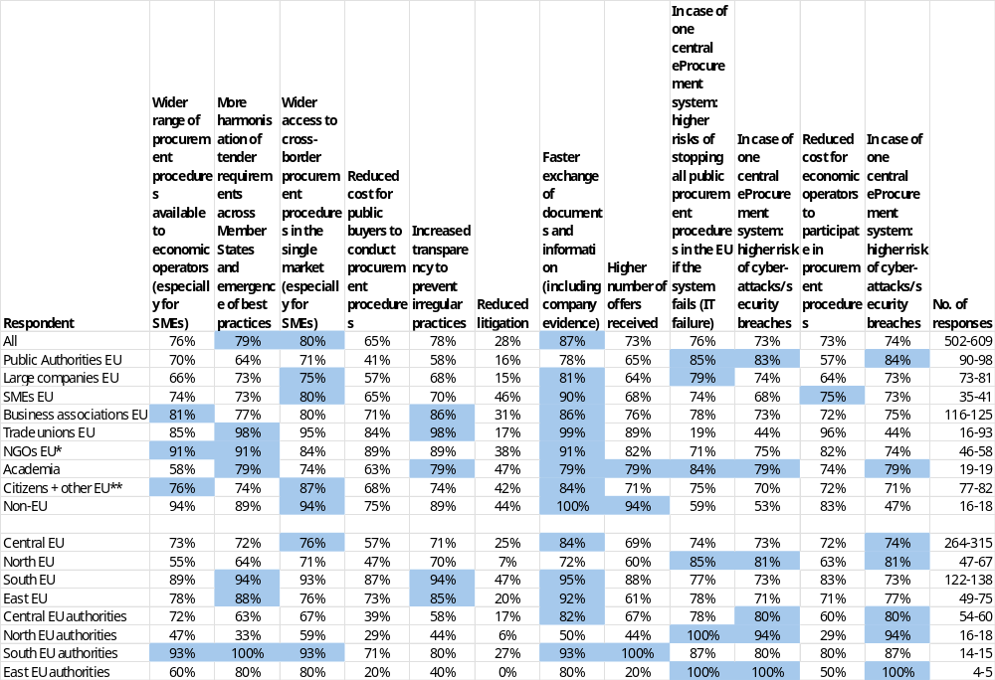
* NGOs + Environmental organisations; ** includes Consumer Organisations
Note: Single-choice responses only; results reflect replies from those who answered Top three responses highlighted. The number of responses in the last column is shown as a range, as the number of replies varied per column. Please note that, due to an error, the questionnaire duplicated the option “In case of one central eProcurement system: higher risk of cyber-attacks/security breaches.” To ensure no responses are omitted, this choice is presented twice in the results.
EU includes NO; Central EU: AT, BE, DE, FR, LU, NL; North EU: DK, FI, IE, SE and NO; South EU: CY, EL, ES, IT, MT, PT; East EU: BG, CZ, EE, HR, HU, LT, LV, PL, RO, SK; replies of only those who answered are provided.
Source: Public Consultations on public procurement reform. Commission own analysis.

Respondents were asked how likely they believed different outcomes would be if a digital public procurement marketplace were set up. The figures below describe, for each outcome and respondent group, the combined shares of “very likely” and “somewhat likely” answers (other response options were also available but are not shown).
Among public authorities, the most likely outcomes were higher risks of cyber-attacks/security breaches in case of one central eProcurement system (84%) and higher risks of stopping all procurement procedures in case of IT failure (85%), together with faster exchange of documents and information (78%). For the remaining outcomes, perceived likelihood ranged from 16% to 85%. Very low likelihood was reported for reduced litigation (16%).
Among large companies, SMEs and business associations, faster exchange of documents and information was consistently regarded as a very likely outcome (large companies: 81%; SMEs: 90%; business associations: 86%), as was wider access to cross-border procedures (75%; 80%; 80%). Business associations also strongly pointed to increased transparency (86%), while SMEs highlighted reduced cost for economic operators (75%). Across these three groups, perceived likelihood of the remaining outcomes ranged from 15% to 90%. Very low likelihood was reported for reduced litigation among large companies (15%).
Among trade unions and NGOs, the outcomes most often regarded as likely were faster exchange of documents and information (trade unions: 99%; NGOs: 91%), wider range of procedures and more harmonisation of tender requirements (trade unions: 85% and 98%; NGOs: both 91%), as well as increased transparency (98% for trade unions and 89% for NGOs). For these two groups, perceived likelihood of the other outcomes ranged from 17% to 99%. Very low likelihood was reported for reduced litigation among trade unions (17%) and NGOs (38%).
Among academia, the most likely perceived outcome was a higher risk of stopping all public procurement procedures in the EU in case of one central eProcurement system, selected by 84% of respondents. Citizens and other participants most frequently highlighted wider access to cross-border procurement procedures (87%). Meanwhile, non-EU respondents unanimously identified faster document and information exchange as the top impact (100%). Across these three groups, the perceived likelihood of other outcomes ranged from 42% to 94%.

Those who selected Other were asked to elaborate. A summary of their responses is presented below.
Public authorities
Public authorities expressed a range of views on the potential impacts of a digital public procurement marketplace. Some respondents, such as research organizations, suggested that exempting them from EU public tendering law could lead to significant increases in speed and reductions in cost, while still maintaining transparency. Others, such as a public authority that uses an online service, reported that they have found no empirical evidence to support accusations that online services hinder effective governance or the fight against corruption. A few respondents, such as a public authority that supports a digital EU-wide procurement platform, emphasized the potential benefits of improved transparency, reduced fragmentation, and simplified monitoring and contract tracking. Some respondents also suggested that a digital marketplace could provide access to standardized procurement documents, helpdesk support, and training for SMEs. However, others expressed concerns about the potential complexity of a centralized system, language barriers, and the need to ensure interoperability with local and national platforms. For example, one respondent stated that "A single centralised system at EU level would further discourage economic operators and make the system even more complex for everyone." Another respondent suggested that "A Portal Guide would increase transparency and ensure consistency of data, making it easier for economic operators and contracting authorities to work." Overall, the comments highlighted the need for a balanced approach that takes into account the diverse needs and interests of different stakeholders.
EU companies and business associations
EU companies and business associations expressed a range of views on the potential impacts of a digital public procurement marketplace. Some emphasized the potential benefits of improved digitalization, including increased transparency, reduced administrative burdens, and enhanced access to procurement opportunities. Others cautioned against creating unnecessary administrative or technical burdens and emphasized the importance of designing a practical and user-friendly platform. Several highlighted the need for a hybrid model that links national systems with a central service, providing redundancy and reducing vulnerability. Some warned against adopting protectionist measures and emphasized the importance of ensuring that any digital marketplace is open and non-discriminatory. Others emphasized the potential benefits of a digital marketplace in terms of increased efficiency, reduced costs, and improved access to procurement opportunities. For example, some suggested that a digital marketplace could simplify onboarding for SMEs, eliminate redundant administrative procedures, and enhance transparency and auditability. Others noted that a digital marketplace could provide a single point of entry for economic operators, improve the visibility of contracts, and reduce the risk of errors and inconsistencies. Overall, the comments highlighted the complexity and diversity of views on the potential impacts of a digital public procurement marketplace, and the need for a careful and nuanced approach to its design and implementation.
All other respondents
A digital public procurement marketplace is expected to have several impacts, including the provision of tools for monitoring and enforcing labour standards and other obligations, such as cross-referencing of data. Many respondents emphasize the importance of excluding operators that do not respect their obligations, including those that engage in tax evasion or avoidance, and creating an EU list of excluded actors. Additionally, digitalisation is expected to improve transparency, reduce administrative burdens, and increase access to procurement opportunities for SMEs and cross-border transactions. Some respondents also highlight the need for a single-entry point for interoperable e-procurement, robust cybersecurity, and resilience to prevent single points of failure. Furthermore, digitalisation is expected to facilitate the monitoring and enforcement of social and environmental standards, and to provide a platform for the exchange of information and best practices among contracting authorities and economic operators. Overall, the comments suggest that a digital public procurement marketplace has the potential to increase efficiency, transparency, and accountability in public procurement, while also promoting fair competition and social responsibility.

Made in Europe (BEU options)
Table 85: Question: Should European goods and services be prioritised in the procurement process?; percentage of answers, by type of respondent.
Respondent | Yes | No | No. of responses
All | 85% | 15% | 730
Public Authorities EU | 81% | 19% | 106
Large companies EU | 81% | 19% | 107
SMEs EU | 92% | 8% | 53
Business associations EU | 80% | 20% | 162
Trade unions EU | 99% | 1% | 96
NGOs EU* | 86% | 14% | 74
Academia | 89% | 11% | 18
Citizens + other EU** | 91% | 9% | 95
Non-EU | 42% | 58% | 19
Central EU | 84% | 16% | 402
North EU | 72% | 28% | 74
South EU | 95% | 5% | 153
East EU | 94% | 6% | 82
Central EU authorities | 78% | 22% | 68
North EU authorities | 76% | 24% | 17
South EU authorities | 94% | 6% | 16
East EU authorities | 100% | 0% | 5
* NGOs + Environmental organisations; ** includes Consumer Organisations
Note: Single-choice responses only; results reflect replies from those who answered. Top response highlighted. EU includes NO; Central EU: AT, BE, DE, FR, LU, NL; North EU: DK, FI, IE, SE and NO; South EU: CY, EL, ES, IT, MT, PT; East EU: BG, CZ, EE, HR, HU, LT, LV, PL, RO, SK; replies of only those who answered are provided
Source: Public Consultations on public procurement reform. Commission own analysis.

All respondent groups except non-EU participants expressed strong support (above 80%) for prioritising European goods and services in the public procurement process.
Figure 77: Question: How should European goods and services should be prioritised in procurement process?, all replies.
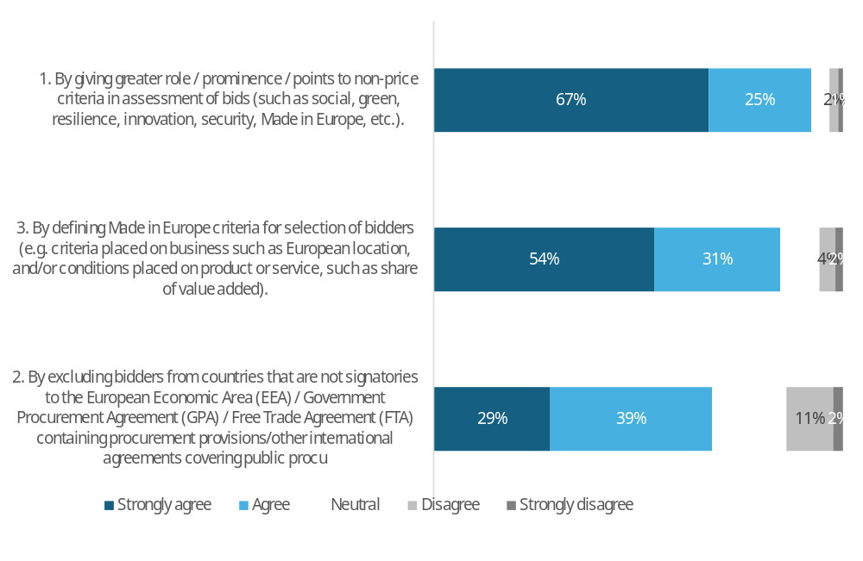
 | 1. By giving greater role / prominence / points to non-price criteria in assessment of bids (such as social, green, resilience, innovation, security, Made in Europe, etc.). | 2. By excluding bidders from countries that are not signatories to the European Economic Area (EEA) / Government Procurement Agreement (GPA) / Free Trade Agreement (FTA) containing procurement provisions/other international agreements covering public procurement or offering goods or services originating from those countries. | 3. By defining Made in Europe criteria for selection of bidders (e.g. criteria placed on business such as European location, and/or conditions placed on product or service, such as share of value added).
Strongly agree | 67% | 29% | 54%
Agree | 25% | 39% | 31%
Neutral | 4% | 18% | 10%
Disagree | 2% | 11% | 4%
Strongly disagree | 1% | 2% | 2%
No. of responses | 607 | 595 | 596
Note: Single-choice responses only; results reflect replies from those who answered.
Source: Public Consultations on public procurement reform. Commission own analysis.

When asked how to prioritise European goods and services, respondents showed the strongest preference (92% support-67% strongly agree, 25% agree) for expanding the role of non-price criteria, such as social, environmental, resilience, innovation, security, and Made in Europe considerations. This was closely followed by defining Made in Europe criteria for bidder selection-such as requiring a European business location or setting conditions on the product/service (e.g., share of value added)-which received 85% support (54% strongly agree, 31% agree). The least favoured option, though still supported by over two-thirds of respondents (68%-29% strongly agree, 39% agree), was excluding bidders from countries lacking a public procurement agreement with the EU. This proposal also faced the highest opposition at around 13%, compared to just 3–6% for the other two options.

Table 86: Question: How should European goods and services be prioritised in procurement process?; percentage of respondents that agree or strongly agree, by type of respondent.
Respondent | 1. By giving greater role / prominence / points to non-price criteria in assessment of bids (such as social, green, resilience, innovation, security, Made in Europe, etc.). | 2. By excluding bidders from countries that are not signatories to the EEA / GPA / FTA /other international agreements with procurement provisions | 3. By defining Made in Europe criteria for selection of bidders | No. of responses
All | 92% | 68% | 85% | 595-607
Public Authorities EU | 76% | 64% | 80% | 83-86
Large companies EU | 94% | 76% | 93% | 84-84
SMEs EU | 100% | 67% | 87% | 45-46
Business associations EU | 94% | 66% | 84% | 121-125
Trade unions EU | 100% | 98% | 100% | 91-95
NGOs EU* | 95% | 34% | 57% | 61-63
Academia | 88% | 38% | 81% | 16-16
Citizens + other EU** | 90% | 65% | 86% | 84-84
Non-EU | 88% | 63% | 100% | 7-8
Central EU | 91% | 64% | 82% | 321-327
North EU | 81% | 73% | 78% | 49-53
South EU | 97% | 68% | 89% | 141-142
East EU | 97% | 80% | 91% | 76-77
Central EU authorities | 74% | 65% | 83% | 52-53
North EU authorities | 54% | 83% | 75% | 12-13
South EU authorities | 93% | 50% | 80% | 14-15
East EU authorities | 100% | 40% | 50% | 4-5
* NGOs + Environmental organisations; ** includes Consumer Organisations; *** European Economic Area (EEA) / Government Procurement Agreement (GPA) / Free Trade Agreement (FTA)
Note: Single-choice responses only; results reflect replies from those who answered. Top response highlighted. The number of responses in the last column is shown as a range, as the number of replies varied per column.
1. By giving greater role / prominence / points to non-price criteria in assessment of bids (such as social, green, resilience, innovation, security, Made in Europe, etc.); 2. By excluding bidders from countries that are not signatories to the European Economic Area (EEA) / Government Procurement Agreement (GPA) / Free Trade Agreement (FTA) containing procurement provisions/other international agreements covering public procurement or offering goods or services originating from those countries; 3. By defining Made in Europe criteria for selection of bidders (e.g. criteria placed on business such as European location, and/or conditions placed on product or service, such as share of value added).
EU includes NO; Central EU: AT, BE, DE, FR, LU, NL; North EU: DK, FI, IE, SE and NO; South EU: CY, EL, ES, IT, MT, PT; East EU: BG, CZ, EE, HR, HU, LT, LV, PL, RO, SK; replies of only those who answered are provided
Source: Public Consultations on public procurement reform. Commission own analysis.

Respondents were asked: "How should European goods and services be prioritised in the procurement process?" The figures reflect the combined shares of "strongly agree" and "agree" responses (other options were available but are not shown here).
The option attracting the highest support in all groups except public authorities and non-EU respondents was giving a greater role to non-price criteria in bid assessments, with backing ranging from 88% to 100%. Public authorities gave a slightly higher preference (80% compared to 76%) to defining Made in Europe criteria for the selection of bidders. This was also the first choice for non-EU respondents. Academia showed almost unanimous support for all three options.

Table 87: Question: If you "agree" or "strongly agree" with point 2 (Table 86). Should such an exclusion be mandatory or voluntary?; % of all answers to point 2, by type of respondent.
Respondent | Voluntary | Mandatory | No. of all responses to point 2
All | 19% | 47% | 595
Public Authorities EU | 41% | 22% | 83
Large companies EU | 25% | 50% | 84
SMEs EU | 20% | 46% | 46
Business associations EU | 21% | 40% | 121
Trade unions EU | 2% | 96% | 92
NGOs EU* | 8% | 25% | 61
Academia | 19% | 19% | 16
Citizens + other EU** | 17% | 46% | 84
Non-EU | 25% | 38% | 8
Central EU | 21% | 40% | 321
North EU | 27% | 45% | 49
South EU | 13% | 53% | 141
East EU | 17% | 63% | 76
Central EU authorities | 38% | 27% | 52
North EU authorities | 58% | 17% | 12
South EU authorities | 36% | 14% | 14
East EU authorities | 40% | 0% | 5
* NGOs + Environmental organisations; ** includes Consumer Organisations; *** European Economic Area (EEA) / Government Procurement Agreement (GPA) / Free Trade Agreement (FTA)
Note: Single-choice responses only; results reflect replies from those who answered. Top response highlighted.
Point 2. By excluding bidders from countries that are not signatories to the European Economic Area (EEA) / Government Procurement Agreement (GPA) / Free Trade Agreement (FTA) containing procurement provisions/other international agreements covering public procurement or offering goods or services originating from those countries;
EU includes NO; Central EU: AT, BE, DE, FR, LU, NL; North EU: DK, FI, IE, SE and NO; South EU: CY, EL, ES, IT, MT, PT; East EU: BG, CZ, EE, HR, HU, LT, LV, PL, RO, SK; replies of only those who answered are provided
Source: Public Consultations on public procurement reform. Commission own analysis.

Respondents who believed European goods and services should be prioritised by excluding bidders from countries without a public procurement agreement with the EU (point 2, Table 86) were then asked whether this exclusion should be mandatory or voluntary. For clarity, the figures in the table and below represent the share of all responses (not just those who agreed or strongly agreed with point 2). In all groups except public authorities, there was a preference for mandatory exclusion.
Table 88: Question: If you "agree" or "strongly agree" with point 3 (Table 86). Should the use of such "Made in Europe" criteria be mandatory or voluntary for public buyers?; If mandatory should there be exceptions?; Which sectors should be covered?; percentage of answers to point 3, by type of respondent.
 | "Made in Europe" criteria mandatory or voluntary? |  | If mandatory, should there be exceptions? |  | Which sectors should be covered?
Respondent | Voluntary | Mandatory | Yes | No | Certain sectors only | All sectors | No. of all responses to point 3
All | 27% | 57% | 48% | 7% | 24% | 58% | 596
Public Authorities EU | 52% | 25% | 23% | 1% | 17% | 58% | 84
Large companies EU | 30% | 60% | 43% | 15% | 42% | 49% | 84
SMEs EU | 24% | 62% | 42% | 20% | 22% | 60% | 45
Business associations EU | 28% | 54% | 45% | 7% | 36% | 43% | 122
Trade unions EU | 2% | 98% | 96% | 0% | 3% | 97% | 91
NGOs EU* | 13% | 41% | 37% | 3% | 11% | 40% | 63
Academia | 38% | 44% | 44% | 0% | 19% | 63% | 16
Citizens + other EU** | 29% | 57% | 46% | 10% | 25% | 58% | 84
Non-EU | 57% | 43% | 43% | 0% | 71% | 29% | 7
 |  |  |  |  |  |  | 0
Central EU | 30% | 50% | 41% | 7% | 23% | 55% | 323
North EU | 24% | 53% | 49% | 4% | 16% | 57% | 49
South EU | 21% | 67% | 58% | 9% | 34% | 53% | 141
East EU | 20% | 70% | 62% | 8% | 8% | 82% | 76
Central EU authorities | 58% | 23% | 21% | 0% | 17% | 62% | 53
North EU authorities | 58% | 17% | 17% | 0% | 8% | 58% | 12
South EU authorities | 33% | 47% | 40% | 7% | 27% | 53% | 15
East EU authorities | 25% | 0% | 0% | 0% | 0% | 25% | 4
* NGOs + Environmental organisations; ** includes Consumer Organisations; *** European Economic Area (EEA) / Government Procurement Agreement (GPA) / Free Trade Agreement (FTA)
Note: Single-choice responses only; results reflect replies from those who answered. Top three responses highlighted.
Point 3. By defining Made in Europe criteria for selection of bidders (e.g. criteria placed on business such as European location, and/or conditions placed on product or service, such as share of value added);
EU includes NO; Central EU: AT, BE, DE, FR, LU, NL; North EU: DK, FI, IE, SE and NO; South EU: CY, EL, ES, IT, MT, PT; East EU: BG, CZ, EE, HR, HU, LT, LV, PL, RO, SK; replies of only those who answered are provided
Source: Public Consultations on public procurement reform. Commission own analysis.

Respondents who selected the option to prioritise European goods and services by defining Made in Europe criteria for bidder selection (point 3, Table 86) were subsequently asked whether these criteria should be applied voluntarily or mandatorily (with or without exceptions) and whether they should cover all sectors or only selected ones. For clarity, the figures in the table and below show the share of all responses, not just those who agreed or strongly agreed with point 3.
In all groups except public authorities and non-EU respondents, there was a preference for mandatory application of these criteria. Across all respondent groups, those who favoured mandatory criteria also agreed that there should be exemptions. The majority of all groups except non-EU respondents believed that all sectors should be covered.

Respondents were invited to comment on which sectors should be subject to Made in Europe provisions.
Public authorities
Public authorities suggested that Made in Europe provisions should apply to various sectors, including those of strategic importance to the EU, such as technology, defence, and security-sensitive contracts. Some respondents mentioned specific sectors, including IT, infrastructure/construction, and critical infrastructure, while others emphasized the need to focus on sectors that are essential for the EU's security, sovereignty, and decarbonization. A few respondents highlighted the importance of considering the availability of European industrial offers in certain sectors, as well as the need to ensure that regulations are respected by all industries. Some examples of sectors mentioned include energy, health, ICT, transport, pharmaceuticals, and wood. Overall, the comments suggest that the scope of Made in Europe provisions should be carefully considered to ensure that they support the EU's strategic interests and promote fair competition. For instance, one respondent stated that "Strategic sectors: technology, defence," should be subject to Made in Europe provisions, while another respondent suggested that "Only certain strategic sectors (Energy, Health, ICT, Transport)" should be included.
EU companies and business associations
EU companies and business associations suggested that Made in Europe provisions should apply to various strategic sectors, including those related to energy, defence, security, and critical infrastructure. Some respondents mentioned specific sectors, such as IT, telecoms, and cloud computing, while others emphasized the importance of considering the entire value chain, from raw materials to final products. Many respondents emphasized the need to promote European industries and jobs, while also ensuring fair competition and protecting international trade partnerships. Some examples of sectors mentioned include:
- Energy infrastructure, such as transformers, grids, and transmission components
- Net-zero technologies, such as hydrogen, wind, solar, and batteries
- E-mobility and automotive value chains
- Transport and high-voltage infrastructure
- Defence and critical security technologies
- Critical infrastructure, such as airports, navigation systems, and air traffic control
- ICT sector, including cloud computing and other critical digital infrastructures
- Biobased products, such as bioplastics, biobased polymers, and biobased textiles
- Pharmaceutical products and medical devices
- Products related to healthcare and food sectors
Some respondents suggested a targeted approach, applying Made in Europe criteria to strategic sectors and considering a voluntary, comply-or-explain framework. Others emphasized the importance of defining European content in a way that captures key parts of value chains, while avoiding disproportionate administrative burden. Overall, the comments suggest that the scope of Made in Europe provisions should be carefully considered to ensure that they support the EU's strategic interests and promote fair competition.
Non-EU respondents
Non-EU respondents suggested that Made in Europe provisions should apply to various strategic sectors, including:
- Strategic sectors, without specifying particular ones
- Personal protective equipment and healthcare
- Steel, energy infrastructure, and construction, where demand certainty can accelerate decarbonisation and the circular economy
- Key technologies such as AI, cloud, quantum, semiconductors, digital infrastructure and platforms, cybersecurity, defence, and space
These respondents generally emphasized the importance of focusing on sectors that are critical to the EU's economic and technological development, as well as those that are essential for ensuring the EU's security and resilience. Overall, the comments suggest that the scope of Made in Europe provisions should be targeted and strategic, with a focus on promoting the EU's competitive advantages and protecting its critical interests.
All other respondents
All other respondents (except Public authorities, companies and business associations) suggested that Made in Europe provisions should apply to various strategic sectors, including:
- Defence, security, and critical infrastructure
- Energy, including grids, storage, and key renewables components
- Health and pharmaceuticals
- Digital and data infrastructures, such as cloud, semiconductors, and AI-enabling hardware
- Transport and mobility systems
- Food procurement, especially sustainable and locally sourced food
- Construction and building materials, such as green steel and low-carbon cement
- Circular economy and waste management, including advanced recycling technologies
- Strategic supplies and services, such as telecommunications and IT
- Sectors related to safety and defence, public transport, and critical infrastructure
- Personal and financial data, utilities such as electricity, water, and gas
Some respondents emphasized the importance of promoting European sovereignty and independence in strategic sectors, while others highlighted the need to support the circular economy and sustainable development. A few respondents noted that the provisions should be focused on sectors where the obligation of "Made in Europe" is realistic and where there is a developed industry in the EU. Overall, the comments suggest that the scope of Made in Europe provisions should be targeted and strategic, with a focus on promoting the EU's competitive advantages and protecting its critical interests.

Respondents were invited to specify what additional Made in Europe criteria should be included in EU legislation.
Public authorities
Public authorities suggested that additional Made in Europe criteria should be included in EU legislation, but with caution and flexibility. Some respondents emphasized the importance of promoting European products and services, while others highlighted the need to avoid protectionism and ensure that the rules are simple and easy to apply. Many respondents suggested that the criteria should be voluntary, rather than mandatory, and that exemptions should be foreseen for certain sectors or cases. Some key points mentioned include:
- The need for clear definitions of what constitutes a European product or service
- The importance of considering the supply chain and the origin of products, rather than just the nationality of the company
- The possibility of using positive incentives, such as award criteria linked to resilience or geographical diversification, to promote European products and services
- The need to avoid increasing the administrative burden on contracting authorities and to ensure that the rules are proportionate and flexible
- The importance of ensuring that the rules do not lead to increased costs for local and regional authorities
- The possibility of using existing instruments, such as the International Procurement Instrument (IPI), to define and activate European preference
- The need to balance the objective of promoting European products and services with the need to simplify the procedural legal framework and reduce administrative burdens.
Some respondents also suggested that the criteria should be limited to certain sectors, such as strategic or critical sectors, and that the rules should be designed to promote European industries and jobs, while also ensuring fair competition and protecting international trade partnerships. Overall, the comments suggest that the inclusion of Made in Europe criteria in EU legislation should be carefully considered and balanced with other policy objectives, such as simplification and flexibility.
EU companies and business associations
EU companies and business associations suggested that additional Made in Europe criteria should be included in EU legislation to promote European products and services, while also ensuring fair competition and protecting international trade partnerships. Many respondents emphasized the importance of defining what "Made in Europe" means, with some suggesting that it should be based on the origin of the product, rather than the origin of the company importing the product. Some key points mentioned include:
- The need for clear and simple rules to determine the origin of products and services
- The importance of considering the entire value chain, from raw materials to final products
- The need for flexibility and proportionality in the application of Made in Europe criteria, to avoid unnecessary administrative burdens and ensure that the rules are effective in promoting European industries and jobs
- The importance of ensuring that Made in Europe criteria do not lead to protectionism or unfair competition, and that they are compatible with EU international commitments and WTO rules
- The need for a nuanced and targeted approach, with different criteria and requirements applying to different sectors and industries
- The importance of promoting European value chains and ensuring that public money is spent on products and services that support European industries and jobs
- The need for certification and traceability tools to ensure the credibility of Made in Europe requirements
- The importance of considering the impact of Made in Europe criteria on small and medium-sized enterprises (SMEs) and ensuring that they do not create unnecessary barriers to entry or disproportionately affect certain industries or sectors.
Some respondents also suggested that Made in Europe criteria should be applied in a way that takes into account the entire life cycle of a product or service, including its production, use, and disposal, and that they should be linked to EU environmental and social standards. Others emphasized the importance of ensuring that Made in Europe criteria do not lead to supply chain disruptions or excessive price increases, and that they are compatible with EU trade policies and international agreements.
Overall, the comments suggest that the inclusion of Made in Europe criteria in EU legislation should be carefully considered and balanced with other policy objectives, such as promoting fair competition, protecting international trade partnerships, and ensuring that the rules are effective in promoting European industries and jobs.
Non-EU respondents
Non-EU respondents suggested that additional Made in Europe criteria should be included in EU legislation, but with caution and careful consideration. Some key points mentioned include:
- The need for objective, transparent, and value-creation-based criteria that incentivize EU investment and promote vendor diversity
- The importance of considering the origin of operators, including quality jobs, ownership, and tax residence, as well as EU added value
- The need for clear definitions and application of Made in Europe criteria, with a focus on strategic industries and avoided blanket rules that could lead to cost increases and supply chain disruptions
- The potential to link EU content provisions with sustainability performance, to support industrial decarbonization and innovation, and create green jobs in the EU
- The importance of promoting collective bargaining, quality jobs, and regulating subcontracting to contribute to the Made in Europe objective
- The need for consistency with EU and WTO law, to avoid discrimination and ensure that the rules are fair and effective.
Some respondents also suggested that multi-winner models, which include designated award slots for EU-based producers, could be a preferred way to introduce Made in Europe criteria, while respecting the Single Market and global trade rules. Others emphasized the importance of voluntary application of Made in Europe criteria, at least in the initial phase, to allow for flexibility and testing of the approach.
Overall, the comments suggest that the inclusion of Made in Europe criteria in EU legislation should be carefully considered and balanced with other policy objectives, such as promoting fair competition, protecting international trade partnerships, and ensuring that the rules are effective in promoting European industries and jobs.
All other respondents
All other respondents (except Public authorities, companies and business associations) suggested that additional Made in Europe criteria should be included in EU legislation to promote European products and services, while also ensuring fair competition and protecting international trade partnerships. Many respondents emphasized the importance of considering the origin of operators, including quality jobs, ownership, and tax residence, as well as EU added value. Some key points mentioned include:
- The need for clear and simple rules to determine the origin of products and services
- The importance of promoting collective bargaining, quality jobs, and regulating subcontracting to ensure fair working conditions
- The need for flexibility and proportionality in the application of Made in Europe criteria, to avoid unnecessary administrative burdens and ensure that the rules are effective in promoting European industries and jobs
- The importance of ensuring that Made in Europe criteria do not lead to protectionism or unfair competition, and that they are compatible with EU international commitments and WTO rules
- The need for a nuanced and targeted approach, with different criteria and requirements applying to different sectors and industries
- The importance of promoting European value chains and ensuring that public money is spent on products and services that support European industries and jobs
- The need for certification and traceability tools to ensure the credibility of Made in Europe requirements
- The importance of considering the impact of Made in Europe criteria on small and medium-sized enterprises (SMEs) and ensuring that they do not create unnecessary barriers to entry or disproportionately affect certain industries or sectors.
Some respondents also suggested that Made in Europe criteria should be applied in a way that takes into account the entire life cycle of a product or service, including its production, use, and disposal, and that they should be linked to EU environmental and social standards. Others emphasized the importance of ensuring that Made in Europe criteria do not lead to supply chain disruptions or excessive price increases, and that they are compatible with EU trade policies and international agreements.
Overall, the comments suggest that the inclusion of Made in Europe criteria in EU legislation should be carefully considered and balanced with other policy objectives, such as promoting fair competition, protecting international trade partnerships, and ensuring that the rules are effective in promoting European industries and jobs.

9.6.1. Made in Europe impacts
Figure 78: Question: How likely do you believe the following outcomes would occur if any type of prioritisation of European products and services was to be implemented?; all replies.
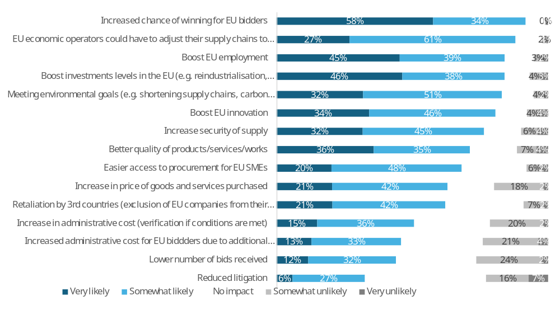
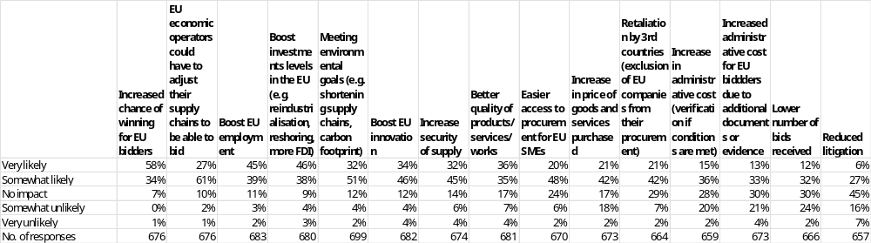
Note: Single-choice responses only; results reflect replies from those who answered.
Source: Public Consultations on public procurement reform. Commission own analysis.

In response to the question “How likely do you believe the following outcomes would occur if any type of prioritisation of European products and services was to be implemented?”, respondents most often expect an increased chance of winning for EU bidders (92%: 58% very likely, 34% somewhat likely), followed by EU economic operators having to adjust their supply chains to be able to bid (88%: 27% very likely, 61% somewhat likely). High shares also anticipate boosts to EU employment (84%: 45% very likely, 39% somewhat likely) and investment levels in the EU (e.g. reindustrialisation, reshoring, more FDI) (84%: 46% very likely, 38% somewhat likely). Majorities consider meeting environmental goals (e.g. shortening supply chains, carbon footprint) (83%: 32% very likely, 51% somewhat likely), boosting EU innovation (80%: 34% very likely, 46% somewhat likely), increasing security of supply (77%: 32% very likely, 45% somewhat likely), and better quality of products, services and works (71%: 36% very likely, 35% somewhat likely) as likely outcomes. Easier access to procurement for EU SMEs is also widely seen as likely (68%: 20% very likely, 48% somewhat likely). On the cost and risk side, a majority expect an increase in price of goods and services purchased (63%: 21% very likely, 42% somewhat likely), retaliation by third countries (exclusion of EU companies from their procurement) (63%: 21% very likely, 42% somewhat likely), and an increase in administrative cost for public buyers (verification if conditions are met) (51%: 15% very likely, 36% somewhat likely). Increased administrative cost for EU bidders due to additional documents or evidence is also often seen as likely (46%: 13% very likely, 33% somewhat likely). A lower number of bids received (44%: 12% very likely, 32% somewhat likely) and reduced litigation (33%: 6% very likely, 27% somewhat likely) attract the lowest shares of positive expectations.
Disagreement that these outcomes will occur (somewhat unlikely or very unlikely) is highest for a lower number of bids received (26%: 24% somewhat unlikely, 2% very unlikely) and reduced litigation (23%: 16% somewhat unlikely, 7% very unlikely), followed by increased administrative cost for EU bidders (25%: 21% somewhat unlikely, 4% very unlikely) and increased administrative cost for public buyers (22%: 20% somewhat unlikely, 2% very unlikely). Perceived likelihood is also more contested for an increase in price of goods and services purchased (20%: 18% somewhat unlikely, 2% very unlikely) and retaliation by third countries (9%: 7% somewhat unlikely, 2% very unlikely). For the more “beneficial” effects, disagreement is relatively low: 5–7% somewhat/very unlikely for increased chance of winning for EU bidders, EU operators needing to adjust supply chains, boosts to EU employment and investment, meeting environmental goals, boosting innovation, increased security of supply, better quality, and easier access for EU SMEs.
Across all outcomes, the share of respondents expecting “no impact” ranges from 7% for increased chance of winning for EU bidders to 45% for reduced litigation. Intermediate “no impact” levels are reported for EU economic operators adjusting supply chains (10%), boosts to EU employment (11%) and investment (9%), meeting environmental goals and boosting EU innovation (each 12%), increased security of supply (14%), better quality (17%), easier access for EU SMEs (24%), and increase in price of goods and services purchased (17%). Around three in ten see no impact on retaliation by third countries (29%), administrative cost for public buyers (28%), and administrative cost for EU bidders and lower number of bids received (each 30%).
Table 89: Question: How likely do you believe the following outcomes would occur if any type of prioritisation of European products and services was to be implemented?; percentage of respondents that indicated “very likely” or “somewhat likely” answers, by type of respondent.
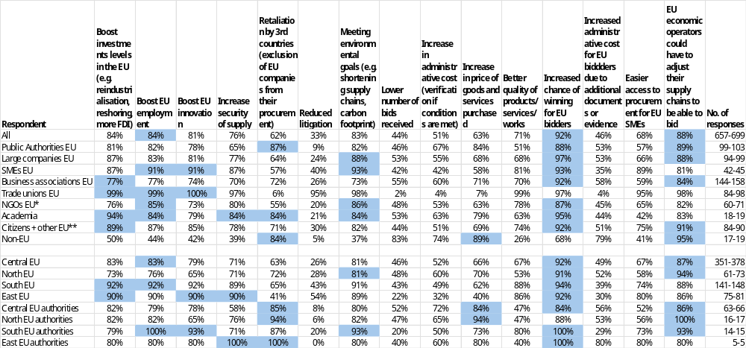
* NGOs + Environmental organisations; ** includes Consumer Organisations
Note: Single-choice responses only; results reflect replies from those who answered. Top three responses highlighted. The number of responses in the last column is shown as a range, as the number of replies varied per column. EU includes NO; Central EU: AT, BE, DE, FR, LU, NL; North EU: DK, FI, IE, SE and NO; South EU: CY, EL, ES, IT, MT, PT; East EU: BG, CZ, EE, HR, HU, LT, LV, PL, RO, SK; replies of only those who answered are provided
Source: Public Consultations on public procurement reform. Commission own analysis.

Respondents were asked how likely they believed different outcomes would be if any type of prioritisation of European products and services was implemented. The figures below refer only to the combined shares of “very likely” and “somewhat likely” answers (other response options were also available but are not shown).
Among public authorities, the outcomes most often seen as likely were increased chance of winning for EU bidders (88%), EU economic operators needing to adjust their supply chains (89%) and retaliation by third countries (87%). For other outcomes, perceived likelihood ranged from 9% to 84%. Very low likelihood was reported for reduced litigation (9%).
Among large companies, SMEs and business associations, increased chance of winning for EU bidders was consistently among the most likely outcomes (large companies: 97%; SMEs: 93%; business associations: 92%), together with meeting environmental goals (88%, 93$, 73%) and need to adjust supply chains (88%, 81%,84%). SMEs in particular, expected easier access to procurement for EU SMEs (89%). Across these three groups, perceived likelihood of the remaining outcomes ranged from 24% to 93%. Very low likelihood was reported for reduced litigation among large companies (24%) and business associations (26%).
Among trade unions, the most likely outcomes were boosts to EU innovation (100%), investments and employment (both 99%), together with meeting environmental goals (98%), better quality of products and services (99%) and EU economic operators having to adjust supply chains (98%). NGOs most frequently pointed to increased chance of winning for EU bidders (87%), meeting environmental goals (86%) and boosts to employment (85%) as likely. For these two groups, perceived likelihood of the other outcomes ranged from 2% to 98%. Very low likelihood was reported for retaliation by third countries (6%), lower number of bids received (2%), increase in administrative cost (4%), increase in price (7%) and increased administrative cost for EU bidders (4%) among trade unions, and for reduced litigation (20%) among NGOs.
Among academia, citizens and other respondents increased chance of winning for EU bidders was again seen as a very likely outcome (academia: 95%; citizens and other respondents: 92%), alongside boosts to investment and employment (academia: 94% and 84%; citizens and other respondents: 89% and 87%). For non-EU respondents the most likely outcomes were EU economic operators needing to adjust their supply chains (95%), increase in price of goods and services purchased (89%) and retaliation by third countries (84%). Across these three groups, perceived likelihood of the remaining outcomes ranged from 5% to 84%. Very low likelihood was reported for reduced litigation among academia (21%) and non-EU respondents (5%).

Respondents were invited to identify any other implications of introducing prioritisation for European products and services.
Public authorities
Public authorities expressed concerns and identified potential implications of prioritizing European products and services in public procurement. Some key points mentioned include:
- The risk of trade disputes and instability in the global environment
- The potential for increased costs and reduced competition, particularly in sectors with limited suppliers
- The need for clear guidance from the Commission to ensure consistent application of European preference criteria
- The importance of complying with WTO agreements and international obligations
- The potential for reduced innovation and quality improvement due to reduced competitive pressure
- The practical challenges of verifying the origin of products and services
- The need for a nuanced approach, considering the specific needs and circumstances of different sectors and contracting authorities
- The potential for increased administrative burdens and costs for contracting authorities and bidders
- The importance of ensuring that European preference criteria do not lead to protectionism or unfair competition
Some respondents also emphasized the need for a voluntary and flexible approach, allowing contracting authorities to prioritize European products and services in specific sectors or cases, while others suggested that the focus should be on promoting high economic, social, and environmental standards, rather than solely on European origin. Additionally, some respondents noted that the introduction of European preference criteria could lead to increased steering and legislation from EU institutions, which could be counterproductive. Overall, the comments highlight the complexity and potential challenges of introducing European preference criteria in public procurement, and the need for careful consideration and balanced approaches to ensure that such criteria are effective and fair.
EU companies and business associations
EU companies and business associations identified various implications of prioritizing European products and services in public procurement, including potential increased costs, reduced competition, and administrative burdens. Some respondents noted that a "Made in Europe" principle could strengthen European industrial capacity, resilience, and security of supply, while others cautioned against rigid geo-prioritization that could fragment global digital ecosystems and undermine European competitiveness. Many emphasized the need for a nuanced and targeted approach, considering the specific needs and circumstances of different sectors and contracting authorities.
Some key concerns mentioned include:
- Retaliatory measures from third countries
- Administrative burdens and costs associated with verifying the origin of products and services
- Potential negative impact on innovation and quality due to reduced competition
- Difficulty in defining what constitutes "local content" or a "European" product or supplier
- Risk of higher prices and reduced competition if European suppliers are not competitive
- Importance of maintaining a level playing field and avoiding protectionism
Respondents also suggested alternative approaches, such as:
- Focusing on non-price criteria like sustainability, innovation, and security of supply
- Using qualitative criteria like recycling rates or material reuse as award criteria
- Introducing a "Buy European Recyclates" model to promote secondary raw materials
- Encouraging open and fair trade, rather than introducing "Made in Europe" preferences
- Supporting European champions through public procurement, while avoiding "vendor lock-in" to non-EU monopolies
Overall, the comments highlight the complexity and potential challenges of introducing European preference criteria in public procurement, and the need for careful consideration and balanced approaches to ensure that such criteria are effective and fair.
Non-EU respondents
Non-EU respondents identified various implications of prioritizing European products and services in public procurement, including potential risks to competition, innovation, and supply chain resilience. Some key concerns mentioned include:
- Increased costs and reduced competition due to restrictive "Made in Europe" criteria
- Administrative burdens and complexity for public procurers and companies
- Risk of retaliation from third countries and erosion of the rules-based trade order
- Potential negative impact on innovation and access to best-in-class technologies
- Difficulty in defining what constitutes "local content" or a "European" product or supplier
- Importance of maintaining a level playing field and avoiding protectionism
Some respondents suggested alternative approaches, such as:
- Focusing on non-price criteria like sustainability, innovation, and security of supply
- Introducing a "Best-of-Breed" Innovation Framework anchored in top-notch research
- Promoting open industry standards to prevent vendor lock-in and maintain global competitiveness and interoperability
- Measuring resilience by a provider's track record in securing global workloads and deploying hyperscale resources instantly during crises
Others emphasized the need for a nuanced and targeted approach, considering the specific needs and circumstances of different sectors and contracting authorities. Some noted that "Made in Europe" criteria may not address the root causes of supply disruptions and risk enforcing and creating new vulnerabilities and barriers to patient and market access.
Overall, the comments highlight the complexity and potential challenges of introducing European preference criteria in public procurement, and the need for careful consideration and balanced approaches to ensure that such criteria are effective and fair.
All other respondents
All other respondents (except Public authorities, companies and business associations) identified various implications of prioritizing European products and services in public procurement, including potential risks to competition, innovation, and supply chain resilience. Some key concerns mentioned include:
- Risk of higher costs and reduced competition due to restrictive "Made in Europe" criteria
- Administrative burdens and complexity for public procurers and companies
- Potential negative impact on innovation and access to best-in-class technologies
- Difficulty in defining what constitutes "local content" or a "European" product or supplier
- Importance of maintaining a level playing field and avoiding protectionism
Some respondents suggested alternative approaches, such as:
- Focusing on non-price criteria like sustainability, innovation, and security of supply
- Introducing a "Best-of-Breed" Innovation Framework anchored in top-notch research
- Promoting open industry standards to prevent vendor lock-in and maintain global competitiveness and interoperability
- Measuring resilience by a provider's track record in securing global workloads and deploying hyperscale resources instantly during crises
Others emphasized the need for a nuanced and targeted approach, considering the specific needs and circumstances of different sectors and contracting authorities. Some noted that "Made in Europe" criteria may not address the root causes of supply disruptions and risk enforcing and creating new vulnerabilities and barriers to patient and market access.
The comments highlight the complexity and potential challenges of introducing European preference criteria in public procurement, and the need for careful consideration and balanced approaches to ensure that such criteria are effective and fair.
The "Made in Europe" principle must be tied to environmental and social standards, and must be defined very carefully to maximize the outcome in terms of employment, investment, and environmental footprint reduction. The criteria must not be a blank check to European firms, but should be complemented by specific dispositions regarding cooperation with third countries.
Giving priority to origin of goods will enhance consumer trust and foster sustainable practices in the supply chain. However, Europe is expensive, so as the cost of goods & services will be. By giving priority to Made in EU, the contracting authorities would be paying more, so it will increase the overall cost. The other developing countries would provide the goods or services at a cheaper value.
The removal of third-country companies from the European market can be counterproductive in highly specialised markets such as research equipment.
Some respondents also pointed out that promoting quality jobs and collective bargaining, as well as ensuring that operators respect labour and social obligations and pay their fair share of taxes in the EU, would benefit EU operators and create a level playing field. It is necessary to eliminate the possibility to award contracts on the basis of price only (lowest price).

Best Price-Quality Ratio (BPQR) (ESI options)
Table 90: Question: Should EU law require public buyers to include minimum quality requirements in technical specifications, subject to a comply-or-explain mechanism?; Should any change be made to the current contract award criteria practice based on the “most economically advantageous tender” (MEAT)?; percentage of answers, by type of respondent.
 | Should EU law require public buyers to include minimum quality requirements in technical specifications, subject to a comply-or-explain mechanism? |  |  | Should any change be made to the current contract award criteria practice based on the “most economically advantageous tender” (MEAT)?
Respondent | Yes | No | No. of responses | Yes | No | No. of responses
All | 77% | 23% | 745 | 72% | 28% | 748
Public Authorities EU | 48% | 52% | 107 | 35% | 65% | 104
Large companies EU | 68% | 32% | 97 | 59% | 41% | 97
SMEs EU | 93% | 7% | 60 | 89% | 11% | 64
Business associations EU | 77% | 23% | 167 | 78% | 22% | 169
Trade unions EU | 98% | 2% | 101 | 98% | 2% | 100
NGOs EU* | 94% | 6% | 84 | 90% | 10% | 84
Academia | 63% | 37% | 19 | 42% | 58% | 19
Citizens + other EU** | 72% | 28% | 93 | 66% | 34% | 94
Non-EU | 100% | 0% | 17 | 88% | 12% | 17
Central EU | 71% | 29% | 419 | 68% | 32% | 424
North EU | 63% | 37% | 78 | 57% | 43% | 77
South EU | 94% | 6% | 154 | 86% | 14% | 154
East EU | 86% | 14% | 77 | 80% | 20% | 76
Central EU authorities | 43% | 57% | 69 | 30% | 70% | 67
North EU authorities | 33% | 67% | 18 | 24% | 76% | 17
South EU authorities | 88% | 13% | 16 | 75% | 25% | 16
East EU authorities | 25% | 75% | 4 | 0% | 100% | 4
* NGOs + Environmental organisations; ** includes Consumer Organisations
Note: Single-choice responses only; results reflect replies from those who answered. Top response highlighted. EU includes NO; Central EU: AT, BE, DE, FR, LU, NL; North EU: DK, FI, IE, SE and NO; South EU: CY, EL, ES, IT, MT, PT; East EU: BG, CZ, EE, HR, HU, LT, LV, PL, RO, SK; replies of only those who answered are provided
Source: Public Consultations on public procurement reform. Commission own analysis.

To the question "Should EU law require public buyers to include minimum quality requirements in technical specifications, subject to a comply-or-explain mechanism?" all respondent groups except public authorities-who were divided on the issue-answered positively, with support ranging from 68% to 100%.
In response to the second question, "Should any change be made to the current contract award criteria practice based on the most economically advantageous tender (MEAT)?" a similar pattern emerged. However, public authorities were more strongly opposed, with

Table 91: Question: If you agree that the current contract award criteria based on the most economically advantageous tender (MEAT) should be changed (answer Yes to the second question in Table 90), please indicate how this should be done; multiple choice, percentage of answers, by type of respondent.
Respondent | EU law should require public buyers to apply Best Price-Quality Ratio (BPQR) as the standard contract award criterion, subject to a comply-or-explain mechanism. | EU law should set a minimum mandatory weight (share) for quality criteria in the application of the use of BPQR. | Member States should be required to set national targets for BPQR awards of contracts and put into place corresponding action plans and supportive measures. | No. of all responses to MEAT question
All | 51% | 50% | 28% | 748
Public Authorities EU | 22% | 13% | 15% | 104
Large companies EU | 38% | 43% | 23% | 97
SMEs EU | 27% | 45% | 27% | 64
Business associations EU | 46% | 46% | 31% | 169
Trade unions EU | 96% | 98% | 11% | 100
NGOs EU* | 81% | 75% | 60% | 84
Academia | 37% | 26% | 11% | 19
Citizens + other EU** | 40% | 38% | 31% | 94
Non-EU | 82% | 59% | 47% | 17
Central EU | 44% | 44% | 26% | 424
North EU | 47% | 45% | 30% | 77
South EU | 63% | 60% | 29% | 154
East EU | 58% | 67% | 26% | 76
Central EU authorities | 18% | 12% | 16% | 67
North EU authorities | 6% | 6% | 18% | 17
South EU authorities | 63% | 25% | 13% | 16
East EU authorities | 0% | 0% | 0% | 4
* NGOs + Environmental organisations; ** includes Consumer Organisations
Note: Multiple choice question; results reflect replies from those who answered. Top response highlighted. EU includes NO; Central EU: AT, BE, DE, FR, LU, NL; North EU: DK, FI, IE, SE and NO; South EU: CY, EL, ES, IT, MT, PT; East EU: BG, CZ, EE, HR, HU, LT, LV, PL, RO, SK; replies of only those who answered are provided
Source: Public Consultations on public procurement reform. Commission own analysis.

Subsequently, respondents who agreed that the current contract award criteria based on the most economically advantageous tender (MEAT) should be changed were asked how this change should be implemented.
The solution that attracted the highest number of replies among most respondent groups, except businesses, was requiring public buyers to apply the Best Price-Quality Ratio (BPQR) as the standard contract award criterion, subject to a comply-or-explain mechanism. Support for this option ranged from 22% among public authorities to 96% among trade unions.
EU large companies and SMEs most frequently selected the option for EU law to set a minimum mandatory weight for quality criteria in the application of the BPQR. Both this option and the BPQR comply-or-explain approach received similar levels of support from all respondents, business associations, trade unions, citizens and other respondents.

9.7.1. BPQR impacts
Figure 79: Question: How likely do you believe the following outcomes would occur if the future general legislative framework incentivised BPQR?; all replies.
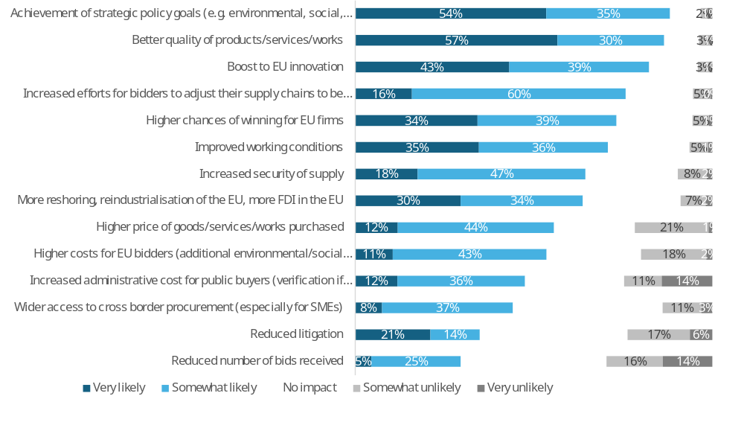
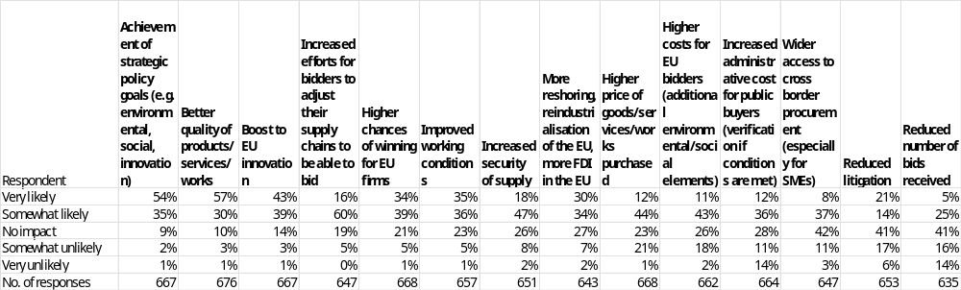
Note: Single-choice responses only; results reflect replies from those who answered.
Source: Public Consultations on public procurement reform. Commission own analysis.

In response to the question “How likely do you believe the following outcomes would occur if the future general legislative framework incentivised BPQR?”, respondents most often expect better achievement of strategic policy goals (e.g. environmental, social, innovation) (89%: 54% very likely, 35% somewhat likely) and better quality of products, services and works (87%: 57% very likely, 30% somewhat likely). High shares also anticipate a boost to EU innovation (82%: 43% very likely, 39% somewhat likely) and increased efforts for bidders to adjust their supply chains to be able to bid (76%: 16% very likely, 60% somewhat likely). Majorities consider increased security of supply (65%: 18% very likely, 47% somewhat likely), higher chances of winning for EU firms (73%: 34% very likely, 39% somewhat likely), improved working conditions (71%: 35% very likely, 36% somewhat likely), and more reshoring, reindustrialisation and FDI in the EU (64%: 30% very likely, 34% somewhat likely) as likely outcomes. On the cost side, a majority foresee higher costs for EU bidders due to additional environmental/social elements (54%: 11% very likely, 43% somewhat likely) and higher prices of goods, services and works purchased (56%: 12% very likely, 44% somewhat likely). Increased administrative cost for public buyers (verification if conditions are met) is also often expected (48%: 12% very likely, 36% somewhat likely). Lower positive expectations are reported for wider access to cross-border procurement (especially for SMEs) (45%: 8% very likely, 37% somewhat likely), reduced litigation (35%: 21% very likely, 14% somewhat likely), and reduced number of bids received (30%: 5% very likely, 25% somewhat likely).
Disagreement that these outcomes will occur (somewhat unlikely or very unlikely) is highest for reduced number of bids received (30%: 16% somewhat unlikely, 14% very unlikely), increased administrative cost for public buyers (25%: 11% somewhat unlikely, 14% very unlikely), higher prices of goods, services and works purchased (22%: 21% somewhat unlikely, 1% very unlikely), and higher costs for EU bidders (20%: 18% somewhat unlikely, 2% very unlikely). For reduced litigation, 23% disagree (17% somewhat unlikely, 6% very unlikely), and for wider access to cross-border procurement 14% disagree (11% somewhat unlikely, 3% very unlikely). For the “beneficial” outcomes, disagreement is comparatively low: 3–6% somewhat/very unlikely for achievement of strategic goals, better quality, EU innovation, adjusted supply chains, higher chances of winning for EU firms, improved working conditions, increased security of supply, and more reshoring/reindustrialisation/FDI.
Across all outcomes, the share of respondents expecting “no impact” ranges from 9–10% for achievement of strategic policy goals and better quality to 42–41% for wider access to cross-border procurement, reduced litigation, and reduced number of bids received. Intermediate “no impact” levels are reported for a boost to EU innovation (14%), increased efforts to adjust supply chains (19%), higher chances of winning for EU firms (21%), improved working conditions (23%), higher prices and higher costs for EU bidders (23–26%), increased security of supply (26%), increased administrative cost for public buyers (28%), and more reshoring, reindustrialisation and FDI in the EU (27%).
Table 92: Question: How likely do you believe the following outcomes would occur if the future general legislative framework incentivised BPQR?; percentage of respondents that indicated “very likely” or “somewhat likely” answers, by type of respondent.
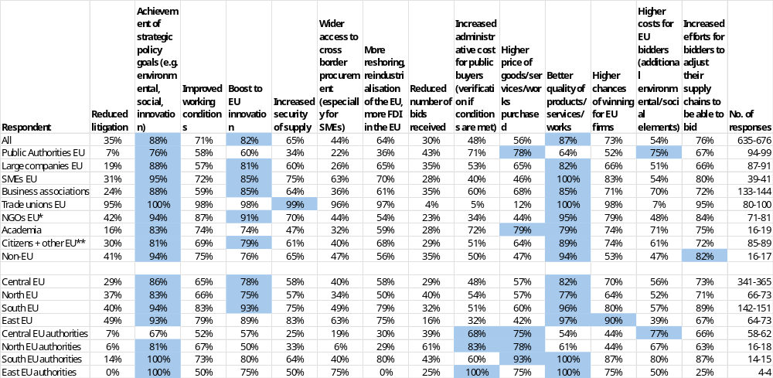
* NGOs + Environmental organisations; ** includes Consumer Organisations
Note: Single-choice responses only; results reflect replies from those who answered. Top three responses highlighted. The number of responses in the last column is shown as a range, as the number of replies varied per column. EU includes NO; Central EU: AT, BE, DE, FR, LU, NL; North EU: DK, FI, IE, SE and NO; South EU: CY, EL, ES, IT, MT, PT; East EU: BG, CZ, EE, HR, HU, LT, LV, PL, RO, SK; replies of only those who answered are provided
Source: Public Consultations on public procurement reform. Commission own analysis.

Respondents were asked how likely they believed different outcomes would be if the future general legislative framework incentivised the best price-quality ratio (BPQR). The figures refer to the combined shares of “very likely” and “somewhat likely” answers (other response options were also available but are not shown).
Among public authorities, the most likely outcomes were higher price of goods/services/works purchased (78%), achievement of strategic policy goals (e.g. environmental, social, innovation) (76%), higher costs for EU bidders (75%) and higher administrative cost for public buyers (71%). For other outcomes, perceived likelihood ranged from 7% to 67%. Very low likelihood was reported for reduced litigation (7%).
Among large companies, SMEs and business associations, better quality of products/services/works was consistently seen as a key likely outcome (large companies: 82%; SMEs: 100%; business associations: 85%), alongside achievement of strategic policy goals (88%; 95%; 88%) and a boost to EU innovation (81%; 85%; 85%). Across these three groups, perceived likelihood of the remaining outcomes ranged from 24% to 80%. Very low likelihood was reported for reduced litigation among large companies (19%) and business associations (24%).
Among trade unions and NGOs, the outcomes most often regarded as likely included achievement of strategic policy goals (trade unions: 100%; NGOs: 94%), better quality of products/services/works (100%; 95%), improved working conditions (98%; 87%) and a boost to EU innovation (98%; 91%). For these two groups, perceived likelihood of the other outcomes ranged from 4% to 99%. Very low likelihood was reported among trade unions for reduced number of bids received (4%), increased administrative cost for public buyers (5%), higher price of goods/services/works (12%) and higher costs for EU bidders (7%), and among NGOs for reduced number of bids received (23%) and increased administrative cost for public buyers (34%).
Among academia, citizens and other respondents, and non-EU respondents, the most likely outcomes were again achievement of strategic policy goals (academia: 83%; citizens and other respondents: 81%; non-EU respondents: 94%), better quality of products/services/works (79%; 89%; 94%) and, to a lesser extent, boosts to EU innovation (74%; 79%; 76%). Across these three groups, perceived likelihood of the remaining outcomes ranged from 16% to 94%. Very low likelihood was reported for reduced litigation among academia (16%).

Green public procurement (ESI options)
Figure 80: Question: To what extent do you agree with the following statements on green/environmentally friendly public procurement?; all replies.
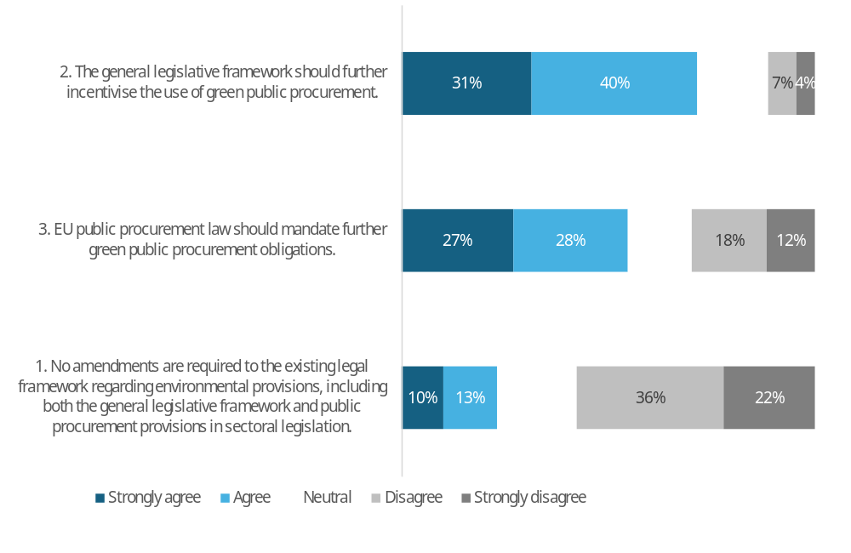
 | 1. No amendments are required to the existing legal framework regarding environmental provisions, including both the general legislative framework and public procurement provisions in sectoral legislation. | 2. The general legislative framework should further incentivise the use of green public procurement. | 3. EU public procurement law should mandate further green public procurement obligations.
Strongly agree | 10% | 31% | 27%
Agree | 13% | 40% | 28%
Neutral | 19% | 17% | 15%
Disagree | 36% | 7% | 18%
Strongly disagree | 22% | 4% | 12%
No. of responses | 748 | 763 | 756
Note: Single-choice responses only; results reflect replies from those who answered.
Source: Public Consultations on public procurement reform. Commission own analysis.

When asked about environmental provisions in public procurement (green procurement), the strongest support was for further incentives to encourage its use, with 72% in favour (31% strongly agree, 40% agree). This was followed by support for mandating additional green procurement obligations, backed by 55% (27% strongly agree, 28% agree).
The proposition that no amendments should be made to existing environmental provisions-whether in general or sectoral public procurement legislation-received support from less than a quarter of respondents, with a majority of 58% opposing this view.

Table 93: Question: To what extent do you agree with the following statements on green/environmentally friendly public procurement?; percentage of respondents that agree or strongly agree, by type of respondent.
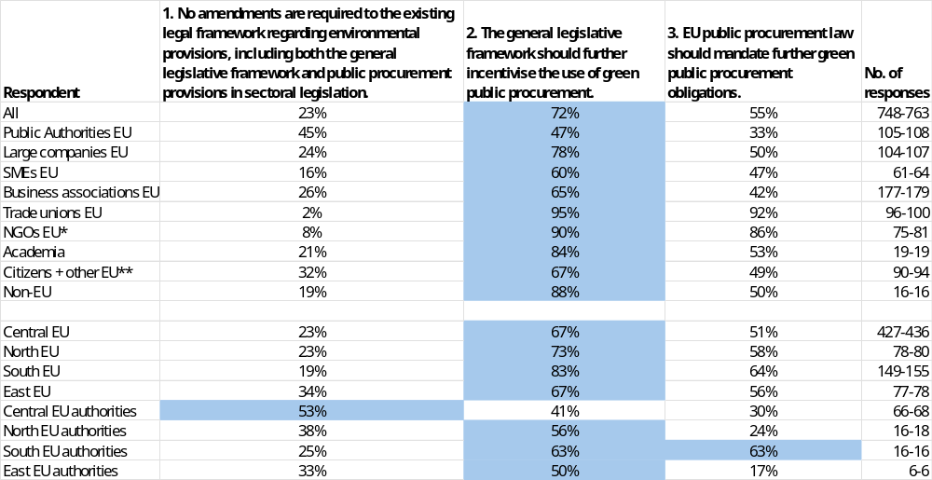
* NGOs + Environmental organisations; ** includes Consumer Organisations
Note: Single-choice responses only; results reflect replies from those who answered. Top response highlighted. The number of responses in the last column is shown as a range, as the number of replies varied per column. EU includes NO; Central EU: AT, BE, DE, FR, LU, NL; North EU: DK, FI, IE, SE and NO; South EU: CY, EL, ES, IT, MT, PT; East EU: BG, CZ, EE, HR, HU, LT, LV, PL, RO, SK; replies of only those who answered are provided
Source: Public Consultations on public procurement reform. Commission own analysis.

This table presents the breakdown of responses by different respondent groups. The figures represent the combined shares of "strongly agree" and "agree" responses (other response options were available but are not shown here). In all main groups, the strongest support was for further incentives to use green procurement.

Table 94: Question: If you "agree" or "strongly agree" with point 2 (Figure 80). Which of the following elements should be introduced to further incentivise the use of green public procurement?; percentage of answers to point 2, by type of respondent.
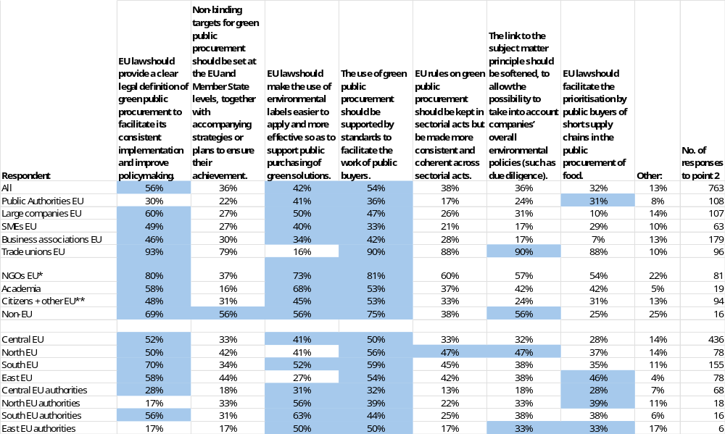
* NGOs + Environmental organisations; ** includes Consumer Organisations
Note: Multiple choice question; results reflect replies from those who answered. Top three responses highlighted. Point 2. The general legislative framework should further incentivise the use of green public procurement.
EU includes NO; Central EU: AT, BE, DE, FR, LU, NL; North EU: DK, FI, IE, SE and NO; South EU: CY, EL, ES, IT, MT, PT; East EU: BG, CZ, EE, HR, HU, LT, LV, PL, RO, SK; replies of only those who answered are provided
Source: Public Consultations on public procurement reform. Commission own analysis.

Respondents were asked, among those who agreed or strongly agreed that the regulatory framework should further incentivise the use of green public procurement, which elements should be introduced for that purpose. The figures below refer to the share of those agreeing respondents selecting each option.
The strongest support among all respondents was for clear definitions (56%) and green standards (54%), followed by easier use of environmental labels (42%). The remaining measures received support from around a third of respondents.
Among public authorities, the most frequently selected elements were easier use of environmental labels (41%) and green standards (36%). Support for other elements ranged from 17% to 31%, with notably lower levels for keeping rules in sectorial acts while making them more coherent (17%) and for non‑binding targets (22%).
Among large companies, SMEs and business associations, a clear legal definition of green public procurement was consistently important (60% for large companies, 49% for SMEs, 46% for business associations). Large companies also placed emphasis on making environmental labels easier to apply (50%), and on green standards (47%), while SMEs and business associations showed moderate support for standards (33% and 42%). Across these three groups, support for other elements ranged from 7% to 50%, with very low support for prioritising short food supply chains among large companies and business associations (7% - 10%).
Trade unions gave very high support (79% - 93%) to all measures except easier use of green labels (16%). NGOs most frequently supported standards (81%), a clear legal definition (80%), with all the remaining measures except non-binding targets receiving above 50% support.
Academia most often favoured easier use of environmental labels (68%), a clear legal definition (58%) and standards (53%). Citizens and other respondents showed balanced support for a definition (48%), standards (53%) and environmental labels (45%). Non‑EU respondents most frequently chose standards (75%) and a clear legal definition (69%).

Those who selected Other were asked to elaborate. A summary of their responses is presented below.
Public authorities
A significant proportion of public authorities who provided comments suggested that changes to incentivise green public procurement should involve simplifying procedures and reducing administrative burdens, with some proposing the inclusion of policy goals to promote environmentally and socially sustainable procurement. Many respondents emphasized the need for consistency and standardisation, with one example stating that "simplifying verification requirements through standardisation would provide significant support to contracting authorities and contracting entities". There was also a call for the procurement directives to better facilitate the use of strategic procurement for strategic objectives like green public procurement, with some advocating for the use of ESG ratings, such as Ecovadis, to weigh companies' environmental and social responsibility. A notable suggestion was to award contracts to the "most economically responsible tender" rather than the most economically advantageous one, which would provide increased legal certainty and incentive for an environmental approach. Some respondents also highlighted the importance of considering fair trade and social criteria in supply chains, particularly for non-European products. Overall, the comments from public authorities indicated a desire for a more streamlined and effective approach to green public procurement, with a focus on simplification, standardisation, and the inclusion of environmental and social considerations.
EU companies and business associations
A significant proportion of EU companies and business associations who provided comments suggested that changes to incentivise green public procurement should involve setting binding targets and providing clear guidance on green criteria, with many emphasizing the need for a harmonized approach across the EU to avoid unnecessary administrative burdens. Some respondents, advocated for the use of existing frameworks like the Ecodesign for Sustainable Products Regulation and the Digital Product Passport to ensure a workable legislative framework. Many companies, supported the use of binding targets for green public procurement, accompanied by clear strategies, to provide legal certainty and drive measurable environmental outcomes. There was also a call for the inclusion of green criteria in public procurement, with some suggesting that these criteria should be outcome-based, proportionate, and linked to the contract. A few companies, emphasized the need for mandatory green public procurement, while others, suggested that incentives should be provided to manufacturers who have decarbonized their industries. Some respondents, highlighted the importance of considering the total cost of ownership and the life cycle costs of products, rather than just the initial price, to ensure that green procurement is effective. Overall, the comments from EU companies and business associations indicated a desire for a more streamlined and effective approach to green public procurement, with a focus on harmonization, clarity, and incentives for sustainable practices, as one respondent noted, "the new directive should reward manufacturers who have decarbonized their industries".
EU NGOs, environmental organisations and trade unions
A significant proportion of EU NGOs, environmental organisations, and trade unions who provided comments suggested that changes to incentivise green public procurement should involve setting binding targets for green public procurement at EU and Member State level, together with accompanying strategies or plans to ensure their achievement, as stated by one respondent, "binding targets for green public procurement should be set at EU and Member State level, together with corresponding strategies or plans to ensure their achievement". Many respondents advocated for the introduction of clear and robust environmental and climate requirements, including the use of lifecycle costing methodologies and the Best Price-Quality and Sustainability Ratio (BPQ&S) as the default award criterion for public contracts. Some respondents, suggested redefining the Most Economically Advantageous Tender (MEAT) criteria as the Most Advantageous Tender (MAT) to provide greater flexibility for social and environmental considerations. There was also a call for the inclusion of animal welfare standards as a criterion in public procurement procedures, particularly for food procurements, with one respondent noting that "short supply chains, in themselves, do not guarantee higher animal welfare outcomes in public food procurement". A few respondents emphasized the need to prioritize sustainability criteria, including those related to circular economy objectives, and to promote negotiated procedures for more flexible requirements and specifications. Overall, the comments from EU NGOs, environmental organisations, and trade unions indicated a desire for a more ambitious and effective approach to green public procurement, with a focus on binding targets, clear environmental and climate requirements, and the use of lifecycle costing methodologies, as one respondent noted, "price-only awards rarely deliver value for money, and should be strictly limited and replaced with the best price-quality ratio (BPQR)".
All other respondents
Respondents from the 'All other respondents' group who provided comments on which other changes should be introduced to further incentivise the use of green public procurement, were essentially asking for adjustments to existing regulations to better promote environmentally friendly practices. The comments reveal a predominant concern for establishing binding targets for green public procurement, particularly for sustainable plastics, at both EU and Member State levels, with many emphasizing the need for accompanying strategies or action plans to ensure effective implementation. Some respondents suggest incorporating policy goals that promote environmentally and socially sustainable procurement. However, a minority argue against a "one-size-fits-all" approach, instead advocating for principles that allow contracting authorities to apply green public procurement methodologies on a case-by-case basis, citing potential restrictions, delays, or increased costs. For instance, one comment notes that rules creating "artificial restrictions" should not be adopted. Additionally, there are suggestions for introducing templates for BPQR criteria and verification methods, incentivising the reuse of existing solutions, and providing free access to a central database of green procurement criteria and case studies. Some respondents also propose offering financial incentives for public buyers and bidders that exceed green procurement targets, while others believe that each Member State should retain control over the level of sustainable development requirements, suggesting legal solutions to facilitate the use of short supply chains. As one respondent puts it, "EU rules on green public procurement should not be based on a 'one-size-fits-all' approach," highlighting the tension between uniform regulations and flexible application.

Table 95: Question: If you "agree" or "strongly agree" with point 3 (Figure 80). Which of the following elements should be made mandatory?; percentage of answers to point 3, by type of respondent.
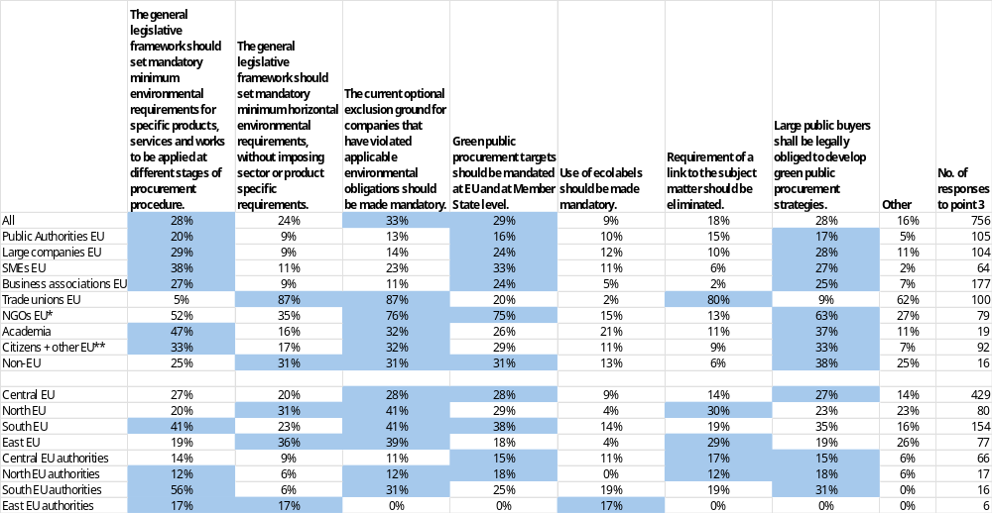
* NGOs + Environmental organisations; ** includes Consumer Organisations
Note: Multiple choice question; results reflect replies from those who answered. Top three responses highlighted. Point 3. EU public procurement law should mandate further green public procurement obligations.
EU includes NO; Central EU: AT, BE, DE, FR, LU, NL; North EU: DK, FI, IE, SE and NO; South EU: CY, EL, ES, IT, MT, PT; East EU: BG, CZ, EE, HR, HU, LT, LV, PL, RO, SK; replies of only those who answered are provided
Source: Public Consultations on public procurement reform. Commission own analysis.

Respondents who agreed or strongly agreed that more regulatory measures are needed for green public procurement were asked which elements should be made mandatory. Figures refer to the share of these respondents selecting each option.
A third of all respondents supported making exclusion grounds mandatory for companies violating environmental obligations. Easier use of environmental labels received slightly lower support at 29%, closely followed by mandatory product-specific minimum requirements and obligatory green procurement strategies for large buyers, both at 28%.
Among public authorities, mandatory minimum environmental requirements for specific products, services and works (20%), mandatory targets at EU and national level (16%) and legal obligations for large public buyers to develop green public procurement strategies (17%) were most often selected.
Among large companies, SMEs and business associations, mandatory product-specific environmental requirements were most frequently chosen (29% for large companies, 38% for SMEs, 27% for business associations), followed by mandatory targets (24%- 33%) and mandatory strategies for large public buyers (25–28%).
Trade unions strongly backed mandatory horizontal environmental requirements and mandatory exclusion grounds for environmental violations (both 87%), and removal of the link to the subject matter (80%). NGOs most often supported mandatory exclusion grounds (76%), mandatory targets (75%) and mandatory strategies (63%).
Among academia, citizens and other respondents, and non-EU respondents, mandatory product-specific requirements, mandatory exclusion grounds and mandatory strategies for large public buyers drew the most support (roughly 25–47%, depending on the group).

Those who selected Other were asked to elaborate. A summary of their responses is presented below.
Public authorities
Public authorities respondents who provided comments on which other mandatory obligations regarding the use of green public procurement should be introduced, were essentially seeking to integrate environmental and social considerations into procurement decisions. Many respondents suggest amending the directives to require binding sustainable development objectives, incorporating social and environmental considerations horizontally across future directives, and considering the durability of products and materials used in contracts. Some propose making it compulsory to take account of sustainable development objectives, leaving it to the buyer to determine the most appropriate considerations for each contract. However, a minority argue against prescribing specific requirements, such as BPQR weighting or technical requirements, to achieve EU strategic objectives, stating that this would unnecessarily restrict freedom of procurement. For instance, one comment notes that "the procurement directives should focus solely on procurement" and that contracting authorities should determine their own objectives and methods. Another respondent suggests simplifying the discussion around ESG (environmental, social, and corporate governance) ratings by introducing a "mandatory weighing 10% of the ESG Ratings of a Company" in platforms like Ecovadis. There is also a call to clarify the legislation concerning the link to the subject matter of the contract, rather than abolishing it, to ensure that considerations relating to durability are presumed to be related and proportionate to the contract.
EU companies and business associations
EU companies and business associations respondents provided comments on which other mandatory obligations regarding the use of green public procurement should be introduced, essentially seeking to promote environmentally friendly and circular economy practices. Many respondents suggest introducing mandatory minimum environmental requirements, such as recycled content obligations, circularity requirements, and carbon footprint considerations, to be applied at different stages of the procurement procedure. Some propose incorporating default carbon values into purchasing criteria, assessing full lifecycle costs, and recognizing environmental contributions that go beyond legal minima. There is also a call for sector-specific requirements, rather than horizontal ones, to ensure targeted and effective implementation. For instance, one comment suggests introducing "bio-based content targets" and embedding Green Public Procurement (GPP) criteria to allow companies to demonstrate compliance using their Product Carbon Footprint data. Another respondent advocates for making the integration of non-price criteria, such as green and social criteria, mandatory in public procurement, and ensuring they influence award decisions through quantifiable scoring systems. However, some respondents caution that mandatory requirements should be accompanied by practical guidance, support, and capacity-building for public buyers to ensure feasible implementation, and that requirements should be proportionate and harmonized at the EU level to avoid fragmentation and increased compliance costs. As one respondent puts it, "clear rules on checks of green claims to avoid 'organised green washing'" are necessary, and another notes that "criteria developed under Public Procurement should be measurable, objective and harmonized at the EU level."
EU NGOs, environmental organisations and trade unions
EU NGOs, environmental organisations, and trade unions respondents provided comments on which other mandatory obligations regarding the use of green public procurement should be introduced, emphasizing the need to prioritize environmental and social considerations. A dominant view is that "Technical Standards" (Annex VII) should not address employment and social issues, as employment law, collective agreements, and human rights standards should take precedence over any label or certification. Many respondents stress that green public procurement must be accompanied by measures to promote quality jobs, collective bargaining, and good working conditions, including for subcontracting. There is a strong call for mandatory horizontal environmental requirements to provide clear direction to Member States and contracting authorities, supporting uniform implementation and advancing environmental objectives. Some respondents propose introducing binding EU-wide targets and strategies, setting minimum sustainability criteria based on scientific evidence, and assessing full lifecycle costs. Others suggest promoting fair trade, using credible third-party verified certifications and labels, and applying circular public procurement criteria to high-impact sectors. For instance, one comment notes that "environmental public procurement cuts emissions, reduces waste, and supports circularity by choosing low-impact goods and services," while another suggests that "integrating Fair Trade strengthens these gains" by ensuring minimum prices, safer production, and ecosystem protection for farmers. However, there is also a recognition that mandatory requirements should be balanced with flexibility to allow for the use of different certifications and labels, and that the "link to the subject matter" rule should be clarified to enable greater flexibility. As one respondent puts it, "greater flexibility is crucial to allow the use of credible, third-party verified certifications and labels that refer to the organization's sustainability performance."
All other respondents
All other respondents provided comments on which other mandatory obligations regarding the use of green public procurement should be introduced, emphasizing the need for a range of measures to promote sustainability and social responsibility. Many respondents suggest introducing technical requirements, such as carbon footprint measurement and reporting, certification, and compulsory training for public buyers in Life Cycle Analysis and sustainability criteria. Some propose binding social criteria, including respect for EU labour standards and gender equality, as well as market reserves for innovative SMEs and digital post-sale monitoring using IoT sensors. There are also calls for centralisation of green purchases, creation of cross-border central purchasing bodies, and removal of discretionary grounds for exclusion. A few respondents emphasize the importance of promoting quality jobs and collective bargaining, including for subcontracting, and suggest that "Technical Standards" should not address employment and social issues, as employment law, collective agreements, and human rights standards should take precedence. Additionally, some respondents propose mandating standard templates and verification methods for environmental criteria, creating joint procurement consortia, and providing technical helpdesks and training for public procurement stakeholders. For instance, one comment suggests that carbon footprint should be measured and reported, while another proposes "mandatory earmarking of a minimum percentage of the annual budget for 'Made in Europe' solutions." Overall, the comments highlight the need for a comprehensive and multi-faceted approach to promoting green public procurement.

9.8.1. Green public procurement impacts
Figure 81: Question: How likely do you believe the following outcomes would occur as a result of further incentivising the use of green public procurement?; all replies.
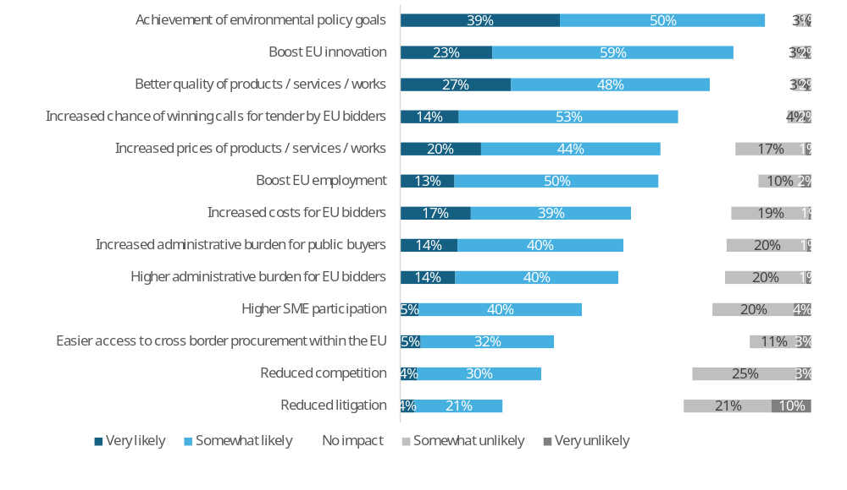
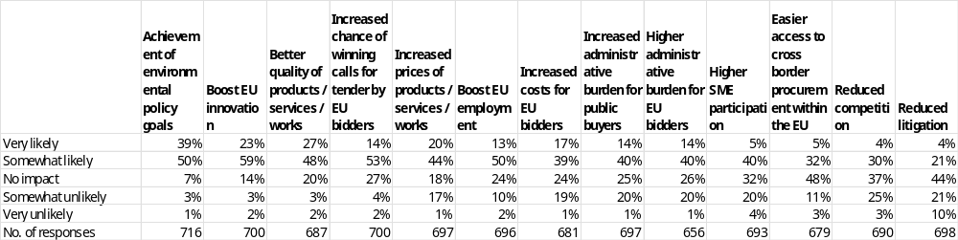
Note: Single-choice responses only; results reflect replies from those who answered.
Source: Public Consultations on public procurement reform. Commission own analysis.

In response to the question “How likely do you believe the following outcomes would occur as a result of further incentivising the use of green public procurement?”, respondents most often expect achievement of environmental policy goals (89%: 39% very likely, 50% somewhat likely), followed by a boost to EU innovation (82%: 23% very likely, 59% somewhat likely) and better quality of products, services and works (75%: 27% very likely, 48% somewhat likely). Majorities also foresee increased chance of winning calls for tender by EU bidders (67%: 14% very likely, 53% somewhat likely), increased prices of products, services and works (64%: 20% very likely, 44% somewhat likely), a boost to EU employment (63%: 13% very likely, 50% somewhat likely), increased costs for EU bidders (56%: 17% very likely, 39% somewhat likely), increased administrative burden for public buyers (54%: 14% very likely, 40% somewhat likely), and higher administrative burden for EU bidders (54%: 14% very likely, 40% somewhat likely). Lower positive expectations are reported for higher SME participation (45%: 5% very likely, 40% somewhat likely), easier access to cross-border procurement within the EU (37%: 5% very likely, 32% somewhat likely), reduced competition (34%: 4% very likely, 30% somewhat likely), and reduced litigation (25%: 4% very likely, 21% somewhat likely).
Disagreement that these outcomes will occur (somewhat unlikely or very unlikely) is highest for reduced litigation (31%: 21% somewhat unlikely, 10% very unlikely), reduced competition (28%: 25% somewhat unlikely, 3% very unlikely), higher SME participation (24%: 20% somewhat unlikely, 4% very unlikely), increased administrative burden for public buyers (21%: 20% somewhat unlikely, 1% very unlikely), higher administrative burden for EU bidders (21%: 20% somewhat unlikely, 1% very unlikely), increased costs for EU bidders (20%: 19% somewhat unlikely, 1% very unlikely), and increased prices of products, services and works (18%: 17% somewhat unlikely, 1% very unlikely). Lower levels of disagreement are seen for easier access to cross-border procurement (14%: 11% somewhat unlikely, 3% very unlikely), boost to EU employment (12%: 10% somewhat unlikely, 2% very unlikely), increased chance of winning calls for tender by EU bidders (6%: 4% somewhat unlikely, 2% very unlikely), boost to EU innovation (5%: 3% somewhat unlikely, 2% very unlikely), better quality (5%: 3% somewhat unlikely, 2% very unlikely), and achievement of environmental policy goals (4%: 3% somewhat unlikely, 1% very unlikely).
Across all outcomes, the share of respondents expecting “no impact” ranges from 7% for achievement of environmental policy goals to 48% for easier access to cross-border procurement and 44% for reduced litigation. Intermediate “no impact” levels are reported for boost to EU innovation (14%), better quality (20%), increased prices (18%), increased chance of winning for EU bidders (27%), boost to EU employment (24%), increased costs for EU bidders (24%), increased administrative burden for public buyers (25%), higher administrative burden for EU bidders (26%), higher SME participation (32%), and reduced competition (37%).
Table 96: Question: How likely do you believe the following outcomes would occur as a result of further incentivising the use of green public procurement?; percentage of respondents that indicated “very likely” or “somewhat likely” answers, by type of respondent.
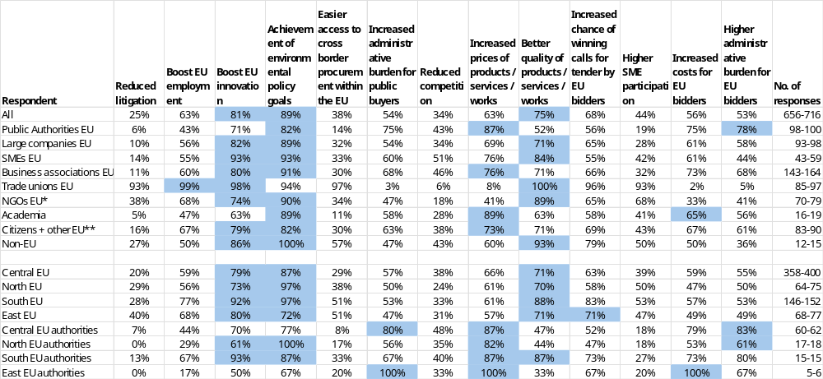
* NGOs + Environmental organisations; ** includes Consumer Organisations
Note: Single-choice responses only; results reflect replies from those who answered. Top three responses highlighted. The number of responses in the last column is shown as a range, as the number of replies varied per column. EU includes NO; Central EU: AT, BE, DE, FR, LU, NL; North EU: DK, FI, IE, SE and NO; South EU: CY, EL, ES, IT, MT, PT; East EU: BG, CZ, EE, HR, HU, LT, LV, PL, RO, SK; replies of only those who answered are provided
Source: Public Consultations on public procurement reform. Commission own analysis.

Respondents were asked how likely they believed different outcomes would be as a result of further incentivising the use of green public procurement. The figures refer to the combined shares of “very likely” and “somewhat likely” answers (other response options were also available but are not shown).
Among public authorities, the outcomes most often seen as likely were increased prices of products, services or works (87%), achievement of environmental policy goals (82%), higher administrative burden for EU bidders (78%) and for public buyers (75%). For other outcomes, perceived likelihood ranged from 6% to 75%. Very low likelihood was reported for reduced litigation (6%).
Among large companies, SMEs and business associations, achievement of environmental policy goals (large companies: 89%; SMEs: 93%; business associations: 91%) and a boost to EU innovation (82%; 93%; 80%) were consistently among the most likely outcomes. All three also pointed to better quality of products, services or works (71% to 84%), and to a lesser extent highlighted increased prices (69% to 76%). Across these three groups, perceived likelihood of the remaining outcomes ranged from 10% to 93%. Very low likelihood was reported for reduced litigation (10% to 14%).
Among trade unions and NGOs, trade unions most frequently regarded better quality of products, services or works (100%), boosts to EU employment (99%) and innovation (98%) as likely outcomes. NGOs most often pointed to achievement of environmental policy goals (90%), better quality (89%) and a boost to EU innovation (74%). For these two groups, perceived likelihood of the remaining outcomes ranged from 2% to 99%. Very low likelihood was reported among trade unions for increased administrative burden for public buyers (3%), reduced competition (6%), increased prices (8%), increased costs for EU bidders (2%) and higher administrative burden for EU bidders (5%), and among NGOs for reduced competition (18%).
Among academia, citizens and other respondents, and non-EU respondents, the outcomes most often seen as likely were achievement of environmental policy goals (academia: 89%; citizens and other respondents: 82%; non-EU respondents: 100%) and a boost to EU innovation (63%; 79%; 86%) and increase in prices (89%; 73%; 60%). Across these three groups, perceived likelihood of the remaining outcomes ranged from 5% to 71%. Very low likelihood was reported for reduced litigation among academia (5%).

Respondents were invited to identify any other likely impacts. A summary of their responses is presented below.
Public authorities
Approximately a tenth of public authorities respondents provided comments on the likely impacts of further incentivizing the use of green public procurement, highlighting both positive and negative effects. Many respondents believe that incentivizing green public procurement can lead to various benefits, such as reduced overall expenditure for public authorities, increased use of sustainable products and services, and promotion of regional economies. Some suggest that clear and mandatory rules can decrease administrative burdens for public buyers, as they provide a clear framework for action. Additionally, respondents propose various measures to facilitate green public procurement, including increased flexibility in contract modifications, the use of negotiation procedures without prior notice, and the development of tools like the carbon performance scale. However, others warn about potential negative impacts, such as increased administrative burdens and costs, particularly if verification obligations are imposed on contracting authorities. There are also concerns about the complexity of environmental criteria and the need for harmonization and simplification of certifications and standards. For instance, one comment notes that "the value of the contract should not be calculated solely on the basis of price," as increased environmental considerations can reduce overall expenditure. Another respondent suggests that "incentivising the use of European products is strongly preferable to mandating it," as mandatory requirements could delay the transition to zero-emission fleets and increase costs. Overall, the comments highlight the need for a balanced approach that promotes green public procurement while minimizing administrative burdens and ensuring flexibility for contracting authorities.
EU companies and business associations
Approximately a fifth of EU companies and business associations respondents provided comments on the likely impacts of further incentivizing the use of green public procurement, highlighting both positive and negative effects. Many respondents believe that incentivizing green public procurement can lead to various benefits, such as increased demand for sustainable products, reduced greenhouse gas emissions, and improved competitiveness of European suppliers. Some propose introducing sector-specific requirements, harmonized criteria, and standardized environmental labels to facilitate the use of green public procurement. Others suggest that a progressive and incentive-based approach, rather than mandatory requirements, would be more effective in promoting environmentally responsible procurement. However, some respondents caution that overly complex processes, burdensome certifications, and rigid criteria can place SMEs at a disadvantage and discourage them from competing. Additionally, there are concerns about the potential increase in costs, administrative burdens, and competitiveness risks for EU value chains. For instance, one comment notes that "incentivising green public procurement can increase legal certainty and market predictability, fostering investments in EU-based circular and bio-based value chains," while another suggests that "mandatory green criteria are needed to push the entire market towards higher environmental standards." Some respondents also emphasize the need for a level playing field, with one comment stating that "the comparison of carbon values between European products and imported goods should be based on default values communicated by the Commission rather than those provided by importers." Overall, the comments highlight the need for a balanced approach that promotes green public procurement while minimizing administrative burdens and ensuring flexibility for contracting authorities.
EU NGOs, environmental organisations and trade unions
Approximately a quarter of EU NGOs, environmental organisations, and trade unions respondents provided comments on the likely impacts of further incentivizing the use of green public procurement, highlighting both positive and negative effects. Many respondents believe that incentivizing green public procurement can lead to various benefits, such as reduced greenhouse gas emissions, improved public health, and increased competitiveness of European bidders. Some propose introducing mandatory requirements, harmonized criteria, and standardized environmental labels to facilitate the use of green public procurement. Others suggest that incentivizing green public procurement can save money, particularly when public authorities award contracts based on life-cycle costing, and can act as a demand-pull instrument for innovation, creating predictable demand for environmentally friendly goods, works, and services. However, some respondents caution that incentivizing green public procurement alone may not be enough to drive significant changes, and that mandatory requirements are needed to provide regulatory certainty and ensure a level playing field. Additionally, there are concerns about the potential increase in administrative burdens, costs, and litigation, particularly for SMEs. For instance, one comment notes that "incentivising green public procurement is critical to addressing the EU agri-food system's current challenges," while another suggests that "mandatory requirements are needed to achieve tangible results and provide regulatory certainty." Some respondents also emphasize the need for a more holistic approach, considering both environmental and social aspects, and ensuring that green public procurement is accessible to social economy actors, such as reuse, repair, and recycling enterprises. Overall, the comments highlight the need for a balanced approach that promotes green public procurement while minimizing administrative burdens and ensuring flexibility for contracting authorities.
All other respondents
Approximately a tenth of all other respondents provided comments on the likely impacts of further incentivizing the use of green public procurement, highlighting both positive and negative effects. Many respondents believe that incentivizing green public procurement can lead to various benefits, such as stimulating demand for compostable packaging, supporting the development of a European circular economy, and delivering environmental benefits. Some propose introducing financial incentives, such as an EU co-funding fund, to reward entities that achieve sustainability targets. Others suggest creating a central library of eco-labelled products, integrating automatic life cycle cost calculators, and providing simplified standard contracts to reduce administrative burdens. However, some respondents caution that incentivising green public procurement alone may not be enough to drive significant changes, and that a more holistic approach is needed, considering both environmental and social aspects. Additionally, there are concerns about the potential increase in costs, and the need for a level playing field. Some respondents also emphasize the importance of promoting innovation, quality, and environmental outcomes, while ensuring that green public procurement does not favour EU bidders by origin and remains consistent with open competition. For instance, one comment suggests that "incentivising green public procurement can deliver meaningful environmental benefits when criteria are linked to verifiable lifecycle performance rather than vendor claims," while another notes that "taking account of the environment in purchasing should not be regarded as generating additional costs, since it obliges purchasers to rethink its definition of needs." Overall, the comments highlight the need for a balanced approach that promotes green public procurement while minimizing administrative burdens and ensuring flexibility for contracting authorities.

Figure 82: Question: How likely do you believe the following outcomes would occur as a result of mandating further green public procurement obligations?; all replies.
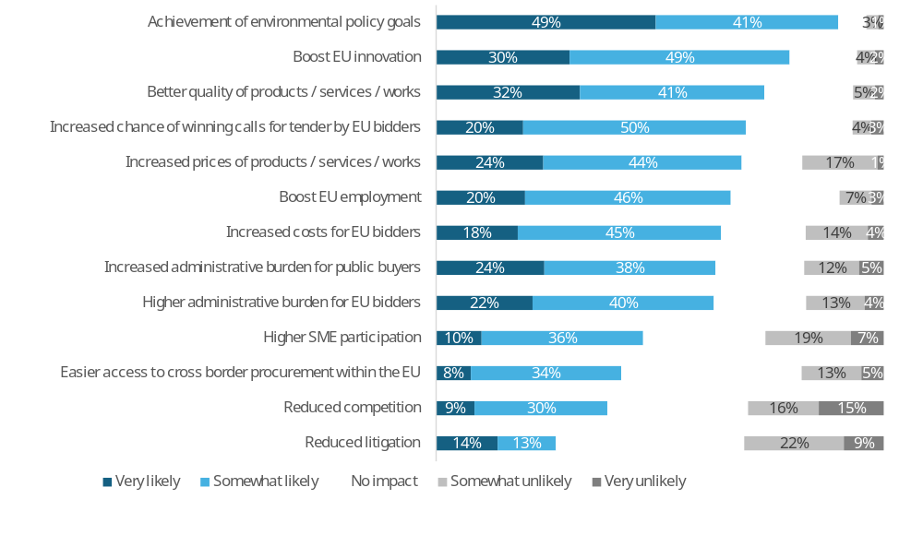
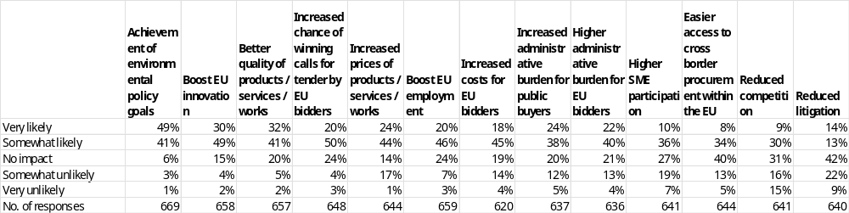
Note: Single-choice responses only; results reflect replies from those who answered.
Source: Public Consultations on public procurement reform. Commission own analysis.

In response to the question “How likely do you believe the following outcomes would occur as a result of mandating further green public procurement obligations?”, respondents most often expect achievement of environmental policy goals (90%: 49% very likely, 41% somewhat likely), followed by a boost to EU innovation (79%: 30% very likely, 49% somewhat likely) and better quality of products, services and works (73%: 32% very likely, 41% somewhat likely). Majorities also foresee increased chance of winning calls for tender by EU bidders (70%: 20% very likely, 50% somewhat likely), increased prices of products, services and works (68%: 24% very likely, 44% somewhat likely), a boost to EU employment (66%: 20% very likely, 46% somewhat likely), increased costs for EU bidders (63%: 18% very likely, 45% somewhat likely), and increased administrative burden for public buyers (62%: 24% very likely, 38% somewhat likely). Higher administrative burden for EU bidders is similarly expected (62%: 22% very likely, 40% somewhat likely). Lower but still substantial shares see higher SME participation (46%: 10% very likely, 36% somewhat likely) and easier access to cross-border procurement within the EU (42%: 8% very likely, 34% somewhat likely) as likely, while reduced competition (39%: 9% very likely, 30% somewhat likely) and reduced litigation (27%: 14% very likely, 13% somewhat likely) attract the lowest positive expectations.
Disagreement that these outcomes will occur (somewhat unlikely or very unlikely) is highest for reduced litigation (31%: 22% somewhat unlikely, 9% very unlikely), reduced competition (31%: 16% somewhat unlikely, 15% very unlikely), higher SME participation (26%: 19% somewhat unlikely, 7% very unlikely), easier access to cross-border procurement (18%: 13% somewhat unlikely, 5% very unlikely), increased prices of products, services and works (18%: 17% somewhat unlikely, 1% very unlikely), increased costs for EU bidders (18%: 14% somewhat unlikely, 4% very unlikely), higher administrative burden for EU bidders (17%: 13% somewhat unlikely, 4% very unlikely), increased administrative burden for public buyers (17%: 12% somewhat unlikely, 5% very unlikely), and boost to EU employment (10%: 7% somewhat unlikely, 3% very unlikely). Lower levels of disagreement are recorded for increased chance of winning for EU bidders (7%: 4% somewhat unlikely, 3% very unlikely), boost to EU innovation (6%: 4% somewhat unlikely, 2% very unlikely), better quality (7%: 5% somewhat unlikely, 2% very unlikely), and achievement of environmental policy goals (4%: 3% somewhat unlikely, 1% very unlikely).
Across all outcomes, the share of respondents expecting “no impact” ranges from 6% for achievement of environmental policy goals to 42% for reduced litigation and 40% for easier access to cross-border procurement. Intermediate “no impact” levels are reported for boost to EU innovation (15%), better quality (20%), increased chance of winning for EU bidders (24%), increased prices (14%), boost to EU employment (24%), increased costs for EU bidders (19%), increased administrative burden for public buyers (20%), higher administrative burden for EU bidders (21%), higher SME participation (27%), and reduced competition (31%).
Table 97: Question: How likely do you believe the following outcomes would occur as a result of mandating further green public procurement obligations?; percentage of respondents that indicated “very likely” or “somewhat likely” answers, by type of respondent.
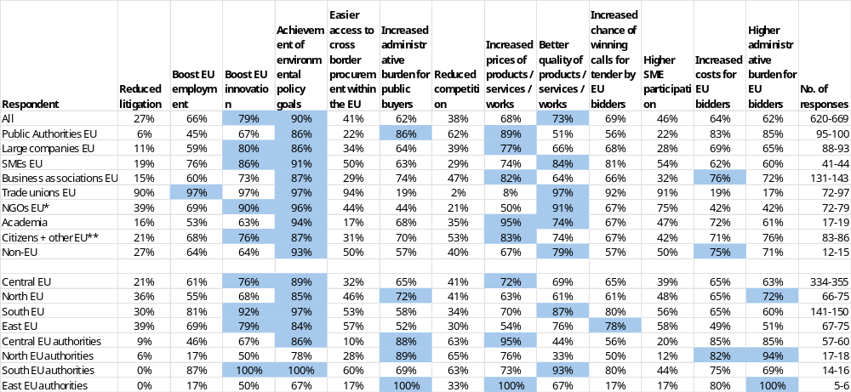
* NGOs + Environmental organisations; ** includes Consumer Organisations
Note: Single-choice responses only; results reflect replies from those who answered. Top three responses highlighted. The number of responses in the last column is shown as a range, as the number of replies varied per column. EU includes NO; Central EU: AT, BE, DE, FR, LU, NL; North EU: DK, FI, IE, SE and NO; South EU: CY, EL, ES, IT, MT, PT; East EU: BG, CZ, EE, HR, HU, LT, LV, PL, RO, SK; replies of only those who answered are provided
Source: Public Consultations on public procurement reform. Commission own analysis.

Respondents were asked how likely they believed different outcomes would be as a result of mandating further green public procurement obligations. The figures refer to the combined shares of “very likely” and “somewhat likely” answers (other response options were also available but are not shown).
Among public authorities, the outcomes most often seen as likely were increased prices of products, services or works (89%), increased administrative burden for public buyers (86%), higher administrative burden for EU bidders (85%) and achievement of environmental goals (86%). For other outcomes, perceived likelihood ranged from 6% to 86%. Very low likelihood was reported for reduced litigation (6%).
Among large companies, SMEs and business associations, the outcomes most consistently regarded as likely were achievement of environmental policy goals (large companies: 86%; SMEs: 91%; business associations: 87%), boosts to EU innovation (80%; 86%; 73%) and increased prices (77%; 74%; 82%). SMEs also highlighted better quality of products, services or works (84%) and increased chance of winning calls for tender by EU bidders (81%). Across these three groups, perceived likelihood of the remaining outcomes ranged from 15% to 91%. Very low likelihood was reported for reduced litigation (11% - 19%).
Trade unions most frequently regarded boosts to EU employment and innovation, achievement of environmental policy goals and better quality of products, services or works (each 97%) as likely outcomes. NGOs most often pointed to achievement of environmental policy goals (96%), better quality (91%) and a boost to EU innovation (90%). For these two groups, perceived likelihood of the remaining outcomes ranged from 2% to 96%. Very low likelihood was reported among trade unions for reduced competition (2%), increased prices (8%), increased administrative burden for public buyers (19%) and for EU bidders (19%), and among NGOs for reduced competition (21%).
Among academia, citizens and other respondents, and non-EU respondents, the outcomes most often seen as likely were achievement of environmental policy goals (academia: 94%; citizens and other respondents: 87%; non-EU respondents: 93%). Academia and citizens and other respondents also pointed to increased prices (95% and 83%) and better quality (74% and 74%). Across these three groups, perceived likelihood of the remaining outcomes ranged from 16% to 95%. Very low likelihood was reported for reduced litigation among academia and citizens (16%-21%).

Respondents were invited to identify any other likely impacts. A summary of their responses is presented below.
Public authorities
Approximately a tenth of public authorities respondents provided comments on the likely impacts of mandating further green public procurement obligations, highlighting concerns about increased administrative burdens and complexity. Many respondents believe that the current legal framework for green procurement does not impede sustainable practices, and that local authorities should have greater autonomy to use procurement as a strategic tool tailored to their specific needs. Some caution that adding more obligations could complicate the purchasing approach for buyers and businesses, and that the EU should instead secure the choice of "the most economically responsible tender" and reduce administrative burdens. Others emphasize the importance of a voluntary approach to sustainable public procurement, as the challenges are mostly linked to professionalization and legal certainty concerns. For instance, one comment notes that "increased environmental considerations have the opposite effect, as they reduce the overall expenditure of the public authority," while another suggests that "incentivising the use of European products is strongly preferable to mandating it," as mandatory requirements could delay the transition to zero-emission fleets and increase costs. Some respondents also highlight the need for clear, mandatory sustainability standards for food procurement, and for a coordinating and advisory role for the EU to ensure that sectoral regulations do not impede procurement. Overall, the comments highlight the need for a balanced approach that promotes green public procurement while minimizing administrative burdens and ensuring flexibility for contracting authorities.
EU companies and business associations
Approximately a seventh of EU companies and business associations respondents provided comments on the likely impacts of mandating further green public procurement obligations, highlighting both positive and negative effects. Many respondents believe that mandatory green public procurement obligations can accelerate the uptake of sustainable solutions, strengthen EU industrial ecosystems, and support the achievement of climate and circular economy objectives. Some propose introducing mandatory green criteria, such as minimum recycled content, and prioritizing local companies and "zero-mile contracts" to reduce carbon emissions and stimulate local economies. Others suggest that mandatory requirements should be preceded by detailed consultation and alignment with full life-cycle LCA rules and European standards. However, some respondents caution that mandatory green public procurement obligations can lead to increased costs, administrative burdens, and reduced competition, and may not be effective in achieving environmental objectives. For instance, one comment notes that "mandatory green public procurement risks narrowing supplier pools, raising costs and administrative burdens, and reducing competition, while delivering almost no decarbonisation benefits," while another suggests that "incentivizing green public procurement can deliver meaningful environmental benefits when criteria are linked to verifiable lifecycle performance rather than vendor claims." Some respondents also emphasize the need for a proportionate and sector-specific approach, taking into account the diversity of markets and the potential impact on SMEs. Overall, the comments highlight the need for a balanced approach that promotes green public procurement while minimizing administrative burdens and ensuring flexibility for contracting authorities.
EU NGOs, environmental organisations and trade unions
Approximately a quarter of EU NGOs, environmental organisations, and trade unions respondents provided comments on the likely impacts of mandating further green public procurement obligations, highlighting both positive and negative effects. Many respondents believe that mandatory green public procurement obligations can accelerate the uptake of sustainable solutions, reduce greenhouse gas emissions, and support the achievement of climate and circular economy objectives. Some propose introducing mandatory green criteria, such as minimum recycled content, and prioritizing local companies and "zero-mile contracts" to reduce carbon emissions and stimulate local economies. Others suggest that mandatory requirements should be preceded by detailed consultation and alignment with full life-cycle LCA rules and European standards. However, some respondents caution that mandatory green public procurement obligations can lead to increased costs, administrative burdens, and reduced competition, and may not be effective in achieving environmental objectives. Overall, the comments highlight the need for a balanced approach that promotes green public procurement while minimizing administrative burdens and ensuring flexibility for contracting authorities.
All other respondents
Approximately a tenth of all other respondents provided comments on the likely impacts of mandating further green public procurement obligations, highlighting both positive and negative effects. Many respondents believe that mandatory green public procurement obligations can contribute to the achievement of environmental and strategic objectives, such as reducing greenhouse gas emissions, promoting the use of renewable and circular materials, and supporting the development of a European circular economy. Some propose introducing mandatory green criteria, such as minimum recycled content, and prioritizing local companies and "zero-mile contracts" to reduce carbon emissions and stimulate local economies. Others suggest that mandatory requirements should be preceded by detailed consultation and alignment with full life-cycle LCA rules and European standards. However, some respondents caution that mandatory green public procurement obligations can lead to increased costs, administrative burdens, and reduced competition, and may not be effective in achieving environmental objectives. For instance, one comment notes that "the introduction of new mandatory criteria in public procurement to address strategic challenges should be avoided," while another suggests that "mandatory green public procurement obligations can drive environmental progress, but only if they are designed to avoid rigid, one-size-fits-all requirements." Some respondents also emphasize the need for a proportionate and sector-specific approach, taking into account the diversity of markets and the potential impact on SMEs. Overall, the comments highlight the need for a balanced approach that promotes green public procurement while minimizing administrative burdens and ensuring flexibility for contracting authorities.

Social considerations in public procurement (ESI options)
Figure 83: Question: To what extent do you agree with the following statements concerning socially responsible public procurement?; all replies.
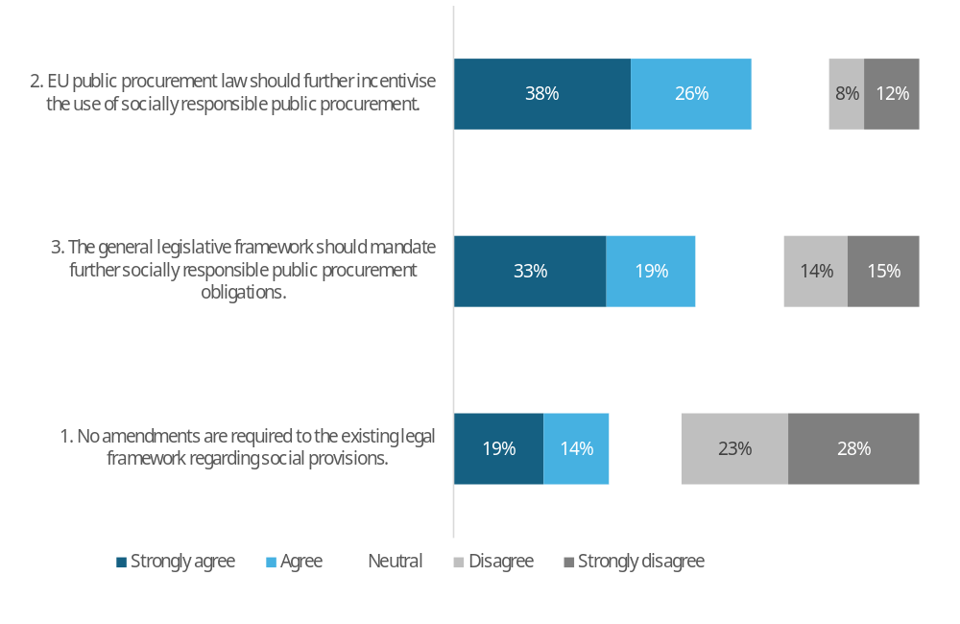
Respondent | 1. No amendments are required to the existing legal framework regarding social provisions. | 2. EU public procurement law should further incentivise the use of socially responsible public procurement. | 3. The general legislative framework should mandate further socially responsible public procurement obligations.
Strongly agree | 19% | 38% | 33%
Agree | 14% | 26% | 19%
Neutral | 16% | 17% | 19%
Disagree | 23% | 8% | 14%
Strongly disagree | 28% | 12% | 15%
No. of responses | 669 | 692 | 638
Note: Single-choice responses only; results reflect replies from those who answered.
Source: Public Consultations on public procurement reform. Commission own analysis.

When asked about socially responsible public procurement, the strongest support was for further incentives to encourage its use, with 64% in favour (38% strongly agree, 26% agree). This was followed by support for mandating additional socially responsible procurement obligations, backed by 52% (33% strongly agree, 19% agree).
The proposition that no amendments should be made to existing social provisions was supported by around one third of respondents, while a majority of 51% opposed this view.

Table 98: Question: To what extent do you agree with the following statements concerning socially responsible public procurement?; percentage of respondents that agree or strongly agree, by type of respondent.
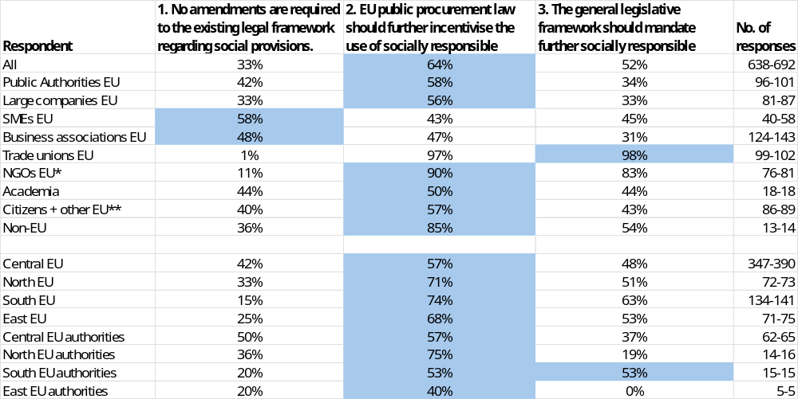
* NGOs + Environmental organisations; ** includes Consumer Organisations
Note: Single-choice responses only; results reflect replies from those who answered. Top response highlighted. The number of responses in the last column is shown as a range, as the number of replies varied per column. EU includes NO; Central EU: AT, BE, DE, FR, LU, NL; North EU: DK, FI, IE, SE and NO; South EU: CY, EL, ES, IT, MT, PT; East EU: BG, CZ, EE, HR, HU, LT, LV, PL, RO, SK; replies of only those who answered are provided
Source: Public Consultations on public procurement reform. Commission own analysis.

This table presents the breakdown of responses by different respondent groups. The figures represent the combined shares of "strongly agree" and "agree" responses (other response options were available but are not shown here).
Support for further incentives to use socially responsible procurement received over 50% backing from all respondent groups except SMEs and business associations, which instead favoured making no amendments. Trade unions and NGOs showed very high support for both incentivising and mandating socially responsible procurement, with approval ranging from 83% to 98%.

Table 99: Question: If you "agree" or "strongly agree" with point 2 (Figure 83). Which of the following elements should be introduced to further incentivise the use of socially responsible public procurement?; % of all answers to point 2, by type of respondent.
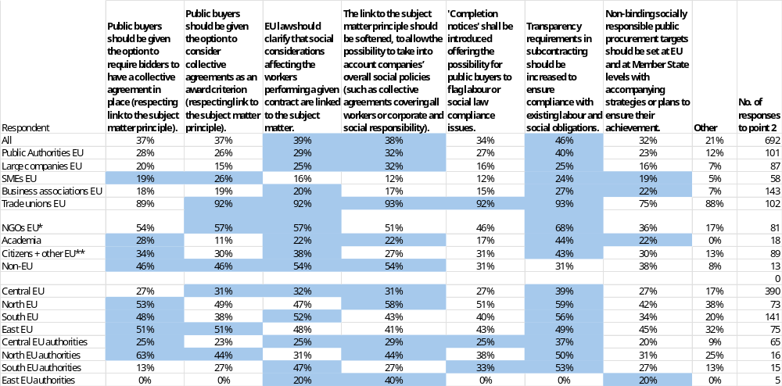
* NGOs + Environmental organisations; ** includes Consumer Organisations
Note: Multiple choice question; results reflect replies from those who answered. Top three responses highlighted. Point 2. EU public procurement law should further incentivise the use of socially responsible public procurement.
EU includes NO; Central EU: AT, BE, DE, FR, LU, NL; North EU: DK, FI, IE, SE and NO; South EU: CY, EL, ES, IT, MT, PT; East EU: BG, CZ, EE, HR, HU, LT, LV, PL, RO, SK; replies of only those who answered are provided
Source: Public Consultations on public procurement reform. Commission own analysis.

Respondents who agreed or strongly agreed that the framework should further incentivise the use of socially responsible public procurement were asked which elements should be introduced. Figures refer to the share of these respondents selecting each option.
Across all respondents, the elements most often selected were increased transparency requirements in subcontracting (46%), clarification that social considerations affecting workers performing a contract are linked to the subject matter (39%), and softening the link to the subject matter to consider companies’ overall social policies (38%) and option to require or consider collective agreements: (37% each). Non-binding targets and completion notices also attracted notable, but slightly lower, support (32% and 34%).
Among public authorities, preferences were more dispersed, with most support for increased subcontracting transparency (40%), followed by clarifying the link to the subject matter (29%) and option for public buyers to require or consider collective agreements (28% and 26%).
Among large companies, SMEs and business associations, support levels were generally modest. The most frequently selected elements were increased subcontracting transparency (25–27%) and, to a lesser extent, options to require or consider collective agreements and to introduce non-binding targets (mostly below 25%). Around one third of large companies favoured softening the link to the subject matter to consider companies’ overall social policies.
Trade unions showed consistently very high support (around or above 90%) for almost all elements NGOs most often supported increased subcontracting transparency (68%) and options to consider or require collective agreements and clarifying the link to the subject matter (each 54–57%).
Academia and citizens most often selected increased subcontracting transparency (44% and 43%). Non-EU respondents most frequently supported clarifying and softening the link to the subject matter (both 54%) and options to require or consider collective agreements (both 46%).

Those who selected Other were asked to elaborate. A summary of their responses is presented below.
Public authorities
Public authorities respondents provided comments on which other changes should be introduced to further incentivise the use of socially responsible public procurement, emphasizing the need for clearer guidelines and flexibility in applying social criteria. Many respondents suggest that the EU should provide incentives for contracting authorities to use human rights and environmental due diligence (HREDD) in a proportionate and risk-based way, and that differences in product categories, risk profiles, and company scale and maturity should be taken into account. Some propose introducing mandatory weighing of ESG ratings, such as a 10% weighting of a company's ESG rating in the tender evaluation process. Others suggest allowing public buyers to consider collective agreements as an eligibility criterion, and giving them the option to limit the number of subcontractors. There are also calls for softening the "link to the subject matter" principle, which currently limits the ability to value broader societal impact, to allow contracting authorities to go beyond mandated requirements when appropriate. For instance, one comment notes that "the link to the subject matter principle should be softened, to make possible, e.g., to use an employment requirement for the contracting entity's general purpose," while another suggests that "clear European incentives on how to apply human rights and environmental due diligence in a proportionate and risk-based way would give contracting authorities more confidence to use these tools effectively." Overall, the comments highlight the need for a more flexible and nuanced approach to socially responsible public procurement, one that balances the need for clear guidelines with the need for contracting authorities to be able to respond to specific social and environmental challenges.
EU companies and business associations
EU companies and business associations respondents provided comments on which other changes should be introduced to further incentivise the use of socially responsible public procurement, highlighting the need for a balanced approach that promotes social responsibility while ensuring competitiveness and avoiding counter-productive effects. Many respondents emphasize the importance of maintaining the principle of the link with the subject matter of the contract, and that social requirements should be directly linked to the contract to avoid imposing too general or disconnected conditions that may exclude small and medium-sized enterprises (SMEs). Some propose enabling companies to value ongoing apprenticeship contracts to meet social clauses, and making it easier to exclude contractors who consistently underpay employees and have many breaches for work environment obligations. Others suggest that socially responsible public procurement should explicitly recognize the societal value of open, interoperable, and vendor-neutral technologies, and that the evaluation of companies' performance should be limited to activities under their operational control. There are also calls for harmonization across Member States, and for making the use of social award criteria obligatory for specific types of tenders and budget thresholds. For instance, one comment notes that "socially responsible public procurement should explicitly recognise the societal value of open, interoperable and vendor-neutral technologies," while another suggests that "maintaining the principle of the link with the subject matter of the contract is fundamental." Overall, the comments highlight the need for a nuanced approach that balances the promotion of social responsibility with the need to ensure competitiveness, avoid unnecessary administrative burdens, and support SMEs.
EU NGOs, environmental organisations and trade unions
EU NGOs, environmental organisations, and trade unions respondents provided comments on which other changes should be introduced to further incentivise the use of socially responsible public procurement, emphasizing the need to promote collective bargaining, quality jobs, and fair working conditions. Many respondents suggest that public money should be used to promote quality jobs and strengthen collective bargaining, and that conditions of workers providing a service should always be linked to the subject matter of the contract. Some propose introducing mandatory award criteria and advantages for bidders whose workers are covered by collective agreements, and limiting subcontracting to one or two sub-layers. Others suggest promoting socially responsible public procurement (SRPP) in social services, encouraging the use of reserved contracts and lotting to open access for social economy/SMEs, and introducing price-revision mechanisms for public contracts based on inflation. There are also calls for stronger enforcement of social clauses, compliance with collective agreements and labour law, and the introduction of black lists for companies that violate labour law. For instance, one comment notes that "public money must be used to promote quality jobs and strengthen collective bargaining, a European strategic goal," while another suggests that "collective bargaining and quality jobs should be promoted, through mandatory award criteria and the advantage given to operators respecting environmental standards, whose workers are covered by collective agreements." Some respondents also emphasize the need to redefine the concept of the most economically advantageous tender (MEAT) to include social and environmental considerations, and to introduce a Best Price-Quality and Sustainability Ratio (BPQ&S) as the standard award criterion for public contracts. Overall, the comments highlight the need for a more robust and effective approach to promoting socially responsible public procurement, one that prioritizes fair working conditions, collective bargaining, and quality jobs.
All other respondents
All other respondents provided comments on which other changes should be introduced to further incentivise the use of socially responsible public procurement, highlighting the need for clearer guidelines and flexibility in applying social criteria. Many respondents emphasize the importance of promoting collective bargaining, quality jobs, and fair working conditions, and suggest introducing mandatory award criteria and advantages for bidders whose workers are covered by collective agreements. Some propose softening or clarifying the "link to the subject matter" principle, which is currently interpreted too strictly, and increasing transparency requirements in subcontracting to ensure compliance with labour and social obligations throughout the supply chain. Others suggest providing model BPQR criteria and verification methods for social performance to reduce administrative burden and litigation risks, and supporting consistent, innovation-friendly implementation across Member States. For instance, one comment notes that "EU public procurement should explicitly recognise and reward the societal value of open source through criteria that value transparency, collaboration, and vendor neutrality." Some respondents also emphasize the need to define the degree of social requirement at the level of each Member State, and to enrich EU law with objectives relating to gender equality in the workplace under the social strand. Overall, the comments highlight the need for a more flexible and nuanced approach to socially responsible public procurement, one that balances the promotion of social responsibility with the need to ensure clarity, transparency, and innovation in the procurement process.

Table 100: Question: You "agree" or "strongly agree" with point 3 (Figure 83). Which of the following elements should be made mandatory?; % of all answers to point 3, by type of respondent.
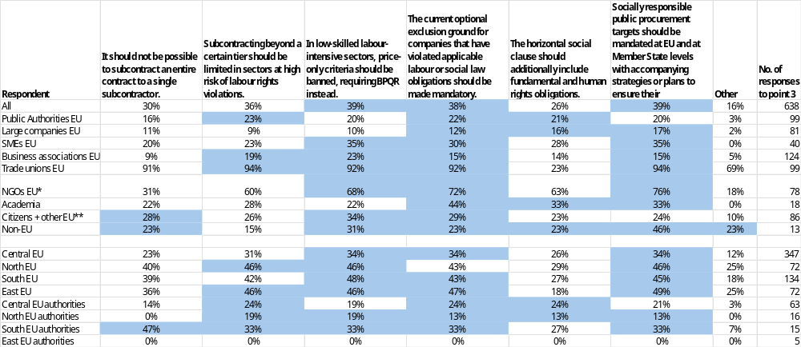
* NGOs + Environmental organisations; ** includes Consumer Organisations
Note: Multiple choice question; results reflect replies from those who answered. Top three responses highlighted. Point 3. The general legislative framework should mandate further socially responsible public procurement obligations. EU includes NO; Central EU: AT, BE, DE, FR, LU, NL; North EU: DK, FI, IE, SE and NO; South EU: CY, EL, ES, IT, MT, PT; East EU: BG, CZ, EE, HR, HU, LT, LV, PL, RO, SK; replies of only those who answered are provided
Source: Public Consultations on public procurement reform. Commission own analysis.

Respondents who agreed or strongly agreed that more regulatory measures are needed for socially responsible public procurement were asked which elements should be made mandatory. Figures refer to the share of these respondents selecting each option.
Across all respondents, the most frequently supported mandatory elements were banning price-only criteria in low-skilled labour-intensive sectors (39%), mandating socially responsible public procurement targets at EU and Member State level (39%), and making the current optional exclusion ground for labour and social law violations mandatory (38%). Limiting subcontracting beyond certain tiers in high-risk sectors also attracted notable support (36%).
Among public authorities, preferences were more moderate and relatively evenly spread, with the highest support for limiting subcontracting beyond a certain tier in high-risk sectors (23%) and making the current optional exclusion ground for labour and social law violations mandatory (22%).
Among large companies, SMEs and business associations, support levels were generally low to moderate. SMEs showed relatively higher support for banning price-only criteria and mandating socially responsible procurement targets (both 35%). Large companies and business associations showed support of around or below 20% for the proposed mandatory measures across all options.
Trade unions expressed over 90% support for all measures, with the exception of including fundamental and human rights obligations in the horizontal social clause, which received 23% support. NGOs most often supported mandatory targets (76%), mandatory exclusion grounds (72%) and banning price-only criteria (68%).
Academia showed moderately high support for mandatory exclusion grounds at 44%. Citizens, other respondents, and non-EU respondents favoured banning price-only criteria, with support ranging from 31% to 34%. Non-EU respondents also supported mandatory targets at 46%.

Those who selected Other were asked to elaborate. A summary of their responses is presented below.
Public authorities
Public authorities respondents provided comments on which other changes regarding socially responsible public procurement should be made obligatory, highlighting the need for clearer guidelines and mandatory requirements. Many respondents emphasize the importance of promoting socially responsible public procurement, and suggest introducing mandatory weighing of ESG ratings, such as a 10% weighting of a company's ESG rating in the tender evaluation process. Some propose making requirements such as systematic environmental management or human rights due diligence obligatory, as they are linked to the subject matter of the contract and regulate the way in which the product or service is provided. Others suggest including social inclusion-related rights in social clauses, to ensure that public procurement promotes social responsibility and respects human rights. For instance, one comment notes that "requirements such as systematic environmental management or human rights due diligence are linked to the subject-matter of the contract," while another suggests that "social inclusion-related rights should be included in social clauses." Overall, the comments highlight the need for a more robust and effective approach to promoting socially responsible public procurement, one that prioritizes social responsibility and respects human rights.
EU companies and business associations
EU companies and business associations respondents provided comments on which other changes regarding socially responsible public procurement should be made obligatory, highlighting the need for a balanced approach that promotes social responsibility while ensuring competitiveness and avoiding unnecessary administrative burdens. Many respondents emphasize the importance of limiting "cascading" subcontracting to a single level, to control the supply chain and protect the workforce, and ensuring the correct application of labour regulations, including collective agreements. Some propose requiring procurement contracts to include price revision clauses that compensate for the higher costs incurred as a result of the renewal of collective agreements. Others suggest that occupational safety and health (OSH) should be an award criterion, and that bidders with poor OSH performance should be penalized or excluded from the competition. Some respondents also emphasize the need for incentivizing the use of socially responsible public procurement, rather than mandating it, and that any obligatory changes should be aligned with existing requirements, such as the CSDDD. Overall, the comments highlight the need for a nuanced approach that balances the promotion of social responsibility with the need to ensure competitiveness, avoid unnecessary administrative burdens, and support businesses in their efforts to operate responsibly.
EU NGOs, environmental organisations and trade unions
EU NGOs, environmental organisations, and trade unions respondents provided comments on which other changes regarding socially responsible public procurement should be made obligatory, emphasizing the need to promote collective bargaining, quality jobs, and fair working conditions. Many respondents suggest that mandatory award criteria and advantages should be given to tenderers whose workers are covered by collective agreements, and that subcontracting should be limited to one or two levels with joint and several liability. Some propose introducing a mandatory requirement for public authorities to allocate a percentage of their annual procurement budget to reserved contracts, and that social impact indicators should be used to assess the preservation of jobs for individuals from disadvantaged groups. Others suggest that the use of the Most Economically Advantageous Tender (MEAT)/Best Price Quality Ratio (BPQR) criteria should be made the standard/default logic for public procurement, and that labour clauses in procurement contracts should be made mandatory. For instance, one comment notes that "essential to support collective bargaining and quality jobs, including mandatory award criteria and giving advantage to tenderers whose workers covered by collective agreements," while another suggests that "at least 5% of the annual value of public supply and service contracts should be used for safeguarding high-risk and very-high-risk product segments from a human-rights and labour-rights perspective." Some respondents also emphasize the need to promote gender equity in public procurement law, and to ensure that public procurement selection and advertising encourage and allow female-led and gender-balanced companies. Overall, the comments highlight the need for a more robust and effective approach to promoting socially responsible public procurement, one that prioritizes fair working conditions, collective bargaining, and quality jobs.
All other respondents
All other respondents provided comments on which other changes regarding socially responsible public procurement should be made obligatory, highlighting the need to promote collective bargaining, quality jobs, and fair working conditions. Many respondents suggest that mandatory award criteria and advantages should be given to tenderers whose workers are covered by collective agreements, and that subcontracting should be limited to one or two levels with joint and several liability. Some propose introducing mandatory model BPQR criteria and proportional verification methods for social performance, and banning price-only criteria in labour-intensive sectors. Others suggest that EU public procurement should recognize the societal value of open source through criteria that reward transparency, collaboration, and vendor neutrality, and that contracting authorities should be incentivized to procure "sustainable software" by giving priority to vendors that contribute to open source projects. For instance, one comment notes that "essential to support collective bargaining and quality jobs, including mandatory award criteria and giving advantage to tenderers whose workers covered by collective agreements," while another suggests that "banning price-only criteria in labour-intensive sectors would help prevent precarious working conditions and social dumping." Some respondents also emphasize the need for a reliable and up-to-date database to enable public buyers to implement exclusion grounds for companies that have not complied with labour law legislation. Overall, the comments highlight the need for a more robust and effective approach to promoting socially responsible public procurement, one that prioritizes fair working conditions, collective bargaining, and quality jobs.

9.9.1. Social considerations in public procurement impacts
Figure 84: Question: How likely do you believe the following outcomes would occur as a result of further incentivising the use of socially responsible public procurement?; all replies.
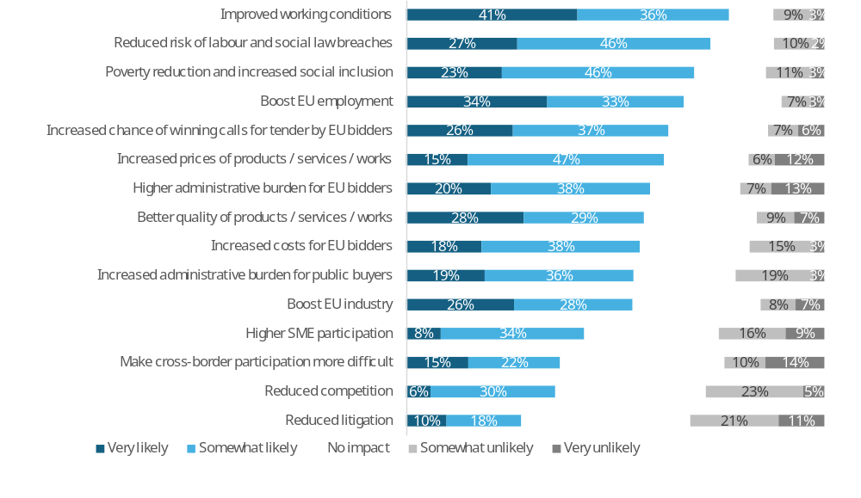
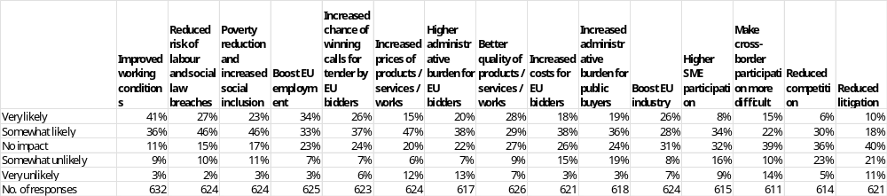
Note: Single-choice responses only; results reflect replies from those who answered.
Source: Public Consultations on public procurement reform. Commission own analysis.

In response to the question “How likely do you believe the following outcomes would occur as a result of further incentivising the use of socially responsible public procurement?”, respondents most often expect improved working conditions (77%: 41% very likely, 36% somewhat likely), followed by reduced risk of labour and social law breaches (73%: 27% very likely, 46% somewhat likely) and poverty reduction and increased social inclusion (73%: 23% very likely, 46% somewhat likely). High shares also anticipate a boost to EU employment (67%: 34% very likely, 33% somewhat likely), increased chance of winning calls for tender by EU bidders (63%: 26% very likely, 37% somewhat likely), and increased prices of products, services and works (62%: 15% very likely, 47% somewhat likely). Majorities consider higher administrative burden for EU bidders (58%: 20% very likely, 38% somewhat likely), better quality of products, services and works (57%: 28% very likely, 29% somewhat likely), increased costs for EU bidders (56%: 18% very likely, 38% somewhat likely), increased administrative burden for public buyers (55%: 19% very likely, 36% somewhat likely), and a boost to EU industry (54%: 26% very likely, 28% somewhat likely) as likely outcomes. Lower positive expectations are reported for higher SME participation (42%: 8% very likely, 34% somewhat likely), making cross-border participation more difficult (37%: 15% very likely, 22% somewhat likely), reduced competition (36%: 6% very likely, 30% somewhat likely), and reduced litigation (28%: 10% very likely, 18% somewhat likely).
Disagreement that these outcomes will occur (somewhat unlikely or very unlikely) is highest for reduced litigation (32%: 21% somewhat unlikely, 11% very unlikely), reduced competition (28%: 23% somewhat unlikely, 5% very unlikely), making cross-border participation more difficult (24%: 10% somewhat unlikely, 14% very unlikely), higher SME participation (25%: 16% somewhat unlikely, 9% very unlikely), higher administrative burden for EU bidders (20%: 7% somewhat unlikely, 13% very unlikely), increased administrative burden for public buyers (22%: 19% somewhat unlikely, 3% very unlikely), and increased costs for EU bidders (18%: 15% somewhat unlikely, 3% very unlikely). Lower levels of disagreement are seen for increased prices of products, services and works (18%: 6% somewhat unlikely, 12% very unlikely), boost to EU industry (15%: 8% somewhat unlikely, 7% very unlikely), better quality (16%: 9% somewhat unlikely, 7% very unlikely), reduced risk of labour and social law breaches (12%: 10% somewhat unlikely, 2% very unlikely), poverty reduction and increased social inclusion (14%: 11% somewhat unlikely, 3% very unlikely), boost to EU employment (10%: 7% somewhat unlikely, 3% very unlikely), improved working conditions (12%: 9% somewhat unlikely, 3% very unlikely), and increased chance of winning calls for tender by EU bidders (13%: 7% somewhat unlikely, 6% very unlikely).
Across all outcomes, the share of respondents expecting “no impact” ranges from 11% for improved working conditions to 40% for reduced litigation and 39% for making cross-border participation more difficult. Intermediate “no impact” levels are reported for reduced risk of labour and social law breaches (15%), poverty reduction and increased social inclusion (17%), boost to EU employment (23%), increased chance of winning calls for tender by EU bidders (24%), increased prices (20%), higher administrative burden for EU bidders (22%), better quality (27%), increased costs for EU bidders (26%), increased administrative burden for public buyers (24%), boost to EU industry (31%), higher SME participation (32%), and reduced competition (36%).

Table 101: Question: How likely do you believe the following outcomes would occur as a result of further incentivising the use of socially responsible public procurement?; Percentage of respondents that indicated "very likely" or "somewhat likely" answers, by type of respondent.
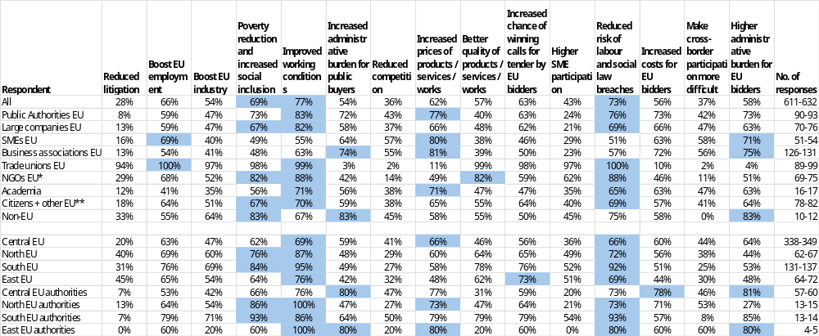
* NGOs + Environmental organisations; ** includes Consumer Organisations
Note: Single-choice responses only; results reflect replies from those who answered. Top three responses highlighted. The number of responses in the last column is shown as a range, as the number of replies varied per column. EU includes NO; Central EU: AT, BE, DE, FR, LU, NL; North EU: DK, FI, IE, SE and NO; South EU: CY, EL, ES, IT, MT, PT; East EU: BG, CZ, EE, HR, HU, LT, LV, PL, RO, SK; replies of only those who answered are provided
Source: Public Consultations on public procurement reform. Commission own analysis.

Respondents were asked how likely they believed different outcomes would be as a result of further incentivising the use of socially responsible public procurement. The figures refer to the combined shares of “very likely” and “somewhat likely” answers (other response options were also available but are not shown).
Among public authorities, the outcomes most often seen as likely were improved working conditions (83%), increase prices (77%) and reduced risk of labour and social law breaches (76%). For other outcomes, perceived likelihood ranged from 8% to 76%. Very low likelihood was reported for reduced litigation (8%).
Among large companies, improved working conditions was a key likely outcome (82%), followed by reduced risk of labour and social law breaches (69%) and poverty reduction and increased social inclusion (67%). SMEs and business associations pointed to increased prices of products, services or works (80% and 81%). Across these three groups, perceived likelihood of the remaining outcomes ranged from 13% to 81%. Very low likelihood was reported for reduced litigation among (13% - 16%), and for higher SME participation (21% - 29%).
Trade unions most frequently regarded boosts to EU employment (100%), reduced risk of labour and social law breaches (100%), improved working conditions (99%) and poverty reduction and increased social inclusion (98%) as likely outcomes. NGOs most often highlighted improved working conditions and reduced risk of labour and social law breaches (both 88%). For these two groups, perceived likelihood of the remaining outcomes ranged from 2% to 100%. Very low likelihood was reported among trade unions for increased administrative burden for public buyers (3%), reduced competition (2%) and higher administrative burden for EU bidders (4%), and among NGOs for reduced competition (14%) and making cross-border participation more difficult (11%).
Among academia, citizens and other respondents, and non-EU respondents, improved working conditions was among the most likely outcomes (academia: 71%; citizens and other respondents: 70%; non-EU respondents: 67%), alongside poverty reduction and increased social inclusion (56%; 67%; 83%) and reduced risk of labour and social law breaches (65%; 69%; 75%). Across these three groups, perceived likelihood of the remaining outcomes ranged from 12% to 83%. Very low likelihood was reported for reduced litigation among academia (12%-33%).

Respondents were invited to identify any other likely impacts. A summary of their responses is presented below.
Public authorities
Approximately a tenth of public authorities respondents provided comments on the likely impacts of further incentivizing the use of socially responsible public procurement, highlighting both positive and negative effects. Many respondents believe that incentivizing socially responsible public procurement can lead to various benefits, such as promoting fair working conditions, reducing social dumping, and encouraging sustainable practices. Some propose introducing binding obligations on socially responsible public procurement, including mandatory human rights and environmental due diligence, to ensure consistent application and sufficient impact. Others suggest that public procurement law is not the right place to implement social policy, and that contracting authorities are already bound by collective agreements and labour law. There are also concerns about the potential complexity and administrative burdens of introducing new legislative obligations, and the need for increased investment in professionalizing public procurement officers to support strategic approaches to public procurement. For instance, one comment notes that "the legislative framework should impose binding obligations on socially responsible public procurement," while another suggests that "public procurement law is not the right place to implement social policy." Some respondents also emphasize the need for flexibility and subsidiarity, allowing Member States to apply their respective models for handling social aspects in the labour market. Overall, the comments highlight the need for a balanced approach that promotes socially responsible public procurement while minimizing administrative burdens and ensuring flexibility for contracting authorities.
EU companies and business associations
Approximately a tenth of EU companies and business associations respondents provided comments on the likely impacts of further incentivizing the use of socially responsible public procurement, highlighting both positive and negative effects. Many respondents believe that incentivizing socially responsible public procurement can lead to various benefits, such as promoting fair working conditions, reducing social dumping, and encouraging sustainable practices. Some propose introducing social criteria, such as mandatory compliance with labour law, collective agreements, and human rights standards, to ensure that public procurement promotes social responsibility and respects workers' rights. Others suggest that social requirements, including incentives, are generally company-specific and not contract-specific, and are rejected in principle as they contradict the goal of simplifying procurement processes. There are also concerns about the potential complexity and administrative burdens of introducing new social requirements, and the need for increased flexibility and proportionality in applying social criteria. For instance, one comment notes that "the use of social criteria must be at the discretion of the public contracting authority," while another suggests that "social requirements, including incentives, are generally company-specific and not contract-specific, and are rejected in principle." Some respondents also emphasize the need for a more nuanced approach, taking into account the specific needs and characteristics of different sectors and industries, and the importance of balancing social considerations with other factors, such as competition and innovation. Overall, the comments highlight the need for a balanced approach that promotes socially responsible public procurement while minimizing administrative burdens and ensuring flexibility for businesses.
EU NGOs, environmental organisations and trade unions
Approximately half of EU NGOs, environmental organisations, and trade unions respondents provided comments on the likely impacts of further incentivizing the use of socially responsible public procurement, highlighting both positive and negative effects. Many respondents believe that incentivizing socially responsible public procurement can lead to various benefits, such as promoting fair working conditions, reducing social dumping, and encouraging sustainable practices. Some propose introducing social criteria, such as mandatory compliance with labour law, collective agreements, and human rights standards, to ensure that public procurement promotes social responsibility and respects workers' rights. Others suggest that incentivizing socially responsible public procurement can improve working conditions, social inclusion, and quality outcomes, particularly in sectors where labour standards and traceability matter. There are also concerns about the potential complexity and administrative burdens of introducing new social requirements, and the need for increased flexibility and proportionality in applying social criteria. For instance, one comment notes that "it is essential to ensure compliance with labour law provisions and collective agreements, as well as to promote collective bargaining and quality jobs through public procurement," while another suggests that "incentivizing socially responsible public procurement can support improved working conditions and compliance with existing labour and social obligations." Some respondents also emphasize the need for a more nuanced approach, taking into account the specific needs and characteristics of different sectors and industries, and the importance of balancing social considerations with other factors, such as competition and innovation. Overall, the comments highlight the need for a balanced approach that promotes socially responsible public procurement while minimizing administrative burdens and ensuring flexibility for contracting authorities.
All other respondents
Approximately a tenth of all other respondents provided comments on the likely impacts of further incentivizing the use of socially responsible public procurement, highlighting both positive and negative effects. Many respondents believe that incentivizing socially responsible public procurement can lead to various benefits, such as promoting fair working conditions, reducing social dumping, and encouraging sustainable practices. Some propose introducing social criteria, such as mandatory compliance with labour law, collective agreements, and human rights standards, to ensure that public procurement promotes social responsibility and respects workers' rights. Others suggest that incentivizing socially responsible public procurement can improve working conditions, social inclusion, and quality outcomes, particularly in sectors where labour standards and traceability matter. There are also concerns about the potential complexity and administrative burdens of introducing new social requirements, and the need for increased flexibility and proportionality in applying social criteria. For instance, one comment notes that "social considerations in public procurement should also be considered as relevant levers to improve the overall competitiveness of the circular economy approach," while another suggests that "incentivising SRPP improves working conditions and reduces labour risks without reducing competition or restricting cross-border access." Some respondents also emphasize the need for a more nuanced approach, taking into account the specific needs and characteristics of different sectors and industries, and the importance of balancing social considerations with other factors, such as competition and innovation. Overall, the comments highlight the need for a balanced approach that promotes socially responsible public procurement while minimizing administrative burdens and ensuring flexibility for contracting authorities.

Figure 85: Question: How likely do you believe the following outcomes would occur as a result of mandating further socially responsible public procurement obligations?; all replies.
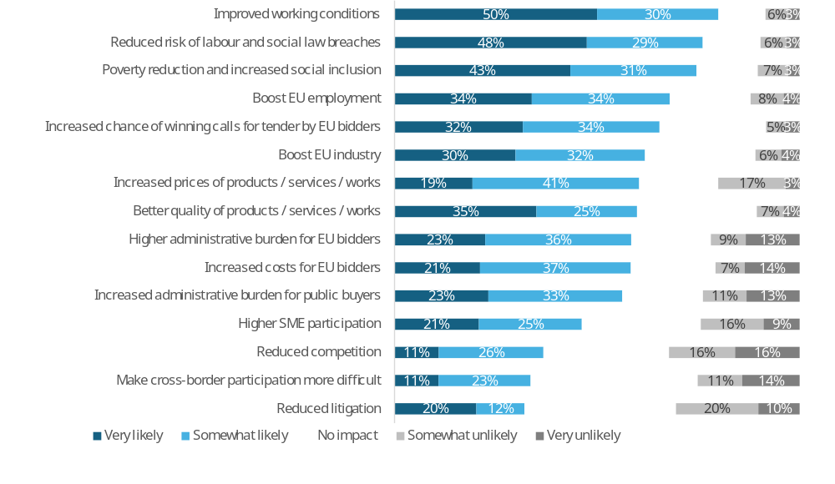
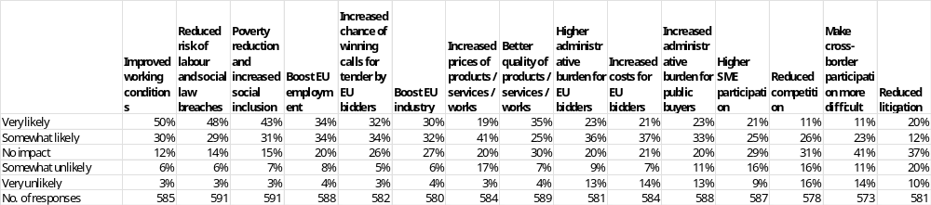
Note: Single-choice responses only; results reflect replies from those who answered.
Source: Public Consultations on public procurement reform. Commission own analysis.

In response to the question “How likely do you believe the following outcomes would occur as a result of mandating further socially responsible public procurement obligations?”, respondents most often expect improved working conditions (80%: 50% very likely, 30% somewhat likely), reduced risk of labour and social law breaches (77%: 48% very likely, 29% somewhat likely), and poverty reduction and increased social inclusion (74%: 43% very likely, 31% somewhat likely). High shares also anticipate a boost to EU employment (68%: 34% very likely, 34% somewhat likely), increased chance of winning calls for tender by EU bidders (66%: 32% very likely, 34% somewhat likely), and a boost to EU industry (62%: 30% very likely, 32% somewhat likely). Majorities consider increased prices of products, services and works (60%: 19% very likely, 41% somewhat likely), better quality of products, services and works (60%: 35% very likely, 25% somewhat likely), higher administrative burden for EU bidders (59%: 23% very likely, 36% somewhat likely), increased costs for EU bidders (58%: 21% very likely, 37% somewhat likely), and increased administrative burden for public buyers (56%: 23% very likely, 33% somewhat likely) as likely outcomes. Lower positive expectations are reported for higher SME participation (46%: 21% very likely, 25% somewhat likely), reduced competition (37%: 11% very likely, 26% somewhat likely), making cross-border participation more difficult (34%: 11% very likely, 23% somewhat likely), and reduced litigation (32%: 20% very likely, 12% somewhat likely).
Disagreement that these outcomes will occur (somewhat unlikely or very unlikely) is highest for reduced competition (32%: 16% somewhat unlikely, 16% very unlikely), reduced litigation (30%: 20% somewhat unlikely, 10% very unlikely), making cross-border participation more difficult (25%: 11% somewhat unlikely, 14% very unlikely), and higher SME participation (25%: 16% somewhat unlikely, 9% very unlikely). Lower, but still notable, disagreement is reported for higher administrative burden for EU bidders (22%: 9% somewhat unlikely, 13% very unlikely), increased administrative burden for public buyers (24%: 11% somewhat unlikely, 13% very unlikely), increased costs for EU bidders (21%: 7% somewhat unlikely, 14% very unlikely), and increased prices of products, services and works (20%: 17% somewhat unlikely, 3% very unlikely). Disagreement is comparatively limited for better quality (11%: 7% somewhat unlikely, 4% very unlikely), a boost to EU industry (10%: 6% somewhat unlikely, 4% very unlikely), boost to EU employment (12%: 8% somewhat unlikely, 4% very unlikely), poverty reduction and increased social inclusion (10%: 7% somewhat unlikely, 3% very unlikely), reduced risk of labour and social law breaches (9%: 6% somewhat unlikely, 3% very unlikely), increased chance of winning for EU bidders (8%: 5% somewhat unlikely, 3% very unlikely), and improved working conditions (9%: 6% somewhat unlikely, 3% very unlikely).
Across all outcomes, the share of respondents expecting “no impact” ranges from 12% for improved working conditions to 41% for making cross-border participation more difficult and 37% for reduced litigation. Intermediate “no impact” levels are reported for reduced risk of labour and social law breaches (14%), poverty reduction and increased social inclusion (15%), boost to EU employment (20%), increased chance of winning for EU bidders (26%), boost to EU industry (27%), increased prices (20%), better quality (30%), higher administrative burden for EU bidders (20%), increased costs for EU bidders (21%), increased administrative burden for public buyers (20%), higher SME participation (29%), and reduced competition (31%).

Table 102: Question: How likely do you believe the following outcomes would occur as a result of mandating further socially responsible public procurement obligations?; percentage of respondents that indicated “very likely” or “somewhat likely” answers, by type of respondent.
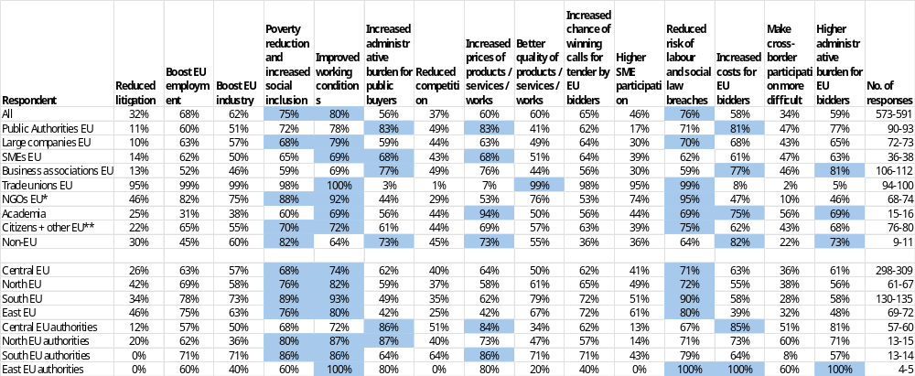
* NGOs + Environmental organisations; ** includes Consumer Organisations
Note: Single-choice responses only; results reflect replies from those who answered. Top three responses highlighted. The number of responses in the last column is shown as a range, as the number of replies varied per column. EU includes NO; Central EU: AT, BE, DE, FR, LU, NL; North EU: DK, FI, IE, SE and NO; South EU: CY, EL, ES, IT, MT, PT; East EU: BG, CZ, EE, HR, HU, LT, LV, PL, RO, SK; replies of only those who answered are provided
Source: Public Consultations on public procurement reform. Commission own analysis.

Respondents were asked how likely they believed different outcomes would be as a result of mandating further socially responsible public procurement obligations. The figures refer to the combined shares of “very likely” and “somewhat likely” answers (other response options were also available but are not shown).
Among public authorities, the most likely outcomes were increased administrative burden for public buyers (83%), increased prices of products, services or works (83%) and increased costs for EU bidders (81%). For the remaining outcomes, perceived likelihood ranged from 11% to 77%. Very low likelihood was reported for reduced litigation (11%).
Among large companies, SMEs and business associations, improved working conditions was consistently among the most likely outcomes (large companies: 79%; SMEs: 69%; business associations: 69%), along with poverty reduction and increased social inclusion (68%; 65%; 59%). Business associations pointed to higher administrative burden for both bidders (81%) and public buyers (77%). Across these three groups, perceived likelihood of the other outcomes ranged between 10% and 77%. Very low likelihood was reported for reduced litigation among large companies (10% - 14%).
Trade unions almost unanimously pointed to improved working conditions (100%), boosts to EU employment and industry (both 99%), reduced risk of labour and social law breaches (99%), better quality of products, services or works (99%), poverty reduction and increased social inclusion (98%). NGOs most often pointed to reduced risk of labour and social law breaches (95%) and improved working conditions (92%). For these two groups, perceived likelihood of the remaining outcomes ranged from 1% to 95%. Very low likelihood was reported among trade unions for reduced competition (1%), increased administrative burden for public buyers (3%), increased prices (7%), increased costs for EU bidders (8%), making cross-border participation more difficult (2%) and higher administrative burden for EU bidders (5%), and among NGOs for making cross-border participation more difficult (10%).
Among academia, citizens and other respondents, and non-EU respondents, the outcomes most often seen as likely included improved working conditions (academia: 69%; citizens and other respondents: 72%; non-EU respondents: 64%), poverty reduction and increased social inclusion (60%; 70%; 82%) and reduced risk of labour and social law breaches (69%; 75%; 64%). Across these three groups, perceived likelihood of the remaining outcomes ranged from 22% to 94%. Very low likelihood was reported for making cross-border participation more difficult among non-EU respondents (22%).

Respondents were invited to identify any other likely impacts. A summary of their responses is presented below.
Public authorities
Approximately a tenth of public authorities respondents provided comments on the likely impacts of mandating further socially responsible public procurement obligations, highlighting both positive and negative effects. Many respondents believe that mandating socially responsible public procurement can lead to various benefits, such as promoting fair working conditions, reducing social dumping, and encouraging sustainable practices. Some propose redefining the Most Economically Advantageous Tender (MEAT) criteria as the Most Advantageous Tender (MAT), establishing the Best Price-Quality and Sustainability Ratio (BPQ&S) as the default award criterion for public contracts. Others suggest that social criteria and requirements are unmanageable due to complexity and may reduce the number of bids and increase costs for buyers. There are also concerns about the potential administrative burdens and costs of implementing new social requirements, and the need for increased flexibility and proportionality in applying social criteria. For instance, one comment notes that "the introduction of the MEAT criteria created opportunities for strategic procurement through non-price award criteria, but legal uncertainty persists." Some respondents also emphasize the importance of monitoring the performance of contracts and the need for expert assistance in implementing social inclusion clauses. Overall, the comments highlight the need for a balanced approach that promotes socially responsible public procurement while minimizing administrative burdens and ensuring flexibility for contracting authorities.
EU companies and business associations
Approximately a tenth of EU companies and business associations respondents provided comments on the likely impacts of mandating further socially responsible public procurement obligations, highlighting both positive and negative effects. Many respondents believe that mandating socially responsible public procurement can lead to various benefits, such as promoting fair working conditions, reducing social dumping, and encouraging sustainable practices. Some propose introducing social criteria, such as mandatory compliance with labour law, collective agreements, and human rights standards, to ensure that public procurement promotes social responsibility and respects workers' rights. Others suggest that mandating socially responsible public procurement can improve compliance and working conditions, while reinforcing green and Made in Europe requirements. However, there are also concerns about the potential complexity and administrative burdens of introducing new social requirements, and the need for increased flexibility and proportionality in applying social criteria. For instance, one comment notes that "mandatory social procurement requirements can improve compliance and working conditions while reinforcing green and Made in Europe requirements," while another suggests that "the introduction of new mandatory criteria in public procurement law to address strategic challenges should be avoided as a matter of urgency." Some respondents also emphasize the need for a more nuanced approach, taking into account the specific needs and characteristics of different sectors and industries, and the importance of balancing social considerations with other factors, such as competition and innovation. Overall, the comments highlight the need for a balanced approach that promotes socially responsible public procurement while minimizing administrative burdens and ensuring flexibility for businesses.
EU NGOs, environmental organisations and trade unions
Approximately over half of EU NGOs, environmental organisations, and trade unions respondents provided comments on the likely impacts of mandating further socially responsible public procurement obligations, highlighting both positive and negative effects. Many respondents believe that mandating socially responsible public procurement can lead to various benefits, such as promoting fair working conditions, reducing social dumping, and encouraging sustainable practices. Some propose introducing mandatory social criteria, such as compliance with labour law, collective agreements, and human rights standards, to ensure that public procurement promotes social responsibility and respects workers' rights. Others suggest that clearer and mandatory rules will ensure better value for money, contributing to quality job creation, and should include mandatory criteria related to quality jobs and collective bargaining, as well as regulation of subcontracting. There are also concerns about the potential complexity and administrative burdens of introducing new social requirements, and the need for increased flexibility and proportionality in applying social criteria. For instance, one comment notes that "clearer and mandatory rules will ensure better value for money, contributing to quality job creation," while another suggests that "mandatory social procurement obligations increase costs and reduce competition, while delivering limited and uneven social outcomes." Some respondents also emphasize the importance of promoting job quality and collective bargaining, and the need for a clear message to companies that violations of social rights are not acceptable. Overall, the comments highlight the need for a balanced approach that promotes socially responsible public procurement while minimizing administrative burdens and ensuring flexibility for contracting authorities.
All other respondents
Approximately a tenth of all other respondents provided comments on the likely impacts of mandating further socially responsible public procurement obligations, highlighting both positive and negative effects. Many respondents believe that mandating socially responsible public procurement can lead to various benefits, such as promoting fair working conditions, reducing social dumping, and encouraging sustainable practices. Some propose introducing mandatory social criteria, such as compliance with labour law, collective agreements, and human rights standards, to ensure that public procurement promotes social responsibility and respects workers' rights. Others suggest that clearer and mandatory rules will ensure better value for money, contributing to quality job creation, and should include mandatory criteria related to quality jobs and collective bargaining, as well as regulation of subcontracting. There are also concerns about the potential complexity and administrative burdens of introducing new social requirements, and the need for increased flexibility and proportionality in applying social criteria. For instance, one comment notes that "clearer and mandatory rules will ensure better value for money, contributing to quality job creation," while another suggests that "introducing mandatory social obligations entails a significant risk of slowing development and creating requirements that quickly become outdated." Some respondents also emphasize the importance of promoting job quality and collective bargaining, and the need for a clear message to companies that violations of social rights are not acceptable. Overall, the comments highlight the need for a balanced approach that promotes socially responsible public procurement while minimizing administrative burdens and ensuring flexibility for contracting authorities.

Public procurement of innovation (FLX and ESI options)
Figure 86: Question: To what extent do you agree with the following statements concerning public procurement of innovation?; all replies.
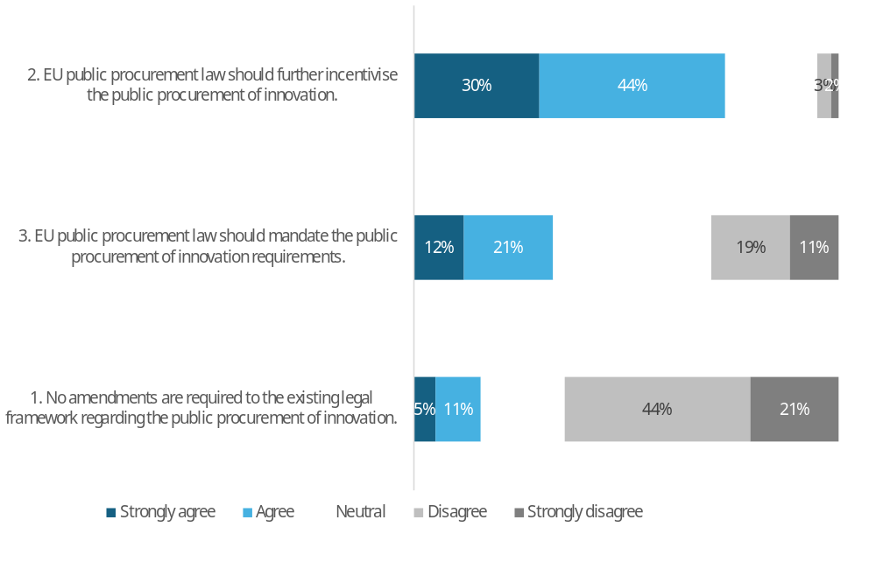
Respondent | 1. No amendments are required to the existing legal framework regarding the public procurement of innovation. | 2. EU public procurement law should further incentivise the public procurement of innovation. | 3. EU public procurement law should mandate the public procurement of innovation requirements.
Strongly agree | 5% | 30% | 12%
Agree | 11% | 44% | 21%
Neutral | 20% | 22% | 37%
Disagree | 44% | 3% | 19%
Strongly disagree | 21% | 2% | 11%
No. of responses | 573 | 678 | 654
Note: Single-choice responses only; results reflect replies from those who answered.
Source: Public Consultations on public procurement reform. Commission own analysis.

When asked about public procurement of innovation, the strongest support was for further incentives to encourage its use, with 73% in favour (30% strongly agree, 44% agree). This was followed by support for mandating public procurement of innovation requirements, backed by 33% (12% strongly agree, 21% agree) and opposed by 30% of respondents.
The proposition that no amendments should be made to the existing legal framework regarding the public procurement of innovation was supported by 16% of respondents, while a majority of 64% opposed this view.

Table 103: Question: To what extent do you agree with the following statements concerning public procurement of innovation?; percentage of respondents that agree or strongly agree, by type of respondent.
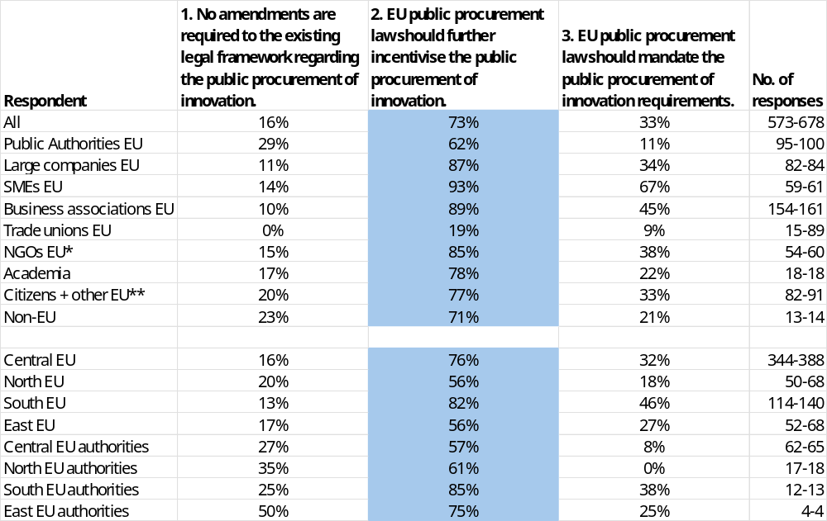
* NGOs + Environmental organisations; ** includes Consumer Organisations
Note: Single-choice responses only; results reflect replies from those who answered. Top response highlighted. The number of responses in the last column is shown as a range, as the number of replies varied per column. EU includes NO; Central EU: AT, BE, DE, FR, LU, NL; North EU: DK, FI, IE, SE and NO; South EU: CY, EL, ES, IT, MT, PT; East EU: BG, CZ, EE, HR, HU, LT, LV, PL, RO, SK; replies of only those who answered are provided
Source: Public Consultations on public procurement reform. Commission own analysis.

This table presents the breakdown of responses by different respondent groups. The figures represent the combined shares of "strongly agree" and "agree" responses (other response options were available but are not shown here).
Respondents in all groups showed high support for further incentives to use procurement of innovation, with backing ranging from 62% among public authorities to 93% for SMEs. The only exception was trade unions, which showed just 19% support for further incentives and even lower levels for other options.
Public authorities registered the highest support for no change at 29%. Regarding mandatory measures, SMEs and business associations were the strongest supporters, with 67% and 45% backing respectively.

Table 104: Question: If you "agree" or "strongly agree" with point 2 (Figure 86). Which of the following elements should be introduced to further incentivise the use of public procurement of innovation?; % of all answers to point 2, by type of respondent.
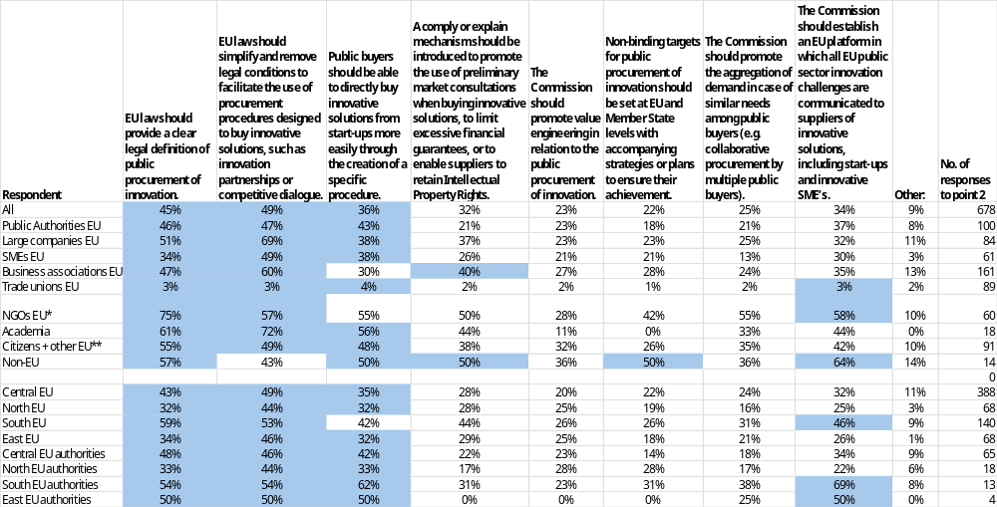
* NGOs + Environmental organisations; ** includes Consumer Organisations
Note: Multiple choice question; results reflect replies from those who answered. Top three responses highlighted.
Point 2. EU public procurement law should further incentivise the public procurement of innovation.
EU includes NO; Central EU: AT, BE, DE, FR, LU, NL; North EU: DK, FI, IE, SE and NO; South EU: CY, EL, ES, IT, MT, PT; East EU: BG, CZ, EE, HR, HU, LT, LV, PL, RO, SK; replies of only those who answered are provided
Source: Public Consultations on public procurement reform. Commission own analysis.

Respondents who agreed or strongly agreed that EU public procurement law should further incentivise the public procurement of innovation were asked which elements should be introduced. Figures refer to the share of these respondents selecting each option.
Across all respondents, the most frequently selected elements were simplifying and removing legal conditions for procedures designed to buy innovative solutions (49%), providing a clear legal definition of public procurement of innovation (45%) and direct purchase from start-ups (36%).
Among public authorities, the same three measures attracted the highest support ranging between 43% and 47%.
Among large companies, SMEs and business associations, simplification of procedures and a clear legal definition were consistently prioritised (simplification: 49–69%; definition: 34–51%). Business associations also favoured a “comply or explain” mechanism (40%) and an EU platform (35%).
Trade unions expressed very low support for all listed elements (generally at or below 4%). NGOs, by contrast, strongly supported a clear legal definition (75%), procedural simplification (57%), direct purchase from start-ups (55%), aggregation of demand (55%) and an EU platform (58%).
Among academia, citizens and other respondents, and non-EU respondents, simplification of procedures was again a core priority (academia: 72%; citizens and other respondents: 49%; non-EU respondents: 43%), alongside a clear legal definition (61%; 55%; 57%). Academia and non-EU respondents also showed relatively high support for direct purchase from start-ups (56% and 50%), while non-EU respondents most often backed an EU platform (64%).

Those who selected Other were asked to elaborate. A summary of their responses is presented below.
Public authorities
Public authorities who provided comments addressed which additional changes could further incentivise public procurement of innovation.
Most comments emphasised greater procedural flexibility to act as a “launching customer”, including wider use of the negotiated procedure “without prior notice/publication”, raising thresholds, and allowing “more room/flexibility to modify” both during tenders and during contract execution to accommodate iterative improvements.
Several advocated measures to improve access for innovative SMEs and very small firms, such as a ‘Young Business Act’ to reserve or reduce barriers for companies seeking their “first clients”, more flexible use of variants “as a matter of principle” to encourage innovative and sustainable tenders, and raising thresholds for small lots.
Some called for clearer, more usable innovation tools: the definition of innovation was described as “insufficiently operational”, and the Innovation Partnership should be simplified and broadened to integrate research, development, production and scale-up phases. A minority proposed enabling the “reuse of existing solutions from previously awarded procedures” across procurers under predefined conditions (e.g. best price–quality ratio) to support diffusion and scale-up.
A minority also urged allowing public buyers to “directly support, facilitate and co-create” innovations initiated by economic operators, not limited to start-ups.
A small number proposed more far-reaching legal changes, including expanding exemptions so that “this Directive shall not apply” to research and development services and/or research organisations.
Overall, comments largely aligned around reducing administrative burden and increasing flexibility to buy and scale innovation; no explicit counter-arguments or concerns about potential trade-offs (e.g. transparency or competition) were recorded in the submissions provided.
EU companies and business associations
EU companies and business associations who commented outlined further changes that would incentivise public procurement of innovation. A clear majority urged allowing variants by default to unlock innovative, better-value offers-especially from SMEs-with safeguards such as “comply or explain” and permitting a variant alongside a compliant offer (“permitted and enabled by default”). Many also backed easing direct purchasing by raising thresholds for awards “without competition,” removing constraints like “cost premium thresholds,” and shifting towards functional, outcome-based specifications, stronger Best-Price–Quality Ratio and lifecycle costing, and “creative award criteria.”
There was broad support for simplifying and de-risking innovation-friendly procedures. Many asked to streamline access to competitive dialogue, negotiated procedures and innovation partnerships; some proposed introducing collaborative models such as an “Alliance/Collaborative Contract.” Several called for clearer use of two-stage contracts and for addressing IP, noting current rules on “transfer of intellectual property rights… do not appear adequate” in fast-moving ICT.
Views differed on how best to support SMEs and start-ups. Some advocated a new specific procedure so public buyers can directly buy innovative solutions from SMEs, while others preferred making existing procedures more “start-up-ready” rather than creating an additional route. Complementary measures suggested included milestone payments, reduced solvency requirements in innovative contracts, mutual guarantees, project financing, on-boarding new suppliers during delivery, and automatic transition from pilots or pre-commercial procurement to operational contracts when targets are met.
There were tensions on definitions, coordination tools and targets. Some favoured a clear legal definition within a comprehensive framework, while others warned such a definition would be “too narrow and too rigid,” preferring Commission guidance on interpreting “innovation.” Opinions split on pooling demand: some supported aggregation to aid smaller actors; others argued the Commission “should not promote” it but should enable collaborative procurement among multiple buyers. Likewise, some backed non-binding targets and an EU-wide innovation challenge platform; others considered targets “not useful” due to red tape and opposed a separate platform, preferring to embed innovation in a broader digitalisation platform.
Sector-specific and societal aims were also raised by a minority: mandatory “planning competitions” in architecture; integrating sustainability and public-health criteria into innovation procurement (e.g. a “shift to more plant-based diets”); accounting for MedTech “clinical workflow optimisation”; and mainstreaming “adaptive management and adaptive monitoring.” A small minority urged using procurement as an industrial policy tool to support “innovations made in Europe” with sovereignty criteria.
EU NGOs, environmental organisations and trade unions
EU NGOs, environmental organisations and trade unions who commented set out which further changes would incentivise public procurement of innovation. A majority urged prioritising innovations with strong environmental and social value, aligned with EU goals on circularity and climate, backed by practical enablers: competence centres, standard templates and lifecycle costing methodologies to “reduce uncertainty and transaction costs,” plus EU-funded capacity-building for local authorities, especially smaller municipalities. Several also called for clearer definitions, easier access to innovation-friendly procedures, market consultations “with safeguards,” lower financial guarantees for SMEs, and fair IPR arrangements.
Many supported creating an EU-wide platform to publish public-sector innovation challenges and connect buyers with suppliers of innovative solutions, including start-ups, innovative SMEs and social-economy actors (e.g. reuse, repair and recycling enterprises) (“an EU platform in which all EU public sector innovation challenges are communicated”). National good practice platforms were cited as useful models.
Some pressed for a circularity hierarchy in PPI that prioritises “direct reuse and upcycling over recycling and downcycling” (9R framework), and for EU and national strategies to identify key “lead markets” (e.g. basic materials). A minority focused on social conditions, arguing public money should promote “quality jobs” and stronger collective bargaining, with worker conditions clearly linked to the subject matter of the contract to enable social clauses, foster upward convergence and avoid a “race to the bottom.”
All other respondents
Other respondents who commented outlined changes to further incentivise public procurement of innovation. A clear majority asked for simplification and standardisation: harmonised EU guidance, “standard legal templates,” clearer and less complex innovation partnership procedures, and practical enablers such as peer exchange, access to best-practice cases, a dedicated marketplace, simplified tendering for emerging technologies, and insurance to reduce supplier risk. Many also sought greater procedural flexibility, including wider use of negotiated procedures beyond “research or small-scale testing,” and the ability to award “follow-up contracts for successful pilots” under transparent criteria and proportionality checks to speed scale-up and support transitions (e.g. energy).
Many supported easier access for small innovators, including “easier direct purchasing from start-ups,” reduced administrative burden, and model documents covering BPQR, IPR clauses, performance-based specifications and verification methods. There was strong emphasis on intellectual property, with repeated calls to “ensure that suppliers retain the intellectual property rights except where the buyer really needs to own IPR,” to enhance scaling. A minority proposed enabling the “reuse of existing solutions from previously awarded procedures,” beyond the original procurer, under predefined BPQR-related conditions.
Sector-specific and ecosystem proposals came from a minority. In software, respondents urged a demand-side ecosystem approach that recognises open source as “a core innovation model,” with award criteria rewarding “interoperability, open standards, auditability, and reuse,” and market structures enabling second-source and multi-vendor ecosystems. In construction, some advocated awarding works and design separately to foster innovation and cut costs. Others proposed formalising collaboration across “businesses, banks and universities” with coordination rules, tax/fiscal benefits, and even a specific legal personality for innovation partnerships; several also called for a new, more flexible (possibly derogatory) procedure, noting the Innovation Partnership is “too complex” and underused.

Table 105: Question: If you "agree" or "strongly agree" with point 3 (Figure 86). Which of the following elements should be made mandatory?; % of all answers to point 3, by type of respondent.
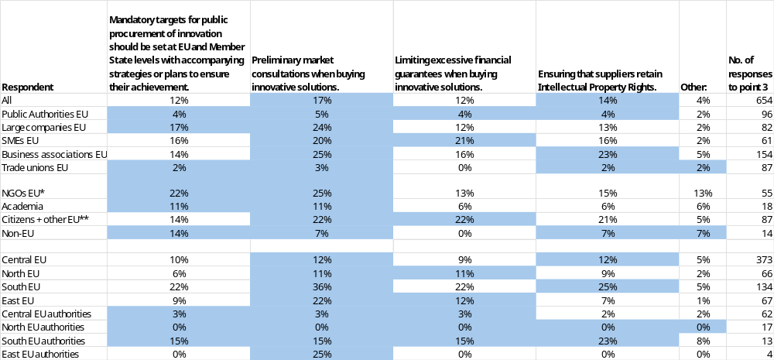
* NGOs + Environmental organisations; ** includes Consumer Organisations
Note: Multiple choice question; results reflect replies from those who answered. Top two responses highlighted. Point 3. EU public procurement law should mandate the public procurement of innovation requirements.
EU includes NO; Central EU: AT, BE, DE, FR, LU, NL; North EU: DK, FI, IE, SE and NO; South EU: CY, EL, ES, IT, MT, PT; East EU: BG, CZ, EE, HR, HU, LT, LV, PL, RO, SK; replies of only those who answered are provided
Source: Public Consultations on public procurement reform. Commission own analysis.

Respondents who agreed or strongly agreed that EU public procurement law should mandate the public procurement of innovation were asked which elements should be made mandatory. Figures refer to the share of these respondents selecting each option.
Across all respondents, the most frequently supported mandatory elements were preliminary market consultations when buying innovative solutions (17%) and ensuring that suppliers retain intellectual property rights (14%).
Among public authorities, support levels were low and relatively even, with 5% in favour of mandatory preliminary market consultations and 4% for each of mandatory targets, limits on financial guarantees and retention of intellectual property rights.
Among large companies, SMEs and business associations, preliminary market consultations attracted the highest support (24% for large companies, 20% for SMEs, 25% for business associations). Business associations also showed relatively higher backing for ensuring that suppliers retain intellectual property rights (23%), while SMEs more often favoured limiting excessive financial guarantees (21%). Across these three groups, support for mandatory targets ranged between 14% and 17%.
Trade unions expressed very low support for any of the listed mandatory elements (0–3%). NGOs, by contrast, reported higher support for preliminary market consultations (25%) and mandatory targets (22%).
Among academia, citizens and other respondents, and non-EU respondents, citizens and other respondents were the most supportive, with 22% backing mandatory preliminary market consultations and limits on excessive financial guarantees, and 21% supporting mandatory retention of intellectual property rights. Academia showed lower but balanced support (around 6–11% across all elements), while non-EU respondents focused mainly on mandatory targets (14%), with limited support for other elements.

Those who selected Other were asked to elaborate. A summary of their responses is presented below.
Public authorities
Public authorities who commented addressed which changes should be made mandatory regarding the use of public procurement of innovation.
Most comments advocated mandating the acceptance of variants by default (“as a matter of principle”) to encourage innovative and sustainable tenders and improve access for VSEs and SMEs. They proposed an obligation to set out “minimum requirements” for variants in the procurement documents and to ensure award criteria are applicable both to compliant offers and to variants meeting those minimum requirements.
A smaller number called for mandatory mechanisms to pool demand through “joint procurement consortia (particularly across country borders)” to address common needs.
EU companies and business associations
EU companies and business associations who commented set out which changes should be made mandatory to strengthen public procurement of innovation. A clear majority argued innovation should be treated as a “cross-cutting principle” across all contract types, with Best Price-Quality Ratio made the default award criterion and high-weighted non-price factors to avoid “downward competitive dynamics.” They called for “systematically allowing variants” to unlock innovative offers and warned that “cost premium thresholds… should not be set” as they could exclude transformative solutions with superior lifecycle value. Many also insisted innovation be aligned with climate, health and resilience goals so procurement becomes “a powerful enabler of better, more sustainable choices.”
Many proposals focused on mandatory process requirements to de-risk and speed uptake: make transparency and “premarket dialogue and communication” compulsory (potentially at EU level) and include diverse end-user perspectives (e.g. “patients, doctors, nurses, technicians”). Create simple, pre-approved procedures for innovation to give legal certainty to small administrations; require proportional solvency/guarantee levels, rapid and milestone payments, document reuse (“Once-Only”), accelerated pilots, incentives for bidders to take technological risk, and “regulatory sandboxes.” Several also asked to mandate reduced formal requirements, shorter deadlines and fewer references for small contracts (e.g. up to EUR 200 000).
There was strong emphasis on intellectual property, with calls to make it mandatory that “suppliers retain the intellectual property rights except where the buyer really needs to own IPR” (e.g. national security), and to improve legal certainty in newer procedures. On targets, where used they should be performance-based and technologically neutral, not prescriptive of specific materials or technologies. A minority, particularly in software, proposed mandatory, high-weighted criteria such as “interoperability, open standards, and code auditability,” favouring “upstream-first open source” and requiring “second source” capability via multiple independent providers to ensure vendor neutrality, resilience and EU strategic autonomy.
EU NGOs, environmental organisations and trade unions
EU NGOs, environmental organisations and trade unions who commented addressed which changes should be made mandatory for public procurement of innovation. A majority called for value-based awards that “move beyond the lowest price,” including mandatory use of BPQR and lifecycle costing, and the systematic inclusion of non-price criteria covering “social and environmental objectives, innovation and circularity.” Several also urged clear, enforceable social and environmental clauses so eligibility aligns with impact goals.
Many supported mandatory reporting and transparency to monitor progress and ensure accountability. A recurring proposal was an EU-level tax compliance certificate for bidders, renewed periodically and based on objective criteria (e.g. limited discrepancies between global and in-country profitability), which could be presented in public tenders to strengthen integrity.
There were tensions on the extent of mandating innovation requirements. A minority argued that, unlike social and environmental conditionalities, innovation should be sector-specific and target-driven, with contracting authorities incentivised-especially in identified lead markets-rather than bound by blanket obligations; they “would not recommend any of the above being made mandatory,” preferring case-by-case or sector-specific decisions.
All other respondents
Other respondents who commented addressed which changes should be made mandatory to strengthen public procurement of innovation. Submissions proposed mandating proportionality and BPQR criteria for innovation-related procurements to ensure performance-based evaluation “without mandating specific technologies or suppliers,” alongside enabling “joint procurement consortia (particularly across country borders)” to meet common needs. One proposal sought to permit making purchases contingent on research/innovation outcomes in the care sector.
Several called for stronger inclusion rules for SMEs and micro firms, notably in architecture, to counter over-demanding reference and staffing requirements that “regularly exclude” the “young and small offices” that drive innovation. Proportionality duties were seen as a way to rebalance access while maintaining quality.
A minority advanced software-specific mandatory provisions: public frameworks should recognise permissive and open licensing as legitimate innovation models, require high-weighted quality criteria such as “interoperability, open standards, and code auditability,” and support “second-source capability” so multiple providers can maintain and evolve solutions. This sits in some tension with strict technological neutrality, but proponents argued these requirements enhance resilience, competition and long-term public value while avoiding “proprietary dependency.”

9.10.1. Public procurement of innovation impacts
Figure 87: Question: How likely do you believe the following outcomes would occur as a result of incentivising public procurement of innovation?; all replies.
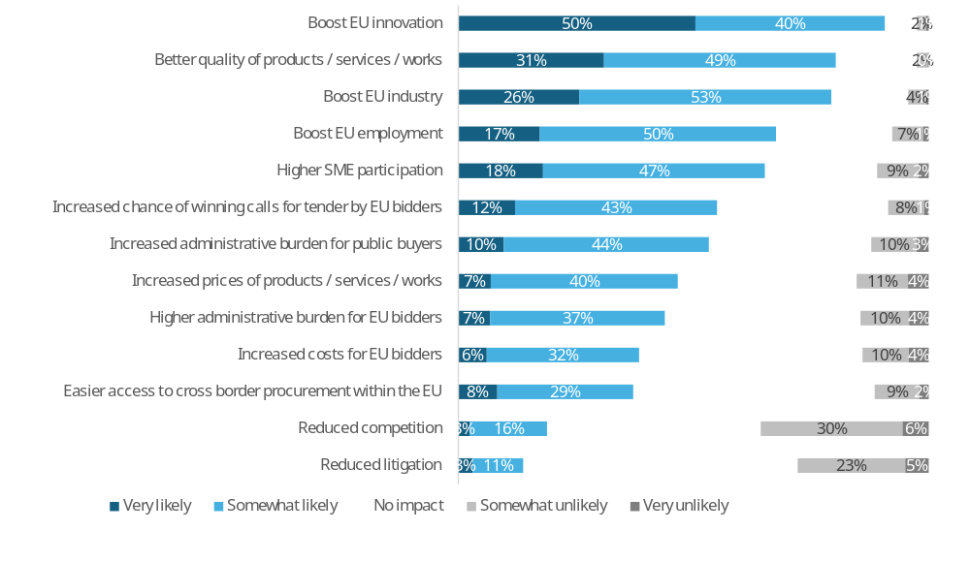
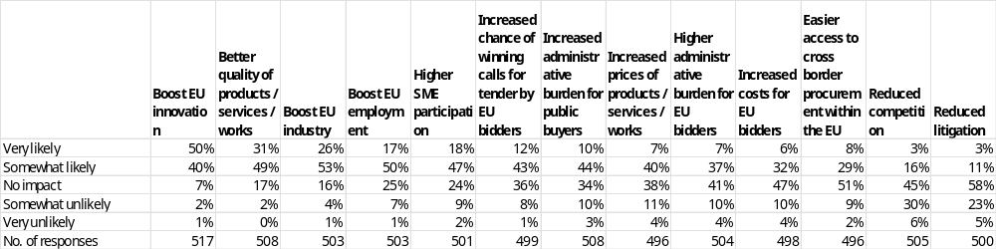
Note: Single-choice responses only; results reflect replies from those who answered.
Source: Public Consultations on public procurement reform. Commission own analysis.

In response to the question “How likely do you believe the following outcomes would occur as a result of incentivising public procurement of innovation?”, respondents most often expect a boost to EU innovation (90%: 50% very likely, 40% somewhat likely), followed by better quality of products, services and works (80%: 31% very likely, 49% somewhat likely), a boost to EU industry (79%: 26% very likely, 53% somewhat likely), and a boost to EU employment (67%: 17% very likely, 50% somewhat likely). Majorities also foresee higher SME participation (65%: 18% very likely, 47% somewhat likely) and increased chance of winning calls for tender by EU bidders (55%: 12% very likely, 43% somewhat likely). On the cost and burden side, around half consider increased administrative burden for public buyers likely (54%: 10% very likely, 44% somewhat likely), as well as increased prices of products, services and works (47%: 7% very likely, 40% somewhat likely). Lower positive expectations are reported for higher administrative burden for EU bidders (44%: 7% very likely, 37% somewhat likely), increased costs for EU bidders (38%: 6% very likely, 32% somewhat likely), and easier access to cross-border procurement within the EU (37%: 8% very likely, 29% somewhat likely). The lowest shares of positive expectations concern reduced competition (19%: 3% very likely, 16% somewhat likely) and reduced litigation (14%: 3% very likely, 11% somewhat likely).
Disagreement that these outcomes will occur (somewhat unlikely or very unlikely) is highest for reduced competition (36%: 30% somewhat unlikely, 6% very unlikely) and reduced litigation (28%: 23% somewhat unlikely, 5% very unlikely), followed by increased prices of products, services and works (15%: 11% somewhat unlikely, 4% very unlikely), increased costs for EU bidders (14%: 10% somewhat unlikely, 4% very unlikely), and higher administrative burden for EU bidders (14%: 10% somewhat unlikely, 4% very unlikely). Lower, but still notable, disagreement is reported for easier access to cross-border procurement (11%: 9% somewhat unlikely, 2% very unlikely) and increased administrative burden for public buyers (13%: 10% somewhat unlikely, 3% very unlikely). Disagreement is comparatively limited for the “beneficial” outcomes: 3–8% somewhat/very unlikely for boost to EU innovation, better quality, boost to EU industry, boost to EU employment, higher SME participation, and increased chance of winning for EU bidders.
Across all outcomes, the share of respondents expecting “no impact” ranges from 7% for a boost to EU innovation to 58% for reduced litigation and 51% for easier access to cross-border procurement. Intermediate “no impact” levels are reported for better quality (17%), boost to EU industry (16%), boost to EU employment (25%), higher SME participation (24%), increased chance of winning for EU bidders (36%), increased administrative burden for public buyers (34%), increased prices (38%), higher administrative burden for EU bidders (41%), increased costs for EU bidders (47%), and reduced competition (45%).

Table 106: Question: How likely do you believe the following outcomes would occur as a result of incentivising public procurement of innovation?; percentage of respondents that indicated “very likely” or “somewhat likely” answers, by type of respondent.
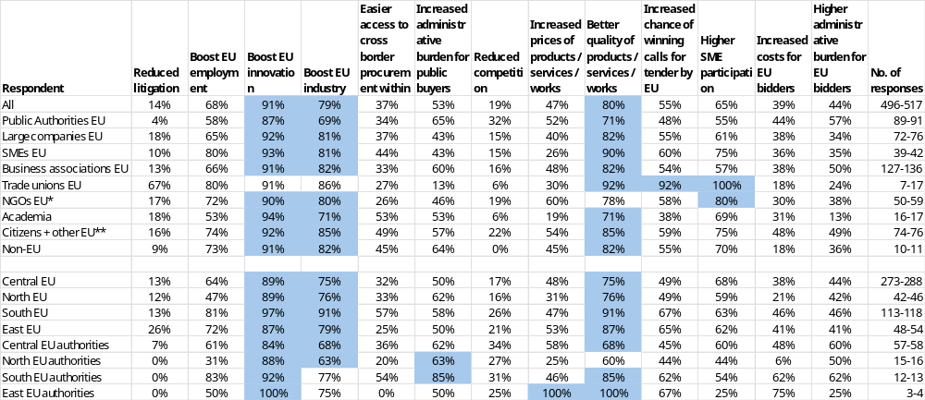
* NGOs + Environmental organisations; ** includes Consumer Organisations
Note: Single-choice responses only; results reflect replies from those who answered. Top three responses highlighted. The number of responses in the last column is shown as a range, as the number of replies varied per column. EU includes NO; Central EU: AT, BE, DE, FR, LU, NL; North EU: DK, FI, IE, SE and NO; South EU: CY, EL, ES, IT, MT, PT; East EU: BG, CZ, EE, HR, HU, LT, LV, PL, RO, SK; replies of only those who answered are provided
Source: Public Consultations on public procurement reform. Commission own analysis.

Respondents were asked how likely they believed different outcomes would be as a result of incentivising public procurement of innovation. The figures refer to the combined shares of “very likely” and “somewhat likely” answers (other response options were also available but are not shown).
Among public authorities, the outcomes most often seen as likely were a boost to EU innovation (87%) and to EU industry (69%), better quality of products, services or works (71%) and increased administrative burden for public buyers (65%). For the remaining outcomes, perceived likelihood ranged from 4% to 65%. Very low likelihood was reported for reduced litigation (4%).
Among large companies, SMEs and business associations, boosts to EU innovation were consistently among the most likely outcomes (large companies: 92%; SMEs: 93%; business associations: 91%), together with improved quality (82%; 90%; 82%) and, particularly for SMEs, higher SME participation (75%). Across these three groups, perceived likelihood of the other outcomes ranged from 10% to 93%. Very low likelihood was reported for reduced litigation among large companies (10 - 18%).
Among trade unions and NGOs, both groups regarded boosts to EU innovation (trade unions: 91%; NGOs: 90%) and higher SME participation (100%; 80%) as likely outcomes. Trade unions also pointed to increased chance of winning for EU bidders (92%). For these two groups, perceived likelihood of the remaining outcomes ranged from 6% to 80%. Very low likelihood was reported among trade unions for reduced competition (6% - 19%).
Among academia, citizens and other respondents, and non-EU respondents, a boost to EU innovation was again the most likely outcome (academia: 94%; citizens and other respondents: 92%; non-EU respondents: 91%), with better quality also frequently mentioned (71%; 85%; 82%). Across these three groups, perceived likelihood of the remaining outcomes ranged from 6% to 82%. Very low likelihood was reported for reduced competition (0 - 6%).

Respondents were invited to identify any other likely impacts. A summary of their responses is presented below.
Public authorities
Around one in ten public authorities provided comments on the wider impacts of incentivising public procurement of innovation, generally supporting innovation as a policy goal but questioning the extent to which procurement should be used to deliver it. Several argued that procurement “may not be the correct policy goal” compared with grant funding, and one proposed excluding research and development services (including those for research organisations) from the directive altogether.
A clear majority preferred incentivising rather than mandating innovation. They warned that “making innovation mandatory is not the way forward” and that a “one-size-fits-all model derived from EU legislation” would increase complexity, administrative burdens, higher prices and “greater risk of litigation”, with some suggesting that “the local level is not the right place for innovation procurement” in all cases. Innovation was seen as emerging from flexibility rather than prescription: “innovation does not occur simply by mandating new solutions”.
Many comments focused on the need for more flexible procedures to support innovation. Authorities called for more scope to use negotiated procedures without prior publication, higher thresholds, and greater flexibility to adjust tenders and contracts “during contract execution to facilitate innovation”, including the role of public buyers as “launching customers”. Market engagement was described as “critical”, with calls for clearer rules on market consultations and even mandatory pre-market engagement for high-value, strategic tenders, partly to support SME and small-scale local suppliers.
A minority stressed that current innovation procedures are “far too complicated and complex”, and that mechanisms such as “comply or explain” are not sufficiently clear, raising concerns that critical obligations could be circumvented. Alongside calls for promotion of “value engineering”, respondents emphasised that innovative procurement must not disregard core principles of non-discrimination and transparency. The main tension lay between the recognised importance of innovation and concerns about complexity, risk and over-regulation if innovation were mandated rather than incentivised.
EU companies and business associations
Around one in ten EU companies and business associations commented on the wider impacts of incentivising public procurement of innovation, generally seeing it as a powerful but underused lever to strengthen European industry, support green and digital transitions, and scale up innovative solutions.
Most viewed incentivised innovation procurement as a way to create “early demand signals”, reduce market risk and accelerate uptake of innovative and sustainable products and services, especially for SMEs and start-ups. Public buyers acting as “launching customers/first buyers”, innovation procurement funds, pilots, outcome-based specifications and public–private partnerships were seen as key to supporting technologies such as AI, cloud, advanced materials, circular and bio-based solutions, efficient buildings and textiles, and to boosting “technological sovereignty and resilience of European value chains”.
A strong majority favoured an incentive-based, voluntary model rather than mandatory innovation criteria. They argued that “more innovation cannot be legislated”, that innovation criteria should remain “at the discretion of the public contracting authority”, and that mandatory requirements risk “complicating and lengthening procedures”, increasing administrative burden and distorting competition or causing technology lock-in. Some underlined that social, environmental and innovation considerations are already possible under current rules if linked to the contract, and warned against overly prescriptive criteria and documentation that could limit SME participation and cross-border competition. A smaller group considered existing tools broadly “adequate and fully sufficient” and cautioned against new constraints.
Many stressed that simplification and flexibility are preconditions for successful incentives. The current framework was often described as “restrictive” and “extremely complex”, with innovation procedures “rarely implemented”. Suggested changes included clearer rules, “agile procedures”, more flexible contract changes and durations, broader scope for negotiated procedures and market dialogue, regulatory sandboxes, milestone payments, reduced guarantees, document standardisation and Once-Only principles. Additional proposals included SME-only variants subject to minimum criteria, general acceptance of variant tenders unless expressly excluded, competitions reserved for SMEs or young professionals, guidelines on “buying innovative”, and stronger market engagement and IP management. A recurring nuance was that incentives should not focus solely on start-ups: “innovations from traditional and long-established companies should also be eligible”.
EU NGOs, environmental organisations and trade unionsnAround one in ten EU NGOs, environmental organisations and trade unions commented on the wider impacts of incentivising public procurement of innovation, with most linking it to strategic autonomy, climate and circular transitions, social resilience and the creation of quality jobs.
A large share argued that clearer and mandatory rules – including “mandatory criteria related to quality jobs and collective bargaining, & regulation of subcontracting” – would secure better value for money, legal certainty, equal treatment and fair competition. Several claimed that keeping criteria optional “guarantees only higher burdens and costs”, as case-by-case interpretation increases transaction costs for both authorities and contractors. Some also stressed that price-only procurement is inadequate, especially for innovation, and that the focus should be on cost-effectiveness and the price–quality ratio, recognising that higher upfront costs can be offset by long-term improvements.
Many respondents underlined that innovation requires sufficient human and financial resources in local and regional administrations. They warned that reforms “not accompanied by human and material support” risk “administrative chaos”, and called for upskilling and reskilling of the workforce, backed by financial guarantees and “innovation-friendly procedures” with clearer guidance, simplification and flexibility while maintaining accountability. Several insisted that the EU should pursue “innovation for the EU’s strategic autonomy, ecological and social resilience and quality job creation”, rather than innovation as an end in itself.
A minority, mainly representing local and regional interests, stressed subsidiarity and opposed prescriptive EU-level obligations. They argued procurement “is about fulfilling the needs that LRGs, and by extension the citizens, have”, and that contracting authorities must retain discretion to decide which innovation criteria are appropriate “in line with their specific needs, capacities and market realities”, with innovation requested “on a voluntary basis”. Others highlighted that, if well designed, incentivising innovation can be manageable administratively, improve resilience and enable SMEs, start-ups and scaleups to compete in strategic sectors, increase supplier diversity and accelerate diffusion of innovative solutions across the Single Market.
All other respondents
Around one in fourteen respondents in this residual group commented on wider impacts of incentivising public procurement of innovation, generally seeing it as a way to transform public services and stimulate industrial and technological restructuring in the EU, provided the framework becomes clearer, more flexible and less burdensome.
Many argued that innovation-oriented procurement can act as a catalyst for scaling and diffusion of innovative solutions, strengthening innovation ecosystems, EU industry and “strategic autonomy”, especially if combined with demand aggregation, challenge-based or joint cross-border procurement, and the State acting as “first buyer”. Several stressed the importance of preliminary market consultations, proportional guarantees, clear IP rules, and support for innovative SMEs and start-ups, particularly in software and digital ecosystems where demand for “openness, interoperability and reuse” can improve market structure and long-term value.
A frequent concern was that existing innovation procedures (notably innovation partnerships and more dialogue-based procedures) are underused because they are “complex, costly and ‘uncertain’”, with limited flexibility for contract modifications and inadequate clarity on pre-commercial procurement. Respondents called for simplified, more flexible rules; clearer and more imperative functional specifications; reconsideration and streamlining of innovation partnership rules; explicit confirmation of PCP exclusions; and, for some, economic or fiscal incentives in large innovation projects and specialised digital platforms or networks to support PCP/PPI across Member States.
On the degree of obligation, most views supported enabling and incentivising innovation, but not imposing automatic or uniform innovation requirements. Some asked for public buyers to be allowed to “prioritize innovative services over non-innovative ones”, including direct awards without thresholds where competition is not meaningful, while others insisted that consideration of innovation “cannot be automatic” and must remain case-by-case. Overall, respondents saw intensified innovation procurement as beneficial for competitiveness and potentially for EU exports, but conditional on reduced administrative and financial barriers and a more predictable legal framework.

Figure 88: Question: How likely do you believe the following outcomes would occur as a result of mandating further socially responsible public procurement obligations?; all replies.
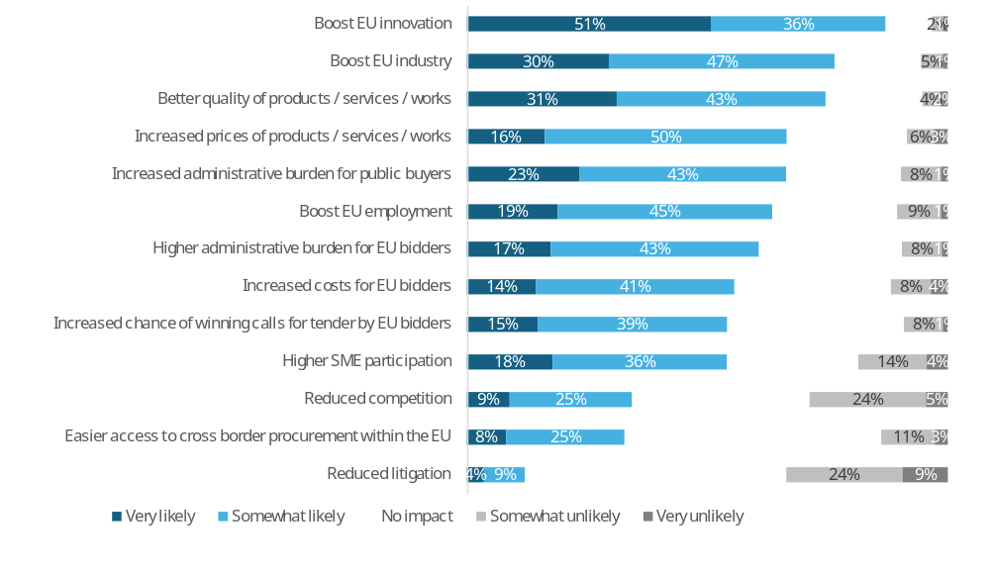
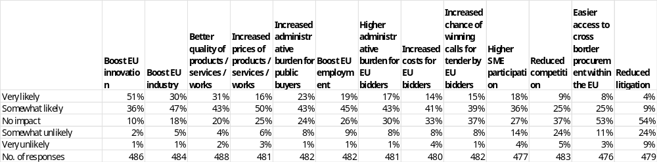
Note: Single-choice responses only; results reflect replies from those who answered.
Source: Public Consultations on public procurement reform. Commission own analysis.

In response to the question “How likely do you believe the following outcomes would occur as a result of mandating public procurement of innovation?”, respondents most often expect a boost to EU innovation (87%: 51% very likely, 36% somewhat likely), followed by a boost to EU industry (77%: 30% very likely, 47% somewhat likely) and better quality of products, services and works (74%: 31% very likely, 43% somewhat likely). Majorities also foresee increased prices of products, services and works (66%: 16% very likely, 50% somewhat likely), increased administrative burden for public buyers (66%: 23% very likely, 43% somewhat likely), a boost to EU employment (64%: 19% very likely, 45% somewhat likely), higher administrative burden for EU bidders (60%: 17% very likely, 43% somewhat likely), and increased costs for EU bidders (55%: 14% very likely, 41% somewhat likely). Increased chance of winning calls for tender by EU bidders (54%: 15% very likely, 39% somewhat likely) and higher SME participation (54%: 18% very likely, 36% somewhat likely) are also often seen as likely. Lower positive expectations are reported for reduced competition (34%: 9% very likely, 25% somewhat likely), easier access to cross-border procurement within the EU (33%: 8% very likely, 25% somewhat likely), and reduced litigation (13%: 4% very likely, 9% somewhat likely).
Disagreement that these outcomes will occur (somewhat unlikely or very unlikely) is highest for reduced litigation (33%: 24% somewhat unlikely, 9% very unlikely), reduced competition (29%: 24% somewhat unlikely, 5% very unlikely), and easier access to cross-border procurement (14%: 11% somewhat unlikely, 3% very unlikely), followed by higher SME participation (18%: 14% somewhat unlikely, 4% very unlikely). Lower, but still notable, disagreement is reported for increased costs for EU bidders (12%: 8% somewhat unlikely, 4% very unlikely), increased prices (9%: 6% somewhat unlikely, 3% very unlikely), higher administrative burden for EU bidders (9%: 8% somewhat unlikely, 1% very unlikely), increased administrative burden for public buyers (9%: 8% somewhat unlikely, 1% very unlikely), and a boost to EU employment (10%: 9% somewhat unlikely, 1% very unlikely). Disagreement is comparatively limited for better quality (6%: 4% somewhat unlikely, 2% very unlikely), a boost to EU industry (6%: 5% somewhat unlikely, 1% very unlikely), increased chance of winning for EU bidders (9%: 8% somewhat unlikely, 1% very unlikely), and a boost to EU innovation (3%: 2% somewhat unlikely, 1% very unlikely).
Across all outcomes, the share of respondents expecting “no impact” ranges from 10% for a boost to EU innovation to 54% for reduced litigation and 53% for easier access to cross-border procurement. Intermediate “no impact” levels are reported for a boost to EU industry (18%), better quality (20%), increased prices (25%), increased administrative burden for public buyers and boost to EU employment (each 24–26%), higher administrative burden for EU bidders (30%), increased costs for EU bidders (33%), increased chance of winning for EU bidders (37%), higher SME participation and reduced competition (each 27–37%).

Table 107: Question: How likely do you believe the following outcomes would occur as a result of mandating further socially responsible public procurement obligations?; percentage of respondents that indicated “very likely” or “somewhat likely” answers, by type of respondent.
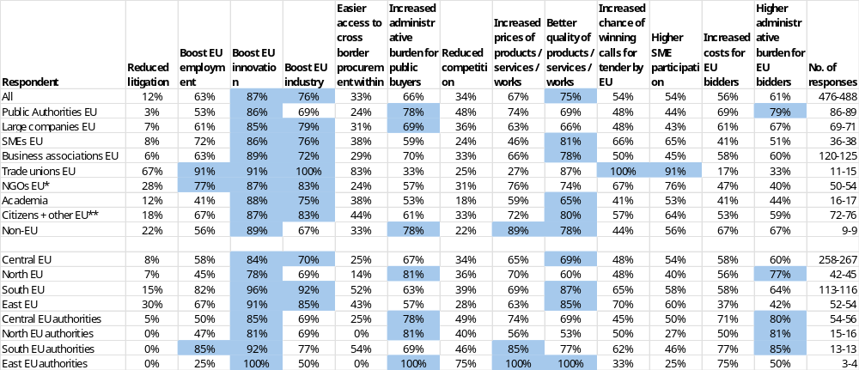
* NGOs + Environmental organisations; ** includes Consumer Organisations
Note: Single-choice responses only; results reflect replies from those who answered. Top three responses highlighted. The number of responses in the last column is shown as a range, as the number of replies varied per column. EU includes NO; Central EU: AT, BE, DE, FR, LU, NL; North EU: DK, FI, IE, SE and NO; South EU: CY, EL, ES, IT, MT, PT; East EU: BG, CZ, EE, HR, HU, LT, LV, PL, RO, SK; replies of only those who answered are provided
Source: Public Consultations on public procurement reform. Commission own analysis.

Respondents were asked how likely they believed different outcomes would be as a result of mandating further socially responsible public procurement obligations. The figures refer to the combined shares of “very likely” and “somewhat likely” answers (other response options were also available but are not shown).
Among public authorities, the outcomes most often seen as likely were boost to EU innovation (86%), increased administrative burden for public buyers (78%), higher administrative burden for EU bidders (79%). For the remaining outcomes, perceived likelihood ranged from 3% to 69%. Very low likelihood was reported for reduced litigation (3%).
Among large companies, SMEs and business associations, a boost to EU innovation was consistently among the most likely outcomes (large companies: 85%; SMEs: 86%; business associations: 89%), alongside boost to EU industry (72% - 79%) and better quality of products, services or works (66% - 81%). SMEs clearly associated these obligations with higher SME participation (65%), while large companies and business associations also highlighted increased administrative burden for public buyers (69% - 70%). Across these three groups, perceived likelihood of the other outcomes ranged from 6% to 70%. Very low likelihood was reported for reduced litigation among large companies (6^ - 8%).
Both trade unions and NGOs most frequently regarded a boost to EU industry (83% - 100%), boosts to EU employment and innovation (77% - 91%). Trade unions also pointed to higher SME participation (91%) and increased chances of winning for EU bidders (100%) as likely outcomes. For these two groups, perceived likelihood of the remaining outcomes ranged from 25% to 100%.
Among academia, citizens and other respondents, and non-EU respondents, a boost to EU innovation and industry were again among the most likely outcomes (67% - 89%), together with better quality (65%; 80%; 78%). Across these three groups, perceived likelihood of the remaining outcomes ranged from 12% to 89%. Very low likelihood was reported for reduced competition and litigation (12%-33%).

Respondents were invited to identify any other likely impacts. A summary of their responses is presented below.
Public authorities
Around one in twelve public authorities commented on the potential wider impacts of mandating public procurement of innovation, generally expressing strong scepticism and preferring incentive-based approaches.
Most respondents argued that “innovation cannot be legislated into existence” and that mandating innovation procurement would be counterproductive. They warned that existing innovation procedures are already “far too complicated and complex”, and “imposing it would be even worse”, increasing costs and administrative burdens for both contracting authorities and bidders. Several stressed that additional regulations inevitably “lead to increased costs and administrative burden for the bidders” and that the local level is “not the right place for innovation procurement” in all cases.
A clear majority favoured voluntary, flexible frameworks over rigid obligations. One explicitly stated that “incentivising the public procurement of innovation is strongly preferred to mandating it”, arguing that voluntary approaches preserve flexibility, foster competition, and allow authorities to choose solutions that best fit local needs and policy objectives. Related comments called for more use of negotiated procedures without prior publication, higher thresholds, and greater flexibility to modify tenders and contracts during execution so that authorities can act as “launching customers”.
Only a small number raised more targeted or alternative mechanisms. These included excluding research and development services (including those for research organisations) from the directive altogether, reserving contracts for “impact companies” to advance social and environmental goals, and strengthening monitoring and reporting on sustainable public procurement (e.g. using e-procurement tools and a Public Procurement Data Space). Overall, the dominant concern was that mandating innovation would increase complexity and risk without guaranteeing better outcomes, whereas enabling and incentivising innovation within a flexible framework was seen as more effective.
EU companies and business associations
Around one in eight EU companies and business associations commented on the wider impacts of mandating public procurement of innovation, with a clear majority warning about increased administrative burden, costs and legal complexity, and preferring incentive-based or product-specific approaches rather than generic mandatory rules.
Most respondents argued that “more innovation cannot be legislated”, “creativity cannot be enforced” and that mandatory innovation criteria risk “artificialising” innovation, driving solutions that comply formally rather than meet real needs. They anticipated higher administrative burdens, longer procedures, reduced flexibility for buyers, and possible discouragement of SME and start-up participation, especially where firms cannot bear the risks of rigid, innovation-heavy contracts. Several stressed that innovation is difficult to “measure and weight” and that broad mandatory criteria to address strategic challenges “should be avoided”, as they could increase litigation and distort competition.
A sizeable group nevertheless underlined potential positive impacts if mandating is targeted and proportionate. They suggested that mandatory innovation procurement could help overcome market inertia, accelerate technology transfer and circular-economy transitions, modernise public services, strengthen EU “sovereignty and competitiveness”, and support re-industrialisation (e.g. via “European preference”, reciprocity clauses, or a “Buy European” -type approach based on product origin). Some sector-specific comments, particularly in textiles and construction, claimed that enforced demand for innovative, sustainable solutions would drive new patents, local innovation ecosystems and progress towards sustainability objectives. One respondent explicitly “supports mandating public procurement of innovation”, provided innovation criteria are tied to EU industrial goals.
Across the spectrum, many emphasised that any move towards mandating innovation must be accompanied by simplification and flexibility. Recurrent proposals included: clearer and simpler rules for innovation partnerships and dialogue-based procedures; more flexible contract modification and duration; accelerated procedures, milestone payments, reduced solvency requirements and mutual guarantees; automatic transition from pilots and PCP to operational contracts; and stronger, mandatory pre-market dialogue with users. Several called for better handling of intellectual property rights, warning that full transfer of IP to contracting authorities “discourages companies from submitting bids”. Design and architectural competitions were repeatedly highlighted as an effective, competition-based tool for embedding innovation without broad mandatory rules.
There were marked tensions between those calling for mandatory, innovation-linked procurement to drive strategic industrial and sustainability goals, and those insisting that rigid obligations would be counterproductive, especially in specific sectors (e.g. energy networks, grids) where innovation is already driven by market and technical dynamics. While a small minority supported mandating in principle, the prevailing position was that public procurement “should promote innovation” and can be a “lever for re-industrialising Europe”, but that this is best achieved through incentives, outcome-based and sector-specific tools, and more agile procedures, not through generic, across-the-board mandatory innovation requirements.

EU NGOs, environmental organisations and trade unions
Around one in twelve EU NGOs, environmental organisations and trade unions commented on the wider impacts of mandating public procurement of innovation, often linking it to climate, circular and industrial transitions, but highlighting strong social, administrative and capacity concerns.
Many respondents warned that imposing obligations would “further complicate regulation”, increase administrative burden and make it harder for smaller contracting authorities and SMEs to participate, with mandatory rules potentially “contradictory and counterproductive” given existing dense sectoral legislation. Some argued that innovation “cannot be measured” and that mandating it risks formalising innovation without enabling it, leading to higher compliance costs, legal uncertainty, risk-averse behaviour by buyers, and self-exclusion by start-ups and SMEs, thereby narrowing supplier pools and favouring incumbents.
At the same time, a sizeable group stressed that, if used, mandatory approaches must be oriented towards “innovation for the EU’s strategic autonomy, ecological and social resilience and quality job creation”, with innovation broadly defined and including incremental, social and environmental aspects. Trade union and labour-focused submissions repeatedly called for the revision to “strengthen social clauses, promote collective bargaining and quality jobs”, end lowest-price awards in favour of MEAT with mandatory criteria on quality employment and collective bargaining, regulate subcontracting (joint and several liability and limits on chain length), exclude firms breaching labour standards or tax obligations, and safeguard public, public-public and in-house service provision. Some also noted that mandatory ecological and social sustainability criteria “automatically lead to innovation”, making an additional innovation layer unnecessary.
Several contributions emphasised that mandated innovation procurement could widen gaps between well-resourced and under-resourced authorities unless accompanied by strong capacity-building, technical assistance and simplified procedures. They called for standards, competence centres and clearer, innovation-friendly procedures, and for attention to IT security and sovereignty in digital procurement. Design contests in architectural services were mentioned as a practical method to achieve innovation while protecting bidders’ copyrights and ensuring remuneration. Overall, the majority preferred encouragement, flexibility and robust social conditionality over rigid innovation obligations that might prioritise procedure over real-world outcomes.
All other respondents
Around one in eleven respondents in this residual group commented on the wider impacts of mandating public procurement of innovation, generally seeing a role for procurement in promoting innovative and circular solutions, but expressing concern about higher costs, administrative burden and rigid rules.
Many respondents argued that public procurement should promote innovation by acquiring “novel solutions – including biodegradable and compostable products – while supporting the circular economy and advancing digitalisation”. Mandating innovation was seen by some as potentially increasing “pilot-to-scale pathways and ecosystem learning effects”, improving market visibility and reducing fragmentation, and, in software-intensive markets, strengthening “quality and innovation capacity” if requirements are outcome-based and aligned with “open, interoperable ecosystems”. A few mentioned possible benefits such as “increased specialisation and more globally competitive companies” and greater familiarity of buyers with innovation topics.
At the same time, a large share warned that any new obligations would “lead to increased costs and administrative burden for the bidders” and risk procurement delays due to complexity and capacity gaps. Several pointed out that “higher prices arise whenever a change is required by law”, and cautioned that rigid or technology-specific mandates could reduce competition, favour only large innovative firms, and be especially problematic where private contracting authorities are financially constrained (e.g. in education). One comment suggested that “incentivising and mandating have more or less the same result”, but that incentives are preferable as they “allow the market player to be more innovative”.
Some contributions called for clearer boundary-setting and better framework conditions rather than blanket obligations. They proposed excluding public R&D and knowledge-generation services (including universities) from public procurement rules and treating them as horizontal cooperation, to strengthen public research networks. Concerns were raised about contracting authorities’ standard practice of demanding full IP transfer, which “discourages participation and reduces innovation”. Respondents also noted that innovation partnerships “have been unsuccessful” in practice and favoured interconnected digital platforms, shared evaluation and AI-supported, interoperable systems to increase transparency and coordinate effort across countries. Overall, the majority saw public procurement as a lever to promote innovation, but considered flexible, outcome-based and interoperability-oriented approaches more effective than rigid mandatory targets.

Final comments
All respondents had the opportunity to provide final comments. A summary of their responses is presented below.

9.11.1. Public authorities
Around half of public authorities provided additional comments, mainly calling for a simpler, more flexible and better-targeted framework, and often linking specific design choices to clear cost and benefit implications for both authorities and bidders.
A very large share argued that simplification and higher thresholds would generate substantial net savings. Authorities described current EU thresholds as “too low” and capturing “almost all spending”, forcing many straightforward, purely local procurements into full EU procedures with limited or no cross-border interest. Several called for thresholds at least to be doubled, with some suggesting specific levels (e.g. EUR 10 million for works and EUR 750 000 for supplies and services) and regular indexation for inflation. They expected this to cut administrative workload, shorten timelines and reduce legal risk (fewer review procedures), while having little impact on competition in practice. One contribution cited that preparing a municipal construction bid can cost suppliers much more than in comparable private tenders, attributing the differential to fragmented documentation and varying carbon and reporting requirements; harmonised methods and “Once-Only” data submission were seen as ways to reduce these transaction costs while preserving competition and enabling robust low-carbon criteria.
Most authorities stressed that current regulation is “too complex” and “too dense”, describing the system as a “bureaucratic crack” rather than a clear, legally certain tool. They warned that additional horizontal obligations (e.g. generic ESG or ‘Made in Europe’ requirements) risk further increasing costs, delays and litigation without guaranteed benefits, especially for small municipalities and SMEs. Many asked for a leaner procedural directive focused on “how to buy”, leaving substantive sector-specific requirements to other instruments and avoiding “stacking” of sectoral legislation (for instance in energy efficiency or environmental law) on top of procurement rules. Across comments, tools such as the ESPD and eForms were often said to have increased administrative burden rather than reduced it; some explicitly called for phasing out the ESPD, replacing it with a single EU-level registry or database of supplier data and exclusion grounds, and a simple yes/no interface at first stage. A number of authorities favoured an EU-wide platform that would centralise “once-only” compliance checks and blacklist enforcement, thereby lowering recurrent verification costs for both contracting authorities and economic operators.
Negotiation and procedural flexibility were highlighted as central to both efficiency and value for money. Many authorities proposed aligning the “classical” regime more closely with the utilities regime, so that negotiation is possible in all procedures beyond a simplified open procedure, arguing that this would better reflect private-sector practice and reduce the risk of unsuccessful or uncompetitive tenders. They called for three or so clear, streamlined procedures (simple open, restricted, and a free negotiation/dialogue option) and for more scope to regularise and correct bids rather than reject offers for minor formal defects-seen as a low-cost way to increase effective competition. Several requested more flexible rules on framework duration (beyond four years) and on contract modifications and extensions, to avoid costly retendering and to manage inflation, supply disruptions or innovation. Authorities responsible for fragile or third-country contexts emphasised that strict electronic and documentation requirements are often impracticable and that negotiated procedures and ex post regularisation are essential for maintaining competition and project delivery in such settings.
There was significant debate on the use of procurement for strategic objectives (green, social, industrial, security of supply). Many authorities accepted that public procurement can deliver long-term benefits in climate, social policy and resilience, and supported clearer, standardised tools such as credible labels, eco-management schemes and model clauses that would simplify verification while driving markets towards low-carbon and sustainable products. Some highlighted specific sectors, notably food, energy, construction and timber, where strategic procurement can “reap multiple benefits”: shifting diets and cutting health and climate costs, stimulating demand for bio-based or low-carbon materials, and strengthening local supply chains. Others, however, saw procurement as a relatively blunt instrument for social and environmental aims and warned that each new layer of obligation tends to raise procurement costs and deter suppliers, especially SMEs, without guaranteeing net social gains; they favoured addressing these goals through dedicated social or environmental legislation or fiscal instruments instead.
On industrial and sovereignty aspects, authorities were split. A number advocated some form of European preference or ‘Buy European’ clause, especially in strategic areas (buses and rolling stock, critical infrastructure, low-carbon materials, pharmaceuticals), arguing that without explicit preference, EU producers face unfair competition and de-industrialisation; they linked this to risks of shortages and loss of R&D and manufacturing capacity. Others-especially export-oriented regions-warned that blanket ‘Made in Europe’ rules would increase prices, reduce supplier choice, be difficult and costly to administer (complex origin tracking), and invite retaliation, thereby harming EU firms and overall welfare. A middle position, supported by several authorities, favoured targeted, sector-specific possibilities to limit procurement to EU-produced goods in “sensitive areas of services of general interest” or for critical infrastructure, coupled with strong reciprocity and security-based exclusion tools, but opposed broad horizontal obligations. Across these positions, authorities emphasised that any strategic conditions must be legally clear and administratively workable, otherwise enforcement costs and litigation risks could outweigh the intended benefits.
Many comments focused on strengthening security of supply and emergency responsiveness. Several authorities argued that the current classical directive gives them “no latitude” to address security-of-supply risks and proposed importing exclusion grounds similar to those in the defence and security directive, including for breaches of information or supply security and lack of reliability. Others called for a wider, clearer definition of urgency and exceptional circumstances (beyond natural disasters) that would explicitly cover failures of key suppliers, supply chain disruptions and critical infrastructure risks, enabling contracts to be awarded without prior publication in well-defined situations. They also supported EU-wide tools to exclude suppliers and subcontractors from high-risk countries in critical infrastructure projects. While these measures might occasionally reduce immediate price competition, respondents considered the risk reduction and continuity benefits for energy, health and other essential services to justify the potential cost.
Smaller municipalities and contracting entities repeatedly stressed capacity constraints and asymmetries in the costs and benefits of complex rules. They reported that complying with detailed procedures, overlapping sectoral regulation and cross-border obligations imposes heavy staff and legal costs, which are not offset by increased competition, since most contracts still attract only domestic bidders. Some advocated a differentiated regime based on contracting authority size (e.g. lighter rules for municipalities under 50 000 inhabitants, or an even lighter regime below 5 000), including simplified procedures, reduced documentation, fewer mandatory strategic criteria, and broader in-house and inter-municipal cooperation exemptions. Authorities argued that in-house provision and inter-municipal cooperation can be both cheaper and socially beneficial and that current rules and case law create uncertainty and deter such arrangements. They asked for clearer codification of public–public cooperation outside the scope of procurement-subject to safeguards such as transparency, joint governance and cost-based remuneration-to avoid costly legal disputes and to allow pooling of scarce resources.
Finally, several authorities underscored the importance of implementation, capacity-building and data rather than only new obligations. They noted that many strategic options in the current directives remain underused because of legal uncertainty, lack of guidance and fear of review procedures. Proposals included: an EU-level “skills academy” for procurement, model templates and standard clauses (e.g. for green or social criteria, carbon accounting), sector-specific networks (e.g. for food), and more use of authentic interpretative guidance to give courts and authorities a common reference point. Many warned that without such support, new mandatory provisions-however well intentioned-risk raising transaction costs and driving down participation, especially among SMEs, while failing to deliver the intended policy benefits. Overall, public authorities tended to see simplification, raised thresholds, more negotiation, better tools and clearer strategic options as reforms with strong net benefits, whereas generic new obligations (green, social or industrial) were regarded as more ambiguous, with benefits highly dependent on how far they are standardised, targeted and supported in practice.

9.11.2. EU companies and business associations
Around half of EU companies and business associations provided additional comments, generally treating the revision as a major opportunity to reduce procurement costs, improve market access for SMEs, and re-orient a share of the EU’s annual public purchasing towards innovation, sustainability and European industrial capacity.
A very large proportion of business respondents stressed simplification and digitalisation as a high-impact, low-risk reform with clear net benefits. They described current documentation and reporting obligations as excessive and duplicative, especially for SMEs and cross-border bidders, and argued that “once-only” submission of evidence, streamlined ESPD or its replacement by EU-wide registries, harmonised e-procurement tools and standardised templates could materially reduce transaction costs (staff time, legal and consulting expenses, bid preparation costs) and shorten timelines. One industry contribution estimated that preparing a municipal construction bid can cost suppliers around EUR 20 000–30 000 per tender, compared with EUR 1 000–2 000 in comparable private contracts, due mainly to fragmented data and technical requirements; harmonised carbon-assessment methods and machine-readable product data were seen as ways to cut these costs while still enabling robust low-carbon criteria. Businesses acknowledged upfront investment needs in interoperable platforms and audit-capable systems, but generally characterised these as one-off or transitional, outweighed by ongoing administrative savings, more bids per tender and better value for money.
SME access was a central concern. Many associations noted that SMEs dominate key ecosystems (for example in construction) yet are “significantly under-represented” in awards. They linked this to high compliance and solvency requirements, large “mega-lots”, complex ESPD and differing national practices. To reduce structural barriers, they advocated mandatory division into lots (“divide or explain”), explicit SME tests before publication of specifications to detect disproportionate requirements, SME reserves for certain low-value or high-local-impact contracts, and simplified rules for SME consortia. Some proposed that at least 30–33% of public spend should go to SMEs, echoing national examples. Others stressed the importance of fair subcontracting, including direct payment to subcontractors if primes fail to pay on time, and bans on changing agreed subcontracting terms after award. Many argued that these adjustments would increase the number and diversity of bidders, reduce cancellation and litigation rates, and ultimately improve competition and local economic returns, even if they require some redesign effort by contracting authorities.
A second major theme was the use of procurement as a lever for EU industrial competitiveness, sovereignty and decarbonisation, with clear tensions on the extent and design of EU preference and green obligations. A large number of industrial organisations (particularly in steel, metals, cement, pharmaceuticals, textiles, PVC, glass, recycling and some energy sectors) argued that price-only procurement and full openness to non-EU suppliers have contributed to de-industrialisation, loss of jobs and relocation of production. They cited, for example, that the majority of pharmaceutical active ingredients are now produced in Asia, and warned of heightened risks of shortages. These respondents called for “privileged access for European producers” through instruments such as European-content criteria, strengthened reciprocity, “Buy European” acts based on product origin and not company nationality, or higher price-preference margins (some argued that the current 3% margin is too low and suggested substantially higher margins to reflect dumping and subsidies, which can make non-EU offers “50–100% cheaper”). Several sectors proposed specific carbon-intensity labels or thresholds (e.g. clearly defined CO₂ classes for stainless steel, or mandatory low-carbon thresholds for strategic materials) to support investments in decarbonisation. They anticipated that such measures would initially increase purchase prices but argued that they would secure strategic supply, sustain quality jobs, and catalyse large-scale industrial and climate investments.
By contrast, many digital, transport and open-trade oriented associations warned that broad “Made in Europe” obligations would shrink supplier pools, raise procurement costs, delay green deployment, and risk trade retaliation. In the digital sector, several respondents highlighted that EU cloud providers hold less than 10% market share and that Europe experiences a “digital haemorrhage” of roughly EUR 264 billion per year to US providers; yet they argued that resilience is better achieved through outcome-based trust criteria (jurisdiction, auditability, interoperability, reversibility, location of data centres within the EU) and support for European integrators and open-source ecosystems, rather than hard origin requirements that could fragment global OSS and software markets. Others, including some large manufacturers, supported a nuanced approach: targeted EU preference in clearly defined strategic sectors or products, voluntary and incentive-based rather than blanket mandatory, including for example awarding EU offers in case of equal bids or using EU content as a tie-breaker. Several stressed that any origin-based criteria must be defined in a way that reflects actual value added and complex supply chains and must be supported by efficient, digital verification systems, otherwise compliance costs and legal uncertainty could outweigh industrial benefits.
Businesses were divided on the extent and form of mandatory green and social criteria, but many acknowledged significant long-term benefits if such rules are well designed. Environmental and circular-economy actors urged the introduction of mandatory green public procurement for specific product groups, aligned with other EU instruments (ESPR, NZIA, Taxonomy, waste and energy legislation), and of life-cycle costing and total cost of ownership to capture long-term savings from energy and resource efficiency. For example, in wood and furniture, stakeholders noted that longer product lifespans reduce environmental impacts and argued that award models should explicitly add climate performance as a third pillar alongside price and quality. Recycling and bio-based industries advocated mandatory recycled or bio-based content criteria and GPP targets to double the circular material use rate, with some calling for public procurement to act like a European Bio Preferred-style market-pull mechanism. The aluminium sector cautioned that current “green premiums” of around EUR 10–30 per tonne of aluminium are far below the costs of decarbonisation investments, and warned that stacking multiple green premiums across materials can raise the cost of vehicles or buildings by EUR 1 000–2 000 per unit; they argued that procurement should complement, not substitute for, direct industrial support (e.g. renewable power access, infrastructure, financing) and should recognise the large emissions savings from recycling EU scrap.
Social partners and service industries emphasised that mandatory minimum weightings for quality and social criteria, especially in labour-intensive sectors (security, cleaning, catering, transport, insurance), can avoid a “race to the bottom” and reduce hidden costs from high staff turnover, accidents and poor service quality. Joint declarations in private security and facility management, for example, proposed a 60/40 weighting of quality over price for awards, with mandatory price-revision clauses to reflect changes in wages, taxes and collective agreements, arguing that this would ensure contract sustainability while preventing underbidding that later leads to service failure. Several insurance and financial actors suggested that award criteria could reward operators that reinvest public insurance premiums in the EU economy, while others stressed the importance of timely payment terms and free assignment of receivables to reduce financing costs, particularly for SMEs that rely on factoring.
Across sectors, many companies stressed that further strategic obligations, whether green, social or industrial, will only deliver net benefits if the underlying framework is simplified, predictable and digitally enabled. They repeatedly called for: higher and inflation-adjusted thresholds to avoid subjecting low-value contracts to full EU procedures; more flexible and longer framework agreements able to be “refreshed”; clearer definitions of abnormally low tenders with mandatory rejection where bidders cannot justify compliance with social or environmental obligations; simplified or merged procedures (e.g. a single negotiated/dialogue route); more flexible contract modification rules to manage inflation, shocks or innovation; and better alignment and consolidation of sector-specific procurement-related regulations to reduce overlapping obligations. Many explicitly warned that each new requirement “adds red tape” and can deter bidders or reduce competition, particularly in narrow or seller-dominated markets (for instance in grids, net-zero technologies or medical devices), potentially leading to more cancellations, higher prices or supply risks. They therefore favoured an incremental, phased approach, with 3-5 years transition and substantial investment in capacity-building, EU-level digital infrastructure, standard templates and model clauses, so that procurement can move from a narrow cost focus to a more strategic, value-based tool without creating disproportionate implementation costs or litigation risks.

9.11.3. EU NGOs, environmental organisations and trade unions
Around seven in ten EU NGOs, environmental organisations and trade unions responding provided additional comments on how the EU public procurement framework should be revised, with a strong focus on shifting away from lowest-price awards towards strategic, social, green and innovation-oriented procurement and on clarifying the cost–benefit balance of such reforms.
Across this group, there is an overwhelming and highly repetitive call to make social conditionality and collective bargaining central to procurement. A large majority want the “horizontal social clause” in Article 18(2) significantly strengthened, ILO Convention C94 explicitly incorporated and enforced, and an obligation that “public money goes only to operators that respect workers’ and trade union rights, apply collective agreements and pay decent wages.” Many propose that compliance with applicable collective agreements be mandatory at all stages (selection, award, performance clauses), with preferential treatment for bidders “whose workers (and subcontractors’ workers) are covered by collective agreements” and mandatory exclusion of companies that violate labour law, social standards, Occupational Safety and Health (OSH) or tax rules.
Several argue that these measures would reduce litigation costs and legal uncertainty for contracting authorities by clarifying what is permissible and expected. A very strong and consistent theme is opposition to the current lowest-price paradigm. A large majority demand a ban on price-only awards and “abnormally low tenders that do not reflect labour costs or compliance with OSH rules.” They call for MEAT/BPQR/MAT to become the default and, in practice, mandatory in labour-intensive sectors (construction, social and health services, food catering, cleaning, security), with “mandatory criteria connected with quality jobs and collective bargaining” and, in some positions, an explicit minimum weight for quality criteria.
Trade unions from several countries state that lowest-price awards lead to “wage theft, social dumping, union-busting and poor quality services,” and reference European Parliament and European Court of Auditors findings that unfair competition based on non-respect of social clauses contributes to declining competition in procurement markets.
Subcontracting regulation is another dominant concern. Many unions and NGOs call for tighter rules on subcontracting, including limitation of the length of subcontracting chains (sometimes to one or two tiers in high-risk sectors), joint and several liability throughout the chain, transparency on all subcontractors, and exclusion of temporary work agencies from public contracts. They argue such limits reduce due-diligence and verification costs for buyers, increase enforceability of social and labour obligations, and curb “labour-only subcontracting” and organised crime, particularly in construction. Some national examples (e.g. Norway’s maximum two tiers, Denmark’s experience with large infrastructure projects) are cited to illustrate both the costs of weak rules (delays, cost overruns, criminal infiltration) and the benefits of stricter frameworks.
A widely shared position is that public authorities must retain the option of direct public provision, in-house arrangements and public-public cooperation. Trade unions and social NGOs stress that procurement rules “must not force outsourcing” and should clearly exempt certain social and health service models (authorisation systems, licensing, user-led funding, triangular arrangements in social law) where access is open to all suitable providers. They highlight that frequent retendering and price-driven awarding in social services produces “quality losses, continuity problems and inefficient performance,” with higher long-term fiscal costs.
Environmental and climate priorities are also prominent. A broad coalition of environmental NGOs, social economy networks and sector-specific actors (healthcare, construction, ship recycling, circular economy advocates) see procurement as “a key lever to create lead markets for low-carbon, circular products.” They argue that voluntary green public procurement has failed to scale (with fewer than about one in six contracts above the thresholds being “green” and only a small minority including social criteria), and therefore call for:
- Mandatory minimum environmental and circularity requirements in high-impact sectors (construction, steel, cement, vehicles, textiles, electronics, healthcare, food and catering), often grounded in life-cycle assessment and aligned with the EU Taxonomy, CSDDD, CSRD and sectoral legislation.
- Wider and easier use of credible labels and certification (including Fair Trade, environmental labels, CO₂ performance tools, Cradle to Cradle, ESG scoring) as proof of compliance, to reduce verification costs and capacity needs for contracting authorities.
- Recognition of due-diligence systems and risk-based approaches as a way to standardise social and environmental checks across supply chains and reduce administrative burdens.
On costs and benefits, several contributions explicitly argue that higher upfront prices are offset by long-term gains. For example, Fair Trade advocates note that public buyers have used Fair Trade criteria in food and textiles “without increasing budgets, once life-cycle costs, durability and reduced waste are taken into account.” Environmental NGOs highlight that life-cycle costing typically recoups “3–10 %” price premia within “3–7 years” via lower energy and maintenance costs. One food-system NGO reports modelling in Germany showing that shifting to plant-rich menus can cut emissions by 16 MtCO₂e by 2030 “at a saving of €156 per tonne of CO₂e reduced,” indicating net fiscal gains rather than extra costs. Other respondents stress that social clauses that prevent social dumping and OSH violations also protect “Made in Europe” operators, enhancing fair competition rather than weakening it.
Food and agriculture are singled out by many NGOs as a strategic area where procurement should drive a just and healthy transition.
Multiple environmental, health and farmers’ organisations argue that food procurement must be recognised as a strategic sector, with minimum EU-wide sustainability and health criteria and explicit references to JRC criteria for sustainable food procurement.
They emphasise that current rules “hinder the choice of local and sustainable products” in schools and canteens, and call for:
- Mandatory criteria favouring healthy, plant-rich, locally rooted and European products, including support for agroecology, organic production, high animal welfare and short supply chains.
- Use of food procurement to prevent diet-related diseases and reduce the burden on EU health systems from poor diets.
- Stronger support for SMEs and small-scale farmers via division into lots, dynamic and decentralised purchasing, long-term contracts and fair prices that reflect the “true cost” of sustainable production.
- Explicit recognition of food’s role in strategic autonomy and resilience, including reduced reliance on imported feed and support for local protein crops.
Social economy actors and NGOs delivering social and disability services stress that procurement should better enable participation of social enterprises, non-profits and SMEs.
They call for reserved contracts (Arts. 20 and 77) to be strengthened, for compulsory division of contracts into smaller lots, and for alternative models (authorisation systems, reserved markets, user-led funding) to be fully recognised. They argue that these models reduce transaction costs, enhance innovation in social services and support inclusive employment, with potential long-term savings through prevention and improved outcomes.
Digitalisation, simplification and data are seen as enabling conditions, not substitutes for social or green ambition. Several NGOs and trade unions welcome eForms, the Public Procurement Data Space and national examples of KPI systems, but underline that only about 60 % of Member States publish below-threshold data as open data.
They urge:
- Full digital end-to-end procurement, once-only data use and interoperable platforms (including for below-threshold contracts).
- Mandatory reporting on sustainability and social criteria (e.g. Fair Trade uptake, labour-rights compliance, CO₂ savings, social enterprise participation) to track outcomes and inform policy.
- Stronger transparency, including publication of data on subcontracting, ESIF-funded contracts and below-threshold awards, to curb corruption and “rogue actors.”
Some contributions stress the need to avoid deregulation under the label of simplification. They caution against raising thresholds or expanding direct awards in ways that weaken transparency and competition. Anti-corruption NGOs, in particular, argue that “smaller contracts often fly under the radar” and that national trends to increase direct award thresholds have “reduced competition and increased the potential for corrupt actors.” They argue that more transparency and data are a precondition for efficient, digitalised procurement, not an administrative luxury.
At the same time, a minority of NGO and worker representatives raise concerns about the complexity and administrative burden of current rules, especially for small contracting authorities and SMEs. They report that “procurement regulation is far too detailed,” pushing small public buyers to hire consultants and discouraging SMEs from bidding, and call for simpler, more proportional rules and easier correction of minor errors in tenders. Entrepreneurial stakeholders also warn that poorly calibrated obligations and risk-averse audit cultures can deter innovative firms and startups from participating, and argue that simplification should focus on reducing fixed participation costs and making procedures more predictable.
On economic security and “Made in Europe”, many trade unions and some NGOs support the Commission’s intention to give preference to European products in strategic sectors (e.g. energy, critical materials, food, strategic manufacturing), but insist that this must be tied to strong social and environmental conditions to avoid mere protection of low-standard production. Some environmental NGOs caution against broad origin-based preferences and argue instead for traceability, due diligence and high standards as the main resilience tools.
Overall, EU NGOs, environmental organisations and trade unions converge on the view that the current largely voluntary, price-driven framework has not produced sufficient social and green outcomes, and that moving to mandatory social clauses, robust environmental and circularity criteria, and value-based award methods would yield net economic benefits over time. They emphasise that this requires clearer legal provisions (to reduce uncertainty about the “link to the subject matter”), stronger enforcement and monitoring, sustained investment in capacity-building for contracting authorities, and digital tools that reduce transaction costs while increasing transparency and accountability.
Just under half of respondents in this heterogeneous “other” group provided comments. They used this open question to suggest simplification and clarification of the EU procurement framework, to argue over the degree to which procurement should pursue wider social, environmental and strategic objectives (including “Made in Europe”), and to highlight specific sectoral needs (research, health, water, food, construction, AI).
Across this group there is a strong perceived need to simplify and clarify rules and reduce transaction costs, both for contracting authorities and for bidders, particularly SMEs. Many describe current rules as “far too detailed”, fragmented and difficult to apply, encouraging risk-averse, formalistic behaviour, appeals and delays rather than focus on outcomes. Recurrent proposals include: raising and dynamically indexing EU thresholds (often linked to inflation) and making low-value purchases more flexible; standardised EU templates for notices, award criteria, contracts, evidence and evaluation; clearer definitions (e.g. of “cross-border interest”, “equivalence”, and contract modifications under Article 72); and more scope to correct “minor omissions and obvious technical errors” without automatic exclusion. Several respondents call for a narrower and more clearly circumscribed notion of “substantial irregularity”, so that exclusion is limited to serious grounds (tax/social debts, criminal convictions, etc.) and more flexibility is left to the buyer to regularise tenders.
Digitalisation and data are seen as central enablers of simplification and better governance. Many respondents propose a European Public Procurement Data Space with harmonised mandatory fields, AI-assisted validation, and interoperability between national platforms. They suggest “once-only” solutions such as an EU-level digital supplier passport or register (sometimes described as ID-wallet with QR code) to avoid repeated submission of the same certificates, and a central database for verifying operators’ eligibility. Several explicitly note that the ESPD has not delivered simplification because many Member States still require both the ESPD and national documentation; they therefore ask for clear Commission guidance and stronger standardisation, and stress that non-submission of an ESPD should not trigger automatic exclusion. Some also propose systematic publication of advance purchasing plans to allow suppliers to prepare, and expanded monitoring via eForms, including environmental and social indicators and risk scores for fraud detection.
At the same time, a number of respondents warn that simplification must not become deregulation. Anti-corruption and civil society actors stress the importance of transparency, especially for below-threshold contracts, and warn against raising thresholds or increasing direct awards in ways that would undermine oversight and competition. They argue that the cost of corruption, poor quality, delays and remedial litigation can exceed any savings from minimal procedures.
A second major theme concerns the strategic orientation of procurement. Many respondents want the framework to operate as a powerful tool for innovation, industrial competitiveness and strategic autonomy. Innovation-focused stakeholders argue that public procurement should be used as a “lead market” instrument and that the low uptake of innovation tools is largely due to over-complexity, legal uncertainty and lack of attractive conditions for suppliers. They propose: derogations from advertising and competition for certain small-scale procurements of innovative solutions (e.g. PPI below EUR 200 000 or EUR 600 000, especially following PCP); more flexible use of negotiated procedures and dialogue (put “procedure with negotiation on an equal footing with the open tender”); and innovation-friendly IPR and guarantee rules. They also call for EU-level financial instruments (for example under a European Competitiveness Fund) to support PPI and help SMEs with upfront costs, and for EU buyer networks and joint/federated procurement to aggregate demand in specific areas (e.g. AI, water technologies, sustainable construction).
There is, however, some tension over how far to go with mandatory strategic requirements. One camp argues for stronger binding criteria: for example, some call for all public expenditure to be aligned with EU Taxonomy rules, for binding greenhouse-gas thresholds to be applied in high-impact sectors, or for plant-based and sustainable food procurement criteria to be mandatory. Others warn that mandatory social/green/innovation obligations, if poorly calibrated, risk increasing prices, reducing supplier pools and disadvantaging SMEs, especially where supply chains are global and product-level evidence is hard to obtain (construction is often cited in this sense). These respondents argue that the main problem is not the absence of legal possibilities for social or green procurement, but the overall overregulation and lack of practical tools and standardised methodologies (e.g. for life-cycle costing). They therefore favour a focus on simplification, standard tools and capacity-building, with more limited and well-defined mandatory elements.
Several respondents ask for procurement to be used more explicitly to support European sovereignty and “Made in Europe” objectives. Proposals range from stronger reciprocity clauses and border checks to ensure imported products actually comply with EU standards, through “Buy European” preferences based on product origin, to minimum European content requirements in strategic sectors. Some caution that such measures should remain compatible with international trade obligations, non-protectionist and linked to high social and environmental standards rather than mere geographic preference. Others argue more bluntly that the current origin-neutral rules encourage long-distance sourcing and undermine EU industrial capacity, and that political use of procurement to foster European industries mirrors practices in major competing economies.
Social and labour considerations feature, but in this group they are less dominant than in the trade-union NGO responses. Some respondents explicitly support the demands for strengthening the social clause, banning lowest-price-only awards and embedding collective-bargaining-based conditions and exclusion of labour-law violators; others insist that social and labour conditions should be addressed in other EU legislation, with procurement remaining primarily a procedural “how to buy” instrument and the “link to the subject matter” preserved as a key proportionality safeguard. This reflects a clear tension: one set of actors sees procurement as a central mechanism to enforce social rights and fair work, another is concerned about procurement being overloaded with social policy tasks at the expense of simplicity and competition.
On cost–benefit aspects, many respondents emphasise that current complexity and legal risks generate substantial hidden costs: long procedures, delays, appeals, renegotiations and extra transaction costs for both sides, especially in construction and research. They argue that simplifying procedures, clarifying rules, and using digital tools and standard templates would reduce administrative costs and time-to-award, and increase bidder participation (particularly SMEs), thereby improving competition and value for money. At the same time, some explicitly argue that paying more for quality, sustainability or local resilience now will reduce long-term public costs – for example, through lower lifecycle costs, fewer failures and litigation, or improved public health from healthier food procurement. Others warn that imposing ambitious sustainability criteria without adequate tools and market readiness can backfire, leading to low competition, higher prices and cancellations.
Sector-specific needs are highlighted:
- Research and development and large scientific equipment: universities and research organisations from several Member States stress that markets are highly concentrated and that EU procurement procedures and remedies cause long delays that “unnecessarily delay or even prevent research projects”. They propose a “genuine exception” for R&D: either full exclusion of R&D-related services and supplies from the Directive, or at least a high dedicated threshold (e.g. EUR 1 million), with only light transparency obligations (notices) applying above it.
- Health and medical technology: hospital and med-tech stakeholders seek more flexibility to enter longer contracts (e.g. eight-year frameworks instead of four), scope to combine supply, research and teaching in university hospitals, and greater room for dialogue and innovative partnership models, while maintaining transparency and equal treatment.
- Food and agriculture: several respondents emphasise the strategic role of food procurement for public health, environment and farmer livelihoods. They advocate adoption or use of JRC sustainable food procurement criteria, simplification of procedures so that small farmers and SMEs can participate, and explicit support for plant-based and plant-forward menus, arguing that these can be cost-competitive and yield health and environmental benefits.
- Water: stakeholders in the water sector see procurement as an instrument to move towards a “Water-Smart Society” and ask for outcome-based, innovation-friendly procurement and harmonised rules to reduce fragmentation.
- Architecture and planning: architectural bodies stress that planning is a public interest service where quality is paramount, propose capping price as a small share of award criteria (e.g. max 10 %), and call for better remuneration and more use of architectural competitions to stimulate innovation and maintain quality.
Several respondents underline the importance of green and circular procurement, and of robust, standardised tools to make it workable. There are calls to promote life-cycle costing systematically (with EU-provided tools and templates), to broaden use of environmental management systems and labels such as EMAS, and to clarify that company-level procedures addressing material sustainability issues can be considered sufficiently linked to the subject matter. Some NGOs and foundations argue that predictable, standard environmental requirements – including mandatory EMS certification in some cases – actually help SMEs by creating a level playing field and reducing arbitrary variation in buyer demands.
On remedies and legal protection, some contributors consider current review mechanisms too easily used as a tactical tool by competitors, causing delays and extra costs, especially in construction. They propose allowing review bodies more discretion to avoid cancelling procedures where infringements are minor or not explicitly grounded in clear legal obligations, and they ask for review rules to focus on maintaining the general interest and continuity of public projects.
Finally, several respondents see AI and advanced analytics as a way to improve procurement governance, through automated checks, risk scoring, fraud detection, and carbon-footprint verification. At the same time, they call for clear rules on the use of AI and algorithmic tools in award processes, to maintain transparency, fairness and legal certainty.
Overall, these “other” respondents converge on the need for a clearer, simpler and more digitally-enabled framework that reduces transaction costs, enables innovation and strategic use of procurement (including for green and health objectives), and improves SME access, while differing over how far procurement should go in enforcing social and environmental objectives and in prioritising European origin.

9.11.4. Non-EU respondents
Around six in ten non-EU respondents provided comments. They mainly used this space to argue how the revised EU procurement framework should balance openness to global competition with strategic EU objectives (resilience, green transition, industrial policy), and to call for simplification, digitalisation and sector-specific approaches, especially in health and pharmaceuticals.
Non-EU healthcare and pharmaceutical companies emphasise that procurement rules should secure timely access to innovative, high-value technologies and medicines, rather than focus narrowly on upfront price. One medical-device manufacturer calls for a dedicated section in the Directive for health procurement, including “a dedicated process for breakthrough implantable devices,” early dialogue with innovators, and value-based and innovation procurement linked to HTA assessments and real-world data on outcomes and efficiency gains. They argue that rewarding devices on their contribution to patient outcomes and hospital efficiency would improve health-system capacity and generate long-term cost savings, even if unit prices are higher. Pharmaceutical industry respondents similarly support procurement reforms that reinforce competitiveness and resilience, but stress that diversification of supply sources – rather than strict localisation – is the most cost-effective way to strengthen supply security and control medicines costs. One contribution calls for procurement criteria that “reward suppliers with a significant footprint in the EU” and recognise the added value of diversified production, while warning that rigid localisation requirements could reduce supplier participation and increase drug prices.
Several non-EU business respondents strongly caution against broad “Made in Europe” provisions. One argues that inserting such clauses, even on a voluntary basis, “would restrict buyer choice without delivering meaningful supply-security gains” and add origin-calculation and reporting burdens in global multi-tier supply chains that contracting authorities are not equipped to manage. They highlight that MEAT/BPQR already allows resilience and localisation to be reflected in award criteria, and suggest any European preference be “strictly pragmatic and limited to sectors where it is objectively unavoidable, with safeguards that subordinate preference to availability, compatibility, safety and continuity of essential services.” Healthcare is frequently cited as a sector where any rigid European preference or application of the International Procurement Instrument would be “unworkable”, because of the need to prioritise patient safety, clinical performance and affordability in systems with fixed reimbursement and limited scope to absorb price premia.
By contrast, a smaller number of non-EU respondents argue that the EU should “promote the use of made-in-Europe, low-carbon products and have high targets to promote those”, especially in strategic sectors like critical raw materials. Another contribution suggests linking any Buy European or minimum EU-content rules directly to environmental performance, so that they reinforce sustainability rather than purely geographical origin. This illustrates a tension: while most non-EU business actors emphasise openness to “trusted suppliers” regardless of nationality, some stakeholders support origin-based preferences, particularly where they are tied to climate and industrial policy goals.
Non-EU sustainability and procurement experts place strong emphasis on digitalisation, data and harmonised criteria as the main levers to improve outcomes without adding new layers of regulation. Several argue that procurement remains “document-driven” rather than “data-driven”, leading to poor visibility, especially below thresholds, and missed opportunities to align spending with strategic objectives. Recommendations include: making procurement “digital by default”; fully using eForms and the Public Procurement Data Space; adopting common data standards across the full procurement lifecycle; and investing in digital tools (including AI-assisted analytics) to support planning, risk detection, and monitoring of environmental performance. These actors advocate a package approach: making green public procurement the default through a “comply or explain” model and clear targets, aligning sectoral legislation and GPP criteria, strengthening monitoring systems to track environmental outcomes, and professionalising procurers through training and standard tools. They argue that such reforms would reduce transaction costs and legal uncertainty, while allowing the EU’s annual public spending to send predictable demand signals for low-carbon and circular solutions.
Non-EU suppliers in ICT and security-sensitive sectors stress that the framework should strengthen European industrial capacity and resilience, but “remain open to trusted non-EU companies that comply with EU law and operate reliably in the EU.” They support outcome-based award criteria that factor in long-term performance and resilience, rather than lowest initial price, and call for greater weighting for security and resilience supported by standardised, non-duplicative evidence. One contribution suggests a single digital marketplace, once-only documentation and EU-wide templates, coupled with an EU-level procurement office to drive coherence and simplify cross-border participation.
On costs and benefits, non-EU respondents tend not to provide precise numerical estimates, but they highlight several economic mechanisms. First, pushing too far towards rigid origin-based preferences or heavy new obligations in complex global supply chains may reduce competition and choice, raise prices (especially in healthcare and construction), and increase the risk of delays and market withdrawals where products need re-certification or cannot easily relocate production. Second, they argue that more strategic, value-based procurement – especially in health and green technologies – should be seen as an investment: higher unit prices can be offset by long-term savings from better outcomes, fewer failures, reduced maintenance and greater resilience. Third, digitalisation, standardisation and once-only documentation are consistently presented as measures that can cut administrative costs, shorten procedures and encourage more SMEs and cross-border bidders to participate, improving value for money.
Finally, some non-EU respondents explicitly align themselves with EU trade union demands on social clauses, arguing that the revision “must strengthen the social clause, promote collective bargaining … and end lowest-price awards in favour of MEAT.” This underlines that, even among non-EU actors, there is support for moving away from lowest-price-only awards towards quality- and value-based approaches, provided that social and environmental criteria are clearly defined and implemented in ways that preserve fair, open and predictable competition.

Annex 10: Digital Marketplace and its effect on the new PP Act

Introduction
The Public Procurement Digital Marketplace would constitute a central element of the future Public Procurement Act.

It will seek to facilitate access to public procurement procedures, information, data and IT solutions to reduce administrative burden and increase transparency and monitoring, thereby increasing participation of companies in procurement procedures, reducing irregular practices and enabling informed policy-making choices. Moreover, the Digital Marketplace aims to support the simplification and promotion of flexibility in procurement procedures by providing technical solutions that simplify stakeholder interaction, consequently also increasing the uptake of other policy objectives with strategic importance such as EU economic security and strategic autonomy as well as environmental, social and innovative goals. The marketplace directly addresses problem drivers such as dispersed information and data and fragmented and misaligned IT solutions.

This Annex sets out in more detail how the marketplace would be designed under the preferred option MLP.1 and how it would support the objectives of the future Public Procurement Act.

The Digital Marketplace and its functions
The below figure shows a high-level view of the components of the Digital Marketplace. These can be divided into three networks:
- Interoperability Network: to establish interoperability between the Member States’ and EU eProcurement platforms.
- Eligibility Network: to provide for the Once Only Principle.
- Data Network: to ensure lifecycle monitoring for all procurement projects.
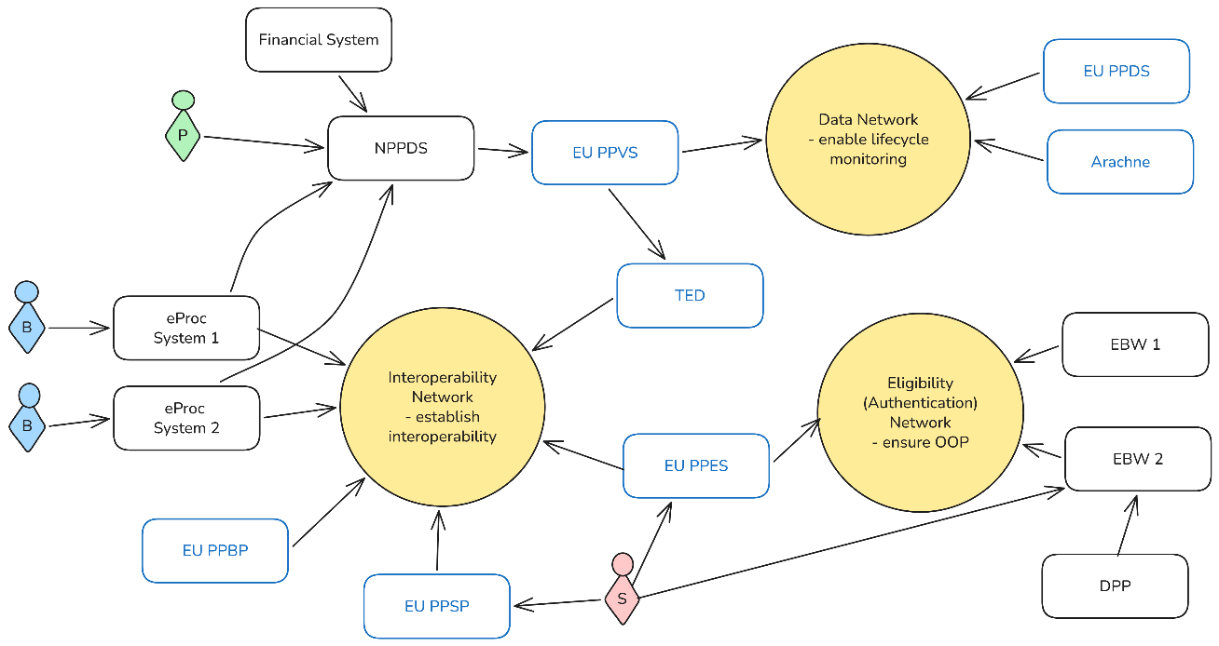
The three yellow circles depict the three networks that underlay the Digital Marketplace.
Squares depict interconnected components. Black squares depict components that will be operated by Member States. Blue squares those that will be provided by the Commission.
Public buyers are depicted in red (‘B’). They use any interconnected eProcurement platform to conduct a public procurement procedure (from planning to award/contract).
Suppliers are depicted in purple (‘S’). They use primarily three platforms: the Public Procurement Supplier Platform (PPSP) for participating in a procurement procedure, the Public Procurement Eligibility Service (PPES) for generating their profile to participate in tenders, and the European Business Wallet (EBW) to provide information and documentation.
Policymakers are depicted in green (‘P’). They have access to a national Public Procurement Data Space (NPPDS) which not only contains information about notices but also transactional data like invoices to monitor contract performance or to identify fraud.

Advantages of this setup

10.3.1. Interoperability Network
The Interoperability Network will leave the existing national eProcurement platforms (public and private) in place which are used for the electronic conduct of procurement procedures. It will however require a network for the communication between all platforms, thereby allowing a supplier to use their chosen platform to participate in procurement procedures across the EU. For this to work, all platforms must join a network which is able to transport the messages necessary in a procurement procedure between them. For the communication to be recognised technically, standards will need to be established which define the necessary communication elements of a procurement procedure, including a standard for the main procurement documents. Finally, the Commission will provide a public buyer and supplier platforms, which will be acting as a reference for the implementation of the network and the associated standards and can be used by public buyers or suppliers as any other eProcurement platform.
The Interoperability Network will contribute to the lowering of administrative burdens for suppliers, as they will only have to use one platform to participate in any procurement procedure. This will also contribute to the increase of competition, including cross-border competition, as the fragmentation of platforms will cease to meaningfully affect participation. Standardisation also supports automation, such as the automated extraction and reuse of data.

10.3.2. Eligibility Network
The Eligibility Network builds on the European Business Wallet (EBW), which will be mandatory to use for suppliers. The EBW will contain connections to national databases such as for example national criminal registers. This means that in a procurement procedure where a supplier must show that they have not been convicted of certain crimes, they will provide their EBW and link with it the business wallets of any other businesses participating with them in the procurement procedure (e.g. subcontractors). This and other information - such as the company information or information on the payment of taxes – will be provided through the Public Procurement Eligibility Service (PPES), which will generate the supplier’s profile. The public buyer will receive this and with it be able to assess the eligibility of the supplier to participate in the procurement procedure. The public buyer will receive the information either as a “green” or “red” light, showing the completed assessment of the individual requirement where this is possible, and/or be able to access the actual up-to-date evidence.
The Eligibility Network will contribute to the lowering of administrative burden for public buyers and suppliers, as they may both rely on a digital tool that provides up-to-date data from trusted sources, and they no longer have to provide and verify documents to show their eligibility It will also contribute to the increase of competition, as it will make it easier for suppliers to participate, including across borders, as the use of the EBW should lower linguistic barriers.

10.3.3. Data Network
The Data Network will streamline and centralise the collection of public procurement and contract implementation data both at national and European level. It will mandate the establishment of National Public Procurement Data Spaces (NPPDS), which will provide access to public as well as unpublished data. This will allow the public as well as oversight and audit authorities, policy makers and public buyers to analyse data for their purposes. From the NPPDS, data will be provided to the European Public Procurement Data Space (PPDS), allowing the Commission and other users with access to the PPDS through the data network to analyse the combined European data. A technical validation of the data prior to its submission to the PPDS will additionally increase the overall data quality. This validation will also be applied for the publication of notices by EUBuys (TED), which will continue as before, with the notices also to be provided to the NPPDS and the PPDS.
The Data Network will provide for improved oversight and monitoring capabilities at national and EU level. It will allow for the analysis of green, innovative and social purchasing trends and for the monitoring of purchases from third country suppliers. The public, including public watchdogs, may access publicly available data to understand their country’s purchasing decisions and management of public money better. Oversight and competition authorities, auditors and other independent authorities may draw inferences from the data as to possible irregularities such as collusion, overpricing, or conflict of interest. Enhanced transparency – achieved through real-time analysis of public procurement patterns – will strengthen accountability, thereby effectively deterring irregularities such as fraud, collusion, and procedural misuse. Such increased transparency will also improve the accountability of public buyers, deterring irregular practices. Public buyers themselves may analyse the data to find opportunities for joint procurement or may improve their purchases by learning from best practice. Policymakers may evaluate the effects of their policies and spot areas for improvement, e.g. regarding professionalisation.

The effect of the Digital Marketplace on the new PP Act

10.4.1. Simplification and increased competition
The Interoperability Network will simplify public procurement for suppliers by eliminating the need to navigate multiple eProcurement platforms. This will reduce administrative burdens and costs, as suppliers will no longer need to repeat registration and data entry across different platforms. Additionally, standardising the main public procurement documents will provide clarity and consistency for public buyers through templates (e.g. for technical specifications, award criteria and contract clauses), ensuring as well that suppliers understand the requirements of the public buyer, regardless of Member State. Establishing interoperability through the network will not only simplify public procurement for suppliers, but also foster greater competition, as fragmentation and technical incompatibilities will no longer discourage suppliers from participating.
The Data Network will provide, through the NPPDS, a reliable digital environment with real-time insight into public procurement data. This will permit public buyers to better understand market trends, supplier performance and pricing benchmarks based on which they can make better informed decisions.
Additionally, the NPPDS and EU PPDS – the EU level data space connecting all NPPDS through a network – both help public buyers to save time and effort by learning from one another through the insight into procurement strategies, performances and outcomes – for example by comparing cost for similar goods in different regions or Member States. A well-structured data network also facilitates better cross-border procurement by improving data quality and accessibility, leading to better value for public money by for example allowing public buyers in different Member States to find opportunities to procure jointly or to use the services of a central purchasing body in another Member State.

Environmental, social and innovative policy objectives
The Data Network will support public buyers in their use of quality requirements, including as award criteria under BPQR, by allowing them to search for best practices. For policy objectives, data analysis will play a key role for future developments and corrections in policy initiatives, enabling public administrations to gain valuable insights into public procurement trends and patterns that will allow them to steer public procurement in a manner that supports their policy objectives. For example, by providing a tool for conducting market consultation in an automatic format, public buyers are enabled to focus on the content rather than the procedural aspects.
The PPES will facilitate environmental and social objectives by linking to other relevant EU tools such as the Digital Product Passport (DPP), which holds the key information of a product’s sustainability through the eco-design requirements. PPES as such can help public buyers to have a standardised automatised way to compare products without administrative complexities. In practise, public buyers could therefore use the PPES not only as a eligibility service for company information, but also for product related data eligibility, making it easier to compare products based on the same requirements. Additionally, social policy objectives could be facilitated by providing an automated tool to connect the social consideration and the subject matter of the contract, making it easier for public buyers to implement social considerations as an aspect of a procurement procedure. Finally, subcontracting could be traced in the PPES when companies apply for a specific procedure, establishing transparency in the subcontracting chain in a digitally traceable way.

EU economic security and strategic autonomy
The PPES will play a key role in facilitating European preference in public procurement by providing an automated support for applying EU market access rules (EU/partner-country coverage, IPI measures, sanctions, and applicable derogations) for public buyers to verify the origin of suppliers. Its direct connection to the EBW, a digital repository of qualified company information deriving from trusted sources, will enable the eProcurement platform of the public buyer to check the origin of the suppliers at least for businesses registered in the EU. The automated solution will provide an efficient and reliable way for public buyers to verify company eligibility, reduce administrative burdens and ensure compliance with the public procurement legal framework. In addition, in times of crisis, the marketplace can mitigate the vulnerability of supply chains and reduce geopolitical dependencies by providing public buyers with real-time data analytics to anticipate and respond to supply disruptions, market developments and price shocks. Given that the PPES as an instrument could provide product specific information through the DPP, whenever DPP is mandated for a product and the origin information in available, this would contribute to strengthening the European industrial capacity and the reinforcement of strategic autonomy in key sectors.
10.4.4. Fraud and irregularities
The PPES will play a crucial role by providing proactive checks through the real-time verification of supplier’s eligibility from the EBW through a traffic-light indicator summarising the assessment. By using the PPES, public buyers can ensure comprehensive due diligence and mitigate the risk of non-compliant or high-risk participants slipping through undetected, for example due to a recent conviction of certain crimes. This information can be accessed at any point of the public procurement procedure as well as beyond during the delivery of the contract, providing a new real time insight for public buyers to understand irregularities regarding a specific supplier and allowing them to follow up by cancelling a contract with a supplier that may in the meantime have been convicted of e.g. fraud.
By enhancing transparency, the marketplace will increase accountability and prevent irregularities. The Data Network will significantly increase oversight and monitoring capabilities both at the national and EU levels, by consolidating high-quality standardised data. The NPPDS will be the key technical infrastructure that systematically gathers national procurement and transaction data from various national sources, providing insight into the entire public procurement and contract execution life cycle. This data will be provided to the EU PPDS, letting the Commission and other users identify potential issues in the single market that may not be apparent at the national level.
The Data Network combined with cross-referencing tools such as EU’s ARACHNE+ system provides a meaningful opportunity to flag potentially irregular practices. ARACHNE+ is a centralised risk scoring and fraud detection tool, which applies advanced algorithms to calculate risk scores for projects, beneficiaries, contractors and subcontractors at every stage. In the selection stage, it focuses on evaluating risks based on conflicts of interest, insufficient financial or administrative capacity, prioritising high-risk cases. Throughout the contract implementation, it can continuously monitor red flags such as specific patterns, qualification breaches and performance anomalies. The system provides automated alerts based on AI prediction forwarded to different stakeholders which needs to be verified and if needed investigated further by the competent authorities. Additionally, by integrating machine learning and rule-based logic, the system can constantly develop and improve to make predictions even more precise. Combining ARACHNE+ with the PPDS will further strengthen preventive control mechanism and early warnings, enabling public buyers to intervene and take appropriate action. Additionally, projects which have received EU funding such as RESPOND (footnote https://www.eu-respond.eu/) and a LT project under which an AI-based pilot model for assessing fraud and corruption risks in public procurement was developed (footnote: https://www.stt.lt/en/news/7481/ai-based-pilot-model-for-assessing-corruption-risks-in-public-procurement-developed:4165 ) may serve as templates for Member States and the EC to further develop the analysis of procurement data in furtherance of integrity goals through the use of advanced tools.
The Data Network will also support oversight bodies, auditors, competition authorities, and regulators by providing historical data in identifying irregularities like collusion, overpricing or conflicts of interest through benchmarking, predictive modelling and anomaly detection. Other important stakeholders, including civil society organisations and watchdogs, will gain access to publicly available procurement data, which helps to foster greater civic scrutiny on how public funds are spent.

Coherence
The Digital Marketplace will be able to support the easier application and management of existing and future sectoral procurement provisions, including the monitoring of their effects and their application, which aids overall coherence through their inclusion within unified digital processes.
Regarding the Eligibility Network, sectoral requirements containing exclusion grounds and selection criteria may be incorporated into the PPES. Where a national database contains the evidence regarding this exclusion ground or selection criterion, this would mean that the database would link to the EBW which the supplier may then use to show their compliance. Even where such a database may not exist, the supplier may use the PPES as a self-declaration. This would also increase the awareness of the relevant exclusion ground or selection criterion, including any criterion relating to economic security and strategic autonomy, as the public buyer would always see the full list of general and sectoral requirements before choosing the applicable ones for the individual procurement procedure.
The Data Network will facilitate the initial assessment of the possible effects of a planned sectoral provision. For example, it would allow the Commission to analyse data on the current participation of third country suppliers in a specific industry, or the overall size and value of a specific category of procurement (e.g. [zero-emission] vehicles or [energy-efficient] white goods), to assess the possible impact of specific rules for public procurement within the internal market overall. This can show policymakers whether the intended effects are sufficient to justify a policy intervention, or whether the status quo justifies such an intervention. Furthermore, the establishment of the NPPDS and the PPDS will help with the centralised collection as well as the standardisation of data, including data required according to sectoral requirements. Member States may also connect national databases to the NPPDS, from which it may draw the required sectoral information where this is available, therefore not asking public buyers to provide such information themselves.

Annex 11: Sectorial Legislation in Public Procurement

11.1 Baseline
The introduction of public procurement provisions outside the Directives has led to a regulatory paradigm shift in which the pursuit of strategic objectives is no longer voluntary but has also become mandatory. Public buyers must include a combination of requirements related to cyber security, energy efficiency, circular economy and due diligence, among others, in a single public procurement procedure.
Currently, public procurement provisions are included in multiple sectoral acts covering different policy objectives in a variety of sectors, ranging from environmental, social, digital, health, justice to trade, transport, security, defence, and energy. In addition, several acts in preparation may include in the future public procurement aspects.
As outlined in the evaluation of the Public Procurement Directives, the rapid increase of the public procurement provisions in sectoral legal acts has contributed to the fragmentation of the legal framework and led to inconsistencies, risking undermining legal certainty, compliance, and the coherence of public procurement as a policy tool. The requirements sometimes overlap, are unclear and spread through various pieces of legislation, making them difficult to interpret and apply. Public buyers and economic operators struggle to identify which rules to apply and are not always aware of newly adopted acts. As a result, public buyers and economic operators are faced with a more complex legislative framework, particularly when multiple legislative instruments apply to the same procurement procedure.
The European Parliament, in its resolution on public procurement, emphasised the fragmentation of the various sector-specific public procurement rules and the difficulty of implementation for both businesses and local governments, calling for streamlining and harmonising sectoral rules with the overall public procurement framework.
Similarly, the European Committee of the Regions, in its draft opinion on the evaluation of the Public Procurement Directives, stressed the importance of addressing sectoral legislation in the revision process. Also, in a recent report, it underlined the difficulties local and regional authorities face navigating such complex framework, especially in certain sectors. The complexity of EU public procurement law is also addressed by the European Economic and Social Committee.
Member States have similarly expressed concerns about the consistency of the public procurement legal framework in different fora. For instance, in the Council Conclusions of 3 June 2024 on the European Court of Auditors’ Special Report, the Council considered that a thorough examination was needed on the interplay between the Directives and the multiplicity of sector-specific legal acts containing procurement provisions. It therefore requested that the Commission examines “the need for streamlining and alignment of the initiatives in the interest of finding a balance among the different objectives, greater legal certainty, overall coherence, and, where appropriate, the reduction of regulatory burden and costs”. In response, under the Single Market Strategy (May 2025), the Commission committed to revise the public procurement framework to streamline its fragmented and complex provisions. Recently, the Commission has announced its intention to tackle the issue in its Communication - A Simpler, Clearer and Better Enforced EU Rulebook: “In the area of public procurement, the EU acquis contains many pieces of legislation setting requirements on substance and procedure for public procurement. While most of these play a facilitating role, regulatory deep cleaning would increase clarity and consistency, thereby facilitating implementation both for public administrations and public contractors. The Public Procurement Act will simplify procedures and eliminate overlaps and duplications with the numerous sectorial procurement rules in EU law. Repealing redundant procurement provisions from sector-specific acts will streamline legislation and ensure coherence.”
In the open public consultation on the revision of the Public Procurement Directives, respondents were asked whether existing and future sectoral rules should be integrated with the new legislative framework, and if so, how. Regarding the existing sectoral rules, views varied across categories of respondents. Overall, the most frequently chosen option was to integrate rules on “how to buy” only (36%), followed by integrating both “how and what to buy” (21%). Almost one in five preferred not to integrate sectoral rules (19%), while 24% selected “Other”. Public authorities were relatively evenly split between integrating “how and what to buy” (30%), integrating “how to buy” only (28%), and not integrating (29%). Among large companies, SMEs and business associations, integrating “how to buy” was the most frequently selected option (36% for large companies, 61% for SMEs, 58% for business associations). Large companies also showed some support for integrating both “how and what to buy” (32%). By contrast, non-integration attracted lower shares across these three groups (generally between 13% and 22%).
Regarding the future sectoral rules, across all respondents, the most frequently chosen option was to integrate rules on “how to buy” only (41%), followed by integrating both “how and what to buy” (22%). A smaller share preferred not to integrate future sectoral rules (16%), while 22% selected “Other”. Among public authorities, views were relatively balanced: 34% favoured integrating “how to buy”, 28% integrating both “how and what to buy”, and 26% not integrating. Among large companies, SMEs and business associations, integrating “how to buy” was again the dominant option (41% for large companies, 63% for SMEs, 58% for business associations). Integrating “how and what to buy” attracted some support, particularly among large companies (33%), while non integration was generally less favoured (between 12% and 16%).
Respondents who chose to integrate “how to buy” requirements only, or who opted not to integrate either “how to buy” or “what to buy” requirements, were still asked whether they agreed that future “what to buy” requirements should be subject to common rules defined in a general legislative framework (e.g. the new general legislative framework should foresee mechanisms and templates for harmonised legislation ensuring coherence of “what to buy” requirements contained in sector-specific rules with the general legislative framework). The majority of these respondents, across all categories, answered affirmatively.
With respect to the “how to buy” rules, the procedural provisions introduced by sectoral acts that raise issues of fragmentation consistency mostly concern exclusion grounds (grounds upon which public buyers must exclude a company from a public procurement process).
Fifteen sectoral legal acts (four of which at the stage of proposals) introduced provisions on exclusion grounds, adding another layer of complexity to the general rules, and in some cases not fully aligned with the terms, definitions and conditions of the current Public Procurement Directives.
Article 57 of the Directive 2014/24/EU sets out grounds for exclusion of economic operators from public procurement procedures. The current article includes two lists of exclusion grounds: mandatory grounds, where contracting authorities must automatically exclude, and that apply only where there is a conviction by final judgment (Art. 57(1)); and optional grounds that contracting authorities may apply – but are not obliged to - and that do not require a final judgment (Art. 57(4)). The article also establishes the possibility of derogation, self-cleaning measures whereby economic operators cannot be excluded if they prove that they are reliable, the burden of proof and the maximum period of exclusion.
The provisions introduced by sectoral acts create fragmentation and raise legal uncertainty and concerns regarding their consistency with Article 57 of Directive 2014/24/EU, especially in terms of scope of application, duration of the exclusion, applicability of self-cleaning measures, means of proof, and extraterritorial enforcement of the exclusions.
Regarding the “what to buy” aspects, sectoral acts have adopted different regulatory approaches. To promote green public procurement, some acts have introduced sustainability mandatory requirements, which can be sectoral (e.g. Batteries Regulation) or being applicable to the same product group across different sectors (e.g. Ecodesign Regulation). Other sectoral instruments have introduced resilience aspects (e.g. Net-Zero Industry Act (NZIA), Heavy-Duty Vehicles Regulation), while others include security and cybersecurity aspects (e.g. Cyber Resilience Act, NIS2 Directive, NZIA).
In terms of techniques, some sectoral acts have introduced targets related to procurement (e.g. Clean Vehicles Directive); others provide that contracting authorities must choose from a list of technical specifications or award criteria (e.g. Heavy-Duty Vehicles Regulation) or a list of technical specifications and contract performance criteria (NZIA). Also, other instruments grant the Commission empowerment to provide for technical specifications, award criteria, contract performance conditions, or targets (e.g. Ecodesign Regulation, Batteries Regulation, Construction Products Regulation, NZIA); one act introduces a new principle (Energy Efficiency Directive).
This is a classification of the types of sectoral acts on “what to buy”:
    - Horizontal provisions on green public procurement requirements
    - Horizontal provisions on socially responsible public procurement requirements
    - Horizontal provisions on (cyber)security requirements in public procurement
    - Procedural aspects of “what do buy” related to resilience in public procurement
    - Sector-specific provisions containing requirements on “what to procure” applicable only to a product group and/or sector
    - Empowerments to establish public procurement criteria

Public buyers face challenges in identifying which rules to apply and how to apply the sustainability and resilience requirements introduced by sectoral acts. For instance, in terms of scope of application, the Energy Efficiency Directive does not fully align with Directive 2014/24/EU: while the Energy Efficiency Directive covers building purchase or rental, buildings are excluded from the application of Directive 2014/24/EU.
Also, requiring companies to comply with due diligence requirements under the Corporate Sustainability Due Diligence Directive may be challenging and legally uncertain for public buyers. This stems from the fact that the Public Procurement Directives require the connection with the subject matter of the contract, excluding criteria and conditions relating to general corporate policy which cannot be linked to the contract itself.
Janssen and Caranta study (2026) highlights the complexity of applying multiple public procurement provisions from sectoral acts, on top of the Public Procurement Directives, within a single public procurement procedure. Through a series of concrete examples related to construction, computers, electric buses, and food and catering procurement, the study illustrates how compliance with these rules works in practice for public buyers and the extent to which this may create practical challenges.
The study finds that horizontal mandatory rules on tenderers are challenging for public buyers as their application depends on information that is unavailable or difficult to access. The combination of requirements related to tenders, such as technical specifications and/or contract performance clauses, may also raise implementation issues as to the technical feasibility of the procurement and the related costs.
Last, there are public procurement provisions included in other sectoral acts, which do not present coherence issues:
- Public procurement provisions included in trade policy instruments, which do not present coherence issues, as the trade policy instruments provide for self-standing mechanisms outside the public procurement framework.
- Defence-related matters, as defence procurement is outside the scope of the general public procurement framework (there is self-standing defence procurement Directive, in the process of being revised); and other provisions on procurement outside the scope of the general public procurement framework.
- Emergency / joint procurement rules, as those rules regulate the upstream question of whether and when certain good or services shall be bought jointly, which is outside the public procurement framework. Once that decision has been made, the ensuing joint procurement will in any event be carried out following the relevant rules (financial regulation / Public Procurement Directives). In addition, there are two acts with governance-related provisions linked to crisis.

11.2. Overview of Sector-Specific legislation
Table 108: Overview of Sector-specific legislation containing public procurement provisions (in grey acts in co-decision)
HOW TO BUY
Exclusion grounds:
 | Title | Provision | Description
1 | Regulation on Deforestation and Forest Degradation  Regulation (EU) 2023/1115 | Article 25(2)(d) | This provision introduces a mandatory exclusion of economic operators from procurement, for a period of 12 months following a final judgement.  The EC shall provide an IT tool to register these judgements.
2 | Directive on Protection of Environment through Criminal Law  Directive (EU) 2024/1203 | Articles 5(3)(c) and 7(2)(c) | This provision mandates Member State to establish penalties that may take the form of exclusion grounds.
3 | Regulation on Shipments of Waste  Regulation (EU) 2024/1157 | Article 63(3)(c) | This provision states that “Member States shall […] be able to impose” as a penalty, among others, exclusion from public procurement procedures.”.
4 | Regulation on Eco-design for sustainable products  Regulation (EU) 2024/1781 | Article 74(3)(b) | This provision states that “Member States shall […] be able to impose” as a penalty, among others, exclusion from public procurement procedures.”
5 | Directive on Preventing and Combating Trafficking in Human Beings and Protecting Victims  Directive 2011/36/EU | Article 6(2)(b) | This provision mandates Member State to establish penalties that may take the form of exclusion grounds.
6 | Directive on Combating Fraud and Counterfeiting of Payments  Directive 2019/713 | Article 11(b) | This provision mandates Member State to establish penalties that may take the form of exclusion grounds.
7 | Directive on Combating Money Laundering  Directive 2018/1673 | Article 8(b) | This provision mandates Member State to establish penalties that may take the form of temporary or permanent exclusion grounds.
8 | Directive on Sanctions against Employers of Illegally Staying Third-Country Nationals  Directive 2009/52/EC | Article 7(b) | This provision introduces a mandatory exclusion ground, leaving discretion to Member States to define how this is to be applied in public procurement.
9 | Directive on Criminal Offences and Penalties for the Violation of Union Restrictive Measures  Directive (EU) 2024/1226 | Article 7(1)(b) | This provision mandates Member State to establish penalties that may take the form of exclusion grounds.
10 | Directive on Pay Transparency (equal pay for equal work)  Directive (EU) 2023/970 | Article 24(2) | This provision establishes that public buyers must always have the possibility to exclude, but Member States may make turn this possibility into a mandatory exclusion ground.
11 | Directive on the Protection of the Union’s financial interests  Directive (EU) 2017/1371 | Article 9(b) | This provision introduces a mandatory exclusion ground, leaving discretion to Member States to define how this is to be applied in public procurement.
12 | Proposal for a Directive on Green Claims  COM/2023/166 final | Article 17 - Exclusion grounds | This provision introduces a mandatory exclusion ground for a maximum of 12 months, leaving discretion to Member States to define how this is to be applied in public procurement.
13 | Proposal for a Directive on the Prevention & Countering the Facilitation of Unauthorised Entry, Transit and Stay in the EU  COM(2023)755 final | Article 6(5)(d) | This provision introduces a mandatory exclusion ground, leaving discretion to Member States to define how this is to be applied in public procurement.
14 | Proposal for a Directive on Combating the sexual abuse and sexual exploitation of children and child sexual abuse material  COM(2024)60 final | Article 14(1) | This provision mandates Member State to establish penalties that may take the form of exclusion grounds.
15 | Proposal for a Directive on combating firearms trafficking and other firearms-related offences  COM(2026)102 Final | Article 5(3)(b) | This provision mandates Member State to establish penalties that may take the form of exclusion grounds.

WHAT TO BUY
Horizontal provisions on green public procurement
 | Title | Provision | Description
1 | Directive on energy efficiency  Directive (EU) 2023/1791 | Article 7 | When using the public procurement Directives to acquire or rent products, services, buildings and works, public buyers shall purchase only products, services buildings and works with high energy-efficiency performance and take into account the energy efficiency first principle.
2 | Directive on Corporate Sustainability Due Diligence  Directive (EU) 2024/1760 | Article 31 | When transposing the Directive Member States need to ensure that compliance with the Directive qualifies as part of award criteria or conditions for the execution of the contract.
3 | Directive on Waste  Directive 2008/98/EC | Article 11, Annexes IV and IVa | Member States shall establish public procurement “criteria” for the recycling and recovery of waste.  Member States may use sustainable public procurement to encourage better waste management and the use of recycled products and materials.
4 | Regulation on Critical Raw Materials  Regulation (EU) 2024/1252 | Art. 26(1)(d) | Member States shall every two years specify in their national programmes measures related to taking recycled content into account in award criteria.

Horizontal provisions on socially responsible public procurement
 | Title |  | Provision | Description
1 | Directive on Adequate Minimum Wages  Directive (EU) 2022/2041 | Article 9 |  | Member States shall take measures to ensure that, economic operators and their subcontractors comply with the applicable obligations regarding wages, the right to organise and collective bargaining on wage setting, in the field of social and labour law established by Union law, national law, collective agreements or international social and labour law provisions
2 | Directive on Accessibility requirements  Directive (EU) 2019/882 | Article 24(1) and Annex I |  | Establishes mandatory accessibility requirements to be included as part of technical specifications.
3 | Directive on Women on boards  Directive (EU) 2022/2381 | Article 8(3) |  | Member States shall ensure that in public contracts and concessions, listed companies comply with the applicable obligations in the Directive (ensuring gender equality), as well as social and labour law.
4 | Directive on late payments  Directive 2011/7/EU  NB: Pending in negotiations Proposal for a Regulation on Late payments  COM(2023) 533 Final | Article 4 |  | The Directive establishes deadlines to provide payments in G2B transactions

Horizontal provisions on (cyber) security in public procurement
 | Title | Provision | Description
1 | Regulation on horizontal cybersecurity requirements  Regulation (EU) 2024/2847 | Article 5, Annex I | Mandatory cybersecurity requirements for public contracts under the Classical Directive and Utilities (it does not cover concessions)
2 | Directive on high common level of cybersecurity (NIS2)  Directive (EU) 2022/2555 | Article 7(2)(b) | Member States shall adopt policies to include cybersecurity related requirements for the procurement of IT services and products.

Procedural aspects of ‘what to buy’ related to resilience and Buy European + Requirements on resilience and Buy European applicable only to a product group and/or sector
 | Title | Provision | Description
1 | Regulation on CO₂ emissions of heavy duty vehicles  Regulation (EU) 2019/1242 | Article 3e | Public buyers must use the most economically advantageous tender, which shall include the best-price quality ratio. Lists conditions to be used as part of award criteria or technical specifications. If security of supply is used as award criterion, it must weigh between 15 and 40%.
2 | Regulation for a Net-Zero Industry Act  Regulation (EU) 2024/1735 | Article 25 | Public buyers shall use minimum mandatory sustainability requirements, as well as contractual obligations related to the resilience of the contract/component. Derogations in case of excessive costs and lack of competition.
3 | Proposal for a Regulation on an Industrial Accelerator  COM(2026) 100 Final | Article 11(3) | Public Buyers shall apply Buy European provisions. Derogations in case of excessive costs or lack of competition.
4 | Proposal for Critical Medicines Act  COM(2025) 102 Final  Provisional trilogue agreement on 11 May | Section I Chapter IV | Public buyers shall use resilience requirements and Buy European provisions.
Sector-specific provisions containing requirements on ‘what to procure’ applicable only to a product group and/or sector
 | Title | Provision
1 | Directive on Clean Vehicles  Directive 2009/33/EC (consolidated version) | Article 5  Tables 3 and 4 of the Annex
2 | Directive on the promotion of the use of energy from renewable sources (RED III)  Directive (EU) 2018/2001 (consolidated version) | Article 15(2), (2a), (3) and (8)
3 | Regulation on Health Data Space  Regulation (EU) 2025/327 | Article 15(1)  Article 36(1)(2)(3)  Annex II
4 | Regulation on Passenger transport services by rail and by road  Regulation (EC) No 1370/2007 | All provisions
5 | Regulation on the Single European Sky  Regulation (EU) 2024/2803 | Article 11
6 | Directive on Trans-European Transport Network (TEN-T)  Directive (EU) 2021/1187 | Article 8
7 | Regulation on the Union Secure Connectivity Programme  Regulation (EU) 2023/588 | Article 7  Article 19-22
8 | Directive on Common Rules for Electricity Directive  Directive (EU) 2019/944 | Article 31  Article 32  Article 38  Article 40
9 | Regulation on Electricity Market Design  Regulation (EU) 2019/943 (consolidated version) | Article 6  Article 20
10 | Proposal for a Cybersecurity Act  COM (2026) 11 Final | Article 100(4)(e)  Article 105(1)
11 | Combating Corruption Directive  Directive (EU) 2026/1021 | Recital 26
12 | Directive on European Works Councils  Directive (EU) 2025/2450 | Recital 31 on social sustainability

Empowerments for public procurement criteria
 | Title | Provision | Description
1 | Regulation on Batteries  Regulation (EU) 2023/1542 | Article 85 | Delegated act to establish green public procurement criteria to be used as technical specifications or award criteria.
2 | Regulation on packaging and packaging waste  Regulation (EU) 2025/40 | Article 63 | Implementing acts to establish minimum green public procurement criteria, to be used as technical specifications, selection criteria or contract performance conditions.
3 | Regulation on eco-design for sustainable products  Regulation (EU) 2024/1781 | Article 65 | Implementing act to establish minimum sustainability criteria in public procurement.
4 | Regulation on Construction Products  Regulation (EU) 2024/3110 | Article 83 | Delegated act to establish minimum sustainability criteria in public procurement to be used as technical specifications, selection criteria, conditions for the performance of contracts or contract award criteria.
5 | Regulation for a Net-Zero Industry Act  Regulation (EU) 2024/1735 | Article 25 | Implementing act to establish minimum sustainability criteria in public procurement, to be used as technical specifications or contract clauses.

Sectoral acts that do not present coherence issues:
- Public procurement provisions included in trade policy instruments:
 | Title | Provision
1 | Regulation on Anti-Coercion Instrument  Regulation (EU) 2023/2675 of | Annex I point 4
2 | Regulation on Foreign Subsidies  Regulation (EU) 2022/2560 | Chapter I, Chapter II, Chapter IV, Chapter V
3 | Regulation on the Enforcement of International Trade Rules  Regulation (EU) No 654/2014 | Article 5(1)(c), 5(2)
4 | Regulation on International Procurement Instrument  Regulation (EU) 2022/1031 | All provisions
5 | Council Regulation on Restrictive Measures – Russia’s Actions Destabilizing the Situation in Ukraine  Council Regulation (EU) No 833/2014 | 5k

- Defence-related matters and other provisions on procurement outside the scope of the general public procurement framework.
 | Title | Provision
1 | Regulation on Security Action for Europe (SAFE)  Regulation (EU) 2025/1106 | Articles 1-2  Articles 16-19
2 | Regulation on European Defence Industry Reinforcement through common Procurement Act  Regulation (EU) 2023/2418 | All provisions
3 | Regulation on European Defence Industry Programme  Regulation (EU) 2025/2643 | Articles 2, 4, 8, 10 -12, 15, 18, 19, 28-32
4 | Regulation on supporting Ammunition Production  Regulation (EU) 2023/1525 | Article 9, 11, 14
5 | Regulation on the Union Space Programme and the European Union Agency for the Space Programme  Regulation (EU) 2021/696 | Title III, Chapter I  Articles 14 to 17
6 | Proposal for a Regulation on establishing a framework of measures to facilitate the transport of military equipment, goods and personnel across the Union  COM(2025) 847 Final | Article 3(13)  Article 39
7 | Regulation on European Media Freedom Act  Regulation (EU) 2024/1083 | Article 25

- Emergency / joint procurement rules
 | Title | Provision
1 | Regulation on Cross-border Threats to Health  Regulation (EU) 2022/2371 | Article 12
2 | Regulation on European Chips Act (Regulation)  Regulation (EU) 2019/943 | Article 22(3)  Article 27
3 | Regulation on Internal Market Emergency and resilience Act  Regulation (EU) 2024/2747 | Article 40 (obligation for Member States to coordinate procurement in emergency mode)
4 | Regulation on Medical Countermeasures Council  Council Regulation (EU) 2022/2372 | Article 7(4) (obligation so that when a Member State intends to procure crisis-relevant medical countermeasures or raw materials, they shall inform the Health Crisis Board accordingly)

Source: in-house analysis

11.3. How would the preferred combination of policy options address sectorial legislation

 | Sectoral acts concerned  (adopted + in co-decision) | Policy options
Driver 1: Complex pp procedures and rules that lack flexibility  - Considerable variation of rules by sector | Exclusion grounds | FLX.2
 | Exclusion grounds | To be deleted as far as possible and integrated into the PP Act
Driver 2: Environmental, social and innovation requirements difficult to apply  - Considerable variation of rules by sector | - Horizontal provisions on green public procurement  - Horizontal provisions on socially responsible public procurement  - Empowerments for public procurement criteria  - Requirements on ‘what to procure’ applicable only to a product group and/or sector | ESI.2
[(a), (b), (c)] To be deleted and integrated as far as possibly in the PP Act as part of general provisions related to strategic procurement
+
Framework for future acts

(d) left untouched
Driver 3: EU procurement framework not sufficiently supporting EU economic security and strategic autonomy  - Some variation of rules by sector | - Horizontal provisions on (cyber) security in public procurement  - Procedural aspects of ‘what to buy’ related to resilience in public procurement  - Requirements on resilience and Buy European applicable only to a product group and/or sector | BEU.2
[(a), (b)] To be deleted and integrated as far as possible in the PP Act as part of general provisions related to Buy European, resilience and security
+
Future framework

(c) left untouched
Driver 4: Dispersed information and data | All mentioned above | MPL.1
Driver 4: Dispersed information and data | All mentioned above | Facilitate monitoring and access to information by public buyers

Annex 12: Legal references
The references below are listed in order of appearance in the main text.
- Concessions – Directive 2014/23/EU of the European Parliament and of the Council of 26 February 2014 on the award of concession contracts, OJ L 94, 28.3.2014, pp. 1–64, ELI: http://data.europa.eu/eli/dir/2014/23/oj.
- Classical – Directive 2014/24/EU of the European Parliament and of the Council of 26 February 2014 on public procurement and repealing Directive 2004/18/EC, OJ L 94, 28.3.2014, pp. 65–242, ELI: http://data.europa.eu/eli/dir/2014/24/oj.
- Utilities – Directive 2014/25/EU of the European Parliament and of the Council of 26 February 2014 on procurement by entities operating in the water, energy, transport and postal services sectors and repealing Directive 2004/17/EC, OJ L 94, 28.3.2014, pp. 243–374, ELI: http://data.europa.eu/eli/dir/2014/25/oj.
- GPA – World Trade Organisation, Agreement on Government Procurement, as amended on 30 March 2012 (https://www.wto.org/english/docs_e/legal_e/rev-gpr-94_01_e.pdf).
- Defence Procurement – Directive 2009/81/EC of the European Parliament and of the Council of 13 July 2009 on the coordination of procedures for the award of certain works contracts, supply contracts and service contracts by contracting authorities or entities in the fields of defence and security, and amending Directives 2004/17/EC and 2004/18/EC, OJ L 216, 20.8.2009, pp. 76–136, ELI: http://data.europa.eu/eli/dir/2009/81/oj.
- Remedies – Council Directive 89/665/EEC of 21 December 1989 on the coordination of the laws, regulations and administrative provisions relating to the application of review procedures to the award of public supply and public works contracts, OJ L 395, 30.12.1989, pp. 33–35, ELI: http://data.europa.eu/eli/dir/1989/665/oj; and Council Directive 92/13/EEC of 25 February 1992 coordinating the laws, regulations and administrative provisions relating to the application of Community rules on the procurement procedures of entities operating in the water, energy, transport and telecommunications sectors, OJ L 76, 23.3.1992, pp. 14–20, ELI: http://data.europa.eu/eli/dir/1992/13/oj.
- Electronic Invoicing – Directive 2014/55/EU of the European Parliament and of the Council of 16 April 2014 on electronic invoicing in public procurement, OJ L 133, 6.5.2014, pp. 1–11, ELI: http://data.europa.eu/eli/dir/2014/55/oj.
- NZIA – Regulation (EU) 2024/1735 of the European Parliament and of the Council of 13 June 2024 on establishing a framework of measures for strengthening Europe’s net-zero technology manufacturing ecosystem and amending Regulation (EU) 2018/1724, OJ L, 2024/1735, 28.6.2024, ELI: http://data.europa.eu/eli/reg/2024/1735/oj.
- Heavy-Duty Vehicles – Regulation (EU) 2019/1242 of the European Parliament and of the Council of 20 June 2019 setting CO2 emission performance standards for new heavy-duty vehicles and amending Regulations (EC) No 595/2009 and (EU) 2018/956 of the European Parliament and of the Council and Council Directive 96/53/EC, OJ L 198, 25.7.2019, pp. 202–240, ELI: http://data.europa.eu/eli/reg/2019/1242/2025-08-14.
- e-Forms – Commission Implementing Regulation (EU) 2019/1780 of 23 September 2019 establishing standard forms for the publication of notices in the field of public procurement and repealing Implementing Regulation (EU) 2015/1986, OJ L 272, 25.10.2019, pp. 7–73, ELI: http://data.europa.eu/eli/reg_impl/2019/1780/2024-11-01.
- IPI – Regulation (EU) 2022/1031 of the European Parliament and of the Council of 23 June 2022 on the access of third-country economic operators, goods and services to the Union’s public procurement and concession markets and procedures supporting negotiations on access of Union economic operators, goods and services to the public procurement and concession markets of third countries, OJ L 173, 30.6.2022, pp. 1–16, ELI: http://data.europa.eu/eli/reg/2022/1031/oj.
- Union Customs Code – Regulation (EU) No 952/2013 of the European Parliament and of the Council of 9 October 2013 laying down the Union Customs Code (recast), OJ L 269, 10.10.2013, pp. 1–101, ELI: http://data.europa.eu/eli/reg/2013/952/oj.
- IMERA – Regulation (EU) 2024/2747 of the European Parliament and of the Council of 9 October 2024 establishing a framework of measures related to an internal market emergency and to the resilience of the internal market and amending Council Regulation (EC) No 2679/98 (Internal Market Emergency and Resilience Act), OJ L, 2024/2747, 8.11.2024, ELI: http://data.europa.eu/eli/reg/2024/2747/oj.
- NIS2 – Directive (EU) 2022/2555 of the European Parliament and of the Council of 14 December 2022 on measures for a high common level of cybersecurity across the Union, amending Regulation (EU) No 910/2014 and Directive (EU) 2018/1972, and repealing Directive (EU) 2016/1148, OJ L 333, 27.12.2022, pp. 80-152, ELI: http://data.europa.eu/eli/dir/2022/2555/oj.
- EU Taxonomy Regulation – Regulation (EU) 2020/852 of the European Parliament and of the Council of 18 June 2020 on the establishment of a framework to facilitate sustainable investment, and amending Regulation (EU) 2019/2088, OJ L 198, 22.6.2020, pp. 13–43, ELI: http://data.europa.eu/eli/reg/2020/852/oj.
- FSR – Regulation (EU) 2022/2560 of the European Parliament and of the Council of 14 December 2022 on foreign subsidies distorting the internal market, OJ L 330, 23.12.2022, pp. 1–45, ELI: http://data.europa.eu/eli/reg/2022/2560/oj.
- Implementing Regulation FSR – Commission Implementing Regulation (EU) 2023/1441 of 10 July 2023 on detailed arrangements for the conduct of proceedings by the Commission pursuant to Regulation (EU) 2022/2560 of the European Parliament and of the Council on foreign subsidies distorting the internal market, OJ L 177, 12.7.2023, pp. 1–44, ELI: http://data.europa.eu/eli/reg_impl/2023/1441/2023-10-27.

Annex 13: Bibliography
- Altaee (2025), Evaluation of the EU public procurement directives – Study on relevance and EU added value, July 2025 (https://data.europa.eu/doi/10.2873/3480868).
- Bek Aagaard, K., & Gregers Linaa, J. (2024). The impact of competition for public contracts on public finances, (https://kfst.dk/media/bmgjjy3w/the-impact-of-competition-for-public-contracts-on-publicfinances.pdf).
- Caranta, R. (2025), Coherence in the EU public procurement directives. A study into the internal coherence between the objectives, the principles and the provisions in the EU public procurement and concessions directives, University of Turin, 2025, (https://data.europa.eu/doi/10.2873/3304248).
- Celotti, P. et al (2021), SME needs analysis in public procurement: Final report, European Commission, DG GROW, Brussels, February 2021 (https://single-market-economy.ec.europa.eu/publications/analysis-smes-needs-public-procurement_en#details).
- Commission Staff Working Paper, Evaluation Report, Impact and Effectiveness of EU Public Procurement Legislation, SEC(2011) 853 final, Brussels 27.6.2011 (Part 1: https://ec.europa.eu/docsroom/documents/15468/attachments/1/translations ; Part 2: https://ec.europa.eu/docsroom/documents/15469/attachments/1/translations).
- Commission Staff Working Paper, Impact Assessment, SEC/2011/1585 final (https://eur-lex.europa.eu/legal-content/EN/TXT/?uri=CELEX:52011SC1585).
- Commission Staff Working document, Evaluation of Directive 2014/23/EU on Concessions, Directive 2014/24/EU on Public Procurement and Directive 2014/25/EU on Utilities, SWD/2025/0332 final, Brussels 14.10.2025 (https://eur-lex.europa.eu/legal-content/EN/TXT/?uri=CELEX:52025SC0332).
- Da Rosa, I., Tátrai, T., Tresó, D. (2025), Evaluation of Transparency and Integrity, 2014 Public Procurement Directives, (https://data.europa.eu/doi/10.2873/9217244).
- de Bas, P. et al. (2019), Analysis of the SMEs' participation in public procurement and the measures to support it, Directorate-General for Internal Market, Industry, Entrepreneurship and SMEs, Brussels, October 2019,, Brussels, October 2019, (https://op.europa.eu/en/publication-detail/-/publication/eec8227c-ecc4-11ea-b3c6-01aa75ed71a1).
- EC (2020). Report on the ESPD survey, European Commission, Luxembourg 2020 ( https://data.europa.eu/doi/10.2873/697154).
- EC (2024), Public Procurement Indicators 2022, European Commission DG GROW.G, June 14, 2024 (https://ec.europa.eu/docsroom/documents/60615).
- ECA (2023), Special report 28/2023: Public procurement in the EU – Less competition for contracts awarded for works, goods and services in the 10 years up to 2021, European Court of Auditors, Luxembourg December 2023 (https://www.eca.europa.eu/en/publications?ref=SR-2023-28).
- Ecorys (2025), Cost-Benefit Analysis on the Quality and Efficiency of Public Procurement Procedures, Final Report, DG GROW, Rotterdam, 2025 (https://op.europa.eu/en/publication-detail/-/publication/d8e2e8e0-daf4-11f0-8da2-01aa75ed71a1/language-en ).
- Janssen, W. A. (2025), The coherence of public procurement legislation in the European Union. A Study for the EU Commission into the external coherence between the public procurement directives and other legislative instruments regulating public procurement, Utrecht University & University of Groningen ( https://data/europa.eu/doi/10.2873/7419429).
- Konkurrence- og Forbrugerstyrelsen (2019), Transaktions - omkostninger ved EU-udbud (https://kfst.dk/media/54393/20190425-transaktionsomkostninger-ved-eu-udbud.pdf).
- OECD (2011), Competition and Procurement: Key Findings, OECD Publishing, Paris, (https://doi.org/10.1787/c6e6d5ae-en).
- OECD (2021), Government at a Glance 2021, OECD Publishing, Paris, (https://doi.org/10.1787/1c258f55-en).
- OECD (2025a), Government at a Glance 2025, OECD Publishing, Paris, (https://doi.org/10.1787/0efd0bcd-en).
- OECD (2025b), Promoting Strategic and Green Public Procurement in France: Professionalising the State Procurement Function, OECD Public Governance Reviews, OECD Publishing, Paris, (https://doi.org/10.1787/70da2048-en).
- OECD (2025c), Implementing the OECD Recommendation on Public Procurement in OECD and Partner Countries: 2020-2024 Report, OECD Public Governance Reviews, OECD Publishing, Paris, (https://doi.org/10.1787/02a46a58-en).
- OECD(2023), Public procurement performance: A framework for measuring efficiency, compliance and strategic goals, OECD, 8 August 2023 (https://www.oecd.org/content/dam/oecd/en/publications/reports/2023/08/public-procurement-performance_0ebfe3e7/0dde73f4-en.pdf).
- Prometeia (2021), Study on the measurement of cross-border penetration in the EU public procurement market, Final report, European Commission, DG GROW, Brussels, Prometeia SpA, BIP Business Integration Partners – Spa, Economics for Policy a knowledge Center of Nova School of Business and Economics Lisboa, Publications Office, March 2021 (https://op.europa.eu/en/publication-detail/-/publication/c7fcd46a-b84d-11eb-8aca-01aa75ed71a1/language-en#).
- PwC(2026), Assessment of policy options on digital procurement, Analysis of costs and benefits, Publications Office of the European Union, 2026, (publication pending).
- SILO (2026), SME Participation in EU Public Procurement: Evidence from TED (2018-2023), Publications Office of the European Union, 2026, (publication pending).
- Titl, V., & Schotanus, F. (2025), Onderzoek naar een nationale dataspace voor overheidsopdrachten, Utrecht University, February 2025 (https://research-portal.uu.nl/en/publications/onderzoek-naar-een-nationale-dataspace-voor-overheidsopdrachten).
- Wainikka, Ch. (2026), Intellectual Property in Public Procurement, Country comparisons and impact on companies, Publications Office of the European Union, 2026 (forthcoming).
- World Bank (2025), European Union: Competition in Public Procurement, © World Bank (https://documents1.worldbank.org/curated/en/099111425044525338/pdf/P507458-5e8721a3-6dbd-4db9-aaa3-8383d86173aa.pdf).

Throughout this document the term “public buyer” refers to contracting authorities and contracting entities as defined in Directive 2014/23/EU, Directive 2014/24/EU and 2014/25/EU; see Annex 7.
Expenditure by the general government sector only, source: Commission Staff Working Document Evaluation of Directive 2014/23/EU on Concessions, Directive 2014/24/EU on Public Procurement and Directive 2014/25/EU on Utilities SWD/2025/332 (https://eur-lex.europa.eu/legal-content/EN/TXT/?uri=celex:52025SC0332 ) p. 1 and Annex II.
An overview of the EU public procurement Directives and sectorial acts is presented and explained in Annex 7.
References to all legal acts referred to in this impact assessment are listed in Annex 12.
SWD(2025)332 final, p. 195.
Public works and concessions are subject to the Directives as of EUR 5 404 000. Supplies and services are subject to the Directives from EUR 140 000 for purchases of the central government, EUR 216 000 for purchases by sub-central authorities, EUR 432 000 for contracts under Utilities, EUR 1 000 000 for social service contracts under Utilities and EUR 750 000 for social services under the Classical.
The revision does not cover Directives 89/665/EEC and 92/13/EEC on Remedies, nor Directive 2014/55/EU on electronic invoicing on public procurement.
SWD(2025) 332 final.
i.e. the objectives of openness, transparency and competition on which EU public procurement rules are based to maximise value for taxpayers’ money remain fully valid and continue to underpin the functioning of the system.
World Bank (2025), European Union: Competition in Public Procurement, © World Bank (https://documents1.worldbank.org/curated/en/099111425044525338/pdf/P507458-5e8721a3-6dbd-4db9-aaa3-8383d86173aa.pdf ), value for 2023 p. 22.
Ecorys (2025), Cost-Benefit Analysis on the quality and efficiency of public procurement procedures (https://op.europa.eu/en/publication-detail/-/publication/d8e2e8e0-daf4-11f0-8da2-01aa75ed71a1/language-en), p. 16.
EC (2024), Public Procurement Indicators 2022, European Commission DG GROW.G, June 14, 2024 (https://ec.europa.eu/docsroom/documents/60615), p. 2.
Ecorys(2025), Cost-Benefit Analysis…, p. 59.
Idem, p. 63.
Idem, pp. 62-63.
Ecorys (2025), Cost-Benefit Analysis…, p. 60.
World Bank (2025), European Union: Competition… p. 50.
The costs were calculated by multiplying the median days reported in the survey by the EU average wage rate of the private sector and public sector, respectively, using the most recently available Structure of Earnings Survey data of 2022, and adding the average expenditures reported in the survey; source: Ecorys (2025), Cost-Benefit Analysis…, p. 60.
Idem.
SWD(2025) 332 final, pp. 56-58.
SWD(2025) 332 final, pp. 10-13.
CoR(2025) How EU…, p. 2, 40.
Ecorys (2025), Cost-Benefit Analysis…, p. 50.
Today there are four procedures where negotiations are possible (as opposed to two where this is not feasible). To access the competitive procedure with negotiation or the competitive dialogue, public buyers need to justify that their needs cannot be met without the adaptation of readily available solutions, that the contract includes design or innovative solutions, that the contract entails “specific circumstances related to the nature, the complexity or the legal and financial make-up or because of the risks attaching to them”, because the technical specifications cannot be sufficiently precise, or because a prior call for an open or restricted procedure received only irregular tenders, taking into account that a situation where there is evidence of collusion would be considered irregular. For negotiations under the innovation partnership, public buyers need to show that the procurement aims at the development of innovative products, services or works and the subsequent purchase of these. Lastly, the negotiated procedure without prior publication is limited to situations where there is a lack of competition, a lock-in situation or cases of extreme urgency.
Hensher, D.A & Stanley, J. (2008) Transacting under performance-based contract: The role of negotiation and competitive tendering, Transportation Research Part A: Policy and Practice, vol. 42(9), pp. 1143-1151. DOI: 10.1016/j.tra.2008.05.004.
Loxbo, K., & Pircher, B. (2025). Complexity meets flexibility: unintended differentiation in EU public procurement. Journal of European Public Policy, 32(11), 2714–2740. https://doi.org/10.1080/13501763.2024.2427196
SWD(2025) 332 final, p. 92
CoR (2025), How EU…, p. 50.
CoR(2025), How EU…, p. 44.
SWD(2025) 332 final, p. 30.
World Bank (2025), Competition in Public Procurement….
SWD(2025)332 final, p. 28 and p. 30.
Celotti, P. et al (2021), SME needs analysis in public procurement: Final report, European Commission, 2021. (https://single-market-economy.ec.europa.eu/publications/analysis-smesneeds-public-procurement_en#details).
“Complexity also affects other stakeholders in the procurement process, such as SMEs that may be discouraged from participating due to procedural burdens” – CoR(2025), How EU…, p. 73.
TED - Supplement to the Official Journal of the EU (https://ted.europa.eu/en/).
EP(2019), Gaps and Errors in the TED database. European Parliament Directorate General For Internal Policies Policy Department D: Budgetary Affairs, IP/D/CONT/IC/2018-154 PE621.804 25/02/2019 (https://www.europarl.europa.eu/RegData/etudes/IDAN/2019/621804/IPOL_IDA(2019)621804_EN.pdf).
Da Rosa, I., Tátrai, T., Tresó, D. (2025), Evaluation of Transparency and Integrity, 2014 Public Procurement Directives, (https://data.europa.eu/doi/10.2873/9217244).
EC. Statistics on TED notices (https://ted.europa.eu/en/simap/statistics-on-ted-notices).
European Court of Auditors (2023) Special Report 28/2023: Public Procurement in the EU. Less competition for contracts awarded for works, goods and services in the 10 years up to 2021, (https://www.eca.europa.eu/en/publications/SR-2023-28), pp. 33 and 49.
OECD (2025c), p. 5.
Committee of the Regions(2025), How EU public procurement rules affect regions and cities (https://op.europa.eu/en/publication-detail/-/publication/c9cbcdca-4beb-11f0-85ba-01aa75ed71a1), p. 72-73.
SWD(332), p.225-228.
SWD(332), p.228-236
SWD(332), p.39.
Fundación Cotec para la Innovación, Index for Measuring Public Procurement of Innovation: the innovation vs price duality (January 2026): https://cotec.es/proyectos-cpt/indice-para-la-medicion-de-la-compra-publica-de-innovaciones/
Report on the use of Innovation Partnerships (IPs) for the period 2016-2024: https://public-buyers-community.ec.europa.eu/resources/report-use-innovation-partnerships-ips-eea-over-period-2016-2024.
OECD (2025c), Implementing the OECD Recommendation on Public Procurement in OECD and Partner Countries: 2020-2024 Report, OECD Public Governance Reviews, OECD Publishing, Paris, https://doi.org/10.1787/02a46a58-en.
When OPC/EV respondents were asked whether the Directives are fit for purpose in situations of supply-chain disruptions (e.g. during a health, energy, or security crisis) 43.9% disagreed (297 replies), while 20.42% (138) thought that the Directives are fit for purpose in these situations (SWD(2025)332 final, p. 65.).
Transparency and integrity are listed as key factors influencing competition, whereas corruption and weak integrity discourage bidders; source: World Bank (2025), Competition…, p. 16.
ECA(2023), Special Report…, p. 62.
Idem.
OLAF (2017) Fraud in public procurement. A collection of red flags and best practices, (https://sfc.ec.europa.eu/system/files/documents/sfc-files/fraud-public-procurement-final-20122017-ares20176254403.pdf).
SWD(2025) 332 final, p. 8.
See Annex 7 - Variability of rules by sector (ad section 2.2).
Public buyers first need to know which type of authority (central or sub-central), entity or body governed by public law they are, exactly what they plan to procure (works, goods and services, or social services), and whether this is a concession or a public contract. Furthermore, there are several applicable thresholds (i.e., monetary values) above which the rules apply per Directive. Under the Classical directive there are four thresholds; the Utilities directive has three other thresholds and the Concessions directive one other.
Baldi, S. et al. (2016) To bid or not to bid: That is the question: Public procurement, project complexity and corruption. European Journal of Political Economy 42, pp. 89-106. DOI: 10.1016/j.ejpoleco.2016.04.002.
Formats and procedures for sending notices are established under point three of Annex VIII to Directive 2014/24/EU, of Annex IX to Directive 2014/25/EU and point two of Annex IX to 2014/23/EU. e-Forms cover the notices related to planning, competition, award, result of the competitions and modifications before and after the award. Transparency obligations in the Directives change depending on the legal basis used, the procedure and type of contract. As such, contracting authorities e.g. cannot use the same template to notify the award of a contract under Utilities than the award of a contract under the special social services regime under Utilities.
CoR(2025), How EU public procurement…., p. 72-73.
SWD(2025) 332 final, p. 9.
See Annex 7 for more details.
SWD (2025) 332 final, p. 161.
CoR(2025), How EU….
Council Conclusions of 3 June 2024 on the European Court of Auditors’ Special Report No. 28/2023. Improve a fair and effective competition for EU public procurement contracts awarded for works, goods, and services (C/2024/3521).
CoR(2025), How EU…, p. 39.
SWD(2025)332 final, p. 93; Altaee (2005), Evaluation of the EU public procurement…, pp. 16-18.
In the OPC/EV 54.1% (364) stated that the Directives did not lead to simpler rules, with only 17.8% (121) taking the opposite view, SWD(2025)332, p. 18.
Respondents to the OPC/EV indicated that the Directives never lead to faster procedures bellow EU thresholds (38%: 251 replies) or rarely (17%: 113 replies). When compared with private procurement, less than 4.2% (27) of respondents considered that the Directive led to faster purchases, while 48.8% (315) of respondents indicated that it is never or rarely the case. SWD (2025)332, p. 19 and 21.
SWD(2025)332 final, p. 14.
SWD(2025)332 final, p. 65.
SWD(2025)332 final, pp. 20, 94 and 215-215.
Ecorys (2025), Table 5.6.
SWD(2025) 332, p. 223.
SWD(2025) 332, pp.133-135.
See Annex 7 for more details
Janssen and Caranta study (2026) highlights the complexity of applying multiple public procurement provisions from sectoral acts, on top of the Public Procurement Directives, within a single public procurement procedure. Examples of this complexity are included in Caranta and Janssen (upcoming), Expert opinion on the coherence of EU public procurement regulation: legal and non-legal solutions from the public buyer perspective.
For an in-depth analysis of “what to buy” provisions in sectoral acts, see Janssen (2025), The Coherence of Public Procurement Legislation in the European Union.
SWD(2025)332 final, pp. 58-59.
Andrea Sundstrand (2026), Green, Social and Labour Considerations in EU Public Procurement. This study identifies as a central issue the “legal uncertainty surrounding the design and application of sustainability requirements”, with “contracting authorities frequently facing uncertainty regarding how far environmental, social, or labour-related requirements can be imposed without breaching procurement principles or distorting competition”.
Andrea Sundstrand (2026), Green, Social and Labour Considerations in EU Public Procurement.
Ecorys (2025) Cost-Benefit Analysis…, p. 147 (in the “Case Study IV: Strategic public procurement and the impact on competition”).
Sustainable public procurement – Current status and environmental impacts – Knowledge to support policymaking, Publications Office of the European Union, 2024, https://data.europa.eu/doi/10.2760/06145
Online consultation of the Green Public Procurement Advisory Group, 10th of July 2025.
Viegand Maagøe (2026), Use of labels in public procurement procedures, DG GROW, Copenhagen, 2026
See Ecolabel Index: http://www.ecolabelindex.com/ecolabels/?st=region=europe.
CCRE-CEMR(2025), Tailoring public procurement to local realities (https://ccre-cemr.org/wp-content/uploads/2025/02/CEMR-Position-on-Public-Procurement.pdf), p. 4-5.
Even the criteria of the ISO 14024 type I ecolabels, certified as meeting specific environmental criteria through independent third-party verification, are not always the same and in fact are often difficult to compare.
Viegand Maagøe (2026), Use of labels in public procurement procedures, DG GROW, Copenhagen, 2026
SWD (332), p. 37
IISD (2025), How Reforming the European Union’s Public Procurement Directive Can Help Drive a Green Transition, p.3
Report from the Commission. Implementation and best practices of national procurement policies in the Internal Market (COM/2021/245 final).
Case C-210/24 AESTE v Ayuntamiento de Ortuella, [2026]
Caimi, V. & Sansonetti, S. (2023). The social impact of public procurement, publication for the Committee on Employment and Social affairs, European Parliament, Luxembourg. Available at: https://www.europarl.europa.eu/RegData/etudes/STUD/2023/740095/IPOL_STU(2023)740095_EN.pdf.
Huyse, H. & Helsen, L. (2025). Socially Responsible Public Procurement: Moving Beyond Islands of Innovation and Success? KU Leuven. Available at https://hiva.kuleuven.be/en/research/theme/globaldevelopment/p/hringvcs/policy-brief-1-srpp-review-2-0.pdf.
EC(2025) Report on the use of Innovation Partnerships (IPs) EEA over the period 2016-2024 (https://public-buyers-community.ec.europa.eu/resources/report-use-innovation-partnerships-ips-eea-over-period-2016-2024).
EC(2025), Innovation Procurement Hubs – Ecosystem Mapping: Summary Final Report (https://public-buyers-community.ec.europa.eu/communities/innovation-procurement-hubs-iph/news/iph-ecosystem-mapping-report-out/), p. 28.
Berkhout, P., et al (2026), Does market engagement in public procurement foster innovation? Results from a Pan-European survey, Research Policy 55(1), Article 105372, Elsevier, https://doi.org/10.1016/j.respol.2025.105372.
Wainikka, Ch. (2026), .Intellectual Property in Public Procurement, Country comparisons and impact on companies, (forthcoming).
Idem.
SWD(2025)332 final, p. 67.
A sample analysis of TED publication data in 2018-2023 focusing on top 10 000 economic operators by award value (Figure 53, p.198). See Annex 7 – Key figures on cross-border public procurement.
European Commission – Guidance on the participation of third country bidders and goods in the EU procurement market (C(2019) 5494 final).
Case C-652/22, Kolin İnşaat Turizm Sanayi ve Ticaret AŞ v State Commission for the Supervision of Public Procurement Procedures [2024] ECLI:EU:C:2024:910.
Case C-266/22, CRRC Qingdao Sifang Co. Ltd and Astra Vagoane Călători SA v Autoritatea pentru Reformă Feroviară and Alstom Ferroviaria SpA [2025] ECLI:EU:C:2025:178.
EC – Access2Markets (https://trade.ec.europa.eu/access-to-markets/en/home).
Feedback received from bilateral exchanges with public buyers and feedback from the Stakeholder Expert Group on Public Procurement (SEGPP).
See Annex 7 for more details.
SWD(2025)332 final, p. 43.
ECA(2023), Special report …, pp. 32, 34-36.
Da Rosa, I., Tátrai, T., Tresó, D. (2025), Evaluation of Transparency and Integrity, 2014 Public Procurement Directives, (https://data.europa.eu/doi/10.2873/9217244).
Celotti, P. et al (2021), SME needs …,pp. 38-39, 43, 58.
World Bank(2025), Competition …, pp. 36, 46-47, 61-62.
Celotti, P. et al (2021), SME needs, pp. 38-39, 58.
Once-only principle means that economic operators provide the same information only once to a public administration. The multitude of input systems stem from national legal and administrative systems, and the absence of a harmonised or interoperable framework for accessing evidence and registries among Member States.
Commission Staff Working Document Accompanying the document Proposal for a Regulation of the European Parliament and of the Council on the establishment of European Business Wallets (SWD(2025) 837 final), p. 11.
Idem, p. 18.
In cross-border procedures involving economic operators from other Member States, tenderers must submit the evidence on exclusion grounds to the public buyer since foreign contract authorities cannot access their national databases. Public buyers are still required to review manually the evidence provided (such as documents and certificates).
Eight more Member States are either preparing to integrate their data into PPDS or announced their intention to do so.
ECA(2023), Special Report….
Gaps and errors are mainly attributed to: the limited number of mandated (compulsory) fields; the fragmentation and complexity of procurement systems in Member States; lack of compatibility between TED and Member State systems and the need to enter data twice; lack of compliance with and enforcement of EU legislation; the structure of the TED platform,; and the limited mandate of the Publications Office of the EU. EP(2019) Gaps and Errors in the TED database (PE 621.804) (https://www.europarl.europa.eu/RegData/etudes/IDAN/2019/621804/IPOL_IDA(2019)621804_EN.pdf).
OECD(2023), Public procurement performance: A framework for measuring efficiency, compliance and strategic goals, OECD, 8 August 2023, pp. 29-63.
Addressing the problem of high administrative burden for public buyers and economic operators.
Addressing the problem of public buyers favouring the least risky choices when running procurement procedures.
Addressing the problem of public buyers favouring the least risky choices and of EU businesses struggling to participate in procurement.
Addressing the problem of insufficient transparency and difficult to monitor public procurement processes as well as the problem of high administrative burden for public buyers and economic operators.
Directive 2014/23/EU, Directive 2014/24/EU and Directive 2014/25/EU.
Remedies, Defence and e-Invoicing will continue to be separate as they do not present a coherence issue due to being either flanking measures (e-Invoicing, Remedies) or pertain to a separate economic sector (Defence).
See ESI.2.
Negotiations may take place, except in respect of the final tenders, in order to “improve the content” of the tenders and may concern all characteristics of the purchased works, supplies and services including, for instance, quantities, aesthetics, commercial clauses, functional elements needed to ensure that the deliverable is adapted to the specific need of the public buyer as well as social, environmental and innovative aspects, in so far as they do not constitute substantially alter the subject-matter of the contract. .
If, after examining the initial offer against the non-negotiable characteristics, public buyers consider that the offers can be further improved, they may conduct several rounds of negotiations. Public buyers would have to inform the participating economic operators of any changes to the specifications or changes to other parts of the procurement detail as a result of the negotiations, as well as document such negotiations and any changes based on them. . Once a public buyer has conducted a round of negotiations, it may either open a new round of negotiations by inviting economic operators to improve their offers; to reduce the number of participants ahead of a new round of negotiations based on the award criteria; or, to invite economic operators to submit their final offers to proceed to the award of the contract.
For more detail see Annex 7, Ad Section 5.2.1 and 2, and Annex 10.4.
Federal Acquisition Regulation, Part 15 (FAC 2026-01), https://www.acquisition.gov/far/part-15.
https://canadabuys.canada.ca/en/buyer-s-portal/buyer-s-guide/negotiate/contract-negotiation.
Commonwealth Procurement Rules 17 November 2025, https://www.legislation.gov.au/F2025L01263/asmade/text.
Annex 7, Ad Section 5.2.1 and 2 – Negotiations in public procurement.
Directive 2014/24/EU, Article 67.
Dynamic Markets. UK Procurement Act 2023, https://www.legislation.gov.uk/ukpga/2023/54/contents.
Arachne and interoperable systems for detection of fraud are already implemented in 14 MS and has already yielded successful outcomes in fields such as EU financed contracts or the CAP. COM/2025/58 final. COM/2021/578 final.
The former set minimum requirements that all bidders must meet (pertinent where public buyers are in a position to define and seek to ensure a defined minimum quality standard that, however, they do not believe needs to be exceeded). The latter promotes competition on quality criteria - such as by awarding additional points - in addition to price (Best Price Quality Ratio, BPQR), which is particularly relevant where public buyers prefer economic operators to compete on a more dynamic basis.
Public buyers may choose not to apply quality as an award criterion with a 30% weighting if the quality of the product, service, or works procured can be ensured by technical specifications, contract performance clauses where relevant, or a combination of quality-based award criteria, technical specifications, and contract performance clauses. Public buyers must indicate in the competition information which of the hypotheses for justifying not applying the quality criteria it relies on.
Directive 2014/24/EU already includes a non-exhaustive list of aspects that are considered as “quality” under BPQR, encompassing, although not limited to, environmental, social and innovation considerations. Quality considerations can refer to any criterion used to assess the extent to which an offer delivers beneficial, efficient, and sustainable outcomes in relation to the subject matter of the contract. Apart from environmental, social and innovation considerations, quality also includes, as per current Directives (among others): i) technical merit (how well it performs technically, e.g.: a machine produces more output per hour than others); ii) functional characteristics (what functions it has, e.g.: an app that allows users to do more things); iii) production methods (how it is made, e.g.: using more sustainable and efficient production processes), trading and its conditions (e.g.: easier electronic invoicing); iv) after-sales service and technical assistance (e.g.: maintenance services, replacement of parts, regular system updates); as well as security and resilience considerations and European preference provisions (following the BEU options).
Recital 92, Directive 2014/24/EU
Recital 90 and 92, Directive 2014/24/EU
See EU Practical Guides on the use of the EU Ecolabel in green public procurement , developed by the Commission (https://green-forum.ec.europa.eu/green-business/green-public-procurement/gpp-criteria-and-requirements_en)
EU voluntary green public procurement (GPP) criteria (https://green-forum.ec.europa.eu/green-business/green-public-procurement/gpp-criteria-and-requirements_en) are developed by the European Commission's Joint Research Centre (JRC) to facilitate public authorities purchasing goods, services and works with reduced environmental impact throughout their life cycle. The criteria are formulated in such a way that they can, if deemed appropriate by the individual authority, be (partially or fully) integrated into the tender documents with minimal editing. The criteria are split into selection criteria, technical specifications, award criteria and contract performance clauses.
See for instance PPE+ (2026) guide “Guidelines on the identification and analysis of cost elements and factors throughout the procurement cycle”. Available at https://public-buyers-community.ec.europa.eu/communities/ppe-europe-2024-2028/resources/guidelines-identification-and-analysis-cost-elements-and
See also EU practical procurement templates for solar panels, which take into account LCC, carbon reduction and price per kWh as part of BPQR assessment. Available at: https://public-buyers-community.ec.europa.eu/ communities/community-public-buyers-sustainable-solar-pv/resources/how-prepare-and-start-pv-project
Guidelines are available at: https://green-forum.ec.europa.eu/green-business/green-public-procurement/gpp-criteria-and-requirements_en.
Public buyers would still be able to apply the general exemptions under Art. 114 TFEU and 346 TFEU.
Access2Market for procurement (https://trade.ec.europa.eu/access-to-markets/en/my-trade-assistant#procurement)
The origin of an economic operator shall be deemed to be: (a) in the case of a natural person, the country of which the person is a national or where that person has a right of permanent residence; (b) in the case of a legal person, either of the following: (i) the country under the laws of which the legal person is constituted or otherwise organised and in the territory of which the legal person is engaged in substantive business operations; (ii) if the legal person is not engaged in substantive business operations in the territory of the country in which it is constituted or otherwise organised, the origin of the legal person is to be that of the person or persons who may exercise, directly or indirectly, a dominant influence on the legal person by virtue of their ownership of that legal person, their financial participation therein, or the rules which govern that legal person.
Under the non-preferential rules of the Union Customs Code, the origin of a product is determined by the country where it was wholly obtained or, if more than one country is involved, the country where it underwent its last substantial transformation, justified economically and resulting in a new product or representing an important stage of manufacture.
Third country that is party to the GPA or with a bilateral/regional free trade agreement with the EU provided that the procurement in question falls within the scope of the public procurement commitments in such agreement.
E.g. (i) Neupane A., Soar J., Vaidya K., and Yong J. (2012) Role of public e-procurement technology to reduce corruption in government procurement, 2012 International Public Procurement Conference; (ii) Jiménez A., Hanoteau J., Barkemeyer R., (2022) E-procurement and firm corruption to secure public contracts: The moderating role of governance institutions and supranational support, Journal of Business Research, Volume 149, P. 640-650, ISSN 0148-2963; (iii) Mackey, T. K., & Cuomo, R. E. (2020). An interdisciplinary review of digital technologies to facilitate anti-corruption, transparency and accountability in medicines procurement. Global Health Action, 13(sup1), 1695241.
COM(2025)58
See section 5.2.2: “a new open procedure with negotiation that would allow public authorities to have the flexibility to negotiate wherever they wish to do so”.
Based on data on the average cost of procedure, two scenarios substituting open by negotiated procedure by increments of 1%, were developed, first without and then with a change in the average number of bidders. The results, based on data per Member State published in TED in 2017-2024, indicate that introducing negotiations is expected to reduce the total cost of procedures, compared to the above-mentioned average costs. The decrease is mainly driven by the fact that the open procedure entails higher costs for bidders, which are multiplied by the average number of bidders in the calculation formula. Differences observed across countries are primarily driven by country-specific levels of competition, as well as by the existing distribution of procedures in each Member State. In a scenario with no change in the number of bidders participating and only 1% change in favour of the negotiated procedure, the savings would be negligible. However, under the scenario of 10% increase in the use of negotiated procedure, the estimated costs savings for authorities and participating firms would reach between 2.1% and 9.7% of the current average administrative costs of procedures. See Annex 8.
The overall conclusion that can be derived from this simulation is that any savings in the administrative costs resulting from the substitution in procedural arrangements would be partially neutralised if the number of bidders increases, or strengthened if it decreases. In any case, it should be noted that this estimate does not account for any potential reduction in overall administrative costs that are expected to materialise if the procurement process is significantly streamlined (involves less administrative requirements), such as under FLX.2 and MPL. Simpler procedures lead to easier access, which fosters more competition, which means public buyers have more options and can get better value for money.
Among all respondents, 24 percentage points more expected a price decrease than a price increase; for public authorities, this margin was 16 percentage points, while for businesses, it was 28 percentage points, see annex 7 Respondents’ views on competition, prices and corruption and Annex 9.
CoR(2025), How EU public procurement rules…, p. 60.
Authorities emphasised that negotiations and ex-post regularisation are essential for maintaining competition and project delivery and that the current documentation requirements are often impracticable.
Annex VII – Ad Section 8 – Trade-offs between allowing more discretion in public procurement and the increased risks of irregularities in public procurement.
See Ecorys (2025), statistics, p. 51.
OLAF – Fraud in public procurement. Available at https://sfc.ec.europa.eu/system/files/documents/sfc-files/fraud-public-procurement-final-20122017-ares20176254403.pdf. OECD – Integrity in public procurement. Available at https://www.oecd.org/en/topics/integrity-in-public-procurement.html.
Lyra, M.S., Damásio, B., Pinheiro, F.L. et al. Fraud, corruption, and collusion in public procurement activities, a systematic literature review on data-driven methods. Appl Netw Sci 7, 83 (2022). https://doi.org/10.1007/s41109-022-00523-6.
Past policy experiences also support this claim, see Annex VII, Ad section 8.
For more information on the conduct of negotiations see Annex VII, Ad section 5.2.1 and 2.
For more detail see Annex 7, Ad Section 8.
For the sensitivity analysis regarding the number of bidders, see Annex 8.
Also known as negotiated procedure with publication under Utilities.
A study by the Danish Competition and Consumer Authority’s suggests that more than 25% of all contracts is cancelled due to the inability to proceed with lawful modifications. Konkurrence og forbrugerstyrelsen(2022), Status for offentlig konkurrence 2022 (https://kfst.dk/media/jtvdhxbu/status-for-offentlig-konkurrence-2022.pdf).
Increased cross-border bidding within the EU is expected by 57% of respondents to the open public consultation (10% finding it very likely and 47% somewhat likely), while 11% found it unlikely (out of 547 responses). This view was shared by business associations (66%), large EU companies (61%), and EU SMEs (46%). See Annex 9.
Espaillat, P., Esteve, M., Bel, G., & Batista Foguet, J. M. (2025). Administrative burden in public contracting: are bidders looking away? Public Management Review, 1–31, doi:10.1080/14719037.2025.2591752.
33% (226) of OPC respondents deemed it a high simplification, and 29% (203) perceived it as some simplification.
Ex-post monitoring and oversight of procedures would be ensured by linking the procedure to the use of e-Invoices.
Work concessions are usually awarded through negotiated procedures or competitive dialogue, while service concessions tend to use open calls for tender, particularly for smaller, less investment-heavy projects. CEPR(2025), Private participation in infrastructure (https://cepr.org/system/files/publication-files/245788-private_participation_in_infrastructure_what_role_for_public_private_partnerships_.pdf), p. 86.
This would have a positive impact on gender equality by clarifying requirements derived from the Women on Boards Directive.
This 51% corresponds to 36% (244) that supported the integration of the “how to buy”, together with the 21% (142) that supported the integration of “how to buy” and “what to buy”.
22% (152) of respondents supports the integration of future acts related to “how and what to buy” and 41% (280) of respondents support the integration of future acts related to “how to buy”.
Hoekman, B., & Taş, B. K. O. (2024).“Discretion and public procurement outcomes in Europe.” European Journal of Political Economy, 82, 1025
Formally, the paper states that a standard deviation decrease in discretion is associated with EUR 4 189 increase per tender in countries with high government effectiveness and with EUR 2 790 in countries with lower government effectiveness.
Lines, B. C., Kakarapalli, R., & Nguyen, P. H. D. (2020). Does best value procurement cost more than low-bid? A total project cost perspective. International Journal of Construction Education and Research.
Applicable from 1 January 2024, https://lovdata.no/dokument/LTI/forskrift/2023-08-01-1305,
The Norwegian Agency for Public and Financial Management, Statistics on climate and environmental considerations in public procurement, https://www.anskaffelser.no/data-statistikk-og-analyse/utgifter-til-offentlige-innkjop; The average annual growth rate for 2021–2023 was 9.5%, while the growth rate from 2023 to 2024 (the first year of the reform) was 7%. After adjusting for inflation, the corresponding rates were 3.7% for 2021–2023 and 3.8% for 2023–2024. NO inflation: https://data.worldbank.org/indicator/FP.CPI.TOTL.ZG?end=2025&locations=NO&start=2021&view=chart.
Abgeordnetenhaus Berlin. (2025, March 12). Vergabebericht 2024. Available at: https://www.berlin.de/vergabeservice/nachhaltige-beschaffung/berliner-ausschreibungs-und-vergabegesetz/vergabebericht-2024.pdf
Carvalho, R. (2023). Sustainable public procurement: Some Portuguese GPP experiences. In Sustainability in Public Procurement, Corporate Law and Higher Education (1st ed). Routledge.
Mähönen, M., Martini, L., Gardiner, J., Lehtilä, S., & Görlach, B. (2023): Public Procurement for Climate Neutrality: a transformative policy instrument? D4.2: 4i-TRACTION case study report. University of Eastern Finland & Ecologic Institute, Berlin.
Lakić, E., Golja, J.G., Gubina, A.F. (2022). “The analysis of the impacts of green public procurement in Slovenia”
Tátrai, T., Vörösmarty, G., & Juhász, P. (2024). “Intensifying Competition in Public Procurement”, Public Organization Review, 24, pp. 237–257.
See Annex 7 for further detail on impact of BPQR on competition.
Krieger, B., Prüfer, M., & Strecke, L. (2024). Public procurement can hinder innovation (ZEW Discussion Paper No. 24-009). ZEW – Leibniz Centre for European Economic Research.
However, when assessing the impact of BPQR on competition it must be noted that in some EU/EEA countries, BPQR is already the default system used by public buyers to award contracts (e.g.: NL, NO, IE, FR, ES, HR, BE and AT). In these countries, the impact of ESI.1 on competition and prices is therefore expected to be minimal.
See Annex 7 and 9 for more details.
Loxbo, K., & Pircher, B. (2025). Complexity meets flexibility: unintended differentiation in EU public procurement. Journal of European Public Policy.
See for example: François Maréchal, Pierre-Henri Morand, Are social and environmental clauses a tool for favoritism? Analysis of French public procurement contracts, European Journal of Political Economy, Volume 73, 2022, 102140, (https://doi.org/10.1016/j.ejpoleco.2021.102140).
See Figure 49 in Annex 7, with an example of a typical professional organisation of evaluation of bids. The illustration shows how different teams handle different aspects of the evaluation in big organisations. An important practical aspect of the administrational safeguards to counteract biased or arbitrary decisions is e.g. to divide the evaluation discretion between different teams, and to make sure that the evaluation of quality is separated from the evaluation of price.
SILO (2026), SME Participation …, p. 49 (publication pending).
Carreras, E., & Vannoni, D. (2023). Mandatory Requirements in Sustainable Public Procurement: The Economic Perspective. In W. Janssen & R. Caranta (Ed.). Mandatory Sustainability Requirements in EU Public Procurement Law: Reflections on a Paradigm Shift (pp. 57–74). Oxford: Hart Publishing (http://dx.doi.org/10.5040/9781509963980.ch-004)
Chiappinelli, O., Giuffrida, L.M. and Spagnolo, G. (2025). Public procurement as an innovation policy: Where do we stand? International Journal of Industrial Organization, https://doi.org/10.1016/j.ijindorg.2025.103157
Blind, K., Pohlisch, J. and Rainville, A. (2020) Innovation and standardization as drivers of companies’ success in public procurement, J Technol Transf 45, pp. 664–693. https://doi.org/10.1007/s10961-019-09716-1
OLAF - Fraud in Public Procurement. A collection of Red Flags and Best Practices. Available at: https://sfc.ec.europa.eu/system/files/documents/sfc-files/fraud-public-procurement-final-20122017-ares20176254403.pdf.
Chiappinelli, O., Giuffrida, L.M. and Spagnolo, G. (2025). Public procurement as an innovation policy: Where do we stand? International Journal of Industrial Organization, https://doi.org/10.1016/j.ijindorg.2025.103157
EC(2025), Ecosystem Mapping Report (https://public-buyers-community.ec.europa.eu/communities/innovation-procurement-hubs-iph/resources/ecosystem-mapping-report-summary-version), p. 28
EIC Scaling Club, Policy Report on Innovation procurement, How Can Policymakers Strengthen the EU Public Innovation Procurement and Deep-Tech Scaleups’ Participation? [forthcoming].
EC(2025), Ecosystem Mapping Report.
EC(2022), Study on the Value of the Innovation Partnership Cooptative, proof pricing for innovation value A methodology based on innovation collaborative value pricing plus rationale, (https://ec.europa.eu/docsroom/documents/49657/attachments/1/translations/en/renditions/native).
EC(2021) Guidance on innovation procurement (https://ec.europa.eu/docsroom/documents/45975).
For instance, in the case of one innovation partnerships procurement project valued at EUR 150 million, the cost of market consultations amounted to EUR 20 000 - just 0.01% of the project value. According to the contracting authority, this represented a minimal cost in relation to the benefits gained.
Wainikka (2026), Intellectual property…. (publication pending)_
See Annex 7, Ad Section 6.2 GPP impacts
EP (2023), The Social Impact of Public Procurement: Can the EU Do More? (PE 740.095) (https://www.europarl.europa.eu/thinktank/en/document/IPOL_STU(2023)740095).
Yeongjun Yeo, SHIN, K., & Jeong-Dong Lee. The Effects and Implication of Green Public Procurement with Economy-wide Perspective (2016) (Issue 9519)
Magrini, C., Gama Caldas, M., Joint Research Centre, Method for the definition of mandatory Green Public Procurement requirements (2026). Available at: JRC Publications Repository
Report from the Commission Implementation and best practices of national procurement policies in the internal market (COM(2021) 245 final).
This estimate is based on matching the 27 product groups covered by the EU Ecolabel to the Common Procurement Vocabulary (CPV) codes and identifying the number and value of contract award notices with these codes in TED.
See, for instance: JRC (2024), Background report to the guide for the use of the EU Ecolabel, (https://publications.jrc.ec.europa.eu/repository/handle/JRC131863).
such information is publicly available at www.ecolabel.eu.
It is not possible to quantify these procedural costs / savings with the available data.
Viegand Maagøe (2026), Use of labels in public procurement procedures, DG GROW, Copenhagen, 2026
Lowest support was among business associations (9%: 11 replies), large EU companies (11%: 11 replies), and public authorities (16%: 16 replies).
This assumption is aligned with the outcome observed in The Netherlands following the implementation of the same system in 2013 (BPQR, with "comply or explain"), see Titl, V., & Schotanus, F. (2025).
In-house analysis based on Ecorys(2025) survey data 2022-2025, See Annex 8.
Idem.
EC(2026), EU Ecolabel Fees Table (https://environment.ec.europa.eu/document/download/081fb4e2-e371-4a44-b42f-90f7300729d5_en?filename=EU_Ecolabel_fees_table_2025_07-withoutTA-V2.pdf) .
Final report from the project “Organisation of workshops in the 27 Member States to develop a dialogue on the use of strategic public procurement (green social and innovation)”, GROW/2022/OP/0018, February 2025.
Fafo, Institute for Labour and Social Research, Experiences with Regulations Limiting the Use of Subcontractors in Public Procurements (https://www.fafo.no/en/publications/publications-in-english/experiences-with-regulations-limiting-the-use-of-subcontractors-in-public-procurements), p. 10.
Confederation of Swedish Enterprise (2025). Effects of limiting the number of subcontractor tiers to two (https://www.svensktnaringsliv.se/bilder_och_dokument/rapporter/7hmwql_effects-of-limiting-the-number-of-subcontractor-tiers-to-twopdf_1240356.html/Effects+of+limiting++the+number+of++subcontractor++tiers+to+two.pdf)
SILO(2026), SME Participation …, p. 49. (publication pending).
See Annex 8 (options ESI) for more details.
In-house analysis, see Annex 7 (Options BEU).
i.e. An extract of submissions made by economic operators or groups of economic operators in accordance with the requirements of Regulation (EU) 2022/2560 (FSR) and Implementing Regulation (EU) 2023/1441 was used. FSR statistics in public domain may differ, as a different classification approach has been used.
Under the FSR, parties bidding for public procurements with an estimated contract value of at least EUR 250 million, must submit either a notification where the tenderer received foreign financial contributions of at least EUR 4 million per third country in the three years preceding the notification, or a declaration.
Orbis is a comprehensive, global database from Moody's containing standardized financial and ownership information on over 400-580 million public and private companies (https://www.moodys.com/web/en/us/capabilities/company-reference-data/orbis.html).
85% "Made in EU" content requirement for steel and aluminium (i.e. upstream / raw materials), which is then used in construction activities procured by the public sector
Supported especially by large companies (132 replies), SMEs (92 replies), business associations (216 replies), NGOs (98 replies) and citizens (137 replies). However, EU public authorities (129 replies) and academia (23 replies) ranked it third and fourth, respectively.
EC – Negotiations and Agreements (https://policy.trade.ec.europa.eu/eu-trade-relationships-country-and-region/negotiations-and-agreements_en).
Sectors subject to European preference requirements will be decided by the co-legislators in sector specific legislation.
Alternative scenarios, including an average time of up to 8 hours, are analysed in Annex 8.
Direct cross border procurement, number of awards, see Annex7 Ad Section 6.3 – Key figures on cross-border public procurement.
Trade unions were the strongest advocates (98%: 88 replies), followed by NGOs (75%: 15 replies), citizens (74%: 39 replies), SMEs (70%: 21 replies), large companies (67%: 42 replies) and business associations (66%: 49 replies).
Bek Aagaard, K., & Gregers Linaa, J. (2024). The impact of competition for public contracts on public finances, p. 7, (https://kfst.dk/media/bmgjjy3w/the-impact-of-competition-for-public-contracts-on-publicfinances.pdf).
OECD (2011), Competition and Procurement: Key Findings, OECD Publishing, Paris, (https://doi.org/10.1787/c6e6d5ae-en).
See Annex 8.
Utrecht University Centre for Public Procurement (2025), Onderzoek naar een nationale dataspace voor overheids-opdrachten (https://www.rijksoverheid.nl/documenten/rapporten/2025/02/10/onderzoek-naar-een-nationale-dataspace-voor-overheidsopdrachten).
EUR 33 000 / 7 years (2026-2032) = EUR 4 714 EUR and EUR 19 000 / 7 years (2026-2032) = EUR 2 714, savings per non-winning economic operator estimated at EUR 2 063. See annex 8.
SWD (2025) 837 final
For the purpose of one-in-one-out calculations, these are treated as adjustment costs.
See Annex 8.
EUR 33 000 / 7 years (2026-2032) = EUR 4 714 EUR and EUR 19 000 / 7 years (2026-2032) = EUR 2 714, savings per non-winning economic operator estimated at EUR 2 063. See annex 8..
Savings for public buyers and economic operators are the same under MPL.1 and MPl.2.
Effectiveness – the extent to which options would achieve the objectives. Efficiency - key economic, social and environmental impacts and benefit/cost ratio, cost-effectiveness of each option. Coherence – the extent to which options are coherent with other EU policy objectives, including the Charter for fundamental rights, and with other policy initiatives and instrument.
Espaillat, P., Esteve, M., Bel, G., & Batista Foguet, J. M. (2025). Administrative burden in public contracting: are bidders looking away? Public Management
Please note that it was not possible to quantify all the savings and costs stemming from the options presented in this impact assessment due to a lack of reliable data. Consequently, the savings, costs, and scenarios presented relate only to the quantified aspects of the analysed options and should not be considered as capturing the total monetary impact of these options. For details, please see annex 8.
Due to significant variation in contract values and the scale of participating economic operators, average savings should be treated as indicative only and not as a definitive measure of outcomes.
It is important to note that the analysis includes both private entities (such as the majority of utilities operators) and public entities among contracting authorities and economic operators. Due to data limitations, the exact proportion of each cannot be determined. This may not fully align with the requirements of Better Regulation Toolbox Tool 59, which specifies that only cost implications for businesses and citizens should be considered.
EC – Commission Work Programme 2026 (https://commission.europa.eu/strategy-and-policy/strategy-documents/commission-work-programme/commission-work-programme-2026_en).
EC – Have your say, Revision of Public Procurement rules (https://ec.europa.eu/info/law/better-regulation/have-your-say/initiatives/15492-EU-public-procurement-rules-revision_en).
https://www.moodys.com/web/en/us/capabilities/company-reference-data/orbis.html
SWD(2025) 332 final
https://ec.europa.eu/info/law/better-regulation/have-your-say/initiatives/15492-EU-public-procurement-rules-revision/feedback_en?p_id=21057
European Union – Transparency Register (https://transparency-register.europa.eu/index_en).
Central EU responses distribution: Germany 38% (223 respondents), Belgium 32% (185), France 18% (106), The Netherlands 7% (41), Austria 4% (25), Luxembourg 1% (4).
Southern EU responses distribution: Italy 41% (82 respondents), Spain 32% (63), Portugal 11% (22), Greece 11% (21), Malta 4% (8), Cyprus 2% (4). Total 19 responses.
Northern EU responses distribution: Sweden 34% (41 respondents), Finland 26% (31), Denmark 19% (23), Ireland 13% (16), Norway 7% (8).
Eastern EU responses distribution: Czechia 23% (25 respondents), Poland 17% (18), Romania 12% (13), Slovakia 10% (11), Croatia 9% (10), Hungary 8% (9), Estonia 6% (7), Lithuania 6% (7), Bulgaria 5% (5), Latvia 3% (3), Slovenia 0%(0).
Public authorities (81%: 86 replies), large companies (81%: 87 replies), SMEs (92%: 49 replies), business associations (80%: 130 replies), trade unions (99%: 95 replies), NGOs (86%: 64 replies), academia (89%: 16 replies), citizens EU (91%: 86 replies), non-EU participants (42%: 8 replies).
However, support for this option varied significantly among respondent groups, ranging from 22% (23) among public authorities to 96% (96) among trade unions.
Section 6.1, Annex 8.
See section 6.4.1.
See section 6.3.2.
See section 6.3.2.
See section 6.1.2.
See section 6.2.1. and annex 4 for technical details.
Assumption: BPQR increase by 18.5% of tenders at EU level; see Annex 8 (option ESI) for more details.
Idem.
Assumption: GPP rises by 18.5% to around 40.5% of all procurement; see Annex 8 (option ESI) for more details.
Idem.
Assumption: 10% of procurement subject to European preference.
Idem.
see Annex 8 (option MPL1) for more details
see Annex 8 (option MPL1) for more details
Prometea (2021), Study on the measurement of cross-border penetration in the EU public procurement market, Final report, European Commission, DG GROW, Brussels, Prometeia SpA, BIP Business Integration Partners – Spa, Economics for Policy a knowledge Center of Nova School of Business and Economics Lisboa, Publications Office, March 2021 (https://op.europa.eu/en/publication-detail/-/publication/c7fcd46a-b84d-11eb-8aca-01aa75ed71a1/language-en#).
References to data sources are provided in Annex 5’ Competitiveness check - the most affected sectors.
Eurostat. Enterprise statistics by size class and NACE Rev. 2 activity (Dataset sbs_sc_ovw). DOI: 10.2908/sbs_sc_ovw
Ibid.
Eurostat. High growth enterprises and related employment by NACE Rev. 2 activity (Dataset bd_hg). DOI: 10.2908/bd_hg
Eurostat. Enterprise statistics by size class and NACE Rev. 2 activity (Dataset sbs_sc_ovw). DOI: 10.2908/sbs_sc_ovw
Eurostat. EU inter-country use table at basic prices (Datasets: naio_10_fcp_u4, naio_10_fcp_u3, naio_10_fcp_u2, naio_10_fcp_u1). DOI: 10.2908/sbs_na_sca_r2
Eurostat. Enterprise statistics by size class and NACE Rev. 2 activity (from 2021 onwards) (Dataset sbs_sc_ovw). DOI: 10.2908/sbs_sc_ovw
Eurostat. Annual enterprise statistics for special aggregates of NACE Rev.2 activities (2005-2020) (Dataset sbs_na_sca_r2). DOI: 10.2908/sbs_na_sca_r2
Eurostat. Enterprise statistics by size class and NACE Rev. 2 activity (from 2021 onwards) (Dataset sbs_sc_ovw). DOI: 10.2908/sbs_sc_ovw
Eurostat. Enterprise statistics by size class and NACE Rev. 2 activity (Dataset sbs_sc_ovw). DOI: 10.2908/sbs_sc_ovw
Ibid.
Eurostat, BERD by NACE Rev. 2 activity (dataset: rd_e_berdindr2). DOI: 10.2908/rd_e_berdindr2
Total number of patents applied for by EU27 countries in 2024 is 199 264.
European Patent Office (https://www.epo.org/en/about-us/statistics/statistics-centre)
Eurostat, EU inter-country supply table at basic prices, industry by industry (dataset: naio_10_fcp_s4 ) DOI: 10.2908/naio_10_fcp_s4
Eurostat, EU inter-country supply table at basic prices, industry by industry (dataset: naio_10_fcp_s3 ) DOI: 10.2908/naio_10_fcp_s3
Eurostat, EU inter-country supply table at basic prices, industry by industry (dataset: naio_10_fcp_s2 ) DOI: 10.2908/naio_10_fcp_s2
Eurostat, EU inter-country supply table at basic prices, industry by industry (dataset: naio_10_fcp_s1 ) DOI: 10.2908/naio_10_fcp_s1
Ibid.
Eurostat, EU inter-country input-output table at basic prices, industry by industry, (dataset: naio_10_fcp_ii4 ) DOI: 10.2908/naio_10_fcp_ii4
Eurostat, EU inter-country input-output table at basic prices, industry by industry, (dataset: naio_10_fcp_ii3 ) DOI: 10.2908/naio_10_fcp_ii3
Eurostat, EU inter-country input-output table at basic prices, industry by industry, (dataset: naio_10_fcp_ii2 ) DOI: 10.2908/naio_10_fcp_ii2
Eurostat, EU inter-country input-output table at basic prices, industry by industry, (dataset: naio_10_fcp_ii1 ) DOI: 10.2908/naio_10_fcp_ii1
In this analysis we use C21 Manufacturing of basic pharmaceutical products and pharmaceutical preparations sector as an indicator of the pharmaceutical industry in the EU.
Eurostat. Enterprise statistics by size class and NACE Rev. 2 activity (Dataset sbs_sc_ovw). DOI: 10.2908/sbs_sc_ovw
Idem.
Eurostat. High growth enterprises and related employment by NACE Rev. 2 activity (Dataset bd_hg). DOI: 10.2908/bd_hg
Eurostat. Annual enterprise statistics for special aggregates of NACE Rev.2 activities (2005-2020) (Dataset sbs_na_sca_r2). DOI: 10.2908/sbs_na_sca_r2
Eurostat. Enterprise statistics by size class and NACE Rev. 2 activity (from 2021 onwards) (Dataset sbs_sc_ovw). DOI: 10.2908/sbs_sc_ovw
Eurostat. Enterprise statistics by size class and NACE Rev. 2 activity (Dataset sbs_sc_ovw). DOI: 10.2908/sbs_sc_ovw
GROSS OPERATING RATES (GOS) – PROFIT, source not provided!
Eurostat, Annual enterprise statistics by size class for special aggregates of NACE Rev.2 activities (Dataset sbs_sc_sca_r2). DOI: 10.2908/sbs_sc_sca_r2
European Patent Office (https://www.epo.org/en/about-us/statistics/statistics-centre )
European Federation of Pharmaceutical Industries and Associations (EFPIA). (2025). The Pharmaceutical Industry in Figures 2025. Brussels: EFPIA.
Eurostat, EU inter-country supply table at basic prices, industry by industry (dataset: naio_10_fcp_s4 ) DOI: 10.2908/naio_10_fcp_s4
Eurostat, EU inter-country supply table at basic prices, industry by industry (dataset: naio_10_fcp_s3 ) DOI: 10.2908/naio_10_fcp_s3
Eurostat, EU inter-country supply table at basic prices, industry by industry (dataset: naio_10_fcp_s2 ) DOI: 10.2908/naio_10_fcp_s2
Eurostat, EU inter-country supply table at basic prices, industry by industry (dataset: naio_10_fcp_s1 ) DOI: 10.2908/naio_10_fcp_s1
Eurostat, EU inter-country input-output table at basic prices, industry by industry, (dataset: naio_10_fcp_ii4 ) DOI: 10.2908/naio_10_fcp_ii4
Eurostat, EU inter-country input-output table at basic prices, industry by industry, (dataset: naio_10_fcp_ii3 ) DOI: 10.2908/naio_10_fcp_ii3
Eurostat, EU inter-country input-output table at basic prices, industry by industry, (dataset: naio_10_fcp_ii2 ) DOI: 10.2908/naio_10_fcp_ii2
Eurostat, EU inter-country input-output table at basic prices, industry by industry, (dataset: naio_10_fcp_ii1 ) DOI: 10.2908/naio_10_fcp_ii1
Ibid.
For more detailed information, please see in Annex 11.
https://ec.europa.eu/docsroom/documents/63274
SILO (2026), SME Participation …, p. 33.
Idem, p. 40.
In-house analysis and Annual Report on European SMEs 2023/2024 (https://publications.jrc.ec.europa.eu/repository/handle/JRC138678) , p. 2.
Ecorys (2025), Cost-benefit analysis …, p. 16.
SILO (2026), SME Participation…, p. 42.
Entire section based on SILO (2026), SME Participation…. (publication pending).
The direct benefits for SMEs can also be cost savings.
See Annex 8 for details.
The best approximate for the share of SMEs participating in public procurement.
https://environment.ec.europa.eu/publications/eu-ecolabel-fees-table-2026_en situation as of 3 March 2026.
SILO (2026), SME Participation …..
A linear regression model including a quadratic term in the number of award criteria.
Yet, it should be noted that more complex procedures may require a greater number of criteria to be properly specified and be more costly to run (to the extent that this effect is not fully captured by the final price variable), or that both the number of criteria and the cost of the procedure are driven by other unobserved factors.
Council Directive 71/305/EEC of 26 July 1971 concerning the co-ordination of procedures for the award of public works contracts, OJ L 185, 16.8.1971, pp. 5–14, ELI: http://data.europa.eu/eli/dir/1971/305/oj.
Recital 3 of Directive 71/305/EEC.
Council Directive 77/62/EEC of 21 December 1976 coordinating procedures for the award of public supply contracts, OJ L 13, 15.1.1977, pp. 1–14, ELI: http://data.europa.eu/eli/dir/1977/62/oj.
Council Directive 88/295/EEC of 22 March 1988 amending Directive 77/62/EEC relating to the coordination of procedures on the award of public supply contracts and repealing certain provisions of Directive 80/767/EEC, OJ L 127, 20.5.1988, pp. 1–14, ELI: http://data.europa.eu/eli/dir/1988/295/oj.
Council Directive 89/440/EEC of 18 July 1989 amending Directive 71/305/EEC concerning coordination of procedures for the award of public works contracts, OJ L 210, 21.7.1989, pp. 1–21, ELI: http://data.europa.eu/eli/dir/1989/440/oj.
‘Europe 1992, the overall challenge (Cecchini Report)’ SEC(88)524, available at: https://op.europa.eu/s/Aegz.
Council Directive 90/531/EEC of 17 September 1990 on the procurement procedures of entities operating in the water, energy, transport and telecommunications sectors, OJ L 297, 29.10.1990, pp. 1–48, ELI: http://data.europa.eu/eli/dir/1990/531/oj.
Council Directive 92/50/EEC of 18 June 1992 relating to the coordination of procedures for the award of public service contracts, OJ L 209, 24.7.1992, pp. 1–24, ELI: http://data.europa.eu/eli/dir/1992/50/oj.
Council Directive 93/38/EEC of 14 June 1993 coordinating the procurement procedures of entities operating in the water, energy, transport and telecommunications sectors, OJ L 199, 9.8.1993, pp. 84–138, ELI: http://data.europa.eu/eli/dir/1993/38/oj.
Directive 2004/17/EC of the European Parliament and of the Council of 31 March 2004 coordinating the procurement procedures of entities operating in the water, energy, transport and postal services sectors, OJ L 134, pp. 1–113, ELI: http://data.europa.eu/eli/dir/2004/17/oj.
Directive 2004/18/EC of the European Parliament and of the Council of 31 March 2004 on the coordination of procedures for the award of public works contracts, public supply contracts and public service contracts, OJ L 134, 30.4.2004, pp. 114–240, ELI: http://data.europa.eu/eli/dir/2004/18/oj.
See Recital 43 of Directive 2004/28/EC.
See Recital 40 of Directive 2004/17/EC.
"‘bodies governed by public law’ means bodies that have all of the following characteristics: (a) they are established for the specific purpose of meeting needs in the general interest, not having an industrial or commercial character; (b) they have legal personality; and (c) they are financed, for the most part, by the State, regional or local authorities, or by other bodies governed by public law; or are subject to management supervision by those authorities or bodies; or have an administrative, managerial or supervisory board, more than half of whose members are appointed by the State, regional or local authorities, or by other bodies governed by public law;". See Article 2(1) point 1 of Directive 2014/24/EU and the corresponding clarifications set out in its Recital 10. See also the identical provision in Article 3 of Directive 2014/25/EU and its Recital 12, and almost identical provision in Article 6 of Directive 2014/23/EU and its Recital 21. According to long-standing jurisprudence these notions must be interpreted functionally.
This definition is completed by a list of circumstances under which there is a legal presumption of a direct or indirect dominant influence. In some ways, the definition of public undertakings can be likened to that of "body governed by public law" except for the distinguishing fact that public undertakings are meeting needs in the general interest, which do have an industrial or commercial character.
The Utilities Directive, 2014/25/EU, sets this out explicitly in its Article 4(3) and lists the procedures under other EU legal acts whose application meet these requirements in its Annex II. The Concessions Directive presents a similar clause under Article 7(2).
Provision or operation of fixed networks intended to provide a service to the public in connection with the production, transport or distribution of drinking water or the supply thereof to such networks.
This covers provision or operation of fixed networks intended to provide a service to the public in connection with the production, transport or distribution of electricity, gas or heat or the supply thereof to such networks. In this context, the "energy" sector is taken as also comprising "exploitation of a geographical area for the purpose of exploring for or extracting oil, gas, coal or other solid fuels". Unlike Directive 2004/17/EC which covered both exploration for and extraction of oil and (natural) gas, the new Utilities Directive only concerns the extraction of oil and gas, This reduction of the Directive's scope was decided on the basis of the experience gained through a series of requests for exemption which had shown that this activity is, as such, fully exposed to competition on markets to which access is not restricted.
Defined as covering the provision or operation of networks providing a service to the public in the field of transport by railway, automated systems, tramway, trolley bus, bus or cable; In the transport sector in a broad sense the Utilities Directive also covers the exploitation of a geographical area for the purpose of the provision of airport, maritime or inland port or other terminal facilities to carriers by air, sea or inland waterway.
Coverage of the postal sector under the Utilities Directive was introduced with Directive 2004/17/EC. The postal sector is considered as comprising "activities relating to the provision of postal services" and, where provided by an entity which also offers postal services (such as typically distribution of letters), the provision of certain "other services than postal services", see Art. 13 of Directive 2014/25/EU. To avoid that contracts awarded in order to provide such other services than postal services fall within the scope of the Classic Directive, an explicit exclusion from the scope of that Directive was inserted in Article 7 of Directive 2014/24/EU.
Such notices are also published in the Tenders Electronic Daily (TED).
Unless the Member State concerned has chosen not to implement this option or restricted it to certain categories of sub-central contracting authorities.
This difference is due to the fact that the GPA does not allow use of a prior information notice as a call for competition by central government authorities in respect of procurement subject to its provision (but it doesn't apply to the services falling within the light regime, cf. point 5 below for further details.)
Periodic indicative notices under the Utilities Directive and Prior Information Notices under Directive 2014/24/EU (and, for that matter, Directive 2014/23/EU) have substantially the same functions (at least for sub-central contracting authorities). However, the different terminologies are so well established (the "prior information notice" goes back to Directive 89/440/EEC, whereas "periodic indicative notice" was used already in Directive 90/531/EEC) that it was decided to leave the difference when negotiating the 2014 Directives.
Or a longer period when used for services falling within the light regime.
Although Member States may impose an obligation to publish a contract award notice for the individual contracts based on the framework agreement, grouped on a quarterly basis, the Directive as such does not impose any such obligation to publish a contract award notice in respect of the individual contracts that are based on the framework agreement. This is one of the differences between framework agreements and dynamic purchasing systems: As there are no awards or even conclusions of an agreement following the publication of a notice to set up a dynamic purchasing system, there is no obligation to publish a contract award notice at that stage. On the other hand, such obligation does exist in respect of the individual contrac
Or, under the Utilities Directive, periodic indicative notices. As explained above such notices may - in addition to a more general "early warning" function - also be used as formal means of calling for competition. These two distinct functions should be borne in mind when examining a given prior information notice or a periodic indicative notice.
The terminology of the Utilities Directive is slightly different in that it refers to a procedure without prior call for competition. This difference is mainly historic. Unless otherwise specified, "negotiated procedure without prior publication " will be used in this Annex also in respect of the just mentioned corresponding procedure under the Utilities Directive.
To simplify, the competitive procedure with negotiation and the competitive dialogues may be used in 5 cases: a) where there is a need for adaptation of readily available solutions; b) the procurement includes design or innovative solutions; c) there is a need for negotiations because of specific circumstances (nature, complexity, legal/financial set-up, risks); d) where the technical specifications cannot be set with sufficient precision by reference to standards etc. and, finally, e) in case of an unsuccessful prior procedure (open or restricted), i. e. where a previous open or restricted procedure yielded only "irregular" or "unacceptable" tenders. For full details of the conditions to be met in order to justify the use of a competitive procedure with negotiation, please see Article 29 of Directive 2014/24/EU.
To simplify, negotiated procedures without prior publication may be used in 8 groups of cases, that may be summarized as follows: a) cases in which a prior procedure (with a call for competition) does not yield any tenders or requests for participation at all or only "unsuitable" ones – this notion is now defined explicitly in the provision itself; b) cases in which there is only one possible supplier of the goods, works or services (e.g. because of exclusivity); c) cases of extreme urgency due to force majeure events; d) for supplies contracts where the products themselves are manufactured purely for the purpose of research or development; this does not include e.g. procurement of microscopes for a laboratory, unless the microscope is itself a prototype manufactured to test it; e) certain cases of additional deliveries; f) purchases on commodity markets or under certain exceptionally advantageous circumstances; g) services contracts which must be awarded to (one of) the winner(s) of a preceding design contest; and, finally, h) certain cases of repetitions, in which an original project was regularly tendered with an explicit condition that (certain of) the works or services might be repeated. For full details of the conditions to be met in order to justify use of a negotiated procedure without prior publication, please see Articles 32 and 50 of, respectively, Directives 2014/24/EU and 2014/25/EU.
Whether carried out during the same stage of an award procedure or during different stages, the rules for each stay the same, respectively.
See Art. 56(2) and Art. 76(7) of, respectively, Directives 2014/24/EU and 2014/25/EU.
In competitive dialogues and in innovation partnerships, the award criterion must necessarily be the best price-quality ratio (BPQR), see among others the last sentences of Art. 30(1) and Art. 31(1) of Directive 2014/24/EU (corresponding to the last sentences of Art. 48(1) and 49(1) of Directive 2014/25/EU).
This is explicitly confirmed in the 2014 Directives, cf. Article 67(2)(b) and Article 82(2)(b) of, respectively, Directives 2014/24/EU and 2014/15/EU. See also, respectively, Recitals 94 and 99.
For full details, see Art. 57 of Directive 2014/24/EU.
See Article 80 of Directive 2014/25/EU.
See Article 38 Directive 2014/23/EU.
See Article 58(3)(2) of Directive 2014/24/EU and Article 80(2) of Directive 2014/25/EU.
See Article 59(4)(2) of Directive 2014/24/EU.
See Article 61 of Directive 2014/24/EU.
See Article 38(1) of Directive 2014/23/EU.
The Directives also include rules on other instruments such as electronic auctions, electronic catalogues, etc.
The initial tenders are thus either fully binding if the contracting authority has stipulated that all conditions will be fixed in the agreement itself. If not, then they are binding as far as certain conditions are concerned and non-binding in respect of the conditions which the contracting authorities have stipulated will be the subject of the subsequent mini-competitions. Article 33(4) of Directive 2014/24/EU has added a third possibility: the contracting authority may indicate from the beginning that while the conditions are binding as a starting point, they (or some of them) may nevertheless be subject to reopened competition in specific cases, which must be defined from the beginning through objective criteria. An example might be that individual, specific contract worth e. g. less than 50 000€ would be awarded according to the terms and conditions established directly in the framework agreement itself – without reopening the competition, that is - to one of the economic operators who are parties to the framework agreement and who is identified in accordance with the previously established objective criteria for so doing. Individual, specific contracts worth more than 50 000€ would on the contrary be awarded to the party to the framework agreement having submitted the winning tender in the reopened competition.
Under the Directive 2014/25/EU, the individual contracts based on a framework agreement shall be "awarded on the basis of objective rules and criteria, which may include reopening the competition among those economic operators party to the framework agreement as concluded", cf. Article 50(2).
i. e. there is no possibilities of the agreement being used by contracting authorities not included from the start, just as no new economic operators may enter the agreements.
In the case of Directive 2014/25/EU, the corresponding period is eight years, cf. its Article 51(1).
Which may be prolonged to 15 working days, cf. Article 34(5) of Directive 2014/24/EU and the corresponding Article 52(5) of Directive 2014/25/EU.
Due to the permanent publication, new requests for participation may both de jure and de facto be submitted at any time. Were they to trigger a "blocking period" then the actual use of the DPS for specific procurement could risk being paralysed and totally unmanageable.
Recitals 74 – 77 and 97, Articles 42 - 44 and Annex VII of Directive 2014/24/EU, Recitals 83 – 86 and 102, Articles 60 - 62 and Annex VIII in Directive 2014/25/EU.
Annex VII to Directive 2014/24/EU and I of Directive 2014/25/EU define technical specifications in a quite broad way, which includes aspects such as the environmental performance levels, design and costing of works, marking and labelling, user instructions, production processes at any stage of the life cycle…
The 1988, 1989, 1992 and 1993 Directives all provided for an obligation to refer to standards and other technical references implementing European ones, with the possibility to derogate from this obligation in duly justified cases. In the absence of European standards, there was a preference for references, in order of preference, to national standards implementing international ones, other national standards and, finally, any other standards. See e.g. Article 8 of Directive 88/295/EEC. This obligation is still present in some national systems.
Comité Européen de Normalisation, the European Committee for Standardisation; Comité Européen de Normalisation Electrotechnique, the European Committee for Electrotechnical Standardization
In the 2014 Directives, the "label requirements" are defined as "the requirements to be met by the works, products, services, processes or procedures in question in order to obtain the label concerned", whereas term "label" is defined generically as "any document, certificate or attestation confirming that the works, products, services, processes or procedures in question meet certain requirements;". See Article 2(1) points 23 and 24 of Directive 2014/24/EU and the identical definitions in Article 2, points 19 and 20 of Directive 2014/25/EU.
See Article 67(3) of Directive 2014/24/EU, and identically, in Article 82(3) of Directive 2014/25/EU.
See Article 43(1) of Directive 2014/24/EU and the identical Article 61(1) of Directive 2014/25/EU. It may in some cases be materially impossible to obtain a given (or an equivalent) label within the time limits applicable in a specific procurement procedure - contracting authorities have the possibility easily to obtain trustworthy information on the average time needed through the Procurement Module of the Internal Market Information System (IMI).
Some of the label requirements might, for instance, require the economic operator to have a certain corporate social responsibility policy in place or, in a Fairtrade-like context, require construction of primary schools in coffee-growing districts.
For additional information on environmental requirements, see e.g. http://ec.europa.eu/environment/gpp/index_en.htm.
See Article 44 and Recitals 74 and 75 of Directive 2014/24/EU or the equivalent provisions of Article 62 and Recitals 83 and 85 of Directive 2014/25/EU. Examples might be third-party certification that a diesel motor is in conformity with Euro 5/6 standards as required in the technical specifications and that the lower emission levels offered is indeed accurate and in conformity with the criteria for obtaining additional points under the award criteria.
See the second subparagraph of Article 18(1) for Directive 2014/24/EU and the corresponding provision of the second subparagraph of Article 36(1) of Directive 2014/25/EU.
See e.g. Article 38 of Directive 2014/24/EU.
See Article 2(14) to (16) and Article 37 of Directive 2014/24/EU. It should be noted that the definition in Art. 2(12) of Directive 2014/25/EU has been broadened compared to those of Directive 2004/17/EC so that all categories of contracting entities may be "central purchasing bodies" (not only contracting authorities but also public undertakings or private undertakings, the latter operating on the basis of a special or exclusive right). The contracting authority in question may or may not itself exercise one of the relevant activities.
E.g.: Regulation (EU) 2022/2371 of the European Parliament and of the Council of 23 November 2022 on serious cross-border threats to health and repealing Decision No 1082/2013/EU (Text with EEA relevance) PE/40/2022/REV/1, OJ L 314, 6.12.2022, pp. 26–63.
Regulation (EU, Euratom) 2024/2509 of the European Parliament and of the Council of 23 September 2024 on the financial rules applicable to the general budget of the Union OJ L, 2024/2509, 26.9.2024, ELI: http://data.europa.eu/eli/reg/2024/2509/oj.
In-house information collected during bilateral workshops with the Member States.
Also known as ‘negotiated procedure with call for competition’ under Directive 2014/25/EU.
Public buyers may also reserve their right to award the contract to one of the initial tenders without negotiations taking place.
This caveat does not apply to Utilities.
Setting a 30% minimum quality threshold would align with established practices in other jurisdictions, such as Norway’s 30% compulsory weighting for climate and environmental considerations, or Poland’s 60% cap on price weighting in most of cases (or, conversely, 40% minimum quality).
Regulation of 12 August 2016 No. 974 on Public Procurement (Norway) (anskaffelsesforskriften) s 7-9.
Statistics on climate and environmental considerations in public procurement (Statistikk om klima- og miljøhensyn i offentlige anskaffelser | Anskaffelser.no)
Polish Public Procurement Law of 11 September 2019 (Journal of Laws 2019, item 2019, as amended), arts 4 and 246.
Schotanus, Fredo. (2024). On what basis to award public contracts.
Article 108 of Decreto Legislativo 31 March 2023, No. 36 (Italian Public Procurement Code).
Cross-sector joint statement from EU social partners calls for quality-based, legally sound public procurement (https://www.uni-europa.org/news/cross-sector-joint-statement-from-eu-social-partners-calls-for-quality-based-legally-sound-public-procurement/)
Titl, V., & Schotanus, F. D. I. (2025). Analysis effects of various pricing models: More lowest price tenders can save more than €500 million annually [Literature research]. Utrecht University Center for Public Procurement.
Decarolis, F. (2014). Awarding price, contract performance, and bids screening: Evidence from procurement auctions. American Economic Journal: Applied Economics, 6(1), 108–132
Estache, A., & Iimi, A. (2012). “Quality or Price? Evidence from ODA-Financed Public Procurement.” Public Finance Review, 40(4), 435–469.
Arai, K. (2021). “Price and quality: relationship between bid rate and construction performance rating ranking.”International Journal of Quality & Reliability Management, 38(10), 2034–2047.
Bulow, J. I., & Klemperer, P. D. (1996). Auctions versus negotiations. American Economic Review, 86(1), 180–194.
The result is derived for an English (ascending) auction under standard assumptions: risk-neutral and symmetric bidders, independent private values, downward-sloping marginal revenue, and the presence of only “serious” bidders (i.e. no bidder has a valuation below the seller’s value).
Tátrai, T., Vörösmarty, G., & Juhász, P. (2024). “Intensifying Competition in Public Procurement”, Public Organization Review, 24, 237–257.
Matas, S., Oplotnik, Ž. J., & Jagrič, T. (2025). “Can We Have Both? The Challenges of Efficiency Outcomes in a Public Procurement System and Reaching the Strategic Goals of Procurement.”, Sustainability, 17(6), 2475.
Evidence also suggests that quality criteria may disproportionately affect smaller firms: Stake (2017) , using micro-level procurement data from Sweden (2007–2008) and econometric analysis (Poisson regression and logistic regression), finds that BPQR reduces the probability of winning for SMEs by around 60%, but participation is unchanged, while larger firms increase their participation by approximately 60%.
Stake, J. (2017). “Evaluating quality or lowest price: consequences for small and medium-sized enterprises in public procurement.” The Journal of Technology Transfer, 42, 1143–1169. https://doi.org/10.1007/s10961-016-9477-4
Lundberg, S., Marklund, P.-O., Strömbäck, E., & Sundström, D. (2015). “Using public procurement to implement environmental policy: an empirical analysis.” Environmental Economics and Policy Studies, 17, 487–520.
Lines, B. C., Kakarapalli, R., & Nguyen, P. H. D. (2020). Does best value procurement cost more than low-bid? A total project cost perspective. International Journal of Construction Education and Research. https://doi.org/10.1080/15578771.2020.1777489
Nguyen, P. H. D., Lines, B. C., & Tran, D. Q. (2018). Best-Value Procurement in Design–Bid–Build Construction Projects: Empirical Analysis of Selection Outcomes. Journal of Construction Engineering and Management.
Hoekman, B., & Taş, B. K. O. (2024).“Discretion and public procurement outcomes in Europe.” European Journal of Political Economy, 82, 1025
Loxbo, K. & Pircher, B. (2025). Complexity meets flexibility: unintended differentiation in EU public procurement, Journal of European Public Policy.
The classification ins based on research on implementation of EU legislation, data from the European Commission, literature on administrative capacity.
Indirect cross-border procurement describes situations, where the successful bidder is based in the same country as the contracting authority, but is a subsidiary of a foreign company (i.e. its GUO is not domestic).
Direct cross-border procurement is understood as procurement, where the successful bidder is not located in the same country as the contracting authority and the bidder is not domestically owned.
Prometea(2021), Study on the measurement…, p. 18.
World Bank(2025), Competition…, p. 59-60.
World Bank (2025), Competition…, p. 13.
Whereas in case of 86 observations the notice number was missing (e.g. due to the exemption of publication on TED).
Orbis
Prometeia (2021), Study on the measurement…, pp. 18 and 20.
Understood as the main NACE Rev.2 division of the GOU company of the company mentioned in FSR.
For more information on how the demand for imports is modelled in FIDELIO see: Rocchi, P., Reynes, F., Hu, J., Pedauga, L., Cai, M. et al. (2025), FIDELIO Manual: Model description, equations, data sources and econometric estimations, Publications Office of the European Union, Luxembourg (https://data.europa.eu/doi/10.2760/1241946, JRC141957), p. 12.
The “Made in EU” concept included the EU 27, Norway, and Switzerland.
C30.1 - Building of ships and boats, C30.1.1 - Building of ships and floating structures, C30.1.2 - Building of pleasure and sporting boats, C30.3 - Manufacture of air and spacecraft and related machinery, C30.4 - Manufacture of military fighting vehicles, C30.9 - Manufacture of transport equipment n.e.c., C30.9.1 - Manufacture of motorcycles, C30.9.2 - Manufacture of bicycles and invalid carriages, C30.9.9 - Manufacture of other transport equipment n.e.c.
As it was the case in the above presented sectors of CPA C26: Radio, television and communication equipment and apparatus, C26: Medical, precision, and optical instruments, watches, and clocks, C26: Office machinery and computers.
https://publications.jrc.ec.europa.eu/repository/handle/JRC141957
European Commission. (2022). Beneficial Ownership Register (BOR) – Austria (European e-Justice Portal). Retrieved March 17, 2026, from https://e-justice.europa.eu/sites/default/files/2022-08/BOR_Austria_EU_en.pdf
European Commission. (2022). Beneficial Ownership Register (BOR) – Belgium (European e-Justice Portal). Retrieved March 17, 2026, from https://e-justice.europa.eu/sites/default/files/2022-08/BOR_Belgium_EU_en.pdf
European Commission. (2022). Information on Bulgaria national Beneficial Ownership Register (BOR). European e-Justice Portal. Retrieved March 17, 2026, from https://e-justice.europa.eu/sites/default/files/2022-08/BOR_Bulgaria_EU_en.pdf
European Commission. (2022). Beneficial Ownership Register (BOR) – Croatia. European e-Justice Portal. Retrieved March 17, 2026, from https://e-justice.europa.eu/sites/default/files/2022-08/BOR_Croatia_EU_en.pdf
European Commission. (2022). Beneficial Ownership Register (BOR) – Czech Republic. European e-Justice Portal. Retrieved March 17, 2026, from https://e-justice.europa.eu/sites/default/files/2022-08/BOR_Czech%20Republic_EU_en.pdf
European Commission. (2022). Beneficial Ownership Register (BOR) – Cyprus. European e-Justice Portal. Retrieved March 17, 2026, from https://e-justice.europa.eu/sites/default/files/2022-08/BOR_Cyprus_EU_en.pdf
European Commission. (2022). Beneficial Ownership Register (BOR) – Denmark. European e-Justice Portal. Retrieved March 17, 2026, from https://e-justice.europa.eu/sites/default/files/2022-08/BOR_Denmark_EU_en.pdf
European Commission. (2022). Beneficial Ownership Register (BOR) – Estonia. European e-Justice Portal. Retrieved March 17, 2026, from https://e-justice.europa.eu/sites/default/files/2022-08/BOR_Estonia_EU_en.pdf
European Commission. (2022). Beneficial Ownership Register (BOR) – Finland. European e-Justice Portal. Retrieved March 17, 2026, from https://e-justice.europa.eu/sites/default/files/2022-08/BOR_Finland_EU_en.pdf
European Commission. (2022). Beneficial Ownership Register (BOR) – France. European e-Justice Portal. Retrieved March 17, 2026, from https://e-justice.europa.eu/sites/default/files/2022-08/BOR_France_EU_en.pdf
European Commission. (2022). Beneficial Ownership Register (BOR) – Germany. European e-Justice Portal. Retrieved March 17, 2026, from https://e-justice.europa.eu/sites/default/files/2022-08/BOR_Germany_EU_en.pdf
European Commission. (2022). Beneficial Ownership Register (BOR) – Greece. European e-Justice Portal. Retrieved March 17, 2026, from https://e-justice.europa.eu/sites/default/files/2022-08/BOR_Greece_EU_en.pdf
European Commission. (2022). Beneficial Ownership Register (BOR) – Hungary. European e-Justice Portal. Retrieved March 17, 2026, from https://e-justice.europa.eu/sites/default/files/2022-08/BOR_Hungary_EU_en.pdf
European Commission. (2022). Beneficial Ownership Register (BOR) – Ireland. European e-Justice Portal. Retrieved March 17, 2026, from https://e-justice.europa.eu/sites/default/files/2022-08/BOR_Ireland_EU_en.pdf
Register of Enterprises of the Republic of Latvia. (n.d.). Information website of the Register of Enterprises. Retrieved March 17, 2026, from https://www.ur.gov.lv/en/
European Commission. (2022). Beneficial Ownership Register (BOR) – Lithuania. European e-Justice Portal. Retrieved March 17, 2026, from https://e-justice.europa.eu/sites/default/files/2022-08/BOR_Lithuania_EU_en.pdf
European Commission. (2022). Beneficial Ownership Register (BOR) – Luxembourg. European e-Justice Portal. Retrieved March 17, 2026, from https://e-justice.europa.eu/sites/default/files/2022-08/BOR_Luxembourg_EU_en.pdf
European Commission. (2022). Information on Malta national BOR. European e-Justice Portal. Retrieved March 17, 2026, from https://e-justice.europa.eu/sites/default/files/2022-08/BOR_Malta_EU_en.pdf
European Commission. (2022). Beneficial Ownership Register (BOR) – Netherlands. European e-Justice Portal. Retrieved March 17, 2026, from https://e-justice.europa.eu/sites/default/files/2022-08/BOR_Netherlands_EU_en.pdf
European Commission. (2022). Beneficial Ownership Register (BOR) – Poland. European e-Justice Portal. Retrieved March 17, 2026, from https://e-justice.europa.eu/sites/default/files/2022-08/BOR_Poland_EU_en.pdf
European Commission. (2022). Beneficial Ownership Register (BOR) – Portugal. European e-Justice Portal. Retrieved March 17, 2026, from https://e-justice.europa.eu/sites/default/files/2022-08/BOR_Portugal_EU_en.pdf
European Commission. (2023). Beneficial Ownership Register (BOR) – Romania. European e-Justice Portal. Retrieved March 17, 2026, from https://e-justice.europa.eu/sites/default/files/2023-09/BOR_Romania_20230921_EU_en.pdf
European Commission. (2022). Beneficial Ownership Register (BOR) – Slovakia. European e-Justice Portal. Retrieved March 17, 2026, from https://e-justice.europa.eu/sites/default/files/2022-08/BOR_Slovakia_EU_en.pdf
European Commission. (2022). Beneficial Ownership Register (BOR) – Slovenia. European e-Justice Portal. Retrieved March 17, 2026, from https://e-justice.europa.eu/sites/default/files/2022-08/BOR_Slovenia_EU_en.pdf
European Commission. (2024). Beneficial Ownership Register (BOR) – Spain (questionnaire v3). European e-Justice Portal. Retrieved March 17, 2026, from https://e-justice.europa.eu/sites/default/files/2024-11/BOR%20questionnaire_Spain_v3_EU_en.pdf
European Commission. (2022). Beneficial Ownership Register (BOR) – Sweden. European e-Justice Portal. Retrieved March 17, 2026, from https://e-justice.europa.eu/sites/default/files/2022-08/BOR_Sweden_EU_en.pdf
Impacts that are not applicable are indicated by strikethrough in the text.
As far as procurement of works goods and services for the health sector is concerned.
Klitgaard, R. (1988). Controlling corruption. University of California Press.
OECD (2011) Competition and Procurement: Key Findings, p. 19.
Idem.
Idem.
Idem.
COMPETITION POLICY PRIORITIES FOR 2026
European Parliament, Directorate-General for Internal Policies of the Union. Nugent, A., & Schwarcz, A. (2022). Briefing: Instruments and tools at EU level and developed at Member State level to prevent and tackle fraud: ARACHNE (PE 737.760)
European Commission. (2022). Arachne: What is new in Arachne V2.3 (Document version 1.0). European Commission.
European Commission, Directorate-General for Employment, Social Affairs and Inclusion, “What is ARACHNE?”, accessed 4 May 2026.
https://www.datacros3.com/the-use-of-machine-learning-in-cartel-detection/
OECD. (2016). Fighting bid rigging in public procurement: Report on implementing the OECD Recommendation. OECD.
Ibid.
The costs for the EU budget differ in the legislative financial statement and the impact assessment. This discrepancy arises because the legislative financial statement includes all costs, while the impact assessment accounts only for the additional costs introduced by the policy measures on top of the so-called business-as-usual costs. Additionally, there are slight differences in cost classification and presentation due to the requirements of the EU financial regulation.
Regarding the number of procedures, contracting authorities, and economic operators, despite the observed growing trend reported in both the Ecorys and World Bank studies, we will assume for our calculations that these numbers remain constant over the projected period. This approach allows us to focus solely on the changes brought by the policy options while keeping other factors constant. However, by the end of this annex, we will lift this stability assumption and present the impacts of applying historical growth rates for these variables on the preferred option. As for the average number of bidders, Ecorys reports a decreasing trend from around 5.9 in 2008–2010 to around 3.3 in 2019–2024. For the main analysis, we will assume that this average will remain at 3.3 over the projected period. This assumption is made for the same reasons as above and also reflects the expectation that policy options related to simplification (FLX) and IT (MPL) will, at a minimum, halt the decline in the number of bidders. However, the impact of changes in the average number of bidders is analysed in the sensitivity analysis of the options.
This is also known as the Jaccard similarity coefficient: Let: - W = number of winner EOs - L = number of loser EOs - O = number of EOs that are both winners and losers - U = total unique EOs Since: U=W+L−O the overlap is: Overlap= O / U = O / (W+L−O)
This is a reduced version of: Unique EOs = Number of winning EOs + (100% – overlap) × (average number of bidders – 1) × CANs / (CANs/ Number of winning EOs)
The lower cost for economic operators in procedures with negotiation is due to the two-stage award process. In the first stage, bidders submit an expression of interest. Contracting authorities then select a limited number of bidders to proceed to the second stage, where they submit a technical offer or enter negotiations (Ecorys, 2025, p. 59). This reduces the average cost for all bidders, as non-winning bidders incur lower costs.
Two hours (based on expert judgement); a sensitivity analysis with alternative time estimates is presented below.
These are: dishwasher detergents; hand dishwashing detergents; hard surface cleaning products; indoor cleaning services; industrial and institutional dishwasher detergents; industrial and institutional laundry detergents; laundry detergents; footwear; textile products; hard covering products; wood-, cork- and bamboo-based floor coverings; electronic displays; bed mattresses; furniture; bed mattresses; growing media and soil improvers; lubricants; decorative paints, varnishes, and related products; performance coatings and related products; water-based aerosol spray paints; graphic paper; printed paper, stationery paper and paper carrier bag products; tissue paper and tissue products; absorbent hygiene products; animal care products; cosmetic products; tourist accommodation.
This estimate is based on matching the 27 product groups covered by the EU Ecolabel to the Common Procurement Vocabulary (CPV) codes and identifying the number and value of contract award notices with these codes in the TED database.
As of March 2026, there were 2 358 companies registered in the EU Ecolabel Product Catalogue and the EU Ecolabel Tourist Accommodation Catalogue, partial data. Source: https://environment.ec.europa.eu/topics/circular-economy-topics/eu-ecolabel/businesses/ecolabel-facts-and-figures_en.
Two hours (based on expert judgement); a sensitivity analysis with alternative time estimates is presented below.
Direct cross border procurement, number of awards, see Annex7 Ad Section 6.3 – Key figures on cross-border public procurement.
For instance, in the case where 6.2% of companies are foreign, an average verification time of 2 hours implies that while checking foreign bidders might take two working days (16 hours), checking domestic bidders would take approximately one hour.
Two hours (based on expert judgement); a sensitivity analysis with alternative time estimates is presented below.
See Annex 5’ on the most affected sectors.
A sensitivity analysis with respect to the average number of bidders has not been presented separately, as it produces less significant changes. For example, with a share of BEU of 10% and a verification time of 2 hours, an average of 3.5 bidders results in a cost of EUR 16 million. However, the sensitivity analysis of the preferred option is based on the share of procurement subject to European preference and the average number of bidders, assuming a time spent of 2 hours per procedure by each participant.
See section 2.2.4.
Savings for economic operators that did not win the contract are reduced by 24%, reflecting the share of time spent on the post-award phase—a stage in which they do not participate (Ecorys (2025), Table 5.14). It is important to note that this adjustment to non-winners’ costs applies only to the MPL options, based on a separate study, whereas for the remaining options, the average cost per procedure for all economic operators is used as provided by the Ecorys study.
For the purpose of one-in-one-out calculations, costs for Member States and the Commission are treated as adjustment costs.
Ecorys (2025), Table 5.10
Ibid.
It is important to note that the increases in BPQR uptake for scenarios 5 and 10 deviate from the standard 4 percentage point increment applied in other scenarios for BPQR. This results in a different pace of cost change between scenarios 4 and 5, 5 and 6 as well as 9 and 10.
Geometric mean growth rates for 2018–2023 were calculated based on the number of contract award notices (CANs) as reported in Ecorys (2025), Table A.39: (304 000 [CANs 2023]/ 215 000 [CANs 2018])^(1/5)-1=7.17%, and on the number of contracting authorities (CA) and winning economic operators (EO) as reported in World Bank (2025), Competition in Public Procurement, p. 22: for CA: (46 648 [CA in 2023] / 40 373 [CA in 2018])^(1/5)-1=2.93%; for EO: (173 228 [EO in 2023] / 136 387 [EO in 2018])^(1/5)-1=4.89%. An additional assumption is that the growth rate for all economic operators is the same as the growth rate for winning economic operators.
https://ec.europa.eu/info/law/better-regulation/have-your-say/initiatives/15492-Revision-of-EU-rules-on-public-procurement/public-consultation_en
https://transparency-register.europa.eu/index_en
Central EU responses distribution: Germany 38% (223 respondents), Belgium 32% (185), France 18% (106), The Netherlands 7% (41), Austria 4% (25), Luxembourg 1% (4).
Southern EU responses distribution: Italy 41% (82 respondents), Spain 32% (63), Portugal 11% (22), Greece 11% (21), Malta 4% (8), Cyprus 2% (4). Total 19 responses.
Northern EU responses distribution: Sweden 34% (41 respondents), Finland 26% (31), Denmark 19% (23), Ireland 13% (16), Norway 7% (8).
Eastern EU responses distribution: Czechia 23% (25 respondents), Poland 17% (18), Romania 12% (13), Slovakia 10% (11), Croatia 9% (10), Hungary 8% (9), Estonia 6% (7), Lithuania 6% (7), Bulgaria 5% (5), Latvia 3% (3), Slovenia 0%(0).
Geographical distribution of business associations responses: BE (34%), DE (23%), FR, IT (9% each), ES (7%), SE (3%), NL, PT, PL (2% each), FI, DK (2% each), AT, CZ, HR (1% each).
Geographical distribution of trade unions responses: BE (16%), IT (12%), FR (10%), RO (8%), DK, SE (7% each), FI, IE (5% each), HU, LT, MT, NL, PL (3% each), AT, BG, HR, EE, DE, EL, LV, NO, ES (2% each), CZ, SK (1% each).
Geographical distribution of EU/EEA NGOs responses: BE (35%), DE (17%), IT (10%), ES (7%), SE (5%), FR, DK (4% each), NL, CZ, PL (3% each), FI, PT (2% each), EL, IE, RO, MT, LT, BG (1% each).
Geographical distribution of academia responses: DE (28%), NL (14%), BE, PT (10% each), FR, IT, ES, HU (7% each), SE, FI, SK (3% each).
Geographical distribution of EU citizens responses: DE (29%), IT, EL (10% each), BE, FR (9% each), ES, SK (5% each), CZ, PT (3% each), AT, PL, RO (2% each), SE, IE, HR, MT, LT, CY, LV (1% each).
Geographical distribution of other responses: BE (17%), IT, ES (12% each), DE, FR (11% each), NL, AT, PT (6% each), CZ (5%), DK (3%), EL, PL, NO (2% each), BG, FI, HU, SK (1% each).
E.g. GARCIA HERRERO, L., PEREZ CORNAGO, A., CASONATO, C., SARASA RENEDO, A., BAKOGIANNI, I. et al., Criteria for Sustainable Public Procurement (SPP) for Food, Food services, and Vending machines, Publications Office of the European Union, Luxembourg, 2025, https://data.europa.eu/doi/10.2760/0895877, JRC139495.
CSRD (Corporate Sustainability Reporting Directive) and CSDDD (Corporate Sustainability Due Diligence Directive)
Metric tons of carbon dioxide equivalent
European Structural and Investment Fund
Eco-Management and Audit Scheme
Environmental Management System
Health Technology Assessment
Information and communications technology
See detailed list of acts in the table at the end of this Annex.
SWD(2025) 333 final.
To facilitate the identification of sectoral acts applicable to specific public procurement procedures and improve awareness among public buyers, the Commission expanded the public procurement section in the Access2Markets tool in 2025. Access2Markets is an online portal that, among other things, helps procuring entities throughout the EU in determining whether, for an intended procurement, they are obliged to take into consideration the tenders submitted by bidders from third countries. The new add-on provides public buyers with guidance on which sectoral acts may apply when procuring works, supplies or services. The tool can be accessed at this link: https://policy.trade.ec.europa.eu/news/commission-launches-new-public-procurement-portal-2024-06-20_en
Examples of this complexity are included in Janssen and Caranta (2026), Expert opinion on the coherence of EU public procurement regulation: legal and non-legal solutions from the public buyer perspective.
European Parliament, Resolution on public procurement, 9 September 2025, https://www.europarl.europa.eu/doceo/document/TA-10-2025-0174_EN.pdf
European Committee of the Regions (CoR), Opinion on the evaluation of the Public Procurement Directives, available at https://cor.europa.eu/en/our-work/opinions/cdr-2298-2025.
European Committee of the Regions: Commission for Economic Policy, Valenza, A., Odoardi, L., Giorgino, E., Marchetti, G. E. et al., How EU public procurement rules affect regions and cities, European Committee of the Regions, 2025, (https://data.europa.eu/doi/10.2863/0379789).
The Opinion was adopted on 4 December 2025. It is available at https://www.eesc.europa.eu/en/our-work/opinions-information-reports/opinions/review-european-public-procurement-legal-framework
OJ C, C/2024/3521, 3.6.2024 (ST 10358/24).
Single Market Strategy, available at https://single-market-economy.ec.europa.eu/document/download/d92c78d0-7d47-4a16-b53f-1cead54bcb49_en?filename=Communication%20-%20Single%20Market%20Strategy.pdf
COM(2026) 380 final; Regulatory Deep Cleaning Action Plan (Annex I to the Communication).
On the results of the public consultation, see more in detail Annex 2 of the Impact Assessment.
The comparable provisions in the Utilities Directive (2014/25/EU) and in the Concessions Directive (2014/23/EU) are Art. 80 and Art. 38, respectively.
For an in-depth analysis of the exclusion grounds provisions in sectoral acts, see Janssen, The Coherence of Public Procurement Legislation in the European Union, 2025.
For a more in-depth analysis of the sectoral acts and their interaction with the general Public Procurement Directives, see Janssen (2025), The Coherence of Public Procurement Legislation in the European Union, published at https://op.europa.eu/en/publication-detail/-/publication/865d0382-a7e4-11f0-a7c5-01aa75ed71a1/language-en .
Regulation (EU) 2024/1735.
Regulation (EU) 2024/1610.
Regulation (EU) 2024/2847.
Directive (EU) 2022/2555.
Directive (EU) 2019/1161.
Regulation (EU) 2024/1781.
Regulation (EU) 2023/1542.
Regulation (EU) 2024/3110.
Directive (EU) 2023/1791.
Janssen – Caranta (2026), Expert opinion on the coherence of EU public procurement regulation: legal and non-legal solutions from the public buyer perspective, upcoming.
Regulation (EU) 2024/2747 of 9 October 2024 establishing a framework of measures related to an internal market emergency and to the resilience of the internal market and amending Council Regulation (EC) No 2679/98 (Internal Market Emergency and Resilience Act), and Regulation (EU) 2022/2371 of 23 November 2022 on serious cross-border threats to health.

