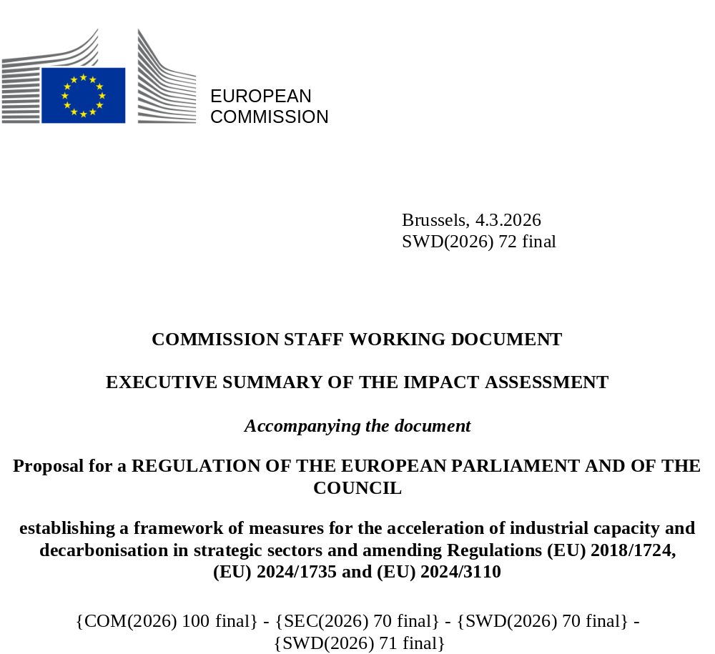

Executive Summary Sheet
Impact assessment for the Industrial Accelerator Act
A. Need for action
Why? What is the problem being addressed?
The overarching problem this initiative aims to address is the need to strengthen the EU industry’s competitiveness and resilience in the context of increased global pressure, while accelerating the decarbonisation of its processes and products. It is fostered by three sub-problems: limited demand for European low-carbon industrial products, supply chain vulnerabilities in strategic sectors and net-zero technologies, and industrial decarbonisation technologies not yet being deployed at scale.
The EU manufacturing sector is the largest employer (18.7%) and value-added provider (24.1%). However, the EU industry is losing ground. Manufacturing as a share of EU GDP declined from 17% in 2000 to 14% in 2024. Low investment levels, along with challenges such as slow economic growth, unfair international trade and competition, the need for decarbonisation and technological competition, affect the competitiveness of EU industry and impact the business case for investing in European low-carbon technologies. The global market for net-zero technologies is projected to nearly triple by 2035. While their deployment in the EU is progressing, the EU’s global market share is declining, and domestic manufacturing capacity remains limited. Furthermore, economic security is a central pillar of EU industrial policy, with key technologies underpinning the green and digital transition, which are currently exposed to strategic dependencies and supply chain risks. Without a competitive and decarbonised industrial base, the EU will not achieve the objectives of the Clean Industrial Deal and the Economic Security strategy.
What is this initiative expected to achieve?
The general objective is to increase resilient and decarbonised industrial production in the EU manufacturing industry, with a special attention on Energy Intensive Industries (EIIs), net-zero technologies, and automotive industry in their contribution to Europe’s competitiveness, economic security, and sustainable economic growth. The general objective is broken down into five specific objectives:
(SO1) Facilitate differentiation for low-carbon industrial products to increase their value and marketability
(SO2) Boost demand for European low-carbon products and net-zero tech
(SO3) Maximise the quality and benefits of foreign investment in the EU
(SO4) Speed-up and simplify permits for industrial decarbonisation
(SO5) Increase investment projects in industrial acceleration areas
What is the value added of action at the EU level?
While national measures may address parts of the challenge, they risk fragmenting the Single Market and undermining collective effectiveness. Given that supply chains are deeply integrated across Member States, a coordinated EU-level approach is essential to promote resilience, industrial decarbonisation and a level playing field. It enables economies of scale, proposes solutions that fit the scope of the problem and helps prevent inefficiencies and duplication.

B. Solutions
What legislative and non-legislative policy options have been considered? Is there a preferred choice or not? Why?
The policy options are organised in three main sets of policy measures (POs), with each measure corresponding to a specific objective (SOs).
Policy option 1 (PO1) proposes, under (SO1), a carbon intensity label for energy-intensive sectors. SO2 aims to create lead markets, by introducing low carbon requirements for energy intensive materials (steel, cement and aluminium) used in selected downstream sectors (automotive and construction) in public procurement and support schemes. It also proposes introducing made in EU requirements for batteries, solar PVs and vehicle components in public procurement and support schemes. SO3 introduces guidance on voluntary conditions for foreign direct investments in the battery supply chain. To streamline permitting (SO4), the option proposes a unified digital procedure for all permits, applicable to the entire manufacturing sector. SO5 recommends to Member States to facilitate public funding for priority projects in industrial areas.
Policy Option 2 (PO2) builds upon the first option by broadening the scope and requirements. SO1 mandates a specific carbon intensity label for steel, with detailed rules that can later be expanded to include other energy-intensive materials. Regarding lead markets (SO2), low-carbon and made in EU requirements are introduced for steel, cement and aluminium used in selected downstream sectors (automotive and construction) in the context of public procurement and support schemes. Conditions for specific investments under SO3 are mandatory rather than voluntary. SO4 increases support for the permitting process by introducing additional measures dedicated to EIIs. Lastly, SO5 requires, instead of recommends, Member States to designate industrial areas.
Policy Option 3 (PO3) further extends the previous two options. SO2 on lead markets extends the low-carbon and made in EU requirements for the steel, cement and aluminium used in the selected downstream sectors, namely the automotive and construction products placed on the market. It also extends the made in EU requirements for batteries, solar PVs and vehicle components to all products placed on the market. SO3 on permitting introduces dedicated measures for industrial areas. SO5 requires the Commission to designate industrial areas according to selection criteria and give priority projects access to funds.
Following the analysis of the impacts of each policy option, as well as their ability to meet the objectives and their interaction with existing and planned EU initiatives, the IA considers PO2 to be the preferred option. Overall, PO2 achieves the objectives in the most effective and efficient manner (as the cost-benefit differences with PO1 are minimal) and contribute to administrative and process efficiency. For the quantified elements, PO2 incurs net overall benefits, which are higher than PO3, but slightly lower than PO1 and the estimated costs are expected to be offset by long-term benefits related to economic security and resilience. However, part of the impacts on downstream sectors and supply chains, positive and negative, could not be quantified due to lack of data. Overall, PO2 facilitates the business case and triggers investment decisions in the EU by streamlining permit procedures for the entire manufacturing sector, boosting demand for European decarbonised materials and net-zero tech products in strategic value chains, and ensure an investment framework that supports value-added creation in the EU. Additionally, PO2 will more effectively mitigate risks of supply chain disruptions and import restrictions by third countries, essential to preserve the economic security of the Union which would suffer large losses from such systemic shocks. Predictability, access to inputs, and strong supply chains are crucial for the competitiveness and well-functioning of EU's industry. Other benefits include, but are not limited to, job creation and upstream growth in gross value added, leading to more economic and social stability overall. It offers the most balanced approach between effectiveness and efficiency, as well as coherence and proportionality.
Who supports which option?
An open public consultation and several targeted ones were organised to gather feedback from all relevant stakeholders. Overall, industry was supportive of the initiative and of provisions facilitating the permitting procedures for industrial manufacturing projects. The steel sector supports a label but debates some of its parameters and the design of the classification system. Steel, cement and aluminium sectors, solar, batteries, and vehicle component manufacturers stand to benefit directly from the IAA and were supportive of the made in EU and low carbon content requirements to support the creation of European lead markets for low-carbon industrial products and net-zero tech. However, some other EIIs may have diverging views regarding the introduction of low-carbon and made in EU requirements. On the other hand, public authorities' views were split, particularly concerning permitting provisions covered under PO2 and PO3, notably for lead market provisions, as it would increase their administrative burden.

C. Impacts of the preferred option
What are the benefits of the preferred option (if any, otherwise main ones)?
PO2 is expected to bring economic benefits for the targeted EIIs and net-zero tech sectors, as it will create demand for European low carbon industrial products and batteries, solar PVs and vehicle components. For example, an increase in GVA of approximately EUR 445 million is expected for the cement industry and EUR 241 million for the steel and aluminium sectors in 2030. Furthermore, the entire EV automotive value chain, including intermediate inputs, is projected to see an increase in value added of around EUR 10.5 billion from entry into force of the vehicle component measures. Manufacturing industries will also benefit from time and costs savings from the e-permitting provisions, potentially reaching up to EUR 240 million cost savings for the digitalisation of permitting procedures. Benefits for industry will include employment opportunities. For example, it is estimated that introducing lead market provisions will generate and maintain 148 352 jobs in 2030. Lastly, the IAA will contribute to the EU climate targets by accelerating decarbonisation projects, leading to estimated GHG emissions reduction of 30,58 Mtonnes CO2eq for PO2 in 2030 only, equivalent to roughly EUR 3 058 million in savings.

What are the costs of the preferred option (if any, otherwise main ones)?
The downstream sectors will experience higher production costs due to lead market conditionalities. Adjustment costs for automotive OEMs from low-carbon and made in EU requirements could result in a EUR 291 million GVA loss while the construction sector could see a EUR 691 million GVA loss. For example, a vehicle's price might increase by 0.225% (EUR 69.27) due to low carbon steel and aluminium provisions, and a passenger EV car by 2.2%EUR 630 due to Made in EU batteries requirements in 2030. The construction cost of a building is expected to rise by 0.45% from the use of low carbon products such as steel, aluminium and cement. Made in EU requirements for solar PV and batteries will also lead to cost increases for all consumers, estimated at EUR 685 million for solar PVs and EUR 2 338 million for BESS/EVs. Public procurement and subsidies could cover a significant portion, reducing the cost impact on citizens. Businesses will face recurring administrative costs, mainly for compliance with lead market provisions, totalling around EUR 1.2 million for PO2, potentially offset by permitting digitalisation savings. These additional costs will decline in the midterm, as production costs lower due to economies of scale and cost parity with carbon intensive products is reached.

How will businesses, SMEs and micro-enterprises be affected?
Businesses of all sizes in the targeted industries will gain from an expanded market for low carbon products and benefit from cost and time savings associated with a faster and simplified permitting process. Industry consultations revealed that SMEs face bigger challenges in permitting due to limited administrative resource. However, businesses in the downstream sector, such as automotive and construction, could incur additional costs (see above costs of the preferred option) related to low carbon and/or EU content requirement, including increased material costs. These increased costs for downstream sectors, however minimal, will be felt more strongly by SMEs.
More concretely, the lead market measures are likely to increase administrative costs to demonstrate compliance reporting, whenever mitigation measures envisaged for the proposal are not enough.

Will there be significant impacts on national budgets and administrations?
Public administrations are expected to incur higher costs in public procurement and support schemes, along with additional administrative expenses for monitoring, reporting, and compliance. Annual administrative costs may increase by up to 8.92 million EU-wide, though these are anticipated to be offset by permitting-related savings. Public procurement costs are projected to rise in all Member States, due to the impact of content requirements.

Will there be other significant impacts?
The Industrial Accelerator Act is expected to enhance the competitiveness of EU EIIs, solar, batteries and vehicle components manufacturing industries by securing demand for their products, as well as EU’s economic security and resilience. International trade flows would be affected, lowering dependencies and favouring foreign investments in the EU with higher value-added creation. Potential negative reactions from some trading partners could result in competitiveness challenges for EU industry on global markets.

D. Follow up
When will the policy be reviewed?
An evaluation should be carried out three years after entry into force, with an explicit review clause applying five years after entry force.

